Compatibility studies between TTT/DSRC in the band 5805-5815 MHz and other systems

Approved 29 April 2016

ECC Report 250

# Executive summary

This report addresses the compatibility between road tolling systems (TTT/DSRC) within the frequency band 5805-5815 MHz and other radio systems, in particular radiolocation systems. Both traditional fixed road tolling stations and movable road toll stations (mobile enforcement vehicles) were studied.

The following radio systems were studied:

Radiolocation systems below 5850 MHz;

BFWA in the band 5725-5875 MHz;

SRDS in the band 5725-5875 MHz.

Other technologies (than 5.8 GHz TTT/DSRC) may be applicable for road tolling applications, while these are not included in this report.

Radiolocation

For the protection of the Radiolocation Service from existing stationary road tolling systems theoretically separation distances between 5 km in urban environment and the radio horizon (rural environment) are required. However, the impact here is comparable to the impact of available SRD devices with up to 25 mW e.i.r.p. on the Radiolocation Service.

Mobile road tolling equipment can have a bigger impact to the Radiolocation Service compared to the stationary road tolling systems due to the possibility that the antenna mainbeam of the mobile road tolling equipment could point to the horizontal plane. That means the mainbeam to mainbeam coupling case is relevant for mobile equipment and requires separation distances up to the radio horizon.

A high impact is theoretically possible from the Radiolocation Service into road tolling due to the huge transmit power values of those radars. Although the road tolling protocol contains some acknowledgement features, the timing parameters of radars could easily be able to interfere the road tolling system. With existing fixed road toll stations with down tilted RSU antennas the interference from Radiolocation Service is less than with mobile road tolling equipment however worst case calculations shows that even with down tilted RSU antennas there is probability for interference.

The following mitigation measures could be used to improve the coexistence between mobile road tolling and the Radiolocation Service:

* A sensing procedure with threshold values between -54 dBm and -65 dBm. However, it should be noted that above sensing approach is only feasible for traditional monostatic radars. The study did not consider the feasibility of detecting frequency hopping radars;
* There may be some possibilities on national levels to ensure the coexistence between both systems since both applications (Radar and road tolling) are often operated by an Administration.

BFWA

For the protection of BFWA from existing stationary road tolling systems theoretically separation distances up to 1 km are required. This could already be seen as manageable and the impact here is comparable to the impact of available SRD devices with up to 25 mW e.i.r.p. on BFWA.

Mobile road tolling equipment has also here a bigger impact to BFWA compared to the stationary road tolling systems. That means the mainbeam to mainbeam coupling case is relevant and requires separation distances of 1 km in urban environments and 3-7 km in rural environments. But the likelihood of the scenario of unobstructed mainbeam-to-mainbeam coupling occurring is expected to be small.

The impact of BFWA into road tolling is comparable to the impact of road tolling into BFWA as shown above.

SRDs

Worst case calculations in this reports show that SRDs with 25mW has the potential to harmfully impact road tolling systems. Separation distances in the road tolling mainbeam are 0.7-1.2 km in urban environment and 2.8-5.5 km rural (in the road tolling sidelobe urban 0.3-0.6 km, rural 1.1-2.2 km). Only the potential impact to the road tolling reader was considered. With fixed road toll installations using down tilted antennas only sidelobe calculations are to be considered except for SRDs used in a vehicle.

General

It should be noted that the calculations in this report are based on worst case assumptions. In realistic scenarios the following considerations will improve the coexistence:

* real antenna pattern (tolling, BFWA, SRDs);
* topography of the environment;
* Duty Cycle of road tolling Tx;
* Azimuth/elevation scanning of radars in some cases.

It should be noted that no interference cases on road tolls from radar installations have been reported to the road toll association ASECAP.

TABLE OF CONTENTS

0 Executive summary 2

1 Introduction 6

2 Background 7

3 Description of TTT/DSRC 10

3.1 Technical Characteristics 10

3.1.1 RF characteristics 10

3.1.2 Antennas 11

3.1.3 Road tolling Protocol 12

3.2 Propagation model 14

3.3 Typical TTT/DSRC applications 15

3.4 Market penetration 16

3.5 Mobile applications in the band 5795-5815 MHz 16

4 Compatibility between Road Tolling and the radiolocation service 19

4.1 Results from other ECC reports 19

4.2 Technical characteristics of Radiolocation systems 19

4.3 Stationary road tolling Impact on Radiolocation systems 20

4.3.1 Worst case MCL calculations 2 W e.i.r.p. European harmonised standard 20

4.3.2 Worst case MCL calculations 8 W e.i.r.p. road tolls in Italy 22

4.3.3 Summary of worst case MCL calculations 23

4.4 Mobile Road Tolling impact on Radiolocation systems 24

4.4.1 Mitigation measures 25

4.5 Radiolocation systems Impact on stationary and mobile Road Tolling 26

4.5.1 Worst case MCL calculations 26

4.6 Radiolocation systems IMPACT ON road tolling TIMING CALCULaTIONS 28

4.7 Summary Radiolocation systems 28

5 Compatibility between Road Tolling and BFWA 30

5.1 Results from other ECC reports 30

Conclusion from ECC Report 68 with respect to sharing between FWA and RTTT systems 30

5.2 Technical characteristics of BFWA 31

5.3 Stationary road tolling impact on BFWA 31

5.4 Mobile Road Tolling impact on BFWA 33

5.5 BFWA impact on stationary Road Tolling 33

5.6 Summary Road Tolling vs BFWA 35

6 The impact of SRDs on Road tolling 36

7 Conclusions 37

ANNEX 1: Regulations from EC DG Move 39

ANNEX 2: Overview on the German road tolling system 40

ANNEX 3: Requirements for a Sensing procedure 41

ANNEX 4: List of Reference 42

LIST OF ABBREVIATIONS

|  |  |
| --- | --- |
| **Abbreviation** | Explanation |
| BFWA | Broadband Fixed Wireless Access |
| CEN | Comité Européen de Normalisation |
| CEPT | European Conference of Postal and Telecommunications Administrations |
| COD | Ordinary legislative procedure |
| DSRC | Dedicated Short-Range Communications |
| ECC | Electronic Communications Committee |
| EETS | European Electronic Toll Service |
| e.i.r.p. | Equivalent isotropically radiated power |
| ETSI | European Telecommunications Standards Institute |
| FWA | Fixed Wireless Access |
| GALILEO | European Global Navigation Satellite System |
| GSM | Global System for Mobile Communications |
| HGVs | Heavy Goods Vehicles |
| ITU | International Telecommunication Union |
| MCL | Minimum Coupling Loss |
| OBE | On-Board Equipment |
| OBU | On-Board Unit |
| OoB | Out Of Band emissions |
| PSD | Power Spectral Density |
| RL | Radiolocation Service |
| RSU | Road Side Unit |
| RTI | Road Traffic Information |
| RTTT | Road Transport and Traffic Telematics |
| Rx | Receiver |
| SRD | Short Range Devices |
| TPC | Transmitter Power Control |
| TTT | Transport and Traffic Telematics |
| TTT/DSRC | TTT applications used for road tolling, road access and parking payment |
| Tx | Transmitter |

# Introduction

This report is intended to analyse the compatibility between road tolling systems (TTT/DSRC) within the frequency band 5805-5815 MHz and other radio systems, in particular radiolocation systems. The focus will be on road tolling applications but other applications such as road access and parking payment systems will not be excluded.

The background to start this study was that even if TTT/DSRC systems have been in operation for 20 years in some countries, no results of compatibility studies are available. Noting that the implementation of this part of the spectrum 5805-5815 MHz for TTT/DSRC is on a voluntary basis, some countries did not implement this regulation due to the lack of compatibility studies.

In the scope of this report the compatibility of TTT/DSRC systems towards the following systems will be investigated:

* Radiolocation systems below 5850 MHz (see section 4);
* BFWA in the band 5725-5875 MHz (see section 5);
* SRDS in the band 5725-5875 MHz (see section 6).

This study is based on technical characteristics of TTT/DSRC defined in the harmonised standard EN 300 674 ([15], [16] and [17]). The influence of various TTT/DSRC RSU antennas and antenna configurations is investigated in this report.

The aim of this study is to define clear operating conditions within 5805-5815 MHz for TTT/DSRC applications to ensure protection to radio services operating in this piece of spectrum. The result of this work may be to create a full harmonisation of this band for TTT/DSRC applications.

The road toll system used in Italy [18] is also studied in this report.

It should be noted that new applications like eTachograph and Weight and Dimension applications were under development when this report was finalised, and that those applications are not considered in this report.

# Background

Fixed road tolling systems with down tilted antennas have been used for almost 20 years and in the most countries all four channels are used. Mobile road toll equipment has been used in some countries such as Austria, Belarus, Czech Republic, Poland and Switzerland for more than 10 years. Practical interference cases have not been officially reported up to now.

This section provides an overview of available reports and regulations regarding Road Tolling.

ERC Report 003 [24]: harmonisation of frequency bands to be designated for road transport information systems, Lisbon, February 1991

* 5. FREQUENCY MANAGEMENT ISSUES INCLUDING SHARING

The frequency bands recommended for the various RTI applications have been selected on the basis that there is a high degree of compatibility with the existing services, so avoiding the need for exclusive bands or complex frequency planning and co-ordination.

The frequency band 5.725 GHz - 5.850 GHz is allocated in Region 1 to the fixed-satellite (Earth-to-space) and radiolocation services on a primary basis and the amateur and amateur-satellite (5.830 GHz - 5.850 GHz) service on a secondary basis. Footnotes provide additional allocations in some countries to other services. Footnote RR 806 designates the band 5.725 GHz - 5.875 GHz for ISM applications; radiocommunications services operating within this band must accept harmful interference from ISM equipment.

Designers of RTI systems should take into account that the frequency bands designated by CEPT for RTI applications are non-exclusive and should develop intelligent systems with robust signalling protocols capable of providing satisfactory operation in these shared bands.

* 7. CONCLUSION

This report has examined the needs of Road Traffic Information (RTI) systems and concludes that three frequency bands are required to meet the short and long term needs of RTI. Suitable frequency bands have been identified; these are available immediately and, as far as can be determined, RTI systems are compatible with existing services such that exclusive bands are not required.

Recommendation T/R 22-04 [25]: Harmonisation of frequency bands for road transport information systems (RTI),

* noting that 1. with careful design, RTI systems would be capable of frequency sharing with other systems and services e.g. short range systems, certain radiolocation systems, the fixed and fixed-satellite service and ISM;
* recommends that

1. CEPT Administrations should designate the band 5.795-5.805 GHz for initial road-to-vehicle systems, in particular road toll systems, with a maximum e.i.r.p. of 3 dBW;
2. an additional sub-band (5.805-5.815 GHz) may be used on a national basis to meet the requirements of multi-lane road junctions;
3. in the development of RTI equipment, special attention should be given to compatibility with the equipment of other services.

ERC Decision of 22 October 1992 on the frequency bands to be designated for the coordinated introduction of Road Transport Telematic Systems (ERC/DEC/(92)02); later replaced by ECC/DEC(02)01.

ECC Decision of 15 March 2002 on the frequency bands to be designated for the co-ordinated introduction of Road Transport and Traffic Telematic Systems (ECC/DEC/(02)01, withdrawn by ECC/DEC(12)04 ):

* Considering h) that the ECC has identified (ERC Report 3: Harmonisation of frequency bands to be designated for road transport information systems) the band 5.795-5.805 GHz with a possible extension in the band 5.805-5.815 GHz, taking account of national situations, as the most suitable frequency band for the initial Road Transport and Traffic Telematic systems in Europe. Additionally, the band 63-64 GHz has been identified for future vehicle-to-vehicle or road-to-vehicle systems and the band 76-77 GHz for vehicular and infrastructure radar systems;
* Considering j) that the Radio Regulations designate the band 5.725-5.875 GHz (center frequency 5.8 GHz) for industrial, scientific and medical (ISM) applications;
* Considering l) that it is not possible to fully protect the RTTT systems from interference from ISM or services operating in accordance with the Radio Regulations;
* Considering m) that RTTT systems must be designed to enable frequency sharing with other systems and services;
* DECIDES 1. that for the purpose of this Decision, RTTT systems are defined as systems providing data communication between road vehicles and between road vehicles and the road infrastructure for various information-based travel and transport applications;
* DECIDES 2. to designate, on a non-exclusive basis, for RTTT systems the frequency bands 5.795-5.805 GHz (with possible extension to 5.815 GHz), 63-64 GHz and 76-77 GHz, in accordance with Decides 3, 4 and 5 and subject to Decides 6;
* DECIDES 3. that the band 5.795-5.805 GHz shall be used for initial road-to-vehicle systems, in particular road toll systems, with an additional sub-band, 5.805-5.815 GHz, to be used on a national basis to meet the requirements of multi-lane road junctions;
* DECIDES 6. that RTTT systems operating in these bands shall conform to such standards as are developed by the European Telecommunications Standards Institute (ETSI) for RTTT systems or any equivalent standards.

Extract from: ERC/REC 70-03 [23] (2015-09), ANNEX 5, TRANSPORT AND TRAFFIC TELEMATICS (TTT):

**Scope of Annex**

This annex covers frequency bands and regulatory as well as informative parameters recommended for radio systems used in the field of transport and traffic telematics (road, rail and water depending on the relevant technical restrictions), traffic management, and navigation and mobility management. Typical applications are used for interfaces between different modes of transport, communication between vehicles (e.g. car-to-car), between vehicles and fixed locations (e.g. car-to-infrastructure), Communication from and to users as well as radar system installations. Automotive radar is defined as a moving radar device supporting functions of the vehicle.

**Regulatory parameters**

| **Frequency Band** | | **Power / Magnetic Field** | **Spectrum access and mitigation requirements** | **Modulation/ maximum occupied bandwidth** | **ECC/ERC deliverable** | **Notes** |
| --- | --- | --- | --- | --- | --- | --- |
| **a** | 870.000-875.800 MHz | 500 mW e.r.p.  100 mW e.r.p. | ≤ 0.1% duty cycle  For ER-GSM protection  (873-875.8MHz, where applicable), the duty cycle is limited to ≤ 0.01% and limited to a maximum transmit on-time of 5ms/1s | ≤ 500 kHz |  | 500 mW restricted to vehicle-to-vehicle applications.  100 mW is restricted to in-vehicle applications.  Adaptive Power Control (APC) is required.  The APC is able to reduce a link’s transmit power from its maximum to ≤ 5 mW.  The frequency band is also identified in Annexes 1 and 2 |
| **b1** | 5795-5805 MHz | 2 W e.i.r.p.  8 W e.i.r.p. | No requirement |  |  | Individual license may be required for the higher power of 8 W systems |
| **b2** | 5805-5815 MHz | 2 W e.i.r.p.  8 W e.i.r.p. | No requirement |  |  | Individual license may be required |

General authorisation according to EC Decision 2013/752/EU for the band 5795-5805 MHz:

|  |  |  |  |  |  |  |
| --- | --- | --- | --- | --- | --- | --- |
| 62 | 5795-5805 MHz | Transport and Traffic Telematics devices (13) | 2W e.i.r.p. | Techniques to access spectrum and mitigate interference that provide at least equivalent performance to the techniques described in harmonised standards adopted under Directive 1999/5/EC must be used. | This set of usage conditions applies only to road tolling applications. | 1 July 2014 |

(13) The transport and traffic telematics device category covers radio devices that are used in the fields of transport (road, rail, water or air, depending on the relevant technical restrictions), traffic management, navigation, mobility management and in intelligent transport systems (ITS). Typical applications are used for interfaces between different modes of transport, communication between vehicles (e.g. car to car), between vehicles and fixed locations (e.g. car to infrastructure) as well as communication from and to users.

German general authorisation as one example of a national implementation:

General frequency allocation for telematic transport systems[1].

According to § 55 of the German telecommunications law (TKG), the following use of frequencies are allocated through the general conditions (i.e. license exempt) for the radio applications for telematic transport systems. […]

|  |  |  |  |
| --- | --- | --- | --- |
| Frequency range in GHz | Maximum allowed equivalent isotropic radiated power (e.i.r.p) in W and respectively in dBm | W0Frequency access and mitigation techniques  (See Note 1) | Remarks |
| a) 5,795 – 5,805 | 2 W respectively 8 W  (See note 2) |  |  |
| b) 5,805 – 5,815 | 2 W respectively 8 W  (See note 2) |  |  |
| c) 63 - 64 | 40 dBm |  | For the communication between vehicles, from vehicle to infrastructure and from infrastructure to vehicle. |
| d) 76 - 77 | 55 dBm  (See Note 3) |  | Only for terrestrial systems for vehicles and infrastructure |
| e1) 24,050 – 24,075 | 100 mW |  | Only for automotive radar |
| e2) 24,075 – 24,150 | 0,1 mW |  | Only for automotive radar |
| e3) 24,075 – 24,150 | 100 mW | Maximum duty cycle and frequency modulation bandwidth according to the harmonised standards | Only for automotive radar |
| e4) 24,150 – 24,250 | 100 mW |  | Only for automotive radar |

Note 1: Spectrum access and mitigation techniques should be implemented, the performance of which meet at least the techniques according to the directive 1999/5/EG described in the appropriate approved harmonised standards.

Note 2: For the frequency range with high power (i.e. 8 W) an individual license is required.

Note 3: Peak radiated power. Mean radiated power 50 dBm and respectively 23.5 dBm for pulsed radars.

# Description of TTT/DSRC

## Technical Characteristics

### RF characteristics

The regulatory parameters (maximum power levels) for TTT/DSRC are given in Annex 5 of ERC/REC 70-03 [23]. The TTT/DSRC parameters used in this Report are taken from the EN 300 674 [15] developed by ETSI and the EN12253 [1] developed by CENELEC. It should be noted that the EN 300 674 deals with both Road Side Units (RSU) and On-Board Units (OBU) and is divided in two parts, the part 1 providing general characteristics and test methods, the part 2 containing the essential requirements under article 3.2 of the R&TTE Directive.

Table 1: Summary of characteristics of the TTT systems

|  |  |  |
| --- | --- | --- |
|  | Road Side Units | On Board Units |
| Frequency range (MHz) | 5795 and 5815 | |
| e.i.r.p. | 2 W (33 dBm) standard for -35° ≤ θ ≤ 35°  18 dBm for θ > 35°  8 W (39 dBm) optional  Note 1 | Maximum re-radiated sub-carrier e.i.r.p.:  -24 dBm (Medium data rate)  -14 dBm (High data rate) |
| Antenna gain | 10 – 20 dB (assumed front-to-back ratio of 15 dB for Rx and 25 dB for Tx) | 1 – 10 dB (assumed front-to-back ratio of 5 dB) |
| Transmitter Bandwidth | 1 MHz | 500 kHz |
| Receiver bandwidth  Note 2 | 500 kHz | 200 MHz – 1.4 GHz |
| Polarisation | left circular | left circular |
| Receiver sensitivity (at the receiver input)  Note 2 | -104 dBm (BPSK) | -60 dBm |
| Receiver noise power  (at the receiver input)  Note 2 | -115 dBm |  |
| Co-channel C/N (dB) | 6 for 2-PSK,  9 for 4-PSK,  12 for 8-PSK | Not defined |
| I/N (dB) | -6 |  |

Note 1: Tx power 2 W e.i.r.p. European harmonised standard ETSI EN 300 674 ([15], [16] and [17]) Tx power 8 W e.i.r.p. road tolls in Italy ETSI ES 200 674-1 [18]

Note 2: The receiver parameters in the standard family ETSI EN 300 674 (2016) may deviate from the values in Table 1.

The following figure depicts the TTT/DSRC frequency utilisation for 1.5 MHz sub-carrier frequency, according the EN 300 674 [15]. The location of downlink channels from RSU to OBU and the location of uplink channels from OBU to RSU become visible.



Figure 1: TTT frequency utilisation for 1.5 MHz sub-carrier frequency, according the EN 300 674

The transmit power limits of TTT downlink, uplink and out of band emissions are depicted in the following Figure.



Figure 2: e.i.r.p. limits of TTT

### Antennas

The RSU Tx and Rx antennas are tilted downside by 45° for the interrogation of the on-board units. A RSU is typically installed in a height of 6 m to 7 m. A typical road toll installation is shown in Figure 3.

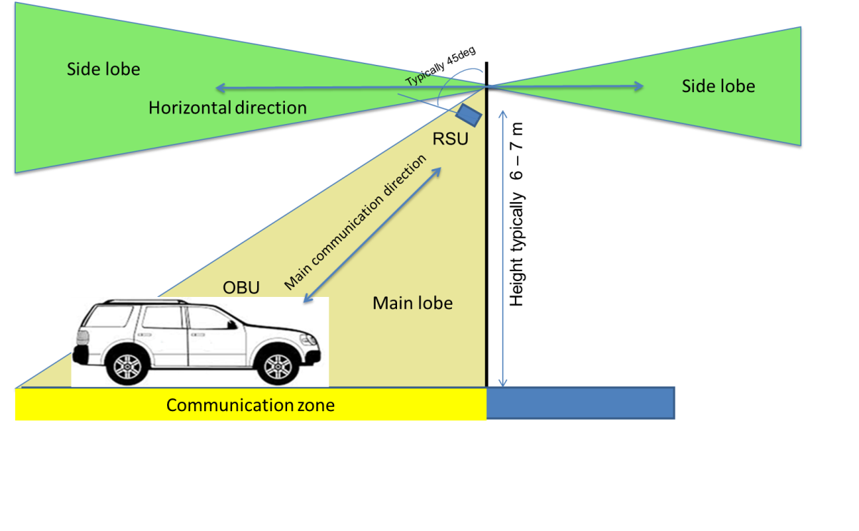

Figure 3: Typical road toll setup, blue line: Rx antenna main beam

In a multilane setup with several parallel lanes a single RSU will cover more than a single lane. This leads to an overlap between two adjacent RSUs. By doing so, a better coverage can be guaranteed.

Characteristics of the road-tolling antennas in RSU (Road Side Unit) and OBU (On Board Unit):

* Main lobe to communication zone (see Fig. below), gain Rx antennas:

RSU 13 dBi left circular (10 dBi vert. lin., Rx antenna uplink (OBU to RSU);

OBU: 8 dBi left circular (5 dBi vert. lin., Rx antenna downlink (RSU to OBU);

* Antenna side lobe suppression in horizontal plane (RSU to/from interferer) (values given are the difference in gain between main lobe and horizontal direction);

-15 dB: Rx antenna for uplink (Interferer to RSU);

-25 dB: Tx antenna for downlink (RSU to Interferer);

* Antenna polarisation: left circular.

### Road tolling Protocol

The communication with TTT/DSRC tolling technology is always between one RSU placed on or beside the road and one OBU placed in a vehicle, figure 3. The RSU acts as master and decides when the OBU shall respond, the OBU is never allowed to transmit without a permission from the RSU. The OBU does not have its own signal generator, the transmission from the OBU is based on reflection and modulation on a sinus carrier sent from the RSU.

The communication protocol of the CEN DSRC tolling system is based on a packet exchange between the RSU and the OBU. In the protocol some degree of redundancy is built in by simple repetition in case a packet has be disturbed by interference. In general the RSU sends out a general non-personalized request to all active OBUs in its range. The first OBU answering with its ID will then be processed further by sending out a personalized request only addressing this single OBU. During this communication then several packets are exchanged and at the end the transaction is closed.

In case an uplink packet (OBU to RSU) will not be received by the RSU (Interference into the RSU) the RSU will retransmit the request packet after a certain waiting time in the range of some ms. This can be repeated several times. The transaction is defined as failed after a number of retrials, which is depending on the individual parameter settings in the RSU. It can be seen in the following that a single interference event during a transaction can only delay the transaction but will not lead to a fail of the transaction. Only when a number of interference events occur during a transaction a transaction failure might be generated.

A part of a typical transaction scheme is depicted in Figure 4. Here the transaction is not depicted for the complete time duration. The typical distribution of transaction durations is given in Figure 5. In Figure 4 an interference event occurs during a downlink (RSU and OBU) communication, thus the OBU has not been able to receive the RSU packet. I can be seen that after a waiting time the RSU repeats the Tx packet and then receives the answer from the OBU with some delay. The timing given here is only tentative and might be different for different installation and systems.



Figure 4: Part of a typical transaction scheme between RSU and OBU in CEN DSRC

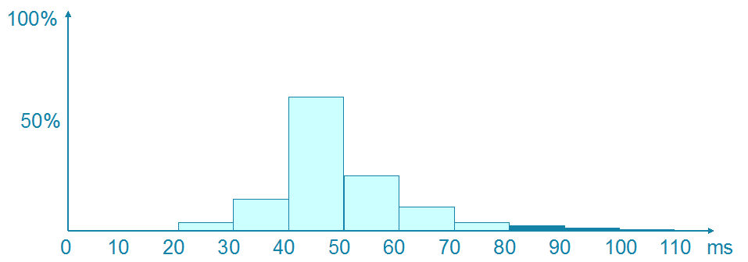

Figure 5: Histogram of a typical tolling transaction duration

## Propagation model

This report assumes the below three slope propagation model from ECC Report 68 [20].

 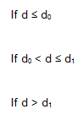

Figure 6: Three slope propagation model from ECC Report 68

Table 2: Parameters for the propagation model

|  |  |  |  |
| --- | --- | --- | --- |
|  | Urban | Suburban | Rural |
| Breakpoint distance d0 (m) | 64 | 128 | 256 |
| Pathloss factor n0 beyond the first break point | 3.8 | 3.3 | 2.8 |
| Breakpoint distance d1 (m) | 128 | 256 | 1024 |
| Pathloss factor n1 beyond the second breakpoint | 4.3 | 3.8 | 3.3 |

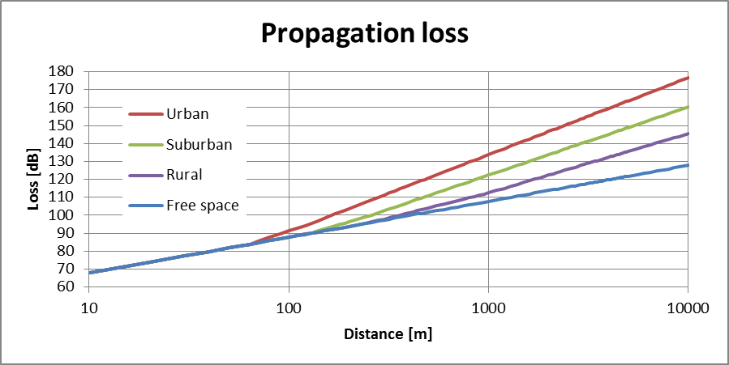

Figure 7: Attenuation of the propagation model used in the calculations

## Typical TTT/DSRC applications

Three main tolling station applications need to be differentiated due their different operational conditions:

* Free-Flow tolling stations and enforcement stations with a maximum of 6 parallel lanes (typical 3 lanes to 4 lanes in each traffic direction). Here the speed of the mobiles can be high. No specific speed limit is given during the tolling operation. See Figure 8.
* Toll plazas with an automatic barrier with up to 40 parallel lanes (Typical around 5 lanes to 20 lanes in each traffic direction). Here the vehicular speed is very limited. See Figure 9, left part.
* Toll plazas with automatic lanes (reduced speed) with up to 40 parallel lanes (typical around 1 lane to 10 lanes in each traffic direction). Here the speed limit is in the range of 30 km/h. See Figure 9, right part.

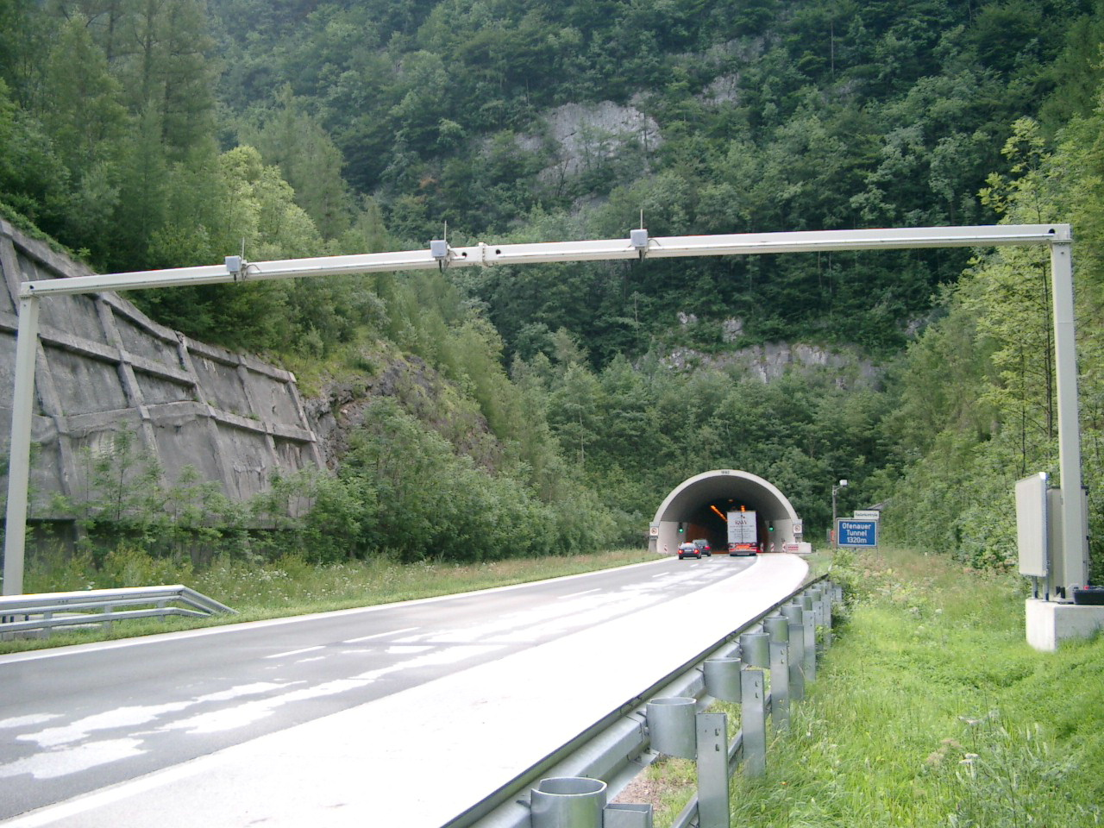

Figure 8: Typical free-flow installation with three lanes

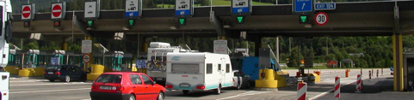

Figure 9: Typical toll plaza with an automatic barrier (left) and a single automatic lane (right)

Besides road tolling TTT is also used for other applications such as access and payment of parking, traffic monitoring and for the future enforcement of tachograph for trucks buses etc. The free-flow application shown in Figure 8 is in this study considered the most demanding application regarding output power, antenna beam width etc. Because of this only this scenario was studied in this study.

## Market penetration

In Directive 2004/52/EC [21], it is stated that all new electronic toll systems brought into service on or after 1st January 2007 shall, for carrying out electronic toll transactions use one or more of the following technologies: satellite positioning, mobile communications using the GSM-GPRS standard, 5.8 GHz microwave technology. . DSRC based EFC systems are in operation in 20 European countries. In 2015 around 28 millions DSRC OBU were in use in Europe, communicating with more than 20.000 Transceivers (beacons) for tolling purposes.

In tolling systems based on GNSS, DSRC is in use for enforcement, following the related European standards.

The enforcement of the Digital Tachograph Regulation 165/2014 and of the Weights & Dimensions Directive is currently awaiting its legislative adoption (procedure 2013/0105 (COD)). Road charging shares the same radio parameters, operates in the same frequency band and uses the same DSRC profile and verification standards as the future enforcement applications foreseen for the Digital Tachograph and the coming Weights and Dimensions Directive.

## Mobile applications in the band 5795-5815 MHz

Mobile road tolling stations are used in some countries such as Austria, Belarus, Czech Republic, Poland and Switzerland. Also in Germany it is planned to use mobile road tolling stations, 278 mobile enforcement vehicles driving on the toll road network and 35 portable enforcement units that can be mounted on existing bridges over the motorway. See ANNEX 1: and ANNEX 2: for more information.

The main use of these mobile road tolling stations are not mainly for road charging but rather for enforcement. The mobile stations are verifying that a vehicle is equipped with an OBU correctly configured. A mobile enforcement vehicle is driving on the road and communicates with other adjacent vehicles but it can also communicate when parked close to the road.

The figures below show the performance with typical mobile enforcement vehicles. It is important that the mobile enforcement vehicle knows exactly which OBU to communicate with. This is typically achieved using narrow antenna beams in azimuth.

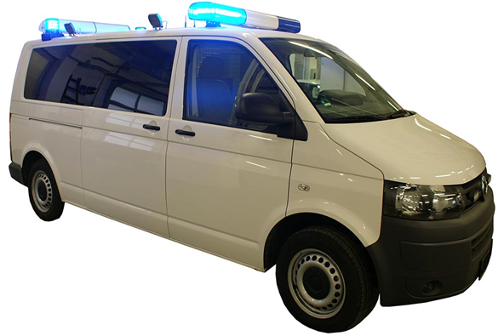

Figure 10: Typical mobile enforcement vehicle, RSU antennas are mounted   
on top of the roof in the back of the vehicle

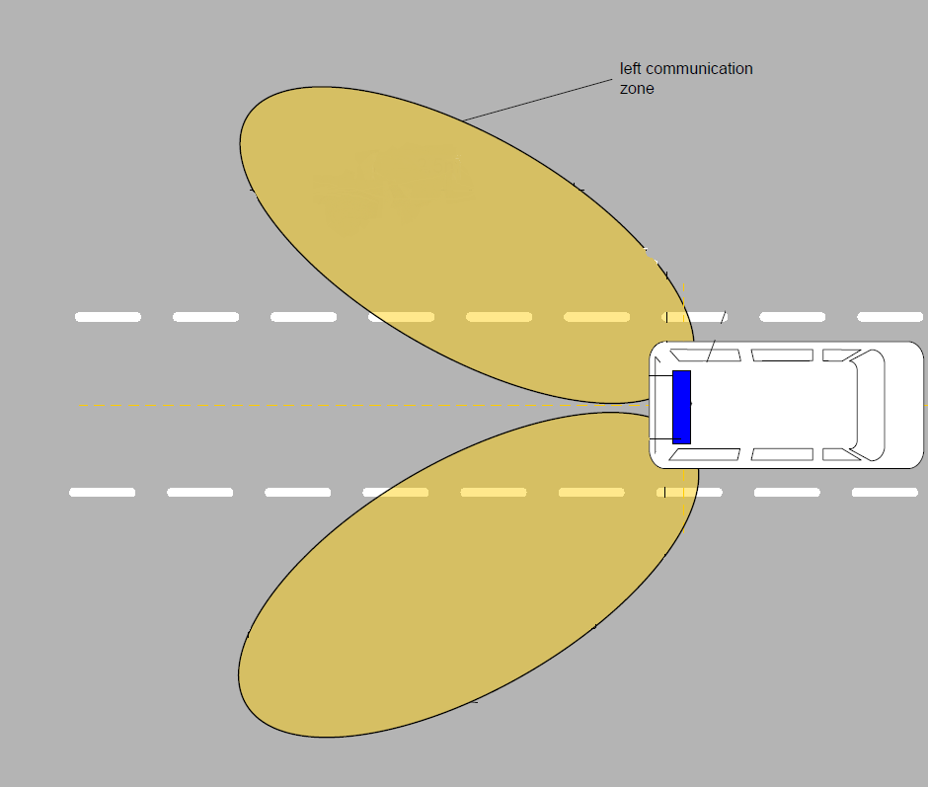

Figure 11: Typical communication zones with a mobile enforcement vehicle

Two individual zones are available, one on the left and one on the right. Only one beam at a time is used. Note that the communication is directed backwards compared with the driving direction.

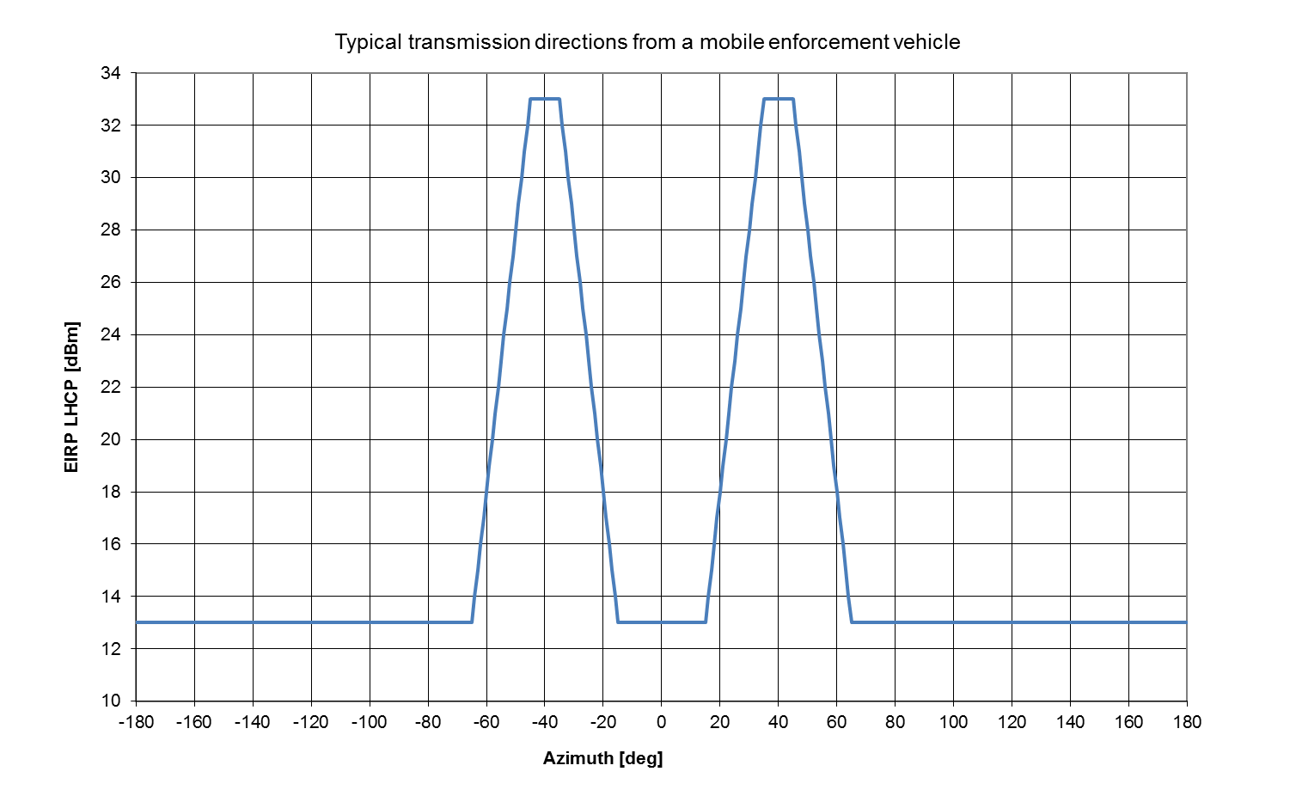

Figure 12: Typical transmission directions in horizontal plane with a mobile enforcement vehicle

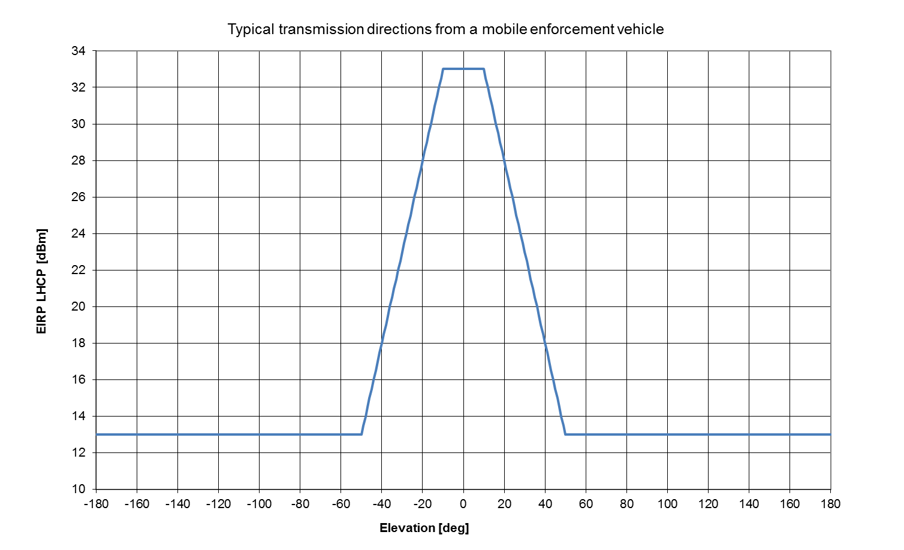

Figure 13: Typical transmission directions in vertical plane with a mobile enforcement vehicle

Tachograph applications were under development when this report was written. Most probably the mobile enforcement vehicles for those applications will be very similar to the ones used for road tolling enforcement.

# Compatibility between Road Tolling and the radiolocation service

## Results from other ECC reports

ERC Report 003 [24]: Harmonisation of frequency bands to be designated for road transport information systems,

* 5. FREQUENCY MANAGEMENT ISSUES INCLUDING SHARING

The frequency bands recommended for the various RTI applications have been selected on the basis that there is a high degree of compatibility with the existing services, so avoiding the need for exclusive bands or complex frequency planning and co-ordination.

The frequency band 5.725 GHz - 5.850 GHz is allocated in Region 1 to the fixed-satellite (Earth-to-space) and radiolocation services on a primary basis and the amateur and amateur-satellite (5.830 GHz - 5.850 GHz) service on a secondary basis. Footnotes provide additional allocations in some countries to other services. Footnote RR 806 designates the band 5.725 GHz - 5.875 GHz for ISM applications; radiocommunications services operating within this band must accept harmful interference from ISM equipment.

Designers of RTI systems should take into account that the frequency bands designated by CEPT for RTI applications are non-exclusive and should develop intelligent systems with robust signalling protocols capable of providing satisfactory operation in these shared bands.

* 7. CONCLUSION

This report has examined the needs of Road Traffic Information (RTI) systems and concludes that three frequency bands are required to meet the short and long term needs of RTI. Suitable frequency bands have been identified; these are available immediately and, as far as can be determined, RTI systems are compatible with existing services such that exclusive bands are not required.

ECC Report 68 [20]**:** Compatibility studies in the band 5725-5875 MHz between fixed wireless access (FWA) systems and other systems.

Table 3: Extract from ECC Report 68

|  |  |  |
| --- | --- | --- |
| Existing Service and its operating band | Required conditions for introducing FWA | Comments |
| Radiolocation  (5725–5850 MHz) | A DFS mechanism with appropriate requirements is required | Suitable protection of some frequency hopping radars is not ensured with DFS compliant to the harmonised standard ETSI EN 301893 v1.2.3 or v1.3.1 |

Summary:

* ERC Report 003 [24] considered the Radiolocation Service from 5725-5850 MHz and concluded that, as far as can be determined, RTI systems are compatible with existing services such that exclusive bands are not required;
* ECC Report 68 [20] considered the impact of FWA systems on the Radiolocation Service and concluded that a DFS mechanism is required.

## Technical characteristics of Radiolocation systems

Recommendation ITU-R M.1638-1 [19] provides characteristics of radars operating under the Radiolocation services in the frequency range 5250-5850 MHz. Within this range, the band between 5 725 and 5 850 MHz is used by many different types of radars on fixed land-based, ship borne and transportable platforms. It should be noted that most of these radars are designed to operate not only in the 5725-5850 MHz band but in a larger portion of the band 5250-5850 MHz.

## Stationary road tolling Impact on Radiolocation systems

### Worst case MCL calculations 2 W e.i.r.p. European harmonised standard

The below MCL calculations uses the propagation model from section 3.3 and the following assumptions for road tolling and Radiolocation:

* Radar Rx;

receiver bandwidth: 1 MHz;

receiver noise floor: -110 dBm;

I/N protection criterion: -6 dB;

Antenna gain mainbeam: 42 dBi;

Antenna gain sidelobe: 0 dBi;

* Road tolling Tx;

Tx bandwidth: 0.5 MHz;

Conducted Tx power: 20 dBm;

Antenna gain mainbeam: 13 dBi;

Antenna gain sidelobe: -12 dBi.

For comparison the results for a non-specific SRD with 25 mW e.i.r.p. are shown.

Table 4: separation distances between road tolling (2 W) and Radiolocation

|  |  |  |  |  |  |  |  |  |
| --- | --- | --- | --- | --- | --- | --- | --- | --- |
|  |  |  |  |  |  | Urban path loss model | Suburban path loss model | Rural path loss model |
|  |  |  |  |  | f/GHz | 5.8 | 5.8 | 5.8 |
|  |  |  |  |  | do m | 64 | 128 | 256 |
|  |  |  |  |  | no | 3.8 | 3.3 | 2.8 |
|  |  |  |  |  | d1m | 128 | 256 | 1028 |
|  |  |  |  |  | n1 | 4.3 | 3.8 | 3.3 |
|  |  |  |  |  | Wall loss dB | 0 | 0 | 0 |
|  |  |  |  |  | Other mitigation factors dB | 0 | 0 | 0 |
| **Radar** | | | | | | | | |
|  |  |  |  | Victim | Noise floor dBm/BW2 | -110 | -110 | -110 |
|  |  |  |  |  | Margin dB | 0 | 0 | 0 |
|  |  |  |  | Victim | I/NdB | -6 | -6 | -6 |
|  |  |  |  | Victim | Imax dBm/BW2 | -116 | -116 | -116 |
|  |  |  |  | Victim | BW2 MHz | 1 | 1 | 1 |
| **Separation distances (m)** | | | | | | | | |
| **Road Tolling** | **Tx Interferer dBm/BW1** | **BW1 MHz** | **Tx Interferer dBm/BW2** | **Gs Interferer dBi** | **Ge Victim**  **dBi** | **Urban path loss model** | **Suburban path loss model** | **Rural path loss model** |
| main-main | 20 | 0.5 | 20.00 | 13.00 | 42.00 | 21481.44 | 64122.39 | 240173.46 |
| side-main | 20 | 0.5 | 20.00 | -12.00 | 42.00 | 5632.07 | 14096.62 | 41970.99 |
| main-side | 20 | 0.5 | 20.00 | 13.00 | 0.00 | 2266.31 | 5032.07 | 12817.34 |
| side-side | 20 | 0.5 | 20.00 | -12.00 | 0.00 | 594.19 | 1106.25 | 2239.87 |
| **Comparison non-specific SRD** | | | | | | | | |
|  | 14 | 1 | 14.00 | 0.00 | 42.00 | 7766.10 | 20277.28 | 63792.18 |
|  | 14 | 1 | 14.00 | 0.00 | 0.00 | 819.33 | 1591.28 | 3404.40 |

### Worst case MCL calculations 8 W e.i.r.p. road tolls in Italy

The below MCL calculations uses the same assumptions as in the previous section 4.3.1, only the Tx power of the road tolling systems is changed to 26 dBm.

For comparison the results for a non-specific SRD with 25 mW e.i.r.p. are shown.

Table 5: separation distances between road tolling (8 W) and Radiolocation

|  |  |  |  |  |  |  |  |  |
| --- | --- | --- | --- | --- | --- | --- | --- | --- |
|  |  |  |  |  |  | Urban path loss model | Suburban path loss model | Rural path loss model |
|  |  |  |  |  | f/GHz | 5.8 | 5.8 | 5.8 |
|  |  |  |  |  | do m | 64 | 128 | 256 |
|  |  |  |  |  | no | 3.8 | 3.3 | 2.8 |
|  |  |  |  |  | d1m | 128 | 256 | 1028 |
|  |  |  |  |  | n1 | 4.3 | 3.8 | 3.3 |
|  |  |  |  |  | Wall loss dB | 0 | 0 | 0 |
|  |  |  |  |  | Other mitigation factors dB | 0 | 0 | 0 |
| **Radar** | | | | | | | | |
|  |  |  |  | Victim | Noise floor dBm/BW2 | -110 | -110 | -110 |
|  |  |  |  |  | Margin dB | 0 | 0 | 0 |
|  |  |  |  | Victim | I/NdB | -6 | -6 | -6 |
|  |  |  |  | Victim | Imax dBm/BW2 | -116 | -116 | -116 |
|  |  |  |  | Victim | BW2 MHz | 1 | 1 | 1 |
| **Separation distances (m)** | | | | | | | | |
| **Road Tolling** | **Tx Interferer dBm/BW1** | **BW1 MHz** | **Tx Interferer dBm/BW2** | **Gs Interferer dBi** | **Ge Victim dBi** | **Urban path loss model** | **Suburban path loss model** | **Rural path loss model** |
| main-main | 26 | 0.5 | 26.00 | 13.00 | 42.00 | 29620.91 | 92236.85 | 365042.30 |
| side-main | 26 | 0.5 | 26.00 | -12.00 | 42.00 | 7766.10 | 20277.28 | 63792.18 |
| main-side | 26 | 0.5 | 26.00 | 13.00 | 0.00 | 3125.03 | 7238.38 | 19481.21 |
| side-side | 26 | 0.5 | 26.00 | -12.00 | 0.00 | 819.33 | 1591.28 | 3404.40 |
| **Comparison non-specific SRD** | | | | | | | | |
|  | 14 | 1 | 14.00 | 0.00 | 42.00 | 7766.10 | 20277.28 | 63792.18 |
|  | 14 | 1 | 14.00 | 0.00 | 0.00 | 819.33 | 1591.28 | 3404.40 |

### Summary of worst case MCL calculations

Table 6: Summary MCL calculations

|  |  |  |
| --- | --- | --- |
|  | Radar mainbeam | Radar sidelobe |
| RSU mainbeam | Large separation distances are required, coordination required; but this scenario is not relevant for typical Road Tolling stations having a fixed RSU with 45° downtilt | 2 W separation distances   * urban: 2 km * suburban 5 km * rural: 13 km   8 W separation distances   * urban: 3 km * suburban 7 km * rural: 19 km |
| RSU sidelobe | 2 W separation distances   * urban: 5 km * suburban 14 km * rural: at least radio horizon   8 W separation distances   * urban: 8 km * suburban 20 km * rural: at least radio horizon | 2 W separation distances   * urban: 0.6 km * suburban 1 km * rural: 2 km   8 W separation distances   * urban: 0.8 km * suburban 2 km * rural: 3 km |
| SRDs 25 mW | separation distances   * urban: 8 km * suburban 20 km * rural: at least radio horizon | separation distances   * urban: 0.8 km * suburban 1.5 km * rural: 3.5 km |

Preliminary conclusions from MCL calculations:

* Mainbeam coupling between RSU and radars would require coordination between RSU and radar. This scenario is not valid because the radar will not be placed within the tolling zone and the height of the radar antenna is higher than the down tilted RSU receiver antenna;
* The separation distances for the case when both are within the antenna sidelobe seems to be manageable;
* The practical relevant scenario of the RSU sidelobe coupling to the radar mainbeam requires theoretically separation distances between 5 km up to the radio horizon (30 km); however, the impact here is comparable to the impact of available SRD devices with up to 25 mW e.i.r.p.;
* 2W or 8 W are not making a big difference;
* The above calculations are based on worst case assumptions. In realistic scenarios the following considerations will improve the coexistence:

real radar antenna pattern;

real RSU antenna pattern;

real RSU installation;

topography of the environment;

Duty Cycle of RSU Tx;

Azimuth/elevation scanning of radars.

## Mobile Road Tolling impact on Radiolocation systems

* The only difference of the mobile road tolling equipment compared to the stationary road tolling systems dealt with in section 4.3 is the possibility that the antenna mainbeam of the mobile road tolling equipment could point to the horizontal plane, and thus a higher potential impact is expected.
* The calculations from section 4.3 are also applicable to this case. A summary for the mobile road tolling case is given below.

Table 7: Summary MCL calculations

|  |  |  |
| --- | --- | --- |
|  | Radar mainbeam | Radar sidelobe |
| Mobile road toll mainbeam | large separation distances are required, coordination required; | 2 W separation distances   * urban: 2 km * suburban 5 km * rural: 13 km   8 W separation distances   * urban: 3 km * suburban 7 km * rural: 19 km |
| Mobile road toll sidelobe | 2 W separation distances   * urban: 5 km * suburban 14 km * rural: at least radio horizon   8 W separation distances   * urban: 8 km * suburban 20 km * rural: at least radio horizon | 2 W separation distances   * urban: 0.6 km * suburban 1 km * rural: 2 km   8 W separation distances   * urban: 0.8 km * suburban 2 km * rural: 3 km |
| SRDs 25 mW | separation distances   * urban: 8 km * suburban 20 km * rural: at least radio horizon | separation distances   * urban: 0.8 km * suburban 1.5 km * rural: 3.5 km |

Preliminary conclusions from MCL calculations:

* Mainbeam coupling between mobile road tolling equipment and radars would require large separation distances or other mitigation measures (see section 4.4.1);
* The separation distances for the case when both are within the antenna sidelobe seems to be manageable;
* The scenario of the mobile road tolling sidelobe coupling to the radar mainbeam requires theoretically separation distances between 5 km up to the radio horizon (30 km); however, the impact here is comparable to the impact of available SRD devices with up to 25 mW e.i.r.p.;
* 2W or 8W from road tolling are not making significant difference regarding final conclusions;
* The above calculations are based on worst case assumptions. In realistic scenarios the following considerations will improve the coexistence:

real radar antenna pattern;

real mobile antenna pattern;

topography of the environment;

Duty Cycle of RSU Tx;

Azimuth/elevation scanning of radars.

### Mitigation measures

The limitation of the e.i.r.p. of the mobile road tolling equipment to the horizon (0° elevation angle) to below 25 mW could reduce the impact to a level comparable with stationary road tolling systems. This would require an essential down tilt (e.g. 30° and more) of the road toll antenna. This maybe not feasible for those mobile applications.

A second mitigation measure would be to implement a sensing procedure (DFS/LBT) on the mobile road tolling RSU. The below calculation is based on the approach presented in ANNEX 3: on how to derive a threshold value for LBT functionality. It shows the required threshold values for mobile road tolling equipment devices to detect radars. Radars from Recommendation ITU-R M.1638-1 [19] with lowest Tx power values are used to derive threshold values.

Table 8: Threshold calculations

|  |  |  |
| --- | --- | --- |
|  | Radar 5 | Radar 22 |
| Victim parameters | | |
| BW2/MHz | 8.00 | 5.00 |
| Pwt dBm/BW2 | 82.2 | 70.80 |
| Noise floor dBm/BW2 | -110.00 | -110.00 |
| I/N dB | -6.00 | -6.00 |
| Imax dBm/BW2 | -116.00 | -116.00 |
| Interferer parameters | | |
| Pit dBm/BW1 | 20.0 | |
| BW1/MHz | 0.50 | |
| Pit dBm/BW2 | 20.00 | 20.00 |
| Pthr dBm/BW2 | -53.83 | -65.21 |

The required threshold values to protect the lowest power radars to a level of the I/N protection objective are between -54 dBm and -65 dBm. However, it should be noted that above sensing approach could be only feasible for traditional monostatic radars where a radar receiver and transmitter are located at the same location. However, all DFS algorithms approved to-date have assumed a non-mobile RLAN infrastructure[2]. For bistatic radars (see Figure 1 of ITU-R M.1638-1 [19]) this sensing procedure would not work and huge hidden nodes are expected where the potentially affected radar receiver could not be detected.

## Radiolocation systems Impact on stationary and mobile Road Tolling

### Worst case MCL calculations

The below MCL calculations uses the propagation model from section 3.3 and the following assumptions for road tolling and Radiolocation:

* Road toll Rx;

receiver bandwidth: 0.5 MHz;

Sensitivity: -104 dBm;

C/I protection criterion: 6 dB;

Antenna gain mainbeam: 13 dBi;

Antenna gain sidelobe: -2 dBi;

* Radar Tx;

Tx bandwidth: 1 MHz;

Conducted Tx power: 70/90 dBm;

Antenna gain mainbeam: 42 dBi;

Antenna gain sidelobe: 0 dBi.

For comparison the results for a non-specific SRD with 25 mW e.i.r.p. are shown.

Table 9: Summary MCL calculations

|  |  |  |  |  |  |  |  |  |
| --- | --- | --- | --- | --- | --- | --- | --- | --- |
|  |  |  |  |  |  | Urban path loss model | Suburban path loss model | Rural path loss model |
|  |  |  |  |  | f/GHz | 5.8 | 5.8 | 5.8 |
|  |  |  |  |  | do m | 64 | 128 | 256 |
|  |  |  |  |  | no | 3.8 | 3.3 | 2.8 |
|  |  |  |  |  | d1m | 128 | 256 | 1028 |
|  |  |  |  |  | n1 | 4.3 | 3.8 | 3.3 |
|  |  |  |  |  | Wall loss dB | 0 | 0 | 0 |
|  |  |  |  |  | Other mitigation factors dB | 0 | 0 | 0 |
| **Roland tolling RSU** | | | | | | | | |
|  |  |  |  | Victim | Sensitivity S dBm/BW2 | -104 | -104 | -104 |
|  |  |  |  |  | Margin dB | 0 | 0 | 0 |
|  |  |  |  | Victim | C/I dB | 6 | 6 | 6 |
|  |  |  |  | Victim | Imax dBm/BW2 | -110 | -110 | -110 |
|  |  |  |  | Victim | BW2 MHz | 0.5 | 0.5 | 0.5 |
| **Separation distances (m)** | | | | | | | | |
| **Radar** | **Tx Interferer dBm/BW1** | **BW1 MHz** | **Tx Interferer dBm/BW2** | **Gs Interferer dBi** | **Ge Victim dBi** | **Urban path loss model** | **Suburban path loss model** | **Rural path loss model** |
| main-main | 70 | 1 | 66.99 | 42.00 | 13.00 | 192891.2 | 768574.6 | 4194084.1 |
| main-main | 90 | 1 | 86.99 | 42.00 | 13.00 | 562896.6 | 2582271.1 | 16931589.9 |
| main-side | 70 | 1 | 66.99 | 42.00 | -2.00 | 86392.3 | 309705.7 | 1472623.3 |
| main-side | 90 | 1 | 86.99 | 42.00 | -2.00 | 252110.8 | 1040554.9 | 5945005.9 |
| side-main | 70 | 1 | 66.99 | 0.00 | 13.00 | 20350.2 | 60314.7 | 223825.7 |
| side-main | 90 | 1 | 86.99 | 0.00 | 13.00 | 59386.0 | 202646.3 | 903588.0 |
| side-side | 70 | 1 | 66.99 | 0.00 | -2.00 | 9114.5 | 24304.5 | 78589.5 |
| side-side | 90 | 1 | 86.99 | 0.00 | -2.00 | 26597.9 | 81658.6 | 317267.1 |
| **Comparison non-specific SRD** | | | | | | | | |
|  | 14 | 0.5 | 14.00 | 0.00 | 13.00 | 1191.93 | 2431.96 | 5548.32 |
|  | 14 | 0.5 | 14.00 | 0.00 | -2.00 | 533.84 | 979.99 | 1948.12 |

From the worst case calculations in section 4.5.1 huge separation distances are required to protect road tolling from radar transmissions even for the RSU sidelobe case for stationary road tolling systems.

The impact from Radar into Road Tolling seems to much more severe as the other way around. But the road tolling protocol (see 3.1.3) could be able to resist the short radar pulses. This will be considered in the following section.

## Radiolocation systems IMPACT ON road tolling TIMING CALCULaTIONS

The road toll communication is only interfered by radiolocation systems during receiving. Because the sensitivity is approximately 40 dB better for RSU than OBU we can exclude the downlink communication to the OBU and it is only relevant to study interference during uplink communication when the RSU is receiving. This analysis is also relevant for the mobile road tolling case.

Figure 5 in section 3.1.3 shows that a uplink packet is typically 5 ms long. Figure 7 shows that complete transaction duration is typically 50 ms however this can vary a lot with different tolling systems.

ITU-R M.1638-1 [19] shows that a typical length of a radiolocation system pulse is some few µs with one exception of 100 µs. The same table shows that the pulse repetition rate (pps) is varying a lot, from approx. 100 up to several thousands.

A pulse repetition rate of 1000 means there will be a pulse every 1 ms. The probability that this pulse will interfere the road toll uplink message of typically 5 ms is very high. Even if the pulses are rather short it is very likely that the road toll communication cannot work under these timing conditions. There is a retransmit function in the road tolling protocol however if each packet will be interfered, this will not solve the interference problem. Radars using a large tuning range with FMCW systems would improve the above timing estimation (e.g. tuning range 5350-5850 MHz), because here it is not expected that they will continuously transmitting in the road toll band.

However, practical interference cases have not been reported from radar into road tolling systems.

## Summary Radiolocation systems

Stationary road tolling impact on radars

Worst case calculations lead to the following results:

* Mainbeam coupling between road tolling and radars would require separation distances up to the radio horizon. But this scenario is not relevant since the stationary road tolling antennas having a down tilted antenna (typically 45°);
* The practical relevant scenario for stationary road tolling is the sidelobe coupling to the radar mainbeam; this requires theoretically separation distances between 5 km in urban environment and the radio horizon (rural environment); however, the impact here is comparable to the impact of available SRD devices with up to 25 mW e.i.r.p.;
* The sidelobe to sidelobe case is expected to be manageable.

Mobile road tolling impact on radars

The only difference of the mobile road tolling equipment compared to the above results of stationary road tolling systems is the possibility that the antenna mainbeam of the mobile road tolling equipment could point to the horizontal plane. That means the mainbeam to mainbeam coupling case is relevant and requires separation distances up to the radio horizon.

Radar impact on road tolling

Worst case calculations showing huge separation distances to protect road tolling from radar transmissions even for the RSU sidelobe case for stationary road tolling systems. The impact from Radar into Road Tolling seems to be much more severe as the other way around presented above due to the huge Tx power of radars. Although road tolling protocol contains some acknowledgement features, the timing parameters of radars from ITU-R M.1638-1 [19] could be easily able to interfere the road tolling system.

Mitigation measures

* The limitation of the e.i.r.p. of the mobile road tolling equipment to the horizon (0° elevation angle) to below 25 mW could reduce the impact to a level comparable with stationary road tolling systems. This would require an essential down tilt (e.g. 30° and more) of the road toll antenna. This maybe not feasible for those mobile applications;
* A second mitigation measure would be to implement a sensing procedure (DFS/LBT) on the mobile road tolling RSU. The required threshold values to protect the lowest power radars to a level of the I/N protection objective are between -54 dBm and -65 dBm. However, it should be noted that above sensing approach could only be feasible for traditional monostatic radars if the efficiency of DFS installed on mobile platform is demonstrated;
* Finally it should be noted that there may be some possibilities on national levels to ensure the coexistence between both systems since both applications (Radar and road tolling) are often operated by an Administration.

It should be noted that the chosen protection criterion for the Radiolocation Service disregards the mitigating effects of improved self-resistance against interference implemented in modern radar system design by using advanced digital signal processing techniques (processing gain, phase sensitive detection, auto-correlated filtering, Moving Target Detection and tracking, Constant False Alarm Rate detection, etc.). Those features will improve the impact but it was not possible to determine this improvement in absolute terms since this depends on the processing capabilities of individual radar and for military radars this tactical information is not public available. Additionally, it should be noted that these technical improvements are developed to improve detection performances (i.e. to deal with stealth or small size targets, increased number of multiple targets, resilience to intentional jamming, etc.), so interferences from road tolling systems may limit or neutralize the benefit of such technical improvements.

# Compatibility between Road Tolling and BFWA

## Results from other ECC reports

ECC Report 68 [20]: Compatibility studies in the band 5725-5875 MHz between fixed wireless access (FWA) systems and other systems.

Table 10 : Extract from ECC Report 68

|  |  |  |
| --- | --- | --- |
| Existing Service and its operating band | Required conditions for introducing FWA | Comments |
| RTTT (5795-5815 MHz) | The mitigation factors are given in section 6.2 of ECC Report 68 | Interference may occur in some scenarios. However, since the FWA has greater vulnerability, co-channel operation should be avoided. The probability for FWA to adversely affect the RTTT OBU battery life is very low |

### Conclusion from ECC Report 68 with respect to sharing between FWA and RTTT systems

“In conclusion, if FWA and RTTT systems were to be operated co-channel and in close proximity (in the order of hundreds of m to a few kilometres) then interference could occur. However, considering that RTTT does not operate across the entire band proposed for FWA, that it is only deployed in a limited number of locations and that it will interfere with FWA at a greater distance than vice versa (and hence FWA installations would avoid operating in active RTTT channels), sharing between FWA and RTTT systems is considered to be possible.

Sharing studies have shown that where RTTT OBUs receive FWA signals in the band allocated to RTTT devices, then separation protection distances above 2 m between FWA TS and car mounted OBUs are sufficient to ensure that the wake-up trigger level is not exceeded. In the case where the OBUs have no discrimination against signals outside of the RTTT band, these separation distances must be in the order of 8-9 m.

Where vehicles are in motion the probability of an OBU receiving a FWA signal that appears like a correctly modulated and coded downlink wake-up signal is small due to the limited time the OBU is in the vicinity of the FWA TS. However where cars are parked in the near vicinity of buildings equipped with FWA there is a greater probability that, over time, the packet nature of a FWA TS signal may resemble the correctly modulated and coded RTTT downlink Wake-Up signal. In many cases the TS signal may be masked due to foliage or obstructions, but there could be cases where the car may have clear line of sight to the FWA TS. If, under these circumstances the OBU is triggered by the FWA TS, then battery life may be adversely affected. Typically the low activity ratio of the TS product will also help in reducing the probability that FWA signals will appear as wanted RTTT Wake-Up message.

The sharing situation will be improved by considering filtering or coding at the OBU receiver.”

## Technical characteristics of BFWA

Characteristics of BFWA systems are given in ECC Report 206 [22] (section 3.1.3).

## Stationary road tolling impact on BFWA

The below MCL calculations uses the propagation model from section 3.3 and the following assumptions for road tolling and BFWA:

* BFWA Rx;

receiver bandwidth: 20 MHz;

Sensitivity: -68 dBm (64 QAM);

Fade margin: 10/20 dB;

C/I protection criterion: 27 dB (64 QAM);

Antenna gain mainbeam: Central station 16 dBi, Terminal station 22 dBi;

Antenna gain sidelobe: 0 dBi;

* Road Tolling Tx;

Tx bandwidth: 0.5 MHz;

Conducted Tx power: 20 dBm;

Antenna gain mainbeam: 13 dBi;

Antenna gain sidelobe: -12 dBi.

For comparison the results for a non-specific SRD with 25 mW e.i.r.p. are shown.

Table 11: Summary MCL calculations

|  |  |  |  |  |  |  |  |  |  |  |  |  |
| --- | --- | --- | --- | --- | --- | --- | --- | --- | --- | --- | --- | --- |
|  |  |  |  |  |  | Urban path loss model | Suburban path loss model | Rural path loss model |  | Urban path loss model | Suburban path loss model | Rural path loss model |
|  |  |  |  |  | f/GHz | 5.8 | 5.8 | 5.8 | 5.8 | 5.8 | 5.8 |
|  |  |  |  |  | do m | 64 | 128 | 256 | 64 | 128 | 256 |
|  |  |  |  |  | no | 3.8 | 3.3 | 2.8 | 3.8 | 3.3 | 2.8 |
|  |  |  |  |  | d1m | 128 | 256 | 1028 | 128 | 256 | 1028 |
|  |  |  |  |  | n1 | 4.3 | 3.8 | 3.3 | 4.3 | 3.8 | 3.3 |
|  |  |  |  |  | Wall loss dB | 0 | 0 | 0 | 0 | 0 | 0 |
|  |  |  |  |  | Other mitigation factors dB | 0 | 0 | 0 | 0 | 0 | 0 |
| **BFWA** | | | | | | | | | | | | |
|  |  |  |  | Victim | Sensitivity S dBm/BW2 | -68 | -68 | -68 |  | -68 | -68 | -68 |
|  |  |  |  |  | Margin dB | 10 | 10 | 10 | 20 | 20 | 20 |
|  |  |  |  | Victim | C/I dB | 27 | 27 | 27 | 27 | 27 | 27 |
|  |  |  |  | Victim | Imax dBm/BW2 | -85 | -85 | -85 | -75 | -75 | -75 |
|  |  |  |  | Victim | BW2 MHz | 20 | 20 | 20 | 20 | 20 | 20 |
| **Separation distances (m) RLAN** | | | | | | | | |  | **Separation distances (m) RLAN indoor** | | |
| **Road Tolling** | **Tx Interferer dBm/BW1** | **BW1 MHz** | **Tx Interferer dBm/BW2** | **Gs Interferer dBi** | **Ge Victim**  **dBi** | **Urban path loss model** | **Suburban path loss model** | **Rural path loss model** | **Urban path loss model** | **Suburban path loss model** | **Rural path loss model** |
| main-main | 20 | 1 | 20.00 | 13.00 | 22.00 | 1399.64 | 2916.79 | 6840.23 | 819.33 | 1591.28 | 3404.40 |
| main-main | 20 | 1 | 20.00 | 13.00 | 16.00 | 1015.04 | 2027.73 | 4500.41 | 594.19 | 1106.25 | 2239.87 |
| side-main | 20 | 1 | 20.00 | -12.00 | 22.00 | 366.96 | 641.22 | 1195.35 | 214.81 | 349.83 | 539.57 |
| side-main | 20 | 1 | 20.00 | -12.00 | 16.00 | 266.13 | 445.77 | 749.73 | 155.79 | 241.31 | 329.43 |
| main-side | 20 | 1 | 20.00 | 13.00 | 0.00 | 430.91 | 769.05 | 1473.68 | 252.25 | 419.56 | 690.54 |
| side-side | 20 | 1 | 20.00 | -12.00 | 0.00 | 111.14 | 158.77 | 182.63 | 57.75 | 57.75 | 57.75 |
| **Comparison non-specific SRD** | | | | | | | | | | | | |
|  | 14 | 1 | 14.00 | 0.00 | 22.00 | 506.01 | 922.37 | 1816.82 |  | 296.21 | 503.21 | 883.76 |
|  | 14 | 1 | 14.00 | 0.00 | 0.00 | 155.79 | 241.31 | 329.43 | 87.22 | 115.23 | 115.23 |

Summary of results:

* Mainlobe – mainlobe: urban 1 km, rural 3-7 km (not relevant for stationary road tolling);
* sidelobe to BFWA mainbeam: urban 0.1-0.4 km, rural 0.3-1.2 km;
* sidelobe to BFWA sidelobe: <0.2 km;
* 25mW into BFWA mainbeam: urban 0.15-0.5 km, rural 0.8-1.8 km.

## Mobile Road Tolling impact on BFWA

The only difference of the mobile road tolling equipment compared to the stationary road tolling systems dealt with in section 5.3 is the possibility that the antenna mainbeam of the mobile road tolling equipment could point to the horisontal plane, and thus the mainbeam to mainbeam scenario become relevant.

## BFWA impact on stationary Road Tolling

The below MCL calculations uses the propagation model from section 3.2 and the following assumptions for road tolling and BFWA:

* BFWA Tx;

transmitter bandwidth: 20 MHz;

Tx power 14 dBm;

Antenna gain mainbeam: Central station 16 dBi, Terminal station 22 dBi;

Antenna gain sidelobe: 0 dBi;

* Road Tolling Rx;

receiver bandwidth: 0.5 MHz;

Sensitivity: -104 dBm;

C/I protection criterion: 6 dB;

Antenna gain mainbeam: 13 dBi;

Antenna gain sidelobe: -2 dBi.

For comparison the results for a non-specific SRD with 25 mW e.i.r.p. are shown.

Table 12: Summary MCL calculations

|  |  |  |  |  |  |  |  |  |  |  |  |  |
| --- | --- | --- | --- | --- | --- | --- | --- | --- | --- | --- | --- | --- |
|  |  |  |  |  |  | Urban path loss model | Suburban path loss model | Rural path loss model |  | Urban path loss model | Suburban path loss model | Rural path loss model |
|  |  |  |  |  | f/GHz | 5.8 | 5.8 | 5.8 |  | 5.8 | 5.8 | 5.8 |
|  |  |  |  |  | do m | 64 | 128 | 256 | 64 | 128 | 256 |
|  |  |  |  |  | no | 3.8 | 3.3 | 2.8 | 3.8 | 3.3 | 2.8 |
|  |  |  |  |  | d1m | 128 | 256 | 1028 | 128 | 256 | 1028 |
|  |  |  |  |  | n1 | 4.3 | 3.8 | 3.3 | 4.3 | 3.8 | 3.3 |
|  |  |  |  |  | Wall loss dB | 0 | 0 | 0 | 0 | 0 | 0 |
|  |  |  |  |  | Other mitigation factors dB | 0 | 0 | 0 | 0 | 0 | 0 |
| **Road tolling RSU** | | | | | | | | | | | | |
|  |  |  |  | Victim | Sensitivity S dBm/BW2 | -104 | -104 | -104 |  | -104 | -104 | -104 |
|  |  |  |  |  | Margin dB | 0 | 0 | 0 | 10 | 10 | 10 |
|  |  |  |  | Victim | C/I dB | 6 | 6 | 6 | 6 | 6 | 6 |
|  |  |  |  | Victim | Imax dBm/BW2 | -110 | -110 | -110 | -100 | -100 | -100 |
|  |  |  |  | Victim | BW2 MHz | 0.5 | 0.5 | 0.5 | 0.5 | 0.5 | 0.5 |
| **Separation distances (m) RLAN** | | | | | | | | | **Separation distances (m) RLAN indoor** | | |
| **Road Tolling** | **Tx Interferer dBm/BW1** | **BW1 MHz** | **Tx Interferer dBm/BW2** | **Gs Interferer dBi** | **Ge Victim**  **dBi** | **Urban path loss model** | **Suburban path loss model** | **Rural path loss model** | **Urban path loss model** | **Suburban path loss model** | **Rural path loss model** |
| main-main | 14 | 20 | -2.02 | 22.00 | 13.00 | 1641.74 | 3493.89 | 8420.84 | 961.05 | 1906.13 | 4191.07 |
| main-main | 14 | 20 | -2.02 | 16.00 | 13.00 | 1190.61 | 2428.93 | 5540.35 | 696.97 | 1325.13 | 2757.44 |
| main-side | 14 | 20 | -2.02 | 22.00 | -2.00 | 735.31 | 1407.90 | 2956.72 | 430.44 | 768.10 | 1471.57 |
| Main-side | 14 | 20 | -2.02 | 16.00 | -2.00 | 533.25 | 978.76 | 1945.32 | 312.16 | 533.97 | 957.88 |
| Side-main | 14 | 20 | -2.02 | 0.00 | 13.00 | 505.45 | 921.22 | 1814.21 | 295.88 | 502.58 | 882.26 |
| side-side | 14 | 20 | -2.02 | 0.00 | -2.00 | 226.38 | 371.22 | 584.83 | 132.55 | 195.46 | 256.97 |
| **Comparison non-specific SRD** | | | | | | | | | | | | |
|  | 14 | 0.5 | 14.00 | 0.00 | 13.00 | 1191.93 | 2431.96 | 5548.32 |  | 697.74 | 1326.78 | 2761.41 |
|  | 14 | 0.5 | 14.00 | 0.00 | 0.00 | 594.19 | 1106.25 | 2239.87 | 347.83 | 603.52 | 1114.79 |

Summary of results:

* Mainlobe – mainlobe: urban 0.7-1.6km, rural 3-8 km (only relevant for mobile tolling);
* BFWA mainbeam to road toll sidelobe: urban 0.3-0.7 km, rural 1-3 km;
* BFWA sidelobe to road toll mainbeam: urban 0.3-0.5 km, rural 0.9-1.8 km;
* BFWA sidelobe to road toll sidelobe: 0.2-0.6 km;
* 25mW into road tolling mainbeam: urban 0.7-1.2 km, rural 2.8-5.5 km;
* 25mW into road tolling sidelobe: urban 0.3-0.6 km, rural 1.1-2.2 km.

## Summary Road Tolling vs BFWA

Stationary road tolling impact on BFWA

Worst case calculations lead to the following results:

* Mainbeam coupling between road tolling and BFWA would require separation distances of 1 km in urban environments and 3-7 km in rural environments. But this scenario is not relevant since the stationary road tolling antennas having a down tilted antenna (typically 45°);
* The practical relevant scenario for stationary road tolling is the sidelobe coupling to the BFWA mainbeam; this requires theoretically separation distances up to about 1 km; however, the impact here is comparable to the impact of available SRD devices with up to 25 mW e.i.r.p.;
* The sidelobe to sidelobe case is expected to be compatible.

Mobile road tolling impact on BFWA

The only difference of the mobile road tolling equipment compared to the above results of stationary road tolling systems is the possibility that the antenna mainbeam of the mobile road tolling equipment could point to the horizontal plane. That means the mainbeam to mainbeam coupling case is relevant and requires separation distances of 1 km in urban environments and 3-7 km in rural environments. The likelihood of this scenario is expected to be small.

BFWA impact on road tolling

* Coupling between mainbeam of BFWA and mainbeam of road tolling would require separation distances between 0.7 and 1.6 km in urban environments and 3-8 km in rural environments. But this scenario is only relevant for mobile tolling stations. The likelihood of this scenario is expected to be small;
* Coupling between the mainbeam from BFWA into the sidelobe of road tolling requires theoretically 0.3-0.7 km separation distances in urban environment and 1-3 km in rural environments; however, the impact here is comparable to the impact of available SRD devices with up to 25 mW e.i.r.p.;
* The sidelobe to sidelobe case is expected to be compatible;
* Case of sidelobe BFWA into the mainbeam of road tolling system doesn't exists in practice.

# The impact of SRDs on Road tolling

The studies in the previous sections are also showing the results for 25 mW SRDs for comparison. The required separation distances from those calculations are summarized below:

* 25mW into road tolling mainbeam: urban 0.7-1.2 km, rural 2.8-5.5 km;
* 25mW into road tolling sidelobe: urban 0.3-0.6 km, rural 1.1-2.2 km.

With fixed road toll installations using down tilted antennas only sidelobe calculations are to be considered except for SRDs used in a vehicle. This shows that an SRD with 25mW has the potential to harmfully impact road tolling systems.

# Conclusions

This report addresses the compatibility between road tolling systems (TTT/DSRC) within the frequency band 5805-5815 MHz and other radio systems, in particular radiolocation systems. Both traditional fixed road tolling stations and movable road toll stations (mobile enforcement vehicles) were studied.

The following radio systems were studied:

Radiolocation systems below 5850 MHz;

BFWA in the band 5725-5875 MHz;

SRDS in the band 5725-5875 MHz.

Other technologies (than 5.8 GHz TTT/DSRC) may be applicable for road tolling applications, while these are not included in this report.

Radiolocation

For the protection of the Radiolocation Service from existing stationary road tolling systems theoretically separation distances between 5 km in urban environment and the radio horizon (rural environment) are required. However, the impact here is comparable to the impact of available SRD devices with up to 25 mW e.i.r.p. on the Radiolocation Service.

Mobile road tolling equipment can have a bigger impact to the Radiolocation Service compared to the stationary road tolling systems due to the possibility that the antenna mainbeam of the mobile road tolling equipment could point to the horizontal plane. That means the mainbeam to mainbeam coupling case is relevant for mobile equipment and requires separation distances up to the radio horizon.

A high impact is theoretically possible from the Radiolocation Service into road tolling due to the huge transmit power values of those radars. Although the road tolling protocol contains some acknowledgement features, the timing parameters of radars could easily be able to interfere the road tolling system. With existing fixed road toll stations with down tilted RSU antennas the interference from Radiolocation Service is less than with mobile road tolling equipment however worst case calculations shows that even with down tilted RSU antennas there is probability for interference.

The following mitigation measures could be used to improve the coexistence between mobile road tolling and the Radiolocation Service:

* A sensing procedure with threshold values between -54 dBm and -65 dBm. However, it should be noted that above sensing approach is only feasible for traditional monostatic radars. The study did not consider the feasibility of detecting frequency hopping radars;
* There may be some possibilities on national levels to ensure the coexistence between both systems since both applications (Radar and road tolling) are often operated by an Administration.

BFWA

For the protection of BFWA from existing stationary road tolling systems theoretically separation distances up to 1 km are required. This could already be seen as manageable and the impact here is comparable to the impact of available SRD devices with up to 25 mW e.i.r.p. on BFWA.

Mobile road tolling equipment has also here a bigger impact to BFWA compared to the stationary road tolling systems. That means the mainbeam to mainbeam coupling case is relevant and requires separation distances of 1 km in urban environments and 3-7 km in rural environments. But the likelihood the scenario of unobstructed mainbeam-to-mainbeam coupling occurring is expected to be small.

The impact of BFWA into road tolling is comparable to the impact of road tolling into BFWA as shown above.

SRDs

Worst case calculations in this reports show that SRDs with 25mW has the potential to harmfully impact road tolling systems. Separation distances in the road tolling mainbeam are 0.7-1.2 km in urban environment and 2.8-5.5 km rural (in the road tolling sidelobe urban 0.3-0.6 km, rural 1.1-2.2 km). Only the potential impact to the road tolling reader was considered. With fixed road toll installations using down tilted antennas only sidelobe calculations are to be considered except for SRDs used in a vehicle.

General

It should be noted that the calculations in this report are based on worst case assumptions. In realistic scenarios the following considerations will improve the coexistence:

* real antenna pattern (tolling, radar, BFWA, SRDs);
* topography of the environment;
* Duty Cycle of road tolling Tx;
* Azimuth/elevation scanning of radars.

It should be noted that no interference cases on road tolls from radar installations have been reported to the road toll association ASECAP.

1. Regulations from EC DG Move

Recital No. 3 of Directive 2004/52/EC of the European Parliament and of the Council of 29 April 2004 on the interoperability of electronic road toll systems in the Community indicates that ‘Manufacturers of equipment and infrastructure managers have nonetheless agreed, within the Community, to develop interoperable products based on existing DSRC 5.,8 GHz systems. The equipment that will need to be made available to users should accordingly be capable of communicating with the technologies that may only be used in new electronic toll systems to be deployed in the Community after 1 January 2007, namely satellite positioning technology, mobile communications technology using the GSM-GPRS standard and 5.,8 GHz microwave technology.’

Article 2 of this Directive stipulates that ‘All new electronic toll systems brought into service on or after 1 January 2007 shall, for carrying out electronic toll transactions, use one or more of the following technologies:

* 1. satellite positioning;
  2. mobile communications using the GSM-GPRS standard (reference GSM TS 03.60/23.060);
  3. 5.8 GHz microwave technology’.

Article 2 No. 4 of Directive 2004/52/EC indicates that ‘Where relevant, on-board equipment may also be linked to the vehicle's electronic tachograph’.

In addition, the Regulation (EU) No. 165/2014 on tachographs in road transport requires in Article 9 that all heavy vehicles in Europe be equipped with a tachograph communication module for compliance checking purposes. Tachographs are mandatory equipment in all European trucks for recording compliance with work and rest hour regulations. Specifications and standards for the 5.8 GHz application are currently being worked out under the lead of the EC Joint Research Centre (JRC).

Commission Decision 2009/750/EC [26] on the definition of the European Electronic Toll Service and its technical elements of 6 October 2009 defines the European Electronic Toll Service (EETS) in accordance with the procedure referred to in Article 5(2) of Directive 2004/52/EC [21]. Annex III paragraph 2.1.2. of the EETS Decision specifies two standards for microwave-related toll systems – EN 15509 and ETSI ES 200 674-1 (only for Italy). Annex II specifies that standardised roadside interfaces between OBE (on-board equipment) and Toll Chargers’ fixed or mobile equipment shall, inter alia, enable DSRC charging transactions and real-time compliance checking transactions.

1. Overview on the German road tolling system

On 1 January 2005, Germany introduced an electronic heavy goods vehicle (HGVs) tolling system covering its entire motorway network with a current length of about 12 800 km. Since August 2011 the HGV toll network includes four or more lane federal roads with a length of about 1 200 km. Another extension of additional 1 100km of federal roads is planned as of 1st July 2015.

The system is a dual one, comprising not only a manual booking option but also a satellite-based automatic tolling. The most convenient way to pay the toll is automatic tolling. The automatic system uses a combination of satellite navigation and mobile communication technology. Some 818 000 HGVs are equipped with on-board units.

The European Directive on the interoperability of electronic road toll systems (Directive 2004/52/EC [21]) prescribes three technologies to be used for interoperability of electronic toll systems in the European Union, namely satellite navigation (GPS/GALILEO), mobile communications according to the GSM standards and TTT in the 5.8 GHz band.

The German toll system is utilising these technologies. The system has been deployed with both infrared and microwave 5.8 GHz technologies being installed in the on-board equipment. Originally only the infrared technology has been utilised, namely for enforcement and localisation support purposes.

Since 2011 the 5.8 GHz TTT interface of the on-board unit is in use to offer customers an interoperable toll service (Toll2Go) with Austria, based on the concepts and technologies as prescribed in the interoperability Directive 2004/52/EC. In order to comply with European legislation Germany also decided to upgrade the road-side enforcement equipment of the truck toll system to 5.8 GHz microwave technology.

It is especially noteworthy that Germany is being forced by European legislation to complement or migrate from infrared towards 5.8 GHz microwave technology. Significant investments have already been taken and will be continued in upgrading the road-side mobile and stationary enforcement equipment to microwave technology in addition to the investments already made in equipping all 800 000 trucks with on-board units containing 5.8 GHz modules. Currently, the enforcement equipment consists of 300 gantries on motorways, 278 mobile enforcement vehicles driving on the toll road network and 35 portable enforcement units that can be mounted on existing bridges over the motorway.

In the German toll system, satellite navigation is utilised by the on-board equipment to determine whether or not the truck passes a charged road segment, and if so, a charge record will be sent to the central system by mobile communications. Both the navigation and the communication elements of this charging process can easily be disabled by the user.

Only continuous enforcement pressure can guarantee that users comply and do not disable their charging equipment. This is accomplished with fixed and mobile road-side enforcement stations that interrogate passing vehicles with a data exchange (operating in the 5.8 GHz TTT band). The German tolling system is based on a modern, free-flow concept. Nothing stops or interferes with trucks in their free movement. Hence, enforcement measures have to force users to comply, much as barriers do in traditional toll-plazas, which only open after the user has paid. In the first ten years since the introduction of the German toll system on 1 January 2005 an income of about 40 bn euros has been achieved.

1. Requirements for a Sensing procedure

In this section the requirements for an interfering systems (Interfering transmitter IT, transmitting to its wanted receiver WR) to detect a victim system (Wanted transmitter WT transmitting to the victim receiver VR) are analysed. The IT is able to sense the WT, which is the basis for the LBT (Listen Before Talk) mechanism. It has to be noted that in that section victim link and interfering link are working continuously at the same frequency. Time domain effects in regard to sensing procedures (e.g. listening time, dead time) are not considered in this section.

The following abbreviations and definitions are used:

* VR Victim receiver;

N: Noise floor kTBF of VR;

F: Noise figure of VR;

SNRlimit: minimum signal to noise ratio;

SNR: signal to noise ratio;

INR: Interference to noise ratio at VR;

Pwt Transmit power of WT;

* IT Interfering Transmitter;

Pit Transmit power of IT;

Pthr: power threshold for the LBT mechanism at IT.

Under the assumption that WT, VR, IT and WR are transmitting and receiving continuously, that on victim side the Tx and Rx antenna gain are equal, it can be shown (see also Annex 1 of ECC Report 181) that the threshold for perfectly detecting the victim system can be derived using the following formula:

Pthr=Pwt-Pit+N+ INR

It should be clear that any antenna gain and path loss have no impact on the derivation of the threshold value in the above formula, and only the conducted Tx power levels are relevant.

1. List of Reference

The CEN 5.8GHz DSRC communication stack is defined by the following set of standards:

1. EN 12253 DSRC Physical layer using microwave at 5.8 GHz.
2. EN 12795 DSRC Data link layer: Medium Access and Logical Link Control.
3. EN 12834 DSRC Application layer.
4. EN 13372 DSRC profiles for RTTT applications.

Electronic fee collection applications

1. EN ISO 14906 Electronic Fee Collection – Application interface definition for dedicated short-range communication.
2. EN 15509 Road transport and traffic telematics. Electronic fee collection. Interoperability application profile for DSRC. An enforcement application. This is the transaction first employed in the German system to enforce users from other systems and after full migration for all users.
3. CEN ISO/TS 12813 Electronic fee collection - Compliance check communication for autonomous systems.

An application to augment satellite navigation at difficult locations:

1. CEN ISO/TS 13141 Electronic fee collection - Localisation augmentation communication for autonomous systems.

Data link and application layer

1. ETSI TS 102 486-1-1 V1.1.1 (2006-03) : Electromagnetic compatibility and Radio spectrum Matters (ERM); Road Transport and Traffic Telematics (RTTT); Test specifications for Dedicated Short Range Communication (DSRC) transmission equipment; Part 1: DSRC data link layer: medium access and logical link control; Sub-Part 1: Protocol Implementation Conformance Statement (PICS) proforma specification.
2. ETSI TS 102 486-1-2 V1.2.1 (2008-10): Intelligent Transport Systems (ITS); Road Transport and Traffic Telematics (RTTT); Test specifications for Dedicated Short Range Communication (DSRC) transmission equipment; Part 1: DSRC data link layer: medium access and logical link control; Sub-Part 2: Test Suite Structure and Test Purposes (TSS&TP).
3. ETSI TS 102 486-1-3 V1.2.2 (2009-05): Intelligent Transport Systems (ITS); Road Transport and Traffic Telematics (RTTT); Test specifications for Dedicated Short Range Communication (DSRC) transmission equipment; Part 1: DSRC data link layer: medium access and logical link control; Sub-Part 3: Abstract Test Suite (ATS) and partial PIXIT proforma.
4. ETSI TS 102 486-2-1 V1.2.1 (2008-10): Intelligent Transport Systems (ITS); Road Transport and Traffic Telematics (RTTT); Test specifications for Dedicated Short Range Communication (DSRC) transmission equipment; Part 2: DSRC application layer; Sub-Part 1: Protocol Implementation Conformance Statement (PICS) proforma specification.
5. ETSI TS 102 486-2-2 V1.2.1 (2008-10): Intelligent Transport Systems (ITS) Road Transport and Traffic Telematics (RTTT); Test specifications for Dedicated Short Range Communication (DSRC) transmission equipment; Part 2: DSRC application layer; Sub-Part 2: Test Suite Structure and Test Purposes (TSS&TP).
6. ETSI TS 102 486-2-3 V1.2.1 (2008-10): Intelligent Transport Systems (ITS); Road Transport and Traffic Telematics (RTTT); Test specifications for Dedicated Short Range Communication (DSRC) transmission equipment; Part 2: DSRC application layer; Sub-Part 3: Abstract Test Suite (ATS) and partial PIXIT proforma.

Physical layer

1. ETSI Harmonised standard EN 300 674-1 V1.2.1 (2004-08): Electromagnetic compatibility and Radio spectrum Matters (ERM); Road Transport and Traffic Telematics (RTTT); Dedicated Short Range Communication (DSRC) transmission equipment (500 kbit/s / 250 kbit/s) operating in the 5,8 GHz Industrial, Scientific and Medical (ISM) band; Part 1: General characteristics and test methods for Road Side Units (RSU) and On-Board Units (OBU).
2. ETSI Harmonised standard EN 300 674-2-1 V1.1.1 (2004-08): Electromagnetic compatibility and Radio spectrum Matters (ERM); Road Transport and Traffic Telematics (RTTT); Dedicated Short Range Communication (DSRC) transmission equipment (500 kbit/s / 250 kbit/s) operating in the 5,8 GHz Industrial, Scientific and Medical (ISM) band; Part 2: Harmonized EN under article 3.2 of the R&TTE Directive; Sub-part 1: Requirements for the Road Side Units (RSU).
3. ETSI Harmonised standard EN 300 674-2-2 V1.1.1 (2004-08): Electromagnetic compatibility and Radio spectrum Matters (ERM); Road Transport and Traffic Telematics (RTTT); Dedicated Short Range Communication (DSRC) transmission equipment (500 kbit/s / 250 kbit/s) operating in the 5,8 GHz Industrial, Scientific and Medical (ISM) band; Part 2: Harmonized EN under article 3.2 of the R&TTE Directive; Sub-part 2: Requirements for the On-Board Units (OBU).
4. ETSI ES 200 674-1 V2.4.1 (2013-05) (Mainly used in Italy): Intelligent Transport Systems (ITS); Road Transport and Traffic Telematics (RTTT); Dedicated Short Range Communications (DSRC); Part 1: Technical characteristics and test methods for High Data Rate (HDR) data transmission equipment operating in the 5,8 GHz Industrial, Scientific and Medical (ISM) band.

Other

1. Recommendation ITU-R M.1638-1 (01/2015): Characteristics of and protection criteria for sharing studies for radiolocation (except ground based meteorological radars) and aeronautical radionavigation radars operating in the frequency bands between 5 250 and 5 850 MHz.
2. ECC Report 68: “Compatibility studies in the band 5725-5875 MHz between Fixed Wireless Access (FWA) systems and other systems” Riga, June 2005.
3. DIRECTIVE 2004/52/EC OF THE EUROPEAN PARLIAMENT AND OF THE COUNCIL of 29 April 2004 on the interoperability of electronic road toll systems in the Community.
4. ECC Report 206, Compatibility studies in the band 5725-5875 MHz between SRD equipment for wireless industrial applications and other systems.
5. ERC Recommendation 70-03 Relating to the use of Short Range Devices (SRD).
6. ERC Report 003 on harmonisation of frequency bands to be designated for road transport information systems (Lisbon 1991).
7. Recommendation T/R 22-04 on harmonisation of frequency bands for road transport information systems (RTI) (February 1991).
8. Commission Decision 2009/750/EC

1. <https://www.bundesnetzagentur.de/SharedDocs/Downloads/DE/Sachgebiete/Telekommunikation/Unternehmen_Institutionen/Frequenzen/Allgemeinzuteilungen/2014_33_VerkehrstelematikAbstandswarngeraete_pdf.pdf?__blob=publicationFile&v=6>
2. ” Extract from ECC Report 140 : “All DFS algorithms approved to-date have assumed a non-mobile RLAN infrastructure. While the 802.11 clients were expected to be mobile, the access points (APs), which serve as the connection point to a wired infrastructure, were expected to be fixed in location. As such, the architects of the DFS algorithm did not explicitly consider the case of RLANs installed within mobile platforms, such as trains, watercraft, or aircraft. Specifically, the notion of a Channel Availability Check, a test that is run by the AP to ensure the channel is clear of radars before the channel is used by the RLAN (discussed further in Section 3.2.1), is compromised if the AP is mobile. As RLAN equipment has become more popular for mobile installations, additional questions arise concerning the applicability and efficacy of DFS to a mobile platform.”