E.164 Numbering and Over-The-Top (OTT) Communications Services

approved 30 May 2018
ECC Report 273
ECC Report 273

Executive summary
National E.164 numbers are essential for communications services because they are required for routing and terminating calls. They can provide information to the caller of the service being called, the price of a call and the location of the called party. They are also a fundamental competitive enabler for communication services.
The telecommunications industry is undergoing an evolution due to the proliferation of Internet Protocol (IP) based services, generally referred to as Over-The-Top (OTT) services. OTT services can be described as content, services or applications that are provided to end users over the Internet independently of the access network provider. This means that the term OTT does not refer to a particular type of service but to a method of provision, namely provision over the public Internet. While a broad range of OTT services allow users to communicate with each other, this Report only considers the OTT communication services (VoIP, Instant messaging, etc.) that use E.164 numbers for call/message routing to/from circuit-switched networks (e.g. PSTN/ISDN), authentication, billing, and/or identification. These services are categorised as OTT-0 and OTT-1 communication services by BEREC, as described in Annex 2. OTT-2 services (e-commerce, video and music streaming) are outside of the scope of this Report. The purpose for doing so is to examine the typical regulatory obligations and conditions that attach to the use of national E.164 numbers and to consider their suitability for OTT services that use E.164 numbers.
The increased popularity of OTT communication services has resulted in an evolution in how E.164 numbers are used. The role of E.164 numbers in networks has evolved from being addresses for physical access paths to being names that identify end points in communications sessions and as authentication keys to verify end-users. OTT communication services are also having an impact on other network operators and service providers in the market. This Report provides an analysis of OTT communication services and their use of E.164 numbers.
Chapter 2 provides an overview of the impact OTT communication services have had on traditional operators and current regulation.
Chapters 3 and 4 describe the evolution in communication networks and signalling protocols.
Chapter 5 describes how E.164 numbers are used in networks.
Chapter 6 provides an analysis of the types of OTT communication services that are available and the role of E.164 numbers in the provision of these services.
Chapter 7 provides an overview of the relationship between OTT communication services and services provided on the Public Switched Telephone Network (PSTN).
Chapter 8 outlines the common rights and obligations that attach to the use of E.164 numbers.
Following an analysis of the current OTT communication services discussed in this ECC Report, Chapter 9 concludes that:
- OTT providers which require national E.164 numbers for interconnection to traditional communications networks should have the right to apply for and be assigned national numbering resources provided they meet national eligibility criteria and regulatory obligations. Regulatory obligations include:
Consumer protection rules and end-user rights (including number portability) should apply to OTT services that use national E.164 numbers;
Any OTT service that uses or connects to services using numbers from national and/or international numbering plans should support access to emergency services numbers;
OTT providers should be required to comply with law enforcement requirements in accordance with relevant national and European legislation;
In order to maintain integrity and trust in E.164 numbers and Calling Line Identification (CLI), OTT providers should implement validation techniques as described in ECC Report 248. The validation should be made periodically in order to prevent the number being used by two different end-users at the same time when the number is re-assigned to a new end user by the original provider.
At time of writing, the European Commission’s proposals for a review of the regulatory framework for electronic communications (“the EECC”) are being considered. It is as yet unclear if the proposed new definition for an ECS will be changed. With regard to the sub categories of interpersonal communications services proposed, namely number-based interpersonal communications services and number-independent interpersonal communications services, CEPT/ECC foresees some ambiguity as to which category certain OTT services would belong.

TABLE OF CONTENTS

0 Executive summary 2
1 Introduction 8
1.1 Aim of the Report 9
2 Digital Disruption - The Rise of OTT Services 10
2.1 Impact on traditional communication providers 10
2.2 Impact on regulation 11
3 IP-based Network Architectures and Protocols 13
3.1 Evolution in networks 13
3.2 IP multimedia sub-system (IMS) 14
3.3 Signalling protocols 15
3.4 Media Gateway Control Protocol (MGCP) 16
4 Evolution from Stove Pipe to Horizontal Network Architecture 17
4.1 OTT service provision 18
5 Use of E.164 Numbers in Networks 20
5.1 Calling line identification (CLI) 21
5.2 Billing and tariff information 21
6 OTT Services and the Role of E.164 Numbers 23
6.1 OTT services/providers 23
6.1.1 VoIP 23
6.1.2 Instant Messaging (IM) 24
6.1.3 Social Networking 24
6.1.4 Unified Communications 24
6.1.5 Cloud Communications 24
6.1.6 Ad tracking and Call Conversion 24
6.2 Role of E.164 numbers 25
6.2.1 Voice services 26
6.2.2 Messaging services 26
6.2.3 Routing 27
6.2.4 Interconnection with circuit-switched networks 27
6.2.5 Identification 27
6.2.6 Authentication and authorisation 27
6.2.6.1 Authentication 27
6.2.6.2 Authorisation 28
7 Relationship between OTT services and services provided over circuit-switched networks 29
7.1 Interconnection 29
7.1.1 Types of IP interconnection 29
7.1.1.1 Direct interconnection link 30
7.1.1.2 Interconnection using Internet connectivity 30
7.2 Outgoing communications from OTT providers to other networks 30
8 Rights and Obligations that attach to the Use of Numbers 31
8.1 Rights of use for assigned numbers 31
8.2 Number portability 31
8.3 Access to emergency services 31
8.4 CLI Validation 32
9 Conclusions 33
ANNEX 1: List of Reference 34
ANNEX 2: BEREC Report on OTT Services (BEREC BoR (16) 35) 35

LIST OF ABBREVIATIONS

Abbreviation | Explanation
AG | Access Gateway
AN | Access Network
API | Application Programming Interface
BEREC | Body of European Regulators for Electronic Communications
CEPT | European Conference of Postal and Telecommunications Administrations
CLI | Calling Line Identification
CP | Communications Provider
CS | Circuit-Switched
DNS | Domain Name System
EC | European Commission
ECC | Electronic Communications Committee
ECJ | European Court of Justice
ECN | Electronic Communications Network
ECS | Electronic Communications Service
ETSI | European Telecommunications Standards Institute
GGSN | Gateway GPRS Support Node
HLR | Home Location Register
IMS | IP Multimedia Sub-System
IP | Internet Protocol
IPX | Internetwork Packet Exchange
ISUP | ISDN User Part
ITU | International Telecommunication Union
IVR  LE | Interactive Voice Response  Local Exchange
MGCP | Media Gateway Control Protocol
MNO | Mobile Network Operator
NRA | National Regulatory Authorities
OSS | Operations Support Systems
OTT | Over-The-Top
PBX | Private Branch eXchange
PCM | Pulse Code Modulation
PGW | Packet data Network Gateway
PSTN | Public Switched Telephone Network
QoS | Quality of service?
Q.SIG | Q. Signalling
RAN | Radio Access Network
RTCP | Real Time Control Protocol
RTP | Real Time Protocol
SDK | Software Development Kit
SG | Signalling Gateway
SIGTRAN | Signalling Transport
SIP | Session Initiation Protocol
SMS | Short Message Service
SP | Service Provider
TDM | Time Division Multiplexing
TE | Transit Exchange
TMG | Trunking Media Gateway
UAM | User Access Module
UMA | Unlicensed Mobile Access
VLR | Visitor Location Register
VoIP | Voice over Internet Protocol
XMPP | eXtensible Messaging and Presence Protocol
2FA | Two Factor Authentication

Introduction
National E.164 numbers are essential for electronic communications services because they ensure effective routing of national and international communications services, and support the correct functioning of billing and settlement regimes for those services. They can provide information to the caller on the type of service called, the price of the call and the location of the called party. They also support supplementary services such as Calling Line Identification Presentation (CLIP). As a fundamental competitive enabler for communications services, it is essential that CEPT Administrations manage their national E.164 numbers in a manner that promotes competition and supports innovative communications services, but also protects and informs consumers.
The telecommunications industry is undergoing an evolution due to the proliferation of Internet Protocol (IP) based services, generally referred to as Over-The-Top (OTT) services. OTT services can be described as content, services or applications that are provided to end-users over the Internet independently of the access network provider. This means that the term OTT does not refer to a particular type of service but to a method of provision, namely provision over the public Internet.
The growth of OTT services is such that it is estimated that the OTT service market in the EU will grow to €124.3 Billion by 2020, of which OTT Communication services (Voice over Internet Protocol (VoIP), instant messaging, etc.) is estimated to be €2.2 Billion. The revenue generated by the OTT Communication services market in 2016 is relatively small (€1 Billion) when compared to revenues (€221 Billion) for overall telecom services in the EU28 [1]. Unlike providers of traditional telecom services, providers of OTT services do not generally generate revenues directly from their user base for the use of the services. Instead, revenue is more likely to be generated by selling advertising on the service, for example, as the OTT service increases its user base and reach. OTT services are an example of two-sided (or multi-sided) platforms where one side subsidises the other - for example, users of a OTT VoIP service may typically pay little or nothing for the service, because advertisers are willing to pay to advertise their products/services.
The rapid uptake of smartphones and improved quality of mobile communications has enabled OTT providers to leverage this evolution to develop communication services that compete directly with traditional communication services. While a broad range of OTT services allow users to communicate with each other, this report only considers the OTT communications services (VoIP, Instant messaging, etc.) that use E.164 numbers for call/message routing to/from circuit-switched networks, authentication, billing, and/or identification. The purpose for doing so is to examine the typical regulatory obligations and conditions that attach to the use of national E.164 numbers and to consider their suitability for OTT services that use E.164 numbers. The increasing popularity of OTT services has led to much debate within Europe and worldwide with regards to how these services should be treated within regulatory frameworks for electronic communications. A central aspect of this debate has been the attempt to define and classify OTT services to understand how they should be treated by current, or future, regulatory frameworks, and whether there should be a 'level playing field' for services which have similar functionality and which compete with each other, i.e. should traditional communication services and OTT services be subject to the same regulatory obligations.
Considering, for example, the current definition of an ECS in the EU Framework Directive [2], this was developed at a time when the Internet was still in the early stages of distribution and IP-based services were limited in their popularity. Certain OTT providers are of the view that their services should not be subject to the same regulatory obligations as traditional ECS providers as they do not consider that their services fit the definition of an ECS, even if their services use national E.164 numbers. This is providing a challenge for CEPT Administrations in cases where an OTT provider seeks to use national E.164 numbers to provide services across interconnected networks, but does not consider that some or all of the regulatory obligations should attach to the use of those numbers.
At time of writing, the European Commission’s proposals for a review of the regulatory framework for electronic communications (“the EECC” [3]) are being considered. The proposed EECC sets out a basis for a pro-competitive regulatory framework for ECSs to create a regulatory level playing field for services which have similar functionality and compete with each other. The EC has also proposed two new definitions of interpersonal communications services to distinguish between regulatory obligations that apply to those services that use E.164 numbers and those that do not as described in Section 2.2. It is as yet unclear if the proposed new definition for an ECS will be changed. With regard to the sub categories of interpersonal communications services proposed, namely number-based interpersonal communications services and number-independent interpersonal communications services, CEPT/ECC foresees some ambiguity as to which category certain OTT services would belong. For example, OTT services which use their end-users respective E.164 numbers to generate uniquely resolvable names for identification and routing.
CEPT/ECC will reconsider the analysis and conclusions of this Report following the practical implementation of the EECC and/or further developments in the market, if needed.

Aim of the Report
The aim of this Report is to examine how OTT services use, either directly or indirectly, national E.164 numbers to provide services, and to consider whether there are any regulatory issues that arise from this use. The report then considers the current regulatory obligations that attach to the use of E.164 numbers and whether these obligations should differ depending on whether the E.164 numbers are used for traditional telecommunication services or for OTT services.
This Report also takes into account the outputs from European Commission (EC) and The Body of European Regulators for Electronic Communications (BEREC) with regards to their work on OTT services. In particular, ECC notes that BEREC published a Report which focuses on the relationship between OTT services and ECS, and provides “an analysis of OTT services, their definition and their impact on the electronic communications sector, both in terms of competition and consumer protection, as well as their impact on the current EU regulatory framework for electronic communications”. In its report [4], BEREC provides an analysis on the relationship between OTT services and an ECS by considering possible definitions of different classes of OTT services and their impact on the electronic communications sector, in terms of competition and consumer protection. An extract from the BEREC Report is provided in Annex 2.
For the purposes of this Report, only OTT-0 and OTT-1 communication services, as described in Annex 2, that use national E.164 numbers will be considered.

Digital Disruption - The Rise of OTT Services
In the pre-Internet world the regulation of electronic communications networks and services was organised primarily on a national basis, with a network and service being provided by the same provider. With the convergence of information and communications technologies and the continued growth of the Internet in terms of scale and importance as a communications network, the jurisdictional boundaries for regulation have been eroded.
Today, the provision of OTT services can be independent of the underlying network which enables the service. Therefore the relationship between the OTT provider and the end-user is not dependent on any one network operator.

Impact on traditional communication providers
The massive popularity of smartphones has resulted in traditional service providers' revenues being eroded as alternative VoIP and Instant messaging services become increasingly available. This may be more attractive to users over traditional voice and Short Message Service (SMS) services because the OTT provider generally generates revenue from advertising rather than directly from end-users. Moreover, OTT services can be accessed through the networks provided by traditional providers and have no requirement to invest in a network of their own. As the proliferation of OTT services has increased there has been a corresponding erosion of traditional operator revenues from voice and messaging services as competing OTT services gain traction with consumers, Figure 1.
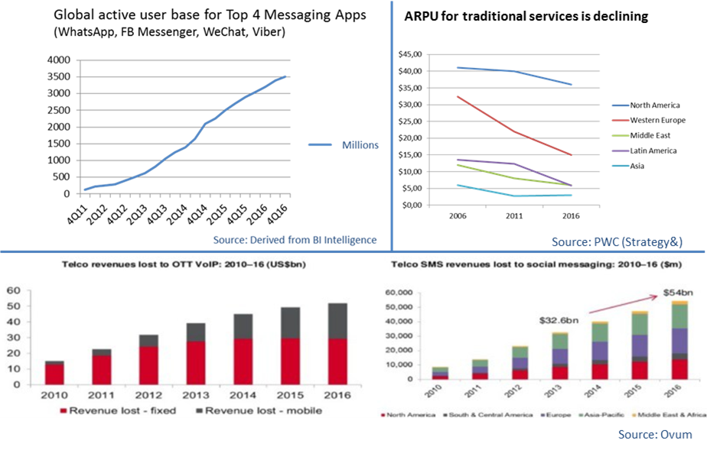
Figure 1: Impact of OTT on traditional operator revenues
Although traditional operator revenues for voice and messaging services is declining, their revenues for fixed and mobile data is increasing with the result that data is becoming the main driver of revenue growth (Figure 2). For example, in 2016 revenues for mobile data will be the same as voice (€62bn each), which shows that consumer demand for connectivity and data is solid and growing [1].
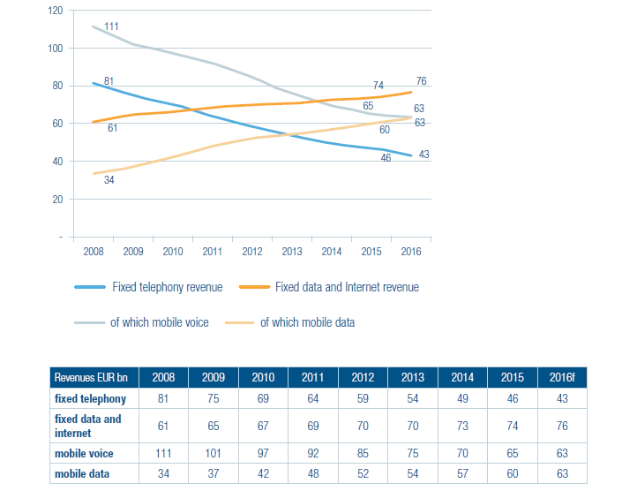
Figure 2: Revenues by type of service (ETNO perimeter, EUR bn)
(Source: ETNO Annual economic Report 2016

Impact on regulation
From a regulatory perspective, there is a growing recognition that the emergence of these types of business models requires a rethink of existing regulatory regimes which currently have separate regulatory frameworks for networks and content. Apart from the applicability of competition law, OTT services are often subject to minimal (if any) regulation [6].
Regulated network operators and service providers have argued that OTT providers operate in a domain which does not always require interconnection. Furthermore, as the services are provided globally they pay taxes only in some jurisdictions where they have a base and have no obligations regarding the provision of universal services. The emergence of OTT services provided competition to traditional service and more choice for end users but because these services now compete directly with regulated operators there is a concern that competition from OTT services could hamper future investments in network infrastructure. This impact on network investment hasn't yet materialised, in its 2016 annual economic report, European Telecommunications Network Operators' Association (ETNO) notes that demand for more connectivity, more data and higher quality of service combine to keep high pressure on network operators to expand and upgrade their infrastructures. In 2015, integrated and stand-alone fixed, mobile and cable players have cumulatively invested EUR 52.5bn in tangible assets. This is a substantial increase compared to 2014’s EUR 49.4bn. It remains to be seen whether these concerns are valid. It should be noted that the scale and reach of the OTT services is increasing rapidly and will have an impact on traditional communication services provided by network operators. For example, WhatsApp, Viber, and Apple already account for more than 80% of all global messaging traffic whereas Skype accounts for more than a third of all international voice traffic minutes [7].
In Europe the consumer benefits of OTT services are recognised and more pragmatic solutions are being investigated. In September 2016, the EC published its proposals (EECC [3]) for amending the regulatory framework. The proposals recognise that certain OTT services compete directly with traditional voice and messaging services. The EECC proposes an amended definition for an ECS with a number of different categories. A new category of interpersonal communications services is proposed which contains two sub categories namely - 1) number-based interpersonal communications services and 2) number-independent interpersonal communications services.
According to the EC's proposals, number-based interpersonal communications services comprise both services to which end-users numbers are assigned for the purpose of ensuring end-to-end connectivity and services enabling end-users to reach persons to whom such numbers have been assigned. The mere use of a number for identification should not be considered equivalent to the use of a number in the networks and should therefore, in itself, not be considered sufficient to qualify a service as a number-based interpersonal communications service.
One could argue that the current use of numbers by some OTT providers is more than just for identification purposes. Furthermore, as circuit-switched networks (e.g. PSTN) continue to be migrated to all-IP the difference between operator managed services and OTT services will be lessened. However, in recital 19 of the draft EECC the EC clarifies its definition by stating that "number-based interpersonal communications services comprise both services to which end-users numbers are assigned for the purpose of ensuring end-to-end connectivity and services enabling end-users to reach persons to whom such numbers have been assigned". The effect of this is that where services use numbers for interpersonal communications across different services, these services are regarded as number-based interpersonal communications services.
The EC's proposal goes on to state that number-independent interpersonal communications services "should be subject only to obligations, where public interests require applying specific regulatory obligations to all types of interpersonal communications services". It seems that this would refer to public interest issues such as access to emergency services. However the EC also proposes that national competent authorities may (in justified cases) be able to impose obligations on number-independent interpersonal communications services (that have significant market power) to make their services interoperable.
This Report does not set out to examine the EC's proposals in detail as they are proposals which will be subject to trilateral negotiations. However, from a numbering perspective, the proposed new ECS definitions raise some questions regarding how OTT voice and messaging services are delivered when compared to traditional voice and messaging services. The following chapters will explore the technical differences.

IP-based Network Architectures and Protocols
The Internet protocol suite is a set of communications protocols used for sending and receiving data over the Internet between devices running on different operating systems. The suite is commonly referred to as IP because the Internet Protocol (IP) was the original protocol in the suite. The Internet's network architecture is generally expressed by the use of the various protocols in the suite, rather than describing the physical interconnects or nodes in a network.
Protocols are essential for routing calls and messages within IP-based networks, and to and from the circuit-switched networks. Protocols support:
- initiation, maintenance, and termination of a communication session between call endpoints; and
- resolving endpoint addresses for the communication session.
This section provides an overview of how networks have evolved and how protocols are used to enable OTT services over the Internet.

Evolution in networks
The PSTN is the most widely used network for the provision of legacy telecommunications services. It supports multiple customers and endpoints through a network of switches designed to facilitate ubiquitous network connectivity that enables voice communication over long distances.
For many decades the core and access networks of the PSTN were analogue, which resulted in long distance calls with poor audio quality (i.e. calls with a low signal level and a high noise level). In order to implement much-needed improvements, network operators started to deploy network technology capable of supporting digital services. The telecommunications industry made network deployment decisions based on the assumption that digital services would follow much the same pattern as voice services, and they conceived a vision of end-to-end circuit-switched services over a network which became known as the Integrated Services Digital Network (ISDN). The focus on ISDN was on transmission of voice signals and low–speed data signals.
With the evolution towards IP-based networks, circuit-switched networks (e.g. PSTN/ISDN) began to be migrated towards a new IP-based architecture called Next Generation Network (NGN). NGN is based on IP-based voice platform (e.g. softswitch, IP multimedia sub-system (IMS)) which emulates the behaviour of the circuit-switched networks. The evolution towards NGN is a process in which whole or parts of the existing networks are replaced or upgraded to the corresponding NGN components providing similar or better functionality, while attempting to maintain the services provided by the original network and the possibility of additional capabilities [8]. The transition to a softswitch-based solution is generally considered a temporary migration measure as it does not provide the benefits of converged services and increased business agility as an IMS-based solution. Figure 3 below illustrates the evolution from circuit-switched networks to the IMS-based NGN. ECC Report 265 [9] provides a more detailed historical and technical background of circuit- and packet-switched networks, and provides an overview of the migration towards IP-based networks.
The widespread implementation of IP-based networks fundamentally changes many paradigms, notably that multiple services (VoIP, messaging, video, television etc.) can now be accessed on a variety of mobile devices.
Figure 3: IMS-based PSTN/ISDN evolution to NGN [7]

IP multimedia sub-system (IMS)
An IMS is an architectural framework for delivering voice (VoIP) or other multimedia services with its own Access Point Name (APN) over IP-based networks. APN is a logical name referring to the packet data network and/or to a service that the subscriber wishes to connect to. An end-user can adjust the APN in its mobile terminal. The APN is hosted at a Gateway GPRS Support Node (GGSN) in 2G/3G mobile networks compliant to pre-3GPP Rel. 8 or a Packet Data Network Gateway (PGW) in a 4G mobile network or 2G/3G mobile networks compliant with 3GPP Rel. 8 onwards. Separate default and dedicated bearers for an IMS network help in separating IMS traffic from normal Internet traffic which is needed to handle VoLTE (Voice over LTE).
GSMA [10] is working on standardisation for IP Packet eXchange (IPX) Networks, which is an inter-Service Provider IP backbone that comprises the interconnected networks. IPX Networks are used for the IMS interconnection, see Figure 4 below. With this architecture, operators identify roaming partners based on Autonomous System Numbers (ASNs). The classic definition of an ASN [11] is a set of routers under a single technical administration, using an Interior Gateway Protocol (IGP) and common metrics to determine how to route packets within the Autonomous System (AS), and using an inter-AS routing protocol to determine how to route packets to other ASs. Most Internet Service Providers (ISPs) have an ASN to express distinct interdomain routing policies.

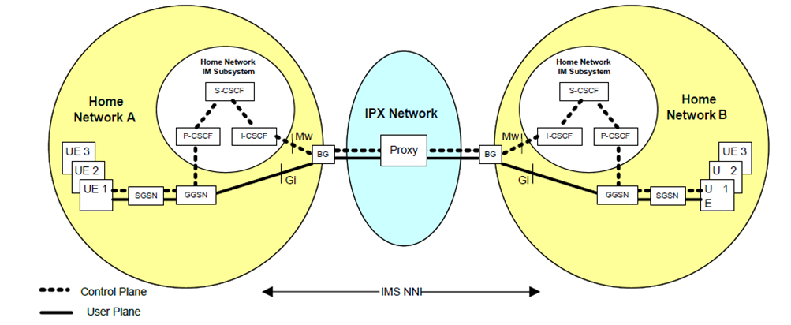
Figure 4: IPX Network used for the IMS Interworking
(Source: GSMA [10])
For Internetwork Packet Exchange (IPX), the GSMA has defined different traffic classes for Quality of service (QoS) differentiation based on service availability, jitter, packet loss and delay parameters.
Some IPX providers are enabling OTT providers to access other connected mobile, fixed and cable operators to exchange IP content and application traffic to improve the end user experience.

Signalling protocols
SS7 is the most widely used signalling protocol in circuit-switched networks and is used for performing out-of-band signalling in support of the call-establishment, billing, routing, and information-exchange functions of circuit-switched networks.
Session Initiation Protocol (SIP), on the other hand, is the most commonly used protocol in IP-based networks for controlling communication sessions. SIP can be used to set up and control voice (VoIP) and video calls, as well as instant messaging. There are two possible solutions for interworking between IP-based networks and circuit-switched networks. One of them is the SIP for Telephones (SIP-T) protocol suite provided by the Internet Engineering Task Force (IETF) and the other is the SIP with Encapsulated ISUP (SIP-I) protocol suite provided by the ITU-T. SIP-T is widely used in inter-softswitch communication as a signalling protocol. SIP-I specification describes supplementary services provisioning, that is not specified in SIP-T. SIP-I can result in better performance than SIP-T when used as the interworking protocol between softswitches and the circuit-switched networks and, although there are still some operators that use SIP-T actively, some operators are already referring to SIP-T as being a legacy protocol.
3GPP defines specific extensions for SIP that are required in mobile networks as structures, protocols and signalling information in mobile networks may be different from fixed line networks. 3GPP extensions for SIP can also be used for other cases.
The H.323 protocol was one of the first VoIP protocols implemented for long-distance traffic and local area network services. It is also widely used for signalling to establish interconnection between the circuit-switched networks and IP-based networks or between two IP-based networks.
Media gateway control protocol (MGCP) is a device control protocol that can be used as support for SIP or H.323. SIP and H.323 handle call setup, connection, management, and tear-down of calls between interfaces, whereas MGCP defines the mechanisms of setup of media paths and streams between IP and other networks.
The other types of open standard protocols used to implement VoIP, include:
- Gateway Control Protocol (Megaco, H.248);
- Real-time Transport Protocol (RTP);
- Real-time Transport Control Protocol (RTCP);
- Secure Real-time Transport Protocol (SRTP);
- Session Description Protocol (SDP).

Media Gateway Control Protocol (MGCP)
VoIP calls are transmitted between an IP-based network and circuit-switched networks using decomposed multimedia gateways in the MGCP architecture [12]. The architecture divides the functions required for the integration of circuit-switched networks and packet networks into several components, notably a media gateway, a media gateway controller, and signalling gateways.
Media gateways provide interfaces to IP-based and circuit-switched networks and they convert media, such as voice, between the two network types. Gateways allow IP-originated voice calls to be terminated by circuit-switched networks and vice versa.
Gateways are split into two logical parts: the part that contains the call control logic is called the media gateway controller (MGC) or call agent (CA), and the other, which interfaces with circuit-switched networks and is responsible for media stream conversion and transcoding, is called the media gateway (MG). The split requires a framework for communication between the elements, resulting in the media gateway control protocol architecture. Figure 5 provides an illustration of the relationship of network components in a MGCP architecture.
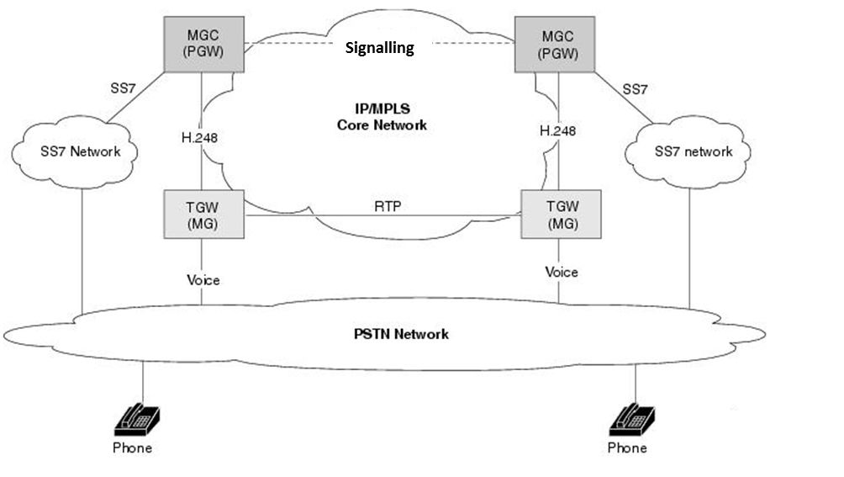
Figure 5: Relationship of network components in a media gateway control protocol architecture (Source: Cisco [13])

Evolution from Stove Pipe to Horizontal Network Architecture
The traditional network architecture, with dedicated networks per service, is evolving from this stove pipe type model with a silo per access network technology/services to a horizontal (IP multimedia service) model with defined layers for service, control and transport for multiple access networks. This evolution of network architectures is illustrated in Figure 6 below.
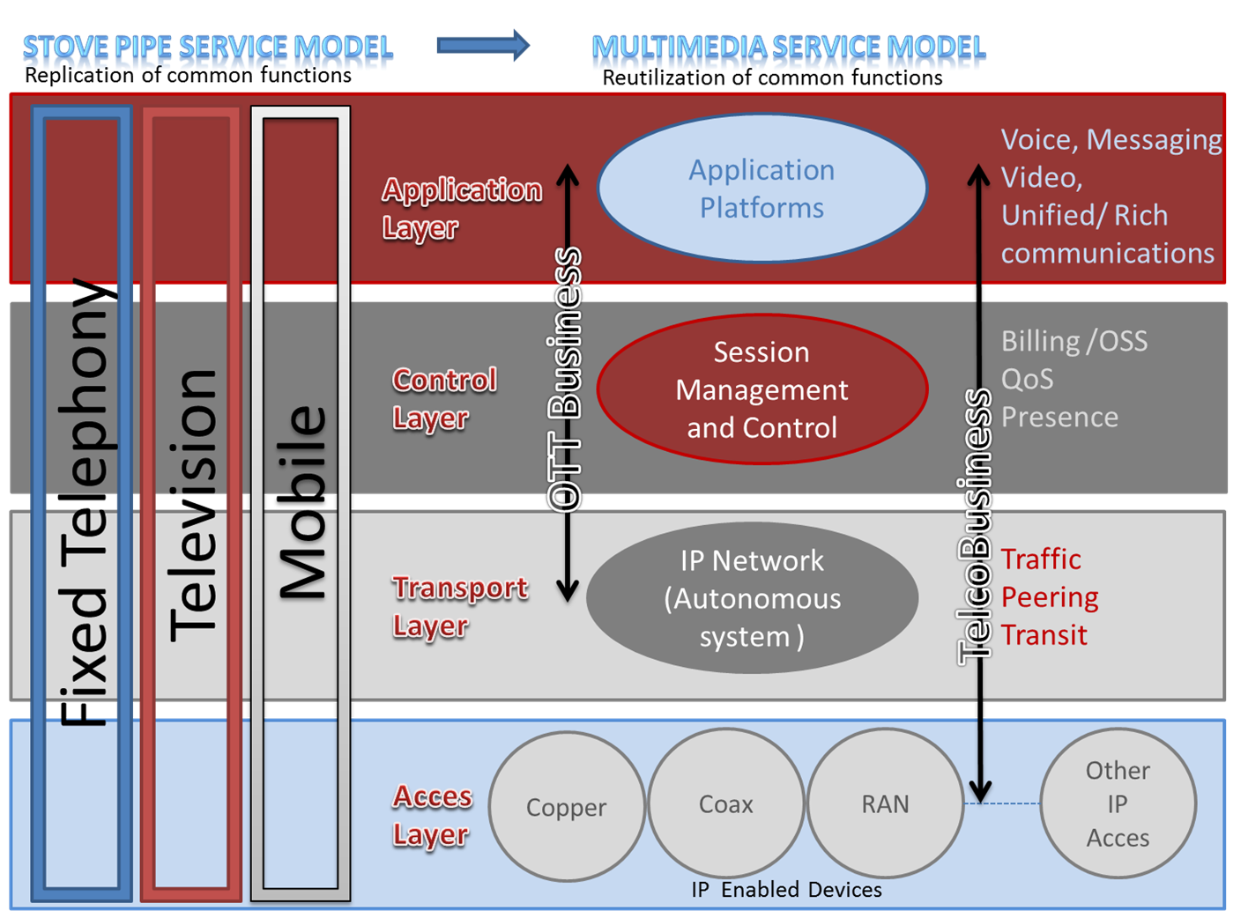
Figure 6: Evolution from Stove Pipe to Horizontal Network Architecture
The stove pipe model has developed into a multimedia service model with reutilisation of common functions. These functions and layers deliver services which are detached and independent of the access network layer. In general, communications networks have four main layers:
- The application layer delivers the features for voice, messaging, video and unified/rich communication services;
- The control layer is for session management and control functions like communication session initiation, billing/OSS and QoS-management. This layer also includes the authentication/login functions, which similarly to the Home Location Register (HLR/AuC) in a GSM- and/or UMTS- based network or the Home Subscriber Server (HSS/AuC) in a LTE-based network, maintain the user profiles;
- The transport layer is for exchanging traffic, peering and interconnecting with other networks and transit of signals;
- The access layer is where IP enabled devices connect to the copper, coax, radio access networks or other access technologies like fibre and Wi-Fi.

OTT service provision
OTT services can be provided on packet-switched networks by two different approaches:
- Over managed and secured IP-based networks with well-defined guarantees for customer reachability, communication quality, reliability and connectivity (managed services); or
- On a “best effort” basis on top of the Internet where the connection is not managed end-to-end by the provider of the service.
One of the main advantages of IP-based networks is that OTT services can employ encoding schemes and compression technology to reduce the size of the voice packets so they can be transmitted more efficiently than in circuit-switched networks. Figure 7 below shows a simplified view of the call paths in both circuit-switched networks and IP-based networks. Figure 7 also illustrates the two different approaches employed to provide OTT services, and how calls are routed across different types of networks.
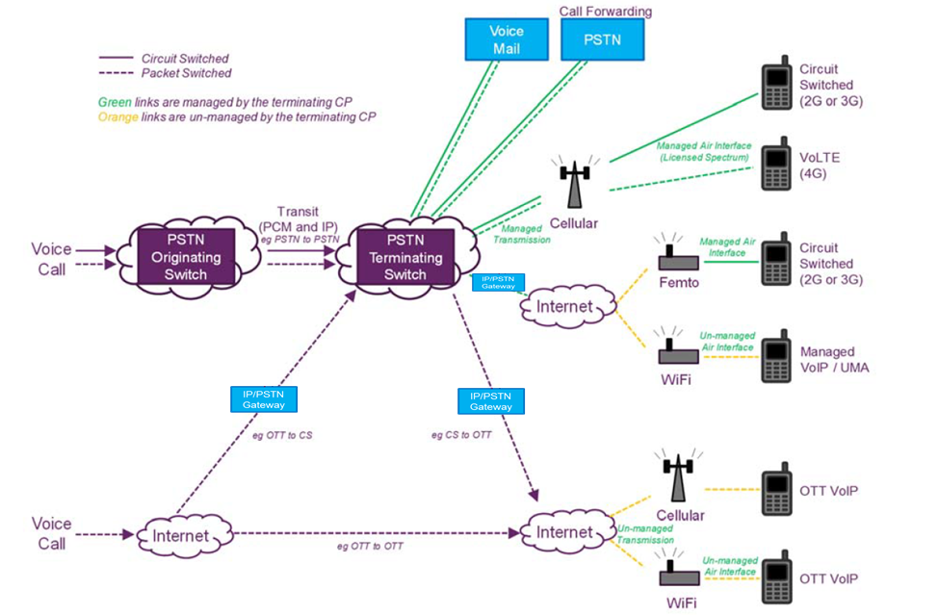
Figure 7: Call Flows
(Source: Ofcom, UK)
To deliver OTT services the OTT provider has a lot of network functions in common with an IMS-based network. OTT providers manage network servers with functions to initiate, control and terminate communication sessions (text, voice, video etc.). OTT servers also control functions to charge the user for provided communication sessions. For OTT services that deliver sessions to circuit-switched networks, the OTT network server determines efficient routes to breakout, like the Breakout Gateway Control Function in an IMS-based network to their interconnection partner telephone network. The OTT servers transmit specific signalling information to their partner's gateway that forms the basis for the payment between the OTT provider and the telephone network operator, for the call completion. The users of OTT communication providers cannot communicate peer-to-peer over the Internet as the functions of the OTT server are required to establish the communication.

Use of E.164 Numbers in Networks
Using numbers to identify end-users has been employed since the earliest days of the telephone service and the design of the PSTN was based on numbering schemes which had a geographic significance to allow networks interconnect seamlessly. As demand for international telephony services increased, a global numbering scheme, based on a hierarchical concept where the country code represented the first level, was introduced and standardised by the ITU. These types of numbers came to be known as E.164 numbers.
The standardisation of E.164 numbers enabled efficient call routing functions to be carried out. This included the identification of the call destination and the call traffic to be routed. It also determined the call charging based on an analysis of the leading digits of the dialled number. Calls would be routed through transit exchanges to local exchanges where the remaining digits were analysed to determine the network termination point for the call. Therefore an E.164 number not only identified the end-user and facilitated billing, but also represented a physical identifier of an access path and network termination point. In the past, origination and termination were offered as one bundled service, while nowadays these functions are increasingly separated and can even be offered by different providers.
As networks evolved and intelligent network functionality (e.g. such as number translation services) was introduced, the dialled number became less associated with identifying a physical access path or network termination point. The dialled number could be associated with a different number which represented a physical element in the network. The mapping between the dialled number (identifying the end-user) and another number (identifying the network termination point) took place in a routing table in the switch following an analysis of the dialled number. This allowed users and operators greater flexibility and facilitated the introduction of innovative services.
With the introduction of Number Portability (NP) the analysis required for resolving addresses to route calls to end-users changed dramatically. For obtaining the benefits of a liberalised telecom market, the implementation of NP was of the utmost importance. NP allows end users to retain their telephone number if they change service provider and, in some countries, geographical location or service type. Digit analysis was replaced by various routing schemes like All Call Query, Query on Release, Onward Routing and Call Dropback. These routing schemes exhibit different behaviour for different parameters such as cost, complexity for implementation, search time etc. These routing schemes have commonalities in that resolving the endpoint address has moved from the switching exchange to a centralised or distributed database that provides the subsequent routing information to be used by the call control device.
Today, the leading digits of an E.164 number may also identify the type of service provided on that number, which can provide tariff transparency regarding the expected call cost to the calling party, e.g. premium rate numbers. At the wholesale level, termination rates may be determined by the type of number used, e.g. Fixed Termination Rates (FTRs) apply when geographic or fixed numbers are called and Mobile Termination Rates (MTRs) apply when mobile numbers are called.
Figure 8 below illustrates that the role of E.164 numbers is much broader than just facilitating connectivity with circuit-switched networks. They are used for a variety of different functions.

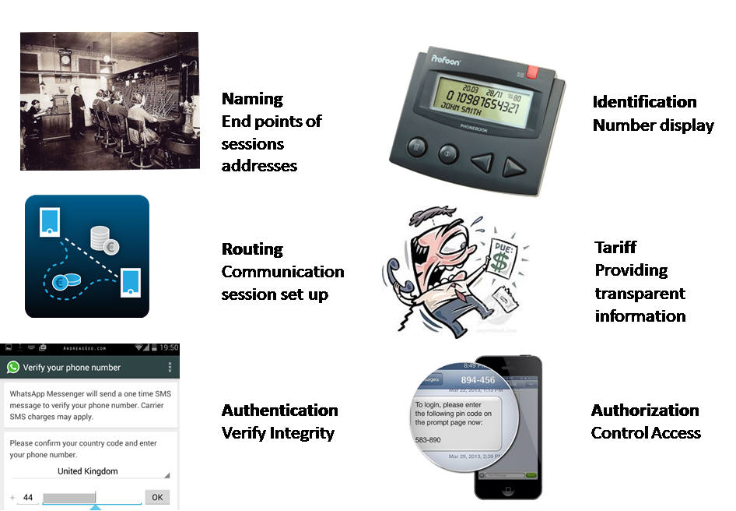
Figure 8: Role of numbers in communication services

Calling line identification (CLI)
Calling Line Identification Presentation (CLIP) is a supplementary service that presents a caller's E.164 number to a called party's telephone display. The most universally used signalling protocol stack to carry CLI parameters was, and still is, the ITU-T Signalling System No. 7 (SS7). The origination, transit and presentation of CLI digits is traditionally the sole responsibility and custody of the network operators and the possibility of manipulating CLI digits was, in the past, remote and required specialised equipment. This secure environment promoted trust in the CLI digits presented to end-users.
Being able to identify the calling party allows the called party to make decisions before answering a call. For example, end-users can use the CLI to screen calls allowing them to choose which calls they wish to accept or a business might use the CLI to query a database for customer account information before a caller is connected to a call centre agent. CLI can in certain situation be problematic where the possibility of caller ID spoofing may render received information unreliable.
For certain networks, such as ISDN, the operator can provide the calling party with the capability of selecting the CLI to be presented for a particular call. This is typically restricted to business users who have Private Branch Exchanges (PBXs) installed that are connected to the ISDN.

Billing and tariff information
A Call Detail Record (CDR) is data which contains details of a telephone call or other telecommunications transaction (e.g. SMS). The CDR contents are recorded by an exchange and used by the end-user's service provider to bill correctly for the call. The CDR contains various elements of the call, such as time, duration, completion status, source E.164 number, and destination E.164 number.
For service providers, the destination E.164 number element of a CDR is critical in determining the correct tariff to apply to a call and identifying who should be billed for the call. The destination E.164 number can in certain cases determine the wholesale origination, transit and termination charges that need to be applied to the call.
E.164 numbers can provide a tariff indicator for end users regarding the expected cost of a communication session. An E.164 number can provide an indication of the service type, for example geographic, mobile or premium rate, and the expected cost. However, the use of E.164 numbers as tariff indicators is diminishing as more and more users have flat rate tariffs and as more telecom operators introduce bundling of voice and messaging as strategies in response to the increased use of OTT services.

OTT Services and the Role of E.164 Numbers
In 2012, the ECC's Working Group Numbering and Networks (WG NaN) published a Green Paper on the Long Term Evolution of Numbering, Naming and Addressing over a 10 year period from 2012-2022 [14]. The Green Paper predicted that E.164 numbers will still be the most common universal identifiers used for the provision of electronic communication services. The document predicts that the use of E.164 numbers for routing purposes will decrease and instead the number will be analysed, in a similar way as a domain name, and converted via a mapping system to, for example, a SIP address.
The use of E.164 numbers by operators and end-users continues to evolve as IP-based technologies are implemented in core and access networks. E.164 numbers are increasingly being used as "resolvable names" on IP-based networks as predicted by the Green Paper. This means that the E.164 number is analysed and translated into an IP-based identifier (e.g. a Session Initiation Protocol (SIP) address [15]) for routing purposes in the same way that a domain name is translated into an IP address.
Many OTT services (e.g. Skype) offer their users a voice service within a closed community without a need to assign or use E.164 numbers. Instead, each user is assigned a unique resolvable name (e.g. Skype Name). However, to enable interoperability and allow end-users make calls and send messages between the PSTN/ISDN and an OTT service an assignment of an E.164 number is required for some of these services (e.g. Skype In).
Certain other OTT services (e.g. WhatsApp and Viber) also operate within a closed community with no access to the PSTN. However, these OTT services use their end-users respective E.164 numbers to generate uniquely resolvable names for identification and routing. The different ways in which OTT providers use E.164 numbers is discussed further in section 6.2.
From a technology perspective, the E.164 number could be designated as a fixed, mobile or nomadic number, and with the development of OTT services the linkage between E.164 numbers and services is no longer a requirement and both can be decoupled. However, the most appropriate number type to be used may be more a question for national regulatory authorities. OTT providers which require national numbers for interconnection to the PSTN should have the right to apply for and be assigned national numbering resources, provided they meet national eligibility criteria and regulatory obligations.

OTT services/providers
OTT services only function where:
- there is a data connection to the Internet; and
- the consumer’s device is capable of using the OTT service, i.e. capable mobile devices must support either OTT applications or a configurable SIP client. Such capabilities are typically offered by PCs, laptops, smartphones and tablets.
The OTT communications market generally consists of six main types of services, VoIP (e.g. Skype), Instant messaging (e.g. WhatsApp), social networking (e.g. Facebook), unified communications (e.g. Microsoft), Cloud communications (e.g. Twillio) and Ad tracking and Call Conversion (e.g. Google).

VoIP
VoIP is the real-time transmission of voice signals using IP over the public Internet or managed IP-based networks. The steps involved in originating VoIP calls are similar to those for voice calls on circuit-switched networks. The steps involve signalling, channel setup, digitalisation of the analogue voice signals, and encoding. Instead of being transmitted over a circuit-switched network, the digital information is packetised and transmission occurs over a packet-switched network. VoIP services employ session control and signalling protocols to control the signalling, set-up, and tear-down of calls.
Video calling over IP works in a similar way as VoIP. However, services that provide video over IP are generally not interoperable between each other as there is no universal protocol to date for video communications. An example of a video over IP service is Apple's FaceTime.

Instant Messaging (IM)
IM services offer real-time transmission of text between two or more parties over IP-based networks. IM applications may use push technology to provide real-time text (RTT) which is transmitted instantly to the recipients as the text is typed. OTT Instant messaging applications may also include functionality that allows users to transfer files, make voice calls, or video chat.

Social Networking
A social network is a service that allows users to distribute voice, video, picture and text messages to other users within the same social networking community, e.g. Facebook or Twitter.

Unified Communications
Unified communications is a business term that describes the integration of communication services such as IM, VoIP, web and video conferencing, fixed-mobile convergence (FMC), etc. The development of the Internet and the availability of higher bandwidth connections have enabled organisations to implement low-cost communication solutions that allow global access to their workforces and client bases. Unified communication solutions can be used anywhere a device can connect to the Internet.

Cloud Communications
Cloud communications can be viewed as the opposite of unified communications because cloud communications platform providers (e.g. Nexmo) do not provide finished communication products or solutions. Instead cloud communications platform providers offer tools and enablers (APIs, SDKs) for developers to build their own communication solutions. The communication solutions, switching and data storage are hosted by cloud communications platform providers, and they are accessed in the "cloud" over the Internet. Because businesses only pay for services or applications they use, they don't need to have a conventional PBX system deployment. One example of businesses using API platform providers to enhance their communications is for SMS. SMS is used by businesses to provide services to customers by sending text messages for password resets, payment receipts, reminders, notices of flight delays, delivery updates, etc.

Ad tracking and Call Conversion
Online advertisers, like Google Call metrics [16], offer services with a call forwarding service provider replacing the advertiser's number, with permission of the advertiser, with a comparable phone number to enable ad tracking. With click on a smartphone on the number in some Google advertisement, a call forwarding service provider will be counting clicks on advertisements as they are forwarding the call to the original advertiser's number. The call forwarding service provider advertisement model works as the advertiser pays for the click or the so called conversion. The call forwarding service providers are rolling out this service over Europe with numbers provided by registered telco’s. The call forwarding service provider has a SIP connection to permit the conveyance of signals to this telco network to make these click conversion count. For these services the call forwarding service provider has technologies for the purpose of transmitting the call while using SIP instead of traditional telecommunications services. Forwarding calls has always been considered a telephony service and needed to fulfil telecommunications obligations, although the provider that makes the call forwarding service never asks the CEPT administration for numbering assignment.

Role of E.164 numbers
While some OTT services do not require E.164 numbers to identify end-users, certain OTT services (e.g. Skype) assign E.164 numbers to end users to enable access to and from the PSTN/ISDN. Other OTT services (e.g. Viber and WhatsApp) use E.164 numbers to generate unique identifiers for their user community. The E.164 numbers used to generate unique identifiers are already assigned to end-users by their respective service providers.
OTT services can be grouped into three types of categories:
- those pre-integrated onto a device by the device or OS manufacturer (e.g. FaceTime);
- third-party applications installed onto a device by the user (e.g. WhatsApp); and
- the user's fixed or mobile provider provides their own OTT communication service (e.g. O2tuGo)
Typically, the third category of OTT services use the same E.164 numbers associated with the traditional services offered by the provider to its customers on the PSTN/ISDN/PLMN. The services can be used on mobile devices such as smartphones, tablets and laptops using either Wi-Fi or mobile data connectivity. From the service provider's perspective, the main advantage of introducing these types of OTT services is that it enables them to compete with global OTT providers. From the user's perspective, the main advantage is that they can access circuit-switched networks and in some cases the roaming tariffs might be lower or not applied.
Table 1 below shows the services being provided by various OTT providers and compares how each uses E.164 numbers. The figure shows how VoIP and messaging have become standard services for OTT providers. For example, WhatsApp launched with just a messaging service, but began offering VoIP in 2015 and video calling in 2016, while Snapchat still has no voice service.
Table 1: Categories of OTT services / providers
OTT services/ providers | VoIP | Instant messaging | E.164 number used within closed platform | E.164 number used to provide access to/from PSTN/ISDN/PLMN
Google Talk | ✓ | ✓
WhatsApp | ✓ | ✓ | ✓ | ✓
Viber | ✓ | ✓ | ✓ | ✓
Skype | ✓ | ✓ |  | ✓
Facebook Messenger | ✓ | ✓
WeChat | ✓ | ✓ | ✓
Twitter |  | ✓
Snapchat |  | ✓ | ✓
Facetime | ✓ |  | ✓ | ✓
iMessenger |  | ✓ | ✓ | ✓
O2tuGo | ✓ | ✓ | ✓ | ✓

Voice services
OTT providers offer voice services to their users that can be divided in two main categories, one only allows voice communications with users of the same OTT service, and the other allows voice communications to and/or from other networks (e.g. PSTN/ISDN/PLMN).
In the first category, the OTT service, typically, does not need an E.164 number for the purpose of the voice communication service, i.e. to route the communication to the destination. The OTT service generates a unique identifier for each of their users and with these unique identifiers the OTT service is able to identify the user and to route calls. Nonetheless, in some cases, the unique identifier is based on the E.164 number that was assigned by the respective service provider of the user, an example of a unique identifier created from an E.164 number can be as follows: e164number@ottservice.foo.
In the second category, and even when the voice service has interconnection with other networks, an E.164 number may not be required from the technical point of view. If the service only allows outbound calls, then an E.164 number may not be needed, since to route the communication the protocol only needs the destination number. However, in some countries an E.164 number is a regulatory requirement for CLI purposes in order to ensure consumer protection and, in the event of an emergency call, to identify the emergency caller and facilitate callback from the Public Safety Answering Point (PSAP). In the majority of cases, users also cannot place calls between different OTT services (e.g. such as Skype to Viber). Additionally, the networks might not, for security reasons, route calls that do not have an originating E.164 number. One relatively simple solution to accessing emergency calls from OTT application on smartphones could be provided through innovative software design. For example, if an end-user attempts to call an emergency number from an OTT application on a smartphone using the OTT application's dialler (e.g. Skype, WhatsApp, Viber)), the OTT service could be designed to, when mobile coverage is available, open the handset’s native dialler and the digits dialled by the end-user could be copied to the native dialler so that the end-user could complete the call using the mobile network.
On the other hand, when the voice service allows incoming calls from circuit-switched networks, then an E.164 number is required. Without using an E.164 number the OTT service is not able to provide a service that allows its users to receive calls from any number from the national and/or international numbering plan, i.e. through the use of an E.164 number the OTT service guarantees that the number can be accessed from circuit-switched networks. However, the OTT service can only provide a voice service with interconnection with circuit-switched networks if it firstly comes to an agreement with an operator in order to have access to the network and, in some cases, also to get the E.164 numbers from that operator.
Voice calls originating on circuit-switched networks and terminating on OTT services, pass through the terminating switch of the circuit-switched networks and from there to a Circuit-Switched (CS)/IP gateway where they are converted to VoIP. Examples of these services include Skype-In. The call is routed to the terminating switch by using an E.164 number.

Messaging services
In a similar manner to the voice service, OTT providers offer messaging services to their users that can, also, be divided in two main categories; one that is only with users of the same OTT service and, another with other networks (e.g. PSTN/ISDN/PLMN).
In the first category, the messaging services run over an IP-based network and not on an SMS channel. OTT messaging services require a centralised server to connect to other OTT users. The server is a "store and forward" system. Instead of opening a connection (from a device) to another user's device, an OTT messaging app's device connects to the OTT server using Transmission Control Protocol (TCP) to communicate end user signalling messages to the server. The server in return will dispatch them to the users' devices. If the other user has their app open or at least the app process running there might be a live connection to the server. OTT messaging services like WhatsApp will use that connection to send them the messages. If the other user is "offline" then the OTT service might choose to send them a push notification instead. In this case, and similarly to the voice service, the OTT relies on the unique identifier that was generated in order to identify and route the message to the user to which the message was sent.
When the messaging service has interconnection with other networks (e.g. PSTN/ISDN/PLMN) the E.164 number is necessary to identify the sender of the message and to identify and route the message to the destination. In the same way as the voice service, if the service only allows outbound messages, the E.164 number may not, technically, be required. But if inbound messages are allowed, then the E.164 number is required.

Routing
Call routing is a method of determining how voice calls and multimedia messages (communication sessions) are conveyed within or between networks or services. OTT services route calls and multimedia between end-users over IP networks.
While OTT services use different protocols for encrypting and conveying signals, they all essentially route their subscribers' calls and messages via an IP network. Some OTT services also interconnect with other networks (e.g. PSTN/ISDN/PLMN) via an IP/CS gateway to allow subscribers communication with subscribers of other services.
To enable routing subscribers need to be identifiable. Within circuit-switched networks, for example, subscribers are identified using E.164 numbers. While OTT services can also support E.164 numbering to identify subscribers and allow calls to be routed to and from IP-based networks, they generally use other identification techniques, e.g. services using SIP can use Uniform Resource Identifiers (URIs), whereas Skype uses "Skype names". Some OTT services can translate non-E.164 identifiers to E.164 numbers and vice versa, for example using the ENUM protocol and Skype's "Skype-In" service. OTT services such as WhatsApp and Viber use an identifier based on the end-user's E.164 number. End-user identification is discussed in more detail in section 6.2.5 below.

Interconnection with circuit-switched networks
Circuit-switched networks uses a hierarchical network structure to route calls, however, IP networks have more flexibility in terms of call routing. For example, VoIP calls that are routed to circuit-switched networks via an IP/CS gateway may (i) exit the IP network at the nearest voice gateway to the circuit-switched network destination, or (ii) (in order to maximize call quality) exit at the gateway that is closest to the caller. OTT services can also implement "Location-Based Routing" which allows providers to determine how calls are managed between VoIP endpoints and circuit-switched networks' endpoints based on the locations of the caller and called party. Interconnection with circuit-switched networks is discussed in more detail in Chapter 7. Where OTT services do not provide interconnection to circuit-switched networks, these services generally only provide end-to-end connectivity between users of that service and not to other services. These types of services do not require an assignment of E.164 numbers from the CEPT Administration for call routing or to identify users of the service.

Identification
For certain OTT services, E.164 numbers are being used as identification keys for the communication within the OTT service community. By employing a subscriber's unique E.164 number, the OTT service allows subscribers to identify and communicate with all possible contacts from their phone's contact list who have also subscribed to the same OTT service. The OTT subscriber can then communicate with its contacts using the OTT service rather than the handset's native dialler application for which the E.164 was assigned by a traditional telecom operator.

Authentication and authorisation

Authentication
Authentication is the action or process of verifying the identity of a user or process. The process of authentication is based on each user having a unique set of criteria for gaining access and is a method to prove and to verify the integrity of the identifier provided. Authentication can provide a way of verifying a user profile.
User authentication must be able to validate that the credentials a user provides have not been altered and thus enable verification that the user is, in fact, a legitimate user of the E.164 number. Many OTT providers secure their application or login session with a "two factor authentication" (2FA) via SMS. After submitting the OTT username and password a unique verification code is transmitted by the OTT provider via circuit-switched networks to the E.164 number of the OTT user, via SMS or by spoken message via IVR.

Authorisation
Following authentication, a user must gain authorisation to access certain services. After logging into a system, for instance, the user may start to use the OTT services. The authorisation process determines whether the user has the authority to enter the services of the OTT provider. Once a user has authenticated, they may be authorised for different types of access or activities. Subscribers to an OTT service (such as WhatsApp or Viber) must first download the application and will then receive an access code, via SMS or callback, which authorises the subscriber to access the services. Entering a password or pin code received over circuit-switched networks activates the OTT service.

Relationship between OTT services and services provided over circuit-switched networks

Interconnection
As the migration from circuit-switched networks to all-IP-based networks continues, E.164 numbers will continue to be used as resolvable names where origination and termination points can be identified using IP addressing. This change in routing functionality will be seamless for users who will still be able to make and receive voice calls and messages using existing E.164 numbering resources.
One of the main problems in interconnection between circuit-switched networks and IP-based networks is the signalling protocol capability between two operators. Operators need to establish interconnection to ensure compatibility between the signalling protocols used on both networks.

Types of IP interconnection
Two basic IP interconnection types are used for interconnection: direct interconnection using physical links and interconnection using the public Internet, i.e. virtual interconnection. Incumbent operators mainly use direct physical interconnection links due to the fact that incumbent network operators have a fully functioning physical network infrastructure. There is a high probability that virtual interconnection will be used more often in the not too distant future especially by new smaller operators which often do not use direct physical interconnection because using public Internet is a more convenient and affordable option.
OTT providers such as WhatsApp, Google Talk and Facebook Messenger use the multimedia service models of Figure 6 (see Chapter 4) as basis of their communication services. OTT providers usually present themselves as the providers of a piece of software or an app on a PC or smartphone. Real peer-to-peer communication cannot exist as setting up sessions through networks requires functions to support protocols for initiation, maintenance, and termination of a communication session between call endpoints and resolving endpoint addresses for the communication session. The OTT provider controls functions for setting up sessions, such as a login server for authentication and authorisation of their OTT subscriber. This login server provides a comparable role as the Home Location Register (HLR/AuC) in a GSM- and/or UMTS- based network or the Home Subscriber Server (HSS/AuC) in a LTE-based network.
To prevent international transit costs, an OTT provider that has sessions from and to other networks using E.164 numbers will decide where to breakout to other networks. The OTT provider will control this breakout decision functionality server as the end user's handset cannot make least cost routing decisions for the right location to the IP/CS gateway of the circuit-switched network operator. The breakout gateway must receive signalling information from the OTT provider in order to know what traffic should be further transmitted to the end user assigned the destination E.164 number.
OTTs have network functions for application, session management and control and IP transport. Skype apologised publicly on 22 September 2015 [17] when they did an update to their network configuration, which caused a network outage and disconnected many users from their network services.
OTT providers such as WhatsApp, Google Talk and Facebook messenger would not be able to open a connection (from a device) to each of the subscriber contact list devices. Instead the device connects to the server. It can then use a custom TCP protocol or HTTP to communicate messages to the server.
Skype for Business [18] uses SIP as an application-layer control (signalling) protocol for creating, modifying, and terminating sessions with one or more participants.
WhatsApp uses Erlang [19] as programming language. This programming language is also used as a backbone for LTE mobile networks by various equipment vendors.

Direct interconnection link
Point-to-Point (P2P) interconnection retains the same structure as interconnection in circuit-switched networks via a direct physical interconnection link. This direct interconnection link is illustrated in Figure 10 below which shows two switches with a direct physical link between them. The schematic structure of interconnection stays basically the same for circuit-switched networks and IP-based networks interconnection with the only difference being that interconnection in circuit-switched networks typically uses SS7 signalling whereas IP-based interconnection typically uses SIP signalling.
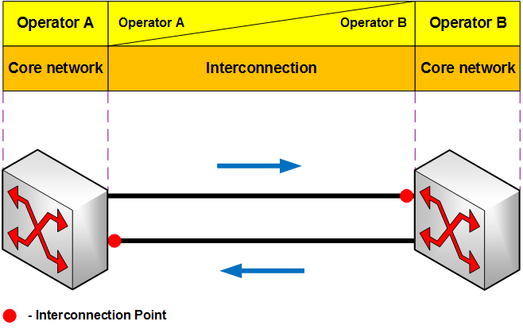
Figure 9: Direct Interconnection Link (P2P)
In this situation a physical link is provided, and the interconnection point is defined as the connection point to the network. The main difference is the signalling protocol used. In circuit-switched networks, SS7 is mostly used which means that separate channels are assigned for signalling. In IP-based networks SIP, for example, is used to transmit data packets with the necessary information for establishing a call session between end-users.

Interconnection using Internet connectivity
Interconnection can be achieved using Internet connectivity. This Internet connectivity entails both Internet access networks as the backhauls, backbones, transit networks, Internet exchanges, communication servers, datacentres and all that is required to keep the Internet running. This type of interconnection is becoming more frequent in many European countries to ensure interconnection both nationally and internationally. This type of interconnection is virtual and costs less than a direct link.
Security is a major problem with this type of interconnection. As the IP packets are transmitted in what is essentially a public environment additional security measures should be applied.

Outgoing communications from OTT providers to other networks
OTT/VoIP sessions originating from the Internet and terminating on circuit-switched networks are known as ‘VoIP Out’ services. Examples of these services include Skype Out and Viber Out. These calls are carried as a VoIP call until they reach an IP/CS gateway from where they are carried as a managed voice call over a circuit-switched network to the terminating switch.

Rights and Obligations that attach to the Use of Numbers

Rights of use for assigned numbers
CEPT Administrations assign numbers to operators and service providers who offer services that are in accordance with the numbering plan. Most national numbering plans evolved from a time when number ranges were designated for specific access technologies and service types, e.g. geographic numbers for fixed telephony services and mobile numbers for services where radio access technologies were involved.
Some numbering plans also have non-geographic numbering ranges designated for nomadic use and for business services. In many CEPT countries, the operator has to complete a notification or registration process with the CEPT Administration before numbers can be assigned.
CEPT Administrations mainly assign E.164 numbers to providers of ECNs or ECSs on condition that the applicant meets specific eligibility criteria as specified by the CEPT Administration for the types of number requested. The legal basis for the assignment of numbers and the conditions attached to rights of use are based on national legislation. For EU Member States the requirements are transposed from the Authorisation Directive.
The assignment of numbers has an effect on the assignee. The assignee will have certain obligations such as supporting number portability between operators and providing supplementary services such as calling line identification presentation (CLIP).
In some CEPT countries sub-assignment of numbers is a procedure, accepted by the CEPT Administration, where part of a number block is used by another provider on the basis of an agreement with the original assignee. In some other CEPT countries this is not allowed. Examples of sub-assignment are MNO to Mobile virtual operators or resellers of VoIP services. How regulatory obligations apply to assignees and sub-assignees is not harmonised across CEPT countries.

Number portability
Number Portability (NP) enables end-users to switch service providers while retaining their E.164 number. An all-IP network infrastructure would facilitate the use of alternative mechanisms for mapping E.164 numbers to URIs in order to identify the terminating network serving E.164 numbers. For example ENUM-like mechanisms could be used in DNS systems for routing purposes.
OTT providers are essentially global operators but generally rely on national traditional operators to connect to the circuit-switched networks. In situations where numbers have been ported, allowing OTT providers to have access to the most up to date NP data would facilitate more efficient and cost effective call routing as the Internet backbone could be used to route the call as close as possible to the terminating network.
However, any OTT provider that has been assigned national numbers to provide services (or that uses national numbers to interconnect to circuit-switched networks) should be required to implement number portability in accordance with the processes established at a national level to ensure consumers have the option to retain their number when changing service provider.

Access to emergency services
In many countries IP-based telephony services provided to the public have to fulfil the same obligations as PSTN-, ISDN- or PLMN- based telephony such as providing access to emergency services and providing emergency caller location information to the appropriate public safety answering point (PSAP).
Session Initiation Protocol (SIP) is a commonly utilised protocol for VoIP. SIP has the advantage that with its Geolocation Header it can submit more location information to the PSAP during call setup than with PSTN/ISDN/PLMN. But like many other IP-based communication protocols SIP has, in the case of nomadic use, a problem with the location estimation specifically when location based routing of emergency calls to the right PSAP is required. It could even happen that a PSAP with regional responsibility receives an emergency voice call coming from a location outside the PSAP’s country.
ECC Report 225 [20] concluded that “even with the ratification of appropriate standards, location of emergency callers using VoIP technology may not be as reliable and effective as for traditional fixed-line services today”.
If an end-user attempts to call an emergency number from an OTT communications service on a smartphone using the OTT application's dialler, the OTT service could, where mobile coverage is available, open the handset’s native dialler and copy the digits dialled by the end-user to the native dialler so that the end-user, on his/her own initiative, can complete the call using the mobile network. This would allow for mobile caller location information to be provided for an emergency call. OTTs should be responsible for the development and proper functioning of their own applications on smartphones;

CLI Validation
The extension of the supply chain to OTT services has resulted in an eroding of the inherent trust that existed in CLI. ECC Report 248 [21] recommends obligations for validation techniques that should be required by all parties in the electronic communication supply chain well beyond the traditional players.
The evolution to IP-based networks has transferred intelligence to the network edge and more sophisticated devices and applications have enabled operators and end-users to make use of the CLI capability in an increasingly flexible way. This development has created an environment where the inherent trust in CLI is being eroded and in some cases the manipulation of the E.164 number CLI has resulted in consumer harm. ECC Report 248 examines this evolution in CLI usage and makes proposals for the use of validation techniques to ensure continued trust in CLI. The report concludes that if the validation measures discussed are implemented then the risk of consumer harm (e.g. Calling/Caller ID Spoofing) is minimised. Spoofing can occur when you have a party in the calling chain that has malicious intent and this is independent of the flexible use of CLI.

Conclusions
The increased popularity of OTT communication services has resulted in an evolution in how E.164 numbers are used. The role of E.164 numbers in networks has evolved from being addresses for physical access paths to being names that identify end points in communications sessions and as authentication keys to verify end-users. OTT communication services are also having an impact on other network operators and service providers in the market, for example, access network providers are increasingly playing a limited role in the routing of OTT services due to the fact that the routing takes place over IP based networks.

From a regulatory perspective, traditional communication services and OTT communication services that use E.164 numbers for end-to-end connectivity share many commonalities and therefore regulatory obligations should apply accordingly to ensure a level playing field and ensure consumer protection.

The analysis of the current OTT communication services discussed in this ECC Report makes it possible for the following conclusions to be made:

- OTT providers which require national E.164 numbers for interconnection to circuit-switched networks should have the right to apply for and be assigned national numbering resources, provided they meet national eligibility criteria and regulatory obligations. These include e.g.:
Consumer protection rules and end-user rights (including number portability) should apply to OTT services that use national E.164 numbers;
Any OTT service that uses or connects to services using numbers from national and/or international numbering plans should support access to emergency services numbers.
OTT providers should be required to comply with law enforcement requirements in accordance with relevant national and European legislation.
- In order to maintain integrity and trust in E.164 numbers and CLI, OTT providers should implement validation techniques as described in ECC Report 248 [21] ]. The validation should be made periodically in order to prevent the number being used by two different end-users at the same time when the number is re-assigned to a new end user by the original provider.

At time of writing, the European Commission’s proposals for a review of the regulatory framework for electronic communications (“the EECC”) are being considered. It is as yet unclear if the proposed new definition for an ECS will be changed. With regard to the sub categories of interpersonal communications services proposed, namely number-based interpersonal communications services and number-independent interpersonal communications services, CEPT/ECC foresees some ambiguity as to which category certain OTT services would belong.

- List of Reference
- ETNO Annual economic Report 2016
- Directive 2002/21/EC of the European Parliament and of the Council of 7 March 2002 on a common regulatory framework for electronic communications networks and services (Framework Directive), as amended.
- Proposal for a Directive of the European Parliament and of the Council establishing the European Electronic Communications Code (Recast) - https://ec.europa.eu/digital-single-market/en/news/proposed-directive-establishing-european-electronic-communications-code
- BoR 16(35): BEREC Report on OTT services -
- http://berec.europa.eu/eng/document_register/subject_matter/berec/reports/5751-berec-report-on-ott-services
- Trends in Telecommunication Reform, 4th Generation Regulation: Driving Digital Communications Ahead, ITU 2014 - https://www.itu.int/dms_pub/itu-d/opb/pref/D-PREF-TTR.15-2014-PDF-E.pdf
- 2017 Telecommunications Trends by Bahjat el-Darwiche, Pierre Péladeau, Christine Rupp, and Florian Groene. PWC Strategy& - https://www.strategyand.pwc.com/trend/2017-telecommunications-industry-trends
- ITU-T Y.2261 - Global Information Infrastructure, Internet Protocol Aspects and Next-Generation Networks - Service Aspects: Interoperability of Services and Networks in NGN
- ECC Report 265 - Migration from PSTN/ISDN to IP-based networks and regulatory aspects - approved 31 May 2017
- Guidelines for IPX Provider networks (Previously Inter-Service Provider IP Backbone Guidelines) - Version 13.0. 17 October 2016 - http://www.gsma.com/newsroom/wp-content/uploads//IR.34-v13.0-1.pdf
- GSMA IR.92/IR.94.
- Media Gateway Control Protocol Architecture and Requirements, N. Greene, M. Ramalho, B. Rosen, IETF, April 2000
- https://www.cisco.com/c/en/us/td/docs/voice_ip_comm/pgw/9/feature/module/9-7_3_/h_248.html accessed 01 November 2017
- WG NaN Green Paper: Long Term Evolution in Numbering, Naming and Addressing 2012-2022 - http://www.cept.org/files/4591/documents/WG%20NaN%20Green%20Paper%20-%20Long%20Term%20Evolution%20in%20NNA%202012-2022%20-%20Stockholm%20outcome.pdf
- A SIP-address is a Uniform Resource Identifier (URI) that addresses a specific endpoint on an IP-based network as described in IETF RFC 3261 concerning SIP.
- Google Call Metrics - https://support.google.com/adwords/answer/2454052#cfcountries
- https://heartbeat.skype.com/2015/09/skype_outage_an_update_and_an.html
- Skype for Business - https://www.skype.com/nl/features/skype-connect/
- http://www.erlang-factory.com/conference/SFBay2012/speakers/RickReed - Rick Reed is a Software engineer at WhatsApp
- ECC Report 225 - Establishing Criteria for the Accuracy and Reliability of the Caller Location Information in support of Emergency Services
- ECC Report 248: Evolution in CLI usage – decoupling of rights of use of numbers from service provision

- BEREC Report on OTT Services (BEREC BoR (16) 35)
BEREC's report on OTT services defines an OTT service as “content, a service or an application that is provided to the end user over the open Internet”. This definition does not refer to a particular type of service but to a method of provision, mainly over the open Internet, that generally occurs independently of the Internet service provider [5]. BEREC distinguishes between three types of OTT services:
  - OTT-0: services that qualify as an ECS;
  - OTT-1: services that do not qualify as an ECS but do potentially compete with ECSs; and
  - OTT-2: services that do not qualify as an ECS and do not potentially compete with ECSs.
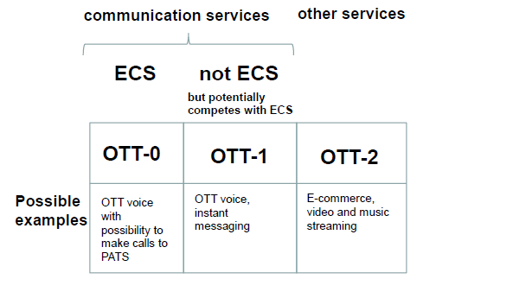
Figure 10: OTT taxonomy
(Source: BEREC BoR (16) 35)
BEREC Report BoR (16) 35 sub-divides ISPs in three categories (i) IAPs (Internet Access Providers) are ISPs for end users, in ‘retail Internet access markets’; (ii) CPs (Connectivity Providers) are ISPs providing services to CAPs (Connectivity and Application Providers) in ‘Internet connectivity markets’. In some cases IAPs and CPs could be the same ISPs; and (iii) ISPs interact with each other in ‘wholesale interconnection markets’.
While BEREC's report analyses and considers the definition, classification and regulatory impact of OTT services, the use of E.164 numbers from national numbering plans by OTT services is only briefly considered in the context of the obligation to support emergency calling under Article 26 of the Universal Service Directive.

The action or process of verifying the identity of a user or process.
IP connectivity between user equipment (UE) and PLMN packet data network (PDN) is referred as PDN connectivity service. The UE establishes a PDN connection with a default Access Point Name (APN). After a PDN connection is established with this APN, the UE attempts to set up additional PDN connections for IMS APN so the UE can do attachment to and IMS registration for VoLTE.
ASNs are assigned by Internet Assigned Numbers Authority (IANA). IANA is responsible for the global coordination of the DNS Root, IP addressing, and other Internet protocol resources. IANA allocates AS Numbers to Regional Internet Registries (RIRs) like RIPE NCC in Amsterdam. RIPE NCC provides Internet resources (like IPv4, IPv6 and AS Number) to Europe, Central Asia and the Middle East.
Conversational, streaming, interactive and background.
Data compression is a process where data is converted into a format that requires less space than usual. It is particularly useful in electronic communications because it enables devices to transmit or store the same amount of data in fewer bits.
IP/PSTN Gateways added to the Ofcom diagram to explain its role in the communications session
The International Telecommunication Union (ITU) in Geneva allocates and assigns country codes (CC) to all of the countries in the world.
Some CEPT Administrations have introduced numbering ranges for nomadic/IP-based services.
OTT services using SIP and MGCP can use proprietary identification schemes specific to those protocols.
E.g. banks, airlines, websites and some OTT providers use this type of authentication.
DIRECTIVE 2002/22/EC, as amended

