ECC Report 243

Wireless video links in the frequency bands   
2700-2900 MHz and 2900-3400 MHz

**Approved 29 January 2016**

# Executive summary

Some possible new spectrum for cordless cameras and video links is identified by the CEPT Report 51 [1], which is the second part of the response to the Mandate issued by the European Commission on technical conditions regarding spectrum harmonization options for wireless radio microphones and cordless video-cameras (PMSE equipment).

Out of the possible bands for video PMSE applications, the frequency bands 2700-2900 MHz and 2900-3400 MHz were considered for detailed studies.

ATC, defence, maritime navigation and meteorological radars operating in the band 2700-3400 MHz are deployed in Europe and would normally be transmitting with high powers, ATC radars are mainly deployed close to airports, maritime radars on sea or on bigger rivers. Defence and meteorological radar are more likely being deployed in rural areas.

For co-frequency sharing a large protection distance between PMSE video transmitter and radar receivers is considered to be necessary. Hence, co-frequency sharing in line-of-sight will be difficult and may require a case-by-case measurement to verify sharing possibilities.

## Considerations for coexistence of the video PMSE in the frequency band 2700-2900 MHz

Studies show that the use of PMSE video transmitters fitted on aircraft (identified as Category C PMSE) is not possible and those for point to point data link applications (identified as Category B PMSE) cannot operate in the frequency band 2700-2900 MHz.

For the adjacent frequencies, the Table 1 below provides the separation distance required for a single category A video PMSE with an e.i.r.p. of 0 dBW at the height of 1.5 m, considering a radar selectivity of   
60 dBc. The separation distances below are derived assuming an urban environment. In Table 1, channel is referring to video PMSE channelling having 10 MHz bandwidth, see Figure 1.

The separation distances may be larger, if aggregated interference or more sensitive radars or other propagation conditions such as rural or suburban have to be taken into account. The separation distance will also depend on the deployment scenario of the video PMSE (like indoor use) and the radar (like antenna height and terrain).

**Table 1: Separation distances (km) to protect radars from video PMSE in adjacent channels**

|  |  |  |  |  |
| --- | --- | --- | --- | --- |
| Single PMSE interferer in an urban environment | | | | |
| PMSE type | Radar type | N+1 adjacent channel | N+2 adjacent channel | N+3 adjacent channel |
| Category A  (e.i.r.p. of 0 dBW) | Meteo | 6.5 km | 4.5 km | 3 km |
| ATC, Terrestrial radars | 3 km | 2.2 km | 1.5 km |

If the gap between PMSE center frequency and radar edge frequency is greater than 35 MHz, then it is assumed that the separation distances are lower than 1.5 km for ATC radar and lower than 3 km for meteo radar.

In addition, if the radar presents blocking response and selectivity below those used in the report, the protection distance may increase.

In the co-channel scenario, a protection distance between PMSE transmitter and radar receivers of 100 km or even more (182 km) may be necessary depending on the PMSE category (see ANNEX 5:). Hence, a co-channel sharing is, in general, not feasible.

Sharing in a co-channel scenario could exist for example, after a coordination on a case-by-case basis, in a category A video PMSE, with a maximum e.i.r.p. of 0 dBW, an antenna height of 1.5 m and an appropriate shielding loss (in accordance with the Recommendation ITU-R P.1411 [22]), located in an urban environment.

Additionally, to protect the radars operating in the adjacent frequency band 2900-3400 MHz, the usage of the upper two channels (i.e. 2x10 MHz) of the band 2700-2900 MHz by video PMSE is not expected to be possible.

**Impact from Radar into PMSE**

Due to the flexibility of PMSE for adjusting the frequency gap, the required separation distance to respect the C/I protection criteria could be considered from 5 to 30 km for the protection of a category A or category B video PMSE in a worst case configuration. For a category C video PMSE, the separation distances exceed in all cases 60 km. (See Annex 3)

However, video PMSE can probably cope with a short pulse that interferes with the receiver. In the cases of radar pulse, the main issue concerns the capability of the video PMSE receiver front-end to handle the input signal power and the time needed to recover a sync state of the video signal.

**Impact from video PMSE into services below 2700 MHz**

To protect radio astronomy stations in the band 2690-2700 MHz, an exclusion area is required with separation distances of 125 km for the 1st adjacent channel, 85 km for 2nd adjacent channel and 60 km for 3rd adjacent channel.

Calculations, including estimation of MCL, related to PMSE above 2700 MHz and E-UTRA below 2690 MHz are given in ANNEX 8: and ANNEX 10:.

The simulations demonstrate that there are various ways to facilitate adjacent band coexistence between video PMSE and LTE Downlink, including the reduction of transmission power of PMSE, applying a sufficient separation distance and/or increasing the frequency separation between the LTE UE and the PMSE equipment, see Annex 10.

A mixture of frequency separation and power restrictions can be made by administrations depending the minimum separation distance expected for each scenario. As examples, based on Annex 10, Class A1 PMSE with an EIRP of 20 dBm/10 MHz would result in negligible probability interference at separation distances of 25 m, 18 m and 6 m and with respectively lower frequency PMSE channel edge above 2700 MHz, 2710 MHz and 2720 MHz.

## Considerations for coexistence of the video PMSE in the frequency band 2900-3400 MHz

For co-frequency sharing a protection distance between PMSE transmitter and radar receivers of 100 km or even more (182 km) might be necessary.

The deployment scenario of PMSE applications (e.g. in buildings or open arena) and the propagation conditions between PMSE and ground based radars determine significantly the separation distance.

The studies indicate that an adjacent frequency sharing between a single cordless video camera and land or maritime based radar applications is feasible, if a minimum separation distance from 20 km in rural and 6 km in urban environments is kept.

For single mobile video uplink, sharing could be possible if a minimum separation distance of 40 km rural and 10 km urban is respected.

Single portable video link could share with these applications with a minimum separation distance between 40 km in a rural environment and 16 km in urban.

The separation distance may be larger for aggregate interference or more sensitive radar types. The separation distance may be smaller if the PMSE is used in buildings due to the additional penetration loss.

For mobile video downlink applications, sharing is not feasible.

Sharing with airborne radiolocation radars however is not possible.

It has to be considered that military land based (fixed or portable platforms) and maritime radars are operating in the NATO harmonized frequency band 2900-3400 MHz. The diversity and especially the operation of aeronautical radiolocation radars may make coordination very difficult or even not possible in practice between military radars and video PMSE.

**Impact from Radar into PMSE**

Since PMSE video links are expected to cause harmful interference to radars operating in the band 2900-3400 MHz, it was not seen necessary to study impact from radars into PMSE.

**Impact from video PMSE into E-UTRA above 3400 MHz**

MCL calculations considering both OOB emissions and blocking effect of video PMSE towards E-UTRA above 3400 MHz indicate that separation distances larger or in the order of the typical E-UTRA coverage radius are required when video PMSE is allocated adjacent (3400 MHz) or at 10 MHz of frequency offset (3410 MHz). An increase of the frequency separation (beyond 10 MHz) will reduce the physical separation needed. The coverage radius for BS in the E-UTRA urban deployment is typically 450 to 500 meters, down to around 200 m in a dense urban environment.

**TABLE OF CONTENTS**

0 Executive summary 2

0.1 Considerations for coexistence of the video PMSE in the frequency band 2700-2900 MHz 2

0.2 Considerations for coexistence of the video PMSE in the frequency band 2900-3400 MHz 3

1 Introduction 9

2 Definitions 10

3 PMSE wireless video links 11

3.1 Summary of the PMSE video link parameters 11

3.1.1 PMSE video link transmission parameters for MFCN cases 12

3.1.2 PMSE video link transmission parameters 12

3.1.2.1 C/N ratio 13

3.1.2.2 C/I ratio 14

3.1.2.3 Blocking 14

4 Band-by-band sharing and compatibility 16

4.1 Frequency band 2700-2900 MHz 16

4.1.1 Use of the band 2700-2900 MHz 16

4.1.2 Use of the band above 2900 MHz 16

4.1.3 Use of the band 2690-2700 MHz 16

4.1.4 Use of the band below 2690 MHz 16

4.1.5 Technical characteristics of ATC/Defence and meteorological radars 17

4.1.6 Operational and other aspects of ATC radars 19

4.1.7 Technical characteristics of radio astronomy 20

4.1.8 Technical characteristics of space research (passive) 20

4.1.9 Technical characteristics of Earth exploration satellite service (passive) 20

4.1.10 Technical characteristics of E-UTRA 21

4.1.11 Compatibility and sharing studies 21

4.1.11.1 Protection of radars from video PMSE interferences 21

4.1.11.2 Protection of video PMSE from radars interferences 22

4.1.11.3 Protection of radioastronomy from video PMSE interferences 24

4.1.11.4 Protection of E-UTRA UE from video PMSE interferences 24

4.1.12 Conclusions for the frequency band 2700-2900 MHz 25

4.1.12.1 Protection of radars from video PMSE interference 25

4.1.12.2 Radioastronomy vs video PMSE 26

4.1.12.3 E-UTRA vs video PMSE 26

4.2 Frequency band 2900-3400 MHz 27

4.2.1 Radionavigation radars technical parameters 27

4.2.2 Conclusion for the frequency band 2900-3400 MHz 28

4.3 Frequency band above 3400 MHz 29

4.3.1 Use of the band above 3400 MHz 29

4.3.2 Technical characteristics of E-UTRA BS and UE 29

4.3.3 Protection of E-UTRA BS and UE from video PMSE interferences 29

4.3.4 Conclusion for the frequency band above 3400 MHz 30

5 Conclusions 32

5.1 Considerations for coexistence of the video PMSE in the frequency band 2700-2900 MHz 32

5.2 Considerations for coexistence of the video PMSE in the frequency band 2900-3400 MHz 33

ANNEX 1: Formulas used in the compatibility calculations 35

ANNEX 2: Results for protection of radar from video PMSE interference in the frequency band 2700-2900 MHz In Adjacent channels 38

ANNEX 3: Results for protection of video PMSE from radar interference 43

ANNEX 4: Results for protection of radioastronomy in the 2690-2700 MHz band from video PMSE interference 46

ANNEX 5: Example of exclusion area calculation for radar protection for co‑channel operation 47

ANNEX 6: MCL analysis 2900-3400 MHz Adjacent channel scenario 50

ANNEX 7: special case of one administraton 55

ANNEX 8: MCL result for E-UTRA UE (below 2690 MHz) vs video PMSE 62

ANNEX 9: MCL result for E-UTRA TDD (above 3400 MHz) vs video PMSE 65

ANNEX 10: Other Study on sharing between mobile video links (MVL) and LTE at 2700 MHz 71

ANNEX 11: List of reference 81

**LIST OF ABBREVIATIONS**

|  |  |
| --- | --- |
| **Abbreviation** | **Explanation** |
| **ACLR** | Adjacent Channel Leakage Ratio |
| **ACS** | Adjacent Channel Selectivity |
| **ADS-B** | Automatic Dependent Surveillance - Broadcast |
| **ARNS** | Aeronautical Radio Navigation Service |
| **ATC** | Air Traffic Control |
| **ATM** | Air Traffic Management |
| **BS** | Base Station |
| **CEPT** | European Conference of Postal and Telecommunications Administrations |
| **DL** | Downlink |
| **DVB-T** | Digital Video Broadcasting — Terrestrial |
| **ECC** | Electronic Communications Committee |
| **ECS** | Electronic Communication Systems |
| **EESS** | Earth Exploration Satellite Service |
| **e.i.r.p.** | equivalent isotropically radiated power |
| **EN** | European Standard |
| **ENG** | Electronic News Gathering |
| **ESE** | Extraneous Signal Environment |
| **FDD** | Frequency Domain Duplexing |
| **HD** | High Definition |
| **IMT** | International Mobile Telecommunication |
| **ISD** | Inter-Site Distance |
| **ISDB-T** | Integrated Services Digital Broadcasting - Terrestrial |
| **ITU-R** | International Telecommunication Union - Radio Sector |
| **LNA** | Low Noise Amplifier |
| **LTE** | Long Term Evolution |
| **MVL** | Mobile Video Link |
| **NATO** | North Atlantic Treaty Organization |
| **NCS** | Non-Cooperative surveillance Sensor |
| **NF** | Noise Figure |
| **OB** | Outside Broadcasting |
| **OFDM** | Orthogonal Frequency Domain Multiplexing |
| **Pd** | Probability of detection |
| **PMSE** | Programme Making and Special Events |
| **PPDR** | Public Protection and Disaster Relief |
| **PSR** | Primary Surveillance Radar |
| **QAM** | Quadrature Amplitude Modulation |
| **QPSK** | Quadrature Phase Shift Keying |
| **RAS** | Radio Astronomy Service |
| **RR** | Radio Regulations |
| **SAB** | Services Ancillary to Broadcasting |
| **SAP** | Services Ancillary to Programme making |
| **SC-FDMA** | Single Channel Frequency Domain Multiple Access |
| **SNG** | Satellite News Gathering |
| **TDD** | Time Domain Duplexing |
| **TMA** | Terminal Manoeuvring Area |
| **TV** | Television |
| **UAS** | Unmanned Aeronautical System |
| **UAV** | Unmanned Aeronautical Vehicle |
| **UE** | User Equipment |
| **UL** | Uplink |
| **UMTS** | Universal Mobile Telecommunications System |
| **VLBI** | Very Long Baseline Interferometry |

# Introduction

Some possible new spectrum for cordless cameras and video links is identified by the CEPT Report 51 [1], which is the second part of the response to the Mandate issued by the European Commission on technical conditions regarding spectrum harmonisation options for wireless radio microphones and cordless video-cameras (PMSE equipment).

Out of the possible bands for video PMSE applications, the frequency bands 2700-2900MHz and 2900- 3400 MHz were considered for detailed studies.

Indeed, it should be noted that the bands 1900-1920 MHz and 2010-2025 MHz were studied when considering the use of the unpaired 2 GHz bands for DA2GC, PMSE, DECT and PPDR, and the results are presented in the ECC Report 220 [24].

ECC decided at its 38 meeting in Montreux, Switzerland (25-28 November 2014) not to consider the frequency band 4400-5000 MHz. It is noticed that video equipment is currently available in this frequency band and already used by some administrations. WG FM in its February 2015 meeting decided that no technical studies concerning the use of video links are needed for the frequency bands 7110-7250 MHz, 7300-7425 MHz and 8460-8500 MHz bands, because sharing arrangements have already been shown to work in these bands..

There is a need to examine the sharing and compatibility issues surrounding the use of the identified candidate bands, on a tuning range basis, by cordless cameras and video links.

Studies cover compatibility between cordless cameras/video links and all existing or planned services allocated in these and the adjacent bands. Consideration should be given to the different cases, for example, indoor and outdoor use, ground-to-air and air-to-ground links. Studies and sharing criteria should be based on realistic sharing scenarios. It is essential to define the technical restrictions on cordless cameras and video links required to enable sharing.

# Definitions

The term Programme Making[1] and Special Events[2] applications (PMSE) describes radio applications used for SAP/SAB, ENG/OB and applications used in meetings, conferences, cultural and education activities, trade fairs, local entertainment, sport, religious and other public or private events for perceived real-time presentation of audio visual information.

The definitions of SAP/SAB and ENG/OB are set out[3] as follows:

**SAP:** Services Ancillary to Programme making (SAP) support the activities carried out in the making of “programmes”, such as film making, advertisements, corporate videos, concerts, theatre and similar activities not initially meant for broadcasting to general public.

**SAB:** Services Ancillary to Broadcasting (SAB) support the activities of broadcasting industry carried out in the production of their programme material.

The definitions of SAP and SAB are not necessarily mutually exclusive. Therefore they are often used together as “SAP/SAB” to refer generally to the whole variety of services to transmit sound and video material over the radio links.

**ENG:** Electronic News Gathering (ENG) is the collection of video and/or sound material by means of small, often hand-held cordless cameras and/or microphones with radio links to the news room and/or to the portable tape or other recorders.

**OB:** Outside broadcasting (OB) is the temporary provision of programme making facilities at the location of on-going news, sport or other events, lasting from a few hours to several weeks. Mobile and/or portable radio links are required for cordless cameras or microphones at the OB location. Additionally, radio links may be required for temporary point to point connections between the OB vehicle, additional locations around it, and the studio.

The definitions of ENG and OB are not mutually exclusive and certain operations could equally well reside in either or both categories. Therefore, it has been a long practice within the CEPT to consider all types of such operations under the combined term “ENG/OB”. It is also understood that ENG/OB refers to terrestrial radiocommunication services, as opposed to SNG/OB term, which refers to similar applications but over the satellite radiocommunication channels.

The SAP/SAB applications include both ENG/OB and SNG/OB applications, but also the communication links that may be used in the production of programmes, such as talk-back or personal monitoring of sound-track, telecommand, telecontrol and similar applications.

Quality requirements of PMSE applications can vary depending on the task in hand. The nature of the signal to be transmitted i.e. audio or video has a direct impact on the spectral bandwidth required. For video PMSE a higher picture quality can also be established by choosing a higher modulation scheme within the same bandwidth.

The perceived quality of the signals is dependent on their potential final use. The uses can vary from SNG links into a news programme through to a high quality HD TV production.

The required reliability of the radio link can vary according to the task in hand; for live news coverage the link may be required for only a short period of time, but during that time the link must be 100% available, in other circumstances, for example in a football match with a number of cordless cameras, a different kind of reliability may be needed. Typically there is a need for a high degree of protection for the signals due to the significance of the event being covered. This required protection inherently puts constraints on the amount of spectrum required to guarantee this quality of service.

With regard to this ECC Report, only PMSE applications dealing with cordless cameras and video links are considered.

# PMSE wireless video links

In this Report, compatibility studies should be on the PMSE use case for SAP/SAB (Services Ancillary to Programme making/Services Ancillary to Broadcasting) and ENG/OB (Electronic News Gathering and Outside Broadcasting) links. Those links are typically used only temporarily at different locations and therefore have a long history of spectrum sharing in different frequency bands. Typical application scenarios and technical characteristics of SAP/SAB equipment are described in detail in ECC Report 219 [3].

## Summary of the PMSE video link parameters

The characteristics of PMSE video link used in the simulation are provided in Table 2 (from ECC Report 219).

Table 2: Technical characteristics of PMSE wireless video links

|  |  |  |  |  |  |
| --- | --- | --- | --- | --- | --- |
| **Type of Link** | **Range** | **Typical Tx power** | **Tx antenna gain @ height agl[4]** | **Rx antenna gain @ height agl[5]** | **Frequency range GHz** |
| Radio Camera Line-of-Sight | <500m | 20dBm | 0 -3dBi @1-2m | 3-13dBi @2-60m | 2 to 8 |
| Radio Camera Non-Line-of-Sight | <500m | 20dBm | 0 -3dBi @1-2m | 3-13dBi @2-60m | 2 to 3.5 |
| Miniature Link | <200m | 20dBm | 0-3dBi @ 100m | 3-13dBi @ 2-60m | 2 to 3.5 |
| Portable Link | <2km | 33dBm | 6-14dBi @ 1 - 4m | 9-17dBi @ 2-60m | 2 to 8 depending on path |
| Air to ground Link | <100km | 36dBm | 3-9dBi @ 15m-6km | 17-24dBi (2GHz)  34dBi (7GHz)  @ 2-60m | <8 |
| Mobile vehicular Link (including ground-to-air) | <10km | 30dBm | 3-9dBi @1-4m | 10-13dBi @ 2-60m  4-9dBi @150m-6km (airborne) | 2 to 3.5 |
| Temporary Point-to-point Link | <80km per hop | 33dBm | 24-38 dBi (7GHz)  @ 20-60m | 24-38 dBi (7GHz)  @ 20-300m | <5-10 for long hops. Hop length at >10 limited by precipitation fading |

PMSE video applications are predominantly digital systems. There are number of different coding and transmissions schemes based on DVB-T, ISDB-T and LMS-T which are often defined in a 10 MHz channel.   
10 MHz channels can be combined in order to provide higher definition video, 3D video or multiplex multiple cameras into a single transmission stream.

As PMSE video applications are based on 10 MHz channels consideration should be given to configuring current and future spectrum on a 10 MHz channel raster in order to easily and efficiently assign spectrum for PMSE video applications.

Note: Some calculations have been conducted before the approval of ECC Report 219 that provides the last updated information on video PMSE. Differences in PMSE parameters will not impact the conclusion of this report.

### PMSE video link transmission parameters for MFCN cases

For MFCN MCL calculations in section ANNEX 9:,the PMSE video link transmission parameters were adopted from ECC Report 219 [3], see Table 3 below.

**Table 3: PMSE video link Tx power and antenna gain**

|  |  |  |
| --- | --- | --- |
| **Type of Link** | **Typical Tx power** | **Maximum Tx antenna gain** |
| CCL | 20 dBm | 3 dBi |
| PVL | 33 dBm | 14 dBi |
| MVL UL | 30 dBm | 6[6] dBi |
| MVL DL | 36 dBm | 9 dBi |

### PMSE video link transmission parameters

The point to point links is considered as a particular application of video PMSE and then are studied for frequency bands higher than 5 GHz.

To conduct the studies in ANNEX 10, video links are classified in 3 categories (see Table 4). The transmitted power of video PMSE is not considered as a variable ranging between a minimum and a maximum value.

* Category A is defined for antenna height about 1.5 m, and mobile application. This corresponds particularly to mobile wireless cameras;
* Category B is defined for antenna height higher than 10 m. This corresponds to the type of links for providing connectivity;
* Category C is defined for airborne video links where the range of antenna height can be very flexible.

Table 4: Video PMSE categories

| **Category** | **Typical Antenna height (m)** | **Range of e.i.r.p (dBW).** |
| --- | --- | --- |
| **A** | 1.5 | -7/26 |
| **B** | 10 / 100 | 10/40 |
| **C** | <10 km | 3/26 |

Note: In category A, the antenna height can be up to 10 m, whereas 1.5 m has been used in the studies.

As described in the Figure 1 below, the first (N+1) and second (N+2) adjacent channels are defined with a 10 MHz bandwidth.



Figure 1: Out-of-Band bandwidth of adjacent channels

The maximum out-of-band e.i.r.p. limit, based on the standard EN 302064-1 [7], is provided in the Figure 2.

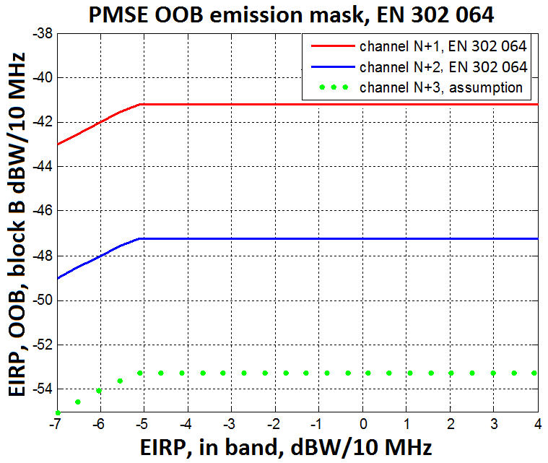

Figure 2: Out-of-Band e.i.r.p. in adjacent channels

The EN 302064-1 [7] does not provide a value for the N+3 adjacent channel. It is assumed that the e.i.r.p. in the 3rd adjacent channel to be 6 dB lower than the 2nd adjacent channel value, to have the same difference between N+1 and N+2 than between N+2 and N+3. Therefore, the value considered in this study for the channel N+3 is -53 dBW/10 MHz.

Note: with this assumption, the emissions in the N+3 adjacent channel is 3 dB lower than -30 dBm/MHz, from the unwanted emissions level in the spurious domain defined in the Recommendation ERC/REC 74-01 [26], noting that the limits defined in ERC/REC 74-01 are set for generic families of Services and do not prevent that specific systems, for specific reasons, might require tighter limits reported in ETSI standards.

#### C/N ratio

In co-channel configuration, the required C/N ratio is assumed to be calculated from a DVB-T modulation signal system. The configuration of DVB-T system at 2.6 GHz can be deduced from the architecture of Tx/Rx DVB-T at 800 MHz.

The Table 5 provides the C/N ratio for a DVB-T channel for a mobile link with a reception probability of 99 % in accordance with ESR5 and a feeder loss of 1 dB.

Table 5: C/N ratio for reception probability of 99 % in accordance   
with ESR5 and a feeder loss of 1 dB

| **Modulation** | **Code rate** | **C/N (dB)** |
| --- | --- | --- |
| QPSK | 1/2 | 11.5 |
| QPSK | 2/3 | 14.7 |
| QPSK | 3/4 | 16.7 |
| 16-QAM | 1/2 | 17.2 |
| 16-QAM | 1/2 | 17.2 |
| 16-QAM | 2/3 | 20.9 |
| 16-QAM | 3/4 | 23.1 |
| 64-QAM | 1/2 | 22.1 |
| 64-QAM | 2/3 | 25.3 |
| 64-QAM | 3/4 | 27.5 |

#### C/I ratio

The protection criteria C/I used in studies, is defined with the following assumptions:

* Out-of-band emission or the interferer is considered to be Gaussian noise;
* C/N required is based on DVB-T in mobile reception;
* In case of some interference, the reception would be assured if the ratio C/(N+I) value would be the same as the ratio C/N which is the requirement for the receiver in case of absence of interferer.

#### Blocking

The table 4 of the standard ETSI ES 202 239 v1.1.1 [8] provides:

* ACS of 30 dB,
* Blocking response of 40 dB.

However, based on manufacturer datasheet, realistic blocking response of 55 dBc is also used as input data for the studies.

Table 6: Blocking response ETSI ES 202 239 v1.1.1 [8]

|  |  |
| --- | --- |
| ∆f fcentral-finterf (MHz) | C/Blocker (dBc) |
| 0 (in-band) | -4 |
| 1 (in-band) | -4 |
| 2 (in-band) | -4 |
| 3 (in-band) | -4 |
| 4 (in-band) | -4 |
| 5 (in-band) | -12 |
| 6 | -36 |
| 8 | -52 |
| 10 | -55 |
| 20 | -57 |
| 30 | -58 |
| 100 | -58 |
| >100 | -58 |

# Band-by-band sharing and compatibility

## Frequency band 2700-2900 MHz

### Use of the band 2700-2900 MHz

The frequency band 2700-2900 MHz is allocated on primary basis to Aeronautical Radionavigation, and restricted to ground-based radars (and to associated airborne transponders…) by RR 5.337. The weather radars are included by RR 5.423:

*“In the band 2 700-2 900 MHz, ground-based radars used for meteorological purposes are authorized to operate on a basis of equality with stations of the aeronautical radionavigation service.”*

Also Radiolocation is listed with secondary status in the RR frequency table in the band 2700-2900 MHz.



**5.337** The use of the bands 1 300-1 350 MHz, 2 700-2 900 MHz and 9 000-9 200 MHz by the aeronautical radionavigation service is restricted to ground-based radars and to associated airborne transponders which transmit only on frequencies in these bands and only when actuated by radars operating in the same band.

**5.423** In the band 2 700-2 900 MHz, ground-based radars used for meteorological purposes are authorized to operate on a basis of equality with stations of the aeronautical radionavigation service.

**5.424A** In the band 2 900-3 100 MHz, stations in the radiolocation service shall not cause harmful interference to, nor claim protection from, radar systems in the radionavigation service. (WRC-03)

**5.425** In the band 2 900-3 100 MHz, the use of the shipborne interrogator-transponder (SIT) system shall be confined to the sub-band 2 930 -2 950 MHz.

**5.426** The use of the band 2 900-3 100 MHz by the aeronautical radionavigation service is limited to groundbased radars.

**5.427** In the bands 2 900-3 100 MHz and 9 300-9 500 MHz, the response from radar transponders shall not be capable of being confused with the response from radar beacons (racons) and shall not cause interference to ship or aeronautical radars in the radionavigation service, having regard, however, to No. **4.9**.

Figure 3: Frequency use in the band 2700-2900 MHz

### Use of the band above 2900 MHz

The upper adjacent band is used for radiolocation, navigation and maritime radars.

### Use of the band 2690-2700 MHz

The band 2690-2700 MHz, between mobile service and radar, is allocated to the passive services Radioastronomy, Space Research (passive) and Earth-Exploration-Satellite (passive) associated with the RR 5.340*.*

### Use of the band below 2690 MHz

The band 2500-2690 MHz is allocated to the terrestrial Mobile Service. The harmonised spectrum scheme for electronic communication systems (ECS) including IMT is defined in the relevant ECC and EC Decisions. The most common use of this band in Europe is expected to be the arrangement: 2*70 MHz for FDD (2500-2570 MHz for FDD UL and 2620-2690 MHz for FDD DL) and between 50 MHz (2570-2620 MHz) for TDD or SDL based on national decisions. It should be noted that other frequency arrangements in the spectrum 2.5-2.69 GHz may apply on a national basis.

In the following, the base station of the mobile service is called simply base station and the mobile station is called terminal. [21]

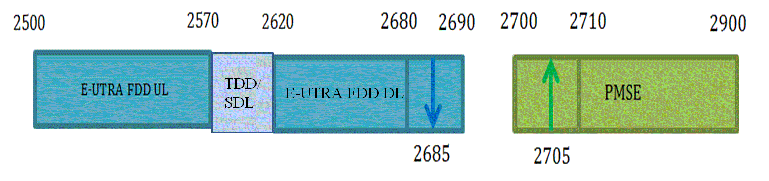

Figure 4: Frequency arrangement between MFCN and PMSE in the band 2500-2900 MHz

### Technical characteristics of ATC/Defence and meteorological radars

The characteristics of the ATC/Defence and meteorological radars in the frequency band 2700-2900 MHz are reused from Table 7, extracted from ECC Report 174 [9] and additional parameters for blocking and selectivity.

Table 7: ATC/Defence and Meteorological radar characteristics

| **Parameter** | **Unit** | **ATC and defence** | | | | **Meteorology** |
| --- | --- | --- | --- | --- | --- | --- |
| **Type 1** | **Type 2** | **Type 3** | | **Type 4** |
| Category |  | Frequency hopping | 2 to 4 frequencies | | | Single frequency |
| Maximum antenna gain | dBi | > 40 | 34 | | | 43 |
| Antenna pattern |  | Not given | Vertical pattern cosecant-squared | | | Rec ITU-R F.1245 |
| Antenna height | m | 5-40 (normal 12) | | | | 7-21 (normal 13) |
| Polarization |  | Circular | | | | H/V |
| Feeder loss | dB | <1 | | Not given | | 2 |
| Minimum elevation angle | ° | Not given | 2 (see Rec ITU-R M.1851 [11]) | | | 0.5 |
| Protection level | dBm/MHz | -122 (for I/N=-10 dB) | | | | |
| 1 dB compression point | dBm | -20 (see Rec ITU-R M.1464 [13]) | | | | 10 |
| Blocking level | dBm | -36 | -36 | -36 | | -36 |
| Transmission power | kW | 1000 | 400 | 30 | | 794 |
| Reference bandwidth | kHz | 2500 | 1000 | 800 | | 1000 |
| 40 dB bandwidth | MHz | 9.5 | 20 | 4 | 2 | section 4.2.1 |
| Out of band roll off | dB/decade | 20 | 20 | 20 | | 40 |
| Spurious level | dBc | -60 | -60 | -60 | | -60 for old radars and -75 to -90 for new radars |
| Unwanted emission mask |  | To be calculated using elements above + section 4.2.1 for actual examples | |  | | section 4.2.1 |
| Pulse repetition rate | Hz | <300 | ~1000 | 825 | | 250 - 1200 (See Rec ITU-R M.1849 [15]) |
| Pulse duration | µs | 20 and 100 | 1 | 1 | 100 | 0.8-2 |
| Rise and fall time | % of pulse length | 1 % | 10 % | 16.9 % | Not given | 10 % |
| Antenna rotation | rpm | 6-12 | 12-15 | 15 | | See Rec ITU-R M.1849 |
| Scan in elevation |  | Not given | Fixed | | | See Rec ITU-R M.1849 |
| Selectivity | dBc | -60 | -60 | | | -60 |

### Operational and other aspects of ATC radars

The band 2700 –2900 MHz is used Europe wide 24h/7 days a week, for civil and military Air traffic Control (ATC) by using Primary Surveillance Radar (ATC-PSR), for detection of all aircraft. It works as a fall-back to Secondary Surveillance Radar (SSR) detection, when SSR detection fails.

Aircraft that are undetectable by SSR, during times of strong solar flares like those occurring in November 2015 in Northern Europe, whenever aircrafts are not are equipped with SSR transponder, when aircraft transponder are dysfunctional, e.g. due to over-interrogation as it occurred on several days in June 2014, or when the transponder are defective or have been deactivated intentionally by hostile action.

Non-Cooperative Surveillance Sensors (NCS), or Primary Surveillance Radars as they are traditionally known as, are essential components of a safe and efficient civilian and military ATM infrastructure. Their use is required enroute and in Major TMA airspace in order to meet the requirements of the EUROCONTROL surveillance standard published in 1997. Implementing Regulation EU1207-2011 published by the European Commission requires Air Navigation Service Providers to conduct a safety case assessment of their ATM infrastructure to be able to provide a safe separation between aircrafts and UAV’s. The findings of which normally require non-cooperative surveillance in order to detect aircraft without SSR or ADS-B avionics infringing in to controlled airspace or to support controllers mitigate the effects of an avionics failure on board their aircraft. Aviation makes a major contribution to the economies of a State. It is essential that ATM supports safe and efficient operations – NCS are crucial and their role and importance in achieving this should not be under-rated or compromised. If a country can’t provide safe air traffic control, it has to introduce restrictions in the number of aircrafts that will be allowed to enter the airspace

Interference free operation of PSR is therefore necessary the prerequisite in providing the safety of life service for Air Traffic Control. Primary surveillance target losses due to interference are insidious, because they do not cause any indication on a ATC display, that would inform an ATC controller of lost targets. An extremely high sensitivity and at least dual frequency operation (frequency diversity) is required, to allow Detection of aircraft in distances of up to 120 NM with a radar cross section of 1 m² or larger under all operational weather conditions and anomalous propagation conditions is therefore the prerequisite for the safety of life ATC service.

Due to the high sensitivity it is important to provide sufficient distance and frequency separation, between the existing and new S-Band ATC radar within confinements of the band 2700 to 2900 MHz. Frequencies for ATC S-Band PSR systems are not assigned based on a channel system, but are assigned in 0.5 MHz steps within the band 2700 to 2900 MHz on any frequency that allows safe operation within the existing environment in the S-Band. Coordination of S-Band ATC PSR, account among other factors for existing S-Band PSR radars around a location, terrain, e.i.r.p., and technical differences between designs, e.g. frequency offset between the diversity center frequencies, transmission of short pulse or pulse compressed signals. It also does not account for propagation probabilities, 95% of the time for ATC radar and 5 % of the time probabilities for the interferer PMSE, using the aeronautical propagation Model ITU-R P.528 (based on IF-77 by Gierhart-Johnson).

Radar systems do operate on any frequency in the band 2700-2900 MHz that allows compatibility to other RADAR stations.

Therefore, in all cases where the bandwidth frequency of PSR is overlapping totally or partially some PMSE channels, these channels have to be considered as co-channel with PSR. Alternatively, it may be possible to shift PMSE center frequency to avoid overlap and to consider them as adjacent channels. While most S-Band ATC PSR are located at and around airports, where they are already subject to a very high number of undesired echoes, e.g. from ground or airborne surfaces (e.g. clouds, birds, vehicles, MM- and land based structures), they can be found also on exposed locations like mountains.

An assessment requires measurements on S-Band ATC PSR under normal operational conditions, for all the different operational S-Band ATC PSR designs in use, including measurements of those S-Band ATC PSRs available on the market, since many states (e.g. Germany, Switzerland, the Netherlands) are in the process to renew PSR ATC radar sensors.

Interference in RADAR is not just a function of the energy received within the receiver pass band and it's impact onto the RADAR receiver. Impact depends to a large degree on the design of the radar receiver, e.g. type of preselector, LNA or type of stages used for processing. Technical parameters of radar, e.g. selectivity, vary from radar design to design and the detection requirements, like range and radar cross section of targets that a design has to be able to detect. This is the reason why some S-Band ATC PSR system radars therefore even have been designed with a bandwidth of a few hundred MHz for multiple frequency diversity PSR designs.

Furthermore only measurements allow establishing the interference parameter for a given PSR design, when the measurements are conducted when the RADAR is operating in the normal operational Extraneous Signal Environment (ESE). The impact of an interfering signal in an already dense signal requirement will lead to a faster degradation of the Probability of Detection (Pd) and in consequence to target losses. Purely theoretical studies do not account for interference mechanism of PSR designs that can only be measured on a case-by-case basis at an operational PSR, and in an operational RADAR ESE which already operates in challenged conditions.

### Technical characteristics of radio astronomy

The diagram antenna pattern can be considered as omnidirectional of 0 dBi in accordance with the Recommendation ITU-R RA.769-2 [16] which advocates this value in some cases.

The height of the antenna used in the study is 21 m that is representative of radioastronomy station of Nancy, France.

**Protection criteria:**

The frequency band 2690-2700 MHz should be protected from any emission by the article 5.340 of the RR.

The Recommendation ITU-R RA.769-2 provides the criteria for the protection of radioastronomy receivers as described in Table 8:

Table 8: Characteristics and protection of radioastronomy receivers

|  |  |  |  |  |  |  |  |
| --- | --- | --- | --- | --- | --- | --- | --- |
| Center frequency (MHz) | Bandwidth (MHz) | Minimum antenna noise temperature (K) | Receiver noise temperature (K) | Temperature (mK) | Spectral density (dBW/Hz) | Input power (dBW) | Surface power (dBW/m2) |
| 2695 | 10 | 12 | 10 | 0.16 | -267 | -207 | -177 |

It has to be noted that the values are calculated using the equation (4) of the Recommendation ITU-R RA.769-2 with Preceived = 0.1∆P∆f. This power received with a bandwidth of 10 MHz is then calculated for a bandwidth of 1 MHz.

### Technical characteristics of space research (passive)

The space research (passive) allocation is used by space-based radioastronomy observatories on highly elliptical orbits. These sensors perform VLBI observations in conjunction with terrestrial observatories. It is expected that PMSE will have much less impact in these space based observatories than the much more powerful radar systems currently using the band 2700-2900 MHz.

### Technical characteristics of Earth exploration satellite service (passive)

The EESS (passive) allocation is normally used by passive sensors on-board low Earth orbiting satellites. However, no characteristic is available in Recommendation ITU-R RS.1861 [17] for this particular frequency band. This band is therefore likely not used by EESS (passive).

### Technical characteristics of E-UTRA

Compatibility between video PMSE above 2700 MHz and LTE UE below 2690 MHz needs to be considered. Table 9 contains the LTE UE RX characteristics for 10 and 20 MHz E-UTRA carriers.

Table 9: LTE UE, Receiver characteristics

|  |  |  |  |
| --- | --- | --- | --- |
| Parameter | Value | | Comment |
| Channel bandwidth | 20 MHz | 10 MHz |  |
| Occupied | 18 MHz | 9 MHz |  |
| Noise figure | 9 dB | | 3GPP TR 36.942 [19], Table 4.8 |
| Reference sensitivity | -98 dBm | -95 dBm | ETSI TS 136 101 [18], Table 7.3.1-1 Reference sensitivity QPSK PREFSENS |
| ACS1 | 27 dB | 33 dB | ETSI TS 136 101, Table 7.5.1-1 Adjacent channel selectivity |
| ACS at 10 MHz (based on in-band blocking) | 39.6 dB | 46.3 dB | ETSI TS 136.101 Table 7.6.1.1-2 in band blocking |
|  |  | |  |
| Antenna height | 1.5 m | |  |
| Antenna gain | 0 dBi | | 3GPP TR 36.942 4.2.2 |

### Compatibility and sharing studies

#### Protection of radars from video PMSE interferences

**Co-channel scenario**

Separation distances between radar and video PMSE are defined by the radio horizon given in a flat ground by the formula:

$$H_{e}\left[km\right]=4.12∙\left(\sqrt{h_{PMSE}}+\sqrt{h_{Radar}}\right)$$

Note: the radar could also be interfered by a transmitter located below line-of-sight.

The topography of the real ground would significantly impact the separation distance and the exclusion area has to be calculated for case by case situation considering the digital terrain model.

In this case, the propagation model could be a combination of the Recommendation ITU-R P.525 [5] (free space) and the Recommendation ITU-R P.526 [6] (diffraction loss) with an additional loss due to the clutter (formula to calculate the clutter loss are provided in the Recommendation ITU-R P.452 [4]).

**Adjacent channel scenario**

In the adjacent channel scenario, the following effects on radar protection have been considered:

* Out-Of-Band and spurious emissions of the PMSE falling into the receiving bandwidth of the radar receiver;
* Blocking of radar receiver, it is the maximum interfering signal due to the PMSE that causes the saturation of the radar receiver front-end. Selectivity of the radar receiver, it is the power transmitted by the PMSE that radar receiver selectivity will not reject; it is assumed that the frequency gap between PMSE and radar are enough to have a selectivity of 60 dBc.

The scenario for calculation of separation distance, is considering:

* Only one single interfering PMSE-device
* Radar antenna pointing into direction of video PMSE; due to the scan of radars, this event may occur regularly;
* Video PMSE antenna pointing into direction of radar: this scenario is a realistic case for omnidirectional antenna, but the worst case for PMSE with directional antenna;
* The e.i.r.p. of video PMSE is a variable;
* The propagation models used for studies are described in the Table 10 below:

**Table 10: Propagation models for different PMSE types**

|  |  |
| --- | --- |
| PMSE type | Propagation model |
| Category A | Extended-Hata |
| Category C | Free space |

The extended-Hata model is used in this case even if antenna height and frequency range are not respecting in its original limitations. However, ECC Report 174 [9] concludes that Extended-Hata would be more appropriated than Free-space except for PMSE on airborne.

The simulations results can be found in the ANNEX 2:.

#### Protection of video PMSE from radars interferences

**Co-channel studies**

Separation distances between radar and video PMSE are defined by the radio horizon given in a flat ground by the formula:

$$H_{e}\left[km\right]=4.12∙\left(\sqrt{h_{PMSE}}+\sqrt{h_{Radar}}\right)$$

The topography of the real ground would significantly impact the separation distance and the exclusion area has to be calculated for case by case situation considering the digital terrain model.

In this case, the propagation model could be a combination of the Recommendation ITU-R P.525 [5] (free space) and the Recommendation ITU-R P.526 [6] (diffraction loss) with an additional loss due to the clutter (formula to calculate the clutter loss is provided in the Recommendation ITU-R P.452 [4]).

**Adjacent channel studies**

Based on an analysis of the Recommendation ITU-R SM.1541-5 [22], 30 dB/decade is considered for the variation of the out of band emissions in this study, except for meteorological radars.



Figure 5: Radar emission mask extracted from Recommendation ITU-R SM.1541

For meteorological radars, 40 dB/decade is considered for the variation of the out of band emissions in accordance with the ECC Report 174 [9].

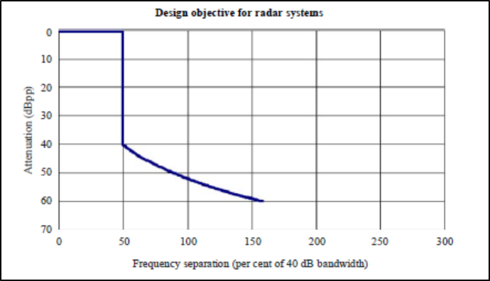

Figure 6: Meteo radar emission mask based on ECC Report 174

The scenario for calculation of separation distance, is considering:

* no antenna discrimination for the radar due to its rotation;
* no discrimination for video PMSE antenna;
* the range of distance between the radar and the video PMSE for the calculation is from 0 to 60 km;
* the results provide the percentage of time that the protection criteria is exceeded, based on random draws on the distribution of the wanted signal received by video PMSE.

The results are provided in the ANNEX 3:.

#### Protection of radioastronomy from video PMSE interferences

**Adjacent channel compatibility**

For the initial compatibility studies between radioastronomy and video PMSE, it has been assumed that:

* Only one video PMSE transmitter (no aggregation) with e.i.r.p. considered as a variable;
* The propagation model used is the ITU-R P.452 [4] with a percentage of time of 2 % and a flat earth;
* Free space is considered for category C video PMSE.

Figure 7 provides the separation distance between video PMSE and radioastronomy.

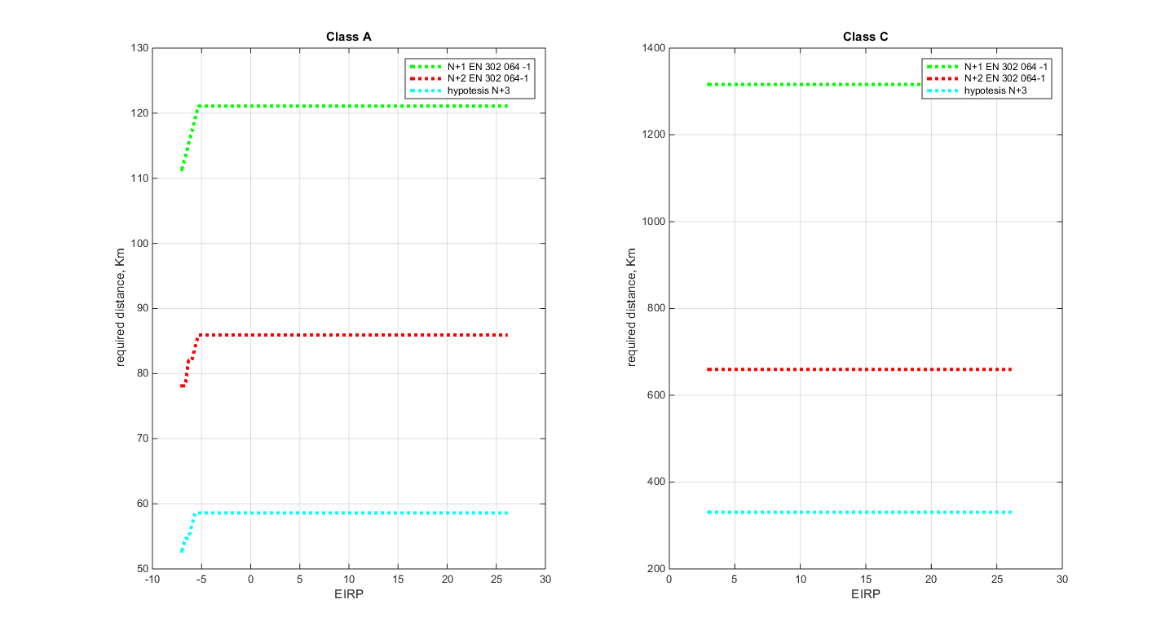

Figure 7: Separation distance between radioastronomy and PMSE with flat earth model

The separation distance for one category A video PMSE transmitter is about 125 km for the N+1 adjacent channel, 85 km for N+2 and 60 km for N+3.

A real configuration is available in ANNEX 4:, as well as an analysis of co-channel situation.

#### Protection of E-UTRA UE from video PMSE interferences

The required separation distances between 10 MHz LTE UE and video PMSE are calculated in Table 11 for 3 dB UE RX desensitization, considering both the video PMSE OOB emissions and blocking effect. The LTE UE parameters are listed in Table 9. The detailed calculations are included in ANNEX 8. The allowed degradation of noise floor for E-UTRA UE is considered to be 3 dB. The propagation model IEEE802.11_Model_C is considered for all scenarios except MVL DL, for which extended Hata is employed.

Table 11: Isolation (dB) and Separation distances (km)   
between 10 MHz E-UTRA UE and video PMSE for 3 dB UE RX desensitization (MCL calculations)

|  |  |
| --- | --- |
|  | LTE DL@2.7GHz（band7） |
|  | 10 MHz guard band |
| CCL | 86.63 dB |
| 0.04 km |
| PVL | 103.48 dB |
| 0.121 km |
| MVL UL | 93.27 dB |
| 0.062 km |
| MVL DL | 108.97 dB |
| 0.14 km |

Increasing the frequency separation between MFCN DL and video PMSE would reduce the required physical separation since the OOB emissions from video PMSE will be lower and the blocking rejection from MFCN will be higher.

### Conclusions for the frequency band 2700-2900 MHz

#### Protection of radars from video PMSE interference

For co-channel sharing a protection distance between PMSE transmitter and radar receivers of 100 km or even more (182 km) may be necessary depending on the PMSE category (see Table 21). Hence, a co-channel, the sharing in line-of-sight is only possible if a case-by-case measurement shows the sharing possibility.

Table 12 provides the separation distance to be kept by one single category A video PMSE application in the adjacent channels and in an urban environment. The use of a category C PMSE is not appropriate.

**Table 12: Separation distances (km) to protect radars from video PMSE interference   
in adjacent channels**

|  |  |  |  |  |
| --- | --- | --- | --- | --- |
| Single PMSE interferer in an urban environment | | | | |
| PMSE type | Radar type | N+1 adjacent channel | N+2 adjacent channel | N+3 adjacent channel |
| Category A  (e.i.r.p. of 0 dBW) | Meteo | 6.5 km | 4.5 km | 3 km |
| ATC, Terrestrial radars | 3 km | 2.2 km | 1.5 km |

The required separation distance may be different considering the altitude of the radar and the topography around the radar. This would have to be addressed on a case-by-case basis.

If the radar presents a blocking response and a selectivity worse than those used in the report the protection distance can increase up to 27 km assuming the other conditions unchanged.

The separation distances for a single video PMSE-device in the adjacent channels in a rural environment are in the order of 14-35 km (see Annex 6.1.1).

The deployment scenario for PMSE (e.g. in buildings or open arena) and the propagation conditions between PMSE and radars determine significantly the separation distance.

Additionally, to protect the radars operating in the frequency band 2900-3400 MHz, the use of the upper two channels (i.e. 2x10 MHz in the band 2880-2900 MHz) of the band 2700-2900 MHz by video PMSE is not expected to be possible.

It is assumed that video PMSE can cope with a short pulse that interferes with the receiver. In the cases of radar pulse, the main issue concerns the capability of the video PMSE receiver front-end to handle the input signal power.

The separation distance may be larger for aggregate interference or more sensitive radar types. The separation distance may be smaller if the PMSE is used in buildings due to the additional penetration loss.

In co-channel the exclusion area would be much larger. Operating a category A video PMSE with an e.i.r.p. of 0 dBW and an antenna height of 1.5 m, would be possible only in urban environment and with an additional building loss in accordance with the Recommendation ITU-R P.1411 [2].

#### Radioastronomy vs video PMSE

Radioastronomy and video PMSE may be possible in adjacent channel considering an exclusion area. Indeed, the separation distance estimated considering a flat earth, nor clutter is about 125 km for the N+1 adjacent channel, 85 km for N+2 adjacent channel and 60 km for N+3 adjacent channel.

#### E-UTRA vs video PMSE

* Compatibility between video PMSE and E-UTRA FDD UL (BS RX) is not considered due to the large frequency separation.;
* E-UTRA UEs will appear in the neighbourhood of CCL/PVL/ MVL usage. Table 14 below shows the isolation required for co-existence between CCL/PVL/MVL and E-UTRA UE and the distances required to achieve such isolation assuming 3dB UE RX desensitization. More detailed MCL calculations related to video PMSE and E-UTRA below 2690 MHz are given in ANNEX 8:.
* An increasing of the frequency separation, i.e. video PMSE further above 2700 MHz, would reduce the required physical separation since the OOB emissions from video PMSE will be lower and the blocking rejection from MFCN will be higher.

Table 13: Isolation (dB) and Separation distances (km)   
to protect E-UTRA UE from video PMSE

|  |  |
| --- | --- |
|  | LTE DL@2.7GHz（band7） |
|  | 10 MHz guard band |
| CCL | 86.63 dB |
| 0.04 km |
| PVL | 103.48 dB |
| 0.121 km |
| MVL UL | 93.27 dB |
| 0.062 km |
| MVL DL | 108.97 dB |
| 0.14 km |

## Frequency band 2900-3400 MHz

The band 2900-3400 MHz is mainly used for radar and navigation systems including defence systems.



Figure 8: Frequency use in the band 2900-3400 MHz

### Radionavigation radars technical parameters

The Table 14 provides the technical characteristics of aeronautical radionavigation radars in the frequency band 2900-3400 MHz.

**Table 14: Technical characteristic of aeronautical radionavigation radars, meteorological radars, military radiolocation radars and radiodetermination systems operating in the frequency band 2700-3400 MHz (as described in Recommendation ITU-R-M.1464, ITU-R M.1460 [12] and ITU-R M.1465 [14])**

| **Type** | **Aeronautical radionavigation radars** | | | | | | **Meteorological radars** | | **Defence Radars** | |
| --- | --- | --- | --- | --- | --- | --- | --- | --- | --- | --- |
|  | **Radar A** | | **Radar B** | **Radar C** | **Radar E** | **Radar F** | **Radar**  **G** | **Radar**  **H** | **Radar I** | **Radar J** |
| Operation frequency range, MHz | 2700-3100 | | | | | | 2700-3000 | 2700-2900 | 2700-3100 | |
| Receiver gain, Grec, dBi | 33.5 | 33.5 | | 34 | 34.3 | 33.5 | 45.7 | 38 | 33.5 | 40 |
| Receiver noise figure, NF, dB | 4 | 4 | | 3.3 | 2.1 | 2.0 | 2.1 | 9 | 2 | 1.5 |
| Receiver pass band, ΔF, kHz | 5 000 | 653 | | 15000 | 1200 | 4000 | 630 | 500 | 3500 | 10000 |
| Protection criterion, I/N, dB (aggregated) | -10 | | | | | | | | -6 | |

Table 15: Continued and ended

| **Type** | **Maritime radionavigation radars** | | | | **Land based Systems** | | **Airborne Systems1)** |
| --- | --- | --- | --- | --- | --- | --- | --- |
|  | **Radar K** | **Radar L** | **Radar M** | **Radar N** | **Radar O** | **Radar P** | **Radar Q** |
| Operation frequency range, MHz | 2900-3100 | | | 3100-3500 | 3100-3700 | | 3100-37002) |
| Receiver gain, Grec, dBi | 38 | 38 | 38 | 42 | 39 | 40 | 40 |
| Receiver noise figure, NF, dB | 4 | 4 | 5.5 | 5 | 3.1 | 4 | 3 |
| Receiver pass band, ΔF, kHz | 3000 | 28000 | 22000 | 4000 | 380000 | 670 | 10000 |
| Protection criterion, I/N, dB (aggregated) | -10 | | | | | | |

1) For Airborne Systems Antenna height is assumed with 300 m.

2) Some radiodetermination airborne systems are operating from 2900 MHz

For the radars, an antenna height of 15 m and an ACS of 15 dB are assumed for the following studies.

### Conclusion for the frequency band 2900-3400 MHz

Some systems described in the frequency band 2700-2900 MHz are also operating in the frequency band 2900-3400 MHz. The previous results to protect radars in the frequency band 2700-2900 MHz are also applicable to the frequency band 2900-3400 MHz.

For co-channel sharing a protection distance between PMSE transmitter and radar receivers of 100 km or even more (182 km) might be necessary. Hence, a co-channel sharing in line-of-sight is not feasible.

The deployment scenario for PMSE (e.g. in buildings or open arena) and the propagation conditions between PMSE and ground based radars determine significantly the separation distance.

The studies indicate that an adjacent channel sharing between a single cordless video camera and land or maritime based radar applications is feasible, given a minimum separation distance from 20 km in rural and 6 km in urban environments depending on the victim radar system. For single mobile video uplinks, sharing would be possible if a minimum separation distance of 40 km rural and 10 km urban is respected.

Single portable video links could share (adjacent channel) with these applications with a minimum separation distance between 40 km in a rural environment and 16 km in urban.

The separation distance may be larger for aggregate interference or more sensitive radar types. The separation distance may be smaller if the PMSE is used in buildings due to the additional penetration loss.

For mobile video downlink applications, sharing is not feasible.

Moreover, it has to be noticed that military land based (fixed or portable platforms) and maritime radars are operating in this NATO harmonized frequency band. The diversity and especially the operation of aeronautical radiolocation radars make coordination procedure most difficult or even not possible in practice between military radars and video PMSE.

## Frequency band above 3400 MHz

### Use of the band above 3400 MHz

The 3400-3600 MHz is allocated to E-UTRA TDD

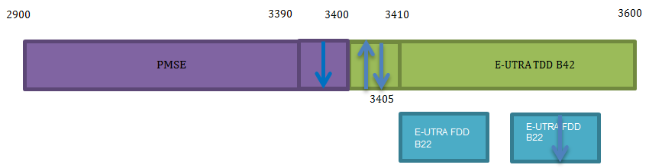

Figure 9: Frequency use above 3400 MHz

### Technical characteristics of E-UTRA BS and UE

Technical characteristics of E-UTRA UE can refer to 4.1.10. Technical characteristics of E-UTRA BS can refer to Table 16 below.

Table 16: LTE BS, Receiver characteristics

|  |  |  |  |
| --- | --- | --- | --- |
| Parameter | Value | | Comment |
| Channel bandwidth | 20 MHz | 10 MHz |  |
| Occupied BW | 18 MHz | 9 MHz |  |
| Noise figure | 5 dB | | 3GPP TR 36.942 [19], Table 4.5 |
| Reference sensitivity | -101.5 dBm | -101.5 dBm | 3GPP TS 37.104 [20] |
| ACS1 | 47.8 dB | | 3GPP TS 37.104 |
| ACS2 | 56.8 dB | | 3GPP TS 37.104 |
| Desensitisation | 1 dB | | ECC Report 220 [24] Table 28 |
| Antenna height | 30 m | | ECC Report 220 Table 28 |
| Antenna gain | 17 dBi | | ECC Report 220 Table 28 |
| Feeder loss | 2 dB | | ECC Report 220 Table 28 |

### Protection of E-UTRA BS and UE from video PMSE interferences

The required separation distances between 10 MHz LTE UE and video PMSE as well as 10 MHz LTE BS are calculated in Table 17 for 3 and 1 dB UE and BS RX desensitization, respectively. Video PMSE is considered between 3390-3400 MHz (no guard band) and 3380-3390 MHz (10 MHz guard band). Both the video PMSE OOB emissions and blocking effect are taken into account. The LTE UE parameters are listed in Table 9 and the LTE BS in Table 16. The propagation model IEEE802.11_Model_C is considered for the co-existence between video PMSE and LTE UE except for the MVL DL scenario, for which extended Hata is employed. Extended-Hata is used for video PMSE and LTE BS co-existence, except for the MVL DL scenario, for which free space is adopted. The detailed calculations are included in ANNEX 9:

Table 17: Isolation (dB) and separation distances (km) between 10 MHz E-UTRA and video PMSE for 3dB UE RX and 1 dB BS RX desensitization, respectively.

|  |  |  |  |  |
| --- | --- | --- | --- | --- |
|  | LTE DL@3.4GHz | | LTE UL@3.4GHz | |
|  | no guard band | 10 MHz guard band | no guard band | 10 MHz guard band |
| CCL | 95.25 dB | 86.63 dB | 126.18 km | 120.10 dB |
| 0.062 km | 0.035 km | 0.400 km | 0.27 km |
| PVL | 116.72 dB | 103.48 dB | 136.60 dB | 127.96 dB |
| 0.253 km | 0.106 km | 0.89 km | 0.500 km |
| MVL DL | 122.18 dB | 10.87 dB | 134.82 dB | 126.35 dB |
| 0.31 km | 0.130 km | 13.53 km | 5.10 km |

It is to be noted that the coverage radius for BS in the E-UTRA urban deployment is typically 450 to 500 meters, while this is around 200 m in a dense urban environment. The calculations above show that even with 10MHz guard band, the required physical separation is in the order of or larger than the coverage radius and may affect several BSs. Further increasing the frequency separation (beyond 10 MHz) would be a possibility to reduce the required physical separation.

### Conclusion for the frequency band above 3400 MHz

Regarding MVL, it can be observed that MVL UL may interfere with both E-UTRA UE and BS RX. This will be a moving interference. MVL DL is also a moving interference. However, in this case, there may be line of sigh towards the BS and thus is considered a worst case scenario.

In addition, PVL and CCL are also investigated. The study is considered both for no guard band and 10 MHz guard band.

E-UTRA UE RX will appear in the neighbourhood of CCL/PVL/ MVL DL usage. Table 18 below includes the required physical separation for co-existence with E-UTRA UE RX and BS Rx. More detailed MCL calculations related to video PMSE and E-UTRA above 3400 MHz are given in ANNEX 6:.

The coverage radius for BS in an E-UTRA urban deployment is typically 450 to 500 m, down to around 200 m in a dense urban environment. The calculations show that even with 10MHz guard band, the required physical separation is in the order of or larger than the coverage radius and will affect several BSs. Further increasing the frequency separation (beyond 10 MHz) would be a possibility to reduce the required physical separation.

Table 18: Isolation (dB) and separation distances (km) to protect 10 MHz E-UTRA from video PMSE for 3dB UE RX and 1 dB BS RX desensitization, respectively.

|  |  |  |  |  |
| --- | --- | --- | --- | --- |
|  | LTE DL@3.4GHz | | LTE UL@3.4GHz | |
|  | no guard band | 10 MHz guard band | no guard band | 10 MHz guard band |
| CCL | 95.25 dB | 86.63 dB | 126.18 dB | 120.1 dB |
| 0.062 km | 0.035 km | 0.40 km | 0.27 km |
| PVL | 116.72 dB | 103.48 dB | 136.6 dB | 127.96 dB |
| 0.253 km | 0.106 km | 0.89 km | 0.5 km |
| MVL DL | 122.18 dB | 108.97 dB | 134.82 dB | 126.35 dB |
| 0.31 km | 0.130 km | 13.53 km | 5.10 km |

# Conclusions

Some possible new spectrum for cordless cameras and video links is identified by the CEPT Report 51 [1], which is the second part of the response to the Mandate issued by the European Commission on technical conditions regarding spectrum harmonization options for wireless radio microphones and cordless video-cameras (PMSE equipment).

Out of the possible bands for video PMSE applications, the frequency bands 2700-2900 MHz and 2900-3400 MHz were considered for detailed studies.

ATC, defence, maritime navigation and meteorological radars operating in the band 2700-3400 MHz are deployed in Europe and would normally be transmitting with high powers, ATC radars are mainly deployed close to airports, maritime radars on sea or on bigger rivers. Defence and meteorological radar are more likely being deployed in rural areas.

For co-frequency sharing a large protection distance between PMSE video transmitter and radar receivers is considered to be necessary. Hence, co-frequency sharing in line-of-sight will be difficult and may require a case-by-case measurement to verify sharing possibilities.

## Considerations for coexistence of the video PMSE in the frequency band 2700-2900 MHz

Studies show that the use of PMSE transmitters fitted on aircraft (identified as Category C PMSE) is not possible and those for point to point data link applications (identified as Category B PMSE) are not appropriate for the frequency band 2700-2900 MHz.

For the adjacent frequencies, the Table 19 provides the separation distance required for a single category A video PMSE with an e.i.r.p. of 0 dBW at the height of 1.5 m, considering a radar selectivity of 60 dBc. The separation distances below are derived assuming an urban environment. In Table 19, channel is referring to video PMSE channelling having 10 MHz bandwidth, see Figure 1.

The separation distances may be larger, if aggregated interference or more sensitive radars or other propagation conditions such as rural or suburban have to be taken into account. The separation distance will also depend on the deployment scenario of the video PMSE (like indoor use) and the radar (like antenna height and terrain).

**Table 19: Separation distances (km) to protect radars from video PMSE in adjacent channels**

|  |  |  |  |  |
| --- | --- | --- | --- | --- |
| Single PMSE interferer in an urban environment | | | | |
| PMSE type | Radar type | N+1 adjacent channel | N+2 adjacent channel | N+3 adjacent channel |
| Category A  (e.i.r.p. of 0 dBW) | Meteo | 6.5 km | 4.5 km | 3 km |
| ATC, Terrestrial radars | 3 km | 2.2 km | 1.5 km |

If the gap between PMSE center frequency and radar edge frequency is greater than 35 MHz, then it is assumed that the separation distances are smaller than 1.5 km for ATC radar and smaller than 3 km for meteo radar.

In addition, if the radar presents blocking response and selectivity below those used in the report, the protection distance may increase.

In the co-channel scenario, a protection distance between PMSE transmitter and radar receivers of 100 km or even more (182 km) may be necessary depending on the PMSE category (see ANNEX 5:). Hence, a co-channel sharing is, in general, not feasible.

Sharing in a co-channel scenario could exist for example, after a coordination on a case-by-case basis, in a category A video PMSE, with a maximum e.i.r.p. of 0 dBW, an antenna height of 1.5 m and an appropriate shielding loss (in accordance with the Recommendation ITU-R P.1411 [22]), located in an urban environment.

Additionally, to protect the radars operating in the adjacent frequency band 2900-3400 MHz, the usage of the upper two channels (i.e. 2x10 MHz) of the band 2700-2900 MHz by video PMSE is not expected to be possible.

**Impact from Radar into PMSE**

Due to the flexibility of PMSE for adjusting the frequency gap, the required separation distance to respect the C/I protection criteria could be considered from 5 to 30 km for the protection of a category A or category B video PMSE in a worst case configuration. For a category C video PMSE, the separation distances exceed in all cases 60 km. (See Annex 3)

However, video PMSE can probably cope with a short pulse that interferes with the receiver. In the cases of radar pulse, the main issue concerns the capability of the video PMSE receiver front-end to handle the input signal power and the time needed to recover a sync state of the video signal.

**Impact from video PMSE into services below 2700 MHz**

To protect radio astronomy stations in the band 2690-2700 MHz, an exclusion area is required with separation distances of 125 km for the 1st adjacent channel, 85 km for 2nd adjacent channel and 60 km for 3rd adjacent channel.

Calculations, including estimation of MCL, related to PMSE above 2700 MHz and E-UTRA below 2690 MHz are given in ANNEX 8: and ANNEX 10:.

The simulations demonstrate that there are various ways to facilitate adjacent band coexistence between video PMSE and LTE Downlink, including the reduction of transmission power of PMSE, applying a sufficient separation distance and/or increasing the frequency separation between the LTE UE and the PMSE equipment, see Annex 10.

A mixture of frequency separation and power restrictions can be made by administrations depending the minimum separation distance expected for each scenario. As examples, based on Annex 10, Class A1 PMSE with an EIRP of 20 dBm/10 MHz would result in negligible probability interference at separation distances of 25 m, 18 m and 6 m and with respectively lower frequency PMSE channel edge above 2700 MHz, 2710 MHz and 2720 MHz.

## Considerations for coexistence of the video PMSE in the frequency band 2900-3400 MHz

For co-frequency sharing a protection distance between PMSE transmitter and radar receivers of 100 km or even more (182 km) might be necessary. The deployment scenario of PMSE applications (e.g. in buildings or open arena) and the propagation conditions between PMSE and ground based radars determine significantly the separation distance.

The studies indicate that an adjacent frequency sharing between a single cordless video camera and land or maritime based radar applications is feasible, if a minimum separation distance from 20 km in rural and 6 km in urban environments is kept.

For single mobile video uplinks, sharing could be possible if a minimum separation distance of 40 km rural and 10 km urban is respected.

Single portable video link could share with these applications with a minimum separation distance between 40 km in a rural environment and 16 km in urban.

The separation distance may be larger for aggregate interference or more sensitive radar types. The separation distance may be smaller if the PMSE is used in buildings due to the additional penetration loss.

For mobile video downlink applications, sharing is not feasible.

Sharing with airborne radiolocation radars however is not possible.

It has to be considered that military land based (fixed or portable platforms) and maritime radars are operating in the NATO harmonized frequency band 2900-3400 MHz. The diversity and especially the operation of aeronautical radiolocation radars may make coordination very difficult or even not possible in practice between military radars and video PMSE.

**Impact from Radar into PMSE**

Since PMSE video links are expected to cause harmful interference to radars operating in the band 2900-3400 MHz, it was not seen necessary to study impact from radars into PMSE.

**Impact from video PMSE into E-UTRA above 3400MHz**

MCL calculations considering both OOB emissions and blocking effect of video PMSE towards E-UTRA above 3400 MHz indicate that separation distances larger or in the order of the typical E-UTRA coverage radius are required when video PMSE is allocated adjacent (3400 MHz) or at 10 MHz of frequency offset (3410 MHz). An increase of the frequency separation (beyond 10 MHz) will reduce the physical separation needed. The coverage radius for BS in the E-UTRA urban deployment is typically 450 to 500 meters, down to around 200 m in a dense urban environment.

1. Formulas used in the compatibility calculations
   1. Video PMSE protection criteria

The two following protection criteria have to be enforced:

$\frac{C}{N+I_{INB}}≥{\left(\frac{C}{N}\right)}_{TARGET}$

$\frac{C}{I_{BLOC}}≥{\left(\frac{C}{I}\right)}_{BLOC}$

with:

* *C* : wanted signal received by PMSE
* *N* : noise level of PMSE receiver (*N=KTBF*)
* *e.i.r.p.int*: e.i.r.p. of interferer in the PMSE receiver direction
* OOBint: e.i.r.p. of interferer out of band emissions in the PMSE receiver direction
* *IINB* : Inband interferer power.
  + In co-channel sharing studies scenarios, *IINB=e.i.r.p.int+GrxPMSE-PLoss*,
  + In adjacent channel scenarios, *IINB=OOBint+GrxPMSE-PLoss*
* *IBLOC*: Out of band interferer power. *IOOB=e.i.r.p.int+GrxPMSE-PLoss*
* : Ration of wanted signal/noise required by the receiver
* ${\left(\frac{C}{I}\right)}_{BLOC}$: Ratio of wanted signal/ out of band interferer signal: PMSE performance to blocking.
* *PLoss* : Propagation path loss
* *GrxPMSE*: Antenna gain of PMSE receiver
  1. radar protection criteria

In adjacent channel, the three following protection criteria have to be enforced:

$\frac{I_{INB}}{N}≤{\left(\frac{I}{N}\right)}_{MAX}$

$\frac{I_{SELEC}}{N}≤{\left(\frac{I}{N}\right)}_{MAX}$

$I_{BLOC}≤I_{BLOC-MAX}$

* ${\left(\frac{I}{N}\right)}_{MAX}$: maximum allowable ratio interferer signal/noise (-10 dB). The maximum intereferer signal can be calculated when noise level is defined: *IMAX=N+ ${\left(\frac{I}{N}\right)}_{MAX}$*
* *N* : noise level of radar reciver (*N=KTBF*)
* *e.i.r.p.int*: e.i.r.p. of interferer in the radar receiver direction
* *OOBint*: e.i.r.p. of interferer out of band emissions in the radar receiver direction
* IINB : Inband interferer power. *IINB=OOBint+GrxRADAR-PLoss*
* *ISELEC*: Interferer power considering the selectivity of radar receiver. *ISELEC=e.i.r.p.int+GrxRADAR+S-PLoss*
* *IBLOC-max*: Maximum out of band interferer power to enforce the radar blocking level.
* *IBLOC*: Out of band interferer power in the radar receiver bandwidth. *IBLOC=OOBint+GrxRADAR-PLoss*
* *S* : selectivity of radar receiver

Following numerical example.

Blocking

Minimum required propagation between radar and PMSE is solved by the formula:

*PLoss* = e.i.r.p.*int* + *GrxRADAR* – *IBLOC-max*

* For category A PMSE with
  + maximum e.i.r.p. of 56 dBm
  + radar antenna gain of 34 dBi
  + IBLOC-max of -36 dBm,

then : *PLoss* = 56 + 34 – (-36) = 126 dB

* For category B PMSE with
  + maximum e.i.r.p. of 70 dBm
  + radar antenna gain of 34 dBi
  + IBLOC-max of -36 dBm,

then : *PLoss* = 70 + 34 – (-36) = 140 dB,

* For category C PMSE with
  + maximum e.i.r.p. of 56 dBm
  + radar antenna gain of 34 dBi
  + IBLOC-max of -36 dBm,

then : *PLoss* = 56 + 34 – (-36) = 126 dB

Radar desensitization due to spurious video PMSE emission

Minimum required propagation between radar and PMSE is solved by the formula:

*PLoss* = *OOBint* + *GrxRADAR* – *IMAX*

* For category A2 PMSE with
  + out of band e.i.r.p. of -41 dBW/10MHz
  + radar antenna gain of 34 dBi
  + Imax of -122 dBm,

then : *PLoss* = -41 + 10*log10(1/10)+30 + 34 - (-122) = 135 dB

* 1. Link budget

Received wanted signal C is given by:

C=e.i.r.p.+Gtx-Ploss-Xpol

with

* e.i.r.p. : e.i.r.p. of victim link transmitter
* Gtx : antenna gain of victim receiver
* Ploss : Propagation path loss
* X*pol* : decoupling of polarization between transmitter and receiver

Interferer power in co-channel scenario is given by:

ICO-CANAL=e.i.r.p.INT+Gtx-Ploss-Xpol

with :

* e.i.r.p. INT : e.i.r.p. of interferer transmitter
* Gtx : antenna gain of victim receiver
* Ploss : Propagation path loss
* Xpol : decoupling of polarization between transmitter and receiver

Out of band interferer power in adjacent channel is given by:

IINB=e.i.r.p.OOB+Gtx-Ploss-Xpol

with:

* e.i.r.p.OOB : out of band e.i.r.p. of interferer transmitter
* Gtx : antenna gain of victim receiver
* Ploss : Propagation path loss
* Xpol : decoupling of polarization between transmitter and receiver

Interferer power in adjacent channel due to selectivity of victim receiver is given by:

ISELEC=e.i.r.p.INT+Gtx-Ploss-Xpol-S

with :

* e.i.r.p .INT : e.i.r.p. of interferer transmitter
* Gtx: antenna gain of victim receiver
* Ploss : Propagation path loss
* Xpol : decoupling of polarization between transmitter and receiver
* S : selectivity of victim receiver

Interferer power for consideration of blocking protection criteria is given by:

IBLOC=e.i.r.p.INT+Gtx-Ploss-Xpol

with:

* e.i.r.p INT : e.i.r.p. of interferer transmitter
* Gtx: antenna gain of victim receiver
* Ploss : Propagation path loss
* Xpol : decoupling of polarization between transmitter and receiver

1. Results for protection of radar from video PMSE interference in the frequency band 2700-2900 MHz In Adjacent channels
   1. Results for protection of radar from Category A video PMSE interference
      1. Protection of ATC radar from Category A video PMSE

The same methodology is applied for ATC radar as the one used for Maritime radar and the results are shown in Figure 10, Figure 11 and Figure 12.

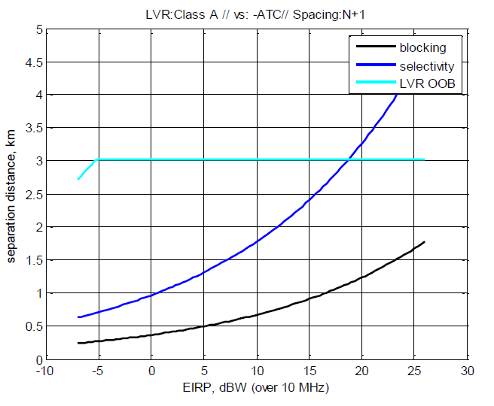

Figure 10: Separation distances to protect ATC radar from Category A video PMSE channel N+1

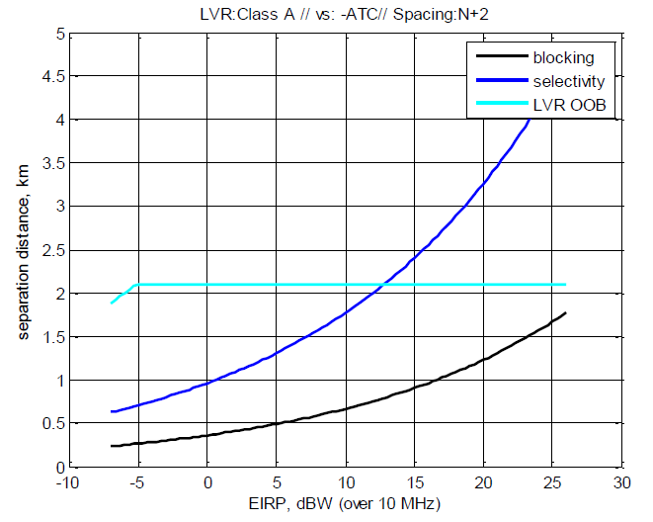

Figure 11: Separation distances to protect ATC radar from   
Category A video PMSE channel N+2

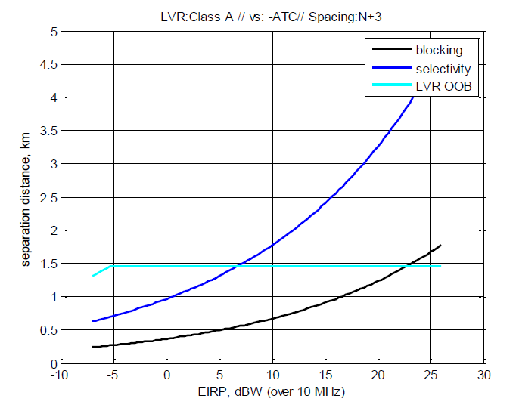

Figure 12: Separation distances to protect ATC radar from   
Category A video PMSE channel N+3

* + 1. Protection of meteorological radar from Category A video PMSE

The same methodology is applied for meteorological radar as the one used for Maritime radar and the results are shown in Figure 13, Figure 14 and Figure 15.

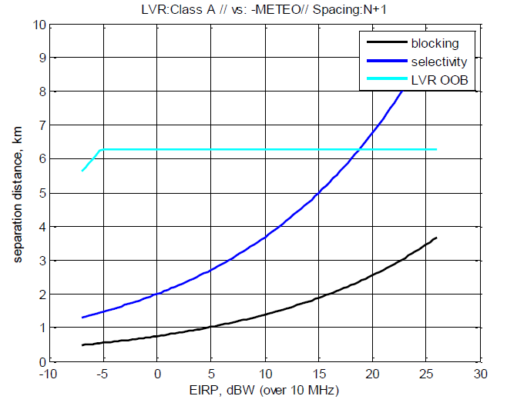

Figure 13: Separation distances to protect Meteorological radar from   
Category A video PMSE channel N+1

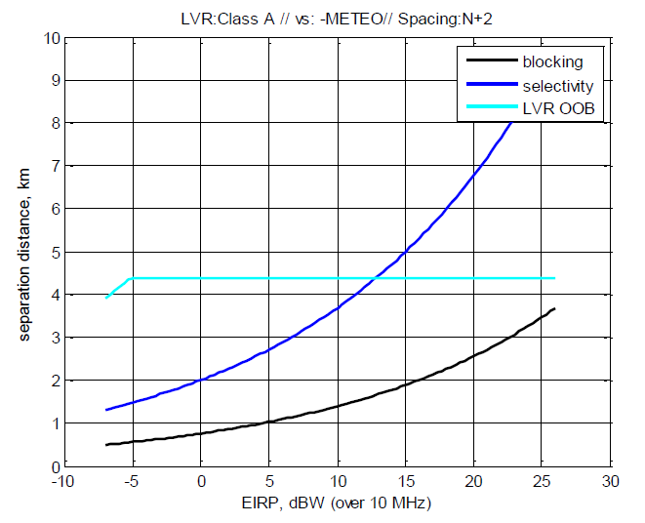

Figure 14: Separation distances to protect Meteorological radar from   
Category A video PMSE channel N+2

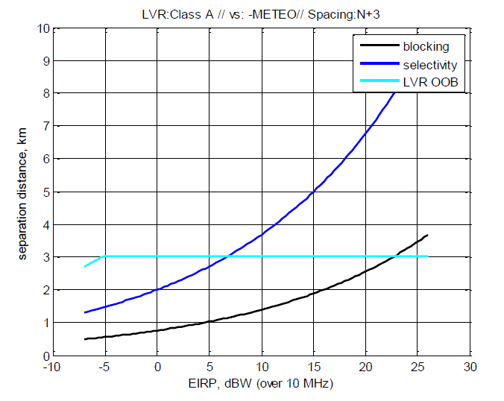

Figure 15: Separation distances to protect Meteorological radar from   
Category A video PMSE channel N+3

* 1. Results for protection of radar from Class C video PMSE interference

For video PMSE fitted on airborne, the propagation model used is the free space and the separation distances are significantly increased. The Figure 16 below shows for example the separation distance to protect meteorological radar from Category C video PMSE.

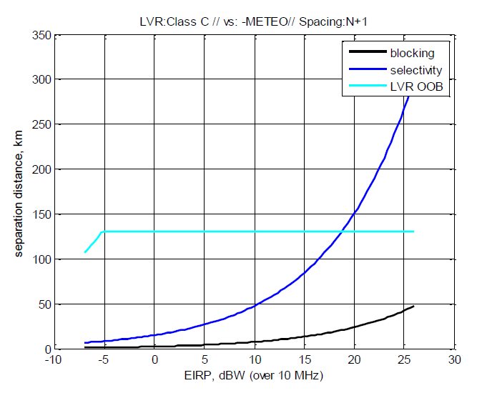

Figure 16: Separation distances to protect Meteorological radar from   
Category C video PMSE channel N+1

1. Results for protection of video PMSE from radar interference
   1. Protection based on C/I criteria of video PMSE from radar

Figure 17 and Figure 18 show the separation distance between different types of radars and video PMSE.

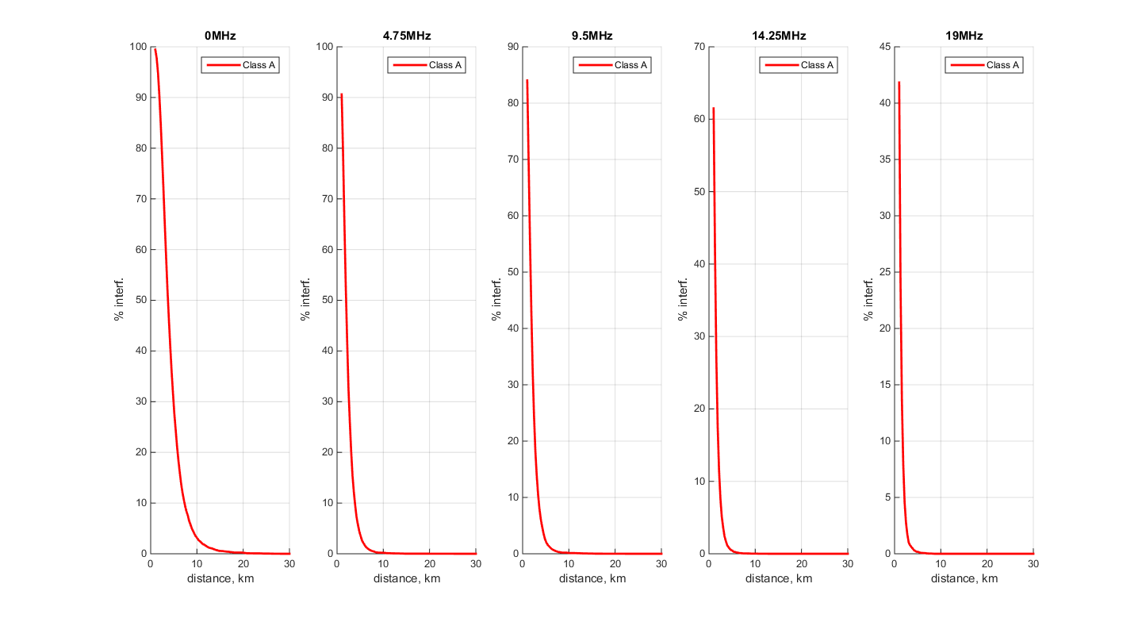

Figure 17: Probability of exceeding C/I criteria of video PMSE from ATC radar

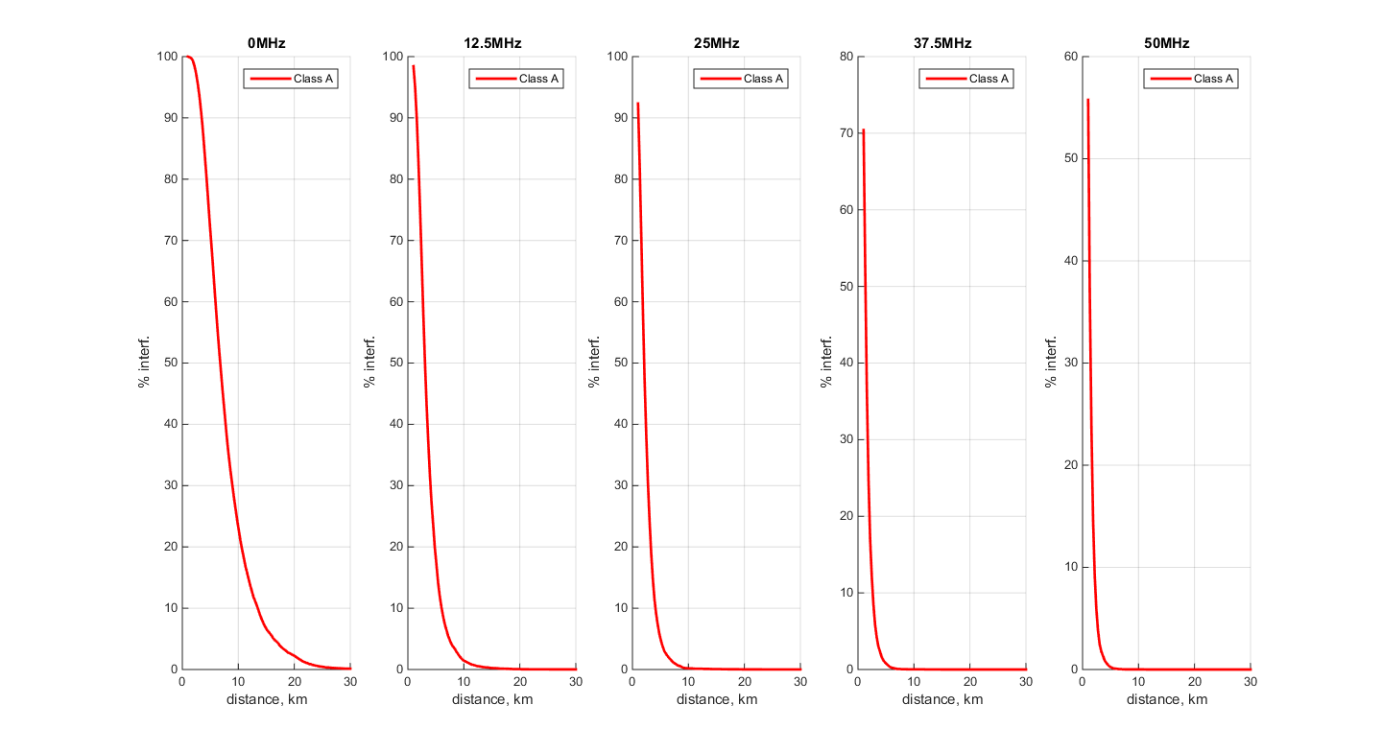

Figure 18: Probability of exceeding C/I criteria of video PMSE due to Meteo radar

Based on previous charts and due to the flexibility of PMSE for adjusting the frequency gap, the required separation distance to respect the C/I protection criteria could be considered from 5 to 30 km for the protection of a category A or category B video PMSE in a worst case configuration.

For a category C video PMSE, the separation distances exceed in all cases 60 km.

* 1. Protection based on blocking criteria of video PMSE from radar

The figures below provide the probability of exceeding the blocking protection criteria of video PMSE.

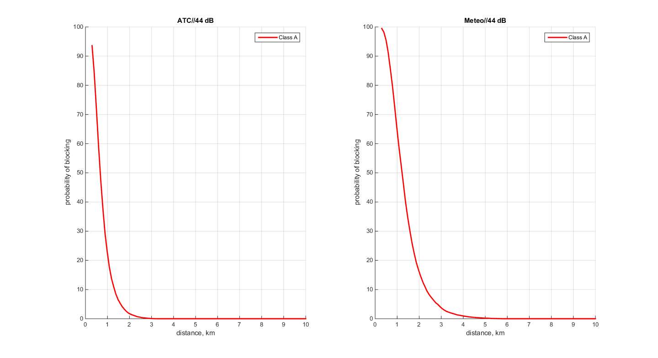

Figure 19: Probability of exceeding 44 dB blocking criteria of video PMSE

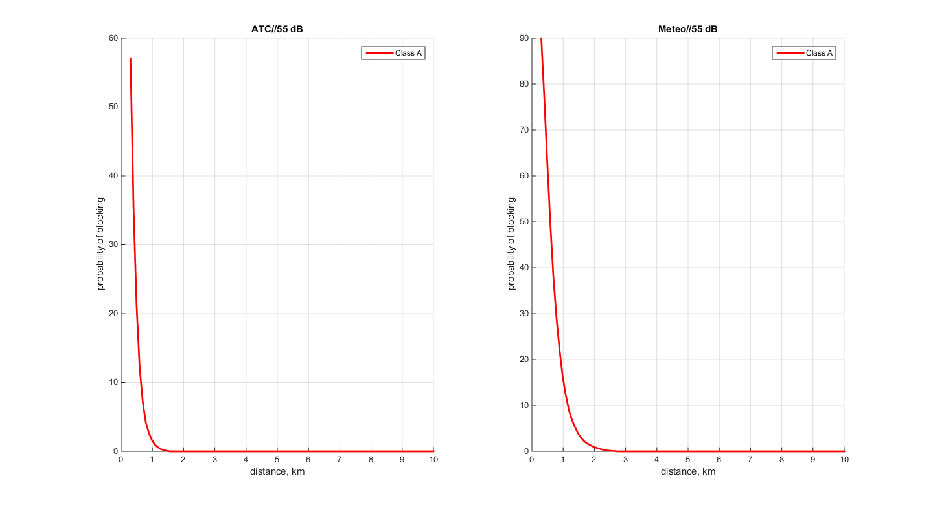

Figure 20: Probability of exceeding 55 dB blocking criteria of video PMSE

1. Results for protection of radioastronomy in the 2690-2700 MHz band from video PMSE interference

A real configuration has been studied between a radioastronomy station in France and one PMSE transmitter.

The topography including clutter data is based on SRTM data base that provide the Digital Terrain Model (DTM) with a sampling of 90 m. The clutter is included in the SRTM data but the sampling generates an average of the heights.

The following key is applicable for Figure 21:

* Red area: no compatibility;
* Yellow area: compatibility with video PMSE using N+3 adjacent channel;
* Cyan area: compatibility with video PMSE using N+2 adjacent channel;
* Blue area: compatibility with video PMSE using N+1 adjacent channel;
* 2 circles with radius respectively of 50 and 100 km.

Figure 21 provides the coordination areas for Category A video PMSE at 1.5 m height, around Nançay radioastronomy station.

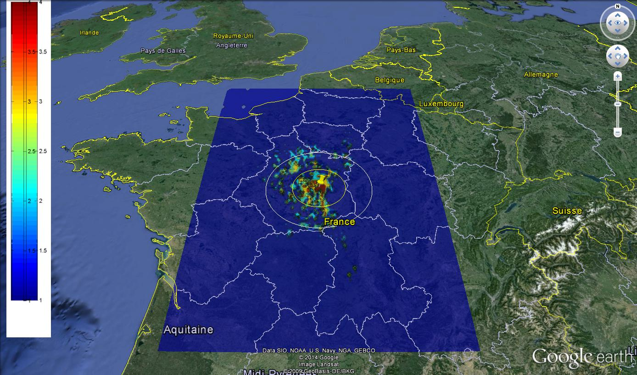

Figure 21: Exclusion areas for Category A video PMSE around Nançay radioastronomy station

1. Example of exclusion area calculation for radar protection for co‑channel operation
   1. Exclusion Area Based On Terrain Data

With the following parameters, the Figure 22 and Figure 23 provide the exclusion area:

Table 20: Parameters for calculation of an example of exclusion area for radar protection

| **Parameter** | **Value** | **Unit** |
| --- | --- | --- |
| Scenario | Co-channel | N.A. |
| Protection criteria | ≤ -109  (desensitization) | dBm |
| Radar antenna gain | 45 | dBi |
| Radar antenna height | 10 | m |
| Radar polarization | Horizontal | N.A. |
| PMSE e.i.r.p. | 36 | dBm |
| PMSE antenna height | 1.5 | m |
| Frequency | 2850 | MHz |

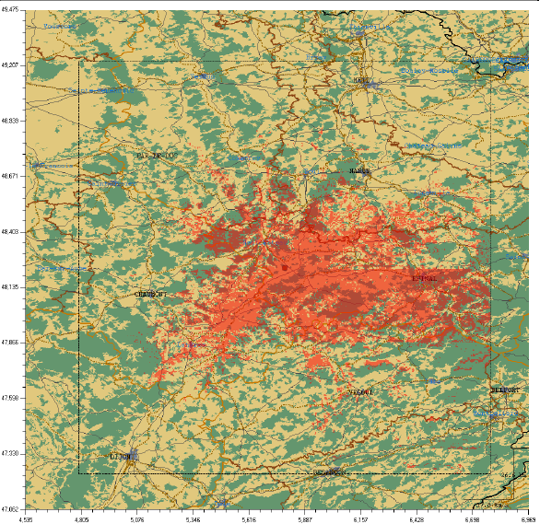

Figure 22: Exclusion area around a radar taking into account a propagation model using DMT

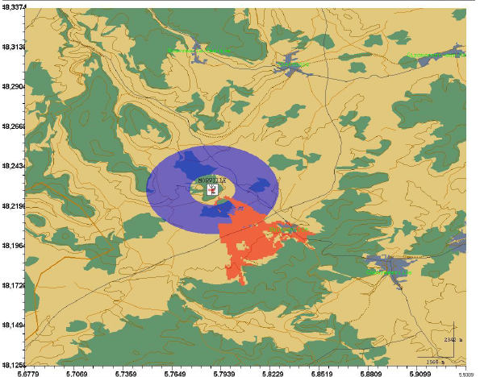

Figure 23: Exclusion areas due to radar blocking with EPM73 propagation model and   
another propagation model using DMT

* 1. Estimation of Exclusion Area Based On Technical Data of Radar 1 of Table 7

Assuming that the antennas are pointing to each other (worst case), the necessary propagation loss can be estimated calculated by the formula:

*PLoss* = e.i.r.p.*int* + *GrxRADAR* – *I-max*

Recommendation ITU-R P.452 [4] can be used for the estimation of the separation distance beyond the radio horizon. Assuming flat terrain, the separation distance is in the order of about 100 km or more depending on the PMSE system.

Table 21: Example of co channel exclusion area for radar protection

|  |  |  |  |
| --- | --- | --- | --- |
|  | Cordless Camera | Portable Link | Mobile Link |
| e.i.r.p (PMSE) | 36 dBm | 46 dBm | 56 dBm |
| Imax (Radar) | -122 dBm | -122 dBm | -122 dBm |
| Gmax (Radar) | 40 dB | 40 dB | 40 dB |
| Ploss | 198 dB | 208 dB | 218 dB |
| Rec ITU-R P.452 incl. diffraction | 125 km | 151 km | 182 km |
| Rec ITU-R P.452 incl. diffraction and 20 dB clutter loss. | 81 km | >100 km | >100 km |

The e.i.r.p. values in Table 21 are higher than in Table 2. If values in Table 2 were used, the required separation distance between PMSE and radar would probably be lower.

1. MCL analysis 2900-3400 MHz Adjacent channel scenario
   1. PMSE applications

Interference from PMSE on radars is considered, the technical parameters for different PMSE applications can be found in section 3. Technical Parameters for victim radars can be found in section 4.2.1.

* + 1. Wireless Camera Links

Protection of radars from PMSE

For wireless camera links a tx antenna height of 2 m is assumed. The propagation path for this case is assumed as Hata.

Table 22: Wireless camera links minimum separation distance

|  |  |  |  |  |  |  |  |  |
| --- | --- | --- | --- | --- | --- | --- | --- | --- |
|  | Adjacent Channel +1 Minimum separation Distance in km | | | | Adjacent Channel +2 Minimum separation Distance in km | | | |
|  | Hata rural | Hata Sub Urban | Hata Urban | Free Space | Hata rural | Hata Sub Urban | Hata Urban | Free Space |
| Radar A | 13.861 | 3.69 | 1.654 |  | 13.834 | 3.683 | 1.651 |  |
| Radar B | 13.861 | 3.69 | 1.654 |  | 13.834 | 3.683 | 1.651 |  |
| Radar C | 14.992 | 3.992 | 1.789 |  | 14.963 | 3.984 | 1.786 |  |
| Radar E | 20.119 | 5.357 | 2.401 |  | 20.08 | 5.346 | 2.397 |  |
| Radar F | 19.219 | 5.117 | 2.294 |  | 19.182 | 5.107 | 2.29 |  |
| Radar G | 34.84 | 9.276 | 4.158 |  | 34.771 | 9.257 | 4.15 |  |
| Radar H | 13.415 | 3.572 | 1.601 |  | 13.389 | 3.565 | 1.598 |  |
| Radar I | 12.162 | 3.238 | 1.452 |  | 12.138 | 3.232 | 1.449 |  |
| Radar J | 19.219 | 5.117 | 2.294 |  | 19.182 | 5.107 | 2.29 |  |
| Radar K | 18.601 | 4.952 | 2.22 |  | 18.565 | 4.943 | 2.216 |  |
| Radar L | 18.601 | 4.952 | 2.22 |  | 18.565 | 4.943 | 2.216 |  |
| Radar M | 16.864 | 4.49 | 2.013 |  | 16.831 | 4.481 | 2.009 |  |
| Radar N | 22.234 | 5.919 | 2.654 |  | 22.19 | 5.908 | 2.649 |  |
| Radar O | 20.691 | 5.509 | 2.469 |  | 20.651 | 5.498 | 2.465 |  |
| Radar P | 20.827 | 5.545 | 2.486 |  | 20.786 | 5.534 | 2.481 |  |
| Radar Q |  |  |  | > 300 |  |  |  | * 300 |

For cordless cameras the studies show that in a rural environment separation distances from 12 to 22 km to most radar systems will be required (exception is Radar G). In Sub Urban or Urban environment 2 to 6 km are required. Sharing with airborne radar systems may only be possible in suburban or urban environments with additional building loss.

The separation distance may be different considering the altitude and the topography around the radar and the number of interferers (other radars or PMSE-equipment).

With the aeronautical Radar Q no sharing will be possible.

* + 1. Mobile Video Uplinks

Protection of radars from PMSE

For mobile video uplinks a transmitter antenna height of 2 m is assumed. The propagation path for this case is assumed as Hata.

Table 23: Mobile video uplinks minimum separation distance

|  |  |  |  |  |  |  |  |  |
| --- | --- | --- | --- | --- | --- | --- | --- | --- |
|  | Adjacent Channel +1 Minimum separation Distance in km | | | | Adjacent Channel +2  Minimum separation Distance in km | | | |
|  | Hata rural | Hata Sub Urban | Hata Urban | Free Space | Hata rural | Hata Sub Urban | Hata Urban | Free Space |
| Radar A | 26.719 | 7.114 | 3.189 |  | 26.614 | 7.086 | 3.177 |  |
| Radar B | 26.719 | 7.114 | 3.189 |  | 26.614 | 7.086 | 3.177 |  |
| Radar C | 28.899 | 7.694 | 3.449 |  | 28.786 | 7.664 | 3.436 |  |
| Radar E | 31.876 | 8.487 | 3.805 |  | 31.751 | 8.453 | 3.790 |  |
| Radar F | 30.45 | 8.107 | 3.634 |  | 30.331 | 8.075 | 3.620 |  |
| Radar G | > 50 | 17.880 | 8.016 |  | > 50 | 17.81 | 7.984 |  |
| Radar H | 25.86 | 6.885 | 3.087 |  | 25.758 | 6.858 | 3.074 |  |
| Radar I | 23.444 | 6.242 | 2.798 |  | 23.353 | 6.217 | 2.787 |  |
| Radar J | 37.048 | 9.863 | 4.422 |  | 36.903 | 9.825 | 4.405 |  |
| Radar K | 35.856 | 9.546 | 4.280 |  | 35.716 | 9.509 | 4.263 |  |
| Radar L | 35.856 | 9.546 | 4.280 |  | 35.716 | 9.509 | 4.263 |  |
| Radar M | 32.507 | 8.655 | 3.880 |  | 32.38 | 8.621 | 3.865 |  |
| Radar N | 42.858 | 11.410 | 5.115 |  | 42.691 | 11.366 | 5.095 |  |
| Radar O | 39.885 | 10.619 | 4.760 |  | 39.729 | 10.577 | 4.742 |  |
| Radar P | 40.147 | 10.688 | 4.791 |  | 39.989 | 10.646 | 4.773 |  |
| Radar Q |  |  |  | > 900 |  |  |  | > 900 |

For mobile video uplinks the studies show that in a rural environment separation distances from 26 to 40 km to most radar systems will be required. In Suburban or Urban environment 4 to 10 km are required. Sharing with airborne radar systems may only be possible in urban environments with additional building loss.

The separation distance may be different considering the altitude and the topography around the radar and the number of interferers (other radars or PMSE-equipment).

With the aeronautical Radar Q no sharing will be possible.

* + 1. Mobile Video Downlinks

For mobile video Downlinks a tx antenna height of 300 m is assumed. The propagation path for this case is assumed as Hata.

Studies show that sharing between mobile video Downlinks and radionavigation applications is not possible.

* + 1. Portable Video Links

Protection of radars from PMSE

For portable video links a tx antenna height of 2 m is assumed. The propagation path for this case is assumed as Hata.

Table 24: Portable video links minimum separation distance

|  |  |  |  |  |  |  |  |  |
| --- | --- | --- | --- | --- | --- | --- | --- | --- |
|  | Adjacent Channel +1 Minimum separation Distance in km | | | | Adjacent Channel +2  Minimum separation Distance in km | | | |
|  | Hata rural | Hata Sub Urban | Hata Urban | Free Space | Hata rural | Hata Sub Urban | Hata Urban | Free Space |
| Radar A | 39.576 | 10.537 | 4.724 |  | 39.37 | 10.482 | 4.699 |  |
| Radar B | 39.576 | 10.537 | 4.724 |  | 39.37 | 10.482 | 4.699 |  |
| Radar C | 42.805 | 11.396 | 5.109 |  | 42.582 | 11.337 | 5.082 |  |
| Radar E | 47.215 | 12.570 | 5.635 |  | 46.969 | 12.505 | 5.606 |  |
| Radar F | 45.103 | 12.008 | 5.383 |  | 44.868 | 11.946 | 5.355 |  |
| Radar G | > 50 | 26.484 | 11.873 |  | > 50 | 26.346 | 11.811 |  |
| Radar H | 38.303 | 10.198 | 4.572 |  | 38.104 | 10.145 | 4.548 |  |
| Radar I | 34.726 | 9.245 | 4.145 |  | 34.545 | 9.197 | 4.123 |  |
| Radar J | > 50 | 14.610 | 6.550 |  | > 50 | 14.534 | 6.515 |  |
| Radar K | > 50 | 14.140 | 6.339 |  | > 50 | 14.066 | 6.306 |  |
| Radar L | > 50 | 14.140 | 6.339 |  | > 50 | 14.066 | 6.306 |  |
| Radar M | 48.15 | 12.819 | 5.747 |  | 47.899 | 12.752 | 5.717 |  |
| Radar N | > 50 | 16.901 | 7.577 |  | > 50 | 16.813 | 7.537 |  |
| Radar O | > 50 | 15.729 | 7.051 |  | > 50 | 15.646 | 7.014 |  |
| Radar P | > 50 | 15.832 | 7.097 |  | > 50 | 15.749 | 7.060 |  |
| Radar Q |  |  |  | > 900 |  |  |  | > 900 |

For portable video links the studies show that in a rural environment separation distances more than 40 km to most radar systems will be required. In Suburban or Urban environment 5 to 16 km are required. Sharing with airborne radar systems may only be possible in urban environments with additional building loss.

The separation distance may be different considering the altitude and the topography around the radar and the number of interferers (other radars or PMSE-equipment).

With the aeronautical Radar Q no sharing will be possible.

* + 1. Protection of PMSE from radars

It is assumed that the interference situation in the 2900-3400 MHz frequency range is similar to the situation in the 2700-2900 MHz range. Therefore a similar separation distance to respect the C/I protection criteria could be considered from 5 to 30 km in a worst case configuration.

1. special case of one administraton

One administration has presented the current situation taking into account its ARNS Radar’s parameters, based on a measurement campaign performed during 2010/2011.

The measurement campaign (using UMTS signal to interfere, with BW = 5 MHz) carried out during 2010/2011 led to the following results, concerning the maximum interference level:

* Pmax_rec_co_channel=~-127 dBm/MHz;
* Pmax_rec_at_60MHz_offset=~-93 dBm/MHz;

Taking the isolation required in order to avoid interference, calculations were performed by using Hata Urban as well free space propagation models, according to the assumptions on PMSE characteristics from Table 37.

For PMSE category A1, A2, A3 and C, the following calculations were performed:

1. Bandwidth: 10 MHz
2. Power ranging from: Category A1: -7 dBW up to 6 dBW; Category A2: -7 dBW up to 16 dBW; Category A3: 3 dBW up to 26 dBW; Category C: 3 dBW up to 26 dBW.
3. co-channel, considering protection criteria of -127 dBm/MHz;
4. adjacent channel calculations:

* PMSE spurious (for different masks: -6 dBc down to -24 dBc);
* Radar blocking selectivity (60; -50; -30 & -15 dB) considering Pmax = ‑93 dBm/MHz.
  1. Category A1: Cordless PMSE

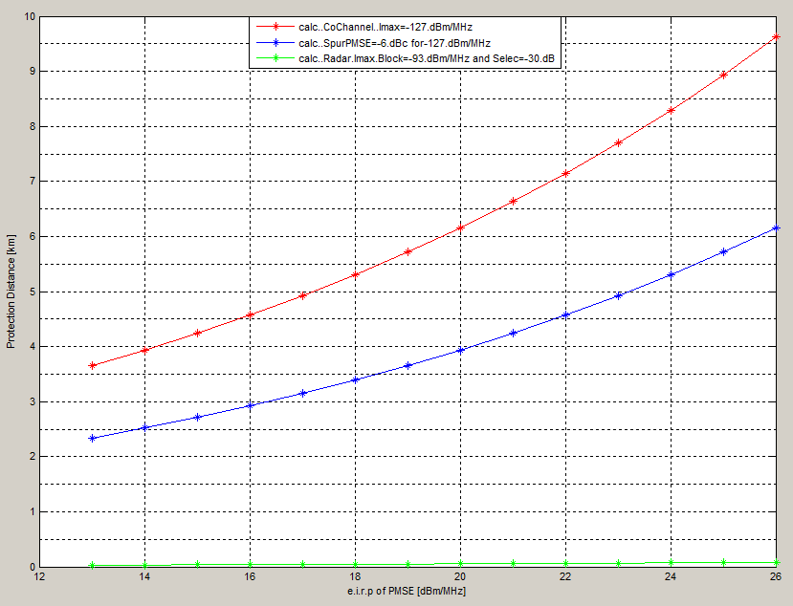

Figure 24 : CATEGORY A1: CORDLESS PMSE

* + 1. Sensitivity analysis of the radar’s selectivity

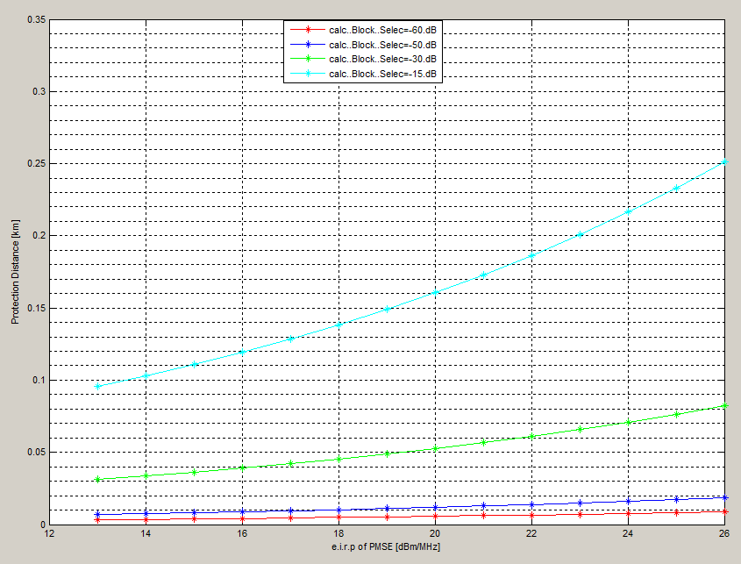

Figure 25: Sensitivity analysis of the radar’s selectivity

* + 1. Sensitivity analysis of the PMSE’s spurious emissions:

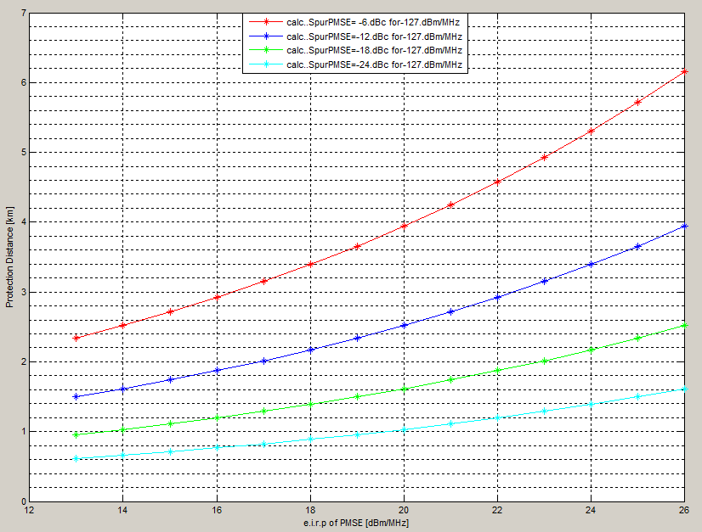

Figure 26: Sensitivity analysis of the PMSE’s spurious emissions

* 1. Category A2: Portable PMSE

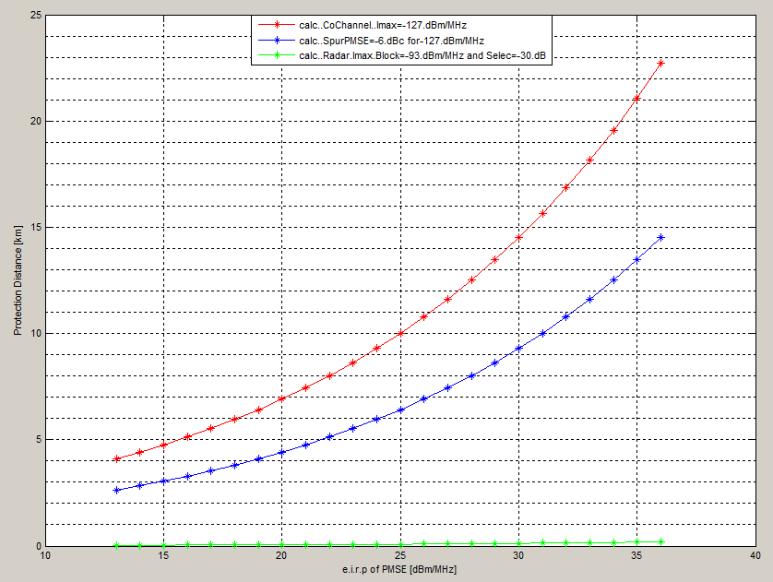

Figure 27: CATEGORY A2: PORTABLE PMSE

* + 1. Sensitivity analysis of the radar’s selectivity:

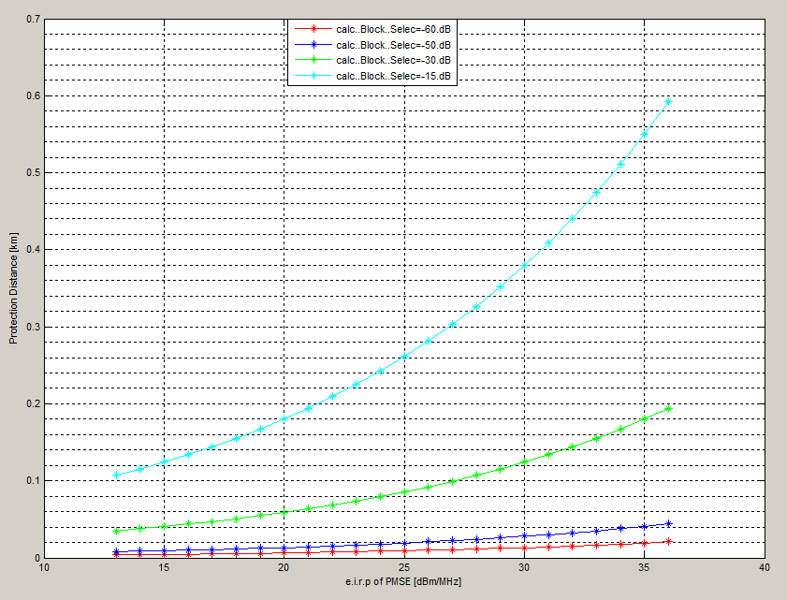

Figure 28: Sensitivity analysis of the radar’s selectivity

* + 1. Sensitivity analysis of the PMSE’s spurious emissions:

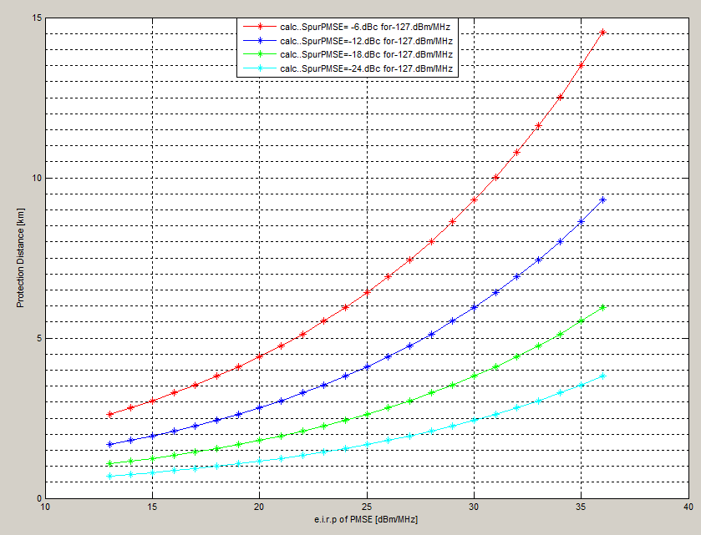

Figure 29: Sensitivity analysis of the PMSE’s spurious emissions

* 1. Category A3: Mobile Terrestrial

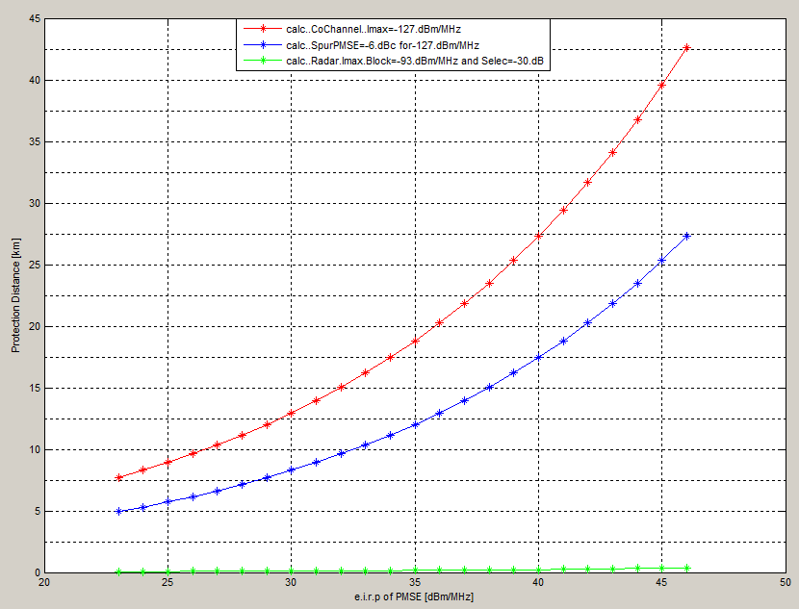

Figure 30: CATEGORY A3: MOBILE TERRESTRIAL

* + 1. Sensitivity analysis of the radar’s selectivity:

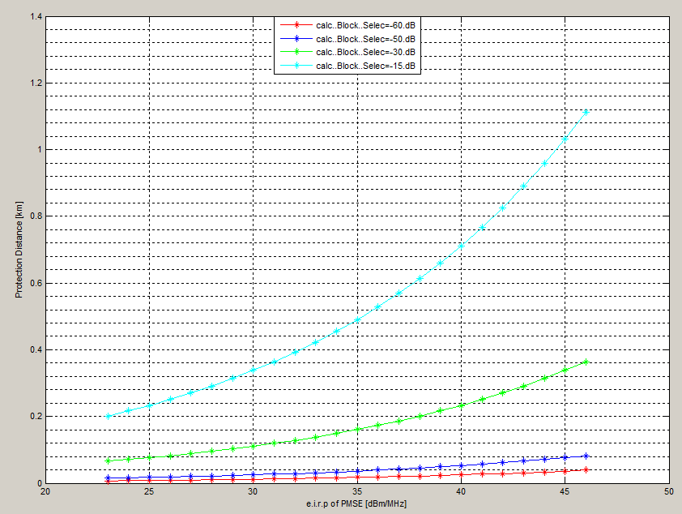

Figure 31: Sensitivity analysis of the radar’s selectivity

* + 1. Sensitivity analysis of the PMSE’s spurious emissions:

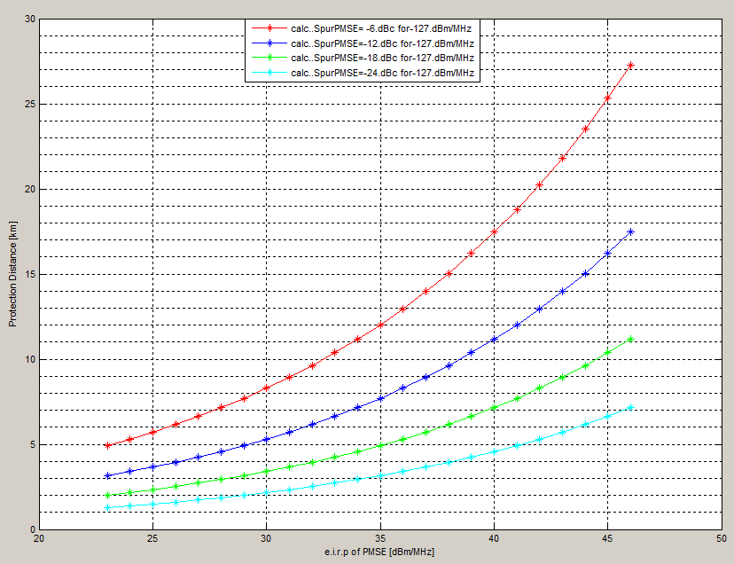

Figure 32: Sensitivity analysis of the PMSE’s spurious emissions

* 1. Category C: Mobile Terrestrial

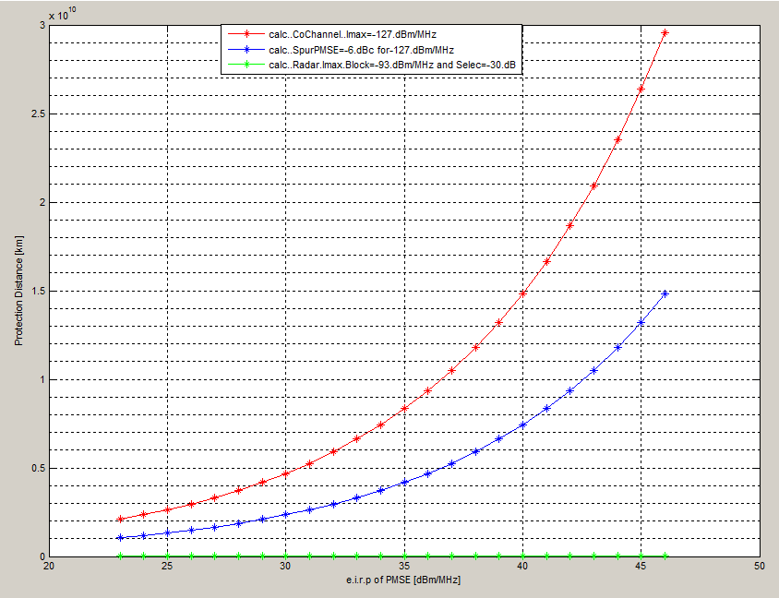

Figure 33: CATEGORY C: MOBILE TERRESTRIAL

* + 1. Sensitivity analysis of the radar’s selectivity:

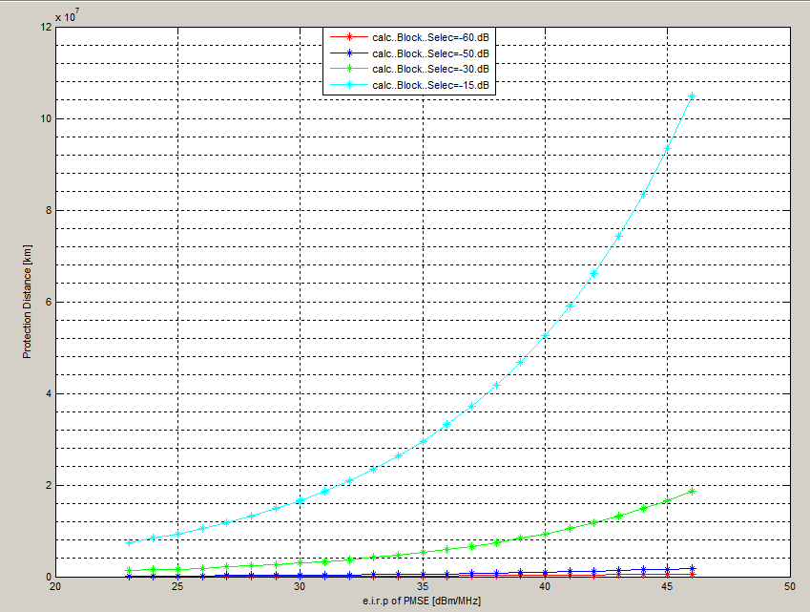

Figure 34: Sensitivity analysis of the radar’s selectivity

* + 1. Sensitivity analysis of the PMSE’s spurious emissions:

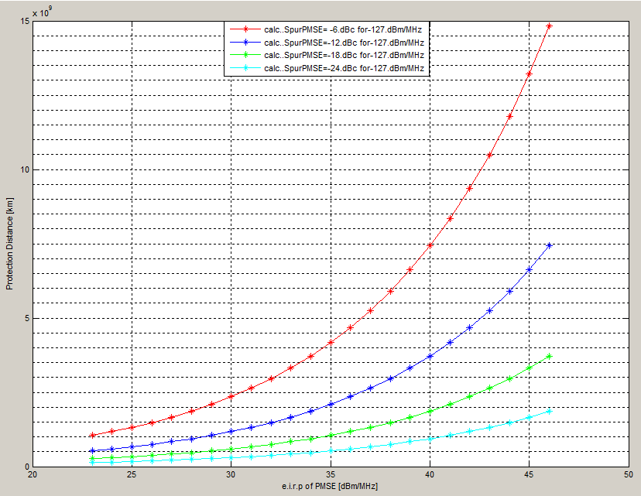

Figure 35: Sensitivity analysis of the PMSE’s spurious emissions

* 1. Conclusions

The analysis of the results shows that:

* **PMSE Category A1, A2,** and **A3** require protection distances up to 6.2 km/14.5 km/27 km, respectively, or a reduction of the transmitted power, due to spurious emissions;
* **PMSE Category C** operation will not be possible, due to the required protection distance, for both co-channel operation and spurious and blocking phenomena;
* Given that the radars can present different protection criteria and characteristics (taking into account the receiver bandwidth as well the *adaptive filtering*) from those used in the studies presented in the main report, administrations need to impose different mitigation techniques (power, separation distances and guard bands).

1. MCL result for E-UTRA UE (below 2690 MHz) vs video PMSE
   * 1. MCL result for E-UTRA UE (below 2690 MHz) vs video PMSE

Table 25: E-UTRA UE (below 2690 MHz) vs video PMSE CCL

| Victim UE characteristics LTE macro | | | Interferer characteristics (CCL) | | |
| --- | --- | --- | --- | --- | --- |
| Channel BW (BWv) | MHz | 9 | Central Frequency | MHz | 2705 |
| Noise Figure (NF) | dB | 9 | Channel BW (BWi) | MHz | 10 |
| Desensitization (D) | dB | 3 | Tx Power (Pi) | dBm | 20 |
| I/N | dB | -0.02 | ACLR_2 | dB | 40 |
| Thermal Noise (Nth) | dBm/BW | -104.29 | Antenna gain (Gi) | dBi | 3 |
| ACS_2 | dB | 46.3 | Antenna height (Hi) | M | 1.5 |
| Antenna gain (Gv) | dBi | 0 |  | | |
| Feeder Loss (Gvfe) | dB | 0 |
| Antenna height (Hv) | m | 1.5 |
| **Results. 10 MHz Guard band** | | | **Calculated values** | | |
| MCL | dB | 86.63 | Max interference & noise (I) | dBm/BW | -95.31 |
| Distance for 5% probability of interference (IEEE802_Model_C) | km | 0.04 | Fading factor for 5% probability of interference | dB | 7.40 |

Table 26: E-UTRA UE (below 2690 MHz) vs video PMSE PVL

| Victim UE characteristics LTE macro | | | | Interferer characteristics (PVL) | | |
| --- | --- | --- | --- | --- | --- | --- |
| Channel BW (BWv) | | MHz | 9 | Central Frequency | MHz | 2705 |
| Noise Figure (NF) | | dB | 9 | Channel BW (BWi) | MHz | 10 |
| Desensitization (D) | | dB | 3 | Tx Power (Pi) | dBm | 33 |
| I/N | | dB | -0.02 | ACLR_2 | dB | 64 |
| Thermal Noise (Nth) | | dBm/BW | -104.29 | Antenna gain (Gi) | dBi | 14 |
| ACS_2 | | dB | 46.3 | Antenna height (Hi) | m | 2 |
| Antenna gain (Gv) | | dBi | 0 |  | | |
| Feeder Loss (Gvfe) | | dB | 0 |
| Antenna height (Hv) | | m | 1.5 |
| **Results. 10 MHz Guard band** | | | | **Calculated values** | | |
| MCL | dB | | 103.48 | Max interference & noise (I) | dBm/BW | -95.31 |
| Distance for 5% probability of interference (IEEE802_Model_C) | km | | 0.121 | Fading factor for 5% probability of interference | dB | 7.40 |

Table 27: E-UTRA UE (below 2690 MHz) vs video PMSE MVL UL

| Victim UE characteristics LTE macro | | | Interferer characteristics (MVL ) | | |
| --- | --- | --- | --- | --- | --- |
| Channel BW (BWv) | MHz | 9 | Central Frequency | MHz | 2705 |
| Noise Figure (NF) | dB | 9 | Channel BW (BWi) | MHz | 10 |
| Desensitization (D) | dB | 3 | Tx Power (Pi) | dBm | 30 |
| I/N | dB | -0.02 | ACLR_2 | dB | 53 |
| Thermal Noise (Nth) | dBm/BW | -104.29 | Antenna gain (Gi) | dBi | 6 |
| ACS_2 | dB | 46.3 | Antenna height (Hi) | m | 2 |
| Antenna gain (Gv) | dBi | 0 |  | | |
| Feeder Loss (Gvfe) | dB | 0 |
| Antenna height (Hv) | m | 1.5 |
| **Results. 10 MHz Guard band** | | | **Calculated values** | | |
| MCL | dB | 93.27 | Max interference&noise (I) | dBm/BW | -95.31 |
| Distance for 5% probability of interference(IEEE802_Model_C) | km | 0.062 | Fading factor for 5% probability of interference | dB | 7.40 |

Table 28: E-UTRA UE (below 2690 MHz) vs video PMSE MVL DL

| Victim UE characteristics LTE macro | | | Interferer characteristics (MVL) | | |
| --- | --- | --- | --- | --- | --- |
| Channel BW (BWv) | MHz | 9 | Central Frequency | MHz | 2705 |
| Noise Figure (NF) | dB | 9 | Channel BW (BWi) | MHz | 10 |
| Desensitization (D) | dB | 3 | Tx Power (Pi) | dBm | 36 |
| I/N | dB | -0.02 | ACLR_2 | dB | 62 |
| Thermal Noise (Nth) | dBm/BW | -104.29 | Antenna gain (Gi) | dBi | 9 |
| ACS_2 | dB | 46.3 | Antenna height (Hi) | m | 30 |
| Antenna gain (Gv) | dBi | 0 |  | | |
| Feeder Loss (Gvfe) | dB | 0 |
| Antenna height (Hv) | m | 1.5 |
| **Results. 10 MHz Guard band** | | | **Calculated values** | | |
| MCL | dB | 108.97 | Max interference&noise (I) | dBm/BW | -95.31 |
| Distance for 5% probability of interference (Ex-Hata Urban) | km | 0.14 | Fading factor for 5% probability of interference | dB | 14.85 |

1. MCL result for E-UTRA TDD (above 3400 MHz) vs video PMSE

Table 29: E-UTRA UE (above 3400 MHz) vs video PMSE CCL

| Victim UE characteristics LTE macro | | | Interferer characteristics (CCL) | | |
| --- | --- | --- | --- | --- | --- |
| Channel BW (BWv) | MHz | 9 | Adjacent Central Frequency(Fv) | MHz | 3395 |
| Noise Figure (NF) | dB | 9 | Central Frequency 10 MHz guard | MHz | 3385 |
| Desensitization (D) | dB | 3 | Channel BW (BWi) | MHz | 10 |
| I/N | dB | -0.02 | Tx Power (Pi) | dBm | 20 |
| Thermal Noise (Nth) | dBm/BW | -104.29 | ACLR_1 | dB | 34 |
| ACS_1 | dB | 33 | ACLR_2 | dB | 40 |
| ACS_2 | dB | 46.3 | Antenna gain (Gi) | dBi | 3 |
| Antenna gain (Gv) | dBi | 0 | Antenna height (Hi) | m | 1.5 |
| Feeder Loss (Gvfe) | dB | 0 | **Calculated values** | | |
| Antenna height (Hv) | m | 1.5 |  |  |  |
| **Results. Adjacent channel** | | | Max interference&noise (I) | dBm/BW | -95.31 |
| **MCL** | **dB** | **95.25** | Fading factor for 5% probability of interference | dB | 7.40 |
| **Distance for 5% probability of interference (IEEE802_Model_C)** | **Km** | **0.062** |  |  |  |
| **Results. 10 MHz Guard band** | | |  |  |  |
| **MCL (including fading effect)** | **dB** | **86.63** |  |  |  |
| **Distance for 5% probability of interference (IEEE802_Model_C)** | **Km** | **0.035** |  |  |  |

Table 30:E-UTRA UE (above 3400 MHz) vs video PMSE PVL

| Victim UE characteristics LTE macro | | | Interferer characteristics (PVL) | | |
| --- | --- | --- | --- | --- | --- |
| Channel BW (BWv) | MHz | 9 | Adjacent Central Frequency(Fv) | MHz | 3395 |
| Noise Figure (NF) | dB | 9 | Central Frequency 10 MHz guard | MHz | 3385 |
| Desensitization (D) | dB | 3 | Channel BW (BWi) | MHz | 10 |
| I/N | dB | -0.02 | Tx Power (Pi) | dBm | 33 |
| Thermal Noise (Nth) | dBm/BW | -104.29 | ACLR_1 | dB | 58 |
| ACS_1 | dB | 33 | ACLR_2 | dB | 64 |
| ACS_2 | dB | 46.3 | Antenna gain (Gi) | dBi | 14 |
| Antenna gain (Gv) | dBi | 0 | Antenna height (Hi) | m | 2 |
| Feeder Loss (Gvfe) | dB | 0 | **Calculated values** | | |
| Antenna height (Hv) | M | 1.5 |  |  |  |
| **Results. Adjacent channel** | | | Max interference&noise (I) | dBm/BW | -95.31 |
| **MCL** | **dB** | **116.72** | Fading factor for 5% probability of interference | dB | 7.40 |
| **Distance for 5% probability of interference (IEEE802_Model_C)** | **Km** | **0.253** |  |  |  |
| **Results. 10 MHz Guard band** | | |  |  |  |
| **MCL** | **dB** | **103.48** |  |  |  |
| **Distance for 5% probability of interference (IEEE802_Model_C)** | **Km** | **0.106** |  |  |  |

Table 31: E-UTRA UE (above 3400 MHz) vs video PMSE MVL DL

| Victim UE characteristics LTE macro | | | Interferer characteristics (MVL) | | |
| --- | --- | --- | --- | --- | --- |
| Channel BW (BWv) | MHz | 9 | Adjacent Central Frequency(Fv) | MHz | 3395 |
| Noise Figure (NF) | dB | 9 | Central Frequency 10 MHz guard | MHz | 3385 |
| Desensitization (D) | dB | 3 | Channel BW (BWi) | MHz | 10 |
| I/N | dB | -0.02 | Tx Power (Pi) | dBm | 36 |
| Thermal Noise (Nth) | dBm/BW | -104.29 | ACLR_1 | dB | 56 |
| ACS_1 | dB | 33 | ACLR_2 | dB | 62 |
| ACS_2 | dB | 46.3 | Antenna gain (Gi) | dBi | 9 |
| Antenna gain (Gv) | dBi | 0 | Antenna height (Hi) | m | 30 |
| Feeder Loss (Gvfe) | dB | 0 | **Calculated values** | | |
| Antenna height (Hv) | M | 1.5 |  |  |  |
| **Results. Adjacent channel** | | | Max interference&noise (I) | dBm/BW | -95.31 |
| **MCL** | **dB** | **122.18** | Fading factor for 5% probability of interference | dB | 14.85 |
| **Distance (for 5% probability of interference Ex-Hata Urban)** | **Km** | **0.31** |  |  |  |
| **Results. 10 MHz Guard band** | | |  |  |  |
| **MCL** | **dB** | **108.97** |  |  |  |
| **Distance for 5% probability of interference (Ex-Hata Urban)** | **Km** | **0.13** |  |  |  |

Table 32: E-UTRA BS (above 3400 MHz) vs video PMSE CCL

| Victim BS characteristics LTE macro | | | Interferer characteristics (CCL) | | |
| --- | --- | --- | --- | --- | --- |
| Channel BW (BWv) | MHz | 9 | Adjacent Central Frequency(Fv) | MHz | 3395 |
| Noise Figure (NF) | dB | 5 | Central Frequency 10 MHz guard | MHz | 3385 |
| Desensitization (D) | dB | 1 | Channel BW (BWi) | MHz | 10 |
| I/N | dB | -5.87 | Tx Power (Pi) | dBm | 20 |
| Thermal Noise (Nth) | dBm/BW | -104.29 | ACLR_1 | dB | 34 |
| ACS_1 | dB | 47.8 | ACLR_2 | dB | 40 |
| ACS_2 | dB | 56.8 | Antenna gain (Gi) | dBi | 3 |
| Antenna gain (Gv) | dBi | 17 | Antenna height (Hi) | m | 1.5 |
| Feeder Loss (Gvfe) | dB | 0 | **Calculated values** | | |
| Antenna height (Hv) | m | 30 |  |  |  |
| **Results. Adjacent channel** | | | Max interference&noise (I) | dBm/BW | -105.16 |
| **MCL** | **dB** | **126.18** | Fading margin (Fm) | dB | 14.85 |
| **Distance for 5% probability of interference (Ex-Hata Urban)** | **Km** | **0.40** |  |  |  |
| **Results. 10 MHz Guard band** | | |  |  |  |
| **MCL** | **dB** | **120.10** |  |  |  |
| **Distance for 5% probability of interference (Ex-Hata Urban)** | **Km** | **0.27** |  |  |  |

Table 33: E-UTRA BS (above 3400 MHz) vs video PMSE PVL

| Victim BS characteristics LTE macro | | | Interferer characteristics (PVL) | | |
| --- | --- | --- | --- | --- | --- |
| Channel BW (BWv) | MHz | 9 | Adjacent Central Frequency(Fv) | MHz | 3395 |
| Noise Figure (NF) | dB | 5 | CentraL Frequency 10 MHz guard | MHz | 3385 |
| Desensitization (D) | dB | 1 | Channel BW (BWi) | MHz | 10 |
| I/N | dB | -5.87 | Tx Power (Pi) | dBm | 33 |
| Thermal Noise (Nth) | dBm/BW | -104.29 | ACLR_1 | dB | 58 |
| ACS_1 | dB | 47.8 | ACLR_2 | dB | 64 |
| ACS_2 | dB | 56.8 | Antenna gain (Gi) | dBi | 14 |
| Antenna gain (Gv) | dBi | 17 | Antenna height (Hi) | m | 2 |
| Feeder Loss (Gvfe) | dB | 0 | **Calculated values** | | |
| Antenna height (Hv) | m | 30 |  |  |  |
| **Results. Adjacent channel** | | | Max interference&noise (I) | dBm/BW | -105.16 |
| **MCL** | **dB** | **136.60** | Fading factor for 5% probability of interference | dB | 14.85 |
| **Distance for 5% probability of interference (Ex-Hata Urban)** | **Km** | **0.89** |  |  |  |
| **Results. 10 MHz Guard band** | | |  |  |  |
| **MCL** | **dB** | **127.96** |  |  |  |
| **Distance for 5% probability of interference (Ex-Hata Urban)** | **Km** | **0.50** |  |  |  |

Table 34; E-UTRA BS (above 3400 MHz) vs video PMSE MVL DL

| Victim BS characteristics LTE macro | | | Interferer characteristics (MVL) | | |
| --- | --- | --- | --- | --- | --- |
| Channel BW (BWv) | MHz | 9 | Adjacent Central Frequency(Fv) | MHz | 3395 |
| Noise Figure (NF) | dB | 5 | Central Frequency 10 MHz guard | MHz | 3385 |
| Desensitization (D) | dB | 1 | Channel BW (BWi) | MHz | 10 |
| I/N | dB | -5.87 | Tx Power (Pi) | dBm | 36 |
| Thermal Noise (Nth) | dBm/BW | -104.29 | ACLR_1 | dB | 56 |
| ACS_1 | dB | 47.8 | ACLR_2 | dB | 62 |
| ACS_2 | dB | 56.8 | Antenna gain (Gi) | dBi | 9 |
| Antenna gain (Gv) | dBi | 17 | Antenna height (Hi) | m | 30 |
| Feeder Loss (Gvfe) | dB | 0 | **Calculated values** | | |
| Antenna height (Hv) | m | 30 |  |  |  |
| **Results. Adjacent channel** | | | Max interference&noise (I) | dBm/BW | -105.16 |
| **MCL** | **dB** | **134.82** | Fading factor for 5% probability of interference | dB | 14.85 |
| **Distance for 5% probability of interference (Freespace)** | **Km** | **13.53** |  |  |  |
| **Results. 10 MHz Guard band** | | |  |  |  |
| **MCL** | **dB** | **126.35** |  |  |  |
| **Distance for 5% probability of interference (Freespace)** | **Km** | **5.10** |  |  |  |

1. Other Study on sharing between mobile video links (MVL) and LTE at 2700 MHz
   1. Sharing in ADJACENT band for VIDEO Reporting LInk (interferer) on LTE (victim)

The following lines summarize hypothesis, scenarios and conclusion of an analysis of realistic conditions of sharing in adjacent band (MVL on LTE).

* + 1. Hypothesis:
* Parameters of LTE terminals are provided in Table 35. We consider a LTE terminal using a channel bandwidth of 10MHz between 2680 and 2690 MHz for downlink. In order to fulfil the Protection Criteria for the LTE receiving terminal, we need to ensure that:
  + - I/N=-6 dB, for the OOB emissions of VRL falling into the LTE in-band frequencies (i.e. 2680-2690 MHz)
    - Receiver blocking level is not reached. Blocking is calculated taking into account the terminal ACS, the effect of the duplex filter and a targeted I/N = -6 dB.
* MVL parameters are specified in Table 37
* The propagation model between MVL and LTE is free space, which corresponds to a worst case configuration. Moreover, a lognormal fading with σ= 7 dB is considered.

Table 35: Technical characteristics for LTE RX terminals

|  |  |
| --- | --- |
| Parameters | Values |
| FDD Downlink frequencies | 2620-2690 MHz |
| Bandwidth (B) | 10 MHz |
| Access Technique | SC-FDMA |
| Antenna Gain | 0 dBi |
| Antenna height | 1.5 m |
| Type of antenna | Omnidirectional |
| Polarization | Linear |
| Number of user per cell emitting simultaneously at maximum power | 1 |
| In-band Blocking (3GPP minimum requirement) | - 44 dBm 2700-2750 MHz |
| RX Duplex filter characteristics considered in the simulations (at room temperature) | 5 dB @2710 MHz  15 dB @ 2720 MHz  25 dB @ 2730 MHz  43 dB @ 2740 MHz |
| Receiver noise figure (NF) | 9 dB(3GPP specification) |
| Receiver noise: 10*log10(K*T*B) [7]+ NF | -95 dBm in 10 MHz |

Table 36: Technical characteristics for LTE TX Base stations

|  |  |
| --- | --- |
| Parameters | Values |
| Downlink frequencies FDD | 2620-2690 MHz |
| bandwidth (BW) | 10 MHz |
| Type of modulation | QPSK/16-QAM/64-QAM |
| Deployment | Macro, urban and rural |
| Cells radius | 4330 m (rural), 220 m (urban) |
| Inter-sites distance ISD | 12990 m (rural), 660 m (urban) |
| Transmitter maximum power (dBm) | 43 for BW = 5 MHz |
| 46 for BW = 10 MHz |
| 46 for BW = 20 MHz |
| Transmitter power ratio between maximum and mean values (dB) | 7-8 |
| Power reduction for static analysis | 3 dB (for base stations transmitting 50 % of time) |
| Antenna maximum gain | 18 dBi |
| Antenna height | 45 m (rural), 30 m (urban) |
| Antenna Tilt (°) | 2,5 (rural), 5 (urban) |
| Feeder loss | 3 dB |
| Polarization | ± 45° cross-polarised |
| Antenna opening at 3dB in elevation (°) | 1,57 |
| Antenna opening at 3dB in azimut (°) | 65 |
| Limit of spurious emission | Reference: ETSI EN 301908-14 v.5.1.1 [23] -30 dBm/MHz |
| Level of unwanted emissions | -30 dBm/MHz applicable at 10 MHz from the DL operating band edge |

Table 37: Description for PMSE systems

|  |  |  |  |  |  |  |  |  |  |
| --- | --- | --- | --- | --- | --- | --- | --- | --- | --- |
| Type of link | Range | Max e.i.r.p. dBW | Typical e.i.r.p. dBW | Min Tx ant. Gain | Min Rx ant. gain | Channel raster | Typical antenna height | PMSE Class | Propagation model |
| Cordless Camera | <500 m | 6 | -7/0 | 0 | 6 | 10-20-30 | 1.5 | A1 | Hata/P 452 |
| Portable link | <2 km | 16 | -7/0 | 6 | 17 | 10-20-30 | 2 | A2 | Hata/P 452 |
| Mobile Link (Terrestrial) | <10 km | 26 | 3/6 | 3 | 13 | 10-20-30 | 1.5 | A3 | Hata/P 452 |
| Mobile Link (Airborne) | <10 km | 26 | 3/6 | 3 | 13 | 10-20-30 | 30-600 | C | Free space |
| Temporary Point-to-point link | <80 km | 40 | 20 | 13 | 17 | 10-20-30 (40 for IP) | 4-10 | B | Hata/P 452 |

Table 38: Summary of EIPR and antenna heights for PMSE video transmitting systems   
used in the simulations

|  |  |  |  |
| --- | --- | --- | --- |
| Class | Antenna height  m | e.i.r.p. range of values dBW | e.i.r.p. range of values dBm |
| A | 1.5 | -7/26 | 23/56 |
| B | 10 | 10/40 | 40/70 |
| C | 10 | 0/26 | 30/56 |

* + 1. Scenario:

The scenario used to perform simulations is the following:

* The results are presented in terms of the probability of LTE receiver blocking as a function of the distance between LTE and PMSE systems
* Each Probability of interference is obtained by positioning LTE terminals at a given separation distance from the PMSE transmitter. The LTE UE can be located anywhere at X meters from the PMSE transmitter, which corresponds to a circumference shape around the video PMSE). Simulations have been done for X varying between 1 and 5000 m;

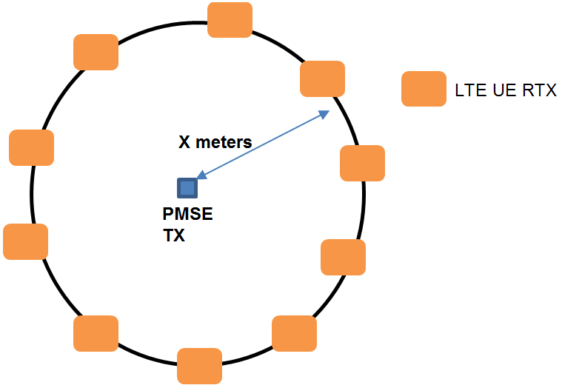

Figure 36: Representation of the separation distance between PMSE and LTE UE

* The propagation loss, consisting of its deterministic component (free space) and random component (slow fading), is selected randomly. The cycle is repeated numerous times to ensure a statistic reliability;
* The blocking probability is calculated as a function of LTE and PMSE parameters and the frequency separation between the two systems;
* PMSE antenna pointing does not have an impact for Class A PMSE (omnidirectional antennas). For Class B PMSE, antenna pointing is considered following a uniform distribution between 0° and 360° in azimuth. Angular separation in the vertical plane is neglected. Antenna patern is described in Recommendation ITU-R.F.1245 (Figure 57 in Annex 3);
* Different transmission powers are considered for the video PMSE, including the minimal, typical and maximum values. Also, a value corresponding to Pmax (as in Table 37) -3dB is investigated, which allows to see the impact of the limitation of PMSE OOBE to the maximum value defined by ITU-R SM369-10.
* The probability of interference indicates the probability of the UE receiving an interfering signal higher than the maximum blocking level of 3GPP in-band blocking minimum requirement plus duplexer rejection
* For a given probability of blocking, the corresponding minimal separation distance between video PMSE and LTE UE can be measured.
* The minimal separation distance required for having less than 1% of LTE UE blocking is considered.
* Estimation of blocking is performed over 100000 instances for each separation distance.
  + 1. Results

Figure 37 to Figure 40 illustrate the results of the analysis for the probability of LTE terminal facing a blocking as a function of the distance from the PMSE classes A1, A2, A3, B and C. Frequencies in these figures correspond to the lower edge of the PMSE channel. Regarding the possible blocking of the LTE receiving terminal because of PMSE, considering an additional protection provided by the duplex filter of the LTE terminal, the figures show that if class A PMSE terminals operate at their respective typical power, the use of the band 2700-2710 MHz creates a negligible probability of LTE blocking for a separation distance of more than 80, 45 and 88 meters for Class A1, A2 and A3, respectively. For class B PMSE at typical power, the probability of blocking can be reduced by having a separation distance of more than 450 meters, which reduces to 143 meters if minimal power is used. This distance can be made negligible by increasing the frequency separation, thus operating the video PMSE in the frequency bands above 2720 MHz.

For all cases, these simulations demonstrate that there are various ways to facilitate adjacent band coexistence between video PMSE and LTE Downlink. In general, the lower PMSE transmission power or the higher frequency separation, the lower distance separation is needed for compatibility of video PMSE and LTE DL.

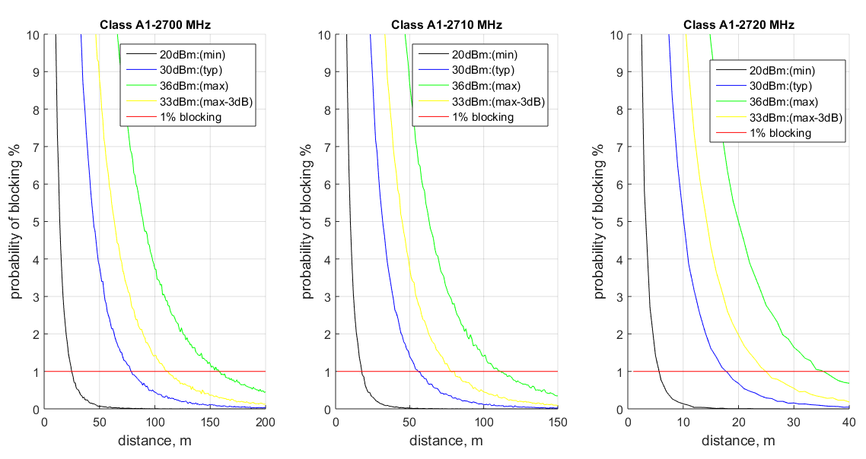

Figure 37: Class A1, blocking

Within each figure representing a given frequency band, it can be seen that operating video PMSE at their typical or minimal transmission power reduces considerably the required separation distance compared to the case of transmission at maximum power. Also, for a given transmission power, when the frequency separation is increased, the distance needed is reduced significantly. Same analysis can be made for the other classes of video PMSE as illustrated in the following pictures.

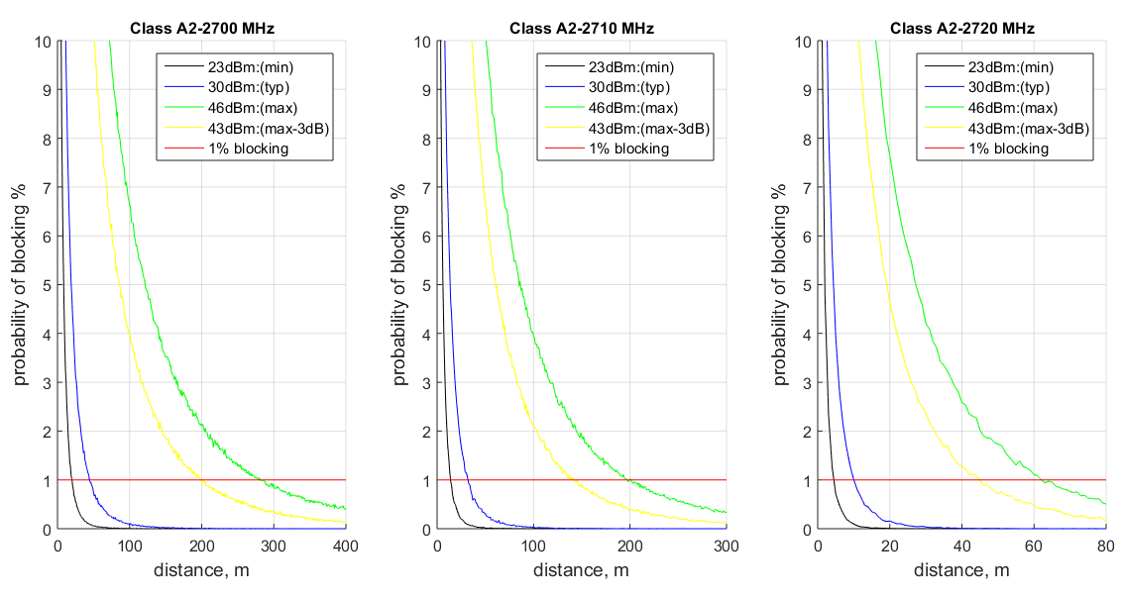

Figure 38: Class A2, blocking

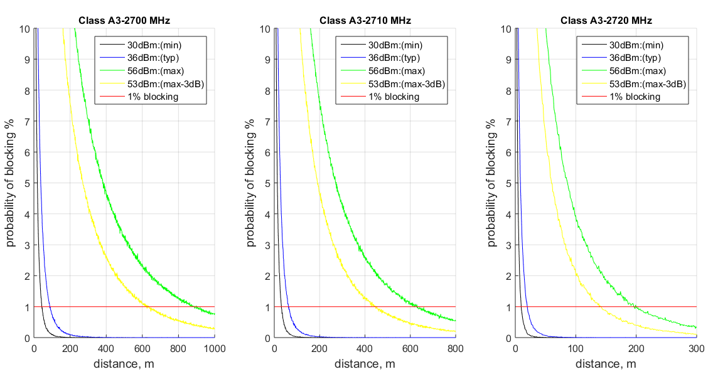

Figure 39: Class A3, blocking

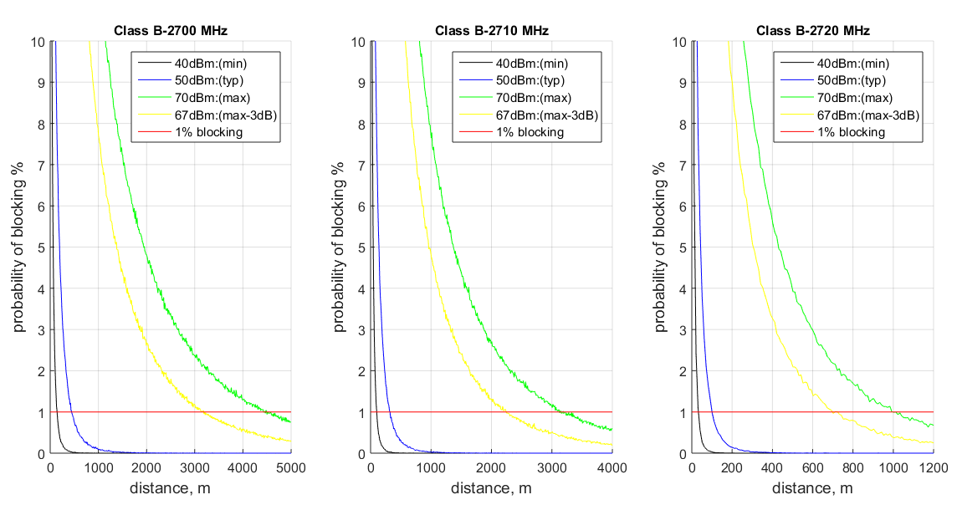

Figure 40: Class B, blocking

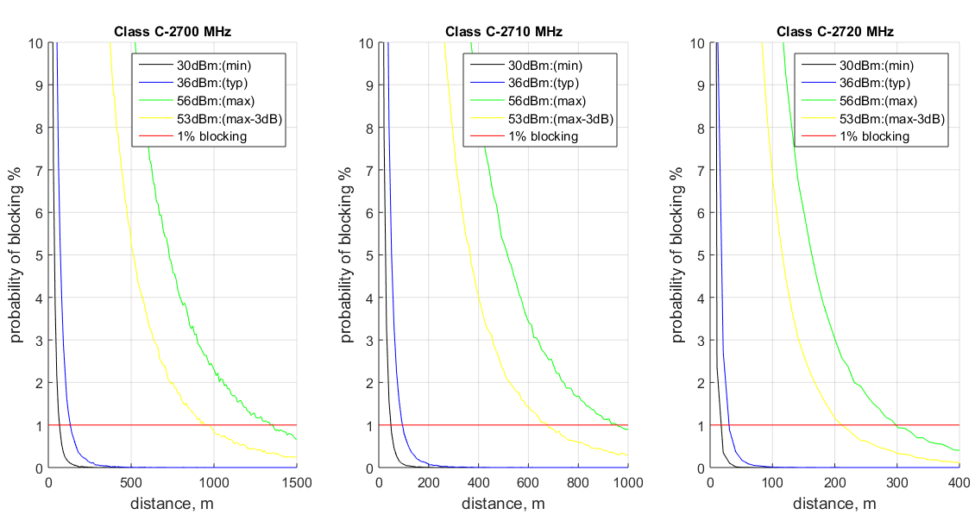

Figure 4041: Class C, blocking

In all the figures above, the curves for the frequency 2720MHz illustrate that the optimal result is obtained by combining both the reduction of the transmission power and the increase of the frequency separation distance.

The table 29 below summarises the results obtained at 1% of probability of blocking, for each class of video PMSE, according to their transmission power and frequency of operation.

Table 39: Separation distance required for video PMSE to protect LTE UE

|  |  |  |  |  |  |
| --- | --- | --- | --- | --- | --- |
| PMSE frequency | Class of PMSE | PMSE transmission power | | | |
| **Minimal** | **Typical** | **Maximal** | **Max-3dB** |
| 2700-2710 MHz | A1 | 25m | 80m | 160m | 111m |
| A2 | 21m | 45m | 281m | 200m |
| A3 | 44m | 88m | 882m | 626m |
| B | 143m | 450m | 4470m | 3182m |
| C | 68m | 133m | 1344m | 943m |
| 2710-2720MHz | A1 | 18m | 56m | 112m | 81m |
| A2 | 14m | 32m | 201m | 142m |
| A3 | 32m | 62m | 630m | 446m |
| B | 102m | 321m | 3130m | 2245m |
| C | 49m | 95m | 956m | 676m |
| 2720-2730MHz | A1 | 6m | 18m | 36m | 25m |
| A2 | 5m | 10m | 62m | 45m |
| A3 | 10m | 20m | 197m | 141m |
| B | 33m | 101m | 1000m | 700m |
| C | 18m | 31m | 298m | 212m |

Effect of OOB emissions of the PMSE

The following figure indicates the distance between an LTE UE and a PMSE, at which the limit I/N=-6 is attainted, as a function of the OOB level of the PMSE in the LTE band.

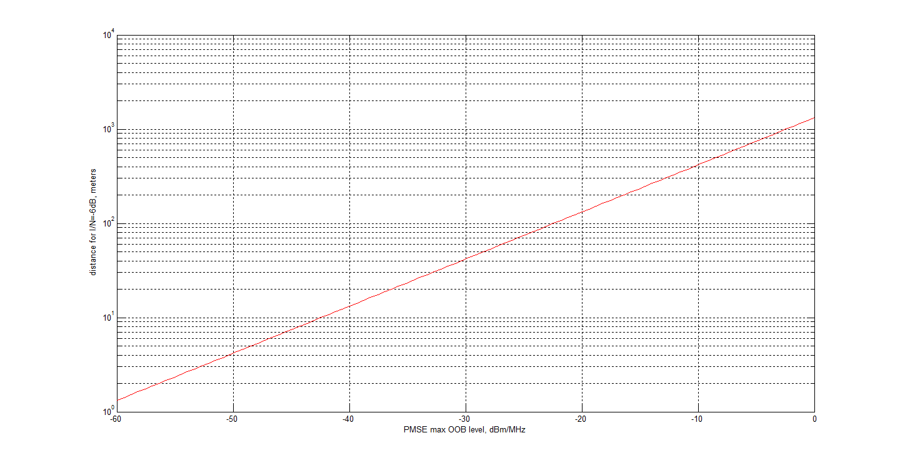

Figure 42: Distance for I/N=-6 dB as function of the OOB level. The value of the PMSE OOB emissions is in the LTE DL band

Of the curve in Figure 40 two points are worth mentioning:

* The point for -30 dBm/MHz, corresponding to a distance of about 40 meters. The value -30dB/MHz is the general spurious emissions limit defined by ITU-R SM369-10 for radio equipment in Europe above 1 GHz (see Table 3);
* The point for -50 dBm/MHz is the 3GPP LTE UE standard protection level to ensure compatibility. This corresponds to a distance of 4 meters.

From the results above, it can be concluded that any interference generated by PMSE could be mitigated either by reducing the transmission power of PMSE, by applying a sufficient separation distance and/or by increasing the frequency separation between the LTE UE and the PMSE equipment. The decision to use or combine any of these three possibilities can be taken on a case by case basis. However, given that the results above were performed considering a free space propagation model, it can be expected that lower separation distances would be needed in real life operation of PMSE in the surroundings of LTE UE.

* 1. Sharing in adjacent band for LTE (inteRferer) on MVL (victim)

The following lines summarise hypothesis, scenarios and conclusion of an analysis of realistic conditions of sharing in adjacent band (LTE on MVL).

* + 1. Hypothesis
* Parameters for MVL systems are described above;
* Parameters for LTE systems are described above.
  + 1. Scenario
* Simulation of a random position of the MVL terminal in the surrounding of the LTE base station;
* Real antenna pattern of the LTE base station;
* Evaluation of the probability of interference taking into account the effects of out of band emissions of the base station and its effects on the blocking of the victim receiver.

Table 40: Some parameters of the simulation

|  |  |  |
| --- | --- | --- |
| Parameters | Value | Remarks |
| LTE BS e.i.r.p. | 61 dBm/5MHz | *Worst case* |
| Blocking value | 55 dB | *Real value measured in one single BS at room temperature* |
| Propagation model | Free space | *Worst case* |
| Antenna pointing | Class A MVL antenna: omnidirectional. Class B MVL antenna: misalignment of 45° compared to the LTE BS | *Operational constraint on the choice of MVL site* |

* + 1. Conclusions

The following results were obtained:

* Regarding the Out of Band emissions of the LTE base station falling into the in-band frequencies of the MVL receiver, the probability of interference is negligible;
* Regarding the blocking effect of the MVL receiver by the emissions of the LTE base station, the probability of blocking is negligible for class A MVL terminals and the probability of blocking becomes negligible for class B MVL terminals if a misalignment is guaranted between its antenna and the antenna of the LTE Base Station.



Figure 43: Probability of blocking

The evolution of the curves is linked to the directivity of the antennas of the LTE Base Stations.

1. List of reference
2. CEPT Report 51: Report B from CEPT to the European Commission in response to the Mandate “On technical conditions regarding spectrum harmonisation options for wireless radio microphones and cordless video-cameras”
3. Recommendation ITU-R P.1411: Propagation data and prediction methods for the planning of short-range outdoor radiocommunication systems and radio local area networks in the frequency range 300 MHz to 100 GHz
4. ECC Report 219: Characteristics of PMSE digital video links to be used in compatibility and sharing studies
5. Recommendation ITU-R P.452: Prediction procedure for the evaluation of microwave interference between stations on the surface of the Earth at frequencies above about 0.7 GHz
6. Recommendation ITU-R P.525: Calculation of free-space attenuation
7. Recommendation ITU-R P.526: Propagation by diffraction
8. ETSI EN 302064-1: Electromagnetic compatibility and Radio spectrum Matters (ERM) - Wireless Video Links (WVL) operating in the 1.3 GHz to 50 GHz frequency band - Part 1: Technical characteristics and methods of measurement
9. ETSI ES 202 239 v1.1.1: Electromagnetic compatibility and Radio spectrum Matters (ERM); Wireless digital video links operating above 1,3 GHz; Specification of typical receiver performance parameters for spectrum planning
10. ECC Report 174: Compatibility between the mobile service in the band 2500-2690 MHz and the radiodetermination service in the band 2700-2900 MHz
11. Recommendation ITU-R F.1245: Mathematical model of average and related radiation patterns for line-of-sight point-to-point radio-relay system antennas for use in certain coordination studies and interference assessment in the frequency range from 1 GHz to about 70 GHz
12. Recommendation ITU-R M.1851: Mathematical models for radiodetermination radar systems antenna patterns for use in interference analyses
13. Recommendation ITU-R M.1460: Technical and operational characteristics and protection criteria of radiodetermination radars in the 2 900-3 100 MHz band
14. Recommendation ITU-R M.1464: Characteristics of radiolocation radars, and characteristics and protection criteria for sharing studies for aeronautical radionavigation and meteorological radars in the radiodetermination service operating in the frequency band 2700-2900 MHz
15. Recommendation ITU-R M.1465: Characteristics of and protection criteria for radars operating in the radiodetermination service in the frequency range 3 100-3 700 MHz
16. Recommendation ITU-R M.1849: Technical and operational aspects of ground-based meteorological radars
17. Recommendation ITU-R RA.769-2: Protection criteria used for radio astronomical measurements
18. Recommendation ITU-R RS.1861: Typical technical and operational characteristics of Earth exploration-satellite service (passive) systems using allocations between 1.4 and 275 GHz
19. ETSI TS 136 101: LTE; Evolved Universal Terrestrial Radio Access (E-UTRA); User Equipment (UE) radio transmission and reception
20. 3GPP TR 36.942: LTE; Evolved Universal Terrestrial Radio Access (E-UTRA); Radio Frequency (RF) system scenarios
21. 3GPP TS 37.104: E-UTRA, UTRA and GSM/EDGE – Multi-Standard Radio
22. Base Station radio transmission and reception
23. Recommendation ITU-R SM.1541-5: Unwanted emissions in the out-of-band domain
24. ETSI EN 301 908-14 v.5.1.1: IMT cellular networks; Harmonized EN covering the essential requirements of article 3.2 of the R&TTE Directive; Part 14: Evolved Universal Terrestrial Radio Access (E-UTRA) Base Stations (BS)
25. ECC Report 220: Compatibility/sharing studies related to PMSE, DECT and SRD with DA2GC in the 2 GHz unpaired bands and MFCN in the adjacent 2 GHz paired band.
26. ECC Report 002: SAP/SAB (Incl. ENG/OB) spectrum use and future requirements.
27. ERC Recommendation 74-01: Unwanted emissions in the spurious domain

1. Programme Making includes the making of a programme for broadcast, the making of a film, presentation, advertisement or audio or video recordings, and the staging or performance of an entertainment, sporting or other public event.
2. A Special Event is an occurrence of limited duration, typically between one day and a few weeks, which take place on specifically defined locations. Examples include large cultural, sport, entertainment, religious and other festivals, conferences and trade fairs. In the entertainment industry, theatrical productions may run for considerably longer.
3. For further information see the ECC Report 002 [25].
4. Typical and maximum value
5. Typical and maximum value
6. Maximum antenna gain is 6 dBi defined in ECC Report 219 [3] Table 6, but 9 dBi in Table 2.
7. K=1.380662*10^(-23) is the Boltzmann’s constant and T=290°K is the receiver ambient temperature