ECC Recommendation (17)01

Measurement uncertainty assessment for field measurements

**Approved** **3 February 2017**

TABLE OF CONTENTS

**INTRODUCTION………………………………………………………………………………………………………..4**

**ECC RECOMMENDATION (17)01 OF 3 FEBRUARY 2017 ON MEASUREMENT UNCERTAINTY ASSESSMENT FOR FIELD MEASUREMENTS……………………………………………………………………5**

ANNEX 1: Method FOR measurement uncertainty calculations 6

A1.1 General considerations regarding the measurement process 6

A1.2 Terms, Definitions, Abbreviations and symbols 6

A1.3 Description of the measurement system (STEP 1) 7

A1.4 Input parameters and their uncertainties (STEP 2) 8

A1.4.1 Determination of the best estimates of the input parameters 8

A1.4.2 Determination of the standard uncertainty of the input parameters. 8

A1.5 Determination of the best estimate of the measurand (STEP 3) 9

A1.6 Calculation of the combined measurement uncertainty (STEP 4) 9

A1.7 Calculation of the expanded measurement uncertainty U (STEP 5) 10

A1.8 Record of the measurement uncertainty (STEP 6) 10

ANNEX 2: Examples 11

A2.1 Uncertainties and Ohm’s Law (V=R×I) 11

A2.2 Uncertainties resulting from the usage of two attenuators 15

A2.3 UNCERTAINTIES AND FIELD STRENGTH MEASUREMENTs (Mismatch uncertainty) 18

A2.4 Uncertainties relating to Field strength measurements in the field 22

ANNEX 3: Combination of distributions – Summary table 26

ANNEX 4: Probabilistic Excursus 29

A4.1 Random variables and their probability density functions 29

A4.2 Moments 33

A4.3 Contribution from each individual source of uncertainty to the combined standard uncertainty 35

A4.4 Extension of the validity 35

A4.4.1 Validity in the case of linear functions and of non-linear functions 35

A4.4.2 Orders of magnitude and approximations 36

A4.4.3 Repetitions of measurements 36

ANNEX 5: List of referenceS 37

**introduction**

The purpose of this Recommendation is to provide a common method which will enable CEPT Administrations to gain more insight into measurement uncertainty and therefore into the quality of their measurements. The knowledge of the quality of measurements in terms of measurement uncertainty associated with the measurement results obtained is essential in order to decide whether a measurement is usable for a certain purpose.

Using this recommendation allows to compare measurement results obtained by different organisations using different equipment.

Information regarding measurement uncertainty concepts, measurement methods and maximum acceptable measurement uncertainty may be found in ETSI documents and standards. These documents, however, are dedicated to laboratory measurement conditions. As these conditions are not given at field measurements, a self-contained Recommendation for field measurements is necessary.

**ECC recommendation (17)01 of** **3 February 2017 on measurement uncertainty assessment for field measurements**

“The European Conference of Postal and Telecommunications Administrations,

*considering*

1. that spectrum management for licenced and licence exempt applications in Europe is based on technical studies resulting in limits and conditions for spectrum use;
2. that compliance to these limits is often determined by measurement;
3. that measurements do not necessarily provide the precise value of the parameter being measured, because there is an inherent measurement uncertainty, which may depend on the effect of measurement environment conditions, measurement procedures and of the measurement equipment itself;
4. that preferred practices concerning the description and assessment of measurement uncertainty are provided in documents such as ETSI TR 100 028 [1], European co-operation for Accreditation document EA-4/02 “Expression of the Uncertainty of Measurement in Calibration” [2] or UKAS M3003 “The Expression of Uncertainty and Confidence in Measurement” [3];
5. that beside field measurements, in measurements performed in laboratories typically Harmonised Standards are used for the assessment of radio products. These standards usually include methods of measurements, the method to calculate the corresponding uncertainty and the associated maximum acceptable measurement uncertainty levels, which are certainly different from those valid for field measurements.

*recommends*

1. that each individual measurement performed in the field to prove compliance with any RF limits is accompanied by an assessment of the measurement uncertainty based on the following aspects:

* performance of the measurement equipment including cables, antennas and attenuators used in that particular measurement;
* the measurement procedure and the prevailing measurement conditions;
* environmental conditions;

1. that in ECC Recommendations defining field measurement methods, a maximum acceptable expanded measurement uncertainty should be stated, this value should consider capabilities of available measurement equipment and measurement methods;
2. that the evaluation of measurement uncertainties and the presentation of the corresponding calculations should follow the principles provided in Annex 1 and, as much as practical, the methodology used in the examples found in ANNEX 2:;
3. that uncertainty calculators (see clause A2.4) should be developed for specific cases, as needed.”

Note:

Generally ETSI TR 100 028 [1] is in use for measurement uncertainty calculations in ETSI. It contains a large number of examples (see clauses 6, 7 and 8 in part 1 and clause 4 in part 2). However it is not exhaustive in terms of examples of measurements because the ETSI TR was specifically developed for measurements made in laboratories and in their test sites. It also offers the general method (in part 2 Annex D).  
Furthermore, the methodology developed in this Recommendation can also support field strength predictions and radio coverage predictions.

1. Method FOR measurement uncertainty calculations
   1. General considerations regarding the measurement process

The science of measurement is called metrology. Any measurement of an object means the determination of a level of measurement which includes dimensions (units) and uncertainty.

There are many reasons why measurements do not generally provide results as accurate as one would have desired. For example, the temperature of an object will be slightly changed by attaching a sensor. The voltage of a power source will be changed due to the impedance of the voltage meter used to measure it.

It is important to distinguish between measurement resolution, precision and measurement uncertainty. A precise scales may have a low resolution, e.g. if the display resolves steps of 1 kg. Conversely, a scale with 100 g resolution may nevertheless have a measurement uncertainty or a measurement error (as appropriate) of 2 kg.

More precisely, measurement uncertainty provides the range of values within which the true value is estimated to lie.

Knowing the measurement uncertainty is essential in order to decide whether a measurement is usable for a certain purpose.

The determination of the measurement uncertainty is generally done using the following sequence of steps – using the terms defined in Table 1(below):

1. characterise the measurement system used to evaluate the value of measurand Y;
2. determine the best estimates xi of the input parameters Xi and their associated standard uncertainties u(xi);
3. determine the best estimate y of the measurand Y e.g. by performing a measurement;
4. calculate the combined measurement uncertainty uc(y);
5. calculate the expanded measurement uncertainty U;
6. record in writing the expanded measurement uncertainty U.
   1. Terms, Definitions, Abbreviations and symbols

Table 1: Definitions

|  |  |
| --- | --- |
| Symbol | Definition |
| **ci** | The **sensitivity coefficient** indicates the impact (or weight) of an uncertainty contribution u(xi) on the combined uncertainty uc(y) of the measurand Y.  It can be calculated with the formula:  This is the partial derivative of the function F with respect to the variable Xi and evaluated at the point (x1, x2, x3, …, xn) where xi is the estimated value of Xi. |
| **F** | The **function F** depends on the measurement setup and provides the expression of the measurand (output variable) as a function of its input parameters.  Y=F(X1, X2, ..., Xn) |
| **k** | The **expansion or coverage factor k** is used to calculate the expanded uncertainty U = kuc(y) of output estimate y from its combined standard uncertainty uc(y) in order to achieve the sought level of confidence. |
| **u(xi)** | **Standard uncertainty u(xi) of the input estimate xi** that estimates the input parameter Xi. (See A1.4.1) |
| **ui(y)** | Intermediate step: **ui(y)** is the component of combined standard uncertainty uc(y) of output estimate y generated by the standard uncertainty of input estimate xi. |
| **uc(y)** | **Combined standard uncertainty** of output estimate y indicates the measurement uncertainty uc(y) of the measurand Y taking account of the function F and the measurement uncertainties of the input parameters. |
| **U** | The **expanded measurement uncertainty U** of the output estimatey defines an interval Y = y ± Uhaving the sought level of confidence, equal to the expansion factor ktimes the combined standard uncertainty uc(y) of y:  U = k uc (y) |
| **xi** | The **estimate** of input parameter Xi which may be the result of a measurement, specification or calculation. |
| **Xi** | ith **input parameter** on which the measurand Y depends |
| **Y** | The measurand, which may sometimes be determined by direct measurements and sometimes indirectly by measurement of other parameters and subsequent calculations. |

* 1. Description of the measurement system (STEP 1)

First a block diagram of the measurement system showing all relevant components (antennas, amplifiers, attenuators, combiners, splitters, cables, connectors, etc.) and their interconnections should be drawn. Also environmental conditions may have to be taken into account. The measurand Y is determined by the input parameters Xi (together with the appropriate equations).



Figure 1: Description of the measurement system

Mathematically the input parameters Xi are associated with the measurand Y by means of a function F which characterises the measuring system. Its general form is:

Y=F(X1, X2, ..., Xn)

F is the function that describes the relation of the n parameters Xi to the value of Y. This formula also illustrates that the measurement uncertainties of the input parameters contribute to the measurement uncertainty of Y.

Example: When measuring the field strength Y, the input parameter X1 could be the displayed voltage, X2 the cable attenuation (linear value) and X3 the linear antenna factor. Function F would then correspond to:

$$Y=\frac{X_{1}X_{3}}{X_{2}}$$

The various components, the way in which the components are interconnected and the measurement procedure determine the measurement uncertainty. Hence, measurement uncertainty calculations cannot be copied from one measurement set-up to another, unless all components, the measurement set-up and the measurement procedures are identical.

Note: In the field, it often happens that values are not expressed in linear terms but in dB. Calculations are as much valid when performed in linear terms as when performed in dB, provided that all the terms are homogeneous. It has to be kept in mind, however, that if the uncertainty has a rectangular density of probability when expressed in dB, it will not have a rectangular density of probability when expressed in linear terms, and vice-versa. Converting densities of probability between dBs and linear terms is addressed in detail in Annex E of part 2 of TR 100 028 [1]. A summary relating to those conversions can be found in Annex 3.

* 1. Input parameters and their uncertainties (STEP 2)

The best estimates xi of all input parameters Xi and their associated uncertainty components u(xi) defined by a probability density function and quantified by the corresponding standard uncertainties have to be integrated into function F.

Note: Below it is assumed that all input parameters Xi are uncorrelated. Failing this, the mathematical relations below are not applicable and much more complex considerations according to [5] have to be undertaken (in such a case see also table D.3.12 in Part 2 of TR 100 028 [1]).

* + 1. Determination of the best estimates of the input parameters

The best estimate xi of the relevant input parameters Xi can be determined by using the reading value of a single measurement which is normally the case in radio measurements or using information from other sources such as the nominal value of a resistor.

* + 1. Determination of the standard uncertainty of the input parameters.

The standard uncertainties of the input parameters can also be determined by using information from other sources such as

* calibration certificates;
* equipment data sheets, e.g. tolerances such as (1 % of the reading ± 2 digits) or ±2 dB;
* literature.

The following considerations and the explanations in Annex 4 are related to the typical situation of radio monitoring and inspection services using singular measurements where the indication of the measurement uncertainty is obtained from “other sources” (corresponding to the terminology “type B” as found in the GUM [4]).

* 1. Determination of the best estimate of the measurand (STEP 3)

In the field measurand Y is often measured while, theoretically, the best estimate y of the measurand Y results from the function Y=F(X1, X2,..., Xn).

When the measurand Y is obtained by measurements systematic errors should be compensated when possible.

* 1. Calculation of the combined measurement uncertainty (STEP 4)

The combined effect of the measurement uncertainties of the input parameters Xi  result in an uncertainty on the measurand Y. This will imply the use of divisors, see A4.3.

In probability theory, the Central Limit Theorem states that under certain (fairly common) conditions, the combination of many independent random variables will converge into an approximately normal distribution. Hence, with uncorrelated input parameters (see A1.4 above) the probability density function of the measurement uncertainty is a normal distribution.

Under these conditions the standard deviation of this normal distribution should be equal to the standard deviation of the combination of the various contributions of the uncertainty.

The combined standard uncertainty uc of the measurand Y is calculated according to

$$u_{c}^{ }{(y)}^{ }=\sqrt{\sum_{i=1}^{N}{{\left(\frac{∂F}{∂X_{i}}\right)}^{2}}u^{2}(x_{i})}$$

The partial derivative of the function F with respect to the variable Xi, evaluated at the point (x1, x2, x3, …, xn) where xi denotes the expected value of Xi may be replaced by its estimate or its nominal value, $c_{i}=\frac{∂F}{∂X_{i}}|_{x_{1}, { x}_{2}, {…, x}_{n}}$ and is called sensitivity coefficient or impact factor.

The expression above is sometimes referred to as the “Square Root of the Sum of the Squares”. Sensitivity coefficients are necessary to use because in many cases some components have more impact on the end result than others, even when their standard uncertainties are equal. This depends on the function F. For example, a component whose value is multiplied by 10 in the function F will have more impact on Y than another component that is divided by 10. Hence, some components of the equation above may even be neglected.

Example: In case we know R and I and we are interested in the corresponding value of V we can use Ohm’s Law formula V= R*I.

The measurement uncertainty of our result V can be calculated when we know the measurement uncertainties of R and I. The impact of these contributions can be calculated as soon as we know the function F. The formula is $V=F\left(R,I\right)=R×I$.

Using the formula above, the respective sensitivity coefficients are:

$c_{R}=\frac{∂V}{∂R}|_{v, i}=I$, *and $c_{I}=\frac{∂V}{∂I}|_{v, i}=R$*

Knowing the sensitivity coefficients and the standard uncertainties of the input parameters we can calculate the combined measurement uncertainty uc of the measurand Y (this has been fully developed in the example provided in A2.1 Step 4A).

* 1. Calculation of the expanded measurement uncertainty U (STEP 5)

The expanded measurement uncertainty equals

$$U=k{ U}_{c}(y)$$

For a given confidence level α, the measured value Y is expected to lie in the interval [Y-U, Y+U].

Often, it is assumed that the distribution of Y is normal and in that case the expansion factor k = 2 can be taken in order to obtain a confidence level close to α= 95% (see also 0).

* 1. Record of the measurement uncertainty (STEP 6)

Reporting measurement uncertainties should comprise a complete description of the measurement system, showing all components such as attenuators, cables and measurement devices, showing all component properties and providing the function F.

The measurement uncertainty budget is often documented in tabular form as shown in Table 2. Such a tabular form is practical for the “linear functions” (see the corresponding example in Annex A2.2)

Table 2: Example of presentation of a measurement uncertainty budget

|  |  |  |  |  |  |  |
| --- | --- | --- | --- | --- | --- | --- |
| Symbol | Source of uncertainty xi | Uncertainty value | Probability distribution | Divisor di | Sensitivity coefficient ci | Uncertainty  u(xi) |
| UAT1 | Tolerance on the value of the attenuation as provided by the manufacturer | 0.8 dB | rectangular | $$\sqrt{3}$$ | 1 | 0.461 dB |
| UAT2 | Tolerance on the value of the attenuation as provided by the manufacturer | 0.5 dB | rectangular | $$\sqrt{3}$$ | 1 | 0.288 dB |
| Uc | Combined measurement uncertainty |  | considered as normal |  |  | 0.544 dB |
| U | Expanded measurement uncertainty |  | normal (k=1.96) |  |  | Approximately: 1.06 dB |

Finally, the value of the measurand is conventionally written as Y=y±U accompanied by the level of confidence α providing the probability that the measurand lies in that interval.

1. Examples

Several examples are provided in this Annex:

* the first one shows a case where the calculations correspond to the case of a non-linear function: Ohm’s law presented with multiplications;
* the second one shows an example with a linear function based on attenuators whose characteristics are expressed in decibels;
* the third one shows the handling of the mismatch uncertainty;
* the fourth one includes support for a practical field measurement and includes an “uncertainty calculator”.

In the first example the evaluation of the combined uncertainty in Step 4 has been performed using   
3 different methods for the evaluation of the “sensitivity coefficients”:

* 4A based on differentiation;
* 4B an empirical method;

and

* 4C a “step by step” method using combination distribution tables.

These examples show, among others, that the more practical method depends of the particular situation. For example, the usage of tables (i.e. the “step by step” approach based on Table 2) is very practical when the uncertainties have to be combined according to a linear function F, but becomes cumbersome when the function F is not linear. When F is not a linear function, the method based upon partial derivatives is, by far, more practical but is often only valid within small intervals (as discussed in 0).

More examples can be found in reference [6].

* 1. Uncertainties and Ohm’s Law (V=R×I)

In this example the uncertainty on V is calculated on the bases of the uncertainties on R and on I. The presentation used to address this example follows the itemised list provided in A1.1.

**Step 1: Characterise the measurement system**

The current that crosses the resistor R is measured with an Ampere meter A.

R

Figure 2: Circuit including a resistor R and an Ampere meter A and a power supply

R = 100 Ω Tolerance 5% 🡺 5 Ω

I = 10 mA Uncertainty 2 % 🡺 0.2 mA

**Step 2: Determine the best estimates xi of the input parameters Xi and their associated standard uncertainties u(xi).**

In this example 2 sources for the uncertainty on V are considered: the tolerance on R and the uncertainty on I. Both uncertainties are considered having a rectangular distribution.

Rectangular distribution corresponding to the

uncertainty on I (in mA).

Rectangular distribution

corresponding to the

uncertainty on R (in Ohms).

**- 5 Ohm + 5 Ohm -0.2 mA +0.2 mA**

Figure 3: Characteristics of the uncertainty relating to R and I

Under these assumptions, one has the standard uncertainties of the input parameters:

$$u_{R}=\frac{5Ω}{\sqrt{3}} and u_{I}=\frac{0.2mA}{\sqrt{3}}$$

Should another density of probability distribution for the uncertainty had been found more appropriate, then these values would have been different, but the calculations below would have been performed in the same way.

**Step 3: Determine the best estimate y of the measurand Y**

Applying Ohm’s Law V = R×Iwe derive V = 1 Volt

**Step 4: Calculate the combined measurement uncertainty uc(y)**

The calculation of the combined measurement uncertainty may be performed using 3 different methods:

* using differentiations (shown in Step 4A) ;
* using an “empirical method” (shown in Step 4B);
* using the “step by step” method (shown in Step 4C).

The calculations below show clearly that they all lead to the same result.

**Step 4A: Using differentiations to find the sensitivity coefficients**

Ohm’s Law is $V=R×I$ therefore one has

$c_{R}=\frac{∂V}{∂R}=I$ and $c_{I}=\frac{∂V}{∂I}=R$

therefore cR= 10 mA and cI = 100 Ohm.

Applying the formula in A1.6 we get $$u_{c}{\left(y\right)}^{2}=\sum_{i=1}^{N}{{\left(\frac{∂F}{∂X_{i}}\right)}^{2}}u^{2}\left(x_{i}\right) \\ u_{c}{\left(y\right)}^{2}=I^{2}{\left(u_{R}\right)}^{2}+R^{2}{\left(u_{I}\right)}^{2}$$

$$u_{c}{\left(y\right)}^{2}={\left(10mA\right)}^{2}{\left(\frac{5Ω}{\sqrt{3}}\right)}^{2}+{\left(100Ω\right)}^{2}{\left(\frac{0.2mA}{\sqrt{3}}\right)}^{2}$$

$$u_{c}=31mV$$

**Step 4B: Using the “empirical method” to find the sensitivity coefficients**

This method is supported by clause D.5.4 of TR 100 028 [1]. This “empiric method” can possibly be used also when neither the method using differentiation (see Step 4A above) nor the method using table D.3.12 of TR 100 028 (the “step by step method”) are usable.

The principle of this method is to make small variations of the parameters, in order to find out the corresponding effect on the result.

For small variations of R and of I, V will vary as follows:

$$V_{R+}=105 Ω×I=105 Ω×10 mA=1.05 V$$

$$V_{R-}=95 Ω×I=95 Ω×10 mA=0.95 V$$

$$V_{I+}=R×10.2 mA=100Ω×10.2 mA=1.02 V$$

$$V_{I-}=R×9.8mA=100Ω×9.8mA=0.98 V$$

From these 4 values, we can get the two sensitivity coefficients:

$$\frac{ΔV}{ΔR}=\frac{1.05 V-0.95 V}{105 Ω-95 Ω}=10 mA$$

$$\frac{ΔV}{ΔI}=\frac{1.02 V-0.98 V}{10.2 mA-9.8 mA}=100 Ω$$

leading to the same sensitivity coefficients as found in in Step 4.A above.

**Step 4C: Using Table 8 in Annex 3 in order to combine the different sources of uncertainty together**

Ohm’s Law corresponds to a multiplication and in Table 8 in Annex 3 we find:

Table 3: excerpt from the table in Annex 3 relating to multiplications

|  |  |  |  |
| --- | --- | --- | --- |
| Multiplication |  |  |  |

where m represents means and sigma represents standard deviations.

The mean of a random variable x defined by its probability density function p is given by:

$$x_{m}=\int_{-∞}^{+∞}{x p\left(x\right)dx}$$

Furthermore, $h\left(z\right)=\int{(1/\left|x\right|})g\left(\frac{z}{x}\right)f\left(x\right)dx$ is the density of probabilities (distribution) corresponding to the result, i.e. to V, when the following correspondence table is used:

H and h (the density of probability of the random variable H) 🡸🡺 V  
F and f (the density of probability of the random variable F) 🡸🡺 R  
G and g (the density of probability of the random variable G) 🡸🡺 I.

Its mean is given by $m_{h}=m_{f}×m_{g}$

and its standard deviation is given by $σ_{h}^{2}+m_{h}^{2}=\left(σ_{f}^{2}+m_{f}^{2}\right)\left(σ_{g}^{2}+m_{g}^{2}\right)$. With notations using V, R and I, one gets for the mean values $m_{V}=m_{R}×m_{I}$ and $σ_{V}^{2}+m_{V}^{2}=\left(σ_{R}^{2}+m_{R}^{2}\right)\left(σ_{I}^{2}+m_{I}^{2}\right)$.

So one has $σ_{V}^{2}=\left(σ_{R}^{2}+m_{R}^{2}\right)\left(σ_{I}^{2}+m_{I}^{2}\right)-m_{V}^{2}=σ_{R}^{2}σ_{I}^{2}+m_{I}^{2}σ_{R}^{2}+m_{R}^{2}σ_{I}^{2}$.

The first term can be neglected because the standard deviations are expected to be much smaller than the means. Finally one has:

$σ_{V}^{2}=I^{2}σ_{R}^{2}+R^{2}σ_{I}^{2}$.

This corresponds to $u_{c}{\left(y\right)}^{2}=I^{2}{\left(u_{R}\right)}^{2}+R^{2}{\left(u_{I}\right)}^{2}$ as found in Step 4A above. Hence, the calculation of the combined measurement uncertainty continues as in Step 4A above.

**Step 5: Calculate the expanded measurement uncertainty U**

Once the combined uncertainty uc(y) has been calculated, the expanded measurement uncertainty can be calculated. In case we are interested in a 95% confidence interval, we use an expansion factor of k = 1.96 (See Table 9 in Annex 4) which leads to the result:

$$Y=1 V ±1.96×31 mV≈1 V±61 mV$$

**Step 6: Record in writing the measurement uncertainty**

Table 4: Measurement uncertainty budget

| **Symbol** | **Source of uncertainty xi** | **Uncertainty value** | **Probability distribution** | **Divisor  di** | **Sensitivity coefficient ci** | **Uncertainty contributions** |
| --- | --- | --- | --- | --- | --- | --- |
| UR | Production tolerance | ±5 Ω | rectangular | $$\sqrt{3}$$ | 10 mA | 0.0288 V |
| UI | Precision of the Ampere meter provided by the manufacturer | ±0.2 mA | rectangular | $$\sqrt{3}$$ | 100 Ω | 0.0115 V |
| Uc | Combined measurement uncertainty |  | considered as normal |  |  | 0.0310 V |
| U | Expanded measurement uncertainty |  | normal (k=1.96) |  |  | 0.0609 V |
| The resulting measurement uncertainty at a 95% confidence interval is approximately: ± 61 mV | | | | | | |

**Conclusion of A2.1**

Three different mathematical approaches provide the same result as shown in steps 4A, 4B and 4C. Which of them is the most practical method depends on the complexity of the measurement system and its function F. It has also to be kept in mind that there are situations where assumptions may need to be made in order to simplify calculations.

* 1. Uncertainties resulting from the usage of two attenuators

In this example the uncertainty of the combination of 2 attenuators is calculated on the bases of the uncertainties provided for each attenuator by the appropriate manufacturer. The presentation used to address this example follows the itemised list provided in A1.1.

**Step 1: Characterise the measurement system**

In this example two attenuators (AT1 and AT2) are used together – for example to protect the input of a spectrum analyser. One can dissipate a maximum of 10 W, the other 2 W.

Both attenuators are specified in the data sheets as respectively 10 dB ±0.8 dB and 10 dB ±0.5 dB (i.e. AT1 = AT2= 10 dB).

**AT2 :10 dB  
2 W**

**AT1 : 10dB  
10 W**

Figure 4: Combining two attenuators

The uncertainty for AT1 is ±0.8 dB and to AT2 is ±0.5 dB. The total attenuation A is the sum of the attenuations of each attenuator: A = AT1 + AT2 (using dBs).

**Step 2: Determine the best estimates xi of the input parameters Xi and their associated standard uncertainties u(xi)**

According to the specifications of the attenuators (see above), one has 10 dB ±0.8 dB and 10 dB ±0.5 dB..

**Step 3: Determine the best estimate y of the measurand Y**

For the measurement setup described in Step 1 and according to specifications of the attenuators as stated above, when using the two attenuators together the total attenuation is A equal to AT1 plus AT2 i.e. 20 dB.

**Step 4: Calculate the combined measurement uncertainty uc(y)**

In this example the 2 sources for the uncertainty on the actual value of A are considered to be the uncertainties on AT1 and AT2 (for the sake of simplicity, the effect of mismatch and of VSWR is not considered).

In this example both uncertainties – expressed in dB – are considered as corresponding to a rectangular distribution.

**- 0.8 dB + 0.8 dB - 0.5 dB + 0.5 dB**

Rectangular distribution

corresponding to the

uncertainty on AT1 (in dB)

Rectangular distribution corresponding to the   
uncertainty on AT2 (in dB)

Figure 5: Characteristics of the uncertainty relating to attenuators AT1 and AT2

Under these assumptions, one has the squares of the corresponding standard deviations i.e. standard uncertainties:

$σ_{At1}^{2}=\frac{{\left[0.8\right]}^{2}}{3}≈0.213$ see Annex 4

and

$σ_{At2}^{2}=\frac{{\left[0.5\right]}^{2}}{3}≈0.0833$ see Annex 4.

Should another density of probability (distribution for the uncertainty) had been found more appropriate, then these values would have been different, but the calculations below would have been performed in the same way.

In this example the Table 8 of Annex 3 is used to combine the different sources of uncertainty together. Using two attenuators together corresponds to an addition (when using dBs, i.e. A = AT1 + AT2 ), and in the Table 8 we find $m_{h}=m_{f}+m_{g}{ and σ}_{h}^{2}=σ_{f}^{2}+σ_{g}^{2}$, where m represents means and sigma represents standard deviations.

In the case of sums the corresponding operation is called taking the “square root of the sum of the squares” and there is usually no need to consider h(z) as found in the table in Annex 3 to continue calculations in this case.

H and h (the density of probability of the random variable H) 🡸🡺 A  
F and f (the density of probability of the random variable F) 🡸🡺 AT1  
G and g (the density of probability of the random variable G) 🡸🡺 AT2.

The mean of the sum is given by mh=mf + mg and its standard deviation is given by

$$σ_{h}^{2}=σ_{f}^{2}+σ_{g}^{2}$$

with notations using A, AT1 and AT2 we get for the mean values

$m_{A}=m_{{AT}_{1}}+m_{{AT}_{2}}$ $=σ_{{AT}_{1}}^{2}+σ_{{AT}_{2}}^{2}$.

with the numerical values of this example, one has

$$σ_{A}^{2}=σ_{{AT}_{1}}^{2}+σ_{{AT}_{2}}^{2}≈0.213+0.0833≈0.296$$

and finally we get the combined standard uncertainty:

$$σ_{A}≈0.544$$

Further details may be found in clause D.3.4 in [1].

It should be noted that in this particular case the resulting probability density corresponds to a triangular distribution.

**Step 5: Calculate the expanded measurement uncertainty U**

Once the combined standard uncertainty $σ_{A}^{ }$ has been calculated, the expanded measurement uncertainty can be calculated. In case we were interested in a 95% confidence interval, we use an expansion factor of k = 1.96 (based upon Table 9 in Annex 4) which leads to the result:

$$Y=y±U=y±k×u_{c}\left(y\right)=20 dB±1.96×0.544 dB≈20 dB±1.06 dB$$

**Step 6: Record in writing the measurement uncertainty**

Table 5: Measurement uncertainty budget

| **Symbol** | **Source of uncertainty xi** | **Uncertainty value** | **Probability distribution** | **Divisor  di** | **Sensitivity coefficient**  **ci** | **Uncertainty** |
| --- | --- | --- | --- | --- | --- | --- |
| $$U_{{AT}_{1}}$$ | Tolerance of the value of the attenuation as provided by the manufacturer | 0.8 dB | rectangular | √3 | 1 | 0.461 dB |
| $${U_{{AT}_{2}}}_{ }$$ | Tolerance of the value of the attenuation as provided by the manufacturer | 0.5 dB | rectangular | √3 | 1 | 0.288 dB |
| Uc | Combined measurement uncertainty |  | considered as normal  (see Note) |  |  | 0.544 dB |
| U | Expanded measurement uncertainty |  | normal (k=1.96)  (see Note) |  |  | approximately: 1.06 dB |
| **The resulting measurement uncertainty at a 95% confidence interval is approximately: 1.06 dB.**  **The attenuation is 20 dB ± 1.06 dB**  Note: There may be cases where the probability distributions to be combined are such that direct calculations are possible; when there are only two contributions to the uncertainty and the uncertainty values are identical, then a triangular probability distribution would have been obtained, but the numerical values obtained at the end, would have been the same, or almost, compared with the case where a normal distribution would have been considered | | | | | | |

**Further iterations**

Should there have been 3 attenuators instead of 2 in the measurement test set up discussed in this clause, it would have been possible to consider in a first phase two of them. For this first phase the outcome would have been as shown above.

At that point it could have been possible to consider the first couple of attenuators and the effect of the connection of the third one on the combined uncertainty. The result would have been then:

$$σ_{A}^{2}=\left[σ_{{AT}_{1}}^{2}+σ_{{AT}_{2}}^{2}\right]+σ_{{AT}_{3}}^{2}$$

and so on, should there have been more attenuators used together:

$$σ_{A}^{2}=σ_{{AT}_{1}}^{2}+σ_{{AT}_{2}}^{2}+σ_{{AT}_{3}}^{2}+…+σ_{{AT}_{n}}^{2}$$

this leads to

$σ_{A}=\sqrt{σ_{{AT}_{1}}^{2}+σ_{{AT}_{2}}^{2}+σ_{{AT}_{3}}^{2}+…+σ_{{AT}_{n}}^{2}}$.

Note: The shape of the resulting probability density function is smoother than each of the probability density functions of the input parameters and gets closer and closer to the Normal distribution as predicted by the Central Limit Theorem   
(as explained in A1.6).

**Conclusion of A2.2**

In an example as simple as this one, the explanations and changing of notations are more tedious than the mathematical work itself.

In the case where F is a linear function the calculation does not depend on the actual values of the various input variables but only on their contributions to the uncertainty. This simplifies the tabular representation.

* 1. UNCERTAINTIES AND FIELD STRENGTH MEASUREMENTs (Mismatch uncertainty)

In this example the uncertainty introduced by a field strength measurement setup is assessed. The measurement uncertainty for a basic field strength measurement setup is calculated with the following sources of the uncertainty: antenna factor, cable loss, measured value at the receiver input and mismatch error.

**Step 1: Characterise the measurement setup**

The measurement setup consists of antenna, cable and receiver with corresponding uncertainties and limits found in their calibration certificates or specifications. The measurement setup can be characterised as:

**S21**

**S12**

**S11**

**S22**

**Γr**

**Γe**

Antenna

Cable

Receiver

Figure 6: Measurement setup

The field strength, expressed in dBuV/m, is calculated as:

$E=AF+L_{C}+{V }_{r}$ (1)

where

$AF$– Antenna factor (dB/m);

$L_{C}$– Cable loss (dB);

${V }_{r}$– Measured value at receiver input (dBµV);

The value of E may be subject to effect of mismatch. The mismatch $δM$ in dB is calculated as follows:

$δM=20\log_{10}\left[\left(1-Γ_{e}S_{11}\right)\left(1-Γ_{r}S_{22}\right)-S_{21}^{2}Γ_{e}Γ_{r}\right] \left(dB\right)$ (2)

where

$Γ_{e}$– Reflection coefficient of antenna output calculated as: $Γ_{e}=\frac{{VSWR}_{ant.}-1}{{VSWR}_{ant.}+1}$; (3)

$S_{11},S_{22}$– Reflection coefficient of cable input/output as: $S_{11}=S_{22}=\frac{{VSWR}_{cab.}-1}{{VSWR}_{cab.}+1}$; (4)

$Γ_{r}$– Reflection coefficient of receiver input calculated as: $Γ_{r}=\frac{{VSWR}_{rec.}-1}{{VSWR}_{rec.}+1}$; (5)

$S_{21}$– Forward reflection coefficient calculated as: $S_{21}={10}^{-L_{c}/20}$. (6)

Table 6: Relevant uncertainties

|  |  |  |  |  |
| --- | --- | --- | --- | --- |
| **Equipment** | **Parameter** | **Value** | **Uncertainty** | **Confidence** |
| Antenna | Antenna factor | 27.9 dB/m | ±1.5 dB | 95.45% (k=2) |
| SWR | <1.95 |  |  |
| Cable | Loss | 2.4 dB | ±0.5 dB | 95.45% (k=2) |
| VSWR | <1.12 |  |  |
| Receiver | Measured value | 60 dBµV | ±1.0 dB | 95% |
| VSWR | <2.0 |  |  |

**Step 2: Determine the best estimates xi of the input parameters Xi and their associated standard uncertainties u(xi)**

The best estimate of the antenna factor is obtained from calibration data:

$$AF=27.9 ({dB}/m)$$

The standard uncertainty of the antenna factor is calculated by the calibration uncertainty and associated expansion factor (k) assuming a normal distribution:

$$u\left(AF\right)=\frac{Uncert. of AF}{k}=\frac{1.5}{2}=0.75 \left(dB\right)$$

The best estimate of cable loss is obtained from calibration data:

$$L_{C}=2.4 \left(dB\right)$$

The standard uncertainty of cable loss is calculated by calibration uncertainty and associated expansion factor (k) assuming a normal distribution:

$$u\left(L_{C}\right)=\frac{Uncert. of L_{C}}{k}=\frac{0.5}{2}=0.25 \left(dB\right)$$

The measured value at receiver input is read on the receiver’s display:

$$V_{r}= 60 dBμV$$

The standard uncertainty of the measured value at receiver input is calculated by specification data and associated expansion factor (k) for the specified confidence level assuming a normal distribution:

$$u\left(V_{r}\right)=\frac{Uncert. of V_{r}}{k}=\frac{1}{1.96}=0.51 \left(dB\right)$$

It is not possible to calculate the actual effect of mismatch, when only magnitudes of reflection coefficients are known (this particular case). Therefore only the uncertainty due to mismatch will be calculated. The standard uncertainty due to mismatch can be calculated by using extremes of magnitudes of reflection coefficients:

${δM}^{±}=20\log_{10}\left[1±\left(\left|Γ_{e}\right|\left|S_{11}\right|+\left|Γ_{r}\right|\left|S_{22}\right|+\left|Γ_{e}\right|\left|S_{11}\right|\left|Γ_{r}\right|\left|S_{22}\right|+\left|Γ_{e}\right|\left|Γ_{r}\right|{\left|S_{21}\right|}^{2}\right)\right] (dB)$ (7)

Equation 7 when filled with values from equations 3 to 6 gives limit values of the probability distribution of $δM$:

$${δM}^{+}=0.88 \left(dB\right); {δM}^{-}=-0.92 \left(dB\right)$$

Mismatch uncertainty usually is considered U-shaped (when the equations are expressed in linear terms or as an approximation when decibels are used) with a standard uncertainty not greater than the half-width divided by $\sqrt{2}$:

$$u\left(δM\right)=\frac{{δM}^{+}-{δM}^{-} }{2\sqrt{2}}=0.64 \left(dB\right)$$

As this is far from obvious it should be noted that more detailed information regarding mismatch uncertainty may be found in Annex G of TR 100 028 which is fully dedicated to this topic.

**Step 3: Determine the best estimate y of the measurand Y**

The best estimate of the measurand *E* is calculated from its function F (equation 1) which includes the outcome of the measurement:

$$E=AF+L_{C}+V_{r}=27.9+2.4+60=90.3 ({dBμV}/m)$$

**Step 4.1: Determine sensitivity coefficients ci**

The sensitivity coefficients for the antenna factor, the measured value at the receiver input and the mismatch are calculated:

$$c_{AF}=\frac{∂E}{∂AF}\left| _{AF=29.7}\right.=\frac{∂AF}{∂AF}+\frac{∂L_{C}}{∂AF}+\frac{∂V_{r}}{∂AF}+\frac{∂δM}{∂AF}=1$$

$$c_{V_{r}}=\frac{∂E}{∂V_{r}}\left| _{V_{r}=60}\right.=\frac{∂AF}{∂V_{r}}+\frac{∂L_{C}}{∂V_{r}}+\frac{∂V_{r}}{∂V_{r}}+\frac{∂δM}{∂V_{r}}=1$$

$$c_{δM}=\frac{∂E}{∂δM}\left| _{δM=…}\right.=\frac{∂AF}{∂δM}+\frac{∂L_{C}}{∂δM}+\frac{∂V_{r}}{∂δM}+\frac{∂δM}{∂δM}=1$$

As mismatch depends also on cable loss, the sensitivity coefficient for cable loss is calculated:

$$c_{L_{C}}=\frac{∂E}{∂L_{C}}\left| _{L_{C}=2.4}\right.=\frac{∂AF}{∂L_{C}}+\frac{∂L_{C}}{∂L_{C}}+\frac{∂V_{r}}{∂L_{C}}+\frac{∂δM}{∂L_{C}}$$

after substituting $δM$ with equation 2, $S_{21}^{ }$ with equation 6 and differentiate constants:

$$c_{L_{C}}=\frac{∂E}{∂L_{C}}\left| _{L_{C}=2.4}\right.=1+\frac{∂(20\log_{10}\left[\left(1-Γ_{e}S_{11}\right)\left(1-Γ_{r}S_{22}\right)-{10}^{-2L_{c}/20}Γ_{e}Γ_{r}\right]) }{∂L_{C}}$$

after filling in constants:

$$c_{L_{C}}=\frac{∂E}{∂L_{C}}\left| _{L_{C}=2.4}\right.=1+\frac{∂(20\log_{10}\left[0.962-0.107×{10}^{-2L_{c}/20}\right]) }{∂L_{C}}$$

after differentiation:

$$c_{L_{C}}=\frac{∂E}{∂L_{C}}\left| _{L_{C}=2.4}\right.=1+\frac{20×107×{10}^{-0.1L_{C}-4}}{\left(0.962-0.107×{10}^{0.1L_{C}}\right)}$$

with respect to $L_{C}=2.4$:

$$c_{L_{C}}=\frac{∂E}{∂L_{C}}\left| _{L_{C}=2.4}\right.≈1.14$$

**Step 4.2: Calculate the combined measurement uncertainty uc(y)**

Filling combined measurement standard uncertainty equation with values from Steps 2 and 4:

$$u_{c}\left(E\right)=\sqrt[ ]{c_{AF}^{2}{u\left(AF\right)}^{2}+{c_{L_{C}}}^{2}{u\left(L_{C}\right)}^{2}+{c_{V_{r}}}^{2}{u\left(V_{r}\right)}^{2}+c_{δM}^{2}{u\left(δM\right)}^{2}}=1.15 (dB)$$

**Step 5: Calculate the expanded measurement uncertainty U**

Assuming a normal distribution of *E*, an expansion factor (*k*) of 1.96 results in a confidence level of 95%:

$$U=ku_{c}\left(E\right)=1.96×1.15≈2.25\left(dB\right)$$

**Step 6: Record the measurement uncertainty**

The measurement uncertainty budget documented in tabular form:

Table 7: Measurement uncertainty budget

|  |  |  |  |  |  |  |  |  |  |
| --- | --- | --- | --- | --- | --- | --- | --- | --- | --- |
| **Input parameter** | | $$X_{i}$$ | **Uncertainty of $x_{i}$** | | | $u\left(x_{i}\right)$**(dB)** | $$c_{i}$$ | ${c_{i}}^{}{u\left(x_{i}\right)}^{}$**(dB)** | |
| **(dB)** | **Distribution** | **Coef** (1) |
| Antenna factor | $$AF$$ | 1.5 | *normal* | 2 | 0.75 | 1 | 0.75 |
| Cable loss | $$L_{C}$$ | 0.5 | *normal* | 2 | 0.25 | 1.14 | 0.285 |
| Measured value | $$V_{r}$$ | ±1.0 | *normal* | 1.96 | 0.51 | 1 | 0.51 |
| Mismatch | $$δM$$ | +0.88 / -0.92 | *U-shape* | $$\sqrt[ ]{2}$$ | 0.64 | 1 | 0.64 |
| Combined standard uncertainty | | | *normal* |  |  | | 1.1460 |
| Expanded measurement uncertainty | | | *normal* | 1.96 |  | | 2.2462 |
| Note 1: “Coef” stands for “coefficient” and it can be either a divisor (in the upper lines) or an expansion factor  (in the last line). | | | | | | | |

Finally, the measurement result can be written as:

$$E=90.3±2.25 \left(dBμV/m\right), with a 95\% confidence level$$

**Conclusion of A2.3**

Measurement setups as simple as in this example sometimes require complex mathematical considerations to determine the measurement uncertainty.

* 1. Uncertainties relating to Field strength measurements in the field

Recommendation ECC/REC/(12)03 [7] shows how the radiated power of a transmitter in the frequency range from 400 MHz to 6000 MHz can be determined through field strength measurements.

**Step 1: Characterise the measurement system**

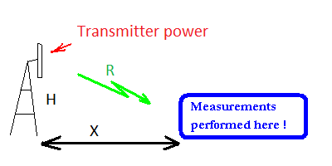

Figure 7: Geometry of the measurement setup

In this example it is expected that the antenna of the van where the measurements are made is at a distance X of the Base Station Tower. The transmitter antenna is at a height H with respect to the antenna of the van. R is the distance from the transmitter antenna to the antenna of the van.

The complete measurement set-up can be subdivided in 3 key sub-sets:

* the measurement chain inside the van;
* the antenna of the van;
* the BS (its positioning, etc.) and the propagation path loss.

The uncertainty calculator addresses explicitly the last 2 sub-sets.

The contribution to the uncertainty of the equipment in the van (cables, switches, splitters, measuring equipment) can be expected to correspond to a linear case, of which a very simple example can be found in clause A2.2. It is assumed that it can be obtained by taking the root of the sum of the squares. The corresponding result (i.e. the combined uncertainty from Step 5), is to be entered in cell K8 (highlighted in light GREEN) of the Uncertainties Calculator (see Figure 8).

**Step 2: Determine the best estimates xi of the input parameters Xi and their associated standard uncertainties u(xi)**

There are two distinct parts in the uncertainty calculator:

* one is non-linear and corresponds to the propagation; the cells to be filled in are E and F in   
  rows 11 and 12 that correspond to X and H and the corresponding uncertainties (as explained in clause A4.4.1, in non-linear cases, both values and uncertainties have to be explicitly used); it takes into account the equations corresponding to the propagation model that has been chosen. The units to be used are meters;
* one is linear and takes into account the characteristics of the antenna and of the rest of the test set up; it leads to a traditional root taking of the sum of the squares; the values are entered in dB in cells G from row 16 to 28.

The values to be provided to the Uncertainty calculator depend on the actual measurement conditions. They depend, among others, on the particular antenna used for a particular measurement.

Alternatively to X and H the uncertainty of a direct measurement of R can be provided in cell F10. In this case X and H should be set to 0 as the uncertainty calculator will add the contents of cells F10 and F13.

When the values corresponding to the uncertainties in the van itself are added (Cell K8 of the uncertainty calculator), they are expected to be processed as shown in the other examples provided in this Recommendation.

It is expected, however, that the set of corresponding (and pre-calculated) values is limited (it could correspond to settings of the measuring equipment and to the positions of possible switches). The value to be inserted in Cell K8 is the combined uncertainty (i.e. before the change in the confidence level – so before any multiplication by k).

Step 3: Determine the best estimate y of the measurand Y

For the measurement setup described in Step 1 and in the case of an indirect evaluation of R, the uncertainty calculator will determine automatically the distance R from the transmitter antenna to the antenna used for the measurement and the corresponding uncertainty, based on the distances provided to it by the operator (in the light green cells in rows 11 and 12).

As explained in clause A4.4.1, for the linear part of the uncertainty calculator the calculation for the uncertainty are independent of the actual values measured. Therefore, the actual values do not appear in the cells of the uncertainty calculator.

The uncertainty calculator provides – for completeness the conversion of the values entered by the operator in dBs into linear terms (cells highlighted in light ROSE color).

Step 4: Calculate the combined measurement uncertainty uc(y)

In this example, the combination of the various contributions to the uncertainty is provided by the uncertainty calculator. This can avoid long calculations.

It is important to keep in mind that the equations incorporated into the uncertainty calculator correspond to both linear (see Example A2.2) and non-linear examples of the function F.

The propagation model is assumed to be the “free space” propagation model.

When exercising the uncertainty calculator, it becomes clear that the contribution due to the uncertainty on the distance R and therefore to the path loss is among the smallest contributions considered in this example.

Therefore, the contribution of the path loss uncertainty, the propagation model itself and the conversion of the contribution of the non-linear part of the uncertainty calculator into the linear part have been simply handled in “one-go” using Cells G, H, I and J of row 14. The corresponding result (i.e. contribution) can be found in Cell K14.

In the linear part of the uncertainty calculator, the root of the sum of the squares is taken including Cells in rows 8 to 28 (i.e. K8 to K28).

The combined uncertainty is finally provided in Cell K29.

**Step 5: Calculate the expanded measurement uncertainty U**

This calculation is also made by the uncertainty calculator. The final result i.e. the expanded uncertainty can be found in cell K30 and repeated below in a box.

Step 6: Record in writing the measurement uncertainty

The input values together with the outcome of the calculations are listed below. The calculations can be followed in the uncertainty calculator found in the embedded Excel-file.

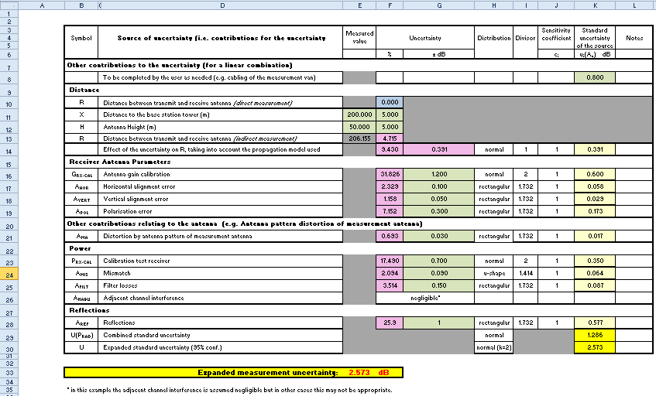

Figure 8: Uncertainty calculator



This uncertainty calculator has been designed to help those evaluating measurement uncertainties in the case of outdoor measurements, in the field. It takes into account some of the contributions to the uncertainty. It focuses on the aspects relating to the distance between base station and measurement vehicle and the antenna used for the measurement.

Color Code used:

* light GREEN has been used for input cells;
* light BLUE has been used for a special cell used for direct input of the distance (R);
* PINK has been used for cells calculated by the uncertainty calculator (please, do not touch those cells!);
* WHITE has been used for parameters used in the calculations (please do not touch those cells!);
* light YELLOW has been used for the various uncertainty contributions;
* dark YELLOW has been used to display the final results.

The presentation used to address this example follows the itemised list provided in A1.1, as for the previous examples.

Note: In the uncertainty calculator as shown above, the input values (in the Cells coloured in light GREEN) shown have been chosen in order to exercise the uncertainty calculator and to test it. The values in WHITE Cells are expected to be representative.

1. Combination of distributions – Summary table

The table below is taken from [1] (table D 3.12). It can be used to support the calculation of combinations and other operations of probability densities and corresponding moments.

Table 8: Combination of distributions

| **Operations relating to random variables** | | | **Equation** (Note 2) | **Resulting distribution** | **Mean value** | **Standard deviation** | **Clause** |
| --- | --- | --- | --- | --- | --- | --- | --- |
| One random variable | Addition of a constant value | | H=F+α | h(z)=f(z-α) | mh=mf+α | σh=σf | D.3.1 |
| Multiplication by pos. const. | | H=(λ)F | h(z)=(1/λ)f(z/λ) | mh=λmf | σh=λσf | D.3.2 |
| Multiplication by neg. const. | | H=(-λ)F | h(z)=-(1/λ)f(z/λ) | mh=λmf | σh2=λ2σf2 | D.3.2 |
| Inverse function | | H= 1/F | h(z)= f(1/z)/z2 | mh=∫ (f(z)/z) dz | σh2+mh2=∫ (f(z)/z2) dz | D.3.7 |
| Two random variable | Sum | | H=F+G | h(z)=∫g(z-x)f(x)dx | mh=mf+mg | σh2=σf2+σg2 (note 3) | D.3.3 |
| independent variables | | H=λF+μG | h(z)=∫(1/λμ)f(x/λ)g((z-x)/μ)dx | mh=λmf+μmg | σh2=λ2σf2+ μ2σg2 | D.3.4 |
| non independent variables | | H=λF+μG  where F=kG | h(z)=(1/(λk+μ))g(z/(λk+μ)) | mh=(λk+μ)mg | σh2=(λk+μ)2σg2 | D.3.4.6 |
| Subtraction | | H=F-G | h(z)=∫g(x-z)f(x)dx | mh=mf-mg | σh2=σf2+σg2 | D.3.5 |
| Multiplication | | H=FG | h(z)=∫(1/ | x |)g(z/x)f(x)dx | mh=mf mg | σh2+mh2=(σf2+mf2)(σg2+mg2) | D.3.6 |
| Division | | H=F/G | h(z)=∫ g(x/z) (| x |/z2) f(x)dx | mh= mf (∫ (g(z)/z) dz) | σh2+mh2=(σf2+mf2)(∫(g(z)/z2)dz) | D.3.7 |
| Using Logs | Using Logs | | H=Log(F) | h(z)=ez f (ez) | mh= ∫ Log(x) f(x) dx | σh2= (∫ Log2(x) f(x) dx) - mh2 | D.3.8 |
| Powers | Linear terms 🡺dB | H=10 log(F) | h(z)=10z/10(Log(10)f(10z/10)/10) | mh=∫ 10 log(x)f(x)dx | σh2=(∫ (10log(x))2f(x) dx) - mh2 | D.3.8.4.1 |
| dB 🡺 linear terms | H= 10 (F/10) | h(z)=10(f(10log(z)))/(zLog10) | mh=∫ e(x/10) Log10f(x)dx | σh2=(∫(e(x/10)Log10)2f(x)dx)-mh2 | D.3.8.4.2 |
| Volts | Linear terms 🡺dB | H=20 log(F) | h(z)=10z/20(Log(10)f(10z/20)/20) | mh=∫ 20 log(x)f(x)dx | σh2=(∫ (20log(x))2f(x) dx) - mh2 | D.3.8.4.1 |
| dB 🡺 linear terms | H= 10 (F/20) | h(z)=20(f(20log(z)))/(zLog10) | mh=∫ e(x/20) Log10f(x)dx | σh2=(∫(e(x/20)Log10)2f(x)dx)-mh2 | D.3.8.4.2 |
| Using a function | One variable | | H=g(F) | h(z)=(f(g-1(z)))/ | g'(g-1(z) |) | mh= ∫ g(x) f(x) dx | σh2= (∫ g2(x) f(x) dx) - mh2 | D.3.9 |
| Two variables | | H=g(F, K) | h(z)=∫((k(ϒ(z,x))/ | δg/δy |)f(x)dx | mh=∫∫g(x,y)f(x)dx k(y)dy | σh2=(∫∫g2(x,y)f(x)dx k(y)dy)-mh2 | D.3.11 |
| Substitutions | t replaces x in a distribution | | x 🡺 k(t) | X(x) 🡺 T(t) = X(k(t)) |k'(t)| | See clause D.9.3 | See clause D.9.3 | D.3.10.3 |
| Reciprocals | y = g (x) ⬄ x = k (y) | | See clause D.3.10.5 | See clause D.3.10.5 |  |  | D.3.10.5 |
| NOTE 1: In the above table, the symbol ∫ stands for: . In the table above, the effect of the sign of a multiplicative constant has been highlighted. Great care is recommended with regard to possible effects on the validity of these expressions due to signs and possible zeros of expressions used above. Functions like ***g*** are supposed to be monotonous; for more details, please refer to the appropriate clause of the annex.  NOTE 2: The equations are related to independent variables, unless otherwise stated.  NOTE 3: TR 100 028 uses extensively this formula. | | | | | | | |

Table 8 shows, in particular, that the complexity of the calculations to be performed depends very directly on characteristics of the combination of random variables being considered:

* when the combination corresponds to a linear equation, the resulting standard deviation can be found using the standard deviations of the corresponding contributions;
* when the combination corresponds to a multiplication, the resulting standard deviation can be found using the standard deviations plus the means of the corresponding contributions;
* in all other cases (e.g. divisions) in order to find the resulting standard deviation integrals have to be calculated (and such calculations may be long).

Such considerations may have an impact on choices to be made. For example, when considering propagation models or attenuations dBs might be used as well as “linear terms”. However, using dBs will make the calculation of standard deviations much simpler.

1. Probabilistic Excursus
   1. Random variables and their probability density functions

A random variable can take a set of possible different values each with an associated probability. It is characterised therefore by its probability density function. The probability density function of a random variable is a function (with specific properties as defined in clause A4.2) that describes the probability of the occurrence of all the possible values that this variable can have.

The random variable can also be characterised by a number of parameters like its mean and standard deviation which also depend (and can be calculated based) on its probability density function.

Different probability density functions are used depending on characteristics of the event being considered. For example, if the measurement uncertainty is specified like “±1 % of the displayed value” a rectangular probability distribution is usually assumed.

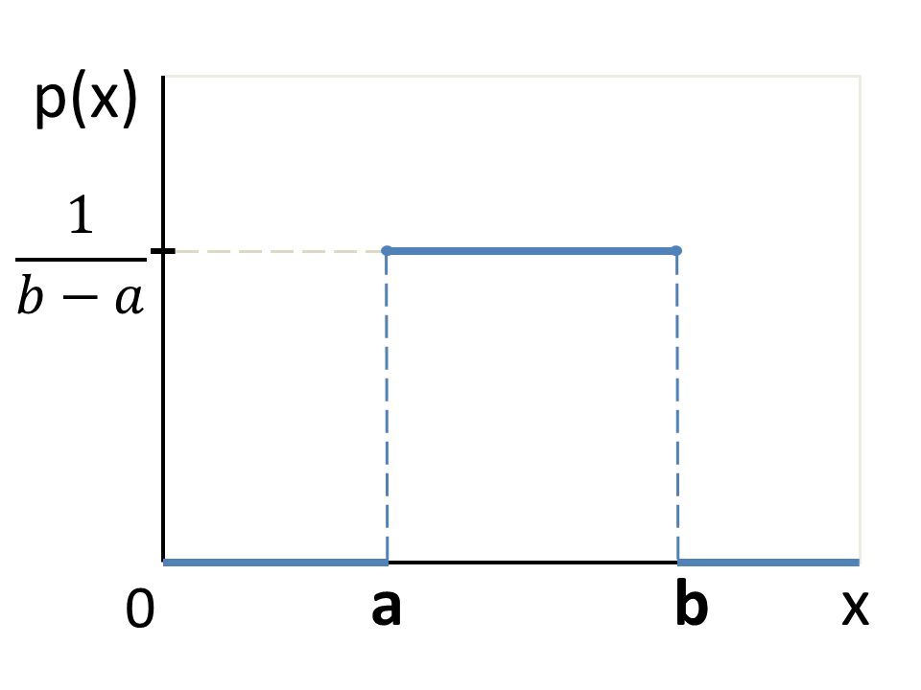

Figure 9: Probability density function of a rectangular distribution

In that case the mean of the variable would be

$$x=\frac{a+b}{2}$$

where a and b are the boundaries (in this case a = -1% and b = 1% away from the mean), see Figure 9.

The probability density function is also often represented centred on zero. The random variable will then spread from –A to +A where A = (b-a)/2.

The standard deviation of a rectangular distributed random variable associated with a measurement is:

$$σ\left(x\right)=\frac{b-a}{2\sqrt{3}}=\frac{A}{\sqrt{3}}$$

This is the standard uncertainty $u\left(x\right)$ associated with the measurement. In other words:

$u\left(x\right)=σ\left(x\right)$.

The corresponding distribution function D(x) yields the probability that the value of the variable X is less than x.

$$D\left(x\right)=P(X≤x)=\left\{\begin{aligned}0 if x≤a \\ \frac{x-a}{b-a} if a<x<b \\ 1 if x≥b\end{aligned}\right.$$

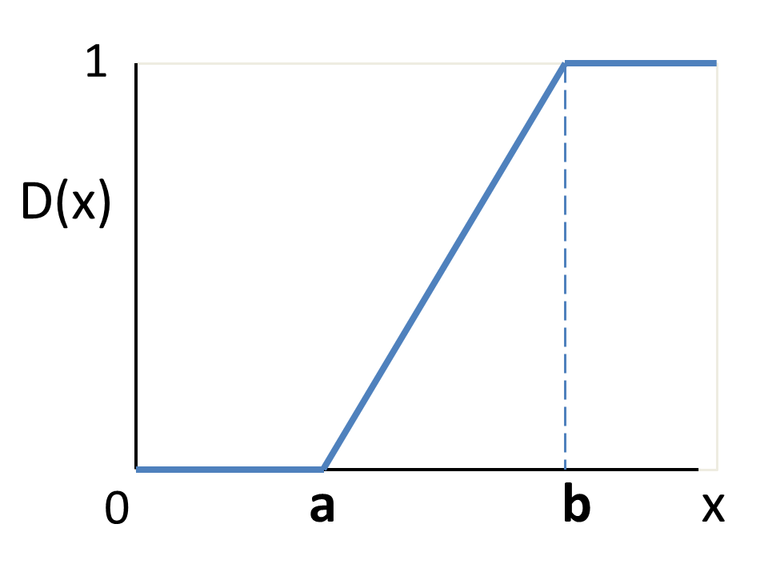

Figure 10: Cumulative density function of a rectangular distribution

Another commonly used probability density function is the Normal distribution:

$$p\left(x\right)=\frac{1}{σ\sqrt{2π}}e^{- \frac{1}{2}{\left(\frac{x-μ}{σ}\right)}^{2}}$$

where µ is its expected value and σ is its standard deviation.

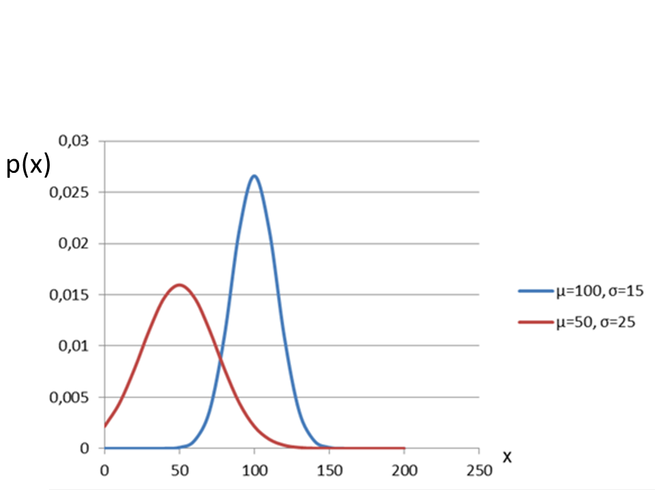

Figure 11: Probability density function of a normal distribution

The total area below the curve equals 1 by definition. The area below the curve within a certain interval around µ provides the confidence levels and can be taken from Table 9. See Figure 12.

Table 9: Confidence levels corresponding to a normal distribution

|  |  |
| --- | --- |
| Interval around µ (the estimate) | Corresponding confidence level |
| ±1 σ | 68.27 % |
| ±1.645 σ | 90.00 % |
| ±1.96 σ | 95.00 % |
| ±2 σ | 95.45 % |
| ±3 σ | 99.73 % |

Note: As often found in the relevant literature, as an approximation, the area within ± 2 σ around µ is associated with a confidence level of “about 95 %”.

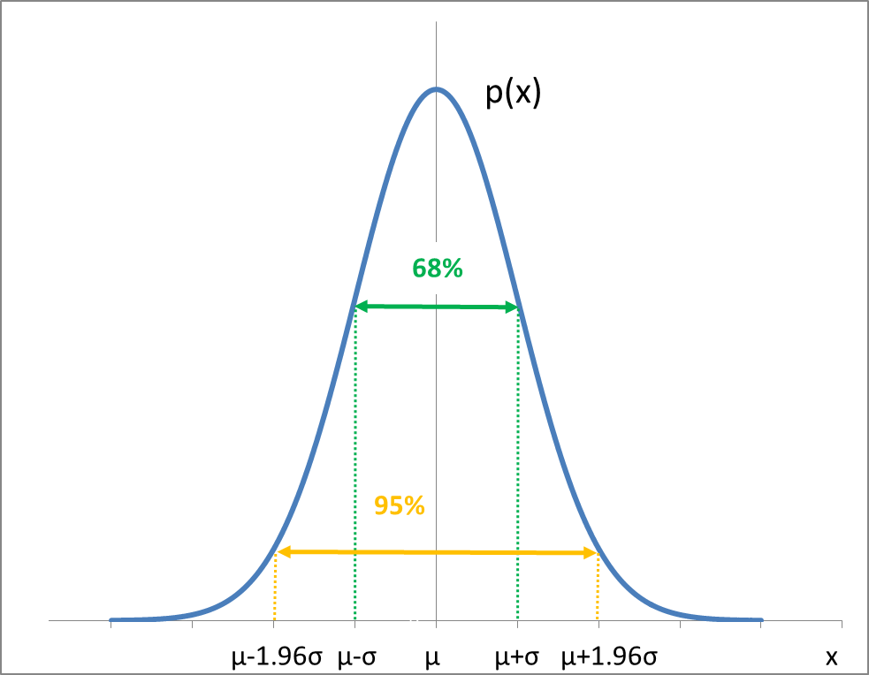

Figure 12: Normal probability function and corresponding confidence levels

The area below the curve of the Normal probability density function between values around its mean corresponds to confidence levels. The most commonly used are provided in Table 8. This figure shows the interval [μ – σ, μ + σ] corresponding to 68% confidence and the interval [μ – 1.96 σ, μ + 1.96 σ] corresponding to 95% confidence.

The corresponding cumulative probability distribution function D(x) yielding the probability that the value of the variable X is less than x is shown below.

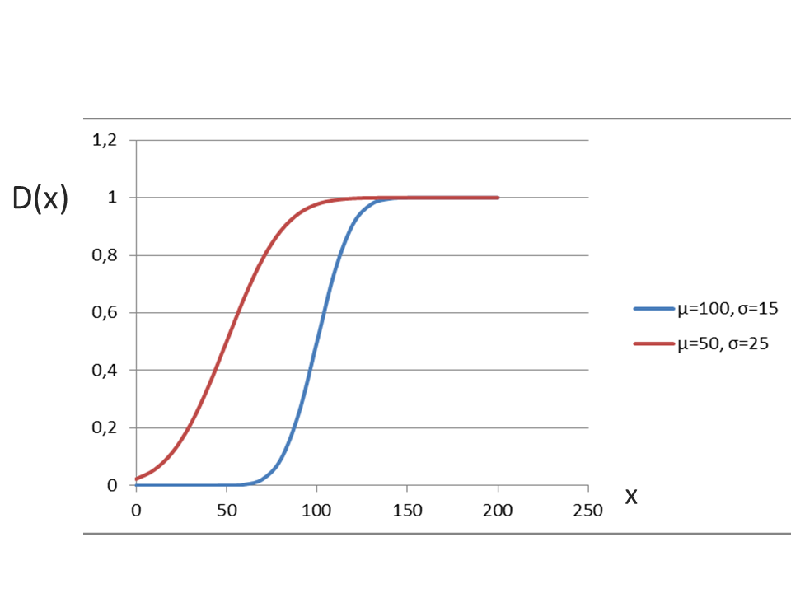

Figure 13: Cumulative probability distribution function of a normal distribution

The majority of equipment datasheets and calibration documents do not state probability distribution functions associated with specified uncertainty values. Fortunately there are clues that may help to find out the relevant probability distribution function.

A Normal distribution may be relevant in case:

* The uncertainty value is given with an associated confidence level (e.g. 95%);
* The uncertainty value is given with an associated expansion factor (e.g. 2σ);
* The uncertainty is a combination of many independent sources of uncertainties.

A Rectangular distribution may be relevant

when

* The uncertainty is specified like “±1 % of the displayed value” or “± 1dB”.

A U-Shaped distribution may be relevant

when

* Evaluating mismatch uncertainty.

A Triangular distribution may be relevant

when

* Considering the sum of two identical rectangular distributions.

The probability distribution functions mentioned above are displayed in Figure 14 below.

Figure 14: Plots of probability density functions having a standard deviation of 1

* 1. Moments

“Statistical moments” are specific properties of a probability density function.

A probability density function is a function with two special properties:

* $f\left(x\right)≥0$, because a probability cannot be negative;
* It has an area of 1 below the curve: $\int_{-∞}^{∞}{f\left(x\right)dx}=1$.

Statistical moments $m_{n}$ with $n≥0$ are calculated as follows $m_{n}=\int_{-∞}^{∞}{x^{n}f\left(x\right)dx}$, where f(x) is the probability density function of the random variable being considered.

The first moment m1, for example, simply represents the expected value of x (the mean of x).

The second moment m2 can be used in order to calculate standard deviations: $σ^{2}=m_{2}^{ }-m_{1}^{2}$.

Table 10 shows standard deviations of some usual probability density functions.

Table 10: Properties of probability distribution functions

|  |  |  |  |  |  |
| --- | --- | --- | --- | --- | --- |
| Distribution | | Normal | U-Shape | Rectangular | Triangle |
| Boundaries | | ± ∞ | ± A | ± A | ± A |
| Probability density function | | $$p\left(x\right)=\frac{1}{σ\sqrt{2π}}e^{- \frac{1}{2}{\left(\frac{x-μ}{σ}\right)}^{2}}$$ | $$p\left(x\right)=\left\{\begin{aligned}\frac{1}{π\sqrt{A^{2}-x^{2}}}, &-A≤x≤A \\ 0. &otherwise\end{aligned}\right.$$ | $$p\left(x\right)=\left\{\begin{aligned}\frac{1}{2A}, &-A≤x≤A \\ 0. &otherwise\end{aligned}\right.$$ | $$p\left(x\right)=\left\{\begin{aligned}\frac{1}{A^{2}}\left(A+x\right), &-A≤x≤0 \\ \frac{1}{A^{2}}\left(A-x\right), &0<x≤A \\ 0. &otherwise\end{aligned}\right.$$ |
| Cumulative density function | | $$h\left(x\right)=\frac{1}{2}\left(1+\operatorname{erf}\left(\frac{x-μ}{σ\sqrt{2}}\right)\right)$$ | $$h\left(x\right)=\left\{\begin{aligned}\frac{arcsin\left(x\right)}{π}+\frac{1}{2}, &-A≤x≤A \\ 0. &otherwise\end{aligned}\right.$$ | $$h\left(x\right)=\left\{\begin{aligned}\frac{x}{2A}+\frac{1}{2}, &-A≤x≤A \\ 0. &otherwise\end{aligned}\right.$$ | $$h\left(x\right)=\left\{\begin{aligned}\frac{1}{{2A}^{2}}{\left(A+x\right)}^{2}, &-A≤x≤0 \\ 1-\frac{1}{{2A}^{2}}{\left(A-x\right)}^{2}, &0<x≤A \\ 0. &otherwise\end{aligned}\right.$$ |
| Standard deviation (σ) | | σ | $$σ=A/{\sqrt{2}}$$ | $$σ=A/{\sqrt{3}}$$ | $$σ=A/{\sqrt{6}}$$ |
| Expansion factors to/ divisors for specified confidence level | 68.27 % | 1 | 1.242 | 1.182 | 1.070 |
| 90.00 % | 1.645 | 1.345 | 1.559 | 1.675 |
| 95.00 % | 1.96 | 1.410 | 1.645 | 1.902 |
| 95.45 % | 2 | 1.411 | 1.653 | 1.927 |
| 99.73 % | 3 | 1.414 | 1.732 | 2.322 |
| 100.00 % | ∞ | $$\sqrt{2}$$ | $$\sqrt{3}$$ | $$\sqrt{6}$$ |
| Note: The lower part of the Table provides the value of expansion factors/divisors to be used in the case of the different probability distributions. The concept of expansion factors can be used together with normal distribution as well as with other distributions. | | | | | |

* 1. Contribution from each individual source of uncertainty to the combined standard uncertainty

The effect of a particular contribution on the combined standard uncertainty depends not only on the associated sensitivity coefficient (see Table 1: Definitions) but also on the characteristics of the corresponding probability density function. When the calculations of the combined standard uncertainty are performed in a tabular form (see Table 2 in clause A1.8) “divisors” are used to calculate the standard deviation corresponding to that uncertainty for further calculation. The values of such divisors depend in particular on the probability density function considered.

In Table 10 the divisors of several commonly used probability density functions are given subject to the considerations in clause A4.4.

For a rectangular probability density the divisor is √3. This would have been the case, for example, with a resistor having a tolerance specified as ± 5 %. In the area of radio measurements, usually, when no information is available on the density of probability (beyond some tolerances), then the density of probability is considered to be rectangular.

In the case of a U-shaped density of probability, the divisor would have been √2.

In the case of a “normal” probability density function the divisor would have been usually 1 when the corresponding confidence interval is 68%.In some cases, however, the characteristics of an uncertainty are provided with a confidence level of 95%, corresponding to an “expansion factor” of 1.96 (see Table 10). This will often happen when some calibration had been performed beforehand.

In this case, a division by 1.96 (i.e. by the “expansion factor” involved) has to be performed before any further processing. As a result, when the distribution is “normal” and the associated confidence level is 95%, the divisor is 1.96.

* 1. Extension of the validity
     1. Validity in the case of linear functions and of non-linear functions

The theoretical aspects presented in clause A1.6 may lead to the understanding that the calculations made are valid in one point i.e. in (X1, X2,..., Xn), the point where the partial derivatives of the function   
F(X1, X2,..., Xn) had been evaluated, and only in that point.

This will be typically the case when the function F is not a linear function. This can be seen in the example A2.1 where input parameters, like “I” appear explicitly in the calculations and in the sensitivity coefficients.

However, in the case of a linear function when the input parameters do not explicitly appear in the sensitivity coefficients the range where the calculations and corresponding tables are valid is much larger (see A2.2).

Table 8 in Annex 3 shows how to combine the different contributions to the uncertainty. When reading the clauses corresponding to “additions” and to “linear combinations”, it becomes clear that “no limiting assumptions” had been made when performing such calculations.

Therefore, in linear cases (and when taking the square root of the sum of the squares) there is no limitation in the validity of the calculations made in accordance with this Recommendation, due to variations of the “input parameters”.

This is why the evaluation of the measurement uncertainty can be done independently of the actual values corresponding to that measurement and both the “input parameters” and the results do not appear in   
Table 2.

Annex 3 also shows non-linear cases where further calculations corresponding to the various entries in the table have to be performed (other than simple operations on the means and standard deviations corresponding to the input parameters) for the combination of the various contributions to the uncertainty.

When calculating the effect of mismatch uncertainty it is necessary to evaluate the effect of a random phase shift (i.e. within 0 and 2 π), so there is a large interval to be considered in a non-linear case.

Note: Function F may be a linear expression involving the various parameters Xi and such situation may be referred to, in the context of this Recommendation, as “a linear case” (i.e. in the sense of “linear Algebra”, i.e. for example F = a1 X1 + a2 X2 +… ak Xk + …). But the word “linear” is also often used, in the context of this Recommendation, associated with the word “terms” to qualify the way in which parameters are expressed, when they are not expressed in dB (decibels).

* + 1. Orders of magnitude and approximations

Another aspect to be taken into account when considering the validity of calculations, is the relation between the various “input parameters” and their corresponding uncertainties in terms of orders of magnitude. While it can be considered that it is acceptable to neglect 0.5 dB in the case of an attenuation of 10 dB it will be more questionable to neglect 0.4 dB in the case of an attenuation of 2 dB.

Such a consideration is key, in particular when considering cables, where the desired attenuation is as close to zero as possible, while there is a non-zero uncertainty on the value of the corresponding cable loss.

The result is that in cases when calculations are made using approximation it is not legitimate to make the uncertainty calculations without having in mind the actual values of the different parameters or at least the corresponding orders of magnitude.

* + 1. Repetitions of measurements

This Recommendation is based upon a probabilistic approach and, as indicated above, an underlying assumption is that all the contributions to the uncertainties are uncorrelated.

It can be tempting to make several measurements, in order to get results with a lower measurement uncertainty. However, in order to get measurements uncorrelated, it would be required to use another set-up with uncorrelated pieces of equipment. When performing several measurements with the same actual test set-up (e.g. same cables, same instruments, same attenuators, etc.), it can be expected that there will be some bias common to several measurements.

Therefore it may be very difficult to draw any conclusions when measurements are repeated.

1. List of referenceS

This annex contains the list of relevant reference documents.

1. ETSI TR 100 028, version 1.4.1 (Dec. 2001), [Parts 1](http://www.etsi.org/deliver/etsi_tr/100001_100099/10002801/01.04.01_60/tr_10002801v010401p.pdf) and [2](http://www.etsi.org/deliver/etsi_tr/100001_100099/10002802/01.04.01_60/tr_10002802v010401p.pdf), “Electromagnetic compatibility and Radio spectrum Matters (ERM); Uncertainties in the measurement of mobile radio equipment characteristics”, ETSI
2. EA-4/02,” Expression of the Uncertainty of Measurement in Calibration” European co-operation for accreditation, EAL Task Force for revision of WECC Doc. 19-1990 on behalf of the EAL Committee 2 (Calibration and Testing Activities).
3. M3003 "The Expression of Uncertainty and Confidence in Measurement", United Kingdom Accreditation Service.
4. JCGM 100:2008 “Evaluation of measurement data – Guide to the expression of uncertainty in measurement
5. JCGM 101:2008 “Evaluation of measurement data – Supplement 1 to the “Guide to the expression of uncertainty in measurement” – Propagation of distribution using Monte carlo method
6. The .zip files associated with TR 100 028 [1] contain .xls files corresponding to the examples provided both in [Part 1](http://www.etsi.org/deliver/etsi_tr/100001_100099/10002801/01.04.01_60/tr_10002801v010401p0.zip) and [Part 2](http://www.etsi.org/deliver/etsi_tr/100001_100099/10002802/01.04.01_60/tr_10002802v010401p0.zip) of the TR
7. ECC Recommendation (12)03: Determination of the radiated power through field strength measurements in the frequency range from 400 MHz to 6000 MHz