
Electronic Communications Committee (ECC)
within
the European Conference of Postal and Telecommunications Administrations (CEPT)

specific UWB Applications
in the bands 3.4 - 4.8 GHz and 6 - 8.5 GHz Location Tracking Applications
for Emergency Services (LAES),
location tracking applications type 2 (LT2) and
location tracking and sensor Applications for automotive and transportation environments (LTA)

Tallinn, October, 2011

Executive summary
CEPT Report 27 [1] provides an overview of CEPT investigations on the generic ultra-wideband (UWB) regulation that have been completed with the amendment of Decision ECC/DEC/(06)12 [2] in October 2008.

CEPT Report 34 [3], developed by FM47 in response to a Mandate on UWB applications from the European Commission (EC), focuses, in particular, on further investigations concerning specific ultra-wideband applications as well as possibilities to expand the scope of the generic UWB regulation to different operating environments. In particular, CEPT Report 34 identifies the need for additional studies for three types of applications as follows:
- Location Tracking Application for Emergency Services (LAES): single interference studies on the impact on FS/FSS and BWA terminals, taking into account the expected low deployment.
- Location Tracking Applications type 2 (LT2) in the frequency bands 3.4 – 4.8 GHz and 6 – 8.5 GHz for person and object tracking and industrial applications: technical studies on the impact of fixed UWB outdoor location-tracking on radio services and in particular on FS/FSS in different single interference scenarios. The potential aggregate interference on radio services will also need to be investigated
- Location Tracking and sensor Applications for automotive and transportation environments (LTA) in the frequency bands 3.1 – 4.8 GHz and 6 – 8.5 GHz: to investigate alternative LDC mitigation technique for the automotive environment.
This ECC Report provides the results of the compatibility studies undertaken within SE24 in response to the request from FM47.
The following tables provide an overview of the compatibility studies:

Table 1: LAES summary
f/GHz | Services/systems | E.i.r.p. density limits.[dBm/MHz] | Additional compatibility requirements
3.4 – 3.8 | FS, MS (WiMAX), FSS | -21.3 | Protection of FS (angular decoupling of 5° to the FS mainbeam assumed) and MS will be ensured for separation distances of:  - Outdoor LAES: about 20 km  - Indoor LAES: about 5 km  Protection of FSS will be ensured for separation distances of:  - Outdoor LAES: about 20 km from any registered/notified FSS earth stations with small diameter antenna (1.2 m and 1.8 m) and 12.3 km for other registered/notified FSS earth stations and MSS feeder link earth stations;  - Indoor LAES: about 7 km from any registered/notified FSS earth stations with small diameter antenna (1.2 m and 1.8 m) and and 3.5 km for other registered/notified FSS earth stations and MSS feeder link earth stations;
3.8 - 4.2 | FS, FSS | -21.3 | Protection of FS (angular decoupling of 5° to the FS mainbeam assumed) will be ensured for separation distances of:  - Outdoor LAES: about 20 km  - Indoor LAES: about 5 km  Protection of FSS will be ensured for separation distances of:  - Outdoor LAES: about 20 km from any registered/notified FSS earth stations with small diameter antenna (1.2 m and 1.8 m) and 12.3 km for other registered/notified FSS earth stations and MSS feeder link earth stations;  - Indoor LAES: about 7 km from any registered/notified FSS earth stations with small diameter antenna (1.2 m and 1.8 m) and and 3.5 km for other registered/notified FSS earth stations and MSS feeder link earth stations;
4.2 - 4.4 | Altimeter | -41.3 | Avoid LAES sites in the vicinity of airports runway (minimum separation distance of 150 m should be considered). Protection will be ensured with the level of -47dBm/MHz for outdoor usage.
4.4 - 4.8 | MS, FS mil , FSS (4.5-4.8 GHz) | -41.3 | MS: protection distances with local rescue operation leader or other national authorities are necessary because UAVs are interfered directly at their normal flight level when operating in the same area. Separation distances should be calculated on a case by case basis.  Protection of FS (angular decoupling of 5° to the FS mainbeam assumed) will be ensured for separation distances of::  - Outdoor LAES: about 2 km  - Indoor LAES: about 500 m  Protection of FSS will be ensured for separation distances of:  - Outdoor LAES: about 2 km from any registered/notified FSS earth stations with small diameter antenna (1.2 m and 1.8 m) and  - Indoor LAES: about 500 m from any registered/notified FSS earth stations with small diameter antenna (1.2 m and 1.8 m).

Table 2: LT2 summary
f/GHz | Services/systems | Power limit for LT2 indoor and outdoor nomadic/tags [dBm/MHz] | LT2 indoor and outdoor nomadic/tags | Power limit LT2 fixed outdoor  transmitters | LT2 fixed outdoor  Transmitters | Additional compatibility requirements  (see also Note 1)
3.4 -3.8 | FS, MS (WiMAX), FSS | -41.3 | +5%/s +Ton<25ms  + 1.5%/minute | -41.3 dBm/MHz | +5%/s +Ton<25ms | Administration may need to consider implementing separation distances or other mitigations on a case by case basis for the protection of FS (see 3.3.4) and MS.  Protection of FSS will be ensured for a separation distances of up to 2.6 km for outdoor tracking systems.
3.8 - 4.2 | FS, FSS | -41.3 | +5%/s +Ton<25ms  + 1.5%/minute | -41.3 dBm/MHz | +5%/s +Ton<25ms | Administration may need to consider implementing separation distances or other mitigations on a case by case basis for the protection of FS (see section 3.3.4).  Protection of FSS will be ensured for a separation distances of up to 2.6 km for outdoor tracking systems.
4.2 - 4.4 | Altimeter | -41.3 | +5%/s +Ton<25ms  + 1.5%/minute | -41.3 dBm/MHz  and -47.3 dBm/MHz for angles above 30°  Note 2 | +5%/s +Ton<25ms | Definition of sensitive zones around airports up to 13 km (see section 3.3.3) where additional mitigation techniques are necessary (see section 3.3.3)
4.4 - 4.8 | MS, FS mil , FSS (4.5 -4.8 (GHz)) | -41.3 | +5%/s +Ton<25ms  + 1.5%/minute | -41.3 dBm/MHz | +5%/s +Ton<25ms | Administration may need to consider implementing separation distances or other mitigations on a case by case basis for the protection of FS (see section 3.3.4) and MS.  Protection of FSS will be ensured for a separation distances of up to 2.6 km for outdoor tracking systems.
Note 1: A 10dB peak power reduction (-41dBm/MHz mean e.i.r.p. and -10dBm/50MHz peak e.i.r.p.) may able to reduce the impact on the radio systems, but not in all cases. The following mitigation should also be considered: peak power reduction, movement sensor for tags/nomadic/mobiles.
Note 2: the limitation above 30° may be removed in some cases subject to site specific authorization (see section 3.3.3).

Table 3: LTA summary
f/GHz | Services/systems | Power limit for one LTA sensor | Additional limits | Comments
3.4 - 4.2 | FS, FSS, MS (WiMAX)  (Note 3) | -41.3 dBm/MHz and -53.3 dBm/MHz  outside the vehicle | +5%/s +Ton<5ms | See Note 3
4.2 - 4.4 | Altimeter | -41.3 dBm/MHz and -53.3 dBm/MHz outside the vehicle | +5%/s  +0.5%/h for vehicle speed ≤20km/h +Ton<5ms
4.4 - 4.8 | MS, FS military, FS , FSS (4.5 - 4.8 GHz) | -41.3 dBm/MHz and -53.3 /-67.3 dBm/MHz outside the vehicle  Note 1 | +5%/s  +0.5%/h for vehicle speed ≤20km/h +Ton<5ms | See Note 3
6.65 -6.6752 GHz | RAS | -41.3 dBm/MHz and -53.3/-61.3 dBm/MHz outside the vehicle  Note 2 | +5%/s + 0.5%/h  + Ton<5ms | Studies ask for -61.3 dBm/MHz  Additional TRP Limit -70dBm/MHz (see Note 2)
6 - 8.5 | FS, FSS | -41.3 dBm/MHz and -53.3 dBm/MHz outside the vehicle | +5%/s + 0.5%/h+ Ton<5ms | See Note 3
Note 1: An I/N of -20dB can be fulfilled with the proposed limit of -53.3dBm/MHz (measured outside) and the current generic LDC-limit 5%/s and 0.5%/h without any speed limit. An I/N of around -6dB would be possible for the limit of -53.3 dBm/MHz with the changed LDC- limit (5%/s and the combination 5%/h > 20km/h and 0.5%/h <20km/h). To achieve an I/N of -20 dB for all cases with the changed LDC-limits (5%/s and the combination 5%/h > 20km/h and 0.5%/h <20km/h) additional mitigation techniques (e.g. DC whole car, mid-term DC, power reduction,..) would be necessary.
Note 2: If a value of -53.3 dBm/MHz - calculated for 1 UWB device active per car - outside the vehicle is implemented the radius of the separation zone will be about 700 m (see section 4.3.5) which may impact the observations of several RAS stations operating in Europe (Effelsberg, Jodrell Bank, Cambridge, Sardinia, Bleien …).
Note 3: No specific studies were undertaken for FSS since the proposed limits are more stringent than the existing limits.

Table of Contents

0 Executive summary 2
1 Introduction and Background 10
2 Location Tracking Application for Emergency Services (LAES) 10
2.1 System description 10
2.2 Assumed mean e.i.r.p. for LAES systems 11
2.3 Deployment, reference scenarios for studies 12
2.4 Coexistence Studies for LAES 12
2.4.1 Coexistence with Radio-Altimeters in 4.2-4.4 GHz 13
2.4.1.1 Aeronautical radio-altimeters characteristics 13
2.4.1.2 Simulation scenario 13
2.4.1.3 Simulation results 14
2.4.1.4 Conclusion 15
2.4.2 Coexistence with Fixed Satellite Service (FSS) / Mobile Satellite Service (MSS) 15
2.4.2.1 Assumptions on MSS and FSS for interference analysis 15
2.4.2.2 Network availability requirements for Earth Stations providing Global Maritime Distress and Safety Services 16
2.4.2.3 LAES assumptions for the study 17
2.4.2.4 Typical interference duration and resulting percentage of time 17
2.4.2.5 Interference analysis results 18
2.4.2.6 Results from simulations with real terrain data for a typical earth station 20
2.4.2.7 Discussion of results 20
2.4.2.8 Conclusions for FSS / MSS 21
2.4.3 Coexistence with FS in 3.4 - 4.2 GHz 21
2.4.4 Conclusions 22
2.4.5 Coexistence with MS 22
2.5 Summary LAES 23
3 Location Tracking Applications type 2 (LT2) in the frequency bands 3.4 - 4.8 GHz and 6 - 8.5 GHz for person and object tracking and industrial applications 25
3.1 System description 25
3.2 Deployment of LT2, reference scenarios for studies 28
3.3 Studies 29
3.3.1 WIMAX 3.4 to 3.8 GHz 29
3.3.1.1 Measurement campaign 30
3.3.1.2 Summary WIMAX 30
3.3.2 FSS / MSS – LT2 outdoor 30
3.3.2.1 Assumptions for interference analysis 30
3.3.2.2 Typical interference duration and resulting percentage of time 30
3.3.2.3 Activity factor assumption Location Tracking Application Type 2 (LT2) to FSS 31
3.3.2.4 e.i.r.p. emission levels of a single UWB device and other assumptions 31
3.3.2.5 Interference analysis results 31
3.3.2.6 Results from simulations with real terrain data for a typical earth station 33
3.3.2.7 Discussion of results 34
3.3.2.8 Conclusions for the FSS / MSS 34
3.3.3 Radio altimeters studies 34
3.3.3.1 Simulation of the impact of aggregation and multiple LT2 on radio-altimeters 34
3.3.3.2 Conclusions on the aggregated impact of LT2 on radio-altimeters 38
3.3.4 FS studies 39
3.3.4.1 Fixed Service characteristics 39
3.3.4.2 Single entry scenario - PP Fixed Service 39
3.3.4.5 Summary FS 44
3.3.5 The impact of LT2 on the Mobile Service in the band 4.4 – 4.8GHz 44
3.3.5.1 Mobile Service characteristics 45
3.3.5.2 Single entry scenario - UAV vs fixed LT2 46
3.3.5.3 Hot spot scenario - UAV vs fixed LT2 49
3.3.5.4 Conclusions for the Mobile Service 51
3.4 Summary LT2 52
4 Location tracking and sensor Applications for automotive and transportation environments (LTA) in the frequency bands 3.4 – 4.8 GHz and 6 - 8.5 GHz 53
4.1 System description 53
4.2 Deployment, reference scenarios for studies 54
4.2.1 Deployment 54
4.2.2 Car screening 54
4.3 Studies 54
4.3.1 Fixed Service at 4.4 and 6 GHz 54
4.3.1.1 Single entry scenario - PP Fixed Service 55
4.3.1.2 Aggregation LTA vs FS 56
4.3.1.3 Summary and conclusion for FS 58
4.3.2 Aggregated effect of LTA on radio-altimeters 59
4.3.3 WIMAX in the band 3.4 to 3.8GHz 61
4.3.4 UGV vs LTA in the band 4.4 to 4.8GHz 61
4.3.4.1 Single Entry - UGV vs LTA 61
4.3.4.2 Static aggregation scenario from ECC Report 23 64
4.3.4.3 Dynamic Aggregation LTA (type C) 64
4.3.4.4 Possible antenna for UGV 70
4.3.4.5 Summary UGV 71
4.3.5 Fixed Satellite Service 72
4.3.6 Radio astronomy in the band 6.65 - 6.6752 GHz 72
4.3.6.1 Use of the band by the RAS and Regulatory Status 72
4.3.6.2 Parameters used in the Study 72
4.3.6.3 Single emitter protection requirement and separation distance 73
4.3.6.4 Aggregation of emissions 73
4.3.6.5 Conclusions for the RAS 74
4.4 Summary LTA 75
5 Summary 76
ANNEX 1: LAES deployment characteristics 79
ANNEX 2: Matlab simulations 86
ANNEX 3: UWB Aggregation 92
ANNEX 4: FSS Studies 99
ANNEX 5: MEASUREMENTS to assess the impact of longer ldc on wimax 100
ANNEX 6: List of references 106

LIST OF ABBREVIATIONS

Abbreviation | Explanation
ARNS | Aeronautical Radio Navigation Service
ATC | Air Traffic Control
BER | Bit Error Rate
BMA | Building Material Analysis
BS | Base Station
CDF | Cumulative Distribution Function
CDMA | Channel Division Multiple Access
CEPT | European Conference of Postal and Telecommunications
CTIF | Centre of Fire Statistics
CRAF | Committee on Radio Astronomy Frequencies
DAA | Detect And Avoid
DC | Duty Cycle
EC | European Commission
FDMA | Frequency Division Multiple Access
FH-UWB | Frequency Hopping Ultra Wide Band
FS | Fixed Service
FSS | Fixed Satellite Service
GAT | General Air Traffic
HALE | High Attitude Long Endurance
IF | Intermediate Frequency
LBT | Listen Before Talk
LDC | Low Duty Cycle
LES | Land Earth Station
LTA | Location Tracking and sensor Applications for automotive and transportation environments
LAES | Location Tracking Application for Emergency Services
LOS | Line Of Sight
LT2 | Location Tracking Applications type 2
MES | Mobile Earth Station
MOS | Mean Opinion Score
MPIfR | Max-Planck-Institute for Radioastronomy
MS | Mobile Service
MSS | Mobile Satellite Service
NSF | National Science Foundation
OAT | Operated Air Traffic
ODC | Object Discrimination Characterisation
OFDM | Orthogonal Frequency Division Multiplex
PRF | Pulse Repetition Frequencies
PRI | Pulse Repetition Interval
QoS | Quality of Service
RAS | Radio Astronomy Service
RF | Radio Frequency
SAS | Satellite Access Station
SIR | Signal to Interference Ratio
SISO | Single Input Single Output
SRR | Short Range Radar
TPC | Transmit Power Control
TDMA | Time Division Multiple Access
TH-UWB | Time Hopping Ultra Wide Band
TRP | Total Radiated Power
UAS | Unmanned Aircraft Systems
UAV | Unmanned Aerial Vehicle
UDP | User Datagram Protocol
UGV | Unmanned Ground Vehicle
UGS | Unmanned Ground System
UWB | Ultra Wide Band
VLBA | Very Long Baseline Array
WiMAX | Worldwide Interoperability for Microwave Access
WRC | World Radiocommunication Conference

ECC Report on specific UWB Applications in the bands 3.4 - 4.8 GHz and 6 - 8.5 GHz Location Tracking Applications for Emergency Services (LAES), location tracking applications type 2 (LT2) and location tracking and sensor Applications for automotive and transportation environments (LTA)

Introduction and Background
CEPT Report 27 [1] provides an overview of CEPT investigations on the generic ultra-wideband (UWB) regulation that have been completed with the amendment of Decision ECC/DEC/(06)12 [2] in October 2008.

CEPT Report 34 [3], developed by FM47 in response to a Mandate on UWB applications from the European Commission (EC), focuses, in particular, on further investigations concerning specific ultra-wideband applications as well as possibilities to expand the scope of the generic UWB regulation to different operating environments. In particular, CEPT Report 34 identifies the need for additional studies for three types of applications as follows:
- Location Tracking Application for Emergency Services (LAES): single interference studies on the impact on FS/FSS and BWA terminals, taking into account the expected low deployment.
- Location Tracking Applications type 2 (LT2) in the frequency bands 3.4 – 4.8 GHz and 6 – 8.5 GHz for person and object tracking and industrial applications: technical studies on the impact of fixed UWB outdoor location-tracking on radio services and in particular on FS/FSS in different single interference scenarios. The potential aggregate interference on radio services will also need to be investigated
- Location Tracking and sensor Applications for automotive and transportation environments (LTA) in the frequency bands 3.1 – 4.8 GHz and 6 – 8.5 GHz: to investigate alternative LDC mitigation technique for the automotive environment.
This ECC Report provides the results of the compatibility studies undertaken within SE24 in response to the request from FM47.

Location Tracking Application for Emergency Services (LAES)

System description
LAES system is described in the ETSI standard TR 102 496 V2.1.1 (2009-05) [4].

In many emergency situations such as fires, the safety and effectiveness of operations are hampered by not knowing where the personnel are. This is particularly true within large buildings, which may be partially or completely collapsed and full of smoke. The greatest use will be by fire-fighters in indoor fires, where they are in a very dangerous environment and often have almost no visibility due to smoke. It will also be important to keep staff members safe in some other incidents, for example rescue in damaged buildings or chemical spills. Other emergency services would have a need for such a system more occasionally. A study concerning the use of LAES system is provided in Annex 1.

Emergency management or disaster response/recovery agencies will use LAES system to provide accurate indoor location and tracking information of personnel displayed in a central control or for each user.

Users would be clearly defined organizations responsible for public safety. It is suggested that users should be licensed, but not sites, since the equipment would only be operated when and where an emergency calls for it. However, a small number of permanent sites will be required for training, and these will need exceptional site-specific licenses. However the proposed licensing will also depend on the specific requirements and organizational structures of individual states.

It has also to be noticed that the usage of the system is considered mission critical, local, and temporary.

The figure below illustrates a typical scenario, in which a building may be damaged or have collapsed due to fire, terrorist attack or earthquake. A team member is in difficulty, and its position is measured and reported back to allow a rescue to be co-ordinated. The proposed system consists of small UWB (radio) terminals worn or carried by people such as fire-fighters. In the case of an Anchor Free Localisation system each LAES terminal will evaluate its distance measurement to all other terminals in the system that it can communicate with allowing to have a full ad hoc network. In the case of an Anchor Based Localisation system, LAES terminals will calculate its distance only to the fixed Anchors.

Figure 1: LAES typical scenario

This application inevitably forms a dynamic mesh network in which the links change as the terminals move. This is also true when there are some fixed (reference) terminals, since the important links are those to and between the mobiles. As the path loss of each link changes, some links become available and some become impossible to use, and each terminal has a changing list of accessible ranging partners. The only way to manage this network and avoid very frequent collisions is to synchronise all of the terminals and allocate time slots to them. FDMA is not possible as the full bandwidth is needed for ranging, and CDMA is not possible with such a wide range of path losses. Thus TDMA is used and can guarantee an optimised network without collisions and with guaranteed latencies.

Assumed mean e.i.r.p. for LAES systems
The following table provides the assumed mean e.i.r.p. for LAES.

Table 4: LAES assumed mean e.i.r.p.
Frequency range | Maximum mean e.i.r.p. spectral density | Maximum peak e.i.r.p. (defined in 50 MHz)
Below 1.6 GHz | -90 dBm/MHz | -50 dBm
1.6 GHz to 2.7 GHz | -85 dBm/MHz | -45 dBm
2.7 GHz to 3.4 GHz | -70 dBm/MHz | -36 dBm
3.4 GHz to 4.2 GHz | -21.3 dBm/MHz | 20 dBm
4.2 GHz to 4.8GHz | -41.3dBm/MHz | 0dBm
4.8 GHz to 6 GHz | -70 dBm/MHz | -30 dBm

The increase of 20 dB for power with respect to current limits in the frequency range 3.4 GHz to 4.2 GHz will extend the protection range but the size of operation is limited and the users will use it mainly in indoor and also in deep indoor environment. Increasing the power improves the ability of the system to operate through heavy walls and floors, and reduces the number of buildings in which LAES would not work satisfactorily.

The duty factor of a single device will not exceed 5 % (within 1ms) which should be sufficient for the operation of the location tracking process itself and the transmission of a small amount of communication data.

Since the system is used to save lives and should have a rapid deployment, it is not appropriate for it to check for other spectrum users before operating at all (as in "LBT" or some forms of "DAA").

For the LDC mitigation as defined for generic applications, Ton max = 5 ms and Toff mean = 38 ms (averaged over 1 s). The “on” time fraction (whether called duty or activity factor) is 5% over 1 second, but only 0.5% over one hour. This reflects the “bursty” nature of high-speed data link usage.

The location application is unlike this: each terminal has a similar activity over the whole duration of the deployment. Several factors offset this:
- The number of deployments is limited (e.g. 6 per day), even in a large city as described in Annex 1, so there is a very low probability of the aggregation of simultaneous transmissions from more than one deployed network.
- The whole deployment is only a few hours long, typically 2-3 hours.
- The numbers of terminals that are deployed on a site are around 25. However, terminals in one deployed network are synchronised by a TDMA access schema for example as described in Annex 1, so as not to transmit simultaneously.
  - the instantaneous average density of events /km² is 0.008 (see Table 5)
  - the aggregation of the terminals in one network is so assumed to be 1.

Deployment, reference scenarios for studies
The details concerning deployment scenarios can be found in Annex 1.

Based on Annex 1 and the following hypotheses for LAES systems are used in the sharing studies:

Table 5: LAES system characteristics
Parameters | Units | Values | Comment
Maximum mean e.i.r.p spectral density | dBm/MHz | -21.3 | only in 3.4-4.2 GHz
10 dB bandwidth at -21.3 dBm e.i.r.p. spectral density | GHz | 0.680 | within 3.4-4.2 GHz
10 dB bandwidth at -41.3 dBm e.i.r.p. spectral density | GHz | up to 1.3 | within 3.1 to 4.8 GHz
Average density of fire | /km²/day | 0.07 | Worst case given by the CTIF fire statistics (London)
Average density of fire | /km² | 0.008 | Instantaneous maximum value (2 hours duration per event), noting that 2/3 of events occurs during the day (12 hours)
Average density of other type of intervention | /km²/day | 1.4 | Worst case given by the CTIF fire statistics (Paris)
Average density of other type of intervention | /km² | 0.16 | Instantaneous maximum value (2 hours duration per event), noting that 2/3 of events occurs during the day (12 hours). It has to be noticed that most of the other interventions will not use LAES.
Wall attenuation | dB | 5 to 12 | Depending on the number of apertures to the outside (ETSI TR 102 496 V2.1.1 [4] and ECC/DEC/(07)01 [5]). However as stated in Annex 1, the attenuation for concrete walls is between 12 and 16 dB.
Number of systems used indoor | % | 90

For the following studies a wall attenuation of 12 dB has been taken into account (as indicated in Annex 1).

Coexistence Studies for LAES
The following table provides the list of compatibility studies which have been identified for LAES.

Table 6: Compatibility studies for LAES
Frequency band | Service/system | Comments
3.4 - 4.2GHz | FS and WIMAX
3.4 - 4.2GHz  4.5 - 4.8 GHz | FSS | Study made for MSS feeder links and other FSS earth stations
4.2 - 4.4 GHz | Radio altimeters
4.4 - 4.8GHz | FS, military MS and FS systems

Coexistence with Radio-Altimeters in 4.2-4.4 GHz

Aeronautical radio-altimeters characteristics
Aeronautical radio-altimeters are systems ensuring the safety of flights. They operate in the 4.2-4.4GHz band under the RR 5.438 [6] allocation to ARNS. Their characteristics are given in table below. The protection criteria used for the studies is taken from ECC Report 064 [7], but with 6dB of additional margin to take into account the fact that LAES UWB are only one type of UWB that can interfere with aeronautical radio-altimeters.

Table 7: Aeronautical radio-altimeters system characteristics
Parameters | Units | Values | Comments
Frequency band | GHz | 4.2-4.4 | Allocation ARNS (RR 5.438)
Maximum reception bandwidth | MHz | 184 | ITU-R Report M.1186 [8]
Range of altitude | m | 0-4500 | Eurocae ED-30 imposes at least a range of 0m-1500m, but in reality radio-altimeters are used up to altitudes of 4500m.
Antenna beam width | degrees | 70 | Recommendation ITU-R RS.1624 [9]. However, some aircrafts require more severe aircraft attitude and therefore the antenna beam width is larger than 70°.
N0 | dBm/MHz | -114
NF | dB | 4 | ITU-R Report SM.2057 [10]
N | dBm/MHz | -110
I/N | dB | -6 | ECC Report 064 [7]
Imax at the antenna port | dBm/MHz | -116
Receiver antenna gain | dBi | 10.5
Imax at the aircraft | dBm/MHz | -126.5 | Account for all UWB applications
Imax at the aircraft | dBm/MHz | -132.5 | Account for one specific type of UWB application (LAES, LT2 or LTA)

It has to be noted that an I/N criteria of -6 dB gives the same value of maximum level of interference at the antenna port as in ITU-R report SM.2057 [10] where and S/I criteria was used. However, the advantage of an I/N criteria is that it does not depend on the minimum sensitivity S and on the receiver bandwidth of the radio-altimeter.

Simulation scenario
Inside a site of deployment, LAES network is a pure TDMA network, without any contention access (apart from during the initial access to the network). Therefore, the equivalent number of active devices to consider in the simulation in a site of intervention is only one.

The simulations are done with 90% of UWB devices located inside the buildings and the aggregate effect of LAES UWB devices deployed in different sites is calculated (there is no aggregated effect in a single site of intervention as mentioned above).

The free space loss propagation model is used in the simulations, and 12dB are considered for building losses.

3 dB beamwidth of 70°
LAES
0m separation distance
±30° to ±40°
Altitude between 50m and 4500m
Figure 2: Simulation scenario 1 (case 1)

3 dB beamwidth of 70°
LAES
150m separation distance
±30° to ±40°
Altitude between 50m and 4500m
Figure 3: Simulation scenario 2 (case 2)

Simulation results
The figures below are showing the ratio of the interference level from LAES to the protection criteria level of radio-altimeters for different aircraft altitudes. The level of interference can directly be read on the Y axis of the Figure 4 and Figure 5.

Case 1: minimum distance separation of 50 m between the UWB deployment site and the aircraft equal to the altitude of the aircraft (see Figure 4).
Case 2: minimum horizontal distance separation of 150 m between the UWB deployment site and the aircraft (see Figure 5).

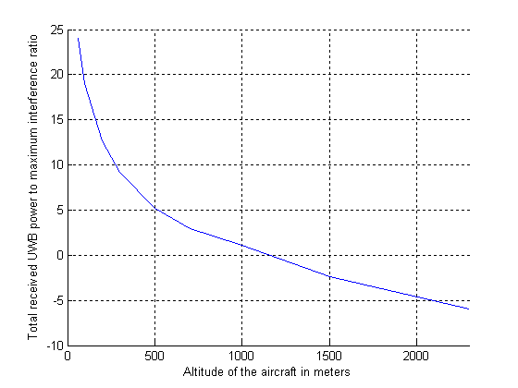  Figure 4: Simulation results for case 1 | 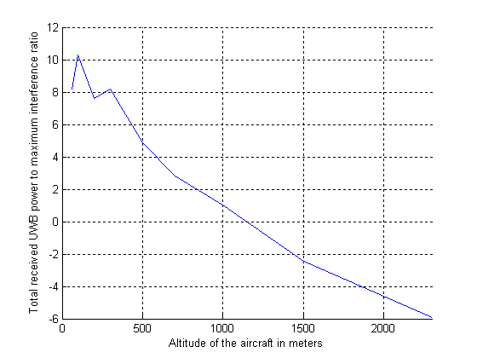  Figure 5: Simulation results for case 2

Analysis of the results:

From the above figures, between 8dB and 22dB of additional isolation is necessary in order to ensure the protection of aeronautical radio-altimeters. This high level of interference is mainly explained by an important UWB power density level.

In the case 1, the simulation shows that when an aircraft flies in the vicinity of a site (i.e. at its vertical) where LAES UWB are in used, there is a risk of interference until the aircraft reaches an altitude of around 800m (supposing that LAES are at the ground level, not at the top of a high building).

In the case 2, a minimum horizontal separation of 150m is considered between the UWB deployment site and the aircraft. Therefore, at very low altitudes (below 100m), the interference decreases significantly. However, at higher altitudes, the deployment site is still in the main beam of the radio-altimeter antenna, and therefore the results are similar to case 1.

Finally, the studies are limited to horizontal aircraft attitudes. However, the aeronautical radio-altimeters shall be able of operating with roll angles of ±40° and pitch angles of ±30°. Accordingly, in more general compatibility studies with UWB, this configuration will have to be considered. Moreover, some recent radio-altimeters have improved characteristics compared to the minimum operational requirement that are used to derive the protection criteria of radio-altimeters. Therefore, it is important to note that the level of interference estimated in the previous simulations may not correspond to the worst case scenario that has to be taken into account to protect the safety system (especially for case 2 for low aircraft altitude).

Conclusion
Based on these studies and the safety of life aspects of radio altimeters, it is proposed to limit the LAES e.i.r.p density in the band 4.2 - 4.4 GHz to -41.3dBm/MHz. Moreover, it is suggested to limit the e.i.r.p density to -47dBm/MHz for elevation angles above 30° and to define appropriate protection zones around airports runway axis. Finally, it is also expected that LAES will be mainly indoor applications. In the case of outdoor usage of LAES devices, the e.i.r.p should be limited to -47.3 dBm/MHz.

It is important to mention that these results consider that any LAES network is TDMA and that there is no contention access in the network (apart from during the initial access to the network), since otherwise the interference level would increase significantly in case of simultaneous transmissions. Note that any equivalent technique that would prevent the aggregation of interference from multiple terminals would also lead to this conclusion.

Coexistence with Fixed Satellite Service (FSS) / Mobile Satellite Service (MSS)
Sections 7.2 and 7.11 in ECC Report 064 [7] provide the results of the compatibility analysis with regard to interference from single UWB emitter with assumed PRF not less than 1 MHz.

This section considers the compatibility between LAES and FSS/MSS.

Assumptions on MSS and FSS for interference analysis
MSS feeder link systems: Feeder Link Earth Station
Antenna gain: 49.2 dBi; System Noise Temp: 71°K; Radiation Pattern: RR Appendix-7 (WRC-07) [6]
Earth Station Elevation angles: 5 deg to 30 deg
FSS earth station systems
The typical characteristics of C band Receive Earth Stations considered in the interference assessment are summarised in the following table. It is recognised here the real system noise temperatures for 4.5m, 3m and 1.8m earth station systems can be different from the values assumed in this report.

Table 8: FSS Earth Station Characteristics in C band
Antenna Diameter (m) | System Noise Temp(°K) | Antenna Rx Gain (dBi) | G/T  (dB/K) | Radiation Pattern
9 | 71 | 49.2 | 30.7 | RR Appendix-7(WRC-07)
6 | 71 | 45.5 | 27.0 | RR Appendix-7(WRC-07)
4.5 | 150 | 43.0 | 21.2 | RR Appendix-7(WRC-07)
3 | 150 | 39.5 | 17.7 | RR Appendix-7(WRC-07)
1.8 | 150 | 35.1 | 13.3 | RR Appendix-8(WRC-07)
1.2 | 120 | 31.5 | 10.7 | RR Appendix-8 (WRC-07)

Earth station antenna height: 12m for 9m dish, 10m for all other antennas. When using the propagation model given in Recommendation ITU-R P.452 [11] instead of the free space model, the antenna height of the 1.8m and 1.2 m dishes is 20m (these small dishes being in top of roofs).
Insertion loss between antenna and receiver input: 2 dB
Shallow log normal fading loss: 2.2 dB

Interference Criteria

The interference criteria based on ITU Recommendations SF.1006 [12], F.1094 [13] and S.1432 [14] are given below for both long term and short term interference criteria.
Table 9: Single Entry Interference Criteria for FSS Earth Stations in C band
Derivation of allowed interference power levels based on Recommendation ITU-R SF.1006
Antenna size | 9 | 6 | 4.5 | 3 | 1.8 | 1.2 | meters
System temp | 71 | 71 | 150 | 150 | 150 | 120 | K
ref BW | 1000 | 1000 | 1000 | 1000 | 1000 | 1000 | kHz
p1 (long term) | 20 | 20 | 20 | 20 | 20 | 20 | %
p2 (short term) | 0.005 | 0.005 | 0.005 | 0.005 | 0.005 | 0.005 | %
n2 ( no of entries) | 3 | 3 | 3 | 3 | 3 | 3
J ( F1094/S1432) | -20 | -20 | -20 | -20 | -20 | -20 | dB
W | 0 | 0 | 0 | 0 | 0 | 0 | dB
Ms | 2 | 2 | 2 | 2 | 2 | 2 | dB
NL | 1 | 1 | 1 | 1 | 1 | 1 | dB
Pr(p) - long term | -140.09 | -140.09 | -136.84 | -136.84 | -136.84 | -137.81 | dBm
Pr(p2) - short term | -121.42 | -121.42 | -118.17 | -118.17 | -118.17 | -119.14 | dBm
p2/n2 - percentage time (short term) | 0.0017 | 0.0017 | 0.0017 | 0.0017 | 0.0017 | 0.0017 | %
I/N long term | -20 | -20 | -20 | -20 | -20 | -20 | dB
I/N short term | -1.33 | -1.33 | -1.33 | -1.33 | -1.33 | -1.33 | dB

Network availability requirements for Earth Stations providing Global Maritime Distress and Safety Services
As per the IMO regulations the complete mobile satellite communication network, including earth stations for the recognized services, is expected to achieve at least 99.9% availability (equivalent to a total of 8.8 hours down time per year).
This is equivalent to 86.7 seconds in 24 hours or 0.733h in any given month.
The overall network consists of the following elements/components comprising the access channel and the radio communication circuits:
– space station;
– feeder-link radio path and service-link radio path under line-of-sight conditions and,
– earth stations (land earth stations (LES), mobile earth stations (MES))

Land Earth Station/ Satellite Access Station is only one of many components and, therefore, the requirement for LES/SAS alone is of the order only few seconds.

LAES assumptions for the study
E.i.r.p. emission level of a single UWB device of LAES application deployed: -21.3 dBm/MHz in frequency band 3.4 - 4.2GHz and – 41.3 dBm/MHz in frequency band 4.5-4.8 GHz.
E.i.r.p. emission level of a single UWB device of LAES application deployed 12 dB building attenuation loss is assumed.
UWB transmitter height: 8m (Note: highest UWB outdoor position, indoor UWB devices can be higher).

Typical interference duration and resulting percentage of time
The typical interference duration and the resulting percentage time of possible interference occurrence to FSS earth station near the vicinity of deployment for each of the UWB specific application are given in Table 10 and Table 11 below.
Table 10: Estimation of interference duration for LAES UWB application for one incident per day
The typical duty cycle factor of a single UWB device | 5%
Typical deployment duration per incident in a day | 2 to 4 hours
Typical duration of operation of UWB device in a day for interference assessment (UWB devices are using a TDMA (or equivalent) access scheme) | (0.05* (2; 4)*3600): 360 to 720 sec
Time percentage of potential interference occurrence to FSS earth station near the vicinity in 24 hours | (360; 720)/(24*3600) i.e.  0.417% to 0.833%  Significantly greater than the allowed short term interference occurrence as well the permissible unavailability figures for MSS feeder link and TT&C earth stations

Table 11: Estimation of interference duration for LAES UWB application for three incidents per month
The typical activity factor of a single UWB device | 5%
Typical deployment duration per incident | 2 to 4 hours
Typical duration of emission of all UWB devices in a network for interference assessment (UWB devices are using a TDMA access scheme) | 0.05*2 or 0.05*4 i.e. 0.1 or 0.2 hour
Time percentage of potential interference occurrence to FSS earth station near the vicinity in one month | 3*0.1/(24*30) i.e.  0.04% or 3*0.2/(24*30) i.e 0.083 %  Greater than the allowed short term interference occurrence as well the permissible unavailability figures for MSS feeder link and TT&C earth stations
Based on CTIF information (see Annex 1), the worst case in cities for fires inside buildings is 0,081 incidents per day per square km (city of Dublin). This would lead to a maximum mean number of 2,41 incidents per month per square km for fires in big European cities. The value of 3 incidents per month is so a maximum and can be seen as a worst case for the time potential interference in one month.

Interference analysis results
The interference analysis results for LAES application are given for long term and short term interference criteria respectively in the attached excel sheet (see Annex 4) when using the free space propagation model. The required separation distances for both types of UWB applications are summarised in Table 12 and Table 13 for long term and short term interference criteria respectively using a free space loss propagation model, except for distances larger than 11 km where the Recommendation ITU-R P.452 [11] model on a flat terrain was used.
For a UWB transmitter height of 2m the results are comparable with the results in this report for 8m height.

Table 12: Required separation distances for short term interference criteria (meters)
 | LAES 3.4 - 4.2GHz -Outdoor (@8m ht)
 | Elevation angle in degrees
Ant size | 5 | 10 | 15 | 20 | 25 | 30
9m | 1511 | 631 | 378 | 263 | 198 | 157
6m | 1538 | 642 | 388 | 270 | 204 | 162
4.5m | 1048 | 439 | 264 | 184 | 139 | 110
3m | 1048 | 439 | 264 | 184 | 139 | 110
1.8m | 3132 | 1310 | 789 | 552 | 414 | 332
1.2m | 2900 | 1652 | 996 | 697 | 527 | 420
LAES 3.4 - 4.2GHz - Indoor with Wall Attenuation of 12 dB (@8m ht)
 | Elevation angle in degrees
Ant size | 5 | 10 | 15 | 20 | 25 | 30
9m | 336 | 136 | 80 | 55 | 41 | 33
6m | 365 | 151 | 90 | 62 | 47 | 37
4.5m | 242 | 99 | 59 | 41 | 30 | 24
3m | 242 | 99 | 59 | 41 | 30 | 24
1.8m | 762 | 318 | 192 | 132 | 100 | 80
1.2m | 726 | 404 | 243 | 168 | 128 | 101
LAES 4.5-4.8 GHz-Outdoor (@8m ht)
 | Elevation angle in degrees
Ant size | 5 | 10 | 5 | 15 | 20 | 25
9m | 60 | 19 | - | - | - | -
6m | 92 | 36 | 21 | 14 | - | -
4.5m | 54 | 20 | 11 | 11 | - | -
3m | 54 | 20 | 11 | 11 | - | -
1.8m | 215 | 88 | 52 | 36 | 27 | 21
1.2m | 244 | 126 | 75 | 52 | 39 | 31
LAES 4.5-4.8 GHz - Indoor with Wall Attenuation of 12 dB (@8m ht)
 | Elevation angle in degrees
Ant size | 5 | 10 | 15 | 20 | 25 | 30
9m | - | - | - | - | - | -
6m | - | - | - | - | - | -
4.5m | - | - | - | - | - | -
3m | - | - | - | - | - | -
1.8m | 30 | - | - | - | - | -
1.2m | 54 | 20 | 11 | - | - | -

Table 13: Required separation distances for long term interference criteria (meters)
 | LAES 3.4 - 4.2GHz - Outdoor (@8mht)
 | Elevation angle in degrees
Ant size | 5 | 10 | 15 | 20 | 25 | 30
9m | 12 300 | 5629 | 3389 | 2364 | 1788 | 1423
6m | 11 300 | 5643 | 3398 | 2371 | 1793 | 1427
4.5m | 9229 | 3877 | 2334 | 1628 | 1231 | 979
3m | 9229 | 3877 | 2334 | 1628 | 1231 | 979
1.8m | 14 200  19 000* | 11368 | 6850 | 4794 | 3595 | 2889
1.2m | 14 200  19 000* | 14327 | 8633 | 6042 | 4531 | 3640
 | LAES 3.4 - 4.2GHz - Indoor with Wall Attenuation of 12 dB (@8m ht)
 | Elevation angle in degrees
Ant size | 5 | 10 | 15 | 20 | 25 | 30
9m | 3323 | 1392 | 837 | 583 | 441 | 350
6m | 3351 | 1405 | 846 | 590 | 446 | 355
4.5m | 2296 | 961 | 579 | 404 | 305 | 243
3m | 2296 | 961 | 579 | 404 | 305 | 253
1.8m | 6772 | 2856 | 1711 | 1194 | 903 | 716
1.2m | 6244 | 3599 | 2169 | 1500 | 1138 | 904
LAES 4.5-4.8 Ghz - Outdoor (@8mht)
 | Elevation angle in degrees
Ant size | 5 | 10 | 15 | 20 | 25 | 30
9m | 987 | 411 | 245 | 170 | 128 | 102
6m | 1015 | 421 | 255 | 177 | 134 | 105
4.5m | 689 | 286 | 173 | 120 | 90 | 71
3m | 689 | 286 | 173 | 120 | 90 | 71
1.8m | 2069 | 868 | 524 | 363 | 275 | 219
1.2m | 2078 | 1193 | 715 | 502 | 379 | 300
LAES 4.5-4.8 GHz - Indoor with Wall Attenuation of 12 dB (@8m ht)
Ant size | Elevation angle in degrees
9m | 202 | 80 | 46 | 31 | 23 | 22
6m | 234 | 96 | 57 | 39 | 29 | 23
4.5m | 150 | 61 | 36 | 24 | 18 | 15
3m | 150 | 61 | 36 | 24 | 18 | 15
1.8m | 494 | 207 | 124 | 85 | 65 | 51
1.2m | 524 | 289 | 174 | 121 | 91 | 72
“*”: The value with an asterisk was obtained with a victim receiver with a 20m height

It has to be noticed that these values are calculated using a free space propagation model. Except from values highlighted in yellow which were calculated using Recommendation ITU-R P.452 propagation model assuming 20 % of time. Additional separation distances based on the P.452 propagation model assuming 20 % of time and different antenna heights have been calculated in Annex 4.

Based on the worst case results, in the 3.4 - 4.2 GHz band, the use of a separation distance equal to 19 km for FSS earth stations with 20m antenna height for protection from LAES potential interferences is sufficient. This distance could be lowered to 15 km for FSS antenna height lower than 8m.

For FSS earth stations in the 4.5-4.8 GHz band a separation distance equal to 2.1 km is required for protection from LAES.

Results from simulations with real terrain data for a typical earth station
Simulations have been performed for a typical earth station of 9 m antenna at 8.69 deg elevation angle using actual terrain data over Netherlands. Recommendation ITU-R P.452 propagation model is used in the simulations assuming a percentage of 20% of the time for the long term and a percentage 0.005% of the time for the short term. Antenna radiation pattern of 32-25log(theta) is assumed in the simulations. The following separation distances are required to meet the long term and short term interference criteria.
Long term interference
- LAES UWB device in outdoor environments: 12300 meters
- LAES UWB device in indoor environments: 2970 meters
Short term interference
- LAES UWB device in outdoor environment: 1753 meters
- LAES UWB device in indoor environment: 361 meters

Discussion of results
For FSS vs. LAES UWB in 3.4 - 4.2GHz frequency band:
- For long term interference criteria, the required separation distances vary from 979 meters to 19 kilometres when a single UWB device is deployed in outdoor environment. The corresponding distances vary from 243 meters to 6772 meters when deployed in indoor environment.
- For short term interference criteria the required separation distances vary from 110 meters to 3132 meters when a single UWB device is deployed in outdoor environment. The required separation distance varies from 24 meters to 762 meters when deployed in indoor environment.
- These separation distances correspond to UWB devices positioned towards the main lobe of the victim FSS Earth station antennas. The reason for adopting this approach is due to the fact at a minimum elevation angle of five degrees this particular condition can happen at all possible azimuth positions, varying from 25 degrees to 335 degrees, of the victim earth station at several latitudes and the relative longitude separations between the GSO satellite and victim earth station.
- As highlighted in section 2.1, LAES will be used in case of emergency situations to provide accurate indoor location and tracking for governmental users such as fire fighters only. In addition, these devices will be used in fixed locations used for training.
- It is noted that a long-term I/N of -20 dB, consistent with the apportionment of 10 dB used for unwanted emissions of systems without any status such as UWB, was considered in the studies. While such a criterion is fully valid when considering generic UWB or licensed free, widely spread devices, which might be operated at any time, Administrations might consider relaxing it up to for instance -10 dB when considering a limited temporal usage of a governmental application for emergency situations. This would reduce the worst case separation distance to 8.2 km.
For FSS vs. LAES UWB in 4.5-4.8 GHz frequency band:
- For long term interference criteria and free space loss propagation model considered the required separation distances vary from 71 meters to 2078 meters when a single UWB device is deployed in outdoor environment. The required separation distance varies from 15 meters to 524 meters when deployed inside the damaged building.
- For short term interference criteria the required separation distances vary from 0 meters to 244 meters when a single UWB device is deployed in outdoor environment. The required separation distance varies from 0 meters to 54 meters when deployed inside the damaged building.

Conclusions for FSS / MSS
There is a potential for interference from LAES applications to C band earth stations for both long term and short term interference criteria - as given in ITU-R Recommendations. Separation distances up to 19 km were calculated for long term criterion in the frequency range 3.4 – 4.2 GHz. In the frequency range 4.5 – 4.8 GHz, the calculated separation ranges are around 2 km.
The separation distances given in table 13 may be used when considering sites where LAES would be operated on a regular basis. It should be noted that these separation distances may be difficult to implement in case of an LAES deployment in an emergency situation.
Therefore, in summary, adequate separations distances/exclusion zones have to be maintained in order to avoid interference into MSS feeder link earth stations as well as registered/notified FSS earth stations from the LAES systems near the vicinity of earth stations operating in the frequency band 3.4 – 4.2 GHz whenever practicable.

Coexistence with FS in 3.4 - 4.2 GHz
The following figure shows the interfering power at a FS antenna with a 3m diameter according to Recommendation ITU-R F.699 [16] (43dBi) produced by an interferer with -41 dBm/MHz e.i.r.p. at 3.4 GHz for a variation of the distance (1-10.000m) and the height offset (10m purple curve and 50m red curve).

Figure 6: Impact of -41 dBm/MHz e.i.r.p. on FS dependent on the height offset (10-50m)

The impact of a 20dB higher power level, in the band 3.4 - 4.2GHz, can be derived from this figure by adding 20dB. For example a 50m height offset results in an I/N of about +10 dB (interfering power of -100dBm/MHz). Table 14 gives additional information on the required separation distance dependent on the protection criterion used (long term I/N -20dB or short term I/N 15dB as given in ECC Report 23 [15]).

Table 14: Calculations for e.i.r.p. of -21.3dBm/MHz
The required separation distance to fulfill the long term protection objective is in the worst case about 200km and for an angular decoupling of 5° about 20km. .

The results for the band 4.4 - 4.8GHz, where LAES have a limit of -41.3 dBm/MHz e.i.r.p., are similar to those given for LT2 in this band (see section 3.4.4). For example a height offset of 10m gives an interfering power of
-108dBm/MHz (I/N +2 dB), if considering the additional free space loss (20log(4.4/3.4)=2dB).

Conclusions
It has to be noted that interferences from LAES applications, being temporary and safety applications, may be considered not severely impacting the Fixed Service applications as far as frequent blocking conditions are avoided. The expected duration of the interference might not short enough to justify a “short-term” protection criteria. Indeed, considering that in average there is 2.3e-4 fires in buildings per square km per day (see statistics in annex 1) and that LAES would be used for 3 hours at the most during an emergency situation, this results in a 0.00283% time ratio (see Annex 1), which is close to 0.0016% and 0.006%, the time ratios considered for short time interference criteria for P-P systems in ECC Report 23 (p16), and so the short term criterion may be applied.

When LAES networks are used in emergency situations close to a FS station, the protection criteria may not be met and this may have an impact on the availability of these stations, but for very limited in time in the frequency ranges (3.4 - 4.2 GHz and 4.4 - 4.8 GHz).
In order to meet the long term objective, separation distances should be implemented:
- For outdoor LAES: about 20 km in the frequency range 3.4 - 4.2 GHz and
- For outdoor: LAES about 2 km in the frequency range 4.4 - 4.8 GHz.
- For indoor LAES: about 7 km in the frequency range 3.4 - 4.2 GHz and
- For indoor LAES: about 500 m in the frequency range 4.4 - 4.8 GHz.
It should be noted that these separation distances may be difficult to implement in case of an LAES deployment in an emergency situation. Considering the fact that LAES are operating on a non interfering and non protected basis, Administrations may need to consider other means to protect existing services in such emergency situations.

Coexistence with MS
2.4.5.1 Coexistence with WIMAX in 3.4 – 3.8 GHz
Tests have been conducted in Ispra in July 2010 applying an increase of 8dB above of the currently authorised mean power (-41.3 dBm/MHz) with a Duty Cycle of 5% (see section LT2 section and Annex 4). It was found during this measurement campaign that as far as UDP throughput and packet loss is concerned, the impact of UWB interference on the WiMAX link remained stable below a SIR of 3 dB, down to ‐24dB. This means that at a distance of 0.5 m between UWB interferer and the WiMAX S Subscriber Station, the UWB maximum mean PSD could be increased up to 8 dB above the currently permitted level of ‐41.3 dBm/MHz without creating any further impairment of the WiMAX systems.

Such a worst case scenario is of course not realistic when considering LAES since in this case the WiMAX terminal would be located in a building in fire. It is expected that when assuming a WiMAX terminal at a greater distance (more than 50 m), the LAES device would not have any impact at all on the WiMAX receiver, in particular if the LAES device is operated indoor allowing for an increase of the e.i.r.p. of 20dB.
2.4.5.2 Coexistence with MS (UAV) 4.4 - 4.8GHz
The necessary separation distances between the UWB-devices and the UAV are derived in the corresponding LT2 section 3.3.6 Case 2.
With an assumed mitigation of 10 dB the protection distance (single interferer) is 58 m for an I/N=-20 dB and 12 m for an I/N= -6dB. Without this assumed 10 dB mitigation the protection distance is above 185 m for an I/N = -20 dB and 37 m for I/N=-6 dB.
These necessary separation distances are higher that the 30 m operating flight level of an UAV.
Taking into account, that rescue forces (military, police and fireman) are using the UAV´s observing the same accident hotspot at the same time within the same frequency range as LAES, this has at least to be coordinated from a local or national authority leading the rescue operation.

Summary LAES
The deployment of LAES is expected to be mainly to indoor.
The use of an e.i.r.p. density of -21.3 dBm/MHz shall be limited to the band 3.4 - 4.2GHz to ensure the protection of aeronautical radio altimeters operating in the frequency range 4.2 – 4.4 GHz.
Separation distances should be applied between receiving FSS Earth stations and sites where LAES would be operated on a regular basis:
- For outdoor LAES:
    - in the frequency range 3.4 - 4.2 GHz, about 20 km from any registered/notified FSS earth stations with small diameter antenna (1.2 m and 1.8 m) and 12.3 km for other registered/notified FSS earth stations and MSS feeder link earth stations;
    - in the frequency range 4.4 - 4.8 GHz, about 2 km from any registered/notified FSS earth stations with small diameter antenna (1.2 m and 1.8 m) and
- For indoor LAES:
    - in the frequency range 3.4 - 4.2 GHz about 7 km from any registered/notified FSS earth stations with small diameter antenna (1.2 m and 1.8 m) and and 3.5 km for other registered/notified FSS earth stations and MSS feeder link earth stations;
    - in the frequency range 4.4 - 4.8 GHz, about 500 m from any registered/notified FSS earth stations with small diameter antenna (1.2 m and 1.8 m).
It should be noted that these separation distances may be difficult to implement in case of LAES deployment in an emergency situation. Considering the fact that LAES are operating on a non-interfering and non-protected basis, Administrations may need to consider other means to protect existing services in such emergency situations.
When LAES networks are used in an emergency situation close to receiving Earth stations the protection criteria for FSS earth stations may not be met and this may have an impact on the availability of these stations, but for very limited in time. Special care should be taken for MSS feeder link earth stations providing safety of life services which have a different sensitivity and for which special measures should be considered.
Alternative mitigation techniques would have to be considered for non-registered/notified stations.
Similarly when LAES networks are used in an emergency situation close to FS stations the protection criteria for FS may not be met and this may have an impact on the availability of these stations, but for very limited in time.
In addition, separation distances up to 20 km should be applied between receiving FS and sites - where LAES would be operated on a regular basis - where LAES devices are used outdoor and around 5 km if the LAES devices are used indoor.
The level of -21.3 dBm/MHz was proposed however based on the results of compatibility studies in the frequency ranges 4.2 GHz to 4.8GHz and 6 GHz to 8,5 GHz a limit of -41.3 dBm/MHz for the maximum mean e.i.r.p. spectral density and 0 dBm for the Maximum peak e.i.r.p. (measured in 50 MHz) is proposed.

In the frequency range 4.2 – 4.4 GHz, in order to protect radio altimeters, it is proposed to limit the LAES e.i.r.p density to -41.3dBm/MHz. Protection will be ensured with the level of -47.3dBm/MHz for outdoor usage and if training sites are not located in the vicinity of airports runways. These conclusions considered that any LAES network is TDMA and that there is no contention access in the network (apart from during the initial access to the network), since otherwise the interference level would increase significantly in case of simultaneous transmissions. Any equivalent technique that would prevent the aggregation of interference from multiple terminals would also lead to the same conclusion.

Table 15: LAES summary
f/GHz | Services/systems | E.i.r.p. density limits.[dBm/MHz] | Additional compatibility requirements
3.4 – 3.8 | FS, MS (WiMAX), FSS | -21.3 | Protection of FS (angular decoupling of 5° to the FS mainbeam assumed) and MS will be ensured for separation distances of:  - Outdoor LAES: about 20 km  - Indoor LAES: about 5 km  Protection of FSS will be ensured for separation distances of:  - Outdoor LAES: about 20 km from any registered/notified FSS earth stations with small diameter antenna (1.2 m and 1.8 m) and 12.3 km for other registered/notified FSS earth stations and MSS feeder link earth stations;  - Indoor LAES: about 7 km from any registered/notified FSS earth stations with small diameter antenna (1.2 m and 1.8 m) and and 3.5 km for other registered/notified FSS earth stations and MSS feeder link earth stations;
3.8 - 4.2 | FS, FSS | -21.3 | Protection of FS (angular decoupling of 5° to the FS mainbeam assumed) will be ensured for separation distances of:  - Outdoor LAES: about 20 km  - Indoor LAES: about 5 km  Protection of FSS will be ensured for separation distances of:  - Outdoor LAES: about 20 km from any registered/notified FSS earth stations with small diameter antenna (1.2 m and 1.8 m) and 12.3 km for other registered/notified FSS earth stations and MSS feeder link earth stations;  - Indoor LAES: about 7 km from any registered/notified FSS earth stations with small diameter antenna (1.2 m and 1.8 m) and and 3.5 km for other registered/notified FSS earth stations and MSS feeder link earth stations;
4.2 - 4.4 | Altimeter | -41.3 | Avoid LAES sites in the vicinity of airports runway (minimum separation distance of 150 m should be considered). Protection will be ensured with the level of -47dBm/MHz for outdoor usage.
4.4 - 4.8 | MS, FS mil , FSS (4.5-4.8) | -41.3 | MS: protection distances with local rescue operation leader or other national authorities are necessary because UAVs are interfered directly at their normal flight level when operating in the same area. Separation distances should be calculated on a case by case basis.  Protection of FS (angular decoupling of 5° to the FS mainbeam assumed) will be ensured for separation distances of:  - Outdoor LAES: about 2 km  - Indoor LAES: about 500 m  Protection of FSS will be ensured for separation distances of:  - Outdoor LAES: about 2 km from any registered/notified FSS earth stations with small diameter antenna (1.2 m and 1.8 m) and  - Indoor LAES: about 500 m from any registered/notified FSS earth stations with small diameter antenna (1.2 m and 1.8 m).

Table 16 : overview of the proposed maximum e.i.r.p. limitations for LAES
Frequency range | Maximum mean e.i.r.p. spectral density | Maximum peak e.i.r.p. (defined in 50 MHz)
Below 1,6 GHz | -90 dBm/MHz | -50 dBm
1,6 GHz to 2,7 GHz | -85 dBm/MHz | -45 dBm
2,7 GHz to 3,4 GHz | -70 dBm/MHz | -36 dBm
3,4 GHz to 4,2 GHz | -21,3 dBm/MHz | 20 dBm
4.2 GHz to 4.8GHz | -41.3 dBm/MHz | 0 dBm
4,8 GHz to 6 GHz | -70 dBm/MHz | -30 dBm

LAES terminals use TDMA, and have a transmitter duty factor of 5% or less in one second.
The long-term duty factor limit in the existing LDC regulations is present to reduce aggregation, but for LAES the use of TDMA and the fact that deployments sparse in time and space mean that such a limit is not needed.

Location Tracking Applications type 2 (LT2) in the frequency bands 3.4 - 4.8 GHz and 6 - 8.5 GHz for person and object tracking and industrial applications

System description
Location Tracking Applications type 2 (LT2) are proposed for the frequency bands 3.4 -4.8 GHz and 6 - 8.5 GHz (indoor only) and are described in ETSI TR 102 495-5 V1.2.1 (2011-02) [16].

LT2 location tracking applications are primarily intended for tracking people and objects in industrial (indoor and outdoor) applications where traditional conventional RF and GNSS solutions are inappropriate, due to insufficient precision in high multipath environments. In LT2 systems, fixed outdoor transmitters will be used.

The deployment sites for such equipment will be managed sites, run by professional users, such as factories, petrochemical facilities, and power stations. The systems will be closed systems, and do not support public access.

An example might be a system operating in the band 3.4 - 4.8 GHz which involves two-way ranging measurements of UWB signals sent between a set of fixed outdoor base stations and a set of mobile units. A system like this might be used for personnel safety applications at an e.g. oil refinery.

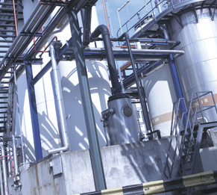
Figure 7: Example of factory where LT2 could be deployed

In a system of this nature, the base station infrastructure is shared between all of the devices being tracked. Therefore, a typical system will ensure that communications from a base station will only take place with one device at any one time, and that each device is only talking to one base station at any one time. This is normally achieved by either time-division multiplexing (in a coordinated network) or statistical multiplexing (by using random access and very short packet durations/duty cycles). In either case, the nature of the shared infrastructure ensures that the number of active devices on the site is very low, and therefore the risk of interference due to aggregation is very low.

Since the single-entry situation is of most interest in interference studies, it is also worth pointing out that the use of UWB systems (as opposed to conventional RF tracking systems) will be preferred in high-multipath environments where tracking accuracy is required even in the presence of substantial obstacles. In open environments, it is likely that lower-cost and longer-range conventional RF or GNSS tracking systems will suffice. Therefore, due to the level of physical obstruction on-site, there will be few line-of-sight paths to victim receivers, and so the likelihood of single-entry interference is low. Furthermore, because fixed outdoor base stations will be deployed to cover areas inside the plant or factory, they will typically be oriented into the area of structure, where the tracking operation will be performed and any signal from them will meet obstruction.

Table 17 gives an overview about the assumed limits. The studies in this report are based on this information and hence only provided for the band 3.4-4.8 GHz. For the band 6 – 8.5 GHz no change to the existing regulation is proposed.

Table 17: Assumed limits
 | Outdoor (note 2) |  |  | Indoor
Frequency
(GHz)
Frequency  (GHz) |  | Present regulation | New regulation requested | Present regulation | Proposed LDC changes for location tracking applications
3.4 < f ≤ 4.8 | Mobile / nomadic | ≤ -41.3 dBm/MHz (note 1) and implementation of LDC (note 3) | ≤ -41.3 dBm/MHz (Note 1) and  DCR – parameters :  - Ton max ≤ 25 ms  - Σ Ton < 5 % per second | ≤ -41.3 (Note 1) and implementation of LDC(note 3) | DCR – parameters :  - Ton max ≤ 25 ms  - Σ Ton < 5 % per second
3.4 < f ≤ 4.8 | Fixed transmitters |  | ≤ -41.3 dBm/MHz (Note 1) and  DCR – parameters :  - Ton max ≤ 25 ms  - Σ Ton < 5 % per second  Note 2 | ≤ -41.3 (Note 1) and implementation of LDC (Note 3) | DCR – parameters :  - Ton max ≤ 25 ms  - Σ Ton < 5 % per second
6 < f ≤ 8.5 | No change request to the existing regulation
NotE 1: Maximum value of mean power spectral density (dBm/MHz e.i.r.p.) and the maximum peak e.i.r.p. (in 50 MHz reference bandwidth), will be limited to 41.3 dB higher than the maximum mean e.i.r.p. spectral density (dBm/MHz).

Note 2: An individual site authorisation / registration for outdoor installation is planned for this applications.

NOTE 3: LDC – parameters (as in ECC/DEC(06)12 [2]):
- Ton max = 5 ms.
- Toff mean ≥ 38 ms (averaged over 1 sec).
- Σ Toff > 950 ms per second.
- Σ Ton < 5 % per second and 0,5 % per hour

Deployment of LT2, reference scenarios for studies
As further described below, in examples 1 and 2, the use of a shared infrastructure tends to minimize the possibility of aggregate interference (which is low anyway in a scenario like that given above, because of the environment and the relatively low number of base station and mobile tags). The environment in which the devices are deployed naturally tends to reduce the possibility of single-entry interference, as does the controlled nature of the deployment. For example, whereas single-entry interference from UWB in the range 3.4-4.8GHz to WiMAX base stations might be a viable interference scenario in generic situations, it will not be a viable interference scenario on controlled sites such as those considered by LT2. The operator of the site will be able to coordinate placement of fixed outdoor base stations and (e.g.) WiMAX base stations so that there is no possibility of interference between the two.

Example 1: personnel tracking
The system measures both the time- and angle-of-arrival of the incoming UWB signal at the receiver, so as to maximise the amount of information gathered from each tag->sensor. To do this, the tag must transmit a 25ms-long signal, which gives the receiver time to acquire the incoming signal and measure its properties. In order to maximise battery lifetime, the tag has an on-board motion-sensing jitter switch which disables the tag when it is stationary, and the tag also has a additional narrowband radio transceiver which disables the device when it is out-of-range of the UWB receiver infrastructure. The system is average-power limited, rather than peak-power limited. Clearly, the activity level of a nomadic tag will depend on a number of factors – what update rate the tag is set to, what fraction of time it spends in motion, and what fraction of time it spends within range of the system. For example, at one end of the spectrum of possibilities, a tag could be set to update twice a second and could be in continuous motion within range of the system – in this case, the potential long-term duty-cycle of the device might be (0.025s*2Hz)=5%, but it is hard to envisage a use-case of this kind. For example, a similar device assigned to an employee for a personnel-tracking application, tracking them twice a second, would be in use approximately 240days/year, 8hrs/day (since the person would only be on-site for this time), and so the activity factor of the device would be scaled by a further fraction of (240/365)*(8/24)=0.22 to around 1%.

The typical duty cycle factor of a single UWB device (tag / nomadic) attached to a personnel tracking location Tracking System (in and outdoor):
- Duty Cycle: 5%/s (Ton: 25ms, two updates/sec)
- Typical deployment duration in a day: average 8h (activity factor of the nomadic tag)
- total duration of operation of UWB device in a day for interference assessment : 0.05*8*3600 = 1440s
- Time percentage of potential interference occurrence in 24 hours: 1.67%
Summary example 1: Personal Tracking

Table 18: Estimation of interference duration from LT2 devices in example 1
The typical duty cycle factor of a single UWB device attached to a fixed outdoor location | 5% / over 8h
Typical deployment duration in a day | 8 hours
Total duration of operation of UWB device in a day for interference assessment | 1440 sec

Example 2: industrial equipment tracking
A more realistic example might be an item of equipment which is used exclusively within an industrial plant, and which is located once every 5s. This item of equipment might be in motion only 5% of the time – the rest of the time it is stationary and the tag’s motion-sensing vibration switch will disable it. The long-term duty-cycle of the device would therefore be ((0.025s*0.2Hz)*0.05)=0.025%. The duty-cycle would be reduced even further, of course, if the equipment was ever taken off-site.

The typical duty cycle factor of a single UWB device (tag / nomadic) attached to a industrial equipment location Tracking System (in and outdoor):
- Worst case Duty Cycle: 2.5%/s (Ton: 25ms, one updates/sec) ,
- Duty Cycle averaged over 5s (one update over 5s) is equal to (25ms/5s)=0.005=0.5%
- Typical deployment duration in a day: average 24h (activity factor of the tag / nomadic)
- total duration of operation of UWB device in a day for interference assessment:
0,005*24*3600 = 432s
Summary example 2: industrial equipment tracking
Table 19: Estimation of interference duration from LT2 devices in example 2
The typical duty cycle factor of a single UWB device attached to a fixed outdoor location  Only 25ms Ton in a period of 5sec | 2.5% / sec  0.5% / 5sec
Typical deployment duration in a day | 8 hours
Total duration of operation of UWB device in a day for interference assessment | 432 sec

Consider the application of ensuring personnel safety in an e.g. oil refinery, given above.
The specific details of a deployment of this nature might be as follows:
- Area of coverage: 500m x 300m
- Number of personnel tracked: 75
- Number of fixed outdoor transmitter base stations: 25
- Characterisation of environment: Dense metal pipework
- Number of location reports per second per person: 1

Based on this deployment assumptions the following overall emissions can occur:
- With all the personnel tracked indoor, the overall emission of such a delpoyment with 5%/sec DC is -39.6 dBm/MHz, since: 10*log10 (25*10^(-41.3/10) + 75*10^(-41.3-12)/10)) + 10*log10(0.05) = -39.6
- Considering that the tracked personnel or tags may be outdoor, a pessimistic overall emission of such a deployment with 5%/sec DC is -34.3 dBm/MHz=10*log10 (100*10^(-41.3/10)) + 10*log10(0.05).

Example 3: Example of LT2 with TDMA
A system may use a slotted TDMA protocol, to minimise the “hidden terminal” problem. Such a system has fixed transceivers that never transmit in the same slot as one another. If mobile terminals choose the same slot their transmissions will both be wasted, so the system has to be designed to make sure this rarely happens. Such clashes can only happen for mobile terminals, and only where one (or both) of those terminals is well screened, and so equivalent to an indoor UWB terminal. Such a design also imposes a strict limit on the number of terminals (specifically, on those that transmit), equal to the number of slots. Thus aggregation within such a system is prevented, and a single-entry calculation is all that is required. Note that there may also be entirely passive mobile terminals, but these need not be considered in the studies.

A typical case has 40 slots of 25 ms in a second, and each terminal uses one slot per second, and occasionally a second slot as well.

Studies

WIMAX 3.4 to 3.8 GHz
Impact of the longer Ton- time:
The impact of a changed Ton time to max values of up to 25ms, which is requested for LT2 tags, was investigated by a measurement campaign. A summary of this study is provided in the next section.
The results indicated that a max Ton time of 25ms has less impact on WiMAX as 5ms, which is the current limit for LDC in ECC/DEC/(06)12 [2].

Fixed outdoor vs WiMAX:
The deployments of LT2 will occur at controlled sites operated by professional users, and therefore some scenarios considered in ECC Report 94 (e.g. placement of a UWB base station within a very short distance of a WiMAX terminal) will not occur. Report 94 considered only spacings up to 4 m, and detected no measurable interference in any mode at 4 m. The distance between an LT2 terminal and a mobile terminal outside the site will be greater than this. ECC Report 120 calculated a theoretical protection distance of 35 m, and this can be used for LT2 as the range within which to look for possible mobile service receivers.

Measurement campaign
In order to investigate the impact of max Ton time of 25ms versus 5ms on WiMAX systems, measurements were conducted in ISPRA. The campaign aimed at determining the impact of UWB LDC signals on different types of services provided by a Mobile WiMAX (IEEE802.16e-2005) victim system, and in particular to examine LDC pulses with a width of more than 5 ms, whilst maintaining an overall activity limit of 5%, equaling 50 ms per second.

The measurements setup and the results are provided in Annex 5.

The main findings of this measurement campaign were:

- LDC can significantly reduce harmful interference from UWB to a Mobile WiMAX link
- UWB LDC schemes with pulse durations > 5 ms cause less interference to Mobile WiMAX services (data, voice video) than those with pulse durations ≤ 5 ms* that are permitted by current European spectrum regulation
- UWB interference negatively affects the QoS of Mobile WiMAX from a SIR of 4 dB ± 1 dB onwards, independent of the type of UWB signal (MB-OFDM or pulsed TH-UWB). With further decreasing SIR the QoS degradation remains relatively constant, particularly for longer pulses.
- From a LOS distance of 6 meters on (worst case observed) the impact of UWB on the QoS of a mobile WiMAX system is negligible

Summary WIMAX

The available studies for Wimax don’t identify any problem with the proposed regulation for LT2. The impact of LT2 on other Mobile Systems (e.g. LTE) was not considered in this report.

FSS / MSS – LT2 outdoor
Sections 7.2 and 7.11 in ECC Report 064 [7] provide the results of the compatibility analysis with regard to interference from single UWB emitter with assumed PRF not less than 1 MHz. This section considers the compatibility between LT2 and FSS/MSS based on the considerations given in 2.4.2 (addressing the compatibility between LAES and FSS/MSS).

Assumptions for interference analysis
The same assumptions as given in section 2.4.2.1 are considered for the characteristics of MSS and FSS.

Typical interference duration and resulting percentage of time
The typical interference duration as per the current document and the resulting percentage time of possible interference occurrence to FSS earth station near the vicinity of deployment for each of the UWB specific application are given in section 3.3.2.3.

Activity factor assumption Location Tracking Application Type 2 (LT2) to FSS
Table 20: Estimation of interference duration from LT2 devices in example 1
Time percentage of potential interference occurrence to FSS earth station near the vicinity in 24 hours  Significantly greater than the allowed short term interference occurrence and comparable to the allowed long term interference occurrence (1,67%/0,005% = 334) (see Table 9) | 1440/(24*3600) i.e.  1.67%

Table 21: Estimation of interference duration from LT2 devices in example 2
Time percentage of potential interference occurrence to FSS earth station near the vicinity in 24 hours  Significantly greater than the allowed short term interference occurrence and comparable to the allowed long term interference occurrence (0.5%/0,005% = 100) (see Table 9) | 432/(24*3600) i.e.  0.5%

e.i.r.p. emission levels of a single UWB device and other assumptions
e.i.r.p. emission level of a single UWB device of LT2 application deployed: - 41.3 dBm/MHz;
e.i.r.p. emission level of a single UWB device of LT2 application deployed a 12 dB building attenuation loss is assumed;
UWB transmitter height: 8m (base stations)
UWB transmitter height: 2m (nomadic/tags)
Earth station antenna height: 10m
Insertion loss between antenna and receiver input: 2 dB
Shallow log normal fading loss: 2.2 dB
It is to be noted that some of the above assumptions are identical to those used in FSS studies of ECC Report 064.

Interference analysis results
The required separation distances for LT2 applications are summarised in Tables 22 and 23 for long term and short term interference criteria respectively. Details are given in Annex 4.
Table 22: Required separation distances for long term interference criteria (meters)
LT-2 Fixed Installation Outdoor (@8m ht)
 | Elevation angle in degrees
Ant size | 5 | 10 | 15 | 20 | 25 | 30
9m | 1288 | 537 | 322 | 223 | 168 | 134
6m | 1315 | 551 | 331 | 231 | 174 | 138
4.5m | 897 | 375 | 225 | 156 | 118 | 94
3m | 897 | 375 | 225 | 156 | 118 | 94
1.8m | 2665 | 1124 | 677 | 473 | 355 | 282
1.2m | 2480 | 1416 | 853 | 597 | 448 | 360
LT-2 Fixed Installation Outdoor (@2m ht)
 | Elevation angle in degrees
Ant size | 5 | 10 | 15 | 20 | 25 | 30
9m | 1201 | 493 | 292 | 201 | 150 | 119
6m | 1230 | 508 | 302 | 209 | 157 | 124
4.5m | 810 | 331 | 195 | 134 | 100 | 79
3m | 810 | 331 | 195 | 134 | 100 | 79
1.8m | 2604 | 1086 | 647 | 452 | 339 | 269
1.2m | 2490 | 1368 | 824 | 570 | 433 | 344
LT-2 Indoor (@8mht)
 | Elevation angle in degrees
Ant size | 5 | 10 | 15 | 20 | 25 | 30
9m | 280 | 113 | 66 | 45 | 33 | 28
6m | 309 | 128 | 76 | 52 | 39 | 31
4.5m | 203 | 83 | 49 | 34 | 25 | 20
3m | 203 | 83 | 49 | 34 | 25 | 20
1.8m | 654 | 270 | 162 | 112 | 85 | 68
1.2m | 624 | 344 | 207 | 143 | 109 | 86
LT-2 Indoor (@2mht)
 | Elevation angle in degrees
Ant size | 5 | 10 | 15 | 20 | 25 | 30
9m | 185 | 63 | 29 | 27 | 27 | 27
6m | 218 | 81 | 44 | 27 | 27 | 27
4.5m | 107 | 31 | 18 | 18 | 18 | 18
3m | 107 | 31 | 18 | 18 | 18 | 18
1.8m | 563 | 227 | 132 | 90 | 66 | 52
1.2m | 625 | 303 | 178 | 122 | 90 | 71

Table 23: Required separation distances for short term interference criteria (meters)
LT-2 Fixed Installation Outdoor (@8m ht)
 | Elevation angle in degrees
Ant size | 5 | 10 | 15 | 20 | 25 | 30
9m | 96 | 35 | 18 | 13 | 13 | 13
6m | 128 | 51 | 30 | 20 | 15 | 13
4.5m | 78 | 30 | 17 | 11 | - | -
3m | 78 | 30 | 17 | 11 | - | -
1.8m | 287 | 118 | 70 | 49 | 36 | 29
1.2m | 289 | 152 | 91 | 63 | 48 | 37
LT-2 Fixed Installation Outdoor (@2m ht)
 | Elevation angle in degrees
9m | - | - | - | - | - | -
6m | - | - | - | - | - | -
4.5m | - | - | - | - | - | -
3m | - | - | - | - | - | -
1.8m | 194 | 71 | 37 | 22 | 17 | 17
1.2m | 278 | 107 | 60 | 39 | 27 | 22
LT-2 Fixed Installation Indoor (@8m ht)
 | Elevation angle in degrees
9m | - | - | - | - | - | -
6m | - | - | - | - | - | -
4.5m | - | - | - | - | - | -
3m | - | - | - | - | - | -
1.8m | 49 | 18 | - | - | - | -
1.2m | 70 | 27 | 15 | - | - | -
LT-2 Fixed Installation Indoor (@2m ht)
 | Elevation angle in degrees
Ant size | 5 | 10 | 15 | 20 | 25 | 30
9m | - | - | - | - | - | -
6m | - | - | - | - | - | -
4.5m | - | - | - | - | - | -
3m | - | - | - | - | - | -
1.8m | - | - | - | - | - | -
1.2m | - | - | - | - | - | -

Results from simulations with real terrain data for a typical earth station
Simulations have been performed for a typical earth station with 9 m antenna diameter at 8.69 deg. elevation angle using actual terrain data over Netherlands. ITU-R Recommendation P.452 propagation model is used in the simulations. Antenna radiation pattern of 32-25log(theta) is assumed in the simulations. The following separation distances are required to meet the long term and short term interference criteria. Using the free space model, the results will be very similar considering the small calculated distances.
Long term interference
LT2 UWB device in a fixed outdoor environments: 1370 meters (UWB in 8meters)
Short term interference
LT2 UWB device in a fixed outdoor environment: 102 meters (UWB in 8meters)

Discussion of results
For long term interference criteria the required separation distances vary from 67 meters to 2665 meters when a single UWB device is deployed in fixed outdoor installation environment. For short term interference criteria a minimum separation distance of about 96 meters is required for large antenna dishes at low elevation angles. For smaller antenna dishes a minimum separation distance of around 290 meters is required at low elevation angles.
As the duration for which potential interference that can occur to the earth station receivers from a single UWB device attached to a fixed outdoor installation is significantly greater than 0.0017% of the time, the minimum separation distances corresponding to long term interference criteria have to be ensured to protect the MSS feeder link earth station and ITU notified FSS earth station sites.

Conclusions for the FSS / MSS
The analysis presented in this report shows that there is a significant potential for interference from UWB specific applications to C band earth stations for both long term and short term interference criteria.
The minimum separation distances corresponding to long term interference criteria have to be maintained for interference from LT2 type UWB specific applications.
Within Annex 3 the aggregated impact of LT2 is provided and shows that this maybe no issue due to the DC and low deployment.
Therefore, adequate separations distances/exclusion zones up to 2.6 km should be maintained in order to avoid interference from LT2 installations into MSS feeder link and FSS earth stations operating in the frequency band 3.4 – 4.2 GHz.

Radio altimeters studies
According to the ECC Report 064, it is considered that in average a low percentage of outdoor mobile UWB applications could operate under certain conditions without impacting aeronautical radio-altimeters.

However, the ECC Report 064 also concludes that in the scenario of a single UWB entry located outside interfering with an aeronautical radio altimeter, the UWB maximum mean e.i.r.p density should be limited to -47.3 dBm/MHz for a separation distance of 50m.

Therefore, if it is expected that the proliferation of LT2 outdoor application would remain limited, there is still some concerns on the possible impact of important concentration of outdoor devices (mobile and fixed) on aeronautical radio-altimeters in some areas (i.e. close to airports, in low altitude training areas, …).

Simulation of the impact of aggregation and multiple LT2 on radio-altimeters
The characteristics and protection criteria of the radio-altimeters are given in section 2.4.1.

The scenario is presented in the following figure:
* LT2 fixed outdoor base station
o Radio-altimeter position
It corresponds to an application of ensuring personnel safety in an e.g. oil refinery given in the above section 3.2:
- Area of coverage: 500m x 300m
- Number of personnel tracked (tags): 75
- Number of fixed outdoor base stations: 25

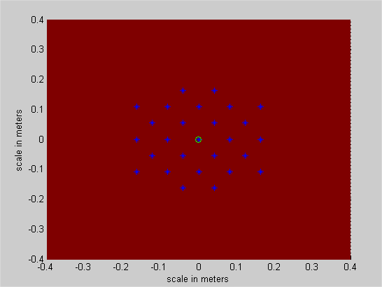
Figure 8: LT2 aggregate scenario – Aircraft above from the LT2 deployment site

In the case the above deployment would be based on TDMA networks, then, the following results should be understood the deployment of 5 adjoining networks. These networks would be around 200 m apart. In any one of these networks, it would not be possible to have simultaneous transmissions from terminals (fixed or mobile).

If there is no mitigation technique applied, the aggregated interference level can be up to 8dB above the protection level of radio-altimeters used in the ECC Report 064.

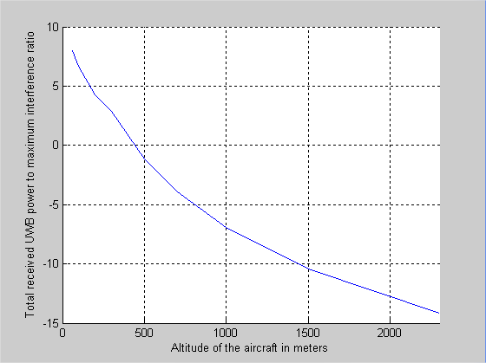
Figure 9: Simulation with 25BS + 75 UE, 5% DC

Therefore it is suggested to impose 6dB antenna gain attenuation for LT2 fixed stations for elevation angles higher than 30° (i.e. the maximum mean e.i.r.p. spectral density for emissions that appear 30° or greater above the horizontal plane shall be less than -47.3 dBm/MHz). However, according to the following simulation (see figure 10), the aggregated interference level can still be up to 7 dB above the protection level of radio-altimeters. However, the impact should not be sensitive for aircraft altitudes higher than about 400m. Considering a landing slope of 3.5%, aircrafts can have an altitude of 400m at 11.4km from the runway threshold. When considering runways of 3.5km for large airports, the potential area of interference around an airport can be rounded to 13.2km. This area is referred as “sensitive area” in the following paragraph in which coordination with local civil aviation authorities would be recommended since interference to radio-altimeters could occur.

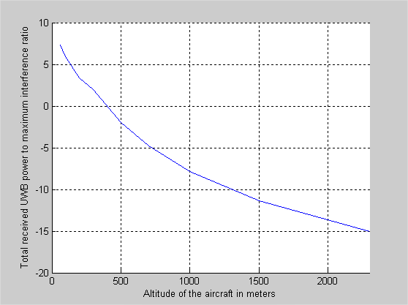
Figure 10: Simulation with 25BS with 6dB antenna gain attenuation + 75 UE

An additional mitigation technique for the tag outdoor use would be needed in order to protect aeronautical systems especially around airports. If a mid term duty cycle of 0.5% per minute in addition to the DC of 5%/s for the tags in airport areas is implemented, then, there will be a need to identify sensitive zones around airports with a radius up to 6.4km (to be compared with 11.4km without the mid term limit).

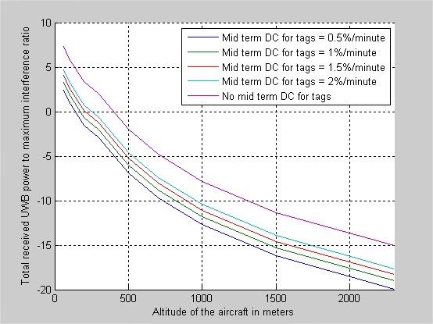
Figure 11: Simulation with 25BS with 6dB antenna gain attenuation + 75 UE with different mid term
DC limits

However, it is important to note that in the case of larger area of LT2 coverage, the sensitive zones located around airports would be impossible to define if no mid or long term DC limit is applied. Indeed, since aircrafts can fly in many areas (and not only around airports) at an height of 500m above the ground while results of simulations in figure 12 show that they could suffer from interference for higher altitudes (e.g. up to 1250m for a LT2 covered area of 1.5km²). Therefore a systematic mitigation technique would be necessary. A systematic mid-term duty cycle for tag outdoor use of 0.5% to 1.5% per minute in addition to the DC of 5%/s would be a solution to enable that definition of sensitive zone located around airports (see Figure 12).

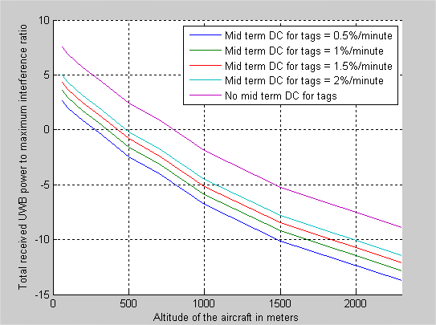
Figure 12: Simulation with 100 BS with 6dB antenna gain attenuation + 300 UE with different mid term DC limits (covered area of 1.5km²)

If it is proposed to keep a mid-term DC limit for tags of 1.5% per minutes on top of a 6dB antenna gain attenuation for elevation angles higher than 30 degrees, then no additional mitigation technique would be necessary outside an area of between 8.4 and 13.2km radius around airport runways (depending on the number of equipment (UE+BS) deployed, i.e. 100 and 400 respectively). Inside this sensitive area of 8.4 to 13.2km radius around airport runways, deployments of LT2 base stations and associated tags should be subject to power limitation to 47.3dBm/MHz in addition to the previous mitigation techniques.

Since only one site of LT2 deployment has been considered, an additional simulation has been performed to check the impact of multiple LT2 deployment site.

The proposed scenario is presented in the following figure:
* LT2 fixed outdoor base station
o Radio-altimeter position (located at 1km from the LT2 deployment site)

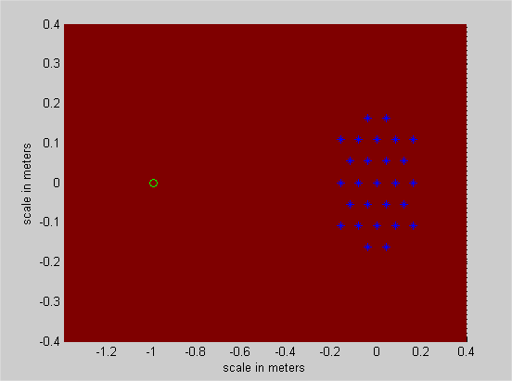
Figure 13: LT2 aggregate scenario – Aircraft at 1km from the LT2 deployment site

The results show that the interference of a LT2 distant of 1km in the horizontal plan should not contribute significantly to the total aggregated noise level. Therefore, it must be recommended that LT2 sites are sufficiently separated (i.e. around 1 km) since otherwise their aggregated impact on radio-altimeters could become sensitive.

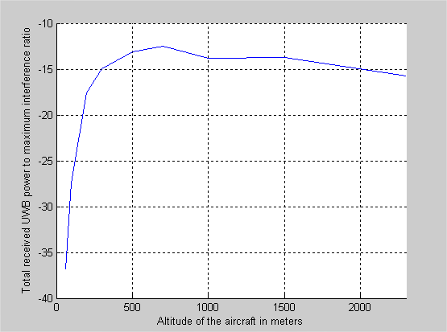
Figure 14: Simulation with 25BS + 75 UE, 5% DC

Conclusions on the aggregated impact of LT2 on radio-altimeters
According to the previous studies, it should be proposed:
- for fixed outdoor stations:
  - to limit the maximum mean e.i.r.p. spectral density to -41.3dBm/MHz
  - to limit the maximum mean e.i.r.p. spectral density for emissions that appear 30° or greater above the horizontal plane to -47.3 dBm/MHz
    - Under a procedure of registration and coordination (see ECC report 167 [ref]), this limitation may be limited to area up to:
      - 8.4 km radius from airport runways, heliports, or low altitude flying areas (300 m) if there are up to 25 fixed outdoor stations
      - 13.2 km radius from airport runways, heliports, or low altitude flying areas (460 m) if there are 100 fixed outdoor stations
  - To apply an LDC mitigation technique with
    - Ton max = 25 ms
    - Σ Toff > 950 ms per second
    - Σ Ton < 18 s per hour (recommended)
- for mobile tags:
  - to limit the maximum mean e.i.r.p. spectral density to -41.3dBm/MHz
  - To apply an LDC mitigation technique with
    - Ton max = 25 ms
    - Σ Toff > 950 ms per second
    - Σ Ton < 0.9 s per minute
- In the case of deployment in airport areas or around airports , to limit the maximum mean e.i.r.p. spectral density to -47.3dBm/MHz. The size of these sensitive areas depends on the number of LT2 devices deployed:
    - Up to 8.4km radius from airport runways, heliport, or low altitude flying areas (300 m) if there are up to 100 LT2 devices (fixed antennas and mobile tags)
    - Up to 13.2km radius from airport runways, heliport, or low altitude flying areas (460 m) if there are 400 LT2 devices (fixed antennas and mobile tags)

In addition, it should be proposed:
- In any case, the activity factor should be minimized (e.g. if there is almost no motion of the tag which is tracked).

The registration of the LT2 systems should facilitate actions under the control of the national administration to mitigate the potential risks of interference. Therefore, the deployment of LT2 systems should be subject to a form of authorisation and in some cases coordination in order to avoid problems that may arise.
Finally, DAA is not envisaged for LT2 applications and therefore it has not be retained as a mitigation technique to protect aeronautical systems.

FS studies
Aggregation effects are expected to be unlikely due to the deployment density and environment, and therefore interferences from single-entry or a hot spot is likely to be the dominant interference scenario with respect to FS. The focus in this section is given to these scenarios. However, Annex 3 shows some idea about the aggregation effects.

Fixed Service characteristics
The following data was considered in the studies in band 4.4 -4.8 GHz.

Fixed Service (fixed installation):

Technical parameters:
Gain of antennas: ~ 40 dBi (conventional antenna pattern)
heights of antennas: 30 m to 60 m
link distance : 10 to 40 km.
Feeder Loss: 0 dB (RF-part close to antenna)
Transmit Power: ~ 0-30 dBm
Bandwidth: 7 to 56 MHz
S/Nmin 6 dB
Availability: 99,99%
BER: 10⁻⁶ (for transmission of data)
According to ITU-R Rec. F. 1094-2 [13] a degradation in performance of 1% is assumed to be tolerable.

Fixed Service (portable/moveable):

The technical parameters are comparable to 1. with the difference, that the transceiver stations are transportable and not stationary.
At the area of operation the stations are used fixed and directed to each other. This systems are used to install temporary links, wherever they are needed (along streets, in towns,…).

Technical parameters:
Gain of antennas: ~ 40 dBi (conventional antenna pattern)
heights of antennas: 12 to 40 m
link distance : 5 to 20 km.
Feeder Loss: 0 dB (RF-part close to antenna)
Transmit Power: ~ 0-30 dBm
Bandwidth: 7 to 56 MHz
S/Nmin 6 dB
Availability: 99,99%
BER: 10⁻⁶ (for transmission of data)
According to ITU-R Rec. F. 1094-2 a degradation in performance of 1% is assumed to be tolerable.

Single entry scenario - PP Fixed Service
The following function is used and contains the technical parameters of some of the calculations in this section: Ivict(e.i.r.p., δg, Y0, h, i, j, D)

The parameters are:
- e.i.r.p. max: Mean e.i.r.p. in dBm/MHz
  - -41 dBm/MHz e.i.r.p. and -47 for elevations >30°
  - -51 dBm/MHz e.i.r.p. and -47 for elevations >30°
- δg: Deviation angle in regards to road axis (0°)
- y0: Distance to the victim of the first car on the y axis (0 m)
- h: Antenna height offset(difference between Victim antenna and UWB height)
- i: running variable in x direction
- j: running variable in y direction (not relevant here, because just one line of interferer is considered; j=1 is used)
- D: Antenna diameter of the FS receiver (pattern calculated based on Recommendation ITU-R F.699 [17]; 3m=41dBi)
- LOS propagation

Figure 15 shows the I/N ratio at a FS receiver with a noise floor of -110 dBm/MHz dependent of the height offset for a single LT2 transmitter with -41 and -51 dBm/MHz max e.i.r.p. and -7 dBi antenna gain for elevation angles >30°. Figure 16 gives the same results for an isotropic LT2 antenna.

Figure 15 : LT2(-6dBi >30° elevation) ; height variation (15-50m) and -41 (left) and -51 (10dB mitigation)

Figure 16 : LT2 (0 dBi antenna) ; height variation (15-50m) and -41 (left) and -51 (10dB mitigation)

It can be seen that the antenna restriction for elevation >30° has no impact on the results for the critical distances.

Figure 17 : LT2, -6dBi >30° elevation ; height offset variation (0m, 0.1m, 1m, 2m, 5m) and -51 dBm/MHz
(10dB mitigation)

Results:
- The reduction of the emissions in elevation >30° gives no essential improvement of the compatibility situation;
- an I/N of -6 dB is fulfilled for an height offset between the FS antenna mainbeam and the UWB transmitter of 50m or for a horizontal separation distance of 3 km
- an I/N of -20 dB can not be fulfilled with a height offset; here a separation of 20km is required.
- Assuming a 10 dB mitigation for LT2, then the long term protection objective of -20dB is fulfilled for a height offsets of >=50m (or a separation distance of 5km) and an I/N of -6dB is fulfilled up to a height offset of 15m (or a separation distance of 1km).
- Even with an assumed 10 dB mitigation for height offsets of less than 5m, the I/N can reach huge values (e.g. at 10m distance in the mainbeam about 30dB) ; however, this is even for fixed LT2 assumed to be irrelevant due to typicals FS antenna heights of about 50m and LT2 heights of about 10m ; one possibility to avoid mainbeam coupling the installation height of LT2 could be restricted (e.g. <=10m)
- In the Band 4.4-4.8 GHz moveable FS antennas with antenna heights of 12m are used. For these antennas low heights offsets are possible. There, the I/N can indeed reach high values.

3.3.4.3 Mitigation due to Peak power reduction

BER degradation from a single LT2
Discussion with the Fixed Service community suggests that a limitation of peak power may be effective in providing coexistence of LT2 fixed outdoor transmitters and FS in single-entry scenarios.
Annex 2 contains simulations which investigate the impact of a LT2 signal on a QPSK signal. Table 24 gives the results for an I/N of -3dB
Table 24: Results LT2 with 5% Duty cycle, -41.3 dBm/MHz mean power and different peak power values
Peak power dBm/50MHz | FS antenna height above ground (or height difference between LT2 antenna and FS antenna) | Degradation at a BER 10^-6 | Degradation at a BER 10^-4
0 | 20m | >10dB | 1dB
-5 | 20m | 7dB | 4dB
-10 | 20m | 4dB | 3dB
-15 | 20m | 1.5dB | 0.5dB
-15 | 40m | 0.2dB | <0.1dB
-15 | 60m | <0.1dB | <<0.1dB

Measurements at 26 GHz: ECC Report 158 [18] contains results of a measurement campaign which investigates the impact of 26 GHz SRR on the Fixed Service. In this study the impact on the BER of a FS system dependent on a combination of mean and peak power values is shown. Table 25 gives a summary of these results.

Table 25: summary of the measurement campaign given in ECC Report 158
 | Both +5dB | Compliant mode | peak -10dB | Mean -10dB | -10dB
Mean power dBm/MHz e.i.r.p. | -36 | -41 | -41 | -51 | -51
Peak power dBm/50MHz e.i.r.p. | +5 | 0 | -10 | 0 | -10
Reference BER | 3e-6/3e-5
1000m | 2e-3 | 4e-4 | 6e-5 | 5e-5 | 5e-5
750m |  | 3e-4
500m |  | 1e-4

It can be seen that with the combination -41/0 the BER is 4*10⁻⁴, while for -41/-10 and -51/0 the BER is about a factor of 10 less.

These results above suggest that a 10dB reduction of the peak power may be equivalent to a 10dB reduction of the mean power. This would mean that a 10dB reduction of the peak power could be seen as 10dB mitigation factor for the studies, which are all based on the mean power. However such an assumption was put into question, therefore measurements were carried out in March 2011, as next subsection details.

Additional measurements in 2011

The main goal of this measurement campaign was to investigate the impact of the reduction of the peak power on the BER of radio systems.

There is no clear positive or negative effect visible out of these measurements.

It seems that UMTS and DVB-S systems are robust against high peak/mean ratios by itself.
The worst case (the biggest impact) for UMTS and DVB-S are AWGN signals (peak/50Mhz to mean/1MHz ratio of about 23dB), the best cases (the lowest impact) the signals with the highest peak to mean ratios (e.g. 48dB).

The DVB-T results didn’t show any difference in the impact of the test signals.

The WLAN measurements are confirming a kind of helpful effect due to a peak power reduction. The worst case is the 48dB signal (e.g. 0dBm/50MHz peak, -48dBm/MHz rms) and the best case the AWGN-like signals.

The rationale behind these diverging results is not totally clear but the modulation (e.g. spreading gain of CDMA) and the involved error correction are assumed to play a major role here.

The results of the 26 GHz measurement campaign from ECC Report 158 [18], which shows a mitigation due to a peak power reduction, were derived without any error corrections. The Matlab simulations provided in ECC Report 158 also not considers any error corrections.

Conclusions

A 10dB peak power reduction (-41dBm/MHz mean e.i.r.p. and -10dBm/50MHz peak e.i.r.p.) may able to reduce the impact on the radio systems, but not in all cases
- For measurements with UMTS, DVB-T and DVB-S there is no mitigation visible.
- For WLAN there is an small positive effect possible
- The positive impact of the peak power reduction on the FS shown in ECC Report 158 (measurements and simulations) and in Annex 2 could be explained with the not considered error corrections there. If the error corrections would have been considered in these studies the impact of the peak power reduction could be less as expected there, but the overall impact of UWB on the FS could be less.

3.3.4.4 Hot spot scenario - PP Fixed Service

The impact of a LT2 hot spot deployment with a overall emission level of -34.3 dBm/MHz as described in section 3.2 upon FS links is investigated here.

A protection criterion of I/N = -10 dB is considered in the interference calculations. Characteristics of typical military FS links are summarized Table below.
Table 26: FS links characteristics
Characteristics | Unit | FS link 1 | FS link 2 | FS link 3 | FS link 4
Operating frequency | MHz | 4500 | 4500 | 4500 | 4500
Bandwidth (IF) | MHz | 28 | 8 | 0,5 | 23
Thermal noise | dBm | -96 | -103 | -114,4 | -99
Ga in the main beam | dBi | 42,5 | 41 | 37 | 44,3
I/N protection criterion | dB | -10 | -10 | -10 | -10
Max interference level  at receiver input | dBm | -106 | -113 | -124,4 | -109
Max interference level  at receiver input | dBm/MHz | -120,5 | -122 | -121,4 | -122,6

The antenna pattern can be derived from ITU-R Recommendation F.699 [17].

The scenario considered here is a “hot spot” where a dense metal pipework is installed nearby a FS link as Figure 18 illustrates. The distance R between the FS link receiver as well as the angle theta between the FS main beam and the hot spot are varying parameters in the Matlab calculations. The FS antenna height is set to 5m and the hot spot at 2m.
Figure 18: FS vs Hot spot scenario configuration
Hot spot -34.3 dBm/MHz
Victim receiver

Theta

Distance R

FS link

The resulting emission levels in the FS receiver from the LT2 hot spot considering various offset angles are shown in Figure 19 below. Only links 2 and 4 are represented since links 1 and 3 give curves located between these two.

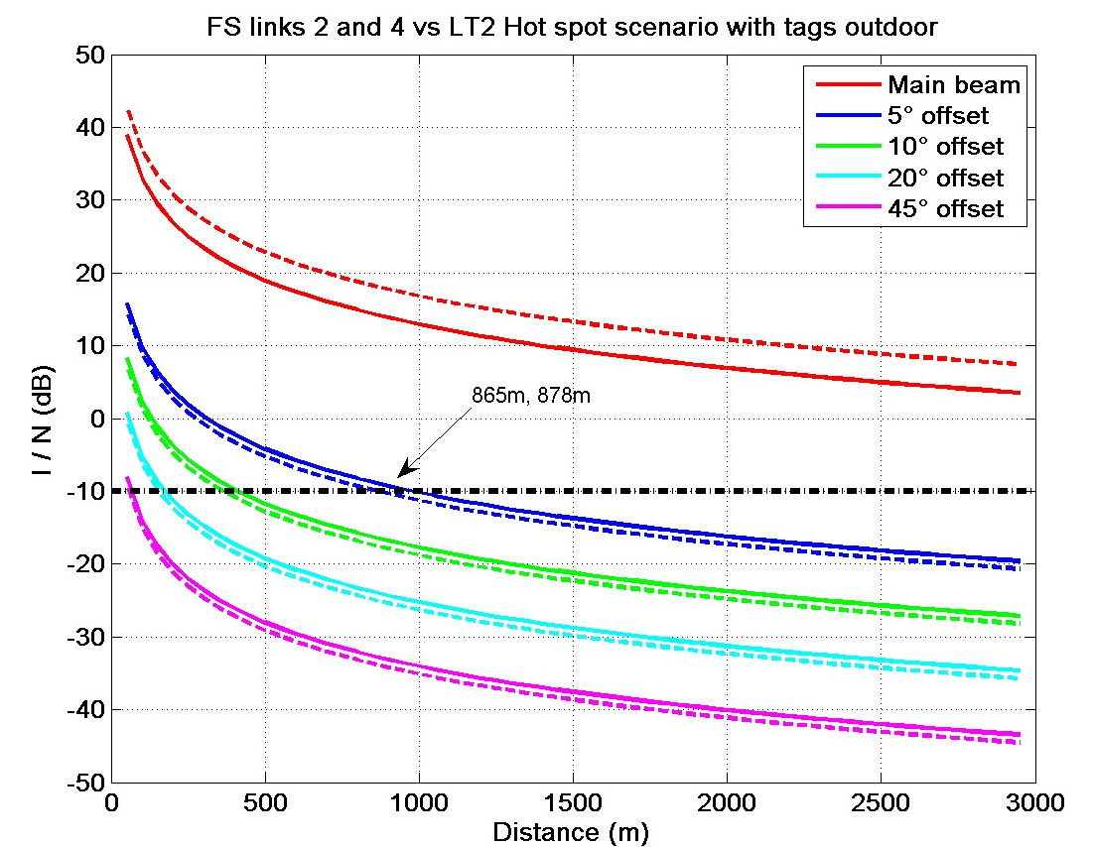 | 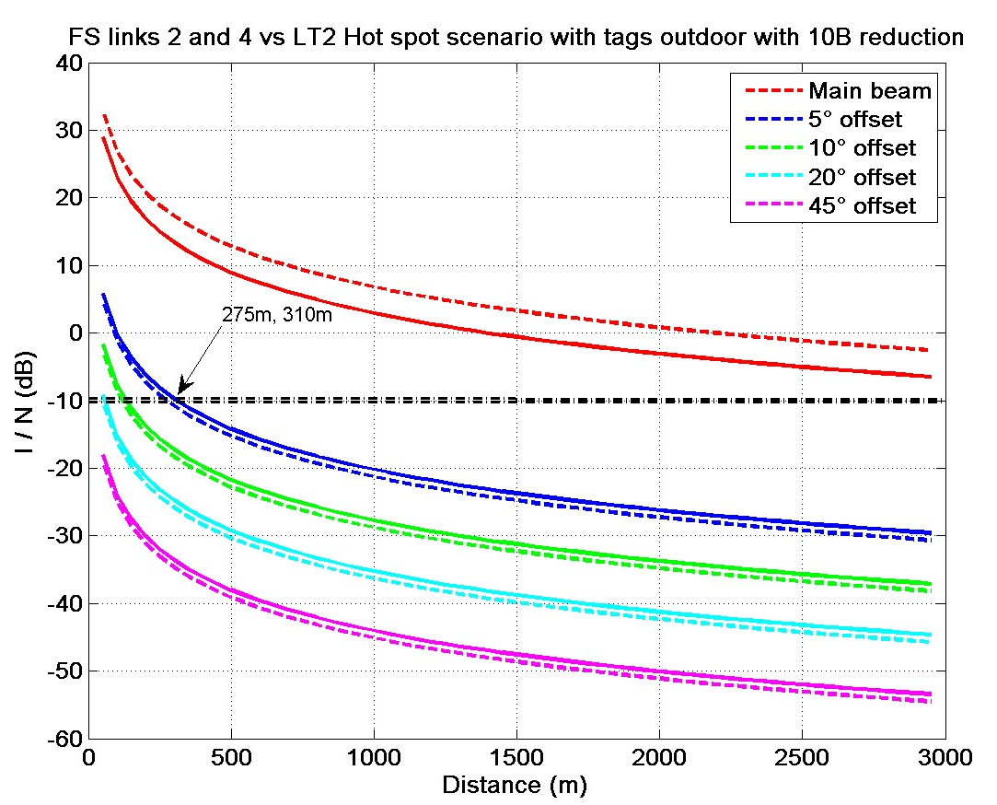
Figure 19: I/N levels versus distance for various offset angles (theta) from main beam for the FS link 2 (plain line) and 4 (dashed line) without mitigation technique (top) and with 10 dB mitigation technique (bottom)

The required protection distances are more than 10km in the FS main beam and 870m at 5° offset angle.

With an I/N of -20dB the protection distance will be 2.8 km at 5° offset angle.

With additional 10 dB mitigation the protection distances are less than 7km in the FS main beam and 300m at 5° offset angle.

With an I/N of -20dB the protection distance will be 870 m at 5° offset angle.

3.3.4.5 Summary FS
- 3.4 - 4.2GHz: Coordination is required for most cases:
  - An I/N of -20dB is fulfilled with
    - -41 dBm/MHz e.i.r.p.: separation distance of 20 km.
    - -51 dBm/MHz e.i.r.p.: height offset of 50 m or a separation distance of 5 km.
  - An I/N of -6dB is fulfilled with
    - -41 dBm/MHz e.i.r.p.: a height offset of 50 m or a separation distance of 3 km.
    - -51 dBm/MHz e.i.r.p.: height offset of 15 m or a separation distance of 1 km.

- 4.4 - 4.8GHz: Coordination is required (in the main beam, the separation distance may be more than 10 km, in the near side lobes depending on the I/N from 870 m (for I/N of -10dB) to 2.8 km (for I/N of -20dB).

A 10dB peak power reduction (-41dBm/MHz mean e.i.r.p. and -10dBm/50MHz peak e.i.r.p.) may able to reduce the impact on the radio systems, but not in all cases. The following mitigation should also be considered: peak power reduction, movement sensor for tags/nomadic/mobiles…

The impact of LT2 on the Mobile Service in the band 4.4 – 4.8GHz
Within the band 4.4 - 4.8 GHz are used for aeronautical (UAS: Unmanned Aircraft Systems) and ground based (UGS: Unmanned Ground Systems) systems are used through the Mobile Service allocation.

Mobile Service characteristics
The following data were considered in the studies in band 4.4 -4.8 GHz.

UAS (Unmanned Aircraft Systems)

UAS are designated to participate in General Air Traffic (GAT) and Operated Air Traffic (OAT). In segregated air space the operation of mainly military UAS is presently allowed. Some UAS are even permitted for flights above minor populated areas. UAS are also evolving more and more for governmental, non-military applications. There is a growing use for police coastguard, border patrol, public security missions (Soccer WM) and surveillance of important areas (G8-Summit in Heilligendamm, Soccer-WM). For transportation of cargo there is an increasing interest in UAS for commercial use too.
Hence the harmonisation of Command and Control (C²) links for UAS is actually an agenda item at the World Radio Conference 2012 on ITU-level. The most appropriate candidate for LOS-links is the 5.0 to 5.15 GHz band for civil UAS and ideally the adjacent band 4.4 to 4.8 (5.0) GHz for governmental use to get equipment suitable for both frequency bands. This is necessary, because governmental UAS have to provide the capability to participate in GAT and OAT. Taking into account the coming decisions of WRC 2012 the UWB regulatory should be reviewed after WRC 2012.

Beside the results of WRC 2012 UAS have already to provide a high reliability of the C²-links since they are participating in air traffic. The level of safety is corresponding to conventional air traffic. Based on Table 27 a system reliability of 99,9999% (=1-10⁻⁶)*100%) has to be fulfilled to avoid catastrophic accidents. In consequence equipment like the C²-link has to fulfill highest demands to get the permission for the UAS for participating in segregated and non-segregated air traffic.

Due to security relevant content of the C²-links at least the protection criteria of the fixed service has to be applied for UAS in the band 4.4 to 4.8 (5.0) GHz. According to ITU-R Recommendation F. 1094-2 [13] a degradation in performance of a primary service of 1% due to use of frequency on a non primary basis (like UWB) is assumed to be tolerable.

Taking into account the ICAO´s publication “Handbook on Radio Frequency Spectrum Requirements for Civil Aviation, including approved ICAO Policies” it is recommended that an additional 6 dB safety margin for uncertainties, which cannot be quantified, should be added to any protection limit.

Table 27: “tolerable” probability of an accident in dependence of its severity (reference taken from a draft report about UAS (since the report is in a draft version it is open for participating companies only)
Severity | Description | Probability
Major | Temporary loss of control | < 10⁻⁴
Hazardous | Crash on open field | < 10⁻⁵
Catastrophic | Crash within town | < 10⁻⁶

Types of UAS
Based on range and endurance the UAS are subdivided into approx. 4 families, each is subdivided in different categories. It is assumed, that for interference aspects the most challenging families are the “Mini UAS” and the High Attitude Long Endurance (HALE) UAS. Beside both types a large variety of different UAS is possible and parameters can vary from UAS to UAS.

Bandwidth UAS
C²-link
Consists of
- smallband uplink (~ 500 kBit/s) with steering data and a
- smallband downlink (~ 500 kBit/s) for status of aircraft, Air Traffic Control (ATC)-Data and communication, and a
- broadband downlink (7 to 28 MBit/s) for video information relevant for C².

Data-Link
An additional, downlink which is not safety critical with ~112 MBit/s or even more is necessary for transmission of exploration/investigation information. The availability of this link is comparable to the fixed service.

Flight attitude

Mini UAV: 30 m - some 100 m
HALE: Operating at ~20000 m (60000 ft)

Antennas
Antenna ground station: 3 dBi for takeoff and landing (all UAS)
26 dBi for transit and mission
36 dBi for HALE

Antenna UAS: 2 dBi for all phases of flight D < 10 km and h < 1000 m (Mini UAS)
12 dBi for D = 500 km and h > 10000 m (HALE).

Single entry scenario - UAV vs fixed LT2
- Ground station height 5m ;
- UAV distance max. 30km,
- Dat arate ~ 56 Mbit/s
- Case 1: High attitude long endurance ground station
  - If installed at airports with restricted areas of about 500m
  - phased array Antenna (25dBi) ;
- Case 2: Mini UAV for estimating the influence depending on the flight level
  - 2dBi receiving-antenna of the UAV receiver
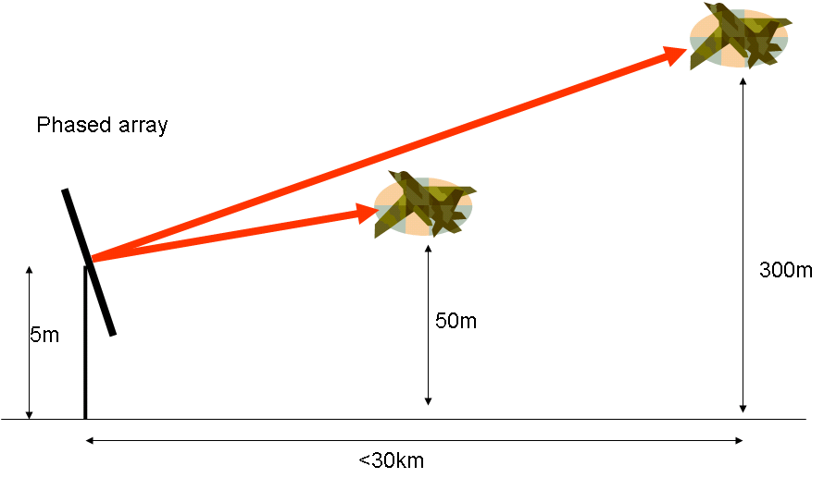
Figure 20: UAV scenario

Case 1: High attitude long endurance ground station
- Installed at airports with restricted areas of about 500m
- Peak power reduction (-> -51dBm/MHz)

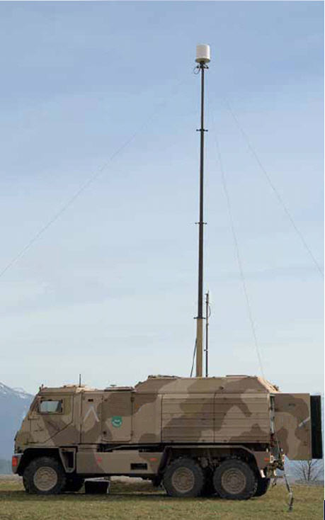
Figure 21 : UAV ground station [19]

Table 28 gives the separation distance for a simple MCL calculation without and with 10 dB mitigation.

Table 28: LT2 impact, protection distance with and without 10 dB mitigation (the Table is inserted as Excel-Sheet, input fields are yellow colored)

In addition Figure 22 shows the real impact considering the UAV antenna pattern.

Figure 22 : angle between UAV mainbeam and LT2 0-45°, height offset 5m (left) and 2m (right) including 10dB mitigation

Case 2: Mini UAV
- 2dBi -> with restricted areas of about 50m
- Peak power reduction (-> -51dBm/MHz)

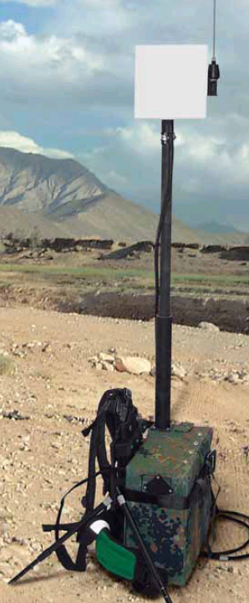
Figure 23 : Mini UAV ground control unit [19]
Table 29 gives the separation distance for a simple MCL calculation.

Table 29: Protection distance (aircraft altitude) with peak power mitigation (the Table is inserted as Excel-Sheet, input fields are yellow colored)

Results:
- Without additional mitigation, the separation distance for I/N -6dB is about 520 m and for -20dB about 2.6 km
- Assuming a 10dB mitigation for the High attitude long endurance ground station in worst case (main beam direction) the separation distance for I/N -6 is about 100m and for -20dB about 800m; with an antenna offset of 10° the separation distance for I/N -6 is about 40m and for -20dB about 300m
- For the mini UAV in worst case separation distances(aircraft altitude) between 12m for an I/N of -6dB and 58m for I/N -20dB are resulting

Hot spot scenario - UAV vs fixed LT2
The figure below gives an overview of the LT2 Hot spot scenario relative to UAV. For simplicity, let us theta be the overall offset angle between the ground station-UAV axis and the ground station-LT2 hot spot axis, accounting for both the horizontal and vertical offset angle (also identified as the beam elevation in Figure below).

Figure 24: LT2 Hot spot scenario and UAV

The characteristics of the UAV ground station are almost similar to those of previous section:
Ground station antenna gain: 26 dBi
Receiver noise floor: -112 dBm/MHz
Considering a protection criterion of I/N<-10 dB, the maximum admissible interference level is -122 dBm/MHz.

Considering a hot spot scenario with 25 LT2 base stations and 75 LT2 tags outdoor, all working with a duty cycle of 5%/s, the overall emission level is -34.3 dBm/MHz:
-41.3 + 10*log10(100) + 10*LOG10(0.05) = -34.3

The figure below shows the I/N levels received by the ground based station for various offset angles. Table 30 indicates the protection distances necessary to protect a UAV receiver in the aircraft, from several LT2 in a hot spot scenario (e.g. for a dense metal pipework).

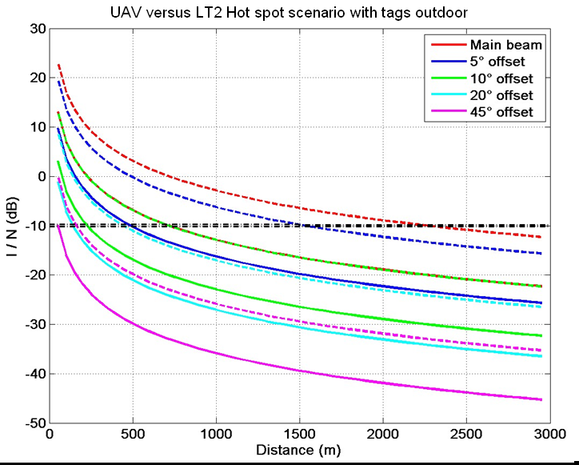
Figure 25: I/N levels versus distance for various offset angles from the ground station main beam with
10 dB mitigation reduction (plain line) and without mitigation technique (dashed line)

Table 30: Protection distance for the UAV-receiver in the aircraft

Conclusions for the Mobile Service
Single interferer

HALE ground station:
- Without additional mitigation, the separation distance for I/N -6dB is about 520 m and for an I/N=-20dB about 2.6 km
- Assuming a 10dB mitigation for the HALE ground station in worst case (main beam direction) the separation distance for I/N -6 is about 100m and for -20dB about 800m; with an antenna offset of 10° the separation distance for I/N -6 is about 40m and for -20dB about 300m
- With a 36 dBi ground station antenna the protection distances would at least be doubled.

Mini UAV flight attitude:
- Without additional mitigation, the protection distance of the UAV-receiver for an I/N -6dB is about 37 m and for an I/N=-20dB about 185 m, which is above the operating flight attitude of 30 m.
- Assuming a 10 dB Mitigation For the mini UAV in worst case the separation distance (aircraft altitude) is between 12m for an I/N of -6dB and 58m for I/N -20dB.

Hot spot Scenario:

Considering the LT2 Hot spot in the ground station main beam (red curves, the protection distance is 2565m without any mitigation and 717m with 10 dB mitigation (same distance as 10° offset without mitigation).

Considering the LT2 Hot spot at 5° offset from the ground station main beam (blue curves), the protection distance is 1539m without any mitigation and 487m with 10 dB mitigation.

For an I/N=-10 dB the necessary protection distance for the UAV-receiver in the aircraft is 65m (with assumed 10dB mitigation) to 206m (without 10dB mitigation).
A 10dB peak power reduction (-41dBm/MHz mean e.i.r.p. and -10dBm/50MHz peak e.i.r.p.) may able to reduce the impact on the radio systems, but not in all cases. The following mitigation should also be considered: peak power reduction, movement sensor for tags/nomadic/mobiles…

Summary LT2
Table 31: LT2 summary
f/GHz | Services/systems | Power limit for LT2 indoor and outdoor nomadic/tags [dBm/MHz] | LT2 indoor and outdoor nomadic/tags | Power limit LT2 fixed outdoor  transmitters | LT2 fixed outdoor  Transmitters | Additional compatibility requirements  (see also Note 1)
3.4 -3.8 | FS, MS (WiMAX), FSS | -41.3 | +5%/s +Ton<25ms  + 1.5%/minute | -41.3 dBm/MHz | +5%/s +Ton<25ms | Administration may need to consider implementing separation distances or other mitigations on a case by case basis for the protection of FS (see section 3.3.4) and MS.  Protection of FSS will be ensured for a separation distances of up to 2.6 km for outdoor tracking systems.
3.8 - 4.2 | FS, FSS | -41.3 | +5%/s +Ton<25ms  + 1.5%/minute | -41.3 dBm/MHz | +5%/s +Ton<25ms | Administration may need to consider implementing separation distances or other mitigations on a case by case basis for the protection of FS (see section 3.3.4).  Protection of FSS will be ensured for a separation distances of up to 2.6 km for outdoor tracking systems.
4.2 - 4.4 | Altimeter | -41.3 | +5%/s +Ton<25ms  + 1.5%/minute | -41.3 dBm/MHz  and -47 dBm/MHz for angles above 30°  Note 2 | +5%/s +Ton<25ms | Definition of sensitive zones around airports up to 13 km (see section 3.3.3) where additional mitigation techniques are necessary (see section 3.3.3)
4.4 - 4.8 | MS, FS mil, FSS (4.5 -4.8) | -41.3 | +5%/s +Ton<25ms  + 1.5%/minute | -41.3 dBm/MHz | +5%/s +Ton<25ms | Administration may need to consider implementing separation distances on a case by case basis for the protection of FS (see section 3.3.4) and MS.  Protection of FSS will be ensured for a separation distances of up to 2.6 km for outdoor tracking systems.
Note 1: A 10dB peak power reduction (-41dBm/MHz mean e.i.r.p. and -10dBm/50MHz peak e.i.r.p.) may able to reduce the impact on the radio systems, but not in all cases. The following mitigation should also be considered: peak power reduction, movement sensor for tags/nomadic/mobiles.
Note 2: the limitation above 30° may be removed in some cases subject to site specific authorization (see section 3.3.3).

Location tracking and sensor Applications for automotive and transportation environments (LTA) in the frequency bands 3.4 – 4.8 GHz and 6 - 8.5 GHz

System description
Location tracking and sensor Applications for automotive and transportation environments (LTA) are proposed for the frequency bands 3,4 - 4,8 GHz and 6 – 8.5 GHz and are described in ETSI TR 102 495-7 V1.2.1 (2010-03) [5].

Table 32 and give an overview about the applications and the requested regulation from ETSI.

Table 32: Overview of location tracking and sensor applications for automotive
and public transportation environments
Category | Frequency | Application | Short description
A | 3.4 GHz to 4.8 GHz,  6.0 GHz to 8.5 GHz | Location Tracking in a public transportation environment | Location positioning datagrams are exchanged through one or more of the reference stations mounted inside the vehicle at convenient locations, with mobile tags carried by passengers and/or luggage. The typical range of radio operation is 1 m to 30 m. Environmental conditions can be challenging in selected cases. All cases need to be covered with high reliability.
B | 3.4 GHz to 4.8 GHz,  6.0 GHz to 8.5 GHz | Location Tracking in the automotive environment | Location tracking datagrams are exchanged between a base station located inside the vehicle and corresponding mobile tags and/or the vehicle key.
C | 3.4 GHz to 4.8 GHz,  6.0 GHz to 8.5 GHz | Sensing in the automotive environment | Telemetry datagrams are exchanged in a vehicle mounted sensor network.

Table 33: Proposed regulation in ETSI
Category | Frequency | Area of operation/Category | Maximum Average power density (e.i.r.p.) (dBm/MHz)
A | 3.4 GHz to 4.8 GHz | public transportation  EFM systems | -41.3 dBm/MHz,  TPC+DAA, ,  or LDC
A | 6.0 GHz to 8.5 GHz | public transportation  EFM systems | -41.3 dBm/MHz  LDC or TPC
B | 3.4 GHz to 4.8 GHz | road vehicles  location systems | -41.3 dBm/MHz,  LDC
B | 6.0 GHz to 8.5 GHz | road vehicles  location systems | -41.3 dBm/MHz,  LDC
C | 3.4 GHz to 4.8 GHz | Smart tire | -41.3 dBm/MHz, duty cycle/activity factor max. 5 %
C | 3.4 GHz to 4.8 GHz | Telemetry network inside vehicles | -41.3 dBm/MHz, duty cycle/activity factor max. 5 % or TPC + DAA
C | 3.4 GHz to 4.8 GHz | Passenger alarm systems | -41.3 dBm/MHz, LDC
C | 6.0 GHz to 8.5 GHz | Telemetry network inside vehicles | -41.3 dBm/MHz, duty cycle/activity factor max. 5 % or TPC
C | 6.0 GHz to 8.5 GHz | Passenger alarm systems | -41.3 dBm/MHz, LDC

ETSI suggested that just the proposal for category C should be considered in this report because all others were in line with existing rules (ECC/DEC(06)04 [20] and (06)12 [2]). However the report considered generic LTA applications.

Deployment, reference scenarios for studies

Deployment
Sensors per car
- 3.4 to 4.8GHz: 6 with LDC of 5%/s
  - Vehicle speed >20km/h: long term LDC: 5%/h
  - Vehicle speed <20km/h: long term LDC: 0.5%/h
- 6 to 8.5 GHz: 4 UWB; with LDC of 5%/s and 0.5%/h

Vehicle density:
- Sub Urban case: 330/km²
- Rural case: 100/km²

Car screening
The issue of car screening attenuation was considered in CEPT Report 17.

Here results of a measurements campaign performed in August 2006 in Ispra indicate that, in most cases, there is in the frequency range from 3-6 GHz and 6-9 GHz a mean attenuation which is comparable to the indoor/outdoor attenuation (about 12dB).

In some exceptional cases, where the UWB antennas were placed directly behind the car windows pointing through the window outside there was less attenuation reported (2dB).

Based on all these studies and the wall attenuation for the indoor/outdoor attenuation following shielding scenarios were defined.

Summary based on all available studies for the spread of car screening attenuation
Lower range 3.4 to 4.8 GHz: 2 - 37dB
Upper Range 6 to 8.5 GHz: 4 - 37dB

Based on the spread of car screen following set of power parameters are defined to take for the studies in the report (for both frequency ranges):
Table 34 : power parameters for the studies
Frequency [GHz] | Limit inside  [dBm/MHz] | Screening  [dB] | Limit outside  [dBm/MHz] | additional screening [dB]
3.4 to 4.8 | -41.3 | 2 – 37 | - 43.3 to -78.3
6 to 8.5 | -41.3 | 4 – 37 | -45.3 to -78.3
both ranges | -41.3 | 12 (Note1) | -53.3 | 0 – 25
Note1: actual regulation (CEPT Report 17 [19]) consider an average regulated attenuation of 12dB

Studies

Fixed Service at 4.4 and 6 GHz
The characteristics for the Fixed Service are given in section 3.3.4.

In this section the impact of LTA devices on the classical Fixed Service link is investigated.
The following antenna pattern is used in this section.

Figure 26: 5dBi and 41dBi Antenna pattern used in this document

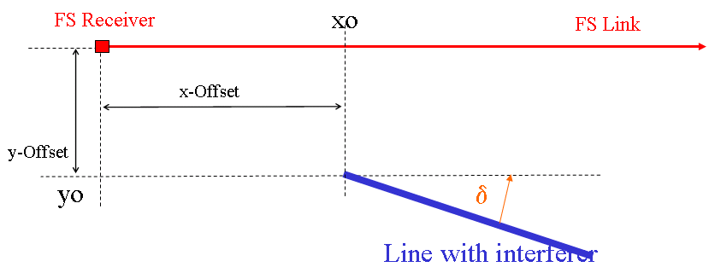
Figure 27: description of the scenario

Single entry scenario - PP Fixed Service
The following function is used in Figure 27 and 28 and shows the technical parameters assumed:
- INR=f(e.i.r.p. max, y0, h, i, j, D)

The parameters are:
- INR = I/N dB (N=-110dBm/MHz)
- e.i.r.p. max: Mean e.i.r.p. in dBm/MHz outside of the vehicle
- y0: Distance to the victim of the first car on the y axis (0 m)
- h: Antenna height offset (difference between Victim antenna and UWB height)
- i: running variable in x direction
- j: running variable in y direction (not relevant here, because just one lane is considered; j=1 is used)
- D: Antenna diameter of the FS receiver (pattern calculated based on Recommendation ITU-R F.699 [17]; see Figure 25)

Figure 28 and Figure 29 shows the interfering power in relation to the noise floor of the victim receiver (I/N ratio, INR) at a FS receiver dependent of the height offset for a single LTA transmitter.

Figure 28 : FS at 6 GHz, height variation (10-50m) and -47 (left) and -53 (right)

Figure 29 : FS at 4.4 GHz, height variation (10-50m) and -53 (left) and -58 (right)

Aggregation LTA vs FS
The aggregation of LTA in accordance with the scenario of ECC Reports 23 [15] and 158 [18] is investigated in this section. Additional aggregated studies can be found in Annex 3.
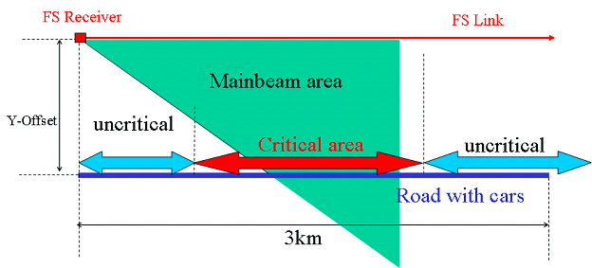
Figure 30 : scenario of ECC Report 23

shows the assumed mitigation factors for aggregated scenarios.

Table 35: Mitigations for aggregated studies
Mitigations | LTA  Traffic jam (20m distance) | LTA  Driving (>50m distance)
Peak power mitigation | 0 | 0
TPC or Duty Cycle | vehicle speed <20km/h 0.5%=23dB | vehicle speed >=20km/h 5%=13dB
Activity factor (car in use) (Note1) | 100%=0dB | 100%=0dB
sum of mitigations | 23dB | 13dB
Note 1: in CEPT Report 17 [21] the typical activity factor for car usage is 1%/day

The basic assumptions for this analysis are:
- One LTA sensor per car with -41.3 dBm/MHz e.i.r.p. (outside the car from-47 dBm/MHz to -58 dBm/MHz e.i.r.p.)
Aggregated Mitigation factor from :
- Car length 4m
- shadowing model from ECC Report 023 [15] (results are shown for 26GHz with and without)
- 1 single lane
- LTA height over ground 0.5m
- Car height 2m
- FS antenna pattern from Recommendation ITU-R F.1245-1 [22]
- FS max antenna gain 43 dBi
- FS antenna diameter 3m
- FS kTBF -110 dBm/MHz.
shows I/N results for the civil FS links at 6 GHz, Table 37 the same for FS at 4.4 GHz.

Table 36: 6 GHz Fixed Service
 | Power outside the vehicle dBm/MHz e.i.r.p. | Mitigation dB | Y offset | δ | hrx | Car distance | Road length | Resulting I/N dB  (without / with shadowing)
Driving scenario
6 GHz | -47 | 13dB | 10m | 0° | 20m | 50m | 10km | -5.7 / -13.9
 | -47 | 13dB | 10m | 0° | 20m | 50m | 1km | -11.1 / -18.1
 | -53 |  |  |  |  |  | 10km | -11.7 / -19.9
 | -58 |  |  |  |  |  | 10km | -16.7 / -24.9
Traffic jam scenario
6 GHz | -47 | 23dB | 10m | 0° | 20m | 5m | 10km | -10.5 / -31.8
 | -47 |  |  |  |  |  | 1km | -28.2 / -39.8
 | -53 |  |  |  |  |  | 10km | -16.5 / -37.8
 | -58 |  |  |  |  |  | 10km | -21.5 / -32.8
6 GHz | -47 | 23dB | 10m | 0° | 20m | 20m | 10km | -12.7 / -27.9
 | -47 |  |  |  |  |  | 1km | -26.1 / -34.5
 | -53 |  |  |  |  |  | 10km | -18.7 / -33.9
 | -58 |  |  |  |  |  | 10km | -23.7 / -38.9

Table 37: 4.4 GHz Fixed Service
 | Power outside the vehicle dBm/MHz | Mitigation dB | Y offset | δ | hrx | Car distance | Road length | Resulting I/N dB  (without / with shadowing)
Driving scenario
4.4 GHz | -47 | 13dB | 10m | 0° | 10m | 50m | 1km | -5/-12
 | -53 |  |  |  |  |  |  | -11/-18
 | -58 |  |  |  |  |  |  | -16/-23
Traffic jam scenario
4.4 GHz | -47 | 23dB | 10m | 0° | 10m | 5m | 1km | -20/-30
 | -53 |  |  |  |  |  |  | -26/-36
 | -58 |  |  |  |  |  |  | -31/-41
4.4 GHz | -47 | 23dB | 10m | 0° | 10m | 20m | 1km | -25/-36
 | -53 |  |  |  |  |  |  | -31/-42
 | -58 |  |  |  |  |  |  | -36/-48

Summary and conclusion for FS
Single entry summary
- A worst case FS antenna height is assumed to be 20m at 6 GHz and in this case the I/N in single entry scenarios can reach values up to -10dB with -47dBm/MHz e.i.r.p. and -16dB with -53 dBm/MHz e.i.r.p..
- For an FS antenna height of 10 m (in 4.4 - 4.8GHz) the resulting I/N can be up to -8dB with -53 dBm/MHz e.i.r.p. and -14dB with -58 dBm/MHz e.i.r.p.; the I/N of -20 dB could be achieved with -64 dBm/MHz.
- The results for the band 3.4 - 4.2GHz are derived from the calculations at 4.4 GHz (Figures 27-28) by considering 2.2dB less propagation loss; here a limit of -53 dBm/MHz e.i.r.p. outside the vehicle results in an I/N of -16 dB for an FS antenna height of 30m and I/N of -20dB for an FS antenna height of 50m.
- These results are based on Free Space path loss without any mitigation factor (Duty Cycle, Shadowing,…).

Aggregation summary
- In the aggregated scenarios mitigation from the Duty Cycle is assumed.
- The most critical LTA mode is the driving mode without the long term duty cycle of 0.5%/h.
- At 6 GHz with an antenna height of 20m the resulting I/N with -47dBm/MHz e.i.r.p. can be up to -6dB for a 10km straight road (with LTA devices in every car) in parallel to the FS link and -11dB for a 1km road. If we consider in addition the shadowing and shielding effects of the cars on the road, then the resulting I/N for -47 dBm/MHz e.i.r.p. with a road length of 1km can be up to -18dB.
- In the band 4.4 - 4.8GHz with an antenna height of 10m the resulting I/N with -47 dBm/MHz e.i.r.p. can be up to -5dB and with -53 dBm/MHz -11dB. If we consider in addition the shadowing effects of the cars on the road, then the resulting I/N for -47 dBm/MHz e.i.r.p. is -11 and for -53 dBm/MHz -18dB.

Conclusions

The single entry scenario seems to be the dominant scenario for most affected services. These single entry results without consideration of mitigation factors are:

- FS 6-8.5 GHz, 20m antenna height: I/N up to
  - -10 dB with -47 dBm/MHz e.i.r.p.
  - -16 dB with -53 dBm/MHz e.i.r.p.
- FS 4.4 - 4.8 GHz, 10m antenna height: I/N up to
  - -8 dB with -53 dBm/MHz e.i.r.p.
  - -13 dB with -58 dBm/MHz e.i.r.p.
- FS 3.4 - 4.2 GHz, 50m antenna height: I/N up to
  - -20 dB with -53 dBm/MHz e.i.r.p.

For the Fixed Service in the bands 3.4 - 4.2 GHz and 6-8.5 GHz in theory a limit of about -53 dBm/MHz e.i.r.p. outside of the vehicle would be needed for low antenna heights.

In the band 4.4 to 4.8 GHz the situation is a bit different due to the lower antenna heights. The required limit outside of the vehicle depends on the claimed protection objective: an I/N of -20dB would need a limit of about -65 dBm/MHz e.i.r.p., an I/N of -6dB a limit of -53 dBm/MHz. However, the long term Duty Cycle limit of 0.5%/h for vehicle speeds less than 20km/h will reduce the probability of interference.

Aggregated effect of LTA on radio-altimeters
All LTA applications considered in the following studies are inside the vehicle with their intended emissions directed toward the interior of the vehicle. They are not specifically LTA Type C applications.

The density of vehicles to consider is 330 per square kilometres. They are distributed as shown in the following figure. In addition, it has been considered that the urban area is limited with a radius of 50km around the aircraft. At further distances, the density of vehicles has been significantly reduced.

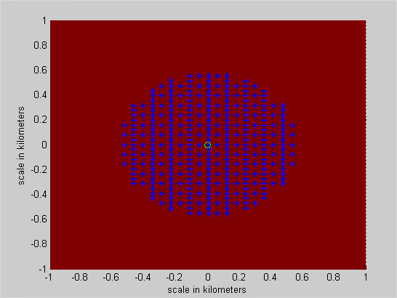
Figure 31: LTA aggregate scenario

It is also supposed that there are 10 LTA transmitters per vehicle. Therefore, one can consider that it is highly possible that more than one LTA transmit at the same time. In these simulations, one considers that no more than one LTA is transmitting at any time in a car.

The characteristics of the radio-altimeters are given in section 2.4.1. Again, an additional 6dB margin is considered to take into account that automotive UWB applications considered in the studies are only on type of UWB applications among many others, and that their number is expected to be closed to the total number of UWB devices considered in previous studies (see ECC Report 064 [7]).

Finally, the penetration rate used in the studies is 100% as suggested in the ETSI SRdoc.

The results are presented in the following table, with or without taking into account some mitigation proposals.

Table 38 : Aggregated interference level compared to the protection level of radio-altimeters – Generic LTA applications with LDC mitigation technique including the long term duty cycle limit
Scenario / Altitude of the aircraft | 100m | 500m | 1000m | 1500m
-41.3dBm/MHz/LTA – no car shielding  - 330 vehicles/km²  - 10 LTA / vehicle  - Max DC of 5%/s/LTA  - Max DC of 0.5%/hour/LTA | 6dB | 5dB | 4dB | 4dB
-47.3dBm/MHz/LTA for elevation higher than 0° (i.e. power reduction or car shielding)  - 330 vehicles/km²  - 10 LTA / vehicle  - Max DC of 5%/s/LTA  - Max DC of 0.5%/hour/LTA | 0dB | -1dB | -2dB | -2dB
-53.3dBm/MHz/LTA for elevation higher than 0° (i.e. power reduction or car shielding)  - 330 vehicles/km²  - 10 LTA / vehicle  - Max DC of 5%/s/LTA  - Max DC of 0.5%/hour/LTA | -6dB | -7dB | -8dB | -8dB

Table 39: Aggregated interference level compared to the protection level of radio-altimeters – Generic LTA applications with LDC mitigation technique excluding the long term duty cycle limit¹
Scenario / Altitude of the aircraft | 100m | 500m | 1000m | 1500m
-41.3dBm/MHz/LTA – no car shielding  - 330 vehicles/km²  - 10 LTA / vehicle  - Max DC of 5%/s/LTA  - No long term DC limit | 16dB | 15dB | 14dB | 14dB
-47.3dBm/MHz/LTA for elevation higher than 0° (i.e. power reduction or car shielding)  - 330 vehicles/km²  - 10 LTA / vehicle  - Max DC of 5%/s/LTA  - No long term DC limit | 10dB | 9dB | 8dB | 8dB
-53.3dBm/MHz/LTA for elevation higher than 0° (i.e. power reduction or car shielding)  - 330 vehicles/km²  - 10 LTA / vehicle  - Max DC of 5%/s/LTA  - No long term DC limit | 4dB | 3dB | 2dB | 2dB

Note: in Table 38 and Table 39, positive integers correspond to interference.

These results don’t depend on the altitude of the aircraft apart from very low altitudes (<200m), where the interference level increase.

In the particular case of LTA type C, antennas are expected to be placed:
- Either in the engine compartment or inside the car (excluding the car interior where passengers are). Therefore, the expected car attenuation is 17dB (value taken from contribution TG3#16_31R0).
- Or in the tire. In that case, the expected car attenuation is around 10dB

From the above results, it can be concluded that the interference level can be:
- With the LDC mitigation technique excluding the long term duty cycle limit up to 16dB above the protection criteria of radio-altimeters
- With the LDC mitigation technique including the long term duty cycle limit up to 6dB above the protection criteria of radio-altimeters
It is therefore clear that the regulation for automotive UWB applications have to be tightened compared to indoors UWB applications to protect properly the radio altimeters. This is especially important since this aeronautical system is a safety application operating as a radionavigation radio service of the RR.

In the long term, the number of LTA applications without the 5%/hour duty cycle limit is assumed to be reduced from 10 to 6 if some systems are also deployed in the band 6-8.5 GHz. The level of interference would then be reduced by 2dB, which is still 2 dB above the protection objective. If the long term duty cycle limit is considered for the low vehicle speeds, the car density with 5%/hour duty cycle would be reduced and with this the objective would be fulfilled.

Based on the above hypothesis, it is therefore proposed to impose for UWB devices installed inside road vehicles in the band 4.2-4.4 GHz:
- To minimize the deployment of transmitters in direct line of sight with the outside as well as their activity factor (especially at low speed – e.g. in traffic jams).
- To implement a maximum mean e.i.r.p spectral density requirement of -53.3dBm/MHz outside the vehicle for elevation angles higher than 0 degree
- And to apply one of the following mitigation techniques:
  - generic LDC mitigation technique, with the long term duty cycle limit of 0.5% per hour
  - modified LDC mitigation technique (i.e. without any long term duty cycle limit) when the vehicle speed is above 20km/h.

WIMAX in the band 3.4 to 3.8GHz
This scenario is assumed to be uncritical, because the DC Limit provided in ECC Report 94 [23] for the protection of WiMAX is fulfilled by LTA.

UGV vs LTA in the band 4.4 to 4.8GHz

Single Entry - UGV vs LTA

Victim parameters of UGS (Unmanned Ground Systems)

Contained in this category of mobile systems are remote controlled vehicles, robots as well as robotic convoys. A robotic convoy is a convoy of vehicles, which are linked by radio links. The steering vehicle can be somewhere within the convoy. In this case data of sensors (Status, Video, Radar, Infrared) and steering data have to be transmitted between the vehicles. Because of roadworthiness and the participation in traffic, the interference situation has to be considered carefully. Remote controlled vehicles/robots are used for example for ordnance disposal during terroristic activities. They should in any case not be interfered.

Distance : less than 1km
Transmit Power : 1-100 mW (power control)
Gain of antennas : (2) 5 to 15 dBi (quasi omnidirectional or sector antenna dependent on system)
Height of antennas : ~ 3m
Bandwidth : 56 MHz
Availability : 99,99(9)%
BER: 10⁻⁶
Feder Loss : 2 dB
S/Nmin 6 dB

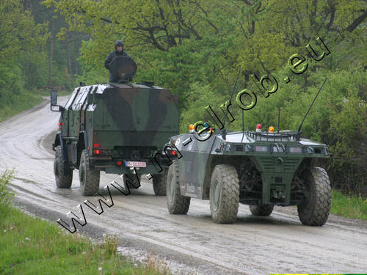

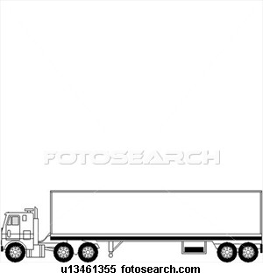

Figure 32: Principle of Robotic convoy and picture of actual study

One master vehicle controls other slave vehicles (master can also be a helicopter).

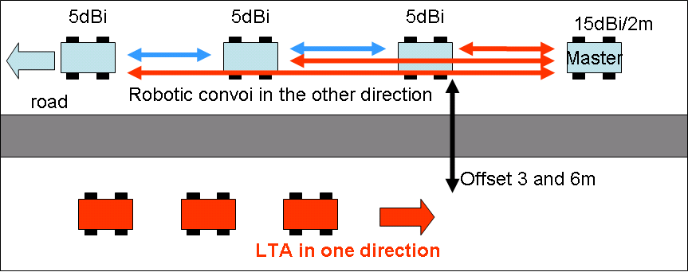
Figure 33: UGV scenario

Figure 34 : 15dBi antenna pattern used in this section

Figure 35 : 5dBi Antenna pattern directed in moving direction (non omidirectional) used in this section

Figures 35 and 36 show the resulting I/N at a UGV receiver (master).

Figure 36 : variable e.i.r.p. outside the vehicle (-47/-53/-58), y offset 6m, 15dBi (left) and 5dBi UGV (right)

Figure 37: variable e.i.r.p. outside the vehicle (-47/-53/-58), y offset 3m, 15dBi (left) and 5dBi UGV (right)

Static aggregation scenario from ECC Report 23

Here the same procedure as in section 4.3.1.2 is used.

An antenna pattern according to Recommendation ITU-R F.1245 [22] with a maximum gain of 15dBi is used.

Table 40: 4.4 GHz UGV scenario
 | Power outside the vehicle dBm/MHz | Mitigation dB | Y offset | δ | hrx | Car distance | Road length | Resulting I/N dB  (without / with shadowing)
Driving scenario
4.4 GHz | -47 | 13dB | 6m | 0° | 2m | 50m | 1km | -11.4 / -14.5
 | -53 |  |  |  |  |  |  | -17.4 / -20.5
 | -58 |  |  |  |  |  |  | -22.4 / -25.5
Traffic jam scenario
4.4 GHz | -47 | 23dB | 6m | 0° | 2m | 5m | 1km | -13.2 / -35.2
 | -53 |  |  |  |  |  |  | -19.2 / -41.2
 | -58 |  |  |  |  |  |  | -24.2 / -46.2
4.4 GHz | -47 | 23dB | 6m | 0° | 2m | 20m | 1km | -17.0 / -24.1
 | -53 |  |  |  |  |  |  | -23.0 / -30.1
 | -58 |  |  |  |  |  |  | -28.8 / -35.1

Dynamic Aggregation LTA (type C)
To assess the impact of the DC or the impact of changed DC-parameters the interference scenario has to be emulated by a mixed model that compromises deterministic and statistical parts. Otherwise the dynamic time-varying effects cannot be evaluated or only traded by additional protection margins. This new model assesses only the influence of the mean power limit. The impact of the peak power limit should be assessed in a further study.

Interference Scenario and Calculation Model
D=3m-6m
.
.
.
.
.
.
z
y
x
3m-6m
y
z
1m
1.5m
x
x
x
x
x
victim
x: UWBs

Figure 38: Scenario with UWB-Distribution along a street

The UWB´s are distributed within blocks of 1.5*2*5 m along a street (x-axis) as shown in Figure 38Figure 38. Each block represents a car and contains 10 randomly distributed UWB´s in its volume. The blocks are separated by a speed dependent distance. The distance between the line of cars and the victim is 3m for a distance of one lane and 6 m for a distance of two lanes.

Each UWB transmits statistically independent from each other, so that the Ton-periods of each UWB are statistically independent. The result is a time dependent signal.

All time dependent power levels of each single UWB are summed up at the victim. Each UWB-Signal is weighted by the free space attenuation and an additional specific attenuation (see Figure 39). This procedure is done for each victim position along x with a new set of statistical parameters to consider the time varying character of the scenario.
$P_{E}\left(\text{DC},t,x\right)=\text{10}⋅{\text{log}}_{\text{10}}\left(\underset{i}{Σ}\left[A_{\text{fs}}\left(i,x\right)⋅A_{\text{spec}}\left(i,x\right)⋅\text{UWB}\left(\text{DC},i,x,t\right)\right]\right)$ with
$A_{\text{fs}}={\left[\frac{λ}{4πD}\right]}^{2}=\text{freespace} \text{attenuation}$,
$A_{\text{spec}}=\text{specific} \text{attenuation} \text{of} \text{each} \text{UWB}$,

The time dependency of the Duty Cycle according to ECC/DEC(06)/12 [2] is represented by the following UWB switching signal. In the simulation the start point t is chosen randomly.

$$\text{UWB}(\text{DC}=5\text{\%,}i,x,t=0)=\left\{ \begin{matrix}1 \text{for} \text{Ton}=2 \text{ms} \\ 0 \text{for} \text{Toff}=\text{38} \text{ms}\end{matrix}\right.$$
$$\text{UWB}(\text{DC}=0\text{.}5 \text{\%,}i,x,t=0)=\left\{ \begin{matrix}1 \text{for} \text{Ton}=2 \text{ms} \\ 0 \text{for} \text{Toff}=\text{475} \text{ms}\end{matrix}\right.$$

Ton
Toff
Ton
UWB signal model
Ton
Toff
Ton
Signal of UWB 1
Ton
Toff
Ton
signal of UWB N
1
1
A_fs,
victim Antenna,
diffraction victim,
random attenuation [0-25 dB]
random time shift
Σ =>
Ton
Toff
Ton
sum of signals
1
.
.
.
Contribution from other UWB’s
Figure 39: Illustration of model

Parameters of the model:
Constant parameters:
- Gs=0dBi
- Ge= 5 dBi (omni directional antenna in xy plane and dipole-like 8-diagram with a gain of 5dBi in xz-plane)
- No=-114 dBm/MHz
- N_{victim}= -112 dBm /MHz (including receiver noise)- Feeder loss 2dB

Variable parameters
Number of UWB/car 6 and 10 (worst case) UWB
Possible Duty Cycles: 0.5%/h, 5%/s
Protection criteria: I/Nreq=-6 dB,-10 dB und -20 dB
Transmit power of UWB: Ps variable

- distance between cars is equal to the safety distance (dependent on simulated relative speed of the cars)
- 10 m (20km/h)
- 20 m (~40 km/h)
- 50 m (~100 km/h)

- distance between cars and victim along y- axis
- 3m (rural road)
- 6 m (highway)

Model includes:
- Attenuation of car
  - For each UWB a randomly calculated attenuation is added
- [12-37] dB for the UWB-sensor-limit including a forced attenuation of 12 dB as suggested in the draft of the proposed regulation or
- [0-25] dB for the outside limit

- Attenuation/Gain due to victim-antenna 5 dBi dipole (see figure 39 green curves)
  - 3D-antennadiagramm is implemented

- Attenuation due to diffraction at the victim itself (see figure 39 red curves)
  - implemented by an additional angular dependent attenuation with 0dB for the main beam direction and additional 10 dB attenuation at the former 3 dB angle of the dipole antenna (see figure 39 red curves).

Figure 40: Antenna diagrams: green: xz-diagram of 5dBi-dipole without additional diffraction; for comparison red: xz-diagram of 5 dBi-dipole with additional added angular dependent attenuation representing diffraction effects at the victim corps; both antennas are omni-directional in xy-plane

Introduction of model and basic results:

Figure 40 and 41 show a typical time varying sequences of the received power for a single location for a DC of 5% and 0.5%. It is the sum of all weighted UWB-signals at the receiver as described in Figure 39. As one result we can see in Figure 41 that for this scenario the DC of each single UWB of 5% results in an aggregated DC of around 100%. This means, that the intended effect of the DC is vanishing.
The reason for the discontinuity in the aggregated 0.5% DC-signal in Figure 42 is, that there are still instances where there is no received signal. The resulting DC is below 100% but definitively higher than the single UWB DC of 0.5%
Figure 41: Example of time dependent received power for UWB´s with DC of 5% at a single location, 10 UWB/car (Note: N_{receiver}=-112 dBm and 2 dB feed loss)

Figure 42: Example for DC of 0.5%

“Time variant system response”

Doing the single point calculation for each location along the x-axis we get a time variant system response as shown in Figure 43. Figure 41 and Figure 42 would be a cut along the direction of the arrow. The speed dependency is represented by varying the (safety) distance between the cars. Figure 43 is calculated with a 1m resolution in x-direction and a 0.1 ms resolution in time, changed geometry and newly calculated statistical parameters (changed UWB-position in cars, car attenuation and time shift) for each location. The time varying character from location to location can easily be seen in Figure 42.
Figure 43: time variant system response for DC = 5%, 10 UWB/car,
Distance between cars = 20 m. Ps=-41 dBm

Cumulative Distribution Function (CDF)

The analysis of the time varying system response can be done with cumulative distribution functions. These functions are derived by calculating the probability a given protection criteria is exceeded. The results are shown in dependence of the UWB-transmit-power and the protection criteria.
Based on these distributions the current proposed regulation is reviewed.

The normal operation condition of the primary application is represented by the mean value of the CDF (=50%) and the corridor (+/- the standard deviation σ ~ 34%) representing the most probable variations of parameters (“most-case”). A violation of the protection criteria is given if the probability is exceeded by 16% (=µ-σ=50%-34%).

The CDF in Figure 43 is based on the following assumptions:
- No long term limit for speed above 20 km/h
- Sensor limit: -41.3 dBm + 12 dB minimum Attenuation due to car body
- Additional: -53 dBm measured outside of car,

Figure 44 : Cumulative Distribution; left : DC=5%, right DC = 0.5%

Safety distance between cars = 10 m corresponding to v = 20 km/h; distance between line of cars and victim 3m (left curves) and 6m (right curves with same color only left figure); antenna and shielding of victim taken into account; additional shielding of cars taken into account (0-25 dB).

Results for the long term perspective – 10 UWB per car - -53 dB measured outside of car

Table 41: Probability I/N is exceeded for PSD-limit of -53 dBm measured outside of the car
I/N | -20dB | -10dB | -6dB
Probability I/N is exceeded | 100% | 71% | 47%

The proposed value of -53 dBm is not sufficient to fulfill the protection criteria.

Table 42 : Necessary PSD -limit measured outside of the car to fulfill the I/N-criteria
 | Distance | I/N = -20dB | I/N = -10dB | I/N = -6dB
PSD_{max} 5% (µ-2σ) | 3m | -76 dBm/MHz | -66dBm/MHz | -62 dBm/MHz
PSD_{max} 16% (µ-σ) | 3m | -73 dBm/MHz | -63 dBm/MHz | -59 dBm/MHz
PSD_{max} 16% (µ-σ) | 6m | -70.5 dBm/MHz | -60.5 dBm/MHz | -56.5 dBm/MHz

The protection criteria of -6dB can be achieved in most cases with a power limit of -59 dBm/MHz. The protection criteria of -10dB can be achieved in most cases with a power limit of -63 dBm/MHz. The protection criteria of -20dB can be achieved in most cases with a power limit of -73 dBm/MHz.

Discussion of influencing parameters:
All UWB devices independently transmitting with a LDC limit of 5%.

Table 43: Results depending on the number if UWBs per car / Distance cars
Number of UWB’s per car | Distance cars | Distance cars -victim | I/N = -20dB  PSD_{max} in dBm/MHz  (Value at µ-σ) | I/N = -10dB  PSDmax in dBm/MHz  (Value at µ-σ) | I/N = -6dB  PSDmax in dBm/MHz  (Value at µ-σ) | Simulation parameters corresponding to:
10 | 10m | 3m | -73 | -63 | -59
10 | 10m | 6m | -70.5 | -60.5 | -56.5
10 | 20m | 3m | -71 | -61 | -57
10 | 50m | 3m | - 65 | - 55 | -51
6 | 10m | 3m | -71 | -61 | -57 | - Speed = 20 km/h  - every car equipped
6 | 20m | 3m | -68 | -58 | -54 | - Speed = 20 km/h  - every second car equipped
6 | 20m | 6m | -67 | -57 | -53 | - Speed = 20 km/h  - every second car equipped
6 | 30 m | 6m | -65 | -55 | -51 | - Speed = 30 km/h  - every second car equipped
6 | 40m | 6m | -63.3 | -53.3 | -49.3 | - Speed = 40 km/h  - every second car equipped
1 | 10m | 3m | -58 | -48 | -44
6 | 40m | 6m | -67 | -57 | -53 | - Speed = 40 km/h  - every second car equipped  - intended emission towards the outside
If the distance between the line of cars and the victim is 6m, then the limits could be reduced by around 2.5 dB in comparison to the reference.
The doubling in distance (10m -> 20m) between the cars results in a reduction of 2 dB.
Five times the distance (10m -> 50m) results in a reduction of 8 dB
If 6 UWB are installed instead of 10 UWB, this results in a reduction of 2 dB.
If 1 UWB is installed instead of 10 UWB, this results in a reduction of 15 dB.

An I/N=-10 dB can be fulfilled for a PSD-limit of -53 to -54 dBm/MHz e.i.r.p. under the following assumptions:
- the distance between the simulated cars is equal to half of the vehicle speed (protection distance to be taught in driving school),
- only every second car would be equipped with UWB-devices
- every equipped car has a maximum of 6 UWB-devices operating in the same frequency range and
- the vehicle speed is equal or above 40 km/h.
For speeds lower than 40 km/h either the DC has to be below 5% or the PSD has to be below -53.3 dBm/MHz to fulfill an I/N=-10 dB.

To achieve an I/N of -20 dB the limits have to be chosen 10 dB more stringent and for an I/N = -6 dB 4 dB less stringent.

Emission towards the outside

With the exception of the last line in table 42 a random radiation of the UWB-devices towards the inside was assumed. For that an additional shielding of the car body between 0 and 25 dB was taken into account for each UWB-device. If the emission is intended towards the outside (e.g. SRR applications or car to car communication), then the additional shielding model is not more applicable because of LOS-conditions.
The result of the simulation without additional shielding is displayed in the last line of table 42.
In comparison with the intended emission towards the inside the PSD-limit (for emissions towards the outside) should be 3-4 dB more stringent to fulfill the corresponding protection criteria under the same boundary conditions.
Assuming the same boundary conditions and comparing the results the PSD-limit for an intended emission towards the outside should be 3-4 dB more stringent than that with intended emission towards the inside to fulfill the same protection criteria.

PSD Limit for the UWB-Sensor: Comparison with LDC=0.5%

Table 44: Probability I/N is exceeded for PSD-limit of -53 dBm (DC=0.5%)
I/N | -20dB | -10dB | -6dB
Probability I/N is exceeded | 24% | 7% | 4%

Table 45: Necessary PSD -limit to fulfil the I/N-criteria (LDC=0.5%) and 10 devices
I/N | -20dB | -10dB | -6dB
PSD_{max} 5% (µ-2σ) | - 66 dBm/MHz | - 56 dBm/MHz | -52 dBm/MHz
PSD_{max} 16% (µ-σ) | - 57 dBm/MHz | -47 dBm/MHz | -43 dBm/MHz

The aim of a long term DC limitation (0.5%/h) to reduce the interference is predominantly given in this scenario. With the proposed PSD limit of -53 dBm/MHz and the DC of 0.5% an I/N of -6 dB could be achieved in all cases and -10 dB in most cases. The protection criteria of -20dB can be achieved in most cases with a power limit of -57 dBm/MHz.

Possible antenna for UGV
The following antenna provides an example of antenna made using a 14-dipoles collinear array and assuming the pattern shown below. The implementation of such antenna pattern in UGV could improve the compatibility between UGV and LTA systems. Other design constraints would also have to be considered.
Figure 45: Polar Patterns for array antenna with different beam pointing from +15° to +20°
over the horizon 0°-180° is the Horizon; 90° is Zenith, 270° is towards ground (Nadir)

Summary UGV
The most critical scenario seems to be the single entry. The results are nearly independent on the UGV antenna and depending mainly on the power limit specified outside the vehicle, and the offset between the two roads For a 6m offset the resulting I/N values are between +1 dB (-47 dBm/MHz), -5 dB (-53 dBm/MHz), -10 dB (-58 dBm/MHz) and -20 dB (- 68 dBm/MHz). For 3m offset those results are 5dB worse.

A dynamic aggregation model taking into account more than one UWB per car and the time varying characteristic of the aggregation scenario was introduced. The results are depending mainly on the power limit specified outside the vehicle, the distances between the vehicles, the long term DC and the speed limit.

For 6 UWB devices and with a LDC of 5%/s only:

  - Speed of cars = 20 km/h, distance 20m: The protection criteria of -6dB can be achieved in most cases with a power limit of -53 dBm/MHz. The protection criteria of -20dB can be achieved in most cases with a power limit of -70 dBm/MHz.
  - Speed of cars = 40 km/h, distance 40m: If the speed of the cars is above 40 km/h then the protection criteria I/N of -10 dB can be achieved with -53.3 dBm/MHz.

For 6 UWB devices and additional with a LDC of 0.5%/h:
The long term DC limitation (0.5%/h) will reduce predominantly the interference. With the proposed PSD limit of -53 dBm/MHz and the DC of 0.5% an I/N of -6 dB could be achieved in all cases and -10 dB in most cases. The protection criteria of -20dB can be achieved in most cases with a power limit of -55 dBm/MHz.

Intended emission of the UWB-devices towards the outside:
Assuming the same boundary conditions the PSD-limits should be 3-4 dB more stringent if the emission is intended towards the outside instead of the previously assumed emission towards the inside.

Following additional possible mitigation could reduce the probability of interference:
- specific UGV antennas
- limitation of the transmission of a single car = DC limit car = e.g. 25%.

Fixed Satellite Service
No specific studies were undertaken for FSS since the proposed e.i.r.p. limit outside the vehicle
(-53.3dBm/MHz) is more stringent than the existing limits (ECC/DEC/(06)12 [2]). It was felt that the removal of the long term duty cycle for car’s speed above 20km/h would have no impact on the existing compatibility studies and therefore no additional studies were needed.

Radio astronomy in the band 6.65 - 6.6752 GHz

Use of the band by the RAS and Regulatory Status
Presently, the methanol (CH₃OH) line (6.65 – 6.675.2 GHz) is covered in Footnotes 5.149 and 5.458A [6]. This line was only discovered in 1991 and has become an important diagnostic for the conditions in high-mass star formation regions. The study of such regions is also important for the understanding of the formation of our solar system and the composition of elements in our sun and the planets of the solar system. That is one of the reasons why extensive new research and equipment programmes have been started in several countries. The MPIfR (Germany) and the NSF (The United States) are planning an astrometric survey of such star forming regions. By measuring trigonometric parallaxes for a large number of such regions in all spiral arms will enable model-independent distances and transverse velocities to be determined. Precision 3-dimensional mapping of the Milky Way Galaxy to determine its size, rotation profile, dark matter halo mass, and classification has been the goal of astronomers for decades. Billions of dollars have been spent on space missions resulting in detailed maps of the local Galaxy but with insufficient precision at large enough distances to address some of the fundamental Galactic structure questions. Significant investments in new receivers for that frequency band are made all over the world. A newly developed receiver system, the ‘Vivaldi’ focal plane array will cover the frequency range of 4 to 8 GHz. It will be installed at the radio telescopes in Westerbork (The Netherlands), Sardinia (Italy) and Jodrell Bank (United Kingdom). Germany and the United States are cooperating on a new receiver system for joint high resolution VLBA observations and in Australia a new 7-beam receiver system found several hundred new star forming regions. It is planned to install a copy of that receiver at the Effelsberg telescope. CRAF indicated that the 6.7 GHz band is of considerable future importance for radio astronomy.

Parameters used in the Study
Output power, and operating frequency
Automotive LTA devices operating in the band 6 - 7 GHz are considered and parameters are taken from section 4.2. Their emissions outside a vehicle are assumed to have a directional peak power spectral density of P=-53 dBm/MHz and a spatially averaged PSD of P=-70 dBm/MHz (or TRP according to ECC Report 123 [24] and ECC/DEC/(07)01 [5]. The assumed average transmitting height above the ground is 1 m.

Radio astronomical parameters

According to footnote 5.149 of the radio regulations, administrations are urged to take all practicable steps to protect the RAS from harmful interference in the band 6 650.0 - 6 675.2 MHz. The band is wide. We use ν_{o}=6.65 GHz as the reference frequency for our calculations.

The spectral power flux limit of dB(Wm⁻²Hz⁻¹)
which has been interpolated for spectroscopic observations at 6.7 GHz from column 9 of table 2 of ITU-R RA.769 [25] is used as the interference threshold.

In-band emitted spectral power flux density
The in-band emitted spectral power flux density is then
yielding or S_{tx} = -105 dB(Wm⁻²Hz⁻¹).

Mitigation factors and activity

A long term duty cycle duty cycle of 0.5% is assumed for four continuously operating sensors, leading to an additional mitigation correction of or .
An active device density of up to 123 km⁻² in suburban/ rural environments was also taken as an upper limit (ECC Report 023 [20]).

Single emitter protection requirement and separation distance
A total path attenuation of or

L_{prot}=-106 dB
is required for shielding the radio telescope from interference by a single LTA source. That corresponds to a minimum separation of

A output power reduction of 8 dB is required for a single interferer protection distance of 280m. Within the radius of 280m, it is considered that observatories may have a certain amount of control of vehicle movements within that range and can manage the interference potential.
Shielding by the vehicle (see section 4.3.4.3), topography and local clutter losses as well as more stringent duty cycle limitations which are not considered in this study can reduce the separation distance to a smaller value, however it is envisaged that each vehicle may be fitted with not just one, but several individual devices. Four active devices have been seen as typical in this report, but the maximum number is as yet unregulated. In that case, the vehicle becomes a cluster of UWB devices and should be treated as one compound emitter and thus a single average outside vehicle limit should be adopted no matter how many devices are located in the vehicle. The following graph shows the maximum externally emitted spectral power density for one vehicle equipped with N randomly operating UWB devices.
Figure 46: For N=1 (green), N=4, (black) and for N=10 (red)
The graph illustrates that a limit of -61 dBm/MHx will still involves a minimum protection distance of 280 m for a vehicle fitted with 4 devices operating randomly with an average individual duty cycle of 0.5%. Interference may therefore still arise in the case of vehicles accessing the telescope site.

Note that local clutter attenuation was not considered in the single interferer scenario because of the height of the telescope (50m) which is directly visible within the perimeter of a km or less.

Aggregation of emissions
The aggregated emissions were calculated by the ring integration method based on an average (TRP) emission of -70 dBm/MHz and an additional clutter correction (attenuation) for rural environments of 18 dB assuming rural environment clutter according to Recommendation ITU-R P.452 section 4.6.3 (height gain model) [26] was used to account for signal path obstructions by rural buildings, crops and trees. No allowance for a particular topography was made these calculations will therefore reflect the conditions near observatories in a flat countryside (like Jodrell Bank, Nancay or Westerbork) and not those around Effelsberg.
Figure 47: Minimum radius of an exclusion zone around a radio observatory as a function of average device emissions parameterised by device density

The green line is for a density of the red for the reference density of and the blue line for . The steep part of the lines corresponds to the free space propagation within the telescope's radio horizon and the flatter right hand part is the result of diffraction propagation. Their intersection with the dashed vertical line (giving the emitted psd) indicates the size of the exclusion zone. The calculated values are:
- gives d_{min}=12.7 km
- gives d_{min}=177m
- gives d_{min}=30m

Active LTA device densities of are not unrealistic even in the rural areas around some of the more remote radio telescopes. In this case a reduction of 10 dB in average output is required in order to avoid interference to radio astronomy.

Conclusions for the RAS
A reduction of the maximum output power of LTA devices of the order of 8dB to -61 dBm/MHz outside the vehicle is required for the protection of radio astronomy in the band 6 650.0 - 6 675.2 MHz against a single interferer up to a distance of 280m. Aggregate emissions with an individual TRP of -70dBm/MHz require a separation distance of 12 km under the assumption of vehicle densities of 100 km⁻² which may be reached during the rush hour around Jodrell Bank and Cambridge observatories. A suitable modulation scheme can suppress radio emissions by LTA devices in the radio astronomical band covered by footnote 5.149.

If a value of -53 dBm/MHz outside the vehicle is implemented the radius of the separation zone will be about 700 m which may impact the observations of several RAS stations operating in Europe (Effeslberg, Jodrell Bank, Cambridge, Sardinia…)

Summary LTA
The following table provides an overview of the results for LTA.
Table 46: LTA summary
f/GHz | Services/systems | Power limit for one LTA sensor | Additional limits | Comments
3.4 - 4.2 | FS, FSS, MS (WiMAX)  (Note 3) | -41.3 dBm/MHz and -53.3 dBm/MHz  outside the vehicle | +5%/s +Ton<5ms | See Note 3
4.2 - 4.4 | Altimeter | -41.3 dBm/MHz and -53.3 dBm/MHz outside the vehicle | +5%/s  +0.5%/h for vehicle speed ≤20km/h +Ton<5ms
4.4 - 4.8 | MS, FS military, FS , FSS (4.5 - 4.8 GHz) | -41.3 dBm/MHz and -53.3 /-67.3 dBm/MHz outside the vehicle  Note 1 | +5%/s  +0.5%/h for vehicle speed ≤20km/h +Ton<5ms | See Note 3
6.65 -6.6752 | RAS | -41.3 dBm/MHz and -53.3/-61.3 dBm/MHz outside the vehicle  Note 2 | +5%/s + 0.5%/h  + Ton<5ms | Studies ask for -61.3 dBm/MHz  Additional TRP Limit -70dBm/MHz (see Note 2)
6 - 8.5 | FS, FSS | -41.3 dBm/MHz and -53.3 dBm/MHz outside the vehicle | +5%/s + 0.5%/h+ Ton<5ms | See Note 3
Note 1: An I/N of -20dB can be fulfilled with the proposed limit of -53.3dBm/MHz (measured outside) and the current generic LDC-limit 5%/s and 0.5%/h without any speed limit. An I/N of around -6dB would be possible for the limit of -53.3 dBm/MHz with the changed LDC- limit (5%/s and the combination 5%/h > 20km/h and 0.5%/h <20km/h). To achieve an I/N of -20 dB for all cases with the changed LDC-limits (5%/s and the combination 5%/h > 20km/h and 0.5%/h <20km/h) additional mitigation techniques (e.g. DC whole car, mid-term DC, power reduction,..) would be necessary.
Note 2: If a value of -53.3 dBm/MHz - calculated for 1 UWB device active per car - outside the vehicle is implemented the radius of the separation zone will be about 700 m (see section 4.3.5) which may impact the observations of several RAS stations operating in Europe (Effelsberg, Jodrell Bank, Cambridge, Sardinia, Bleien …).
Note 3: No specific studies were undertaken for FSS since the proposed limits are more stringent than the existing limits.

Summary
The following tables provide an overview of the compatibility studies:
Table 47 : LAES summary
f/GHz | Services/systems | E.i.r.p. density limits [dBm/MHz] | Additional compatibility requirements
3.4 – 3.8 | FS, MS (WiMAX), FSS | -21.3 | Protection of FS (angular decoupling of 5° to the FS mainbeam assumed) and MS will be ensured for separation distances of:  - Outdoor LAES: about 20 km  - Indoor LAES: about 5 km  Protection of FSS will be ensured for separation distances of:  - Outdoor LAES: about 20 km from any registered/notified FSS earth stations with small diameter antenna (1.2 m and 1.8 m) and 12.3 km for other registered/notified FSS earth stations and MSS feeder link earth stations;  - Indoor LAES: about 7 km from any registered/notified FSS earth stations with small diameter antenna (1.2 m and 1.8 m) and and 3.5 km for other registered/notified FSS earth stations and MSS feeder link earth stations;
3.8 - 4.2 | FS, FSS | -21.3 | Protection of FS (angular decoupling of 5° to the FS mainbeam assumed) will be ensured for separation distances of:  - Outdoor LAES: about 20 km  - Indoor LAES: about 5 km  Protection of FSS will be ensured for separation distances of:  - Outdoor LAES: about 20 km from any registered/notified FSS earth stations with small diameter antenna (1.2 m and 1.8 m) and 12.3 km for other registered/notified FSS earth stations and MSS feeder link earth stations;  - Indoor LAES: about 7 km from any registered/notified FSS earth stations with small diameter antenna (1.2 m and 1.8 m) and and 3.5 km for other registered/notified FSS earth stations and MSS feeder link earth stations;
4.2 - 4.4 | Altimeter | -41.3 | Avoid LAES sites in the vicinity of airports runway (minimum separation distance of 150 m should be considered). Protection will be ensured with the level of -47dBm/MHz for outdoor usage.
4.4 - 4.8 | MS, FS mil , FSS (4.5-4.8 GHz) | -41.3 | MS: protection distances with local rescue operation leader or other national authorities are necessary because UAVs are interfered directly at their normal flight level when operating in the same area. Separation distances should be calculated on a case by case basis.  Protection of FS (angular decoupling of 5° to the FS mainbeam assumed) will be ensured for separation distances of::  - Outdoor LAES: about 2 km  - Indoor LAES: about 500 m  Protection of FSS will be ensured for separation distances of:  - Outdoor LAES: about 2 km from any registered/notified FSS earth stations with small diameter antenna (1.2 m and 1.8 m) and  - Indoor LAES: about 500 m from any registered/notified FSS earth stations with small diameter antenna (1.2 m and 1.8 m).

Table 48 : LT2 summary
f/GHz | Services/systems | Power limit for LT2 indoor and outdoor nomadic/tags [dBm/MHz] | LT2 indoor and outdoor nomadic/tags | Power limit LT2 fixed outdoor  transmitters | LT2 fixed outdoor  Transmitters | Additional compatibility requirements  (see also Note 1)
3.4 -3.8 | FS, MS (WiMAX), FSS | -41.3 | +5%/s +Ton<25ms  + 1.5%/minute | -41.3 dBm/MHz | +5%/s +Ton<25ms | Administration may need to consider implementing separation distances or other mitigations on a case by case basis for the protection of FS (see section 3.3.4) and MS.  Protection of FSS will be ensured for a separation distances of up to 2.6 km for outdoor tracking systems.
3.8 - 4.2 | FS, FSS | -41.3 | +5%/s +Ton<25ms  + 1.5%/minute | -41.3 dBm/MHz | +5%/s +Ton<25ms | Administration may need to consider implementing separation distances or other mitigations on a case by case basis for the protection of FS (see section 3.3.4).  Protection of FSS will be ensured for a separation distances of up to 2.6 km for outdoor tracking systems.
4.2 - 4.4 | Altimeter | -41.3 | +5%/s +Ton<25ms  + 1.5%/minute | -41.3 dBm/MHz  and -47 for angles above 30°  Note 2 | +5%/s +Ton<25ms | Definition of sensitive zones around airports up to 13 km (see section 3.3.3) where additional mitigation techniques are necessary (see section 3.3.3)
4.4 - 4.8 | MS, FS mil , FSS (4.5 -4.8 GHz) | -41.3 | +5%/s +Ton<25ms  + 1.5%/minute | -41.3 dBm/MHz | +5%/s +Ton<25ms | Administration may need to consider implementing separation distances on a case by case basis for the protection of FS and MS.  Protection of FSS will be ensured for a separation distances of up to 2.6 km for outdoor tracking systems.
Note 1: A 10dB peak power reduction (-41dBm/MHz means e.i.r.p. and -10dBm/50MHz peak e.i.r.p.) may able to reduce the impact on the radio systems, but not in all cases. The following mitigation should also be considered: peak power reduction, movement sensor for tags/nomadic/mobiles.
Note 2: the limitation above 30° may be removed in some cases subject to site specific authorization (see section 3.3.3).

Table 49 : LTA summary
f/GHz | Services/systems | Power limit for one LTA sensor | Additional limits | Comments
3.4 - 4.2 | FS, FSS, MS (WiMAX)  (Note 3) | -41.3 dBm/MHz and -53.3 dBm/MHz  outside the vehicle | +5%/s +Ton<5ms | See Note 3
4.2 - 4.4 | Altimeter | -41.3 dBm/MHz and -53.3 dBm/MHz outside the vehicle | +5%/s  +0.5%/h for vehicle speed ≤20km/h +Ton<5ms
4.4 - 4.8 | MS, FS military, FS , FSS (4.5 - 4.8 GHz) | -41.3 dBm/MHz and -53.3 /-67.3 dBm/MHz outside the vehicle  Note 1 | +5%/s  +0.5%/h for vehicle speed ≤20km/h +Ton<5ms | See Note 3
6.65 -6.6752 | RAS | -41.3 dBm/MHz and -53.3/-61.3 dBm/MHz outside the vehicle  Note 2 | +5%/s + 0.5%/h  + Ton<5ms | Studies ask for -61.3 dBm/MHz  Additional TRP Limit -70dBm/MHz (see Note 2)
6 - 8.5 | FS, FSS | -41.3 dBm/MHz and -53.3 dBm/MHz outside the vehicle | +5%/s + 0.5%/h+ Ton<5ms | See Note 3
Note 1: An I/N of -20dB can be fulfilled with the proposed limit of -53.3dBm/MHz (measured outside) and the current generic LDC-limit 5%/s and 0.5%/h without any speed limit. An I/N of around -6dB would be possible for the limit of -53.3 dBm/MHz with the changed LDC- limit (5%/s and the combination 5%/h > 20km/h and 0.5%/h <20km/h). To achieve an I/N of -20 dB for all cases with the changed LDC-limits (5%/s and the combination 5%/h > 20km/h and 0.5%/h <20km/h) additional mitigation techniques (e.g. DC whole car, mid-term DC, power reduction,..) would be necessary.
Note 2: If a value of -53.3 dBm/MHz - calculated for 1 UWB device active per car - outside the vehicle is implemented the radius of the separation zone will be about 700 m (see section 4.3.5) which may impact the observations of several RAS stations operating in Europe (Effelsberg, Jodrell Bank, Cambridge, Sardinia, Bleien …).
Note 3: No specific studies were undertaken for FSS since the proposed limits are more stringent than the existing limits.

- LAES deployment characteristics
  - Deployment characteristics
One way to predict deployment levels and numbers is to use national statistics, where these are available. The following sections are based on the approach used in the “Expected Market Size and value” section of the ETSI TR 102 496 document. Given the number of fires per year, fire-fighters on duty, and the population, estimates can be made of the usage of LAES systems and terminals by fire and rescue services per day per square km. The results presented in the document are based on national statistics in France and in England giving some indication of the number of fires inside buildings and outside buildings. These numbers have been then compared to CTIF statistics to obtain more data.
    - National statistics
In round numbers, in England each year (statistics from DCLG), there are 350 000 fires, a similar number of false alarms, and 150 000 non-fire incidents. The fires break down as: buildings fires 90 000, vehicles and other outdoor 60 000, abandoned vehicles and rubbish etc, 120 000, other secondary fires (some of which may actually be quite dangerous) 80 000, road accidents 40 000, other non-fire 110 000.
In calculating the number of incidents at which the system is used, two values will be used. For the upper limit value, which applies if the system is always used as a matter of routine on all calls where it might conceivably be needed, we count all incidents including false alarms: nearly 1 million for England or 1 per 50 people per year. For a city of 1 million people (which can be scaled up or down), on any one day (of 365), there would be 55 incidents. For a lower limit figure, we will assume that the number of incidents where the use of the system is vital is half the count of buildings fires. This yields about 50 000; on a population basis 50 000/50 million is 1 per 1000 people per year, or one in 20 of all incidents. In our city of 1 million there would be only 3 such incidents per day.
It would be useful to convert the above figures into the frequency of fires per unit area. Some work has been done for England and Wales that defines “settlements” – urban areas defined by where the buildings are, and ignoring administrative boundaries. These show a surprisingly uniform density for settlements from ten thousand population right up to London with 8.3 million. The mean and the median density are both 4 thousand per km², or 250 km² per million. Thus for major fires, with three per million inhabitants, the next fire on the same day is typically about 9 km away. For all building fires (six per day), and allowing for that fact that they last much less than a day (usually less than three hours), the next simultaneous deployment will be a similar distance away.
In order to reinforce the network connectivity between the fire fighters, some dropped units can also be used. Each dropped unit is a UWB transceiver in a slightly different housing from the units that the fire-fighters carry in their clothing. The number deployed will be very variable, and will be highest inside buildings that have the highest losses for signals going through walls, floors, etc. Thus for coexistence purposes it would be reasonable to choose a low figure for dropped units deployed, of one per fire-fighter.
In France the report of the SSDI in 2006 (source Ministry of the Interior, statistics report 2007), shows that the total number of interventions for the fire brigades and ambulances services is around 3 827 300. This number includes several types of intervention as depicted in the following figure.
Figure 48: Types of intervention in France

In round numbers, in France, there were 380 000 interventions for fires in 2006 which is quite similar to the numbers in England if we don’t take into account the false alarms.
In 2008 the total number of interventions for the fire brigades and ambulances services was around 4 027 851. The number of fires for one year in 2008 is 312 119. The following graph gives an overview of the different fires. It should be noted that the number of fires for buildings and houses is only 86060.
Figure 49: Fires in France in 2008 per category

    - CTIF statistics
There is no good source of statistics for emergency service operations for Europe, nor for the EU. The CTIF fire statistics reports collate national figures from the whole world, though not from all countries, and the figures still have a lot of inconstancies and errors in them.
The CTIF (Centre of Fire Statistics) report indicates per country the number of fires for the year 2004. It also indicates the number of fires per category (structure fires, chimneys, out of buildings, vehicle, forests, grass, rubbish and others. In order to take into account fires inside buildings corresponding to the use case of LAES standard, the figures for “structure fires” and “chimneys” have been added.
For France the total number of fires is 334 421 for the year 2004 which is in line with the numbers from the national statistics. The estimated fires inside buildings (from structure fires and chimneys) is 116 143 which is in line with the numbers of fires inside buildings given by the national statistics. CTIF statistics can thus be considered as valid entries for the number of events per country in most cases. Of course some caution is still needed as to whether the figures record real differences or different definitions.
The average population density has also been added for each country to the CTIF report. This is used to give a figure for the number of fires per day per square km. The number of fires has been indicated per day only as a rate and it would be possible to choose another unit (per month for example).
The following table provides a summary of CTIF statistics per country and adds the fires estimated in buildings when available as well as the average population density. Here “number of fires” etc. should be understood as per year where not stated. Then the number of fires inside buildings per day and per thousand inhabitants has been indicated.
The maximum value is for Ireland with a number of fires inside building per day per 1000 inhabitants which is 0,00749. However, the range of values from mean to maximum is still not very great.

Thus the incidence of fires per inhabitant is relatively uniform, at least for European countries. However, for coexistence studies it is the incidence per km² that is most useful, and this is much more variable.
As the population density is only an average and can be very different in regions, CTIF statistics in big cities will be evaluated as well.

Table 50 : CTIF Fire statistics and average population density per country

The following table gives an overview of the number of fires per year and then per day for big cities in Europe. In line with the greater population density, these numbers are much higher, but it has to be noticed that they include all types of fires. Some non-buildings fires will be less common in cities (forests, heathland, etc) but others (vehicles, rubbish bins) may be more common. In the absence of a breakdown of the figures, the indicated values have to be seen as maximum values.
Confirmation of this interpretation can be found from more detailed figures for individual cities, for example from the website of the London Fire Brigade (for 2008-9).
All fires: 29,6
Primary fires: 13,8
(Building fires: 9,8 (71% of primary fires)
Secondary fires: 15,6
House fires: 6,5
Incidents: 138,
False alarms: 64,
(The above all in thousands)
Large incidents (10 appliances or more): 32
Population (from other standard sources): 7.53 million
Taking into account the number of fires in buildings per day per square km, the average number of fires is about 0.000226713 in buildins/day/km² on whole countries. In average toward 21 countries (where the value is not null), considering that one intervention requires an operation time from LAES ofabout 3 hours, the time probability is 3 hours/24hours*0.000226713=0.00283%
Table 51 : CTIF Fire statistics and average population density per big cities
As shown in the previous statistics, the number of building fires per day per square km in European big cities is very low. The numbers are in the same order of magnitude for all cities. The mean value is 0,032. For countries, the number of fires inside buildings is much lower (less than 10⁻³ per day per km²).
    - Deployment duration
Assuming that the duration of the operation will be 2-3 hours , 15 man hours will lead for two hours to 7-8 people operating at a time.
In the scope of FM47 a questionnaire on the use of LAES systems has been provided. The relevant answers in the questionnaire for the estimate of the use of LAES systems for fire and rescue services in Europe are indicated in the following table. There are only five such responses with reasonably complete sets of answers.

Table 52 : Answers on deployment to FM47 questionnaire - For the number of deployments, scaled per million of populations and per day, four respondents give figures at the low end of our range: 3-6. These all indicate in words that only selected deployments would warrant the use of LAES. For Madrid, the words say “most of the operations”, and the figure is accordingly higher at 25. How many of these are building fires is not clear
Service | Used for | Area  Th-km² | Pop  Mln | Ops  /day | Ops  /day  /Th-km² | Ops  /day  /mln | Dura-tion  hours | Team  size
Portugal - National Authority for Civil Protection | Fires (urban and industrial), SAR operations, forest fires | 0.083 | 0.5 | 3 | 36.14 | 6.00 | 3 | 5
Poland - National Fire Brigade Units | during specific incidents | 322 | 38.5 | 30 | 0.09 | 0.78 | 1 | 4
Ireland - Dublin Fire Brigade | Search and Rescue, Health and Safety (2000 incidents per year) | 6.9 | 1.4 | 6 | 0.87 | 4.29 | 1 | 12
UK-Hampshire Fire and Rescue Service | Services and Rescue operations. Breathing apparatus deployments. | 3.777 | 1.3 | 4 | 1.06 | 3.08 | 2 | 7
Spain Municipality Fire Services -Madrid | Most of the operations | 0.604 | 4 | 100 | 165.56 | 25.00 | 2 | 8
The responses for the duration of operations indicate different values, but say that most fires take 1-3 hours to put out and make safe. Obviously some large fires take a lot longer, but at very much lower incidence rates.
The mean value for duration of operation that has to be taken into account for the compatibility studies is 2 hours. When this duration is combined with the rate of incidence per hour and per km², it leads to the probability of a deployment being underway per km²: for 0.032 per km² per day this is 0.0027 per km².
  - Building properties
It has already been pointed out that more extra “dropped” terminals are required where building penetration losses are higher. The principal reason for operating such systems below 5 GHz, and for requesting a relatively high power, is to allow penetration into and through the fabric and contents of buildings. Of course this also reduces the external power levels from terminals inside the building.
Buildings vary enormously in their properties, so defining a single model is difficult to achieve. It would thus be best to try a few simple models (e.g. high loss/low loss) to establish how important this factor is and to establish the worst case.
In this respect, some measurements have been performed in the scope of ECC TG3 for Building Material Analysis. The following picture from TG3#18_12R0_BMA_Wall measurement gives the attenuation through different walls depending on the frequencies. These walls due to their thickness will correspond for LAES applications to outside walls.

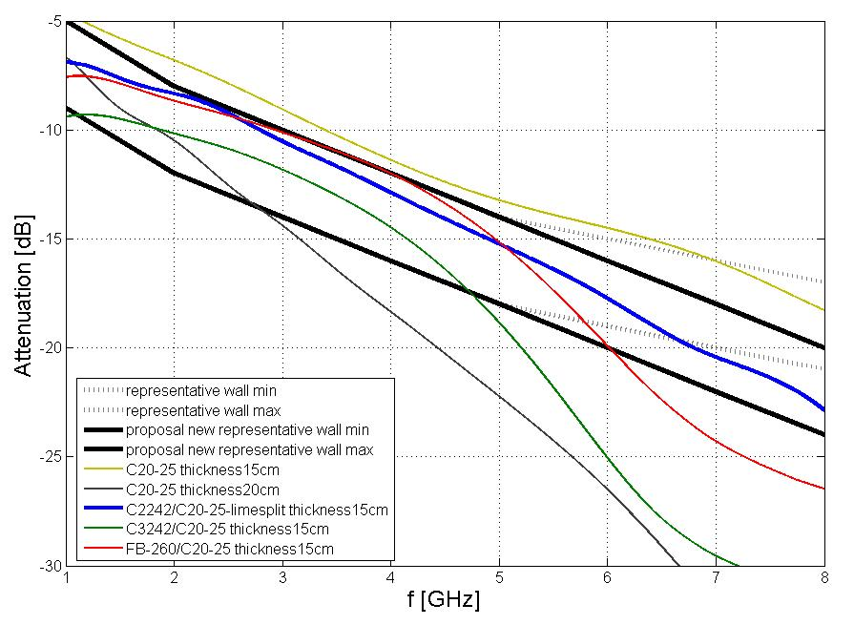

Figure 50: Frequency dependency of attenuation
Typical representative wall measurement have also been specified in EN 302 435 [26].
The following figure gives min and max attenuation for deep concrete walls depending on the frequency band. Based on this study it appears that a min value between 3.4 GHz and 4.8 GHz is around 12 dB and that a max value is around 16 dB. For the compatibility studies, the value of 12 dB has been taken into account.
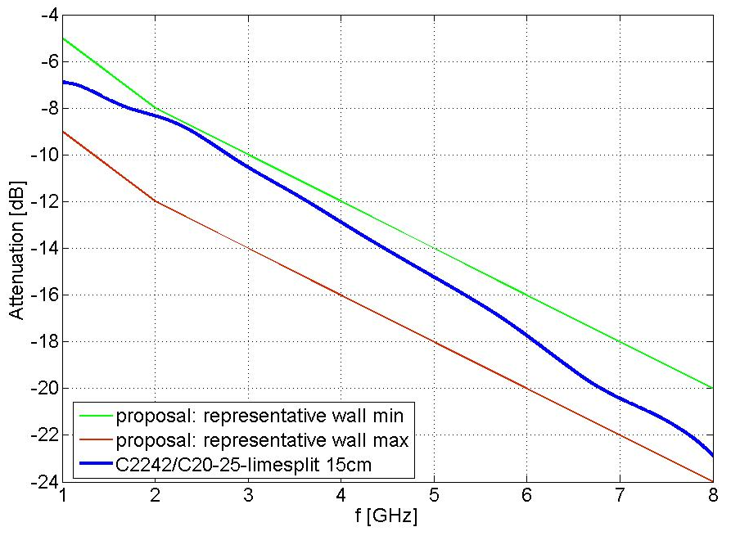
Figure 51: Min and max deep concrete wall attenuation
- Matlab simulations
For the calculation of the potential FS BER degradation recent work performed in CEPT ECC WG SE, for the 24 GHz automotive SRR studies, has been reused partly and modified accordingly. The base of this work is described in ECC Report 158 [18]. While further explanation and introduction into the changes applied for this investigation is given in this section below.

For that purpose, the I/N = −20 dB objective has to be translated into the “physical” equivalent fade margin (e.g. at BER ≤ 10⁻⁴) reduction of 0.04 dB, which is generally assumed to fulfil Recommendation ITU-R F.1094 [13] objectives for interference from non co-primary sources.

For practical purpose the following Matlab simulations consider satisfactory a BER = 10⁻⁴ degradation less than 0.1 dB.
BERCalc.m as provided from SRR investigations applied to all UWB signals
The BERCalc code (BERCalc.m, Main.m, PErrConv.m, plus Readme_BERCalc.doc) plots the BER versus SNR curves for some specific UWB pulse and frequency hopping waveforms. The signal is assumed to be BPSK, which is not representative of current equipment but very much simpler to analyse. The higher-order modulations actually used now will have different performance, but only by a small factor relative to the unknowns in this kind of coexistence study. The pulse waveforms are PPM (time modulated), but this does not need to be represented in the calculation since moving a pulse in time has no effect on the number of bit errors. The FH waveforms are those proposed for automotive short-range radars (SRR).
For all UWB signals the aim has been to re-use the code where possible to provide comparability, but to extend it to cover the pulse and FH waveforms proposed for those systems. This note explains what has been done and why. It starts, necessarily, with a description of the code as supplied.
Script Main.m (now renamed Main_old.m) calls subroutine BERCalc.m for the parameter sets of interest and plots the results. It also computes the BER when no interference is present on the following basis:
BER = 0.5* erfc(1/sqrt(2)* sigma), where sigma=sqrt(n/2).
The standard formula for this BER has:
BER = 0.5* erfc(√(E_{b}/N₀₁)).
As N₀₁ is the one-sided noise PSD (i.e. for positive frequencies), so the in-band power is n=B·N₀₁. Making some simplifying assumptions about the channel filter, it is often assumed that bit duration T_{b} = 1/B, hence if the signal power is unity E_{b} = 1/B and E_{b}/N₀₁ = (1/B)/(n/B) = 1/n = SNR, if “n” is the noise power relative to the signal power in a coherent detector. The two factors of two are not necessary, and cancel.
Truly noise-like interference can be dealt with by modifying the SNR. Subroutine PErrConv.m is intended to evaluate the probability of bit errors resulting from interference that is not noise-like. It is called from BERCalc.m, with the parameters d, sigma, and M. Now “d” is the signal amplitude (√power), sigma is as before but relative to d, and M defines the interference, described as uniformly distributed between ±M. The algorithm implemented in PErrConv.m is analytically derived, so its actual behaviour cannot be confirmed. While it does not converge for M=0, for small M (e.g.10⁻⁴⁾) it returns very nearly the same values as the formula above. It was compared it with a simple method (see below note 1) and got almost the same result for a linear distribution of noise amplitude.
In the calculation within BERCalc.m the signal and noise levels are intended to be real-world values, not just relative to the signal=1 as in Main.m. In fact they are all worked out from the assumed noise level of -114 dB/MHz, which relates to a receiver with a noise figure of 0 dB, and a bandwidth that is an argument (Bw). However, as the symbol rate is fixed at 50 MHz, the bandwidth should be 50 MHz or the effect of the code is hard to predict. The interference level is specified as the I/N ratio in the receiver bandwidth and this is applied to the same thermal noise value of -114 dBm/MHz. However, the actual I/N after the receiver noise is added should be used in the function call, and the same should be true of the SNR, which is now been made a function call argument as well.
The signal pulse stream is represented by two “duty factors”, noting that this term should be used with care to avoid confusion with the parameters of the LDC mitigation. The first of these is specified as the argument “PiccoSuRms” or peak to mean ratio. Within BERCalc.m this is used with “ImpDistance” (the PRI) to give ImpTime (the pulse duration), but then converted back to the original peak:mean ratio to generate the interference span “M” from the mean interference level “interf”. However, the PRI is also used to work out the number of data stream symbols per pulse of interference, where the comment says “between pulses”. The concept being applied is that the BER is computed with noise alone (BER1) and also with interference spread across a span between (or is just uniform between discrete values) ±M (BER2), then a weighted sum of these two BERs is formed. The code that implements the weighted sum is:
(BER1*(Nsymb-1) + BER2) / Nsymb
This is a correct weighted sum if the number of symbols with BER2 is exactly one, for Nsymb-1 symbols with BER1. There is an unstated assumption that the pulse duration and the symbol duration are the same – this is not unreasonable as the UWB pulse is much shorter than the symbol time of 1/Bw.
The second duty factor is applied in Main.m to the values returned from BERCalc.m (in res()) to give BER_M_DC(). In this case the formula says:
BER_M_DC() = res() – ((1-2/100*DC()) * (res()-BERNoInterf)), which is equivalent to
BER_M_DC() = res() * 2/100*DC() + (1-2/100*DC()) * BERNoInterf).
This is a true weighted sum, but the duty factor DC() has been doubled because a car has two of these radars synchronised not to overlap. Note that this gating is applied to the interference as represented by the mean power – that mean should be calculated in the receiver bandwidth (50 MHz) for a continuous stream of pulses. Thus both peak and mean power, and their ratio PiccoSuRms, must be for a bandwidth of 50 MHz. For UWB signals, where the mean power at mid-band (where it is highest) is nearly constant per MHz, the I/N ratio does not vary significantly with bandwidth anyway.
Pulsed UWB
The pulse calculation is left almost unchanged in BERCalc_P.m, apart from making the array of SNR values an argument. The pulse stream parameters are defined in Main.m, where the ratio IS() is simply computed as the pulse interval (x in ns)* receiver bandwidth (0.05 GHz). Note that the use of the PErrConv.m routine means that this peak is used as the outer limit of a uniform distribution (or as the discrete values +-M, which needs to be clarified with Christian Sturm from University Karlsruhe), so it should be a true envelope peak (PEP) and not the mean power over the nominal pulse duration of 20 ns.
This (pulse) section needs to be split/extended into LT2 and LTT to explain the different settings.
The TRT(UK) FH-UWB
For the FH-UWB signal a separate function BERCalc_FH has been made. This does not use PErrConv.m, since the waveform for in-band hops is a constant carrier for 4.6 μs. This has been modelled as a constant tone of uniformly-distributed phase, which could be random or constantly changing due to a frequency offset. Now the interference power supplied as I/N ratio is a carrier power exactly like the signal, and it can be multiplied by cos(phase angle) over the range 0-π and added to the signal. The BER is then calculated for this range of SNR values, and averaged over all phases to give the BER with interference.
1: This method was checked against the uniform distribution both implemented in the same manner and in PErrConv.m. FErrConv.m is a test routine called identically to PErrconv.m used in this comparison. As noted above the linear distribution does match PErrConv.m.
The set of hops that overlap the receiver bandwidth are found, and for those at the edges the power is reckoned to be proportional to the overlap. This is not very accurate, but there are enough in-band hops that these edge hops do not matter much. The BER is summed over the set of hops before it is averaged over the phase.
In Main.m, the power passed into BERCalc_FH.m is the hop carrier power, not the mean power. The mean power in 50MHz averaged over 1 ms is the “on” power times the set of overlap fractions times the “on” time (4.6 μs) per 1 ms. This is used to set an equivalent mean_INR for any other UWB signal, and also used to define an equivalent noise-like UWB signal. When extra noise defined by noise_INR is added to the receiver noise, this rises by linear addition of the power so as to reduce the SNR.
Further notes and comparisons
The ITU-R calculation (e.g. SF.1006 [12]) includes the factor W (in dB) to convert from the actual mean power to the mean power of noise with the same interfering effect. So far we have assumed this is 0 dB.
There is a statement in Recommendation ITU-R SM.1448 [27] Annex 2 section 2.4, that says "When the wanted signal is digital, W is usually equal to or less than 0 dB, regardless of the characteristics of the interfering signal." So the value of 0 dB for W is justified.
It was indicated that it is the performance at a BER of 10⁻⁴ to 10⁻⁵ that matters, but no degradation limit was given – instead it was referred to ITU-R Rec. F.758 [28].
Table 53: Input parameters
MatLab Parameter. |  | PPM 100% | 5% DC | 5% DC | 5% DC | 5% DC
 | Peak eirp dBm/50MHz | 0 | -5 | -10 | -15 | -20
 | Mean eirp dBm/1MHz | -41.3 | -41.3 | -41.3 | -41.3 | -41.3
 | Peak eirp dBm/50MHz | 0 | -5 | -10 | -15 | -20
 | Mean eirp dBm/50MHz | -24.31 | -24.31 | -24.31 | -24.31 | -24.31
 | PRF opt. MHz | 0.185 | 0.586 | 1.853 | 5.861 | 18.533
ID | 1/PRF ns | 5395.85 | 1706.32 | 539.59 | 170.63 | 53.96
PSR | Peak/Mean dB (RBWpeak/RBWmean) | 24.31 | 19.31 | 14.31 | 9.31 | 4.31
 | Duty Cycle | 100% | 5% | 5% | 5% | 5%

Based on the studies in SE24 only this calculation was used for LT2 scenarios.
Results LT2
For the investigation of the impact of duty cycle on the victim system in case of LT2, the following parameters are used for the Matlab simulation. The bandwidth of the interference signal is fixed to 50 MHz because of the limited victim receiver bandwidth.
For maintaining the instantaneous mean power of the UWB signal during the burst duration to the desired −41.3 dBm/MHz, the interference to noise ratio I/N for the simulation is set to -3dB (worst case result of Report 64 in lower band outdoor ) respond . -9dB (worst case result of Report 64 in upper band outdoor). The impulse time is set to a fixed value of 20ns.
The interfering UWB signal is characterized by variable impulse distance, resulting in different impulse Peak power ranging from 0 dBm to –15 dBm and controlling the PSR consequently. The 1 s averaged BER graphs with UWB duty cycle of 5% are compared against the instantaneous BER degradation (assumed with 100% DC). The results of the investigation are illustrated in the following figures.

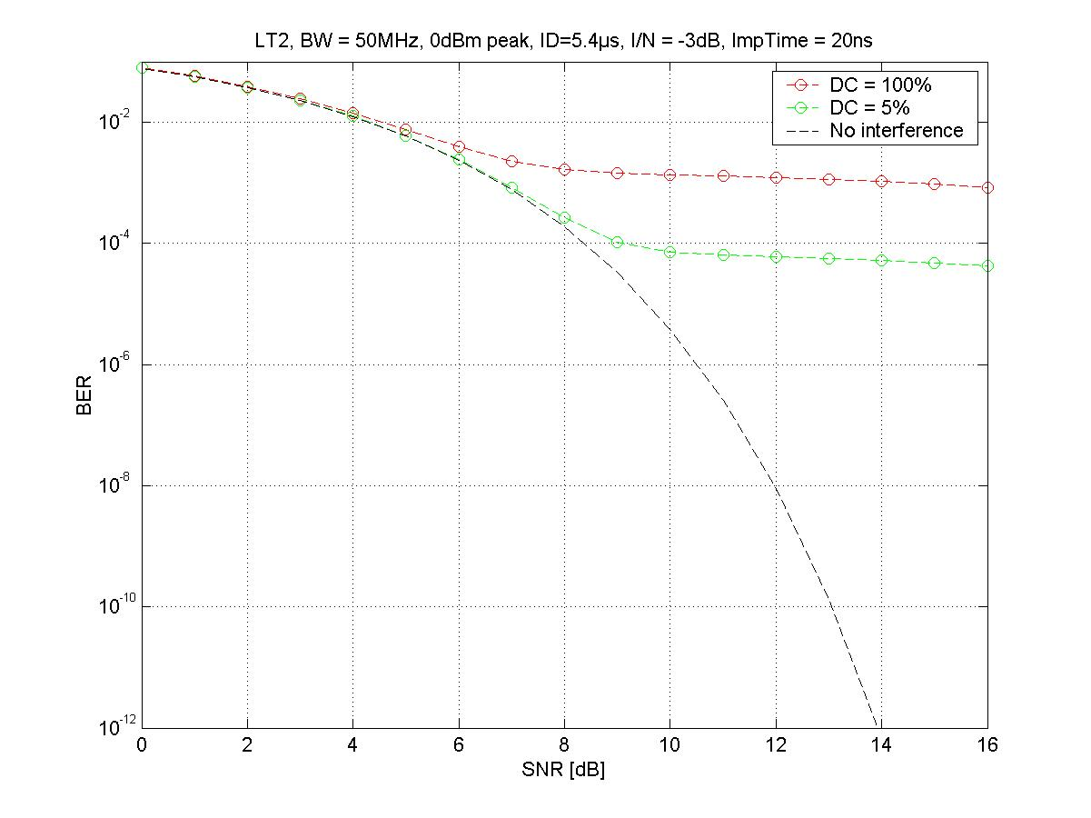
Figure 52: FS PP 4 GHz, worst case result with 0dBm peak power and a PRF of 185 kHz

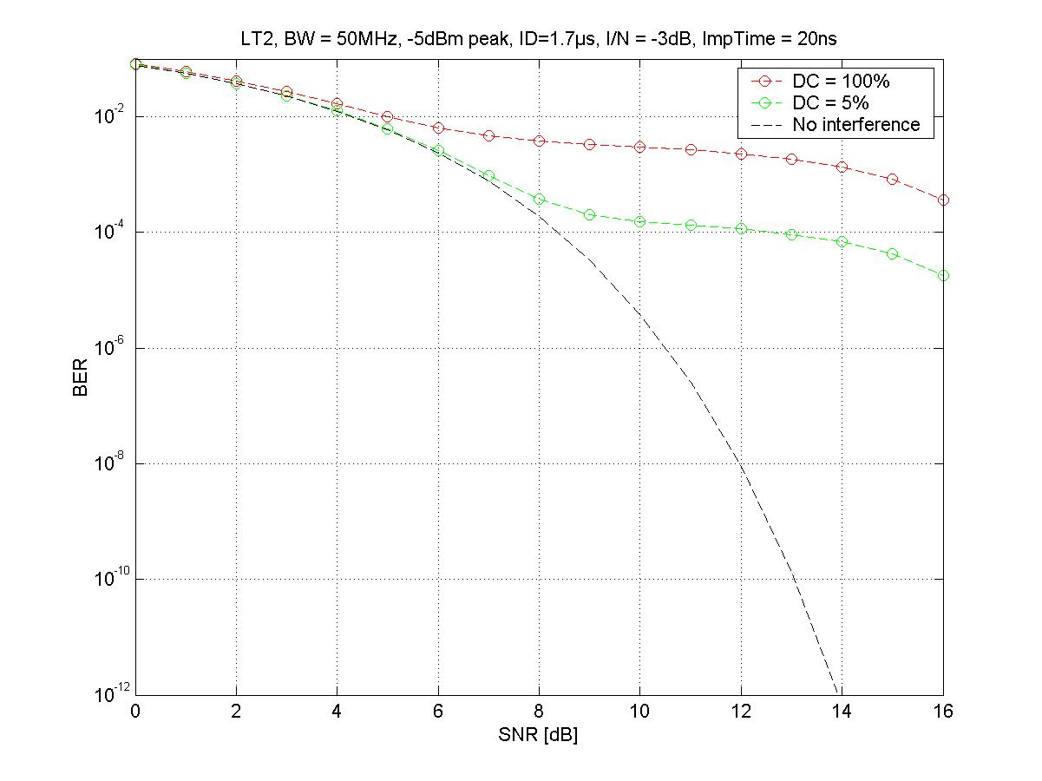
Figure 53: FS PP 4 GHz, worst case result with -5dBm peak power and a PRF of 580 kHz
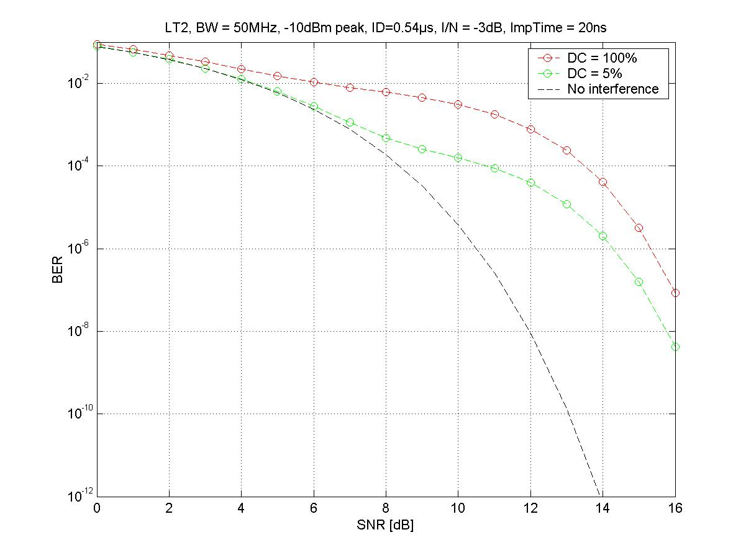
Figure 54: FS PP 4 GHz, worst case result with -10dBm peak power and a PRF of 1800 kHz
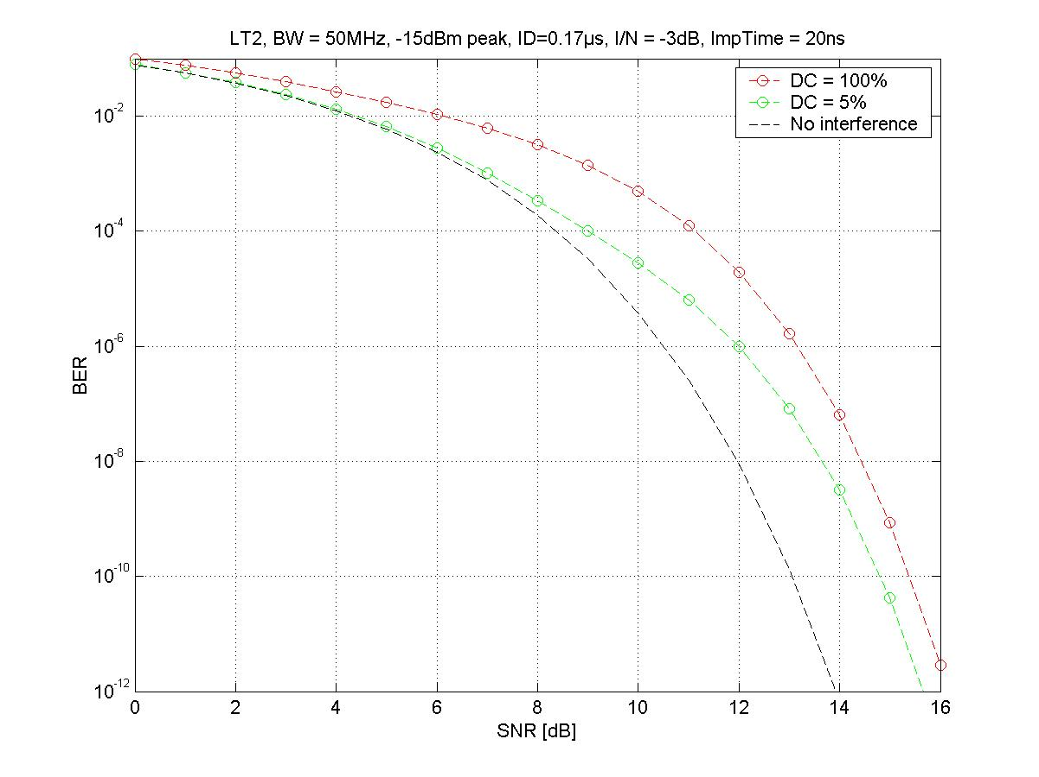
Figure 55: FS PP 4 GHz, worst case result with -15dBm peak power and a PRF of 5800 kHz
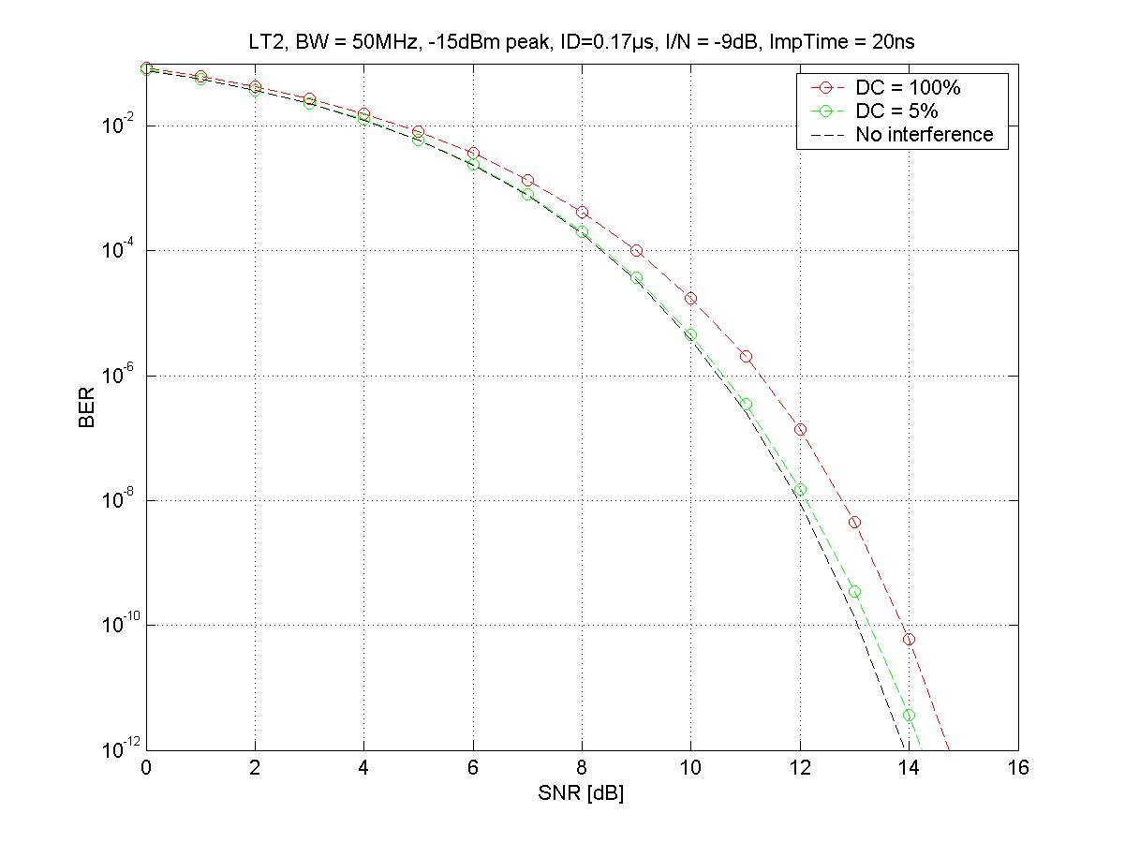
Figure 56: FS PP 4 GHz, worst case result with -15dBm peak power and a PRF of 5800 kHz
with 6dB higher antenna decoupling (e.g. 40m FS antenna height instead of 20m)
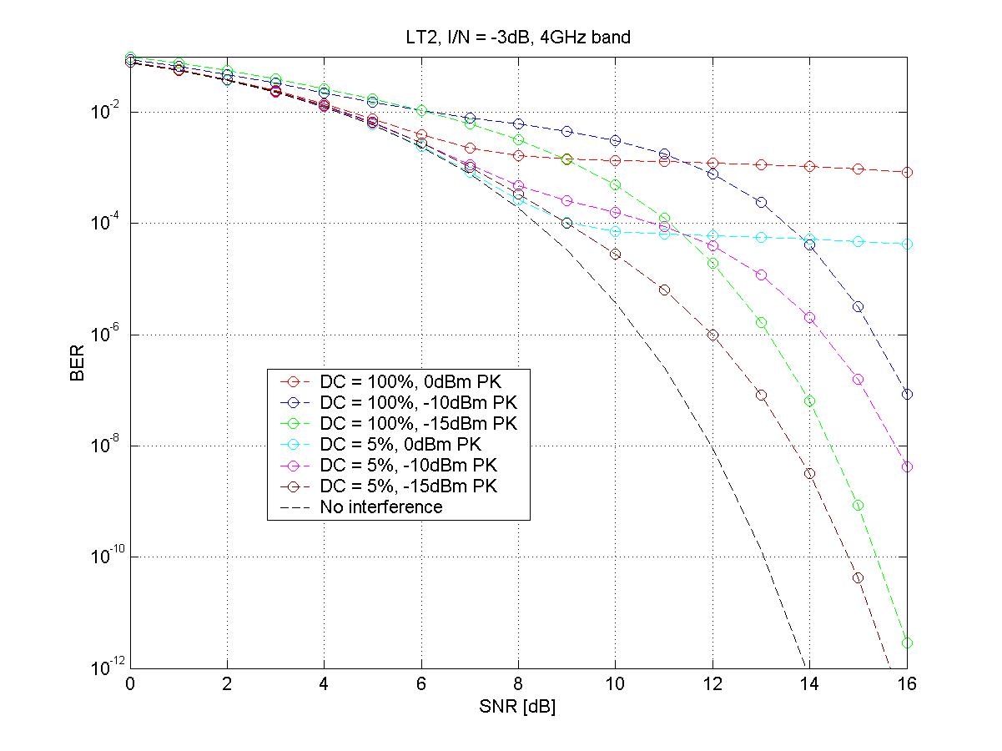
Figure 57: Overview 4 GHz
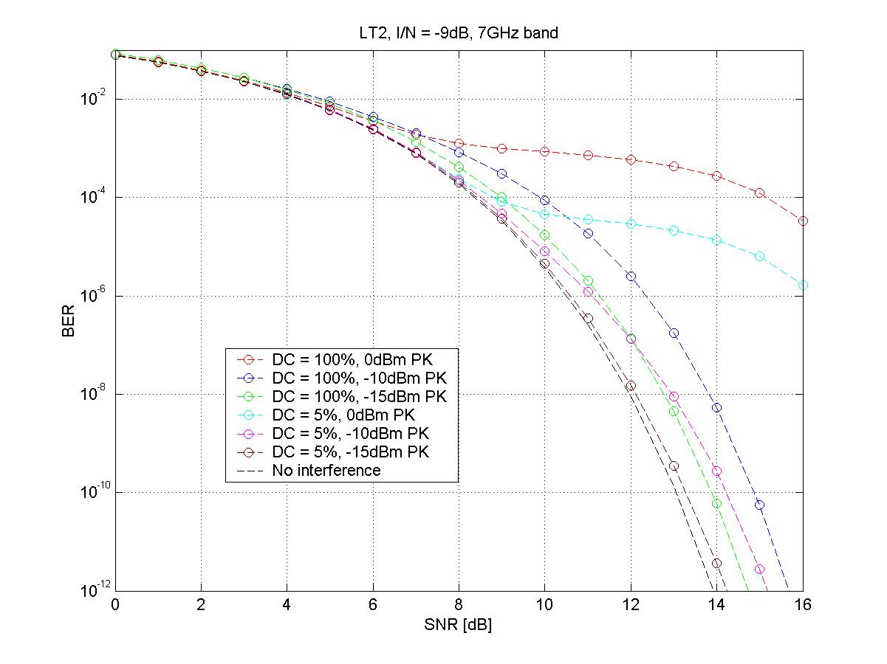
Figure 58: Overview 7 GHz

Peak power dBm/50MHz | FS antenna height above ground (or height difference between LT2 antenna and FS antenna) | Degradation at a BER 10^-6 | Degradation at a BER 10^-4
0 | 20m | >10dB | 1dB
-5 | 20m | 7dB | 4dB
-10 | 20m | 4dB | 3dB
-15 | 20m | 1.5dB | 0.5dB
-15 | 40m | 0.2dB | <0.1dB
-15 | 60m | <0.1dB | <<0.1dB
Table 54: Degradation at a BER

Additional remarks for usage of the Matlab simulation:
The uniform distribution between +-M for the BER calculation means a uniform distribution within the interval of +-M, not a uniform distribution of the discrete values +M and –M.
The obtainment of IS (which stands for I/N) is given in Report 23 [15]. The used values further include a reduction of the power spectral density according to the new regulation.

- UWB Aggregation
Table 55: UWB aggregation
 |  | ECC Report 123 [24] |  |  |  | CEPT Report 17 [21], Annex 2
 |  | Generic UWB ECC/DEC/ (06)04 | ECC/DEC/(07)01 on BMA | ODC |  | Automotive | Location tracking (sides) (tags + active base stations) | Impact on aggregation and probabilistic scenarios | Impact on single entry scenarios
Densities rural/  suburban/  dense urban per km² |  | 100/  1000/  10000 | 0.052/  0.46/  6.7 | 0.3/  2.5/  19 |  | not defined /  not defined /  330 (cars) | not defined /  not defined /  150
Device Activity Factor |  |  |  |  |  |  | 0.5% to 1.67% per 24h  1.0% to 3.34% per 12h (working day)
Aggregated Activity Factor per 12h |  | 1% | 0.28% | between 1.4% and 3% |  | 0,01% | between 1.0% and 3%
Density of active devices rural/  suburban  /dense urban per km² |  | 1/  10/  100 | 0.00015/  0.0013/  0.019 | 0.004  0.049  0.563 |  | Not defined /  Not defined /  0.033 (cars) | Not defined /  Not defined /  1.5 – 5.0
Total radiated power |  | NA | 5dB below the max limits (especially 10dB within the RAS bands 2.69-2.7 and 4.8-5GHz) | For application A (saw) no TRP limit (see antenna rejection)  For application B (drill) just TRP in RAS band 4.8-5 GHz
Proximity sensor |  | NA | Yes | No for application A (saw (see TPC)  Yes for the application B (drill)
Working sensor |  | NA | Movement | Running sensor
Acceptable protection distance around mobile services |  | 0.36cm | 3m due to the working area around | 2m to mobiles and 3m to BWA/WLAN
Additional wall attenuation (for RAS studies) shielding |  | 10 dB | 7.4 dB | 7.4 dB |  | 10 dB
TPC |  | 12dB in vehicles | NA |  |  | 12dB in vehicles
Duty Cycle |  | NA | NA | Not for Application A;  For Application B (drill) 10% DC (100ms/s) |  | 5%/s (Ton max 5ms) | . 5%/s (Ton max 25ms)
Antenna radiation pattern (measured for ODC embedded in the machine) |  | NA | NA | For application A (saw, quasi fixed) installations: Rejection in the elevation from -20° to 30°
Measurement scenario for the standard d |  |  | Radiated power over a sphere around the BMA on a representative wall | Radiated power over a sphere around the ODC:  - Application B (e.g. a drill) on a representative wall  - Application A (e.g. a saw) installed in a saw table
The following table shows the assumed mitigation factors for aggregated scenarios.

Mitigations | Generic | LT2 tags | LT2 fixed | LTA  Traffic jam (20m distance) | LTA  Driving (>50m distance)
Peak power mitigation | 0 | 0 | 10dB | 0 | 0
Average screening attenuation | 10dB | 0 | 0 | 17dB* | 17dB*
TPC or Duty Cycle | 0 | 5%=13dB | 5%=13dB | Standing cars  0.5%=23dB  ** | Driving 5%=13dB  **
Activity factor | 1%=20dB | 5%=13dB | 50%=3dB | 100%=0dB | 100%=0dB
sum of mitigations | 30dB | 26dB | 26dB | 40dB | 30dB
Table 56: Mitigations for aggregated studies
- * Engine Compartment values from document TG3#16_31
- ** this was proposed during the process of studies in SE24
  - Integral methodology
The integration methodology is descibed in Annex 2 of Recommendation ITU-R SM. 1757 [29]. Integrating over a range bounded by an inner ring (RI) and an outer ring (Ro), the average aggregate interference power density I (W) per reference bandwidth can be written as:
I = 2*α*η*σ* ln(Ro/RI)
where:
- α = (e.i.r.p.)*GR *(λ/4π)²: constant term valid in the case of omnidirectional emissions and
- free-space propagation;
- e.i.r.p.: average e.i.r.p. of the UWB transmitting device (W) per reference
- bandwidth)
- λ: wavelength (m)
- σ: average density of emitters (emitters per m²)
- η: activity factor of emitters
- Ro: outer radius of the observed zone
- RI: inner radius of the observed zone.

Table 56 (I/N -20dB) and 57 (I/N -6dB) provide the inner protection radius needed to fulfill the protection criterion for LT2 and LTA based on the integration a uniform density of interferer.
Table 57: Protection distance with mitigation factors with I/N -20dB
(the Table is inserted as Excel-Sheet; input fields are yellow colored)

Table 58: Protection distance with mitigation factors and an I/N of -6dB
(the Table is inserted as Excel-Sheet; input fields are yellow colored)

Note: the uniform density for LT2 fixed antennas is assumed unrealistic high in this table to avoid an error in the calculation

With this the aggregation of each new outdoor UWB application should be able to fulfill the long term protection criterion of I/N -20dB.
The following tables use the same methodology but estimates the aggregation of all UWB applications (BMA and ODC are neglected, see ECC Report 123 [24]).

Table 59 : 4 GHz Aggregated impact of all UWB applications

Table 60 : 4 GHz Aggregated impact of all UWB applications

Table 61 : 7 GHz Aggregated impact of all UWB applications

Result: It can be seen from Table 59 that at 4GHz I/N of -20dB would require in theory an exclusion zone with a radius of about 900m around all victim stations. But the integral methodology is a sensitive methodology with sharp crossover distances; Table 60 shows that an I/N of -17dB would be fulfilled without any protection area at 4GHz and Table 61 that even an I/N of -20dB is fulfilled at 7 GHz.
- FSS Studies

- MEASUREMENTS to assess the impact of longer ldc on wimax
This Annex provides information relating to the measurement conducted by ISPRA in order to investigate the impact of max Ton time of 25ms versus 5ms on Wimax systems [30].

The campaign aimed at determining the impact of UWB LDC signals on different types of services provided by a Mobile WiMAX (IEEE802.16e-2005,) victim system, and in particular to examine LDC pulses with a width of more than 5 ms, whilst maintaining an overall activity limit of 5%, equalling 50 ms per second.

1. Set up

The main elements of the test setup were a Mobile WiMAX link and a UWB interferer.

The Mobile WiMAX link was realized with a commercially available base station (BS) and subscriber station (SS). Two different types of UWB interferers were employed. The first round of tests was done using a WiMedia-compliant UWB evaluation kit that allows a large number of UWB parameters to be freely configured. In order to create a realistic scenario comparable to that of ECC Report 94 the measurements were done in a radiated manner. For verification purposes, certain measurements were also done with a conducted setup. In a second round an additional set of measurements was done with a TH-UWB system.
The minimum RSSI at which a stable WiMAX link without CRC errors was maintained was -90.6 dBm. At this RSSI the maximum UDP data rate that could be achieved with a packet error rate of 0% was 1660 Kbits per second (Kbits/s), and the FTP throughput was 1638 Kbits/s. Considering that in a real-world deployment a certain fading margin would be applied measurements were made at an RSSI level of -84.6 dBm, corresponding to a fading margin of 6 dB. In reality, operators work with even higher RSSI levels in order to guarantee a certain quality of service.

BS max. Tx power [dBm] | 27
SS max. Tx power [dBm] | 25.5
Centre frequency [MHz] | 3500
Duplexing method | TDD
Channel bandwidth [MHz] | 10
FFT size | 1024
Frame length [ms] | 5
DL:UL TDD ratio | 29:18 (60%)
Modulation | Adaptive
Antenna diversity | No (SISO)
Table 62: Mobile WiMAX system and signal characteristics

UWB TFC | 5
Frequency [MHz] | 3168 – 3696
UWB Tx PSD [dBm/MHz] | -41.3
Superframe duration [ms] | 62
Tx/(Rx+TX) ratio | 100%
Table 63: MB-OFDM UWB transmitter characteristics

Pulse width [ns] | 0.45
PRI [ns] | 72
Modulation | PPM, PPoM
UWB Tx PSD [dBm/MHz] | -41.3
Table 64: TH-UWB transmitter characteristics

Activity factor | T_{On}  [ms] | T_{Off_mean}  [ms] | f_{Pulse}  [Hz]
5% | 1 | 19 | 50
5% | 2 | 38 | 25
5% | 5 | 95 | 10
5% | 10 | 190 | 5
5% | 25 | 475 | 2
5% | 50 | 950 | 1

Table 65: LDC pulse parameters

2. Description of the measurements

Measurements were made with constant and with random LDC pulse durations. In the case of a constant duration the temporal position of the interfering UWB pulse in relation to the Mobile WiMAX DL and UL bursts remained more or less constant at all times, due to the fact that for all LDC pulsing schemes the pulse duration (T_{ON} + T_{OFF}) was an integer multiple of the Mobile WiMAX frame rate of 5 ms. As a consequence, the impact of the interfering signal on the victim signal varied, particularly for small pulse widths, depending on the amount of overlap between UWB pulse and Mobile WiMAX DL burst. The results for the three different cases that were investigated.

- Worst case (constant LDC pulse duration, maximum Mobile WiMAX overlap = maximum interference).
- Best case (constant LDC pulse duration, minimum Mobile WiMAX overlap = minimum interference).
- Realistic case (randomized LDC pulse duration, random Mobile WiMAX overlap).
In this case T_{ON} remained constant, and T_{OFF} was randomized whilst maintaining the conditions T_{OFFmin} ≥ 38 ms and T_{OFF_Total} ≥ 950 ms/s.

3. Results of Measurements

It was observed that UDP traffic is adversely affected by signals with a high pulse frequency while longer LDC pulses with a lower frequency generate less interference.

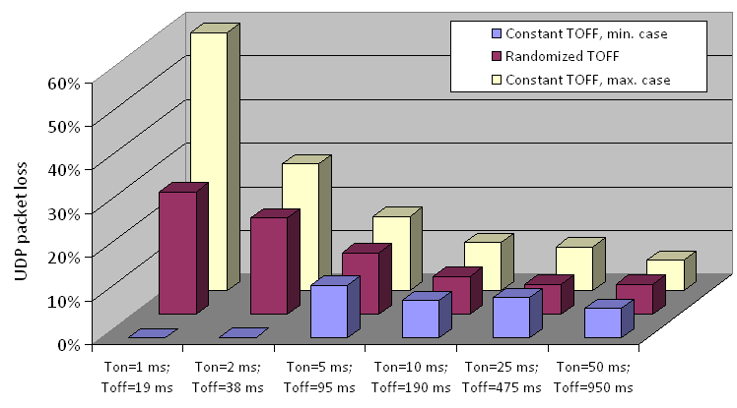
Figure 59: UDP packet loss for different LDC pulsing schemes,
equivalent UWB distance = 0.5 m, SS RSSI = -84.6 dBm

The maximum UDP packet loss was found to occur at a pulse width of 100 μs which corresponds more or less to the WiMAX useful symbol time of 91.4 μs. For pulse widths < 100 μs UDP packet loss decreases again.

Figure 60: WiMAX UDP packet loss for different UWB LDC schemes (5% activity level),
equivalent UWB distance = 0.5 m (LOS), SS RSSI = -84.6 dBm

The transition from the non-interference to the interference region is very sharp. Within 1 m (equivalent LOS distance at 3.5 GHz, corresponding to a change in SIR of 2 dB) UDP packet loss increases drastically once the SIR threshold of 3dB is reached shows this transition for various LDC pulse durations in comparison to a continuous UWB signal.
Figure 61: UDP packet loss vs. equivalent distance to interferer (LOS), SS RSSI = -84.6 dBm

Once the 3 dB threshold was passed, packet loss rates remained relatively constant, even when the UWB Tx power was increased above the maximum level of -41.3 dBm/MHz permitted by the current spectrum regulation. The following figure shows the UDP packet loss rates in relation to the WiMAX SIR for the various pulses types. Down to a SIR of -24 dB, packet loss rates remain more or less constant for all pulse types. When the UWB signal level was increased further, the WiMAX link started breaking down.

Figure 62: UDP packet loss rates vs. WiMAX Signal-to-Interference Ratio (SIR) for various LDC pulse durations, RSSI = -84.6 dBm

The UDP throughput tests were then repeated using a pulsed TH-UWB signal. With a mean power level matching that of the MB-OFDM transmitter the impact of the TH-UWB signal on the Mobile WiMAX QoS was almost identical to that of the MB-OFDM signal. There was a small difference (~1 dB) in the UWB signal levels from which the Mobile WiMAX QoS became impacted. At this signal level (-85 dBm), however, small variations (due to path attenuation, temperature change, etc.) have a big impact on the Mobile WiMAX signal and service quality.
Figure 63: Comparison of pulsed TH-UWB and MB-OFDM UWB
impact on WiMAX UDP throughput

Next, the impact of UWB LDC interference on the quality of a VoIP link was examined. For this purpose a VoIP connection was established via the WiMAX link, using a Linksys IP phone on the BS side and a PC emulating a VoIP phone on the SS side.

A common benchmark used to determine the quality of sound produced by specific codecs is the mean opinion score (MOS). In order to determine the MOS of a particular voice codec, a wide range of listeners judge the quality of a voice sample on a scale of 1 (bad) to 5 (excellent). The results are then averaged to provide an overall score. Three voice codecs with distinctively different characteristics in terms of bit rate/compression and voice quality were examined.

Table 66: Characteristics of the examined voice codecs
Voice codec: | G.711u | G.723.1 | G.729a
Compression scheme | None | ACELP | CS-CELP
Packet duration [ms] | 20 | 60 | 20
Packets/s | 50 | 16,67 | 50
Bit rate [Kbits/s] | 64 | 5,3 | 8
Bits/packet | 1280 | 318 | 160
Bandwidth [Kbits/s] | 80 | 11 | 24
Reference MOS | 4.3 | 3.74 | 3.76

All three codecs were first tested without UWB interference in order to determine the basic MOS achievable over the WiMAX link. It showed that all values were in line with the reference values. We then applied the interfering UWB LDC signals (MB-OFDM only) and measured the resulting MOS.

The MOS results confirmed the observation made in the UDP throughput tests, i. e. short pulses with a high PRF impair service quality more than longer pulses with a lower PRF do.

Figure 64: Impact on VoIP quality for different LDC pulsing schemes,
equivalent UWB distance = 0.5 m, SS RSSI = -84.6 dBm

4. Findings

The main findings of this measurement campaign were:

- LDC can significantly reduce harmful interference from UWB to a Mobile WiMAX link;
- UWB LDC schemes with pulse durations > 5 ms cause less interference to Mobile WiMAX services (data, voice video) than those with pulse durations ≤ 5 ms* that are permitted by current European spectrum regulation;
- UWB interference negatively affects the QoS of Mobile WiMAX from a SIR of 4 dB ± 1 dB onwards, independent of the type of UWB signal (MB-OFDM or pulsed TH-UWB). With further decreasing SIR the QoS degradation remains relatively constant, particularly for longer pulses;
- From a LOS distance) of 6 meters on (worst case observed) the impact of UWB on the QoS of a mobile WiMAX system is negligible.

- List of references
[1] CEPT Report 27: Report A from CEPT to EC in response to the Mandate 4 on UWB
[2] ECC/DEC/(06)12 : UWB devices using mitigation techniques
[3] CEPT Report 34: Report B from CEPT to European Commission in response to the Mandate 4 on Ultra-Wideband (UWB)
[4] TR 102 496: Technical characteristics for Location tracking Applications for Emergency Services (LAES) in disaster situations operating within the frequency range from 3,4 GHz to 4,8 GHz
[5] ECC/DEC/(07)01: specific Material Sensing devices using Ultra-Wideband (UWB) technology
[6] Radio Regulations (www.itu.int)
[7] ECC Report 064: Generic UWB applications below 10.6 GHz
[8] ITU-R Report M.1186: Use of frequency band 4 200 MHz to 4 400 MHz by radio altimeters
[9] Recommendation ITU-R RS.1624: Identify the conditions relating to the harmonised introduction in the European Union of radio applications based on UWB technology
[10] ITU-R Report SM.2057: Studies related to the impact of devices using ultra-wideband technology on radiocommunication services
[11] Recommendation ITU-R P.452: Prediction procedure for the evaluation of interference between stations on the surface of the Earth at frequencies above about 0.1 GHz
[12] Recommendation ITU-R SF.1006: Identify the conditions relating to the harmonised introduction in the European Union of radio applications based on UWB technology
[13] Recommendation ITU-R F.1094: Identify the conditions relating to the harmonised introduction in the European Union of radio applications based on UWB technology
[14] Recommendation ITU-R S.1432: Identify the conditions relating to the harmonised introduction in the European Union of radio applications based on UWB technology
[15] ECC Report 023: Compatibility of 24 GHz Automotive Radars with FS, EESS, Radio Astronomy
[16] TR 102 495: Technical characteristics for SRD equipment using Ultra Wide Band Sensor technology (UWB); System Reference Document
[17] Recommendation ITU-R F.699: Reference radiation patterns for fixed wireless system antennas for the use in coordinaton studies and interference assessment in the frequency range from 100 MHz to about 70 GHz
[18] ECC Report 158: SRR 26 GHz applications using UWB Technology on Radio Services
[19] See at http://www.emt-penzberg.de
[20] ECC/DEC(06)04: UWB technology in bands below 10.6 GHz
[21] CEPT Report 17: Identify the conditions relating to the harmonised introduction in the European Union of radio applications based on UWB technology
[22] Recommendation ITU-R F.1245-1: Reference radiation patterns for fixed wireless system antennas for use in coordination studies and interference assessment in the frequency range from 100 MHz to about 70 GHz
[23] ECC Report 94: Technical requirements for UWB LDC to protect FWA systems
[24] ECC Report 123 The impact of ODC applications using UWB technology on radio services
[25] Recommendation ITU-R RA.769: Protection criteria used for radio astronomical measurements
[26] EN 302 435: Technical characteristics for SRD equipment using Ultra WideBand technology (UWB);Building Material Analysis and Classification equipment applications operating in the frequency band from 2,2 GHz to 8,5 GHz
[27] Recommendation ITU-R SM.1757: Impact of devices using ultra-wideband technology on systems operating within radiocommunication services
[28] Recommendation ITU-R SM.1448: Determination of the coordination area around an earth station in the frequency bands between 100 MHz and 105 GHz
[29] Recommendation ITU-R F.758: Considerations in the development of criteria for sharing between the terrestrial fixed service and other services
[30] Report on Radio Frequency Compatibility Measurements between UWB LDC Devices and Mobile WiMAX (IEEE 802.16e-2005) BWA Systems

The reduction of field strength with the altitude of the aircraft in the following tables is a consequence of the simulation, which has used a limited area with UWB devices. In widespread urban areas there will be negligible reduction of field strength with the altitude of the aircraft.
the market share of UWB is assumed to be 50% because there are other competing technologies offering the same functionality; e.g. there are different technologies for tire pressure monitoring
Ideal Conditions: No Network Load with Both Gender Voice. Source: http://www.vocal.com/speech_coders/psqm_data.html

