
Electronic Communications Committee (ECC)
within the European Conference of Postal and Telecommunications Administrations (CEPT)

STUDYING THE Compatibility issues of the UIC Euroloop System with other systems in the frequency band 9.5 to 17.5 MHz

Bern, February 2007

EXECUTIVE SUMMARY
This Report investigates the impact of the change of the Euroloop centre frequency from 4.5 MHz to 13.5 MHz (frequency band 9.5 - 17.5 MHz), on other systems / services, following a request initiated by UIC and UNISIG to CEPT WGFM.
The report contains a brief description of the Euroloop system and considerations on the proposed change of frequency.
In addition, the report contains compatibility analyses between Euroloop system and the systems/services which might be affected by the change in frequency. The systems identified are:
- Amateur Services
- Broadcasting Services
- Military Services
Compatibility analyses were developed using the result of measurements campaign to model the behaviour of the Euroloop antenna and to validate the propagation models (ERC Report 69).
The consideration of the impact of different limits for Euroloop systems on the services listed above and the possibility of implementing such a limit for the Euroloop systems led to the conclusion that a limit for the measured magnetic field strength, spatially averaged over any 200 m length of the loop (leaky coax) of -7dBμA/m at 10 m in 10 kHz was a satisfactory compromise.

Table of contents
1 Introduction 4
2 Description of Euroloop System 4
2.1 Overview 4
2.2 Duty-Cycle of Euroloop Sub-System 5
3 Market Size 5
4 Modelling and behaviour of Euroloop systems 5
4.1 Simulation of the Euroloop system as an antenna 5
4.2 Propagation model 6
4.3 Test Results on Euroloop Transmission levels 6
5 Calculations for Services which may be affected by the Euroloop System 7
5.1 Amateur services 7
5.1.1 Signal aggregation of skywave propagated signals from multiple Euroloops 7
5.1.2 Impact assessment for the Amateur service from a nearby Euroloop 8
5.2 Broadcasting services 8
5.3 Military Services 8
6 Summary of the Compatibility analysis 9
6.1 Amateur service 9
6.1.1 Signal aggregation of skywave propagated signals from multiple Euroloops 9
6.1.2 Impact assessment for the Amateur service from a nearby Euroloop 9
6.2 Results for Broadcasting Service 9
6.3 Results for Military Service 10
7 Conclusions 11
ANNEX A: Overview of the Euroloop System 12
ANNEX B: Test Results of Far Field Measurement on Euroloop System 21
ANNEX C: Simulation of the Euroloop system as an antenna 28
ANNEX D: Amateur service models 31
ANNEX E: Impact of Euroloop on broadcasting service 40
ANNEX F: Military Services 45
ANNEX G: List of References 50
ANNEX H: List of Abbreviations 51

Studying the compatibility issues of the UIC Euroloop system with other systems
in the frequency band 9.5 to 17.5 MHz
- Introduction
This Report investigated the impact of the change of the Euroloop centre frequency from 4.5 MHz to 13.5 MHz (frequency band 9.5-17.5 MHz) on other systems/services, following a request initiated by UIC and UNISIG to CEPT WGFM.
WGFM requested that a study should be carried out to identify any effects this frequency change might have on other systems/systems which operate in the frequency band 9.5-17.5 MHz. This report contains compatibility analyses between Euroloop system and:
- Amateur services
- Broadcasting Services
- Military Services.
The report considered limits extending from +9 dBµA/m to -10 dBµA/m, with a value of +9 dBµA/m initially proposed.
It was felt that Euroloop systems should be treated as a radiocommunications application and therefore not only the EMC limits should be considered when assessing their impact on the other radio systems/services. Consequently, EN 50121 [1] is not applicable when considering the impact of Euroloop systems on other systems/services.
It has to be noted that the Euroloop systems are not requesting any protection from the other systems/services operating in the band 9.5-17.5 MHz and therefore the protection of Euroloop system was not considered in this report. If Euroloop systems suffer interference from other services/systems, then the railways will accept the corresponding degradation in its performance.
- Description of Euroloop System
  - Overview
The Euroloop system is foreseen within the ERTMS/ETCS level 1 system (see Annex A) to provide new information to the driver as soon as it becomes available for trains at standstill and motion. The main benefits of the Euroloop system are reduction of travel time and increase of track capacity.
The Euroloop system is a semi-continuous, intermittent (i.e. operating only in the presence of the train) transmission system. Magnetic coupling is used between the Trackside and On-board equipment to provide signalling information in advance as regard to the next main signal from the trackside infrastructure to the train. A leaky coaxial cable of up to 1000 m length is fastened to the inner or outer side of rail's web (the vertical height from the foot of the rail to its running surface) and is used as trackside magnetic coupling device. A typical installation of a Euroloop sub-system along a track is shown in Annex A, section 3.
The Euroloop system operates in a harsh electromagnetic environment. Traction currents in the order of magnitude of kA flow from the wheels into the rails. The contact resistance from wheels to rail at a moving train is not constant. Due to this fluctuating resistance, electromagnetic noise is generated. In the vicinity of these noise generating contacts, a reliable data transmission is required.
Modulation Scheme | Direct Sequence Spread Spectrum (DSSS) using Binary Phase Shift Keying (BPSK)
Spectrum mask
  Frequency | Relative attenuation for the magnetic  field strength
  ≤ 1 MHz | 37 dB
  7.3 MHz | 23 dB
  11.1 MHz | 0 dB
  16.0 MHz | 0 dB
  23.0 MHz | 23 dB
  ≥ 30 MHz | 35 dB
Table 1: Relative spectrum mask of the Euroloop System
  - Duty-Cycle of Euroloop Sub-System
The Euroloop signal is transmitted only in the presence of a train. The corresponding activation function of the Euroloop signal can either be controlled by the detection of the Eurobalise Tele-powering signal or by a control signal of a track system (e.g. wheel sensor, interlocking, etc.). Hence, in the vast majority of the time there is no emission from the Euroloop.
Detailed calculations of the duty cycle of the Euroloop sub system are set out in Annex A, section 4.4.
These indicate that the loop occupancy, which equates to duty cycle for the loop, falls as train speed increases. For a typical suburban line the duty cycle will be between 5 and 10% in the busy hour. For a busy intercity route the duty cycle will be between 2 and 4 % depending on the headway (the time between trains).
Where a train stops at a station it is calculated that the length of the loop and the station stop times are not significant factors in the % loop occupancy. The train headway is the most significant factor. For a typical suburban route averaged throughout a 24 hour period the duty cycle will be around 2.5%. It will rise to 10% during peak periods (“rush hour”) on suburban routes. The highest levels likely to be reached in practice will be around 30% on very busy city centre routes.
- Market Size
The UNISIG currently estimated market size for Euroloop in Europe is a maximum of 5000 loops. This is based on their use in no more than 10 countries (i.e. Switzerland, Austria, Belgium, Luxembourg, Germany, Spain, Denmark, Hungary, Italy) as it is anticipated that other communication methods such as coded track circuits and GSM-R will be used in other countries.
- Modelling and behaviour of Euroloop systems
There are three aspects to the study which have been undertaken:
- Developing a simulation of the behaviour of the loop as an antenna, as it was questioned whether the “long” Euroloop loop was in conformity with the "small" loops considered in Report 69 [2].
- Test results of measurements of field strength of Euroloop system.
- Compatibility calculations for services/systems to be possibly affected by the Euroloop system.
This section provided a summary of the material that was developed to model the Euroloop antenna and its behaviour in view of investigating the impact of Euroloop systems on other systems/services.
  - Simulation of the Euroloop system as an antenna
Simulations were performed to have an idea about the radiation patterns generated by the Euroloop radiator. Detailed information can be found in Annex C. Both simulations and measurements show that the antenna has directivity in the 0°-180° direction and there is a difference in the broadside and endfire directions (broadside and endfire directions are described in Annex C). Maximum directivity can be found in a ± 15° direction from the 0° endfire direction. The large dimensions of the antenna and the travelling wave behaviour make it impossible to translate a near field magnetic field strength value directly to a far field strength value therefore additional measurement were conducted to characterise the behaviour of the antenna in the far field (see Annex B section 1.4).
  - Propagation model
The propagation models used for the calculations were:
- For Line of Sight situations: Free Space Model,
- For ground – ground propagation: Propagation model of ERC Report 69 [2].
- For distant receivers (i.e. amateur systems): a model was developed in order to determine the impact of aggregated Euroloop systems (see section 5.1 and Annex D section 2)
It is recognized that the approach of ERC Report 69 is not fully applicable to the situation of the leaky cable antenna of Euroloop and may lead to underestimate the impact of Euroloop on other services/systems. In the absence of other more suitable propagation model and to make progress, the HF radio community accepts this drawback. However, the results of the propagation loss calculations were compared with the results of the measurements. It turned out that the results of the calculations were in agreement with the results of the measurements with differences less than 5 dB (see Annex B section 3.3).
  - Test Results on Euroloop Transmission levels
Measurements were conducted at a distance of 10 m at a railway site in Switzerland with a typical Euroloop system installed to characterise:
- the background level,
- the increase in that level when Euroloop is activated and,
- finally, the level produced by passing trains.
Following discussion of these results, further measurements were made:
- to identify the variation in signal level along the loop,
- to measure the fields generated by the loop at a distance of around 1 km and
- to determine sky wave propagations to distant receivers (see Annex D, section 2).
Since it was not possible to measure the field from an operating loop at a large distance (1 km), a narrow band carrier was applied to the loop at a higher power level than the loop itself uses. The loop was also configured as a receiver to estimate its gain relative to dipole (see Annex C). The detailed test results of transmissions from the Euroloop system are given in Annex B.
In summary, the test results after conversion from the carrier signal measured to that which would be received from a Euroloop transmission showed that:
- the maximum field strength along the loop varies between -15 and 0dBµA/m at 10m in 10 kHz, with a mean level of approximately -10dBµA/m at 10m in 10 kHz.
- The measured fields at distances of around 1km from a single loop are given in the following table.
Frequency | Location 1 (934 m) | Location 2 (1046 m) | Location 3 (1077 m)
6.9 MHz | 16.6 dBμV/m | 21.4 dBμV/m | 11.6 dBμV/m
10.9 MHz | 10.9 dBμV/m | 19.3 dBμV/m | 18.4 dBμV/m
14.9 MHz | 14.1 dBμV/m | 14.7 dBμV/m | <5dBμV/m (*)
Table 2: Mean measured (CW) E-field strength (in 10 kHz) at far field locations
(*) this level was too low to be measured compared to the environment noise at this location.
The CW test-signal is +28.7 dB stronger than the Euroloop spread-spectrum signal measured in 10 kHz bandwidth so this can be converted to equivalent field strength for the loop as shown in the following table.
Frequency | Location 1 (934 m) | Location 2 (1046 m) | Location 3 (1077 m)
6.9 MHz | -12.1dBμV/m | -7.3 dBμV/m | -17.1 dBμV/m
10.9 MHz | -17.8 dBμV/m | -9.4 dBμV/m | -10.3 dBμV/m
14.9 MHz | -14.6 dBμV/m | -14.0 dBμV/m | <-23.7dBμV/m (*)
Table 3: Converted Euroloop E-field strength (in 10 kHz) at far field locations
(*) the converted level is below the level corresponding to the environment noise at this location (-5dBμV/m in 10 kHz)
- Calculations for Services which may be affected by the Euroloop System
The following services were identified as potential victims from the Euroloop system:
- Amateur Service – two cases were considered (distant receivers affected by sky wave transmissions and receivers close to an Euroloop installation)
- Broadcast Service
- Military Services
  - Amateur services
The impact of the Euroloop proposal on the Amateur service was considered in two ways. Firstly, a model was produced to investigate the noise floor increase due to signal aggregation from energy propagated via the ionosphere from multiple loop installations. Secondly, a statistical model of the number of stations in the Amateur service that might be within the protection distance from Euroloop installations was developed.
5.1.1 Signal aggregation of skywave propagated signals from multiple Euroloops
A background to ionospheric radio-propagation and the development of the model for assessing the aggregation effects from multiple Euroloop installations is given in Annex D, section 1.
To use this aggregation framework, a model was needed for the effective radiated power from different lengths of the Euroloop leaky coax radiator (see Annex D, section 2). Taking into account that the transmissions from the separate installations will be concurrent during the “rush-hour” periods each day (see section 4 in Annex A) a set of figures was produced for the equivalent radiated power from multiple Euroloops (see table D.1 in Annex D).
Whilst the figure of –90dBW/Hz for the equivalent input transmit-power to a single Euroloop installation is very low the potential remains for this level of radiation to increase the noise floor over a wide area through ionospheric propagation and signal aggregation of coincident transmissions from multiple Euroloop installations.
Whilst some significant simplifications have been made in the modelling, i.e. to ignore the effects of the track infrastructure, rolling stock, etc, from the calculations, the model was validated during a field-test (see Annex D, section 3) . This validation demonstrated that the Euroloop skywave model used in conjunction with a propagation prediction program [3], based upon ITU-R Recommendation P.533 propagation prediction model [4], was able to predict the S/N to within 5dB at 14.9 MHz of actual measurements over the ionospheric path from Wallisellen in Switzerland to Kendal in England. Thus, more complex modelling and further experimental validation was not thought to be worthwhile; as the Euroloop skywave model was sufficiently accurate for its intended use.
The calculations for skywave propagations in Annex D, section 2 were extended to compare the effects of multiple loops across the frequency band 3.5-18 MHz. This covered the existing centre frequency used by Euroloop (4.5 MHz) and the new proposed centre frequency of 13.5 MHz. In a few cases the model predicted that the noise floor could be increased by 1000 Euroloop installations, which is somewhat less than the market size predictions stated in section 3.
5.1.2 Impact assessment for the Amateur service from a nearby Euroloop
In considering the potential degradation of service for those users of the Amateur service who are likely to operate in proximity to a Euroloop installation the calculations and measurements carried out for military fixed systems and for broadcast service systems elsewhere in this report can be used.
Whilst the protection distance for the Euroloop for a number of different maximum H-Field levels at 10m from the loop have been calculated and validated for these services, the likely effect on the Amateur Service is more difficult to assess without knowledge of where the installations might be.
A first approximation has been made, based upon a rather speculative set of countries that might adopt Euroloop (see section 3). The detail of this model and its findings are given in (see section 4 in Annex D).
  - Broadcasting services
The co-channel impact of Euroloop on the broadcasting service was assessed in band 11-16 MHz according to the methodology used in the ERC Report 69 [2]. Minimum distance for providing adequate protection to the broadcasting service was calculated from the measured magnetic field strength at a given measuring range by means of the propagation model defined in the ERC Report 69.
The overall impact of Euroloop on the broadcasting service in cities having a well developed railway network was assessed by using the Monte-Carlo method (see Annex E).
  - Military Services
The HF radio services are essential for the military operations. They are used for HF radio communications, HF networks as well as Signal Intelligence (SIGNIT) listening to very weak HF transmissions. In order to maintain the above-described capabilities, it is essential to maintain the noise level in the HF spectrum low.
Detailed description of the military service can be found in the Annex F. The low noise level is maintained by applying protection requirement that is based on amongst others, an increase in the noise level of less than 0.5 dB due to the presence of the new services/systems.
The calculations results in protection distances are provided in table 4 in paragraph 6.4.

- Summary of the Compatibility analysis
  - Amateur service
The two different mechanisms described in section 5.1.1 and 5.1.2, which were considered in terms of the compatibility assessment for the Amateur service need to be treated separately in terms of their results.
    - Signal aggregation of skywave propagated signals from multiple Euroloops
The model described in section 5.1.1 showed that the potential for interference could be removed for most of the sunspot cycle by lowering the excitation H field from 9 to 0dBµA/m in 10 kHz at 10m. The model demonstrated that if the H field excitation level was reduced to –10dBµA/m at 10m the potential for interference was removed for all but the peak of the sunspot cycle. At this level, whilst some possibility was shown to exist for interference over short paths during the peak of the sunspot cycle, generally over the rest of the sunspot cycle there was a 20 dB margin relative to the normal noise-floor resulting from up to 10000 loops.
Taking into consideration the various factors effecting the validity of the model, and recognising that the effects would be felt by users of the Amateur service over a much wider area than just Europe, the results show that there is a possibility that there would be a degradation of service on the 10MHz Amateur Band at the lowest level of excitation considered (–10dBµA/m at 10m). This degradation would be over a small number of paths at the peak of the 11-year sunspot cycle, and for the condition where there were between 1000 and 10000 loop installations. For higher levels of H field excitation the risk of service degradation increases both in terms of spectral and temporal frequency.
    - Impact assessment for the Amateur service from a nearby Euroloop
It has been estimated that there are approximately 155 000 licensed Radio Amateurs within the group of countries that might have Euroloop installations. The model predictions suggest that between a few hundred and fifteen hundred users might be affected due to their station’s proximity to Euroloop installations. The number of Amateur service users likely to be effected is proportional to the H field excitation level, the number of loops and to an extent the number of countries in which they are deployed. The lower level figure of a few hundred effected users was modelled with an H field excitation level of –10dBµA/m and 5000 loops.
  - Results for Broadcasting Service
Results of the compatibility study based on I/N_{env}=-9.14 dB clearly show that an Euroloop emission level of 9 or 0 dBµA/m/10kHz at 10 m does not provide adequate protection to the broadcasting service. With these emission levels interference from Euroloop into broadcasting service is inevitable over a large area with a probability of 16%. If I/N_{env}=-20 dB is used, this probability reaches 50%. Moreover, the Euroloop co-channel interference affects more than 70 broadcasting channels due to its very large bandwidth (BW > 5 MHz).
In conclusion, the average emission level of Euroloop leaky cables should not exceed -10 dBµA/m/10kHz at 10 m to guarantee an overall probability of interference from Euroloop into the broadcasting service less than 5% (see Annex E).

  - Results for Military Service
The results of the calculations with respect to the possible impact of Euroloop onto military HF radio systems are displayed in the following table:

Euroloop Limit = 0 dBµA/m/10kHz
Frequency (MHz) | Minimal Separation Distance (m) (Ground wave) |  |  |  | Minimal Separation Distance (m) (Free Space)
Frequency (MHz) | Quiet Rural | Rural | Residential | Business | Quiet Rural | Rural | Residential | Business
7 | 325.5 | 159.8 | 93.5 | 57.1 | 707.9 | 170.7 | 93.5 | 57.1
8 | 425.3 | 219.2 | 162.6 | 108.0 | 1209.0 | 321.1 | 176.7 | 108.0
10 | 582.9 | 375.3 | 284.0 | 223.3 | 3207.5 | 1329.5 | 761.2 | 470.9
12 | 802.9 | 513.1 | 387.9 | 305.0 | 7661.7 | 3128.8 | 1788.0 | 1105.4
14 | 784.3 | 499.3 | 377.3 | 296.6 | 8203.2 | 3324.3 | 1898.1 | 1173.2
16 | 807.6 | 512.5 | 387.2 | 304.4 | 8698.3 | 3503.1 | 1998.9 | 1235.3
18 | 534.4 | 340.2 | 257.1 | 202.2 | 4273.3 | 1732.0 | 989.2 | 611.5
20 | 331.6 | 212.5 | 160.8 | 126.4 | 2070.7 | 850.9 | 486.9 | 301.2
Euroloop Limit = -7 dBµA/m/10kHz
Frequency (MHz) | Minimal Separation Distance (m) (Ground wave) |  |  |  | Minimal Separation Distance (m) (Free Space)
Frequency (MHz) | Quiet Rural | Rural | Residential | Business | Quiet Rural | Rural | Residential | Business
7 | 217.5 | 76.3 | 41.8 | 25.5 | 316.2 | 76.3 | 41.8 | 25.5
8 | 284.3 | 143.4 | 78.9 | 48.3 | 540.1 | 143.4 | 78.9 | 48.3
10 | 389.6 | 250.8 | 189.8 | 149.3 | 1432.8 | 593.9 | 340.0 | 210.3
12 | 536.6 | 342.9 | 259.2 | 203.8 | 3422.4 | 1397.6 | 798.7 | 493.8
14 | 524.2 | 333.7 | 252.1 | 198.2 | 3664.2 | 1484.9 | 847.8 | 524.1
16 | 539.8 | 342.6 | 258.8 | 203.4 | 3885.4 | 1564.8 | 892.9 | 551.8
18 | 357.2 | 227.4 | 171.8 | 135.1 | 1908.8 | 773.6 | 441.9 | 273.1
20 | 221.6 | 142.0 | 107.5 | 84.5 | 924.9 | 380.1 | 217.5 | 134.5
Euroloop Limit = -10 dBµA/m/10kHz
Frequency (MHz) | Minimal Separation Distance (m) (Ground wave) |  |  |  | Minimal Separation Distance (m) (Free Space)
Frequency (MHz) | Quiet Rural | Rural | Residential | Business | Quiet Rural | Rural | Residential | Business
7 | 183.0 | 54.0 | 29.6 | 18.1 | 223.9 | 54.0 | 29.6 | 18.1
8 | 239.2 | 101.5 | 55.9 | 34.2 | 382.3 | 101.5 | 55.9 | 34.2
10 | 327.8 | 211.0 | 159.7 | 125.6 | 1014.3 | 420.4 | 240.7 | 148.9
12 | 451.5 | 288.5 | 218.1 | 171.5 | 2422.8 | 989.4 | 565.4 | 349.6
14 | 441.1 | 280.8 | 212.2 | 166.8 | 2594.1 | 1051.2 | 600.2 | 371.0
16 | 454.2 | 288.2 | 217.7 | 171.2 | 2750.6 | 1107.8 | 632.1 | 390.6
18 | 300.5 | 191.3 | 144.6 | 113.7 | 1351.3 | 547.7 | 312.8 | 193.4
20 | 186.4 | 119.5 | 90.4 | 71.1 | 654.8 | 269.1 | 154.0 | 95.2
Table 4: Minimal separation distances for Euroloop limit of 0, -7 and -10 dBμA/m/10kHz at 10m
These results lead to the following conclusions:
- In principle, it is the responsibility of the national Administrations to justify whether the coordination of the existing HF radio services and Euroloop would be practical.
- However, based on the large required minimal separation distances shown in table 4, even for a limit of -10 dBμA/m/10kHz at 10 m, NATO is of the opinion that Euroloop is not compatible with the existing HF radio services.

- Conclusions
The measured results for the Euroloop system show the levels of the H field at 10m are significantly less than the value of 9dBµA/m initially proposed, varying from -15 to 0 dBµA/m at 10 m in 10 kHz depending on the position along the loop. Therefore in considering the possible interference to other systems calculations have been made from +9 to -10dBµA/m at 10 m in 10 kHz.

It was recognized that the approach of ERC Report 69 [2] might not be fully applicable to the situation of the leaky cable antenna of Euroloop and might lead to underestimate the impact of Euroloop on other services/systems. In the absence of other more suitable propagation model the HF radio community accepted this drawback.
The results of the propagation loss calculations were comparable with the results of the measurements with differences less than 5 dB.
Some administrations already have generic limits that exceed the proposed limit in this band and therefore these administrations may not implement the proposed limit in the event of such systems being installed in those administrations.
The consideration of the impact of different limits for Euroloop systems on the other services/systems and the possibility of implementing such a limit for the Euroloop systems led to the conclusion that a limit for the measured magnetic field strength, spatially averaged over any 200 m legth of the loop (leaky coax) of -7dBμA/m at 10 m in 10 kHz was a satisfactory compromise.
It has to be noted that the average value of -7dBμA/m at 10 m in 10 kHz may represent the minimum value to allow the deployment of Euroloop systems whilst, noting some existing HF services desire more stringent limit.

ANNEX A: Overview of the Euroloop System
A.1 Introduction
In ETCS Level 0, line side optical signals or other means of signalling external to ERTMS/ETCS are used to give movement authorities to the driver. ETCS Level 0 uses no track to train transmission except (unlinked) Eurobalise to announce/command ETCS level transitions. Therefore, Eurobalise still have to be read.
In ETCS Level 1, the train control information is transmitted to the train using either a controlled or a fixed Eurobalise. In-fill information may be provided by the Eurobalise system, by the Euroloop, or by the radio in-fill system (see Figure A-1).
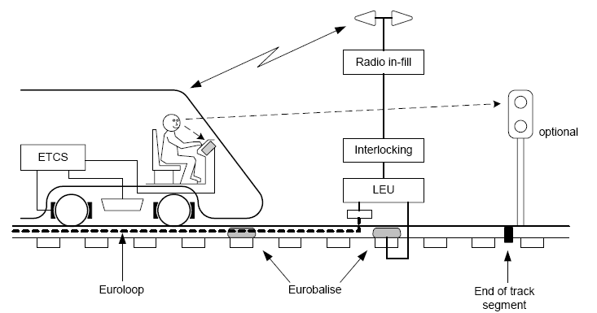
Figure A-1: ERTMS/ETCS Level 1

ERTMS/ETCS Level 1 provides a continuous train speed supervision system, which also protects against overrun of the authority. Train detection and train integrity supervision are performed by the trackside equipment of the underlying signalling system (interlocking, track circuits etc.) and are outside the scope of ERTMS/ETCS.
Level 1 is based on Eurobalise as spot transmission devices. The information provided by the Eurobalise includes movement authorities and track description data. The trackside equipment does not know the train to which it sends information. Although the transmission by the Eurobalise system is effected locally, the train speed supervision takes place continuously. This is assured by the continuous computations of train’s breaking curve based on the data received from the previous Eurobalise.
As a consequence of this spot transmission system, the limits of the breaking curve received from the previous Eurobalise must be maintained until the train passes the next Eurobalise where the train computer, the European Vital Computer (EVC), receives updated information. This leads to the well known traffic performance degradation problem in case the signal aspect changes from the “stop aspect” to the “proceed aspect” while the train approaches the main signal. In this situation, the engine driver is aware of the changed signalling aspect. However, he has to break the train as if the signal would still show the “stop aspect” as the EVC did not receive any updated movement authority. Therefore, if in Level 1 a lineside signal clears, an approaching train can not receive this information until it passes the Eurobalise group at that signal. Figure A-2 and A-3 illustrate this situation along an ERTMS/ETCS Level 1 track without Euroloop infill function before, and after change of the main signal aspect, respectively.
Figure A-2: Train performance along track without Euroloop infill function. Situation before change of main signal aspect
Figure A-3: Train performance along track without Euroloop infill function. Situation after change of main signal aspect
A.2 Euroloop Infill Function
The basic idea of all infill systems is to close the gap in information provision between the distant and the main signal to mitigate the traffic performance degradation problem caused by the Eurobalise spot transmission system. The Euroloop Sub-system (ELS) is foreseen within the ERTMS/ETCS system to close this gap. It provides new information to the driver as soon as it becomes available for trains at standstill and motion. The main benefits of the ELS are travel time reductions and increase of track capacity. Figures A-4 and A-5 illustrate the benefit of the infill provided by the ELS.
Figure A-4: Train performance along track with Euroloop infill function. Top: Situation before change of main signal aspect
Figure A-5: Train performance along track with Euroloop infill function. Top: Situation after change of main signal aspect
A.3 Euroloop Sub-System
A3.1 Overview
The Euroloop Sub-system (ELS) is a semi-continuous, intermittent (in the presence of the train) transmission system. Magnetic coupling is used between the Trackside and On-board Equipment to provide signalling information in advance as regard to the next main signal from the trackside infrastructure to the EVC. The infill information is transmitted by the Trackside Equipment only in the presence of a train. A leaky coaxial cable, the Euroloop Leaky Cable (ELC), of up to 1000 m length is fastened to the inner or outer side of rail's web (the vertical height from the foot of the rail to its running surface) and is used as trackside magnetic coupling device.
The ELS is composed of an On-board and Trackside Equipment function. A typical installation of a Euroloop sub-system along a track is shown in the following figure.
Figure A-6: Typical Installation of Euroloop Trackside Equipment
The On-board Equipment function consists of an Antenna Unit (AU) function and a Loop Transmission Module (LTM) function with the Loop Receiver (LR) function and the Loop Decoder (LD) function. The Trackside Equipment function is made up of the Loop Modem (LOOMO) function and the Euroloop Leaky Cable (ELC) function. Figure A-7 illustrates the trackside and on-board components of the ELS.
Figure A-7: Trackside & On-board Equipment of Euroloop Sub-System (ELS)
A.3.2 Physical Transmission Medium
Leaky cables are widely employed in environments to enable radio communication where free space wave propagation using antennas is impaired or rendered impossible. Along rails, leaky cables are well suited as little hindrance can be expected with points and the maintenance work performed regularly along tracks.
In the ELS, the up-link data transmission from the trackside to the on-board equipment is based on magnetic coupling within the contact zone that extends at the height of 300 mm above the Top of Rail (ToR) along the middle of the track. The required magnetic radio frequency field within that zone is generated by the currents flowing along two coupled transmission lines:
- a leaky coaxial cable with its termination, called the Euroloop Leaky Cable (ELC), and
- a bifilar line consisting of the outer conductor of the ELC and the rail.
Figure A-8 visualizes the ELC with its termination, the bifilar line, and the Cartesian co-ordinate system used throughout this document.
Figure A-8: ELC Mounted on Outer Side of Rail’s web with Indication of Magnetic Field Lines
The coupling between the signal propagating along the bifilar line and the on-board Antenna Unit (AU) on the vehicle is accomplished by the same principle as for the Eurobalise system. The z-component of the magnetic field is used to induce a signal into this loop antenna which shall be parallel to the xy-plane.
The advantages of this magnetic coupling mechanism are its capabilities to penetrate thick layers of debris, and the relatively fast decrease of the magnetic field strength with distance from the rail.
The leaky coaxial cable is laid down in the inside or the outside base of a rail (also known as the rail's ‘web’ i.e. the vertical part connecting the foot of the rail to its running surface). Its connection to the Loop Modem (LOOMO) may be established directly or via a coaxial interconnection cable (jumper cable). The ELC is terminated at the other end by a termination matching the characteristic impedance of the cable.
A3.3 Key Parameters of the Euroloop Sub-System
The signal modulation of the ELS employs Direct Sequence Spread Spectrum (DSSS) technology
- to allow for Code Division Multiple Access (CDMA) among adjacent ELS installations in the air gap.
- to increase the ELS’ immunity with respect to narrowband interferer generated by e.g. the train.
- to mitigate multipath propagation of the ELS signal between the transmitting and receiving antenna.
A set of 16 different spread spectrum codes of length N_{c} = 472 are used, enabling 16 nearly orthogonal transmission channels within the same frequency range.
The proposed centre frequency is 13.5475 MHz ±30 ppm. This choice prevents interference with the Eurobalise system covering the frequency band from roughly 1 MHz to 7.4 MHz and the Tele-powering signal at 27.095 MHz ± 5 kHz (see section A.5).
The ELS relies on magnetic coupling in the selected frequency range to allow reliable data transmission over the required distance from track to train in the presence of debris such as clear and salt water, iron ore, mud, sand, ballast, snow, ice, etc.
The carrier is modulated in a non-coherent way by the DSSS modulated data signal using Binary Phase Shift Keying (BPSK) modulation.
A.4 Euroloop duty cycles
A.4.1 Background
The duration of the Euroloop transmission is limited to the minimum that can be set by the detection of the presence of a train.
However the length of the transmission is still governed by the length of the loop as indicated in figure A-9. The Euroloop system is switched on as soon as the front part of the train reaches the loop.
Figure A-9: Euroloop transmission period
A.4.2 Factors in the loop occupancy (duty cycle)
There are four factors that affect the time for which the loop transmits:
  - The length of the loop
  - The speed of the train
  - Headway (time between trains)
  - If the train stops on the loop then the length of time for which the train stops and the associated acceleration/deceleration rate
Typical loop lengths are 300 m up to 500 m and exceptionally up to1000 m.
Train speeds for a suburban route are generally up to 120 km/h and for intercity routes up to 200km/h. Speeds of 200-300+ km/h are normally only applicable to newly built high speed routes.
The headway (i.e. the time between trains) depends on a number of factors. In the peak hour this will generally be higher than an average calculated over 24 hours. Very busy lines in the centre of cities where a number of routes come together might have headways of 3 minutes although this timing is more applicable to metro systems. A busy suburban station would expect headways of 5-10 minutes in the peak and a 15-20 minute service off-peak. My local route has a suburban service to London every 18 minutes and every 30 minutes off peak with a six hour period at night with no train service. Taking the average over 24 hours gives a mean headway of 45 minutes. This will be greater during the weekend.
The length of time for which a train may stop is not predictable for unscheduled stops. However station stop times for most trains will be between 45 and 60s, except in major termini. Here trains are shut down before beginning the next part of there journey so it can be assumed that the loop will be off for most of the time when the train is standing on the loop. A typical deceleration rate for a modern train is in the order of 5%g i.e. 0.5m/s. Acceleration rates are similar or slightly higher.
Measurements of shuttle trains in Wallisellen (Switzerland) reveal typical de-acceleration / re-acceleration times of 20 s to 30 s and stop times of 40 s – 60 s. The occupancy time of the Euroloop is therefore in the range between 80 s and 120 s.
A.4.3 Results
Figure A-10 shows loop duty cycle against train speed for different loop length and headways at constant train speeds.
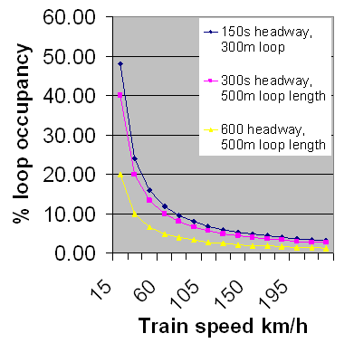
Figure A-10: Loop Occupancy versus Train Speed
As would be expected the loop occupancy, which equates to duty cycle for the loop, falls as train speed increases. For a typical suburban line the duty cycle will be between 5 and 10% in the busy hour. For a busy intercity route the duty cycle will be between 2 and 4 % depending on the headway.
Figure A-11 covers the case where a station stop is included. In this case the train has been assumed to have a maximum speed of 120km/h and decelerate to a stop at 0.5m/s².
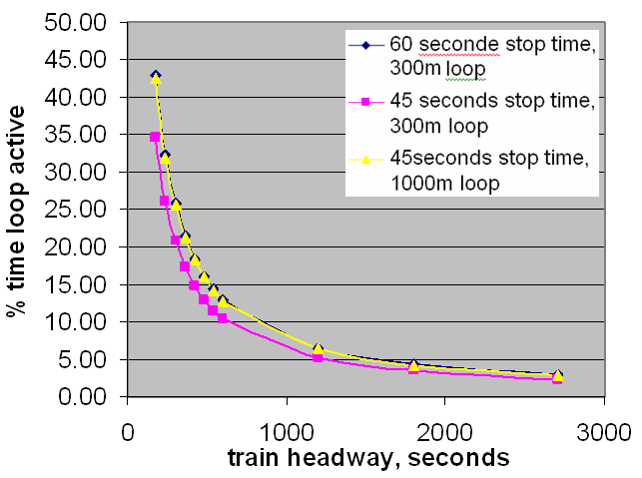
Figure A-11: Loop Occupancy versus Train Headway for Different Station Stop Times
It can be seen from Figure A-11 that the length of the loop and the station stop times are not significant factors in the % loop occupancy. The train headway is the most significant factor. For a typical suburban route averaged throughout a 24 hour period the duty cycle will be around 2.5%. It will rise to 10% during peak periods on suburban routes. The highest levels likely to be reached in practice will be around 30% on very busy city centre routes as 1000m loops would not be used in this situation.
A.5 Reason for Change of Euroloop frequency
With the Eurobalise and Euroloop operating in the same frequency band, it has been found that the Euroloop causes disturbance to the detection of the Eurobalise. The Eurobalise transmits the relevant parts of the train control information (ETCS/ERTMS) where the Eurobalise is used, in particular an exact location which enables the position of the train to be identified to within less than 1m.
As there are a large number of existing Eurobalises in operation it is not possible to make any changes to the Eurobalise system. It has therefore been found necessary to move the Euroloop frequency completely out of the band used by Eurobalise.
The Euroloop and Eurobalise shall use the same train antenna (for practical installation reasons, because the space under the train is limited).
The Euroloop frequency range should therefore lie between the upper limit of the Eurobalise up-link frequency (7.5 MHz) and well below the Eurobalise Tele-powering signal of 27.095 MHz (which is of much higher power). The Euroloop centre frequency is chosen to be ½ of the Tele-powering frequency. Hence the side lobes of the Euroloop up-link signal have a minimum at the Tele-powering frequency. Furthermore the centre frequency should be an even divisor of the 27 MHz Tele-powering signal to reduce interference for the detection of the Tele-powering signal. This function can be used for the activation of the transmitter (transmit only in presence of a train).

f
o
-5 kHz
f
o
-200 kHz
f
o
-500 kHz
f
o
+5 kHz
f
o
+200 kHz

f
o
+500 kHz
+42 dBµA/m
+5 dBµA/m
-1 dBµA/m
f
o
= 27.095 MHz
Optional Euroloop
triggering receiver
27.095MHz
Existing On
-
track Euroloop equipment
Euroloop Spread spectrum transmitter 4.516MHz centre
frequency, bandwidth +/
-
4MHz max level +7dB
µ
A/m at
10m
f
o
-5 kHz
f
o
-200 kHz
f
o
-500 kHz
f
o
+5 kHz
f
o
+200 kHz

f
o
+500 kHz
+42 dBµA/m
+5 dBµA/m
-1 dBµA/m
f
o
= 27.095 MHz
Eurobalise
powering &
optional Euroloop triggering
transmitter 27.095MHz,
+42dB
µ
A/m at 10m
Existing On
-
train Euroloop equipment
Euroloop Spread spectrum receiver 4.516MHz centre
frequency, bandwidth +/
-
4MHz
f
o
-5 kHz
f
o
-200 kHz
f
o
-500 kHz
f
o
+5 kHz
f
o
+200 kHz

f
o
+500 kHz
+42 dBµA/m
+5 dBµA/m
-1 dBµA/m
f
o
= 27.095 MHz
Eurobalise
power
receiver 27.095MHz
& optional data
receiver
On
-
track
Eurobalise
equipment
Eurobalise
FSK transmitter 4.234MHz centre
frequency, bandwidth +/
-
3MHz max level +9dB
µ
A/m at
10m
f
o
-5 kHz
f
o
-200 kHz
f
o
-500 kHz
f
o
+5 kHz
f
o
+200 kHz

f
o
+500 kHz
+42 dBµA/m
+5 dBµA/m
-1 dBµA/m
f
o
= 27.095 MHz
Eurobalise
27.095MHz
telepowering
transmitter at
+42dB
µ
A/m at 10m & optional
data transmitter at +5dB
µ
A/m
On
-
train
Eurobalise
equipment
Eurobalise
4.234MHz centre
frequency FSK receiver
f
o
-5 kHz
f
o
-200 kHz
f
o
-500 kHz
f
o
+5 kHz
f
o
+200 kHz

f
o
+500 kHz
+42 dBµA/m
+5 dBµA/m
-1 dBµA/m
f
o
= 27.095 MHz
Optional Euroloop
triggering receiver
27.095MHz
Eurobalise
with Proposed On
-
track Euroloop equipment
Euroloop Spread spectrum transmitter
13.5MHz centre frequency, bandwidth +/
-
4MHz
Eurobalise
FSK transmitter
4.234MHz centre frequency,
bandwidth +/
-
3MHz max level
+9dB
µ
A/m at 10m
f
o
-5 kHz
f
o
-200 kHz
f
o
-500 kHz
f
o
+5 kHz
f
o
+200 kHz

f
o
+500 kHz
+42 dBµA/m
+5 dBµA/m
-1 dBµA/m
f
o
= 27.095 MHz
Eurobalise
powering &
optional Euroloop triggering
transmitter 27.095MHz,
+42dB
µ
A/m at 10m
Eurobalise
with Proposed On
-
train Euroloop
equipment
Euroloop Spread spectrum receiver
13.5MHz centre frequency, bandwidth
+/
-
4MHz
Eurobalise
4.234MHz centre
frequency FSK receiver
Figure A-12: Spectrum masks ETCS-Data-link channels
ANNEX B: Test Results of Far Field Measurement on Euroloop System
B.1 Test Specification
B.1.1 Description of the measurements
Four sets of measurements were conducted: one set at a distance of 10m (near field) and three sets at a distance of 1-2 km (far field), see figure B-1.
Frequencies at which the measurements were performed are ≈7, ≈10, ≈15 and ≈20 MHz. A constant carrier should be used to produce sufficient field strength for the far field measurements. During the measurements no train should be present.
B.1.2 Near field measurements
Only H field shall be measured in X, Y and Z direction because H field @10 m is the specification item. To level out the variation in field strength due to fading loss of the coupled mode cable the measurement should be repeated at a minimum of 3 different locations with a separation of ≈5m.
B.1.3 Reverse Measurements
The Euroloop cable as receiving antenna of broadcast radio signals. The signal strength of the Euroloop cable in comparison to signal received by a reference antenna shall be measured.
B.1.4 Far field measurements
Only E field shall be measured because the E field measurement is more convenient and Z direction is the dominant E field direction near ground at ground wave propagation. At 1-2 km distance is assumed far field, fading losses are a very small issue here and can be ignored. One set is performed broadside and 2 sets endfire.
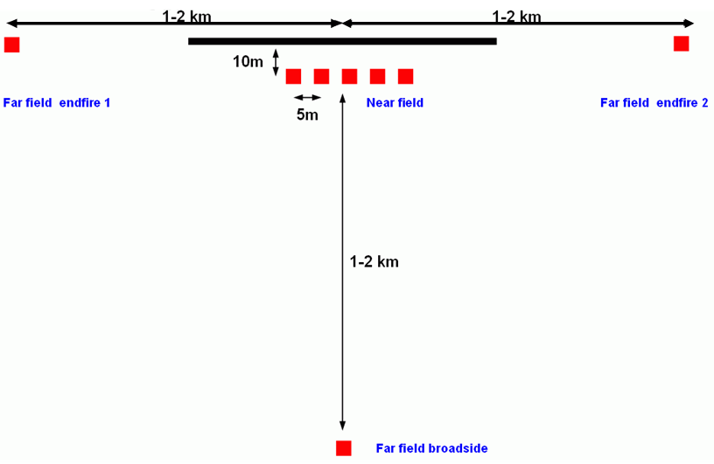
Figure B-1: Topology of Euroloop far field measurements
B.1.5 Euroloop Transmit-Signal
To achieve a reasonable receive-power density at a distance of 1 km no Spread Spectrum TX signal shall be used. Instead a single frequency CW signal shall be transmitted therefore the field strength will be about 27 dB (spreading factor of the Euroloop signal) stronger than the normal power density at 10 kHz BW of a Euroloop signal. Additional the TX Power shall be about twice the normal Euroloop TX Power.
TX-Signal: non-modulated CW Sinus 40 W at the Euroloop feed point.
Frequency 1: 6.900 MHz
Frequency 2: 10.900 MHz
Frequency 3: 14.900 MHz
(Note: relevant (-10 dB) Euroloop bandwidth: ~ 11 … 16 MHz)
B.2 Actual test set-up
Far field measurement range, Locations 1 … 3
At all Locations three measurements have been taken at positions separated by app. 30…50m.
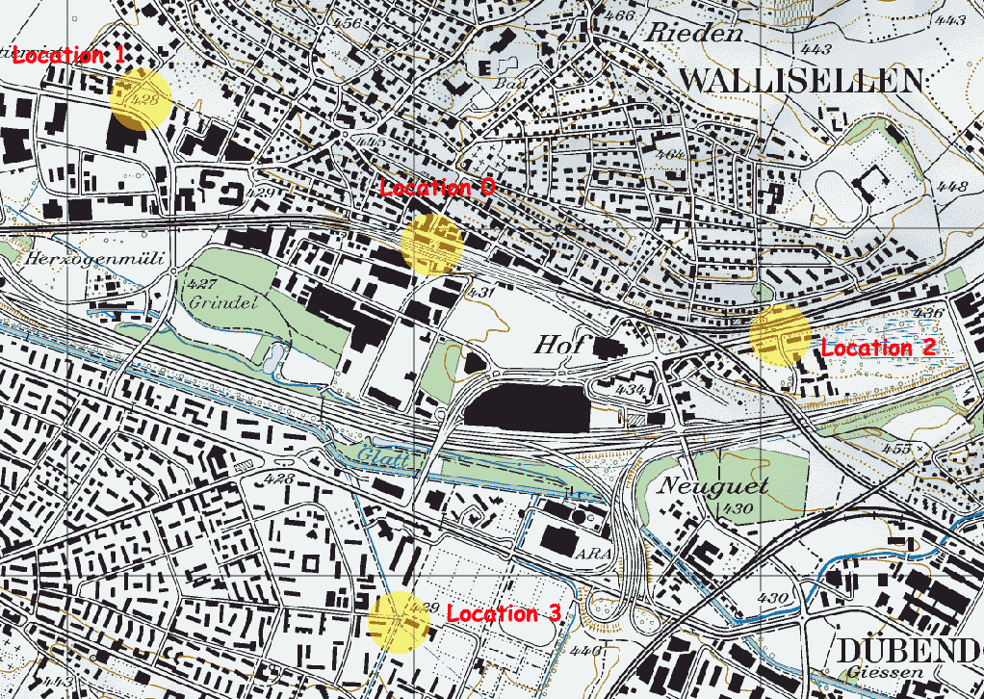
Figure B-2: Measurement locations in Wallisellen around the railway station
Pos. 0: GPS: N: 47° 24.781’ E: 8° 35.413 Swiss metric coordinates: 686909 / 251993
feeding point of Euroloop, railway station Wallisellen, track 3
Pos. 0-1: lateral distance to Euroloop 10m, longitudinal distance to feeding point 45m
Pos. 0-2: lateral distance to Euroloop 10m, longitudinal distance to feeding point 35m
Pos. 0-3: lateral distance to Euroloop 10m, longitudinal distance to feeding point 25m
Pos. 0-4: lateral distance to Euroloop 10m, longitudinal distance to feeding point 15m
Pos. 0-5: lateral distance to Euroloop 10m, longitudinal distance to feeding point 5m
Pos. 1-0: GPS: N: 47° 24.988’ E: 8° 34.831 Swiss metric coordinates: 686171 / 252366
distance to Euroloop 934 m
Roadside, near busy 3-way road division. Concrete screen on one side <5m
Pos. 1-1: GPS: N: 47° 25.015’ E: 8° 34.875 Swiss metric coordinates: 686226 / 252417
distance to Euroloop 910 m
Roadside, near 3-way road division. Quiet street with 2-storey houses
Pos. 1-2: GPS: N: 47° 24.989’ E: 8° 34.790 Swiss metric coordinates: 686120 / 252367
distance to Euroloop 981 m
Roadside of busy road.
Pos. 2-0: GPS: N: 47° 24.605’ E: 8° 36.294 Swiss metric coordinates: 688022 / 251684
distance to Euroloop 1046 m
Roadside of busy road
Pos. 2-1: GPS: N: 47° 24.599’ E: 8° 36.329 Swiss metric coordinates: 688066 / 251684
distance to Euroloop 1092 m
Inside road
Pos. 2-2: GPS: N: 47° 24.611’ E: 8° 36.354 Swiss metric coordinates: 688097 / 251696
distance to Euroloop 1116 m
Roadside of busy road
Pos. 3-0: GPS: N: 47° 24.184’ E: 8° 35.413 Swiss metric coordinates: 686925 / 250887
distance to Euroloop 1077 m
Clear site, but near power lines, little higher than around
Pos. 3-1: GPS: N: 47° 24.165’ E: 8° 35.413 Swiss metric coordinates: 686926 / 250852
distance to Euroloop 1112 m
about 2 meters lower, park
Pos. 3-2: GPS: N: 47° 24.159’ E: 8° 36.445 Swiss metric coordinates: 686966 / 250841
distance to Euroloop 1120 m
same as before, but metal fence nearby
B.3 Test results
B.3.1 Near field test results
B.3.1.1 Near field @10 m conclusion
The CW test-signal is stronger than the Euroloop Spread-Spectrum signal measured in 10 kHz bandwidth:
Spreading factor (472) +26.7 dB
Signal power +2.0 dB
Total +28.7 dB (to be subtracted from the CW test signal strength)

The calculated equivalent Euroloop Spread Spectrum field strength in 10 kHz BW at 10 m is:
Location | Frequency | CW test signal field strength | Euroloop – DSSS field strength
0-1 | 6.9 MHz | 19.4 dBμA/m | -9.3 dBμA/m
0-2 | 6.9 MHz | 18.8 dBμA/m | -9.9 dBμA/m
0.3 | 6.9 MHz | 16.3 dBμA/m | -12.4 dBμA/m
0-4 | 6.9 MHz | 16.1 dBμA/m | -12.6 dBμA/m
0-5 | 6.9 MHz | 5.0 dBμA/m | -23.7 dBμA/m
maximum | 6.9 MHz | 19.4 dBμA/m | -9.3 dBμA/m
0-1 | 10.9 MHz | 24.3 dBμA/m | -4.4 dBμA/m
0-2 | 10.9 MHz | 25.3 dBμA/m | -3.4 dBμA/m
0.3 | 10.9 MHz | 26.1 dBμA/m | -2.6 dBμA/m
0-4 | 10.9 MHz | 23.8 dBμA/m | -4.9 dBμA/m
0-5 | 10.9 MHz | 22.7 dBμA/m | -6.0 dBμA/m
maximum | 10.9 MHz | 26.1 dBμA/m | -2.6 dBμA/m
0-1 | 14.9 MHz | 19.0 dBμA/m | -9.7 dBμA/m
0-2 | 14.9 MHz | 16.7 dBμA/m | -12.0 dBμA/m
0-3 | 14.9 MHz | 14.9 dBμA/m | -13.8 dBμA/m
0-4 | 14.9 MHz | 19.5 dBμA/m | -9.2 dBμA/m
0-5 | 14.9 MHz | 14.7 dBμA/m | -14.0 dBμA/m
maximum | 14.9 MHz | 19.5 dBμA/m | -9.2 dBμA/m
Table B-1: Euroloop Spread Spectrum field strength in 10 kHz BW
B.3.2. Euroloop reverse-measurements results
Broadcast signal levels received from the Euroloop cable have been measured in the frequency ranges 9.2 – 10.2, 11.2 – 12.2 and 15 – 16 MHz.
Reference measurements have been made on the roof of the Siemens building with R+S HFH2-Z2 loop-antenna (see Annex D).
Figure B-3: Euroloop receiving gain histogram 9.2 – 10.2 MHz
mean value Euroloop gain at 9.7 MHz: -50.7 dBi
standard deviation: 7.8 dB
Figure B-4: Euroloop receiving gain histogram 11.2 – 12.2 MHz
mean value Euroloop gain at 11.7 MHz: -48.3 dBi
standard deviation: 6.7 dB
Figure B-5: Euroloop receiving gain histogram 15 – 16 MHz
mean value Euroloop gain at 15.5 MHz: -46.7 dBi
standard deviation: 6.2 dB
B.3.2.2 Euroloop reverse-measurements conclusion
The signals received from Euroloop are weaker than those from the reference antenna.
The calculated Euroloop antenna gain is:
Frequency range | Mean value | Standard deviation
9.2 … 10.2 MHz | - 50.7 dBi | 7.8 dB
11.2 … 12.2 MHz | - 48.3 dBi | 6.7 dB
15.0 … 16.0 MHz | - 46.9 dBi | 6.2 dB
Table B-2: Euroloop measured “Antenna-Gain”
B.3.3 Far field measurements results
B.3.3.1 Overview of measured and calculated far field strength
Mean measured (CW) E-field strength at far field locations
Frequency | Location 1 | Location 2 | Location 3
6.9 MHz | 16.6 dBμV/m | 21.4 dBμV/m | 11.6 dBμV/m
10.9 MHz | 10.9 dBμV/m | 19.3 dBμV/m | 18.4 dBμV/m
14.9 MHz | 14.1 dBμV/m | 14.7 dBμV/m | < 5 dBμV/m
Table B-3: Measured far field strength for CW test-signal

The CW test-signal is +28.7 dB stronger than the Euroloop spread-spectrum signal measured in 10 kHz bandwidth.
Frequency | Location 1 | Location 2 | Location 3
6.9 MHz | -12.1dBμV/m | -7.3 dBμV/m | -17.1 dBμV/m
10.9 MHz | -17.8 dBμV/m | -9.4 dBμV/m | -10.3 dBμV/m
14.9 MHz | -14.6 dBμV/m | -14.0 dBμV/m | <-23.7dBμV/m
Table B-4: Mean calculated Euroloop E-field strength at far field locations for spread spectrum signal
B.3.3.2 Comparison of measured field strength to expected values
The measured E field strength is compared to the expected value according to ERC Report 69. To get a common range for all Locations the figures have been normalized to 1000m by the relation 40*log(R/1000m). Also field strength has been normalized to source field strength of 0dBμA/m at 10m. The endfire 2 direction is at 0°.
Figure B-6: Expected field versus measured field at 6.9 MHz | Figure B-7: Expected field versus measured field at 10.9 MHz

Figure B-8: Expected field versus measured field at 14.9 MHz
B.4 Conclusion
The results of measurements to characterise the behaviour of the Euroloop antenna are given in Annex C.
In addition, results of measurements used to assess the impact of Euroloop system on Radio Amateur systems are given in Annex D.
ANNEX C: Simulation of the Euroloop system as an antenna

C.1 Model
A leaky coax radiator can be simulated with an array of uniformly spaced point sources since it behaves as a very low efficiency travelling wave antenna ([5] [6]). About one radiator for 1/20λ each has proven to be sufficient. The phase of the sources depends on the distance from the start point of the array, the velocity factor of the slow wave structure feeding the sources and the working frequency. The amplitude depends on the cable loss, radiation loss and distance from the start point of the array. Because the simulation contains radiators near earth a proper simulation tool should be used. In our case NEC4.1 was used.
The model consist of an array of vertical polarized E field radiators with a length of 1 cm at 0.1m height above intermediate conductive ground (S= 3 ms/m, ε_{r}=22 - ERC Report 69 curve 6, land). Simulations were performed at 6.9, 10.9 and 14.9 MHz. Cable attenuation and radiation loss is assumed to be less than 2dB/100m in the model for the three frequencies. The velocity factor is assumed to be 0.88.
ϕ=0° (endfire)
0.1m
ϕ=90° (broadside)
200m

Dimensions (red=radiator)
Figure C-1: Model for the Euroloop antenna
The first model contained two passive elements, a railroad track and a power conductor above the track. Both conductors exhibited resonance effects. Practical experience shows that these resonances do occur, augmenting radiation at local spots and in very specific directions. However their intensity and occurrence depends completely on the local practical installation of the Euroloop antenna. Therefore, these parasitic structures where omitted in the final model, and the model without parasitic resonances is modelled. The realized model converges well and performs as was expected from theory. All diagrams are plotted relative with 0dB reference.

C.2 Known imperfections in the model
The amplitude slope over the cable is assumed equal for all frequencies, in reality this is not the case. Cable attenuation is about the same but there is a small difference due to extra VSWR dependent losses. The radiator is built with small vertical polarised E radiators. In reality the polarisation is mixed, but most of the horizontal polarised field is shortened by ground so this is an acceptable simplification for the far field, in the near field this simplification is not correct. It is not possible to make proper magnetic dipoles in NEC and accurate near field E measurements are not performed so no attempt is made to do this. The far field pattern of the model is accurate in an ideal situation. In reality objects and structures near the radiator cause the diagram to change. These changes can be in the order of 5-10 dB.

C.3 Absolute Gain
From the measurements (see Annex B), we can conclude that the antenna has directivity in the 0° and 180° (endfire) azimuth directions and there is a difference in the broadside and end fire directions, this is in conformity with the simulation results. Maximum directivity can be found in a ± 15° direction from the 0° end fire direction.
Based on inverse measurements using the Euroloop as a receiving antenna we can have an idea about the gain. For more accurate measurements, it would have been necessary to identify all received stations in order to calculate their signals angle of arrival. However, the results provided an acceptable approximation of the antenna behaviour.
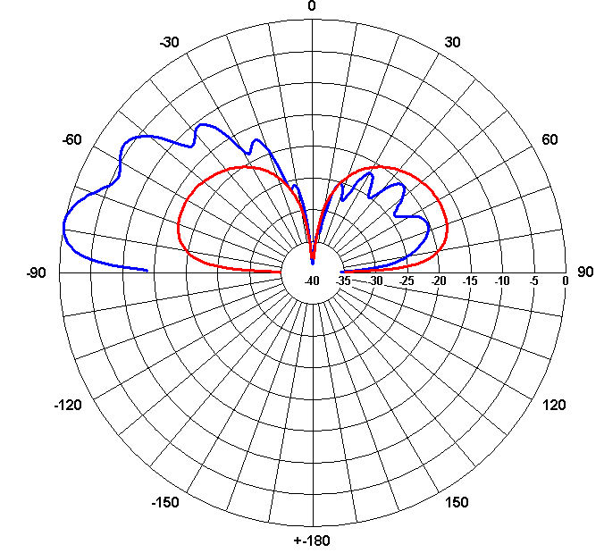
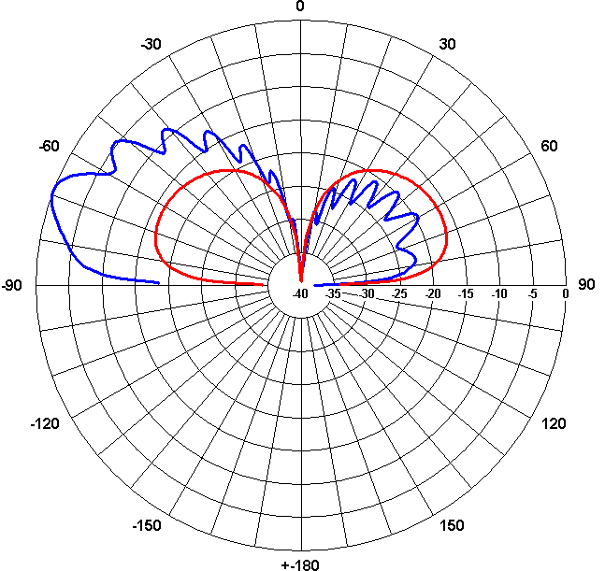
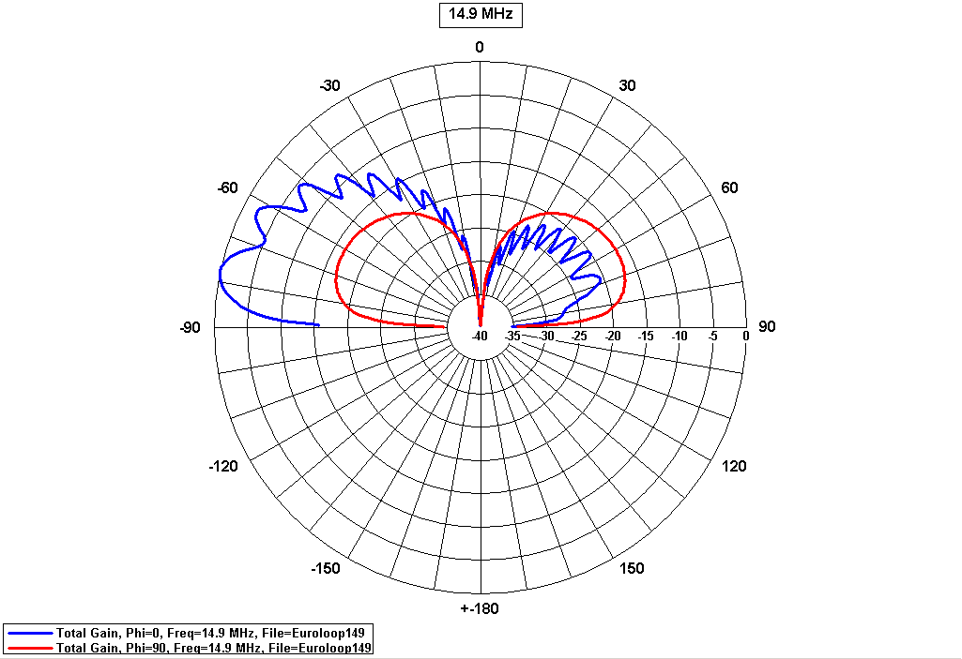
Phi=0º
Phi=90º
10.9 MHz
Phi=0º
Phi=90º
14.9 MHz
Phi=0º
Phi=90º
6.9 MHz

Figure C-2: Vertical diagrams at 6.9, 10.9 and 14.9 MHz ϕ= 0° ( ), 90° ( )
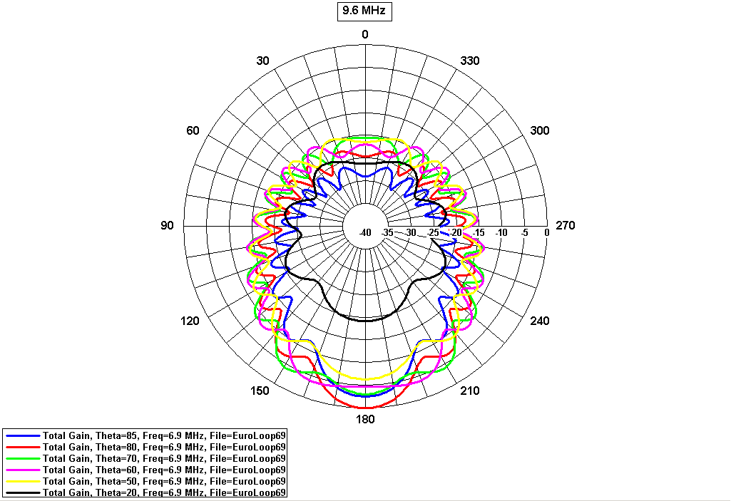
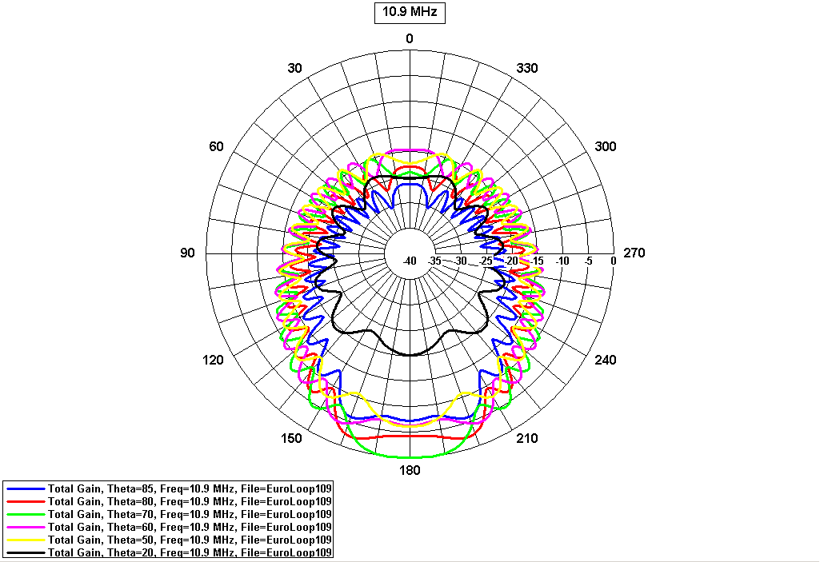
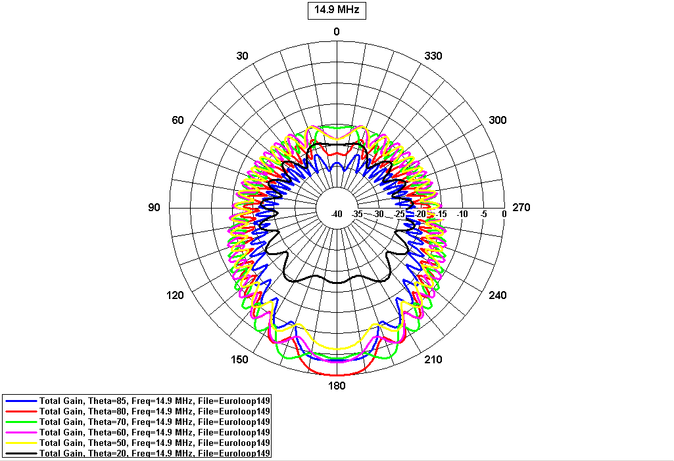
6.9 MHz
10.9 MHz
14.9 MHz

Figure C-3: Horizontal diagrams at 6.9, 10.9 and 14.9 MHz θ = 85° ( ), 80° ( ), 70° ( ), 60° ( ), 50° ( ), 20° ( ) (ground level is θ = 0°)

Note: in Figure C-3, the end fire direction corresponds to 180º.

C.4 Conclusions about antenna
Both simulations and measurements have shown that the Euroloop radiator has directivity and behaves as a travelling wave antenna.
The gain of the radiator was measured by means of an inverse measurement. The inverse measurement is performed by using the Euroloop radiator as a receiving antenna and comparing the terminal voltage with the voltage at the terminals of reference antenna under the same conditions. The gain was -40dBi worst case over the whole Euroloop frequency range. It is typical less than this -45 to -50 dBi.
The large dimensions of the antenna and the travelling wave behaviour make it impossible to translate a near field magnetic field strength value directly to a far field strength value ([6], [8] and [9]). Therefore measurements were conducted in the far field to characterise the emission of the Euroloop system (see Annex B and Annex D).
ANNEX D: Amateur service models

D.1 Background to HF ionospheric propagation
The radio spectrum between 3 and 30MHz exhibits both ground wave and sky wave propagation. In relative close proximity to an HF transmitter a direct line-of-sight propagation, which even extends to quite long distances when one considers reception by aircraft in proximity of a transmitter, is the normal propagation mode considered, which is treated in detail elsewhere in this report. However, beyond the point where the attenuation of signals from this mode of propagation drops below the ambient noise floor, the dominant propagation mode is that whereby the electromagnetic field is refracted in the ionosphere back to the earth, giving path lengths up to several thousand kilometres. This distance depends upon the height of the refraction layer and the highest angle at which refraction occurs varies with frequency, time of day, the season, and also the date within an 11-year sunspot cycle.
Radio Amateurs tend to operate close to the ambient noise floor with small S/N ratios. Maintaining the ambient noise floor close to its natural level by the avoidance of its degradation from man-made sources is thus important to this service. For assessing the possible effects of Euroloop the complexity of ionospheric propagation was modelled using the US NITA program, called REC533 [3] based upon ITU-R Recommendation ITU-R P.533 [4] model. It is important to appreciate that these noise models are based upon median values, whereas Radio Amateur usage normally operates well below median levels.
D.2 Aggregation of skywave propagated signals from multiple Euroloop systems
D.2.1 Introduction
The skywave model calculates the power density from a unit length of the leaky coax used for the Euroloop. The power density is directly related to the H field level agreed at 10m from the loop. From this the effective power radiated from the loop can be calculated by integrating the power density over the cylindrical surface around the leaky coax. In fact only half of the cylindrical surface is used, as it is assumed that the energy in the lower half would be absorbed, as the H field would be in the ground. Since the Euroloop transmissions from the “loop” only occur when a train is passing, it is further assumed that the power from the “loops” would be reduced to account for the low duty-cycle. A figure of 30% duration for 300m “loops” and 10% for 1000m “loops” was agreed. These figures approximated for the transmit duty-cycle expected during the peak “rush-hour” times (see Annex A), when headway between trains is at its shortest.
Since it is generally accepted that multiple signals from uncorrelated sources can be treated as Gaussian noise, the total power from multiple “loops” can be added linearly, thus enabling the effective total power from different numbers of “loops” to be calculated. Whilst the ionospheric propagation from each of these “loops” ideally should have been treated independently, and aggregation carried out at the victim receiver, the complexity that this level of modelling would involve was not considered necessary. Instead, an approximation was made, whereby it was assumed that all the “loops” were in close proximity.
D.2.2 Effective radiated power model for Euroloop
The first part of the calculation is to determine the effective radiated power from each size of the loops. Firstly, one needs to calculate the power density at the stated measurement distance of 10m from the leaky coax. Taking the proposed limit of 9dBμA/m/9kHz one needs to convert from logarithmic units to determine the Magnetic Field strength, H (A/m2) as follows:
H (dBA/m) = 20*log(H(A/m) Or H (A/m) = 10^(H (dBA/m)/20)
or
H = 2.8E-06 A/m/9kHz
The power density at 10m from the leaky coax can be found from
S = Z0 * H^2 W/m^2
where it is assumed that Z0, the intrinsic impedance of free space, is 120*π Ohm
or
S = 2.99E-09 W/m^2/9kHz
To determine the effective radiated power from the leaky coax one needs now to integrate this over a complete surface around the leaky coax. There are several ways of modelling this depending on what part of the volume around the leaky-coax one considers contributes to the far-field radiation. The view taken in deriving this model is that only the half-cylindrical space below the leaky coax should be excluded from contributing to the radiation. The effects of the adjacent rail and any trains on the rail is best not excluded, since whilst their presence will modify the spatial effects of the radiated energy from the leaky coax, because they do not form enclosed surfaces currents will be induced into their metallic structure, which themselves will re-radiate. Other nearby environmental factors such as attenuation from nearby buildings, trees, etc, will not be modelled, but will contribute to the difference between predicted field-strength levels and those found in experimental measurements. Thus, the approximation used here is to take the upper half of a cylindrical surface, A300 or A1000, given by
A300 = (2πr^2 + 2πr*300)/2
A1000 = (2πr^2 + 2πr*1000)/2
where the radius, r, is the distance, 10m, at which the power density was determined, and where the length is given either 300m or 1000m depending upon which loop is under consideration. It is assumed that the power radiating from the lower half of the cylindrical surface is absorbed.
The effective radiated power in a 9 kHz bandwidth is then found by multiplying A300 or A1000 by the calculated power density S. Alternative figures for the total 9MHz spread spectrum transmission or the effective power per Hz bandwidth can then be simply derived taking into account the different usage factors (30% and 10%) which it was agreed occurred during the daily rush-hour periods (see Annex A).
It is generally accepted that multiple signals from uncorrelated sources can be treated as Gaussian noise and thus the total power is a linear addition of the separate contributions of received power at the victim receiver [9].
Table D-1 shows the calculated effective radiated power from multiple instances of the two lengths of loop:
No of loops | P (dBW/Hz)
1 | -90
10 | -80
100 | -70
1000 | -60
10000 | -50
Table D-1: Effective radiated power from multiple instances of the two lengths of loop

Note that the above levels assume the worst-case scenario, which it has been agreed would occur during the “rush-hour” periods each day. Under these conditions it has been offered by UIC that 30% of the 300m loops and 10% of the 1000m loops would be transmitting concurrently. (Since the effective power levels from the two different lengths of loop are within 0.3dB the levels for the two different sizes of loop have been rounded and can then be combined). Note also that no attempt has been made to offset any directionality effect of the loop’s radiated pattern – it is considered that this type of refinement of the model would add a significant level of complexity requiring a totally different modelling approach. Using this simple approach, together with experimental validation, we can at least understand the order of magnitude of the effect of signal aggregation from a Euroloop implementation.
D.2.3 Propagation modelling
The final stage in the skywave modelling is to take these effective transmit power levels and calculate the predicted S/N at the victim receiver, over a range of European paths, at different frequencies and noise floor levels, using the HF propagation-prediction program called REC533 [3] [4]. Rather than undertake propagation assessments across a large variety of inter-European paths, three paths will be chosen to test whether interference is likely to existing services.
REC533 allows a variety of parameters to be customised for the path assessment. Thus, London and a dipole aerial were selected for the receive site and three transmit locations were chosen: Vienna at 1,237km, Frankfurt at 639 km and Paris at 342 km from London. Each would be modelled using an isotropic aerial. Although a user-defined noise floor mask can be defined, it was decided for convenience to use REC533’s pre-configured noise-floor mask which is from CCIR Report 258 (which has been superseded by ITU-R Rec. P.372-8) [10], This could well give an optimistic result, as its noise floor is generally higher that the ITU-R noise floor used elsewhere in this report. A comparison between the REC533 noise mask and those given in section 6 to Annex F is given in table D-2. One can see that the REC533 noise mask is only stated at 3MHz in comparison to that derived from the expression below, used in the calculations for Annex F-section 6:
E (dBµV/m/Hz) = Pi (dBm/Hz) + 20log(f (MHz))+ 77.2

Annex F noise floor |  |  |  | Program REC533
 | 10MHz | 14MHz | 18MHz | 3MHz
Quiet Rural | -44.3 | -45.6 | -46.5 | -46.9 | Remote
Rural | -36.6 | -37.8 | -38.6 | -33.3 | Rural
Residential | -31.8 | -32.3 | -33.8 | -28.0 | Residential
Business | -27.6 | -28.8 | -29.6 | -23.7 | Industrial
Table D-2: Electric Field strengths in dBµV/m/Hz Hz for different noise-floor models

Because REC533 cannot take a lower transmit power than 1W, we need to adopt some scaling. To achieve this, the transmit power in REC533 was set to 1 watt and the resulting S/N output from the model studied to see the percentage of time for which it exceeded the magnitude of the total effective radiated powers in Table D-1. The validity of this approach can be seen by considering one of the cases, say, the 100 loop case where the effective transmit power has been modelled as –70dBW/Hz. When the S/N of the 1W transmitted signal, modelled in REC533, exceeds 70dB/Hz (i.e. the magnitude of the total ERP for the 100 loop case in table D-1) it would be equivalent to a –70dBW/Hz transmit power creating an S/N of 0dB. In order to evaluate the effects of operating the “loops” at lower levels of H field excitation than the initial 9dBµA/m level, different excitation H fields levels were substituted into the model derived in section D.2.2 above to yield the following set of equivalent power levels:

 | Power (dBW/Hz)
H Field (dBµA/m) | Number of loops
H Field (dBµA/m) | 1 | 10 | 100 | 1000 | 10000
9 | -90 | -80 | -70 | -60 | -50
0 | -99 | -89 | -79 | -69 | -59
-10 | -109 | -99 | -89 | -79 | -69
-25 | -124 | -114 | -104 | -94 | -84
Table D-3: Variation equivalent power levels versus different levels of signal aggregation and H field excitation level
It should be noted that these figures assume the worst-case scenario of “rush-hour” loop usage, so the 30% and 10% factors have been included. Again, no consideration has been given to actual radiation patterns; it is assumed that the Euroloops are radiating isotropically but only energy from the upper half-cylinder is included in the model.
D.2.4 REC533 propagation predictions
Tables D-4 to D-8 provide the results considering different extents of Euroloop installation and excitation levels, path lengths between Euroloop and the victim receiver, frequency, sunspot number and season. The colour-coded cells indicate the likely extent of problem to the Amateur service from different extents of Euroloop installations.

Skywave S/N levels
Vienna | 3.5 |  | 7 |  | 10.1 |  | 14 |  | 18
 | Low | High | Low | High | Low | High | Low | High | Low | High
Winter | 39 | 36.1 | 35.2 | 39.7 | 28.1 | 37.3 | 28.9 | 38.8 | 16.9 | 37.2
Equinox | 40 | 37.3 | 37.7 | 38.5 | 30.1 | 37.2 | 23 | 36.9 | 15.7 | 40.1
Summer | 33.4 | 32.4 | 34.2 | 33.9 | 32.1 | 35.6 | 19.9 | 25.3 | 15.1 | 19.2
Frankfurt | 3.5 |  | 7 |  | 10.1 |  | 14 |  | 18
 | Low | High | Low | High | Low | High | Low | High | Low | High
Winter | 48.3 | 45.8 | 45.9 | 46.7 | 36 | 44.7 | 20.4 | 46.1 | 15.8 | 40.5
Equinox | 45.9 | 46.2 | 45.3 | 43.7 | 31.9 | 43.7 | 18.2 | 44.6 | 13.3 | 31.8
Summer | 38.7 | 37.7 | 41.3 | 40.5 | 27.3 | 33.9 | 14.3 | 23.3 | 8.8 | 16.7
Paris | 3.5 |  | 7 |  | 10.1 |  | 14 |  | 18
 | Low | High | Low | High | Low | High | Low | High | Low | High
Winter | 58 | 58.1 | 58.3 | 55.9 | 37.3 | 55.9 | 24.9 | 53.4 | 20.1 | 39.5
Equinox | 56.7 | 56.7 | 55.5 | 52.6 | 33.9 | 51.7 | 21.9 | 42.4 | 16.8 | 34.7
Summer | 51 | 49.3 | 48.1 | 48.4 | 27.5 | 36 | 17.8 | 25.3 | 12 | 19.9
Table D-4: Euroloop median S/N ratios, for a radiated power of 0dBW, predicted by the model and Rec. ITU-R P.533

Vienna | 3.5 |  | 7 |  | 10.1 |  | 14 |  | 18
 | Low | High | Low | High | Low | High | Low | High | Low | High
Winter | -11 | -13.9 | -14.8 | -10.3 | -21.9 | -12.7 | -21.1 | -11.2 | -33.1 | -12.8
Equinox | -10 | -12.7 | -12.3 | -11.5 | -19.9 | -12.8 | -27 | -13.1 | -34.3 | -9.9
Summer | -16.6 | -17.6 | -15.8 | -16.1 | -17.9 | -14.4 | -30.1 | -24.7 | -34.9 | -30.8
Frankfurt | 3.5 |  | 7 |  | 10.1 |  | 14 |  | 18
 | Low | High | Low | High | Low | High | Low | High | Low | High
Winter | -1.7 | -4.2 | -4.1 | -3.3 | -14 | -5.3 | -29.6 | -3.9 | -34.2 | -9.5
Equinox | -4.1 | -3.8 | -4.7 | -6.3 | -18.1 | -6.3 | -31.8 | -5.4 | -36.7 | -18.2
Summer | -11.3 | -12.3 | -8.7 | -9.5 | -22.7 | -16.1 | -35.7 | -26.7 | -41.2 | -33.3
Paris | 3.5 |  | 7 |  | 10.1 |  | 14 |  | 18
 | Low | High | Low | High | Low | High | Low | High | Low | High
Winter | -2 | -1.9 | -1.7 | -4.1 | -12.7 | -4.1 | -25.1 | 3.4 | -29.9 | -10.5
Equinox | -3.3 | -3.3 | -4.5 | -7.4 | -16.1 | -8.3 | -28.1 | -7.6 | -33.2 | -15.3
Summer | -9 | -0.7 | -1.9 | -1.6 | -22.5 | -14 | -32.2 | -24.7 | -38 | -30.1
 | Aggregated Euroloop signals below the 1,000 loop threshold
 | Aggregated Euroloop signals below the 10,000 loop threshold
 | Aggregated Euroloop signals more than 20dB below the 10,000 loop threshold
Table D-5: Euroloop 9dBµA/m compatibility assessment

Vienna | 3.5 |  | 7 |  | 10.1 |  | 14 |  | 18
 | Low | High | Low | High | Low | High | Low | High | Low | High
Winter | -20 | -22.9 | -23.8 | -19.3 | -30.9 | -21.7 | -30.1 | -20.2 | -42.1 | -21.8
Equinox | -19 | -21.7 | -21.3 | -20.5 | -28.9 | -21.8 | -36 | -22.1 | -43.3 | -18.9
Summer | -25.6 | -26.6 | -24.8 | -25.1 | -26.9 | -23.4 | -39.1 | -33.7 | -43.9 | -39.8
Frankfurt | 3.5 |  | 7 |  | 10.1 |  | 14 |  | 18
 | Low | High | Low | High | Low | High | Low | High | Low | High
Winter | -10.7 | -13.2 | -13.1 | -12.3 | -23 | -14.3 | -38.6 | -12.9 | -43.2 | -18.5
Equinox | -13.1 | -12.8 | -13.7 | -15.3 | -27.1 | -15.3 | -40.8 | -14.4 | -45.7 | -27.2
Summer | -20.3 | -21.3 | -17.7 | -18.5 | -31.7 | -25.1 | -44.7 | -35.7 | -50.2 | -42.3
Paris | 3.5 |  | 7 |  | 10.1 |  | 14 |  | 18
 | Low | High | Low | High | Low | High | Low | High | Low | High
Winter | -1 | -0.9 | -0.7 | -3.1 | -21.7 | -3.1 | -34.1 | -5.6 | -38.9 | -19.5
Equinox | -2.3 | -2.3 | -3.5 | -6.4 | -25.1 | -7.3 | -37.1 | -16.6 | -42.2 | -24.3
Summer | -8 | -9.7 | -10.9 | -10.6 | -31.5 | -23 | -41.2 | -33.7 | -47 | -39.1
 | Aggregated Euroloop signals below the 1,000 loop threshold
 | Aggregated Euroloop signals below the 10,000 loop threshold
 | Aggregated Euroloop signals more than 20dB below the 10,000 loop threshold
Table D-6: Euroloop 0dBµA/m compatibility assessment

Vienna | 3.5 |  | 7 |  | 10.1 |  | 14 |  | 18
 | Low | High | Low | High | Low | High | Low | High | Low | High
Winter | -30 | -32.9 | -33.8 | -29.3 | -40.9 | -31.7 | -40.1 | -30.2 | -52.1 | -31.8
Equinox | -29 | -31.7 | -31.3 | -30.5 | -38.9 | -31.8 | -46 | -32.1 | -53.3 | -28.9
Summer | -35.6 | -36.6 | -34.8 | -35.1 | -36.9 | -33.4 | -49.1 | -43.7 | -53.9 | -49.8
Frankfurt | 3.5 |  | 7 |  | 10.1 |  | 14 |  | 18
 | Low | High | Low | High | Low | High | Low | High | Low | High
Winter | -20.7 | -23.2 | -23.1 | -22.3 | -33 | -24.3 | -48.6 | -22.9 | -53.2 | -28.5
Equinox | -23.1 | -22.8 | -23.7 | -25.3 | -37.1 | -25.3 | -50.8 | -24.4 | -55.7 | -37.2
Summer | -30.3 | -31.3 | -27.7 | -28.5 | -41.7 | -35.1 | -54.7 | -45.7 | -60.2 | -52.3
Paris | 3.5 |  | 7 |  | 10.1 |  | 14 |  | 18
 | Low | High | Low | High | Low | High | Low | High | Low | High
Winter | -11 | -10.9 | -10.7 | -13.1 | -31.7 | -13.1 | -44.1 | -15.6 | -48.9 | -29.5
Equinox | -12.3 | -12.3 | -13.5 | -16.4 | -35.1 | -17.3 | -47.1 | -26.6 | -52.2 | -34.3
Summer | -18 | -19.7 | -20.9 | -20.6 | -41.5 | -33 | -51.2 | -43.7 | -57 | -49.1
 | Aggregated Euroloop signals below the 1,000 loop threshold
 | Aggregated Euroloop signals below the 10,000 loop threshold
 | Aggregated Euroloop signals more than 20dB below the 10,000 loop threshold
Table D-7: Euroloop -10dBμA/m compatibility assessment

Vienna | 3.5 |  | 7 |  | 10.1 |  | 14 |  | 18
 | Low | High | Low | High | Low | High | Low | High | Low | High
Winter | -45 | -47.9 | -48.8 | -44.3 | -55.9 | -46.7 | -55.1 | -45.2 | -67.1 | -46.8
Equinox | -44 | -46.7 | -46.3 | -45.5 | -53.9 | -46.8 | -61 | -47.1 | -68.3 | -43.9
Summer | -50.6 | -51.6 | -49.8 | -50.1 | -51.9 | -48.4 | -64.1 | -58.7 | -68.9 | -64.8
Frankfurt | 3.5 |  | 7 |  | 10.1 |  | 14 |  | 18
 | Low | High | Low | High | Low | High | Low | High | Low | High
Winter | -35.7 | -38.2 | -38.1 | -37.3 | -48 | -39.3 | -63.6 | -37.9 | -68.2 | -43.5
Equinox | -38.1 | -37.8 | -38.7 | -40.3 | -52.1 | -40.3 | -65.8 | -39.4 | -70.7 | -52.2
Summer | -45.3 | -46.3 | -42.7 | -43.5 | -56.7 | -50.1 | -69.7 | -60.7 | -75.2 | -67.3
Paris | 3.5 |  | 7 |  | 10.1 |  | 14 |  | 18
 | Low | High | Low | High | Low | High | Low | High | Low | High
Winter | -26 | -25.9 | -25.7 | -28.1 | -46.7 | -28.1 | -59.1 | -30.6 | -63.9 | -44.5
Equinox | -27.3 | -27.3 | -28.5 | -31.4 | -50.1 | -32.3 | -62.1 | -41.6 | -67.2 | -49.3
Summer | -33 | -34.7 | -35.9 | -35.6 | -56.5 | -48 | -66.2 | -58.7 | -72 | -64.1
 | Aggregated Euroloop signals below the 1,000 loop threshold
 | Aggregated Euroloop signals below the 10,000 loop threshold
 | Aggregated Euroloop signals more than 20dB below the 10,000 loop threshold
Table D-8: Euroloop –25dBµA/m compatibility assess

D.3 Model validation: Euroloop field tests
D.3.1 Test outline
As an adjunct to tests at Wallisellen to measure the far field from its 200m loop at 1 and 2km (see section 1.5 in Annex B). It was agreed that the signals at precise times and frequency would be transmitted in a pre-determined sequence so that monitoring could take place in an attempt to measure the S/N from ionospherically propagated signals. To ensure that possible errors in the monitoring did not occur, it was agree that a transmission into a reference dipole would be a part of the transmit sequence. The two monitoring sites were a residential location in Southampton, on the south coast of England, and a rural location near Kendal, NW England. The same monitoring arrangement was used at both sites, a communications receiver with its audio output fed into a PC soundcard, with the digitised audio being analysed by a FFT algorithm locked to GPS. The software measured signal amplitude in a 1Hz bandwidth at 15-minute intervals, with each measurement being preceded by a noise measurement.
D.3.2 Euroloop & reference dipole test arrangement
A reference dipole, suspended 2 m above a building, was designed to cover both frequencies through use of traps resonant at 14.9MHz. It was installed horizontally about 2 m above a Siemens’ building and oriented in a SW/NE direction. Because of different feeders and different matching losses the input power to the Euroloop and reference dipole were different, as detailed in the table below:

 | 6.9MHz | 14.9MHz
Ref dipole | 7.6W | 8.3W
Euroloop | 26.3W | 31.0W
Table D-9: ‘Radiated‘ power derived from measurement

The input power to the reference dipole includes energy that is absorbed in nearby structures as well as that propagated away from the aerial. In the case of the Euroloop the same applies, but also most of the input power is absorbed in the leaky coax termination. No measurement of this was made during the test.
D.3.3 Euroloop test: effective radiated power prediction for a 200m Euroloop
Since the “loop” in the test setup was 200m in length the effective radiated power modelled in section D.2.2 above had to be re-run and produced a figure of -86.5dBW/Hz. However, as the test the loop was excited with a CW signal instead of the spread-spectrum modulation, and it was assumed that the power supplied to the “loop” would be contained within a 1 Hz bandwidth, the level would be 10*log(9000000) or 69.5dB higher. The effective radiated power in a 1 Hz band is thus –17dBW. Using REC533 1the following S/N predictions, in a 1Hz bandwidth, for the two monitoring sites, Southampton and near Kendal are given as follows:

 | Southampton | Nr Kendal
6.9MHz | 10dB | 19dB
14.9MHz | -9dB | 5dB
Table D-10: Predicted receive S/N in the 1 Hz bandwidth of the transmitted CW signal from the test Euroloop

The accuracy of the above predictions would be affected by the time of day when the tests were run as it was during the time of day when propagation conditions were changing from night to day, thus a small error in time in relation to the average values computed by REC533 for the month could be significant. The equivalence of this model to the practical test also relies upon the equality of the power delivered to the Euroloop in the model and during the test. In the case of this prediction there is an implicit assumption that the power delivered to the Euroloop would be 20W.

D.3.4 Measurements taken during the Euroloop test
As mentioned in the last section the monitoring took place at two sites, Southampton, a path length of 825km, and a rural location near Kendal, with a path length of 1100km. The tests ran between 0755 and 0848 UTC. The following measurements were made:

Location | Frequency (MHz) | Noise level (dB) | Ref dipole (dB) | Euroloop signal (dB)
Southampton | 6.9 | 40.3 | 74.9 | -
Southampton | 14.9 | 36.4 | - | -
Nr Kendal | 6.9 | 17.6 | 73.8 | -
Nr Kendal | 14.9 | 18.5 | 58.5 | 29.8
Table D-11: Averages of measurements taken at the two monitoring sites (note that 0dB does not signify any absolute level, the measurement levels are merely relative)

It can be seen from Table D-11 that the monitoring at Southampton, carried out in a residential area, only produced reception of signals from the reference dipole at 6.9 MHz. No signals were received at 14.9 MHz; due it was thought to the ionisation being insufficient at the time of the tests for the relatively high-angle of refraction from the ionosphere. By comparison, the longer path to the second monitoring location results in a more oblique angle of refraction that allowed signals to be monitored at 14.9 MHz.
The measurements from Kendal indicate that the Euroloop has a gain of –28.7 dB relative to the reference dipole at 14.9 MHz. However, this needs decreasing by a correction factor of 5.7 dB to –34.4 dB to take into account that the Euroloop had more power applied to it than the reference dipole, see Table D-9 above. At 6.9 MHz the reference dipole was received with an S/N of 56.2 dB, but no signal was received from the Euroloop. This would imply that the Euroloop’s gain relative to the reference dipole is equal to or less than –61.6 dB, the S/N of the signal received from the reference dipole increased by the factor to 5.4dB to account for the greater transmit power delivered to the Euroloop.
In terms of whether these limited tests validated the modelling used in the last paper and discussed above the case is still somewhat open. Certainly for Kendal 14.9MHz test the received Euroloop skywave signal had a S/N of 11.3 dB, which agrees favourably with the 5dB figure predicted in Table D-10, more so if one includes the 1.9 dB correction for the actual power delivered to the Euroloop relative to 20 W. To a lesser extent there is also some agreement in the 14.9 MHz test at Southampton, where the lack of monitoring the Euroloop signal was in broad agreement of the predicted S/N of –10 dB. However, the levels at both monitoring locations for 6.9 MHz fail to agree with the predictions, by a large margin, albeit in a way favourable to finding compatibility with existing HF use.
D.4. Modelling of the Amateur population density
The modelled the Amateur population density was carried out using the assumptions that Radio Amateurs were evenly distributed by their overall number per nation relative to the area of that country. It was also assumed that only those countries that were likely to have Euroloop installed would be included in the model. Finally it was also assumed that the instances of Euroloops were evenly distributed. Based upon the minimum groundwave separation distances detailed in section 6 of Annex F for the Military service the percentage of Radio Amateurs likely to be affected in the four categories of noise floor was calculated:

 |  | Percentage of Amateurs affected
Limit (dBμA/m) | Freq (MHz) | Quiet Rural | Rural | Residential | Business
9 | 10 | 1.9% | 0.8% | 0.5% | 0.3%
9 | 14 | 1.6% | 0.6% | 0.4% | 0.2%
9 | 18 | 1.6% | 0.6% | 0.4% | 0.2%
0 | 10 | 0.7% | 0.3% | 0.2% | 0.1%
0 | 14 | 0.6% | 0.2% | 0.1% | 0.1%
0 | 18 | 0.6% | 0.2% | 0.1% | 0.1%
-9 | 10 | 0.2% | 0.1% | 0.1% | 0.0%
-9 | 14 | 0.2% | 0.1% | 0.0% | 0.0%
-9 | 18 | 0.2% | 0.1% | 0.0% | 0.0%
Table D-12: Percentage of Amateurs likely to be affected by Euroloop groundwave emissions

ANNEX E: Impact of Euroloop on broadcasting service

E.1 Introduction
The co-channel impact of Euroloop on the broadcasting service was assessed in band 11-16 MHz according to the methodology used in the ERC Report 69 [2]. Minimum distance for providing adequate protection to the broadcasting service was calculated from the measured magnetic field strength at a given measuring range by means of the propagation model defined in the ERC Report 69.
The overall impact of Euroloop on the broadcasting service in cities having a well developed railway network was assessed by using the Monte-Carlo method.
Technical assumptions used and results obtained are presented in the following sections.
E.2 Protection criteria
The protection criteria used for victim broadcasting receiver were I/N_{env} =-9.14 and -20 dB, which implies a noise floor degradation of 0.5 and 0.04 dB respectively.
I/N_{env} =-9.14 dB criterion is situated in midway between I/N_{env}=0 and I/N_{env}=-20. I/N_{env}=0 was used in some previous impact analysis for the broadcasting service and strongly criticised by the broadcasting community as being to loose. Whereas, I/N_{env}=-20 recommended by SG 6 is criticised by some administrations as being too stringent. The absence of a regulatory basis for the use of this criterion for the protection of terrestrial sound broadcasting has also been evoked. Consequently, it is felt within SE24 that I/N_{env} =-9.14 dB could be a compromise protection criterion.
In frequency bands below 30 MHz, environmental noise is predominant to thermal noise of broadcasting receivers (see Figure E-1). Consequently, in this study, N_{env} was substituted to N.
Figure E-1: AM and DRM minimum field strengths to be protected and environmental noise

E.3 Permissible interference level
Three different interfering Euroloop emission levels were considered: 9, 0 and –10 dBµA/m/10kHz at 10 m. Minimum distance for providing adequate protection to broadcasting service was calculated for business, residential and rural environments in ground wave propagation defined in Rec. ITU-R P.368-7. Permissible interference level for different frequency ranges and environments was calculated by simply subtracting I/N_{env} dB from environment noise levels derived by using the methodology defined in Rec. ITU-R P.372-8 [9] (see Table E-1).

I/N_{env} =-9.14 dB
Frequency  Range (MHz) | N_{business} (dBµV/m) | I_{business} (dBµV/m) | N_{residential} (dBµV/m) | I_{residential} (dBµV/m) | N_{rural} (dBµV/m) | I_{rural} (dBµV/m)
11.60 – 12.10 | 13.0 | 3.86 | 8.8 | -0.34 | 3.4 | -5.74
13.57 – 13.87 | 12.5 | 3.36 | 8.2 | -0.94 | 2.9 | -6.24
15.10 –15.80 | 12.1 | 2.96 | 7.8 | -1.34 | 2.5 | -6.64
I/N_{env} =-20 dB
Frequency  Range (MHz) | N_{business} (dBµV/m) | I_{business} (dBµV/m) | N_{residential} (dBµV/m) | I_{residential} (dBµV/m) | N_{rural} (dBµV/m) | I_{rural} (dBµV/m)
11.60 – 12.10 | 13.0 | -7.00 | 8.8 | -11.20 | 3.4 | -16.60
13.57 – 13.87 | 12.5 | -7.50 | 8.2 | -11.80 | 2.9 | -17.10
15.10 –15.80 | 12.1 | -7.90 | 7.8 | -12.20 | 2.5 | -17.50
Table E-1: Permissible interference levels (I) defined in 10 kHz bandwidth
E.4 Minimum protection distance
Minimum distance (d_{min}) for providing adequate protection to the broadcasting service was calculated according to the methodology used in the ERC Report 69. Results obtained are given in Tables E-2 and E-3.

Minimum distance for an Euroloop emission level of 9 dBµA/m/10kHz@10m

Services | Freq.  Range | Victim receiver BW | E_1kW@  1km  Land | Permissible I level in business environment | d_{min} | Permissible I level in residential environment | d_{min} | Permissible I level in rural environment | d_{min}
Analogue/  Digital  broadcasting | MHz | kHz | dBµV/m | dBµV/m | m | dBµV/m | m | dBµV/m | m
Analogue/  Digital  broadcasting | 11.60 – 12.10 | 10 | 89 | 3.86 | 1014 | -0.34 | 1291 | -5.74 | 1762
Analogue/  Digital  broadcasting | 13.57 – 13.87 | 10 | 87 | 3.36 | 921 | -0.94 | 1180 | -6.24 | 1601
Analogue/  Digital  broadcasting | 15.10 –15.80 | 10 | 86 | 2.96 | 886 | -1.34 | 1134 | -6.64 | 1539
Minimum distance for an Euroloop emission level of 0 dBµA/m/10kHz@10m

Services | Freq.  Range | Victim receiver BW | E_1kW@  1km  Land | Permissible I level in business environment | d_{min} | Permissible I level in residential environment | d_{min} | Permissible I level in rural environment | d_{min}
Analogue/  Digital  broadcasting | MHz | kHz | dBµV/m | dBµV/m | m | dBµV/m | m | dBµV/m | m
Analogue/  Digital  broadcasting | 11.60 – 12.10 | 10 | 89 | 3.86 | 604 | -0.34 | 769 | -5.74 | 1049
Analogue/  Digital  broadcasting | 13.57 – 13.87 | 10 | 87 | 3.36 | 549 | -0.94 | 703 | -6.24 | 954
Analogue/  Digital  broadcasting | 15.10 –15.80 | 10 | 86 | 2.96 | 528 | -1.34 | 676 | -6.64 | 917
Minimum distance for an Euroloop emission level of -10 dBµA/m/10kHz@10m

Services | Freq.  Range | Victim receiver BW | E_1kW@  1km  Land | Permissible I level in business environment | d_{min} | Permissible I level in residential environment | d_{min} | Permissible I level in rural environment | d_{min}
Analogue/  Digital  broadcasting | MHz | kHz | dBµV/m | dBµV/m | m | dBµV/m | m | dBµV/m | m
Analogue/  Digital  broadcasting | 11.60 – 12.10 | 10 | 89 | 3.86 | 340 | -0.34 | 432 | -5.74 | 590
Analogue/  Digital  broadcasting | 13.57 – 13.87 | 10 | 87 | 3.36 | 309 | -0.94 | 395 | -6.24 | 536
Analogue/  Digital  broadcasting | 15.10 –15.80 | 10 | 86 | 2.96 | 297 | -1.34 | 380 | -6.64 | 515
Table E-2: Minimum distances required to provide adequate protection for the broadcasting service (I/N_{env}=-9.14 dB)

Minimum distance for an Euroloop emission level of 0 dBµA/m/10kHz@10m

Services | Freq.  Range | Victim receiver BW | E_1kW@  1km  Land | Permissible I level in business environment | d_{min} | Permissible I level in residential environment | d_{min} | Permissible I level in rural environment | d_{min}
Analogue/  Digital  broadcasting | MHz | kHz | dBµV/m | dBµV/m | m | dBµV/m | m | dBµV/m | m
Analogue/  Digital  broadcasting | 11.60 – 12.10 | 10 | 89 | -7.00 | 1128 | -11.20 | 1437 | -16.60 | 1961
Analogue/  Digital  broadcasting | 13.57 – 13.87 | 10 | 87 | -7.50 | 1026 | -11.80 | 1314 | -17.10 | 1782
Analogue/  Digital  broadcasting | 15.10 –15.80 | 10 | 86 | -7.90 | 986 | -12.20 | 1262 | -17.50 | 1713
Minimum distance for an Euroloop emission level of -10 dBµA/m/10kHz@10m

Services | Freq.  Range | Victim receiver BW | E_1kW@  1km  Land | Permissible I level in business environment | d_{min} | Permissible I level in residential environment | d_{min} | Permissible I level in rural environment | d_{min}
Analogue/  Digital  broadcasting | MHz | kHz | dBµV/m | dBµV/m | m | dBµV/m | m | dBµV/m | m
Analogue/  Digital  broadcasting | 11.60 – 12.10 | 10 | 89 | -7.00 | 635 | -11.20 | 808 | -16.60 | 1103
Analogue/  Digital  broadcasting | 13.57 – 13.87 | 10 | 87 | -7.50 | 577 | -11.80 | 739 | -17.10 | 1002
Analogue/  Digital  broadcasting | 15.10 –15.80 | 10 | 86 | -7.90 | 554 | -12.20 | 710 | -17.50 | 963
Table E-3: Minimum distances required to provide adequate protection for the broadcasting service (I/N_{env}=-20 dB)
E.5 Probability of interference
Monte-Carlo simulations were carried out by SEAMCAT software for assessing the overall impact of Euroloop on the broadcasting service.
E.5.1 Description of the scenario
The interference scenario was based on the number of installed or planned Euroloop systems in the city of Vienna in Austria having a well developed railway network. 150 Euroloop systems uniformly distributed over an area of 414 km² were assumed.
Only co-channel interference in business environment was simulated.
E.5.2 Technical parameters used
Technical parameters used in SEAMCAT simulations are shown in Tables E-4 to E-6.
bandwidth | 10 kHz
sensitivity | -103 dBm
I/N_{env} | -9 dB | -20 dB
Noise floor | -87.2 dBm¹
¹ see ITU-R P.372-8 for business environment at 13.5 MHz
Table E-4: Victim receiver parameters

Mode | Uniform density
Density of transmitters | 0.362
Number of active transmitters | 150
Probability of transmission | 0.5 ²
Activity | 0.3
Protection distance | 0.05 ³
Interfering field strengths | 0 dBµA/m/10 kHz@ 10m  -7 dBµA/m/10 kHz@ 10m  -10 dBµA/m/10 kHz@ 10m
² it has been assumed that during 50% of the time all loops are active at the same time
³ assuming that DRM receivers are not used on the tracks
Table E-5: Euroloop parameters

SEAMCAT propagation model | User defined
Plug-in Report 69 propagation model parameters
Magnetic field strength [dB(µA/m)] |  | 0 / -7 / -10
Wall loss [dB] |  | 0
I/N [dB] |  | -9 | -20
Number of interferers |  | 1 ⁴
Protection distance |  | 0 ⁴
⁴ these numbers are defined within the main part of SEAMCAT (see Table E-5)
Table E-6: Propagation model parameters
E.5.3 Simulation results
SEAMCAT simulation results are given in Table E-7.

Interfering field strength | Probability of interference (%)
Interfering field strength | I/N =-9 | I/N=-20
0 dBµA/m | 15.6 | 49.6
-7 dBµA/m | 6.6 | 22.1
-10 dBµA/m | 4.7 | 16.1
Table E-7: Probability of co-channel interference
E.6 Conclusion
With emission levels of 9 and 0 dBµA/m/10kHz at 10 m interference from an Euroloop leaky cable into the broadcasting service is inevitable over a large area (up to 2 km²), while an emission level of -10 dBµA/m/10kHz at 10 m reduces the interference area to 0,4 and 1 km² for I/N=-9.14 and -20 dB respectively.
In cities having a well developed railway network, the probability of interference from Euroloop leaky cables, emitting at a level of 0 dBµA/m/10kHz at 10 m, into the broadcasting service was estimated to be 16 and 50% for I/N=-9.14 and -20 dB respectively. An emission level of -10 dBµA/m/10kHz at 10 m reduces these probabilities to 5 and 16%.
Results based on I/N_{env}=-9.14 clearly shows that an Euroloop emission level of 9 or 0 dBµA/m/10kHz at 10 m does not provide adequate protection to the broadcasting service. With these emission levels co-channel interference will occur not only over a large area but it will also affect a large number of broadcasting channels due to the very large bandwidth of Euroloop signal (BW > 5 MHz). The total number of interfered channels is grater than 70.
On the grounds of these results, it is concluded that the average emission level of Euroloop leaky cables should not exceed -10 dBµA/m/10kHz at 10 m to guarantee an overall probability of interference from Euroloop into the broadcasting service less than 5%.
ANNEX F: Military Services

F.1 General
The experience in military missions shows, that HF communication is the only way to distribute missions and progress reports without delays and without the danger of signal jamming. In addition, in case of a nuclear explosion, SATCOM links will be disrupted. By contrast, the HF links will still be available. Disruptions on HF links will be only for a short time. In general, adaptive radio systems are used which can automatically choose the best frequencies in relation to the best propagation conditions and the maximum of data throughput but only if the noise floor is low enough (i. e. below the decision threshold of the systems). Beside these HF radio links special units (i.e. crisis reaction forces) are using low power radios for their internal communications. Additionally the Armed Forces are using installations for radio monitoring (i.e. for detection of weak signals) throughout Europe within the entire band from 1.5 MHz to 30 MHz. Modern communications in the HF band have specific attributes which make it a viable solution for many military requirements:
- HF can provide both local and beyond line-of-sight communications,
- It is capable of supporting low and medium data rates,
- It can support varying degrees of Electronic Protection Measures (EPM) ranging from protection from natural electronic interference to substantial protection from deliberate jamming,
- It is generally available, rapidly and readily deployable,
- It is the only fully military-controlled command system used for long-distance with secured transmissions without additional costs and easy frequency coordination,
- It can be integrated or used in conjunction with many commercial hardware products.
F.2 Military HF Utilization
In view of the new strategic concept with its increased emphasis on dialogue, crisis management and the prevention of conflict, NATO forces need to possess military attributes such as readiness, deployability and inherent Command and Control capabilities. By the same token, the incorporation of potential non-NATO contributions in contingencies not related to collective defence will have to be accomplished. In addition to the requirements of the operational task and of the single services, there may be other requirements which will generate CIS requirements. Modern HF technology with its specific technical attributes and features can meet the requirements derived from these new roles of the Alliance. In conclusion, the development of both the doctrine concerning CIS planning for Crisis Response Operations (CRO) and the advancement in modern HF technology will equally contribute to the increasing importance of military HF communications in the future.
F.3 Particular aspects of military HF communications
Military HF radio communications contain the following signatures:
• Airborne Platforms
Many of the military HF radios are located at airborne platforms. Therefore, they quickly suffer
interference due to the low propagation loss of the interfering signals and also the large Radio
Horizon Distance (RHD) of airborne radios.
• Maritime / Ships
In addition to the airborne platforms, military radios are often mounted on ships to provide maritime services.
• SIGINT
Signal Intelligence (SIGINT) activities are important to the military. Therefore, listening to (very weak) signals is done by the military and this activity can be disturbed by low level interference.
F.4 Use by each military service
The use of the HF radio service by the individual military services is as follows:
Land Forces
Land Forces need HF communications to ensure effective Consultation, Command and Control, both within NATO and with PfP Nations. In addition, HF Combat Net Radio communications are used at lower echelons as primary or secondary means where terrain, distance, or mobility requirements preclude reliance on Tactical Area Communications Systems.
Air Forces
HF radio is used in the Air environment as the primary beyond-line-of-sight (BLOS) communication means to aircraft, land and maritime mobile platforms. Information is exchanged via HF radio in voice, message, and data link formats. HF communications are used between Air Command and Control ground elements and aircraft for exchanging mission control and surveillance/sensor data at extended ranges and when other communications are not available due to equipment failure or interference. HF is also used for Air Traffic Control (ATC) purposes when beyond the range of VHF facilities. HF communications are used between Air Command and Control elements and ground elements mainly in a backup mode when primary and higher capacity means are not available.
This includes:
- backup to NATO Communications Systems
- links to Partner for Peace and non-NATO elements;
- links to deployed / mobile entities;
- links to tactical formations.
Maritime Forces
The NATO maritime community, due to its mobility, uses HF for BLOS communication requirements. Consequently, NATO is modernizing its Broadcast and Ship Shore systems. Air/Ground/Air HF communications within the maritime environment are supported by the NATO CIS infrastructure. Within the maritime community, HF is widely fitted throughout NATO and Partner for Peace (PfP) nations, and is common to virtually all warships. Where HF equipment is already fitted, only inexpensive enhancements such as a modem and a PC are generally required to achieve near error-free communications at user data rates significantly better than those used prior to the development of digital signalling techniques.
F.5 Protection Criteria and Protection Requirement
F.5.1 Protection Criteria
In order to ensure HF military communications, the interference protection criteria is based on the levels of thermal-, man-made-, galactic- and atmospheric noise levels at the victim HF Receiver.
0.5 dB Degradation of Sensitivity
In order to be generic, the criterion of acceptable interference is based on a maximal sensitivity degradation of 0.5 dB. It means that the total noise and interference (generated by Euroloop) should not be more than 0.5 dB higher than the total noise at the HF receiver without interference from Euroloop.
In other words: (TOTAL I AND N) (dBm/Hz) < N (dBm/Hz) + 0.5
where:
I = Interference generated by Euroloop (dBm) in a bandwidth of 1 Hz
N = Total of Receiver Noise and Man-made Noise (dBm) in a bandwidth of 1 Hz
The above 0.5 dB sensitivity degradation criterion is selected based on the fact that military radio systems are operated close to their sensitivity level.

Basic parameters of HF radios required for the calculations

The required parameters of the victim HF radios are as follows:
a. Receiver noise figure: 10 dB
b. Antenna Gain Rx: 0 dBi
c. Thermal Noise: -174 dBm per Hz.

With this approach, further parameters of HF radios are not required.
F.5.1 Protection Requirement
Based on the above protection criteria, the protection requirement of military HF radio systems are as follows:
a. The increase of background noise and interference per Hz should not exceed 0.5 dB due to the unwanted emissions of Euroloop system.
b. The reference noise level, depending on the area, can be either that for Quiet Rural, Rural, Residential or Business. At locations closed to the railway, the noise level considered should be the noise level of railway measured in the scope of the work of SE 24.
c. The minimal separation between railway and victim HF Rx is assumed to be 10 m.

F.6 Required Separation Distances to Protect HF Radio Services

F.6.1 Reference of the calculations of the Degradation of Sensitivity

The reference of the calculations of the degradation of sensitivity degradation is the noise level of the environment of the victim HF receiver. As background noise level, the ITU-R Recommendation P.372-8 [9] is used. The recommendation gives the values of noise levels for Quiet Rural, Rural, Resident and Business areas. In addition, based on the recent noise measurements in the environment of railways, it is recognized that the noise levels in the vicinity of railway systems are higher than the ones recommended in the ITU-R. Therefore, in this approach, for each type ITU-R noise areas, the areas are divided in three zones:

- Zone 1: Close to the railway, 0 – 10 m
In this zone the background noise level is the level of noise measured in the Railway measurement campaign
- Zone 2, 10 m to a calculated distance d
The railway noise is attenuated due to propagation loss and at a calculated distance d will have noise level equal to ITU-R levels for the Quiet Rural, Rural, Residential and Business Areas
- Zone 3, distances beyond d from the railway
In zone 3, the noise levels of ITU-R are used for the reference noise regarding the criterion of Degradation of Sensitivity

Frequency (MHz) | Quiet Rural d(m) | Rural d(m) | Residential d(m) | Business d(m)
7 | 499.6 | 254.3 | 181.5 | 141.9
8 | 578.6 | 298.2 | 221.2 | 173.0
10 | 395.1 | 254.4 | 192.5 | 151.4
12 | 309.6 | 197.8 | 149.6 | 117.6
14 | 272.7 | 173.6 | 131.2 | 103.1
16 | 436.8 | 277.2 | 209.4 | 164.6
18 | 405.3 | 258.0 | 195.0 | 153.3
20 | 286.2 | 183.5 | 138.8 | 109.2
Table F-1: The distance of zone 2 of the various ITU-R man-made noise areas
F.6.2 Required separation distances in the various noise areas
The required separation distances can be found in table F-2. It can be seen that the required minimal separation distances are large.
Euroloop Limit = 0 dBµA/m/10kHz
Frequency (MHz) | Minimal Separation Distance (m) (Ground wave) |  |  |  | Minimal Separation Distance (m) (Free Space)
Frequency (MHz) | Quiet Rural | Rural | Residential | Business | Quiet Rural | Rural | Residential | Business
7 | 325.5 | 159.8 | 93.5 | 57.1 | 707.9 | 170.7 | 93.5 | 57.1
8 | 425.3 | 219.2 | 162.6 | 108.0 | 1209.0 | 321.1 | 176.7 | 108.0
10 | 582.9 | 375.3 | 284.0 | 223.3 | 3207.5 | 1329.5 | 761.2 | 470.9
12 | 802.9 | 513.1 | 387.9 | 305.0 | 7661.7 | 3128.8 | 1788.0 | 1105.4
14 | 784.3 | 499.3 | 377.3 | 296.6 | 8203.2 | 3324.3 | 1898.1 | 1173.2
16 | 807.6 | 512.5 | 387.2 | 304.4 | 8698.3 | 3503.1 | 1998.9 | 1235.3
18 | 534.4 | 340.2 | 257.1 | 202.2 | 4273.3 | 1732.0 | 989.2 | 611.5
20 | 331.6 | 212.5 | 160.8 | 126.4 | 2070.7 | 850.9 | 486.9 | 301.2
Euroloop Limit = -7 dBµA/m/10kHz
Frequency (MHz) | Minimal Separation Distance (m) (Ground wave) |  |  |  | Minimal Separation Distance (m) (Free Space)
Frequency (MHz) | Quiet Rural | Rural | Residential | Business | Quiet Rural | Rural | Residential | Business
7 | 217.5 | 76.3 | 41.8 | 25.5 | 316.2 | 76.3 | 41.8 | 25.5
8 | 284.3 | 143.4 | 78.9 | 48.3 | 540.1 | 143.4 | 78.9 | 48.3
10 | 389.6 | 250.8 | 189.8 | 149.3 | 1432.8 | 593.9 | 340.0 | 210.3
12 | 536.6 | 342.9 | 259.2 | 203.8 | 3422.4 | 1397.6 | 798.7 | 493.8
14 | 524.2 | 333.7 | 252.1 | 198.2 | 3664.2 | 1484.9 | 847.8 | 524.1
16 | 539.8 | 342.6 | 258.8 | 203.4 | 3885.4 | 1564.8 | 892.9 | 551.8
18 | 357.2 | 227.4 | 171.8 | 135.1 | 1908.8 | 773.6 | 441.9 | 273.1
20 | 221.6 | 142.0 | 107.5 | 84.5 | 924.9 | 380.1 | 217.5 | 134.5
Euroloop Limit = -10 dBµA/m/10kHz
Frequency (MHz) | Minimal Separation Distance (m) (Ground wave) |  |  |  | Minimal Separation Distance (m) (Free Space)
Frequency (MHz) | Quiet Rural | Rural | Residential | Business | Quiet Rural | Rural | Residential | Business
7 | 183.0 | 54.0 | 29.6 | 18.1 | 223.9 | 54.0 | 29.6 | 18.1
8 | 239.2 | 101.5 | 55.9 | 34.2 | 382.3 | 101.5 | 55.9 | 34.2
10 | 327.8 | 211.0 | 159.7 | 125.6 | 1014.3 | 420.4 | 240.7 | 148.9
12 | 451.5 | 288.5 | 218.1 | 171.5 | 2422.8 | 989.4 | 565.4 | 349.6
14 | 441.1 | 280.8 | 212.2 | 166.8 | 2594.1 | 1051.2 | 600.2 | 371.0
16 | 454.2 | 288.2 | 217.7 | 171.2 | 2750.6 | 1107.8 | 632.1 | 390.6
18 | 300.5 | 191.3 | 144.6 | 113.7 | 1351.3 | 547.7 | 312.8 | 193.4
20 | 186.4 | 119.5 | 90.4 | 71.1 | 654.8 | 269.1 | 154.0 | 95.2
Table F-2: Minimal separation distances for Euroloop limit of 0, -7 and -10 dBμA/m/10 kHz at 10 m
F.7 Conclusions
It can be concluded that:
1. In principle, it is the responsibility of the national Administrations to justify whether the coordination of the existing HF radio services and Euroloop would be practical.
2. However, based on the large required minimal separation distances shown in table F-2, even for a limit of -10 dBμA/m/10kHz at 10m, NATO is of the opinion that Euroloop is not compatible with the existing HF radio services.

ANNEX G: List of References

[1] EN50121-2: Emission of the whole railway system to the outside world
Rev 2000-09
[2] ERC Report 69:Propagation model and interference range calculation for inductive systems 10 kHz -30 MHz
[3] http://www.its.bldrdoc.gov/elbert/hf.html
[4] ITU-R Recommendation P.533-8: HF propagation prediction method (http://www.itu.int)
[5] Carlton H. Walter PhD, Travelling wave Antennas, Dover publications, 1965 (reprint).
[6] Samuel P. Morgan, Prediction of indoor wireless coverage by leaky coaxial cable using ray tracing, Bell Laboratories Lucent Technologies)
[7] J.Litva and B.J Rook, Beverage antenna’s for HF communications, Communications research center, Department of communications, Canada, 1976
[8] Victor A. Misec, The beverage antenna handbook, Misec, 1977
[9] Cumulative effects of distributed interferers, J H Scott, August 2001, BBC White Paper, WHP 004, available from http://www.bbc.co.uk/rd/pubs/whp/whp004.shtml
[10] ITU-R Recommendation P.372-8 « Radio Noise » (www.itu.int)

ANNEX H: List of Abbreviations

AU: Antenna Unit
BPSK: Binary Phase Shift Keying
CEPT: European Conference of Postal and Telecommunications Andministrations
CEPT WGFM: CEPT Working Group Frequency Management
DSSS: Direct Sequence Spread Spectrum
ERTMS/ETCS: European Rail Traffic Management System / European Train Control System
ELC: Euroloop Leaky Cable function
ELS: Euroloop Sub-system
EVC: European Vital Computer
ELC: Euroloop Leaky Cable
LD: Loop Decoder
LOOMO: Loop Modem
LR: Loop Receiver
LTM: Loop Transmission Module
NEC: Numerical Electromagnetic Code
NVIS: Near Vertical Incident Skywave (propagation mode for frequencies between 2 and 12 MHz using reflections against the ionosphere using very high elevation angles. Mainly used for short range military communication)
PfP: Partner for Peace
RHD: Radio Horizon Distance
SIGINT: Signal Intelligence
UIC: Union Internationale des Chemins de Fer
UNISIG: UNIted SIGnal Industry
VSWR: Voltage Standing Wave Ratio (measure for the match of an RF source to a load)

NEC (Numerical Electromagnetic code) is an electromagnetic simulation tool based on the Method of Moments (MoM). At this moment it is one of the oldest and most widely used EM simulation tool. Version 4.1 is only available to government institutions and NATO partners and a license for this version can be obtained at the Lawrence Livermore National Lab www.llnl.gov/IPandC/technology/software/softwaretitles/nec.php A previous edition of the tool named NEC 2.0 doesn't have the security restrictions of NEC 4.1 and can be downloaded free of charge from the unofficial nec2 homepage www.nec2.org This website also contains all manuals and many supporting tools. NEC 2 however doesn’t perform proper calculations with narrow spaced conductors and conductors close to earth.
Transmit aerial assumed to be isotropic and transmit power set to 0dBW. Output S/N reduced by 17dB to account for the –17dBW effective transmit power from the Euroloop. Smoothed Sunspot Number = 30, Bandwidth = 1Hz. Time 0830UTC.

