ECC Decision (05)05

Harmonised utilization of spectrum for Mobile/Fixed Communications Networks (MFCN) operating within the band 2500-2690 MHz
Approved 18 March 2005
Amended 03 July 2015

explanatory memorandum

INTRODUCTION
On 9 March 2001, the European Commission issued Mandate 4 calling upon CEPT to undertake preliminary investigations and to adopt the measures necessary to ensure the availability in the community of harmonised frequency bands, within the additional spectrum bands identified by WRC-2000 for the provision of terrestrial and satellite IMT-2000 services. In response to this mandate the ECC adopted ECC/DEC/(02)06 [7], which decided:
- to designate the 2500 to 2690 MHz band to IMT-2000/UMTS systems;
- that the 2500 to 2690 MHz band should be made available for use by IMT-2000/UMTS systems by 1 January 2008, subject to market demand and national licensing schemes;
- to designate the 2520 to 2670 MHz band for use by terrestrial IMT-2000/UMTS systems; and
- that the detailed spectrum arrangements for the 2500 to 2690 MHz band, as well as the utilisation of the bands 2500 to 2520 MHz / 2670 to 2690 MHz, should be decided in an additional ECC Decision by the end of 2004.
This resulted in the development of ECC/DEC/(05)05. With the 2015 revision of ECC/DEC/(05)05, CEPT has decided to withdraw ECC/DEC/(02)06 since all relevant aspects of an MFCN usage of the 2500-2690 MHz band have now been included into the revised ECC/DEC/(05)05 so that ECC/DEC/(02)06 was no longer needed as a separate ECC-Decision.
Following CEPT’s response to Mandate 4, the European Commission issued Mandate 5 in August 2003. This mandate requires CEPT to develop and adopt the measures necessary to ensure a harmonised and efficient use of the frequency band 2500-2690 MHz for IMT-2000/UMTS. Specifically CEPT is mandated to develop channelling arrangements for the band 2500-2690 MHz taking into account and commenting on at least the following issues;
- Availability of the bands 2500-2520 / 2670-2690 MHz for the use by the IMT-2000 satellite component and/or terrestrial component;
- The impact of BSS sound at 2605-2655 MHz (and possibly other services in the band 2500-2690 MHz) on IMT-2000/UMTS services;
- The impact of technological advances such as variable duplex spacing or other developments that may facilitate flexible channelling arrangements as well as technology neutrality, noting that these technologies must be commercially available by 2008;
- The desirability to take utmost account of making regulation technologically neutral, and
- Efficient and harmonised use of spectrum.
On 5 July 2006, the European Commission issued a Mandate to CEPT to develop least restrictive technical conditions for frequency bands addressed in the context of WAPECS (Wireless Access Policy for Electronic Communications Services). In response to this mandate the ECC adopted CEPT Report 19 [2] which contains the least restrictive technical conditions (e.g. a block-edge mask (BEM)) for the 2500-2690 MHz band amongst other bands.
In 2015, the ECC/DEC/(02)06 [7] of 15 November 2002 related to the designation of frequency band 2500-2690 MHz for UMTS/IMT-2000 was reviewed and it was concluded that this Decision was suitable for withdrawal as the content of this decision has been incorporated into the revision of ECC/DEC/(05)05 which now contains both the designation of and channelling arrangements for the band 2500-2690 MHz and covers mobile/fixed communications networks (MFCN) in a technology neutral way.

BACKGROUND
The CEPT has recognised the importance of the European-wide harmonised availability of MFCN services to the citizens of Europe.
The first IMT-2000/UMTS systems have been introduced within Europe utilising the frequency bands identified for IMT-2000 at the WARC-92 in RR 5.388 and in accordance with the ERC/DEC/(97)07 [3], ERC/DEC/(99)25 [4] and ERC/DEC/(00)01 [5] and ERC/REC/(02)10 [6].
In 1998, the European Community adopted a Decision, to facilitate the rapid and coordinated introduction of compatible UMTS networks and services, Commission Decision 128/1999/EC [8], the ‘UMTS Decision’. This Decision defined UMTS and described the characteristics which UMTS is to be capable of supporting. It instructed the Commission to give Mandates to CEPT to harmonise frequency use, and to take measures, where appropriate in cooperation with ETSI, to promote a common and open standard for the provision of compatible UMTS services throughout Europe.
The latest of these mandates was issued on 5 July 2006 to develop least restrictive technical conditions for frequency bands addressed in the context of WAPECS (Wireless Access Policy for Electronic Communications Services). In response to this mandate the ECC adopted CEPT Report 19 [2] which contains the least restrictive technical conditions (LRTC), e.g. a BEM, for the 2500-2690 MHz band amongst other bands.
Initially two separate ECC Decisions addressed the band 2500-2690 MHz for UMTS/IMT-2000. ECC/DEC/(02)06 [7] designated the band for UMTS/IMT-2000 whilst ECC/DEC/(05)05 provided the channelling arrangements for UMTS/IMT-2000.
During the revision process of ECC/DEC/(05)05 carried out in 2015 care was taken to make it technology neutral by designating it for MFCN instead of UMTS/IMT-2000. As a consequence, this Decision, revising ECC/DEC/(05)05, also covers the designation of the 2500-2690 MHz band for MFCN

REQUIREMENT FOR AN ECC DECISION
The ECC recognises that a harmonised implementation of MFCN in the band 2500-2690 MHz will be of greatest benefit to operators, manufacturers and end users and will promote the continued development of MFCN services across Europe.
The ECC recognises that for MFCN services to continue to be developed successfully and in accordance with the global IMT definitions, manufacturers and operators must be given the confidence to make the necessary investment. The ECC believes that the continued development of MFCN services will be facilitated by harmonised use of IMT spectrum across the CEPT, and a commitment by CEPT member countries to implement this Decision will provide a clear indication that additional paired and unpaired frequency bands, necessary for the future successful development of MFCN services of will be made available in a timely manner, subject to market demand, and on a Europe-wide basis.
The ECC recognises that harmonised use of the frequency band 2500-2690 MHz must ensure that spectrum is available for MFCN systems while allowing administrations to respond to market demand.

ECC Decision of 18 march 2005 on the harmonised utilisation of spectrum for Mobile/Fixed Communications Networks (MFCN) operating within the band 2500-2690 MHz (ECC/DEC/(05)05) amended 3 July 2015
“The European Conference of Postal and Telecommunications Administrations,
considering
- that MFCN for the purpose of this Decision includes IMT and other communications networks in the mobile and fixed services;
- that IMT covers both IMT-2000 and IMT-Advanced, as defined in Resolution ITU-R 56 [11] (Naming for International Mobile Telecommunications);
- that detailed specifications of IMT radio interfaces are described in Recommendation ITU-R M.1457 [10] for IMT-2000 and Recommendation ITU-R M.2012 [9] for IMT-Advanced;
- that WRC-2000 identified additional frequency bands for IMT-2000 in RR 5.384A of the Radio Regulations applying to the Mobile Service together with Resolutions 223 [12] and 225[14] and in RR 5.317A together with Resolution 224 [13];
- that WRC-07 revised these identifications to cover IMT as described in considering b) above;
- that there is a need to facilitate the interoperability of MFCN throughout Europe;
- that MFCN spectrum may be used for Supplemental DownLink (SDL), i.e. downlink without paired uplink spectrum;
- that the band 2500-2690 MHz is currently used for MFCN in most CEPT member countries;
- that there will be differences in the demand for MFCN spectrum and there are different licensing schemes across Europe which could lead to an offset in timescales concerning the use of the band 2500-2690 MHz for MFCN;
- that CEPT supports the development by ITU-R of globally harmonised frequency arrangements for the bands identified for IMT;
- that ECC Report 45 addresses sharing and adjacent band compatibility studies between IMT-2000/UMTS in the band 2500-2690 MHz and other services;
- that CEPT Report 19 [2] contains least restrictive technical conditions in the context of WAPECS (Wireless Access Policy for Electronic Communications Services) for the frequency band 2500-2690 MHz amongst other bands;
- that co-ordination may be required on a national basis to protect the Radioastronomy Service (see RR 4.6, RR 5.30, RR 5.149, RR 5.340)
- that to facilitate global roaming it is important to have harmonised spectrum, licensing and circulation arrangements for the use of IMT terminals;
- that measures are necessary to ensure a harmonised and efficient use of the frequency band 2500-2690 MHz for MFCN;
- that flexibility should be afforded to administrations to determine, at a national level, the availability of the 2500-2690 MHz band for MFCN in order to meet their specific deployment of existing systems (e.g. fixed service, MMDS, ENG-OB), based on market demand and other national considerations;
- that data traffic over public mobile broadband networks is predicted to increase over the coming years with an evolution towards asymmetrical traffic due to mobile multimedia usage which may lead to an increasing demand for downlink capacity which could be addressed by MFCN Supplemental downlink (SDL);
- that the existing ECC Decision ECC/DEC/(02)06 is no longer required and suitable at CEPT level;
- that this ECC Decision, updating the original version of ECC/DEC/(05)05 which entered into force at 18 March 2005, caters for the latest developments at a technical and regulatory level;
- that in case of TDD networks in the same geographical area, it is beneficial to synchronise them (avoiding simultaneous uplink and downlink transmissions) to improve the efficient usage of spectrum by avoiding restricted blocks/guardbands between their networks and custom operator-specific filters on their equipments as described in ECC Report 216;
- that in case of TDD networks, in some situations, special measures from the administration may be needed to ensure whole-band inter-operator synchronization, such as defining a default time reference, default UL/DL ratio, and scope of those measures (e.g. small cells may be excluded from those constraints);
- in the case of unsynchronized TDD networks and adjacent TDD and FDD UL blocks, the compliance of two adjacent operators with the BEM requirements may be achieved by introducing frequency separation (e.g. through the authorisation process at national level) between the block edges of both operators. Another option may be for CEPT administrations to introduce restricted spectrum block. Operators would then be required to limit the power used in the upper or lower part of their assigned spectrum, to limit the interference due to the selectivity of the adjacent operator’s receiver.
- that wider channel bandwidths such as 10, 20 and 40 MHz could be accommodated thereby enabling higher data rates;
- mobile network operators could enter into bilateral or multilateral agreements to develop less stringent technical parameters
- Base Station operating in this band may also make use of equivalent isotropically radiated power (e.i.r.p.) limits other than those set out in Annex 2 provided that appropriate mitigation techniques are applied which comply with Directive 1999/5/EC and which offer at least an equivalent level of protection to that provided by these technical parameters.
- that in EU/EFTA countries the radio equipment that is under the scope of this Decision shall comply with the R&TTE Directive (1999/5/EC ). Conformity with the essential requirements of the R&TTE Directive may be demonstrated by compliance with the applicable harmonised European standard(s) or by using the other conformity assessment procedures set out in the R&TTE Directive;

DECIDES
- that CEPT administrations shall designate the frequency band 2500-2690 MHz to mobile/fixed communications networks (MFCN);
- that administrations shall make provisions to allow for the harmonised utilisation of spectrum in the frequency band 2500-2690 MHz for MFCN, as identified in ANNEX 1: to this Decision;
- that the LRTC to be applied to the MFCN frequency arrangement are specified in Annex 2;
- that the frequency band in decides 1 is available for MFCN systems, subject to market demand and national licensing schemes;
- to withdraw the ECC Decision ECC/DEC/(02)06 of 15 November 2002 related to the designation of frequency band 2500 - 2690 MHz for UMTS/IMT-2000
- that this Decision shall enter into force at 3 July 2015;
- that CEPT administrations shall communicate the national measures implementing this Decision to the ECC Chairman and the Office when the Decision is nationally implemented.”

Note:
Please check the Office documentation database http://www.ecodocdb.dk for the up to date position on the implementation of this and other ECC Decisions.
- HARMONISED SPECTRUM SCHEME FOR MFCN IN THE BAND 2500-2690 MHz
- The frequency band 2500-2570 MHz is paired with 2620-2690 MHz for FDD operation with the mobile transmit within the lower band and base station transmit within the upper band;
- Administrations may assign the frequency band 2570-2620 MHz either for TDD or for Supplemental Downlink. Any guard bands required to ensure adjacent band compatibility at 2570 MHz and 2620 MHz boundaries will be decided on a national basis and taken within the band 2570-2620 MHz;
- Assigned blocks shall be in multiple of 5.0 MHz;
- The MFCN channelling arrangements blocks in the band 2500-2690 MHz are depicted in Figure 1.

2500 MHz | 2505 MHz | 2510 MHz | 2515 MHz | 2520 MHz | 2525 MHz | 2530 MHz | 2535 MHz | 2540 MHz | 2545 MHz | 2550 MHz | 2555 MHz | 2560 MHz | 2565 MHz | 2570 MHz | 2575 MHz | 2580 MHz | 2585 MHz | 2590 MHz | 2595 MHz | 2600 MHz | 2605 MHz | 2610 MHz | 2615 MHz | 2620 MHz | 2625 MHz | 2630 MHz | 2635 MHz | 2640 MHz | 2645 MHz | 2650 MHz | 2655 MHz | 2660 MHz | 2665 MHz | 2670 MHz | 2675 MHz | 2680 MHz | 2685 MHz | 2690 MHz

UL01 | UL02 | UL03 | UL04 | UL05 | UL06 | UL07 | UL08 | UL  09 | UL  10 | UL  11 | UL 12 | UL  13 | UL  14 | Alternative 1: TDD blocks*  Alternative 2: Supplemental Downlink blocks* | DL  01 | DL  02 | DL03 | DL04 | DL05 | DL06 | DL07 | DL08 | DL09 | DL  10 | DL11 | DL12 | DL13 | DL14
FDD Uplink Blocks |  |  |  |  |  |  |  |  |  |  |  |  |  |  | FDD Downlink Blocks

*Any guard bands required to ensure adjacent band compatibility at 2570 MHz and 2620 MHz boundaries will be decided on a national basis and taken within the band 2570-2620 MHz.

- MFCN channelling arrangements blocks in the band 2500-2690 MHz

- Least restrictive technical conditions for mfcn in the frequency band 2500-2690 mhz
The following technical parameters called Block Edge Mask (BEM) shall be applied as an essential component of conditions necessary to ensure coexistence in the absence of bilateral or multilateral agreements between neighbouring networks, without precluding less stringent technical parameters if agreed among the operators of such networks.
- MFCN BS BEM elements
In-block | Block for which the BEM is derived.
Baseline | Spectrum used for TDD and FDD UL, DL and SDL, except from the operator block in question and corresponding transitional regions
Transitional region | For FDD DL blocks, the transitional region applies 0 to 5 MHz below and above the block assigned to the operator. For TDD blocks, the transitional region applies 0 to 5 MHz below and above the block assigned to the operator. Transitional regions do not apply to TDD blocks allocated to other operators, unless networks are synchronised. The transitional regions do not apply below 2570MHz or above 2690 MHz.
Guard bands | Any guard bands required to ensure adjacent band compatibility at 2570 MHz  and 2620 MHz boundaries will be decided on a national basis and taken within  the band 2570-2620 MHz.

CEPT administrations should ensure that network operators are free to enter into bilateral or multilateral agreements to develop less stringent technical parameters and, if agreed among all affected parties, these less stringent technical parameters may be used.
Equipment operating in this band may also make use of equivalent isotropically radiated power (e.i.r.p.) limits other than those set out below provided that appropriate mitigation techniques are applied which comply with Directive 1999/5/EC and which offer at least an equivalent level of protection to that provided by these technical parameters.
In the case of unsynchronized TDD networks and adjacent TDD and FDD UL blocks, the compliance of two adjacent operators with the BEM requirements may be achieved by introducing frequency separation (e.g. through the authorisation process at national level) between the block edges of both operators.
Another option may be for CEPT administrations to introduce restricted spectrum block. Operators would then be required to limit the power used in the upper or lower part of their assigned spectrum, to limit the interference due to the selectivity of the adjacent operator’s receiver.
It should also be noted that a 5 MHz TDD block (2615-2620 MHz) immediately adjacent to a FDD DL block may suffer an increased risk of interference due to the emissions from the FDD DL. This may however for instance be mitigated by a TDD BS receiver antenna with lower gain or by placing the TDD BS receiver antenna at lower height. Administrations should also be aware of the above and therefore treat it appropriately when they award spectrum.
In the case of downlink only operation in the 2615-2620 MHz that is adjacent to FDD downlink there is no reason to treat it differently from the remaining blocks in 2570-2615 MHz..
Where small cells have specifically been considered within this annex, these include various cell types including in-building cells (that may typically operate at up to 20 dBm eirp in residential scenarios and up to 24 dBm eirp in enterprises) and outdoor cells that may typically operate at up to 40 dBm eirp.
  - UNRESTRICTED BEM FOR BASE STATIONS
The BEM for an unrestricted spectrum block is built up by combining Tables 2, 3 and 4 in such a way that the limit for each frequency is given by the higher value out of the baseline requirements and the block specific requirements:
- BS In-block e.i.r.p power limit
BEM element | Frequency range | Power limit, e.i.r.p
In-block | Block assigned to the operator | + 61 dBm/5 MHz  CEPT administrations can relax this limit to 68 dBm/5 MHz for specific deployments e.g. in areas of low population density provided that this does not significantly increase the risk of terminal station receiver blocking.

- BS Baseline requirement
BEM element | Frequency range | Maximum mean e.i.r.p
Baseline | FDD DL blocks (including SDL blocks), TDD blocks synchronized with the interfering TDD block ⁽²⁾, or used for downlink only operation. It further applies to 2615-2620 MHz. | +4 dBm/ MHz ⁽¹⁾
Baseline | Frequencies in the band 2 500-2 690 MHz not covered by the definition in the row above. | -45 dBm/ MHz
⁽¹⁾ the BS baseline BEM elements calculated for protection of spectrum used for downlink transmissions is based on the assumption that the emissions come from a Macro BS. It should be noted that small cells may be deployed at lower heights and thus closer to UEs which can result in higher levels of interference if the above power limits are used.
⁽²⁾ Synchronized operation in the context of this Decision means operation of TDD in two different systems, where no simultaneous UL reception and DL transmissions occurs.
- BS Transitional region power limits
BEM element | Frequency range | Maximum mean e.i.r.p
Transitional region | -5 to 0 MHz offset from lower block edge | +16 dBm/ 5 MHz ⁽¹⁾
Transitional region | 0 to 5 MHz offset from upper block edge | +16 dBm/ 5 MHz ⁽¹⁾

⁽¹⁾ In table 4, the BS transitional region BEM elements are based on the assumption that the emissions come from a Macro BS. It should be noted that small cells may be deployed at lower heights and thus closer to UEs which can result in higher levels of interference if the above power limits are used. For such cases, administrations could establish lower maximum mean e.i.r.p on a national level.
  - RESTRICTED BEM FOR BASE STATIONS
The BEM for a restricted spectrum block is built up by combining Tables 3 and 5 in such a way that the limit for each frequency is given by the higher value out of the baseline requirements and the block specific requirements.
The restricted blocks are 2570-2575 MHz (except in UL mode operation in that block) and any 5 MHz block between unsynchronized TDD networks.
- BS In-block power limit for restricted spectrum blocks
BEM element | Frequency range | Power limit, e.i.r.p
In-block | Restricted Block spectrum | + 25 dBm/5 MHz ⁽¹⁾

⁽¹⁾ It is noted that in some deployment scenarios this in-block power limit may not guarantee interference free UL operation in adjacent channels, although this would typically be mitigated by building penetration loss and/or difference in antenna height. Other mitigation methods may also be applied.
  - RESTRICTED BEM FOR BASE STATIONS WITH RESTRICTIONS ON ANTENNA PLACEMENT
In cases where antennas are placed indoors or where the antenna height is below a certain height, a CEPT administration may use alternative parameters in line with Table 6, provided that at geographical borders to other countries Table 3 applies and that Table 5 remains valid nationwide.
It should be noted that restricted power use along with additional restrictions on the placement of antennas (such as being indoor or under a certain height) is applicable even if the channel bandwidth of the restricted power use is more than 5MHz.
- BS BEM for restricted spectrum blocks with restrictions on antenna placement
BEM element | Frequency range | Maximum mean e.i.r.p
Baseline | Start of the band (2500 MHz) to -5 MHz (lower edge) | -22 dBm/MHz
Transitional region | -5 to 0 MHz offset from lower block edge | -6 dBm/ 5MHz
Transitional region | 0 to 5 MHz offset from upper block edge | -6 dBm/ 5 MHz
Baseline | +5 MHz (upper edge) to end of band (2690 MHz) | -22 dBm/MHz
  - LIMITS FOR TERMINAL STATIONS
- In-block power limits for terminal stations
BEM element |  | Maximum mean power  (including Automatic Transmitter Power Control (ATPC) range)
In-block | Total radiated power (TRP) | 31 dBm/5 MHz
In-block | e.i.r.p. | 35 dBm/5 MHz
NB: e.i.r.p. should be used for fixed or installed terminal stations and the TRP should be used for the mobile or nomadic terminal stations. TRP is a measure of how much power the antenna actually radiates. The TRP is defined as the integral of the power transmitted in different directions over the entire radiation sphere.
  - Examples of Combining BEM elements
The BEM elements as described above are combined to provide a BEM for a particular block. Figures 2 to 5 provide examples of such combinations of BEM elements for TDD and FDD.

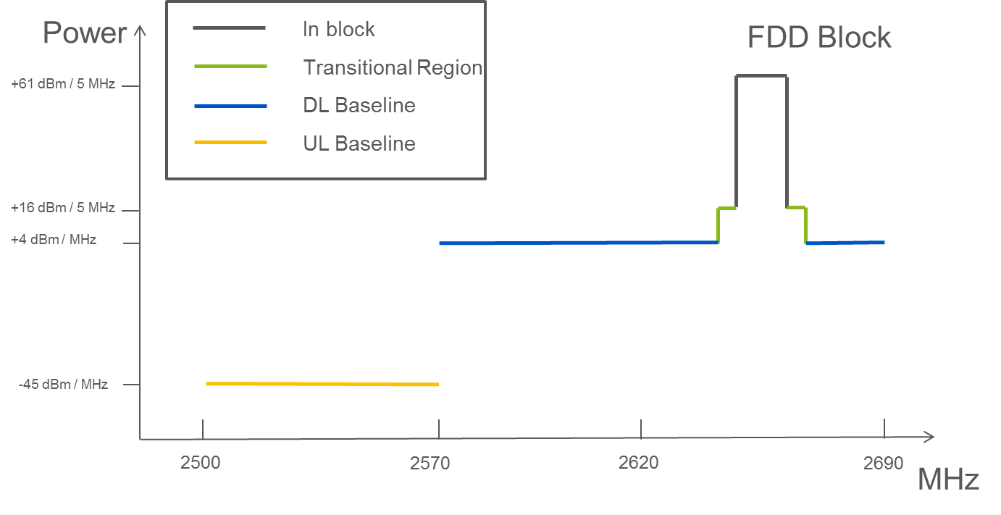

- Combined BEM elements for an FDD block above 2620 MHz
with downlink only operation within 2570-2620 MHz

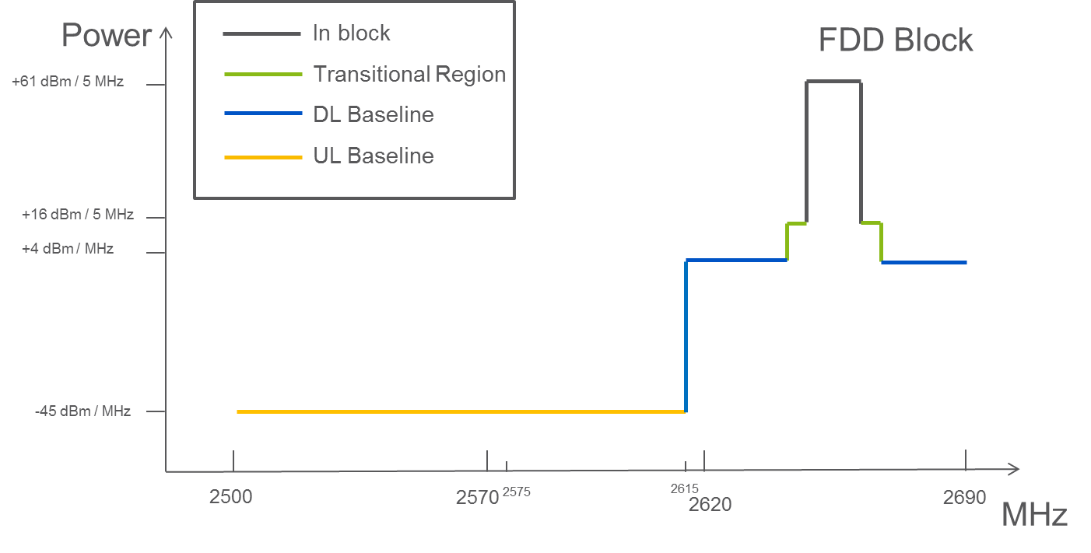
- Combined BEM elements for an FDD block with TDD
(synchronized/unsynchronized) networks within 2570-2620 MHz

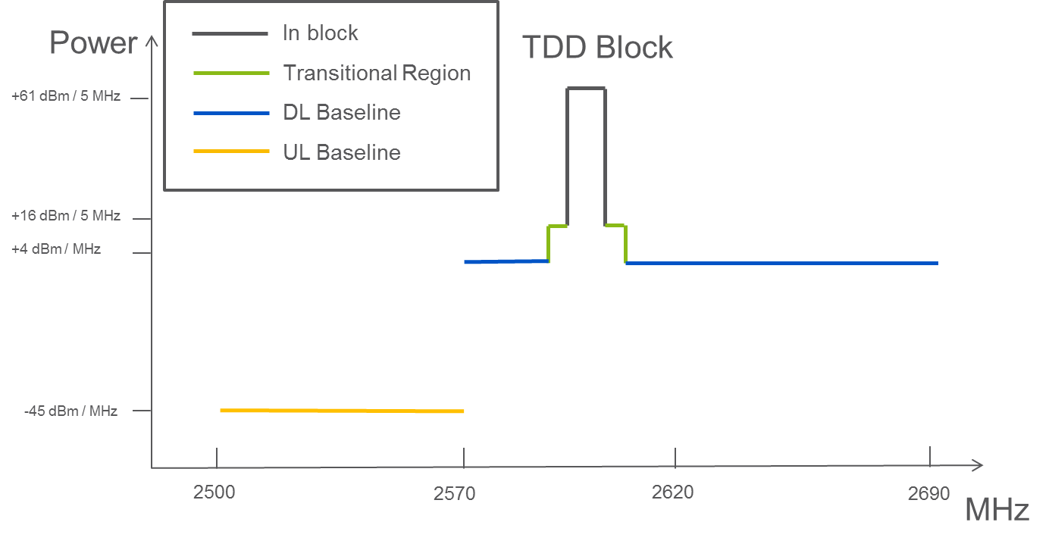
- Combined BEM elements for synchronized TDD blocks / downlink only blocks

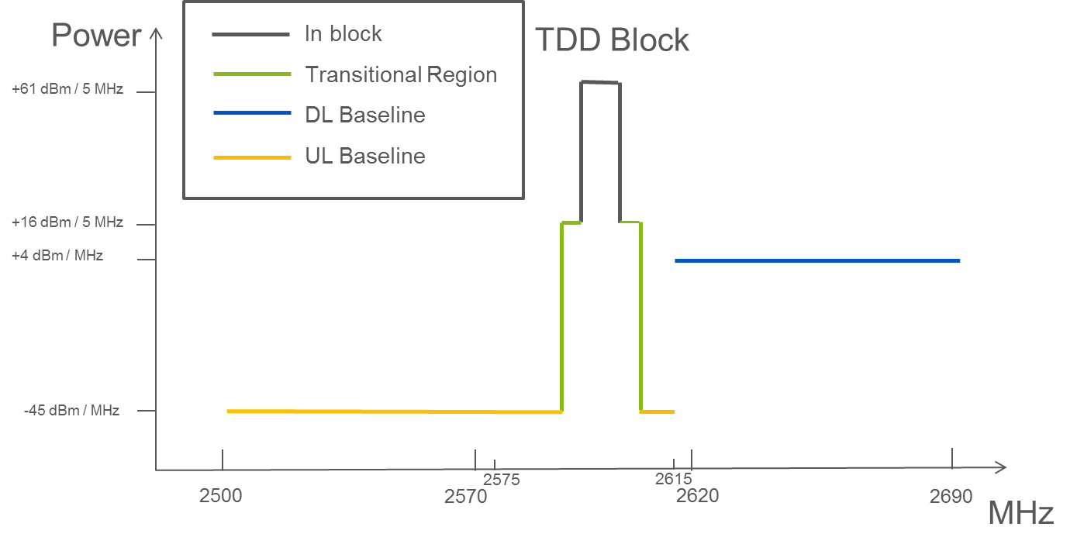
- Combined BEM elements for Unsynchronized TDD blocks

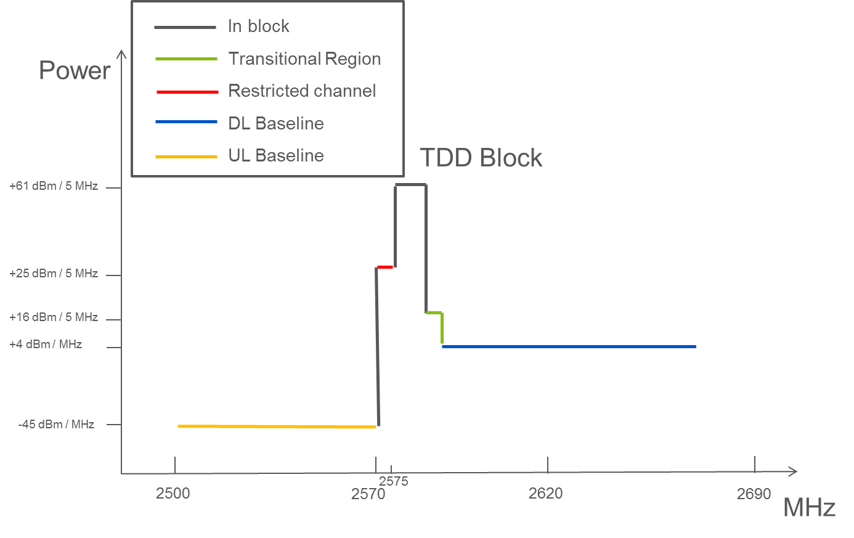
- Combined BEM elements for synchronized TDD/downlink only blocks and
a restricted spectrum block in 2570-2575 MHz

- List of referenceS
This annex contains the list of relevant reference documents.
- Commission Decision 2008/477/EC on the harmonisation of the 2500-2690 MHz frequency band for terrestrial systems capable of providing electronic communications services in the Community
- CEPT Report 19: Report from CEPT to the European Commission in response to
EC Mandate to develop least restrictive technical conditions for frequency bands addressed in the context of WAPECS
- ERC Decision (97)07 on the frequency bands for the introduction of the Universal Mobile Telecommunications System (UMTS)
- ERC Decision (99)25 on the harmonised utilisation of spectrum for terrestrial Universal Mobile Telecommunications System (UMTS) operating within the bands 1900 - 1980 MHz, 2010 - 2025 MHz and 2110 - 2170 MHz
- ERC Decision (00)01 on the frequency bands for the introduction of terrestrial Unversal Mobile Telecommunications System (UMTS)
- ERC Recommendation (02)10: Harmonised utilisation of spectrum for 1.28Mcps UTRA TDD option in connection with ERC/DEC/(99)25
- ECC/DEC/(02)06 on the designation of frequency band 2500-2690 MHz for UMTS/IMT-2000
- Commission Decision 128/1999/EC on the coordinated introduction of a third-generation mobile and wireless communications system (UMTS) in the Community
- Recommendation ITU-R M.2012: Detailed specifications of the terrestrial radio interfaces of International Mobile Telecommunications Advanced (IMT-Advanced)
- Recommendation ITU-R M.1457: Detailed specifications of the terrestrial radio interfaces of International Mobile Telecommunications-2000 (IMT-2000)
- Resolution ITU-R 56: Naming for International Mobile Telecommunications
- Resolution ITU-R 223: Additional bands identified for IMT-2000
- Resolution ITU-R 224: Compatibility studies in relation to Resolution 224 in the bands 698-806 MHz and 790-862 MHz
- Resolution ITU-R 225: Use of additional frequency bands for the satellite component of IMT

Comparable technical specifications to those given in this ECC Decision are given in Commission Decision 2008/477/EC of 13 June 2008 [1]. EU/EFTA Member States and, if so approved by the EEA Joint Committee, Iceland, Liechtenstein and Norway are obliged to implement the EC Decision.
Mandate to CEPT to harmonise frequency usage in order to facilitate a co-ordinated implementation in the Community of third generation mobile and wireless communication systems operating in additional frequency bands as identified by WRC-2000 for IMT-2000 systems, 9 March 2001.
Mandate to CEPT to harmonise the frequency usage within the additional frequency band of 2500-2690 MHz to be made available for IMT-2000/UMTS systems in Europe (Mandate 5), August 2003.

