Electronic Communications Committee (ECC)
within the European Conference of Postal and Telecommunications Administrations (CEPT)

COMPATIBILITY BETWEEN INDUCTIVE LF AND HF RFID TRANSPONDER
AND OTHER RADIO COMMUNICATION SYSTEMS
IN THE FREQUENCY RANGES
135–148.5 kHz, 4.78–8.78 MHz AND 11.56–15.56 MHz

Beaune, February 2002

INDEX TABLE

1 INTRODUCTION 1
1.1 Scope 1
1.2 Application overview 1
1.3 Inductive RFID Technology and Transponder operating frequencies 2
2 TRANSPONDER EMISSION LEVELS 3
2.1 Theoretical evaluation 3
2.2 LF transponder transmission levels, calculated 3
2.3 HF transponder transmission levels, calculated 4
2.4 HF transponder transmission levels, measured 4
3 INTERFERENCE ASSESSMENT TO PRIMARY USERS 4
3.1 LF and HF Services 4
3.2 Requirements of the primary services 5
4 INTERFERENCE FROM PRIMARY USERS 7
5 CONCLUSIONS 7
6 REFERENCES 7
ANNEX 1 : ITU defined noise levels in the range up to 30 MHz 8

ANNEX 2 : Power / field strength calculations for transponder devices of RFID Systems operating in the frequency 9
bands below 135 kHz and at 13.56 MHz 9

INTRODUCTION

Scope
The emissions from the RFID transponder considered as intentional radio transmission signals despite their very low emission levels.

As such they have to be published in the national air interfaces, which according to the RTTE Article 4 must be notified to the Commission.

The compatibility with radio communication systems and services below 30 MHz is a precondition to accept listing of RFID Transponder frequencies in the ERC SRD Rec 70-03, Annex 9 or in the relevant national frequency tables.
This report defines the technical characteristics, the justification of the various RFID systems with regard to the transponder frequencies and the sharing of primary and secondary services.

Application overview
RFID systems operating in the Low Frequency (LF) and High Frequency (HF) ranges at frequencies below 30 MHz have found a wide acceptance.

Present production figures are approx 300–500 Million transponders/year for inductive transponders in both frequency ranges.

The market size is estimated to be 2 Billion transponders by the year 2004, see Fig.1.

0
500
1000
1500
2000
2500
1999
2000
2001
2002
2003
2004

Figure 1: Market for Inductive Transponders

This has driven development of ISO standards for inductive RFID systems for instance the ISO 14443, ISO 15693, ISO 11785, ISO 14223, 18000-2, 18000-3, RPC 1740c (IATA RFID Baggage ID Standard).

The range of applications cover logistics in a supply chain, airline baggage, postal services, animal identification, personal identification and peoples belongings, automotive applications as car access systems, industrial control, safety areas, person access control, payment systems (Smart Card), Automatic Recognition of Customer (ARC) or customer loyalty systems, automatic fuelling, waste management, environmental control, tagging of endangered species, medical (medicine) logistics and many more.

Inductive RFID Technology and Transponder operating frequencies
RFID systems use passive devices in the majority of cases. For powering, they depend on the RF interrogating signal in the vast majority of systems. The powering works like a loose-coupled transformer.

In the return link the transponders mostly use the principle of load modulation, caused by an impedance change at the transponder coil, see Figure 2.

Figure 2: Function of the load modulation

Often the data is modulated onto a subcarrier, which is derived from the interrogation signal by dividing the received carrier by an integer number. This results in subcarrier data return frequencies, which can be outside RFID or other SRD frequency bands.

For systems with optimum performance, the separation from the carrier frequency is needed in order to allow reception of very low transponder signals in presence of the strong reader interrogation signals. With reference to the reader signal, the transponder signals can be –80dB or lower and received by the same reader interrogation antenna.
Other RFID systems in the LF range use the energy to charge a small capacitor and use the tuned transponder circuit with an oscillator function to send for instance an FSK modulated transponder signal back to the reader.

Some RFID systems use battery operated transponders in the ‘semi passive’ mode. This means that the battery is used to power the tag. It does not increase the transponder signal as compared to passive transponders powered by the RF signal.

Therefore such RFID systems can be placed and operated in close vicinity without causing mutual interference.
For the various systems and applications, different subcarrier transponder frequencies are used. Higher frequency subcarriers are generally used for higher data rates.

In order to cover all sub carrier systems a HF transponder frequency range of +/- 2 MHz is defined, while the range of 135 to 148.5 kHz is needed for the LF frequency operation.

According to Annex 9 of the ERC Rec 70-03, inductive RFID Reader systems primarily operate either below
135 kHz or at 6.78 or 13.56 MHz. Therefore the correlated transponder data return frequencies reside in the following ranges.
LF Range Transponder Frequencies: f_{C} = < 135 kHz, f _{TRP} = 135 to 148.5 kHz
HF Range Transponder Frequencies: f_{C} = 6.78 MHz f _{TRP} = 4.78 to 8.78 MHz
f_{C} = 13.56 MHz f _{TRP} = 11.56 to 15.56 MHz.

TRANSPONDER EMISSION LEVELS
Due to the very low field strength emitted by RFID transponders, not measurable at ETSI EN 300 330-1 measurement conditions, the theoretical determination of the fieldstrength is given.
Consequently, the magnetic dipole moment of the transponder must be calculated in order to determine the field strength of the transponders.

Theoretical evaluation
The field strength calculation for transponder devices in the inductive frequency bands is described in Annex 2.
The results of the field strength calculations are summarised below for the most commonly used transponder devices. The values in dBµA/m are calculated for distance levels of d = 10 metres .

LF transponder transmission levels, calculated
In the LF range, the calculated average transponder levels are about -40 dBµA/m @ d = 10 m. The CISPR 16 quasi–peak signal weighting of –10 dB is taken into account. Table 1 gives an overview over LF transponder frequencies as well as the field strenght levels.

Tag |  |  | 
 | kHz | kHz | dBµA/m
NEDAP | 120 | fc ± 2 | -28
ISO-11785/FDX | 134.2 | fc ± 4 | -32
ISO-11785/HDX | 134.2 | 134.2 | -28
 |  | 124.2 | -28
Various suppliers | 125 | fc ± 2, ±4, ± 64 | -32
 | 128 | fc ± 64 | -42
ISO 18000-2 | 125/134.2 | fc ± 4, ±64, +0 /-10 | -32/-28
Table 1: LF Transponder Frequencies and Emission levels

Considering the atmospheric noise level at 135 kHz of approx –18 dBµA/m (in 2.7kHz BW) the probability of interference will be very low.

The atmospheric noise level masks the terrestrial noise level by approx 10-12 dB. However in industrial and business type locations, the EMC levels in the LF range stemming e.g. from SMPS (switching mode power supplies), motor drives and monitors can be substantially higher locally.

The calculated transponder emission levels are 35 dB below the spurious levels defined in EN 300330–1.

HF transponder transmission levels, calculated
Most of the calculated average transponder levels in the HF range are - 30 … -33 dBµA/m @ d=10m or lower. The CISPR 16 signal weighting will reduce the measured level by about 10 dB.

Tag
 |  | MHz |  | kHz | dBµA/m
ISO-14443, proximity |  | 13.56 |  | fc ± 846 | -41
ISO-15693, vicinity |  | 13.56 |  | fc ± 423/484 | -36
ISO-18000-3 | 13.56 |  | Similar to the below listed 13.56 MHz systems
I-code (Philips) |  | 13.56 |  | fc ± 423 | -36
Tag-It (TIRIS) |  | 13.56 |  | fc ± 423/484 | -36
Microchip |  | 13.56 |  | fc ± 70 | -24
Gemplus |  | 13.56 |  | fc ± 106 | -27
 |  |  |  | fc ± 212 | -30
Legic |  | 13.56 |  | fc ± 212 | -33
Table 2: HF Transponder Frequencies and Emission levels
Table 2 gives an overview over the HF transponder frequencies and the field strength levels.

HF transponder transmission levels, measured
An actual “label” type transponder has been measured at d = 0.5 metre, corresponding to an emission level of – 50 dBµA/m at d = 10 metres.
The measured value yield good agreement between the calculated and measured transponder emission levels.
At 13.56 MHz, the terrestrial noise level dominates the atmospheric by about –10 dB (for 80% distribution and noise in business areas). The terrestrial noise level is approx. – 40 dBµA/m in 9 kHz Bandwidth.

INTERFERENCE ASSESSMENT TO PRIMARY USERS

LF and HF Services
LF Range: 130 – 148.5 kHz Maritime Mobile (MM), Fixed, Amateur
HF Range: 4.750 – 8.815 MHz Fixed, MM, Aeronautical Mobile, Land Mobile,
BC, Standard Frequency, Amateur,

11.56 – 15.56 MHz Fixed, BC, Standard Frequency, Aeronautical Mobile, Radio
Astronomy, Amateur Radio,

Requirements of the primary services
Various types of primary and secondary services, as defined in the ITU Radio Regulations and CEPT/ERC/REC 62-01, were identified. These types were grouped into generic types, which have similar protection needs:

LF Range Services
a) Maritime radio navigation / Mobile
-These services are protected. They do not, however, require special protection from inductive short range devices and in particular emissions from RFID transponders, because the receivers are located at greater than 100 m distance from the inductive loop systems, secondly the emitted signals will be below the spurious levels of radio receivers.

b) Amateur
- Amateur radio service is operating on a global basis and using sensitive receivers. However the low transponder levels are unlikely to impair reception, co-location is highly unlikely.

HF Range Services
c) Aeronautical radionavigation
- These services do not require special protection from inductive loop RFID Transponder systems because the receivers are located at greater than 100 m height from the inductive systems. At low heights the ILS or similar systems are used.

d) Land mobile navigation
- The receivers of these systems are mobile and any interference is both localised and temporary. There would not be any significant degradation in the service caused by inductive systems.

e) Fixed (point-to-point)
- These systems operate between dedicated, defined sites. They have high quality receivers, which could be protected by distance and site engineering due to their location.

f) Fixed (point-to-multi point)
- There are a number of systems, which have a single point transmitter with multiple receivers. The location of the receivers is not specific and often not known in advance. Examples of this type of system are Radio controlled clocks and Utility Control. Special protection at lower power levels may be required for these systems.

g) Amateur
- Amateur radio service is operating on a global basis and using sensitive receivers. However the low transponder levels are unlikely to impair reception, co-location is highly unlikely.

Service | Freqency range  MHz | Signal to be  protected  dBµV/m | SNR  dB | Permissible  interference  dBµV/m | Envir.  Noise³  2.7 kHz  dBµV/m | Transp.  level  dBµA/m  @10m | Interference  range  m
LF Range: | 0.130 - 0.1485 |  |  |  |  | -40
Maritime Mobile | 0.130 - 0.1485 | 32 | 12 | 20 | 20, 80% |  | 7
/Fixed/ | 0.130 - 0.1485 | 63 | 12 | 51 |  |  | 3
Amateur | 0.1357 - 0.1378 | 9 |  |  | 10, 20% |  | 16
HF Range: | 4.75 - 8.815 |  |  |  |  | -43
Fixed (point-to-point) | 4.75 - 4.995 | 14 | 14 | 0 |  |  | 10
 | 5.005 - 5.480 | 14 | 14 | 0 |  |  | 10
 | 6.765 - 7.00 | 14 | 14 | 0 |  |  | 11
 | 7.30 - 8.195 | 14 | 14 | 0 |  |  | 11
Maritime Mobile | 6.20 - 6.525 |  |  |  | 5, 80% |  | 8
 | 8.10 - 8.815 |  |  |  | 3, 80% |  | 9
Aeronautical Mobile | 4.75 - 4.85 | 21 | 15 | 6 |  |  | 8
 | 5.45 - 5.73 | 21 | 15 | 6 |  |  | 8
 | 6.525 - 6.685 | 21 | 15 | 6 |  |  | 8
Land Mobile | 4.75 - 4.85 |  |  |  | 6, 80% |  | 8
 | 5.45 - 5.48 |  |  |  | 6, 80% |  | 8
 | 5.73 - 5.93 |  |  |  | 6, 80% |  | 8
 | 7.30 - 8.10 |  |  |  | 4, 80% |  | 9
Broadcasting | 5.95 - 6.20 | 60-16 | 34 | 10 |  |  | 8
 | 7.10 - 7.30 | 60-16 | 34 | 10 |  |  | 8
Standard Frequency | 4.995 - 5.005 |  |  |  | 6, 80% |  | 8
Amateur | 7.000 - 7.100 |  |  |  | -15, 20% |  | 71
HF Range: | 11.56 - 15.56 |  |  |  |  | -43
Fixed (point-to-point) | 11.56 - 11.65 | 14 | 14 | 0 |  |  | 22
 | 12.05 - 12.23 | 14 | 14 | 0 |  |  | 22
 | 13.36 - 13.60 | 14 | 14 | 0 |  |  | 22
 | 13.87 - 14.00 | 14 | 14 | 0 |  |  | 22
 | 14.35 - 14.99 | 14 | 14 | 0 |  |  | 22
Broadcasting | 11.60 - 12.10 | 60-16 | 34 | 10 |  |  | 13
 | 13.60 - 13.80 | 60-16 | 34 | 10 |  |  | 13
Standard Frequency | 14.99 - 15.01 |  |  |  | -3, 80% |  | 30
Aeronautical Mobile | 13.20 - 13.36 | 21 | 15 | 6 |  |  | 11
 | 15.01 - 15.10 | 16 | 15 | 1 |  |  | 19
Radio Astronomy | 13.36 - 13.41 |  |  |  |  |  | <10
Amateur | 14.00 - 14.35 |  |  |  | -13, 20% |  | 72
Table 3 : Summary of calculated interference ranges

INTERFERENCE FROM PRIMARY USERS
Inductive RFID systems operate over a distance of approx. 1 metre limiting the sensitivity to outside interferer to a degree.
Field measurements in the LF range with RFID systems were done in the past during which a co-channel interferer (a “broadcast” data telemetry station operating at a power level of 20 kW) caused a reduction of reading range of approx 30 % at distances of approx 2-5 km from the RFID system considered as victim. This range reduction can in practice be compensated by site engineering techniques such as turning the RFID Antenna such that the null-out of the interferer occurs or by using shielding techniques or still another mean is to use separate receive and transmit antennas.
The sub-carrier technology provides a redundant data transmission function because the sub-carrier data return signal modulates the carrier frequency thus producing two data signals above and below the activation carrier frequency.
The receiver of the RFID systems can select either the lower or upper sub-carrier frequency for the reception of the data signal. It is unlikely that both sub-carriers will suffer from interference simultaneously.
A third receiver design option is that the data signal frequency is down-converted into the base band using the powering signal as local oscillator and either low-pass or band-pass filters prior to demodulation.
Therefore the interference from primary services to RFID systems is unlikely.

CONCLUSIONS
There are several aspects to be considered for interference to primary users:
- The magnitude of the emission levels of the transponder return signals is in the order or below the atmospheric and/or the environmental noise. The presence of transponder signals will not impair reception quality of primary services.
- There are a few hundred million transponders with valid type approvals in the field. The type approval has been granted in a number of ERC countries as the test of transponders has been done in conjunction with the readers and no particular emissions of transponder signals were detected.
- Considering the ERC report 74 “Compatibility Between Radio Frequency Identification Devices (RFID) and The Radio Astronomy Service At 13 MHz”, the measurement results show that under realistic conditions, even the interference from RFID reader systems which emit about 70-80 dB higher signals as the transponders, do not cause interference in astronomy sites. Relating this to the considerably lower transponder emission levels, interference is unlikely to occur.
- Concluding, the proposed signal levels of – 40 dBµA/m at d = 10 metre can be justified.

REFERENCES
ERC Report 69 : Propagation Model And Interference Range Calculation. For Inductive Systems
10 kHz - 30 MHz
ERC Report 74 : Compatibility Between Radio Frequency Identification Devices (RFID) and The Radioastronomy Service At 13 MHz
ERC Rec 70-03 : Relating to the Use of Short Range Devices
ERC Rec 62-01 : Use of the Band 135.7-137.8 kHz by the Amateur Service
CISPR 16 : Specification for Radio Disturbance and Immunity Measurement Apparatus and Methods;
Part 1: Radio Disturbance and Immunity Measurement Apparatus
ISO/IEC 15693-2 : Identification cards -Contactless integrated circuit(s) cards -Vicinity cards-Part2:
Air interface and initialisation
ISO/IEC 14443-2 : Identification cards - Contactless integrated circuit(s) cards - Proximity cards
Part 2 : Radio frequency power and signal interface
ISO 11785 : Radio Frequency Identification of Animals, Technical concept
ISO 14223-1 Radio Frequency Identification of Animals, Advanced Transponders
EN 300 330-1 Short Range Devices, Radio Equipment in the Frequency Range 9 kHz to 25 MHz and Inductive Loop Systems in the Frequency Range 9 kHz to 30 MHz; Part 1, Technical Characteristics and Test Methods.

ANNEX 1

ITU defined noise levels in the range up to 30 MHz

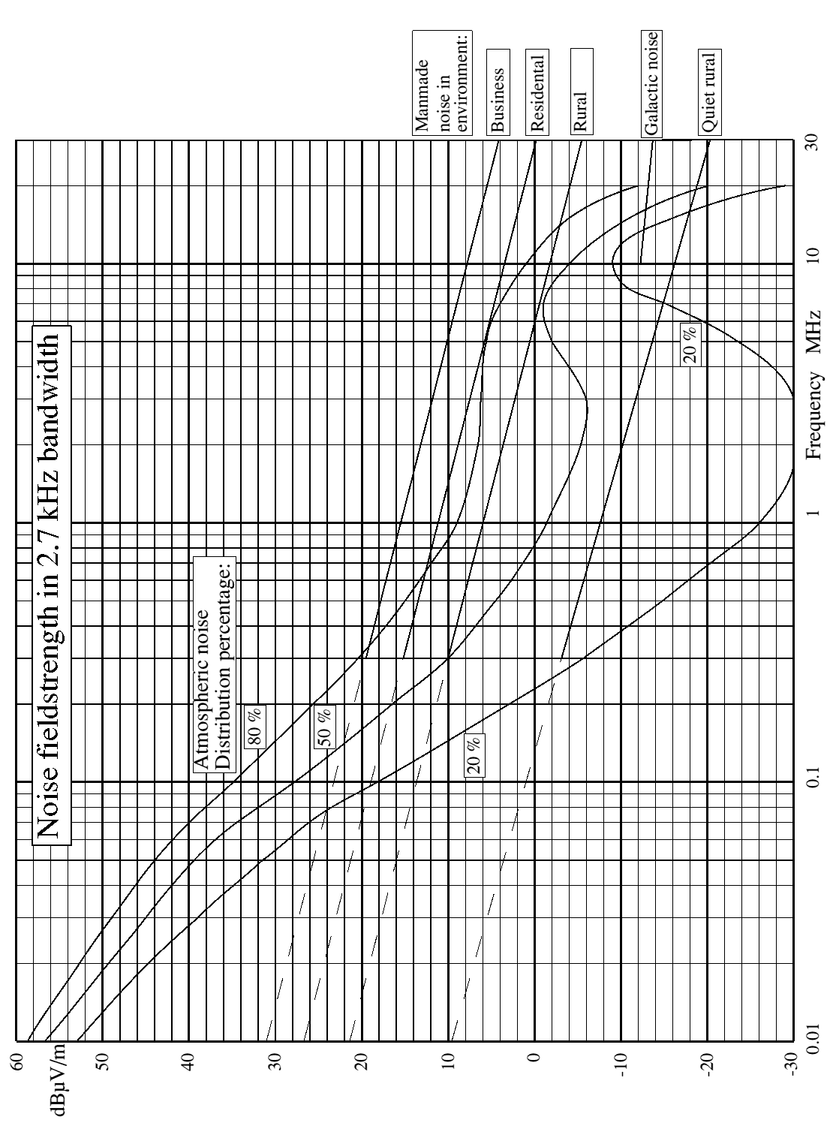

ANNEX 2

Power / field strength calculations for transponder devices of RFID Systems operating

in the frequency bands below 135 kHz and at 13.56 MHz

The field strength at the measuring distance = 10 m is determined by the magnetic dipole moment, , of the return signal of the tag according the formulas:

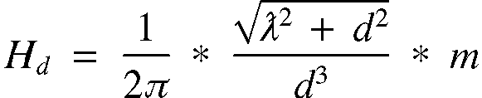
for MHz (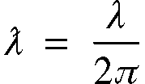)
and

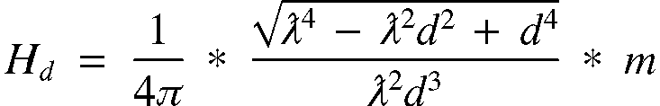
for  MHz

For tags in the lower band ( < 135 kHz), where , formula (1) simplifies into:

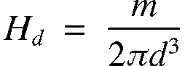

The magnetic dipole moment is depending on several parameters:
- The dimensions of the tag coil and the number of windings.
- The tuning capacitance.
- The Q-factor under condition of loading by powering the chip.
- The modulation frequency of the return signal or subcarrier frequency.
- The modulation depth of the load modulation.
- The voltage over the tag coil.

Conditions for the maximum value of the magnetic dipole moment of the return signal from a tag
Consider a tag placed in an interrogator field which strength is increasing from zero upwards. As a result of this increasing field strength the induced voltage, in the tag coil increases. The chip starts functioning when  From  on and higher, the voltage over the coil, , is clamped.
Under the conditions of a constant loaded Q-factor and a constant modulation depth, the magnetic dipole moment, , is proportional with , so saturates at .
In the range it is reasonable to assume that as well as the loaded Q-factor as the modulation depth are more or less constant. Because in the situation that  is just above  the distance between reader antenna and tag is maximal, so a high magnetic dipole moment is needed for the return path, making a high modulating depth necessary. This rationalize the use of a switched resistor or a switched capacitor for modulation, which makes the modulation depth essentially independent from the level of .
In the range  the voltage over the coil, , is constant. The modulation depth will decrease because the effect of the loading by the clamping will added to the loading by the modulation resistor, thereby reducing the on/off ratio.
On the other hand the loaded Q-factor will decrease too. For tags with a relative high subcarrier frequency, wherein the return signal is attenuated by the effect that its frequency is situated half way the resonance curve, a lower Q means a broader resonance curve, so less attenuation.
Both effects can compensate each other, but only for values of not much higher than . So in a generic approximation it is reasonable to assume that the maximum magnetic dipole moment is reached at .

CALCULATION

Using the IIsim program the above mentioned condition is assessed by taking the value of at the activation range at , the (specified) minimum value of the field strength of the reader field to activate the tag, so that , and multiply it with the ratio between the (specified) and .

In the next tables is calculated for a number of RFID tags, with the next assumptions:
- Dimensions of the tag coil: 5 x 7 cm.
- Minimum voltage, : 3 V.
- Maximum voltage, : 6 V.
- Unloaded Q of the tag coil: 70.
- Modulation depth: 80 %.
- For the modulated signals, ASK or FSK, the ON value for each frequency has been used.
- No effects of burst emissions on the Quasi-Peak reading has been incorporated.

Tag
 |  | kHz | µAm² | dBµA/m
NEDAP | 120 kHz | fc ± 2 | 250 | -28
ISO-11785/FDX | 134.2 kHz | fc ± 4 | 160 | -32
ISO-11785/HDX | 134.2 kHz | 134.2 | ≈250 | -28
 |  | 124.2 | ≈250 | -28
Various suppliers | 125 kHz | fc ± 2, 4, ± 64 | 150 | -32
 | 128 kHz | fc ± 64 | ≈50 | ≈-42
ISO 18000-2 | 125/134.2 kHz | fc ± 4, 64, +0 /-10 | 160/250 | -32/-28
Table 4: LF Transponder Frequencies, magnetic dipole moments and Emission levels
Table 4 gives an overview over the LF transponder frequencies, the magnetic dipole moment, , of the return signal of the tag and the resulting field strength levels.

Tag
 |  | kHz | µAm² | dBµA/m
ISO-14443, proximity | 13.56 MHz | fc ± 846 | 15 | -41
ISO-15693, vicinity | 13.56 MHz | fc ± 423/484 | 27 | -36
ISO-18000-3 | 13.56 MHz | Similar to the below listed 13.56 MHz systems
I-code (Philips) | 13.56 MHz | fc ± 423 | 27 | -36
Tag-It (TIRIS) | 13.56 MHz | fc ± 423/484 | 27 | -36
Microchip | 13.56 MHz | fc ± 70 | 105 | -24
Gemplus | 13.56 MHz | fc ± 106 | 72 | -27
 |  | fc ± 212 | 50 | -30
Legic | 13.56 MHz | fc ± 212 | 34 | -33
Table 5: HF Transponder Frequencies, magnetic dipole moments and Emission levels
Table 5 gives an overview over the HF transponder frequencies, the magnetic dipole moment, , of the return signal of the tag and the resulting field strength levels.

3
60 dBµV/m carrier level -16 dB, assuming 30% modulation depth.
Concluded from ERC Report 74. ³ See Annex 1
Inductive Identification system Simulation program (IIsim) is a simulation program for calculating the activation and the reading range of an inductive RF ID system. It is developed by NEDAP General R&D and distributed for public use under the Open Source Definition.

