CEPT Report 61

Report from CEPT to the European Commission in response to the Mandate

“Harmonised compatibility and sharing conditions for video PMSE in the 2.7-2.9 GHz frequency band, taking into account radar use”

**Report approved on 17 June 2016 by the ECC**

# Executive summary

This CEPT Report is the response to the Mandate issued by the European Commission on harmonised compatibility and sharing conditions for video PMSE in the 2.7-2.9 GHz frequency band, taking into account radar use.

According to this Mandate, only video PMSE applications dealing with cordless cameras and associated wireless links, identified as portable and mobile links, are considered in this CEPT Report.

In CEPT Report 51 [1], CEPT identified the band 2.7-2.9 GHz and other bands as possible new spectrum for cordless cameras and video links, however, subject to further sharing studies. Such studies and appropriate compatibility and sharing conditions should be developed in order to maximise the possibility to use this spectrum for video PMSE while guaranteeing continuous use of the band by radars (aeronautical radio navigation service and radiolocation service). Moreover, harmonisation at European level of those conditions will contribute to facilitate economies of scale, lower prices and foster cross-border portability and interoperability.

In particular, CEPT is mandated to identify compatibility and sharing scenario(s) for use of the band 2.7-2.9 GHz between video PMSE and radar systems and to define relevant coexistence/protection parameters that ensure efficient spectrum use.

This CEPT Report is based, among other reference documents, on ECC Report 243 [2] which deals with sharing and compatibility studies for the introduction of video PMSE in the bands 2.7-2.9 GHz in particular.

This CEPT Report highlights opportunities for harmonised compatibility and sharing conditions for the following video PMSE applications: cordless camera links, portable video links and terrestrial mobile video links, under relevant parameters as described in Table 1 and Table 2.

An overview on operational and regulatory aspects for the various types of Primary Surveillance Radars (PSR) used for civil and military Air Traffic Control (ATC) is also provided in this CEPT Report (see Annex 3). In this respect, it should be noted that video PMSE equipment shall not cause harmful interference to radars and cannot claim protection from these radars.

Temporary point-to-point links, with high directivity antennas, are not appropriate for the band 2.7-2.9 GHz. Those links, which are used for carrying broadcast quality video/audio signals, are preferably deployed in higher frequency bands (higher than 5 GHz). Their usage may be possible on a national basis depending on local conditions. This scenario is provided for information only in this CEPT Report as those links are not covered by the Mandate.

Moreover, compatibility studies between airborne video PMSE (air-to-ground link) and radars show that the use of such video PMSE is not possible in the band 2.7-2.9 GHz, due to the required separation distance.

1. Parameters for video PMSE in the band 2.7-2.9 GHz

|  |  |  |  |
| --- | --- | --- | --- |
| **Type of link** | **Cordless camera link** | **Portable video link** | **Terrestrial mobile video link** |
| **Range of e.i.r.p. (dBW)** - see note | -7/0 | -7/0 | 3/6 |
| **Typical antenna height (m)** | 1.5 | 2 | 1.5 |
| Note: the range indicates the power generally used by operators in order to extend battery life, etc. | | | |

1. Compatibility for cordless camera links, portable video links and terrestrial mobile video links in the band 2.7-2.9 GHz

|  |  |
| --- | --- |
| **Compatibility between video PMSE (10 MHz channel, note) and radars (ATC, terrestrial and meteorological) in the band 2.7-2.9 GHz, with a radar selectivity of 60 dBc** | |
| **Co-channel scenario** | In the co-channel scenario, a separation distance between PMSE transmitter and radar receivers of 100 km or even more (182 km) may be necessary. Hence a co-channel sharing is in general not feasible.  However, co-channel operation may be possible, only after coordination on a case-by-case basis, for a video PMSE with a maximum e.i.r.p. of 0 dBW and an antenna height of 1.5 m. The coordination should take into account shielding loss (in accordance with the Recommendation ITU-R P.1411 [23]), brought for example by an urban environment and by a building loss. |
| **Adjacent channel scenarios** | **Separation distances (km) required for one single video PMSE (no aggregated interference) with e.i.r.p. between -7 and 6 dBW** |
| **Offset between PMSE centre frequency and edge of radar channel between 5 MHz and 25 MHz** | 3 km for ATC radar and 6.5 km for meteorological radar |
| **Offset between PMSE centre frequency and edge of radar channel ≥ 25 MHz** | ≤ 1.5 km for ATC radar and ≤ 3 km for meteorological radar |
| **Compatibility between video PMSE in the band 2.7-2.9 GHz and radars above 2.9 GHz** | |
| **Adjacent channel scenario** | The usage of the upper two channels (i.e. 2x10 MHz in the band 2880-2900 MHz) of the band 2.7-2.9 GHz by video PMSE is not possible on a European harmonised framework but can be authorised at national level, after coordination on a case-by-case basis. |
| **Compatibility between video PMSE in the band 2.7-2.9 GHz and radio astronomy in the band  2.69-2.7 GHz, the propagation model used is the Recommendation  ITU-R P.452-13 [24] with a percentage of time of 2 % and a flat Earth** | |
| **Adjacent channel scenarios** | **Separation distances (km) for one single video PMSE (no aggregated interference)** |
| **10 MHz PMSE channel, centre frequency 2705 MHz** | 125 |
| **10 MHz PMSE channel, centre frequency 2715 MHz** | 85 |
| **10 MHz PMSE channel, centre frequency 2725 MHz** | 60 |

Note: The frequency offset considered should be amended if multiple 10 MHz PMSE channels are aggregated.

CEPT confirms that the use of the band 2.7-2.9 GHz by video PMSE must be subject to an individual authorisation granted after a coordination procedure.

* The separation distances may be larger, if aggregated interference or more sensitive radars or other propagation conditions such as rural or suburban have to be taken into account. The separation distances may also vary depending on the deployment scenario of the video PMSE (such as indoor use) and the radar (such as antenna height and terrain).
* CEPT confirms that it is not required to define harmonised conditions to ensure compatibility between video PMSE in the band 2.7-2.9 GHz and E-UTRA/LTE user equipment in the band 2.5-2.69 GHz. Only some specific cases can require, on a national basis, the implementation of conditions to facilitate adjacent band coexistence, including the reduction of transmission power of PMSE, applying a sufficient separation distance and/or increasing the frequency separation between video PMSE and LTE user equipment.
* In some countries, there are radio astronomy stations using frequencies in the band 2.7-2.9 GHz. Administrations in those countries may need to implement specific measures for the use of video PMSE, after coordination on a case-by-case basis.
* It should be noted that, where a high number of PSR in the band 2700 to 2900 MHz exists, PSR stations are already operating close to the probability of detection of aircraft specified by Eurocontrol for civil and military ATC. The national coordination for a potential introduction of video PMSE would be more complex in this case.

In such cases, Administrations may define relevant specific conditions in their authorisation for use of frequencies. The opportunities for sharing of the 2.7-2.9 GHz band between incumbent radar and video PMSE contain limitations and assignments in this band will generally not be sufficient to compensate for loss of other bands.

It should also be noted that the necessary separation distances may lead to cross-border coordination requirements, depending on the location where the video PMSE will operate. These requirements are relevant on national level and may have an impact on the coordination process for video PMSE. This issue has not been studied in detail in this Report as it is not included in the tasks of the Mandate.

The studies focused on the protection of incumbent services and applications against PMSE signals and the report provides limited information for required quality of video PMSE. Regarding the interference from radar into PMSE, it is expected that the flexibility of video PMSE for adjusting the frequency offset would help in reducing the required separation distance to respect the C/I protection criteria. Concerning the impact on video PMSE from a short radar pulse, the main issue concerns the capability of the video PMSE receiver front-end to handle the input signal power and the time needed to recover a sync state of the video signal.

**TABLE OF CONTENTS**

0 Executive summary 2

1 Introduction 8

2 Definitions and general overview related to video PMSE 9

2.1 Description of PMSE applications considered in this CEPT Report 9

2.2 Frequency bands for video PMSE 10

2.3 Technical characteristics and operational deployment scenarios of video PMSE in the band 2.7-2.9 GHz 10

3 Radio services and technical characteristics of systems using the band 2.7-2.9 GHz and the adjacent bands 12

3.1 Allocation and use of the band 2.7-2.9 GHz 12

3.2 Use of the band above 2.9 GHz 15

3.3 Use of the band 2.69-2.7 GHz 15

3.3.1 Technical characteristics of Earth-exploration-satellite (passive) 15

3.3.2 Technical characteristics of radio astronomy 15

3.3.3 Technical characteristics of space research (passive) 15

3.4 Use of the band below 2.69 GHz 16

4 compatibility and sharing scenarios 17

4.1 Compatibility between video PMSE and radars in the band 2.7-2.9 GHz (ATC/defence and meteorological radars) 17

4.1.1 Co-channel scenario 17

4.1.2 Adjacent channel scenario 17

4.1.2.1 Protection of ATC radar from video PMSE 17

4.1.2.2 Protection of meteorological radar from video PMSE 19

4.1.2.3 Example: Protection of ATC and meteorological radars from video PMSE with an e.i.r.p. of 0 dBw 21

4.2 Compatibility between video PMSE in the band 2.7-2.9 GHz and radars above 2.9 GHz 22

4.3 Compatibility between video PMSE in the band 2.7-2.9 GHz and radio astronomy in the band 2.69-2.7 GHz 22

4.4 Compatibility between video PMSE in the band 2.7-2.9 GHz and E-UTRA/LTE user equipment in the band 2.5-2.69 GHz 22

5 Conclusions 24

ANNEX 1: mandate to CEPT to study and identify harmonised compatibility and sharing conditions for video PMSE in the 2.7 – 2.9 GHz frequency band, taking into account radar use, 14 July 2015 26

ANNEX 2: PMSE video link transmission parameters 32

ANNEX 3: Operational and regulatory aspects for ATC radars 35

ANNEX 4: List of references 37

**LIST OF ABBREVIATIONS**

|  |  |
| --- | --- |
| **Abbreviation** | **Explanation** |
| **ACS** | Adjacent Channel Selectivity |
| **ASR** | Airport Surveillance Radar |
| **ATC** | Air Traffic Control |
| **C** | Carrier |
| **CCL** | Cordless Camera Link |
| **CEPT** | European Conference of Postal and Telecommunications Administrations |
| **DVB-T** | Digital Video Broadcasting - Terrestrial |
| **ECC** | Electronic Communications Committee |
| **e.i.r.p.** | equivalent isotropically radiated power |
| **ENG** | Electronic News Gathering |
| **ESE** | Extraneous Signal Environment |
| **ESR** | Equivalent Series Resistance |
| **ETSI** | European Telecommunications Standards Institute |
| **E-UTRA** | Evolved - Universal Terrestrial Radio Access |
| **FDD** | Frequency Domain Duplexing |
| **I** | Interference |
| **IMT** | International Mobile Telecommunication |
| **ISDB-T** | Integrated Services Digital Broadcasting - Terrestrial |
| **ITU-R** | International Telecommunication Union - Radiocommunication sector |
| **LMS-T** | Link Modulation Scheme - Terrestrial |
| **LTE** | Long Term Evolution |
| **MFCN** | Mobile/Fixed Communications Networks |
| **MVL** | Mobile Video Link |
| **N** | Noise |
| **NATO** | North Atlantic Treaty Organization |
| **NCS** | Non-Cooperative Surveillance Sensors |
| **NJFA** | NATO Joint civil/military Frequency Agreement |
| **OB** | Outside Broadcasting |
| **OOB** | Out-Of-Band |
| **PMSE** | Programme Making and Special Events |
| **PSR** | Primary Surveillance Radar |
| **PVL** | Portable Video Link |
| **QAM** | Quadrature Amplitude Modulation |
| **QPSK** | Quadrature Phase Shift Keying |
| **RR** | Radio Regulations |
| **Rx** | Receiver |
| **SAB** | Services Ancillary to Broadcasting |
| **SAP** | Services Ancillary to Programme making |
| **SSR** | Secondary Surveillance Radar |
| **Tx** | Transmitter |
| **UAV** | Unmanned Aerial Vehicle |
| **VLBI** | Very Long Baseline Interferometry |
| **3GPP** | 3rd Generation Partnership Project |

# Introduction

This CEPT Report is the response to the Mandate issued by the European Commission on harmonised compatibility and sharing conditions for video PMSE in the 2.7-2.9 GHz frequency band, taking into account radar use. Various types of radar operate in this band in Europe.

According to this Mandate, only video PMSE applications dealing with cordless cameras and associated wireless links, identified as portable and mobile links, are considered.

Video PMSE often used frequency bands which now have been subject to harmonisation for terrestrial systems capable of providing electronic communications services. Considering the resulting reduced availability and the increasing spectrum needs for video PMSE, the development of additional sharing possibilities requires further study of additional frequency bands.

In CEPT Report 51 [1], CEPT identified the band 2.7-2.9 GHz and other bands as possible new spectrum for cordless cameras and video links, however, subject to further sharing studies. Such studies and appropriate compatibility and sharing conditions should be developed in order to maximise the possibility to use this spectrum for video PMSE while guaranteeing continuous use of the band by radars (aeronautical radio navigation service and radiolocation service). Moreover, harmonisation at European level of those conditions will contribute to facilitate economies of scale, lower prices and foster cross-border portability and interoperability.

Temporary point-to-point video links with high directivity antennas, which use higher frequency bands, are not covered by this Mandate.

This CEPT Report is based, among other reference documents, on ECC Report 243 [2] which deals with sharing and compatibility studies for the introduction of video PMSE in the bands 2.7-2.9 GHz in particular.

In its Section 2, this CEPT Report draws up some definitions and a general overview related to video PMSE, including frequency bands, technical characteristics and operational deployment scenarios in the band 2.7-2.9 GHz.

Section 3 describes radio services and technical characteristics of systems using the band 2.7-2.9 GHz and the adjacent bands.

In its Section 4, this CEPT Report develops compatibility and sharing scenarios for the introduction of video PMSE in the band 2.7-2.9 GHz, taking into account the requirements of radars in this band as well as existing radio services in the adjacent bands.

Finally, Section 5 presents, as a conclusion, relevant harmonised compatibility conditions that ensure efficient spectrum use.

# Definitions and general overview related to video PMSE

Video programme making[1] and special events[2] (PMSE) applications include services ancillary to programme making (SAP) and services ancillary to broadcasting (SAB), support the production of audio-visual content, such as films, advertisement, corporate videos, concerts, theatre and activities of the broadcasting industry, as well as electronic news gathering (ENG) and outside broadcasting (OB). The definitions of PMSE, SAP/SAB and ENG/OB are detailed in the CEPT Report 50 [3] and ECC Report 204 [4].

With regard to this CEPT Report, only video PMSE applications dealing with cordless cameras and associated video links, identified as portable and mobile links, are considered. Temporary point-to-point video links with high directivity antennas, which use higher frequency bands, are not covered by the Mandate.

## Description of PMSE applications considered in this CEPT Report

In the context of the ECC Report 243 [2], different video PMSE types of links have been defined when conducting the sharing and compatibility studies.

This CEPT Report deals with cordless camera links, portable video links and terrestrial mobile video links as defined in Table 3.

Compatibility studies between airborne video links (air-to-ground link) and radars show that the use of such video PMSE is not possible in the band 2.7-2.9 GHz, due to the required separation distance.

The band 2.7-2.9 GHz is not appropriate for temporary point-to-point links, with high directivity antennas. Those links, which are used for carrying broadcast quality video/audio signals, are preferably deployed in higher frequency bands (higher than 5 GHz). They are not covered by the Mandate. Their usage may be possible on a national basis depending on local conditions.

Cordless cameras and associated video links often also carry the associated radio microphone audio, service links and telemetry. There may be more than one wireless link required to deliver the signal from a cordless camera to the production studio. In some cases, all the requirements of video, audio and control may be combined into a single IP link.

The categories of PMSE video links used for spectrum study purposes are provided in Table 3:.

1. Categories of PMSE video links for spectrum study purposes

|  |  |
| --- | --- |
| **Type of link** | **Definition** |
| **Cordless camera link** | Handheld or otherwise mounted camera with integrated or Clip-on transmitter, power pack and antenna for carrying broadcast-quality video together with sound signals over short-ranges (line-of-sight and non-line-of-sight). |
| **Portable video link** | Small transmitter, for deployment over greater ranges, typically up to 2 km. |
| **Terrestrial mobile video link (air-to-ground link excluded)** | Video transmission system employing radio transmitter and receivers mounted in/on motorcycles, racing motorbikes, pedal cycles, cars, racing cars, boats, helicopters, airships or other aircraft (includes repeaters and relays). One or both link terminals may be used while moving. |

## Frequency bands for video PMSE

Video PMSE often used frequency bands which now have been subject to new allocations, such as wireless broadband, and/or harmonisation for mobile/fixed communications networks (MFCN). Sharing with those services is not practical. The reduction in spectrum availability for video PMSE use is particularly significant in the bands below 3 GHz.

Moreover, PMSE applications rely on spectrum with advantageous radio wave propagation conditions, relatively low signal attenuation and the possibility to enable deployment of antennas with an acceptable size as well as reliable non-line-of-sight operation which is necessary for many scenarios. This is best met by the frequency range below 3 GHz.

As a consequence, spectrum is still required in the bands below 3 GHz to sustain current video PMSE levels and future needs.

In CEPT Report 51 [1], CEPT identified the band 2.7-2.9 GHz and other bands as possible new spectrum for cordless cameras and video links, however, subject to further sharing studies. The results of these studies are presented in this CEPT Report.

It is noticed that video equipment is currently available in the band 2.7-2.9 GHz. Such equipment is already used or about to be used in some CEPT countries, for example in France.

## Technical characteristics and operational deployment scenarios of video PMSE in the band 2.7-2.9 GHz

Typical application scenarios and technical characteristics of video PMSE equipment, considered for sharing studies, are described in details in ECC Report 219 [8].

The technical characteristics of PMSE video links used for spectrum study purposes are provided in Table 4:.

1. Technical characteristics of PMSE video links

|  |  |  |  |  |  |
| --- | --- | --- | --- | --- | --- |
| **Type of link** | **Range (km)** | **Typical TX power (dBm)** | **TX antenna gain @ height agl[3]** | **RX antenna gain @ height agl[4]** | **Frequency range (GHz)** |
| Cordless camera link | < 0.5 | 20 | 0-3 dBi @ 1-2 m | 3-13 dBi @ 2-60 m | 2 to 8 |
| Portable video link | < 2 | 33 | 6-14 dBi @ 1-4 m | 9-17 dBi @ 2-60 m | 2 to 8 depending on path |
| Terrestrial mobile video link (air-to-ground link excluded) | < 10 | 30 | 3-9 dBi @ 1-4 m | 10-13 dBi @ 2-60 m  4-9 dBi  @ 150 m-6 km (airborne) | 2 to 3.5 |

PMSE video applications use a number of different coding and transmissions schemes based on DVB-T, ISDB-T and LMS-T which are often defined in a 10 MHz channel. Multiple 10 MHz channels can be combined in order to provide sufficient bandwidth to carry higher definition video, 3D video or multiplex multiple cameras into a single transmission stream.

Consideration for video PMSE applications should be based on 10 MHz bandwidth in order to easily and efficiently assign spectrum for those applications.

As described in Figure 1, the first (N+1), second (N+2) and third (N+3) adjacent channels, referring to video PMSE, are defined with a 10 MHz bandwidth. Radars may have various different bandwidths.

|  |
| --- |
| The first (N+1) adjacent channel corresponds to an offset between PMSE centre frequency and edge of radar channel between 5 and 15 MHz.  The second (N+2) adjacent channel corresponds to an offset between PMSE centre frequency and edge of radar channel between 15 and 25 MHz.  The third (N+3) adjacent channel corresponds to an offset between PMSE centre frequency and edge of radar channel between 25 and 35 MHz. |

Figure 1: Out-of-band bandwidth of adjacent channels

The PMSE video link transmission parameters are detailed in ANNEX 2: of this CEPT Report.

# Radio services and technical characteristics of systems using the band 2.7-2.9 GHz and the adjacent bands

## Allocation and use of the band 2.7-2.9 GHz

The band 2.7-2.9 GHz is allocated on primary basis to aeronautical radionavigation service, and restricted to ground-based radars (and to associated airborne transponders) by the Radio Regulations [5] (RR) 5.337. The meteorological radars are included in RR 5.423:

“*In the band 2 700-2 900 MHz, ground-based radars used for meteorological purposes are authorized to operate on a basis of equality with stations of the aeronautical radionavigation service.*”

Also radiolocation service is listed with secondary status in the Radio Regulations frequency table in the band 2.7-2.9 GHz.

The use of the band 2.7-2.9 GHz, according to the Radio Regulations, is provided in Figure 2.



**5.337** The use of the bands 1 300-1 350 MHz, 2 700-2 900 MHz and 9 000-9 200 MHz by the aeronautical radionavigation service is restricted to ground-based radars and to associated airborne transponders which transmit only on frequencies in these bands and only when actuated by radars operating in the same band.

**5.423** In the band 2 700-2 900 MHz, ground-based radars used for meteorological purposes are authorized to operate on a basis of equality with stations of the aeronautical radionavigation service.

**5.424A** In the band 2 900-3 100 MHz, stations in the radiolocation service shall not cause harmful interference to, nor claim protection from, radar systems in the radionavigation service. (WRC-03)

**5.425** In the band 2 900-3 100 MHz, the use of the shipborne interrogator-transponder (SIT) system shall be confined to the sub-band 2 930 -2 950 MHz.

**5.426** The use of the band 2 900-3 100 MHz by the aeronautical radionavigation service is limited to ground-based radars.

**5.427** In the bands 2 900-3 100 MHz and 9 300-9 500 MHz, the response from radar transponders shall not be capable of being confused with the response from radar beacons (racons) and shall not cause interference to ship or aeronautical radars in the radionavigation service, having regard, however, to No. **4.9**.

Figure 2: Use of the band 2.7-2.9 GHz, according to the Radio Regulations [5]

As mentioned in ECC Report 6 [12], the band 2.7-2.9 GHz is used by radars for both civil and military applications.

* For the aeronautical radionavigation service, there are three types of radar operating within the CEPT:
  + ground-based systems for air traffic control (ATC) for civil purposes (also addressed as civil S-band radars);
  + ground-based systems for ATC for military purposes;
  + mobile bird-strike radars, designed to detect the flight of birds, which may collide with aeroplanes.
* For the radiolocation service, radars are ground-based meteorological systems; the aim of these radars is to measure and predict precipitation (rain, snow, hail and sleet).

Moreover, the band 2.7-2.9 GHz is identified to answer to permanent NATO needs, for land and naval applications in the aeronautical radio navigation and radiolocation service, specifically for airport surveillance radars (ASR) and air defence radars. No public information on the number and location of military radar sites is available.

ATC radars are mainly deployed close to airports; maritime radars on sea or on bigger rivers; defence and meteorological radar are more likely being deployed in rural areas.

Considering the existence of geographical areas where the band 2.7-2.9 GHz is unused, geographical sharing with video PMSE should therefore be possible in some or all countries, on a case-by-case basis.

The characteristics of the ATC/defence and meteorological radars in the band 2.7-2.9 GHz are summarised in Table 5:. They originate from ECC Report 174 [14] with additional parameters for blocking and selectivity.

The technical and operational aspects related to Primary Surveillance Radars (PSR) used for the Air Traffic Control (ATC) are provided in ECC Report 243 [2] (see also Annex 3).

1. ATC/defence and meteorological radar characteristics

| **Parameter** | **Unit** | **ATC and defence** | | | | **Meteorology** |
| --- | --- | --- | --- | --- | --- | --- |
| **Type 1** | **Type 2** | **Type 3** | | **Type 4** |
| **Category** |  | Frequency hopping | 2 to 4 frequencies | | | Single frequency |
| **Maximum antenna gain** | dBi | > 40 | 34 | | | 43 |
| **Antenna pattern** |  | Not given | Vertical pattern cosecant-squared | | | Recommendation ITU-R F.1245-1 [15] |
| **Antenna height** | m | 5-40 (normal 12) | | | | 7-21 (normal 13) |
| **Polarisation** |  | Circular | | | | H/V |
| **Feeder loss** | dB | < 1 | | Not given | | 2 |
| **Minimum elevation angle** | ° | Not given | 2 (Recommendation ITU-R M.1851 [16]) | | | 0.5 |
| **Protection level** | dBm/MHz | -122 (for I/N = -10 dB) | | | | |
| **1 dB compression point** | dBm | -20 (Recommendation ITU-R M.1464-1 [17]) | | | | 10 |
| **Blocking level** | dBm | -36 | -36 | -36 | | -36 |
| **Transmission power** | kW | 1000 | 400 | 30 | | 794 |
| **Reference bandwidth** | kHz | 2500 | 1000 | 800 | | 1000 |
| **40 dB bandwidth** | MHz | 9.5 | 20 | 4 | 2 | Annex 1 of ECC Report 174 |
| **Out-of-band roll off** | dB/decade | 20 | 20 | 20 | | 40 |
| **Spurious level** | dBc | -60 | -60 | -60 | | -60 for old radars and -75 to -90 for new radars |
| **Unwanted emission mask** |  | To be calculated using elements above + Annex 2 of ECC Report 174 [14] | |  | | Annex 1 of ECC Report 174 |
| **Pulse repetition rate** | Hz | < 300 | ~ 1000 | 825 | | 250-1200 (Recommendation ITU-R M.1849 [18]) |
| **Pulse duration** | µs | 20 and 100 | 1 | 1 | 100 | 0.8-2 |
| **Rise and fall time** | % of pulse length | 1 % | 10 % | 16.9 % | Not given | 10 % |
| **Antenna rotation** | rpm | 6-12 | 12-15 | 15 | | Recommendation ITU-R M.1849 |
| **Scan in elevation** |  | Not given | Fixed | | | Recommendation ITU-R M.1849 |
| **Selectivity** | dBc | -60 | -60 | | | -60 |

## Use of the band above 2.9 GHz

The upper adjacent band is used for radiolocation, navigation and maritime radars. Some systems using the band 2.7-2.9 GHz are also operating in the band 2.9-3.1 GHz.

## Use of the band 2.69-2.7 GHz

The band 2.69-2.7 GHz is allocated to Earth-exploration-satellite (passive), radio astronomy and space research (passive) services, and associated with RR 5.340 and 5.422 [5].

5.340: “*All emissions are prohibited in the (…) [band] (…) 2690-2700 MHz, except those provided for by No. 5.422 (…)*”.

### Technical characteristics of Earth-exploration-satellite (passive)

Since there is no characteristic available in Recommendation ITU-R RS.1861 [19] for the band 2.69-2.7 GHz, it is assumed that this band is currently not used by Earth exploration-satellite (passive) systems.

### Technical characteristics of radio astronomy

The diagram antenna pattern can be considered as omnidirectional of 0 dBi in accordance with the Recommendation ITU-R RA.769-2 [20] which advocates this value in some cases.

The height of the antenna used in the study is 21 m which is representative of the radio astronomy station of Nancy, France.

The frequency band 2.69-2.7 GHz should be protected from any emission by RR 5.340 [5].

The Recommendation ITU-R RA.769-2 provides the criteria for the protection of radio astronomy receivers as described in Table 6:.

1. Characteristics and protection of radio astronomy receivers

|  |  |  |  |  |  |  |  |
| --- | --- | --- | --- | --- | --- | --- | --- |
| Centre frequency (MHz) | Bandwidth (MHz) | Minimum antenna noise temperature (K) | Receiver noise temperature (K) | Temperature (mK) | Spectral density (dBW/Hz) | Input power (dBW) | Surface power (dBW/m²) |
| 2695 | 10 | 12 | 10 | 0.16 | -267 | -207 | -177 |

It has to be noted that the values are calculated using the equation (4) of the Recommendation ITU-R RA.769-2 with Preceived = 0.1∆P∆f. This power received with a bandwidth of 10 MHz is then calculated for a bandwidth of 1 MHz.

### Technical characteristics of space research (passive)

The space research (passive) allocation is used by space-based radio astronomy observatories on highly elliptical orbits. These sensors perform VLBI observations in conjunction with terrestrial observatories. It is expected that PMSE would have much less impact in these space based observatories than the much more powerful radar systems currently using the band 2.7-2.9 GHz.

## Use of the band below 2.69 GHz

The band 2.5-2.69 GHz is allocated to terrestrial mobile service. ECC/DEC/(05)05 [6] and Commission decision 2008/477/EC [7] aim at harmonising this band for MFCN, including E-UTRA/LTE. The MFCN channelling arrangements blocks, provided by ECC/DEC/(05)05, are depicted in Figure 3.

|  |
| --- |
| *Any guard bands required to ensure adjacent band compatibility at 2570 MHz and 2620 MHz boundaries will be decided on a national basis and taken within the band 2570-2620 MHz. |

Figure 3: MFCN channelling arrangements blocks in the band 2.5-2.69 GHz

Note that other frequency arrangements in the band 2.5-2.69 GHz may apply on a national basis.

Compatibility between video PMSE and E-UTRA FDD uplink (base station RX) is not considered due to the large frequency separation. On the other hand, the separation between video PMSE and E-UTRA FDD downlink (user equipment RX) is only 10 MHz.

The receiver characteristics of LTE user equipment are described in Table 7:.

1. Receiver characteristics of LTE user equipment

|  |  |  |  |
| --- | --- | --- | --- |
| Parameter | Value | | Comment |
| **Channel bandwidth (MHz)** | 10 | 20 |  |
| **Occupied (MHz)** | 9 | 18 |  |
| **Noise figure (dB)** | 9 | | 3GPP TR 36.942 [21], Table 4.8 |
| **Reference sensitivity (dBm)** | -95 | -98 | ETSI TS 136 101 [22], Table 7.3.1-1 |
| **ACS1 (dB)** | 33 | 27 | ETSI TS 136 101, Table 7.5.1-1 |
| **ACS at 10 MHz (based on in-band blocking) (dB)** | 46.3 | 39.6 | ETSI TS 136 101, Table 7.6.1.1-2 |
| **Antenna height (m)** | 1.5 | |  |
| **Antenna gain (dBi)** | 0 | | 3GPP TR 36.942, 4.2.2 |

# compatibility and sharing scenarios

Parameters for video PMSE in the band 2.7-2.9 GHz, used when conducting the sharing and compatibility studies, are described in Table 8:.

1. Parameters for video PMSE in the band 2.7-2.9 GHz

|  |  |  |  |
| --- | --- | --- | --- |
| **Type of link** | **Cordless camera link** | **Portable video link** | **Terrestrial mobile video link** |
| **Range of e.i.r.p. (dBW)** - see note | -7/0 | -7/0 | 3/6 |
| **Typical antenna height (m)** | 1.5 | 2 | 1.5 |
| Note: the range indicates the power generally used by operators in order to extend battery life, etc. | | | |

## Compatibility between video PMSE and radars in the band 2.7-2.9 GHz (ATC/defence and meteorological radars)

### Co-channel scenario

In the co-channel scenario, a separation distance between PMSE transmitter and radar receivers of 100 km or even more (182 km) may be necessary. Hence, a co-channel sharing is, in general, not feasible.

However, co-channel operation may be possible, only after coordination on a case-by-case basis, for a video PMSE, with a maximum e.i.r.p. of 0 dBW and an antenna height of 1.5 m. The coordination should take into account shielding loss (in accordance with the Recommendation ITU-R P.1411 [23]), brought for example by an urban environment and by a building loss.

### Adjacent channel scenario

In the adjacent channel scenario, the following three effects on radar protection have been considered:

* out-of-band and spurious emissions of the PMSE transmitter falling into the receiving bandwidth of the radar receiver;
* blocking of the radar receiver, corresponding to the maximum interfering signal due to the PMSE transmitter that causes the saturation of the radar receiver front-end;
* selectivity of the radar receiver, corresponding to the power transmitted by the PMSE that the radar receiver selectivity will not reject; it is assumed that the frequency gap between PMSE and radar is enough to have a selectivity of 60 dBc.

#### Protection of ATC radar from video PMSE

The Figure 4, Figure 5 and Figure 6 provide the separation distances required to protect ATC radar from one single video PMSE (no aggregated interference) with e.i.r.p. considered as a variable and a radar selectivity of 60 dBc. The separation distances are derived assuming an urban environment.

Each of those figures includes three separate curves, corresponding to the three effects on radar protection that are considered in the adjacent channel scenario: out-of-band, blocking and selectivity. The separation distance to protect radar corresponds, for a specified e.i.r.p., to the distance that ensures the protection against the three effects and thus to the maximum value of the three curves.

As described in Figure 1 of this CEPT Report, the first (N+1), second (N+2) and third (N+3) adjacent channels are defined with a 10 MHz bandwidth.

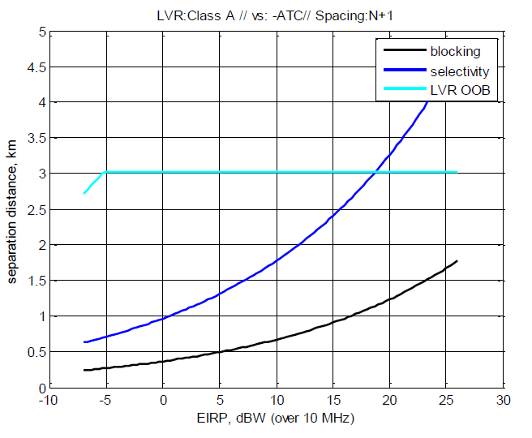

**Figure 4: Separation distances to protect ATC radar from video PMSE channel N+1**

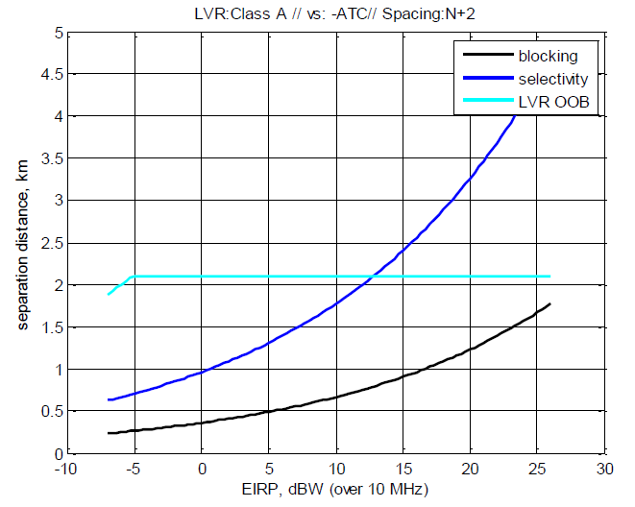

**Figure 5: Separation distances to protect ATC radar from video PMSE channel N+2**

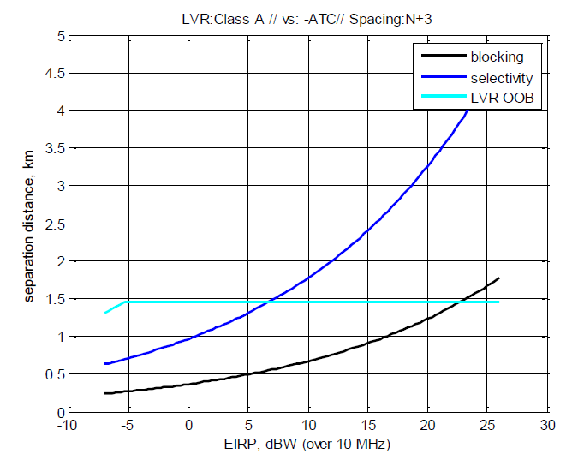

**Figure 6: Separation distances to protect ATC radar from video PMSE channel N+3**

#### Protection of meteorological radar from video PMSE

The Figure 7, Figure 8 and Figure 9 provide the separation distances required to protect meteorological radar from one single video PMSE (no aggregated interference) with e.i.r.p. considered as a variable and a radar selectivity of 60 dBc. The separation distances are derived assuming an urban environment.

Each of those figures includes three separate curves, corresponding to the three effects on radar protection that are considered in the adjacent channel scenario: out-of-band, blocking and selectivity. The separation distance to protect radar corresponds, for a specified e.i.r.p., to the distance that ensures the protection against the three effects and thus to the maximum value of the three curves.

As described in Figure 1 of this CEPT Report, the first (N+1), second (N+2) and third (N+3) adjacent channels are defined with a 10 MHz bandwidth.

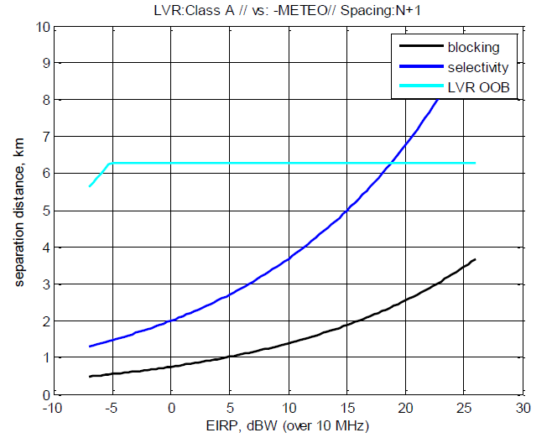

**Figure 7: Separation distances to protect meteorological radar from video PMSE channel N+1**

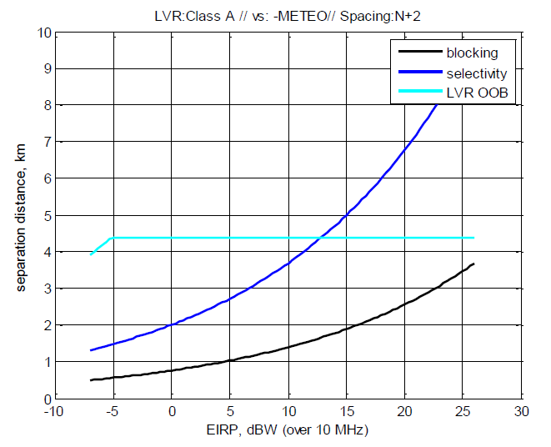

**Figure 8: Separation distances to protect meteorological radar from video PMSE channel N+2**

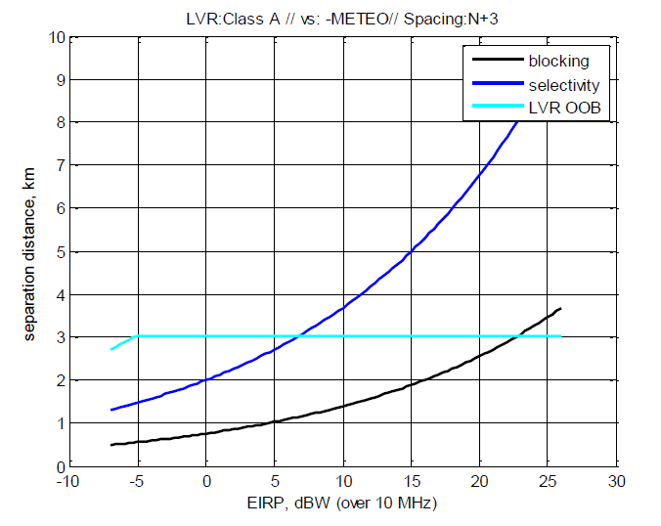

**Figure 9: Separation distances to protect meteorological radar from video PMSE channel N+3**

#### Example: Protection of ATC and meteorological radars from video PMSE with an e.i.r.p. of 0 dBw

The Table 9: is derived from Figures 4 to 9 of this CEPT Report. It provides the separation distances required to protect ATC and meteorological radars from one single video PMSE (no aggregated interference) with an e.i.r.p. of 0 dBW at the height of 1.5 m and a radar selectivity of 60 dBc. The separation distances are derived assuming an urban environment.

1. Separation distances to protect radars from video PMSE[5]

|  |  |  |  |
| --- | --- | --- | --- |
| Radar type | (N+1) adjacent channel | (N+2) adjacent channel | (N+3) adjacent channel |
| **ATC, terrestrial radar** | 3 km | 2.2 km | 1.5 km |
| **Meteorological radar** | 6.5 km | 4.5 km | 3 km |

The separation distances may be larger for aggregated interference or a more sensitive radar.

In addition, they may be different considering the altitude of the radar, the topography of the real ground around the radar and the propagation conditions between the radar and the video PMSE link (such as rural or suburban environments). This would have to be addressed on a case-by-case basis.

If the radar presents a blocking response and a selectivity below those used in this CEPT Report, the separation distances may increase (up to 27 km assuming the other conditions unchanged).

The separation distances will also depend on the deployment scenario of video PMSE (they may be smaller if PMSE is used in buildings due to the additional penetration loss).

Regarding the interference from radar into PMSE, taking into account the flexibility of video PMSE for adjusting the frequency gap, the required separation distance to respect the C/I protection criteria could be considered from 5 to 30 km for the protection of a video PMSE in a worst case configuration. It is assumed that video PMSE can cope with a short pulse that interferes with the receiver. In the case of radar pulse, the main issue concerns the capability of the video PMSE receiver front-end to handle the input signal power and the time needed to recover a sync state of the video signal.

## Compatibility between video PMSE in the band 2.7-2.9 GHz and radars above 2.9 GHz

Some systems using the band 2.7-2.9 GHz are also operating in the band 2.9-3.1 GHz.

Additionally to the protection conditions detailed in Section 4.1, to protect the radars operating in the frequency band 2.9-3.4 GHz, the usage of the upper two channels (i.e. 2x10 MHz in the band 2880-2900 MHz) of the band 2.7-2.9 GHz by video PMSE is not possible in a European harmonised framework but can be authorised on a national basis, after coordination on a case-by-case basis.

Compatibility studies between portable video links in the band 2880-2900 MHz and different types of radars (Annex 6 of ECC Report 243 [2]) show that about 40 km separation distance would be needed.

Moreover, it has to be noticed that military land based (fixed or portable platforms) and maritime radars are operating in this NATO harmonised band from 2.9 GHz. The diversity and especially the operation of aeronautical radiolocation radars make the coordination procedure between military radars and video PMSE very difficult in practice.

## Compatibility between video PMSE in the band 2.7-2.9 GHz and radio astronomy in the band 2.69-2.7 GHz

For the compatibility studies between video PMSE and radio astronomy, it has been assumed that:

* there is only one video PMSE transmitter (no aggregation) and e.i.r.p. is a variable;
* the propagation model used is the Recommendation ITU-R P.452-13 [24] with a percentage of time of 2% and a flat Earth.

A separation distance is required to protect radio astronomy stations in the band 2.69-2.7 GHz from a video PMSE transmitter. The separation distance estimated for one video PMSE transmitter is about 125 km for the first (N+1) adjacent channel, 85 km for the second (N+2) adjacent channel and 60 km for the third (N+3) adjacent channel; see Figure 1 of this CEPT Report.

## Compatibility between video PMSE in the band 2.7-2.9 GHz and E-UTRA/LTE user equipment in the band 2.5-2.69 GHz

For MFCN MCL calculations, the PMSE video link transmission parameters were adopted from ECC Report 219 [8]. They are provided in Table 4: of this CEPT Report.

E-UTRA user equipment will appear in the neighbourhood of CCL/PVL/MVL usage. Table 11: provides the isolation for co-existence between CCL/PVL/MVL and E-UTRA user equipment and the separation distances required for such isolation.

Those required separation distances are calculated for 3 dB user equipment receiver desensitisation, considering both the video PMSE out-of-band emissions and the blocking effect. The allowed degradation of noise floor for LTE user equipment is considered to be 3 dB. The propagation model IEEE802.11_Model_C is considered for all scenarios except MVL downlink, for which extended Hata is employed.

1. Isolation and separation distances to protect E-UTRA user equipment from video PMSE

|  |  |
| --- | --- |
| Type of link | LTE downlink @ 2.7 GHz（band 7) |
|  | 10 MHz guard band |
| **Cordless camera link** | 86.63 dB |
| 0.04 km |
| **Portable video link** | 103.48 dB |
| 0.121 km |
| **Terrestrial mobile video uplink** | 93.27 dB |
| 0.062 km |

Increasing the frequency separation between video PMSE and E-UTRA user equipment would reduce the required separation distances since the out-of-band emissions from video PMSE will be lower and the blocking rejection from E-UTRA user equipment will be higher.

Calculations, including estimation of MCL, related to video PMSE and E-UTRA are detailed in Annex 8 and Annex 10 of the ECC Report 243 [2].

It results from those calculations that compatibility between video PMSE in the band 2.7-2.9 GHz and E-UTRA/LTE user equipment in the band 2.5-2.69 GHz does not justify the definition of harmonised conditions on a European framework. Only some specific cases can require, on a national basis, the implementation of conditions to facilitate adjacent band coexistence, including the reduction of transmission power of PMSE, applying a sufficient separation distance and/or increasing the frequency separation between video PMSE and LTE user equipment.

# Conclusions

This CEPT Report highlights opportunities for harmonised compatibility and sharing conditions for the following video PMSE applications: cordless camera links, portable video links and terrestrial mobile video links, under relevant parameters as described in Table 11 and Table 12.

Temporary point-to-point links, with high directivity antennas, are not appropriate for the band 2.7-2.9 GHz. Those links, which are used for carrying broadcast quality video/audio signals, are preferably deployed in higher frequency bands (higher than 5 GHz).

Moreover, compatibility studies between airborne video PMSE (air-to-ground link) and radars show that the use of such video PMSE is not possible in the band 2.7-2.9 GHz, due to the required separation distance.

1. Parameters for video PMSE in the band 2.7-2.9 GHz

|  |  |  |  |
| --- | --- | --- | --- |
| **Type of link** | **Cordless camera link** | **Portable video link** | **Terrestrial mobile video link** |
| **Range of e.i.r.p. (dBW)** - see note | -7/0 | -7/0 | 3/6 |
| **Typical antenna height (m)** | 1.5 | 2 | 1.5 |
| Note: the range indicates the power generally used by operators in order to extend battery life, etc. | | | |

1. Compatibility for cordless camera links, portable video links and terrestrial mobile video links in the band 2.7-2.9 GHz

|  |  |
| --- | --- |
| **Compatibility between video PMSE (10 MHz channel, note) and radars (ATC, terrestrial and meteorological)  in the band 2.7-2.9 GHz, with a radar selectivity of 60 dBc** | |
| **Co-channel scenario** | In the co-channel scenario, a separation distance between PMSE transmitter and radar receivers of 100 km or even more (182 km) may be necessary . Hence, a co-channel sharing is, in general, not feasible.  However, co-channel operation may be possible, only after coordination on a case-by-case basis, for a video PMSE with a maximum e.i.r.p. of 0 dBW and an antenna height of 1.5 m. The coordination should take into account shielding loss (in accordance with the Recommendation ITU-R P.1411 [23]), brought for example by an urban environment and by a building loss. |
| **Adjacent channel scenarios** | **Separation distances (km) required for one single video PMSE (no aggregated interference) with e.i.r.p. between -7 and 6 dBW** |
| **Offset between PMSE centre frequency and edge of radar channel between 5 MHz and 25 MHz** | 3 km for ATC radar and 6.5 km for meteo radar |
| **Offset between PMSE centre frequency and edge of radar channel ≥ 25 MHz** | ≤ 1.5 km for ATC radar and ≤ 3 km for meteo radar |
| **Compatibility between video PMSE in the band 2.7-2.9 GHz and radars above 2.9 GHz** | |
| **Adjacent channel scenario** | The usage of the upper two channels (i.e. 2x10 MHz in the band 2880-2900 MHz) of the band 2.7-2.9 GHz by video PMSE is not possible on a European harmonised framework but can be authorised at national level, after coordination on a case-by-case basis. |
| **Compatibility between video PMSE in the band 2.7-2.9 GHz and radio astronomy in the band 2.69-2.7 GHz, the propagation model used is the Recommendation ITU-R P.452-13 [24] with a percentage of time of 2 % and a flat Earth** | |
| **Adjacent channel scenarios** | **Separation distances (km) for one single video PMSE (no aggregated interference)** |
| **10 MHz PMSE channel, centre frequency 2705 MHz** | 125 |
| **10 MHz PMSE channel, centre frequency 2715 MHz** | 85 |
| **10 MHz PMSE channel, centre frequency 2725 MHz** | 60 |

Note: The frequency offset considered should be amended if multiple 10 MHz PMSE channels are aggregated.

CEPT confirms that the use of the band 2.7-2.9 GHz by video PMSE must be subject to an individual authorisation granted after a coordination procedure.

* The separation distances may be larger, if aggregated interference or more sensitive radars or other propagation conditions such as rural or suburban have to be taken into account. The separation distances may also vary depending on the deployment scenario of the video PMSE (such as indoor use) and the radar (such as antenna height and terrain).
* CEPT confirms that it is not required to define harmonised conditions to ensure compatibility between video PMSE in the band 2.7-2.9 GHz and E-UTRA/LTE user equipment in the band 2.5-2.69 GHz. Only some specific cases can require, on a national basis, the implementation of conditions to facilitate adjacent band coexistence, including the reduction of transmission power of PMSE, applying a sufficient separation distance and/or increasing the frequency separation between video PMSE and LTE user equipment.
* In some countries, there are radio astronomy stations using frequencies in the band 2.7-2.9 GHz. Administrations in those countries may need to implement specific measures for the use of video PMSE, after coordination on a case-by-case basis.
* It should be noted that, where a high number of PSR in the band 2700 to 2900 MHz exists, PSR stations are already operating close to the probability of detection of aircraft specified by Eurocontrol for civil and military ATC. The national coordination for a potential introduction of video PMSE would be more complex in this case.

In such cases, Administrations may define relevant specific conditions in their authorisation for use of frequencies. The opportunities for sharing of the 2.7-2.9 GHz band between incumbent radar and video PMSE contain limitations and assignments in this band will generally not be sufficient to compensate for loss of other bands.

It should also be noted that the necessary separation distances may lead to cross-border coordination requirements, depending on the location where the video PMSE will operate. These requirements are relevant on national level and may have an impact on the coordination process for video PMSE. This issue has not been studied in detail in this Report as it is not included in the tasks of the Mandate.

The studies focused on the protection of incumbent services and applications against PMSE signals and the report provides limited information for required quality of video PMSE. Regarding the interference from radar into PMSE, it is expected that the flexibility of video PMSE for adjusting the frequency offset would help in reducing the required separation distance to respect the C/I protection criteria. Concerning the impact on video PMSE from a short radar pulse, the main issue concerns the capability of the video PMSE receiver front-end to handle the input signal power and the time needed to recover a sync state of the video signal.

1. mandate to CEPT to study and identify harmonised compatibility and sharing conditions for video PMSE in the 2.7 – 2.9 GHz frequency band, taking into account radar use, 14 July 2015

|  |  |
| --- | --- |
|  | EUROPEAN COMMISSION  Communications Networks Content & Technology Directorate-General  Electronic Communications Networks & Services  **Spectrum** |

Brussels, 14 July 2015

DG CONNECT/B4

**RSCOM15-18 final**

**INTERNAL DOCUMENT**

**RADIO SPECTRUM COMMITTEE**

**Working Document**

**Subject: Mandate to CEPT to study and identify harmonised compatibility and sharing conditions for Video PMSE in the 2.7 – 2.9 GHz frequency   
band, taking into account radar use**

*This is a Committee working document which does not necessarily reflect the official position of the Commission. No inferences should be drawn from this document as to the precise form or content of future measures to be submitted by the Commission. The Commission accepts no responsibility or liability whatsoever with regard to any information or data referred to in this document.*

**Mandate to CEPT   
to study and identify harmonised compatibility and sharing conditions for Video PMSE in the 2.7-2.9 GHz frequency band, taking into account radar use**

1. **PURPOSE**

This mandate aims at developing harmonised compatibility and sharing conditions for the introduction of Video PMSE[6] (mainly cordless video cameras and as far as possible wireless video links, identified as portable and mobile links[7]) in the 2.7-2.9 GHz frequency band.

Appropriate technical conditions should be developed in order to maximise the possibility to use this spectrum for Video PMSE while guaranteeing continuous use of the band by radars (aeronautical radio navigation service and radiolocation service).

1. **BACKGROUND AND EU POLICY OBJECTIVES**

Pursuant to Article 8.5 of the Radio Spectrum Policy Programme (RSPP)[8], "Member States shall, in cooperation with the Commission, seek to ensure the necessary frequency bands for PMSE, in accordance with the Union's objectives to improve the integration of the internal market and access to culture".

Video PMSE often used frequency bands which now have been subject to harmonisation for terrestrial systems capable of providing electronic communications services. Considering the resulting reduced availability and the spectrum needs for Video PMSE, the development of additional sharing possibilities requires further study of additional frequency bands.

Video PMSE requires sufficient bandwidth and is used for audio-visual PMSE services and in some Member States for Public Protection and Disaster Relief (PPDR) services,. Video PMSE applications, include services ancillary to programme making (SAP) and service ancillary to broadcasting (SAB), support the production of audio-visual content, such as films, advertisement, corporate videos, concerts, theatre and activities of the broadcasting industry, as well as electronic news gathering (ENG) and outside broadcasting (OB). Part of the Video PMSE and, where needed, PPDR related activities require temporary use of spectrum at unpredictable locations.

With regard to the PPDR spectrum needs, article 8.3 of the RSPP states that "the Commission shall, in cooperation with the Member States, seek to ensure that sufficient spectrum is made available under harmonised conditions to support the development of safety services and the free circulation of related devices as well as the development of innovative interoperable solutions for public safety and protection, civil protection and disaster relief".

This mandate is a follow-up to the response to the 2011 Commission mandate to CEPT[9] to identify the technical conditions and the frequency bands necessary for **sustainable operation of cordless video cameras in the EU**, including spectrum sharing opportunities possible through technological developments. In its Report 51[10], CEPT identified the 2700-2900 MHz band and other bands as possible new spectrum for cordless cameras and video links, however, subject to further sharing studies. Such studies should be undertaken in this mandate taking into account updated technical characteristics.[11]

In its Report to Parliament and Council on the spectrum inventory, the Commission stressed the need to investigate the possibility for radars and other services to share the 2.7-2.9 GHz band[12]. In its Report on Strategic Sectoral Spectrum Needs[13], RSPG stressed that spectrum needs for PMSE should be studied and protected and that, with regard to the PMSE video applications, harmonisation at European level of expanded tuning ranges and sharing conditions is necessary to meet future spectrum demands. Reference is made to the already identified potential candidate bands and sharing conditions under study by CEPT, which include the 2.7-2.9 GHz frequency band. Moreover this RSPG Report underlines that PMSE needs should be recognised in case of re-allocation of primary services.

In 2012, the European Commission published a Communication[14] promoting the shared use of radio spectrum resources in the internal market, by allowing various independent users and/or devices to access the similar frequency ranges subject to appropriate conditions, in such a way as to maximise efficient spectrum use to meet growing demand for wireless connectivity, while avoiding deterioration in the quality of spectrum use by incumbent users.

Taking into account both guaranteeing the quality of the incumbent radar use in the 2.7-2.9 GHz frequency band and providing a certainty to the Video PMSE stakeholders for a long term solution, the compatibility and sharing conditions should focus on these services.

1. **JUSTIFICATION**

Pursuant to Article 4(2) of the Radio Spectrum Decision[15], the Commission may issue mandates to the CEPT for the development of technical implementing measures with a view to ensuring harmonised conditions for the availability and efficient use of radio spectrum necessary for the functioning of the internal market. Such mandates shall set the tasks to be performed and their timetable.

There are four types of radar operating in the 2.7-2.9 GHz in the Union:

* Civilian Air Traffic Control (ATC) radars (also addressed as civil S-band radars);
* Military radars;
* Mobile bird-strike radars, designed to detect the flight of birds, which may collide with aeroplanes;
* Meteorological radars.

Moreover, the frequency band 2.7-2.9 GHz is identified as a 'Class A' band in the NATO Joint civil/military frequency agreement (NJFA). This band is essential to NATO and is in military use for land and naval applications in the aeronautical radio navigation and radiolocation service, specifically for airport surveillance radars (ASR) and air defence radars.

A study conducted for the European Commission[16] reported a total of 112 civilian ATC radars in the Union operating in the 2.7-2.9 GHz band, with between 1 and 42 radars in each Member State. 14 Member States are operating aeronautical radars at fewer than five sites in the entire country (usually airports) and most Member States having less than 20 national radar sites in operation. No public information on the number of military radar sites in the EU is available. Considering the existence of geographical areas where the 2.7-2.9 GHz band is unused, geographical sharing with cordless video cameras should therefore be possible in parts of the Union.

Relevant adjacent services shall be considered during the studies, as appropriate.

In response to an EC mandate on PMSE dated 15 December 2011 which included cordless video-cameras, CEPT Report 51 identified also the 2.7-2.9 GHz band as one of the possible new bands for temporary use by cordless cameras, subject to appropriate geographical constraints to protect radar applications.

Moreover, considering the need for more efficient use of spectrum to satisfy demand, studies should identify technical conditions appropriate to allow sharing capabilities of the 2.7-2.9 GHz band between radars and Video PMSE in particular through geographical sharing.

Shared use of the 2.7-2.9 GHz frequency band should be fostered, in line with the following EU objectives:

* Ensure efficient use of spectrum;
* Promote innovation through enhanced flexibility in spectrum use;
* Provide the necessary frequency bands for PMSE to improve the integration of the internal market and access to culture, without affecting incumbent uses and their development in the 2.7-2.9 GHz band;
* Maximise the socio-economic and cultural benefit for EU citizens and PMSE users to the fullest extent by facilitating economies of scale, lowering price and fostering cross-border portability and interoperability;
* Ensure that sufficient spectrum is made available to support the development of safety services.

1. **TASK ORDER AND SCHEDULE**

CEPT is herewith mandated to develop harmonised technical conditions for the use of the 2.7-2.9 GHz frequency band by Video PMSE (mainly cordless video cameras and as far as possible wireless video links, identified as portable and mobile links[17]) while ensuring the long term radar use of the band in the territory of those Member States that wish to maintain such use. Temporary point-to-point video links with high directivity antennas, which use higher frequency bands, are not covered by this Mandate.

In the work carried out under the Mandate, the general and specific policy objectives of the RSPP, such as effective and efficient spectrum use and the support for specific Union policies shall be given utmost consideration. In implementing this mandate, CEPT shall, where relevant, take utmost account of EU law applicable and support the principles of service and technological neutrality, non-discrimination and proportionality insofar as technically possible. CEPT is also requested to collaborate actively with the European Telecommunications Standardisation Institute (ETSI) which develops harmonised standards for conformity under Directive 1999/5/EC and Directive 2014/53/EU.

To support the policy objectives presented above, CEPT is mandated to carry out technical studies in fulfilment of the following tasks:

**Task 1 – Identification of compatibility and sharing scenario(s)**

To take stock of the current situation and future plans in the Member States regarding sharing concepts to enable the deployment of Video PMSE in the 2.7-2.9 GHz frequency band.

Clarify the assumptions for operation and the operational footprint for Video PMSE use.

To study and identify compatibility and sharing scenario(s) for use of the 2.7-2.9 GHz frequency band between Video PMSE and radar systems and to define relevant coexistence/protection parameters that ensure efficient spectrum use.

To study and identify compatibility scenario(s) for use of the 2.7 - 2.9 GHz frequency band by Video PMSE and the use of radio services in the adjacent frequency bands.

**Task 2 – development of compatibility and sharing conditions**

Depending on the outcome of Task 1, develop technical compatibility and sharing conditions and appropriate mitigation techniques and/or harmonised least restrictive technical conditions for Video PMSE use in the 2.7-2.9 GHz frequency band, taking into account the requirements of radars as well as existing radio services in adjacent bands.

CEPT should provide deliverables according to the following schedule:

|  |  |  |
| --- | --- | --- |
| **Delivery date** | **Deliverable** | **Subject** |
| March 2016 | Interim Report from CEPT to the Commission | Description of work undertaken and stable results under tasks (1) and interim results under tasks (2) of this Mandate. |
| June 2016[18] | Final Draft Report from CEPT to the Commission. | Description of work undertaken and final results under tasks (1) and (2) of this Mandate. |
| September 2016 | Final Report from CEPT to the Commission. taking into account the outcome of the public consultations | Description of work undertaken and final results under this Mandate taking into account the results of the public consultations. |

In addition, CEPT is requested to report on the progress of its work pursuant to this Mandate to all meetings of the Radio Spectrum Committee taking place during the course of the Mandate.

The Commission, with the assistance of the Radio Spectrum Committee and pursuant to the Radio Spectrum Decision, may consider applying the results of this mandate in the EU, pursuant to Article 4 of the Radio Spectrum Decision.

1. PMSE video link transmission parameters

As described in the Figure 10, the first (N+1), second (N+2) and third (N+3) adjacent channels are defined with a 10 MHz bandwidth.



Figure 10: Out-of-band bandwidth of adjacent channels

The maximum out-of-band e.i.r.p. limit, based on the standard ETSI EN 302 064-1 [9], is provided in Figure 11.

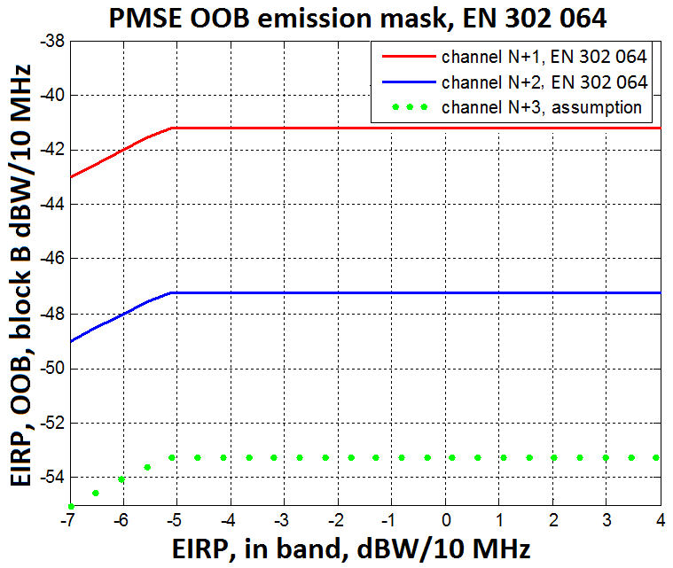

Figure 11: Out-of-band e.i.r.p. in adjacent channels

The ETSI EN 302 064-1 [9] does not provide a value for the third (N+3) adjacent channel. It is assumed that the e.i.r.p. in the third (N+3) adjacent channel to be 6 dB lower than the second (N+2) adjacent channel value, to have the same difference between (N+1) and (N+2) than between (N+2) and (N+3). Therefore, the value considered in this study for the third (N+3) adjacent channel is -53 dBW/10 MHz.

Note: with this assumption, the emissions in the third (N+3) adjacent channel is 3 dB lower than -30 dBm/MHz, from the unwanted emissions level in the spurious domain defined in the Recommendation ERC/REC 74-01 [10], noting that the limits defined in this Recommendation are set for generic families of services and do not prevent that specific systems, for specific reasons, might require tighter limits reported in ETSI standards.

***C/N ratio***

In a co-channel configuration, the required C/N ratio is assumed to be calculated from a DVB-T modulation signal system. The configuration of DVB-T system at 2.6 GHz can be deduced from the architecture of Tx/Rx DVB-T at 800 MHz.

Table 14: provides the C/N ratio for a DVB-T channel for a mobile link with a reception probability of 99% in accordance with ESR5 and a feeder loss of 1 dB.

1. C/N ratio for reception probability of 99 % in accordance with ESR5   
   and a feeder loss of 1 dB

| **Modulation** | **Code rate** | **C/N (dB)** |
| --- | --- | --- |
| **QPSK** | 1/2 | 11.5 |
| **QPSK** | 2/3 | 14.7 |
| **QPSK** | 3/4 | 16.7 |
| **16-QAM** | 1/2 | 17.2 |
| **16-QAM** | 1/2 | 17.2 |
| **16-QAM** | 2/3 | 20.9 |
| **16-QAM** | 3/4 | 23.1 |
| **64-QAM** | 1/2 | 22.1 |
| **64-QAM** | 2/3 | 25.3 |
| **64-QAM** | 3/4 | 27.5 |

***C/I ratio***

The protection criteria C/I used in the studies is defined with the following assumptions:

* out-of-band emission or the interferer is considered to be Gaussian noise;
* C/N required is based on DVB-T in mobile reception;
* in case of some interference, the reception would be assured if the ratio C/(N+I) value would be the same as the ratio C/N which is the requirement for the receiver in case of absence of interferer.

***Blocking***

The Table 15 of the standard ETSI ES 202 239 V1.1.1 [10] provides:

* ACS of 30 dB;
* blocking response of 40 dB.

However, based on manufacturer datasheet, a realistic blocking response of 55 dBc is also used as input data for the studies.

1. Blocking response ETSI ES 202 239 V1.1.1 [10]

|  |  |
| --- | --- |
| ∆f fcentral-finterf (MHz) | C/Blocker (dBc) |
| **0 (in-band)** | -4 |
| **1 (in-band)** | -4 |
| **2 (in-band)** | -4 |
| **3 (in-band)** | -4 |
| **4 (in-band)** | -4 |
| **5 (in-band)** | -12 |
| **6** | -36 |
| **8** | -52 |
| **10** | -55 |
| **20** | -57 |
| **30** | -58 |
| **100** | -58 |
| **>100** | -58 |

1. Operational and regulatory aspects for ATC radars

This annex provides additional information on operational and regulatory aspects for ATC radars, also by taking into account the requirements from the ITU Radio Regulations, which are also relevant for the case by case compatibility considerations on national level:

* The technical and operational aspects related to Primary Surveillance Radars (PSR) used for the Air Traffic Control (ATC) are provided in ECC Report 243 [3].
* According to the ITU Radio Regulations [5], PSR is operated under the primary allocation to the Aeronautical Radionavigation service in the band 2.7-2.9 GHz whilst there is no allocation to the mobile service in this band.
* Video PMSE equipment shall not cause harmful interference to radars and cannot claim protection from these radars.
* ECC Report 243 identified a max. separation distance of 182 km between an ATC PSR and a video PMSE transmitter under specific conditions, this would require a cross-border coordination between administrations.
* Where a high number of PSR exists in the band 2700 to 2900 MHz, PSR stations are already operating close to the probability of detection of aircraft specified by Eurocontrol for civil and military ATC. The national coordination for a potential introduction of video PMSE would be more complex in this case to meet the required detection probability.
* Loss of detection of PSR aircraft target is insidious, because there is no warning display technically possible to warn ATC controllers that one or more aircraft have not been detected due to PMSE interferences. PSR unreliable for target detection would reduce the overall traffic capacity because higher aircraft separation would have to be implemented.
* ATC PSR is the only means for ATC control to detect and control aircraft undetectable for ATC Secondary Surveillance Radar (SSR), e.g. during solar storms, when SSR transponders are defective, aircraft not mandated to be equipped with SSR transponder, or when the SSR transponder has been disabled intentionally, e.g. as a result of hostile actions.
* ATC PSR requires simultaneous operation of 2 or more frequencies to achieve the required detection ranges of up to 222 km. PSR are mostly but not only located at or nearby airports. Airports are often in or close to areas with a high density of population, where more than 4 PSR could have overlapping coverage. Therefore in some countries a high probability to be in a co-channel interference situation has to be assumed, while in other countries the opportunities for video PMSE would be more optimistic.

The band 2700-2900 MHz is used for civil and military Air traffic Control (ATC) by using Primary Surveillance Radar (ATC-PSR), for detection of all aircraft. It works as a fall-back to Secondary Surveillance Radar (SSR) detection, when SSR detection fails.

Aircraft that are undetectable by SSR, during times of strong solar flares like those occurring in November 2015 in Northern Europe, whenever aircrafts are not are equipped with SSR transponder, when aircraft transponder are dysfunctional, e.g. due to over-interrogation as it occurred on several days in June 2014, or when the transponder are defective or have been deactivated intentionally by hostile action.

Non-Cooperative Surveillance Sensors (NCS), or Primary Surveillance Radars as they are traditionally known as, are essential components of a safe and efficient civilian and military ATM infrastructure. Their use is required enroute and in Major TMA airspace in order to meet the requirements of the Eurocontrol surveillance standard published in 1997. Implementing Regulation EU 1207-2011 published by the European Commission requires Air Navigation Service Providers to conduct a safety case assessment of their ATM infrastructure to be able to provide a safe separation between aircrafts and UAV’s. The findings of which normally require non-cooperative surveillance in order to detect aircraft without SSR or ADS-B avionics infringing in to controlled airspace or to support controllers mitigate the effects of an avionics failure on board their aircraft. Aviation makes a major contribution to the economies of a State. It is essential that ATM supports safe and efficient operations – NCS are crucial and their role and importance in achieving this should not be under-rated or compromised. If a country can’t provide safe air traffic control, it has to introduce restrictions in the number of aircrafts that will be allowed to enter the airspace.

Interference free operation of PSR is therefore the necessary prerequisite in providing the safety of life service for Air Traffic Control. Primary surveillance target losses due to interference are insidious, because they do not cause any indication on a ATC display, that would inform an ATC controller of lost targets. An extremely high sensitivity and at least dual frequency operation (frequency diversity) is required, to allow Detection of aircraft in distances of up to 120 NM with a radar cross section of 1 m² or larger under all operational weather conditions and anomalous propagation conditions is therefore the prerequisite for the safety of life ATC service.

Due to the high sensitivity it is important to provide sufficient distance and frequency separation, between the existing and new S-Band ATC radar within confinements of the band 2700 to 2900 MHz. Frequencies for ATC S-Band PSR systems are not assigned based on a channel system, but are assigned in 0.5 MHz steps within the band 2700 to 2900 MHz on any frequency that allows safe operation within the existing environment in the S-Band. Coordination of S-Band ATC PSR, account among other factors for existing S-Band PSR radars around a location, terrain, e.i.r.p., and technical differences between designs, e.g. frequency offset between the diversity centre frequencies, transmission of short pulse or pulse compressed signals. It also does not account for propagation probabilities, 95% of the time for ATC radar and 5 % of the time probabilities for the interferer PMSE, using the aeronautical propagation Model ITU-R P.528 (based on IF-77 by Gierhart-Johnson).

Radar systems do operate on any frequency in the band 2700-2900 MHz that allows compatibility to other radar stations.

Therefore, in all cases where the bandwidth frequency of PSR is overlapping totally or partially some PMSE channels, these channels have to be considered as co-channel with PSR. Alternatively, it may be possible to shift PMSE centre frequency to avoid overlap and to consider them as adjacent channels. While most S-Band ATC PSR are located at and around airports, where they are already subject to a very high number of undesired echoes, e.g. from ground or airborne surfaces (e.g. clouds, birds, vehicles, MM- and land based structures), they can be found also on exposed locations like mountains.

An assessment requires measurements on S-Band ATC PSR under normal operational conditions, for all the different operational S-Band ATC PSR designs in use, including measurements of those S-Band ATC PSRs available on the market, since many states (e.g. Germany, Switzerland, The Netherlands) are in the process to renew PSR ATC radar sensors.

Interference in radar is not just a function of the energy received within the receiver pass band and it's impact onto the radar receiver. Impact depends to a large degree on the design of the radar receiver, e.g. type of preselector, LNA or type of stages used for processing. Technical parameters of radar, e.g. selectivity, vary from radar design to design and the detection requirements, like range and radar cross section of targets that a design has to be able to detect. This is the reason why some S-Band ATC PSR system radars therefore even have been designed with a bandwidth of a few hundred MHz for multiple frequency diversity PSR designs.

Furthermore only measurements allow establishing the interference parameter for a given PSR design, when the measurements are conducted when the radar is operating in the normal operational Extraneous Signal Environment (ESE). The impact of an interfering signal in an already dense signal requirement will lead to a faster degradation of the Probability of Detection (Pd) and in consequence to target losses. Purely theoretical studies do not account for interference mechanism of PSR designs that can only be measured on a case-by-case basis at an operational PSR, and in an operational RADAR ESE which already operates in challenged conditions.

1. List of references
2. CEPT Report 51 - Report B from CEPT to the European Commission in response to the Mandate “On technical conditions regarding spectrum harmonisation options for wireless radio microphones and cordless video-cameras” - Technical conditions for ensuring the sustainable operation of cordless video-cameras - Report approved on 8 November 2013 by the ECC.
3. ECC Report 243 - Wireless video links in the frequency bands 2700-2900 MHz and 2900-3400 MHz.
4. CEPT Report 50 - Report A from CEPT to the European Commission in response to the Mandate “On technical conditions regarding spectrum harmonisation options for wireless radio microphones and cordless video-cameras (PMSE equipment)” - Technical conditions for the use of the bands 821-832 MHz and 1785-1805 MHz for wireless radio microphones in the EU - Report approved on 8 March 2013 by the ECC.
5. ECC Report 204 – Spectrum use and future requirements for PMSE, approved February 2014.
6. ITU Radio Regulations - Edition of 2012
7. ECC Decision (05)05 - Harmonised utilization of spectrum for Mobile/Fixed Communications Networks (MFCN) operating within the band 2500-2690 MHz, approved 18 March 2005, amended 03 July 2015.
8. Commission decision 2008/477/EC of 13 June 2008 on the harmonisation of the 2 500-2 690 MHz frequency band for terrestrial systems capable of providing electronic communications services in the Community.
9. ECC Report 219 - Characteristics of PMSE digital video links to be used in compatibility and sharing studies, approved October 2014.
10. ETSI EN 302 064-1 - Electromagnetic compatibility and Radio spectrum Matters (ERM) - Wireless Video Links (WVL) operating in the 1.3 GHz to 50 GHz frequency band - Part 1: Technical characteristics and methods of measurement.
11. CEPT/ERC/Recommendation 74-01E (Siófok 98, Nice 99, Sesimbra 02, Hradec Kralove 05, Cardiff 11) – Unwanted emissions in the spurious domain.
12. ETSI ES 202 239 V1.1.1 - Electromagnetic compatibility and Radio spectrum Matters (ERM) - Wireless digital video links operating above 1.3 GHz - Specification of typical receiver performance parameters for spectrum planning.
13. ECC Report 6 – Technical impact on existing primary services in the band 2700-2900 MHz due to the proposed introduction of new systems, Baden, June 2002.
14. "Inventory and review of spectrum use: Assessment of the EU potential for improving spectral efficiency", WIK-Consult study for the European Commission, 11 September 2012.
15. ECC Report 174 - Compatibility between the mobile service in the band 2500-2690 MHz and the radiodetermination service in the band 2700-2900 MHz, March 2012.
16. Recommendation ITU-R F.1245-1 (05/2000) - Mathematical model of average and related radiation patterns for line-of-sight point-to-point radio-relay system antennas for use in certain coordination studies and interference assessment in the frequency range from 1 GHz to about 70 GHz.
17. Recommendation ITU-R M.1851 (06/2009) - Mathematical models for radiodetermination radar systems antenna patterns for use in interference analyses.
18. Recommendation ITU-R M.1464-1 (2000-2003) - Characteristics of radiolocation radars, and characteristics and protection criteria for sharing studies for aeronautical radionavigation and meteorological radars in the radiodetermination service operating in the frequency band 2 700-2 900 MHz.
19. Recommendation ITU-R M.1849 (06/2009) - Technical and operational aspects of ground-based meteorological radars.
20. Recommendation ITU-R RS.1861 (01/2010) - Typical technical and operational characteristics of Earth exploration‑satellite service (passive) systems using allocations between 1.4 and 275 GHz.
21. Recommendation ITU-R RA.769-2 (1992-1995-2003) - Protection criteria used for radio astronomical measurements.
22. ETSI TR 136 942 V12.0.0 (2014-10) – LTE; Evolved Universal Terrestrial Radio Access (E-UTRA); Radio Frequency (RF) system scenarios (3GPP TR 36.942 version 12.0.0 Release 12.
23. ETSI TS 136 101 V11.7.0 (2014-03) – LTE; Evolved Universal Terrestrial Radio Access (E-UTRA); User Equipment (UE) radio transmission and reception (3GPP TS 36.101 version 11.7.0 Release 11).
24. Recommendation ITU-R P.1411-1 - Propagation data and prediction methods for the planning of short-range outdoor radiocommunication systems and radio local area networks in the frequency range 300 MHz to 100 GHz.
25. Recommendation ITU-R P.452-13 - Prediction procedure for the evaluation of microwave interference between stations on the surface of the Earth at frequencies above about 0.7 GHz.

1. Programme making includes the making of a programme for broadcast, the making of a film, presentation, advertisement or audio or video recordings, and the staging or performance of an entertainment, sporting or other public event.
2. A special event is an occurrence of limited duration, typically between one day and a few weeks, which take place on specifically defined locations. Examples include large cultural, sport, entertainment, religious and other festivals, conferences and trade fairs. In the entertainment industry, theatrical productions may run for considerably longer.
3. Typical and maximum value.
4. Typical and maximum value.
5. As described in Figure 1 of this CEPT Report, the first (N+1), second (N+2) and third (N+3) adjacent channels are defined with a 10 MHz bandwidth.
6. For the definition of PMSE see CEPT Report 50.
7. ECC Report 219, Characteristics of PMSE digital video links to be used in compatible and sharing studies,  
    Table 3, Category of PMSE video links for spectrum study purposes.
8. Decision 243/2012/EU of 14 March 2012, OJ L 81 of 21.3.2012
9. RSCOM11-59 final, Mandate to CEPT on technical conditions regarding spectrum harmonisation options  
    for wireless radio microphones and cordless video-cameras (PMSE equipment), dated 15 December 2011.
10. CEPT Report 51 on the technical conditions for ensuring the sustainable operation of cordless video-  
     cameras in the EU, approved on 8 November 2013 by the ECC
11. ECC letter to EC dated 3 December 2014 on spectrum for video links and cordless cameras.
12. COM(2014) 536 final, "Report from the Commission to the European Parliament and the Council on the   
     Radio Spectrum Inventory", 1 September 2014
13. RSPG13-540(rev2) "RSPG Report on Strategic Sectoral Spectrum Needs"
14. COM(2012) 478 final (date 03.09.2012);

    http://eur-lex.europa.eu/LexUriServ/LexUriServ.do?uri=COM:2012:0478:FIN:EN:PDF
15. Decision 676/2002/EC of the European Parliament and of the Council of 7 March 2002 on a regulatory  
     framework for radio spectrum policy in the European Community, OJL 108 of 24.4.2002
16. "Inventory and review of spectrum use: Assessment of the EU potential for improving spectral efficiency",  
     WIK-Consult study for the European Commission, 11 September 2012
17. ECC Report 219, Characteristics of PMSE digital video links to be used in compatible and sharing studies,   
     Table 3, Category of PMSE video links for spectrum study purposes.
18. Subject to subsequent public consultation