CEPT Report 51

Report B from CEPT to the European Commission in response to the Mandate “On technical conditions regarding spectrum harmonisation options for wireless radio microphones and cordless video-cameras”

Technical conditions for ensuring the sustainable operation of cordless video-cameras

**Report approved on 8 November 2013 by the ECC**

# Executive summary

This CEPT Report is the second part of the response to the Mandate issued by the European Commission on technical conditions regarding spectrum harmonisation options for wireless radio microphones and cordless video-cameras (PMSE equipment).

It deals with the technical conditions for ensuring the sustainable operation of cordless video-cameras.

Currently a wide range of activities use PMSE. These activities range from sport to advertising and court reporting through to nature recording. The economic benefit of these activities are difficult if not impossible to define but with the creative and cultural nature captured and expressed via PMSE the general public has had access to pictures, recordings and information which would not have been possible even ten years ago. If the economic and cultural benefits of this creativity are to continue in a similar way as today, sufficient spectrum needs to be available.

Due to the reduction in spectrum availability below 3 GHz for video PMSE use, additional spectrum is required to sustain current PMSE levels of use. These applications rely on spectrum with advantageous radio wave propagation conditions, relatively low signal attenuation and the possibility to enable deployment of antennas with an acceptable size as well as reliable non-line-of-sight operation which is necessary for many scenarios. This is best met by the frequency range below 3 GHz.

Spectrum identified for use by PMSE is considered on a tuning range basis and therefore it can appear that there is a large amount of spectrum available. However, since PMSE has always shared spectrum with a wide range of services, the available spectrum within the tuning ranges in any particular country is determined on a national basis; each tuning range may be wholly, partially or not available on a given day, in a given location, in a given country.

Traditionally PMSE has shared with various primary services but with the new allocations to services such as wireless broadband sharing is not practical. It is noted that changes to spectrum allocations outside identified PMSE bands may also have a significant impact on the ability to satisfy PMSE spectrum needs for major events as spectrum is often ‘loaned’ from other bands in order to meet peak demand.

In order for PMSE to share with a primary service it is important that any procedure is efficient and reliable to ensure that spectrum can be accessed within a suitable time scale, recognising that in some cases there may not be much time to satisfy the spectrum requirement for an event or occasion.

The provision of news reporting from natural or man-made disasters has a highly valuable public information and public safety function, and this can only be realised where sufficient PMSE spectrum is available.

As current PMSE video applications are based on 10 MHz channels, consideration should be given to configuring current and future spectrum on a 10 MHz channel raster in order to easily and efficiently assign spectrum for PMSE video applications.

With the allocation of spectrum to services that PMSE cannot share with and the future possibility that further changes to spectrum allocations may result in fewer sharing options, it is important that any candidate bands identified for sharing provide sustainable access to spectrum to allow the PMSE industry to invest in and develop new equipment.

Some possible new spectrum for cordless cameras and video links is identified by this Report. Sharing studies will need to be carried out in order to determine if these bands may be brought into use.

The identified possible new bands are:

* 1900-1920 MHz
* 2010-2025 MHz
* 2700-2900 MHz
* 2900-3400 MHz
* 4400-5000 MHz
* 7110-7250 MHz
* 7300-7425 MHz
* 8460-8500 MHz

**TABLE OF CONTENTS**

0 Executive summary 2

1 Introduction 6

2 PMSE – Definitions and general overview 7

3 background on cordless cameras and video links 9

3.1 Description of PMSE applications considered in this Report 9

3.2 CEPT Regulatory framework and Background for PMSE systems 10

3.3 Current usage of cordless cameras and video links in CEPT countries 11

3.4 Technical characteristics and deployment scenario of cordless cameras and video links 13

4 REQUIREMENTS for THE IDENTIFICATION of spectrum for cordless cameras and video links 15

4.1 Spectrum requirements 15

4.2 Operational requirements 16

4.3 Sharing requirements 16

4.4 Other requirements 17

4.4.1 EMF 17

4.4.2 Operating frequency considerations 17

4.4.3 Physical 18

5 BAND BY BAND ASSeSSMENT on the sustainable operation of cordless cameras and Video Links 19

5.1 Range below 3 GHz 19

5.1.1 Band 2025-2110 MHz 19

5.1.2 Band 2200-2300 MHz 19

5.1.3 Band 2300-2400 MHz 19

5.1.4 Band 2400-2500 MHz 19

5.1.5 Band 2500-2690 MHz 20

5.1.6 Summary for the range below 3 GHz 20

5.2 Range 3 - 6 GHz 20

5.2.1 Band 3400-3600 MHz 20

5.2.2 Summary for the range 3-6 GHz 20

5.3 Spectrum above 10 GHz 20

5.4 Possible new spectrum 21

5.4.1 Unpaired 2 GHz bands (1900-1920 MHz and 2010-2025 MHz) 21

5.4.2 Band 2.7 to 2.9 GHz / 2.9 to 3.4 GHz 21

5.4.3 Band 4.5 – 5 GHz 21

5.4.4 Range 6 to 9 GHz 22

6 FUTURE Standards 23

6.1 Technological developments for production 23

6.2 Technological developments for cordless video cameras 23

6.3 Other Technological developments which have been explored for cordless video cameras 24

7 Conclusions 25

ANNEX 1: MANDATE TO CEPT ON TECHNICAL CONDITIONS REGARDING SPECTRUM HARMONISATION OPTIONS FOR WIRELESS RADIO MICROPHONES AND CORDLESS VIDEO-CAMERAS (PMSE EQUIPMENT 26

ANNEX 2: DEPloyment Scenarios of Cordless Cameras And Video Links 30

ANNEX 3: USE of the range 6 - 9 GHz by PMSE in CEPT 35

ANNEX 4: Germany:12th IAAF World Championships in Athletics, 15–23 August 2009 36

ANNEX 5: Celebration of the 20th anniversary of the fall of the Berlin wall 9. November 2009 38

ANNEX 6: Berlin state elections, 18 September 2011, Prussian Landtag building 40

ANNEX 7: Tour de France 2010 - 2012 41

ANNEX 8: Ice Skating 42

ANNEX 9: lower saxony election 2013 43

ANNEX 10: list of reference 44

**LIST OF ABBREVIATIONS**

|  |  |
| --- | --- |
| **Abbreviation** | **Explanation** |
| **BWA** | Broadband Wireless Access |
| **CEPT** | European Conference of Postal and Telecommunications Administrations |
| **DVB-NGH** | Digital Video Broadcasting - Next Generation Handheld |
| **DVB-T** | Digital Video Broadcasting – Terrestrial |
| **ECC** | Electronic Communications Committee |
| **ENG** | Electronic News Gathering |
| **FSS** | Fixed Satellite Services |
| **FWA** | Fixed Wireless Access |
| **ICNIRP** | International Commission on Non-Ionizing Radiation Protection |
| **ISDB-T** | Integrated Services Digital Broadcasting - Terrestrial |
| **LDPC** | Low Density Parity Check |
| **LMS-T** | Link Modulation System - Terrestrial |
| **LOS** | Line of Sight |
| **MFCN** | Mobile and Fixed Communication Networks |
| **MIMO** | Multiple input Multiple output |
| **OB** | Outside broadcasting |
| **PMSE** | Programme making and special events |
| **SAB** | Services Ancillary to Broadcasting |
| **SAP** | Services Ancillary to Programme making |
| **UHD** | Ultra high definition television |
| **UWB** | Ultra-wideband |

# Introduction

This CEPT Report is the second part of the response to the Mandate issued by the European Commission on technical conditions regarding spectrum harmonisation options for wireless radio microphones and cordless video-cameras (PMSE equipment).

It deals with the technical conditions for ensuring the sustainable operation of cordless video-cameras..

This Report focuses primarily on the following task set up in the Mandate (see ANNEX 1: for the full text of the EC Mandate):

*(3)* *To identify the technical conditions and the necessary frequency bands for ensuring the sustainable operation of cordless video-cameras in the EU, including spectrum sharing opportunities possible through technological developments.*

Through the work related to the task (3) above, this Report also deals with the task (4) of the EC Mandate by addressing the technical conditions which can contribute to facilitate the use of cordless video-camera-equipment for EU-wide operations, including specific aspects to improve the frequency management and the overall spectrum efficiency of equipment.

This Report focuses on PMSE video applications as identified in Table 1:

The EC mandate to CEPT on PMSE also contains other tasks dealing with wireless microphones which were addressed in the CEPT Report 50 [1] and its addendum.

Further information on the range of PMSE devices and spectrum use is available in the ECC Report 002 [2] and in ECC Report 204 [3].

# PMSE – Definitions and general overview

The term Programme Making[1] and Special Events[2] applications (PMSE) describes radio applications used for SAP/SAB, ENG/OB and applications used in meetings, conferences, cultural and education activities, trade fairs, local entertainment, sport, religious and other public or private events for perceived real-time presentation of audio visual information.

The definitions of SAP/SAB and ENG/OB are set out[3] as follows:

**SAP:** Services Ancillary to Programme making (SAP) support the activities carried out in the making of “programmes”, such as film making, advertisements, corporate videos, concerts, theatre and similar activities not initially meant for broadcasting to general public.

**SAB:** Services Ancillary to Broadcasting (SAB) support the activities of broadcasting industry carried out in the production of their programme material.

The definitions of SAP and SAB are not necessarily mutually exclusive. Therefore they are often used together as “SAP/SAB” to refer generally to the whole variety of services to transmit sound and video material over the radio links.

**ENG:** Electronic News Gathering (ENG) is the collection of video and/or sound material by means of small, often hand-held cordless cameras and/or microphones with radio links to the news room and/or to the portable tape or other recorders.

**OB:** Outside broadcasting (OB) is the temporary provision of programme making facilities at the location of on-going news, sport or other events, lasting from a few hours to several weeks. Mobile and/or portable radio links are required for cordless cameras or microphones at the OB location. Additionally, radio links may be required for temporary point to point connections between the OB vehicle, additional locations around it, and the studio.

The definitions of ENG and OB are not mutually exclusive and certain operations could equally well reside in either or both categories. Therefore, it has been a long practice within the CEPT to consider all types of such operations under the combined term “ENG/OB”. It is also understood that ENG/OB refers to terrestrial radiocommunication services, as opposed to SNG/OB term, which refers to similar applications but over the satellite radiocommunication channels.

The SAP/SAB applications include both ENG/OB and SNG/OB applications, but also the communication links that may be used in the production of programmes, such as talk-back or personal monitoring of sound-track, telecommand, telecontrol and similar applications.

Quality requirements of PMSE applications can vary depending on the task in hand. The bandwidth of the signal to be transmitted i.e. audio or video has a direct impact on the spectral bandwidth required.

The perceived quality of the signals is dependent on their potential final use. The uses can vary from SNG links into a news programme through to a high quality HD TV production.

The required reliability of the radio link can vary according to the task in hand; for live news coverage the link may be required for only a short period of time, but during that time the link must be 100% available, in other circumstances, for example in a football match with a number of cordless cameras, a different kind of reliability may be needed. Typically there is a need for a high degree of protection for the signals due to the significance of the event being covered. This required protection inherently puts constraints on the amount of spectrum required to guarantee this quality of service.

With regard to this CEPT Report, only PMSE applications dealing with cordless cameras and video links are considered.

# background on cordless cameras and video links

## Description of PMSE applications considered in this Report

Programme Making and Special Events (PMSE) covers a wide range of equipment and applications. This Report addresses cordless cameras and associated video links. These links will often also carry the associated radio microphone audio, service links and telemetry. There may be more than one wireless link required to deliver the signal from a cordless camera to the production studio, for example, when a signal is relayed via an airborne platform. In some cases all the requirements of video, audio and control may be combined into a single IP link.

1. Definition of video SAB/SAP links (from ERC Report 38 [4])

| **Type of link** | **Definitions** |
| --- | --- |
|
| Cordless cameras | Handheld or otherwise mounted camera with clipped on transmitter, power pack and antenna for carrying broadcast-quality video together with sound signals over short-ranges. |
| Portable video link | Handheld camera with separate body-worn transmitter, power pack and antenna. |
| Mobile airborne video link | Video transmission system employing radio transmitter and receivers mounted on helicopters, airships or other aircraft.(includes repeaters and relays) |
| Mobile vehicular video link | Video transmission system employing radio transmitter mounted in/on motorcycles, pedal cycles, cars, racing cars or boats. One or both link terminals may be used while moving. |
| Temporary point-to-point video links | Temporary link between two points (e.g. part of a link between an OB site and a studio or network terminating point), used for carrying broadcast quality video/audio signals. Link terminals are mounted on tripods, temporary platforms, purpose built vehicles or hydraulic hoists. Two-way links are often required. |

The following figure describes an example deployment of the various applications considered in the Report.

**Macintosh HD:Users:sebastian:Desktop:Blockschema tds 2013.pdf**

**Figure 1: Actual Example of ENG/OB production line of a cycle race produced by TPC / SRG SSR**

Cordless cameras are used in many different scenarios. Details are provided in ANNEX 2:. The transmitters can be mounted directly onto the back of the camera, on a racing car or motorcycle, or in a helicopter etc. The various video sources may be relayed via a helicopter or aeroplane, which in turn sends the signals to a receiver station and on to the production van or studio.

## CEPT Regulatory framework and Background for PMSE systems

The ERC/REC 25-10 [5] was last revised in 2003. This Recommendation provides a list of tuning ranges that CEPT administrations may consider for audio and video PMSE applications. The term “tuning range” for PMSE means a range of frequencies over which radio equipment is envisaged to be capable of operating; within this tuning range, the use in any one country of radio equipment will be limited to the range of frequencies identified nationally (if any) within that country for PMSE, and will be operated in accordance with the related national regulatory conditions and requirements.

The following table is a subset of Annex 2 of ERC/REC 25-10 relevant for cordless cameras and video links.

1. Current recommended frequency ranges for use by video SAP/SAB links  
   (subset of Annex 2 of ERC/REC 25-10)

| **Type of link** | **Recommended frequencies** | | **Technical parameters** |
| --- | --- | --- | --- |
| **Tuning ranges** | **Preferred sub-bands** |
| Cordless cameras | 2025-2110 / 2200-2500 MHz  10.0-10.60 GHz  21.2-24.5 GHz  47.2-50.2 GHz | 10.3-10.45 GHz  21.2-21.4 GHz, 22.6-23.0 GHz and 24.25-24.5 GHz | ERC Report 38 |
| Portable video links | 2025-2110 / 2200-2500 MHz  2500-2690 MHz (Note 4)  10.0-10.60 GHz | 10.3-10.45 GHz | ERC Report 38 |
| Mobile video links  (airborne and vehicular) | 2025-2110 / 2200-2500 MHz  2500-2690 MHz (Note 4)  3400-3600 MHz (Note 5) |  | ERC Report 38 |
| Temporary point-to-point video links | Fixed service bands (Note 6)  10.0-10.68 GHz (Note 3)  21.2-24.5 GHz | 10.3-10.45 GHz  21.2-21.4 GHz, 22.6-23.0 GHz and 24.25-24.5 GHz | ERC Report 38 |

Note 3: Only occasional temporary point-to-point links should be allowed in the frequency band 10.6-10.68 GHz. Studies have concluded that even limited deployment of cordless cameras and portable video links in the band 10.6-10.68 GHz will result in interference to the EESS (passive) services using this band (see ECC Report 017).

Note 4: The band 2500-2690 MHz will not be available for video SAP/SAB links after the introduction of UMTS/IMT-2000 (see ECC/DEC/(02)06).

Note 5: In countries where the band 3400-3600 MHz is widely used for Fixed Wireless Access (FWA), availability of this band for mobile video SAP/SAB links may be restricted.

Note 6: Temporary point-to-point video links are often accommodated in the traditional fixed services’ bands, following the same channel arrangements as the FS links.

## Current usage of cordless cameras and video links in CEPT countries

Prior to this Report the ECC developed a questionnaire on the regulatory procedures used by administrations in granting access to spectrum for PMSE. The questionnaire was circulated to CEPT administrations and covered all PMSE applications and frequency ranges. The responses and summary can be found in [6].

The following table provides an overview of the responses received on the frequency bands and tuning ranges relevant for cordless cameras and video links.

1. Overview of the responses received to the questionnaire for the frequency bands and tuning ranges relevant for cordless cameras and video links

| **Frequency band** | **Level of availability for PMSE  applications** | **Main use** | **Remarks** |
| --- | --- | --- | --- |
| **2025-2110 MHz (ERC/REC 25-10)** | From the 32 countries providing a response on this band, 19 of them report about the availability of the band or parts of it for PMSE applications | Temporary video links (portable, mobile with some allowance for airborne use) and cordless cameras | Use under an individual licensing regime.  No change expected for this band in relation to PMSE. |
| **2200-2500 MHz (ERC/REC 25-10)** | From the 32 countries providing a response on this band, 29 of them report about the availability of the band or parts of it for PMSE applications. | Temporary video links (portable, mobile with some allowance for airborne use) and cordless cameras | In most cases, use under an individual licensing regime, although low power cordless cameras can in a few countries operate under a general license.  For 5 countries, the potential introduction of MFCN in the band 2300-2400 MHz may have an impact on the availability of the band for PMSE. |
| **2500-2690 MHz (ERC/REC 25-10)** | From the 32 countries providing a response on this band, 5 of them report about the availability of the band or parts of it for PMSE application | SAB/SAP, video links | 3 countries expect that the use of PMSE will cease because of the introduction of MFCN in the 2500-2690 MHz band |
| **3400-3600 MHz (ERC/REC 25-10)** | From the 32 countries providing a response on this band, 9 of them report about the availability of the band or parts of it for PMSE applications | Temporary video links (portable, mobile with some allowance for airborne use) and cordless cameras | Use under an individual licensing regime. The development of IMT may have an impact on the spectrum available for PMSE in this band. |
| **4400-5000 MHz** | From the 32 countries providing a response on this band, 7 of them report about the availability of the band or parts of it for PMSE applications | SAB/SAP links for temporary use | Use in most cases under an individual licensing regime. Deployed in a coordinated way to protect other use (mainly military applications). |
| **10.0-10.68 GHz (ERC/REC 25-10)** | From the 32 countries providing a response on this band, 26 of them report about the availability of the band or parts of it for PMSE applications | Cordless cameras, portable video links and point-to-point video links for temporary use | The amount of available spectrum and the frequency bands within the overall tuning range vary significantly depending upon the country.  Use in most cases under an individual licensing regime. No major change expected for this band in relation to PMSE. |
| **21.20-24.50 GHz (ERC/REC 25-10)** | From the 32 countries providing a response on this band, 25 of them report about the availability of the band or parts of it for PMSE applications. | Cordless cameras, portable video links and point-to-point video links for temporary use | The amount of available spectrum and the frequency bands within the overall tuning range vary significantly depending upon the country. Use in most cases under an individual licensing regime.  A few changes are expected, which may slightly increase the availability of spectrum for PMSE. |
| **47.20-50.20 GHz (ERC/REC 25-10)** | From the 32 countries providing a response on this band, 16 of them report about the availability of the band or parts of it for PMSE applications. | Cordless cameras and portable video links | Use in most cases under an individual licensing regime. |
| **Other bands** | the availability of frequency bands within the 6/8 GHz range is mentioned by 8 countries for fixed and/or mobile ENG/OB. | | |

## Technical characteristics and deployment scenario of cordless cameras and video links

The following table (based on ERC Report 38) contains some typical characteristics for cordless cameras and video links.

1. Technical Characteristics for ENG/OB video links

| **Type of link** | **Range** | **Max e.i.r.p.** | **Min Tx ant. gain** | **Min Rx ant. gain** | **Channel raster** | **Radio Link Path** | **Suitable Frequency Range** |
| --- | --- | --- | --- | --- | --- | --- | --- |
| **Cordless Camera** | <500m | 6dBW (Note) | 0dBi | 6dBi | 10 MHz  20 MHz  30 MHz | Usually clear line of sight. | Currently < 12GHz |
| **Portable Link** | <2km | 16dBW | 6dBi | 17dBi | 10 MHz  20 MHz  30 MHz | Not always clear line of sight. | <8GHz |
| **Mobile Link** | <10km | 26dBW | 3dBi | 13dBi | 10 MHz  20 MHz  30 MHz | Often obstructed and susceptible  to multipath impairment. | <8GHz |
| **Temporary Point-to-point**  **Link** | <80km  each hop  for links at  <10GHz | 40dBW | 13dBi | 17dBi | 10 MHz  20 MHz  30 MHz  40 MHz (for ip links) | Usually clear line of sight for OB, but often obstructed for ENG use. | <10GHz for long hops.  Hop length at >10GHz limited by precipitation fading. |

Note: cordless cameras today typically operate between -10 dBW and 0 dBW E.I.R.P.

PMSE video applications are predominantly digital systems. There are a number of different coding and transmissions schemes based on DVB-T, ISDB-T and LMS-T which are often defined in a 10 MHz channel. 10 MHz channels can be combined in order to provide higher definition video, 3D video or multiplex multiple cameras into a single transmission stream.

As PMSE video applications are based on 10 MHz channels consideration should be given to configuring current and future spectrum on a 10 MHz channel raster in order to easily and efficiently assign spectrum for PMSE video applications.

# REQUIREMENTS for THE IDENTIFICATION of spectrum for cordless cameras and video links

## Spectrum requirements

Due to the range of activities that PMSE covers, from single camera news-gathering to multi-camera international sporting or cultural events, and the temporal and location specific nature of use it is difficult to quantify spectrum requirements. However, it is clear that the use of cordless cameras has seen an increase over the last few years as production values and coverage requirements have increased. This has correspondingly led to an increase in demand for spectrum, especially to support major events. With the continuing move towards High Definition / Ultra High Definition/ 3D and higher frame rates the bandwidth required for wireless video links is further increasing given the same transmission technology.

Advances in signal coding and compression may help to partially mitigate the increasing demand for spectrum in the long term but this is not expected to be a material consideration for a number of years.

The following figure shows the number of daily allocations of video links in Paris in 2012. As can be seen, defining the spectrum requirement is a complex thing. Indeed the number of allocations in one day and one place can vary from 1 to around 50. Countries allocate a number of frequencies to video links for daily usage, but when this allocation is exhausted some additional spectrum needs to be borrowed from other services if all requests are to be satisfied. A balance needs to be found such that the amount of allocated spectrum is appropriate: if too many frequencies are allocated to PMSE some are likely to be unused on numerous days; if too few frequencies are allocated, it might prove difficult to borrow enough spectrum for specific events.

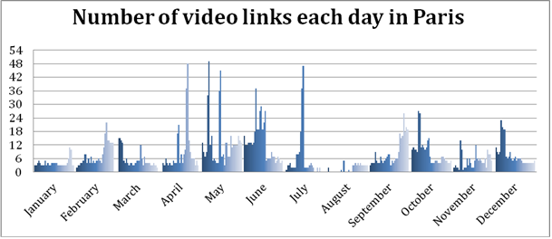

**Figure 2: Daily video link allocation in Paris**

It is important to note that the number of video links does not directly reflect the quantity of spectrum needed, since a given frequency may be used several times during the day at different locations or for different events.

Due to a number of changes to the allocation of spectrum in the 2-3 GHz range, spectrum availability is becoming more limited for use by PMSE. ERC/REC 25-10 [5] identifies 575 MHz of tuning range in the 2-3 GHz range for PMSE, always on a shared basis. However, recent allocations to services with which PMSE cannot share (e.g. in the 2.5-2.69 GHz band and potentially within the 2.3-2.4 GHz band depending on future studies within CEPT) has resulted in a significant reduction of spectrum identified as being available for PMSE (between 190 and 290 MHz). To mitigate this loss it is important to identify and carry out compatibility studies on bands that could potentially accommodate cordless cameras.

The table below shows the numbers of links used in various major events and, where possible to determine, the total spectrum used. For these types of events, part of the spectrum is often borrowed from other services in order to meet peak demand. In order to fulfil the peak spectrum demand for these types of events, also considering that they can be unexpected, countries need to identify spectrum that can be borrowed from other services.

1. Information on major event usage

| **Event** | **Number of links** | **Total spectrum MHz** | **Condition** | **Annex for further details** |
| --- | --- | --- | --- | --- |
| **12th World Championships in Athletics, 15-23 August 2009, Germany** | 42 | 619 | Loaned/PMSE | 4 |
| **Celebration of the 20th anniversary of the fall of the Berlin wall, 9 November 2009** | 38 | 350 | Loaned/PMSE | 5 |
| **Berlin state elections, 18 September 2011, Prussian Landtag building** | 17 | 162 | Loaned/PMSE | 6 |
| **Tour de France 2011** | 35 | 350 | Loaned/PMSE | 7 |
| **Natural ice skating over 200 km (all airborne use)** | 13 | 133 | Loaned/PMSE | 8 |
| **Lower Saxony election** | 13 | 144 | Loaned/PMSE | 9 |

## Operational requirements

Deployment of video links as with other radio services is dependent upon a range of factors which contribute to the link budget[4]. A major consideration is the propagation of the spectrum. Frequencies in the 2 to 3 GHz range provide the best conditions for many applications, especially for airborne and mobile use. The relative bandwidth and size of antennas at these frequencies allow automatic or manual antenna systems to track successfully for mobile use; as the frequency increases, so the bandwidth of the antenna narrows and it is therefore harder to successfully track the moving camera.

Frequency ranges below 5 GHz are favoured for low power cordless cameras operating over short unobstructed paths with the advantage of relatively low diffraction loss. Multiple carrier forms of digital modulation, particularly COFDM, which are rugged and perform well in the presence of multipath, have driven greater and increasing use of low power cordless cameras in recent years.

## Sharing requirements

Spectrum identified for use by PMSE is considered on a tuning range basis, and therefore it can appear that there is a large amount of spectrum available. However, PMSE has always shared spectrum with a wide range of services and to manage use individual licenses are generally issued for a specific use on specific dates and at a specific location. Recent reallocations of spectrum use in CEPT countries mean that the former tuning ranges have been restricted since the introduced services are not able to share with PMSE. The available spectrum within the tuning ranges in any particular country is determined on a national basis; each tuning range may be wholly, partially or not available on a given day, in a given location, in a given country.

Typically, the services that allow sharing with PMSE have low density of use and/or are geographically fixed, such as military systems, the Fixed Service Links and the Satellite Service.

With the allocation of spectrum to services that PMSE cannot share with and the future possibility that further changes to spectrum allocations may result in fewer sharing options it is important that any candidate bands identified for sharing provide sustainable access to spectrum to allow the PMSE industry to invest in and develop new equipment.

Major events currently rely on borrowing spectrum from bands outside of core PMSE bands when spectrum demand exceeds supply. The use of these loan bands is made possible by the use of procedures at the event location that allows PMSE to operate without causing harmful interference to the allocated users of the bands. The transfer of spectrum that currently provides loan opportunities for PMSE to services with operational characteristics that preclude sharing with PMSE means that there are fewer loan bands available for PMSE.

In order for PMSE to share with a Primary service it is important that any procedure is efficient and reliable to ensure that spectrum can be accessed within a suitable time scale, recognising that in some cases there may not be much time to satisfy the spectrum requirement for an event or occasion.

For indoor use, for example in studio centres, it would be beneficial to conduct studies into whether increased screening would allow greater use of spectrum in the 2 to 6 GHz range on a general license basis.

In order to fully exploit sharing possibilities between PMSE and the primary service, compatibility studies and sharing criteria should be based on realistic sharing scenarios and measurements. As an example, ERC Report 38 [4] indicates a maximum e.i.r.p. value of 6 dBW for cordless cameras whereas, in practice, the majority of current assignments are at 0 dBW or below. Another factor to consider in sharing studies is the performance of transmitter and receiver filters: manufacturers often exceed the requirements provided by the relevant technical standard.

## Other requirements

### EMF

Cordless cameras must conform to the EMF (Electromagnetic Fields) limits imposed by ICNIRP and the EC decisions on EMF. With the introduction of the Workers Directive (EMF) by the EC, additional restrictions may be required.

PMSE equipment must work within the European EMF radiation limit of 61 V/m [7] and therefore the maximum power in links when close to cameraman and technicians must be moderated. As an example, a motorcycle mounted camera transmitter is limited to 6 dBW due to the need to observe this limit (assuming the antenna has a gain of 6 dB and is placed on a pole extended to the maximum extent possible whilst still remaining safe to other road users).

### Operating frequency considerations

Major events are increasingly relying on fixed wing aircraft for relaying video content to the production studio for reasons of reliability: fixed wing aircraft are able to stay airborne longer than helicopters due to greater fuel efficiency and are less dependent on favourable weather conditions. However, fixed wing aircraft must operate at much higher altitude and consequently the radio path is longer. At 2 GHz the difference is some 20 dB when comparing a helicopter platform at 300m with a fixed wing platform at 3 000m. Operating the links at higher frequencies increases the path loss.

Frequencies below 3 GHz have beneficial propagation in regard to operation where line-of-sight cannot be achieved. This is often the case when operating in built-up areas or with natural obstacles. Links operated at higher frequencies require LOS conditions.

### Physical

For all mobile equipment the physical size and weight are critical, battery weight is a major part of this and therefore RF output power is kept to a minimum in order to minimise the size of the battery required.

# BAND BY BAND ASSeSSMENT on the sustainable operation of cordless cameras and Video Links

## Range below 3 GHz

The frequency range below 3 GHz provides the best conditions for many applications, especially airborne and mobile use. The relative bandwidth and size of antennas allow automatic or manual antenna systems to track successfully for mobile use.

All the bands in this range are identified in ERC/REC 25-10 [5].

### Band 2025-2110 MHz

Frequencies in this band are generally used for cordless cameras and downlinking video signals from airborne relay platforms such as helicopters, aeroplanes or airships. This type of use provides some opportunities of sharing with the primary services in the band (Space Science Service, Earth-to-space).

### Band 2200-2300 MHz

Frequencies in this band are mainly used for cordless cameras and up-linking video signals from motorcycles, cars, boats and camera helicopters. This type of use provides some opportunities of sharing with the primary services in the band (in particular, Space Science Services, space-to-Earth).

The usage (except for cordless cameras) is ground to air so complementary to the space operation in this band.

### Band 2300-2400 MHz

This band is mainly used for cordless cameras, portable video links and mobile video links. According to the questionnaire [6], 27 countries answered that they are using this band, or part of it, for PMSE. This band is also used for telemetry (aeronautical and terrestrial), fixed links, governmental use (including military) and amateur services (Secondary service). Some countries are considering the introduction of Broadband Wireless Systems in the band 2300-2400 MHz which may have an impact on the availability of the band for PMSE.

CEPT is currently studying the introduction of MFCN in the band 2300-2400 MHz under the concept of LSA (Licensed Shared Access). The goal of this concept is to ensure the long term incumbent use (e.g. wireless video applications in the PMSE case) of the band in the territory of the administrations that wish to maintain such use while making available the band for MFCN.

### Band 2400-2500 MHz

This band benefits from the advantageous radio wave propagation conditions. However, this band is an ISM[5] band and is used by a variety of Short Range Devices such as WiFi and Bluetooth, especially the sub-band 2400-2483.5 MHz . This band is often intensively used by non-PMSE applications supporting an event, such as timing, race control and mobile credit card readers and interference to and from PMSE into these support services is not acceptable. For these reasons the utility of the band for video applications is significantly restricted.

Despite the significant restrictions for use of the band for video PMSE the tuning range should be maintained as some PMSE applications may be able to use the band depending on the circumstances.

### Band 2500-2690 MHz

This band can no longer be considered for sustainable operation of any PMSE application. The band is now designated for the harmonised used of MFCN as per the Commission Decision 2008/477/EC [8] and the ECC/DEC/(05)05 [9]. Taking into account the current and planned deployment of MFCN in the band and that the opportunities for sharing between MFCN and PMSE are extremely limited, there is no real prospect for future use of the band 2500-2690 MHz by cordless cameras and video links.

### Summary for the range below 3 GHz

The spectrum below 3 GHz is the prime range for the use of mobile cordless cameras and other wireless video applications due to the advantageous radio wave propagation conditions, relatively low signal attenuation and the amount of equipment available. Moreover, this frequency range enables deployment of antennas with an acceptable size as well as reliable non-line-of-sight operation which is necessary for many scenarios. Since a major part of the lost spectrum for video PMSE application is in this range (below 3 GHz) it would be appropriate to identify new spectrum on a tuning range basis for cordless cameras and video applications in this range. See section 5.4.

## Range 3 - 6 GHz

### Band 3400-3600 MHz

This band is identified in ERC/REC25-10 [5] for mobile video links (airborne or vehicular).

This type of PMSE use provides some opportunities for sharing with the Primary services in the band (Space science services, Space-Earth).

Due to the introduction of FWA in Europe this band is only available for PMSE in 9 of the countries that responded to the questionnaire (see [6]) on a limited and temporary basis.

At or near borders, operation for airborne usage is even more limited.

### Summary for the range 3-6 GHz

The range from 3.0 to 4.4 GHz is heavily used by applications such as defence systems, radiolocation, UWB, radio astronomy, FSS, BWA, fixed links and MFCN and is therefore unlikely to provide opportunities for sharing with PMSE.

The range from 4.4 to 5.0 GHz may provide some possibilities for the temporary use of PMSE if a coordination process is provided with the (mainly) military users (see 5.4.3).

## Spectrum above 10 GHz

ERC/REC25-10 [5] identifies the bands 10.0 to 10.6 GHz, 21.2 to 24.5 GHz and 47.2 to 50.2 GHz for video PMSE use.

It should be noted that as the frequency increases the link budget also increases with increasing path loss due to the poorer propagation characteristics at higher frequencies. Precipitation[6] becomes problematic, and directional antennas of some form are required.

The 10.0 to 10.6 GHz band has in the past been used for hand or tripod mounted cameras using an active antenna with a feedback channel (usually in the UHF range) to align the transmit and receive antennas. Due to reductions in spectrum availability this usage has ceased and the band is used mainly for short point-to-point links.

Similarly, the 21.2 to 24.5 GHz tuning range, where available, is primarily used for fixed use.

The 47.2 to 50.2 GHz range is also used for fixed use. In the past, some light weight cameras were produced for operation in this range, but this has ceased mainly due to propagation issues.

## Possible new spectrum

### Unpaired 2 GHz bands (1900-1920 MHz and 2010-2025 MHz)

The unpaired 2 GHz bands are currently subject to an EC Mandate (see [10]), which is looking at possible shared uses for this spectrum. One such use is for cordless cameras and video links. The neighbouring band 2025-2110 MHz is already used in at least 19 CEPT countries for PMSE applications on a shared basis, (see section 5.1) and the unpaired 2 GHz bands share the same beneficial propagation conditions for many applications including airborne and mobile use. The physical size of 2 GHz antennas and the attractive propagation characteristics, including using reflections from surrounding objects, allow successful capture of high quality images for mobile use, for example a camera operator running along the touchline at a football match or sitting on a motorbike following a road race. This frequency range is effective even in partially obstructed propagation paths such as ground to air links obstructed by trees. The unpaired 2 GHz bands are already within the operating range of PMSE video equipment and could be put into use without delay.

An exclusive use of these bands by PMSE would ensure the availability of spectrum when it is needed in a suitable timescale. However, in principle PMSE is able to share these bands with other services.

### Band 2.7 to 2.9 GHz / 2.9 to 3.4 GHz

The possible use of the band 2.7 to 2.9 GHz for temporary use of cordless cameras should be studied. Most PMSE video equipment is able to tune to this range which shares similar propagation characteristics to existing PMSE tuning ranges below 3 GHz. We foresee possible use of the band with geographical constraints to protect the existing applications (i.e. radius around existing or planned radar sites).

It is recommended to carry out the following studies:

* Sharing studies between cordless cameras and mobile video links and aeronautical navigation in co-channel;
* Sharing studies between cordless cameras and mobile video links and earth exploration satellite (passive) / radio astronomy / space research (passive) / radiolocation / radionavigation in adjacent bands.

It should also be noted that ECC/REC/(02)09 [11] and ECC Report 006 [12] regarding the use of digital cordless cameras in the band 2700-2900 MHz contain technical characteristics in order to avoid harmful interference to radars operating in this band, but these reports should be considered for updating.

Possible use of the band 2.9 to 3.4 GHz could also be studied for countries where sharing with military services may be possible.

### Band 4.5 – 5 GHz

This band is identified by CEPT administrations as a harmonized military band for fixed and mobile systems. Parts of the band are also used for radio astronomy measurements and radiodetermination applications.

Although not identified in ERC/REC 25-10 [5], at least seven CEPT countries allow temporary use of this band or parts of it for PMSE links under an individual license regime (as stated in the answers to the questionnaire [6]). In most cases precise coordination with the military or other users of the band is necessary to protect their applications.

Due to its propagation characteristics this band is suitable for fixed or low mobility video link applications such as temporary point-to-point links, portable links or cordless cameras.

Given a proper arrangement with the military and depending on conditions in individual countries, this band could be considered suitable for geographically limited PMSE use in those areas where no military or astronomy use is established. An example for this is the ground usage of cordless cameras in city centre areas. Depending on the results of further studies this frequency range may be considered for inclusion in ERC/REC 25-10 [5] as a new tuning range for video PMSE applications.

### Range 6 to 9 GHz

The possible use of additional tuning ranges between 6 and 9 GHz should be studied. Some of these tuning ranges are already used in several countries as shown in [6] and in ANNEX 3:.

This band is suitable for mobile air to ground video link which could be migrated out of the 2 to 3 GHz range in order to reserve the 2 to 3 GHz band for cordless cameras and mobile video uplinks.

Three possible tuning ranges are proposed for study according to the information provided by administrations:

* 7110-7250 MHz
* 7300-7425 MHz
* 8460-8500 MHz

Several countries are using fixed links service in these tuning ranges (especially in regard to ECC/REC/(02)06) [13]. Considering this tuning range for PMSE would require administrations to accommodate this use in the FS channelling arrangements, .as is the case in other FS bands. Adding these bands as tuning ranges for PMSE would therefore promote the use of these bands and help to the development of new equipment.

# FUTURE Standards

## Technological developments for production

The broadcasting landscape has changed dramatically as a result of the EU decision to switch over analogue terrestrial television distribution to digital distribution. The change is much greater than the change of distribution technology - the content choices for viewers have dramatically increased, and the 4:3 aspect ratio of analogue television has been replaced by the 16:9 aspect ratio bringing widescreen pictures. In parallel, the equipment available to consumers has shifted from bulky cathode ray tube (CRT) televisions and VHS video cassette recorders to flat panel devices with plasma, LCD or LED displays, larger screens and superior sound, along with DVD and BluRay video players and hard-disk based digital recorders. Together, these developments have brought dramatic picture quality improvements to consumers. European analogue television had a picture resolution of approximately 640 x 480 pixels, whilst standard definition digital television has a resolution of 720 x 576. High definition is increasingly available, but has been associated to a number of different resolutions. "Full HD" is now considered to be a panel with a resolution of 1920 x 1080 pixels, which is six times the resolution of an analogue television picture.

The introduction of 3-D and higher resolution images is in discussion by standards bodies: the so called 4k UHD and 8k UHD modes having resolutions of 3840 x 2160 and 7680 x 4320 see ITU-R recommendation BT.2020 [14] respectively, meaning 4 and 16 times higher resolution than Full HD. Demonstrations of such systems have been made at trade conferences and special public events in Japan and elsewhere. In addition, the motion artefacts caused by the temporal sampling of the scene are leading to the development of higher frame-rate systems with current work focusing on 120 and 300 frames per second.

Traditionally cordless cameras used analogue modulation techniques to carry the video stream from camera to the reception point and on to the production studio. These analogue techniques typically used around 30 MHz of spectrum per camera, and provided essentially real-time delivery of the video. More recently, the use of digital modulation based on widely deployed distribution standards, such as DVB and ISDB-T, have reduced the bandwidth requirements to typically 10 MHz per camera. Although these digital standards provide modes which allow greater data compression for distribution links, these are not available for contribution quality cordless camera links due to the requirements for high picture quality, low coding delay and high robustness to transmission errors.

However, the increasing demand by the public for higher picture quality requires correspondingly higher quality production and this has a consequence on the spectrum requirements for the connection between the cordless camera and the production studio. Higher resolution pictures require links to be capable of carrying higher bit-rate data streams and this has led to the use of channels of greater than 10 MHz.

The future direction for wireless production will need to embrace 3-D, higher definition, and higher frame-rates, the latter especially for sports coverage to provide smoother motion. All these developments require higher capacity links, since higher resolution and higher frame-rates both demand additional data to be coded.

## Technological developments for cordless video cameras

The market for PMSE equipment is small compared to other radio sectors but new technologies are being developed, including the application of techniques used in the security surveillance and military sectors.

Military technologies permitting dynamically steerable antennas at high altitude have been employed for the provision of airborne links using fixed wing aircraft, which have some cost savings over the use of less directional airborne antennas used at lower altitudes from helicopters.

The BBC's Research and Development department, which has contributed much to the current cordless camera link technology, has been developing new techniques making use of more recent modulation and coding standards, as found for instance in DVB-T2 and DVB-NGH, to allow a ‘next generation’ cordless camera which would approximately double the spectrum efficiency compared to those based on the DVB-T standard. A key ingredient is the inclusion of ‘Multiple Input Multiple Output’ (MIMO) technologies in conjunction with COFDM in order to provide a foundation for the increased throughput sought. This is supported by an LDPC-based error-correction chain based on those used in DVB-T2 and DVB-NGH. The current state of development offers 40 Mb/s in 10 MHz, but it is envisaged that a variant offering 60 Mb/s in the same bandwidth is feasible, as well as ‘scaled’ systems providing up to 120 Mb/s in 20 MHz, a bit-rate intended to support lightly-compressed studio quality video.

As the name implies, MIMO operation requires the use of multiple transmission and receiving antennas. The BBC technique is based on system dimension of 4x4 (i.e. four receive and four transmit antenna elements), in order to allow effective operation in environments characterised by a high degree of signal reflection and scattering (typically indoors) and those where a strong line-of-sight component is dominant (typically outdoors). Although based on a 4x4 dimension, typically two physical antennas will be used for transmission and two for reception, permitted by the use of sophisticated signal processing.

## Other Technological developments which have been explored for cordless video cameras

With the plethora of developments in communication systems in recent years the PMSE and other industries have sought to become more spectrums efficient by exploiting other forms of infrastructure. This section highlights a few of these experiments.

Mobile Phone Networks for:

* *Contribution quality:* The roll-out of 4G networks has raised interest in providing contribution quality video links. A number of companies have experimented with the development of systems that can use LTE networks for delivering video to production studios. To date the technical obstacles, including lack of bandwidth, consistency of quality and reliability for a prolonged transmission, high latency (time delay) and synchronisation of contribution and studio equipment, have prevented any successful introduction. In general, the industry considers that these issues cannot be satisfactorily resolved for contribution quality links.
* *News quality:* For the rapid provision of news coverage, ahead of the arrival by full news crews, "reporter backpacks" have been developed that send the video stream back to the production studio using multiple connections over mobile phone networks. However, these systems suffer from large delays and so cannot be used for two-way interviews between the studio staff and on-site reporter. The link also suffers from whatever congestion is present in any of the contributing mobile networks or even the denial of service when public bodies have taken over the capacity for emergency services requirements. The aim of these "reporter backpacks" is to be able to present the news before rival news services, but they do not provide the quality, reliability or flexibility needed for general PMSE use.

Mesh technologies, whereby wireless nodes in a network work together to provide a self-healing network, can be used to improve the reliability of video links. However, the cost of the systems and the complexity of deployment, as well as the need for low delay, make these systems unattractive and impractical for use by PMSE.

An extremely successful marrying of fixed telecommunication networks and cordless cameras are the “network access points" provided by major telecoms companies at strategic positions around a city, such as parliaments, sports grounds, law enforcement headquarters, which provide access to high speed fibre optic cable which allows a cordless camera receiver output to be connected to the production studio.

# Conclusions

Currently a wide range of activities use PMSE. These activities range from sport to advertising and court reporting through to nature recording. The economic benefit of these activities are difficult if not impossible to define but with the creative and cultural nature captured and expressed via PMSE the general public has had access to pictures, recordings and information which would not have been possible even ten years ago. If the economic and cultural benefits of this creativity are to continue in a similar way as today, sufficient spectrum needs to be available.

Due to the reduction in spectrum availability below 3 GHz for video PMSE use, additional spectrum is required to sustain current PMSE levels of use. These applications rely on spectrum with advantageous radio wave propagation conditions, relatively low signal attenuation and the possibility to enable deployment of antennas with an acceptable size as well as reliable non-line-of-sight operation which is necessary for many scenarios. This is best met by the frequency range below 3 GHz.

Spectrum identified for use by PMSE is considered on a tuning range basis, and therefore it can appear that there is a large amount of spectrum available. However, since PMSE has always shared spectrum with a wide range of services, the available spectrum within the tuning ranges in any particular country is determined on a national basis; each tuning range may be wholly, partially or not available on a given day, in a given location, in a given country.

Traditionally PMSE has shared with various primary services but with the new allocations to services such as wireless broadband sharing is not practical. It is noted that changes to spectrum allocations outside identified PMSE bands may also have a significant impact on the ability to satisfy PMSE spectrum needs for major events as spectrum is often ‘loaned’ from other bands in order to meet peak demand.

In order for PMSE to share with a Primary service it is important that any procedure is efficient and reliable to ensure that spectrum can be accessed within a suitable time scale, recognising that in some cases there may not be much time to satisfy the spectrum requirement for an event or occasion.

The provision of news reporting from natural or man-made disasters has a highly valuable public information and public safety function, and this can only be realised where sufficient PMSE spectrum is available.

As current PMSE video applications are based on 10 MHz channels, consideration should be given to configuring current and future spectrum on a 10 MHz channel raster in order to easily and efficiently assign spectrum for PMSE video applications.

With the allocation of spectrum to services that PMSE cannot share with and the future possibility that further changes to spectrum allocations may result in fewer sharing options, it is important that any candidate bands identified for sharing provide sustainable access to spectrum to allow the PMSE industry to invest in and develop new equipment.

Some possible new spectrum for cordless cameras and video links is identified by this Report. Sharing studies will need to be carried out in order to determine if these bands may be brought into use.

The identified possible new bands are:

* 1 900 – 1 920 MHz
* 2 010 – 2 025 MHz
* 2 700 – 2 900 MHz
* 2 900 – 3 400 MHz
* 4 400 – 5 000 MHz
* 7 110 – 7 250 MHz
* 7 300 – 7 425 MHz
* 8 460 – 8 500 MHz

1. MANDATE TO CEPT ON TECHNICAL CONDITIONS REGARDING SPECTRUM HARMONISATION OPTIONS FOR WIRELESS RADIO MICROPHONES AND CORDLESS VIDEO-CAMERAS (PMSE EQUIPMENT

|  |  |
| --- | --- |
|  | EUROPEAN COMMISSION  Information Society and Media Directorate-General  Electronic Communications Policy  **Radio Spectrum Policy** |

Brussels, 15 December 2011

DG INFSO/B4

**FINAL**

**Mandate to CEPT   
on technical conditions regarding spectrum harmonisation options for wireless radio microphones and cordless video-cameras (PMSE equipment)**

1. **PURPOSE**

This mandate is a follow-up to the commitment made by the Commission in the Communication on the digital dividend[7] and in the proposal for a Radio Spectrum Policy Programme.[8] The main objective of this mandate is to identify technical conditions and options to make EU harmonised spectrum available for wireless radio microphones and cordless video-cameras. The aim is not to satisfy all the spectrum requirements[9] of the relevant users, but rather to create a baseline for economies of scale and the functioning of the internal market.

Programme Making and Special Events (PMSE) applications fulfil an important role supporting social and cultural activities, ranging from local to EU-wide events and broadcasts, which also make a significant economic contribution. Various types of equipment are involved, such as wireless microphone applications, in-ear systems, cordless video-cameras and remote control systems, used in both professional and non professional environments.

1. **JUSTIFICATION**

Pursuant to Article 4 of the Radio Spectrum Decision[10] the Commission may issue mandates to the CEPT for the development of technical implementing measures with a view to ensuring harmonised conditions for the availability and efficient use of radio spectrum; such mandates shall set the task to be performed and the timetable therefore.

Without prejudice to the final text to be adopted by the European Parliament and the Council, the draft Radio Spectrum Policy Programme states that Member States shall examine ways and, where appropriate, take technical and regulatory measures, to ensure that the freeing of the 800 MHz band does not adversely affect PMSE users. In addition it states that Member States shall, in cooperation with the Commission, seek to ensure the necessary frequency bands for PMSE, according to the Union's objectives to improve the integration of the internal market and access to culture.

CEPT Report 32[11] concludes that:

* The historic use of PMSE of the 470-862 MHz band will need to be adapted.
* PMSE demand for spectrum is expected to continue to rise in the medium term.
* Interleaved channels/white spaces in the UHF band are the principal spectrum for wide band audio applications. Therefore, the 470 MHz to 790 MHz range should be maintained for PMSE allowing them to operate on a temporary basis in areas where broadcasting is not yet used.
* New frequency bands could be made available to PMSE in addition to 470-790 MHz.

In order to address in particular non-professional applications and a substantial amount of professional applications, and while recognising that it is not the aim to address all spectrum requirements, there is considerable justification for harmonising the band 821-832 MHz for wireless microphones.

Furthermore, the identification of detailed technical conditions for the use of band 1785-1805 MHz by wireless radio microphones is required before considering a possible harmonisation measure which includes EU-wide operations (this could include for example indoor and outdoor use and the variety of professional and non-professional situations).

In addition to the audio applications (wireless microphones) there is another important category of PMSE equipment, cordless video-cameras, which may face spectrum access issues. Currently, cordless video-cameras are often operating in the 2.3 GHz band and additional in the 2.6 GHz band. The fact that the 2.6 GHz band has been harmonised for terrestrial systems providing electronic communications services under new conditions of use and that some Member States are contemplating the use of the 2.3 GHz in the same way, makes it necessary to consider an alternative and sustainable solution for spectrum access for cordless video-cameras. Therefore, options or alternatives for spectrum use by cordless video-cameras need to be developed. It would be desirable to investigate new bands for cordless video-cameras use and sharing opportunities.

Considering the above and taking into account the fact that EU-wide operations (such as touring shows) as well as ordinary citizens using wireless microphone equipment for non-professional purposes, could both benefit from harmonisation, the Commission believes that an additional mandate is justified. The mandate should concentrate on the analysis of the 821-832 MHz and 1785-1805 MHz bands for wireless microphones and on clarifying technical options to address future needs for cordless video-cameras.

1. **Main EU policy objectives**

With this mandate, the Commission issues guidance to the CEPT to continue developing technical conditions and studies serving policy objectives which contributes to an improvement of efficient use of spectrum resulting in positive economic, social and cultural benefits in the EU. These main policy objectives include:

* To ensure the availability of core spectrum for some categories of PMSE equipment, respectively wireless radio microphones and cordless video-cameras, with a view to supporting the development of media and entertainment industry (PMSE);
* To strengthen the Internal Market dimension for potential single market services and PMSE equipment, that can improve frequency management, in relation to PMSE use as well as to improve the spectrum efficiency of PMSE equipment.
* To exploit the socio-economic and cultural benefit for EU citizens and PMSE users to the fullest extent by facilitating economies of scale, lower prices and foster cross-border portability and interoperability.

1. **Task order and schedule**

Task order and schedule

Through this mandate, the CEPT is requested:

(1) To identify the technical conditions for the use of the band 821-832 MHz for wireless radio microphones (which optionally include in-ear systems and control systems) in the EU. This should take into account the technical conditions specified in EC Decision 2010/267/EU on the EU harmonisation of the 800 MHz band as well as any relevant outcomes of WRC-12.

(2) To identify the technical conditions resulting in a harmonisation of technical parameters in the band 1785-1805 MHz for the use of wireless radio microphones (which optionally include in-ear systems and control systems).

(3) To identify the technical conditions and the necessary frequency bands for ensuring the sustainable operation of cordless video-cameras in the EU, including spectrum sharing opportunities possible through technological developments.

(4) To identify technical conditions which can contribute to facilitate the use of wireless radio microphone and cordless video-camera-equipment for EU-wide operations, including specific aspects to improve the frequency management and the overall spectrum efficiency of equipment.

The Commission may provide CEPT with further guidance on this mandate.

The deliverable for this mandate will be two reports A and B:

* Report A on the technical conditions for the use of the bands 821-832 MHz and 1785-1805 MHz for wireless radio microphones in the EU, including the technical conditions which can contribute to facilitate the PMSE equipment for EU-wide operations;
* Report B on the technical conditions for ensuring the sustainable operation of cordless video-cameras in the EU.

The following delivery dates are scheduled:

|  |  |
| --- | --- |
| **Delivery date** | **Deliverable** |
| 3/07/12 | For RSC#40 Progress report A |
| 4/12/12 | For RSC#42 Progress report B |
| 4/12/12 | For RSC#42 Draft final report A, subject to public consultation |
| 11/03/13 | Final report A delivery |
| July 2013 | For RSC#44 Draft final report B, subject to public consultation |
| November 2013 | Final report B delivery |

In implementing this mandate, the CEPT shall, where relevant, take the utmost account of Community law applicable and support the principles of technological neutrality, non-discrimination and proportionality insofar as technically possible.

The Commission, with the assistance of the Radio Spectrum Committee pursuant to the Radio Spectrum decision, may consider applying the results of this mandate in the EU, pursuant to Article 4 of the Radio Spectrum Decision.

***

1. DEPloyment Scenarios of Cordless Cameras And Video Links

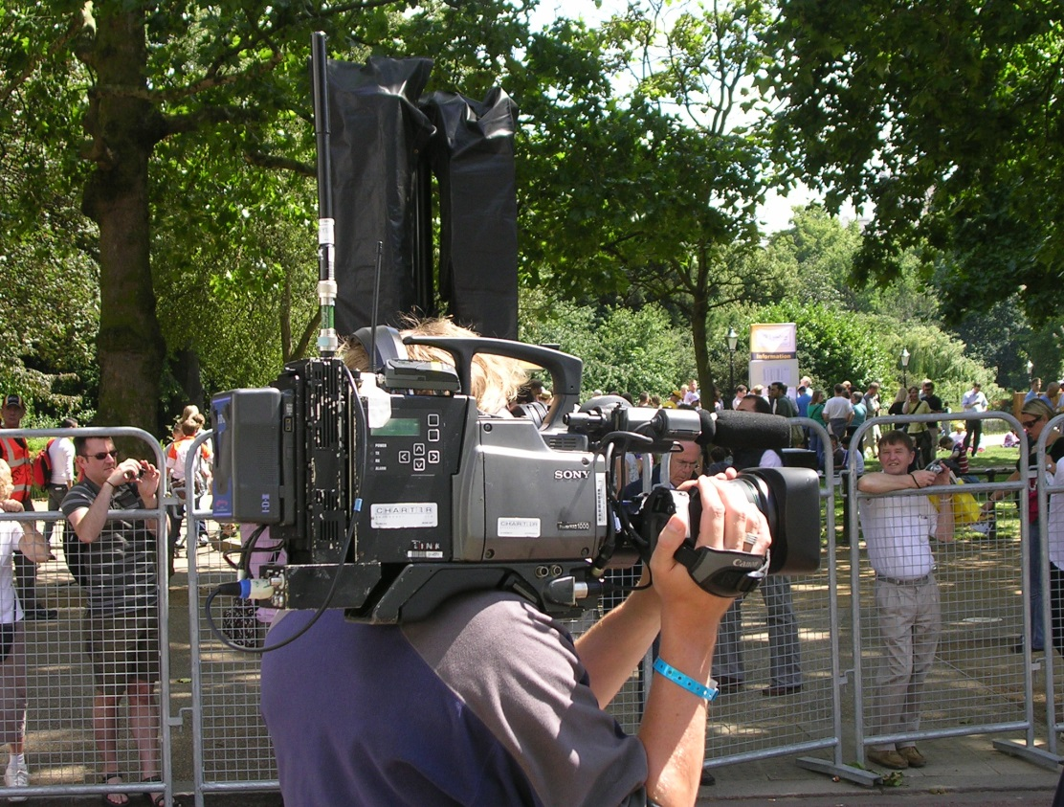

**Figure 3: Cordless Camera**

A conventional cordless camera transmitter docks on the back of a traditional camera. Audio is incorporated with the pictures on the cordless camera link either from an onboard microphone or else there may be a separate wireless microphone receiver mounted on the camera. Remote control of the camera for colour balance and exposure can also be by radio telemetry via a separate wireless channel received on the camera.

Often to bring pictures from close to the action, miniaturised cameras and transmitters are mounted on participants in cycling and motorsport, utilising low profile antennas, such as patch antennas, to minimise the impact on performance. These can then be received on the ground via a network of switched receivers placed along the route, or received via an airborne platform.

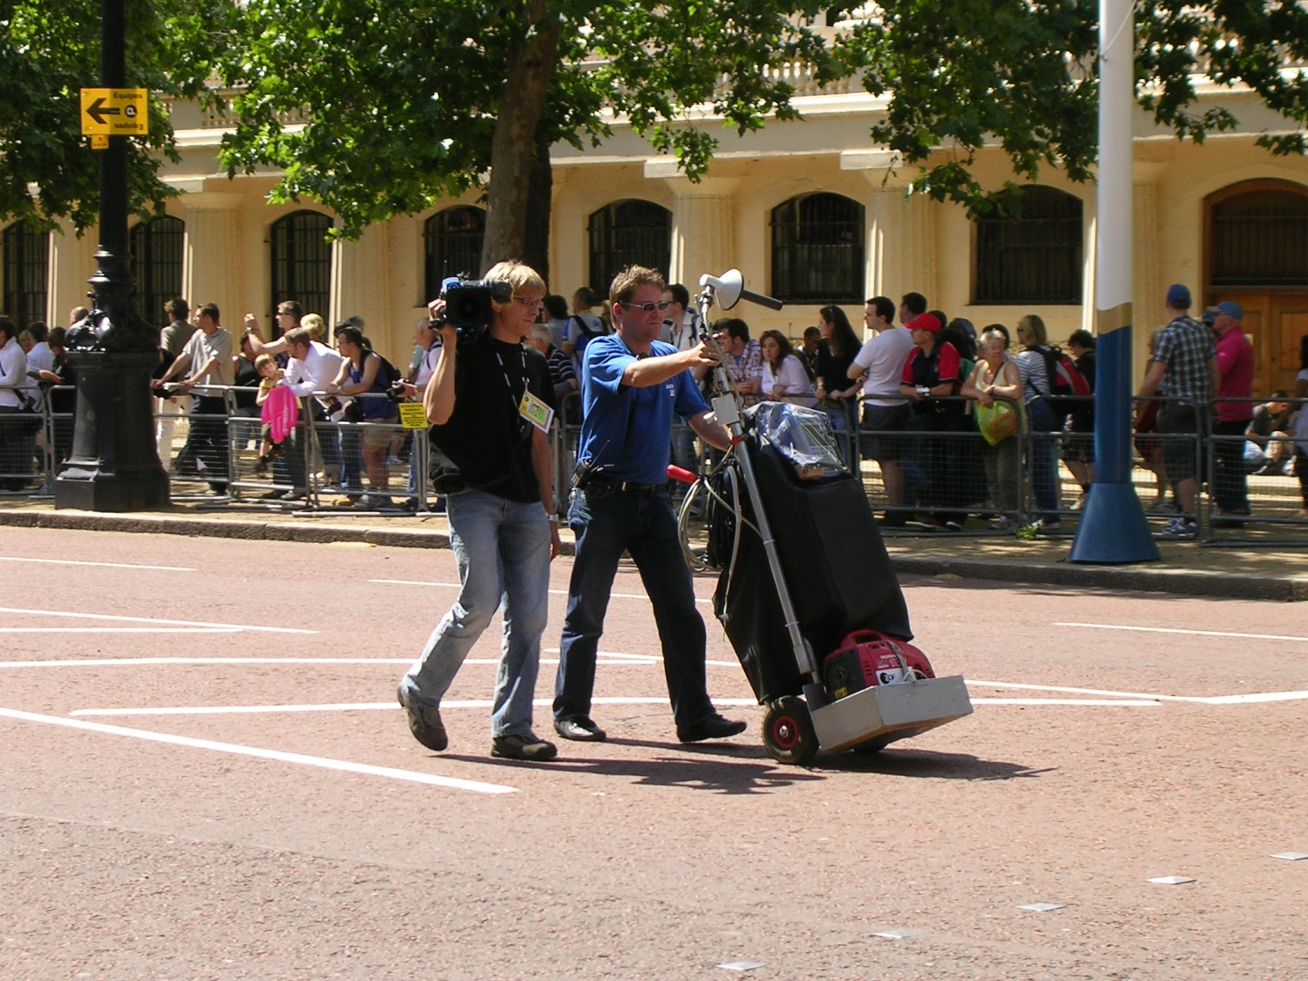

**Figure 4: Portable Camera Transmitter**

To give a reliable link over a greater range a Portable Camera Transmitter is used along with a directional antenna. In the example below, being moved to a new location, the transmitter, its only portable power supply, test equipment and the directional antenna are carried on a trolley. Once in place the camera is connected to it by cable. Typical applications would be motorsport or a golf course where the camera location is determined by the action. The equipment may also be mounted on a vehicle such as a golf buggy.

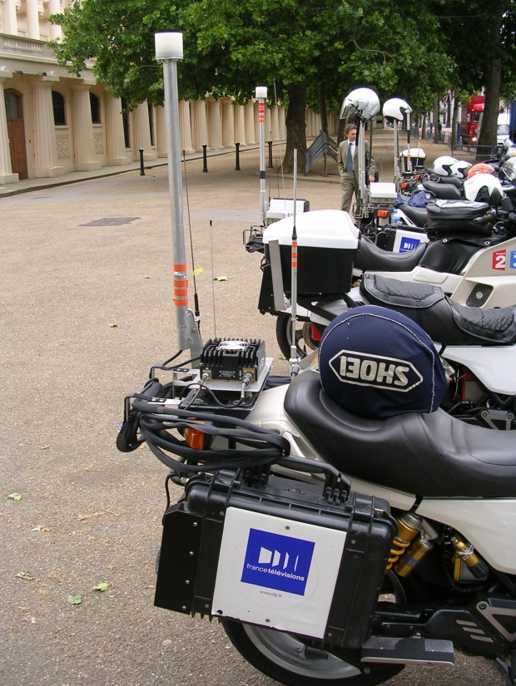

**Figure 5: Mobile vehicular video link**

Mobile links can be mounted on a variety of vehicles including cars, buggies and motorcycles. In the example shown in figure 5 the cameraman sits on the rear of the motorcycle connected by cable to the video link, its components in the rear panniers and above the rear wheel. A low gain, typically a patch antenna, is mounted high, for safety and a clear view of the sky.

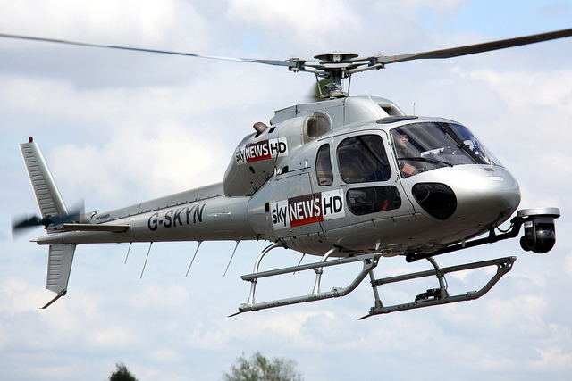

**Figure 6: Airborne video link**

The gyroscopically stabilised camera can be seen on the front of the helicopter with receive and transmit antennas mounted on the landing skids. Other airborne vehicles such as airships and tethered blimps can also carry airborne video links. As well as relaying pictures directly from the onboard camera the airborne platform can additionally receive multiple links from the ground, then transpose and transmit them down to another point on the ground.

Point-to-point video links are used to relay pictures, sound and data from remote locations to a central production location. Programme makers need their own high quality, low delay links to be able to seamlessly combine the elements of a production. These may be relatively short distances for an individual camera at a horse racing meeting or many kilometres from a remote outside broadcast part way along a cycle race, to the finish line.

* 1. Live Newsgathering

It is commonplace to pair a cordless camera with a vehicle equipped with a satellite uplink or alternatively a terrestrial video link. The advantages of wireless operation include the ability to adapt to real-time changes as events unfold, the lack of trip hazards caused by having to run cables, the ability to park vehicles safely, the flexibility to cover a number of angles without equipment re-rigging.

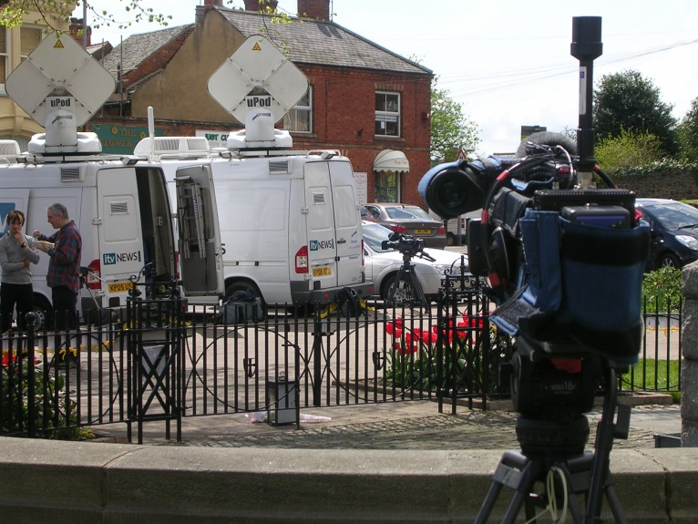

**Figure 7: Cordless Camera for Newsgathering**

* 1. Sports Coverage

Cordless cameras are routinely deployed close to the action and can be handheld or mounted on moving vehicles. The link may be made to a central receive point in a football stadium, or may be relayed to an airborne receiver for onward linking. The advantages of wireless operation include the ability to follow the action: in a stadium, cabled cameras have very limited mobility due to requirements to route cables safely; in a road race, the camera is likely to be mounted on a motorbike; at a golf links, the camera can move from tee to tee. In addition, reportage of the athletes is common in modern production. The rugged nature and reliability of digital cordless camera links has also led to much greater use in coverage of sporting events.

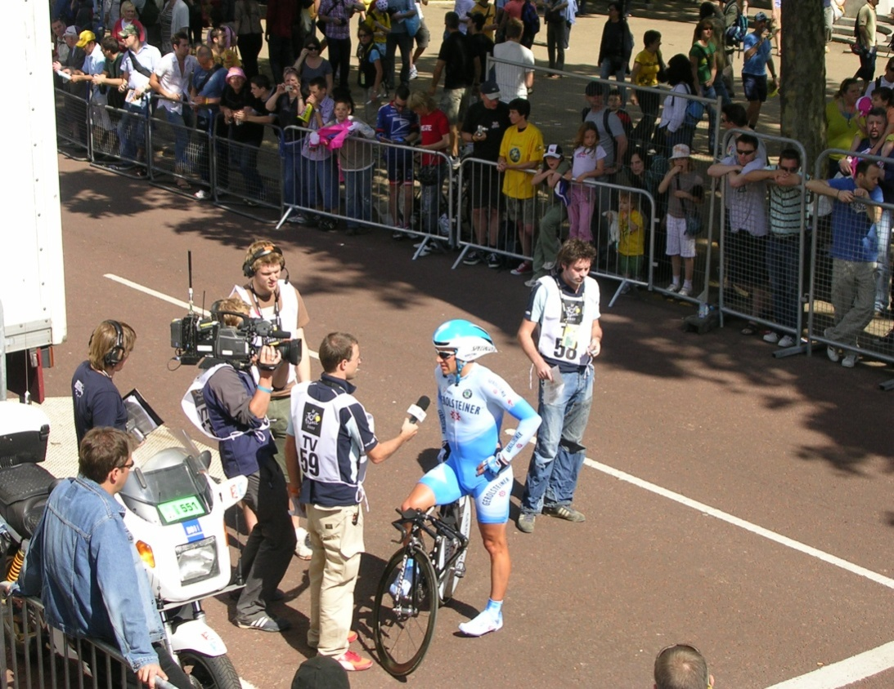

**Figure 8: Cordless Camera for Sports Coverage**

* 1. major event

Live coverage of major state occasions and major cultural events are greatly enhanced through the use of Cordless Camera and Video Links. Audiences have come to expect the wide range of shots from different standpoints along with close-ups that show the detail of the action. These are only possible when cameras can be located in a variety of locations, without the need to be cabled.

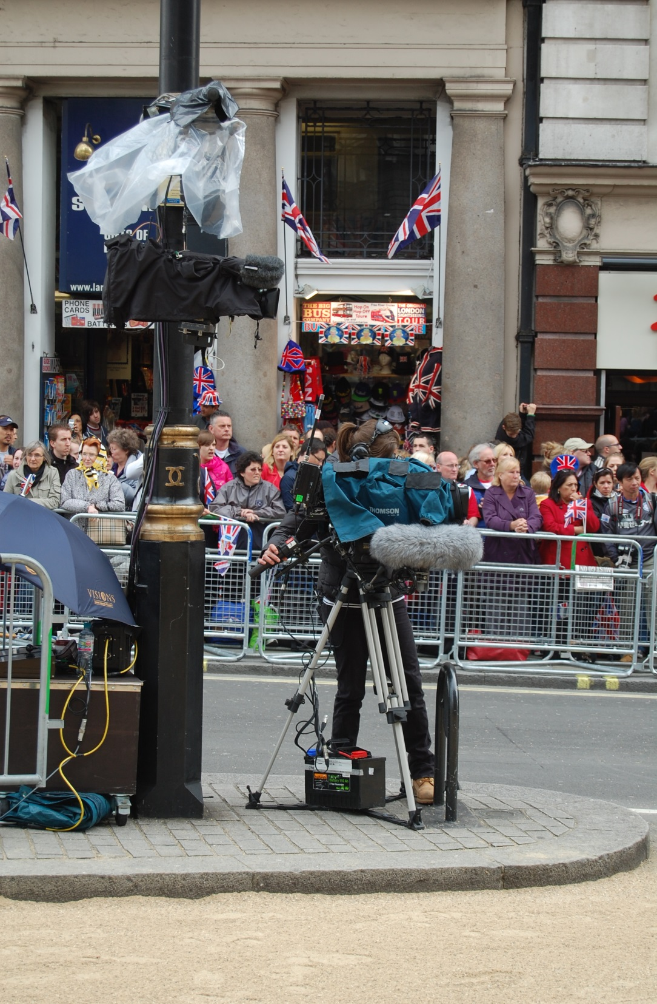

**Figure 9: Cordless Camera for Major Event Coverage where cabling is not an option**

Portable Video links are employed where path lengths are greater, for example to provide reliable and rugged coverage over wide areas, perhaps an entire golf course. Lower power Cordless Cameras with shorter paths to a greater number of receive points are an alternative but practical and cost implications will determine the operational decisions. Multiple hops can permit a lower power Cordless Camera to be relayed on via a higher power video link perhaps rigged in a vehicle such as a motorbike or golf buggy.

The use of video links has grown as the artistic freedom they create has resonated with producers and directors in all forms of media. Their deployment spans all forms of programme making with variations in each sector for example the film industry uses “video assist” to allow the director to see the set from the remote cameras.

* 1. Considerations on PMSE deployment scenarios and planning practice

The temporary nature of PMSE deployment can lead to less than optimum installation practices. Production vehicles and equipment are often corralled closely together creating radio frequency hotspots. Isolation between radio systems may therefore have to be compromised and it is not always possible to efficiently use spectrum in the way it would be possible with a permanent installation. The need to co-ordinate multiple PMSE users occupying the same ranges of spectrum can also limit the possibilities to promote the optimum use of spectrum in an operational environment where requirements are continually changing.

1. USE of the range 6 - 9 GHz by PMSE in CEPT

Some tuning ranges between 6 and 9 GHz are already used in several countries as shown in the following table (information from the questionnaire [6]). This not an exhaustive list and some other countries may also use this band for video links and cordless cameras.

1. Use of the 6 to 9 GHz range by PMSE

|  | **Frequency band (MHz)** | | | | | | | | | | | | | | | | |
| --- | --- | --- | --- | --- | --- | --- | --- | --- | --- | --- | --- | --- | --- | --- | --- | --- | --- |
| Country | 5925-6425 | 6425-7110 | 7110-7125 | 7125-7138 | 7138-7140 | 7140-7195 | 7195-7250 | 7250-7300 | 7300-7425 | 7425-7550 | 7550-7750 | 7750-7890 | 7890-7900 | 7900-8460 | 8460-8500 | 8500-8550 | 8550-8700 |
| FIN |  |  |  |  |  |  |  |  |  |  |  |  |  | √ | √ |  |  |
| F |  |  | **√** | √ | √ | √ | √ |  |  |  |  | √ |  |  |  |  |  |
| SVK |  |  |  |  | √ | √ |  |  |  |  |  |  |  |  |  |  | √ |
| G |  |  | √ | √ | √ | √ | √ |  | √ |  |  |  |  |  | √ |  |  |
| RUS |  |  |  |  |  |  |  |  |  |  | √ |  |  |  | √ | √ | √ |
| IRL |  | √ | √ | √ | √ | √ | √ | √ | √ |  |  |  |  |  |  |  |  |
| GRC | √ | √ |  | √ | √ | √ | √ |  | √ |  |  |  |  |  |  |  |  |
| NL |  |  |  |  |  | √ | √ |  |  |  |  |  |  |  |  |  |  |

1. Germany:12th IAAF World Championships in Athletics, 15–23 August 2009
2. Video PMSE usage for 12th IAAF 2009

| **Frequency MHz** | **Power Watt** | **Band-width MHz** | **Picture Res.** | **Height m** | **Location** | **Device** |
| --- | --- | --- | --- | --- | --- | --- |
| 2025.0 | 5.0 | 8 | SD | 3 | Berlin City | video link |
| 2050.0 | 5.0 | 8 | SD | 300 | Berlin City | video link |
| 2075.0 | 5.0 | 8 | SD | 300 | Berlin City | video link |
| 2103.5 | 5.0 | 8 | SD | 3 | stadium+City | camera |
| 2190.0 | 1.0 | 8 | SD | 300 | Berlin City | video link |
| *2205.0* | *1.0* | *8* |  | *300* | *all* | *camera - PPDR* |
| 2215.0 | 5.0 | 8 | SD | 300 | Berlin City | video link |
| 2240.0 | 5.0 | 8 | SD | 300 | Berlin City | video link |
| 2250.0 | 1.0 | 8 | SD | 2 | stadium | camera |
| 2265.0 | 5.0 | 8 | SD | 300 | Berlin City | video link |
| 2290.0 | 5.0 | 8 | SD | 300 | Berlin City | video link |
| 2312.0 | 0.5 | 8 | SD | 2 | Brandenburg Gate | camera |
| 2337.0 | 0.1 | 8 | SD | 2 | Berlin City | camera |
| 2391.5 | 1.0 | 8 | SD | 3 | stadium | camera |
| 2394.0 | 0.1 | 8 | SD | 2 | Berlin City | camera |
| 2440.0 | 0.1 | 8 | SD | 2 | Brandenburg Gate | camera |
| 2490.0 | 5.0 | 8 | SD | 300 | Berlin City | video link |
| 2515.0 | 5.0 | 8 | SD | 2 | Berlin City | video link |
| 2530.0 | 5.0 | 8 | SD | 300 | Berlin City | video link |
| 2540.0 | 5.0 | 8 | SD | 2 | Berlin City | video link |
| 2545.0 | 1.0 | 8 | SD | 3 | stadium | camera |
| 2590.0 | 5.0 | 8 | SD | 2 | Berlin City | video link |
| 2620.0 | 5.0 | 8 | SD | 300 | Berlin City | video link |
| 2665.0 | 5.0 | 8 | SD | 2 | Berlin City | video link |
| 3174.0 | 1.0 | 27 | HD | 2 | stadium | camera |
| 3222.0 | 1.0 | 27 | HD | 2 | stadium | camera |
| 3246.0 | 1.0 | 27 | HD | 2 | stadium | camera |
| 3270.0 | 1.0 | 27 | HD | 2 | stadium | camera |
| 3294.0 | 1.0 | 27 | HD | 2 | stadium | camera |
| 3318.0 | 1.0 | 27 | HD | 2 | stadium | camera |
| 3342.0 | 1.0 | 27 | HD | 2 | stadium | camera |
| 3366.0 | 1.0 | 27 | HD | 2 | stadium | camera |
| 3390.0 | 1.0 | 27 | HD | 2 | stadium | camera |
| 3414.0 | 1.0 | 27 | HD | 2 | stadium | camera |
| 3438.0 | 1.0 | 27 | HD | 2 | stadium | camera |
| 3462.0 | 1.0 | 27 | HD | 2 | stadium | camera |
| 3486.0 | 1.0 | 27 | HD | 2 | stadium | camera |
| 3525.0 | 0.1 | 8 | SD | 3 | Berlin City | camera |
| 7008.0 | 5.0 | 17 | HD | 80 | stadium+City | video link |
| 7080.0 | 5.0 | 17 | HD | 80 | stadium+City | video link |
| 10386.0 | 5.0 | 17 | HD | 80 | stadium+City | video link |
| 10615.0 | 5.0 | 17 | HD | 80 | stadium+City | video link |

In total there were 42 links and the total occupied bandwidth sums up to 619 MHz (without consideration of guard bands/separation distances between the applications or intermodulation effects).

Note: In Germany, the range 2347 - 2384 MHz is allocated for PPDR (audio & video) and may not be available for PMSE at future events because of the increased PPDR use.

1. Celebration of the 20th anniversary of the fall of the Berlin wall 9. November 2009
2. Video PMSE usage for 20th anniversary celebrations, 2009

| **Frequency MHz** | **Power Watt** | **Band-width MHz** | **Picture Res.** | **Height m** | **Location** | **Device** |
| --- | --- | --- | --- | --- | --- | --- |
| 1985.0 | 0.5 | 8 | SD | 3 | Brandenburg Gate | camera |
| 1995.0 | 0.5 | 8 | SD | 3 | Brandenburg Gate | camera |
| 2065.0 | 0.5 | 8 | SD | 3 | Brandenburg Gate | camera |
| 2105.0 | 0.5 | 9 | SD | 3 | Brandenburg Gate | camera |
| 2175.0 | 0.5 | 8 | SD | 3 | Brandenburg Gate | camera |
| 2190.0 | 0.5 | 9 | SD | 3 | Brandenburg Gate | camera |
| 2215.0 | 0.5 | 8 | SD | 3 | Brandenburg Gate | camera |
| 2250.0 | 0.5 | 18 | HD | 2 | Brandenburg Gate | camera |
| 2270.0 | 0.5 | 18 | HD | 3 | Brandenburg Gate | camera |
| 2285.0 | 0.5 | 8 | SD | 2 | Brandenburg Gate | camera |
| 2295.0 | 0.5 | 8 | SD | 2 | Brandenburg Gate | camera |
| 2305.0 | 1.0 | 8 | SD | 2 | Brandenburg Gate | camera |
| *2316.0* | *5.0* | *8* |  | *10* | *Brandenburg Gate* | *camera - PPDR* |
| 2328.5 | 0.1 | 8 | SD | 5 | Brandenburg Gate | camera |
| 2342.5 | 0.1 | 8 | SD | 5 | Brandenburg Gate | camera |
| *2356.0* | *5.0* | *8* |  | *10* | *Brandenburg Gate* | *camera - PPDR* |
| *2368.0* | *5.0* | *8* |  | *10* | *Brandenburg Gate* | *camera - PPDR* |
| 2391.5 | 0.1 | 8 | SD | 5 | Brandenburg Gate | camera |
| 2392.5 | 0.1 | 8 | SD | 2 | Brandenburg Gate | camera |
| 2455.0 | 0.1 | 8 | SD | 5 | Brandenburg Gate | camera |
| 2469.0 | 0.1 | 8 | SD | 5 | Brandenburg Gate | camera |
| 2504.0 | 0.1 | 8 | SD | 2 | Brandenburg Gate | camera |
| 2510.0 | 0.1 | 8 | SD | 2 | Brandenburg Gate | camera |
| 2530.0 | 0.1 | 8 | SD | 2 | Brandenburg Gate | camera |
| 2545.0 | 0.1 | 8 | SD | 2 | Brandenburg Gate | camera |
| 2585.0 | 0.1 | 8 | SD | 2 | Brandenburg Gate | camera |
| 2605.0 | 0.5 | 10 | HD | 2 | Brandenburg Gate | camera |
| 2615.0 | 0.5 | 10 | HD | 2 | Brandenburg Gate | camera |
| 2660.0 | 0.5 | 10 | HD | 2 | Brandenburg Gate | camera |
| 3300.0 | 0.1 | 10 | HD | 10 | Brandenburg Gate | camera |
| 3320.0 | 0.1 | 10 | HD | 10 | Brandenburg Gate | camera |
| 3340.0 | 0.1 | 10 | HD | 10 | Brandenburg Gate | camera |
| 3380.0 | 0.1 | 10 | HD | 10 | Brandenburg Gate | camera |
| 3400.0 | 0.1 | 10 | HD | 10 | Brandenburg Gate | camera |
| 3420.0 | 0.1 | 10 | HD | 10 | Brandenburg Gate | camera |
| 3440.0 | 0.1 | 10 | HD | 10 | Brandenburg Gate | camera |
| 3460.0 | 0.1 | 10 | HD | 10 | Brandenburg Gate | camera |
| 3480.0 | 0.1 | 10 | HD | 10 | Brandenburg Gate | camera |

In total there were 38 links and the total occupied band with sums up to 350 MHz (without consideration of guard bands/separation distances between the applications or intermodulation effects).

Note: In Germany, the range 2347 - 2384 MHz is allocated for PPDR (audio & video) and may not be available for PMSE at future events because of the increased PPDR use.

1. Berlin state elections, 18 September 2011, Prussian Landtag building
2. Video PMSE usage for Berlin state elections, 2011

| **Frequency MHz** | **Power Watt** | **Band-width MHz** | **Picture Res.** | **Height m** | **Location** | **Device** |
| --- | --- | --- | --- | --- | --- | --- |
| 2185.0 | 1.0 | 8 | SD | 3 | Prussian Landtag | camera |
| 2212.0 | 1.0 | 8 | SD | 2 | Prussian Landtag | camera |
| 2225.0 | 1.0 | 8 | SD | 2 | Prussian Landtag | camera |
| 2237.0 | 1.0 | 8 | SD | 2 | Prussian Landtag | camera |
| 2273.0 | 1.0 | 18 | HD | 2 | Prussian Landtag | camera |
| 2294.0 | 1.0 | 18 | HD | 2 | Prussian Landtag | camera |
| 2325.0 | 0.5 | 8 | SD | 2 | Prussian Landtag | camera |
| 2337.0 | 0.5 | 8 | SD | 2 | Prussian Landtag | camera |
| 2356.0 | 0.1 | 8 | SD | 2 | Prussian Landtag | camera |
| 2391.5 | 1.0 | 8 | SD | 2 | Prussian Landtag | camera |
| 2394.0 | 0.5 | 8 | SD | 2 | Prussian Landtag | camera |
| 2510.0 | 0.5 | 8 | SD | 2 | Prussian Landtag | camera |
| 2590.0 | 0.1 | 8 | SD | 2 | Prussian Landtag | camera |
| 3410.0 | 0.1 | 10 | HD | 2 | Prussian Landtag | camera |
| 3440.0 | 0.1 | 10 | HD | 2 | Prussian Landtag | camera |
| 3470.0 | 0.1 | 10 | HD | 2 | Prussian Landtag | camera |
| 5863.0 | 0.1 | 8 | SD | 2 | Prussian Landtag | camera |

In total there were 17 links and the occupied band width sums up to 162 MHz (without consideration of guard bands/separation distances between the applications or intermodulation effects).

Note: In Germany, the range 2347 - 2384 MHz is allocated for PPDR (audio & video) and may not be available for PMSE at future events because of the increased PPDR use.

1. Tour de France 2010 - 2012
2. Video PMSE usage for Tour de France, 2010 - 2012



Note that the decrease of the number of video links between 2011 and 2012 was due to the withdrawal of German television in 2012.

1. Ice Skating

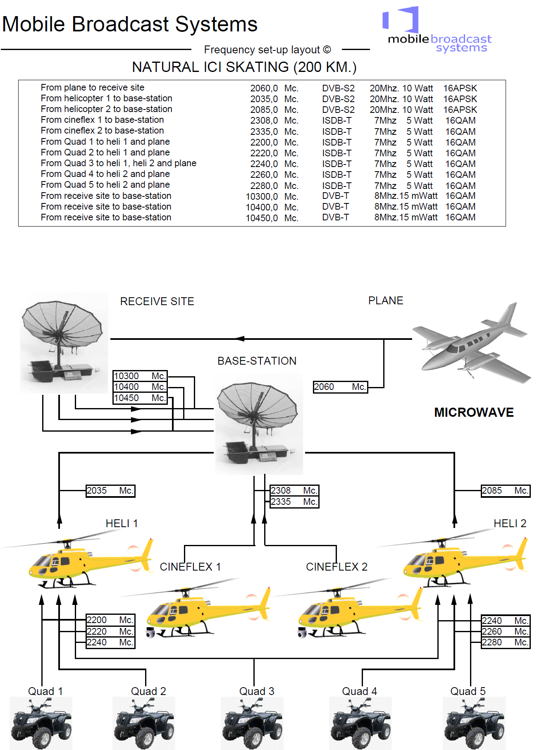

**Figure 10: Provision of video PMSE for ice skating championship**

1. lower saxony election 2013
2. Video PMSE usage for Lower Saxony election, 2013

| **Frequency in MHz** | **Service** | **Bandwidth** | **Location** | **Remarks** |
| --- | --- | --- | --- | --- |
| 2215.0 | camera | 18 MHz | Landtag | HD |
| 2236.5 | camera | 8 MHz | Köbelinger St / Am Markt | SD |
| 2250.0 | camera | 8 MHz | Landtag | SD |
| 2262.0 | camera | 8 MHz | Landtag | SD |
| 2275.0 | camera | 8 MHz | Landtag | SD |
| 2292.0 | camera | 18 MHz | Old Town Hall / Köbelinger St./ Karmarsch St | HD |
| 2312.0 | camera | 8 MHz | Landtag | SD |
| 2323.5 | camera | 8 MHz | Köbelinger St / Am Markt | SD |
| 2339.0 | camera | 18 MHz | Landtag | HD |
| 2356.0 | camera | 8 MHz |  | SD |
| 2370.0 | camera | 8 MHz | Landtag | SD |
| 2393.0 | camera | 18 MHz | Landtag | HD |
| 2491.0 | camera | 8 MHz | Köbelinger St / Am Markt | SD |

In total there were 13 video links and the total occupied bandwidth sums up to 144 MHz (without consideration of guard bands/separation distances between the applications or intermodulation effects).

Note: In Germany, the range 2347-2384 MHz is allocated for PPDR (audio & video) and may not be available for PMSE at future events because of the increased PPDR use.

1. list of reference
2. CEPT Report 50: Report A from CEPT to the European Commission in response to the Mandate on PMSE - Technical conditions for the use of the bands 821-832 MHz and 1785-1805 MHz for wireless radio microphones in the EU
3. ECC Report 002: SAP/SAB (Incl. ENG/OB) spectrum use and future requirements
4. ECC Report 204: Revision of ECC Report 002 (SAP/SAB (Incl. ENG/OB) spectrum use and future requirements)
5. ERC Report 38: Handbook on radio equipment and systems video links for ENG/OB use
6. ERC Recommendation 25-10 on Frequency ranges for the use of temporary terrestrial audio and video SAP/SAB links (incl. ENG/OB)
7. Questionnaire to CEPT administrations on the regulatory procedures used by administrations in granting access to spectrum for PMSE (<http://www.cept.org/ecc/topics/programme-making-and-special-events-applications-%28pmse%29>)
8. FOR LIMITING EXPOSURE TO TIME‐VARYING ELECTRIC, MAGNETIC AND ELECTROMAGNETIC FIELDS (UP TO 300 GHz) <http://www.icnirp.de/documents/emfgdl.pdf>
9. Commission Decision 2008/477/EC on the harmonisation of the 2500-2690 MHz frequency band for terrestrial systems TRA-ECS.
10. ECC Decision (05)05 on harmonised utilisation of spectrum for IMT-2000/UMTS systems operating within the band 2500-2690 MHz
11. EC Mandate on 2 GHz unpaired bands
12. ECC Recommendation (02)09: Protection of aeronautical radio navigation service in the band 2 700 – 2 900 MHz from interference caused by the operation of digital cordless cameras
13. ECC Report 006: Technical impact on existing primary services in the band 2700-2900 MHz due to the proposed introduction of new systems
14. ECC Recommendation (02)06 : “Channel arrangements for digital fixed service systems operating in the frequency range 7125-8500 MHz”
15. ITU-R Recommendation BT.2020

1. Programme Making includes the making of a programme for broadcast, the making of a film, presentation, advertisement or audio or video recordings, and the staging or performance of an entertainment, sporting or other public event.
2. A Special Event is an occurrence of limited duration, typically between one day and a few weeks, which take place on specifically defined locations. Examples include large cultural, sport, entertainment, religious and other festivals, conferences and trade fairs. In the entertainment industry, theatrical productions may run for considerably longer.
3. For further information see the ECC Report 002 [2]
4. See ERC Report 38 for further details
5. ISM – Industrial, Scientific and Medical
6. ERC Report 033 The use of radio frequencies above 20 GHz by fixed services and ENG/OB provides further information
7. Communication from the Commission to the European Parliament, the Council, the European Economic and Social Committee and the Committee of the Regions – Transforming the digital dividend into social benefits and economic growth /*COM/2009/0586 final*/
8. Proposal for a Decision of the European Parliament and of the Council establishing the first radio spectrum policy programme /*COM/2010/0471 final – COD 2010/0252*/
9. Large events may have much higher spectrum requirements. However, these are very local and may vary over time. Consequently, they are best addressed through national case by case solutions on the base of appropriate equipment standards that specify tuning ranges for equipment.
10. Decision 676/2002/EC of the European Parliament and of the Council of 7 March 2002 on a regulatory framework for radio spectrum policy in the European Community, OJL 108 of 24.4.2002.
11. 30 October 2009.