ECC Report **246**

Wideband and Higher DC Short Range Devices   
in 870-875.8 MHz and 915.2-920.8 MHz   
(companion to ECC Report 200)

**Approved 27 January 2017**

# Executive summary

This ECC Report complements the previous ECC Report 200 [1] that addressed possibility of using the frequency bands 870-876 MHz and 915-921 MHz for various Short Range Devices (SRD) and Radio Frequency Identification (RFID) applications. It showed that introduction of SRD/RFIDs in these bands would require restrictions in order to safeguard operation of several radiocommunication systems operated in those bands in some European countries, such as military Tactical Radio Relays or civil GSM-Railways. Details can be found in table 47 of ECC Report 200. ECC Report 200 outlined several solutions for ensuring co-existence, which could be used by the respective countries depending on which of those other systems they might have in actual operation. Ultimately, ECC Report 200 also offered a complete framework of technologically neutral SRD regulation suitable for many countries that did not have prior deployments in these bands and therefore could allow SRD/RFIDs deployed under “green field” conditions.

However, some additional developments had taken place since the completion of ECC Report 200, which warranted additional look at the situation around 870-876/915-921 MHz band, more specifically, in the sub-bands 870.0-875.8[1] MHz and 915.2-920.8 MHz. One of them was industry demand to consider more relaxed Duty Cycle (DC) limits for 25 mW non-specific SRD applications. Another one was the fast proliferation of wideband technologies, bringing the requirement of allowing channel bandwidth of up to 1 MHz, compared with 600 kHz considered and allowed according to findings of ECC Report 200. One example application that would be dependent on these new requirements was described in ETSI SRDoc TR 103 245 (November 2014) [2].

Therefore this report complements the previous intra-SRD and adjacent band studies and findings of ECC Report 200 (section 4.5 and 5 of ECC Report 200) by additional analysis of impact of the aforementioned new requirements for the intra-SRD deployment scenarios in “green field” conditions that is without consideration of need to share with any of the different radiocommunication services. So the conclusions derived in this report would affect only those conditions for SRD deployment that were outlined under the deployment Option D of the ECC Report 200 (“Countries that do not use the bands 870-876/915-921 MHz”). That means this Report is not applicable to countries with primary radio users in that band, such as TRR and UAV, GSM-R and wind profile radars. The relevant results for those countries are summarised in the executive summary of ECC Report 200 under Option A, B and C.

As conclusions of the analysis of this report, the following may be summarised.

* Wideband SRDs

The results of intra-SRD studies presented in Section 4.1 show that co-existence of new emerging WB SRD applications (25mW, 1MHz bandwidth, DC up to 2.8% for the network end-nodes and DC of up 10% for the Access Points) in the bands 870-875.8 MHz and 915.2-920.8 MHz, such as those implemented in accordance with TR 103 245, with legacy SRDs should be feasible on the assumptions that;

the existing SRD applications are using at least Category 2 receivers

WB SRDs use channel access mechanism with LBT functionality with a threshold of at least -75 dBm.

The results of analysis presented in section 4.2 indicate that the protection of public cellular systems below 915 MHz from WB SRDs with a bandwidth of 1 MHz and DC up to 2.8% for the network end-nodes and DC of up 10% for the Access Points may be achieved with the following assumptions:

A lower edge for IoT WB SRD tuning range is set to 915.8 MHz;

Unwanted emissions compliant with Mask Option 1 (see ANNEX 1: Figure 8:).

* Non-specific SRDs

The constituent partial solution of just relaxing DC limits for 25 mW Non-specific SRDs from 1% to 2.8% was considered as Case C in the simulations, and its results suggest that such relaxation of DC to 2.8% for Non-specific SRD with 25 mW output power (Type A as per Report 200 classification) may be allowed without additional conditions.

The simulations on the introduction of WB SRDs and relaxation of the duty cycle from 1% to 2.8% for non-specific SRDs were performed assuming a high density of these combined types of devices of 1000 per square kilometer and an indoor scenario, as this is considered to be predominant in real life.

**TABLE OF CONTENTS**

0 Executive summary 2

1 Introduction 7

2 New Considerations for SRD Applications 9

2.1 Requirement for Higher DC 9

2.2 Wideband SRD 10

2.3 Applications and parameters used in this report 12

3 Efficiency of CSMA-CA as Interference Mitigation Mechanism for WB SRD 15

3.1 Advanced Spectrum Sharing Capabilities 15

3.2 Impact on intra-band coexistence analysis 16

3.2.1 Intra-system 16

3.2.2 Inter-system 16

3.3 Impact on adjacent band coexistence analysis 17

4 Study of Introducing higher DC, higher bandwidth and LBT 21

4.1 Intra SRD studies 870-876 MHz anD 915-921 MHZ 21

4.1.1 Impact on Intra-SRD Sharing in 870-876 MHz 22

4.1.2 Impact on Intra-SRD/RFID Sharing in 915-921 MHz 28

4.1.3 Complementary calculations of LBT threshold values for WB SRDs 33

4.1.4 Summary Intra SRD 34

4.2 Impact on GSM/UMTS/LTE Uplink in adjacent band 34

5 Conclusions 45

ANNEX 1: SEAMCAT METHODOLOGY AND Scenario SETTINGs: UNWANTED EMISSION MASKS, RECEIVER SELECTIVITY, Antenna Gains AND OTHERs 46

ANNEX 2: Time domain considerations 59

ANNEX 3: 802.11ah spectrum emission mask lab measurements 65

ANNEX 4: co-existence between RFID and WB SRD 68

ANNEX 6: statistics on the household density in europe 71

ANNEX 7: Considerations that may worsen or improve co-existence Compared with Findings in section 4.2 72

ANNEX 8: List of referencES 74

**LIST OF ABBREVIATIONS**

|  |  |
| --- | --- |
| **Abbreviation** | **Explanation** |
| **ALD** | Assistive Listening Devices |
| **AP** | Access Point (wideband SRDs) |
| **APC** | Automatic Power Control |
| **BSS** | Base Station Subsystem |
| **CAGR** | Compound Annual Growth Rate |
| **C&C** |  |
| **CCA** | Clear channel assessment |
| **CEPT** | European Conference of Postal and Telecommunications Administrations |
| **CSMA-CA** | Carrier Sensing Multiple Access protocol with Collision Avoidance |
| **CW** | Contention Window |
| **DC** | Duty Cycle |
| **DCF** | Distributed Coordination Function |
| **DIFS** | DCF Inter-frame Spacing |
| **dRSS** | desired Received Signal Strength (term used in SEAMCAT) |
| **ECC** | Electronic Communications Committee of CEPT |
| **EDCA** | Enhanced Distributed Channel Access |
| **EFTA** | European Free Trade Association |
| **EN** | European Standard |
| **ETSI** | European Telecommunications Standards Institute |
| **EU** | European Union |
| **GSM** | Global System for Mobile Communications |
| **GSM-R** | GSM for Railways |
| **HA** | Home Automation SRD family |
| **IEEE** | Institute of Electrical and Electronics Engineers |
| **IL or ILK** | Interfering Link |
| **ILT** | Interfering Link Transmitter |
| **IoT** | Internet of Things |
| **IP** | Internet protocol |
| **iRSS** | interfering Received Signal Strength (term used in SEAMCAT) |
| **LBT** | Listen Before Talk (Transmit) |
| **LDC** | Low Duty Cycle |
| **M2M** | Machine to Machine communication |
| **M3N** | Metropolitan Mesh Machine Networks |
| **MAC** | Media-Access-Control |
| **MCL** | Minimum Coupling Loss |
| **NAP** | Network Access Point (high power SRDs) |
| **PA** | Power Amplifier |
| **PHY** | Physical Layer |
| **RFIC** | Radio Frequency Integrated Circuit |
| **RFID** | Radio Frequency Identification |
| **Rx** | Receiver |
| **SEAMCAT** | Spectrum Engineering Advanced Monte-Carlo Analysis Tool ([www.seamcat.org](http://www.seamcat.org)) |
| **SM** | Smart Metering |
| **SRD** | Short Range Device |
| **TR** | Technical Report |
| **TRR** | Tactical Radio Relays |
| **Tx** | Transmitter |
| **TXOP** | Transmit Opportunity |
| **UAV** | Unmanned Aircraft Vehicle |
| **UHF** | Ultra-High Frequency band (300-3000 MHz) |
| **VL or VLK** | Victim Link |
| **VLR** | Victim Link Receiver |
| **WB SRD** | Wideband SRD used in this report as synonym for devices according to IEEE 802.11ah |

# Introduction

This ECC Report continues a series of studies undertaken by CEPT in fulfilment of its Roadmap for review of spectrum requirements for various Short Range Devices (SRD) and Radio Frequency Identification (RFID) applications in the UHF spectrum below 1 GHz. One of these lines of inquiry looked at the possibility of opening frequency bands 870-876/915-921 MHz for the broad variety of existing as well as newly emerging SRD applications. As a result, ECC Report 200 [1] was approved and published in September 2013. It showed that introduction of SRD/RFIDs in these bands would require striking a delicate balance in order to safeguard operation of several radiocommunication systems operated in those bands in some European countries, such as military Tactical Radio Relays (TRR) or civil GSM-Railways. Therefore Report 200 outlined several possible solutions for ensuring viable co-existence, which could be used by the respective countries depending on which of those other systems they might have in actual operation. Ultimately, the Report also offered a complete framework of technologically neutral SRD regulation suitable for many countries that did not have prior deployments in these bands and therefore could allow SRD/RFIDs deployed under “green field” conditions.

However, some additional developments had taken place since the completion of ECC Report 200, which warranted additional look at the situation around 870-876/915-921 MHz band, more specifically, in the sub-bands 870.0-875.8 MHz and 915.2-920.8 MHz (more details are given in ECC Report 189 [5]). Figure 1: shows for example the approach taken in ECC Report 189 [5] for the band 915-921 MHz.



1. Overview 915-921 MHz from [5]

One of these new developments was industry demand to consider more relaxed Duty Cycle (DC) limits for 25 mW non-specific SRD applications. Another one was the fast proliferation of wideband technologies, bringing the requirement of allowing channel bandwidth of up to 1 MHz, compared with 600 kHz considered and allowed according to findings of ECC Report 200.

Therefore this Report was conceived as a companion to ECC Report 200, with a view on possibly complementing the SRD regulatory framework in the 870.0-875.8/915.2-920.8 MHz with additional provisions for less restricted DC operations and wider channels. Several important notes derive from the fact of the complementarity to the ECC Report 200:

* this Report should be seen only as providing additional information and studies on the specific subjects; it therefore neither diminishes nor disregards the remaining issues that were considered and findings provided in the ECC Report 200, most notably as regards co-existence with other radiocommunication services and applications;
* as the ECC Report 200 has already shown that previously studied SRD applications have little room for sharing spectrum with other radiocommunication services and applications (TRR, GSM-R, UAV C&C), this Report analyses only the impact of newly proposed technological SRD evolutions in greenfield SRD scenarios, i.e. possible changes to SRD regulatory framework outlined as Option D in the ECC Report 200;
* this Report avoids repeating any materials that had been already presented in the ECC Report 200, instead using direct cross-referencing to relevant sections therein where necessary;
* similarly, all methodology and scenarios for co-existence analysis are used as they were developed for ECC Report 200, and this Report reviews only the amendments to those scenarios required to address the objectives of this Report;
* It should be therefore obvious that also the studies in this Report should be seen as complementing rather than substituting or superseding those of the ECC Report 200.

# New Considerations for SRD Applications

## Requirement for Higher DC

The general description of various applications and in-depth analysis of technical parameters for SRDs envisaged to be used in the bands 870-876/915-921 MHz are provided in ECC Report 200 [1] (Section 3 and ANNEX 1:).

One of the key premises for analysing impact of non-specific/generic SRDs (i.e. what was termed “Non-specific SRD Type A” in the ECC Report 200) in the subject band had been that they would be operated with 25 mW and a DC of up to 1%. However lately SRD industry voiced their opinion that this limits for Type A non-specific SRDs need to be lifted to around 2.8%, which would better correspond to modern operational realities for SRD applications in this frequency range. Most notably, the proliferation of various Machine-to-Machine (M2M) communication circuits and applications means that their nodal points would see increased traffic compared with traditional human-centric operations of SRDs.

Subsequently, the ETSI moved this concept further with developing TR 103 245 [2], which promotes the use of M2M and its evolution to increasingly interconnected “Internet-of-Things” (IoT) applications. While functionally similar, the key conceptual difference between M2M and IoT is that while M2M was traditionally limited to communication within a closed group of devices and using some dedicated/proprietary networking protocols (e.g. Smart Home network that links to central home management console a wide range of wireless sensors, sub-metering devices, actuators spread around the house; or on a different level, an utility-driven metropolitan network for Smart Metering, etc.), the IoT takes the concept further by envisaging that various wireless M2M devices, networking end-nodes, would eventually each have their own IP addresses assigned and thus allow more ubiquitous connectivity and communication using standardised TCP/IP protocols. This would also allow developing much wider plethora of wirelessly connected IoT devices, e.g. a very new and explosively growing category of personal “wearable” devices, such as smart watches, smart glasses, fitness trackers, or smart garments. The broad diffusion and ubiquitous connectivity of IoT devices would need to rely on providing some minimal networked infrastructure, akin to today’s Wi-Fi networks with “hot spot” access points spread to offer wireless connectivity in some key locations with anticipated high demand. Some of the examples of IoT/M2M applications and their anticipated market uptake are quoted in TR 103 245 [2] based on reports of industry analysts, for instance:

* globally installed base of wirelessly connected devices will grow from over 10 billion units in 2013 to over 30 billion units in 2020;
* the market for new installs of Home Automation systems in Europe is expected to grow by 40% (CAGR) between 2014 and 2019 to 7.3 million in 2019;
* the unit shipment volume market for the emerging "Wearable" technology in Europe is projected to be around 70 million units in 2018. This market (e.g. for smart watches, fitness trackers, etc.) is projected to have a high wireless connectivity attach rate (over 60 %).

The TR 103 245 argues that with anticipated demand for such services, it is indispensable to offer Wi-Fi like connectivity in some lower UHF band, such as 870-876/915-921 MHz bands, in order to have reliable connectivity with minimized battery drain. It further suggests that in order to cope with growing IoT traffic, the network end-nodes should be allowed to operate with DC of up to 2.8% while the Access Points (AP) may need DC of up to 10%.

Therefore this Report looks at the impact of allowing such increased DC values for 25 mW non-specific SRDs including those to be used for M2M/IoT, to the intra-SRD co-existence scenarios and to the cellular networks in adjacent bands previously studied in the Report 200.

## Wideband SRD

At the time of writing of ECC Report 200 [1] it was considered that 600 kHz maximum channel bandwidth would be adequate to model the channelling options for SRDs.

The extraordinary success and global proliferation of IEEE 802.11-based communications meant that industry and consumers alike turned their attention to increasingly higher bitrates to be achieved for supporting the plethora of personal as well as M2M communications in always-on mega-Internet environments, what later became known as IoT. To cater for this growing demand, IEEE has developed standard 802.11ah that addresses possibilities of achieving energy efficient wideband communications in M2M and IoT use scenarios. It was also felt crucial by the industry that possibility of deploying new wideband M2M/IoT applications, such as those provided for under IEEE 802.11ah [3], exists in sub-1 GHz bands.

To that effect, ETSI has developed and submitted to CEPT a System Reference Document TR 103 245 [2] , which addresses scenarios of deploying wideband SRDs with advanced spectrum sharing capabilities in the bands 870-876/915-921 MHz. One of the key premises of this new technology is that it would require channel bandwidth of at least 1 MHz in order to provide the anticipated services. As ETSI recognised that the proposed wideband applications would be deployed in generic non-interference non-protected conditions of band shared with other SRDs, the TR 103 245 describes using of advanced spectrum sharing capabilities by IEEE 802.11ah in order to ease sharing by mitigating possible interference in both directions. The key element of the proposed mitigation mechanism is that IEEE802.11ah would use Carrier Sensing Multiple Access protocol with Collision Avoidance (CSMA-CA). This procedure allows for a distributed control of channel access that aims to reduce collisions between transmissions while allowing for fairness in transmit opportunities. Additionally, the CSMA-CA protocol accounts for coexistence and spectrum sharing with non-IEEE 802.11ah technologies through the use of Energy Detection-based deferral. This procedure detects for all transmissions in the subject channel independent of transmission pattern, modulation type, etc., based on measured received energy. Further technical details of practical implementation of CSMA-CA in IEEE802.11ah applications and analysis of its impact on co-existence in both intra-band and adjacent-band scenarios are provided in Chapter 3.

This Report therefore considers possibilities of allowing channel bandwidth of up to 1 MHz associated to duty cycle up to 2.8% for end-nodes or up to 10% for AP type of devices with advanced wideband communication technologies according TR 103 245 [2].

This two-tier structure is illustrated in the following Figure 2: reproduced from the ETSI SRDoc. This concept is also very similar to the concept of utilities infrastructure envisaged in ECC Report 200 for professional Metropolitan Mesh Machine Networks (M3N) and Smart Metering (SM) applications. The key difference would be that the M3N/SM would have metropolitan level networking infrastructure with 500 mW 200 kHz-channel outdoor-mounted Network Access Points, whereas the wideband applications envisaged in TR 103 245 would be low power and predominantly indoor applications with channel bandwidth of up to 1 MHz.



1. An illustrative example of IoT network, reproduced from ETSI TR 103 245 [2]

It is therefore important to make separate entries for simulation of respectively end nodes vs. network APs. However since both these device types would have the same physical interface, the only different settings distinguishing the two types of devices in the simulations would be the different DC (2.8% for end nodes vs. 10% for APs) and the different deployment density.

Next it is important to agree on the respective densities of constituent network elements. Since TR 103 245 did not provide specifics on expected densities of proposed WB IoT devices, a reasonable starting point would be to assume densities similar to IoT-like applications such as SM/M3N networks discussed in 5.1 and ECC Report 200, i.e. approx. 2000/km2 for terminal devices and 100/km2 for network nodes/access points in urban areas. However, noting that the prime target for deploying 802.11ah devices remains the 870-876/915-921 MHz, it may be hypothesised that a complementary deployment of WB IoT devices in the band 862-868 MHz would constitute half of that number, i.e. 1000/km2 active terminal devices and some 50/km2 access points.

Statistics on the number of households per square kilometre are given in ANNEX 6: and they indicate for densely populated areas of the EU-28 and EFTA countries on average 584 households per square kilometre. The highest densities are found in the cities of Paris and London with 11067 and 4423 households per square kilometre.

The resulting set of assumptions for DC, densities and resulting number of potentially interfering transmitters to be considered representative of two layers of proposed WB IoT SRD networking applications is given in section 2.3. Further information as regards assumptions used for masks may be found in Annexes ANNEX 1: and ANNEX 3:

## Applications and parameters used in this report

The below assumptions are based on the existing regulation in ERC/REC 70-03 including the “Low Duty Cycle” (LDC) bands 870-870.2, 915-915.2 and 920.8-921 MHz.

1. Applications and parameters for studies in the band 870-876 MHz

| Parameters  (Note 1) | Applications | | | | |
| --- | --- | --- | --- | --- | --- |
| **Portable alarms** | **Smart Metering** | **Non-specific SRDs  (IoT including home automation)** | **Automotive** | **Sub-metering** |
| ERC/REC 70-03 entry | Annex 1, g2 | Annex 2, c | Annex 1, g2.1 | Annex 5, a | Annex 1, g2 |
| Frequency range | 875.8-876 MHz | 870.0-875.6 MHz | 870-875.8 MHz | 870-875.8 MHz | 870-876 MHz |
| Tx power e.r.p. | 14 dBm  (ECC Report 200 assumed 20 dBm) | 27 dBm | 14 dBm | 27 dBm | 14 dBm |
| Tx mask and Receiver selectivity | See ANNEX 1: | | | | |
| Duty Cycle limit | 0.1% | Low DC terminal nodes: 0.1%  High DC terminal nodes: 2.5%  NAPs: 10% | ECC Report 200: 1%  **New request**: **IoT Non-specific SRDs & WB SRD Terminal nodes**  **2.8 %**  **WB SRD AP:**  **10 % DC** | 0.1% | 0.1% |
| Average DC per hour (input for simulations) | Same as DC limit | Same as DC limit | Same as DC limit | Same as DC limit | 0.0025 % |
| Bandwidth | 25 kHz | 200 kHz | ECC Report 200: 600 kHz  **New Request for WB SRD:** **1 MHz** | 500 kHz | 200 kHz |
| Sensitivity as victim | -105 dBm/25 kHz | N/A | N/A | N/A | -96 dBm/200 kHz |
| C/I criterion as victim | 8 dB | N/A | N/A | N/A | 8 dB |
| Typical operational range urban environment | 100 m | 300 m | 155 m | 300 m | 155 m |
| Simulation radius m | 130 m | 200-300 m | 85-155 m | 200-300 m | 155 m |
| Assumed average density per km2 | 12 | Low DC terminal nodes: 1900  High DC terminal nodes: 90  NAPs: 10 | ECC Report 200: 1000/500  **New request:**  **IoT incl. WB SRD Terminal nodes:**  **1000/500**  **WB SRD AP: 50/25** | 80 | 50000/25000 |
| Comments | Existing application from ECC Report 200 | Existing application from ECC Report 200 | New application with increased Dc from 1% to 2.8% (Terminal) and 10 % (AP) and BW from 600 kHz to 1 MHz | Existing application from ECC Report 200 | Existing application from ECC Report 200 |
| Considered as victim and interferer | Only considered as interferer | Only considered as interferer | Only considered as interferer | Considered as victim and interferer |

Note 1: Most of the parameters were taken from ECC Report 200 (section 5)

It is assumed that the portable alarms represent the worst sharing case but are most likely to use the safe harbour bands; their use of the band 870-875.8 MHz is opportunistic.

1. Applications and parameters for studies in the band 915-921 MHz

| Parameters  (Note 1) | Applications | | | | |
| --- | --- | --- | --- | --- | --- |
| **RFID**  Note 4 | **Non-specific SRDs type A (IoT, including Home Automation)** | **Non-specific SRDs type B** | **ALD** | **Sub-metering** |
| ERC/REC 70-03 entry | Annex 11, c | Annex 1, g3.1 | Annex 1, g3.1 | Annex 10, c1 | Annex 1, g3 |
| Frequency range | 916.3; 917.5; 918.7; 919.9 MHz; | 915.2-920.8 MHz | 916.3; 917.5; 918.7; 919.9 MHz; | 916.3; 917.5; 918.7; 919.9 MHz; | 915-921 MHz |
| Tx power e.r.p. | 20 dBm  *Note 2* | 14 dBm | 20 dBm | 10 dBm | 14 dBm |
| Tx mask and Receiver selectivity | See ANNEX 1: | | | | |
| Duty Cycle limit | 100% | ECC Report 200: 1%  **New request:**  **IoT Non-specific SRD and WB SRD Terminal nodes 2.8 % IoT AP 10%** | ECC Report 200: 1% | 25% | 0.1% |
| Average DC per hour (input for simulations) | 2.5% | Same as the DC limit | Same as the DC limit | Same as the DC limit | 0.0025% |
| Bandwidth | 400 kHz | ECC Report 200: 600 kHz  **New Request for WB SRD:** **1 MHz** | 400 kHz | 200 kHz | 200 kHz |
| Sensitivity as victim | dRSS distribution | N/A | N/A | N/A | -96 dBm/200 kHz |
| C/I criterion as victim | 12 dB | N/A | N/A | N/A | 8 dB |
| Typical operational range urban environment | 90 m | 60 m | 90 m | 50 m | 155 m |
| Assumed average density per km2 | 480 | ECC Report 200: 500/250  **New Request:**  **IoT incl. WB SRD Terminal nodes**  **1000/250**  **WB SRD AP: 50/12**  *Note 3* | 500/250 | 40 | 50000/25000 |
| Comments | Existing application from ECC Report 200, | New application with increased DC from 1% to 2.8% (Terminal) and 10 % (AP) and BW from 600 kHz to 1 MHz | Existing application from ECC Report 200 | Existing application from ECC Report 200 | Existing application from ECC Report 200 |
| Considered as victim and interferer  (ALD is assumed not to operate in the same location as RFID) | Only considered as interferer | Only considered as interferer | Only considered as interferer  (ALD is assumed not to operate in the same location as RFID) | Considered as victim and interferer |

Note 1: Most of the parameters were taken from ECC Report 200 (section 5).

Note 2: RFID transmits using directional antenna with a resulting e.r.p. of up to +36 dBm, however, in most cases they will be deployed in a semi-shielded environment, and pointed downwards, meaning that their environmental emission levels should be comparable to those from an SRD transmitting with e.r.p. of +20 dBm.

Note 3: The density was increased compared to ECC Report 200 for Type A from 500 to 1000 to account for the new introduced IoT application.

Note 4: A set of more optimistic RFID assumptions have been used for the adjacent band studies in section 4.2(see Table 10:).

It should be noted from Table 1:and Table 2: that for majority of analysed applications the DC for all simulated devices was set to maximum allowed limit, which is absolute worst case assumption as it may be otherwise assumed that in real life not all devices would be reaching their DC limit for most of the time.

# Efficiency of CSMA-CA as Interference Mitigation Mechanism for WB SRD

This chapter analyses how the use of CSMA-CA spectrum access scheme would impact the SEAMCAT simulation results presented in this report. Indeed the main limitation of the simulations performed in this study is the lack of time domain modelling in SEAMCAT tool. In other words, SEAMCAT tool assumes that each interfering node is independent of each other and only a DC is applied to the transmission pattern. This does not reflect the nature of proposed WB SRD applications based on IEEE 802.11ah standard, which is instead a coordinated system. The following sub-sections first of all give a general description of 802.11ah spectrum access mechanism and then describe its benefits as interference mitigation factor to both adjacent band and intra-SRD coexistence.

## Advanced Spectrum Sharing Capabilities

In accordance with ETSI TR 103 245 [2], the IEEE 802.11ah-based system employs a Distributed Coordination Function (DCF) for enabling spectrum sharing and allowing for contending devices to fairly contend for and transmit on the medium. The procedure, which is inherited from prior IEEE 802.11 systems, is based on a Carrier Sense Multiple Access protocol with collision avoidance (CSMA-CA) that all devices are required to follow prior to transmitting. This procedure allows for a distributed control of channel access across devices and across BSSs (Base Station Subsystem) that aims to reduce collisions between transmissions while allowing for fairness in transmit opportunities.

Reducing the number of collisions translates into reducing the amount of cumulative interference caused to other in-band and in adjacent bands systems.

The IEEE 802.11ah CSMA-CA is based on a slotted timeline, where the physical (PHY) layer, i.e. the RF front-end of the radio device, provides channel "busy" or "idle" indications to the Media Access Control (MAC) layer based on a Clear Channel Assessment (CCA) procedure. The MAC layer will use these indications from the PHY to drive its countdown/back-off procedure. A device is permitted to transmit only once the MAC countdown/back-off procedure is completed. The duration for which the device is granted channel access is termed a Transmit Opportunity, or TXOP.

The PHY layer is responsible for performing the CCA: monitoring the contended channel of interest for ongoing traffic or interference and declaring to the MAC whether the channel (i.e. medium) can be considered "busy" or "idle". The conditions for declaring "busy" and "idle" are dependent on checking for both intra‑technology and inter-technology traffic on the medium as described below.

The MAC layer performs Enhanced Distributed Channel Access (EDCA, or more descriptively, CSMA-CA with an exponential random back-off/countdown) based on the "busy" or "idle" indications generated by the PHY for the channel of interest. Once the channel has been considered idle for an accumulated duration of time, the device is given access to the channel and may transmit.

When a device wants to access the channel to transmit, it will start the EDCA procedure in the MAC. The first step is waiting for the channel to be idle: if the channel is busy with other traffic or interference (as indicated by the PHY), it should wait until the CCA indication transitions to "idle".

Once the channel is idle, the device will monitor the channel for an additional DIFS (DCF Inter-frame Spacing) duration, defined in IEEE 802.11ah to be 264 us. If the channel remains idle continuously for at least a full DIFS duration, it can then start the binary exponential random back-off process. The device will randomly choose a back-off countdown value between [0, CW] where CW is the initial Contention Window size parameter. The unit of the countdown value is a number of slots.

During the back off, the countdown value is decremented at every slot if the CCA indication from the PHY for that slot shows idle. If the counter is successfully decremented to 0 without interruption, the device will gain access to the channel to transmit.

However if at any point during the countdown procedure, the MAC receives a CCA indication of "busy" from the PHY, the countdown is temporarily halted. The device will then wait for the on-going traffic to clear and for the CCA indication from the PHY to return to "idle". Once the CCA indication is "idle", the device will again need to observe that the channel remains idle for an additional continuous DIFS duration. After this is satisfied, the device will resume the countdown procedure, picking up the counter value where it left off previously.

After the device is given access to the channel and transmits its data, it will wait for an acknowledgement (i.e. ACK response) indicating successful reception of the packet at the other end. In IEEE 802.11ah [2], the receiver of any packet is required to generate an ACK response within a Short Inter-frame Spacing (SIFS) duration, which is 160 us. The receiving device does not need to repeat the LBT procedure for transmitting the ACK response. If a negative acknowledgement or no response is received, and the device wishes to retransmit the data, the same EDCA procedure will be repeated again for access to the channel. However in this instance the randomly chosen back-off counter value will be taken from a larger set (e.g. {0, CW_init × 2^failed attempts – 1}, such that the initial contention window range increases exponentially with every subsequent packet failure/retransmission). The maximum size of this set is determined by the CWmax, defined according to the AC of the device.

Note that the exponential back off of the contention window will increase the average time after which a device can transmit. Therefore this mechanism will have a significant impact in the high dense scenarios analysed in this report. This behaviour is not taken into account in SEAMCAT simulations.

## Impact on intra-band coexistence analysis

As described in the previous section, the combination of PHY layer CCA and MAC layer EDCA allows 802.11ah devices to strongly reduce the amount of intra-band interference.

The different impact between intra-system and inter-system interference depends on the different detection threshold adopted by the 802.11ah PHY layer, this is described in next sub-sections.

### Intra-system

For intra-technology coexistence, to prevent devices from transmitting over on-going IEEE 802.11ah traffic and causing collisions, the PHY layer detects for valid IEEE 802.11ah frames in the channel being monitored. The required sensitivities depend on the bandwidth of the channel being monitored and the measurement intervals depend the type of detection being performed. When signals are detected according to this criterion, the channel is declared "busy", otherwise the channel is "idle". As a point of reference, 802.11ah devices must detect and defer to 1MHz 802.11ah transmissions at levels down to -98dBm.

### Inter-system

The CSMA-CA protocol accounts for coexistence and spectrum sharing with non-IEEE 802.11ah Technologies through the use of Energy Detection-based (ED) deferral. This procedure detects for all transmissions on the medium independent of transmission pattern, modulation type, etc., based on measured received energy. The energy detection sensitivity for the 1 MHz operation bandwidth is   
-75 dBm / 1 MHz, with the signal energy level measured at each receiving antenna. The observation duration is 40 us, meaning that if any signal is detected above the detection sensitivity threshold, and continues to exceed the threshold for at least 40 us, the PHY layer declares that the channel is "busy". The -75 dBm / 1 MHz level should be checked for compatibility with other systems.

Therefore, based on the above observations a system employing CSMA-CA with Energy Detection deferral could significantly mitigate the probability of collisions. Again, it is worth highlighting that the benefit of having ED will have significant impact in the most dense deployment scenarios. Indeed, 11ah devices will defer to on-going transmissions detected as low as -75dBm/1MHz, which likely will include other technology devices within closest proximity (i.e. those that would be most affected by the interference).

ECC Report 181 [6] discusses various cases of systems using channel sensing. Section 3.3.2 of ECC Report 200 [1] analyses the case considered here (one system using LBT and the other not). It shows that, in certain circumstances, the packet collision rate is approximately halved compared to the case where neither system uses LBT. If both systems use LBT then the collision rate can be almost eliminated, so the effect of only one system using LBT can be seen as providing half the benefit.

This result applies assuming:

* No hidden nodes;
* Victim and interferer have the same packet length;
* One device of each system rather than populations of each.

It should be noted. However, that this halving of the interference effect applies to the packet collision rate or packet loss rate (PLR) and this may not be equal to the probability of interference derived from SEAMCAT.

## Impact on adjacent band coexistence analysis

When analysing the impact on adjacent systems (see SEAMCAT simulations in section 4.2), the access mechanism implemented by 802.11ah nodes should be also taken into account. Indeed the collision avoidance mechanism will lower the total amount of simultaneous transmissions, thus reducing the overall RF leakage in the adjacent bands. Unfortunately, because of SEAMCAT limitations, it is not easy to quantify this effect. Indeed, following the approach used in ECC Report 200 [1], each 802.11ah node will transmit based on a transmission probability given by the Duty Cycle (DC). Therefore, coordination and deferral mechanism are not taken into account at all in the simulation presented in this report.

In IMST study [4], a very detailed comparison between different access schemes was presented. In particular, a comparison between DC based random access and CSMA-CA LBT scheme was analysed. While the actual performance depends on the actual LBT parameters, conclusions of the report clearly emphasized that much higher DC value can be assumed for LBT systems.

Assuming a random access based on DC we can estimate the collision probability for node *n* by following [4]:

$$P_{coll}\left(n\right)=1- \prod_{\begin{matrix}m=1 \\ m≠n\end{matrix}}^{N}{max\left(0,1-\frac{T_{tx,m}+T_{tx,n}}{T_{int,m}}\right)}$$

where $T_{tx,i}$ is the on-time duration for node *i* and $T_{int,i}$ is the repetition period for node *i*.

Let us assume a 20 to 1 split between STAs (station=terminal) and APs. In other words, on average 20 STAs belong to the same BSS. Let us call $T_{tx,STA_{i}}$ and $T_{tx,AP_{j}}$ the on time duration for STA *i* and AP *j*, respectively. $T_{int}$ is the repetition interval for both STA and AP. In this particular scenario we can derive the probability of collisions for both STA and AP:

$$P_{coll,STA}= 1-{\left(1-2DC_{STA}\right)}^{19}\left(1-DC_{STA} DC_{AP}\right)$$

and

$$P_{coll,AP}= 1-{\left(1-2DC_{STA}\right)}^{20}$$

where $DC_{STA}$ and $DC_{AP}$ are the STA and AP duty cycle respectively. By assuming $DC_{STA}=2.8\%$ and $DC_{AP}=10\%$ we get $P_{coll,STA}=66.6\%$ and $P_{coll,AP}=68.42\%$. Therefore in the scenario we are considering, i.e. a scenario in which on average a BSS is composed of 20 STAs, if uncoordinated nodes are assumed the probability of collision is significantly high. On the other hand a 802.11ah system will minimize the total amount of collisions thanks to LBT and CSMA-CA schemes. Therefore, from a collision point of view a system employing CSMA-CA with LBT the DC allowed should be much higher compared to a system based on random DC access. This is line with conclusions in [4].

The above considerations could be then applied to interpret the results of simulations generated in this report. SEAMCAT does not emulate the time domain evolution of the system. In other words each simulation snapshot is independent and uncorrelated with respect to the previous one. Therefore in a given snapshot each node can transmit or not based on his DC. Focusing on one BSS, we can estimate the probability that simultaneous transmissions from more than one node happen. This will be given by the probability that AP is transmitting and one or more STAs are transmitting at the same time plus the probability that APs is not transmitting and 2 or more STAs are transmitting at the same time. In formulaic expression:

$$P_{BSSColl}=DC_{AP} \sum_{i=1}^{20}{\frac{20!}{i!\left(20-i!\right)}} DC_{STA}^{i}{\left(1-DC_{STA}\right)}^{20-i}+(1-DC_{AP}) \sum_{i=2}^{20}{\frac{20!}{i!\left(20-i!\right)}} DC_{STA}^{i}{\left(1-DC_{STA}\right)}^{20-i}$$

For the case of interest, the $PBSScoll$, i.e. the probability to have more than 1 transmission in a BSS is 13.9%. Therefore on average in 13.9% of the simulated snapshots, interference to adjacent systems will be created by more than one node in the BSS. When multiple BSS are considered the probability that one strong interference case is generated in one snapshot will be also higher.

Compared to the behaviour of a real 802.11ah this behaviour is extremely pessimistic. Indeed, when considering a CSMA-CA scheme with LBT the following considerations need to be taken into account:

* Within the BSS when AP is transmitting associated STAs cannot transmit. Just considering this factor, the probability of simultaneous transmission will go down to 9.7% (only second term in previous equation needs to be considered);
* Collisions can happen because of hidden nodes or STAs finishing count down at the same instant. However it can be noted that:
* In a scenario with potential hidden nodes, an 11ah AP has scheduling techniques available to mitigate scenarios (e.g. RTS-CTS, TWT, RAW, etc.);
* In case of multiple stations with same back-off counter values, because of the exponential random back-off the chance of repeated collisions becomes more and more rare.

Based on the observations above, the simulation of 802.11ah-based WB SRD applications would lead to much better results in terms of cumulative generated interference in adjacent bands compared to the results generated in this report. Indeed, the actual number of nodes transmitting at the same time will be much lower compared to the way simulated in SEAMCAT.

The fact the collision avoidance mechanism is not taken into account needs to be considered in interpreting SEAMCAT results. Especially in the high dense scenario case, i.e. the more critical one in terms of interference to other systems, both in-band/intra-SRD and adjacent band. It may be expected that the system impact of the higher DC to be mitigated by CSMA-CA. This distributed coordination allows IEEE 802.11ah-based devices to avoid collisions even with devices not implementing LBT-techniques, and ultimately will lead to a more efficient utilization of the spectrum.

To further quantify the impact of coordination in case of coordination across nodes, a simplistic analysis can be carried out by considering a scenario in which hidden nodes are not present within the same BSS, i.e. RTC-CTS and other mechanisms are in place and allow to mitigate the impact of hidden nodes. For this very low duty cycle we can also assume that the probability of collisions due to same back-off number will be very low and, in case of collisions, exponential back-off mechanism will kick in thus reducing the number of future collisions. As mentioned before, in such as scenario we can assume that within one BSS only one node can transmit at a given time, i.e. perfect coordination is achieved within the BSS. With this assumption we can estimate the difference in terms of number of simultaneously transmitting nodes between a pure duty cycle system and a coordinated system. Let us call $N_{AP}$ and $N_{STA}$ the number of active AP and STA simulated, respectively. In case of pure duty cycle (uncoordinated) system, the average number of simultaneously transmitted nodes in each snapshot can be calculated as:

$$N_{TX,noCoord}= N_{AP}DC_{AP}+N_{STA}DC_{STA}=N_{AP}\left(DC_{AP}+K_{BSS}DC_{STA}\right)$$

where $DC_{STA}$ and $DC_{AP}$ are the STA and AP duty cycles respectively, whereas $K_{BSS}$ represents the number of STAs within one BSS ($K_{BSS}=20$ is assumed in the report). Following the above assumptions, in case of coordination within the BSS we can assume that either AP or one STA are transmitting at the same time.

$$N_{TX,Coord}=\left[DC_{AP} +(1-DC_{AP}) \sum_{i=1}^{K_{BSS}}{\frac{K_{BSS}!}{i!\left(K_{BSS}-i!\right)}} DC_{STA}^{i}{\left(1-DC_{STA}\right)}^{K_{BSS}-i}\right]N_{BSS}$$

The expression in square brackets represents the probability that either one AP or at least one STA needs to transmit within the same BSS. Since $N_{AP}=N_{BSS}$, we can write:

$$\frac{N_{TX,Coord}}{N_{TX,NoCoord}}=\frac{DC_{AP} +(1-DC_{AP}) \sum_{i=1}^{K_{BSS}}{\frac{K_{BSS}!}{i!\left(K_{BSS}-i!\right)}} DC_{STA}^{i}{\left(1-DC_{STA}\right)}^{K_{BSS}-i}}{DC_{AP}+K_{BSS}DC_{STA}}$$

Therefore the ratio between simultaneous transmission in case of no coordination and coordination does not depend on the number of BSS/AP. In case of $DC_{AP}=0.1, DC_{STA}=0.028 and K_{BSS}=20$ we get $\frac{N_{TX,Coord}}{N_{TX,NoCoord}}=0.74.$ In other words, in case of coordination within each BSS the number of simultaneously transmitting nodes will be 26% lower compared to the case of pure duty cycle systems. Figure 3: shows the average number of simultaneously transmitting nodes as a function of the AP density. A circular area of 0.5km radius and 20 STAs per BSS are taken into account. As it can be noted the ratio between the coordinated and non-coordinated case is constant, and in this case equal to 74%.



1. Impact of coordination within BSS on the number of simultaneously transmitting nodes

The above analysis confirms that coordination across nodes will play an important role in lowering the amount of cumulative interference.

Another important consideration is related to interaction across different BSS. Nodes belonging to different BSS will be able to “listen” each at other’s preambles at a very low threshold (much lower compared to the energy detection threshold). This means that in case BSS are close to each other, the total number of simultaneous transmissions will be further lowered down due to preamble detection across BSS. This is particularly true when nodes distribution is not uniform (which is the case in realistic deployment). Figure 4: shows a comparison between uniform uncoordinated deployment and clustered coordinated deployment. In the left figure each node is uniformly distributed within the dropping area (circular area of 500m radius in the example). In the right part of Figure 4:, the nodes are clustered to emulate deployment of a BSS, each cluster having radius of 30 m.

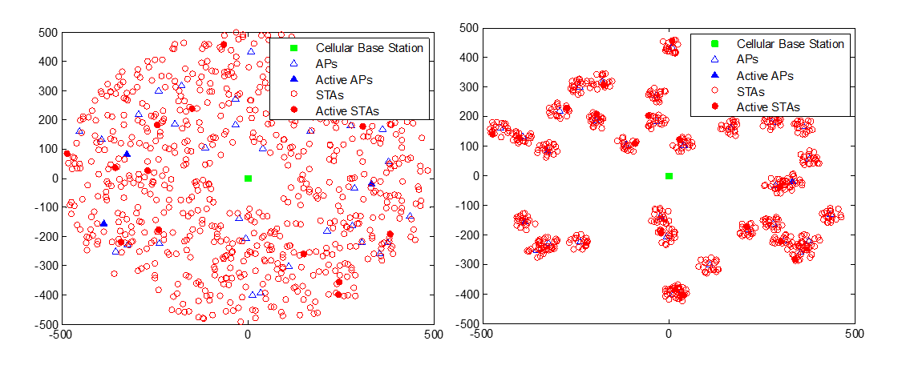

1. Uniform vs not uniform nodes placement

Finally, another factor, which will result in lowering the amount of simultaneous transmissions, is related to the inter-system LBT. As already described in the report, 802.11ah nodes will perform LBT based on energy detection. Therefore, each technology operating in the band can potentially trigger a back-off procedure for 802.11ah nodes. This cannot be simulated in SEAMCAT, however such interference-reducing factor will have impact when looking at the adjacent channel coexistence simulation. Indeed, in that case LBT would help to lower the peak interference created by the mix of devices operating in the band. This is particularly true in case of dense and not uniform scenarios.

To summarise, the following additional mitigating factors where not accounted for in simulations reported in this document, but are expected to have practical impact towards reducing the real risk of cumulative interference from WB SRDs:

* In case of coordinated deployment only one node transmits within each BSS;
* When two BSS are within the preamble detection threshold, LBT mechanism will ensure that the nodes belonging the two BSS will not transmit simultaneously;
* The overall amount of interference created by 802.11ah operating in mixed scenarios will be mitigated by detecting energy of other technologies operating within the same band.

# Study of Introducing higher DC, higher bandwidth and LBT

As described above, this study re-considers the scenarios of the original ECC Report 200 [1] (see chapter 5 of ECC Report 200). It looks at the scenarios where non-specific SRD with DC of 1% and a bandwidth of 600 kHz was considered as interferer and re-does the simulations with DC increased to 2.8% (and up to 10% for IoT access points), bandwidth increased to 1 MHz and LBT introduced, all in the bands 870.0-875.8/915.2-920.8 MHz, so that the effect of this proposed change could be evaluated.

## Intra SRD studies 870-876 MHz anD 915-921 MHZ

This study uses the same assumptions and scenarios as were used in the ECC Report 200 (cf. section 5.1 of ECC Report 200) for intra-SRD analysis. These are all derived from key Mixed-SRD scenario in a dense urban environment, whereas one of the SRDs acts as a victim, while other representative SRD families (including the focus of this study - non-specific SRD with proposed increased DC and bandwidth) acting as interferers. Since the only need is assessing the effect of increasing one parameter; the “sensitivity analysis” looks only at those victims that were established in ECC Report 200 as most susceptible to intra-SRD interference. Considering the wide spread and ubiquitous use of generic SRD applications, all interfering and victim devices shall be mixed in one random spot, as illustrated in the following Figure 5: that shows a screenshot of SEAMCAT simulation window for this scenario.

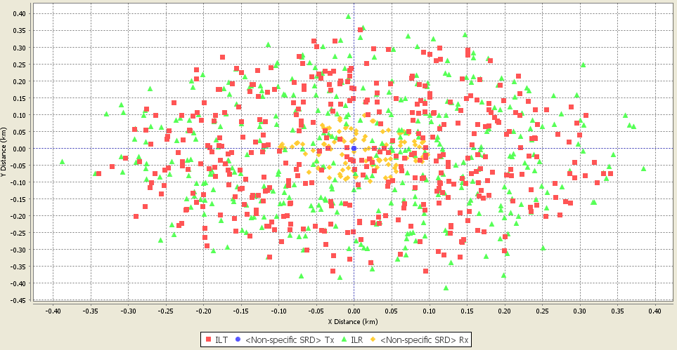

1. Example of SEAMCAT simulation window: Intra-SRD co-existence scenario

All other key simulation parameters remain the same as derived in ECC Report 200, such as using of Hata-SRD propagation path loss model and assumption of impact area sizes and numbers of active interfering devices as established in Tables 39 and 45 of ECC Report 200. An overview of the most important parameters is provided in section 2.3.

It should be noted that SEAMCAT simulations model dynamics of possible physical movement and the impact of differing mutual placement on respective link budgets.. Additional simulations using Cognitive Radio option in SEAMCAT will be carried out to model the effect of LBT mitigation avoidance as an essential element of CSMA-CA channel access protocol to be employed by IEEE 802.11ah-based IoT systems. However, SEAMCAT is a tool, which is not considering the detailed interactions in time domain. ANNEX 2: provides a simplified proposal to use a time domain correction factor.

### Impact on Intra-SRD Sharing in 870-876 MHz

This section makes an assessment of the combined impact of DC and channel bandwidth increase plus the introduction of LBT on the intra-SRD sharing in the band 870-876 MHz. The following Table 3: and Table 4: are summarising the details for the SEAMCAT simulations with portable alarms and Sub-metering as victims.

1. Intra-SRD co-existence simulation results: *Portable Alarms SRD as a victim*

| **Simulation input/output parameters** | **Settings/Results** |
| --- | --- |
| **VL: Portable Alarms** | |
| Frequency | 875.8-876 MHz,0.025 MHz steps |
| VLR sensitivity | -105 dBm/25 kHz |
| VLR selectivity | EN54-25 (see Annex 1) |
| VLR C/I threshold | 8 dB |
| VLR/Tx antenna | 0 dBi, Non-directional |
| VLR/Tx antenna height | 1.5 m |
| VL Tx output power | 14 dBm/25 kHz |
| VL Tx → Rx path | Hata-SRD, urban, Indoor-Outdoor/below roof, R=0.1 km |
| dRSS | -72 dBm, 15 std dev |
| **IL1.A: Smart Metering – Terminal nodes** | |
| Frequency | 870-875.6 MHz, 0.2 MHz steps |
| ILT output power | 27 dBm/200 kHz |
| ILT antenna | 0 dBi, Non-directional |
| APC threshold and range/step | -86 dBm/200 kHz; range 20 dB, step 2 dB  Propagation model Hata-SRD urban indoor-outdoor, R=100 m |
| ILT probability of transmission | 0.1% |
| ILT → VLR interfering path | Hata-SRD, urban, Indoor-Outdoor/below roof |
| ILT → VLR minimum distance | 0 m |
| ILT → VLR positioning mode | None (simulation radius 300 m) |
| ILT density | 1900/km2 |
| Number of transmitters | 537 |
| **IL1.B: Smart Metering – Network nodes** | |
| Frequency | 870-875.6 MHz, 0.2 MHz steps |
| ILT output power | 27 dBm/200 kHz |
| ILT antenna | 2.15 dBi, Non-directional |
| APC threshold and range/step | -86 dBm/200 kHz; range 20 dB, step 2 dB  Propagation model Hata-SRD urban indoor-outdoor, R=100 m |
| ILT probability of transmission | 2.5% |
| ILT → VLR interfering path | Hata-SRD, urban, Indoor-Outdoor/below roof |
| ILT → VLR minimum distance | 0 m |
| ILT → VLR positioning mode | None (simulation radius 300 m) |
| ILT density | 90/km2 |
| Number of active transmitters | 25 |
| **IL1.C: Smart Metering – NAPs** | |
| Frequency | 870-875.6 MHz, 0.2 MHz steps |
| ILT output power | 27 dBm/200 kHz |
| ILT antenna | 2.15 dBi, Non-directional |
| APC threshold and range/step | -86 dBm/200 kHz; range 20 dB, step 2 dB  Propagation model Hata-SRD urban indoor-outdoor, R=100 m |
| ILT probability of transmission | 10% |
| ILT → VLR interfering path | Hata-SRD, urban, Outdoor-Outdoor/below roof |
| ILT → VLR minimum distance | 0 m |
| ILT → VLR positioning mode | None (simulation radius 300 m) |
| ILT density | 10/km2 |
| Number of active transmitters | 3 |
| **IL2.A: Non-specific SRDs – IoT terminal nodes (changed compared to ECC report 200)** | |
| Frequency | 870-875 MHz, **1 MHz steps** |
| ILT output power | 14 dBm/**1000 kHz** (600kHz in ECC Report 200) |
| ILT antenna | 0 dBi, Non-directional |
| ILT probability of transmission | **2.8%** (1% in ECC Report 200) |
| ILT → VLR interfering path | Hata-SRD, urban, Indoor-Outdoor/below roof |
| ILT → VLR minimum distance | 0 m |
| ILT → VLR positioning mode | None (simulation radius 155 m) |
| ILT density, Options I/II | 1000/500 1/km2 |
| Number of transmitters, Options I/II | 75/38 |
| **IL2.B: Non-specific SRDs – IoT APs (this link is new compared to ECC Report 200)** | |
| Frequency | 870-875 MHz, **1 MHz steps** |
| ILT output power | 14 dBm/**1000 kHz** |
| ILT antenna | 2.15 dBi, Non-directional |
| ILT probability of transmission | **10%** |
| ILT → VLR interfering path | Hata-SRD, urban, Indoor-Outdoor/below roof |
| ILT → VLR minimum distance | 0 m |
| ILT → VLR positioning mode | None (simulation radius 155 m) |
| ILT density, Options I/II | 50/25 1/km2 |
| Number of transmitters, Options I/II | **4/2** |
| **IL3: Automotive** | |
| Frequency | 870-875.8 MHz, 0.5 MHz steps |
| ILT output power | 27 dBm/500 kHz |
| ILT antenna | 0 dBi, Non-directional |
| ILT probability of transmission | 0.1% |
| APC threshold and range/step | -86 dBm/200 kHz; range 20 dB, step 2 dB. Propagation model Hata-SRD urban outdoor-outdoor, R=100 m |
| ILT → VLR interfering path | Hata-SRD, urban, Outdoor-Outdoor/below roof |
| ILT → VLR minimum distance | 10 m |
| ILT → VLR positioning mode | None (simulation radius 300 m) |
| ILT density | 80/km2 |
| Number of active transmitters | 22 |
| **IL4: Sub-metering** | |
| Frequency | 870-876 MHz, 0.2 MHz steps |
| ILT output power | 14 dBm/200 kHz |
| ILT antenna | -2.85 dBi, Non-directional |
| ILT probability of transmission | 0.0025% |
| ILT → VLR interfering path | Hata-SRD, urban, Indoor-Outdoor/below roof |
| ILT → VLR minimum distance | 0 m |
| ILT → VLR positioning mode | None (simulation radius 155 m) |
| ILT density, Options I/II | 50000/25000 1/km2 |
| Number of active transmitters. Options I/II | 3770/1885 |

Sub-metering was used as another representative victim system in that band.

1. Intra-SRD co-existence simulation results: *Sub-metering SRD as a victim*

| **Simulation input/output parameters** | **Settings/Results** |
| --- | --- |
| **VL: Sub-metering** | |
| Frequency | 870-876 MHz, 0.2 MHz steps |
| VLR sensitivity | -96 dBm/200 kHz |
| VLR selectivity | Realistic cat 2 (see Annex 1) |
| VLR C/I threshold | 8 dB |
| VLR/Tx antenna | -2.85 dBi, Non-directional |
| VLR/Tx antenna height | 1.5 m |
| VL Tx output power | 14 dBm/200 kHz |
| VL Tx → Rx path | Hata-SRD, urban, ind-ind/below roof, R=0.04 km |
| dRSS dBm | -78 dBm, std dev 18 dB |
| **IL1.A: Smart Metering – Terminal nodes** | |
| Frequency | 870-875.6 MHz, 0.2 MHz steps |
| ILT output power | 27 dBm/200 kHz |
| ILT antenna | 0 dBi, Non-directional |
| APC threshold and range/step | -86 dBm/200 kHz; range 20 dB, step 2 dB  Propagation model Hata-SRD urban indoor-indoor, R=100 m |
| ILT probability of transmission | 0.1% |
| ILT → VLR interfering path | Hata-SRD, urban, Indoor-Indoor/below roof |
| ILT → VLR minimum distance | 0 m |
| ILT → VLR positioning mode | None (simulation radius 200 m) |
| ILT density | 1900/km2 |
| Number of transmitters | 239 |
| **IL1.B: Smart Metering – Network nodes** | |
| Frequency | 870-875.6 MHz, 0.2 MHz steps |
| ILT output power | 27 dBm/200 kHz |
| ILT antenna | 2.15 dBi, Non-directional |
| APC threshold and range/step | -86 dBm/200 kHz; range 20 dB, step 2 dB  Propagation model Hata-SRD urban indoor-indoor, R=100 m |
| ILT probability of transmission | 2.5% |
| ILT → VLR interfering path | Hata-SRD, urban, Indoor-Indoor/below roof |
| ILT → VLR minimum distance | 0 m |
| ILT → VLR positioning mode | None (simulation radius 200 m) |
| ILT density | 90/km2 |
| Number of active transmitters | 11 |
| **IL1.C: Smart Metering – NAPs** | |
| Frequency | 870-875.6 MHz, 0.2 MHz steps |
| ILT output power | 27 dBm/200 kHz |
| ILT antenna | 2.15 dBi, Non-directional |
| APC threshold and range/step | -86 dBm/200 kHz; range 20 dB, step 2 dB  Propagation model Hata-SRD urban indoor-outdoor, R=100 m |
| ILT probability of transmission | 10% |
| ILT → VLR interfering path | Hata-SRD, urban, Outdoor-Indoor/below roof |
| ILT → VLR minimum distance | 0 m |
| ILT → VLR positioning mode | None (simulation radius 200 m) |
| ILT density | 10/km2 |
| Number of active transmitters | 1 |
| **IL2.A: Non-specific SRDs – IoT terminal nodes (changed compared to ECC report 200)** | |
| Frequency | 870-875 MHz, **1 MHz steps** |
| ILT output power | 14 dBm/**1000 kHz** (600kHz in ECC Report 200) |
| ILT antenna | 0 dBi, Non-directional |
| ILT probability of transmission | **2.8%** (1% in ECC Report 200) |
| VLT -> ILT sensing path | Propagation model Hata-SRD urban indoor-indoor,  LBT Threshold -75 dBm in 1 MHz |
| ILT → VLR interfering path | Hata-SRD, urban, Indoor-Indoor/below roof |
| ILT → VLR minimum distance | 0 m |
| ILT → VLR positioning mode | None (simulation radius 85 m) |
| ILT density, Options I/II | 1000/500 1/km2 |
| Number of transmitters, Options I/II | 22/11 |
| **IL2.B: Non-specific SRDs – IoT APs (this link is new compared to ECC Report 200)** | |
| Frequency | 870-875 MHz, **1 MHz steps** |
| ILT output power | 14 dBm/**1000 kHz** |
| ILT antenna | 2.15 dBi, Non-directional |
| ILT probability of transmission | **10%** |
| VLT -> ILT sensing path | Propagation model Hata-SRD urban indoor-indoor,  LBT Threshold -75 dBm in 1 MHz |
| ILT → VLR interfering path | Hata-SRD, urban, Indoor-Indoor/below roof |
| ILT → VLR minimum distance | 0 m |
| ILT → VLR positioning mode | None (simulation radius 85 m) |
| ILT density, Options I/II | 50/25 1/km2 |
| Number of transmitters, Options I/II | **2/1** |
| **IL3: Automotive** | |
| Frequency | 870-875.8 MHz, 0.5 MHz steps |
| ILT power | 27 dBm/500 kHz |
| ILT antenna | 0 dBi, Non-directional |
| ILT probability of transmission | 0.1% |
| APC threshold and range/step | -86 dBm/200 kHz; range 20 dB, step 2 dB  Propagation model Hata-SRD urban outdoor-outdoor, R=100 m |
| ILT → VLR interfering path | Hata-SRD, urban, Outdoor-Indoor/below roof |
| ILT → VLR minimum distance | 10 m |
| ILT → VLR positioning mode | None (simulation radius 200 m) |
| ILT density | 80/km2 |
| Number of active transmitters | 10 |
| **IL4: Portable alarms** | |
| Frequency | 875.8-876 MHz,0.025 MHz steps |
| ILT output power | 14 dBm/25 kHz |
| ILT antenna | 0 dBi, Non-directional |
| ILT probability of transmission | 0.1% |
| ILT → VLR interfering path | Hata-SRD, urban, Outdoor-Indoor/below roof |
| ILT → VLR minimum distance | 0 m |
| ILT → VLR positioning mode | None (simulation radius 130 m) |
| ILT density | 12/km2 |
| Number of active transmitters | 1 |

1. Simulation results

| Simulation case | Combined Probability of interference | | | |
| --- | --- | --- | --- | --- |
| **Victim: Portable alarm (Table 3:)** | | **Victim: Sub-metering (Table 4:)** | |
| **IL Density Option I** | **IL Density Option II** | **IL Density Option I** | **IL Density Option II** |
| A = ECC Report 200 | 3.6% Note 1 | 2.5% Note 1 | 2.1% | 1.5% |
| B = A + only 0.1% DC in the band 875.8-876 + updated densities/masks | 1.1% (0.2% unwanted, 0.9% blocking) | 1.1% (0.2% unwanted, 1.0% blocking) | 2.0%  (1.8% unwanted,  0.3% blocking) | 1.5% (1.3% unwanted, 0.3% blocking) |
| C = B + Non-specific SRDs DC 2.8 % instead of 1 % | 1.4% (0.4% unwanted, 1.1% blocking) | 1.2% (0.3% unwanted, 1.0% blocking) | 3.9%  (3.6% unwanted,  0.8% blocking) | 2.4% (2.2% unwanted, 0.5% blocking) |
| D = C + Non-specific SRDs==IoT TN with bandwidth 1 MHz (802.11ah mask) instead of 600 kHz | 1.7% (0.6% unwanted, 1.3% blocking) | 1.5% (0.5% unwanted, 1.2% blocking) | 4.8%  (4.5% unwanted,  1.1% blocking) | 2.8% (2.6% unwanted, 0.6% blocking) |
| E = D + IoT APs with 10% DC and 1 MHz bandwidth | 1.9 % (0.7% unwanted, 1.4% blocking) | 1.5% (0.5% unwanted, 1.2% blocking) | 6.6 %  (6.1% unwanted, 1.5% blocking) | 3.9%  (3.7%unwanted, 0.8% blocking) |
| Ebis = E with average DCs: IoT TN 0.1%, IoT AP 2.5%; SM NN 0.7%, SM NAP 2.5% | 0.7% (0.2% unwanted, 0.6% blocking) | 0.5% (0.1% unwanted, 0.4% blocking) | 1.2% (1.1% unwanted, 0.3% blocking) | 1.0% (0.8% unwanted, 0.3% blocking) |
| F = E + LBT/AFA feature for IoT (2.8%/10%/1MHz BW, threshold -75 dBm) | N/A Note 3 | N/A Note 3 | 4.9%  (4.6% unwanted, 1.0% blocking) | 2.8% (2.6% unwanted, 0.6% blocking) |
| G = F + threshold -98 dBm | N/A Note 2 | N/A Note 2 | 2.4% (2.2% unwanted, 0.4% blocking) | 1.7% (1.5% unwanted, 0.3% blocking) |

Note 1: ECC report 200 did not consider an exclusive band for alarms.

Note 2: Simulation of LBT/AFA feature was not relevant for this case due to operation of interferer and victim in adjacent sub-bands.

The following results could be drawn from the SEAMCAT simulations for the case that 5% would be used as max acceptable interference probability:

* Portable alarms as victim vis-à-vis IoT: Coexistence feasible in all IoT deployment scenarios, and with alarms used in the dedicated bands.
* Sub-metering with realistic Cat. 2 receiver as victim vis-à-vis IoT at maximum deployment density:
* Only 2.8% and 1 MHz: coexistence feasible;
* Up to 10% without LBT: coexistence feasible assuming active transmitters working near their average DC;
* Up to 10% with LBT and threshold of at least -75 dBm: coexistence feasible.
* Sub-metering with realistic Cat. 2 receiver as victim vis-à-vis IoT at less dense deployment:
* Coexistence feasible in all scenario configurations.

The above results with sub-metering and adjacent portable alarms as victims might not represent the worst case. The above simulation with sub-metering considers on average up to 22 IoT devices in a radius 85m and operating in a given band. It may be considered that in the future if the IoT becomes truly widespread it would be quite possible for these devices to be present in even higher densities, i.e. the same number of simulated devices would be concentrated in a smaller area. For example placing 5 x 1 MHz channels in the range 870.8 MHz to 875.8 MHz may impact the Low duty cycle SRD usage in the safe harbour band 875.8-876 MHz for more critical scenarios as considered above. This point is eased if the range is moved lower by a minimum of 200 kHz so that the upper edge is 875.6 MHz or lower.

The following factors were not considered in the simulations, but which will improve the real life co-existence situation further:

* Only the full generic emission masks (see ANNEX 1:) were used, while the real life unwanted emissions are expected to be much lower (see ANNEX 3:);
* The DC for all simulated devices was set to the maximum allowed limit, which is absolute worst case assumption as it may be otherwise assumed that in real life not all devices would be reaching their DC limit for most of the time. This scenario was tested with Case Ebis and indeed demonstrated significant reduction of probability of interference;
* All devices are assumed to transmit with max allowed Tx power and antenna gain, which is another worst case assumption. For instance, many of the sensors do not have power amplifier, meaning that achievable maximum transmit power would be limited. Also, achieving 0 dBi antenna gain would be very challenging for cheap sensors;
* Mitigation techniques used by existing users (like error correction, redundant signals).

***In summary***, acceptable protection for existing SRDs is assumed to be achieved by WB SRDs using LBT (CSMA-CA) with a threshold of -75 dBm, but the existing applications should apply at least Category 2 receivers.

It should be noted that the expected channel arrangement for WB SRD devices was not clear at the time of the preparation of this report. But it is expected that the WB SRD channel arrangement will only affect the adjacent band studies with Low duty cycle SRD usage in the safe harbour bands. A reasonable solution for this could be to apply an upper edge for WB SRDs tuning range of 875.6 MHz or lower.

The constituent partial solution of just relaxing DC limits for 25 mW Non-specific SRDs (Type A) was considered as Case C in the above simulations, and its results indicated in Table 5: above show that this relaxation of DC to 2.8% for Non-specific SRD with 25 mW output power may be allowed without additional conditions.

### Impact on Intra-SRD/RFID Sharing in 915-921 MHz

This section makes an assessment of the combined impact of DC and channel bandwidth increase plus the introduction of LBT on the intra-SRD sharing in the band 915-921 MHz. The following Table 6: and Table 7:are summarising the details for the SEAMCAT simulations with RFID and ALD as victims.

1. Intra-SRD vs RFID co-existence in 915-921 MHz: *RFID* as a victim

| **Simulation input/output parameters** | **Settings/Results** |
| --- | --- |
| **VL: RFID Interrogator’s receiver** | |
| Frequency | 916.3; 917.5; 918.7; 919.9 MHz; 400 kHz channels |
| VLR sensitivity | -85 dBm/400 kHz |
| VLR selectivity | EN 302 208 (see Annex 1) |
| VLR C/I threshold | 12 dB |
| VLR antenna | 6 dBi, Directional |
| VLR antenna height | 1.5 m |
| VL dRSS user defined (from tags) | User defined -87…-57 dBm (mean -69 dBm, std dev 7.5 dB) |
| **IL1.A: Non-specific SRD Type A – IoT terminal nodes (changed compared to ECC Report 200)** | |
| Frequency | 915.5-920.5 MHz, **1 MHz channels** |
| ILT output power | 14 dBm/**1000 kHz** (600kHz in ECC Report 200) |
| ILT antenna | 0 dBi, Non-directional |
| ILT probability of transmission | **2.8%** (1% in ECC Report 200) |
| ILT → VLR interfering path | Hata-SRD, urban, Indoor-Outdoor/below roof |
| VLT -> ILT sensing path | Propagation model Hata-SRD urban indoor-indoor,  LBT Threshold -75 dBm in 1 MHz |
| ILT → VLR minimum distance | 0 m |
| ILT → VLR positioning mode | None (simulation radius 60 m) |
| ILT density, Options I/II | 1000/250 1/km2 |
| Number of transmitters, Options I/II | 12/3 |
| **IL1.B: Non-specific SRD Type A – IoT APs (this link is new compared to ECC Report 200)** | |
| Frequency | 915.5-920.5 MHz, **1 MHz channels** |
| ILT output power | 14 dBm/**1000 kHz** |
| ILT antenna | 2.15 dBi, Non-directional |
| ILT probability of transmission | **10%** |
| ILT → VLR interfering path | Hata-SRD, urban, Indoor-Outdoor/below roof |
| VLT -> ILT sensing path | Propagation model Hata-SRD urban indoor-indoor,  LBT Threshold -75 dBm in 1 MHz |
| ILT → VLR minimum distance | 0 m |
| ILT → VLR positioning mode | None (simulation radius 150 m; was increased from 60m according to ECC report 200 to 150 m to achieve at least one device per simulation radius) |
| ILT density, Options I/II | 50/12 1/km2 |
| Number of transmitters, Options I/II | 4/1 |
| **IL2: Non-specific SRD Type B** | |
| Frequency | 916.3; 917.5; 918.7; 919.9 MHz; 400 kHz channels |
| ILT output power | 20 dBm/400 kHz |
| ILT antenna | 0 dBi, Non-directional |
| ILT probability of transmission | 1% |
| ILT → VLR interfering path | Hata-SRD, urban, Indoor-Outdoor/below roof |
| ILT → VLR minimum distance | 0 m |
| ILT → VLR positioning mode | None (simulation radius 90 m) |
| ILT density, Options I/II | 500/250 1/km2 |
| Number of transmitters, Options I/II | 13/7 |
| **IL3: ALD** | |
| Frequency | 916.3; 917.5; 918.7; 919.9 MHz; 200 kHz channels |
| ILT output power | 10 dBm/200 kHz |
| ILT antenna | 0 dBi, Non-directional |
| ILT probability of transmission | 25% |
| ILT → VLR interfering path | Hata-SRD, urban, Indoor-Outdoor/below roof |
| ILT → VLR minimum distance | 0 m |
| ILT → VLR positioning mode | None (simulation radius 90 m; was increased from 50m according to ECC report 200 to 90 m to achieve at least one device per simulation radius) |
| ILT density | 40/km2 |
| Number of transmitters | 1 |
| **IL4: Sub-metering** | |
| Frequency | 915-921 MHz, 0.2 MHz steps |
| ILT power | 14 dBm/200 kHz |
| ILT antenna | -2.85 dBi, Non-directional |
| ILT probability of transmission | 0.0025% |
| ILT → VLR interfering path | Hata-SRD, urban, Indoor-Outdoor/below roof |
| ILT → VLR minimum distance | 0 m |
| ILT → VLR positioning mode | None (simulation radius 60 m) |
| ILT density, Options I/II | 50000/25000 1/km2 |
| Number of transmitters, Options I/II | 566/283 |

1. Intra-SRD co-existence in 915.2-920.8 MHz: *Assistive Listening Device* as a victim

| **Simulation input/output parameters** | **Settings/Results** |
| --- | --- |
| **VL: ALD** | |
| Frequency | 917.5 MHz |
| VLR sensitivity | -96 dBm/200 kHz |
| VLR selectivity | EN 301 357-1 Cat. 2 (see Annex 1) |
| VLR C/I threshold | 8 dB |
| VLR/Tx antenna | 0 dBi, Non-directional |
| VLR/Tx antenna height | 1.5 m |
| VL Tx output power | 10 dBm/200 kHz |
| VL Tx → Rx path | Hata-SRD, urban, ind-ind/below roof, R=0.04 km |
| **IL1.A: Non-specific SRD Type A – IoT terminal nodes (changed compared to ECC Report 200)** | |
| Frequency | 915.5-920.5 MHz, **1 MHz channels** |
| ILT output power | 14 dBm/**1000 kHz** (600 kHz in ECC Report 200) |
| ILT antenna | 0 dBi, Non-directional |
| ILT probability of transmission | **2.8%** (1% in ECC Report 200) |
| ILT → VLR interfering path | Hata-SRD, urban, ind-ind/below roof |
| VLT -> ILT sensing path | Propagation model Hata-SRD urban indoor-indoor,  LBT Threshold -75 dBm in 1 MHz |
| ILT → VLR minimum distance | 0 m |
| ILT → VLR positioning mode | None (simulation radius 85 m) |
| ILT density, Options I/II | 1000/250 1/km2 |
| Number of transmitters, Options I/II | 22/6 |
| **IL1.B: Non-specific SRD Type A – IoT APs (this link is new compared to ECC Report 200)** | |
| Frequency | 915.5-920.5 MHz, **1 MHz channels** |
| ILT output power | 14 dBm/**1000 kHz** |
| ILT antenna | 2.15 dBi, Non-directional |
| ILT probability of transmission | **10%** |
| ILT → VLR interfering path | Hata-SRD, urban, ind-ind/below roof |
| VLT -> ILT sensing path | Propagation model Hata-SRD urban indoor-indoor,  LBT Threshold -75 dBm in 1 MHz |
| ILT → VLR minimum distance | 0 m |
| ILT → VLR positioning mode | None (simulation radius 150 m; was increased from 85m according to ECC report 200 to 150 m to achieve at least one device per simulation radius) |
| ILT density, Options I/II | 50/12 1/km2 |
| Number of transmitters, Options I/II | 4/1 |
| **IL2: Non-specific SRD Type B** | |
| Frequency | 916.3; 917.5; 918.7; 919.9 MHz; 400 kHz channels |
| ILT output power | 20 dBm/400 kHz |
| ILT antenna | 0 dBi |
| ILT probability of transmission | 1% |
| ILT → VLR interfering path | Hata-SRD, urban, ind-ind/below roof |
| ILT → VLR minimum distance | 0 m |
| ILT → VLR positioning mode | None (simulation radius 125 m) |
| ILT density, Options I/II | 500/250 1/km2 |
| Number of transmitters, Options I/II | 24/12 |
| **IL3: Sub-metering** | |
| Frequency | 915-921 MHz, 0.2 MHz steps |
| ILT output power | 14 dBm/200 kHz |
| ILT antenna | -2.85 dBi, Non-directional |
| ILT probability of transmission | 0.0025% |
| ILT → VLR interfering path | Hata-SRD, urban, ind-ind/below roof |
| ILT → VLR minimum distance | 0 m |
| ILT → VLR positioning mode | None (simulation radius 85 m) |
| ILT density, Options I/II | 50000/25000 1/km2 |
| Number of transmitters | 1135/567 |
| **IL4: RFID** | |
| Frequency | 916.3; 917.5; 918.7; 919.9 MHz; 400 kHz channels |
| ILT power | 20 dBm/400 kHz |
| ILT antenna | 6 dBi, Directional |
| ILT probability of transmission | 2.5% |
| ILT → VLR interfering path | Hata-SRD, urban, outd-ind/below roof |
| ILT → VLR minimum distance | 0 m |
| ILT → VLR positioning mode | None (simulation radius 125 m) |
| ILT density | 480/km2 |
| Number of transmitters | 23 |

1. Simulation results

|  |  |  |  |  |
| --- | --- | --- | --- | --- |
| Simulation case | Combined Probability of Interference | | | |
| **Victim: RFID (Table 6:)** | | **Victim: ALD (Table 7:)** | |
| **IL Density Option I** | **IL Density Option II** | **IL Density Option I** | **IL Density Option II** |
| A = ECC Report 200 | 3.9% Note 1 | 3.2% Note 1 | 5.8 % | 3.8% |
| B= A with safe harbor bands and updated masks/densities | 3.5% (3.3% unwanted, 0.3% blocking) | 2.4% (2.2% unwanted, 0.2% blocking) | 7.4% (5.9% unwanted, 3.0% blocking) | 4.6% (3.8% unwanted, 1.1% blocking) |
| C = B + Non-specific SRD Type A's DC 2.8 % instead of 1 % | 5.5% (4.9% unwanted, 1.4% blocking) | 3.0% (2.7% unwanted, 0.4% blocking) | 11.1% (8.8% unwanted, 7.0% blocking) | 5.3% (4.3% unwanted, 2.1% blocking) |
| D = C + Non-specific SRD Type A's == IoT TN with bandwidth 1 MHz (802.11ah mask) instead of 600 kHz | 6.0% (5.4% unwanted, 2.5% blocking) | 3.0% (2.8% unwanted, 0.7% blocking) | 11.5% (10.1% unwanted, 6.6% blocking) | 5.4% (4.6% unwanted, 2.2% blocking) |
| E = D + IoT APs with 10% DC and 1 MHz bandwidth | 7.4% (6.7% unwanted, 3.2% blocking) | 3.4% (3.2% unwanted, 1.0% blocking) | 14.1% (12.2% unwanted, 8.2% blocking) | 6.9% (6.0% unwanted, 2.8% blocking) |
| Ebis = E with average DCs: IoT TN 0.1%, IoT AP 2.5% | 3.5% (3.4% unwanted, 0.6% blocking) | 2.3% (2.2% unwanted, 0.2% blocking) | 6.5% (5.6% unwanted, 1.8% blocking) | 4.2% (3.6% unwanted, 0.8% blocking) |
| F = E + LBT/AFA feature for IoT (2.8%/10%/1MHz BW, threshold -75 dBm) | 3.0% (2.9% unwanted, 0.2% blocking) | 1.9% (1.8% unwanted, 0.1% blocking) | 9.3% (6.5% unwanted, 7.7% blocking) Note 2 | 4.4% (2.4% unwanted, 4.4% blocking) Note 2 |

Note 1: ECC Report 200 assumed different RFID receiver selectivity as in this report: ECC Report 200 used a blocking response of constant 35 dB, while this report uses the values from the new RFID standard EN 302 208 (see ANNEX 1:), adjusted for in-channel value to correct a shortcoming in SEAMCAT evaluation of blocking in cases of overlapping channels. In addition ECC Report 200 used a fixed user defined dRSS of -72 dBm while this reports uses a specific distribution with a mean value of -69 dBm.

Note 2: The ALD victim frequency in this case changed from fixed single value to random distribution within the band due to peculiarity of LBT modelling in SEAMCAT (the frequency distribution of CR/LBT-enabled interferer is slaved to that of victim).

The following results could be drawn from the SEAMCAT simulations for the case that 5% would be used as max acceptable interference probability:

* RFID as victim vis-à-vis IoT:
* Only 2.8% and 1 MHz: coexistence feasible with the more optimistic density option;
* Up to 10% without LBT: coexistence feasible assuming active transmitters working near their average DC, or at maximum DC but with the more optimistic density option;
* Up to 10% with LBT and threshold of at least 75 dBm: coexistence feasible;
* It should be noted that the SEAMCAT simulation assumed all IoT devices using only the 4 RFID channels, which is clearly a worst case.
* ALD as victim vis-à-vis IoT:
* First of all it should be noted that in this scenario already the baseline situation (before introducing IoT into the mix of current SRDs) exhibits high level of ambient risk of interference in excess of 5%. Therefore the following results should be seen in the light of this very high ambient interference potential;
* Only 2.8% and 1 MHz: coexistence feasible with the more optimistic density option. In high density option IoT adds around 4% of additional interference on its own;
* Up to 10% without LBT: coexistence feasible assuming active transmitters working near their average DC, or at maximum DC but with the more optimistic density option;
* Up to 10% with LBT and threshold of at least 75 dBm: less than 4% added by introducing IoT in high density option; coexistence fully feasible with the more optimistic density option;
* It should be noted that the SEAMCAT simulation assumed all IoT devices using only the 4 ALD channels, which is clearly a worst case.

It should be noted that the above SEAMCAT analysis only considers the impact of WB SRD in the high power RFID channels. ANNEX 4: provides an analysis, which examines the impact of WB SRD on tag emissions corresponding to transmissions by interrogators in each of the high power channels. According to that analysis there might be some impact into the low power tag responses possible. It should be noted that the shielding of high power RFID installations (e.g. up to 16 dB) is not considered in the above simulation. However there are many other RFID applications, which operate at much reduced ranges and where there is no need for shielding.

The above results with RFID and ALD as victim might not represent the worst case. The above simulation considers that the given band is used by 11 IoT devices within a radius of 60 m for victim RFID and 22 devices in a radius 85m for victim ALD. However if in the future the IoT becomes truly widespread it would be quite possible for these devices to be present in even higher densities, i.e. the same number of simulated devices would be concentrated in a smaller area.

Low duty cycle SRD usage in the safe harbour bands should be comparable to the situation in the lower bands (see section 4.1.1) and thus the WB SRD usage might be possible up to the band edges. However, the following points may need to be considered when placing 5 x 1 MHz channels in the range 915.8 MHz to 920.8 MHz:

* The impact on radio services above 921 MHz (e.g. GSM-R) has not been studied as part of this report;
* It may impact the Low duty cycle SRD usage in the safe harbour band 920.8-921 MHz for more critical scenarios as considered in section 4.1.1.

Both these points are eased if the range is moved lower by a minimum of 200 kHz so that the upper edge is 920.6 MHz or lower.

However, the following factors were not considered in the simulations, but which will improve the real life co-existence situation further:

* Only the full generic emission masks (see ANNEX 1:) were used, while the real life unwanted emissions are expected to be much better (see ANNEX 3:);
* The DC for all simulated devices was set to the maximum allowed limit, which is absolute worst case assumption as it may be otherwise assumed that in real life not all devices would be reaching their DC limit for most of the time. This scenario was tested with Case Ebis and indeed demonstrated significant reduction of probability of interference;
* All devices are assumed to transmit with max allowed Tx power and antenna gain, which is another worst case assumption. For instance, many of the sensors do not have power amplifier, meaning that achievable maximum transmit power would be limited. Also, achieving 0dBi would be very challenging for cheap sensors;
* Mitigation techniques used by existing users (like error correction, redundant signals).

***In summary***, acceptable protection for existing SRDs is assumed to be achieved by WB SRDs in the band 915.8-920.8 MHz using LBT (CSMA-CA) with a threshold of -75 dBm.

According to RFID industry, a specific listening time for the detection mechanism might improve further the detection (see ANNEX 4:, e.g. at least 1ms). However, to generalize the listening time at 1ms would hamper the whole SRD industry whereas it might only improve co-located sites. For industrial premises where an RFID high level of service is expected, it’s also recommended to resort to site engineering.

It should be noted that the expected channel arrangement for WB SRD devices was not clear at the time of the preparation of this report. It is expected that the WB SRD channel arrangement will mainly affect the adjacent band studies for Low duty cycle SRD usage in the safe harbour bands. A reasonable solution could be to apply an upper edge for WB SRDs tuning range of 920.6 MHz or lower.

The constituent partial solution of just relaxing DC limits for 25 mW Non-specific SRDs (Type A) was considered as Case C in the above simulations, and its results indicated in Table 8: above show that this relaxation of DC to 2.8% for Non-specific SRD with 25 mW output power may be allowed without additional conditions as it would result in just marginal exceeding of the 5% threshold for combined probability of interference.

### Complementary calculations of LBT threshold values for WB SRDs

The below calculation is based on the approach presented in ANNEX 5: on how to derive a threshold value for LBT functionality of CSMA-CA channel access mechanism. It shows the required threshold values for IoT devices to detect Alarms, Sub metering, RFID and ALD. In addition the table contains the required link margin at the victim receiver where a LBT threshold of -75 dBm would be able to detect the victim link.

1. LBT threshold values

|  |  |  |  |  |
| --- | --- | --- | --- | --- |
| Victim | Alarms | Sub metering | RFID | ALD |
| BW2/MHz | 0.025 | 0.2 | 0.4 | 0.2 |
| Pwt dBm/BW2 | 14 | 14 | 27 | 10 |
| Sensitivity dBm/BW2 | -105.00 | -96.00 | -85.00 | -96.00 |
| C/I dB | 8.00 | 8.00 | 12.00 | 8.00 |
| margin dB | 0.00 | 0.00 | 0.00 | 0.00 |
| Imax dBm/BW2 | -113.00 | -104.00 | -97.00 | -104.00 |
| Pit dBm/BW1 | 14 | | | |
| BW1/MHz | 1 | | | |
| Pit dBm/BW2 | -2.02 | 7.01 | 10.02 | 7.01 |
| required separation distance m (propagation exponent 3.5) | 190.04 | 190.42 | 146.46 | 190.42 |
| Pthr dBm/BW2 | -96.98 | -97.01 | -80.02 | -101.01 |
| Required margin above sensitivity with threshold -75 dBm/1MHz | 21.98 | 22.01 | 5.02 | 26.01 |

The protection of the considered victims systems by an energy detection threshold of -75 dBm used by the WB SRD device is possible if the victim links are working with a certain margin above sensitivity: alarm systems 22 dB, sub metering 22 dB, RFID 5 dB and for ALD 26 dB.

However, in real life scenarios (and that was considered in SEAMCAT simulations) the victim links are working with a margin above sensitivity threshold, and thus the energy detection by IoT devices is expected to improve the situation. SEAMCAT simulations reported in sections 4.1.1& 4.1.2confirmed this.

### Summary Intra SRD

The results of studies presented in above sections show that co-existence of new emerging wideband SRD applications in the bands 870-875.8 MHz and 915.2-920.8 MHz, such as those implemented in accordance with TR 103 245, should be feasible on the assumptions that the existing applications are using at least Category 2 receivers and provided the use of LBT by wideband SRDs with a threshold of at least -75 dBm.

It should be noted that the expected channel arrangement for WB SRD devices was not clear at the time of the preparation of this report. It is expected that the WB SRD channel arrangement will mainly affect the adjacent band studies for Low duty cycle SRD usage in the safe harbour bands. A reasonable solution could be to apply upper edges for WB SRDs tuning ranges: 875.6 MHz in the lower band and 920.6 MHz in the upper band.

The constituent partial solution of just relaxing DC limits for 25 mW Non-specific SRDs (Type A) was considered as Case C in the above simulations, and its results suggest that such relaxation of DC to 2.8% for Non-specific SRD with 25 mW output power (Type A as per Report 200 classification) may be allowed without additional conditions.

## Impact on GSM/UMTS/LTE Uplink in adjacent band

This section will analyse the impact of the combined impact of DC and channel bandwidth increase in the band 915.2-920.8 MHz on cellular systems using adjacent band below 915 MHz.

The details of various parameter settings (mainly based on those used in ECC Report 200) and the results of SEAMCAT simulations of impact of WB SRD on various types of cellular systems are given in the following tables.

1. Simulation settings: mix of SRDs to GSM/UMTS/LTE Uplink/Urban Cell in adjacent band

| **Simulation input/output parameters** | **Settings/Results** | |
| --- | --- | --- |
| **VL: GSM uplink** | | |
| Frequency | 914.8, 0.2 MHz channel | |
| VLR sensitivity | -110 dBm/200 kHz | |
| VLR blocking sensitivity | See ECC Report 200 Annex 1.2 | |
| VLR C/I threshold | 19 dB (GSM data) | 12 dB (GSM voice) |
| VLT antenna gain and height a.g.l. | 0 dBi, 1.5 m, non-directional | |
| VLR antenna gain and height a.g.l. | 15 dBi, 30 m, 65O sector, ITU Rec. F.1336-4 | |
| VLR antenna feeder loss | 3 dB | |
| VL Tx → Rx path | User defined dRSS, see Fig. 20 in Annex 1 | |
| **VL: UMTS uplink** | | |
| Frequency | 912.4, 5 MHz channel | |
| VLR selectivity | see ECC 200 Annex 1.2 | |
| VLR noise figure | Macro: 5 dB  Pico: 19 dB | |
| Cell noise rise | 0.01 dB / 1 dB | |
| VLT antenna gain and height a.g.l. | 0 dBi, 1.5 m, non-directional | |
| VLR antenna gain and height a.g.l., Macro | 18 dBi, 30 m, 65O sector, Recommendation ITU R F.1336-3 | |
| VL Voice activity factor | 1 | |
| VLR antenna gain and height a.g.l., Pico | 6 dBi, 3 m, non-directional | |
| VLR antenna feeder loss | 3 | |
| VL Tx power e.i.r.p | 23 dBm | |
| VL Tx → Rx path, Macro | Extd-Hata, urban, outd-outd/above roof, R=500m | |
| VL Tx → Rx path, Pico | IEEE 802.11 model C, breakpoint distance 5m, R=50m | |
| **VL: LTE Macro uplink** | | |
| Frequency | 910 MHz, 10MHz channel | |
| VLR selectivity | See ECC Report 200 Annex 1.2 | |
| VLT antenna gain and height a.g.l. | 0 dBi, 1.5 m, non-directional | |
| VLR antenna gain and height a.g.l. | 18 dBi, 30 m, 65O sector, Recommendation ITU R F.1336-3 | |
| VLR antenna feeder loss | 3 | |
| VL Tx power e.i.r.p | 23 dBm | |
| VL Tx → Rx path | Extd-Hata, urban, outd-outd/above roof, R=1.5km  Power control:  UE min power = -40dBm  Power scaling factor: 0.99  (Report 200 setting)  1 UE  SEAMCAT cell layout: tri-sector (3GPP2) | Extd-Hata, urban, outd-outd/above roof, R=500m  Power control:  UE min power = -40dBm  Power scaling factor: 0.974  Radius 500m  3 UE  SEAMCAT cell layout: tri-sector (3GPP) |
| **IL1A: Non-specific SRD Type A == IoT Terminal Node** | | |
| Frequency | 915.2-920.8 MHz, 1 MHz steps | |
| ILT output power | 14 dBm/1000 kHz (600kHz in ECC Report 200) | |
| ILT mask | Two mask options, see Annex 1 | |
| ILT antenna | 0 dBi, Non-directional | |
| ILT probability of transmission, Average/Max | 0.1/2.8% (1% in ECC Report 200) | |
| ILT → VLR interfering path, macro | Extended-Hata, urban, ind-outd/above roof | |
| ILT → VLR interfering path, pico | IEEE 802.11 model C, breakpoint distance 5m, R=50m | Extd-Hata-SRD, urban, outd-outd, R=50m |
| ILT density, Options I/II | 1000/km2 | 250/km2 |
| ILT impact distance (macro; pico) | 500m; 50m | |
| ILT number of transmitters Options I (macro; pico)/II (macro; pico) | 262 (per 120° sector); 8 | 65 (per 120° sector); 2 |
| **IL1B: IoT Access Point (this link is new compared to ECC Report 200)** | | |
| Frequency | 915.2-920.8 MHz, 1 MHz steps | |
| ILT output power | 14 dBm/1000 kHz | |
| ILT mask | Two mask options, see Annex 1 | |
| ILT antenna | 2.15 dBi, Non-directional | |
| ILT probability of transmission, Average/Max | 2.5/10% | |
| ILT → VLR interfering path | GSM/ LTE Macro/ UMTS Macro: Extended-Hata, urban, ind-outd/above roof | |
| UMTS Pico : IEEE 802.11 model C | UMTS Pico : Extd-Hata-SRD, urban, ind-ind |
| ILT density, Options I/II | 50/km2 | 12/km2 |
| ILT impact distance (macro; pico) | (500m; 160m) (160m for picocell so that at least one device is in this radius) | |
| ILT number of transmitters Options I (macro; pico)/II (macro; pico) | 12 (per 120° sector); 4 | 3 (per 120° sector); 1 |
| **IL2: Non-specific SRD Type B** | | |
| Frequency | 916.3; 917.5; 918.7; 919.9 MHz; 400 kHz channels | |
| ILT output power | 20 dBm/400 kHz | |
| ILT mask | Two mask options, see Annex 1 | |
| ILT antenna | 0 dBi, Non-directional | |
| ILT probability of transmission | 1% | |
| ILT density, Options I/II | 500/km2 | 250/km2 |
| ILT distance (macro; pico) | (500 m; 50 m) | |
| ILT number of transmitters Options I (macro; pico)/II (macro; pico) | 131(per 120° sector) ; 4 | 65 (per 120° sector); 2 |
| **IL3: ALD (Note 3)** | | |
| Frequency | 916.3; 917.5; 918.7; 919.9 MHz; 200 kHz | |
| ILT output power | 10 dBm/200 kHz | |
| ILT mask | Two mask options, see Annex 1 | |
| ILT antenna | 0 dBi, Non-directional | |
| ILT probability of transmission | 25% | |
| ILT density | 40/km2 | |
| ILT distance (macro ; pico) | 500 m ; 50 m | |
| ILT number of transmitters (macro ; pico) | 11 (per 120° sector); 1 | |
| **IL4: Sub-metering** | | |
| Frequency | 915-921 MHz, 0.2 MHz steps | |
| ILT output power | 14 dBm/200 kHz | |
| ILT mask | Two mask options, see Annex 1 | |
| ILT antenna | -2.85 dBi, Non-directional | |
| ILT probability of transmission | 0.0025% (Note 1) | |
| ILT density, Options I/II | 50000/km2 | 25000/km2 |
| ILT distance (macro / pico) | 500 m / 50m | |
| ILT number of transmitters Options I (macro; pico)/II (macro; pico) | 13000 (per 120° sector); 393 (Note 1) | 6500 (per 120° sector); 196 (Note 1) |
| **IL5: RFID (Note 3)** | | |
| Frequency | 916.3; 917.5; 918.7; 919.9 MHz; 400 kHz channels | |
| ILT output power e.i.r.p. | 20 dBm/400 kHz (Note 2) | 27 dBm/400 kHz (Note 2) |
| ILT mask | Two mask options, see Annex 1 | |
| ILT antenna | 0 dBi | 8 dBi (Type 3, see Annex 2.5 of ECC Report 200) |
| ILT probability of transmission | 2.5% | 12.5% |
| ILT (density Option I/II) | 480/km2 | 20/km2 |
| ILT distance (macro ; pico) | (500 m; 50 m) | |
| ILT number of transmitters (macro ; pico) | 126 (per 120° sector); 4 | 5 (per 120° sector); 1 |
| **General settings for all ILs** | | |
| ILT → VLR positioning mode | None | |
| ILT → VLR interfering path, macro | Extended-Hata, urban, ind-outd/above roof. | |
| ILT → VLR interfering path, pico | IEEE 802.11 model C,  breakpoint distance 5m, R=50m | Extd-Hata-SRD, urban,  ind-ind, R=50m |

Note 1: to limit the simulation time the device number for Home Automation was reduced by a factor of 10 and the DC increased by the same factor

Note 2: RFID transmit using directional antenna with a resulting e.r.p. of up to +36 dBm, however, in most cases they will be deployed in a semi-shielded environment, and pointed downwards, meaning that their environmental emission levels should be comparable to those from an SRD transmitting with e.r.p. of +20 dBm.

Note 3: Either ALD or RFID are considered in the simulated SRD mix, on the assumption that these two applications are very unlikely to be deployed in the same facility.

It should be noted that the DC for simulated IoT WB SRD devices was set to either long-term average or maximum allowed limit. The latter assumption would represent an absolute worst and only hypothetically possible case as it may be otherwise assumed that in real life majority of deployed SRD devices would be rarely reaching their DC limit.

The below tables Table 11: Table 12: Table 13: show the simulation results presented as a comparison of probability of interference for baseline scenario (in which only currently allowed SRDs are simulated as interferers), against a considered future scenario where wideband IoT devices had been added to the mix of SRD applications. Two values of probability are given in each scenario, assuming that RFID and ALD will not be used at the same location, hence the first value represent SRD mix without ALD, second value without RFID. The results are given for different combinations of key assumptions and input parameters. Note that as regards future IoT WB SRD applications, their maximum configuration (WB=1000 MHz and IoT TN’s DC limit of 2.8%, IoT AP’s DC limit of 10%) is considered, corresponding to Case E in scenarios considered in intra-SRD sections.

1. SEAMCAT simulation results for all mixed SRDs to GSM/UMTS/LTE Uplink/Urban Cell (without ALD/without RFID)  
   with duplex filter; *Baseline: without Non-specific-SRD/IoT WB SRD*

| **Victim Link C onfiguration:** | **Victim: GSM**  **Probability of exceeding  the C/I objective  (%, unwanted & blocking)** | | **Victim: UMTS pico  Average capacity loss in reference cell  (%)** | | **Victim: UMTS macro**  **Average capacity loss in reference cell  (%)** | | **Victim: LTE Macro Average bitrate loss in reference cell  (%)** | |
| --- | --- | --- | --- | --- | --- | --- | --- | --- |
| C/I 19 dB (GSM data) | C/I =12 dB (GSM voice) | Cell noise rise 0.01 dB | Cell noise rise 1 dB | Cell noise rise 0.01 dB | Cell noise rise 1 dB | R=1.5km Power scaling factor 0.99 | R=0.5km Power scaling factor 0.9 |
| Mask Option 1, Density Option I | 0.1* / 0.1** | 0.0* / 0.0** | 5.8* / 3.0** | 5.1* / 2.8** | 20.5* / 3.3** | 11.8* / 1.6% | 21.3* / 4.3** | 2.2* / 0.3** |
| Mask Option 1, Density Option II | 0.0* / 0.0** | 0.0* / 0.0** | 1.5* / 2.5** | 1.6* / 2.6** | 2.1* / 3.0** | 1.2* / 1.2 | 1.2* / 3.1** | 0.2* / 0.2** |
| Mask Option 2, Density Option I | 1.2* / 7.2** | 1.8* / 2.4** | 9.6* /1 6.2** | 8.9* / 15.3** | 28.1* / 18.7** | 25.4* / 13.1** | 22.2* / 17.8** | 2.3* / 2.0** |
| Mask Option 2, Density Option II | 1.4* / 5.6** | 0.5* / 2.1** | 3.4* / 15.4** | 3.2* / 12.7** | 2.4* / 21.8** | 1.2* / 18.0** | 3.9* / 14.9** | 0.5* / 1.7** |

Note*: the percentage value obtained without ALD in the SRD mix, with RFID present.

Note**: the percentage value obtained without RFID in the SRD mix, with ALD present.

1. SEAMCAT simulation results for all mixed SRDs to GSM/UMTS/LTE Uplink/Urban Cell (without ALD/without RFID)  
   with duplex filter; *IoT WB SRD in the SRD mix with Average Duty Cycle*

| **Victim Link Configuration:** | **Victim: GSM**  **Probability of exceeding  the C/I objective  (%, unwanted & blocking)** | | **Victim: UMTS pico  Average capacity loss in reference cell  (%)** | | **Victim: UMTS macro**  **Average capacity loss in reference cell  (%)** | | **Victim: LTE Macro Average bitrate loss in reference cell  (%)** | |
| --- | --- | --- | --- | --- | --- | --- | --- | --- |
| C/I 19 dB (GSM data) | C/I =12 dB (GSM voice) | Cell noise rise 0.01 dB | Cell noise rise 1 dB | Cell noise rise 0.01 dB | Cell noise rise 1 dB | R=1.5km Power scaling factor 0.99 | R=0.5km Power scaling factor 0.9 |
| Mask Option 1, Density Option I | 1.4* / 1.4** | 0.2* / 0.6** | 7.1* / 3.5** | 6.1* / 2.3** | 21.3* / 5.5** | 12.3* / 2.6** | 22.7* / 5.0** | 2.3* / 0.4** |
| Mask Option 1, Density Option II | 0.3* / 0.3** | 0.1* / 0.2** | 2.5* / 2.2** | 2.0* / 1.8** | 1.9* / 2.2** | 1.1* / 1.1** | 2.2* / 3.4** | 0.2* / 0.3** |
| Mask Option 2, Density Option I | 2.7* / 9.7** | 2.5* / 3.2** | 10.2* / 17.2** | 10.2* / 16.2** | 33.3* / 18.7** | 27.2* / 15.5** | 23.2* / 20.0** | 2.6* / 2.1** |
| Mask Option 2, Density Option II | 1.7* / 6.3** | 0.7* / 1.9** | 4.3* / 16.8** | 3.2* / 11.8** | 2.6* / 24.7** | 2.5* / 15.7** | 5.1* / 15.2** | 0.6* / 1.7** |

Note*: the percentage value obtained without ALD in the SRD mix, with RFID present.

Note**: the percentage value obtained without RFID in the SRD mix, with ALD present.

1. SEAMCAT simulation results for all mixed SRDs to GSM/UMTS/LTE Uplink/Urban Cell (without ALD/without RFID)  
   with duplex filter; *IoT WB SRD in the SRD mix with Maximum Duty Cycle*

| **Victim Link Configuration:** | **Victim: GSM**  **Probability of exceeding  the C/I objective  (%, unwanted & blocking)** | | **Victim: UMTS pico  Average capacity loss in reference cell  (%)** | | **Victim: UMTS macro**  **Average capacity loss in reference cell  (%)** | | **Victim: LTE Macro Average bitrate loss in reference cell  (%)** | |
| --- | --- | --- | --- | --- | --- | --- | --- | --- |
| C/I 19 dB (GSM data) | C/I =12 dB (GSM voice) | Cell noise rise 0.01 dB | Cell noise rise 1 dB | Cell noise rise 0.01 dB | Cell noise rise 1 dB | R=1.5km Power scaling factor 0.99 | R=0.5km Power scaling factor 0.9 |
| Mask Option 1, Density Option I | 16.5* / 16.7** | 7.7* / 7.6** | 7.6* / 3.6** | 5.1* / 1.6** | 22.2* / 13.2** | 17.8* / 7.4** | 27.1* / 10.9** | 2.5* / 0.9** |
| Mask Option 1, Density Option II | 4.4* / 4.2** | 1.6* / 2.0** | 2.7* / 2.5** | 1.6* / 2.3** | 3.5* / 5.3** | 2.4* / 1.9** | 4.1* / 4.9** | 0.4* / 0.4** |
| Mask Option 2, Density Option I | 29.7* / 30.9** | 13.5* / 13.5** | 10.7* / 18.4** | 10.0* / 15.9** | 59.6* / 52.8** | 51.4* / 43.0** | 40.2* / 39.3** | 4.8* / 4.3** |
| Mask Option 2, Density Option II | 8.5* / 12.6** | 3.0* / 4.5** | 4.6* / 16.5** | 3.7* / 12.4** | 10.1* / 30.8** | 9.6* / 23.5** | 11.4* / 21.6** | 1.1* / 2.1** |

Note*: the percentage value obtained without ALD in the SRD mix, with RFID present

Note**: the percentage value obtained without RFID in the SRD mix, with ALD present

1. SEAMCAT simulation results for IoT WB SRD alone to GSM/UMTS/LTE Uplink/Urban Cell *with Average Duty Cycle*

| **Victim Link Configuration:** | **Victim: GSM**  **Probability of exceeding  the C/I objective  (%, unwanted & blocking)** | | **Victim: UMTS pico  Average capacity loss in reference cell  (%)** | | **Victim: UMTS macro**  **Average capacity loss in reference cell  (%)** | | **Victim: LTE Macro Average bitrate loss in reference cell  (%)** | |
| --- | --- | --- | --- | --- | --- | --- | --- | --- |
| C/I 19 dB (GSM data) | C/I =12 dB (GSM voice) | Cell noise rise 0.01 dB | Cell noise rise 1 dB | Cell noise rise 0.01 dB | Cell noise rise 1 dB | R=1.5km Power scaling factor 0.99 | R=0.5km Power scaling factor 0.9 |
| Mask Option 1, Density Option I | 1.1 | 0.6 | 0.06 | 0.07 | 0.58 | 0.36 | 0.55 | 0.02 |
| Mask Option 1, Density Option II | 0.3 | 0.1 | 0.03 | 0.02 | 0.11 | 0.04 | 0.09 | 0.01 |
| Mask Option 2, Density Option I | 2.0 | 0.8 | 0.44 | 0.13 | 2.40 | 2.15 | 2.52 | 0.23 |
| Mask Option 2, Density Option II | 0.5 | 0.1 | 0.05 | 0.14 | 0.74 | 0.66 | 0.66 | 0.09 |

1. SEAMCAT simulation results for IoT WB SRD alone to GSM/UMTS/LTE Uplink/Urban Cell *with Maximum Duty Cycle*

| **Victim Link Configuration:** | **Victim: GSM**  **Probability of exceeding  the C/I objective  (%, unwanted & blocking)** | | **Victim: UMTS pico  Average capacity loss in reference cell  (%)** | | **Victim: UMTS macro**  **Average capacity loss in reference cell  (%)** | | **Victim: LTE Macro Average bitrate loss in reference cell  (%)** | |
| --- | --- | --- | --- | --- | --- | --- | --- | --- |
| C/I 19 dB (GSM data) | C/I =12 dB (GSM voice) | Cell noise rise 0.01 dB | Cell noise rise 1 dB | Cell noise rise 0.01 dB | Cell noise rise 1 dB | R=1.5km  Power scaling factor 0.99 | R=0.5km  Power scaling factor 0.9 |
| Mask Option 1, Density Option I | 16.31 | 7.61 | 0.27 | 0.29 | 7.15 | 4.28 | 7.90 | 0.50 |
| Mask Option 1, Density Option II | 4.3 | 1.9 | 0.05 | 0.1 | 1.53 | 1.26 | 2.46 | 0.13 |
| Mask Option 2, Density Option I | 25.63 | 11.51 | 1.66 | 0.71 | 39.06 | 30.70 | 26.98 | 2.71 |
| Mask Option 2, Density Option II | 6.94 | 2.82 | 0.36 | 0.07 | 12.83 | 7.40 | 7.42 | 0.74 |

The results of simulations of adjacent band coexistence reported in Tables Table 11: Table 12:Table 13: Table 14: Table 15: may be illustrated by the following set of graphs.

Interference from SRD mix without ALD



Interference from SRD mix without RFID



Interference from SRD mix without ALD



Interference from SRD mix without RFID



The results of simulations of adjacent band coexistence reported in Tables Table 11: Table 12: Table 13: show the following trends:

* GSM as a victim:

assuming SRD Unwanted Mask Option 1, introduction of IoT WB SRD with devices working near their average DC would add only marginal risk of interference on the order of 1..2% to the baseline. Only in the hypothetical worst case with all devices operating at their DC limits, the added probability of interference would increase the 5% threshold;

assuming SRD Unwanted Mask Option 2, introduction of IoT WB SRD would also not likely cause significant increase of baseline interference levels for realistic scenarios with average DC. However the overall probability of interference would be reaching significant levels above 10%, which illustrates the necessity of implementing better unwanted emissions masks in SRDs;

* UMTS Pico as victim:

assuming SRD Unwanted Mask Option 1, introduction of IoT WB SRD with devices working near their average DC would add only marginal risk of interference on the order of 1..2% to the baseline. Even in the hypothetical worst case with all devices operating at their DC limits, the added probability of interference would be still minor 1…2%;

assuming SRD Unwanted Mask Option 2, introduction of IoT WB SRD would also cause only marginal increases of baseline interference levels for all scenarios. However also for this victim the overall probability of interference with this mask option would be reaching significant levels above 10%, which illustrates the necessity of implementing better unwanted emissions masks in SRDs;

* UMTS Macro as victim:

assuming SRD Unwanted Mask Option 1, introduction of IoT WB SRD with devices working near their average DC would add only marginal risk of interference on the order of 1..2% to the baseline. Even in the hypothetical worst case with all devices operating at their DC limits, the added probability of interference would be between 1…5%;

assuming SRD Unwanted Mask Option 2, introduction of IoT WB SRD would cause some 2…5% increase of interference compared with baseline for the IoT WB SRD operating near average DC. However with this relaxed mask, the hypothetical option of all SRDs working at their maximum DC would push the interference into completely unsustainable levels of some additional 5…25%. This provides another evidence in favour of implementing better unwanted emissions masks in SRDs;

* LTE as victim:

similarly as with UMTS victim, simulations of LTE as victim proved to be highly susceptible to interference from RFID if LTE is assumed to utilise power scaling factor of 0.99, which even in baseline scenario leads to simulated probability of interference on the order of 20%;

the above fact suggests that using power scaling factor of 0.99 may lead to making system over-sensitive to simulated interference. In contrast, simulation with power scaling factor of 0.9 in baseline scenario shows moderate interference with bitrate losses on the order of 1…2%;

nevertheless, even with power scaling factor of 0.99, if adjusted for baseline interference levels, introducing the proposed IoT WB SRD devices leads to only modest differential increase of interference, with resulting bitrate losses on the order of 1…2% for scenarios with average DC and up to 5% for hypothetical worst case scenarios with maximum DC.

Furthermore, the simulation results of adjacent band coexistence reported in Table 14: and Table 15:for WB SRD alone case clearly convey the same trends: The WB SRD’s impact on the cellular systems including GSM, UMTS Pico, UMTS Marco, and LTE systems are marginal:

* For the most realistic case of WB SRDs with long-term average DC, if Unwanted Emission Mask Option 1 is assumed, the losses of GSM, UMTS and LTE systems are either less than 1% or negligible. Even when Unwanted Emission Mask Option 2 as the worst case Emission Mask is set, only up to around 2% losses are observed for the most sensitive scenarios including LTE system with 0.99 power scaling factor.
* For the absolute worst case of WB SRDs with DC being set to the maximum allowed limits, simulations are conducted as well in order to provide a full picture. For GSM system, some moderate losses greater than 10% are observed for a few scenarios with the high density and/or the worst case Emission Mask assumptions. However, for UMTS Pico, UMTS Marco, and LTE systems, the losses caused by SRDs alone are either comparable or less that those from the existing SRDs.

Furthermore, although the studied worst case scenario to ensure protection of LTE 10 MHz channels operating below 915 MHz resulted by mask Option 1, some stakeholders are of the opinion that an additional restriction of 800 kHz guard band may be implemented between the frequency 915 MHz and the WBN lower band edge (i.e. 915.8 MHz).

# Conclusions

As conclusions of the analysis of this report, the following may be summarised.

* Wideband SRDs

The results of intra-SRD studies presented in Section 4.1 show that co-existence of new emerging WB SRD applications (25mW, 1MHz bandwidth, DC up to 2.8% for the network end-nodes and DC of up 10% for the Access Points) in the bands 870-875.8 MHz and 915.2-920.8 MHz, such as those implemented in accordance with TR 103 245, with legacy SRDs should be feasible on the assumptions that;

the existing SRD applications are using at least Category 2 receivers;

WB SRDs use channel access mechanism with LBT functionality with a threshold of at least   
-75 dBm.

The results of analysis presented in section 4.2 indicate that the protection of public cellular systems below 915 MHz from WB SRDs with a bandwidth of 1 MHz and DC up to 2.8% for the network end-nodes and DC of up 10% for the Access Points may be achieved with the following assumptions:

A lower edge for IoT WB SRD tuning range is set to 915.8 MHz;

Unwanted emissions compliant with Mask Option 1 (see ANNEX 1: Figure 8:).

* Non-specific SRDs.

The constituent partial solution of just relaxing DC limits for 25 mW Non-specific SRDs from 1% to 2.8% was considered as Case C in the simulations, and its results suggest that such relaxation of DC to 2.8% for Non-specific SRD with 25 mW output power (Type A as per Report 200 classification) may be allowed without additional conditions.

The simulations on the introduction of WB SRDs and relaxation of the duty cycle from 1% to 2.8% for non-specific SRDs were performed assuming a high density of these combined types of devices of 1000 per square kilometer and an indoor scenario, as this is considered to be predominant in real life.

1. **SEAMCAT METHODOLOGY AND Scenario SETTINGs: UNWANTED EMISSION MASKS, RECEIVER SELECTIVITY, Antenna Gains AND OTHERs**

**SEAMCAT methodology and interpretation of results**

The studies presented in this report relied on using so called Monte Carlo statistical method whereas a computational random sampling of established coexistence scenarios is performed in order to derive statistical probability of interference.

The most important characteristics of the Monte Carlo method are:

* it allows the user to model realistic scenarios and evaluate, for example, appropriate minimum frequency/distances separations;
* multiple interferers using multiple channels may be considered;
* the effect of features such as power control may be included.

When comparing Monte Carlo methodology with other available methods for compatibility analysis (such as Minimum Coupling Loss or Enhanced Minimum Coupling Loss methods), it may be noted that the statistical nature of Monte Carlo simulations, which model a victim receiver amongst a population of interferers, is capable of modelling highly complex systems. The result is spectrally efficient but requires careful interpretation.

SEAMCAT (Spectrum Engineering Advanced Monte Carlo Tool) is based on the Monte Carlo simulation method, to enable statistical modelling of different radio interference situations. It has been developed to deal with a complex range of spectrum engineering and radio compatibility problems. SEAMCAT is developed within the framework of the CEPT/ECC Working Group Spectrum Engineering (WGSE) within its sub-entity SEAMCAT Technical Group (STG). The theoretical background of the model is presented in the ITU-R Report SM.2028.

It was thus long established in the CEPT that the Monte Carlo method is the most appropriate and versatile method. Accordingly, the SEAMCAT tool was developed through the cooperation of CEPT administrations and wireless industry, which is aimed to provide a universal and reliable tool for use in Spectrum Engineering studies. This tool is now entering its Fifth generation, having seen constant development and improvement over the last two decades. So far, there were no reported instances when some regulatory decision taken based on SEAMCAT simulations would be later shown to result in inordinate interference in real life deployments of authorised systems. The exhaustive handbook for SEAMCAT use had been recently published in CEPT as ECC Report 252 [11].

As regards the important issue of careful interpretation of results of Monte Carlo simulations, the ERC Report 101 noted that “what the Monte Carlo simulation is computing will depend upon the scenario being modelled. For simulations where the victims are all treated equally and do not have restrictions placed upon their positions, then each will experience the same level of interference. In this case the meaning of the result is that 100% of the users experience a P% probability of being disturbed. For simulations where the position of some or all of the victims is restricted then it is possible that some victims will experience more interference than others. In this case the meaning of the result will be somewhere between 100% of the users experiencing a P% probability of being disturbed and P% of users experiencing a 100% probability of being disturbed”.

A Monte Carlo simulation is a set of statistical calculations based upon the consideration of several events (also called snapshots or trials), which are independent in time, space and frequency domains. For each event, a scenario is set out using a number of random variables that define the systems to be simulated (e.g. frequency, power, propagation loss, positioning of the transmitters and receivers, etc.).

SEAMCAT tool was designed to perform statistical simulations using the Monte Carlo method. Statistical simulations by definition imply variation of some or all parameters. The variation of a given parameter can be described as a random variable, which is used in the simulation. It can be appropriate to include both constant values for some parameters and random variables for others in a Monte Carlo simulation.

It is possible in SEAMCAT to obtain a single value of interference probability calculations as well as to analyse the entire vectors of wanted and unwanted signals per each event. An example below presents a typical intra-SRD simulation scenario with average interference probability of 10%.

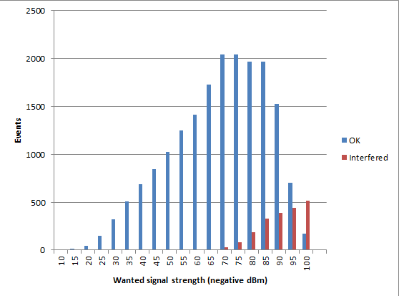

1. Example of wanted signal vector analysis   
   (wanted signal is grouped in 5dB bins)

From Figure 6: it can be seen that victim devices receiving weakest signal from their transmitters (e.g. due to being in unfavourable geometry) will suffer interference the most. The following Figure 7: illustrates the proportion of devices experiencing different percentage of interference.

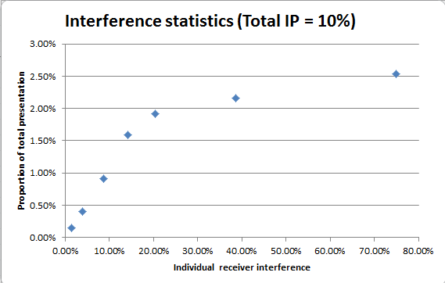

1. Detailed Interference statistics for total IP=10%

It can be seen from Figure 7: that 2.5% of simulated events experience around 80% interference; whereas 1% of devices experience around 10% interference; and 0.4% have around 0.34% interference, giving overall interference for this case 10%.

**Unwanted emissions masks and receiver selectivity**

It is very important to carefully define the unwanted emissions masks for considered legacy as well as proposed future SRD applications. Traditionally these masks are focused on reflecting the OOB limits as they are dominant factor in most in-band studies. However this report also considered the case of adjacent band interference with cellular systems, where the interferer and victim were far removed in frequency, much beyond the OOB domain of unwanted emissions of narrowband SRD devices. Therefore in case of SRD to cellular systems interference the spurious domain emissions may become a predominant factor, which requires that the unwanted emission masks of SRD transmitters should be carefully defined to ensure that they properly reflect the suitable spurious emission limits.

The ERC/REC 74-0 1 [8] stipulates that SRD spurious emissions below 1 GHz should not generally exceed -36 dBm/100 kHz. There is still however an optional limit mentioned in the ERC/REC 74-01 of -54 dBm/100 kHz applicable in the (former) broadcasting bands, such as 470-862 MHz. It was set specifically for protection of domestic TV reception and is now proposed to be rescinded for band segments transferred to use by mobile services. Nevertheless, all the incumbent SRDs in the band 863-870 MHz were designed to respect the reduced spurious emissions limit and therefore by extension the same RF technology might also transfer into new bands 870-876/915-921 MHz. In order to accommodate this transitional uncertainty and to build basis for a better informed decision on appropriate SRD spurious emissions limits below 862 MHz, it was decided that the simulations of adjacent band interference carried out in this report should be based on two options for SRD unwanted masks:

* Option 1 of "Generic emissions mask" based on -54 dBm/100 kHz spurious limit;
* Option 2 of "Worst case emissions mask" based on -36 dBm/100 kHz spurious limit.

ANNEX 3: provides an emission mask of a real 802.11ah device obtained in the lab, which might not be representative for all devices.

The following figures show the specifics of the masks for both of the above options that were used in SEAMCAT simulations reported in this report. The remaining simulations concerned with in-band sharing scenarios were carried using generic emissions mask option.

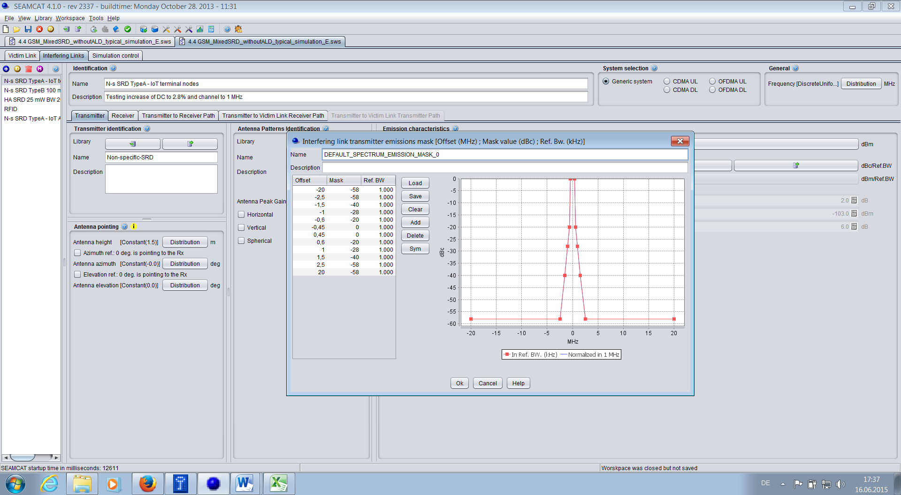

1. WB SRD Mask Option 1

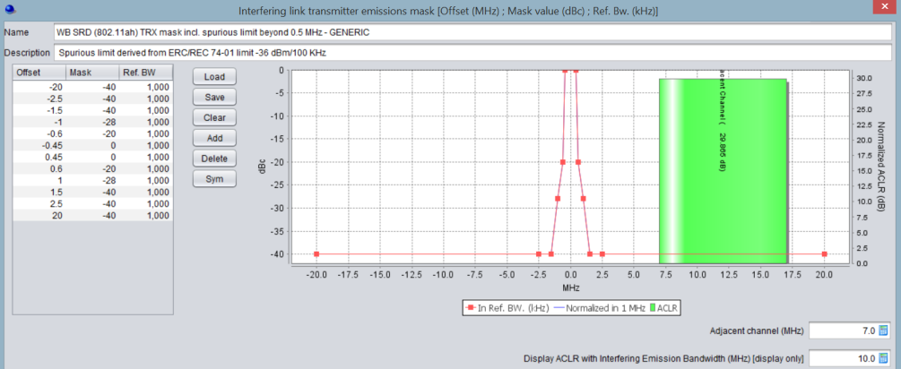

1. WB SRD Mask Option 2

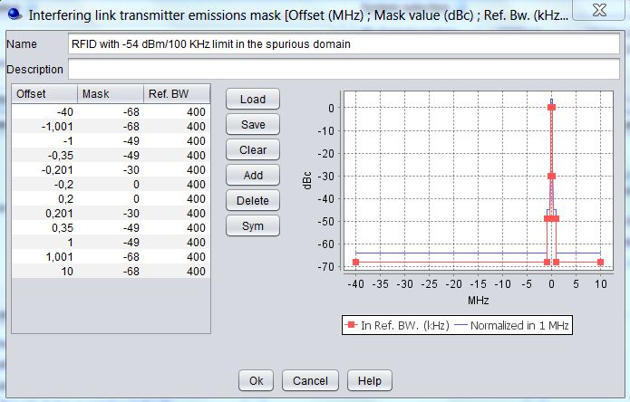

1. RFID Mask Option 1

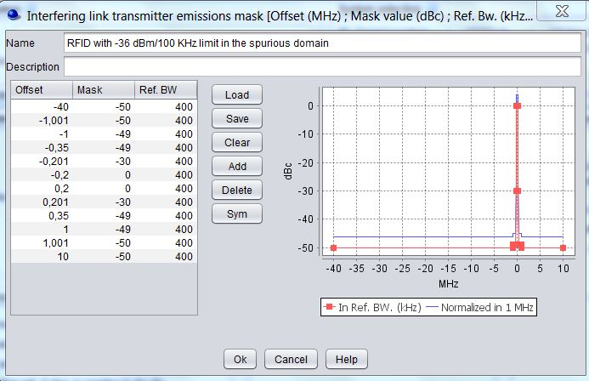

1. RFID Mask Option 2

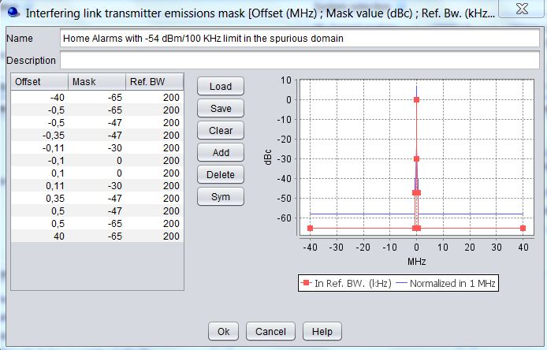

1. Sub-metering SRD Mask Option 1

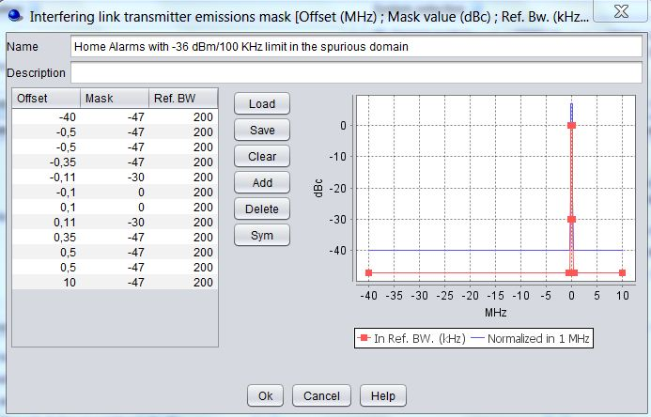

1. Sub-metering SRD Mask Option 2

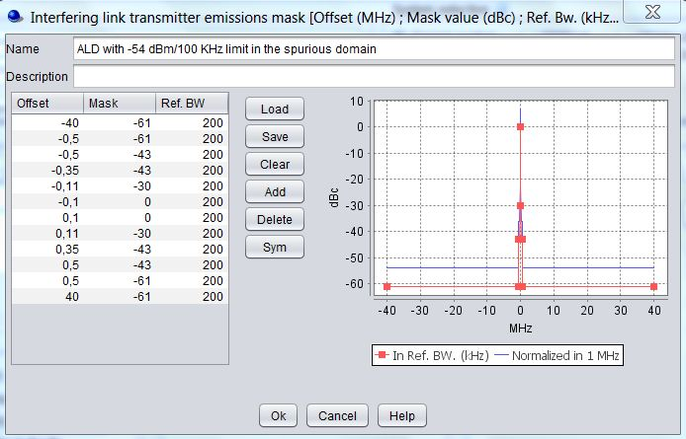

1. ALD SRD Mask Option 1

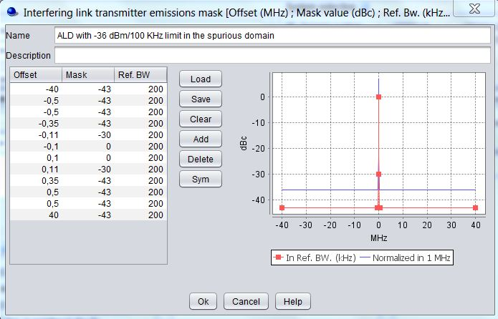

1. ALD SRD Mask Option 2

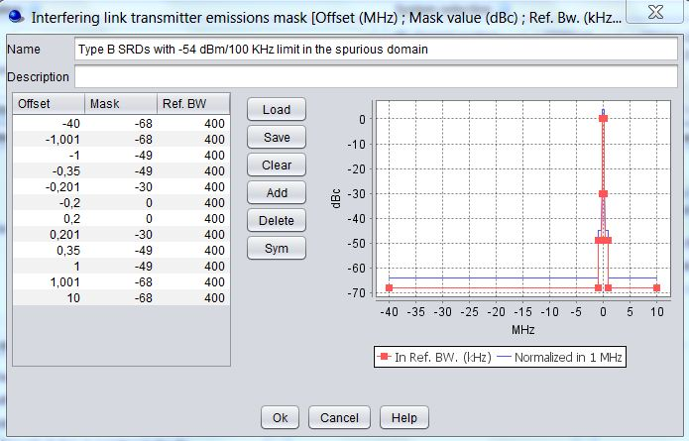

1. Type B SRD Mask Option 1

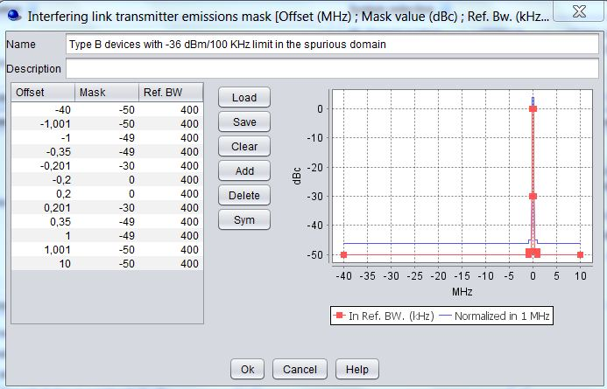

1. Type B SRD Mask Option 2

*Note:* the ACS and blocking values have to be chosen carefully. It is not correct to assume that the adjacent or out of band power reduced by the ACS or blocking value from the standard can be assumed as an equivalent co-channel interfering power; ACS is usually measured as the difference between adjacent power and wanted signal. Thus, the equivalent interfering power of the adjacent signal is the actual power reduced by the ACS/blocking value plus C/I. The values from EN 300 220 [5] are for Cat. 2 receivers 35dB-10log(BW/16kHz) at 2MHz offset from the center frequency and 60dB -10log(BW/16kHz). For the studies a bandwidth of 100 kHz and a C/I of 8dB where assumed, resulting in 60dB at 10MHz and 35 dB at 2 MHz.

It should be further noted that the in-channel attenuation visible in the following figure is not representative of a real receiver performance. That attenuation is actually a work-around measure made specifically for mask representation in SEAMCAT, in order to address a certain peculiarity of how SEAMCAT calculates blocking interference. I.e. the calculation of blocking in SEAMCAT is tailored for cases where there is some separation between victim and interferer frequencies. However the scenarios addressed in this report routinely considered situations with frequency agility in either or both victim and interferer. Hence there may be snapshots where victim and interferer occupy the same channel. So in order to clearly distinguish genuine blocking vs. unwanted interference impacts in analysing results of SEAMCAT simulations, it was considered a suitable work-around technique to introduce some arbitrarily high “artificial” in-band attenuation in victim receiver’s filter mask, which results that when SEAMCAT is calculating blocking attenuation and there happens to be a snapshot with overlapping victim and interferer frequency channels, the mask will return very high attenuation which will effectively negate the interference impact and thus discount that snapshot from blocking interference statistics. Whereas the same snapshot would remain accounted in interference statistics for the unwanted interference type, as that calculation does not consider impact of victim receiver’s filter.

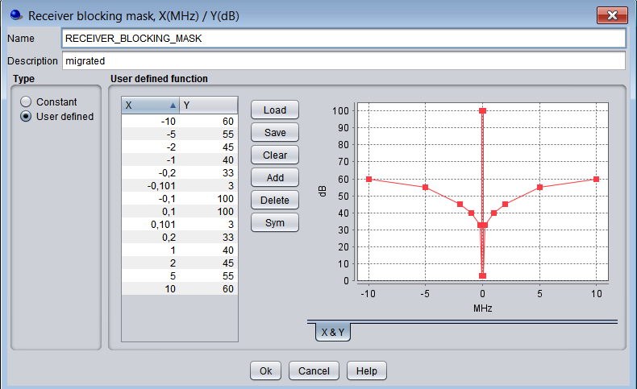

1. Realistic selectivity mask used in studies for SRDs (realistic Cat.2 receiver)

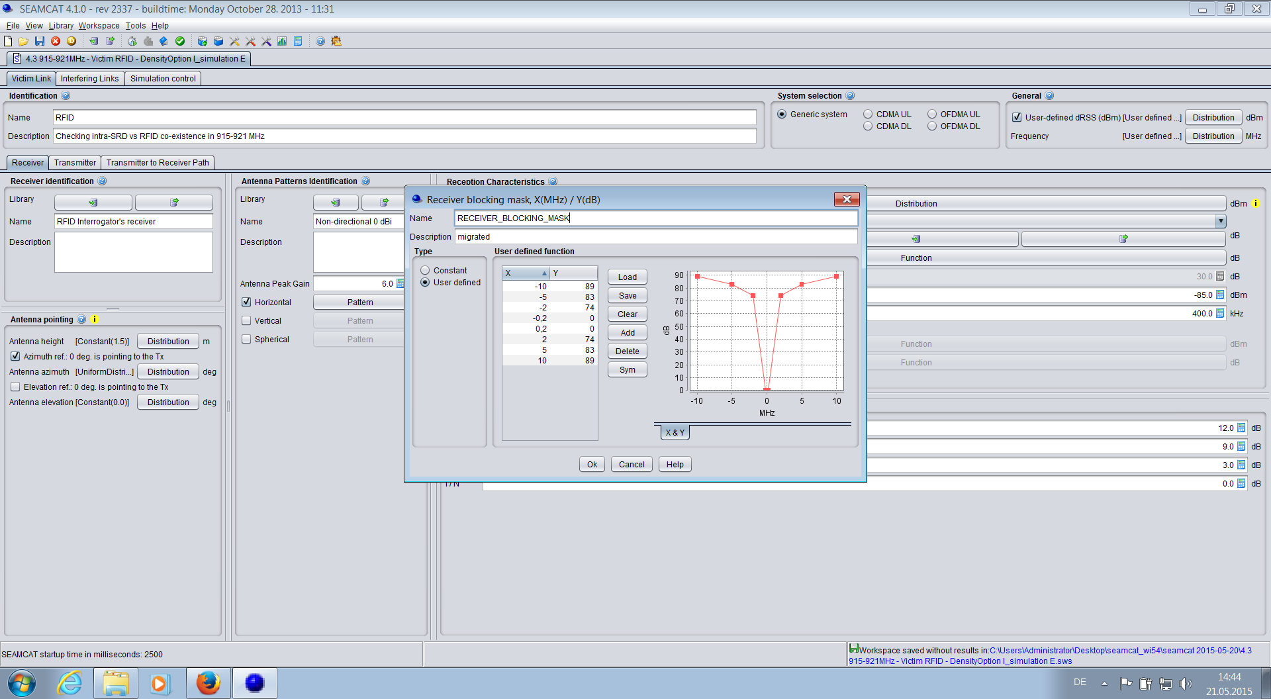

1. Selectivity used for RFID (from draft EN 302 208)



1. GSM User defined dRSS

**Consideration of e.r.p. vs. e.i.r.p. and resulting expression of antenna gain in SEAMCAT simulations**

Quite often antenna gain of various SRD products is loosely expressed by vendors and considered in compatibility studies in decibels, without explicit clarification as to whether it is an absolute gain relative to theoretical isotropical radiator (dBi) or gain relative to practical dipole (dBd). This distinction is however important, because in accordance with practice in ERC/REC 70-03, the regulatory limits for power emission levels below 1 GHz are usually defined in "e.r.p." units. This power metric is traditionally defined as power effectively radiated from a half-way dipole.

Importantly for practical implementation of the SRD regulations such as ERC/REC 70-03, this definition of e.r.p. is also embedded in ETSI EN 300 220-1 through combination of clauses 5.2.1 and 5.2.2, from where it becomes unambiguously clear that the antenna gain used for measuring e.r.p. of SRDs tested for compliance should be expressed related to dipole antenna.

Noting that the half-wave dipole has theoretical gain of 2.15 dBi, any ambiguity in definition of antenna gain in either dBi or dBd as used for simulations may introduce 2.15 dB error in definition of actual simulated emitted power.

Therefore during studies of this report an additional investigation was carried out to clarify the antenna gain references and ensure that all SRD antennas in the report are uniformly defined in dBd and reflected in simulation settings accordingly. Because SEAMCAT does not have an option to distinguish e.r.p. emitted power and performs all calculations using e.i.r.p. reference. Therefore antenna gain used in SEAMCAT need to consider and possibly adjust for difference between dBd and dBi reference antennas ir order to ensure that the modelled power level corresponds to relevant regulatory power limit (e.r.p. in the case of ERC/REC 70-03).

The following table summarises the antenna gains in dBd units for various SRDs considered in this report as well as their corresponding dBi values used in SEAMCAT simulations.

1. SRD antenna gains used in the Report

|  |  |  |
| --- | --- | --- |
| SRD type | Nominal *Ga* | *Ga* used in SEAMCAT |
| Non-specific (Types A/B) | -2.15 dBd | 0 dBi |
| Sub-metering | -5 dBd | -2.85 dBi |
| Portable alarms | -2.15 dBd | 0 dBi |
| RFID | 3.85 dBd | 6 dBi |
| Automotive | -2.15 dBd | 0 dBi |
| Assistive Listening Devices | -23 dBd | -20.85 dBi |
| IoT Wideband SRD Access Points | 0 dBd | 2.15 dBi |
| IoT Wideband SRD Terminal Nodes | -2.15 dBd | 0 dBi |
| Smart Metering: NAP & Network Nodes | 0 dBd | 2.15 dBi |
| Smart Metering: Terminal Nodes | -2.15 dBd | 0 dBi |

**SEAMCAT scenario settings for cellular systems**

The study team spent significant time in consultation with cellular operators and equipment vendors, trying to establish the most suitable parameters for simulation of victim cellular systems. This proved to be not a trivial task because cellular systems are deployed in ever expanding manner and with widely varying deployment patterns. The final set of essential SEAMCAT parameters agreed for this study is provided in the following tables.

1. LTE Victim system

|  |  |
| --- | --- |
| SINR Minimum | -1000.0 |
| Max subcarriers per BaseStation | 48 |
| Number of subcarriers per mobile | 16 i.e. 3 UEs per base station |
| Receiver Noise Figure | 5.0 |
| Handover Margin | 1.0 |
| Minimum Coupling Loss | 70.0 |
| System bandwidth | 9.0 |
| Bandwidth of Resource Block | 180.0 |
| Victim Receiver Blocking Mask /ACS | Per Section A1.9 of CEPT Report 40 |
| Maximum allowed disconnection attempts | 3 |
| Maximum allowed transmit power of mobile | 23.0 |
| Minimum transmit power of mobile | -30.0 |
| Power Scaling Threshold | 0.9 & 0.99 |
| Balancing Factor | 1.0 |
| Users per Base Station | 30 |
| Network Wrap-Around Model | false |
| Wrap-Around option | false |
| Number of Base stations in the system | 19 |
| Cell Layout | 2-tier, Tri-Sector |
| Grid Layout | 3GPP grid layout |
| Cell Radius | 0.5 |
| **Base Station:** |  |
| Antenna Height: | Constant(30.0) |
| Antenna Tilt: | Constant(-6.0) |
| **Antenna:** |  |
| Reference | ITU-R.F1336 17 dBi k=0.2 |
| Peak Gain: | 17.0 dBi |
| Use Horizontal Pattern: | true |
| **Mobile Station:** |  |
| Antenna Height: | Constant(1.5) |
| Antenna Gain | Constant(0.0) |

1. UMTS Victim system Macro base station

|  |  |
| --- | --- |
| Receiver Noise Figure | 5.0 |
| Handover Margin | 3.0 |
| Call drop threshold | 3.0 |
| Voice bit rate | 12.2 |
| Reference bandwidth | 3.84 |
| Voice activity factor | 1.0 |
| Minimum Coupling Loss | 70.0 |
| cell Noise Rise Selection | true |
| Target Network Noise Rise | 6.0 |
| Target Cell Noise Rise | 0.01 & 1.0 |
| Mobile Station Maximum Transmit Power | 24.0 |
| Mobile Station Power Control Range | 75.0 |
| Power Control Convergence Precision | 0.01 |
| User per cell | 30 users |
| Simulate non inferred capacity | true |
| Delta users per cell | 20 users |
| Number of trials | 10 |
| Tolerance of initial outage | 0.05 |
| Number of Base stations in the system | 19 |
| Cell Layout | 2-tier, Tri-Sector |
| Grid Layout | 3GPP-2 grid layout |
| Cell Radius | 0.5 (Urban) |
| **Base Station:** |  |
| Antenna Height: | Constant(30.0) |
| Antenna Tilt: | Constant(-6.0) |
| **Antenna:** |  |
| Reference | ITU-R.F1336 17 dBi k=0.2 |
| Peak Gain: | 17.0 dBi |
| **Mobile Station:** |  |
| Antenna Height: | Constant(1.5) |
| Antenna Gain | Constant(0.0) |

1. GSM

|  |  |
| --- | --- |
| Sensitivity | -110.0 dBm |
| Reception bandwidth | 200.0 kHz |
| Use Power Control Threshold | false |
| Use Receiver Overloading | false |
| C / I | 12.0 dB |
| C / (N + I) | 9.0 dB |
| (N + I) / N | 3.0 dB |
| I / N | 0.0 dB |
| **Base Station:** |  |
| Antenna Height: | Constant(30.0) |
| Antenna Tilt: | Constant(-6.0) |
| **Antenna:** |  |
| Reference | ITU-R.F1336 17 dBi k=0.2 |
| Peak Gain: | 17.0 dBi |
| Use Horizontal Pattern: | true |
| **Mobile Station:** |  |
| Antenna Height: | Constant(1.5) |
| Antenna Gain | Constant(0.0) |

1. **Time domain considerations**

As noted in section 4 above SEAMCAT does not model in detail the time behaviour aspects of the interaction between interferer and victim. The work around of using the interferer DC as the Probability of Transmitting in SEAMCAT is not necessarily correct. One solution that has been proposed is the use of a correction factor to derive an adjusted Probability of Transmitting to be used as input parameter for the SEAMCAT simulations.

Section A.2.1 is providing the mathematical formulas for the correction factor, Annex A.2.2 transmission times for different systems and Section A.2.3 examples.

At the time of the preparation of this report there was no agreement on the correction factor for SEAMCAT simulations. Below are concerns that remain unresolved:

* Any such method, the correction factor, and the subsequent results of simulation would be applicable to a very specific considered pair of interferer vs. victim device types, which may be dependent on proprietary (i.e. not specified in ETSI standards) technological solutions defining channel access and timing parameters of a specific product;
* the approach assumes that any short overlap in time destroys the packet or message, which is not necessarily the case. This is, however, the assumption made in ECC Report 181, the IMST Study and most of the academic literature. SEAMCAT analyses whether the interfering packet is strong enough to destroy the victim packet and allows for that,
* the approach only looks at the DC aspect and does not account for real-time dynamics of interactions resulting from interference, i.e. LBT effects nor advanced channel access protocols such as CSMA-CA, packet acknowledgement/re-transmission, etc. In other words, it is not a complete solution to the problem of time domain analysis but a step along the way;
* in some cases, transmission times are dependent on the application and are different for every user: e.g. 802.11ah, max 27 ms, but will seldom be used, min 1-2 ms; suitable values will need to be chosen; however, a way out could be to derive restrictions to the max transmission time from the simulation;
* The proposed corrections will always results in worse or equal results compared with SEAMCAT results using the existing workaround;
* With the correction we get a packet loss rate, therefore the criterion may need to be adjusted. E.g. if the acceptable interference probability is 5%, then the acceptable packet loss value could be 10%. The criterion will need to be assessed for each victim, but ideally we should already be doing that anyway. Interpretation of “probability of interference” is open to discussion;
* in some scenarios the correction factor results in very large changes; for example wireless audio as victim: large tvict, small tint with very small Dcint. This results in an interference probability of 1 with the analytical formula; but a low interference probability without it. Which result is correct? The current SEAMCAT results, not using the victims perspective, can be interpreted in a way that an interference probability of 1% could be seen as short annoying interruptions, eg 100ms every 10s. Is that harmful? Do we expect a 24h interference effect in that way, or is it more a time limited effect similar to an EMC interference, e.g. from a drilling machine use nearby? The scenario of digital interferer – analogue victim may be a case for special treatment, with or without the correction factor;
* a question was raised whether the connection of the analytical time domain approach with the current SEAMCAT tool is correct.
  1. Use of Probability of transmitting in SEAMCAT

Suppose an interferer and a victim system are both on the same channel and within range of each other.

Section 4.2 of the IMST Study [4] states:

In case two users *m* and *n* are transmitting with random time offsets, the probability of a packet collision of user *n* depends on the two packet lengths *Tx,m* and *Tx,n* as well as the repetition interval *Tint,m* of user *m*.



Section 3.1 of ECC Report 181 [5] states:

Suppose user 1 sends transmissions of duration T1, at a rate of F1. User 2 sends transmissions of T2 at F2, etc. Therefore their duty cycles are

etc



The relative timings between users is random. User N sends a transmission of duration TN. The probability that this collides with a transmission from user m is

for otherwise



It can be seen that the two formulae are the same, apart from a difference in notation.

For convenience, let us replace *m* and *n* or N with INT and VICT, then:

The probability that a transmission in the victim system suffers a collision with a transmission from the interferer is:

for otherwise



SEAMCAT models the probability of interference on the assumption that the interferers and the victim are all 100% duty cycle systems. An accepted method of allowing for duty cycles of less than 100% is to use the Probability of Transmitting parameter, *PTX*.

It is necessary, however, to choose the correct value for *PTX*.

In the case above, with interferer and victim on the same channel and in range, a collision is certain if both devices are active at the same time and therefore SEAMCAT will model the probability of interference as



therefore, the value for the collision probability can be obtained by using a value for the interferer’s probability of transmitting of:



or



The above proposal is in agreement with:

* The IMST Study [4]
* ECC Report 181 [6]
* ECC Report 234 [9]

Subject to a maximum value for *PTX* of 1.

The above approach assumes that any overlap in time is destroying the packet, which is not always the case.

* 1. Transmission durations

The table below lists some indicative example durations of a transmission from each type of device. It should be noted that transmission times are mostly dependent on the application and are changing dynamically. It should be noted that the values in the table are only examples.

1. Examples for typical durations of a transmission from each type of device

|  |  |  |  |
| --- | --- | --- | --- |
| Device | Information Source | Typical transmission (ms) | Comment |
| Wideband devices | TR 103 245 | 1-27 ms | 802.11ah specifies 27.92 ms max, but will seldom be used, minimum 1-2 ms |
| Portable alarms | TR 103 056 indicates 100 bits | 35 | Note 1 |
| Fire/Smoke alarms | TR 103 056 indicates 100 bits | 35 | Note 1 |
| Intruder Alarms | ECC Report 181 Annex 7  TR 103 056 indicates 100 bits | 25 | Note 1 |
| Social Alarms | STF 411  TR 103 056 indicates 100 bits | 35 | Note 1 |
| Smart Metering  Terminals | EN 303 204 | 250 | EN 303 204 specifies 400 ms max |
| Smart Metering  Aps | EN 303 204 | 250 | EN 303 204 specifies 400 ms max |
| Automotive | ECC Report 181 Annex 7 | 150 | Range is 30 ms to 30 s. |
| Home Automation | ECC Report 181 Annex 7 | 50 | Range is 10 ms to 36 s. |
| Lighting control | Measurements at GCD | 8 | Subset of HA requiring very low latency |
| Sub metering | ECC Report 181 Annex 7 | 25 | Range is 25 ms to 1.2 s. |
| RFID |  | 5 | Time to read 1 tag |
| Wireless Audio |  | 500 sec | Note 2 |
| ALD |  | 500 sec | Note 2 |
| Non specific SRDs IoT Terminal |  | 50 |  |
| Non-specific SRDs IoT APs |  | 50 |  |
| Non-specific SRDs Type B |  | 50 |  |
| Non-specific SRDs IoT Terminal |  | 50 |  |
| GSM Uplink |  | 25 |  |
| UMTS Uplink |  | 25 |  |
| LTE Macro Uplink |  | 1 |  |

Note 1: There is a particular consideration here, especially for uni-directional alarms. A device may embed a number of packets into one transmission. When the device is considered as an interferer it is the total transmission duration that is important. When it is considered as a victim it is the duration of an embedded packet that is important. The value listed is the embedded packet.

Note 2: These systems are effectively continuous operation. The value listed is based on the user’s reasonable expectation of a period of uninterrupted use.

* 1. Examples of PTX

This Annex lists some examples of how to derive the Probability of Transmitting parameter in various cases.

It can be seen that the use of the correction factor sometimes results in small changes, sometimes in large ones.

**Case 1: Equal transmission durations**

Interferer: Sends transmissions of 50 ms at average rate of 1 per 50 secs

DCINT = 0.1%

Victim: Uses packets of 50 ms duration



or



**Case 2a: Unequal durations – Long victim, short interferer**

Interferer: Sends transmissions of 25 ms at average rate of 1 per 25 secs

DCINT = 0.1%

Victim: Uses packets of 100 ms duration



or



**Case 2b: Unequal durations – Short victim, long interferer**

Interferer: Sends transmissions of 100 ms at average rate of 1 per 100 secs

DCINT = 0.1%

Victim: Uses packets of 25 ms duration



or



**Case 3: Almost certain collision**

Interferer: Sends transmissions of 50 ms at average rate of 2 per sec

DCINT = 10%

Victim: Uses packets of 700 ms duration



or



In this case *PTX* should be set to 1 representing an almost certain collision if the two systems coincide in space and frequency.

Note: if the interfering transmissions are randomly timed then there is a tiny probability that a victim signal does get through, but it is negligible for practical purposes.

**Case 4 Audio victim**

Interferer: Sends transmissions of 100 ms at average rate of 1 per 20 secs

DCINT = 0.5%

Victim: Listens continually. Let’s assume he listens to music tracks of 300 secs duration.



or



In this case *PTX* should be set to 1 representing an almost certain interruption of each music track if the two systems coincide in space and frequency.

**Case 5a: Concatenated packets as victim**

Interferer: Sends transmissions of 200 ms at average rate of 1 per 20 secs

DCINT = 1%

Victim: An alarm system that sends transmissions of 200 ms, but consisting of a 50 ms packet repeated 4 times.



or



In this case the duration of the individual packets in the victim system is used rather than the overall transmission duration. This will lead to the Packet Loss Rate experienced by the victim. The probability that all 4 packets in a transmission will be lost is different and beyond the remit of this discussion.

**Case 5b: Concatenated packets as interferer**

Interferer: An alarm system that sends transmissions of 200 ms, but consisting of a 50 ms packet repeated 4 times. The transmissions are sent at an average rate of 1 per 20 secs.

DCINT = 1%

Victim: Uses packets of 200 ms duration.



or



In this case the duration of whole transmission is used rather since this is what the victim will experience.

* 1. Example

The DC values used in this report could be corrected using the time domain parameters from Table 17:. The corrected DC values could be then used as input for the SEAMCAT simulations. The following table shows a few examples with an alarm system as victim.

1. Examples of time domain correction

|  |  |  |  |  |  |  |
| --- | --- | --- | --- | --- | --- | --- |
| Victim alarm | SM Term | SM AP | Iot | IoT AP | Automotive | ha |
| Ton_int s | 0.25 | 0.25 | 0.02 | 0.02 | 0.15 | 0.05 |
| Ton_vict s | 0.03 | 0.03 | 0.03 | 0.03 | 0.03 | 0.03 |
| Dc_int | 2.50% | 10.00% | 2.50% | 10.00% | 0.10% | 0.0025% |
| Ptx | 2.80% | 11.20% | 6.25% | 25.00% | 0.12% | 0.0040% |

1. **802.11ah spectrum emission mask lab measurements**

This Annex analyses emission masks of a real 802.11ah device obtained in the lab, which might not be representative for all devices. The goal of this measurement is to understand which of the two spectrum emission masks adopted in this report (see ANNEX 1:) is more realistic in terms of modelling real device behaviour. The two considered masks are depicted in Figure 21: below for the case of 14dBm max output power.

As it can be observed the in band region is the same as the one described in ETSI TR 103 245. The two masks plotted in black and red differ in the spurious domain region. The black curve represents the IEEE mask, where the spurious level has a floor at -40 dBr, i.e. 14 dBm/MHz - 40 dBr =- 26 dBm/MHz as shown in the picture. The red curve shows instead the case when an absolute value of -54 dBm/100 kHz at 2.5 MHz offset to the carrier frequency (-44 dBm/1MHz in the picture).



1. Spectrum emission masks adopted in this report (red and black curves)

Since these two masks are used to determine the power leakage into adjacent channels, we want to get a better understanding of what would be the emission of a real device transmitting 802.11ah waveform in 900 MHz. In the next we will present the emission level obtained by testing a power amplifier driven by 802.11ah waveform operating on 900 MHz band.

* 1. lab measurements

Tests were performed in a lab under the following assumptions:

* Power Amplifier (PA) only test (no RFIC and Front End);
* Carrier frequency: 915 MHz;
* PA driven to 17.5 dBm to compensate 3.5 dB front end loss, 14 dBm would be available at antenna;
* PA driven using 11ah waveforms;
* Lab equipment: Agilent E4438C with Agilent PXA.

Results of the lab measurement are provided in Figure 22:, where the emission mask available from the spectrum analyser is depicted. In order to correctly read the results, the following should be noted:

* Measurement performed with resolution bandwidth of 91 kHz;
* Yellow plot represents the emission considering PA driven @17.5dBm. This means that the real output power at the antenna would be attenuated by the front-end loss. Assuming that this loss is mainly due to insertion loss, we expect attenuation flat in the frequency domain. This means that the antenna emission can be obtained by shifting down the yellow curve by a factor of 3.5 dB (the estimated front end loss);
* Red line represents the -36 dBm/100kHz limit (note that in picture this value is slightly scaled down due to the different resolution bandwidth, i.e. resulting value is -36 dBm/100kHz + 10*log10(91/100) ~-36.4 dBm/91kHz;
* Magenta line represents the -40 dBm/100kHz limit (note that in picture this value is slightly scaled down due to the different resolution bandwidth, i.e. resulting value is -36 dBm/100kHz + 10*log10(91/100) ~-40.4 dBm/91kHz;
* Green line represents the -54 dBm/100KHz limit (note that in picture this value is slightly scaled down due to the different resolution bandwidth, i.e. resulting value is -54 dBm/100kHz + 10*log10(91/100) ~ -54.4 dBm/91kHz;
* Blue lines represent ±1.5MHz and ±2.5MHz offset with respect to the carrier frequency.

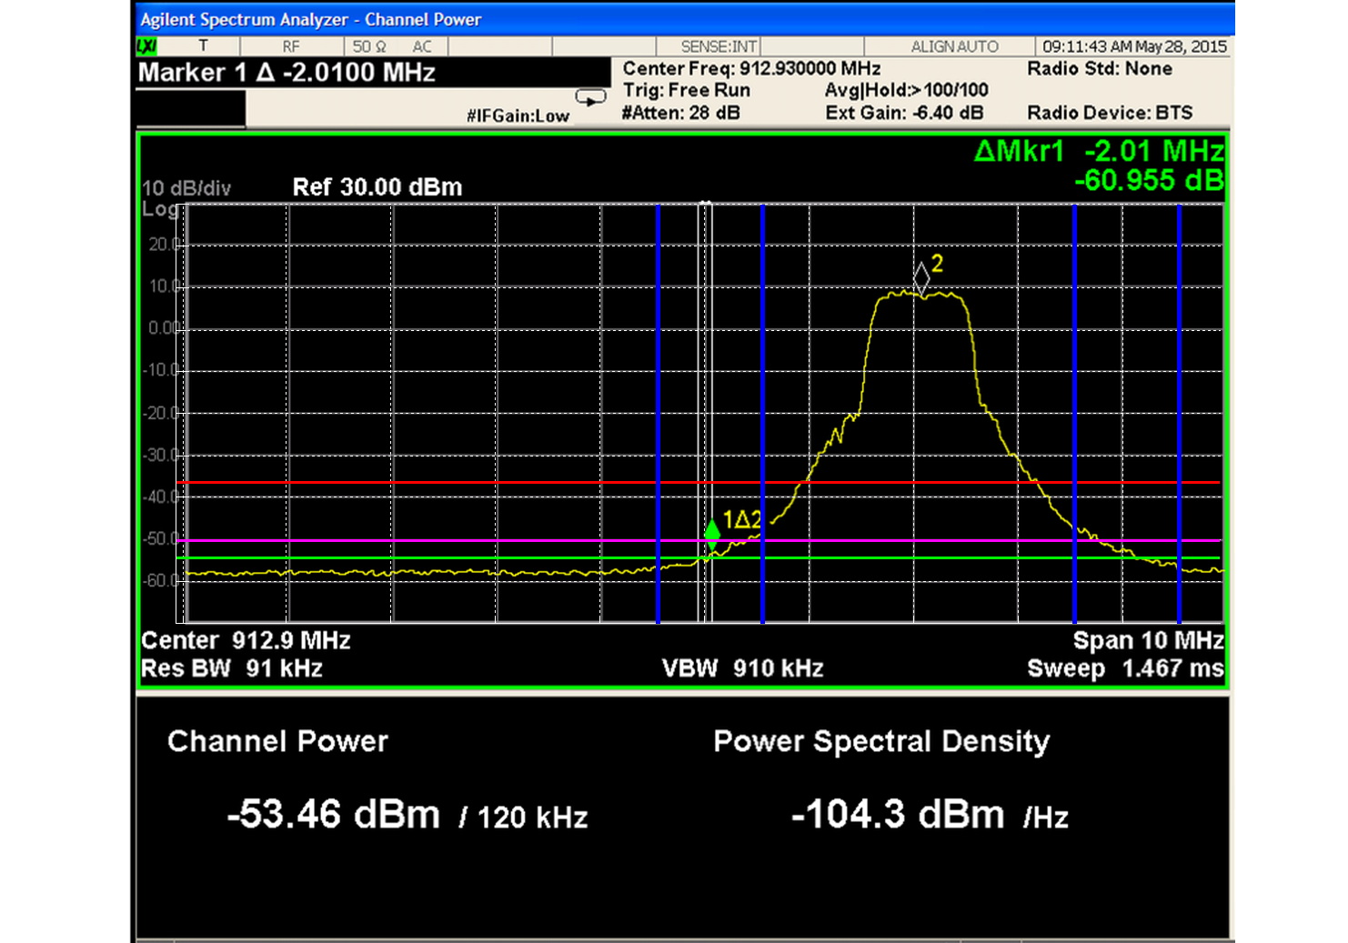

1. Spectrum emission of device under testing

From analysing the measurement data the following observations can be made:

* @±1.5MHz offset with respect to the carrier frequency a value of -40 dBm/MHz can be reached (note that emission at antenna will be 3.5 dB lower compared to the yellow curve);
* @±2.5MHz offset with respect to the carrier frequency a value of -54 dBm/100kHz can be reached;
* The emission floor is below the -54 dBm/100kHz value.

Of course, when understanding these test results, several additional factors need to be kept in mind:

* Test have been made on a specific PA from one vendor only; factors such as phase noise, baseband noise/linearity, and digital baseband processing may contribute to the final emission which cannot be characterized here;
* PA from different vendors can behave differently;
* PA from the same vendor can have statistical variation in terms of performance;
* Behaviour of same devices can vary dependent on ambient temperature.

However, based on the above measurement results the following may be concluded for this report:

* The emission floor of -54 dBm/100kHz can be achieved by 802.11ah devices operating @900MHz;
* The emission mask based on ETSI TR 103 245 specification only is pessimistic. This implies that results obtained through that mask must be interpreted as a very worst case scenario;
* It is not possible to define a specific mask based on one set of results only because of the intra-vendor and inter-vendors performance variation. However, the data provided gave a strong indication of the capability of 802.11ah devices operating in 900 MHz band to meet the requirements for certain level of unwanted emissions.

1. **co-existence between RFID and WB SRD**

**Listening time to detect RFID**

According to RFID industry, a specific listening time for the detection mechanism might improve further the detection. Some RFID manufacturers have pointed out that during the interrogation of a large number of tags, it is sometimes desirable to send a reset command. This requires the interrogator to stop transmitting for a period of 1 msec. The procedure is documented in in clause 6.3.1.2.7 of ISO/IEC 18000-6 [7] and says "Once powered off, an Interrogator shall remain powered off for at least 1ms before powering up again." To ensure that another device, wishing to occupy part of the band, does not monitor only during this silent period, the listening time should be at least 1 msec.

During the ongoing EN 300220 revision process in ETSI, the minimum listening time for polite systems was extensively discussed. An agreement was found on a minimum listening time of 160µs for all devices with LBT or equivalent technique. This common value, necessary for an equal medium access, is a compromise between existing and high throughput systems.

To generalise the listening time at 1ms would hamper the whole SRD industry whereas it might only improve co-located sites. A reasonable approach is therefore to have the listening time of 1ms being recommended to be set in case of co-location with an RFID system. For industrial premises where an RFID high level of service is expected, it’s also recommended to resort to site engineering.

**Impact of WB SRD on tag emissions**

The analysis below examines the impact of WB SRD on tag emissions corresponding to transmissions by interrogators in each of the high power channels. For simplicity the five WB SRD channels have been numbered WBS1 to WBS5 respectively (assuming a channel arrangement of 5 non-overlapping 1 MHz channels between 915.8-920.8 MHz as an example).

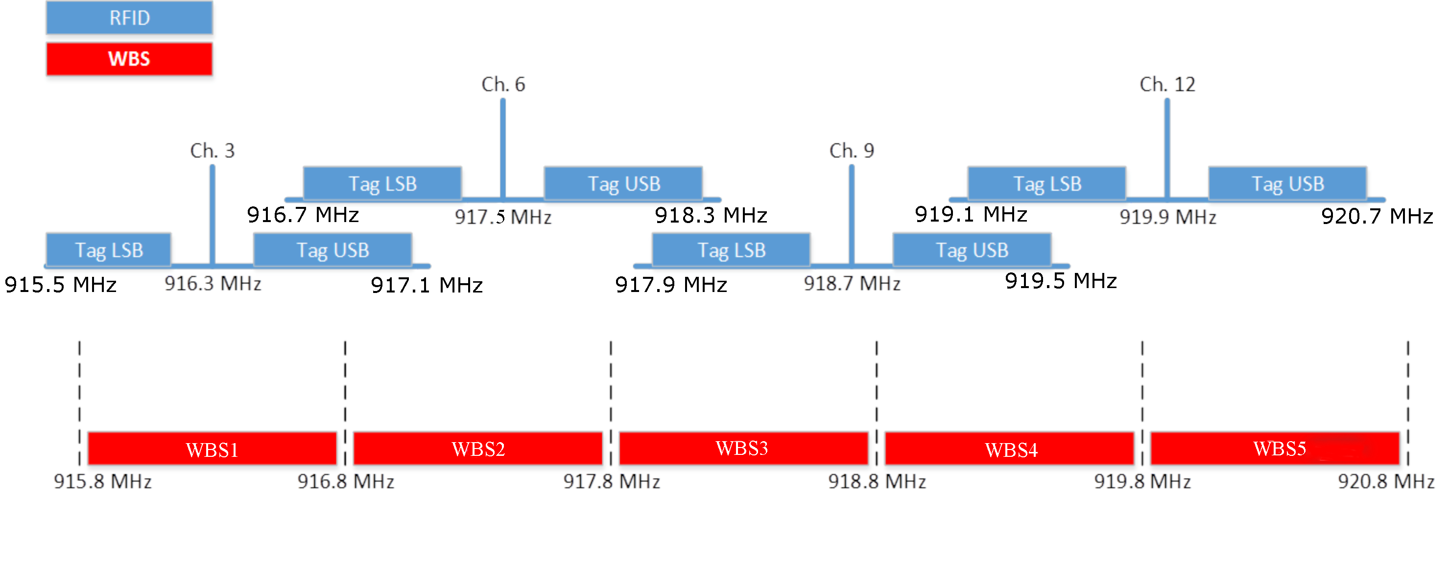

1. Overview RFID and WB SRD channels

Inspection of the above Figure 23: shows the channels where co-existence of WBS and RFID may be possible. This is based on the revised band-plan proposed by the WB SRD manufacturers. From the diagram the following deductions may be reached.

1. WBS1 Any transmission by RFID on channel 3 will be detected by the CSMA-CA mitigation technique in the WBS equipment. Channel WBS1 will be deselected until RFID ceases to transmit.
2. WBS 1 Any transmission by RFID on channel 6 will not be detected by a WBS operating on WBS1. The bottom 100 kHz of the LSB of channel 6 will be exposed to transmissions by WBS. This is equal to a signal level of 4 dBm/100 kHz, which equates to a signal of -4 dBm/600 kHz over the LSB of an interrogator. Depending on the nature of the installation this may create unacceptable interference to RFID.
3. WBS1 RFID channels 9 and 12 are outside WBS1 and will not be subject to any interference.
4. WBS 2 Operation in WBS2 would detect channel 6 of RFID, which would be protected. However CSMA-CA would not detect channel 3 meaning that 300 kHz of the upper side band would be exposed to transmissions by WBS. Operation in WBS2 is not recommended.
5. WBS3 Operation in WBS3 would detect channel 9 of RFID, which would be protected. However CSMA-CA would not detect channel 6 meaning that 500 kHz of the upper side band would be exposed to transmissions by WBS. Operation in WBS3 is not recommended.
6. WBS4 Operation in WBS4 would detect channels 9 and 12 of RFID, which would both be protected. (Note that in both cases 100 kHz of the RFID high power channels are present in WBS4) Where WBS4 is pre-selected, operation of RFID should be free from interference by WBS.
7. WBS5 Operation in WBS5 would detect channel 12 of RFID, which would be protected. Where WBS5 is pre-selected, operation of RFID should be free from interference by WBS.

The following conclusions can be made from this investigation for the case that WB SRDs would operate between 915.8 - 920.8 MHz:

1. Selection of either WBS4 or WBS5 should permit RFID to operate free from any interference from WB SRD.
2. Operation on WBS1 may be possible depending on the nature of the installation.
3. Existing chipsets for RFID interrogators decode tag signals in both the upper and lower sidebands. It is therefore not possible for interrogators to handle tag emissions in only one sideband.
4. Requirements for a Sensing procedure

In this section the requirements for an interfering system (Interfering transmitter IT, transmitting to its wanted receiver WR) to detect a victim system (Wanted transmitter WT, transmitting to the victim receiver VR) are analysed. The IT is able to monitor the WT (e.g. pure power detection or preamble detection), which is the basis for the Listen Before Transmit (LBT) sensing mechanism. It has to be noted that in the following analysis it is assumed that victim and interfering links are working continuously at the same frequency. Time domain aspects of sensing procedure (e.g. listening time, dead time) are not considered in this Annex.

The following abbreviations and definitions are used:

* VR Victim receiver;

N: Noise floor kTBF of VR;

F: Noise figure of VR;

SNRlimit: minimum signal to noise ratio;

SNR: signal to noise ratio;

INR: Interference to noise ratio at VR;

Margin=SNR-SNRlimit;

Pwt Transmit power of WT;

* IT Interfering Transmitter;

Pit Transmit power of IT;

Pthr: power threshold for the LBT mechanism at IT.

Under the assumption that WT, VR, IT and WR are transmitting and receiving continuously, that on victim side the Tx and Rx antenna gain are equal, it can be shown (see also Annex 1 of ECC Report 181 [6]) that the threshold for perfectly detecting the victim system can be derived using the following formula:

*Pthr*=*Pwt* – *Pit* + *N* + *margin* + *INR*

It should be clear that any antenna gain and path loss have no impact on the derivation of the threshold value in the above formula, and only the conducted Tx power levels are relevant.

1. **statistics on the household density in europe**

Statistics on household densities in the European Union were provided by the Joint Research centre of the European Commission (JRC) in 2015. Some key conclusions from that contribution are:

* The majority of European households are located in densely populated areas.
* In the EU-28 between 45% and 51% of households are located in densely populated areas (figures vary depending on the source and nature of the statistical information).
* In densely populated areas of the EU-28 and EFTA countries there are on average 584 households per square kilometre. Until 2025 the number of households per square kilometre in densely populated areas of the EU-28 and EFTA countries is expected to increase to 650.
* The highest densities are found in the cities of Paris and London with 11067 and 4423 households per square kilometre respectively (see Figure 24:).



1. Household density vs. city/province surface area
2. **Considerations that may worsen or improve co-existence Compared with Findings in section 4.2**

The following considerations may worsen or improve the co-existence results derived in section 4.2 further:

|  |  |  |
| --- | --- | --- |
|  | Considerations that may worsen the co-existence further | Considerations that may improve the co-existence further |
| GSM |  | * Further mitigation effects are expected due to better blocking characteristics of public cellular network BS in real systems compared to the assumed requirements from the standard. * GSM is usually working in a frequency-hopping mode, which was not considered in the simulations. |
| UMTS | * The 'target cell noise' parameter is a threshold, which determines if a snapshot should be analysed for impact of interference or not. A low number will analyse all snapshots while a high number may exclude snapshots having impact of interference. | * Further mitigation effects are expected due to better blocking characteristics of public cellular network BS in real systems compared to the assumed requirements from the standard. |
| LTE | * It should be noted that the OFDMA setting used for setting 2 assumes 3 UEs, whereas 1 UE was assumed in both setting 1 and ECC Report 200 [1]. Issues related to having more than 1 UE for OFDMA systems in the current version of SEAMCAT has been reported. Assuming 3 UEs may lower the probability of interference by ~50% compared to having 1 UE in case of mask Option 2 and ~10-60% in case of mask Option 1. | * Further mitigation effects are expected due to better blocking characteristics of public cellular network BS in real systems compared to the assumed requirements from the standard. |
| Tx power and antenna |  | * All devices are assumed to transmit with maximum allowed Tx power and antenna gain, which is another worst-case assumption. For instance, many of the sensors do not have power amplifier, meaning that achievable maximum transmit power would be limited. Also, achieving 0 dBi antenna gain would be very challenging for cheap sensors. |
| SRD device Density assumptions | * Statistics on the number of households per square kilometre are given in Annex 6; they indicate figures up to ~5000 and 11000 households per square kilometre respectively for inner London and Paris city. These figures together with the assumptions made in this report on the number of devices per square kilometre could be translated into number of devices per household to provide an indication on the level of the assumed device density in this report, which may be underestimated for dense cities even in the densest case (i.e. density option I). * The number of WB SRDs Type A terminal nodes that are served by 1 access point is assumed to be 20 in this report. However, other figures as 10 terminal nodes per access point are also reasonable to consider. Since the density of the terminal nodes are calculated based on the assumed density per square kilometer and then used to extract the corresponding number of access points, the considered density of access points in the simulations of this report will be doubled in this case, which in turn may create a higher probability of interference. * The LBT and CSMA mechanisms employed by Wide Band SRD devices may increase the traffic due to the additional signalling (e.g. RTS-CTS, TWT, RAW, etc…), which in turn may increase the probability of interference. | * Results presented in this report do not take into account the impact of LBT and CSMA mechanism employed by Wide Band SRD devices. As described in chapter 3, due to the reduced number of simultaneous transmissions, the amount of adjacent channel interference created by Wide Band SRD nodes may be further reduced when LBT and CSMA mechanisms are taken into consideration. |

1. **List of referencES**
2. ECC Report 200: Co-existence studies for proposed SRD and RFID applications in the frequency band 870-876 MHz and 915-921 MHz, September 2013
3. ETSI TR 103 245: Technical characteristics and spectrum requirements of wideband SRDs with advanced spectrum sharing capability for operation in the UHF 870 - 876 MHz and 915 - 921 MHz frequency bands, November 2014
4. IEEE 802.11 ah: license-exempt IEEE 802.11 wireless networks in frequency bands below 1 GHz
5. “Channel Access Rules for SRDs”, study by IMST GmbH (November 2012), available online: <http://www.bundesnetzagentur.de/SharedDocs/Downloads/DE/Sachgebiete/Telekommunikation/Unternehmen_Institutionen/Koexistenzstudie_EN.pdf?__blob=publicationFile&v=2>.
6. ECC Report 189: Future Spectrum Demand for Short Range Devices in the UHF frequency bands, February 2014
7. ECC Report 181: Improving spectrum efficiency in SRD bands, September 2012
8. ISO/IEC 18000-6 (2013); Information technology - Radio frequency identification for item management -Part 6: Parameters for air interface communications at 860 MHz to 960 MHz General
9. ERC Recommendation 74-01 : Unwanted emissions in the spurious domain
10. ECC Report 234: Analyses of LDC UWB mitigation techniques with respect to incumbent radiocommunication services within the band 3.1 to 3.4 GHz
11. ERC Recommendation 70-03: Relating to the use of Short Range Devices (SRD)
12. ECC Report 252: SEAMCAT Handbook, April 2016

1. Noting that according to ERC/REC 70-03, the remaining portions of the subject band are reserved for SRDs with DC of 0.1/1% and therefore cannot be considered for higher duty cycle devices.