Earth Stations operating in the frequency bands 4-8 GHz, 12-18 GHz and 18-40 GHz in the vicinity of aircraft

approved 26 January 2018

ECC Report 272

# Executive summary

This ECC Report examines earth stations operating in the vicinity of aircraft and their ability to comply with high intensity radiated field (HIRF) levels established by the European Aviation Safety Agency (EASA) to protect aircraft safety systems. The HIRF protection criteria used for the analysis have been provided and verified by EASA as relevant to all civil aircraft (fixed and rotor-wing) in operation today and having systems on board which could be affected by high HIRF levels. This includes older aircraft which have been modified to incorporate safety equipment which could be affected by satellite earth station transmissions since such older aircraft would have to be re-certified to comply with the EASA HIRF requirements. The ECC Report also confirms that military aircraft are able to sustain higher HIRF levels than the values provided by EASA for civil aircraft. Therefore, the conclusions of this ECC Report are applicable to all military aircraft as well.

EASA also provided the ECC with the HIRF calculation methodology and assumptions regarding minimum separation distances between transmitters and aircraft that were used by aviation airworthiness authorities to establish the relevant aircraft HIRF protection criteria. The elements provided by EASA were used in this ECC Report to calculate earth station e.i.r.p levels (as specified in Table 1) for various earth station deployments communicating with GSO or NGSO satellites, for which it can be concluded that there will be no impact to the aeronautical safety of aircraft during any phase of the flight (take off, landing, cruising, taxiing). Consequently, no restrictions on operations in the proximity of or within airfields[1] are required for earth stations complying with the e.i.r.p. levels specified in Table 1 below.

Table 1: Maximum Earth station e.i.r.p. levels to ensure compliance with aircraft HIRF protection criteria

|  |  |  |  |
| --- | --- | --- | --- |
| Earth station deployment type | Maximum e.i.r.p. levels (dBW) | | |
| **4-6 GHz** | **12-18 GHz** | **18-40 GHz** |
| Earth station on board aircraft located within airport premises | 59.0 | 60.5 | 58.4 |
| Earth stations in a fixed location within airport premises | 67.0 | 68.4 | 66.4 |
| Land mobile earth stations located within airport premises | 53.0 | 54.5 | 52.4 |
| Fixed earth stations or mobile earth stations on land within a wedge shaped area originating at the departure and arrival end of the runway and extending for 3 nautical miles from the runway over which aircraft would normally track** | 73.0 | 74.5 | 72.4 |
| Fixed earth stations or land mobile earth stations operating with NGSO satellites located outside the wedge shaped area extending for 3 nautical miles from the runway of an airfield over which aircraft would normally track** | 79.0 | 80.5 | 78.4 |
| Fixed earth stations or land mobile earth stations operating with GSO satellites located outside the wedge shaped area extending for 3 nautical miles from the runway of an airfield over which aircraft would normally track** | 80.7-93.0* | 82.2-94.5* | 80.2-92.4* |
| Earth station on vessels | 79.0 | 80.5 | 78.4 |
| Earth stations on board aircraft in flight | 73 | 74.5 | 72.4 |

NOTE 1: For satellite earth stations operating within TDMA networks, the above e.i.r.p values shall be respected after taking into consideration the duty cycle (see section 3.3 and 3.4).

* e.i.r.p values are dependent on earth station latitude (see section 3.4.6)

** the width of the wedge shaped area originating at the departure and arrival end of the runway and extending for 3 nm from the runway over which aircraft would normally track depends on the airfield and is determined by the airport authority

NOTE 2: In the context of this Report, the term “Mobile” refers to the definition in section 3.1.1 of the FAA Report and it relates to earth stations that are not operated in a fixed location

TABLE OF CONTENTS

0 Executive summary 2

1 Introduction 7

2 Aeronautical regulation relevant to HIRF 8

2.1 General methodology 8

2.2 Immunity level of aircraft equipment 8

2.3 Minimum distance between aircraft and transmitters 9

3 HIRF calculations for earth stations 11

3.1 Antenna radiation regions 11

3.2 Calculation methodology 11

3.2.1 Far-field region 11

3.2.2 Near-field region 12

3.2.2.1 Rectangular apertures 12

3.2.2.2 Circular apertures 14

3.2.3 Near-field analysis 17

3.3 Duty cycle 17

3.4 Earth station HIRF calculations based on far field only 18

3.4.1 Earth stations on board aircraft within airport premises 19

3.4.1.1 Scenario when aircraft are parked next to each other 20

3.4.1.2 Scenario when one plane is parked and the other is taking off/landing 21

3.4.2 Earth stations on board aircraft in flight 22

3.4.3 Land mobile earth stations operated within airport premises 22

3.4.4 Earth stations in a fixed location within airport premises 23

3.4.5 Earth stations in a fixed location or land mobile earth stations within 3 nautical miles of an airfield 23

3.4.6 Earth stations in a fixed location or land mobile earth stations beyond 3 nautical miles of an airfield 23

3.4.7 Earth stations operated on vessels 25

4 Conclusions 26

ANNEX 1: Example calculations for Inmarsat Ka-Band (18-40 GHz) ESIM 27

ANNEX 2: Examples of ViaSat Ka-Band antenna characteristics 30

ANNEX 3: List of References 33

LIST OF ABBREVIATIONS

|  |  |
| --- | --- |
| Abbreviation | Explanation (style: ECC Table Header red font) |
| AM | Amplitude Modulation |
| CEPT | European Conference of Postal and Telecommunications Administrations |
| CW | Continuous Wave |
| e.i.r.p. | equivalent isotropically radiated power |
| EASA | European Aviation Safety Agency |
| ECC | Electronic Communications Committee |
| ES | Earth Station |
| ESIM | Earth Stations In Motion |
| ESOMP | Earth Stations On Mobile Platforms |
| ESV | Earth Stations on Vessels |
| FAA | Federal Aviation Administration |
| FM | Frequency Modulation |
| GSO | Geostationary |
| HIRF | High Intensity Radiated Field |
| ICAO | International Civil Aviation Organization |
| NATO | North Atlantic Treaty Organisation |
| NGSO | Non-geostationary |
| NPRM | Notice of Proposed Rule Making |
| PCM | Pulse Code Modulation |
| TDMA | Time Division Multiple Access |

# Introduction

There are different ECC decisions related to exemption from individual licensing (and harmonised use) of satellite equipment operating in different frequency bands. The location of operation of the individual satellite terminals covered by such ECC decisions is normally not known to the regulatory authority. When these satellite terminals operate in the vicinity of aircraft, it needs to be ensured that the electric field produced at the aircraft would not exceed the aircraft protection criteria (HIRF criteria).

As CEPT is not a competent body to establish conditions on aeronautical safety aspects, ECC asked assistance from the European Aviation Safety Agency (EASA). EASA provided the ECC with the current aircraft HIRF protection criteria as well as the assumptions and methodology to calculate the electric field strength produced at the aircraft for various earth station deployment scenarios. These assumptions were based on an analysis by the aviation airworthiness authorities of the HIRF environment an aircraft could encounter and were deemed by the aviation airworthiness authorities to be sufficient to ensure protection of aircraft from HIRF sources.

Based on the information provided by EASA, this ECC report calculates the e.i.r.p levels for various earth station deployment scenarios for which there is no impact on the safety of aircraft.

ECC Report 066 “Protection of aircraft from satellite earth station operating on the ground in the vicinity of airfields”, published in 2005 has been withdrawn and replaced by this ECC Report since EASA noted that the aircraft HIRF protection criteria (20 V/m) used as basis of Report 066 is not the appropriate criteria for aircraft protection and the methodologies and parameters used in Report 066 do not correspond to the ones established by aviation regulatory bodies for HIRF calculations. Furthermore, EASA indicated that aircraft built before 1988 were not susceptible to safety issues regarding HIRF environment. The reason for that is that before that date, electronic systems that could be affected by HIRF environment were not used in safety critical functions.

# Aeronautical regulation relevant to HIRF

## General methodology

The methodology and assumptions for the calculation of HIRF levels between aircraft and transmitters are defined in the document ED-107A “Guide to Certification of Aircraft in a High-Intensity Radiated Field (HIRF) Environment” [1] (henceforth ED-107A) and were originally harmonised with FAA in 1998 and reflected in the report DOT/FAA/AR-98/69 “High Intensity Radiated Field External Environments for Civil Aircraft Operating in the United States of America” [2] (henceforth FAA Report).

In fact, as mentioned in ED-107A, the FAA Report is a complementary document that provides further information on the development of the HIRF environment. For instance, the assumptions for aircraft (airplanes and helicopters) exposure scenarios used for calculation of the HIRF environment have been extracted from the FAA Report.

As indicated in the ED-107A, it took several years for the airworthiness authorities of Europe and the United States to develop detailed models of the electromagnetic field strength environments which aircraft might encounter during their operation. These environments were divided into airport, non-airport ground, shipboard, off-shore platform and air-to-air environment and took into consideration all transmitters (including satellite earth stations) that contribute to the aircraft electromagnetic environment in the frequency range from 10 kHz to 40 GHz.

ED-107A also establishes the assumptions for minimum separation distances between any transmitter and aircraft for the aforementioned environments. Using such minimum separation distance, the maximum field strength level produced by the identified transmitters at the specified separation distance was calculated, based on which the required immunity level of aircraft equipment was established. This immunity level is now used for the certification of all aircraft based on ED-107A to ensure that there is no impact to aircraft equipment when the aircraft is exposed to the established field strength levels.

For the purposes of this Report, the following elements established by the European and United States airworthiness bodies during their analysis are replicated to calculate the HIRF levels produced at the aircraft by satellite earth station transmitters:

* The immunity level of aircraft (see section 2.2);
* The assumptions for minimum separation distances between transmitters and aircraft for various environments (see section 2.3);
* The HIRF calculation methodology indicated in ED-107A and FAA Report (see section 3).

Calculations in the ED-107A and FAA Report consider illumination by only one transmitter at a time to produce the HIRF protection criteria for a certain environment. This assumption was considered sufficient by airworthiness authorities as it was validated by simulations and actual flight test measurements. Further, there has been no indication that the methodology or the above assumptions considered for minimum separation distances and immunity levels would not be sufficient, as there have been no safety issues linked to HIRF events for the past 30 years. Consequently, this ECC Report has been developed following the methodology of ED-107A and FAA Report and only considers HIRF levels produced at the aircraft by one earth station.

## Immunity level of aircraft equipment

The correspondence between CEPT and EASA [3] indicated that the current HIRF certification environment for the protection of aircraft (fixed winged aircraft and rotorcraft) is established in the following regulations:

* FAA: FAR 23.1308, 25.1317, 27/29.1317 published in September 2007 [4](adoption of HIRF NPRM) and associated AC 20-158A [5];
* EASA: Certification Specification 23.1308 [6], 25.1317 [7] July 2015, 27.1317 [8], 29.1317 [9] November 2016 and AMC 20-158 [10].

EASA noted that in order to determine a maximum e.i.r.p. level for an earth station, a conservative approach should be applied in order to keep safety margins to maintain the HIRF levels generated by the transmitters below the threshold of equipment susceptibility. For such purpose, HIRF Environment II in Annex III, Table 3 of AC 20-158 should be used as this is the environment with the lowest HIRF levels and ensures that critical functions are maintained for all the systems. The applicable C, Ku and Ka-bands frequency field strength limits have been indicated in

Table 2 below.

Table 2: HIRF environment II from AMC 20-158 for C, Ku and Ka frequency ranges

|  |  |  |
| --- | --- | --- |
| Frequency range | Field Strength (V/m) | |
| **Peak** | **Average** |
| 4 GHz - 6 GHz | 3000 | 160 |
| 6 GHz - 8 GHz[2] | 400 | 170 |
| 12 GHz -18 GHz | 730 | 190 |
| 18 GHz - 40 GHz | 600 | 150 |

EASA indicated that the average HIRF field strength values for the protection of aircraft (i.e. 160, 170, 190 and 150 V/m for 4-6 GHz, 6-8 GHz, 12-18 GHz and 18-40 GHz respectively) in

Table 2 shall be used in order to determine the acceptable e.i.r.p. levels for operation of satellite transmitters in the vicinity of aircraft. The concepts of peak and average field strength values are defined in section 3.1.1 of the FAA Report [2] as follows:

* The peak field strength is based on the maximum power level of the transmitter and antenna gain for the frequency range;
* The average field strength is based on the maximum average field strength (peak output power of the transmitter times the maximum duty cycle times the antenna gain) for the frequency range. However, the FAA Report indicates that duty cycle is only taken into consideration for pulsed transmitters.

The application of duty cycle in the context of this ECC Report is further explored in section 3.3 below.

EASA confirmed that the above HIRF field strength values protect the aeronautical safety of all aircraft (fixed wing and rotorcraft) having systems on board which could be affected by high HIRF levels. This includes legacy aircraft in operation before adoption of special HIRF conditions in 1988, since such aircraft were not susceptible to safety issues regarding HIRF environment. Before this date, electronic systems that could be affected by HIRF environment were not used in safety critical functions. Following the adoption of HIRF special conditions in 1988, any aircraft updated with new onboard electronic safety system is subject to HIRF certification.

In addition, CEPT liaised with NATO [11] and received confirmation that military aircraft protection limits are higher than presented in Table 3 of AC 20-158: HIRF environment II [10]. Therefore, military aircraft are able to sustain the HIRF environment acceptable to civil aircraft as noted in Table 2 above. For reference, CEPT was advised that the HIRF protection limits for military aircraft are defined in Table 258-3B of NATO Air Operations EME Field Strength Levels of §3.3.3 NATO Air EME of the AECTP 250 Leaflet 258 [12].

## Minimum distance between aircraft and transmitters

CEPT's correspondence with EASA indicated that the assumptions for the minimum separation distances between aircraft and transmitters in various environments are indicated in Section 3.5.1 of ED-107A [1]. EASA also confirmed that the minimum separation distances between transmitters and aircraft used to calculate the HIRF levels are applicable for all stages of the flight (take off, landing, cruising, taxiing). The relevant distances and environments are reproduced below and apply for both, airports and helipads:

* For transmitters on board aircraft the minimum separation distance from another aircraft within airport premises is 50 feet (15.24 m) direct range. For earth stations on board aircraft this distance has been extended to 100 feet (30.48 m)[3]. For flight phase, the minimum separation distance between aircraft is 500 feet (150.24 m) direct range;
* For a mobile earth station (e.g. land ESIM) operated within airport premises, the minimum separation distance from an aircraft is 50 feet (15.24 m) direct range;
* for an earth station in a fixed location within airport premises, the minimum separation distance from an aircraft to be considered is 250 feet (76.2 m);
* for an earth station in a fixed location or mobile earth station (e.g. land ESIM) within a wedge shaped area of airspace, originating at the departure and arrival end of the runway, over which aircraft would normally track, and extending for 3 nautical miles (5.556 km) from the runway, the minimum separation distance with an aircraft to be considered is 500 feet (150.24 m) slant range. The width of the wedge shaped area originating at the departure and arrival end of the runway and extending for 3 nm from the runway over which aircraft would normally track depends on the airfield and is determined by the airport authorities;
* for an earth station in a fixed location or mobile earth station (e.g. land ESIM) outside the wedge shaped area extending for 3 nautical miles (5.556 km) from a runaway, the slant range is calculated using the maximum elevation angle for the antenna of the earth station, taking into account that aircraft were assumed to be at a minimum flight altitude of 1000 feet (304.8 m) above local terrain, except for take-off and landing, and avoiding all obstructions, including transmitters, as 1000 feet (304.8 m);
* For earth stations operated on vessels (e.g. ESVs, maritime ESIM) that are located in the vicinity of airports, the minimum separation distance from an aircraft is 1000 feet (304.8 m) slant range.

In the context of the previous bullets and in general in this Report, the term “Mobile” refers to the definition in section 3.1.1 of the FAA Report that relates to earth stations that are not operated in a fixed location.

Section 3.5.1 of ED-107A [1] and Section 3.1 of the FAA Report [2] indicate that the above separation distances are applicable for both fixed winged aircraft and rotorcraft operation within the vicinity of airfields (airports and heliports).

The above separation distances are indicated as either slant or direct ranges, which are defined in the FAA Report as follows:

* Slant range: is the distance between the transmitters and the aircraft taking into account the aircraft altitude and the maximum antenna elevation angle of the transmitter;
* Direct range: is the “line-of-sight” distance between the transmitter and the aircraft.

These concepts have been illustrated on Figure 1 below.



Figure 1: Illustration of the concepts of direct and slant range

# HIRF calculations for earth stations

## Antenna radiation regions

The radiation from antennas is characterised as falling into one of several regions: a reactive near-field, a radiative near-field region (Fresnel region), a transition region, and a far-field region (Fraunhofer region). However, many references do not consider the transition region separately and consider the near-field as extending all the way to the start of the far-field region.

While the power density in the far-field region decreases inversely with the square of the distance, the power density in the near-field region is more complex. The calculations of power density in the far-field and   
near-field region of an antenna are explained in the following section.

To properly evaluate the HIRF level, it is important to know which radiation region applies to the distance considered so that the appropriate power density calculation formula can be used. The distance from the antenna to the various radiation regions is a function of frequency and the antenna dimensions.

However, it is important to note that it is possible to use the HIRF level calculation formulas of the far-field region for distances that fall within the near-field region of the antenna. This results in a simplified methodology that can significantly overestimate the HIRF levels within the near-field region, but can be advantageous since it does not require detailed knowledge of the antenna characteristics for the calculation.

For the purposes of this ECC Report only the far field approach was considered for the calculation of maximum earth station e.i.r.p. levels for which there will be no impact to aeronautical safety (see section 3.4). This was considered practical for this Report as it was not possible to establish the full range of antenna characteristics for earth stations operated by various satellite service providers and the resulting e.i.r.p values can be easily met in the majority of cases by current earth station operation. However, if it is desired to conduct a more refined analysis for specific earth stations that would exceed the e.i.r.p. values in this Report, it is advised that both far-field and near-field calculations should be taken into consideration for calculations, which would lead to less conservative results.

## Calculation methodology

Section 4.4 of the FAA Report [2] establishes the HIRF level calculation methodology. Two different calculation methods are defined in the report: one for the far-field and the other for the near-field region surrounding the transmitter. The applied calculation method depends on whether the distance indicated in Section 3.3 is situated in the far-field or the near-field region of the transmitter.

### Far-field region

In order for the aircraft to be in the far-field region of the transmitter, the criteria shown in Equation (1) needs to be met:

$r>\frac{2 d^{2}f}{300}$ (1)

where

* $f$– transmitter carrier frequency (in MHz);
* $d$– maximum antenna dimension (in metres);
* $r$– distance or range from antenna (in metres).

Once the aircraft has been determined to be in the far-field region of the transmitter antenna, Equation (2) below can be used to determine the power density at the aircraft:

$P_{D}=\frac{P_{T}G}{4πr^{2}}$ (2)

where

* $P_{D}$– power density (in Watts/square metre);
* $P_{T}$– transmitter output power (in Watts);
* $G$– antenna gain (unitless);
* $r$– distance or range from antenna (in metres);
* $π$– the constant pi (3.1415…);
* $P_{T}G$- can also be defined as the e.i.r.p. of the transmitter (in Watts).

### Near-field region

The near-field region surrounding the antenna does not have the same properties as the far-field region, therefore antenna performance must be evaluated using special considerations.

The power densities in the near field are calculated using the far-field power density together with a near field reduction factor $χ$ as shown in Equation (3)

$P_{D}=\frac{P_{T}G χ}{4πr^{2}}$ (3)

The near field reduction factor depends on the type of antenna aperture: rectangular, circular or linear. Phased array antennas are treated as rectangular or circular aperture antennas depending on their shape. For the purposes of this report, the earth station antennas under consideration would mainly have a circular aperture, except for some asymmetrical phased array antennas used for earth stations on board aircraft, which are mostly rectangular in shape. Therefore, the concepts related to the calculation of the near field reduction factor for rectangular and circular apertures are introduced in section 3.2.2.1 and 3.2.2.2 respectively.

#### Rectangular apertures

Rectangular aperture antenna may not have the same vertical and horizontal axis illumination taper. Therefore, the gain reduction for each axis is independently determined.

In order to calculate the gain reduction, the illumination distribution constants need to be determined based on the following equation:

$I_{d}=\left(5.8384×{10}^{-5}\right) f B d$ (4)

where

* $I_{d}$–Illumination Distribution constant (unitless);
* $d$– largest dimension (in metres);
* $f$– transmitter carrier frequency (in MHz);
* $B$– beamwidth of antenna at the -3 dB point (in degrees).

Once the value of $I_{d}$ has been calculated, Table 3 and Table 4 can be used to determine the corresponding illumination curve.

Table 3: Illumination distribution for rectangular apertures

|  |  |
| --- | --- |
| Limits of $I_{d}$ | Estimated illumination |
| 0.088 - 1.2 | Uniform |
| 1.2 – 1.45 | Cos1 |
| 1.45 – 1.66 | Cos2 |
| 1.66 – 1.93 | Cos3 |
| 1.93 – 2.03 | Cos4 |

Note: Cos1 to Cos4 are defined in Table 4

When $I_{d}$ is found to be overlapping the two orders of illumination, the higher value is used since the power density in the near field will be greater and therefore, more conservative.

Next, the distance from the antenna must be normalised and divided by the far-field boundary for both, horizontal and vertical axes. The normalised distance for each axis is determined using Equations (5) and (6)[4] below:

(5)

$∆_{v}=\frac{r 300}{{d_{v}}^{2}f}$ (6)

where

* $∆_{h}$– horizontal axis normalized distance (unitless);
* $r$– separation distance or range (in metres);
* $f$– transmitter carrier frequency (in MHz);
* $d_{h}$– horizontal axis dimension (in metres);
* $∆_{v}$– vertical axis normalized distance (unitless);
* $d_{v}$– vertical axis dimension (in metres).

Using the axis illumination curve and the normalised distances for vertical and horizontal axes, the near field gain reduction can be determined for each axis using Table 4. When ∆h or ∆v is found to be between two values, the higher value is used since the power density in the near field will be greater and therefore, more conservative. It should be noted that in some cases in Table 4 there is a significant difference between the resulting near-field reduction values of two adjacent ∆h or ∆v. Should additional granularity be required, then the illumination curves in the FAA Report can be used for guidance or the values in Table 4 can be interpolated.

Table 4: Rectangular aperture near-field reduction ($χ_{h}$ and $χ_{v}$)

|  |  |  |  |  |  |
| --- | --- | --- | --- | --- | --- |
| $∆_{h}$ or $∆_{v}$ | Uniform | Cos1 | Cos2 | Cos3 | Cos4 |
| 0.010 | 20.3 | 16.0 | 14.0 | 12.6 | 11.5 |
| 0.015 | 17.6 | 14.0 | 12.4 | 11.0 | 9.8 |
| 0.020 | 17.3 | 13.2 | 11.2 | 9.7 | 8.6 |
| 0.025 | 15.3 | 12.2 | 10.2 | 8.8 | 7.8 |
| 0.030 | 15.3 | 11.4 | 9.5 | 8.0 | 7.0 |
| 0.035 | 14.4 | 10.8 | 8.8 | 7.4 | 6.4 |
| 0.040 | 14.2 | 10.2 | 8.2 | 6.8 | 5.8 |
| 0.050 | 13.0 | 9.2 | 7.2 | 5.8 | 4.8 |
| 0.060 | 12.4 | 8.4 | 6.6 | 5.0 | 4.0 |
| 0.070 | 12.0 | 7.6 | 5.8 | 4.4 | 3.4 |
| 0.080 | 10.4 | 7.0 | 5.3 | 3.8 | 2.8 |
| 0.090 | 9.3 | 6.6 | 4.7 | 3.4 | 2.4 |
| 0.100 | 9.2 | 6.1 | 4.2 | 3.0 | 2.1 |
| 0.150 | 10.0 | 4.3 | 2.6 | 1.6 | 1.2 |
| 0.200 | 7.0 | 3.0 | 1.6 | 0.9 | 0.6 |
| 0.250 | 5.2 | 2.0 | 1.1 | 0.6 | 0.4 |
| 0.300 | 4.0 | 1.5 | 0.8 | 0.4 | 0.3 |
| 0.350 | 3.0 | 1.1 | 0.6 | 0.2 | 0.2 |
| 0.400 | 2.2 | 0.8 | 0.4 | 0.2 | 0.2 |
| 0.500 | 1.8 | 0.5 | 0.2 | 0.0 | 0.0 |
| 0.600 | 1.5 | 0.4 | 0.2 | 0.0 | 0.0 |
| 0.700 | 1.1 | 0.2 | 0.1 | 0.0 | 0.0 |
| 0.800 | 0.8 | 0.2 | 0.0 | 0.0 | 0.0 |
| 0.900 | 0.6 | 0.1 | 0.0 | 0.0 | 0.0 |
| 1.000 | 0.3 | 0.0 | 0.0 | 0.0 | 0.0 |

Once the near field gain reduction factors for both, horizontal axis $χ_{h}$ and vertical axis $χ_{v}$ have been determined based on Table 3, the sum of the gain reduction based on Equation (7) can be calculated.

$χ={10}^{-\frac{\left(χ_{h}+χ_{v}\right)}{10}}$ (7)

The result of Equation (7) is consequently inserted into Equation (3) to obtain the power density. Once the power density is established it can be converted into the electric field strength intensity using Equation (8):

$E={\left(P_{D} Z\right)}^{\frac{1}{2}}$ (8)

where

* $E$– Electric field strength intensity (Volts/metre);
* $P_{D}$– Power Density (Watts/square metre);
* $Z$– Impedance of free space (120π or 377 Ohms).

#### Circular apertures

A similar process as for the rectangular aperture antennas above has been established for circular apertures in the FAA Report [2]. The illumination distribution constant can be calculated based on the formula in Equation (9) below

$I_{d}=\left(5.8384×{10}^{-5}\right) f B d_{c}$ (9)

where

* $I_{d}$–Illumination Distribution constant;
* $d_{c}$– circular aperture diameter (in metres);
* $f$– transmitter carrier frequency (in MHz);
* $B$– beamwidth of antenna at the -3 dB points (in degrees).

Based on the calculated value of $I_{d}$, the illumination distribution curve can be identified using Table 4. The illumination distribution curves are defined in Table 5 and Table 6.

Table 5: Illumination distribution for circular aperture antenna

|  |  |
| --- | --- |
| Limits of $I_{d}$ | Estimated illumination |
| 1.02 - 1.27 | Uniform |
| 1.27 – 1.47 | (1-ρ2)1 |
| 1.47 – 1.65 | (1-ρ2)2 |
| 1.65 – 1.81 | (1-ρ2)3 |

Note: (1-ρ2)1 to (1-ρ2)3 are defined in Table 6

Consequently, the distance from the antenna must be normalized by dividing it with the far-field boundary for the given diameter of the circular aperture based on the formula in Equation (10)[5].

(10)

where

* $∆_{c}$– circular aperture normalized distance (unitless);
* $r$– separation distance or range (in metres);
* $f$– transmitter carrier frequency (in MHz);
* $d_{c}$– circular aperture diameter (in meters).

The resulting gain reduction factor $χ_{c}$ can be established by using the illumination type and the normalised distance using Table 5. When ∆c is found to be between two values, the higher value is used since the power density in the near field will be greater and therefore, more conservative. It should be noted that in some cases in Table 6 there is a significant difference between the resulting near-field reduction values of two adjacent ∆c. Should additional granularity be required, then the illumination curves in the FAA Report can be used for guidance or the values in Table 6 can be interpolated.

Table 6: Circular aperture reduction factor $χ_{c}$

|  |  |  |  |  |
| --- | --- | --- | --- | --- |
| $$∆_{c}$$ | Uniform | (1-ρ2)1 | (1-ρ2)2 | (1-ρ2)3 |
| 0.01 | 26 | 27.7 | 59.0 | 103.5 |
| 0.02 | 26 | 28.1 | 59.2 | 102.5 |
| 0.03 | 26 | 30.1 | 59.4 | 102.0 |
| 0.04 | 26 | 31.9 | 59.7 | 102.0 |
| 0.05 | 26 | 33.5 | 60.7 | 101.0 |
| 0.06 | 26 | 35.0 | 62.6 | 98.0 |
| 0.07 | 26 | 37.0 | 63.7 | 92.0 |
| 0.08 | 26 | 39.0 | 63.5 | 84.0 |
| 0.09 | 26 | 40.0 | 61.0 | 77.0 |
| 0.10 | 26 | 40.7 | 56.0 | 69.0 |
| 0.15 | 24 | 29.0 | 32.0 | 35.0 |
| 0.20 | 18 | 19.5 | 20.1 | 22.0 |
| 0.30 | 9.5 | 10.5 | 10.5 | 11.0 |
| 0.40 | 5.5 | 6.0 | 6.0 | 6.0 |
| 0.50 | 3.5 | 3.9 | 3.9 | 3.5 |
| 1.00 | 1 | 1.0 | 1.0 | 1.0 |

In order to calculate the near-field power density, Equation (3) is used, with the modification that the value “r” is set at the far field boundary; the resulting formula is shown as Equation (11)[6] below.

(11)

where

* $P_{D}$– power density (in watts/square metre);
* $P_{T}$– transmitter output power (in Watts);
* $G$– antenna gain (unitless);
* $χ_{C}$– near-field gain reduction factor (unitless);
* $d_{c}$– circular aperture diameter (in metres);
* $f$– frequency of transmitter (in MHz);
* $π$– the constant pi (3.1415…);
* $P_{T}G$- can also be defined as the e.i.r.p. of the transmitter (in Watts).

The final step in the process is to convert the power density specified in Watts/metre2 into the electric field strength intensity, which can be done using Equation (8) noted in the section above:

$E={\left(P_{D} Z\right)}^{\frac{1}{2}}$ (12)

where

* $E$– Electric field strength intensity (volts/metre);
* $P_{D}$– Power Density (Watts/square metre);
* $Z$– Impedance of free space (120π or 377 ohms).

### Near-field analysis

As explained in section 4.4.8 of the FAA Report [2], there are illumination curves for which the near field may actually increase when the separation distance between the transmitter and aircraft increases. This can occur only for certain portions of some circular and rectangular curves and in this case, the worst case value should be taken into consideration instead. Therefore, additional analysis is required when dealing with:

* Circular illumination curve (1-ρ2)1 and (1-ρ2)2 for normalised distance values that are less than 0.1;
* Rectangular illumination curve "Uniform" for normalised distance values that are less than roughly 0.15.

This concept is illustrated in Figure 2 below for circular antennas. It can be seen that illumination curves   
(1-ρ2)1 and (1-ρ2)2 include a section where the level of field strength actually increases. The FAA Report can be consulted for further information on this aspect.



Figure 2: Illumination curves for circular antennas

## Duty cycle

Section 4.4.3 of the FAA Report indicates that average and peak power densities were used for all transmitters to establish the HIRF levels for the protection of aircraft. For systems using AM, FM, or PCM modulations, such as AM, FM, and TV broadcast, the peak power was set at the transmitters CW output rating, and average power was set equal to peak power. However, for pulsed transmitters (e.g. radar applications) equipment modulation characteristics are used. This is taken into consideration using the duty cycle (or "duty" when expressed in %) which can be expressed as follows:

$P_{TA}=P_{TP}D$ (13)

where

* $P_{TA}$– Transmitter average output (Watts);
* $P_{TP}$- Transmitter peak output (Watts);
* $D$– Duty cycle (unitless, duty/100).

The FAA Report [2]further provides that in cases where duty cycle is not known the pulse width and pulse repetition rate are used to determine the duty cycle:

$D=T_{W}F_{R}$ (14)

where

* $T_{W}$– Transmitter pulse width (milliseconds);
* $F_{R}$- Transmitter pulse repetition frequency (kHz);
* $D$– Duty cycle (unitless).

According to section 2.2 of this document, the average HIRF immunity levels need to be used to determine the acceptable e.i.r.p. levels for satellite transmitters in various environments. Therefore, for pulsed transmitters the concept of duty cycle should be taken into consideration. This is relevant in the context of satellite earth station transmission that uses TDMA. In this case, earth station transmissions are based on a shared allocation of satellite network resources and the terminals will transmit short bursts of data periodically as instructed by the network and are not designed or capable of continuous transmission. The length and carrier frequency of each transmission burst depend on the earth station's traffic requirements and satellite network architecture. An example of Ka-band (18-40 GHz) operation of one satellite operator is considered in Annex 2 for which the nominal duty of the earth stations is 6.25%.

Considering the above, earth station transmissions in TDMA networks can be considered similar to pulse transmissions. In this case the, acceptable e.i.r.p. levels for satellite transmitters in various environments for which there will be no impact to aeronautical safety should be calculated using the duty cycle. The duty cycle for these calculations can be determined using Equation 14 above or directly included into Equation 13 if already known.

In order to incorporate this into the calculations outlined in section 3.2 above, Equation 2 can be modified as indicated by Equation 15 below.

$P_{D_TDMA}=\frac{P_{TA}G}{4πr^{2}}$ (15)

where

* $P_{D_TDMA}$– power density for earth stations in TDMA networks (in Watts/square metre);
* $P_{TA}$– transmitter average output power, calculated based on Equation 13 above (in Watts);
* $G$– antenna gain (unitless);
* $r$– distance or range from antenna (in meters);
* $π$– the constant pi (3.1415…);
* $P_{TA}G$- can also be defined as the e.i.r.p. of the transmitter (in Watts).

## Earth station HIRF calculations based on far field only

Following the calculation methodology and minimum distance between earth stations and aircraft established in section 3 and section 2.3 respectively, the HIRF level produced by an earth station at the aircraft can be established for various environments.

Consequently, if the immunity level of an aircraft (as shown in section 3.2) is higher than the HIRF levels produced by the satellite earth station (with a specific e.i.r.p.) at the aircraft, then it can be concluded that the satellite earth station will have no impact to aeronautical safety and can be operated in that environment without any constraints.

This section establishes maximum e.i.r.p. levels for earth stations in various environments, for which it can be concluded that there will be no impact to aeronautical safety due to the operation of such earth stations.

The HIRF levels calculated in this section only consider the far-field formula introduced in section 3.2.1 regardless of whether the minimum separation distance between the aircraft and transmitter falls within the far-field or near-field region. Therefore, only formula (2) and (12) in section 3.2.1 are required for the calculations below. Far-field region formulas overestimate the HIRF levels within the near-field region of the antenna, but it significantly simplifies the calculation process to determine the maximum allowed e.i.r.p. for earth stations in these environments since it does not require knowledge of antenna characteristics of these earth stations.

This approach is considered practical as the maximum e.i.r.p. levels for earth station operation calculated in the section below exceed, in majority of the cases, the maximum e.i.r.p. limits provided in ECC Decisions regarding free circulation of satellite earth stations. If it is necessary to calculate HIRF levels at the aircraft for earth stations that operate with higher e.i.r.p. levels than indicated in this section, the methodology in Section 3 can be used. The calculated maximum e.i.r.p. levels are applicable for both GSO and NGSO satellite earth stations.

For earth stations operating within TDMA satellite networks, all of the maximum e.i.r.p. levels for earth stations calculated in the sections below should take into account the duty cycle of terminals. In this case, the maximum allowable e.i.r.p levels for which there will be no impact to aeronautical safety would be defined as:

${EIRP}_{TDMA}=EIRP×D$ (16)

where

* ${EIRP}_{TDMA}$– e.i.r.p. for TDMA networks considering duty cycle (in Watts);
* $EIRP$- e.i.r.p. calculated without considering duty cycle (in Watts) ;
* $D$– Duty cycle (unitless), calculated as per Equation 14 in section 4.3.

### Earth stations on board aircraft within airport premises

The far-field region calculations indicate that when considering the 50 ft. (15.24 m) minimum separation distance between transmitters on board aircraft within airport premises and other aircraft, the maximum e.i.r.p. for which the aircraft immunity levels in 4-6 GHz, 12-18 GHz and 18-40 GHz are not exceeded are as follows:

* 52.97 dBW in 4-6 GHz;
* 54.46 dBW in 12-18 GHz;
* 52.41 dBW in 18-40 GHz.

However, it should be noted that the 50 ft. (15.24 m) minimum separation distance is identified as a direct range. According to section 4.4.5 of the FAA Report [2], for transmitters with limited elevation angles (e.g. satellite earth stations) a slant range should be used instead. A slant range has not been identified for the mobile airport environment, since the environment includes other transmitters in addition to transmitters on board aircraft such as VHF radios on ground support vehicles, doppler navigation radars, radio altimeters, weather radars, etc. Since some of these systems have transmitters that have no restriction on the direction of the main beam, these were chosen to establish the worst-case separation distance for the whole mobile airport environment group. Satellite earth station transmissions on board aircraft however are always limited in elevation angle and consequently these were not the transmitters that defined the worst-case minimum separation of 50 ft. (15.24 m) between aircraft and transmitters in the mobile airport environment. Therefore, HIRF calculations using the 50 ft. (15.24 m) separation distance could result in unnecessarily low maximum e.i.r.p. level for the operation of earth stations on board aircraft while on the ground at airfields.

The maximum e.i.r.p. levels in ECC Decisions for earth stations operated on board aircraft in 12-18 GHz and 18-40 GHz are generally higher than identified above for the airport environment. Hence, there is merit in determining the minimum slant range between an aircraft with an earth station on board and another aircraft.

The sections below analyse two possible scenarios for such operation:

1. when two aircraft are parked next to each other;
2. when one plane is parked and the other is taking off or landing through the main beam of the satellite earth station on board the parked aircraft.

#### Scenario when aircraft are parked next to each other

In the case of HIRF levels caused by a satellite earth station on board an aircraft to another aircraft parked on the ground next to it, the main beam of an earth station antenna would never directly point at the other aircraft. The minimum elevation angle of an earth station on board an aircraft when communicating with a satellite is between 5-10 degrees in Europe so another aircraft on the ground 50 ft. (15.24 m) away would be well below the main beam of the transmitting earth station antenna. The reduction in e.i.r.p. for off-axis angles for such a scenario can be assessed using Recommendation ITU-R S.580-6 [13], which is applied as a design objective for earth station antennas. The reduction in e.i.r.p. towards the other aircraft on the ground is calculated below for 2, 5 and 10 degrees off-axis angle relative to the e.i.r.p. at 1 degree off-axis angle. The reduction of radiated power would be even higher when maximum antenna gain would be used.

Figure 3 below illustrates the scenario described above.

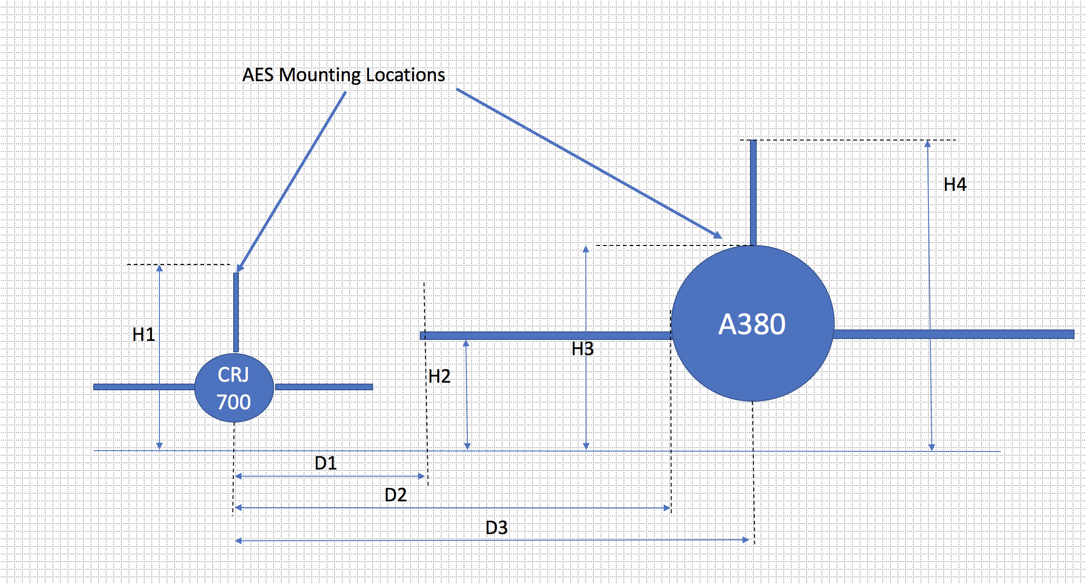

Figure 3: Worst case inter-aircraft pointing scenario

Table 7: Dimensions of two types of aircraft and corresponding distances[7]

|  |  |
| --- | --- |
| Dimension | Distance |
| H1 – Height of tail for CRJ from ground | 7.6 m |
| H2 – wingtip height of Airbus A380 from ground | 7.55 m |
| H3 – height of crown of Airbus A380 from ground | 10.76 m |
| H4 – height of tail of Airbus A380 from ground | 24.18 m |
| D1 – distance between CRJ tail and A380 wingtip, including the minimum parking distance of 3 m | 17.6 m |
| D2 – distance between CRJ tail and A380 fuselage,  including the minimum parking distance of 3 m | 49.9 m |
| D3 – distance between CRJ and A380 centreline  including the minimum parking distance of 3 m | 53.47 m |

Different aircraft earth stations have been developed for different airframe sizes. In smaller aircraft, the body of the aircraft is too narrow to accommodate a fuselage-mounted antenna. In the case of these smaller regional aircraft – such as the Bombardier CRJ 700 – the earth station is mounted on the tail of the aircraft instead of the crown. The worst case inter-aircraft scenario, therefore, is the case of a small aircraft with a small wingspan parked adjacent to the largest aircraft (e.g. an Airbus A380). This is illustrated above, where the small wingspan of the CRJ700 means that aircraft is closest to the wingtip of a larger aircraft.

Considering the worst case aircraft scenario when two planes are parked next to each other:

* ES elevation angle 5 degrees;
* D1, the distance between a CRJ tail and an A380 wingtip, is 17.6 m.

$H1+17.6*\tan\left(5\right)=1.54$ (m)

$H1+1.54=7.6+1.54=9.14$ (m)

One can see that 9.14 m > H2 (7.55 m) therefore the maximum radiation direction of an antenna installed on the CRJ would be higher than the wingtip of an A380. Even if we consider the main beam beamwidth of an antenna, then H1 + 17.6 * tan (3) = 0.92 (m) then H1 + 0.92 = 8.52, which is higher than the wingtip of an A380. An additional reduction in power of 7.5 dB (see Table 8) compared to the main beam can be applied in this case.

In most cases of the scenario of one aircraft operating a satellite earth station on an airfield next to another aircraft, the e.i.r.p. towards the other aircraft would be reduced by at least 17.5 dB (see Table 8 below). Therefore, the e.i.r.p. limits for the airport environment calculated above could be increased by at least 17.5 dB. In practice, the reduction of radiated power would be even higher when the maximum antenna gain of real antenna patterns are taken into account. For example, based on antenna patterns provided by one satellite operator for earth stations on board aircraft in Annex 2, the reduction of radiated power for 5 degrees of elevation compared to the maximum direction of radiation is at least 25 dB.

Table 8: Reduction in antenna gain towards horizon for 1, 2, 5 and 10 degrees of elevation

|  |  |  |
| --- | --- | --- |
| Off-axis angle  (degrees) | Maximum gain  (ITU-R S.580-6 [13]) (dBi) | Reduction in power (dB) |
| degrees | dBi | dB |
| 1 | 29 | - |
| 2 | 21.5 | 7.5 |
| 5 | 11.5 | 17.5 |
| 10 | 4 | 25 |

#### Scenario when one plane is parked and the other is taking off/landing

The other scenario to consider is when an aircraft with an earth station on board is operating on the ground at the airport and another aircraft is landing or taking off through the main beam of the earth station. For such a scenario, the separation between the two aircraft would be defined by the separation between the runway and the point where the aircraft might be waiting for take-off on the taxi way - the "hold position". All civilian airfields have to comply with Annex 14 “Aerodromes” of the ICAO “Convention on International Civil Aviation”. This document specifies the minimum distance from the runway centre line to a hold position, which is indicated in **Error! Reference source not found.** below.

Table 9: Minimum separation distance between the runway and the hold position on the taxiway

|  |  |  |  |  |
| --- | --- | --- | --- | --- |
| Type of runway | Code number 1 | Code number 2 | Code number 3 | Code number 4 |
| Non-instrument | 30 m | 40 m | 75 m | 75 m |
| Non-precision approach | 40 m | 40 m | 75 m | 75 m |
| Precision approach category I | 60 m | 60 m | 90 m | 90 m |
| Precision approach categories II and III | B | B | 90 m | 90 m |
| Take-off runway | 30 m | 40 m | 75 m | 75 m |

Note: the runway code numbers indicate the length of the landing strip

The document provides that for all runway lengths and types, the minimum separation between a hold position and the centre of a runway is 30 m. This distance would be even higher when considering the minimum elevation angle of an earth station on board an aircraft and the slant angle that is created due to it. These considerations are valid for fixed-wing aircraft, but can be different for rotorcraft. However, it is indicated in section 3.1.1 of the FAA Report [2] that the closest distance a rotorcraft observes from a ground obstacle (including a transmitter) is 100 ft (30.48 m).

Considering the above, it can be concluded that for all scenarios and aircraft types (fixed wing and rotorcraft) a 30.48 m minimum separation distance between earth stations on board aircraft within airport premises and another aircraft can be used and therefore the maximum e.i.r.p. for which the aircraft immunity levels in 4-6 GHz, 12-18 GHz and 18-40 GHz are not exceeded are as follows:

* 58.99 dBW in 4-6 GHz;
* 60.48 dBW in 12-18 GHz;
* 58.43 dBW in 18-40 GHz.

Comparing the two additional scenarios considered above, it is clear that the earth station on board the aircraft creates a higher field strength at the victim aircraft when considering the scenario of the victim aircraft flying through the main beam of the earth station 30.48 m away rather than the scenario when two aircraft are next to each other on the ground and there is no possibility for main beam illumination. Therefore, the above e.i.r.p. levels calculated using the 30.48 m separation distance should be used as the maximum allowable e.i.r.p. levels for which there are no restrictions related to aeronautical safety.

### Earth stations on board aircraft in flight

The far-field region calculations indicate that when considering the 500 ft (152.4 m) minimum separation distance between two aircraft in flight, the maximum e.i.r.p. level for earth stations on board aircraft for which the aircraft immunity levels in 4-6 GHz, 12-18 GHz and 18-40 GHz are not exceeded are as follows:

* 72.97 dBW in 4-6 GHz;
* 74.46 dBW in 12-18 GHz;
* 72.41 dBW in 18-40 GHz.

### Land mobile earth stations operated within airport premises

The far-field region calculations indicate that when considering the 50 ft. (15.24 m) minimum separation distance between mobile earth stations (e.g. land ESIM) operated within airport premises and aircraft, the maximum e.i.r.p. values for which aircraft immunity levels in 4-6 GHz, 12-18 GHz and 18-40 GHz are not exceeded are as follows:

* 52.97 dBW in 4-6 GHz;
* 54.46 dBW in 12-18 GHz;
* 52.41 dBW in 18-40 GHz.

### Earth stations in a fixed location within airport premises

The far-field region calculations indicate that when considering the 250 ft. (76.2 m) minimum separation distance between earth stations in a fixed location within airport premises and aircraft, the maximum e.i.r.p. values for which the aircraft immunity levels in 4-6 GHz, 12-18 GHz and 18-40 GHz are not exceeded are as follows:

* 66.95 dBW in 4-6 GHz;
* 68.44 dBW in 12-18 GHz;
* 66.39 dBW in 18-40 GHz.

### Earth stations in a fixed location or land mobile earth stations within 3 nautical miles of an airfield

The far-field region calculations indicate that when considering the 500 ft. (152.4 m) minimum separation distance between earth stations in a fixed location and mobile earth stations (e.g. land ESIM) within a wedge shaped area of airspace, originating at the departure and arrival end of the runway, over which aircraft would normally track, and extending for 3 nautical miles (5.556 km) from the runway, the maximum e.i.r.p. values for which the aircraft immunity levels in 4-6 GHz, 12-18 GHz and 18-40 GHz are not exceeded are as follows:

* 72.97 dBW in 4-6 GHz;
* 74.46 dBW in 12-18 GHz;
* 72.41 dBW in 18-40 GHz.

### Earth stations in a fixed location or land mobile earth stations beyond 3 nautical miles of an airfield

The minimum separation distance between earth stations in a fixed location and mobile earth stations (e.g. land ESIM) outside a wedge shaped area of airspace, originating at the departure and arrival end of the runway, over which aircraft would normally track, and extending for 3 nautical miles (5.556 km) from the runway needs to be determined considering the maximum elevation angle of the antenna and a minimum flight altitude of 1000 ft. (304.8 m) above all obstructions (including transmitters).

Earth stations operating with non-geostationary (NGSO) satellites can have a maximum elevation angle of 90 degrees, so the minimum separation angle between the transmitter and aircraft is 1000 ft. (304.8 m) in which case the maximum e.i.r.p. values for which the aircraft immunity levels in 4-6 GHz, 12-18 GHz and 18-40 GHz are not exceeded are as follows:

* 78.99 dBW in 4-6 GHz;
* 80.48 dBW in 12-18 GHz;
* 78.43 dBW in 18-40 GHz.

Earth stations operating with geostationary (GSO) satellites in CEPT countries will always have a maximum elevation angle, which depends on the latitude of earth station. Table 10 below provides the maximum elevation angle in various European cities.

Table 10: Maximum earth station elevation angle at different European cities

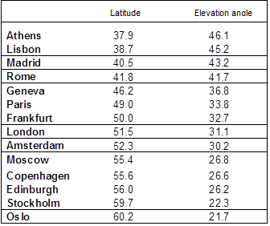

Therefore, for earth stations operating in CEPT countries, the minimum separation distance between the transmitter and aircraft can only occur for certain geometry when the earth station is operating with maximum elevation angle and the aircraft flying into the beam at an altitude of 1000 ft. (304.8 m). The minimum separation distance can be calculated in this case using the following formula:

$Minimum separation distance (m)= \frac{304.8 m(1000 ft.)}{\sin\left(maximum elevation angle in degrees\right)}$ (17)

Table 11 below indicates the maximum e.i.r.p. values calculated using the far-field formula for latitudes between 30-70 degrees for which the aircraft immunity levels in 4-6 GHz, 12-18 GHz and 18-40 GHz are not exceeded:

Table 11: Maximum e.i.r.p. values for earth stations located on latitudes between 30-70 degrees operating with GSO satellites

|  |  |  |  |  |  |
| --- | --- | --- | --- | --- | --- |
| Latitude (degrees) | Maximum elevation (degrees) | Minimum separation distance (m) | Max e.i.r.p. 4-6 GHz (dBW) | Max e.i.r.p. 12-18 GHz (dBW) | Max e.i.r.p. 18-40 GHz (dBW) |
| 30 | 55 | 372.1 | 80.7 | 82.2 | 80.2 |
| 31 | 53.8 | 377.7 | 80.9 | 82.4 | 80.3 |
| 32 | 52.7 | 383.2 | 81.0 | 82.5 | 80.4 |
| 33 | 51.6 | 388.9 | 81.1 | 82.6 | 80.6 |
| 34 | 50.5 | 395.2 | 81.3 | 82.7 | 80.7 |
| 35 | 49.3 | 402.0 | 81.4 | 82.9 | 80.8 |
| 36 | 48.2 | 408.9 | 81.5 | 83.0 | 81.0 |
| 37 | 47.1 | 416.1 | 81.7 | 83.2 | 81.1 |
| 38 | 46.0 | 424.0 | 81.9 | 83.4 | 81.3 |
| 39 | 44.8 | 432.6 | 82.0 | 83.5 | 81.5 |
| 40 | 43.7 | 441.2 | 82.2 | 83.7 | 81.6 |
| 41 | 42.6 | 450.3 | 82.4 | 83.9 | 81.8 |
| 42 | 41.5 | 460.0 | 82.6 | 84.1 | 82.0 |
| 43 | 40.4 | 470.3 | 82.8 | 84.3 | 82.2 |
| 44 | 39.3 | 481.2 | 83.0 | 84.5 | 82.4 |
| 45 | 38.2 | 492.9 | 83.2 | 84.7 | 82.6 |
| 46 | 37.1 | 505.3 | 83.4 | 84.9 | 82.8 |
| 47 | 36 | 518.6 | 83.6 | 85.1 | 83.1 |
| 48 | 34.9 | 532.7 | 83.8 | 85.3 | 83.3 |
| 49 | 33.8 | 547.9 | 84.1 | 85.6 | 83.5 |
| 50 | 32.7 | 564.2 | 84.3 | 85.8 | 83.8 |
| 51 | 31.6 | 581.7 | 84.6 | 86.1 | 84.0 |
| 52 | 30.5 | 600.5 | 84.9 | 86.4 | 84.3 |
| 53 | 29.4 | 620.9 | 85.2 | 86.7 | 84.6 |
| 54 | 28.3 | 642.9 | 85.5 | 87.0 | 84.9 |
| 55 | 27.3 | 664.6 | 85.8 | 87.3 | 85.2 |
| 56 | 26.2 | 690.4 | 86.1 | 87.6 | 85.5 |
| 57 | 25.1 | 718.5 | 86.4 | 87.9 | 85.9 |
| 58 | 24.1 | 746.5 | 86.8 | 88.3 | 86.2 |
| 59 | 23 | 780.1 | 87.2 | 88.7 | 86.6 |
| 60 | 21.9 | 817.2 | 87.6 | 89.1 | 87.0 |
| 61 | 20.9 | 854.4 | 87.9 | 89.4 | 87.4 |
| 62 | 19.8 | 899.8 | 88.4 | 89.9 | 87.8 |
| 63 | 18.8 | 945.8 | 88.8 | 90.3 | 88.3 |
| 64 | 17.7 | 1002.5 | 89.3 | 90.8 | 88.8 |
| 65 | 16.7 | 1060.7 | 89.8 | 91.3 | 89.3 |
| 66 | 15.6 | 1133.4 | 90.4 | 91.9 | 89.8 |
| 67 | 14.6 | 1209.2 | 91.0 | 92.5 | 90.4 |
| 68 | 13.5 | 1305.7 | 91.6 | 93.1 | 91.1 |
| 69 | 12.5 | 1408.2 | 92.3 | 93.8 | 91.7 |
| 70 | 11.5 | 1528.8 | 93.0 | 94.5 | 92.4 |

### Earth stations operated on vessels

The far-field region calculations indicate that when considering the 1000 ft. (304.8 m) minimum separation distance between aircraft and earth stations operated on vessels (e.g. ESVs and maritime ESIM) that are located in the vicinity of airfields, the maximum e.i.r.p. values for which the aircraft immunity levels in 4-6 GHz, 12-18 GHz and 18-40 GHz are not exceeded are as follows:

* 78.99 dBW in 4-6 GHz;
* 80.48 dBW in 12-18 GHz;
* 78.43 dBW in 18-40 GHz.

# Conclusions

This ECC Report examines earth stations operating in the vicinity of aircraft and their ability to comply with high intensity radiated field (HIRF) levels established by the European Aviation Safety Agency (EASA) to protect aircraft safety systems. The HIRF protection criteria used for the analysis have been provided and verified by EASA as relevant to all civil aircraft (fixed and rotor-wing) in operation today and having systems on board which could be affected by high HIRF levels. This includes older aircraft which have been modified to incorporate safety equipment which could be affected by satellite earth station transmissions since such older aircraft would have to be re-certified to comply with the EASA HIRF requirements. The ECC Report also confirms that military aircraft are able to sustain higher HIRF levels than the values provided by EASA for civil aircraft. Therefore, the conclusions of this ECC Report are applicable to all military aircraft as well.

EASA also provided the ECC with the HIRF calculation methodology and assumptions regarding minimum separation distances between transmitters and aircraft that were used by aviation airworthiness authorities to establish the relevant aircraft HIRF protection criteria. The elements provided by EASA were used in this ECC Report to calculate earth station e.i.r.p levels (as specified in Table 1) for various earth station deployments communicating with GSO or NGSO satellites, for which it can be concluded that there will be no impact to the aeronautical safety of aircraft during any phase of the flight (take off, landing, cruising, taxiing). Consequently, no restrictions on operations in the proximity of or within airfields[8] are required for earth stations complying with the e.i.r.p. levels specified in Table 12 below.

Table 12: Maximum earth station e.i.r.p. levels to ensure compliance with aircraft HIRF protection criteria

|  |  |  |  |
| --- | --- | --- | --- |
| Earth station deployment type | Maximum e.i.r.p. levels (dBW) | | |
| **4-6 GHz** | **12-18 GHz** | **18-40 GHz** |
| Earth station on board aircraft located within airport premises | 59.0 | 60.5 | 58.4 |
| Earth stations in a fixed location within airport premises | 67.0 | 68.4 | 66.4 |
| Land mobile earth stations located within airport premises | 53.0 | 54.5 | 52.4 |
| Fixed earth stations or mobile earth stations on land within a wedge shaped area originating at the departure and arrival end of the runway and extending for 3 nautical miles from the runway over which aircraft would normally track** | 73.0 | 74.5 | 72.4 |
| Fixed earth stations or land mobile earth stations operating with NGSO satellites located outside the wedge shaped area extending for 3 nautical miles from the runway of an airfield over which aircraft would normally track** | 79.0 | 80.5 | 78.4 |
| Fixed earth stations or land mobile earth stations operating with GSO satellites located outside the wedge shaped area extending for 3 nautical miles from the runway of an airfield over which aircraft would normally track** | 80.7-93.0* | 82.2-94.5* | 80.2-92.4* |
| Earth station on vessels | 79.0 | 80.5 | 78.4 |
| Earth stations on board aircraft in flight | 73 | 74.5 | 72.4 |

Note: For satellite earth stations operating within TDMA networks, the above e.i.r.p values shall be respected after taking into consideration the duty cycle (see section 3.3 and 3.4).

* e.i.r.p values are dependent on earth station latitude (see section 3.4.6)

** the width of the wedge shaped area originating at the departure and arrival end of the runway and extending for 3 nm from the runway over which aircraft would normally track depends on the airfield and is determined by the airport authority

1. Example calculations for Inmarsat Ka-Band (18-40 GHz) ESIM

Generally, there are two types of earth stations on board aircraft depending on how the terminal is mounted on the aircraft – tail mounted and fuselage mounted terminals. A tail mount terminal is normally a two-axis stabilised earth station employing a 30 cm or larger diameter antenna. The antenna is a circular aperture with a symmetrical centre-fed design. The fuselage mounted terminal is a two-axis stabilised earth station employing an asymmetrical rectangular phased array antenna with dimensions ranging from 65 cm by 19.5 cm or larger aperture. Both of these terminal types are depicted on Figure 4 below.

 

Figure 4: Tail mounted (on the left) and fuselage mounted (on the right) Ka-band ESIM antenna

Inmarsat operates both of these terminal types in the Ka-band (27.5-30.0 GHz), which are known as aircraft Earth Stations on Mobile Platforms (ESOMPs) and their operations conforms with ECC/DEC/(13)01 [14][9]. The parameters of these terminals that are relevant in the context of determination of the HIRF levels have been indicated in Table 13.

Table 13: Operational parameters for the tail mounted and fuselage mounted antenna

|  |  |  |  |
| --- | --- | --- | --- |
| Parameters | Unit | Tail mounted antenna | Fuselage mounted antenna |
| Antenna type | - | Circular | Rectangular phased array |
| Dimensions | m | 0.3 | 0.65 x 0.195 |
| Beamwidth | ° | 2.51 | 1.18 (horizontally) |
| Antenna gain | dBi | 37 | 39.8 |
| Maximum e.i.r.p. | dBW | 44.6 | 46 |

* 1. calculations for tail mounted earth station

For the purposes of the calculations specified in the sections above, the tail mounted earth stations have an antenna that would fall under the circular antenna category. The first check that needs to be performed for this earth station is whether the 100 ft (30.48 m) distance as specified in section 3.4.1 would fall under the near-field or far-field range of the antenna. The far-field distance “ $r_{farfield}$” can be calculated as follows:

$$r_{farfield}=\frac{2 d^{2}f}{300}=\frac{2∙{0.3}^{2}∙27500}{300}=16.5 m$$

The frequency of 27500 MHz (beginning of the Ka-band) was used as this provides worst case results for the power density.

Based on the formula above, it can be seen that the border between far-field and near-field is at 16.5 m. As the distance we need to use to calculate the HIRF level is 30.48 m, then we need to take into consideration only the far-field calculation.

Equation (2) in section 3.2.1 can be used for the calculation of the power density at the aircraft as follows:

$$P_{D}=\frac{P_{T}G}{4πr^{2}}= \frac{{10}^{\frac{44.6}{10}}}{4∙3.14∙{30.48}^{2}}=2.47 W/m^{2}$$

Consequently, the field power density can the converted into electric field intensity:

* 1. calculations for fuselage mounted earth station

Similar calculation to the section above can be performed for the fuselage mounted earth station, but in this case we need to consider the methodology for a rectangular antenna. However, as a first step, it needs to be confirmed whether the 30.48 m distance is in the near-field or far-field, based on the maximum dimension of the antenna, which in this case is 0.65 m.

$$r_{farfield}=\frac{2 d^{2}f}{300}=\frac{2∙{0.65}^{2}∙27500}{300}=77.46 m$$

The threshold between the near-field and far-field is 77.46 m away from the station, which means that at 100 ft. (30.48 m) near-field reduction needs to be taken into consideration.

Therefore, the illumination distribution constant needs to be determined:

$$I_{d}=\left(5.8384×{10}^{-5}\right) f B d= \left(5.8384∙{10}^{-5}\right)∙27500∙1.18∙0.65=1.23$$

Based on the illumination distribution constant, it can be determined using Table 3 of section 3.2.1 that the distribution curve we need to consider is cos1.

In order to establish the near field gain reduction, the normalised distance needs to be calculated for both horizontal and vertical antenna aperture dimensions:

$$∆_{h}=\frac{r 300}{{d_{h}}^{2}f}=\frac{ 30.48∙300}{{0.65}^{2}∙27500}=0.79$$

$$∆_{v}=\frac{r 300}{{d_{v}}^{2}f}=\frac{ 30.48∙300}{{0.195}^{2}∙27500}=8.74$$

Using the normalised distances and the uniform distribution curve, the near field gain reduction can be determined in dB based on Table 4 of section 3.2.1. It can be seen that $χ_{h}$ = 0.2 dB and $χ_{v}$ = 0 dB. The vertical and horizontal near field gain reduction needs to be summarised in order to determine the final near field gain reduction factor using the formula:

$$χ={10}^{-\frac{\left(χ_{h}+χ_{v}\right)}{10}}= {10}^{-\frac{\left(0.2+0\right)}{10}}95=0.83$$

The above allows us to calculate the near field power density, which can then be converted into the electric field intensity at the aircraft:

* 1. calculations RESULTS

Following the methodology set out in the FAA Report [2], it can be seen that at the 100 ft. (30.48 m) distance established for the calculation of HIRF levels for earth station on board aircraft, the tail mounted and fuselage mounted ESIM terminals produce a field strength level of 30.5V/m and 34.95V/m respectively. The limit for aircraft protection in the Ka-band is 150 V/m, it can therefore be concluded that neither of these terminals poses a threat for aeronautical safety when operated while parked on the airfield or during taxing, landing and take-off.

1. Examples of ViaSat Ka-Band antenna characteristics

The Viasat network is based on shared allocation of satellite resources. Viasat terminals transmit short bursts of data periodically as instructed by the network and are neither designed for nor capable of continuous transmission. The ES terminal transmits bursts of information at designated times that are assigned to the terminal by the network. The length and carrier frequency of each transmission burst depend on the ES terminal's traffic requirements. In normal operation, the ES terminal transmits burst traffic to the network with a nominal duty of less than 6.25%. Therefore, the average power during the averaging period is calculated as the maximum transmitter peak transmit power output adjusted by the duty of 6.25%.

As an example, an aircraft earth station with a relatively short duty (e.g. 6.25%) could have a peak transmit power of 60 dBW. So, the average power for each ES terminal can be calculated as   
Average power = Peak power* Duty cycle, therefore taking into account the low duty cycle: 47.9 dBW. This value is well below the EASA limitation.

The figures below show different antenna types installed by Viasat, and they demonstrate their antenna patterns.

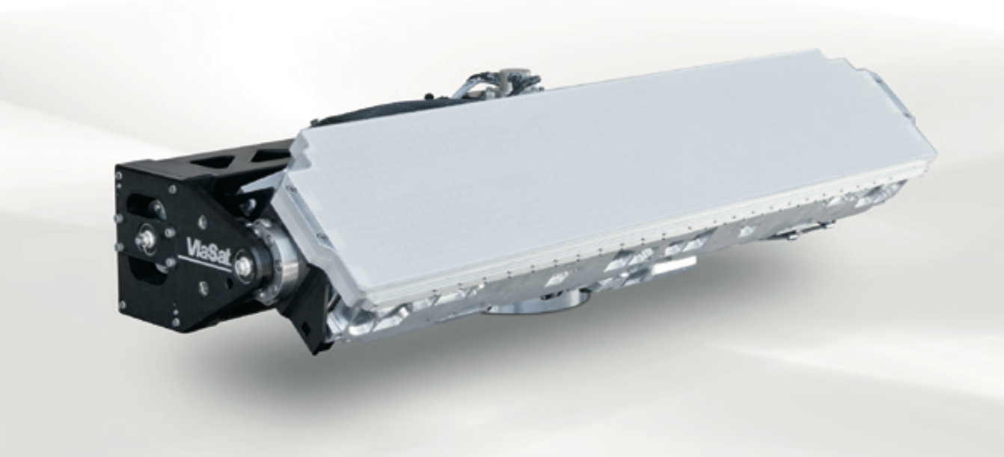

Figure 5: Viasat GM-40 antenna (antenna pattern is shown in Figure 9 below)

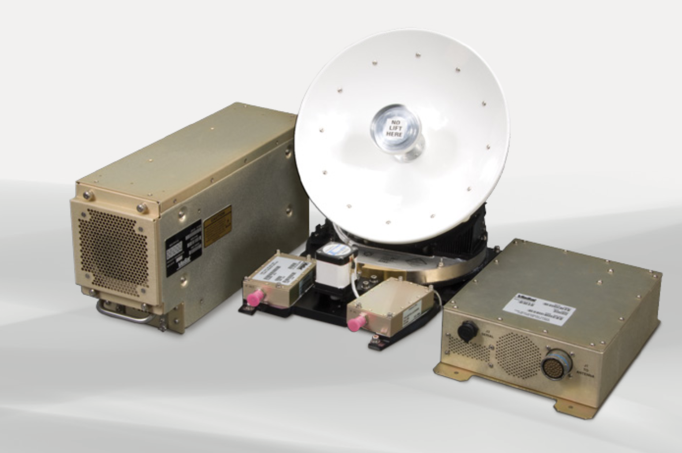

Figure 6: Viasat – G-12 Ka-Band antenna

Examples of the antenna patterns installed by Viasat:

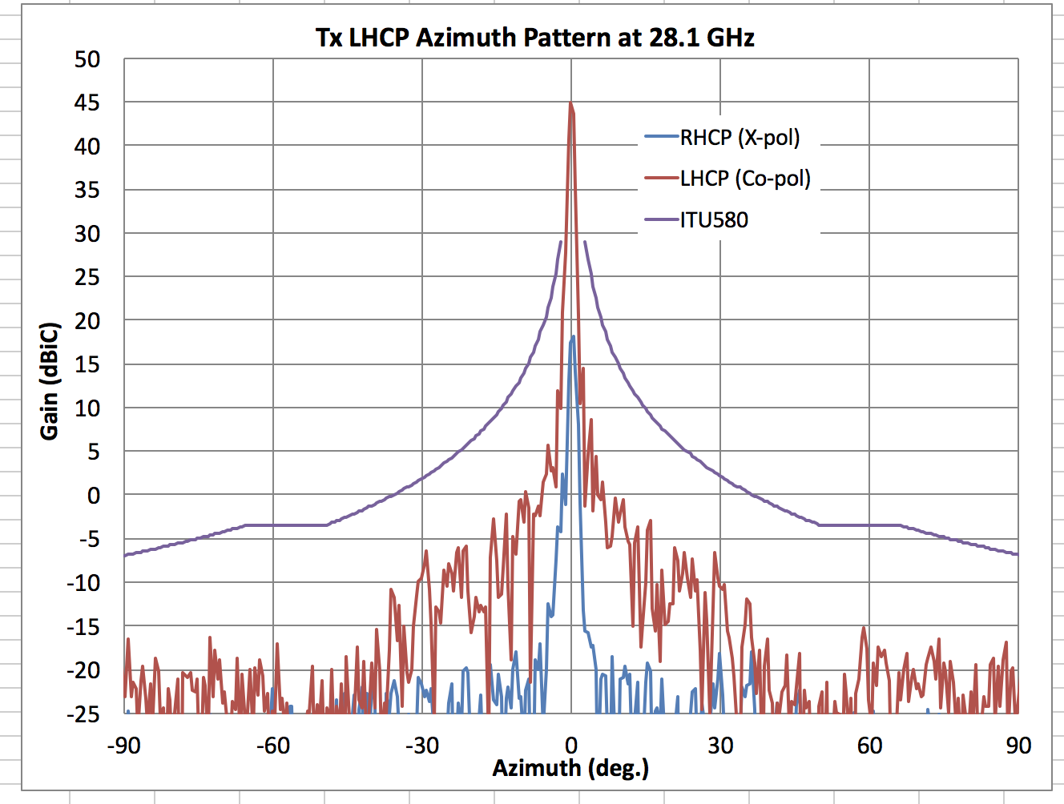

Figure 7: Representative Azimuth Tx gain plots for 75 cm class antennas   
(for VS-1 and Ka-Sat in Europe)

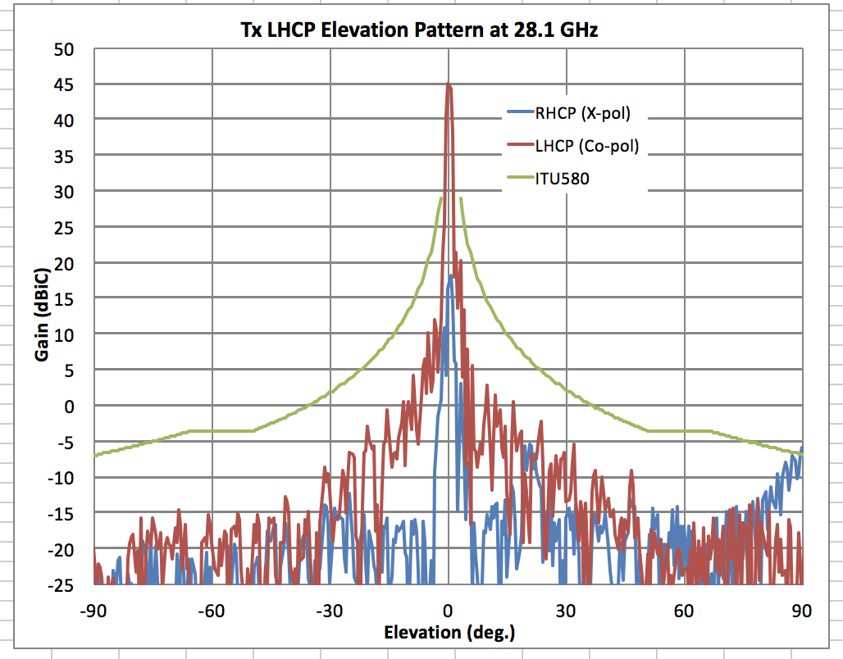

Figure 8: Representative Elevation Tx gain plots for 75 cm class antennas   
(for VS-1 and Ka-Sat in Europe)

The figure below corresponds to the antenna type shown in Figure 5.

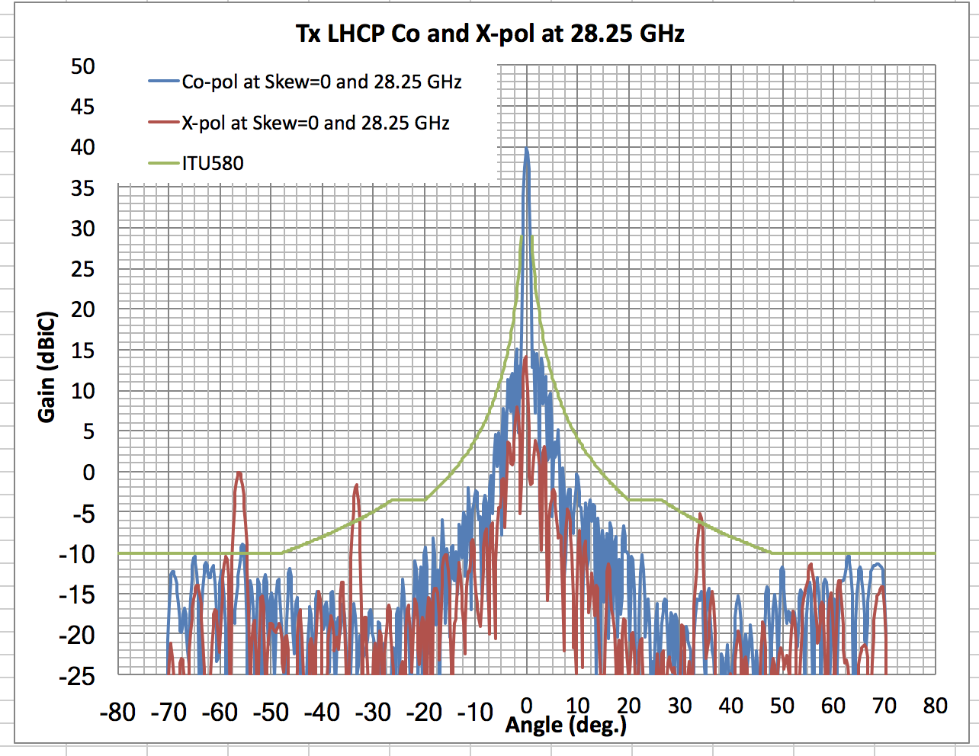

Figure 9: GM40 antenna pattern (skew angle = 0)

1. List of References
2. ED-107A, Guide to Certification of Aircraft in a High-Intensity Radiated Field (HIRF) Environment, July 2010
3. FAA Report DOT/FAA/AR-98/69, High Intensity Radiated Field External Environments for Civil Aircraft Operating in the United States of America
4. FM44(16)029, Current aeronautical regulation and methodologies for HIRF protection of aircraft, September 2016
5. FAA-2006-23657, High-Intensity Radiated Fields (HIRF) Protection for Aircraft Electrical and Electronic Systems, Federal Aviation Administration, September 2007
6. AC 20-158, The Certification of aircraft Electrical and Electronic Systems for Operation in the High-Intensity Radiated Fields (HIRF) Environment, Federal Aviation Administration, July 2007
7. EASA CS-23 Amendment 4, Certification Specifications and Acceptable Means of Compliance for Normal, Utility, Aerobatic, and Commuter Category Aeroplanes, European Aviation Safety Agency, July 2015
8. EASA CS-25 Amendment 17, Certification Specifications and Acceptable Means of Compliance for Large Aeroplanes, European Aviation Safety Agency, July 2015
9. EASA CS-27 Amendment 4, Certification Specifications and Acceptable Means of Compliance for Small Rotorcraft, European Aviation Safety Agency, November 2016
10. EASA CS-29 Amendment 4, Certification Specifications and Acceptable Means of Compliance for Large Rotorcraft, European Aviation Safety Agency, November 2016
11. ED Decision 2015/017/R amending the Acceptable Means of Compliance for the airworthiness of products, parts and appliances (AMC-20), ‘AMC-20 - Amendment 13 ’- High Intensity Radiated Fields (HIRF) and Lightning, July 2015
12. FM44(16)036, Reply from NATO CPA3 Civ-mil session for HIRF protection of military aircraft, November 2016
13. AECTP-250 Edition 1, Electrical and Electromagnetic Environmental Conditions, NATO, February 2009 http://www2.fhi.nl/plot2012/archief/2010/images/aectp-250ed1.pdf
14. Recommendation ITU-R S.580-6, Radiation diagrams for use as design objectives for antennas of earth stations operating with geostationary satellites
15. ECC Decision (13)01, The harmonised use, free circulation and exemption from individual licensing of Earth Stations On Mobile Platforms (ESOMPs)within the frequency bands 17.3-20.2 GHz and   
    27.5-30.0 GHz, March 2013

1. Airfield: in the context of this Report covers both, airport and helipads.
2. In the rest of the document the most conservative value was used for the C band, ie 160V/m for 4-6 GHz. The same conditions and results apply for 6-8 GHz band.
3. Further information on the determination of the 100 feet (30.48 m) distance is included in section 3.4.1
4. Equation 5 and Equation 6 have been modified from the original Equations 8 and 9 in section 4.4.2.2 of the FAA Report, since there appears to be an error in the original formula – the ratio $f$/300 should be 300/ $f$ instead.
5. Equation 10 differs from the original Equation 14 in section 4.4.2.3 of the FAA Report [2], since there appears to be an error in the original formula – the ratio $f$/300 should be 300/ $f$ instead.
6. Equation 11 is different from the Equation 15 in section 4.4.2.3 of the FAA Report [2], as there appears to be an error in the FAA Report – the variable” $f$” in the formula should be “ $f^{2}$” instead.
7. For dimensions of Bombardier CRJ700, see:

   <http://commercialaircraft.bombardier.com/content/dam/Websites/bca/literature/crj/BCA_5446_02_CRJ_Factsheet_Update_CRJ700_EN_vF.pdf>.

   For Airbus A380 see: <http://nata.aero/agso/ASTGCache/f6a9e8b3-ab2e-4502-bedc-92f463486e22.pdf>
8. Airfield: in the context of this Report covers both, airport and helipads.
9. The term “ESOMPs” in ECC/DEC/(13)01 is equivalent to the term “ESIM” in this document