Additional co-existence studies between SRDs/RFIDs and E-GSM-R in the 900 MHz frequency band

approved 21 May 2020

Addendum to   
ECC Report 200

# Summary

ECC Report 200 covers co-existence between Short Range Devices (SRDs) and different incumbent systems operating in the frequency bands 870-876 MHz and 915-921 MHz, including E-GSM-R. It concludes that co-frequency sharing with E-GSM-R is generally not possible without applying additional mitigation techniques. The mitigation techniques have not been studied in ECC Report 200.

This Addendum complements ECC Report 200 and assesses separation distances between E-GSM-R applications operating in the frequency bands 873-876 MHz/918-921 MHz and SRDs/RFIDs operating in the frequency bands 874-874.4 MHz / 915-919.4 MHz.

MCL calculations show that for co-existence between E-GSM-R and SRDs operating co-frequency in the frequency bands 874-874.4 MHz and 918-919.4 MHz separation distances range up to 64 km in worst-case scenario.

A statistical analysis in the 870-874.4 MHz band shows that for co-frequency operation the separation distances lie between 7 km and 39 km. The exact spectrum used by SRDs affects the probability of interference to any of E-GSM-R channels, but also the number of channels affected.

It should be noted that for co-frequency operation the long separation distances of several tens of kilometres are calculated for those 20% of locations representing low propagation losses and may not apply for cases where for example, mountains or high hills are surrounding the location of the E-GSM-R BTS antenna and are limiting the SRD interference range accordingly.

The computed separation distances are presented in sections 2.1 and 2.2 of this Addendum.

TABLE OF CONTENTS

0 Summary 2

1 Introduction 5

2 Separation distances considered for co-existence between SRDs and E-GSM-R 6

2.1 Study A - Results of MCL analysis 6

2.2 Study B - Results of statistical analysis 7

2.2.1 Interference scenarios 7

2.2.2 Interfered channels 9

2.2.3 Issues to be considered for worst case and best case scenarios 11

2.2.3.1 Effects of automatic power control parameter settings on interference probability 11

2.2.3.2 Deployment density of UNB NAP 11

2.2.4 Propagation model 11

2.2.5 Separation distance evaluation 12

2.2.6 Results 12

3 Conclusions 14

ANNEX 1: Separation distance calculations for E-GSM-R and Short Range Devices 15

ANNEX 2: Protection criterion assessment 31

ANNEX 3: Propagation Model considerations 35

ANNEX 4: SEAMCAT simulation details 43

ANNEX 5: List of References 53

LIST OF ABBREVIATIONS

|  |  |
| --- | --- |
| Abbreviation | Explanation |
| ACIR  ACLR  ACS  BEL  BS  BTS  C  CEPT  CSS  EC | Adjacent Channel Interference Ratio  Adjacent Channel Leakage Ratio  Adjacent Channel Selectivity  Building Entry Loss  Base Station  Base Transceiver System  Carrier  European Conference of Postal and Telecommunications Administrations  Chirp Spread Spectrum  European Commission |
| ECC  E-GSM-R  e.i.r.p.  EN  ETCS  ETSI  EU  GMSK  GSM  GSM-R  HPBW  I  ITU-R  LOS  MCL  MS  N  NAP  NBN  NN  RFID  SRD  TN  TR  UNB  WB | Electronic Communications Committee  Extended Global System for Mobile Communications for Railways  equivalent isotropically radiated power  European Norm  European Train Control System  European Telecommunications Standards Institute  European Union  Gaussian Minimum Shift Keying  Global System for Mobile Communications  Global System for Mobile Communications for Railways  Half Power Band Width  Interference  International Telecommunication Union – Radiocommunication Sector  Line Of Sight  Minimum Coupling Loss  Mobile Station  Noise  Network Access Point  Narrow Band Networked  Network Node  Radio Frequency Identification  Short Range Device  Terminal Node  Technical Report  Ultra Narrow Band  Wide Band |

# Introduction

ECC Report 200 [1] investigated sharing between Short Range Devices (SRDs) and different incumbent systems operating in the frequency bands 870-876 MHz and 915-921 MHz. Among other systems, the E-GSM-R was studied as well. It was concluded that co-frequency sharing with E-GSM-R was not generally possible without additional mitigation. Low duty cycle, low deployment density or cognitive approach were identified as possible mitigation techniques. Separation distances between SRDs/RFIDs and E-GSM-R were not evaluated.

The frequency bands 873-876 MHz and 918-921 MHz are used for E-GSM-R in some countries. The EC SRD Decision (2018/1538) [6] does not define specific mitigation techniques regarding co-existence between SRDs and E-GSM-R.

Accordingly, separation distances are evaluated for as possible co-existence mechanism between E-GSM-R and SRD.

# Separation distances considered for co-existence between SRDs and E-GSM-R

The “Decision (EU) 2018/1538 on the harmonisation of radio spectrum for use by SRDs within the 874-876 and 915-921 MHz frequency bands” [6] defines operational parameters without considering technical mitigation techniques. Instead, geographical restrictions amongst others were identified in ECC Report 200 as possible co-existence mechanism between SRDs and E-GSM-R. This addendum evaluates separation distances to meet the protection criteria as shown in Table 1.

## Study A - Results of MCL analysis

Table 1 below summarises calculated separation distances between SRDs and E-GSM-R in co-channel operation based on a I/N = -6 dB protection criterion. Thereby three different propagation environments are taken into account: rural, suburban and urban. It should be noted that the propagation model is applied in such a manner that the calculated separation distances guarantee protection for 80% of the time and 80% of places. During 20% of the time, propagation conditions occur which may result in longer separation distances in the considered interference scenarios. This case was not studied. The assumptions made for the studies are based on the relevant ITU-R, ETSI and CEPT documentation. For other scenarios and different assumptions (as transmit power, antenna height etc.), are not covered in this addendum, other propagation models may be preferred:

* Scenario A: Median cell edge coverage wanted signal level for 95% confidence: -83 dBm;
* Scenario B: Median coverage wanted signal level for “good link” condition: -73 dBm.

Table 1: Separation distances between SRD/RFIDs and E-GSM-R devices with flat terrain and additional assessed terminal surroundings clutter for co-channel operation representative for 20% of locations (calculations based on propagation model Recommendation ITU-R P. 2001):

|  |  |  |  |  |  |  |
| --- | --- | --- | --- | --- | --- | --- |
| Interferer | | | | Separation distances for different environments | | |
| **Frequency range (MHz)** | **Device** | **Scenario** | **Rural** | | **Suburban** | **urban** |
| 874-874.4 | NBN NAP | A | 47.8 km | | 40.2 km | 33 km |
| 874-874.4 | UNB/CSS NAP | A | 64.4 | | 64.4 | 64.4 km |
| 916.1-918.9 | RFID, indoor@h=1.5 m | A | 2.5 km | | 1.3 km | 0.7 km |
| 916.1-918.9 | RFID, outdoor@h=1.5 m | A | 12.0 km | | 5.2 km | 2.1 km |
| 916.1-918.9 | RFID, indoor@h=4.5 m | A | 3.8 km | | 2.1 km | 1.2 km |
| 916.1-918.9 | RFID, outdoor@h=4.5 m | A | 12.5 km | | 6.4 km | 3.3 km |
| 916.1-918.9 | RFID, indoor@h=7.5 m | A | 6.1 km | | 3.5 km | 1.7 km |
| 916.1-918.9 | RFID, outdoor@h=7.5 m | A | 17.6 km | | 10.2 km | 4.6 km |
| 917.3-918.9 | NBN NAP | A | 21.4 km | | 8.8 km | 3.6 km |
| 917.3-918.9 | UNB/CSS NAP | A | 30.0 km | | 21.9 km | 17.0 km |
| 917.4-919.4 | WB @200kHz BW 1.5 m | A | 1.4 km | | 0.8 km | 0.4 km |
| 917.4-919.4 | WB @200kHz BW 4.5 m | A | 2.3 km | | 1.3 km | 0.7 km |
| 917.4-919.4 | WB @200kHz BW 7.5 m | A | 3.6 km | | 2.2 km | 0.9 |
| 917.4-919.4 | Non-specific SRD@h=1.5 m | A | 2.4 km | | 1.2 km | 0.7 km |
| 917.4-919.4 | Non-specific SRD@h=4.5 m | A | 3.6 km | | 2.0 km | 1.1 km |
| 917.4-919.4 | Non-specific SRD@h=7.5 m | A | 5.7 km | | 3.3 km | 1.6 km |
| **Frequency range (MHz)** | **Device** | **Scenario** | **Rural** | | **Suburban** | **urban** |
| 874-874.4 | NBN NAP | B | 31.4 km | | 24.4 km | 17.2 km |
| 874-874.4 | UNB/CSS NAP | B | 44.7 km | | 44.7 km | 44.7 km |
| 916.1-918.9 | RFID, indoor@h=1.5 m | B | 0.8 km | | 0.5 km | 0.3 km |
| 916.1-918.9 | RFID, outdoor@h=1.5 m | B | 2.7 km | | 1.4 km | 0.7 km |
| 917.3-18.9 | NBN NAP | B | 8.4 km | | 3.2 km | 1.4 km |
| 917.3-918.9 | UNB/CSS NAP | B | 15.0 | | 10.0 km | 7.4 km |
| 917.4-919.4 | WB @200kHz BW | B | 0.52 | | 0.3 km | 0.1 km |
| 917.4-919.4 | Non-specific SRD | B | 0.8 | | 0.5 km | 0.3 km |

Details of calculated separation distances taking different scenarios into account, can be found in ANNEX 1. It should be noted that the minimum separation distances are calculated with the propagation model P.2001 taking into account a typical terrain profile, which is representative for those 20% of places which have the smallest propagation attenuation. It should be further noted that in case SRD/RFIDs and E-GSM-R systems do not operate on the same channel, the calculated separation distance is significantly reduced as also shown in ANNEX 1. In ANNEX 1 information is also given on possible interference area for scenarios considering directive BTS antennas. This interference area is shown for the specific geographical situation of the city of Basel, where a BTS antenna is installed at Basel main station area, with 18 dBi gain heading in the direction of the city of Mulhouse. The interference area simulation is done with real terrain data of the considered area, applied to the propagation ITU-R P.2001 model. It can be shown that based on the results of that simulation, the separation distance for some SRD technologies and interference scenarios are even longer than calculated with MCL calculations based on the typical terrain profile. However, it appears that the situation of the "Basel scenario" represent a worst-case situation, because it represents a geographical situation with very long LOS distances to densely populated areas. Average geographical situations may be different. Accordingly, the long separation distances of several tens of kilometres, may not apply for an average case, where eventually mountains or high hills are surrounding the location of the E-GSM-R BTS antenna and limiting the interference range accordingly.

## Study B - Results of statistical analysis

The aim of this statistical analysis is to evaluate the interference probability of E-GSM-R BTS in several specific scenarios.

### Interference scenarios

The aim of this Monte Carlo analysis is to assess the interference probability for E-GSM-R victim receivers operating in different reception scenarios, which are defined based on E-GSM-R network planning. In Annex 2 of this Addendum, some basic parameters used in E-GSM-R Network planning are introduced including the minimum recommended coverage signal level at the locomotive of -95 dBm for 95% of locations is set out. Experience shows, that for a -95 dBm reception level with a 95% confidence, the median signal level in the network planning process must be -81 dBm with standard deviation of 8.5 dB. Furthermore, networks are set up such that neighbouring cells have the median level that is 31.8 dB lower with a confidence of 95%, also with a standard deviation of 8.5 dB in order for the serving cell to maintain a minimum C/I ratio of 12 dB. The balanced nature of the duplex link is such that the signal received at the base station will have a similar statistical nature.

Based on these radio network planning basics, the following level settings for the serving and interfering cell are defined for the Monte Carlo simulation:

* The wanted signal field strength at the base station has a log-normal distribution with the median values of -81 dBm, and the standard deviation of 8.5 dB;
* The interfering cell field strength from adjacent cells has a log-normal distribution with the median values of -112.8 dBm and the standard deviation of 8.5 dB.

Different interference scenarios based on a topology as shown in Figure 1 are analysed for E-GSM-R BTS as victim receivers. All scenarios include the following three radio links:

* Victim link (with a cab radio as victim link transmitter);
* Intra-system interference link (with an interfering cell as intra-system interference source);
* SRD links as interfering links;

Two distinct type of interference situations are considered:

Handover zone: The train moves on a short track length, such that a median reception level of -81 dBm can be assumed as constant over the entire considered track length. Then the interference probability is evaluated for the reception situation with a single E-GSM-R signal level;

Outermost 25%: The train moves on a track that crosses the outermost 25% of the cell radius. For studies of the interfered BTS, the following relative locations of the SRD deployment with respect to the BTS locations are considered in order to take into account the effect of the BTS antenna directivity.

* The assumed orientation between BTS and interfering links are:

The location of the interfering links are in the direction of the BTS main beam;

The location of the interfering links are oriented at 45° to the BTS main beam;

The location of the interfering links are oriented at 90° to the BTS main beam.

The deployment of the interference links is simulated over a circular area for the urban case (5% of population) and an additional concentric in an annular area for the suburban case. The diameter of the urban area is half the outer diameter of the annular area. This above made definitions are based on the assumption, that the population density in urban areas is 4 times higher than in suburban areas.

The separation distance between SRDs and victim receivers are measured between the centre of the circle describing the urban area and the victim receiver.

The victim receiver and transmitter locations, as well as the interfering cell locations within the simulation area are fixed at a single position for each transmitter or receiver. The distance between victim transmitter, respectively interfering cell transmitter and victim receiver are not relevant, because the wanted signal level as well as the signal level of the interfering cell at the victim receiver input is adjusted to the above mentioned signal levels by adjusting the transmitter e.i.r.p. accordingly.

A graphical representation of the topology is shown in Figure 1 and the respective SEAMCAT implementation in Figure 2.

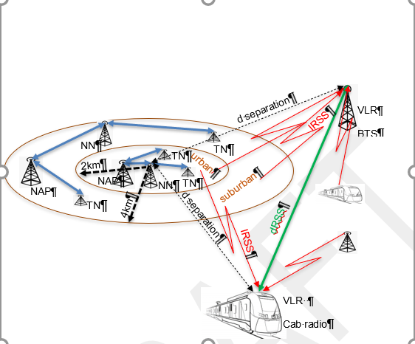

Figure 1: Scenario description and SEAMCAT representation

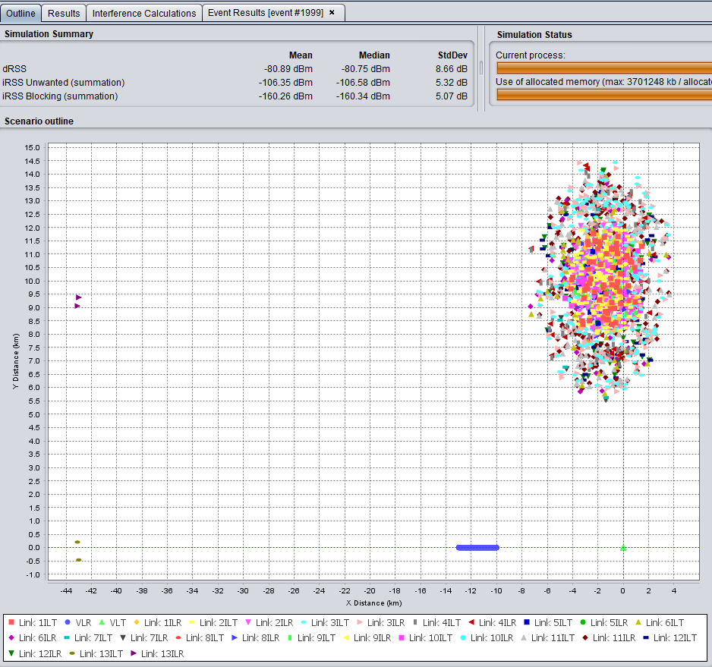

Figure 2: SEAMCAT implementation of the scenario

The different SRD devices do not operate at a fixed duty cycle, but the value of the duty cycle follows a statistical distribution. However, the statistical distribution of the duty cycle value is unknown. Therefore, simulations are done by using an average duty cycle value. It should be noted, that calculating with average duty cycle values may introduce some errors, such that the result may represent rather an underestimate of interference probability.

### Interfered channels

The frequency bands under study are shown in Table 2. It should be noted that the frequency band 916.1-916.5 MHz and its availability for 500 mW SRD operation are currently under study in ECC.

It is assumed, that the SRD devices are uniformly distributed over the three available frequency bands 865-868 MHz, 874-874.4 MHz, 917.3-917.7 MHz coupled with 918.5-918.9 MHz, as shown in Table 20. It is also assumed that all the three types of SRDs (NAPs, NNs and TNs) are operating in the same geographical area. Therefore, the densities for different types of SRDs (NAPs, NNs and TNs shown in Table 2) need to be divided by 3, when used to define the total density of the SRDs, which are interfering within a single E-GSM-R channel.

Table 2: Harmonised EC Networked SRD Frequency bands

|  |  |  |
| --- | --- | --- |
| Parameter | Value | Technology |
| Frequency bands | 865-868 MHz | All |
| 874-874.4 MHz[1] | All |
| 916.1-916.5 MHz  917.3-917.7 MHz  918.5-918.9 MHz | All |

The detailed spectrum position in the 870 MHz band used by SRD versus E-GSM-R band is shown in the example below.



Figure 3: ECC harmonised spectrum

In the configuration shown in Figure 3, the channel centred on 874.2 MHz is most acutely affected, and calculations are carried out to predict the interference to this channel. The two adjacent channels will suffer marginally less interference. Under these circumstances and taking into account the exact number of channels available in the three bands, the density of devices associated with these two channels is reduced by a factor of 5.5[2] (rather than three for the base case).

Due to E-GSM-R channel planning the SRD signal does not fully overlap the E-GSM-R victim channel. The adjacent channel blocking mask of E-GSM-R receivers is typically -9 dB, but the 50% channel overlap between E-GSM-R and SRD does not cover the whole of the adjacent channel.



Figure 4: ERC Recommendation 70-03 harmonised spectrum

In this configuration, the channels from 873-874.2 MHz are most acutely affected, and calculations are carried out to predict the interference to each of these channels. Under these circumstances and taking into account the exact number of channels available in the three bands, the density of devices associated with these two channels is reduced by a factor of 4.4[3] (rather than three for the base case).

### Issues to be considered for worst case and best case scenarios

Deployment definitions and assumed parameters represent an average interference situation, although maximum deployment density figures are considered. Namely with the duty cycle and the power control settings used in simulations, the SRD radiate at its maximum power with a probability of 0.7% and the level of 5 mW is not exceeded with the probability greater than 79%. Furthermore, the simulations account for the SRD frequency channels are considered which are identified by the EC Decision 1538 [6]. Interference assessment using SRD deployments in other frequency channels is done for information purpose only. In addition, it can be shown, that available deployment density figures of some technologies figures may be too low. Nevertheless, no corrections on the density figures are made. The above mentioned considerations are given in more details in what follows:

#### Effects of automatic power control parameter settings on interference probability

The MCL calculations are based on the interference from SRD transmitters which are operating on maximum transmit power only. The Monte Carlo study on the other hand takes into account the effects of power control. To understand the statistical behaviour of the effective radiated power of the different SRD transmitter types, SEAMCAT simulations are done considering one specific scenario: The Victim Link Transmitter (VLT) and the interference link transmitter (ILT) are placed on opposite sides of the Victim Link Receiver (VLR) at a fixed identical distance. For both, the Victim System Link (VLT to VLR) and the Interference Link (ILT to VLR) the same propagation model is used. The VLT radiation power is adjusted to the same radiation power of the ILT, when the latter is operating at its minimum transmit power. The ILR is placed at an arbitrary position within a range of 300 m from the ILT. Running this scenario in SEAMCAT, the ILT radiated power statistics can be evaluated by analysing the C/I value. The following can be observed:

* For NBN systems operating in a range of 100 m, the maximum power of the transmitter of 500 mW is radiated with a probability of 0.7% and the level of 5 mW is not exceeded with the probability greater than 79%. An APC threshold increase by 10 dB would cause a transmit power increase such that 11% of the devices would radiate with the maximum e.i.r.p.;
* In ERC Recommendation 70-03, the application of APC is required for 500 mW network SRDs. However, the requirements for some important APC parameter values, such as the APC threshold, are not defined. The APC parameters used in this study seem to be optimized for noise-limited SRD networks. In case of interference-limited SRD networks, modified APC parameters may be more appropriate or even required and could, in turn, significantly increase the interference potential of SRDs.

#### Deployment density of UNB NAP

Deployment density figures available for UNB NAPs are comparably low. Based on that NAP density figure and deployments, the coverage area for a UNB NAP can be calculated. The coverage area determine the required range for the UNB transmitters. It turns out, that the possible maximum range of a UNB NAP is too short for a coverage area calculated based on the considered density figure. Consequently, the simulated UNB interference probability, and the corresponding separation distance may be underestimated.

### Propagation model

The propagation model for the ILT - VLR link applied in these studies is the same as used in the studies of section 2.1. Accordingly, geographical situations which represent those 20% of E-GSM-R receiver locations, where minimum propagation losses can be found. It should be noted that the propagation losses in real terrain may be higher for most of the cases but may also be lower for less than 20% of cases. Sharing studies on this approach focus on a protection of 80% of situation. When considering propagation models for median propagation loss prediction, the protection probability reduces to 50%. A comparison between the path loss values calculated based on the explained model and values calculated based on a path specific analysis as well as free space loss is shown in A4.3.1. It is interesting to note, that calculations with the Longley Rice model, when configured for 20% location probability, give very similar results as the calculation with the explained model. A detailed description of the applied propagation models, including those applied for the ILsis given in A4.3

### Separation distance evaluation

Separation distances are evaluated for the case, where the C/I = 12 dB criterion is exceeded for more than 7% of links, noting that 5% of links are inviable due to E-GSM-R self-interference (causing an outage increase of 40%). The separation distance is measured between the centre of the circular area deployed with the SRDs and the victim receiver.

### Results

The SEAMCAT simulation results are summarized in Table 3. In the third column the respective scenario is indicated. The scenario "Handover zone" simulates the situation, where the train moves on short track length, such that a median reception level of -81 dBm can be assumed as constant over the entire considered track length. Then the interference probability is evaluated for the reception situation with a single E-GSM-R signal level. The scenario "Outermost 25%" simulates the situation, where the train moves on track that crosses the outermost 25% of the cell radius.

Table 3: Evaluated separation distances when considering different scenarios of SRDs deployments and interference to the base station

|  |  |  |  |  |  |
| --- | --- | --- | --- | --- | --- |
| Interferer | Scenario | Victim antenna alignment | Separation distance | C/I outage | Remarks |
| NBN | Handover Zone | Main lobe | 30 km | 8.2% | Assumes traffic divided evenly on Harmonised EC Networked SRD Frequency bands |
| NBN | Outermost 25% | Main lobe | 25 km | 7.2% | Assumes traffic divided evenly on Harmonised EC Networked SRD Frequency bands |
| NBN | Outermost 25% | 45° | 16.7 km | 6.8% | Assumes traffic divided evenly on Harmonised EC Networked SRD Frequency bands |
| NBN | Outermost 25% | 90° | 11 km | 7.2% | Assumes traffic divided evenly on Harmonised EC Networked SRD Frequency bands |
| NBN | Outermost 25% | 90° | 7.8 km | 7.1% | ECC harmonised spectrum |
| NBN | Outermost 25% | Main lobe | 22.5 km | 7.8% | ECC harmonised spectrum |
| NBN | Outermost 25% | 90° | 6 km | 7.1% | REC 70-03 harmonised spectrum |
| NBN | Outermost 25% | 90° | 5 km | 8% | REC 70-03 harmonised spectrum, average density |
| NBN | Outermost 25% | Main lobe | 26 km | 7.1% | ECC harmonised spectrum, APC threshold = - 81 dBm |
| UNB | Outermost 25% | Main lobe | 22 km | 8.4% | Assumes traffic divided evenly on Harmonised EC Networked SRD Frequency bands.  Because of low UNB NAP deployment density and low average DC, the interference is dominated by UNB TN. |
| UNB | Outermost 25% | Main lobe | 39 km | 6.8% | Ditto. Operation with maximum DC = 10% assumed. APC threshold value is not specified for the UNB technology. For the simulations a value of -112 dBm is assumed. |
| CSS | Outermost 25% | Main lobe | 39 km | 6.4% | Assumes traffic divided evenly on Harmonised EC Networked SRD Frequency bands |
| CSS | Outermost 25% | 45° | 19 km | 8.4% | Assumes traffic divided evenly on Harmonised EC Networked SRD Frequency bands |
| CSS | Outermost 25% | 90° | 16 km | 9.1% | Assumes traffic divided evenly on Harmonised EC Networked SRD Frequency bands |
| CSS | Outermost 25% | 90° | 15 km | 8.5% | ECC harmonised spectrum |
| CSS | Outermost 25% | 90° | 11 km | 6.8% | REC 70-03 harmonised spectrum |

# Conclusions

Co-frequency sharing with E-GSM-R requires large separation distances and/or may need additional mitigation techniques.

The EC SRD Decision (2018/1538) [6] does not define specific mitigation techniques regarding co-existence between SRDs and E-GSM-R however, interference could be mitigated to a certain extent by arranging channels in order to avoid clashing with critical base stations. MCL calculations show that for co-existence between E-GSM-R and SRDs operating co-frequency in the frequency bands 874-874.4 MHz and 918-919.4 MHz separation distances range up to 64 km in worst case scenario.

Statistical analysis in the 870-874.4 MHz band shows that separation distances lie between 7 km and 39 km. The exact spectrum used by SRDs in neighbouring countries affects the probability of interference to any one GSM-R channel, but also the number of channels affected.

It should be noted that the long separation distances of several tens of kilometres are calculated for those 20% of locations representing low propagation losses and may not apply for cases where for example, mountains or high hills are surrounding the location of the GSM-R BTS antenna and are limiting the SRD interference range accordingly.

1. Separation distance calculations for E-GSM-R and Short Range Devices
   1. MCL calculations

Separation distances between different type of short range devices operating according the «EC Decision (EU) 2018/1538 on the harmonisation of radio spectrum for use by short range devices within the 874-876 and 915-921 MHz frequency bands" [6], and E-GSM-R receivers are calculated based on the MCL method. Rural, urban, and suburban environments are considered for SRDs operating in co- and adjacent E-GSM-R channels.

* + 1. SRD characteristics

The studied SRD device types are described below. The main operational parameters of the considered SRD/RFIDs are summarised in Table 4:

* Radio Frequency Identification Devices (RFID): As pointed out in ECC Report 200, annex 2.5 [1], RFID are mostly used in indoor environment. The building entry loss (BEL) reduces the effective radiated power to be considered in compatibility studies to 22 dBm e.i.r.p. in average. However, some applications are used outdoor. According to the RFID emission mask shown in ECC Report 200, annex 2.5, Figure 31, 90% of the transmit power is radiated within a 400 kHz bandwidth. Accordingly, a bandwidth correction factor of -3.5 dB is applied with respect to the E-GSM-R receiver bandwidth. With a maximum power of 38.2 dBm e.i.r.p., a BEL of 16 dB and a bandwidth correction factor of 3.5 dB, a radiated power of 18.7 dBm e.i.r.p. has to be considered for most cases. In some rare scenarios, a radiated power of 34.7 dBm e.i.r.p. has to be considered. Because no typical antenna height is defined for this application, the three different antenna heights h=1.5 m, h=4.5 m and h=7.5 m are considered;
* Short Range Devices in data networks: SRD in data networks can be used as Network Access Point (NAP), Network Nodes (NN) and Terminal Nodes (TN). Compatibility for mesh networks (NBN) are studied for the NAP devices only, because the NAP represent that NBN device with the highest interference potential. The NAP is radiating with 29 dBm e.i.r.p. with an antenna at a height of 7 m. The bandwidth of a NAP signal is 200 kHz, such that no bandwidth correction factor need to be applied for co-existence studies with E-GSM-R. The out of band emissions are given in document ETSI EN 303 204 [7]. The assumption of a 200 kHz SRD signal bandwidth represents a worst case in terms of Out-of-band emission impact. In that case, the adjacent channel power is calculated by integrating the emission mask and results in maximum 14 dBm, the second and third adjacent channel power levels are maximum -13 dBm;
* Ultra-narrowband one-hop network (UNB): Compatibility with UNB is studied for the Network Access Point (NAP) devices only, because the NAP represents that UNB device with the highest interference potential. The NAP is radiating with 29 dBm e.i.r.p. with an antenna at a height of 25 m. The bandwidth of a NAP signal is smaller than 1 kHz, such that no bandwidth correction factor needs to be applied. The out-of-band emissions are given in document ETSI TR 103 435 [8]. Because of the very narrow bandwidth of the interfering signal, it is very likely that the interference in adjacent channel is -13 dBm as it is in the second and third adjacent channel;
* Chirp spread spectrum one-hop networks (CSS): For CSS the NAP of CSS represents that NBN - device with the highest interference potential because of the antenna height of 25 m and the e.i.r.p. of 29 dBm. But according to ETSI TR 103 526 V1.1.1 [10] only the frequency 869.525 MHz is used for 500 mW downlink. This frequency is below the E-GSM-R frequencies and would therefore not need to be studied in this context. However, in the case where E-GSM-R frequencies for CSS NAP would be used, results for the same separation distances in co-channel interference scenarios obtained from studies with UNB would apply also to CSS. It should be noted that both CSS and UNB transmission signal bandwidths for most of the CSS signal configuration options as well as the UNB signal bandwidth are smaller than the E-GSM-R receiver bandwidth and the antenna height of CSS NAPs and UNB NAP are the same;
* Wide band data transmission systems (WB): Because no typical antenna height is defined for WB systems, the three different antenna heights h = 1.5 m, h = 4.5 m and h = 7.5 m are considered;
* Non-specific Short Range Devices (SRD): Because no typical antenna height is defined for non-specific SRD , the three different antenna heights h=1.5 m, h=4.5 m and h=7.5 m are considered.

Table 4: Main operational SRD parameters

|  |  |  |  |  |
| --- | --- | --- | --- | --- |
| Band no. | Frequency band  [MHz] | Category of short range devices | Transmit power limit/ field strength limit/power density limit | Additional parameters (antenna height, channelling and/or channel access and occupation rules) |
| 1 | 874.0-874.4 | Non-specific short range devices: NBN NAP  UNB NAP | 29 dBm e.i.r.p. APC | h=7 m / 25 m  Bandwidth: ≤ 200 kHz  Duty cycle: ≤ 10% for network access points  Duty cycle: 2.5% otherwise |
| 2 | 917.4-919.4 | Wideband data transmission devices | 14 dBm e.r.p. | h ≥ 1.5 m  Bandwidth: ≤ 1 MHz  Duty cycle: ≤ 10% for network access points  Duty cycle: ≤ 2.8% otherwise |
| 3 | 916.1-918.9 | Radio Frequency Identification (RFID) Devices | 38.2 dBm e.i.r.p. @ 916.3 MHz, 917.5 MHz, 918.7 MHz  18.7 dBm e.i.r.p. @BW=200kHz, indoor  34.7 dBm e.i.r.p. @BW=200kHz, outdoor | h ≥ 1.5 m  Primarily indoor use with BEL=16dB  Bandwidth: ≤ 400 kHz |
| 4 | 917.3-918.9 | Non-specific short range devices  NBN NAP  UNB NAP | 29 dBm e.i.r.p.  @ 917.3-917.7 MHz, 918.5-918.9 MHz with APC | h=7 m / 25 m  Bandwidth: ≤ 200 kHz  Duty cycle: ≤ 10% for network access points  Duty cycle: ≤ 2.5% otherwise |
| 5 | 917.4-919.4 | Non-specific short range devices | 14 dBm e.r.p. | h ≥ 1.5 m  Bandwidth: ≤ 600 kHz  Duty cycle: ≤ 1% |

The adjacent channel leakage ratios of the different SRD devices are summarised in Table 5. The respective values can be found in, ETSI EN 303 204 [7] and ETSI TR 102 886 [11] for NBN, ETSI TR 103 435 [8] for UNB and ETSI EN 300 220 [9] for non-specific SRDs. The respective emission masks are shown in Figure 3 to Figure 6.

The NBN adjacent channel power is calculated by integrating the emission mask and results in maximum 14 dBm, the second and third adjacent channel power levels are maximum -13 dBm. The adjacent channel power is calculated as follows:

|  |  |  |
| --- | --- | --- |
|  | $$p_{adj}=\frac{1mW}{1kHz}\int_{0}^{200kHz}{e^{\frac{- f}{24.114kHz}}df}=13.82 dBm$$ | (1) |

Due to the very narrow UNB bandwidth, the adjacent channel power is 13 dBm as well as in the second and third adjacent channel.

For non-specific SRDs, the operational bandwidth for the adjacent channel study is assumed to be 200 kHz. The adjacent channel power is calculated by integrating the emission mask. This results in a maximum of 14 dBm. The second and third adjacent channel power levels are maximum -13 dBm. The adjacent channel power calculation is similar to the calculation for NBN.

For RFID the adjacent channel power is calculated similar as it is calculated for the NBN:

|  |  |  |
| --- | --- | --- |
|  | $$p_{adj}=\frac{4mW}{1kHz}\int_{0}^{200kHz}{e^{\frac{- f}{20.661kHz}}df}=19.17 dBm$$ | (2) |

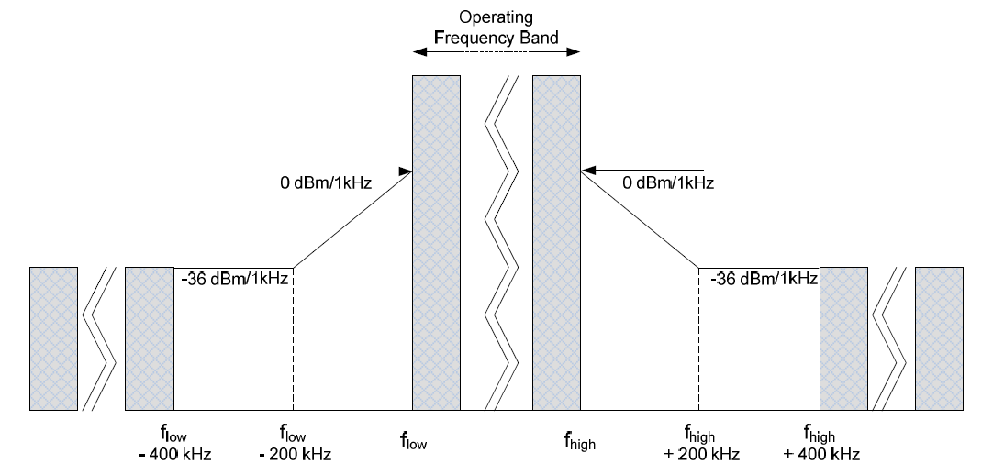

Figure 3: Emission according to ETSI EN 303 204 (NBN) [7]

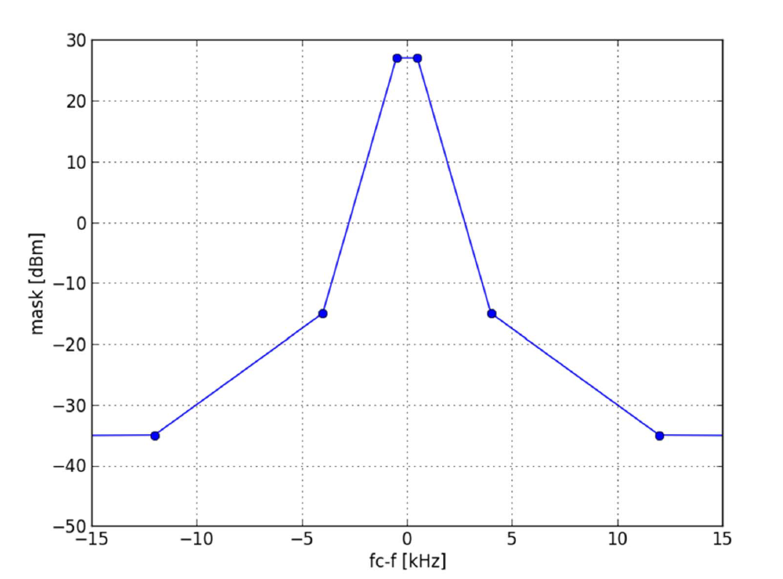

Figure 4: Emission according to ETSI TR 103 435 (UNB) [8]

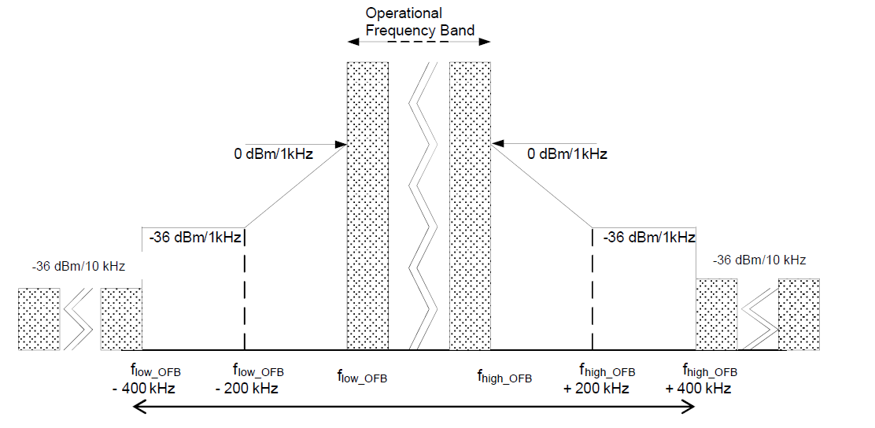

Figure 5: Emission mask according to ETSI EN 300 220 (non-specific SRD) [9]

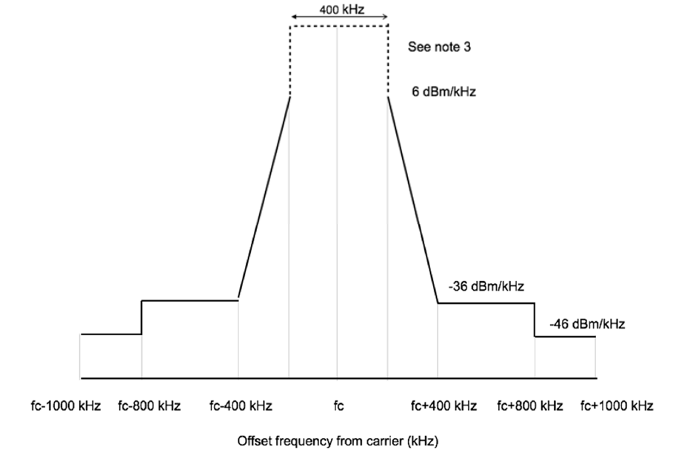

Figure 6: Emission mask according to ETSI EN 302 208 (RFID) [12]

Because no emission mask for WB is available, no adjacent channel scenarios are considered for this application.

Table 5: Adjacent channel leakage ratio of the different SRD devices

|  |  |  |  |  |
| --- | --- | --- | --- | --- |
| SRD type | Radiated power | Adjacent E-GSM-R channel power (ACI) | | ACLR |
| NBN NAP | 29 dBm e.i.r.p. | first | 14 dBm | 15 dB |
| second | -13 dBm | 42 dB |
| third | -13 dBm | 42 dB |
| UNB NAP | 29 dBm e.i.r.p. | first | -13 dBm | 42 dB |
| second | -13 dBm | 42 dB |
| third | -13 dBm | 42 dB |
| Non-specific SRD | 16.2 dBm e.i.r.p. | first | 14 dBm | 2.2 dB |
| second | -13 dBm | 29.2 dB |
| third | -13 dBm | 29.2 dB |
| RFID | 34.7 dBm e.i.r.p. @BW=200 kHz | first | 19 dBm | 15.7 dB |
| second | -13 dBm | 47.7 dB |
| third | -13 dBm | 47.7 dB |

* + 1. Technical characteristics of the E-GSM-R Victim Link

For the MCL studies, the same main parameters of the E-GSM-R system are used as shown in Annex 1, section A1.1 and are shown in Table 6.

There are two types of E-GSM-R Mobile Station (MS): hand-held MS and train-mounted MS. The train-mounted MS is permanently inside the driver’s cabin. It uses the train’s electricity main supply to transmit at greater power levels. The external antenna mounted on the roof of the train improves the propagation conditions with the BTS as well. Hand-held MS may be used by railway personnel.

The HPBW of the E-GSM-R BTS antennas are around 30 degrees and the respective gain is up to 21 dBi. For the MCL calculations, an average gain of 18 dBi is assumed for the MCL calculations. The signal is typically split between two antennas with a splitting loss of 3 dB and a cable loss of additional 3 dB, therefore an efficient antenna gain reduction of 6 dB may be assumed in order to calculate the e.i.r.p.

Table 6: Main ER-GSM-R system parameters

|  |  |  |  |  |
| --- | --- | --- | --- | --- |
| Parameter | Values | | | |
| Channel bandwidth, kHz | 200 | | | |
| Receiver Bandwidth | 180 | | | |
| Modulation | GMSK | | | |
| Considered transceiver types | BTS | Hand-held MS | Train MS |
| Thermal noise, dBm | -121.5 | | | |
| Rx noise figure, dB | 5 | 9 | 7 |
| Noise floor, dBm | -116.5 | -112.5 | -114.5 |
| Antenna height above ground, m | 20 m (urban)  20/45 m (rural) | 1.5 | 4.5 |
| Antenna gain, dBi | 18 | 0 | 0 |
| Feeder loss, dB | 3 | 0 | 0 |
| Splitter loss, dB | 3 | 0 | 0 |

Reference interference ratio values, respectively adjacent channel selectivity (ACS) for E-GSM-R receivers are given in ETSI TS 145 005 [13] and shown in the Table 7.

Table 7: Adjacent Channel Selectivity (ACS) according ETSI TS 145.005

|  |  |  |  |
| --- | --- | --- | --- |
| Frequency range | Hand-held MS | Train MS | BTS |
| Adjacent channel C/I | -18 dB | -18 dB | -18 dB |
| Second adjacent channel C/I  Third adjacent channel C/I | -50 dB  -58 dB | -50 dB  -58 dB | -50 dB  -58 dB |

* + 1. Interference scenarios

With respect to E-GSM-R victim receivers, three different interference scenarios are studied. In two scenarios, E-GSM-R MS are considered as victim receivers with omnidirectional antenna patterns, while in the scenario with the E-GSM-R BTS as victim receiver directional antennas are considered.

RFID; hantenna ≥ 1.5 m;   
NBN /UNB; hantenna = 7 m / 25 m   
WB SRD; hantenna ≥ 1.5 m   
nsSRD; hantenna ≥ 1.5 m

RFID; hantenna  ≥1.5 m

NBN/UNB; hantenna = 7 m / 25 m;

WB SRD; hantenna ≥ 1.5 m

nsSRD; hantenna ≥ 1.5m

916.1 – 918.9 MHz

917.3 – 918.9 MHz

917.4 – 919.4 MHz

916.1 – 918.9 MHz  
917.3 – 918.9 MHz  
917.4 – 919.4 MHz

874.0 - 874.4 MHz

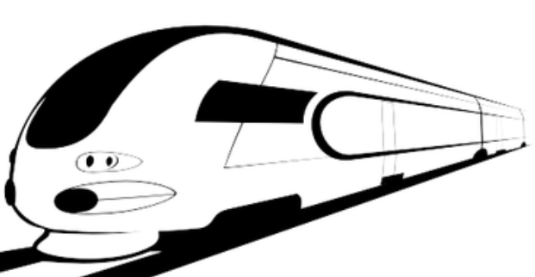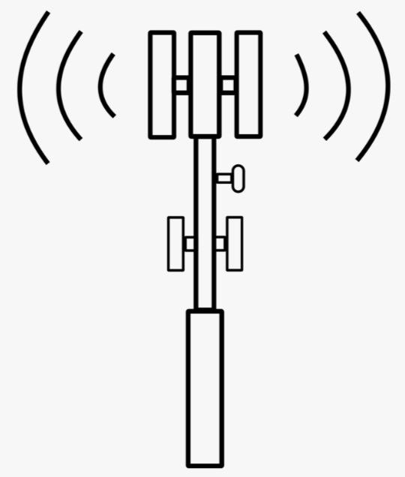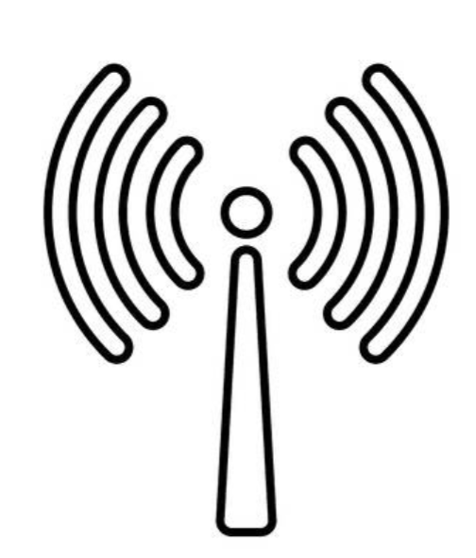

NBN/UNB; hantenna = 7 m / 25 m

Train MS

MS

BTS

Figure 7: Scenarios studied in MCL calculations

In studies considering BTS victim receivers, the BTS antenna pattern must be taken into account. The directivity of the high gain BTS antenna limits the area of potential interference sources. In this Report, BTS antennas with 12 dBi gain including feeder and splitting losses are considered. Exemplarily for situations of highly directive antennas, the interference situation for the case of an E-GSM-R BTS antenna of the type Kathrein K 80010456 installed in the Basel main station is analysed. This interference area is shown in Figure 8 for the specific geographical situation of the city of Basel, where a BTS antenna is installed at Basel main station area, with 12 dBi gain antenna including feeder and splitting losses at a height of 20 m, heading in the direction of the city of Mulhouse. The interference area simulation is done with real terrain data of the considered area, applied to the propagation model in Recommendation ITU-R P.2001 [4]. It can be shown that based on the results of that simulation, the minimum separation distance for some SRD technologies are even longer than calculated with MCL calculations, which are based on the typical terrain profile. However, it appears that the situation of the “Basel scenario” represent a real worst-case situation and that in other geographical situations the separation distances may be shorter. This is especially true for the calculated long separation distances exceeding distances of several tens of kilometres, which represent an overestimate for typical geographical area.

The different colours in Figure 8 represent areas where any NBN NAP SRD would cause an interference to the E-GSM-R BTS, which exceeds the protection level by different interference level values. For visualisation purposes, only a single BTS antenna is considered, although there are different antennas operating at different sites within the area of the city of Basel.

It can be concluded that the considered directive antenna for the BTS installed at the Basel main station could experience interferences from NBN SRD NAP installations of a rather large area, although the antenna is directive. In the shown example, the interference level originating for SRDs operating in the area of Mulhouse could be significantly higher than the protection level. Figure 6 is showing possible interference areas, where NAPs could generate Interference signals which are significantly above protection level. NAP deployed in the green coloured area, would interfere with -81 dBm, which is about 30 dB above protection level.

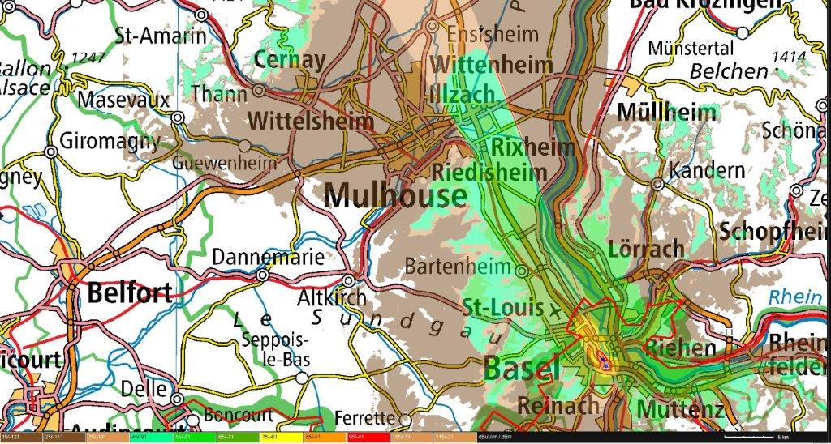

Figure 8: Example interference areas for a BTS Antenna installed at the Basel main station

* + 1. Propagation model

In this study the model according to Recommendation ITU-R P.2001 [4] is used. The P.2001 model is a semi analytical one, considering specific propagation path terrain profile. For any co-existence or compatibility studies, the probability of protection need to be defined because, the interference is following statistical rules, especially with respect to radio wave propagation. The statistical behaviour of interference signals to mobile receivers is due to two distinct effects: propagation path variations due to movement of the mobile receiver or interference transmitter and due to variation of radio wave attenuation with respect to time dependent propagation conditions, such as atmospheric absorption or anomalous propagation. Those time dependent propagation conditions are considered in the propagation ITU-R P.2001 model with the parameter Tpc. For this study, a Tpc probability of 20% is assumed to represent a high probability situation with attenuation values, which exceed the calculated attenuation during 80% of the time. During the remaining 20% of the time, propagation conditions occur with lower propagation attenuation, which would imply larger separation distances. The propagation model is configured with a time probability parameter of 20%, accordingly looking into the 20% of most critical situations in time. Furthermore, 3 example E-GSM-R BS sites have been considered in this report and the terrain data around these sites have been analysed. These terrain data was generalized as a generic environment situation for which simulations where performed with scenarios by looking into the 20% of most critical locations. The Rec ITU-R P.2001 propagation model is a terrain specific one. Accordingly, the terrain data to be used in the simulations with the ITU-R P.2001 propagation model need to represent a typical situation for the considered scenarios. Therefore, a typical terrain profile needs to be specified, which causes a path loss equivalent to the path loss, which is not exceeded at 20% of all possible locations in the radio coverage area

Terrain analysis around existing Extended GSM-R Base station (E-GSM-R BTS) sites in hilly terrain environment has shown that in a range of 10 km, LOS conditions for the radio wave propagation predominate for 20% of locations (For longer ranges, a lower percentage of locations may apply). This is even the case for situations, where antenna heights would be taken into account, which are 7 m below the real antenna heights of E-GSM-R and SRD NAPs. Accordingly, the radio wave propagation from SRD NAPs to E-GSM-R Base stations can be characterized by LOS conditions with a minimum clearance of 7 m. Due to that clearance value, the Fresnel ellipse of the radio propagation path is partially obstructed. This partial obstruction causes diffraction losses, which are maximum in case of flat, smooth surface terrains. When evaluating maximum diffraction losses over flat smooth surfaces with a clearance of 7 m, it can be shown that the diffraction causes additional losses of not more than 7.6 dB at a distance of 5 km, respectively 12.9 dB. However, as it is shown in ANNEX 3:, the use of ITU-R P.2001 model with flat terrain represents well the propagation situation for 20% of locations by considering no Bullington diffraction but spherical diffraction.

The median of clutter losses due to different terminal surroundings is taken into account by applying the height gain terminal correction model according to section 3.1 of Recommendation ITU-R P.2108 [3]. Values for the additional clutter loss to be added, at both transmitting and receiving end of the path, to the basic transmission loss of the path calculated above are shown in below table. These values are based on the street width parameter set to 27 m (default value).

Table 8: Median of additional for clutter loss due to different terminal surroundings according to Recommendation ITU-R P.2108

|  |  |  |  |  |
| --- | --- | --- | --- | --- |
| Antenna height | 1.5 m | 4.5 m | 7 m | 20 m |
| Rural | 17.7 dB | 7.5 dB | 3.3 dB | 0 dB |
| Suburban | 18.8 dB | 15.1 dB | 10.3 dB | 0 dB |
| Urban | 22.6 dB | 20.5 dB | 18.2 dB | 0 dB |
| Dense urban | 25.1 dB | 23.7 dB | 22.3 dB | 0 dB |

Figure 9 to Figure 12 show a graphical representation of the propagation loss calculated according to the model of Recommendation ITU-R P.2001 with a flat terrain, including clutter additional losses from Table 6 based on the Recommendation ITU-R P.2108 and considering the different antenna heights for E-GSM-R mobile station (E-GSM-R MS), E-GSM-R BTS, NBN and UNB NAP, WB, RFID and non-specific SRD.

Details on the propagation model verification is shown in ANNEX 3.



Figure 9: Propagation loss according to the ITU-R P.2001 model in flat rural terrain



Figure 10: Propagation loss according to the ITU-R P.2001 model in flat suburban terrain



Figure 11: Propagation loss according to the ITU-R P.2001 model in flat urban terrain



Figure 12: Propagation loss according to the ITU-R P.2001 model for different antenna heights

* + 1. Protection criterion

The protection criterions I/N = -6 dB, -10 dB or -20 dB are widely applied in sharing studies considering mobile service systems as victim receivers. The application of those protection criterions can be found for example in ECC Report 239 [15], ECC Report 278 [16], Report ITU-R M.2292 [17], Report ITU-R M.2478 [18] and Recommendation ITU-R M.1808 [19]. It should be noted that protection criterion I/N = -6 dB is equivalent to a desensitization of 1 dB. In two ECC Reports on co-existence studies with the mobile service, protection criterions different from the "standard" ones are also applied: For example, a desensitization of 2.2 dB. As shown in ANNEX 2, the protection criterion I/N = -6 dB as well as the desensitization of 2.2 dB is assessed and it turns out that the application of the I/N = -6 dB protection criterion is reasonable and not too stringent to protect E-GSM-R networks. The assessment is made considering E-GSM-R system and planning parameters, according the UIC E-GSM-R network planning guidelines [14]. It is further shown that a coverage planning level with a median value of -83 dBm, the UIC recommendation for a level of > -95 dBm for 95% of locations with a C/I = 12 dB can be achieved.

When protection would be considered based on the 2.2 dB desensitization, the MCL would be reduced by 1.2 dB with respect to the MCL calculated based on the -6 dB I/N criterion. As it can be easily derived from propagation attenuation plots shown in Figure 9 to Figure 12, the reduction of the MCL by 1.2 dB would reduce the separation distance by less than about 3%.

The required protection levels are calculated based on the E-GSM-R characteristics of Table 6. The respective protection levels are shown in Table 9.

Table 9: Interference level for different E-GSM-R receiver types

|  |  |  |  |
| --- | --- | --- | --- |
| Parameter | Values | | |
| **Considered transceiver types** | **BTS** | **Hand-held MS** | **Train MS** |
| Noise floor, dBm | -116.5 | -112.5 | -114.5 |
| Protection ratio I/N, dB | -6 | -6 | -6 |
| Interference level, dBm | -122.5 | -118.5 | -120.5 |

For the protection distance evaluation, only BTS and Train MS are considered as victim receivers. Hand-held MS are less sensitive to interference than the train MS. Accordingly, hand-held MS are protected when separation distances evaluated for train MS are also applied for hand-held MS.

Studies are done for two different ER-GSM reception levels, representing typical operational scenarios in an E-GSM-R Network:

* Scenario A: Median cell edge coverage wanted signal level for 95% confidence: -83 dBm;
* Scenario B: Median coverage wanted signal level for “good link” condition: -73 dBm.

Following the analysis method given in ANNEX 2: and assuming that the interference level of neighbouring cells can be neglected, then the SRD interference level has to be 31.8 dB below the signal of the serving cell in order to reach a confidence level of 95%.

Table 10: Maximum Interference level for different E-GSM-R receiver types

(based on specific operational receiving levels)

|  |  |  |
| --- | --- | --- |
| Parameter | Values | |
| **Scenario A** | **Scenario B** |
| Wanted signal level | -83 dBm | -73 dBm |
| Protection ratio C/I SRD | 37 dB | 31.8 dB |
| Protection level Pprot (Train MS) | -120 dBm | -104.8 dBm |
| Protection level Pprot BTS | -122 dBm | -104.8 dBm |

* + 1. Adjacent and Co-channel interference

The effects of adjacent channel interference is studied by considering the adjacent channel leakage ratio and the adjacent channel selectivity. By combination of both parameters, the adjacent channel interference ratio is calculated as follows:

|  |  |  |
| --- | --- | --- |
|  | $$ACIR=\frac{1}{\frac{1}{ACS}+\frac{1}{ACLR}}$$ | (3) |

Where:

* ACS: Adjacent channel selectivity;
* ACLR: Adjacent channel leakage ratio;
* ACIR: Adjacent channel interference ratio.

Table 11: Adjacent channel interference ratio

|  |  |  |  |  |  |
| --- | --- | --- | --- | --- | --- |
| SRD type | Radiated power | ACS | | ACLR | ACIR |
| NBN NAP | 29 dBm e.i.r.p. | first | -18 dB | 15 dB | 13.2 dB |
| second | - 50 dB | 42 dB | 41.4 dB |
| third | - 58 dB | 42 dB | 41.9 dB |
| UNB/CSS NAP | 29 dBm e.i.r.p. | first | -18 dB | 42 dB | 18 dB |
| second | - 50 dB | 42 dB | 41.4 dB |
| third | - 58 dB | 42 dB | 41.9 dB |
| Non-specific SRD | 18 dBm e.i.r.p. | first | -18 dB | 2.2 dB | 2.1 dB |
| second | - 50 dB | 29.2 dB | 29.2 dB |
| third | - 58 dB | 29.2 dB | 29.2 dB |
| RFID | 34.7 dBm e.i.r.p. /  18.7 dBm e.i.r.p. | first | -18 dB | 15.7 dB | 13.7 dB |
| second | - 50 dB | 47.7 dB | 45.7 dB |
| third | - 58 dB | 47.7 dB | 47.3 dB |

Calculations are based on interference transmitter bandwidth of less or equal than 200 kHz, except for the WB SRD devices, where 1 MHz bandwidth is assumed. Thus, only the interference power PINT for the WB SRD needs to be corrected according to the interference bandwidth:

|  |  |  |
| --- | --- | --- |
|  | $$P_{INT}=P_{ERP}-10log\left(\frac{{BW}_{INT}}{200 kHz}\right)$$ | (4) |

The interference power, PINT, values for co-channel and adjacent channel to be considered in the MCL calculations are shown in Table 12:

Table 12: Interference Power within 200 kHz bandwidth

|  |  |  |  |  |  |
| --- | --- | --- | --- | --- | --- |
| Frequency range  (MHZ) | Interferer | Interference power | | | |
| **Co-channel** | **first adjacent channel** | **second adjacent channel** | **third adjacent channel** |
| 874-874.4 | NBN NAP | 29 dBm | 15.8 dBm | -12.4 dBm | -12.9 dBm |
| 874-874.4 | UNB/CSS NAP | 29 dBm | 11 dBm | -12.4 dBm | -12.9 dBm |
| 916.1-918.9 | RFID, indoor | 18.7 dBm | 5 dBm | -27 dBm | -27.3 dBm |
| 916.1-918.9 | RFID, outdoor | 34,7 dBm | 21 dBm | -11 dBm | -11.3 dBm |
| 917.3-918.9 | NBN NAP | 29 dBm | 15.8 dBm | -12.4 dBm | -12.9 dBm |
| 917.3-918.9 | UNB/CSS NAP | 29 dBm | 11 dBm | -12.4 dBm | -12.9 dBm |
| 917.4-919. | WB @200 kHz BW | 11 dBm | - | - | - |
| 917.4-919.4 | Non-specific SRD | 18 dBm | 15.9 dBm | -11.2 dBm | - 11.2 dBm |

* + 1. Separation distance evaluation

The results of the separation distance calculations are shown in the following. In Table 13 the MCL values are shown. A BTS antenna gain of 18 dBi and a splitter and feeder loss of 6 dB are considered to calculate the MCL values. Values calculated for scenario A and B are related to the scenario definitions in section A1.1.5.

Table 13: MCL calculation results

|  |  |  |  |  |  |  |
| --- | --- | --- | --- | --- | --- | --- |
| Frequency range  (MHZ) | Interferer | Scenario | MCL power | | | |
| **Co-channel** | **first adjacent channel** | **second adjacent channel** | **third adjacent channel** |
| 874-874.4 | NBN NAP | A | 163.5 dB | 150.3 dB | 122.1 dB | 121.6 dB |
| 874-874.4 | UNB/CSS NAP | A | 163.5 dB | 145.5 dB | 122.1 dB | 121.6 dB |
| 916.1-918.9 | RFID, indoor | A | 139.2 dB | 125.5 dB | 93.5 dB | 93.2 dB |
| 916.1-918.9 | RFID, outdoor | A | 155.2 dB | 141.5 dB | 109.5 dB | 109.2 dB |
| 917.3-918.9 | NBN NAP | A | 149.5 dB | 136.3 dB | 108.1 dB | 107.6 dB |
| 917.3-918.9 | UNB/CSS NAP | A | 149.5 dB | 131.5 dB | 108.1 dB | 107.6 dB |
| 917.4-919.4 | WB @200 kHz BW | A | 131.5 dB | - | - | - |
| 917.4-919.4 | Non-specific SRD | A | 138.5 dB | 136.4 dB | 109.3 dB | 109.3 dB |
| 874-874.4 | NBN NAP | B | 146.3 dB | 133.1 dB | 104.9 dB | 104.4 dB |
| 874-874.4 | UNB/CSS NAP | B | 146.3 dB | 128.3 dB | 104.9 dB | 104.4 dB |
| 916.1-918.9 | RFID, indoor@h=1.5 m | B | 124 dB | 110.3 dB | 78.3 dB | 78 dB |
| 916.1-918.9 | RFID, outdoor@h=1.5 m | B | 140 dB | 126.3 dB | 94.3 dB | 94 dB |
| 917.3-918.9 | NBN NAP | B | 134.3 dB | 121.1 dB | 92.9 dB | 92.4 dB |
| 917.3-918.9 | UNB/CSS NAP | B | 134.3 dB | 116.3 dB | 92.9 dB | 92.4 dB |
| 917.4-919.4 | WB @200 kHz BW | B | 116.3 dB | - | - | - |
| 917.4-919.4 | Non-specific SRD | B | 123.3 dB | 121.2 dB | 94.1 dB | 94.1 dB |

Table 14: Separation distances in rural environment

|  |  |  |  |  |  |  |
| --- | --- | --- | --- | --- | --- | --- |
| Frequency range  (MHZ) | Interferer | Scenario | MCL power | | | |
| **Co-channel** | **first adjacent channel** | **second adjacent channel** | **third adjacent channel** |
| 874-874.4 | NBN NAP | A | 47.8 km | 34.5 km | 10.7 km | 10.3 km |
| 874-874.4 | UNB/CSS NAP | A | 64.4 km | 43.9 km | 20.5 km | 20 km |
| 916.1-918.9 | RFID, indoor@h=1.5 m | A | 2.5 km | 0.9 km | <0.1 km | <0.1 km |
| 916.1-918.9 | RFID, outdoor@h=1.5 m | A | 12.0 km | 3.1 km | 0.3 km | 0.3 km |
| 916.1-918.9 | RFID, indoor@h=4.5 m | A | 3.8 km | 1.5 km | <0.1 km | <0.1 km |
| 916.1-918.9 | RFID, outdoor@h=4.5 m | A | 12.5 km | 4.4 km | 0.4 km | 0.4 km |
| 916.1-918.9 | RFID, indoor@h=7.5 m | A | 6.1 km | 2.5 km | 0.1 km | <.1 km |
| 916.1-918.9 | RFID, outdoor@h=7.5 m | A | 17.6 km | 7.0 km | 0.7 km | 0.7 km |
| 917.3-918.9 | NBN NAP | A | 21.4 km | 9.7 km | 1.6 km | 1.5 km |
| 917.3-918.9 | UNB/CSS NAP | A | 30.0 km | 12.9 km | 2.9 km | 2.8 km |
| 917.4-919.4 | WB @200kHz BW 1.5 m | A | 1.4 km | - | - | - |
| 917.4-919.4 | WB @200kHz BW 4.5 m |  | 2.3 km | - | - | - |
| 917.4-919.4 | WB @200kHz BW 7.5 m |  | 3.6 km | - | - | - |
| 917.4-919.4 | Non-specific SRD @h=1.5 m | A | 2.4 km | 2.0 km | 0.3 km | 0.3 km |
| 917.4-919.4 | Non-specific SRD @h=4.5 m | A | 3.6 km | 3.1 km | 0.4 km | 0.4 km |
| 917.4-919.4 | Non-specific SRD @h=7.5 m | A | 5.7 km | 4.9 km | 0.7 km | 0.7 km |
| 874-874.4 | NBN NAP | B | 31.4 km | 18.6 km | 1.3 km | 1.2 km |
| 874-874.4 | UNB/CSS NAP | B | 44.7 km | 26 km | 2.0 km | 2.0 km |
| 916.1-918.9 | RFID, indoor@h=1.5 m | B | 0.8 km | 0.4 km | <0.1 km | <0.1 km |
| 916.1-918.9 | RFID, outdoor@h=1.5 m | B | 2.7 km | 1.0 km | <0.1 km | <0.1 km |
| 917.3-918.9 | NBN NAP | B | 8.4 km | 3.5 km | <0.1 km | <0.1 km |
| 917.3-918.9 | UNB/CSS NAP | B | 15.0 km | 5.6 km | 0.1 km | 0.1 km |
| 917.4-919.4 | WB @200kHz BW | B | 0.52 km | - | - | . |
| 917.4-919.4 | Non-specific SRD | B | 0.8 km | 0.7 km | <0.1 km | <0.1 km |

Table 15:Separation distances in suburban environment

|  |  |  |  |  |  |  |
| --- | --- | --- | --- | --- | --- | --- |
| Frequency range  (MHZ) | Interferer | Scenario | MCL power | | | |
| **Co-channel** | **First adjacent channel** | **second adjacent channel** | **third adjacent channel** |
| 874-874.4 | NBN NAP | A | 40.2 km | 28.5 km | 7.3 km | 7.1 km |
| 874-874.4 | UNB/CSS NAP | A | 64.4 km | 43.9 km | 20.5 km | 20 km |
| 916.1-918.9 | RFID, indoor@h=1.5 m | A | 1.3 km | 0.5 km | 0.2 km | 0.2 km |
| 916.1-918.9 | RFID, outdoor@h=1.5 m | A | 5.2 km | 1.5 km | <0.1 km | <0.1 km |
| 916.1-918.9 | RFID, indoor@h=4.5 m | A | 2.1 km | 0.9 km | <0.1 km | <0.1 km |
| 916.1-918.9 | RFID, outdoor@h=4.5 m | A | 6.4 km | 2.5 km | 0.2 km | 0.2 km |
| 916.1-918.9 | RFID, indoor@h=7.5 m | A | 3.5 km | 1.5 km | <0.1 km | <0.1 km |
| 916.1-918.9 | RFID, outdoor@h=7.5 m | A | 10.2 km | 4.1 km | 0.3 km | 0.3 km |
| 917.3-918.9 | NBN NAP | A | 8.8 km | 3.6 km | 0.2 km | 0.2 km |
| 917.3-918.9 | UNB/CSS NAP | A | 21.9 km | 8.6 km | 1.2 km | 1.2 km |
| 917.4-919.4 | WB @200kHz BW 1.5 m | A | 0.8 km | - | - | - |
| 917.4-919.4 | WB @200kHz BW 4.5 m | A | 1.3 km | - | - | - |
| 917.4-919.4 | WB @200kHz BW 7.5 m | A | 2.2 km | - | - | - |
| 917.4-919.4 | Non-specific SRD | A | 1.2 km | 1.1 km | 0.2 km | 0.2 km |
| 917.4-919.4 | Non-specific SRD @h=4.5 m | A | 2.0 km | 1.8 km | 0.2 km | 0.2 km |
| 917.4-919.4 | Non-specific SRD @h=7.5 m | A | 3.3 km | 2.9 km | 0.3 km | 0.3 km |
| 874-874.4 | NBN NAP | B | 24.4 km | 13.2 km | 0.3 km | 0.3 km |
| 874-874.4 | UNB/CSS NAP | B | 44.7 km | 26 km | 0.8 km | 0.8 km |
| 916.1-918.9 | RFID, indoor@h=1.5 m | B | 0.5 km | 0.2 km | <0.1 km | <0.1 km |
| 916.1-918.9 | RFID, outdoor@h=1.5 m | B | 1.4 km | 0.6 km | <0.1 km | <0.1 km |
| 917.3-918.9 | NBN NAP | B | 3.2 km | 1.4 km | <0.1 km | <0.1 km |
| 917.3-918.9 | UNB/CSS NAP | B | 10.0 km | 3.1 km | 0.1 km | 0.1 km |
| 917.4-919.4 | WB @200kHz BW | B | 0.3 km | - | - | - |
| 917.4-919.4 | Non-specific SRD | B | 0.5 km | 0.4 km | <0.1 km | <0.1 km |

Table 16: Separation distances in urban environment

|  |  |  |  |  |  |  |
| --- | --- | --- | --- | --- | --- | --- |
| Frequency range  (MHZ) | Interferer |  | MCL power | | | |
| **Co-channel** | **first adjacent channel** | **second adjacent channel** | **third adjacent channel** |
| 874-874.4 | NBN NAP | A | 33 km | 20.7 km | 4.2 km | 4.0 km |
| 874-874.4 | UNB/CSS NAP | A | 64.4 km | 43.9 km | 20.5 km | 20 km |
| 916.1-918.9 | RFID, indoor@h=1.5 m | A | 0.7 km | 0.3 km | <0.1 km | <0.1 km |
| 916.1-918.9 | RFID, outdoor@h=1.5 m | A | 2.1 km | 0.8 km | <0.1 km | <0.1 km |
| 916.1-918.9 | RFID, indoor@h=4.5 m | A | 1.2 km | 0.4 km | <0.1 km | <0.1 km |
| 916.1-918.9 | RFID, outdoor@h=4.5 m | A | 3.3 km | 1.4 km | <0.1 km | <0.1 km |
| 916.1-918.9 | RFID, indoor@h=7.5 m | A | 1.7 km | 0.5 km | <0.1 km | <0.1 km |
| 916.1-918.9 | RFID, indoor@h=7.5 m | A | 4.6 km | 2.0 km | <0.1 km | <0.1 km |
| 917.3-918.9 | NBN NAP | A | 3.6 km | 1.6 km | <0.1 km | <0.1 km |
| 917.3-918.9 | UNB/CSS NAP | A | 17.0 km | 6.3 km | 0.6 km | 0.6 km |
| 917.4-919.4 | WB @200kHz BW | A | 0.4 km | - | - | - |
| 917.4-919.4 | WB @200kHz BW 4.5 m | A | 0.7 km | - | - | - |
| 917.4-919.4 | WB @200kHz BW 7.5 m | A | 0.9 km | - | - | - |
| 917.4-919.4 | Non-specific SRD@h=1.5 m | A | 0.7 km | 0.6 km | <0.1 km | <0.1 km |
| 917.4-919.4 | Non-specific SRD@h=4.5 m | A | 1.1 km | 1.0 km | <0.1 km | <0.1 km |
| 917.4-919.4 | Non-specific SRD@h=7.5 m | A | 1.6 km | 1.5 km | <0.1 km | <0.1 km |
| 874-874.4 | NBN NAP | B | 17.2 km | 8.6 km | <0.1 km | <0.1 km |
| 874-874.4 | UNB/CSS NAP | B | 44.7 km | 26 km | 0.4 km | 0.4 km |
| 916.1-918.9 | RFID, indoor@h=1.5 m | B | 0.3 km | <0.1 km | <0.1 km | <0.1 km |
| 916.1-918.9 | RFID, outdoor@h=1.5 m | B | 0.7 km | 0.3 km | <0.1 km | <0.1 km |
| 917.3-918.9e | NBN NAP | B | 1.4 km | 0.4 km | <0.1 km | <0.1 km |
| 917.3-918.9 | UNB/CSS NAP | B | 7.4 km | 1.7 km | 0.1 km | 0.1 km |
| 917.4-919.4 | WB @200kHz BW | B | 0.1 km | - | - | - |
| 917.4-919.4 | Non-specific SRD | B | 0.3 km | 0.2 km | <0.1 km | <0.1 km |

1. Protection criterion assessment
   * 1. E-GSM-R Planning guidelines

In the “UIC 2009 GSM-R Procurement and Implementation guide” [14], section 6.4 the radio coverage fundamentals are given. Accordingly, the following minimum values shall apply:

* coverage probability of 95% based on a coverage level of 38.5 dBµV/m (-98 dBm) for voice and non-safety critical data;
* coverage probability of 95% based on a coverage level of 41.5 dBµV/m (-95 dBm) on lines with ETCS levels 2/3 for speeds lower than or equal to 220 km/h;

Note 1: The specified coverage probability means that with a probability value of at least 95% in each location interval (length: 100m) the measured coverage level shall be greater than or equal to the figures stated above. The coverage levels specified above consider a maximum loss of 3 dB between antenna and receiver and an additional margin of 3 dB for other factors such as ageing;

Note 2: The values for ETCS levels 2/3 concerning coverage and speed-limitations are to be validated and, if necessary, reviewed after the first operational implementation of ETCS.

* + 1. Derivation of minimum required median C/I

In the following, parameter values are used for the calculations, which are based on the numbers used in the document “UIC 2009 GSM-R Procurement and Implementation guide”, section 9, except for that one used for the BTS/MS E-GSM-R receiver noise figure. The E-GSM-R receiver noise figure is assumed to be 5 dB instead of 8 dB to consider advances made in the radio technology during the last years. With a noise figure of 5 dB, the noise floor in the receiver is -116 dBm.

Signal strength variations, mostly due to shadowing effects, must be taken into account when the protection criterion for the E-GSM-R system is assessed. The signal strength variations follow a log normal distribution. The median required signal level can be determined, based on the minimum required signal level (which must be ensured for 95% of places) and the signal level standard deviation. In the example shown in UIC 2009 GSM-R Procurement and Implementation guide, section 9.2.10, the standard deviation (analogous to the standard deviation of slow fading) is assumed to be 8.5 dB. However, UIC 2009 GSM-R Procurement and Implementation guide states that this value will vary depending on type of terrain, the type and density of vegetation/tree foliage present, the number of buildings, etc.

For a -95 dBm level with a 95% confidence and considering a standard deviation of 8.5 dB, the median signal level in the network planning process must be -81 dBm as shown in Figure 13, respectively as shown in UIC 2009 GSM-R Procurement and Implementation guide, section 9.2.10.8.



Figure 13: pdf of E-GSM-R reception level

In section 9.2.5.11, C/I planning values for different applications are given: “Typically, radio engineers would plan for at least 9 dB for voice and at least 12-15 dB for data applications». C/(I+N) = 12 dB is proposed for critical applications. Based on those definitions, C/I = 12 dB is also considered for the further calculations of the analysis below.

To define the minimum C/I ratio for the respective median signal levels (which provides a minimum C/I = 12 dB for 95% of cases) the statistical properties of the interference signal strength must be taken into account. It can be assumed that the shadowing effects in a given area are similar and not correlated for both signal propagation paths the one from serving cell to receiver as well as the one from interfering cell to victim receiver. Accordingly, the interference signal strength is following the same fading statistics as the signal strength for the serving cell does. Because of that, the C/I ratio is following also a normal distribution with a sigma calculated as follows:

|  |  |  |
| --- | --- | --- |
|  | $$σ_{TOT}=\sqrt{{σ_{Serving cell}}^{2}+{σ_{Interfering cell}}^{2}}=\sqrt{{8.5 dB}^{2}+{8.5 dB}^{2}}=12 dB$$ | (5) |

Where:

* σServing cell standard deviation of the serving cell provision signal level;
* σInterferring cell standard deviation of the interfering cell signal;
* σTOT standard deviation of C/I ratio.

Considering the standard deviation of 12 dB, a confidence of 95% and a minimum C/I ratio of 12 dB, the median level ratio of the serving and interference cell must be 31.8 dB:

|  |  |  |
| --- | --- | --- |
|  | $C/{I_{median}}=σ_{TOT}∙norminv\left(0.95\right)+C/{I_{min}}=12 dB∙1.645+12 dB=31.8 dB$ | (6) |

Accordingly, the median Interference level of the interfering cell must be lower than -112.8 dBm at the receiver antenna:

|  |  |  |
| --- | --- | --- |
|  | $$I_{median}=C_{median}-C/{I_{median}}=-81 dBm-31.8 dBm=-112.8 dBm$$ | (7) |

Considering 0 dB antenna gain and 2 dB feeder loss, as proposed in UIC 2009 GSM-R Procurement and Implementation guide [14], section 9.2.8.11 for “MS”, the following signal levels need to be taken into account for the sharing studies:

|  |  |  |
| --- | --- | --- |
|  | $$I_{median receiver}=I_{median}-{loss}_{feeder}= -114.8 dBm$$ $$C_{median receiver}=C_{median}-{loss}_{feeder}= -83 dBm$$ $$N_{receiver}=N= -116 dBm$$ | (8) |

When considering the above mentioned numbers in an analysis, an outage probability for the criterion C/I ratio = 12 dB of 5% and an outage probability for the ratio C/(I+N) = 12 dB of 5.9% can be calculated. The analytical treatment of the C/(I+N) outage analysis is rather complicated, such that the analysis is done numerically.

The analysis above is done to evaluate the E-GSM-R system performance with respect to interference caused by signals from E-GSM-R interfering cells and receiver noise. Additional interfering signal will degrade the E-GSM-R system availability further, depending on the additional interference signal level.

In the following, an analysis is done, assuming median wanted signal level Cmedian of -83 dBm, where in addition to the interference from a neighbouring cell with interference level of Imed = -114.8 dBm, a SRD signal as second interferer is considered. The outage probability of that scenario for the outage criterion C(I+N) = 12 dB is calculated for different SRD interference signal levels, ranging from-145 dBm to-115 dBm. In Figure 14, the outage at C/(I+N) = 12 dB criterion with respect to different SRD interference signal levels and a standard deviation of 8.5 dB is shown.

In case of SRD interference below about -135 dBm, about 5.94% outage is expected, respectively in about 94% of places a C/(I+N) is larger than 12 dB. When assuming an interference level of -122 dBm at the receiver input, which corresponds to a ratio I(SRD)/N = -6 dB, then an outage of 6.76% must be expected. The rise of the outage from 5.94% to 6.76% corresponds to a relative outage increase of 13.8%. An SRD interference with a level of -118 dBm would cause an outage of 7.8%. The rise of the outage from 5.94% to 7.80% corresponds to a relative outage increase of 31.3%. The C/(N+I) = 12 dB outage with respect to SRD interference level is shown graphically in Figure 14.



Figure 14: C/(N+I) outage with 8.5 dB shadowing standard deviation

The probability density functions of the different signals is shown graphically in Figure 15, where the signal “Serving cell” correspond to “C”, “Interfering cell” to “I”, “Noise” to N and “Short Range Device” to “SRD”. All signals are related to the receiver input (considering the feeder loss) and not to the antenna input.



Figure 15: pdf of interference, noise and useful signals

As mentioned earlier, the standard deviation of the signal power depends on the local, geographical environment. If a standard deviation of 5 dB would be assumed, the required minimum C/I value of the median would be smaller than for the case of a 8.5 dB standard deviation.

Figure 16 of SRD interference below about -135 dBm, about 6.37% outage is expected, respectively in about 93% of places a C/(I+N) is larger than 12 dB. When assuming an interference level of -122 dBm at the receiver input, then the outage of 6.79% must be expected. The rise of the outage from 6.37% to 6.79% corresponds to a relative outage increase of 6.59%. An SRD interference with a level of -118 dBm would cause an outage of 7.51%. The rise of the outage from 6.37% to 7.51% corresponds to a relative outage increase of 17.9%.



Figure 18: C/(N+I) outage with 5 dB shadowing standard deviation

In summary the following can be concluded: when for sharing studies with E-GSM-R as victim system a protection criterion I/N = -6 dB is applied, then the planned minimum signal/noise ratio outage is increased by about 7%. This degradation of less than 10% is acceptable.

Based on the above made observations, it can be concluded that the application of the I/N = -6 dB protection criterion for sharing studies is reasonable and not too stringent to protect E-GSM-R networks.

1. Propagation Model considerations
   * 1. Introduction

In radio wave propagation scenarios, many different type of propagation situations occur: Strongly obstructed, obstructed, partly obstructed or free space path as well as multipath, just to name some of possible situations. If co-existence or compatibility scenarios are studied, where the victim system requires a high level of protection, let’s say to be protected in 80% of locations, then the interference scenarios to be studied need to represent those 20% of locations which have the most favourable propagation conditions. At least some of those 20% of locations for example may represent LOS conditions. When calculating with a propagation model based on statistical values, any median path loss values obtained would need to be corrected such that the path loss values represent a median value considering path loss situations for those 20% of locations with favourable propagation condition (like free space or LOS with partially obstructed Fresnel ellipse). On the other hand, when calculating with a site specific propagation model, a path profile need to be considered which is representative for the median value of the 20% of locations with the mentioned favourable propagation conditions.

In the following, the site specific propagation model according Recommendation ITU-R P.2001 is considered.

It can be shown that at the frequency of 900 MHz the propagation attenuation for LOS conditions are dominated by the free space attenuation and diffraction attenuation, where the diffraction attenuation is due to partial obstruction of the Fresnel Zone. Two different diffraction situations are considered: Diffraction over obstacles, which can be treated as “knife-edge”, and diffraction over objects with a smooth surface. While knife edge diffraction loss represent minimum expected diffraction losses, the diffraction losses due to obstructing objects with smooth surfaces, such as spherical earth diffraction represent maximum expected diffraction losses. To avoid any diffraction loss, any obstacles in the radio propagation path should keep a minimum distance to the line of sight. This minimum distance is called the clearance.

* + 1. Clearance to avoid diffraction loss

First, a calculation of diffraction loss over spherical earth according to Recommendation ITU-R P.526-13 for LOS propagation situations is done. The minimum required clearance to avoid significant diffraction loss is evaluated. The following parameters are assumed:

* h1 = 20 m;
* h2 = 7 m;
* d = 5 km, 10 km;
* ae = 8500 km;
* $m= \frac{d^{2}}{4a_{e}\left(h_{1}+h_{2}\right)}=0.02723, 0.1089$;
* $c= \frac{h_{1}-h_{2}}{h_{1}+h_{2}}=0.481$;
$b=2\sqrt{\frac{m+1}{3m}}\cos\left\{\frac{π}{3}+\frac{1}{3}\cos^{-1}\left(\frac{3c}{2}\sqrt{\frac{3m}{{\left(m+1\right)}^{3}}}\right)\right\}=0.4710, 0.4422 ;$

* $d_{1}=\frac{d}{2}\left(1+b\right)=3.678km, 7.211 km$;
* $d_{2}=1.322 km, 2.789 km$;
* $h=\frac{\left(h_{1}-\frac{{d_{1}}^{2}}{2a_{e}}\right)d_{2}+\left(h_{2}-\frac{{d_{2}}^{2}}{2a_{e}}\right)d_{1}}{d}=10.43 m, 10.62 m$;

$h_{req}=0.552\sqrt{\frac{d_{1}d_{2}}{d}λ}=9.352m, 13.44m.$

Because the minimum required clearance height is lower than the effective clearance height for distances up to 5km in the considered scenarios, no spherical diffraction loss need to be considered. For 10 km distance in line of sight conditions, the minimum clearance condition is not met, such that additional diffraction loss need to be taken into account.

* + 1. Diffraction over unknown ground topography

The path loss in line of sight propagation conditions depend on the Fresnel zone clearance. When the Fresnel zone is partially obstructed, the path loss increases accordingly. The loss dependent on the clearance CLOS must be evaluated by taking into account the specificity of the obstruction:

Losses due to obstruction by obstacles with edges can be calculated based on the evaluation of the Fresnel integral. This case represent a situation with minimum diffraction losses. A possible propagation scenario corresponding to this case is shown in Figure 17.

Losses due to obstruction by obstacles with very smooth surfaces can be evaluated by diffraction of smooth objects (similar to spherical diffraction loss evaluation techniques). This case represent a situation with maximum diffraction losses. A possible propagation scenario corresponding to this case is shown in Figure 18.

**LOS**

**D1**

**D2**

**REFZ**

**CLOS**

Figure 17: LOS propagation condition with partially obstructed Fresnel zone which may be treated as knife edge diffraction

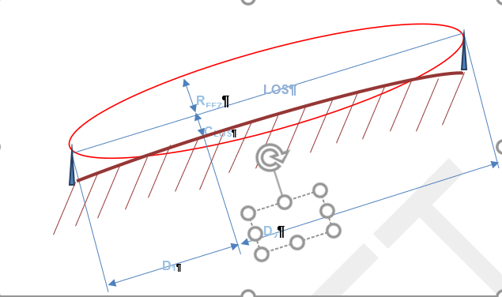

Figure 18: LOS propagation condition with partially obstructed Fresnel zone which must be treated as smooth object diffraction

For a point at a given distance along the path of propagation, which introduces knife-edge diffraction, the radius of the first Fresnel zone can be determined by the following equation:

|  |  |  |
| --- | --- | --- |
|  | $$R_{EFZ}=\sqrt{\frac{D_{1}D_{2}}{D_{1}+D_{2}}}λ$$ | (9) |

Where:

* λ is wavelength of the propagating signal;
* d1 is the distance of the point from one end of the path;
* d2 is the distance of the point from the opposite end of the path.

Given the parameters:

* f = 900 MHz;
* d1 = 2.5 km;
* d2 = 2.5 km.

The above equation gives *REFZ* = 20.41 m.

The Fresnel-Kirchhoff diffraction parameter is calculated as follows:

|  |  |  |
| --- | --- | --- |
|  | $$v=h\sqrt{2\frac{D_{1}+D_{2}}{{λD}_{1}D_{2}}}=h\frac{\sqrt{2}}{R_{EFZ}}$$ | (10) |

To calculate the diffraction loss, the Fresnel integral

|  |  |  |
| --- | --- | --- |
|  | $$f\left(v\right)=\int_{v}^{∞}{\left(\frac{1+j}{2}\right)}e^{\left(\frac{-jπt^{2}}{2}\right)}dt$$ | (11) |

Can be approximated reasonably accurate for values of -1 <= v <= 0 by the following formula

|  |  |  |
| --- | --- | --- |
|  | $$Loss\left(v\right)=20 log\left(0.5-0.62v\right)$$ | (12) |

Looking for a loss of 2 dB the following v is required

|  |  |  |
| --- | --- | --- |
|  | $$v=\frac{{0.5-10}^{\frac{-2}{20}}}{0.62}=-0.4731$$ | (13) |

The required maximum clearance is calculated in the middle of the Fresnel ellipse as follows:

|  |  |  |
| --- | --- | --- |
|  | $$h=v\frac{R_{EFZ}}{\sqrt{2}}=-0.4731 \frac{20.41}{1.414}=-6.83 m$$ | (14) |

When looking for scenarios with 5 km propagation distance, where the path loss due to knife edge diffraction is maximum 2 dB higher than free space loss, LOS conditions are selected for supposed transmitter and receiver antenna heights which are 6.83 m below effective antenna heights. The correction of the minimum clearance height for angles of arrival with a tilt smaller or larger than 0° can be neglected for the considered scenarios. Figure 19 shows a typical situation of the above described scenario where the diffraction loss is 2 dB @ d=5 km because of Fresnel zone obstruction with a clearance of -6.83 m.

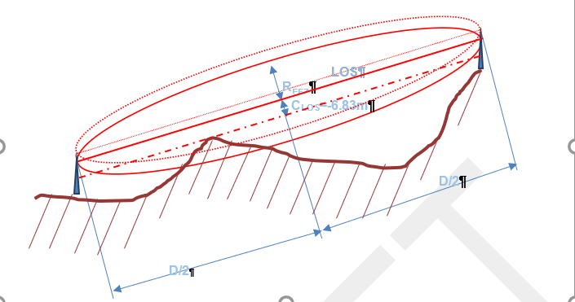

Figure 19: LOS scenario where the diffraction loss is 2 dB at a distance of d=5 km

When considering smooth rounded surfaces obstructing the path at a clearance of h=-6.83 m, the diffraction loss is evaluated according to Recommendation ITU-R P.526-13 by using the following deployment models as depicted in Figure 20 and Figure 21. The antenna height of those models are different to the effective antenna heights. This modelling is required to evaluate spherical diffraction loss according to the conditions with -6.83 m clearance.

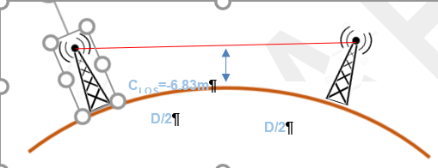

Figure 20: Model 1 for diffraction loss calculation over smooth obstacles

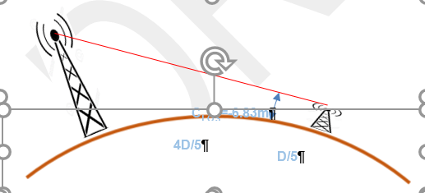

Figure 21: Model 2 for diffraction loss calculation over smooth obstacles

The path loss due to diffraction on spherical earth, considering the models above, is evaluated using the antenna heights h1 and h2 as shown in Table 17 The calculation of the attenuation due to spherical earth diffraction is also shown in Table 17.

Table 17: Antenna heights for smooth object diffraction evaluation

|  |  |  |  |  |  |  |
| --- | --- | --- | --- | --- | --- | --- |
| Parameter | D=5 km | | | D=10 km | | |
| **Model 1** | **Model 2** | **Model 1** | | **Model 2** |
| h1 | 7.2 m | 7.8 m | 8.3 m | | 10.6 m |
| h2 | 7.2 m | 6.9 m | 8.3 m | | 7.1 m |
| Diffraction attenuation | 7.6 dB | 7.2 dB | 12.9 dB | | 12.2 dB |

Significant additional attenuation due to atmospherically effects at 900 MHz are in the range of a few dBs but occur with a low probability (Therefore relevant for time probability (Tpc) values well above 50%). On the other hand, with rather low probability, the path loss due to anomalous propagation effects may be below the attenuation given by free space loss + diffraction loss. However, for scenarios assuming a probability 20 < Tpc < 50% at a frequency of 900 MHz, it can be concluded that for the above considered cases (line of sight condition with 6.83 m clearance) the path loss is dominated by free space loss and diffraction loss. This path loss can be calculated according to Recommendation ITU-R P.526-13. As shown in Table 17 the path loss may not exceed a value given by the free space loss 7.6 dB at a distance of 5 km, respectively 12.9 dB at a distance of 10 km, if clutter loss is not taken into account. It should be noted that those values represent the worst cases, because on one hand the diffraction attenuation could be lower in case of knife edge diffraction, which may occur with a certain probability, and on the other hand, the clearance may be much more than 6.83 m in many cases.

* + 1. PROBABILITY FOR SCENARIOS WHERE THE PROPAGATION LOSS DOES NOT EXCEED THE VALUE OF THE PATHLOSS CALCULATED FOR 7.6 dB RESPECTIVELY 12 dB DIFFRACTION LOSS AND FREE SPACE LOSS

The methodology above is applied to evaluate to probability for scenarios, where the propagation loss is does not exceed the value of the path loss calculated for 7.6 dB, respectively 12.9 dB diffraction loss an free space path loss for 4 different typical E-GSM-R base station sites close to the Swiss border. Accordingly, any of the scenarios identified with that probability correspond to LOS situations with minimum clearance of 6.83 m. The following sites are considered:

* Kleinhünigen              611267 / 269980;
* Muttenz                      615630 / 265085;
* Genève Aéroport       497215 / 120558;
* Carouge                     499059 / 115158.

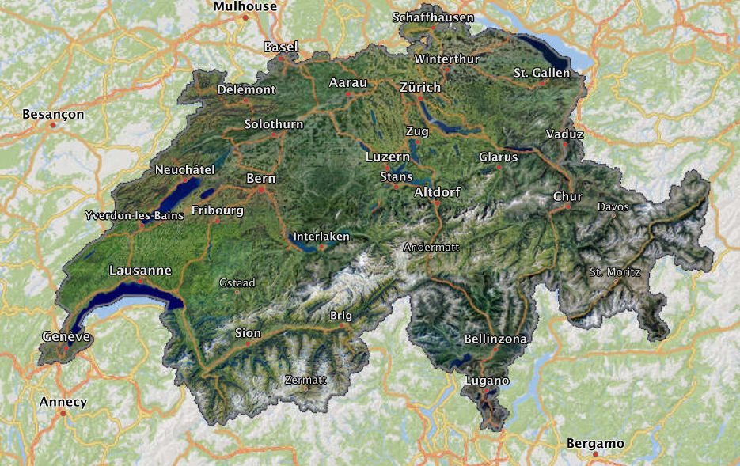

Figure 22: Typical sites of E-GSM-R Base stations close to the Swiss border indicated by the symbol

The probabilities for line of sight conditions with 6.83 m clearance for all the considered sites is shown graphically in Figure 23. It can be concluded that LOS conditions with 6.83 m clearance for a typical E-GSM-R base station antenna in a range of 10 km appears with a probability of 20% or more.

Figure 23: Probability for LOS conditions at height of the antennas –6.78 m

A summary of the probability for the before mentioned propagation conditions at a distance of 5 km is shown in Table 18.

Table 18: Probability for line of sight conditions at a range of 5 km and 10 km, when assuming antenna heights which a reduced by 7 m

|  |  |  |
| --- | --- | --- |
| Site | Probability for LOS @ d= 5 km | Probability for LOS @ d= 10 km |
| Kleinhünigen | 67.7% | 35.5% |
| Muttenz | 45.8% | 26.5% |
| Genève | 30.6% | 21.9% |
| Carrouge | 29.7% | 17.8% |

Based on the above made conclusions, requirements may be derived which should be met by any propagation model. Those requirements are summarised in Table 19.

Table 19: Requirements for propagation model results for considered scenarios

|  |  |  |
| --- | --- | --- |
| Distance | Minimum loss Tpc = 20% Location probability 20% | Maximum loss Tpc = 20% Location probability 20% |
| 5 km | Free space loss | Free space loss + clutter loss + max. 7.6 dB |
| 10 km | Free space loss | Free space loss + clutter loss +max. 12.9 dB |

When the maximum diffraction loss considering 6.83 m clearance is calculated for all distances up to 10 km, then the path attenuation loss limit values as shown in Figure 24 can be defined.



Figure 24: Path loss limit lines for typical topographical situations with a 20% location variability

When the path loss is calculated according to Recommendation ITU-R P.2001, considering a time probability of 20% and considering clutter losses according to Recommendation ITU-R P.2108 for rural environments, values are obtained as shown in Figure 25.



Figure 25 Path loss calculated according to Recommendation ITU-R P.2001 including clutter losses according to Recommendation ITU-R P.2108 for rural environment

1. SEAMCAT simulation details
   1. SRD parameters For typical operation situations

The below table lists the SRD parameters in typical operation scenarios that are assumed in this analysis It is assumed, that 30% of the TNs are operating outdoor. A bandwidth correction factor needs to be applied when the bandwidth of the interferer is larger than the reception bandwidth of the victim system. Where APC parameter values of are unknown, estimated values are used.

Table 20: SRD characteristics

|  |  |  |  |  |
| --- | --- | --- | --- | --- |
| Parameter | UNB | | NBN | CSS |
| NAP Antenna height | 25 m; outdoor only | 7 m; outdoor only | | 25 m; outdoor only |
| NN Antenna height | - | 5 m; outdoor only | | - |
| TN Antenna height | 1.5 m;  70%indoor, 30% outdoor | 1.5 m;  70%indoor, 30% outdoor | | 1.5 m;  70%indoor, 30% outdoor |
| NAP EIRP | 29 dBm (APC) | 29 dBm (APC) | | 29 dBm (APC) |
| NN EIRP | - | 29 dBm (APC) | | - |
| TN e.i.r.p. | 16 dBm | 29 dBm (APC) | | 16 dBm |
| Typical NAP duty cycle | 0.7% | 2.5% | | 0.5% |
| Typical NN duty cycle | - | 0.7% | | - |
| Maximum NAP density | 0.1/km² | 10/km² | | 3.5/km² |
| Maximum NN density | - | 90/km² | | - |
| Maximum TN density | 2000/km² | 1900/km² | | 3000/km² |
| Typical  TN density | 343/km² | 950/km² | | 360/km² |
| Bandwidth correction factor | 0 dB | 0 dB | | 0 dB |
| APC threshold  APC dynamic range  APC step width | unknown | -89 dBm  20 dB  2 dB | | unknown |

* 1. SRD Deployments FOR average DC Interference scenarios

In the modelled scenarios, a typical city is assumed with a population of about 200'000, living in an area of 50 km² with 50% of the population in urban and 50% in suburban environments. It is additionally assumed that 70% of TNs are deployed indoor. SRD interference is calculated for each technology separately and no aggregation of SRD interferences from distinct technologies is considered. Based on those assumptions, the number of SRD devices that need to be considered for the interference simulation of a single E-GSM-R radio channel, assuming SRD deployments in three different frequency bands, is shown in Table 21.

Table 21: Number of SRD devices to be considered in the simulations (in the area of 50 km²) in case of SRD deployments in three frequency bands

|  |  |  |  |
| --- | --- | --- | --- |
| Parameter | UNB | NBN | CSS |
| Maximum NAP number | 2 (1.67) | 167 | 58 |
| Maximum NN number | - | 1500 | - |
| Maximum TN number indoor | 23333 | 22167 | 35000 |
| Maximum TN number outdoor | 10000 | 9500 | 15000 |

Deployment figures to be considered in the SEAMCAT scenarios dealing with a 50 km urban / suburban environment and high density SRD deployments according EC harmonised SRD frequency bands are given in Table 22.

Table 22 Figures to be considered in the SEAMCAT scenario in case of high density SRD deployments according EC harmonized spectrum for a 50 km² urban / suburban environment

|  |  |  |  |  |  |  |  |  |
| --- | --- | --- | --- | --- | --- | --- | --- | --- |
| Environment / propagation condition |  | UNB  NAP | UNB  TN | NBN  NAP | NBN  NN | NBN TN | CSS  NAP | CSS  TN |
| Suburban / NLoS | Indoor | - | 11667* | - | - | 8311 |  | 17500* |
| Outdoor | 1 | 5000* | 63 | 563 | 3564 | 29 | 7500* |
| Suburban / LoS | Indoor | - | - | - | - | 2771 |  |  |
| Outdoor | - | - | 21 | 187 | 1188 | - |  |
| Urban / NLoS | Indoor | - | 11667* | - | - | 8311 |  | 17500* |
| Outdoor | 1 | 5000* | 63 | 563 | 3564 | 29 | 7500* |
| Urban / LoS | Indoor | - | - | - | - | 2771 |  |  |
| Outdoor | - | - | 21 | 187 | 1188 | - |  |
| * For the extended Hata model no distinction between LoS and NLoS conditions are required | | | | | | | | |

Deployment figures to be considered in the SEAMCAT scenarios dealing with a 50 km² urban / suburban environment and high density SRD deployments according ECC harmonized SRD frequency bands are given in Table 23.

Table 23 Figures to be considered in the SEAMCAT scenario in case of high density SRD deployments according ECC harmonised spectrum for a 50 km² urban / suburban environment

|  |  |  |  |  |  |  |  |  |
| --- | --- | --- | --- | --- | --- | --- | --- | --- |
| Environment / propagation condition |  | UNB  NAP | UNB  TN | NBN  NAP | NBN  NN | NBN TN | CSS  NAP | CSS  TN |
| Suburban / NLoS | Indoor | - | 6364* | - | - | 4533 | 12 | 9545* |
| Outdoor | - | 2727* | 34 | 307 | 1944 | - | 4091* |
| Suburban / LoS | Indoor | - |  | - | - | 1511 | 4 |  |
| Outdoor | - |  | 11 | 102 | 648 | - |  |
| Urban / NLoS | Indoor | - | 6364* | - | - | 4533 | 12 | 9545* |
| Outdoor | 1 | 2727* | 34 | 307 | 1944 | - | 4091* |
| Urban / LoS | Indoor | - |  | - | - | 1511 | 4 |  |
| Outdoor | - |  | 11 | 102 | 648 | - |  |
| *For the extended Hata model no distinction between LoS and NLoS conditions are required. | | | | | | | | |

Table 25: Figures to the above table are be considered in the SEAMCAT scenario in case of high density SRD deployments according ERC Recommendation 70-03 spectrum for a 50 km² urban / suburban environment

|  |  |  |  |  |  |  |  |  |
| --- | --- | --- | --- | --- | --- | --- | --- | --- |
| Environment / propagation condition |  | UNB  NAP | UNB  TN | NBN  NAP | NBN  NN | NBN TN | CSS  NAP | CSS  TN |
| Suburban / NLoS | Indoor | - | 2257* | - | - | 1608 | 4 | 3386* |
| Outdoor | - | 966* | 12 | 109 | 689 | - | 1450* |
| Suburban / LoS | Indoor | - |  | - | - | 536 | 1 |  |
| Outdoor | - |  | 4 | 36 | 229 | - |  |
| Urban / NLoS | Indoor | - | 2257* | - | - | 1608 | 4 | 3386* |
| Outdoor | 1 | 966* | 12 | 109 | 689 | - | 1450* |
| Urban / LoS | Indoor | - |  | - | - | 536 | 1 |  |
| Outdoor | - |  | 4 | 36 | 229 | - |  |
| * For the extended Hata model no distinction between LoS and NLoS conditions are required. | | | | | | | | |

* 1. Propagation models
     1. Interfering Link Transmitter (NAP, NN, TN) to Victim Link Receiver

The propagation model from Recommendation ITU-R P.2001 is used. This propagation model can be used to calculate basic transmission loss by taking into account a specific terrain data. However, for these studies no specific terrain data, but flat only terrain is considered. Analysis of terrain data around some E-GSM-R base station locations has shown, that flat terrain can be considered as typical, if only geographical situations are taken into account which represent those 20% of E-GSM-R receiver locations, where minimum propagation losses can be found. With simulation results based on these propagation condition assumptions, a protection of the railway communication system for 80% of locations can be studied. This protection demand seems to be reasonable in view of the mission critical aspect of the railway communication system.

The above made assumptions are verified by comparison with the real topographical situation given in a scenario considering a BTS antenna at Basel main station and locations of possible interferers on a straight line between Base main station and the highway cross close to the city of Mulhouse. The terrain profile and LOS lines (red lines) between Basel main station and the highway cross near Mulhouse are shown in Figure 26. The LOS lines are drawn for 7 m and 25 m SRD antenna height and 20 m E-GSM-R BTS antenna height.



Figure 26: Terrain profile and LOS lines between Basel main station (CH) and highway cross at Mulhouse (F)

The propagation losses calculated according the propagation model ITU-R P.2001 when considering on the one hand the specific “Basel – highway cross Mulhouse” terrain data, and on the other hand considering typical terrain profile are shown in Figure 27. The dashed line show the propagation loss values calculated by using the Model ITU-R P.2001 with typical terrain data, representative for 20% of locations. The solid lines show the propagation loss values calculated by using the Model ITU-R P.2001 considering site-specific terrain data of the topographical situation between Basel Main Station and highway cross at Mulhouse. The green lines indicate values for the scenario considering 25 m SRD antenna height, whereas the blue lines represent results for 7 m SRD antenna height.



Figure 27: Propagation loss calculated using the propagation model ITU-R P.2001 considering the specific Basel – highway cross Mulhouse terrain data as well as typical terrain profile

The LOS distance between Basel main station and Mulhouse highway cross is 29.8 km. The propagation loss simulation for that distance using propagation model ITU-R P.2001 with site-specific terrain data and for a 25 m SRD antenna height is 127 dB. The propagation loss for the same path length using ITU-R P.2001 taking into account flat terrain (typical terrain profile considered to be valid for 20% of locations) is 132 dB. The free space loss for that distance is 121 dB. When doing the same comparison for an SRD antenna height of 7 m, a simulated propagation loss calculated based on site specific terrain data a path loss of 136 dB is obtained. The propagation loss for the same path length using ITU-R P.2001 considering the flat terrain (typical terrain profile considered to be valid for 20% of locations) is 141 dB. It should be noted that no clutter loss was considered for this analysis, neither for the specific terrain profile calculations nor for the calculation using the typical terrain profile. Therefore, the comparison holds for all type of environments. The results with the 25 m SRD antenna could be considered for rural, urban or suburban (clutter height for all these environments is below 20 m).

Similar propagation conditions can also be found for example in the cross-border area with France between the cities of Lausanne and Geneva.

For the propagation attenuation calculations, clutter loss according Recommendation ITU-R P.2108 must be taken into account. The clutter loss also has important effects on the interference situation when E-GSM-R cab radios are considered as victim receiver. A statistical clutter loss distribution may be introduced to overcome shortcomings of simulations based on median values. The cab radio as victim receiver is assumed to be most of the time in rural environments. For that reason, a clutter height of 6 m is assumed for the scenarios considering CAB radio as victim receiver.

For the interfering transmitter to victim receiver link, a propagation model need to be used, which can also simulate Gaussian distributed attenuation (in log scale) in order to simulate local propagation loss variations due to shadowing. When the Longley rice model is configured for 20% location probability, the attenuation calculated with this model is very similar to the attenuation calculated with the model according Recommendation ITU-R P.2001. Therefore, the Longley Rice model is used to simulate the interference to the CAB radio receiver.

* + 1. SRD Link

The extended Hata propagation model is appropriate, where the antenna heights are for between 1 m and 10 m for one terminal of the radio link and 30 m - 200 m for the other terminal of the radio link. Therefore, this requirement matches nearly propagation specifications of the UNB and CSS systems, such that the error introduced by using this model in the studies of the two mentioned systems may be tolerable.

For the NBN system, the antenna height requirements of the extended Hata model not fulfilled and the propagation model ITU-R P.1411-10, §4.1.1 (street canyon propagation below rooftop) is more appropriate because of the low TN antenna heights within urban or suburban areas. Both LOS and cluttered NLOS scenarios can be covered. It is assumed, that 25% of interfering links are under LoS conditions and 75% under NLoS conditions. Accordingly, it is proposed for 25% of SRD links to select the model ITU-R P.1411-10, §4.1.1. "LoS Urban(high rise, low rise)/Suburban" and for 75% of the SRD links the model ITU-R P.1411-10, §4.1.1. and "NLoS Urban high rise".

Due to the lack of an appropriate model for suburban NLoS SRD propagation model, the ITU-R P.1411-10, §4.1.1 NLoS Urban high rise may be used for NN to TN transmission in suburban environments as well.

It must be noted, that due to the low density of UNB NAP, the distance range of the UNB interference link is longer than the ITU-R P.1411-10 model range.

A building entry loss (BEL) according Recommendation ITU-R P.2109 is used by applying the same parameters as in ECC Report 316, where two different BEL classes are considered, thermal efficient in 30% of cases and for traditional buildings in 70% of cases.

* + 1. Victim Link and intra-system interference to the Victim Link

As outlined in Section 2, any propagation model may be used, which is configurable for log normal distributed (normal distributed in dB) propagation loss with a standard deviation of 8.5 dB. It is proposed to use the Longley Rice model configured for a location probability of 20% and a standard deviation of 8.5 dB.

* 1. seamcat configurations

The scenarios studied in this addendum are based on two distinct propagation models for the ILT:

* For the interfering link (IL) the model ITU-R P.1411-10 is used, because the model is specifically designed to consider radio signal propagation effects of short range radiocommunication taking into account line of sight as well as non-line of sight situations (e.g. street canyons) in urban and suburban environments;
* Analysis has shown, that for the ILT - VLR link simulation, the model ITU-R P.2001 in combination with the model ITU-R P.2108 is the most suitable choice. However, SEAMCAT does not support the selection of two different clutter loss models for a single ILT. Therefore, only the use of propagation models in SEAMCAT which have integrated clutter loss models may be used for the considered scenarios. The propagation model ITU-R P.452-16 as well as the propagation model ITU-R P.2001 uses the same sub models for free space, spherical diffraction, Bullington diffraction, anomalous propagation and troposcatter propagation. Accordingly, the calculated propagation losses for the considered scenarios are the same when calculated with either one or the other model. Furthermore, both models are equally well suited for Monte Carlo simulator implementation. But, in contrast to the model ITU-R P.2001, the model ITU-R P.452 has a built - in clutter loss model. Therefore, the model ITU-R P.452-16 is used for the ILT - VLR simulations in SEAMCAT;
* According the defined scenarios, the ILT and ILR are positioned within circular, respectively annular areas. SEAMCAT provides that positioning process by uniform distribution of ILT or ILR on the radius and angle of circular or angular area. It should be noted, that this positioning process does not provide a uniform distribution of ILT or ILR in the respective areas, but a more dense distribution for places closer to the centre of the circular or annular areas;
* The NBN NN DC is based on transmitter activity in two directions, NN🡪 NAP and NN 🡪 TN. Because the antenna height and environment of both directions are not the same, the propagation losses are also different for both directions and consequently the transmit power statistics of the APC is different for both directions. Therefore, both directions are simulated separately with the assumption that the traffic load is equal in both directions;
* The TN are simulated with an antenna height of 1.5 m only. The mean activity of outdoor NBN TN (TN DC * TN density) is lower than the mean activity of NBN NNs (NN DC * NN density). Due to those operational parameter values of the TN and NN, it can be concluded, that the effect of the TN emissions on the overall NBN system emissions are minor. To save computation power in the SEAMCAT simulations, the NBN TNs are not considered but should be noted that the simulated results therefore represent a slight underestimate;
* As pointed out in 2.2.1 of the main body text different scenarios are considered. For illustration purposes some of the scenarios are shown in the figures below

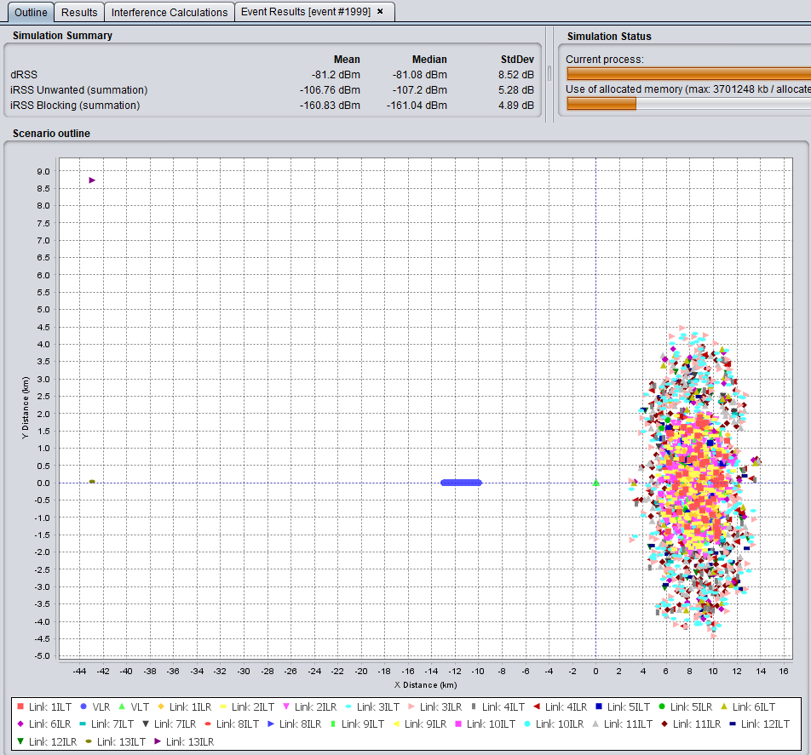

Figure 28: SEAMCAT implementation of a scenario with BTS main beam directing to SRD deployments



Figure 29: SEAMCAT implementation of a scenario with BTS main beam directing at 45° with respect to SRD deployments

* 1. UNB deployment density assessment

Results of SEAMCAT simulation configured with maximum UNB NAP densities show, that some UNB TNs did not receive the NAP signal above the sensitivity level. Therefore, some analysis is made on the UNB link budget. The following assumptions are made for the link budget analysis:

* UNB NAP deployment density is 1/km2. If hexagonal shaped coverage area is assumed, then the UNB range must be up to 2 km;
* UNB TN may be deployed with a probability of 70% indoors and with a probability of 30% outdoors;
* Because the UNB NAPs operate on a 25m antenna height, the extended Hata model (which requires an antenna height of >30 m) may be applied when accepting slight calculation errors. The SRD propagation model in Recommendation ITU-R P.1411, which is used for the NBN studies may not be applied for scenarios considering ranges of up to 2 km.
* For the building entry loss calculations, 30% thermal efficient and 70% traditional buildings are assumed. The losses are calculated according Recommendation ITU-R P.2109.

Based on the above assumptions, the propagation losses are calculated with extended Hata propagation model for urban environments. The results of that calculations show the median path loss for the three scenarios “outdoor”, “indoor considering traditional buildings”, “indoor considering thermal efficient buildings”. In the below figure, the calculations results are shown.

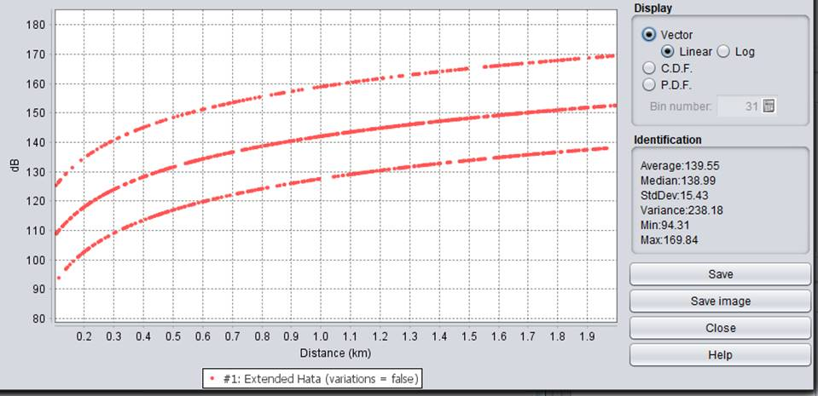

 Figure 30: Path attenuation calculated with extended Hata for outdoor and indoor deployments

In the following, the link budget is analysed based on the following assumptions:

* P(TX) = 29.15 dBm e.i.r.p.;
* G(RX) = 0 dB;
* Sensitivity = -126 dBm;
* Fading margin = 10 dB.

The link budget is calculated as follows: A = 29.15 dB + 126 dB – 10 dB = 147.1 dB is obtained.

It seems, that for indoor deployments, the link budget does not match for 2 km ranges. When analysing the cumulative distribution of the path attenuation values as shown in below figure, it can be concluded, that about 35% of TNs operate out of coverage range. Accordingly, a denser UNB NAP deployment would be required to provide coverage for indoor TN deployments.

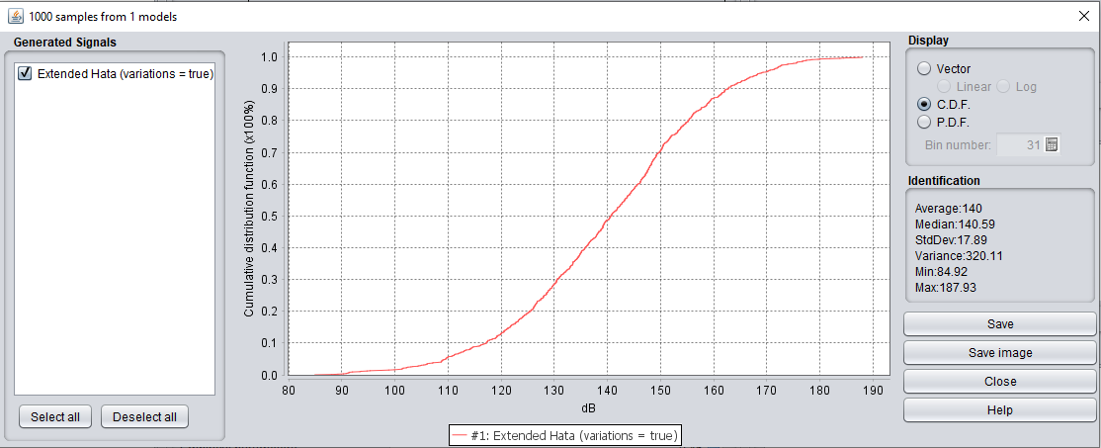

Figure 32: Cumulative distribution of attenuation results calculated with extended Hata for outdoor and indoor deployments within a 2 km range

When assuming a range of 0.5 km, the outage probability would be ~5% as shown in the below figure.

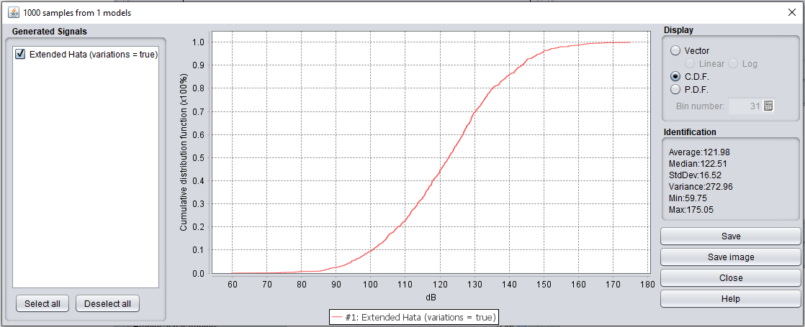

Figure 33: Cumulative distribution of attenuation results calculated with extended Hata for outdoor and indoor deployments within a 0.5 km range

1. List of References
2. ECC Report 200: “Co-existence studies for proposed SRD and RFID applications in the frequency band 870-876 MHz and 915-921 MHz”, September 2013
3. Recommendation ITU-R P.452: “Prediction procedure for the evaluation of interference between stations on the surface of the Earth at frequencies above about 0.1 GHz”
4. Recommendation ITU-R P.2108: “Prediction of Clutter Loss2
5. Recommendation ITU-R P.2001: “A general purpose wide-range terrestrial propagation model in the frequency range 30 MHz to 50 GHz”
6. Recommendation ITU-R P.526: “Propagation by diffraction”
7. Commission Implementing Decision (EU) 2018/1538 of 11 October 2018 on the harmonisation of radio spectrum for use by short-range devices within the 874-876 and 915-921 MHz frequency bands
8. ETSI EN 303 204: “Network Based Short Range Devices (SRD); Radio equipment to be used in the 870 MHz to 876 MHz frequency range with power levels ranging up to 500 mW; Harmonised Standard covering the essential requirements of article 3.2 of the Directive 2014/53/EU
9. ETSI TR 103 435: “System Reference document (SRdoc); Short Range Devices (SRD); Technical characteristics for Ultra Narrow Band (UNB) SRDs operating in the UHF spectrum below 1 GHz”
10. ETSI EN 300 220: “Short Range Devices (SRD) operating in the frequency range 25 MHz to 1 000 MHz; Part 2: Harmonised Standard for access to radio spectrum for non specific radio equipment”
11. ETSI TR 103 526 V1.1: “System Reference document (SRdoc); Technical characteristics for Low Power Wide Area Networks Chirp Spread Spectrum (LPWAN-CSS) operating in the UHF spectrum below 1 GHz”
12. ETSI TR 102 886: “Electromagnetic compatibility and Radio spectrum Matters (ERM); Technical characteristics of Smart Metering (SM) Short Range Devices (SRD) in the UHF Band; System Reference Document, SRDs, Spectrum Requirements for Smart Metering European access profile Protocol (PR-SMEP)”
13. ETSI EN 302 208: “Radio Frequency Identification Equipment operating in the band 865 MHz to 868 MHz with power levels up to 2 W and in the band 915 MHz to 921 MHz with power levels up to 4 W; Harmonised Standard for access to radio spectrum”
14. ETSI TS 145 005: “Digital cellular telecommunications system (Phase 2+); Radio transmission and reception (3GPP TS 45.005 version 13.3.0 Release 13)
15. UIC 2009 GSM-R Procurement and Implementation guide, March 2009
16. ECC Report 239: “Compatibility and sharing studies for BB PPDR systems operating in the 700 MHz range”, September 2015
17. ECC Report 278: “Specific UWB applications in the bands 3.4-4.8 GHz and 6.0-8.5 GHz: Location tracking and sensor applications (LTA) for vehicular access systems”, April 2018
18. Report ITU-R M.2292: “Characteristics of terrestrial IMT-Advanced systems for frequency sharing/ interference analyses”
19. Report ITU-R M.2478: “ Spectrum needs for the amateur service in the frequency band 50-54 MHz in Region 1 and sharing with mobile, fixed, radiolocation and broadcasting services”
20. Recommendation ITU-R M.1808: “Technical and operational characteristics of conventional and trunked land mobile systems operating in the mobile service allocations below 869 MHz to be used in sharing studies in bands below 960 MHz”

1. Harmonised frequency band as per Decision EU 2018/1538
2. 2 channels from a possible 11
3. 7 channels from a possible 31