The impact of UWB applications on board aircraft in the band 6-8.5 GHz on FS links used around airports and on EESS earth stations
Approved 29 April 2016
ECC Report 251

Executive summary
This report studies the compatibility between UWB on board aircrafts and FS links plus EESS earth stations in the frequency range 6-8.5 GHz.
The impact on FS links
The most critical situation would be when an aircraft is crossing the main beam of a FS antenna. Such events are quite common in countries like Norway where the topography favours the use of microwave systems instead of cable in airfield areas.
It has been shown that aircrafts in motion would not give interference events which exceeds10 consecutive seconds. It can thus be considered as performance degradation, where the FS short term interference protection criterion used in Recommendation ITU-R SF.1650 [1] has been selected, based on the advice from SE19. Concerning the interference from a stationary aircraft, the long term interference protection criterion in Recommendation ITU-R F.758 [2] has been applied.
Based on the ITU-R recommended systems parameters to be used in such compatibility studies – as shown in Table 2– the worst case minimum protection distance between an aircraft and a FS receiver is estimated to be about 150 m and 14 km for in motion and stationary aircrafts respectively.
With on a minimum separation of 150 m only it can be concluded that, except for helicopters, an aircraft in motion with UWB on board should not cause any interference problems to FS links. It is also assumed that interference from UWB on board a stationary aircraft to FS links would be a seldom if ever case. A Norwegian investigation, based on the impact on total 64 FS links in airport areas, where the actual systems parameters has been used in the calculation of the expected interference level, is conforming these findings.
The impact on EESS earth stations
The impact on EESS earth stations from UWB interference on board aircrafts has been studied by means of dynamic analysis tools in order to evaluate the occurrence of events where an aircraft is within the main beam of a receiving earth station, depending on the fuselage attenuation considered.
This simulation has shown that these events would happen for very small fraction of time only.
A simple calculation indicates that there may be cases where UWB on board aircraft might exceed the long-term protection criterion of -145 dBW/10 MHz set forth in Recommendation ITU-R SA.1026 [3]. However, this criterion refers to at least 20% of the time and thus not valid for these few short interference events. The short-term protection criterion contained in the same recommendation would never be exceeded. Similarly, the protection criteria defined when considering a 1% apportionment usually considered for UWB would never be exceeded.
It can therefore be concluded that there is no compatibility issue between EESS and UWB on board aircraft in the band 8 025-8 400 MHz.

TABLE OF CONTENTS

0 Executive summary 2
1 Introduction 5
2 The impact of UWB applications on board aircrafts 6
2.1 The impact on FS links 6
2.1.1 Interference criteria 6
2.1.2 Interference characteristics 6
2.1.3 Interference calculation methodology 7
2.1.4 Blocking factor 8
2.1.5 FS protection distances 10
2.1.5.1 Worst case protection distances 11
2.2 The impact on EESS earth stations 11
2.2.1 EESS Earth stations characteristics 11
2.2.1.1 Wideband, high data-rate science data downlinks 11
2.2.1.2 Narrow-band, moderate data-rate science data downlinks 11
2.2.2 Protection criterion 12
2.2.3 Dynamic analysis 13
3 Conclusions 15
3.1 The impact on FS links 15
3.2 The impact on EESS earth stations 15
ANNEX 1: Maximum impact of UWB on FS 16
ANNEX 2: Calculated UWB impact on EESS earth stations 21
ANNEX 3: List of Reference 23

LIST OF ABBREVIATIONS

Abbreviation | Explanation
CEPT | European Conference of Postal and Telecommunications Administrations
DB | Direct broadcast
dBi | Decibel isotropic
dBic | Decibel isotropic radiator circularly polarized
DRo | Direct Readout
ECC | Electronic Communications Committee
EESS | Earth Exploration Satellite Service
e.i.r.p. | equivalent isotropically radiated power
ES | Errored Second
ESA | European Space Agency
FS | Fixed Service
FSS | Fixed Satellite Service
ILS | Instrument Landing System
ITU | International Telecommunication Union
KSAT | Kongsberg Satellite Services
MATLAB | Matrix Laboratory
MS | Mobile Service
SFCG | Space Frequency Coordination Group
STK | System Tool Kit
TT&C | Telemetry, Tracking & Command
UWB | Ultra-wideband
WAIC | Wireless Avionics Intra Communications
WRC | World Radiocommunication Conference

Introduction
The impact of UWB on board aircraft in the band 6-8.5 GHz on FS links used around airports and on EESS earth stations using the band 8025-8400 MHz will be analysed in this report. This is a complementary work to ECC Report 175 [4].

The impact of UWB applications on board aircrafts
This chapter consists of two parts; the first dealing with the impact on FS links and the second part dealing with the impact on EESS earth stations.

The impact on FS links
In ECC Report 175 [4] the UWB-FS compatibility study is based on the ITU-R long-term interference criterion which is valid when the interfering signal is present for more than about 20 % of the time. As most FS are to be affected by such interfering signals for a very short period of time (i.e. when the aircraft is in motion) also short-term interference criteria must be included in such an analysis.
The ES (Errored Seconds) criterion applied in Recommendation ITU-R SF.1650 [1] has been used in the study of the 5925-6425 MHz band between in-motion earth stations located vessels and FS.

Interference criteria
The following interference criteria has been used to protect the FS in the 6 to 8.5 GHz band from time varying aggregate interference from UWB onboard aircrafts:
- for the long- term, the I/N at the input of the FS receiver should not exceed –20 dB for more than 20 % of the time;
- for the short- term, the I/N at the input of the FS receiver should not exceed +19 dB for more than 0.00045 % of the time for ES (Errored Seconds)

Interference characteristics
The quality of a FS transmission circuit is characterized by limits for both performance and availability degradations. In order to get degradation of the availability an interference event must have duration of at least 10 consecutive seconds. Shorter interference events can cause performance degradations only. It is thus necessary to have information available on the typical consecutive length of an UWB on board aircraft interference period.
From a Norwegian study it has been concluded that in order to get harmful interference an aircraft must be in the landing and and/or departure of the mode of the flight movements, where the aircraft has a velocity down to about 200 km/hour. The aircraft must be situated within the main beam of the FS antenna and at the same time the separation distance between the aircraft and antenna is quite short.
With the assumptions of a 40 m long aircraft body and a FS antenna gain of 42 dBi, the length of an interference event has been estimated as shown in Table 1.
Table 1: Example of the duration of an interference event
Aircraft-FS antenna separation distance (km) | Aircraft velocity  (km/seconds) | Length of aircraft body  (m) | FS antenna gain  (dBi) | 15 dB beam-width (deg.) | Interference event duration  (seconds)
1 | 200 | 40 | 42 | 3 | 1.7
It is not likely that a harmful UWB interference event from an aircraft in motion would exceed 10 seconds. It can therefore be concluded that only the performance would be affected and thus that the defined short term interference criterion can be applied.
In contrast to this situation interference from a stationary aircraft has to be considered as long-term interference. It is also assumed that a helicopter could cause long-term interference even when it is in motion.

Interference calculation methodology
The flight path during arrival and departure is quite precise described in the ILS navigation charts. This is illustrated as shown in Figure 1 where a FS path is crossing a distance just above the flight path.
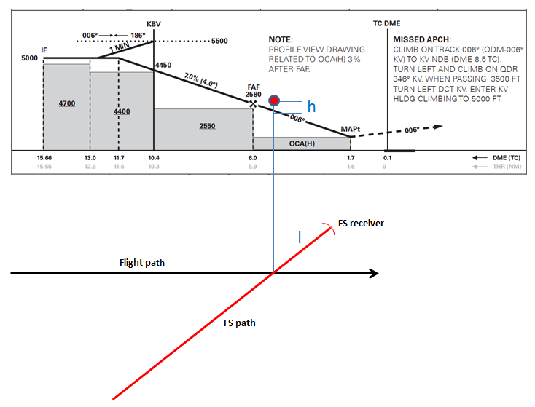
Figure 1: Flight path

The level of UWB interference (I) into the FS receiver is calculated as follows:
I = P – AS – AF + G
where:
- P is the UWB e.i.r.p. (dbm/MHz);
- AS is the airplane screening attenuation (dB);
- The values should be based Report ITU-R M.2283 [6];
- AF is the free space loss (dB) for path length l (i.e. between crossing-point and FS receiver);
- G is the FS antenna gain in the direction to the aircraft (dBi).
The gain and its pattern for the actual antenna should be used. If not available “typical” antenna pattern for sharing studies is given in Recommendation ITU-R F.699 [7].
The angle parameter in the antenna diagram is calculated from the following formula:
Angle = $\frac{180}{3.14}$ x $\frac{h}{l}$ $(^{o})$
where:
h and l (m) is the distances as shown in Figure 1.

Blocking factor
When the aircraft is passing is through the main beam of the FS antenna the wanted signal is reduced by diffraction loss because of the aircraft is blocking parts of the Fresnel zone area. An estimate of this diffraction loss, which is often named “the blocking factor”, can be done in the following way:
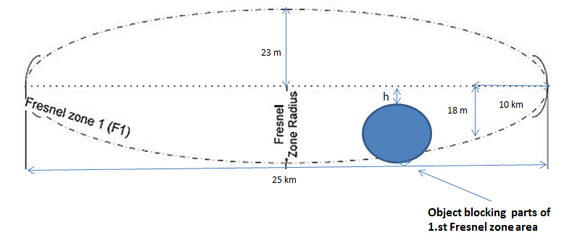
Figure 2: Fresnel zone area

Assume a 50 km long path with the extent of the 1.st Fresnel zone area for 7 GHz as shown in Figure 2. If an object is obstructing parts of the 1.st Fresnel zone area then the blocking factor can be estimated from Figure 3 which is based on empirical diffraction data (as given in Recommendation ITU-R P.530 [5]). Because of the size of the 1.st Fresnel zone area (which in practice is valid for frequencies up to 10-15 GHz) compared with the extent of the aircraft body it is not likely that an aircraft can obstruct more than 50 % of the full 1.st Fresnel zone area. The maximum blocking factor (using the empirical diffraction curve) is therefore estimated to be about 10 dB.
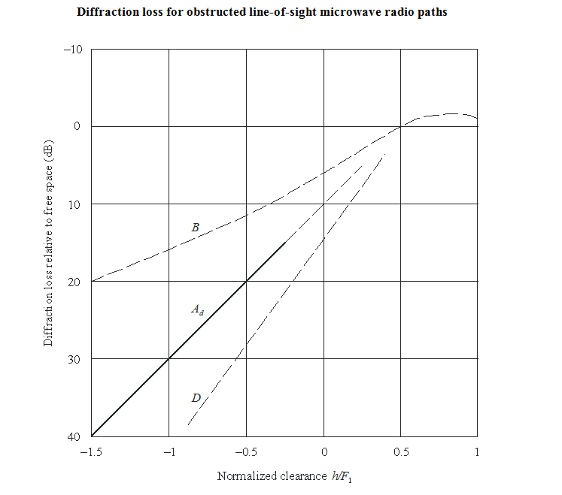
B: theoretical knife-edge loss
D: theoretical spherical-edge loss
Ad: empirical diffraction loss
F1: radius of 1.st Fresnel zone
h: amount by which the radio path clears the object
Figure 3: Diffraction loss

In comparison to this theoretical estimate of the blocking factor 5 critical radio paths were picked out in Norway and the signals have been monitored for several days and correlated with the actual (regular) air traffic in the area.
Attenuation caused by aircrafts during this period has been detected on one of these paths only as shown in Figure 4.
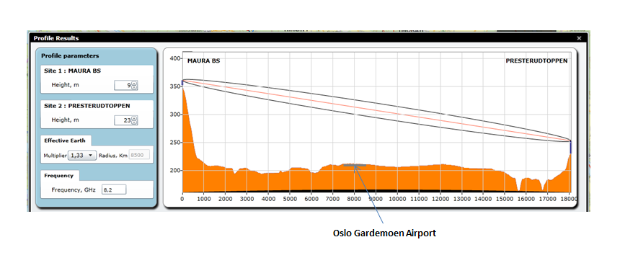
Figure 4: Example of path profile with possible blocking

The link is using the 8.2 GHz band and the maximum aircraft attenuation during the measuring period is
6 dB.

FS protection distances
The aircraft to FS protection distances can be estimated based on the system parameters as shown in
Table 2.
Table 2: FS and UWB parameters
Frequency (F), GHz | 6.77
FS receiver noise (N), dBm/MHz | –109 | From Recommendation ITU-R F.758
Aircraft blocking factor (AB), dB | 6 | From Norwegian measurements
FS antenna gain (G), dBi | 45 | From Recommendation ITU-R F.758
I/N long term criterion (I/NLT), dB | –20 | From Recommendation ITU-R F.758
I/N short term criterion (I/NST), dB | +19 | From Recommendation ITU-R SF.1650
UWB e.i.r.p. (P), dBm/MHz | –41.3 | From ECC Decision (06)04 [8]
Number of simultaneous UWB devices | 2
Aircraft screening attenuation (AS), dB | 10 | From Report ITU-R M.2283
P aircraft e.i.r.p. (PA), dBm/MHz | –48.3

The formula for the calculation of the protection distance D (km):
D = 10↑( PA + G + AB – N – I/N – 20*logF – 92,4)/20

Worst case protection distances
UWB on board aircrafts in motion:
D = 10(-48.3 + 45 + 6 + 109 – 19 – 20*log6.77 – 92.4)/20
D = 0.153 km
UWB on board a stationary aircrafts:
D = 10(-48.3 + 45 + 6 + 109 + 20 – 20*log6.77 – 92.4)/20
D = 13.627 km
The study in ANNEX 1: based on real links in Norway confirms that an aircraft in motion would not cause any interference problems to FS.

The impact on EESS earth stations

EESS Earth stations characteristics
The band 8 025-8 400 MHz is heavily used by all space agencies, including government and private companies, to download data obtained by EESS satellites. Future EESS missions will continue to use this band. The Space Frequency Coordination Group (SFCG) maintains a database on a best effort basis to provide an overview of all EESS missions operating in the 8025-8400 MHz range. This database includes mainly Administration-sponsored and space agencies scientific missions, and cover commercial missions to a limited extent. The SFCG database currently includes more than 180 EESS satellites using X-Band for payload data downlink: 110 are operational missions, plus dozens of missions in development phase.
There are two types of EESS users of that band, one requiring wideband communications (several hundred megabits/second) and the other requiring moderate data rates (15-20 megabits/sec).

Wideband, high data-rate science data downlinks
The wideband data links are crucial to the Earth observing community as they are used to transmit the payload data collected and stored on-board EESS satellites to the ground, where it can be processed and analysed. The stored data are transmitted at rates up to 1200 megabits/second. As the data include error-correcting coding, bandwidths of up to 375 MHz may be required. Earth stations with wideband capability typically require antennas at least 10 meters in diameter and have both receive and transmit capabilities, although the TT&C operations (commanding and reception of housekeeping telemetry) is done in S-band. The ESA Estrack network uses 13 and 15 m earth stations in X-band.
These stations are the primary data downlink stations for the EESS satellites that they service. Their locations are known, and they are expected to remain a permanent part of the EESS communications infrastructure.

Narrow-band, moderate data-rate science data downlinks
These links provide real-time data transmitted directly from the satellite to any earth station with a direct line-of-sight to the satellite. These real-time data systems are called “direct readout” (DRO) or “direct broadcast” (DB) systems. Their data-rates are 15 to 20 megabits/second, and the required antenna is typically 3 meters in diameter. Such EESS earth station systems are commercially available, and they include everything from the antenna system through the data processing equipment (both hardware and software). Over 130 direct readout earth stations are known to be in use today.
These systems provide immediate observations of the local environment and are used for tasks ranging from forecasting weather to monitoring plant health to directing fire fighters battling wildland fires. As these are receive-only stations, they need not be licensed and hence all of their locations may not be known.
The overall characteristics are summarised in Table 3

Table 3: Parameters of EESS earth stations
EESS Parameter | Values | Units
Frequency | 8025-8400 | MHz
Min. tracking angle | 5 | deg
Antenna diameter | 2.4 to 15 | m
Antenna Height | 5 to 20 | m
Antenna gain pattern | ITU RR AP 8-10 Annex III

Protection criterion
Recommendation ITU-R SA.1026 [3] provides the relevant protection criteria for EESS earth stations in the band 8025-8400 MHz, which are recalled in Table 4.

Table 4: Protection criteria from recommendation ITU-R SA.1026
Frequency band | Type of earth station | Interfering signal power  (dBW) in the reference  bandwidth to be exceeded  no more than 20%  of the time | Interfering signal power  (dBW) in the reference  bandwidth to be exceeded  no more than 0.0125%  of the time
8 025-8 400 MHz | 54.8 dBic antenna gain  Recorded data playback | −145 dBW per 10 MHz | −133 dBW per 10 MHz
 | 41.7 dBic antenna gain Recorded data playback | −135 dBW per 10 MHz | −127 dBW per 10 MHz
 | 42.5 dBic antenna gain  Direct data readout | −139 dBW per 10 MHz | −129 dBW per 10 MHz
The EESS already shares the band with FS and MS, as well as FSS. The receiving earth stations may therefore receive interference from these services, on top of other operating EESS satellites. As usual for studies involving UWB devices, a 1% apportionment in level should be considered for the long-term protection criterion. The same apportionment should be considered on the percentage of time associated with the short-term criterion, since the short-term events would aggregate in time.

Table 5: Proposed protection criteria vs UWB when considering apportionment
Frequency band | Type of earth station | Interfering signal power  (dBW) in the reference  bandwidth to be exceeded  no more than 20%  of the time | Interfering signal power  (dBW) in the reference  bandwidth to be exceeded  no more than 0.0001%  of the time.
8 025-8 400 MHz | 54.8 dBic antenna gain  Recorded data playback | −165 dBW per 10 MHz | −133 dBW per 10 MHz
 | 41.7 dBic antenna gain Recorded data playback | −155 dBW per 10 MHz | −127 dBW per 10 MHz
 | 42.5 dBic antenna gain  Direct data readout | −159 dBW per 10 MHz | −129 dBW per 10 MHz

Dynamic analysis
A calculation is provided in ANNEX 2: showing some potential issues when an aircraft is within the main beam of a receiving earth station, depending on the fuselage attenuation considered.
Since the main beam of the antenna is unlikely to be pointed towards an EESS satellite and an aircraft passing by at the same time, such high interference levels should be rare. A simulation has been developed using STK and MATLAB to evaluate the occurrence of such events.
STK is used to simulate the trajectory of an EESS satellite on a sun-synchronous polar orbit and determine the pointing direction of the EESS earth station over time. MATLAB is then used to simulate the passage of thousands of aircraft in visibility of the earth station over the simulation time and calculate the aggregate interference produced in the EESS earth station. The trajectory of each aircraft corresponds to actual air routes. A similar tool has been used in the studies involving WAIC and FS under WRC-15 AI 1.17. The FS station has simply been replaced by an EESS receiving earth station.
The parameters used for the simulation are given in Table 6.
Table 6: Parameters used for the simulation
Earth station latitude | 43.4292° | Aussaguel (France – Toulouse area)
Earth station longitude | 1.4972°
Earth station antenna gain | 55 dBi | 10-11 m dish
Satellite tracked | Sun-synchronous, 600 km
Frequency | 8 200 MHz
Number of aircraft in visibility | Variable (about 360 per day – 3600 in total)
Altitude of aircraft | 7000, 9000, 11000m | Randomly attributed
UWB eirp | -38.3 dBm/MHz | 2 UWB devises each -41.3 dBm/MHz, no fuselage attenuation
Protection criteria | See Table 2 and Table 3

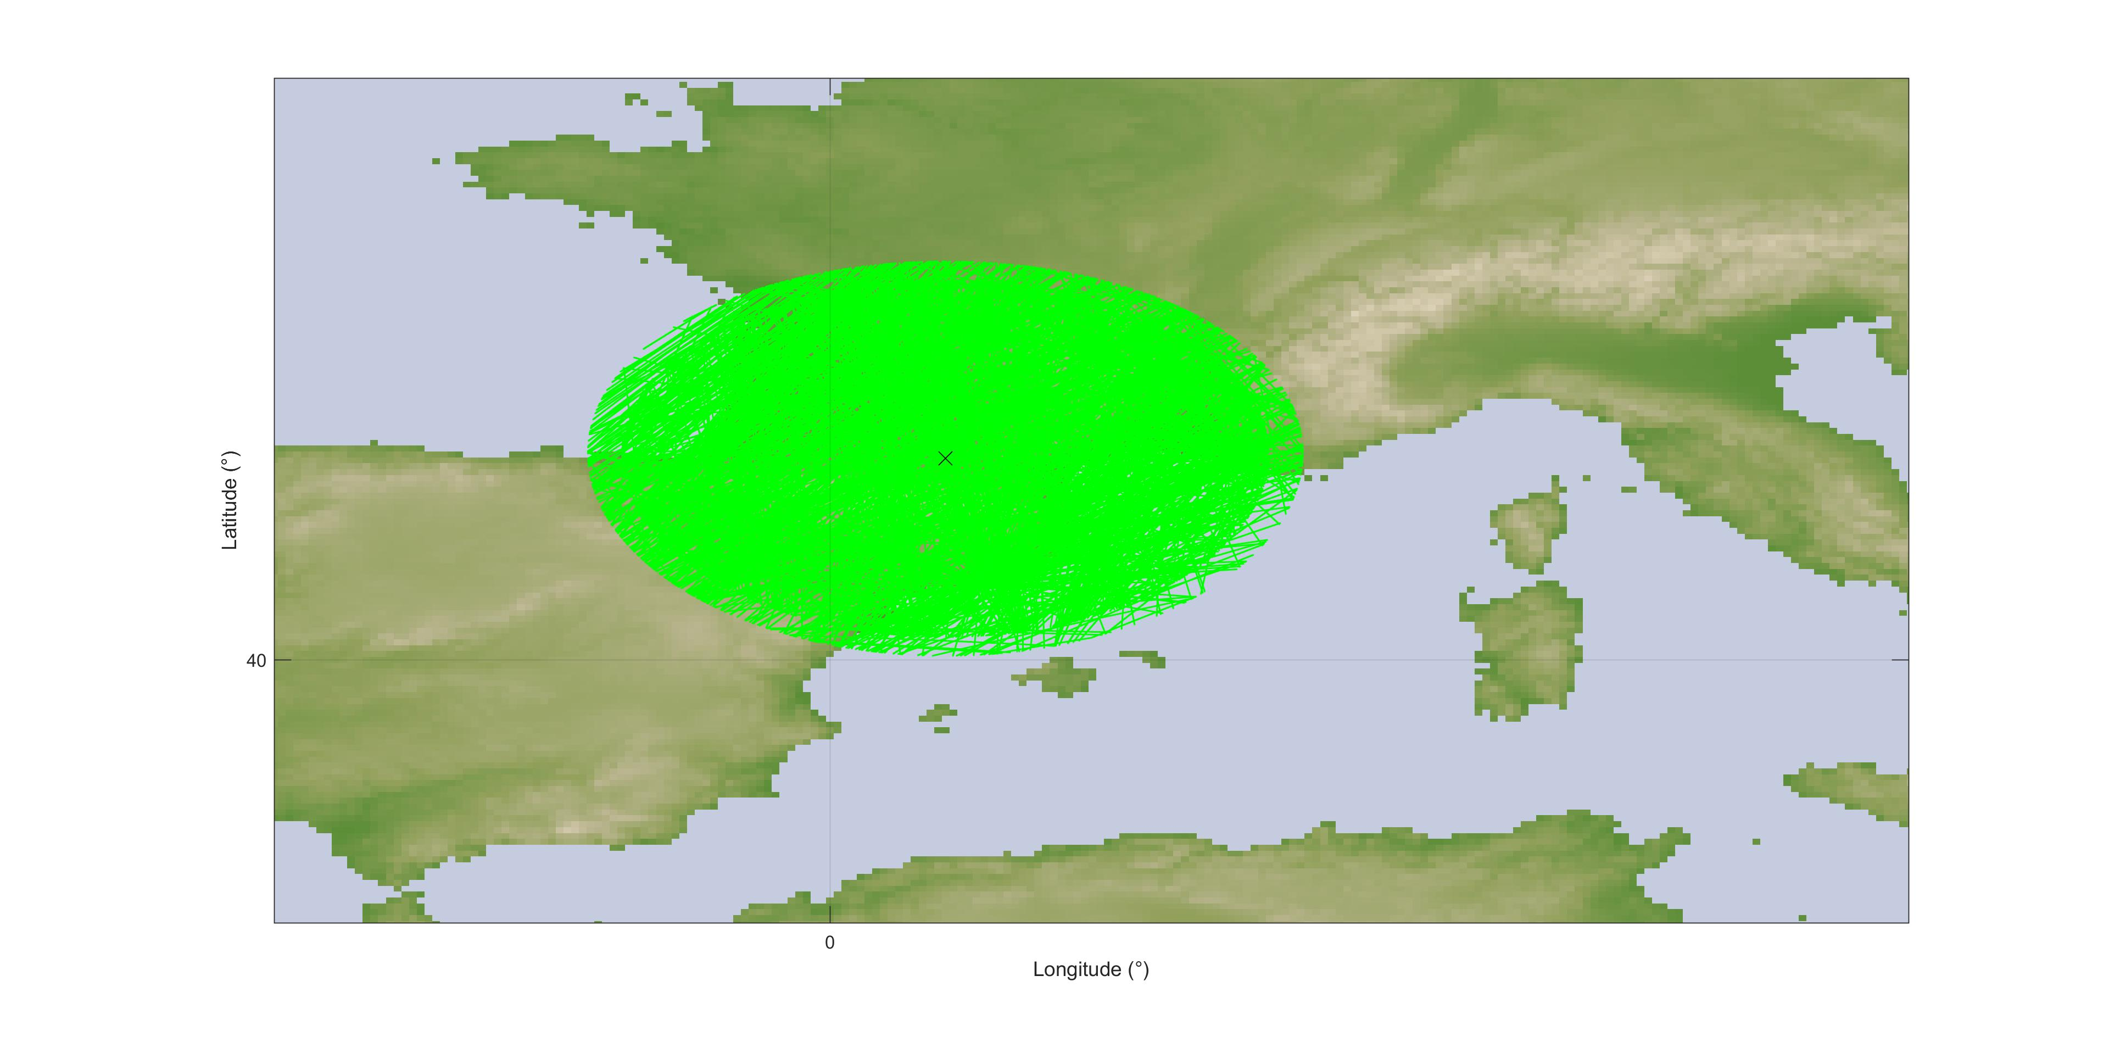
Figure 5: Aircraft trajectories simulated over 10 days

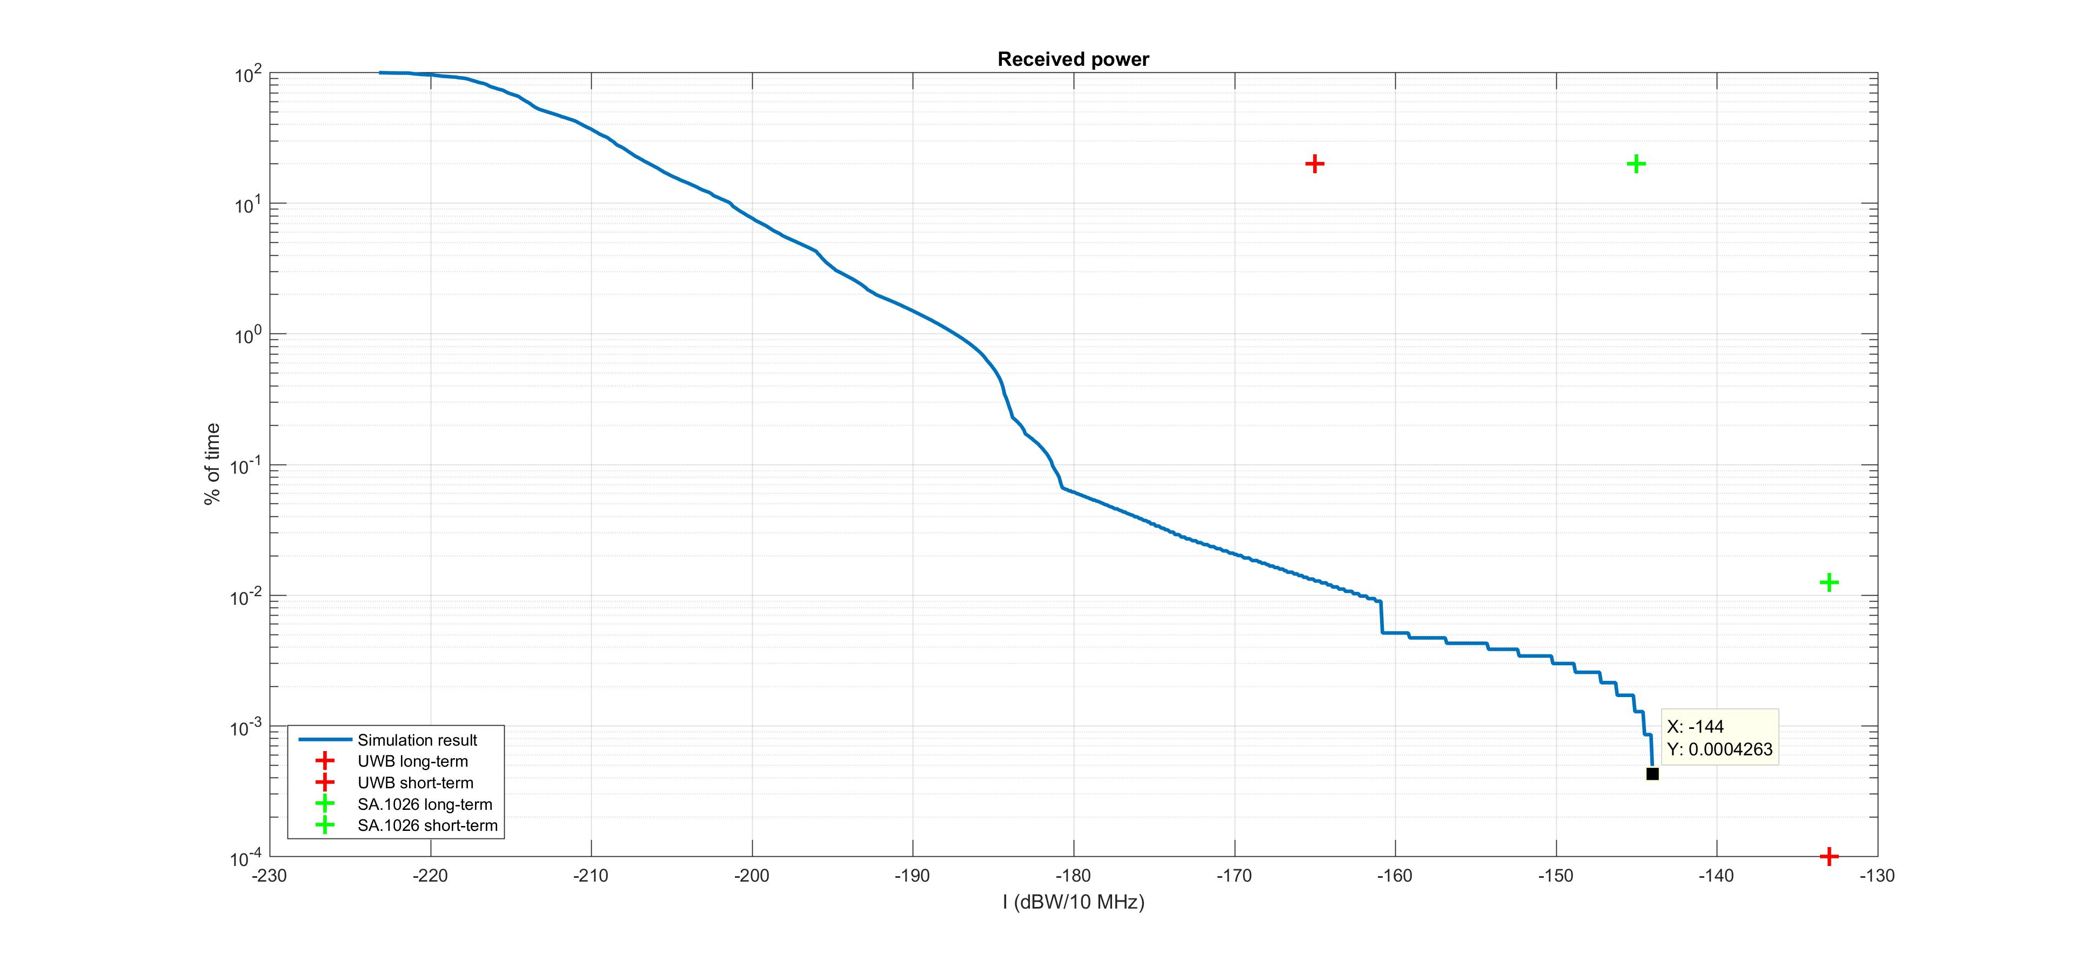
Figure 6: Aggregate Interference cumulative distribution function

This result confirm that the protection criterion of -145 dBW/10 MHz (or -125 dBm/MHz) – upper green cross) would be exceeded when considering no fuselage attenuation. However it also shows that this would happen for very low percentage of time (0.0004% of the time the satellite is in visibility of its earth station which is 0.1 second over 10 days). In all cases the short-term protection criterion is never reached. Additional margins would exist when considering additional losses due to fuselage attenuation.

Conclusions

The impact on FS links
It is shown in section 2.1 that UWB interference from an aircraft in motion can be characterized as
short-term interference which a FS system in most cases is able to withstand, thanks to its high fade margin (above 30 dB). The worst case minimum protection distance between an aircraft in motion and a FS receiver would be about 150 m.
In contrast to this, UWB interference from a stationary aircraft is characterized as long-term interference where the worst case minimum separation distance would be about 14 km.
The study in ANNEX 1: based on real links in Norway confirms that an aircraft in motion would not cause any interference problems to FS. It is also assumed in general, except for helicopters, that an aircraft would not pass a FS antenna closer than 150 m.
In the study in ANNEX 1: also possible UWB interference from a stationary aircrafts has been investigated without finding any actual case. However, this is a situation which can happen elsewhere.

The impact on EESS earth stations
Although a simple calculation indicates that there may be cases where UWB on board aircraft might exceed the long-term protection criterion of -145 dBW/10 MHz set forth in Recommendation ITU-R SA.1026 [3] a dynamic simulation has shown that this would happen for only a very small fraction of time. The short-term protection criterion contained in the same recommendation would never be exceeded. Similarly, the protection criteria defined when considering a 1% apportionment usually considered for UWB would never be exceeded.
It can therefore be concluded, based on the studies, that there is no compatibility issue between EESS and UWB on board aircraft in the band 8 025-8 400 MHz.

- Maximum impact of UWB on FS
Worst case UWB impact from aircrafts (in motion) to FS systems close to Norwegian airports is calculated in the following Table 7. The calculations are based on the actual FS system parameters.
Table 7: Worst case calculations
Airport area | Disturbed radio path | Distance to disturbed link-site (m) | Crossing path height difference (m) | Antenna discrim. angle (Deg) | Antenna diameter (m) | Antenna gain (dBi) | Antenna discrim. Loss  (dB) | Frequency band (GHz) | Path  loss (dB) | Fuselage attenua. (dB) | e.i.r.p aggregated power for  2 act. dev. (dBm/MHz) | Interference level for  2 act. dev. (dBm/MHz) | Short term (0.00045 %) permissible interference level (dBm/MHz) | Assumed blocking factor (dB) | Interference margin (dB)
Vadsø | Torsvarden - Lyngberget | 3650 | 35 | 0.5 | 2.4 | 43.8 | 1 | 8.2 | 121.9 | 10 | -48.3 | -127.4 | -90 | 6 | 31.4
Vadsø | Torsvarden - Svartaksla | 3650 | 15 | 0.2 | 4.5 | 46.9 | 0 | 6.7 | 120.2 | 10 | -48.3 | -121.6 | -90 | 6 | 25.6
Vadsø | Melkevarden - Lyngberget | 1276 | 5 | 0.2 | 3.0 | 43.6 | 0 | 6.2 | 110.4 | 10 | -48.3 | -115.1 | -90 | 6 | 19.1
Båtsfjord | Hamnefjell - Domen | 5190 | 30 | 0.3 | 3.7 | 45.6 | 0 | 6.7 | 123.2 | 10 | -48.3 | -125.9 | -90 | 6 | 29.9
Berlevåg | Trollhetta - Hamnefjell | 35600 | 200 | 0.3 | 3.7 | 45.6 | 0 | 6.7 | 140.0 | 10 | -48.3 | -142.7 | -90 | 6 | 46.7
Mehavn | Trollhetta -Oksen | 11100 | 10 | 0.1 | 3.0 | 43.6 | 0 | 6.7 | 129.8 | 10 | -48.3 | -134.5 | -90 | 6 | 38.5
Honningsvåg | Honningsvågfj. - Oksen | 22000 | 20 | 0.1 | 3.0 | 43.6 | 0 | 6.7 | 135.8 | 10 | -48.3 | -140.5 | -90 | 6 | 44.5
Hammerfest | Hammerfjell - Torskefjell | 1040 | 10 | 0.6 | 3.0 | 42.4 | 1 | 6.2 | 108.6 | 10 | -48.3 | -115.5 | -90 | 6 | 19.5
Lakselv | Lakselv - Jekkir | 2000 | 0 | 0.0 | 1.8 | 39.6 | 0 | 6.7 | 114.9 | 10 | -48.3 | -123.6 | -90 | 6 | 27.6
Lakselv | Jekkir-Siribekken | 23500 | 50 | 0.1 | 3.0 | 45.3 | 0 | 8.2 | 138.1 | 10 | -48.3 | -141.1 | -90 | 6 | 45.1
Hasvik | Håen - Breivikeidet REFL | 1070 | 100 | 5.4 | 4.5 | 47.5 | 22 | 6.7 | 109.5 | 10 | -48.3 | -132.3 | -90 | 6 | 36.3
Hasvik | Fuglen - Nuvsvåg | 16700 | 30 | 0.1 | 1.2 | 36.4 | 0 | 6.2 | 132.7 | 10 | -48.3 | -144.6 | -90 | 6 | 48.6
Alta | Hjemmeluft - Stifjell | 6300 | 70 | 0.6 | 4.5 | 47.4 | 8 | 6.7 | 124.9 | 10 | -48.3 | -133.8 | -90 | 6 | 37.8
Alta | Komsa - Helligfjell | 3400 | 90 | 1.5 | 1.2 | 37.5 | 4 | 8.2 | 121.3 | 10 | -48.3 | -136.1 | -90 | 6 | 40.1
Sørkjosen | Bertelfjell-Rappesvarre | 2100 | 0 | 0.0 | 3.0 | 43.6 | 0 | 6.2 | 114.7 | 10 | -48.3 | -119.4 | -90 | 6 | 23.4
Tromsø | Stalheim RL-Kvitbergfjell | 1450 | 0 | 0.0 | 4.5 | 46.9 | 0 | 6.7 | 112.1 | 10 | -48.3 | -113.5 | -90 | 6 | 17.5
Bardufoss | Johaugen-Kistefjell | 7700 | 200 | 1.5 | 1.8 | 41.4 | 5 | 8.2 | 128.4 | 10 | -48.3 | -140.3 | -90 | 6 | 44.3
Andøya | Ramnan-Grunnfarnes | 6100 | 180 | 1.7 | 1.2 | 37.3 | 3 | 8.2 | 126.4 | 10 | -48.3 | -140.4 | -90 | 6 | 44.4
Andøya | Ramnan-Kaldfarnes | 6300 | 170 | 1.5 | 1.8 | 40.6 | 5 | 8.2 | 126.7 | 10 | -48.3 | -139.4 | -90 | 6 | 43.4
Evenes | Håfjell-Samaåsen | 11400 | 100 | 0.5 | 3.7 | 44.7 | 1 | 6.7 | 130.1 | 10 | -48.3 | -134.7 | -90 | 6 | 38.7
Bodø | Rønvikfjell Vest-Sørarnøy TVO | 6100 | 50 | 0.5 | 1.8 | 41.1 | 0 | 8.2 | 126.4 | 10 | -48.3 | -133.6 | -90 | 6 | 37.6
Bodø | Rønvikfjell Vest-Kunna | 5400 | 35 | 0.4 | 3.7 | 44.7 | 0 | 6.7 | 123.6 | 10 | -48.3 | -127.2 | -90 | 6 | 31.2
Bodø | Rønvikfjell Vest-Salten | 4800 | 60 | 0.7 | 2.4 | 41.3 | 0 | 6.2 | 121.9 | 10 | -48.3 | -128.9 | -90 | 6 | 32.9
Stokmarknes | Storheia-Sortland TVO | 7000 | 150 | 1.2 | 1.8 | 41.1 | 3 | 8.2 | 127.6 | 10 | -48.3 | -137.8 | -90 | 6 | 41.8
Stokmarknes | Storheia-Eidet TVO | 4850 | 30 | 0.4 | 1.8 | 41.1 | 0 | 8.2 | 124.4 | 10 | -48.3 | -131.6 | -90 | 6 | 35.6
Stokmarknes | Storheia-Eidet Vesterålen | 4850 | 50 | 0.6 | 2.4 | 41.3 | 1 | 6.2 | 122.0 | 10 | -48.3 | -130.0 | -90 | 6 | 34.0
Leknes | Ballstad TVO-Borge TVO | 2770 | 40 | 0.8 | 1.2 | 37.5 | 1 | 8.2 | 119.5 | 10 | -48.3 | -131.3 | -90 | 6 | 35.3
Røst | Røst-Værøyfjell | 200 | 90 | 25.8 | 1.8 | 41.4 | 34 | 8.2 | 96.7 | 10 | -48.3 | -137.6 | -90 | 6 | 41.6
Sandnessjøen | Åsen RL-Gulsvågfjell | 11900 | 100 | 0.5 | 3.7 | 45.5 | 3 | 6.7 | 130.4 | 10 | -48.3 | -136.2 | -90 | 6 | 40.2
Brønnøysund | Brønnøysund-Gulsvågfjell | 600 | 110 | 10.5 | 0.9 | 35.5 | 22 | 8.2 | 106.2 | 10 | -48.3 | -141.0 | -90 | 6 | 45.0
Rørvik | Falkhetta- Rørvik Lufthavn | 5800 | 5 | 0.0 | 0.9 | 35.5 | 0 | 8.2 | 125.9 | 10 | -48.3 | -138.7 | -90 | 6 | 42.7
Namsos | Spillumsaksla-Munken | 3030 | 60 | 1.1 | 2.4 | 43.8 | 6 | 8.2 | 120.3 | 10 | -48.3 | -130.8 | -90 | 6 | 34.8
Namsos | Forbordfjell- Sundal BS | 13400 | 30 | 0.1 | 1.2 | 37.3 | 0 | 8.2 | 133.2 | 10 | -48.3 | -144.2 | -90 | 6 | 48.2
Namsos | Forbordefjell-Kirkebyfjell REP | 10000 | 240 | 1.4 | 1.8 | 41.4 | 5 | 8.2 | 130.7 | 10 | -48.3 | -142.6 | -90 | 6 | 46.6
Ørland | Kopparen-Myrafjellet | 16000 | 90 | 0.3 | 1.8 | 40.6 | 0 | 8.2 | 134.8 | 10 | -48.3 | -142.5 | -90 | 6 | 46.5
Ørland | Kopparen-Opphaug | 17000 | 150 | 0.5 | 2.4 | 42.4 | 2 | 6.7 | 133.5 | 10 | -48.3 | -141.4 | -90 | 6 | 45.4
Røros | Røros-Hummelfjell | 1200 | 0 | 0.0 | 1.8 | 38.6 | 0 | 6.2 | 109.8 | 10 | -48.3 | -119.5 | -90 | 6 | 23.5
Krisiansund | Varden-Reinsfjell | 2250 | 80 | 2.0 | 1.2 | 37.5 | 6 | 8.2 | 117.7 | 10 | -48.3 | -134.5 | -90 | 6 | 38.5
Krisiansund | Norlandet BS-Reinsfjell | 950 | 70 | 4.2 | 3.0 | 44.2 | 24 | 6.7 | 108.5 | 10 | -48.3 | -136.6 | -90 | 6 | 40.6
Molde | Tusten-Gamlemsveten | 7500 | 0 | 0.0 | 3.7 | 45.7 | 0 | 6.7 | 126.4 | 10 | -48.3 | -129.0 | -90 | 6 | 33.0
Molde | Tusten-  Tresfjord 1 | 4575 | 55 | 0.7 | 1.8 | 41.1 | 1 | 8.2 | 123.9 | 10 | -48.3 | -132.1 | -90 | 6 | 36.1
Molde | Tusten-  Tomrefjord 1 | 8670 | 120 | 0.8 | 1.8 | 41.1 | 3 | 8.2 | 129.4 | 10 | -48.3 | -139.6 | -90 | 6 | 43.6
Molde | Tusten-Torvikveten | 3890 | 50 | 0.7 | 1.8 | 40.6 | 1 | 8.2 | 122.5 | 10 | -48.3 | -131.2 | -90 | 6 | 35.2
Ørsta-Volda | Kaldsethola-Nerlandsøy | 4800 | 50 | 0.6 | 1.2 | 37.4 | 0 | 8.2 | 124.3 | 10 | -48.3 | -135.2 | -90 | 6 | 39.2
Florø | Kinn-Ramsdalsheia | 6990 | 70 | 0.6 | 3.0 | 45.5 | 5 | 8.2 | 127.6 | 10 | -48.3 | -135.4 | -90 | 6 | 39.4
Florø | Storåsen-Skredvarden REFL | 990 | 70 | 4.1 | 3.7 | 45.6 | 24 | 6.7 | 108.8 | 10 | -48.3 | -135.5 | -90 | 6 | 39.5
Sogndal | Storehogen-Geisdalsåsen REFL | 6470 | 100 | 0.9 | 2.4 | 43.6 | 5 | 8.2 | 126.9 | 10 | -48.3 | -136.6 | -90 | 6 | 40.6
Sogndal | Storehogen-Lærdalsøyri | 5400 | 140 | 1.5 | 1.8 | 40.6 | 8 | 8.2 | 125.3 | 10 | -48.3 | -141.0 | -90 | 6 | 45.0
Sogndal | Sogndal Lufthavn-Holmåsen REFL | 150 | 0 | 0.0 | 0.9 | 35.5 | 0 | 8.2 | 94.2 | 10 | -48.3 | -107.0 | -90 | 6 | 11.0
Bergen | Ulriken-Knappefjell | 11960 | 40 | 0.2 | 1.2 | 37.5 | 0 | 8.2 | 132.2 | 10 | -48.3 | -143.0 | -90 | 6 | 47.0
Stord | Siggjo-Fitjar RL | 7920 | 105 | 0.8 | 0.9 | 35.2 | 0 | 8.2 | 128.7 | 10 | -48.3 | -141.7 | -90 | 6 | 45.7
Stord | Siggjo-Kattnakken | 5160 | 80 | 0.9 | 1.2 | 34.4 | 0 | 6.2 | 122.5 | 10 | -48.3 | -136.4 | -90 | 6 | 40.4
Stavanger | Ullandhaug RL-Urdalsnipa | 10100 | 230 | 1.3 | 3.0 | 44.0 | 10 | 6.7 | 129.0 | 10 | -48.3 | -143.3 | -90 | 6 | 47.3
Kristiansand | Odderøya-Risdalsheia | 9000 | 170 | 1.1 | 3.0 | 43.6 | 8 | 6.7 | 128.0 | 10 | -48.3 | -140.7 | -90 | 6 | 44.7
Skien | Vealøs-Bronane | 6700 | 115 | 1.0 | 3.0 | 45.3 | 8 | 8.2 | 127.2 | 10 | -48.3 | -138.2 | -90 | 6 | 42.2
Skien | Vealøs-Trollfjell | 10700 | 140 | 0.8 | 1.2 | 37.4 | 0 | 8.2 | 131.3 | 10 | -48.3 | -142.2 | -90 | 6 | 46.2
Torp | Kamfjordåsen-Frodeåsen tele | 2400 | 160 | 3.8 | 1.8 | 41.4 | 16 | 8.2 | 118.3 | 10 | -48.3 | -141.2 | -90 | 6 | 45.2
Notodden | Jonsknuten-Bronane | 20000 | 270 | 0.8 | 3.7 | 45.4 | 5 | 6.7 | 134.9 | 10 | -48.3 | -142.8 | -90 | 6 | 46.8
Rygge | Ramberg-Sprinklerfjell | 6000 | 180 | 1.7 | 1.2 | 37.3 | 4 | 8.2 | 126.2 | 10 | -48.3 | -141.2 | -90 | 6 | 45.2
Kjeller | Røverkollen-Runddelen | 7900 | 130 | 0.9 | 1.8 | 40.6 | 1 | 8.2 | 128.6 | 10 | -48.3 | -137.3 | -90 | 6 | 41.3
Oslo (Gardemoen) | Mistberget-Tryvannstårnet | 9500 | 130 | 0.8 | 3.7 | 45.5 | 3 | 6.7 | 1/28.5 | 10 | -48.3 | -134.3 | -90 | 6 | 38.3
Oslo (Gardemoen) | Maura BS-Presterudstoppen | 8150 | 90 | 0.6 | 0.9 | 35.5 | 0 | 8.2 | 128.9 | 10 | -48.3 | -141.7 | -90 | 6 | 45.7
Oslo (Gardemoen) | Mistberget-Presterudtoppen | 6300 | 290 | 2.6 | 1.2 | 34.4 | 5 | 6.2 | 124.2 | 10 | -48 | -143 | -90 | 6 | 47.1

- Calculated UWB impact on EESS earth stations

Table 8: EESS earth station parameters for a 10m antenna
UWB e.i.r.p. figures for 2 units in different damping sectors
Basic e.i.r.p for 2 units is |  | -38.3 | dBm/MHz
X-Band Downlink 7.750-8.400 GHz |  | 8.075 | GHz
Hor. Distance (km) | 0.5
Altitude (km) | 10
Range (km) | 10.01 | Elevation | 87.14
Ant. Gain (dB) | 55.376 | 10m ant
Syst. G/T (dB/K) | 33.165
Syst. N Temp (dB) | 22.211
Ant. Noise (dBm/MHz) | -116.389
Allowed I (dBm/MHz) | -124 | Req. I/N | -7.61

Table 9: Worst case interference level for a 10m antenna
Att sector | Attenuation (dB) | Actual e.i.r.p. (dBm) | Range (km) | Dist. Loss (dB) | Ant. Gain (dBic) | Rec. Signal (dBm) | Ant noise (dBm/MHz) | I/N (dB) | I/N Margin (dB)
Case 3 a,b,c | 45 | -83.3 | 10.01 | 130.60 | 55.38 | -158.53 | -116.39 | -42.14 | 34.53
Case 1 b,c | 35 | -73.3 | 10.01 | 130.60 | 55.38 | -148.53 | -116.39 | -32.14 | 24.53
Case 1 a | 25 | -63.3 | 10.01 | 130.60 | 55.38 | -138.53 | -116.39 | -22.14 | 14.53
Case 2 a | 10 | -48.3 | 10.01 | 130.60 | 55.38 | -123.53 | -116.39 | -7.14 | -0.47
Case 4 a | 5 | -43.3 | 10.01 | 130.60 | 55.38 | -118.53 | -116.39 | -2.14 | -5.47
Case 4 b | 0 | -38.3 | 10.01 | 130.60 | 55.38 | -113.53 | -116.39 | 2.86 | -10.47

Table 10: EESS earth station parameters for a 5m antenna
Ant. Gain | 50 | 5m ant
Syst. G/T | 28.24 (dB/K)
Syst. N Temp | 21.76 (dBK)
Ant. Noise | -116.84 (dBm/MHz)
Allowed I | -124 (dBm/MHz) | Req. I/N | -7.16 (dB)

Table 11: Worst case interference level for a 5m antenna
Att sector | Attenuation (dB) | Actual e.i.r.p (dBm) | Range (km) | Dist. Loss (dB) | Ant. Gain (dBic) | Rec. Signal (dBm) | Ant noise (dBm/MHz) | I/N (dB) | I/N Margin (dB)
Case 3 a,b,c | 45 | -83.3 | 10.01 | 130.60 | 50.00 | -163.90 | -116.84 | -47.06 | 39.90
Case 1 b,c | 35 | -73.3 | 10.01 | 130.60 | 50.00 | -153.90 | -116.84 | -37.06 | 29.90
Case 1 a | 25 | -63.3 | 10.01 | 130.60 | 50.00 | -143.90 | -116.84 | -27.06 | 19.90
Case 2 a | 10 | -48.3 | 10.01 | 130.60 | 50.00 | -128.90 | -116.84 | -12.06 | 4.90
Case 4 a | 5 | -43.3 | 10.01 | 130.60 | 50.00 | -123.90 | -116.84 | -7.06 | -0.10
Case 4 b | 0 | -38.3 | 10.01 | 130.60 | 50.00 | -118.90 | -116.84 | -2.06 | -5.10

Table 12: EESS earth station parameters for a 2.4m antenna
Ant. Gain | 43 | 2.4m ant
Syst. G/T | 24 (dB/K)
Syst. N Temp | 19 (dBK)
Ant. Noise | -119.6 (dBm/MHz)
Allowed I | -124 (dBm/MHz) | Req. I/N | -4.4 (dB)

Table 13: Worst case interference level for a 2.4m antenna
Att sector | Attenuation (dB) | Actual e.i.r.p (dBm) | Range (km) | Dist. Loss (dB) | Ant. Gain (dBic) | Rec. Signal (dBm) | Ant noise (dBm/MHz) | I/N (dB) | I/N Margin (dB)
Case 3 a,b,c | 45 | -83.3 | 10.01 | 130.60 | 43.00 | -170.90 | -119.60 | -51.30 | 46.90
Case 1 b,c | 35 | -73.3 | 10.01 | 130.60 | 43.00 | -160.90 | -119.60 | -41.30 | 36.90
Case 1 a | 25 | -63.3 | 10.01 | 130.60 | 43.00 | -150.90 | -119.60 | -31.30 | 26.90
Case 2 a | 10 | -48.3 | 10.01 | 130.60 | 43.00 | -135.90 | -119.60 | -16.30 | 11.90
Case 4 a | 5 | -43.3 | 10.01 | 130.60 | 43.00 | -130.90 | -119.60 | -11.30 | 6.90
Case 4 b | 0 | -38.3 | 10.01 | 130.60 | 43.00 | -125.90 | -119.60 | -6.30 | 1.90

- List of Reference
- Recommendation ITU-R SF.1650-1: The minimum distance from the baseline be The minimum distance from the baseline beyond which in-motion earth stations located on board vessels would not cause unacceptable interference to the terrestrial service in the bands 5 925-6 425 MHz and 14-14.5 GHz
- Recommendation ITU-R F.758-6: System parameters and considerations in the development of criteria for sharing or compatibility between digital fixed wireless systems in the fixed service and systems in other services and other sources of interference
- Recommendation ITU-R SA.1026-4: Aggregate interference criteria for space-to-Earth data transmission systems operating in the Earth exploration-satellite and meteorological-satellite services using satellites in low-Earth orbit
- ECC Report 175: Co-existence study considering UWB applications inside aircraft and existing radio services in the frequency bands from 3.1 GHz to 4.8 GHz and from 6.0 GHz to 8.5 GHz
- Recommendation ITU-R P.530-16: Propagation data and prediction methods required for the design of terrestrial line-of-sight systems
- Recommendation ITU-R M.2283: Technical characteristics and spectrum requirements of Wireless Avionics Intra-Communications systems to support their safe operation
- Recommendation ITU-R F.699: Reference radiation patterns for fixed wireless system antennas for use in coordination studies and interference assessment in the frequency range from 100 MHz to about 70 GHz
- ECC Decision (06)04: The harmonised conditions for devices using Ultra-Wideband (UWB) technology in bands below 10.6 GHz

