ECC Recommendation (05)08

Frequency planning and cross-border coordination between GSM Land Mobile Systems
(GSM 900, GSM 1800, and GSM-R)
Replacing recommendations T/R 20-08 [1] and 22-07 [2]
Approved 01 February 2006
Amended 03 February 2017

introduction
Recommendation T/R 20-08 [1] and T/R 22-07 [2] were combined and replaced with the first version of this Recommendation and it contains provisions for planning and coordination of frequencies for GSM land mobile systems in the bands 900 MHz and 1800 MHz.
It should be noted that this Recommendation does not cover land mobile systems other than GSM (for instance UMTS, LTE or WiMAX).

ECC recommendation (05)08 on Frequency planning and cross-border coordination between Gsm land mobile systems (GSM 900, GSM 1800 and GSM-R) amended 3 february 2017
“The European Conference of Postal and Telecommunications Administrations,
considering
- that the GSM 900 and 1800 MHz systems use the frequency bands 880-915 MHz / 925-960 MHz and 1710-1785 MHz / 1805-1880 MHz in accordance with relevant agreements, Directives and ECC Decisions and Recommendations, such as ERC/DEC(94)01 [3], ERC/DEC(97)02 [4], ERC/DEC(95)03 [5];
- that the GSM-R system uses the frequency bands 876-880 MHz / 921-925 MHz in accordance with ECC/DEC/(02)05 [6], the European Rail Traffic Management System (ERTMS) and the Directive 2008/57/EC [7] of the European Parliament and of the Council on the interoperability of the rail system within the Community, and Commission Regulation (EU) 2016/919 [8] on the technical specification for interoperability relating to the ‘control-command and signalling’ subsystems of the rail system in the European Union;
- that the bands 873.0-876.0 MHz / 918.0-921.0 MHz may be used on a national basis as extension bands for GSM-R as considered in ECC/DEC/(04)06 [9] and ECC/DEC/(02)05, and administrations may use the guidance provided in this Recommendation when negotiating bilateral or multilateral agreements for the coordination between GSM-R systems;
- that the ECC Report 162 [10] and the ECC Report 229 [11] may be considered by administrations and/or operators to address interference cases between GSM-R and public mobile networks on a local/regional/national basis, taking into account the operational aspects;
- that GSM equipment complies with the harmonised European standards EN 301 502 [12] (base stations) or EN 301 511 [13] (mobile stations);
- that ETSI has developed and published TS 102 933-1 [14] and TS 102 933-2 [15] on improved GSM-R receiver parameters, mandatory for all new, upgraded, or renewed GSM-R equipment as per Commission Regulation (EU) 2016/919 [19];
- that GSM systems operate in 200 kHz channels;
- that in the implementation of the GSM and GSM-R systems it is necessary to take into account national policies for the use of the frequency bands in question;
- that national frequency planning for the GSM and GSM-R systems is carried out by the operators and approved by the national administrations or carried out by such administrations in cooperation with the operators;
- that the frequency bands 880-915 MHz / 925-960 MHz and 1710-1785 MHz / 1805-1880 MHz can also be used for other land mobile systems (UMTS, LTE and WiMAX) than GSM according to ECC/DEC/(06)13 [16];
- that frequency planning and frequency coordination for GSM/UMTS/LTE/WiMAX land mobile systems operating within the 900 and 1800 MHz bands should be based on ECC/REC/(08)02 [17];
- that to balance interference-free frequency usage and service coverage needs in border areas, coordination or bilateral agreements are likely to be required;
- that frequency planning and cross-border coordination should be based on bi- or multilateral agreements between national administrations;
- that agreements have successfully been concluded between some administrations concerning coordination of frequencies for the land mobile service, notably the “HCM (Harmonised Calculation Method) Agreement” which also contains details of propagation issues and co-ordination procedures;
- that in order to facilitate coordination and to avoid inefficient frequency usage in border areas, a large number of parameters (technical and operational) need to be exchanged;
- that in the case of operator arrangements approved by national administrations it is possible to deviate from this Recommendation and bi- or multilateral agreements;
- that in many CEPT member countries there are multiple operators for the GSM system;
- that cross-border coordination between a GSM system and land mobile systems other than UMTS/LTE/WiMAX should be based on bi- or multilateral agreement, taking account of compatibility studies, interservice sharing and other relevant deliverables in accordance with the Radio Regulations;

recommends
- that frequency co-ordination between GSM systems (GSM900, GSM1800 and GSM-R) in neighbouring countries shall be based on bi/multi-lateral agreements;
- that frequency co-ordination between GSM systems in border areas shall be based on the concept of preferential frequencies and common threshold levels;
- that each new frequency assignment exceeding the defined coordination threshold level must be coordinated with frequencies already assigned in the same geographical area for use by the stations of neighbouring administration(s);
- that frequency coordination in border areas is based on the following concept:
  - In the case of a preferential frequency agreement.
    - Preferential frequencies, except adjacent block-end preferential frequencies, may be used without coordination if the field strength of each carrier produced by the base station does not exceed a value of 19 dBµV/m/200 kHz in the 900 MHz band and 25 dBµV/m/200 kHz in the 1800 MHz band for digital systems at a height of 3 m above ground at a distance of 15 km inside the neighbouring country.
When blocks of preferential frequencies are allocated to different countries in border areas, all adjacent block-end channels shall be treated in such a way, that adjacent channel interference should be avoided by either forwarding the characteristics of base stations using block-end channels or regulating the use of the block-end channels in bi/multi-lateral agreements.
    - Non-preferential frequencies may be used without coordination if the field strength of each carrier produced by the base station does not exceed a value of 19 dBµV/m/200 kHz in the 900 MHz band and 25 dBµV/m/200 kHz in the 1800 MHz band for digital and analogue systems at a height of 3 m above ground at the borderline.
    - Frequencies on which the field strength exceeds the limits laid down in 4.1.1 and 4.1.2 shall be co-ordinated.
  - In the case where a preferential frequency agreement is not available:
All frequencies shall be treated as non-preferential ones.
  - Frequency planning in coastal areas is based on the concept of preferential frequencies and coordinated frequencies, assuming a middle line between the countries involved. Other principles for frequency planning and frequency coordination in coastal areas may be agreed between the administrations concerned.
  - Propagation criteria for calculating the interfering field strength are described in Annex 1.
  - For adding multiple interferers the simplified algorithm described in Annex 2 can be used.
  - The technical parameters described in Annex 3 are used in the frequency coordination for GSM systems.
- that frequency coordination is subject to operators’ agreement.
  - When requesting coordination, at least the following characteristics of base stations shall be forwarded to the administration(s) affected unless otherwise laid down in bi/multi-lateral agreements:
- carrier frequency (MHz);
- name of transmitter station;
- country of location of transmitter station;
- geographical coordinates (W/E, N);
- effective antenna height (m);
- antenna polarisation;
- antenna azimuth (deg);
- directivity in antenna systems or antenna gain (dBi);
- effective radiated power (dBW);
- expected coverage zone or radius (km);
- date of entry into service (month, year).

  - The administration affected shall evaluate the request for coordination and shall within 30 days notify the result of the evaluation to the administration requesting coordination.
  - The administration affected may request additional information on stations to be co-ordinated.
  - If no reply is received by the administration requesting coordination within 30 days it may send a reminder to the administration affected. An administration not having responded within 30 days following communication of the reminder shall be deemed to have given its consent and the frequency may be put into use with the characteristics given in the request for coordination.
  - The periods mentioned above may be extended by common consent.
- that in general, administrations may diverge from the technical parameters, calculation method and procedures described in this Recommendation subject to bi/multi-lateral agreements, for example HCM (Harmonised Calculation Method) Agreement.”

- propagation curves
The curves attached to this Annex should be used to determine the interfering field strength. Administrations may agree on other curves and methods.
  - Correction factors for GSM 900 and GSM-R
A general correction factor of -2 dB is used in the 900 MHz band.

Correction factor to convert receiving antenna heights from 10 m to 3 m:
Distance < 50 km: -10 dB
Distance > 100 km: -3 dB
Linear interpolation is used for intermediate distances from 50 to 100 km.
For sea path propagation the correction factor to convert receiving antenna heights from 10 m to 3 m is
-10 dB.
  - Correction factors applicable for GSM 1800
A general correction factor of -9 dB is used in the 1800 MHz band.

Correction factor to convert receiving antenna heights from 10 m to 3 m:
Distance < 50 km: -10 dB
Distance > 100 km: -3 dB
Linear interpolation is used for intermediate distances.
For sea path propagation the correction factor for receiving antenna from 10 m to 3 m is -10 dB.
  - Effective antenna height
The effective antenna height used to determine interfering field strength is defined as its height in metres over the average level of the ground between distances of 3 and 15 km from the base station/transmitting antenna in the direction of the mobile/receiving antenna. The evaluation of the average height of the terrain may be subject to agreement between administrations.
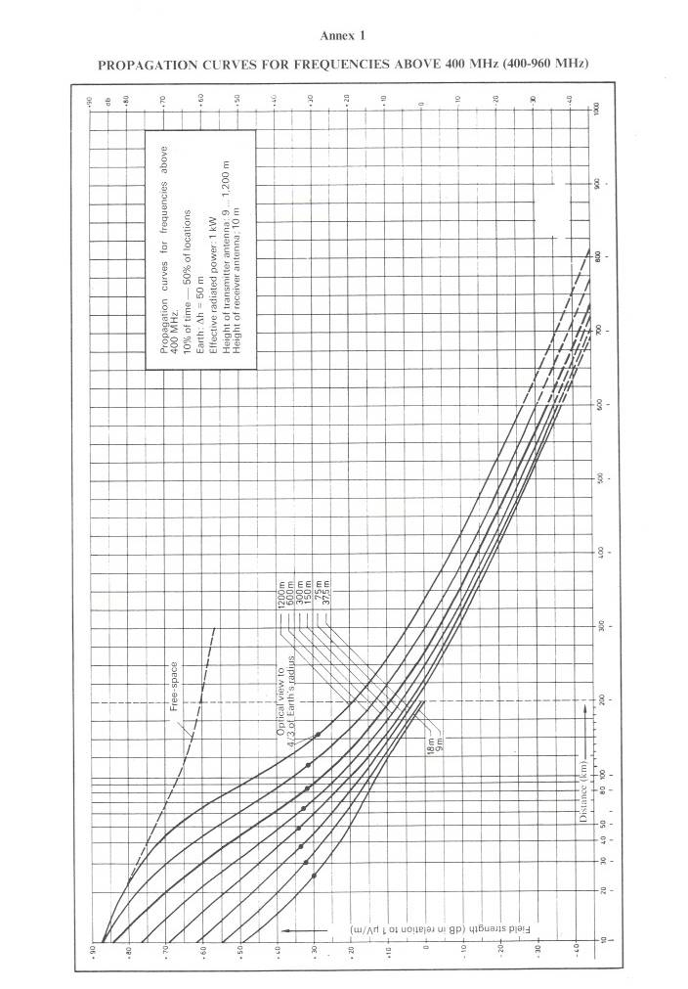
- Propagation curves for frequencies above 400 MHz (400-960 MHz)
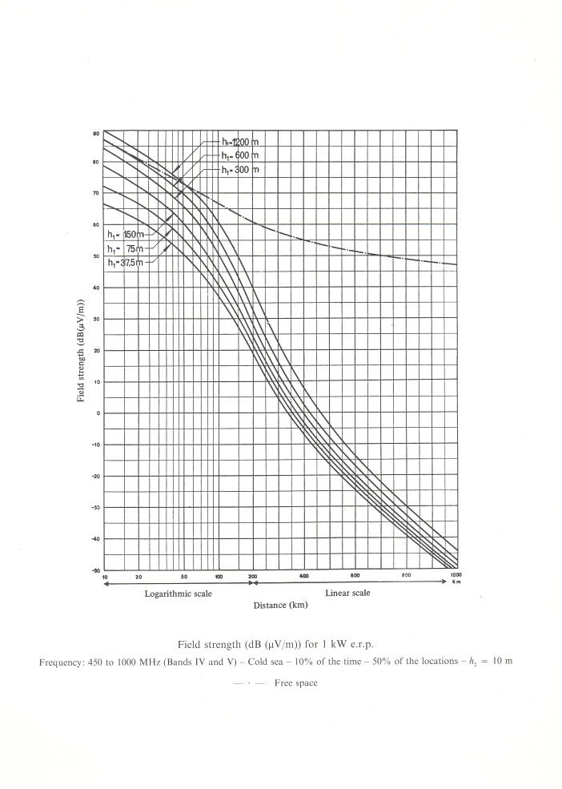
- Propagation curves for frequencies 450 MHz to 1000 MHz
- SIMPLIFIED ALGORITHM FOR CALCULATION OF TOTAL interfering FIELD strength IN THE CASE OF MULTIPLE-ENTRY INTERFERENCE
  - Notation
P = e.i.r.p. of wanted transmitter in the direction of receiver (dBm);
L = Isotropic path loss from wanted transmitter to receiver (dB);
P_{i} = e.i.r.p. of interfering transmitter into the direction of receiver (dBm);
L_{i} = Isotropic path loss from interfering transmitter i to receiver (dB);
a = Receiver antenna gain towards wanted transmitter (dBi);
a_{i} = Receiver antenna gain towards interfering transmitter i (dBi);
β_{i} = Gain due to receiver filter selectivity on interference from transmitter i (dB);
γ = Estimated shadowing margin to be allowed on C/I value (dB);
C = Total wanted carrier power at receiver input (dBm);
I_{i} = Effective interfering power due to transmitter i at receiver input (allowing for the effect of receiver filtering) (dBm);
I = Total effective interfering power at receiver input (allowing for shadowing margin) (dBm);
χ =C/I threshold value.
  - Base mobile Path Algorithm
- For each cell in question, take one or more "worst case" mobile station MS locations. These are locations at which the C/I is known, or believed to be, lowest.
- Calculate the wanted carrier power at the receiver input:
$$C=P-L+a$$
- Calculate the effective interfering power due to each potentially interfering transmitter (whether co-channel or adjacent channel) at the receiver input (allowing for the effect of receiver filtering):
$$I_{i}=P_{i}-L_{i}+a_{i}+β_{i}$$
- Sum the interfering powers at the receiver and allow for the shadowing margin:
$$I=10 \log_{10}\sum{{10}^{(I_{i}/10)}+γ}$$
- Check the effective C/I ratio against the threshold value λ.
  - Mobile base Path Algorithm
- Take each cell that has a potentially interfering mobile station (MS). If N is the number of carrier frequencies allocated to that cell that can cause potential interference to the base station (BS), assume there are N MS's, one radiating each carrier, in that cell.
A proportion of the total number of MS's so identified (e.g. 20%) should be assumed to be the worst case locations of their cells and the rest at the mid-point of their cells.
Alternatively a "Monte Carlo" simulation can be undertaken in which a number of "snapshots" of the interference scenario are taken. In each snapshot, the interfering MS's are placed at random locations (uniformly distributed) within their cells. To find for example the 90% C/I value. 100 snapshots could be taken, and the C/I which is exceeded by 90 of the snapshots used.
- Perform steps (b) to (e) of the base-mobile path algorithm.
  - Notes on Calculation of Parameters
- P, P_{i} – These should be supplied by the land mobile network operators. For GSM transmitters each P, P_{i} is the power in the active part of the timeslot.
- L, L_{i} – These can either be calculated using appropriate terrain modelling, or some simplified power distance law, e.g. d^{-3.3}.
- a, ai – These should be supplied by the land mobile network operators.
- βi – These can be read off Figure 3
- If shadowing effects have been allowed for in the calculation of L and L_{i}, γ can be set to 0. Otherwise a value of 7 dB could be used (this assumes the wanted and unwanted signals each have a 5 dB shadowing margin (log normal distribution) and the composite shadowing margin is √2 x 5 dB, i.e. 7 dB).
- χ can be taken as follows:
GSM receiver = 9 dB.

Note
The calculation must take into account all interfering transmitters from the wanted Land Mobile Network as well as those from the neighbouring Land Mobile Networks.
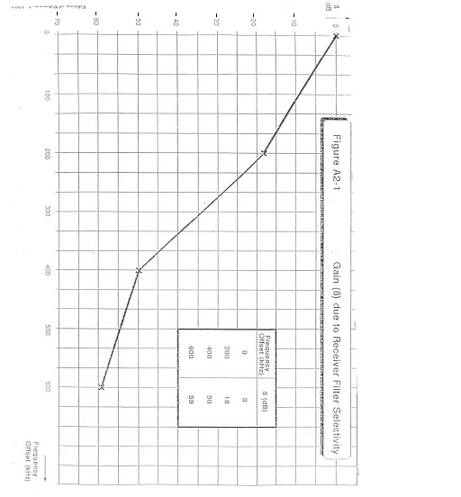
- Receiver filter selectivity
- TECHNICAL PARAMETERS NECESSARY FOR COORDINATION OF THE GSM SERVICE
C/I ratios applicable to GSM 900, GSM-R and GSM 1800 systems.
The C/I ratio is the ratio between wanted signal power to interfering signal power at the receiver input during the active part of the GSM timeslot including multiple interferes.
The following C/I ratios apply:
Wanted signal | Interferer signal | Co-channel interference | Adjacent channel interference  200 kHz | Adjacent channel interference  400 kHz | Adjacent channel interference  600 kHz
GSM | GSM | 9 dB | - 9 dB | - 41 dB | - 49 dB
Curves indicating C/I values for intermediate values of frequency offset are attached to this Annex.
For GSM 900 and GSM-R system:
Minimum field strength to be protected (Emin) for mobile stations: 32 dBμV/m/200 kHz
(50% of location and 50% of time in the mobile receive band).
For GSM 1800 system
Minimum field strength to be protected (Emin):
(50 % of location and 50 % of time).
GSM-1800 MS 42 dB µV/m/200 kHz;
GSM-1800 BS 38 dB µV/m/200 kHz.

Notes
Values from ETSI TS 145 005 [18] – Digital cellular telecommunications system (Phase 2+); Radio Transmission and Reception
- Receiver filter selectivity

Annex 4: List of References
- CEPT Recommendation T/R 20-08: Frequency planning and frequency coordination for the GSM system (withdrawn)
- CEPT Recommendation T/R 22-07: Frequency bands, planning and coordination for systems using the DCS 1800 standards (withdrawn)
- ERC Decision (94)01 of 24 October 1994 on the frequency bands to be designated for the coordinated introduction of the GSM digital pan-European communications system
- ERC Decision (97)02 of 21 March 1997 on the extended frequency bands to be used for the GSM Digital Pan-European Communications System
- ERC Decision (95)03 of 1 December 1995 on the frequency bands to be designated for the introduction of DCS 1800
- ECC Decision (02)05 of 8 March 2013 on the designation and availability of frequency bands for railway purposes in the 876-880 MHz and 921-925 MHz bands
- Directive 2008/57/EC OF THE EUROPEAN PARLIAMENT AND OF THE COUNCIL of 17 June 2008 on the interoperability of the rail system within the Community
- Commission Regulation (EU) 2016/919 of 27 May 2016 on the technical specification for interoperability relating to the ‘control-command and signalling’ subsystems of the rail system in the European Union
- ECC Decision (04)06 of 19 March 2004 on the availability of frequency bands for the introduction of Wide Band Digital Land Mobile PMR/PAMR in the 400 MHz and 800/900 MHz bands
- ECC Report 162: Practical mechanism to improve the compatibility between GSM-R and public mobile networks and guidance on practical coordination
- ECC Report 229: Guidance for improving coexistence between GSM-R and MFCN in the 900 MHz band
- EN 301 502: Global System for Mobile communications (GSM); Base Station (BS) equipment
- EN 301 511: Global System for Mobile communications (GSM); Mobile Stations (MS) equipment
- TS 102 933-1: Railway Telecommunications (RT); GSM-R improved receiver parameters; Part 1: Requirements for radio reception
- TS 102 933-2: Railway Telecommunications (RT); GSM-R improved receiver parameters; Part 2: Radio conformance testing
- ECC Decision (06)13 of 21 June 2013 on the designation of the bands 880-915 MHz, 925-960 MHz, 1710-1785 MHz and 1805-1880 MHz for terrestrial UMTS, LTE and WiMAX systems.
- ECC Recommendation (08)02: Frequency planning and frequency coordination for GSM / UMTS / LTE / WiMAX Land Mobile systems operating within the 900 and 1800 MHz bands
- ETSI Technical Specification TS 145 005: Digital cellular telecommunications system (Phase 2+) (GSM); Radio transmission and reception
- Commission Regulation (EU) 2016/919 of 27 May 2016 on the technical specification for interoperability relating to the ‘control-command and signalling’ subsystems of the rail system in the European Union

Agreement between the administrations of Austria, Belgium, the Czech Republic, Germany, France, Hungary, the Netherlands, Croatia, Italy, Liechtenstein, Lithuania, Luxembourg, Poland, Romania, the Slovak Republic, Slovenia and Switzerland on the Coordination of frequencies between 29.7 MHz and 43.5 GHz for the Fixed Service and the Land Mobile Service. The latest version of this agreement can be found from http://www.hcm-agreement.eu/
Agreement between the administrations of Austria, Belgium, the Czech Republic, Germany, France, Hungary, the Netherlands, Croatia, Italy, Liechtenstein, Lithuania, Luxembourg, Poland, Romania, the Slovak Republic, Slovenia and Switzerland on the Coordination of frequencies between 29.7 MHz and 43.5 GHz for the Fixed Service and the Land Mobile Service. The latest version of this agreement can be found from http://www.hcm-agreement.eu/
For example HCM (Harmonised Calculation Method) Agreement

