Unwanted emissions of IRIDIUM satellites in the band 1610.6-1613.8 MHz, monitoring campaign 2013

**Approved 30 January 2015**

ECC Report 226

# EXECUTIVE SUMMARY

This ECC Report describes measurements and simulation results of IRIDIUM’s out-of-band emissions into the radio astronomy (RAS) band 1 610.6-1 613.8 MHz. The measurements were carried out in 2013 and are part of a recurring monitoring program of this RAS band as requested by Decides 5 of ECC Decision (09)02 [2]. In the framework of Sat MoU, the Leeheim space radio monitoring station (Germany) measured 12 satellites of IRIDIUM’s first generation MSS network. Two out of these 12 IRIDIUM satellites were also measured in 2010, namely IRIDIUM 29 and IRIDIUM 32. The measurement setup and calibration in 2013 was functionally identical the one described in ECC Report 171 [1].

The analysis of the observations shows that the normal daytime operation of the satellites cause interference in the radio astronomy band 1 610.6-1 613.8 MHz, in excess of the limits given in Recommendation ITU-R RA.769 [4]. Epfd simulations according to Recommendation ITU-R M.1583 [5], using pfd data derived from the Leeheim measurements, estimate the combined effect of the visible satellites and show that the data loss in a reference time interval of 2 000 seconds reaches 100.0% in the upper part of the RAS band around 1 613.8 MHz and goes down to about 94.4 % close to the lower boundary of the RAS band at 1 610.6 MHz. Recommendation ITU-R RA.1513 specifies a criterion of 2 % to be used for data loss to the RAS due to interference by any single MSS network.

Table 1: Comparison of the measurement and simulation results

|  |  |  |  |
| --- | --- | --- | --- |
| **Dates of measurements** | **Number of measured satellites1** | **Data loss for an integration time of 2 000 s** | |
| 1 610.6 MHz (lower edge of the RAS band) | 1 613.8 MHz (upper edge of the RAS band) |
| 2013-11 | 12 | 94.4 % | 100.0 % |
| 2010-06 (ECC Report 171) | 23 | 93.2 % | 100.0 % |

1 Only satellites without corrupted data or tracking errors are considered.

Table 1 compares and confirms earlier measurement and simulation results carried out in 2010. The RAS band 1 610.6-1 613.8 MHz is still interfered by IRIDIUM’s out-of-band emissions. There is no significant change in data loss or number of lost channels from the values given in ECC Report 171.

TABLE OF CONTENTS

0 EXECUTIVE SUMMARY 2

1 INTRODUCTION 5

2 MSS and RAS FREQUENCY ALLOCATIONs 6

3 RADIOASTRONOMY CHARACTERISTICS AND PROTECTION CRITERIA 8

3.1 RAS operations in the band 1610.6-1613.8 MHz 8

3.2 Protection criteria of RAS 8

4 IRIDIUM SYSTEM CHARACTERISTICS 10

4.1 Iridium constellation description 10

4.2 Particularities of the Iridium signal 10

5 Measurements of IRIDIUM satellites 12

5.1 Description of Leeheim monitoring station 12

5.2 Description of the FFTS 13

5.3 Calibration procedure 14

5.4 Leeheim measurements sessions 15

6 Assessment of IRIDIUM IMPACT to RAS 16

6.1 Direct (Static) Analysis 16

6.2 EPFD (Dynamic) Methodology 17

6.3 EPFD Methodology: Results and Discussion 17

7 CONCLUSIONS 19

ANNEX 1: Table of annexes containing raw data 20

ANNEX 2: Results of raw data reduction 22

ANNEX 3: List of reference 25

LIST OF ABBREVIATIONS

|  |  |
| --- | --- |
| Abbreviation | Explanation |
| CEPT | European Conference of Postal and Telecommunications Administrations |
| ECC | Electronic Communications Committee |
| epfd | equivalent power flux density |
| FDMA | Frequency Division Multiple Access |
| ITU | International Telecommunications Union |
| LEO | Low Earth Orbit |
| MSS | Mobile Satellite Service |
| PFD | Power Flux Density |
| RA | Radiocommunication Assembly |
| RAS | Radio Astronomy Service |
| TDD | Time-Division Duplex |
| TDMA | Time Division Multiple Access |
| **WRC** | World Radiocommunication Conference |
|  |  |

# INTRODUCTION

The out -of-band emissions of IRIDIUM satellites into the radio astronomy (RAS) band 1 610.6-1 613.8 MHz was originally documented in ECC Report 171 [1]. This report also includes a description of the measurement setup, its parameters and calibration procedure. Based on these findings, ECC amended its ECC/DEC/(09)02 [2] in November 2012 and included a new Decides 5, stating:

* “that the compliance with the conditions for use of radio frequencies by current and future MSS systems in the band 1613.8-1626.5 MHz (space-to-Earth) and the degree of interference in the frequency band 1610.6-1613.8 MHz caused by this usage shall be monitored regularly (e.g. once a year) by a competent body and the results be reported to the ECC;”

The purpose of Decides 5 is to compare measurements over a several years and show possible changes in the interference situation due to changes of the satellite configuration, parameters or traffic load. This Report contains new measurements carried by the Leeheim space radio monitoring station (Germany) on the 13th and 15th November 2013 during daytime (08:02:36 – 15:39:23 local time). The measurement results were used in a simulation tool to assess the equivalent power flux density (epfd) generated in the RAS band and the resulting data loss is compared with the results in ECC Report 171. It should be noted, that due to the possible contribution of thermal ground radiation and terrestrial interference sources, measurements at lower elevations angles (<6°) were disregarded.

The measurement setup and calibration in 2013 was identical to the one described in ECC Report 171. Results, tables and diagrams can be found in [2]. However, for the measurements carried out in 2010, a spectrometer was provided by the radio astronomy community. In the meantime the Leeheim space radio monitoring station replaced this instrument by a new spectrometer which permits the simultaneous recording of in-band and out-of-band signals. The exchange of the spectrometers also explains the different channel bandwidths used.

# MSS and RAS FREQUENCY ALLOCATIONs

Table 2: Frequency allocations in the band 1610-1626.5 MHz

|  |  |  |
| --- | --- | --- |
| **Allocation to services** | | |
| **Region 1** | **Region 2** | **Region 3** |
| **1 610-1 610.6**  MOBILE-SATELLITE (Earth-to-space) 5.351A  AERONAUTICAL RADIONAVIGATION | **1 610-1 610.6**  MOBILE-SATELLITE (Earth-to-space) 5.351A  AERONAUTICAL RADIONAVIGATION  RADIODETERMINATION- SATELLITE (Earth-to-space) | **1 610-1 610.6**  MOBILE-SATELLITE (Earth-to-space) 5.351A  AERONAUTICAL RADIONAVIGATION  Radiodetermination-satellite (Earth-to-space) |
| 5.341 5.355 5.359 5.364 5.366 5.367 5.368 5.369 5.371 5.372 | 5.341 5.364 5.366 5.367 5.368 5.370 5.372 | 5.341 5.355 5.359 5.364 5.366 5.367 5.368 5.369 5.372 |
| **1 610.6-1 613.8**  MOBILE-SATELLITE (Earth-to-space) 5.351A  RADIO ASTRONOMY  AERONAUTICAL RADIONAVIGATION | **1 610.6-1 613.8**  MOBILE-SATELLITE (Earth-to-space) 5.351A  RADIO ASTRONOMY  AERONAUTICAL RADIONAVIGATION  RADIODETERMINATION- SATELLITE (Earth-to-space) | **1 610.6-1 613.8**  MOBILE-SATELLITE (Earth-to-space) 5.351A  RADIO ASTRONOMY  AERONAUTICAL RADIONAVIGATION  Radiodetermination-satellite (Earth-to-space) |
| 5.149 5.341 5.355 5.359 5.364 5.366 5.367 5.368 5.369 5.371 5.372 | 5.149 5.341 5.364 5.366 5.367 5.368 5.370 5.372 | 5.149 5.341 5.355 5.359 5.364 5.366 5.367 5.368 5.369 5.372 |
| **1 613.8-1 626.5**  MOBILE-SATELLITE (Earth-to-space) 5.351A  AERONAUTICAL RADIONAVIGATION  Mobile-satellite (space-to-Earth)  5.208B | **1 613.8-1 626.5**  MOBILE-SATELLITE (Earth-to-space) 5.351A  AERONAUTICAL RADIONAVIGATION  RADIODETERMINATION- SATELLITE (Earth-to-space)  Mobile-satellite (space-to-Earth)  5.208B | **1 613.8-1 626.5**  MOBILE-SATELLITE (Earth-to-space) 5.351A  AERONAUTICAL RADIONAVIGATION  Mobile-satellite (space-to-Earth)  5.208B  Radiodetermination-satellite (Earth-to-space) |
| 5.341 5.355 5.359 5.364 5.365 5.366 5.367 5.368 5.369 5.371 5.372 | 5.341 5.364 5.365 5.366 5.367 5.368 5.370 5.372 | 5.341 5.355 5.359 5.364 5.365 5.366 5.367 5.368 5.369 5.372 |

The RAS has a primary allocation in the band 1610.6-1613.8 MHz. Two footnotes are applicable in this band:

5.149:“….administrations are urged to take all practicable steps to protect the radio astronomy service from harmful interference”

5.372:“Harmful interference shall not be caused to stations of the radio astronomy service using the band 1610.6-1613.8 MHz by stations of the radiodetermination-satellite and mobile-satellite services (No. 29.13 applies”).

Mobile-Satellite (Earth-to-Space) is allocated in the band 1610.0-1626.5 MHz and Mobile-Satellite (Space-to-Earth) has a secondary allocation in the band 1613.8-1626.5 MHz. Footnote 5.208B stipulates that Resolution 739 (WRC-03) applies to future systems planned for this band.

# RADIOASTRONOMY CHARACTERISTICS AND PROTECTION CRITERIA

## RAS operations in the band 1610.6-1613.8 MHz

The 1 610.6-1 613.8 MHz band is used for spectral line observations of the hydroxyl radical (OH). The OH transition at rest frequency 1 612 MHz is one of the most important spectral lines for RAS, and is listed as such in Recommendation ITU-R RA.314. OH was the first cosmic radical to be detected at radio frequencies (1963) and continues to be a powerful research tool. In its ground state the OH molecule produces four spectral lines, at frequencies of approximately 1612, 1665, 1667 and 1720 MHz, all of which have been observed in emission and in absorption in our Galaxy, as well as in external galaxies. The study of OH lines provides information on a wide range of astronomical phenomena, e.g. the formation of protostars and the evolution of stars. To interpret most observations made of the OH molecule, it is necessary to measure the relative strength of several of these lines. The loss of the ability to observe any one of these lines will prevent the study of these classes of physical phenomena.

Spectral line observations are made using spectrometers that can simultaneously integrate the power in each of a large number of frequency channels (typically 256-4 096) distributed across the frequency band used. The width and number of channels has to be large enough to accurately reproduce the spectral shape of the emission or absorption received by the radio telescope. Instantaneous channel bandwidths of typically ~0.2‑20 kHz are used, depending on the scientific program.

Observations in the 1612 MHz band are carried out at a number of RAS sites in numerous countries, worldwide. Observations in the 1612 MHz band are sometimes conducted on targets of opportunity, e.g. particularly on objects such as comets, which have been observed to produce transient emissions in this line.

## Protection criteria of RAS

Recommendation ITU-R RA.769 specifies the protection criteria for radio astronomical observations and gives threshold levels of detrimental interference for primary RAS bands. In the 1610.6-1613.8 MHz band, the threshold pfd limit is ‑194 dB(W/m2) per 20 kHz spectrometer channel bandwidth, assuming 0 dBi antenna gain and an integration time of 2000 seconds for the RAS station. Because this band is used only for spectral line observations, the continuum threshold does not apply. The limits for other integration times and bandwidths scale as the square root of the ratio of the product of time and bandwidth to that of the nominal 2000 s and 20 kHz, as expressed in Recommendation ITU-R RA.769 [4]. A shortened integration time will raise the corresponding threshold pfd limit. A scaling of the interference limits according to Recommendation ITU-R RA.769 and the derivation in the astronomical unit Jansky (Jy) can be found in annex 4 of this Report.

To determine the impact of interference from non-GSO systems, the protection criteria and the relevant epfd methodologies are described in Recommendations ITU-R RA.769-2 [4] and ITU-R RA.1513-1 [5], as well as in Recommendation ITU-R S.1586-1 for FSS systems and in Recommendation ITU‑R M.1583-1 [6] for MSS and RNSS systems. In particular, an epfd threshold of -258 dB(W/m2) per 20 kHz may be derived from the threshold pfd level considering a maximum antenna gain of 64 dBi for a representative RAS antenna and an integration time of 2000 seconds.

Data loss is defined in Recommendation ITU-R RA.1513-1 [5] as “data that have to be discarded because they are contaminated by the aggregate interference, from one or more sources that exceeds the levels of Recommendation ITU-R RA.769”. This “data loss may result from loss of part of the observing band, part of the observing time or from blockage of part of the sky”. Recommendation ITU-R RA.1513-1 [5] recommends “that the percentage of data loss, in frequency bands allocated to the RAS on a primary basis, be determined as the percentage of integration periods of 2 000 s in which the average spectral pfd at the radio telescope exceeds the levels defined (assuming 0 dBi antenna gain) in Recommendation ITU-R RA.769”. The 2000 s integration period is a reference duration used in ITU-R recommendations, but in practice different integration times are used by radio astronomy stations. For the case of a non-geostationary satellite network the epfd rather than spfd was used, as described in M.1583 [6].

Recommendation ITU-R RA.1513 [5] recommends a data loss criterion of 2% caused by any single MSS network. This percentage of data loss is considered an average value calculated over all the possible pointing directions of the RAS station (see Recommendation ITU-R M.1583 [6]).

# IRIDIUM SYSTEM CHARACTERISTICS

## Iridium constellation description

The Iridium system employs 66 Low Earth Orbit (LEO) satellites that support user-to-user, user-to-gateway, and gateway-to-gateway communications. The 66 satellites are evenly distributed in six orbital planes with a 86.4° inclination, with one in-orbit spare for each orbital plane. Except for planes 1 and 6, the orbital planes are co-rotating planes spaced 31.6° apart. The first and last orbital planes are spaced 22° apart and form a seam where the satellites are counter-rotating. The Iridium satellite constellation is depicted in Figure 1. The satellites orbit at an altitude of 780 km and have an orbital period of approximately 100 min 28 s.

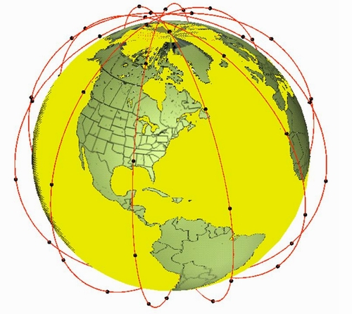

Figure 1: Iridium Satellite Constellation

## Particularities of the Iridium signal

Iridium is designed to operate in up to 10.5 MHz of spectrum in the band 1616-1626.5 MHz and utilises time division multiple access (TDMA) technology for satellite access using bi-directional service link transmissions. At launch in 1998, the Iridium system was initially authorised to operate within the band 1621.35-1626.5 MHz, but has additionally been authorised in the USA and a number of other countries worldwide to operate down to 1617.775 MHz.

Iridium user terminals employ a time-division duplex (TDD) approach wherein they transmit and receive in an allotted time window within the frame structure. The TDD structure is built on a 90 ms frame and is composed of a 20.32 ms downlink simplex time slot, followed by four 8.28 ms up-link time slots and four 8.28 ms down-link time slots, with some guard times interspersed as is depicted in Figure 2. Since the system is using TDD, the subscriber units transmit and receive in the same frequency band. The access technology is a Frequency Division Multiple Access/ Time Division Multiple Access (FDMA/ TDMA) method whereby a subscriber is assigned a channel composed of a specific frequency and time slot in any particular beam. Channel assignments may be changed across cell/ beam boundaries (and across satellite handover) and are controlled by the satellite.



Figure : Iridium Frame Structure

# Measurements of IRIDIUM satellites

## Description of Leeheim monitoring station

The Leeheim Space Radio Monitoring Station is located approximately 35 km south-west of Frankfurt/Main.

The Leeheim MS has a number of satellite antennas including a 12 m parabolic reflector Antenna 1 designed to cover the 1-13 GHz frequency range, with which the monitoring was done. High-precision angular pointing allowed for accurate tracking of moving satellites. The relevant parameters of the Leeheim MS Antenna 1 are:

* Antenna type: cassegrain
* Dish diameter: 12 m
* Aperture efficiency (including taper): 0.64
* Polarization: linear
* Antenna gain: 44 dBi (1.5 – 1.8 GHz band)
* Figure of merit: 17 dB/K (1.5 – 1.8 GHz band)
* Zenith system temperature: 120 K at 1620 MHz (without stop band filter)
* Antenna tracking: programmable tracking using orbital elements
* Frequency stability: 10-12 s/s
* Measurement uncertainty: 1.6 dB r.s.s. error (95% confidence level)
* Band Reject Filter - Type: Wainwright Instruments GmbH
* Filter Model Number: WRCD 1616/1627-1614/1630-70/16EE
* Filter Reject Attenuation: 1616.0 to 1627.0 MHz / 70 dB minimum

The dependence of antenna temperature TA on elevation has been carefully determined in 1980 at the time of antenna commissioning (Figure 3). The filter loss (Figure 4) is responsible for the majority of the system noise, only for elevations near the horizon can we expect a significant contribution of the ground radiation. Combining these filter losses with the elevation dependent antenna temperature Tant(ϕ), as interpolated from the measured values, yields the system temperature as a function of frequency and elevation:

Tsys(ν, ϕ) = Tant (ϕ) + TRX + 290 (L1(ν) – 1)

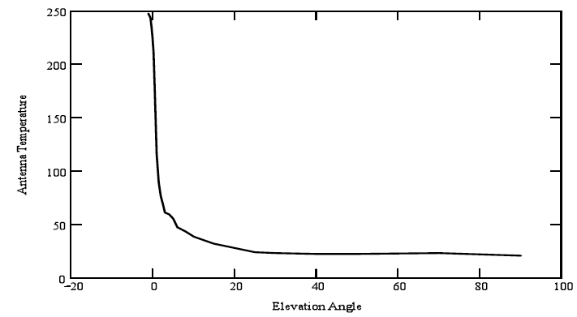

Figure 3: Leeheim antenna temperature as determined in 1980

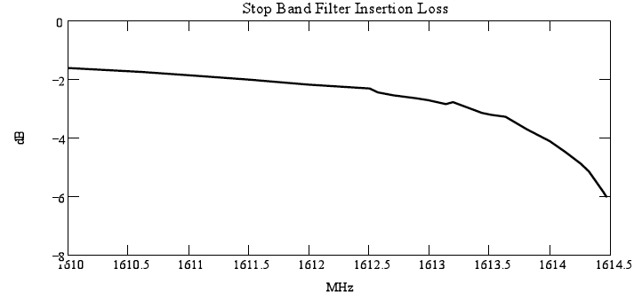

Figure 4: Insertion loss of the stop band filter

The graph in Figure 5 illustrates the expected behaviour of the system temperature for different elevations within the radio astronomical band.

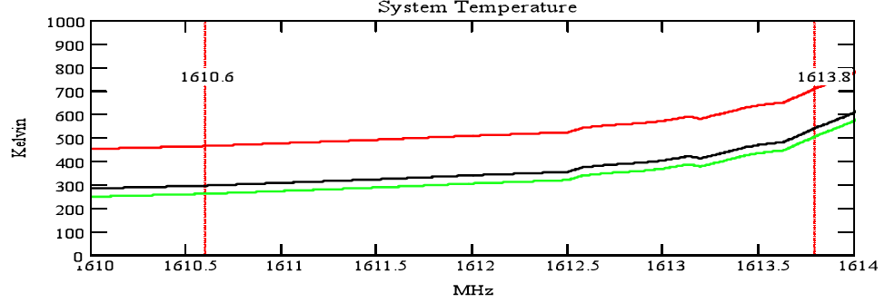

Figure 5: Total expected noise temperature for the Leeheim satellite tracking system used in the measurements. The green trace shows the expected system temperature at ϕ=90° (zenith), the black trace at ϕ=5° and the red trace at ϕ=0° (horizontal)

## Description of the FFTS

A new spectrometer was used in Leeheim.

Technical specifications of the dual channel real-time digitising and recording system:

* FFT: 4096
* Digitisation: 16 bit
* Output range: 256 dBm
* Dynamic resolution: 0.0039 dBm (value ‘ydelta” in mat-files)
* Oversampling factor: 4/3

Due to these specifications the following settings were chosen to match the required values:

* Internal bandwidth: 7.5 MHz
* Bandwidth used for RAS band: 4 MHz
* Sampling rate: ~1e-7 s
* Averaging: 128

This results in the following time and frequency resolution:

* Integration time: ~52.4 ms (value ‘duration’ in mat-files)
* Channel bandwidth: ~2.4414 kHz (value ‘xdelta’ in mat-files)

Time synchronisation:

* Antenna control unit: internal GPS receiver
* Dual channel real-time digitising and recording system: Meinberg LANtime M300

## Calibration procedure

The observing procedures used for all satellite measurements incorporate the well-established calibration procedures used in radio astronomy. These incorporate the following measurement steps:

1. During each measurement session the two strong celestial calibrator sources Cassiopeia A and Cygnus A were observed. These sources, which emit known flux strength in the band of interest, were used to calibrate the system bandpass across the RAS band and to provide the calibration scale from antenna temperature to absolute flux in units of Wm-2Hz-1 for the satellite observations.
2. All satellite observations consisted of a continuous tracking observations (from horizon to horizon) with a typical duration of 700 seconds followed by an observation of a blank sky position (antenna azimuth of 0° and elevation of 50°). The blank sky section of each observation was used to subtract the zero level baseline from the tracking part of the data.

Calibration Sources: The celestial calibrator sources Cassiopeia A (size 4.3’) and Cygnus A (size 2’) have a known (calibrated) flux density and are unresolved by the Leeheim MS antenna beam (HPBW = 1.05°). The measured total flux at the antenna in mW per channel (antenna temperature) of the calibrator source directly determines scaling of the individual channels of the FFTS in astronomical flux units given as 1 Jansky (Jy) = 10-26 Wm-2Hz-1.

Cyg A has a flux density of 1690±3 Jy at 1304 MHz and 1210±3 Jy at 1765 MHz (Baars et al., Astronomy and Astrophysics, 61, 99-106, 1977). Linear interpolation yields a flux density of 1371 ±5 Jy at 1610 MHz (interpolated flux density). Similarly the flux density of Cas-A is 1851 Jy at 1610 MHz. An example calibration measurements of Cygnus A is presented in Figure 6.

The shape of the bandpass across the RAS band is strongly affected by the stop-band filter in Figure 7 (left). A “spline fit” (interpolation) through the spectrum may be used to correct for this bandshape and produces a spectrum for Cyg-A as presented in Figure 7 (right). Using the system noise and the conversion efficiency of the antenna, 0.026 K/Jy one can calculate the system temperatures across the band and their range from 350 – 700 K is in good agreement with predictions derived from the system characteristics. After flattening of the bandpass of the measurement data may be converted to flux units using the conversion function (from antenna temperature to Jansky) shown in Figure 7 (right). Some strong and narrow interference was sporadically found in the data, which was ignored in subsequent data processing.

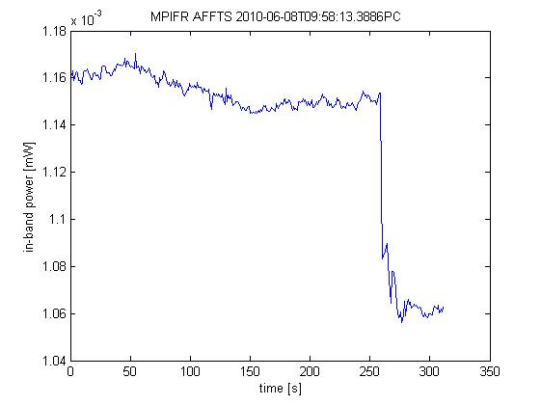

Figure 6: Example measurement of Cyg-A with Leeheim. The Cygnus A source is present till 250 sec followed by the background measured for an antenna azimuth of 0° and elevation of 50°

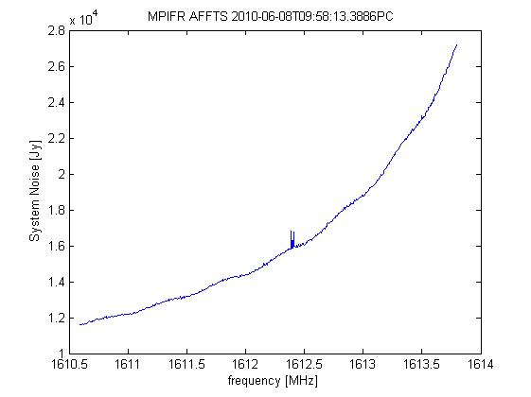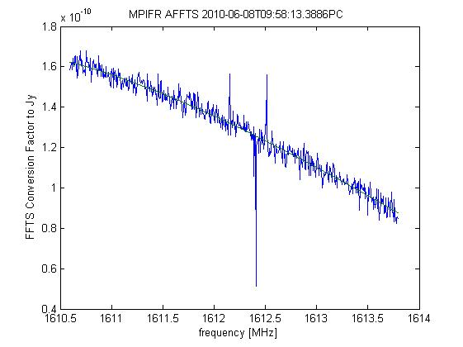

Figure 7: System noise and transfer function from calibration on Cyg-A01

## Leeheim measurements sessions

The Leeheim measurements session used the same procedure as described in section 5.4 of ECC Report 171 [1].

The period of monitoring spanned from 13.11.2013 to 15.11.2013.

# Assessment of IRIDIUM IMPACT to RAS

## Direct (Static) Analysis

A direct (static) analysis provides a first estimate of the impact of interference on radio astronomy measurements. However, a static analysis may not be considered as a full assessment as it assumes interference levels seen by a 0 dBi antenna and does not take into account a full RAS antenna pattern which provides suppression beyond 14° offset. Only use of the epfd approach described in Recommendation ITU-R M.1583 [6], using a simulation tool such as that used in section 6.2, can provide results directly comparable to RA.769 and RA.1513.

* Out-of-band emissions are detected on each of 12 monitored IRIDIUM satellites.
* In the spectra that were averaged over the transit time of the satellites, the number of 19.5 kHz channels that exceeded the scaled ITU-R RA.769 threshold specified in section 7.1 of ECC Report 171 ranged from 100 to 164 of 164. Table 3 below provides detailed information for each satellite transit.
* The origin of the out-of-band emissions is proven by the comparison of simultaneous in-band and out-of-band signals.
* To confirm that no GLONASS or GLOBALSTAR satellite crossed the antenna main lobe during the measurements, the calculated angles of GLONASS and GLOBALSTAR satellites are compared to those of the observed IRIDIUM satellites. Annex 3 of [3] lists satellites and times for angular distances below 5°. The directivity of the antenna is supplied as Annex 39.

Table 3: Spectrum contamination after transit of IRIDIUM Satellites

| Satellite | Channels exceeding flux threshold | Percentage of lost spectral channels, % |
| --- | --- | --- |
| Iridium 40 | 164 of 164 | 100.0 |
| Iridium 70 | 127 of 164 | 77.4 |
| Iridium 65 | 122 of 164 | 74.4 |
| Iridium 11 | 164 of 164 | 100.0 |
| Iridium 76 | 149 of 164 | 90.9 |
| Iridium 32 | 103 of 164 | 62.8 |
| Iridium 59 | 125 of 164 | 76.2 |
| Iridium 29 | 164 of 164 | 100.0 |
| Iridium 12 | 114 of 164 | 69.5 |
| Iridium 86 | 100 of 164 | 61.0 |
| Iridium 77 | 164 of 164 | 100.0 |
| Iridium 75 | 164 of 164 | 100.0 |
| Median | 138 of 164 | 84.1 |

The spectra were averaged over the transit time of the individual satellites using a channel bandwidth of 19.5 kHz.

The median number of lost spectral channels in the average spectra taken over the transit of 12 satellites was 138 of 164 corresponding to a loss of 84.1 %. This number is of the same order of magnitude as the one (76 %) given in ECC Report 171 [1].

Detailed results are presented as diagrams and can be found in Annexes 7 to 18 of [3] (accessible only for the members of ECC PT SE40) .

## EPFD (Dynamic) Methodology

The measurements performed during 13th November 2013 and 15th November 2013 were captured with a time resolution of 52.3 msec. The spectrometer channel bandwidth used was 2.44 kHz.

The raw data measured with the spectrometer was calibrated using the RAS procedure described in ECC Report 171. The tools used to perform such procedure make it possible to aggregate the data over both, the time and frequency domains. This aggregation was done to obtain frequency channels as close as possible to 20 kHz (19.5 kHz) and a time resolution of around one second.

The methodology to obtain the epfd results from the calibrated data follows the guidelines described in ECC Report 171. After performing this procedure on the 12 datasets corresponding to the 12 measured satellites, the direction of the RAS antenna during the measurements was considered. It was observed that the percentage of measurements for which the elevation angle of the antenna was lower than 6°, ranges from 0 to 1.7 % for 11 of the 12 calibrated datasets. In the case of IRIDIUM 40, this value reaches 2.8 %. In consequence, this last dataset was excluded for the epfd calculation.

The mean and standard deviation of the background noise observations were used to set the offset and the threshold of the data points as described in ECC Report 171 [1].

Cumulative distribution functions were generated to model the interference power levels from each of the measured satellites. The Figure below presents the distributions for the highest channel of the measured band centred al frequency 1613.7878 MHz.



Figure 8: Cumulative distribution functions for the satellites of the 2013 measurements campaign

The generated distributions were used as input data for the simulation tool to carry out the epfd calculations according to methodology described in Recommendation ITU-R M.1583 [6].

## EPFD Methodology: Results and Discussion

The variation of the data loss (in percentage) across the sky for the frequency channel 1610.6267 MHz at the lower edge of the RAS frequency band is presented in the figure below.



Figure 9: Variation of the data loss (in percentage) across the sky at frequency 1610.6267 MHz

The overall data loss is found to be 94.4% when considering an integration time of 2000 seconds. In order to meet the 2% criterion, the average interference power level should be reduced by 22.8 dB.

For the frequency channel at the highest edge of the RAS frequency band (1613.7908 MHz) the overall data loss across the sky is found to be 100%, when considering an integration time of 2000 seconds. In order to meet the 2% criterion, the average interference power level should be reduced by 32.3 dB.

# CONCLUSIONS

The analysis of observations at the Leeheim space monitoring station in November 2013 shows that the normal daytime operation of the satellites in the IRIDIUM MSS network causes interference in the radio astronomical band 1 610.6-1 613.8 MHz, in excess of the limits given in Recommendation ITU-R RA.769 [4]. Epfd simulations according to Recommendation ITU-R M.1583 [6], using pfd data derived from the new Leeheim measurements, estimate the combined effect of the visible satellites and show that the data loss in a reference time interval of 2 000 seconds reaches 100.0 % in the upper part of the RAS band around 1613.8 MHz and goes down to about 94.4% close to the lower boundary of the RAS band at 1 610.6 MHz. Recommendation ITU-R RA.1513 specifies a criterion of 2 % to be used for data loss to the RAS due to interference by any single MSS network.

Table 4: Comparison of the measurement and simulation results

|  |  |  |  |
| --- | --- | --- | --- |
| Dates of measurements | Number of measured satellites1 | Data loss for an integration time of 2 000 s | |
| 1 610.6 MHz  (lower edge of the RAS band) | 1 613.8 MHz  (upper edge of the RAS band) |
| 2013-11 | 12 | 94.4 % | 100.0 % |
| 2010-06 (ECC Report 171) | 23 | 93.2 % | 100.0 % |

1 Only satellites without corrupted data or tracking errors are considered.

Table 4 compares and confirms earlier measurement and simulation results carried out in 2010. The RAS band 1 610.6-1 613.8 MHz is still interfered by IRIDIUM’s out of band emissions. There is no significant change in data loss or number of lost channels from the values given in ECC Report 171[1] .

1. Table of annexes containing raw data

All Annexes are kept in the SE40 document area at the CEPT web-site [3].

|  |  |  |  |
| --- | --- | --- | --- |
| Annex | Satellite | File name | Description |
| 1 |  | A01_Results_Summary.xls | Table of measurements |
| 2 |  | A02_ib-oob_comparison.ppt | In-band / Out-of-band comparison |
| 3 |  | A03_Anomalies.xls | Anomalies (angles) |
| 4 |  | A04_Description_MAT_Files.doc | Description of Matlab files |
| 5 |  | A05_Matlab_Scripts.zip | Matlab scripts |
| 6 |  | A06_Matlab_Documentation.zip | Documentation of Matlab scripts |
| 7 | Iridium 40 | A07_Diagrams_Iridium_40.doc | Results as diagrams |
| 8 | Iridium 70 | A08_Diagrams_Iridium_70.doc |
| 9 | Iridium 65 | A09_Diagrams_Iridium_65.doc |
| 10 | Iridium 11 | A10_Diagrams_Iridium_11.doc |
| 11 | Iridium 76 | A11_Diagrams_Iridium_76.doc |
| 12 | Iridium 32 | A12_Diagrams_Iridium_32.doc |
| 13 | Iridium 59 | A13_Diagrams_Iridium_59.doc |
| 14 | Iridium 29 | A14_Diagrams_Iridium_29.doc |
| 15 | Iridium 12 | A15_Diagrams_Iridium_12.doc |
| 16 | Iridium 86 | A16_Diagrams_Iridium_86.doc |
| 17 | Iridium 77 | A17_Diagrams_Iridium_77.doc |
| 18 | Iridium 75 | A18_Diagrams_Iridium_75.doc |
| 19 | Iridium 40 | A19_IR40_13112013_1010_RX1_20131113_100632.00001.mat | Matlab files of Iridium measurements |
| 20 | Iridium 70 | A20_IR70_13112013_1035_RX1_20131113_103046.00001.mat |
| 21 | Iridium 65 | A21_IR65_13112013_1110_RX1_20131113_110551.00001.mat |
| 22 | Iridium 11 | A22_IR_11_13112013_1310_RX1_20131113_131102.00001.mat |
| 23 | Iridium 76 | A23_IR_76_13112013_1350_RX1_20131113_134614.00001.mat |
| 24 | Iridium 32 | A24_IR_32_13112013_1415_RX1_20131113_141018.00001.mat |
| 25 | Iridium 59 | A25_IR_59_13112013_1450_RX1_20131113_144553.00001.mat |
| 26 | Iridium 29 | A26_IR_29_13112013_1525_RX1_20131113_152552.00001.mat |
| 27 | Iridium 12 | A27_IR12_15112013_0802_RX1_20131115_075851.00001.mat |
| 28 | Iridium 86 | A28_IR86_15112013_0830_RX1_20131115_082702.00001.mat |
| 29 | Iridium 77 | A29_IR77_15112013_0929_RX1_20131115_092632.00001.mat |
| 30 | Iridium 75 | A30_IR75_15112013_1058_RX1_20131115_105504.00001.mat |
| 31 |  | A31_cass_cold_13112013_0950.mat | Matlab files of reference measurements |
| 32 |  | A32_cass_cold_13112013_1135.mat |
| 33 |  | A33_cass_cold_13112013_1301.mat |
| 34 |  | A34_cass_cold_13112013_1510.mat |
| 35 |  | A35_cass_cold_15112013_0745.mat |
| 36 |  | A36_cass_cold_15112013_1115.mat |
| 37 |  | A37_Settings_evaluation.xls | Evaluation settings |
| 38 |  | A38_Filter data sheet.gif | Band stop data sheet |
| 39 |  | A39_SHF1 directivity.doc | Antenna directivity diagram |

1. Results of raw data reduction

This section displays the raw data from measurements taken on one satellite of the IRIDIUM constellation (IRIDIUM 32). Measurements from several satellites are used in sections above, as described in Recommendation ITU-R M.1583, to estimate the impact on radio astronomy data loss.

The figures below represents examples of calibrated measurements of IRIDIUM 32. Figures of Cassiopea A and blank sky used as calibration sources are shown in Annex 12 of [3]. Figures 10 and 14 can be used for comparison with results of measurements campaign performed in June 2010.

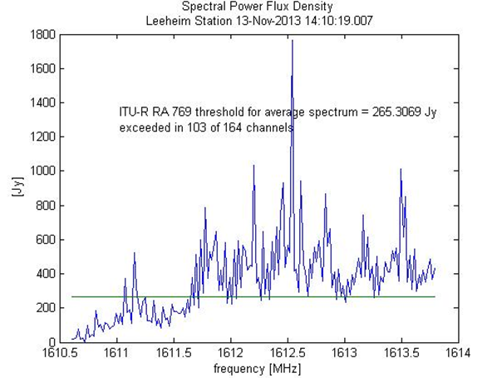

Figure 10: Calibrated spectrum obtained from averaging all spectrum measurements during the transit of IRIDIUM 32. The channel bandwidth is 19.5 kHz. The green line corresponds to the threshold calculated for the averaging time and bandwidth according to   
Recommendation ITU-R RA. 769-2

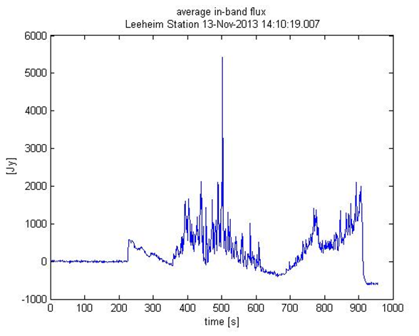

Figure 11: Total flux of unwanted emissions across the band 1 610.6-1 613.8 MHz   
during the satellite transit.

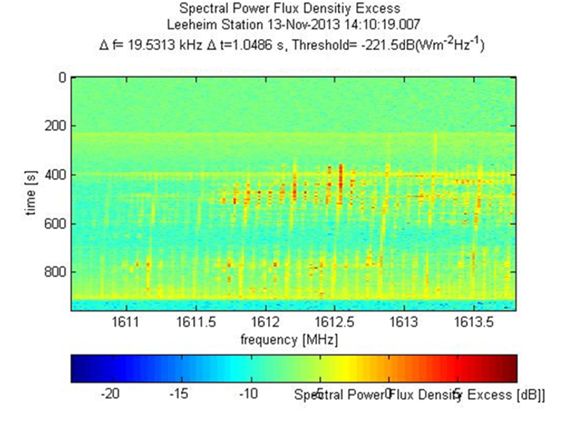

Figure 12: Spectrogram taken during the transit of IRIDIUM 32 and calibrated in units of the interference threshold for tint=1 second, ∆f=19.5 kHz, logarithmic colour bar,   
yellow to red areas exceed the threshold

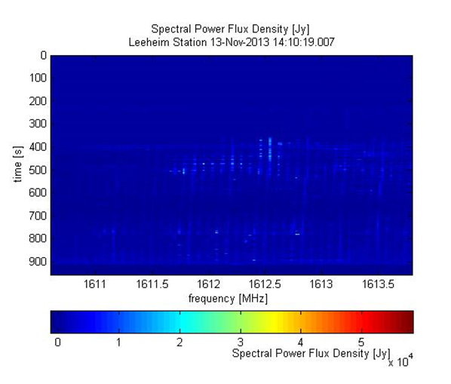

Figure 13: Spectrogram taken during the transit of IRIDIUM 32 and calibrated in absolute flux units (10 kJy = 10-22 Wm-2Hz-1) for tint=1 second, ∆f=19.5 kHz, linear colour bar

Note: 10 kJy is the typical radio flux from the quiet sun.

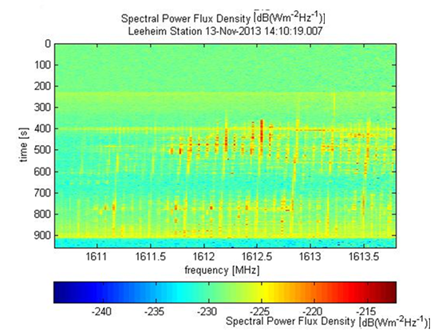

Figure 14: Spectrogram taken during the transit of IRIDIUM 32 and calibrated in absolute flux units for tint=1 second, ∆f=19.5 kHz, logarithmic colour bar

1. List of reference
2. ECC Report 171: “Impact of unwanted emissions of IRIDIUM satellites on radioastronomy operations in the band 1610.6-1613.8 MHz”  
   Tallinn, October 2011
3. ECC Decision (09)02: “The harmonisation of the bands 1610-1626.5 MHz and 2483.5-2500 MHz for use by systems in the Mobile-Satellite Service”  
   approved 26 June 2009, amended 02 November 2012
4. “Leeheim measurements report 22.11.2013 + Annex 1 – 39”, available on the ECO website, ECC PT SE40 meeting documents, M42, 2 - 3 December 2013, Copenhagen
5. Recommendation ITU-R RA.769-2: “Protection criteria used for radio astronomical measurements”
6. Recommendation ITU-R RA.1513-1, “Levels of data loss to radio astronomy observations and percentage-of-time criteria resulting from degradation by interference for frequency bands allocated to the radio astronomy on a primary basis”
7. Recommendation ITU-R M.1583-1: “Interference calculations between non-geostationary mobile-satellite service or radionavigation-satellite service systems and radio astronomy telescope sites”