

CEPT Report 32

Report from CEPT to the European Commission
in response to the Mandate on

“Technical considerations
regarding harmonisation options for the digital dividend in the European Union”

“Recommendation on the best approach to ensure the continuation of existing Program Making and Special Events (PMSE) services operating in the UHF (470-862 MHz), including the assessment of the advantage of an EU-level approach”

Final Report on 30 October 2009 by the

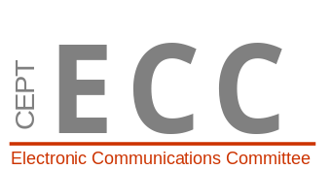

Electronic Communications Committee (ECC)
within the European Conference of Postal and Telecommunications Administrations (CEPT)

executive summary
Justification

This report was developed within CEPT in the framework of the second EC mandate on technical considerations regarding harmonisation options for the digital dividend in the European Union. PMSE equipments are currently intensively operated in the UHF band in most CEPT countries in the interleaved spectrum between broadcasting allotments on a secondary basis, e.g. on a non-interfering and non-protected basis with regard to the terrestrial broadcasting and other primary services. The introduction of digital TV in the UHF band and the possible usage of the upper part of the UHF band (790-862 MHz) by the mobile service will reduce the amount of spectrum available for PMSE operation. However, there is a strong economic, cultural and political interest to ensure a continued usage of PMSE in the UHF band also in future. Therefore, this report investigated, approaches in order to ensure the continuation of PMSE systems operating in the UHF band. It also investigated alternative common solutions outside the UHF band.

Findings

PMSE demand for spectrum is expected to continue to rise in the medium term. Even if there was no reduction in the quantity of interleaved spectrum available for PMSE, users would eventually face increasing constraints in spectrum supply and the need to change the way that they used it.

Interleaved channels/white spaces in the UHF band are the principal spectrum for wide band audio applications. Therefore, the 470 MHz to 790 MHz range should be maintained for PMSE allowing them to operate on a temporary basis in areas where broadcasting is not yet used.
The PMSE applications in the 470-790 MHz band should primarily be the PMSE applications that require some protection (i.e. “Critical use”). This may be achieved by a “controlled” access to the spectrum. The “controlled” access may allow improving the frequency re-use in the band 470-790 MHz. This could be achieved by administrations via individual licensing regime (see ERC/REC 70-03) or by specifying the type of equipments allowed to operate in this band. In most cases, this would provide sufficient amount of spectrum for average demand and in some cases also for peak demand.
Two kinds of bands could be made available to PMSE in addition to 470-790 MHz:
- For “less critical” uses which can tolerate higher interference levels or which can not operate in the band 470-790 MHz, frequency bands should be identified without a “controlled” access to the spectrum.
- Where interleaved channels are insufficient for “critical” PMSE uses in the band 470-790 MHz to satisfy peak demand, new frequency bands need to be identified, where “critical” PMSE uses can ensure the protection of services such as broadcasting. This may be achieved by a “controlled” access to this new spectrum.
Bands to be considered could be the TV-VHF band (including 216-223 MHz), part of the L band (1452 - 1559 MHz), 1785-1800 MHz or available spectrum in 790-862 MHz, if any (e.g. duplex gap).
It has to be noted that the band 863-865 MHz is already available in most CEPT countries for wireless microphones users who do not require guaranteed interference-free spectrum access and do not wish to obtain a license.

Furthermore, efficiency of the PMSE systems should be improved. This would also help to meet the increase of PMSE usage in the UHF band. This could be achieved by improving:
- the frequency management of PMSE (i.e. a more effective approach to planning assignments); and
- the spectrum efficiency of the equipment (i.e. using new equipment that uses less spectrum overall in a sharing environment).

Table of contents

0 executive summary 2
List of abbreviations 4
1 introduction 5
2 PMSE in the band 470 – 862 MHz 5
2.1 Description of PMSE 5
2.2 Current usage of PMSE in the band 470-862 MHz 6
2.2.1 Applications 6
2.2.2 Nature of use 7
2.2.3 PMSE “access to spectrum” 8
2.3 Regulatory framework 9
2.3.1 ERC/REC 70-03 9
2.3.2 Rec. 25-10 10
2.3.3 Licensing regime in the UHF band 10
2.4 Technical characteristics of PMSE systems 10
3 Considerations on the band 790-862 MHz 10
3.1 Compatibility between PMSE and Mobile/Fixed Communication Networks 11
3.2 Potential use of the FDD centre gap 11
3.3 Potential use of the guard bands 11
3.3.1 Guard band as defined in Annex 1 to the draft ECC Decision (preferred channelling arrangement of the band 790-862 MHz) 11
3.3.2 Guard band as defined in Annex 2 to the draft ECC Decision 12
3.4 Protection of ARNS 12
3.5 Conclusions on the band 790-862 MHz 12
4 Considerations on the band 470-790 MHz 12
4.1 Compatibility with DVB-T 12
4.2 Compatibility with DVB-H 13
4.3 Compatibility with other potential systems 13
4.3.1 RAS 13
4.3.2 ARNS 13
4.3.3 Cognitive Radio 13
4.4 Possible development in the band 470-790 MHz 14
4.4.1 Technical development of PMSE - not limited to the band 470-790 MHz 14
4.4.2 Management of PMSE 15
4.5 Conclusions on the band 470-790 MHz 15
5 considerations relating to Other BANDS and ongoing CEPT activities 15
5.1 VHF band 15
5.2 1785 to 1800 MHz 16
5.3 1.5 GHz (L Band) 16
5.4 WRC-12 Agenda Item 1.5 16
5.5 863 – 865 MHz 16
5.6 Other bands 17
6 Conclusions 17
Annex 1: SECOND EC Mandate on digital dividend 19
Annex 2: Case Study concerning the open air stage in Bregenz („Seebühne Bregenz“) 23
Annex 3: Examples of peak demand 24
Annex 4: Spectrum Requirement of PMSE 26
Annex 5: Characteristics of PMSE systems 27
LIST OF REFERENCES 31

List of abbreviations

Abbreviation | Explanation
AD/DA | Analogue to Digital/ Digital to Analogue
Band III | Channels 05 - 12 (174 - 230 MHz )
Band IV | Channels 21 - 34 (470 - 582 MHz)
Band V | Channels 35 - 69 (582 - 862 MHz)
CEPT | European Conference of Postal and Telecommunications Administrations
EC | European Commission
ECC | Electronic Communications Committee
e.i.r.p. | Equivalent isotropically radiated power
ENG | Electronic News Gathering
HD | High Definition
IEM | In Ear Monitor
L Band | In this report the frequency range 1452 - 1559 MHz
PMSE | Program Making and Special Events
PWMS | Professional Wireless Microphone Systems
SAP/SAB | Services Ancillary to Programme making and Services Ancillary to Broadcasting
SDTV /HDTV | Standard definition Television/ High definition television
TV | Television
VHF | Very High Frequency
UHF | Ultra High Frequency

Recommendation on the best approach to ensure the continuation of existing Program Making and
Special Events (PMSE) services operating in the UHF (470-862 MHz),
including the assessment of the advantage of an EU-level approach

introduction
This report was developed within CEPT in the framework of the second EC mandate on technical considerations regarding harmonisation options for the digital dividend in the European Union (see Annex 1). The EC considered the CEPT Reports developed in response to the first mandate [1] and in particular CEPT Report B [2] and its supplement [3] which “have retained the upper part of the UHF band allocated to the mobile service at WRC-07 (790-862 MHz) while noting that further work is needed for the development of detailed technical usage conditions, including compatibility studies. It concluded, with a reservation from some administrations, that harmonisation of a sub-band of the UHF band is feasible from a technical, regulatory and administrative point of view provided that it is not made mandatory and any decision about the use of the harmonised sub-band is left to individual administrations within the framework of the GE-06 Agreement.”[4]

In addition, WRC-07 allocated on a co-primary basis the upper part of the UHF band (790-862 MHz) to the mobile service in Region 1 as from 17 June 2015. In a number of CEPT countries the band 790-862 MHz was already allocated to the mobile service on a co-primary basis (RR 5.316).

For the purpose of this CEPT Report, the term Programme Making and Special Events (PMSE) covers SAP/SAB and ENG/OB as defined in reports ERC Report 38 [5] and ERC Report 42 [6] (see also ITU-R Report BT.2069 [7] and ECC Report 002 [8]) including multimedia productions such as radio, television and news gathering to performing arts, culture, concerts, sport events, conferences, trade fairs, education and much more.

PMSE equipments are currently intensively operated in the UHF band in most CEPT countries in the interleaved spectrum between broadcasting allotments on a secondary basis, e.g. on a non-interfering and non-protected basis with regard to the terrestrial broadcasting and other primary services. The introduction of digital TV in the UHF band and the possible usage of the upper part of the UHF band (790-862 MHz) by the mobile service will reduce the amount of spectrum available for PMSE operation. However, there is a strong economic, cultural and political interest to ensure a continued usage of PMSE in the UHF band also in future. Therefore, this report investigated in response to the second EC mandate on digital dividend, approaches in order to ensure the continuation of PMSE systems operating in the UHF band. It also investigated alternative common solutions outside the UHF band.

PMSE in the band 470 – 862 MHz

Description of PMSE
PMSE-related equipments used in the UHF broadcast spectrum include wireless microphones systems and associated systems, e.g. In-Ear Monitors (IEM) systems, talk-back systems, etc.

Typical broadcaster’s usages includes: TV production, radio production, sport production, news gathering, and national events.
Typical non broadcast usage includes: actors ‘on tour’, audio and video distribution systems, business installations, church installations, conference installations, entertainment production, industry trade shows, contents to be distributed on Internet, movie production, music groups ‘on tour’, musical production, studio production, theatre installations, theatres ‘on tour’, universities and schools.

There is no clear delimitation of both areas. Both ‘areas’ work closely together; many events are realized as a joint production.

The most significant PMSE use is for wireless microphones, talkback systems and/or in-ear monitors.

These systems are used extensively, and increasingly, in non-broadcast, as well as broadcast applications. Perhaps the most noticeable areas are stage shows, where stage monitor speakers have been replaced by in-ear monitors. All major artists currently employ multiple channels of wireless microphones and wireless instrument systems. ‘Reality’ television shows are also heavily dependent on wireless systems. Contestants typically have a wireless microphone each, more wireless microphones will be deployed to capture sound effects and multiple teams of television commentators will have their own wireless microphone and talk-back systems. It has now reached the stage where the situation is reversed and these productions have been designed around this wireless technology. Consequently they are so heavily dependant on wireless systems that they could not exist without them.

Entire multimedia production chains are now totally dependant on PMSE applications, to the extent that disruptions can have expensive repercussions (e.g. if the wireless microphone for the main artist in a live music show is disrupted, that entire song will be unusable for multimedia productions based on it).

Current usage of PMSE in the band 470-862 MHz
    - Applications
PMSE industry estimates 4-5 million users within Europe. The relation between the usage for broadcast applications to non-broadcast applications is:
- 70% = non-broadcast applications
- 30% = broadcast applications

The following figure is extracted from a survey of PMSE broadcasting applications used in the bands from 29.7 MHz to 2400 MHz [9].

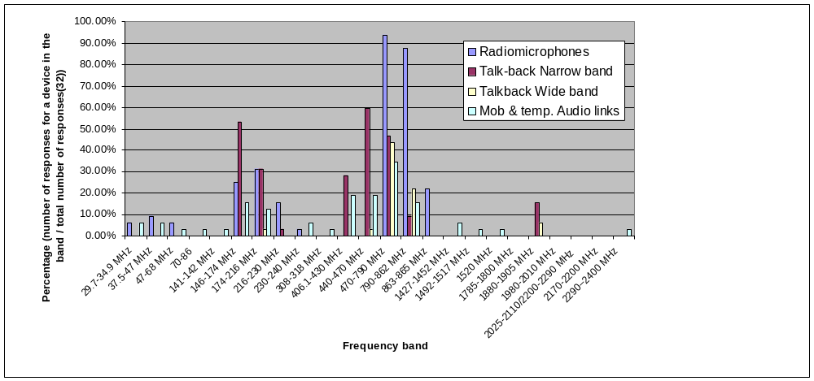

Figure 1: Overview of PMSE broadcasting applications used in the band 29.7 to 2400 MHz

Bands IV/V (470-862 MHz) are of great importance for PMSE applications. It is the primary band for radiomicrophones, in-ear monitoring and portable audio links, talk-back and wireless intercom, mobile and temporary audio links. It should be noted that, within the Bands IV/V, sometimes only the 790-862 MHz band is used for PMSE services. The following figure provides an overview of applications used in the band 470–862 MHz [9].

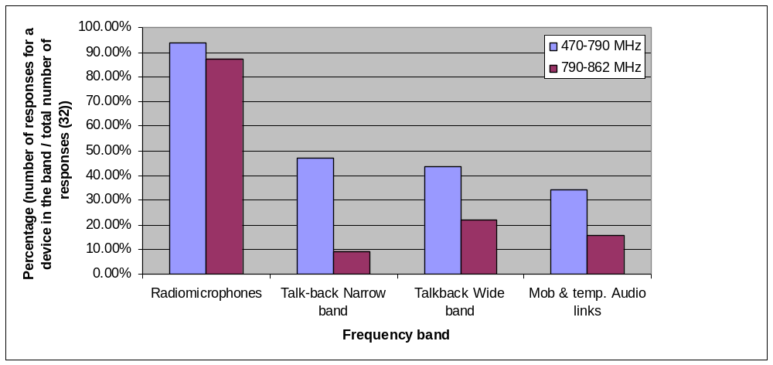
Figure 2: Overview of PMSE broadcasting applications used in the band 470 – 862 MHz

- Wireless microphones

These are the most common and widespread PMSE users of the 470-862 MHz band. PMSE users characterise wireless microphones as critical to their ability to make and mount high-quality programmes and productions.

With some limited exceptions, wireless microphones operate generally with a maximum e.r.p. of 50 mW. To enable high-quality sound, they operate in a bandwidth of 200 kHz.

- Talkback systems

Talkback (narrow band and wide band) systems are also heavy users of the 470-862 MHz band as depicted in Figure 2.

Talkback systems are designed to facilitate production control communication between PMSE users and so do not usually require the same bandwidth as for high-sound quality. Talkback devices typically operate in 12.5 kHz, although they often require higher power levels than wireless microphones – often as high as 1 W e.r.p. for hand-held devices and up to 5 W for talkback base stations.

- In-ear monitors

The use of in-ear monitors has increased in recent years, partially as result of health and safety requirements that restrict the use of cables during performances. They operate in similar ways to wireless microphones and are subject to the same bandwidth and power constraints.
    - Nature of use
There is no “typical” PMSE user since this sector is diverse and fragmented. A distinction can be drawn between “critical” usage and “less critical” usage or between licensed and unlicensed use. The regulation for PMSE is not harmonised in Europe except in the band 863–865 MHz.

There are many different densities of usages which range from a large scale event down to small scale users of a single microphone. Users may be cooperating with each other to ensure that there is no mutual interference. However, they could be working completely independently and unaware of each other existence, until they suffer mutual interference. This situation varies with national regulation.

Users may need to use equipment throughout a whole country; that is in many different places, which causes logistical complexity because of the differing availability of interleaved spectrum for PMSE use from one location to the next. This configuration will change after digital switchover, creating additional challenges for users.

- Critical use

Often undertaken by what is called “professional users” of the 470-862 MHz band, these include both broadcasters and non-broadcasters requiring high audio quality with no interference, e.g. large touring companies and theatres that put on large-scale theatrical and musical productions.

Prime examples include countries capital cities, where productions can require the use of up to 60 wireless microphones at a single show. To avoid intermodulation, current practice is to use no more than eight microphones in an 8 MHz channel in very large productions. For smaller productions with optimized equipment, there is a practical limit of 12 microphones per 8 MHz TV channel before additional operational constraints are needed.

- Less critical Use

These are typically community users covering local events. Their use is generally not coordinated with other users. These users are often called “consumer”. They expect easy access to small amount of spectrum with no cost and typically use a limited amount of equipment.

- Licensed and licence-exempt use

There is no common approach within CEPT countries on the licensing regime. PMSE may be authorized under general national regulations or individual licences, depending on national licensing regime and on the category of PMSE (see section 2.3.3).
    - PMSE “access to spectrum”
PMSE are currently operating in the UHF band on a national basis and on a secondary basis with regard to the broadcast service.

Traditionally, PMSE applications have been using the interleaved spectrum (also called white spaces [6]) between the analogue television transmissions in Bands IV and V. Usage is commonly on a ‘tuning range’ basis, allowing different administrations to authorise these systems where and when they are needed. This maintains maximum flexibility and avoids ‘sterilizing’ spectrum. The only down-side to this is that events such as a tour across Europe have to set up different channels as they move across different countries. In addition, the use of white spaces has limitations because of the need to protect the Broadcasting Service and other Primary Services in the neighbouring areas.

PMSE cannot use occupied channels in the neighbourhood of a transmitter as this would also interfere with their systems. Therefore, there is an inherent necessity on the part of the PMSE user to avoid co-channel interference scenarios for their own protection, in particular by operating in empty TV channels with geographical separation from the co-channel TV transmitters.

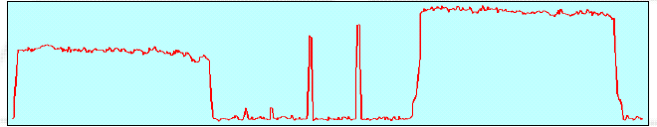
Figure 3: two wireless microphones operating between DVB-T channels

Within a pure analogue terrestrial television environment, as it previously existed, PMSE could easily coexist with analogue transmission. This situation has changed in ‘critical areas’ with the introduction of digital terrestrial broadcasting applications (SD and HD TV, mobile TV, etc.), as in some areas almost no spectrum gaps will be useable by PMSE in the future (see also section 4.1 and Annex 2).

In particular, the EBU reported that in the 470-862 MHz band where the spectrum is crowded with analogue TV, DVB-T and other services and it is difficult to find enough frequencies in some areas (big cities) for major events. The increased number of operators using the band (DVB-T is more spectrum efficient and more TV services are possible) increases the difficulties to find enough frequencies for radio microphones for all operators. In some cases, interference (sometimes intermodulation) and break up occur.

The amount of spectrum available for PMSE in the UHF band depends on the use of the band by digital television, on the intensity of demand for those channels by different PMSE users, as well as on the potential harmonisation of a sub-band for fixed/mobile applications in the sub-band 790–862 MHz (see [2] and [3] for details).

PMSE “spectrum requirement”

In assessing the spectrum requirement for PMSE, it is important to consider the normal regular demand in spectrum should be distinguished from the “peak demand”. ”Peak demand” may be temporary or geographically limited.

The geographical peaks correspond to long term use within fixed sites in certain geographical areas (e.g. large urban conglomerations) where there is always a continuous heavy demand (typically multi-equipment, multi-channel users), thus most of the available UHF spectrum is needed to satisfy this demand. Every country has these in a few locations.

The temporary peaks correspond to special events of a short term nature (big concerts, festivals etc.).

When temporary events are staged at existing geographical peak locations they result in major issues requiring detailed intervention by a band manager or the administration, as you have a double overload. Then, carefully controlled reuse between indoors and outdoors may be needed every kilometer or less.

It should be noted that peak demand most often comes from professional users (e.g. broadcasters).
Annex 3 provides information on the number of links/channels for some long term peak and temporary events.

Annex 4 provides examples of analysis of spectrum requirements for PMSE for regular demand. It shows that around 150 MHz are needed in order to accommodate 100 PMSE links.

Manufacturers indicated that a yearly average increase of about 5% in PMSE units is to be expected in the coming 10 years.

Regulatory framework
The PMSE systems operate in general on a non-interfering and non-protected basis. ERC/REC 70-03 [10] and ERC/REC 25-10 [11] provide guidance for the regulatory framework for PMSE.
    - ERC/REC 70-03
Harmonised technical conditions of use are defined in ERC/REC 70-03, Annex 10 focusing on audio devices or equipment (i.e. radio micro-phones and other audio devices). The following table provides an overview of the regulatory framework for radio microphones and assistive listening devices according to ERC/REC 70-03.

Frequency Band | Power | Duty cycle | Channel spacing | Notes
a 29.7-47.0 MHz | 10 mW e.r.p. | up to 100% | 50 kHz | On a tuning range basis  The frequency bands 30.3-30.5 MHz, 32.15-32.45 MHz and 41.015-47.00 MHz are harmonised military bands 32.45 MHz and 41.015-47.00 MHz are harmonised military bands
b 173.965-174.015 MHz | 2 mW e.r.p. | up to 100% | 50 kHz | Aids for the hearing impaired
c 863-865 MHz | 10 mW e.r.p. | up to 100% | No spacing
d 174-216 MHz | 50 mW e.r.p. | up to 100% | No spacing | On a tuning range basis  Individual license required
e 470-862 MHz | 50 mW e.r.p. | up to 100% | No spacing | On a tuning range basis  Individual license required
f 1785-1795 MHz | 20 mW e.i.r.p.  50 mW e.i.r.p. | up to 100% | No spacing | Individual license required  50 mW restricted to body worn microphones
g 1795-1800 MHz | 20 mW e.i.r.p.  50 mW e.i.r.p. | up to 100% | No spacing | 50 mW restricted to body worn equipment
Table 1: Radio microphones and Assistive Listening Devices according to ERC/REC 70-03

Note: The band 863-865 MHz is harmonised for radio microphones (sub-class 46) and wireless audio applications (sub-class 48) (see also Harmonised Standard EN 301 357- 2 [12]).

    - Rec. 25-10
The ERC Recommendation 25-10 [11] has been revised in 2003. It recommends CEPT Administrations to assign frequencies for audio and video SAP/SAB links from the following tuning ranges:

Type of link | Recommended frequencies | Technical parameters
Type of link | Tuning ranges | Technical parameters
Radio microphones and  in-ear monitors | 174-216 MHz  470-862 MHz  1785-1800 MHz  (Note 1) | ERC/REC 70-03
Portable audio links and  mobile audio links and  temporary point-to-point audio links | VHF/UHF (Note 2) | ERC REP 42
Table 2: Audio SAP/SAB frequencies for according to Rec. 25-10

Note 1: The band 863-865 MHz is available for radio microphones, however due note should be taken that it is used also for non-professional and consumer radio applications (cordless audio, etc.).
Note 2: Depending on application scenario, channel width and required transmitter power, the portable, mobile and temporary point-to-point audio links may be accommodated either in the frequency bands 174-216 MHz/470-862 MHz identified for professional radio microphones (typically for low power/wideband applications) or in other VHF/UHF bands, including private mobile radio (PMR) bands (typically for high power/narrowband applications).
    - Licensing regime in the UHF band
There is no common approach within CEPT countries on the licensing regime. PMSE may be authorized under general national regulations or individual licenses, depending on national licensing regime and on the category of PMSE.
General licensing (license exempt/license free) regime may be applicable in part(s) of the UHF band for systems meeting technical constraints (i.e. an e.r.p limit - see for example the conditions provided in ERC/REC 70-03 – and/or maximum channel spacing), for some type of applications (i.e. professional devices) or on a temporary basis (for example maximum 2 weeks).
In other parts of the UHF band or in particular channel, an individual licensing regime may be applicable for all PMSE applications or for specific applications (i.e. Radio Microphone and In-ear Microphone transmitters).
Licenses are afforded directly by the administration or by band manager.
PMSE user may coordinate frequencies at the event location using frequency compatibility programs offered by the PMSE manufacturers.

Technical characteristics of PMSE systems
The main characteristics of PWMS systems (PMSE Audio) are provided in ETSI TR 102 546 [13] and measurement standard EN 300 422 [14]. Additional characteristics are provided in Annex 5.

Considerations on the band 790-862 MHz
The band 790-862 MHz is currently available for PMSE usage in most CEPT countries. It has to be noted that in several CEPT countries for historical reasons (availability of equipment, the relatively light use of these channels for analogue terrestrial television and the availability of some channels) the upper part of the UHF band was extensively used for PMSE (see also figure 2). In particular, some CEPT countries indicated that at present, within the UHF band only parts of the spectrum above 790 MHz were available for PMSE systems.
Considering the possible usage of the band 790-862 MHz by the mobile service or by digital television or by other primary services, some administrations already planned to restrict the access to this band for PMSE applications in the future.
The considerations relating to the impact of PMSE on DVB-T given in section 4.1 (band 470-790 MHz) are also applicable in the frequency range 790-862 MHz for those administrations wishing to deploy DVB-T in this frequency range. It has to be noted that in response to task 2 (channelling arrangements) of 2nd EC Mandate on digital dividend (see Annex 1), ECC PT1 has developed ECC Decision ECC/DEC/(09)03 for Harmonised conditions for mobile/fixed communication networks operating in the band 790-862 MHz.

Compatibility between PMSE and Mobile/Fixed Communication Networks
The amount of spectrum available for PMSE in the UHF band depends on the use of the band by digital television, on the intensity of demand for those channels by different PMSE users, as well as on the potential harmonisation of a sub-band for fixed/mobile applications in the sub-band 790-862 MHz (see [2] and [3] for details). It is expected that mobile systems will be deployed, in particular, in dense areas, i.e. in locations where PMSE could be deployed.
PMSE cannot use occupied channels in the neighbourhood of a transmitter as this would also interfere with their systems. Therefore, there is an inherent necessity on the part of the PMSE user to avoid co-channel interference scenarios for their own protection.
The co-location of mobile and PMSE systems and the difficulty of detecting mobile transmission make the co-existence of PMSE and mobile systems not practicable. Therefore, only the operation in adjacent or nearby frequencies are considered (see section 3.2 and 3.3).
One administration has assessed the impact of mobile uplinks operating in the 790-854 MHz band on wireless microphones operating in an adjacent channel [15]. It was concluded that, in most cases, mobile handsets operating in the 790-854 MHz band will not cause harmful interference to wireless microphones operating in an adjacent channel. In addition, later work by SE42 has further considered the compatibility between PMSE and mobile/fixed communications as described in the following sections.

Potential use of the FDD centre gap
While PMSE would technically be a good potential use of this spectrum, we also note that the utility of any band of 5-12 MHz – with no adjacent available spectrum – may be limited for PMSE users who require significant bandwidth for large-scale productions (often more than 24 MHz of contiguous spectrum).
The ECC Decision ECC/DEC/(09)03 dealing with task 2 of the EC Mandate contains a preferred channel arrangement for FDD systems which includes a centre gap of 11 MHz (see Annex 1: Preferred Harmonised frequency arrangement). SE42 considered the possible usage of this centre gap by PMSE.
With regard to the protection of PMSE from mobile/fixed communications networks, SE42 concluded that (see [16]), with the exception of the upper 1 MHz and the lower 200 kHz of the FDD duplex gap where the required protection distances may be considered prohibitive for certain applications, the operation of radio microphones in the FDD duplex gap would not be hindered by interference from mobile/fixed communication networks equipment.
SE42 also considered the potential impact of PMSE on mobile/fixed communication networks and those results are retained in Annex 3 to the ECC Decision ECC/DEC/(09)03.
It has to be noted that the centre gap will not be available in countries using TDD systems in this frequency range or using Annex 2 of draft ECC Decision (Guidance for administrations not implementing the preferred frequency arrangement in Annex 1).

Potential use of the guard bands
    - Guard band as defined in Annex 1 to the draft ECC Decision (preferred channelling arrangement of the band 790-862 MHz)
For those administrations implementing the preferred channel arrangement as given in Annex 1 to the draft ECC Decision, a guard band at the edge of the 790 MHz band of 1 MHz is considered. There is only a limited potential for the use of this frequency separation by PMSE, unless used in addition to spectrum below 790 MHz.
The usage of this 1 MHz guard band should also account for the protection of the potential impact of PMSE on mobile/fixed communication networks. Therefore, the conditions relating to the protection of mobile/fixed communication networks as given in the draft ECC Decision may be considered at 790 MHz.
    - Guard band as defined in Annex 2 to the draft ECC Decision
For those administrations implementing the channel arrangement as given in Annex 2 to the draft ECC Decision, a guard band at the edge of the 790 MHz band of 7 MHz is considered. This frequency separation may provide an opportunity for the use of PMSE in that country considering the conclusions of SE42.
For the protection of PMSE from the emission of mobile/fixed communication networks, SE 42 considered that, while the analysis was performed specifically in the context of the use of the FDD duplex gap by PMSE equipment (see 3.2), these results also apply to the use by PMSE equipment of any guard-band between the mobile/fixed communication networks systems and broadcast systems in a TDD-only band-plan for the 790-862 MHz digital dividend spectrum. This would, however, be with the understanding that the emission levels of the relevant TDD base stations (BSs) and terminal stations (TSs) would not exceed those of their FDD counterparts as considered in this analysis and that the impact of broadcast systems to PMSE is not taken into account. Therefore, it may be concluded that a guard band of 1 MHz is necessary in order to protect PMSE systems from the emissions of TDD systems.
The usage of this guard band should also account for the protection of the potential impact of PMSE on mobile/fixed communication networks. The conditions relating to the protection of mobile/fixed communication networks as given in the draft ECC Decision may be considered at 790 MHz.

Protection of ARNS
This band is allocated in some countries to the ARNS in accordance with 5.312 on a primary basis, and administrations listed in 5.312 may not allow PMSE in this frequency band.

Conclusions on the band 790-862 MHz
Future access to the band for PMSE will be limited by the introduction of the mobile/fixed communication networks, digital television and current usage of other primary services. PMSE may not be maintained within the band 790-862 MHz when mobile/fixed communication networks become operational in this band.

Exceptions to this rule could be managed on a national basis, in particular concerning the use of PMSE within centre gap of the FDD channel arrangement and the guard band of the channel arrangements. PMSE may need to consider the implementation of filtering in order to avoid interference from mobile/fixed communication networks.
The usage of PMSE at the border of countries may need to take into account the usage of this band for the broadcast service or other primary services. However, the level of power used by PMSE being quite low, the impact of PMSE on the broadcast service or other primary services in the neighbouring countries is not expected to be significant.
Considering the potential new usage in the band 790-862 MHz and the related compatibility issues, it does not seem appropriate to consider the band 790-862 MHz as a harmonised European band for PMSE in the future.
CEPT and administrations may need to identify alternative sub-band(s) for PMSE usage. The migration of the frequencies used by these devices needs to be planned in association with the users and according to the possible introduction of the mobile systems.

Considerations on the band 470-790 MHz
This section considers the possible future usage of PMSE in the band 470-790 MHz, also considering the compatibility with other systems. The band 470-790 MHz is available for PMSE in most of CEPT countries and PMSE systems are widely used in this frequency range.

Compatibility with DVB-T
As indicated in section 2.2, within a pure analogue terrestrial television environment, as it previously existed, PMSE could easily coexist with analogue transmission. This situation has changed in ‘critical areas’ with the introduction of digital terrestrial broadcasting applications (SD and HD TV, mobile TV, etc.), as in some areas almost no spectrum gaps will be useable by PMSE in the future (see Annex 2). This section considers compatibility between PMSE and DVB-T considering the results provided in a number of ERC Reports.

ERC Report 88 [17] considered compatibility and sharing analysis between DVB-T and radio microphones in bands IV and V. It concluded that radio microphones services could continue to be operated on an interleaved basis within the white space spectrum, providing that they are subject to restrictions on the operating power of the transmitters and the need for coordination of specific assignments to ensure that they do not interfere with the reception of the digital broadcasting services in areas adjacent to their location.

In most cases, co-channel operation of DVB-T and radio microphones within a DVB–T coverage area will cause unacceptable interference to radio microphones and vice-versa. However, indoor operation of radio microphones, for instance in theatres, may be feasible even if these operate on the same channel as a digital broadcasting service depending on building shielding loss and the location of the nearest DVB-T receiver, and depending on the type of network and whether it aims to cover indoor or not. These cases may be evaluated on a site by site basis.

Operation of radio microphones in the adjacent channel to that used by a DVB-T service will be possible in a lot of cases provided a guard band is used (e.g. 500 kHz). In practice, use of the 2nd adjacent channel (n+2) by radio microphones will be feasible in most cases. This applies to both indoor and outdoor operation of radio microphones.
The measurements of these protection ratios were limited to professional DVB-T receivers. However, the immunity of domestic receivers, particularly for adjacent channel rejection, is not fully known and therefore additional measurements are needed.

ERC Report 89 [18] considered the Compatibility and sharing analysis between DVB-T and Talkback links in bands IV and V. ERC Report 90 [19] considered compatibility and sharing analysis between DVB-T and OB (Outside Broadcast) audio links in bands IV and V. These ERC Reports reached similar conclusions.

Compatibility with DVB-H
No assessment of the impact of DVB-H on PMSE was conducted. It is expected that the conclusion reached for DVB-T given in section 4.1 are also applicable to DVB-H.

Compatibility with other potential systems
    - RAS
The band 608-614 MHz (UHF channel 38) is used by the radio astronomy service for studying extraterrestrial radio sources. This use has secondary status in Europe. Footnote RR 5.149, which applies to this band, urges administrations to take all practical steps to protect the radio astronomy service from harmful interference. Administrations may need to consider appropriate measures on a national basis in order to protect the radio astronomy stations from PMSE operations.
    - ARNS
The band 645-790 MHz is allocated in some countries to the ARNS in accordance with 5.312 on a Primary basis and administrations listed in 5.312 may not allow PMSE in this frequency band
    - Cognitive Radio
CEPT Report 24 [20] considered the possible use of white spaces by systems implementing cognitive radio and concluded as follows:
“CEPT identifies white space as a part of the spectrum, which is available for a radiocommunication application (service, system) at a given time in a given geographical area on a non-interfering non-protected basis with regard to primary services and other services with a higher priority on a national basis.
The feasibility of cognitive sharing schemes has not yet been conclusively demonstrated. It is too early in the development cycle to judge the final capabilities of cognitive radio technology for white space devices. Any sharing scheme will have to be carefully assessed and confirmed, including by testing, before it can be put in place. This includes compatibility with other services such as terrestrial broadcasting and PMSE equipment but also the consequence in terms of possibility of evolution of terrestrial broadcasting planning and technology.
…
Since the Cognitive radio (CR) technology is at a very early stage the CEPT recommends looking further into the requirements within the European environment for CR devices to be deployed in white space spectrum in order to facilitate the further development of CR technology.
The current CEPT view is that any new white space applications should be used on a non protected non interfering basis.”
Therefore, if the band 470 – 862 MHz, or part of it, is made available to cognitive radio systems, the protection of PMSE should also be considered.
CEPT is currently studying this issue further in order to define technical and operational requirements for the operation of cognitive radio systems in the white spaces of the UHF broadcasting band (470-790 MHz) to ensure the protection of incumbent radio services/systems and investigate the consequential amount of spectrum potentially available as “white space”.

Possible development in the band 470-790 MHz
    - Technical development of PMSE - not limited to the band 470-790 MHz
Tunning range of existing equipment
Tuning range (varies between equipments / manufacturers) are currently as follows:
  - UHF:
    - Receiver: 5.5 MHz up to 155 MHz average 60 MHz
    - Transmitter: 5.5 MHz up to 155 MHz average 30 MHz
  - VHF: 5 MHz
Increase of the tuning range is considered. However, the tuning range has an impact on the spectrum efficiency of PMSE devices as further described in the following paragraph.
Intermodulation product

The maximum number of PMSE systems to be deployed in a given bandwidth at a given location is highly dependent with the intermodulation product generated by the systems themselves. In the future, if the equipments are designed in order to decrease the non linearities, this would result in less intermodulation problems, facilitating the possibilities of identifying frequencies for PMSE systems in a given area. In addition, in order to face the problem of intermodulation response rejection of PMSE, the systems should become more selective. A smaller RF frontend bandwidth leads to noticeable better frequency efficiency by increasing the number of PMSE per available channel. Reducing the receiver intermodulation response rejection can be achieved by high selective filters directly at the antenna feeding point. As a drawback, this will also result in decreasing the frequency agility of the systems.

Enhancement of audio quality

As the start point of a very long production chain for multimedia content PWMS has to face the growing interest in the enhancement of audio quality of an increasing user community. In digital terms, CD quality with a sampling rate of 44.1 kHz and a 16 bit AD/DA conversion resolution are no longer future-proof. Actual recording equipment works with a sampling rate of 96 kHz or even 192 kHz and a AD/DA conversion resolution of 24 bit. Future PWMS must implement these values to avoid additional latency due to additional conversion steps and not to truncate the audio quality right at the beginning of the production chain. An implementation of a high sampling rate and conversion resolution results in a higher
data volume and therefore a higher spectral demand.
Considering the enhancement of audio quality and a very small PMSE channel bandwidth of 200 or 400 kHz in the UHF range it has not been possible to find a market ready solution yet.
Digitalisation
Today’s PMSE are still a basically analogue application. Digital pendants to contemporary analogue systems have to come up with a very short latency of about 2 ms to be valuable for the professional production of multimedia content and no significant increase in power consumption. Digitalisation will also require proper AD and DA conversion ensuring high audio quality (around 120 dB dynamic range). The digitalisation of PMSE equipment could result in:
- offering better quality and better robustness
- increasing by 10% the number of units in 8 MHz.
It has to be noted that manufacturers have been working on digitalisation for almost 10 years now, but despite the R&D efforts, it is a fact that very few digital equipments are available on the world-wide market in other frequency bands than UHF which is used by the actual majority of PMSE. The new digital technology is increasingly entering the market and being used for professional productions (e.g. in London’s West End). For digital PMSE systems similar intermodulation effects are expected.
Spectrum efficiency
Because of the lack of incentives to use spectrum efficiently in the past, PMSE has tended not to maximise its use of the 470-862 MHz band fully. PMSE solutions may have to be developed in the future, to make a better frequency coordination and management possible. The development of new more spectrum efficient may require from 3 to 8 years.
    - Management of PMSE
As indicated in section 2.3.3, there is no common approach within CEPT countries on the licensing regime. In some CEPT countries, PMSE are authorized under general licensing regime (license exempt/license free) or individual licenses, depending on national licensing regime and on the category of PMSE.
It is understood that, the licensing regime should enable administrations to retain certain degree of control over the spectrum usage and the interference situation.
At a given location the PMSE applications requiring a “high degree of protection” should not share the channels with consumer devices because the adequate protection cannot be guaranteed. It may therefore be appropriate to identify separate parts of spectrum depending on the requirements of PMSE applications (critical / less critical).

Conclusions on the band 470-790 MHz
The amount of white spaces – possibly available for PMSE - will be reduced after the introduction of digital broadcasting applications (SD and HD TV, mobile TV, etc.).

The PMSE demand for spectrum is expected to increase in CEPT over the coming years. Manufacturers indicated a yearly average 5% increase in the number of devices in the coming 10 years. In addition, according to a report published in December 2006 [21], demand for wireless microphones was expected to increase significantly until 2014 to accommodate even more complex productions and events and greater demand for news and sports coverage.

It is expected that the controlled access of PMSE services to white space spectrum in the band 470-790 MHz will continue in the foreseeable future available in order to ensure the continuation of PMSE operation in the UHF band, taking into account the development of digital broadcasting in such band.
Furthermore, spectrum efficiency should be improved via the implementation of new technologies in PMSE systems. This would also help to meet the increase of PMSE usage in the UHF band. Technical efficiency could indeed be improved by using technically more advanced equipment (digitalisation…).

considerations relating to Other BANDS and ongoing CEPT activities

VHF band
According to ERC/REC 70-03 and ERC/REC 25-10, the band 174-216 MHz is available for PMSE usage (see section 2.3.1) and is intensively used within CEPT for analogue TV broadcasting. At RRC-06, plans were developed in order to accommodate T-DAB and DVB-T systems. As in the UHF band, the introduction of digital systems in this band may result in reducing the number of white spaces available for PMSE devices.

The band is of interest for PMSE systems due to its good propagation conditions. The man-made noise is higher than in the UHF band which could reduce the audio quality. However, the antenna length is not practicable. As for the UHF band, there is no harmonised licensing approach within CEPT.

PMSE equipments are currently not available on the market; however, the technology is not new since this band was more intensively used in the past. The use of this band may require additional development time before putting equipments on the market.

In addition, the band 216-223 MHz (or part of this band) is available in several CEPT countries for PMSE.

1785 to 1800 MHz
According to Annex 10 to ERC/REC 70-03 [11] and ERC/REC 25-10 [12], the band 1785 to 1800 MHz may be available for PMSE. In the band 1785-1795 MHz, individual license are required while the band 1795-1800 MHz may be used on an unlicensed basis. However, there is no past or present use of this band and no known plans for this to change.

The propagation condition are less good in this band compared to the VHF / UHF band, therefore the number of potential applications is quite limited. Some equipment is now available.

This band is also used in some countries for other usages such as governmental applications. In addition, some countries are also considering the deployment of WAPECS systems.

In addition, WG FM is currently studying the possibilities for the implementation of the frequency bands 1800-1805 MHz into Annex 10 of ERC/REC 70-03 for professional radio microphones.

1.5 GHz (L Band)
WG FM is currently considering the question of possible identification of the 1.5 GHz for PMSE.
For the band 1452-1477.5, the ECC Report 121 [22] provides technical elements about T-DAB to allow regulators to perform national compatibility studies. Furthermore, WG FM is currently working on the characteristics of other multimedia systems which could potentially be deployed in this band. Suitability of this spectrum for PMSE would require full compatibility studies with T-DAB as well as other systems as identified by FM45 (including T-DMB, DVB-H and FLO).
In addition, WG SE is conducting additional compatibility studies relating to PMSE in the L-band excluding the band 1544 – 1545 MHz in order to consider the feasibility of implementing the DAA in PMSE.
Due to the propagation conditions, for the same coverage range as in the UHF band (470-862 MHz), PMSE would need more output power.
This spectrum is not available for PMSE use in all CEPT countries. In some countries the future use of the band is under consideration. In the UK, the band 1452 – 1492 MHz has been allocated to a license.
CEPT may need to finalise the study relating to the L band in order to identify sub-bands, in particular 1452-1477.5 MHz, which could be used by PMSE equipment. It has to be noted that similarly to the situation in the VHF and UHF band, it may be difficult to identify a band available in the whole CEPT and administrations may have to decide which part of the L band is available on a national basis.

WRC-12 Agenda Item 1.5
The aim of this agenda item is to consider worldwide/regional harmonisation of spectrum for electronic news gathering (ENG) within the framework of ITU-R. CEPT CPG is the European group responsible for the WRC-12 agenda item 1.5.

863 – 865 MHz
For those users who do not require guaranteed interference-free spectrum access and do not wish to purchase a license, the 863-865 MHz band is available for wireless-microphone use on an unlicensed basis in most of CEPT countries and is already identified as an EU harmonised band.

It has to be noted that according to the results provided by SE42, the 1MHz separation between 862 MHz and 863 MHz will ensure that the PMSE operating in the EU harmonised band are not interfered by the operation of mobile/fixed communication networks.

In addition, administrations may need to consider the conditions relating to the protection of mobile/fixed communication networks as given in the draft ECC Decision.

Other bands
The whole 29.7 – 47 MHz band, or part of it, is available in several CEPT countries. This band is seldom used due to the level of interference and therefore only suitable for low quality audio usage.

In Europe, the 2.4 GHz ISM band is very crowded because of the utilization of radio remote control, Bluetooth and WLAN, especially in urban areas. According to this, a stable and reliable PMSE connection cannot be guaranteed in this frequency band for professional usage.

The 6 GHz frequency range may be used by PMSE UWB technology. It has to be noted that the civil usage of UWB technology is still in its infancy, particularly with regard to PMSE. Actually the range and the number of possible parallel working PMSE are quite limited and UWB PMSE is likewise not able to replace conventional UHF PMSE.

Conclusions
PMSE users are facing significant change in CEPT. The implications of digital switchover and the award of the digital dividend mean that their historic use of the 470-862 MHz band will need to adapt.

PMSE demand for spectrum is expected to continue to rise in the medium term. Even if there was no reduction in the quantity of interleaved spectrum available for PMSE, users would eventually face increasing constraints in spectrum supply and the need to change the way that they used it.

Interleaved channels/white spaces in the UHF band are the principal spectrum for wide band audio applications. Therefore, the 470 MHz to 790 MHz range should be maintained for PMSE allowing them to operate on a temporary basis in areas where broadcasting is not yet used.
The PMSE applications in the 470-790 MHz band should primarily be the PMSE applications that require some protection (i.e. “Critical use”). This may be achieved by a “controlled” access to the spectrum. The “controlled” access may allow improving the frequency re-use in the band 470-790 MHz. This could be achieved by administrations via individual licensing regime (see ERC/REC 70-03) or by specifying the type of equipments allowed to operate in this band. In most cases, this would provide sufficient amount of spectrum for average demand and in some cases also for peak demand.
Two kinds of bands could be made available to PMSE in addition to 470-790 MHz:
- For “less critical” uses which can tolerate higher interference levels or which can not operate in the band 470–790 MHz, frequency bands should be identified without a “controlled” access to the spectrum.
- Where interleaved channels are insufficient for “critical” PMSE uses in the band 470-790 MHz to satisfy peak demand, new frequency bands need to be identified, where “critical” PMSE uses can ensure the protection of services such as broadcasting. This may be achieved by a “controlled” access to this new spectrum.
Bands to be considered could be the TV-VHF band (including 216-223 MHz), part of the L band (1452 - 1559 MHz), 1785-1800 MHz or available spectrum in 790-862 MHz, if any (e.g. duplex gap).
It has to be noted that the band 863-865 MHz is already available in most CEPT countries for wireless microphones users who do not require guaranteed interference-free spectrum access and do not wish to obtain a license.
Furthermore, efficiency of the PMSE systems should be improved. This would also help to meet the increase of PMSE usage in the UHF band. This could be achieved by improving:
- the frequency management of PMSE (i.e. a more effective approach to planning assignments); and
- the spectrum efficiency of the equipment (i.e. using new equipment that uses less spectrum overall in a sharing environment).

The following table provides a non-exhaustive list of the bands to be further considered:

Possible bands to be considered | Comments
216-223 MHz | Currently only the band 174 -216 MHz is included in ERC/REC 70-03 and ERC/REC 25-10
790-862 MHz | Guard band and center gap (see Annex 3 to draft ECC Decision) in those countries where it is available
L band | CEPT may need to finalise the study relating to the L band in order to identify sub-bands which could be used by PMSE equipment. It has to be noted that similarly to the situation in the VHF and UHF band, it may be difficult to identify a band available in the whole CEPT and administrations may have to decide which part of the L band is available on a national basis.
1800-1805 MHz | Possibly in conjunction with band 1785 to 1800 MHz
Table 3: Possible bands to be further considered for future use by PMSE

Annex 1: SECOND EC Mandate on digital dividend
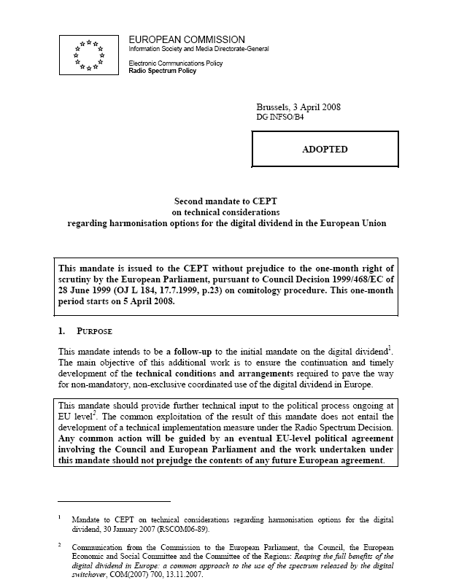
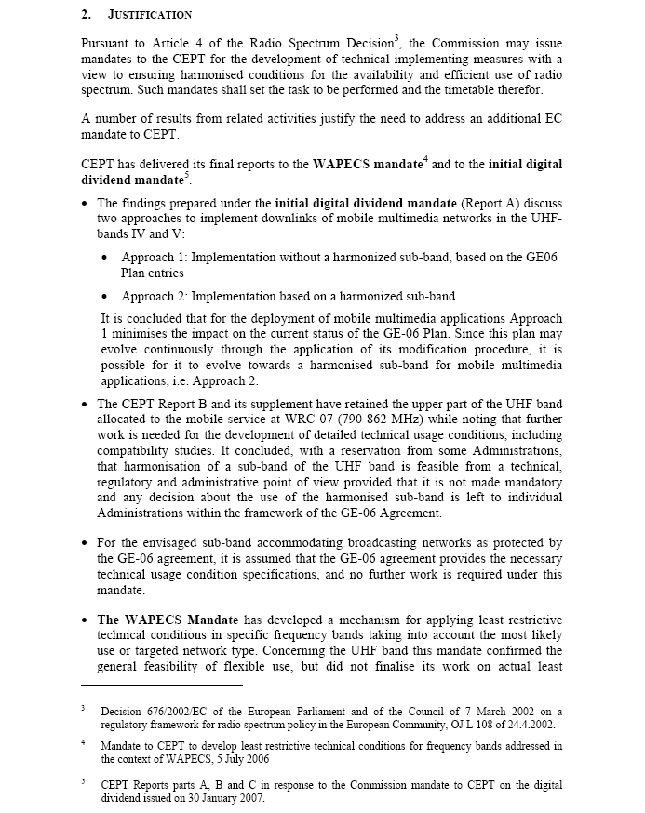

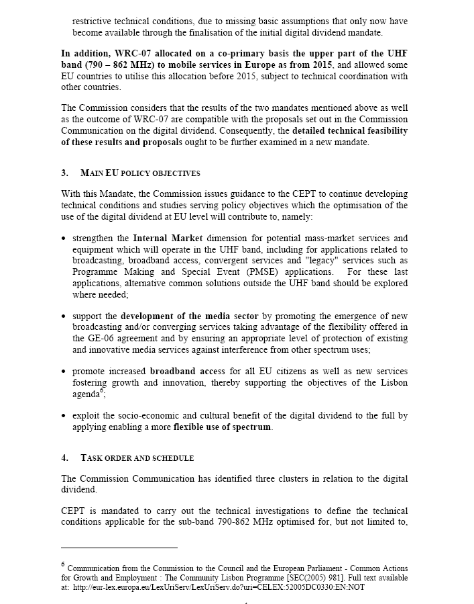
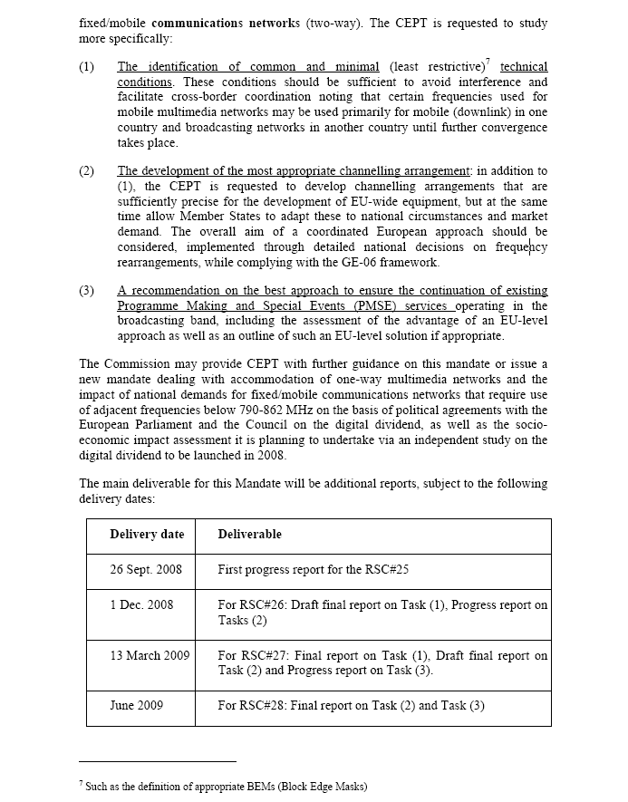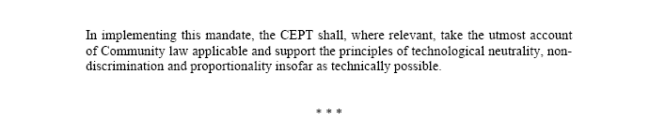
Annex 2: Case Study concerning the open air stage in Bregenz („Seebühne Bregenz“)

During the open air event „Bregenzer Festspiele“ in July and August 2008 significant problems were experienced on the operation of PMSE in the UHF band due to the start of DVB-T in this area in AUT and in the neighbouring countries (D and SUI).

Most of the available PMSE-equipment in Bregenz can only operate within the range of TV channel 31 to 49.
Within this range now 5 channels, which were used in the past for PMSE, cannot be used anymore due to existing DVB-T operation.

The measured field strength at the open air stage (mainly of DVB-T transmissions) is in the range of 67dBµV/m to 88dBµV/m and makes an operation of PMSE impossible on these channels.

The location of Bregenz is a border city to D and SUI and therefore also very sensitive to transmissions from these other countries (no shielding of signals due to its open surrounding and its location on the shore of the lake Bodensee; more or less line of sight propagation characteristics to many DVB-T transmitters).

At the end of the Switch Over Process from analogue to digital broadcasting it is expected, that additional 12 channels within the channel range 31 to 49 cannot be used on the long term for PMSE operation in Bregenz.

Compared to the analogue broadcasting environment a major part of the available spectrum for PSME-applications is now lost due to digitalization and the situation will get even worse in future.

Similar problems for PMSE-applications will occur also on other event locations in Austria, for example at the festivals in Salzburg (border area to D) and Moerbisch (border Area to HNG). These cultural events are of enormous importance for Austria.

Taking into account a full implementation of DVB-T by about 2011/12 in central Europe the available spectrum for PMSE applications will further decrease significantly, so that in many cases operation of PMSE-applications will not be possible anymore.

On the one hand there is an increasing demand for PMSE applications in the UHF band, but on the other hand spectrum resources in the UHF band are dramatically decreasing. From operators economic point of view spectrum resources for PSME applications in the medium and long term must be predictable (PMSE equipment cannot be changed every year, because of economic reasons).
Annex 3: Examples of peak demand
This annex provides examples of temporary or geographically limited “peak demands” (see also Annex 2).
The demand for some temporary events in the year 2008 in Switzerland is given below:
International Motor Show in Geneva (06.-16.03.2008)
- 40 PMSE links in channels 21-60
- 51 PMSE links in channels 61-69

Open-Air pop concert of Madonna in Dübendorf (30.08.2008)
- 35 PMSE links in channels 21-60
- 6 PMSE links in channels 61-69

European Football Championship EURO08 (07.-29.06.2008)
Assigned frequencies in the whole UHF-band (470-862 MHz):
- for the opening game in Basel: 415 links
- total for all games in Basel: 481 links
- total for all games in Bern: 328 links
- total for all games in Genève: 274 links
- total for all games in Zürich: 343 links
Examples of geographical peaks:
- In the TV-studio “Leutschenbach” in Zürich up to 100 links are required during TV-productions
- At the Federal Institute of Technology in Zürich around 200 permanent links are installed for educational purposes in lecture rooms.

Figure A2.1 provides the overview of typical days frequency plan across the Wes End theatres in central London where all TV channels can be used for radio microphones except not all the current 5 Analogue and 6 Digital TV channels of Crystal Palace.

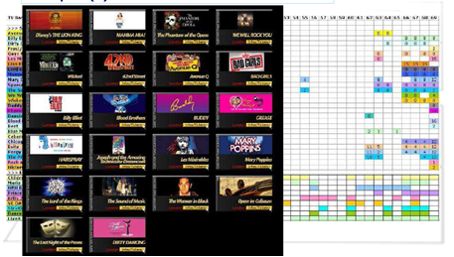
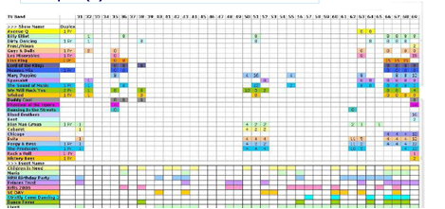
Figure A3.1: Overview of the Radio Microphones usage in London West End – Crystal Palace

In addition, the following data were provided by PMSE manufacturers.

  - In “average”, a normal musical show uses 40 to 60 frequencies.
  - Media production in studio: ~ 50
  - Music-Band, Musical, Theatre: ~ 80
  - Sport events, standard football game): ~ 30
  - Annual events (regional election, sport,…): ~ 120
  - Special events (national elections, sport championships…): ~ 250 up to 800 ‘
    - Table1 describes the demand well, although it does not include some frequencies and the yearly average 5% increases in demand that will appear in the coming 10 years. Needed frequencies for one program:
55 frequencies including the protection gap between microphones, in ear monitoring and talk back links=72MHz.
    - 80 frequencies on the same conditions require 150 MHz.
    - For a media location we have (for example 8 studio’s in 1 area) more than 200 frequencies

Annex 4: Spectrum Requirement of PMSE

Introduction

This section provides calculations in order to assess the spectrum requirements for analogue PWMS. The sample calculation below is only a calculation of the needed interference free spectrum and does not evaluate DVB-T allocations or any other circumstances in the RF environment.

Daily / every day productions:

Total number of channels | Wireless Microphones | IEM | TV channels  needs to be  interference free | TV channels x 8 MHz  needs to be  interference free
12 | 12 |  | 1 | 8 MHz
12 | 10 | 2 | 2 | 16 MHz
32 | 32 |  | 5 | 40 MHz
42 | 42 |  | 7 | 56 MHz
42 | 32 | 10 | 9 | 72 MHz
53 | 53 |  | 9 | 72 MHz
62 | 62 |  | 11 | 88 MHz
62 | 52 | 10 | 13 | 104 MHz
85 | 85 |  | 15 | 120 MHz
98 | 98 |  | 18 | 144 MHz
(Frequency spectrum is one package, e.g. 11 channels = 470 – 558 MHz)

Peak demand:

- High demand during large short term events
- Mobile application is hitting a location with a daily / every day production

In peak demand applications the complete UHF band is occupied. Furthermore due to the lack of available interference free frequency bands working frequencies for special applications (e.g. short range camera team) is calculated to work only for maximum 5 m distance.

Annex 5: Characteristics of PMSE systems
The main characteristics of PWMS systems (PMSE Audio) are provided in ETSI TR 102 546 [23] and measurement standard EN 300 422 [24].

A5.1 Body worn antenna (Handheld or Bodypack equipment; internal or external)

Wireless microphones transmit with omnidirectional antenna and are therefore not subject to antenna gain.

Handheld equipment are equipped usually with λ/2 or λ/4 omnidirectional antenna, gain ≤ 0 dB (≤ 2,2 dBi)
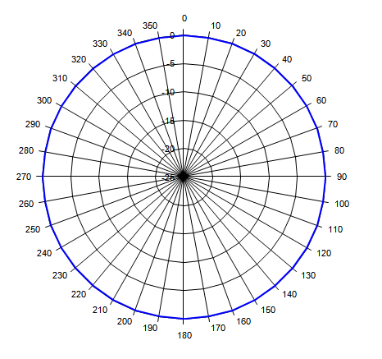  Omnidirectional antenna; horizontal view | 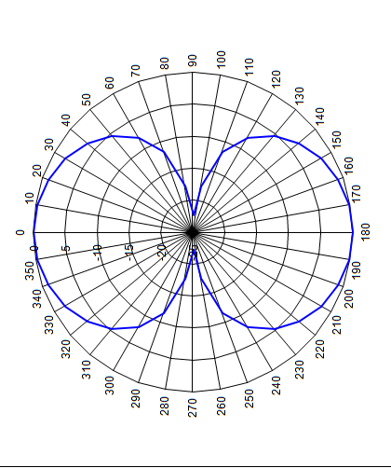  Omnidirectional antenna, vertical view
Figure A5.1: Handheld antenna

Bodypack Y are equipped usually with λ/2 or λ/4 omnidirectional antenna, through human body significant reduced gain of about ≤ -2 dB (≤ 0,2 dBi).

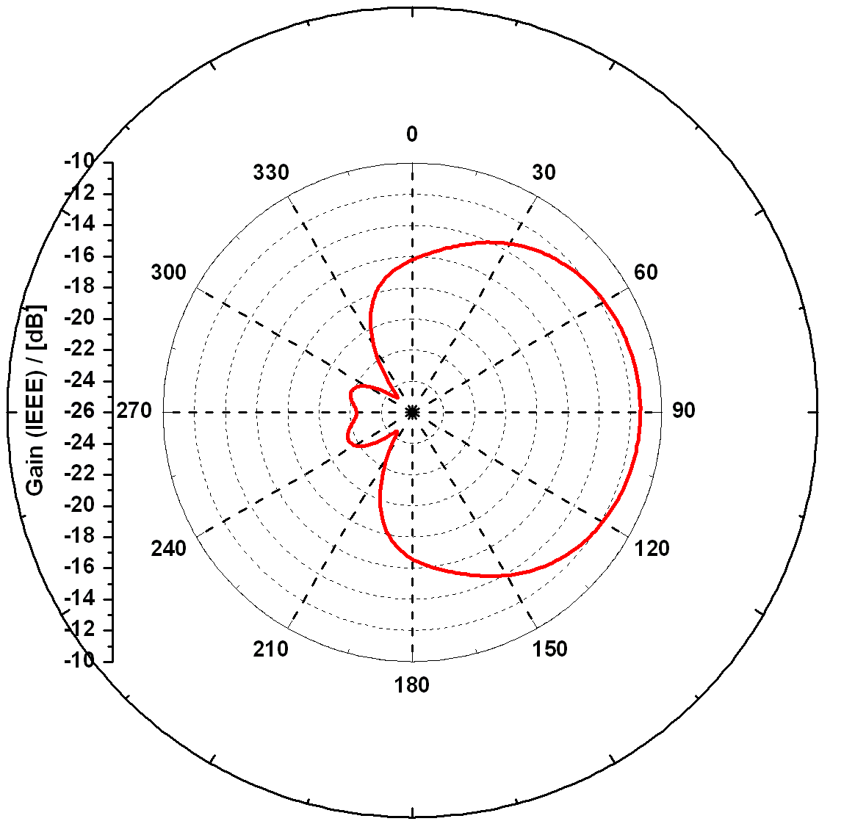  Omnidirectional antenna; horizontal view | 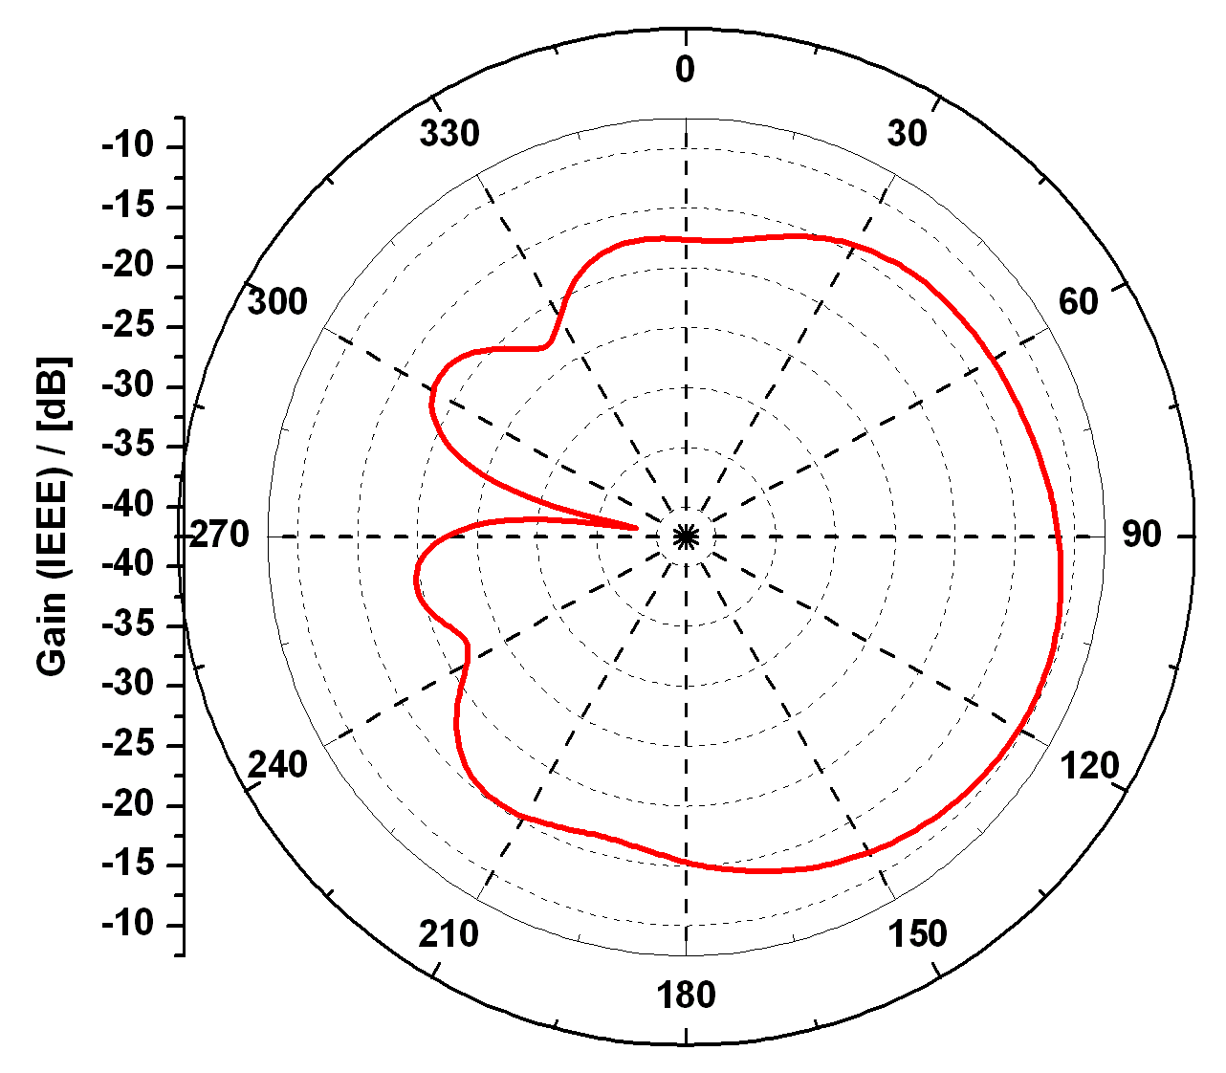  Omnidirectional antenna, vertical view
Figure A5.2: Bodypack antenna
Examples bodypack antenna are provided in Figure A.5.3.

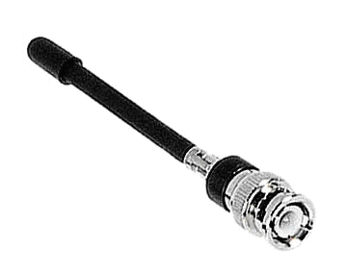
Figure A5.3: Example of Bodypack antenna (λ/4 wire - Size ~ 10 cm)

A5.2 Fixed antenna (IEM, audio links,…; internal or external)
In-ear monitors typically operate with directional antenna and, as a result, have an antenna gain of approximately 6 dB.

Fixed antenna could be either a λ or λ/2 omnidirectional antenna, gain ≤ 0 dB or a directional antenna. These directional antennas can change in beam width and therefore antenna gain can differ. Standard antenna gain is ~ 7dB (9,2 dBi).
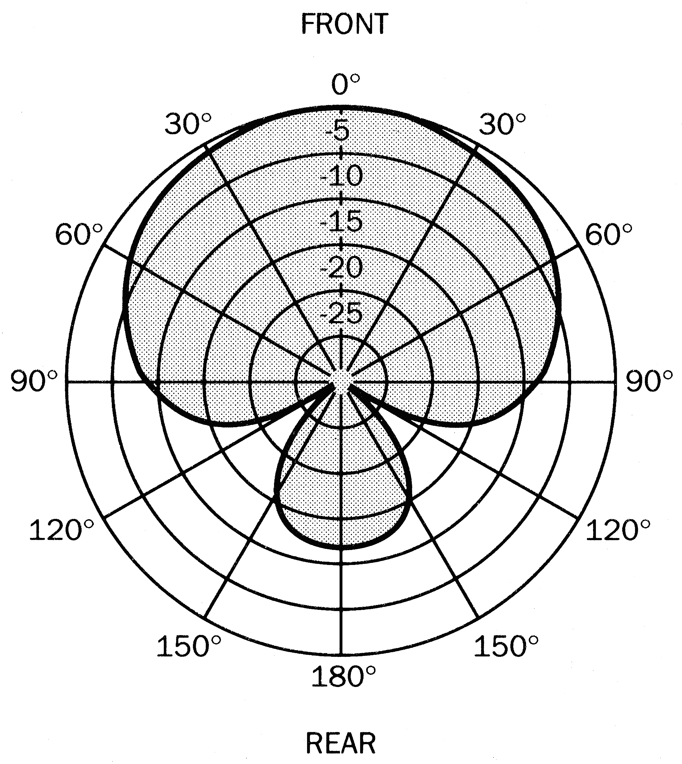
Figure A5.4: Examples of directional antenna

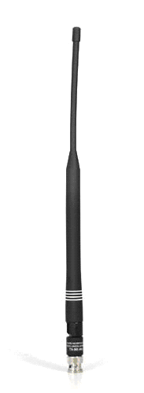  λ/2 dipole - Size ~ 20 cm | 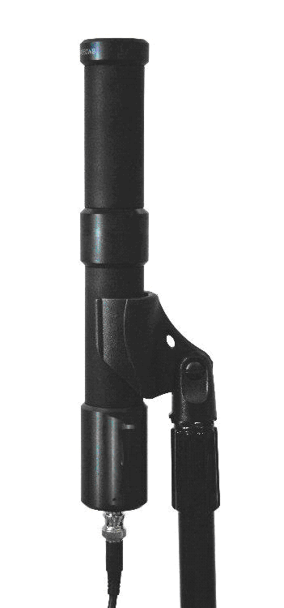 | 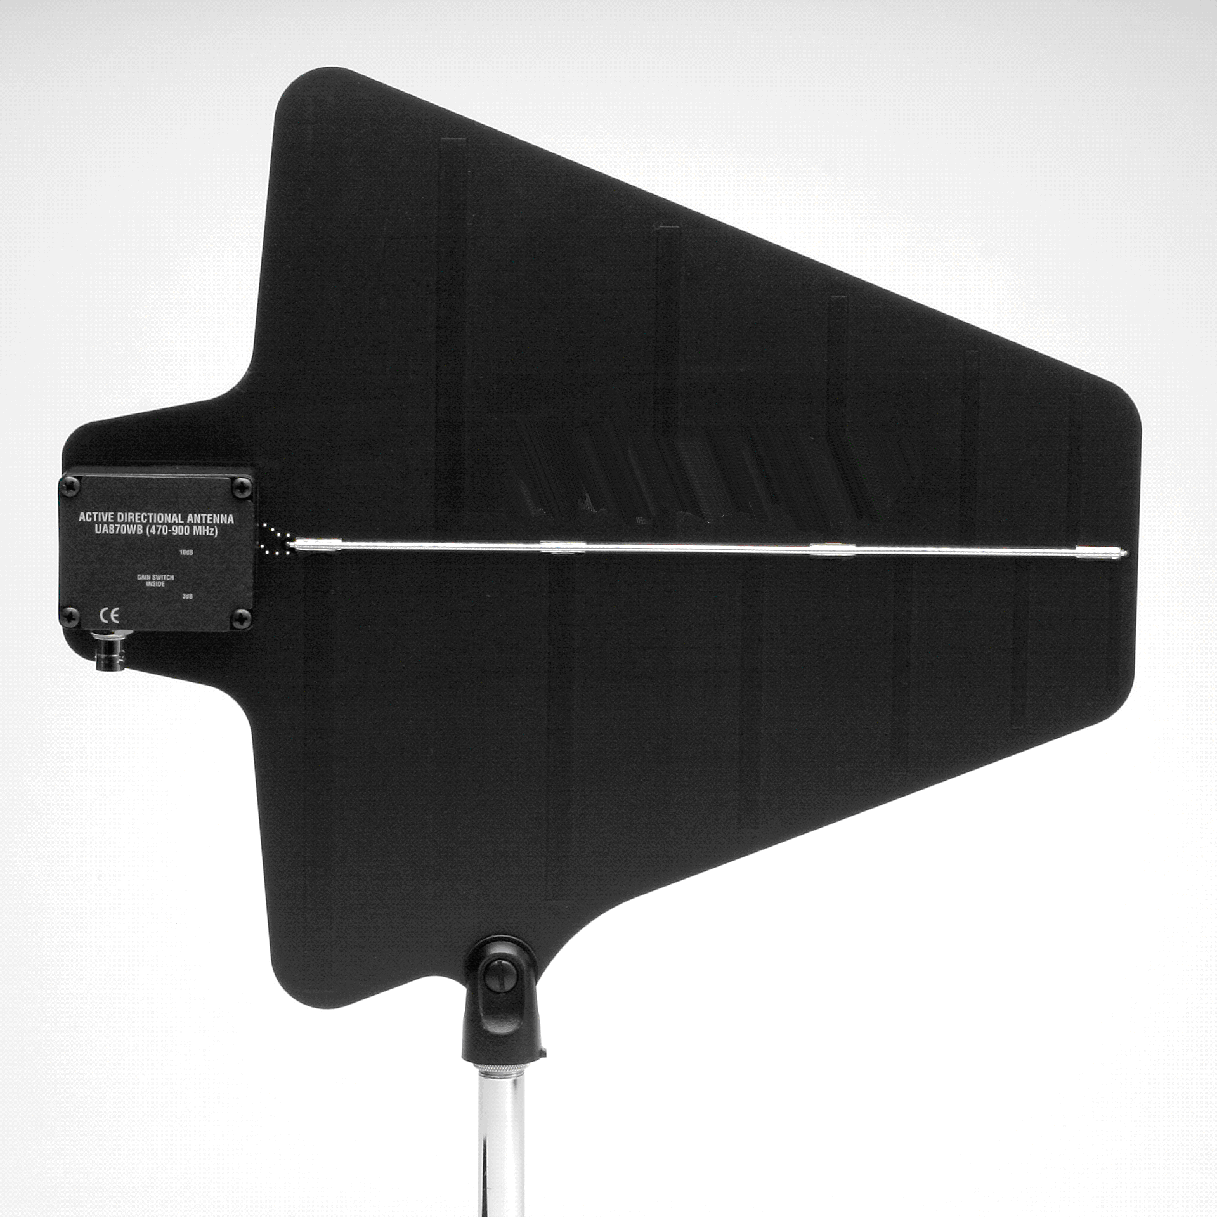  Logperiodic; ±45° | 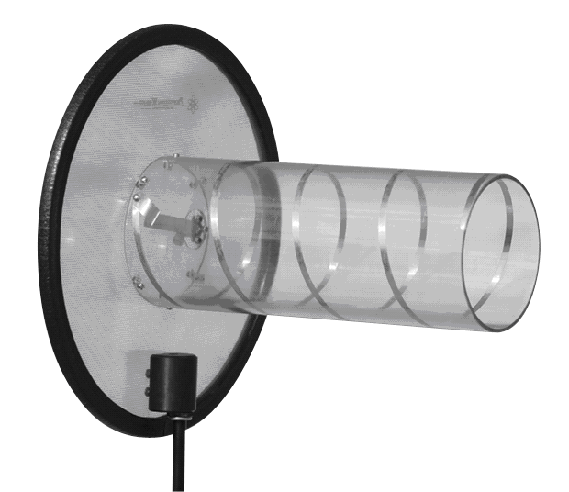  Helical; Circular ± 25°
Omnidirectional dipole |  | Directional antennas
Figure A5.5: Examples of antenna

A5.3 RF bandwidth (EN 300 422)

The following figures provide spectrum mask for PMSE systems.
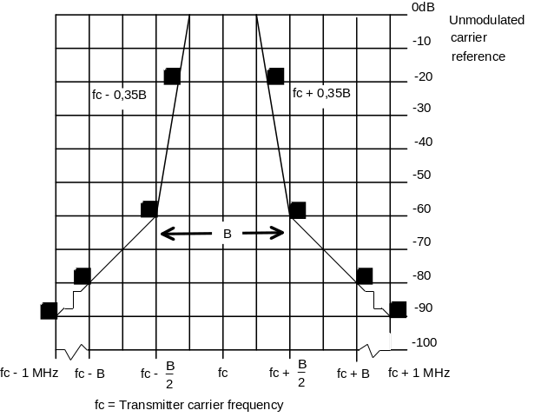
Figure A5.6: Emission mask – for analogue modulation; B ≤ 200 kHz

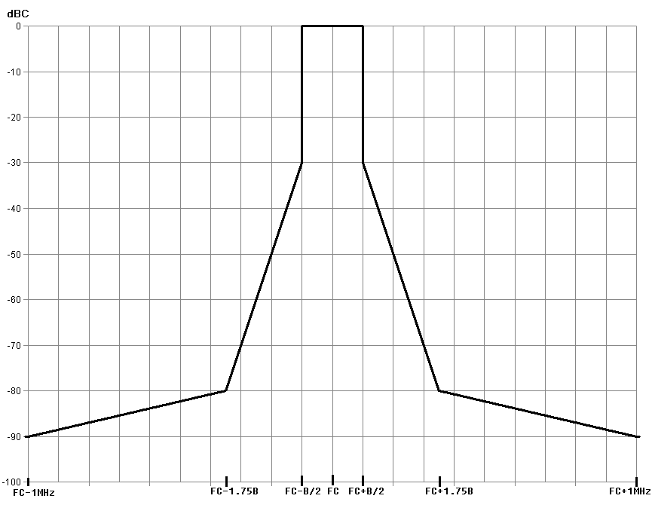
Figure A5.7: Emission mask – for digital modulation below 1 GHz; B ≤ 200 kHz
A5.4 Specification tables

 | EN 300 422 + ERC/REC 70-03 | Country variation
RF power | ≤ 50 mW | UK:Handheld 10mW, Bodyworn 50 mW
RF bandwidth | ≤ 200 kHz (see 2.2.3)
Table A5.1: Specification for PMSE

State | Frequency
 | 47 MHz to 74 MHz  87,5 MHz to 137 MHz  174 MHz to 230 MHz  470 MHz to 862 MHz | Other Frequencies  below 1 000 MHz | Frequencies above  1 000 MHz
Operation | 4 nW | 250 nW | 1 µW
Standby | 2 nW | 2 nW | 20 nW
TableA5.2: Spurious emissions limits

A5.5 PMSE Receiver mask

The following figure provides an example of receiver mask for Audio applications (200 kHz). The blue coloured mask relates to frequencies below 1 GHz and the green coloured mask to frequencies above 1 GHz.

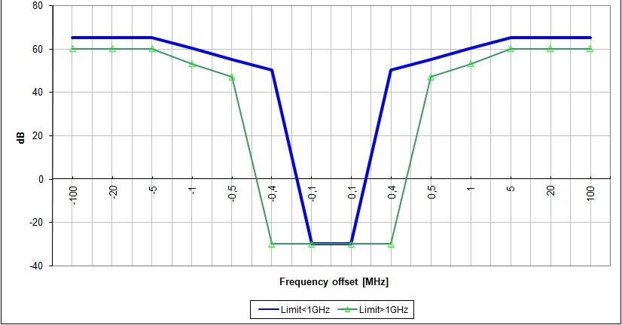
Figure A5.8: Example of receiver mask – 200 kHz – Audio application

The 0 dB reference level corresponds to -85dBm in 200 kHz.
LIST OF REFERENCES

[1] First Mandate to CEPT on digital dividend: Mandate to CEPT on technical considerations regarding harmonisation options for the digital dividend (TG4(07)24.rev1)
[2] CEPT Report 22/CEPT Report B: Final Report from CEPT to the EC on Technical feasibility of harmonising a sub-band of bands IV and V for Fixed/Mobile applications (including uplinks), minimising the impact on GE06
[3] CEPT Report 23/ Supplementary Report to Report B: Final Report from CEPT to the EC on Technical options for the use of a harmonised sub-band in the band 470 - 862 MHz for Fixed/Mobile applications (including uplinks)
[4] GE06: Final Acts of the Regional Radiocommunication Conference for planning of the digital terrestrial broadcasting service in parts of Regions 1 and 3, in the frequency bands 174-230 MHz and 470-862 MHz (RRC-06)
[5] ERC Report 38: Technical Impact of introducing CDMA-PAMR in the 870-876 / 915-921 MHz band on 12.5 kHz UIC DMO & 200 kHz GSM-R radio systems
[6] ERC Report 42: Spectrum efficiency of CDMA-PAMR and other wideband systems for PMR/PAMR
[7] ITU-R Report BT.2069: Spectrum usage and operational characteristics of terrestrial electronic news gathering (ENG), television outside broadcast (TVOB) and electronic field production (EFP) systems
[8] ECC Report 002: SAP/SAB (Incl. ENG/OB) spectrum use and future requirements
[9] EBU Technical Report 001: Questionnaire on spectrum requirements for SAB/SAP & ENG/OB - results (http://tech.ebu.ch/webdav/site/tech/shared/techreports/tr001.pdf)
[10] ERC/REC 70-03: Short Range Devices (SRD)
[11] ERC Recommendation 25-10: Frequency ranges for the use of temporary terrestrial audio and video SAP/SAB links (incl. ENG/OB)
[12] Harmonised Standard EN 301 357: Technical characteristics and test methods for analogue cordless wideband audio devices using integral antennas operating in the CEPT recommended 863 MHz to 865 MHz frequency range
[13] ETSI TR 102 546: Frequency ranges for the use of temporary terrestrial audio and video SAP/SAB links (incl. ENG/OB)
[14] EN 300 422: Wireless microphones in the 25 MHz to 3 GHz frequency range
[15] Interference from user equipment in the DDR upper subband to radio microphones in channel 69 (http://www.ofcom.org.uk/consult/condocs/clearedaward/user.pdf)
[16] Liaison Statement to TG4 on PMSE in FDD duplex gap (SE42) dealing with the protection of PMSE operating in the FDD duplex gap from Mobile/Fixed Communication Networks
[17] ERC Report 88: Compatibility and sharing analysis between DVB-T and radio microphones in bands IV and V
[18] ERC Report 89: Compatibility and sharing analysis between DVB-T and Talkback links in bands IV and V
[19] ERC Report 90: Compatibility and sharing analysis between DVB-T and OB (Outside Broadcast) audio links in bands IV and V
[20] CEPT Report 24: Technical considerations regarding harmonisation options for the digital dividend.
A preliminary assessment of the feasibility of fitting new/future applications/services into non-harmonised spectrum of the digital dividend (namely the so-called "white spaces" between allotments)
[21] Supply and demand of spectrum for Programme Making and Special Event in the UK: http://www.ofcom.org.uk/consult/condocs/ddr/reports/quotient_associates.pdf.
[22] ECC Report 121: Compatibility studies between Professional Wireless Microphone Systems (PWMS) and other services/systems in the bands 1452-1492 MHz, 1492-1530 MHz, 1533-1559 MHz also considering the services/systems in the adjacent bands (below 1452 MHz and above 1559 MHz)
[23] ETSI TR 102 546: Technical characteristics for Professional Wireless Microphone Systems (PWMS); System Reference Document
[24] ETSI EN 300 422: Technical characteristics and test methods for wireless microphones in the 25 MHz to 3 GHz frequency range.

