PP2 Scenario traffic analysis

London Riots

The estimates below are for communications using the permanent wide area network. On site additional capacity may be provided by other means such as a wireless LAN. This additional capacity can be used for local data exchanges between responders on the site or for specific applications (for example if a robot is deployed, the necessary command and control links would be provided locally). This additional local capacity has not been estimated (but may be estimated at a later stage).

The information in this paper has been distilled from discussions on 16th November 2012 with the Metropolitan police on how Public Safety broadband communications might have been used had they been available to them during the riots in London of August 2011.

The rioting was triggered by a fatal shooting of a 29 year old man by police. The riots started in the Tottenham area of London where the shooting occurred and then rapidly spread to neighboring areas around Tottenham and areas further afield both within in London and outside of London. Rioting occurred over four consecutive days.

The PP2 scenarios developed here to assist FM49 calculate spectrum requirements assumes there are two focal points of rioting within close proximity to each other – potentially covered by the same radio communications base station. Figure 1 below illustrates actual rioting focal points around Tottenham on which the discussions with the Metropolitan police were centered. It should be noted that the there could easily have been more focal points of high police activity being supported on a base station given the nature of the rioting in London.

All incidents are managed by a tried and tested hierarchical Gold (strategic level), Silver (tactical level) Bronze (operational level) command structure. A typical bronze commander would in the case of a dynamic situation such as rioting manage locally up to 300 police officers.

Due to the number of rioting focal points in close proximity to each other two sub Bronze Commanders would have been deployed, one for each rioting focal point reporting to a common Bronze Commander.

The geographic spread and scale of rioting in London required 16,000 additional police officers being drafted in from surrounding forces into London to assist the Metropolitan police contain the situation (through an arrangement known as mutual aid). The immediate issue for police is the protection of the public and property. Identifying and arresting the perpetrators of criminality would not be an immediate priority. Analysis of photographs and video captured at the time would be used post riots to identify culprits for later questioning.

The communication requirements for this PP2 scenario can be summarised as below.

- 2 high quality video streams - one from each sub Bronze Command area – being fed back to Gold and Silver Command. The video would be used to help manage the situation and would be recorded remotely for evidential purposes.
- Bronze and Sub bronze commanders receive regular GPS based location updates of the officers under their command.
- Interactive maps are pushed to officers on the ground to help them navigate to where they needed to be and also which areas/streets they should avoid. Particularly important as many of the officers deployed to contain and quell the rioting were not familiar with the area in which they were working.
- An infrared video feed from a helicopter is fed to fire fighters on the ground to help them tactically fight large fires.
- A video feed from a helicopter is fed back to Gold and Silver Command.
- Numerous still pictures captured by police officers are transmitted back to Gold and Silver command to help manage the situation and to be recorded remotely for evidential purposes.

The above excludes ambulance, fire (except for the down link infrared video feed) and business as usual traffic.

Figure 1: Areas of rioting focal points around Tottenham, London.
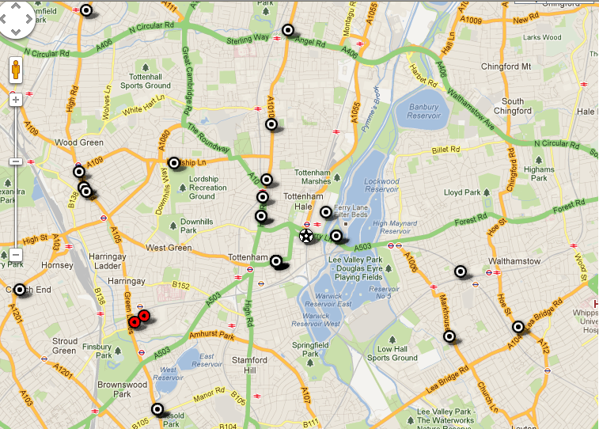
Approximate scale:
500m

