Recommendation
T/R 12-01

Harmonised radio frequency channel arrangements for analogue and digital terrestrial fixed systems operating in the band 37-39.5 GHz
Approved 1991
Amended 29 May 2019

recommendation T/R 12-01 of 1991 on PREFERRED CHANNEL ARRANGEMENTS FOR FIXED SERVICE SYSTEMS OPERATING IN THE FREQUENCY BAND 37.0 - 39.5 GHz, amended 2010 and amended 29 May 2019
“The European Conference of Postal and Telecommunications Administrations,
considering
- that CEPT has a long-term objective to harmonise the use of frequencies throughout Europe in order to make the most effective use of the spectrum available;
- that within the European Common Allocation and the ITU Radio Regulations (RR), the band 37.0-37.5 GHz is allocated, on primary basis, to the fixed service (FS) and the band 37.5-39.5 GHz is allocated, on equal primary basis, to the mobile, fixed and fixed-satellite services (FSS) (space-to-Earth); moreover, the band 37.0-38.0 GHz is also allocated on equal primary basis to the space research service;
- that ERC/DEC/(00)02 designates the band 37.5-39.5 GHz for the use of point-to-point fixed links and uncoordinated FSS earth stations shall not claim protection from FS stations;
- that Recommendations ITU-R F.1669 and ITU-R SF.1573 defines the protection criteria and the maximum power flux density (PFD) for the protection of FS systems from the FSS space stations;
- that Recommendation ITU-R F.749 contains radio-frequency arrangements for systems of fixed service operating in the 38 GHz band;
- that, when very high capacity links are required, it may be achieved by using wider channel bandwidth.
recommends
- that CEPT administrations should consider the radio frequency channel arrangements in the band 37.0-39.5 GHz given in ANNEX 1;
- that in order to improve spectrum utilisation, administrations may wish to consider using parts of the centre gap and guard bands as given in ANNEX 1;
- that CEPT administrations may consider merging any two adjacent 112 MHz channels recommended in ANNEX 1 to create one 224 MHz channel, with its centre frequency between the merged channels. To assist cross-border co-ordination, administrations may refer to the channel identifiers described in ANNEX 2.”

Note:
Please check the Office documentation database https://www.ecodocdb.dk for the up to date position on the implementation of this and other ECC Recommendations.
- Radio frequency channel arrangements in the band 37.0-39.5 GHz
The radio frequency channel arrangement for carrier spacings of 112 MHz, 56 MHz, 28 MHz, 14 MHz, 7 MHz and 3.5 MHz shall be derived as follows.

Let
F_{R} be the reference frequency of 38248 MHz;
F_{N} be the centre frequency (MHz) of a radio frequency channel in the lower half of the band;
F´_{N} be the centre frequency (MHz) of a radio frequency channel in the upper half of the band.

then the frequencies of individual channels are expressed by the following relationships:

- For systems with a carrier spacing of 112 MHz:
lower half of band: F_{N} = (F_{R} - 1246 + 112n) MHz
upper half of band: F´_{N} = (F_{R} + 14 + 112n) MHz where: n = 1, 2, 3, …. 10

- For systems with a carrier spacing of 56 MHz:
lower half of band: F_{N} = (F_{R} -1218 + 56n) MHz
upper half of band: F´_{N} = (F_{R} + 42 + 56n) MHz where: n = 1, 2, 3, …. 20

- For systems with a carrier spacing of 28 MHz:
lower half of band: F_{N} = (F_{R} - 1204 + 28n) MHz
upper half of band: F´_{N} = (F_{R} + 56 + 28n) MHz where: n = 1, 2, 3, …. 40
In addition, according to recommends 2, where practical, administrations may consider the use of channels with index n = 0 and 41

- For systems with a carrier spacing of 14 MHz:
lower half of band: F_{N} = (F_{R} - 1197 + 14n) MHz
upper half of band: F´_{N} = (F_{R} + 63 + 14n) MHz where: n = 1, 2, 3, …. 80
In addition, according to recommends 2, where practical, administrations may consider the use of channels with index n = -2,-1, 0 and 81 and 82, 83

- For systems with a carrier spacing of 7 MHz:
lower half of band: F_{N} = (F_{R} - 1193.5 + 7n) MHz
upper half of band: F´_{N} = (F_{R} + 66.5 + 7n) MHz where: n = 1, 2, 3, …. 160
In addition, according to recommends 2, where practical, administrations may consider the use of channels with index n = -5, -4,-3, -2, -1, 0, and 161, 162, 163, 164, 165, 166

- For systems with a carrier spacing of 3.5 MHz:
lower half of band: F_{N} = (F_{R} - 1191.75 + 3.5n) MHz
upper half of band: F´_{N} = (F_{R} + 68.25 + 3.5n) MHz where: n = 1, 2, 3, …. 320
In addition, according to recommends 2, where practical, administrations may consider the use of channels with index n = -11, -10, to 0 and 321 to 332.
A fully homogeneous band plan, based on a 3.5 MHz raster, with channel edges aligned is shown in Figure 1.

Figure 1: Occupied spectrum 37.0-39.5 GHz band

- Channel arrangement and identifiers for 224 MHz channels by merging 112 MHz channels
The 224 MHz channels (ref. recommends 3) can be identified by using the following numbering.

Let
F_{R} be the reference frequency of 38248 MHz;
F_{N} be the centre frequency (MHz) of a radio-frequency channel in the lower half of the band;
F´_{N} be the centre frequency (MHz) of a radio-frequency channel in the upper half of the band;

then the frequencies of individual channels are expressed by the following relationships:

Lower half of band: F_{N} = (F_{R} - 1190 + 112n) MHz
Upper half of band: F´_{N} = (F_{R} + 70 + 112n) MHz where: n = 1, 2, 3, …. 9

It is to be noted that the numbering is just for identification of the channelling. It should also be noted that two consecutive channel numbers cannot be used on the same physical link due to channel overlap. See figures below for channel arrangement example with identifiers.

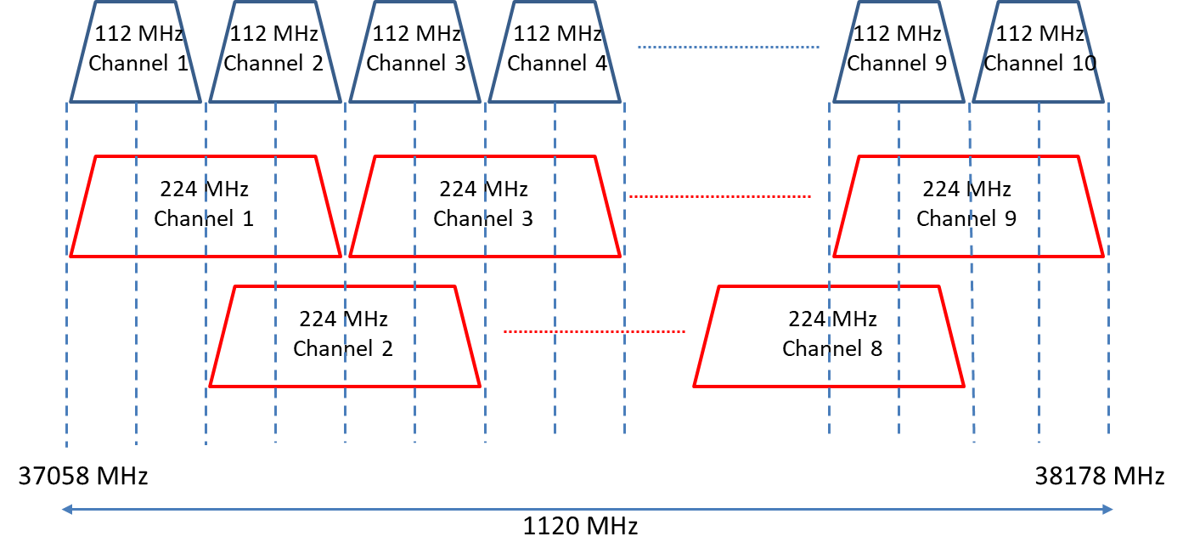

Figure 2: Channel arrangement and identifiers with channel width of 224 MHz (lower half of band)
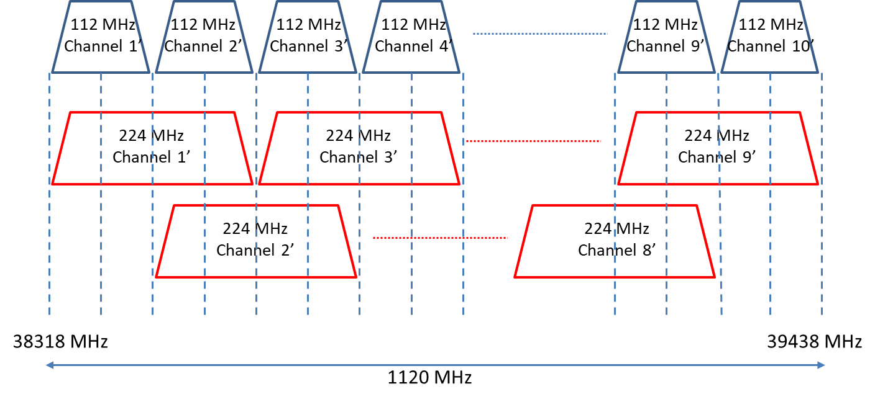
Figure 3: Channel arrangement and identifiers with channel width of 224 MHz (upper half of band)

