Guidance on the interpretation of the requirements of ECC/DEC/(01)03 on EFIS
approved 28 September 2012
ECC Report 180
updated 9 February 2018

Executive summary
This ECC Report provides guidance on the interpretation of the ECC/DEC/(01)03 [1] requirements. It provides assistance to administrations to implement this ECC Decision and to upload data to the EFIS database, in similar and comparable ways.
ANNEX 1:informs about requirements under ECC/DEC/(01)03 Annex 3 for the national radio interface information
ANNEX 2: contains the Radio Interface Specifications (RIS) template skeleton for National Radio Interfaces with which the EFIS database system is compatible.
ANNEX 3: informs about requirements under ECC/DEC/(01)03 Annex 4 for the right of use information.
ANNEX 4: provides the list of Electronic Communications Services (ECS) frequency bands.
ANNEX 5: provides guidance on licensing information type documents.
ANNEX 6: provides the tables showing the mapping of the application grouping in the spectrum inventory section with the EFIS layer 1 and 2 terminology.
ANNEX 7: contains the list of references.
ECO Report 05 [27] provides a list of the CEPT, ECC and EC deliverables which include definitions for the application terminology used in EFIS and ECA (European Common Allocations) for radio services and applications.
The Report highlights demonstrations of how administrations have fulfilled the implementation of the ECC/DEC/(01)03. The requirements of the EC Decision 2007/344/EC [2], applicable to EU Member States, in particular concerning the RIS information and the right of use information are also mentioned in relevant annexes of the present Report.
This Report was reviewed and updated. It supersedes the earlier editions of ECC Report 180.

TABLE OF CONTENTS

0 Executive summary 2
1 Introduction 6
2 Demonstrations showing how requirements can be fulfilled 8
2.1 Allocations 8
2.2 Applications 12
2.3 National Radio Interface Information 18
2.3.1 RIS model 18
2.3.2 How to upload information 19
2.4 Right of Use information 20
2.4.1 How to upload information 22
2.4.2 Confidentiality 22
2.5 European Common Allocation Table merged into EFIS 22
2.6 Non-regulatory information on spectrum usage (Spectrum inventory information) 23
2.7 CEPT Report 46 and CEPT Report 47 30
3 Conclusions 32
ANNEX 1: National radio interfaces information 33
ANNEX 2: RIS Template skeleton 34
ANNEX 3: National Right of Use Information 35
ANNEX 4: Harmonised ECS Bands 38
ANNEX 5: Licensing information type documents 40
ANNEX 6: Example of Mapping of the spectrum inventory section with the EFIS layer 1 and 2 terminology (for further Study) 41
ANNEX 7: List of reference 50

LIST OF ABBREVIATIONS

Abbreviation | Explanation
ALD | Assistive Listening Devices
CB | Citizens’ Band
CEPT | European Conference of Postal and Telecommunications Administrations
CRAF | Committee on Radio Astronomy Frequencies
DA2GC | Direct Air To Ground Communications
DSC | Digital Selective Calling
DTD | Document Type Definition
EC | European Commission
ECA | European Common Allocation
ECC | Electronic Communications Committee
ECO | European Communications Office
ECS | European Committee for Standardization
EESS | Earth Exploration-satellite Service
EFIS | European Frequency information System
EFIS/MG | ECO Frequency Information System Maintenance Group (EFIS/MG)
ERC | European Radiocommunications Committee
ERM | ETSI Technical Committee EMC and Radio Spectrum Matters
ERO | European Radiocommunication Office
ETSI | European Telecommunications Standards Institute
EU | European Union
FS | Fixed Service
FSS | Fixed-Satellite Service
GALILEO | European Global Navigation Satellite System
GLONASS | Globalnaya Navigatsionnaya Sputnikovaya Sistema
GMDSS | Global Maritime Distress and Safety System
GNSS | Global Navigation Satellite System
ITS | Intelligent Transport Systems
ITU | International Telecommunication Union
LoU | Letter of Understanding
MFCN | Mobile/Fixed Communications Networks
MoU | Memorandum of Understanding
MSS | Mobile-Satellite Service
NAVTEX | Narrow-band direct-printing telegraphy system for transmission of navigational and meteorological warnings and urgent information to ships
NTFA | National Table of Frequency Allocations
(OR) | Off-Route
PAMR | Public Access Mobile Radio
PMR | Private Mobil Radio, Professional Mobile Radio
PMSE | Programme Making and Special Events
PPDR | Public Protection and Disaster Relief
(R) | Route
RED | Radio Equipment Directive
RF | Radio Frequency
RFID | Radio Frequency Identification
RoU | Right of Use
RSCOM | Radio Spectrum Committee- Consulting Inc. designs, develops and maintains custom software programs for a wide cross section of industries
RTE | Radar Target Enhancer
RIS templates | Guide for usage of Radio Interface Specifications template within the ECC
RR | Radio Regulation
RSPG | Radio Spectrum Policy Group
SAR | Search and Rescue
SATCOM | Satellite Communication
SRD | Short Range Devices
TCAM | Telecommunications Conformity Assessment and Market Surveillance Committee
TRA-ECS | Terrestrial Radio Applications Capable of Providing Electronic Communications
TTT | Transport and Traffic Telematics
UHF | Ultra High Frequency
VLBI | Very Long Baseline Interferometry
WAPECS | Wireless Access Policy for Electronic Communication Services
WG FM | Working Group Frequency Management
WRC | World Radiocommunication Conference
UWB | Ultra-Wideband

Introduction
On 31 January 2002 the ERO (now ECO) launched a new online frequency information system called EFIS. EFIS is available to the public on the Internet either via the ECO website or directly under www.efis.dk.
EFIS contributes to the CEPT policy objectives of harmonisation and transparency of information in spectrum rights and usage. The RSPG Opinion on Spectrum Review [22] highlights the role of EFIS in the context of the European Union policy objectives laid down in the Decision of the Council and European Parliament on Radio Spectrum Policy (article 9 of Decision 243/2012/EU of the European Parliament and of the Council [21]).
In 2005, the European Commission issued a mandate to CEPT on the feasibility for EFIS to develop into a European portal for spectrum information. The response from CEPT is given in CEPT Report 11 [3].
ECC developed and updated ECC/DEC/(01)03 [1] taking into account evolution of the European regulatory framework.
Based on the CEPT Report 11 responding to the above EC mandate, EC Decision 2007/344/EC [2] on harmonised availability of information regarding spectrum use within the European Community was published on the 16th of May 2007 and entered into force on 1st January 2008. In accordance with this EC Decision, EU Member States shall upload data into EFIS about the use of radio spectrum on their territory.
CEPT administrations upload information on regulatory framework in force: the national table of frequency allocations, national application plans, national radio interfaces, and right of use (ROU) information, and, when and where relevant, on future usage of spectrum. This ECC report provides additional background information to ensure that administrations upload information in EFIS according to the same approach. A better harmonisation improves the visibility, for example, on spectrum usage comparisons and how the spectrum is used by various sectors either private or public.
EFIS is a unique and central source of information in Europe on spectrum usage and is regularly updated by the CEPT administrations (at least twice a year).
With EFIS, ECO, with the support of CEPT administrations supplying data, aims at providing a valuable service to all parties with an interest in spectrum rights and usage.
In EFIS you can search for and compare spectrum utilisation across Europe (allocations, applications, radio interfaces) and find related information such as documents about CEPT activities and national or international regulations. One major issue is that various terms attached to allocations, applications, radio interfaces and right of use should have the same interpretations among CEPT members in order to ensure a harmonised upload of information in the database. The following sections and information in the annexes to the present report provide information on this issue.
The Commission Implementing Decision 2013/195/EU [34] defines the practical arrangements, uniform formats and a methodology in relation to the radio spectrum inventory established by the RSPP. Data from the EFIS database is a core part of spectrum inventory established by the RSPP (243/2012/EU) [21]
According to recital 24 of the Radio Equipment Directive 2014/53/EU [13], Member states are to use the Frequency Information System (EFIS) of the European Communications Office (ECO) in order to make comparable information regarding the use of radio spectrum in each Member State available to the public via the internet.
EFIS is an information tool, not a legally binding instrument. Although all is being done to ensure that the data contained in EFIS is valid and up-to-date, ECO cannot be held responsible for any incorrect information contained in EFIS.
As of September 2017, all CEPT countries have an account in the EFIS database.
By end of 2011, ECO merged EFIS and ECA (the European table of Frequency Allocations and Applications in the frequency range 8.3 kHz to 3 000 GHz) and launched a new software release for EFIS accordingly. The interaction between EFIS and ECA is clarified in the relevant section of this report. ECA established a strategic framework for the utilisation of the radio spectrum in Europe.

demonstrations showing how requirements can be fulfilled
While allocations and designated applications are comprehensively uploaded into the EFIS database, some discrepancies exist in the comments sections. There are some differences in the level of information provided by the administrations in the national radio interface and right of use sections. This report provides some possible explanations and ways for improvements.

Allocations
Allocations provide information on the regulatory status of a given frequency band.
EFIS only accepts allocations from the list of services used by ITU Radio Regulations (RR) (see Annex 1 of the ECC/DEC/(01)03 [1]). Only these allocations are valid and can be selected by administrations.
Regarding the allocations with additions, only those combinations of the annexed list are allowed, with the disadvantage that this list is to be updated if necessary. The list in Table 1 reflects all currently used radio communication services and their additions used in the EFIS database.
The list is updated by the ECO after a WRC.
- Rights in a given frequency band identified by the RR (and also in the ECA table) could be “split” differently at national level in relevant sub bands. Various radiocommunications services may share same frequency bands. Multiple allocations could be foreseen in such context in a given band.
Within Section “comments”, administrations are invited to enter additional regulatory information relevant to the allocation:
- Administrative body in charge (this can be in relation to the spectrum management organisation at national level such as civil/military organisational split);
- Relevant RR footnotes;
- International Agreement or Treaty in force (other than RR);
Table 1: Layer 1 to 3 structure in EFIS in the allocations
Layer 1 | Layer 2 | Layer 3
Amateur
Amateur-Satellite
Broadcasting
Broadcasting-Satellite
Earth Exploration-Satellite | Earth Exploration-Satellite (active)  Earth Exploration-Satellite (passive)  Meteorological-Satellite
Fixed
Fixed-Satellite
Inter-Satellite
Mobile | Aeronautical Mobile | Aeronautical Mobile (R)  Aeronautical Mobile (OR)
 | Land Mobile
 | Maritime Mobile
 |  | Maritime Mobile (distress and safety)
 |  | Maritime Mobile (distress and calling)
 |  | Maritime Mobile (distress, safety and calling)
 |  | Maritime Mobile (distress and calling via DSC)
 | Mobile (distress and safety)
 | Mobile (distress and calling)
 | Mobile (distress, safety and calling)
 | Mobile except aeronautical mobile
 | Mobile except aeronautical mobile (R)
Mobile-Satellite | Aeronautical Mobile-Satellite | Aeronautical Mobile-Satellite (R)  Aeronautical Mobile-Satellite (OR)
 | Land Mobile-Satellite
 | Maritime Mobile-Satellite
 | Mobile-satellite except aeronautical mobile-satellite
 | Mobile-satellite except aeronautical mobile-satellite (R)
Meteorological Aids
Radio Astronomy
Radiodetermination | Radionavigation | Aeronautical Radionavigation  Maritime Radionavigation  Maritime Radionavigation (radiobeacons)
 | Radiolocation
Radiodetermination-Satellite | Radionavigation-Satellite | Aeronautical Radionavigation-Satellite  Maritime Radionavigation-Satellite
 | Radiolocation-Satellite
Space Operation |  | Space Operation (satellite identification)
Space Research | Space Research (active)  Space Research (deep space)  Space Research (passive)
Standard Frequency and Time Signal
Standard Frequency and Time Signal-Satellite
Note:
For bolded services it is possible to give additions/attributes (space-to-Earth, Earth-to-space, space-to-space). An alphabetical list of services with all additions as used in the EFIS database, and existing combinations of additions/attributes for allocations is provided below.
Table 2: LIST OF ALL RADIOCOMMUNICATION SERVICES WITH ADDITIONS
USED IN THE EFIS Database
Radiocommunication service: | Addition:
Aeronautical mobile | (R)
Aeronautical mobile | (OR)
Amateur-satellite | (Earth-to-space)
Amateur-satellite | (space-to-Earth)
Earth exploration-satellite | (Earth-to-space)
Earth exploration-satellite | (space-to-Earth)
Earth exploration-satellite | (Earth-to-space) (space-to-space)
Earth exploration-satellite | (space-to-Earth) (space-to-space)
Earth exploration-satellite | (active)
Earth exploration-satellite | (passive)
Fixed-satellite | (Earth-to-space)
Fixed-satellite | (space-to-Earth)
Fixed-satellite | (Earth-to-space) (space-to-Earth)
Fixed-satellite | (space-to-Earth) (Earth-to-space)
Maritime mobile | (distress and calling via DSC)
Maritime mobile | (distress and calling)
Maritime radionavigation | (radiobeacons)
Meteorological-satellite | (Earth-to-space)
Meteorological-satellite | (space-to-Earth)
Mobile | except aeronautical mobile
Mobile | except aeronautical mobile (R)
Mobile | (distress and calling)
Mobile-satellite | (Earth-to-space)
Mobile-satellite | (space-to-Earth)
Mobile-satellite | except aeronautical mobile-satellite (Earth-to-space)
Radiodetermination-satellite | (Earth-to-space)
Radiodetermination-satellite | (space-to-Earth)
Radiolocation-satellite | (Earth-to-space)
Radionavigation-satellite | (Earth-to-space)
Radionavigation-satellite | (space-to-Earth) (space-to-space)
Space operation | (satellite identification)
Space operation | (Earth-to-space)
Space operation | (space-to-Earth)
Space operation | (Earth-to-space) (space-to-space)
Space operation | (space-to-Earth) (space-to-space)
Space research | (Earth-to-space)
Space research | (space-to-Earth)
Space research | (space-to-space)
Space research | (deep space)
Space research | (Earth-to-space) (space-to-space)
Space research | (space-to-Earth) (space-to-space)
Space research | (deep space) (Earth-to-space)
Space research | (deep space) (space-to-Earth)
Space research | (active)
Space research | (passive)
Standard frequency and time signal | (20 kHz)
Standard frequency and time signal | (2 500 kHz)
Standard frequency and time signal | (5 000 kHz)
Standard frequency and time signal | (10 000 kHz)
Standard frequency and time signal | (15 000 kHz)
Standard frequency and time signal | (20 000 kHz)
Standard frequency and time signal | (25 000 kHz)
Standard frequency and time signal-satellite | (400.1 MHz)
Standard frequency and time signal-satellite | (Earth-to-space)
Standard frequency and time signal-satellite | (space-to-Earth)
Users of the database can select for searches and comparisons a term from each of the layers, either from a flat selection panel or from structured windows selection through layers 1, 2, or 3. Selection of an allocation term in Layer 1 will include in the results also the information for which a Layer 2 or 3 allocations under this Layer 1 term is used. This is valid for the search function as well as for comparisons amongst several countries.
Administrations are encouraged to also provide allocation footnotes and frequency band footnotes together with their allocation table information. RR Article 5 footnotes and ECA footnotes as used in the ECA Table can be imported from the EFIS database, and can be used for the national NTFA information. National footnotes can also be imported using the XML format or manually added by using the footnote editor, the frequency band footnote editor or the allocation editor.

Applications
The objective of the application section is to provide visibility on the usage of a given frequency band. Various applications could share the same frequency band.
CEPT administrations upload relevant usage information in accordance to the applications structured in Layers 1, 2 and 3 of the Annex 2 of the ECC/DEC/(01)03 [1].
This 3 layers approach is to give administrations a possibility of depth of information about applications used in a frequency band and give the search a structure for finding all applications used within frequency bands.
The idea behind is that the administrations have the possibility, where no detailed information is available or there are existing national restrictions (e.g. military frequency applications) for detailed information, to decide themselves about the detailed depth of application information (Layer 1, 2 or 3) they will publish in the EFIS system.
The information about military (defence) applications in the ECA Table in EFIS was improved in 2016/2017, aligning the ECA Table and the NATO Joint Civil/Military Frequency Agreement (NJFA - Extract for Public Disclosure from 14 February 2017), the latter one also available in the EFIS.
Where such information is available, administrations should always try to provide application information at Layer 3 level of detail in EFIS. Layer 1 applications and definitions are broad in scope, and Layers 2 and 3 narrow down the scope to be used for searches and comparisons. For example, the Layer 1 application “Land Mobile” does not differentiate between public cellular services and private mobile radio, which tend to use spectrum in a very different way and are generally subject to quite different licensing processes. On the other hand, adopting the Layer 2 application definitions would result in over 80 separate categories, making analysis of the data difficult, particularly with regard to comparing utilisation across different bands with similar applications.
Layer 2 provides most commonly used terms that are also used in ECC deliverables and act often as ‘umbrella terms’ or major categories for a lot of similar applications. Typical examples are PPDR, PMSE, PMR/PAMR.
Layer 3 provides better visibility on the application which is authorised in a given band. Various applications could share the same frequency band.
Terminologies of applications listed in Layers 1, 2 and 3.
In order to ensure the same understanding of the definition of applications listed in the Layers, a listing of the documents and their relation to application terms is given in Annex 9 of this report. The applications terminology originates from ECC deliverables where the application terms are used. The same terms are also used in the ECA table. The definitions are therefore found in the applicable ECC deliverables and these deliverables are indicated in the list of searchable applications (Annex 2 of the ECC/DEC/(01)03 [1]. Administrations are encouraged to follow the terminology which is also used in the ECA table to the maximum extent possible in order to avoid any ambiguity, for administrations with uploaded information in the database, but also for any external users of the database. It should be noted that the application terms in ECA are used in the RIS templates too, which are also found in the EFIS database.
Administrations can export the list of the agreed application terminology used in EFIS in excel/csv format:
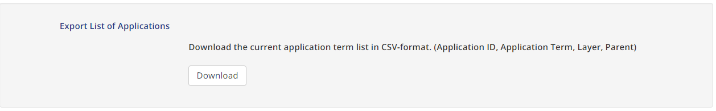
Table 3: Export list of applications
This list also includes the information about the Application ID, layer and parenting of the application terms. This information can be used to exactly define in an XML import file the term and its parent term(s) to be used in EFIS.
Search & comparisons
Users of the database can select a term for searches and comparisons from each of the layers, either from a flat selection panel or from structured windows selection through the layer 1, 2, or 3. Selection of an application term in Layer 1 will include in the results also the information for which a Layer 2 or 3 applications under this term is used.
Example to describe the result of a search (update):
Table 4: Maritime
Layer 1 term Maritime is given; the search result will include all entries available
in the database of layers 1 to 3
Maritime
Maritime | GMDSS
Maritime | GMDSS | DSC
Maritime | GMDSS | EPIRBs
Maritime | GMDSS | MSI
Maritime | GMDSS | NAVTEX
Maritime | GMDSS | SAR (communications)
Maritime | Satellite navigation systems
Maritime | Satellite navigation systems | GALILEO
Maritime | Satellite navigation systems | GPS
Maritime | Satellite navigation systems | GLONASS
Maritime | Maritime communications
Maritime | Maritime communications | AIS
Maritime | Maritime communications | Inland waterway communications
Maritime | Maritime communications | INMARSAT
Maritime | Maritime communications | On-board communications
Maritime | Maritime communications
Maritime | Maritime navigation
Maritime | Maritime navigation | Beacons (maritime)
Maritime | Maritime navigation | Inland waterway radar
Maritime | Maritime navigation | Loran C
Maritime | Maritime navigation | Maritime radar
Maritime | Maritime navigation | SAR (navigation)
Maritime | Maritime navigation | RTE
Some Layer 2 and Layer 3 terms are included under more than one Layer 1 term.
Administrations have the freedom to include information about PMSE for example under the Broadcasting or the Land mobile application. This takes into account that some administrations have PMSE in some frequency ranges under the Broadcasting service allocation and some have categorised PMSE applications under the Land mobile application for frequency ranges where both service radio allocations are given. It is also the case, that such PMSE applications are used by broadcasting services for generating programmes as well as other users. Therefore, this approach gives administrations full flexibility in such cases of having a term in several upper layer categories. Searches after PMSE in EFIS will however show all the results, so that no information will be overlooked.
However, in some cases, in particular for military, securities and enforcement agencies, to use Layer 3 may not always be possible and administrations may need to use Layer 1 or 2 information. In these cases Layer 3 is not used and stays empty. Some guidance on where this might be appropriate is listed below.
Reasons of national security
Certain information relating to the use of frequencies used for military, security services and enforcement agencies may not be available due to national security or other confidential considerations. In these cases administrations should look towards providing Layer 1 or 2 information where this is already publicly available.
Information not held by the administration
EFIS should be based on the non-confidential information that the CEPT administrations have in their records. For some administrations spectrum has been allocated to applications on a Layer 2 basis and rights holders can use any Layer 3 service under the provision of their licence. In these instances, it is therefore appropriate only to use the Layer 2 application as the administration has no accurate information on what Layer 3 applications are in use.
Use of any or all layers
The use of any or all layers is not problematic for the EFIS system and does not lead to malfunction of the system. The EFIS system is able to generate information independent of its availability in one single layer or in all layers combined.
The example in Figure 1 shows the result of a comparison of national tables in EFIS (and including ECA) for the Layer 3 terms ‘Medical implants’. It can be seen from the results that Denmark has used the Layer 3 term, whereas Croatia and Austria have not supplied the same level of detail; they have used parent terms, Layer 2 (Active medical implants) and Layer 3 (Short Range Devices) respectively. EFIS, however, displays occurrences of the immediate parent term of the term specified where there is no Layer 3 information, and of the Layer 1 term, where there is no Layer 2 term specified.
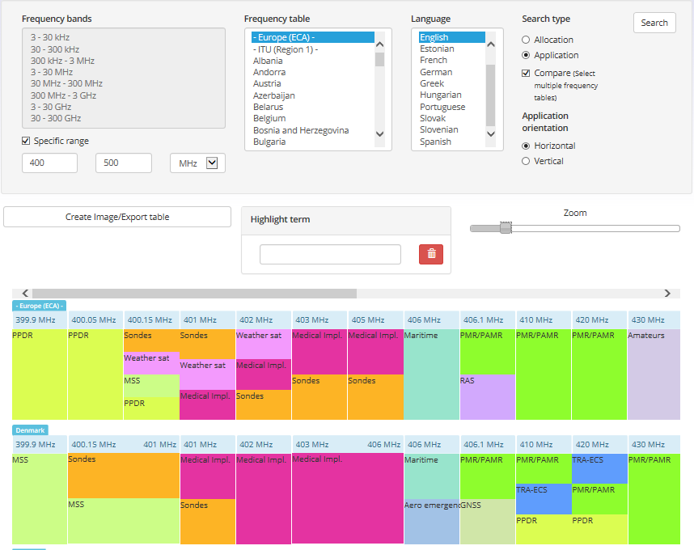
Figure 1: Comparison of national application entries
TRA-ECS:
TRA-ECS (Terrestrial radio applications capable of providing electronic communications services) describes a regulatory status. It can be applied in principle to all terrestrial applications in a given frequency band.
TRA-ECS is relative to particular rights granted in a given frequency band. The comment field should be used to provide the typical application that is currently used, planned to be used or mainly used in the respective frequency band when available and as far as possible. When using TRA-ECS as application, administrations should provide information in the “comments” field, as otherwise the usage of this frequency band is not identified. The EFIS application terms should be used in the “comments” field in order to facilitate search. The TRA-ECS term should always be used in combination with one ECA or national frequency range. A broad application of the term TRA-ECS over several consecutive frequency ranges should not be done.
The related studies in the ECC and resulting documentation can also be indicated in the comment field to describe the real application in the band.
However, it is to be noted that the usage of the comments field is not mandatory in the EFIS system. Nevertheless, without usage information in the comments field there is no visibility on the usage of the band and the mapping to the spectrum inventory category (see example in annex 6) remains also unclear.
Consequently the search for applications in the EFIS system will be extended to the comment field to find all applications used.
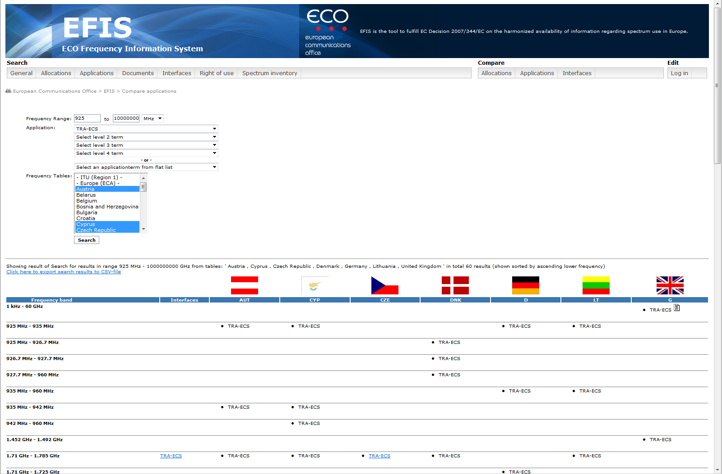
Figure 2: TRA-ECS
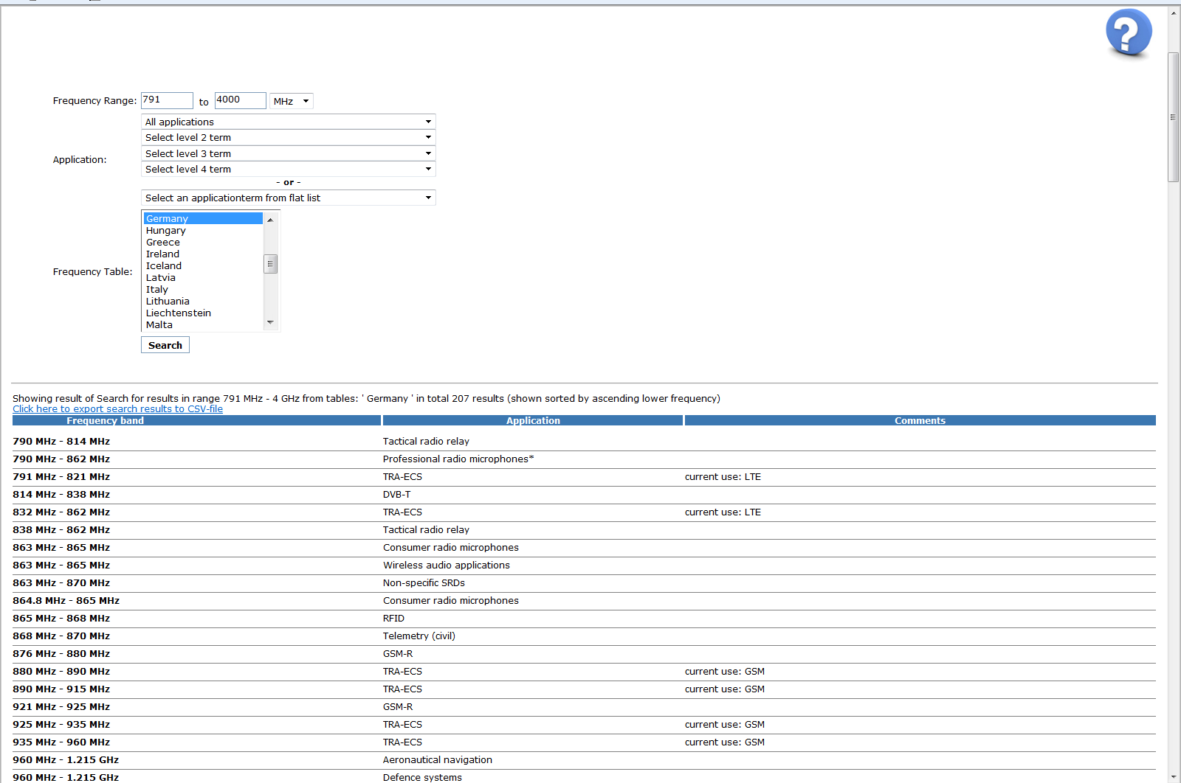
Figure 3: Usage of the comments field to describe TRA-ECS application
Comments for applications can contain:
- Current use: application term1, application term2, …(term2 if used by various apps)
- Main use: application term1, application term2, …
- Planned use: application term1, application term2, …
- Text “application term in the future”
- Text “application term will be phased out”.
A comparison of the actual usage of the application terminology reveals that the administrations in the great majority of cases provide the Layer 3 term. As an example, one can select and compare all countries for a specific maritime or SRD application, and the result in general shows that the Layer 3 terms are used in the vast majority of cases. Sometimes, however, the ‘umbrella’ terms are used, i.e. in these cases the Layer 1 or 2 terminology. In many of these individual cases, this will not lead to “in availability” of information because the related documentation in the EFIS database (EC, CEPT, ECC/ERC deliverables, standards, RIS models and R&TTE equipment subclasses, but also spectrum inventory information) will normally include sufficient information to explain the usage of the frequency band.

National Radio Interface Information
For the EU Member States the Annex 1 of the EC Decision defines normative requirements for the information on National Radio Interface Specifications.
The most efficient way to provide national radio interface data to the EFIS system is to make reference to the frequency harmonisation measure, i.e. ECC and/or EC deliverables, and to the applicable Harmonised European Standard since in the vast majority of cases, the national frequency utilisation does not deviate from the requirements stipulated in these documents. After the merger of the ECA information into the EFIS database and the implementation of a new document category for EC Decisions, all relevant information is included in the EFIS database for such cases.
It is also going to be possible to attach illustrations, e.g. a more descriptive document or figure, to a national radio interface with a link to the national home page. Possible exceptions for CEPT administrations where the EU Member States should fill in all the normative fields as contained in Annex 1 of the EC Decision are described in Annex 3 of the present document.
The differences in the numbers of available radio interfaces in EFIS amongst countries simply arise from the grouping and packaging of different user categories (e.g. in PMR) in an application or grouping of frequency bands in one and the same application.

RIS model
The EFIS database system is compatible with the RIS template skeleton / TCAM RIG II template for National Radio Interfaces (see template in Annex 3) and National Radio Interfaces are also translated in all EU languages when being notified to the EU commission.
In June 2010, the European Commission submitted to ECC a request to implement a radio interface model developed by TCAM and RSCOM (ECC(08)38) [20][15]. ECC launched a trial period in order to develop relevant models implementing this radio interface model. Results of this trial period are contained in an internal ECC Report on implementation of the RIS template, Annex 3 to doc RA(11)086, September 2011 [4].
This information on radio interface is complementary information on the regulatory sides and provides visibility on requirements applicable in a given band. This RIS is only available in few frequency bands.
Nevertheless, in the context of the Spectrum Decision, the European Commission does intend to follow the spirit of the RIS model and will aim to use the relevant fields (parameter descriptions) from the template when developing spectrum Decisions.
ECC develops RIS models where appropriate and relevant. One of the aims of the RIS model is to provide “ready to use” radio interfaces that administration can adapt to update the EFIS database with comments and explanation.
The ECC is developing RIS models in order to ensure that upload of information is done on an harmonised basis. The prime aim of developing RIS implementations within CEPT is precisely to facilitate the work of administrations when declaring into EFIS their new radio interfaces.
The RIS models are available in EFIS under the document type ‘RIS Models’. These RIS model implementations shall be in accordance with the “Guide for usage of Radio Interface Specifications template within the ECC”, which is available on the Office website. The RIS model implementations in EFIS are validated by (checking for compliance with the Guide) the EFIS/MG and adopted by ECC WG FM after the initial trial period ended in December 2011. Due to the change of the ECC structure end 2011, the work of validating the implementation provided by the ECC entities (responsible for the drafting of RIS model deliverables in relation with ECC Decision) will be carried out within the EFIS/MG (with the support of the entity which drafted the initial deliverable).
Should national administrations find it difficult to create certain national radio interfaces or have questions related to the subject, they can approach the ECO or the EFIS/MG for assistance. It is also always a good idea to have a look in the EFIS database, how other administrations have solved the issue of filling the differently data fields with information.
Below is a screenshot showing the result of a search for RIS model documents in EFIS (these are uploaded by ECO and linked to the ECA table).

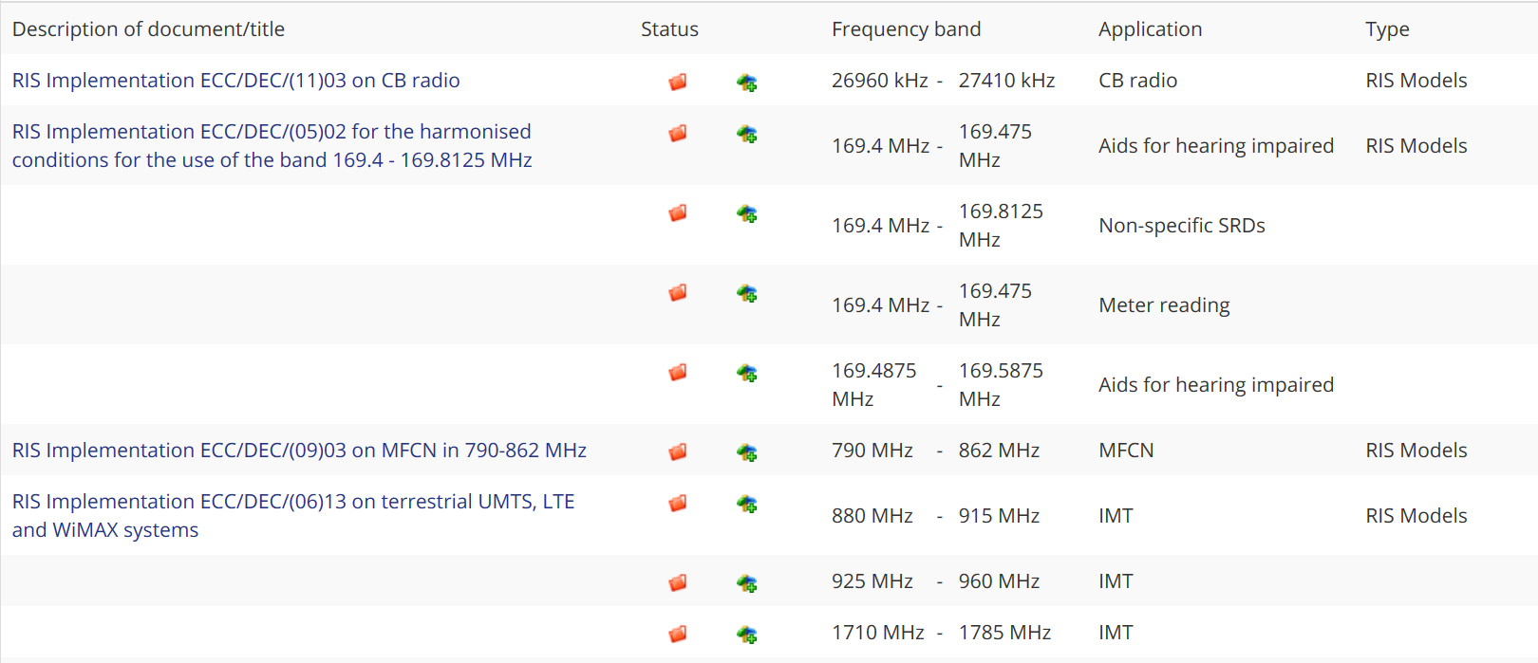
Figure 4: Example of RIS Models
The RIS model format is identical with the format used in TCAM for the RE Directive [13] Class1 equipment sub-classes. EFIS provides also the Class 1 equipment information in the RIS format, i.e. RIS models and Class 1 equipment subclasses are available in EFIS and can be searched for in the database according to frequency range and/or application.
Discrepancies appear between CEPT administrations regarding the availability of national radio interfaces due to national organisations in spectrum management.
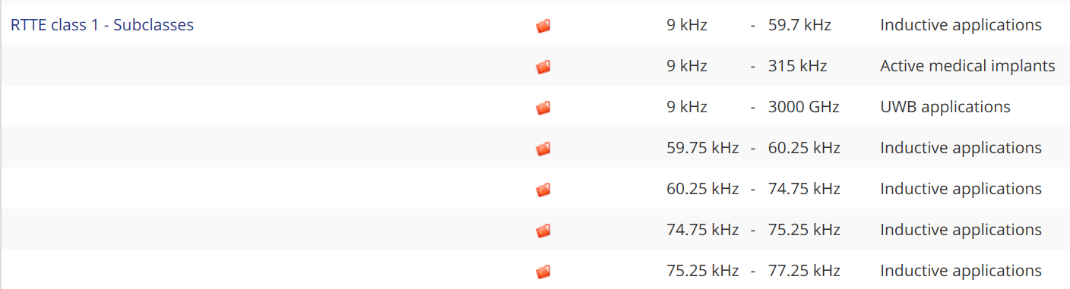
Figure 5: Example of Class 1 equipment information

How to upload information
There are two possibilities to import national radio interface information into EFIS. It can be done manually or by using the XML data exchange format. The latter is recommended since it is a much more efficient way of entering information. For XML data exchanges, there is the possibility to use export functions from national database information/systems converting data into the XML data exchange format needed for the EFIS database system.
The EFIS harmonised XML interface can be used for uploading data to or downloading data from EFIS.
The interface is an XML file with a defined structure, called the EFIS XML format, which is defined by the Document Type Definition (DTD) given in Annex 5 of the ECC/DEC/(01)03 [1].
Note: This DTD will be updated shortly to reflect a change in the EFIS XML file format.
The terms used for allocations and applications shall be taken from the List of Radio Services in the ITU RR (see Annex 1 of ECC/DEC/(01)03) and the list of searchable applications (see Annex 2 of the ECC/DEC/(01)03).
An additional assistance and information (tutorial) is given under EFIS information/ graphical visualisations on how to translate excel data into XML Format. Administrations can take another xml-file and match 'column-by-column' as appropriate in the excel/csv file. The ECA table file can be taken as an example for this. Save the file and correct the header for the national EFIS account. Save again (as xml and right format, choose UTF, not ANSI).

Right of Use information
ECC/DEC/(01)03 [1] invites CEPT administrations to provide information on right of use (RoU). Annex 2 of the EC Decision requires EU Member States administrations to provide information on ECS services which are tradable or were awarded by through competitive or comparative selection procedures. Most administrations provide rights of use in EFIS for those ECS bands covered under the Wireless Access Policy for Electronic Communication Services (WAPECS) approach (see Annex 4 with the list of ECS frequency bands). These bands have major economic interest or significance. However, other bands are not excluded. Outside ECS, availability of information depends of organisation of spectrum management at national level. For example, In case of governmental usage of spectrum, another governmental body than the civil national regulatory authority is often responsible for administering the spectrum used exclusively by governmental users. Some details of the rights-of-use in these cases may not be publicly available and are only available at the national level. Such usage may also be not limited to a defined duration.
The level of information will depend of the type of usage (either governmental, civil or shared).
According to Annex 2 of the EC Decision 2007/344/EC [2] it is only mandatory to provide information regarding:
<< Information on Rights of Use may be limited to frequency bands used for the provision of electronic communications services, which are tradable in accordance with Article 9.3 of Directive 2002/21/EC [6] or which are granted through competitive or comparative selection procedures pursuant to Directive 2002/20/EC [10].>> This information on radio spectrum Rights of Use that may be tradable is a complementary information on the regulatory status. This information is not relevant in a context of existing actual usage of spectrum Trading of the rights of use of radio spectrum is not harmonised in Europe except where mentioned in RSPP for the WAPECS bands for EU Member States. The authorisation regime depends also on the national approach: For example, some countries apply general authorisation for PMSE in UHF bands, others individual authorisations. As a result of this, the right of use information provided in EFIS can differ from one administration to another and the information in EFIS can be less detailed than the information held by the national administrations,
In addition to the ECS bands, some administrations have also made a number of other allocations tradable. In some cases these are high volume, but with lower economic value/interest than the ECS bands and covering technologies such as PMR and Fixed. Given the volume and nature of these services two emerging examples how to provide information on these services via EFIS are described below.
Example 1: Right of Use information regarding all tradable spectrum in a country
from Denmark:
- As of May 2011 Denmark has uploaded information about all individual licences. There are more than 22,000 licences provided to the EFIS system on a data set-by-data set basis, i.e. more than 22,000 entries.
from the United Kingdom:
Administrations can provide links to the national database in EFIS.
- The United Kingdom provides in EFIS the link to the national Wireless Telegraphy Register (http://spectruminfo.ofcom.org.uk/spectrumInfo/licences) that contains information on the UK’s 70,000 licences. The advantage of this solution is that it provides more detailed information and functionality. For example, one could search after licence types (i.e. applications) or in a specific geographical area. In addition the database is updated daily.
Example 2: Right of Use information regarding spectrum granted through a comparative or competitive process
from Sweden:
- Sweden provides information on all licences granted through a comparative or competitive process. The advantage of this solution is that it is easy to recognise in EFIS those licences that have significant economic value. These are typically the most interesting for spectrum trading.
Both examples demonstrate how the requirements from ECC/DEC/(01)03 [1] and Annex 2 of the EC Decision 2007/344/EC [2] could be interpreted in different ways.
It is of great benefit to all users of EFIS, in the case of right of use information most notably industry, but also other users, that the information available in EFIS is as detailed and complete (and up-to date) as possible. It is therefore of importance that administrations do their utmost to ensure that EFIS contains the relevant data, as available to them. In this context administrations are strongly encouraged to actually upload information in EFIS.
The effort of each single administration depends on how the information is available. If the information is only available in paper form it requires a lot of manpower, financial expenditure and time to convert this information into a useful electronic format. Germany, for example, for its approximately 150,000 frequency licences, has estimated 1.5 million Euro for new software and software modifications and more than 6,300 man-days to convert them all into electronic form (only for the “right of use” information in the EFIS format).
Should national administrations find it difficult to provide right of use information or have questions related to the subject, they can approach the ECO or the EFIS/MG for assistance. It is also always a good idea to have a look in the EFIS database, how other administrations solve the issue of filling the different data fields with information.
Although EFIS provides information on right of use, some national databases provide additional information on rights of use than what is mandated by the EC Decision. This includes information such as channel modulation, frequency type, channel bandwidth, antenna height, transmission power, antenna type and gain and polarisation (see radio interface section) However, it should be noted that due to issues of privacy, confidentiality and security legislation this information is sometimes only partly or not available in some countries. Moreover, such detailed information is not relevant when considering the objective of EFIS and there is no invitation to provide such detail.
A link to a national database may be a good source of supplementary information, but it cannot be considered on its own to be sufficient for the purposes of meeting the requirements of ECC/DEC/(01)03 and Annex 2 of the EC Decision 2007/344/EC. On the other side, the advantage of including links to the national database is often to make available detailed information with much higher granularity also through EFIS.
National administrations are also encouraged to provide licensing related information which is of interest for spectrum users and industry under the document type “licensing information”. This document type is complementary to the right-of-use information. Annex 5 describes which documents or links should be uploaded under this document type.
Annex 3 of this Report includes additional information on the elements of the rights-of-use to be provided in the EFIS.

How to upload information
There are two possibilities to import right of use information to EFIS. It can be done manually or by using the XML data exchange format (see Annex 5). The latter is recommended since it is a much more efficient way to enter data. For XML data exchanges, administrations can use EFIS export functions that convert national database information in EFIS into the XML exchange format needed for the EFIS database system and update such an XML-file and re-import the updated information (see also section 2.3.2 of the present Report).
Overall information on rights of use that were awarded by competitive or comparative awards is provided by most administrations. It is recommended that all administrations provide, as a minimum, information on those ECS services awarded by comparative or competitive awards that are covered by the WAPECS approach.
EFIS provides under information an update history which can be checked to find out the latest updates of the information in the EFIS database.

Confidentiality
Related to right of use information are some aspects regarding confidentiality. These may depend on legal requirements which stem directly from national telecommunication laws and regulations concerning the individual licence issuing process (registration of an application, confirmation of the necessary payments, reception of the licence etc.). All these actions may include information which is confidential. Also, applicants may not want their application to be made public before licence awards. This may affect in specific cases more detailed information such as the exact location of a transmitting station or identities of licence holders and their related affiliations. It should furthermore be noted that the information provided by the administrations shall be in accordance with the requirements of Directive 95/46/EC [8] regarding the protection of individuals with regard to the processing of personal data and on the free movement of such data and Directive 2002/58/EC [9] on privacy and electronic communications.

European Common Allocation Table merged into EFIS
In order to develop European common positions and proposals for use in the framework of international and regional bodies, and to forward plan and harmonise within Europe the efficient use of the radio spectrum and satellite orbits so as to satisfy the requirements of users and industry, the CEPT endorsed in 2002 the principle of adopting a harmonised European Table of Frequency Allocations and Applications to establish a strategic framework for the utilisation of the radio spectrum in Europe. After a detailed review in 2010 of the key principles defining the ECA Table, WG FM concluded at its meeting in February 2011 that the Table should essentially deliver information on the current situation, although some future-oriented information could still be maintained for some specific frequency bands.
The task of developing and maintaining the ECA Table is the responsibility of the Working Group Frequency Management (WG FM). Much of this work is carried out by the European Communications Office (ECO) on behalf of WG FM.
The ECA includes the frequency range 8.3 kHz to 3000 GHz (the ‘ECA Table’) and is provided in EFIS. It is included in the ERC Report 25 [11].
The ECA Table in EFIS also contains European footnotes and ITU Radio Regulations footnotes for Region 1.
In addition to the actual ECA table of Allocations and Publications, a wealth of additional information is uploaded to the ECA table in EFIS in the form of documents: ECC Decision and Recommendations, RIS models, EC Decisions, Class 1 sub-class information and Harmonised Standards. In the special Spectrum Inventory section, and linked to the ECA table, non-regulatory information on spectrum inventory and the evolution of spectrum use can be found in the form of documents such as ECC and CEPT Reports, ETSI SRDocs and Draft SRDocs.
In 2011, the content of the ECA database was transferred to the EFIS database. The ECA table includes a lot of information on applicable documentation for each frequency bands and these documents are therefore available in EFIS. Furthermore, this ensures that the same application terminology is used in both ECA and EFIS. Finally, documents can now be searched for according to frequency and/or application.
The ECO will update the information on ECC/ERC deliverables and on harmonised standards in the ECA Table when it becomes available (expected three updates a year).
Information on “ Allocations” in the ECA Table of major use or major interest in CEPT member countries should include allocations made available in at least 15 CEPT administrations according to EFIS.
Information on “Applications” should in general be seen as of factual nature and should primarily be specified for corresponding ECC/ERC Decisions and Recommendations. Information on applications for which at least 10 CEPT administrations have made available a relevant frequency band according to EFIS is also considered to be of factual nature.
ECA is maintained by ECO and the EFIS/MG according to rules identified by WG FM.
The content of the ECA Table can also be exported from the EFIS in excel/csv format.

Non-regulatory information on spectrum usage (Spectrum inventory information)
EFIS provides non-regulatory information for spectrum inventory purposes and the evolution of spectrum use. This information in EFIS provides guidance to support searches for information on spectrum inventory documentation and the evolution of spectrum use.
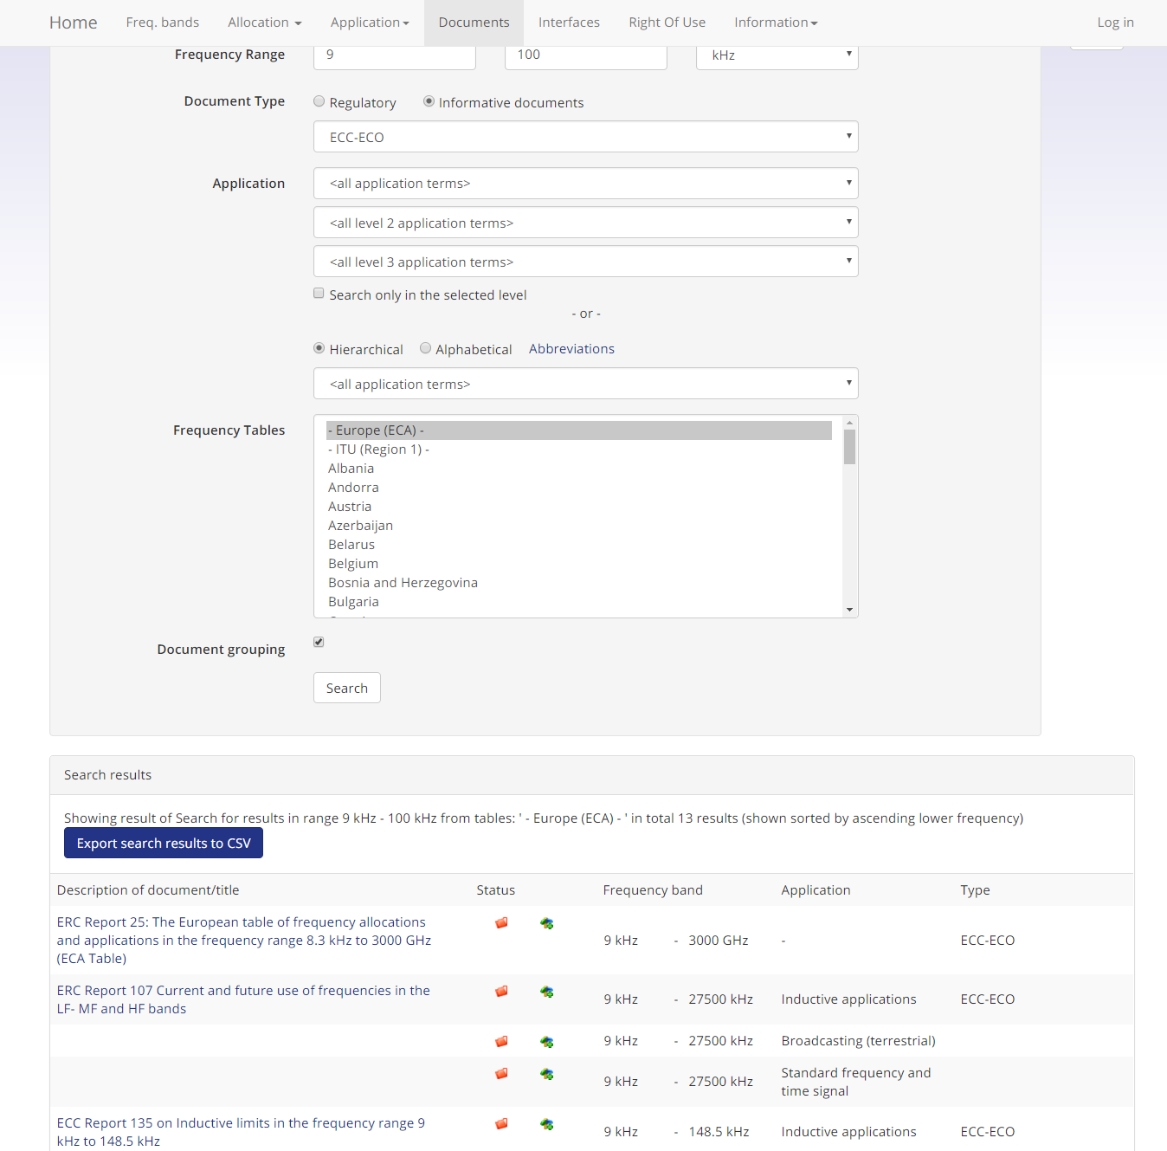
Figure 6: Example ECC and CEPT Reports in EFIS
Informative documentation in EFIS includes the following documentation types:
- ECC-ECO
This document type includes ECC or ECO documents with relevant information about current usage of one or several frequency bands, or expected future usage. The information is contained in documents such as CEPT questionnaire summaries and assessments, dedicated frequency band reviews, official ECC or ECO deliverables or external/public domain ECC/ECO documentation. Other information about application usage scenarios and usage densities may also be found in published ECC Reports.
- ETSI System Reference Documents(ETSI SRDocs and Draft ETSI SRDocs)
A Memorandum of Understanding (MoU) for co-operation exists between ETSI and the CEPT Electronic Communications Committee (ECC). One purpose of the MoU is to ensure that ECC and ETSI deliverables do not contradict each other: ETSI produces System Reference documents (ETSI SRDocs) - ECC carries out sharing studies.
Results of these sharing studies should be mutually acceptable and implemented consistently by both parties in ECC deliverables and ETSI Harmonised European Standards.
If there is a sharing or compatibility problem or when a new spectrum allocation is required, then the originating ETSI technical group generates an SRDoc describing the radio frequency (RF) characteristics and any RF compatibility issues as detailed in ETSI EG 201 788 [12]. The information for CEPT (i.e. SRDoc, proposal, Liaison Statement) is coordinated within ETSI by ETSI TC ERM, which is responsible for interfacing with CEPT. TC ERM sends the resulting SRDoc to CEPT for consideration.
The ETSI SRDocs contained in EFIS may also include information about the market such as existing spectrum usage, current regulations, forecasted spectrum usage and a proposal for the future spectrum usage as well as regulation. Documents under document type ETSI SRDoc are already published by ETSI and sent to the CEPT.
The ETSI Draft SRDocs type includes ETSI SRDocs which are not published yet, but exist as adopted ETSI ERM Work Items or draft SRDocs. Stage 1 means that the status of the draft is that it has not yet been applied to the ETSI internal consultation. Stage 2 means that the draft SRDoc has already been in the ETSI internal consultation conducted by ETSI ERM.
- Feedback from national inventory not already provided in other sections of EFIS
ECC-ECO, ETSI SRDoc, EU and Third Party document types are uploaded by the ECO whereas national non-regulatory spectrum usage information is uploaded by the national regulatory authorities.
National administrations may have information of non-regulatory nature on the possible evolution of spectrum use under study in their country. Such information can be uploaded in this national spectrum inventory document type. Examples are results of national consultations, spectrum reviews, reports or re-farming activities which provide information about the current usage (market) or evolution of spectrum usage (e.g. forecasts, growth or decline). The document can be either provided directly or as a link to a publicly available website of the national regulatory authority. Where possible, it should be linked to one or more frequency ranges and applicable applications of the ECA, but administrations are free to select sub frequency ranges or other applications.
Documents can be provided in the national language and should be accompanied by a title and short introduction (comments field, up to 300 characters) in the English language. This introduction as well as the title in English may include such information as whether the document describes the current use of spectrum (the word <<inventory>> should be used) and/or is also related to changes in the future or forecasted use of spectrum (the word <<demand>> should be used).
Existing application terms should be used as a general rule. Where it is not possible to even use a broad Layer 1 term, the comment field should be used to describe a future application.
In certain cases, it is more appropriate to provide documentation without a link to specific frequency ranges and/or applications. This could be a valid approach for:
- Non-technical information such as framework information on spectrum policy, allocation or trading of frequencies;
- Technical information related to the efficient use of spectrum or e.g. general information about medium access/ mitigation techniques.
This section is planned to be enhanced to enable also future information collection processes such as dedicated questionnaires or spectrum review processes. This may also contain the introduction of protected/restricted areas (to administrations) within EFIS, an issue which should be discussed. In a first step, a contact list with the responsible contact persons for spectrum inventory persons and information in EFIS needs to be established. This document type may also be used for future surveys on spectrum use if requested by the ECC.
Another feature that is available is to provide a date (publication date “valid from” and expiry date of the relevant information). This is to enable the EFIS system to also show whether information is still relevant and to provide a document history, where applicable.
- EU
This document type includes information collected by means of EC questionnaire or EC commissioned tasks or projects related to spectrum use which has subsequently become publicly available.
This section is planned to be enhanced to include also information provided by Member States in response to EC questionnaires in a given band.
- Third parties
A “third party” document category is also planned to be established. This will first of all address spectrum inventory relevant information from e.g. MoU/LoU partners of the ECC. For some radio services, institutions such as CRAF (radio astronomy) or EUMETSAT (EESS) may provide relevant information for spectrum inventory purposes at their own level in a context of harmonised approach. The basic rule will be that the third party can propose a document and it is uploaded by the ECO in agreement. The list of third party documentation will be provided to the WGFM.

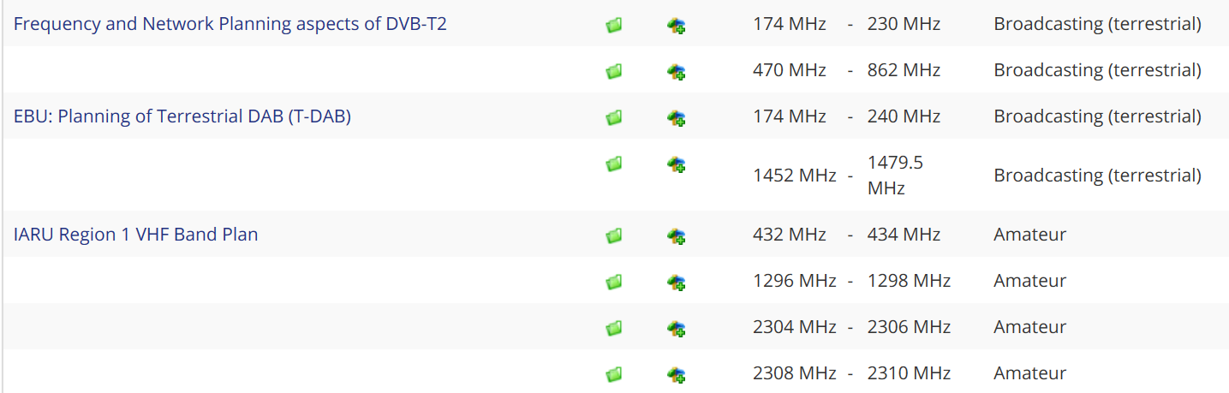
Figure 7: Example of Third Party Information
Third party information is occasionally also available via the questionnaire information in EFIS, e.g. when questionnaires were addressed to stakeholders or the collection of specific information was organised outside of the ECC (e.g. information collection from satellite operators).
Applications grouping in the spectrum inventory section of EFIS:
The complete application terminology used in EFIS encompasses more than 300 terms.
It may be advisable to use fewer categories for spectrum inventory purposes in this informative section of the database. In line with the layer search rules in the regulatory sections of EFIS, one can still use the full terminology available to provide as detailed information as possible while at the same time the mapping to a limited number of categories may be suggested. This application grouping is currently outside the EFIS Decision; only implemented on an optional basis in the EFIS database and in only the spectrum inventory section. The item is still for further study and the mapping shown in annex 6 of the present document can change and will also be maintained in the future (e.g. withdrawal/ adding of application terms).
Such application grouping may reduce visibility on information available in EFIS system and the understanding on how the radio frequency spectrum is used. It is therefore not used in the sections of EFIS dealing with regulatory information
In order to identify at a strategic level how the spectrum is used, a grouping of applications into categories may be investigated. This should be considered on the basis of usage information available and following clear objectives, inter-alia to provide a strategic overview of the actual spectrum usage. This also reflects functional similarities or trends in spectrum usage. The application grouping may also be used in the spectrum inventory section (in addition to the existing application layer 1 to 3 terms) for uploading documents as well as for conducting searches. The grouping is going to be further investigated. The Annex 6 in the present Report is therefore to be understood as example only ECO may provide on demand on its own responsibility extracts from EFIS to third parties.
Examples of mapping can be found in ANNEX 6:, Table 7 and Table 8.
Confidentiality issues
Confidential Information remains at national level. It seems not appropriate to investigate a possible restricted area in this context.
- Questionnaires in EFIS
CEPT Report 46 [24] set out that it is possible to collect on a case-by-case basis on "bands of interest" identified by either CEPT, the Commission or Radio Spectrum Policy Group (RSPG) comprehensive data for the frequency ranges and applications outside of the ECS bands through electronic CEPT questionnaires.
The format will be set each time a questionnaire is designed for a dedicated frequency band(s) and/or application(s). Information collected via electronic questionnaires may take into account that both regulatory and non-regulatory information. Non-regulatory information can be for example number of users, demand trends, or other specific non-regulatory information in relation to the actual use of the spectrum in a given frequency band or for a specific application. The electronic questionnaire concept is also proposed since it is considered difficult to transfer the Rights-of-Use (RoU) concept to some applications and frequency bands such as satellite services, governmental use, licence-exempt use or to some applications in some frequency bands that only need an authorisation, but do not require an RoU.
The use of questionnaires in CEPT as well as other organisations for spectrum inventory purposes is well proven.
This electronic questionnaire concept is well-suited to ensure that the data obtained is available for further analysis. This approach is in line with the request stipulated in the RSPG opinion on "Review of Spectrum Use" for a more developed version of EFIS that could become a key source depending on its future capability to illustrate actual availability and resources of Member States to provide such information.
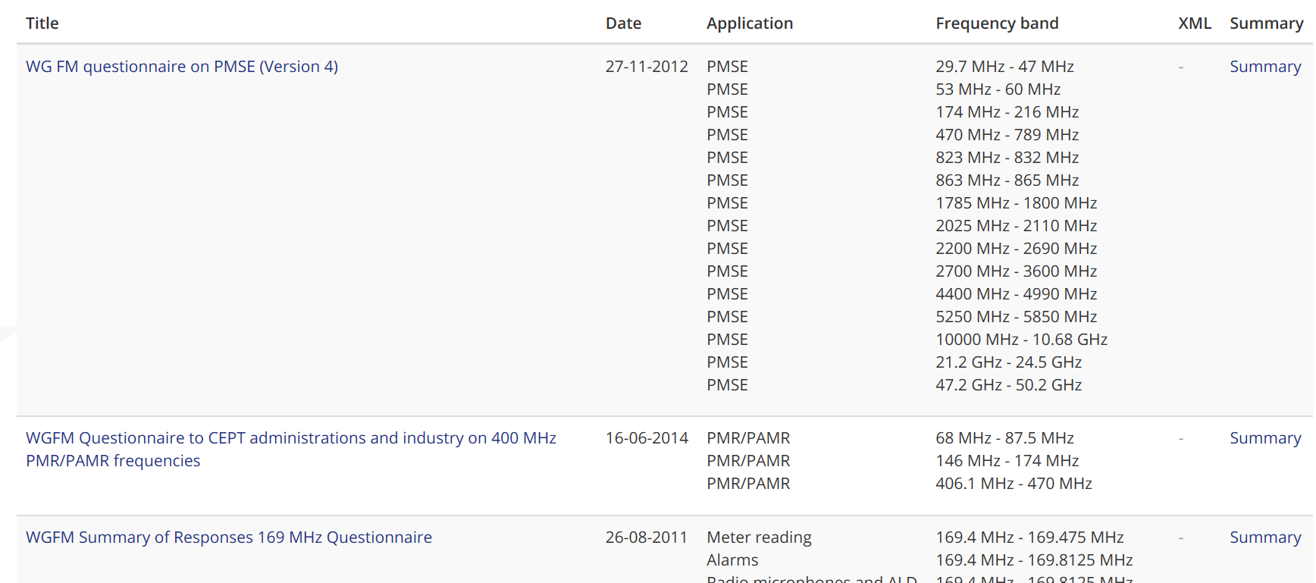
Figure 8: Example of CEPT questionnaire information
- National Implementation information in EFIS
ERC Recommendation 70-03 [23] on the use of short range devices is fully included and generated out of the EFIS database including the national implementation information. Administrations can provide and update their national implementation information via EFIS. This includes the status and notes about applicable restrictions or use conditions in their country. This implementation information is also graphically visible in EFIS.
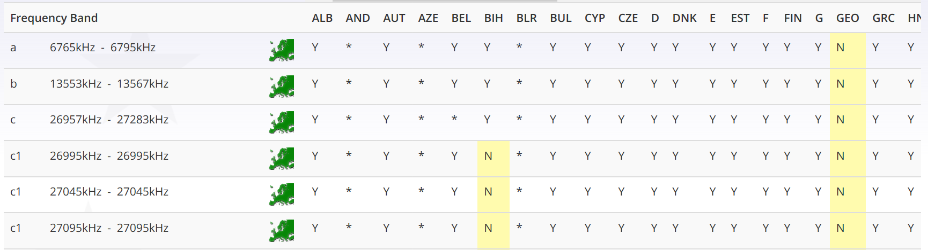
Figure 9: Example short range device national implementation information
National implementation information about fixed service channelisation arrangements as set out in about two dozens of ERC/ECC Recommendations is also available in EFIS. Administrations can provide and update their national implementation information via EFIS. In addition, they can provide notes, files and links with regard to specific national arrangements.
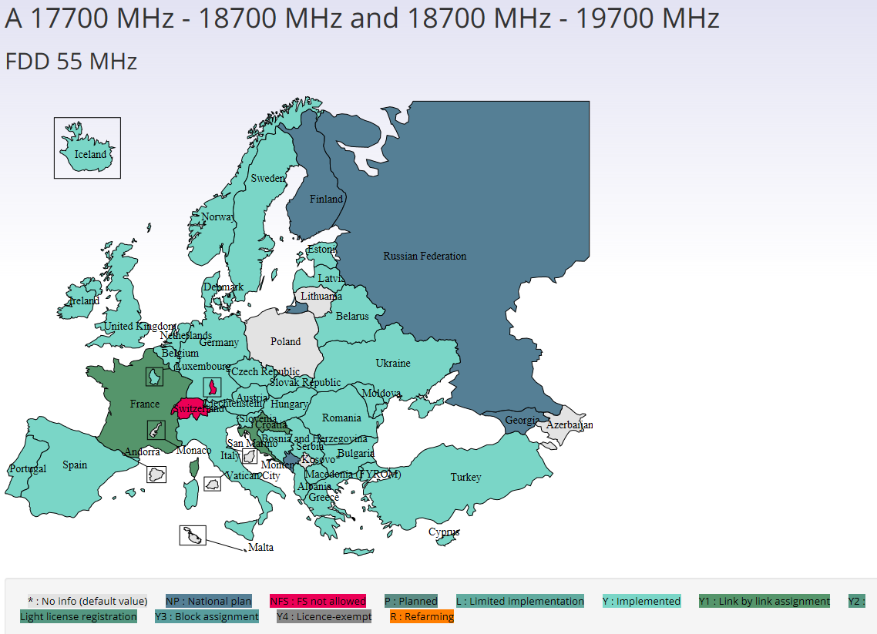
Figure 10: Example fixed service implementation information (European map)
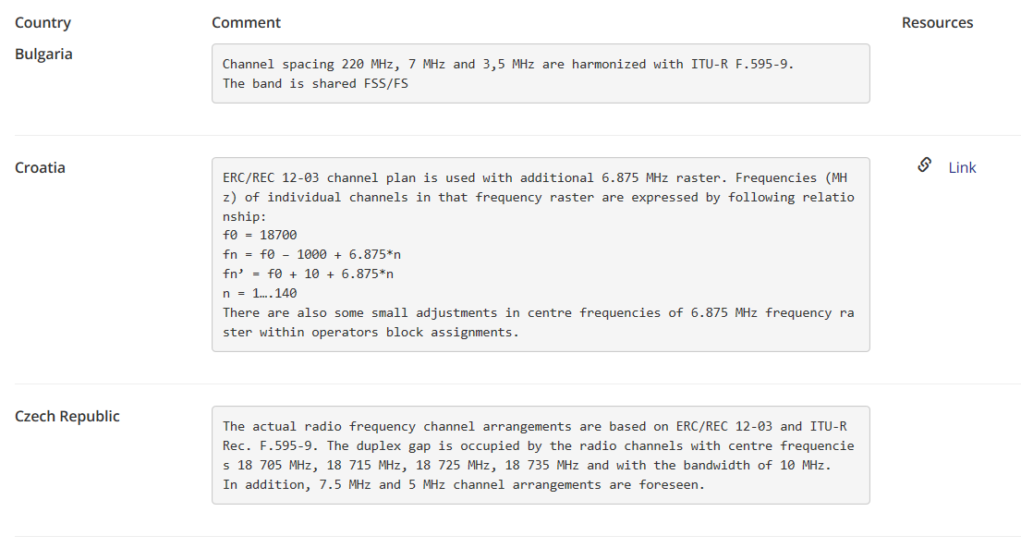
Figure 11: Example of national fixed service information
In addition to the fixed service related information in EFIS, ECC Report 173 [26] contains quantitative information (number of assignments) about the fixed service usage. This information is also available via the documentation section in EFIS or the questionnaire information in EFIS. Thumbnails in the applications section in EFIS indicate the availability of additional documentation/information. The National implementation information about fixed service channel arrangements and block assignments are provided in ECO Report 04 [29] which is generated up-to-date out of the EFIS database. The information is also available as graphical visualisation of the implemented channelisation arrangements and can be exported. In addition, ECO Report 04 also includes radio interface template information for the fixed service which can be used by administrations when creating their own national radio interface information for fixed service applications.
The applicable definitions, recommended frequency arrangements and related national implementation information for audio links and audio and video PMSE applications are included in ERC Recommendation 25-10 [30] which is created out of the EFIS database. The information can also be exported.
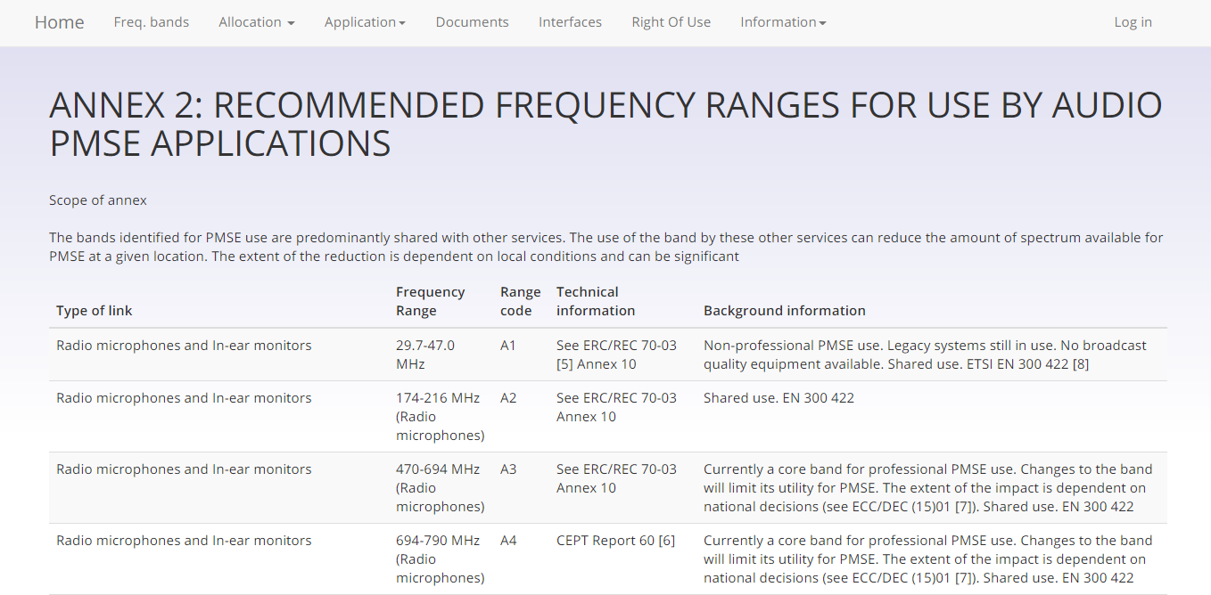
Figure 12: Example PMSE frequency information

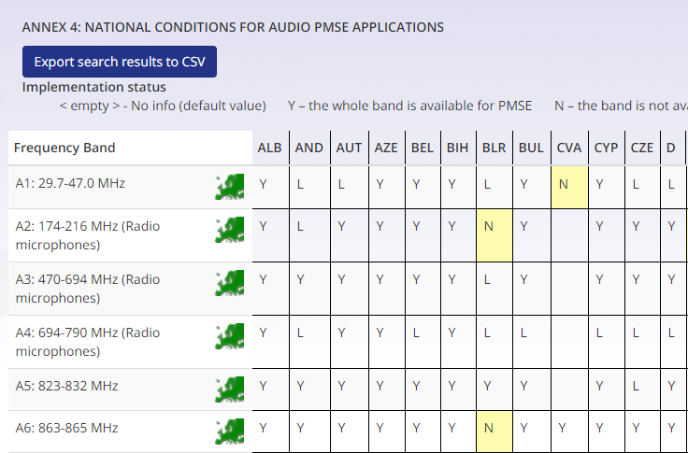
Figure 13: Example PMSE national implementation information

CEPT Report 46 and CEPT Report 47
The CEPT Report 46 [24] and CEPT Report 47 [25] responded to the EC Mandate on EFIS and addressed specific questions relevant to the gathering of information which could be used as input to a spectrum inventory on various spectrum usages either for commercial or public purposes.
This Mandate, adopted by the RSC in August 2012, aimed to extend the scope of the Decision regarding rights of use and possibly radio interface information in the spectrum range 400 MHz to 6 GHz as well as the means to keep the information as up-to-date as possible and specifically recognized the existing role of the ECO Frequency Information System (EFIS)” and the potential to develop it in such a way as to enable it to serve as a primary input source to the spectrum inventory. The role and objectives of the spectrum inventory are set out in the present Radio Spectrum Policy Programme (RSPP, Decision 243/2012/EU, Art. 9) [21].
The principal conclusions of CEPT Report 46 [24] have been as follows:
- The most valuable contribution which EFIS could make to the spectrum inventory requirement is to assimilate and present electronic questionnaires optimised to the band and applications under consideration for technical evaluation of spectrum usage. The use of CEPT electronic questionnaires is an efficient method to retrieve qualitative and quantitative information. Based on the information given in the questionnaires an analysis can be done in relation to the goals set out in the Radio Spectrum Policy Programme. This is an efficient, demand-oriented and cost-effective method to complete the information available in EFIS;
- No amendments are proposed with regard to Annex I of EC Decision 2007/344/EC [2]. As a matter of fact, the current radio interface information in EFIS according to Annex I of the EC Decision is complementary information of a regulatory nature and provides the necessary visibility on requirements applicable to a given band;
- Some amendments are proposed for Annex II of EC Decision 2007/344/EC [2]. These relate to duplex pairing arrangements as well as collection of RoU (Right of Use)/ authorisation information by means of electronic questionnaires;
- It is technically possible for the EFIS system to accommodate comprehensive information regarding spectrum usage rights/ authorisations for the whole range from 400 MHz to 6 GHz without limit to the type of application, based on the current common formats in Annex 2 of Commission Decision 2007/344/EC;
- Although the information provided by Member States is largely coherent for the purposes of regulatory information (used for aspiring market entrants), there are some differences in the level, and particularly the uniformity of that information. This is to a large extent due to variations in the mechanics of the licensing and authorisation regimes in the different countries, even if they follow common principles. There are also major differences in level and uniformity across different services. This is to be expected, and it tends to highlight the need for additional input information for spectrum inventory purposes;
The principal conclusions of CEPT Report 47 [25] have been as follows:
- Task 4 under the Mandate: to state the necessary additional operational details, if any, in particular the links and updating mechanisms between ECO and national administrations and assess the technical and administrative impacts on Member States, taking into consideration the need to minimise additional costs and manpower for national administrations with a clear distribution of responsibilities. In this context it should be investigated which Member States use direct automatic updates from national databases to EFIS and where national databases do not exist;
- National allocations, applications, Rights of Use (RoU) and Radio Interface Specifications (RIS) information are or will in future be stored in a database or an Excel spread sheet in nearly all administrations. This means that this information is or will be available in electronic format;
- The actualisation of the current level of RoU information (number of entries) for EFIS does not pose a problem for the administrations. The upload of a high number of RoU entries is seen as much more critical and will require modifications in database tools or new national database systems. This poses an additional burden (financial and manpower) for the administrations, the extent of which could currently not be evaluated;
- Making all the RoU information available in EFIS will mean internal costs for providing information to the national authority by the licence holders (i.e. the operators). These costs cannot be estimated today;
- Administrations call mainly for assistance from the ECO in first-time cases when they start to upload information into EFIS or change from manual upload to semi-automatic or automatic upload to EFIS. In addition, assistance from the ECO is called for when changes in the XML file common format take place;
- The objective to enable automatic upload of EFIS data is to minimise the administrative burden in future.

Conclusions
This ECC Report recognises that it might be possible to include more information in the EFIS system by all CEPT administrations.
The administrations should use the guidance provided in the present document for preparing their national regulatory information relative to allocation, applications, national radio interface data, right of use and licensing information as well as the non-regulatory information (‘National information’ to import them in EFIS.
National radio interface data:
- ECC/DEC/(03)05 [7] on publication of national tables of frequency allocations and utilisations (NTFAs);
- ECC/DEC/(01)03 [1] on EFIS;
- RIS model as proposed by ECC entities and available on line ECC Decisions and Reports;
- Information gained from the data of other administrations which is available in EFIS as examples;
- Assistance from ECO and EFIS/MG in cooperation with the relevant entity which drafted the RIS model;
- EC Decision 2007/344/EC [2] (only for EU Member States obliging);
- Decision 676/2002/EC [5] (only for EU Member States obliging).
Right of use information:
- National licence regimes and confidentiality;
- Information of other administrations which are available in EFIS as examples;
- Assistance from ECO and EFIS/MG;
- ECC/DEC/(01)03 on EFIS;
- ECC/DEC/(03)05 on publication of national tables of frequency allocations and utilisations;
- EC Decision 2007/344/EC (only for EU Member States obliging);
- EC Decision 676/2002/EC (only for EU Member States obliging).
National administrations are also encouraged to provide licensing related information which is of interest for spectrum users and industry under the document type “licensing information”. This document type is complementary to the right-of-use information. Annex 5 describes which documents or links should be uploaded under this document type.
National administrations may have information of non-regulatory nature on the possible evolution of spectrum use under study in their country. They are also encouraged to provide non-regulatory information under ‘National’ in the spectrum inventory section. This section is planned to be enhanced to enable also future information collection processes such as dedicated questionnaires or spectrum review processes.

- National radio interfaces information
The normative requirements for the information on National Radio Interface Specifications in Annex 1 of the EC Decision 2007/344/EC [2] are as follows:
Member States shall provide either by reference to the relevant standard or descriptive text and any comments as necessary regarding the following parameters:
Channelling;
Modulation/occupied bandwidth;
Direction/separation;
Transmit power/power density;
Channel access and occupation rules;
Authorisation regime;
Additional essential requirements according to Article 3(3) of RE Directive [13];
Frequency planning assumptions.

All other information provided is voluntary and purely informative.
- RIS Template skeleton
Note: the RIS template format has not been changed for the RE Directive and is still the same as it was for the R&TTE Directive. There is a guidance document for the template [35] which was updated for RIS information under the RE-D.
Table 5: Normative Part
Nr | Parameter | Description | Comments
1 | Radiocommunication  Service
2 | Application
3 | Frequency band
4 | Channelling
5 | Modulation /  Occupied bandwidth
6 | Direction /  Separation
7 | Transmit power / Power density
8 | Channel access and occupation rules
9 | Authorisation regime
10 | Additional essential requirements according to Art. 3.3 of RE Directive
11 | Frequency planning assumptions
Table 6: Informative Part
Nr | Parameter | Description | Comments
12 | Planned changes
13 | Reference
14 | Notification number
15 | Remarks
- National Right of Use Information
The intentions of Annex 2 of the EC Decision 2007/344/EC [2] were to focus on the bands of major economic interest or significance.
The normative requirements for the information on right of use as defined in the EC Decision 2007/344/EC are as follows:
Information on rights of use may be limited to frequency bands used for the provision of electronic communications services which are tradable in accordance with Article 9.3 of Directive 2002/21/EC [6] or which are granted through competitive or comparative selection procedures pursuant to Directive 2002/20/EC [10]
For relevant frequency bands Member States shall provide in accordance with the requirements of Directive 95/46/EC [8] and Directive 2002/58/EC [9] and Community and national rules on business confidentiality, the following information:
Identity of the radio frequency right holder;

Expiry date of the right or, in the case where there is none, the expected duration;
Geographic validity of the right by at least providing the information whether the right is local (i.e. one station), regional or nation-wide;
An indication of whether or not the right of use is tradable. If tradable, the transfer of a RoU is normally subject to agreement with the national regulatory authority and in this case, this indication should be given as ‘YES’.
All other information provided by the regulatory authority in EFIS is voluntary and purely informative. It should be noted that the contact provided in EFIS for the right of use information can also be a contact point from the administration.
Specific national legislation or jurisdiction may make it difficult for a country cases to provide in specific cases more detailed information such as the exact location of a transmitting station or identities of licence holders and their related affiliations.
In addition, the EFIS database provides the possibility of adding the following information which is also used in ECO Report 03 [28]:
- Right of use start date;
- Technology in use;
- Duplex or simplex of an RoU;
- Whether the RoU is considered relevant for ECO Report 03.
Annex 4 includes the information about the EC and ECC Decisions for ECS bands. RoU in the EFIS database should be provided in duplex format for those bands which are identified in these harmonisation deliverables as duplex paired bands (uplink and downlink should not be provided in these cases as individual simplex RoU).
Administrations are requested to provide the information about the right-of-use start and expiry date which is also used to generate statistics for the rights-of-use information in ECO Report 03.
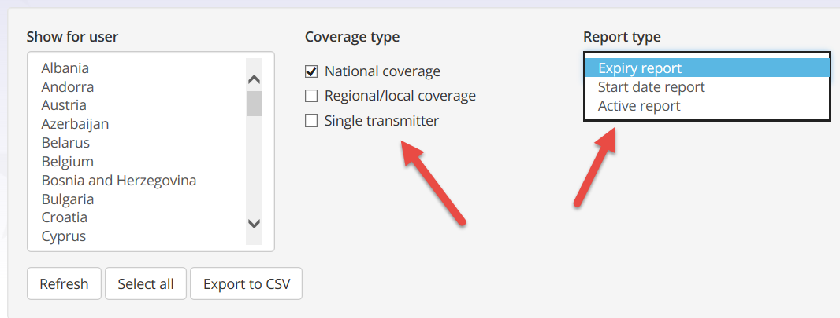
Figure 14: ECO Report 03 statistics

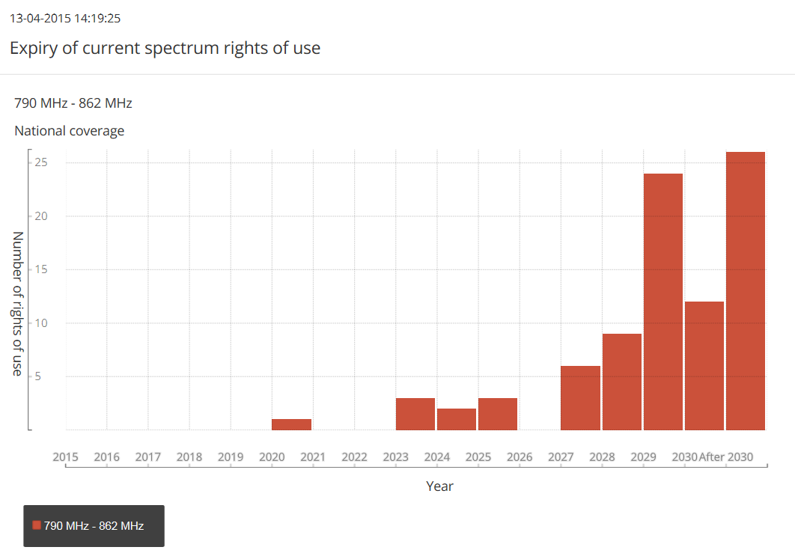
Figure 15: Example expiry date statistics
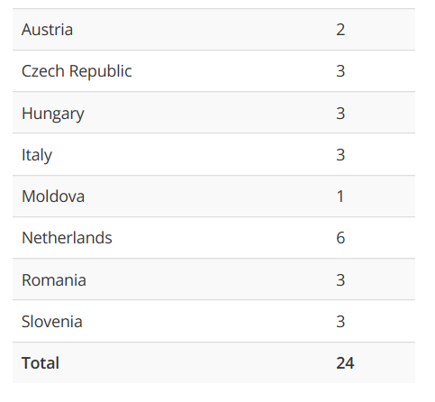 | 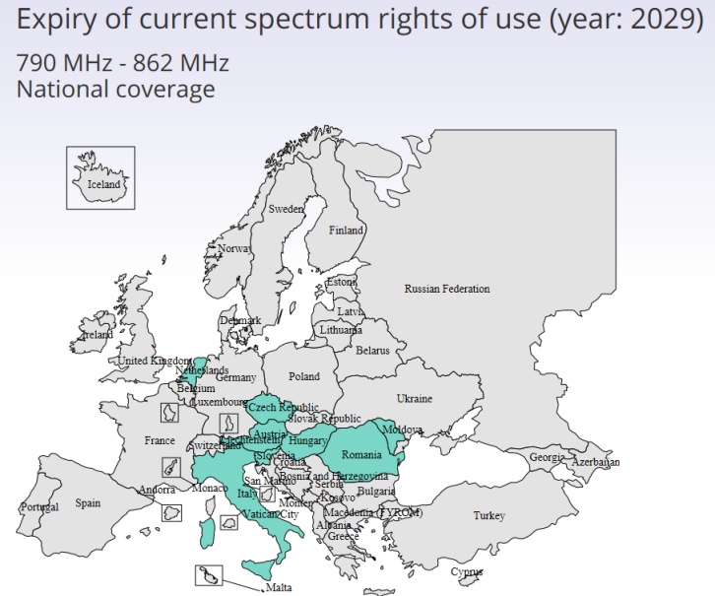
Figure 16: Example detailed statistical information
ECO Report 03 can be exported from EFIS in pdf format. This exported version always takes into account recent changes/updates from the national administrations.
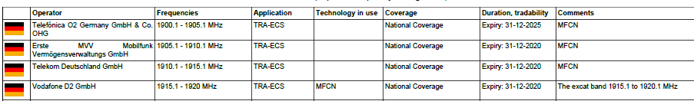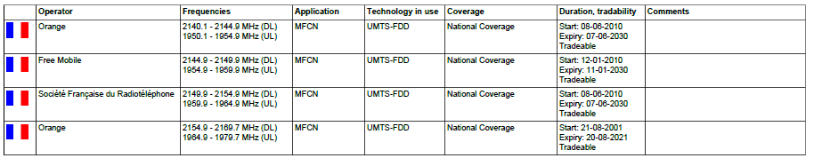
Figure 17: Right-of-Use table format
An auto-complete function has been added in EFIS to get more commonality for the operator names in EFIS.
For rights-of-use in the ECS bands which are not intended to be included in the ECO Report 03 [28] (e.g. those not used by mobile network operators or for very special purposes), flags can be used in EFIS to exclude them from the ECO Report 03 information.

- Harmonised ECS Bands
The bands that have been designated for harmonised Electronic Communications Services (ECS) during the last two decades are the following:
Table 7: Harmonised ECS
Frequency Band | CEPT & EC Decision references | Year of designation | Amount of Spectrum
700 MHz | ECC/DEC/(15)01  Dec 2016/687/EU [31] | 2015 | 2x30 MHz
800 MHz | ECC/DEC/(09)03  Dec 2010/267/EU [14] | 2010/2015 | 2x30 MHz
900 MHz | Dir 87/372/CEE [15]  ERC/DEC/(94)01  ERC/DEC/(97)02  ECC/DEC/(06)13 [36]  Dir 2009/114/EC [19]  Dec 2009/766/EC [16] | 1987 - 1994 - 1997 | 2x35 MHz
1400 MHz | ECC/DEC/(13)03 [37]  ECC/DEC/(17)06 [38]  Dec 2015/750/EU [33] | 2013-2017 | 91 MHz
1800 MHz | ERC/DEC/(95)03  ECC/DEC/(06)13  Dec 2009/766/CE | 1995 | 2x75 MHz
2100 MHz | ERC/Dec/(97)07  ERC/Dec/(99)25  ERC/Dec/(00)01  ECC/DEC/(06)01 | 1997 – 2000 | 155 MHz
2300 MHz | ECC/DEC/(14)02 | 2014 | 100 MHz
2600 MHz | ECC/DEC/(02)06  ECC/DEC/(05)05  Dec 2008/477/EC [17] | 2002 - 2008 | 190 MHz
3600 MHz | ECC/DEC/(07)02  ECC/DEC/(11)06  Dec 2008/411/EC [18]  Dec 2014/276/EU [32] | 2007 - 2008  2011 | 400MHz
 |  | Total | 1276 MHz

- Licensing information type documents
National administrations are encouraged to provide licensing related information which is of interest for spectrum users and industry under this document type. The document type is complementary to the right-of-use information which includes certain individual licenses (see section 2.4).
Examples are:
Application forms for licensing purposes (where applicable);
General authorisation, licence-exempt rulings;
General/Master/framework documentation on licensing (e.g. PMR or FS frequencies);
Information related to licensing for short term/temporary/occasional usage of spectrum;
Licensing contact information points to branch offices of the regulatory authority.
A document can be either provided directly or as a link to a publicly available website of the national regulatory authority.
In this context, it should be noted that the ECO manages a list of contacts from administrations on experimental/ testing use of spectrum and that the link to this information is also provided via the EFIS database. Administrations therefore do not need to include such information again in the database.
Where possible, it should be linked to one or more frequency ranges and applicable applications of the ECA but administrations are free to select frequencies and applications.
Documents can be provided in the national language and should be accompanied by a title and short introduction (comments field, up to 300 characters) in English language.
Licensing information may differ from one sector to another. In case of governmental services, only information on the rights granted according to the National Table of Frequency Allocation may be available.

- Example of Mapping of the spectrum inventory section with the EFIS layer 1 and 2 terminology
(for further Study)
The 0 and 0 shows an example of the mapping of the application terms in EFIS used for spectrum inventory purposes. Depending on precise objectives, other mapping configurations may be defined.
Table 8: Mapping of EFIS Applications to Spectrum Inventory Application Groupings
EFIS Layer 1 | EFIS Layer 2 | Application Grouping for Spectrum Inventory | Comments
Aeronautical | Aeronautical communications | Aeronautical, Maritime and Civil Radiolocation / Navigation Systems (AMCRN) | Similar communication, radiolocation and radionavigation requirements apply across aeronautical and maritime sector.
 | Aeronautical navigation
 | Aeronautical surveillance
 | Aeronautical emergency
 | Aeronautical telemetry
 | Aeronautical telecommand
 | Aeronautical telemetry/telecommand
 | Satellite navigation systems
Broadcasting | Broadcasting (terrestrial) | Broadcasting (terrestrial)
 | Broadcasting (satellite) | Satellite systems (civil) | Propose to group together with other satellite services for efficiency analysis
 | PMSE | PMSE | Reflects current terminology
Fixed | Point-to-Multipoint | Fixed
 | Point-to-Point
 | BWA | BWA / Cellular | Reflects trend towards service neutrality
 | MFCN
Defence systems | Aeronautical military systems | Defence Systems
 | Land military systems
 | Maritime military systems
 | Meteorological aids (military)
 | Radiolocation (military)
 | Satellite systems (military)
 | Telemetry (military)
 | Telecommand (military)
 | Telemetry/Telecommand (military)
Land mobile | Digital cellular | BWA / Cellular | Reflects trend towards service neutrality
 | BWA
 | DA2GC
 | ITS | ITS | New transport related services may require specific efficiency criteria
 | Analogue cellular | BWA / Cellular
 | Cordless telephones | SRDs | Reflects licence exempt status
 | D-GPS | Not currently included | Not under consideration currently
 | PPDR | PPDR | Reflects current terminology
 | Inland waterway communications | PMR/PAMR | Reflects commonalities between these services (e.g. technology, functionality)
 | MFCN | BWA / Cellular
 | Paging | PMR/PAMR | Reflects similarity between these services
 | PMR/PAMR
 | PMSE | PMSE | Reflects current terminology
 | Telemetry (civil) | Fixed(licensed) or SRDs (licence exempt) | These are generally fixed (point to multipoint) systems rather than mobile (though often deployed in mobile bands)
 | Telemetry/Telecommand (civil)
Maritime | GMDSS | Aeronautical, Maritime and Civil Radiolocation / Navigation Systems (AMCRN) | Similar communication, radiolocation and radionavigation requirements apply across aeronautical and maritime sector
 | Satellite navigation systems
 | Maritime communications
 | Maritime navigation
Meteorology | Oceanographic buoys | Meteorology
 | Sondes
 | Weather radar
 | Weather satellites
 | Wind profilers
Satellite systems (civil) | Aeronautical satcoms | Satellite systems (civil)
 | Broadcasting (satellite)
 | Earth exploration-satellite
 | Feeder links
 | FSS Earth stations
 | Inter-satellite links
 | MSS Earth stations
 | Satellite navigation systems | Aeronautical, Maritime and Civil Radiolocation / Navigation Systems (AMCRN) | Reflects functional similarity to other navigation systems
 | Standard frequency and time signal-satellite | Satellite systems (civil)
 | Space operations
 | Space research
Radio astronomy | Continuum measurements | Radio Astronomy
 | Spectral line observations
 | VLBI observations
Short Range Devices | Alarms | Short Range Devices (SRDs)
 | Railway applications | Intelligent Transport Systems (ITS) | New transport related services may require specific efficiency criteria
 | Tracking, tracing and data acquisition | Short Range Devices (SRDs)
 | Radiodetermination applications
 | Inductive applications
 | Active medical implants
 | Model control
 | Non-specific SRDs
 | Radio microphones and ALD
 | Wideband data transmission systems | Wideband Data Transmission | Likely to require different efficiency criteria from other SRD applications
 | RFID | Short Range Devices (SRDs)
 | TTT | Intelligent Transport Systems (ITS) | New transport related services may require specific efficiency criteria
 | UWB applications | Short Range Devices (SRDs)
 | Wireless audio applications
TRA-ECS |  | BWA / Cellular or  Fixed
Other | Amateur and Amateur-satellite | Not currently included
 | CB radio
 | GNSS Repeater
 | HAPS
 | ISM
 | Meteor scatter communications
 | Land radionavigation | Aeronautical, Maritime and Civil Radiolocation / Navigation Systems (AMCRN)
 | Radiolocation (civil)
 | Standard frequency and time signal | Not currently included
 | Tracking systems
ALL |  | No implementation | Frequency ranges that have been allocated but not assigned would be mapped here, this could in principle be nearly all EFIS application terms

Table 9: Mapping of Spectrum Inventory Application Groupings to EFIS Applications (Level 2)
Application Grouping for Spectrum Inventory Section of EFIS |  | EFIS Layer 2 Applications
 | Aeronautical, Maritime and Civil Radiolocation / Navigation Systems (AMCRN) |  | Aeronautical communications
 |  |  | Aeronautical emergency
 |  |  | Aeronautical navigation
 |  |  | Aeronautical surveillance
 |  |  | Aeronautical telecommand
 |  |  | Aeronautical telemetry
 |  |  | Aeronautical telemetry/telecommand
 |  |  | GMDSS
 |  |  | Land radionavigation
 |  |  | Maritime communications
 |  |  | Maritime navigation
 |  |  | Radiolocation (civil)
 |  |  | Satellite navigation systems
 | Broadcasting (Terrestrial) |  | Broadcasting (Terrestrial)
 | BWA / Cellular |  | Analogue cellular
 |  |  | BWA
 |  |  | Digital cellular
 |  |  | MFCN
 |  |  | TRA-ECS (Level 1)
 | Defence Systems |  | Aeronautical military systems
 |  |  | Land military systems
 |  |  | Maritime military systems
 |  |  | Meteorological aids (military)
 |  |  | Radiolocation (military)
 |  |  | Satellite systems (military)
 |  |  | Telemetry (military)
 |  |  | Telecommand (military)
 |  |  | Telemetry/Telecommand (military)
 | Fixed |  | Point-to-Multipoint
 |  |  | Point-to-Point
 |  |  | Telemetry (civil)
 |  |  | Telemetry/Telecommand (civil)
 | Intelligent Transport Systems (ITS) |  | ITS
 |  |  | Railway Applications
 |  |  | TTT
 | Meteorology |  | Oceanographic buoys
 |  |  | Sondes
 |  |  | Weather radar
 |  |  | Weather satellites
 |  |  | Wind profilers
 | PMR / PAMR |  | Inland waterway communications
 |  |  | Paging
 |  |  | PMR / PAMR
 | PMSE |  | PMSE
 |  |  | Radio Microphones
 | PPDR |  | PPDR
 | Radio Astronomy |  | Continuum measurements
 |  |  | Spectral line observations
 |  |  | VLBI observations
 | Satellite Systems (Civil) |  | Aeronautical satcoms
 |  |  | Amateur-satellite
 |  |  | Broadcasting-satellite receivers
 |  |  | Earth exploration-satellite
 |  |  | Feeder links
 |  |  | FSS Earth stations
 |  |  | Inter-satellite links
 |  |  | MSS Earth stations
 |  |  | Satellite navigation systems
 |  |  | Standard frequency and time signal-satellite
 |  |  | Space operations
 |  |  | Space research
 | Short Range Devices (SRDs) |  | Active medical implants
 |  |  | Alarms
 |  |  | Inductive applications
 |  |  | Model control
 |  |  | Non-specific SRDs
 |  |  | Radio microphones and ALD
 |  |  | Radiodetermination applications
 |  |  | RFID
 |  |  | Tracking, tracing and data acquisition
 |  |  | UWB applications
 |  |  | Wireless audio applications
 | Wideband data transmission systems |  | Wideband data transmission systems

- List of reference
- ECC Decision (01)03: ECC Decision of 15 November 2001 on ECO Frequency Information System (EFIS) amended November 2017
- Commission Decision 2007/344/EC of 16 May 2007 on harmonized availability of the information regarding spectrum use within the community;
- CEPT Report 11: Report from CEPT to the European Commission in response to the Mandate on: EFIS (ECO Frequency Information System);
- ANNEX 3 to doc RA(11)086, September 2011: Internal ECC Report on implementation of the RIS template;
- Decision 676/2002/EC: of the European Parliament and of the Council of 7 March 2002 on a regulatory framework for radio spectrum policy in the European Community (Radio Spectrum Decision);
- Directive 2002/21/EC of the European Parliament and of the Council of 7 March 2002 on a common regulatory framework for electronic communications networks and services (Framework Directive);
- ECC Decision (03)05: ECC Decision of 17 October 2003 on the publication of national tables of frequency allocations and utilisations;
- Directive 95/46/EC: of the European Parliament and of the Council of 24 October 1995 on the protection of individuals with regard to the processing of personal data and on the free movement of such data;
- Directive 2002/58/EC: of the European Parliament and of the Council of 12 July 2002 concerning the processing of personal data and the protection of privacy in the electronic communications sector (Directive on privacy and electronic communications);
- Directive 2002/20/EC of the European Parliament and of the Council of 7 March 2002 on the authorisation of electronic communications networks and services (Authorisation Directive)
- ERC Report 25: European Common Allocations Table
- ETSI EG 201 788: Guide for the creation of ETSI System Reference Documents
- Radio Equipment (RED) 2014/53/EU: OJ L153 22 May 2014; replaced the Radio & Telecommunication Terminal Equipment Directive (R&TTE Directive) 1999/5/EC, repealed with effect from 13 June 2016
- Commission Decision 2010/267/EU on harmonised technical conditions of use in the 790-862 MHz frequency band for terrestrial systems capable of providing electronic communications services in the European Union
- Council Directive 87/372/ECC on the frequency bands to be reserved for the coordinated introduction of public pan-European cellular digital land-based mobile communications in the Community (GSM)
- Commission Decision 2009/766/EC on the harmonisation of the 900 MHz and 1800 MHz frequency bands for terrestrial systems capable of providing pan-European electronic communications services in the community
- Commission Decision 2008/477/EC on the harmonisation of the 2500-2690 MHz frequency band for terrestrial systems capable of providing electronic communications services in the Community
- Commission Decision 2008/411/EC on the harmonisation of the 3400 - 3800 MHz frequency band for terrestrial systems capable of providing electronic communications services in the Community
- Directive 2009/114/EC of the European Parliament and of the Council amending Council Directive 87/372/EEC on the frequency bands to be reserved for the coordinated introduction of public pan-European cellular digital land-based mobile communications in the Community
- ECC(08)38: TCAM-RSC RIG II update (RIS model)
- Decision No 243/2012/EU of the European Parliament and of the Council of 14 March 2012 establishing a multiannual radio spectrum policy programme
- RSPG12-408: RSPG Opinion on Review of Spectrum Use
- ERC Recommendation 70-03: Relating to the use of Short Range Devices (SRD)
- CEPT Report 46: Report from CEPT to the European Commission in response to the Mandate on inclusion of information on rights of use for all uses of spectrum between 400 MHz and 6 GHz
- CEPT Report 47: Second Report from CEPT to the European Commission in response to the Mandate on inclusion of information on rights of use for all uses of spectrum between 400 MHz and 6 GHz (Tasks 4 and 5 in response to the EC Mandate on EFIS)
- ECC Report 173: Fixed Service in Europe - Current use and future trends post 2011 (last update in 2012)
- ECO Report 05: CEPT, ECC and EC Deliverables; Relation to application terminology specified in ECC Decision (01)03 Annex 2
- ECO Report 03: The licensing of 'Mobile bands' in CEPT
- ECO Report 04: Fixed Service in Europe - Implementation Status
- ERC Recommendation 25-10: Frequency Ranges for the Use of Terrestrial Audio and Video Programme Making and Special Events (PMSE) applications
- Commission Decision (EU) 2016/687 of 28 April 2016 on the harmonisation of the 694-790 MHz frequency band for terrestrial systems capable of providing wireless broadband electronic communications services and for flexible national use in the Union
- Commission Decision (EU) 2014/276 of 2 May 2014 on amending Decision 2008/411/EC on the harmonisation of the 3400-3800 MHz frequency band for terrestrial systems capable of providing electronic communications services in the Community
- Commission Decision (EU) 2015/750 of 8 May 2015 on the harmonisation of the 1452-1492 MHz frequency band for terrestrial systems capable of providing electronic communications services in the Union
- Commission Implementing Decision 2013/195/EU of 23 April 2013 defining the practical arrangements, uniform formats and a methodology in relation to the radio spectrum inventory established by Decision No 243/2012/EU of the European Parliament and of the Council establishing a multiannual radio spectrum policy programme
- Notification of radio interface specifications and radio equipment classes - Notification template and guidance (http://ec.europa.eu/docsroom/documents/26844)
- ECC Decision (06)13: ECC Decision of 21 June 2013 on the designation of the bands 880-915 MHz, 925-960 MHz, 1710-1785 MHz and 1805-1880 MHz for terrestrial UMTS, LTE and WiMAX systems.
- ECC Decision (13)03: ECC Decision of 3 July 2015 on the harmonised use of the frequency band 1452-1492 MHz for Mobile/Fixed Communications Networks Supplemental Downlink (MFCN SDL)
- ECC Decision (17)06: ECC Decision of 17 November 2017 on the harmonised use of the frequency bands 1427-1452 MHz and 1492-1518 MHz for Mobile/Fixed Communications Networks Supplemental Downlink (MFCN SDL)

