ECC Report 174

Compatibility between the mobile service in the band 2500-2690 MHz and
the radiodetermination service in the band 2700-2900 MHz
March 2012

Executive summary
ATC, defence and meteorological radars operating in the band 2700-2900 MHz are deployed in Europe and would normally be transmitting with high powers, ATC radars are mainly deployed close to airports with defence and meteorological radar more likely being deployed in rural areas. The frequency spectrum 2500-2690 MHz allocated to the mobile service , has not seen mobile services deployed in the past but due to recent technology advances is expected to be heavily used in future by mobile/broadband systems (e.g. LTE and WIMAX) in line with or similar to the frequency arrangements defined in the ECC Decision (05)05[2]. Therefore, these studies have been carried out to assess the mutual compatibility between these systems, i.e. mobile service operating below 2.69 GHz and aeronautical radio navigation and radiolocation services operating above 2.7 GHz.
The studies, based on worst case assumptions (i.e. line-of-sight conditions), have shown that there is potential interference from mobile service to radar and vice versa which will depend on the deployment scenario with factors such as frequency separation, relative antenna orientation, and distance. In addition, interference may be less severe than the results indicate when realistic assumptions about propagation, actual mobile and radar deployments and equipment performance are taken into account. It should be noted that the worst case assumptions used in this report may not be encountered in a large number of actual situations. In these cases additional mitigation may not need to be applied.
Two interference effects of potential mutual interference have been studied:
- Blocking: where a signal outside of the nominal receiver bandwidth causes the victim receiver to experience an increased noise level or go into compression, thus producing non-linear responses.
- Unwanted emissions: where the unwanted emissions (OOB and spurious) of the interfering transmitter fall into the receiving bandwidth of the victim receiver.

Impact from mobile systems into radars:
- Blocking
Studies have shown that additional isolation depending on the separation distance would be required between the mobile service base station and the radar. As an example, for a separation distance of 1 km this additional required isolation is in the order of 20-60 dB depending on the radar characteristics such as antenna height, gain, radiation patterns, radar frequency and bandwidth, number and size of mobile blocks, etc. The actual impact should be determined on a case-by-case basis. Currently, it is planned in a number of administrations to address this issue by improving the radar adjacent band rejection capability through enhancing receiving chains where needed.
It should be noted that the non-linear responses could be dominant for some radar frequencies compared with other effects.
In addition studies have shown that the blocking effect from mobile service terminals operating in accordance with the FDD band-plan (in the 2500-2570 MHz band) is not considered to be a problem and no additional isolation is required for this case.
- Unwanted Emissions
Based on the assumption that unwanted emissions of mobile equipment are -30 dBm/MHz in the band 2700-2900 MHz, studies have indicated that there would be a need for an additional isolation depending on the separation distance between the two services. As an example, for a separation distance of 1 km, this additional isolation would be in the order of 30-45 dB for the base station and 15-20 dB for the mobile service terminal depending on the radar characteristics such as antenna height, gain, radiation patterns, etc..
Impact from radar into mobile systems:
- Blocking
The additional isolation due to blocking of mobile receivers by radar in-band emissions was not assessed in such details, but by comparison with the impact of radar unwanted emissions. Two different cases were addressed:
  - In-band blocking which refers to a situation of interference that is not attenuated by the duplex filter, i.e. reaches the LNA without being filtered within LTE band.
  - Out-of-band blocking refers to the case when the interference falls outside of LTE band but it could be within the pass band of the duplex filter.

In cases where the radar unwanted emissions (OoB and/or spurious) attenuation is lower than 78 dBc, in-band blocking to the LTE BS becomes the dominant factor and this blocking level can only be improved accordingly through additional receiver rejection.
In cases where the radar unwanted emissions (OoB and/or spurious) attenuation are above 78 dBc, the LTE BS out of band blocking effect becomes dominant and should be improved accordingly. The out-of-band blocking of user terminal equipment may also be problematic for radar frequencies close to the mobile band, due to the lack of duplexer suppression of the radar interference.
However, the real FDD BS receiver blocking performance is much better than the minimum requirements of in-band & out of band blocking levels defined in the standard due to the duplexer which protects the BS receiver reception (2500 - 2570 MHz) against its own emission (2620 - 2690 MHz).
- Unwanted Emissions
The results for radar unwanted emissions apply only to LTE systems. Results for other mobile systems may be substantially different, as the analysis relies on very detailed aspects of system characteristics.
Based on the assumption that unwanted emissions of radars are at the regulatory limit contained in ERC Recommendation 74-01 [13] which depends on the radar type and characteristics, studies have shown that there would be a need for additional isolation depending on the separation distance. As an example, based on a separation distance of 1 km, a limit in the spurious domain of -60 dBc and limited to the impact of the radar antenna main beam, the additional isolation needed would be in the order of 75-95 dB to protect the base station and 40-65 dB to protect the terminal equipment. It is recognised that such isolation cannot be fulfilled by additional filtering of radars only.
When the mobile service equipment is within the side lobe of the radar, the required additional isolation would instead be 40 – 60 dB for BS and 10 – 30 dB for terminal. It should be noted that 60 dBc attenuation is only valid if there is sufficient separation in frequency between interferer and victim. Otherwise, the attenuation may be as low as 40 dBc instead.
Measurements of some radars indicate that the level of unwanted emission falling into the band 2500-2690 MHz may be much lower than the above mentioned limit and hence the impact may be less severe than the results based on the regulatory levels. Additionally, the intermittent aspect of the interference due to the radar antenna sweeping pattern may limit its impact on the mobile equipment, although a degradation of the quality of service would still be expected in vicinity of radars. The studies related to the latter effect have not been completed.
Possible Mitigation Techniques
The following is a non-exhaustive list of possible mitigation techniques:
- Improvement of the receiver selectivity, in particular for radars, which would help solve the blocking of radars by the mobile service;
- Reduce unwanted emissions of radar transmitters
  - Measured examples of the spectral masks would indicate that the radars are, in practice achieving better than the regulatory limit and hence the impact may be less severe than the results based on the regulatory levels would indicate.
- Reduce unwanted emissions of mobile service transmitters
  - Measured examples, in isolation, (see annex 4) would indicate that mobile service equipment (i.e. base station and user terminal) are in practice better that the regulatory limit (-30 dBm/MHz limit specified in the appropriate EN for mobile equipment operating in these bands). Based on these measurement results it looks like no additional isolation may be needed with at least some existing production equipment.
  - With regard to the base station, if necessary, more stringent unwanted emissions limits above 2.7 GHz may be achieved by introducing additional filtering on a case-by case basis, when appropriate at a national level. This approach has been chosen by some administrations.
  - With regard to the user terminal, the additional isolation cannot be achieved by introducing additional filtering on a case by case basis and can only be achieved through harmonized approach.
- Reduced power from the mobile service base station;
  - This solution may only be used in some specific instances with base stations near a radar station.
- Site specific deployment, e.g.
  - avoid mobile service base station antennas pointing towards radars (both in azimuth and elevation);
  - take advantage of natural shielding that terrain and buildings provide
- Increase of the distance separation between radar and stations of the mobile service;
- Increase of the frequency separation;
  - This will enable a further reduction of spurious emissions from mobile service transmitters, which may be considerably lower at e.g. 2730 MHz than at 2700 MHz.
  - The risk of out-of-band emissions from a radar falling into the mobile service spectrum is reduced, and additional suppression of spurious emissions is simplified.

Given the scale of the additional isolation required in certain cases one single mitigation technique may not resolve each particular issue. However the knock on impact of each mitigation technique can have a positive effect and reduce or avoid the need for a mitigation technique to solve another issue (e.g. to achieve the required improvement in a radar receiver filtering to avoid blocking by mobile systems there may be a need to migrate the radar up in frequency away from 2.7 GHz thus increasing the frequency separation which may aid or solve another issue such as mobile system unwanted emissions). Therefore the design of mitigation techniques will have to be carefully considered to ensure the correct combination is selected to minimise the impact on all systems and reduce the cost of the overall mitigation solution.
Studies have shown that in some cases blocking of radars due to mobile in-band transmissions was the dominating problem, and in other cases the dominant factor was the impact of mobile unwanted emissions falling into the radar receiver. However, it should be noted that both the impact of blocking and unwanted emissions have to be addressed at the same time. Indeed, if for instance the selectivity of radar receiver chain is upgraded in order to improve its ability to withstand the impact of mobile service base stations transmitting nearby within the mobile allocation, then the issue of the impact of unwanted emissions of mobile service base stations will remain if nothing is done at the base station transmitter, thus jeopardizing the actions taken on the radar side. Similarly, not improving the radar selectivity makes the improvement of mobile base stations spurious emissions useless. The same principle stands for the other direction of interference, even if study results show that in the direction of interference from radar to mobile service system, the interference from radar unwanted emissions to FDD base stations should be the dominant factor, depending on the duplex filter characteristics of the FDD base stations. This may not be the case for all mobile service terminals or for TDD base stations using the upper part of the MS band.
It should be noted that although the worst case analysis shown in this report suggests that there could be compatibility problems in certain circumstances between the mobile service and radar operations, the actual situation in practice throughout CEPT will vary from country to country. In addition it is expected that by considering more realistic assumptions, including unwanted emissions levels for both services, and using a combination of the mitigation techniques highlighted in the report, where appropriate, sufficient protection can be given to both services.

TABLE OF CONTENTS

0 Executive summary 2
1 Introduction 9
2 USAGE OF THE BANDS 10
2.1 Usage of the band 2500-2690 MHz 11
2.2 Usage of the band 2700-2900 MHz 11
3 TECHNICAL CHARACTERISTICS OF MOBILE service SYSTEMS 11
3.1 Base stations 11
3.2 Terminals (UE) 15
3.3 Protection criteria for interference from radars to Mobile Service terminals 17
3.3.1 Co-channel interference due to radar unwanted emissions 17
3.3.1.1 Study 1: Link level simulations 17
3.3.1.2 Study 2: Measurements 18
3.3.1.3 Calculation of protection levels 19
3.4 Protection criteria for interference from radars to Mobile Service base stations 20
3.4.1 Co-channel interference due to radar unwanted emissions 20
3.4.1.1 Study 2: First set of measurements 20
3.4.1.2 Study 3: Second set of measurements 21
3.4.1.3 Calculation of protection levels 22
4 technical CHARACTERISTICS OF RADARS 23
5 Compatibility scenarios 29
5.1 Scenario 1): Radar interferes Terminalof mobile service 30
5.2 Scenario 2): Radar interferes base station of mobile service 31
5.3 Scenario 3): Base station of mobile serviceinterferes Radar 32
5.4 Scenario 4): Terminal of mobile service interferes Radar 32
5.5 Methodology 33
5.5.1 Unwanted emissions 33
5.5.2 Blocking 33
5.5.3 Assumptions 34
5.5.4 Sensitivity Analysis 35
5.5.4.1 Height differential 35
5.5.4.2 Antenna discrimination 37
5.5.4.3 Different bandwidth of mobile service base station 40
5.5.4.4 Impact of different propagation models and environments 40
6 Compatibility analyses 41
6.1 Impact of radars on terminals 41
6.1.1 Additional isolation for different separation distances 41
6.1.2 Temporal aspects of radar interference 44
6.1.3 In-band blocking 46
6.1.4 Out-of-band blocking 46
6.1.5 Other effects of radar interference 46
6.2 Impact of radars on base stations 47
6.2.1 Additional isolation for different separation distances 47
6.2.2 Temporal aspects of radar interference 50
6.2.3 In-band blocking 52
6.2.4 Out-of-band blocking 52
6.2.5 Other effects of radar interference 52
6.3 Quality of Service Issues for LTE equipment when interfered by radars 52
6.4 Impact of mobile on radars 54
6.4.1 ATC radars (Type 2) 54
6.4.2 Meteorological radars 55
6.4.3 Analysis 56
7 Possible Mitigation techniques 56
7.1 List of possible mitigation techniques 57
7.2 Applicability of these mitigation techniques 57
7.2.1 Improvement of receiver selectivity 57
7.2.2 Reduce unwanted emissions of transmitters 57
7.2.3 Reduced power from the mobile service base station 58
7.2.4 Site specific deployment: 58
7.2.5 Physical separation 58
7.2.6 Frequency separation 58
7.3 Synthesis of applicable mitigation techniques 59
8 Conclusions 59
ANNEX 1: EMISSION MASKS FOR S-BAND METEOROLOGICAL RADARS 63
ANNEX 2: Information on Out of Band Emissions of Civil ATC radars 65
ANNEX 3: METEOROLOGICAL RADAR selectivity 68
ANNEX 4: Measurement results of Mobile Service equipment unwanted emmission Masks 74
ANNEX 5: Radar Pulse Overload in LTE Handset Receivers 82
ANNEX 6: First Set of Measurements of Interference from Radar to LTE equipment 89
ANNEX 7: Simulations of Interference from Radars to LTE mobile service terminal 95
ANNEX 8: Calculation of interference from radar to LTE UE and BS 105
ANNEX 9: Simulations of radar interference to the LTE uplink 106
ANNEX 10: Measurements of radar interference to the LTE uplink 111
ANNEX 11: Separation distances required due to radar interference to LTE equipment 114
ANNEX 12: NON LINEAR EFFECT CALCULATION IN RADAR RECEPTION CHAIN 119
ANNEX 13: List of referenceS 120

LIST OF ABBREVIATIONS

Abbreviation | Explanation
3GPP | 3rd Generation Partnership Project
ACLR | Adjacent Channel Leakage Ratio
ACS | Adjacent Channel Selectivity
AGC | Automatic Gain Control
ADC | Analogue-to-Digital Converter
AMCS | Adaptive Modulation and Coding Scheme
ATC | Air Traffic Control
BEM | Block Edge Mask
BS | Base Station
BW | Bandwidth
CEPT | European Conference of Postal and Telecommunications Administrations
CW | Continuous Wave
DL | Downlink
EC | European Commission
ECC | Electronic Communications Committee
ECS | Electronic Communication Systems
EESS | Earth Exploration Satellite Service
ERC | European Radiocommunications Committee
ESD | Electrostatic discharge
ETSI | European Telecommunication Standards Institute
E-UTRA | Evolved Universal Terrestrial Radio Access
FDD | Frequency Division Duplex
FDMA | Frequency Division Multiple Access
HARQ | Hybrid Automatic Repeat reQuest
IMP3 | Inter Modulation Product of 3rd order
IMT | International Mobile Telecommunications
ISD | Inter-Site Distance
ITU-R | International Telecommunication Union – Radio communications Bureau
LNA | Low Noise Amplifier
LOS | Line-of-sight
LTE | Long-Term Evolution
MCL | Minimum Coupling Loss
MCS | Modulation coding scheme
MSCs | Mobile Switching Center
NF | Noise Figure
NLOS | Non Line-of-sight
OFDM | Orthogonal Frequency Division Multiplexing
OFDMA | Orthogonal Frequency Division Multiple Access
OOB | Out-of-Band
PDN GW | Packet Data Network GateWay
PRF | Pulse Repetition Frequency
PRR | Pulse Repetition Ratio
QCI | QoS Class Identifiers
QoS | Quality of Service
QPSK | Quadrature Phase-Shift Keying
QAM | Quadrature Amplitude Modulation
RAS | Radio Astronomy Service
rpm | revolutions per minute
RR | Radio Regulation
SC-FDMA | Single-carrier FDMA
SNR | Signal to Noise Ratio
TDD | Time Division Duplex
TS | Technical Specification (3GPP)
UMTS | Universal Mobile Telecommunications System
UE | User Equipment
UL | Uplink
VCO | Voltage Control Oscillator
WAPECS | Wireless Access Policy for Electronic Communications Services
WiMAX | Worldwide Interoperability for Microwave Access

Introduction
This Report contains the study on compatibility between the mobile service allocated in the band 2500-2690 MHz and the radionavigation and radiolocation services allocated in the band 2700-2900 MHz. ATC, defence and meteorological radars operating in the band 2700-2900 MHz are deployed in Europe and would normally be transmitting with high powers. ATC radars are mainly deployed close to airports with defence and meteorological radar normally deployed in more in rural areas. The frequency spectrum 2500-2690 MHz allocated to the mobile service, though this band has not seen mobile services deployed in the past but will be heavily used in by future by mobile/broadband systems (e.g. LTE and WIMAX) according in line with or similar to the frequency arrangements defined in the ECC Decision (05)05.
The band 2690-2700 MHz between the mobile service and the radar can be considered as guard band for the requested study. Noting, the protection of RAS in that band is already addressed sufficiently in other ECC studies.
The main goal of this study is the identification of the possibility mutual interference between mobile service allocated in the band 2500-2690 MHz and radars operating in the band 2700-2900 MHz and providing the list of mitigation techniques to eliminate the possible interference. It should be mentioned that this Report has not the intention to modify the technical conditions for the mobile service as defined in the EC Decision 2008/477/EC.
Taking into account that, from a technical point of view there is no difference between national and international scenarios, the proposed mitigation techniques may also be considered by administrations in their bilateral discussion.
The Chapter 2 of this Report contains detailed information on the allocation and current usage of the band 2500-2690 MHz by the mobile service and 2700-2900 MHz by the radionavigation and radiolocation services.
The Chapter 3 provides technical characteristics of the mobile service systems including base stations and user terminals. The protection criteria for interference from radars to mobile service (base stations and terminals) were derived from measurements and simulations that have been carried out for LTE FDD downlink. The results of radar pulse overload in LTE handset receivers are contained in Annex 5. The first set of measurements of interference from radar to LTE equipment is submitted in Annex 6, whereas the simulations of interference from radars to LTE mobile service terminal are in Annex 7. These results may also be used for the LTE TDD downlink but no results are currently available for UMTS or WiMAX. In addition, Annex 4 contains measurement results of mobile service equipment unwanted emission masks.
The Chapter 4 contains the technical characteristics of radars. Three different types of radars (Defence, Air Traffic Control (ATC) and Meteorology) are considered in the study. In addition Annex 1 provides emission masks for S-band meteorological radars and Annex 2 contains information on Out of Band emissions of civil ATC radars. Annex 3 provides information on meteorological radars selectivity.
The Chapter 5 provides 4 compatibility scenarios considered and methodology.
- Radar interferes terminal of mobile service
- Radar interferes base station of mobile service
- Base station of mobile service interferes radar
- Terminal of mobile service interferes radar

Two types of interference mechanisms are considered for each scenario:
- Blocking: where a signal outside of the nominal receiver bandwidth causes the victim receiver to experience an increased noise level or go into compression, thus producing non-linear responses.
- Unwanted emissions: where the unwanted emissions (OOB and spurious) of the interfering transmitter fall into the receiving bandwidth of the victim receiver.

The results of the compatibility analyses are presented in the Chapter 6 of the Report. The Annex 8 contains the details of calculation of interference from radar to LTE UE and BS and the simulations of radar interference to the LTE uplink and measurements of radar interference to the LTE uplink is submitted in the Annexes 9 and 10 accordingly. The information on the separation distances required due to radar interference to LTE equipment is contained in the Annex 11.
The list of possible mitigation techniques and their applicability for the different scenarios are provided in the Chapter 7.

USAGE OF THE BANDS
The primary frequency allocation in the range 2500-2900 MHz in Region 1 is depicted in Figure 1: (source: RR 2008 [1]). The band 2500-2690 MHz is allocated to the terrestrial Mobile Service. The harmonised spectrum scheme for electronic communication systems (ECS) including IMT is defined in the relevant ECC and EC Decisions [2], [3]. The most common use of this band in Europe is expected to be the arrangement: 2*70 MHz for FDD and between 50 MHz for TDD. In the following, the base station of the mobile service is called simply base station and the mobile station is called terminal

.
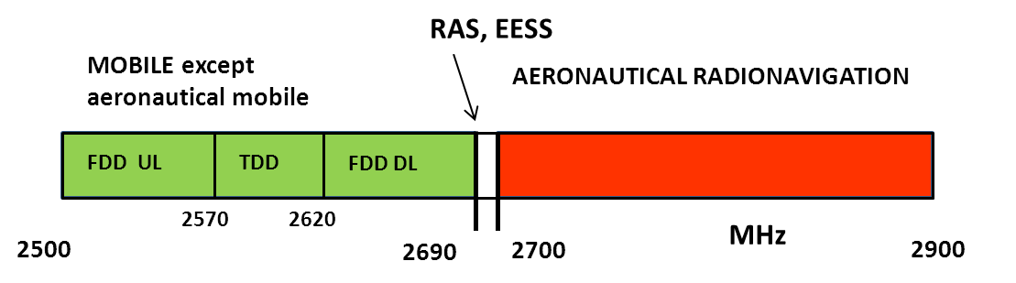
- Primary frequency allocations in the band 2500-2900 MHz
Note that other frequency arrangements in the spectrum 2.5-2.69 GHz may apply on a national basis, see Section 2.1
The band 2690-2700 MHz, between mobile service and radar, is allocated to the passive services RAS and EESS associated with the RR 5.340: “All emissions are prohibited...”. There are compatibility studies between S-band radars and RAS [4] and between IMT and RAS [5] which conclude – due to the limited number of RAS stations - that these cases can be solved by appropriate case-by-case coordination by the national Administration concerned.

Usage of the band 2500-2690 MHz
ECC/DEC/(05)05 [2], on harmonised utilisation of spectrum forIMT-2000/UMTS systems operating within the band 2500-2690 MHz, contains the relevant frequency arrangement as follows:

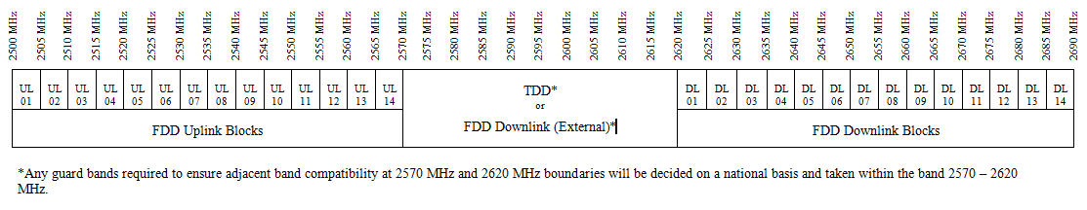
- Frequency arrangement in the band 2500-2690 MHz
In this frequency arrangement, any FDD uplink block (UL XX) is paired with its corresponding FDD downlink block (DL XX). Uplink means that the mobile service terminals (UE: user equipment) transmits whereas downlink means that the base station transmits.
As an exception, Annex A of EC Decision 2008/477/EC [3] allows a departure from the arrangement in Figure 2:for TDD operation on a national basis. This would result in TDD operation starting in DL and UL blocks 14 and extending downwards the band in contiguous blocks as required.

Usage of the band 2700-2900 MHz
The band 2700-2900 MHz is allocated on primary basis to Aeronautical Radionavigation, and restricted to ground-based radars (and to associated airborne transponders…) by RR 5.337. The weather radars are included by RR 5.423:
“In the band 2 700-2 900 MHz, ground-based radars used for meteorological purposes are authorized to operate on a basis of equality with stations of the aeronautical radionavigation service.”

Also Radiolocation is listed with secondary status in the RR frequency table in the band 2700-2900 MHz.

TECHNICAL CHARACTERISTICS OF MOBILE service SYSTEMS
Among the possible technologies for the mobile service in the band 2500-2690 MHz, LTE FDD, LTE TDD and Mobile WiMAX are envisaged to be deployed by operators. Characteristics for these technologies are provided in this section. It is assumed that TDD systems will be deployed in the centre gap, 2570-2620 MHz but consideration will need to be given to the exception described in Annex A of the EC Decision 2008/477/EC[3].
The technical data of the LTE systems are contained in the document STG(10)39 Annex 1[16], CEPT Report 40 [30] and the Report ITU-R M.2039-2 [17].
The technical data of the Mobile WiMAX systems are extracted from documents STG(10)58 [16], Report ITU-R M.2039-2 [17], EN302-544-1 [26] and EN302-544-2 [27].

Base stations
In the framework of WAPECS, a block edge mask (BEM) was defined for the base station operating in the band 2620-2690 MHz ([3] or [8]). This technology neutral approach can be used in this study for describing the various radio systems (UMTS, LTE, and Mobile WiMAX), too. The BEM is a regulatory concept which applies to usage of this spectrum by licensees in Europe. It is thus not a characteristic of the different technologies. Furthermore, the BEM defined for this band does not apply in the radar band 2700-2900 MHz.
The used channel bandwidths are 5, 10 or 20 MHz.
Table 1: contains base station parameters. As macro base stations will provide the highest interference, micro and pico cells are not considered. Both LTE and Mobile WiMAX may be deployed with different bandwidths, as indicated in the table below. Although all bandwidths should be considered as possible, 20 MHz for LTE and 10 MHz for Mobile WiMAX are most likely to be used.
- Base station characteristics
Mobile service base station | LTE | Mobile WIMAX
Downlink frequency (MHz) FDD | 2620 - 2690 | 2620-2690 MHz – FDD
Downlink frequency (MHz) TDD | 2570 - 2620 | 2570-2620 MHz – TDD  (2500-2690 MHz in the exceptional case)
Bandwidth | 5, 10 or 20 MHz | 5 or 10 MHz
Access technique | OFDM | OFDM/OFDMA
Modulation type | QPSK/16-QAM/64-QAM | QPSK/16-QAM/64-QAM
Deployment (worst case) | Macro, urban and rural | Macro, urban and rural
Cell radius (sectorised cells) R_{s} | 4330 m (rural), 220 m (urban) | 4330 m (rural), 220 m (urban)
Intersite distance ISD | 12990 m (rural), 660 m (urban) | 12990 m (rural), 660 m (urban)
Maximum transmitter power dBm [Note 5] | 43 for BW = 5 MHz  46 for BW = 10 MHz  46 for BW = 20 MHz | 43 for 5/10MHz BW (max)
Peak-to-Average Power Ratio of transmitter power (dB) | 7 - 8 | 11-12
Power reduction in a statistical analysis (many interfering base stations) | 3 dB (assuming that base stations will be transmitting roughly 50% of the time) | 3 dB (assuming that base stations will be transmitting roughly 50% of the time)
Max Antenna gain dBi (3-sector sites assumed for macro) | 18 | 18
Antenna height (m) | 45(rural), 30(urban) | 45(rural), 30(urban)
Tilt of antenna (degrees down) | 2.5 (rural), 5 (urban) | 2.5 (rural), 5 (urban)
Antenna type | Sectoral (3 sectors) | Sectoral (3 sectors)
Antenna Pattern | ITU-R F.1336 - 2 | ITU-R F.1336 - 2
Polarization | ± 45° cross-polarized | ± 45° cross-polarized
Feeder loss | 3 dB | 3 dB
3 dB antenna aperture in elevation (°) | 1.57 | 1.57
3 dB antenna aperture in azimuth (°) | 65 | 65
ACLR (1st adjacent channel) | N.A. (see unwanted emission below) | N.A. (see unwanted emission below)
ACLR (2nd adjacent channel) | N.A. (see unwanted emission below) | 50dB for 10 MHz Channel over 2700 MHz to 2710 MHz only when operating in the uppermost 10 MHz channel [Note 3]. Otherwise N.A.
Unwanted emission limit above 2700 MHz  (mean power or, when applicable, average power during bursts duration in the reference bandwidth) [Note 4] | -30 dBm/MHz applies 10 MHz from the band edge | -30 dBm/MHz [See Note 3]; but unless below 2710 MHz and operating in the uppermost 10 MHz channel (see ACLR2 above).
ACS (1st adjacent channel) | N.A. above 2700 MHz | N/A above 2700 MHz
ACS (2nd adjacent channel) | N.A. | 56dB for 10 MHz Channel over 2700 MHz to 2710 MHz only when operating in the uppermost 10MHz channel. Otherwise N/A.
Blocking [Note 1] | -15 dBm (interferer = CW carrier) for the non-exceptional case, and above 2710 MHz in the exceptional case  -43 dBm (interferer = E-UTRA 5 MHz) for exceptional case below 2710 MHz | -15 dBm (interferer = CW carrier) for FDD and TDD non-exceptional case, and TDD above 2710 MHz in the exceptional case  -40 dBm (interferer like modulated) for TDD exceptional case below 2710 MHz
Relative ACS calculated from blocking level -15 dBm  (based on noise figure 5 dB) [Note 2] | 82.7 dB (5 MHz)  79.7 dB (10 MHz)  76.7 dB (20 MHz) | 82 dB (5 MHz)  79 dB (10 MHz)
Relative ACS calculated from blocking level -43 dBm (LTE) and -40 dBm (Mobile WiMAX)  (based on noise figure 5 dB) [Note 1] | 54.7 dB (5 MHz)  51.7 dB (10 MHz)  48.7 dB (20 MHz) | 57 dB (5 MHz)  54 dB (10 MHz)
Spurious emission limits  (mean power or, when applicable, average power during bursts duration in the reference bandwidth) [Note 4] | Reference: ETSI EN 301908-14 v.5.1.1  -30 dBm/MHz  (Spurious emission limits (mean power or, when applicable, average power during bursts duration in the reference bandwidth)) | -30 dBm/MHz [See Note 3]
Receiver NF (worst case) | 5 dB for macro BS | 5 dB
Receiver thermal noise level | -102 dBm in 5 MHz  -99 dBm in 10 MHz  -96 dBm in 20 MHz | -102 dBm with 5 dB NF in 5 MHz.  -99 dBm with 5 dB NF in 10 MHz
Interference threshold for macro BS based on I/N = -6 dB (i.e. 1 dB impact on the receiver sensitivity) (style: Arial 10pt bold white) | -108 dBm in 5 MHz  -105 dBm in 10 MHz  -102 dBm in 20 MHzColumn 2 | -108 dBm with 5 dB NF in 5 MHz.  -105 dBm with 5 dB NF in 10 MHz3

1. Although blocking is listed in the table above, it should not be used as protection ratio, as it assumes a 6 dB desensitization. Relative ACS values are preferable.
2. For details on calculating relative ACS from blocking levels see Section 6 of [28]. The relative ACS that has been calculated from three blocking level of the Base Stations is likely to be better for real equipment, considering the duplex filter needed for 2620-2690 MHz to avoid interference from downlink transmissions of the base stations themselves.
3. For Mobile WiMAX TDD systems operating in the exceptional frequency arrangement and Mobile WiMAX FDD Base Stations, the unwanted emission spectrum mask and ACLR specification for 10 MHz systems could extend to 2710 MHz if operating in the uppermost 10 MHz channel below 2690 MHz.
4. The tests of some pre-production equipment indicate that it is possible to design mobile service equipment which performs significantly better than the level given in ERC/REC 74-01 and ETSI EN 301 908-14 v.5.1.1 [45].
5. The maximum e.i.r.p is normally 61dBm/5MHzbut can be up to 68 dBm/5MHz for specific applications as per decision 2008/477/EC [3].

Figure 3: describes the geometry of a macro cellular network and parameters used in the Table 1: above, where Rs is the cell radius in a network geometry based on 3-sector antennas and ISD is the Inter-Site Distance.

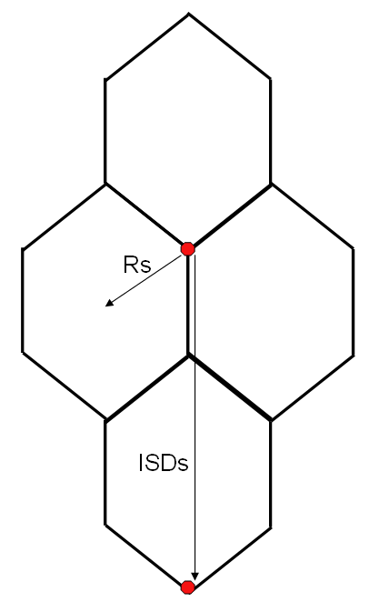
ISDs = 3*Rs
- LTE deployment parameters for studied scenarios (Geometry based on 3-sector antennas)
The Base station has a sector antenna with three different sectors covering the whole 360° azimuths. The antenna pattern for this type of antenna may be found in Recommendation ITU-R F.1336-2[19] and is reproduced below for scenarios where peak side-lobe characteristics should be used for worst case (deterministic) analysis. For statistical assessments with multiple interfering antennas, Section 3.2 of Recommendation ITU-R F.1336-2 [19] applies. The antenna pattern contained in Recommendation ITU-R F.1336-2 [19] is valid for the frequency range from 1 GHz to about 70 GHz and an example of BS antenna patterns contained in Figure 4:
$G_{\text{ref}}(x)=G_{0}−\text{12}x^{2}$ for $0 ≤x<x_{k}$
$G_{\text{ref}}(x)=G_{0}−\text{12}+\text{10} \text{log}(x^{−1\text{.}5}+k)$ for $x_{k}≤x<4$
$G_{\text{ref}}(x)=G_{0}−λ_{k}−\text{15} \text{log}(x)$ for $x≥4$

with :
$$λ_{k}=\text{12}−\text{10} \text{log}\left(1+8k\right)$$
$$x_{k}=\sqrt{1−0\text{.}\text{36}k};$$
$$G_{\text{ref}}(x)=G(ϕ,θ)$$
$$x=ψ/{ψ_{α}}$$
where :
$$α=\text{arctan}\left(\frac{\text{tan}θ}{\text{sin}ϕ}\right)$$
$ψ_{α}=\frac{1}{\sqrt{{\left(\frac{\text{cos}α}{ϕ_{3}}\right)}^{2}+{\left(\frac{\text{sin}α}{θ_{3}}\right)}^{2}}}$$=ϕ_{3}⋅θ_{3}\sqrt{\frac{(\text{sin}θ)^{2}+(\text{sin}ϕ⋅\text{cos}θ)^{2}}{(ϕ_{3}⋅\text{sin}θ)^{2}+(θ_{3}⋅\text{sin}ϕ⋅\text{cos}θ)^{2}}}$
$ψ=\text{arccos}(\text{cos}ϕ⋅\text{cos}θ)$

ϕ:Azimuth angle relative to the angle of maximum gain (°)
θ: Elevation angle expressed in [0 ; 90] °
ϕ_{3:} 3 dB beamwidth in the azimuth plane (°) (generally equal to the sector beamwidth).

- in cases involving typical antennas the parameter k should be 0.7 (therefore, λ_{k = 0.7} = 3.8 and x_{k = 0.7} = 0.86);
- in cases involving antennas with improved side-lobe performance the parameter k should be 0 (therefore, λ_{k = 0} = 12 and x_{k = 0} = 1);

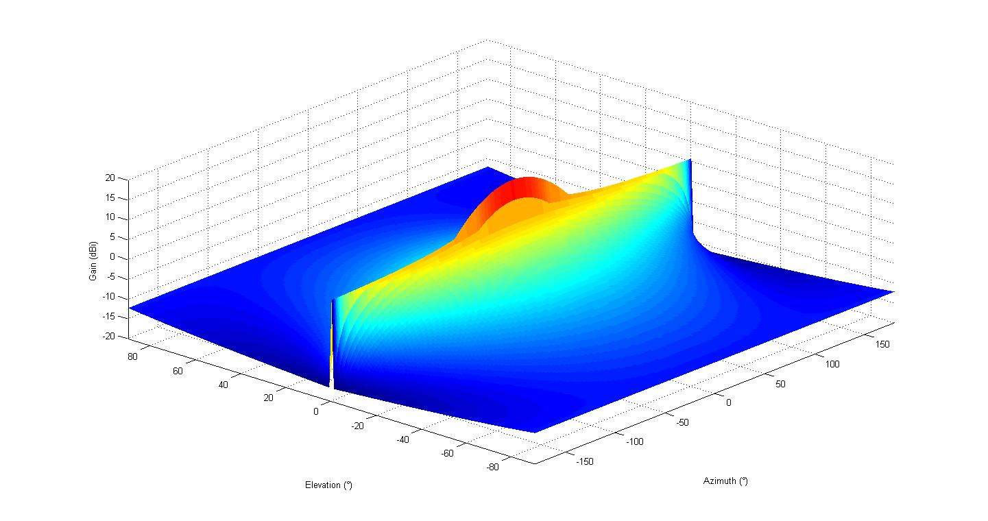
- Example of BS antenna pattern

Terminals (UE)
Further mobile service terminal (UE: user equipment) parameters are provided in Table 2:
- Mobile service terminals (UE) characteristics
Mobile service terminal (UE) | LTE | Mobile WIMAX
Uplink frequency (MHz) FDD | 2500-2570 | 2500-2570 - FDD
Uplink frequency (MHz) TDD | 2570-2620 | 2570-2620 MHz – TDD  (2500-2690 MHz in the exceptional case)
Bandwidth | 5, 10 or 20 MHz | 5 or 10 MHz
Access technique | SC-FDMA | OFDMA
Modulation type | QPSK/16-QAM/64-QAM | QPSK/16-QAM/64-QAM
Transmitter power (dBm) (maximum) | 23 | 23
Peak-to-Average Power Ratio of transmitter power (dB) | 7 - 8 | 11-12
Antenna gain (dBi) | 0 | 0
Antenna height (m) | 1.5 | 1.5
Antenna type | Omnidirectional | Omnidirectional
Polarization | Linear | Linear
Number of simultaneously transmitting users/cell with maximum power | 1 | 1
Spectrum mask | Ref: 3GPP TS 36.101  For worst case (20 MHz):  - 13 dBm/MHz 2700 - 2710 MHz  - 25 dBm/MHz 2700-2715 MHz | N.A.
ACLR (1st adjacent channel) | For worst case (nominal 20 MHz channel, ACLR calculated over 18 MHz BW):  30 dB.  23 dBm output power => -7 dBm/18 MHz in 2690 – 2710 MHz,  - 19.5 dBm/MHz | N.A.
ACLR (2nd adjacent channel) | N.A. | 44dB for 10 MHz Channel over 2700 MHz to 2710 MHz only when transmitting in the uppermost 10 MHz channel [Note 1]. Otherwise N/A.
ACS (1st adjacent channel) | N.A. above 2700 MHz | N/A above 2700MHz
ACS (2nd adjacent channel) | N.A. | 47dB for 10 MHz Channel over 2700 MH to 2710 MHz only when operating in the uppermost 10 MHz channel [Note 2].
Blocking [Note 1] | - 44 dBm 2700-2750 MHz  - 30 dBm 2750-2775 MHz  - 15 dBm above 2775 MHz | [Note 3]
Relative ACS calculated from blocking levels  (based on noise figure 9 dB for LTE) | For 20 MHz:  43.7 dB 2700-2750 MHz  57.7 dB 2750-2775 MHz  72.7 dB above 2775 MHz | [Note 3]
Spurious emission limits  (mean power or, when applicable, average power during bursts duration in the reference bandwidth) [Note 4] | Reference: ETSI EN 301 908-14 v.5.1.1[45]  -30 dBm/MHz  Applicable for 2700-2900 MHz in the non-exceptional case and from 2705/2710/2715 for 10/15/20 MHz in the exceptional case. | Reference: ETSI EN 302544-2  -30dBm/MHz  [See Note 2]
Receiver NF (dB) | 9 (3GPP specification requirement) | 5 dB for single band and 8 dB for multi-band designs
Receiver thermal noise level | -98 dBm in 5 MHz  -95 dBm in 10 MHz  -92 dBm in 20 MHz | For NF = 5dB:  –108 dBm in 5 MHz  –105 dBm in 10 MHz  For NF = 8dB:  –105 dBm in 5 MHz  –102 dBm in 10 MHz
Interference threshold based on I/N = -6 dB (i.e. 1 dB impact on the receiver sensitivity) | -104 dBm in 5 MHz  -101 dBm in 10 MHz  -98 dBm in 20 MHz Column 2 | Reference:  ETSI EN 302 544-2 [44]  -30dBm/MHz  [See Note 2]

1. Although blocking is listed in the table above, it should not be used as protection ratio, as it assumes a 6 dB desensitization. Relative ACS values are preferable.
2. For Mobile WiMAX TDD systems operating in the exceptional frequency arrangement the unwanted emission spectrum mask and ACLR specification for 10 MHz systems could extend to 2710 MHz if operating in the uppermost 10 MHz channel below 2690 MHz.
3. For Mobile WiMAX out of band blocking characteristics are not specified in the available references.
4. The tests of some pre-production equipment indicate that it is possible to design mobile service equipment which performs significantly better than the level given in ERC Recommendation 74-01 [13] and ETSI EN 301 908-14 v.5.1.1 [45].

Protection criteria for interference from radars to Mobile Service terminals
Measurements and simulations have been carried out for LTE FDD downlink. The results largely carry over to LTE TDD downlink. No results are currently available for UMTS or WiMAX.

Co-channel interference due to radar unwanted emissions

Study 1: Link level simulations
Link level simulations have been carried out in order to evaluate the interference from radars to base stations, including the effects on the analogue parts of the mobile station equipment. See ANNEX 7: for additional details on the simulations. The simulations have been carried out with 5 MHz LTE bandwidth, and the radar interference is modelled as white Gaussian noise. The simulations represent a possible implementation of LTE terminals, but it should be noted that results will vary depending on implementation, as can be seen in ANNEX 7:
Simulations have also been carried out to investigate the results of varying the interference power levels for different interference pulse lengths and LTE MSCs, as well as for varying pulse repetition rate of the radar. Simulations have also been carried out to investigate the results of varying the interference power levels for different interference pulse lengths and LTE MSCs, see Figure 5: The PRR is here 1 kHz. This figure shows that radar interference with shorter pulse length will produce very similar results to 1 microsecond, whereas for radars with long pulses, say 100 micro seconds, protection levels are considerably higher, in the range of 10-15dB more strict.

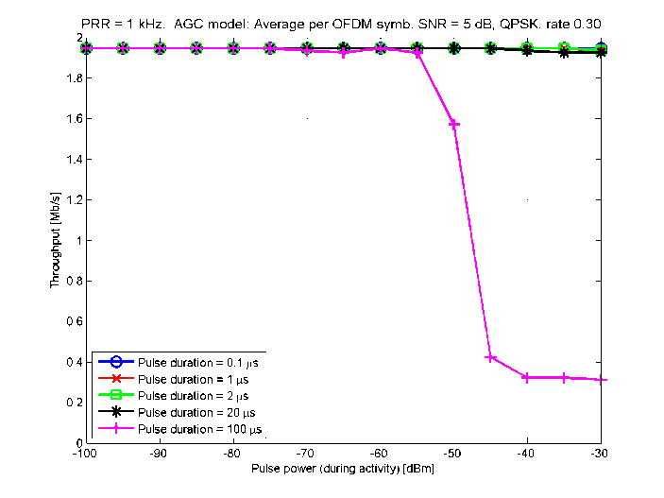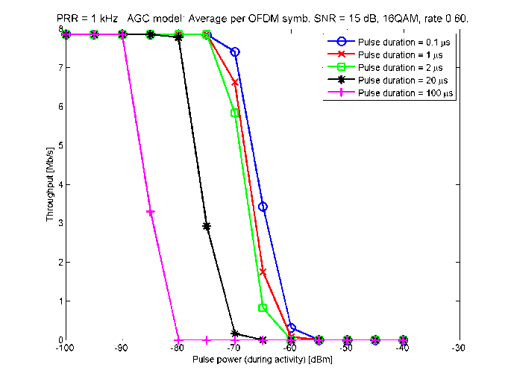

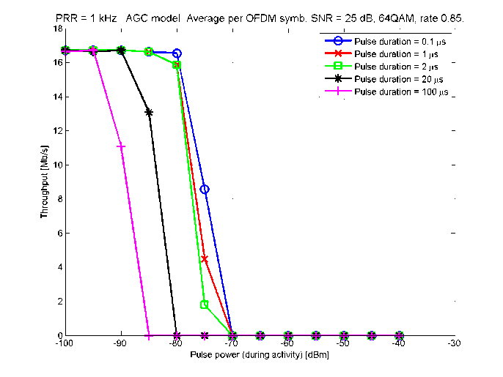
- Radar interference as a function of pulse power at UE antenna and pulse duration
In the last simulations of downlink performance, an adaptive modulation and coding scheme (AMCS) was investigated for different interference levels of a radar with 1 microsecond pulses and PRR 1 kHz, see Figure 6:. Results for other radar interference levels can be found in ANNEX 7:.

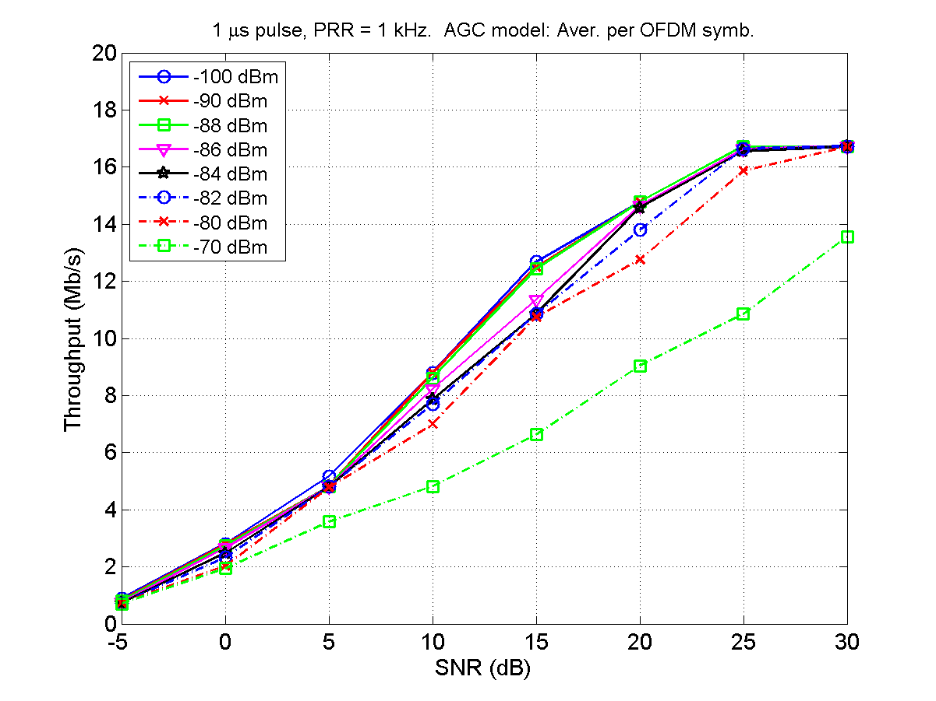
- Throughput degradation as a function of radar interference power

Study 2: Measurements
ANNEX 6:contains detailed information about these measurements of radar interference to LTE terminals.
Two types of radar interference have been studied. In the first set of measurements, the downlink throughput loss is measured in the presence of interfering radar pulse signals of length 4 microseconds and with PRR 1000 Hz. In the second set of measurements, the downlink throughput loss is measured in the presence of interfering radar pulse signals of length 1000 microseconds and with PRR 300 Hz.
As can be seen in ANNEX 6: the interference levels cannot be compared directly to those of the simulations. ANNEX 6: also shows that for the downlink this type of interference is underestimating the throughput reduction due to the radar interference.
Results are summarized for different LTE signal levels in Figure 7: and Figure 8: See ANNEX 6: for the definition of Psens.

- DL throughput loss in the presence of interfering radar pulse signals of length
4 microseconds, PRR 1000 Hz
- DL throughput loss in the presence of an interfering radar pulse signal of length
100 micro seconds, PRR 300 Hz

Calculation of protection levels
The simulation and measurement results above can be used to derive protection criteria for the LTE downlink for different radar stations (see Table 5: below). The underlying assumption is that there should be no significant degradation of the LTE throughput.
Table 3: contains the results of such an analysis, expressed as acceptable interference from different types of radars. The value given is the peak power during the actual radar pulse. Furthermore, polarization discrimination has not been applied. For some scenarios this may give additional isolation.
For the measurement results, the power level Psens has not been used, as it is assumed that terminals with such low power levels will also experience lower radar interference levels. Instead Psens + 10 have been used.
The details of extracting acceptable interference levels for different types of radars are as follows.
Radar type 2: The simulations of Figure 6: show that -86 dBm/5 MHz gives a clear throughput reduction. Setting the protection level to -88 dBm/5 MHz, this corresponds to -95 dBm/MHz. The measurements for PRR 1 kHz and pulse length 4 micro seconds show that -80 dBm of interference (0.4% throughput loss) is acceptable. First this needs to be converted to 1 microsecond pulse length. An approximation for this can be obtained from Figure 5: showing that the difference between allowed pulse power for a certain throughput decrease for 1 and 2 micro seconds is very small, in the order of 1 dB. This is due to the extension of the pulse in the UE receiver of about 3 micro seconds, meaning that we are actually comparing the effects 1+3 to 2+3 micro second pulses. Similarly, we should compare 1+3 with 4+3 microseconds to relate the measurements to the effects of a radar with a 1 microsecond long pulse. Based on this we set the allowed interference for a 1 microsecond radar pulse with (approximately) PRR 1 kHz to -78 dBm. Based on Section 3.3.1.2, it thus follows that -78 dBm – 13 dB = -91 dBm/MHz underestimates the protection level, which is consistent with the simulations.
Radar type 1: The simulations can be used to relate a100 microsecond pulse length radar to one with 1 microsecond pulses, based on Figure 5: The relevant information is for higher modulation and coding schemes and low throughput loss approximately 15 dB lower interference allowed than for 1 microsecond. Comparing with radar type 2 this gives -110 dBm/MHz. The lower PRR of radar type 1 relative to radar type 2 should also be taken into account, but ANNEX 7:shows that for the relevant higher MCSs and low throughput reduction, there is a very small difference between the different PRRs and in order to be conservative no modification is made for the acceptable interference level based on this.
Radar type 3: Type 3 has the same pulse length as type 1, but with different PRR. However, since PRR does not influence very much, the same level -110 dBm/MHz is used.
Radar type 4: This type of radar may use different PRR, but in the light of the discussion above this is not necessary to take into account. Since the pulse length is 2.2 microseconds, the acceptable interference level will be somewhat lower than for type 2, see Figure 5:. However, it is clear that this difference is very small, so the same level is used, i.e. -95 dBm/MHz.
The results can be compared with the interference level corresponding to I/N = -6 dB, which is -104.5 dBm in a 5 MHz channel. Furthermore, the acceptable throughput reduction for calculating the protection criteria in Table 3: can be compared with the interference corresponding to I/N = -6 dB, by considering a 1 dB reduction of SNR in Figure 6: The result is that the throughput reduction levels are comparable.
- Acceptable interference levels, LTE DL, for different types of radars
Radar type (see Table 5:) | Type 1 and 3 | Type 2 and 4
Acceptable interference at UE receiver (dBm/MHz) | -110 | -95

Protection criteria for interference from radars to Mobile Service base stations
Measurements and simulations have been carried out for LTE FDD uplink. The simulation results are not used to derive protection levels, and can be found in ANNEX 9:. The results largely carry over to LTE TDD uplink. No results are currently available for UMTS or WiMAX.

Co-channel interference due to radar unwanted emissions

Study 2: First set of measurements
ANNEX 6: contains detailed information about these measurements of radar interference to LTE base stations.
Two types of radar interference have been studied.
The measured uplink throughput loss in the presence of interfering radar pulse signals of length 4 microseconds, PRR 1000 Hz, for different LTE signal levels is summarized in Figure 9:. Psens equals -101.5 dBm.
- UL throughput loss(%) with presence of interfering pulse signal 1 (4μS/1000Hz)
The measured uplink throughput loss in the presence of an interfering radar pulse signal of length 100 microseconds, PRR 300 Hz, for different LTE signal levels is summarised in Figure 10:. Automatic link adaptation is applied.
- UL throughput loss(%) in the presence of an interfering radar pulse signal of length 100 micro seconds, PRR 300 Hz

Study 3: Second set of measurements
The full set of results can be found in ANNEX 9:. Two figures with measurement results are also incorporated below, for the more sensitive MCS 20.

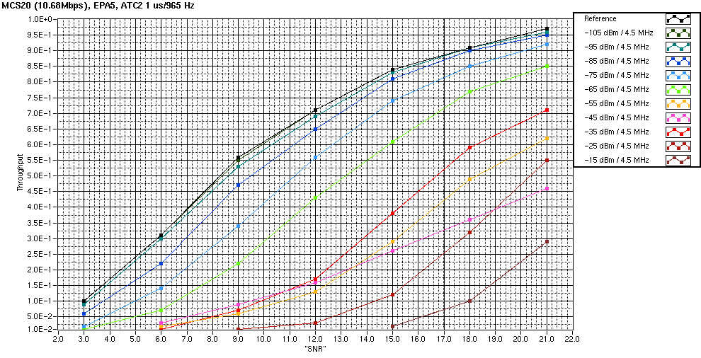

- UL throughput loss(%) in the presence of an interfering radar of type 2 for MCS 20

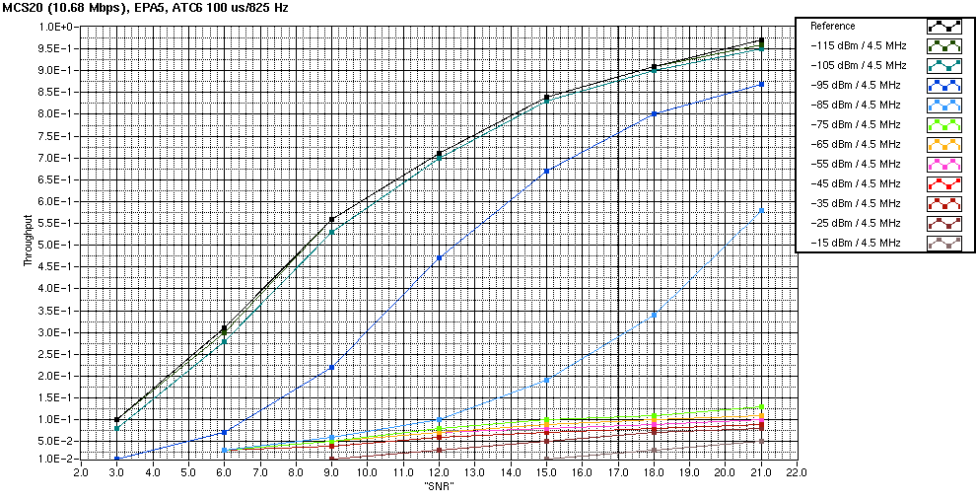
- UL throughput loss(%) in the presence of an interfering radar of type 6 for MCS 20

Calculation of protection levels
The measurement results above can be used to derive protection criteria for the LTE uplink for different radar stations. The underlying assumption is that there should be no significant degradation of the LTE throughput.
Table 4: below contains the results of such an analysis. The values given correspond to the peak power during the actual radar pulse.
Polarization discrimination has not been applied. For some scenarios this may give additional isolation.
The details of extracting acceptable interference levels for different types of radars are as follows.
Radar type 2: Using the second set of measurements and considering the relevant higher MCSs, -95 dBm/5 MHz gives very little degradation in throughput for the relevant upper part of the curve. -95 dBm/5 MHz is thus chosen, corresponding to -102 dBm/MHz.
Radar type 3: The second set of measurements show that -105 dBm/5 MHz gives very little degradation for the relevant upper part of the curve. The protection level is thus set to -112 dBm/MHz.
Radar type 1: Due to the similarities with type 3, -112 dBm/MHz is chosen.
Radar type 4: The second set of measurements shows a very small degradation for -95 dBm/5 MHz. The acceptable interference is set to -102 dBm/MHz.
As for the downlink the results can be compared with the interference level corresponding to I/N = -6 dB, which is -108.5 dBm in a 5 MHz channel. Furthermore, the acceptable throughput reduction for calculating the protection criteria in Table 4: can be compared with the interference corresponding to I/N = -6 dB, by considering a 1 dB reduction of SNR in Figure 6:. The result is again that the throughput reduction levels are comparable.

- Acceptable interference levels, LTE DL, for different types of radars
Radar type (see Table 5:) | Type 1 and 3 | Type 2 and 4
Acceptable interference at BS receiver (dBm/MHz) | -112 | -102

technical CHARACTERISTICS OF RADARS
Three different applications of radars are using this frequency band: Defence, Air Traffic Control (ATC) and Meteorology. The characteristics of representative radars operating in the frequency band 2 700-2 900 MHz are summarized in Table 5: The spurious level indicated in Table 5: is the limit from ERC/REC 74-01 [13] for the appropriate category of radar.

- Radar characteristics
Parameter | Unit | ATC and defense |  |  |  | Meteorology
Parameter | Unit | Type 1 | Type 2 | Type 3 |  | Type 4
Category |  | Frequency hopping | 2 to 4 frequencies |  |  | Single frequency
Maximum antenna gain | dBi | >40 | 34 |  |  | 43
Antenna pattern |  | Not given | Vertical pattern cosecant-squared (see figure 5) |  |  | ITU-R F.1245[22]
Antenna height | m | 5-40 (normal 12) |  |  |  | 7-21 (normal 13)
Polarization |  | Circular |  |  |  | H/V
Feeder loss | dB | <1 |  | Not given |  | 2
Minimum elevation angle | ° | Not given | 2 (see ITU-R M.1851[38],  see also Figure 13:) |  |  | 0.5
Protection level (Note 1) | dBm/MHz | -122
1 dB compression point | dBm | -20 (see ITU-R M.1464[39]) |  |  |  | 10
Blocking level | dBm | Not given | See Figure 13:Error: Reference source not found |  |  | ANNEX 3:
Transmission power | kW | 1000 | 400 | 30 |  | 794
Reference bandwidth | kHz | 2500 | 1000 | 800 |  | 1000
40 dB bandwidth | MHz | 9.5 | 20 | 4 | 2 | ANNEX 1:
Out of band roll off | dB/decade | 20 | 20 | 20 |  | 40
Spurious level | dBc | -60 | -60 | -60 |  | -60 for old radars and -75 to -90 for new radars
Unwanted emission mask |  | To be calculated using elements above + Annex 2 for actual examples |  |  |  | ANNEX 1:
Pulse repetition rate | Hz | <300 | ~1000 | 825 |  | 250 - 1200  (See ITU-R M.1849[21])
Pulse duration | µs | 20 and 100 | 1 | 1 | 100 | 0.8-2
Rise and fall time | % of pulse length | 1% | 10% | 16.9% | Not given | 10%
Antenna rotation | rpm | 6-12 | 12-15 | 15 |  | See ITU-R M.1849[21]
Scan in elevation |  | Not given | Fixed |  |  | See ITU-R M.1849[21]
Note 1: This protection level is derived from measurements as explained in recommendation ITU-R M.1464-1 ([39]), which leaded to an I/N criterion of -10 dB. During the measurements campaigns commissioned by Belgian Institute for Postal Services and Telecommunications, other levels were measured for different radars and specific test conditions, with values varying between -115 dBm/MHz and -106dBm/MHz. However, due to the conservative measurement approach, Belgium BIPT decided to adopt -122dBm /MHz (cfr. Decision of the BIPT council of 3/10/2011, §4.4.1).
Table 6: gives the maximum level of interference at the radar antenna port that an ATC radar can withstands from a LTE signal of 4.5 MHz. It shows that for different radars, the impact can be very different.
The levels are based on measurements of the following effects at the antenna port of the radar receiver:
- The saturation of the LNA by one LTE signal, due to the lack of selectivity of the radar receiver;
- The generation of intermodulation products between 2 LTE signals by the radar receiver, that fall into the radar receiver bandwidth, depending on LTE and radar operating frequencies.

As soon as an intermodulation product occurs within the radar bandwidth, it sums up with the interference due to unwanted emissions, and may exceed the radar protection criterion.
- Comparison of the radar receiver selectivity
Radar type \ Frequency band | Saturation (1 LTE signal) | Intermodulation  (2 LTE signals)
Radar Type 2 (at 2700 MHz) | -36.5 dBm/4.5MHz | -59.6 dBm/4.5MHz
Radar Type 3 | -42 dBm
Other ATC radar (A) (at 2700 MHz) | -31.5 dBm/4.5MHz | -56 dBm/4.5MHz
Other ATC radar (B) | -50 dBm/4.5MHz | -53 dBm/4.5 MHz
Other ATC radar (C) | -56 dBm/CW
Other ATC radar (D) | -20 dBm/4.5MHz | -44 dBm/4.5 MHz

The level, where saturation of the LNA occurs, is constant for all frequencies over the range 2500-2690 MHz and encompasses measurements uncertainties.
It should be noted that a deployment of base stations operating between 2620 and 2690 MHz (FDD LTE only) will not generate any intermodulation products in the receiver of a radar operating above 2760 MHz.
The effect of intermodulation measured was limited to the case of 2 LTE/WIMAX signals. Similarly, the effect of saturation measured was limited to the case of 1 single LTE signal. In practice the radar will face a deployment of several operators using different number of LTE blocks, with different sizes. The effects of all possible combinations of intermodulation products falling into the radar receiver bandwidth will sum up, leading to interference occurring above the level derived for 2 signals. A correction factor must therefore be applied to take account of this. The methodology to derive this correction factor is given in ANNEX 6:. Similarly, the contributions of all LTE blocks to the saturation of the receiver will sum up, and a correction factor should be considered.
For example, when considering a very extreme worst case with 24 TDD and FDD LTE/WIMAX blocks of 5 MHz between 2570 and 2690 MHz, there are 44 combinations of 2 LTE/WiMAX signals and 463 combinations of 3 LTE/WiMAX signals that fall in the receiver bandwidth of a radar operating at 2700 MHz. One can derive that the intermodulation correction factor may be up to 10.9 dB.
At the same time the proposed very extreme worst case (24 TDD and FDD LTE/WIMAX) will not generate any intermodulation products in the receiver of a radar operating above 2800 MHz.
However in practice, the actual correction factors will vary with a number of parameters such as the radar frequency and bandwidth, the number and size of LTE blocks used in the mobile allocation. Therefore, this correction factor should be determined on a case by case basis by each Administration for each particular case.
Figure 13: and Figure 14: give the typical antenna pattern of an ATC radar in elevation and azimuth. No additional antenna tilt was considered in the studies.
- ATC radar antenna pattern in elevation
- ATC radar antenna pattern in azimuth
Weather radars perform volume scanning based on rotation / elevation variations. Figure 15: describes a typical sweeping pattern in elevation, based on the elements from Recommendation ITU-R M.1849 [21].
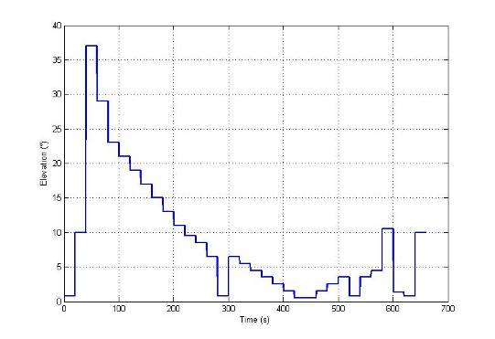
- Meteorological radars, typical elevation variation over time
The only difference from Recommendation ITU-R M.1849 [21] where this pattern was provided is that the rotation speed of the antenna has been chosen constant at 3 rpm instead of variable between 2 and 3 rpm. This is for simulation simplification purpose.
With this sweeping pattern and an antenna pattern based on Recommendation ITU-R F.1245 [22], the radar antenna gain towards the horizon (hence in the direction of potential mobile service stations) varies with time as shown in Figure 16:
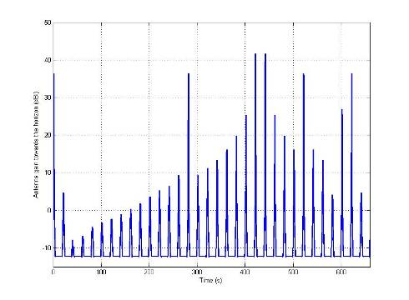
- Meteorological radars, typical variation over time of antenna gain towards horizon(radar antenna gain = 45 dBi)
The cumulative distribution of the antenna gain towards the horizon (elevation 0°) is shown in Figure 17:
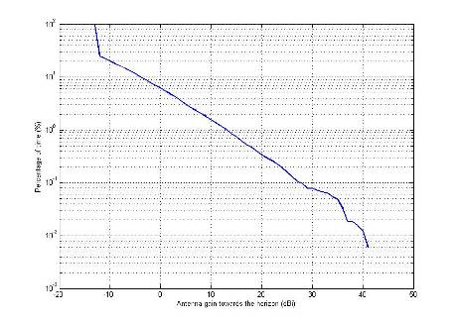
- Meteorological radars, probability distribution of antenna gain towards horizon(radar antenna gain = 45 dBi)
The result is the same when considering a victim receiver seen at a higher elevation angle (5°) from the radar. The average antenna gain towards the FS station is 7 dBi.

Compatibility scenarios
There are 4 interference scenarios to be studied:
- Radar interferes terminal of mobile service
- Radar interferes base station of mobile service
- Base station of mobile service interferes radar
- Terminal of mobile service interferes radar

The scenarios are described in detail in the Sections 5.1 to 5.4 and illustrated in Figure 18: - Figure 21: respectively.
According to Section 4, the more critical cases are if the frequency separation between the interfering transmitter and the receiving victim is small. The minimum frequency separation is assumed by at least 10 MHz. Noting the possibility of having TDD in the upper part of the mobile services spectrum, all four scenarios above need to be considered, although the FDD frequency arrangement is in the focus of this study. Interference to radar from mobile equipment and as well as interference from radar to mobile equipment depend on the frequency arrangement in question.
There are two types of interference mechanisms to be considered for each scenario:
- Blocking: where a signal outside of the nominal receiver bandwidth causes the victim receiver to experience an increased noise level or go into compression, thus producing non-linear responses.
- Unwanted emissions: where the unwanted emissions (OOB and spurious) of the interfering transmitter fall into the receiving bandwidth of the victim receiver.

For interference Scenarios 3 and 4 below, one possible non-linear response for the blocking mechanism is the combination of MS signals creating inter modulation products in the radar (receiver) which fall in the reception bandwidth. This will lead to desensitization of the radar receiver. It should be noted also that the base stations can also generate and transmit inter modulation products of 3rd order (IMP3). These are considered as spurious emissions of the base stations and tested as such.

Scenario 1): Radar interferes Terminalof mobile service
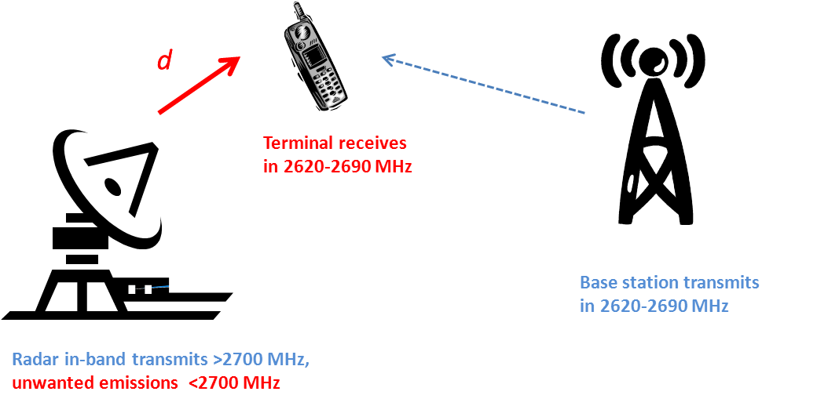

- Scenario 1): Radar interferes terminal of mobile service, FDD frequency arrangement
The scenario sketched in Figure 18: shows the case “radar interferes terminal of the mobile service”. The radar is operated at a fix location, whereas the terminal is located randomly around the base station in the radio cell. The antenna height of the terminal may vary from the typical height of 1.5 m (in building, parking garages, etc.) as well as the environments (urban, rural and indoor/outdoor) may change.
This scenario is characterised by a varying and unknown separation distance d between the radar station and the terminal, the terminal can be located very closely to the radar station or far apart. The proper methodology for the worst case analysis is MCL combined with free space propagation. However, taking account also more realistic scenarios, e.g. the consideration of the low antenna height of the terminal and/or the surrounding environment, Monte-Carlo based simulation, described in ITU-R Report SM.2028[41],and a more tailored propagation model should be used, e.g. the widely used “extended Hata” propagation model for urban or rural area as described in the SEAMCAT documentation
(http://tractool.seamcat.org/wiki/Manual).

Scenario 2): Radar interferes base station of mobile service

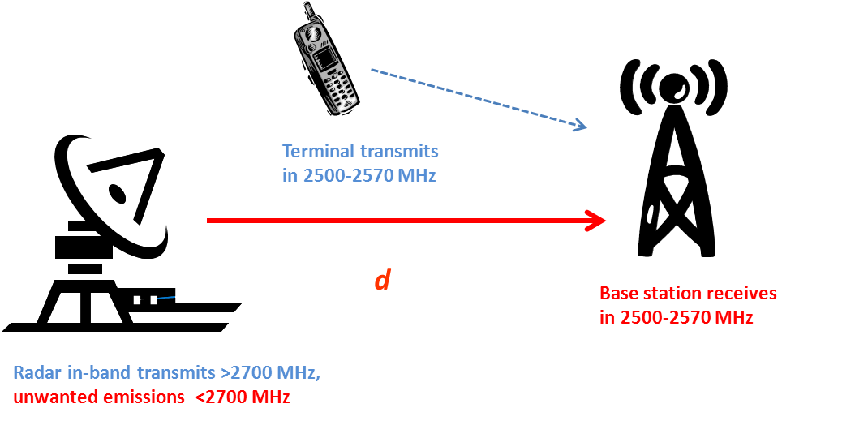
- Scenario 2): Radar interferes base station of mobile service,FDD frequency arrangement
The scenario sketched in Figure 19: shows the case “radar interferes base station of the mobile service”. Both the radar station and the base station are separated by the distance d.
The worst case of this scenario is characterised by antennas which are installed well above the surrounding buildings. Therefore, the appropriate methodology is MCL in combination with the point-to-point propagation model defined in Recommendation ITU-R P.452 (including multipath propagation) [37].

Scenario 3): Base station of mobile serviceinterferes Radar
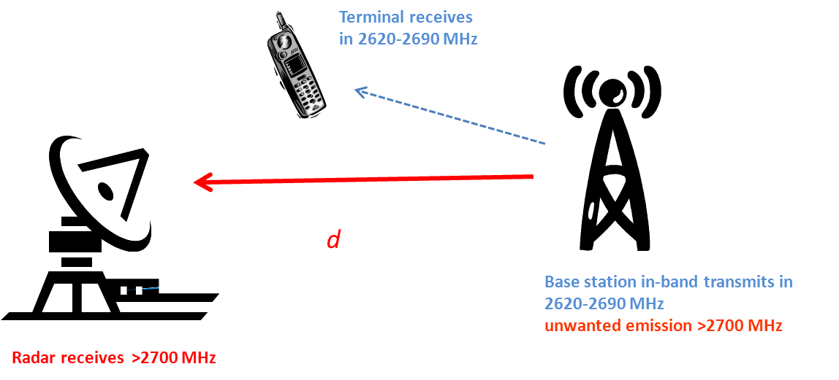
- Scenario 3): Base station of mobile service interferes Radar, FDD frequency arrangement
The scenario sketched in Figure 20: shows the case “base station of the mobile service interferes radar”. Both the radar station and the base station are separated by the distance d.
The worst case of this scenario is characterized by antennas which are installed well above the surrounding buildings. Therefore, the appropriate methodology is MCL in combination with the point-to-point propagation model defined in Recommendation ITU-R P.452[37].

Scenario 4): Terminal of mobile service interferes Radar
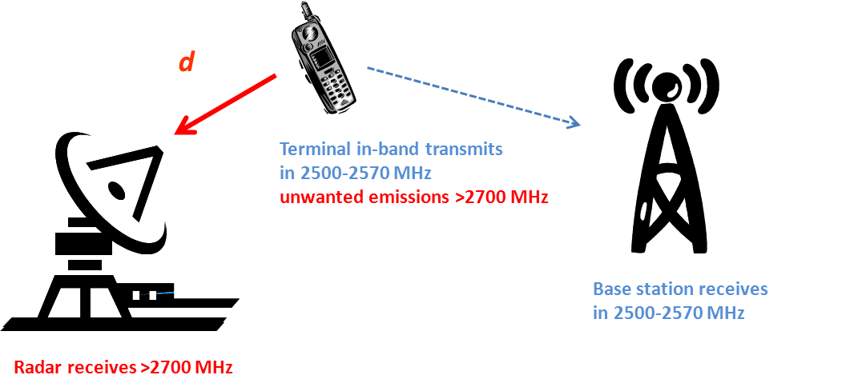

- Scenario 4): Terminal of mobile service interferes Radar, FDD frequency arrangement
The scenario sketched in Figure 21: shows the case “terminal of the mobile service interferes radar”. Similar like for Scenario 1) in Section 5.1, the terminal is randomly located in the radio cell, the exact position is unknown.
MCL combined with free space is used for the worst case analysis. Considering more realistic conditions, the antenna height of the terminal and land-usage should be taken into account by applying the “extended Hata” model.

Methodology
As it was mentioned above there are two types of interference mechanisms to be considered:
- Blocking: where a signal outside of the nominal receiver bandwidth causes the victim receiver to experience an increased noise level or go into compression, thus producing non-linear responses.
- Unwanted emissions: where the unwanted emissions (OOB and spurious) of the interfering transmitter fall into the receiving bandwidth of the victim receiver.

For simplification the worst case assumption is applied that the antennas of the radar and mobile stations are pointing directly to each other in azimuth; i.e. only the elevation patterns are considered in the following equations.

Unwanted emissions
The received signal can be determined by the following equation;
$$P_{\text{Rx}−\text{unwanted}}=P_{I−\text{unwanted}}+G_{I}(θ_{I})+G_{R}(θ_{R})−L_{P}(d,f,h_{1}\text{.}h_{2})−L_{\text{feeder}}+M_{\text{multipath}}$$

where P_{Rx-unwanted} Received interfering power density in dBm/MHz
P_{I-unwanted} Interfering emissions density in dBm/MHz
G_{I} Antenna gain of the interferer depending on the elevation angle
and tilt in dBi
G_{R} Antenna gain of the receiver depending on the elevation angle
and tilt in dBi
L_{P} Path loss depending on distance d, frequency f, antenna heights of the interfering transmitter h₁ and victim receiver h₂ in dB
L_{feeder} Feeder loss in dB
M_{multipath} Multipath propagation margin in dB (is 0 dB in all studies presented in this Report).
The required isolation to ensure protection of the radar is then given by
$$I(d)_{\text{unwanted}}=P_{\text{Rx}−\text{unwanted}}−P_{{\text{radar}}/{\text{mobile}}−\text{unwanted}}$$

where I(d)_{unwanted} required isolation depending on distance in dB
P_{Rx-unwanted} received interfering power density in dBm/MHz
P_{radar/mobile-unwanted} “unwanted” protection level of the radar or mobile station, respectively

Blocking
Similar to the case for unwanted, the received signal impairing radar can be determined by the following equation:

$$P_{\text{Rx}−\text{blocking}}=P_{I−\text{blocking}}+G_{I}(θ_{I})+G_{R}(θ_{R})−L_{P}(d,f,h_{1}\text{.}h_{2})−\text{att}(Δf)−L_{\text{feeder}}+M_{\text{multipath}}$$

where P_{Rx-blocking} Received interfering power density in dBm/MHz
P_{I-blocking} Interfering transmitted power density in dBm/MHz
G_{I} Antenna gain of the interferer depending on the elevation angle
and tilt in dBi
G_{R} Antenna gain of the receiver depending on the elevation angle
and tilt in dBi
L_{P} Path loss depending on distance d, frequency f, antenna heights of the interfering transmitter h1 and victim receiver h2 in dB
att filter attenuation depending on the frequency offset Δf in dB
L_{feeder} Feeder loss in dB
M_{multipath} Multipath propagation margin in dB is 0 dB in all studies presented in this Report.

The required isolation to ensure protection of the radar is then given by

$$I(d)_{\text{blocking}}=P_{\text{Rx}−\text{blocking}}−P_{{\text{radar}}/{\text{mobile}}−\text{blocking}}(Δf)$$

where I(d)_{blocking} required isolation depending on distance in dB
P_{Rx-blocking} received interfering power density in dBm/MHz
P_{radar/mobile-blocking}(Δf) “blocking” protection level of the radar or mobile station, respectively, depending on the frequency offset in dBm/MHz,
note that the blocking protection can either be covered by this protection value or by the filter attenuation att(Δf) used in the equation above.

Assumptions
For the compatibility analysis, all technical parameters are provided in Section 3 and Section 4 for mobile service and radar, accordingly. The protection levels to protect LTE equipment are derived in Section 3 and ANNEX 4: to ANNEX 9:.
There are no further assumptions required for the determination of the required isolation with respect to the unwanted emission. However for blocking, a frequency offset Δf between the interferer and victim has to be assumed. Assuming the FDD frequency arrangement, the minimum frequency offset is:
- Δf > 10 MHz for the scenarios 1) and 3) and
- Δf > 130 MHz for the scenarios 2) and 4).

Sensitivity Analysis

Height differential
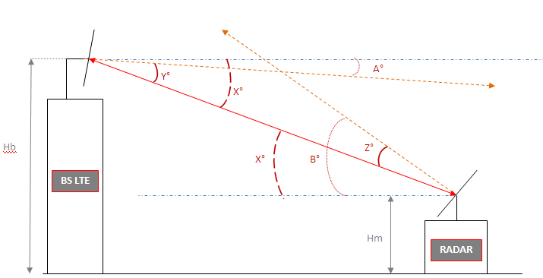
d
h_{base}
h_{radar}

- Geometrical parameters in elevation
Figure 22: shows the geometry of the antenna configuration in the vertical plane:

- A° and B° are the respective tilt angles for the LTE base station and the radar;
- X° varies with the distance d and the difference in height between both stations;
- Y° and Z° are the respective offset angles for the LTE base station and the radar;
- h_{base} and h_{radar} are denoted as antenna heights of the LTE base station and radar station.

For the following sensitivity analysis, the height differential Δh is defined by

$$Δh=h_{\text{base}}−h_{\text{radar}}$$

The impact of the antenna characteristics is illustrated in the following Figure 23: and Figure 24:. The required isolation is sketched as function of Δh, certain distances d and two different fixed antenna heights of the radar station. The antenna of the base station is tilted by 5 deg down the used antenna pattern of the radar is described in Recommendation ITU-R F.1245 [22].
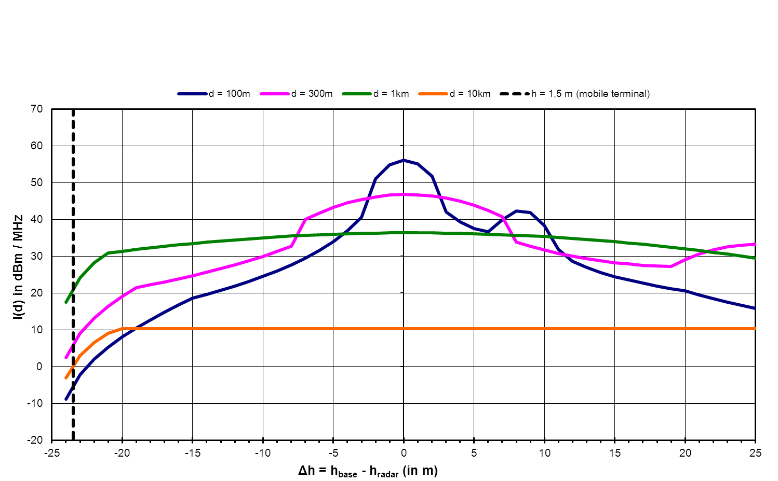
- Isolation required for unwanted emissions depending on the difference of antenna heights, height of radar: 25 m, propagation model: Rec ITU-R P.452
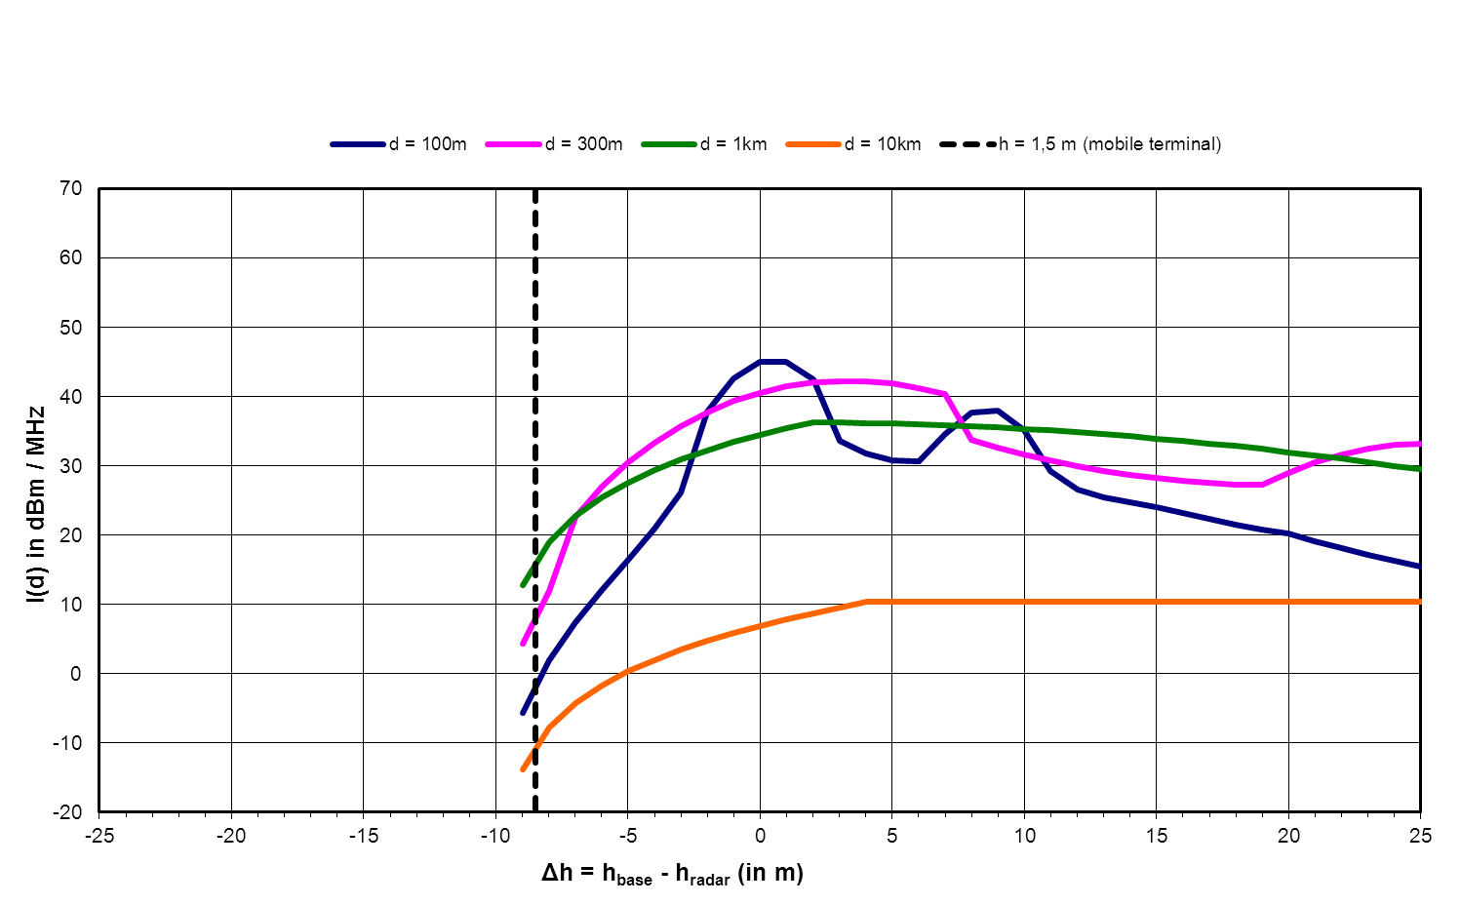
- Isolation required for unwanted emissions depending on the difference of antenna heights, height of radar: 10 m, propagation model: Rec ITU-R P.452
Noting that applying other antenna types and tilt angles for the radar and base stations, the diagrams will be different. But nevertheless, some general conclusions with respect to the variation of the antenna heights can be drawn:
- The variation of the isolation is significant for particular short separation distance (e.g., for distances < 300 m up to 40-60 dB).
- For distances >1km, the variation of the isolation due to the antenna configuration can be neglected.
- The mitigation effect is greater if the antenna height of the base station is below the antenna height of the radar due to the negative tilt of the base station antenna.

Antenna discrimination
The following figures give the antenna discrimination values considered in the simulation conducted in the rest of the document, in rural environment. Similar figures were also derived for urban environment.
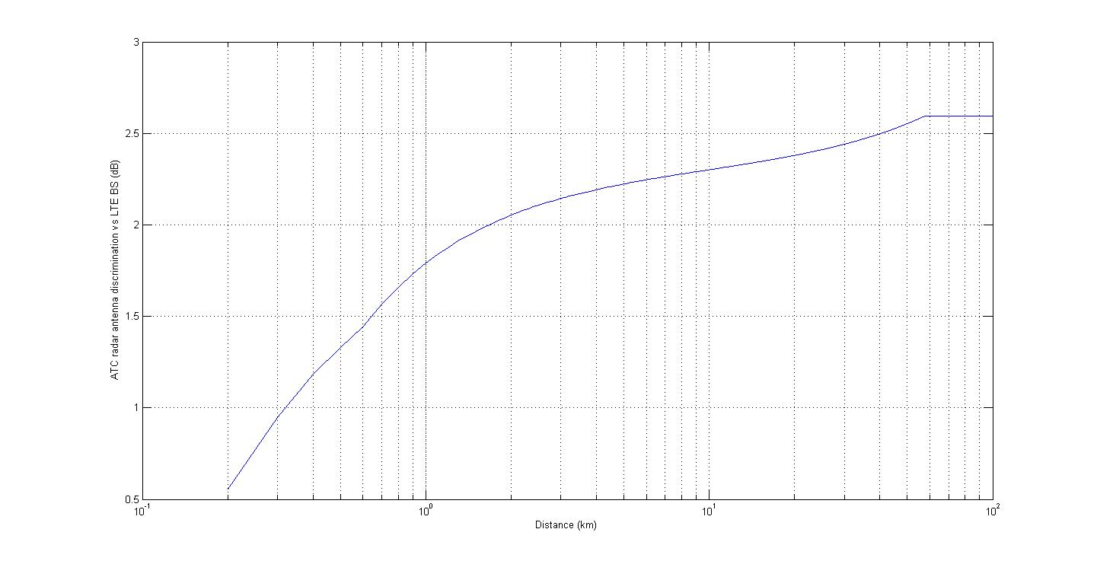
- ATC radar antenna discrimination for studies involving the LTE base station
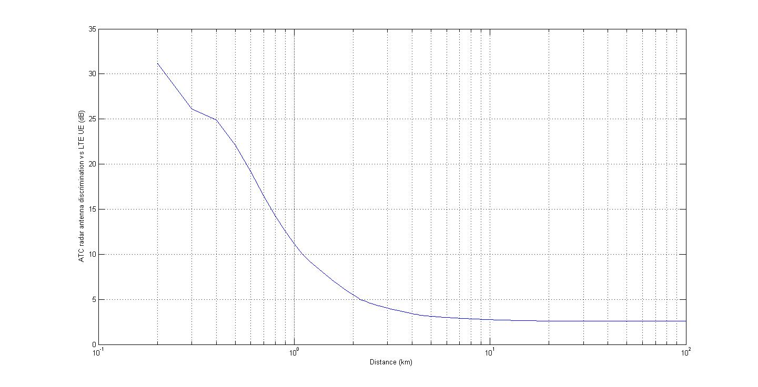
- ATC radar antenna discrimination for studies involving the LTE UE
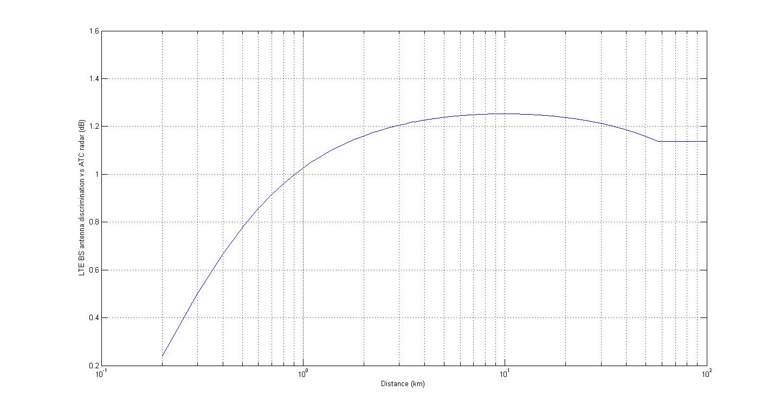
- LTE base station antenna discrimination for studies involving ATC radars
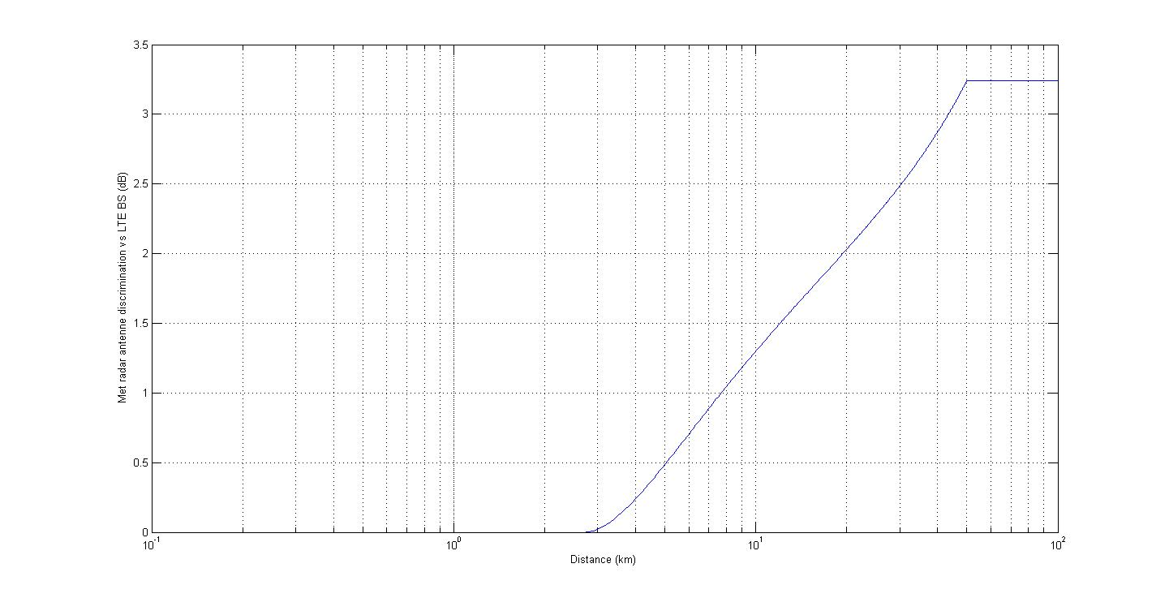
- MET radar antenna discrimination for studies involving the LTE base station
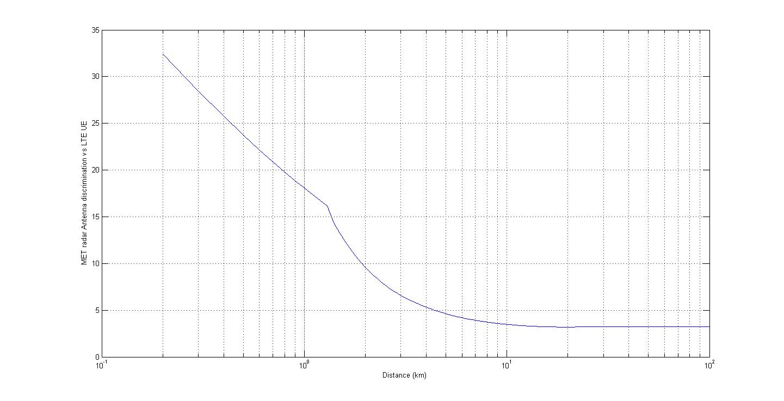
- MET radar antenna discrimination for studies involving the LTE UE
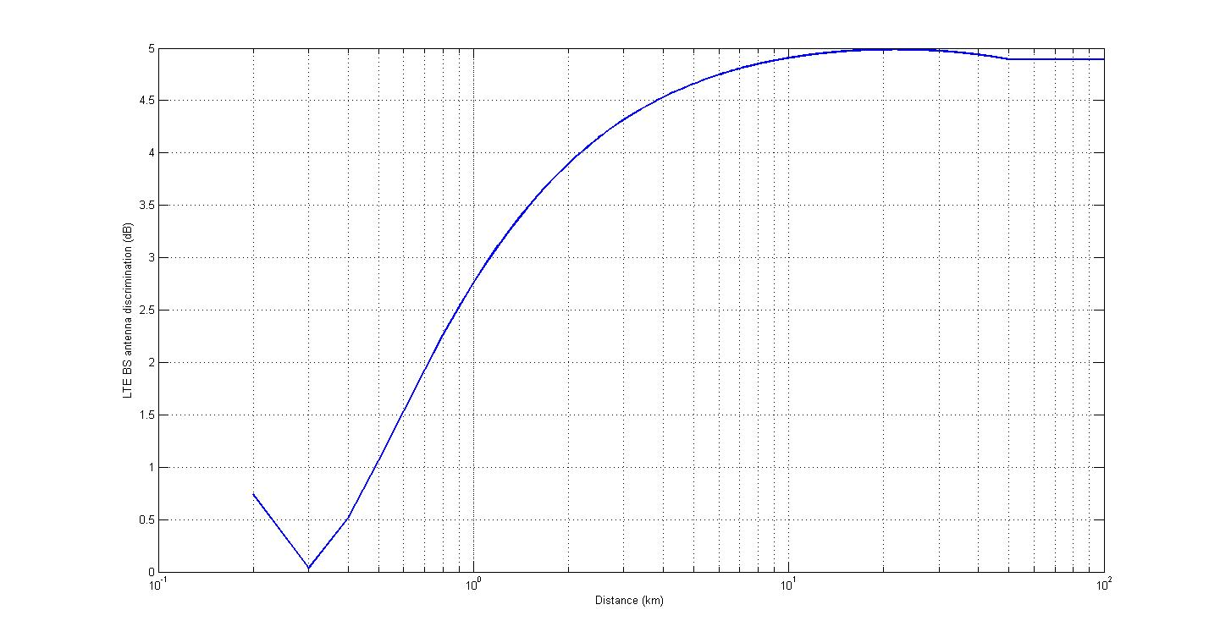
- LTE base station antenna discrimination for studies involving MET radars

Different bandwidth of mobile service base station
- LTE base station emission power
Parameters | LTE | WiMAX
maximum transmitter power of mobile service Base station (dBm) | 43 for BW = 5 MHz  46 for BW = 10 MHz  46 for BW = 20 MHz | 43 for 5/10MHz BW
peak to average ratio of transmitter power of mobile service base station, dB | 7 - 8 dB (even for very low probabilities such as 10-6 ) | 11- 12 dB

Blocking is determined by the maximum in-band power of the interfering system. Comparing the different bandwidth, the power density (dBm/MHz) is equal for 5 and 10 MHz, whereas for 20 MHz this value is reduced by 3 dB resulting in a smaller required isolation for protection of the radar system.
It should be noted that according these maximum transmit powers and the base station characteristics given in Table 1: this report does not consider the possibility given in decision 2008/477/EC of having a maximum e.i.r.p of 68 dBm/5MHz for specific applications.

Impact of different propagation models and environments
The impact of the environment can be taken well into account by free space or the propagation model defined in Recommendation ITU-R P.452 if the antennas are well above the surrounding clutters (buildings, trees, etc.). This assumption is reasonable for the cases radar interferes base station and vice versa. However, if terminals are considered, the aforementioned worst cases will be observed with a very low probability because the surrounding clutters will prevent LOS to the radar with higher probability.
The path loss between a radar station and the mobile terminal is computed by 3 different propagation models in the following Figure 31:
- Free space taking into account only distance and frequency
- Rec. ITU-R P.452 [37]considering additionally antenna heights and diffraction by the earth curvature
- Extended Hata considering urban land cover.
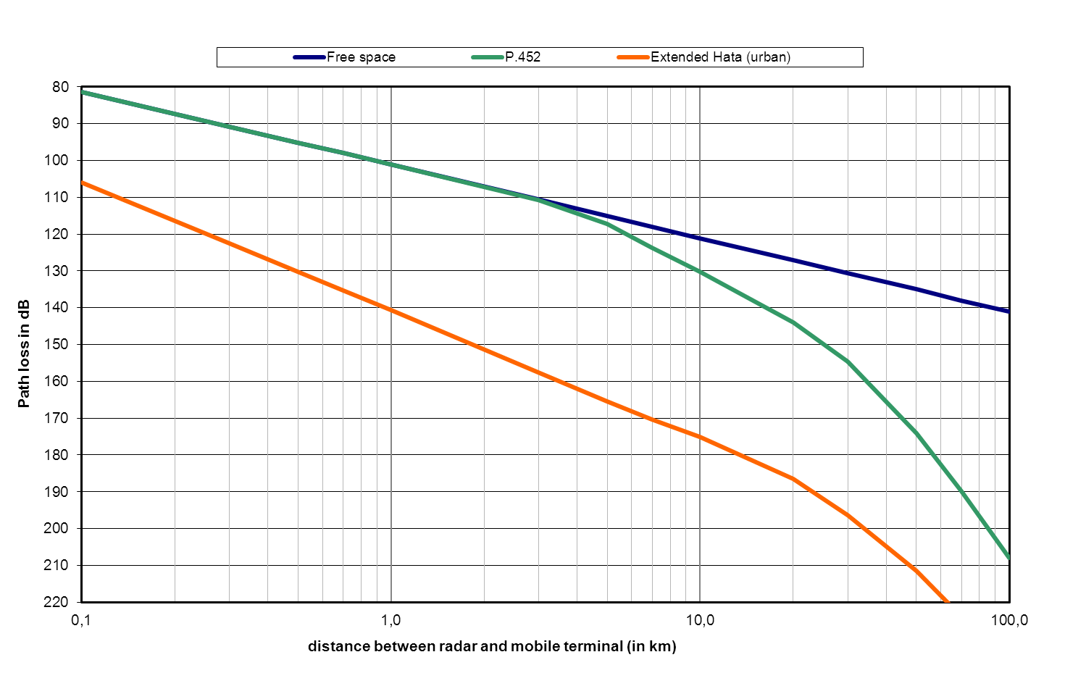
- Path loss between radar station and mobile terminal (f=2700 MHz, h_{radar}=25 m,
h_{terminal}=1.5 m)
It can be noted that
- LOS is dominating up to the radio horizon (for terminals <10 km, for base stations typically between 10 and 20 km), if no clutters are considered. Free space is a good approximation.
- However, beyond the radio horizon, the path loss is underestimated. The diffraction by the earth needs to be taken into account, even for base stations.
- Estimating the path loss for terminals in NLOS environment, the empirical extended Hata model is more appropriate. The difference is in the order of more than 20 dB.

Compatibility analyses

Impact of radars on terminals
The analysis below has been carried out for LTE FDD terminals. Since relevant LTE TDD terminal characteristics are the same as for LTE FDD, the results carry over to that case as well. Note also that the results may vary depending on the modelling assumptions, as illustrated by the results in ANNEX 7:

Additional isolation for different separation distances
Figure 32: - Figure 36: below contain required additional isolation for different separation distances (propagation model ITU-R P.452) for different radar suppression levels. Antenna height is 40 and 21 meters respectively for ATC and meteorological radars. LTE terminal height is assumed to be 1.5 m throughout. Horizontal side-lobe suppression in relation to maximum antenna gain is assumed to be 35 dB for ATC radars (Types 2 and 3), and 30 dB for meteorological radar (Type 4). This corresponds roughly to angles other than the 10 degrees beamwidth with the highest gain. Note that this is just an example of analysis incorporating side-lobe suppression of the radar antenna, and that the antenna gain with the 10 degrees not considered as side-lobe in this example will not be equal to the maximum antenna gain, but rather vary between no additional suppression and roughly 30 or 35 dB additional suppression. For further details on the radar antenna diagrams, see Section 4 (Table 5: and Figure 13: - Figure 17:).
Antenna discrimination is included in the analysis, see Section 5.5.4.1. ANNEX 8: contains information about calculations of interference from radars to LTE UEs.
It should be noted that a radar using PRR of exactly 1 kHz may cause more severe interference by repeatedly destroying OFDM symbols containing reference symbols.
ANNEX 11: contains results on required separation distances for radar OOB/spurious suppression levels between -40 and -100 dBc.
- Required additional isolation needed for interference from radar type 1 to LTE UE

- Required additional isolation needed for interference from radar type 2 to LTE UE

- Required additional isolation needed for interference from radar type 3 to LTE UE

- Required additional isolation needed for interference from radar type 4 to LTE UE

Temporal aspects of radar interference
Figure 36: provides an example of calculation of the interference level generated at the LTE UE receiver input at 5 km from radar type 2, taking into account 80 dBc spurious attenuation, and an antenna rotation of 15 rpm. In order to derive this Figure and for simplification an average level was considered for the radar antenna side-lobe.
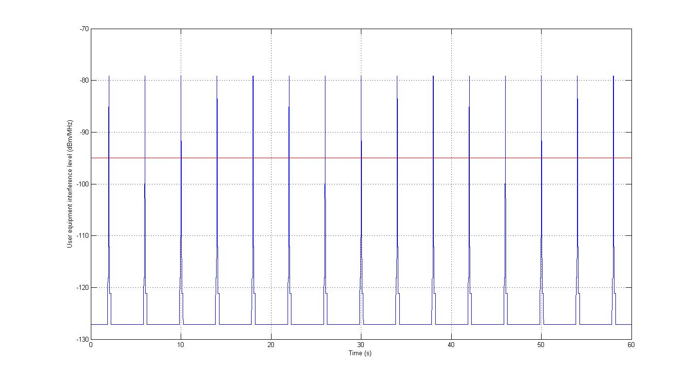
- Downlink Interference level for radar type 2 spurious emissions at 5 km distance
The -95 dBm/MHz threshold is exceeded 1.1% of the time, which is 44 ms each 4 seconds.
Figure 37: provides a calculation of the interference level generated at the LTE UE receiver input at 5 km from radar type 4, taking into account 75 dBc spurious attenuation, antenna rotation of 3 rpm and the pattern in elevation given in Figure 15:
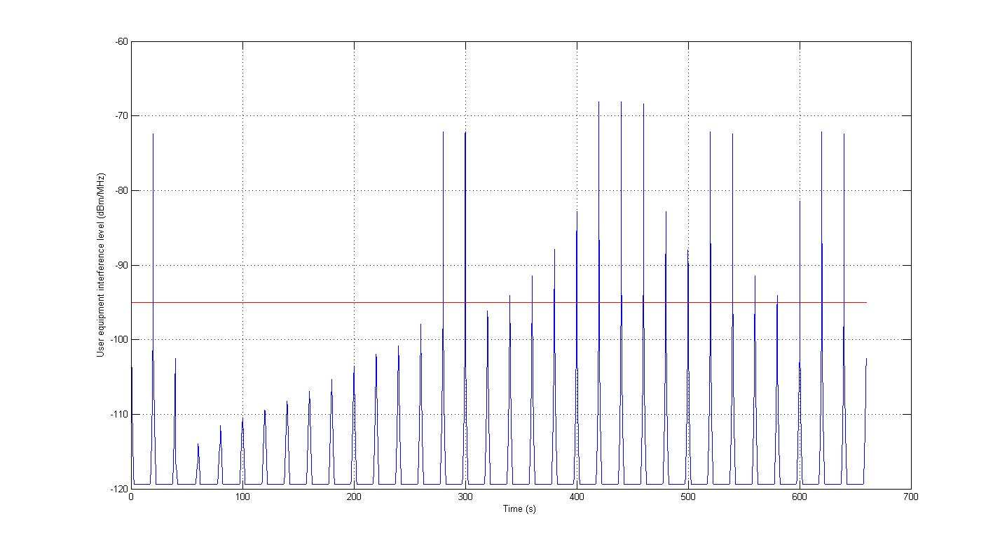
- Downlink Interference level for radar type 4 spurious emissions at 5 km distance
The -95 dBm/MHz threshold is exceeded 1.1% of the time, which is about 220 ms each 20 seconds.

In-band blocking
ANNEX 5:contains a detailed analysis of this aspect of radar interference to LTE terminals.
In this context, in-band blocking refers to a situation of interference that is not attenuated by the duplex filter, i.e. reaches the LNA without being filtered within LTE band.
The conclusion is that this in-band blocking effect is dominated by others, such as OOB/spurious emissions.

Out-of-band blocking
ANNEX 5: contains a detailed analysis of this aspect of radar interference to LTE terminals. It is summarized below.
In this context, out-of-band blocking refers to the case when the interference falls outside of LTE band but it could be within the pass band of the duplex filter.
Since duplexer manufacturers try to obtain a receive pass band that is as flat as possible over the range 2620-2690 MHz it may happen that the filter cut-off frequency extends above 2690 MHz and falls into the radar band. In this case, there will be very little attenuation of the radar signal if the radar is located close to the lower edge of the radar band, and the terminal will be overloaded, or blocked. The analysis of out-of-band blocking can thus be divided into two parts, the first corresponding to radar frequencies beyond the point where the terminal duplexer provide substantial suppression, e.g. 40 dB at 2730 MHz, and one for radar frequencies lower than this point.
For the first case there will be no degradation of the LTE downlink throughput if after the mixer there are sufficient receive filters to attenuate any interference. In Annex 5, this scenario is compared with TX leakage. The receiver of the LTE UE is designed to handle TX leakage of at least -25 dBm, which is higher than the radar interference in this case, about -29 dBm for a meteorological radar (worst case) at 1 km line-of-sight, primarily thanks to the duplexer suppression of the LTE UE.
For the second case interference will be more severe, due to the lack of duplexer suppression of radar interference. For a meteorological radar transmitting within the duplexer of the LTE terminal the interference level at 1 km line-of-sight may be 11 dBm. This may interrupt transmission for the duration of the radar pulse and in addition for a short recovery time of around 1 microsecond. For the consequences of this, see Section 3.3.1.1 above, in particular Figure 7:, as well as ANNEX 5:.

Other effects of radar interference
ANNEX 5: contains a detailed analysis of other phenomena that need to be considered in this context. They are also summarized below.
Electrostatic discharge (ESD) events are very worst case events for which the maximum radar interference must be taken into account, for short distances and in the main lobe of the antenna. 300 meters distance has been used in the calculations. Such worst case events are analysed in ANNEX 5: and it is found that radar signals will not cause any catastrophic failures under these assumptions.
Electro migration effects are also considered in ANNEX 5: and it is concluded that this will not pose any problems even when LTE terminals are in use continuously near the radar.
One effect that must be taken into account, however, is Rx or Tx VCO pulling, which may extend the recovery time to up to 20 microseconds instead of e.g. 1 microsecond (see A.5.2.2). The simulation analysis provided in Section 3.3.1.1 above, in particular Figure 7: as well as ANNEX 5: can be used to conclude on the damage done to the LTE DL throughput in such cases. VCO pulling is expected to vary considerably from one implementation to another.

Impact of radars on base stations
The analysis has been carried out for LTE FDD base stations. Since relevant LTE TDD base station characteristics are the same as for LTE FDD, the results carry over to that case as well. One exception that needs to be considered is the ability to suppress out-of-band interference from radars, due to the lack of duplex filters in the TDD base station, see further Section 6.2.4.

Additional isolation for different separation distances
Figure 38: – Figure 41: below contain requirements expressed additional isolation needed for different radar interference scenarios (propagation model ITU-R P.452). Antenna height is 40 and 21 meters respectively for ATC and meteorological radars. LTE BS height is assumed to be 45 m throughout (rural area). Side-lobe suppression in relation to maximum antenna gain is assumed to be 35 dB for Type 1 – 3 radars and 30 dB for Type 4 radar. This corresponds to angles other than the 10 degrees beamwidth with the highest gain. Note that this is just an example of analysis incorporating side-lobe suppression of the radar antenna, and that the antenna gain with the 10 degrees not considered as side-lobe in this example will not be equal to the maximum antenna gain, but rather vary between no additional suppression and roughly 30 or 35 dB additional suppression. For further details on the radar antenna diagrams, see Section 4 (Table 5:andFigure 13: - Figure 17:).
Antenna discrimination is included in the analysis, see Section 5.5.4.1 and ANNEX 8: contains information about calculations of interference from radars to LTE BSs.
Just as for case with interference to the LTE UE, see Section 6.1.3, the fact that the radar antenna is rotating should be applied with caution.
The simulations and measurements have been carried out under the assumption that the radar pulses will not be transmitted at exactly 1 kHz, and thus represent an averaged case where the radar occasionally but not constantly erases reference symbols. In the case of a radar with PRR of exactly 1 kHz the interference may be considerably worse.
It should be noted that the results may vary depending on the modelling assumptions, as illustrated for the downlink case in Figure 89: - Figure 92: in ANNEX 7:.
- Required additional isolation needed for interference from radar type 1 to LTE BS
- Required additional isolation needed for interference from radar type 2 to LTE BS
- Required additional isolation needed for interference from radar type 3 to LTE BS.

- Required additional isolation needed for interference from radar type 4 to LTE BS

Temporal aspects of radar interference
Figure 42: provides an example of calculation of the interference level generated at the LTE BS receiver input at 5 km from a type 3 radar, taking into account 80 dBc spurious attenuation, and an antenna rotation of 15 rpm.
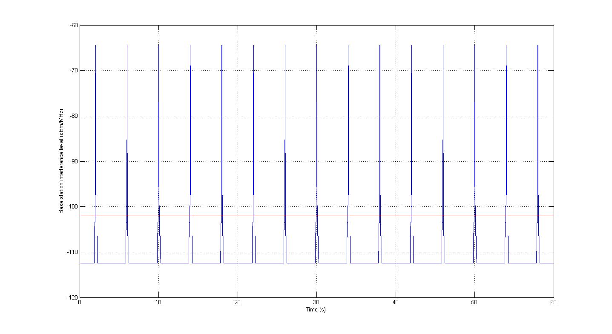
- Uplink Interference level for radar type 3 spurious emissions at 5 km distance
The -102 dBm/MHz threshold is exceeded 3.1% of the time, which is 125 ms each 4 seconds.
Figure 43:provides a calculation of the interference level generated at the LTE BS receiver input at 5 km from a type 8 radar, taking into account 75 dBc spurious attenuation, antenna rotation of 3 rpm and the pattern in elevation given in Figure 15: of Section 4.
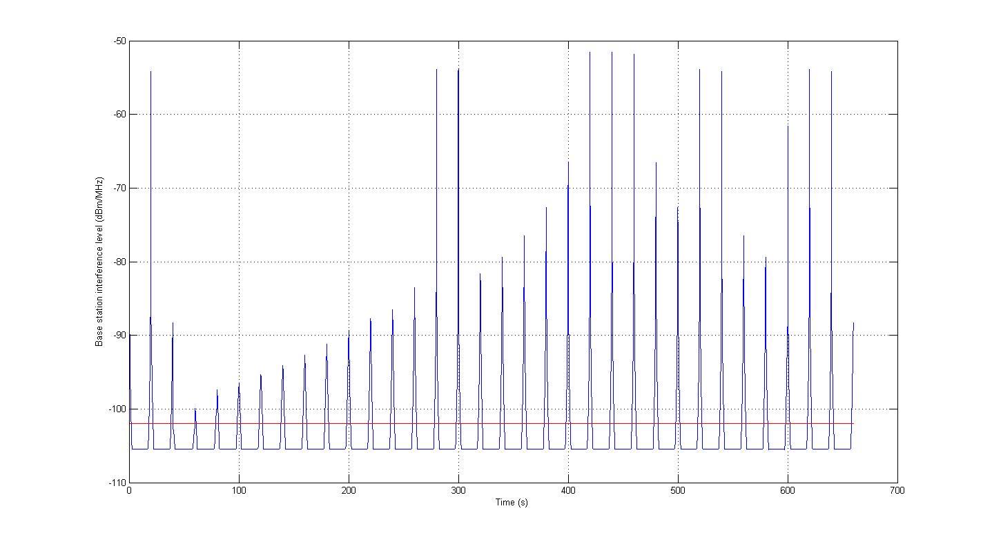
- Uplink Interference level for MET radar spurious emissions at 5 km distance
The -102 dBm/MHz threshold is exceeded 17.9% of the time, which is about 3.6 seconds each 20 seconds.

In-band blocking
The in-band blocking level for LTE BS is defined within 20 MHz frequency offset from the band edge (upper band edge 2690 MHz), the test condition is specified in 3GPP TS36.104 as -43 dBm for 6 dB desensitisation, this in-band blocking level correspond a LTE BS receiver rejection of 50.7 dB (with 3 dB BS noise figure for LTE BS 20 MHz channel). This 50.7 dB LTE BS receiver rejection is applicable to radar in-band emission between 2700-2710 MHz. For radar emission above 2710 MHz, the LTE BS receiver rejection derived from the LTE BS out-of-band blocking applies.
For the radar OOB emission up to 50 dBc, this LTE BS receiver rejection of 50.7 dB is sufficient. In case the radar OOB emissions can be improved to more than 50 dBc, the LTE BS in-band blocking level should also improve accordingly.

Out-of-band blocking
LTE BS out of band blocking in radar emission band 2700-2900 MHz was defined in 3GPP TS36.104 as
-15 dBm for the frequency range above 2710 MHz (20 MHz from the upper band edge 2690 MHz). This out of band blocking level corresponds to a receiver rejection of 78.7 dB (with 3 dB noise figure for LTE BS 20 MHz channel).
The interference level in LTE uplink reception band from radar in-band emission and out-of-band/spurious emissions can be calculated as
I_total = Ptx –ACIR - MCL
where Ptx is the radar in-band emission power level
MCL is the minimum coupling loss between radar transmitter and LTE BS receiver including radar and LTE BS antenna gains and feeder losses
ACIR is the adjacent channel interference ratio
1/ACIR = 1/ACLR + 1/ACS_oob
ACLR is the radar out-of-band/spurious emission reduction, ACS_oob = 78.7 dB is the LTE BS receiver rejection derived from the out of band blocking level of -15 dBm.
With 60 dBc radar spurious emission reduction, the dominant interference from radar to LTE BS is the radar spurious emission; , and there is no need to improve the LTE BS receiver out of band blocking level by additional filter. In case radar spurious emission reduction is improved more than 78 dB, for example, with 90 dBc radar spurious emission reduction, the LTE BS out of band blocking should be improved accordingly with an additional filter of 12 dB.
It should be pointed out that FDD BS has a duplexer which protects the BS receiver reception (2500-2570 MHz) against its own emission (2620-2690 MHz), this BS duplexer provides in practice additional rejection in the frequency range above 2700 MHz, the real FDD BS receiver blocking performance is much better than the minimum requirements of in-band & out of band blocking levels defined in the standard.

Other effects of radar interference
For LTE terminals, ESD events, electro migration and VCO pulling have been discussed. For FDD base stations with duplex filter, it is not believed that these effects will cause any performance degradation due to the additional frequency separation and the fact the base stations in general are more robust than terminals. For TDD base stations without duplex filter, see Section 6.2.3 and 6.2.4.

Quality of Service Issues for LTE equipment when interfered by radars
Sections 6.1 and 6.2 have shown the impact on the LTE throughput of a radar pulse falling into the LTE receive channels (uplink for the base station case and downlink for the mobile terminal case). Especially, the results have been presented as instantaneous throughput losses (when the radar main lobe or side lobes faces a base station or a mobile terminal) and as averaged throughput losses (when considering the radar rotation as in sub-section 6.1.2 and 6.2.2 “temporal aspects of radar interferences”). Both aspects are of importance, especially the instantaneous loss of throughput since it could prevent a LTE system from providing the services with the required QoS to the connected users.
Indeed, the instantaneous degradations of throughput during 120ms and 50ms for the ATC radar example (respectively for the uplink as shown on Figure 42: and downlink cases as shown on Figure 36:) and during 3.4s and 100ms for the radar type 4 example (respectively for the uplink as shown on Figure 43: and downlink cases as shown on Figure 37:) are due to a combination of the following two aspects:
- Since the channel quality is seen as poor, the mobile system physical layer adapts the modulation and coding scheme (i.e. link adaptation) so that the transmission is more robust to interferences. As a consequence, the data bit rate is decreased (because of the lower modulation used and because of the increase in data redundancy);
- because of the interfering signal, the resource blocks (containing the data bits) can’t be decoded on the receiver side. The Hybrid Automatic Repeat Request (HARQ) mechanism is responsible for the retransmission of resource blocks. As resources are allocated to the retransmissions, the effective throughput of the system is decreased.

These two aspects may, depending on the load of the mobile system, lead to increases in the packet transmission delays (because of longer queuing of packets) and packet losses (because of buffer overflow and/or breach of maximum retransmission limit) to levels not compliant to the QoS requirements of the data transmissions. Indeed, VoIP, as well as other types of highly interactive traffic/applications are very sensitive to packet loss, delay and variations in delay (i.e. jitter). Especially, bursty packet loss degrades significantly the quality of the VoIP call as perceived by the end user (the end user will perceive a clear break in the speech or audible error or echo). As for the delay, the user voice is sampled every 20ms and the speech frame has to reach the other side of the network within 200ms (which corresponds to 100ms budget between a LTE mobile terminal and the LTE network gateway) for the delay not to be noticeable by the end user (clear break in the speech or talk-over effect). Another impact of the radar interferences on VoIP service is the degradation of the jitter (i.e. variation in the packet transmission delay). Frames and packets produced by the encoder while the transmitter is attempting to send the oldest packet in the transmission queue will be buffered, resulting in a longer and longer queue. Long buffering times will result in late arrival at the receiver. For real-time services such as voice, the jitter buffer may only be able to handle up to 100 - 150 ms jitter spikes, and thus there is a large risk for so-called "late losses", i.e. packets arriving at the client too late for decoding. They will thus be dropped by the jitter buffer. If an adaptive jitter buffer is used, it may adapt to a situation will small jitter in-between the interference periods. When there is interference, there will not be enough frames in the jitter buffer to cover the delay spikes, causing underflow in the jitter buffer and bad quality for the user.
- If an adaptive jitter buffer is used, it may adapt to a situation will small jitter in-between the interference periods. When there is interference, there will not be enough frames in the jitter buffer to cover the delay spikes, causing underflow in the jitter buffer and bad quality for the user.
- More generally, for the purpose of QoS management in LTE, each data flow (i.e. EPS bearer) is associated to a QoS Class Identifiers (QCI) [42]. There are 9 QCIs [43] covering all the possible type of services, ranging from conversational VoIP to TCP applications such as web browsing. Each QCI is associated to a maximum packet error loss rate and a packet delay budget. As an example, the QCI corresponding to conversational voice has a maximum packet error loss rate of 10-2 and a packet delay budget of 100ms (between the mobile terminal and the LTE network gateway, PDN GW (Packet Data Network GateWay). Having an interfering signal causing a significant degradation of the LTE throughput, even over a short period of time, may introduce delay in the packet transmission (because of retransmissions and longer queuing of packets) and thus make it impossible for the LTE system to provide a wide range of services with an acceptable quality. For VoIP service, ITU G.114 recommends a maximum end-to-end delay of 150ms for voice packet transmission. Delays greater than 200ms are noticeable to the end users. Packet loss may also increase dramatically for real-time services since the only retransmission mechanism used is Hybrid Automatic Repeat Request (HARQ) for which the number of retransmissions is limited.

Consequently, the degradation for some services may be more severe than what is indicated by the throughput loss only.
When considering the average throughput loss using the radar rotation, it should not be forgotten that a mobile service equipment is made of several base stations and user terminals distributed in the area surrounding a radar. Given the number of mobile service equipment likely to be operating in the large area considered, the radar main lobe (and side lobes) will always point to at least one of these equipment, causing a constant degradation of the overall system throughput.
Further study is needed to better understand the impact of the radar intermittent aspect presented in section 6.1.2 and 6.2.2 above on the degradation of the QoS of the mobile service.

Impact of mobile on radars
The results are given in terms of missing isolation vs separation distance between the radar and mobile service base station or terminal, for the unwanted emissions and blocking scenarios. Elements are missing with regard to the defence radar Type 1 antenna pattern as well as blocking characteristics. This radar was therefore not taken into account. It is expected however, in view of its antenna gain and possible scanning in elevation, that the results for this radar would be similar to the meteorological radar (type 4) with regard to the impact of unwanted emissions of mobiles.
In Figure 44: - Figure 45: presented below only one BS or one UE with the maximum transmitting output power was considered as source interference to radars.

ATC radars (Type 2)
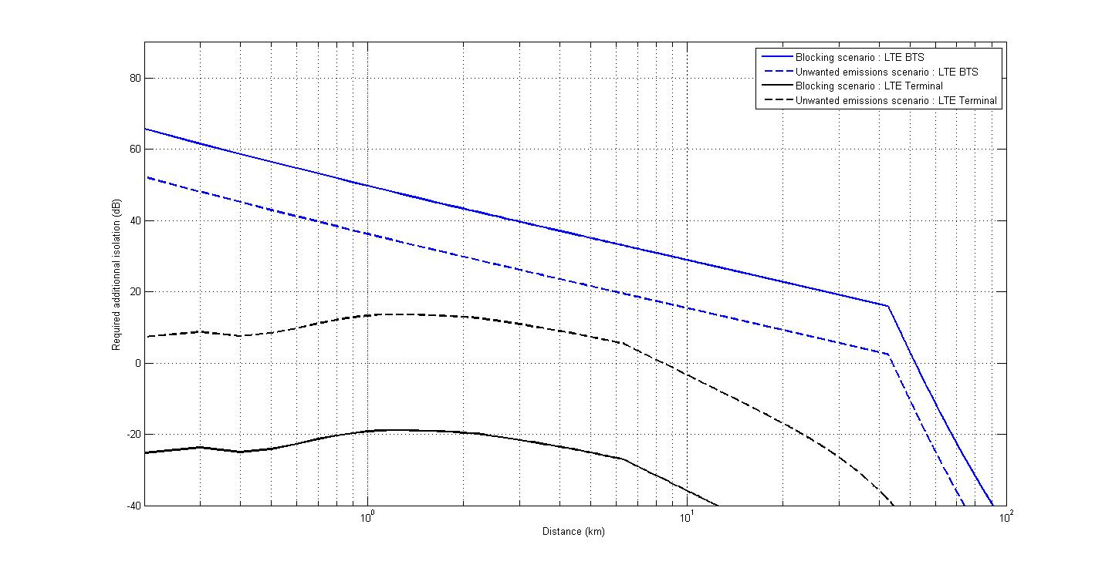
- Impact of LTE BS and UE in rural environment on Type 2
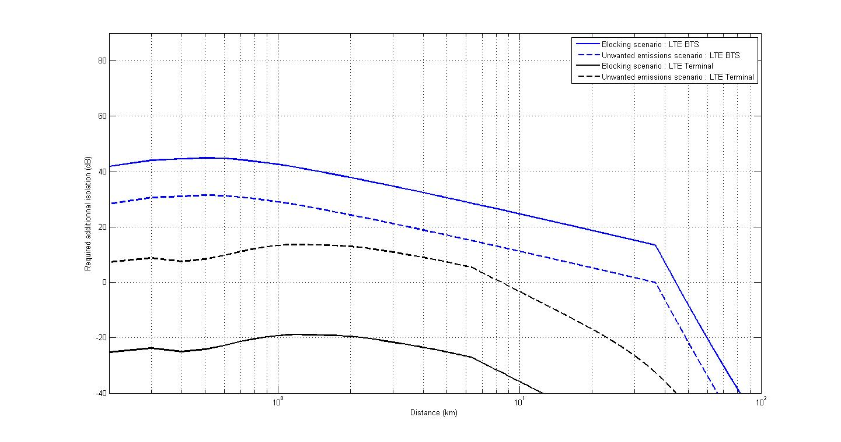

- Impact of LTE BS and UE in urban environment on radar Type 2
Note: It should be noted that Figure 44: and Figure 45: contain results of study relevant to radar Type 2 based on protection ratio given in Table 6:Error: Reference source not found of Section 4, with only two 4.5 MHz LTE blocks generating intermodulation products into the radar receiver.
In the case where more than 2 LTE blocks are being used, depending on other radar and LTE parameters, the curves shown above for blocking scenarios (Figures 44 and 45) would be up to 10.9 dB more stringent (see Section 4).

Meteorological radars
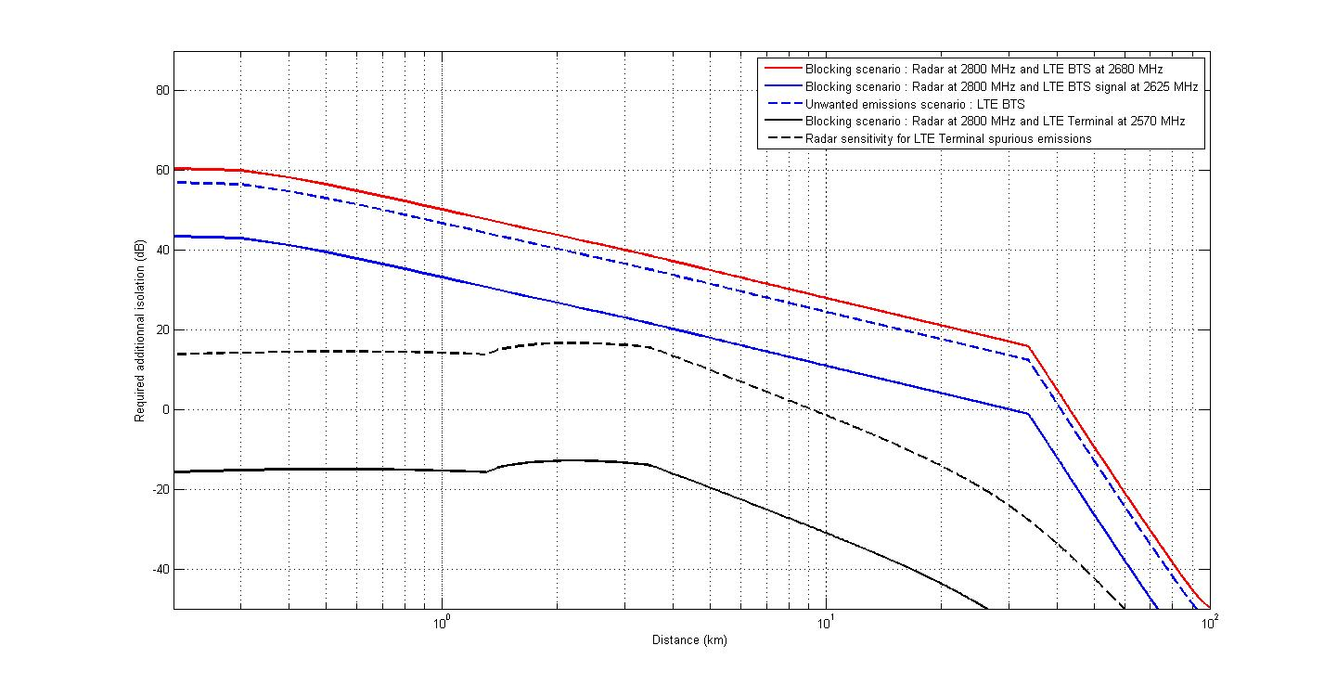
- Impact of LTE BS and UE in rural environment on radar Type 4
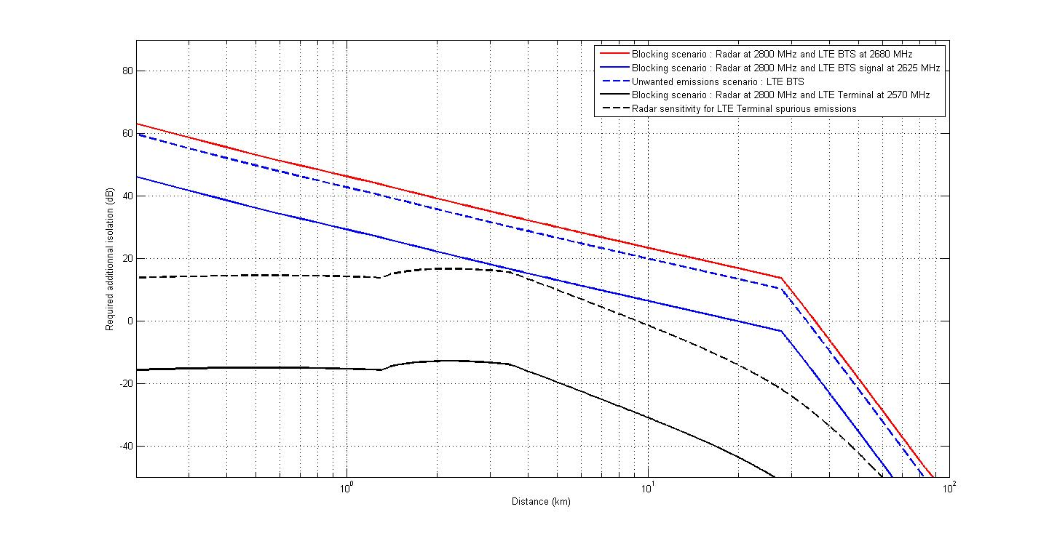
- Impact of LTE BS and UE in urban environment on radar Type 4

Analysis
The blocking of radars by mobile terminals is not expected to be a problem for any kind of radar. A further reduction by 20 dB of the unwanted emission limit of -30 dBm/MHz would solve the problem of unwanted emissions of mobile terminals. Measurements performed in one Administration on several terminals have shown that the actual spurious emission level of such terminals would be below -50 dBm/MHz. However, concerns were expressed on the limited number of equipment that was tested. It would be useful to gather further information from different manufactures. In addition, these measurements don’t guarantee that terminals produced in the future would have equivalent performance. On the other hand, it should also be noted that the calculations performed do not take into account the effects of power control or the mobility of terminals, as well as any shielding that may exist between the terminal and the radar that would in practice reduce the impact of unwanted emissions on the radar receiver.
When considering the impact of BS on ATC radars, the main problem is due to the lack of selectivity of the radar chain or the saturation of the LNA. For instance the protection from interference due to the fundamental emission of BS located at 1 km from the radar would require an additional 63 dB isolation. In addition, this BS would have to further reduce its unwanted emissions by 36 dB to protect the radar receiver.
For new meteorological radars, the saturation of the LNA is not expected to be a problem. The main problem is therefore due to particular image frequencies for which the selectivity is not sufficient. For instance the protection from interference due to the fundamental emission at 2680 MHz of a BS located at 1 km from the radar would require an additional 50 dB isolation. In addition, this BS would have to further reduce its unwanted emissions by 48 dB to protect the radar receiver.

Possible Mitigation techniques
There are potential mitigation techniques which may be considered by administrations to solve the interference cases and these mitigation techniques could be applied for both services. Study has shown that no single mitigation techniques may solve all possible interference cases on appropriate manner. A non-exhaustive list of mitigation techniques is provided below. Some of these techniques can only be applied on the harmonized level, the others to be applied case-by-case approach.

List of possible mitigation techniques
- improvement of the receiver selectivity
- reduce unwanted emissions of transmitters
- reduced Power from the mobile service Base Station
- site specific deployment
- physical separation between radar and mobile service stations
- frequency separation

Applicability of these mitigation techniques

Improvement of receiver selectivity
This mitigation technique addresses blocking.
To avoid blocking of radars:
Design a receiving chain that would provide the additional isolation required which would have to be fitted in the radar receiver. Investigations carried out for some ATC radars indicate that this technique may substantially reduce interference, for example using additional filters. The impact of such a filtering on the whole radar receiver chain still needs to be assessed. However for radars using frequencies that are not in proximity to 2700 MHz, design of such filters may be simplified.
To avoid blocking of mobile service (BS & UE):
For radars that operate in the lower part of the band 2700-2900 MHz (e.g. below 2730 MHz) additional mobile service receiver selectivity may be required to protect the mobile service BS&UE receiver.

Reduce unwanted emissions of transmitters
To protect the radars from unwanted emissions of mobile service equipment:
Some additional isolation is required for the protection of radar reception. It may be achieved by improvement of mobile equipment to reduce unwanted emissions in relation to regulatory requirements indicated in ERC/REC 74-01 Error: Reference source not found. The measurements provided by one Administration have shown (ANNEX 4:) that base stations may be designed to be substantially superior to ERC/REC 74-01 [13] spurious requirement of -30 dBm/MHz already at 2700 MHz, and to reach –65 dBm/MHz or better at roughly 2725 MHz.
For terminals, the measurements indicate that they may be designed to have spurious emissions no higher than –52 dBm/MHz in the radar spectrum 2.7-2.9 GHz. These results may apply only to FDD terminals transmitting in the 2500-2570 MHz band.
It must be remembered though that these measurements may have been carried out on pre-production equipment in ideal conditions, and that margins may be needed in relation to these results. Further information is required from different manufactures to assess real situation.
If some further filtering is required it may be achieved by adding filters to base stations at specific sites.
To protect the mobile service equipment from unwanted emissions of radars:
Some additional isolation is required for the protection of mobile service BS&UE receptions. It may be achieved by considering improved radar unwanted emissions compared to regulatory requirements indicated in ERC/REC 74-01 [13]. For example, information provided by Administrations show that some multi-frequency ATC radars exhibit spurious attenuation below 2690 MHz which are better than the ERC/REC 74-01 [13] requirement of - 60 dB PEP (see ANNEX 2:). Radars should be designed to reduce their spurious emission levels to the best possible extent although it would not solve the problem of interference from the radar spurious emissions onto mobile service completely. This improvement could also imply redesign of radar transmitter.
However, non withstanding the question of cost, there are technical limitations which may render additional emission filters on some radars difficult to implement, as written in Recommendation ITU-R M.1314 [40].
The interference rejection capabilities of LTE equipment will depend on the actual implementation. It should be noted however that there are difficulties associated with this implementation which may add considerable complexity to the equipment.

Reduced power from the mobile service base station
Reducing power of mobile system equipment is not realistic as a general solution, since it would have very substantial implications on deployment of mobile networks in terms of base station density.
However the power of base stations located very closed to radar may be reduced thus reducing the blocking impact. On the other hand this will result in smaller cell sizes and/or a reduction in the downlink data rate. Also there is no guarantee that reducing the power will reduce the unwanted emissions.

Site specific deployment:
Mobile service base stations could be located in such a way as to avoid main beam coupling between the mobile service base station and the radar by e.g. antenna direction, tilt, height, etc., taking advantage where possible of terrain, shielding by obstacles such as buildings or other structures. This could reduce the impact on radar and vice versa but may also compromise the coverage of each cell thus requiring additional infrastructure to provide the same coverage. When considering the antenna direction in azimuth, the impact on the mobile service deployment would not be limited to the base stations in the immediate vicinity of the radars but would imply adjusting also the antenna azimuths of the neighbouring base stations of the latter to ensure an efficient spectrum reuse between cells.

Physical separation
Increase the separation distance between the mobile service base station and the radar. The increase in the isolation can be estimated for LOS by 20 dB/decade and for NLOS by about 35-40 dB/decade. However given the additional isolation required this is unlikely to be an effective technique in itself as the mobile stations would have to be located a significant distance from the radar and could create coverage problems for the mobile service operators in the 2.6 GHz range. The extent of this problem can only be judged nationally on the case by case basis.

Frequency separation
It is recognised that there is the 10 MHz band allocated to RAS which can be considered as implicit guard band between the bands allocated to radar and mobile service.
To address blocking:
Studies to date have shown that due to the differences of existing radar designs the impact of this mitigation will vary. However frequency separation will facilitate the improvement of radar and mobile service BS&UE receiver selectivity.
To address unwanted emissions:
An increase in frequency separation would have no effect based on the current regulated spurious levels however test carried out on pre-production equipment would suggest that this would allow those equipments unwanted emissions to have rolled off sufficiently to provide effective protection to the radar. Similar considerations are valid for the opposite direction about the radar unwanted emissions into LTE BS&UE in the frequency band 2500-2690 MHz. Further testing however is required to confirm these in future. Although this would be difficult to implement in some part of Europe.

Synthesis of applicable mitigation techniques
Study has shown that no single mitigation techniques may solve all possible interference cases on appropriate manner. Therefore there is a need to evaluate further the effect of combining some of these mitigation techniques. However due to some time constraints this study was not conducted but this evaluation may be done further at the national level.

Conclusions
ATC, defence and meteorological radars operating in the band 2700-2900 MHz are deployed in Europe and would normally be transmitting with high powers, ATC radars are mainly deployed close to airports with defence and meteorological radar more likely being deployed in rural areas. The frequency spectrum 2500-2690 MHz allocated to the mobile service, has not seen mobile services deployed in the past but due to recent technology advances is expected to be heavily used in future by mobile/broadband systems (e.g. LTE and WIMAX) in line with or similar to the frequency arrangements defined in the ECC Decision (05)05. Therefore, these studies have been carried out to assess the mutual compatibility between these systems, i.e. mobile service operating below 2.69 GHz and aeronautical radionavigation and radiolocation services operating above 2.7 GHz.
The studies, based on worst case assumptions (i.e. line-of-sight conditions), have shown that there is potential interference from mobile service to radar and vice versa which will depend on the deployment scenario with factors such as frequency separation, relative antenna orientation, and distance. In addition, interference may be less severe than the results indicate when realistic assumptions about propagation, actual mobile and radar deployments and equipment performance are taken into account. It should be noted that the worst case assumptions used in this report may not be encountered in a large number of actual situations. In these cases additional mitigation may not need to be applied.
Two interference effects of potential mutual interference have been studied:
- Blocking: where a signal outside of the nominal receiver bandwidth causes the victim receiver to experience an increased noise level or go into compression, thus producing non-linear responses.
- Unwanted emissions: where the unwanted emissions (OOB and spurious) of the interfering transmitter fall into the receiving bandwidth of the victim receiver.

Impact from mobile systems into radars:
- Blocking
Studies have shown that additional isolation depending on the separation distance would be required between the mobile service base station and the radar. As an example, for a separation distance of 1 km this additional required isolation is in the order of 20-60 dB depending on the radar characteristics such as antenna height, gain, radiation patterns, radar frequency and bandwidth, number and size of mobile blocks,etc. The actual impact should be determined on a case-by-case basis. Currently, it is planned in a number of administrations to address this issue by improving the radar adjacent band rejection capability through enhancing receiving chains where needed.
It should be noted that the non-linear responses could be dominant for some radar frequencies compared with other effects.
In addition studies have shown that the blocking effect from mobile service terminals operating in accordance with the FDD band-plan (in the 2500-2570 MHz band) is not considered to be a problem and no additional isolation is required for this case.

- Unwanted Emissions
Based on the assumption that unwanted emissions of mobile equipment are -30 dBm/MHz in the band 2700–2900 MHz, studies have indicated that there would be a need for an additional isolation depending on the separation distance between the two services. As an example, for a separation distance of 1 km, this additional isolation would be in the order of 30-45 dB for the base station and 15-20 dB for the mobile service terminal depending on the radar characteristics such as antenna height, gain, radiation patterns, etc..
Impact from radar into mobile systems:
- Blocking
The additional isolation due to blocking of mobile receivers by radar in-band emissions was not assessed in such details, but by comparison with the impact of radar unwanted emissions. Two different cases were addressed:
  - In-band blocking which refers to a situation of interference that is not attenuated by the duplex filter, i.e. reaches the LNA without being filtered within LTE band.
  - Out-of-band blocking refers to the case when the interference falls outside of LTE band but it could be within the pass band of the duplex filter.

In cases where the radar unwanted emissions (OoB and/or spurious) attenuation is lower than 78 dBc, in-band blocking to the LTE BS becomes the dominant factor and this blocking level can only be improved accordingly through additional receiver rejection.
In cases where the radar unwanted emissions (OoB and/or spurious) attenuation are above 78 dBc, the LTE BS out of band blocking effect becomes dominant and should be improved accordingly. The out-of-band blocking of user terminal equipment may also be problematic for radar frequencies close to the mobile band, due to the lack of duplexer suppression of the radar interference.
However, the real FDD BS receiver blocking performance is much better than the minimum requirements of in-band & out of band blocking levels defined in the standard due to the duplexer which protects the BS receiver reception (2500-2570 MHz) against its own emission (2620-2690 MHz).
- Unwanted Emissions
The results for radar unwanted emissions apply only to LTE systems. Results for other mobile systems may be substantially different, as the analysis relies on very detailed aspects of system characteristics.
Based on the assumption that unwanted emissions of radars are at the regulatory limit contained in ERC/REC 74-01 [13] which depends on the radar type and characteristics, studies have shown that there would be a need for additional isolation depending on the separation distance. As an example, based on a separation distance of 1 km, a limit in the spurious domain of -60 dBc and limited to the impact of the radar antenna main beam, the additional isolation needed would be in the order of 75-95 dB to protect the base station and 40-65 dB to protect the terminal equipment. It is recognised that such isolation cannot be fulfilled by additional filtering of radars only.
When the mobile service equipment is within the side lobe of the radar, the required additional isolation would instead be 40 – 60 dB for BS and 10 – 30 dB for terminal. It should be noted that 60 dBc attenuation is only valid if there is sufficient separation in frequency between interferer and victim. Otherwise, the attenuation may be as low as 40 dBc instead.
Measurements of some radar indicate that the level of unwanted emission falling into the band 2500-2690 MHz may be much lower than the above mentioned limit and hence the impact may be less severe than the results based on the regulatory levels. Additionally, the intermittent aspect of the interference due to the radar antenna sweeping pattern may limit its impact on the mobile equipment, although a degradation of the quality of service would still be expected in vicinity of radars. The studies related to the latter effect have not been completed.
Possible Mitigation Techniques
The following is a non-exhaustive list of possible mitigation techniques:
- Improvement of the receiver selectivity, in particular for radars, which would help solve the blocking of radars by the mobile service;
- Reduce unwanted emissions of radar transmitters
  - Measured examples of the spectral masks would indicate that the radars are, in practice achieving better than the regulatory limit and hence the impact may be less severe than the results based on the regulatory levels would indicate.
- Reduce unwanted emissions of mobile service transmitters
  - Measured examples, in isolation, (see ANNEX 4:) would indicate that mobile service equipment (i.e. base station and user terminal) are in practice better that the regulatory limit (-30 dBm/MHz limit specified in the appropriate EN for mobile equipment operating in these bands). Based on these measurement results it looks like no additional isolation may be needed with at least some existing production equipment.
  - With regard to the base station, if necessary, more stringent unwanted emissions limits above 2.7 GHz may be achieved by introducing additional filtering on a case-by case basis, when appropriate at a national level. This approach has been chosen by some administrations.
  - With regard to the user terminal, the additional isolation cannot be achieved by introducing additional filtering on a case by case basis and can only be achieved through harmonized approach.
- Reduced power from the mobile service base station;
  - This solution may only be used in some specific instances with base stations near a radar station.
- Site specific deployment, e.g.
  - avoid mobile service base station antennas pointing towards radars (both in azimuth and elevation);
  - take advantage of natural shielding that terrain and buildings provide
- Increase of the distance separation between radar and stations of the mobile service;
- Increase of the frequency separation;
  - This will enable a further reduction of spurious emissions from mobile service transmitters, which may be considerably lower at e.g. 2730 MHz than at 2700 MHz.
  - The risk of out-of-band emissions from a radar falling into the mobile service spectrum is reduced, and additional suppression of spurious emissions is simplified.

Given the scale of the additional isolation required in certain cases one single mitigation technique may not resolve each particular issue. However the knock on impact of each mitigation technique can have a positive effect and reduce or avoid the need for a mitigation technique to solve another issue (e.g. to achieve the required improvement in a radar receiver filtering to avoid blocking by mobile systems there may be a need to migrate the radar up in frequency away from 2.7 GHz thus increasing the frequency separation which may aid or solve another issue such as mobile system unwanted emissions). Therefore the design of mitigation techniques will have to be carefully considered to ensure the correct combination is selected to minimise the impact on all systems and reduce the cost of the overall mitigation solution.
Studies have shown that in some cases blocking of radars due to mobile in-band transmissions was the dominating problem, and in other cases the dominant factor was the impact of mobile unwanted emissions falling into the radar receiver. However, it should be noted that both the impact of blocking and unwanted emissions have to be addressed at the same time. Indeed, if for instance the selectivity of radar receiver chain is upgraded in order to improve its ability to withstand the impact of mobile service base stations transmitting nearby within the mobile allocation, then the issue of the impact of unwanted emissions of mobile service base stations will remain if nothing is done at the base station transmitter, thus jeopardizing the actions taken on the radar side. Similarly, not improving the radar selectivity makes the improvement of mobile base stations spurious emissions useless. The same principle stands for the other direction of interference, even if study results show that in the direction of interference from radar to mobile service system, the interference from radar unwanted emissions to FDD base stations should be the dominant factor, depending on the duplex filter characteristics of the FDD base stations. This may not be the case for all mobile service terminals or for TDD base stations using the upper part of the MS band.
It should be noted that although the worst case analysis shown in this report suggests that there could be compatibility problems in certain circumstances between the mobile service and radar operations, the actual situation in practice throughout CEPT will vary from country to country. In addition it is expected that by considering more realistic assumptions, including unwanted emissions levels for both services, and using a combination of the mitigation techniques highlighted in the report, where appropriate, sufficient protection can be given to both services.

- EMISSION MASKS FOR S-BAND METEOROLOGICAL RADARS
The two Figures below are indicating the spurious emissions level which are consider to be feasible across a whole frequency range up to around 15 GHz (5th harmonics). Actual spurious emission levels are expected to be much better in the band 2500-2690 MHz.
Assumptions:
- 0.8 µs pulse width
- 10% rise time
- OOB roll-off of 40 dB/decade

Resulting in:
- 25 MHz “40 dB bandwidth”
- Spurious domain starting at 94 MHz from the radar centre frequency

- Emission mask for radar at minimum frequency (2712.5 MHz)
- Emission mask for radar at frequency (2784 MHz) to ensure spurious only in the LTE band

- Information on Out of Band Emissions of Civil ATC radars
  - Radar (Type 6)
The centre frequencies of the 2 signals are 2784.5 & 2809.5 MHz and hence an offset will need to be applied to take account of the fact that the lowest assignable frequency is 2720 MHz.
- Radar type 6 spectrum from 2 to 14 GHz

- Radar type 6 spectrum from 2.6 to 3 GHz
  - Radar (Type 5)
The centre frequencies of the 2 signals are 2765 & 2885 MHz and hence an offset will need to be applied to take account of the fact that the lowest assignable frequency is 2750 MHz.
- Radar type 5 spectrum from 2 to 14.5 GHz

- Radar type 5 spectrum from 2.6 to 3 GHz

- METEOROLOGICAL RADAR selectivity
The following elements are representative of a radar receiving chain for which the block diagram is described in the Appendix.
Selectivity response for such radars has been measured for a radar with a centre frequency of 2850 MHz.
- Radar type 8 selectivity for a centre frequency of 2850 MHz
The following elements can be noted:
- The blue curve represent the LTE frequency band and the shape of its top represents the shape of the radar RF filter within this LTE band
- the first peak is at a fixed 120 MHz from the centre frequency (i.e. the image frequency of the second IF) and represent an attenuation of 60 dB
- the second peak is at a fixed 230 MHz from the centre frequency (i.e. half the frequency of the fist IF) and represent an attenuation of 67 dB
- the width of these 2 peaks is around 2 MHz, corresponding to the band pass of the digital match filter
- for all other frequencies, the selectivity is better than 80 dBc (the depicted constant value of 80 dBc is due to the measurement conditions)

From these elements, using the measurements at 2850 MHz and the RF filter shape within the LTE band, it is possible to extrapolate the selectivity mask for other radar centre frequencies (2712 MHz, 2750 MHz, 2800 MHz and 2900 MHz are given below)
- Radar type 8 selectivity for a centre frequency of 2712 MHz
The minimum selectivity is at 2592 MHz (74 dB attenuation)

- Radar type 8 selectivity for a centre frequency of 2750 MHz
The minimum selectivity is at 2630 MHz (70 dB attenuation)

- Radar type 8 selectivity for a centre frequency of 2800 MHz
The minimum selectivity is at 2570 MHz (73 dB attenuation) and 2680 (63 dB attenuation).

- Radar type 8 selectivity for a centre frequency of 2900 MHz
The minimum selectivity is at 2670 MHz (61 dB attenuation)
For a given radar at a specific frequency, the selectivity of the meteorological radar within the LTE band presents either 1 or 2 peaks (of around 2 MHz width) with attenuation ranging 61 to 80 dB whereas in all other part of the LTE band, the selectivity is lower than 80 dB.

Appendix: Block diagram of receiving chain of a S-Band Meteorological radar
(based on Meteo France radar in Nimes)

LO (2.24 – 2.44) GHz)
Em
Rec
RF filter
(fig 62)
F
IF1
(460 MHz)

IF2
(60 MHz)
Digital filter
(fig 65)

I/Q
LO (400 MHz)
IF1 filter
(fig 63)
IF2 filter
(fig 64)

- Radar type 8 block diagram

Note 1: similar receiving chain is implemented on both Horizontal and Vertical polarisations
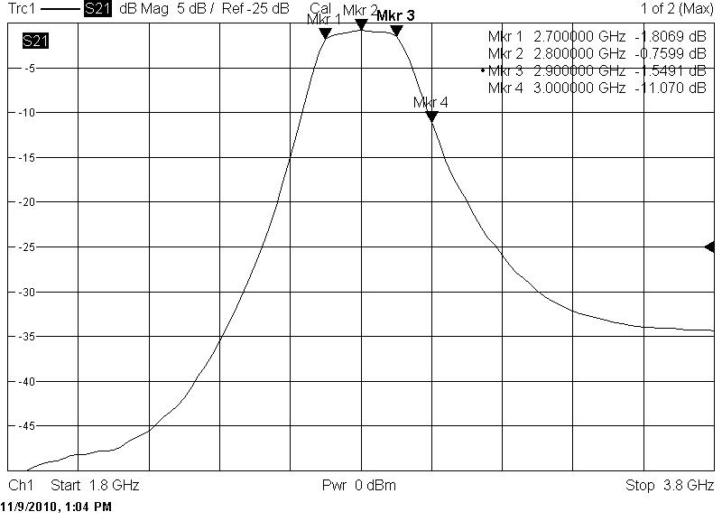
- RF Filter (BP 2700-2900 MHz)

- IF1 Filter (BP 450-470 MHz)

- IF2 Filter (BP 55-65 MHz)

- Digital Match Filter

- Measurement results of Mobile Service equipment unwanted emmission Masks
The Figures shown below are the results of an extensive series of measurements commissioned by OFCOM (UK) looking at the Unwanted emissions (out of band and spurious) characteristics of mobile equipment.
When considering the results from the measurements presented below, it is necessary to bear in mind that there are additional factors that may influence the out-of-band and spurious emissions from base stations and terminals, such as ageing and temperature. Furthermore there will be a certain variation in the performance of different base stations and terminals. To account for these effects, a margin needs to be taken into account before applying any such results.
The studies focused on providing a series of OOB and spurious emission measurements for mobile equipment operating in the radar band 2.7-3.1 GHz. The measurements covered the following:
- Both BS’s and UE’s
- 2.6 GHz LTE and WiMAX technology
- The measurements were mean power conducted (i.e. not EIRP)
- The equipment was stimulated to operate at maximum power
A4.1 Results for Base Station Equipment
Figure 64: to Figure 66: show the results for a normal production line 2.6 GHz LTE Base Station 1 (BS1) with following characteristics:
- Characteristics of a 2.6 GHz LTE Base Station 1 (BS1).
Description | 2.6 GHz LTE Base Station 1 (BS1)
Declared Output Power: | 44.8 dBm/20 MHz Conducted
Tx Frequency Range: | 2620 MHz to 2690 MHz
Bandwidth Tested: | 20 MHz

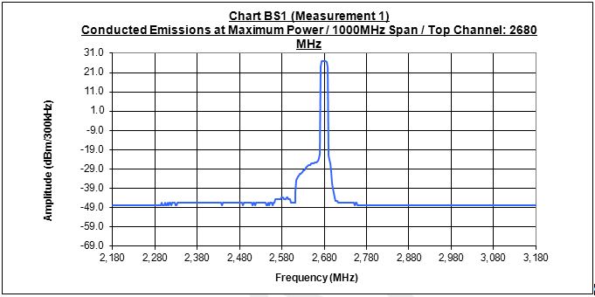
- BS1 - A View of results on spectrum analyser over broad frequency range
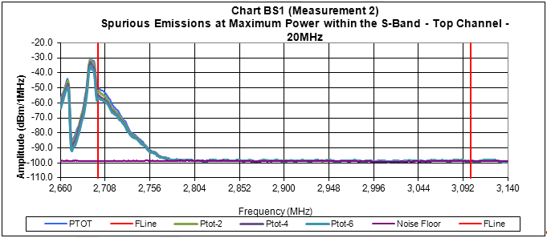
- BS1 - Emissions results in radar frequency band (between red markers)
Figure 65: and Figure 66: – BS 1 LTE production device – conducted emissions 20 MHz
- Looking at in radar band OOB noise and spurious (to the right of 1st red marker line)
- OOB domain worst case measurement approx -50 dBm/MHz = -32 dBm/MHz with gain
- Spurious emission limit is -30dBm Worst case measurement in Spurious domain approx -80 dBm/MHz conducted = -62 dBm with antenna gain

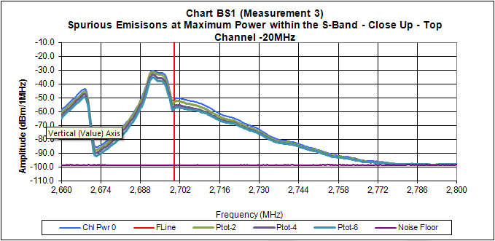
- BS1 - Emissions focussed on the results at bottom of radar frequency band
Figure 67:Figure 67: to Figure 69: show the results for a normal production line 2.6 GHz LTE Base Station 2 (BS2) with following characteristics:

- Characteristics of a 2.6 GHz LTE Base Station 1 (BS2).
Description | 2.6 GHz LTE Base Station 2 (BS2)
Declared Output Power: | 43 dBm/20 MHz Conducted
Tx Frequency Range: | 2620 MHz to 2690 MHz
Bandwidth Tested: | 20 MHz

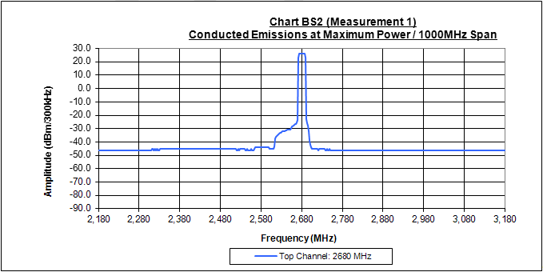
- BS2 - A View of results on spectrum analyser over broad frequency range
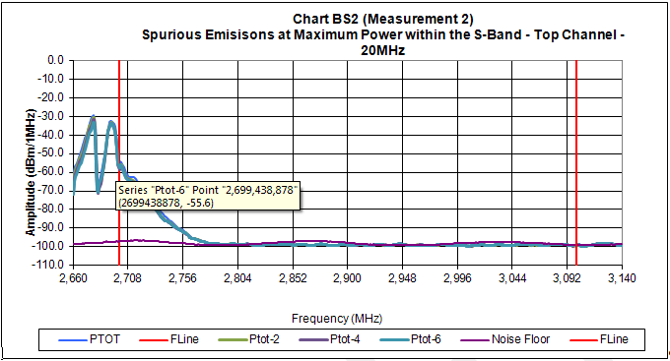
- BS2 - Emissions results in radar frequency band (between red markers)
Figure 68: and Figure 69: – BS 2 LTE production device – conducted emissions 20 MHz
- Looking at in radar band OOB noise and spurious (to the right of 1st red marker line)
- OOB domain worst case measurement approx -55 dBm/MHz = -37 dBm/MHz with gain
- Spurious emission limit is -30dBm Worst case measurement in Spurious domain approx -85 dBm/MHz conducted = -67 dBm with antenna gain

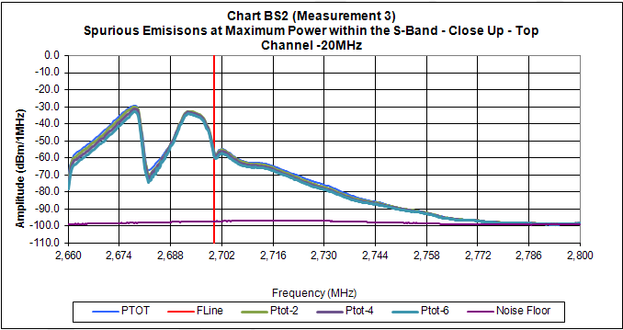
- BS2 - Emissions focussed on the results at bottom of radar frequency band
Figure 70: - Figure 72: show the results for a normal production line 2.6 GHz WiMAX Base Station 3 (BS3) with following characteristics:
- Characteristics of a 2.6 GHz WiMAX Base Station 3 (BS3).
Description | 2.6 GHz WiMAX Base Station 3 (BS3)
Declared Output Power: | 36 dBm/10 MHz Conducted
Measured Output Power | 31.9 dBm/10 MHz Conducted
Tx Frequency Range: | 2583 MHz to 2690 MHz
Bandwidth Tested: | 10 MHz

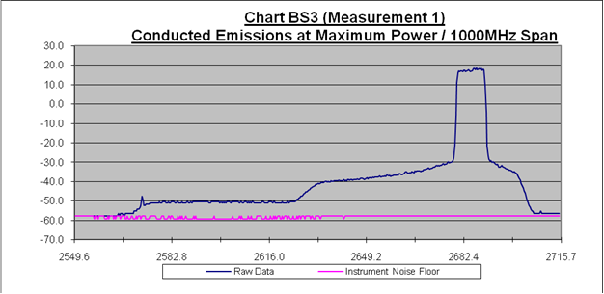

- BS3 - A View of results on spectrum analyser over broad frequency range
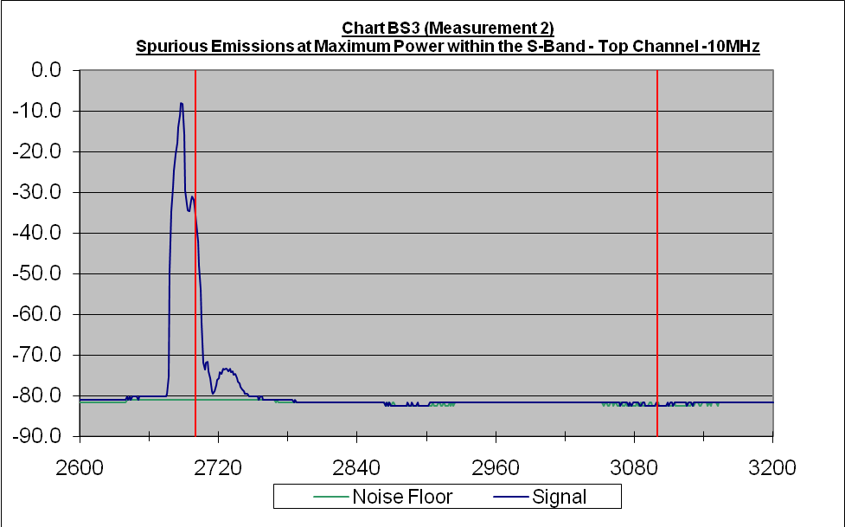
- BS3 - Emissions results in radar frequency band (between red markers)
Figure 71: and Figure 72: – BS3 WiMAX production device – conducted emissions 10 MHz
- Looking at in radar band OOB noise and spurious (to the right of 1st red marker line)
- OOB domain worst case measurement approx -40 dBm/MHz = -22 dBm/MHz with gain
- Spurious emission limit is -30dBm Worst case measurement in Spurious domain approx -75 dBm/MHz conducted = -57 dBm with antenna gain

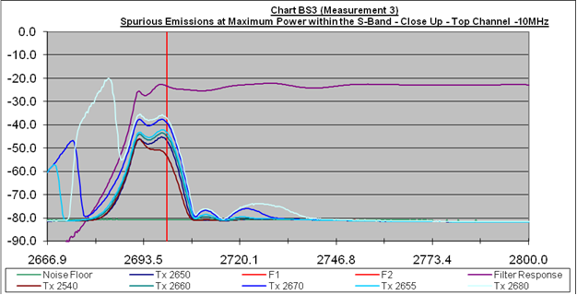

- BS3 - Emissions focussed on the results at bottom of radar frequency band
A4.2 Results for User Station Equipment
Figure 73: and Figure 74: shows results for a normal production line 2.6 GHz LTE mobile service terminal (UE1) with following characteristics:
- Characteristics of a 2.6 GHz LTE User Station 1 (UE1)
Description | 2.6 GHz LTE User Station 1 (UE1)
Declared Output Power: | 24 dBm Conducted
Tx Frequency Range: | 2500 MHz to 2570 MHz
Bandwidth Tested: | 20 MHz and 5 MHz

Figure 73:– UE1 LTE production device – conducted emissions 20MHz
- Looking at in radar band spurious emissions (to the right of 1st red marker line)
- Spurious emission limit is -30dBm Worst case measurement in Spurious domain approx -85 dBm/MHz

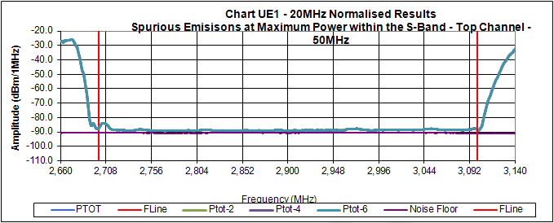
- UE1 - Emissions in radar frequency band - 20 MHz (between red markers)
Figure 74:– UE1 LTE production device – conducted emissions 5MHz
- Looking at in radar band spurious emissions (to the right of 1st red marker line)
- Spurious emission limit is -30dBm Worst case measurement in Spurious domain approx -85 dBm/MHz

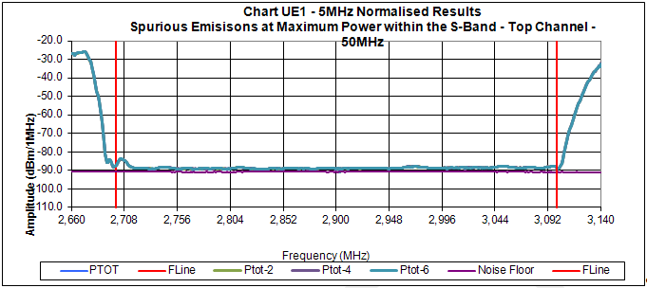
- UE1 - Emissions in radar frequency band - 5 MHz (between red markers)
Figure 75: shows results for a pre-production line 2.6 GHz LTE mobile service terminal (UE2) with following characteristics:
- Characteristics of a 2.6 GHz LTE User Station 1 (UE2)
Description | 2.6 GHz LTE User Station 2 (UE2)
Declared Output Power: | 23 dBm Conducted
Tx Frequency Range: | 2500 to 2570 MHz
Bandwidth Tested: | 20 MHz

Figure 75: – UE1 LTE pre-production device – conducted emissions 20 MHz
- Looking at in radar band spurious emissions (to the right of 1st red marker line)
- Spurious emission limit is -30dBm Worst case measurement in Spurious domain approx -55 dBm/MHz

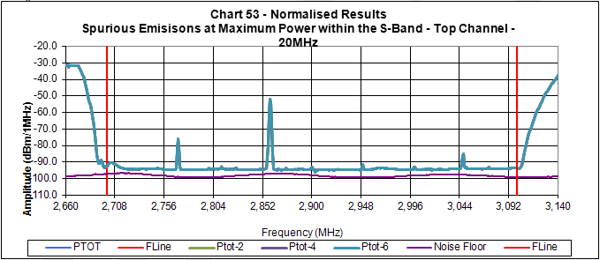
- UE2 - Emissions in radar frequency band - 20 MHz (between red markers)
- Radar Pulse Overload in LTE Handset Receivers
  - BACKGROUND
The S-band frequency range 2700-2900 MHz is allocated for radars such as air traffic control and meteorological. This band is directly above the LTE core band VII with only a 10 MHz guard band. Radars operating in this S-band will cause interference to mobile handsets in the vicinity of such radars.

- Assumed S-band radar and UE characteristics for the ESD and blocking cases.
 | Radar Type
Radar characteristics |  | Type 2 | Type 3 |  | Type 4 | Unit
Pulse power |  | 86 | 75 |  | 89 | dBm
Reference bandwidth |  | 1 | 0.8 |  | 1 | MHz
Approximate OOB emissions |  | -40 | -40 |  | -40 | dBc
Spurious emissions |  | -60 | -60 |  | -75 | dBc
Antenna gain and feeder losses |  | 34 | 34 |  | 41 | dBi
Minimum separation LTE UE to radar for ESD events |  | 0.3 | 0.3 |  | 0.3 | km
Antenna discrimination for ESD events |  | 26 | 26 |  | 28
Minimum separation LTE UE to radar for non-ESD events |  | 1 | 1 |  | 1 | km
Antenna discrimination for non-ESD events |  | 11 | 11 |  | 18
UE characteristics
Antenna gain |  | 0 | 0 | 0 |  | dBi
Duplexer selectivity 2600-2730 MHz |  | 0 | 0 | 0 |  | dB
Duplexer selectivity above 2730 MHz |  | 40 | 40 | 40 |  | dB
Compression point |  | -49 | -49 | -49 |  | dBm
Cross-compression adjacent channel |  | -44 | -44 | -44 |  | dBm
Duplex distance |  | -20 | -20 | -20 |  | dBm
UE Interference cases
Out-of-band blocking (ESD event) in the band 2700 - 2730 MHz |  | 3 | -7 | 11 |  | dBm
Out-of-band blocking (ESD event) > 2730 MHz |  | -37 | -47 | -29 |  | dBm
Out-of-band blocking (non ESD event) in the band 2700 - 2730 MHz |  | 8 | -2 | 11 |  | dBm
Out-of-band blocking (non ESD event) > 2730 MHz |  | -32 | -42 | -29 |  | dBm
In-band blocking due to radar OOB |  | -32 | -42 | -29 |  | dBm
In-band blocking due to radar spurious |  | -52 | -62 | -64 |  | dBm

S-band radar characteristics vary a lot but we will assume the characteristics indicated in Table 13:. These data can be considered to be typical for worst case air traffic control (ATC) and meteorological radars.
  - Radar pulse impact on handset
Based on the characteristics in Table 13: we can assume that the meteorological radar poses the worst case with 11 dBm out-of-band blocking (OOB) in the lower part of the radar band and -29dBm in-band blocking (IB) for an LTE handset operating in band VII. Since a handset can be closer to the radar than what is assumed for the performance estimation cases we have to assess whether such a case is destructive in addition to its jamming properties. For that purpose we also define an ESD case with a shorter path length. However, taking into account the radar antenna discrimination, this lead to similar results compared to the non-ESD event calculated: the LTE handset (UE) is hit by 11dBm pulses in the lower part of the S-band.
    - Out-of-band blocking
Avago produce an LTE band VII duplexer [24] who’s typical antenna to RX port attenuation is shown in Figure 78:. From this we can see that attenuation of radar pulses close to the lower radar band edge is very limited, and we will assume 0dB in the range 2700-2730 MHz and -40dB above 2730 MHz. A transition region of 40 MHz for the upper band edge corresponds to some 1.5% relative bandwidth. This distance is a compromise between pass-band losses, production tolerances, cost and size and is usually kept above 1% for UE applications (but then for lower frequencies). With a radar pulse bandwidth of some 1 MHz, the duplexer filtering will result in two radar center frequency regions. At, or above, 2730 MHz, where we assume at least 40dB attenuation, and below 2730 MHz with no attenuation (we ignore the gradual transition for simplicity).
A typical duplexer provides 50dB of TX→RX attenuation. Almost all handsets are homodyne (zero-IF) receivers, and with typical TX powers of some 25dBm the RX chain ${\text{IP}}_{2}$is designed to handle at least -25dBm at the duplex distance. For band VII this duplex distance is 120 MHz, but the design has to be robust for the smallest possible duplex distance across all supported bands (e.g. 30 MHz (4.3%) for band XII and 100 MHz (2.9%) for band XXII). In practice this limit will typically be set by the first passive filter pole directly at the mixer output. For wide-band homodyne receivers this pole will be just above half the maximum RF bandwidth or 10 MHz in the LTE case. Before this passive pole there is no selectivity, except for the duplexer, and the TX leakage defines the (cross-) compression point. After the mixer we will suppress off-channel signals significantly relative to the wanted signal.
The BB filter is usually of high order, say 3–5, with an asymptotic attenuation of at least 60dB/decade, effectively removing OOB as long as it is not clipping. The passive pole will not clip the signal and it will protect the active poles, resulting in an increased cross-compression point as the frequency offset relative the channel center increases. On channel we have a low compression point, typically around -49dBm for LTE, because of a higher gain for the wanted signals. As we move away from the channel, the cross-compression point gradually reaches the levels set by TX leakage at the duplex distance. For a ≳2730 MHz radar signal the passive pole will add some 14dB of selectivity, in addition to the 40db duplexer selectivity, and we can assume that the active filter will be able to handle this signal level without clipping as the signal is far out in the stop band.
Even if the radar pulse is removed by the BB filter it may cause inter-modulation noise in the baseband via even-order nonlinearities after the mixer (${\text{IM}}_{2}$) or odd-order nonlinearities together with LO leakage before the mixer (${\text{IM}}_{\text{cross}}$). The ${\text{IM}}_{2}$noise is caused by the square (or other even-order) term in the Taylor expansion of the gain nonlinearity. When a signal is squared, sum and difference products are generated at the double and zero signal frequency. Before the mixer, these products are harmless as they fall out of band but after the mixer the difference term falls on channel. Even if the channel-select filter attenuates off-channel interference, ${\text{IM}}_{2}$ can be generated inside the filter due to internal nonlinearities. As the receiver is designed to handle some -25dBm of TX leakage with only a very small desensitization, the same will be true for radar pulses hitting the receiver up to the same power levels. Radars above 2730 MHz will cause interference below -36dBm which will be properly removed by the BB filter.
In addition to ${\text{IM}}_{2}$ a UE may suffer from cross-modulation between the radar pulse and its own RX LO leakage. This cross-modulation is due to an odd order nonlinearity, like${\text{IM}}_{3}$, and any odd order nonlinearity can be expressed as the product of an even and an odd component. The even term will rectify the radar-pulse envelop and amplitude modulate any LO leakage via the odd term. For example, a cubic nonlinearity will cause squaring of the radar-pulse envelop and amplitude modulate the LO leakage. This AM-modulated LO leakage will be down-converted by the mixer to baseband as it is on-channel. Higher order cross-modulation terms will show up at odd harmonics of the LO and will be down converted to BB via harmonic mixing. For the same reason as with${\text{IM}}_{2}$, cross-modulation of amplitude-modulated interferers will be harmless up to the typical TX leakage levels seen by the LNA. The actual noise contribution resulting from ${\text{IM}}_{2}$ depends on the spectral distribution of the squared interference spectrum.

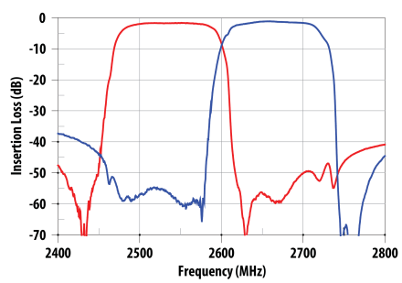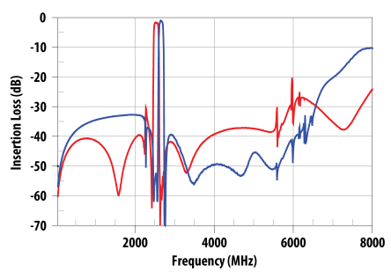

- Avago LTE band VII duplexer attenuation
Because of the duplexer we will have two OOB scenarios.
- 2700-2730 MHz: The blocking level may be as high as 4dBm, which will interrupt reception completely during the pulse and for some short recovery time after the pulse, around 1μs. This power level can be harmful and below we compare it with electrostatic discharge events to assess its severity.

- 2730-2900 MHz: Duplexer attenuation is high enough to push OOB down to levels similar to, or even below, the TX leakage and we can treat it as TX leakage.

Thus, radars located above 2730 MHz will cause LNA blocking levels below the TX leakage levels. The LNA and mixer will have a high enough ${\text{IP}}_{2}$ to prevent the radar-pulse envelop to fold to baseband (i.e. to be shifted via second-order nonlinearities to baseband frequencies). The power of the radar pulse will therefore have no impact on RX performance if then there is a sufficient selectivity at the UE receiver (i.e. after the mixer there are sufficient filters to attenuate any far-out interference).
    - ESD events
All handset components are designed to be robust against electrostatic discharge (ESD) events. Various ESD source models are used in the literature. The most relevant for a transceiver ASIC are the human body model (HBM) and charged device model (CDM), and these two are typically the ones that are tested. Typical ESD source model parameters are shown in Figure 76:. Obviously the CDM is the closest to the antenna impedance and we can use this to compare against the S-band radar pulses.
A common CDM test value is 300V [25] which corresponds to 180–1350nJ and a peak current of 3.45A with the small test module [25]. This is to be compared to 44dBm during 2.2μs, or 55μJ from the radar pulse into 50Ω (i.e. some 35V_{RMS} or 0.71A_{RMS}). Thus, the ESD test is significantly higher in voltage than the radar pulse, for single events, but lower in energy. The radar pulse recurs with roughly 1 kHz when the beam points at the handset, which in turn happens every four seconds, or so. The average power of the worst ESD case pulse is approximately 55mW (44dBm in 2.2μs every 1ms). As on-chip thermal time constants are on the order of some 100μs[28] we may use the average power level for comparison, and 55mW is significantly lower than the typical average transceiver power dissipation, see e.g.[29]. Thus, the radar pulse energy does not pose a thermal problem, even at 300m in the main lobe center.
Since the radar pulse has a lower voltage, and peak current, than a typical ESD CDM event no catastrophic failure is to be expected. The pulse current is very high and we do not know what on-chip signal wire dimensions are used, it cannot be ruled out, though, that electromigration-related issues may occur in handsets operated for extended periods of time in the proximity of a S-band radar. Since the pulse is AC coupled into the transceiver it is thermally activated electromigration that may be an issue.
The maximum current densities for Joule heating are often higher than for DC currents. Typical limits are around $\text{20}⋅{\text{10}}^{−9}$A/m² [31] for the RMS current density. An OOB peak power of 44dBm corresponds to some 710mA of peak RMS current into 50Ω. With an on-chip conductor height of 0.25μm, the wire has to be at least 150μm wide not to exceed this limit. Considering the radar-pulse duty cycle (here 0.22%), this width limit can be scaled accordingly, or to some 0.35μm.
Because the wire parasitic resistance contributes to the receiver insertion loss it is unlikely that any long wire segment exceeds 1Ω, or 0.1dB noise figure contribution. For wires with a resistivity of 0.05Ω/□ and a height of 0.25μm any wire over 7μm length will automatically be wider than 0.35μm (i.e. L/W<20□) and fulfill electromigration rules. Shorter wire segments may be more narrow but wires shorter than the Blech length [32] will not be subject to electromigration at all. The Blech current-density-length limit (i.e. ${I_{\text{RMS}}}/A⋅L$) for an interconnect is typically 150–500kA/m[33], which means that wires with an L/W aspect ratio less than 5.3–17 will be shorter than the Blech limit. This ratio is inversely with RMS current and if the radar-pulse duty cycle is less than some 25%, wires with a length less than some 20□ will be free of electromigration. Combining the noise-figure, Blech limit and duty-cycle arguments we can conclude that continuous use of a handset with 44dBm OOB is not going to cause any long term electromigration effects.
A strong radar pulse may pull either of the RX or TX VCOs which may make the pulse recovery time longer than the 1μs assumed above. In such a case the synthesizer settling time may approach some 20μs when a typical fractional-N synthesizer with a reference clock ≳26MHz is used, see e.g. [34]. Such electromigration and VCO pulling issues will, however, depend a lot on the actual transceiver ASIC design and may not impact all makes.
We have no data for the duplexer RX port maximum power handling. But, because of manufacturing constraints, it is reasonable to assume that the duplexer ESD properties are similar to those of the transceiver, and that it will not be damaged by the radar pulses.

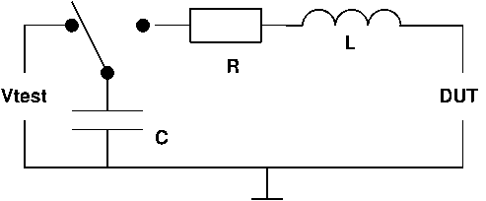
 | R (Ω) | C (pF) | L (nH)
HBM | 1500 | 100 | stray
CDM | <10 | 4-30 | <10

- Typical ESD model and parameters
    - In-band blocking
In-band blocking will contribute to the receiver noise floor via gain desensitization, during receiver overload, and via OOB radar pulse emission and spurious. In this section we estimate the impact of these effects.
The desensitization is of course more prominent in the OOB cases but spurious from radars above 2730 MHz may drive the receiver into compression (i.e. when the pulse is harmless but its noise emissions are strong). To compare the effect of this kind of noise floor increase to the regular radar noise emissions we discuss gain desensitization in the context of in-band blocking.
    - Gain desensitization
When the input signal v_{i} exceeds the receiver compression point, CP_{i}, desensitization occurs, and the lowered gain, according to Friis’ formula (see [34]), will increase noise contributions from stages following the compressing stage.
Assume we compress the handset transceiver input stage, then with typical handset data, i.e. a front-end insertion loss of 3dB ($F_{1}=2$) and a transceiver noise figure of 2.5dB (${\left(F_{2}−1\right)}/{G_{1}}=1\text{.}8$), we can express the desensitized total noise factor as a function of the normalized input level ${v_{i}}/{{\text{CP}}_{i}}$ as
$F\left(\frac{v_{i}}{{\text{CP}}_{i}}\right)=F_{1}+\frac{F_{2}−1}{G_{1}⋅G_{\text{sat}}\left(\frac{v_{i}}{{\text{CP}}_{i}}\right)},$

where $G_{\text{sat}}{v_{i}}/{{\text{CP}}_{i}}$ corresponds to the gain variation due to compression ($G_{\text{sat}}$ goes from 1→0 as compression increases). F will vary with the signal level and we can derive the noise figure as $\text{NF}=\text{10}{\text{log}}_{\text{10}}\left(F\left({v_{i}}/{{\text{CP}}_{i}}\right)\right)$.
Normally gain compression would be modelled by means of a cubic polynomial, see e.g. [35]. Polynomial analysis is based on a weak nonlinearity assumption, which is only valid at the onset of compression and breaks down for strong input signals. For band-limited systems we can, however, use describing functions to analyze the gain behaviour under strong overdrive conditions, or saturation [36].

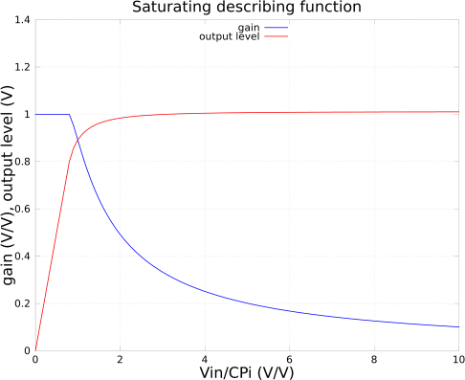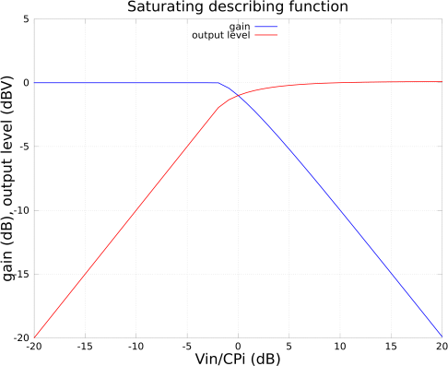

- Saturating describing function characteristics (i.e. $G_{\text{sat}}$)

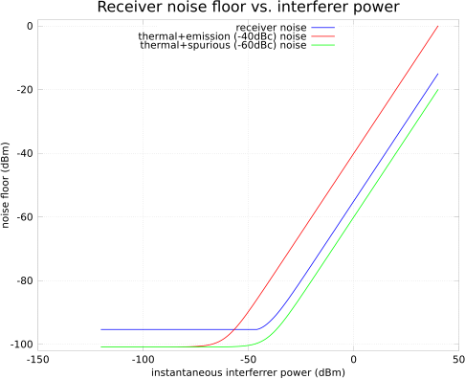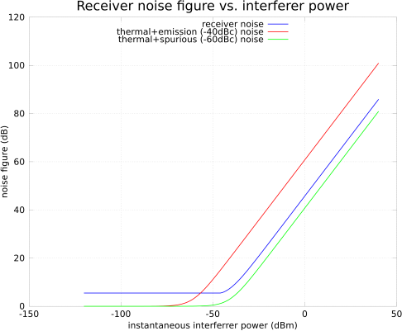

- Noise floor and figure vs. instantaneous interference power (i.e. during a radar pulse)
A saturating front end can be approximated as a normalized linear gain (i.e. G=1) with clipping, or
$\frac{v_{o}}{G}=\left\{\begin{matrix}v_{\text{clip}} & v_{i}≥v_{\text{clip}} & \\ v_{i} & \left|v_{i}\right|<v_{\text{clip}} & \\ −v_{\text{clip}} & v_{i}≤−v_{\text{clip}} & \end{matrix}\right.$

where $v_{\text{clip}}$ corresponds to the maximum input, or output, amplitude.

The describing function of the saturating nonlinearity (in the formula above) can be shown to be [36].
$G_{\text{sat}}=\left\{\begin{matrix}1 & r≥1 \\ \frac{2}{π}\left(\text{arcsin}\left(r\right)+r\sqrt{1−r^{2}}\right) & r<1\end{matrix}\right.$

where $r={v_{\text{clip}}}/{v_{i}}$. We do not normally characterise $v_{\text{clip}}$, but it can be shown that $v_{\text{clip}}≈{\text{CP}}_{i}−2$dB, and we can normalize our signals to ${\text{CP}}_{i}$ if we compensate the r calculation properly, see Figure 77:.
The above compression analysis is based on the signal itself going into compression. In the case of the S-band radar interference we are subject to cross-modulation, when an off-channel jammer compresses our receiver. By comparing the compression and cross-compression points, as defined by the cubic polynomial approximation, it can be shown that the cross-compression point is 3dB lower than the compression point. For the radar interference we should use the cross-compression point as ${\text{CP}}_{i}$.
Applying $G_{\text{sat}}$ to the noise factor $F\left(\frac{v_{i}}{{\text{CP}}_{i}}\right)$, we can sweep the noise floor and noise figure of a typical handset assuming a 20 MHz channel bandwidth and ${\text{CP}}_{i}=−\text{44}$dBm at maximum receiver gain, see Figure 78:. We see in the blue curve how the noise floor and NF increases when the out-of-band interference exceeds the cross-compression point. When we also add the effect of a -40dBc emission mask, or -60dBc spurious, we can see that with a ${\text{CP}}_{i}$ of -44dBm the desensitization-related noise is dominated by the radar pulse emission mask for radars close to the lower S-band limit and by desensitization for radars up to 2730 MHz. Above 2730 MHz the duplexer selectivity will increase the cross-compression point by some 40dB, and gain desensitization will not occur (except for the ESD case), so noise is then dominated by radar pulse spurious emissions.
The cross-over between the pulse noise sources and desensitization is sensitive to parameter assumptions since the noise contributions are similar in magnitude. However, a cross-compression point exceeding -36dBm (e.g. when the receiver is not operating at its maximum gain) will make the desensitization-effect smaller than the others. For simplicity it is, thus, reasonable to just include the emission and spurious effects in the model.
  - Discussion
S-band radars below 2730 MHz will not be attenuated by the UE band VII duplexer. Any such radar pulse hitting the UE antenna with more than some -44dBm will drive the receiver into compression. In spite of the resulting gain desensitization the receiver noise floor will be dominated by the radar pulse emission mask. During the radar pulse the receiver is blocked, but after, the UE analogue and RF parts will recover in a few μs, unless the synthesizer VCO was disturbed when an additional 20μs settling time can be expected.
When the radar is operating at, or above, 2730 MHz, the received radar pulse will be lower than the UE self-interference from its TX leakage. Thus, these radars will only impact the reception via their band VII in-band pulse noise levels. From this interference there will mostly be high co-channel noise during the radar pulse and no additional RF transceiver recovery time is required.

- First Set of Measurements of Interference from Radar to LTE equipment
  - Measurement set-up & method

- Uplink measurement set-up
The uplink measurement set-up is illustrated in Figure 79:. A test mobile LTE is used for generating the LTE signal with fixed Tx power of 23 dBm. The uplink measurement set-up parameters are summarised in Table 14:. In this table, Psens is the LTE BS reference sensitivity level (-101.5 dBm) defined in 3GPP TS36.104 for 20 MHz channel bandwidth.
- Parameters used in the uplink measurement.
 | LTE UL | Pulse Signal_1 | Pulse Signal_2
Signal generator | LTE Test UE | E4438C | E4438C
Pulse width (μs) |  | 4 | 100
PRF (Hz) |  | 1000 | 300
LTE UE Tx power (dBm) | 23
Center frequency (MHz) | 2560 | 2560 | 2560
Channel bandwidth (MHz) | 20
Rx signal level (dBm) | Psens,  Psens+10,  Psens+20,  Psens+30 | -100,  -80,  -60,  -40,  -20 | -100  -80,  -60,  -40,  -20

In the uplink measurement, the UE is set with its maximum transmitting power of 23 dBm, the power control was not activated. The LTE UL signal level was measured at BS receiver antenna port, LTE BS has two Rx activated as shown in Figure 79:. The uplink throughput was measured as the reference uplink throughput.
The pulse interfering signal was generated with the signal generator E4438C with the fixed pulse repetition frequency (PRF), the pulse interference level is measured at BS Rx antenna port. Automatic modulation scheme change is used in the measurement in the same way as in the real LTE operation environment. The uplink throughput with the presence of pulse interfering signal is then measured and recorded.
Throughput loss is calculated as

TP_LOSS = $\frac{{\text{TP}}_{1}−{\text{TP}}_{2}}{{\text{TP}}_{1}}∗\text{100}\text{\%}$

where: TP_1 is the measured throughput without interfering pulse signal
TP_2 is the throughput with presence of interfering pulse signal.

The downlink measurement set-up is illustrated in Figure 80:. LTE signal is generated with a LTE BS with two Tx/Rx antennas, 40 W power at each Tx antenna. The downlink measurement set-up parameters are summarised in Table 15:. In this table, the Psens is the LTE UE reference sensitivity level (-92 dBm) defined in 3GPP TS36.101 for 20 MHz channel bandwidth.
In the downlink measurement, the BS is set with its maximum transmitting power of 40 W per antenna, the power control was not activated. The LTE DL signal level was measured at UE receiver antenna port, LTE UE has two Rx activated as shown in Figure 80:. The downlink throughput was measured as the reference downlink throughput.
The interfering pulse signal was generated with the signal generator E4438C with the fixed pulse repetition frequency (PRF), the interference pulse level is measured at UE Rx antenna port. Automatic modulation scheme change is used in the measurement in the same way as in the real LTE operation environment. The downlink throughput with the presence of pulse interfering signal is then measured and recorded.
The downlink throughput loss is calculated using the same formula as presented above.
- Parameters used in the downlink measurement.
 | LTE DL | Pulse Signal_1 | Pulse Signal_2
Signal generator | LTE BS | E4438C | E4438C
Pulse width (μs) |  | 4 | 100
PRF (Hz) |  | 1000 | 300
LTE UE Tx power (dBm) | 49
Center frequency (MHz) | 2680 | 2680 | 2680
Channel bandwidth (MHz) | 20
Rx signal level (dBm) | Psens,  Psens+10,  Psens+20,  Psens+30 | -100,  -80,  -60,  -40,  -20 | -100,  -80,  -60,  -40,  -20

- Downlink measurement set-up

  - Measurement results
    - UL throughput loss with pulse signal_1 (4μS/1000Hz)
The measured uplink throughput loss with presence of interfering pulse signal 1 (4μS/1000Hz) for different LTE signal levels are summarised in Table 16: and Figure 81:.
- UL throughput loss(%) with presence of interfering pulse signal 1 (4μS/1000Hz)
I (dBm) | Psens | Psens+10 | Psens+20 | Psens+30
-100 | 21,6 | 0,2 | 0,0 | 0,0
-80 | 24,7 | 5,8 | 0,0 | 0,0
-60 | 56,3 | 68,2 | 53,3 | 19,3
-40 | 85,3 | 77,4 | 64,1 | 63,3
-20 | 90,5 | 91,3 | 83,9 | 80,7

- UL throughput loss(%) with presence of interfering pulse signal 1 (4μS/1000Hz)
    - UL throughput loss with pulse signal_2 (100 μS/300Hz)
The measured uplink throughput loss with presence of interfering pulse signal 2 (100μS/300Hz) for different LTE signal levels are summarised in Table 17:and Figure 82:.
- UL throughput loss(%) with presence of interfering pulse signal 2 (100μS/300Hz)
I (dBm) | Psens | Psens+10 | Psens+20 | Psens+30
-100 | 25,5 | 0,2 | 0,0 | 0,0
-80 | 39,4 | 18,2 | 4,6 | 0,0
-60 | 79,2 | 73,8 | 60,6 | 25,0
-40 | 84,8 | 87,2 | 83,4 | 78,5
-20 | 99,1 | 93,9 | 93,9 | 92,2

- UL throughput loss with presence of interfering pulse signal 1 (100μS/300Hz)
    - DL throughput loss with pulse signal_1 (4 μS/1000Hz)
The measured downlink throughput loss with presence of interfering pulse signal 1 (4μS/1000Hz) for different LTE signal levels are summarised in Table 18: and Figure 83:.
- DL throughput loss(%) with presence of interfering pulse signal 1 (4μS/1000Hz)
I (dBm) | Psens | Psens+10 | Psens+20 | Psens+30
-100 | 0,0 | 0,0 | 0,1 | 0,1
-80 | 10,0 | 0,4 | 1,8 | 0,1
-60 | 38,5 | 31,1 | 24,7 | 4,8
-40 | 71,0 | 60,2 | 45,8 | 37,5
-20 | 77,5 | 77,9 | 81,7 | 68,3

- DL throughput loss with presence of interfering pulse signal 1 (4μS/1000Hz)
    - DL throughput loss with pulse signal_2 (100 μS/300Hz)
The measured downlink throughput loss with presence of interfering pulse signal 2 (100μS/300Hz) for different LTE signal levels are summarised in Table 19: and Figure 84:.
- DL throughput loss(%) with presence of interfering pulse signal 2 (100μS/300Hz)
I (dBm) | Psens | Psens+10 | Psens+20 | Psens+30
-100 | 0,0 | 0,0 | 0,1 | 0,1
-80 | 9,1 | 3,5 | 2,0 | 0,0
-60 | 77,5 | 60,5 | 26,6 | 16,3
-40 | 99,1 | 94,8 | 90,6 | 69,6
-20 | 100,0 | 99,8 | 97,4 | 96,6

- DL throughput loss with presence of interfering pulse signal 1 (100μS/300Hz)
  - Analysis and interpretation of the measurement results
As given in Table 14: and Table 15: in both uplink and downlink measurements, a signal pulse interfering signal is generated at the center carrier frequency of 20 MHz channel LTE signal. The measured results presented in section A.5.2 are the LTE UL & DL throughput losses with the presence of a signal pulse interfering signal located at the center frequency of 20 MHz LTE signal. In real situation, a radar signal pulse is about 1 MHz, the unwanted emissions of radar signal are pulse type signals, in particular the out of band emission signals with each pulse bandwidth about 1 MHz, within a LTE 20 MHz channel, there are multiple pulse type of interference signals (about 18 pulses). So the measured throughput loss with one single pulse interfering signal within 20 MHz LTE channel underestimates the impact of interference from radar unwanted emissions to LTE uplink & downlink.
Even with a single pulse interfering signal in LTE 20 MHz channel, the measured results in the section A.5.3 clearly show that:
- Both LTE UL & DL suffer significant throughput loss with the presence of pulse type interference signal, the throughput loss is function of LTE signal power level and pulse-type interfering signal level;
- LTE UL throughput loss is higher than DL throughput loss;
- Larger duration pulse signal creates more interference to LTE than shorter pulse signal.
- Simulations of Interference from Radars to LTE mobile service terminal
  - LTE subframe structure
The LTE subframe structure plays an important role in the analysis of radar signal impact, and is for convenience illustrated in Figure 85:. The 1 ms subframe is divided into 14 OFDM symbols, which are referred to as symbols number 0, 1, …,13 in this report. Note that only 2-symbol control region is used in this report.
See 3GPP specifications for further information.
Control region
(varying size)
Control signaling
Reference symbols
One subframe (1 ms)
0 1 2 3 4 5 6 7 8 9 10 11 12 13

- Typical LTE subframe structure for transmission with up to two antennas. There are 14 OFDM symbols, numbered 0, 1, …, 13 in this report. The control region can be 1, 2 or 3 OFDM symbols; we use 2 symbols in this report unless otherwise explicitly stated.
  - Radar pulse characteristics
    - Pulse power levels at the terminal
In order to know the right order of magnitude for radar pulse powers in simulations, we need an estimate of the typical radar pulse power as it enters the analogue parts of the terminal receiver. This pulse power may vary greatly depending on radar out-of-band and spurious emission performance, main lobe vs side lobe, distance between radar and LTE terminal etc. Assuming main lobe (35 dBi) interference, OOB suppression of -40 dBc, 90 dBm output power and a distance of 1 km (roughly 100 dB propagation loss) with line-of-sight, the interference will be about -15 dBm, whereas for a case with spurious suppression of -60 dBc, 10 km distance line-of-sight, and radar side lobe interference, say 35 dB lower than the main lobe, the interference will be -90 dBm. Simulations are thus carried out to cover a large range of interference levels.
Pulse shapes
Three different types of radar pulse shape in the out-of-band and spurious domain have been investigated:
- AWGN pulse: The pulse is modelled as white Gaussian noise, and added in the receiver in exactly the same way as to thermal noise (but with a different average power). The noise is present throughout the duration of the pulse, and zero otherwise.
- Random constant pulse: In this case, the pulse is modelled as a random complex constant with the specified power. (The phase angle is selected randomly for each pulse but remains constant throughout the pulse.)
- Chirp pulse: The pulse is modelled as a chirp, i.e. a frequency sweep:

for ,

where rect is a function that is 1 in the range 0 … 1 and 0 otherwise, Tw is the pulse duration, Trep is the inverse of the pulse repetition rate, and we set where B is the radar pulse bandwidth. Chirp-like pulses are suitable for a radar due to their low autocorrelation properties. The chirp pulse is in the simulations centred in the LTE baseband.
Note that in none of the case the radar pulse is assumed to undergo fast fading.
In Figure 86: through Figure 88: we compare our three different models for the radar pulse. In all cases the radar pulse has power -60 dBm, is 1 μs long and occurs within symbol 3 of each subframe (i.e. a symbol without reference symbols).
It can be seen the different types give similar results. We will henceforth primarily use an AWGN pulse in the simulations.
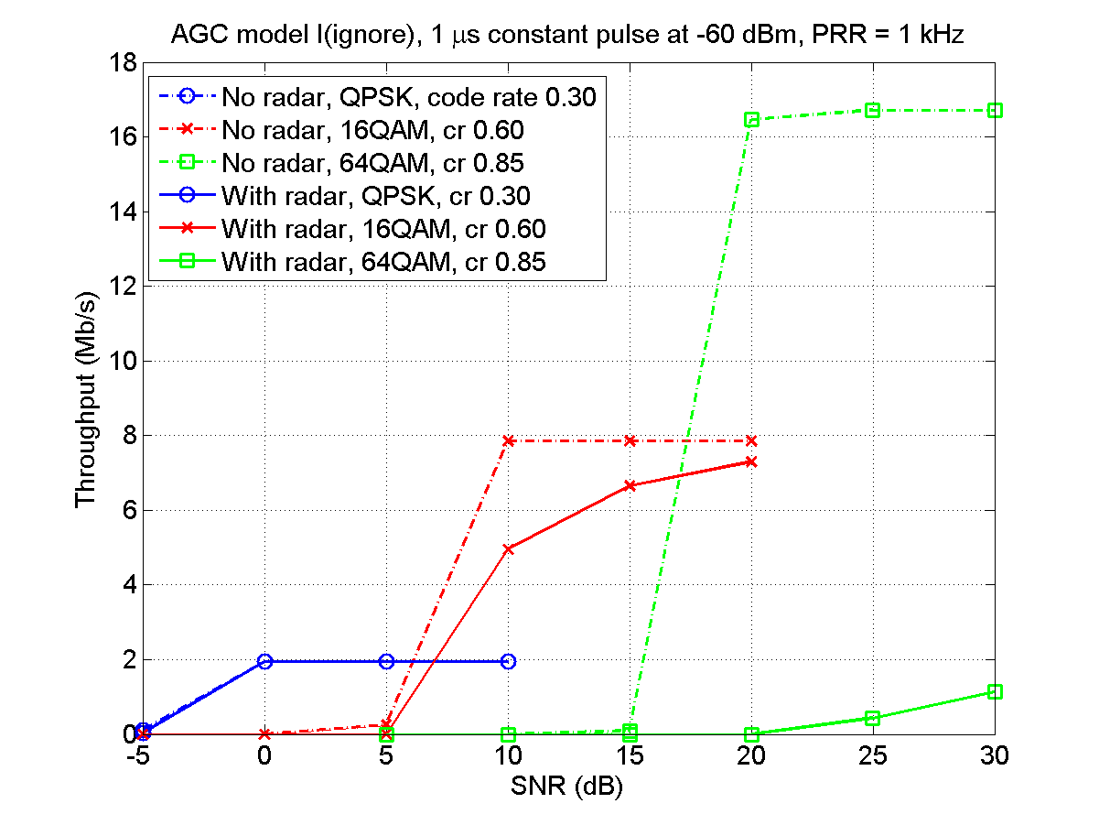
- Performance with radar pulse of constant type
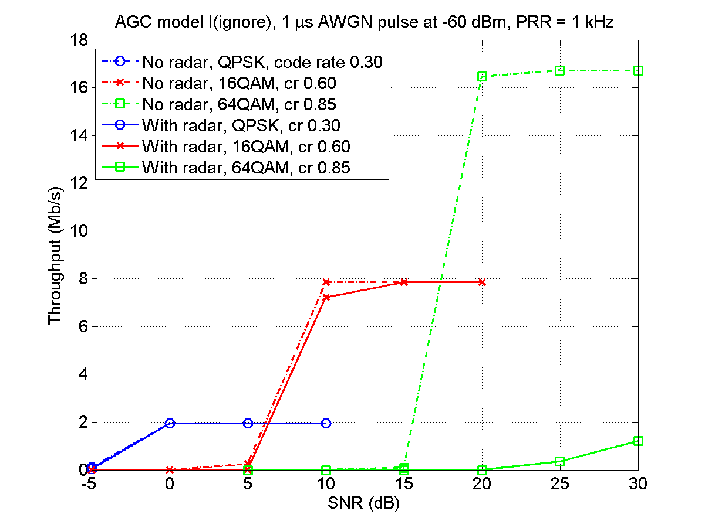
- Performance with radar pulse of AWGN type.

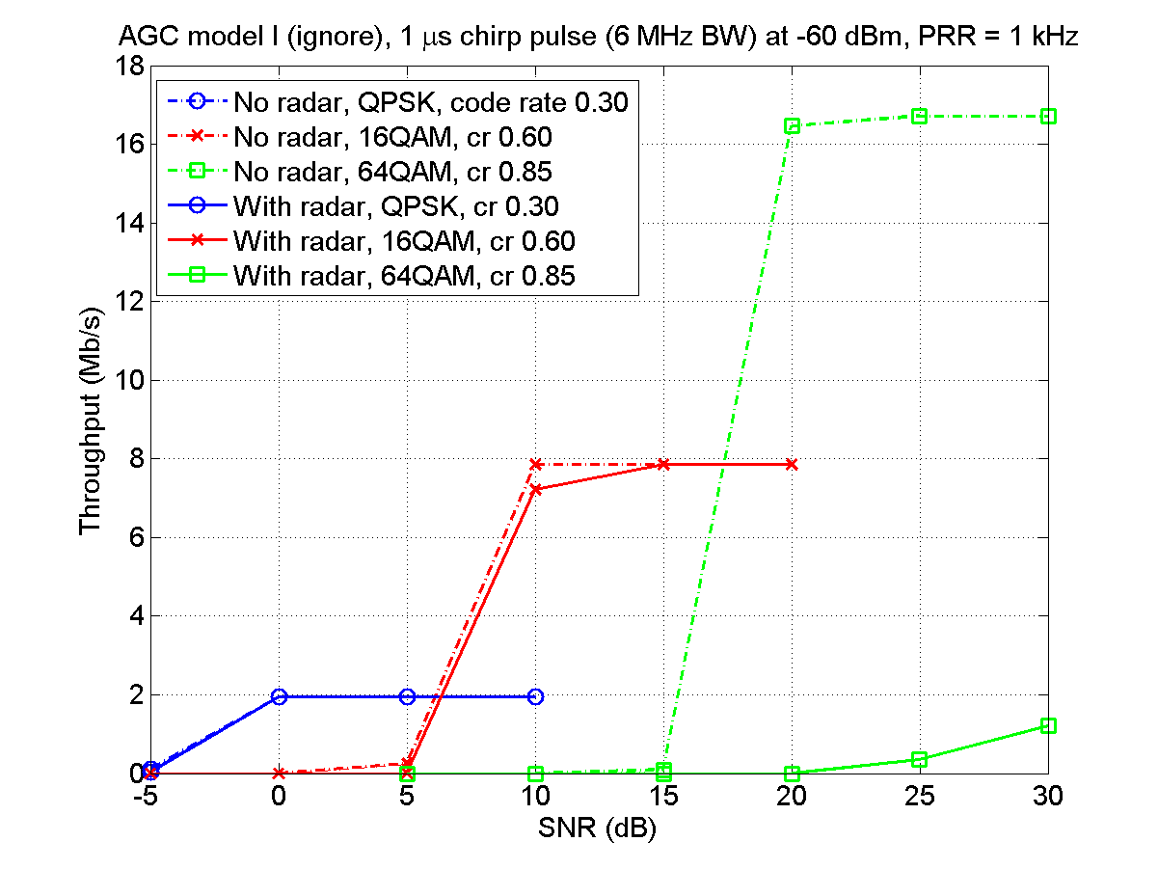
- Performance with radar pulse of chirp type (6.0 MHz bandwidth).
  - Analogue receiver parts characteristics and modeling
A full analysis of the effect of a radar pulse on the analogue parts of the receiver chain is of high importance for this type of analysis. A key issue is the operation of the automatic gain control (AGC), the operation and modelling of which is discussed in Section A.7.3.1. The effect and modelling of other analogue parts, such as filters and amplifiers, are then discussed in Section A.7.3.2.
    - Automatic Gain Control (AGC)
      - AGC Basics
The purpose of an AGC is to control the amplification of the incoming signal power so that it fits within the useful operating range of the analogue-to-digital converter (ADC). The amplification, henceforth referred to as “gain”, is typically adjusted once per subframe, since the gain should preferably be constant over a subframe in order not to complicate the channel and impairment estimation in the digital processing.
The AGC typically measures the signal power in each subframe and filters (averages) the power over a number of subframes (in the order of 10 subframes may be a reasonable assumption).
      - AGC Models in this report
We now describe the various AGC models used in this report. The models are intended to span the different AGC designs possible. The AGC models considered are as follows:
- ignore pulse: Here we assume that the AGC always ignores the radar pulse, not making it part of the signal power estimation.
- adapt to pulse: Here we assume that the AGC always adapts to radar pulse power during its active periods. AGC model P can be seen as the most pessimistic AGC model.
- average per subframe: This model by default averages power over all samples in the subframe and is therefore expected to correspond to some situation in-between model I and model P.
- average per OFDM symbol: Here the AGC uses windowing over OFDM symbols, covering the whole subframe.

The models ignore pulse and adapt to pulse can thus be seen as extreme cases between which AGCs from any manufacturer can be expected to fall. For evaluation of the different types of AGC models see below in Section A.7.4.1.1.
    - Other analogue parts
The behaviour of analogue parts other than the AGC may also determine the digital baseband signal characteristics. First of all, the extremely strong radar pulse may become severely distorted, changing its characteristics during the actual duration as well as lingering afterwards for a short period before the receiver has recovered normal operation. Secondly, if the receiver goes into compression, the noise floor is effectively increased. We now explain the modelling of these effects in simulations.
Receiver recovery times are not modelled explicitly in simulations; instead the recovery time is assumed to be part of the specified pulse time. Typical recovery times in a real receiver may according to ANNEX 5: be around 1 μs, unless the pulse is strong enough to pull the VCOs, in which case the recovery time may be as long as 20 μs. In the simulations we span effective pulse times from 1 μs to 100 μs.
Also other distortions of the radar pulse are for simplicity not modelled explicitly in the simulations. For strong pulses (above the receiver compression level) this is probably a poor approximation, but at those levels, all useful information during the pulse is anyway lost. Furthermore, it is believed that impact of possible smaller distortions are rather well covered by including an AWGN model for the radar pulse.
In ANNEX 5: a model for thermal noise rise given. This model roughly has the effect of giving a noise rise that is directly proportional to how much the radar pulse exceeds the receiver compression point, which may be in the order of -30 dBm. Since a thermal noise level is typically around -100 dBm in LTE, the radar pulse itself is thus typically in the order of 70 dB stronger than the increased thermal noise level, and the noise rise can be neglected. However, a special case of consideration is when the radar signal falls inside the LTE duplex filter (which can be quite wide), but still outside the actual LTE band. The noise rise caused by the full unsuppressed radar signal should then be compared with the spurious radar signal level inside the LTE band. However, with a spurious level of -60 dBc, we find that the (spurious) signal level is still about 10 dB (= (-30-60)-(-100) dB) stronger than the increased thermal noise floor when the receiver goes into compression. Hence, we for simplicity always neglect the noise rise in this report.
  - Digital Baseband Processing
In this chapter we very briefly discuss some relevant aspects of digital baseband processing and what effects the radar pulse can be expected to have.
The first aspect is that the digital receiver filter will extend the radar pulse by a few micro seconds. For simplicity, the simulations were performed without oversampling and explicit modelling of digital receiver filters, and instead it was assumed that this adds 2 micro seconds, on top of the micro second due to recovery time in the analogue parts as described above, i.e. a total of 3 micro seconds.
Additional effects that are taken into account in the simulations are how the discrete Fourier transform spreads the pulse energy over the different subcarriers (raising the noise level within the OFDM symbol) and the possibility of interfering reference symbols (i.e. an OFDM symbol not only containing data channels).
Performance evaluations
    - General simulation assumptions and settings
Parameter settings used in all simulations include:
- 1 transmit antenna, 2 two receive antennas
- 5 dB noise factor, resulting in thermal noise level -100.1 dBm for 5 MHz bandwidth
- EVA LOW channel model (delay spread of less than 0.5 μs, no antenna correlation)
- Radar pulse not undergoing fast fading.
- 5 MHz bandwidth
- 200 subframes per result point
- No hybrid ARQ (HARQ)

Note:
- No hybrid ARQ (HARQ)
- The radar pulse power indicated in this chapter is always power during the actual pulse (i.e. not long-term average power) measured at the terminal antenna.
- The pulse power level is always the power within the LTE bandwidth.
      - Different AGC models
In Figure 89: through Figure 92: different AGC models are compared. In all cases there is a 1 μs radar pulse at -60 dBm once per subframe (on symbol 5, i.e. PDSCH only, except for synchronization signal in some subframes).
As can be seen, performance differs substantially between the models. Models ignore and adapt to pulse can as mentioned earlier be seen as extremes.
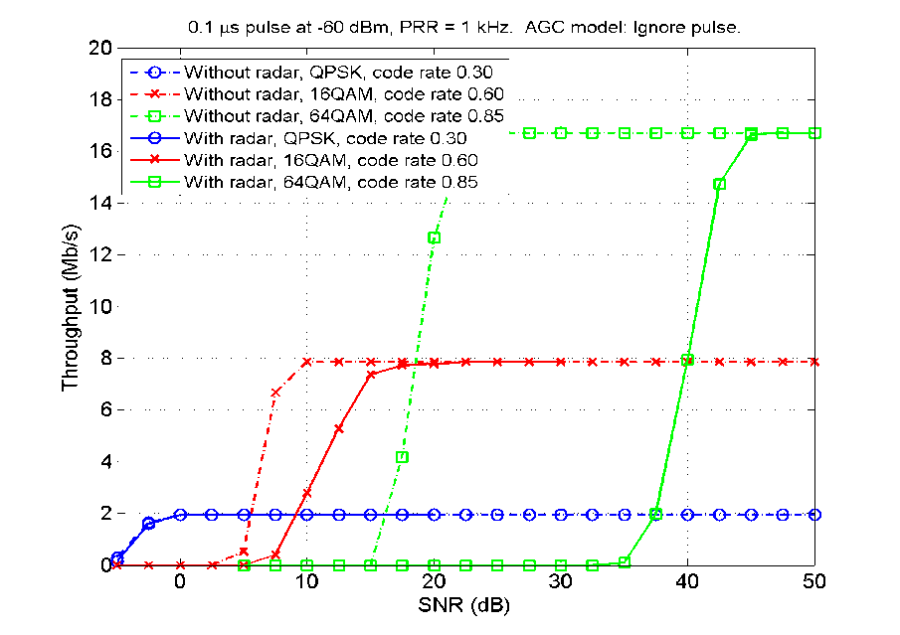
- AGC model Ignore pulse

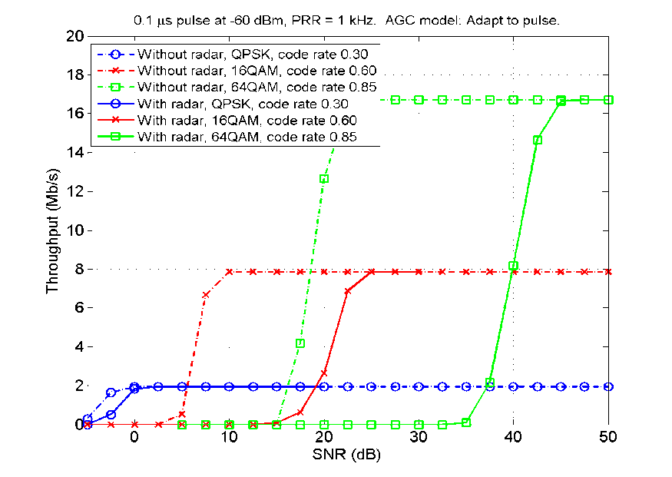
- AGC model Adapt to pulse

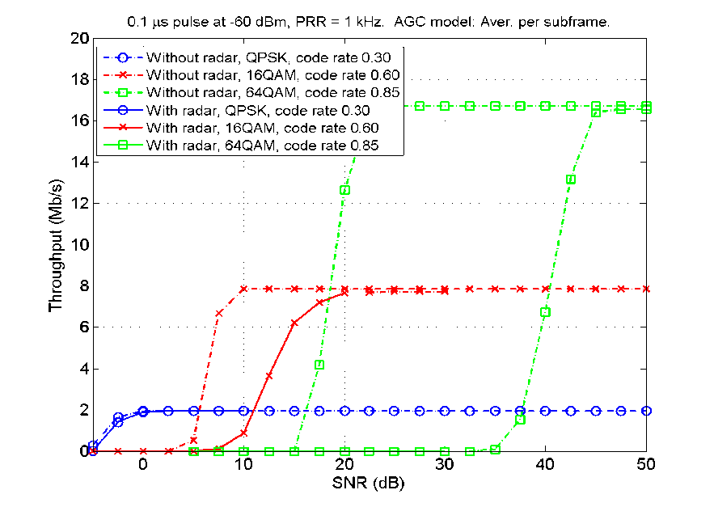
- AGC model Average per subframe

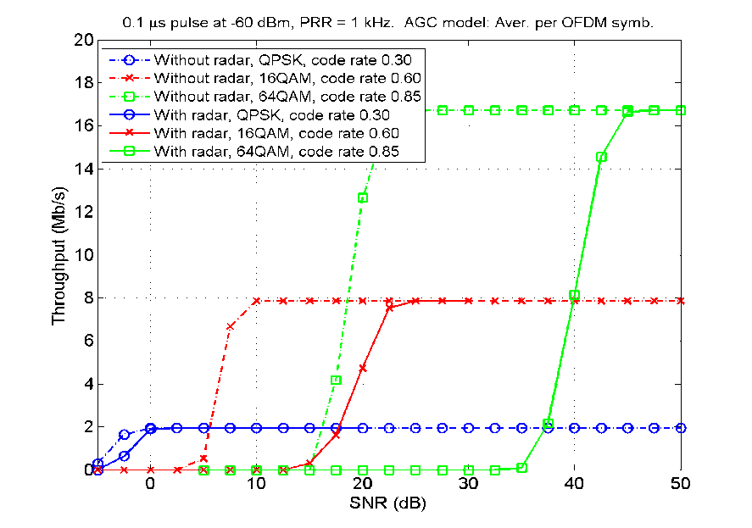
- AGC model Average per OFDM symbol
In Figure 93: we show performance for a range of different pulse durations and pulse powers, at a constant SNR of 5 dB. Corresponding results at SNRs 15 dB and 25 dB are shown in Figure 94: and Figure 95: respectively. (Note that modulation schemes, code rates, and y-axis scales differ between the figures.)
As can be seen, only very low throughput is possible above -60 dBm pulse power.
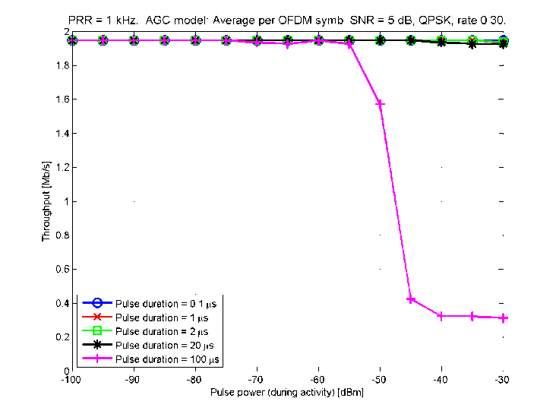
- SNR 5 dB - QPSK

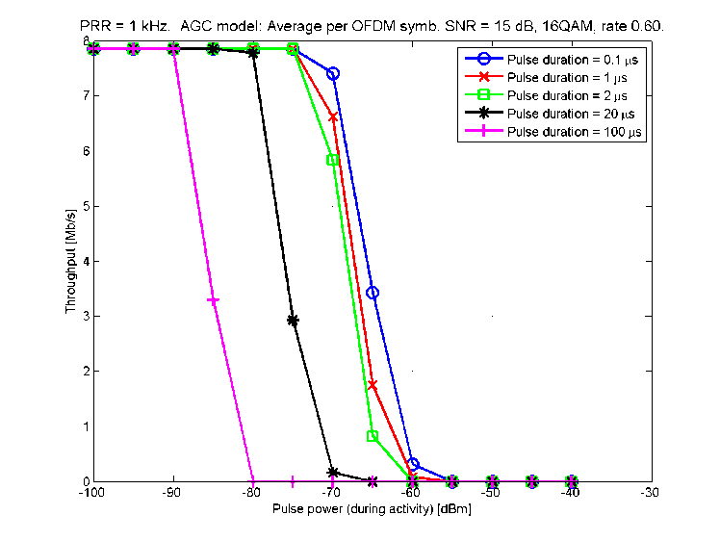
- SNR 15 dB – 16 QAM
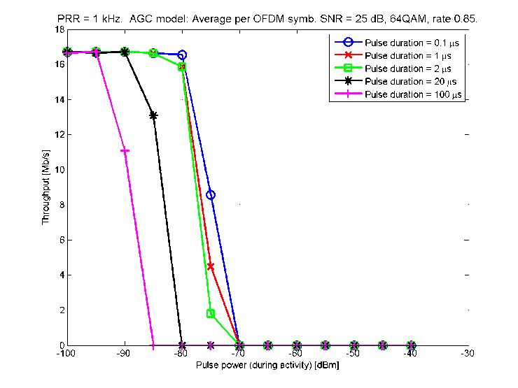

- SNR 25 dB – 64 QAM
      - Different pulserepetition rates
In Figure 96: and Figure 97: we examine performance with a pulse repetition rate (PRR) of 1 kHz vs 300 Hz. With the lower rate, the radar pulse appears only in about one third of all subframes.
It is clear from the Figure 96: and Figure 97: that the performance is much better than with 1 kHz PRR, primarily due to the fact that many subframes are uninterfered. The first performance drop, down to the plateaus in the curves, occurs when the radar pulse is strong enough to completely destroy the interfered subframes.
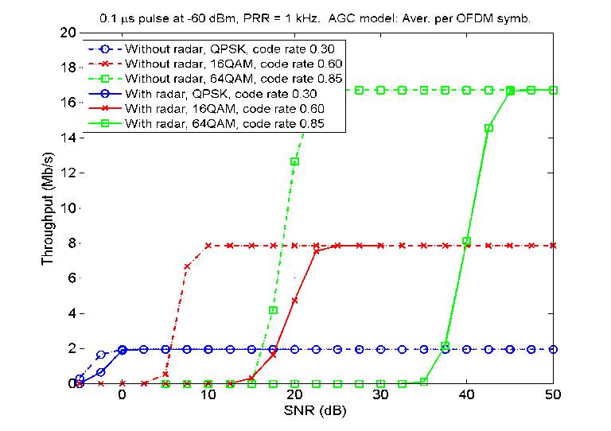
- 1 kHz PRR
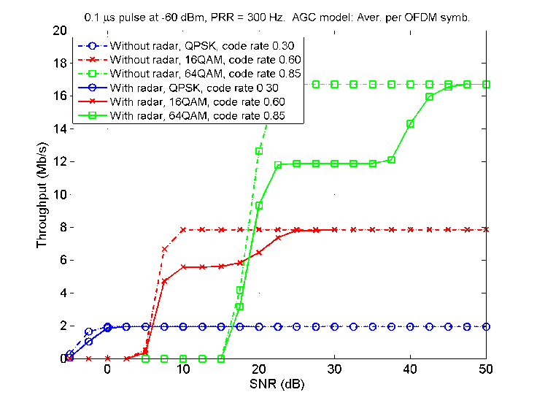
- 300 Hz PRR
      - Automatic Link Adaptation
LTE link adaptation was investigated for different interference levels of a radar with 1 microsecond pulses and PRR 1 kHz, see Figure 98:. For interference levels -100 dBm and -90 dBm there is no throughput decrease, whereas for -80 dBm the decrease is about 15% for SNR 20 dB and close to 30% at SNR 10 dB. As can be seen in the pictures above, radar interference with shorter pulse length will produce very similar results, whereas for radars with long pulses, say 100 micro seconds, protection levels are considerably higher, in the range of 20 dB more strict than for 1 micro second pulses. Similarly in the case of VCO pulling, see Figure 65:, resulting in 20 micro seconds recovery time from the radar signal, sensitivity to radar interference can be expected to increase by some 10 – 15 dB, see Figure 94: - Figure 96: above.
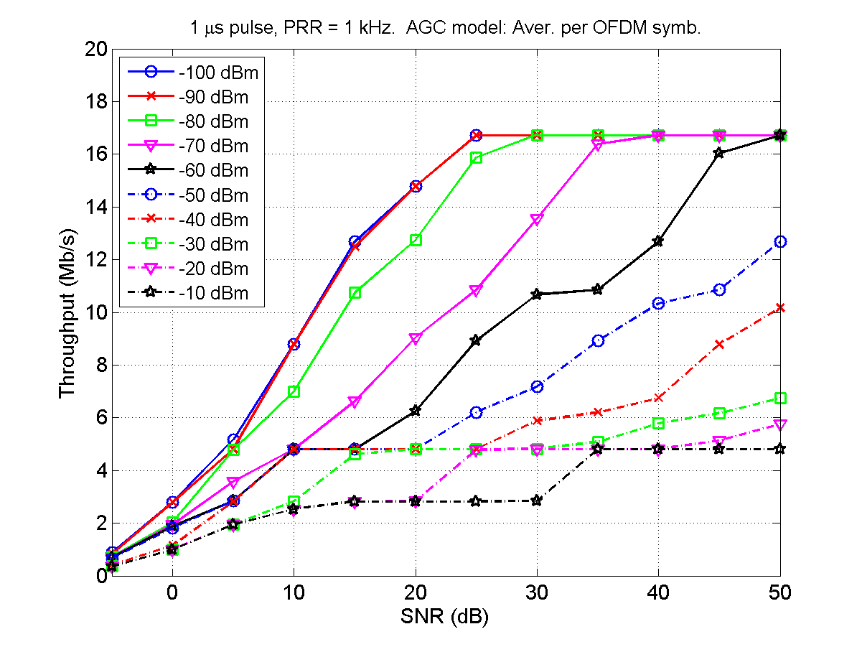
- Throughput degradation in a 4.5 MHz bandwidth LTE
      - Different LTE bandwidths
A few simulations with other LTE bandwidths have also been performed, but no major qualitative differences were observed in the cases simulated However, since it with this wide bandwidth is possible to fit a whole code block (of which there are several in a transport block) in one OFDM symbol, performance is potentially more sensitive to radar pulses (one pulse may more easily destroy a whole code block).

- Calculation of interference from radar to LTE UE and BS
The tables below show how interference from different types of radars to LTE UEs and BSs has been computed. The calculations do not incorporate OOB and spurious suppression, propagation losses or antenna side lobe suppression.
- Interference to LTE UE
Radar type | Type 1 | Type 4 | Type 2 | Type 6 | Type 8
radar power (dBm) | 90 | 89 | 86 | 75 | 89
Bandwidth conversion (dB) (bandwidth of radar rel 1 MHz) | -4 | -1 | 0 | 1 | 0
radar antenna gain (dBi) | 40 | 34 | 33 | 35 | 43
feeder loss (dB) | 0 | 0 | 0 | 0 | 2
Antenna gain UE (dBi) | 0 | 0 | 0 | 0 | 0
Feeder loss UE (dBi) | 0 | 0 | 0 | 0 | 0
Total interference power (excluding OOB/spurious  suppression, propagation loss or antenna side lobe  suppression) (dBm/MHz) | 126 | 122 | 119 | 111 | 134

- Interference to LTE BS
Radar type | Type 1 | Type 2 | Type 6 | Type 8
radar power (dBm) | 90 | 86 | 75 | 89
Bandwidth conversion (dB) (bandwidth of  radar rel 1 MHz) | -4 | 0 | 1 | 0
radar antenna gain (dBi) | 40 | 33 | 35 | 43
feeder loss (dB) | 0 | 0 | 0 | 2
Antenna gain BS (dBi) | 18 | 18 | 18 | 18
Feeder loss BS (dBi) | -3 | -3 | -3 | -3
Total interference power (excluding  OOB/spurious suppression,  propagation loss or antenna side lobe  suppression) (dBm/MHz) | 141 | 134 | 126 | 149

- Simulations of radar interference to the LTE uplink
Simulations have been carried out with a link level simulation tool also reflecting the analogue parts of the BS receiver, such as the AGC. Throughout this section the results with radar interference are compared to a reference case without interference. SNR at the x-axis corresponds to the situation without interference from radars. The simulations have been carried out with 5 MHz LTE bandwidth. The simulations have been carried out under the assumption that the radar pulses will not be transmitted at exactly 1 kHz, and thus represent an averaged case where the radar occasionally but not constantly erases reference symbols. In the case of a radar with PRR exactly 1 kHz the interference may be considerably worse.
Figure 99: below show the results of interference from a type 2 radar. This ATC radar uses 1 micro second long pulses, has PRR about but not exactly 1 kHz, power 86 dBm and max antenna gain 35 dBi. Three different levels of interference have been tested, referred to as Optimistic, Medium and Worst case. Worst case corresponds to spurious suppression -60 dBc, 90 dB propagation loss and radar antenna main lobe interference. Medium corresponds to -80 dBc spurious suppression, 100 dB propagation loss and side lobe interference, i.e. -35 dBm relative main lobe interference. Optimistic, finally, corresponds to -100 dBc spurious suppression, 110 dB propagation loss and -40 dB side lobe interference. For this radar these different cases correspond to -4 dBm, -69 dBm and -104 dBm respectively.
The first three subgraph on Figure 99: correspond to low code rate MCSs (thus less sensitive to interference from radar, but also with lower throughput) and the last two to high code rate MCSs.

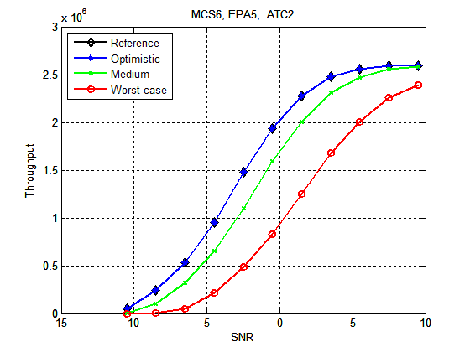
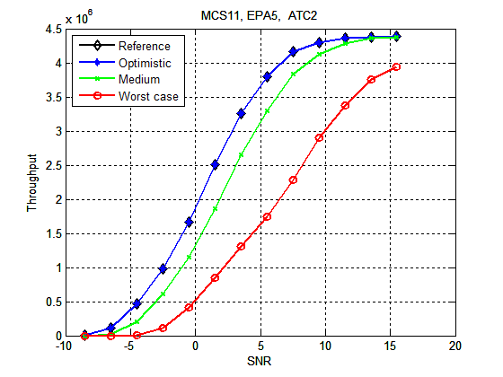

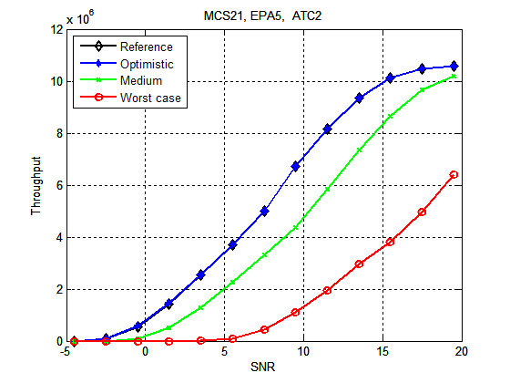

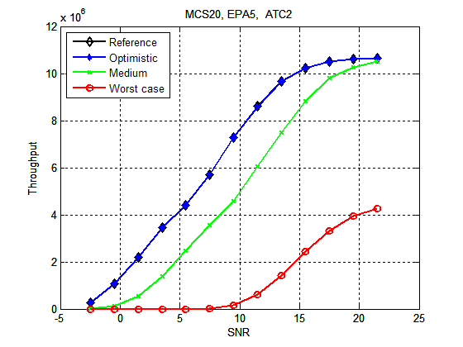

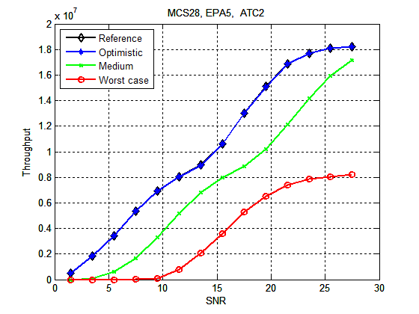
- UL throughput loss in the presence of an interfering radar of Type 2.
The following subgraphs on Figure 100: contain information about Type 6 radar (ATC), which has pulse length 100 micro seconds, output power 75 dBm, PRR 825 Hz and antenna gain 35 dBi. As for the Type 2, the first three are low code rate MCSs and the last two high code rate MCSs. The definitions for Optimistic, Medium and Worst case are the same as for Type 2, which due to the lower power of Type 6 corresponds to -15 dBm, -80 dBm and -115 dBm.

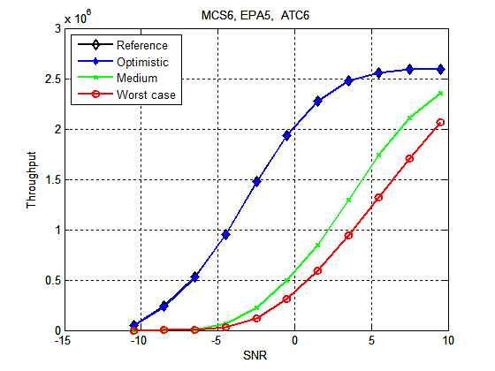

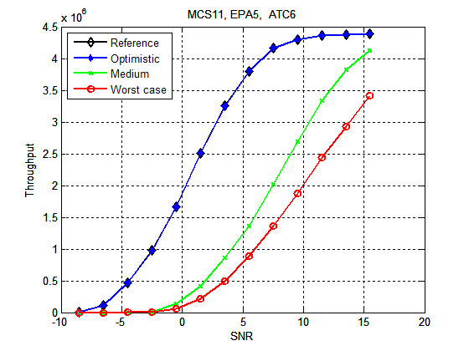

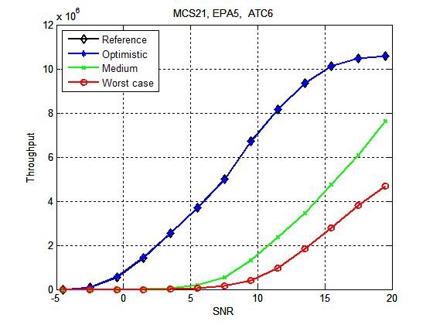

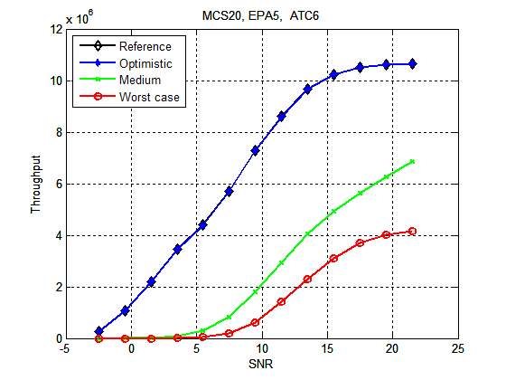

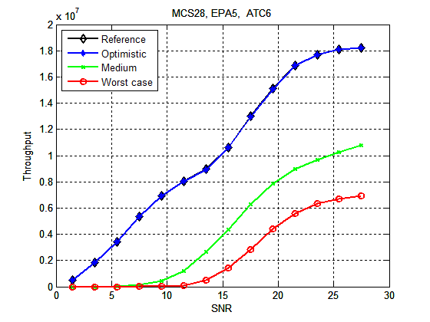
- UL throughput loss in the presence of an interfering radar of Type 6.
The final set of results is for a meteorological radar with output power 89 dBm, pulse length 2.2 microseconds, PRR 725 Hz and max antenna gain 45 dBi. Side lobe suppression for a meteorological radar is here considered to be -25 dBi for Medium and -35 dBi for the Optimistic case. Here Worst case, Medium and Optimistic thus correspond to 9 dBm, -46 dBm and -86 dBm.
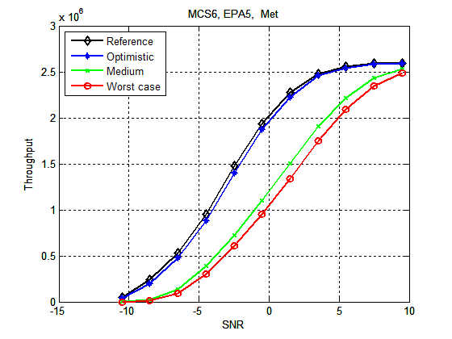
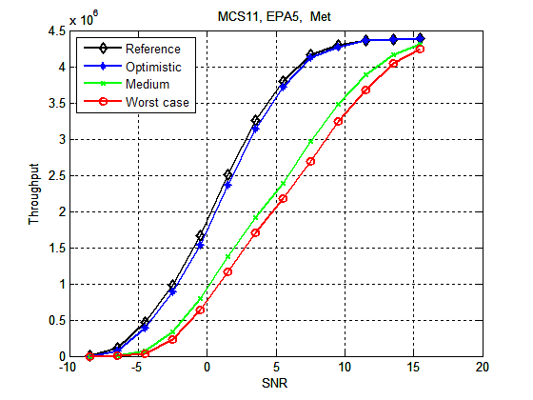

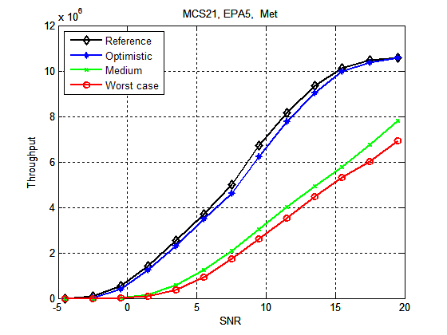

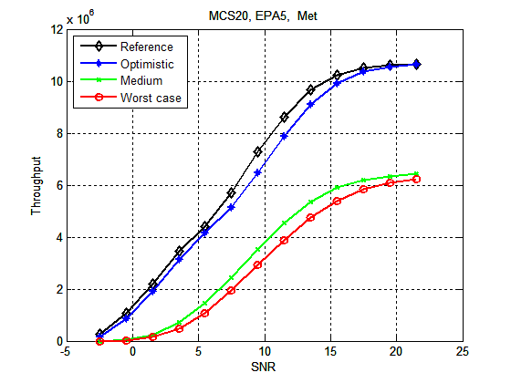

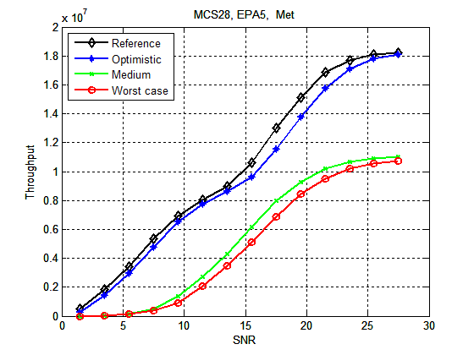
- UL throughput loss in the presence of an interfering meteorological radar.
- Measurements of radar interference to the LTE uplink
Measurements have been carried out with test equipment in a lab environment. The LTE bandwidth is 5 MHz. Figure 102: through Figure 104: below show the influence of interference from Type 2 and Type 6 radars (ATC) and a meteorological radar on LTE. For each radar type, two different MCSs are investigated, one with low throughput and one with high. A number of different interference levels have been analysed for a range of different LTE SNR values. The radar pulse power is considered to be constant within the frequency range of the LTE carrier. The radar spurious interference has been approximated by an LTE carrier of the same bandwidth as the interfered channel.
The measurements have been carried out under the assumption that the radar pulses will not be transmitted at exactly 1 kHz, and thus represent an averaged case where the radar occasionally but not constantly erases reference symbols. In the case of a radar with PRR exactly 1 kHz the interference may be considerably worse.
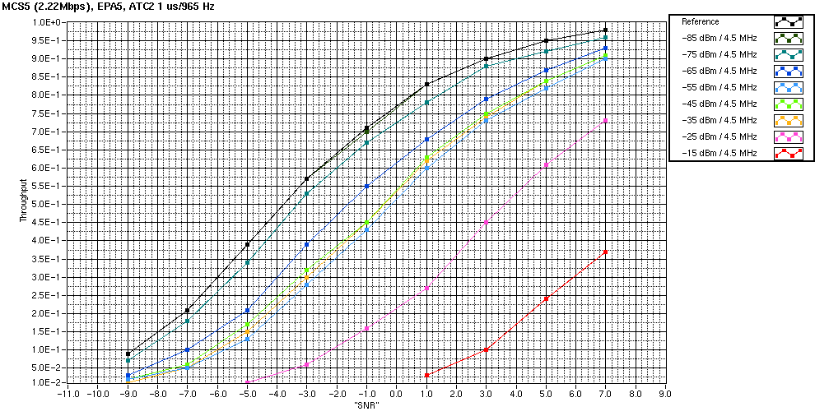

- UL throughput loss(%) in the presence of an interfering radar of type 2 for MCS 5 and 20

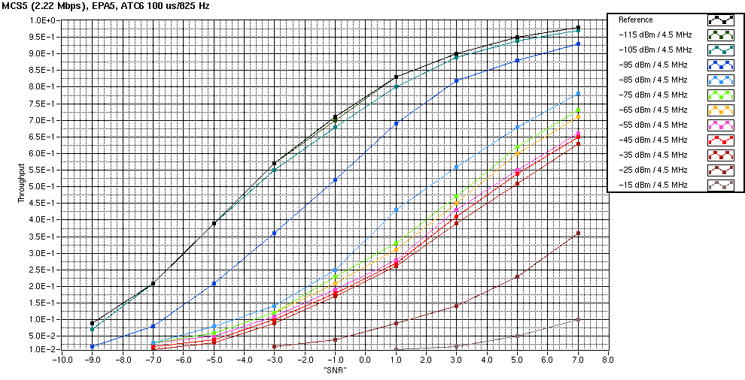

- UL throughput loss (%) in the presence of an interfering radar of type 6 for MCS 5 and 20

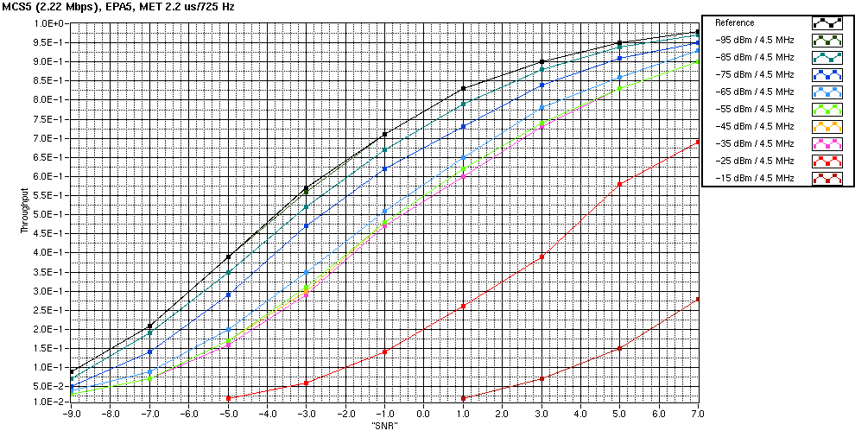

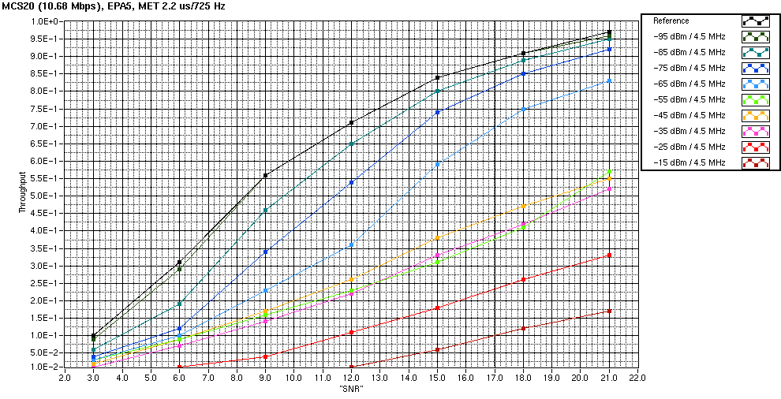
- UL throughput loss (%) in the presence of an interfering meteorological radar
for MCS 5 and 20.

- Separation distances required due to radar interference to LTE equipment
  - Results for LTE UE
Figure 105: - Figure 108: below contain required separation distances for different radar suppression levels(propagation model ITU-R P.452). Antenna height is 40 and 21 meters respectively for ATC (including type 1, military radar) and meteorological radars. LTE terminal height is assumed to be 1.5 m throughout. Horizontal side-lobe suppression in relation to maximum antenna gain is assumed to be 35 dB for Type 1 and ATC radars, and 30 dB for meteorological radar. This corresponds roughly to angles other than the 10 degrees beamwidth with the highest gain. Note that this is just an example of analysis incorporating side-lobe suppression of the radar antenna, and that the antenna gain with the 10 degrees not considered as side-lobe in this example will not be equal to the maximum antenna gain, but rather vary between no additional suppression and roughly 30 or 35 dB additional suppression. For further details on the radar antenna diagrams, see Section 4 (Table 5: and Figure 13:).
Antenna discrimination is included in the analysis, see Section 5.5.4.1. ANNEX 8: contains information about calculations of interference from radars to LTE UEs.
- Required separation distance needed for interference from radar type 1 to LTE UE

- Required separation distance needed for interference from radar type 2 to LTE UE
- Required separation distance needed for interference from radar type 3 to LTE UE

- Required separation distance needed for interference from meteorological radar (type 4) to LTE UE
  - Results for LTE BS
Figure 109: – Figure 112: below contain requirements on separation distances needed for different radar interference OOB/spurious suppression (propagation model ITU-R P.452). Antenna height is 40 and 21 meters respectively for ATC and meteorological radars. LTE BS height is assumed to be 45 m throughout (rural area). Side-lobe suppression in relation to maximum antenna gain is assumed to be 35 dB for Type 1 and ATC radars, and 30 dB for meteorological radar. This corresponds to angles other than the 10 degrees beamwidth with the highest gain. Note that this is just an example of analysis incorporating side-lobe suppression of the radar antenna, and that the antenna gain with the 10 degrees not considered as side-lobe in this example will not be equal to the maximum antenna gain, but rather vary between no additional suppression and roughly 30 or 35 dB additional suppression. For further details on the radar antenna diagrams, see Section 4 (Table 5: and Figure 13:).
Antenna discrimination is included in the analysis, see Section 5.5.4.1. ANNEX 5: contains information about calculations of interference from radars to LTE BSs.
Just as for case with interference to the LTE UE, see Section 6.1.2, the fact that the radar antenna is rotating should be applied with caution.
The simulations and measurements have been carried out under the assumption that the radar pulses will not be transmitted at exactly 1 kHz, and thus represent an averaged case where the radar occasionally but not constantly erases reference symbols. In the case of a radar with PRR exactly 1 kHz the interference may be considerably worse.
Please note also that the results may vary depending on the modelling assumptions, as illustrated for the downlink case in Figure 89: and Figure 92: in ANNEX 7:.
- Required separation distance needed for interference from radar type 1 to LTE BS
- Required separation distance needed for interference from radar type 2 to LTE BS
- Required separation distance or needed for interference from radar type 3 to LTE BS
- Required separation distance needed for interference from meteorological radar (type 4) to LTE BS
- NON LINEAR EFFECT CALCULATION IN RADAR RECEPTION CHAIN
The following analysis considers only intermodulation products of the third order.
For intermodulations with signal powers below the compression point of the linear amplifier, the power of intermodulation products is usually defined by the following:
IMP(n) = n * P - (n-1) * IP(n)

with : n : intermodulation product order
IMP(n) : power of intermodulation products with order n (dBm)
P : Power of the fundamental signal (dBm)
IP(n) : interception point with order n
Considering the important number of LTE/WiMAX carrier that could be used in the band 2500-2690 MHz, it is necessary to consider the combined effect of all these carriers to calculate their effective non-linear effect at the radar reception.
Depending on the type of combination between LTE/WiMAX carriers, the intermodulation product effect will differ. Indeed, at the third order, two cases have to be considered (see the table below).
- Third order intermodulation products
Type | Quantity of carriers |  |  |  | Normalized power level
Type | 2 | 4 | 8 | 16 | Normalized power level
2 f_{A} – f_{B} | 2 | 12 | 56 | 240 | 1
f_{A} + f_{B} – f_{C} | 0 | 12 | 168 | 1680 | 4

A more general formula should thus be used to estimate the power of intermodulation products (previously defined for a frequency combination 2 f_{A} – f_{B}). A correction factor η is added:
IMP(n) = n * P - (n-1) * IP(n) + η

This correction factor will consider the sum of the intermodulation products that could fall in a certain bandwidth as well as their relative power. As the radar protection level is given by P, the correction factor applied to the protection level will be η/n.
Therefore, for radars of type 2 and type A given in table 6, the impact of non-linear effect is based on a measurement limited to 2 LTE signals which takes into account only the combinations (2 f_{A} – f_{B}) and then the protection level of radar is calculated by adding the correction factor η/3 when considering 3rd order intermodulation products.
It need to be mentioned that the actual correction factor level will vary with a number of parameters such as the radar frequency and bandwidth, the number and size of LTE blocks used in the mobile allocation. Therefore, this correction factor should be determined on a case by case basis.
- List of referenceS
- ITU, Radio Regulation, version 2008
- ECC/DEC/(05)05, 18 March 2005, “Harmonised utilisation of spectrum forIMT-2000/UMTS systems operating within the band2500 – 2690 MHz”,
- EC Decision 2008/477/EC, 13 June 2008, “Harmonisation of the 2 500-2 690 MHz frequency band for terrestrial systems capable of providing electronic communications services in the Community”,
- ECC Report 157, January 2011, “The Impact of spurious emissions of radars at 2.8, 5.6 and 9.0 GHz on other radiocommunication services/systems”.
- ECC Report 45, February 2004, “ Sharing and adjacent band compatibility between UMTS/IMT-2000 in the band 2500-2690 MHz and other services”.
- ITU-R Report SM.2028-1, 2002, “Monte Carlo simulation methodology for the use in sharing and compatibility studies between different radio services or systems”
- ITU-R Recommendation M.1461-1, June 2003, “Procedures for determining the potential for interference between radars operating in the radiodetermination service and systems in other services”
- CEPT Report 19, 17 March 2008, Report from CEPT to the European Commission in response to the Mandate to develop least restrictive technical conditions for frequency bands addressed in the context of WAPECS
- ECC Report 131, January 2009, “Derivation of a Block Edge Mask (BEM) for terminal stations in the 2.6 GHz frequency band (2500-2690 MHz)”
- ITU-R Recommendation M.1464-1, June 2003, “Characteristics of radiolocation radars, and characteristics and protection criteria for sharing studies for aeronautical radionavigation and meteorological radars in the radiodetermination service operating in the frequency band 2 700-2 900 MHz”
- ITU-R Recommendation M.1580-3, October 2009, “Generic unwanted emission characteristics of base stations using the terrestrial radio interfaces of IMT-2000”
- ITU-R Recommendation M.1581-3, October 2009, “Generic unwanted emission characteristics of mobile stations using the terrestrial radio interfaces of IMT-2000
- CEPT/ERC/REC 74-01E, 2011, “Unwanted emissions in the spurious domain”
- ITU-R Report 2039-1, June 2009, “Characteristics of terrestrial IMT-2000 systems for frequency sharing interference analyses”
- ITU-R Recommendation M.1179, October 1995,“Procedures for determining the interference coupling mechanisms and mitigation options for systems operating in bands adjacent to and in harmonic relationship with radar stations in the radiodetermination service”
- STG (10)39 Annex 1, 18 May 2010,Liaison Statement to ECC PT1 on request for LTE parameters in the 800, 900, 1800 and 2500 MHz band.
- ITU-R Report M.2039-2, 2010 (Before the publication by ITU-R, that document can be downloaded at : http://www.itu.int/md/R07-SG05-C-0216/en)
- ITU-R Report M.2112, 2007, Compatibility/sharing of airport surveillance radars and meteorological radar with IMT systems within the 2 700-2 900 MHz band
- ITU-R Recommendation F.1336-2, 2007, Reference radiation patterns of omnidirectional, sectorial and other antennas in point-to-multipoint systems for use in sharing studies in the frequency range from 1 GHz to about 70 GHz
- ITU-R Recommendation SM.1541-2, 2006, Unwanted emissions in the out-of-band domain
- ITU-R Recommendation M.1849, 2009, Technical and operational aspects of ground-based meteorological radars
- ITU-R Recommendation F.1245-1, 05/2000, Mathematical model of average and related radiation patterns for line-of-sight point-to-point radio-relay system antennas for use in certain coordination studies and interference assessment in the frequency range from 1 GHz to about 70 GHz
- ITU-R Recommendation M.1177, 06/2003, Techniques for measurement of unwanted emissions of radar systems
- “ACMD-6007 datasheet,” "http://www.avagotech.com/docs/AV02-2568EN", 2011, downloaded on March 31, 2011.
- JEDEC Solid State Technology Association, Field-Induced Charged-Device Model Test Method for Electrostatic-Discharge-Withstand Thresholds of Microelectronic Components , JESD22-C101E edition, Dec. 2009.
- Broadband Data Transmission Systems operating in the 2 500 MHz to 2 690 MHz frequency band; Part 1: TDD Base Stations; Harmonized EN covering the essential requirements of article 3.2 of the R&TTE Directive
- Broadband Data Transmission Systems operating in the 2 500 MHz to 2 690 MHz frequency band; Part 2: TDD User Equipment Stations; Harmonized EN covering the essential requirements of article 3.2 of the R&TTE Directive.
- Sven Mattisson, Hans Hagberg, and Pietro Andreani, “Sensitivity Degradation in a Tri-Band GSM BiCMOS Direct-Conversion Receiver Caused by Transient Substrate Heating,” IEEE Journal of Solid State Circuits, pp. 486–496, Feb. 2008.
- Magnus Nilsson, Sven Mattisson, Nikolaus Klemmer, et al., “A 9-band WCDMA/EDGE transceiver supporting HSPA Evolution,” in IEEE International Solid-State Circuits Conference Digest of Technical Papers, 2011, To be publsihed.
- CEPT Report 40, 12 November 2010, Compatibility study for LTE and WiMAX operating in the 900/1800 MHz bands
- Jim R. Lloyd, “Electromigration for designers: An introduction for the non-specialist,” "http://www.eetimes.com/design/eda-design/4017969/Electromigration-for-Designers-An-Introduction-for-the-Non-Specialist", 2002, downloaded on May 2, 2011.
- “International Technology Roadmap for Semiconductors, 2009 Edition, Interconnect,” "http://www.itrs.net/Links/2009ITRS/2009Chapters\_2009Tables/2009\_Interconnect.pdf", 2009, downloaded on May 3, 2011.
- Jan-Wim Eikenbroek and Sven Mattisson, “Frequency Synthesis for Integrated Transceivers,” in Advances in Analog Circuit Design (AACD) Workshop, Munich, Germany, Apr. 2000, Invited paper.
- T.H. Lee, The Design of CMOS Radio-Frequency Integrated Circuits, Cambridge University Press, Cambridge, 1998.
- W.Sansen, “Distortion in Elementary Transistor Ciruits,” IEEE Transactions on Circuits and Systems II: Analog and Digital Signal Processing, vol. 46, pp. 315–325, Mar. 1999.
- D.P. Atherton, Nonlinear Control Engineering, Van Nostrand, 1982.
- ITU-R Recommendation P.452, 2009, Prediction procedure for the evaluation of interference between stations on the surface of the Earth at frequencies above about 0.1 GHz
- ITU-R Recommendation M.1851, 2009, Mathematical models for radiodetermination radar systems antenna patterns for use in interference analyses
- ITU-R Recommendation M.1464, 2003, Characteristics of radiolocation radars, and characteristics and protection criteria for sharing studies for aeronautical radionavigation and meteorological radars in the radiodetermination service operating in the frequency band 2 700-2 900 MHz
- ITU-R Recommendation M.1314, 2005, Reduction of unwanted emissions of radar systems operating above 400 MHz
- ITU-R Report SM.2028, 2002, Monte Carlo simulation methodology for the use in sharing and compatibility studies between different radio services or systems
- 3GPP TS 23.401 v9.9.0 3rd Generation Partnership Project; Technical Specification Group Services and System Aspects; General Packet Radio Service (GPRS) enhancements for Evolved Universal Terrestrial Radio Access Network (E-UTRAN) access (Release 9)
- 3GPP TS 23.203 v9.9.0 3rd Generation Partnership Project; Technical Specification Group Services and System Aspects; Policy and charging control architecture (Release 9)
- ETSI EN 302 544-2 - Broadband Data Transmission Systems operating in the 2 500 MHz to 2 690 MHz frequency band
- ETSI EN 301 908-14 v.5.1.1 – Repeaters and User Equipment (UE) for IMT-2000 third-Generation cellular networks

For Mobile WiMAX TDD systems operating in the exceptional frequency arrangement and Mobile WiMAX FDD Base Stations, the unwanted emission spectrum mask and ACLR specification for 10MHz systems could extend to 2710 MHz if operating in the uppermost 10 MHz channel below 2690 MHz.
Measurements of some mobile service equipment indicate that the level of unwanted emissions falling into the band above 2700 MHz may be much lower than the above mentioned limit and hence the impact may be less severe than the results based on the regulatory levels.
“Study of the Performance Degradation of the Belgian S-bandAir Surveillance Radars due to the Interference of Upcoming4G Technologies », Intersoft, http://www.auction2011.be/images/stories/documents/ie_test_report.pdf
Multipath propagation may require up to 6 dB additional margin.
Multipath propagation may require up to 6 dB additional margin.
For Mobile WiMAX TDD systems operating in the exceptional frequency arrangement and Mobile WiMAX FDD Base Stations, the unwanted emission spectrum mask and ACLR specification for 10MHz systems could extend to 2710 MHz if operating in the uppermost 10 MHz channel below 2690 MHz.
For Mobile WiMAX TDD systems operating in the exceptional frequency arrangement and Mobile WiMAX FDD Base Stations, the unwanted emission spectrum mask and ACLR specification for 10MHz systems could extend to 2710 MHz if operating in the uppermost 10 MHz channel below 2690 MHz.
Measurements of some mobile service equipment indicate that the level of unwanted emissions falling into the band above 2700 MHz may be much lower than the above mentioned limit and hence the impact may be less severe than the results based on the regulatory levels.
The peak just below 2900 MHz is at -38dB but the UE antenna and matching roll-off will contribute with at least an additional 2dB.
2690–2730 MHz
Switching mixers are often used for noise reasons and their mixing waveform has high harmonic content.
The settling time of filters and bias points is ∝1/BW, and here we assume bandwidths exceeding 1 MHz.
Representative for current 65–90nm CMOS technologies.
Square (□) is a dimension-less relative length of a wire, i.e. L/W.
The cross-compression point depends on the receiver gain and frequency offset. At the duplex distance it is typically around -20dBm, on-channel -49dBm, and one channel away it is around -44dBm.

