
Electronic Communications Committee (ECC)
within the European Conference of Postal and Telecommunications Administrations (CEPT)
IMPACT OF UNWANTED EMISSIONS OF IRIDIUM SATELLITES
ON RADioastronomy operations in the band 1610.6-1613.8 MHz

Tallinn, October 2011

EXECUTIVE SUMMARY
In 2010, in view of the limitations of the earlier measurements of Iridium emissions in the radio astronomy band 1610.6-1613.8 MHz, it was decided to carry out new measurements using a spectrometer provided by the radioastronomy community. This instrument significantly increased sensitivity and permitted the collection of data for the whole RAS band. A procedure for the calibration of the whole measurement chain was defined, that is valid for the whole frequency band and is similar to those used for the calibration of radio astronomy observatories.
This ECC Report describes the new measurements, the simulation method used to calculate the epfd gives the results of these measurements in terms of data loss. The ECC Report also describes potential solutions to improve compatibility.
Analysis of recent observations at the Leeheim satellite monitoring station shows that the normal daytime operation of the satellites in the Iridium MSS network causes interference in the radio astronomical band 1610.6 -1613.8 MHz, in excess of the limits given in Recommendation ITU-R RA.769-2 [3]. Epfd simulations according to Recommendation ITU-R M.1583 [6], using pfd data derived from the new Leeheim measurements, estimate the combined effect of the visible satellites and show that the data loss in a reference time interval of 2000 seconds reaches 90-100% in the upper part of the RAS band around 1613.8 MHz and goes down to about 90% close to the lower boundary of the RAS band at 1611 MHz. For shorter reference time intervals of 30 seconds the percentages data loss vary from 5% to 44% at the lower and upper edges of the RAS band. Interference signal levels need to be reduced by between 10 and 25 dB in order to keep the data loss below the threshold given by Recommendations ITU-RA.769-2 [3] and ITU-R M.1583 [6].
Measurements were only taken during the period 08:40 – 17:30 (local time), which does not cover any possible variation of interference outside of this window.
The findings of the current Leeheim MS measurements are consistent with pre-operational measurements carried out on fully-loaded satellites in 1998 and summarised in Recommendation ITU-R SM.1633 [7].
The interference is likely to be caused by non-linearities in the satellite transmitting elements, the effects of which increase with the 7th power of the output power. It has been suggested that a reduction of satellite output power by 3-5 dB can sufficiently suppress the interference, but the practical impact of this on operations of the satellite network have not been assessed here. A modified channel allocation scheme has also been suggested, such that the generated interference avoids the radio astronomical frequency band, but this would significantly reduce the capacity of the satellite system. In its simplest mode, such a scheme will leave 56% of the available spectrum unaffected. A combination of channel allocation and power control may be used to optimize the MSS network operation, while ensuring that no harmful interference occurs in the radio astronomical band, but the practical implications of this were not assessed.
Some mitigation techniques have been identified that can be employed by radio astronomy observatories, some of which have already been employed to take RAS measurements in the presence of Iridium unwanted emissions. However, there may be practical limitations to their applicability. In addition, these would still imply unacceptable data loss.
The planned new generation of Iridium MSS satellites should be designed, built and operated to avoid interference detrimental to radio astronomy.
Regular monitoring of the Iridium out of band emissions in the radio astronomical band by the Leeheim MS should be used to verify the compliance with Recommendations ITU-R.769-2 [3] and ITU-R M.1583 [6]. The measurements should be made at least twice per year on an otherwise random schedule, using similar equipment and measurement techniques as described here.

Table of contents

0 EXECUTIVE SUMMARY 2
1 INTRODUCTION 5
2 MSS and RAS FREQUENCY ALLOCATIONs 6
3 RADIOASTRONOMY CHARACTERISTICS AND PROTECTION CRITERIA 7
3.1 RAS operations in the band 1610.6-1613.8 MHz 7
3.2 Protection criteria of RAS 7
4 IRIDIUM SYSTEM CHARACTERISTICS 7
4.1 Iridium constellation description 7
4.2 Particularities of the Iridium signal 8
5 Measurements of IRIDIUM satellites 9
5.1 Description of Leeheim monitoring station 9
5.2 Description of the FFTS 10
5.3 Calibration procedure 11
5.4 Leeheim measurements sessions 12
6 Assessment of IRIDIUM IMPACT to RAS 13
6.1 Direct (static) Analysis 13
6.2 Epfd (dynamic) Methodology 16
6.3 Results of epfd Methodology 17
7 DISCUSSION OF RESULTS and COMPARISON WITH PREVIOUS measurements 18
7.1 Difference with previous measurements 18
7.2 Origin of Intermodulation Products in the Band 1610.6-1613.8 MHz 19
7.3 Potential solutions for the Iridium system to address the interference situation 19
7.4 Potential solutions for the RAS stations to address the interference situation 20
8 CONCLUSIONS 20
ANNEX 1: Trajectories of Satellite Passes used in Deriving Interference Profile 22
ANNEX 2: Direct (static) analysis of measured data 24
ANNEX 3: Determination of measurement periods where the elevation angle exceeds 6° 26
ANNEX 4: Scaling of Interference Limits given in Recommendation ITU-R RA 769 27
ANNEX 5: LIST OF REFERENCE 29

List of Abbreviations

Abbreviation | Explanation
CEPT | European Conference of Postal and Telecommunications Administrations
CRAF | Commitee for Radioastronomy Frequencies
DSP | Digital Signal Processing
ECC | Electronic Communications Committee
EPFD | Equivalent Power Flux Density
ERO | European Radiocommunication Office
ESF | European Science Foundation
FDMA | Frequency Division Multiple Access
FFT | Fast Fourier Transform
FSS | Fixed Satellite Service
GSO | Geostationary Orbit
ITU | International Telecommunications Union
LEO | Low Earth Orbit
MRC | Milestone Review Committee
MSS | Mobile Satellite Service
NRAO | National Radio Astronomy Observatory
OH | Hydroxyl
PFD | Power Flux Density
RAS | Radioastronomy Service
SEPFD | Spectral Equivalent Power Flux Density
SPFD | Spectral Power Flux Density
TDD | Time Division Duplex
TDMA | Time Division Multiple Access
WGSE | Working Group Spectrum Engineering

Impact of unwanted emissions of Iridium satellites on radioastronomy operations in the band 1610.6-1613.8 MHz

INTRODUCTION
This Report adresses the compatibility of the Iridium MSS system using the band 1618.25-1626.5 MHz with the Radioastronomy Service (RAS) in the band 1610.6-1613.8 MHz. Summarized below are the various activities, which have been made within CEPT and ITU on this subject since 1997.
CEPT (WGSE PT28) addressed the issue of unwanted emissions of MSS systems (including Iridium) falling into the RAS band 1610.6-1613.8 MHz in 1997 before the Iridium MSS system became fully operational. The results of studies are contained in ERC Report 050 [9].
Recommendation ITU-R SM.1633 [7] (2003) Annex 6 reports of a collaborative test program, conducted by Iridium (HIBLEO-2) and the United States National Radio Astronomy Observatory (NRAO) in 1998, measured spfd values ranging from -220 to -240 dB(W/(m²/Hz)) at these sites. A small number of narrowband peaks were observed with average spfd peak values of -227 dB(W/(m²/Hz)) over 90 ms, which were assumed to have been generated by the broadcast channels. Theoretical spfd estimates undertaken at that time indicatedindicate a range between -214 dB(W/(m²/Hz)) and -223 dB(W/(m²/Hz)) under fully loaded conditions. However, these measurements predated the adoption of the epfd methodology (see Recommendation ITU-R M.1583 [6]), which takes into consideration the antenna gain profile of the RAS antenna and the impact of non-geostationary orbits.
In 1998, a Framework Agreement was signed between Iridium and the European Science Foundation (ESF), under whose auspices the Committee for Radioastronomy Frequencies (CRAF) operates [8]. This agreement stipulates that “From 1 January 2006, European radio astronomers shall be able to collect measurement data consistent with the Recommendation ITU-R RA.769-1.”
Around 2002 – 2003, Iridium undertook a number of unspecified operational changes to the satellite constellation, including some modifications to improve compatibility with the adjacent radio astronomy band.
In 2004, the Leeheim Space Radio Monitoring Sation (MS; Germany) made initial measurements on the Iridium satellite network but the data could not be directly compared to the levels contained in Recommendation ITU-R RA.769-1 because of the particular nature of the Iridium system (non-GSO constellation) and signal (TDMA), and the required integration of the signals over a larger period of time.
In 2005, it was agreed to use the latest version of Recommendation ITU-R RA.769-2 [3], which gives a methodology to adress the specific case of non-GSO constellations based on the epfd concept. It was also agreed to use the criteria and methodology contained in Recommendations ITU-R RA.1513-1 [4] and M.1583 [6], which were not available when the Iridium-CRAF Agreement was established. Further measurements were performed by the Leeheim MS in November 2006 [1] on the unwanted emissions of Iridium satellites, while they were using the extended band 1618.25-1626.5 MHz. The measurement results were used in a simulation tool to assess the epfd generated in the RAS band and compare it to the RAS protection criteria contained in the relevant ITU-R recommendations. The epfd simulations show that the level of data loss produced in one single 20 kHz channel of the band 1610.6-1613.8 MHz at a RAS station located in Europe by the unwanted emissions measured by Leeheim would not exceed a percentage of 0.7%, as compared with the 2% criterion contained in Recommendation ITU-R RA.1513-1 [4]. Those results are reported in ECC Report 112 [10].
National radio observatories (Germany, the Netherlands, and others) notified their respective administrations about continuing radio interference in the band 1610.6-1613.8 MHz.
In 2008, similar measurements were carried out at the Leeheim MS, showing a slightly higher percentage of data loss atributed to an apparent increase in the activity of Iridium satellites. During ECC discussions, several administrations questioned the validity of the findings of ECC Report 112 [10] and suggested that the actual percentages of data loss were much higher.
In 2010, in view of the limitations of the available recording equipment at the Leeheim MS for this kind of measurements, it was decided to carry out new measurements using a spectrometer provided by the radioastronomy community. This instrument significantly increased sensitivity and permitted the collection of data for the whole RAS band. A procedure for the calibration of the whole measurement chain was defined, that is valid for the whole frequency band and is similar to those used for the calibration of radio astronomy observatories.
This ECC Report describes the new measurements, the simulation method used to calculate the epfd gives the results of these measurements in terms of data loss. The ECC Report also describes potential solutions to improve compatibility.

MSS and RAS FREQUENCY ALLOCATIONs
Allocation to services
Region 1 | Region 2 | Region 3
1 610-1 610.6  MOBILE-SATELLITE  (Earth-to-space) 5.351A  AERONAUTICAL  RADIONAVIGATION | 1 610-1 610.6  MOBILE-SATELLITE  (Earth-to-space) 5.351A  AERONAUTICAL  RADIONAVIGATION  RADIODETERMINATION-  SATELLITE  (Earth-to-space) | 1 610-1 610.6  MOBILE-SATELLITE  (Earth-to-space) 5.351A  AERONAUTICAL  RADIONAVIGATION  Radiodetermination-satellite  (Earth-to-space)
5.341 5.355 5.359 5.364 5.366 5.367 5.368 5.369 5.371 5.372 | 5.341 5.364 5.366 5.367 5.368 5.370 5.372 | 5.341 5.355 5.359 5.364 5.366 5.367 5.368 5.369 5.372
1 610.6-1 613.8  MOBILE-SATELLITE  (Earth-to-space) 5.351A  RADIO ASTRONOMY  AERONAUTICAL  RADIONAVIGATION | 1 610.6-1 613.8  MOBILE-SATELLITE  (Earth-to-space) 5.351A  RADIO ASTRONOMY  AERONAUTICAL  RADIONAVIGATION  RADIODETERMINATION- SATELLITE (Earth-to-space) | 1 610.6-1 613.8  MOBILE-SATELLITE  (Earth-to-space) 5.351A  RADIO ASTRONOMY  AERONAUTICAL  RADIONAVIGATION  Radiodetermination-satellite  (Earth-to-space)
5.149 5.341 5.355 5.359 5.364 5.366 5.367 5.368 5.369 5.371 5.372 | 5.149 5.341 5.364 5.366 5.367 5.368 5.370 5.372 | 5.149 5.341 5.355 5.359 5.364 5.366 5.367 5.368 5.369 5.372
1 613.8-1 626.5  MOBILE-SATELLITE  (Earth-to-space) 5.351A  AERONAUTICAL  RADIONAVIGATION  Mobile-satellite (space-to-Earth)  5.208B | 1 613.8-1 626.5  MOBILE-SATELLITE  (Earth-to-space) 5.351A  AERONAUTICAL  RADIONAVIGATION  RADIODETERMINATION-  SATELLITE (Earth-to-space)  Mobile-satellite (space-to-Earth)  5.208B | 1 613.8-1 626.5  MOBILE-SATELLITE  (Earth-to-space) 5.351A  AERONAUTICAL RADIONAVIGATION  Mobile-satellite (space-to-Earth)  5.208B  Radiodetermination-satellite  (Earth-to-space)
5.341 5.355 5.359 5.364 5.365 5.366 5.367 5.368 5.369 5.371 5.372 | 5.341 5.364 5.365 5.366 5.367 5.368 5.370 5.372 | 5.341 5.355 5.359 5.364 5.365 5.366 5.367 5.368 5.369 5.372
Table 1: Frequency allocations in the band 1610-1626.5 MHz
The RAS has a primary allocation in the band 1610.6-1613.8 MHz. Two footnotes are applicable in this band:
- 5.149 :“….administrations are urged to take all practicable steps to protect the radio astronomy service from harmful interference”
- 5.372 :“Harmful interference shall not be caused to stations of the radio astronomy service using the band 1610.6-1613.8 MHz by stations of the radiodetermination-satellite and mobile-satellite services (No. 29.13 applies”).
Mobile-Satellite (Earth-to-Space) is allocated in the band 1610.0-1626.5 MHz and Mobile-Satellite (Space-to-Earth) has a secondary allocation in the band 1613.8-1626.5 MHz. Footnote 5.208B stipulates that Resolution 739 (WRC-03) applies to future systems planned for this band.

RADIOASTRONOMY CHARACTERISTICS AND PROTECTION CRITERIA

RAS operations in the band 1610.6-1613.8 MHz
The 1 610.6-1 613.8 MHz band is used for spectral line observations of the hydroxyl radical (OH). The OH transition at rest frequency 1 612 MHz is one of the most important spectral lines for RAS, and is listed as such in Recommendation ITU-R RA.314. OH was the first cosmic radical to be detected at radio frequencies (1963) and continues to be a powerful research tool. In its ground state the OH molecule produces four spectral lines, at frequencies of approximately 1612, 1665, 1667 and 1720 MHz, all of which have been observed in emission and in absoprtion in our Galaxy, as well as in external galaxies. The study of OH lines provides information on a wide range of astronomical phenomena, e.g. the formation of protostars and the evolution of stars. To interpret most observations made of the OH molecule, it is necessary to measure the relative strength of several of these lines. The loss of the ability to observe any one of these lines will prevent the study of these classes of physical phenomena.
Spectral line observations are made using spectrometers that can simultaneously integrate the power in each of a large number of frequency channels (typically 256-4 096) distributed across the frequency band used. The width and number of channels has to be large enough to accurately reproduce the spectral shape of the emission or absorption received by the radio telescope. Instantaneous channel bandwidths of typically ~0.2-20 kHz are used, depending on the scientific program.
Observations in the 1612 MHz band are carried out at a number of RAS sites in numerous countries, worldwide. Observations in the 1612 MHz band are sometimes conducted on targets of opportunity, e.g. particularly on objects such as comets, which have been observed to produce transient emissions in this line.

Protection criteria of RAS
Recommendation ITU-R RA.769 specifies the protection criteria for radio astronomical observations and gives threshold levels of detrimental interference for primary RAS bands. In the 1610.6-1613.8 MHz band, the threshold pfd limit is -194 dB(W/m²) per 20 kHz spectrometer channel bandwidth, assuming 0 dBi antenna gain and an integration time of 2000 seconds for the RAS station. Because this band is used only for spectral line observations, the continuum theshold does not apply. The limits for other integration times and bandwidths scale as the square root of the ratio of the product of time and bandwidth to that of the nominal 2000 s and 20 kHz, as expressed in Recommendation ITU-R RA.769-2 [3]. A shortened integration time will raise the corresponding threshold pfd limit. A scaling of the interference limits according to Recommendation ITU-R RA.769 and the derivation in the astronomical unit Jansky (Jy) can be found in annex 4 of this Report.
To determine the impact of interference from non-GSO systems, the protection criteria and the relevant epfd methodologies are described in Recommendations ITU-R RA.769-2 [3] and ITU-R RA.1513-1 [4], as well as in Recommendation ITU-R S.1586-1 for FSS systems and in Recommendation ITU-R M.1583-1 [6] for MSS and RNSS systems. In particular, an epfd threshold of -258 dB(W/m²) per 20 kHz may be derived from the threshold pfd level considering a maximum antenna gain of 64 dBi for a representative RAS antenna and an integration time of 2000 seconds.
Data loss is defined in Recommendation ITU-R RA.1513-1 [4] as “data that have to be discarded because they are contaminated by the aggregate interference, from one or more sources that exceeds the levels of Recommendation ITU-R RA.769”. This “data loss may result from loss of part of the observing band, part of the observing time or from blockage of part of the sky”. Recommendation ITU-R RA.1513-1 [4] recommends “that the percentage of data loss, in frequency bands allocated to the RAS on a primary basis, be determined as the percentage of integration periods of 2 000 s in which the average spectral pfd at the radio telescope exceeds the levels defined (assuming 0 dBi antenna gain) in Recommendation ITU-R RA.769”. The 2000 s integration period is a reference duration used in ITU-R recommendations, but in practice different integration times are used by radio astronomy stations. For the case of a non-geostationary satellite network the epfd rather than spfd was used, as described in M.1583 [6].
Recommendation ITU-R RA.1513 [4] recommends a data loss criterion of 2% caused by any single MSS network. This percentage of data loss is considered an average value calculated over all the possible pointing directions of the RAS station (see Recommendation ITU-R M.1583 [6]).

IRIDIUM SYSTEM CHARACTERISTICS

Iridium constellation description
The Iridium system employs 66 Low Earth Orbit (LEO) satellites that support user-to-user, user-to-gateway, and gateway-to-gateway communications. The 66 satellites are evenly distributed in six orbital planes with a 86.4° inclination, with one in-orbit spare for each orbital plane. Except for planes 1 and 6, the orbital planes are co-rotating planes spaced 31.6° apart. The first and last orbital planes are spaced 22° apart and form a seam where the satellites are counter-rotating. The Iridium satellite constellation is depicted in Figure 1. The satellites orbit at an altitude of 780 km and have an orbital period of approximately 100 min 28 s.

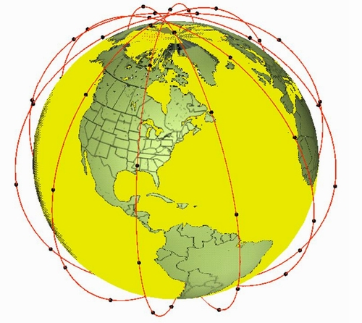
Figure 1: Iridium Satellite Constellation

Particularities of the Iridium signal
Iridium is designed to operate in up to 10.5 MHz of spectrum in the band 1616-1626.5 MHz and utilises time division multiple access (TDMA) technology for satellite access using bi-directional service link transmissions. At launch in 1998, the Iridium system was initially authorised to operate within the band 1621.35-1626.5 MHz, but has additionally been authorised in the USA and a number of other countries worldwide to operate down to 1617.775 MHz.
Iridium user terminals employ a time-division duplex (TDD) approach wherein they transmit and receive in an allotted time window within the frame structure. The TDD structure is built on a 90 ms frame and is composed of a 20.32 ms downlink simplex time slot, followed by four 8.28 ms up-link time slots and four 8.28 ms down-link time slots, with some guard times interspersed as is depicted in Figure 2. Since the system is using TDD, the subscriber units transmit and receive in the same frequency band. The access technology is a Frequency Division Multiple Access/ Time Division Multiple Access (FDMA/ TDMA) method whereby a subscriber is assigned a channel composed of a specific frequency and time slot in any particular beam. Channel assignments may be changed across cell/ beam boundaries (and across satellite handover) and are controlled by the satellite.

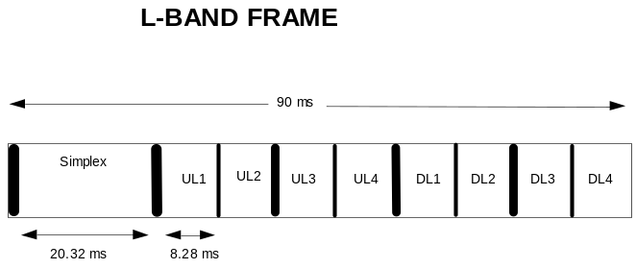
Figure 2: Iridium Frame Structure

Measurements of IRIDIUM satellites

Description of Leeheim monitoring station
The Leeheim Space Radio Monitoring Station is located approximately 35 km south-west of Frankfurt/Main.
The Leeheim MS has a number of satellite antennas including a 12 m parabolic reflector Antenna 1 designed to cover the 1-13 GHz frequency range, with which the monitoring was done. High-precision angular pointing allowed for accurate tracking of moving satellites. The relevant parameters of the Leeheim MS Antenna 1 are:
- Antenna type: cassegrain
- Dish diameter: 12 m
- Aperture efficiency (including taper): 0.64
- Polarization: linear
- Antenna gain: 44 dBi (1.5 – 1.8 GHz band)
- Figure of merit: 17 dB/K (1.5 – 1.8 GHz band)
- Zenith system temperature: 120 K at 1620 MHz (without stop band filter)
- Antenna tracking: programmable tracking using orbital elements
- Frequency stability: 10⁻¹² s/s
- Measurement uncertainty: 1.6 dB r.s.s. error (95% confidence level)
- Band Reject Filter - Type: Wainwright Instruments GmbH
- Filter Model Number: WRCD 1616/1627-1614/1630-70/16EE
- Filter Reject Attenuation: 1616.0 to 1627.0 MHz / 70 dB minimum
The dependence of antenna temperature T_{A} on elevation has been carefully determined in 1980 at the time of antenna commisioning (Figure 3). The filter loss (Figure 4) is responsible for the majority of the system noise, only for elevations near the horizon can we expect a significant contribution of the ground radation. Combining these filter losses with the elevation dependent antenna temperature Tant(φ), as interpolated from the measured values, yields the system temperature as a function of frequency and elevation:
T_{sys}(ν, ϕ) = T_{ant} (ϕ) + T_{RX} + 290 (L₁(ν) – 1)
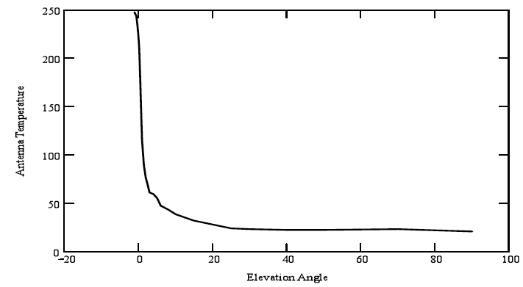
Figure 3: Leeheim antenna temperature as determined in 1980

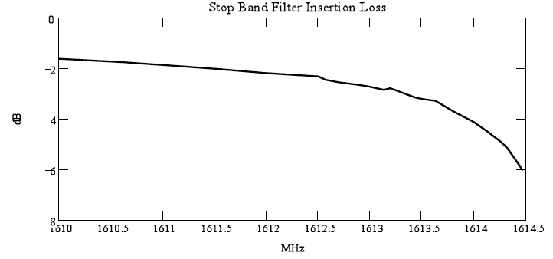
Figure 4: Insertion loss of the stop band filter
The graph in Figure 5 illustrates the expected behaviour of the system temperature for different elevations within the radio astronomical band.

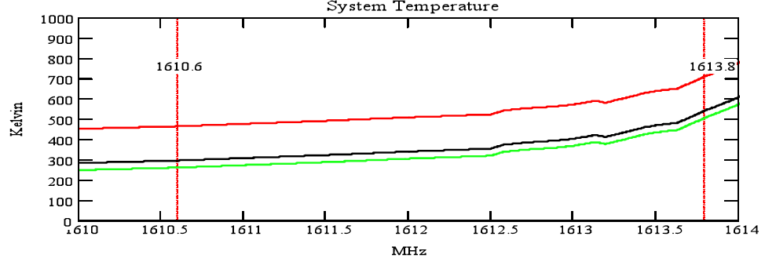
Figure 5: Total expected noise temperature for the Leeheim satellite tracking system used in the measurements. The green trace shows the expected system temperature at φ=90° (zenith), the black trace at φ=5° and the red trace at φ=0° (horizontal)

Description of the FFTS
The Fast Fourier Transform Spectrometer (FFTS) is a development of the Digital Laboratory of the Max Planck Institut für Radioastronomie (Germany) and is employed for radio astronomical observations at the Effelsberg (Germany) and APEX (Chile) telescopes. A compact and portable version of the instrument is capable of operation in a non-astronomical environment and could therefore be used for Leeheim MS satellite measurements.
The operational characteristics of the FFTS are as follows:
- Spectrometer bandwidth: 100 MHz (base band input : 0 – 100MHz )
- Number of channels: 16384
- channel bandwidth: 6104 Hz
- Minimum integration time : 0.1 second
- Minimum dead time between integrations: τ_{blank} = 50μs
- Optimal input level (50 Ohm): -10 dBm (total power one single channel):
For a channel bandwidth of 38 dB(Hz) this corresponds to a spectral power density of -48 dBm/Hz.
- Maximum full bandwidth noise power density: -10 -10∙log(Δν(ffts)/Hz) = -90 dBm/Hz
The minimum integration and dead times are constrained by the available bandwidth for internal data transfers and control, but continuous recording of spectra is possible within these constraints, leading to a data loss of less than 0.05%
The signal is digitized by an 8 bit ADC and the maximum input amplitude of the ADC limits the input power levels. This will result is different input limits depending on the spread of the signal spectrum. For smaller noise bandwidths, the input level may be adjusted accordingly. Because the FFTS does not contain an anti-aliasing input filter, the input level will have to be adjusted to the actual bandwidth of the supplied input signal.
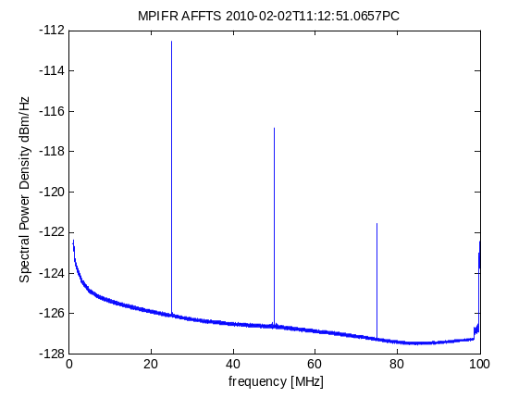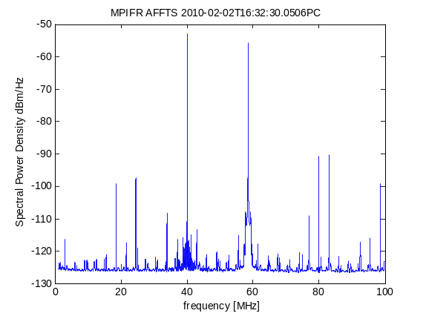
Figure 6: FFTS noise floor and IM properties
Noise floor and IM properties: The left hand panel of Figure 6 shows the spectrum without any input signal. FFT artefacts occur at integer fractions of the sampling frequency: 25, 50, 75 and 100 MHz. The strongest artefacts correspond to a signal spd of -112 dBm/Hz. These artefacts are narrow band (single channel) and can be masked out if necessary. For the remaining spectrum, the noise floor is at -125dBm/Hz. The available dynamic range is determined to be about 70 dB.
The right hand panel of Figure 6: shows the spectrum obtained after feeding two -13 dBm signals, one from a Schomandl frequency synthesizer at 40 MHz and the other from a Wavetek signal generator at 58.51 MHz. The signals themselves show harmonics at about -40 dBc, which made determination of higher harmonic intercept levels difficult. However, from the two second order products at f₂ – f₁ = 18.51 MHz and f₂ + f₁ = 98.51 MHz, the IIP2 of the detection system may be determined as -2.8 dBm per channel or equivalently -40 dBm/Hz. For a maximum input dual frequency signal level of -50 dBm/Hz, the second order IM products occur at -50 dBc, or -100 dBm/Hz. An input reduction by about 10dB will reduce the IM2 to values below the noise floor. Third and higher order IM products were visible at about -110 dBm/Hz, but did not rise with the input signal within the safe operating range of the FFTS.
Dataformat and Software: The data are binary 16k 4 Byte floating point values plus a small header, in total 65kB per recorded spectrum. For the shortest integration time of 0.1 seconds, the data rate will be 40MB per minute. The format is documented and MATLAB routines have been provided for control of the FFTS and for the data reduction. Measurement data can be made available by contacgtingthe SAT MoU (add link).

Calibration procedure
The observing procedures used for all satellite measurements incorporate the well-established calibration procedures used in radio astronomy. These incorporate the following measurement steps:
1. During each measurement session the two strong celestial calibrator sources Cassiopeia A and Cygnus A were observed. These sources, which emit a known flux strength in the band of interest, were used to calibrate the system bandpass across the RAS band and to provide the calibration scale from antenna temperature to absolute flux in units of Wm⁻²Hz⁻¹ for the satellite observations.
2. All satellite observations consisted of a continuous tracking observations (from horizon to horizon) with a typical duration of 700 seconds followed by a observation of a blank sky position (antenna azimuth of 0° and elevation of 50°). The blank sky section of each observation was used to subtract the zero level baseline from the tracking part of the data.

Calibration Sources: The celestial calibrator sources Cassiopeia A (size 4.3’) and Cygnus A (size 2’) have a known (calibrated) flux density and are unresolved by the Leeheim MS antenna beam (HPBW = 1.05°). The measured total flux at the antenna in mW per channel (antenna temperature) of the calibrator source directly determines scaling of the individual channels of the FFTS in astronomical flux units given as 1 Jansky (Jy) = 10⁻²⁶ Wm⁻²Hz⁻¹.
Cyg A has a flux density of 1690±3 Jy at 1304 MHz and 1210±3 Jy at 1765 MHz (Baars et al., Astronomy and Astrophysics, 61, 99-106, 1977). Linear interpolation yields a flux density of 1371 ±5 Jy at 1610 MHz (interpolated flux density). Similarly the flux density of Cas-A is 1851 Jy at 1610 MHz. An example calibration measurements of Cygnus A is presented in Figure 7.
The shape of the bandpass across the RAS band is strongly affected by the stop-band filter in Figure 8 (left). A “spline fit” (interpolation) through the spectrum may be used to correct for this bandshape and produces a spectrum for Cyg-A as presented in Figure 8 (right). Using the system noise and the conversion efficiency of the antenna, 0.026 K/Jy one can calculate the system temperatures across the band and their range from 350 – 700 K is in good agreement with predictions derived from the system characteristics. After flattening of the bandpass of the measurement data may be converted to flux units using the conversion function (from antenna temperature to Jansky) shown in Figure 8 (right). Some strong and narrow interference was sporadically found in the data, which was ignored in subsequent data processing.

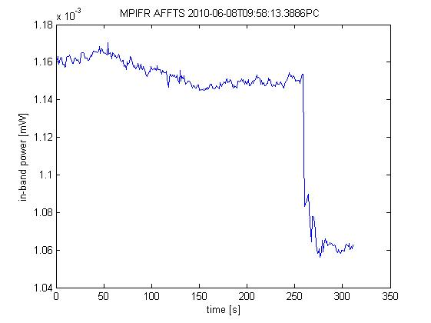
Figure 7: Example measurement of Cyg-A with Leeheim. The Cygnus A source is present till 250 sec followed by the background measured for an antenna azimuth of 0° and elevation of 50°

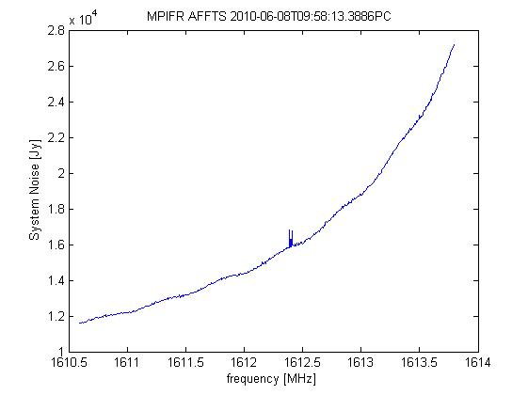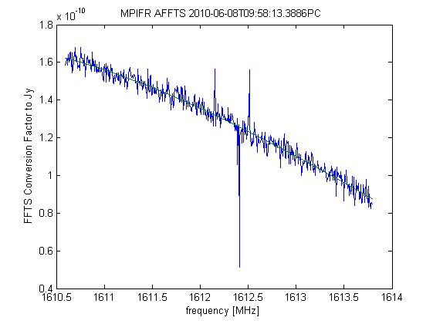
Figure 8: System noise and transfer function from calibration on Cyg-A01

Leeheim measurements sessions
The measurement sessions at the Leeheim MS were executed by staff of MPIfR and BNetzA (Germany) supported by staff from ASTRON (Netherlands). During the session in June an Iridium representative was present at the Leeheim MS. The main campaign took measurements during a window between 08:40 – 17:30 (CEST) during two days. Measurements were not taken outside of that window.
Measurements at Leeheim MS on 26.2.2010
This session was used to conduct test observations in order to verify the compatibility of the FFTS with the signals and environment of the Leeheim MS. Initial tests to verify the frequency alignment, the power levels and the intermodulation characteristics were followed by two calibration measurements on celestial radio sources Cyg-A and Cas-A to verify the consistency and stability of the observing system. Observation conditions were excellent on that day and the source strengths over the band were consistent with the literature. They were also found to be about 10% of the noise level of the observation system, as predicted by previous estimates. Two satellites (IR-95 and IR-97) were tracked with the antenna and their spectra were recorded by the FFTS.
Measurements at Leeheim MS on 8.3.2010
A further test observation was conducted during the SE40 kick-off meeting to define the measurement campaign. After calibration observations of Cyg-A, one scan for a full transit (700 seconds) of IR-82 was taken.
Measurements at Leeheim MS on 8-9.6.2010
The main measurement campaign at Leeheim was jointly carried out by MPIfR, ASTRON and BNetzA on Iridium satellites on 8th and 9th June, 2010.Measurements were taken once per second in 6.1 kHz channels in the range 1610.6-1613.8 MHz from 28 satellite passes of the Iridium constellation, observed between 08:30 and 17:30 (local time) over two days. Data corruption or tracking errors resulted in 5 data sets being discarded, but the remaining 23 data sets were collected. The table in Annex 1 shows the satellite identification, the approximate start time for beginning measurements, the azimuths that the satellite rose above and fell below the horizon, and the maximum elevation angle at the Leeheim site.
Due to the contribution of thermal ground radiation the antenna temperature is elevated at low elevation angles (<6°). In addition, terrestrial interference sources have a greater impact at lower elevations. For these reasons, measurement data taken below 6° elevation were not used in the subsequent analysis.
Calibrations were made on Cas-A and Cyg-A. Their values agreed within 10% and the best one for Cyg-A was used for an evaluation of the spectra obtained on the 8th and 9th of June. Annex 2 gives an overview of the individual measurements.

Assessment of IRIDIUM IMPACT to RAS

Direct (static) Analysis
As detailed in section 3.2, ITU-R Recommendations define the method for measuring the impact of interference on RAS observations by use of an epfd and a dynamic simulation. A direct (static) analysis, such as that shown here, may provide a first estimate of the impact and allows for comparison with predictions made in Recommendation ITU-R SM.1633 [7]. However, a static analysis may not be considered as a full assessment as it provides an estimate of the interference levels seen by a 0 dBi antenna but does not take into account the full RAS antenna pattern which provides suppression beyond 14° offset, and also higher gain close to the main beam. RA.769 states that “the particular case of non-GSO satellites presents a dynamic situation, that is, the positions of the satellites relative to the beam of the radio astronomy antenna show large changes within the time scale of the 2 000 s integration time. Analysis of interference in this case requires integrating the response over the varying side-lobe levels, for example, using the concept of epfd defined in No. 22.5C of the Radio Regulations”. The epfd approach described in Recommendation ITU-R M.1583 [6] can only be assessed using a simulation tool such as that used in section 6.2.
The uncalibrated data of a full transit of IR-95 on 26.02.2010 is presented in Figure 9 (left), using an (data record) integration time of 1 second and a total recording time of 867 seconds in the band 1610-1614 MHz (logarithmic display after bandpass correction and without background subtraction). Figure 1 (right) shows the averaged spectrum for the complete transit of the satellite.
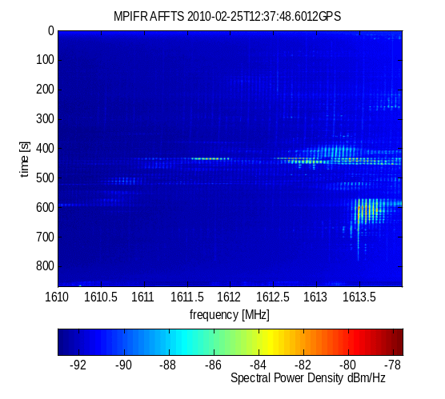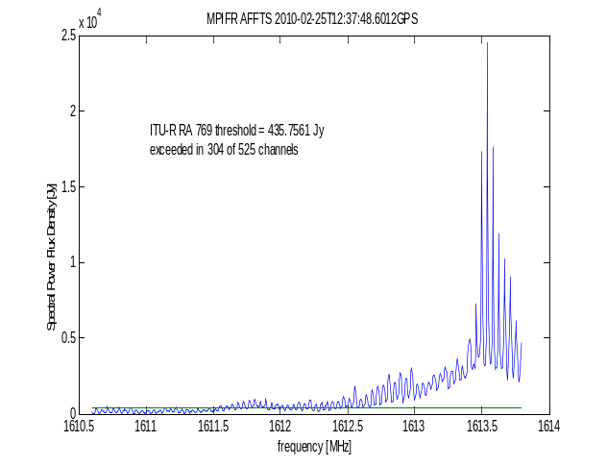
Figure 9: Uncalibrated spectrogram (left) and averaged spectrum (right) of Iridium 95 unwanted emissions in the band 1610-1614 MHz
The noise background for the measurements of IR-95 in Figure 9 was determined by averaging unaffected spectra taken from the recording between 790 – 850 seconds after its beginning for which there was no evidence of any satellite emissions in the spectrum. The average background was subtracted from each of the spectra before the production of the linear scale spectrogram. The spectra were then averaged in the time domain and a small residual offset was subtracted from the mean spectrum to account for the variation of the system noise during the observation. The rms of a time averaged spectrum channel was about 33 Jy. The Recommendation ITU-R RA 769 threshold for this observations is
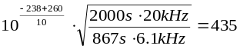 Jy
and that level was exceeded in the average spectrum in 304 of the 525 (≈ 60%) available channels.
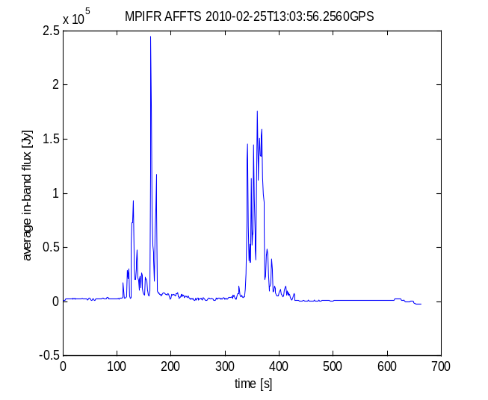

Figure 10: Calibrated evolution of Iridium 97 unwanted emissions with time
A second example for the monitoring data is presented for IR-97, which was monitored during a full transit with a high time resolution of 0.1 s during 680 seconds on 26.02.2010 in Figure 10. The higher time resolution did not provide significant additional information and the subsequent measurements were all done with 1 second time resolution. This plot shows the highly transient nature and the strong peaks of the satellite emissions. The calibrated spectrogram in dB(Jy) for IR-97 is presented in Figure 11 (left) and displays the same patterns as the previous observations by the Leeheim station using the industrial equipment. The averaged spectrum obtained after 680 seconds in Figure 11 (right) shows two strong emission centres one around 1611.5 MHz and the around 1613.25 MHz.
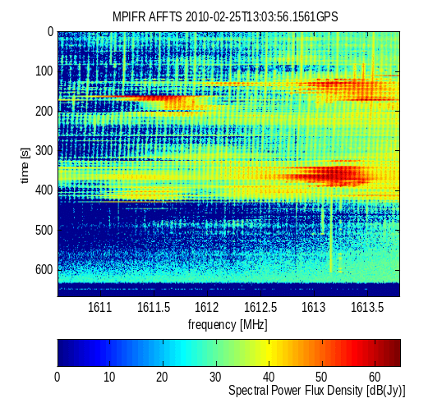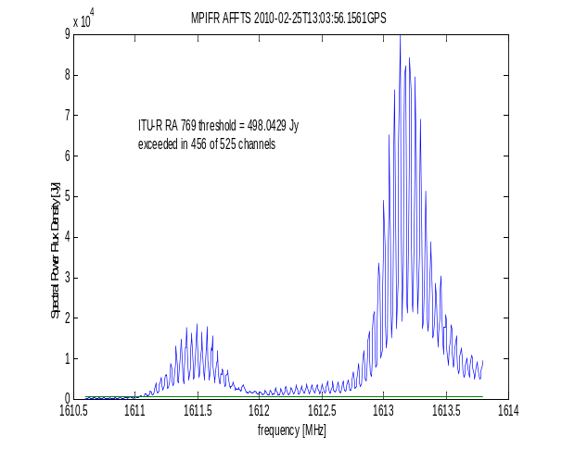
Figure 11: Calibrated spectrogram (left) and average spectrum (right) of Iridium 97 unwanted emissions in the band 1610.6-1613.8 MHz
Analysis for the IR-97 observation shows that 456 out of 525 (≈ 79%) channels are affected by excessive satellite emissions. These are signal above the 0dBi entry level as required for an assessment of compliance with Recommendation ITU-R 769. The gain of the observing system is already incorporated in the calibration factors.
A third example of the IR-82 transit on 8.3.2010 shows that the previously described behaviour is typical and that the results are reproducible in Figure 12. The maximum elevation for the satellite was 29° and the satellite exceed the RFI limit of the average spectrum in 52% of the available bandwidth.

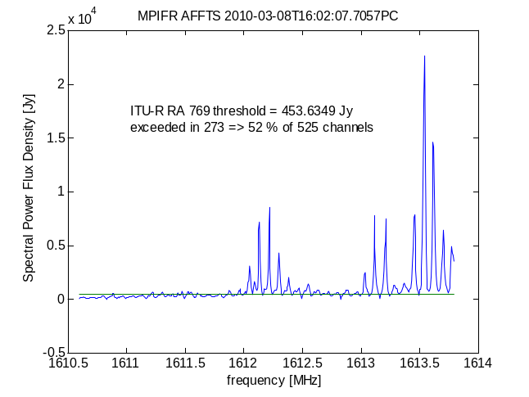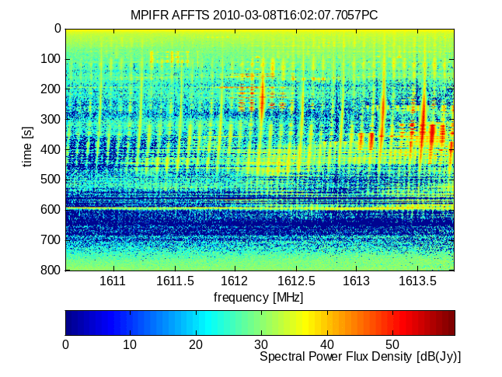
Figure 12: Calibrated average spectra and spectrogram of Iridium 82 unwanted emissions in the band 1610.6-1613.8 MHz
The direct analysis (Annex 2) of the thirty Leeheim measurements shows that any single Iridium satellite transit causes ground-level interference exceeding the time and bandwidth adjusted Recommendation ITU-R RA.769 thresholds for the band 1610.6-1613.8 MHz by more than 20dB on timescales ranging from 1 second to 800 seconds. The loss of bandwidth exceeded 30% in all averaged spectra (median 76%) and a minimum of 11% (with a median of 47%) of all 1 second spectra had to be discarded because of spectral contamination by Iridium out-of-band emissions. The measurements in Leeheim also confirm the findings of the Effelsberg interference report from 1.3.2006.
It should be noted that measurements conducted by NRAO on individual satellites run under artificial full-load conditions in 1998 showed similar results as this static analysis. Changes to some of the operational parameters of the Iridium system were made after the NRAO tests (around 2003) to improve compatibility with RAS.

Epfd (dynamic) Methodology
The calibration procedure presented above in Section 5.3 has been used to convert the FFTS power measurements into power flux densities in W/m²/Hz. The following steps have been taken to prepare the available data for the epfd calculations using the Figure 13 for IR-21 as a guideline:
- Sum the 3 contiguous 6.1 kHz measurement channels (green curves) for each time step as represented by the blue curve in Figure 13.
- Determine the range of the useable data by determining the average (offset) and standard deviation (threshold) of each frequency bin using the background noise tracking obtained between 120 to 180 sec. Substract this offset and set all data points below the (one sigma) threshold to 0 W/m². This produces the combined red and black curve in Figure 13.
- Select the measurement portion where the elevation angle is greater than 6° (see start and end times in Annex 3) as depicted by the red curve in Figure 13. The antenna charcteristic (Figure 3) and its impact on the system noise in Figure 5 indicate a steep rise in system noise below 3° elevation under ideal conditions. The influence of topography may increase the noise background at elevations slightly higher than these 3° and the fact that geometrical projection effects let the satellite dwell for longer at lower elevation will lead to a noise increase for a substantial time at the end of the measurement as shown in the end of the tracking in Figure 13.
- To characterise the resulting distribution of interference power levels, a suitable bin size was chosen in which to place the values: linear bin sizes (i.e. in terms of W/m²/Hz) or logarithmic bin sizes ( i.e. in terms of dBW/m²/Hz). The number of bins was chosen to be the square root of the number of samples (e.g. 25 bins for 600 samples). The binned pfd distribution for the IR-21 has been presented in Figure 14.
- In four of the data sets obtained on 8-9.6.2010, satellite emissions were found to be present in the whole track and the noise background could not be determined. These measurements were discarded and the remaining 23 measurements were used for the determination of the sample distribution of interference power levels.
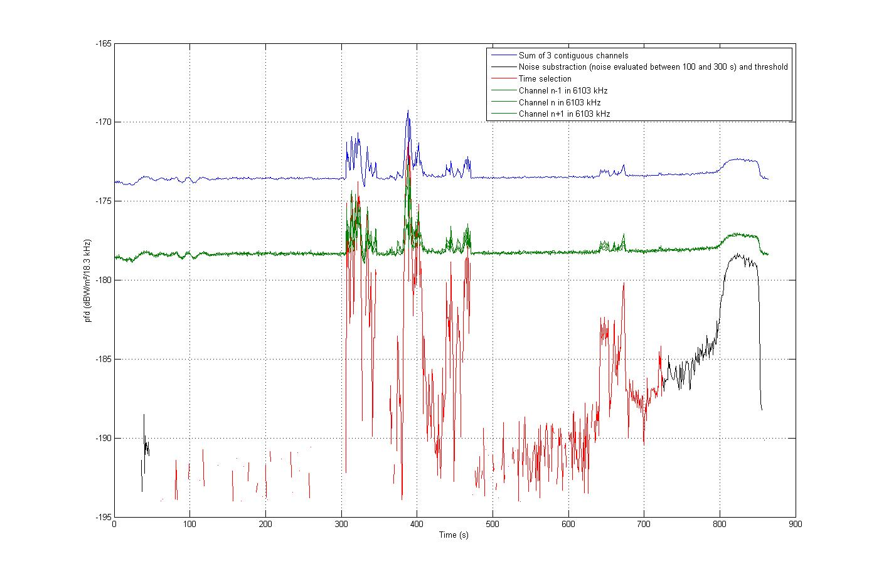
Figure 13: Iridium 21 in the frequency channel 1613.7695MHz
(The calculations are made in linear values and converted in dB for display)
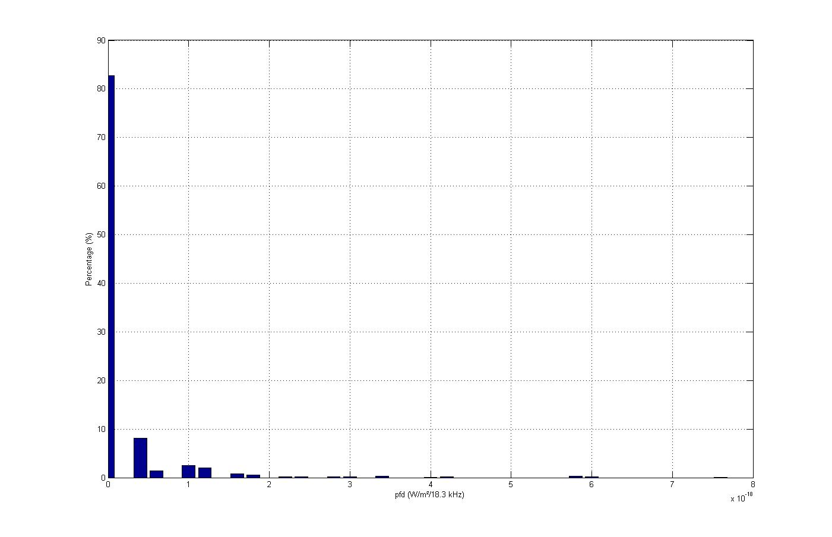
Figure 14: Example of pfd distribution for Iridium 21 and channel 1613.7695 MHz (28 bins)
The rest of the methodology was carried out using a simulation tool based on a modified version of the methodology contained in Recommendation ITU-R M.1583 [6] that takes into account the Doppler effect and the pfd difference from one satellite to the other. The algorithm flow with two iteration loops is summarized below:
For each trial:
For each cell over the sky:
- Determine a random pointing of the telescope within the cell
- Determine a random initial time of simulation T₀
For each satellite:
  - Calculate the position of the satellite for each second of the integration time, starting at T₀
  - Determine for each time step an interference pfd value following the distribution law derived above
  - Calculate the RAS antenna gain in the direction of the satellite
  - Calculate the sum of RAS gain and interference pfd
- Calculate the epfd at the RAS station by linearly summing the contribution of each satellite, then divide by the maximum antenna gain to get an epfd instead of an aggregate pfd, then determine the mean value over the integration time.
- Compare the epfd value in dB to (the Recommendation ITU-R RA.769 limit – maximum antenna gain) to determine whether there is a data loss or not
These trials are repeated to obtain a statistical significance, in this case 100 times to give a resolution of 1%. Data loss as a percentage of trials was calculated for each cell, and the average was calculated for the whole sky as the average of all cells as described in Recommendation ITU-R M.1583 [6].

Results of epfd Methodology
The variation of the data loss across the sky (in azimuth and elevation) for the frequency channel 1610.6199 MHz at the lower edge of the RAS frequency band is presented in the Figure 15. The data loss is found to be 93.2% when considering an integration time of 2000 seconds. In order to meet the 2% criterion the interference power level should be reduced by 13 dB. The data loss across the sky for the frequency 1613.7878 MHz at the higher edge of the RAS frequency band is found to be 100% when considering an integration time of 2000 seconds. In order to meet the 2% criterion the interference power level should be reduced by 20 dB.

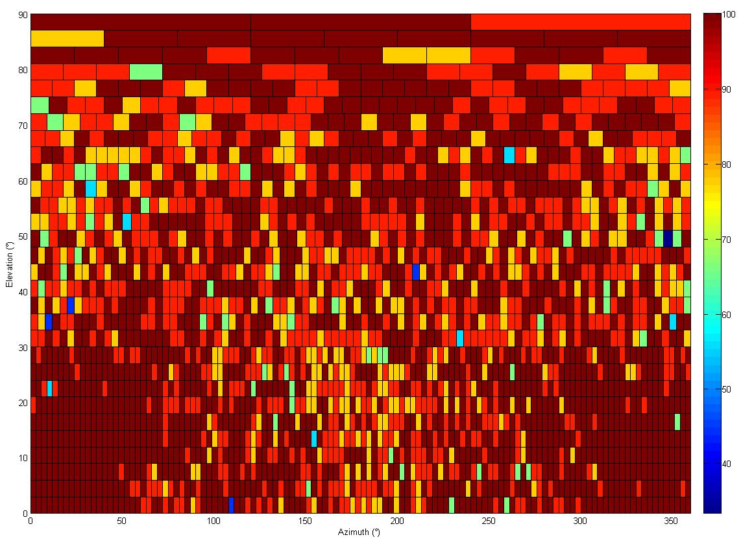
Figure 15: Data loss over the sky for a 2000s integration time and the channel 1610.6199 MHz
The data loss for the frequency 1610.6199 MHz at the lower bound of the RAS frequency band is 4.7% when considering an integration time of 30 seconds in Figure 16 left. In order to meet the 2% criterion the interference power level should be reduced by 4 dB.
The data loss for the frequency 1613.7878 MHz at the higher bound of the RAS frequency band is 43.5% when consideringan integration time of 30 seconds in Figure 16 right. In order to meet the 2% criterion the interference power level should be reduced by 11 dB.
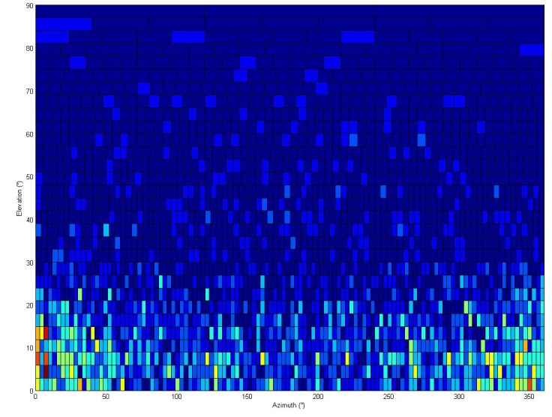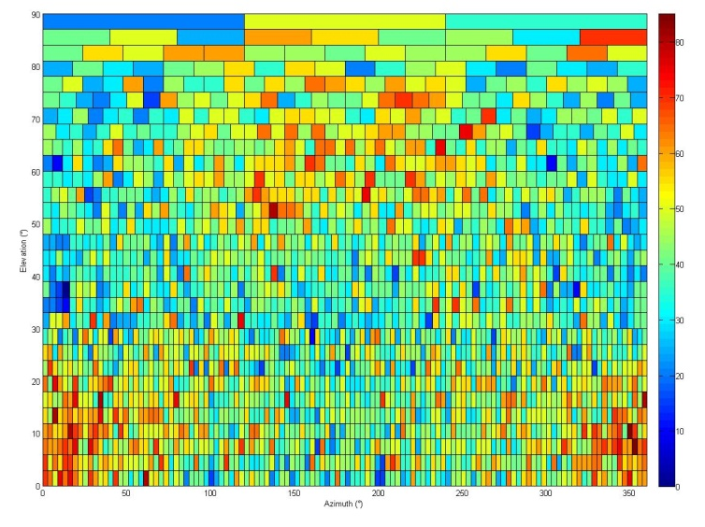
Figure 16: Data loss over the sky for a 30s integration time for the channel at 1610.6199 MHz
and the channel at 1613.7878 MHz

DISCUSSION OF RESULTS and COMPARISON WITH PREVIOUS measurements

Difference with previous measurements
Previous measurement at Leeheim MS have been reported in ECC Report 112 [10]. The data presented in that report had not been calibrated using external reference sources and the calibration is thus only estimated from the known system characteristics. The detection equipment employed a swept LO technique which has an inherently lower sensitivity for noise and other time variable signals given by the square root of the ratio of integration time over channel dwell time. For a spectrum of 1000 channels taken during 1 second has a sensitivity that is or 15 dB less than that of a continuously sampling and integrating FFT spectrometer. Test measurements by the German UWB Measurement Committee have shown that there can be significant differences between the values measured by commercial equipment. The differences in statistical distributions between the earlier measurements (2006, 2008) and current (2010) measurements may be the consequence of different equipment characteristics and inferior calibration methods used during the previous measurements, in addition to increases in Iridium satellite traffic.
Theoretical predictions and measurements carried out in 1998 with the Iridium (HIBLEO-2) constellation under artificial full-load conditions have been summarised in Recommendation ITU-R SM.1633[7] (2003), Annex 6:
“4.2 Calculation of the interference level
Unwanted emissions in terms of aggregate spfd of HIBLEO-2 satellite transmissions in the 1610.6-1613.8 MHz band have been theoretically estimated to range between -214 dB(W/(m²/Hz)) and -223 dB(W/(m²/Hz)) at some radio astronomy sites, under fully loaded conditions..
4.3 Values achieved
A collaborative test program, conducted by HIBLEO-2 (Iridium) and the United States National Radio Astronomy Observatory (NRAO), in 1998 measured spfd values ranging from -220 to -240 dB(W/(m²/Hz)) at these sites [11]. These values refer to the so-called voice channels that are turned on when communication takes place. In addition the HIBLEO-2 system was found to radiate broadcast signals at all times. The spectra of the broadcasting channels showed 9-10 narrow (less than 40 kHz wide) peaks within the radio astronomy band. spfd peak values appeared to average -227 dB(W/(m²/Hz)) over 90 ms.”
The observed interference in the RAS band has the same peak characteristics as those reported in Recommendation ITU-R SM.1633 [7] dating from 1998. The peak emission values obtained in the current Leeheim MS measurements are comparable with those predicted theoretically for fully loaded conditions, where -214 dB(W/m²Hz) translates into 40 kJy. A comparison of the measured spfd values from Recommendation ITU-R SM.1633 [7] with the thresholds obtained from Recommendation ITU-R RA.769 indicates that the measurements from 1998 exceeded the -238 dB(W/m²Hz) threshold value for a significant fraction of time.

Origin of Intermodulation Products in the Band 1610.6-1613.8 MHz
The Iridium satellite interference in the band 1610.6 -1613.8 MHz is caused by 7th order intermodulation products generated on the satellite and not by overloading of radio astronomical receivers. Analysis of spectra of the interference taken at the Effelsberg telescope (report from 1.3.2006) shows that the two fundamental Iridium carriers at f₁ = 1618.25 MHz and f₂= 1620.25 MHz produce the observed interference at 1612.25 MHz, which corresponds to the intermod relation f₁ - 3δf = 4f₁ - 3f₂ and suggests a 4 + 3 = 7-th order IM product. No evidence was found of any lower order products at 1.61425 and 1.61625 GHz. Ordinary amplifiers and mixers would produce an interference pattern where the power in IM products decreases with increasing order. These low (3-5) IM orders are evidently suppressed by signal processing on board the Iridium satellite while high order IM products are evident.
State-of-the-art microwave amplifiers and radio astronomical receivers have third order intercept points (IIP₃) at -30 to -25 dBm. A main carrier of –178 dBm of the Iridium satellite (as observed) cannot create detectable self-interference in a radio astronomical receiver frontend. The strength of the interference allows an estimate of the 7th order intercept for the satellite transmitter of about +19dBW, which is close to the satellite e.i.r.p. of +11 dBW. This suggests that the satellite transmitter has been driven into compression will produce strong out of band emissions on both sides of the Iridium band. For certain transmission channel allocations, the 7th order intermodulation products will fall into the RAS band.

Potential solutions for the Iridium system to address the interference situation
One or a combination of the following measures may result in a substantial reduction of the intermodulation products from the MSS satellite operation into the RAS band:
- Because of a steep dependence of the IM products on transmitter power, it is expected that a reduction of peak power by about 3 dB or alternatively a bandwidth reduction for multichannel operations can significantly reduce the generation of interference.
- Modification of the channel allocation sequencing can assure that 7th order intermodulation product of any two transmission channels will be outside the band 1610.6-1613.8 MHz. On the basis of such a scheme, assuming Iridium operation within the band 1618.25-1626.5 MHz, a simple analysis shows that some 56% of the allocated MSS band can be used without restriction in the choice of channels or output powers. The remaining frequency intervals can be used with some restriction. Full occupation of the lower channels by one satellite will forbid the additional use of some higher frequency channels.
- A suitable combination of power control and channel spacing may be employed to optimize the operation of the Iridium MSS network while avoiding interference detrimental to radio astronomy.
- The construction and operation of new satellites that by their design do not create interference detrimental to radio astronomical stations.
The combination of a reduction of the peak power and a modified channel allocation scheme, that avoids the creation of interference in the radioastronomical band, could serve as an intermediate solution until the improved satellites are in operation. However, these methods have a technical and operational impact that may limit or prevent the intended purpose of the satellite constellation.

Potential solutions for the RAS stations to address the interference situation
A number of measures have been identified which can mitigate the impact of interference from non-GSO satellites on RAS observations, including:
- Satellite “dead time”. Iridium satellites operate on a TDD mode (see Figure 2, section 4.2), with the satellite transmitting for approximately 55% of a frame, and receiving for the remaining 45%. As the entire constellation is synchronised, all satellites are in receive mode at the same time and no interference is generated in the RAS band. Synchronisation of the RAS data recording with the timing of the satellite constellation allows the data impacted by interference to be removed before integration.
- Polarisation discrimination. Iridium signals at L-band, both wanted and unwanted, are right-hand circular polarised. Observation of RAS emissions in the opposite polarisation significantly reduce the levels of interference power received. A study undertaken at the Raman Research Institute, Bangalore, and Arecibo Observatory, Puerto Rico, identified methods that may provide up to 32dB of additional suppression to interference in the RAS band. (“Iridium Satellite Signals: A Case Study In Interference Characterization And Mitigation For Radio Astronomy Observations”, Deshpande & Lewis [12]).
- Digital Signal Processing (DSP) techniques to remove Iridium unwanted emissions from RAS meausrements. A thesis developed at the Virginia Polytechnic Institute, USA, describes a technique to meaure Iridium signals in parallel to RAS observations, and then apply DSP techniques to subtract the interference from the wanted RAS emissions. This author suggests up to 15dB of interference suppression can be achieved in this way. (“Mitigation of Interference From Iridium Satellites By Parametric Estimation And Subtraction”, Shahriar [13]).
- Observations during low-traffic periods. Measurements taken in 1998 (see Recommendation ITU-R SM.1633 [7]) showed a significant drop in interference during low traffic periods, typically below the thresholds given in RA.769. Futher operational modifications to the Iridium constellation have further reduced emissions during these periods.
These techniques may be used individually or in combination, and can mitigate the impact of interference on RAS observations. However, these techniques would still imply considerable data loss ranging between 30 and 55%, which would be an undue burden on Radio astronomy as a victim service. In addition, item d) would be difficult to achieve in practice.

CONCLUSIONS
Analysis of recent observations at the Leeheim satellite monitoring station shows that the normal daytime operation of the satellites in the Iridium MSS network causes interference in the radio astronomical band 1610.6 -1613.8 MHz, in excess of the limits given in Recommendation ITU-R RA.769-2 [3]. Epfd simulations according to Recommendation ITU-R M.1583 [6], using pfd data derived from the new Leeheim measurements, estimate the combined effect of the visible satellites and show that the data loss in a reference time interval of 2000 seconds reaches 90-100% in the upper part of the RAS band around 1613.8 MHz and goes down to about 90% close to the lower boundary of the RAS band at 1611 MHz. For shorter reference time intervals of 30 seconds the percentages data loss vary from 5% to 44% at the lower and upper edges of the RAS band. Interference signal levels need to be reduced by between 10 and 25 dB in order to keep the data loss below the threshold given by Recommendations ITU-RA.769-2 [3] and ITU-R M.1583 [6].
Measurements were only taken during the period 08:40 – 17:30 (local time), which does not cover any possible variation of interference outside of this window.
The findings of the current Leeheim MS measurements are consistent with pre-operational measurements carried out on fully-loaded satellites in 1998 and summarised in Recommendation ITU-R SM.1633 [7].
The interference is likely to be caused by non-linearities in the satellite transmitting elements, the effects of which increase with the 7th power of the output power. It has been suggested that a reduction of satellite output power by 3-5 dB can sufficiently suppress the interference, but the practical impact of this on operations of the satellite network have not been assessed here. A modified channel allocation scheme has also been suggested, such that the generated interference avoids the radio astronomical frequency band, but this would significantly reduce the capacity of the satellite system. In its simplest mode, such a scheme will leave 56% of the available spectrum unaffected. A combination of channel allocation and power control may be used to optimize the MSS network operation, while ensuring that no harmful interference occurs in the radio astronomical band, but the practical implications of this were not assessed.
Some mitigation techniques have been identified that can be employed by radio astronomy observatories, some of which have already been employed to take RAS measurements in the presence of Iridium unwanted emissions. However, there may be practical limitations to their applicability. In addition, these would still imply unacceptable data loss.
The planned new generation of Iridium MSS satellites should be designed, built and operated to avoid interference detrimental to radio astronomy.
Regular monitoring of the Iridium out of band emissions in the radio astronomical band by the Leeheim MS should be used to verify the compliance with Recommendations ITU-R.769-2 [3] and ITU-R M.1583 [6]. The measurements should be made at least twice per year on an otherwise random schedule, using similar equipment and measurement techniques as described here.

ANNEX 1: Trajectories of Satellite Passes used in Deriving Interference Profile

 | Approx Start time (UTC)
Satellite # | hr | min | sec | Azimuth-up (°) | Azimuth-down (°) | Elevation (max)(°)
June 8th, 2010
3 | 9 | 33 | 37 | 2 | 150 | 34
25 | 10 | 10 | 8 | 357 | 170 | 67
49 | 10 | 56 | 1 | 351 | 194 | 52
32 | 12 | 4 | 34 | 359 | 164 | 54
58 | 12 | 32 | 1 | 356 | 178 | 88
55 | 12 | 59 | 33 | 352 | 192 | 54
29 | 13 | 17 | 59 | 349 | 202 | 38
4 | 14 | 17 | 21 | 358 | 168 | 62
61 | 14 | 35 | 40 | 356 | 177 | 86
97 | 15 | 12 | 24 | 351 | 195 | 48
6 | 15 | 30 | 47 | 348 | 205 | 34
June 9th, 2010
82 | 6 | 40 | 51 | 160 | 10 | 42
43 | 6 | 59 | 2 | 170 | 8 | 59
42 | 7 | 17 | 12 | 190 | 5 | 84
39 | 7 | 35 | 24 | 189 | 3 | 70
64 | 8 | 18 | 42 | 355 | 180 | 85
67 | 8 | 46 | 15 | 351 | 194 | 50
21 | 9 | 4 | 39 | 349 | 204 | 36
76 | 9 | 27 | 33 | 2 | 150 | 34
32 | 11 | 31 | 7 | 3 | 149 | 32
57 | 11 | 49 | 21 | 0 | 159 | 44
59 | 12 | 7 | 38 | 358 | 168 | 62
55 | 12 | 25 | 57 | 355 | 178 | 88
Table 2: trajectory of Iridium satellites measured, as seen from the Leeheim station

To illustrate the trajectories of each satellite under observation, the azimuths that each satellite rose above and fell below the horizon are shown in the following two figures.
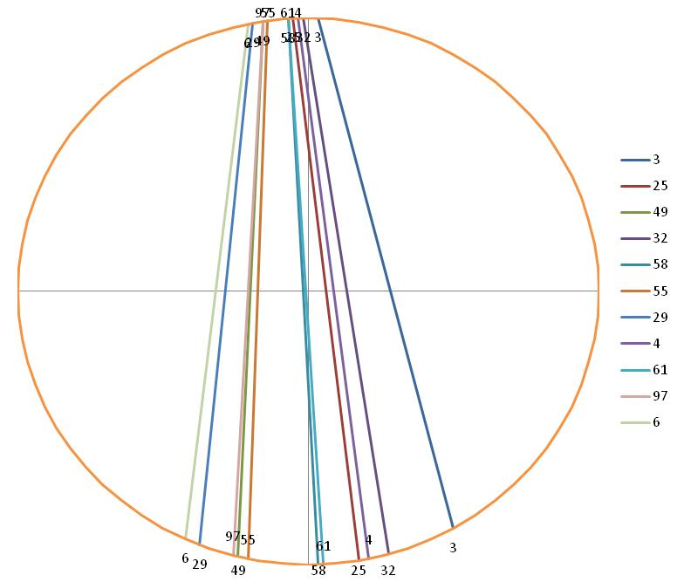

Figure 17: Trajectories of Satellites Observed, 8th June 2010

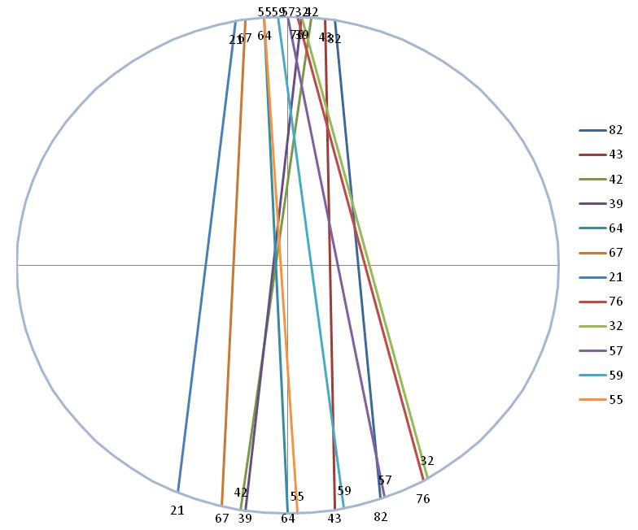

Figure 18: Trajectories of Satellites Observed, 9th June 2010

ANNEX 2: Direct (static) analysis of measured data
As detailed in section 3.2, ITU-R Recommendations define the method for measuring the impact of interference on RAS observations by use of an epfd and a dynamic simulation. A direct (static) analysis, such as that shown here, may provide a first estimate of the impact and allows for comparison with predictions made in Recommendation ITU-R SM.1633 [7]. However, a static analysis may not be considered as a full assessment as it provides an estimate of the interference levels seen by a 0 dBi antenna but does not take into account the full RAS antenna pattern which provides suppression beyond 14° offset, and also higher gain close to the main beam. RA.769 states that “the particular case of non-GSO satellites presents a dynamic situation, that is, the positions of the satellites relative to the beam of the radio astronomy antenna show large changes within the time scale of the 2 000 s integration time. Analysis of interference in this case requires integrating the response over the varying side-lobe levels, for example, using the concept of epfd defined in No. 22.5C of the Radio Regulations”. The epfd approach described in Recommendation ITU-R M.1583 [6] can only be assessed using a simulation tool such as that used in section 6.2.

 |  |  | Iridium Measurements at Leeheim 2010
 | Emissions exceeding RA.769 levels
Satellite | In average spectrum with 525 channels (limit 450 Jy) |  |  | In single 1 second spectra |  |  |  | Peak fluxes (kJy)
IR - nn | No. of channels | % of channels |  | No. of spectra | No. with RFI | % |  | In average spectrum | In single channel
Date: 25.02.2010
95 | 307 | 58 |  | 868 | 348 | 40 |  | 23 | 567
97 | 457 | 87 |  | 665 | 309 | 46 |  | 85 | 2955
Date: 8.3.2010
82 | 273 | 52 |  | 801 | 319 | 39 |  | 22 | 866
Date: 8.6.2010
3 | 160 | 30 |  | 857 | 90 | 11 |  | 2 | 50
25 | 460 | 87 |  | 836 | 592 | 71 |  | 11 | 452
46 | 466 | 89 |  | 634 | 431 | 68 |  | 13 | 358
49 | 392 | 75 |  | 745 | 431 | 58 |  | 14 | 1575
32 | 303 | 57 |  | 840 | 400 | 48 |  | 14 | 334
58 | 402 | 76 |  | 866 | 329 | 38 |  | 9 | 557
55 | 282 | 53 |  | 815 | 306 | 38 |  | 13 | 376
29 | 189 | 36 |  | 800 | 85 | 10 |  | 3 | 80
7 |  |  | Receiver failure,- no signal
4 | 439 | 83 |  | 860 | 699 | 81 |  | 10 | 174
61 | 511 | 97 |  | 830 | 395 | 48 |  | 10 | 622
54 | 386 | 73 |  | 837 | 443 | 53 |  | 5 | 116
97 | 428 | 82 |  | 815 | 499 | 61 |  | 9 | 222
6 | 174 | 33 |  | 810 | 220 | 27 |  | 8 | 504
Date: 9.6.2010
82 | 521 | 99 | * | 840 | 669 | 80 |  | 15 | 1865
43 | 514 | 98 | * | 830 | 655 | 79 |  | 46 | 1348
42 | 514 | 98 | * | 850 | 475 | 56 |  | 6 | 357
39 | 522 | 99 | * | 850 | 767 | 90 |  | 23 | 1397
62 | 453 | 86 | ** | 258 | 132 | 51 |  | 13 | 568
64 | 357 | 68 |  | 850 | 393 | 46 |  | 6 | 321
67 | 254 | 48 |  | 825 | 300 | 36 |  | 23 | 1041
21 | 356 | 68 | † | 864 | 253 | 29 |  | 17 | 7617
76 | 402 | 77 |  | 843 | 542 | 64 |  | 52 | 1664
76 | 501 | 95 | * | 830 | 779 | 94 |  | 51 | 3310
32 | 212 | 40 |  | 800 | 221 | 28 |  | 4 | 54
57 | 203 | 39 |  | 860 | 263 | 31 |  | 5 | 294
59 | 156 | 30 |  | 860 | 172 | 20 |  | 2 | 169
55 | 469 | 89 |  | 850 | 224 | 26 |  | 17 | 1012
 |  |  | * Background affected by Iridium signals, received signal levels are underestimated!
 |  |  | ** incomplete track
 |  |  | † maximum peak emission in this observation
 | Median fraction of lost channels in average spectrum |  |  |  | Median fraction of 1 second spectra contaminated with RFI
 |  | 76 | % |  |  | 47 | %
Table 3: Direct (static) analysis of Iridium measurements

ANNEX 3: Determination of measurement periods where the elevation angle exceeds 6°

 | Elevation above 6°  (UTC time) |  |  | Elevation below 6°  (UTC time) |  |  | Duration (secs) | Reference points in data set
Satellite # | hr | Min | sec | hr | min | sec |  | Start | Stop
3 | 9 | 35 | 7 | 9 | 46 | 24 | 677 | 296 | 973
25 | 10 | 11 | 32 | 10 | 23 | 37 | 725 | 42 | 767
49 | 10 | 57 | 25 | 11 | 9 | 12 | 707 | 1 | 708
32 | 12 | 5 | 59 | 12 | 17 | 55 | 716 | 41 | 757
58 | 12 | 33 | 24 | 12 | 45 | 32 | 728 | 102 | 830
55 | 13 | 0 | 57 | 13 | 12 | 48 | 711 | 49 | 760
29 | 13 | 19 | 25 | 13 | 30 | 47 | 682 | 43 | 725
4 | 14 | 18 | 45 | 14 | 30 | 47 | 722 | 49 | 771
61 | 14 | 37 | 2 | 14 | 49 | 11 | 729 | 14 | 743
97 | 15 | 13 | 48 | 15 | 25 | 33 | 705 | 48 | 753
6 | 15 | 32 | 14 | 15 | 43 | 23 | 669 | 61 | 730
82 | 6 | 42 | 16 | 6 | 53 | 46 | 690 | 73 | 763
43 | 7 | 0 | 17 | 7 | 12 | 12 | 715 | 36 | 751
42 | 7 | 18 | 28 | 7 | 30 | 35 | 727 | 46 | 773
39 | 7 | 36 | 46 | 7 | 48 | 52 | 726 | 48 | 774
64 | 8 | 20 | 5 | 8 | 32 | 12 | 727 | 49 | 776
67 | 8 | 47 | 39 | 8 | 59 | 25 | 706 | 25 | 731
21 | 9 | 6 | 6 | 9 | 17 | 20 | 674 | 52 | 726
76 | 9 | 29 | 3 | 9 | 40 | 20 | 677 | 55 | 732
32 | 11 | 32 | 37 | 11 | 43 | 50 | 673 | 19 | 692
57 | 11 | 50 | 47 | 12 | 2 | 32 | 705 | 59 | 764
59 | 12 | 9 | 2 | 12 | 21 | 5 | 723 | 48 | 771
55 | 12 | 27 | 20 | 12 | 39 | 28 | 728 | 48 | 776
Table 4: Determination of measurement periods where the elevation angle exceeds 6°

ANNEX 4: Scaling of Interference Limits given in Recommendation ITU-R RA 769

Thermal noise has a Gaussian distribution p(u,u₀) of amplitudes, characterised by its rms amplitude u₀:
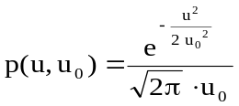
As a result, the distribution of noise power w, with average power w₀, is that of the squares of amplitudes given by a γ-distribution:
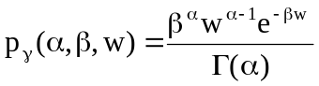
with α=1/2 and β=1/2w₀ . The γ-distribution is not symmetric and defined only for positive values of μ = α/β = w₀. The mean of a γ-distribution is and its variance is σ = α/β² = 2.w₀² and yields the familiar 2^{1/2} factor for the calculation of the standard deviation of from the average noise power.
One can show that the averages x of N noise power measurements also follow a γ-distribution given
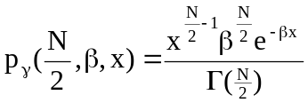
The mean value is given by α/β which evaluates to w₀ as expected for α=N/2 and β=N/2w₀, but the variance 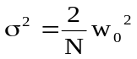 is linearly decreasing with the number of noise power measurements.
Hence the standard deviation ΔN for the average of N independent noise measurements is given by
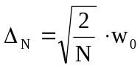
The Nyquist-Shannon sampling theorem states that a function that contains no higher frequency components than ν, is fully defined by sampling τs
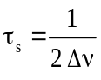
and the number of independent measurements that are averaged over an integration time tint is then
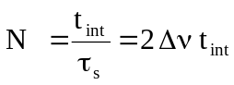
Using this result in the expression for Δn gives 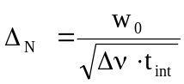
or more familiar as the sensitivity according to Recommendation ITU-R RA 769-2, Annex 1, Equation 1:
Δ_{N}/w₀ = ΔP/P = (Δν . t_{int})^{-1/2} (1)
where: P and ΔP: power spectral density of the noise
Δν: measurement bandwidth
t_{int}: integration time.
P and ΔP in equation (1) can be expressed in temperature units through the Boltzmann’s constant, k:
∆P = k ∆T and P = k T
Tables 1 and 2 of Recommendation ITU-R 769-2 [3] provide a convenient access to the interference limits calculated from the radiometer equation (e.g. t_{int} = 2000s, ν = 1612 MHz and a measurement bandwidth Δν = 20 kHz).
- Columns 3 and 4 give typical receiver (T_{R}= 10 K) and antenna temperatures (T_{A}=12 K), together yielding a system temperature T_{sys} = 22K.
- Using the radiometer equation (1) for the temperature sensitivity ΔT = (T_{A} + T_{R})(Δν.t_{int})^{-1/2} yields the entry of 3.479 mK in column 5.
- Multiplication with the Boltzmann constant and division by the measurement bandwidth Δν gives the system sensitivity in terms of power spectral density:

ΔP = -253.2 dB(W/Hz) listed in column 6.

- The interference limit is set to be 10 dB below the sensitivity and the product with the observation bandwidth gives the input power limit in column 7:

ΔP_{H} = ΔP +10 log(Δν/Hz)-10 = -220.2 dB(W).

The power flux density S_{H}Δν in column 8 is obtained through division by the isotropic antenna c²/4πν² area and is explicitly given by:
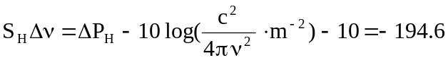 dB(W/m²)
Note that S_{H}Δν + 145.7 yields the field strength threshold in dB(µV/m)

- The last column (9) gives the emission limit in terms of spectral power flux density spfd and can be had by simply omitting the bandwidth term in the equation above:
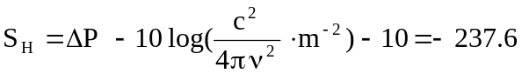 dB(Wm⁻²Hz⁻¹)
Note that the conversion to the radio astronomical unit of Jansky is achieved by adding 260 to the value in column 9. Hence the spectroscopy limit for 2000 s integration at 1420 MHz is equivalent to 22.4 dB(Jy) or 174.5 Jy.
It follows from eqn. 1 and the derivation of the table entries that changes in the measurement bandwidth δf are to be treated in the same manner as changes in integration time t_{int}:
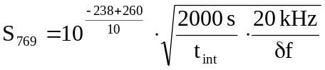

ANNEX 5: LIST OF REFERENCE
- Measurement Report of Leeheim Satellite Monitoring Facility: “Iridium (November 2006)”, available on the ECO website, WGSE meeting documents
- Measurement Report of Leeheim Satellite Monitoring Facility: “Iridium (June 2009)”, available on the ECO website, WGSE meeting documents
- Recommendation ITU-R RA.769-2, “Protection criteria used for radio astronomical measurements”
- Recommendation ITU-R RA.1513-1, “Levels of data loss to radio astronomy observations and percentage-of-time criteria resulting from degradation by interference for frequency bands allocated to the radio astronomy on a primary basis”
- Recommendation ITU-R RA.1631, “Reference radio astronomy antenna pattern to be used for compatibility analyses between non-GSO systems and radio astronomy service stations based on the epfd concept”
- Recommendation ITU-R M.1583, “Interference calculations between non-geostationary mobile-satellite service or radionavigation-satellite service systems and radio astronomy telescope sites”
- Recommendation ITU-R SM. 1633, “Compatibility analysis between a passive service and an active service allocated in adjacent and nearby bands”
- Agreement CRAF/Iridium: “Framework Agreement between Iridium LLC and the European Science Foundation”, August 1998 and the CEPT Milestone Review Committee (MRC) Recommendation nº4 of 27 March 1998 referenced in this document;
- ERC Report 050 : “Interference calculations from MSS satellites into radio astronomy observations”
- ECC Report 112 : “Impact of unwanted emissions of Iridium satellites to radio astronomy stations in the band 1610.6-1613.8 MHz”
- NRAO measurement Report : “Tests of emissions from an Iridium satellite in the 1610.6-1613.8 MHz radioastronomy band”, 7th May 1998, A.R. Thompson
- “Iridium Satellite Signals: A Case Study In Interference Characterization And Mitigation For Radio Astronomy Observations”, Deshpande & B.M. Lewis
- “Mitigation of Interference From Iridium Satellites By Parametric Estimation And Subtraction”, Shahriar

