 Electronic Communications Committee (ECC)
within the European Conference of Postal and Telecommunications Administrations (CEPT)
ECC REPORT 166
COEXISTENCE BETWEEN ZENITH-POINTING METEOROLOGICAL RADARS
AT 24 GHz AND 35 GHz
AND
SYSTEMS IN OTHER RADIO SERVICES

Montegrotto Terme, May 2011

executive summary
Observation of the atmosphere for research and operational activities is key to the meteorological community. These observations can be performed using mainly satellites, radars, radionsondes, or even terrestrial radiometers, each of these presenting various advantages and interests in the atmosphere parameters to be retrieved and/or the scale at which the measurements are made.
Among these, meteorological radars operated under radiolocation service play a crucial role in that they allow for in-situ real time measurements, either for precipitation (weather radars) or wind conditions (weather radars and wind profilers).
Recently, following specific research programmes, new meteorological radar applications and measurement types arose at 24 GHz (Micro-rain radar) and 35 GHz (Cloud radar) to provide precipitation size distribution or cloud composition, respectively.
Based on compatibility analysis, this Report elaborates relevant conditions under which these radars, using zenithal pointing, should operate while ensuring coexistence with existing services, in view to provide a relevant background for future developmement and/or standardisation of these radars.
Compatibility findings for MRR 24 GHz:
- Terrestrial services in the band 24.05-24.25 GHz and in the adjacent bands
For the case of the protection of terrestrial services, only horizontal emissions of MRR 24 GHz are concerned. Assuming that MRR will be deployed under the Radiolocation service allocation, which is the only primary service in the band 24.05-24.25 GHz, no in-band analysis was performed. In addition, the horizontal MRR 24 GHz emissions are below the generic 24 GHz SRD emission limits and allow de facto to confirm compatibility with all terrestrial services.
- Inter-satellite service and Amateur satellite service
For the case of the protection of the satellite services operated in adjacent band, considering that EESS (passive) (and SRS(passive)) in the 23.6-24 GHz are far more sensitive to interference than Amateur-satellite service in the 24-24.05 GHz band and inter-satellite service in the 24.45-24.65 GHz band, adjacent band conditions ensuring compatibility with EESS (passive) will also ensure compatibility with Amateur-satellite and inter-satellite services.
- EESS (passive) and RAS in the frequency band 23.6-24 GHz.
For the case of the protection of the EESS (passive) in the 23.6-24 GHz band, compatibility can be ensured by shifting the MRR 24 GHz operating frequency at the upper edge of the 24.05-24.25 GHz band and by limiting the MRR unwanted emissions power density in the 23.6-24 GHz band to a maximum level of -84 dBm/MHz (corresponding to a -44 dBm/MHz e.i.r.p. density). It is considered that this unwanted emission level will also ensure protection of Radioastronomy stations in the 23.6-24 GHz band.
- Proposed conditions for the operation of MRR 24 GHz:
- centre frequency: 24.23 GHz
- maximum bandwidth: ± 17.5 MHz (including frequency excursion and tolerance)
- maximum unwanted power density: -84 dBm/MHz (corresponding to a -44 dBm/MHz e.i.r.p. density) below 24.05 GHz and above 24.45 GHz
Compatibility findings for 35 GHz cloud radars:
- Terrestrial services in the band 35 GHz and in adjacent bands
For the case of the protection of terrestrial services (Fixed, Mobile, Radionavigation, …) only horizontal emissions of Cloud radars 35 GHz are concerned. Assuming that 35 GHz cloud radars will be deployed under the Radiolocation service allocation or in the Meteorological Aids allocation (35.2-35.5 GHz), which are the only primary terrestrial services in the frequency range 33.4-36 GHz, no in-band analysis was performed. In addition it is considered that compatibility with terrestrial services in the adjacent bands below 33.4 GHz and above 36 GHz is covered by regular unwanted emissions limits (e.g. ECC/REC/(02)05, ERC/REC 74-01).
- EESS (active) in the band 35.5-36 GHz and EESS (passive) in the 36-37 GHz band (assuming a typical radar operating mode with pulse length of 200 ns)
  - Cloud radars are not compatible with both EESS (active) in the 35.5-36 GHz band and EESS (passive) in the 36-37 GHz band and should hence not be operated in these frequency bands.
  - Cloud radars operated below 35.5 GHz are compatible with both EESS (active) in the 35.5-36 GHz band and EESS (passive) in the 36-37 GHz band provided that their average unwanted e.i.r.p. density in these bands are 6.2 dBW/MHz and -2 dBW/MHz respectively, corresponding to attenuations relative to maximum power of 54.6 dB and 62.8 dB respectively.
- Proposed conditions for the operation of 35 GHz cloud radars:
- centre frequency: within the range 33.4-35.22 GHz
- maximum bandwidth: ± 30 MHz (including frequency tolerance)
- maximum average unwanted e.i.r.p. density of 6.2 dBW/MHz in the 35.5-36 GHz band
- maximum average unwanted e.i.r.p. density of -2 dBW/MHz in the 36-37 GHz band.

Table of contents

0 executive summary 2
List of Abbreviations 5
1 introduction 6
2 CHARACTERISTICS OF METEOROLOGICAL RADARS AT 24 AND 35 GHz 6
2.1 Micro-Rain Radar at 24 GHz 6
2.2 Cloud radar at 35 GHz 7
3 Radio services to be considered in the compatibility analysis 8
3.1 24 GHz 8
3.2 35 GHz 10
4 Compatibility analysis at 24 GHz 11
4.1 Determination of the geometric worst case for analysis 11
4.2 Different types of passive sensors used in the analysis 13
4.3 Interference scenarios for static analysis 14
4.3.1 Case A (unwanted emission scenario) 14
4.3.2 Case B (MRR in-band emission in EESS sensor filter scenario) 15
4.4 Dynamic simulations 16
4.4.1 Simulation 1 16
4.4.2 Simulation 2 17
4.5 Conclusions for the MRR 24 GHz 19
5 Compatibility analysis at 35 GHz 19
5.1 EESS (passive) sensors in the 36-37 GHz band 19
5.2 EESS (active) sensors in the 35.5-36.0 GHz band 21
5.2.1 Compatibility analysis: static case 21
5.2.1.1 Compatibility with altimeter 22
5.2.2.1 Compatibility with scatterometer 23
5.2.3.1 Compatibility with precipitation radar 23
5.2.2 Compatibility analysis: dynamic simulations 24
5.2.1.2 Compatibility with altimeter 24
5.2.2.2 Compatibility with precipitation radar 26
5.2.3 Summary of results 27
5.3 Compliance with unwanted emissions regulations 28
5.4 Conclusions for the Cloud Radar at 35 GHz 30
6 Conclusions 31
6.1 Micro-Rain Radar at 24 GHz 31
6.2 Cloud radar at 35 GHz 31

List of Abbreviations

Abbreviation | Explanation
CEPT | European Conference of Postal and Telecommunications Administrations
CDF | Cumulative distribution function
EESS | Earth Exploration Satellite Service
FMCW | Frequency Modulated Continuous Wave
LDR | Linear De-polarization Ratio
MRR | Micro-Rain Radar
PRF | Pulse Repetition Frequency
PSD | Power Spectral Density
SRD | Short range device
SRR | Short rang radar
SRS | Space Research Service

Coexistence between zenith-pointing meteorological radars at 24 and 35 GHz and systems in other radio services

introduction
Observation of the atmosphere for research and operational activities is key to the meteorological community. These observations can be performed using mainly satellites, radars, radionsondes or even terrestrial radiometers, each of these presenting various advantages and interests in the atmosphere parameters to be retrieved and/or the scale at which the measurements are made.
Among these, meteorological radars operated under radiolocation service play a crucial role in that they allow for in-situ real time measurements, either for precipitation (weather radars) or wind conditions (weather radars and wind profilers).
Recently, following specific research programmes, new meteorological radar applications and measurement types arose at 24 GHz (Micro-rain radar) and 35 GHz (Cloud radar) to provide precipitation size distribution or cloud composition, respectively.
These applications, expected to be operated on a licensed basis, are using frequency bands already allocated to radiolocation and/or meteorological aids. However, their specific characteristics (zenithal pointing in particular) are quite different than those usually depicted for other radars in these bands and justify a specific attention with regards to other services in or adjacent to these frequency bands, in particular satellite applications.
This Report describes compatibility analysis for these 24 and 35 GHz meteorological radars and elaborates relevant conditions under which these zenith-pointing radars should operate while ensuring coexistence with existing services, in view to provide a relevant background for future developmement and/or standardisation of these radars.

CHARACTERISTICS OF METEOROLOGICAL RADARS AT 24 AND 35 GHz

Micro-Rain Radar at 24 GHz
Micro Rain Radar (MRR) is a compact 24 GHz FMCW radar for the measurement of profiles of drop size distributions and – derived from this – rain rates, liquid water content and characteristic falling velocity resolved into 30 range gates.
Due to the high sensitivity and fine temporal resolution, very small amounts of precipitation are detectable (below the threshold of conventional rain gauges). Due to the large scattering volume (compared to in situ sensors), statistically stable drop size distributions can be derived within few seconds.
The droplet number concentration in each drop-diameter bin is derived from the backscatter intensity in each corresponding frequency bin. In this procedure the relation between terminal falling velocity and drop size is exploited.
The main technical characteristics of this radar are:
- Centre frequency: within the Radiolocation allocation: 24.05-24.25 GHz
- Frequency excursion: max 15 MHz (± 7.5 MHz), typical 1.5 MHz,
- Frequency tolerance: ± 5 MHz
- Maximum transmit power: 100 mW (20 dBm)
- Antenna Gain: 40 dBi (parabolic dish)
- Elevation angle: 90°
- Modulation: FMCW
- Sweep period: 0.52 ms
- Sweep rate: 1.922 kHz.
Figure 1: Micro Rain radar with vertically pointing offset parabolic dish antenna

Cloud radar at 35 GHz
There are different cloud radar currently in operation around 35 GHz. However the following radar is assumed to be representative and has been considered in the analysis performed in this Report. It is a magnetron based pulsed Ka-Band Doppler radar for unattended long term observation of atmospheric clouds.
In its standard configuration linear polarized signal is transmitted while co and cross polarized signals are received simultaneously to detect Doppler spectra of the reflectivity and Linear De-polarization Ratio (LDR).
The reflectivity is used to determine the density of cloud constituents while LDR helps to identify the target type. Different configurations for measuring other polarization variables, e.g. the differential reflectivity or phase can be developed on request.
Cloud radar is usually installed with a vertically pointing antenna for measuring profiles from 150 m above ground to 15 km (above 15 km no signals are observed).
Alternatively, scanning version of Cloud radars can be used with rotating antenna. However, in this case, cloud radars are not specific compared to other radars types deployed under the 35 GHz radiolocation allocation and are hence not covered by this Report.
The main technical characteristics of cloud radar are:
- Centre frequency: within the Radiolocation allocation: 33.4-36.0 GHz
- Maximum transmit power: 30 kW (peak) (44.8 dBW)
- PRF: 2.5 to 10 kHz
- Pulse width¹: 100 ns, 400 ns or 200 ns (typical)
- Necessary bandwidth: 2.5 to 10 MHz
- Frequency tolerance: ± 25 MHz
- Peak-to-rms ratio¹: 24 to 36 dB
- Average power: 8.8 to 20.8 dBW (17.8 dBW for a typical 200 ns pulse width and 10 kHz PRF)
- Antenna Gain: up to 55 dBi (typical 50 dBi, parabolic dish)
- Elevation angle: 90°.
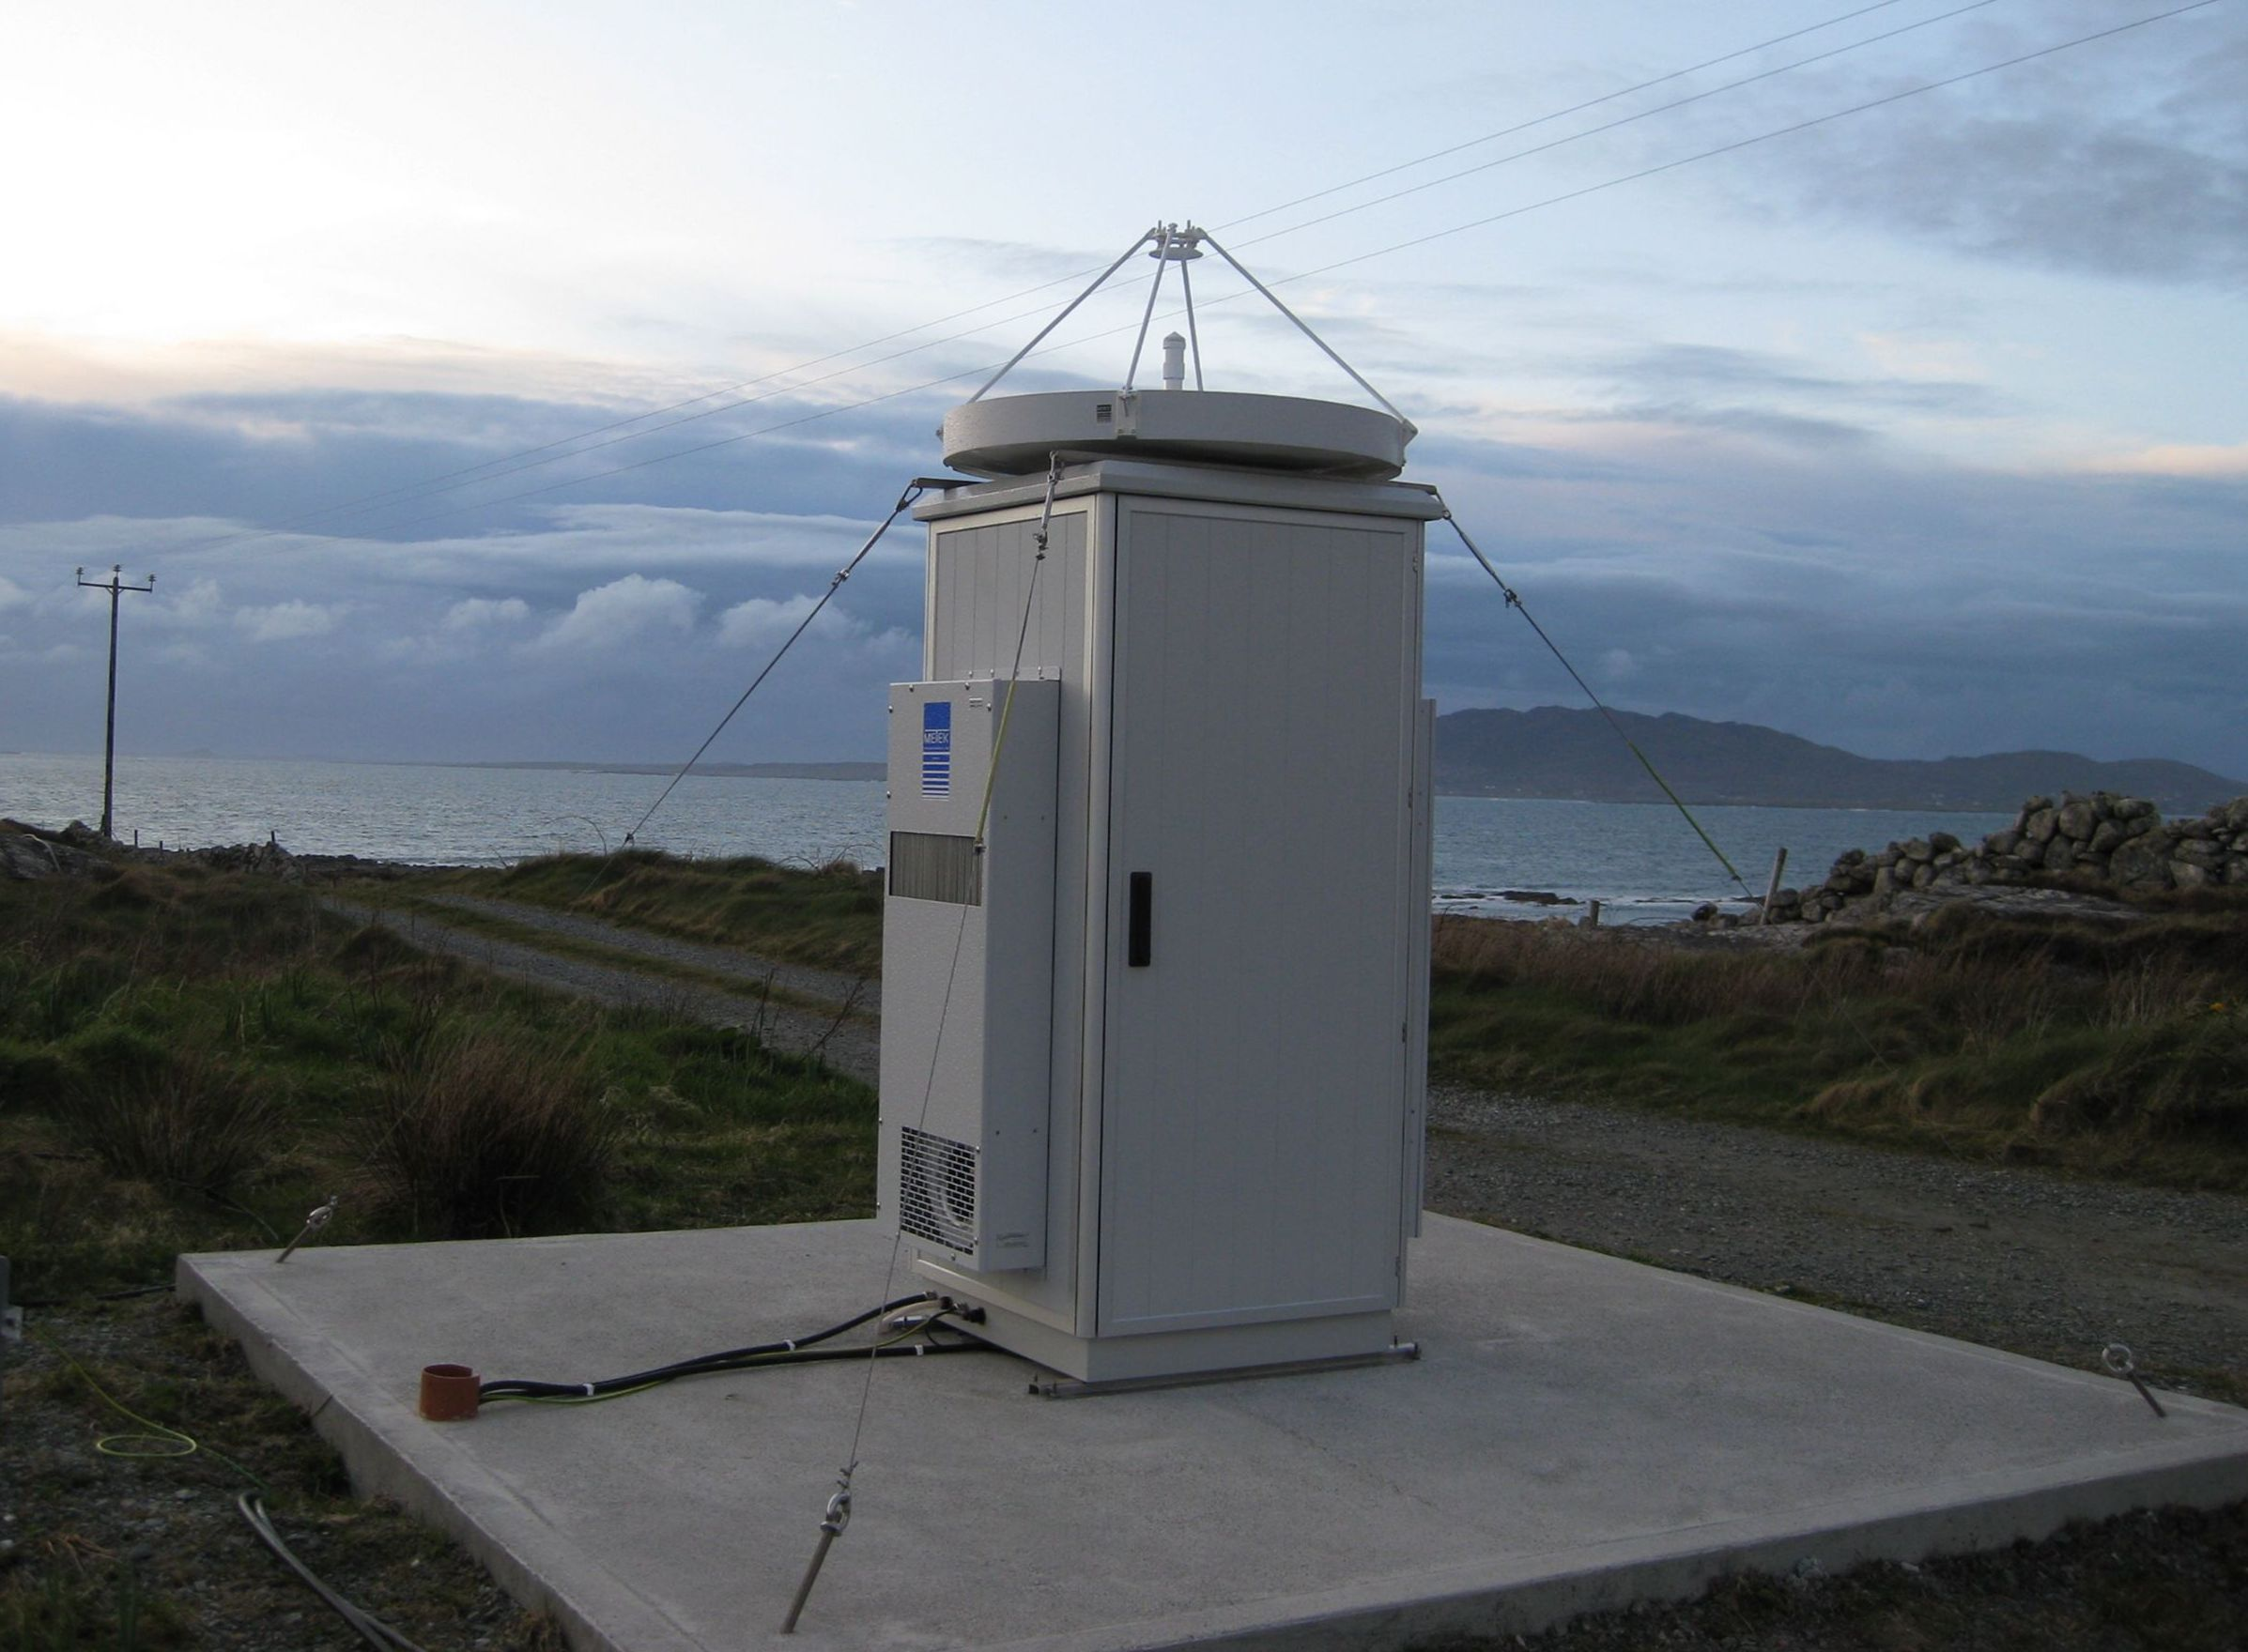
Figure 2: Cloud radar with fixed vertically pointing parabolic dish antenna

Radio services to be considered in the compatibility analysis

24 GHz
The Radio Regulations allocation table at around 24 GHz is provided in Table 1.
Table 1: Allocations around 24 GHz
Allocation to services
Region 1 | Region 2 | Region 3
23.6-24.0 EARTH EXPLORATION-SATELLITE (passive)
RADIO ASTRONOMY
SPACE RESEARCH (passive)
5.340
24.00-24.05 AMATEUR
AMATEUR-SATELLITE
5.150
24.05-24.25 RADIOLOCATION
Amateur
Earth exploration-satellite (active)
5.150
24.25-24.45  FIXED | 24.25-24.45  RADIONAVIGATION | 24.25-24.45  RADIONAVIGATION  FIXED  MOBILE
24.45-24.65  FIXED  INTER-SATELLITE | 24.45-24.65  INTER-SATELLITE  RADIONAVIGATION | 24.45-24.65  FIXED  INTER-SATELLITE  MOBILE  RADIONAVIGATION
One can also note that the band 24-24.25 GHz is specified as a non-specific Short-Range Device band according to ERC/REC 70-03 (Annex 1) with a maximum e.i.r.p. of 100 mW (20 dBm).
It can be seen that in the band 24.05-24.25 GHz, the only primary service is the radiolocation service and that there is hence no “in-band” compatibility analysis to be performed.
As far as terrestrial services are concerned, only horizontal emissions of MRR 24 GHz should be considered. Considering a parabolic antenna of 40 dBi, Recommendation ITU-R F.699 antenna pattern gives a -6 dBi gain at 90° that leads to an “in-band” maximum horizontal e.i.r.p. of 14 dBm (i.e. below the generic SRD maximum e.i.r.p.). Regarding the Fixed service allocation above 24.25 GHz, one can note that the frequency band 24.25 – 24.50 GHz is used by fixed links and cordless cameras on a temporary basis. Therefore one can conclude that any interference caused by MRR unwanted emissions on these systems is unlikely. One can assume that the “horizontal” unwanted emissions of MRR 24 GHz will also be below those of SRD (-30 dBm/MHz according to ERC/REC 74-01), which de facto confirm compatibility with all terrestrial services.
- As far as the RAS is concerned, according to ECC/DEC/(04)10 for SRR the required e.i.r.p. level for the protection of the radioastronomy service is -74dBm/MHz without the necessity for a deactivation mechanism. One can assume that this level for the unwanted emissions is also relevant for MRR to protect stations in the radioastronomy service and therefore no additional study is needed.
- As far as satellite services are concerned, EESS (passive) (and SRS(passive)) in the 23.6-24.0 GHz is to be considered, as well as Amateur-satellite service in the 24-24.05 GHz and inter-satellite service in the 24.45-24.65 GHz. However, the 2 latter services being far less sensitive to interference than EESS (passive), it is expected that any adjacent band conditions ensuring compatibility with EESS (passive) will also ensure compatibility with Amateur-satellite and inter-satellite services.
As a summary, only adjacent band compatibility between EESS (passive) in the 23.6-24.0 GHz and MRR 24 GHz will be further studied in details.

35 GHz
The Radio Regulations allocation table at around 35 GHz is provided in Table 2.

Table 2: Allocations around 35 GHz
Allocation to services
Region 1 | Region 2 | Region 3
33-33.4 FIXED 5.547A
RADIONAVIGATION
5.547 5.547E
33.4-34.2 RADIOLOCATION
5.549
34.2-34.7 RADIOLOCATION
SPACE RESEARCH (deep space) (Earth-to-space)
5.549
34.7-35.2 RADIOLOCATION
Space research 5.550
5.549
35.2-35.5 METEOROLOGICAL AIDS
RADIOLOCATION
5.549
35.5-36 METEOROLOGICAL AIDS
EARTH EXPLORATION-SATELLITE (active)
RADIOLOCATION
SPACE RESEARCH (active)
5.549 5.549A
36-37 EARTH EXPLORATION-SATELLITE (passive)
FIXED
MOBILE
SPACE RESEARCH (passive)
5.149 5.550A

Considering the bands allocated to the radiolocation service that could potentially be used by cloud radars, the following in-band cases are to be considered:
- Space research service (deep space) (Earth-to-Space): being an Earth-to-space allocation, it is not assumed that cloud radars could present any problem to the SRS;
- Meteorological Aids: there are no known METAIDS applications in this band. It can even be considered that “cloud” radars could be deployed under this METAIDS service;
- Earth Exploration Satellite Service (active): considering the zenithal pointing of “Cloud” radars and their high e.i.r.p., compatibility between the 2 services need to be considered.
With regard to the terrestrial services (Fixed, Mobile, Radionavigation, …) operated in the adjacent bands below 33.4 GHz and above 36 GHz, it can be assumed that the compatibility is covered by the unwanted emissions limits. (i.e. Recommendations ECC/REC/(02)05 (OOB domain) and ERC/REC 74-01 (spurious domain)). Therefore, only the case of Earth Exploration Satellite Service (active and passive) would require a detailed analysis, in the case of the zenithal pointing of “Cloud” radars.
As a summary, the following compatibility analysis will be further studied in details with cloud radars:
- compatibility with EESS (active) in the 35.5-36 GHz band for both in-band and adjacent cases;
- adjacent band compatibility with EESS (passive) in the 36-37 GHz band.

Compatibility analysis at 24 GHz
This section aims at analysing the compatibility between MRR 24 GHz and EESS (passive) sensors in the 23.6-24 GHz band both for the unwanted and in-band emissions of the MRR.

Determination of the geometric worst case for analysis
Figure 3 provides the general situation of MRR (pointing at Zenith) compared to a passive EESS sensor.

Figure 3: Geometric configuration between a MRR and a passive sensor

where $\text{sin}\left(α'\right)={\left(1+\frac{h}{R}\right)}^{−1}\text{sin}(β')$
and the distance between the satellite and the MRR location on the ground is $D=R\frac{\text{sin}(β^{'}−α^{'})}{\text{sin}\left(α^{'}\right)}$
(in both equations R is the Earth radius (6378 km)).
Both equipments making use of parabolic dishes, the potential interference from MRR to EESS passive sensor will be mainly controlled by the antennas discriminations in the interfering path. The sum of the 2 relative antenna gain is proposed to be called the “composite link gain”.
One can expect that the “composite link gain” will present 1 or 2 maximums, depending on the type of EESS sensor:
- For nadir sensors (or sensors having a nadir component, such as cross-track or push-broom), the maximum “composite link gain” will correspond to the situation where the MRR will be at the nadir of the satellite. In such case, the “composite link gain” will be the sum of the 2 antenna main beam gains;
- For conical scan sensors, there will be 2 maximum corresponding to the 2 following cases:
  - Case 1 (main beam EESS vs MRR side lobe);
  - Case 2 (main beam MRR vs EESS side lobe).
As a verification, Figure 4 and Figure 5 provide the value of the “composite link gain” for all situations in the direction of the EESS sensor pointing (i.e. varying the angle α’ on Figure 3 above from 0° to the angle for which the satellite is not anymore in visibility from the MRR). Both Figure 4 and Figure 5 are using the MRR antenna gain of 40 dBi and the antenna patterns of Recommendations ITU-R F.699 and RS.1813 for the MRR and EESS sensor respectively.
Figure 4 corresponds to the example situation with a conical scan sensor with the following parameters (Meghatropic case, see Table 3):
- antenna gain of 40 dBi
- off-nadir angle of 44.5 °
- altitude satellite of 817 km.

Figure 4: Variation of the composite antenna gain depending on the satellite sensor visibility angle
for a conical scan satellite passive sensor

Figure 4 confirms the assumption that, for conical scan sensors, there are indeed 2 maxima (their value depending on the EESS sensor antenna pattern).

Figure 5 corresponds to the example situation with a nadir sensor with the following parameters (AMSU-A):
- antenna gain of 34.4 dBi
- off-nadir angle of 0 °
- altitude satellite of 833 km.
Figure 5: Variation of the composite antenna gain depending on the satellite sensor visibility angle
for a nadir satellite passive sensor

Figure 5 confirms the assumption that, for nadir sensors, there is only 1 maximum (its value being the sum of maximum gain of both antennas and depending on the EESS sensor antenna pattern).

Different types of passive sensors used in the analysis
Table 3 provides the sensors characteristics used in the analysis, consistently with the recent technical studies of compatibility with 24/26 GHz automotive Short-Range Radars (SRR). It is not aimed at limiting the analysis to existing sensors but to represent a large variety of sensor types.

Table 3: Sensors characteristics
 | Conical scan |  |  |  | Nadir sensors *
 | MEGHATROPIC | AMSR-E | CMIS | PUSH Broom |  | AMSU-A | ATMS | JASON AMR | JASON JMR | ALTIKa
Antenna gain (dBi) | 40 | 46.7 | 52 | 45 |  | 34.4 | 30.4 | 44.4 | 40 | 46
Bandwidth (MHz) | 400 | 400 | 400 | 400 |  | 270 | 270 | 400 | 400 | 400
Off nadir angle (°) | 44.5 | 47.5 | 46.6 | 0 |  | 0 | 0 | 0 | 0 | 0
Altitude (km) | 817 | 705 | 828 | 850 |  | 833 | 824 | 1336 | 1336 | 800
* nadir sensors or sensors having a nadir component (such as cross-track or push broom)

With these characteristics and the MRR antenna gain of 40 dBi, one can calculate the maximum “composite link gain” for these different sensors, corresponding to the worst case geometric situation, and the associated path length as follows:

Table 4: Composite link gain and propagation losses
 | MEGHATROPIC | AMSR-E | CMIS | PUSH Broom | AMSU-A | ATMS | JASON AMR | JASON JMR | ALTIKa
Composite link gain (dBi) | 33.9 | 40.6 | 45.9 | 85 | 74.4 | 70.4 | 84.4 | 80 | 86
Path length (km) | 1227 | 1123 | 1309 | 850 | 833 | 824 | 1336 | 1336 | 800
Free space attenuation (dB) | 181.9 | 181.1 | 182.4 | 178.7 | 178.5 | 178.4 | 182.6 | 182.6 | 178.1
Atmospheric losses (dB) | 1.7 | 1.6 | 1.7 | 1 | 1 | 1 | 1.7 | 1.7 | 1

One can therefore note that, assuming MRR 24 GHz pointing at the Zenith, the analysis is driven by the “Nadir” sensors”. On the other hand, should MRR be operated at a different elevation, the situation of conical scan sensors would become equivalent to “nadir” sensors.

Interference scenarios for static analysis
Figure 6 describes the overall situation and the 2 scenarios to be studied, namely:
Case A: impact of MRR unwanted emissions in the EESS sensor bandwidth in order to determine the maximum level of MRR unwanted emissions to ensure protection of EESS sensors;
Case B: impact of MRR in-band emission in the EESS filter in order to determine the required level of filtering to ensure similar protection than for the unwanted case, and analyse whether such filtering level is feasible, considering state-of-the art.
Figure 6: Summary of scenarios to be studied

In both cases, the EESS (passive) protection criteria are given by Recommendation ITU-R RS 1029-2.
For the 23.6-24.0 GHz band, the aggregate protection criterion for all sources is -166 dBW/200 MHz. For a single application, consistently with the recent study on SRR 24 and 26 GHz, an apportionment is necessary. A 5% apportionment has been used, leading to a protection criterion of -179 dBW/200 MHz to be applied to MRR 24 GHz.

Case A (unwanted emission scenario)
The following parameters are used for this scenario:
- maximum theoretical unwanted emission power density of MRR (- 30 dBm/MHz (see Rec. ERC 74-01))
- MRR antenna gain (40 dBi)
- assumed number of MRR simultaneously in the same pixel (N=3)
- the “composite link gain” (see Table 4)
- the Path length (see Table 4)
On this basis, one can calculate, for all EESS sensor type, the interference in excess (or “negative margin”) to the protection criteria that would result from a MRR presenting unwanted emissions at -30 dBm/MHz, using the following formula:

I (dB) = U_{MRR}+G_{c}-L_{fs}-L_{atm}-P_{EESS}-30+10log(200)+10log(N)

where:
U_{MRR} = MRR theoretical unwanted emission power density (-30 dBm/MHz)
N = number of MRR (N=3)
G_{c} = composite link gain (dB)
L_{fs} = free space losses (dB)
L_{atm} = atmospheric losses (dB), from Recommendation ITU-R P.676
P_{EESS} = EESS sensor protection criteria (-179 dBW/200 MHz).
Finally, this “negative margin” is used to determine the required unwanted emission power density to ensure protection of EESS passive sensors as:

U_{MRR-required} = U_{MRR} - I (dB)

The corresponding results are summarised in Table 5.
Table 5: required unwanted emission levels
 | MEGHATROPIC | AMSR-E | CMIS | PUSH Broom | AMSU-A | ATMS | JASON AMR | JASON JMR | ALTIKa
Negative Margin  (dB) | -2.8 | 4.8 | 8.6 | 52.2 | 41.8 | 37.9 | 47 | 42.5 | 53.7
Required MRR unwanted emission power density (dBm/MHz) | -27.2 | -34.8 | -38.6 | -82.2 | -71.8 | -67.9 | -77.0 | -72.5 | -83.7
Required MRR unwanted emission e.i.r.p. density (dBm/MHz) | 12.8 | 5.2 | 1.4 | -42.2 | -31.8 | -27.9 | -37.0 | -32.5 | -43.7
As expected, the conical scan instruments are less susceptible to interference from MRR, whereas, for Nadir instruments or instrument presenting a Nadir component, a maximum MRR unwanted emission power density ranging -67.9 to -83.7 dBm/MHz would be required.

Case B (MRR in-band emission in EESS sensor filter scenario)
The following parameters are used for this scenario:
- maximum emission power of MRR ( 20 dBm)*
- assumed number of MRR simultaneously in the same pixel (N=3)
- the “composite link gain” (see Table 4)
- the Path length (see Table 4)
- the EESS sensor bandwidth.
* One can note that in this scenario, unlike for the unwanted emission one, there is no aggregation of power in the EESS bandwidth. There is hence no need to consider the MRR bandwidth (or any power density). The whole MRR power will be received in the EESS receiver.
On this basis, one can calculate, for all EESS sensor types, the required filtering at 24.140 MHz (current operating frequency of MRR) to limit the interference below the protection criterion, using the following formula:
F (dB) = P_{MRR}+G_{c}-L_{fs}-L_{atm}-P_{EESS}-30+10log(200/B_{EESS})+10log(N)
where:
P_{MRR} = MRR transmit power (20 dBm)
N = number of MRR (N=3)
G_{c} = composite link gain (dB)
L_{fs} = free space losses (dB)
L_{atm} = atmospheric losses (dB)
P_{EESS} = EESS sensor protection criterion (-179 dBW/200 MHz)
B_{EESS} = EESS sensor bandwidth
The corresponding results are summarised in Table 6.

Table 6: Required EESS filtering
 | MEGHATROPIC | AMSR-E | CMIS | PUSH Broom | AMSU-A | ATMS | JASON AMR | JASON JMR | ALTIKa
Required EESS filtering at 24.140 MHz | 21.0 | 28.6 | 32.5 | 76.1 | 67.4 | 63.5 | 70.9 | 66.5 | 77.7

As expected, the required filtering at 24.140 GHz for conical scan instruments is less important, ranging 21 to 32.5 dB.
On the other hand, the required filtering for Nadir instruments or instrument presenting a Nadir component ranges 63.5 to 77.7 dB. This latter figure of 77.7 dB filtering at 140 MHz from the band edge could be quite challenging for EESS sensors using a 400 MHz bandwidth. However, the situation could be improved, if the MRR would be operated at the upper edge of the 24.05-24.25 GHz band.

Dynamic simulations
In order to verify the above analysis, made under static conditions, some dynamic simulations were performed.
These dynamic simulations consisted in deploying over a given area a number of MRRs 24 GHz and to simulate the pass of a passive sensor over this area.

Simulation 1
This simulation consist in deploying 3 MRR in 100 hot spots of 200 km² themselves spread in an area of 2 000 000 km² as shown below. The MRR antenna pattern is modelled using Recommendation ITU-R F.1245. As a reference calculation, the power radiated by the MRR is first assumed to be 0 dBW in 200 MHz (or -23 dBW/MHz or 7 dBm/MHz).
The JASON AMR instrument is used for the calculation with an antenna pointing at Nadir with a gain of 44 dBi.
The antenna pattern chosen is also based on F.1245. The protection criterion is -179 dBW in 200 MHz.
Only free space loss is assumed.
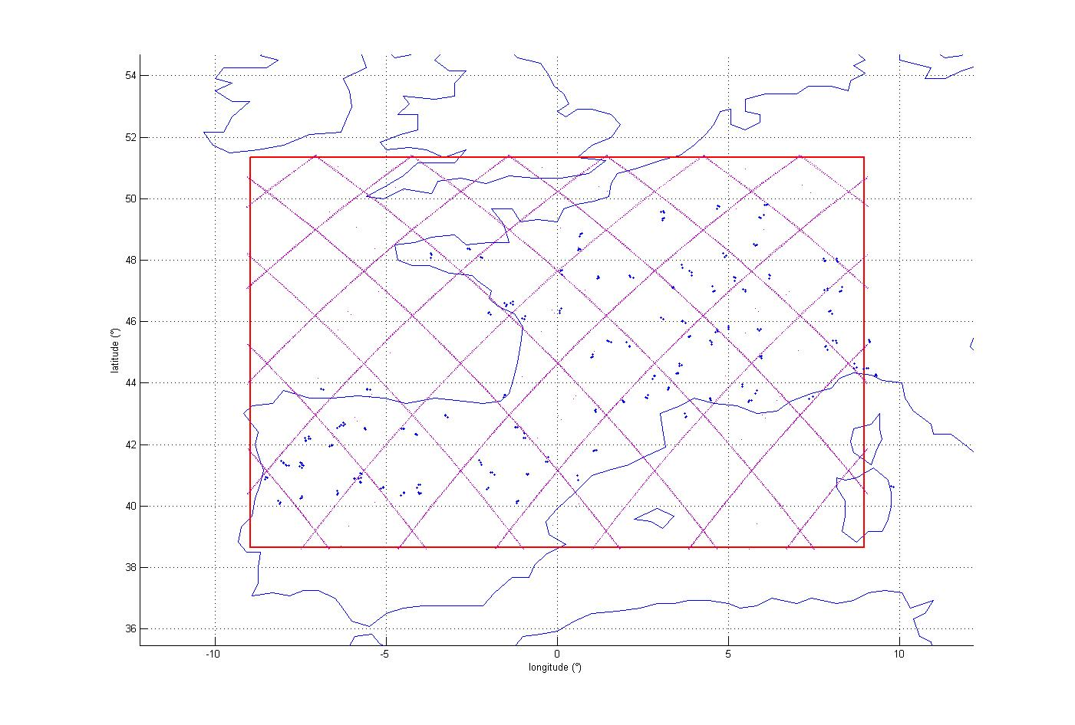
Figure 7: MRR deployment for Simulation 1
The following cdf is obtained:
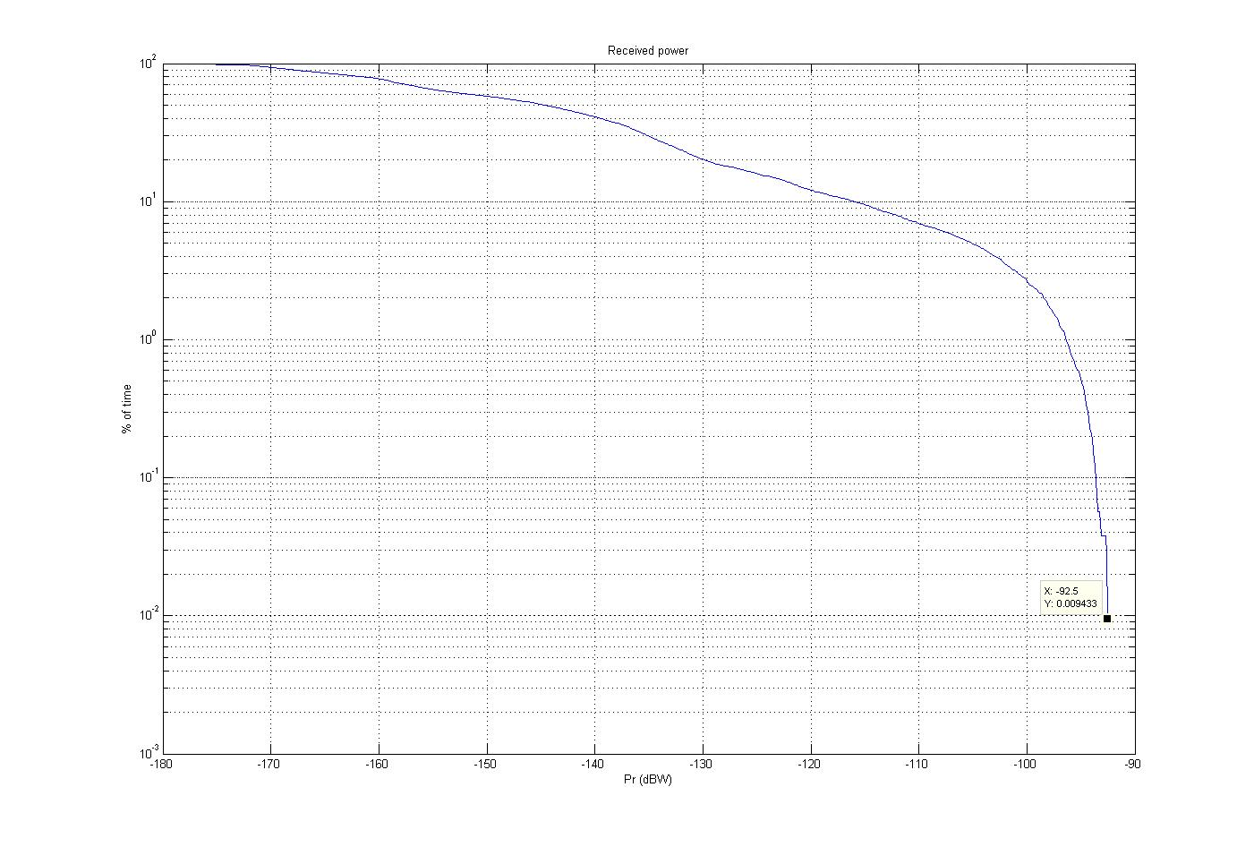
Figure 8: Interference power distribution for Simulation 1

The power received for 0.01% of the time is about -93 dBW in 200 MHz, which means that the emission power level of the MRR should be reduced by -93-(-179) = 86 dB.
This leads to an unwanted emission power level of -86 dBW in 200 MHz (or -109 dBW/MHz or -79 dBm/MHz), therefore consistent with what was calculated in the static analysis (-77 dBm/MHz). The difference relates to the atmospheric attenuation that was not considered in this dynamic analysis.
In the same way, the MRR wanted signal of 20 dBm (or -10 dBW) should be attenuated by 76 dB in order not to exceed
-86 dBW in 200 MHz and therefore to meet the sensor protection criterion, also consistent with the static analysis (71 dB), the difference being roughly explained by the atmospheric attenuation and the bandwidth correction factor of 3 dB not considered in the dynamic analysis.

Simulation 2
The MRR antenna pattern is modelled using Recommendation ITU-R F.1245 and the power radiated by the MRR is
20 dBm.
The JASON AMR instrument is used for the calculation with an antenna pointing at Nadir with a gain of 44 dBi. The EESS antenna pattern is modelled based on Recommendation ITU-R F.1813. The protection criterion is -179 dBW in 200 MHz.
Case 1: 100 MRR randomly deployed over the globe (land mass) between -50 and 70 deg. Latitude.
Case 2: 100 MRR randomly deployed within a 2000000 km² in Europe (land-mass), as shown on picture below.

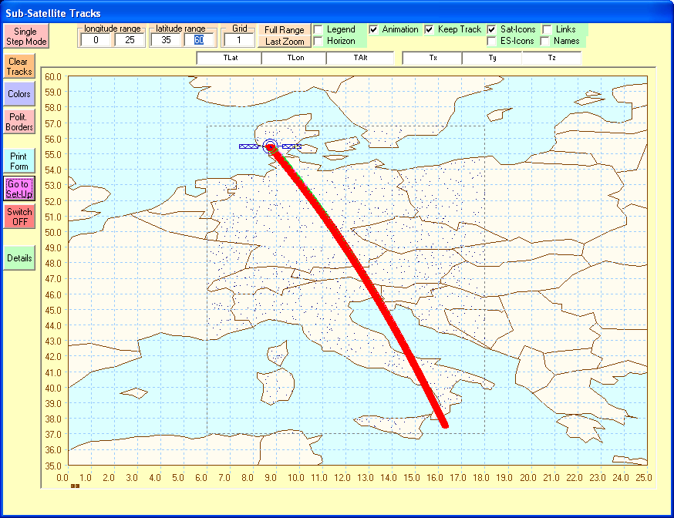
Figure 9: MRR deployment for Simulation 2

The following cdf are obtained:

Figure 10: Interference power distribution for Simulation 2

At 0.01%, the power received by the EESS sensor is -115 dBW for case 2 and -111 dBW for case 1, representing respectively a 64 dB to 68 dB filter attenuation requirement to comply with relevant protection criteria (-179 dBW). This also roughly confirms the static analysis (71 dB), the difference being explained by the fact that the static analysis considered a collocation of 3 MRR (hence 5 dB).
One can also note that some simulations were performed with MRR presenting a slight depointing to 80 or 85° elevation (instead of 90°), showing the quite high sensitivity of the potential interference issue to the MRR pointing. However, such gain can only be envisaged for “purely nadir” EESS sensors (such as JASON) but not for other sensors (push-broom or cross-track) that, in addition to nadir component also present beams at different angles.

Conclusions for the MRR 24 GHz
These analyses allowed specifying the conditions under which MRR 24 GHz would be compatible with EESS sensors operating in the 23.6-24 GHz band.
For the unwanted emission case, the MRR unwanted emissions power density in the 23.6-24 GHz band should be limited to a maximum level of -84 dBm/MHz (corresponding to a -44 dBm/MHz e.i.r.p. density). One can also assume that, considering a symmetric MRR 24 GHz emission mask, such level of unwanted emission will also be experienced in other frequency bands, hence also ensuring protection of other satellite services. In addition, it is also considered that this unwanted emission level will ensure protection of Radioastronomy stations in the 23.6-24 GHz band.
For the MRR in-band case, the EESS sensor filter discrimination should be in a range 63.5 to 77.7 dB. At the current operating frequency of MRR 24 GHz (i.e. 24.140 GHz), a 77.7 dB filtering at 140 MHz from the band edge could be quite challenging for EESS sensors using a 400 MHz bandwidth. To improve the situation and ensure a long-term coexistence with EESS (passive) sensors, it would be wise to shift MRR 24 GHz operating frequency at the upper edge of the
24.05-24.25 GHz band.
Overall, the following conditions could therefore be proposed for MRR 24 GHz operations:
- centre frequency: 24.23 GHz;
- maximum frequency bandwidth: ± 17.5 MHz (including frequency excursion and tolerance);
- maximum unwanted power density of -84 dBm/MHz (corresponding to a -44 dBm/MHz maximum e.i.r.p. density) in the frequency bands below 24.05 GHz and above 24.45 GHz.

Compatibility analysis at 35 GHz
This section aims at analysing the compatibility between “cloud” radars at 35 GHz and EESS (passive) sensors in the
36-37 GHz (unwanted emission case) and EESS (active) sensors in the band 35.5-36 GHz (in-band and unwanted emissions).

EESS (passive) sensors in the 36-37 GHz band
According to Recommendation ITU-R RS.1861 about technical characteristics of EESS (passive) systems, the following Table 7 provides the passive sensor parameters valid for the band 36-37 GHz.
Table 7: EESS (passive) sensors characteristics in the band 36-37 GHz
Type of sensor | MADRAS | AMSR-E | CMIS
Channel bandwidth | 1 GHz | 1 GHz | 1 GHz
Pixel size across track (diameter of the pixel) | 38 km | 7.8 km | 12 km
Incidence angle i at footprint centre | 52.3° | 55° | 55.7°
Offset angle to the nadir or half cone angle α | 44.5° | 47.5° | 47°
Polarization | H | H,V | H,V
Altitude of the satellite | 817 km | 705 km | 833 km
Maximum antenna gain | 45 dBi | 53 dBi | 55 dBi
Reflector diameter | 0.65 m | 1.6 m | 2.2 m
Half power antenna beamwidth θ_{3dB} | 1.8° | 0.4° | 0.52°
Useful swath | 1 607 km | 1 450 km | 1 782 km

Table 8 provides a compatibility analysis between the CMIS EESS sensor operated in the 36-37 GHz band and cloud radars.
The following assumptions were made:
- Typical radar operating mode with pulse length of 200 ns (leading to 5 MHz bandwidth), 10 kHz PRF and 17.8 dBW average power
- 2 different scenarios “radar main beam to EESS side lobe” and “EESS main beam to radar side lobe”, noting that EESS sensors in this band being “conical scan”, maim beam to main beam coupling is not realistic.

Table 8: Adjacent compatibility analysis between CMIS sensor and cloud radar
scenario | radar main beam to EESS side lobe | radar side lobe to EESS main beam
Path length (km) | 833 | 1336
Path loss (Free space)(dB) | 182 | 186
Radar Power (dBW) | 17.8 | 17.8
Radar Pulse length (ns) | 200 | 200
Radar Reference bandwidth (MHz) | 5 | 5
Radar power density (dBW/MHz) | 11 | 11
Atmospheric loss (dB) | 1 | 1
EESS Antenna gain (dBi) | -10 | 55
Radar Antenna gain (dBi) | 50 | -2
PSD at EESS receiver input (dBW/MHz) | -132.2 | -123.2
Protection criterion EESS (passive) (dBW/MHz) | -186 | -186
Margin (dB) | -53.8 | -62.8
Required radar power density to ensure EESS protection (dBW/MHz) | -43 | -52
Required radar e.i.r.p. density to ensure EESS protection (dBW/MHz) | 7 | -2
As a conclusion, cloud radars at 35 GHz are compatible with EESS (passive) in the 36-37 GHz band provided that their maximum average unwanted e.i.r.p. in this band is -2 dBW/MHz (i.e. a maximum power density of -52 dBW/MHz with an antenna gain of 50 dBi), corresponding to an attenuation of 62.8 dB compared to maximum radar e.i.r.p. density.

EESS (active) sensors in the 35.5-36.0 GHz band
The EESS (active) service encompasses various types of instruments: scatterometers, altimeters, Synthetic Aperture Radars, Precipitation radars and Cloud profile radars. In the 35.5-36 GHz, only SAR instruments are not expected.
The following EESS (active) sensor characteristics are used in this compatibility study.
The characteristics of the ALTIKa altimeter are as follows.

Table 9: characteristics of the pure nadir altimeter ALTIKa
 | ALTIKa
Antenna gain (dBi) | 48.5
Bandwidth (MHz) | 35.75 GHz ±250 MHz
Interference criterion (ITU-R Recommendation RS 1166-4) | –119 dB(W/450 MHz)
Availability | 99 % of all locations
Altitude (km) | 800

The characteristics of a typical scatterometer at 35 GHz are as follows.

Table 10: characteristics of a typical scatterometer
 | Scatterometer
Antenna gain (dBi) | 35
Beamwidth (°) | 3
Bandwidth (MHz) | 35.6 GHz ± 500 kHz
Antenna diameter | 21 cm (52% efficiency)
Incidence angle range (several beams) | 0° (nadir) – 80°
Interference criterion (ITU-R Recommendation RS 1166-4) | –195 dB(W/Hz)
Availability | 99 % of all locations
Altitude (km) | 800

Rain precipitation radars usually operate at 13.5 GHz. However, a 13.5/35 GHz dual frequency radar would greatly enhance overall performance, in particular the light rain and drizzle measurement sensitivity. There are therefore great advantages of adding higher-frequency (35 GHz) radar thanks to much bigger radar backscattering cross sections of rain particles. The following characteristics correspond to a TRMM follow on are as follows.

Table 11: characteristics of a typical precipitation radar
 | Precipitation radar, GPM
RF centre frequency | 35.55 GHz
Antenna gain (dBi) | 51.5
Antenna diameter | 1.4 m (52% efficiency)
Bandwidth | 35.55 GHz ± 7 MHz
Antenna beam width | 0.5°
Antenna orientation | –5° to +5° (cross track)
Interference criterion (ITU-R Recommendation RS 1166-4) | –152 dB(W/600 kHz)
Availability | 99.8 % of all locations
Altitude (km) | 407/65° inclination

Compatibility analysis: static case
The geometric situation pertaining to MRR 24 GHz and EESS (passive) sensors as described in Figure 3 (section 4.1) remains valid for the study at 35 GHz. The total cloud radar output average power of 17.8 dBW in the following analysis is derived using the fact that the cloud radar average power is taken into account (e.i.r.p. of 67.8 dBW and an antenna gain of 50 dBi), corresponding to the typical emission used (200 ns pulse width and 10 kHz PRF).

Compatibility with altimeter
The composite gain of EESS sensor antenna and Cloud radar antenna is given in Figure 11.
Figure 11: variation of the composite antenna gain depending on the satellite sensor visibility

The maximum composite gain is 98.5 dBi whereas for 99% of the visibility angles, this gain drops to 80 dBi.
The corresponding results are as detailed in Table 12.

Table 12: compatibility analysis between cloud radar and space borne altimeter at 35 GHz
 |  | Maximum case | 99% of visibility angles
Composite gain | dBi | 98,5 | 80
Distance cloud radar-passive sensor | km | 800 | 800
Free space loss | dBi | 181.5 | 181.5
Atmospherical loss (ITU-R P.676) | dB | 1 | 1
Number of cloud radar |  | 1 | 1
Total cloud radar output average power | dBW | 17.8 | 17.8
Received power at altimeter receiver | dBW | -66.2 | -84.7
EESS altimeter protection criterion | dBW/450 MHz | -119 | -119
Margin | dB | -52.8 | -34.3

The static compatibility analysis with altimeters shows a negative margin ranging -52.8 to -34.3 dB.

Compatibility with scatterometer
The composite gain of EESS sensor antenna and Cloud radar antenna is given in Figure 12.
Figure 12: variation of the composite antenna gain depending on the satellite sensor visibility

The maximum composite gain is 85 dBi whereas for 99% of the visibility angles, this gain drops to 71 dBi.
The corresponding results are as detailed in Table 13.

Table 13: compatibility analysis between cloud radar and space borne scatterometer at 35 GHz
 |  | Maximum case | 99% of visibility angles
Composite gain | dBi | 85 | 71
Distance cloud radar-passive sensor | km | 800 | 800
Free space loss | dBi | 181.5 | 181.5
Atmospherical loss (ITU-R P.676) | dB | 1 | 1
Number of cloud radar |  | 1 | 1
Total cloud radar output average power | dBW | 17.8 | 17.8
Cloud radar necessary bandwidth | MHz | 5 | 5
Received power at scatterometer | dBW/MHz | -86.7 | -100.7
EESS scatterometer protection criterion | dBW/MHz | -135 | -135
Margin | dB | -48.3 | -34.3

The static compatibility analysis with scatterometer shows a negative margin ranging -48.3 to -34.3 dB.

Compatibility with precipitation radar
The composite gain of EESS sensor antenna and Cloud radar antenna is given in Figure 13.
Figure 13: variation of the composite antenna gain depending on the satellite sensor visibility

The maximum composite gain is 101.5 dBi whereas for 99% of the visibility angles, this gain drops to 70 dBi.
The corresponding results are as detailed in Table 14.

Table 14: compatibility analysis between cloud radar and space borne precipitation radar at 35 GHz
 |  | Maximum case | 99.8% of visibility angles
Composite gain | dBi | 101.5 | 99.7
Distance cloud radar-passive sensor | km | 400 | 400
Free space loss | dBi | 175.7 | 175.7
Atmospherical loss (ITU-R P.676) | dB | 1 | 1
Number of cloud radar |  | 1 | 1
Total cloud radar output average power | dBW | 17.8 | 17.8
Received power density at rain radar | dBW/14 MHz | -57.4 | -59..2
EESS rain radar protection criterion | dBW/14 MHz | -138.3 | -138.3
Margin | dB | -80.9 | -79.1

The static compatibility analysis with precipitation radars shows a negative margin ranging -80.9 to -79.1 dB.
This precipitation radar case is obviously representing the worst case among EESS (active) sensors, due to its low altitude and its more stringent protection criterion.

Compatibility analysis: dynamic simulations
This simulation consist in deploying 1 cloud radar in 100 hot spots of 200 km² themselves spread in an area of 2 000 000 km² as shown below. The cloud radar antenna pattern is modelled using Recommendation ITU-R F.1245.

Compatibility with altimeter
As a reference calculation, the mean power radiated by the cloud radars is first assumed to be 0 dBW in 500 MHz.
The ALTIKA instrument is used for the calculation with an antenna pointing at Nadir with a gain of 48.5 dBi. The antenna pattern chosen is also based on F.1245. The protection criterion is -119 dBW in 450 MHz (or -118.5/500 MHz), associated with a percentage of time of 1% from Recommendation ITU-R RS.1166 for fixed interferer locations. Contrary to EESS passive sensors, there is no reference area attached to the percentage of time criterion. However, the same area as for the
24 GHz case was taken into account in this simulation.
Only free space loss is assumed.
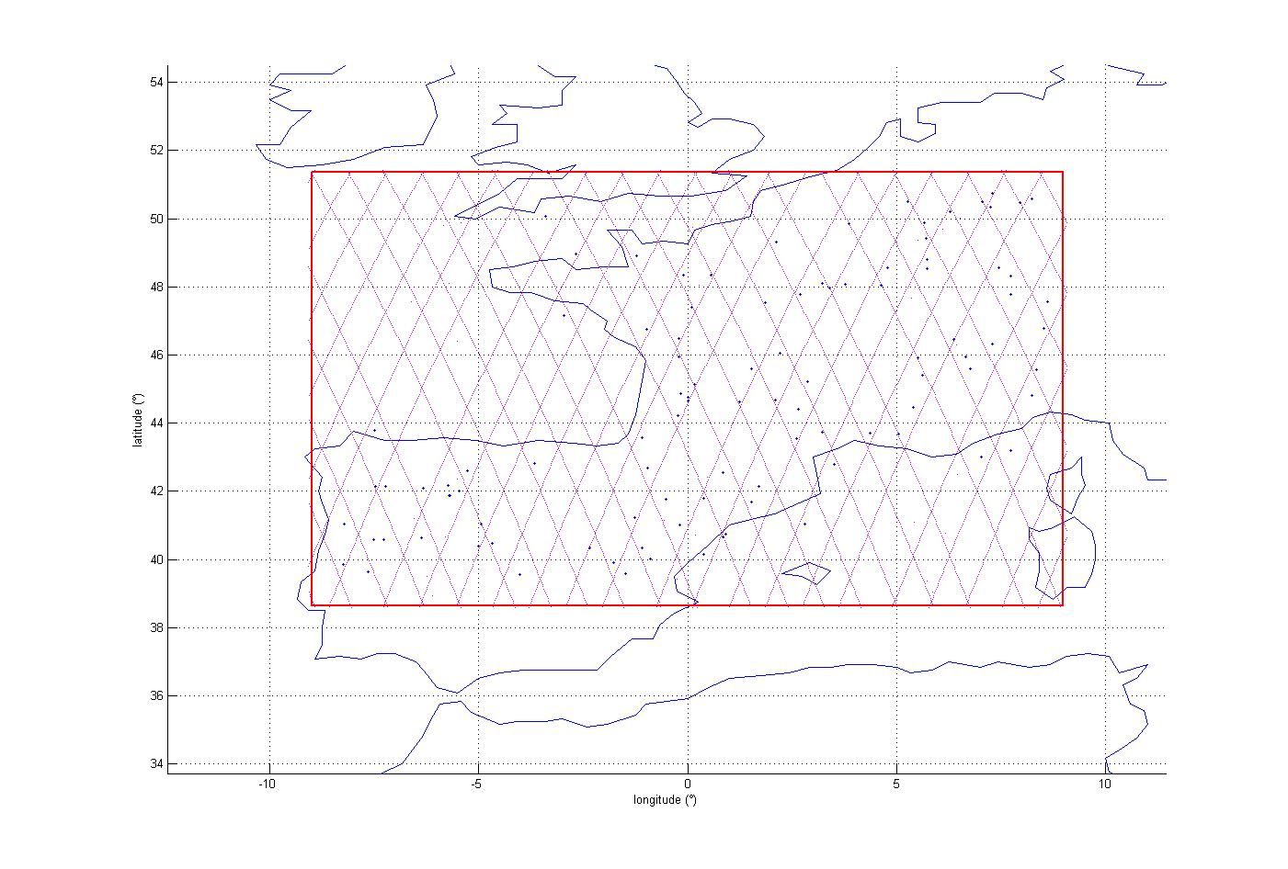
Figure 14: cloud radars deployment
The following cdf is obtained:
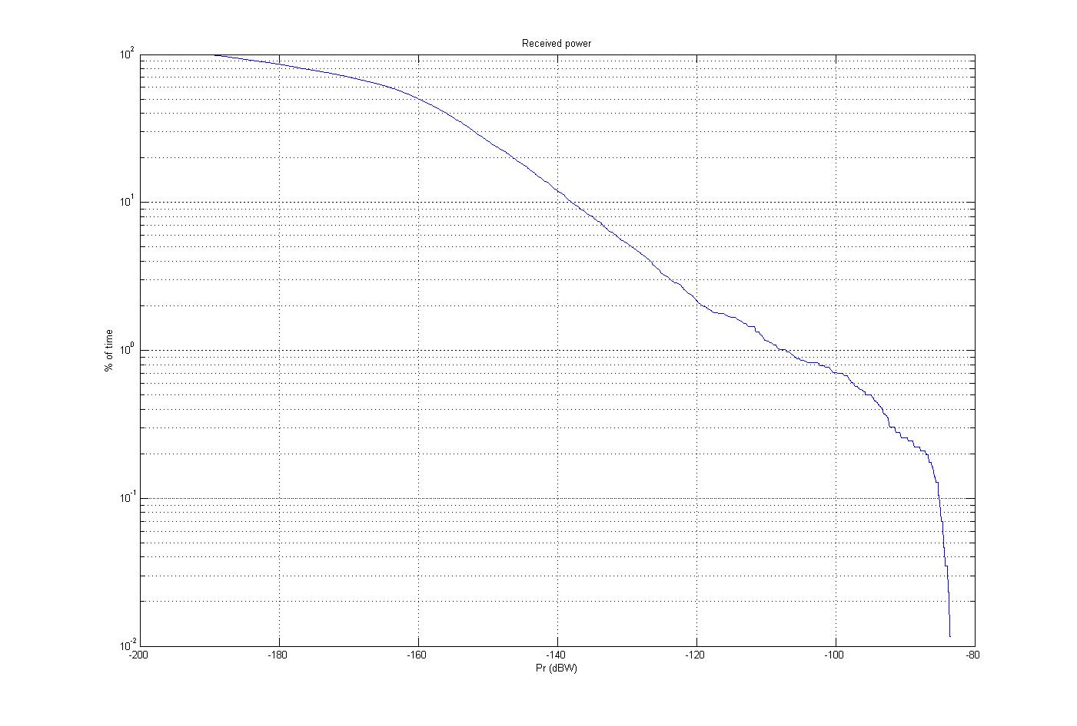
Figure 15: Interference power distribution for Altimeter

For the assumed 0 dBW power, the power received for 1% of the time is about -107.1 dBW in 500 MHz, which means that the emission power level of the cloud radars should be reduced by -107.1-(-118.5) = 11.4 dB.
This leads to an emission average power level of -11.9 dBW in 500 MHz (or -38.4 dBW/MHz).
The cloud radar wanted signal of 17.8 dBW (average power for a typical 200ns pulse (i.e. 5 MHz bandwidth and 10 kHz PRF)) should therefore be attenuated by 29.2 dB (11.4+17.8) in order not to exceed -11.9 dBW in 500 MHz and to meet the sensor protection criterion.

Compatibility with precipitation radar
As a reference calculation, the mean power radiated by the cloud radars is first assumed to be 0 dBW in 14 MHz.
The TRMM instrument is used for the calculation with an antenna pointing at Nadir with a gain of 51.5 dBi. This is a simplification since normally such a sensor operates a limited cross-track sweeping. The antenna pattern chosen is also based on ITU-R F.1245. The protection criterion is -152 dBW in 600 kHz (-138.3 dBW/14 MHz), associated with a percentage of time of 0.2% for fixed interferer locations. Contrary to EESS passive sensors, there is no reference area attached to the percentage of time criterion. However, the same area as for the 24 GHz case was taken into account in this simulation.
Only free space loss is assumed.

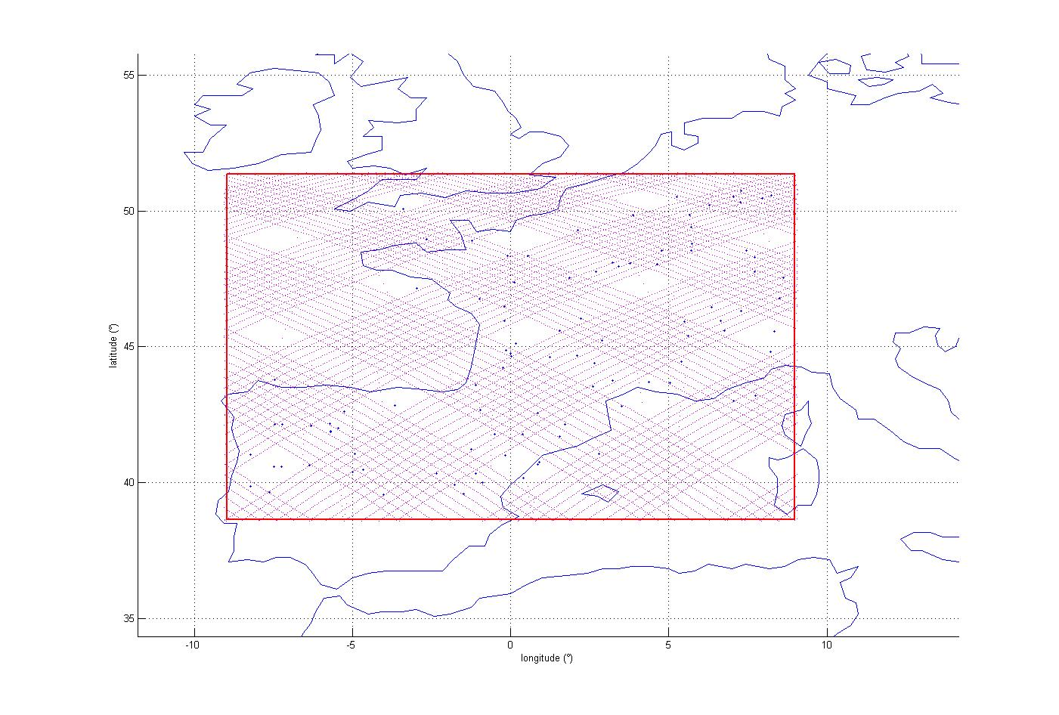
Figure 16: cloud radars deployment

The following cdf is obtained:
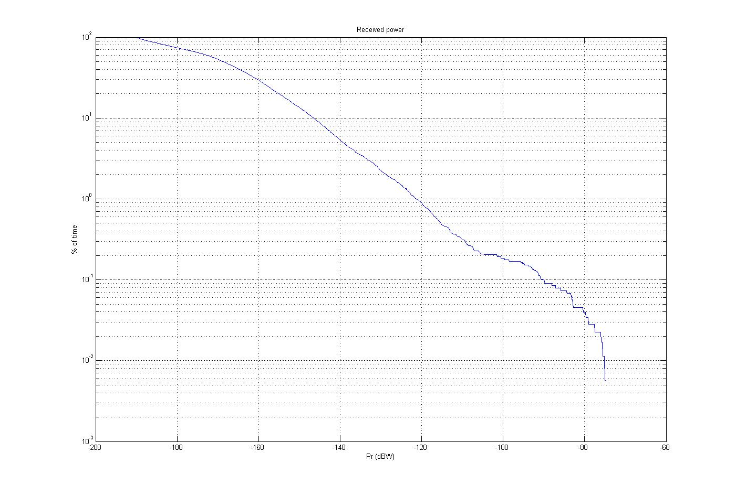
Figure 17: Interference power distribution for precipitation radar
For the assumed 0 dBW power, the power received for 0.2% of the time is about -101.5 dBW in 14 MHz, which means that the emission power level of the cloud radars should be reduced by -101.5-(-138.3) = 36.8 dB.
This leads to an unwanted emission average power level of -36.8 dBW in 14 MHz (or -48.3 dBW/MHz).
The cloud radar wanted signal of 17.8 dBW (average power for a typical 200 ns pulse (i.e. 5 MHz bandwidth and 10 kHz PRF)) should therefore be attenuated by 54.6 dB (36.8+17.8) in order not to exceed -36.8 dBW in 14 MHz and to meet the sensor protection criterion.
The required attenuation of 54.6 dB hence corresponds to a cloud radar unwanted emission e.i.r.p. of 17.8 + 50 -54.6 -10 log(5) = 6.2 dBW/MHz.

Summary of results
Table 15 provides the summary of the compatibility analysis with EESS (active) sensors, in terms of attenuation (or negative margin) required in the 35.5-36.0 GHz band compared to the cloud radar wanted signal

Table 15: Required attenuation of cloud radar wanted signal
 | Altimeters | Scatterometers | Precipitation radars
Static analysis (Worst case) | 52.8 dB | 48.3 dB | 80.9dB
Static analysis (99% or 99.8%) | 34.3 dB | 34.3 dB | 79.1 dB
Dynamic analysis (99% or 99.8%) | 29.2 dB | N/A | 54.6 dB
Considering the dynamic analysis results, a negative margin ranging 29.2 to 54.6 dB shows that:
- cloud radars are not compatible with EESS (active) and should not be operated in the radiolocation band
35.5-36 GHz;
- cloud radars operating below 35.5 GHz are compatible with EESS (active) provided that their unwanted emissions in the 35.5-36 GHz band are at least 54.6 dB below their wanted signal, corresponding to a
6.2 dBW/MHz average unwanted emission e.i.r.p.

Compliance with unwanted emissions regulations
In any case, cloud radars need to be compliant with unwanted emission regulations, as given in Recommendations ECC/REC/(02)05 and ERC/REC 74-01.
Regarding the unwanted emissions of fixed radar stations, Annex 2 of ECC/REC/(02)05 defines the limits for unwanted emissions in the out-of-band domain. By providing these limits, the boundary between the out-of-band domain and the spurious domain is also defined for this type of systems. Figure 18 is copied from ECC/REC/(02)05 and shows the limits for unwanted emissions as a function of the -40 dB bandwidth in the out-of-band domain. The dashed line (from 0.5 to 23.2 on the x-axis) shows the limit for unwanted emissions in the out-of-band domain (see also Table 16). The solid line represents the proposed design objective (see also Table 17).
The equations for determining the B-40 bandwidth are given in Annex 8 of Recommendation ITU-R SM.1541-2. For non-FM pulse radars, including spread spectrum or coded pulse radars, the bandwidth is the lesser of:
$B_{−\text{40}} = \frac{K}{\sqrt{t ⋅ t_{r}}} \text{or} \frac{\text{64}}{t}$ (2),
where t is the pulse duration (at half amplitude) and t_{r} is the rise time, both in seconds.

The coefficient K is 6.2 for radars with output power greater than 100 kW and 7.6 for lower power radars and radars operating in the radio navigation service in the 2 900-3 100 MHz and 9 200 - 9 500 MHz bands. The latter expression applies if the rise time t_{r} is less than about 0.0094t when K is 6.2, or about 0.014t when K is 7.6.
Figure 18: Emission masks for radars
(The dashed line shows the limit for unwanted emissions in the out-of-band domain.
The solid line represents the proposed design objective)

Table 16: Limits for unwanted emissions
Offset  Frequency x B₋₄₀ | Limit  dB | Slope  dB/decade
0 to 0.5 | 0 | 0
0.5 | 40 | ∞
0.5 to 5 | 40 to 60 | 20
5 to 23.2 | 60 to 100 | 60
23.2 to ∞ | 100 | 0

Table 17: Design objective limits for unwanted emissions
Offset  Frequency x B₋₄₀ | Limit  dB | Slope  dB/decade
0 to 0.5 | 0 | 0
0.5 | 40 | ∞
0.5 to 5 | 40 to 80 | 40
5 to 10.75 | 80 to 100 | 60
10.75 to ∞ | 100 | 0

For cloud radars, the following parameters are considered:
- pulse width: 100 ns
- pulse rise time: 10 ns
- K = 7.6
- centre frequency: 35.22 GHz.
On this basis, Figure 19 provides the required radar emission mask (based on ECC/REC/(02)05 objective limits) compared with relevant levels to ensure protection to EESS (active) in the 35.5-36 GHz (corresponding to a 54.6 dB attenuation) and EESS (passive) in the 36-37 GHz (corresponding to a 62.8 dB attenuation).
Figure 19: Emission mask for Cloud radar operated at 35.22 GHz

Figure 19 shows that, when operating at 35.22 GHz and in compliance with ECC/REC/(02)05, cloud radars unwanted emissions in the 35.5-36 GHz and 36-37 GHz bands are compatible with required levels to ensure protection of EESS (active) and EESS (passive) respectively.
It can therefore be recommended that cloud radars should be operated below 35.22 GHz.

Conclusions for the Cloud Radar at 35 GHz
These analyses allowed to specify the conditions under which Cloud radar 35 GHz would be compatible with EESS sensors (active and passive):
- Cloud radars are not compatible with both EESS (active) in the 35.5-36 GHz band and EESS (passive) in the 36-37 GHz band and should hence not be operated in these frequency bands;
- Cloud radars operated below 35.5 GHz are compatible with both EESS (active) in the 35.5-36 GHz band and EESS (passive) in the 36-37 GHz band provided that their average unwanted e.i.r.p. density in these bands are
6.2 dBW/MHz and -2 dBW/MHz respectively, corresponding to attenuations relative to maximum power of 54.6 dB and 62.8 dB respectively.
Overall, the following conditions could therefore be proposed for cloud radars operations:
- centre frequency: within the range 33.4-35.22 GHz
- maximum frequency bandwidth: ± 30 MHz (including frequency tolerance)
- maximum average unwanted e.i.r.p. density of 6.2 dBW/MHz in the 35.5-36 GHz band
- maximum average unwanted e.i.r.p. density of -2 dBW/MHz in the 36-37 GHz band.

Conclusions

Micro-Rain Radar at 24 GHz
The compatibility analysis related to MRR 24 GHz allows to draw the following conclusions:
- Terrestrial services in the band 24.05 – 24.25 GHz and in the adjacent bands
For the case of the protection of terrestrial services, only horizontal emissions of MRR 24 GHz are concerned. Assuming that MRR will be deployed under the Radiolocation service allocation, which is the only primary service in the band 24.05 – 24.25 GHz, no in-band analysis was performed. In addition, the horizontal MRR 24 GHz emissions are below the generic 24 GHz SRD emissions limits and allow de facto to confirm compatibility with all terrestrial services.
- Inter-satellite service and Amateur satellite service
For the case of the protection of the satellite services operated in adjacent band, considering that EESS (passive) (and SRS(passive)) in the 23.6-24 GHz are far more sensitive to interference than Amateur-satellite service in the 24-24.05 GHz band and inter-satellite service in the 24.45-24.65 GHz band, adjacent band conditions ensuring compatibility with EESS (passive) will also ensure compatibility with Amateur-satellite and inter-satellite services
- EESS (passive) and RAS in the frequency band 23.6 – 24 GHz
For the case of the protection of EESS (passive) in the 23.6-24 GHz band, compatibility can be ensured by shifting the MRR 24 GHz operating frequency at the upper edge of the 24.05-24.25 GHz band and by limiting the MRR unwanted emissions power density in the 23.6-24 GHz band to a maximum level of -84 dBm/MHz (corresponding to a -44 dBm/MHz e.i.r.p. density). It is considered that this unwanted emission level will also ensure protection of radioastronomy stations in the 23.6-24 GHz band.
Proposed conditions for the operation of MRR 24 GHz:
- centre frequency: 24.23 GHz
- maximum bandwidth: ± 17.5 MHz (including frequency excursion and tolerance)
- maximum unwanted power density: -84 dBm/MHz (corresponding to a -44 dBm/MHz e.i.r.p. density) below 24.05 GHz and above 24.45 GHz

Cloud radar at 35 GHz
The compatibility analysis related to Cloud radars at 35 GHz allow to draw the following conclusions:
- Terrestrial services in the band 35 GHz and in adjacent bands
For the case of the protection of terrestrial services (Fixed, Mobile, Radionavigation, …), only horizontal emissions of Cloud radars 35 GHz are concerned. Assuming that 35 GHz cloud radars will be deployed under the Radiolocation service allocation or in the Meteorological Aids allocation (35.2-35.5 GHz), which are the only primary terrestrial services in the frequency range 33.4-36 GHz, no in-band analysis was performed. In addition it is considered that compatibility with terrestrial services in the adjacent bands below 33.4 GHz and above 36 GHz is covered by regular unwanted emissions limits (e.g. ECC/REC/(02)05, ERC/REC 74-01).
- EESS (active) in the band 35.5-36 GHz and EESS (passive) in the 36-37 GHz band:
  - Cloud radars are not compatible with both EESS (active) in the 35.5-36 GHz band and EESS (passive) in the 36-37 GHz band and should hence not be operated in these frequency bands
  - Cloud radars operated below 35.5 GHz are compatible with both EESS (active) in the 35.5-36 GHz band and EESS (passive) in the 36-37 GHz band provided that their average unwanted e.i.r.p. density in these bands are 6.2 dBW/MHz and -2 dBW/MHz respectively, corresponding to attenuations relative to maximum power of 54.6 dB and 62.8 dB respectively.
Proposed conditions for the operations of 35 GHz cloud radars:
- centre frequency: within the range 33.4-35.22 GHz
- maximum bandwidth: ± 30 MHz (including frequency tolerance)
- maximum average unwanted e.i.r.p. density of 6.2 dBW/MHz in the 35.5-36. GHz band
- maximum average unwanted e.i.r.p. density of -2 dBW/MHz in the 36-37 GHz band.

The different combinations of PRF and Pulse duration lead to attenuations of the Peak Power between 24 dB (t = 400 ns, PRF=10kHz) and 36 dB (t =100 ns, PRF =2.5 kHz)

