 Electronic Communications Committee (ECC)
within the European Conference of Postal and Telecommunications Administrations (CEPT)
ECC REPORT 163
THE USAGE OF THE 7125-8500 MHz BAND
WITHIN THE CEPT FOR THE ELABORATION OF THE REVISION OF THE ECC/REC/(02)06 FROM VERSION 2002 TO VERSION 2011

Montegrotto Terme, May 2011

executive summary
In process of revising ECC/REC/(02)06 over the period from 2009 to 2011 there was a need to get the overview, of what channelization did CEPT Administrations use in different bands of the frequency range 7125-8500 MHz. This is in order to find solution for limited number of channelization options on one hand, and to allow, on the other hand, a wider implementation of the ECC Recommendation.

A number of the administrations had implemented the Annex 1 (7125-7725 MHz) of the ECC/REC/(02)06 (version 2002). In the gap (7725-7900 MHz) between Annex 1 and Annex 2 (7900-8500 MHz) of ECC/REC/(02)06 (version 2002), a number of administrations had implemented their channel arrangement in accordance with different annexes of Recommendation ITU-R F.385 and Recommendation ITU-R F.386 or national plans.
In 2010, the most implement channel arrangements in the CEPT are summarised below:
Table 1: Major usage of the 7125-8500 MHz within CEPT
ECC/REC/(02)06 (Version 2011) | ECC/REC/(02)06 (Version 2002) | 7125-7725 MHz | 7900-8500 MHz
ECC/REC/(02)06 Annex 1.1 and Annex 2.1 | ECC/REC/(02)06 Annex 1 | 63.2% | -
ECC/REC/(02)06 Annex 2.3 | ECC/REC/(02)06 Annex 2 | - | 31.6%
ITU-R F.385-9 basic | ITU-R F.385-9 basic | 21.1 % | -
ECC/REC/(02)06 Annex 2.2 | ITU-R F.385-9 Annex 4 | 10.5%
ECC/REC/(02)06 Annex 1.2 | ITU-R F.386-8 Annex 6 | - | 28.9 %
ECC/REC/(02)06 Annex 1.3 | ITU-R F.386-8 Annex 2 | - | 26.3 %

Differences in channel arrangements (e.g. frequency ranges, carrier spacing, duplex spacing) are significant, therefore the harmonization of the band 7125 – 8500 MHz is difficult.

ECC/REC (02)06 (version 2002) did not cover the whole range. It had a gap band between 7725-7900 MHz.
Table 2: Channel arrangement for the ECC/REC/(02)06 – version 2002
 | Frequency ranges (MHz)
ECC(02)06 (version 2002) | 7125 - 7425 | 7425 - 7725 | 7725 – 7900 | 7900 - 8500
Annex 1 | 1st range Arrangement  ECC/REC/(02)06 V.2002 An 1.1 | 2nd range Arrangement  ECC/REC/(02)06 V.2002 An 1.2 | Blank | − | −
Annex 2 | − | − | Blank | 3rd range Arrangement  ECC/REC/(02)06 V.2002 An 2

The ECC/REC/(02)06 (version 2002) was revised based on the outcome of this report by introducing the most common approaches taken by administrations for managing the whole (or the available portions) of the band 7125-8500 MHz. Two options are introduced depending on the national availability of the various sub-ranges, which give possibility to widely implement the recommendation ECC/REC/(02)06 (version 2011).

Note that the channel arrangement in 7725-8275 MHz, based on Annex 6 to ITU-R Recommendation F.386 (with 29.65 MHz channel arrangement providing 8 bidirectional channels), has been used for a long time by a number of CEPT administrations because no other arrangement is available for this frequency band. However, when planning to restructure the band or in case Administrations are newly designating this band to fixed wireless systems, Administrations are encouraged to consider a new channel arrangement, based on 28 MHz channel separation (providing 9 bidirectional channels), which is provided in ECC/REC/(02)06 (version 2011) as defined in Annex 1.2.1.

 | Frequency ranges (MHz)
ECC(02)06 (version 2011) | 7125 - 7425 | 7425 - 7725 | 7725 – 7900 | 7900 - 8275 | 8275 - 8500
Annex 1  (1st Option for the whole range) | 1st range Arrangement  ECC/REC/(02)06 V.2011 An.1.1 | 2nd range Arrangement  ECC/REC/(02)06 V.2011 An.1.1 | 3rd range Arrangement  ECC/REC/(02)06 V.2011 An.1.2.2 or An.1.2.1 (new 28 MHz channel arrangement) |  | 4th range Arrangement  ECC/REC/(02)06 V.2011 An.1.3
Annex 2  (2nd Option for the whole range) | 1st range Arrangement  ECC/REC/(02)06 V.2011 An.2.1  (same as  ECC/REC/(02)06 V.2011 An.1.1) | 2nd range Arrangement  ECC/REC/(02)06 V.2011 An.2.2 |  | 3rd range Arrangement  ECC/REC/(02)06 V.2011 An.2.3
Table 3: Channel arrangement for the ECC/REC/(02)06 – version 2011

Table of contents

0 executive summary 2
List of abbreviations 5
List of Countries abbreviations 6
1 introduction 7
2 uSAGE OF THE FREQUENCY BAND 7125-8500 MHz 8
2.1 Analysis of frequency bands 7125 – 8 500 MHz by sub-bands 12
2.2 Military usage of the frequency bands 7125-8 500 MHz 13
2.3 Conclusion for frequency bands 7125-8 500 MHz 15
3 study of channel arrangements in the frequency band 7725-8500 MHz or overlapping part of this range 16
3.1 Overview of channel arrangements used within CEPT countries 16
3.2 Descriptions of channel arrangements used within CEPT countries 18
3.3 Conclusion for frequency band 7725-8500 MHz or bands overlapping this bands 19
4 Conclusions 20
ANNEX 1: national plan 1 (AUT) 22
ANNEX 2: National plan 2 (FIN) 23
ANNEX 3: National plan 3 (NOR) 24
ANNEX 4: National plan 4 (LTU) 25
ANNEX 5: National plan 5 (HNG) 26
ANNEX 6: National plan 6 (CZE) 28
ANNEX 7: LIST OF REFERENCES 29

List of abbreviations

Abbreviation | Explanation
ADD | Added by administration
An | Annex
CEPT | European Conference of Postal and Telecommunications Administrations
DS | Duplex Spacing
ECC | Electronic Communications Committee
ENG/OB | Electronic News Gathering / Outside Broadcasting
SAB | Service Ancillary to Broadcasting
SAP | Services ancillary to programme making
SG | Study Group
ITU | International Telecommunication Union
MOD | Modified
NJFA | NATO joint civil/Military frequency
P-P | Point to point
REC | Recommendation
UWB | Ultra Wideband

List of Countries abbreviations
ALB | Albania
AND | Andorra
AUT | Austria
AZE | Azerbaijan
BEL | Belgium
BIH | Bosnia-Herzegovina
BLR | Belarus
BUL | Bulgaria
CVA | Vatican City
CYP | Cyprus
CZE | Czech Republic
D | Germany
DNK | Denmark
E | Spain
EST | Estonia
F | France
FIN | Finland
G | United Kingdom
GEO | Georgia
GRC | Greece
HNG | Hungary
HOL | Netherlands
HRV | Croatia
I | Italy
IRL | Ireland
ISL | Iceland
LIE | Liechtenstein
LTU | Lithuania
LUX | Luxembourg
LVA | Latvia
MLT | Malta
MCO | Monaco
MDA | Moldova
MKD | Former Yugoslav Republic of Macedonia
MNE | Montenegro
NOR | Norway
POL | Poland
POR | Portugal
ROU | Romania
RUS | Russian Federation
S | Sweden
SMR | San Marino
SRB | Serbia
SUI | Switzerland
SVK | Slovak Republic
SVN | Slovenia
TUR | Turkey
UKR | Ukraine

The usage of the 7125-8500 MHz band within the CEPT for the elaboration of
the revision of the ECC/REC/(02)06 from version 2002 to version 2011

introduction
In the process of revising recommendation ECC/REC/(02)06 for including additional channel arrangements in the band (7725-8500 MHz), over the period from the beginning of 2009 till the end of 2010, this ECC report was used as a basis for finding a solution to cover the whole frequency range from 7125-8500 MHz by limited number of channelization options on one hand, and allow, on the other hand, a wider implementation of the ECC Recommendation.
It was recognised that a number of the administrations have implemented the ECC/REC/(02)06 (Version 2002) Annex 1 (7125-7725 MHz). It was noted that in the gap (7725-7900 MHz) between Annex 1 and Annex 2 (7900-8500 MHz), a number of administrations had already implemented their channel arrangement in accordance with different annexes of Recommendation ITU-R F.385 and Recommendation ITU-R F.386. Therefore the harmonization of the band 7125-8500 MHz with a limited number of annexes in the revised ECC/REC/(02)06 seemed to be difficult at that point of time.

The aim of this ECC Report was at collecting and assessing the usage of the 7725-8500 MHz band per country in order to get the overview of the usage of the ECC/REC/(02)06 Annex 2 (version 2002). The information on the usage of the 7125-7725 MHz was also provided in this report in order to find the optimal solution for covering the gap between Annex 1 and Annex 2 of ECC/REC/(02)06 (version 2002) with limited number of annexes.

uSAGE OF THE FREQUENCY BAND 7125-8500 MHz
Data of 38 CEPT countries AUT, BEL, BIH, BLR, BUL, CVA, CYP, CZE, D, DNK, E, EST, F, FIN, G, HNG, HOL, HRV, I, IRL, ISL,LIE, LTU, LUX, LVA, MKD, MLT, NOR, POL, POR, ROU, RUS, S, SRB, SUI, SVK, SVN, TUR has been analysed regarding current usage of frequency bands 7125 – 8500 MHz.
Table 4: Overview of frequency band 7125-8500 MHz usage used within 48 CEPT countries
Adm. | 7125-7425 MHz |  | 7425-7725 MHz |  | 7725-8275 MHz |  | 8275-8500 MHz |  | Military
 | Actual boundaries | Arrangement references | Actual boundaries | Arrangement references | Actual boundaries | Arrangement references | Actual boundaries | Arrangement references | Actual boundaries
ALB
AND
AUT | 7125 MHz − 7425 MHz | National 1.A (100 kHz – 7 MHz, DS 161MHz ) | 7425 – 7725 MHz | ITU-R F.385-9-An 3H (28MHz, DS 168MHz, fo=7597 MHz)  ITU-R 385-9 An 1  (28 MHz, DS 154 MHz)  As of 2011: ECC/REC/(02)06  An 1.1.2 (V.2011) =  (An 1.2 (V.2002))  (28 MHz only | 7750 – 8017 MHz | National 1.B  (28 MHz,Simplex) | 7900 - 8500 MHz | ECC/REC/(02)06 An 2.3 (V.2011) = (An 2 (V.2002)) | 7857 - 7902 MHz, 8017 - 8062 MHz
AZE
BEL | 7375 MHz - 7484 MHz, 7596 MHz - 7729 MHz, 7841 MHz - 7900 MHz | SAP/SAB Point-to-Point video link | 7450-7900 MHz | ECC/REC/(02)06  An 2.2 (V.2011) =  ( ITU-R F.385-9 An 4)) (7/14/28 MHz DS 245 MHz) |  |  | 8200-8500 MHz | ITU-R F.386-8 basic (11.662/2x16.662 MHz,  DS 151.614 MHz) | 7250 - 7750 MHz,  7900 - 8400 MHz
BIH | 7125 MHz - 7425 MHz | ECC/REC/(02)06 An 1.1.1 (V.2011) =  (An 1.1 (2002)) | 7425 – 7725 MHz | ECC/REC/(02)06  An 1.1.2 (V.2011) =  (An 1.2 (V.2002)) | 7725 – 8275 MHz | ECC/REC/(02)06  An 1.2 (V.2011) =  (ITU-R F. 386-8  An 6)  (29.65 MHz, DS 311.32 MHz) | 8275 – 8500 MHz | ECC/REC/(02)06  An 1.3 (V.2011) =  (ITU-R F.386-8 An 2)  (7/14/28 MHz , DS 119 MHz ) | 7250-7300 MHz
BLR | 7187-  7243 MHz  7355-  7425 MH | ITU-R F.385-9 Basic  (7/14/28 MHz, DS 161 MHz)  for 154 MHz DS ECC/REC/(02)06 An 1.1.1 (V.2011) =  (An 1.1 (2002))  for 168 MHz DS:  National raster 7 (7/14/28 MHz).  258 RRL | 7425-  7700 MHz | ITU-R F.385-9 Basic (7/14/28 MHz, DS 161 MHz )  ITU-R F.385-9 An 1 (DS 154 MHz)  1055 RRL | 7900-  8275 MHz | ITU-R F.386-8 An 3 (28 MHz,  DS 266 MHz)  88 RRL | 8275-  8400 MHz | ITU-R F.386-8 An 3  (28 MHz,  DS-266 MHz)  88 RRL
BUL | 7110 MHz - 7750 MHz | ITU-R F.385-9 An 3L  (28MHz,  DS 196MHz, fo=7275 MHz) | 7425 - 7.725 MHz | ECC/REC/(02)06  An 2.2 (V.2011) =  (ITU-R F.385-9 An 4) (7/14/28 MHz, DS 245 MHz) | 7725 - 7970 MHz | ECC/REC/(02)06  An 1.2 (V.2011) = ITU-R F. 386-8 An 6 (29.65 MHz, DS 311.32 MHz) | 7970 - 8500 MHz | Military | 7970 - 8500 MHz
CVA | 7110 - 7425 MHz | ITU-R F.385-9 An 3L  (28MHz,  DS 196MHz, fo=7275 MHz) | 7250 - 7300 MHz |  | 7425 - 7750 MHz | ITU-R F.385-9 An3H  (28MHz,  DS 168MHz, fo=7597 MHz)
CYP | 7125 - 7425 MHz | ECC/REC/(02)06 An 1.1.1 (V.2011) =  (An 1.1 (2002)) | 7425 – 7725 MHz | ECC/REC/(02)06  An 1.1.2 (V.2011) =  (An 1.2 (V.2002)) | 7900 - 8500 MHz | ECC/REC/(02)06 An 2.3 (V.2011) =  (An 2 (V.2002)) | 7900 - 8500 MHz | ECC/REC/(02)06 An 2.3 (V.2011) = (An 2 (V.2002))
CZE | 7125 - 7425 MHz | National 6-MOD ITU-R F.385-9 Basic  (14 MHz DS 161 MHz,  fo=7275 MHz) | 7425 – 7725 MHz | ITU-R F.385-9 basic,  (7/(14) MHz,  DS 161 MHz,  fo=7575 MHz) | 7725 – 8275 MHz | Military | 8275 – 8500 MHz | Military | 7125–7219, 7247–7380, 7408–7423,5  7718,5 – 8500 MHz
D | 7125 MHz - 7425 MHz | ITU-R F.385-9 Basic  (3.5/7/14 MHz DS 161 MHz, fo=7275 MHz) | 7425 – 7725 MHz | ECC/REC/(02)06  An 1.1.2 (V.2011) =  (An 1.2 (V.2002)) (28MHz/56MHz only CCDP) | 7750 MHz-8500 MHz | Military | 7750 MHz-8500 MHz | Military | 7750 MHz-8500 MHz
DNK | 7125 - 7425 MHz  7250-7300MHz | ECC/REC/(02)06 An 1.1.1 (V.2011) =  (An 1.1 (2002)) (NJFA) | 7425 – 7725 MHz | ECC/REC/(02)06  An 1.1.2 (V.2011) =  (An 1.2 (V.2002)) | 7750 - 7850 MHz | 5.461B | 7900 - 8500 MHz  7900 –8025MHz | ECC/REC/(02)06 An 2.3 (V.2011) = (An 2 (V.2002))  (NJFA) | 7250 - 7300  MHz,  7900 - 8025 MHz
E | 7125 MHz - 7425 MHz | ITU-R F.385-9 Basic  (7/14/28 MHz, DS 161 MHz, fo=7275 MHz) | 7425 MHz - 7725 MHz | ITU-R F.385-9 An1  (28 MHz, DS 154 MHz) | 7725 MHz - 8275 MHz | ECC/REC/(02)06  An 1.2 (V.2011) =  (ITU-R F. 386-8  An 6)  (29.65 MHz, DS 311.32 MHz) | 8275 MHz - 8500 MHz | ECC/REC/(02)06  An 1.3 (V.2011) =  (ITU-R F.386-8 An 2)  (28 M, DS 119 M, 14 M, DS 126 M)
EST | 7125–7425 MHz | ITU-R F.385-9 Basic  (28 MHz) | 7425-7725 MHz | ITU-R F.385-9  Basic  (28 MHz) | 7725-8275 MHz |  | 8275-8500 MHz | ITU-R F.386-8  An 3  (14 / 28 MHz) | Civil-military sharing  7250-7300 MHz  7975-8025 MHz  8275-8500 MHz
F | 7110 - 7250 MHz | 28MHz, FX, SAP/SAB P-P link, Temporary individual authorisations | 7750 - 7890 MHz | 28MHz, FX, SAP/SAB P-P video link, Temporary individual authorisations | 8025 -8500 MHz | ITU-R F.386-8 An 5 (28/14/7/(3.5 MHz ADD), DS 208 MHz) | 8025 -8500 MHz | ITU-R F.386-8 An 5 (28/14/7/(3.5 MHz ADD), DS 208 MHz) | 7250 -7375 MHz  7890 -7900 MHz, 7900 - 8025 MHz
FIN | 7.107 - 7415 MHz | National 2A  (28 MHz, DS 168) | 7414 - 7722 MHz | National 2B  (7/14/28 MHz, DS 168) | 7732.875 - 8500 MHz | National 2C  (29.65 MHz,  DS 266.85) | 7900 – 8500 MHz | planned ECC/REC/(02)06 An 2.3 (V.2011) = (An 2 (V.2002))
G | 7110 MHz - 7250 MHz, 7300 MHz - 7425 MHz | SAP/SAB and ENG/OB | 7425 MHz - 7900 MHz | ECC/REC/(02)06  An 2.2 (V.2011) =  (ITU-R F.385-9 An 4)) (7/14/28 MHz,  DS 245 MHz) | 7900 – 8400 MHz | Military | 8460 MHz - 8500 MHz | SAP/SAB and ENG/OB | 7900 – 8400 MHz
GEO
GRC
HNG | 7125 MHz - 7425 MHz | ECC/REC/(02)06 An 1.1.1 (V.2011) =  (An 1.1 (2002)) -governmental use | 7425 MHz - 7725 MHz | ECC/REC/(02)06 An 1.1.2 (V.2011) =  (An 1.2 (V.2002)) | 7725 MHz - 7900 MHz | National 5A, simplex,  P-P for ENG | 7900 MHz - 8200 MHz,  8200 MHz - 8500 MHz | National 5B1 (MOD of ECC/REC/(02)06 An 1.1.1 (V.2011) = (An 1.1 (2002))  fc=8050 MHz),  National 5B2 (MOD of ECC/REC/(02)06 An 1.1.2 (V.2011) = (An 1.2 (V.2002)), fc=8350 MHz)
HOL | 7425 MHz – 7568 MHz | ECC/REC/(02)06 An 1.1.2, An 3 (V.2011) =  (An 1.2 (V.2002)) (28/56 MHz) | 7582 MHz - 7725 MHz | ECC/REC/(02)06  An 1.1.2, An 3 (V.2011) =  (An 1.2 (V.2002)) (28/56 MHz)
HRV | 7125 MHz - 7425 MHz | One duplex channel (28 MHz, DS 154 MHz– 7235 / 7389 MHz) | 7425 – 7725 MHz | ECC/REC/(02)06 An 1.1.2 (V.2011) =  (An 1.2 (V.2002)) | 7725 – 8275 MHz | ECC/REC/(02)06  An 1.2 (V.2011) =  (ITU-R F. 386-8  An 6)  (29.65 MHz,  DS 311.32 MHz) | 8275 – 8500 MHz | ECC/REC/(02)06  An 1.3 (V.2011) =  (ITU-R F.386-8 An 2)  (28 M, DS 119 M, 14 M, DS 126 M) | 7250 – 7375 MHz  7900 – 8025 MHz
I | 7110 - 7425 MHz | ITU-R F.385-9-An 3L  (28MHz,  DS 196MHz, fo=7275 MHz) | 7250 - 7300 MHz | Military | 7425 - 7750 MHz  …….  7750 – 8500 MHz | ITU-R F.385-9  An 3H  (28MHz,  DS 168MHz,  fo=7597 MHz)  ........  Military | 7750 - 8500 MHz | Military | 7250 - 7300 MHz, 7750 - 8500 MHz
IRL | 7125 MHz - 7425 MHz | ECC/REC/(02)06 An 1.1.1 (V.2011) =  (An 1.1 (2002)) (7/14/28 MHz, DS 154 MHz) | 7425 – 7725 MHz | ECC/REC/(02)06  An 1.1.2 (V.2011) =  (An 1.2 (V.2002)) (7/14/28 MHz, DS 154 MHz) | 7725 – 8275 MHz | ECC/REC/(02)06  An 1.2 (V.2011) =  (ITU-R F. 386-8  An 6 =  F.386-6 An 1 )  (29.65 MHz,  DS 311.32 MHz) | 8275 – 8500 MHz | ECC/REC/(02)06  An 1.3 (V.2011) =  (ITU-R F.386-8 An 2 =  F.386-6 An 3 )  (28 M, DS 119 M, 14 M, DS 126 M)  (3.5/7/14 MHz)
ISL | 7125 MHz - 7425 MHz | ECC/REC/(02)06 An 1.1.1 (V.2011) =  (An 1.1 (2002)) | 7425 MHz - 7725 MHz | ECC/REC/(02)06  An 1.1.2 (V.2011) =  (An 1.2 (V.2002)) | 7725 MHz - 7900 MHz | Not in use | 7900 - 8500 MHz | ECC/REC/(02)06 An 2.3 (V.2011) = (An2 (V.2002))
LIE | 7125 MHz - 7425 MHz | ECC/REC/(02)06 An 1.1.1 (V.2011) =  (An 1.1 (2002)) (7/14 MHz, | 7425 – 7725 MHz | ECC/REC/(02)06  An 1.1.2 (V.2011) =  (An 1.2 (V.2002))  (14/28 MHz, | 7725 – 8275 MHz | UWB applications | 8275 – 8500 MHz | UWB applications
LTU | 7125 MHz - 7425 MHz | ITU-R F.385-9 Basic  (7/14/28 MHz, DS 161 MHz) | 7425 MHz - 7725 MHz | ECC/REC/(02)06  An 1.1.2 (V.2011) =  (An 1.2 (V.2002)) | 7750-7900 MHz | National 4  (7/14/28 MHz, Simplex) | 7900 - 8500 MHz | ECC/REC/(02)06 An 2.3 (V.2011) = (An2 (V.2002))
LUX | 7125 MHz - 7425 MHz | ECC/REC/(02)06 An 1.1.1 (V.2011) =  (An 1.1 (2002)) | 7425 MHz - 7725 MHz | ECC/REC/(02)06  An 1.1.2 (V.2011) =  (An 1.2 (V.2002)) | 7725 MHz - 8275 MHz | ECC/REC/(02)06  An 1.2 (V.2011) =  (ITU-R F. 386-8  An 6)  (29.65 MHz, DS 311.32 MHz) | 8275 MHz - 8500 MHz | ECC/REC/(02)06  An 1.3 (V.2011) =  (ITU-R F.386-8 An 2)  (28 M, DS 119 M, 14 M, DS 126 M) | 7250 - 7300 MHz, 7975 - 8025 MHz
LVA | 7125 MHz - 7250 MHz, 7331 MHz - 7800 MHz | ITU-R F.385 | 7331 MHz - 7800 MHz | ITU-R F.385 | 7900 MHz - 7925 MHz, 8024 MHz - 8500 MHz | ECC/REC/(02)06  An 2.3 (V.2011) =  (An 2 (V.2002)) | 8024 MHz - 8500 MHz | ECC/REC/(02)06 An 2.3 (V.2011) = (An2 (V.2002)) | 7250 - 7331 MHz, 7850 - 7900 MHz,  7975 - 8024 MHz
MLT | 7125 MHz - 7425 MHz | ECC/REC/(02)06 An 1.1.1 (V.2011) =  (An 1.1 (2002)) | 7425 MHz - 7725 MHz | ECC/REC/(02)06  An 1.1.2 (V.2011) =  (An 1.2 (V.2002)) | 7725 MHz - 8275 MHz | ECC/REC/(02)06  An 2.3 (V.2011) =  (An 2 (V.2002)) | 8275 MHz - 8500 MHz | ECC/REC/(02)06 An 2.3 (V.2011) = (An2 (V.2002))
MCO
MDA
MKD | 7125 MHz - 7425 MHz | ITU-R F.385-9 Basic  (3.5/7/14 MHz DS 161 MHz, fo=7275 MHz) | 7425 MHz - 7725 MHz | ITU-R F.385-9 An1  compatible with ECC/REC/(02)06  An 1.1.2 (V.2011) =  (An 1.2 (V.2002)),  ITU-R F.385-9 Basic (7MHz, DS 161 MHz, fo=7575 MHz) | 7725 – 8275 MHz | ECC/REC/(02)06  An 1.2 (V.2011) =  (ITU-R F. 386-8  An 6)  (29.65 MHz, DS 311.32 MHz) | 8275 – 8500 MHz | ECC/REC/(02)06  An 1.3 (V.2011) =  (ITU-R F.386-8 An 2 =  F.386-6 An 3 )  (28 M, DS 119 M, 14 M, DS 126 M)
MNE
NOR | 7125 MHz – 7425 MHz | ITU-R F.385-9 Basic  (7 MHz,  DS 161 MHz), National 3A for 28 M channel | 7425 – 7725 MHz | ITU-R F.385-9 Basic  (7 MHz, DS 161 MHz) National 3B  (28MHz, DS 161 MHz) | 7900 - 8500 MHz | ECC/REC/(02)06  An 2.3 (V.2011) =  (An 2 (V.2002)) | 7900 - 8500 MHz | ECC/REC/(02)06  An 2.3 (V.2011) =  (An 2 (V.2002))
POL | 7075 MHz – 7450 MHz | ITU-R F.385-9 Basic  (7 /14 MHz,  DS 161 MHz, ITU-R SG09 ) | 7300 – 7750 MHz | ITU-R F.385-9 Basic  (7 /(14) MHz,  DS 161 MHz,  ITU-R SG09 ) | 7750 – 8125 MHz | ECC/REC/(02)06  An 1.3 (V.2011) =  (ITU-R F.386-8 An 2)  (28 M, DS 119 M, 14 M, DS 126 M)  ITU-R SG09  ??? SIAE:  ECC/REC/(02)06  An 1.3 (V.2011) =  (ITU-R F.386-8 An 2) is 8275-8500; either it refers to An 1.2 and ITU-R An 6, or ?? | 8275– 8500 MHz | ECC/REC/(02)06  An 1.3 (V.2011) =  (ITU-R F.386-8 An 2)  (28 M, DS 119 M, 14 M, DS 126 M) | 7075 – 8500  MHz  SIAE: just for saving space (all contiguous channels)
POR | 7125 MHz - 7425 MHz | ECC/REC/(02)06 An 1.1.1 (V.2011) =  (An 1.1 (2002)) (1.75/3.5/7/14/ 28 MHz,  DS 154 MHz) | 7425 – 7725 MHz | ECC/REC/(02)06  An 1.1.2 (V.2011) =  (An 1.2 (V.2002)) (1.75/3.5/7/14/28 MHz, DS 154 MHz)  ECC/REC/(02)06 An 3 (56 MHz, DS 154 MHz) | 7730-7975 / 8040-8290 MHz | ECC/REC/(02)06  An 1.2 (V.2011) =  (ITU-R F. 386-8  An 6)  (29.65 MHz, DS 311.32 MHz)
ROU | 7125 MHz - 7425 MHz | ECC/REC/(02)06 An 1.1.1 (V.2011) =  (An 1.1 (2002)) | 7425 – 7725 MHz | ECC/REC/(02)06  An 1.1.2 (V.2011) =  (An 1.2 (V.2002)) | 7725 – 8275 MHz | ECC/REC/(02)06  An 1.2 (V.2011) =  (ITU-R F. 386-8  An 6)  (29.65 MHz,  DS 311.32 MHz)  ECC/REC/(02)06 An 2.3 (V.2011) =  (An 2 (V.2002)) (Exceptional cases) | 8275 – 8500 MHz | ECC/REC/(02)06  An 1.3 (V.2011) =  (ITU-R F.386-8 An 2)  (28 M, DS 119 M, 14 M, DS 126 M)
RUS | 7250 MHz - 7550 MHz | ITU-R F.385-9 An 5  (3.5/7/14/28 MHz DS 161 MHz) |  |  | 7900 – 8400 MHz | ITU-R F.386-8 An 3  (28M, DS 266) | 7900 – 8400 MHz | ITU-R F.386-8 An 3  (28M, DS 266)
S | 7125 MHz – 7425 MHz | Military | 7425 – 7725 MHz | ECC/REC/(02)06  An 1.1.2 (V.2011) =  (An 1.2 (V.2002)) | 7725 - 7900 MHz | No new FS-assignment in this segment between the “An1 and 2 bands”. Issued licenses, where the duplex separation Rx/Tx is 364 MHz, expire 2015. | 7900 –  8500 MHz | ECC/REC/(02)06 An 2.3 (V.2011) = (An 2 (V.2002)) | 7125 – 7425 MHz
SMR
SRB | 7125 MHz - 7425 MHz | ECC/REC/(02)06 An 1.1.1 (V.2011) =  (An 1.1 (2002)) | 7425 – 7725 MHz | ITU-R F.385-9 Basic  (7 MHz DS 161 MHz) MOD. ITU-R F.385-9 Basic  (14/28 MHz,  DS 161 MHz) | 7725 – 8275 MHz | ECC/REC/(02)06  An 1.2 (V.2011) =  (ITU-R F. 386-8  An 6)  (29.65 MHz,  DS 311.32 MHz) | 8275 – 8500 MHz | ECC/REC/(02)06  An 1.3 (V.2011) =  (ITU-R F.386-8 An 2)  (28 M, DS 119 M, 14 M, DS 126 M)
SUI | 7125 MHz - 7425 MHz | ECC/REC/(02)06 An 1.1.1 (V.2011) =  (An 1.1 (2002))  (7/14 MHz,) | 7425 – 7725 MHz | ECC/REC/(02)06  An 1.1.2 (V.2011) =  (An 1.2 (V.2002))  (14/28 MHz,) | 7750 MHz - 8500 MHz | Military | 7750 MHz - 8500 MHz | Military | 7750 MHz - 8500 MHz
SVK | 7125 MHz - 7425 MHz | ECC/REC/(02)06 An 1.1.1 (V.2011) =  (An 1.1 (2002)) | 7425 – 7725 MHz | ITU-R F.385-9 Basic (3.5/7/14 MHz) DS 161 MHz | 7750 MHz - 8500 MHz | Military | 7750 MHz - 8500 MHz | Military | 7750 MHz - 8500 MHz
SVN | 7125 MHz - 7425 MHz | ECC/REC/(02)06 An 1.1.1 (V.2011) =  (An 1.1 (2002)) | 7425 – 7725 MHz | ECC/REC/(02)06  An 1.1.2 (V.2011) =  (An 1.2 (V.2002)) | 7725 – 8275 MHz | ECC/REC/(02)06  An 1.2 (V.2011) =  (ITU-R F. 386-8  An 6)  (29.65 MHz,  DS 311.32 MHz) | 8275 – 8500 MHz | ECC/REC/(02)06  An 1.3 (V.2011) =  (ITU-R F.386-8 An 2)  (28 M, DS 119 M, 14 M, DS 126 M) | 7975 – 8025 MHz
TUR | 7125 MHz - 7425 MHz | ITU-R F.385-9 Basic  (7/14 /28MHz, DS 161 MHz, fo=7275 MHz) | 7425 MHz - 7900 MHz | ECC/REC/(02)06  An 2.2 (V.2011) =  ( ITU-R F.385-9 An 4)) (7/14/28 MHz, DS 245 MHz) | 7900 - 8500 MHz | Military  ECC/REC/(02)06  An 2.3 (V.2011) = (An2 (V.2002)) | 7900 - 8500 MHz | Military  ECC/REC/(02)06 An 2.3 (V.2011) = (An 2 (V.2002)) | 7900 - 8500 MHz
UKR

Analysis of frequency bands 7125 – 8 500 MHz by sub-bands
Analysis has been done for 4 sub-bands: 7125 – 7425 MHz, 7 425-7 725 MHz, 7 725-8 275 MHz and 8 275 - 8 500 MHz, Figure 1).

Table 5: Overview of channel arrangements in the frequency range 7125-8500 MHz used within 38 CEPT countries
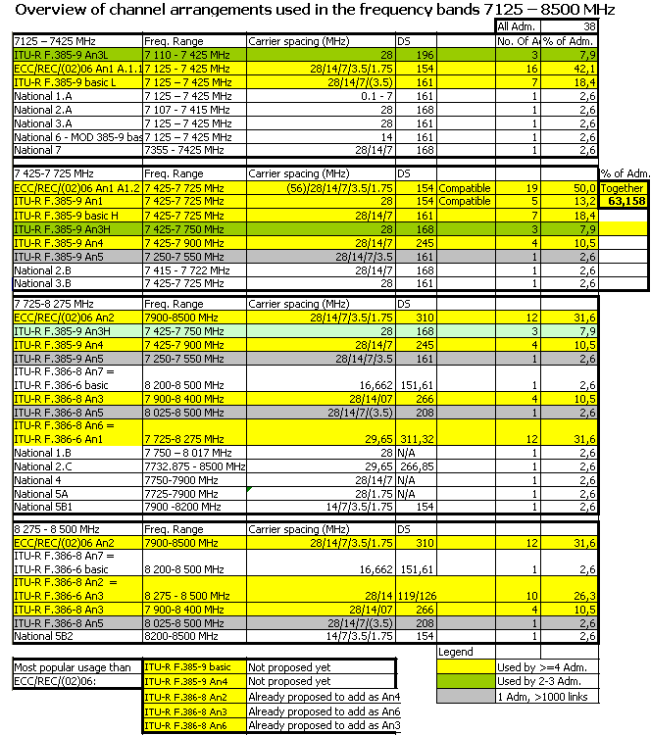

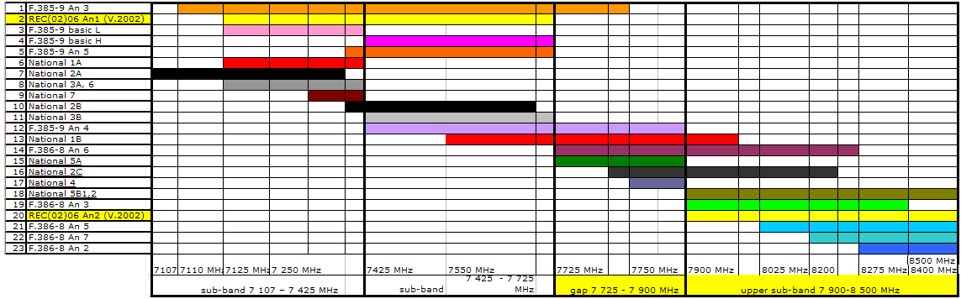
Figure 1: Channel arrangements in the frequency range 7125-8500 MHz
(annexes refer to the ECC/REC/(02)06 version 2002 unless otherwise mentioned)

Military usage of the frequency bands 7125-8 500 MHz
In most countries military is present in at least part of the band 7125-8500 MHz. The overview is presented in Error: Reference source not found. Parts of the band 7125-8500 MHz are used for military purpose. They are illustrated in Figure 2.
Table 6: Military usage of the frequency range 7125-8500 MHz within CEPT countries

Adm. | Military | Shared Civil P-P /Military
AUT | 7857 - 7902 MHz, 8017 - 8062 MHz | 7226 - 7425 MHz, 7780 – 7819 MHz,  7940 – 7979 MHz
BEL | 7250 - 7750 MHz, 7900 - 8400 MHz | 8200 - 8500 MHz
BIH | 7250 - 7300 MHz | 7125 - 7425 MHz
BUL | 7970 - 8500 MHz | 7075 - 7145 MHz, 7250 - 7750 MHz,  7850 - 7970 MHz
CZE | 7125 – 7219 MHz, 7247 – 7380 MHz, 7408 – 7423.5 MHz, 7718.5 – 8500 MHz | 7219 – 8500 MHz
D | 7750 - 8500 MHz
DNK |  | 7250 - 7300 MHz, 7900 - 8025 MHz
G | 7900 – 8400 MHz
E |  | 7450 - 7850 MHz, 7900 - 8025 MHz
EST |  | 7250-7300 MHz, 7975-8025 MHz,  8275-8500 MHz
F | 7250 - 7375 MHz , 7890 - 7900 MHz,  7900 - 8025 MHz. | 7375 - 7750 MHz, 8025 - 8500 MHz
HNG |  | 7125 - 7425 MHz,
HRV | 7250 – 7375 MHz, 7900 – 8025 MHz
I | 7250 - 7300 MHz, 7750 - 8500 MHz | 7300 - 7750 MHz
LUX | 7250 - 7300 MHz, 7975 - 8025 MHz
LVA | 7250 - 7331 MHz, 7850 -7900 MHz,  7975 - 8000 MHz, 8000 - 8024 MHz | 7723 - 7751 MHz, 7800 - 7850 MHz,  7900 - 7925 MHz, 8024 - 8025 MHz,  8215 - 8271 MHz
NOR |  | 7450 - 7750 MHz, 8025 - 8400 MHz
POL | 7250 – 7300 MHz, 7975 – 8025 MHz | 7075 – 7250 MHz, 7300 – 7975 MHz,  8025 – 8500 MHz
ROU |  | 7125 – 7425 MHz,  7484 – 7568 / 7638 – 7725 MHz,  7725 – 8500 MHz
S | 7125 – 7425 MHz
SUI | 7750 - 8500 MHz
SVK | 7750 - 8500 MHz
SVN | 7975 – 8025 MHz | 7250 – 7300 MHz, 8025 – 8400 MHz
TUR | 7900 – 8500 MHz | 7425 – 7900 MHz

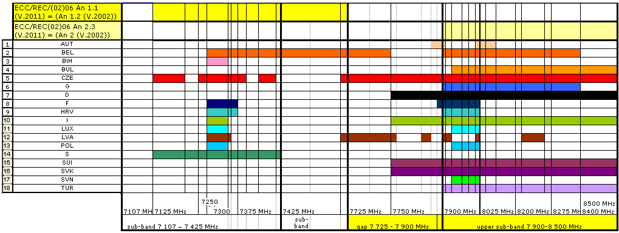Figure 2: Graphic presentation of parts of the frequency range 7125-8500 MHz
used for military within CEPT countries

Conclusion for frequency bands 7125-8 500 MHz
- In the lower bands 7125–7725 MHz 63.2 % of administrations use channel arrangements in ECC/REC/(02)06 Annex 1 (version 2002) - ECC/REC/(02)06 Annex 1.1 (version 2011) or ITU-R F.385-9 Annex 1, which are compatible. Other usages are ECC/REC/(02)06 Annex 2.2 (version 2011) - ITU-R F.385-9 Annex 4, ITU-R F.385-9 basic, Annex 3, Annex 5. Some administrations have their own national channel arrangements.
- In the upper bands 7725-8500 MHz 12 administrations of 38 use ECC/REC/(02)06 Annex 2 (version 2002) - ECC/REC/(02)06 Annex 2.3 (version 2011) (31.6 %). Other usages are ECC/REC/(02)06 Annex 1.2 (version 2011) - ITU-R F.386-8 Annex 6, ECC/REC/(02)06 Annex 1.3 (version 2011) - ITU-R F.386-8 Annex 2, ECC/REC/(02)06 Annex 2.2 (version 2011) - ITU-R F.385-9 Annex 4, ITU-R F.385-9 Annexes 3, 5 and ITU-R F.386-8 basic + Annexes 3, 5, 7 (some administrations have added some additional carrier spacing compatible with the ITU-R Recommendations). Some administrations have their own national channel arrangements.
- Most commonly used channel arrangements other than in ECC/REC/(02)06 (version 2002) - ECC/REC/(02)06 (version 2011) Annexes 1.1, 2.1, 2.3 are:
- 7 110 - 7 425 MHz: ITU-R F.385-9 An3L (3 administrations of 38) 7.9 %
- 7 125 – 7 425 MHz: ITU-R F.385-9 basic L (7 administrations of 38) 18.4 %
- 7 425 – 7 725 MHz: ITU-R F.385-9 basic H (8 administrations of 38) 21.1 %
- 7 425-7 750 MHz: ITU-R F.385-9 An3H (3 administrations of 38) 7.9 %
- 7 425-7 900 MHz: ITU-R F.385-9 Annex 4 - ECC/REC/(02)06 (version 2011) Annex 2.2.
(4 administrations of 38) 10.5 %
- 7 725-8 275 MHz: ITU-R F.386-8 Annex 6 - ECC/REC/(02)06 (version 2011) Annex 1.2.
(11 administrations of 38) 28.9 %
- 8 275 -8 500 MHz: ITU-R F.386-8 Annex 2 - ECC/REC/(02)06 (version 2011) Annex 1.3.
(10 administrations of 38) 26.3 %.
- In most countries military is present in at least part of the band 7125-8500 MHz. But approximately half of the countries have parts of the band allocated for defence systems. In approximately one fourth of the countries a large portion of the band is allocated for military usage. But in only 1 Administration of 38 the whole gap band is used by the military.
- study of channel arrangements in the frequency band 7725-8500 MHz or overlapping part of this range
A number of administrations have implemented the current Annex 1 (7125-7725 MHz) of ECC/REC/(02)06. A more detailed analysis is done for the band 7 725-8 500 MHz. In addition in some countries the band 7 425-7725 MHz is also used in conjunction with a lower portion of the band 7 725-8 500 MHz.

Overview of channel arrangements used within CEPT countries
The usage of the band 7425-8500 MHz within CEPT countries is presented in Table 7.
Table 7: Channel arrangements in the band 7425 – 8500 MHz used within 38 CEPT countries 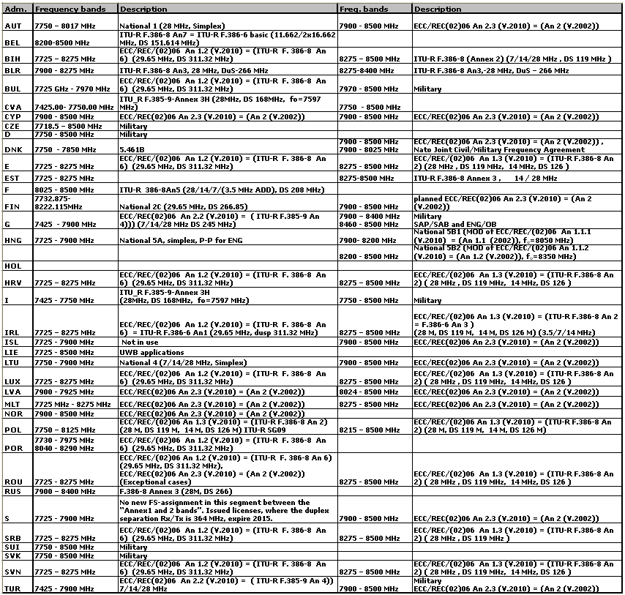

Descriptions of channel arrangements used within CEPT countries
Overview of channel arrangements used in the frequency bands 7725-8500 MHz

Table 8: Overview of channel arrangements in the bands 7725-8500 MHz used within 38 CEPT countries
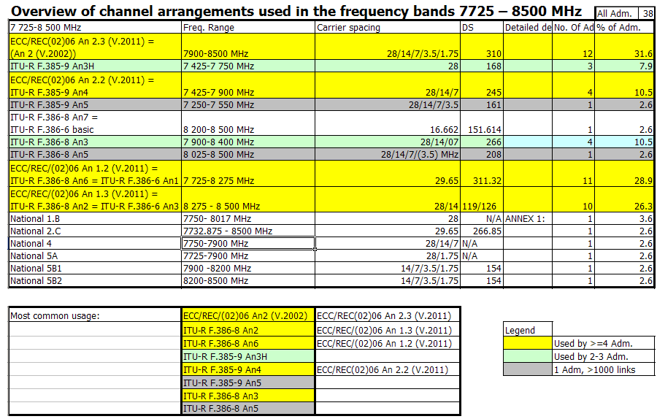

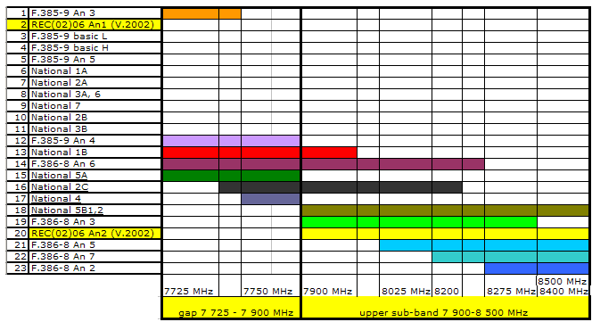
Figure 3: Channel arrangements in the band 7725-8500 MHz
(annexes refer to the ECC/REC/(02)06 version 2002 unless otherwise mentioned)

Conclusion for frequency band 7725-8500 MHz or bands overlapping this bands
In the band 7 725- 8 500 MHz or overlapping bands 12 administrations of 38 use ECC/REC/(02)06 Annex 2 (version 2002) - ECC/REC/(02)06 Annex 2.3 (version 2011) (31.6 %). Other usages are ECC/REC/(02)06 Annex 1.2 (version 2011) - ITU-R F.386-8 Annex 6, ECC/REC/(02)06 Annex 1.3 (version 2011) - ITU-R F.386-8 Annex 2, ECC/REC/(02)06 Annex 2.2 (version 2011) - ITU-R F.385-9 Annex 4, ITU-R F.385-9 Annexes 3, 5 and ITU-R F.386-8 basic + Annexes 3, 5, 7 (some administrations have added some additional carrier spacing compatible with the ITU-R Recommendations). Some administrations have national channel arrangements.
Most commonly used channel arrangements other than in ECC/REC/(02)06 (version 2002) are:
- 7 425-7 900 MHz: ITU-R F.385-9 Annex 4 - ECC/REC/(02)06 (version 2011) Annex 2.2.
(4 administrations of 38) 10.5 %
- 7 725-8 275 MHz: ITU-R F.386-8 Annex 6 - ECC/REC/(02)06 (version 2011) Annex 1.2.
(11 administrations of 38) 28.9 %
- 8 275 -8 500 MHz: ITU-R F.386-8 Annex 2 - ECC/REC/(02)06 (version 2011) Annex 1.3.
(10 administrations of 38) 26.3 %.
Channel arrangements of some CEPT administrations with >1000 links in the ITU Master register + three most commonly used channel arrangements other than in ECC/REC/(02)06 (version 2002) are:
- 7 425-7 900 MHz: ITU-R F.385-9 Annex 4 - ECC/REC/(02)06 (version 2011) Annex 2.2. (10.5 %)
- 7 725-8 275 MHz: ITU-R F.386-8 Annex 6 - ECC/REC/(02)06 (version 2011) Annex 1.2. (28.9 %)
- 7 250-7 550 MHz: ITU-R F.385-9 Annex 5 (one administration with 18416 links)
- 7 900-8 400 MHz: ITU-R F.386-8 Annex 3 (3 administrations, 1 with 18416 links) (7.9 %)
- 8 025-8 500 MHz ITU-R F.386-8 Annex 5 + 3.5M carrier spacing (one administration with 3407 links)
8 275-8 500 MHz: ITU-R F.386-8 Annex 2 (= ITU-R F.386-6 An3) - ECC/REC/(02)06 (version 2011) Annex 1.3.
(26.3 %)
Most administrations have parts of the band allocated to military or other services such as SAP/SAB Point-to-Point video link, SAP/SAB - ENG/OB, UWB applications, BMA or Space research.

Conclusions
A number of the administrations (from 38 responses) had implemented the current Annex 1 (7125-7725 MHz) of ECC/REC/(02)06(version 2002). In the gap (7725-7900 MHz) between Annex 1 and Annex 2 (7900-8500 MHz), a number administrations had implemented their channel arrangement in accordance with different annexes of Recommendation ITU-R F.385 and Recommendation ITU-R F.386. Table 5, Figure 1, Figure 3 and Table 8 are describing differences in channel arrangements
Figure 2 illustrates military usage of parts of the band. In two thirds of the countries military is present in at least part of the band 7125-8500 MHz. But approximately half of the countries have parts of the band allocated for defence systems. In approximately one fourth of the countries a large portion of the band is allocated for military usage (in the lower part or in the upper part of the band). But in only one Administration of 38 the whole gap band is used by the military.

Table 9 summarises the most implement channel arrangement in the CEPT. Figure 4 illustrates the most implemented channel arrangement in the CEPT in 8GHz frequency band (7 125-8 500 MHz) not covered by ECC/REC/(02)06 (Version 2002) Annex 1 and 2.
Table 9: Major usage of the 7125-8500 MHz within CEPT
The most implement channel arrangements in the CEPT are:
ECC/REC/(02)06 (Version 2011) | ECC/REC/(02)06 (Version 2002) | 7125-7725 MHz | 7900-8500 MHz
ECC/REC/(02)06 Annex 1.1 and Annex 2.1 | ECC/REC/(02)06 Annex 1 | 63.2% | -
ECC/REC/(02)06 Annex 2.3 | ECC/REC/(02)06 Annex 2 | - | 31.6%
ITU-R F.385-9 basic | ITU-R F.385-9 basic | 21.1 % | -
ECC/REC/(02)06 Annex 2.2 | ITU-R F.385-9 Annex 4 | 10.5%
ECC/REC/(02)06 Annex 1.2 | ITU-R F.386-8 Annex 6 | - | 28.9 %
ECC/REC/(02)06 Annex 1.3 | ITU-R F.386-8 Annex 2 | - | 26.3 %

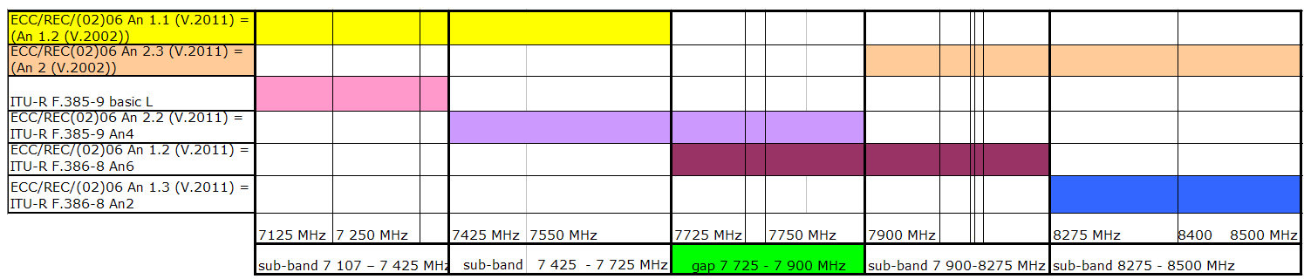
Figure 4: The most implemented channel arrangement in the CEPT in 8GHz frequency band (7 125-8 500 MHz) not covered by ECC/REC/(02)06 (version 2002) Annex 1 and 2

Differences in channel arrangements (e.g. frequency ranges, carrier spacing, duplex spacing) are significant, therefore the harmonization of the band 7125 – 8500 MHz is difficult.

ECC/REC/(02)06 (version 2002) did not cover the whole range. It had a gap band between 7725-7900 MHz.

 | Frequency ranges (MHz)
ECC/REC/(02)06 | 7125 - 7425 | 7425 - 7725 | 7725 - 7900 | 7900 - 8500
Annex 1 | 1st range Arrangement  ECC/REC/(02)06 V.2002 An 1.1 | 2nd range Arrangement  ECC/REC/(02)06 V.2002 An 1.2 | Blank | − | −
Annex 2 | − | − | Blank | 3rd range Arrangement  ECC/REC/(02)06 V.2002 An 2
Table 10: Channel arrangement for the ECC/REC/(02)06 – version 2002

The ECC/REC/(02)06 (version 2002) on the outcome of this report by introducing the most common approach taken by administrations for managing the whole (or the available portions) of the band 7125 – 8500 MHz. Two options are introduced depending on the national availability of the various sub-ranges, which give possibility to widely implement the recommendation ECC/REC/(02)06 (version 2011).

Note that the channel arrangement in 7725-8275 MHz, based on Annex 6 to ITU-R Recommendation F.386 (with 29.65 MHz channel arrangement providing 8 bidirectional channels), has been used for a long time by a number of CEPT administrations because no other arrangement is available for this frequency band. However, when planning to restructure the band or in case Administrations are newly designating this band to fixed wireless systems, Administrations are encouraged to consider a new channel arrangement, based on 28 MHz channel separation (providing 9 bidirectional channels), which is provided in ECC/REC/(02)06 (version 2011) as defined in Annex 1.2.1.

Table 11: Channel arrangement for the ECC/REC/(02)06 – version 2011
 | Frequency ranges (MHz)
ECC/REC/(02)06 | 7125 - 7425 | 7425 - 7725 | 7725 - 7900 | 7900 - 8275 | 8275 - 8500
Annex 1  (1st Option for the whole range) | 1st range Arrangement  ECC/REC/(02)06 V.2011 An.1.1  (ECC/REC/(02)06 V.2002 An 1.1) | 2nd range Arrangement  ECC/REC/(02)06 V.2011 An.1.1  (ECC/REC/(02)06 V.2002 An 1.2) | 3rd range Arrangement  ECC/REC/(02)06 V.2011 An.1.2.2 or An.1.2.1 (new 28 MHz channel arrangement) |  | 4th range Arrangement  ECC/REC/(02)06 V.2011 An.1.3  (from ITU-R F.386-8 Annex 2)
Annex 2  (2nd Option for the whole range) | 1st range Arrangement  ECC/REC/(02)06 V.2011 An.2.1  (same as  ECC/REC/(02)06 V.2011 An.1.1  (ECC/REC/(02)06 V.2002 An 1.1) | 2nd range Arrangement  ECC/REC/(02)06 V.2011 An.2.2  (from ITU-R F.385-9 Annex 4) |  | 3rd range Arrangement  ECC/REC/(02)06 V.2011 An.2.3  (ECC/REC/(02)06 V.2002 An 2)
- national plan 1 (AUT)

A. Frequency band 7125-7425 MHz: 7124.5-7264.5 MHz in pair with 7285.5-7425.5 MHz

A national channel plan is applied with maximum channel bandwidth of 7 MHz. Applicable radio interface description is in FSB-RR007:
- Service: Fixed
- Utilization: Point-to-Point links for private networks or networks of public importance, shared civil/military use.
- Technical specifications:
  - Licensing regime: Individual assignment.
  - Duplex = 161 MHz
- n x 100 kHz, n = 1, 2, …….70
- Output power = 40 dBm
- Max. e.i.r.p. = 40 dBW

B. Frequency band 7750-8017 MHz: 7754-7852 MHz and 7933-8017 MHz

A national channel plan is applied with maximum channel bandwidth of 28 MHz. Applicable radio interface description is in FSB-RR067:
- Service: Fixed
- Utilization: Point-to-Point video links for BC, civil use.
- Technical specifications:
  - Licensing regime: Individual assignment.
- Simplex
- 28 MHz
- Channels for H Polarisation: 7782 MHz, 7810 MHz, 7838 MHz, 7961 MHz, 7989 MHz
- Channels for V Polarisation: 7768 MHz, 7796 MHz, 7824 MHz, 7947 MHz, 7975 MHz, 8003 MHz
- Output power = 43 dBm
- Max. e.i.r.p. = 47 dBW
- National plan 2 (FIN)

- Frequency band 7107 – 7415 MHz

Channel arrangement in the frequency range 7107-7415 MHz is modified from the ITU-R Recommendation F.358 with a centre frequency of 7261 MHz. Only 28 MHz channel separation is in use, and the frequencies (MHz) of the individual channels are expressed by the following relationships:
lower half of the band: f_{n} = f₀  168 + 28 n
upper half of the band: f_{n}’ = f₀ + 28 n
where:
n = 1, 2, 3, 4 and 5.

- Frequency band 7415 - 7722 MHz

Channel arrangement in the frequency range 7414 - 7722 MHz is modified from the ITU-R recommendation F.358 with a centre frequency of 7568 MHz. 7, 14 and 28 MHz channel separations are in use. The frequencies (MHz) of the individual channels with 7 MHz separation are expressed by the following relationships:
lower half of the band: f_{n} = f₀  157.5 + 7 n
upper half of the band: f_{n}’ = f₀ + 10.5 + 7 n
where:
n = 13, 14, ... , 20.

The frequencies (MHz) of the individual channels with 14 MHz separation are expressed by the following relationships:
lower half of the band: f_{n} = f₀  161 + 14 n
upper half of the band: f_{n}’ = f₀ + 7 + 14 n
where:
n = 7, 8, ... , 10

The frequencies (MHz) of the individual channels with 28 MHz separation are expressed by the following relationships:
lower half of the band: f_{n} = f₀  168 + 28 n
upper half of the band: f_{n}’ = f₀ + 28 n
where:
n = 1, 2, 3, 4 and 5.

- Frequency band 7732.875 - 8222.115 MHz

Channel arrangement in the frequency range 7732.875 - 8222.115 MHz is a national channel arrangement with a centre frequency of 7977.495 MHz. Only 29.65 MHz channel separation is in use. The frequencies (MHz) of the individual channels are expressed by the following relationships:
lower half of the band: f_{n} = f₀  259.445 + 29.65 n
upper half of the band: f_{n}’ = f₀  7.405 + 29.65 n
where:
n = 1, 2, ..., 8.
- National plan 3 (NOR)

- Frequency band 7125-7425 MHz

Channel plan for 28 MHz channels:
lower half of the band: fn = f₀ – 175 + 28 n
upper half of the band: fn2′= f₀ 14 + 7 n
where:
f₀ = 7275 MHz
n = 1, 2, 3, 4 or 5
Duplex = 161 MHz

- Frequency band 7425-7725 MHz

Channel plan for 28 MHz
realized by the same f0 and the following relationship:
lower half of the band is taken from ITU-R-F.385-9, Annex 1, point 4:
fn = f₀ – 175 + 28 n
upper half of the band is not in accordance to any international recommendations:
fn’ = f₀ – 14 + 28 n
where:
n = 1, 2, 3, 4 and 5
f₀=7575 MHz
Duplex = 161 MHz

- National plan 4 (LTU)

Frequency band 7750-7900 MHz:

One way low capacity Point-to-Point links

f_{n} = 7743 + 28·n
f_{n} = 7743 + 7 + 14·n
f_{n} = 7743 + 3.5 + 7·n

- National plan 5 (HNG)

- Frequency band 7725-7900 MHz
- Service: Fixed
- Utilization: Point-to-Point ENG for civil use.
- Technical specifications:
- Licensing regime: Individual assignment.
- Channel centre frequencies:
TV channels: 7743 MHz, 7771 MHz, 7799 MHz, 7827 MHz, 7855 MHz, 7883 MHz
Radio channels: Subdivision of 28 MHz TV channels by 16.
- Minimum antenna gain: min. G = 30 dBi
- Max. e.i.r.p. = 40 dBW

B1 Frequency band 7900 - 8200 MHz
- Service: Fixed
- Utilization: Point-to-Point for civil use.
- Technical specifications:
- Licensing regime: Individual assignment.
- Channelling and channel capacities:
1.75 MHz min. 2 Mbit/s,
3.5 MHz min. 4 Mbit/s,
7 MHz min. 8 Mbit/s,
14 MHz min. 16 Mbit/s.
- Minimum antenna gain: min. G = 40 dBi
- Max. e.i.r.p. as a function of the hop length
if L < 20 km then max. e.i.r.p. = 40 – 20 log (20/L) (L in kms)
if L ≥ 20 km then max. e.i.r.p. = 40 dBW

Channel centre frequencies according to formulas in ECC/REC/(02)06, Annex 1,
f0 = 8050 MHz

Then the centre frequencies (MHz) of individual channels are expressed by the following relationships:

a) for channel spacing of 14 MHz:
lower half of the band: fn = f0 – 154 + 14∙n,
upper half of the band: fn′ = f0 + 14∙n, where n = 1,2,…, 10;

b) for channel spacing of 7 MHz:
lower half of the band: fn = f0 – 150.5 + 7∙n,
upper half of the band: fn′ = f0 + 3.5 + 7∙n, where n = 1,2,…, 20;

c) for channel spacing of 3.5 MHz:
lower half of the band: fn = f0 – 148.75 + 3.5∙n,
upper half of the band: fn′ = f0 + 5.25 + 3.5∙n, where n = 1,2,…, 40;

d) for channel spacing of 1.75 MHz:
lower half of the band: fn = f0 – 147.875 + 1.75∙n,
upper half of the band: fn′ = f0 + 6.125 + 1.75∙n, where n = 1,2,…, 80.

The duplex separation between Tx/Rx is 154 MHz,

B2 Frequency band 8200 - 8500 MHz
- Service: Fixed
- Utilization: Point-to-Point for civil use.
- Technical specifications:
- Licensing regime: Individual assignment.
- Channelling and channel capacities:
1.75 MHz min. 2 Mbit/s,
3.5 MHz min. 4 Mbit/s,
7 MHz min. 8 Mbit/s,
14 MHz min. 16 Mbit/s.
- Minimum antenna gain: min. G = 40 dBi
- Max. e.i.r.p. as a function of the hop length
if L < 20 km then max. e.i.r.p. = 40 – 20 log (20/L) (L in kms)
if L ≥ 20 km then max. e.i.r.p. = 40 dBW

Channel centre frequencies according to formulas in ECC/REC/(02)06, Annex 1,
f0 = 8350 MHz

Then the centre frequencies (MHz) of individual channels are expressed by the following relationships:

a) for channel spacing of 14 MHz:
lower half of the band: fn = f0 – 154 + 14∙n,
upper half of the band: fn′ = f0 + 14∙n, where n = 1,2,…, 10;

b) for channel spacing of 7 MHz:
lower half of the band: fn = f0 – 150.5 + 7∙n,
upper half of the band: fn′ = f0 + 3.5 + 7∙n, where n = 1,2,…, 20;

c) for channel spacing of 3.5 MHz:
lower half of the band: fn = f0 – 148.75 + 3.5∙n,
upper half of the band: fn′ = f0 + 5.25 + 3.5∙n, where n = 1,2,…, 40;

d) for channel spacing of 1.75 MHz:
lower half of the band: fn = f0 – 147.875 + 1.75∙n,
upper half of the band: fn′ = f0 + 6.125 + 1.75∙n, where n = 1,2,…, 80.

The duplex separation between Tx/Rx is 154 MHz,

- National plan 6 (CZE)
Frequency band 7125-7425 MHz

The band 7125-7425 MHz may be used by fixed links point-point and following conditions apply:

a) the channel separation is 14 MHz, whereas centre frequencies fn and fn’ [MHz] of particular operating channels are in relation to the reference frequency f₀ = 7275 MHz given by formulas

fn = f₀ – 147 + 14n in the lower part of the band and
fn’ = f₀ + 14 + 14n in the upper part of the band,

where n = 1, 2, 3 up to 8.

The arrangement is derived from Recommendation ITU-R F.385-7 – Radio-frequency channel arrangements for radio-relay systems operating in the 7 GHz band. ),

b) for radio channels Nos. 1 to 6 the Office issues individual authorisations valid till 31 December 2007. Radio channels Nos. 7 and 8 may be used without limitation.

- LIST OF REFERENCES
- ECO Frequency Information System (EFIS), http://www.efis.dk/
- SE19 (09)53: Russian Federation, Draft revision ECC/REC/(02)06, 10 August 2009
- SE19 (09)60: Finnish Communications Regulatory Authority: ERC/REC/(02)06- 8 GHz, 16. September 2009
- SE19 (09)65: SIAE Microelettronica SpA, ECC/REC/(02)06 - INFO for 7 & 8 GHz national channel arrangements survey, 6 October 2009
- SE19 (09)70: Croatia, Channel arrangements for microwave links in 7 GHz frequency range in Republic of Croatia, 24th September 2009
- SE19 (10)14: Norwegian Post and Telecommunication Authority: Channel arrangements for microwave links in 7 and 8 GHz frequency range in Norway, 6th January 2010
- SE19(10)18: RATEL, Serbia, Revision of ECC/REC/(02)06 – Draft new ECC Report 7125-8500 MHz implementation in CEPT, 05 March 2010
- SE19 (10)20: OFCOM CH, Revision of ECC/REC/(02)06 – Draft new ECC Report 7125-8500 MHz implementation in CEPT, 16. March 2010
- SE19(10)23: ANFR, Revision of ECC/REC/(02)06 – Draft new ECC Report 7125-8500 MHz implementation in CEPT, 11 February 2010
- SE19(10)25: Lithuania (RRT), Usage of the frequency band 7125-8500 MHz in Lithuania, 7 April 2010
- SE19(10)28: National Communications Authority, Hungary, Revision of ECC/REC/(02)06 – Draft new ECC Report 7125-8500 MHz implementation in CEPT, 13 April 2010
- SE19(10)31: Swedish Telecom Agency (PTS), Revision of ECC/REC/(02)06, 21 April 2010
- SE19(10)039: Austria, Current channel plan implementation in the 7125-8500 MHz, 27.05.2010
- SE19(10)040: Iceland, Current channel plan implementation in the 7125-8500 MHz, 01.06.2010
- SE19(10)041: Turkey, Current channel plan implementation in the 7125-8500 MHz, 07.06.2010

Nato Joint Civil/Military Frequency

