
Electronic Communications Committee (ECC)
within
the European Conference of Postal and Telecommunications Administrations (CEPT)
ECC REPORT 157

the impact of spurious emissions of radars
at 2.8, 5.6 and 9.0 GHz
on other radiocommunication services/systems

Cardiff, January 2011

executive summary
This ECC Report presents detailed analysis of the impact of fixed radiodetermination systems on other services/systems (i.e. Fixed service (P-P application), Mobile service (RLAN in 5 GHz band) and Radioastronomy service) operating in adjacent or different bands. This analysis was done on a theoretical approach, but results of some measurements of existing filtering solutions were also considered.
A number of cases have been considered of major importance for defining levels of unwanted emissions in the spurious domain giving confidence of reasonably low occurrence probability of interference. Particular attention has been given to meteorological radars, which represent the majority of fixed installations presently subject to the 100 dB_{PEP} attenuation required in ERC/REC 74-01. Further consideration was given to the levels in ERC/REC 74-01.
In relation to FS, the Report considered:
- the impact of spurious emission, the very high power of the primary radars under consideration confirm the common assumption that, whichever would be the spurious limit in dBc, main-beam to main-beam coupling between radars and FS stations is not possible because in all cases the protection distance is in the order of several tens of km (in most cases lies beyond the horizon). Therefore, it is assumed that information about the FS and radar locations are known to administrations licensing their use;
- the impact of typical C band meteo radars on the variation of the potentially blocked azimuth angles for FS stations in the 6-8 GHz band was considered as more representative case. The resulting expected blocked sectors of 6-8 GHz P-P stations due to the spurious emissions of various types of S band radars in different scenarios were assessed for the most representative scenario cases 1 and 3. From the results for FS in the band 68 GHz, it appears that some relaxation (down to -90dBc) for the spurious emissions level for the C-band meteorological radars would have limited impact on the FS P-P deployment;
- further relaxation (down to e.g. -75dBc) for S-band radar would be much more problematic; however there are only few of such S-band meteoradar in Europe deployed in specific area. It should also to be noted that the analysis for S-band radars shows that the impact of some particular very high power radars for which only -60 dBc presently applies (in particular the civil aviation radars and the military radars considered in this study) could produce complete FS azimuth blocking up to the horizon.
In relation to RLAN operating in MS, the Report considered that radars are often installed in or close to residential areas where RLAN, indoor or outdoor, could be deployed. To avoid that, in certain situations, radars make part of the 5 GHz band unusable for RLAN operation the radar spurious emissions should be kept below -80 to -90 dBc. This will ensure that RLAN operation remains possible even at distances down to or even below 1 km from the radar.
It should be stressed that the report does not address the compatibility issues between the radars at 2.8 GHz and the Mobile service in the frequency band 2500-2690 MHz. Therefore, corresponding studies are required.
In relation to RAS, irrespective of the radar spurious emission limit, the worst case required separation distances between radars and RAS stations are in the order of several tens km. The distances range from 45 km (for 100 dBc attenuation) to more than 100 km (for 65dBc attenuation), depending on radar type. Similarly to the Fixed Service case, it is assumed that information about the RAS and radar locations is available for administrations and that these cases are solved by appropriate coordination taking into account in particular terrain shielding. One can also report that, for the same spurious limit, the civil aviation radar considered in this report requires larger separation distances compared to meteorological radars.
It is further noted that the current regulations in both CEPT and ITU-R Recommendations (and Radio Regulations) provide definition of the boundary between out-of band and spurious domains strictly related to the Necessary Bandwidth of the radar emissions, which is assumed to be equal to B₄₀. Recommendation ITU-R SM.1541, for calculating B₄₀ for the primary radars in subject, provides formulas that are highly variable with the pulse parameters (by a factor of 10 or more in particular with the rise-fall time relative to pulse duration) with the consequence that also the boundary of the spurious domain cannot be clearly fixed for any radar “category” under study, but can vary by several GHz from the carrier, because their pulse parameters are not recommended anywhere.
It is recognized that there are some difficulties in practice to achieve -100 dBc limit for spurious emission of radar in the whole range of frequencies covered by the ERC/REC 74-01, as confirmed by measurements. However there are filtering solutions that show that the limit of spurious emissions of -100 dBc can be met in most part of the spectrum for meteorological radar, operating in the frequency band 5.6 GHz (C-band). To this respect, it is assumed that for these radars, a limit set at -90 dBc will in any case impose an efficient filtering solution while ensuring that such limit can be met over the whole spectrum.
For lower frequency bands (S-band) in which radars radiate higher power compared with C-band radars (up to 1 MW) similar solution providing -100 dBc may not be feasible. Therefore, on a site by site basis, an Administration may decide, taking into account potential cross-border compatibility issues where relevant, to deploy meteorological radars in the band 2700-2900 MHz with a peak power above 750 kW with relaxed spurious emission limits. Further studies are required in this respect.
Finally, it is expected that radars operating in the higher frequency bands (X-band; 8.5-10.5 GHz) with significant lower power (in the order of 50/60 kW) could meet -100 dBc more easily.

Table of contents

0 executive summary 2
1 introduction 7
2 Radars characteristics 7
2.1 Typical pulsed radar emission characteristics 7
2.2 Meteorological radars at ~ 5.6 GHz 9
2.3 Radars at ~ 2.8 GHz 10
2.4 Radars operating in bands > ~ 8 GHz 11
3 Coexistence scenario 11
4 Coexistence analysis with FIXED SERVICE 12
4.1 Frequency bands 12
4.2 Protection criteria 12
4.2.1 Broad-band victim receivers 13
4.2.2 Narrow-band victim receivers 13
4.3 Protection distance 13
4.4 Point-to-point equipment and antenna characteristics 14
4.4.1 Broad-band systems 14
4.4.2 Narrow-band systems 14
4.4.3 P-P Antennas 14
4.5 Point-to-multipoint equipment and antenna characteristics 16
4.6 Summary of FS victim characteristics 16
4.7 Coexistence analysis 17
4.7.1 5.6 GHz meteorological radars 17
4.7.2 2.7-3.4 GHz (S-band) radars 28
5 Coexistence analysis with MOBILE SERVICE (RLAN 5 Ghz) 32
5.1 Frequency bands 32
5.2 RLAN co-existence objectives and deployment scenario 32
5.3 Summary of typical RLAN characteristics 33
5.4 DFS trigger by radar unwanted emissions 33
5.5 Scenario and co-existence distance 33
6 Coexistence analysis with RADIOASTRONOMY 35
6.1 RAS at 4.9 GHz 35
6.1.1 Characteristics of RAS 35
6.1.2 Characteristics of meteorological radars at 5.6 GHz (see Section 2.2): 35
6.1.3 Calculations 36
6.2 RAS at 2690-2700 MHz 38
6.2.1 Characteristics of RAS 38
6.2.2 Characteristics of meteorological radars at 2.8 GHz (see Section 2.3): 38
6.2.3 Characteristics of one civil aviation radars at 2.8 GHz (see Section 2.3): 38
6.2.4 Calculations 38
6.3 Summary of results for Radioastronomy 40
7 impact of FILTERING on radars 40
7.1 General considerations 40
7.2 Experience of filtering solution in some Administrations 41
7.2.1 Experience in one country 41
7.2.2 Experience in another country 44
7.2.3 Experience in the third country 47
7.2.4 Experience and comments from one meteorological organization 51
8 Conclusions 53
8.1 Conclusion in relation to the FS 53
8.2 Conclusion in relation to the RLAN 55
8.3 Conclusion in relation to the RAS 55
8.4 Additional considerations on boundary between spurious and OoB domains of radar emissions 55
8.5 Conclusion in relation to the filtering capability 56
ANNEX 1 : Spectral characteristics of pulsed RF signal 57
ANNEX 2 : TECHNICAL BACKGROUND FOR THE FS PROTECTION CRITERIA 64
ANNEX 3 : LIST OF REFERENCES 66

LIST OF ABBREVIATIONS

Abbreviation | Explanation
BPF | Band-Pass Filter
CEPT | European Conference of Postal and Telecommunications Administrations
BWA | Broadband Wireless Access
DFS | Dynamic Frequency Selection
e.i.r.p. | effective isotropically radiated power
ETSI | European Telecommunications Standards Institute
EUMETNET | European Meteorological Network
FCC | Federal Communications Commission
FDP | Fractional Degradation in Performance
FICORA | Finnish Communication Regulatory Authority
FS | Fixed Service
FSS | Fixed Satellite Service
FWA | Fixed Wireless Access
ITU-R | International Telecommunication Union-Radiocommunication
LPF | Low-Pass Filter
MSSR | Monopulse Secondary Surveillance Radar
OOB | Out Of Band
PEP | Peak Envelope Power
P-MP | Point-to-MultiPoint
P-P | Point-to-Point
PRF | Pulse Repetition Frequency
RADAR | RAdio Detection And Ranging
RAS | Radio Astronomy Service
RLAN | Radio Local Access Network
RMS | Root Mean Square
RPE | Radiation Pattern Envelope
UWB | Ultra Wide Band

The impact of spurious emissions of radars at 2.8, 5.6 and 9.0 GHz on other radiocommunication services/systems

introduction
ERC/REC 74-01 [1] recommends that fixed radars installed after 1.1.2006 should fulfil the limit of −100 dBc for their spurious emissions with an exception of wind profiler, multi-frequency and active array radars which are required to comply with -60 dBc, which is the regulatory limit for radars as given in Radio Regulations Appendix 3.
Within the general review of Recommendation ERC/REC 74-01 [1], concerns were expressed by the meteorological community about “the difficulty to comply with the current -100 dBc limit for some types of radars and the obvious current unbalanced situation for meteorological radars”. In addition, although recognising the need for improved spurious emissions levels for all radiocommunication applications, and in particular radars, the meteorological community raised the point of the rationale for such low -100 dBc discrimination, facing current situation in Europe where, in mature deployment of meteorological radars (about 200 radars, not compliant with -100 dBc, because deployed before January 2006) and telecommunication networks (in particular with several thousands FS links in the 6-7 GHz band) only few interference cases have been reported, in very specific geometric situations.
This ECC Report presents detailed analysis of the coexistence between fixed radiodetermination systems and other services/systems operating in adjacent or different bands. This analysis was done on a theoretical approach, but results of some measurements of existing filtering solutions were also considered.
The following case analysis have been retained of major importance for defining levels of unwanted emissions in the spurious domain giving confidence of reasonably low occurrence probability of interference. Particular focus has been done to meteorological radars, which represent the majority of fixed installations presently subject to the 100 dB_{PEP} attenuation required in Recommendation ERC/REC 74-01 [1].
Three different victim services were considered in this Report, i.e. Fixed service (P-P application), Mobile service (RLAN in 5 GHz band) and Radioastronomy service. Consideration of impact on Mobile service in the frequency band 2500-2690 MHz is not given in this report.

Radars characteristics

Typical pulsed radar emission characteristics
From theoretical point of view the emissions of unfiltered high power pulsed radars can be mathematically described, for very wide frequency range around the main carrier, with typical sin(x)/(x) envelope of spectral lines mutually spaced by Pulse Repetition Frequency (PRF).
Annex 1, based on basic Fourier formulas and available ITU-R Recommendations, offers theoretical background.
In practical emissions a number of additional true spurious emissions, e.g. due to parasitic oscillation, which may either be single frequency peaks or still modulated with characteristics similar to the main emission. Such spectral components are over imposed to the main emission at some spot frequency as shown in Figure 1.
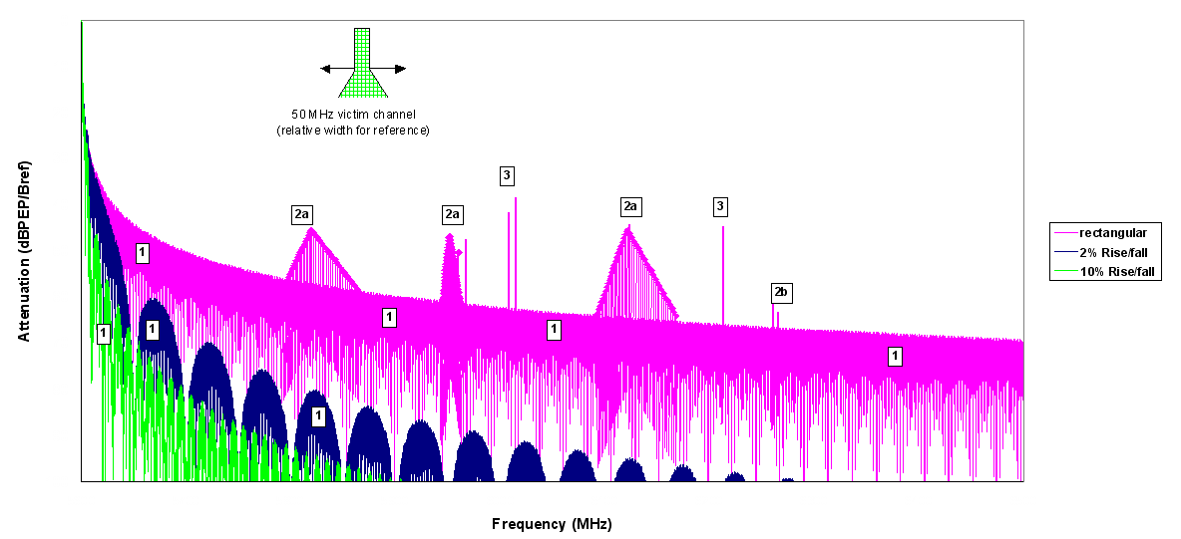
Figure 1: Spectral-lines ideal envelope with over imposed narrower-band spurious (Note: qualitative information, for quantitative information see Annex 1)

ERC/REC 74-01 [1] sets spurious domain emission limits within a reference bandwidth that, for radars, Recommendation ITU-R M.1177 [2] defines as variable but close to ~1 MHz.
In frequency regions with a high density of spectral lines, the wide-band peak aggregation of potential interference into wide band victims may become more and more important.
Recommendation ITU-R M.1177 [2] suggests that the aggregation factor may range from 0 to 20 dB with respect to the bandwidth ratio.
With reference to Figure 1, typical spectral zones 1, 2 and 3 have been identified, which would represent different interference scenario cases due to the different expected wide-band Peak Envelope Power (PEP) aggregation factor and the related peak-to-rms ratio, as shown in Table 1.
Spectrum zone  (see Figure 1) | Wide-band PEP  aggregation factor (dB) over actual PEP in the reference bandwidth (Bref) | peak-to-rms ratio (dB) | Notes
Scenario case 1  (radar out-of-band (OOB) portion in the spurious domain) | ~20 ×  log (victim Bw/Bref)  (Note 1) | ~10 ×  log (victim Bw/PRF)  (Note 2) | The radar spectrum is assumed nearly flat in the victim Bw (unless the victim is very close to the radar carrier)
Scenario case 2  (modulated undesired emissions) | ~10 ×  log (victim Bw/Bref)  (Notes 1 and 3) | ~5 ×  log (victim Bw/PRF)  (Notes 3 and 4) | Either the “parasitic” modulated emission is significantly decaying within the victim Bw  (2a areas), or a single frequency peak is slightly predominant over the (flat) radar spectrum lying underneath (2b areas)
Scenario case 3  (Random frequency peaks) | ~ 0 | ~ 3 | A single frequency peak is largely predominant over any other spectral components
Note 1: It should be reminded that, according the definition of Bref = 1/T, the factor, for the various radar types reported in Recommendation ITU-R M.1849 [3], the aggregation factor may have ~ 30 dB variation in spectrum zone 1 and ~ 15 dB in spectrum zone 2 .
Note 2: With these assumptions, for the range of victim bandwidth (3.5 MHz ≤ Bw ≤50 MHz) and PRF (250 Hz through 1.2 kHz), the peak-to-rms ratio in the victim bandwidth would always exceed ~34.5 dB.
Note 3: With respect to the maximum level seen within the victim Bw; this is a budgetary simplification for “not flat” spectrum-lines zones, which would need more complex integration within the victim Bw.
Note 4: With these assumptions, for the range of victim bandwidth (3.5 MHz ≤ Bw ≤50 MHz) and PRF (250 Hz through 1.2 kHz), the peak-to-rms ratio in the victim bandwidth would reach a maximum of ~26.5 dB.
Table 1: Expected PEP band-aggregation factor and peak-to-rms ratios
The detailed theory analysis of the spectral emissions of pulsed radars is given in Annex 1. The unwanted emissions in spectral “zone 1” are linked to the rise/fall time and the pulse width; for 2% rise/fall time, which might be considered a lower technology bound, the main spectrum emission falls below ~60 dB at ~50 MHz and below 80 dB at ~250 MHz from the carrier. Therefore, only in few cases of adjacent bands the “zone 1” situation may be relevant.
It shall be noted that Figure 1 still shows the sin(x)/(x) portion of a “band unlimited” spectral emission; the actual emission experienced by a FS receiver will be “filtered” by the antenna feed operating outside its operating frequency, resulting in a number of amplitude dips; however, it would still contain a portion of continuous spectral lines along the FS bands.
Example of real spectrum of filtered and unfiltered weather radars at far-field location are available e.g. in Appendix 1 to Recommendation ITU-R F.1097-1 [4].
In addition, ECC and Recommendations ITU-R on unwanted emissions define that radar unwanted emissions shall be evaluated as emission radiated from the antenna (i.e. far-field condition excluding the antenna gain and propagation losses); therefore, feed and antenna will also play a significant role, alas, case-by-case different.

Meteorological radars at ~ 5.6 GHz
The output of all radars is waveguide. Then any interference to frequency bands below the cut-off frequency could be excluded.
According ERC Report 025 [5], meteorological radars are allocated in the range 5250 MHz to 5850 MHz. Most of these radars operate within the 5600-5650 MHz band.
Meteorological radars use directional antennas, which are continuously rotating in azimuth and elevation; therefore, the interference given to other systems would be of time-varying nature.
Meteorological radars characteristics, including antennas can be found in Recommendation ITU-R M.1849 [3]. From Recommendation ITU-R M.1849 [3]:
- Output power +84 dBm (250 kW)
- Pulse duration τ ≅ 0.5 to 3 μs [10 μs] (1/τ ≅ [0.1] 0.33 to 2 MHz)
- Pulse Repetition Frequency PRF ≅ 250 to 1 200 Hz
- Rise/fall time ~0.05 to 0.2 × τ
- Antenna gain typical 45 dBi
- Antenna side lobe gain reduction 25 to 35 dB
- Antenna back lobes gain reduction 50 to 60 dB
Taking the case of radars deployed in the French network, the average PRF and pulse widths are respectively 330 Hz and
2 µs.
From these values it comes that the duty cycle is around 0.07%, representing a peak-to-rms power ratio of the main carrier of 31.8 dB.
Other radars make use of different PRF/pulse width combination that varies from one rotation to another. The following describe some typical figures:
- 0.8 µs with alternative 450-600 Hz PRF (33.8 dB peak-to-rms ratio)
- 1 µs with alternative 800-1200 Hz PRF (30 dB peak-to-rms ratio)
- 0.5 µs with 1200 Hz PRF (32.2 dB peak-to-rms ratio)
- 0.8 µs with 1180 Hz PRF (30.2 dB peak-to-rms ratio)
- 2 µs with 550 Hz PRF (29.6 dB peak-to-rms ratio)
- 0.58 µs with alternative 900-1200 Hz PRF (32.1 dB peak-to-rms ratio).
One can see from these examples that, roughly, typical peak-to-rms ratio of meteorological radars is the range 30-32 dB. It should also be stressed that, on a more general basis, even using different combination of PRFs and pulse width, it is necessary when designing any radar emission scheme to ensure smooth variations and almost constant value of the mean (rms) power of the radar in the above range.
Typical peak power of meteorological radars in the C-Band is 250 kW (i.e. about 54 dBW). The mean (rms) power of meteorological radars is therefore in the range 52-54 dBm.
The reference bandwidth of the radars is roughly inversely proportional to the pulse width (about 600 kHz for 2 µs pulses up to 2 MHz for 0.5 µs pulses).
For the French radars, within a reference bandwidth of 600 kHz, the mean (rms) spectral density is therefore (54 dBW +30 -31.8 -10log(0.6)) = 54.4 dBm/MHz.
For the other types of radars above, the mean (rms) spectral density (in dBm/MHz) is therefore given as 54 dBW +30 – (P-to-rms ratio) -10log(10⁶/τ) that gives :
- 0.8 µs with alternative 450-600 Hz PRF (49.2 dBm/MHz)
- 1 µs with alternative 800-1200 Hz PRF (54 dBm/MHz)
- 0.5 µs with 1200 Hz PRF (48.8 dBm/MHz)
- 0.8 µs with 1180 Hz PRF (52.8 dBm/MHz)
- 2 µs with 550 Hz PRF (57.4 dBm/MHz)
- 0.58 µs with alternative 900-1200 Hz PRF (49.5 dBm/MHz)
The range of mean (rms) power density of C-band meteorological radars is hence in the 48.8-57.4 dBm/MHz.

Radars at ~ 2.8 GHz
According ERC Report 025 [5], Radiolocation systems are allocated in the range 2700 to 3400 MHz. Most meteorological radars are operating in the range 2700-2900 MHz.
The 2700-3400 MHz band is a major band for Military and Civil Aviation primary radars whereas the meteorological radars represent a minority of the total radars population.
Civil Aviation and Meteorological radars are limited to the 2700-2900 MHz band whereas Military radars are covering the whole 2700-3400 MHz band.
The following Table 2 provides relevant characteristics of typical radar for each of the usage:
 | Civil Aviation ¹ | Military¹ | Meteorological²
Peak Power (kW) | 1400 | 1000 | 850
Pulse width (μs) | 0.6 | 100 | 2
Pulse rise time (μs) | 0.15 | not given  (assumed < 1% pulse width) | not given  (assumed ~5% pulse width)
Bref (kHz)* | 1700 | 10 | 500
B₋₄₀ (MHz) ** | ~24 | ~ 0.6 | ~ 14
PRF (Hz) | 1000 | 300 | 330
Max gain (dBi) | 33.5 | >40 | 42-45
¹ Respectively radar A and radar K from Recommendation ITU-R M.1464 [6]. In term of peak powers, these radars correspond to the worst case of the Recommendation.
² Typical S-Band radar in Europe
* Bref is derived from the pulse width
** Estimated from Recommendation ITU-R M.1177 [2]
Table 2: S-band radar characteristics

Radars operating in bands > ~ 8 GHz
Radars in this frequency range are characterised by a significantly lower power (typically few kW); filtering in this case is also far simpler. Therefore, they are likely to meet the currently recommended limits.

Coexistence scenario
The generic interference scenario is shown in Figure 2.
Figure 2: Coexistence scenario
The heights of the two antennas are important for defining the “horizon” distance (D_{H}) of the interfering path, beyond which the diffraction losses should be taken into account.
The values of antenna height should represent a “flat land” situation with radar posed on the roof of a station or a tower and antenna of victim station (FS (P-P); FS (P-MP); RAS or FSS).

Coexistence analysis with FIXED SERVICE

Frequency bands
In principle, this study should cover all kind of radar emissions in any Radiodetermination band adjacent or nearby Fixed Service (FS) primary band. The 5.6 GHz and 2.8 GHz meteorological radars are a suitable example where ITU-R has recently developed a comprehensive Recommendation with useful systems characteristics.
Therefore, this study refers to the evaluation of the compatibility of the unwanted emissions in the spurious domain of Meteorological Radars operating, in fixed locations, at ~5.6 GHz with peak power 250 kW and ~2.8 GHz with peak power 800 kW with the primary FS systems in nearby bands as well as in non adjacent bands (e.g. 11 GHz where the 2nd harmonic of the 5.6 GHz radar emission falls). The concerned FS bands are summarised in Table 3.
Band (conventional  ITU-R reference) | Band extremes  (MHz) | ITU-R Recommendation | CEPT Recommendation
1.5 GHz | 1350-1517 | F.1242 [7] | ERC T/R 13-01 [8]
2 GHz | 2025-2290 | F.1098 [9] | ERC T/R 13-01 [8]
3.5 GHz (BWA) | 3400-3800 | F.1488 [10] | ECC/REC/(04)05 [11]
4 GHz | 3600-4200 | F.382 [12]; F.635 [13] | ERC/REC 12-08 [14]
U4 GHz | 4400-5000 | F.1099 [15] | (note 2)
L6 GHz | 5925-6425 (note 1) | F.383 [16] | ERC/REC 14-01 [17]
U6 GHz | 6425-7125 | F.384 [18] | ERC/REC 14-02 [19]
7 GHz | 7125-7725 | F.385 [20] | ECC/REC/(02)06 [21]
8 GHz | 7725-8500 | F.386 [22] | ECC/REC/(02)06 [21]
11 GHz | 10700-11700 | F.387 [23] | ERC/REC 12-06 [21]
Note 1: In some CEPT Countries the lower limit is extended down to 5.670 GHz in accordance with RR 5.455
Note 2: No CEPT channel arrangement is recommended; however, the band is used for NATO harmonised FS links and also in civil use in some CEPT Countries.
Table 3: FS frequency bands

Protection criteria
As shown in previous sections, unwanted emissions of high power pulsed radars might still present, in some portion of the spectrum, even far from the carrier, a considerable peak factor.
Consequently, compatibility studies with pulsed emissions interference need to include information on the spectral characteristics of the pulsed source in order to evaluate the effects of both rms and peak power interference into the FS receiver.
FS protection objectives, for various source of interference, are set by Recommendation ITU-R F.1094-2 [24] and further subdivided by Recommendation ITU-R F.758-4 [25] into:
- “long-term” interference objective (>20% of the time)
- “short-term” interference objective (<1% of the time)
- interference objective for intermediate time periods (1% < time < 20%) to be determined on a case by case.
Meteorological Radars use directional antennas, which are continuously rotating in azimuth and elevation; therefore, the interference into FS systems would be of time-varying nature.
Therefore, in average, the interference from a fixed radar is permanent all day and year round; consequently we would consider as “long term” case also the majority of the “case by case” occurrence, when the side and back lobes of radar antenna radiation patterns are concerned.
Even if the Report assumes that time the radar antenna boresight is pointing at or nearly to the FS station as “short term” interference and therefore does not take it into account, it has to be considered by the calculation/simulation of the impact it causes, as this ‘short time’ is permanently repeated, e.g. three times a minute (the assumed rotation speed of the radar). Statistically, this ‘short time’ interference changes to a ‘constant’ interference with the probability of x%, where x is the integral over the time to be considered, e.g. one hour, which may then be interpreted as ‘duty cycle’. For this purpose assuming that the radar antenna is rotating (e.g. as in meteorological radarss applications), the FS receiver is subject to a time-varying interference level. In such cases a Fractional Degradation in Performance (FDP) criteria analysis is appropriate (see Recommendation ITU-R F.1108 [26]).
It should be noted that pulsed interference may repeatedly erase specific information that can result in additional loss of information on top of that erased by the radar interference. Evaluation of such a scenario requires detailed analysis of FS link behaviour as a result of intermittent interference, and has not been carried out in this report.

Broad-band victim receivers
The effect of pulsed interference signals on P-P FS systems has been assessed in ECC Report 023 (2003) [27] dealing with Short Range Radars in 24 GHz band.
Based on the background in that ECC Report (see summary background in Annex 2), the same two independent protection criteria are assumed:
- I_{rms}/N ≤−20 dB within 1MHz (or more in general within the victim bandwidth):
rms densities ratio within 1MHz.
Note: The above criteria is generally considered when interference are of “broad-band”, noise-like nature; however, when single frequency peaks or very narrow band interference are concerned, the I_{rms}/N ≤−20 dB should be intended as overall aggregation of I and N over the victim bandwidth.
- IPeak/N ≤+ 5 dB within 50 MHz (or more in general within the victim bandwidth):
I_{peak} to N_{rms} ratio within 50 MHz (equivalent to interference peak power lower than noise peak power for a probability p > ~4%).
The noise peak of the FS receiver was derived from band-limited Rayleigh distribution (Annex 1 of ECC Report 064 [28] contains theory background about it).
The above protection criteria have been adopted by ECC and ITU-R also in all subsequent studies for UWB pulsed emissions compatibility with FS and was used in the present study, unless a more specific test campaign is carried out. Similar, more “empirical” assessment for conventional radar emissions is available in Recommendation ITU-R F.1097-1 (2000) [4].
The integration bandwidth 50 MHz was chosen for three reasons:
- It is close to the maximum bandwidth used for FS;
- It is inappropriate to define I_{peak} levels in the same density unit of rms (1 MHz), when the victim bandwidth is significantly wider;
- It was also selected by FCC for same purpose.
Provided that 56 MHz FS channels are already in use in higher bands and certainly going to be used also in L6 GHz to 8 GHz FS bands, an actual victim receiver bandwidth of 50 MHz may still be appropriately used.

Narrow-band victim receivers
No specific tests or literature has been found specifically dealing with peak effects on narrow-band receivers; however, there is no reason indicating that the physical rationale, derived from the above broad-band tests, of maintaining interference peak below noise peak for a probability p > ~4% should not be valid for any victim bandwidth.
Therefore, the protection criteria might be more generally assumed to be:
- Irms/N ≤−20 dB within 1 MHz (or any narrower victim bandwidth)
- IPeak/N ≤+ 5 dB within the victim bandwidth

Protection distance
In principle, being primary service interfered by unwanted emissions from an adjacent band, the FS stations should be capable to be deployed at any distance and with any azimuth direction with respect to the radar site. However, the same principle also apply for radar, primary in their band, that should also be capable to be deployed at any distances from FS operated in an adjacent or nearby band. In practice, for physical reasons but also for operational considerations, the distance between radar and P-P FS stations need to be assessed in the light of a balanced situation and probability of potential interference from unwanted emissions in both ways.

Point-to-point equipment and antenna characteristics

Broad-band systems
Provided that 56 MHz FS channels are already in use in higher bands and certainly going to be used also in L6 GHz to 8 GHz FS bands, an actual victim receiver bandwidth of 50 MHz, used for similar purpose in coexistence studies with UWB, may still be appropriately used.

Narrow-band systems
Narrow-band representative system are assumed to be ~3.5 MHz for 1.5 GHz and 7/8 GHz bands or ~1 MHz or less for 1.5 GHz band only.

P-P Antennas
Antenna directional characteristics are also necessary; for the P-P FS systems they can be derived from Recommendation ITU-R F.699-7 [29]
- FS P-P equipment in 1.5 GHz bands mostly uses parabolic grid antennas with diameter = 3-4 m; however, 2 m antennas are also used;
- FS P-P equipment in 4 GHz bands mostly uses parabolic antennas with diameter = 3-4 m; however, 2.4 m antennas are also used;
- FS P-P equipment in 6-8 GHz and 11 GHz bands mostly uses parabolic antennas with diameter = 2-3 m; however, 1 m antennas are not infrequent.
Figure 3 shows the FS RPE derived from Recommendation ITU-R F.699-7 [29] with the above diameters, representing the majority of the deployed types.

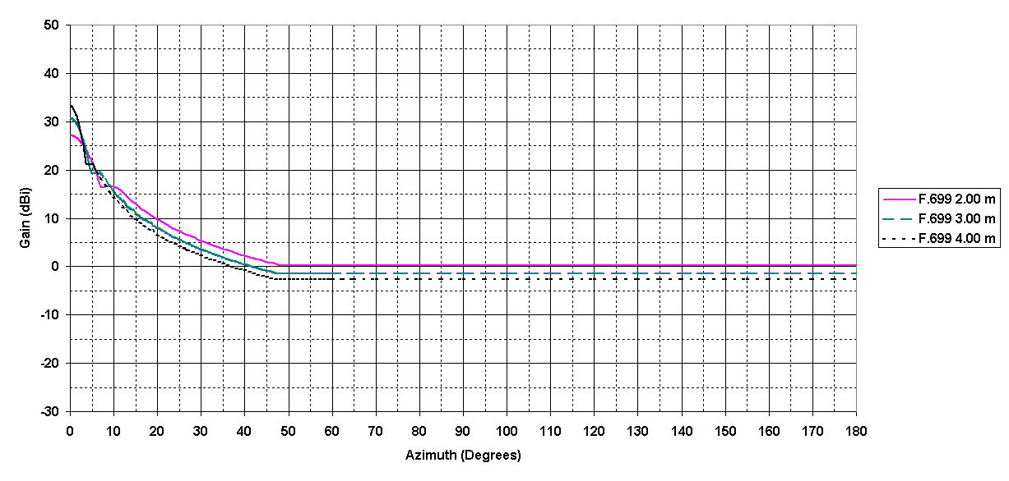
A) 1.5 GHz band
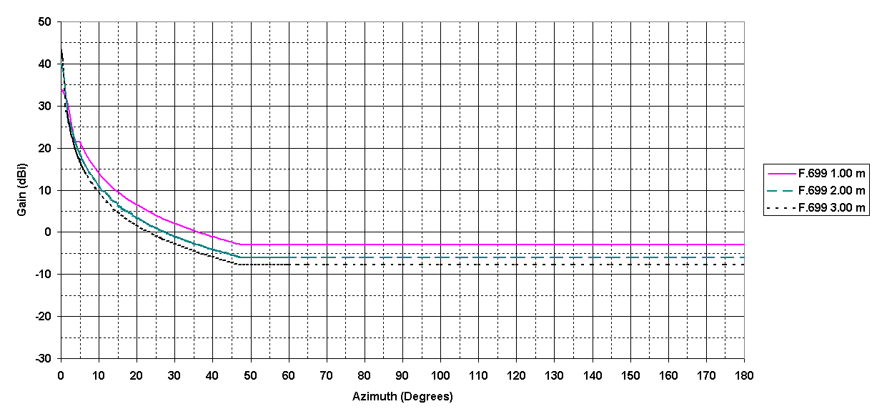
C) 6÷8 GHz bands
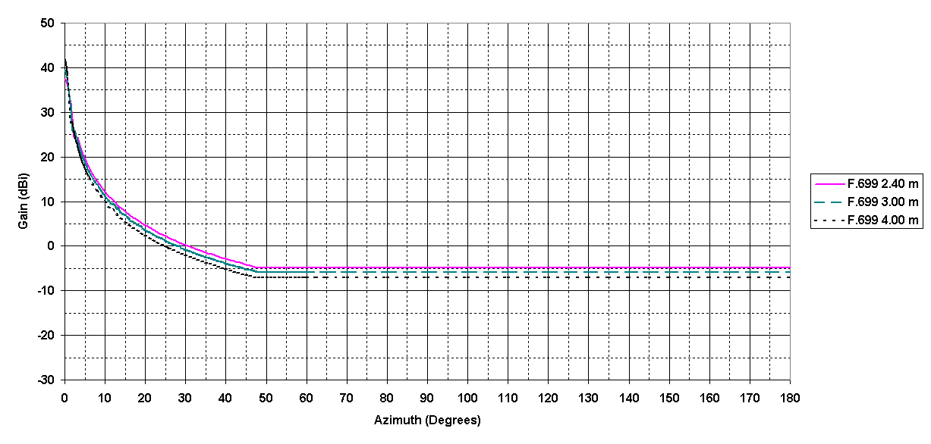
B) 4 GHz band
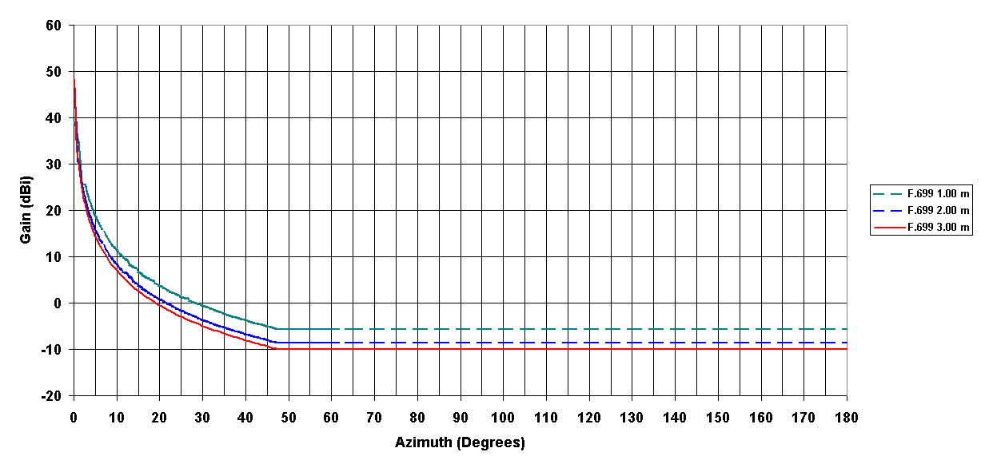
D) 11 GHz band

Figure 3: P-P FS antennas RPE

Point-to-multipoint equipment and antenna characteristics
ECC Report 033 [30] offers typical characteristics used for FWA/BWA Central Stations equipment and antenna that may be used for compatibility study. However, ECC Report 033 [30] was tuned to conventional European equipment band of 7 MHz, while most of the equipment on the market are actually tailored for 5/10 MHz channels; nevertheless, besides the channel size, other characteristics can still be profitably used.
For each sector, the typical azimuth radiation pattern of a 90° Sector antenna, according Recommendation ITU-R F.1336 [31], is shown in Figure 4.
However, provided that Central Stations usually cover the whole azimuth with different sectors using adjacent radio frequency channels, it can be assumed that the antenna is equivalent to an omnidirectional one with gain equal to the maximum per sector.
Figure 4: FS P-MP Base station antennas azimuth RPE

Summary of FS victim characteristics
The relevant data for the evaluation are summarised as:
- FS antenna diameter (1.5 GHz) 2, 3 and 4 m
(3.5 GHz) sector antenna (P-MP base station)
(4 GHz) 2.4, 3 and 4 m
(6 to 11 GHz) 1, 2 and 3 m
- FS antenna gain (G_{FS}) (1.5 GHz) 27, 31 and 33 dBi
(3.5 GHz) 14, 17 and 21 dBi (P-MP base station)
(4 GHz) 37, 39 and 42 dBi
(6 GHz) 34, 40 and 43 dBi
(11 GHz) 39, 45 and 48 dBi
- FS antenna RPE (G_{FS}(θ)) ITU-R F.699-7 [29] (P-P stations)
Constant gain (P-MP base stations, all sectors)
- Height of FS antenna 20 – 80 m – P-P and P-MP base station;
5 – 20 m – P-MP (user station)
- Victim equivalent bandwidth (Broad-band) 50 MHz (bands 4 GHz through 8 GHz and 11 GHz)
14 MHz (1.5 GHz and 3.5 GHz)
(Narrow-band) 3.5 MHz (3.5 GHz, 7 GHz and 8 GHz)
1 MHz (1.5 GHz)
- Protection objectives (Broad-band) (I_{Peak}/N) ≤+ 5 dB (within 50 MHz victim bandwidth)
(Narrow-band) (I_{Peak}/N) ≤+ 5 dB (within victim bandwidth)
(I_{rms}/N) ≤− 20 dB (within victim bandwidth)
- FS Noise figure 6 dB
- Victim noise level (Broad-band) N = –91 dBm/50 MHz
N = −96.5 dBm/14 MHz
(Narrow-band) N = –108 dBm/1 MHz
- Interference objective level (RSL_{obj})
(Broad-band) I_{Peak} ≤ –86 dBm_{PEP}/50 MHz
I_{Peak} ≤ –91.5 dBm_{PEP}/14 MHz
(Narrow-band) I_{Peak} ≤ –103 dBm_{PEP}/1 MHz
I_{rms} ≤ –128 dBm/1 MHz

Coexistence analysis

5.6 GHz meteorological radars

Generality
The interference to noise ratio in the FS receiver may be expressed in the victim receiver bandwidth as:
$\frac{I}{N}=P_{\text{spurious}}+G_{\text{rad}}−L_{F_{\text{rad}}}+G_{\text{FS}}−L_{F_{\text{FS}}}−L_{p}−N$
Where:
P_{spurious} Spurious level in the victim receiver bandwidth (dBm)
G_{rad} Radar antenna gain towards the FS station (dBi)
L_{Frad} Radar feeder loss (2 dB)
G_{FS} FS antenna gain towards the radar (dBi)
L_{FFS} FS feeder loss (0 dB)
L_{p} Propagation loss
N Noise level in the victim receiver bandwidth (dBm)
As only G_{rad} and L_{p} vary with time, the I will also vary with time, and the distribution function of I will be the convolution of the distribution functions of G_{rad} and L_{p}, that need to be determined. If distances are short enough, then the propagation loss may be assumed to be only free space. In this case only G_{rad} will vary with time. The radar antenna gain corresponding to the relevant percentage of time needs to be determined.

Distribution function of the radar antenna gain towards the horizon
Weather radars perform volume scanning based on rotation / elevation variations. Figure 4 describes a typical sweeping pattern in elevation, based on the elements from Recommendation ITU-R M.1849 [3].
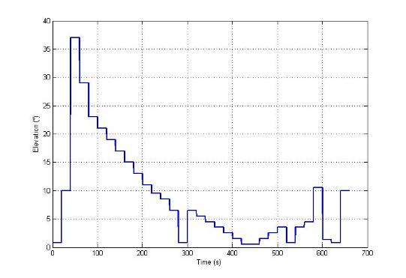
Figure 5: 5.6 GHz Meteorological radars, typical elevation variation over time
The only difference from Recommendation ITU-R M.1849 [3] where this pattern was provided is that the rotation speed of the antenna has been chosen constant at 3 rpm instead of variable between 2 and 3 rpm. This is for simulation simplification purpose.
With this sweeping pattern and an antenna pattern based on Recommendation ITU-R F.1245 [32], the radar antenna gain towards a particular point on the horizon (hence in the direction of potential FS links) varies with time as shown in Figure 6.
Note: Recommendation ITU-R F.1245 [32] is for multiple fixed interferers on the one side but also for single moving interferer. In this specific case, the antenna is rotating, meaning that, from the FS point of view, the antenna gain rapidly passes from antenna peaks and nulls. Considering Recommendation ITU-R F.699 [29] radiation pattern (that is based on peaks only), the average gain will be overestimated by 3 to 6 dB.
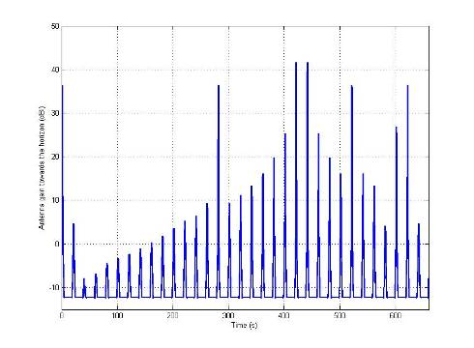
Figure 6: Meteo radars, typical variation over time of antenna gain towards horizon
(5.6 GHz radar antenna gain = 45 dBi)
The cumulative distribution of the antenna gain towards a particular point on the horizon (elevation 0°) is shown in Figure 7.
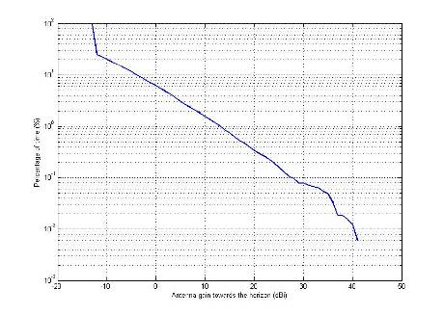
Figure 7: Meteorological radars, probability distribution of antenna gain towards horizon
(5.6 GHz radar antenna gain = 45 dBi)
The result is the same when considering a FS receiver seen at a higher elevation angle (5°) from the radar. The average antenna gain towards the FS station is 7 dBi. The antenna gain corresponding to 20% of the time is -10 dBi. The antenna gain corresponding to 1% of the time is 13 dBi.

Distribution function of the propagation loss
The propagation loss may be calculated using the complete dry air methodology of Recommendation ITU-R P.452-13 [33], assuming a flat terrain without any clutter, for a radar located in France. Its distribution function may be calculated for different separation distances.
For example at 2 km, the propagation loss at 6 GHz shown in Figure 8 does not vary a lot as it is mainly based on free space loss and atmospheric attenuations. In this example the height of the radar above ground is 30 m, the height of the FS receiver 70 m.
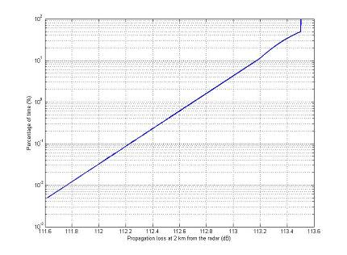
Figure 8: 6 GHz propagation loss probability distribution (2 km interfering path)
At 60 km, beyond the horizon, other short-term effects such as ducting create a larger variation in the propagation loss (30 dB) as shown in Figure 9.
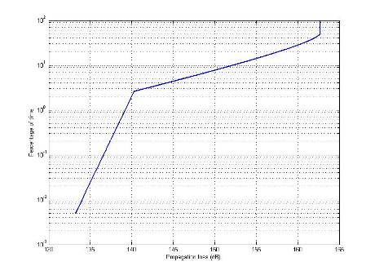
Figure 9: 6 GHz propagation loss probability distribution (60 km interfering path)
Finally, the following Figure 10 provides, for a percentage of time of 50%, the relation between the propagation losses and distance, confirming the huge impact on attenuation beyond the visibility distance (at about 50 km) and on which one can assume that the compatibility analysis can be limited to free space conditions.
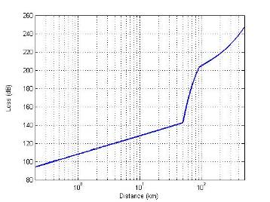
Figure 10: 5.6 GHz propagation loss vs distance for 50% probability

Interference level in the FS receiver
A number of cases relevant to different composition of the radar unwanted emissions (see Figure 1 and Table 1 above) could be envisaged with respect to narrow-band and wide band FS point-to-point victim receivers operating in bands ~1.5 GHz, ~4 GHz and ~6/7 GHz. They are summarised in Table 4.
It should be noted that the difference between the peak and the rms protection criteria is 25 dB (+5 dB_{peak} to −20 dB_{rms}) and in the spectrum zone 2 and 3 the expected interference peak-to-rms ratio would not exceed ~26.5 dB (see Table 1) and more likely be lower than 25 dB; therefore, we can in practice consider that the I_{rms}/N is always the most critical. On the contrary, when spectrum zone 1 is concerned, the expected interference peak-to-rms ratio would exceed 25 dB (see Table 1); therefore, we can in practice consider that the I_{peak}/N is always the most critical.
From regulatory point of view the peak and rms limits are defined in different reference bandwidth; however, from the physical point of view of the interference produced, each I/N should be evaluated within the victim bandwidth. Table 4 indicate the absolute value (integrated in the victim bandwidth) at the radar antenna port that has to be taken into account for the evaluation of the impact in the victim receiver.
Case # | Frequency / bandwidth (MHz) of FS victim | Unwanted emissions spectrum zone (Scenario N°) | Unwanted emissions power level  for 250 kW (+83 dBm) emission  (absolute power within the victim bandwidth) | FS most relevant protection criteria in the victim Bw | Absolute power with typical values for meteorological radar  PRF = 1 kHz Bref = 1.25 MHz | Total noise in the victim bandwidth  (NF=6 dB)
 | 1 500 / 3.5^{(Note)} | 3 | Single frequency peaks (rms power):  +23 dBm − 3 dB  through  −17 dBm − 3 dB | I_{rms}/N = −20 dB (within 3.5 MHz) | +20 dBm_{rms} (for 60 dB_{PEP})  through  −20 dBm_{rms} (for 100 dB_{PEP}) | −102.5 dBm
 | 3 400 / 10  (FWA EC DEC) | 3 | Single frequency peaks (rms power):  +23 dBm − 3 dB  through  −17 dBm − 3 dB | I_{rms}/N = −20 dB (within 10 MHz) | +20 dBm_{rms} (for 60 dB_{PEP})  through  −20 dBm_{rms} (for 100 dB_{PEP}) | −98 dBm
 | 4 000 / 50 | 2 | Wide-band rms value:  +23dBm +10*log (50/Bref) −5*log(50/PRF)  through  −17dBm +10log (50/Bref) −5*log(50/PRF) | I_{rms}/N = −20 dB (within 50 MHz) | +15.5 dBm_{rms} (for 60 dB_{PEP})  through  −24.5 dBm_{rms} (for 100 dB_{PEP}) | −91 dBm
 | 4 000 / 50 | 3 | Single frequency peaks (rms power):  +23 dBm − 3 dB  through  −17 dBm − 3 dB | I_{rms}/N = −20 dB (within 50 MHz) | +20 dBm_{rms} (for 60 dB_{PEP})  through  −20 dBm_{rms} (for 100 dB_{PEP}) | −91 dBm
 | 5 700 / 50 (some CEPT countries are using it)  and 6 200 / 50 | 1  (Meteorological radar at  5.6 GHz in the OOB domain) | Wide-band peak value:  +23dBm +20*log (50/Bref)  through  −17dBm +20log (50/Bref) | I_{peak}/N = +5 dB (within 50 MHz) | +55 dBm_{PEP} (for 60 dB_{PEP})  through  +15 dBm_{PEP} (for 100 dB_{PEP}) | −91 dBm
 | 6 200 / 50 and  6 800 / 50 | 2 | Wide-band rms value:  +23dBm +10*log (50/Bref)−5*log(50/PRF)  through  −17dBm +10log (50/Bref) −5*log(50/PRF) | I_{rms}/N = −20 dB (within 50 MHz) | +15.5 dBm_{rms} (for 60 dB_{PEP})  through  −24.5 dBm_{rms} (for 100 dB_{PEP}) | −91 dBm
 | 6 200 / 50 and  6 800 / 50 | 3 | Single frequency peaks (rms power):  +23 dBm − 3 dB  through  −17 dBm − 3 dB | I_{rms}/N = −20 dB (within 50 MHz) | +20 dBm_{rms} (for 60 dB_{PEP})  through  −20 dBm_{rms} (for 100 dB_{PEP}) | −91 dBm
 | 7 400 / 3.5 | 3 | Single frequency peaks (rms power):  +23 dBm − 3 dB  through  −17 dBm − 3 dB | I_{rms}/N = −20 dB (within 3.5 MHz) | +20 dBm_{rms} (for 60 dB_{PEP})  through  −20 dBm_{rms} (for 100 dB_{PEP}) | −102.5 dBm
 | 11 / 50 | 1  (Meteorological radar at 5.6 GHz 2nd harmonic) | Wide-band peak value:  +23dBm +20*log (50/Bref)  through  −17dBm +20log (50/Bref) | I_{peak}/N = +5 dB (within 50 MHz) | +55 dBm_{PEP} (for 60 dB_{PEP})  through  +15 dBm_{PEP} (for 100 dB_{PEP}) | - 91 dBm
Note: Considering that radars have waveguide output circuits and this band is lower that the cut-off frequency of the S-band radars range, no evaluation has been made for this case.
Table 4: Summary of the cases to be potentially studied for the interference from 5.6 GHz meteorological radars

FDP analysis
Assuming that the radar antenna is rotating (e.g. as in meteo-radars applications), the FS receiver is subject to a time-varying interference level. In such cases a Fractional Degradation in Performance (FDP) criteria analysis is appropriate (see Recommendation ITU-R F.1108 [26]).
The FDP criteria takes into account both the distribution of interference and the distribution of fading of the FS link and provides the fraction of “non-performance” due to situations for which the fading on the FS link would be higher than the interference level. The FDP is calculated based on a probabilistic calculation that, after simplification, is expressed as FDP = I/N_{Average}. However, this expression should not confuse about the nature of FDP that is not an averaging of the interference but indeed represents the overall impact on FS link of any interference type (varying or even constant).
It should be noted that, as probability integration, the FDP remains only valid for cases for which the interference level and the fading on the FS link are uncorrelated. This is usually not the case in frequency bands for which the FS link fading is controlled by rain and, typically, the FDP criteria is therefore only valid for bands below 15 GHz.
Also, the FDP approach provides an accurate estimate of the degradation in performance as long as the maximum I/N do not exceed a certain level (typically in the order of the FS fade margin) for a certain portion of time. On the contrary, during extreme conditions like main-to-main beam coupling, with short separation in distance, very high I/N may cause loss of sync and even unavailability. These extreme cases should be managed by the proper frequency planning and coordination between radars and FS links.
a) Mean power analysis
The assumptions above can be used to assess impact of radars on FS in the 6-7 GHz band on the basis of the Fractional Degradation in Performance (FDP) criteria.
The FDP being calculated as the average of the I/N distribution (see ITU-R Recommendation F.1108 [26]) and assuming a free-space propagation, it is hence expressed in this case as a function of the average radar antenna gain (7 dBi) and is hence given as :
$\text{FDP}(\text{\%})={\text{10}}^{\frac{(\frac{I}{N})\text{Av}}{\text{10}}}$* 100
where
$(\frac{I}{N})\text{Av}=P_{\text{spurious}}+G_{\text{Av}}−L_{p}+G_{\text{FS}}−F_{l}−N$
In which
P_{spurious} mean (rms) radar spurious power in the victim bandwidth (dBm)
G_{Av} Radar average gain towards the FS (dBi) = 7 dBi
L_{p} Propagation free space loss
G_{FS} FS antenna gain towards the radar (dBi) = max 43 dBi
F_{l} Feeder losses = 2 dB
N FS kTBF in the victim bandwidth (dBm) = −114 + NF + 10 log (victim Bw)
The evaluation of I/N in the victim bandwidth better reflects the impairments when the interference spectrum is not constant within that band.
b) Wide band Peak power analysis
Based on previous elements in this Report, it appears also necessary to perform a Peak analysis from radar spurious emissions to FS.
In general, the FDP concept enables description of the overall impact of a time varying interference to an FS receiver, taking into account both the distribution of interference and the distribution of fading on the FS link (assuming, for multipath, a 10 dB/decade variation).
Although usually used for mean interference power (as in previous section), the FDP can also be used for peak interference, recognising that in such a case, both the interfering signal and FS protection criteria will be higher while the other parameters (antenna gains, interfering propagation path, …) would remain the same. One can therefore derive the “Peak FDP” based on the “Mean PDF” analysis on the following principle:
- Difference in interfering power: depending on the radar pulse characteristics and to the integration in the victim bandwidth. It also depends on the spurious emission typology and its closeness to radar carrier frequency (see Figure 1 and Table 1); a peak enhancement factor due to integration in the assumed ~50 MHz wide FS victim bandwidth ranging from 0 dB up to ~34 dB, i.e. 20 log 50/B_{ref} (reference bandwidth for spurious levels definition) in frequency zone 1 (see Figure 1);
- Difference in interfering power due to average factor, in bands from 5.9 GHz and above, where a value of ~17 dB, (10 log 50/B_{ref}), is assumed in frequency zone 2 (see Figure 1);
- Difference in FS interference criteria : > 25 dB ( (+5) dB (peak criteria) – (-20 dB) (rms criteria)) (corresponding to 316% peak FDP a and a 1% rms FDP criteria respectively)
c) Calculation and comparison for FS in the 6-8 GHz range
When assuming the worst case aggregation factor (i.e. ~34 dB), which might be valid for victim FS bands adjacent to the Radiodetermination bands (e.g. the 5.7 GHz band used in some CEPT countries with respect to the that would therefore represent a 5 to 7 dB increase of the potential impact on FS, confirming that the Peak impact may be dominant over the mean impact. One can note that with a median difference of 6 dB, such peak analysis would double the potential interference distances.
In addition, it can be seen that, from the point of view of mean power analysis, the worst case is when a single frequency peak spurious interferes a victim, in particular of relatively narrow band (i.e. the 3.5 MHz of case 9 in Table 4). However, narrow band systems are no longer of particular interest in these bands and the probability that they are affected by single peaks is lower; therefore, no specific analysis has been made.
The following figures provide, for various radar spurious discrimination (60 to 100 dBc) and corresponding, for a 250 kW radar emission, power at antenna port to:
- Scenario 1 : wide-band peak interference power of +56 dBm_{peak}/50 MHz, (case 5 in Table 4 for 60 dBc);
- Scenario 2 : wide-band mean interference power of +16.5 dBm_{rms}/50 MHz, (case 6 in Table 4 for 60dBc);
- Scenario 3 : single peak mean interference power of +21 dBm_{rms}/50 MHz), (case 7 in Table 4 for 60 dBc)
On the basis of a maximum relevant FDP figure of (1% for rms, corresponding to I/N of -20 dB, or 316 % for peak, corresponding to I/N of +5 dB) the following figure provides the maximum distance at which a FS receiver (for various azimuth) will not suffer interference from meteorological radar spurious emissions. One should note that a free-space propagation model having been used, the calculated distances beyond the radio horizon (mainly corresponding to the FS main beam area) have not been reproduced on the following figures.
One can note that only distances below the maximum visibility distance (50 km), at about the radio horizon are depicted. To this respect, the following Table 5 provides the maximum separation distances that relates to main beam, using Recommendation ITU-R P.452 [33], propagation, including diffraction, beyond visibility distance:
Max distance (P.452) | 60 dBc | 80 dBc | 85 dBc | 90 dBc | 100 dBc
Scenario 1 | 77.0 | 62.0 | 59.0 | 57.0 | 53.0
Scenario 2 | 65.0 | 55.0 | 53.0 | 51.0 | ~25 (Note)
Scenario 3 | 69.0 | 57.0 | 55.0 | 53.0 | ~40 (Note)
Note: line of sight is still valid for these cases.
Table 5: maximum separation distances that relates to main beam (using P.452 propagation)

Figure 11: C-band meteorological radars, Scenario 1 on 6 GHz FS links

Figure 12: C-band meteorological radars, Scenario 2 on 6-8.5 GHz links

Figure 13: C-band meteorological radars, Scenario 3 on 6-8.5 GHz links
In addition, the following figure provides the results of calculations for these 3 scenarios in case of a 85 dBc radar spurious.

Figure 14: Comparison for all scenarios for 85 dBc on 6-8.5 GHz links
From these plots (Figure 11 to Figure 14) it can be observed that a 60dBc spurious emissions attenuation limit requires quite large separation distances whereas an obviously huge improvement can already be seen for a 80 dBc attenuation for which the impact on FS is limited in all scenarios to some degrees close to the direct axis to the radar. For 85 dBc attenuation, high impact (e.g. >10 km separation distance) is mostly expected around 2° to 5°, whereas for 90 or 100 dBc attenuation the minimum distance is radically reduced by in all azimuth directions, apart from main beam.
d) Calculation and comparison for FS in the 11 GHz range
In this range, being interested by the 2nd harmonic of the C-band radars, the scenario 1 is more likely to happen than in 6-8 GHz; scenario 3 is considered as general case.
Figure 15 and Figure 16 shows the impact of different spurious limits on 11 GHz FS station.
Figure 15: C-band meteorological radars, Scenario 1 on 11 GHz links (for 39dBi and 48dBi FS antennas)

Figure 16: C-band meteorological radars, Scenario 3 on 11 GHz links (for 39dBi and 48dBi FS antennas)

FS and radars deployment impact
It could be interesting to generalize the impact of the attenuation limit (e.g. 60dBc or lower limit) as the probability that a certain planned link cannot be deployed, even if with coordination, because of expected interference from a 5.6 GHz weather radar (i.e. different path should be found). This can be expressed as:
P = p_{loc} x p_{pointing} x p_{spurious}
Where:
p_{loc} is the probability that the FS receiver is located within a certain distance from a radar
p_{pointing} is the probability that the FS receiver is pointing directly through the radar
p_{spurious} is the probability that the FS is operated on a channel in which the spurious are at the limit
The probability of interference described above (P) may be considered as mitigation factor for compatibility study dealing with interference from spurious emissions; however a practical numeric evaluation of P is very difficult and would require a case-by-case analysis. Rationale is that the three factors p_{loc} , p_{pointing} , p_{spurious} do not have a definite distribution (e.g. Gaussian), but depend on unpredictable factors (geographic, physical and network deployment dependent, of both FS and meteorological radars). The following are just qualitative consideration about the potential impact of each factor in the probability P.
a) p_{loc}
The range of meteorological radars in the C-band is about 100 to 200 kms, meaning that, within this range around a victim receiver of a FS link, only a single meteorological radar might impact the link. This corresponds to a certain “area of possible interference” (A_{P}).
On the other side, the maximum “main beam” distance of potential impact from the radar source is mainly related to the distance of the “horizon” (were the spherical diffraction loss becomes sensible); this distance depends on the FS frequency and geographic/topology factors (FS and radars tower heights, flatness or not of the territory, FS link elevation angle, ….); this would result in an “interference area” (A_{D}) that would depend also on the FS antenna maximum gain considered.
A certain lower off-side gain could be considered when coordination avoids that FS boresight could have an offset angle (θ) too close to the radar location for avoiding possible FS receiver overload and even LoS blocking due to the radar tower. When no coordination at all between radars and FS links is used the boresight gain should be considered within a very narrow θ close to 0° (e.g. the 3 dB boresight angle). p_{loc}(θ) would be related to areas ratio A_{D}(θ) / A_{P} described above.
b) p_{pointing}
The probability p_{pointing} that an FS link, while in the “interference area” (A_{D}(θ)), is actually pointing in the corresponding azimuth.
p_{pointing} is therefore related to the angle ratio between the possible critical angle used for A_{D}(θ) and the sum of possible FS link direction angles, which, in principle, span 360°, but geographic situations (valleys, major cities trunk connection axes) might reduce the practical FS directions.
c) p_{spurious}
Radar spurious emissions, as in any other radio systems, are of erratic nature, presenting number of peaks (which may also be modulated as happen for the harmonics) such as on the example in Figure 17 below.
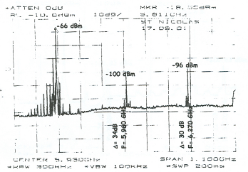
Figure 17: Current C-band meteorological radar spurious emissions measurements
(old deployment not subject to limitations)
The probability of interference p_{spurious} would take into account the fact that, although pointing within angle (θ) (used for the definition of p_{pointig} described above) toward the radar location, the FS would make use of a channel where a peak spurious would be present.

2.7-3.4 GHz (S-band) radars

Radars characteristic
Based on the characteristics of the radars in Section 2.3, one can calculate the reference peak and rms spurious power for the different spectrum zones 1, 2 and 3, as given in the following Table 6 for 60 dBc spurious limit.

 |  | Spurious power (dBm/victim Bw) with 60 dBc reduction
Spectrum zone | Victim FS system operating band (Note 2) | Civil Aviation radar (+ 91.5 dBm carrier) | Military radar  (+ 90 dBm carrier) | Meteorological radar (+ 89.3 dBm carrier)
1 (Note 1) | 5.6-6.8 GHz | 60.9 peak | 70 peak (Note 3) | 64.3 peak (Note 3)
1 (Note 1) | 5.6-6.8 GHz | 13.9 Rms | 55 Rms (Note 3) | 32.1 Rms (Note 3)
2 | 5.6-8.5 GHz | 46.1 Peak | 67 Peak | 49.3 Peak
2 | 5.6-8.5 GHz | 22.7 Rms | 40.9 Rms | 23.2 Rms
3 | 5.6-8.5 GHz | 31.5 Peak | 30 Peak | 29.3 Peak
3 | 5.6-8.5 GHz | 28.5 Rms | 27 Rms | 26.3 Rms
2 | 3.4-4.2 GHz | 39.2 Peak | 60 Peak | 42.3 Peak
2 | 3.4-4.2 GHz | 19.2 Rms | 37.4 Rms | 19.7 Rms
3 | 3.4-4.2 GHz | 31.5 Peak | 30 Peak | 29.3 Peak
3 | 3.4-4.2 GHz | 28.5 Rms | 27 Rms | 26.3 Rms
Note 1: Spectrum zone 1 (see Table 1 above) is relevant only in the victim bands affected by the radar harmonics (i.e. 5.4-6.8 GHz) for the 2.7-3.4 GHz radar band.
Note 2: in the range 5.6-8.5 GHz, a 50 MHz FS bandwidth is considered whereas in the 3.4-3.8 GHz, a 10 MHz FS bandwidth for FWA base stations is taken into account, P-P systems in the 4 GHz bands are no longer considered as main FS applications. There may be a need to further consider the influence of radar spurious emissions on FS FWA stations in the 3.4-3.8 GHz. It is expected that the main scenario to be studied for such FS application would related to S-band radars spurious emissions
Note 3: With these radars characteristics the main spectral emission bandwidth is lower than few MHz (B₋₄₀ less than 0.6 MHz and 14 MHz, respectively); therefore, the aggregation factor of the second harmonic emission is limited to 20 log(2*B₋₄₀/B_{ref}) and the peak to Rms is derived from the radar duty cycle only.
Table 6: Reference peak and rms spurious power for 60 dBc spurious limit
In addition, meteorological radars make use of parabolic antennas, as in C-band, together with similar elevation scanning schemes. The average gain towards FS stations is therefore similar, i.e. 7 dBi.
Civil Aviation and Military radars make use of different antenna types presenting different vertical and horizontal pattern (see typical pattern below (Figure 18 and Figure 19), for radars having two different beams in elevation to cover low and high elevation angles, extracted from ECC Report 128 [34]), typically with no variation in elevation.
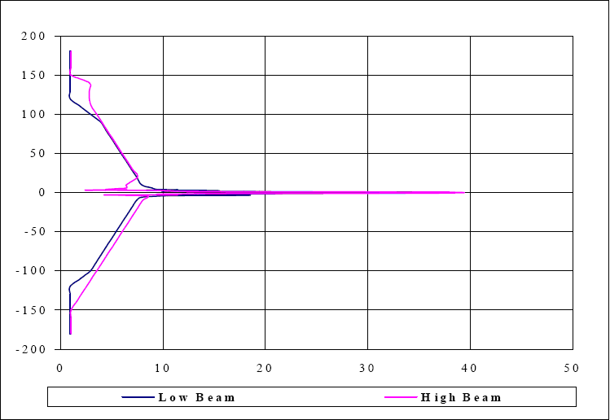
Figure 18: Typical antenna pattern in azimuth of a primary radar
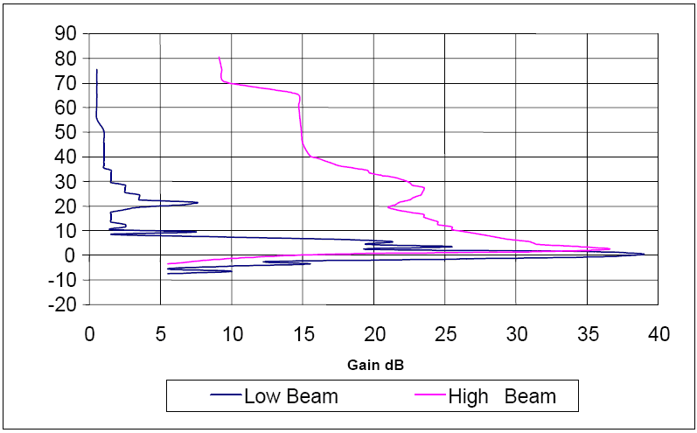
Figure 19: Typical antenna pattern in elevation of a primary radar
For the determination of the average gain towards FS stations, only the horizontal pattern is to be considered, that present an average gain of about 10 dBi.

FDP analysis
a) Impact on P-P FS links in the 6-8 GHz range
In general the impact of S band radars (including Civil Aviation and Military referred in Table 2) into the same 6-8 GHz FS stations, can be derived from the values derived from C-band just shifting the spurious axis by:
- the relevant differences between the levels in Table 4 and Table 6 (for each study case)
- the difference in the radar antenna calculated average gain (0 dB for meteorological radars and +3 dB for Civil Aviation and Military radars as said in section 4.7.2.1 above.
The following Table 7 summarises the overall differences in the interference levels.

S-band radar type | Scenario 1 (peak only relevant): Harmonics | Scenario 2 (Rms only is relevant): | Scenario 3 (Rms only relevant): Single peaks
Meteo (+0 dB antenna) | + 9.3 dB | + 7.7 dB | + 6.3 dB
Civil Av. (+3 dB antenna) | + 8.9 dB | + 10.2 dB | + 11.5 dB
Military (+3 dB antenna) | + 18 dB | + 28.4 dB | + 10 dB
Table 7: Interference levels into 6-8 GHz P-P stations due to S-band radars;
variation (dB) with respect to levels from C-band radars
On this basis, using similar FDP methodology as for C-band radars in previous sections, the following Figure 20 and provide the resulting separation distance between radars and FS links at 6-7 GHz, for scenarios 2 and 3. The Scenario 1 is relevant only for the OOB domain of 5.6 GHz radars in relation to these FS links and was not considered here.

Figure 20: S-band radars (Scenario 2) into 6-8.5 GHz FS links
(Note : for military radars, the separation distance is always higher than the radio horizon)

Figure 21: S-band radars (Scenario 3) into 6-8.5 GHz FS links

From these plots (Figures 20 and 21) it can be observed that a 60dBc spurious emissions attenuation limit results in very large separation distances for all three types of radars. Although additional attenuation for meteorological radars, 75 dBc, improves the situation, there is high impact (e.g. > 10 km separation distance) for around 20° discrimination angle.

Coexistence analysis with MOBILE SERVICE (RLAN 5 Ghz)

Frequency bands
The use of the 5 GHz band by Wireless Access Systems, including Radio Local Area Networks (WAS/RLAN), further referred to as RLAN in this Report, is regulated by ECC/DEC/(04)08 [35], RR N° 5.450A and EC Decision 2005/513/EC [36], amended by EC Decision 2007/90/EC.
This frequency range, apart from the band 5150-5250 MHz, is also used by radars and the possible impact of different radar spurious emissions limits on RLAN needs to be studied.
The objective of this section is therefore to evaluate the compatibility of (due to spurious emissions of) Meteorological Radars operating in the 5.60-5.65 GHz band with 5 GHz RLAN operating in adjacent frequencies (see Table 8 below). In addition, radars in the 2.7-3.4 GHz band may generate 2nd harmonic emissions in the 5 GHz band.

Frequency Band (MHz) | RLAN use (Indoor/Outdoor) | Recommendation  ITU-R | CEPT Recommendation | ECC Decision
5 150-5 350 | Indoor | ITU-R M.1652 [37] | ERC/REC 70-03 – Annex 3 [38] | ECC/DEC/(04)08 [35]
5 470-5 725 | Indoor + Outdoor | ITU-R M.1652 [37] | ERC/REC 70-03 – Annex 3 [38] | ECC/DEC/(04)08 [35]
Table 8: 5 GHz RLAN frequency bands

RLAN co-existence objectives and deployment scenario
Figure 22 below provides a spectrum plot of weather radar operating at 5605 MHz. It is producing high levels of unwanted emissions at frequencies below and above the main carrier and over a range of about 150 MHz wide. These radar unwanted emissions may trigger the DFS mechanism used by 5 GHz RLANs when operating in other parts of the 5 GHz bands.
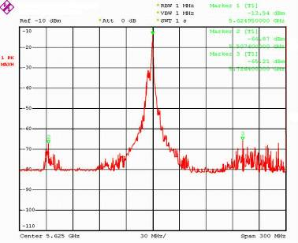
Figure 22: Radar emissions spectrum

Using relevant propagation model and scenarios, it can calculate the area around a radar in which no (outdoor)
5 GHz RLAN deployment is possible because of the DFS triggers caused by such radar emissions as illustrated in the example in Figure 22 above.

Summary of typical RLAN characteristics
The relevant data for the evaluation are summarized as:
- RLAN antenna gain (G_{RLAN}) 0 – 18 dBi
- RLAN antenna height
    - Indoor RLAN 3 + m (typical height is 3 m above the floor but this can be a multi-floor office building or flat, hence the ‘+’ sign)
    - Outdoor RLAN 11 m (e.g. light pole mounted device)
- RLAN DFS threshold level < −70 dBm (regulatory limit (-64 dBm) − 6 dB design margin)
- RLAN bandwidth 20 / 40 MHz
For the purpose of this report, only outdoor RLANs will be considered.

DFS trigger by radar unwanted emissions
Unwanted emissions of high power pulsed radars might result in signals received by RLANs above the DFS threshold level even at frequencies far away from the radar frequency.
Meteorological radars use directional antennas, which are continuously rotating in azimuth and elevation according to a certain scanning scheme or cycle (strategy). Therefore, the DFS trigger into a RLAN may only occur once every such cycle. Nevertheless, due to the DFS requirements, a single DFS trigger will result that the corresponding RLAN channel becomes unusable for at least 30 minutes. Therefore, in the case the DFS is triggered by spurious emissions, there is no need to distinguish between short term and long term scenarios as a single DFS trigger e.g. every 30 minutes will permanently prevent the RLAN to use this channel.
Note: For the example given in Figure 3, where the measurements were performed at around 900 m from the radar, one can assume that about half of the 11 channels available for outdoor RLANs might become unusable at that location.
The regulatory requirement for the DFS Detection Threshold is given by the following expression (in dBm):
DFS Threshold = -62 + 10 - EIRP Spectral Density (dBm/MHz) + G (dBi), however the DFS threshold level shall not be lower than -64 dBm assuming a 0 dBi receive antenna gain.
The above DFS threshold levels for radar detection are the minimum required in order to ensure the protection of radars. One can assume that, to ensure compliance with these levels throughout a channel, the actual implemented DFS threshold level might be 6 dB or more below this value. In addition, the sensitivity of the DFS mechanism depends on the RLAN traffic load. This means that a RLAN with low traffic will be more sensitive as compared to a ‘busy’ RLAN device.
Therefore, in order to study the potential impact of radar emissions on RLANs, the actual DFS threshold under low RLAN traffic load need to be taking into account, rather than the regulatory value for the threshold.
For the purpose of this study, −70 dBm was assumed for the DFS threshold level. In any case, due to the applicable propagation models (typically partial obstruction is assumed) the difference in triggering distance would be limited.

Scenario and co-existence distance
In developing scenarios to assess distances at which the RLAN DFS may be triggered by radar unwanted emissions, the following assumptions have been considered:
- different levels of radar unwanted emissions limits (-60 dBc to -100 dBc)
- different RLAN locations (antenna height) compared to the radar main beam:
  - scenario 1 : RLAN at 2 m below the radar plan (i.e. 11 m above the ground)
  - scenario 2 : RLAN within the radar main beam (e.g. RLAN on top of buildings)
- different propagation conditions :
  - Free space conditions for scenario 1 and 2
  - Path loss exponent of 2.2, 2.5 and 2.7 for scenario 2
- Balanced situation between the impact of radar spurious emissions on RLANs and of RLAN spurious emissions on radar.
Table 9 below gives an overview of the impact of different radar spurious emissions limits on the minimum distance between RLAN and radar to avoid DFS triggers for scenario 2 (RLAN within the radar main beam).

Path Loss exponent | Min distance from radar (km)  (for -70 dBm DFS threshold and radar e.i.r.p. of 129 dBm)
Path Loss exponent | -60 dBc limit  [Km] | -80 dBc limit  [Km] | -90 dBc limit  [Km] | -100 dBc limit  [Km]
2 (free space)  (note 1) | 37.8 | 3.8 | 1.2 | 0.38
2.2 (note 2) | 16.5 | 2 | 0.72 | 0.25
2.5 (note 2) | 6.1 | 0.97 | 0.39 | 0.15
2.7 (note 2) | 3.6 | 0.65 | 0.28 | 0.12
Note 1: Values for free space only applicable in case of line of sight
Note 2: At close distances, in the order of few hundred meters, the relevant path loss coeff. may be no longer appropriate

Table 9: Minimum co-existence distance for scenario 2

In addition, the following Figure 23 and Figure 24 provide the level of signal received by RLAN from radar spurious emissions for scenarios 1 and 2 at different distances and under free-space conditions.
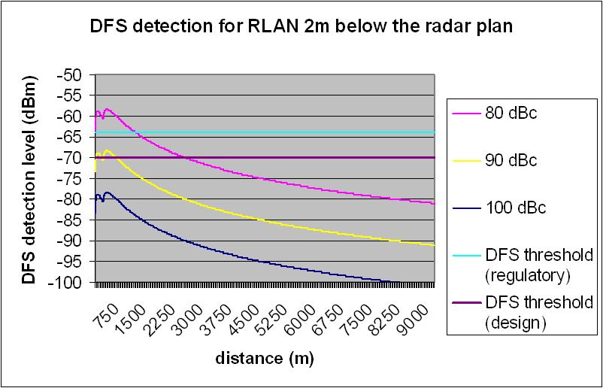
Figure 23: DFS detection distance for Scenario 1 under free space conditions

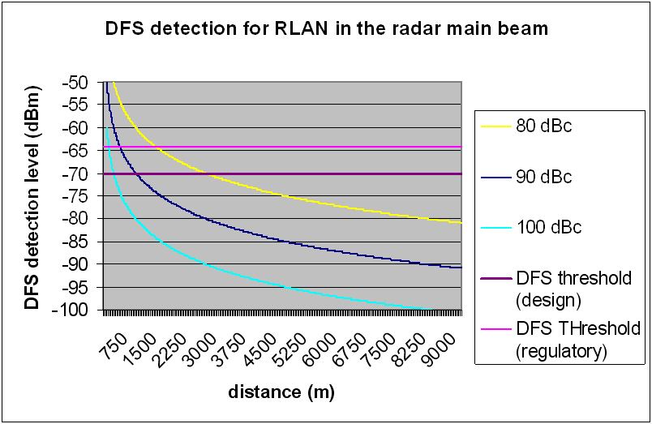
Figure 24: DFS detection distance for Scenario 2 under free space conditions

These Figures show that there might be situations where radar spurious emissions could trigger RLAN DFS and render one or several channels unusable.
However, in particular for scenario 2 (RLAN in the radar main beam), the results need to be carefully considered in light of the following:
- for outdoor deployments of e.g RLAN mesh networks, the RLAN antenna could be mounted at such heights (in particular on buildings) where they could potentially be within the radar main beam;
- on the other hand, radar locations and antenna heights are carefully chosen to ensure that no major obstacles (e.g. buildings) appear within the radar main beam unless they are at least a few kms away from the radar;
- therefore, such direct coupling of (outdoor) RLAN in radar main beam could occur but should certainly not be considered as the typical case.
As a conclusion, to ensure a balanced situation between meteo radar and RLAN, a maximum spurious emission limit of -80 to -90 dBc was considered as appropriate. This could prevent RLANs to be deployed real close to the radar, but at that close distance RLANs with spurious emissions levels close to the allowed limit of -30 dBm/MHz would also present a risk for radar operations.

Coexistence analysis with RADIOASTRONOMY

RAS at 4.9 GHz
This section addresses the coexistence between RAS at 4.9 GHz and meteorological radars at 5.6 GHz. The following characteristics are considered:

Characteristics of RAS
RAS centre frequency: 4.9 GHz
RX Bandwidth (following ECA Report 025 [5]): 200 MHz

Characteristics of meteorological radars at 5.6 GHz (see Section 2.2):
Transmitter peak power spectral density (dBm/MHz): 84 dBm
Transmitting antenna Gain : 45 dBi
Transmitter centre frequency: 5.6 GHz
Pulse width (τ) : 2 μs
Pulse rise time: τ_{r} : 0.05 τ
Transmitting height (assumed):

Calculations
We calculate the spurious emission of the radar for a single pulse from the given characteristics, assuming a perfect rectangular pulse of width τ tapered by a rise time τ_{r} which is modelled by a 6dB/octave low pass filter. The effective spectral power density within the protected band is then given by:

and the rel. power in band is:
We calculate the output power spectral density without any additional spurious attenuation G_{off}=0 :

The peak power transmitted within the band: => or

and effective isotropic spectral flux density (spfd) at tx is

=> => dB(W m-2 Hz-1)

or in radio astronomical units:

Recommendation ITU–R RA.769 [39] specifies interference levels for an integration time of 2000 s, for shorter integrations times, i.e. single pulse detections on a time scale τ, these have to be adjusted by or dB.
The unadjusted threshold for 4.9 GHz according to Recommendation ITU-R RA.769 [39] is dB(W m-2 Hz-1) or =>

The required attenuation is then: => L_{prot} = 189 dB

A calculation of the path loss according to ITU-R P. 452 [33] (neglecting ducting propagation and local topography G_{topo}=0) will give the following Figure 25:

Figure 25: Path loss for 5.6 GHz. Black is the total attenuation, green the troposcatter attenuation, blue the line of sight and red indicates the required attenuation for protection against interference

It obtains a minimum separation distance for a radar with -60dBc spurious emission rejection of d_{min} = 83.076 km. Similar calculations for various spurious emission rejection are summarised in the following Table 10:

OOB Rejection (dBc) | separation distance (km)
-60 | 83
-80 | 62
-90 | 52
-100 | 42
Table 10: Required separation distance depends on spurious emission rejection

RAS at 2690-2700 MHz
This section addresses the coexistence between RAS in frequency band 2690-2700 MHz and meteorological and civil aviation radars at 2.8 GHz. The following specific characteristics are considered:

Characteristics of RAS
RAS centre frequency: 2677.5 MHz
RX Bandwidth (following ECA Report 025 [5]): 45 MHz

Characteristics of meteorological radars at 2.8 GHz (see Section 2.3):
Transmitter peak power spectral density (dBm/MHz): 89 dBm
Transmitting antenna Gain : 45 dBi
Transmitter centre frequency: 2.8 GHz
Pulse width (τ) : 2 μs
Pulse rise time: τ_{r} : 0.1 τ
Transmitting height (assumed):

Characteristics of one civil aviation radars at 2.8 GHz (see Section 2.3):
Transmitter peak power spectral density (dBm/MHz): 91 dBm
Transmitting ant. Gain : 33 dBi
Transmitter centre frequency: 2.8 GHz
Pulse width (τ) : 0.6 μs
Pulse rise time : τ_{r} : 0.1 τ
Transmitting height (assumed):

Calculations
We calculate the spurious emission of the radar for a single pulse from the given characteristics, assuming a perfect rectangular pulse of width τ tapered by a rise time τ_{r} which is modelled by a 6dB/octave low pass filter. The effective spectral power density within the protected band is then given by:

And the rel. power in band is: which is close to the -75 dBc value quoted.

We calculate the output power spectral density without any additional spurious attenuation G_{off}=0 :

The peak power transmitted within the band: => or

and effective isotropic spectral flux density (spfd) at tx is

=> => dB(W m-2 Hz-1)

or in radio astronomical units:

Recommendation ITU–R RA.769 [39] specifies interference levels for an integration time of 2000 s, for shorter integrations times, i.e. single pulse detections on a time scale τ , these have to be adjusted by or dB.
The unadjusted threshold for 2.7 GHz according to Recommendation ITU-R RA 769 [39] is dB(W m-2 Hz-1) or =>

The required attenuation is then: => L_{prot} = 187 dB

A calculation of the path loss according to Recommendation ITU-R P. 452 [33] (neglecting ducting propagation and local topography G_{topo}=0) will give the following Figure 26:

Figure 26: Path Loss for 2.8 GHz. Black is the total attenuation, green the troposcatter attenuation, blue the line of sight and red indicates the required attenuation for protection against interference

For meteorological radars, one obtains a minimal separation distance for a radar with -72dBc spurious emission rejection of d_{min} = 92 km. For 100 dBc spurious rejection, this distance decreases to 45 km.

Similar calculation for the particular civil aviation radar presented in Section 6.2.3 leads to a minimum separation distance of 103 km for a 65 dBc spurious rejection and 56 km for 100 dBc spurious rejections.

Summary of results for Radioastronomy
The following Table 11, Table 12 provide the required separation distances for the scenarios studied in this section. These distances can be considered as worst case since they relate to the impact of one single radar pulse and “flat Earth” conditions without shielding.
- Meteorological radars at 5.6 GHz and RAS at 4.9 GHz

Spurious Rejection (dBc) | separation distance (km)
-60 | 83
-80 | 62
-90 | 52
-100 | 42
Table 11: Required separation distance
- Meteorological and civil aviation radars at 2.8 GHz and RAS in frequency band 2690-2700 MHz

Spurious Rejection (dBc) | separation distance (km) for meteorological radars | separation distance (km) for one civil aviation radar (see Section 6.2.3)
-72/-65 | 92 | 103
-100 | 45 | 56
Table 12: Required separation distance

impact of FILTERING on radars

General considerations
In principle, a suitable filter solution is necessary to solve the problems to meet specific radar spurious emission limits.
However, when considering filtering solution, a number of parameters have to be taken into consideration, such as insertion and connecting losses, maximum peak and average power of the radar, necessity to pressurise the wave guide to avoid arcing and subsequently burning, impact on the emission chain availability radar range and coverage is directly related to the emitted signal power and subsequently to the signal to noise ratio (SNR). Any additional insertion losses in the emission chain will therefore lead to decreasing the SNR by the same amount.
Unlike for other radars, the meteorological radar equation (i.e. the received signal) is proportional to a factor 1/r² and the free-space range proportional to the square root of the resulting SNR.
A reduction of the received signal, will then lead to a range (distance) and coverage (area) reduction expressed as:
$$R_{\text{red}}=1−({\text{10}}^{−\frac{L_{\text{ins}}}{\text{10}}})^{\frac{1}{2}}$$
Cred = 1 – (1-Rred)²
with R_{red} being the range reduction (in %), C_{red} the coverage reduction (in %) and L_{ins} the insertion losses (in dB). The following Figure 27 provides the resulting reductions for a 0 to 2 dB range of the insertion losses.

Figure 27: Meteorological radar range and coverage reduction as a function of insertion loss

Experience of filtering solution in some Administrations

Experience in one country
During past years several interference cases have occurred in a given administration between radars and radio links. The worst cases could only be solved by refarming certain links to other locations and frequency bands.
About 15 years ago when the 5 GHz weather radar network in this administration was under construction it was found out that these radars may cause a problem to radio links on 6 and 7 GHz bands. Few possible interference cases could be solved case by case, but it was also noted that a general reduction in the radar spurious levels was required. At the same time experience was gained internationally and a decision was made to require additional filtering to 5 GHz weather radars to protect 6 and 7 GHz radio link bands. After the national decision a low pass filtering was installed to all weather radars build since.
At the moment the reduction of spurious levels of most weather radars in this administration are of the order of -90 to -100 dBc on the 6 and 7 GHz radio link bands. Figure 28 shows a typical spectrum of radar with low pass filter (LPF).

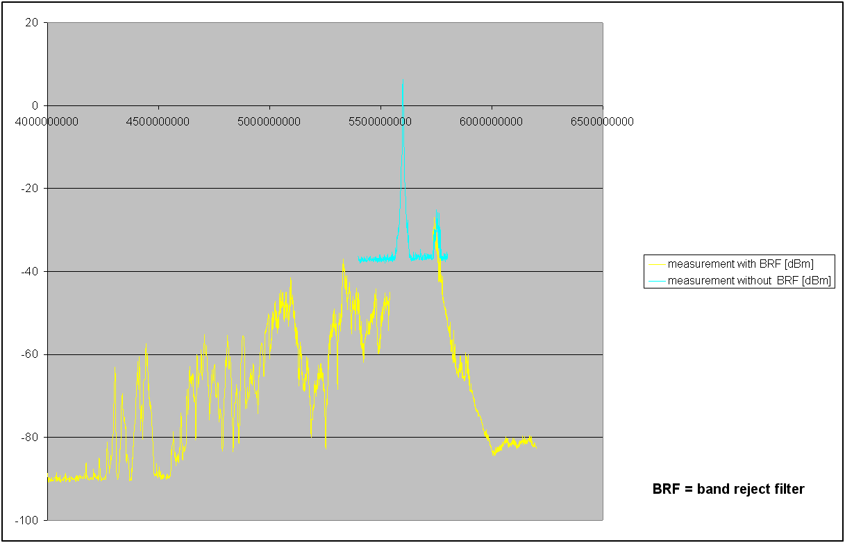
Figure 28: Measured spectrum of a radar with LPF
Measurement of a radar spectrum like depicted in Figure 1 is not quite easy. The problem is how to create enough measurement dynamic range to detect the spurious domain and in the same time to protect the measurement system.
Typically a radar measurement will be conducted as follows:
- Measurement of the radar carrier frequency
The vicinity of the carrier can be measured simply by using antenna, attenuator, cables and spectrum analyzer. One will get about 50 dB dynamic range (see curve magenta in picture 1). In addition, to define absolute results it is good to have a calibrated frequency generator.
- Measurement of the spurious domain
Measuring spurious domain requires large dynamic range. The range is possible to achieve by using band reject filter and a low noise amplifier in addition to the above mentioned tools. In this case the measurement is threefold:
  - to measure a suitable range of spectrum (typically 600 MHz) by using band reject filter and amplifier,
  - to measure the transfer function (calibration curve) of the band reject filter by using the frequency generator.
  - to sum up those two above mentioned curves by computer to get results (see yellow curve in Figure 1).

Magnetron radar without filters
ERC/REC 74-01 [1] defines that fixed radars installed after 1.1.2006 should fulfil the limit of -100 dBc for high power weather radars. In co-operation with a weather radar manufacturer and the national regulator authority several tests have been carried out in order to find out if this stringent spurious limit with steep out-of-band roll-of defined in other ITU-R and ECC recommendations is realisable.
In Figure 29 one can see the measured spectrum of two modern magnetron radars without any filtering. The out-of-band and spurious domain mask is also added for reference. It can be seen that spurious levels in this case are about -60 to -65 dBc on the radio link bands.

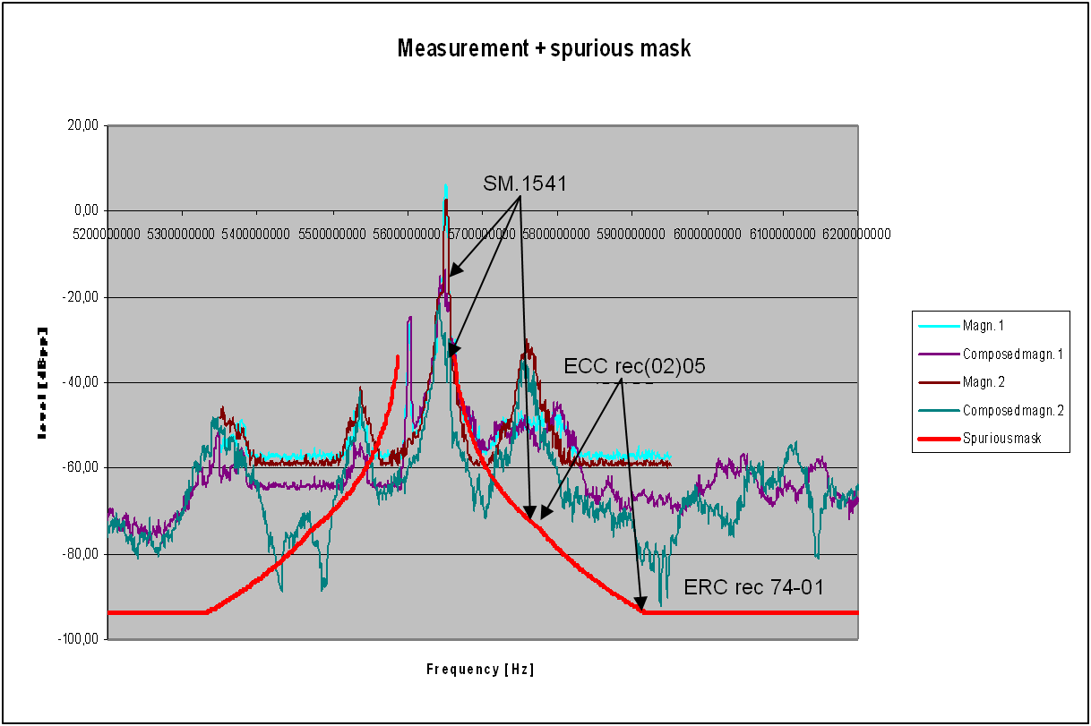
Figure 29: Two magnetron radars without filtering

One effective filtering solution
Below on Figure 30 one can see some filter information of a filter used by one weather radar manufacturer. To fulfil the limits defined in ERC/REC 74-01 [1] two filters should be used:
1. High Power Band Pass Filter 5.6-5.65 GHz:
Maximum peak power 280 kW
Maximum average power 300 W
Max attenuation at band 5.6-5.65 GHz 0.4 dB (typical 0.25 dB)
Input VSWR at band 5.6-5.65 GHz 1.25:1
Dimensions length 570 mm
width 90 mm
height 90 mm
Figure 30: S-parametres of a band pass filter
2. High Power Harmonic absorptive Filter 5.6-5.65 GHz
Maximum peak power 350 kW
Maximum average power 350 W
Max attenuation at band 5.6-5.65 GHz 0.1 dB
Input VSWR at band 5.6-5.65 GHz 1.1:1
Min second harmonic attenuation 40 dB
Min third harmonic attenuation 30 dB
Input VSWR harmonic frequency 1.8:1
Dimensions length 326 mm
width 176 mm
height 90 mm

Magnetron radar with band pass filter (BPF)
Quite recently we have made a measurement of magnetron radar equipped with proper band pass filter (BPF). In Figure 31 one can see that the radar fulfils the limits defined in ERC/REC 74-01 [1]. The second and third harmonics were also measured but could not be detected, so they are also below the limit. It should also be noted that the size, price and complexity of this kind of filter is reasonable compared to the total cost of a radar system.
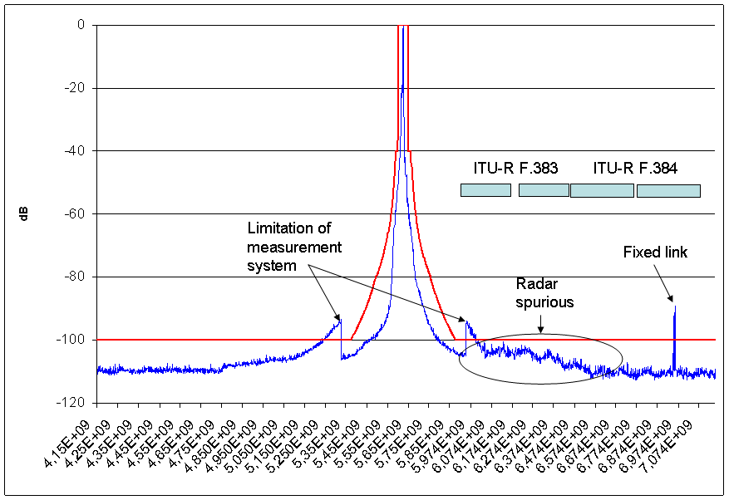
Figure 31: Magnetron radar with proper filtering

Conclusion
Based on submitted information above it can be shown that efficient filtering solution allows to limit spurious emissions to -100 dBc in most part of the spectrum for this type of meteorological radar, operating in the frequency band 5.6 GHz.
Corresponding reduction in coverage due to the total insertion loss of 0.35 dB is assumed to be acceptable.

Experience in another country

Introduction
New radar equipment was already installed in this administration by the organisation dealing with weather forecast in this given country in spring 2010. The new oscillator is implemented with a magnetron tube.
In co-operation with the organisation dealing with weather forecast the monitoring service of the national regulator authority made measurements at this radar from 5th to 7th may 2010.
It should be noted that those measurements were initially presented in the view of compliance with OoB limits (established in Rec.(02)05 [40]). However these measurements were also considered relevant to the spurious domain analysis.

Measurement results
Measurements were carried out directly at the radar device – at an interface between radar oscillator and radar filter – and also in the radio field in line-of-sight to the radar-antenna in a distance of 1.5 km.
The following diagrams show the relative power level relating to the peak power of the radar-signal spectrum. The blue (solid) line describes the measured relative power-level, the green (dashed) line and the red (solid) line are the threshold limits according to CEPT Recommendations ECC/REC/(02)05 [40], Annex 2, Figure A2.1. The dashed line shows the old limit for unwanted emissions in the out-of-band domain, the solid line represents the proposed design objective.
The measured frequency range was extended to 12 GHz because of the detection of the potentially existing second harmonic (see klystron radars) near the frequency 11.2 GHz.
Figure 32 shows the relative power level of the yet unfiltered radar-signal spectrum directly behind the oscillator. The pulse-duration is 800 ns. The measured frequency range (measured with high-pass receive filter) spans from 5.5 to 12.0 GHz.
Figure 32: pulse width 800 ns, measured at the oscillator
The measured relative power level in the spurious domain at missing of the radar-filter deviates between -90 to
-70 dBpp.
Figure 33 to Figure 35 show the relative power level of the filtered radar-signal spectrum in the radio field for pulse-durations of 400 ns, 800 ns and 3000 ns. Also these diagrams show the measured frequency range (measured by high-pass receive filter) from 5.5 to 12.0 GHz.
Figure 33: Pulse width 400 ns, measured in the radio-field
Figure 34: Pulse width 800 ns, measured in the radio-field
Figure 35: Pulse width 3000 ns, measured in the radio-field

Figure 36 shows the relative power level in the radio field. The pulse-duration is 800 ns. The measured frequency range (measured with a receive tuneable YIG filter) spans from 3.0 to 5.5 GHz.

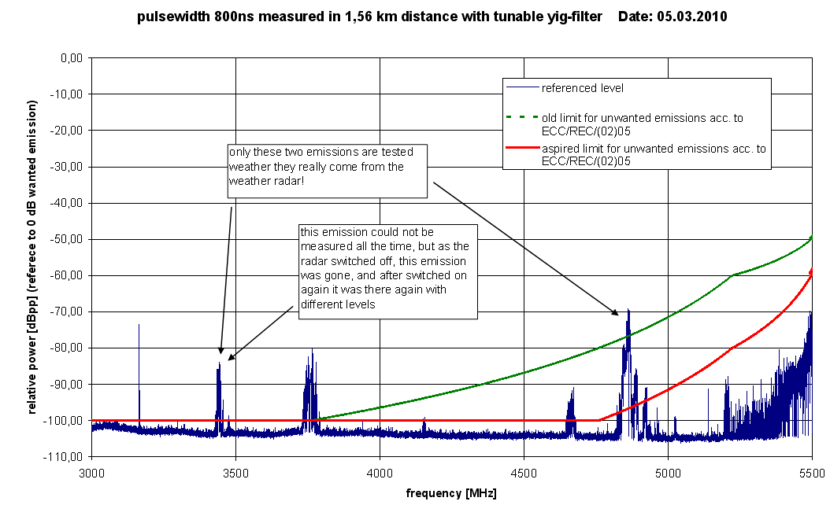
Figure 36: Pulse width 800 ns, measured in the radio-field, lower radar emission spectrum

Examination of the measured unwanted radar-signal emissions
According to Figure 32 – describing the unfiltered radar-emission spectrum – it is recognized a flat decline of the radar-emission level up to the frequency of 6.4 GHz and from there a spurious-domain level of up to -70 dBpp, in one case up to -60 dBpp.
Figure 33 to Figure 35 – describing the filtered radar-emissions in the upper radar-spectrum – show a very sharp decline of the radar-emission level up to the frequency of 5.9 respectively 6.0 GHz and from there a spurious-domain level of -100 dBpp. There is only a marginal variation of the declination among the individual pulse-durations. That means a compliance with both threshold limits according to ECC/REC/(02)05 [40] for the pulse durations of 400 ns and 800 ns in the upper frequency range. For the pulse duration of 3000 ns the old threshold-limit is nearly complied, but not the aspired limit.
With the pulse-durations of 400, 800 and 3000 ns the -100-dBpp-thresholdlevel in the upper spurious domain was adhered completely. The second harmonic near 11.2 GHz could not be found.
According to Figure 36 – describing the lower radar-emission spectrum – the requirement relating to ECC/REC/(02)05 [40] is also nearly complied in the lower frequency range. But the measurements show top levels at four positions in the lower unwanted-emission frequency-range which excess the threshold-level. The cause of two top levels is stated in assurance recognized as failing in the radar device. The lower frequency range wasn’t considered in previous measurements, because nobody expected the excess of the unwanted-emission threshold in the lower frequency range.
The German measurement campaign – carried out in May 2010 at a magnetron weather radar – demonstrated that this filtering solution allows to limit spurious emissions to -100 dBc in most part of the spectrum for this type of meteorological radar, operating in the frequency band 5.6 GHz

Experience in the third country
The following radars were investigated:
- Air navigation monopulse secondary surveillance radar at 1030 MHz in the region of one airport located in this country.
- Air navigation primary surveillance radar at 2720 MHz in the region of this airport.
- Airport surface movement radars at 9175 MHz and 9420 MHz in the region of the airport.
- Weather radar at 5628 MHz located in the main city in the vicinity of the airport.
The specifications of the different radars investigated are detailed in Table 13. It should be noted that the weather radar at 5628 MHz was tested with two different pulse lengths, thus corresponding to two different spectrum masks. As it is operated with a BP filter added to the original design, the spectrum both prior to and after the filter was measured.
Parameter | Radar 1 | Radar 2 | Radar 3 | Radar 4 | Radar 5a | Radar 5b
Purpose | Air navigation | Air navigation | Surface movement radar |  | Weather radar
 | Monopulse secondary surveillance radar | Primary surveillance radar | Surface movement radar
Reference | MSSR | ASR-10SS Mk2 | Scanter 2001 |  | WR100-5
Frequency | 1030 MHz | 2720 MHz | 9175 MHz | 9420 MHz | 5628 MHz
Output device | Solid state | Solid state | Magnetron | Magnetron | Magnetron
Peak Power | 1 kW | 16 kW | 20 kW | 20 kW | 250 kW
Pulse length | 750 ns | 1.6 µs | 60 ns | 54 ns | 580 ns | 3.0 µs
Rise time  Fall time | 88 ns  60 ns | 200 ns  2.6 ns | 4.3 ns  16.8 ns | 5.7 ns  15 ns | 36 ns  457 ns | 29 ns  567 ns
PRF | 150 Hz | 770 Hz | 8000 Hz | 8000 Hz | 1180 Hz | 250 Hz
40 dB Bandwidth | 29.8 MHz | 40 MHz | 474 MHz | 432 MHz | 42.7 MHz | 19.4 MHz
Spectrum | Fig. 2 | Fig. 3 | Fig. 4 | Fig. 5 | Fig. 6; Fig. 7 | Fig. 8
Table 13: List of radars investigated in the third country

Monopulse Secondary Surveillance Radar (MSSR) 1030 MHz
This radar has a spectrum that easily meets the spec given by the 20 dB/decade mask and also the planned future spec based on the 40 dB/decade mask from the design objective. From all systems tested this is the only one easily meeting current and future specs.
Figure 37: MSSR Mode S, Frequency 1030 MHz
(spectrum measured at monitor output with RBW=500 kHz)

Primary surveillance radar 2720 MHz
This radar system represents the biggest surprise of all system measured. Despite of the fact that it is a solid state design it fails to meet even current specs. The reason for this fact is unknown. However, it should be noticed that its transmit power (16 kW) is much lower than the air navigation radar considered in the previous Sections (1.4 MW).
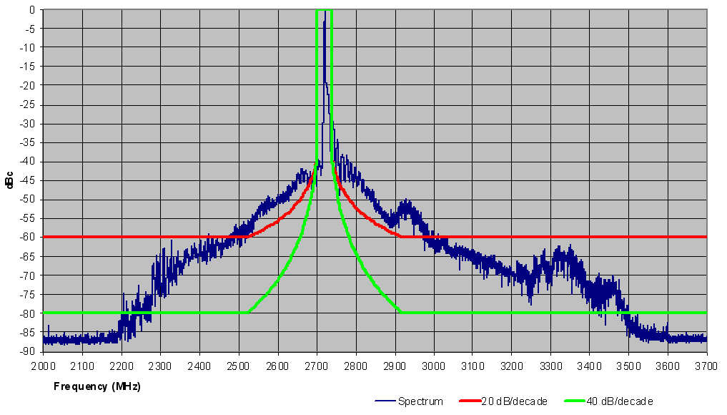
Figure 38: Air navigation primary surveillance radar, Frequency 2720 MHz
(spectrum measured at monitor output with RBW=500 kHz)

Surface movement radars 9175 and 9420 MHz
These radar systems operate with a common antenna so they need a combining filter that, if implemented as band pass design, will further improve the spectrum shaping. However the roll-off is rather smooth, especially in the light of the fact that this radar is a magnetron-based design.
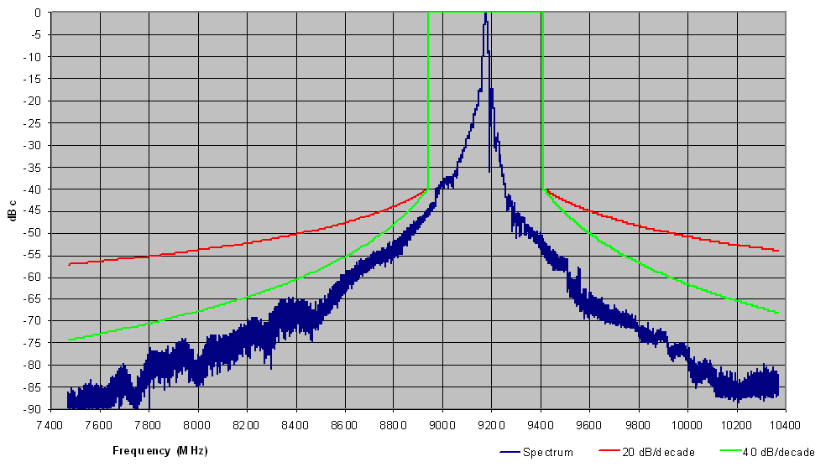
Figure 39: Airport surface movement radars, Frequency 9175 MHz
(spectrum measured at monitor output with RBW=500 kHz)

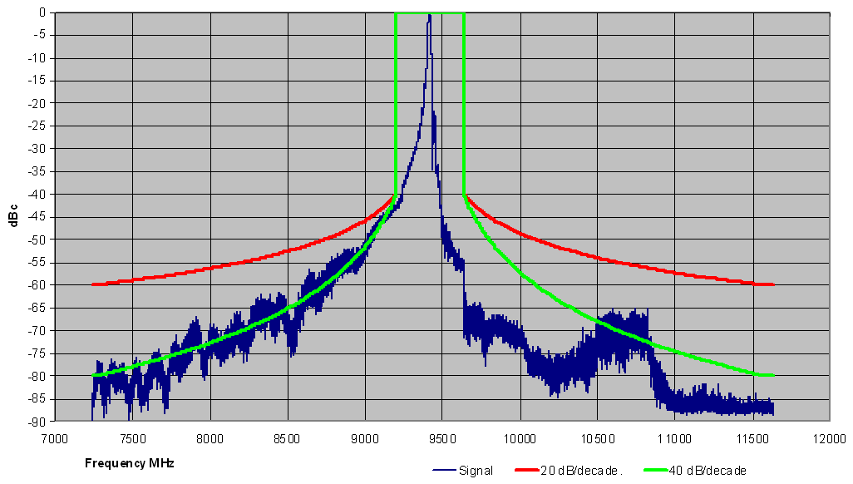
Figure 40: Airport surface movement radars, Frequency 9520 MHz
(spectrum measured at monitor output with RBW=500 kHz)

Weather radar 5628 MHz
This weather radar is a heritage system which is the only remaining in this country with this design. The spectrum generated by the radar itself is rather wide (Figure 41) and the limits of Recommendation ITU-R SM.1541-2 [41] could not be met. Therefore a band pass filter was added which efficiently limits the spurious response when the system was commissioned. The filter response can be clearly seen in the output spectrum measured (Figure 42 and Figure 43). With the filter inserted even a 40 dB/decade slope can almost be met. This clearly shows the potential of filters.
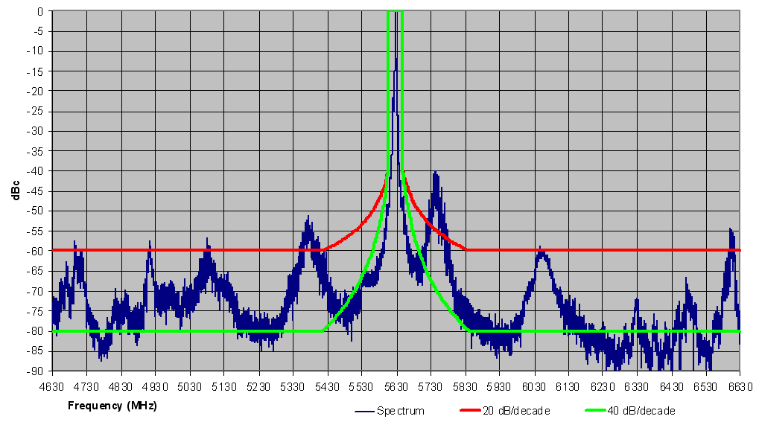
Figure 41: Weather radar, Frequency 5628 MHz, Pulse width 0.58µs
(spectrum measured at monitor output prior to BP filter with RBW=500 kHz)

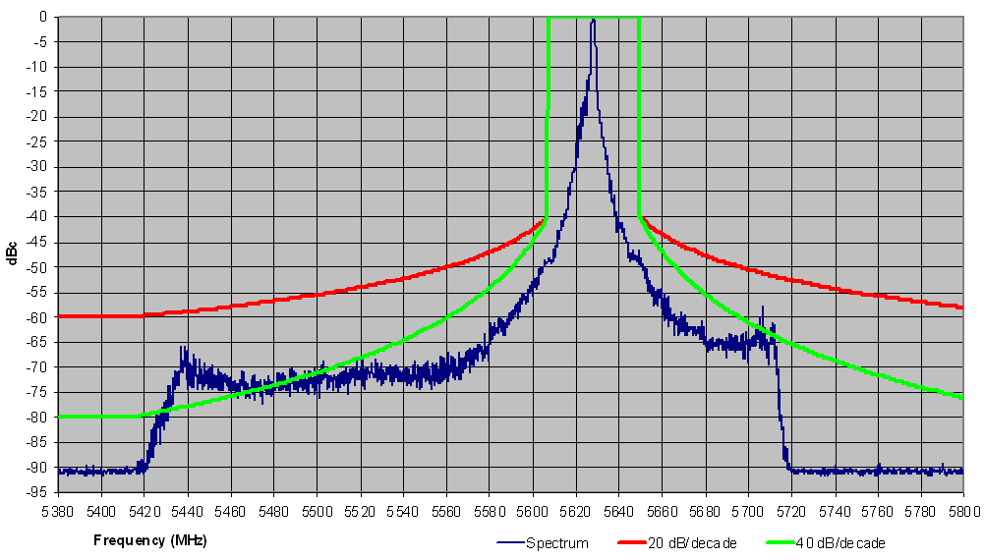
Figure 42: Weather radar, Frequency 5628 MHz, Pulse width 0.5µs
(spectrum measured at monitor output after BP filter with RBW=500 kHz)

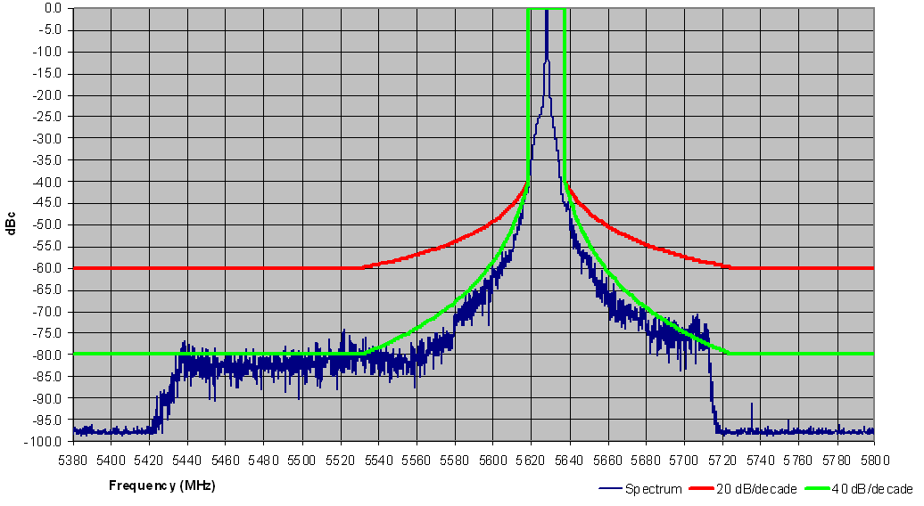
Figure 43: Weather radar, Frequency 5628 MHz, Pulse width 3.3µs
(spectrum measured at monitor output after BP filter with RBW=500 kHz)

Conclusion for the measurements in the third country
The measurement campaign conducted in the third country for different types of radar shows that a level around -80 dBc may be achieved for some type of radars. Furthermore for the weather radar operating at 5.6 GHz the level close to -90 dBc was achieved.

Experience and comments from one meteorological organization
Among members of one meteorological organization, although numerous contacts with filter manufacturers as well as testing, no current filters have been shown as allowing radar/filter combination to fully comply with current 100 dBc requirements (i.e over the 30 MHz to 26 GHz frequency range), while authorising nominal operation of meteorological radars. This is valid for C-band radars and even more for S-band radars.
This meteorological organization certainly does not deny that some efficient filtering solutions exists and will be applied by its members, but the following comments need to be made:
- Drawing some general conclusions about an overall compliance to ERC/REC 74-01 [1] based on measurements limited to some parts of the spectrum needs to be considered with the highest care.
- The specified maximum peak power of the filter described in Section 7.2.1 above is 280 kW :
  - For C-band radars with typical peak power of 250 kW, this only leaves 0.5 dB margin;
  - For S-band radars with typical peak power of 850 kW, this type of filter is not relevant;
- The specified maximum average power of the filter described in the one country is 300 W. The average power of radars is roughly controlled by the combination of PRF and pulse width figures. This filter will therefore limit the Peak-to-average ratio of radars to a minimum figure of 29.2 dB. Some signals used by meteorological radars already present figures down to 29.6 dB (see Section 2.2). Such filter may therefore limit future development of radar emissions schemes.
- Such efficient filtering solution requires 2 filters (a band-pass filter and a harmonic filter). It is obviously feasible but adding a new component in the emission chain would have impact on the radar availability.
- The impact of insertion losses is to be stressed
  - the maximum insertion loss of the band-pass filter at 0.4 dB is to be noted, compared to reasonable filter insertion losses (0.2-0.3 dB)
  - although the insertion loss of the harmonic filter is quite limited (0.1 dB), the overall losses of such of a “a filter” solution may finally range between 0.7 and 1 dB, considering the insertion losses and the different connection losses
When considering one single filter with reasonable insertion losses (0.2 - 0.3 dB), the total losses including connecting losses would roughly range between 0.3 and 0.4 dB that would then imply a range reduction between 3.4% and 4.5% and a coverage reduction between 6.7% and 8.8%, that is assumed as being acceptable.
With the efficient filtering solution that could represent 0.7-1 dB insertion losses, it would then imply a range reduction between 7.7% and 10.9% and a coverage reduction between 14.9% and 20.6%, i.e. between 6.2 and 10.8% additional coverage losses.
Considering a potential new radar network to be deployed, such radar coverage reduction would then imply about 10 % additional radars, with obvious cost impact, far from the only costs of the filters.
However, it should be considered that currently, in Europe, most national networks are already deployed and mature, based on ‘typical” radars ranges. Most future radars (that would have to comply with ERC/REC 74-01 [1]) would then potentially come only in replacement of existing radars. With high range reduction as given above, it will not be possible to ensure this replacement on a radar-to-radar basis. Obviously, a much higher number of radars than 10% would then be necessary to fill the gaps between existing radar location.
Overall, this meteorological organization stresses that:
- for C-band radars, although recognising that some filtering solutions exists that could allow to comply with 100 dBc requirement over large part of the spectrum, there is currently no evidence that solutions exist to fully comply with this 100 dBc consistently with ERC/REC 74-01 [1] (i.e. over the whole spectrum between 30 MHz and 26 GHz).
- For C-band radars, efficient filtering solutions may :
  - limit the future development of radar emission schemes
  - reduce the range of meteorological radars
  - reduce the radar availability
  - impose costs constraints far from the only cost of filters

Conclusions
To derive appropriate limit for radar spurious emissions it is necessary to take into account the requirements of protection of other services together with filtering capability of radars.

Conclusion in relation to the FS
For a balanced estimation of the impact of radars unwanted emissions in the spurious domain, we should consider the following results of this report:
- At close distance, even if the FS antenna is pointing away from the radar location, during a volume scanning cycle, when the radar points to the FS antenna, the FS receiver might be overloaded by the off-frequency carrier of the radar. For example, at 1 km distance assuming a off-angle FS antenna gain of 0 dBi, the power of a 250 kW radar with 45 dBi antenna gain reach the FS receiver at ~ +20 dBm requiring more than 120 dB of total (RF to base-band) filter attenuation in the receiver for having no impact on the FS receiver functionality; this, in some cases might not be provided by common FS receiver, in particular if related to some specific frequencies such as image(s) frequencies. Intermediate attenuation in the receiver chain (e.g. RF antenna to front-end and RF to IF) might even be more critical.
- Regarding the impact of spurious emission, the very high power of the primary radars under consideration confirm the common assumption that, whichever would be the spurious limit in dBc, main-beam to main-beam coupling between radars and FS stations is not possible because in all cases the protection distance is in the order of several tens of km (in most cases lies beyond the horizon). Therefore, it is assumed that information about the FS and radar locations are known to administrations licensing their use.
- When FS stations are deployed at intermediate distance a certain sector of possible FS azimuth angles could be potentially blocked by the presence of radar spurious emissions. Obviously, at given radar spurious emission level, the smaller the separation distance between the FS victim and radar station is, the wider the blocked azimuth sector is.
Table 14 and Figure 44 summarise the impact of typical C-band meteorological radars on the variation of the potentially blocked azimuth angles for FS stations in the 6-8 GHz band.
C band Radar peak power  = 250 kW | FS Azimuth angle (degrees/%)
Spurious limit →  Distance between FS  and radar locations ↓ | 100 dBc | 90 dBc | 80 dBc | 60 dBc (estimated)  (Note 1)
5 km
Scenario 1  (Note 2) | ± 6/3.32% | ± 15/8.32% | ± 37/20.54% | ± 180/100%  (reached for > ~77 dBc)
Scenario 2  (Note 3) | ± 1.5/0.82% | ± 4/2.22% | ± 10/5.54% | ± 180/100%  (reached for > ~63 dBc)
Scenario 3  (Note 4) | ± 2.5/1.38% | ± 6/3.32% | ± 15/8.32% | ± 180/100%  (reached for > ~67 dBc)
15 km
Scenario 1  (Note 2) | ± 2.5/1.38% | ± 6/3.32% | ± 15/8.32% | ± 180/100%  (reached for > ~67 dBc)
Scenario 2  (Note 3) | ± 0.5/0.28% | ± 1.5/0.82% | ± 4/2.22% | ± 25/14%
Scenario 3  (Note 4) | ± 1/0.54% | ± 2.5/1.38% | ± 6/3.32% | ± 40/22%
Note 1: 60 dBc represents, for reference, the impact of radars currently exempted from the 100 dBc requirement
Note 2. Mostly relevant for harmonics emissions (e.g. S-band radars 2nd harmonic into 6 GHz FS or OOB domain (e.g. C-band radars into lowermost 6 GHz FS)
Note 3: Mostly relevant for wide-band spurious emissions
Note 4: Mostly relevant Narrow-band (single peak) spurious emissions
Table 14: 6 to 8 GHz FS P-P links - Azimuth angle potentially affected by spurious emissions of 250 kW radar exceeding the shown limits (function of distance between FS and radar locations)

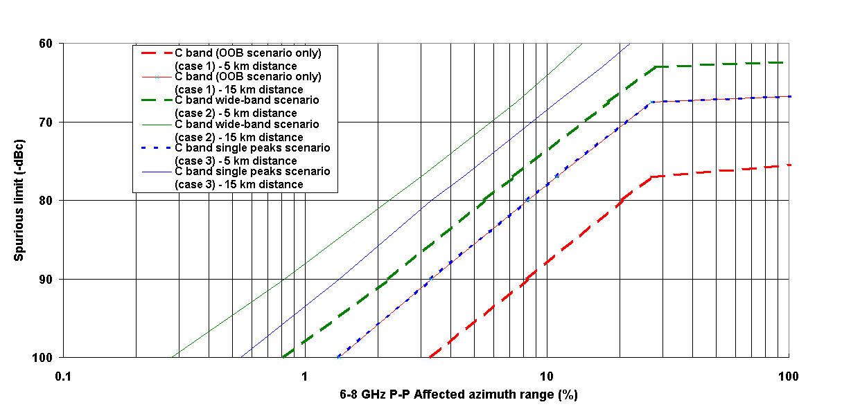
Figure 44: C Band radars impact on 6-8 GHz P-P station
Linearly applying the differences in Table 9 we can derive the expected blocked sectors of 6-8 GHz P-P stations due to the spurious emissions of various types of S-band radars in different scenarios. Figure 45 summarises the results (only most representative scenario cases 1 and 3 are reported).
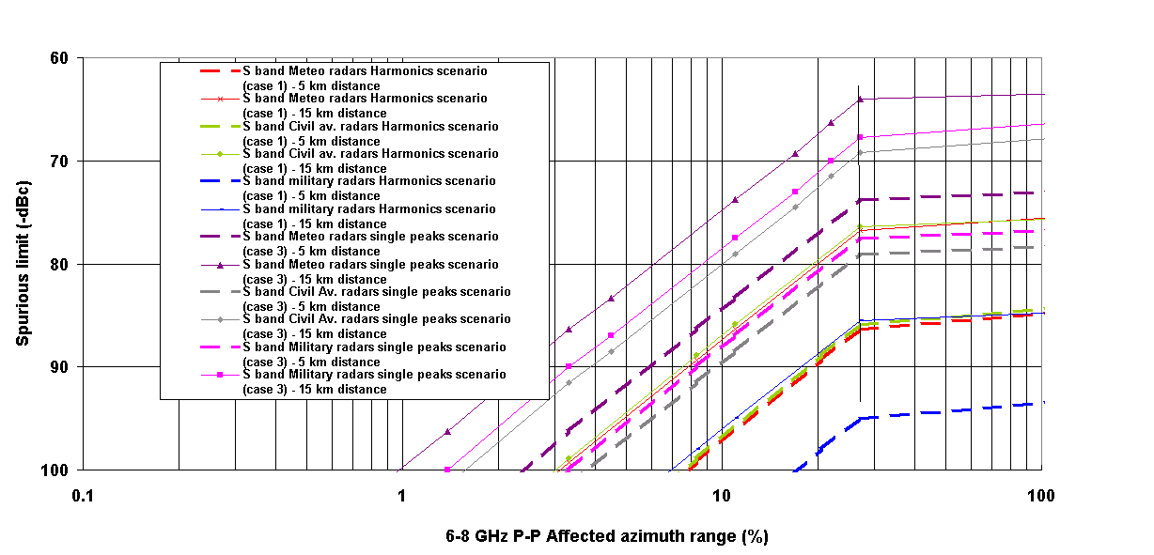
Figure 45: S-band radars impact on 6-8 GHz P-P station
- From Figure 45, it should be also considered that some particular very high power radars could create a possible complete blocked azimuth even at distance beyond the 15 km. In addition, it can also be seen that, at the same spurious level, the particular civil aviation and military radars considered in this report present larger blocked azimuth compared to meteorological radars.
- Figure 15 and Figure 16 show that for P-P stations at 11 GHz (from harmonics of S and C-bands radars) the situation of interference is better in comparison with 6 GHz P-P FS due to higher level of propagation attenuation and higher directivity of FS P-P station antennas.
- There may be a need to further consider the influence of radar spurious emissions on FS FWA stations in the 3.4-3.8 GHz. It is expected that the main scenario to be studied for such FS application would related to S-band radars spurious emissions.
- For the S-band radars it can be observed that a 60 dBc spurious emissions attenuation limit results in very large separation distances for all three types of radars (meteorological, civil aviation and military). Although additional attenuation for meteorological radars, 75 dBc, improves the situation, there is high impact (e.g. > 10 km separation distance) for around 20° discrimination angle.
From above results for FS in the band 6 – 8 GHz it appears that some relaxation (down to -90 dBc) for the spurious emissions level for the C-band meteorological radars would have limited impact on the FS P-P deployment.
On the other hand, further relaxation (down to e.g. -75 dBc) for S-band meteo radar would be much more problematic; however there are only few of such S-band meteorological radars in Europe deployed in specific area. It should also to be noted that the analysis for S-band radars shows that the impact of some particular very high power radars for which only -60 dBc presently applies (in particular the civil aviation radars and the military radars considered in this study) could produce complete FS azimuth blocking up to the horizon.

Conclusion in relation to the RLAN
Radars are often installed in or close to residential areas where RLAN, indoor or outdoor, could be deployed. To avoid that, in certain situations, radars make part of the 5 GHz band unusable for RLAN operation, the C-band radar spurious emissions should be kept below -80 to -90 dBc corresponding to the minimum separation distance of 1.2 – 3.8 km (for free space propagation condition and main beam to main beam coupling). However taking into account that such situation is unlikely, this range of spurious emissions level will ensure that RLAN operation remains possible even at distances down to or even below 1 km from the radar.
It should be stressed that the report does not address the compatibility issues between the radars at 2.8 GHz and the Mobile service in the frequency band 2500-2690 MHz. Therefore, corresponding studies are required.

Conclusion in relation to the RAS
As far as RAS is concerned, irrespective of the radar spurious emission limit, the worst case required separation distances between radars and RAS stations are in the order of several tens km. The distances range from 45 km (for 100 dBc attenuation) to more than 100 km (for 65dBc attenuation), depending on radar type. Similarly to the Fixed Service case, it is assumed that information about the RAS and radar locations is available for administrations and that these cases are solved by appropriate coordination taking into account in particular terrain shielding. One can also report that, for the same spurious limit, the civil aviation radar considered in this report requires larger separation distances compared to meteorological radars.

Additional considerations on boundary between spurious and OoB domains of radar emissions
It is finally underlined that the current regulations in both CEPT and ITU-R Recommendations (and Radio Regulations) provide definition of the boundary between out-of band and spurious domains related to the “-40 dB bandwidth” (B₋₄₀). Recommendation ITU-R SM.1541 [41], for calculating B₋₄₀ for the primary radars in subject, provides formulas that are highly variable with the pulse parameters (by a factor of 10 or more in particular with the rise-fall time relative to pulse duration) with the consequence that also the boundary of the spurious domain cannot be clearly fixed for any radar “category” under study, but can vary by several GHz from the carrier, because their pulse parameters are not recommended anywhere.
Therefore, the studies here made for the “spurious domain” limits might become inapplicable for the protection of other services because they can be actually affected by unpredictable, radar-by-radar dependent, out-of-band emissions, obviously subject to higher limits.
The only possibility for defining a “stable” coexistence situation would be the definition of specific “category” spectrum mask in term of “absolute frequency” limits independent form the actual pulse characteristics. The present “relative frequency” emission masks (both present and design objective cases) in ECC/REC/(02)05 [40] do not fulfil such scope, while a suitable example is reported in Annex 1 (i.e. EUMETNET recommendation for the presently deployed weather radars).

Conclusion in relation to the filtering capability
There are some difficulties in practice to achieve -100 dBc limit for spurious emission of radar in the whole range of frequencies covered by the ERC/REC 74-01 [1], as confirmed by measurements.
However there are filtering solutions that show that the limit of spurious emissions of -100 dBc can be met in most part of the spectrum for meteorological radar, operating in the frequency band 5.6 GHz (C-band). To this respect, it is assumed that for these radars, a limit set at -90 dBc will in any case impose an efficient filtering solution while ensuring that such limit can be met over the whole spectrum.
For lower frequency bands (S-band) in which radar presents much higher power (up to 1 MWatt) similar solution providing -100 dBc may not be feasibleTherefore, on a site by site basis, an Administration may decide, taking into account potential cross-border compatibility issues where relevant, to deploy meteorological radars in the band 2 700-2 900 MHz with a peak power above 750 kW with relaxed spurious emission limits. Further studies are required in this respect.
Finally, it is expected that radars operating in the higher frequency bands (X-band; 8.5-10.5 GHz) with significant lower power (in the order of 50/60 kW) could meet -100 dBc more easily.

- : Spectral characteristics of pulsed RF signal
A.1.1 Basic ideal Spectral characteristic (Fourier analysis)
For a better understanding of the methodology used in the study, this section presents a quick overview of the ideal spectral characteristics of pulsed signals.
An ideal radiofrequency carrier modulated in amplitude by a rectangular signals with certain Pulse Repetition Frequency (PRF) and duration τ, exhibits the normalised spectral emission shown in Figure 46.
Figure 46: Normalised spectrum of a pulse train (duration = τ ; repetition rate = PRF)

The spectrum is made by a number of lines spaced by PRF with individual relative levels according:
- Carrier reduction factor = 20*log(PRF*τ) (1)
- Lines envelope = 20*log{sin(πτf)/( πτf)} (2)

Within a certain integration bandwidth (Bwi) in any portion of the whole spectrum, where a number N_{L} = Bwi/PRF of lines fall, the mean (rms) and peak power density in the band follow the well known rules:
- Mean (rms) power (dBm) = $\text{10}\text{*log}\left\{\sum_{i=1}^{N_{L}}{({\text{line}}_{i}\left[\text{mV}\right]})^{2}\right\}$ (3)
- Peak power (dBm) = $\text{20}\text{*log}\left\{\left|\sum_{i=1}^{N_{L}}{{\text{line}}_{i}\left[\text{mV}\right]}\right|\right\}$ (4)

A.1.2 Application to the example of 5.6 GHz Meteorological radars emissions
A.1.2.1 Radar Emission characteristics
Meteorological radars characteristics, including antennas can be found in ITU-R M.1849 [3].
From Recommendation ITU-R M.1849 [3] we learn that typical values for their pulse characteristics are:
- τ ≅ 0.8 ÷ 3 μs (1/τ ≅ 0.33 ÷ 1.25 MHz)
- PRF ≅ 250 ÷ 1 200 Hz (mean PRF 333 Hz)
- Rise/fall time ≤ 0.1*τ
For the example below we assume τ = 1 μs and PRF = 1 kHz.
However, in some cases, higher variance in pulse duration and rise/fall time are present (e.g. the case with duration = 0.05-18 us; rise/fall time = 0.005 us; PRF = 0-4 000 Hz) would lead to far different assumptions, which, however, would be more related to their highly variant boundary of the out-of-band and spurious domain discussed later on in section 2.1.3 of this annex.

A.1.2.1.1 Ideal emission (rectangular, band unlimited pulses)

In each 1 MHz integration bandwidth (Bwi) there will be a number of lines N_{L}:
NL = Bwi/PRF = 1000 lines/MHz
The Figure 47 below graphically show the expected ideal emissions over the band 5600-8600 MHz and the details near the radar carrier frequency (5600 MHz) and into a victim FS bandwidth (centred at ≅ 6000 MHz).

The graphs show the power of each line relative to the centre frequency residual carrier; however, provided that, the reference bandwidth (B_{ref}) for the spurious emissions limits, according ERC/REC 74-01 [1] and Recommendation ITU-R M.1177 [2], is defined as B_{ref} = 1/τ, the carrier reduction factor (20*log(PRF*τ)) is compensated by the aggregation factor 20log (B_{ref}/PRF) of the lines in the reference bandwidth. In the example B_{ref} = 1 MHz therefore the plot represents the ideal output emission in term of dB_{PEP}/1 MHz (note).

Note: Actually, because the lines power is not flat within one MHz, but follows the Sin(x)/(x) law (see Figure 48 and Figure 49), their aggregation would be ~ 6 dB lower.
Figure 47: Wide-band ideal spectral-lines envelope of a rectangular pulse train
(duration = 1μs ; repetition rate = 1 kHz)
Figure 48: Near carrier detail of the ideal spectral-lines envelope
Figure 49: FS victim bandwidth detail of the ideal spectral-lines envelope

Provided that the radar emission is assumed to have:

- Unfiltered output
- Fixed PRF and τ
- rise/fall time short in comparison with the pulse duration.

The unwanted emissions of pulsed radars into the FS adjacent bands (up to ~8.5 GHz and down to 3.4 GHz) can still be simulated with the main emission and have the same spectral-lines characteristics.

Within the victim bandwidth (Bv) the interference is practically flat comprising Bv/PRF number of lines and Bv*τ side lobes of the sin(x)/x envelope of spectral lines.

A.1.2.1.2 Practical emission differences

The attenuation of practical spectrum (in term of dB_{PEP}/1 MHz) at certain distance from the radar centre frequency is function of various emission characteristics, e.g. pulse duration (shorter duration higher attenuation), PRF (higher PRF higher attenuation); in addition emissions may significantly vary also according the pulses rise/fall-time (longer rise/fall time higher attenuation). Recommendation ITU-R F.1097-1 [4] reports the general formulation for a “trapezoidal” pulse modulation train; the example of Figure 50 shows the spectral reduction of a 1 μsec rectangular pulse train due to a 2% or a 10% rise/fall time.
As it may be seen the rise/fall time plays a significant role for understanding whether the wide-band cues of the main radar carrier (which generate the highest peak aggregation factor) have to be taken into consideration in the study.

Present OOB boundary (1 microsec)
Figure 50: Effect of rise/fall time on the ideal Spectral-lines envelope

A.1.2.1.3 OOB and spurious emissions domain boundary
A.1.2.1.3.1 Generic radars

For identifying the spurious emissions domain boundary reported in Figure 51, we should refer to ECC/REC(02)05 [40], which defines the OOB domain as 23.2 * B₋₄₀ (present radars) or 10.75 * B₋₄₀ (design objective).
Figure 51: Emission masks for radars
(The dashed line shows the limit for unwanted emissions in the out-of-band domain.
The solid line represents the proposed design objective)

B₋₄₀ is defined, as function of pulse duration (t) and rise-time (tr), by Recommendation ITU-R SM.1541 [41], for the typical weather radars (conventional pulse radars) as follows:

“For non-FM pulse radars, including spread spectrum or coded pulse radars, the bandwidth is the lesser of:
where the coefficient K is 6.2 for radars with output power greater than 100 kW and 7.6 for lower-power radars and radars operating in the radionavigation service in the 2900-3100 MHz and 9200-9500 MHz bands. The latter expression applies if the rise time tr is less than about 0.0094t when K is 6.2, or about 0.014t when K is 7.6.”

For example, considering the radar type 2 in ITU-R M.1849 [3], the fixed raise-time of 0.005 μs and the pulse duration range is 0.05 μs < t < 18 μs; the first B₋₄₀ value is relevant for t < ~ 0.53 μs, while the second is valid for t ≥ ~ 0.53 μs; therefore for the relevant range of pulse durations:

B₋₄₀ (t = 0.05 to 0.53 μs) ≅ 6.2/√(t*tr) → 400 MHz > B₋₄₀ > 120 MHz
B₋₄₀ (t = 0.53 to 18 μs) ≅ 64/t → 120 MHz > B₋₄₀ > 3.5 MHz

Second example, considering the radar type 8 B₋₄₀ = 277 MHz
Typically, considering a pulse duration range 0.5 μs < t < 2 μs and a raise-time of 10% t; only the first B₋₄₀ value is relevant:

B₋₄₀ ≅ 6.2/√(t*tr) → 10 MHz < B₋₄₀ < 124 MHz

This would result in a spurious emissions domain boundary as shown in Table 15.

Radar type  (ITU-R M.1849) | Present radars boundary |  | Design objective boundary
Radar type  (ITU-R M.1849) | min (fo ± MHz) | MAX (fo ± MHz) | min (fo ± MHz) | MAX (fo ± MHz)
Type 2 | 3.5 * 23.2 = 81.2 | 400 * 23.2 = 9 280 | 3.5 * 10.75 = 37.6 | 400 * 10.75 = 4 300
Typical | 10 * 23.2 = 232 | 124 * 23.2 = 2 868 | 10 * 10.75 = 107.5 | 124 * 10.75 = 1 333
Type 8 | 277 * 23.2 = 6 426 |  | 277 * 10.75.2 = 2 977
Table 15: Comparison of the spurious emission domain boundary between the present and design objective radars
Figure 52 shows the calculated variation of the boundary for some radars type in Recommendation ITU-R M.1849.

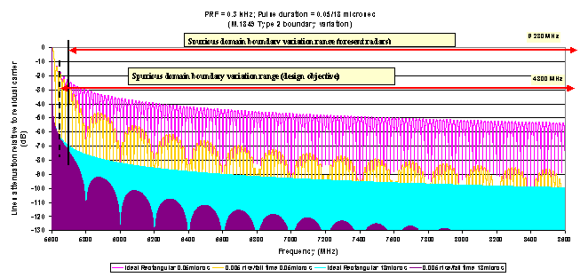
Figure 52: Calculated variation of the boundary for some radars type in Recommendation ITU-R M.1849
A.1.2.1.3.2 Specific European meteorological radars at 5.6 GHz

One international meteorological organization in Europe, in the attempt of solving coexistence problems with RLAN in the 5 GHz band, has recently released a recommendation (adopted 04/12/08 by the 35th EUMETNET council in Reading, UK) for harmonised use of 5.6 GHz current (already deployed) meteorological radars in Europe [42].

It recommends specific limits for:
- Nominal operating frequency (limited to 5600-5650 MHz)
- Emission limitation for radars with pulse length 0.5 μs and 0.8 μs with 10% rise/fall time.
- Frequency tolerance = ± 17.5 MHz
With the above parameters we can derive a possible emission mask width as follows:
- -40 dB at 5581 MHz and 5669 MHz
The 40 dB starting points for the calculation of the 40 dB roll-off is kept 53 MHz (i.e. 50 MHz + B₄₀); the mask is widened by a constant ± 17.5 MHz (for frequency tolerance).
For the purpose of this report, it is necessary to estimate the possible further reduction of the attenuation down to −100 dB presently under investigation; extrapolating the mask in the above mentioned EUMETNET Recommendation on C-Band Meteorological radars) with the guideline of design objectives in ECC/REC/(02)05 [40], as shown in Figure 53. The mask has been extended:
- Down to −61 dB at 5552 MHz and 5698 MHz
- Down to −81 dB/MHz (−80 dB/B_{ref}) with the same 40 dB roll-off.
This happen for offset ±(5*53 + 17.5) = ±282.5 MHz corresponding to 5342.5 MHz and 5907.5 MHz
- Further down to −101 dB/MHz (−100 dB/B_{ref}) with the 60 dB roll-of.
This happen after an additional offset of ±5.75*53 = ±304.75 MHz corresponding to 5037.75 MHz and 6212.25 MHz.
Figure 53: Regulations of one meteorological organization in Europe, extrapolated to 100 dB

Depending on the recommended level of the spurious emissions the domains boundary will change accordingly. In any case, the following apply:
- The FS band below 5925 MHz (i.e. down to 5650 MHz, used in some CEPT countries under RR 5.455) is not within the spurious domain; therefore, it should not be in the scope of this report;
- More than the lower half of the L6 band, either is also not within the spurious domain (if the limit stays at the present 100 dBpp), or might benefit only up to 80 dBpp limit (if the limit would be so changed);
- The RLAN band also is in the OOB domain (with 100 dB limit) or might benefit only up to 80 dBpp limit (if the limit would be so changed) in the lower range 5150-5350 MHz;
- Only bands U6 and above, as well as 4 and U4 bands, could definitely be considered in the spurious domain;
- When in the spurious domain the wide-band peak aggregation factor would reach the 20*log(Bw) factor only when harmonics of the main carrier are considered (i.e. in the 11 GHz band).

A.1.2.1.4 Impact of the reference bandwidth in which the limits are defined

ERC/REC 74-01 [1] and Recommendation ITU-R SM.329 [43] defines that the reference bandwidth (B_{ref}) in which the spurious emission domain limits are defined shall be derived from RR Appendix 3, which, for the most common pulsed radar types states that B_{ref} = 1/τ.

Therefore, the aggregation factor within the 50 MHz wide-band victim is also variable with τ with a factor up to 20log(τ ratio).

Example, from ITU-R M.1849 (see Annex 3) [3], the maximum variance is 18 μs < τ < 0.05 μs and the expected difference might go up to 20log(18/0.05) ≅ 31 dB.

- : TECHNICAL BACKGROUND FOR THE FS PROTECTION CRITERIA
A.2.1 Pulsed interference effects on FS receivers
A.2.1.1 Recommendation ITU-R F.1097-1 [4]
In this Recommendation ITU-R (developed ~1999) a suggested protection criterion of Ipeak/N ≅ 0 dB was “empirically” derived from various experienced interference cases.
A.2.1.2 ECC Report 023[27]: 24 GHz SRR – FS test campaign
A.2.1.2.1 Introduction

For an a more detailed background, we refer to the more recent (2003) and more organic Short Range Radars (SRR) tests campaign with victim 23 GHz FS P-P equipment. Standing the far lower power of SRR specific and accurate laboratory tests were possible.

Also UWB SRR emissions were of pulsed type with a spectral emission content characterised by multiple-lines spaced by PRF. Besides the different pulse duration and PRF, the emission characteristics and the basic considerations about their effect on FS receivers should be considered equivalent to those of any pulsed radar.

Those tests had demonstrated that the impact on the FS receiver can be reduced to the simple noise-floor increase due to the rms content of the SRR emission related to the assumed I/N ratio, provided that the peak of the interfering signal within the wide-band FS receiver does not exceed a certain value.

In practice it was estimated that the interference may be assumed noise like until the ratio:

→ (IPeak/50 MHz)/(Irms/MHz) < 42 dB

Therefore, ECC Report 023 [27] have set the two independent protection criteria for rms and peak interference levels:

→ Irms/N ≤−20 dB within 1MHz:

rms densities ratio within 1MHz (which is the usual FS protection criteria for interference other than co-primary).

→ IPeak/N ≤+ 5 dB within 50 MHz:

Additional criteria for wide-band peaking protection; the I_{peak} to N_{rms} ratio within 50 MHz, derived from the tests, was found to be equivalent an interference peak lower than the noise peak for a probability p > ~4%.

The noise peak of the FS receiver follows the band-limited Rayleigh distribution (Annex 1 of ECC Report 064 [28] describes the physical rationale about it).

The above limits have been adopted also in all subsequent studies for UWB pulsed emissions compatibility with FS and resulted in the definition by FCC, EC, ECC and ITU-R of the general UWB and SRR power limitations:

→ Power density (peak) ≤ − 0 dBm within 50 MHz
→ Power density (rms) ≤ − 41.3 dBm within 1 MHz

The above limits are considered “independent” objectives and applicable to UWB and SRR emissions with any peak factor. Depending on whether the ratio P_{peak}(50 MHz)/P_{rms}(1 MHz) is higher or lower than 41.3 dB, the first or the second becomes the most stringent (Annex 1 of ECC Report 064 [28] reported physical background about it). Figure 54 graphically show the above concept applied to UWB and SRR emissions.
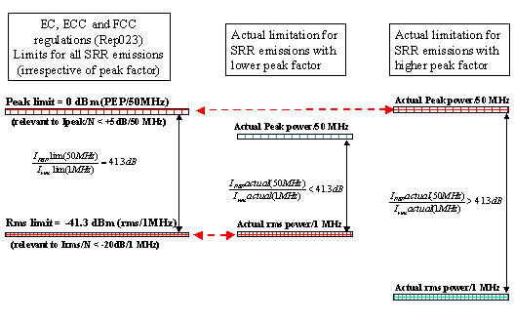
Figure 54: Interpretation of the dual limitation of pulsed SRR emissions
The integration bandwidth 50 MHz was chosen for three reasons:
- It is close to the maximum bandwidth used for FS
- Being the PRF of most application higher than 1 MHz, it is inappropriate to define I_{peak} levels in the same density unit of rms (1 MHz)
- It was also selected by FCC for same purpose

It should be noted that a similar protection criteria.

- : LIST OF REFERENCES
- ERC/REC 74-01: Unwanted Emissions in the Spurious Domain
- Recommendation ITU-R M.1177: Techniques for measurement of unwanted emissions of radar systems
- Recommendation ITU-R M.1849: Technical and operational aspects of ground-based meteorological radars
- Recommendation ITU-R F.1097-1: Interference mitigation options to enhance compatibility between radar systems and digital radio-relay systems
- ERC Report 025: The European Table of frequency allocations and utilisations covering the frequency range
9 kHz to 275 GHz
- Recommendation ITU-R M.1464: Characteristics of radiolocation radars, and characteristics and protection criteria for sharing studies for aeronautical radionavigation and meteorological radars in the radiodetermination service operating in the frequency band 2700-2900 MHz
- Recommendation ITU-R F.1242: Radio-frequency channel arrangements for digital radio systems operating in the range 1350 MHz to 1530 MHz
- ERC T/R 13-01 : Preferred channel arrangements for fixed service systems operating in the frequency range 1-2.3 GHz
- Recommendation ITU-R F.1098 : Radio-frequency channel arrangements for fixed wireless systems in the 1900-2300 MHz band
- Recommendation ITU-R F.1488: Frequency block arrangements for fixed wireless access systems in the range 3400-3800 MHz
- ECC/REC/(04)05: Guidelines for accommodation and assignment of Multipoint Fixed Wireless systems in frequency bands 3.4-3-6 GHz and 3.6-3-8 GHz
- Recommendation ITU-R F.382 : Radio-frequency channel arrangements for fixed wireless systems operating in the 2 and 4 GHz bands
- Recommendation ITU-R F.635: Radio-frequency channel arrangements based on a homogeneous pattern for fixed wireless systems operating in the 4 GHz band
- ERC/REC 12-08: Harmonised radio frequency channel arrangements and block allocations for low, medium and high capacity systems in the band 3600 MHz to 4200 MHz
- Recommendation ITU-R F.1099: Radio-frequency channel arrangements for high- and medium-capacity digital fixed wireless systems in the upper 4 GHz ( 4400-5000 MHz) band
- Recommendation ITU-R F.383: Radio-frequency channel arrangements for high-capacity fixed wireless systems operating in the lower 6 GHz (5925 to 6425 MHz) band
- ERC/REC 14-01: Radio-frequency channel arrangements for high capacity analogue and digital radio-relay systems operating in the band 5925 MHz - 6425 MHz
- Recommendation ITU-R F.384: Radio-frequency channel arrangements for medium- and high-capacity digital fixed wireless systems operating in the upper 6 GHz ( 6425-7125 MHz) band
- ERC/REC 14-02: Radio-frequency channel arrangements for high, medium and low capacity digital Fixed Service systems operating in the band 6425-7125 MHz
- Recommendation ITU-R F.385: Radio-frequency channel arrangements for fixed wireless systems operating in the 7 GHz (7110-7900 MHz) band
- ECC/REC/(02)06: Preferred channel arrangements for digital Fixed Service Systems operating in the frequency range 7125-8500 MHz
- Recommendation ITU-R F.386: Radio-frequency channel arrangements for fixed wireless systems operating in the 8 GHz (7725 to 8500 MHz) band
- Recommendation ITU-R F.387: Radio-frequency channel arrangements for fixed wireless systems operating in the 11 GHz band
- Recommendation ITU-R F.1094-2: Maximum allowable error performance and availability degradations to digital fixed wireless systems arising from radio interference from emissions and radiations from other sources
- Recommendation ITU-R F.758-4: Considerations in the development of criteria for sharing between the terrestrial fixed service and other services
- Recommendation ITU-R F.1108-4: Determination of the criteria to protect fixed service receivers from the emissions of space stations operating in non-geostationary orbits in shared frequency bands
- ECC Report 023: Compatibility of automotive collision warning Short Range Radar operating at 24 GHz with FS, EESS and Radio Astronomy (Cavtat, May 2003)
- ECC Report 064: The protection requirements of radiocommunications systems below 10.6 GHz from generic UWB applications (Helsinki, February 2005) − ANNEX 1: Fixed Service (FS)
- Recommendation ITU-R F.699-7: Reference radiation patterns for fixed wireless system antennas for use in coordination studies and interference assessment in the frequency range from 100 MHz to about 70 GHz
- ECC Report 033: The analysis of the coexistence of Point-to-Multipoint FWS cells in the 3.4-3.8 GHz band
- Recommendation ITU-R F.1336: Reference radiation patterns of omnidirectional, sectoral and other antennas in point-to-multipoint systems for use in sharing studies in the frequency range from 1 GHz to about 70 GHz
- Recommendation ITU-R F.1245-1: Mathematical model of average and related radiation patterns for line of sight point-to-point radio-relay system antennas for use in certain coordination studies and interference assessment in the frequency range from 1 GHz to about 70 GHz
- Recommendation ITU-R P.452: Prediction procedure for the evaluation of microwave interference between stations on the surface of the Earth at frequencies above about 0.7 GHz
- ECC Report 128: Compatibility studies between pseudolites and services in the frequency bands 1164-1215, 1215-1300 and 1559-1610 MHz
- ECC/DEC/(04)08 on the harmonised use of the 5 GHz frequency bands for the implementation of Wireless Access Systems including Radio Local Area Networks (WAS/RLANs)
- EC Decision 2005/513/EC/2007/90/EC on the harmonised use of radio spectrum in the 5 GHz frequency band for the implementation wireless access systems including radio local area networks (WAS/RLANs)
- Recommendation ITU-R M.1652: Dynamic frequency selection (DFS) in wireless access systems including radio local area networks for the purpose of protecting the radiodetermination service in the 5 GHz band
- ERC/REC 70-03: Relating to the use of Short Range Devices (SRD)
- Recommendation ITU-R RA.769: Protection criteria used for radio astronomical measurements
- ECC/REC/(02)05: Unwanted emissions
- Recommendation ITU-R SM.1541-2: Unwanted emissions in the out-of-band domain
- Recommendation (adopted 04/12/08 by the 35th EUMETNET council in Reading, UK) for harmonised use of 5.6 GHz current (already deployed) meteo radars in Europe
- Recommendation ITU-R SM.329: Unwanted emissions in the spurious domain

A lot of civil aviation and military radars are operating with multi-frequency or/and active array.
Recommendation on C-band Meteorological radars design to ensure global and long-term coexistence with 5 GHz RLAN adopted 04/12/08 by the 35th EUMETNET council in Reading, UK

