

CEPT Report 42

Report from CEPT to the European Commission
in response to Task 3 of the Mandate to CEPT on the 900/1800 MHz bands

“Compatibility between UMTS and existing and planned aeronautical systems above 960 MHz”

Final Report on 12 November 2010 by the

Electronic Communications Committee (ECC)
within the European Conference of Postal and Telecommunications Administrations (CEPT)

executive summary

A Commission Decision of 16 October 2009 (2009/766/EC) and a Directive of the European Parliament and of the Council of 16 September 2009 (2009/114/EC) have been approved as measures to enable the introduction of new technologies into the 900/1800 MHz bands. The annex to the EC Decision contains essential technical parameters for systems for which studies have demonstrated the ability to coexist with GSM. In addition to UMTS, which is already included in this annex, there are signs that other technologies are envisaged for deployment in the 900/1800 MHz bands. Before further technologies can be included in this annex, coexistence studies are necessary.

This CEPT Report was written to answer to the Task 3 of the Mandate from the European Commission to CEPT on the 900 and 1800 MHz frequency bands. The task reads as:
“(3) Investigate compatibility between UMTS and adjacent band systems above 960MHz: Noting that compatibility with systems outside of the 900/1800 MHz bands will be studied for LTE and any other identified technology at all band edges under Task 2, the aim of this task is to review the risk of interference between UMTS and existing and planned aeronautical systems above 960 MHz, in order to enable the development of all systems below and above 960 MHz without taking a risk relating to aeronautical safety.”
This Report focuses on the compatibility between UMTS 900 on the one hand, and the aeronautical systems (existing: DME and future: L-DACS) in the band 960-1215/1164 MHz.

Two different types of LDACS (an FDD option, L-DACS 1, and a TDD option, L-DACS 2) are under consideration in Europe. Although the parameters of L-DACS 1 and 2 are provided in this Report, the study and associated results are only provided for L-DACS 2. Restricting the studies to L-DACS 2 option only both ensures the protection of L-DACS 1 and 2 with regards to UMTS systems on the one hand and considers the most stringent adjacent system in terms of compatibility with UMTS on the other hand. However, L-DACS 1 would provide less interference to UMTS base stations than L-DACS-2, depending on the final band plan.
It has also to be noted that the studies were conducted with the L-DACS 2 parameters available to date. If these parameters were subject to change in the future, then the results would need to be adjusted.

Additionally, this Report has assumed that if the required protection for DME is guaranteed for the entire band 960 - 1164 MHz then this level of protection will be acceptable for both L-DACS1 & L-DACS2 airborne stations.

The results cover interference from L-DACS airborne and ground station transmissions to the UMTS terminals as well as interference from UMTS base stations to DME/L-DACS airborne receivers and L-DACS ground station receivers. Rural and mixed urban deployments of UMTS have been studied.

Currently DME systems are mostly deployed above 977 MHz. L-DACS is expected to be deployed in 2020 at the earliest, whereas UMTS is currently being rolled out in Europe in the 900 MHz band.

The results of the studies are as follows:

- L-DACS 2 airborne transmitters will not cause any interference to UMTS terminals, when the distance between the aircraft and an outdoor UMTS terminal is greater than 8.6 km, with a L-DACS 2 transmitting frequency of 960,1 MHz. For a L-DACS 2 transmitting frequency of 962,6 MHz, this distance becomes 6.5 km. The limiting factor is currently the selectivity of the UMTS UE.
- L-DACS 2 ground stations could cause desensitization to UMTS terminals at a distance up to 17.5 km, depending on the propagation characteristics in the area considered and L-DACS 2 ground station antenna height, with a L-DACS 2 transmitting frequency of 960,1 MHz. For a L-DACS 2 transmitting frequency of 962,6 MHz, this distance becomes 14.7 km. The limiting factor is currently the selectivity of the UMTS UE.
- No interference from UMTS base stations to DME airborne receivers is expected above 972 MHz. Below 972 MHz some interference, in the order of 3 to 4 dB, may occur at low altitudes for the mixed-urban case.
- L-DACS airborne receivers are no more sensitive to interference than DME.
- UMTS base station transmissions may cause interference to L-DACS ground stations, if these stations are deployed in the lowest part of the band, and if the L-DACS TDD option is selected, in the order of 17 – 25 dB, depending on the distance from the ground station to the nearest base station. If the FDD (LDACS-1) option is chosen and the associated ground stations receive at frequencies far above 960 MHz, then the interference from UMTS base stations to these ground stations would be alleviated.

It is recommended that the section of this Report, on sensitivity analysis for UMTS interference into DME and L-DACS airborne receivers, is taken into account when assessing these results and deploying systems, as it provides information on how to mitigate possible interference. In particular they address the role of the apportionment factor, UMTS base station antenna diagrams, multiple margins in the DME/L-DACS link budgets, local network configuration of UMTS, base station duplex filters and DME ground station configuration (power, antenna configuration, height of antenna).

The study has been carried out assuming base stations deployed with:
- slant polarized antennas
- a power control reduction of 3.5dB in average
- output power of 43dBm

This study has not taken into account a possible improvement of UMTS UE receivers performance and L-DACS transmitters characteristics. Improving the filtering on both categories of equipments may alleviate potential interference from L-DACS 2 to UMTS UE, noting that L-DACS systems are planned to be deployed by 2025.
Furthermore it is recommended that future design, specifications and deployment of L-DACS ground stations consider the potential interference from UMTS. Moreover, L-DACS ground stations could be deployed only after a successful coordination process, where needed, on a case by case basis with UMTS base stations currently rolled out in the 900 MHz band in order to ensure the compatibility between the systems and appropriate use of the band above 960 MHz by AM(R)S.

Table of contents

0 executive summary 2
List of abbreviations 5
1 introduction 6
2 SYSTEM CHARACTERISTICS including protection criteria 7
2.1 Aeronautical systems 7
2.1.1 DME system characteristics and protection criterion 7
2.1.2 L-DACS system characteristics and protection criterion 13
2.2 UMTS system characteristics and protection criterion 19
2.2.1 Frequency usage 19
2.2.2 General characteristics 19
2.2.3 Interference criterion for the protection of UMTS 20
2.2.4 Transmission mask (Out of band emissions) 21
2.2.5 Reception mask (selectivity) 22
2.2.6 Deployment scenarios 22
2.2.7 Antenna Pattern 23
3 CASE STUDY : decription of scenarios and simulations assumptions 25
3.1 Propagation models 25
3.1.1 L-DACS on board transmitter to UMTS mobile receiver 25
3.1.2 L-DACS ground transmitter to UMTS mobile receiver 25
3.1.3 UMTS base station to DME or L-DACS airborne station 26
3.1.4 UMTS base stations to L-DACS ground receivers 26
3.2 Simulation scenarios 26
3.2.1 UMTS base stations impact on DME/L-DACS airborne receiver 26
3.2.2 L-DACS airborne transmitter impact on UMTS terminals 27
3.2.3 UMTS base stations impact on L-DACS ground receivers 28
3.2.4 L-DACS ground transmitter impact on UMTS terminals 28
3.3 Average versus peak characteristics of base station antennas and power control 28
3.4 Polarization effects 29
4 INTERFERENCE ANALYSIS RESULTS 29
4.1 L-DACS 2 impact (ground and airborne) on UMTS mobile receiver 29
4.1.1 L-DACS 2 ground transmitter impact on UMTS mobile receiver 29
4.1.2 L-DACS 2 airborne transmitter impact on UMTS mobile receiver 30
4.1.3 L-DACS 2 impact (ground and airborne) on UMTS mobile receiver: conclusion 31
4.2 UMTS base stations impact on DME airborne receiver 32
4.2.1 Simulation results 32
4.2.2 Sensitivity analysis (applicable to UMTS base stations impact on DME airborne receiver) 36
4.3 UMTS base stations impact on L-DACS system (ground and airborne) 38
4.3.1 UMTS base stations impact on airborne L-DACS 2 system 38
4.3.2 UMTS base stations impact on Ground L-DACS 2 system 41
5 CONCLUSIONS 42
ANNEX 1: L-DACS 2 PROTECTION CRITERIA 44
ANNEX 2: EC Mandate to CEPT 46
ANNEX 3: LIST OF REFERENCES 49

List of abbreviations

Abbreviation | Explanation
AM(R)S | Aeronautical Mobile (Route) Service
ARNS | Aeronautical Radio Navigation Service
BS | Base Station
DME | Distance Measuring Equipment
EIRP | Equivalent Isotropic Radiated Power
FCS | Future Communication System
L-DACS | L-band Digital Aeronautical Communication System
PSD | Power Spectral Density
UE | User Equipment
UMTS | Universal Mobile Telecommunications System

introduction
The European Commission has issued a mandate to CEPT on the technical conditions for allowing LTE and possibly other technologies within the bands 880-915 MHz / 925-960 MHz and 1710-1785 MHz / 1805-1880 MHz (900/1800 MHz bands).
A Commission Decision of 16 October 2009 (2009/766/EC) and a Directive of the European Parliament and of the Council of 16 September 2009 (2009/114/EC) have been approved as measures to enable the introduction of new technologies into the 900/1800 MHz bands. The annex to the EC Decision contains essential technical parameters for systems for which studies have demonstrated the ability to coexist with GSM. In addition to UMTS, which is already included in this annex, there are signs that other technologies are envisaged for deployment in the 900/1800 MHz bands. Before further technologies can be included in this annex, coexistence studies need to be carried out.
The mandate comprises the following elements for study:

(1) Verify whether there are other technologies besides LTE developing equipment for 900/1800 MHz that would need to be studied concerning their coexistence with GSM at this stage.

(2) Study the technical conditions under which LTE technology can be deployed in the 900/1800 MHz bands: With the aim of adding LTE and possibly other technologies (identified in Task 1) to the list in the annex of the draft decision on 900/1800 MHz frequency bands (see Footnote 6), technical coexistence parameters should be developed. A Block Edge Mask is not requested at this stage, noting that common and minimal (least restrictive) parameters would be appropriate after strategic decisions concerning the role of GSM as the reference technology for coexistence have been taken.

(3) Investigate compatibility between UMTS and adjacent band systems above 960MHz: Noting that compatibility with systems outside of the 900/1800 MHz bands will be studied for LTE and any other identified technology at all band edges under Task 2, the aim of this task is to review the risk of interference between UMTS and existing and planned aeronautical systems above 960 MHz, in order to enable the development of all systems below and above 960 MHz without taking a risk relating to aeronautical safety.
This Report deals with the reply to Task 3 of the mandate.
The existing aeronautical system identified is the DME (that operates under the ARNS allocation) and the planned aeronautical systems are L-DACS (or FCS, that operates under the AM(R)S allocation).

Two different types of LDACS (a FDD option, L-DACS 1, and a TDD option, L-DACS 2) are under consideration in Europe. Although the parameters of L-DACS 1 and 2 are provided in this Report, the study and associated results are only provided for L-DACS 2. Restricting the studies to L-DACS 2 option only both ensures the protection of L-DACS 1 and 2 with regards to UMTS systems on the one hand and considers the most stringent adjacent system in terms of compatibility with UMTS on the other hand.

However, L-DACS 1 would provide less interference to UMTS base stations than L-DACS-2, depending on the final band plan. The studies were conducted with the L-DACS 2 parameters available to date. If these parameters were subject to change in the future, then the results would need to be adjusted.
Additionally, this Report has assumed that if the required protection for DME is guaranteed for the entire band 960 - 1164 MHz then this level of protection will be acceptable for both L-DACS1 & L-DACS2 airborne stations.

The following scenarios are addressed in this Report:
- UMTS base stations → DME (airborne receiver)
- L-DACS 2 airborne transmitter → UMTS user equipments
- L-DACS 2 ground transmitter → UMTS user equipments
- UMTS base stations → L-DACS 2 airborne receiver
- UMTS base stations → L-DACS 2 ground receiver

The purpose of scenarios and studies involving L-DACS are to define the sharing conditions between UMTS and L-DACS stations and inform the bodies in charge of specifying L-DACS of the potential interference from UMTS, given that UMTS900 is already deployed in some countries and given that the schedule of the L-DACS deployment is around 2020 at the earliest.

SYSTEM CHARACTERISTICS including protection criteria

Aeronautical systems

DME system characteristics and protection criterion

Frequency allocation
– Frequency of band of operation: 960-1215 MHz

General characteristics
– Polarization: linear, vertical
– Maximum DME antenna gain: 5.4 dBi
– Channelization: 1 MHz
– Receiver bandwidth: 1 MHz

Interference criterion for the protection of DME
The protection criterion of DME, from UMTS, is in line with the maximum interference TRP (Total Received Power) received at the DME antenna port in a 1 MHz bandwidth, including the safety margin and the apportionment, as given in Table 1.

 | Parameter | Value | Reference
1 | DME interference threshold (at DME antenna port) | –129 dB (W/MHz) | ECC Report 096
2 | Safety margin | 6 dB | Article 1.33 of the Radio Regulations
3 | Apportionment of UMTS interference to all the interference sources (MIDS, L-DACS, GSM, etc.) | 6 dB above 966.5 MHz, 3 dB below 966.5 MHz | Apportion 25% of total permissible interference to UMTS above 966.5 MHz. Higher percentage is used in the band 960-966.5 MHz.
4 | Maximum UMTS aggregate PSD, received at the DME receiver input, including the safety margin and the apportionment | −138/-141 dB(W/MHz) | Combine 1, 2 and 3 (1 minus 2 minus 3)
Table 1: Maximum allowable aggregated PSD level to protect DME from UMTS

However, it is recognized that the low altitudes were the most critical cases and the interference from the base stations of the mobile service is higher at low altitudes. But at the same time, the signal, coming from the ground DME transmitter to the airborne DME receiver is higher. It is therefore sensible to consider a different criterion for the low altitudes -below 3000m (see Table 3).

Below 3000m, DME is used for departure and arrival procedures. In these procedures, the position of the aircraft is calculated by a triangulation process using several DME simultaneously. In order to get a sufficient precision, the on-board flight management system will exclude DME that are closer than 5.6 km (e.g. below 300m) and it will have to use DME that are located outside the airport. This scenario, described in Figure 1, is or will be appropriate for most of the major terminal areas in Europe.

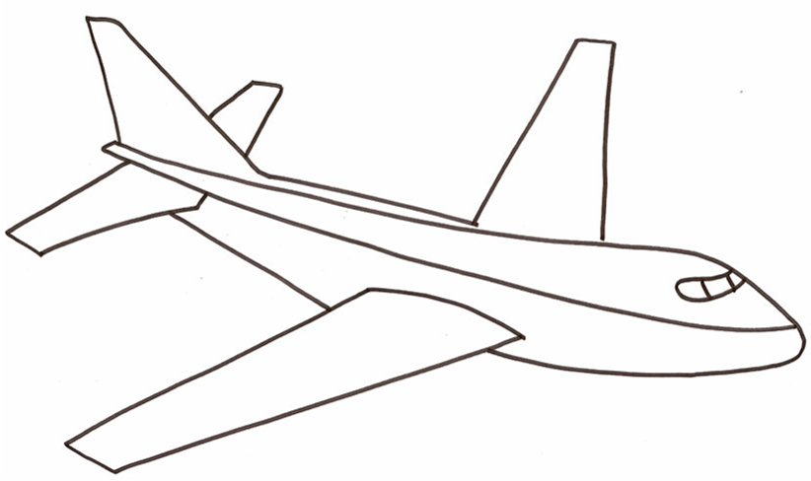
AIRPORT
DME n°1
DME n°2
Figure 1: Low altitude scenario

The useful parameters of DME are defined in the MOPS of the EUROCAE:
- Receiver sensitivity :
  - -80 dBm (search and track mode)
  - -83 dBm (to maintain tracking)
- Interference susceptibility : -99 dBm
- e.i.r.p. and coverage range distance of ground DME transmitter:
Nominal values of the necessary EIRP to achieve a power density of minus 89 dBW/m² at the aircraft are given in Figure 2. They are extracted from ICAO material. They all refer to deployed systems. For coverage under difficult terrain and sitting conditions it may be necessary to make appropriate increases in the EIRP. Conversely, under favourable deployment conditions, the stated power density may be achieved with a lower EIRP.
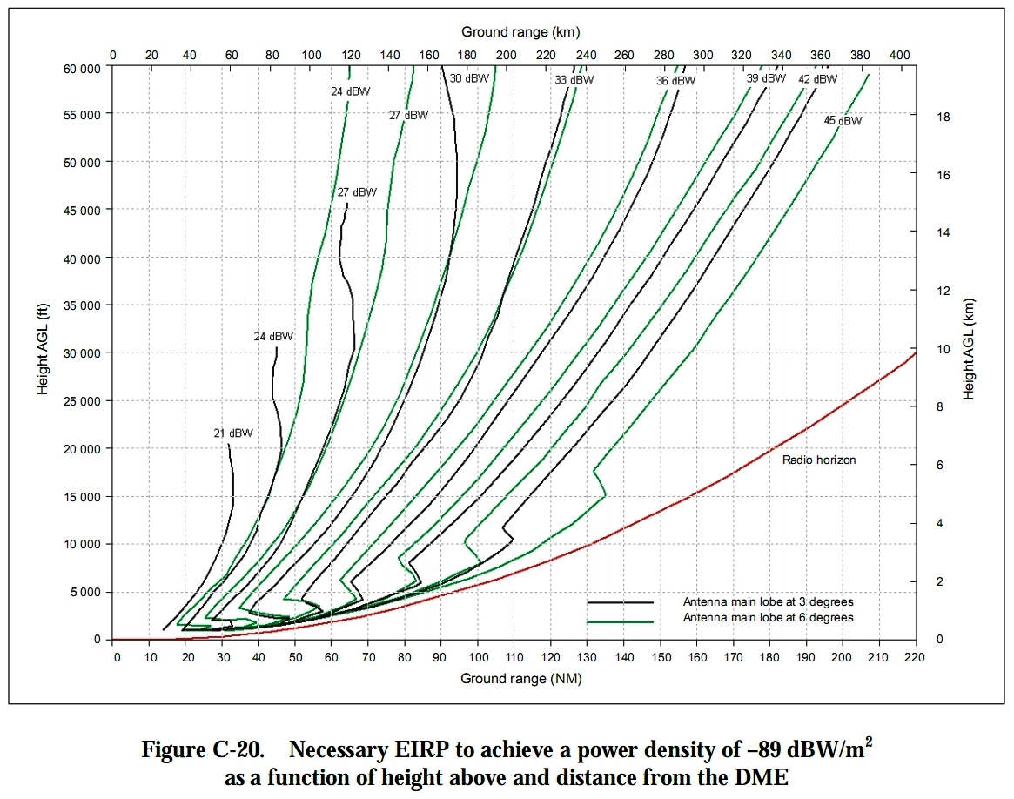
Figure 2: Necessary EIRP to achieve a power density of -89 dBW/m² as a function of height
above and distance from the DME

Note 1 The curves are based on the IF-77 propagation model with a 4/3 Earth radius which has been confirmed by measurements.
Note 2 The radio horizon in Figure 2 is for a DME antenna located 5 m (17 ft) AGL over flat terrain. Terrain shielding will reduce the achievable range.
Note 3 If the antenna is located significantly higher than the assumed reference antenna, the radio horizon and power density will increase.

In order to take a realistic case in terms of compatibility, an EIRP value of 29 dBW has been considered as appropriate. It corresponds to a standard DME EIRP value used for approaches and departures. Moreover, the appropriate propagation model is the IF-77 propagation model, as recommended in ITU-R P528. Finally, in order to comply with navigation procedure, the operational range of these DME is around 13.5 NM or 25 km up to altitudes of 500 m, 25 NM or 46 km up to altitudes of 1000 m and 35 NM or 65 km above 1000 m (e.g. the DME can be used a very low altitude (<500m) while the separation between the transmitter and the receiver is 25 km). The signal level at the aircraft to consider in calculations is thus given in Table 2.

Note that in ECC Report 096 which also studied the interference from UMTS base stations to the DME airborne receivers, the simulations were based on a constant interference criterion that did not reflect the fact that, for the low altitudes of aircraft, the signal from the DME ground station is increasing and therefore the maximum tolerated interference from UMTS should be higher. The interference scenario has been changed in the ECC Report 146 dealing with GSM multi carrier base stations to reflect the operational usage of DME while including a C/I criterion. Therefore these results update the ECC Report 096 studies with these elements.

 | Parameter | Value for a separation distance of 25 km Note 1 | Value for a separation distance of 46 km Note 2 | Value for a separation distance of 65 km Note 3 | Reference
1 | DME EIRP | 29 dBW | 29 dBW | 29 dBW
2 | Free Space Loss | 120 dB | 125.4 dB | 128.3 dB
3 | Attenuation for a wanted signal (ensure the reception of the wanted signal 95% of the time) | 127.6dB | 133 dB | 136 dB | IF-77 propagation model, recommendation, ITU-R P528-2
4 | Maximum wanted DME signal received at the aircraft (antenna gain not included) | -68.6 dBm | -74 dBm | -77 dBm | Combine 1 and 3 (1 minus 3)
5 | Maximum wanted DME signal received at the receiver port | -65.6 dBm | -71 dBm | -74 dBm | Combine 1 and 3 (1 minus 3) using a 3 dB antenna gain– Note 4
Table 2: Maximum wanted signal level received at the aircraft
Note 1: A maximum distance of 25 km, between an aircraft and a DME ground station, is considered for an altitude of aircraft below 500m
Note 2: A maximum distance of 46 km, between an aircraft and a DME ground station, is considered for an altitude of aircraft between 500m and 1000m
Note 3: A maximum distance of 65 km, between an aircraft and a DME ground station, is considered for an altitude of aircraft between 1000m and 3000m
Note 4: The airborne antenna gain is considered higher than 3dBi, which correspond to elevation angles between 0 and -37 degrees. These configurations provide coverage for a stable flight attitude (not manoeuvring).
Note 5: Some DME are deployed with an EIRP of 27 dBW.
Those values do not take into account any safety margin nor any apportionment margin.
- A safety margin of 6 dB is added,
- An apportionment margin is added :
  - 3 dB at 966,5 MHz and below,
  - 6 dB above 966,5 MHz
Therefore, the criterion corresponds to:

Between 0 and 500 m:
The interference criterion “Imax” is derived from Table 2 and the following assumptions:
• “C/I” = 28 dB at 966.5 MHz and below, including margins,
• “C/I” = 31 dB above 966.5 MHz, including margins,
• Cmax = -65.6 dBm

• Imax = -93.6 dBm at 966.5 MHz and below, including margins,
• Imax = -96.6 dBm above 966.5 MHz, including margins,

Above 500 and up to 1000 m:
The interference criterion “Imax” is derived from Table 2 and the following assumptions:
• “C/I” = 28 dB at 966.5 MHz and below, including margins,
• “C/I” = 31 dB above 966.5 MHz, including margins,
• Cmax = -71 dBm

• Imax = -99 dBm at 966.5 MHz and below, including margins,
• Imax = -102 dBm above 966.5 MHz, including margins,

Above 1000 and up to 3000 m:
The interference criterion “Imax” is derived from Table 2 and the following assumptions:
• “C/I” = 28 dB at 966.5 MHz and below, including margins,
• “C/I” = 31 dB above 966.5 MHz, including margins,
• Cmax = -74 dBm

• Imax = -102 dBm at 966.5 MHz and below, including margins,
• Imax = -105 dBm above 966.5 MHz, including margins,

Above 3000 m:
The interference criterion “Imax” is derived from Table 1 and the following assumptions:

• Imax = -108 dBm/MHz at 966.5 MHz and below, including margins,
• Imax = -111 dBm/MHz above 966.5 MHz, including margins,

Table 3: Protection criteria of DME

The figure below provides information regarding the reference port where the protection criteria of DME is defined.
Throughout this Report, RP3 (reference point at the receiver port) has been chosen. That means that both the wanted signal (to DME or airborne L-DACS) as well as the interfering signal (UMTS base station) are calculated up to that point.

Receiver
Receiver port
Antenna gain
Feeder loss
RP2

RP3

RP1

Antenna port
Figure 3: Reference points for the definition of the protection criteria of DME and L-DACS

Transmission mask (Out of band emissions)
This information is not necessary for this study, as interference from DME to UMTS is not considered.

Reception mask (selectivity)
Two reception masks are presented below:
- DME 442 Rockwell Collins. The attenuations are:
6 dB at -0.38 MHz/+0.32 MHz (-0.88 MHz/+0.82 MHz from the central frequency)
20 dB at -0.55 MHz/+0.49 MHz (-1.05 MHz/+0.99 MHz from the central frequency)
40 dB at -0.80 MHz/+0.62 MHz (-1.30 MHz/+1.12 MHz from the central frequency)
60 dB at -0.96 MHz/+0.64 MHz (-1.46 MHz/+1.14 MHz from the central frequency)
- KN 62A Honeywell. The attenuations are:
6 dB at -0.15 MHz/+0.34 MHz (-0.65 MHz/+0.84 MHz from the central frequency)
20 dB at -0.26 MHz/+0.48 MHz (-0.76 MHz/+0.98 MHz from the central frequency)
40 dB at -0.29 MHz/+0.49 MHz (-0.79 MHz/+0.99 MHz from the central frequency)
60 dB at -0.30 MHz/+0.50 MHz (-0.80 MHz/+1.00 MHz from the central frequency)
It has to be noted that the values of the selectivity masks have been set to 70 dBc beyond 250% of the bandwidth (+/-2.5 MHz) with a linear interpolation between 60 and 70 dBc.

Historically, DME was designed with a selectivity mask as low as -75 dBc to -80 dBc. However, ICAO requirement are limited to a selectivity of -60 dBc. Therefore, a value of -70 dBc was chosen.

Antenna patterns
The simulations do not request any ground antenna characteristics for DME. For the airborne antenna gain, the information in Table 4 is extracted from Recommendation ITU-R M.1642 and provides the antenna gain for elevation values between -90° and 90°.

For intermediate elevation angles, between two defined values, a linear interpolation should be used. The G_{r, max} value is 5.4 dBi as specified in Recommendation ITU-R M.1639. It is assumed that the elevation and gain pattern is the same for all azimuth angles. The relevant range of elevation angles for the study to be conducted is: -90°…0°, as shown in Table 5.

Elevation angle  (degrees) | Antenna gain  G_{r}/G_{r, max}  (dB) | Elevation angle  (degrees) | Antenna gain  G_{r}/G_{r, max}  (dB) | Elevation angle  (degrees) | Antenna gain  G_{r}/G_{r, max}  (dB)
–90 | –17.22 | 22 | –10.72 | 57 | –15.28
–80 | –14.04 | 23 | –10.81 | 58 | –15.49
–70 | –10.51 | 24 | –10.90 | 59 | –15.67
–60 | –8.84 | 25 | –10.98 | 60 | –15.82
–50 | –5.40 | 26 | –11.06 | 61 | –16.29
–40 | –3.13 | 27 | –11.14 | 62 | –16.74
–30 | –0.57 | 28 | –11.22 | 63 | –17.19
–20 | –1.08 | 29 | –11.29 | 64 | –17.63
–10 | 0.00 | 30 | –11.36 | 65 | –18.06
–5 | –1.21 | 31 | –11.45 | 66 | –18.48
–3 | –1.71 | 32 | –11.53 | 67 | –18.89
–2 | –1.95 | 33 | –11.60 | 68 | –19.29
–1 | –2.19 | 34 | –11.66 | 69 | –19.69
0 | –2.43 | 35 | –11.71 | 70 | –20.08
1 | –2.85 | 36 | –11.75 | 71 | –20.55
2 | –3.26 | 37 | –11.78 | 72 | –20.99
3 | –3.66 | 38 | –11.79 | 73 | –21.41
4 | –4.18 | 39 | –11.80 | 74 | –21.80
5 | –4.69 | 40 | –11.79 | 75 | –22.15
6 | –5.20 | 41 | –12.01 | 76 | –22.48
7 | –5.71 | 42 | –12.21 | 77 | –22.78
8 | –6.21 | 43 | –12.39 | 78 | –23.06
9 | –6.72 | 44 | –12.55 | 79 | –23.30
10 | –7.22 | 45 | –12.70 | 80 | –23.53
11 | –7.58 | 46 | –12.83 | 81 | –23.44
12 | –7.94 | 47 | –12.95 | 82 | –23.35
13 | –8.29 | 48 | –13.05 | 83 | –23.24
14 | –8.63 | 49 | –13.14 | 84 | –23.13
15 | –8.97 | 50 | –13.21 | 85 | –23.01
16 | –9.29 | 51 | –13.56 | 86 | –22.88
17 | –9.61 | 52 | –13.90 | 87 | –22.73
18 | –9.93 | 53 | –14.22 | 88 | –22.57
19 | –10.23 | 54 | –14.51 | 89 | –22.40
20 | –10.52 | 55 | –14.79 | 90 | –22.21
21 | –10.62 | 56 | –15.05
Table 4: On board antenna gain for DME

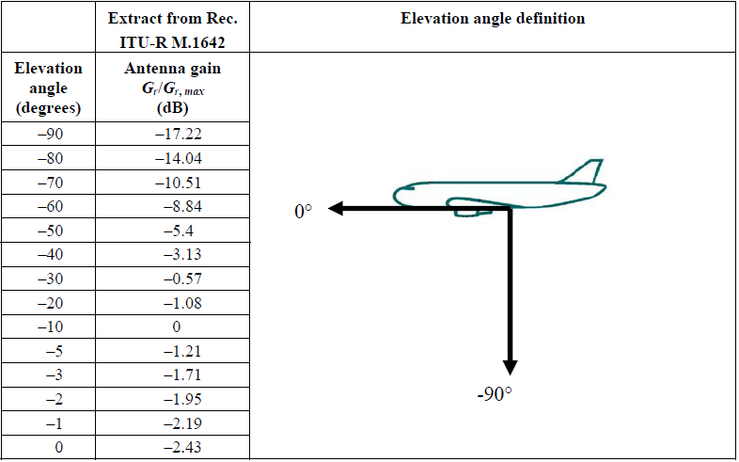
Table 5: Elevation angle definition

L-DACS system characteristics and protection criterion
The assumptions and parameters relating to the definition of L-DACS are based on the latest version of the specifications: made available by Eurocontrol / European organisation for the safety of air navigation:

 | L-DACS1 System Definition Proposal : Deliverable D2 | L-DACS2 System Definition Proposal : Deliverable D2
Edition Number | 1.0 | v1.0
Edition Date | 13/02/2009 | 11th May 2009
Status | Final | Draft
Table 6: L-DACS specification information

It has therefore to be noted that these parameters may be subject to future changes, especially for L-DACS2 whose specifications are still in a draft status. Consequently, the results given in that document may need to be adjusted in case the input parameters were changed.

Planned frequency usage
L-DACS 1 is designed as inlay system, i.e. to be operated between two adjacent DME channels in L-band, each centred on a round figure frequency assignment in MHz (See in ICAO Annex 10 “paired VOR/DME/MLS assignment table” for details). The frequency plan inside the 960-1164 MHz band is still under discussions. In particular, an additional uplink (ground to air) component of the system is envisioned in the 960 – 977 MHz band with the same technical characteristics (see the figure below).

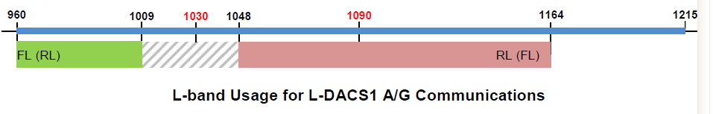

With L-DACS 2, uplink and downlink occur in simplex mode on the same channel, using a time division duplex (TDD) scheme. A 12 channel re-use scheme is assumed for the compatibility assessment. The total bandwidth required for L-DACS 2 is nominally 4.8 MHz (24x200 kHz). Up to three 4.8 MHz sub-bands can be thus fitted in the 960-977 MHz band.

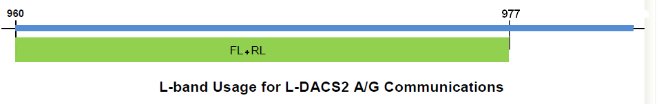
Return link: air to ground.
Forward link: ground to air.

General characteristics
Table 7 and Table 8 below give the characteristics of the two categories, named L-DACS 1 and L-DACS 2, for digital aeronautical communications in the band 960-1164 MHz:

 | Duplexing technique | Modulation type | Origins
L-DACS 1 | FDD | OFDM | B-AMC, TIA 902 (P34)
L-DACS 2 | TDD | CPFSK/GMSK type | LDL, AMACS
Table 7: L-DACS (the L-band data link) options key characteristics

Parameters | L-DACS 1 option | L-DACS 2 option | Comments/ references
Airborne transmit power, dBW | 11 (range = 70 NM)  16 (range = 200 NM) | 17 (range = 200 NM) | (1)
Airborne maximum antenna gain, dBi | 0 | 0 | (2)
Airborne antenna cable loss, dB | 3,5 | 3 | (3)
Airborne equipment necessary transmit bandwidth, KHz | 500 | 200
Airborne receiver noise figure, dB | 9.5 (including an implementation margin of 4 dB) | 13 (Composite noise including Rx noise and cable loss)
Airborne receiver IF bandwidth , KHz | 500 | 200
Return Link (Air -> Gnd) channel centre frequencies in MHz | From 1048.5 to 1071.5 every 1 MHz apart | Up to 3 times 4.8 MHz (24x200 kHz) in the band 960-977 MHz | Section 2.1.2.1
Uplink s/band (Gnd -> Air)channel centre frequencies, , MHz | From 985.5 to 1007.5 MHz, every 1MHz apart | Up to 3 times 4.8 MHz (24*200 KHz) in the band 960-977 MHz | Section 2.1.2.1
bit-rate, kbps | 303/480 | 270
Modulation | OFDM | GMSK | (4)
Transmit mask, out of band and non essential radiations | See section 2.1.2.4 | See section 2.1.2.4 (Complies with Rec ITU-R SM 329-10) | (5)
Ground transmit power, dBW | 11 (range = 70 NM)  16 (range = 200 NM) | 25,4(range = 200 NM)  20,4(range = 40 NM) | (6)
Ground antenna gain, dBi | 8 | 8 | (7)
Ground necessary transmit bandwidth, KHz | 500 | 200
Ground antenna cable loss, dB | 2 | 2.5 | (8)
Ground receiver noise figure, dB | 9.5 (including an implementation margin of 4 dB) | 9.5 (Composite noise including Rx noise and cable loss)
Ground receiver IF bandwidth , KHz | 500 | 200
Polarization | Linear, vertical | Linear, vertical
Table 8: Main L-DACS system parameters
Notes:
(1) L-DACS1 transmit power figure is lower than L-DACS2 on account of OFDM requiring power amplifiers with good linear characteristics. Powers are given for a channel bandwidth.
(2) The minimum antenna gain value is used for link budget margins calculation .The maximum antenna gain is used for interference impact assessment. The antenna pattern is omni-directional in the horizontal plane, and in the vertical plane the radiation pattern is similar to ITU-R M.1639.
(3) L-DACS1 antenna cable loss value of 3 dB. As for L-DACS2 a customary on-board loss figure of 3 dB is selected as higher transmitter output power is readily achievable on account of the type of modulation used (GMSK)
(4) Modulation:
a) L-DACS1 OFDM is characterized as follows:
- Length of FFT: 64
- Number of used sub-carriers: 50
- Sub-carrier spacing: 9.765 kHz
b) L-DACS2 selected modulation scheme is:
- GMSK with : h = 0.5 & BT = 0.3
- Gross bit rate : ~ 270 kbps
- Channel bandwidth: 200 kHz.
(5) L-DACS1 and L-DACS2 non essential emissions: see section 2.1.2.4. The transmit mask characteristics should also be used to conduct compatibility studies as the receiving filter.
(6) Powers are given for a channel bandwidth.
(7) The antenna pattern is omni-directional in the horizontal plane, and in the vertical plane the radiation pattern is similar to Recommendation ITU-R F.1336, sections 2.1 and 2.1.1.
(8) Ground Station receiver performance is better compared to that airborne receiver on account of lower antenna cable loss.

Interference criterion for the protection of L-DACS1 and L-DACS2
Table 9 contains an interference criterion for the protection of L-DACS. Only L-DACS2 information has been incorporated, since it is considered that these quality criteria also will protect L-DACS1.

 | Parameter | On-board  L-DACS2, below 3000m | On-board  L-DACS 2 above 3000m | Ground  L-DACS 2
1 | On board L-DACS interference threshold (at antenna port) | -131.4 dBW/200kHz | - 133.7 dBW/200kHz | - 138.6 dBW/200kHz
2 | Safety margin | 6 dB | 6 dB | 6 dB
3 | Apportionment of UMTS interference to all the interference sources (MIDS, , DME, etc.) | 3 dB below 966.5 MHz | 3 dB below 966.5 MHz | 3 dB below 966.5 MHz
3 |  | 6 dB above 966.5 MHz | 6 dB above 966.5 MHz | 6 dB above 966.5 MHz
4 | Maximum UMTS aggregate TRP, received at the L-DACS receiver input, including the safety margin and the apportionment, (at antenna port) | -140.4 dBW/200kHz below 966.5 MHz  and  -143.4 dBW/200kHz above 966.5 MHz | -142.7 dBW/200kHz below 966.5 MHz  and  -145.7 dBW/200kHz above 966.5 MHz | -147.6 dBW/200kHz below 966.5 MHz  and  -150.6 dBW/200kHz above 966.5 MHz
Table 9: Protection criterion for L-DACS 2

Further technical justification of these criteria can be found in Annex 1.

As for DME, the reference point is at the receiver port, see further Figure 3 in Section 2.1.1.3.

Transmitting mask (Out of band emissions)
L-DACS options out-of-band emissions are as follow:
a) L-DACS 2 out-of-band emissions are expected to comply with ITU-R SM. 329-9: the spurious domain consists of frequencies separated from the centre frequency of the emission by 250% of the necessary bandwidth of the emission. A reference bandwidth is a bandwidth in which spurious domain emission levels are specified. The following reference bandwidths are used:
– 100 kHz between 30 MHz and 1 GHz,
- 1 MHz above 1 GHz.
The maximum permitted spurious domain emission power in the relevant reference bandwidth (see above) is -13 dBm as category A requirement; in Europe the spurious emission requirement category B should be applied, for which the maximum permitted spurious domain emission power is defined as:
-36 dBm/1 kHz for frequency range between 9 kHz and 150 kHz
-36 dBm/10 kHz for frequency range between 150 kHz and 30 MHz
-36 dBm/100 kHz for frequency range between 30 MHz and 1 GHz
-30 dBm/1 MHz for frequency range between 1 GHz and 12.75 GHz

The spectrum emission mask that has been retained is in fact more efficient than this. Its specifications are given in Table 10 and Figure 4.

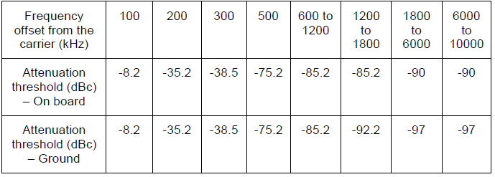
Table 10: Spectrum emission mask for L-DACS 2
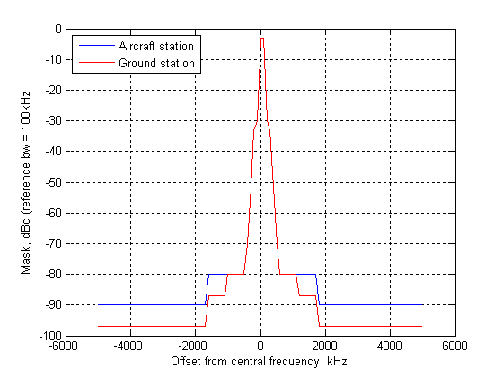
Figure 4: Specified L-DACS 2 transmit mask

b) L-DACS 1 radiated out-of band emissions level is depicted in Figure 5 below.

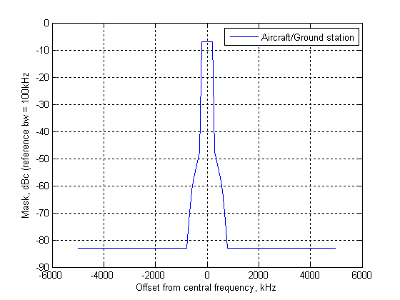
Figure 5: Specified L-DACS 1 transmit mask
The spectrum mask for L-DACS 1 presented in Figure 5 is different from the one for L-DACS 2 presented in Figure 4. The interference analysis results/conclusions on IMT obtained with L-DACS 2 spectrum mask may not be applicable to L-DACS 1.

Reception mask (selectivity)
As above stated (see Note 5 relating to Table 8), the receiving mask should be based on the transmit mask.

Deployment scenario
A possible L-DACS deployment scenario is given below. However, the real deployment will depend on local radio-communication requirements, and on the environment. For sharing studies, a maximum L-DACS cell radius of 200NM (370 km) is considered for altitudes higher than 3000m. For lower altitudes, a typical cell radius of 40NM (75km) is used.
Therefore, the theoretical number of ground stations to ensure a single coverage a country like France would vary between 2 and 33
a) L-DACS 1 option: the cellular re-use pattern with the cell radius R and the re-use distance of “4,6 R” is shown in Figure 6. A size of 200 NM or 40 NM for each cell radius (R=d_{w}) will be used for sharing studies depending on the altitude (above or below 3000m respectively).

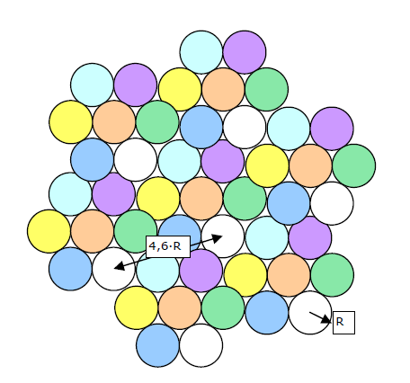
Figure 6: Co-channel interference in a 7 channels re-use pattern

b) L-DACS 2 option: with the frequency plan described in Figure 2, the distance from the interfered aircraft to its ground station is the wanted signal path d_{w} = R. The distance from the interfered aircraft to its interferer on the same channel is the interfered signal path d_{i} = 4R. A size of 200 NM or 40 NM for each cell radius (d_{w}) will be used for sharing studies depending on the altitude (above or below 3000m respectively)..

Figure 7: Co-channel interference in a 12 channels re-use pattern

Antenna Patterns
The ground antenna pattern used for the study is defined by Recommendation ITU-R F.1336-2 (sections 2.1 and 2.1.1) and is recalled below:
The Gr, max value is 8 dBi for both L-DACS options, according to Table 8. It is assumed that the elevation and gain pattern are the same for all azimuth angles.
$$\text{Gr}(θ)=\begin{aligned}\left\{−\text{12}{\left(\frac{θ}{\text{17}}\right)}^{2} \text{for} 0 ≤|θ|<\text{15} | \right.\left\{−9\text{.}7 \text{for} \text{15}≤θ<\text{17} | \right.\end{aligned}$$

Where Gr(θ) is theAM(R)S ground antenna gain relative to Gr, max (maximum gain), and |θ| is the absolute value of the elevation angle relative to the angle of maximum gain (degrees).

For the airborne antenna, the same antenna characteristics as for DME applies, as shown in Table 4 and Table 5, Section 2.1.1.6, but with the maximum gain, G_{r,max}, specified to be 0 dBi.

UMTS system characteristics and protection criterion

Frequency usage
Table 11 below provides a description of UMTS uplink and downlink bands. Note that the highest UMTS channel can be centred on 957.6 MHz in the band 955-960 MHz due to a channel raster of 200 kHz (see Table 5.1 of document 3GPP TS 25.104, applicable to band VIII).

General characteristics
UMTS900 technical specifications have been developed by 3GPP in Release 8 [20-21]. The main characteristics are summarized in Table 11 below:

Parameter | UMTS 900
Downlink band (MHz) | 925 – 960
Uplink band (MHz) | 880 – 915
Carrier separation (MHz) | 5
Channel raster (kHz) | 200
 | BS | UE
Tx Power (Maximum) (dBm) | 43 | 21
Maximum Antenna gain (dBi) | 18 (rural)  15 (urban) | 0
Feeder loss (dB) | 3 | 0
Antenna height (m) | 45 (Rural)  30 (Urban) | 1.5
Antenna down-tilt (°) | 3 | -
Spectrum mask | TS25.104 [2] | TS25.101 [3]
Spurious emissions | TS25.104 [2] | TS25.101 [3]
Occupied Bandwidth (MHz) - 99% | 3.84 | 3.84
Receiver Temperature (KBT) | -108 dBm | -108 dBm
Receiver noise figure | 5 dB | 12 dB
Receiver Thermal Noise Level | -103 dBm | -96 dBm
Receiver reference sensitivity | -121 | -114
Receiver in-band blocking | TS25.104 [2] | TS25.101 [3]
Receiver out-of-band blocking | TS25.104 [2] | TS25.101 [3]
Elevation antenna pattern | Recommendation ITU-R F.1336-2 | Omni-directional
Vertical aperture | 8° (Gmax = 18 dBi)  16° (Gmax = 15 dBi) | Not applicable
Azimuth antenna pattern | tri-sectorized | Omni-directional
Horizontal aperture | 65° | Not applicable
Polarisation | slant | N.A
Table 11: UMTS system characteristics

Regarding the model of power control, the investigations made by one manufacturer led to the followings settings:
- The worst cells in UMTS networks with HSPA deployed use peak power 1 dB lower than max power during busy hour.
- The average power is 3.5 dB below max power during busy hour.
The application of peak (worst case) or average characteristics to different base stations should be applied according to the methodology defined for peak/average antenna characteristics, see Section 4.3.

Interference criterion for the protection of UMTS
An interference criterion based on the noise floor and the appropriate value of I/N is used for the protection of UE. Additionally, an interference criterion is proposed for the protection of BS : although there is a significant frequency separation between the aeronautical transmissions (transmission above 960 MHz) and the BS stations receptions (reception in the band 880-915 MHz) , this criteria can be used in order to verify that the practical unwanted emission of FCS will not interfere with UMTS BS.

The proposed criteria appear in the following table:

 | Airborne component of FCS to BS/UE scenario | Ground component of FCS to BS/UE scenario
Value for I/N | -10 | -6
Table 12: UMTS interference criterion

The following table derives the maximum interference for each scenario.

Parameter | BS | UE | Comments
Receiver noise figure (dB) | 5 | 9 | (1)
Receiver thermal noise level (dBm/3.84 MHz) | -103 | -99 | (2)
Airborne component of DME/L-DACS to BS/UE scenario
Interference protection ratio, I/N (dB) | -10 | -10 | (3)
Interference protection level (dBm/3.84MHz) | -113 | -109 | (4) = (2) + (3)
Interference protection level without any apportionment factor (dBW/MHz) | -149 | -145 | (5) = (4) – 10log(3.84)
Ground component of DME/L-DACS to BS/UE scenario
Interference protection ratio, I/N (dB) | -6 | -6 | (6)
Interference protection level (dBm/3.84MHz) | -109 | -105 | (7) = (2)+ (6)
Interference protection level without any apportionment factor (dBW/MHz) | -145 | -141 | (8) = (7) – 10log(3.84)
Table 13: UMTS interference protection level

It has to be noted that DME is not the only system to operate above 960 MHz. There is at the least the military system MIDS. Therefore, there may be a need to consider an apportionment factor to finalize the definition of the maximum interference levels.

In addition, the mobile systems standards usually define spurious emissions requirements in order to ensure compatibility amongst mobile networks, such as the following ones:

Band | Maximum level | Measurement bandwidth
791 MHz to 821 MHz | -57 dBm | 100 kHz
822 MHz to 862 MHz | -61 dBm | 100 kHz
876 MHz to 915 MHz | -61 dBm | 100 kHz
921 MHz to 960 MHz | -57 dBm | 100 kHz
1 710 MHz to 1 785 MHz | -61 dBm | 100 kHz
1 805 MHz to 1 880 MHz | -47 dBm | 100 kHz
1 920 MHz to 1 980 MHz | -49 dBm | 1 MHz
2 110 MHz to 2 170 MHz | -52 dBm | 1 MHz
1 900 MHz to 1 920 MHz | -39 dBm | 3,84 MHz
2 010 MHz to 2 025 MHz | -39 dBm | 3,84 MHz
2 500 MHz to 2 570 MHz | -49 dBm | 1 MHz
2 570 MHz to 2 620 MHz | -45 dBm | 1 MHz
2 620 MHz to 2 690 MHz | -52 dBm | 1 MHz
3 400 MHz to 3 800 MHz | -45 dBm | 1 MHz
Table 14: Additional spurious emissions requirements applicable to mobile equipments in order to
protect the mobile equipments

It should be noted that these levels are more stringent than those of section 2.1.2.4 (themselves extracted from Recommendation ITU-R SM.329). The compliance of L-DACS to Recommendation ITU-R SM.329 may not be sufficient to protect the mobile equipments. However, this has not been studied in this Report.

Transmission mask (Out of band emissions)
Only the out-of-band emissions from the base station are relevant, as there is a guard band of 45 MHz between the upper part of the mobile station emissions and 960 MHz.

Figure 8: UMTS900 Base station out of band emissions mask

Reception mask (selectivity)
The adjacent channel selectivity (ACS) defined in document 3GPP TS25.101 [3] was used as a basis to derive the UMTS UE reception masks and they are recalled in table 15. ACS parameters are usually applicable to a mobile-mobile scenario. These parameters have been adjusted to the scenarios L-DACS → UMTS UE assuming the use of the 957,6 MHz carrier by UMTS:

Frequency (MHz) | ACS (dB) | Comment
960.2 | 30.5 | derived from the narrow band blocking level
962.6 | 33 | defined in the standard for the first adjacent channel
Table 15: UMTS900 user equipment selectivity

Finally, it should be noted that the base stations were not studied as victims due to the large frequency separation distance (> 45 MHz).

Deployment scenarios
Three deployment scenarios are considered for UMTS, one rural, one urban and one Mixed-urban, with cell radii given in Table 16 below. Parameters for sectorized antennas as well as omni antennas are provided.

 | Rural | Mixed-urban | Urban
Rs (km) | 2.8 | 1.4 | 0.6
Ro (km) | 5 | 2.5 | 1
Intersite distance (km) | 8.5 | 4.2 | 1.8
BS max gain (dB) | 18-3 | 15-3 | 15-3
BS antenna height (m) | 45 | 30 | 30
BS antenna tilt (°) | 3 | 3 | 3
Table 16: UMTS deployment parameters for studied scenarios

Note: Regarding the Mixed-urban and urban environments, only results associated to Mixed-urban are shown in the following tables, this environment being the most representative for the range of altitudes given.

Rs: cell radius in a network geometry based on tri-sectorized antennas
Ro: cell radius in a network geometry based on omnidirectional antennas

The relationship between both is explained in Figure 9.

For a geometry based on omnidirectional antennas: | For a geometry based on tri-sectorized antennas:
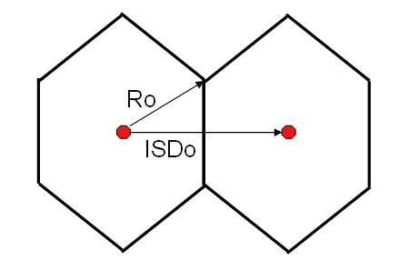 | 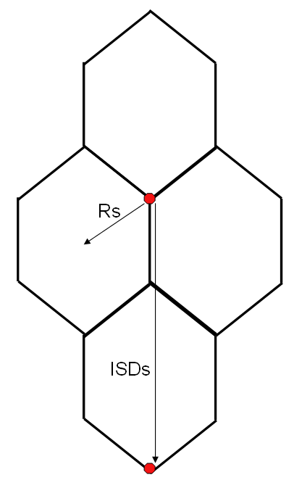
ISDo = 2*Ro*cos(30deg) | ISDs = 3*Rs
Figure 9: UMTS deployment parameters for studied scenarios
To get the same number of sites in a sectorized geometry and in an omnidirectional geometry:
ISDo = ISDs
so 3*Rs = 2*Ro*cos(30deg)

Antenna Pattern
The UMTS ground antenna pattern used for the study is defined by recommendation ITU-R F 1336-2, with the following settings:
- Peak characteristics:
  - If the omni/peak model is used (see section 2.1 of Recommendation ITU-R F.1336-2), then a side-lobe factor (k) of 0.7 is taken;
  - If the sectoral/peak model is used (see section 3.1 of Recommendation ITU-R F.1336-2), then a side-lobe factor (k) of 0.7 is taken
- Average characteristics:
  - If the omni/average model is used (see section 2.2 of Recommendation ITU-R F.1336-2), then a side-lobe factor (k) of 0.7 is taken;
  - If the sectoral/average model is used (see section 3.2 of Recommendation ITU-R F.1336-2), then a side-lobe factor (k) of 0.2 is taken

The application of peak or average characteristics are described in Section 4.3.

In the case where omnidirectional antennas are used, the interference from the UMTS network is reduced by 2.5 dB at low elevation angles, which are mostly applicable to this Report (see Figure 10 and Figure 11). This 2.5 dB factor represents the difference between the magenta curve (omni with a constant gain of 15 dBi) and the average of the values defining the red curve (tri-sectorized antenna) Figure 12.

Figure 10: Sectoral antenna diagram in azimuth for different elevation angles (Gmax = 18 dBi)

Figure 11: Sectoral antenna diagram in azimuth for different elevation angles (Gmax = 15 dBi)

Figure 12: Sectoral/peak antenna diagram in azimuth for an elevation angle of 0°

CASE STUDY : decription of scenarios and simulations assumptions
Due to the arrangement of the band in the mobile service below 960 MHz, the cases studied are the following ones:
- UMTS base stations → DME (airborne receiver)
- L-DACS 2 airborne transmitter → UMTS UE
- L-DACS 2 ground transmitter → UMTS UE
- UMTS BS → L-DACS 2 airborne receiver
- UMTS BS → L-DACS 2 ground receiver

The DME interference to UMTS UE has not been studied in this Report.

Propagation models

L-DACS on board transmitter to UMTS mobile receiver
Free space loss (Recommendation ITU-R P.525): all the base stations are visible from the aircraft, without any obstacle.

L-DACS ground transmitter to UMTS mobile receiver
For ground/ground scenario, and when the mobile user equipment is considered, a Hata model is used.

In the rural case, the model is as follows:

$\begin{aligned}L\left(R\right)=\text{69}\text{.}\text{55}+\text{26}\text{.}\text{16}\text{log}\left(f\right)−\text{13}\text{.}\text{82}\text{log}\left(H_{b}\right)+\left[\text{44}\text{.}9−6\text{.}\text{55}\text{log}\left(H_{b}\right)\right]\text{log}\left(R\right) \\ −4\text{.}\text{78}{\left[\text{log}\left(f\right)\right]}^{2}+\text{18}\text{.}\text{33}\text{log}\left(f\right)−\text{40}\text{.}\text{94}−\left[1\text{.}1\text{log}\left(f\right)−0\text{.}7\right]×H_{m} \\ −\left[1\text{.}\text{56}\text{log}\left(f\right)−0\text{.}8\right]\end{aligned}$ (1)
where :
H_{b} is the L-DACS antenna height above ground in m,
f is the frequency in MHz,
R is the distance in km,
H_{m} is the UE antenna height in m.

with H_{m} = 1.5m, the table below gives the results of equation (1) for different values of H_{b} :

H_{b} (m) | equation (1) becomes
30 | $$L\left(R\right)=\text{10}\text{.}\text{05}+\text{41}\text{.}\text{28}\text{log}\left(f\right)−4\text{.}\text{78}{\left[\text{log}\left(f\right)\right]}^{2}+\text{35}\text{.}\text{22}\text{log}\left(R\right)$$
45 | $$L\left(R\right)=7\text{.}\text{61}+\text{41}\text{.}\text{28}\text{log}\left(f\right)−4\text{.}\text{78}{\left[\text{log}\left(f\right)\right]}^{2}+\text{34}\text{.}\text{07}\text{log}\left(R\right)$$
60 | $$L\left(R\right)=5\text{.}\text{89}+\text{41}\text{.}\text{28}\text{log}\left(f\right)−4\text{.}\text{78}{\left[\text{log}\left(f\right)\right]}^{2}+\text{33}\text{.}\text{25}\text{log}\left(R\right)$$

In the urban case, the propagation model is as follow:

$L\left(R\right)=\text{40}×\left(1−0\text{.}\text{004}H_{b}\right)×\text{log}\left(R\right)−\text{18}\text{log}\left(H_{b}\right)+\text{21}\text{log}\left(f\right)+\text{80}$ (2)

where
H_{b} is the L-DACS antenna height above average building top in m,
f is the frequency in MHz,
R is the distance in km,
H_{m} is the UE antenna height in m.

with H_{m} = 1.5m, the table below gives the results of equation (2) for different values of H_{b} :

H_{b} (m) | Equation (2) becomes
5 | $$L\left(R\right)=\text{67}\text{.}\text{42}+\text{21}\text{log}\left(f\right)+\text{39}\text{.}2\text{log}\left(R\right)$$
15 | $$L\left(R\right)=\text{58}\text{.}\text{83}+\text{21}\text{log}\left(f\right)+\text{37}\text{.}6\text{log}\left(R\right)$$
30 | $$L\left(R\right)=\text{52}\text{.}\text{21}+\text{21}\text{log}\left(f\right)+\text{35}\text{.}2\text{log}\left(R\right)$$
The Recommendation ITU-R P.528 is considered for the DME planning link budgets (availability of 95% of the time).

UMTS base station to DME or L-DACS airborne station
Free space loss (Recommendation ITU-R P.525): all the base stations are visible from the aircraft, without any obstacle. This propagation model is used for the rural scenario, and for the semi-urban scenario when the angle between the horizon and the aircraft as seen from the antenna of a base station is more than 1.5 degrees. If the angle is smaller than that, multi-screen diffraction is applied. The Walfisch-Ikegami propagation model of Cost 231, Section 4.41, contains a description of such a multi-screen diffraction model where the diffraction loss (with parameters h_roof = 15, b = 30, h_base = 50) provides an additional 6.4 and 3.2 dB in relation to free space loss for 1 and 1.5 degrees respectively. This type of diffraction loss may not be applicable to all antennas in an urban environment. In the simulations a diffraction loss is selected for each base station/antenna in a (semi-)urban environment from a uniform random distribution between 0 and 6 dB when the angle between the horizon and the aircraft is no more than 1.5 degrees.

UMTS base stations to L-DACS ground receivers
The free space loss model is used for calculation of the UMTS interference (Recommendation ITU-R P.525): all closest UMTS base stations are visible from the L-DACS ground receiver, without any obstacle.

Simulation scenarios

UMTS base stations impact on DME/L-DACS airborne receiver
The ECC Report 096 has already studied the interference from UMTS base stations to the DME airborne receivers. The basic methodology remains the same in this Report; the interference from the base stations visible by the aircraft is summed up and compared with the allowed interference level. This analysis is carried out for different altitudes of the aircraft, and for different deployment scenarios (rural and Mixed-urban) of the interfering mobile system. It should be noted that more favourable scenarios (where the interference from UMTS base station to DME/L-DACS airborne receiver would be decreased) have not been studied, such as costal areas (no base station in the sea…). The interference criteria for DME employed in this Report are presented in Table 3, and depends on the altitude of the aircraft.

The interference on the DME/L-DACS receiver comes from all the UMTS base stations which have visibility of the aircraft at its altitude, see Figure 14. Considering a frequency re-use scheme of 1, at each site, 3 carriers are transmitted (involving several operators). The base stations generate 3 sub-interferences at the following frequencies:
- f1=957.5 MHz (1st adjacent channel interference to be considered)
- f2=952.5 MHz (2nd adjacent channel interference to be considered)
- f3=947.5 MHz (3rd adjacent channel interference to be considered)
In practise, there may be additional UMTS carriers with frequencies below f3, but these are not taken into account in the simulations.
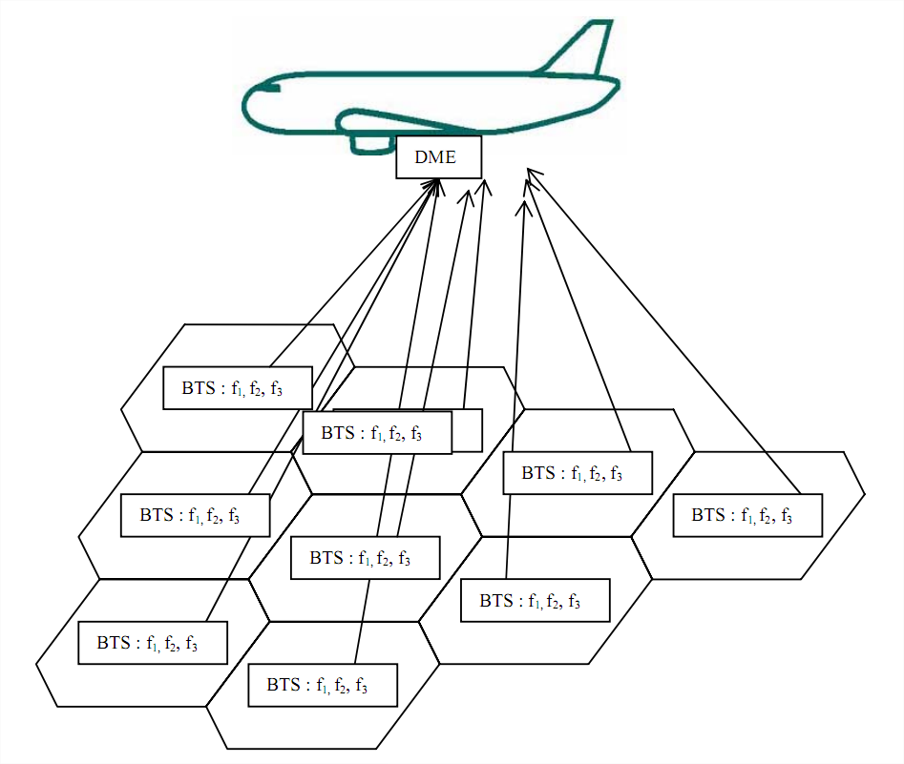
Figure 13: Scenario of the study
According to section 3.2, two environments have been considered: Mixed-urban and rural.
The number of visible base stations as a function of aircraft altitude in km is given in Figure 14. It has to be noted that a uniform UMTS distribution is used. Close to urban areas, the density of UMTS is expected to be higher (the cell radius is lower). This is shown by the red curve in the Figure 14 below.
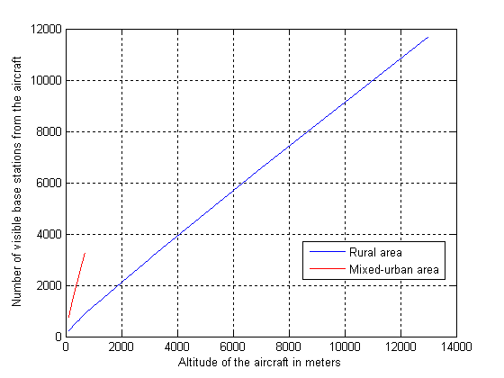
Figure 14: Number of UMTS visible base stations

The simulations are based on scenarios in which the DME/L-DACS airborne receivers are considered at the following altitudes:
- 200 m (mixed urban and rural scenarios).
- 700 m (mixed urban)
- 1500 m (rural scenario)
- 12 000 m (rural scenario)

Regarding the urban environment, only results associated to an aircraft altitude lower than 1000 m are shown in the section 5, as this environment is not representative for higher altitudes.

L-DACS airborne transmitter impact on UMTS terminals
Figure 13 above can also be used to describe the reversed scenario, with an airborne L-DACS transmitter interfering UMTS terminals, only with the direction of the interference in the other direction. Each UMTS terminal will only be interfered by one airborne L-DACS transmitter at a time.

UMTS base stations impact on L-DACS ground receivers
The rural case should represent the typical case whereas the urban case remains possible. Regarding the simulations, this has mainly an impact on the way to model the UMTS interfering network whose parameters somewhat differs from the rural scenario to the urban scenario.

The interference to L-DACS comes mainly from the closest UMTS base stations which have visibility of the L-DACS ground receiver, see Figure 15. Considering a frequency re-use scheme of 1, at each site, 3 carriers are transmitted (involving several operators).

Therefore, the base stations generate 3 sub-interferences at the following frequencies:
- f1=957.5 MHz (1st adjacent channel interference to be considered)
- f2=952.5 MHz (2nd adjacent channel interference to be considered)
- f3=947.5 MHz (3rd adjacent channel interference to be considered)

In practise, there may be additional UMTS carriers with frequencies below f3, but these are not taken into account in the simulations.

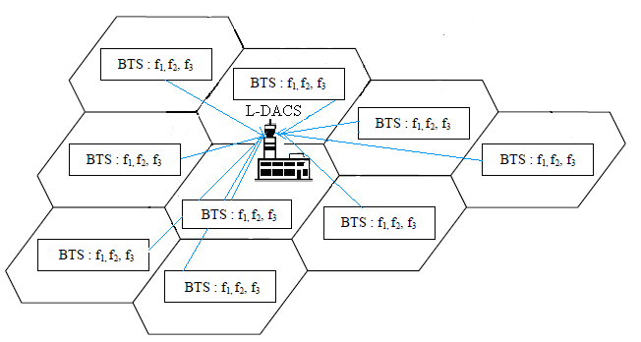
Figure 15: Scenario of the study

L-DACS ground transmitter impact on UMTS terminals
An L-DACS ground transmitter will interfere UMTS terminals receiving on frequencies below 960 MHz. Each UMTS terminal will only receive interference from one L-DACS ground transmitter at a time, as these will be separated by fairly large distances.

Average versus peak characteristics of base station antennas and power control
Base station antennas are defined by Recommendation ITU-R F.1336, as described above. One aspect of that Recommendation is the selection of “peak” or “average” performance of the antenna, by setting the value of a parameter k appropriately. Peak characteristic corresponds to a worst case scenario with a single, or a few, interferers, whereas average characteristics correspond to a statistical case with a larger number of interferers where no single interferer is dominating. In other words, peak characteristics should be used only for a set of base stations that strongly influence the total interference. As a consequence, at higher aircraft altitudes, above 1000 m, average characteristics should be applied to all BS antennas. For lower altitudes only the antennas of the base stations (sectors) causing the worst interference should use peak characteristics. Based on simulation tests, this number of worst interferers has been set to 10 in the simulations.

Similarly, according to the model of power control given in section 3.2.2, peak characteristics for the BS power, 1 dB below maximum power, should only be used in the case where the airborne antenna is below 1000m in altitude, and then only for the 10 worst interferers in each simulation step. For the other base stations the power should be set to 3.5 dB lower than maximum power.

For the scenario with UMTS base stations interfering with an L-DACS ground receiver, the ten worst interferers have peak characteristics in the simulations, whereas the remaining base stations have average characteristics. Nevertheless, it should be noted that in a worst case situation, the closest interferer can transmit the maximum power (1 dB more) during a short period of time

Polarization effects
A UMTS network is slant polarised (+45°/-45°) whereas L-DACS and DME has a vertical polarisation. Therefore, a polarisation discrimination of 3 dB is introduced in the simulations.

INTERFERENCE ANALYSIS RESULTS

L-DACS 2 impact (ground and airborne) on UMTS mobile receiver

L-DACS 2 ground transmitter impact on UMTS mobile receiver
A UMTS mobile receiver will have a maximum of one L-DACS 2 ground transmitter in its coverage cell. The following tables give a distance between this UMTS user equipment and L-DACS 2 ground transmitter to ensure that no interference will occur on UE in function of different value of the L-DACS 2 antenna height.
L-DACS 2 ground station transmitter spectrum mask is given in the Table 10. With the assumption that there is no guard band between UMTS900 and L-DACS 2 ground station transmission band, it can be assumed that the carrier separation between the nearest L-DACS 2 ground station transmission carrier and UMTS carrier is 2.8 MHz. (with L-DACS 2 Ground station TxP=55.4 dBm)

ACLR=81,1 dB with a guard of 2,5 MHz as a guard band
ACLR=70,3 dB without any guard band

UMTS UE ACS=30.5 dB derived from narrow band blocking at 2.8 MHz frequency offset (reference ECC report 082, Table 6).

ACIR =30.5 dB

 |  | L-DACS 2 |  |  | Comments
1 | L-DACS 2 EIRP, dBm | 60.9
2 | ACIR | 30.5 |  |  | Consider UMTS and L-DACS 2 masks
3 | Signal level before propagation attenuation with a perfect L-DACS 2 filter, dBm | 30.4
4 | Frequency (MHz) | 960.1
5 | Maximum interference signal level at UMTS UE antenna port, dBm | -105 |  |  | I/N criteria
6 | Necessary signal attenuation, dB | 135.5 |  |  | (2) - (5)
7 | L-DACS 2 Antenna height, m | 30 | 45 | 60
8 | Corresponding separation distance, km | 11.3 | 14.5 | 17.5 | Rural Hata propagation model
9 | Corresponding separation distance, in km by taking 8dB of building loss (indoor case) | 6.7 | 8.5 | 10 | Rural Hata propagation model
10 | Corresponding separation distance,, km | 3.3 | 4.1 | 4.7 | Urban Hata propagation model
11 | Corresponding separation distance, in km by taking 8dB of building loss (indoor case) | 2 | 2.4 | 2.7 | Urban Hata propagation model
Table 17: Ground L-DACS 2 transmitter impact on UMTS UE Rx

The results of this section show that the maximum radius, at which a 1dB desensitization (I/N = -6dB) of UE receivers can occur, is up to 17.5 km in rural area and up to 2.7 km in urban area. The limiting factor is UMTS UE receiver selectivity. A guard band of 2.5 MHz may improve a little bit the situation, but it is not sufficient, since UMTS UE has relative flat receiver selectivity. As indicated in ECC report 082, the UMTs UE ACS is 30.5 dB at 2.8 MHz carrier frequency offset, and 33 dB at 5 MHz frequency offset. If a guard band of 2,5 MHz is considered (i.e L-DACS 2 ground transmitter frequency is 962.6 MHz), there is still a potential interference zone around L-DACS2 ground station equivalent to a disk with radius up to 14.7 km in rural area. In the urban area, this radius could be up to 4 km.

L-DACS 2 airborne transmitter impact on UMTS mobile receiver
For the studies of the impact of L-DACS 2 on-board transmitter on UMTS UE receiver, the following hypotheses are used:
- Since L-DACS 2 has a TDMA access scheme, no more than one aircraft will transmit in a cell at a time.
- The maximum duty cycle for of an on-board transmitter is 6.8%.

L-DACS 2 airborne station transmitter spectrum mask is given in the Table 10. With the assumption that there is no guard band between UMTS900 and L-DACS 2 airborne station transmission band, it can be assumed that the carrier separation between the nearest L-DACS 2 airborne station transmission carrier and UMTS carrier is 2.8 MHz. (with L-DACS 2 airborne station TxP=47 dBm)
ACLR=74.1 dB with 2,5 MHz as a guard band
ACLR=68.4 dB without any guard band
UMTS UE ACS=30.5 dB derived from narrow band blocking at 2.8 MHz frequency offset (reference ECC report 082, Table 6).

ACIR =30.5 dB

 |  | L-DACS 2 | Comments
1 | L-DACS 2 EIRP, dBm | 32.3 | Txp=47 dBm, 3 dB cable loss, and 6.8% duty cycle:  47-3-10*log10(6.8)=32.3 dBm
2 | ACIR | 30.5 | Consider UMTS and L-DACS 2 masks
3 | Signal level before propagation attenuation with a perfect L-DACS 2 filter, dBm | 1.8 | 32.3-30.5 = 1.8 dBm
4 | Frequency (MHz | 960.1
5 | Maximum interference signal level at UMTS UE antenna port, dBm | -109 | I/N criteria
6 | Necessary signal attenuation, dB | 110.8 | (3) - (5)
7 | Corresponding distance, m | 8613 | Free space propagation model
8 | Corresponding distance in m by taking 8dB of building loss (indoor case) in m | 3429 | Free space propagation model
Table 18: On-board L-DACS 2 (first adjacent channel above 960 MHz to 967 MHz)
transmitter impact on UMTS UE

The results of this section show that the maximum radius, at which a 0,5 dB desensitization (I/N = -10 dB) of UE receivers can occur, is 8613 m, whereas the distance corresponding distance for a 1 dB desensitization (I/N = -6 dB) of UE is 5434 m..

The limiting factor is UMTS UE receiver selectivity. A guard band of 2.5 MHz may improve the situation, but it is not sufficient, since UMTS UE has relative flat receiver selectivity. As indicated in ECC report 082, the UMTs UE ACS is 30.5 dB at 2.8 MHz carrier frequency offset, and 33 dB at 5 MHz frequency offset. With 2.5 MHz guard band (i.e L-DACS 2 Airborne transmitter frequency is 962,6 MHz), the required separation distance from Aircraft to ground is 6459 m.

It should be pointed out that in the calculation of interference from L-DACS2 airborne transmitter to UMTS terminal, an EIRP=32.3 dBm/200 kHz is used. Table 26 in Annex 1 proposed an airborne transmitter Tx power=47 dBm, with 3 dB cable loss, the EIRP=44 dBm. The 11.7 dB difference comes from the assumption of 6.8% on-board transmitter duty-cycle.

L-DACS 2 impact (ground and airborne) on UMTS mobile receiver: conclusion

The studies have shown that a protection distance of several kilometres is necessary to fulfil the protection criterion of UMTS, considering only the emissions from L-DACS 2, ground and airborne stations.

The consideration of the blocking of UMTS UE leads to lower protection distances.

No study involving multiple aircraft creating aggregate interference to UMTS UE receiver was carried out.

This study has not taken into account a possible improvement of UMTS UE receiver performance and L-DACS transmitter characteristics. Improving the filtering on both categories of equipments may alleviate potential interference from L-DACS 2 to UMTS UE, noting that L-DACS systems are planned to be deployed by 2025.

UMTS base stations impact on DME airborne receiver
Section 4.2.1 below contains the results from the simulations, and 4.2.3 elaborates on further aspects that influence interference to the airborne DME receiver.

Simulation results
This section contains two different sets of results. The first one (section 4.2.1.1) relates to the impact of a single UMTS channel on an airborne DME receiver (centered at 957.5 MHz). The second one (section 4.2.1.2) refers to the impact of three UMTS channels (centered at 947.5, 952.5 and 957.5 MHz)

Impact of a single UMTS channel on an airborne DME receiver

Study n°1

- Rural only
In this scenario it is supposed that the plane is only seeing at each height of its trajectory a rural area. According to parameters in section 3, a UMTS network configuration has been defined and depending on the height of the plane this will be larger or smaller.
Here below are represented the total interference generated by this UMTS network at each height of the aircraft up to the landing (0m of height) into a DME airborne receiver centred in the frequencies 961.5MHz and 966.5MHz.

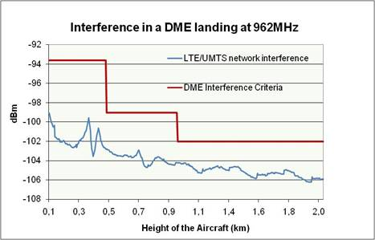 | 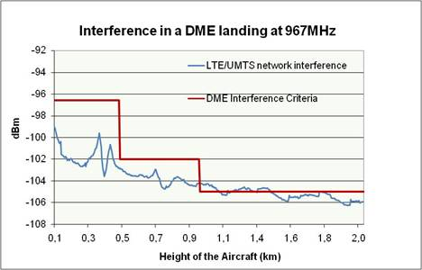
Figure 16: Results of the total interference of a UMTS network in a DME airborne receiver with power control
As it can be observed in Figure 16, there is no interference in the DME receiver in the closest channel to the LTE network (962MHz). With a frequency offset of 7MHz there is only 1dB of interference above 1000m, due to the fact that the DME protection criteria changes above 1000m.

- Urban only
A pure urban scenario is not realistic since airports are generally located away from urban and suburban areas, and will not fly over a city or an urban area at very low altitudes.

- Mixed-urban
As it is indicated above, it is not realistic to consider an urban only scenario. Hence, it has been decided to study an urban/rural mixed scenario where the general radio cell of a mobile base station is larger than in an urban only scenario. In this scenario Ro=2.5km; however, it should be noted that according to the number of base stations seen by the plane at each altitude, this area would correspond to a dense urban and suburban area mixed with a small rural area. This scenario is only considered for altitudes lower than 1000 meters, as the number of base stations interfering the aircraft would otherwise be unrealistically large.

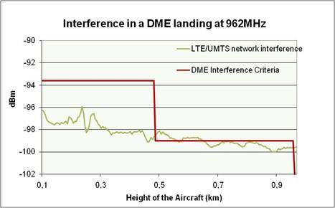 | 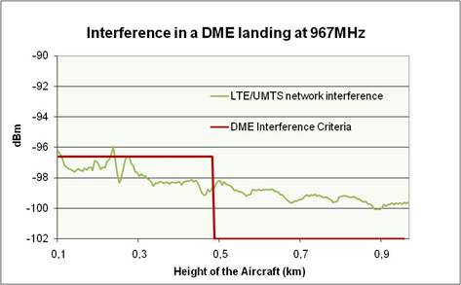
Figure 17: Results of the total interference of a UMTS network in a DME airborne receiver with power control
Results show also in this scenario that there is no interference in any DME first adjacent channel. Above 966MHz, there is 1 dB interference at about 200m and from 2-3dB above 500m.

Study n°2
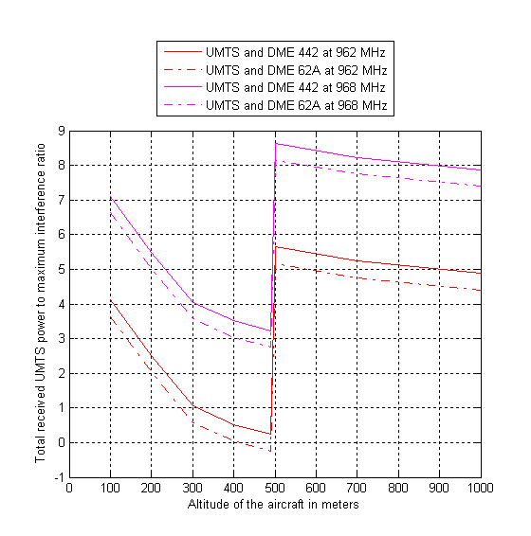 | 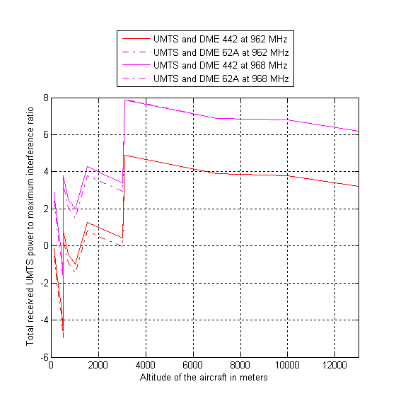
Figure 18: Total received UMTS interference in the urban case, without power control (Mixed-urban) | Figure 19: Total received UMTS interference in the rural case, without power control (rural)

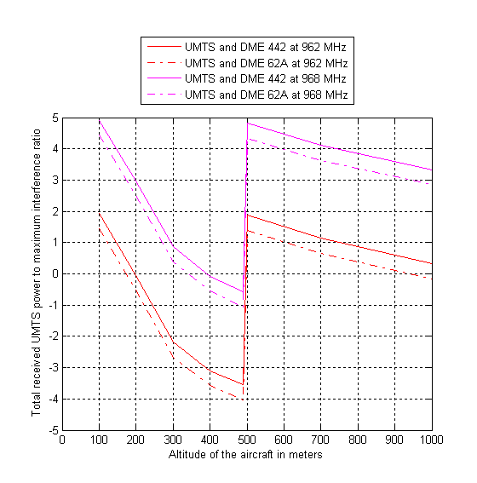 | 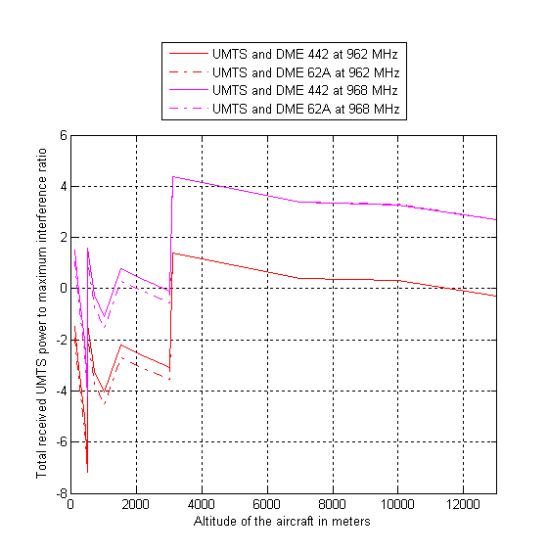
Figure 20: Total received UMTS interference in the urban case, with power control (Mixed-urban) | Figure 21: Total received UMTS interference in the rural case, with power control

It has to be noted that the use of power control is part of the features of a CDMA network. Therefore, the following table is more relevant for the purpose of this study.

Synthesis of the two studies
The two studies provide the same results except for the 200 m altitude for which there is a 3 dB difference:

 | Rural |  |  |  | Mixed-urban
 | 962MHz |  | 967MHz |  | 962MHz |  | 967MHz
RESULTS OF THE TWO STUDIES
Simulation/Altitude | 200m | 1500m | 200m | 1500m | 200m | 700m | 200m | 700m
Study n°1 (dBm) | -100 | -105 | -100 | -105 | -96 | -98 | -96 | -98
Study n°2 (dBm) | -97 | -105 | -97 | -105 | -93 | -97 | -93 | -97
Delta between studies 1 and 2 (dB) | 3 | 0 | 3 | 0 | 3 | 1 | 3 | 1
COMPARISON BETWEEN THE TWO STUDIES AND THE PROTECTION CRITERION
Criterion | -94 | -102 | -97 | -105 | -94 | -99 | -97 | -102
Delta between study 1 and the criterion | -6 | -3 | -3 | 0 | -2 | +1 | +1 | +4
Delta between study 2 and the criterion | -3 | -2 | 0 | +1 | 0 | +1 | +3 | +4
Table 19: Comparison between the two studies for one single UMTS channel

The 3 dB difference at 200 m can be explained by different network configurations.

It has to be noted that the “approach” and “landing” phases are critical for the aviation community and that the results for 12000 m have not been integrated in synthesis of the results, neither in the conclusion of this Report.

Impact of three UMTS channels on an airborne DME receiver

Study n°1
- Rural only

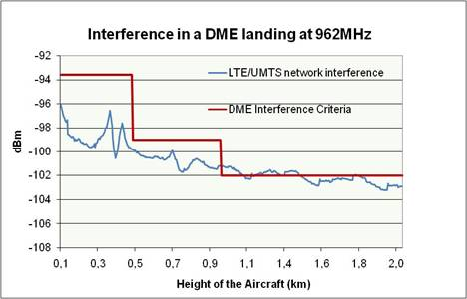 | 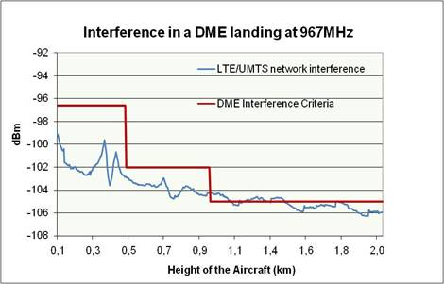
Figure 22: Results of the total interference of a UMTS/LTE network in a DME airborne receiver with power control (rural)

- Mixed-urban scenario
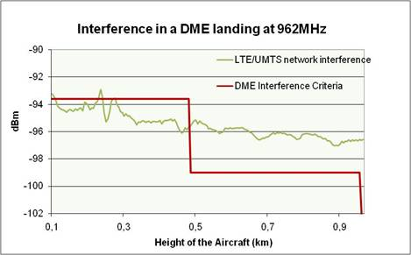 | 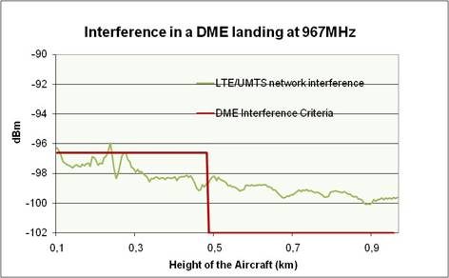
Figure 23: Results of the total interference of a UMTS/LTE network in a DME airborne receiver with power control (Mixed-urban)

Study n°2
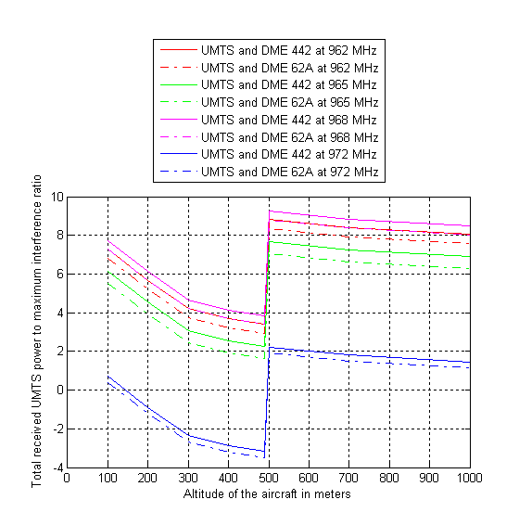 | 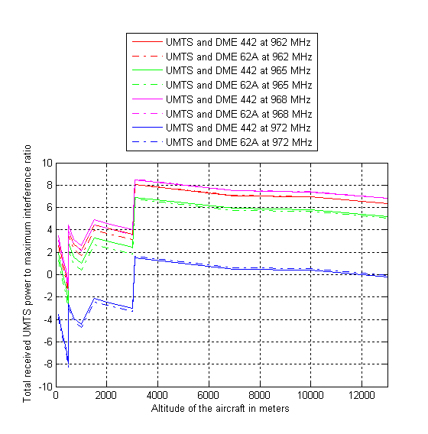
Figure 24: Total received UMTS interference in the Mixed-urban case, without power control (Mixed-urban) | Figure 25: Total received UMTS interference in the rural case, without power control (rural)
It has to be noted that the use of power control is part of the features of a CDMA network. Therefore, the following figures are more relevant for the purpose of this study.
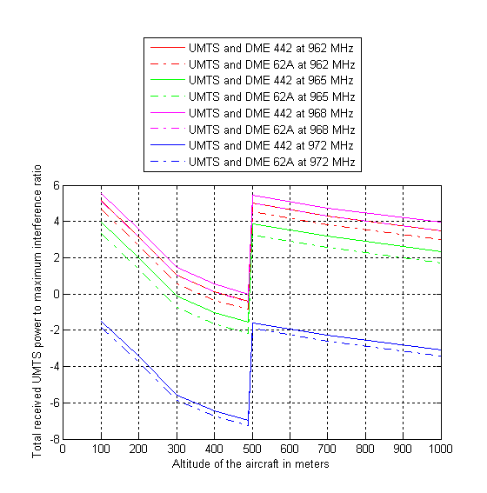 | 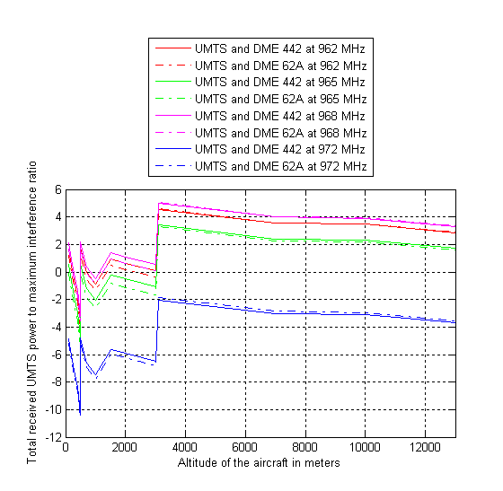
Figure 26: Total received UMTS interference in the urban case, with power control (Mixed-urban) | Figure 27: Total received UMTS interference in the rural case, with power control

Synthesis of the two studies and analysis of the results
The two studies provide the same results except for the 200 m altitude for which there is a 3 dB difference:

 | Rural |  |  |  | Mixed-urban
 | 962MHz |  | 967MHz |  | 962MHz |  | 967MHz
RESULTS OF THE TWO STUDIES
Simulation/Altitude | 200m | 1500m | 200m | 1500m | 200m | 700m | 200m | 700m
Study n°1 (dBm) | -97 | -102 | -100 | -105 | -93.5 | -96 | -96.5 | -99
Study n°2 (dBm) | -94 | -101 | -96 | -104 | -91 | -95 | -94 | -98
Delta between studies 1 and 2 (dB) | 3 | 1 | 4 | 1 | 2.5 | 1 | 2.5 | 1
COMPARISON BETWEEN THE TWO STUDIES AND THE PROTECTION CRITERION
Criterion | -94 | -102 | -97 | -105 | -94 | -99 | -97 | -102
Delta between study 1 and the criterion | -3 | 0 | -3 | 0 | +0.5 | +3 | +0.5 | +3
Delta between study 2 and the criterion | 0 | +1 | +1 | +1 | +3 | +4 | +3 | +4
Table 20: Comparison between the two studies for three UMTS channels

Some differences between studies 1 and 2, up to 4 dB, can be explained by different network configurations.

It has to be noted that the “approach” and “landing” phases are critical for the aviation community and that the results for 12000 m have not been integrated in synthesis of the results, neither in the conclusion of this Report.

The results are very much dependant on the scenarios: the major parameters that have an impact on the results are:
  - the network geometry (cell radius) and also the aggregation of all base stations seen by the plane (especially in urban scenario and at very high altitudes),
  - the base station EIRP associated to the antenna pattern and tilt
  - the unwanted emissions mask
  - The frequency separation between the uppermost UMTS channel and the DME channel under consideration.
The network geometry and the base stations settings are significant different from the urban scenario to the rural scenario and therefore lead to different results. The location of the aircraft relatively to the closest base station at low altitudes is an important parameter. In the simulations, the closest distance between an aircraft and a BTS in the horizontal plane is 600m in the rural scenario and 300m in the urban scenario. The consideration of one of these scenarios (rural or urban), taken separately, is not representing the reality. Neither rural nor urban scenarios should be considered by themselves, as the reality is between both. Above a certain height (around 1000 m), the urban scenario is not relevant. The urban scenario is pessimistic in the sense that the urban area is not geographically limited, and that the number of base stations per area may be exaggerated.

With the hypotheses of the studies (especially the averaging effect and power control), and with three interfering UMTS networks below 960 MHz, no interference from UMTS base stations to DME airborne receiver is expected above 972 MHz. Below 972 MHz some interference, 3 to 4 dB, may occur at low altitudes for the mixed-urban case.

Sensitivity analysis (applicable to UMTS base stations impact on DME airborne receiver)
This section gives an analysis on different assumptions, parameters and factors that have been considered in this Report. In the presence of remaining interference, these could be used to improve the results.

Apportionment factor
The apportionment is proposed to model that several sources of interferences may occur simultaneously on the DME devices. However, the pre-requisite is that the interferences are contributing in the same order. Otherwise, if one source of interference is predominant and the others are negligible, then the apportionment factor has no longer to be taken into account.
An apportionment factor (of 3 dB ≤ 966.5 MHz and 6 dB > 966.5 MHz) has been included in the calculations. If the UMTS represent the major source of interference, then these values may be too conservative especially for the low altitudes of the aircraft. This would result in interference requirements 3 – 6 dB more relaxed than assumed here.

DME receiver bandwidth
Reception bandwidths of 1 MHz have been assumed in the study. However, the DME MOPS specify that 90% of the transmitted power is contained in a 500 KHz bandwidth.
The requirement for the receiving characteristics (the interrogator pulse rise time shall not exceed 1,2 µs and shall not be less than 0,8 µs) implies a receiving bandwidth of around 1 MHz. However, if the receiving bandwidth of the DME is lower than 1 MHz (e.g. 0,X MHz), then the interference will be decreased by 10.log₁₀(1/0,X) dB.

DME Receiver Selectivity

To derive the above results, a selectivity of -70 dBc for the DME receiver has been used in this Report.
There are no measurements available of DME receivers that specify this any further, but it has been suggested that the DME receivers could be improved beyond this selectivity to approximately -80 dBc. Of course this improvement would be progressive and therefore would occur over a number of MHz offset from the DME carrier.

However, in the document MOPS it is stated that:
“The sensitivity requirement shall be met within + 3dB tolerance when a continuous wave signal having a level of -40 dBm is applied over at the input frequency range of 90 kHz to 10000 MHz excluded the frequencies within ±10 MHz of the selected frequency.”

It is observed that a significant difference between the assumption of a selectivity of -70 dBc and the reference selectivity defined in the standard.

UMTS base station antenna diagram used for the studies
It should be noted that the antenna pattern model used for the studies (Recommendation UIT-R M.1336) may not be fully representative of the widely deployed base station antennas. Measurements performed on state-to-the-art equipments may show that the compatibility scenarios assessed can be improved through the consideration and measured pattern (and not on a model).
Moreover, in the case where omnidirectional antennas are used, the interference from the UMTS network is reduced by 2.5 dB at low elevation angles. This has been considered applicable as a first approximation for all elevation and azimuth angles but in more detailed simulations, the interference level will be increased by about 2dB if the aircraft is in the main beam of a BS antenna and 1.5 dB if the elevation angle between the BS and the aircraft is higher than 10 to 15 degrees (see Figure 10 and Figure 11). However, this is only applicable when considering the interference from a single base station.

Size of the urban deployment
In the simulations above, it is assumed that the urban area covers the entire area visible from the aircraft, a total of more than 3000 sectors (at a 1000 m altitude) with a maximum ground distance of more than 80 km. This provides a pessimistic assessment of the interference, since urban areas are considerably smaller than that.

Gain of DME airborne antenna

Table 21 gives the protection criterion for non horizontal aircraft, when the plane is rolling (+/- 10 °) during the approach and landing phases. These effects are of transitory nature and have not been included in the simulations above. If they are taken into account, a different protection criterion is needed.
This protection criterion has been derived from a method similar to the one of Table 9 with a maximum antenna gain of -1,6 dBi instead of 3 dBi.

 | Frequency below 966.5 MHz |  | Frequency above 966.5 MHz
Altitude | Horizontal flight attitude | Non-horizontal flight attitude | Horizontal flight attitude | Non-horizontal flight attitude
Below 500m | -93.6dBm | -98.2dBm | -96.6dBm | -101.2dBm
Above 500m and up to 1000m | -99dBm | -103.6dBm | -102dBm | -106.6dBm
Above 1000m and up to 3000m | -102dBm | -106.6dBm | -105dBm | -109.6dBm
Above 3000m | -108dBm/MHz |  | -111dBm/MHz
Table 21: Alternative protection criteria of DME
The use of this alternative criterion would increase the interference signals by 5 to 6 dB, for the altitudes below 3000 m. For the altitudes above 3000 m, the criterion is not modified. This case is considered as to be the worst case in terms of compatibility with UMTS.

Propagation model
The analysis assumes line of sight propagation between all base stations and the DME airborne receiver in the rural scenarios whereas diffraction phenomenon has been considered in the mixed-urban case (COST 231).
Shielding by the terrain has not been considered for rural scenarios. As a result, free space propagation is applied between the very large number of base stations seen by the aircraft at higher altitudes, even though the angle seen from most of the base stations between the horizon and the aircraft is very small. In reality, there will frequently be obstacles in between the base station antenna and the aircraft (i.e. with the consideration the terrain model), decreasing the interference substantially. This is a particularly important effect at higher altitudes, as a large portion of the interference then will not be dominated by a few nearby base stations, but rather by the aggregation of a large number of base stations.

Multiple margins used in the link budgets
Several different margins have been included in the analysis. The propagation model describing the link from the DME ground station to the airborne receiver contains a 7.6 dB margin in comparison with free space propagation. The apportionment between different interfering systems is either 3 or 6 dB, and the safety margin due to safety-of-life is a further 6 dB. The character of the phenomena that these margins have been introduced to cover is transitory and rare, and it is thus very unlikely that they will all be needed at the same time.

Local network configuration
At very low altitudes, the interference is dominated by very few base stations. Therefore, the relative locations of the aircraft and the base stations have a significant impact on the results. Site engineering for this limited number of base stations may decrease the interference substantially.
When considering study n°2 for instance, the consideration of a more favourable network configuration would improve the results by roughly 4 dB (no base station closer than 2 km) for the urban case.

Configuration of the DME (height of the antenna, power, …)
Results may be improved by increasing the received carrier strength at the airborne DME receiver port. This can be achieved by increasing the power of the DME ground station, increasing the height of the DME ground station antenna or modification of the DME ground station antenna diagram. However, this would require an increased distance for the frequency reuse for a particular channel and may lead to a congestion of the ARNS L-band.

Duplex filter of UMTS base stations
The suppression of unwanted emissions of a UMTS base station is better than the specification indicates, due to the duplex filter. This additional suppression of interference starts at an offset of a few MHz from the 960 MHz border, and should provide additional protection for scenarios considered here at roughly 965 MHz and above.

UMTS base stations impact on L-DACS system (ground and airborne)

UMTS base stations impact on airborne L-DACS 2 system
Results about the compatibility from UMTS base stations to airborne LDACS-2 systems are provided in this section, mainly for information. It should be noted that the conclusion of this Report does not take these results into account since the UMTS base station to DME studies have been identified as sufficient to cover the airborne systems as a whole. This statement is only valid for this Report.

The analysis in section 3.1.2.6 (definition of L-DACS 2 protection criterion) indicates that L-DACS 1 and 2 airborne receivers are as robust towards interference as DME. The results above thus carry over to this scenario, which means in other words that UMTS would, for realistic scenarios, not cause more interference to L-DACS airborne receivers than acceptable apart from the mixed-urban case at low altitudes (see section 5.2).
However, the following scenario and associated simulations are provided.

Two configurations have been tested regarding the mobile networks: impact of one single UMTS channel (section 4.3.1.1) and impact of three adjacent UMTS channels (section 4.3.1.2). The differences between both configurations result in a 3 dB difference, below 965 MHz; above 965 MHz, the results are mostly the same.

Results for a 960.5 MHz L-DACS carrier have been included, although it is not expected that frequencies so close to 960 MHz will be used.

Impact of one UMTS channel on an airborne LDACS-2 receiver
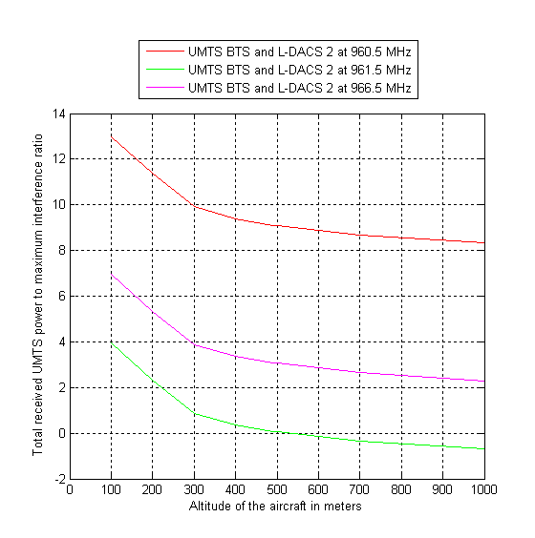 | 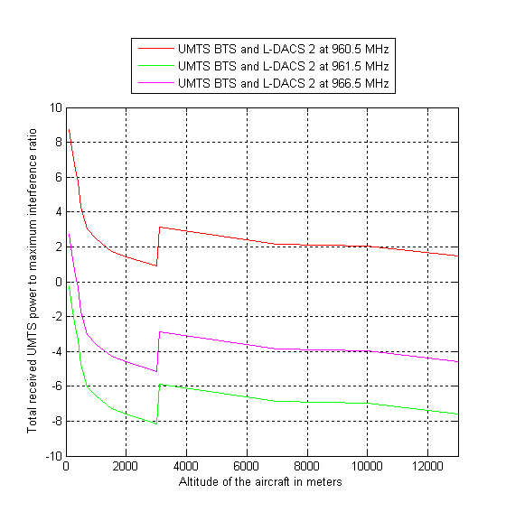
Figure 28: Total received UMTS interference in the Mixed-urban case, without power control | Figure 29: Total received UMTS interference in the rural case, without power control

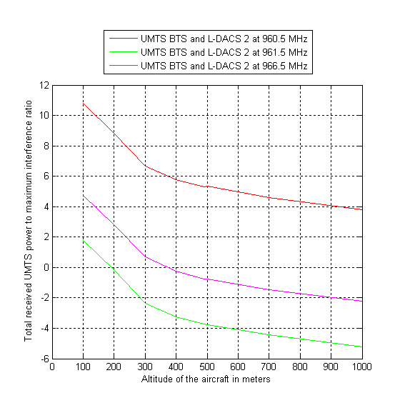 | 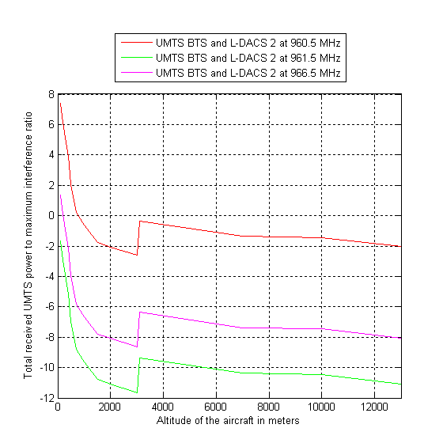
Figure 30: Total received UMTS interference in the Mixed-urban case, with power control | Figure 31: Total received UMTS interference in the rural case, with power control

It has to be noted that the use of power control is part of the features of a CDMA network. Therefore, the following figures are more relevant for the purpose of this study.

Impact of three UMTS channels on an airborne LDACS-2 receiver
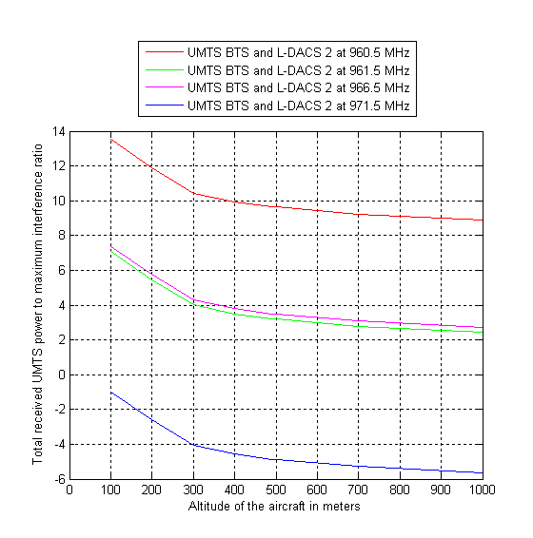 | 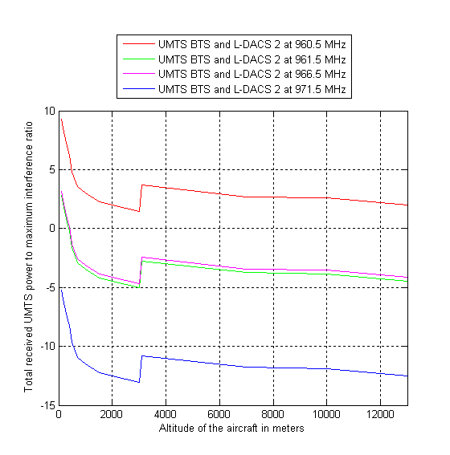
Figure 32: Total received UMTS interference in the Mixed-urban case, without power control | Figure 33: Total received UMTS interference in the rural case, without power control

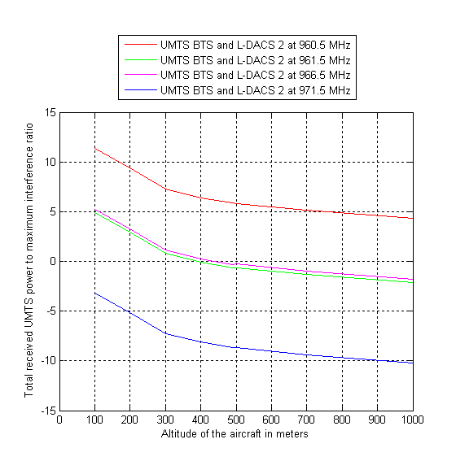 | 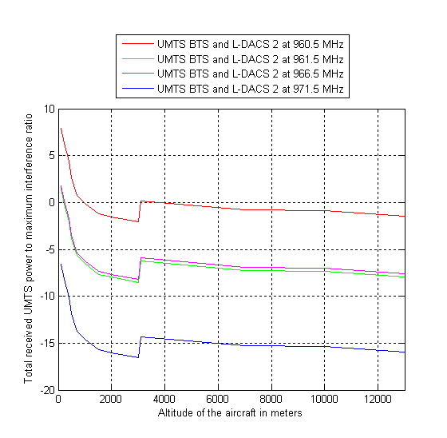
Figure 34: Total received UMTS interference in the Mixed-urban case, with power control | Figure 35: Total received UMTS interference in the rural case, with power control

- Analysis of the results

The results are very much dependant on the scenarios: the major parameters that have an impact on the results are:
  - the network geometry (cell radius) and also the aggregation of all base stations seen by the plane (especially in urban scenario and at very high altitudes),
  - the base station EIRP associated to the antenna pattern and tilt
  - the unwanted emissions mask
  - The frequency separation between the uppermost UMTS channel and the L-DACS channel under consideration
The network geometry and the base stations settings are significant different from the urban scenario to the rural scenario and therefore lead to different results. The location of the aircraft relatively to the closest base station at low altitudes is an important parameter. In the simulations, the closest distance between an aircraft and a BTS in the horizontal plane is 600m in the rural scenario and 300m in the urban scenario. The consideration of one of these scenarios (rural or urban), taken separately, is not representing the reality. Neither rural nor urban scenarios should be considered by themselves, as the reality is between both. Above a certain height (around 1000 m), the urban scenario is not relevant. The urban scenario may be pessimistic in the sense that the urban area is not geographically limited, and that the number of base stations per area may be exaggerated.

With the hypotheses of the studies (especially the average effect and power control), no interference from UMTS base stations to an L-DACS airborne receiver is expected above 971.5 MHz. Below 971.5 MHz some interference may occur in one scenarios: at low altitudes for the mixed-urban case, 3 to 4 dB.

Sensitivity analysis (applicable to UMTS base stations impact on LDACS airborne receiver)
The different factors discussed in the section on sensitivity analysis for DME apply to the L-DACS scenario as well, except the ones relating to DME receiver bandwidth and selectivity as well as the one relating to the configuration of the DME.

Furthermore, for L-DACS additional margin have been taken into account in the link budget:
- 4 dB implementation margin
- 1,5 dB to compensate ground multipath interference

UMTS base stations impact on Ground L-DACS 2 system
The purpose of this section is to define the sharing conditions between UMTS and L-DACS ground stations and inform the bodies in charge of specifying L-DACS of the potential interference from UMTS, given that UMTS900 is already deployed in some countries and given that the schedule of the L-DACS deployment is around 2020 at the earliest.

The aim of this section is also to investigate coexistence between UMTS base stations and L-DACS ground stations in order to enable the development of L-DACS in the long term. This could be achieved through coordination on a case by case basis.

The results presented in this section are based on simulation assumptions given in section 4.4. In addition, 2 sets of additional hypotheses are considered to define 2 possible interference scenarios. In study case 1 which results are given in Table 22, the following hypotheses are used:
- UMTS transmit power is at its maximum level without power control;
- The antenna gain is maximum in azimuth (main antenna lobe);
- No planning coordination is considered, and therefore the interferer and the victim are separated by 600 m;
- The free space loss model is used (no obstacle between the ground stations)

The results are given in Table 22:

L-DACS antenna height | Type of environment
L-DACS antenna height | Mixed-urban |  |  |  | Rural
L-DACS antenna height | 960.5 | 961.5 | 966.5 | 971.5 | 960.5 | 961.5 | 966.5 | 971.5
15m | 34 | 27 | 28 | 19 | 37 | 30 | 31 | 22
30m | 33 | 27 | 27 | 19 | 36 | 29 | 30 | 21
45m | 31 | 24 | 25 | 16 | 35 | 28 | 28 | 20
Table 22: Additional isolation needed in dB in the link budget from UMTS base stations to ground
L-DACS 2 system

In study case 2 which results are given in Table 23, the following hypotheses are used:
- UMTS transmit power is 1 dB below maximum power for sectors with peak characteristics, and 3.5 dB below maximum power for sectors with average characteristics;
- Peak characteristics for antenna and power control is assumed for the 10 sectors causing the worst interference;
- Considering the placement of ground stations in rural areas and the limited number of ground stations expected, a certain amount of coordination is assumed. The minimum distance between a ground station and a base station is set to be equal to 1.2km in mixed-urban environment and 2.4km in the rural environment;
- The free space loss model is used (no obstacle between the ground stations). This is a pessimistic assumption considering that interference from many base stations will be reduced by diffraction phenomena.

L-DACS antenna height | Type of environment
L-DACS antenna height | Mixed-urban |  |  |  | Rural
L-DACS antenna height | 960.5 | 961.5 | 966.5 | 971.5 | 960.5 | 961.5 | 966.5 | 971.5
15m | 28 | 22 | 22 | 14 | 24 | 18 | 18 | 10
30m | 28 | 21 | 22 | 13 | 23 | 17 | 17 | 9
45m | 28 | 21 | 21 | 13 | 23 | 17 | 17 | 9
Table 23: Additional isolation needed in dB in the link budget from UMTS base stations to ground
L-DACS 2 system (more realistic case)

According to Table 23, the compatibility between L-DACS ground station and UMTS base station is not possible without coordination.

Therefore, L-DACS ground stations could be deployed only after a successful coordination process, where needed on a case by case basis with UMTS base stations currently rolled out in the 900 MHz band in order to ensure the compatibility between the systems.

CONCLUSIONS
This Report focuses on the compatibility between UMTS 900 on the one hand, and the aeronautical systems (existing: DME and future: L-DACS) in the band 960-1215/1164 MHz.

Two different types of LDACS (a FDD option, L-DACS 1, and a TDD option, L-DACS 2) are under consideration in Europe. Although the parameters of L-DACS 1 and 2 are provided in this Report, the study and associated results are only provided for L-DACS 2. Restricting the studies to L-DACS 2 option only both ensures the protection of L-DACS 1 and 2 with regards to UMTS systems on the one hand and considers the most stringent adjacent system in terms of compatibility with UMTS on the other hand. However, L-DACS 1 would provide less interference to UMTS base stations than L-DACS-2, depending on the final band plan.
It has also to be noted that the studies were conducted with the L-DACS 2 parameters available to date. If these parameters were subject to change in the future, then the results would need to be adjusted.

Additionally, this Report has assumed that if the required protection for DME is guaranteed for the entire band 960 - 1164 MHz then this level of protection will be acceptable for both L-DACS1 & L-DACS2 airborne stations.

The results cover interference from L-DACS airborne and ground station transmissions to the UMTS terminals as well as interference from UMTS base stations to DME/L-DACS airborne receivers and L-DACS ground station receivers. Rural and mixed urban deployments of UMTS have been studied.

Currently DME systems are mostly deployed above 977 MHz. L-DACS is expected to be deployed in 2020 at the earliest, whereas UMTS is currently being rolled out in Europe in the 900 MHz band.

The results of the studies are as follows:

- L-DACS 2 airborne transmitters will not cause any interference to UMTS terminals, when the distance between the aircraft and an outdoor UMTS terminal is greater than 8.6 km, with a L-DACS 2 transmitting frequency of 960,1 MHz. For a L-DACS 2 transmitting frequency of 962,6 MHz, this distance becomes 6.5 km. The limiting factor is currently the selectivity of the UMTS UE.
- .
- L-DACS 2 ground stations could cause desensitization to UMTS terminals at a distance up to 17.5 km, depending on the propagation characteristics in the area considered and L-DACS 2 ground station antenna height, with a L-DACS 2 transmitting frequency of 960,1 MHz. For a L-DACS 2 transmitting frequency of 962,6 MHz, this distance becomes 14.7 km. The limiting factor is currently the selectivity of the UMTS UE.No interference from UMTS base stations to DME airborne receivers is expected above 972 MHz. Below 972 MHz some interference, in the order of 3 to 4 dB, may occur at low altitudes for the mixed-urban case.
- L-DACS airborne receivers are no more sensitive to interference than DME.
- UMTS base station transmissions may cause interference to L-DACS ground stations, if these stations are deployed in the lowest part of the band, and if the L-DACS TDD option is selected, in the order of 17 – 25 dB, depending on the distance from the ground station to the nearest base station. If the FDD (LDACS-1) option is chosen and the associated ground stations receive at frequencies far above 960 MHz, then the interference from UMTS base stations to these ground stations would be alleviated.

It is recommended that the section of this Report, on sensitivity analysis for UMTS interference into DME and L-DACS airborne receivers, is taken into account when assessing these results and deploying systems, as it provides information on how to mitigate possible interference. In particular they address the role of the apportionment factor, UMTS base station antenna diagrams, multiple margins in the DME/L-DACS link budgets, local network configuration of UMTS, base station duplex filters and DME ground station configuration (power, antenna configuration, height of antenna).

The study has been carried out assuming base stations deployed with:
- slant polarized antennas
- a power control reduction of 3.5dB in average
- output power of 43dBm
This study has not taken into account a possible improvement of UMTS UE receivers performance and L-DACS transmitters characteristics. Improving the filtering on both categories of equipments may alleviate potential interference from L-DACS 2 to UMTS UE, noting that L-DACS systems are planned to be deployed by 2025.

Furthermore it is recommended that future design, specifications and deployment of L-DACS ground stations consider the potential interference from UMTS. Moreover, L-DACS ground stations could be deployed only after a successful coordination process, where needed, on a case by case basis with UMTS base stations currently rolled out in the 900 MHz band in order to ensure the compatibility between the systems and appropriate use of the band above 960 MHz by AM(R)S.

- L-DACS 2 PROTECTION CRITERIA
Formula to determine the protection criteria: $\frac{C}{N+I}>\frac{S}{N}$, with C the carrier level and S the sensitivity level.

 |  | Above 3000m | Below  3000m
Tx power | dBm | 55.4 | 50.4
Tx antenna gain | dBi | 8.0 | 8.0
Tx cable loss | dB | 2.5 | 2.5
Tx EIRP | dBm | 60.9 | 55.9
Frequency | MHz | 960.0 | 960.0
Tx-Rx distance | Km | 370.0 | 75.0*
Path loss | dB | -143.5 | -129.6
Implementation margin | dB | 4.0 | 4.0
Bancking loss | dB | 0.0 | 7.0
Rx duplexer and cable loss | dB | 3.0 | 3.0
Rx received signal power | dBm | -89.5 | -87.7
Rx noise temperature | K | 290.0 | 290.0
Rx bandwidth | kHz | 200.0 | 200.0
Thermal noise level | dBm | -121.0 | -121.0
Rx Noise figure | dB | 13.0 | 13.0
Rx noise level | dBm | -108.0 | -108.0
Required C/N | dB | 11.3 | 11.3
Rx sensitivity | dBm | -96.6 | -96.6
I max without internal interference | dB | -101.8 | -99.6
Co-channel interference ratio C/Ic | dB | 9.0 | 9.0
Associated interference Ic (10%) | dBm | -108.5 | -106.7
Ground multipath interference (loss) | dB | 1.5 | 1.5
I max without external interference | dBm | -103.7 | -101.4
Safety margin | dB | 6.0 | 6.0
Apportionment margin | dB | 6.0 | 6.0
I max with external interference | dBm | -115.7 | -113.4
 | dBW/200kHz | -145.7 | -143.4
Table 24: L-DACS 2 on-board protection criteria

* A maximum distance of 75 km, between an aircraft and a L-DACS ground station, is considered for an altitude of aircraft below 3000m

Parameter | Unit | Value
Tx power | dBm | 47.0
Tx antenna gain | dBi | 0.0
Tx cable loss | dB | 3.0
Tx EIRP | dBm | 44.0
Frequency | MHz | 960.0
Tx-Rx distance | km | 370.0
Path loss | dB | -143.5
Implementation margin | dB | 0.0
Blanking loss | dB | 0.0
Rx duplexer and cable loss and antenna gain | dB | -5.5
Rx received signal power | dBm | -94.0
Rx noise temperature | K | 290.0
Rx bandwidth | kHz | 200.0
Thermal noise level | dBm | -121.0
Rx Noise figure | dB | 9.5
Rx noise level | dBm | -111.5
Required C/N | dB | 11.3
Rx sensitivity | dBm | -100.1
I max without interference | dB | -106.5
Co-channel interference ratio C/Ic | dB | 9.0
Associated interference Ic (10%) | dBm | -113.0
Ground multipath interference (loss) | dB | 1.5
I max without external interference | dBm | -108.6
Safety margin | dB | 6.0
Apportionment margin | dB | 6.0
I max with external interference | dBm | -120.6
 | dBW/200kHz | -150.6
Table 25: L-DACS 2 ground protection criteria
- EC Mandate to CEPT

EUROPEAN COMMISSION
Information Society and Media Directorate-General

Electronic Communications Policy
Radio Spectrum Policy

Brussels, 15 June 2009
DG INFSO/B4
ADOPTED
Mandate to CEPT on the 900/1800 MHz bands
PURPOSE
The purpose of this Mandate is to contribute to putting into practice the concept of flexibility as advocated in the Opinion of the RSPG on Wireless Access Policy for Electronic Communications Services (WAPECS), by developing least restrictive technical conditions which are sufficient to avoid harmful interference in the frequency bands that have been tentatively identified by the RSC for the implementation of the WAPECS approach.
The technical conditions specific to each frequency band expected in response to this mandate will be considered for the introduction or amendment of harmonised technical conditions within the Community in order to achieve internal market objectives and facilitate cross-border coordination.
JUSTIFICATION
Pursuant to Article 4 of the Radio Spectrum Decision, the Commission may issue mandates to the CEPT for the development of technical implementing measures with a view to ensuring harmonised conditions for the availability and efficient use of radio spectrum. Such mandates shall set the task to be performed and the timetable therefore.
Flexibility and facilitating market entry are key requirements for ensuring that information and communication technologies help to deliver growth and jobs, in line with the renewed Lisbon Strategy. The issue of flexible spectrum use has been identified as an important aspect by the Commission as well as Member States and the success of this approach will now depend on an optimal implementation on the basis of concrete measures at the level of specific frequency bands. In this context it is necessary to look into the technical conditions attached to the rights of use of spectrum with the aim of implementing the defined policy approach. Reviewing the results of the CEPT Mandate on WAPECS as well as recent developments in the market place, it seems necessary to continue the process towards an environment with a similar and minimal set of conditions for electronic communications services across all the relevant frequency bands and all Member States, while taking into account the experience of Member States so far.
In December 2008 the European Council adopted conclusions regarding the economic recovery plan, which inter alia include support for regulatory incentives to develop broadband internet, including in areas that are poorly served. Ensuring that state-of-the-art wireless broadband technologies have access to a number of spectrum bands so that both capacity and coverage can be achieved is an important aspect that will stimulate broadband deployment.
Concerning the bands 880-915 MHz / 925-960 MHz and 1710-1785 MHz / 1805-1880 MHz (900/1800 MHz bands) a draft Decision has been approved by the RSC as a mechanism that will gradually introduce new technologies (i.e. technology neutrality) into the GSM bands and it will come into force when Council and Parliament agree on the amendment of the GSM Directive. The annex to this draft Decision contains essential technical parameters for systems that have demonstrated the ability to coexist with GSM. In addition to UMTS, which is already in the list, there are signs that other technologies, such as LTE, are envisaged for deployment in the 900/1800 MHz bands by incumbent operators. In order to ensure that LTE is recognised through insertion into the annex of the decision on 900/1800 MHz as a technology that should be taken into account when conducting in band and adjacent band interference studies, there is a need for CEPT to study the technical implications in order to ensure coexistence as well as flexible spectrum use.
TASK ORDER AND SCHEDULE
CEPT is mandated to study the following issues:
Verify whether there are other technologies besides LTE developing equipment for 900/1800 MHz that would need to be studied concerning their coexistence with GSM at this stage.
Study the technical conditions under which LTE technology can be deployed in the 900/1800 MHz bands: With the aim of adding LTE and possibly other technologies (identified in Task 1) to the list in the annex of the draft decision on 900/1800 MHz frequency bands (see Footnote 6), technical coexistence parameters should be developed. A Block Edge Mask is not requested at this stage, noting that common and minimal (least restrictive) parameters would be appropriate after strategic decisions concerning the role of GSM as the reference technology for coexistence have been taken.
Investigate compatibility between UMTS and adjacent band systems above 960MHz: Noting that compatibility with systems outside of the 900/1800 MHz bands will be studied for LTE and any other identified technology at all band edges under Task 2, the aim of this task is to review the risk of interference between UMTS and existing and planned aeronautical systems above 960 MHz, in order to enable the development of all systems below and above 960 MHz without taking a risk relating to aeronautical safety.
The main deliverable for this Mandate will be a report, subject to the following delivery dates:
Delivery date | Deliverable
18 Sept. 2009 | For the RSC#29: First progress report
27 Nov. 2009 | For RSC#30: Second progress report including a final report on Task 1
10 March 2010 | For RSC#31: Draft final report
24 June 2010 | For RSC#32: Final report

In implementing this mandate, the CEPT shall, where relevant, take the utmost account of Community law applicable and support the principles of technological neutrality, non-discrimination and proportionality insofar as technically possible.

- LIST OF REFERENCES
- ECC Report 096 “Compatibility between UMTS900/1800 and systems operating in adjacent bands”, March 2007.
- 3GPP Technical Specification TS25.104 (Release 8), “Base Station (BS) Radio Transmission and Reception (FDD)”, 2005-12.
- 3GPP Technical Specification TS25.101 (Release 8), “User Equipment (UE) radio transmission and reception (FDD)”, 2005-12.
- L-DACS 1 System definition proposal, Deliverable D2, v1.0, 2009-02.
- L-DACS 2 System definition proposal, Deliverable D2, v1.0, 2009-05.

The review of planned systems should be based on the latest available information on the new aeronautical communication system being developed above 960 MHz in the context of the Single European Sky ATM Research (SESAR) programme.
The review of planned systems should be based on the latest available information on the new aeronautical communication system being developed above 960 MHz in the context of the Single European Sky ATM Research (SESAR) programme.
I/N = 6 dB is applicable to cases where interferences affect a limited number of cells. In other cases, such as estimating the interferences from a satellite or an aeronautical system, a threshold value of I/N = 10 dB is appropriate. See document R07-CPM-R-0001!R1!PDF-E.pdf (TABLE 1.9-1 on page 25 of chapter 3) available for download at http://www.itu.int/md/R07-CPM-R-0001/en.
N= F.k.T.B
Minimum Operational Performance Requirements For distance Measuring Equipment Interrogator (DME/N and DME/P) Operating Within The Radio Frequency Range 960 to 1215 MHz, January 1987
Decision 676/2002/EC of the European Parliament and of the Council of 7 March 2002 on a regulatory framework for radio spectrum policy in the European Community, OJ L 108 of 24.4.2002.
Communication on “Rapid access to spectrum through more flexibility”, COM(2007)50
RSPG Opinion on Wireless Access Policy for Electronic Communications Services (WAPECS)
http://ec.europa.eu/information_society/policy/ecomm/radio_spectrum/_document_storage/mandates/ec_to_cept_wapecs_06_06.pdf
Presidency Conclusions, Council of the European Union, Brussels, 12 December 2008 17271/08
http://ec.europa.eu/information_society/policy/ecomm/radio_spectrum/_document_storage/rsc/rsc20_public_docs/07_04%20final_900_1800.pdf
On 19.11.2008 the Commission issued a proposal for an amendment of the GSM Directive (see COM(2008) 762final), which is currently in co-decision procedure.
Long Term Evolution (LTE) is the next major step of technological development in the GSM and UMTS product line. It is currently being standardised by 3GPP.
The review of planned systems should be based on the latest available information on the new aeronautical communication system being developed above 960 MHz in the context of the Single European Sky ATM Research (SESAR) programme.
Public consultation should take place based on this version of the text.

