ECC Report 150

Compatibility studies between RDSS and other services in the band 2483.5-2500 MHz
Approved September 2010
Amended September 2012

BREVIATIONS

executive summary
WRC-12 Agenda Item 1.18 is considering the extension of the existing primary and secondary radiodetermination-satellite service (space-to-Earth) allocations in the band 2483.5-2500 MHz in order to make a global primary allocation, in accordance with Resolution 613 (Rev. WRC-07).
Resolution 613 invites the ITU-R to conduct, and complete in time for WRC-12, the appropriate technical, operational and regulatory studies leading to technical and procedural recommendations to the Conference enabling it to decide whether a global primary allocation for the radiodetermination-satellite service in the frequency band 2483.5-2500 MHz (space-to-Earth) is compatible with other services in the band.
The band 2483.5-2500 MHz is allocated to the fixed, mobile, mobile satellite, radiolocation and radiodetermination-satellite services. Sharing studies have been performed with those services, as well as with IMT systems identified in the adjacent band 2500-2690 MHz and WLAN systems in the adjacent band 2400-2483.5 MHz. Complementary Ground Component (CGC) usage in the MSS is not considered in this report.
Except for the Radiolocation Service, a pfd limit of -129 dBW/m²/MHz for the RDSS would enable the protection of existing services in the band or IMT systems identified in the adjacent band.
For the case of RLS, this same limit is not sufficient for the protection of some types of radars. Therefore, it is necessary to find other regulatory and/or technical solutions to protect the Radiolocation service. These other solutions should at the same time also protect other services in the band and adjacent bands.
Considering that the main interferer in Europe would be MSS and IMT in the adjacent band, RDSS would be able to operate under most circumstances. RDSS receivers would need to accept some interference from MS above 2500 MHz. RDSS receivers would also need to accept interference in countries using MS or FS services in the band 2483.5-2500 MHz.
For information, the SEAMCAT files used for the calculations for the study are available in a zip-file at the www.ecodocdb.dk (ECO Documentation Area) next to this Report.

Table of contents

0 executive summary 2
List of abbreviations 5
1 introduction 6
2 CHARACTERISTICS OF RDSS SYSTEMS EXPECTED TO OPERATE IN THE BAND 2483.5-2500 MHz 7
2.1 Satellite parameters 7
2.2 Mobile RDSS Receiver parameters 8
3 COMPATIBILITY BETWEEN RDSS AND OTHER SERVICES 9
3.1 RDSS vs Fixed Service 9
3.1.1 Fixed Service characteristics 9
3.1.2 Impact of FS links on RDSS receivers 9
3.1.3 Impact of RDSS satellites on FS stations 10
3.1.4 Conclusion on RDSS-FS compatibility 12
3.2 RDSS vs mobile-satellite service 12
3.2.1 Mobile-Satellite Service characteristics 12
3.2.2 Methodology used 13
3.2.3 Impact of MSS mobile earth stations on RDSS receivers 15
3.2.4 Impact of RDSS satellites on MSS mobile earth stations 16
3.2.5 Conclusion on RDSS-MSS compatibility 18
3.3 RDSS vs mobile service 18
3.3.1 Mobile Service characteristics 18
3.3.1.1 SAB/SAP systems 18
3.3.1.2 WIMAX systems 19
3.3.1.3 VICS characteristics 20
3.3.2 Impact of MS transmitters on RDSS receivers 20
3.3.2.1 In case of SAP/SAB systems 20
3.3.2.2 In case of WIMAX systems: 21
3.3.2.3 In case of the VICS system: 22
3.3.3 Impact of RDSS satellites on MS receivers 22
3.3.3.1 In case of SAP/SAB systems: 22
3.3.3.2 In case of WIMAX systems: 24
3.3.3.3 In case of the VICS system: 26
3.3.4 Conclusion on RDSS-MS compatibility 29
3.4 RDSS vs radiolocation service 30
3.4.1 Radiolocation characteristics 30
3.4.2 Impact of RLS transmitters on RDSS receivers 30
3.4.3 Impact of RDSS satellites on RLS receivers 30
3.4.3.1 First study 30
3.4.3.1.1 Methodology 30
3.4.3.1.2 Radar antenna pattern 31
3.4.3.1.3 Results 31
3.4.3.2 Second study 34
3.4.3.2.1 Methodology 34
3.4.3.2.2 Assumptions 35
3.4.3.2.3 Results 36
3.4.3.2.4 Verification of the compatibility between the planned GALILEO system and the RLS system with proposed PFD mask. 37
3.4.4 Conclusion on RDSS-RLS compatibility 38
3.5 RDSS vs IMT systems identified in the adjacent band 2500-2690 MHz 39
3.5.1 IMT characteristics 39
3.5.1.1 IMT Base Station characteristics 39
3.5.1.1 IMT User Equipment characteristics 40
3.5.2 Impact of IMT transmitters on RDSS receivers 40
3.5.3 Impact of RDSS satellites on IMT receivers 42
3.5.4 Conclusion on RDSS-IMT compatibility 47
3.6 RDSS vs WLAN systems operating in the adjacent band 2400-2483.5 MHz 47
3.6.1 WLAN characteristics 47
3.6.2 Impact of a WLAN transmitter on a RDSS receiver 48
3.6.2.1 Methodology used in the study 48
3.6.2.2 Results 50
3.6.3 Impact of RDSS satellites on WLAN receiver 50
3.6.4 Conclusion on RDSS-WLAN compatibility 50
4 GALIleo TYPE RDSS performances according to the pfd value 51
4.1 C/No computation 51
4.2 Tracking performances 53
4.3 Acquisition performances 54
4.4 Conclusion 55
5 OVERALL Conclusions OF THE REPORT 55
ANNEX 1: RNSS CONSTELLATION ORBITAL PARAMETER 57
ANNEX 2: Implementation of first adjacent criterion within SEAMCAT when modelling interference from LTE/UMTS UE to RNSS receivers 60
ANNEX 3: List of references 62

List of abbreviations
Abbreviation | Explanation
3GPP | 3rd Generation Partnership Project
ACLR | Adjacent Channel Leakage Power Ratio
ACS | Adjacent Channel Selectivity
BOC | Binary Offset Carrier
BPSK | Binary Phase Shift Keying
BS | Base Station
CDMA | Code division multiple access
CEPT | European Conference of Postal and Telecommunications Administrations
CGC | Complementary Ground Component
DVB-T | Digital Video Broadcasting – Terrestrial
ECC | Electronic Communications Committee
e.i.r.p. | equivalent isotropic radiated power
ENG | Electronic News Gathering
FDD | Frequency Division Duplex
FDMA | Frequency Division Multiple Access
FDP | Fractional Degradation of Performance
FM | Frequency Modulation
FS | Fixed Service
GMSK | Gaussian Minimum Shift Keying
GSO | Geostationary
IF | Intermediate Frequency
IMT | International Mobile Telecommunications
ITU-R | International Telecommunication Union - Radio
LTE | Long-Term Evolution
MES | Mobile Earth Station
MS | Mobile Service
MSK | minimum-shift keying
MSS | Mobile-Satellite Service
OFDMA | Orthogonal Frequency Division Multiple Access
OoB | Out-of-Band
PFD | Power-flux Density
PSD | Power Spectral Density
QPSK | Quadrature Phase Shift Keying
RDSS | Radiodetermination Satellite Service
RLS | Radiolocation Service
RNSS | Radionavigation Satellite Service
SAB | Services Ancillary to Broadcasting
SAP | Services Ancillary to Programme-making
SNR | Signal-to-Noise Ratio
SSC | Spectral Separation Coefficient
UE | User Equipment
UMTS | Universal Mobile Telecommunications System
VICS | Vehicle Information and Communication System
WRC | World Radiocommunication Conference

Compatibility studies between RDSS and other services in the band 2483.5-2500 MHz

introduction
This report is addressing technical studies related to WRC-12 agenda item 1.18 “to consider extending the existing primary and secondary radiodetermination-satellite service (space-to-Earth) allocations in the band 2483.5-2500 MHz in order to make a global primary allocation, and to determine the necessary regulatory provisions based upon the results of ITU R studies, in accordance with Resolution 613 (WRC 07);”

Resolution 613 invites the ITU-R:
to conduct, and complete in time for WRC-11, the appropriate technical, operational and regulatory studies leading to technical and procedural recommendations to the Conference enabling it to decide whether a global primary allocation for the radiodetermination-satellite service in the frequency band 2483.5-2500 MHz (space-to-Earth) is compatible with other services in the band,

The band 2483.5-2500 MHz is allocated to the fixed, mobile, mobile satellite, radiolocation and radiodetermination-satellite services in accordance with the following provisions of RR Article 5.

2 450-2 520 MHz
Allocation to services
Region 1 | Region 2 | Region 3
2 450-2 483.5  FIXED  MOBILE  Radiolocation  5.150 5.397 | 2 450-2 483.5  FIXED  MOBILE  RADIOLOCATION  5.150
2 483.5-2 500  FIXED  MOBILE  MOBILE-SATELLITE  (space-to-Earth) 5.351A  Radiolocation | 2 483.5-2 500  FIXED  MOBILE  MOBILE-SATELLITE  (space-to-Earth) 5.351A  RADIOLOCATION  RADIODETERMINATION-  SATELLITE  (space-to-Earth) 5.398 | 2 483.5-2 500  FIXED  MOBILE  MOBILE-SATELLITE  (space-to-Earth) 5.351A  RADIOLOCATION  Radiodetermination-satellite  (space-to-Earth) 5.398
5.150 5.371 5.397 5.398 5.399 5.400 5.402 | 5.150 5.402 | 5.150 5.400 5.402
2 500-2 520  FIXED 5.410  MOBILE except aeronautical mobile 5.384A | 2 500-2 520  FIXED 5.410  FIXED-SATELLITE (space-to-Earth) 5.415  MOBILE except aeronautical mobile 5.384A | 2 500-2 520  FIXED 5.410  FIXED-SATELLITE (space-to-Earth) 5.415  MOBILE except aeronautical mobile 5.384A  MOBILE-SATELLITE (space-to-Earth) 5.351A 5.407 5.414 5.414A
5.405 5.412 | 5.404 | 5.404 5.415A
Table 1: RR Article 5 for the band 2 450-2 520 MHz
5.371 Additional allocation: in Region 1, the bands 1 610-1 626.5 MHz (Earth-to-space) and 2 483.5-2 500 MHz (space-to-Earth) are also allocated to the radiodetermination-satellite service on a secondary basis, subject to agreement obtained under No. 9.21.
5.397 Different category of service: in France, the band 2 450-2 500 MHz is allocated on a primary basis to the radiolocation service (see No. 5.33). Such use is subject to agreement with administrations having services operating or planned to operate in accordance with the Table of Frequency Allocations which may be affected.
5.398 In respect of the radiodetermination-satellite service in the band 2 483.5-2 500 MHz, the provisions of No. 4.10 do not apply.
5.399 In Region 1, in countries other than those listed in No. 5.400, harmful interference shall not be caused to, or protection shall not be claimed from, stations of the radiolocation service by stations of the radiodetermination satellite service.
5.400 Different category of service: in Angola, Australia, Bangladesh, Burundi, China, Eritrea, Ethiopia, India, Iran (Islamic Republic of), the Libyan Arab Jamahiriya, Lebanon, Liberia, Madagascar, Mali, Pakistan, Papua New Guinea, the Dem. Rep. of the Congo, the Syrian Arab Republic, Sudan, Swaziland, Togo and Zambia, the allocation of the band 2 483.5-2 500 MHz to the radiodetermination-satellite service (space-to-Earth) is on a primary basis (see No. 5.33), subject to agreement obtained under No. 9.21 from countries not listed in this provision. (WRC-03)
5.402 The use of the band 2 483.5-2 500 MHz by the mobile-satellite and the radiodetermination-satellite services is subject to the coordination under No. 9.11A. Administrations are urged to take all practicable steps to prevent harmful interference to the radio astronomy service from emissions in the 2 483.5-2 500 MHz band, especially those caused by second-harmonic radiation that would fall into the 4 990-5 000 MHz band allocated to the radio astronomy service worldwide.

CHARACTERISTICS OF RDSS SYSTEMS EXPECTED TO OPERATE IN THE BAND 2483.5-2500 MHz

Satellite parameters
The band 2483.5-2500 MHz is foreseen for the operation of Radio Navigation Satellite Service (RNSS) constellations and it is understood that these constellations will not operate safety service within this band.
It is expected that such constellation would have the same orbital characteristics that the systems already filled in the 1164-1215 MHz frequency band, which are given in Annex 3 of the record of decisions of the consultation meeting for ITU-R Resolution 609 (Frequency band 1164-1215 MHz) and pasted in Annex 1 of this document.

Those RNSS constellations parameters show that the number of satellites visible at any location considered on Earth is around 12 for one constellation.

The PFD per satellite for a RNSS constellation is considered to be constant, regardless of the elevation angle.

Four different hypothetic waveforms can be considered:
- BPSK(1): Globalstar-like” or “IRNSS-like” signal
- BPSK(4):
- BPSK(8): example of signal having a main lobe occupying all the 2483.5-2500 MHz band
- BOC(1,1): having the same spectrum than the central signal of the GPS/GALILEO MBOC at E1 central frequency.

The Power Spectral Density (normalized to 1W) of the RNSS signal, PSD_{RNSS(f)}, depends on the considered modulation associated to the spreading factor k, also called processing gain:
BPSK(k): ${\text{PSD}}_{\text{RNSS}}(f)=\frac{1}{k∗f_{f}}\text{sin}c{\left(\frac{πf}{k∗f_{f}}\right)}^{2}$ (ff=1.023 MHz)
BOC(1,1): ${\text{PSD}}_{\text{RNSS}}(f)=\frac{1}{f_{f}}{\left(\frac{\text{tan}\left(\frac{πf}{2∗f_{f}}\right)\text{sin}\left(\frac{πf}{f_{f}}\right)}{πf}\right)}^{2}$
Figure 1: PSD for BSPK(4) and BOC(1,1) Signal

Mobile RDSS Receiver parameters
The interference analysis considers interference to a general purpose RNSS receiver operating within the RDSS allocation in a mobile or handheld application at a height of about 1.5 metres above ground level. The maximum interference value will be in accordance with the figure for a General Purpose receiver given in [3], which is -146 dBW/MHz, strictly this value is only appropriate for the band 1559-1610 MHz. However, in the absence of information relating to systems operating in the band under consideration, we have used the value given in this document.

In assessing the interference to a RNSS receiver, the receiver bandwidth is supposed equal to the width of the main lobe of the RNSS signal and thus depends on the considered waveform as shown in Table 2.

RNSS signal waveform | Receiver bandwidth (MHz)
BPSK(1) | 2.046
BPSK(4) | 8.184
BPSK(8) | 16.368
BOC(1,1) | 4.092
Table 2: RNSS receiver bandwidth

COMPATIBILITY BETWEEN RDSS AND OTHER SERVICES

RDSS vs Fixed Service

Fixed Service characteristics
Fixed Service links characteristics can be found and derived from Recommendation ITU-R F.758. Those are presented in Table 3 below.

Service | Emission characteristics
Service | Receiver Bandwidth | Antenna pattern | e.i.r.p. | Modulation
Fixed Service | 14 MHz | Recommendation ITU-R F. 699 (single entry interference or with GEO satellite)  Recommendation ITU-R F.1245 (multiple entry interference or with non-GEO satellite)  Gmax = 25 dBi | 26-33 dBW | MSK or QPSK
 |  | Interference Criteria |  | Emission restrictions
Fixed Service |  | Maximum acceptable received power  –150 dBW/MHz (20%)  –114 dBW/MHz (0.005%) |  | None
Table 3: FS characteristics
In addition to the characteristics above, Recommendation ITU-R F.758-4 indicates for this specific system a feeder link of 4 dB to take into account in the studies.
In addition, FS links generally use linear polarization, whereas the RDSS systems use circular polarization. This implies an additional 3 dB attenuation limited to the main lobe of the FS station antenna as depicted in Recommendation ITU-R F.1245.

Impact of FS links on RDSS receivers
Taking into account the cross polarization isolation (the feeder loss is assumed to be already included in the FS e.i.r.p. calculation) and Recommendation ITU-R P.452 on a flat terrain and a percentage of time of 0.1% leads to the following results.

 | FS parameters
Bandwidth (MHz) | 14
e.i.r.p. (dBW) | 33
e.i.r.p. (dBW/MHz) | 21.5
Antenna height (m) | 15 | 30
Cross-polarization isolation (dB) | 3
Maximum isotropic RNSS interference (dBW/MHz) | -146
Propagation loss (dB) | 164.5
Horizon distance (km) | 13.9 | 19.6
Separation distance (km) – P.452 (0.1%) | 288 | 293
Separation distance (km) – P.452 (50%) | 39 | 44
Table 4: Separation distance between a FS transmitter and RDSS receiver in its main beam

This assumes a RDSS receiver in the main lobe of the FS. When considering a moving RDSS receiver and the isolation provided by an antenna following F.1245, an additional attenuation of 29 dB may be assumed.
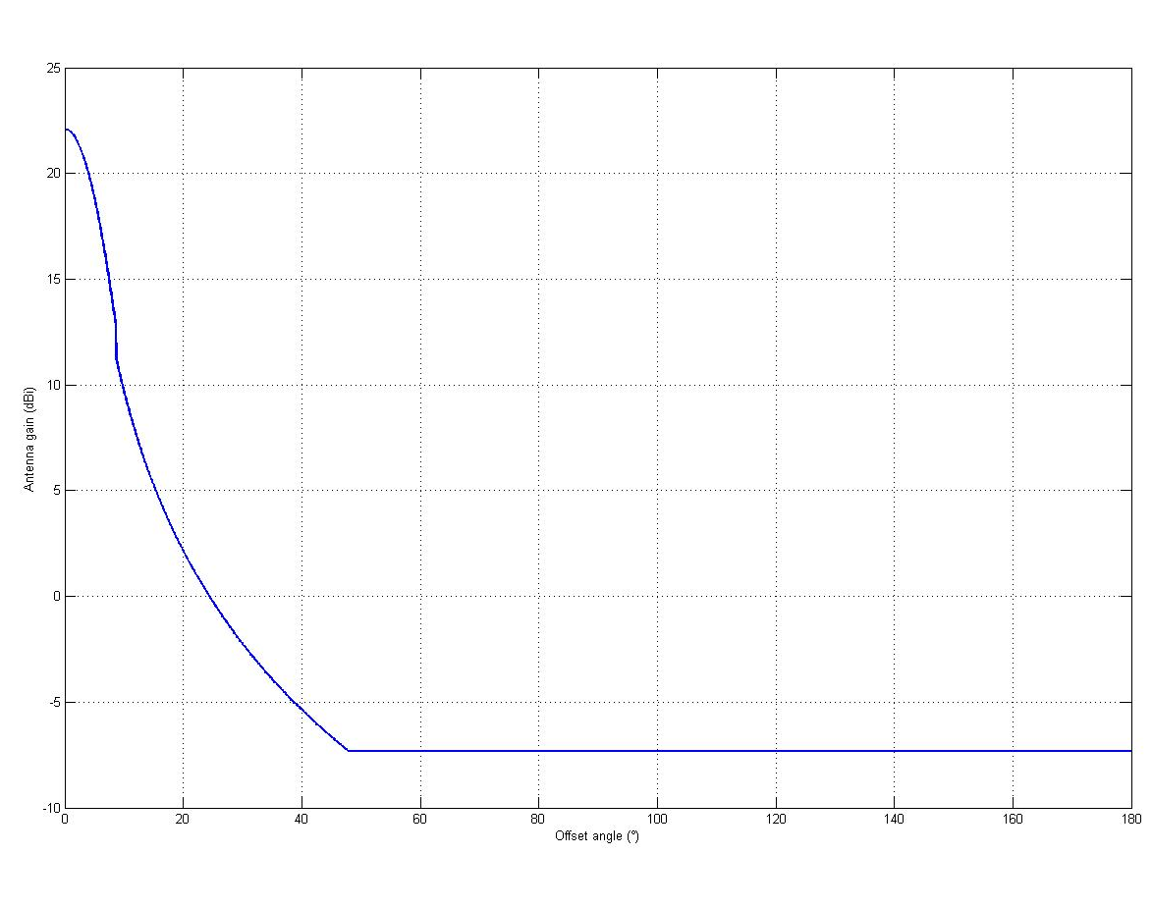
Figure 2: F.1245 Antenna pattern

 | FS parameters
Bandwidth (MHz) | 14
e.i.r.p. (dBW) | 33
e.i.r.p. (dBW/MHz) | 21.5
Antenna height (m) | 15 | 30
Antenna isolation (dB) | 29
Maximum isotropic RNSS interference (dBW/MHz) | -146
Propagation loss (dB) | 138.5
Horizon distance (km) | 13.9 | 19.6
Separation distance (km) – P.452 (0.1%) | 22.6 | 28.0
Separation distance (km) – P.452 (50%) | 13.7 | 17.1
Table 5: Separation distance between a FS transmitter and RDSS receiver in its sidelobes

It is concluded that some interference issues might be encountered in countries using FS in this frequency range, for separation distances lower than 28 km.

Impact of RDSS satellites on FS stations
A simulation tool using the Fractional Degradation of Performance (FDP) described in Recommendation ITU-R F.1108, commonly used for sharing between non-GSO systems and FS applications and more or less based on the long-term protection criterion was used. A FDP criterion of 10% was assumed. The calculation was done for a FS system deployed in United Kingdom for all azimuths of pointing and elevation angles varying from 0 to 5°.
The FS antenna pattern used was based on F.1245 (see Figure 2) including the cross polarization loss.
A pfd value of -126 dBW/m²/MHz similar to the MSS coordination threshold was used as a starting point. The results are given in Figure 3 for a RDSS system having the same orbital characteristics as GPS and a FS system pointing at an elevation angle of 0°.
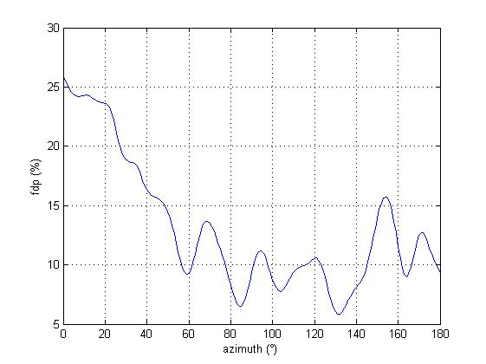
Figure 3: FDP for all azimuth angles for a pfd of -126 dBW/m²/MHz and a FS at 0° elevation

In order to meet the 10% FDP criterion for all azimuths the pfd should be reduced by a factor of 10 log (2.5) which is 4 dB, leading to a pfd value of -130 dBW/m²/MHz..
Another simulation was performed with this pfd value for a FS system pointing at 5° elevation. The results are given in Figure 4.

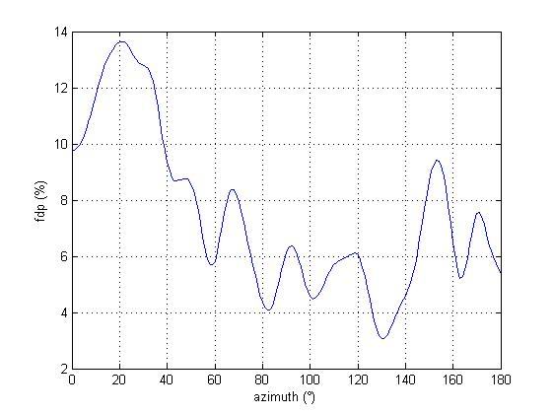
Figure 4: FDP for all azimuth angles for a pfd of -130 dBW/m²/MHz and a FS at 5° elevation

In order to meet the 10% FDP criterion for all azimuths the pfd should be further reduced by a factor of 10 log (1.4) which is 1.5 dB, leading to a pfd value of -131.5 dBW/m²/MHz. If the FDP criterion was to be met only in average on all azimuths, a pfd limit of -129 dBW/m²/MHz would be sufficient.

Conclusion on RDSS-FS compatibility
A pfd limit of -132 dBW/m²/MHz would be sufficient to provide full protection to the FS systems used by worldwide from RDSS systems that may operate in the band 2483.5-2500 MHz for all azimuth pointing angles This limit may be further relaxed to -129 dBW/m²/MHz if the FDP criterion is to be met only in average (i.e. a FDP value of 25% may be accepted for a limited number of azimuths). It should be noted that the GLOBALSTAR system transmitting with a pfd level of
-126 dBW/m²/MHz would only meet the FDP criterion in average.
The RDSS receivers operating in those countries where FS is deployed would have to accept interference at separation distances lower than a few tens of km.

RDSS vs mobile-satellite service
The band is used by GLOBALSTAR only. The orbital characteristics of this system are available either from Recommendation ITU-R M.1184 or from ECC Report 095. The emission e.i.r.p. is available from Recommendation ITU-R M.1184. The protection criterion for the receiver is assumed to be an increase in noise of 6 dB when the terminal is operating with CDMA.

Mobile-Satellite Service characteristics
Table 6 provides the characteristics of the service downlinks of the GLOBALSTAR system, which is currently the only MSS system using the band 2483.5-2500 MHz. The characteristics of this system are available either from Recommendation ITU-R M.1184 or from ECC Report 095.

System  Parameter | D
Service link polarization | LHCP
Frequency Band | 2.5
Shadowed user e.i.r.p. (dBW) | 0-5
e.i.r.p./CDMA channel (dBW) | 0 to 16
User G/T (dB(K^{–1})) | –23
Minimum elevation angle (degrees) | 10
Modulation | QPSK
Coding | FEC
Access scheme | FDMA/CDMA
Duplex scheme | FDD
Chip rate (Mchip/s) | 1.228
Voice activity factor | 0.4
Required E_{b}/N₀ (dB) | 3.5
Table 6: Characteristics of GLOBALSTAR service downlinks

It is proposed to retain a criteria based on an increase in noise of 6% at the GLOBALSTAR Mobile Earth Station (MES) antenna port, corresponding to an I/N ratio of -12 dB.

Globalstar operates so as its power flux density received on the ground is below the threshold given in Appendix 5 of the Radio Regulation: -126 dBW/m²/MHz.
Interference calculations in this document are performed, taking into account this reference value.

Globalstar uses the 2483.5-2500 MHz band for its downlink communications between the satellite and user terminals. The system uses multi-beam antennas to allow frequency reutilization. In every beam, the 16.5 MHz bandwidth is divided into 13 FDM channels, each 1.23 MHz wide, as shown in the Figure 5.
Figure 5: Globalstar FDMA scheme

The following power spectral density (PSD) represents the Globalstar signal for a given k^{th} FDMA channel:

$G_{\text{SRC}}^{k}(f)=\left\{\begin{matrix}1 & & & \text{if} & \left|f−f_{0}−\text{kB}\right|≤\frac{B}{2}(1−ρ) \\ 0 & & & \text{if} & \left|f−f_{0}−\text{kB}\right|≥\frac{B}{2}(1+ρ) \\ 1+\text{cos}(\frac{π}{2{ρf}_{c}}(f−{ρf}_{c}−f_{0}−\text{kB})) & & & \text{if} & \frac{B}{2}(1−ρ)≤\left|f−f_{0}−\text{kB}\right|≤\frac{B}{2}(1+ρ)\end{matrix}\right.$ k=-6…6

where:
- f₀ is the central frequency of the FDMA channel f₀=2491.77MHz .
- f_{c} is the cut-off frequency of the filter, f_{c}=B/2, being B=1.23 MHz the bandwidth of a single FDMA channel.
- ρ the roll-off factor.

Finally, the whole Globalstar signal PSD can be expressed as the sum of the PSDs of the 13 FDMA channels:
$$G_{\text{GLOB}}(f)=\sum_{k=−6}^{6}{G_{\text{SRC}}^{k}(f)}$$

Methodology used
The C/N_{o} degradation is calculated as the difference between the C/N_{o} of the interfered system when there is no external interference and the C/N_{o} taking into account the interfering system.
$${\text{Degradation}}_{\text{dB}}={\left(\frac{C}{N_{0}+P_{0}}\right)}_{\text{dBHz}}−{\left(\frac{C}{N_{0}+P_{0}+I_{0}}\right)}_{\text{dBHz}}={\left(\frac{N_{0}+P_{0}+I_{0}}{N_{0}+P_{0}}\right)}_{\text{dB}}$$
where:
- No is the thermal noise floor (W/Hz).
- Po is the intra-system interference (W/Hz).
- Io is the external interference.(W/Hz).

The external interference level is calculated as follows,
I’_{o}(dBW/Hz)= PSD _{Interf} + Bw + G_{Ant} + SSC
where:
- PSD _{Interf} is the power spectral density of the signal corresponding to the interfering system at the receiver antenna (dBW/MHz).
- Bw the receiver bandwidth (MHz).
- G_{Ant} the receiver antenna gain. Two values have been taken into account: a maximum value of 3 dBi and a middle value of 0 dBi (dB).
- SSC is the Spectral Separation Coefficient between the interfering and the interfered signals (dB/Hz))

In general, SSC is computed through the formula:
$\text{SSC}({\text{dB}}/{\text{Hz}})=\text{10}\text{log}\left[\int_{\text{2483}\text{.}5}^{\text{2500}}{{\text{NSPD}}_{\text{int}\text{erfering}}(f)∗{\text{NSPD}}_{\text{int}\text{erfered}}(f)}\text{df}\right]$
where:
NSPD _{interfering} is the normalized power spectral density of the interfered signal
NSPD _{interfered} is the power spectral density of the interfering signal, normalized in the receiver bandwidth.

The SSC coefficient will not be the same for both directions of the interference (Galileo into Globalstar and vice versa). In the case of the impact of Globalstar into Galileo, it can be expressed as:
$\text{SSC}({\text{dB}}/{\text{Hz}})=\text{10}\text{log}\left[\frac{1}{N_{\text{Glob}}N_{\text{RNSS}}}\sum_{k=−6}^{+6}{\left(\int_{f_{0}−\text{kB}−\frac{B}{2}(1+ρ)}^{f_{0}−\text{kB}+\frac{B}{2}(1+ρ)}{G_{\text{SRC}}^{k}(f)∗{\text{PSD}}_{\text{RNSS}}(f)\text{df}}\right)}\right]$
where:
f₀ is the central frequency of the Globalstar band, f₀ = 2.491.77 MHz
B is the Globalstar FDMA channel bandwidth, B=1.23 MHz
ρ the roll-off factor of the SRC filter (ρ=0,2)
N_{GLOB} and N_{RNSS} normalization factors:
$N_{\text{RNSS}}=\int_{\text{2483}\text{.}5}^{\text{2500}}{{\text{PSD}}_{\text{RNSS}}(f)}\text{df}$
$N_{\text{GLOB}}=\text{13}×\int_{f_{0}−\frac{B}{2}(1+ρ)}^{f_{0}+\frac{B}{2}(1+ρ)}{G_{\text{SRC}}^{0}(f)\text{df}}$
In the case of the impact of Galileo into Globalstar, the Spectral Separation Coefficient can be expressed as:
$\text{SSC}({\text{dB}}/{\text{Hz}})=\text{10}\text{log}\left[\frac{1}{N_{\text{Glob}}N_{\text{RNSS}}}\sum_{k=−6}^{+6}{\left(\int_{f_{0}−\text{kB}−\frac{B}{2}(1+ρ)}^{f_{0}−\text{kB}+\frac{B}{2}(1+ρ)}{G_{\text{SRC}}^{k}(f)∗{\text{PSD}}_{\text{RNSS}}(f)\text{df}}\right)}\right]$
Where:
f₀ is the central frequency of the Globalstar channel
B is the Globalstar FDMA channel bandwidth, B=1.23 MHz
ρ the roll-off factor of the SRC filter (ρ=0,2)
N_{GLOB} and N_{RNSS} normalization factors:
$N_{\text{RNSS}}=\int_{f_{0}−\frac{B}{2}(1+ρ)}^{f_{0}+\frac{B}{2}(1+ρ)}{{\text{PSD}}_{\text{RNSS}}(f)}\text{df}$
$N_{\text{GLOB}}=\int_{f_{0}−\frac{B}{2}(1+ρ)}^{f_{0}+\frac{B}{2}(1+ρ)}{G_{\text{SRC}}^{0}(f)\text{df}}$

where PSD_{RNSS}(f) is the PSD of the Galileo signal which depends on the considered modulation:
BPSK(4): ${\text{PSD}}_{\text{RNSS}}(f)=\frac{1}{4f_{f}}\text{sin}c{\left(\frac{πf}{4f_{f}}\right)}^{2}$ (f_{f}=1.023 MHz)
BPSK(1): ${\text{PSD}}_{\text{RNSS}}(f)=\frac{1}{f_{f}}\text{sin}c{\left(\frac{πf}{f_{f}}\right)}^{2}$
BOC(1.1): ${\text{PSD}}_{\text{RNSS}}(f)=\frac{1}{f_{f}}{\left(\frac{\text{tan}\left(\frac{πf}{f_{f}}\right)\text{sin}\left(\frac{πf}{f_{f}}\right)}{πf}\right)}^{2}$

Simulations have been conducted in order to assess the intra-system interference of Galileo-like RNSS system and Globalstar constellations in S band. The obtained results for the RNSS system show that it is always below -222 dBW/Hz, so this value is assumed as a worst case, while for Globalstar it is below -220 dBW/Hz 95% of the time, and reaches a maximum value of -205 dBW/Hz

A typical noise PSD of -201.5 dBW/Hz has been considered

Impact of MSS mobile earth stations on RDSS receivers
Calculations in the tables below are done using methodology described in 3.2.2.

- Galileo C/No degradation (3 dB antenna gain):

 | BPSK(1) | BPSK(4) | BPSK(8) | BOC(1,1)
PSD_{GLOB}(dBW/MHz) | -155.4
Maximum number of satellites in view | 4
Cumulated PSD [dBW/MHz] | -149.4
G_{Ant}(dB) | 3
BW(MHz) | 2.046 | 8.184 | 16.368 | 4.092
SSC(dB/Hz) | -72.4 | -72.3 | -72.0 | -72.5
Io’(dBW/Hz) | -215.7 | -209.5 | -206.2 | -212.8
Po(dBW/Hz) | -222
No(dBW/Hz) | -201.5
C/No deg.(dB) | 0.16 | 0.63 | 1.26 | 0.31
Table 7: Galileo C/No worst case degradation due to Globalstar emissions

- Galileo C/No degradation (0 dB antenna gain):
 | BPSK(1) | BPSK(4) | BPSK(8) | BOC(1,1)
PSD_{GLOB}(dBW/MHz) | -155.4
Maximum number of satellites in view | 4
Cumulated PSD [dBW/MHz] | -149.4
G_{Ant}(dB) | 0
BW(MHz) | 2.046 | 8.184 | 16.368 | 4.092
SSC(dB/Hz) | -72.4 | -72.3 | -72.0 | -72.5
Io’(dBW/Hz) | -218.7 | -212.5 | -209.2 | -215.8
Po(dBW/Hz) | -222
No(dBW/Hz) | -201.5
C/No deg.(dB) | 0.08 | 0.33 | 0.68 | 0.16
Table 8: Galileo C/No degradation due to Globalstar emissions

Impact of RDSS satellites on MSS mobile earth stations
The interference from a RNSS system to Globalstar has been first assessed using an I/N criterion and assuming a receiver bandwidth equal to one Globalstar FDMA channel width (1.23 MHz).
Assuming an omnidirectionnal antenna for the MES, the interference received at the antenna port of the MSS MES receiver in one frequency channel is given by:
$$I=\text{apfd}\frac{G_{r}λ^{2}}{4π}$$
where:
apfd : Aggregate pfd from all RNSS satellites in visibility of the MSS receiver (W/m²)
Gr : MES antenna gain (assumed constant)
λ : Wavelength (m) at 2.5 GHz

The thermal noise power of the MES receiver is given by:
$$N=\text{kTB}$$
where:
k : Boltzman constant (1.38e⁻²³ J/K)
T : Total noise temperature (K)
Β : Channel bandwidth (Hz)

Therefore, using the same parameters,
$$\frac{I}{N}=\text{apfd}\frac{G_{r}}{T}\frac{λ^{2}}{4πk}\frac{1}{B}$$

Expressed in dB and in a reference bandwidth of 1 MHz:
$$\text{apfd}=\frac{I}{N}−\frac{G_{r}}{T}−\text{10}\text{log}\left(\frac{λ^{2}}{4πk}\right)+\text{60}$$

In order to respect an I/N ratio of -12 dB, the aggregate pfd generated at one point on the ground by all satellites from all RNSS systems in visibility of this point at one moment in time should therefore be limited to a value of -128.2 dBW/m²/MHz.

To derive the pfd for each satellite, it is necessary to estimate the number N of satellites visible at any location considered on Earth. Then, assuming a constant pfd for each satellite, we can easily derive the pfd from the aggregate
pfd:$\text{PFD}=\text{apfd}−\text{10} {\text{log}}_{\text{10}}(N)$

Considering a maximum of 12 satellites in visibility, the PFD per satellite should therefore be limited to -139
dBW/m²/MHz.

However, it is possible to refine the study using the actual waveform of the RNSS signal and the methodology defined in 3.2.2.

- Globalstar C/No degradation (3 dB antenna gain):

 | BPSK(1) | BPSK(4) | BPSK(8) | BOC(1,1)
GALILEO pfd per satellite (dBW/m²/MHz) | -129
PSD_{GAL}(dBW/MHz) | -158.4
G_{Ant}(dB) | 3
Maximum number of satellites in view | 12
Maximum GALILEO aggregate pfd (dBW/m²/MHz) | -118.2
Bw(MHz) | 1.23
SSC(dB/Hz) | -60.66 | -60.05 | -60.01 | -61.40
Io’(dBW/Hz) | -204,36 | -203.75 | - -203.71 | -205.10
No(dBW/Hz) | -203.83
C/No deg.(dB)  Po=-220 dBW/Hz  (95% of time) | 2.70 | 3.00 | 3.02 | 2.38
C/No deg.(dB)  Po=-205 dBW/Hz  (worst case) | 1.77 | 1.98 | 1.99 | 1.53
Table 9: Globalstar C/No worst case degradation due to RNSS emissions

- Globalstar C/No degradation (0 dB antenna gain):

 | BPSK(1) | BPSK(4) | BPSK(8) | BOC(1,1)
Aggregate GALILEO pfd (dBW/m²/MHz) | -129
PSD_{GAL}(dBW/MHz) | -158.4
G_{Ant}(dB) | 0
Maximum number of satellites in view | 12
Maximum GALILEO aggregate pfd (dBW/m²/MHz) | -118.2
Bw(MHz) | 1.23
SSC(dB/Hz) | -60.66 | -60.05 | -60.01 | -61.40
Io’(dBW/Hz) | -204,36 | -203.75 | -203.71 | -205.10
No(dBW/Hz) | -203.83
C/No deg.(dB)  Po=-220 dBW/Hz  (95% of time) | 1.56 | 1.76 | 1.77 | 1.35
C/No deg.(dB)  Po=-205 dBW/Hz  (worst case) | 0.97 | 1.10 | 1.11 | 0.84
Table 10: Globalstar C/No degradation due to RNSS emissions

Conclusion on RDSS-MSS compatibility
With the purpose of assessing a worst case interference, calculations have been performed based on maximum pfd value of -126 dBW/m²/MHz (corresponding to the threshold value of RR Appendix 5) for Globalstar and maximum pfd value of -129 dBW/m²/MHz for Galileo satellites.

From Tables 9 and 10, we see that Galileo degrades the C/N0 of Globalstar. These calculations have been done in a worst case considering 12 Galileo Satellites in visibility with the same PFD value for each satellite. In reality, in many locations on Earth, the number of satellite in visibility is less important and the terrain shielding will add attenuation for satellites seen from low elevation angles. On the other hand, Tables 7 and 8 show that Globalstar signal induces degradations in the order of some tenths of dBs to Galileo (1,2 dB in the worst case, corresponding to a BPSK(8)). Based on these results, additional measures may be needed to overcome the additional degradation caused by RDSS systems on MSS receivers.

RDSS vs mobile service
The band 2483.5-2500 MHz is extensively used by Services Ancillary to Broadcasting (SAB), Services Ancillary to Programme-making (SAP), Electronic News Gathering (ENG) and Outside Broadcasting (OB). This band is also planned for the use of WIMAX applications in the US.

Mobile Service characteristics

SAB/SAP systems
In the analysis, we consider typical radio camera operating with parameters according to ERC Report 038 and ECC Report 006. The transmitter parameters are given in Table 11.

Field | Value | Comments
Bandwidth (MHz) | 8 MHz | DVB-T standard channel width
e.i.r.p. (dBW) | 0 | This value is appropriate for digital links based on DVB-T with a bandwidth of 8MHz. Previously, a power of 6 dBW was typical  However, this was for analogue systems with a bandwidth of 20 MHz.
Antenna pattern | Isotropic | From ERC Report 38
Antenna height (m) | 2 | The antenna is typically higher than the average mobile height in order to improve the probability of a line-of-sight path to the receiver.
Table 11: Radio Camera Parameters

Typical SAB/SAP scenarios generally involve wireless cameras which can be hand-held, mounted on a vehicle or in some cases airborne. The signals from these cameras are received by a suitable receiver mounted on a tripod, vehicle, mast or other structure. Recent information from operators suggests that, currently, extensive use is made of omni-directional receiving antennas. However, various types of directional receiving antenna may also be used. This document, then, considers the omni-directional antenna and three different types of directional antenna that may be used.

In performing a compatibility analysis it is necessary to select a suitable interference criterion. SAP/SAB systems will be deployed in a wide range of locations on an ad-hoc and random basis that cannot be co-ordinated. Consequently, the received signal levels and associated C/N values will be largely unknown and will vary between different deployment scenarios and may also change dynamically as a camera moves to follow an event. A criterion based on C/N is, therefore, not suitable in this case. A C/I ratio has been proposed as an alternative. However, this will also vary between different deployment scenarios and may also change dynamically as a camera moves to follow an event. We require a measure that limits the loss of noise margin, and relates directly to the operating range of the systems and hence the loss of operational flexibility regarding the location of receivers and coverage area for cameras. A criterion of I/N is appropriate and -6 dB has, therefore, been selected. This corresponds to a loss of noise margin of about 0.4 dB.

When considering the aggregate interference from several interference sources, for a dish antenna, a pattern similar to Recommendation ITU-R F.1245 should be used. This pattern shows sidelobes as low as -6 dBi for a 21 dBi maximum antenna gain. The following figure shows such a pattern.
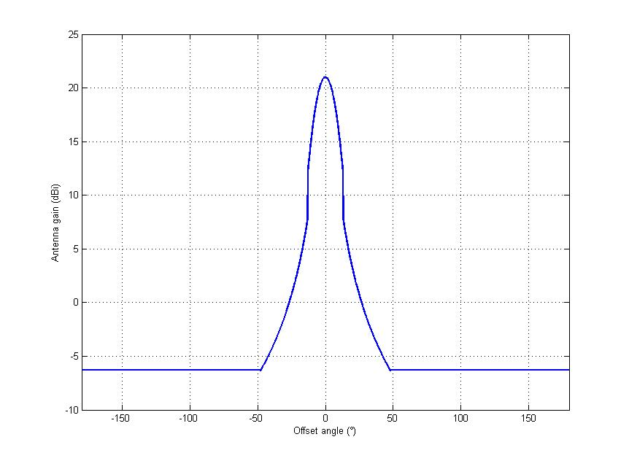
Figure 6: Recommendation ITU-R F.1245 antenna pattern for a nominal gain of 21 dBi

WIMAX systems
WIMAX parameters are likely the same as the one used in the adjacent band 2500-2690 MHz and can be found in Report ITU-R M.2116.

Table 12 summarized those parameters.

 | Base Station | Mobile Station
Channel bandwidth (MHz) | 5*
Average Power (dBm) | 36 | 20
Antenna Gain (dBi) | 18 | 0 to 6
Antenna height (m) | 15 to 30 | 1.5
Line loss (dB) | 2 | 0
Noise figure (dB) | 3 | 5
Thermal Noise (dBW/Hz) | -204 | -204
Interference criterion, I/N (dB) | -6 or -10 | -6 or -10
Max tolerable interference power dBW | -140 or -144 | -138 or -142
Table 12: WIMAX parameters
* While other nominal channel bandwidths are allowed in the standard IEEE 802.16e, 5 MHz was chosen as a typical configuration for the 2.5 GHz frequency band.

VICS characteristics
The Vehicle Information and Communication System (VICS) is operated in Japan. Its characteristics are the following:

Technical Characteristics | Value
Center frequency (MHz) | 2499.7
Signal bandwidth (kHz) | 85
Modulation | GMSK
Antenna type | Omni-directional
Antenna gain (dBi) | -2 (typical)
Noise figure (dB) | 6.0 (typical)
Operating temperature range (degree C) | -30 to +85  +25 (typical)
Table 13: Example of technical characteristics of VICS for sharing study

Item | Value
Temperature (degree C) | 25
Bandwidth of VICS receivers (kHz) | 85
Noise figure (dB) | 6.0
Noise level of VICS receivers (dBW/85kHz) | -148.6
Table 14: Noise power at receiver

Impact of MS transmitters on RDSS receivers

In case of SAP/SAB systems
The analysis was performed using propagation models contained in Recommendation ITU-R P.1411. These were chosen because they can model situations where both terminals are below the height of local clutter. Two different propagation environments were considered. The first of these was the line of sight case within street canyons using Section 4.1 of the Recommendation. The second was the case of non-line of sight with terminals below the height of clutter using Section 4.3 of the Recommendation. These may be regarded as extremes and propagation for a SAP/SAB deployment is likely to fall between (depending on the nature of the specific location.)

The interference analysis is given in Table 15. From this analysis it is clear that a wireless camera operating in the band 2483.5-2500 MHz has the potential to interfere with an RDSS receiver operating in the same band over a significant area.

Technical parameter | Value
Frequency (MHz) | 2500
SAP/SAB e.i.r.p (dBW/8MHz) | 0
Maximum RDSS interference at antenna output (dBW/1MHz)  (From Annex 7 of ITU-R WP4C Document 66) | -146.0
RDSS antenna gain (dB) | 0
Maximum isotropic RDSS interference (dBW/1MHz) | -146.0
Bandwidth Correction (dB) | 9.0
Propagation loss (dB) | 137.0
Separation distance – free space (km) | 67.3
Separation distance - Line of Sight in street canyons (km) | 5
Separation distance - Non line of sight 50% locations (km) | 0.21
Separation distance - Non line of sight 50% locations 10% locations (km)Error: Reference source not found | 0.35
Separation distance - Non line of sight 50% locations 50% locations (km)Error: Reference source not found | 1
Table 15: Calculation of interference distances for wireless cameras interfering with RDSS

From the results it can be seen that RDSS reception is incompatible with SAP/SAB emissions for distances within 5 km in urban areas where a line of sight path exists. Where the interference path is obstructed by buildings the interference distance will depend on the nature of the buildings. In 50% of cases the distance would be around 200 metres or less. However, in 1% of cases interference could still occur at up to 1 km. In metropolitan areas, the SAP/SAB interference is limited by building obstructions. However, even in such heavily cluttered areas, interference is likely at distances in excess of 300 metres.

In case of WIMAX systems:
This study has been carried out using the SEAMCAT software and the Monte-Carlo simulations.

In order to determine separation distances for the WIMAX study, the “relative position mode” such as “VRx → ITx” (RNSS (Victim receiver) and WIMAX MS (Interfering transmitter)) was chosen to simulate the separation distance between RNSS receiver and WIMAX UE. The interference probabilities are determined depending on the separation distances.

The following criteria has been used for the protection of RNSS receivers, in line with section 2.2
Interference criterion (acquisition mode):  - threshold power level of aggregate narrow-band interference at the passive antenna output (dB(W/MHz)) | -146
- to be met for | 95% locations for mobile receivers
Table 16: RNSS protection criteria

For the purposes of this study the interference criterion which correspond to the BPSK(1) signal modulation case was considered as an example.
Separation distances are calculated using Extended-Hata and Free space propagation models provided in the table below:

 | WIMAX Mobile Station
Transmit power (dBm) | 20 dBm
Channel bandwidth (MHz) | 5 MHz
Antenna gain, dB | 0 | 3 | 6
Separation distance - Extended-Hata model (rural) (km) | 2.7 | 3.2 | 4
Separation distance - Free space model (km) | 47 | 65 | 91.5
Table 17: Calculated separation distances between RNSS receiver and WIMAX site

In case of the VICS system:
Since this system is only operated in Japan, this impact was not assessed.

Impact of RDSS satellites on MS receivers

In case of SAP/SAB systems:
Table 18 below gives a calculation of the maximum interference in an 8 MHz channel at the input to the SAP/SAB receiver, assuming the receiver characteristics specified in ERC Report 38. This analysis is based on an I/N ratio of -6dB.
Technical parameter | Value
Frequency (MHz) | 2500
Boltzmanns Constant (dB) | -228.6
Receiver noise temp (dBk) | 32
Bandwidth (dBHz) | 69
Receiver noise (dBW/8MHz) | -127.6
I/N (dB) | -6
Maximum interference into the SAP/SAB receiver (dBW/8MHz) | -133.6
Table 18: Calculation of interference distance between SAP/SAB and RDSS
This value of maximum interference can be used to calculate the maximum PFD per satellites at the SAP/SAB receiver in dBW/m²/MHz.

The RNSS system is assumed to consist of a constellation of low earth orbit satellites such that a maximum of 12 satellites are visible in the sky at any given time. Of these, one or several satellites may or may not fall in the main beam of the SAB/SAP receiving antenna, depending on its alignment. Clearly, a higher level of interference will occur if this is the case. Consequently, this is the case that will be considered.

In the analysis it will also be assumed that the satellite in the main beam will produce a signal at the output of the SAB/SAP antenna according to the nominal gain of the antenna and all satellites not in the main beam will be subject to an attenuation equivalent to the highest side lobe level relative to the nominal gain.
In the case of the omni-directional antenna we assume that all satellites are in the main beam of the antenna. Consequently, all satellites will produce an output from the antenna corresponding to its nominal gain. In reality, the antenna is only omni-directional in the horizontal plane and the gain would be lower for satellites with increasing elevation angle. The effect of this simplification would be a slight overestimation of interference.
Table 19 gives the maximum Power Flux Density (PFD) per satellite in order for the maximum interference into the receiver derived in Table 18 to be met.

Antenna type | Omni Dipole | Hand-held helix | Disk yagi | 0.6 metre dish
SAP/SAB Antenna gain (dBi) | 3 | 12 | 16 | 21
Number of on-axis satellites | 12 | 2/3 | 1 | 0/1
Maximum sidelobe relative using Recommendation ITU-R F.1245 (dB) | - | -16 | -21 | -27
Off axis gain (dBi) | - | -4 | -5 | -6
Number of off-axis satellites | 0 | 10/9 | 11 | 12/11
Aggregate gain - 12 satellites (dBW/8MHz)  (Ratio of power at SAB/SAP receiver input/Maximum isotropic power per satellite) | 13.8 | 15.5/17.1 | 16.4 | 4.8/21.1
Maximum total interference power at SAP/SAB receiver input (dBW/8MHz) | -133.6 | -133.6 | -1337.6 | -133.6
Maximum isotropic power per satellite (dBW/8MHz) | -147.4 | -149.1/-150.7 | -151.0 | -138.4/-154.7
Maximum isotropic power per satellite (dBW/MHz) | -156.4 | -158.1/-159.7 | -160.0 | -147.4/-163.7
Maximum PFD/Satellite (dBW/m²/MHz) | -127.0 | -128.7/-130.3 | -129.6 | -118.0/-134.3
Table 19: Maximum PFD per RDSS satellite that will still protect SAB/SAP

It can be seen that, due to higher gain, the more directional antennas are more susceptible to interference from RDSS. However, this is only when a satellite is in the main beam of the antenna. Table 20 gives an estimate of the probability of this occurring at any given time for an antenna directed in a random direction towards the sky. This is based on the ratio of the solid angle of the receiving antenna beam to the solid angle of a hemisphere (2π steradians). Assuming that 12 satellites are visible in the sky this ratio is multiplied by 12.

Antenna | Handheld Helix | Disc Yagi | 0.6 metre dish
3 dB beam width (degrees) | 40 | 40 | 14
Solid angle (steradians) | 0.38 | 0.38 | 0.047
Probability based on one satellite | 0.060 | 0.060 | 0.0075
Probability based on 12 satellites | 0.72 | 0.72 | 0.09
Table 20: Probability of an RDSS satellite falling within the main beam of a SAP/SAB receiving antenna

For the Handheld Helix and Disc Yagi antennas it is highly likely that a satellite will be in the beam of the antenna. In the case of the dish antenna it is much less likely due to the narrow beam-width, but would still occur for an estimated 9% of time. While a satellite is in the beam of a dish antenna the system may be susceptible to interference. However, in view of the relatively infrequent use of such antennas this is not seen as a major issue.
It is, therefore, proposed that a maximum PFD of -130 dBW/m²/MHz should be used to protect SAP/SAB systems using the same polarisation as the RNSS system. If SAP/SAB are using a linear polarisation, this PFD value may be further relaxed by 2 dB at least, leading to -128 dBW/m²/MHz.”

As stated, the omnidirectional is the most common antenna used for SAP/SAB systems. Since we have assumed that such an antenna will receive signals from all 12 satellites, we can easily calculate the equivalent PFD for interference from a single satellite (e.g. MSS) by using a correction factor of 10.8 dB. This leads to a value of -117.2 dBW/m²/MHz.
In addition, it should be remembered that the analysis assumes that the antenna has a clear view of the whole sky. Although this is possible, in many cases some of the sky could be obscured by buildings/trees etc.

In case of WIMAX systems:
The interference level at WIMAX receiver is calculated by assessing the level of emissions from Galileo satellites falling within the receiver bandwidth according to:

$$I=P_{r}+G_{\text{agg}}+L_{\text{pol}}+K_{\text{\%}}$$

$P_{r}$ is the received Galileo power per satellite at the receiver antenna input.
$G_{\text{agg}}$ is the aggregated gain taking into account the maximum possible number of satellites in view (12 satellites for the Galileo constellation).
$L_{\text{pol}}$ are the polarization mismatch losses, assumed 3dB
$K_{\text{\%}}$ is the percentage of power that falls within the receiver bandwidth. It is calculated as follows:
$$K_{\text{\%}}=\frac{\int_{5\text{MHz}}{\text{PSD}(f)\text{df}}}{\int_{\text{16}\text{.}5\text{MHz}}{\text{PSD}(f)\text{df}}}$$

where PSD(f) is the theoretical power spectrum density of the modulation.

The received power at base station level and at mobile station, in function of maximum PFD in dBW/m2/MHz for several hypotheses of Galileo spectrum are given on the figures hereafter:
Figure 7: Received power of the Base station vs GALILEO PFD | Figure 8: Received power of the Mobile station vs GALILEO PFD

With the hypothesis that GALILEO max PFD is –129 dBW/m2/MHz:

Modulation | BPSK(1) | BPSK(4) | BPSK(8) | BOC(1,1)
Pr Mobile Station [dBW] | -154.1 | -148.1 | -145.1 | -151.6
Pr Base Station [dBW] | -142.1 | -136.1 | -133.1 | -139.6
Table 21: Received power level for a maximum PFD of –129 dBW/m2/MHz
From the table above and considering the tolerable interference power for a mobile station, defined in Table 11, it can be concluded that mobile station will not suffer any interference from RDSS satellites.

The study needs to be refined in the case of a base station.
In the analysis further led, the GALILEO constellation is emulated and statistics are performed to assess the interference from GALILEO to WIMAX in S band.
A more realistic scenario is thus considered that takes account of the elevation angle with which the satellite signal is received. For that purpose, the elevation angle between the base station and GALILEO satellites has been determined at each latitude and longitude over the whole surface, with a 1° step in latitude during 24 hours.

The considered antenna gain pattern is the sectoral one taken from Recommendation ITU-R F.1336-2.
The obtained results are given on the figures below:

Figure 9: mean interference power at Base station vs GALILEO PFD

Figure 10: mean I/N at Base station vs GALILEO PFD

In the following section, the probability distribution of the interference power is determined for the different modulations and for several assumptions of GALILEO max pfd. On the figures that follow, the ordinate gives the probability that the interference power indicated by the abscissa be exceeded in percentage of time. The WIMAX station is located at latitude: 40° N and longitude: 100° and PFD level fixed at -129 dBW(m².MHz).

Figure 11: Impact of a GALILEO type RDSS system on WIMAX for different modulations
At this location, with BOC(1,1) modulation, the threshold is reached less than 1.4% of the time. With BPSK(1) modulation, the threshold is not reached.

With modulation such as BPSK(4) and BPSK(8), WIMAX Base Station would suffer some in-band interference from RDSS satellites.

In case of the VICS system:
The tolerable interference level is set so that the threshold of -6 dB for the I/N ratio is not exceeded.
A receiver is said to be unavailable if the interference power threshold is exceeded.

The interference level at VICS receiver is calculated by assessing the level of emissions from Galileo satellites falling within the receiver bandwidth according to:

$$I=P_{r}+K_{\text{\%}}$$

$P_{r}$ is the received Galileo power per satellite at the receiver antenna input.
$K_{\text{\%}}$ is the percentage of power that falls within the receiver bandwidth. It is calculated as follows:
$$K_{\text{\%}}=\frac{\int_{\text{85}\text{kHz}}{\text{PSD}(f)\text{df}}}{\int_{\text{16}\text{.}5\text{MHz}}{\text{PSD}(f)\text{df}}}$$

where PSD(f) is the theoretical power spectrum density of the modulation.

No polarization losses have been considered in this study.

The associated spectra are represented in the figures that follow.

Figure 12: Frequency position of the VICS system with regard to the RDSS signal

The received power is derived from the PFD value in dBW/m2/MHz for Galileo emissions.

Figure 13: Interference level from one Galileo satellite at VICS receiver vs GALILEO PFD

With the hypothesis that GALILEO max PFD is –129 dBW/m2/MHz:

Modulation | BPSK(1) | BPSK(4) | BPSK(8) | BOC(1,1)
Interference power at VICS rx [dBW] | -199.8 | -199 | -199 | -208.1
Table 22: Interference power level for one Galileo satellite with a maximum PFD of –129 dBW/m2/MHz

To consider a worst case regarding Galileo satellites visibility, an aggregate gain Gagg of 10.8 dB (corresponding to 12 satellites in visibility) is added to the Interference power level value due to one satellite:
Figure 14: Interference level (12 satellites in visibility) at VICS receiver vs GALILEO PFD

Modulation | BPSK(1) | BPSK(4) | BPSK(8) | BOC(1,1)
Interference power at VICS rx [dBW] | -187.8 | -187 | -187 | -196.1
Table 23: Total Interference power level (12 satellites in visibility) with a maximum PFD of –129 dBW/m2/MHz

The tolerable interference power corresponding to a I/N ratio of –6 dB is –154.6 dBW. The evaluated interference power is much lower than this threshold. There is no in-band interference due to GALILEO and hence no induced loss of availability of VICS service. The VICS system should not suffer in-band interference from Galileo.

Conclusion on RDSS-MS compatibility
The general conclusion from these studies is that it is highly unlikely that SAP/SAB systems or WIMAX systems will experience interference from RDSS systems in the band 2483.5-2500 MHz. The same applies for the VICS system.
The study provides a maximum PFD value per RDSS satellites of -130 dBW/m²/MHz in order to avoid causing interference to mobile or fixed (SAP/SAB) receivers operating in the band 2483.5-2500 MHz with the same polarisation. Considering that SAP/SAB are mainly using a linear polarisation, this PFD value could be further relaxed by 2 dB at least, leading to -128 dBW/m²/MHz.
It also provides a maximum PFD value per RDSS satellites of -129 dBW/m²/MHz in order to avoid causing interference to WIMAX receivers, in case of in-band scenario. Since WIMAX operating in the band 2483.5-2500 MHz in some countries outside CEPT would be protected using this pfd limit, it can be concluded that WIMAX operating above 2500 MHz in CEPT countries will also be protected with some margin because of the additional out-of-band attenuation.
It is also shown that there is a high probability of interference from SAB/SAP transmitters, such as wireless cameras operating in the band 2483.5-2500 MHz, to any future RDSS receivers operating in the same band.
Since WIMAX and VICS are used in the band 2483.5-2500 MHz in a limited number of countries outside CEPT, those systems will not have any impact on RDSS receivers deployed within CEPT countries.

RDSS vs radiolocation service

Radiolocation characteristics

No. | Characteristics | Radar type 1 | Radar type 2 | Radar type 3
1 | 2 | 3 | 4 | 5
1 | Carrier bandwidth, MHz | 0.635 | 10 | 15
2 | Max. e.i.r.p., dBW | 94.7 | 96 | 78
3 | Modulation | Pulsed | Non-linear FM, pulsed | Pulsed
4 | C/N, dB | 6 | –6 | –7
5 | Interference criteria I/N, dB | –6 | –6 | –6
6 | Antenna characteristics
6.1 | Antenna type | Parabolic reflector | Planar array or parabolic reflector | Parabolic reflector
6.2 | Antenna main beam gain, dBi | 33.5 | 43 | 34
6.3 | Antenna polarization | Vertical or circular | Linear or circular | Vertical or circular
6.4 | Elevation beam width (degrees) | 1.5 … 30 | 1.5 … 30 | 1.5 … 30
6.5 | Azimuthal beam width (degrees) | 1.1 … 2 | 1.1 … 2 | 1.1 … 2
6.6 | Horizontal scan rate (degrees/s) | 75 … 90 | 75 … 90 | 75 … 90
6.7 | Vertical scan rate (degrees/s) | - | - | -
7 | Pulse repetition rate (pps) | 700 … 1500 | 700 … 1500 | 700 … 1500
Table 24: Preliminary typical characteristics of the radiolocation service in the frequency band 2483.5-2500 MHz

Impact of RLS transmitters on RDSS receivers
This impact was not assessed. However, any impact of pulsed radars on RDSS receivers may be suppressed using mitigation techniques such as pulse blanking, as already used in the band 1215-1300 MHz.

Impact of RDSS satellites on RLS receivers

First study

Methodology
For the purpose of assessing the level of interference from Galileo, the Galileo constellation was modelled.

The tolerable interference level is set so that the threshold of -6 dB for the I/N ratio is not exceeded.
The I/N ratio is computed considering that the receiver inherent noise level N is:
N= -174 dBW + 10.log(B_rx)+NF
with
B_rx : the receiver bandwidth
NF : the receiver noise figure in dB

At each time step, the interference level is computed and the availability of the radar is determined. Then statistics are used to assess the percentage of time that the radar is available at the considered location.
A radar is said to be unavailable if the interference power threshold is exceeded.

The interference level at a radar receiver is calculated by assessing the level of emissions from Galileo satellites falling within the receiver bandwidth according to:

$$I=P_{r}−L_{\text{rx}}+K_{\text{\%}}$$
$P_{r}$ is the received Galileo power per satellite at the receiver antenna input.
$L_{\text{rx}}$ refers to insertion losses at receiver level assumed 2 dB in the simulations
$K_{\text{\%}}$ is the percentage of power that falls within the receiver bandwidth. It is calculated as follows:

$$K_{\text{\%}}=\frac{\int_{5\text{MHz}}{\text{PSD}(f)\text{df}}}{\int_{\text{16}\text{.}5\text{MHz}}{\text{PSD}(f)\text{df}}}$$

where:
PSD(f) is the theoretical power spectrum density of the modulation.
The received power is derived from the PFD value in dBW/m2/MHz for Galileo emissions

Radar antenna pattern
The antenna pattern taken for the analysis is the cosecant squared pattern recommended in Recommendation ITU-R M.1851: “Mathematical model for radiation patterns for radar antennas for use in interference assessment”:
The formula for this pattern is recalled hereafter:

$$\begin{aligned}h\left(θ\right)=\frac{\text{sin}\left[2\text{.}\text{7831}\left(\frac{θ}{θ_{3}}\right)\right]}{2\text{.}\text{7831}\left(\frac{θ}{θ_{3}}\right)} \\ \end{aligned}$$
where:
θ_{Max} is the csc² pattern maximum angle
θ is the off-axis angle
θ3 is the 3 dB beamwidth

Results
In this set of simulations, the GALILEO constellation is modelled for duration of 10 days with a step of 1 second.

Specific locations:
Location:
Latitude: 40° N
Longitude: 100° W
GALILEO PFD: -129 dBW/m2/MHz

 | Radar type 1 | Radar type 2 | Radar type 3
Elevation beam width (degrees) | 30 | 30 | 30
Azimuthal beam width (degrees) | 2 | 2 | 2
Horizontal scan rate (degrees/s) | 90 | 90 | 90
Max tolerable interference power in dBW | -150.4 | -136 | -134.2
Radar availability with BPSK(1) modulation for GALILEO signal | 100% | 100% | 100%
Radar availability with BPSK(4) modulation for GALILEO signal | 100% | 99.3% | 100%
Radar availability with BPSK(8) modulation for GALILEO signal | 100% | 99.2% | 100%
Radar availability with BOC(1,1) modulation for GALILEO signal | 100% | 99.6% | 100%
Table 25: Results for a longitude of 100°W and latitude of 40°N and a pfd of -129 dBW/M²/MHz

Location:
Latitude: 50° N
Longitude: 40° E
GALILEO PFD: -129 dBW/m2/MHz

 | Radar type 1 | Radar type 2 | Radar type 3
Elevation beam width (degrees) | 30 | 30 | 30
Azimuthal beam width (degrees) | 2 | 2 | 2
Horizontal scan rate (degrees/s) | 90 | 90 | 90
Max tolerable interference power in dBW | -150.4 | -136 | -134.2
Radar availability with BPSK(1) modulation for GALILEO signal | 100% | 100% | 100%
Radar availability with BPSK(4) modulation for GALILEO signal | 100% | 99.3% | 100%
Radar availability with BPSK(8) modulation for GALILEO signal | 100% | 99.2% | 100%
Radar availability with BOC(1,1) modulation for GALILEO signal | 100% | 99.6% | 100%
Table 26: Results for a longitude of 40°E and latitude of 50°N and a pfd of -129 dBW/M²/MHz

Location:
Latitude: 55° N
Longitude: 100° E
GALILEO PFD: -129 dBW/m2/MHz

 | Radar type 1 | Radar type 2 | Radar type 3
Elevation beam width (degrees) | 30 | 30 | 30
Azimuthal beam width (degrees) | 2 | 2 | 2
Horizontal scan rate (degrees/s) | 90 | 90 | 90
Max tolerable interference power in dBW | -150.4 | -136 | -134.2
Radar availability with BPSK(1) modulation for GALILEO signal | 96.1% | 96.1% | 97.5%
Radar availability with BPSK(4) modulation for GALILEO signal | 97.2 % | 96% | 96.4 %
Radar availability with BPSK(8) modulation for GALILEO signal | 97.5 % | 96% | 96.2 %
Radar availability with BOC(1,1) modulation for GALILEO signal | 99.9 % | 96% | 97 %
Table 27: Results for a longitude of 100°E and latitude of 55°N and a pfd of -129 dBW/M²/MHz

Statistical approach:

In the following section, the interference power was determined at several points on the Earth's surface (spaced by 10°), forming a grid.

• using radar 2 type
The hypotheses for the simulation are shown in the following table:

Radar type | 2
Elevation beam width (degrees) | 15
Azimuthal beam width (degrees) | 1.5
Horizontal scan rate (degrees/s) | 75
Table 28: Assumptions taken for radar 2 antenna

Radar type 2 with the maximal antenna gain is considered.

The minimum availability over the Earth's surface is given on the following table for each modulation:
Min Radar availability with BPSK(1) modulation for GALILEO signal | 95.8%
Min Radar availability with BPSK(4) modulation for GALILEO signal | 95.3%
Min Radar availability with BPSK(8) modulation for GALILEO signal | 95.3%
Min Radar availability with BOC(1,1) modulation for GALILEO signal | 98.4%
Table 29: Minimum radar 2 availability

At worst, the radar is unavailable, 5% of the time for the BPSK(8) case.

The mean availability over the Earths' surface is given on the following table for each modulation:
Mean Radar availability with BPSK(1) modulation for GALILEO signal | 98.4%
Mean Radar availability with BPSK(4) modulation for GALILEO signal | 98.3%
Mean Radar availability with BPSK(8) modulation for GALILEO signal | 98.2 %
Mean Radar availability with BOC(1,1) modulation for GALILEO signal | 97.7%
Table 30: Mean radar 2 availability

If considering the mean values, the radar unavailability falls to 2.3% for the BPSK(8) case.

• using radar 3 type
A second simulation was run considering a type 3 radar. The hypotheses for the simulation are shown in the following table:

Radar type | 3
Elevation beam width (degrees) | 15
Azimuthal beam width (degrees) | 1.5
Horizontal scan rate (degrees/s) | 75
Table 31: Assumptions taken for radar 3 antenna

The minimum availability over the Earth's surface is given on the following table for each modulation:
Min Radar availability with BPSK(1) modulation for GALILEO signal | 98%
Min Radar availability with BPSK(4) modulation for GALILEO signal | 96.7%
Min Radar availability with BPSK(8) modulation for GALILEO signal | 96.2%
Min Radar availability with BOC(1,1) modulation for GALILEO signal | 97.5%
Table 32: Minimum radar 3 availability

At worst, the radar is unavailable, 4 % of the time for the BPSK(8) case.

The mean availability over the Earth's surface is given on the following table for each modulation:
Mean Radar availability with BPSK(1) modulation for GALILEO signal | 99.2%
Mean Radar availability with BPSK(4) modulation for GALILEO signal | 98.7%
Mean Radar availability with BPSK(8) modulation for GALILEO signal | 98.5%
Mean Radar availability with BOC(1,1) modulation for GALILEO signal | 99%
Table 33: Mean radar 3 availability

With mean values, the unavailability is under 1.5% for radar type 3

Second study

Methodology
Interference from the GALILEO system was estimated at 3 typical RLS stations located randomly at longitude and evenly at North latitude in the range from 0° to 80°. This location is the result of situation when interference level, caused by satellite constellations of the considered systems to non-GSO will be symmetrical to equator.
Simulations have been done using height azimuths for the main beam of each typical RLS station antenna: 0°, 45°, 90°, 135°, 180°, 225°, 270° and 315°. Simulation was carried out while fixing the azimuth for the main beam of the radar antenna. This allows to determine the most interference susceptible directions and percentage of time when the protection criteria I/N=-6 dB of the RLS station is exceeded. It should be noted that this does not refer to tracking mode or scanning mode of the radar.
In accordance with Recommendation ITU-R М.1464, an I/N ratio of -6 dB is used as the RLS protection criteria. This criteria should not be exceeded by the interference sources:

I/N=-6 dB,

where I – interference caused by the satellite transmitters of the considered satellite services;

N –RLS receiver noise level.

The I/N ratio (1) is determined at each time step, allowing the calculation of the percentage of time when the criterion is exceeded.

The simulation is based on interference power calculation at the RLS receiver input. The interference power levels for each RDSS satellite in visibility were aggregated as follows:

$P_{Σ}=\sum_{i=1}^{N}{\frac{P_{i}⋅G_{\text{Ri}}⋅G_{i}⋅λ^{2}}{(4⋅π⋅R_{i})^{2}}}$
where i – certain satellite index,
Р_{i} – power radiated by satellite with index i in the band of RLS station, (W);
N – number of satellites which are in view for the RLS station;
G_{Ri} - radar antenna gain towards satellite with index i;
G_{i} –antenna gain of the satellite with index i towards radar;
R_{i} –distance between radar and satellite with index i, (m);
λ - operating wave length, (m).
It is worth mentioning that the location of the spacecraft of the considered space service systems is changing. It means that in different moments of time the aggregate interference power level in the RLS receiver from the fixed direction will be varied.

The computation uses the same power transmitted by the satellite as the Galileo system using the frequency band 1164-1215 MHz which is as follows:

Maximum antenna gain, dBi | 13.3
Antenna power, dBW | 24
Maximum E.i.r.p., dBW | 37.3
Table 34: Emission assumptions for the GALILEO type system
Using the result obtained by formula above, the cumulative distribution function from I/N is performed at each time moment.

Assumptions
In interference calculation, the following constraints and assumptions were used:
- The Simulation period is 12 days; simulation time step is 1 second.
- The orbits are considered as circular and only node lines in the equator plane caused by imperfect Earth spherical geometry were taken into account. This orbital model shows the satellite movement in the geocentric inertial coordinate system.
- Polarization discrimination between the considered systems of the space services and RLS systems was not taken into account.
- Noise temperature of the RLS stations was accepted 300⁰ K.
- The satellite PFD is assumed to be equal in any 1 MHz of the frequency band 2483.5-2500 MHz (independent of the signal spectrum shape used by the GALILEO system).

Comments on assumption 1: It should be noted that the choice of simulation period is referred directly with rotation period of the space constellation. Satellites in constellation leave the so called ‘traces” on the earth surface. These “traces” put over the previous ones completely in the certain period of time. It means that the satellite system has a certain period of location repetition of the whole constellation. Each system has its own period and its duration can be from several days up to several months. This fact should be taken into account as it is needed to consider all possible cases e.g. consider the whole group of events in order to receive the correct results. Study results show that a simulation period of 12 days allows obtaining valid results.
Furthermore it should be mentioned that the simulation time step should be as small as possible in order to have the correct results. It is important to know the main beam width of the receiving station to obtain highly accurate results. In this case the central angle augmentation of transmitting station should be equal or more than the main beam width. Since the radar antenna patterns are “narrow” the simulation step was 1 second to obtain results of high accuracy.
Comments on assumption 5: This assumption is necessary to derive the PFD limit invariantly to the signal spectrum shape or the number of RDSS operating systems. It is important for the RLS operator to know that the required PFD level will be provided in any 1 MHz of the frequency band 2483.5 -2500 to give full protection to any type of radars. This fact is very important for radar type 1 as the required bandwidth is 0.635 MHz.

Results

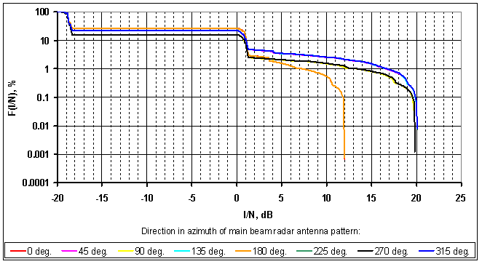
Figure 15: Interference impact from the planned GALILEO system in the RDSS to the radar type 2 located at 0⁰ north

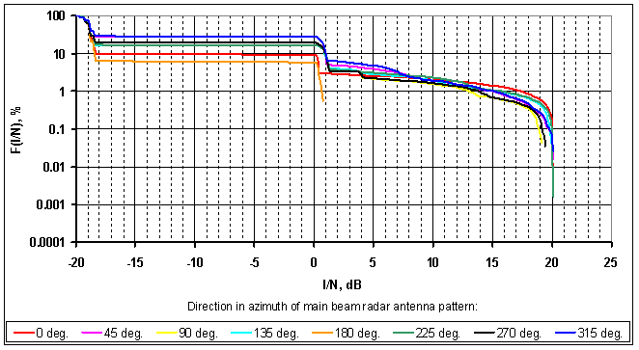
Figure 16: Interference impact from the planned GALILEO system in the RDSS to the radar type 2 located at 50⁰ north
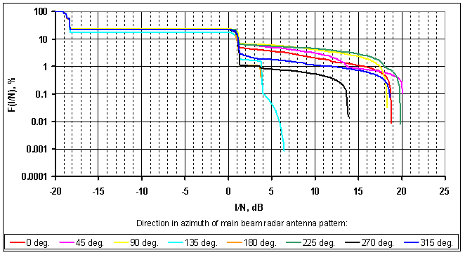
Figure 17: Interference impact from the planned GALILEO system in the RDSS to the radar type 2 located at 80⁰ north

Thus it can be concluded that in case of one planned GALILEO system in the frequency band 2483.5-2500 MHz with an e.i.r.p. of 37.3dBW from one spacecraft operates in the RDSS then interference will exceed the criterion I/N=-6 dB in 28.16 % of time and it is unacceptable.

Using in the GALILEO system a PFD mask from one spacecraft -159 dBW/m² in 1 MHz interferences will exceed the criterion I/N= -6 dB in 1 % of time, assuming that the RDSS system is using the whole 10 MHz bandwidth of the radar with a flat signal (i.e. the system is transmitting at PFD limit in every MHz of the band)

Verification of the compatibility between the planned GALILEO system and the RLS system with proposed PFD mask.
This section contains the results of the interference impact from the planned GALILEO system to the RLS systems using the proposed PFD mask -159 dBW/m² in 1 MHz from one spacecraft. This section assumes that the RDSS system is using the whole 10 MHz bandwidth of the radar with a flat signal (i.e. the system is transmitting at PFD limit in every MHz of the band) which is not an operational scenario for the envisaged Galileo system. This PFD mask meets the criterion I/N=-6 dB in 1% of time. The following figures contain estimation results of interference impact from planned GALILEO system to RLS system.

Interference impact from the planned GALILEO system in the RDSS to the radar type 2

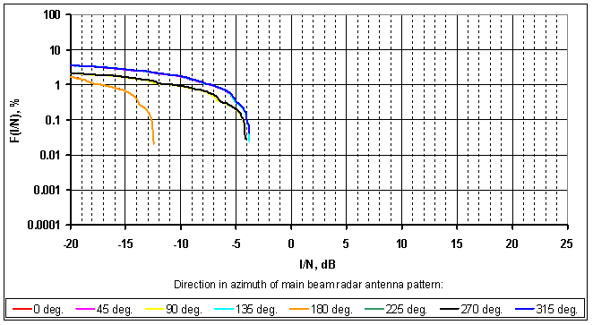
Figure 18: Interference impact from the planned GALILEO system in the RDSS to the radar type 2 located at 0⁰ north

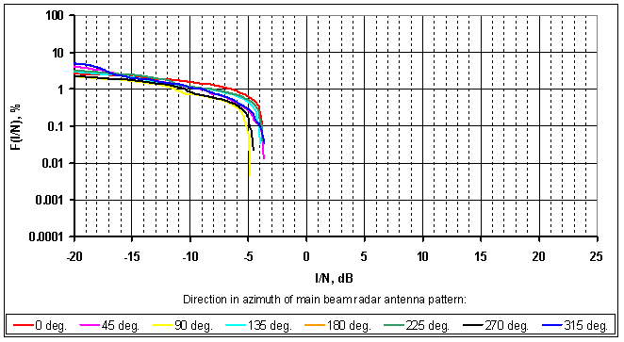
Figure 19: Interference impact from the planned GALILEO system in the RDSS to the radar type 2 located at 50⁰ north

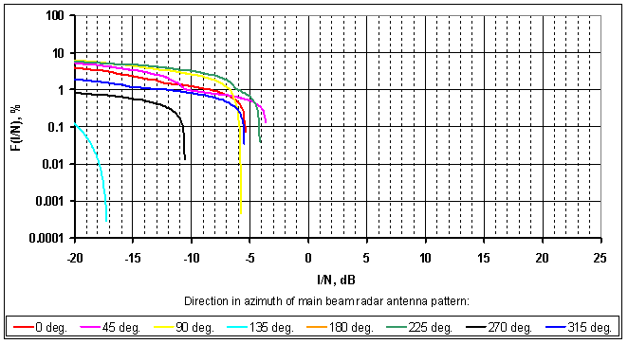

Figure 20: Interference impact from the planned GALILEO system in the RDSS to the radar type 2 located at 80⁰ north

Thus it can be concluded that in case of one planned GALILEO system operates in the RDSS with PFD level from one spacecraft -159 dBW/m² in 1 MHz then interferences will exceed the criterion I/N= -6 dB in 1 % of time.

Conclusion on RDSS-RLS compatibility
The first study presented in section 3.4.3.1 shows that a PFD of -129dBW/m².MHz per RDSS satellite may, in some cases, interfere with the Radiolocation Service. However, it can be seen that the interference will occur in the worst case less about 5% of the time, when considering mean values. These results are obtained with an antenna pattern not favourable. With a more directive antenna pattern, the results would show a better availability.
The second study presented in section 3.4.3.2 indicates that in case of one planned RDSS GALILEO system in the frequency band 2483.5-2500 MHz operating with an e.i.r.p. of 37.3dBW from one spacecraft, then interferences will exceed the criterion I/N=-6 dB in 28.16 % of time and it is unacceptable.
Using for the GALILEO system a PFD mask from one spacecraft of -159 dBW/m² in 1 MHz, interference will exceed the criterion I/N= -6 dB in 1 % of time, assuming that the RDSS system is using the whole 10 MHz bandwidth of the radar with a flat signal (i.e. the system is transmitting at PFD limit in every MHz of the band) which is not an operational scenario for the envisaged Galileo system. This required PFD mask is significantly more stringent than the considered PFD levels from one spacecraft in the planned GALILEO system. Moreover usage of the stringent PFD mask as the condition for upgrading the allocation status of the RDSS does not ensure protection of the radiolocation service stations from the interferences caused by the RDSS because there is no guarantee that only one RDSS system will operate.
Therefore it is required to find other regulatory and/or technical solutions to cover this issue. These other solutions should at the same time also protect other services in the band and adjacent bands.
It should be also noted that the MSS non-GEO system Globalstar has operated worldwide using PFD values of -126dBW/m²/MHz for many years without any reported difficulties for the Radiolocation Service. However it should be mentioned that the MSS and RDSS systems operation principles are different. For example, the emission level from Globalstar is changing constantly depending on user activity. It means that the emission level from Globalstar is at its maximum value only for the biggest traffic period. However, a RDSS system such as GALILEO will operate with a constant pfd value.
The situation is similar to the study results considered under WRC-03 AI 1.15 dealing with the compatibility between the RNSS and the radiolocation service in the frequency band 1215-1300 MHz. At that time it was difficult to explain how both services can be compatible because theoretical studies showed that the existing RNSS system was causing interferences exceeding the protection criteria of the radiolocation service. Consequently, an additional regulatory option was inserted in the Radio Regulation: the RNSS should not cause harmful interference to the radiolocation service.

RDSS vs IMT systems identified in the adjacent band 2500-2690 MHz

IMT characteristics

IMT Base Station characteristics
EC Decision 2008/477/EC and it ECC counter part ECC/DEC/(05)05 provides the channelling arrangement IMT systems operating within the band 2500-2690 MHz in CEPT. The lower part of the 2500-2690 MHz band is planned to be used for FDD uplink with 5MHz block size.

Figure 21: Annex 2 of ECC/DEC/(05)05 (in case of 2x70 MHz FDD plan)

IMT Base Stations characteristics are provided in the following table:
Parameter | UMTS | LTE
Antenna gain (dBi) | 17 | 17 | 17
Antenna gain pattern | F.1336  k=0.2 | F.1336  k=0.2 | F.1336  k=0.2
Antenna height (m) | 30 | 30 | 30
Bandwidth (MHz) | 5 | 10 | 20
Receiver effective Bandwidth (MHz) | 5 | 9 | 18
Noise Factor (dB) | 5 | 5 | 5
Noise temperature (K) | 290 | 290 | 290
Thermal noise level N | -132 dBW/5MHz | -129.4 dBW/9MHz | -126.4 dBW/18MHz
Relative ACS (Adjacent Channel Selectivity) (dB)  - first channel  - second channel  - third channel and beyond | 46  58  66 | 42.7  51.7  NA | 39.7  NA  NA
I/N (dB) | -10 | -10⁵ | -10⁵
Table 35: BS parameters for a Macro cell (Worst Case)

IMT User Equipment characteristics
The following characteristics were used for an IMT User Equipment:
User Equipment parameters
 | UMTS | LTE
Antenna gain (dBi) | 0 | 0 | 0
Antenna height (m) | 1.5 | 1.5 | 1.5
Bandwidth (MHz) | 5 | 10 | 20
In-band Transmitting power (dBm) | 24 | 23 | 23
ACLR (from Report ITU-R M.2039) | 1st channel : ACLR  = 33 dB/5MHz  2nd channel : ACLR  = 43 dB/5MHz.  The value of 43 dB can be extended beyond the second IMT channel. | 1st channel : ACLR1  = 30 dB/10 MHz  2nd channel : ACLR2  = 43 dB/10 MHz | 1st channel : ACLR1 = 30 dB/20 MHz  2nd channel : ACLR2 = 40 dB/20 MHz
Table 36: UE parameters
The following Figure shows an example of the mask of the transmitting power from an UE in the band 2500-2505 MHz, corresponding to the mask defined in table 36 above. In the SEAMCAT study regarding the impact of LTE systems on RDSS receivers, one active user per system was considered.

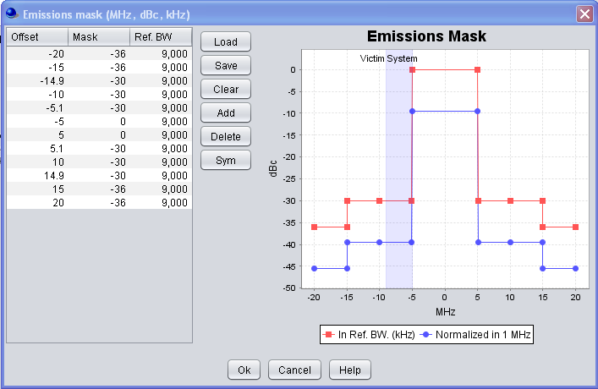
Figure 22: IMT User Equipment in-band and OoB transmitted power for a LTE system bandwidth of 10 MHz

Impact of IMT transmitters on RDSS receivers
This study has been carried out using the SEAMCAT software and the Monte-Carlo simulations.

In the case of compatibility between RNSS and LTE sites the mode “Wt → Central (reference) cell of LTE network” of OFDMA module was chosen. In the considered scenario Victim receivers are randomly located at 1.3 km from its satellite transmitter. The interference probability is determined depending on the modulation type of the RDSS receiver and the LTE UMTS deployment scenario (urban or rural area - see an example of scenario on Figure 23).

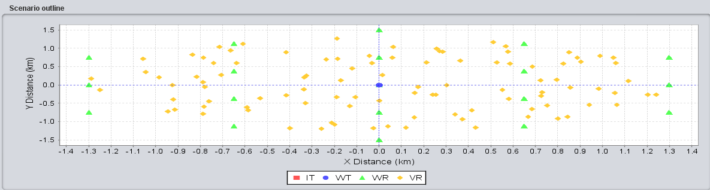
Figure 23: SEAMCAT outline of the scenario were “virtual” Wt located at the same point as central cell of LTE network (IT (UE) is not shown on the picture, they are located around its BS’s)

The following criteria has been used for the protection of RDSS receivers, in line with section 2.2
Interference criterion (acquisition mode):  - threshold power level of aggregate narrow-band interference at the passive antenna output (dB(W/MHz)) | -146
- to be met for | 95% locations for mobile receivers
Table 37: RDSS protection criteria

Detailed explanation on the implementation of first adjacent criterion within SEAMCAT when modelling interference from LTE/UMTS UE to RDSS receivers can be found for the information in Annex 2 to this document.
- Results in the case of UMTS system:
Free space propagation and Extended-Hata models (rural, suburban and urban) were considered. Compatibility studies have shown that there is no impact on any type of RNSS receiver from UMTS UE.
- Results in the case of LTE system:
Separation distances between the LTE UE (interferers) and the RDSS receivers (victim) are calculated using two models:
- IEEE 802.11 Model C propagation model provided in the ECC Report 131 “Derivation of a block edge mask (BEM) for terminal stations in the 2.6 GHz frequency band (2500-2690 MHz)”. This model was used for the compatibility study between terminal equipment operating in 2.6 GHz band;
- Extended Hata model (urban).

For the interfering LTE system, the propagation model for the urban and suburban areas from 3GPP TR 36.942 V9.0.1 was considered:
L= 128.1 + 37.6log₁₀(R),
where R is the BS (base station) – UE separation in km.

For the victim RDSS receivers, no propagation model are used because the dRSS is a user defined value.

Propagation model (between LTE UE and RDSS receiver) | Interference probability, %
Modulation (RDSS receiver) | BPSK(1)  (BW= 2 MHz,  dRSS = -113 dBm) | BPSK(4)  (BW= 8 MHz,  dRSS = -107 dBm) | BPSK(8)  (BW= 16 MHz,  dRSS = -104 dBm) | BOC(1,1)  (BW= 4 MHz,  dRSS = -110 dBm)
IEEE 802.11 Model C | 12.2 | 4.6 | 4.6 | 10.6
Extended-Hata model  (for urban area) | 6.0 | 3.4 | 5.4 | 5.8
Table 38: Calculated probability of interference in the case of LTE (10 MHz) interfering network

Propagation model (between LTE UE and RDSS receiver) | Interference probability
Modulation (RDSS receiver) | BPSK(1)  (BW= 2 MHz,  dRSS = -113 dBm) | BPSK(4)  (BW= 8 MHz,  dRSS = -107 dBm) | BPSK(8)  (BW= 16 MHz,  dRSS = -104 dBm) | BOC(1,1)  (BW= 4 MHz,  dRSS = -110 dBm)
IEEE 802.11 Model C | 3.0 | 1.6 | 0.2 | 2.6
Extended-Hata model  (for urban area) | 1.4 | 3.2 | 3.6 | 2.2
Table 39: Calculated probability of interference in the case of LTE (20 MHz) interfering network

Compatibility studies have shown that impact on any type of RNSS receiver from LTE UE (10 MHz, 20 MHz) is as follows:
- calculated probability of interference for RDSS receiver modulation format BPSK(4) and BPSK(8) in the case of LTE (10 MHz) network is varying from 3.4 to 5.4% which almost satisfies the interference criterion which should be met in 95% locations for mobile receivers;
- calculated probability of interference for RDSS receiver modulation format BPSK(1) and BOC(1,1) in the case of LTE (10 MHz) network is varying from 5.8 to 12.2%, thus more interference than the protection criteria of 5 % ;
- calculated probability of interference in the case of LTE (20 MHz) network is varying from 1.4 to 3.6% which satisfies the interference criterion which should be met in 95% locations for mobile receivers.

These results could however be much better in practice, since:
- the actual transmitter may perform better in terms of unwanted emissions than the masks
- a minimum distance of 0 m as taken in the studies means an LTE transmitter and a RDSS receiver which are collocated, such as in a car , which would in effect necessitate specific measures by the manufacturer in order to avoid any interference from one system to the other.
In the case of a common device, special measures, either in time- or frequency domain or combinations, are needed.
The calculated interference from LTE (10 MHz) is therefore lower in practice and the protection criteria for RDSS is expected to be met in practice. Consequently, no new/additional constraints are needed for IMT systems.

Impact of RDSS satellites on IMT receivers
The study is based on an I/N ratio calculation for different values of PFD limit per satellite defined for a 1 MHz bandwidth.

The maximum power in 1 MHz at ground level can be derived from the power spectral density as follows:
For a BPSK signal, $P_{\text{max}}=A∗\int_{−0\text{.}5}^{0\text{.}5}{{\text{PSD}}_{\text{RNSS}}}(f)\text{.}\text{df}$
For the BOC(1,1) signal, $P_{\text{max}}=A∗\int_{−1\text{.}\text{25}}^{−0\text{.}\text{25}}{{\text{PSD}}_{\text{RNSS}}}(f)\text{.}\text{df}$
with A is a constant depending on the satellite e.i.r.p. and the propagation loss (corresponding to the amplitude of the signal at ground level)
P_{max} is in W

and P_{max} in 1 MHz can also be derived from the PFD, expressed in W/(m. MHz) by:
$$P_{\text{max}}=\text{PFD}∗\frac{λ²}{4π}∗(1 \text{MHz})$$
Finally, the constant A can be derived
$$A=\frac{\text{PFD}∗\frac{λ²}{4π}}{\int_{−0\text{.}5}^{−0\text{.}5}{{\text{PSD}}_{\text{RNSS}}}(f)\text{.}\text{df}}$$
The interfering signal power can be defined as:
$$I=G_{\text{BS}}(ϕ,θ)∗\int{A∗{\text{PSD}}_{\text{RNSS}}}(f)∗H(f)\text{.}\text{df}$$

with H(f) the transfer function of the IMT Base Station filter
G_{BS}(ϕ,θ) the Base Station antenna gain from ITU-R F.1336
ϕ the elevation the satellite is seen
θ the azimuth the satellite is seen

We can approximate this value, considering a theoretical filter for the IMT receiver (0 dB in the IMT channel, -ACS beyond the IMT channel) and considering that except in the RNSS and the IMT bands, the signal power will be really low.
For example, in the case of UMTS systems, ACS is defined for two 5 MHz IMT adjacent blocks, as the relative power transmitted by one of them filtered by the other one. Using figures in Table 35, we can then define the filtering function of the UMTS Base Station:
H (f) = 66 dB for -8.25 ≤ f ≤ -1.75
H (f) = 58 dB for -1.75 ≤ f ≤ 3.25
H (f) = 46 dB for 3.25 ≤ f ≤ 8.25
H (f) = 0 dB for 8.25 ≤ f ≤ 13.25
with f frequency in MHz

The same approach applies for LTE systems.

Then, $I=A∗G_{\text{BS}}(ϕ,θ)∗\left[\int_{−8\text{.}\text{25}}^{8\text{.}\text{25}}{{\text{PSD}}_{\text{RNSS}}(f)∗{\text{10}}^{\frac{−H(f)}{\text{10}}}}\text{.}\text{df}+\int_{8\text{.}\text{25}}^{\text{13}\text{.}\text{25}}{{\text{PSD}}_{\text{RNSS}}(f)∗{\text{10}}^{\frac{−H(f)}{\text{10}}}\text{.}\text{df}}\right]$$I=\frac{\text{PFD}∗\frac{λ²}{4π}}{\int_{−0\text{.}5}^{0\text{.}5}{{\text{PSD}}_{\text{RNSS}}(f)\text{.}\text{df}}}∗G_{\text{BS}}(ϕ,θ)∗\left[\int_{−8\text{.}\text{25}}^{8\text{.}\text{25}}{{\text{PSD}}_{\text{RNSS}}(f)∗{\text{10}}^{\frac{−H(f)}{\text{10}}}}\text{.}\text{df}+\int_{8\text{.}\text{25}}^{\text{13}\text{.}\text{25}}{{\text{PSD}}_{\text{RNSS}}(f)\text{.}\text{df}}\right]$
$$I_{\text{dBW}}={\text{PFD}}_{{\text{dBW}}/(m²\text{.}\text{MHz})}+\text{10}{\text{*log}}_{\text{10}}\left(\frac{λ²}{4π}\right)+G_{\text{BS}}(ϕ,θ)+\text{ratio}$$
An attenuation ratio can then be defined by
$$\text{ratio}=\text{10}{\text{*log}}_{\text{10}}\left[\frac{\int_{−8\text{.}\text{25}}^{8\text{.}\text{25}}{{\text{PSD}}_{\text{RNSS}}(f)∗{\text{10}}^{\frac{−H(f)}{\text{10}}}}\text{.}\text{df}+\int_{8\text{.}\text{25}}^{\text{13}\text{.}\text{25}}{{\text{PSD}}_{\text{RNSS}}(f)\text{.}\text{df}}}{\int_{−0\text{.}5}^{0\text{.}5}{{\text{PSD}}_{\text{RNSS}}(f)\text{.}\text{df}}}\right]$$

For a BOC(1,1) signal, the ratio is then

$$\text{ratio}=\text{10}{\text{*log}}_{\text{10}}\left[\frac{\int_{−8\text{.}\text{25}}^{8\text{.}\text{25}}{{\text{PSD}}_{\text{RNSS}}(f)∗{\text{10}}^{\frac{−H(f)}{\text{10}}}}\text{.}\text{df}+\int_{8\text{.}\text{25}}^{\text{13}\text{.}\text{25}}{{\text{PSD}}_{\text{RNSS}}(f)\text{.}\text{df}}}{\int_{−1\text{.}\text{25}}^{−0\text{.}\text{25}}{{\text{PSD}}_{\text{RNSS}}(f)\text{.}\text{df}}}\right]$$
Finally,
$$\begin{aligned}\sum_{\text{Visible} \text{satellites}}{}\text{All} \text{RNSS}\end{aligned}−N$$

For each satellite of the RNSS constellation, the interference power in the BS is computed during one day and for each BS azimuth, and only the worst case is presented here (case with one satellite in the main beam and the others are in the secondary lobs).
The base station is located in Paris (France). It would not change significantly the results if the location changes as there would always be 12 visible satellites.

In case of a UMTS victim:

Figure 24: I/N versus RNSS PFD limit per satellite for BPSK signal

Figure 25: I/N versus RNSS PFD limit per satellite for the BOC(1,1) signal

Signal | Ratio  dB | PFD for I/N = -10  dB(W/m².MHz)
BPSK(1) | -25.0 | -108.0
BPSK(4) | -14.4 | -118.5
BPSK(8) | -8.09 | -124.8
BOC(1,1) | -13.3 | -119.6
Table 40: Results of the interference of RNSS on IMT

In case of a LTE victim, with 10 MHz bandwidth:
Figure 26: I/N versus RNSS PFD limit per satellite, with regards to LTE 10 MHz

Signal | Ratio  dB | PFD for I/N = -10  dB(W/m².MHz)
BPSK(1) | -23.3 | -106.6
BPSK(4) | -12.5 | -117.4
BPSK(8) | -7.0 | -122.9
BOC(1,1) | -15.6 | -114.3
Table 41: Results of the interference of RNSS on IMT/LTE 10MHz

In case of a LTE victim, with 20 MHz bandwidth:
Figure 27: I/N versus RNSS PFD limit per satellite, with regards to LTE 20 MHz

Signal | Ratio  dB | PFD for I/N = -10  dB(W/m².MHz)
BPSK(1) | -22.2 | -104.7
BPSK(4) | -11.3 | -115.6
BPSK(8) | -5.6 | -121.3
BOC(1,1) | -14.5 | -112.5
Table 42: Results of the interference of RNSS on IMT/LTE 20MHz

It should be noted that a value of -126 dBW/m²/MHz (Appendix 5 coordination trigger) might be acceptable. Thus, the RNSS signal is unlikely to interfere with an IMT Base Station in the adjacent band if the PFD limit is set below -126 dBW/m²/MHz, which is coherent with the values foreseen in other parts of this report.

Conclusion on RDSS-IMT compatibility
There is no impact on any type of RDSS receiver from UMTS UE.
Regarding the LTE case, compatibility studies have shown that there may be some impact on the RDSS receiver. However, these results could be much better in practice, since:
- the actual transmitter may perform better in terms of unwanted emissions than the masks
- A minimum distance of 0 m as taken in the studies means an LTE transmitter and a RDSS receiver which are collocated, such as in a car, which would in effect necessitate specific measures by the manufacturer in order to avoid any interference from one system to the other.

In the case of a common device, special measures, either in time- or frequency domain or combinations, are needed.
The calculated interference from LTE (10 MHz) is therefore lower in practice and the protection criteria for RDSS is expected to be met in practice. Consequently, no new/additional constraints are needed for IMT systems.
Considering a PFD for RDSS satellites of -126 dBW/(m².MHz), studies show that there would be no interference from the planned Galileo system on an IMT receiver in the adjacent band.

RDSS vs WLAN systems operating in the adjacent band 2400-2483.5 MHz

WLAN characteristics
Following assumptions were taken for the study from the ETSI EN 300 328 V1.7.1:
- For all equipment the frequency range shall lie within the band 2400 MHz to 2483.5 MHz (fL > 2400 MHz and fH < 2483.5 MHz).
- Following case was considered for the calculations: f_{c} = 2471 MHz and the bandwidth is 24 MHz. The last upper channel shall be below 2483.5 MHz.
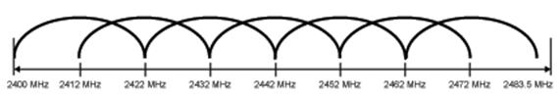
Figure 28: Example of channel selection with overlapping (illustration is from IEEE 802.11 family standards)
- The equivalent isotropic radiated power (e.i.r.p.) shall be equal to or less than -10 dBW (100 mW). This limit shall apply for any combination of power level and intended antenna assembly.
- The spurious emissions of the transmitter shall not exceed the values in tables 43 and 44 in the indicated bands.
Frequency range | Limit when operating | Limit when in standby
30 MHz to 1 GHz | -36 dBm | -57 dBm
above 1 GHz to 12.75 GHz | -30 dBm | -47 dBm
1.8 GHz to 1.9 GHz  5.15 GHz to 5.3 GHz | -47 dBm | -47 dBm
Table 43: Transmitter limits for narrowband spurious emissions

Frequency range | Limit when operating | Limit when in standby
30 MHz to 1 GHz | -86 dBm/Hz | -107 dBm/Hz
above 1 GHz to 12.75 GHz | -80 dBm/Hz | -97 dBm/Hz
1.8 GHz to 1.9 GHz  5.15 GHz to 5.3 GHz | -97 dBm/Hz | -97 dBm/Hz
Table 44: Transmitter limits for wideband spurious emissions
The following Figure shows an example of the mask of the out-of band mask for narrowband and wideband WLAN transmission operating band is 2400-2483.5 MHz,

a) narrowband transmission | b) wideband transmission
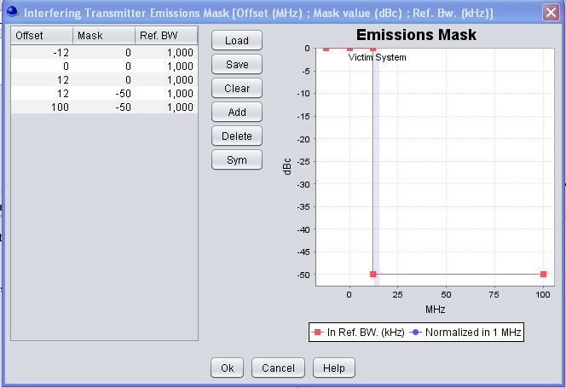 | 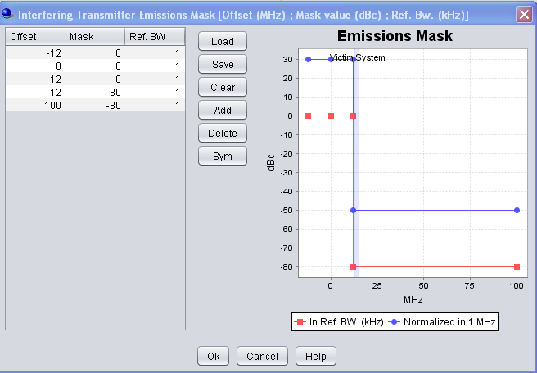

Figure 29: OoB transmitted power for WLAN equipment (victim system is BPSK(1))

Impact of a WLAN transmitter on a RDSS receiver

Methodology used in the study
Simulations were conducted using the SEAMCAT tool in order to determine the probability of interference due to unwanted effect received by the RDSS receivers (supposed to operate in the frequency range 2483.5-2500 MHz) from WLAN network (operating in the frequency range 2400-2483.5 MHz).
The interference mode “relative positioning of interfering link” so called “None” was chosen (see the figure below):
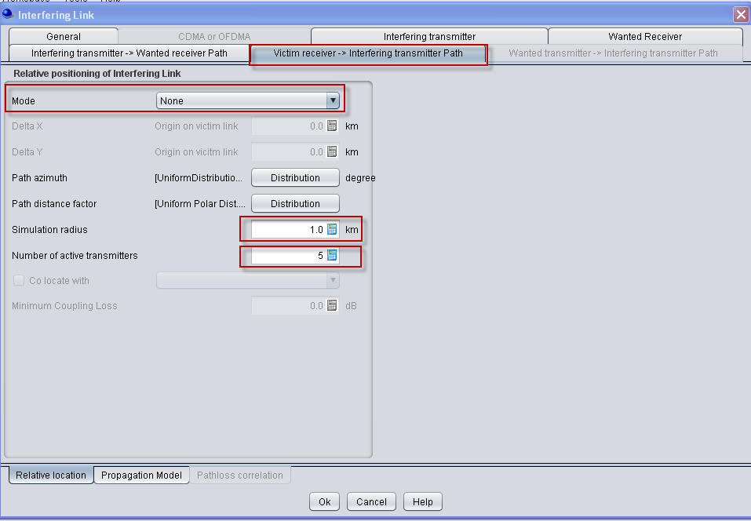
Figure 30: Relative positioning of interfering link
This means that 5 interfering transmitters are located in a circular area with a simulation radius (sim. radius = 1 km). The random placement of the interfering transmitters in this area is defined by the path azimuth (0; 360) and the path distance factor parameters (equal = 1).
The interference probabilities for unwanted effect are determined in the following way:
SEAMCAT checks if the calculated ratio is greater then C/I then
- if yes then this event is considered as “good” one;
- if not then this event is considered as “interfered” event.

Free space propagation and Extended Hata (rural, suburban and urban) models were considered for the purpose of the study.

In the considered scenario victim receivers are randomly located at 4 km from its “virtual” satellite transmitter (WT). Figure 31 is SEAMCAT outline of the considered scenario (for illustration purpose 1 active transmitter per snapshot is shown).

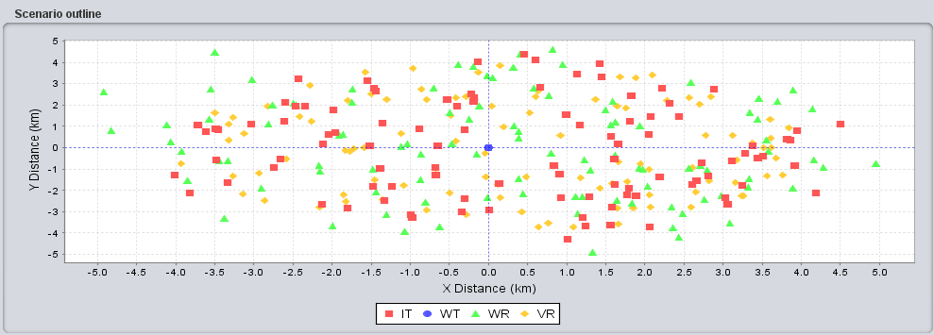
Figure 31: SEAMCAT outline of the considered scenario

Results
Following results were obtained from the simulations:

Transmission type | Propagation model (between VR and IT) | Interference probability, %
Transmission type | Modulation (RDSS receiver) | BPSK(1)  (BW= 2 MHz,  dRSS = -113 dBm) | BPSK(4)  (BW= 8 MHz,  dRSS = -107 dBm) | BPSK(8)  (BW= 16 MHz,  dRSS = -104 dBm) | BOC(1,1)  (BW= 4 MHz,  dRSS = -110 dBm)
narrowband transmission | Extended-Hata model (for urban area) | 1.46% | 1.28% | 1.31% | 1.34%
narrowband transmission | Extended-Hata model (for rural area) | 5.98% | 6.24% | 5.94% | 5.98%
wideband transmission | Extended-Hata model (for urban area) | 1.37% | 1.20% | 1.30% | 1.43%
wideband transmission | Extended-Hata model (for rural area) | 5.97% | 4.47% | 5.99% | 6.01%
Table 45: Calculated probability of interference for the WLAN case

It should be noted that these results could however be much better in practice, since:
- the actual WLAN transmitter may perform better in terms of unwanted emissions than the masks
- A minimum distance of 0 m as taken in the studies means a WLAN transmitter and a RDSS receiver which are collocated, such as in a car, which would in effect necessitate specific measures by the manufacturer in order to avoid any interference from one system to the other.
In the case of a common device, special measures, either in time- or frequency domain or combinations, are needed.

Impact of RDSS satellites on WLAN receiver
As there is no impact from RDSS satellites on a WIMAX system operating in the same band (see section 3.3.3.2), it is assumed and expected, taking into account an additional attenuation due to the filtering, that it is the same conclusion when assessing the impact of RDSS satellites on WLAN receiver operating in the adjacent band.

Conclusion on RDSS-WLAN compatibility
Compatibility studies have shown that the impact from RDSS satellites on WLAN systems is negligible.

Moreover, the impact on any type of RNSS receiver from WLAN systems is as follow:

1) narrowband transmission:
- calculated probability of interference in the case of urban area case varying from 1.28% to 1.46% which satisfies the interference criterion which should be met in 95% locations for mobile receivers;
- calculated probability of interference in the case of rural area case is varying from 5.98% to 6.24% which almost satisfies the interference criterion which should be met in 95% locations for mobile receivers.

2) wideband transmission:
- calculated probability of interference in the case of urban area case varying from 1.20% to 1.43% which satisfies the interference criterion which should be met in 95% locations for mobile receivers;
- calculated probability of interference in the case of rural area case is varying from 4.47% to 6.01% which almost satisfies the interference criterion which should be met in 95% locations for mobile receivers.

GALIleo TYPE RDSS performances according to the pfd value

C/No computation
C/N0 is computed in function of the PFD max value for the 4 hypotheses of modulation described above in section 2.1.

The maximum Satellite transmitted power density ${\text{Pt}}_{\text{max}}$ in dBW/Hz is first derived from PFD in dBW/m2/MHz.

$${\text{Pt}}_{\text{max}}=\text{PFD}+\text{60}−\text{Gt}+\text{FSL}+\text{Latm}−\text{10}\text{log}\text{10}\left(\frac{λ²}{4π}\right)$$
FSL Free-space losses
Latm Atmospheric attenuation
Gt=15.4 transmitter antenna gain in dB

The total losses are the sum of FSL, Free-space losses according to distance between satellite and user, Atmospheric attenuation and other losses encompassing Polarization loss, implementation loss and depointing loss.

The total losses hypothesis comes from document [21].

The decomposition of total losses taken for the analysis is given in the following table:

Total losses in S band at 5° elevation (dB) | 190.95
Free-space losses (dB) | 188.85
Atmospheric attenuation (dB) | 0.7
Other losses (dB) | 1.4
Table 46: Propagation losses taken in the GALILEO link budget

Then, the normalized power spectral density is translated to correspond to the computed maximum power density and the transmitted power is determined in the reference bandwidth $\text{Bref}$in MHz in which the power is received:
$$P_{\text{tx}}=\int_{\text{Bref}}{{\text{PSD}}_{\text{RNSS}}}(f)\text{.}\text{df}$$

The Table below and the two figures present respectively the assumptions for the link budget in S-band and the results for the link budget.
Noise level [dBWHz⁻¹] (T=600K) | -200.82
Receiver antenna gain at 5º[dB] | -3
Total losses in S band at 5° elevation [dB] | 190.95
Transmitter antenna gain $\text{Gt}$ [dB] | 15.40
Table 47: Assumptions for Link budget
Figure 32: Transmitted power vs maximum PFD level for each modulation

Figure 33: C/N0 vs maximum PFD level for each modulation

If we focus on a –132 dBW/MHz/m² PFD limit assumption, we have:

 | BOC(1,1) | BPSK(1) | BPSK(4) | BPSK(8)
Pfdmax [dBW/MHz/m²] | -132 | -132 | -132 | -132
Corresponding Tx Power [dBW] | 14.29 | 11.73 | 17.75 | 20.76
Corresponding C/No [dBHz] | 36.56 | 34 | 40 | 43
Table 48: C/N0 for a pfd of -132 dBW/m²/MHz

If we focus on a – 129 dBW/MHz/m² PFD limit assumption, we have:

 | BOC(1,1) | BPSK(1) | BPSK(4) | BPSK(8)
Pfdmax [dBW/MHz/m²] | -129 | -129 | -129 | -129
Corresponding Tx Power [dBW] | 17.29 | 14.73 | 20.75 | 23.76
Corresponding C/No [dBHz] | 39.56 | 37 | 43 | 46
Table 49: C/N0 for a pfd of -129 dBW/m²/MHz

Tracking performances
In the following figure, the pseudo-range tracking jitter is given in function of the C/No. This theoretical figure of merit is obtained with the following hypotheses:
- Signal with a pilot tone, tracking on the pilot tone
- Tracking loop bandwidth : 1Hz
- Pre-detection : 100ms
- E-L = 0.5 chips for BPSK and 0.25 chips for BOC(1,1)

Figure 34: Tracking jitter function of the C/N0

 | BOC(1,1) | BPSK(1) | BPSK(4) | BPSK(8)
Max Pfd [dBW/MHz/m²] | -132 | -132 | -132 | -132
Corresponding C/No [dBHz] | 36.56 | 34 | 40 | 43
Jitter (m) | 0.81 | 2.72 | 0.34 | 0.12
Table 50: Tracking jitter for a pfd of -132 dBW/m²/MHz

The decision criterion that is proposed to be selected consisted in insuring the same level of performances as the one provided by the Galileo E1 signal. The jitter accuracy in E1 is 0.74m. It comes then out from the previous figures that only BPSK(4) and BPSK(8) allow to comply with the objective.
However, these signals present a large bandwidth, which implies a higher receiver complexity, in particular for the acquisition of the signal.

Acquisition performances
Simulations have been executed, emulating the search process and using the actual power distributions. Thus, for various coherent integration times, and according to the total integration duration (i.e. number of summations), the minimum SNR (at IF level) needed to achieve fixed Pd and Pfa has been computed.
The following figure provides the obtained results.

Figure 35: Detection probability function of C/N0

Table 51: Detection performance and complexity of implementation for all modulations

The acquisition complexity is much higher for BPSK(4) and BPSK(8). On the contrary BOC(1,1) and BPSK(1) present the same acquisition complexity. Indeed the intrinsic higher complexity for the BOC(1,1) is compensated by a higher the signal to noise ratio.

Conclusion
A PFD limit of –132dBW/m2/MHz appears to be stringent for the definition of a Galileo signal. Indeed, to reach a level of performances comparable to what is expected in E1 Band, a high complexity on the receiver is required.
It is to be noted that having a PFD limit of –129 dBW/m2/MHz would allow the same level of service as in the E1 L band, from the tracking and acquisition point of view.
For a targeted data rate of 500 bits/s for an RDSS service in the 2483.5-2500 MHz band, a PFD limit of –126 dBW/m2/MHz would be necessary to keep the same bit error rate as in the E1 L band.

OVERALL Conclusions OF THE REPORT
Sharing studies have been performed between a possible new RNSS system and other existing services in the band 2483.5-2500 MHz, as well as with IMT systems in the above adjacent band and WLAN systems in the below adjacent band. Results regarding the protection of existing services are summarized as follows:
- sharing with FS:
A pfd limit of -132 dBW/m²/MHz would be sufficient to provide full protection to the FS systems used worldwide from RDSS systems that may operate in the band 2483.5-2500 MHz for all azimuth pointing angles This limit may be further relaxed to -129 dBW/m²/MHz if the FDP criterion is to be met only in average (i.e. a FDP value of 25% may be accepted for a limited number of azimuths)
- sharing with MSS:
Operating with a pfd of -129 dBW/m²/MHz, a Galileo-like RNSS system degrades the C/N0 of Globalstar .Additional measures may be needed to overcome the additional degradation caused by RDSS systems on MSS receiver.
- sharing with MS:
The general conclusion from these studies is that it is highly unlikely that SAP/SAB systems, WIMAX systems or VICS system (the three of them using the MS allocation) will experience interference from RDSS systems in the band 2483.5-2500 MHz.
The study provides a maximum pfd value per RDSS satellites of -130 dBW/m²/MHz in order to avoid causing interference to mobile or fixed (SAP/SAB) receivers operating in the band 2483.5-2500 MHz with the same polarisation. Considering that SAP/SAB are mainly using a linear polarisation, this PFD value could be further relaxed by 2 dB at least, leading to -128 dBW/m²/MHz.
It also provides a maximum pfd value per RDSS satellites of -129 dBW/m²/MHz in order to avoid causing interference to WIMAX receivers, in case of in-band scenario.
- sharing with RLS:
The first study shows that a pfd of -129dBW/m².MHz per RDSS satellite may, in some cases, interfere with the Radiolocation Service, using an unfavourable antenna pattern. However, it can be seen that the interference will occur in the worst case about 5% of the time, when considering mean values.
A second study indicates that using for the GALILEO system a pfd mask from one spacecraft of -159 dBW/m² in 1 MHz, interference will exceed the criterion I/N= -6 dB in 1 % of time, assuming that the RDSS system is using the whole 10 MHz bandwidth of the radar with a flat signal (i.e. the system is transmitting at pfd limit in every MHz of the band) which is not an operational scenario for the envisaged Galileo system. This required pfd mask is significantly more stringent than the considered pfd levels from one spacecraft in the planned GALILEO system. Moreover usage of the stringent pfd mask as the condition for upgrading the allocation status of the RDSS does not ensure protection of the radiolocation service stations from the interferences caused by the RDSS because there is no guarantee that only one RDSS system will operate.
- c ompatibility with IMT systems identified in the adjacent band above 2500 MHz:
Considering a pfd for RDSS satellites of -126 dBW/(m².MHz), studies show that there would be no interference from the planned Galileo system on an IMT receiver in the adjacent band.
- compatibility with WLAN systems identified in the adjacent band below 2483.5:
Considering a pfd for RDSS satellites of -126 dBW/(m².MHz), studies show that there would be no interference from the planned Galileo system on an WLAN receiver in the adjacent band.
Except for the Radiolocation Service, a pfd limit of -129 dBW/m²/MHz for the RDSS would enable the protection of existing services in the band or IMT systems identified in the adjacent band. This limit would allow the same level of service as in the E1 L band, from the tracking and acquisition point of view. For the case of RLS, this same limit is not sufficient for the protection of some types of radars. Therefore, it is necessary to find other regulatory and/or technical solutions to protect the Radiolocation service. These other solutions should at the same time also protect other services in the band and adjacent bands.
Considering the impact of existing services on RDSS receivers, results show that interference from the Globalstar MSS system in the band 2483.5-2500 MHz is unlikely. However, the RDSS receivers operating in those countries where FS is deployed would have to accept interference at separation distances lower than a few tens of km and there is a high probability of interference from SAB/SAP transmitters to any future RDSS receivers operating in the same band. In addition, systems operating in the adjacent bands (IMT or WLAN) may interfere with a RDSS receiver in close vicinity.
In a general manner, RDSS receivers would have to accept some interference from primary services already allocated in the band 2 483.5-2 500 MHz as well as from systems in adjacent bands.

- RNSS CONSTELLATION ORBITAL PARAMETER
  - MSATNAV-2 (GALILEO)

N=27 number of space stations of the non-GSO system
K=3 number of orbital planes
H=23616 satellite altitude above the Earth (km)
I=56 inclination angle of the orbital plane above the Equator (degrees).

Satellite index  I | RAAN  Ωi,0 (degrees) | Argument of latitude  ui,0 (degrees) | Satellite index  I | RAAN  Ωi,0 (degrees) | Argument of latitude  ui,0 (degrees)
1 | 0 | 0 | 15 | 120 | 213.3
2 | 0 | 40 | 16 | 120 | 253.3
3 | 0 | 80 | 17 | 120 | 293.3
4 | 0 | 120 | 18 | 120 | 333.3
5 | 0 | 160 | 19 | 240 | 26.6
6 | 0 | 200 | 20 | 240 | 66.6
7 | 0 | 240 | 21 | 240 | 106.6
8 | 0 | 280 | 22 | 240 | 146.6
9 | 0 | 320 | 23 | 240 | 186.6
10 | 120 | 13.3 | 24 | 240 | 226.6
11 | 120 | 53.3 | 25 | 240 | 266.6
12 | 120 | 93.3 | 26 | 240 | 306.6
13 | 120 | 133.3 | 27 | 240 | 346.6
14 | 120 | 173.3
Table A1-1: GALILEO orbital parameters

  - NAVSTAR GPS-IIRF

N=24 number of space stations of the non-GSO system
K=6 number of orbital planes
H=20182 satellite altitude above the Earth (km)
I=55 inclination angle of the orbital plane above the Equator (degrees).

Satellite index  I | RAAN  Ωi,0 (degrees) | Argument of latitude  ui,0 (degrees) | Satellite index  I | RAAN  Ωi,0 (degrees) | Argument of latitude  ui,0 (degrees)
1 | 272.847 | 11.676 | 13 | 92.847 | 135.226
2 | 272.847 | 41.806 | 14 | 92.847 | 167.356
3 | 272.847 | 161.786 | 15 | 92.847 | 265.446
4 | 272.847 | 268.126 | 16 | 92.847 | 35.156
5 | 332.847 | 80.956 | 17 | 152.847 | 197.046
6 | 332.847 | 173.336 | 18 | 152.847 | 302.596
7 | 332.847 | 204.376 | 19 | 152.847 | 333.686
8 | 332.847 | 309.976 | 20 | 152.847 | 66.066
9 | 32.847 | 111.876 | 21 | 212.847 | 238.886
10 | 32.847 | 241.556 | 22 | 212.847 | 345.226
11 | 32.847 | 339.666 | 23 | 212.847 | 105.206
12 | 32.847 | 11.796 | 24 | 212.847 | 135.346
Table A1-2: GPS orbital parameters

  - GLONASS-M

N=24 number of space stations of the non-GSO system
K=3 number of orbital planes
H=19100 satellite altitude above the Earth (km)
I=64.8 inclination angle of the orbital plane above the Equator (degrees).

Satellite index  I | RAAN  Ωi,0 (degrees) | Argument of latitude  ui,0 (degrees) | Satellite index  I | RAAN  Ωi,0 (degrees) | Argument of latitude  ui,0 (degrees)
1 | 251 | 145 | 13 | 11 | -20
2 | 251 | 100 | 14 | 11 | -65
3 | 251 | 55 | 15 | 11 | -110
4 | 251 | 10 | 16 | 11 | -155
5 | 251 | -35 | 17 | 131 | 175
6 | 251 | -80 | 18 | 131 | 130
7 | 251 | -125 | 19 | 131 | 85
8 | 251 | -170 | 20 | 131 | 40
9 | 11 | 160 | 21 | 131 | -5
10 | 11 | 115 | 22 | 131 | -50
11 | 11 | 70 | 23 | 131 | -95
12 | 11 | 25 | 24 | 131 | -140
Table A1-3: GLONASS orbital parameters

  - COMPASS-H/M/MG

N=27 number of space stations of the non-GSO system
K=3 number of orbital planes
H=21500 satellite altitude above the Earth (km)
I=55 inclination angle of the orbital plane above the Equator (degrees).

Satellite index  I | RAAN  Ωi,0 (degrees) | Argument of latitude  ui,0 (degrees) | Satellite index  I | RAAN  Ωi,0 (degrees) | Argument of latitude  ui,0 (degrees)
1 | 0 | 0 | 15 | 120 | 285
2 | 0 | 45 | 16 | 120 | 330
3 | 0 | 90 | 17 | 240 | 30
4 | 0 | 135 | 18 | 240 | 75
5 | 0 | 180 | 19 | 240 | 120
6 | 0 | 225 | 20 | 240 | 165
7 | 0 | 270 | 21 | 240 | 210
8 | 0 | 315 | 22 | 240 | 255
9 | 120 | 15 | 23 | 240 | 300
10 | 120 | 60 | 24 | 240 | 345
11 | 120 | 105 | 25 | 0 | 10
12 | 120 | 150 | 26 | 120 | 55
13 | 120 | 195 | 27 | 240 | 105
14 | 120 | 240
Table A1-4: COMPASS orbital parameters

- Implementation of first adjacent criterion within SEAMCAT when modelling interference from LTE/UMTS UE to RNSS receivers

General
Figure A2-1. below illustrates general principles of SEAMCAT interference modelling using statistical simulation model based on Monte-Carlo method.
Monte Carlo simulation tool considers many independent events (trials) in time and space. For each trial SEAMCAT calculating desired signal strength (dRSS=C) and interfering signal strength (iRSS=I) (shown on the left-hand side of the Fig. 1). Right-hand side of the diagram shows that in the presence of interference. The interference is added to the noise floor. The difference between wanted signal (dRSS) and interference signal is calculated in dB. This difference or ratio is calculated at every trial:
dRSS- iRSS=C/I.

SEAMCAT checks if the calculated ratio is greater then C/I and
- if yes then this event is considered as “good” one
- if not then this event is considered as “interfered” event.

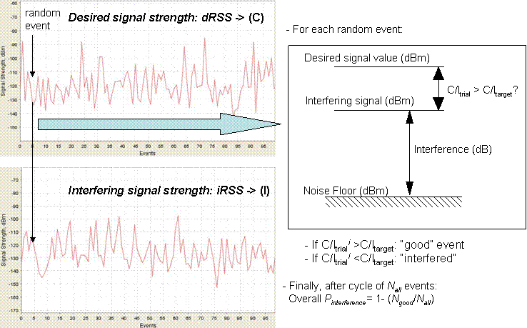
Figure A2-1: Interference criteria calculations.

Implementation

In the case of RNSS receiver interference criterion (at output of receiving antenna) when it is in the acquisition mode -146 dB(W/MHz) to be met for 95% locations.

In this case the dRSS (i.e. wanted signal, or carrier - C) was defined in SEAMCAT as following (see illustration on Figure A2-2):
- dRSS=-113 dBm (2 MHz);
- dRSS=-107 dBm (8 MHz);
- dRSS=-104 dBm (16 MHz);
- dRSS=-110 dBm (4 MHz);

The iRSS (Interfering power – I) must be below the dRSS value in order not to exceed the interference criterion for the acquisition mode - 95% locations.

This implies that the criterion of C/I=0 dB should be met according to these percentages associated with each of the mode.

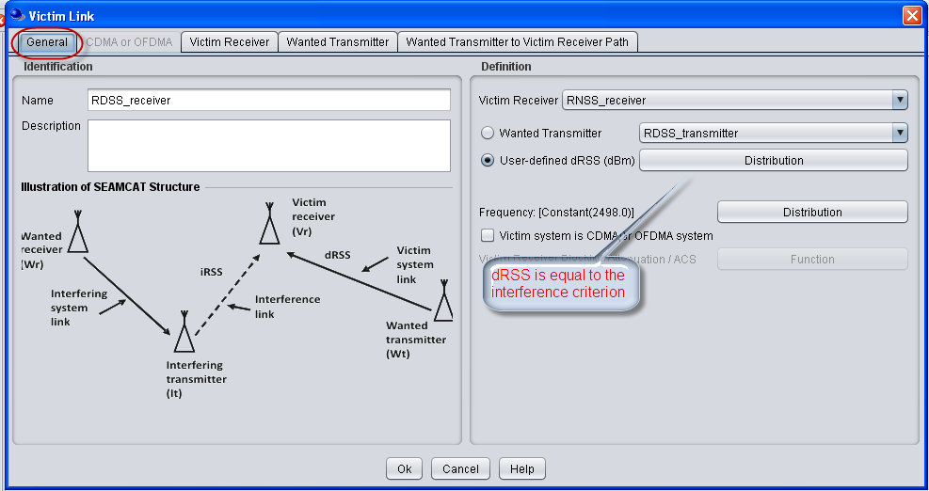
Figure A2-2: How dRSS was defined in SEAMCAT.

Conclusions

Different dRSS (interference criterion) values are tested in order to reach the probability of interference according to the percentages associated with the acquisition mode (5 %). When the probability of interference will reach the requested value it means that the right number of the maximum transmitter power in adjacent Victim band are determined.

- List of references
[1] ITU-R Resolution 613 (WRC-07) – “Global primary allocation to the radiodetermination-satellite service in the frequency band 2 483.5-2 500 MHz (space-to-Earth)”
[2] Annex 3 of the record of decisions of the consultation meeting for ITU-R Resolution 609 – “Protection of aeronautical radionavigation service systems from the equivalent power flux-density produced by radionavigation-satellite service networks and systems in the1 164-1 215 MHz frequency band”
[3] document 4/98 “DRAFT NEW RECOMMENDATION ITU R M.[1477_NEW] Characteristics and protection criteria for receiving earth stations in the radionavigation-satellite service (space-to-Earth) and receivers in the aeronautical radionavigation service operating in the band 1 559-1 610 MHz”
[4] Recommendation ITU-R F.758 – “Considerations in the development of criteria for sharing between the terrestrial fixed service and other services”
[5] Recommendation ITU-R F.1245 – “Mathematical model of average radiation patterns for line-of-sight point-to-point radio-relay system antennas for use in certain coordination studies and interference assessment in the frequency range from 1 GHz to about 70 GHz”
[6] Recommendation ITU-R P.452 – “Prediction procedure for the evaluation of microwave interference between stations on the surface of the Earth at frequencies above about 0.7 GHz”
[7] Recommendation ITU-R F.1108 – “Determination of the criteria to protect fixed service receivers from the emissions of space stations operating in non-geostationary orbits in shared frequency bands”
[8] Recommendation ITU-R M.1184 – “Technical characteristics of mobile satellite systems in the frequency bands below 3 GHz for use in developing criteria for sharing between the mobile-satellite service (MSS) and other services”
[9] ECC Report 095 – “Sharing between MSS systems using TDMA and MSS systems using CDMA in the band 1610-1626.5 MHz”
[10] ERC Report 038 – “Handbook on radio equipment and systems video links for ENG/OB use”
[11] ECC Report 006 – “Technical impact on existing primary services in the band 2.7-2.9 GHz due to the proposed introduction of new systems”
[12] Report ITU-R M.2116 – “Characteristics of broadband wireless access systems operating in the land mobile service for use in sharing studies”
[13] Recommendation ITU-R P.1411 – “Propagation data and prediction methods for the planning of short-range outdoor radiocommunication systems and radio local area networks in the frequency range 300 MHz to 100 GHz”
[14] Recommendation ITU-R F.1336 – “Reference radiation patterns of omnidirectional, sectoral and other antennas in point-to-multipoint systems for use in sharing studies in the frequency range from 1 GHz to about 70 GHz”
[15] Recommendation ITU-R M.1851 – “Mathematical models for radiodetermination radar systems antenna patterns for use in interference analyses”
[16] Recommendations ITU-R М.1464 – “Characteristics of radiolocation radars, and characteristics and protection criteria for sharing studies for aeronautical radionavigation and meteorological radars in the radiodetermination service operating in the frequency band 2 700-2 900 MHz”
[17] EC Decision 2008/477/EC – “Commission Decision 2008/477/EC on the harmonisation of the 2500-2690 MHz frequency band for terrestrial systems capable of providing electronic communications services in the Community”
[18] ECC/DEC/(05)05 – “ECC Decision of 18 March 2005 on harmonised utilisation of spectrum for IMT-2000/UMTS systems operating within the band 2500-2690 MHz”
[19] ECC Report 131 – “Derivation of a Block Edge Mask (BEM) for terminal stations in the 2.6 GHz frequency band (2500-2690 MHz)”
[20] 3GPP TR 36.942 V9.0.1 – “Evolved Universal Terrestrial Radio Access (E-UTRA); Radio Frequency (RF) system scenarios”
[21] GNSS ION 2009 – Conference Paper: “Exploration of possible GNSS signals in S-band”
[22] ETSI EN 300 328 V1.7.1 ETSI EN 300 328 V1.7.1 – “Electromagnetic compatibility and Radio spectrum Matters (ERM);Wideband transmission systems;Data transmission equipment operating in the 2,4 GHz ISM band and using wide band modulation techniques;Harmonized EN covering essential requirements under article 3.2 of the R&TTE Directive”

Propagation model from Section 4.1 of Recommendation ITU-R P.1411
Propagation model from Section 4.3 of Recommendation ITU-R P.1411
Aggregate gain is calculated as 10.Log (M.10^{X/10} +N.10^{Y/10}) where: X = On-axis gain (dB)
Antenna effective Area λ²/4(π) @2500 = -29.4dB m²
I/N = −6 dB is applicable to cases where interferences affect a limited number of cells. In other cases, such as estimating the interferences from a satellite or an aeronautical system, a threshold value of I/N = −10 dB is appropriate. See document R07-CPM-R-0001!R1!PDF-E.pdf (TABLE 1.9-1 on page 25 of chapter 3) available for download at http://www.itu.int/md/R07-CPM-R-0001/en.

