CEPT Report 49

Report from CEPT to the European Commission in response to the Mandate

“Technical conditions regarding spectrum harmonisation for terrestrial wireless systems in the 3400-3800 MHz frequency band”

**Report approved on 8 November 2013 by the ECC  
  
Corrected on 14 March 2014 by the ECC**

# Executive summary

This CEPT Report provides the answer to the Mandate issued by the European Commission on technical conditions regarding spectrum harmonisation for terrestrial wireless systems in the 3400-3800 MHz frequency band.

It provides the requested technical conditions (task 1) together with elements in relation with the possible channelling arrangements (task 2). Under task 2, CEPT has also reviewed the key principles related to the coordination between Broadband Wireless Access (BWA) stations and Fixed-Satellite Service (FSS) Earth stations in order to ensure that relevant principles will be available when MFCN (including IMT) systems will be introduced in these bands in accordance with new technical conditions.

**TASK 1 (Block Edge Mask)**

For the purposes of this report the term “BWA” (Broadband Wireless Access) refers to legacy BWA systems licenced under the existing 3400-3600 MHz licencing regimes as described in ECC/DEC/(07)02 [1] or 2008/411/EC [3] as well as the term “FS” (Fixed Service). The term “MFCN” (Mobile/fixed communications networks) includes IMT and other communications networks in the mobile and fixed services and for the purposes of this report refers to radio communication systems which should comply with the BEM defined in this report.

The technical requirements defined in this report are applicable to base stations with different power levels, enabling network deployment with both macro cells and small cells. In the figures below it is assumed for simplicity that all blocks have been licensed to MFCN (individual license granted to mobile operators with rights of use of one or more 5 MHz blocks).

For the spectrum 3400 – 3800 MHz, the BEM has not been developed to protect other services or applications, and only applies in blocks that have been licensed to MFCN according to the new harmonized frequency arrangement. However, the BEM incorporates protection of military radiolocation below 3400 MHz for country specific cases.

The BEM consists of several elements. In-block power limit is applied to a block owned by an operator. The out-of-block elements consist of a baseline level, designed to protect the spectrum of other MFCN operators, and transitional levels enabling filter roll-off from in-block to baseline levels. Additionally, levels are provided for guard bands and for protection of radar operation below 3400 MHz. The BEM applies to macro, micro, pico and femto base stations. The BEM was derived from a minimum coupling loss (MCL) analysis and simulations.

Table 1 contains the different elements of the BEM for the 3400-3600 MHz and 3600-3800 MHz bands. The guard bands apply in case of an FDD allocation in 3400-3600 MHz. It should be noted that whenever guard bands are mentioned in this report, it is understood that those apply only for an FDD allocation.

Tables 2 to 6 contain the power limits for the different BEM elements. PMax is the maximum carrier power for the base station in question, measured as e.i.r.p. Synchronized operation in the context of this Report means operation of TDD in two different systems, where no simultaneous UL and DL transmissions occur.

To obtain a BEM for a specific block, the BEM elements that are defined in Table 1 are used as follows:

1. In-block power limit is used for the block assigned to the operator.
2. Transitional regions are determined, and corresponding power limits are used. The transitional regions may overlap with guard bands, in which case transitional power limits are used.
3. For remaining spectrum assigned to MFCN FDD or TDD, baseline power limits are used.
4. For remaining guard band spectrum, guard band power limits are used.
5. For spectrum below 3400 MHz, one of the “additional baseline” power limits is used.

Frequency ranges in the tables depend on the frequency arrangement chosen (FDD or TDD in 3400-3600 MHz).

The base station BEM as described below may be relaxed whenever there are bilateral agreements between operators.

1. BEM elements

|  |  |
| --- | --- |
| **BEM elements** | |
| In-block | Block for which the BEM is derived |
| Baseline | Spectrum used for TDD and FDD UL and DL, except from the operator block in question and corresponding transitional regions |
| Transitional region | For FDD DL blocks, the transitional region applies 0 to 10 MHz below and above the block assigned to the operator.  For TDD blocks, the transitional region applies 0 to 10 MHz below and above the block assigned to the operator. Transitional regions do not apply to TDD blocks allocated to other operators, unless networks are synchronised.  The transitional regions do not apply below 3400 MHz or above 3800 MHz. |
| Guard bands | The following guard bands apply in case of an FDD allocation:  3400-3410, 3490-3510 (duplex gap) and 3590-3600 MHz  In case of overlap between transitional regions and guard bands, transitional power limits are used. |
| Additional baseline | Below 3400 MHz |

1. In-block power limit

|  |  |  |
| --- | --- | --- |
| **BEM element** | **Frequency range** | **Power limit** |
| In-block | Block assigned to the operator | Not obligatory.  In case an upper bound is desired by an administration, a value of 68 dBm/5 MHz per antenna [12] may be applied.  For femto base stations, power control should be applied to minimize interference to adjacent channels. |

1. Baseline power limits

| **BEM element** | **Frequency range** | **Power limit** |
| --- | --- | --- |
| Baseline | FDD DL (3510-3590 MHz).  Synchronized TDD blocks with the same UL/DL configuration (3400-3800 or 3600-3800 MHz). | Min(PMax – 43, 13) dBm/5 MHz  e.i.r.p. per antenna |
| Baseline | FDD UL (3410-3490 MHz).  Unsynchronised TDD blocks (3400-3800 or 3600-3800 MHz). | -34 dBm/5 MHz e.i.r.p. per cell |

1. Transitional region power limits

|  |  |  |
| --- | --- | --- |
| **BEM element** | **Frequency range** | **Power limit** |
| Transitional region | -5 to 0 MHz offset from lower block edge  0 to 5 MHz offset from upper block edge | Min(PMax – 40, 21) dBm/5 MHz  e.i.r.p. per antenna |
| Transitional region | -10 to -5 MHz offset from lower block edge 5 to 10 MHz offset from upper block edge | Min(PMax – 43, 15) dBm/5 MHz  e.i.r.p. per antenna |

Note: For TDD blocks the transitional region applies in case of synchronized adjacent blocks, and in-between adjacent TDD blocks that are separated by 5 or 10 MHz. The transition region does not extend below 3400 MHz or above 3800 MHz

1. Guard band power limits for the FDD frequency arrangement

| **BEM element** | **Frequency range** | **Power limit** |
| --- | --- | --- |
| Guard band | 3400-3410 MHz | -34 dBm/5 MHz e.i.r.p. per cell |
| Guard band | 3490-3500 MHz | -23 dBm/5 MHz per antenna port(1) |
| Guard band | 3500-3510 MHz | Min(PMax – 43, 13) dBm/5 MHz  e.i.r.p. per antenna |
| Guard band | 3590-3600 MHz | Min(PMax – 43, 13) dBm/5 MHz  e.i.r.p. per antenna |

(1) The power limit for the frequency range 3490 – 3500 MHz is based on the spurious emission requirement of -30 dBm/MHz at the antenna port, converted to 5 MHz bandwidth.

1. Base station baseline power limits below 3400 MHz for country specific cases

|  |  |  |  |  |
| --- | --- | --- | --- | --- |
| **Case** | | **BEM element** | **Frequency range** | **Power limit** |
| A | CEPT countries with military radiolocation systems below 3400 MHz | Additional Baseline | Below 3400 MHz for both TDD and FDD allocation(1) | -59 dBm/MHz e.i.r.p.(2) |
| B | CEPT countries with military radiolocation systems below 3400 MHz | Additional Baseline | Below 3400 MHz for both TDD and FDD allocation(1) | -50 dBm/MHz e.i.r.p.(2) |
| C | CEPT countries without adjacent band usage or with usage that does not need extra protection | Additional Baseline | Below 3400 MHz for both TDD and FDD allocation | Not applicable |

(1) Administrations may choose to have a guard band below 3400 MHz. In that case the power limit may apply below the guard band only.

(2) Administrations may select the limit from case A or B depending on the level of protection required for the radar in the region in question.

Cases A; B and C can be applied per region or country so that the adjacent band may have different levels of protection in different geographical areas or countries, depending on the deployment of the adjacent band systems.

In addition, the levels given in Table 6 are applicable only to outdoor cells. In case of indoor cell, the levels can be relaxed on a case by case basis.

**In-block limits**

The in-block power limit, as defined in Table 2 above, is not mandatory.

The requirement on power control for femto base stations results from the need to reduce interference from equipment that may be deployed by consumers and may thus not be coordinated with surrounding networks.

Different licencing methodologies might be chosen by administrations to license TDD spectrum. One example for a regulation methodology could be the definition of restricted blocks, where the in-block limit could be restricted and would be different than the one as defined in Table 2.

**Baseline limits**

There are two different types of baseline levels: the first for FDD downlink spectrum and synchronized TDD blocks, the second for FDD uplink spectrum and unsynchronised TDD.

* **Baseline level type 1 (FDD downlink and synchronised TDD)**

This BEM element is expressed by combining attenuation relative to the maximum carrier power with a fixed upper limit. The stricter of the two requirements applies. The fixed level provides an upper bound on the interference from a BS (see also Figure 3). The values are derived from BS – UE interference analysis, and are expressed as e.i.r.p. limits per antenna.

When two TDD blocks are synchronized and have the same UL/DL configuration, there will be no BS – BS interference. In this case, the same baseline as for the FDD DL region is used.

* **Baseline level type 2 (FDD uplink and unsynchronised TDD)**

This baseline is defined for FDD UL and TDD spectrum without synchronization, and is expressed as a fixed limit only, calculated based on BS – BS interference. The e.i.r.p. limit is given per cell. An exception for this type of baseline can be negotiated between adjacent operators for femto base stations in the case when there is no risk for interference to macro base stations. In that case -25 dBm/5MHz e.i.r.p. per cell may be used.

In Figure 1 the baseline levels are presented for a TDD-only allocation and in Figure 2 for an allocation with both FDD (3400-3600 MHz) and TDD (3600-3800 MHz). In the figures it is assumed that the TDD blocks are either all synchronised or all unsynchronised. In-block and transitional power limits have not been included in the figures.

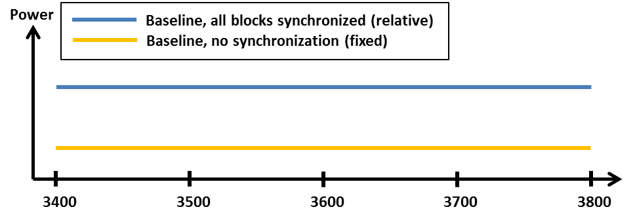

1. Schematic description of baseline power levels for a TDD-only allocation. In the case of synchronized TDD, it is assumed that all blocks are synchronized.

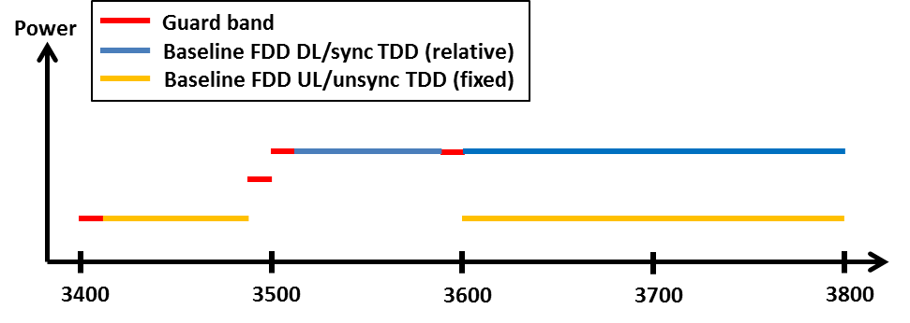

1. Schematic description of baseline and guard band power levels for a mixed FDD and TDD allocation. In the case of synchronized TDD, it is assumed that all blocks are synchronized.

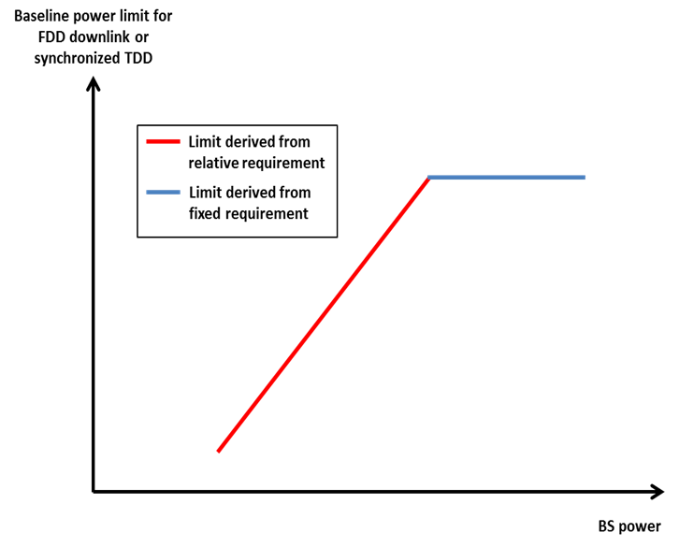

1. Combining the relative and the fixed limit for the baseline applying to FDD DL spectrum

**Transitional region power limits**

The transitional region power limits are defined to enable the reduction of power from the in-block level to the baseline or guard band levels, and is defined as in Table 4 above. The general shape of the transitional region is presented in Figure 4 below.

The requirements are defined for 0–5 MHz and 5–10 MHz offset from the upper and lower edges of an operator’s block (see Table 1 for further details) They are expressed as attenuation relative to the maximum carrier power, combined with a fixed upper limit, as for the baseline requirement in the FDD DL. The stricter of the two requirements applies.

**Guard band limits**

In the case of an FDD allocation there will be guard bands below the FDD UL, above the FDD DL, and in-between the FDD UL and DL, see Figure 3 above. For the guard band 3400-3410 MHz, the power limit is chosen to be the same as the baseline in the adjacent FDD UL spectrum, 3410-3490 MHz. Similarly, the baseline defined for 3510-3590 MHz band is also used in the guard band regions 3500-3510 MHz and 3590-3600 MHz. Finally, spurious requirements converted to 5 MHz bandwidth are used in the 3490-3500 MHz band.

**Additional baseline limits**

The additional baseline limits have been introduced to reflect the need for protection for military radiolocation in some countries. Further details can be found in the paragraph “Coexistence with other services than MFCN” below.

**Combination of BEM elements**

The BEM elements as described above are combined to provide a BEM for a particular block following the five steps listed above. Figure 4 provides an example of such a combination of BEM elements for a FDD block in the lower part of the FDD DL spectrum. Note in particular that different baseline levels are defined for different parts of the spectrum and that the power limit of the lower transitional region is used in a part of the guard band 3490 – 3510 MHz. Spectrum below 3400 MHz has not been included in this figure, although the BEM element “additional baseline” may be applied to protect military radiolocation.

|  |
| --- |
|  |

1. Combined BEM elements for an FDD block starting at 3510 MHz

**Licensing approaches for unsynchronised TDD networks**

In the case of unsynchronized TDD networks, different licensing approaches may be applied to avoid interference between adjacent operators. Examples are provided in the two bullets below.

* The regulator may introduce a separation between the block edges of two adjacent operators, to enable sufficient roll-off of filters to meet the baseline.
* In case of no frequency separation of adjacent operators’ blocks, operators may be required to limit the power used in the upper or lower part of their assigned spectrum. The level that will ensure the protection of an adjacent operator block is equal to 4.1 dBm/5MHz e.i.r.p. per cell.

**UE In-block requirement**

This report provides a recommended upper limit of 25 dBm for the in-block power of the terminals.

This power limit is specified as e.i.r.p. for terminal stations designed to be fixed or installed and as TRP[[1]](#footnote-1) for terminal stations designed to be mobile or nomadic.

A tolerance of up to +2 dB has been included in this limit, to reflect operation under extreme environmental conditions and production spread.

**UE to UE interference**

The interference between UEs belonging to different FDD operators will be very limited due to the duplex gap and the associated filters for both transmitters and receivers.

Similarly, interference from TDD UEs to FDD UEs and vice versa will also be limited due to the guard band between FDD and TDD spectrum.

On the contrary, there could be UE to UE interference between UEs of unsynchronized TDD networks, in case a UE is transmitting in the vicinity of another UE using an adjacent channel.

**Co-existence with other services than MFCN**

Co-existence studies for other services than MFCN have been carried out for both in-band and out-of-band scenarios. The in-band services considered are FSS, FS and BWA and the out-of-band services considered are civil and military Radiolocation.

No single separation distance, guard band or signal strength limit can be provided for FSS and FS to ensure co-existence with MFCN.

It is assumed that BWA systems are similar to MFCN systems and that BWA can co-exist under the new BEM licensing regime. It should however be noted that BWA systems compliant to the former technical characteristics (as defined in ECC Recommendation (04)05)) may suffer interference from MFCN systems compliant with the BEM described above. The BWA UL needs to be protected from MFCN DL interference in the same way as a MFCN UL is protected. This can be achieved by frequency separation, or by applying the appropriate BEM elements as described above.

As a consequence of the above, a transitional phase could be considered during which previous and new technical characteristics should coexist. During this transitional phase, new authorisations shall be based on the new technical characteristics. This transitional phase may only apply in countries (and possibly neighbouring countries) where a BWA network has been effectively deployed and has not been updated with the new technical characteristics.

In some CEPT countries military radiolocation systems that are deployed below 3400 MHz need a fixed limit for protection from base station interference (cases A and B in Table 3). Other mitigation measures like geographical separation, coordination on a case by case basis or an additional guard band may be necessary for a TDD allocation.

For UEs other mitigation measures will be necessary such as e.g. geographical separation or an additional guard band for both FDD and TDD allocation.

**Cross-border coordination**

Cross-border coordination in the band 3400-3800 MHz will be subject to an ECC Recommendation and national agreements as for cross-border coordination in other bands.

**TASK 2**

* **Channelling Arrangements**

In this report CEPT has assessed and justified the need to introduce channelling arrangements in the 3400-3800 MHz band to develop a harmonised solution that is sufficiently precise for the development of EU-wide equipment.

For the 3400-3600 MHz band two channelling arrangements have been introduced: one comprising of a  
200 MHz TDD plan, the other one comprising of the 2x80 MHz FDD plan (see Figures 6 and 7 below respectively and Section 3.1.4.4 of this report for details).

The possibility of a preferred channelling arrangement for the 3.4-3.6 GHz band has been studied by ECC, as well as the possibility to have FDD and TDD on the same footing.

After the Public consultation on this CEPT Report, the ECC decided in favour of having TDD as the preferred frequency arrangement with FDD frequency arrangement as an alternative.

For the 3600-3800 MHz band one channelling arrangement has been introduced comprising of a 200 MHz TDD plan (see Figure 5 below and Section 3.1.4.3 of this report for details).



1. Harmonised frequency arrangement for the 3600-3800 MHz band based on TDD



1. Frequency arrangement for the 3400-3600 MHz band based on TDD



1. Frequency arrangement for the 3400-3600 MHz band based on FDD

* **Key principles related to the coordination of MFCN and FSS**

The following key principles related to the coordination between Mobile/Fixed Communication Network stations and Fixed-Satellite Service (FSS) Earth stations should be implemented at national level and between neighbouring administrations in order to ensure coordination between these systems:

1. Frequency coordination is primarily concerned with local implementation, local propagation conditions and local licensed use of the shared band. This is best dealt with by national administrations;
2. Some administrations have effective co-ordination arrangements in place. The implementation of these guidelines is at the discretion of the national administrations to the extent this may help them;
3. The key objectives of co-ordination processes are maximising efficient use of the available spectrum for the benefit of the EU whilst protecting existing licensed uses of the band;
4. Coordination processes and associated protection should only apply to registered/licensed spectrum users;
5. Data exchange and coordination processes are mutual and reciprocal to all band users;
6. Data on registered use of the band should be available to all users under relevant legal protections and confidentiality obligations;
7. The coordination process must be both accurate and fast to enable all operators to efficiently plan spectrum utilisation and network deployments;
8. Operators should have access to registered band usage to maximise the successful coordination of spectrum through propagation modelling without physical measurement at the planning stage;
9. All parties are responsible for the efficient use of spectrum. In deploying new MFCN stations and new FSS Earth stations, operators should be cognisant of the need to minimise constraints on the other service;
10. These guidelines primarily relate to co-ordination within national boundaries. For the situation where MFCN and FSS stations are within the territories of different administrations, the use of these guidelines within bilateral agreements may help to expedite cross border co-ordination[[2]](#footnote-2);
11. All parties should undertake reasonable efforts to successfully complete the coordination exercise as quickly as possible;
12. Either party has the inherent right to refer the co-ordination to the relevant NRA(s) if agreement cannot be reached.

**TABLE OF CONTENTS**

[0 Executive summary 2](#_Toc382553805)

[1 Introduction 13](#_Toc382553806)

[2 task 1 of the mandate (Block edge mask) 14](#_Toc382553807)

[2.1 Justification for the need to revise the existing BEM 14](#_Toc382553808)

[2.2 Development of the new BEM 14](#_Toc382553809)

[3 task 2 of the mandate (channelling arrangements) 24](#_Toc382553810)

[3.1 Channelling arrangements in the 3400-3600 MHz and 3600-3800 MHz 24](#_Toc382553811)

[3.1.1 Background information 24](#_Toc382553812)

[3.1.2 EC context 24](#_Toc382553813)

[3.1.3 General justification for harmonised frequency arrangements 25](#_Toc382553814)

[3.1.4 Justification of channelling arrangements 25](#_Toc382553815)

[3.1.4.1 Block size 25](#_Toc382553816)

[3.1.4.2 Sub-bands 3400-3600 MHz and 3600-3800 MHz are treated separately 25](#_Toc382553817)

[3.1.4.3 Channelling arrangement for the sub-band 3600-3800 MHz 25](#_Toc382553818)

[3.1.4.4 Channelling arrangements for the sub-band 3400-3600 MHz 26](#_Toc382553819)

[3.2 Key principles related to the coordination of MFCN and FSS 26](#_Toc382553820)

[3.2.1 Key principles for coordination between FSS and MFCN 27](#_Toc382553821)

[4 Conclusions 28](#_Toc382553822)

[4.1 Task 1 (Block Edge Mask) 28](#_Toc382553823)

[4.2 Task 2 Channelling arrangements and coordination with FSS 35](#_Toc382553824)

[ANNEX 1: Technical analysis for the justification of new BEM 37](#_Toc382553825)

[ANNEX 2: Comparison of the 3400-3800 MHz ECC deliverables 44](#_Toc382553826)

[ANNEX 3: EC mandate on 3400-3800 MHz 46](#_Toc382553827)

[ANNEX 4: List of reference 47](#_Toc382553828)

**LIST OF ABBREVIATIONS**

|  |  |
| --- | --- |
| **Abbreviation** | **Explanation** |
| **BEM** | Block Edge Mask |
| **BS** | Base stations |
| **BWA** | Broadband Wireless Access systems |
| **CEPT** | European Conference of Postal and Telecommunications Administrations |
| **ECC** | Electronic Communications Committee |
| **EC** | European Commission |
| **ECO** | European Communications Office |
| **ENG** | Electronic News Gathering |
| **e.i.r.p.** | equivalent isotropic radiated power |
| **ERO** | European Radiocommunications Office |
| **ETSI** | European Telecommunications Standards Institute |
| **EU** | European Union |
| **E-UTRA** | Evolved Universal Terrestrial Radio Access |
| **FDD** | Frequency Division Duplex |
| **FS** | Fixed Service |
| **FSS** | Fixed Satellite Service |
| **FWS** | Fixed Wireless Systems |
| **IMT** | International Mobile Telecommunications |
| **LRTC** | Least Restrictive Technical Conditions |
| **MFCN** | Mobile/Fixed Communications Networks |
| **MFW** | Multipoint Fixed Wireless |
| **MCL** | Minimum Coupling Loss |
| **OB** | Outside Broadcasting |
| **PMP** | Point-to-Multipoint |
| **PP FS** | Point-to-Point (fixed service) |
| **TDD** | Time Division Duplex |
| **UE** | User Equipment |
| **UL/DL** | Uplink/Downlink |
| **WAPECS** | Wireless Access Policy for Electronic Communications Services |

# Introduction

The European Commission has issued a Mandate to CEPT on technical conditions regarding spectrum harmonisation for terrestrial wireless systems in the 3400-3800 MHz frequency band (see Annex 3) to review and amend the technical conditions for the harmonised use of the 3400-3800 MHz frequency band in order to adapt them to the latest developments in technology by preserving flexibility of use in line with the WAPECS approach, including the updating of the Block Edge Mask (BEM) and introducing harmonised frequency arrangements.

CEPT is mandated to undertake the following tasks:

1. “Assess and justify any need to revise the common minimal (least restrictive) technical conditions, including BEM, which underlie the harmonised use of in the 3400-3800 MHz frequency band in the EU and, if necessary, identify modified conditions in view of accommodating developments in wireless broadband access technology in particular larger bandwidths. These conditions should be sufficient to avoid interference, facilitate cross-border coordination, and ensure co-existence with other existing systems and services in the same band and adjacent bands.”
2. “Assess and justify any need to introduce channelling arrangements in addition to (1) and, if necessary, develop a harmonised solution that is sufficiently precise for the development of EU-wide equipment.”

CEPT has developed a roadmap to structure the work in response to this Mandate to address the following issues:

1. Assess and justify any need to revise the common minimal (least restrictive) technical conditions including BEM;
2. Identify modified conditions in view of accommodating developments in wireless broadband access technology in particular larger bandwidths;
3. Assess and justify any need to introduce channelling arrangements in addition to the LRTC (BEM);
4. If necessary, develop a harmonised solution that is sufficiently precise for the development of EU-wide equipment;
5. A review of the key principles related to the coordination between Broadband Wireless Access (BWA) stations and Fixed-Satellite Service (FSS) Earth stations in order to ensure that relevant principles will be available when future for MFCN (including IMT) systems to be introduced in these bands in accordance with new conditions.

# task 1 of the mandate (Block edge mask)

## Justification for the need to revise the existing BEM

Regarding the work on issue (a) (see Introduction), ECC agreed on the justification for the need to revise the common minimal (least restrictive) technical conditions including BEM. The justification being the following:

In 2004 ECC adopted ECC/REC/ (04)05 [2] on “Guidelines for accommodation and assignment of Multipoint Fixed Wireless systems in frequency bands 3400-3600 MHz and 3600-3800 MHz” and in 2007 ECC/DEC/(07)02 [1] on “Availability of frequency bands between 3400-3800 MHz for the harmonised implementation of Broadband Wireless Access systems (BWA)”. In 2008 the BEM contained in ECC/REC/(04)05 [2] were included in the Commission Decision 2008/411/EC [3] on the harmonisation of the 3400-3800 MHz frequency band for terrestrial systems capable of providing electronic communications services in the Community.

WRC-07 identified the band 3400-3600 MHz for IMT, so ECC developed band plans for MFCN systems including IMT (see ECC/DEC/(11)06 [4]).

ECC analysed the existing BEM contained in ECC/REC/(04)05 [2], which were developed for PMP FWS systems in 2004 and concluded that it is not suitable for the introduction of MFCN systems including IMT in the 3400-3600 MHz band, due to the following reasons:

* The BEM available have been designed to ensure co-existence between PMP FWS applications only.
* The BEM were derived with the assumption of an internal guard band (half a channel width).
* The effect of blocking was not considered for establishing the BEM (which may lead to more stringent masks).
* The BEM may not even be suitable when PMP FWS are based on adjacent TDD blocks.
* The BEM is developed under the assumption that a high gain antenna leads to a lower probability of interference than a low gain antenna. While that might be appropriate for Fixed Wireless Systems, it is certainly inappropriate for other types of MFCN systems.
* The ETSI SEM (for 3GPP band class 7/38) do not allow an operation to fit to the BEM. It is anticipated that the SEMs of IMT-Advanced systems would not allow an operation to fit the BEM of the ECC/REC/(04)05 [2] as well (due to their large bandwidths).
* When band plans are available and adopted, there is no need for the unnecessarily tight BEM but it should be adjusted to the more harmonised conditions in order to facilitate affordable equipment, maximise the spectrum efficiency (e.g. by reduced guard bands) and thus maximize the available amount of spectrum.

The technical analysis is provided in Annex 1 of this report.

## Development of the new BEM

In this report the BEM was derived from a minimum coupling loss (MCL) analysis and simulations.

For the purposes of this report the term “BWA” (Broadband Wireless Access) refers to legacy BWA systems licenced under the existing 3400-3600 MHz licencing regimes as described in ECC/DEC/(07)02 or 2008/411/EC as well as the term “FS” (Fixed Service). The term “MFCN” (Mobile/fixed communications networks) includes IMT and other communications networks in the mobile and fixed services and for the purposes of this report refers to radio communication systems which should comply with the BEM defined in this report.

The base station BEM requirements as described below may be relaxed whenever there are bilateral agreements between operators. For the spectrum 3400-3800 MHz, the BEM has not been developed to protect other services or applications, and only applies in blocks that have been licensed to MFCN according to the new harmonized frequency arrangement. However, the BEM incorporates protection of military radiolocation below 3400 MHz.

In the figures below it is assumed for simplicity that all blocks have been licensed to MFCN.

Figure 8 describes a general BEM.

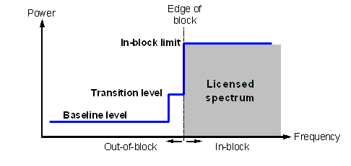

1. Illustration of a general block-edge mask

Table 7 contains the different elements of the BEM for the 3400-3600 MHz and 3600-3800 MHz bands. Tables 8 to 12 contain the power limits for the different BEM elements. PMax is the maximum carrier power for the base station in question, measured as e.i.r.p. Synchronized operation in the context of this Report means operation of TDD in two different systems, where no simultaneous UL and DL transmissions occur.

To obtain a BEM for a specific block, the BEM elements that are defined in Table 7 are used as follows:

1. In-block power limit is used for the block assigned to the operator.
2. Transitional regions are determined, and corresponding power limits are used. The transitional regions may overlap with guard bands, in which case transitional power limits are used.
3. For remaining spectrum assigned to MFCN FDD or TDD, baseline power limits are used.
4. For remaining guard band spectrum, guard band power limits are used.
5. For spectrum below 3400 MHz, one of the “additional baseline” power limits is used.

Frequency ranges in the tables depend on the frequency arrangement chosen (FDD or TDD in 3400 – 3600 MHz).

1. BEM elements

|  |  |
| --- | --- |
| **BEM elements** | |
| In-block | Block for which the BEM is derived |
| Baseline | Spectrum used for TDD and FDD UL and DL, except from the operator block in question and corresponding transitional regions |
| Transitional region | For FDD DL blocks, the transitional region applies 0 to 10 MHz below and above the block assigned to the operator.  For TDD blocks, the transitional region applies 0 to 10 MHz below and above the block assigned to the operator. Transitional regions do not apply to TDD blocks allocated to other operators, unless networks are synchronised.  The transitional regions do not apply below 3400 MHz or above 3800 MHz. |
| Guard bands | The following guard bands apply in case of an FDD allocation:  3400-3410, 3490-3510 (duplex gap) and 3590-3600 MHz  In case of overlap between transitional regions and guard bands, transitional power limits are used. |
| Additional baseline | Below 3400 MHz |

1. In-block power limit

|  |  |  |
| --- | --- | --- |
| **BEM element** | **Frequency range** | **Power limit** |
| In-block | Block assigned to the operator | Not obligatory.  In case an upper bound is desired by an administration, a value of 68 dBm/5 MHz per antenna [12] may be applied.  For femto base stations, power control should be applied to minimize interference to adjacent channels. |

1. Baseline power limits

| **BEM element** | **Frequency range** | **Power limit** |
| --- | --- | --- |
| Baseline | FDD DL (3510-3590 MHz).  Synchronized TDD blocks with the same UL/DL configuration (3400-3800 or 3600-3800 MHz). | Min(PMax – 43, 13) dBm/5 MHz  e.i.r.p. per antenna |
| Baseline | FDD UL (3410-3490 MHz).  Unsynchronised TDD blocks (3400-3800 or 3600-3800 MHz). | -34 dBm/5 MHz e.i.r.p. per cell(1) |

1. Transitional region power limits

|  |  |  |
| --- | --- | --- |
| **BEM element** | **Frequency range** | **Power limit** |
| Transitional region | -5 to 0 MHz offset from lower block edge  0 to 5 MHz offset from upper block edge | Min(PMax – 40, 21) dBm/5 MHz  e.i.r.p. per antenna |
| Transitional region | -10 to -5 MHz offset from lower block edge 5 to 10 MHz offset from upper block edge | Min(PMax – 43, 15) dBm/5 MHz  e.i.r.p. per antenna |

Note: For TDD blocks the transitional region applies in case of synchronized adjacent blocks, and in-between adjacent TDD blocks that are separated by 5 or 10 MHz. The transition region does not extend below 3400 MHz or above 3800 MHz

1. Guard band power limits for the FDD frequency arrangement

| **BEM element** | **Frequency range** | **Power limit** |
| --- | --- | --- |
| Guard band | 3400-3410 MHz | -34 dBm/5 MHz e.i.r.p. per cell |
| Guard band | 3490-3500 MHz | -23 dBm/5 MHz per antenna port(1) |
| Guard band | 3500-3510 MHz | Min(PMax – 43, 13) dBm/5 MHz  e.i.r.p. per antenna |
| Guard band | 3590-3600 MHz | Min(PMax – 43, 13) dBm/5 MHz  e.i.r.p. per antenna |

(1) The power limit for the frequency range 3490 – 3500 MHz is based on the spurious emission requirement of -30 dBm/MHz at the antenna port, converted to 5 MHz bandwidth.

1. Base station baseline power limits below 3400 MHz for country specific cases

|  |  |  |  |  |
| --- | --- | --- | --- | --- |
| **Case** | | **BEM element** | **Frequency range** | **Power limit** |
| A | CEPT countries with military radiolocation systems below 3400 MHz | Additional Baseline | Below 3400 MHz for both TDD and FDD allocation(1) | -59 dBm/MHz e.i.r.p.(2) |
| B | CEPT countries with military radiolocation systems below 3400 MHz | Additional Baseline | Below 3400 MHz for both TDD and FDD allocation(1) | -50 dBm/MHz e.i.r.p.(2) |
| C | CEPT countries without adjacent band usage or with usage that does not need extra protection | Additional Baseline | Below 3400 MHz for both TDD and FDD allocation | Not applicable |

(1) Administrations may choose to have a guard band below 3400 MHz. In that case the power limit may apply below the guard band only.

(2) Administrations may select the limit from case A or B depending on the level of protection required for the radar in the region in question.

Cases A, B and C can be applied per region or country so that the adjacent band may have different levels of protection in different geographic areas, depending on the deployment of the adjacent band systems.

In the following paragraphs the different BEM elements are described further.

**In-block limits**

The in-block power limit, as defined in Table 8 above, is not obligatory. The requirement on power control for femto base stations results from the need to reduce interference from equipment that may be deployed by consumers and may thus not be coordinated with surrounding networks.

Different licencing methodologies might be chosen by administrations to license TDD spectrum. One example for a regulation methodology could be the definition of restricted blocks, where the in-block limit could be restricted and would be different than the one as defined in Table 8.

**Baseline limits**

There are two different types of baseline levels. The first is defined for FDD downlink spectrum and for the case when two TDD blocks are synchronized, i.e. when there is no BS – BS interference. This BEM element is expressed by combining attenuation relative to the maximum carrier power with a fixed upper limit. The stricter of the two requirements applies. The fixed level provides an upper bound on the interference from a BS (see also Figure 9). The values are derived from BS – UE interference analysis, and are expressed as e.i.r.p. limits per antenna.



1. Combining the relative and the fixed limit for the baseline applying to FDD DL spectrum and to synchronized TDD spectrum

The second type of baseline is defined for FDD UL and TDD spectrum without synchronization, and is expressed as a fixed limit only, calculated based on BS – BS interference. The e.i.r.p. limit is given per cell. An exception for this type of baseline can be negotiated between adjacent operators for femto base stations in the case when there is no risk for interference to macro base stations. In that case -25 dBm/5MHz e.i.r.p. per cell may be used.

In Figure 10 the baseline levels are presented for a TDD-only allocation and in Figure 11 for an allocation with both FDD (3400-3600 MHz) and TDD (3600-3800 MHz). In the figures it is assumed that the TDD blocks are either all synchronised or all unsynchronised. In-block and transitional power limits have not been included in the figures.



1. Schematic description of baseline levels for a TDD-only allocation. In the case of synchronized TDD, it is assumed that all blocks are synchronized.



1. Schematic description of baseline and guard band power levels for a mixed FDD and TDD allocation. In the case of synchronized TDD, it is assumed that all blocks are synchronized.

**Transitional region power limits**

The transitional region power limits are defined to enable the reduction of power from the in-block level to the baseline or guard band levels, and is defined as in Table 12 above. The general shape of the transitional region is presented in Figure 12 below.

The requirements are defined for 0–5 MHz and 5–10 MHz offset from the upper and lower edges of an operator’s block (see Table 7 for further details) They are expressed as attenuation relative to the maximum carrier power, combined with a fixed upper limit, as for the baseline requirement in the FDD DL. The stricter of the two requirements applies.

**Guard band limits**

In the case of an FDD allocation there will be guard bands below the FDD UL, above the FDD DL, and in-between the FDD UL and DL, see Figure 11 above. For the guard band 3400-3410 MHz, the power limit is chosen to be the same as the baseline in the adjacent FDD UL spectrum, 3410-3490 MHz. Similarly, the baseline defined for 3510-3590 MHz band is also used in the guard band regions 3500-3510 MHz and 3590-3600 MHz. Finally, spurious requirements converted to 5 MHz bandwidth are used in the 3490-3500 MHz band.

**Additional baseline limits**

The additional baseline limits have been introduced to reflect the need for protection for military radiolocation in some countries. For further details can be found in the paragraph “Coexistence with other services than MFCN” below.

**Combination of BEM elements**

The BEM elements as described above are combined to provide a BEM for a particular block following the five steps listed above. Figure 5 provides an example of such a combination of BEM elements for a FDD block in the lower part of the FDD DL spectrum. Note in particular that different baseline levels are defined for different parts of the spectrum and that the power limit of the lower transitional region is used in a part of the guard band 3490-3510 MHz. Spectrum below 3400 MHz has not been included in this figure, although the BEM element “additional baseline” may be applied to protect military radiolocation.

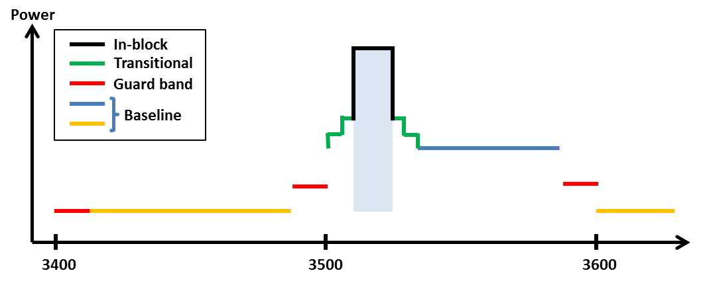

1. Combined BEM elements for an FDD block starting at 3510 MHz

**Licensing approaches for unsynchronised TDD networks**

In the case of unsynchronized TDD networks, different licensing approaches may be applied to avoid interference between adjacent operators. Examples are provided below.

Figure 13 depicts the case where there is no frequency separation between the block edges of two adjacent operators. The baseline should then be met starting from the block edge of the other operator.

**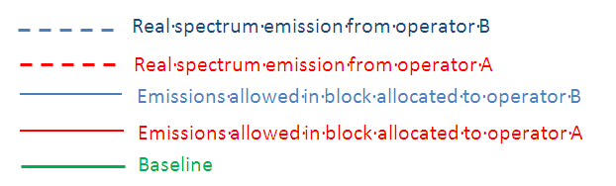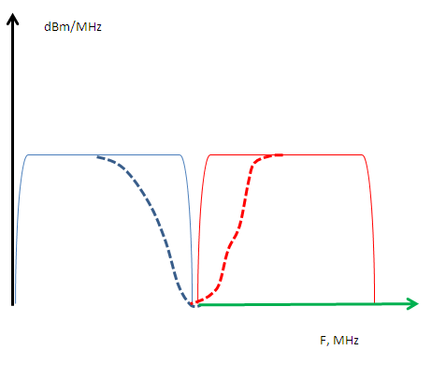**

1. Licensing approach with no frequency separation between the block edges of two adjacent unsynchronised TDD networks

Spectrum usage could be increased by bilateral agreements, for instance by sharing an internal guard band as indicated in Figure 14.

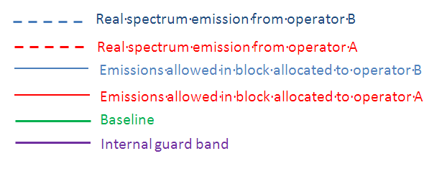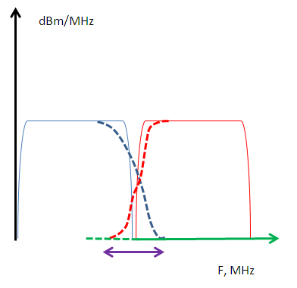

1. Licensing approach with no frequency separation between the block edges of two adjacent unsynchronised TDD networks

Figure 15 shows a case where the regulator has introduced a separation between the block edges of the two adjacent operators, to enable sufficient roll-off of filters to meet the baseline.

**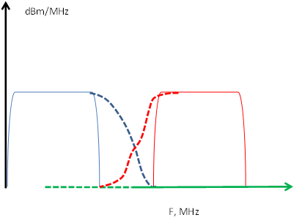**

1. Licensing approach with separation between the block edges of the two adjacent operators

Figure 16 displays the case without frequency separation of adjacent operators’ blocks, but where the operators are required to limit the power used in the upper or lower part of their assigned spectrum. The level that will ensure the protection of an adjacent operator block is equal to 4.1 dBm/5MHz e.i.r.p. per cell.

**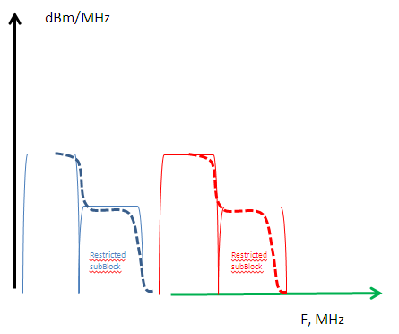**

1. Licensing approach with restricted blocks

**UE In-block requirement**

This report provides a recommended upper limit of 25 dBm for the in-block power of the terminals.

This power limit is specified as e.i.r.p. for terminal stations designed to be fixed or installed and as TRP[[3]](#footnote-3) for terminal stations designed to be mobile or nomadic.

A tolerance of up to +2 dB has been included in this limit, to reflect operation under extreme environmental conditions and production spread.

**UE to UE interference**

The interference between UEs belonging to different FDD operators will be very limited due to the duplex gap and the associated filters for both transmitters and receivers.

Similarly, interference from TDD UEs to FDD UEs and vice versa will also be limited due to the guard band between FDD and TDD spectrum.

On the contrary, there could be UE to UE interference between UEs of unsynchronized TDD networks, in case a UE is transmitting in the vicinity of another UE using an adjacent channel.

**Co-existence with other services than MFCN**

Co-existence studies for other services than MFCN have been carried out for both in-band and out-of-band scenarios. The in-band services considered are FSS, FS and BWA and the out-of-band service are civil and military Radiolocation.

The conclusions are as follows:

BWA

For the purpose of co-existence, it is assumed that BWA systems are similar to MFCN systems. Therefore no studies were carried out for MFCN – BWA co-existence.

However, considering the similarity between BWA and MFCN systems it is concluded that BWA can co-exist with MFCN systems that are licenced under the new BEM licensing regime. Still, it should be noted that BWA systems compliant to the former technical characteristics (as defined in ECC Recommendation (04)05)) may suffer interference from MFCN systems compliant with the BEM described above. The BWA UL needs to be protected from MFCN DL interference in the same way as a MFCN UL is protected. This can be achieved by frequency separation, or by applying the appropriate BEM elements as described above.

As a consequence of the above, a transitional phase could be considered during which previous and new technical characteristics should coexist. During this transitional phase, new authorisations shall be based on the new technical characteristics. This transitional phase may only apply in countries (and possibly neighbouring countries) where a BWA network has been effectively deployed and has not been updated with the new technical characteristics.

Fixed Service

Due to the varying characteristics of different types of FS systems and their deployment, no single separation distance, guard band or signal strength limit can be provided to guarantee co-existence with mobile systems. Co-existence can be achieved through coordination on a case-by-case basis. Based on the results of analysis of both directions of interference (mobile service interfering into P-P and vice-versa) some general observations can be made. Overlapping channel sharing, i.e. a scenario with any amount of overlap between spectrum of interfering and interfered signals, is not feasible in the same geographical area. Consequently if spectrum is used ubiquitously by the FS it cannot be used by the mobile service in the same region. With larger frequency separation and distances coordination is needed, depending on the characteristics of the mobile and the P-P services.

The studies in this report take into account a single interferer. In the case of multiple interferers co-existence could be more difficult to achieve.

Also interference from FS systems to mobile systems may exceed the acceptable interference level.

The similarities between Mobile Systems and P-MP Fixed Systems indicate that the results for mobile – mobile adjacent channel co-existence largely apply to the mobile – P-MP scenario as well. In case of BS – BS interference additional measures may thus be necessary, such as frequency separation and/or additional filters, whereas otherwise co-existence is expected to be possible without such measures.

MFCN UEs and BWA terminal stations have similar characteristics, which justifies that the conclusions of the ECC Report 100 [13] on the coexistence of BWA TS with Fixed Service can be extended to MFCN UEs. With that understanding while coordinating MFCN BS and FS it is sufficient to ensure that MFCN BS do not interfere with FS, since that will also guarantee the protection of the FS from MFCN UEs.

Fixed Satellite Service

Due to the varying characteristics of different types of FSS earth stations and their deployment, no single separation distance, guard band or signal strength limit can be provided to ensure co-existence with MFCN. Co-existence should be achieved through co-ordination on a case-by-case basis, assuming FSS earth stations locations are known. This has been studied in ECC Report 100 [13], as referenced by ECC Decision (07)02, and in ITU-R Report M.2109 [18] noting that maximum e.i.r.p. for base stations was limited to   
53 dBm/MHz only in ECC/REC/(04)05 [2].

Some general observations about MFCN – FSS co-existence can also be made. Separation distances for co-existence vary considerably depending on type of equipment and deployment (e.g. tilt and clutter), but can be large. User equipment impact earth stations less than base stations, so separation that prevents interference from base stations will also protect earth stations from UE interference. There are several mitigation techniques that can be applied, in particular site shielding of earth stations. Interference from FSS satellites to MFCN may exceed the acceptable interference level, but in most cases only by a small margin.

The coordination of MFCN BS and FSS will ensure that MFCN UEs do not interfere with FSS, based on the analysis conducted in ECC Report 100 [13] and ITU-R Report M.2109 [14].

Radiolocation

Due to the varying characteristics of different types of radar stations and their deployment, no single separation distance, guard band or signal strength limit can be provided to ensure co-existence with MFCN. Co-existence should be achieved through co-ordination on a case-by-case basis. However, some general observations can be made. Separation distances due to interference from MFCN to radars can be large, but may be limited to a few km in case of sufficient frequency separation to enable roll-off for MFCN unwanted emissions and good selectivity of radars.

There are mitigation techniques which can reduce the separation distance or frequency separation required. In particular, for adjacent channel/adjacent band interference, improved receiver performance and decreased unwanted emissions can be efficient.

With regard to blocking of radars by mobile systems, additional isolation on the separation distance could be required between the mobile service base station and the radar. The actual impact should be determined on a case-by-case basis. One way to address this issue would be to improve the radar adjacent channel rejection capability through enhancing receiving chains where needed. Non-linear responses could be dominant for some radar frequencies, but this would be subject to further studies on a case-by-case basis.

Regarding interference from radars to MFCN networks, it is concluded that adjacent channel interference may be perceived by MFCN stations at distances of up to tens of kilometres. The analysis did however not take into account the fact that interference from radars are of an intermittent nature (pulsed interference and rotating antenna), which means that the results may be pessimistic.

If the separation distance based on base station interference is smaller than the size of the cell, UE interference to the radar may occur. In this case UE interference must be taken into account and mitigated by e.g. increasing the separation distance to at least the size of the cell.

Adjacent band limit in the case of adjacent band usage by military systems

In some CEPT countries military radiolocation systems that are deployed below 3400 MHz need a fixed limit for protection from base station interference (cases A and B in Table 3). Other mitigation measures like geographical separation, coordination on a case by case basis or an additional guard band may be necessary for a TDD allocation.

For UEs other mitigation measures will be necessary such as e.g. geographical separation or an additional guard band for both FDD and TDD allocation.

**Cross-border coordination**

Cross-border coordination in the band 3400-3800 MHz will be subject to an ECC Recommendation and national agreements as for cross-border coordination in other bands.

# task 2 of the mandate (channelling arrangements)

## Channelling arrangements in the 3400-3600 MHz and 3600-3800 MHz

The aim of this section is to assess and justify the need to introduce channelling arrangements in addition to the BEM developed as task 1 of the mandate. The channelling arrangements should be sufficiently precise to enable the development of EU-wide equipment.

In the year 2011 CEPT approved ECC/DEC/(11)06 [4] that precisely provides channelling arrangements in the 3400-3600 MHz and 3600-3800 MHz frequency bands. The reasoning and justification that led to the improvement of the regulatory framework in terms of channelling arrangements is used as basis for this section.

The possibility of a preferred channelling arrangement for the 3.4-3.6 GHz band has been studied by ECC, as well as the possibility to have FDD and TDD on the same footing.

After the Public consultation on this CEPT Report, the ECC decided in favour of having TDD as the preferred frequency arrangement with FDD frequency arrangement as an alternative.

### Background information

Any harmonised frequency arrangements for the 3400-3800 MHz band should facilitate high data rate mobile/fixed communications networks (MFCN) including International Mobile Telecommunications (IMT) services supported by larger channel bandwidths as an evolution to the existing framework without the consequential requirement for a replacement of systems based on the existing regulatory framework. It aims at providing the basis to the mobile industry and administrations to respond to the growth of mobile broadband and technological developments for wider channel bandwidths and increased data rates.

At WRC-07, the 3400-3600 MHz band was allocated on a primary basis to the mobile, except aeronautical mobile, service and identified for IMT in almost all CEPT member countries.

The term IMT covers IMT-2000 and IMT-Advanced systems. A wide range of systems are defined under this term: 6 IMT-2000 radio interfaces and 2 IMT-Advanced radio interfaces ensure a competitive environment.

Recommendation ITU-R M.1036 [5] on frequency arrangements for implementation of the terrestrial component of IMT has been revised in 2012 to include, among others, the arrangements for the 3400-3600 MHz band.

At the beginning of 2012, ITU-R agreed on the IMT-Advanced technologies in cooperation with standardisation organisations paving the way for future mobile broadband usage going beyond IMT-2000.

The ECO (formerly ERO) carried out a survey in 2008 [8] which found diverse implementations of BWA/FWA within 3400-3800 MHz in CEPT countries, including some IMT systems. This is reflected in various licensing coverage (national, regional) and various frequency blocks choices (different portions of the 3400-3800 MHz band). Moreover, this survey showed that paired blocks are used or planned to be used in TDD mode in some countries.

As far as practicable, the frequency arrangements are intended to be technology neutral and capable of facilitating competitive provision of services using a range of technologies and modes (fixed, nomadic and mobile) with sufficient flexibility to accommodate current wireless broadband services deployed in the band.

### EC context

The existing Commission Decision 2008/411/EC [3] on the harmonisation of the 3400-3800 MHz frequency band for terrestrial systems capable of providing electronic communications services in the Community is based on the results of studies in response to EC mandates that are documented in CEPT Reports 15 and 19 (which defines least restrictive technical conditions for the 3400-3800 MHz band).

Under the scope of this EC mandate (Task 1) CEPT is conducting additional analysis to determine whether the existing least restrictive technical conditions (BEM) are suitable also for the high data rate IMT services supporting larger channel bandwidths.

### General justification for harmonised frequency arrangements

It was recognised by the CEPT that implementation of MFCN including IMT systems providing high data rate applications in the band 3400-3800 MHz based on a harmonised frequency arrangement will maximise the opportunities and benefits for end users and society, reduce development and implementation costs of equipment and will secure future long term investments by providing economies of scale. Harmonised frequency arrangements facilitate economies of scale resulting in the availability of affordable equipment. A harmonised frequency arrangement will also reduce complexity in cross border coordination. Global roaming is facilitated by common frequency arrangements and measures for free circulation for IMT terminals. The opportunity to utilize larger channel bandwidths will support the provision of high data rates for IMT (especially with IMT-Advanced).

### Justification of channelling arrangements

#### Block size

CEPT chose to use block sizes of 5 MHz. It was considered that spectrum licensed for MFCN is generally assigned in multiples of 5 MHz, except where this is not possible, e.g. due to the presence of existing users. This block size enables (by combination of adjacent blocks) to utilize larger channel bandwidths creating the possibility to provide high data rates for IMT (especially with IMT-Advanced). Channel bandwidths such as 10, 20 and 40 MHz or more that could be accommodated in the bands 3400-3600 MHz and 3600-3800 MHz will enable higher data rates.

#### Sub-bands 3400-3600 MHz and 3600-3800 MHz are treated separately

The two sub-bands are treated as separate bands considering that they are treated differently in the Radio Regulations context and that the incumbent use of spectrum for each sub-band varies. For instance use of these two sub-bands for Fixed Satellite Service (FSS) is not the same (the band 3600-3800 MHz is used for FSS more intensively than the band 3400-3600 MHz).

#### Channelling arrangement for the sub-band 3600-3800 MHz

A TDD band plan has been chosen for this sub-band. It was considered that TDD may allow more flexible accommodation of current use of the frequency bands by other services. There is more flexibility to create “holes” in the band to protect incumbent users, as these holes are not replicated in the UL/DL band as is the case for FDD. For example TDD allows more efficient spectrum use when taking into account existing fixed satellite usage in case of geographical sharing. This is especially relevant to the 3600-3800 MHz band since this band is more intensively used for FSS than the band 3400-3600 MHz.

The TDD arrangement is based on a block size of 5 MHz starting at the lower edge of 3600 MHz (see the Figure below). If blocks need to be offset to accommodate other uses, the raster should be 100 kHz. Narrower blocks can be defined adjacent to other users, to allow full use of spectrum. It has to be noted that TDD in one extreme case also covers downlink only operation.



1. Harmonised frequency arrangement for the 3600-3800 MHz band based on TDD

#### Channelling arrangements for the sub-band 3400-3600 MHz

The possibility of a preferred channelling arrangement for the 3.4-3.6 GHz band has been studied by ECC, as well as the possibility to have FDD and TDD on the same footing.

After the Public consultation on this CEPT Report, the ECC decided in favour of having TDD as the preferred frequency arrangement with FDD frequency arrangement as an alternative.

It is also noted in ECC/DEC/(11)06 [4] that although there are licensed paired frequency arrangements in many CEPT countries, TDD systems are currently used in a number of those countries in the band 3400-3600 MHz due to the better availability of TDD systems.

Figure 18 below is the frequency arrangement based on TDD duplex mode. The block size is 5 MHz starting at the lower edge of 3400 MHz. If blocks need to be offset to accommodate other users, the raster should be 100 kHz. Narrower blocks can be defined adjacent to other users, to allow full use of spectrum. It has to be noted that TDD in one extreme case also covers downlink only operation.



1. Frequency arrangement for the 3400-3600 MHz band based on TDD



1. Frequency arrangement for the 3400-3600 MHz band based on FDD

## Key principles related to the coordination of MFCN and FSS

There are currently 170 fixed satellite earth stations authorized within the EU Member States (deployed on 78 sites). As such, they are protected by Member States against harmful interference.

For MFCN and FSS coordination, similar principles can be used as for BWA and FSS coordination. Indeed in the case of BWA, the “central stations” are coordinated with the FSS earth stations. This implies that all the (fixed) terminal stations, operating under the control of central stations are consequently coordinated under the umbrella of the central stations (this typically requires to slightly extend the coordination distances). The same idea can be applied to MFCN where the BWA terminal stations are now replaced with mobile terminal stations that also operate under the control of the base stations (which need to be coordinated with the FSS stations).

### Key principles for coordination between FSS and MFCN

The following key principles related to the coordination between Mobile/Fixed Communication Network stations and Fixed-Satellite Service (FSS) Earth stations should be implemented at national level and between neighbouring administrations in order to ensure coordination between these systems:

1. Frequency coordination is primarily concerned with local implementation, local propagation conditions and local licensed use of the shared band. This is best dealt with by national administrations;
2. Some administrations have effective co-ordination arrangements in place. The implementation of these guidelines is at the discretion of the national administrations to the extent this may help them;
3. The key objectives of co-ordination processes are maximising efficient use of the available spectrum for the benefit of the EU whilst protecting existing licensed uses of the band;
4. Coordination processes and associated protection should only apply to registered/licensed spectrum users;
5. Data exchange and coordination processes are mutual and reciprocal to all band users;
6. Data on registered use of the band should be available to all users under relevant legal protections and confidentiality obligations;
7. The coordination process must be both accurate and fast to enable all operators to efficiently plan spectrum utilisation and network deployments;
8. Operators should have access to registered band usage to maximise the successful coordination of spectrum through propagation modelling without physical measurement at the planning stage;
9. All parties are responsible for the efficient use of spectrum. In deploying new MFCN stations and new FSS Earth stations, operators should be cognisant of the need to minimise constraints on the other service;
10. These guidelines primarily relate to co-ordination within national boundaries. For the situation where MFCN and FSS stations are within the territories of different administrations, the use of these guidelines within bilateral agreements may help to expedite cross border co-ordination[[4]](#footnote-4);
11. All parties should undertake reasonable efforts to successfully complete the coordination exercise as quickly as possible;
12. Either party has the inherent right to refer the co-ordination to the relevant NRA(s) if agreement cannot be reached.

# Conclusions

With this report CEPT replies to the Mandate from the European Commission “Technical Conditions regarding spectrum harmonisation for terrestrial wireless systems in the 3400-3800 MHz frequency band” (provided in Annex 3).

## Task 1 (Block Edge Mask)

The justification for the development of new BEM is included in Section 2.1 of this report.

The resulting new BEM is outlined in Section 2.2 of this report.

The technical requirements defined in this Report are applicable to base stations with different power levels, enabling network deployment with both macro cells and small cells. In the figures below it is assumed for simplicity that all blocks have been licensed to MFCN (individual license granted to mobile operators with rights of use of one or more 5 MHz blocks).

For the spectrum 3400-3800 MHz, the BEM has not been developed to protect other services or applications, and only applies in blocks that have been licensed to MFCN according to the new harmonized frequency arrangement. However, the BEM incorporates protection of military radiolocation below 3400 MHz for country specific cases.

The BEM consists of several elements. In-block power limit is applied to a block owned by an operator. The out-of-block elements consist of a baseline level, designed to protect the spectrum of other MFCN operators, and transitional levels enabling filter roll-off from in-block to baseline levels. Additionally, levels are provided for guard bands and for protection of radar operation below 3400 MHz. The BEM applies to macro, micro, pico and femto base stations.

Table 13 contains the different elements of the BEM for the 3400-3600 MHz and 3600-3800 MHz bands. The guard bands apply in case of an FDD allocation in 3400-3600 MHz. It should be noted that whenever guard bands are mentioned in this report, it is understood that those apply only for an FDD allocation.

Tables 14 to 18 contain the power limits for the different BEM elements. PMax is the maximum carrier power for the base station in question, measured as e.i.r.p. Synchronized operation in the context of this Report means operation of TDD in two different systems, where no simultaneous UL and DL transmissions occur.

To obtain a BEM for a specific block, the BEM elements that are defined in Table 13 are used as follows:

1. In-block power limit is used for the block assigned to the operator.
2. Transitional regions are determined, and corresponding power limits are used. The transitional regions may overlap with guard bands, in which case transitional power limits are used.
3. For remaining spectrum assigned to MFCN FDD or TDD, baseline power limits are used.
4. For remaining guard band spectrum, guard band power limits are used.
5. For spectrum below 3400 MHz, one of the “additional baseline” power limits is used.

Frequency ranges in the tables depend on the frequency arrangement chosen (FDD or TDD in 3400 – 3600 MHz).

The BEM applies to macro, micro, pico and femto base stations.

The base station BEM as described below may be relaxed whenever there are bilateral agreements between operators.

1. BEM elements

|  |  |
| --- | --- |
| **BEM elements** | |
| In-block | Block for which the BEM is derived |
| Baseline | Spectrum used for TDD and FDD UL and DL, except from the operator block in question and corresponding transitional regions |
| Transitional region | For FDD DL blocks, the transitional region applies 0 to 10 MHz below and above the block assigned to the operator.  For TDD blocks, the transitional region applies 0 to 10 MHz below and above the block assigned to the operator. Transitional regions do not apply to TDD blocks allocated to other operators, unless networks are synchronised.  The transitional regions do not apply below 3400 MHz or above 3800 MHz. |
| Guard bands | The following guard bands apply in case of an FDD allocation:  3400-3410, 3490-3510 (duplex gap) and 3590-3600 MHz  In case of overlap between transitional regions and guard bands, transitional power limits are used. |
| Additional baseline | Below 3400 MHz |

1. In-block power limit

|  |  |  |
| --- | --- | --- |
| **BEM element** | **Frequency range** | **Power limit** |
| In-block | Block assigned to the operator | Not obligatory.  In case an upper bound is desired by an administration, a value of 68 dBm/5 MHz per antenna [12] may be applied.  For femto base stations, power control should be applied to minimize interference to adjacent channels. |

1. Baseline power limits

| **BEM element** | **Frequency range** | **Power limit** |
| --- | --- | --- |
| Baseline | FDD DL (3510-3590 MHz).  Synchronized TDD blocks with the same UL/DL configuration (3400-3800 or 3600-3800 MHz). | Min(PMax – 43, 13) dBm/5 MHz  e.i.r.p. per antenna |
| Baseline | FDD UL (3410-3490 MHz).  Unsynchronised TDD blocks (3400-3800 or 3600-3800 MHz). | -34 dBm/5 MHz e.i.r.p. per cell(1) |

1. Transitional region power limits

|  |  |  |
| --- | --- | --- |
| **BEM element** | **Frequency range** | **Power limit** |
| Transitional region | -5 to 0 MHz offset from lower block edge  0 to 5 MHz offset from upper block edge | Min(PMax – 40, 21) dBm/5 MHz  e.i.r.p. per antenna |
| Transitional region | -10 to -5 MHz offset from lower block edge 5 to 10 MHz offset from upper block edge | Min(PMax – 43, 15) dBm/5 MHz  e.i.r.p. per antenna |

Note: For TDD blocks the transitional region applies in case of synchronized adjacent blocks, and in-between adjacent TDD blocks that are separated by 5 or 10 MHz. The transition region does not extend below 3400 MHz or above 3800 MHz

1. Guard band power limits for the FDD frequency arrangement

| **BEM element** | **Frequency range** | **Power limit** |
| --- | --- | --- |
| Guard band | 3400-3410 MHz | -34 dBm/5 MHz e.i.r.p. per cell |
| Guard band | 3490-3500 MHz | -23 dBm/5 MHz per antenna port(1) |
| Guard band | 3500-3510 MHz | Min(PMax – 43, 13) dBm/5 MHz  e.i.r.p. per antenna |
| Guard band | 3590-3600 MHz | Min(PMax – 43, 13) dBm/5 MHz  e.i.r.p. per antenna |

(1) The power limit for the frequency range 3490 – 3500 MHz is based on the spurious emission requirement of -30 dBm/MHz at the antenna port, converted to 5 MHz bandwidth.

1. Base station baseline power limits below 3400 MHz for country specific cases

|  |  |  |  |  |
| --- | --- | --- | --- | --- |
| **Case** | | **BEM element** | **Frequency range** | **Power limit** |
| A | CEPT countries with military radiolocation systems below 3400 MHz | Additional Baseline | Below 3400 MHz for both TDD and FDD allocation(1) | -59 dBm/MHz e.i.r.p.(2) |
| B | CEPT countries with military radiolocation systems below 3400 MHz | Additional Baseline | Below 3400 MHz for both TDD and FDD allocation(1) | -50 dBm/MHz e.i.r.p. (2) |
| C | CEPT countries without adjacent band usage or with usage that does not need extra protection | Additional Baseline | Below 3400 MHz for both TDD and FDD allocation | Not applicable |

(1) Administrations may choose to have a guard band below 3400 MHz. In that case the power limit may apply below the guard band only.

(2) Administrations may select the limit from case A or B depending on the level of protection required for the radar in the region in question.

Cases A; B and C can be applied per region or country so that the adjacent band may have different levels of protection in different geographical areas or countries, depending on the deployment of the adjacent band systems.

In addition, the levels given in Table 18 are applicable only to outdoor cells. In case of indoor cell, the levels can be relaxed on a case by case basis.

**In-block limits**

The in-block power limit, as defined in Table 14 above, is not mandatory.

The requirement on power control for femto base stations results from the need to reduce interference from equipment that may be deployed by consumers and may thus not be coordinated with surrounding networks.

Different licencing methodologies might be chosen by administrations to license TDD spectrum. One example for a regulation methodology could be the definition of restricted blocks, where the in-block limit could be restricted and would be different than the one as defined in Table 14.

**Baseline limits**

There are two different types of baseline levels: the first for FDD downlink spectrum and synchronized TDD blocks, the second for FDD uplink spectrum and unsynchronised TDD.

* **Baseline level type 1 (FDD downlink and synchronised TDD)**

This BEM element is expressed by combining attenuation relative to the maximum carrier power with a fixed upper limit. The stricter of the two requirements applies. The fixed level provides an upper bound on the interference from a BS (see also Figure 22). The values are derived from BS – UE interference analysis, and are expressed as e.i.r.p. limits per antenna.

When two TDD blocks are synchronized and have the same UL/DL configuration, there will be no BS – BS interference. In this case, the same baseline as for the FDD DL region is used.

* **Baseline level type 2 (FDD uplink and unsynchronised TDD)**

This baseline is defined for FDD UL and TDD spectrum without synchronization, and is expressed as a fixed limit only, calculated based on BS – BS interference. The e.i.r.p. limit is given per cell. An exception for this type of baseline can be negotiated between adjacent operators for femto base stations in the case when there is no risk for interference to macro base stations. In that case -25 dBm/5MHz e.i.r.p. per cell may be used.

In Figure 20 the baseline levels are presented for a TDD-only allocation and in Figure 21 for an allocation with both FDD (3400-3600 MHz) and TDD (3600-3800 MHz). In the figures it is assumed that the TDD blocks are either all synchronised or all unsynchronised. In-block and transitional power limits have not been included in the figures.



1. Schematic description of baseline power levels for a TDD-only allocation. In the case of synchronized TDD, it is assumed that all blocks are synchronized



1. Schematic description of baseline and guard band power levels for a mixed FDD and TDD allocation. In the case of synchronized TDD, it is assumed that all blocks are synchronized



1. Combining the relative and the fixed limit for the baseline applying to FDD DL spectrum

**Transitional region power limits**

The transitional region power limits are defined to enable the reduction of power from the in-block level to the baseline or guard band levels, and is defined as in Table 16 above. The general shape of the transitional region is presented in Figure 23 below.

The requirements are defined for 0–5 MHz and 5–10 MHz offset from the upper and lower edges of an operator’s block (see Table 13 for further details) They are expressed as attenuation relative to the maximum carrier power, combined with a fixed upper limit, as for the baseline requirement in the FDD DL. The stricter of the two requirements applies.

**Guard band limits**

In the case of an FDD allocation there will be guard bands below the FDD UL, above the FDD DL, and in-between the FDD UL and DL, see Figure 21 above. For the guard band 3400-3410 MHz, the power limit is chosen to be the same as the baseline in the adjacent FDD UL spectrum, 3410-3490 MHz. Similarly, the baseline defined for 3510-3590 MHz band is also used in the guard band regions 3500-3510 MHz and 3590-3600 MHz. Finally, spurious requirements converted to 5 MHz bandwidth are used in the 3490-3500 MHz band.

**Additional baseline limits**

The additional baseline limits have been introduced to reflect the need for protection for military radiolocation in some countries. Further details can be found in the paragraph “Coexistence with other services than MFCN” below.

**Combination of BEM elements**

The BEM elements as described above are combined to provide a BEM for a particular block following the five steps listed above. Figure 5 provides an example of such a combination of BEM elements for a FDD block in the lower part of the FDD DL spectrum. Note in particular that different baseline levels are defined for different parts of the spectrum and that the power limit of the lower transitional region is used in a part of the guard band 3490 – 3510 MHz. Spectrum below 3400 MHz has not been included in this figure, although the BEM element “additional baseline” may be applied to protect military radiolocation.

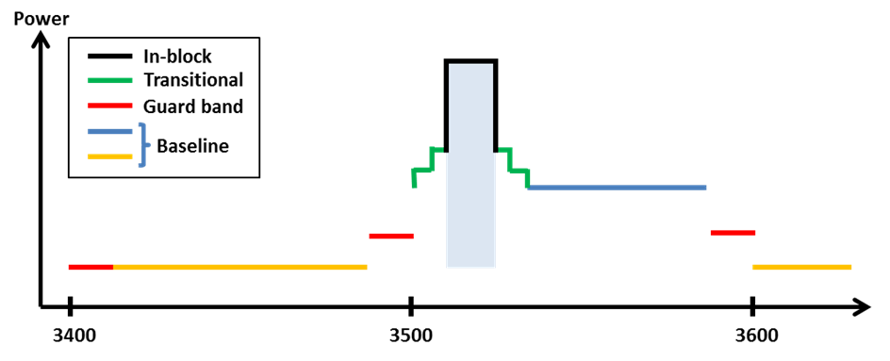

1. Combined BEM elements for an FDD block starting at 3510 MHz

**Licensing approaches for unsynchronised TDD networks**

In the case of unsynchronized TDD networks, different licensing approaches may be applied to avoid interference between adjacent operators. Examples are provided in the two bullets below.

* The regulator may introduce a separation between the block edges of two adjacent operators, to enable sufficient roll-off of filters to meet the baseline.
* In case of no frequency separation of adjacent operators’ blocks, operators may be required to limit the power used in the upper or lower part of their assigned spectrum. The level that will ensure the protection of an adjacent operator block is equal to 4.1 dBm/5MHz e.i.r.p. per cell.

**UE In-block requirement**

This report provides a recommended upper limit of 25 dBm for the in-block power of the terminals.

This power limit is specified as e.i.r.p. for terminal stations designed to be fixed or installed and as TRP[[5]](#footnote-5) for terminal stations designed to be mobile or nomadic.

A tolerance of up to + 2 dB has been included in this limit, to reflect operation under extreme environmental conditions and production spread.

**UE to UE interference**

The interference between UEs belonging to different FDD operators will be very limited due to the duplex gap and the associated filters for both transmitters and receivers.

Similarly, interference from TDD UEs to FDD UEs and vice versa will also be limited due to the guard band between FDD and TDD spectrum.

On the contrary, there could be UE to UE interference between UEs of unsynchronized TDD networks, in case a UE is transmitting in the vicinity of another UE using an adjacent channel.

**Co-existence with other services than MFCN**

Co-existence studies for other services than MFCN have been carried out for both in-band and out-of-band scenarios. The in-band services considered are FSS, FS and BWA and the out-of-band services considered are civil and military Radiolocation.

No single separation distance, guard band or signal strength limit can be provided for FSS and FS to ensure co-existence with MFCN.

It is assumed that BWA systems are similar to MFCN systems and that BWA can co-exist under the new BEM licensing regime. It should however be noted that BWA systems compliant to the former technical characteristics (as defined in ECC Recommendation (04)05)) may suffer interference from MFCN systems compliant with the BEM described above. The BWA UL needs to be protected from MFCN DL interference in the same way as a MFCN UL is protected. This can be achieved by frequency separation, or by applying the appropriate BEM elements as described above.

As a consequence of the above, a transitional phase could be considered during which previous and new technical characteristics should coexist. During this transitional phase, new authorisations shall be based on the new technical characteristics. This transitional phase may only apply in countries (and possibly neighbouring countries) where a BWA network has been effectively deployed and has not been updated with the new technical characteristics.

In some CEPT countries military radiolocation systems that are deployed below 3400 MHz need a fixed limit for protection from base station interference (cases A and B in Table 3). Other mitigation measures like geographical separation, coordination on a case by case basis or an additional guard band may be necessary for a TDD allocation.

For UEs other mitigation measures will be necessary such as e.g. geographical separation or an additional guard band for both FDD and TDD allocation.

**Cross-border coordination**

Cross-border coordination in the band 3400-3800 MHz will be subject to an ECC Recommendation and national agreements as for cross-border coordination in other bands.

## Task 2 Channelling arrangements and coordination with FSS

* **Channelling Arrangements**

In this report CEPT has assessed and justified the need to introduce channelling arrangements in the 3400-3800 MHz band to develop a harmonised solution that is sufficiently precise for the development of EU-wide equipment.

For the 3400-3600 MHz band two channelling arrangements have been introduced: one comprising of a   
200 MHz TDD plan, the other one comprising of the 2x80 MHz FDD plan (see Figures 25 and 26 below respectively and Section 3.1.4.4 of this report for details).

The possibility of a preferred channelling arrangement for the 3.4-3.6 GHz band has been studied by ECC, as well as the possibility to have FDD and TDD on the same footing.

After the Public consultation on this CEPT Report, the ECC decided in favour of having TDD as the preferred frequency arrangement with FDD frequency arrangement as an alternative.

For the 3600-3800 MHz band one channelling arrangement has been introduced comprising of a 200 MHz TDD plan (see Figure 24 below and Section 3.1.4.3 of this report for details).



1. Harmonised frequency arrangement for the 3600-3800 MHz band based on TDD



1. Frequency arrangement for the 3400-3600 MHz band based on TDD



1. Frequency arrangement for the 3400-3600 MHz band based on FDD

* **Key principles related to the coordination of MFCN and FSS**

The following key principles related to the coordination between Mobile/Fixed Communication Network stations and Fixed-Satellite Service (FSS) Earth stations should be implemented at national level and between neighbouring administrations in order to ensure coordination between these systems:

1. Frequency coordination is primarily concerned with local implementation, local propagation conditions and local licensed use of the shared band. This is best dealt with by national administrations;
2. Some administrations have effective co-ordination arrangements in place. The implementation of these guidelines is at the discretion of the national administrations to the extent this may help them;
3. The key objectives of co-ordination processes are maximising efficient use of the available spectrum for the benefit of the EU whilst protecting existing licensed uses of the band;
4. Coordination processes and associated protection should only apply to registered/licensed spectrum users;
5. Data exchange and coordination processes are mutual and reciprocal to all band users;
6. Data on registered use of the band should be available to all users under relevant legal protections and confidentiality obligations;
7. The coordination process must be both accurate and fast to enable all operators to efficiently plan spectrum utilisation and network deployments;
8. Operators should have access to registered band usage to maximise the successful coordination of spectrum through propagation modelling without physical measurement at the planning stage;
9. All parties are responsible for the efficient use of spectrum. In deploying new MFCN stations and new FSS Earth stations, operators should be cognisant of the need to minimise constraints on the other service;
10. These guidelines primarily relate to co-ordination within national boundaries. For the situation where MFCN and FSS stations are within the territories of different administrations, the use of these guidelines within bilateral agreements may help to expedite cross border co-ordination[[6]](#footnote-6);
11. All parties should undertake reasonable efforts to successfully complete the coordination exercise as quickly as possible;
12. Either party has the inherent right to refer the co-ordination to the relevant NRA(s) if agreement cannot be reached.
13. Technical analysis for the justification of new BEM
    1. Technical conditions for PMP FWS base stations

The technical conditions provided in this section are extracted from ECC/REC/(04)05 [2], Annexes 2 and 3.

* 1. Maximum e.i.r.p., defined in Annex 2 of ECC/REC/(04)05.

The following texts have been extracted form Annex 2:

*“Maximum e.i.r.p. density limits are set by administrations in their national licensing conditions in order to define pfd levels for co-ordination distances between different geographical areas or for cross-border agreements or sharing with other services. Transmit output power and e.i.r.p. levels for Multipoint FWS systems are more driven by trade-offs between the required service coverage and other operational considerations. e.i.r.p. density depends also on the system bandwidth that in modern PMP FWS might be flexibly changed.”*

Maximum e.i.r.p. within a block:

|  |  |
| --- | --- |
| **Station Type** | **Max e.i.r.p. spectral density (dBW/MHz)** |
|  | (Including tolerances and ATPC range, Note 1) |
| Central Station (CS) (and Repeater Station(RS) down-links) | +23 Note 2 |
| Note 2: CS e.i.r.p. density value given in the table is considered suitable for conventional 90 deg sectorial antennas. Administrations may consider to adjust this value if other type of antennas are used (e.g. decrease the limit for omni-directional antennas, or increase when narrow-sector or adaptive antennas are used) | |

*“For further enhancing the efficiency, administrations may allow operators to apply mutual co-ordination at the block edge and at the service border edge for potential further relaxation of the above e.i.r.p. limits, depending on requirements for protecting other services or systems, such as PP FS. This could be reached, for instance, by taking advantage of mitigation techniques such as the shielding effect, limiting the height of Central Stations, or for stations that are located far from the service area boundary.”*

* 1. Reference Block Edge Mask, defined in Annex 3 of ECC/REC/(04)05.

The following texts have been extracted form Annex 3:

*“The block edge mask given in this annex was developed to ensure co-existence between PMP FWS applications only; different considerations would be required where the adjacent system is not a PMP FWS system, but for example ENG/OB or other.”*

*“The floor level in the mask provided in this annex has been based on co-existence studies reported in ECC Report 33 [7]; where the PMP FWS co-existence studies were mostly made with statistical tools and assumptions of typical radio systems, their deployment and service performance objectives. The reference points of the transition slope were chosen based on consideration of practical filters and various modulation envelopes. These studies and considerations may be subject to refinement as operational experience and system characteristics evolve. Therefore the block edge mask based upon these studies may also be subject to refinement.”*

*“Emissions from one operator’s frequency block into another operator’s frequency-adjacent block will need to be controlled. This was done in few other frequency bands by establishing fixed guard bands between the assignments. However, taking due account of the possible variety of broadband systems considered in this recommendation, different network and service requirements, and considering the expected broadening of the required bandwidth, it would be impossible to uniquely and efficiently set such guard bands and it is recommended that coordination and interference mitigation techniques be implemented between operators.”*

*“Also adjacent block receiver rejection concurs to a reduced interference scenario, however the study in Report 33 did not consider the effect of receiver selectivity since the technology neutrality assumption did not allow deciding on its typical parameters. Therefore it is not in the scope of this recommendation to set limits for it; nevertheless it is expected that ETSI standards will adequately cover the issue.”*

*“It should be also noted that when TDD or mixed FDD/TDD systems are placed in immediately adjacent blocks, the probability of occurrence of worst cases of interference between CSs is quite higher than in situations where only FDD are deployed. Therefore, even if the mask proposed in this annex would offer a suitably low probability of interference for such cases, when TDD systems are concerned additional mitigation techniques (geographic separation of stations, natural/physical shielding, etc.) and/or additional co-ordination (including networks synchronisation) between operators should be implemented as far as possible.”*

Definition of the block edge mask:

*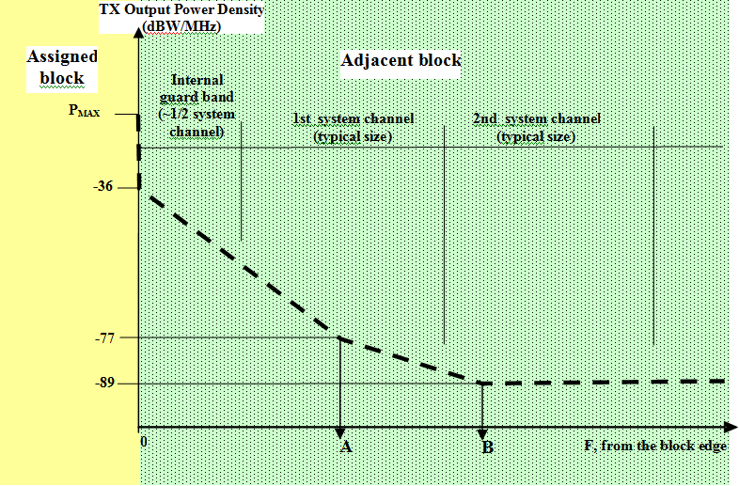*

|  |  |
| --- | --- |
| **Frequency offset break points**  **for the CS mask** | **Definition**  **(% of the size of the assigned block, Note)** |
| **A** | 20% |
| **B** | 35% |

**Note:** X% of the smaller of adjacent blocks, if blocks are of unequal size

1. Central Station Block Edge Spectral Density Mask
2. Tabular description of Central Station Block Edge Spectral Density Mask

| **Frequency offset** | **CS Transmitter Output Power Density Limits(dBW/MHz)** |
| --- | --- |
| **In-band (within assigned block)** | See Annex 2 |
| **ΔF=0** | -36 |
| **0<ΔF<A** | -36 - 41·(ΔF/A) |
| **A** | -77 |
| **A<ΔF<B** | -77 - 12·((ΔF-A)/(B-A)) |
| **ΔF≥B** | -89 |

* 1. ETSI requirements for LTE

The relevant document to consider is ETSI EN 301 908-14 V5.2.1 (2011-05) [6]: Evolved Universal Terrestrial Radio Access (E-UTRA) Base Stations (BS).

It should be noted that the bands 3400-3600 MHz and 3600-3800 MHz are not yet part of the E-UTRA Base Station operating bands; see Table 1-1 in [6], copied below as Table 20.

1. E-UTRA Base Station operating bands

| **E-UTRA band** | **Direction of transmission** | **E-UTRA Base Station operating bands** |
| --- | --- | --- |
| 1 | Transmit | 2 110 MHz to 2 170 MHz |
| Receive | 1 920 MHz to 1 980 MHz |
| 3 | Transmit | 1 805 MHz to 1 880 MHz |
| Receive | 1 710 MHz to 1 785 MHz |
| 7 | Transmit | 2 620 MHz to 2 690 MHz |
| Receive | 2 500 MHz to 2 570 MHz |
| 8 | Transmit | 925 MHz to 960 MHz |
| Receive | 880 MHz to 915 MHz |
| 20 | Transmit | 791 MHz to 821 MHz |
| Receive | 832 MHz to 862 MHz |
| 33 | Transmit and Receive | 1 900 MHz to 1 920 MHz |
| 34 | Transmit and Receive | 2 010 MHz to 2 025 MHz |
| 38 | Transmit and Receive | 2 570 MHz to 2 620 MHz |

The closest E-UTRA band from the 3.5 GHz band is band 7 (and 38). Therefore the comparison between the ETSI mask and the CEPT BEM has been made on that basis although this represents a tightening of the SEM.

1. e.i.r.p. defined by ETSI in band 7 and 38

ETSI currently defines no in-band e.i.r.p. limit, nor output power values.

1. Spectrum Emission Mask for band 7 and 38

The following tables are extracted from document ETSI EN 301 908-14 [6]. Three different types of base stations have been defined: wide area, local area and home.

1. Wide Area BS operating band unwanted emission limits for 5 MHz, 10 MHz, 15 MHz and 20 MHz channel bandwidth (E-UTRA bands 7 and 38)

| **Frequency offset of measurement filter ‑3 dB point, Δf** | **Frequency offset of measurement filter centre frequency, f\_offset** | **Test requirement** | **Measurement bandwidth** |
| --- | --- | --- | --- |
| 0 MHz ≤ Δf < 5 MHz | 0,05 MHz ≤ f\_offset < 5,05 MHz |  | 100 kHz |
| 5 MHz ≤ Δf <  min(10 MHz, Δfmax) | 5,05 MHz ≤ f\_offset < min(10,05 MHz, f\_offsetmax) | -12,5 dBm | 100 kHz |
| 10 MHz ≤ Δf ≤ Δfmax | 10,5 MHz ≤ f\_offset < f\_offsetmax | -15 dBm (see note) | 1 MHz |
| NOTE: The requirement is not applicable when Δfmax < 10 MHz. | | | |

1. Local Area BS operating band unwanted emission limits for 5 MHz, 10 MHz, 15 MHz and 20 MHz channel bandwidth

| **Frequency offset of measurement filter ‑3 dB point, Δf** | **Frequency offset of measurement filter centre frequency, f\_offset** | **Minimum requirement** | **Measurement bandwidth** |
| --- | --- | --- | --- |
| 0 MHz ≤ Δf < 5 MHz | 0,05 MHz ≤ f\_offset < 5,05 MHz |  | 100 kHz |
| 5 MHz ≤ Δf <  min(10 MHz, Δfmax) | 5,05 MHz ≤ f\_offset <  min(10,05 MHz, f\_offsetmax) | -35,5 dBm | 100 kHz |
| 10 MHz ≤ Δf ≤ Δfmax | 10,05 MHz ≤ f\_offset < f\_offsetmax | -37 dBm (see note) | 100 kHz |
| NOTE: The requirement is not applicable when Δfmax < 10 MHz | | | |

1. Home BS operating band unwanted emission limits for 5 MHz, 10 MHz, 15 MHz and 20 MHz channel bandwidth

| **Frequency offset of measurement filter ‑3 dB point, Δf** | **Frequency offset of measurement filter centre frequency, f\_offset** | **Minimum requirement** | **Measurement bandwidth** |
| --- | --- | --- | --- |
| 0 MHz ≤ Δf < 5 MHz | 0,05 MHz ≤ f\_offset < 5,05 MHz |  | 100 kHz |
| 5 MHz ≤ Δf < 10 MHz | 5,05 MHz ≤ f\_offset < 10,05 MHz | -40,5 dBm | 100 kHz |
| 10 MHz ≤ Δf ≤ Δfmax | 10,5 MHz ≤ f\_offset < f\_offsetmax | *P* – 52 dB, 2 dBm ≤ *P* ≤ 20 dBm  -50 dBm, *P* < 2 dBm  (see note) | 1 MHz |
| NOTE: For Home BS, the parameter P is defined as the aggregated maximum power of all transmit antenna ports of Home BS | | | |

Note: for home BS, with frequency offset ≥ 10 MHz, an output power of 20 dBm has been chosen for the purpose of this contribution; the corresponding minimum requirement is therefore -32 dBm/MHz.

* 1. Analysis of these technical conditions

1. Maximum e.i.r.p.

As there is no value specified in the ETSI harmonised standard, the comparison with the value mentioned in the CEPT Recommendation is not possible. However, a short analysis is provided below:

The e.i.r.p. value as provided in ECC/REC/(04)05 [2] = 23 dBW/MHz=30 dBW/ 5 MHz=60 dBm/5 MHz

This value is similar to what would be expected for a macro base station (also in the order of 60 dBm/5 MHz).

Conclusion: the maximum e.i.r.p. (in-band value) set up in ECC/REC/(04)05 [2] is compatible with typical in-band e.i.r.p. mobile deployments.

1. BEM vs. SEM

The three following figures show the comparisons of BEM and SEM for BEM based on a 5 MHz block assignment, as well as 10 MHz and 20 MHz.

|  |  |
| --- | --- |
| 5 MHz | F6_3500_BEM%205 |

1. BEM of ECC/REC/(04)05 based on 5 MHz block assignment

|  |  |
| --- | --- |
| 10 MHz | F6_3500_BEM%2010 |

1. BEM of ECC/REC/(04)05 based on 10 MHz block assignment

|  |  |
| --- | --- |
| 20 MHz | F6_3500_BEM 20 |

1. BEM of ECC/REC/(04)05 based on 20 MHz block assignment

It can be seen from the above figures that the SEM exceed the BEM for any value of block assignment.

* 1. ETSI requirements for BWA

The relevant document to consider is ETSI EN 302 774 V1.1.1 (2011-05) “Broadband Wireless Access Systems (BWA) in the 3 400 MHz to 3 800 MHz frequency band (Base Stations)” [9].

Taking the same approach to compare the SEM of BWA and the current given BEM for the 3400-3600 MHz band, the conclusions are the same as described in Section 2.2 of this report.

1. Comparison of the 3400-3800 MHz ECC deliverables

This annex provides an overview of the current ECC framework for the band 3400-3800 MHz including a comparison of ECC/DEC/(07)02, ECC/REC/(04)05 and ECC/DEC/(11)06 that confirms the consistency of ECC framework according to evolution of market needs and the need to maintain this consistency in the future.

At this stage, there are three relevant deliverables for the band 3400-3800 MHz:

* **ECC/DEC/(07)02** “Availability of frequency bands between 3400-3800 MHz for the harmonised implementation of Broadband Wireless Access systems (BWA)”
* **ECC/REC/(04)05** “Guidelines for accommodations and assignments of multipoint fixed wireless systems 3400-3600 MHz and 3600-3800 MHz”
* **ECC/DEC/(11)06** : “Harmonised frequency arrangements for mobile/fixed communications networks (MFCN) (including IMT) operating in the bands 3400-3600 MHz and 3600-3800 MHz”
  1. scope of deliverables

**ECC/REC/(04)05** covers Point multipoint fixed wireless systems (*Point-to-Multipoint Fixed Wireless Systems (PMP FWS)*. It has a more narrow scope than the other two ECC deliverables.

**ECC/DEC/(07)02** on Broadband Wireless Access systems (BWA) covers Fixed, Nomadic and, also, Mobile Wireless Access (MWA). It provides in its Annex considerations for an implementation of a flexible usage mode for BWA in 3400-3600 MHz and/or in 3600-3800 MHz on the basis initially of a fixed and nomadic usage. In particular, these considerations refers to ECC/REC/(04)05 and state that the technical conditions in ECC/DEC/(04)05 may be used for implementation of flexible usage mode. Moreover ECC/DEC/(07)02 mentions that the introduction of MWA usage mode will be subject to additional requirements for deployment of mobile TS Mobile Wireless Access (annex 1 §3 of the Decision).

**ECC/DEC/(11)06**, focusing primarily on a mobile usage includes a forward looking approach. The harmonised frequency arrangements for the 3400-3600 MHz and 3600-3800 MHz bands are intended to facilitate high data rate International Mobile Telecommunications (IMT) services supported by larger channel bandwidths as an evolution to the existing framework without the consequential requirement for a replacement of systems based on the existing regulatory framework.

* 1. co-existence with incumbent users

For **ECC/DEC/(07)02**, the designation of spectrum within 3400-3800 MHz for BWA should take due consideration of incumbent users (see decides 1 and 3).

Although the wording is different, ECC/DEC/(11)06 also designates spectrum for MFCN on a non-exclusive basis (“without prejudice to the protection and continued operation of other existing users in these bands”). It is assumed that transition from legacy terrestrial systems to future terrestrial systems will be managed at national level.

* 1. Band plan and duplex mode

**ECC/DEC/(07)02** does not provided a definite duplex mode or any band plan.

**ECC/DEC/(11)06** provides two possible band plans for the band 3400-3600 MHz, one TDD and one FDD. The band plan for 3600-3800 MHz is TDD.

**ECC/REC/(04)05** lets the possibility to have a mix of FDD and TDD blocks (i.e. recommends paired blocks that can be used either for FDD or for TDD). The guidelines for these flexible arrangements are:

* the bands 3400-3600 MHz and 3600-3800 MHz are treated as separate bands;
* 100 MHz duplex separation for paired blocks;
* in the case of paired FDD blocks the lower block of the two paired FDD blocks is used for uplink;
* that 3400 MHz to 3410 MHz is not included in the band plan.
  1. block size

**ECC/REC/(04)05** The blocks are designed to fit 3.5 MHz and 7 MHz channels (4 of them per block). The preferred size for blocks is multiple of these channels and may include internal guard bands. The resulting sizes for paired spectrum are (2x17.5 MHz, 2x21 MHz, 2x35 MHz, 2x42 MHz) and for unpaired spectrum (35 MHz, 42 MHz, 70 MHz and 84 MHz).

In case of external guard bands the sizes of the blocks may be reduced.

**ECC/DEC/(11)06:** the block sizes are multiples of 5 MHz.

* 1. emission requirements

**ECC/DEC/(07)02** refers to ECC/REC/(04)05 for emission levels. But since it covers also MWA which is not covered by ECC/REC/(04)05 additional requirements are provided for mobile terminal stations (in block emission level and spacing of the carrier from the block edge to protect adjacent networks).

* For the technical requirements it refers in its annex to ECC/REC/(04)05: “As a starting point, the guidance given in ECC/REC/(04)05 on technical conditions for implementation of flexible usage mode, to be set in the technology neutral BWA licence process, shall be considered”.
* For mobile terminals, the annex of ECC/DEC/(07)02 provides additional requirements

In the case of adjacent band TDD/FDD systems additional mitigation techniques should be considered (geographical separation of stations, natural/physical shielding, and/or additional co-ordination including networks synchronisation)

**ECC/REC/(04)05** provides emission requirements in the form of Block Edge Masks (BEM).

* For the Central Station (CS) BEM are provided with an “in block” limit (annex 2) and “out of block” limits (annex 3).
* For the terminal stations (NB: which are fixed in the context of ECC Recommendation (04)05) only an “in block” limit is provided (annex 2). The equipment requirements in the relevant harmonised standards are considered to provide sufficient protection for adjacent networks, so that “out of block” BEM limits for terminals are not needed.

**ECC/DEC/(11)06** There is no emission technical requirement.

Least restrictive technical conditions suitable for IMT systems with larger channel bandwidth are developed separately.

* 1. Harmonisation

**ECC/DEC/(07)02** does not contain a harmonised band plan, since it refers to ECC/REC/(04)05 for detailed frequency arrangements, which itself allows for flexibility and a mix of duplex modes.

**ECC/DEC/(11)06** provides one harmonised band plan for the band 3600-3800 MHz (TDD) and two harmonised band plans for the band 3400-3600 MHz (FDD and TDD). ECC decided that the band plans for the band 3400-3600 MHz should be subject to review no later than end 2013 with the aim to identify a preferred band plan.

1. EC mandate on 3400-3800 MHz

EC Mandate to the CEPT “Technical conditions regarding spectrum harmonisation for terrestrial wireless systems in the 3400-3800 MHz frequency band”



1. List of reference
2. ECC Decision (07)02 on availability of frequency bands between 3400-3800 MHz for the harmonised implementation of Broadband Wireless Access systems (BWA)
3. ECC Recommendation (04)05 on Guidelines for accommodations and assignments of multipoint fixed wireless systems 3.4-3.6 GHz and 3.6-3.8 GHz
4. Commission Decision 2008/411/EC on the harmonisation of the 3400-3800 MHz frequency band for terrestrial systems capable of providing electronic communications services in the Community).
5. ECC Decision (11)06 on Harmonised frequency arrangements for mobile/fixed communications networks (MFCN) (including IMT) operating in the bands 3400-3600 MHz and 3600-3800 MHz
6. Recommendation ITU-R M.1036 “Frequency arrangements for implementation of the terrestrial component of International Mobile Telecommunications (IMT) in the bands identified for IMT in the Radio Regulations (RR)”
7. ETSI EN 301 908-14 V5.2.1 (2011-05) “Harmonized EN for IMT-2000, Evolved Universal Terrestrial Radio Access (E-UTRA) (BS) covering the essential requirements of article 3.2 of the R&TTE Directive”
8. ECC Report 33 on the analysis of the co-existence of Point-to-Multipoint FWS cells in the 3.4-3.8 GHz band
9. ECC PT1(09)109R1 Annex 16: “ERO Information Document on the use of the bands 3400-3600 MHz and 3600-3800 MHz in CEPT”, Final Minutes of the 32nd ECC PT1 meeting (27-29 April 2009)
10. ETSI EN 302 774 V1.1.1 (2011-05) “Broadband Wireless Access Systems (BWA) in the 3 400 MHz to 3 800 MHz frequency band (Base Stations)”
11. CEPT Report 15 Report from CEPT to the European Commission in response to the Mandate to identify the conditions relating to the provision of harmonised radio frequency bands in the European Union for Broadband Wireless Access applications
12. CEPT Report 19 Report from CEPT to the European Commission in response to EC Mandate to develop least restrictive technical conditions for frequency bands addressed in the context of WAPECS
13. ECC Report 203 “Least Restrictive Technical Conditions suitable for Mobile/Fixed Communication Networks (MFCN), including IMT, in the frequency bands 3400-3600 MHz and 3600-3800 MHz”
14. ECC Report 100 “Compatibility studies in the band 3400- 3800 MHz between Broadband Wireless Access (BWA) systems and other services”
15. ITU-R Report M.2109 ''Report on sharing studies between IMT-Advanced systems and geostationary satellite networks in the fixed satellite service in the 3 400-4 200 and 4 500-4 800 MHz frequency bands''

1. TRP is a measure of how much power the antenna actually radiates. The TRP is defined as the integral of the power transmitted in different directions over the entire radiation sphere. E.i.r.p. and TRP are equivalent for isotropic antennas. [↑](#footnote-ref-1)
2. For cross-border coordination with non-EU administrations not listed in the 5.430A footnote of RR the provisions of this footnote should be taken into account. [↑](#footnote-ref-2)
3. TRP is a measure of how much power the antenna actually radiates. The TRP is defined as the integral of the power transmitted in different directions over the entire radiation sphere. E.i.r.p. and TRP are equivalent for isotropic antennas. [↑](#footnote-ref-3)
4. For cross-border coordination with non-EU administrations not listed in the 5.430A footnote of RR the provisions of this footnote should be taken into account. [↑](#footnote-ref-4)
5. TRP is a measure of how much power the antenna actually radiates. The TRP is defined as the integral of the power transmitted in different directions over the entire radiation sphere. E.i.r.p. and TRP are equivalent for isotropic antennas. [↑](#footnote-ref-5)
6. For cross-border coordination with non-EU administrations not listed in the 5.430A footnote of RR the provisions of this footnote should be taken into account. [↑](#footnote-ref-6)