
Electronic Communications Committee (ECC)
within the European Conference of Postal and Telecommunications Administrations (CEPT)

Additional Compatibility Studies relating to PWMS
in the band 1518-1559 MHz excluding
the bands 1543.45-1543.95 MHz AND 1544-1545 MHz

Tromsø, May 2010

Executive summary
ECC Report 121 provides compatibility studies between Professional Wireless Microphone Systems (PWMS) and the services possibly affected by their deployment in the bands 1452-1492 MHz, 1492-1530 MHz, 1533-1559 MHz also considering the services in the adjacent bands (below 1452 MHz and above 1559 MHz). Those studies concluded that sharing between PWMS devices and Mobile Satellite Service (MSS) in the bands 1518-1530 MHz and 1533-1559 MHz is not feasible, without considering mitigation techniques like Detect and Avoid (DAA). The aim of this report is to investigate the possibility of using DAA to improve the sharing situation between fixed indoor installed PWMS and MSS in the band 1518-1559 MHz (excluding 1544-1545 MHz and 1543.45-1543.95 MHz).

The use of PWMS in the MSS downlink band 1518-1559 MHz (excluding 1544-1545 MHz and 1543.45- 1543.95 MHz), considered in this report, is limited to in-ear monitoring in indoor installations, which can be subject of regulatory provisions.

In ECC Report 121 three types of representative GSO MES terminals namely GAN, BGAN and handheld were considered. Further, in this report the following systems/terminal types have been considered to expand the compatibility studies:
- Fleet 77 (F77)
- Fleet Broadband (FBB),
- Swift Broadband (SBB),
- AMS (R) S
- VOLNA,
- Complementary Ground Component (CGC).

In respect to the investigated DAA the following two main characteristics of MSS systems are to be considered:
- There are two kinds of Geostationary Orbit (GSO) MSS systems, one with fixed duplex spacing between the uplink and downlink directions and the other with flexible duplex spacing.
- Some MSS services operate in uplink only or downlink only, either continuously or intermittently, so that the presence or absence of a signal in the uplink spectrum does not definitely indicate the presence or absence of a signal in the downlink direction at the same instant.

Based on the above considerations and on the results of the studies, it was found that the current proposed PWMS concept using DAA techniques is not feasible for the detection of MSS signals in the whole band 1518-1559 MHz for the following reasons:
- The protection of MSS through the detection of its uplink signal is not achievable because it is not possible to determine through monitoring of the uplink spectrum whether or not there are MSS signals present in the downlink spectrum; this conclusion is based on MSS systems with a flexible duplex spacing and MSS services with signals only in the downlink direction.
- The downlink detection is not feasible because the signal levels of some sensitive carrier types that would need to be detected by the PWMS monitoring equipement are below the noise floor of the monitoring equipment due to the lack of gain of its antenna.

Within ETSI, a Special Task Force (STF 386) has been established to study different methods and test procedures for cognitive interference mitigation techniques for use by PMSE devices (Programme Making and Special Events). Review of existing studies and/or additional compatibility studies may be required if this task force identifies any potential and innovative new mitigation techniques.

Table of contents

0 Executive summary 2
abbreviations 4
1 Introduction 5
2 Description of PWMS 5
3 MSS systems in the band 1518-1559 MHz 6
3.1 MSS bands and allocations 6
3.2 MSS services 7
3.3 MSS deployment 8
3.4 Complementary Ground Component (CGC) parameters 8
3.5 List of visible satellites in Europe 9
4 Compatibility situation without mitigations 9
5 Principle of the DAA Mechanism Investigaed 11
6 DAA Detection threshold values 12
6.1 MSS Uplink detection 12
6.2 MSS Downlink Monitoring 17
6.3 Threshold values 19
7 Options considered for PWMS operation 20
7.1 Option 1: Uplink detection 20
7.2 Option 2: Downlink detection 20
8 investigated DAA Concept 21
9 Conclusions 25
9.1 AMS(R)S Services 25
9.2 Other Mobile Satellite Systems 25

abbreviations
Abbreviation | Explanation
AES | Aeronautical satellite terminal
AMS(R)S | Aeronautical Mobile Satellite (Route) Service
BACH | Broadcasting Alert Channel
Band III | Channels 05 - 12 (174 - 230 MHz)
Band IV | Channels 21 - 34 (470 - 582 MHz)
Band V | Channels 35 - 69 (582 - 862 MHz)
BCCH | Broadcast Control Channel
BGAN | Broadband Global Area Network
CCCH | Common Control Channel
CD | Compact Disk
CEPT | European Conference of Postal and Telecommunications Administrations
CGC | Complementary Ground Component
DAA | Detect and Avoid
DAU | Data Acquisition Unit
e.i.r.p. | Equivalent isotropically radiated power
EC | European Commission
E&E services | Existing and evolving satellite services provided via Inmarsat-3 global and spot beams and Inmarsat-4 global and regional beams
F77 | Service in Inmarsat maritime services family and one among many E&E services
FBB | Fleet Broadband service (maritime service) provided via Inmarsat-4 narrow spot beams
FFT | Fast Fourier transform
FS | Fixed Service
GAN | Global Area Network
GMDSS | Global Maritime Distress Safety System
GSO | GeoStationnary Orbit
HD | High Definition
ITU | International Telecommunication Union
LOS | Line Of Sight
MES | Mobile Earth Station
MSS | Mobile Satellite Service
PFD | Power Flex Density
PLMN | Public Land Mobile Network
PWMS | Professional Wireless Microphone Systems
RF | Radio Frequency
RR | Radio Regulations
SBB | Inmarsat SwiftBroadband service (aeronautical service) provided via Inmarsat-4 narrow spot beams
SESAR | Single European Sky Programme
SIM | Subscriber Identity Module
TR | Technical Report

Additional Compatibility Studies relating to PWMS in the band 1518-1559 MHz
excluding the bands 1543.45-1543.95 MHz and 1544-1545 MHz

Introduction
ECC Report 121 [1] provides compatibility studies between PWMS (Professional Wireless Microphone Systems) and the services possibly affected by their deployment in the bands 1452-1492 MHz, 1492-1530 MHz, 1533-1559 MHz also considering the services in the adjacent bands (below 1452 MHz and above 1559 MHz). Those studies concluded that sharing between PWMS devices and Mobile Satellite Service in the bands 1518-1530 MHz and 1533-1559 MHz is not feasible, without considering mitigation techniques such as the DAA concept. The aim of this report is to investigate the possibility of using DAA to improve the sharing situation between fixed indoor installed PWMS systems and MSS in the band 1518-1559 MHz (excluding 1544-1545 MHz and 1543.45-1543.95 MHz).

Description of PWMS
The term PWMS includes all wireless equipment used at the front-end of all professional audio productions. PWMS are intended for use in the entertainment and installed sound industry by Professional Users involved in stage productions, public events, TV programme production, public and private broadcasters’ installation in conference centres / rooms, city halls, musical and theatres, sport / event centres or other professional activities / installation.

PWMS have traditionally been used in broadcasting bands III, IV and V, since 1957. The growth of theatrical and musical productions along with the requirements of “wireless” microphones in all forms of media, plus the growth of independent television and film production has resulted in the plethora of uses.

The main characteristics of PWMS systems are provided in ETSI TR 102 546 [2] which provides the technical characteristics required to assess the compatibility between PWMS and other systems/services. Two types of PWMS systems are considered:
- Radiomicrophone transmitters (either hand held, or used as body packs, where the transmitter unit will be hidden about the person of the artist, using a minimally-sized microphone affixed to their clothing). Wireless microphones, including the new High Definition microphones. These would be both hand held and body worn devices, used mainly indoors, but with some outdoor usage.
- In Ear Monitor transmitters using fixed installations

Frequency band | Maximum mean power and mean power density | Duty cycle | Channel spacing  (see note 1) | Remarks
1452 MHz to 1492 MHz | 50 mW e.i.r.p. | No restriction | Up to 600 kHz | All user groups individual license required.
1492 MHz to  1530 MHz and  1533 MHz to  1559 MHz | 50 mW e.i.r.p. | No restriction | Up to 600 kHz | All user groups individual  license required.  For indoor installations only.
1. The PWMS channel is always at least at a distance of channel spacing/2 from the respective band edge.
Table 1: Extract of the PWMS characteristics - ETSI TR 102 546 [2]

More details can be found in ETSI TR 102 546 [2] and ECC Report 121 [1].

PWMS are mostly used in urban areas.

The usage of PWMS systems in the MSS downlink band 1518-1559 MHz, to be taken into account in this report, is limited to in-ear monitoring in indoor installations, which can be subject of regulatory provisions.

PWMS are used in theatres, conference centers or other venues. In emergency or disaster situations PWMS operation in the MSS downlink band is very unlikely. It is expected that in emergency or disaster situations, the operation in these venues will stop.

MSS systems in the band 1518-1559 MHz

MSS bands and allocations
Table 2 gives an overview about the relevant MSS frequency allocations and provisions in the band 1518-1559 MHz.

Frequency band MHz  Downlink |  | Relevant RR [4] Footnotes Region 1 |  | Frequency band MHz  Uplink
1518-1525 | MOBILE SATELLITE  (space-to-earth) | 5.348: Coordination with FS | ECC/DEC/(04)09
1525-1530 | MOBILE SATELLITE  (space-to-earth) |  | ECC/DEC/(02)08 and ECC/DEC/( (02)11
1530-1544  Note 1 | MOBILE SATELLITE  (space-to-earth) | 5.353A: priority to GMDSS, Note 1 | ECC/DEC/(02)08 and ECC/DEC/( (02)11 | 1626.5-1645.5
1544-1545 | MOBILE SATELLITE  (space-to-earth) | 5.356: limited to distress and safety communications | ECC/DEC/(02)08 and ECC/DEC/( (02)11
1545-1555  Note 2 | MOBILE SATELLITE  (space-to-earth) | 5.357 and 5.357A: priority to aeronautical mobile-satellite (R) service, Note 2 | ECC/DEC/(02)08 and ECC/DEC/( (02)11 | 1646.5-1656.5
1555-1559 | MOBILE SATELLITE  (space-to-earth)
Table 2: MSS frequency allocations and provisions in the band 1518-1559 MHz

Note 1: Mobile-satellite systems shall not cause unacceptable interference to, or claim protection from, distress, urgency and safety communications of the GMDSS. Account shall be taken of the priority of safety-related communications in the other mobile-satellite services.
Note 2: Mobile-satellite systems shall not cause unacceptable interference to, or claim protection from aeronautical mobile-satellite (R) service communications with priority 1 to 6 in Article 44. Account shall be taken of the priority of safety-related communications in the other mobile-satellite services.

The MSS bands covered in this report are used for many different MSS applications. Three of the MSS applications relate to provision of safety and distress communications for the maritime and aeronautical communities. The band 1530-1544 MHz is identified by RR footnote 5.353A with a high priority to Global Maritime Distress and Safety System (GMDSS), the band 1544-1545 MHz is limited to distress and safety communications (5.356) and the band 1545-1555 MHz is identified by RR footnotes 5.357 and 5.357A with a high priority to aeronautical mobile-satellite (R) service (AMS(R)S).

The European Space Agency and the EC within the Single European Sky Programme (SESAR) is using satellite communications for aeronautical services.

Except of the exclusive band 1544-1545 MHz the other bands are not exclusive given to safety services but with a certain priority (see Note 1 and 2 below Table 2).

It is not possible to identify parts of the bands where there are usage limited to maritime and/or aeronautical systems.

MSS services
For the compatibility studies it is appropriate to consider the following three types of representative GSO MES terminals (parameters are given in ECC Report 121 [1]):
- GAN
- BGAN
- Handheld

The following services have not been covered in ECC Report 121, but have been considered in this report to conduct additional compatibility studies :
- F77 (maritime Service),
- FBB (maritime service),
- SBB (aeronautical service),
- VOLNA,
- CGC (compementary ground component)

According to [6] a MES terminal can only be have 5 different levels of service: Normal Service, Alerting Service, Limited Service, Position-Restricted Service, and No Service.
- Normal Service:
    - the MES has full service access to the GMR-1 system and
    - sufficient signal quality for two-way communication.
    - the MES shall be registered.
    - the MES shall select a suitable spot beam, tune to that spot beam's BCCH + CCCH associated with the selected PLMN, and register within the PLMN (public land mobile network).
- Limited Service: There are a number of situations in which the MES is not allowed to register with any PLMN or the PLMN denies registration, but the signal strength is acceptable for Normal Service. Example: No SIM in the MES.
- Position-restricted service: There are a number of situations in which the registration status of the MES cannot be determined, and access to the system is blocked in any case. The inability to obtain Normal Service is due to one or more of the following factors:
  - An "Invalid Position" or "Invalid Position for the MES's Service Provider" response to a Channel Request.
  - A "Position Too Old" response to a Channel Request for an LR.
- Alerting Service: The purpose of this service is to notify registered users when they have an incoming call, under highly attenuated signal conditions. The Alerting Service has the following features:
  - The signal level is too low for normal operation.
  - Therefore, a special high-penetration alerting channel with modulation suitable for very low signal to noise ratios, called the BACH, is used.
  - Therefore, the MES has limited knowledge about the incoming call at the point of reception of the alert.
  - The MES might not be able to monitor broadcast information in signal conditions where the Alerting Service is functioning.
  - The high-penetration alerting channel is one-way. The user shall move the MES into a position in which it can obtain Normal Service in order to respond to the high-penetration alert.
- No Service: If the MES cannot obtain any better level of service, it is in No Service. The MES may be in the process of acquiring the system but not camped on any system channel; or the signal may have dropped into the high penetration alerting range, but it is not registered or it may not be camped on the proper BACH; or the signal may be insufficient for high penetration alerting.

Technical details of MSS-GSO systems are given in [5] and [6]

MSS deployment
Table 3 gives an overview about the worldwide deployment of relevant MSS terminals of one global MSS operator.
As at 30th September 2009
(000’s) | 2009 | 2008
Maritime | 169.6 | 151.4
Land mobile | 73.6 | 80.4
Aeronautical | 10.8 | 9.8
Total active terminals | 254.0 | 241.6
Table 3: overview about the worldwide deployment of relevant MSS terminals (one global operator)

Additional information about Inmarsat subscribers
BGAN: 31864
Fleet Broadband: 1591

Complementary Ground Component (CGC) parameters
It has to be noted, that the characteristics of the L-band CGC system are still beeing refined taking into account the issues surrounding the compatibility with other systems or the protection to be afforded to other systems.

For the purpose of compatibility studies, it was assumed that receivers in CGC terminals have the similar characteristics and the same protection criteria as those of handheld MES. Therefore the parameters as described in chapter 6.1.3 are considered.

List of visible satellites in Europe
In the Table below a total of 15 GSO MSS satellites from different operators are listed , that are visible in Europe (information as for August 2009).

GSO MSS satellites covering Europe
Nr | operator |  | name | Position
1 | Thuraya |  | Thuraya 2 | 44,1E
2 | Inmarsat |  | I4-F2 | 25,1E
3 | Inmarsat |  | I3-F5 | 24,8E
4 | Inmarsat |  | I3-F4 | 54W
5 | Inmarsat |  | I3-F2 | 15,4W
6 | Inmarsat |  | I3-F1 | 64,5E
7  8  9  10  11  12  13  14  15 | RSCC  RSCC  RSCC  RSCC  RSCC  RSCC  RSCC  RSCC  RSCC |  | VOLNA-2  VOLNA-3R  VOLNA-3  VOLNA-4R  VOLNA-4  VOLNA-5  VOLNA-5R  VOLNA-8  VOLNA-8R | 14W  11W  45E  40E  53E  85E  96.5E  90E  80E
Table 4: GSO MSS satellites from different operators

Compatibility situation without mitigations
Table 5 shows the assumed parameters for MSS from ECC Report 121.
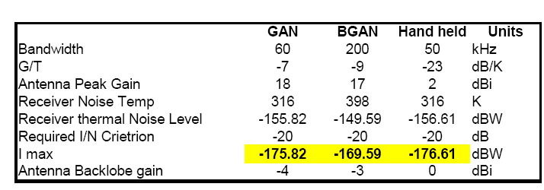
Table 5: representative MSS terminal parameters from ECC Report 121

Table 6 provides the results of calculated separation distances from ECC Report 121 (on the left side) and new results for the Fleet 77, FBB and SBB terminals (in the middle) and the results of revised studies with different parameters for I/N and wall attenuation (right hand side).

Table 6: Separation Distances
NA: Non Applicable

Additionally the following should be considered for aeronautical terminals:
- The line of sight free space propagation model is applicable in the case of aeronautical SBB terminal. The required separation distance is about 230 km. At 230 km distance, an SBB terminal could be in a different satellite beam from the one where the PWMS transmitter is located.
- It is possible that one PWMS transmitter can be within the field of view of some SBB terminal antennas for a considerable amount of time.
It could be possible that some PWMS transmitters are within the field view of one SBB terminal antenna. For the derivation of uplink detection threshold levels, it should be assumed that up to 10 PWMS transmitters can be present but maybe with different propagation conditions each.
For the AMS(R)S the required separation distance would be grater than 400km, in the aggregate interference scenario with a density of 0.1 PWMS transmitters per square kilometer.
With this it can be expected that the absolute compatibility between MSS systems (MSS terminals deployed outdoor) and the PWMS systems (deployed indoor) can not be achieved under worst case conditions and without taking into account further mitigation techniques. The required separation distance varies for terrestrial MSS terminals between 5 km (I/N -6 dB) to 40 km (I/N -20dB).
The concept of Detect And Avoid (DAA) technique is proposed to be further investigated in this report with the aim of improving the co-channel situation between the outdoor deployed MSS terminal (the MSS Downlink) and the indoor deployed PWMS installations.

Principle of the DAA Mechanism Investigaed
It has to be noted that just the MSS terminal can be interfered by the PWMS system, therefore the challenge of the DAA mechanism is to detect whether an MSS terminal is there or not. An MSS terminal that can be affected means in this context a physically present terminal which uses a downlink frequency. The distances within which MSS terminals may be affected are provided in section 4, table 6.

To achieve this goal the following steps were investigated:
- Power Detection: Whether it is possible to conclude from the monitored up- and/or downlink bands on the presence of an MSS terminal. Threshold values for DL (Th_{DL}) and UL (Th_{UL}) for decision “occupied” or “not occupied” -> see chapter 6
  - Uplink detection (chapter 6.1):
    - if the monitored UL power is below the Uplink threshold Th_{UL} then the whole downlink can be used by PWMS
    - if the monitored UL power is above the Uplink threshold Th_{UL} at a certain frequency fu then
- For MSS systems with fixed duplex separation of 101.5MHz between uplink and downlinlk, the downlink band fd=fu-101.5 MHz has to be avoided
- For MSS systems without fixed duplex separation either the whole downlink band has be avoided by PWMS or it may be possible to use parts of the band, using potential new mitigation techniques, to be developed by the ETSI special task force.

    - There are fundamental concerns with these assumptions for uplink detection. Two characteristics of MSS systems should be taken into account:
- Some MSS systems have flexible duplex spacing, i.e., there is no fixed frequency spacing between uplink and downlink carriers.
- Some MSS services operate in uplink only or downlink only, either continuously or intermittently, so that the presence or absence of a signal in the uplink spectrum does not definitely indicate the presence or absence of a signal in the downlink direction at the same instant.
    - Since the proposed DAA system does not have the ability to determine what service is operating – it would only monitor the received signal level – the first of these characteristics indicates that if an uplink signal is detected, then the whole of the downlink band must be avoided by PWMS. The second characteristic indicates that even if no signal is detected in the uplink, the whole downlink spectrum must be avoided by PWMS. In other words, it may be not possible to determine only through monitoring of the uplink spectrum whether or not there are signals present in the downlink spectrum. PWMS uplink detection only might be therefore not feasible.

  - Downlink detection (chapter 6.2):
    - If frequency ranges within the Downlink band have PFD values lower than the Downlink threshold value Th_{DL} then these bands can be used by PWMS indoor systems
  - Combination up- and downlink detection
- Timing of the DAA mechanism:
  - What happens if an MSS Downlink channel changes from “unoccupied” to “occupied”
- Monitoring antenna:
  - Uplink: has to be isotropic and on top of a building
  - Downlink:
    - one isotropic 0dBi antenna (maybe problems with the sensitivity)
    - or a directional antenna with an opening angle of about 100degrees in the horizontal plane and about 8-10dBi (see chapter 8 for details), e.g. a circular polarized antenna with reflector.

DAA Detection threshold values
The threshold values for MSS detection are derived in this chapter based on the most sensitive carriers among different Inmarsat land, maritime and aeronautical services. In addition, the detection thresholds in both down- and uplink directions have to be obtained from the e.i.r.p. values of a single victim carrier. The measured PFD values may not correspond to single carrier. In addition, the detection thresholds are required to be specified in 20 kHz for narrow band services and 50 kHz for medium/wideband and hand-held services.
Moreover, the current values given in this contribution do not consider other operators or possible future terminals. Once a threshold is established it would create a constraint for all future terminals. It should be remembered that MSS satellites are getting progressively bigger, which allows smaller terminals with lower e.i.r.p. to be deployed. It is important for MSS to be allowed to continue this evolution.

The principle of the DAA detection is shown in Figure 1.
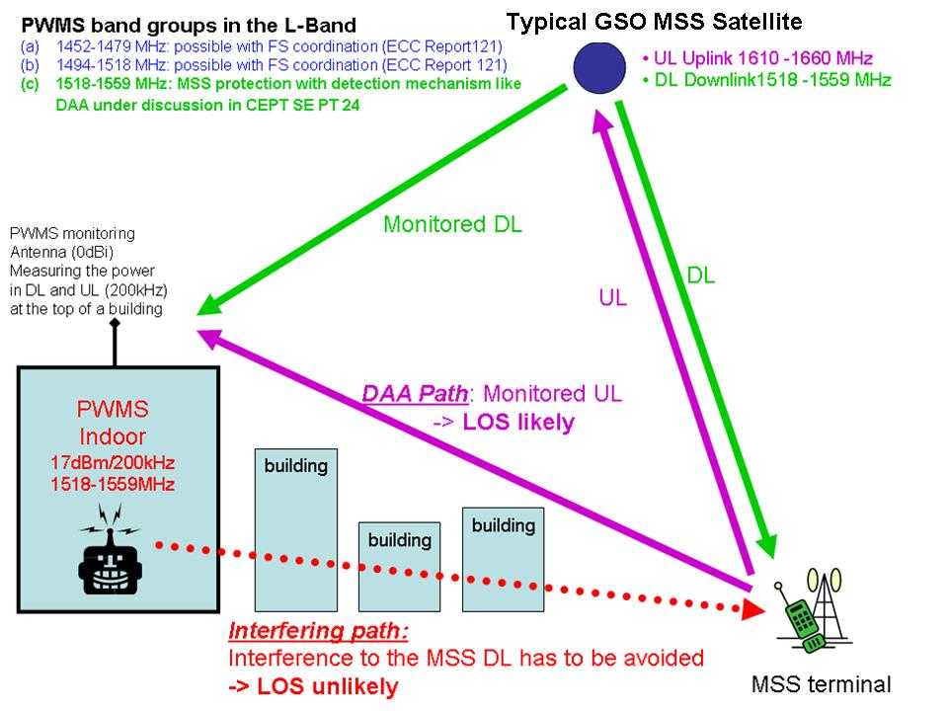
Figure 1: Principle of the DAA detection

MSS Uplink detection
    - Threshold calculation
The DAA Path: The power produced by the MSS uplink at the PWMS monitoring antenna can be calculated with the following formula:
$P_{{R_{\text{PWMS}}}/{\text{BW}}2}=P_{{T_{\text{MSS}}}/{\text{BW}}2}+G_{T_{\text{MSS}}}+G_{R_{\text{PWMS}}}−{\text{PL}}_{1}$ (1)

- $P_{R_{\text{PWMS}}}$/ dBm/BW2: Received power at the PWMS monitoring receiver on top of a building
within the Bandwidth BW2
- ${\text{PL}}_{1}$/ dB: DAA Path Loss, e.g. Free space loss
- $P_{T_{\text{MSS}}}$/ dBm/BW2: Power of the MSS terminal within the Bandwidth BW2
- $G_{T_{\text{MSS}}}$/dBi: Antenna Gain of the MSS terminal in direction of the PWMS monitoring
antenna ( back lobe gain)
- $G_{R_{\text{PWMS}}}$/dBi : Antenna gain of PWMS monitoring antenna in direction of the MSS
terminal

The Interfering Path: The power produced by the PWMS indoor device at the MSS terminal antenna can be calculated with the following formula:
$P_{{R_{\text{MSS}}}/{\text{BW}}2}=P_{{T_{\text{PWMS}}}/{\text{BW}}2}+G_{T_{\text{PWMS}}}+G_{R_{\text{MSS}}}−{\text{PL}}_{2}$ (2)
- $P_{R_{\text{MSS}}}$/ dBm/BW2: Received power at the MSS receiver caused by the PWMS device within the
Bandwidth BW2
- ${\text{PL}}_{2}$/ dB: Interfering Path Loss, e.g. Free space loss plus wall attenuation
- $P_{T_{\text{PWMS}}}$/ dBm/BW2: Power of the PWMS device within the Bandwidth BW2
- $G_{R_{\text{MSS}}}$/dBi: Antenna Gain of the MSS terminal in direction of the PWMS indoor device
- $G_{T_{\text{PWMS}}}$/dBi : Antenna gain of the PWMS indoor device in direction of the MSS terminal ( back lobe gain)

To get the connection between the DAA path and the Interfering path we can take the mathematical difference between Formula 1 and Formula 2:

$P_{{R_{\text{PWMS}}}/{\text{BW}}2}−P_{{R_{\text{MSS}}}/{\text{BW}}2}=P_{{T_{\text{MSS}}}/{\text{BW}}2}−P_{{T_{\text{PWMS}}}/{\text{BW}}2}+G_{T_{\text{MSS}}}−G_{R_{\text{MSS}}}−G_{T_{\text{PWMS}}}+G_{R_{\text{PWMS}}}−{\text{PL}}_{1}+{\text{PL}}_{2}$ (3)
    - Path loss model
For the path loss calculation the following formulas are proposed:

- Single slope model: PL(d,f)=32.5 dB + 10*n*log(r/m) + 20*log(f/GHz) + A (4)

- Dual slope model: PL(d,f)=32.5 dB + 20*log(R0/m) + 20*log(f/GHz) +10*n*log(r/R0) + A (5)

with
- n = path loss exponent and
- A =the building attenuation
- R0=LOS up to r0 and beyond with the exponent n

ECC Report 121 has assumed for the interfering path (PL2)
- A=10dB
- N=2 up to R0=5km, and n=4 beyond 5 km

    - MES uplink characteristics
As on today, the most sensitive E&E carrier in the uplink direction is Inmarsat F77 voice operated through Inmarsat 3 Global-/ spot- and Inmarsat 4 regional beams. The most sensitive carrier operated via Inmarsat-4 narrow spot beams in the uplink direction is Fleet BB data service on the ground and Swift broadband services on board aircraft. These services are important for maritime safety applications. The reason for including this carrier is to cover the possible operational situation near the coasts not very far from the urban centre environment in which PWMS systems may be deployed.

The characteristics for different systems are summarized in table 7. The parameters for other satellite services are similar.

 | GAN | BGAN | Hand-held | F77 | FBB | SBB | VOLNA
f/GHz | 1.64 | 1.64 | 1.64 | 1.64 | 1.64 | 1.64 | 1.64
Channel BW (MHz) | 0.06 | 0.2 | 0.05 | 0.005 | 0.2 | 0.200 | 0.024
Max e.i.r.p. (dBm) | 59 | 51 | 35 | 51 | 53 |  | 42.5
Min e.i.r.p. (dBm) | 52.6 | 48.3 | 28 | 39.4 | 46 | 43.8 | 30.5
Max antenna gain (dBi) | 18 | 17 | 0 | 20 | 18 | 12 | 13.5
Gain in the back-lobe direction(dBi) | -4 | -3 | 0 | -3 | -4 | -3 | -3
Min Off-axis e.i.r.p. in the direction of  PWMS monitoring station (dBm) | 30.6 | 28.3 | 28 | 16.4 | 24 | 28.8 | 14
Reference bandwidth (kHz) | 20 | 50 | 50 | 20 | 50 | 50 | 50
Min Off-axis e.i.r.p. in the direction of PWMS monitoring station (dBm) in the reference bandwidth | 25.82 | 22.3 | 28 | 22.4 | 18 | 22.8 | 17.2
Transmitter power dBm in the reference bandwidth | 29.82 | 31.3 | 28 | 19.4 | 22 | 25.8 | 20.1
Table 7: characteristics for different systems

A further reduction of about 3 dB is required to take into account the evolution of new MES terminals that can operate via more powerful MSS satellites in the near future than current MSS satellites.
    - DAA threshold for a MSS Terminal station
FBB terminal is more sensitive compared to the hand-held terminal. Therefore, the detection thresholds are derived for three types of terminals namely: F77, Hand-held and FBB
- the antenna gain values are assumed to be same in transmit and receive direction
- P_{R_MSS/BW2:} max acceptable interfering power at the MSS terminal receiver , with a thermal noise of N_{MSS}=kTBF (-126 dBm/50kHz for handheld, FBB, VOLNA and SBB terminals and -136 dBm/5kHz for F77 and an certain I/N value -> PR_MSS= N_{MSS} +I/N

- P_{T_MSS} (Note: not the e.i.r.p. values are important but the power values, because the antenna gain values are valid in both directions and are therefore redundant)
- Handheld: 28 dBm/50kHz
- VOLNA: 20 dBm/50kHz
- F77: 19 dBm/5kHz (used in maritime environments)
- FBB: 22 dBm/50 kHz (used in maritime environments)
- SBB: 25.8 dBm/50 kHz (used in aeronautical environments)
- Interfering path PL2
  - n2=2 up to 5km and n2=4 beyond 5km, or n2=3
  - wall attenuation 10dB
- DAA path PL1
  - Case 1: n1=2, A1=0dB
  - Case 2: n1=3, A1=0dB

For single slope models in both paths:
$\begin{aligned}P_{R_{\text{PWMS}}}−N_{\text{MSS}}−I/N=P_{T_{\text{MSS}}}−P_{T_{\text{PWMS}}}−\text{10}∗n1\text{*log}(r/m)+\text{10}∗n2\text{*log}(r/m)+A2 \\ P_{T_{\text{PWMS}}}=P_{T_{\text{MSS}}}−P_{R_{\text{PWMS}}}+\text{10}\text{*log}(r/m)∗(n2−n1)+A2+N_{\text{MSS}}+I/N \\ \text{handheld}: \\ −P_{T_{\text{PWMS}}}=\text{28}\text{dBm}−P_{R_{\text{PWMS}}}+\text{10}\text{*log}(r/m)∗(n2−n1)+\text{10}\text{dB}−\text{126}\text{dBm}+I/N \\ −P_{T_{\text{PWMS}}}=−\text{88}\text{dBm}−P_{R_{\text{PWMS}}}+\text{10}\text{*log}(r/m)∗(n2−n1)+I/N \\ \text{FBB}: \\ −P_{T_{\text{PWMS}}}=\text{22}\text{dBm}−P_{R_{\text{PWMS}}}+\text{10}\text{*log}(r/m)∗(n2−n1)+\text{10}\text{dB}−\text{126}\text{dBm}+I/N \\ −P_{T_{\text{PWMS}}}=−\text{94}\text{dBm}−P_{R_{\text{PWMS}}}+\text{10}\text{*log}(r/m)∗(n2−n1)+I/N \\ \text{SBB} \\ −P_{T_{\text{PWMS}}}=\text{25}\text{.}8\text{dBm}−P_{R_{\text{PWMS}}}+\text{10}\text{*log}(r/m)∗(n2−n1)+\text{10}\text{dB}−\text{126}\text{dBm}+I/N−M \\ −P_{T_{\text{PWMS}}}=−\text{90}\text{.}2\text{dBm}−P_{R_{\text{PWMS}}}+\text{10}\text{*log}(r/m)∗(n2−n1)+I/N−M \\ F\text{77}: \\ −P_{T_{\text{PWMS}}}=\text{19}\text{dBm}−P_{R_{\text{PWMS}}}+\text{10}\text{*log}(r/m)∗(n2−n1)+\text{10}\text{dB}−\text{136}\text{dBm}+I/N \\ −P_{T_{\text{PWMS}}}=−\text{107}\text{dBm}−P_{R_{\text{PWMS}}}+\text{10}\text{*log}(r/m)∗(n2−n1)+I/N\end{aligned}$
VOLNA:
$$\begin{aligned}−P_{T_{\text{PWMS}}}=\text{20}\text{dBm}−P_{R_{\text{PWMS}}}+\text{10}\text{*log}(r/m)∗(n2−n1)+\text{10}\text{dB}−\text{126}\text{dBm}+I/N \\ −P_{T_{\text{PWMS}}}=−\text{96}\text{dBm}−P_{R_{\text{PWMS}}}+\text{10}\text{*log}(r/m)∗(n2−n1)+I/N\end{aligned}$$

For the dual slope model in path 2 (interfering path):
$$\begin{aligned}P_{R_{\text{PWMS}}}−N_{\text{MSS}}−I/N=P_{T_{\text{MSS}}}−P_{T_{\text{PWMS}}}−\text{10}∗n1\text{*log}(r/m)+\text{20}\text{*log}(r0)+\text{10}∗n2\text{*log}(r/r0)+A2 \\ P_{T_{\text{PWMS}}}=P_{T_{\text{MSS}}}−P_{R_{\text{PWMS}}}+\text{10}\text{*log}(r/m)∗(n2−n1)−\text{10}\text{log}(r0/m)∗(n2−2)+A2+N_{\text{MSS}}+I/N \\ \text{handheld}: \\ −P_{T_{\text{PWMS}}}=\text{28}\text{dBm}−P_{R_{\text{PWMS}}}+\text{10}\text{*log}(r/m)∗(n2−n1)−\text{10}\text{log}(r0/m)∗(n2−2)+\text{10}\text{dB}−\text{126}\text{dBm}+I/N \\ −P_{T_{\text{PWMS}}}=−\text{88}\text{dBm}−P_{R_{\text{PWMS}}}+\text{10}\text{*log}(r/m)∗(n2−n1)−\text{10}\text{log}(r0/m)∗(n2−2)+I/N \\ \text{FBB} \\ P_{T_{\text{PWMS}}}=\text{22}\text{dBm}−P_{R_{\text{PWMS}}}+\text{10}\text{*log}(r/m)∗(n2−n1)−\text{10}\text{log}(r0/m)∗(n2−2)+\text{10}\text{dB}−\text{126}\text{dBm}+I/N \\ −P_{T_{\text{PWMS}}}=−\text{94}\text{dBm}−P_{R_{\text{PWMS}}}+\text{10}\text{*log}(r/m)∗(n2−n1)−\text{10}\text{log}(r0/m)∗(n2−2)+I/N \\ \text{SBB} \\ P_{T_{\text{PWMS}}}=\text{25}\text{.}8\text{dBm}−P_{R_{\text{PWMS}}}+\text{10}\text{*log}(r/m)∗(n2−n1)−\text{10}\text{log}(r0/m)∗(n2−2)+\text{10}\text{dB}−\text{126}\text{dBm}+I/N−M \\ −P_{T_{\text{PWMS}}}=−\text{90}\text{.}2\text{dBm}−P_{R_{\text{PWMS}}}+\text{10}\text{*log}(r/m)∗(n2−n1)−\text{10}\text{log}(r0/m)∗(n2−2)+I/N−M \\ F\text{77}: \\ −P_{T_{\text{PWMS}}}=\text{19}\text{dBm}−P_{R_{\text{PWMS}}}+\text{10}\text{*log}(r/m)∗(n2−n1)−\text{10}\text{log}(r0/m)∗(n2−2)+\text{10}\text{dB}−\text{136}\text{dBm}+I/N \\ −P_{T_{\text{PWMS}}}=−\text{107}\text{dBm}−P_{R_{\text{PWMS}}}+\text{10}\text{*log}(r/m)∗(n2−n1)−\text{10}\text{log}(r0/m)∗(n2−2)+I/N \\ \text{VOLNA}: \\ −P_{T_{\text{PWMS}}}=\text{20}\text{dBm}−P_{R_{\text{PWMS}}}+\text{10}\text{*log}(r/m)∗(n2−n1)−\text{10}\text{log}(r0/m)∗(n2−2)+\text{10}\text{dB}−\text{126}\text{dBm}+I/N \\ −P_{T_{\text{PWMS}}}=−\text{96}\text{dBm}−P_{R_{\text{PWMS}}}+\text{10}\text{*log}(r/m)∗(n2−n1)−\text{10}\text{log}(r0/m)∗(n2−2)+I/N\end{aligned}$$

For SBB terminals a further reduction of M=10 dB is assumed in the uplink detection threshold to take into account multiple interference into SBB terminals from n PWMS transmitters. The 10dB reduction is just valid if the following conditions are fulfilled:
- 10 simultanious active PWMS transmitters
- All 10 at the same MSS downlink channel
- And all under LOS

 | Interfering path
DAA Path | <5km (n2=2) | >5km (n2=4) | n2=3
n1=2 (LOS to the PWMS monitoring antenna) | Case A :  P_{T_PWMS}=-88dBm - P_{R_PWMS} + I/N | Case C :  P_{T_PWMS}=-88dBm - P_{R_PWMS} + I/N + 20*log(r/m) – 20*log(5000) | Case D :  P_{T_PWMS}=-88dBm - P_{R_PWMS} + I/N  + 10*log(r/m)
n1=3 (NLOS to the PWMS monitoring antenna) | Not applicable | Case B :  P_{T_PWMS}=-88dBm - P_{R_PWMS} + I/N + 10*log(r/m) -10*log(5000) | Case A :  P_{T_PWMS}=-88dBm - P_{R_PWMS} + I/N
Table 8: formulas for handheld

 | Interfering path
DAA Path | <5km (n2=2) | >5km (n2=4) | n2=3
n1=2 (LOS to the PWMS monitoring antenna) | Case A :  P_{T_PWMS}=-107dBm - P_{R_PWMS} + I/N | Case C :  P_{T_PWMS}= -107dBm - P_{R_PWMS} + I/N + 20*log(r/m) – 20*log(5000) | Case D :  P_{T_PWMS}= -107dBm - P_{R_PWMS} + I/N  + 10*log(r/m)
n1=3 (NLOS to the PWMS monitoring antenna) | Not applicable | Case B :  P_{T_PWMS}= -107dBm - P_{R_PWMS} + I/N + 10*log(r/m) -10*log(5000) | Case A :  P_{T_PWMS}= -107dBm - P_{R_PWMS} + I/N
Table 9: formulas for F77 (referenced to a bandwidth of 5 kHz)

 | Interfering path
DAA Path | <5km (n2=2) | >5km (n2=4) | n2=3
n1=2 (LOS to the PWMS monitoring antenna) | Case A :  P_{T_PWMS}=-96dBm - P_{R_PWMS} + I/N | Case C :  P_{T_PWMS}=-96dBm - P_{R_PWMS} + I/N + 20*log(r/m) – 20*log(5000) | Case D :  P_{T_PWMS}=-96dBm - P_{R_PWMS} + I/N  + 10*log(r/m)
n1=3 (NLOS to the PWMS monitoring antenna) | Not applicable | Case B :  P_{T_PWMS}=-96dBm - P_{R_PWMS} + I/N + 10*log(r/m) -10*log(5000) | Case A :  P_{T_PWMS}=-96dBm - P_{R_PWMS} + I/N
Table 10: formulas for VOLNA

The following table summaries the results.
 | Uplink threshold values dBm/50kHz and a wall attenuation in path 2 of 10 dB
I/N | Case A | Case B (10km) | Case C (10 km) | Case D (10km)
-20 dB | -114 | -111 | -108 | -74
-6 dB | -100 | -97 | -94 | -60
Table 11: Summary of threshold values for handheld terminals and PWMS with Pt=6.2 dBm/50kHz (=17dBm/600kHz)

 | Uplink threshold values dBm/5kHz and a wall attenuation in path 2 of 10 dB
I/N | Case A | Case B (10km) | Case C (10 km) | Case D (10km)
-20 dB | -123 | -120 | -117 | -83
-6 dB | -109 | -106 | -103 | -69
Table 12: Summary of threshold values for F77 terminals and PWMS with Pt=-3.8 dBm/5kHz (=17dBm/600kHz)

 | Uplink threshold values dBm/50kHz and a wall attenuation in path 2 of 10 dB
I/N | Case A | Case B (10km) | Case C (10 km) | Case D (10km)
-20 dB | -120 | -117 | -114 | -80
-6 dB | -106 | -103 | -100 | -66
Table 13: Summary of threshold values for FBB terminals and PWMS with Pt=6.2 dBm/50kHz (=17dBm/600kHz)

 | Uplink threshold values dBm/50kHz and a wall attenuation in path 2 of 10 dB
I/N | Case A | Case B (10km) | Case C (10 km) | Case D (10km)
-20 dB | -122 | -119 | -116 | -42
-6 dB | -108 | -105 | -102 | -28
Table 14: Summary of threshold values for VOLNA terminals and PWMS with Pt=6.2 dBm/50kHz (=17dBm/600kHz)

 | Uplink threshold values dBm/50kHz and a wall attenuation in path 2 of 10 dB
I/N | Case A | Case B (10km) | Case C (10 km) | Case D (10km)
-20 dB | -126.2 | -123.2 | -120.2 | -86.2
-6 dB | -112.2 | -109.2 | -106.2 | -72.2
Table 15: Summary of threshold values for SBB terminals and PWMS with Pt=6.2 dBm/50kHz (=17dBm/600kHz)

In ECC Report 121, section 2.2 the technical parameters for PWMS have been described.
From the parameters 2 significant sets of parameters for a PWMS device can be derived:

→Device with 50mW e.i.r.p. and 200kHz TX bandwidth →17dBm/200kHz => -13dBW/200kHz
→Device with 50mW e.i.r.p. and 600kHz TX bandwidth→17dBm/600kHz => -17.8dBW/200kHz

MSS Downlink Monitoring
    - Theoretical values
Table 16: Downlink values based MSS PFD values on the surface of the earth (see ECC Report 121)

The values given in Table 16 are derived from typical channel bandwidth and scaling up the value in 1 MHz reference bandwidth (see ECC Report 121). The maximum e.i.r.p.values have been considered.

One GSO Operator expressed that, normally maximum e.i.r.p. values are used to determine the ITU-R co-ordination triggers with respect to terrestrial services in this frequency band. For the protection of MSS carriers in the downlink directions it is more appropriate to consider minimum e.i.r.p. values of a single victim carrier instead of maximum values.

The parameters of other MSS systems need to be considered as well to derive the threshold values for uplink and downlink detection.

Because the measured PFD values may not correspond to a single downlink carrier, it is more appropriate to use the received power level from a single carrier.

Received power levels for the down link detection

E&E services (see also Annex 1)

Currently the most sensitive E&E carrier in the down direction is Inmarsat F77 voice. This service is very important for maritime safety applications. The reason for including this carrier is to cover the possible operational situation near the coasts not very far from the urban centre environment in which PWMS systems may be deployed.

The e.i.r.p. in the downlink direction minimum e.i.r.p. value = 6 dBW
Bandwidth of the channel = 5 kHz
Free space path loss = 188.14 dB
Received power level at 0 dBi isotropic antenna = 6-188.14 +10*log10(20/5) +30
-146.11 dBm in 20 kHz
Received power level at 10 dBi antenna = -136.11 dBm in 20 kHz

Broadband and Hand-held services

As on today, the most sensitive carrier in the down direction operated via Inmarsat-4 narrow spot beams Inmarsat hand-held carrier and Swift Broadband carrier. In the case of SBB service, (and other aeronautical services), the affected AES may be in a different satellite beam from the one where the interfering PWMS transmitter is located. In this situation, the satellite downlink signal would be further suppressed by the satellite antenna discrimination and may be undetectable by the PWMS monitoring system.

Hand-held service

The e.i.r.p. in the downlink direction minimum e.i.r.p. value = 38.4 dBW
Bandwidth of the channel = 200 kHz
Free space path loss = 188.14 dB
Received power level at 0 dBi isotropic antenna = 38.4-188.14 +10*log10(50/200) +30
-125.8 dBm in 50 kHz
Received power level at 10 dBi isotropic antenna = -115.8 dBm in 50 kHz

SBB service

The e.i.r.p. in the downlink direction minimum e.i.r.p. value = 38.5 dBW
Bandwidth of the channel = 200 kHz
Free space path loss = 188.14 dB
Received power level at 0 dBi isotropic antenna = 38.5-188.14 +10*log10(50/200) +30
-125.7 dBm in 50 kHz
Received power level at 10 dBi isotropic antenna = -115.7 dBm in 50 kHz

The required separation distance is about 230 km. At 230 km distance, an SBB terminal could be in a different satellite beam from the one where the PWMS transmitter is located. With this the downlink detection could not be able to the detect the downlink of the SBB terminal
Case of AES in the adjacent beam:

Assumed satellite antenna discrimination = 20 dB
Received power level @0 dBi = -145.7 dBm in 50 kHz
Received power level @10 dBi = -135.7 dBm in 50 kHz

VOLNA

The VOLNA satellite network is used in L-band and is a system with global coverage which are used for land applications including applications for governmental purposes.

The e.i.r.p. in the downlink direction minimum e.i.r.p. value = -20.1 dBW
Bandwidth of the channel = 24 kHz
Free space path loss = 188.14 dB
Received power level at 0 dBi isotropic antenna = 20.1-188.14 +10*log10(50/24) +30
-134.8 dBm in 50 kHz
Received power level at 10 dBi isotropic antenna = -124.8 dBm in 50 kHz
    - Measurement results
Table 17 summarizes the results of practical measurements that were performed at BNetzA Leeheim monitoring station in the beginnig of 2008. The four Inmarsat orbit positions where observed 24 hours each in the band 1518-1559 MHz.

 |  | Results of measurements |  |  |  | Planning parameters MSS for comparison (Note)
 |  | 3-F4 | 3-F2 | 3-F1 | 4-F1 | Planning parameters MSS for comparison (Note)
Frequency range of transmissions |  | 1525-1553 MHz | 1525-1553 MHz | 1525-1553 MHz | 1530-1555 MHz
continous narrowband transmissions (<30kHz) | PFD dBm/(m²*4kHz) | -115 to -107 | -116 to -111 | -115 to -105 | -111 to -101 | -101 to -114
continous narrowband transmissions (<30kHz) | PFD dBm/(m²*MHz) | -91 to -83 | -92 to -87 | -91 to -81 | -87 to -77 | -77 to -90
continous narrowband transmissions (<30kHz) | Calculated power at a virtual 0dBi monitoring antenna dBm/MHz | -116 to -108 | -117 to -112 | -116 to -106 | -112 to -102 | -102 to -115
short (<10 minutes) narrowband (<30kHz) bursts up to | PFD dBm/(m²*4kHz) | -100 | -95 |  |  | -101 to -114
short (<10 minutes) narrowband (<30kHz) bursts up to | PFD dBm/(m²*MHz) | -76 | -71 |  |  | -77 to -90
short (<10 minutes) narrowband (<30kHz) bursts up to | Calculated power at a virtual 0dBi monitoring antenna dBm/MHz | -101 | -96 |  |  | -102 to -115
Broadband continous transmissions (about 200kHz) | PFD dBm/(m²*4kHz) |  |  |  | -100 | -101 to -114
Broadband continous transmissions (about 200kHz) | PFD dBm/(m²*MHz) |  |  |  | -76 | -77 to -90
Broadband continous transmissions (about 200kHz) | Calculated power at a virtual 0dBi monitoring antenna dBm/MHz |  |  |  | -101 | -102 to -115
Table 17: Results of practical measurements

Note: MSS PFD planning parameters from ECC Report 121
- Inmarsat GAN: -89.5 dBm/(m²*MHz)
- Inmarsat BGAN: -81.2 dBm/(m²*MHz)
- Inmarsat handheld: -77 dBm/(m²*MHz)

Coordination threshold is given in 1MHz as well as in 4kHz for satellite services between 1-3GHz for GSO MSS systems.

Threshold values
The following Table contains threshold values for the detection of potential victim MSS terminals.

Monitoring antenna | Isotropic 0 dBi | 10dBi
Uplink threshold  1626.5-1660.5 MHz | Land handheld: -114 dBm/50kHz  Land VOLNA: -122 dBm/50kHz  Maritime F77: -123 dBm/5kHz  FBB maritime: -120 dBm/50kHz  SBB aeronautical:-126.2 dBm/50 kHz | NA
Downlink threshold  1518/1525-1559 MHz | Land handheld: -125.8 dBm/50kHz  Land VOLNA: -135 dBm/50 kHz  Maritime F77: -146 dBm/20kHz=-142 dBm/50kHz  AMS(R)S / Aeronautical SBB: -125.7 dBm/50 kHz; -145.7 dBm/50 kHz for the case AES in adjacent beam | Land handheld: -115.8 dBm/50kHz  Land VOLNA: -125 dBm/ 50 kHz  Maritime F77 -136 dBm/20kHz=-132 dBm/50kHz  AMS(R)S / Aeronautical SBB: -115.7 dBm/50 kHz; -135.7 dBm/50 kHz for the case AES in adjacent beam
For comparision: Thermal noise floor kTB | -126 dBm/50 kHz  =-131 dBm/20kHz  =-136 dBm/5 kHz
Table 18: Threshold values for the detection of potential victim MSS terminals

Options considered for PWMS operation

Option 1: Uplink detection
An isotropic monitoring antenna has to be installed on top of the building where the PWMS system is installed. The threshold values should be taken from table 12. A detailled decription of the concept is provided in chapter 8.

Basic routine
  - (A) PWMS transmit power off
  - (B) Run the UL scanning routine continuously
  - (C) Call the results of the database on a periodic basis
  - (D) Is there at least one occupied DL channel in the database?
    - NO: PWMS transmission allowed in the whole DL
    - YES: PWMS transmission allowed in the unoccupied DL bands with the following restriction: all used unoccupied DL bands will implement a frequency hopping mode: dwell time (for considering MSS modes without a fixed duplex frequency)
      - PWMS channel switching off within the fatest time as possible if the status is changed from unoccupied to occupied
  - (E) Goto (C)

It was highlighted that due to the safety obligations of the MSS service, long interference times can not be accepted.

Option 2: Downlink detection
An isotopic or a directional monitoring antenna has to be installed on top of the building where the PWMS system is installed. The threshold values are should be taken from table 18 dependent on the used antenna.
A detailled decription of the concept is provided in chapter 8.

Basic routine
  - (A) PWMS transmit power off
  - (B) Run the DL scanning routine continuously
  - (C) Call the results of the database on a periodic basis 4.1 s
  - (D) PWMS transmission allowed in the unoccupied DL bands
  - (E) PWMS channel switching off within the fatest time as possible if the status is changed from unoccupied to occupied
  - (F) Goto (C)

investigated DAA Concept
The description provided in figure 2 refers to figure 1 and shows the detailed structure of the PWMS system.

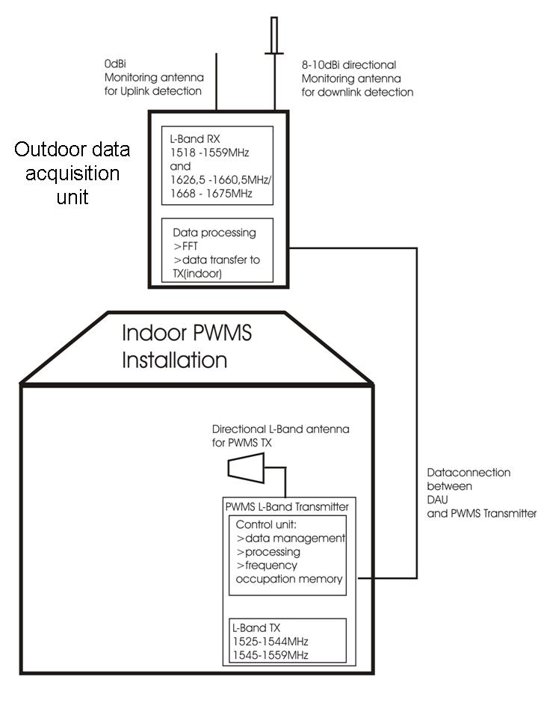
Figure 2: detailed structure of the PWMS system with one PWMS transmitter

The PWMS system consists of two basic units: the data acquisition unit (DAU) and the Indoor PWMS L-Band transmitter.

DAU (data acquisition unit)

The DAU has to be placed on top of the building where the PWMS system is installed and the PWMS system inside the building. Both units are connected via a data connection. The PWMS system will remain in disabled mode ( no TX) if there is no data connection to the DAU.
Two L-Band receivers are located in the DAU with separate antennas that the unit can independently monitor the uplink and downlink band in parallel. The receiver for the downlink detection covers the frequency band 1518-1559MHz. The receiver for the uplink detection coves the frequency bands 1626.5-1660.5MHz and 1668-1675MHz.
The two receivers in the DAU will use different antennas. The uplink detection receiver will use a omni directional antenna 0dBi. To cover and monitor all GSO satellites visible from a western europe position, the downlink detection receiver will use a uni directional circular polarized antenna with an opening angle of about 150degrees (+/-75 degrees) with 8 -10dBi gain.
The signal processing for the incoming data is located directly after the L-Band receivers in the DAU. In the DAU signal processing unit, the received signals are processed and FFT –ed and converted into a continuous data stream that is sent to the PWMS system inside the building.
The PWMS data acquisition unit monitors continuously the MSS uplink and downlink bands in parallel. This represents a combination of Option 1 (7.1) and Option 2 (7.2). The resulting data is stored in the PWMS control unit.

For scanning the spectrum, different methods have been studied:
- linear scanning and receiving of the spectrum activity: If linear scanning is used, the time for scanning 34MHz of uplink or downlink would take approximately 10minutes. In worst case situation, this would mean, that a PWMS system could interfere for at maximum 10 minutes before the usage and occupation of the band by MSS is detected. This method was found not usable taking in account that MSS services provide AMS (R) S and GMDSS services that come under special protection in the RR 5.353A and 5.357A. As linear scanning was found not applicable for a fast and reliable detection of spectum activity, FFT techniques have been studied.
- scanning using FFT: A number of 2048 bins is proposed for the FFT. With a frequency range of 34MHz to be scanned, this results in a bin – width dF : 34MHz/2048= 16.6kHz. After the FFT-ing, a signal processing is implemented. In the signal processing, averaging over the aquired data is applied in order to increase the signal to noise ratio to have a better discrimination between the noise and the MSS signal. With commercially available DSP the FFT – ing and processing of the incoming data for a 34MHz range can be done in appox. 100ms. This would reduce the max duration between an MSS activity occurring in the band and the detection by the PWMS system, to a maximum of 100ms.

Indoor PWMS L-Band transmitter

In the PWMS control unit, the frequency ranges 1544-1545MHz and 1645.5 to 1646.5MHz are permanently stored as not a valid transmission frequency that cannot be used for transmission. This is to make sure that the PWMS signal will not cause any interference into GMDSS services in those frequency ranges. In addition, taking into account that non-standard frequency separation is used in VOLNA-series networks for 1543.45 – 1543.95 MHz / 1652.12 – 1652.62 MHz frequency bands it is advisable to exclude 1543.45-1543.95 MHz band for PWMS usage. Uplink earth station detection could not provide the guarantee of non interference to the earth station as it could work with asymmetrical traffic in uplink and downlink directions.

If multiple PWMS transmitters are used in an installation, the DAA data connection will be sent to all PWMS transmitters. The first PWMS transmitter is the designated master in the system that takes control over the additional transmitters installed.
If the data connection from the data acquisition unit is not correctly established or lost, the PWMS transmitter will stop transmission and will not start transmitting before the connection has been re-established..
The PWMS transmitter stores and analyzes continuously the incoming data from the data acquisition unit for the MSS downlink and uplink band and stores the data in the PWMS frequency occupation memory.
The data stored in the frequency occupation memory always reflect the latest situation of spectrum occupation in the uplink and downlink band. As the data stored continiously over the time the PWMS system is powered up and running, the PWMS system has always the latest data on the spectrum usage, and the usage history available.
With the continuous storage and analysis of the incoming data in the PWMS control unit during the operating time of the system, the system can derive information on the usage probability for certain spectrum areas by the MSS service in reference to the place of operation/ installation of the PWMS system .
To avoid interference to MSS services, only these areas of the band will be used, that are not used by the MSS.

The following data from the scanning are stored in the PWMS control unit during the operating time of the sytem:
- Time: time when the measurement result was received.
- Frequency: frequency at which the measurement was taken
- Received signal level: signal level that was received at a given frequency (related to the number of FFT bins)

With the continuous storage and analysis of the incoming data in the PWMS control unit during the operating time of the system, the system can derive information on the usage probability for certain spectrum areas by the MSS service in reference to the place of operation/ installation of the PWMS system .
To avoid interference to MSS services, only these areas of the band will be used, that are found not used at all.

Spectrum areas that are found to be in MSS usage by the data acquisition, will be marked in the PWMS control unit frequency usage memory and will not be considered as a valid usable transmit frequency for the PWMS transmitter.

Based on the data stored in the frequency occupation memory the PWMS system will use frequencies that are found unused as transmit frequency.
If multiple PWMS transmitters are installed in one place, the data connection from the data acquisition unit is fed to all installed PWMS transmitter systems.

The basic structure of a PWMS system with multiple Tx is shown in figure 3.

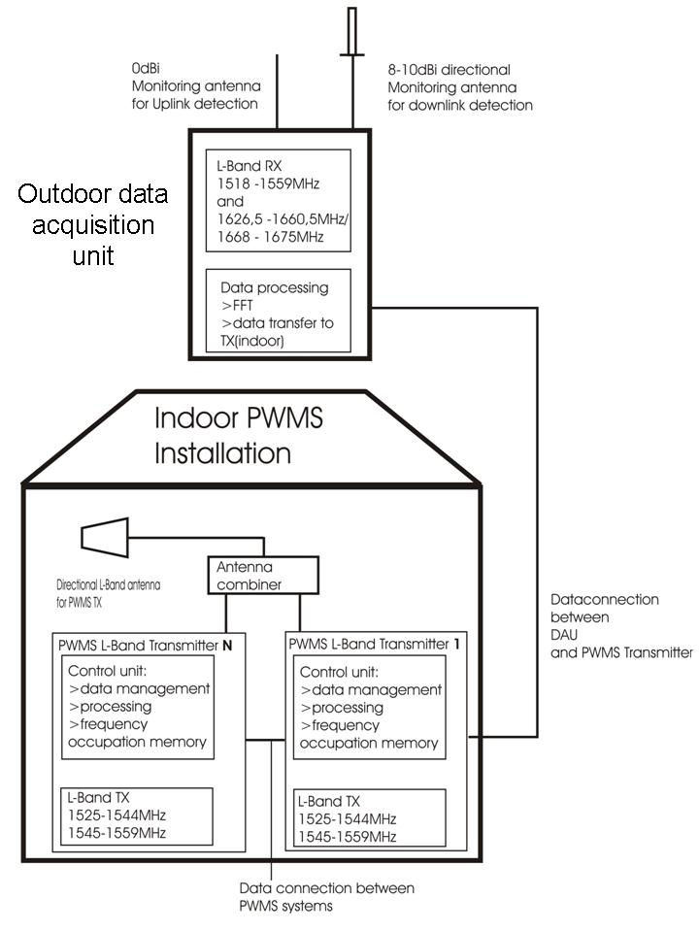
Figure 3: structure of a PWMS system with multiple PWMS transmitters

The PWMS transmitter system where the data acquisition unit is connected to, is set as dedicated master for the installation.
The system that is set as dedicated master will control the calculation and setting the transmit frequencies of the additional PWMS systems connected through the data connection between the systems. If the data connection is lost or not established, the transmitters of the additional PWMS systems will stop transmission and will not start transmitting before the connection has been re-established.

In multiple PWMS systems, the dedicated master unit will calculate the interference free transmit frequencies for the setup based on the information stored in the frequency occupation memory

It is proposed that for the L-band PWMS- transmitters only directional antennas are to be used.

Conclusions

AMS(R)S Services
A DAA concept has to present the following characteristics in order to prevent interference from PWMS into AMS(R)S services:

1/ It is necessary to have a DAA system that is able to detect any use of a AMS(R)S channel and to stop emitting on that channel immediately,

2/ It is necessary to have a non-stop DAA mechanism that scans the usage of the AMS(R)S band in real time.

3/ The PWMS monitoring system directional antenna shall receive all the MSS downlink signals from different GSO MSS satellites at a given PWMS installation site. This includes the ability to receive signals with very low elevation angles according to distance over which aeronautical receivers could suffer from interferences.

It is expected that a guard band will be necessary between the first PWMS channel and the AMS(R)S band, depending on the filtering characteristics of systems.

Based on the considerations presented above, it is concluded that the proposed DAA mechanism is not an appropriate solution to mitigate the effect of PWMS on AMS(R)S systems operating in the band 1545-1555 MHz.

Other Mobile Satellite Systems
Based on the results of the studies with assumptions presented section 6 of this document, it was found that the proposed DAA technique is not feasible for the detection of MSS signals for the following reasons:
- The uplink detection is not feasible because it is not possible to determine through monitoring of the uplink spectrum whether or not there are MSS signals present in the downlink spectrum; this conclusion is based on MSS systems with a flexible duplex spacing and MSS services with signals only in the downlink direction.

- The protection of MSS through the detection of its uplink signal is not achievable because the signal levels of some sensitive carrier types that would need to be detected by the PWMS monitoring equipement are below the noise floor of the monitoring equipment due to the lack of gain of its antenna. Table 19 shows the summary of the threshold investigations.

 | Uplink threshold  dBm/50kHz | Downlink threshold 10dBi  dBm/50kHz | Comment
Worst case all services | -126 (SBB) | -136 (SBB) | Not feasible (kTB=-126)
Worst case outside the AMS (R) S bands | -113 (F77) (-123 dBm per 5 kHz) | -132 (F77) | Not feasible (kTB=-126)
Worst case outside the AMS (R) S bands and without maritime systems (avoiding coasts) | -122 (VOLNA) | -125 (VOLNA)
Worst case outside the AMS (R) S and VOLNA bands, without maritime systems (avoiding coasts) | -114 (handheld) | -116 (handheld)
Table 19: detection threshold

Therefore, based on the currently proposed DAA concept, compatibility between PWMS and MSS in the whole band 1518-1559 MHz, excluding 1544-1545 MHz can not be achieved.

It has to be noted that ETSI STF (STF 386) has been established:
“Methods, parameters and test procedures for cognitive interference mitigation techniques for use by PMSE devices (Programme Making and Special Events)”
The documents to be produced by the STF are:
- ETSI Technical Report on “Operation methods and principles for spectrum access systems for PMSE technologies and the guarantee of a high sound production quality on selected frequencies utilising cognitive interference mitigation techniques”. This Report will analyse the various possible techniques and recommend a specific method.
- ETSI Technical Specification on the recommended spectrum access technique, defined in (a)
- ETSI Technical Report of the different RF compliance tests for the selected spectrum access mechanism, as defined in (b) Approval of the TR on validation of the RF tests, with measurements from a technology demonstrator.

At the conclusion of the STF, if new mitigation techniques are identified then additional compatibility studies may be required.
Annex 1: Background information on E&E

The term E&E services was adopted before Inmarsat-4 satellites were brought into service to distinguish the following different existing and evolved services (E&E) currently provided via different Inmarsat-3 satellites (global and spot beams) from the new services like streaming, background IP, circuit switched ISDN voice, fax, data through Broadband Global Area Network (BGAN) (land), Fleet Broadband (FBB)(maritime), Swift Broadband (SBB) (aero) Mobile Earth Station (MES) terminals via Inmarsat-4 narrow spot beams.

Inmarsat B (voice, fax, data and HSD) (Land and Maritime)
Inmarsat C (safety and low data rate services) (Land, Maritime and Aero)
Inmarsat D+ (low data rata services)
Inmarsat mini M (voice/fax/data)(Land, maritime and aero)
GAN (voice, HSD and Packet data) (Land) - (Global Area Network)
Maritime services under Fleet category
F33 (voice, fax, data)
F55 (voice, fax, ISDN, packet data)
F77 (voice, fax, ISDN, packet data)
Classic Aero circuit switched and packet data services
SWIFT 64 (ISDN and packet data) (aero).

Each 200 kHz channel of Inmarsat-4 satellite can carry a mix of traffic from streaming, background IP, ISDN and voice services. The hand-held global satellite phone terminal mainly carries voice traffic and some amount of low speed fax traffic. This service is also provided via narrow spot beams of Inmarsat-4 satellite.

In addition to several narrow spot beams, each Inmarsat-4 satellite also has one global beam and 19 regional beams. The above mentioned different E&E services can also be provided through these beams in order to maintain continuity of these services after the end of life of any particular Inmarsat-3 satellite. One example is aero classic traffic is currently carried over seven satellites – four Inmarsat-3 (global and spot beams) and three Inmarsat-4 satellites (global and regional beams).

Annex 2: List of references

[1] ECC Report 121: Compatibility studies between PWMS and other services/systems in the bands 1452-1492 MHz, 1492-1530 MHz, 1533-1559 MHz also considering the services/systems in the adjacent bands
[2] ETSI TR 102 546: Technical characteristics for Professional Wireless Microphone Systems (PWMS)
[3] CEPT/ERC Recommendation 70-03 : Short Range Devices (SRD)
[4] Radio Regulations: 5.348; 5.353A; 5.356; 5.357; 5.357A
[5]ITU-R M.1184-2: Technical characteristics of mobile satellite systems in the frequency bands below 3 GHz for use in developing criteria for sharing between the mobile-satellite service (MSS) and other services: Inmarsat parameters: given in Table 2; Thuraya parameters: given in Table 1: system described under designator “F”
[6] ETSI TS 101 376 series; GEO-Mobile Radio Interface Specifications

