 Electronic Communications Committee (ECC)
within the European Conference of Postal and Telecommunications Administrations (CEPT)
COMPATIBILITY BETWEEN GSM MCBTS AND OTHER SERVICES
(TRR, RSBN/PRMG, HC-SDMA, GSM-R, DME, MIDS, DECT)
OPERATING IN THE 900 AND 1800 MHz FREQUENCY BANDS

Baden, June 2010

executive summary
GSM Multi Carrier Base Transceiver Stations (MCBTS) have relaxed specifications compared to Single Carrier Base Transceiver Stations (SCBTS). Relaxed intermodulation and spurious emission requirements may potentially create additional interference to systems operating in adjacent bands.

This Report covers the following studies:
- coexistence studies between GSM MCBTS and Tactical Radio Relay (TRR) links in the 915 - 935 MHz band;
- coexistence studies between GSM MCBTS and ARNS (RSBN/PRMG) system operating in the 915 - 935 MHz band;
- coexistence studies between GSM MCBTS and HC-SDMA system operating in the 1787.5 - 1802.5 MHz;
- sharing and compatibility studies between GSM MCBTS and Aeronautical systems in 960 - 1215 MHz (DME);
- coexistence studies between GSM MCBTS and military systems above 960 MHz (MIDS);
- coexistence studies between GSM MCBTS and DECT in the band 1880 - 1990 MHz and
- studies on minimum distances between public GSM MCBTSs and GSM-R along railway tracks including interference mitigation technique between GSM networks using MCBTSs and GSM-R networks operating in the same geographical area.
3GPP TSG GERAN have conducted a number of studies on the impacts of relaxations of the specifications for GSM MCBTS on coexistence of public coordinated and uncoordinated GSM networks operating in the same frequency band and the same geographical area. The conclusion has been that there was no noticeable impact of the relaxations. Consequently, this Report does not address this issue.
The following conclusions can be drawn based on the analysis in this Report:
- For the TRR case there are no changes for MCBTS compared to SCBTS when it concerns the planning of the two systems adjacent to each other for carrier separation less than 1 MHz. For larger carrier separation site engineering is required together with a separation distance of 2-3 km to keep the TRR cell size as for the SCBTS case.
- Considering the worst case, the interference criteria for RSBN and PRMG are met when RSBN/PRMG is operated with at least 1 MHz carrier separation from the lowest carrier of MC BTS. Taking into account averaging effects (like GSM power control and DTX) the compatibility will improve considerably.
- The probability of interference from MCBTS to the nearest HC-SDMA channel is negligible.
- For the coexistence between GSM MCBTS and GSM-R, the MCL analysis indicates that under certain worst-case conditions the GSM-R network can experience interference, but also that the dominating interference effects are the blocking and adjacent channel performance of the GSM-R terminal. GSM-R terminals performances can be improved by additional filtering. The simulation analysis which also incorporates dynamic aspects of both networks show that the minimum required separation distances range between 20 meters and 55m, depending on the network assumptions. A carrier separation of 0.4 MHz (0.2 MHz between the edges of the channels) between GSM MC BTS and GSM-R as defined in ECC/DEC/(02)05 is thus sufficient to avoid harmful interference to GSM-R downlink due to unwanted emissions from a MCBTS, both class 1 and class 2.
- The interference between GSM MCBTS and DME has been studied for rural and urban scenarios. For current DME deployments, at 977 MHz and above, there will be no increase in interference from MCBTS in relation to SCBTS. This is due to the fact that for such an offset, the unwanted emissions from an SCBTS and an MCBTS have the same characteristics.
In case DME is deployed below 977 MHz, a detailed analysis has been carried out. Realistic aspects such as power control for GSM and polarisation discrimination were considered in the simulations.

When power control is used, the result is that no additional isolation is needed for the unwanted emissions from MCBTSs for either the rural or the urban scenario, for both classes 1 and 2, for any altitude of an aircraft.

When power control is not used in GSM downlink, the results are as follows:
- for BTS Class 1, no additional isolation is needed
- for BTS class 2:
  - no additional isolation is needed when the DME frequency is above 962 MHz.
  - For a DME frequency of 962 MHz: an isolation of 4 dB is needed for the urban scenario studied (for an aircraft altitude below 200m); an isolation of 2 dB (below 200m) to 5 dB (above 1000m) is needed for the rural environment. For altitudes of 1000m and above, simulations considering average behaviour of base stations show that there is sufficient isolation.

It should be noted that power control is a widely deployed technique in the mobile networks so that no specific measure would be necessary to GSM MC BTS so as to fulfil the interference criterion of DME. Additionally, a number of possibilities to improve the compatibility between DME and GSM MC that do not appear in the simulations results have been investigated in this Report.

- In the case of coexistence between MC BTS and MIDS, the protection distance between GSM MC base station and MIDS stations should be up to 1 km in the worst case (if the MIDS receiver is placed in the direction where the GSM MC base station antenna gain is maximum) to avoid any interference on each MIDS frequency above 1 GHz. However, the protection distance when the MCBTS sector is transmitting directly in the main lobe of the MIDS antenna is reduced if the real unwanted emission level of the GSM MC equipment is better than specified. An improvement of 12 dB compared to the 3GPP specification in the 1000 - 1206MHz MIDS band (corresponding to the 1-12.75GHz spurious band) ensures the compatibility and no additional separation distance is required to enable adjacent band sharing between MCBTS and the MIDS receiver. In the worst case (if the MIDS receiver is placed in the direction where the GSM MC base station antenna gain is maximum), for a separation distance greater than 1 km, no specific measure is needed. For other azimuths of antenna, the separation distance and the additional filtering requirements decrease. In this context, it should be noted that this study does not take into account the regulatory status of JTIDS/MIDS, which operates in the band 960 - 1215 MHz under the conditions of provision 4.4 of the Radio Regulations.
- Blocking of DECT is the dominating interference mechanism, is spite of increased unwanted emissions (intermodulation products and spurious) from MCBTS compared to single carrier GSM BTS. It can be concluded that the interference created by the GSM MC system would be the same to the interference created by GSM Single carrier. The conclusion is the same as for the previous study [13], that no guard band is required between the 1800 and DECT allocations, provided that DECT is able to properly detect GSM interference on closest DECT carriers F9-F7 and escape to more distant carriers F6-F0.

- All the studies were done mainly using worst-case situations for the MCBTS network structure and channel plan, resulting in a pessimistic interference assessment compared to real network deployments. The baseline assumption in each co-existence study has been the GSM MCBTS specification. For some co-existence studies the specification has been used in conjunction with other agreed assumptions, to reflect realistic behaviour of GSM MCBTSs. The main source of interference from an MCBTS with an offset of 1.8 - 10 MHz are intermodulation products which means that the interference is not evenly spread out over this frequency range but rather consists of occasional peaks, decreasing in magnitude with increasing frequency offset. Individual intermodulation products will be at a level not greater than that defined in the ETSI MCBTS specification. This need to be taken into account in certain scenarios, since assuming a constant interference level would seriously overestimate the interference generated. In particular, when a large number of base stations together are responsible for the interference, the analysis needs to reflect the statistical characteristics that results from this, as it would be incorrect to assume that all base stations are simultaneously interfering maximally over the whole interfered frequency interval. The methodology has been explained in detail in Annexes 1, 3, 9 and 10.

Concerning the interference from other systems to GSM MCBTS it can be concluded that the situation does not change compared to GSM SCBTS.

Table of contents

0 executive summary 2
List of abbreviations 6
1 introduction 8
2 Frequency usage 9
2.1 900 MHz band 9
2.2 1800 MHz band 10
3 Sharing scenarios 11
4 methodology 11
4.1 MC BTS characteristics, GSM system parameters, deployment scenarios and propagation models 11
4.2 TRR adjacent channel operation 12
4.3 RSBN/PRMG 13
4.3.1 RSBN/PRMG adjacent channel operation 13
4.3.2 RSBN/PRMG co-channel operation 15
4.4 HC-SDMA broadband wireless system 16
4.5 DME adjacent channel operation 16
4.5.1 Respective frequency plan 16
4.5.2 Methodology 17
5 calculation results 21
5.1 TRR adjacent channel 21
5.2 RSBN/PRMG adjacent channel 22
5.2.1 Calculation with omnidirectional MCBTS antennas 22
5.2.2 RSBN calculations with 3-sectorized MC BTS antennas 24
5.2.3 PRMG calculations with 3-sectorized MCBTS antennas 25
5.2.4 PRMG calculations with omni-directional MC BTS antennas 26
5.2.5 RSBN calculations with omni-directional MC BTS antennas 27
5.3 RSBN/PRMG co-channel 27
5.4 HC-SDMA 28
5.5 GSM MCBTS – GSM-R (GSM900 band) 28
5.5.1 GSM-R and Public GSM System Characteristics 29
5.5.2 Minimum Coupling Loss Analysis (Worst case analysis) 32
5.5.3 Simulation analysis 37
5.5.4 Conclusions 46
5.6 GSM MCBTS – DME in 960 - 1215 MHz 47
5.6.1 Assumptions and parameters 47
5.6.1.1 System Characteristics of DME 47
5.6.1.2 System characteristics for GSM MC BTS 48
5.6.1.3 DME selectivity and MCBTS unwanted emissions 50
5.6.1.4 Effects on current deployments of DME 51
5.6.2 Simulations 51
5.6.2.1 Propagation model 51
5.6.2.2 Polarisation 51
5.6.2.3 Simulation scenarios 51
5.6.2.4 Basic analysis of interference to DME (in the band 962 - 971 MHz) without power control 52
5.6.2.5 Use of power control for GSM for MCBTS 53
5.6.2.6 Results with power control 54
5.6.3 Sensitivity analysis 54
5.6.3.1 Apportionment factor 54
5.6.3.2 Uppermost GSM carrier used in the study 54
5.6.3.3 Frequency planning 54
5.6.3.4 Number of carriers in GSM base stations 55
5.6.3.5 Frequency Hopping of GSM base station 55
5.6.3.6 DTX 55
5.6.3.7 DME receiver bandwidth 55
5.6.3.8 Aggregation effect 55
5.6.3.9 DME Receiver Selectivity 56
5.6.3.10 Averaging at higher altitudes 56
5.6.3.11 Averaging at lower altitudes. 56
5.6.3.12 Multi-Screen Diffraction 57
5.6.4 Conclusions for DME versus GSM MC 57
5.7 GSM MCBTS – MIDS 960 - 1215 MHz 57
5.7.1 Brief description of MIDS 57
5.7.2 Existing compatibility study involving UMTS900 58
5.7.3 Compatibility between GSM MC BTS and MIDS 60
5.7.4 Conclusion on the compatibility between GSM MC BTS and MIDS 60
5.8 GSM MCBTS – DECT 1880 - 1990 MHz 61
5.8.1 Analysis based on the comparison of GSM MC unwanted effects to the DECT blocking response 61
5.8.2 Coexistence between macro MCBTS and DECT (1880 – 1900 MHz) 63
5.8.3 Conclusions 63
5.9 Interference from other Systems into MCBTS Due to relaxations in blocking requirements for MCBTS 64
5.9.1 Description of the relaxed MCBTS requirements 64
5.9.2 Application to interference from the systems considered in this Report 65
5.9.3 Network simulations 67
5.9.4 Conclusions 68
6 Conclusions 68
Annex 1: MC BTS UNWANTED EMISSIONS characteristiCs 71
Annex 2: MC BTS Systems parameters 79
Annex 3: Characterization of GSM MC BTS intermodulation products 82
Annex 4: TRR characteristics 92
Annex 5: RSBN/PRMG characteristics 95
Annex 6: HC-SDMA characteristics 98
Annex 7: Coexistence between macro MCBTS and DECT (1880 – 1900 MHz) 99
Annex 8: DME characteristics 104
Annex 9: POWER CONTROL FOR MCBTS CLASS 2 106
ANNEX 10: magnitude of unwanted emissions with averaging 111
ANNEX 11: DME coverage 113
Annex 12: LIST OF REFERENCES 115

List of abbreviations

Abbreviation | Explanation
ACLR | Adjacent Channel Leakage Ratio
ACS | Adjacent Channel Selectivity
AGL | Above Ground Level
AL | Aeronautical radionavigation Land station
ARNS | Aeronautical Radio Navigation Service
AWGN | Additive White Gaussian Noise
BCCH | Broadcasting Channel
BPSK | Binary Phase Shift Keying
BS | Base Station
BTS | Base Transceiver Station
BW | Bandwidth
CEPT | European Conference of Postal and Telecommunications Administrations
C/I | Carrier to Interference ratio
DEC | Decision
DECT | Digital Enhanced Cordless Telecommunications
DME | Distance Measuring Equipment
DTX | Discontinuous Transmission
ECA | European Common Allocation
ECC | European Communications Committee
EDGE | Enhanced Data for GSM Evolution
E-GSM | Extended Global System for Mobile communications
E-GSM-R | Extended Global System for Mobile communications for Railroads
ERC | European Radiocommunications Committee
ERP | Effective Radiated Power
ETSI | European Telecommunications Standards Institute
ETSI TSG GERAN | ETSI Task-Group GSM/EDGE Radio Access Network
ETSI TC MSG | ETSI Technical Committee Mobile Standards Group
E-UTRA | Evolved Universal Terrestrial Radio Access
FDMA | Frequency Division Multiple Access
GMSK | Gaussian Minimum Shift Keying
GSM | Global System for Mobile communications
GSM-R | Global System for Mobile communications for Railroads
HC-SDMA | High Capacity Spatial Division Multiple Access
ILS | Instrumental Landing System
IM | Intermodulation
IM3 | Third order Intermodulation
ITU-R | International Telecommunication Union - Radiocommunication Sector
MC | Multi Carrier
MCBTS | Multi Carrier Base Transceiver Station
MCL | Minimum Coupling Loss
MIDS | Multifunctional Information Distribution System
MS | Mobile Station
N/A | Not Available
ND | Non-Directional
PAMR | Private Access Mobile Radio
PC | Power Control
PMR | Private Mobile Radio
PRMG | Radio Beacon System for Landing
PSK | Phase Shift Keying
QAM | Quadrature Amplitude Modulation
QPSK | Quadrature Phase Shift Keying
RC | Non-directional radiobeacon
RD | Directional radiobeacon
RF | Radio Frequency
RSBN | Short-Range Aeronautical Radio Navigation
RT | Revolving radiobeacon
Rx | Receiver
SC | Single Carrier
SCBTS | Single Carrier Base Transceiver Station
SDMA | Spatial Division Multiple Access
SEAMCAT | Spectrum Engineering Advanced Monte-Carlo Analysis Tool
SINR | Signal to Interference and Noise Ratio
SRD | Short Range Device
TACAN | Tactical Air Navigation
TAPS | TETRA Advanced Packet Service
TBD | To Be Defined
TC | Technical Committee
TCH | Traffic Channel
TDD | Time Division Duplexing
TDMA | Time Division Multiple Access
TETRA | Terrestrial Trunked Radio
TFTS | Terrestrial Flight Telecommunications System
TR | Technical Report
TRR | Tactical Radio Relay
TS xxx xxx | Technical Specification
TS | Terminal Station
TSG | Technical Specification Group
Tx | Transmitter
UMTS | Universal Mobile Telecommunications System
UTRA | Universal Terrestrial Radio Access
VHF | Very High Frequency
VOR | VHF Omnidirectional Range
WBN | Wideband Noise
WCDMA | Wideband Code Division Multiple Access
WRC | World Radiocommunication Conference
3GPP | Third Generation Partnership Project

“Compatibility between GSM MCBTS and other services
(TRR, RSBN/PRMG, HC-SDMA, GSM-R, DME, MIDS, DECT)
operating in the 900 and 1800 MHz frequency bands”

introduction
Multicarrier transceiver technology in the case of GSM BTS allows several GSM carriers to be processed by a single transmitter and power amplifier in the downlink direction and by a single wideband receiver in the uplink direction.

3GPP has completed the specification (3GPP TR 45.050 [19]) of GSM Multicarrier Base Stations (MCBTS) for the GSM 900 and 1800 frequency bands. GSM MCBTSs have relaxed specifications (as compared to Single Carrier Base Transceiver Stations (SCBTS)) in the area of intermodulation, spurious emissions (on the transmitter side) and blocking requirements (on the receiver side). Relaxed intermodulation and spurious emission requirements may potentially create additional interference to systems operating in adjacent bands.

Multicarrier transceiver technology in the case of GSM BTS allows several GSM carriers to be processed by a single transmitter and power amplifier in the downlink direction and by a single wideband receiver in the uplink direction. A comparison of the conventional architecture with such a new Multi Carrier Base Station (MCBTS) architecture is depicted below.
180W heat
Abis I/F
TRX/PA
4:1 TX Combiner
LNA /
RX Splitter
Duplex Filter
TRX/PA
TRX/PA
TRX/PA
Antenna
4x60W
- 6 dB
4x15W
Traditional Architecture of a Normal BTS

Abis I/F
Digital IF & Baseband multi-carrier Processor
analog wideband RX
Duplex Filter
Antenna
4x15W
4x15W
D / A Convertor
Analog wideband
TX & PA
A / D Convertor
Digital domain
Analog domain
MCBTS Architecture
Figure 1: Comparison of traditional and MCBTS Architectures
The MCBTS architecture has several advantages:
- The analog RF components (mixers, amplifiers, oscillators, filters, etc.) are needed only once per antenna instead of once per carrier. The per-carrier circuitries are shifted to the digital part where they can be integrated into a few chips of silicon.
- The loss of energy in the passive TX combiner is avoided because the carriers are combined in the digital domain (by mathematical ADD operation on digitized carrier signals) and the multicarrier PA output goes directly to the antenna. This results in a better power efficiency of the BTS when multiple carriers are to be transmitted over one antenna (the more carriers per antenna the more efficient the improvement).
- Operators benefit from higher integration level, that reduces site requirements, leads to higher power efficiency and to reduced complexity of the antenna systems.

3GPP TSG GERAN has conducted a number of studies on the impacts of relaxations of the specifications for GSM MCBTS on the coexistence of public coordinated and uncoordinated GSM networks operating in the same frequency band and the same geographical area. The conclusion has been that there was no noticeable impact of the relaxations.

3GPP TSG GERAN has also conducted some coexistence studies between GSM networks using MCBTSs and GSM-R networks operating in the same geographical area. It was recognized that in some particular situations there might be a need to recommend some minimum distances between public GSM MCBTSs and railway tracks or some other interference mitigation technique.

ETSI TC MSG has identified that there might be a need to perform the following studies:
- coexistence analysis between GSM MCBTS and GSM-R (GSM 900 band) (consolidation of the work already performed in 3GPP TSG GERAN);
- coexistence analysis between GSM MCBTS and aeronautical systems operating in the 960 - 1215 MHz band;
- coexistence analysis between GSM MCBTS operating in the GSM 1800 band and DECT operating in the 1880 - 1900 MHz band;
- coexistence studies between GSM MCBTS and UMTS in the 900 MHz band;
- coexistence analysis between GSM MCBTS operating in the GSM 1800 band and any system operating in the 1800 - 1805 MHz band (formerly allocated to TFTS);
- coexistence analysis between GSM MCBTS and military systems operating in the 915 - 935 MHz band (mainly in Eastern Europe, but also in some countries in Western Europe).
ETSI has approved the revised technical specifications ETSI TS 45.005 [9]for the GSM base stations in order to include MCBTSs. Later on ETSI informed CEPT that the UMTS studies will be performed within 3GPP and therefore are not requested by CEPT any mote.

This Report therefore covers studies to all of the above mentioned bullet points except the one on UMTS.

The SEAMCAT files used for the calculations are available in a zip-file at the www.ecodocdb.dk next to this Report.

Frequency usage

900 MHz band
In the CEPT countries, the frequency range 870 - 960 MHz is mainly used by mobile systems. There are also military radio relay links and aeronautical radionavigation systems.

The frequency bands 870 - 876 MHz (uplink) / 915 - 921 MHz (downlink) are intended for wide band digital land mobile systems (ECC/DEC/(04)06).

The frequency bands 876 - 880 MHz (uplink) / 921 - 925 MHz (downlink) are intended for railway operations (ECC/DEC/(02)05). The frequency bands 873 - 876 MHz (uplink) / 918 - 921 MHz (downlink) may be allocated to GSM-R on a national basis.

The frequency bands 870 - 876 MHz / 915 - 921 MHz (in some cases 870 - 880 MHz / 915 - 925 MHz) are used in some countries by military systems like tactical radio relay links.

The frequency bands 960 MHz and upwards are used for military systems (MIDS) and DME, which is operating under the allocation to the Aeronautical Radionavigation Service (ARNS).
It has also to be noted that WRC-07 has allocated the band 960 - 1164 MHz to the AM(R)S Service. However, no corresponding study is included in this Report, noting that this issue will be covered in another ECC Report.

The frequency band 915 - 960 MHz is also used by aeronautical radionavigation systems under RR 5.323.

5.323 Additional allocation: in Armenia, Azerbaijan, Belarus, Bulgaria, the Russian Federation, Hungary, Kazakhstan, Moldova, Mongolia, Uzbekistan, Poland, Kyrgyzstan, Slovakia, the Czech Rep., Romania, Tajikistan, Turkmenistan and Ukraine, the band 862 - 960 MHz is also allocated to the aeronautical radionavigation service on a primary basis. Such use is subject to agreement obtained under No. 9.21 with administrations concerned and limited to ground-based radiobeacons in operation on 27 October 1997 until the end of their lifetime. (WRC-03)

In the European Common Allocation (ECA) table (ERC Report 025) exists an additional footnote.

EU13 CEPT Administrations are urged to take all practical steps to clear the band 645 - 960 MHz of the assignments to the aeronautical radionavigation service.

Figure 2 contains information about the systems relevant for the studies in this Report.

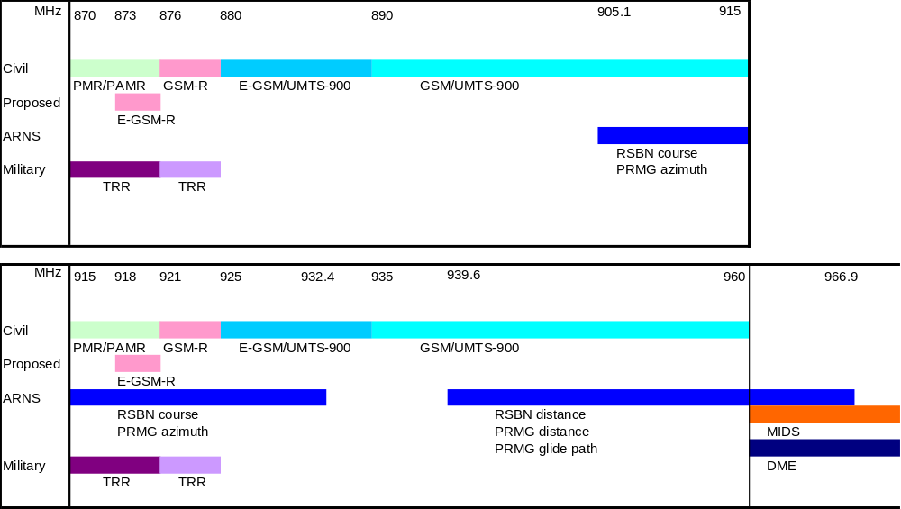
Figure 2: Frequency usage at the 900 MHz range relevant for the studies in this Report

1800 MHz band
In the CEPT countries, the frequency range 1710 - 1880 MHz is mainly used by mobile systems. In some countries there are also other systems like HC-SDMA broadband wireless system (so-called iBurst) in the band 1787.5 - 1802.5 MHz.

The band 1880 - 1900 MHz is used by DECT (see Figure 3).

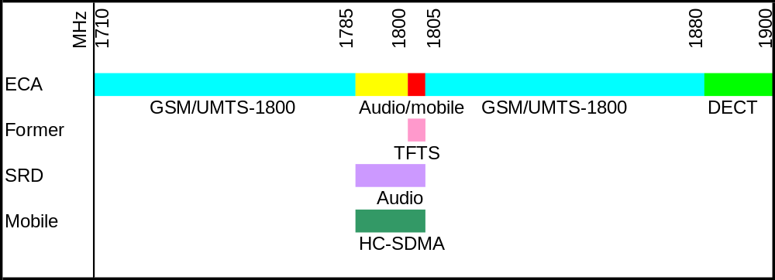
Figure 3: Frequency usage at the 1800 MHz range relevant for the studies in this Report

Sharing scenarios
The purpose of this Report is to define the figure of necessary geographical separation if systems would operate within distinctly separate geographical areas and/or to define the figure of necessary frequency separation if systems would operate co-located in the same area or in general to define the technical conditions that would ensure proper conditions of operation without putting undue constraint on adjacent systems.

3GPP TSG GERAN have conducted a number of studies on the impacts of relaxations of the specifications for GSM MCBTS on coexistence of public coordinated and uncoordinated GSM networks operating in the same frequency band and the same geographical area. The conclusion has been that there was no noticeable impact of the relaxations. Consequently, this Report does not address this issue.

The analysis have been carried out for worst-case scenarios for the MCBTS network structure and channel plan, resulting in a conservative interference assessment compared to real network deployments.

SEAMCAT® is used in this Report to calculate the interference probability of MCBTS into the HC-SDMA broadband wireless system (so-called iBurst) and for one of the simulation studies calculating interference into the GSM-R system.

The Minimum Coupling Loss method is used to analyse the interference between stations without taking dynamic aspects into account, and provides the necessary attenuation required between the systems to enable interference-free operation under specified conditions. Systems simulations provide more detailed analysis with realistic dynamic aspects of the involved systems.

For the RSBN/PRMG studies a large cellular network is generating the interference and the RSBN/PRMG ground station beacon the carrier towards the aircraft. This to calculate the C/I in the aircraft.

Parameters used for TRR were taken from previous studies for ECC Report 058.

The Report considers the scenarios listed below to assess the impact on each system of introducing MCBTS into the band:
- MCBTS into TRR adjacent channel at 925 MHz. Not applicable in the countries where the band 921-925 MHz is used for GSM-R;
- MCBTS into RSBN/PRMG co-channel at 925 - 935 MHz;
- MCBTS into RSBN/PRMG adjacent channel in the band 925 - 935 MHz (RSBN course, PRMG azimuth);
- MCBTS into HC-SDMA broadband wireless system (so-called iBurst) in the band 1787.5 - 1802.5 MHz.

In the case of RSBN/PRMG systems, there are no differences between MCBTS and SCBTS for the co-channel cases and therefore no specific studies have been performed. The introduction of MCBTS does not result in changes of the site-planning. Therefore the results from ERC Report 081 are still valid.

Additionally, the compatibility band compatibility between GSM MCBTS and the following systems are addressed: Aeronautical systems in 960 - 1215 MHz (DME), military systems above 960 MHz (MIDS) and DECT in 1880 - 1990 MHz.

methodology

MC BTS characteristics, GSM system parameters, deployment scenarios and propagation models
Information on MCBTS parameters and GSM system characteristics has been collected in Annexes 1 – 3.

Annex 1 contains an explanation of those parts of the GSM specification that cover the unwanted emissions of an MC BTS. In particular there are figures and tables describing the values of unwanted emissions for in-band and out-of-band scenarios for both the 900 and the 1800 MHz bands.
Annex 2 contains information on general GSM BTS characteristics, as well as GSM system deployment parameters. Two different scenarios are suggested, rural and urban deployments.

Annex 3 contains an in-depth analysis of intermodulation products and how they affect the unwanted emissions of an MCBTS. A reference case MCBTS is analysed to provide a detailed description of unwanted emissions to be used in the difference co-existence scenarios.

An implementation with 4 carriers in 5 MHz has been used as a reference case in this Report. 80W total power is assumed for the MC BTS, resulting in 43 dBm per carrier. Additional information can be obtained from Annex 1 of this Report.
The 4 carriers are equally separated by 600 kHz, one of them being placed at the edge of the transmit band to get a worst case scenario. This is illustrated for the 900 MHz band by Figure 4:

925 MHz
960 MHz
Figure 4: MC BTS carrier distribution
The same carrier distribution applies also to the 1800 MHz studies.

Several different propagation models have been used in this Report, depending on the interference scenarios between GSM and other systems. These models are presented very briefly here; see Table 1. The propagation models are described in further details in the relevant sections of the report.

Co-existence scenario |  | Propagation model | Comment
MCBTS | GSM-R | Okumura-Hata (Rural open area)) | FS for short distances
MCBTS | DME | Free Space (FS)
MCBTS | MIDS | Free Space
MCBTS | DECT | Free Space and Okumura-Hata
MCBTS | RSBN/PRMG | Free Space
MCBTS | TRR | Okumura-Hata Extended
Table 1: Propagation models

TRR adjacent channel operation
In the scenario the MCBTS and TRR systems were deployed in an urban environment. The MCBTS interference to the adjacent TRR in the frequency band 915 - 925 MHz is analyzed.

The MC BTS out of band emission mask for 900 MHz (see also Annex 1) and the TRR adjacent channel selectivity (see Annex 4) show that the ACLR is higher than the ACS when the carrier separation is larger than 1.1 MHz. Therefore the ACLR is used in the calculation. A carrier separation of less than 1 MHz would result in the ACS being the dominant factor. The effect of the emission into the TRR is investigated to see the reduction of the cell radii of the TRR cell. The cell radii for a TRR station for urban case would be between 30 and 70 km. In this case around 50 km is used. The effect of the antenna tilt is included as 4 dB.

MCBTS Parameters (in urban environment) |  |  | TRR Parameters
Tx Power | 43 dBm |  | Rx Sensitivity | -93 dBm
Antenna Gain incl. feeder loss | 12 dBi * |  | Protection Ratio | 15 dB
EIRP | 55 dBm |  | Protected Sensitivity | -108 dBm
 |  |  | Antenna Gain | 16 dB *
 |  |  | Bandwidth | 1500 kHz
Table 2: MCL parameters for interference from MCBTS into TRR
* Only the main lobe is considered. The results would be better in the reality than what the MCL figures indicate. This should for example be the case for SEAMCAT studies.

For 1.65 MHz carrier separation the emission from the MCBTS would be -26.0 dBm/30 kHz. This unwanted emission can be seen as a worst case since there are also some lower emissions that will also be received in the TRR case since the out-of band emission varies from -26dBm/30kHz to -29dBm/30 kHz. The conversion factor between 30 kHz to 1500 kHz is 17 dB.

TRR Receiver sensitivity - protection ratio >= Emission value + conversion factor + GSM antenna gain – feeder loss – antenna tilt/vertical and horizontal – Path loss + TRR antenna gain

-93 dBm -15 dB = -108 dBm >= -26 dBm + 17 dB + 15 dBi - 3 dB – 4 dB – Lp + 16 dBi

Lp >= -26 dBm + 17 dB + 15 dBi - 3 dB – 4 dB + 108 dBm + 16 dBi = 123 dB

This gives the distance of 5.4 km for an urban environment.
This is perhaps too much and a tolerable distance could be 2-3 km. This would require an additional attenuation of 9-15 dB or more likely a reduction of the cell radii of the TRR cell from 50 km down to 25-33 km.

With the assumption that the TRR antenna is not in the bore sight of the closest GSM antenna an additional loss of 0-40 dB could be assumed and 15-20 dB has been used to compare the effects. This is in the same range as the required attenuation and the cell radii for the TRR would then not be decreased.

RSBN/PRMG

RSBN/PRMG adjacent channel operation

The study covers non-ICAO ARNS standardized systems in the frequency range 915 - 935 MHz. The channels used are the channels 15 to 40 for the ARNS systems (see also Annex 5).

The corresponding transmitting equipments are ground stations whose transmitting signals are received by airborne equipments. The only equipments that may be interfered by the GSM MCBTS are “PRMG azimuth” and “RSBN course”. Both are airborne receivers and both may operate in co-channel and adjacent channel situations.

The other direction of interference (ARNS ground station →GSM MS) is not part of the scope since the MC concept of GSM does not introduce any change with respect to the mobile stations.

Consequently, the scenario addressed in this Report is GSM MCBTS → Airborne ARNS receiver (PRMG azimuth and RSBN course).

For the studies it is important to include the effects of both out-of band emissions and the effects of the ARNS adjacent channel selectivity. Both these effects should be summarized to calculate the total interference seen by the ARNS receiver.

For the adjacent channel operation the effects of MCBTS has been analyzed in rural areas.

The general start values due to RSBN/PRMG channel plans are PRMG azimuth below 932.4 MHz and RSBN course below 932.4 MHz.

Assumptions for the studies of ARNS are:
- For each case the MCBTS has been assumed to transmit at 935 MHz and 925 MHz. The MCBTS lowest channel is always above the ARNS channel.
- If ARNS is between 925 - 935 MHz the in-band emission mask for the typical MCBTS case (see Annex 1) should be used.
- For ARNS using frequencies below 925 MHz the out-of-band emission mask for the reference MCBTS case should be used (see Annex 1).
- A general case with 1, 2 and 5 MHz carrier separation has been calculated.
- The required C/I levels should be met at the aircraft receivers from 0 up to at least 2000 meters height.

The basic ARNS parameters (contained in Annex 5) and the basic GSM system parameters (contained in Annex 2) are generally the basis for all co-existence studies.

The C/I levels at the aircraft from 0 up to 2000 meters height for the RSBN azimuth and PRMG channel should be higher than the C/I limits specified below.

The wanted carrier to interference signal ratios of the RSBN/PRMG receivers are shown in Table 3: Carrier to interference criteria for PRMG azimuth and RSBN course channels [4]:

 | PRMG azimuth | RSBN course
C/I (dB) | 7 | 17
Table 3: Carrier to interference criteria for PRMG azimuth and RSBN course channels
These values are based on the measurements when processing of the wanted signal of the RSBN/PRMG compared to the interfering GSM signal on the same carrier frequency.

It should also be mentioned that not all the SCBTSs will be changed into MCBTSs at the same time, so some averaging between SC- and MCBTS should be expected and hence some total lower emissions.

The usage of standard features in GSM to improve the performance for GSM capacity figures (e.g. PC and DTX) would also improve the interference situation when it concerns the ARNS system co-existence cases. This is especially when many BTSs are considered (see also Annex 1 and 3). These effects are shown in Figure 5, see also Annex 10. For the offset range 1 - 3 MHz, the additional reduction in unwanted emission is 8-10 dB.

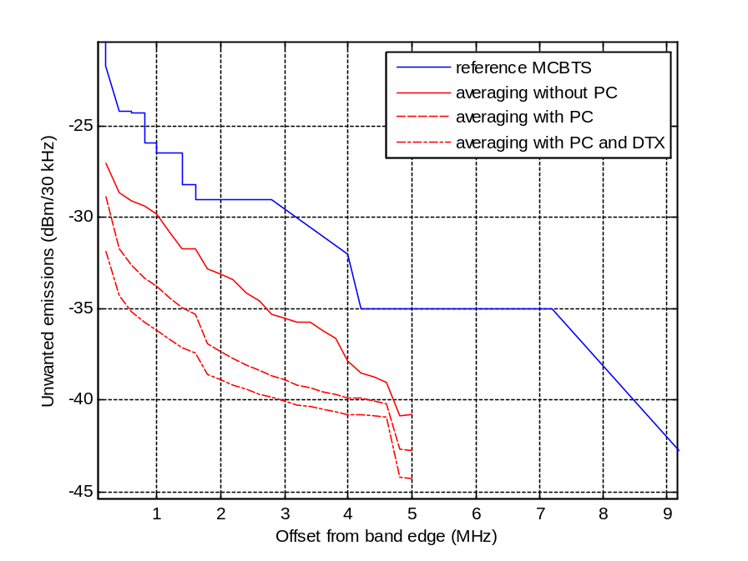
Figure 5: Averaging effect above 1000 m
For the 935 MHz case the carrier separation between the lowest GSM and the highest RSBN/PRMG channel is at least 2.5 MHz since the uppermost RSBN/PRMG channel is located at 932.4 MHz. For RSBN/PRMG channels below 932.4 MHz there are several potential cases since the GSM channel spacing is 200 kHz. Hence the more general case of 1, 2 and 5 MHz is appropriate to study.

The distribution of GSM frequencies was chosen like shown in Figure 6 to represent a theoretical worst case scenario with a frequency reuse of 3 to ease the simulations, even though it is not a practical situation in network deployment.

Figure 6: MC BTS carrier distribution
GSM carriers
600
200 k
200 k
200 k
200 k
200 k
200 k
200 k
200 k
200 k
200 k
200 k
600 k
600 k
600 k
Cells #1
600 k
600 k
600 k
Cells #2
600 k
600 k
600 k
Cells #3
2.2 MHz
Free space loss (Recommendation ITU-R P.525) was used for the calculations since more or less all the base stations are visible from the aircraft, without any obstacle.

For the MCBTS antennas (see Figure 7) the models of Recommendation ITU-R F.1336-2 are used:
- Between 0 and 1000 m (altitude of the aircraft): the omni/sector/peak model is used (see section 2.1 of Recommendation ITU-R F.1336-2), in association with a side-lobe factor (k) of 0.7;
- Above 1000 m: the omni/sector/average model is used (see section 2.2 of Recommendation ITU-R F.1336-2), in conjunction with a side-lobe factor (k) of 0.7 for the omni case and 0.2 for the sector case.

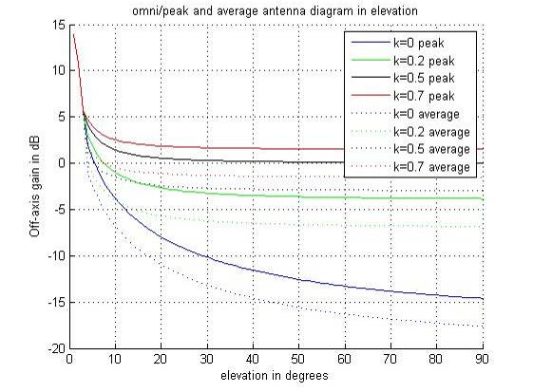
Figure 7: Antenna diagram in elevation for MCBTS, omni case

RSBN/PRMG co-channel operation
There is no difference for the co-channel case between MCBTS and SCBTS and therefore no studies have been performed specifically for this case. Additional studies for the co-channel case could be found in ERC Report 081.

HC-SDMA broadband wireless system
For the purpose of this study SEAMCAT (Spectrum Engineering Advanced Monte Carlo Analysis Tool) methodology was used in the interference calculations. The characteristics of the HC-SDMA broadband wireless system can be obtained from Annex 6. The parameters of GSM 1800 were extracted from Annex 1.

The implementation of power control capability for MC BTS is considered with the following characteristics:
- min threshold is -102 dBm;
- dynamic range is 30 dB;
- step of the power control is 2 dB.
To assess if there is an impact on HC-SDMA broadband wireless system by introducing MCBTS into the band the Report considers the MCBTS into an adjacent channel of an HC-SDMA Terminal station which is centred at 1802.1875 MHz, the scenarios consider the worst case distribution of the interferers with respect to the victim receiver by using the “closest interferer” mode in SEAMCAT (ver 3.2.0).
Both urban and rural deployments scenarios were considered.
The cell radii for both cases are shown in the Table 4: List of SEAMCAT parameters for interference from MCBTS into HC-SDMA system.

MCBTS Parameters |  |  | HC-SDMA Parameters
Tx Power | 43 dBm |  | MS Reference sensitivity | -108.5 dBm
Antenna Gain incl. feeder loss | 15 dBi * |  | C/I** | 0, 5, 10, 14 dB
EIRP | 58 dBm |  | Tx Power | 24.2 dBm
Bandwidth | 200 kHz |  | Antenna Gain | 15 dB
Antenna height (m) | 45 (rural)  30 (urban) |  | Antenna Gain | 15 dB
Antenna downtilt (°) | 3 (Rural)  3 (Urban) |  | Antenna Gain | 15 dB
Cell radius | 0.6 km (urban)  2.4 km (rural) |  | BS Height | 30 m
Power control | used |  | Bandwidth | 625 kHz
 |  |  | Cell radius | 1 km (urban)  6 km (rural)
Table 4: List of SEAMCAT parameters for interference from MCBTS into HC-SDMA system
* For the MBS GSM1800 the BTS antenna was considered as omnidirectional.
** Following ratios for C/I criterion were considered for the study: C/I = 0, 5, 10, 14 dB.

DME adjacent channel operation

Respective frequency plan

880 |  |  | 915 |  |  | 925 |  |  | 960
 | Uplink  (GSM MS transmit) |  |  |  |  |  | Downlink  (GSM MC BTS transmit)
Figure 8: The frequency plan of GSM in the 900 MHz band
The frequency plan of GSM in the 900 MHz band is described in Figure 8. The relevant frequency border is at 960 MHz.

The frequency plan of DME is as follows:

DME systems consist of two categories of equipments:
- Airborne DME interrogator. The corresponding transmitting frequencies are all above 1025 MHz.
- Ground station reply. The corresponding transmitting frequencies are as follows:

962 | 963 | 964 | 965 | 966 | 967 | 968 | 969 | 970 | 971 | 972 | 973 | 974 | 975 | 976 | …
DME | DME | DME | DME | DME | DME | DME | DME | DME | DME | DME | DME | DME | DME | DME | DME

Figure 9: The frequency plan of DME
Currently only frequencies above 977 MHz are used for DME. Similar systems such as TACAN are deployed below 977 MHz. These latter systems are not addressed in this report; however, given the similarities between these systems and DMEs, the conclusions for DME are assumed to be applicable to TACAN.

Therefore, the only equipments that may be interfered by the GSM MC BTS are the airborne receivers. The other direction of interference (DME ground station →GSM MS) is not part of the scope since the MC concept of GSM does not introduce any change with respect to the mobile stations.

Consequently, the only scenario addressed in this document is: GSM MC BTS → Airborne DME receiver

Methodology
This protection criterion of DME, from MC BTS, is in line with the maximum interference TRP (Total Received Power) received at the DME antenna port in a 1 MHz bandwidth, including the safety margin and the apportionment, as given in Table 5.

 | Parameter | Value | Reference
1 | DME interference threshold (at DME antenna port) | –129 dB (W/MHz) | ECC Report 096
2 | Safety margin | 6 dB | Recommendation ITU-R M.1477
3 | Apportionment of MCBTS interference to all the interference sources (MIDS, L-DACS, UMTS, etc.) | 6 dB above 966.5 MHz, 3 dB below 966.5 MHz | Apportion 25% of total permissible interference to MCBTS above 966.5 MHz. Higher percentage is used in the band 960 - 966.5 MHz.
4 | Maximum MCBTS aggregate PSD, received at the DME receiver input, including the safety margin and the apportionment | −138/-141 dB(W/MHz) | Combine 1, 2 and 3 (1 minus 2 minus 3)
Table 5: Maximum allowable aggregated PSD level to protect DME from MCBTS
However, it is recognized that the low altitudes are the most critical cases and the interference from the base stations of the mobile service is higher at low altitudes. But at the same time, the signal, coming from the ground DME transmitter to the airborne DME receiver is higher. It is therefore sensible to consider a different criterion for the low altitudes -below 3000m (see Table 7).
Below 3000m, DME is used for departure and arrival procedures. In these procedures, the position of the aircraft is calculated by a triangulation process using several DMEs simultaneously. In order to get a sufficient precision, the on-board flight management system will exclude DMEs that are closer than 5.6 km (e.g. below 300m) and it will have to use DMEs that are located outside the airport. This scenario, described in Figure 10, is or will be appropriate for most of the major terminal areas in Europe.

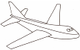
AIRPORT
DME n°1
DME n°2

Figure 10: Low altitude scenario

The useful parameters of DME are defined in the MOPS of the EUROCAE:
- Receiver sensitivity :
  - -80 dBm (search and track mode)
  - -83 dBm (to maintain tracking)
- Interference susceptibility : -99 dBm
- E.i.r.p. and coverage range distance of ground DME transmitter:
Nominal values of the necessary EIRP to achieve a power density of minus 89 dBW/m² are given in Figure 11. They are extracted from ICAO material. They all refer to deployed systems. For coverage under difficult terrain and siting conditions it may be necessary to make appropriate increases in the EIRP. Conversely, under favourable siting conditions, the stated power density may be achieved with a lower EIRP.

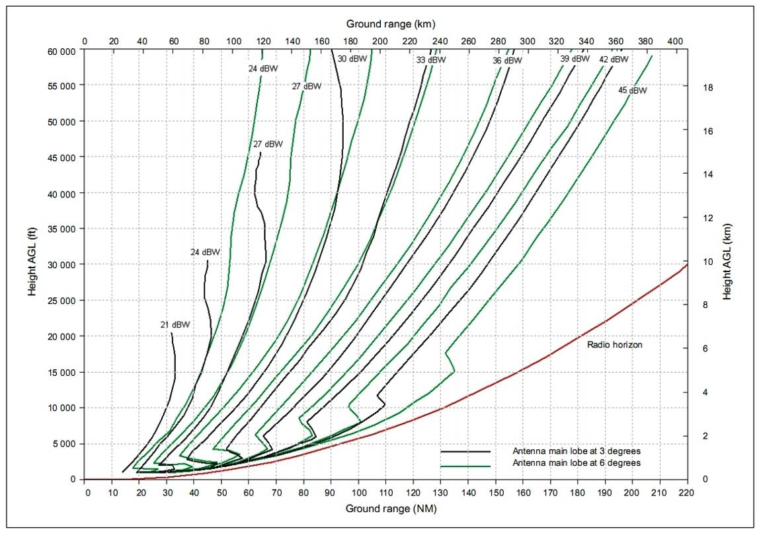
Figure 11: Necessary EIRP to achieve a power density of -89 dBW/m² as a function of height above and distance from the DME

Note 1.— The curves are based on the IF-77 propagation model with a 4/3 Earth radius which has been confirmed by measurements.
Note 2.— The radio horizon in Figure 11 is for a DME antenna located 5 m (17 ft) AGL over flat terrain. Terrain shielding will reduce the achievable range.
Note 3.— If the antenna is located significantly higher than the assumed reference antenna, the radio horizon and power density will increase.

In order to take a realistic case in terms of compatibility, an EIRP value of 29 dBW has been considered as appropriate. It corresponds to a standard DME EIRP value used for approaches and departures. Moreover, the appropriate propagation model is the IF-77 propagation model, as recommended in ITU-R P528. Finally, in order to comply with navigation procedure, the operational range of these DME systems is around 25 NM or 46 km until 1000 m and 35 NM or 65 km above 1000 m (e.g. the DME can be used at a very low altitude (<500m) when the separation between the transmitter and the receiver is no more than 46 km). The signal level at the aircraft to consider in calculations is thus given in Table 6.

 | Parameter | Value for a separation distance of 25 km* | Value for a separation distance of 46 km** | Value for a separation distance of 65 km*** | Reference
1 | DME EIRP | 29 dBW | 29 dBW | 29 dBW
2 | Free Space Loss | 120 dB | 125.4 dB | 128.3 dB
3 | Attenuation for a wanted signal (ensure the reception of the wanted signal 95% of the time) | 127.6dB | 133 dB | 136 dB | IF-77 propagation model, recommendation, ITU-R P528-2
4 | Maximum wanted DME signal received at the aircraft | -68.6 dBm | -74 dBm | -77 dBm | Combine 1 and 3 (1 minus 3)
Table 6: Maximum wanted signal level received at the aircraft
*A maximum distance of 25 km, between an aircraft and a DME ground station, is considered for an altitude of aircraft below 500m (see annex 4 to this document)
** A maximum distance of 46 km, between an aircraft and a DME ground station, is considered for an altitude of aircraft between 500m and 1000m
*** A maximum distance of 65 km, between an aircraft and a DME ground station, is considered for an altitude of aircraft between 1000m and 3000m

Those values do not take into account any safety margin nor any apportionment margin.
- A safety margin of 6 dB is added,
- An apportionment margin is added :
  - 3 dB at 966,5 MHz and below,.
  - 6 dB above 966.5 MHz

Therefore, the criterion corresponds to:

Between 0 and 500 m:
The interference criterion “Imax” is derived from the following assumptions:
• “C/I” = 28 dB at 966.5 MHz and below, including margins,
• “C/I” = 31 dB above 966.5 MHz, including margins,
• Cmax = -68.6 dBm

• Imax = -96.6 dBm at 966.5 MHz and below, including margins,
• Imax = -99.6 dBm above 966.5 MHz, including margins,

Above 500 and up to 1000 m:
The interference criterion “Imax” is derived from the following assumptions:
• “C/I” = 28 dB at 966.5 MHz and below, including margins,
• “C/I” = 31 dB above 966.5 MHz, including margins,
• Cmax = -74 dBm

• Imax = -102 dBm at 966.5 MHz and below, including margins,
• Imax = -105 dBm above 966.5 MHz, including margins,

Above 1000 and up to 3000 m:
The interference criterion “Imax” is derived from the following assumptions:
• “C/I” = 28 dB at 966,5 MHz and below, including margins,
• “C/I” = 31 dB above 966.5 MHz, including margins,
• Cmax = -77 dBm

• Imax = -105 dBm at 966.5 MHz and below, including margins,
• Imax = -108 dBm above 966.5 MHz, including margins,

Above 3000 m:
The interference criterion “Imax” is derived from the following assumptions:

• Imax = -108 dBm/MHz at 966.5 MHz and below, including margins,
• Imax = -111 dBm/MHz above 966.5 MHz, including margins,

Table 7: protection criteria

calculation results

TRR adjacent channel
The results are dependent on the carrier separation and are plotted in Figure 12.

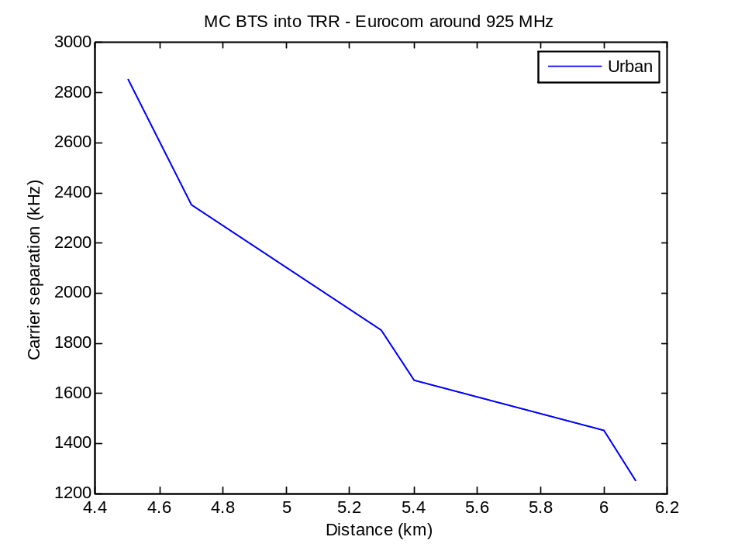
Figure 12: Worst case MCL for MCBTS into Eurocom TRR depending on carrier separation
For a carrier separation less than 1 MHz the ACS is the dominating factor and there would be no difference between SCBTS and MCBTS when it comes to affect the TRR.

The studies show that around one receiver bandwidth for the TRR as carrier separation, more precisely 1.65 MHz, and 2-3 km separation distance should be sufficient to keep the TRR cell area for urban environment with proper antenna planning. This is to avoid direct bore sight of TRR antenna into the GSM antenna.

In reality it would be possible to have shorter distances, or smaller carrier separations, but with some probability of interference between MCBTS and TRR.

Where sharing is wanted there are several mitigation techniques that can be applied, some of which require some degree of co-ordination and others that are mainly good engineering practices. These techniques are mainly applicable where there is a geographical separation between GSM and the TRR systems and are:
- Use of directional antennas for GSM base stations pointing away from known military exercise areas.
- Optimise, when practicable, the alignment of the TRR antennas to minimise interference but at the same time maintain the wanted link. However, this may imply reduction of the TRR operational capabilities.
- Using the power setting of the TRR to increase the wanted link signal level in case of interference from GSM. The same limitations as above apply. However, it will also increase the interference from TRR to GSM.
- The use of direct contact to the GSM operator for reducing the power of a particular base station (this implies regulatory measures such as license requirements).

If a degree of co-ordination was introduced between the operators, solutions could be found for cases where the two systems are not overlapping geographically, such as specific military exercise areas, if directional antennas are used for nearby GSM coverage.

RSBN/PRMG adjacent channel
For the MCBTS reference case and normal GSM features usage, such as Power Control (PC) and Discontinuous Transmission (DTX), the Adjacent Channel Selectivity (ACS) is the main parameter for all studies. Since the ACS is the same for both SCBTS and MCBTS the difference between the usage of either SC- or MCBTS is negligible.

Calculation with omnidirectional MCBTS antennas
For the MCBTS reference case the results give that the interference criteria of RSBN (ERP of 19 dBW) is satisfied for an approach angle of 3 degrees and carrier separation of 1 MHz. The difference between 2 and 5 MHz carrier separation is only 1-2 dB due to the fact that the main part of the interference is from the RSBN adjacent channel selectivity (ACS). It is also noticeable that the large range in ERP for the RSBN is an important factor. For ERP of 44.8 dBW for RSBN reference channel, all approach angels give satisfying results for all heights.

- For PRMG azimuth, a carrier separation of 1 MHz between the closest GSM MC carrier and the PRMG carrier is sufficient to comply with the interference criterion (see Figure 13).

PRMG azimuth
GSM carriers
1 MHz
Figure 13: Carrier separation between MCBTS and PRMG azimuth channel
- For RSBN course, the results are very much dependant on the type of equipment:
  - RSBN course channel (19 dBW) : for classes 1 and 2, the interference criterion is complied with:
    - for the low altitudes only (below 3500 m) for a frequency difference of 1 MHz,
    - for any altitude for a frequency difference of 2 MHz and above.

  - RSBN course reference channel (44.8 dBW): for both classes 1 and 2, the interference criterion is satisfied whatever the aircraft altitude is and whatever the frequency difference is.

  - For both RSBN, it has to be noted that the results for class 1 and the results for class 2 are very similar since the ACIR is very much dominated by the selectivity (ACS) of the RSBN (10 to 15 dB above the spectrum mask of MC GSM). Therefore, the multi-carrier feature of GSM does not introduce any degradation of the RSBN performance.
The compatibility situation can be slightly improved by choosing a different carrier distribution (Figure 14) than the one presented in Figure 13.
GSM carriers
600 k
600 k
600 k
600 k
600 k
600 k
600 k
600 k
600 k
600 k
600 k
1800 k
Cells #1
1800 k
Cells #2
1800 k
Cells #3
6.6 MHz
Figure 14: Different carrier distribution

With such a network design, the results of the simulation are evolving as follows:

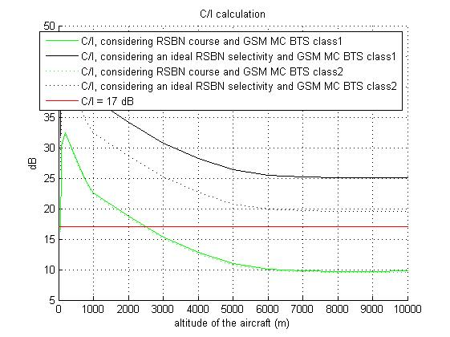 | → | 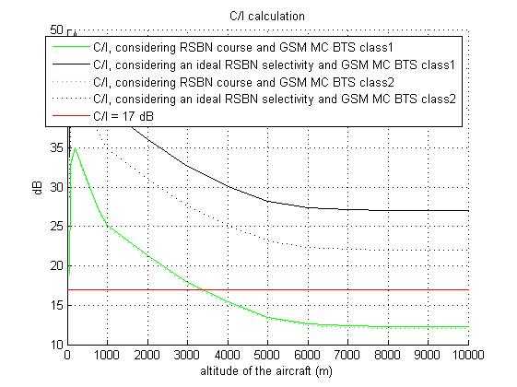
Figure 15: Effect of different carrier distributions
The improvement can be obtained due to the fact that the interference is mainly dominated by the closest GSM frequencies from the RSBN carrier. For altitudes above 3500 m, there is a need for an additional isolation of 5 dB. This isolation may be obtained by either/both:
- The 3-sectorized antennas for the GSM base stations that have been approximated by omni-directional antennas.
- The network scheme that has been simplified for easiness of implementation.

It has to be noted that the ERP of RSBN, that varies from 19 to 44.8 dBW depending on the type of RSBN channel, is the most influent parameter on the results since the C/I threshold is constant.

The results shown above have not taken into account the averaging effects of power control and DTX. When incorporated the results would be 8-10 dB improved.

Since the receiver characteristics of the RSBN/PRMG system is the dominant factor in sharing situations, it would be good to improve the ACS for the RSBN/PRMG receivers.

RSBN calculations with 3-sectorized MC BTS antennas
If 3-sectorized antennas are used, then the simulation results will be as in Figure 16.

 | Type of equipment
Carrier separation | RSBN Course channel  (ERP=19 dBW) | RSBN Course Reference channel  (ERP=44.8 dBW)
1 MHz | 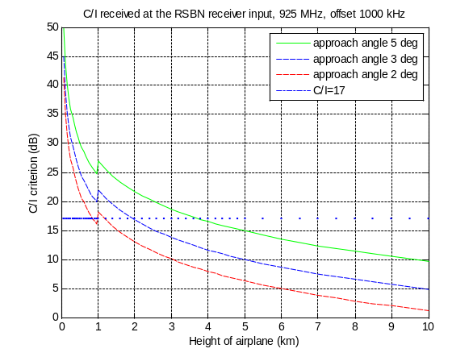 | 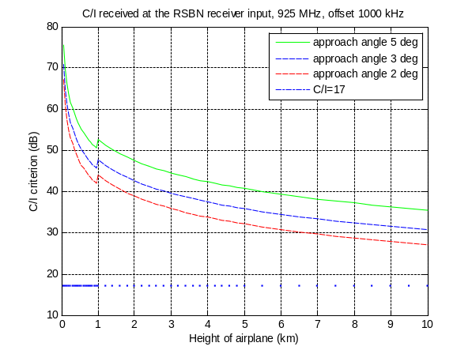
2 MHz | 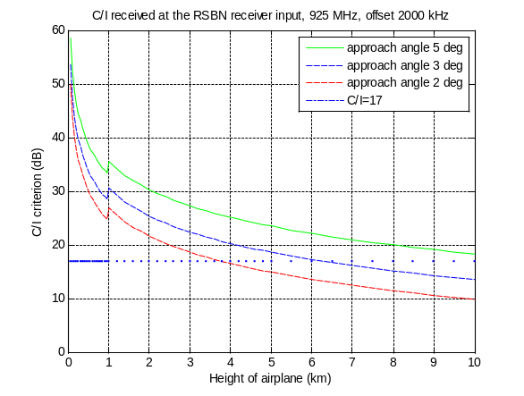 | 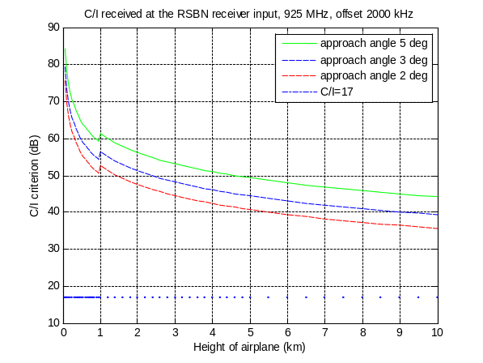
5 MHz | 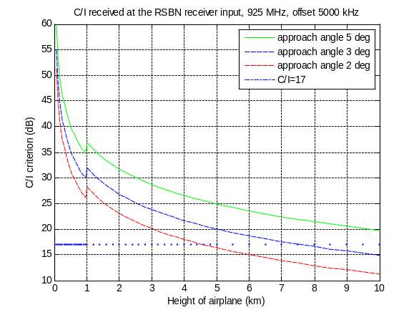 | 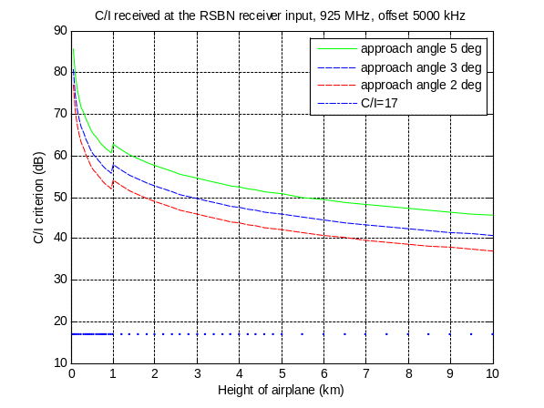
Figure 16: RSBN (ERP=44.8 dBW) C/I with 5 MHz carrier offset to MCBTS

PRMG calculations with 3-sectorized MCBTS antennas
The PRMG case is satisfied for all approach angles and all carrier separations (1, 2 and 5 MHz). It might also be possible to have smaller carrier separations to satisfy the 2000 m height criteria.

If 3-sectorized antennas are used, then the simulation results will be as in Figure 17. It represents the cases for PRMG azimuth channel with 9 dBW ERP.

Carrier separation
1 MHz | 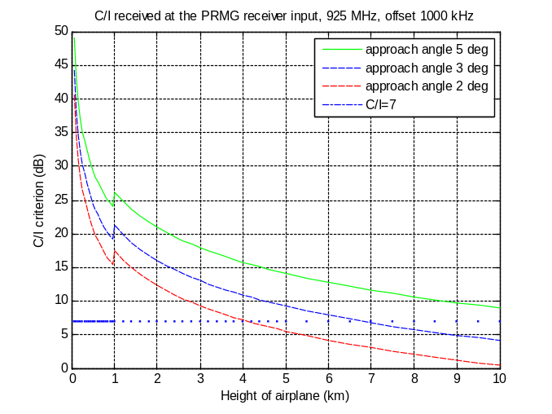
2 MHz | 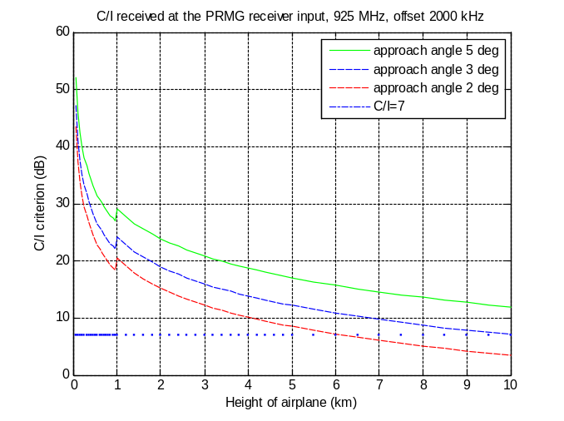
5 MHz | 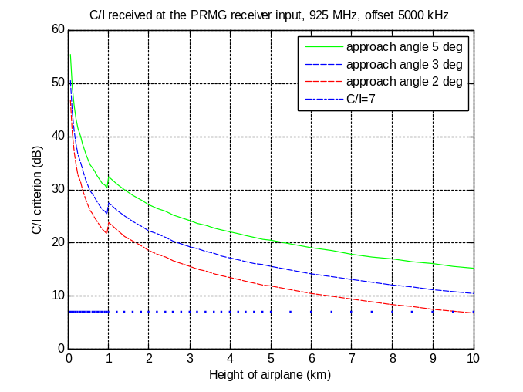
Figure 17: RSBN C/I with 1, 2 and 5 MHz carrier separation to MC BTS

PRMG calculations with omni-directional MC BTS antennas
Figure 18 shows the altitudes, where C/I = 7 dB criteria for PRMG azimuth channel is exceeded.

Carrier separation
1 MHz | 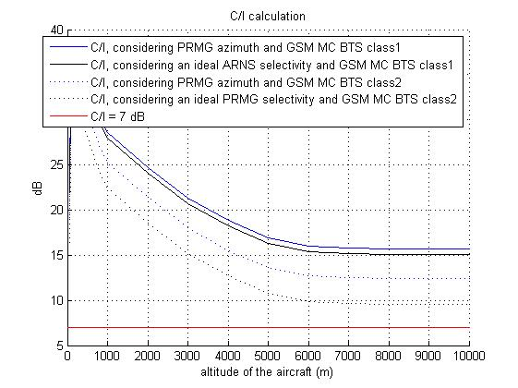
2 MHz | 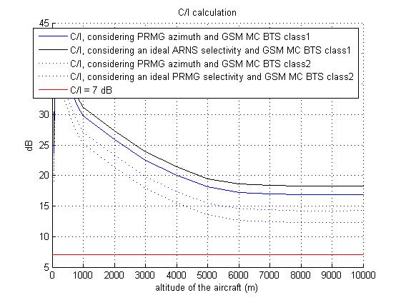
5 MHz | 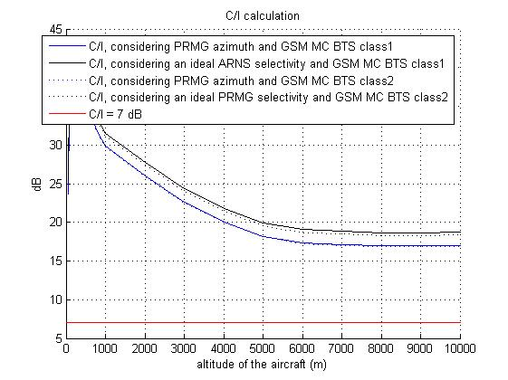
Figure 18: PRMG C/I with 1, 2 and 5 MHz carrier offset to MC BTS

RSBN calculations with omni-directional MC BTS antennas
Figure 19 shows the altitudes, where C/I = 17 dB criteria for RSBN channels is exceeded.

 | Type of equipment
Carrier separation | RSBN Course channel  (ERP=19 dBW) | RSBN Course Reference channel  (ERP=44.8 dBW)
1 MHz |  | 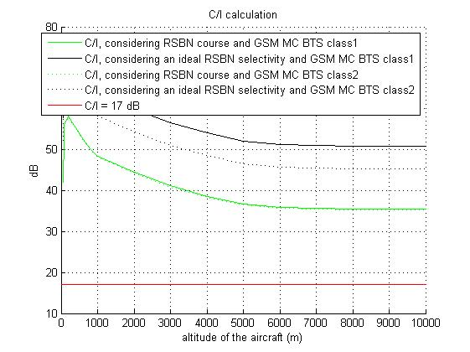
2 MHz | 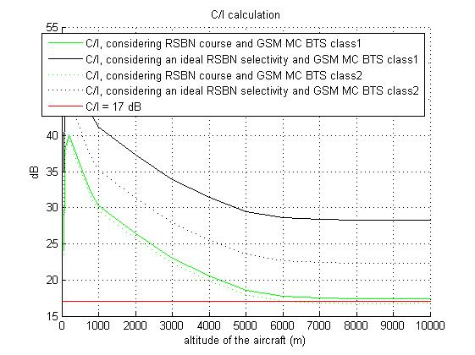 | 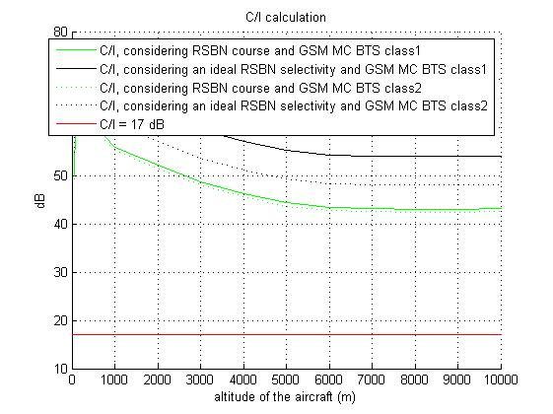
5 MHz | 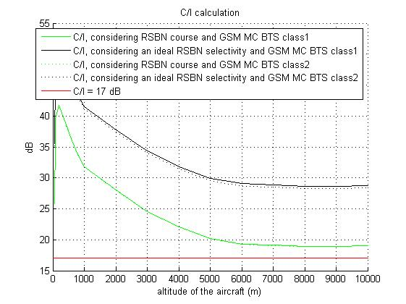 | 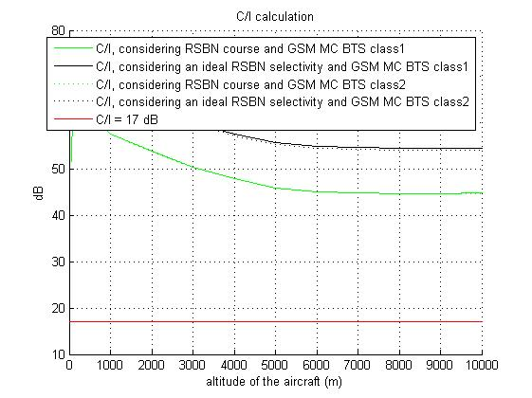
Figure 19: RSBN C/I with 1, 2 and 5 MHz carrier separation to MC BTS

RSBN/PRMG co-channel
No changes due to the introduction of MC BTS compared to SC BTS. For results concerning planning etc. for GSM, see ERC Report 081.

The results of section 5.2 were based on the RSBN/PRMG characteristics given in Table A5.2. There are RSBN systems in one country that have different parameters than the ones studied and which are given in Table A5.2bis. The results of the compatibility studies in sections 5.2 may not be applicable for those systems, but it is anticipated that those alternative values would lead to lower probability of interference due to higher wanted signal levels.

HC-SDMA
SEAMCAT simulation (ver. 3.2.0) using a blocking attenuation mode set to “protection ratio” with a blocking response (calculated based on the ASC_2) = ACS_2 + C/I (where C/I=0, 5, 10, 14) were performed and summarised in Tables 8a and 8b.

C/I | Unwanted (%) | Blocking (%) | Unwanted+blocking (%)
0 | 0.47 | 0.01 | 0.47
5 | 0.98 | 0.01 | 0.98
10 | 2.17 | 0.01 | 2.17
14 | 3.75 | 0.00 | 3.75
Table 8a: Probability of the interference in % for
C/I = 0, 5, 10, 14 dB for rural scenarios
The results of the SEAMCAT simulations demonstrate that the interference probability due to unwanted effect in the worst case (C/I=14 dB) is about 3.75 %. Interference probability due to the blocking effect is negligible for rural case.

C/I | Unwanted (%) | Blocking (%) | Unwanted+blocking (%)
0 | 0.01 | 0.00 | 0.01
5 | 0.03 | 0.00 | 0.03
10 | 0.04 | 0.00 | 0.04
14 | 0.15 | 0.00 | 0.15

Table 8b: Probability of the interference in % for
C/I = 0, 5, 10, 14 dB for urban scenarios
It can be concluded that in the worst case situation (rural scenario and C/I = 14) the probability of interference due to the unwanted mechanism is about 3.75 %. In most cases, the probability of interference is less than 1%. The interference due to the blocking mechanism is 0% almost in all considered cases. Therefore it can be concluded that there is almost no impact from the introduction of MCBTS on HC-SDMA when interference criteria C/I=0, 5 (rural) and C/I=0, 5, 10, 14 (urban) are considered.

GSM MCBTS – GSM-R (GSM900 band)
This section is dealing with the coexistence between GSM-R and GSM multi-carrier systems.

The GSM frequency band is arranged as:
- Uplink (UE transmit, BS receive): 880 - 915 MHz
- Downlink (BS transmit, UE receive): 925 - 960 MHz
- Carrier separation: 200 kHz whose first frequency is centred onto 880.2 MHz
The GSM-R frequency band is arranged as:
- Uplink (MS transmit, BS receive): 876 - 880 MHz
- Downlink (BS transmit, MS receive): 921 - 925 MHz
- Carrier separation: 200 kHz
The frequency band plans for GSM-R and GSM are shown in Figure 20. GSM-R railway services in the E-GSM-R frequency band (873 - 876 & 918 - 921 MHz) are not covered by this contribution, since the frequency separation between that band and the public GSM downlink is greater which leads to lower interference.

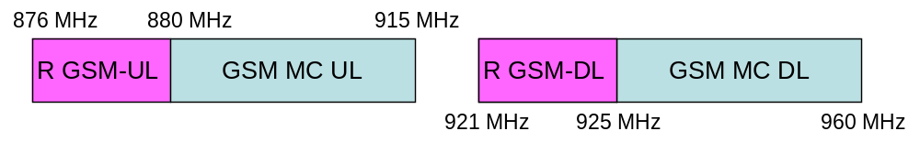
Figure 20: Frequency band plan for GSM-R and GSM in 900 MHz band

GSM-R and Public GSM System Characteristics
GSM-R networks offer a linear coverage of railway lines with bi-sector radio sites installed along the railway, as shown in Figure 21.
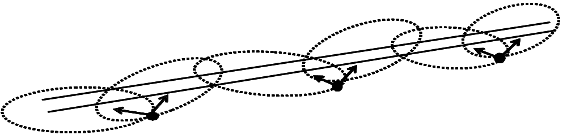

Figure 21: GSM-R deployment scenario

Two major characteristics of GSM-R coverage are: 1) Linear coverage; 2) High quality coverage (95% in each 100 m section of track at any time). In Europe, most GSM-R networks are designed with a BS antenna height of about 30 m. The assumption of respectively BS antenna height at 30 m and cell range at 4 km for rural areas and BS antenna height at 30 m and cell range at 1.5 km for urban areas represents the worst case scenario for the sharing study. The cell range varies typically between 1.5 km and 8 km.
There are two types of GSM-R MS terminals: 2W handset MS and 8W train mounted MS. As shown in Figure 22 below, the GSM-R 8W train mounted MS is the MS that is located inside the train, connected to the external MS antenna mounted on the roof top of the train.

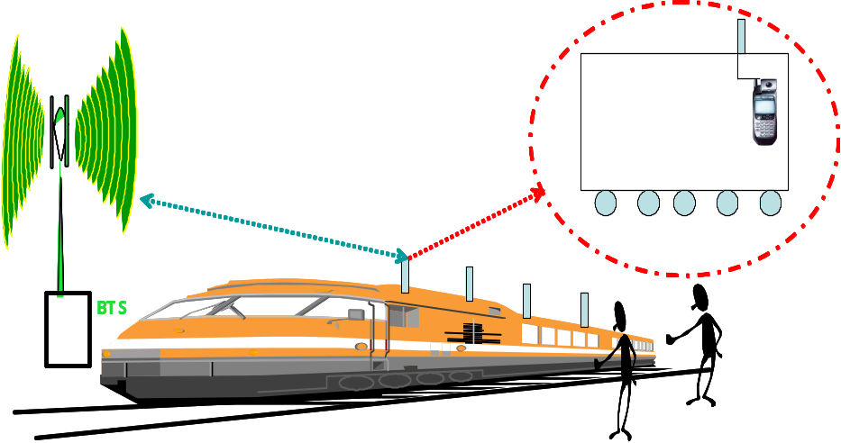

Figure 22: Connection between train mounted antenna and MS situated inside of the train
Details of the GSM-R RF performance and system parameters can be found in 3GPP technical specification 3GPP TS 45.005 [9]. The main GSM-R system characteristics are summarized in Table 9. System deployment characteristics for GSM-R and public GSM are found in Table 10.

 | GSM-R
Frequency band (UL) (MHz) | 876-880
Frequency band (DL) (MHz) | 921-925
Carrier separation (kHz) | 200
Frequency Hopping | No
Typical cell range (for this study) (km) | 4
 | BS | Train Mounted MS
Maximum Tx power (dBm) | 43 | 39
Antenna gain (dBi) | 18 | 0
Power Control | No | No/Yes (depending on the networks)
Feeder loss and coupling loss (dB) | 3+3 | 3
Antenna height (m)  (rural scenario assumed in study) | 30 m | 4
Antenna down-tilt (°) | 0 | -
Antenna | Sector antennas used. 20-65 deg horizontal beamwidth. Horizontal and vertical according to ITU-R F1336.2 | Omni-directional
Spectrum mask and spurious emissions | 3GPP TS45.005 [9] | 3GPP TS45.005 [9]
Receiver Noise figure (dB) | 5 | 7
Thermal noise (dBm) | -121 | -121
Receiver sensitivity (dBm) | -110 | -104
Receiver protection ratio (dB)  (For the terminal 12 dB is assumed for critical handover region.) | 9 | 9/12
Table 9: Main GSM-R system parameters

 | GSM-R | E-GSM
Frequency reuse | 6 | BCCH group: 4/12  Hopping group: 1/6 (full load on all carriers)
Number of frequencies | 19 | BCCH group: 12  Hopping group: 18  (Hopping group located in proximity to GSM-R frequencies)
Number of TRXs | 1/2 | 4
Cell radius in rural areas | 3500 m (cell range 7000 m) | 2400 m (cell range 4800m)
Site-to-site distance in rural areas | 7000 m | 7200 m
Table 10: System deployment parameters for simulations of GSM-R and E-GSM
For GSM-R normally 1 carrier is used, and on high speed lines maximum 2 carriers. For public GSM, all carriers are fully loaded (6-reuse) in the simulations, to obtain a worst case scenario. For public GSM system parameters, except from deployment parameters found above, see Annex 2. It was assumed one public GSM MCBTS operator. If there is a second operator, the interference will be lower due to the frequency offset. Moreover, the geographical separation would ensure the interferences may issue on different areas.
This report is dealing with typical situations and is not addressing tunnel coverage.

For the coexistence scenario with interference from GSM MCBTS to GSM-R, the GSM-R carrier centre is fixed on 924.8 MHz (see Decision CEPT (02)05) for the main scenario.. However, as the frequency hopping capability is feasible, the results will be also provided when the frequency hopping is implemented for the GSM-R system. It is assumed that the frequency hopping list is limited to 6 channels in order to take into account the GSM-R allocation bandwidth. Only interference into the train mounted MS is considered. As it was discussed during the development [6], the train mounted MS is not implementing the Power Control functionality and is transmitting at 39 dBm EIRP.

The propagation model is described in Table 11. Note that the Okumura-Hata open area model gives lower path loss than free space for up to slightly more than a kilometre of distance, which means that free space propagation will be used there instead. These models used in this report refer to a worst-case in terms of coexistence studies. These models may not be in line with the propagation models used by GSM-R network planning.

Propagation model | Okumura-Hata open area propagation model, for this frequency range and BS and terminal heights:  34.1*log(R) + 89.2 for BS antenna at 45 m height  35.2*log(R) + 91.7 for BS antenna at 30 m height  Path loss never lower than free space loss.
Table 11: Propagation models
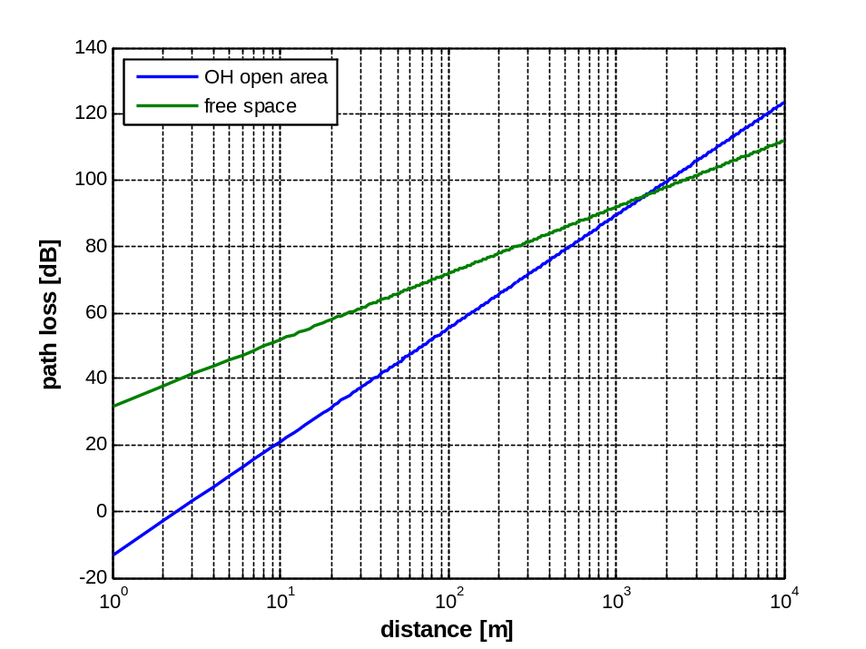
Figure 23: A comparison of Okumura-Hata open area, BS antenna at 45 meters with free space propagation
System design of the GSM-R network is assumed to be based on a signal strength no lower than -95 dBm (-98 dBm for some of railway lines) at any point on the railway track at 4 meters altitude, not including antenna gain or feeder loss of the GSM-R terminal [7].

The coexistence studies are assessing the impact onto GSM-R terminals of the relaxation of the GSM MCBTS out-of-band emissions. The simulations are not addressing the inter-modulation products and the blocking phenomenon inside the GSM-R terminals, for which the multi-carrier capability should not change the impact compared to the single carrier GSM systems.

Minimum Coupling Loss Analysis (Worst case analysis)

5.5.2.1 Comparison of impacts of different types of interference protection requirements
This section provides a MCL-analysis for interference from a MCBTS (of a public operator) into a GSM-R terminal. The aim is to compare the impact of receiver blocking, adjacent channel interference and interference due to unwanted emissions to GSM-R frequencies. It should be noted that some aspects of this section are not only related to MCBTS (receiver blocking, adjacent channel interference) while others are (unwanted emissions that include IM3 products).

The analysis is based on assumptions and parameters in Table 9 and Table 10 above. Table 12 below contains some additional information about the propagation necessary for this analysis, which is based on standard assumptions for GSM-R dimensioning.

Shadow fading margin (for conversion from 50% percentile to 95% percentile; i.e. 95% coverage in 100m parts of railway tracks): | 10 | dB (log normal fading)
Cell radius: | 4 | Km (7 km site-to-site, 0.5 km overlap in handover region)
Table 12: Radio network planning margins

The figure below is showing the configuration under consideration. The azimuth of the GSM antenna which is transmitting perpendicular to the railway track is maximizing the interference received by the GSM-R terminal placed at the cell edge. In other terms, this configuration represents the worst-case in terms of compatibility. In real deployments, the GSM BTS are generally oriented more or less parallel to the railway in order to cover the trains when they are in close vicinity of railway tracks. This scenario is not representative of real deployments.

GSM-R BTS 1
GSM-R BTS 2
GSM-R HO-area
Public BTS/ MCBTS
Figure 24: Assumed co-existence scenario
Calculation of Signal level requirement for GSM-R handover area

Using the parameters as described a minimum signal level along the railway track in the handover area can be calculated:

With a cell radius of 4km, with the Okumura-Hata propagation model for quasi-open area and the antenna heights given above, this corresponds to a pathloss of 118 dB.

This means that BS output power + BTS antenna gain – BS feeder loss – path loss = -60 dBm which is the mean signal level at the GSM-R terminal antenna and at the cell edge.

Taking into account the coverage criterion for railways (95%-percentile) by applying a shadow fading margin of 10 dB, this results in -60 dBm – 10dB = -70 dBm as a lower limit for the signal level at the edge of a GSM-R cell.

This minimum signal level is used for the analysis of the impact of co- and adjacent channel interference as a reference value to calculate needed pathloss between railway tracks/HO-area and GSM MCBTS.

[9] defines several co-channel and adjacent channel C/I limits and blocking criteria that are used to determine the maximum allowed interference from Public GSM MCBTS operation.

Calculation of Interference level due to adjacent channel interference (i.e. C/I)

Allowed interference for offset of | 0kHz | 200kHz | 400kHz | 600kHz
 | C/Ic | C/Ia1 | C/Ia2 | C/Ia3
C/I-ratio [dB] | 9 | -9 | -41 | -49
Table 13: Required co-channel and adjacent channel C/I performance for GSM receiver in 45.005
The C/I-values are used to calculate a maximum acceptable Interference level for Co-Channel Interference and for an offset of n*200 kHz from the considered GSM-R channel:

Offset | 0kHz | 200kHz | 400kHz | 600kHz
 | Ic | Ia1 | Ia2 | Ia3
Acceptable interference related to the 95% coverage requirement [dBm] | -79 | -61 | -29 | -21
Table 14: Acceptable co-channel and adjacent channel interference levels for the GSM-R terminal

The value for “Acceptable interference related to the 95% coverage requirement [dBm]” in table 14 represents the “Maximum permitted interference from Public GSM at railway tracks [dBm].
Interference limitations due to blocking

Blocking behaviour of GSM MS is difficult to estimate because specified blocking characteristic values are aimed for CW signals as a blocker and serving cell signal is static. In practice it was noticed GSM-R MS starts suffer of blocking when the GSM signal level exceeds level of -40 dBm. It is therefore suggested using value of -40 dBm to describe blocking threshold value from GSM BTS interference to GSM-R MS. It is meaning that the GSM-R equipments are not fulfilling the minimal specifications requirements in terms of blocking.

Applicable frequency range | 600 - <800kHz | 800 - <1600 kHz | 1600 kHz - …
Maximum Blocking Pwr for 3dB sensit.degradation [dBm] | -40 | -40 | -40
+MSAntennaFeederloss and Gain (because we consider signal strength at railway tracks) [dB] | 3 | 3 | 3
+Shadow fading for I [dB] (full fading t.b. applied as related against the fix blocking limit) [dB] | -10 | -10 | -10
Max. interference power to prevent Blocking (incl. Shadow fading)  (This is a worst case assumption as with C sufficiently above sensitivity a higher interference than indicated here might be possible – but this is not specified.) [dBm] | -47 | -47 | -47
Table 15: Required receiver blocking performance for GSM-R terminal in practice
Cochannel interference caused by unwanted emissions of MCBTSs

Results provided in Annex 1 have been used to estimate the needed pathloss to protect GSM-R terminals from co-channel interference that stems from unwanted emissions of MCBTS (modulation and wideband noise, spurious emissions and IM products) operating in a certain frequency offset from the considered GSM-R carrier. These results indicate a maximum of unwanted emissions for a class 2 MCBTS (as an example) as follows:

Offset 400 kHz: -21.7dBm/30kHz = -13.7dBm/200kHz
Offset 600 kHz: -24.2dBm/30kHz = -16.2dBm/200kHz
Offset 800 kHz: -24.3dBm/30kHz = -16.3dBm/200kHz

These values are used as TxPwr of MCBTS (per carrier) in Table 16 below to determine the resulting co-channel interference.

Resulting pathloss requirements

The assumptions above for Public GSM MCBTS parameters lead to the following pathloss requirements between Public GSM MCBTS and railway tracks, for co-channel interference due to unwanted emissions, Adjacent Channel interference and Blocking.

 | Co-channel from unwanted emissions |  |  | Adjacent channel |  |  | Blocking
 | Ic for 400 kHz | Ic for 600 kHz | Ic for 800 kHz | Ia1 at 200 kHz | Ia2 at 400 kHz | Ia3 at 600 kHz | 600 – <800 kHz | 800 – <1600 kHz | 1,6 MHz - …
Upper limit for acceptable Interference at railway tracks [dBm] (from Table 14 and Table15) | -79 | -79 | -79 | -61 | -29 | -21 | -47 | -47 | -47
unwanted emissions or TxPwr of MCBTS (per carrier) [dBm] | -13.7 | -16.2 | -16.3 | 43 | 43 | 43 | 43 | 43 | 43
MCBTSAntenna_gain + MCBTSfeeder_loss | 15 | 15 | 15 | 15 | 15 | 15 | 15 | 15 | 15
Needed pathloss [dB] between GSM-R HO-area and MCBTS | 80.2 | 77.7 | 77.6 | 118.9 | 86.9 | 78.9 | 105 | 105 | 105
Table 16: Determination of required pathloss between GSM MCBTS and railway tracks

Results for Worst Case scenario of 95% signal strength of -95dBm in the handover area

If GSM-R cells are larger then e.g. 4km, the GSM-R signal strength in the handover area can fall below the calculated values above. Moreover in real GSM-R deployments the minimal signal strength criterion is only -95dBm for 95% probability. Therefore it cannot be excluded that under very unfavourable propagation conditions the signal strength of GSM-R can fall below the values of -70dBm calculated above. Table 8a provides the results of the comparison between the interference components for this case.

 | Co-channel from unwanted emissions |  |  | Adjacent channel |  |  | Blocking
 | Ic for 400 kHz | Ic for 600 kHz | Ic for 800 kHz | Ia1 at 200 kHz | Ia2 at 400 kHz | Ia3 at 600 kHz | 600 – <800 kHz | 800 – <1600 kHz | 1,6 MHz - …
Upper limit for acceptable Interference at railway tracks [dBm] (results from C/I | -104 | -104 | -104 | -86 | -54 | -46 | -47 | -47 | -37
unwanted emissions or TxPwr of MCBTS (per carrier) [dBm] | -13.7 | -16.2 | -16.3 | 43 | 43 | 43 | 43 | 43 | 43
MCBTSAntenna_gain + MCBTSfeeder_loss | 15 | 15 | 15 | 15 | 15 | 15 | 15 | 15 | 15
Needed pathloss [dB] between GSM-R HO-area and MCBTS | 105.3 | 102.8 | 102.7 | 144 | 112 | 104 | 105 | 105 | 105
Table 17: Determination of required pathloss between GSM MCBTS and railway tracks under the assumption of a 95% signal strength of -95dBm (Assumption of a significantly higher propagation attenuation than resulting from Okumura-Hata Quasi-Open model)

Assessment of results of the MCL-analysis

Based on parameters in Table 9 to Table 12 GSM-R base stations yield a minimum signal level of -70 dBm in the GSM-R handover area for 95% of the cases. From this consideration it can be concluded that railway tracks in a rural area are sufficiently covered given the set of parameters used for GSM-R.

As a consequence, for this analysis it is assumed that problems for GSM-R operation are not caused by too small GSM-R signal levels along railway tracks. Potential problems of GSM-R operation result therefore rather from interference and blocking effects. Table 16 summarizes the results of these effects considered one at a time. This is of course a simplification, but shows which effect is the most serious.

In Table 16 above the case Ia1 appears to be most critical. However, this case can be ignored because due to the 200 kHz guard channel between Public-GSM operation and GSM-R operation this channel is not used.

The second most critical cases exist if interference for offsets of 400 kHz, 600 kHz, 800 kHz etc. is considered. In case of offsets for 400 kHz and 600 kHz the adjacent channel interference criteria lead to a higher needed pathloss than resulting from the OOB emissions for the same frequency offsets. For 600 kHz offset this is also true for blocking. Note that for frequency offset of 400 kHz no blocking requirement is specified in [9].

For the offset of 800 kHz no requirement exists in [9] for adjacent channel interference rejection. Thus it is assumed that the adjacent interference rejection is similar to that at offset 600 kHz and hence the required pathloss is 78.9 dB. This identifies a higher pathloss requirement than for unwanted emissions being 77.6 dB, whilst blocking leads to a pathloss requirement of 105 dB, also a more stringent requirement than OOBE. Consequently again in this case the limiting factor is not the unwanted emissions of the MCBTS, but the adjacent interference rejection and blocking in the GSM-R terminal.

At the moment railways investigate possibilities to improve blocking behaviour of GSM-R train radio by using external filter. Aim of the filter is to reduce signals from GSM900. If filters are taken into use and ETSI STF390 tightens the specification, then the different interference components could be balanced.

Intermodulation products generated in the GSM-R terminal may also limit performance of the GSM-R network, but have not been studied here.

For higher frequency offsets (not covered by Table 16) this relation might change, as blocking and adjacent interference rejection performance may improve.

Generally, the following aspects should be taken into account in such a comparison:

1) As depicted above the adjacent channel rejection and blocking performance of the GSM-R terminal for the first n adjacent channels is impacting this comparison.

2) For GSM-R blocking performance used values were estimated from measurement results. In reality, the terminals may be more susceptible to blocking than what could be expected from the standard. Those values should be validated
Hence further input on adjacent channel rejection and blocking performance of GSM-R terminals regarding the above aspects would be needed for a refined analysis.

Finally it should be noted, that for all scenarios the calculated absolute values (pathloss) depend on the chosen parameters for the interference from public BTS/MCBTS (i.e. antenna gain, cable loss, Tx-power, impact due to Frequency Hopping and Power Control etc.) and for the GSM-R receive power along the railway tracks.

Table 8a considers the case that the GSM-R signal strength is significantly smaller, than what results from the Okumura-Hata Quasi-Open model and what is assumed in Table 8. This case is of importance
- if GSM-R cells are larger then e.g. 4km or
- if because of very unfavourable propagation conditions the pathloss between GSM-R basestation and handover area is larger then the pathloss according Okumura-Hata Quasi Open
In such cases the GSM-R signal strength in the handover area is limited by the requirements for real GSM-R deployments which is -95dBm for a 95% probability. As the comparison of the needed pathloss figures in Table 8a shows, in such cases problems for GSM-R operation can be caused to the same extent by IM3-emissions specific for MCBTS and usual OOBE emissions according the specification for Normal-BTS.

5.5.2.2 MCL analysis restricted to MCBTS unwanted emissions
An example of MCL analysis is given, taking into account only one kind of interference, unwanted emissions from an MCBTS. As this type of analysis does not take into account dynamic aspects such as power control, frequency hopping, error correction capabilities, shadow and Rayleigh fading and temporal variations in unwanted emissions, it is a somewhat crude tool providing a worst case analysis that may be somewhat pessimistic. However, it does provide a general understanding of the basic aspects of the problem and may point out the critical factors determining interference levels.

The scenario considered is based on the parameters in Table 9– Table 12 above, and the following further specifications:
- MCBTS antenna height = 45 meters.
- MCBTS antenna tilt = 3 degrees.
- Unwanted emissions from MCBTS: -25 dBm/30 kHz = -17 dBm/200 kHz (corresponding to the worst case requirements on spurious and IM3 products requirement, see Annex 1).
- A combined MCBTS antenna gain (ITU-R F.1336, sector antenna with peak lobes) and (free space) path loss according to Figure 25 below.

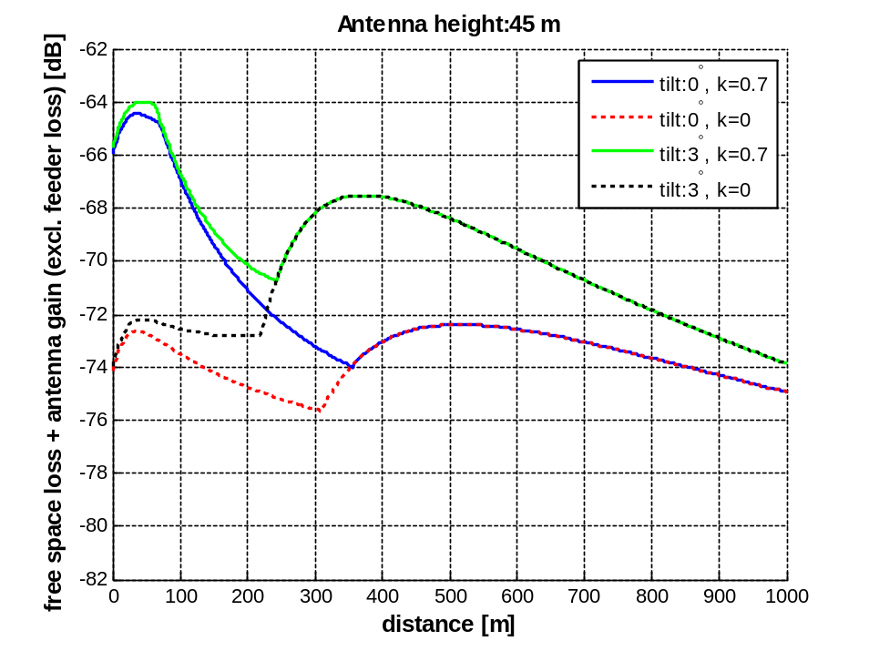
Figure 25: Free space path loss and public GSM BTS antenna gain as a function of distance between GSM-R terminal and public GSM BTS. Antenna height 45 m

From Figure 25 it is clear that the combined path loss and antenna gain for this particular antenna height and characteristics between the MCBTS and GSM-R terminal will not be more than -64 dB, even for very short distances due to reason that BTS antennas main beam shoot above the train and its antenna. For 30 m or lower BS antenna height, the interference may be higher.

The maximum interference that could reach a GSM-R train mounted receiver can be approximated as follows:

-14 dBm (MCBTS unwanted emission/200 kHz) – 3 dB (feeder loss at MCBTS) – 64 dB (lowest combined path loss and MCBTS antenna gain) + 0 dBi (antenna gain of GSM-R terminal) = - 81 dBm

This simplistic analysis indicates that in a worst-case scenario the part of the railway located at the maximum distance from the GSM-R base station may experience some interference evaluated to 23 dB in this case (-81 dBm – -95 dBm + 9 dB = 23 dB). A high-quality antenna (k=0) for interfering GSM MCBTS may provide additional protection for the GSM-R network. It is also clear that proper site engineering may be useful to avoid interference. It is also important to note that the actual unwanted emissions from a MC BTS will, in many cases considerably lower than the worst-case presented in the specification, see further Annexes 1 and 3. Last, but not least, a realistic analysis must incorporate dynamic effects, as in the simulation analysis below, Section 5.5.3.

Simulation analysis
This section contains two case studies based on Monte Carlo simulations, analysing of the impact of MCBTS unwanted emissions (modulation and wide-band noise, spurious emissions and intermodulation products) on a GSM-R network. The aim is incorporate detailed and realistic behaviour of both public GSM and GSM-R networks.

5.5.3.1 Case Study 1
Simulation methodology
Figure 26 describes the worst case scenario, with a GSM-R MS located near the edge of its serving cell, and an E-GSM MCBTS (one of many in the simulated E-.GSM system) within a certain short distance of the railway track and with its antenna pointing directly towards the GSM-R terminal. The quality is studied for a train-mounted GSM-R terminal along a 100 meter stretch of the GSM-R covered railway, while the distance between the GSM BTS and the track is varied, to determine the necessary separation distance for acceptable GSM-R quality.

The interference from the MCBTSs in the E-GSM system includes modulation and wideband noise, spurious emissions and intermodulation products, as described in Annex 1. Intermodulation includes third- and fifth order products that are calculated according to [8]. Wideband noise is calculated as the aggregated spectrum mask from the active carriers in the MC-BTS. Spurious emissions are modeled as a random contribution based on the maximum number of spurious occurrences which are described in 3GPP TS 45.005 [9]. The different parts are then combined as specified in Annex 1, Table A1.4. The limited selectivity of the GSM-R terminal has not been taken into account, i.e. an infinite ACS is assumed. Since a worst-case approach is taken, the main scenario is to analyse interference to the GSM-R frequency closest to the public GSM spectrum.
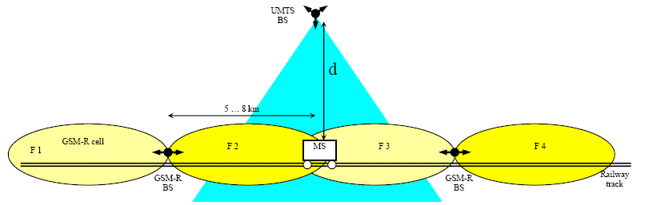
GSM
BTS
GSM
BTS
Figure 26: Worst case scenario: E-GSM MCBTS interference to GSM-R MS

The basic steps of the simulation tool are as follows:

-- Assign frequencies to the different MCBTSs in the network according to the hopping sequence (BCCH frequency remains fixed).
-- Assign power to the four carriers in each MCBTS. If power control is not applied maximum power is used for all four carriers. If power control is applied, then a conservative scenario is considered with two carriers using maximum power, one is 2 dB below maximum power and one 4 dB below maximum power. If discontinuous transmission (DTX) is applied, the non-BCCH channels are active with a probability of 0.6.
-- Based on the MCBTS frequencies and the power assigned to them, calculate the unwanted MCBTS class 2 emissions for different offsets from the public GSM transmit band and the path loss from the MCBTS to the GSM-R terminal, i.e. the interference to different GSM-R down link frequencies (including slow and fast fading).
-- Compare the interference to the carrier strength of the GSM-R connection.

One time step as described above corresponds to one burst in the GSM-R system. For the next step, the frequency allocation, fast fading etc is updated, and this is repeated until sufficient quality information is collected for each point along the 100 meter stretch analyzed. For each such point, the quality of the bursts for all the different time steps are entered into a link-to-system interface, incorporating the TCH/ASF12.2 codec (no frequency hopping). The behaviour of such a codec is presented in Figure 27, showing that a quality of higher than 12 dB C/I (GSM-R C/I criterion for the handover region) is needed for a Frame Error Rate less than 2%, which is the quality measure for each point. A point on the railway line is considered to have sufficient quality if the FER is no more than 2%, and the separation distance between the MCBTS and the railway line is sufficient if at least 95% of the points have good enough quality. This procedure is carried out for a number of different separation distances between the railway line and the MCBTS.

Note that blocking of the GSM-R equipment is not studied. Since the carrier power is no different for a MCBTS than for a single carrier BTS, the blocking risk for GSM-R equipment does not change based on the introduction of MCBTSs.

Frequency Hopping is not applied to the GSM-R network in the simulations, but would most likely decrease the susceptibility to interference from MCBTSs considerably. Additional frequencies have recently been made available in certain countries for GSM-R usage, which should increase the possibility for introducing frequency hopping in the future.
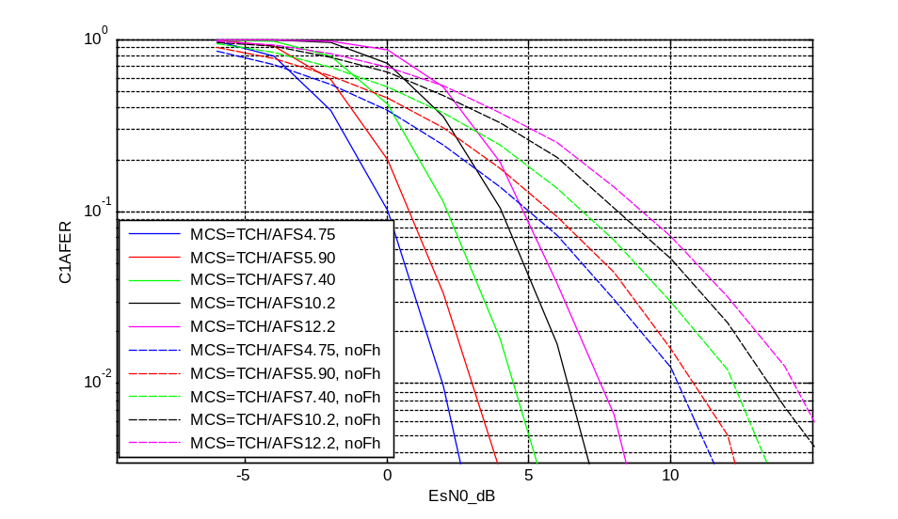
Figure 27: Link-level performance of AMR speech codecs. Channel model is TU3. Single-antenna receiver.

One of the crucial points of the simulation analysis is to have a worst-case design of the GSM-R network analysed. In other words, the 100 meter stretch must have a carrier that is equal to or near the design limit, -95 dBm, including the lognormal and Rayleigh fading margins. As this is not the case with the simulation set-up defined by the parameters above, and a cell radius of 4 km, the GSM-R BTS power was decreased in the simulations to achieve this worst-case signal strength. This is done to ensure that the analysis represents a scenario where the GSM-R terminal is maximally sensitive to interference.

Simulation results
The following figures include results for different MCBTS antenna heights and MCBTS features (PC, DTX). Different levels of power margins (+3 and +6 dB) in the GSM-R network have also been studied. This corresponds to either power boosting or overdimensioning of the network in relation to the -95 dBm minimum signal strength at the handover region discussed above. As a reference, results for a single carrier BTS have also been included. Minimum frequency separation between public GSM and GSM-R is assumed. Results are provided both for 0 degrees and 3 degrees antenna tilt, since it is clear from the MCL analysis that antenna characteristics may influence the results.

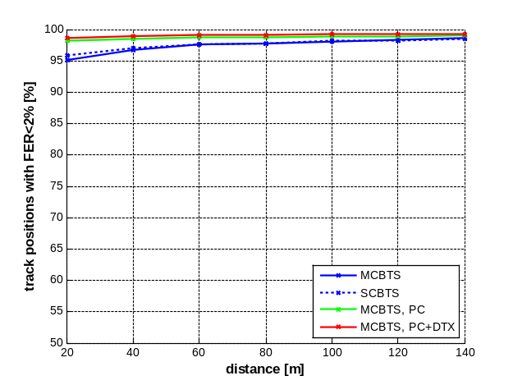 | 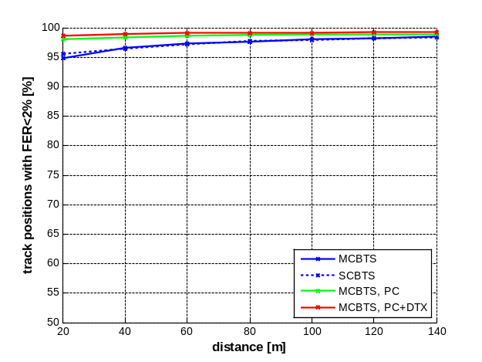
MC-BTS antenna height 45m, k=0.7, tilt 0° MC-BTS antenna height 45m, k=0.7, tilt 3°
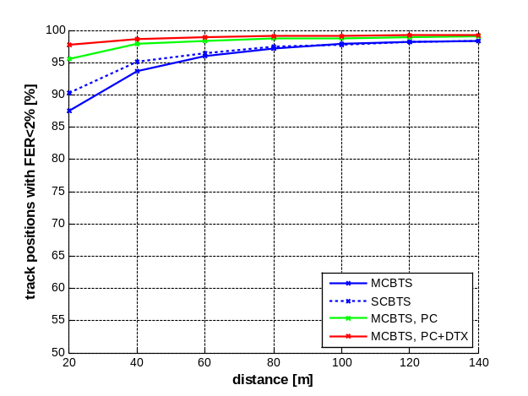 | 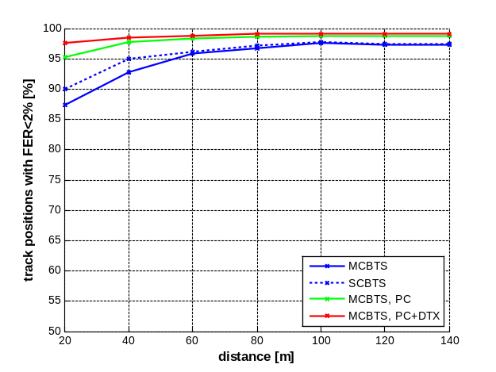
MC-BTS antenna height 30m, k=0.7, tilt 0° MC-BTS antenna height 30m, k=0.7, tilt 3°

Figure 28: Simulation results for 0 dB GSM-R power margin

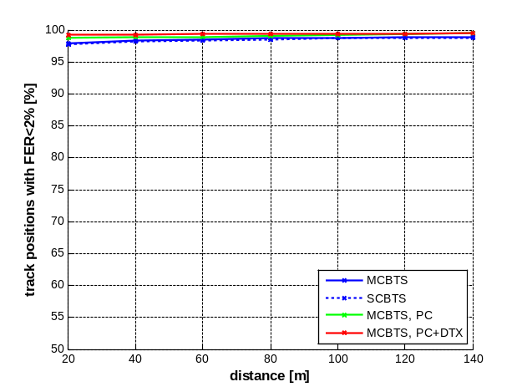 | 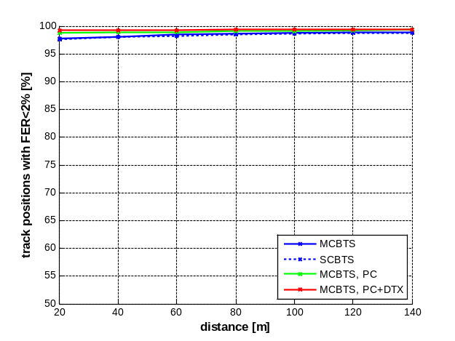
MC-BTS antenna height 45m, k=0.7, tilt 0° MC-BTS antenna height 45m, k=0.7, tilt 3°
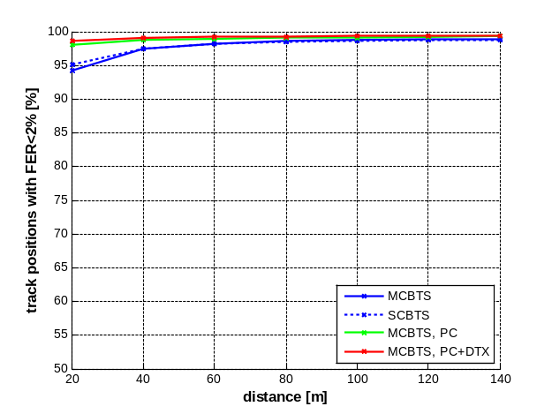 | 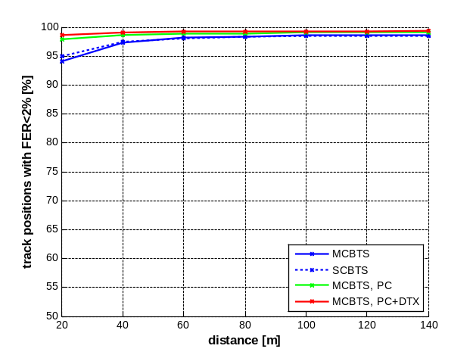
MC-BTS antenna height 30m, k=0.7, tilt 0° MC-BTS antenna height 30m, k=0.7, tilt 3°
Figure 29: Simulation results for 3 dB GSM-R power margin

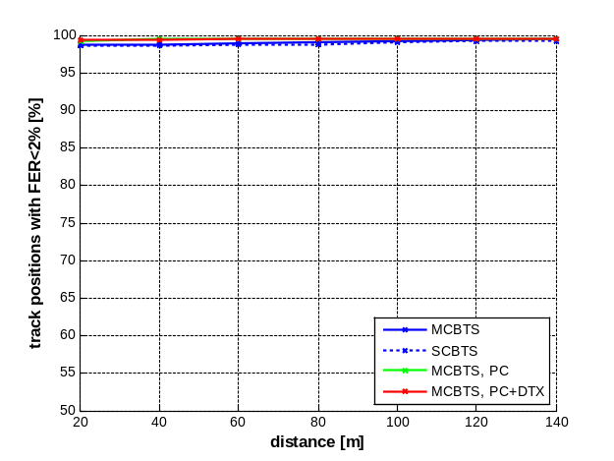 | 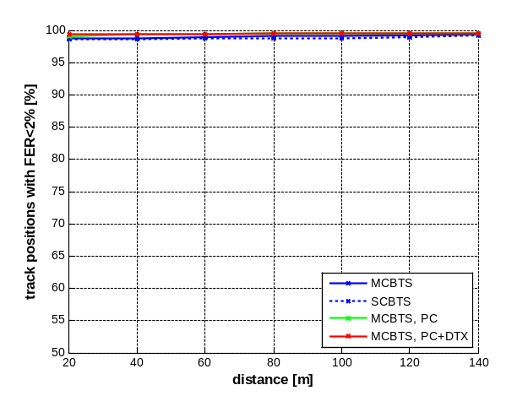
MC-BTS antenna height 45m, k=0.7, tilt 0° MC-BTS antenna height 45m, k=0.7, tilt 3°
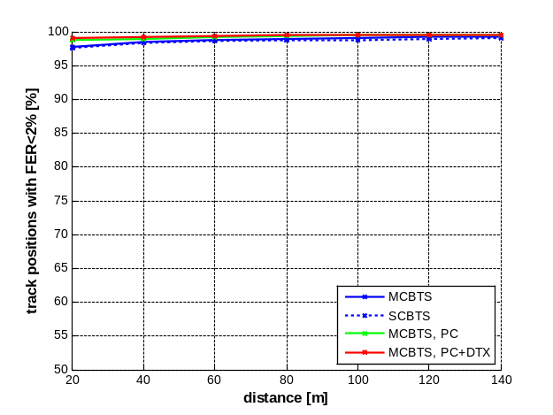 | 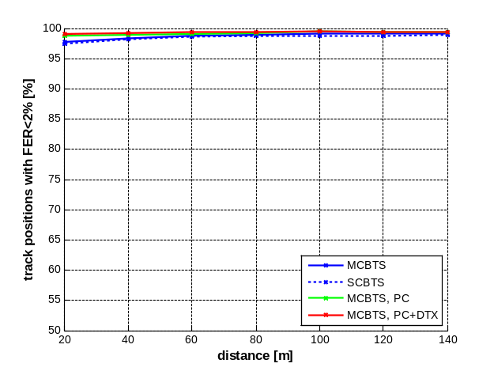
MC-BTS antenna height 30m, k=0.7, tilt 0° MC-BTS antenna height 30m, k=0.7, tilt 3°
Figure 30: Simulation results for 6 dB GSM-R power margin

Table 18 (45 m MCBTS antenna height), and Table 19 (30 m MCBTS antenna height) contain summaries of the results expressed as necessary separation distances for different sets of simulation parameters.

Separation distances between MCBTS and railway line. Antenna height 45 meters. Minimum frequency separation. |  | GSM-R Power Margin
 |  | 0 | 3 | 6
No tilt | Ref | 20 | <20 | <20
No tilt | PC | <20 | <20 | <20
No tilt | PC + DTX | <20 | <20 | <20
3 degrees tilt | Ref | 20 | <20 | <20
3 degrees tilt | PC | <20 | <20 | <20
3 degrees tilt | PC + DTX | <20 | <20 | <20
Table 18: Required separation distances between MCBTS with antenna at 45 m height and railway line

Separation distances between MCBTS and railway line. Antenna height 30 meters. Minimum frequency separation.  No tilt |  | GSM-R Power Margin
 |  | 0 | 3 | 6
No tilt | Ref | 50 | 25 | <20
No tilt | PC | 20 | <20 | <20
No tilt | PC + DTX | <20 | <20 | <20
3 degrees tilt | Ref | 55 | 25 | <20
3 degrees tilt | PC | 20 | <20 | <20
3 degrees tilt | PC + DTX | <20 | <20 | <20
Table 19: Required separation distances between MCBTS with antenna at 30 m height and railway line

5.5.3.2 Case Study 2
GSM MC System Characteristics
In this analysis, both rural and urban environments are distinguished for the GSM-R system in the co-existence analysis. For the rural environment, the GSM MCBTS cell radius is fixed to 2.4 km with a BS antenna height of 45 m whereas for the urban environment, the cell radius is reduced to 0.6 km with a 30 m BS antenna height, as indicated in Annex 2.

Regarding the GSM MCBTS power, the simulations are developed with a power of 43 dBm for each GSM carrier in both environments.
According to the previous assumptions, it is assumed the GSM MCBTS is transmitting over 4 channels. The migration towards UMTS has also begun in several countries that imply the resources to GSM will certainly decrease progressively. Therefore, 4 traffic channels in urban areas seem to be a maximum considering the spectrum available for GSM and the issue of traffic.

Specific features of MCBTS implemented in the simulations:

a) Implementation of Power Control capability
The assumption that the Power control functionality is used by GSM MCBTS is made for the coexistence assessment. As described in [9] and [10], the dynamic of the power control is 30 dB with a 2 dB step.

b) Implementation of Frequency Hopping (FH) capability
The frequency hopping – FH - capability as described in [11] is introduced since it is a standard feature available in most modern GSM systems. The FH list is fixed to respectively 18 frequencies whatever the environment.

It is important to note that only GSM MCBTS Class 2 has been used for this study. GSM MCBTS Class 1 compatibility with GSM-R is included in GSM MCBTS Class 2 characteristics.

Simulation assumptions
For assessing the impact of GSM MC onto the GSM-R system as well as the impact GSM-R onto GSM MCBTS, the first channel used by GSM is fixed at 880.2 MHz (centre of the carrier) paired with 925.2 MHz.

The GSM-R carrier arrangement relative to the GSM MC carrier and the GSM-R frequency re-use plan are given below in Figure 31.
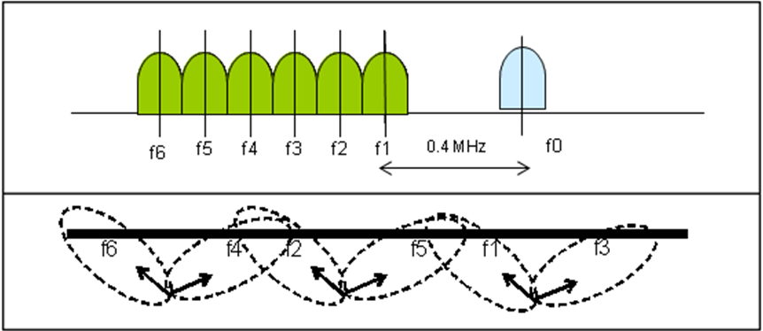
Figure 31: GSM-R frequency re-use

Simulation results, GSM MCBTS onto GSM-R MS scenario
For assessing the impact of GSM MC emissions onto GSM-R DL, the worst case is considered in terms of configuration. The Figure 32 below is showing that the interfering GSM MCBTS based on a three sector antenna configuration is placed near the railway track. The GSM MC sector which is transmitting on the frequency f0 is directed towards the railway as shown in Figure 32 and in particular, is transmitting over the area corresponding to the coverage limit of GSM-R sector (see case 3 in Figure 32).

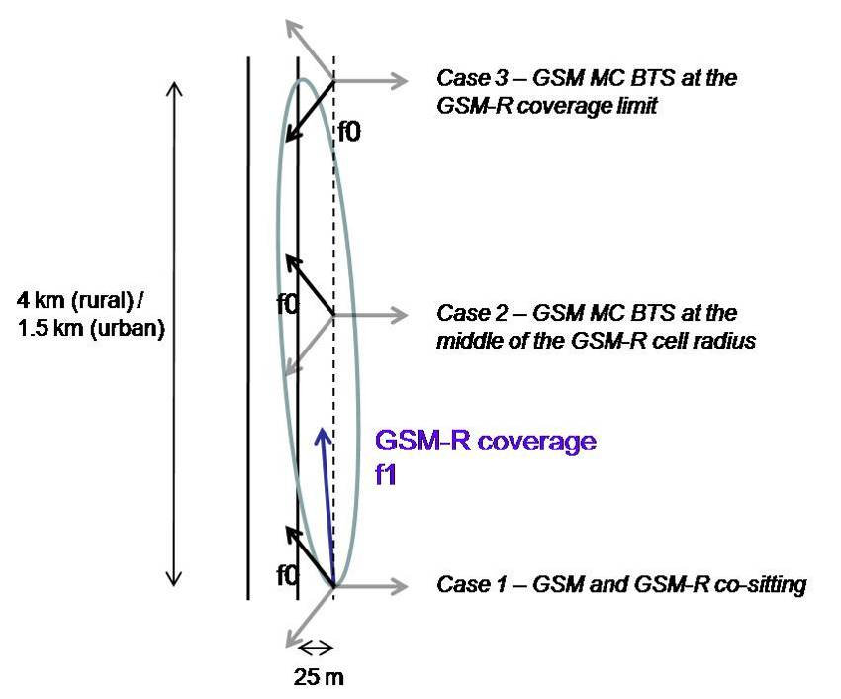
Figure 32: configuration for assessing the interference of GSM MC DL onto GSM-R DL (GSM MC tri-sector antenna)
It should be highlighted that this configuration is a worst case; in practice, a GSM MC BS situated close to a railway track should present a wider aperture between two sectors in order to better cover the railway track. Therefore, in this case, the fact that the interfering GSM MC sector is directed towards the railway track is artificially increasing the impact onto GSM-R DL.

Interference between GSM MCBTS operating in the 900 MHz band and GSM-R was analyzed with the method of Monte-Carlo simulations. The tool SEAMCAT is based on Monte-Carlo methodology and enables to model a GSM BS when using the power control mechanism. The GSM-R interference criteria is the outage degradation based on C/I threshold. The simulated GSM-R DL outage with a C/I = 9 dB without any interference from GSM MC is nearly zero.

The table below is giving the probability of interferences for the GSM-R cell which is considered performed with SEAMCAT 3.1.44. The first column is giving the outage when the GSM MCBTS is using only power control mechanism. The two other columns are giving simulations results when the Frequency Hopping – FH – mechanism is implemented.

 |  | Outage
 |  | Without frequency hopping | + FH 18 for GSM MC
Rural environment | Case 1 | 0.02% | 0.0%
Rural environment | Case 2 | 0.44% | 0.02%
Rural environment | Case 3 | 0.78% | 0.07%
Urban environment | Case 1 | 0.25% | 0.02%
Urban environment | Case 2 | 2.74% | 0.27%
Urban environment | Case 3 | 4.16% | 0.43%
Table 20: GSM-R outage for the worst case scenarios (GSM MC tri-sector antenna)
The impact of GSM MC DL onto GSM-R DL is reasonable, taking into account the fact nowadays, the modern GSM networks are implementing both Power Control and frequency hopping mechanisms and considering this is the worst case scenario where the GSM MCBTS is at the GSM-R coverage limit. Therefore, in a normal configuration, the impact of GSM MCBTS onto GSM-R DL should be negligible.

In the following, the impact of adding frequency hopping for GSM-R is also assessed. The probability of interference is nearly null.

 |  | Outage
 |  | GSM MC FH 18 + GSM-R FH 6
Rural environment | Case 1 | 0.0%
Rural environment | Case 2 | 0.0%
Rural environment | Case 3 | 0.01%
 |  | GSM MC FH 18 + GSM-R FH 6
Urban environment | Case 1 | 0.0%
Urban environment | Case 2 | 0.04%
Urban environment | Case 3 | 0.12%
Table 21: GSM-R DL outage when both systems are implementing frequency hopping mechanisms (GSM MC tri-sector antenna)
Frequency Hopping is not in practice implemented by GSM-R networks, but would be beneficial (comparison of tables 20 and 21).

In the following paragraph, the simulations are developed with a 170° aperture between the GSM MC sectors directed towards the railway track, Figure 33, which is a case more typical for covering the railway areas. It should be noted that the worst case where the GSM BS is in proximity of the GSM-R cell edge is still considered.

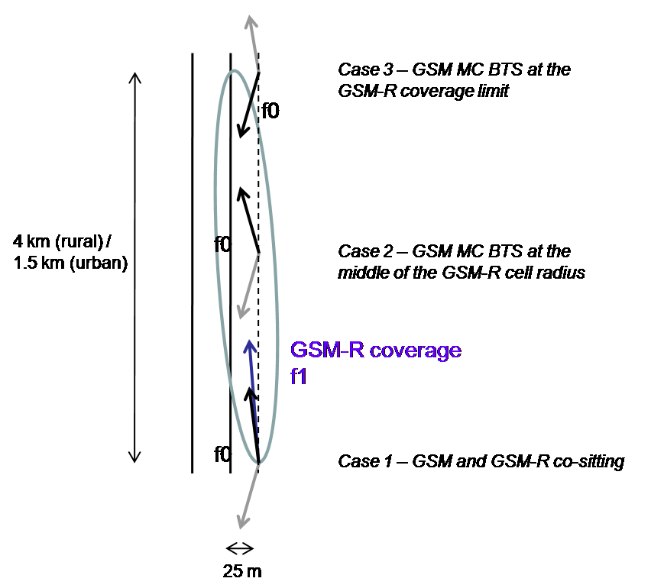
Figure 33: configuration for assessing the interference of GSM-R MC DL onto GSM-R DL (GSM MC bi-sector antenna)

 |  | Outage
 |  | Without frequency hopping | + FH 18 for GSM MC
Rural environment | Case 1 | 0.01% | 0.0%
Rural environment | Case 2 | 0.33% | 0.02%
Rural environment | Case 3 | 0.63% | 0.04%
Urban environment | Case 1 | 0.08% | 0%
Urban environment | Case 2 | 1.15% | 0.10%
Urban environment | Case 3 | 1.84% | 0.16%
Table 22: GSM-R outage depending on the configuration (GSM MC bi-sector antenna)

 |  | Outage
 |  | GSM MC FH 18 + GSM-R FH 6
Rural environment | Case 1 | 0.0%
Rural environment | Case 2 | 0.0%
Rural environment | Case 3 | 0.0%
 |  | GSM MC FH 18 + GSM-FH 6
Urban environment | Case 1 | 0.0%
Urban environment | Case 2 | 0.01%
Urban environment | Case 3 | 0.03%
Table 23: GSM-R DL outage when both systems are implementing frequency hopping mechanisms (GSM MC bi-sector antenna)

Usually, the GSM BTS deployed close to the railway track are implementing a coupler so as both sectors are transmitting on the same frequency. In the previous simulations, the coupling factor is not taken into account; it would decrease the interference probability.

Considering the occurrence of having the worst case, the interference level created by GSM MC onto GSM-R would be acceptable.

Simulation results, GSM-R train mounted MS onto GSM MC BTS

The impact of GSM-R UL onto GSM MCBTS is assessed in this section. In this case, the GSM MCBTS is again placed close to the railway track in order to simulate a worst case, as shown in Figure 34 below. The GSM BS interference criteria is based on the desensitization created by the GSM-R train mounted MS emissions. The GSM-R MS is moved in the GSM MCBTS main lobe in order to evaluate the maximal desensitization that the GSM MCBTS could suffer from.

Usually, a I/N ratio of -10 dB which leads to a desensitization of about 0.5 dB is considered as acceptable for IMT base stations.

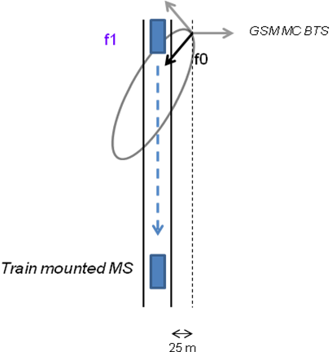
Figure 34: configuration for assessing the interference from GSM UL onto GSM MC BTS

Table 24 gives the desensitization for both environments and for different frequency offsets between the GSM-R UL and the lowest GSM MC carrier.

Rural environment
GSM-R carrier | 879.8 MHz | 879.2 MHz | 878.6 MHz | 878 MHz and below
Maximal GSM MC BS Desensitization | 36.94 dB | 8.86 dB | 8.71 dB | 3.65 dB
Urban environment
GSM-R carrier | 879.8 MHz | 879.2 MHz | 878.6 MHz | 878 MHz and below
Maximal GSM MC BS Desensitization | 35.22 dB | 7.41 dB | 7.27 dB | 2.78 dB
Table 24: Maximal desensitization of GSM MC BS when interfered by GSM-R MS

In that case, GSM operators should be aware their network could suffer from harmful interferences when the GSM MC network is using the 2 MHz adjacent to GSM-R allocation and is deployed in vicinity of a GSM-R network.

Summary and Analysis
Under the assumptions described above, the Monte-Carlo simulation results show that the impact on GSM-R DL by the potential interference from GSM MC DL is very low, and a carrier separation of 0.4 MHz as planned in CEPT Decision (02)05 between the GSM and GSM-R carriers would be enough.
In case where GSM-R uplink power control is not used, the simulation results indicate the GSM MC network can suffer from desensitization, especially for the cells located near the railway track.

Conclusions
Interference from due to unwanted emissions from MCBTSs into GSM-R train mounted terminals has been studied by Minimum Coupling Loss Analysis and Simulation analysis. GSM-R railway services in the E-GSM-R frequency band are not covered by this contribution, since the frequency separation between that band and the public GSM downlink is greater which leads to lower interference. The E-GSM-R frequencies are not usable for GSM-R purposes in all CEPT countries. Furthermore this study did not address tunnel coverage. The results are obtained for GSM MC BTS Class 2. For GSM MCBTS Class 1, the interference would be reduced further.
The MCL analysis indicates that under certain worst-case conditions the GSM-R network can experience interference. The MCL analysis also indicates, however, that the dominating interference problems are the blocking and adjacent channel performance of the GSM-R terminal. GSM-R terminals performances can be improved by additional filtering. However, this filtering would not provide mitigation in those cases where the leakage from MCBTS into the GSM-R pass-band is the critical effect.

The simulation analysis, two case studies, considers a more detailed scenario, incorporating also dynamic aspects of both networks. Table 18 and Table 19 contain a summary of the separation distances between the MCBTS and the GSM-R train mounted terminal for different scenarios in the first simulation study. Tables 20 to 24 contain results from the second simulation study. It is clear from the analysis that height, tilt and quality of the antenna used in the public GSM network is an important factor, as is the geographical separation.

For the case with minimum frequency separation between GSM-R and public GSM, the geographical separation distances for the different deployment scenarios with typical antennas (as defined by Rec. ITU-R F.1336) are never more than 55 meters, provided that only unwanted emissions from the MCBTS are taken into account in the interference analysis, i.e. GSM-R terminal limitations regarding IM products, blocking and adjacent channel performance are disregarded. If PC is applied to the public GSM network, which is normally the case the required separation distance is never more than 20 meters under these assumptions. Results are also incorporated for power margins of 3 or 6 dB in the GSM-R network, decreasing separation distances further. A carrier separation of 0.4 MHz (0.2 MHz carrier edge to carrier edge) between GSM MC BTS and GSM-R as defined in ECC/DEC/(02)05 is thus sufficient to avoid harmful interference to GSM-R dowlink due to unwanted emissions from a MCBTS.

However, GSM operators should take care when they would deploy GSM sites close to the railway track and close to the GSM-R limit coverage, if the power control functionality is not implemented and if the transmitting channel is adjacent to the GSM-R channel. Sites engineering measures would be necessary in this case to match the attenuation as obtained with DL power control.

The GSM-R uplink power control, especially for the train mounted MS, is necessary to reduce constraints on GSM Base stations in the same geographical areas; otherwise the impact on GSM UL capacity could be important when the GSM network is using the 2 MHz band adjacent to the GSM-R band.

GSM MCBTS – DME in 960 - 1215 MHz

Assumptions and parameters

System Characteristics of DME
The complete set of DME parameters can be found annex 8 to this document, and the methodology is indicated in section 4.5.2. The associated interference criteria are recalled below.

Between 0 and 500 m:
The interference criterion “Imax” is derived from the following assumptions:
• “C/I” = 28 dB at 966.5 MHz and below, including margins,
• “C/I” = 31 dB above 966.5 MHz, including margins,
• Cmax = -68.6 dBm

• Imax = -96.6 dBm at 966.5 MHz and below, including margins,
• Imax = -99.6 dBm above 966.5 MHz, including margins,

Above 500 and up to 1000 m:
The interference criterion “Imax” is derived from the following assumptions:
• “C/I” = 28 dB at 966.5 MHz and below, including margins,
• “C/I” = 31 dB above 966.5 MHz, including margins,
• Cmax = -74 dBm

• Imax = -102 dBm at 966.5 MHz and below, including margins,
• Imax = -105 dBm above 966.5 MHz, including margins,

Above 1000 and up to 3000 m:
The interference criterion “Imax” is derived from the following assumptions:
• “C/I” = 28 dB at 966.5 MHz and below, including margins,
• “C/I” = 31 dB above 966.5 MHz, including margins,
• Cmax = -77 dBm

• Imax = -105 dBm at 966.5 MHz and below, including margins,
• Imax = -108 dBm above 966.5 MHz, including margins,

Above 3000 m:
The interference criterion “Imax” is derived from the following assumptions:

• Imax = -108 dBm/MHz at 966.5 MHz and below, including margins,
• Imax = -111 dBm/MHz above 966.5 MHz, including margins,
Table 25: interference criterion to protect DME

System characteristics for GSM MC BTS
The annexes 1, 2 and 3 were taken into account to derive the characteristics of GSM MC BTS to be used in the simulations.

For the definition of the unwanted emissions mask, annex 1 was considered. This is a worst case analysis for the scenario described in annex 2.

The interference from the GSM system to a DME airborne receiver depends on the frequency planning of the GSM network. In particular, the frequency planning determines the uppermost carrier frequency for each sector, and thus, the offset used for the unwanted emissions mask defined in annex 1 in relation to the 960 MHz border. This placement ensures that a worst case is considered in the simulations.

According to annex 2, the typical number of carriers envisaged by the operators is 4, for a single base station. Given the maximum Tx power per carrier of 43 dBm, this gives 49 dBm for four carriers (i.e. 80 W). This is consistent with the state of the art technologies.

As suggested above, the frequency reuse factor is usually a key parameter to properly address scenarios involving GSM.
Normally, for network planning purpose, the most accurate model uses tri-sectorized antennas associated to a frequency reuse pattern of 7 as illustrated below. This needs 21 different frequencies.

2
3
1
4
5
6
7
2
3
1
4
5
6
7
2
3
1
4
5
6
7
2
3
1
4
5
6
7
2
3
1
4
5
6
7
2
3
1
4
5
6
7

Figure 35: GSM 7-reuse pattern
However, a simpler model (frequency reuse of 3) is used and is sufficient to perform the simulations and to draw the conclusions. Each cell of the pattern has a base station at its centre, using an omnidirectional antenna and using one set of frequencies among the following ones:
Cells #1: 959.8, 959.2, 958.6, 958.0 MHz
Cells #2: 959.6, 959.0, 958.4, 957.8 MHz
Cells #3: 959.4, 958.8, 958.2, 957.6 MHz

1
3
2
1
3
2
1
3
2
1
3
2
1
3
2
1
3
2
1
3
2

Figure 36: GSM 3-reuse pattern

For a geometry based on omnidirectional antennas: | For a geometry based on tri-sectorized antennas:
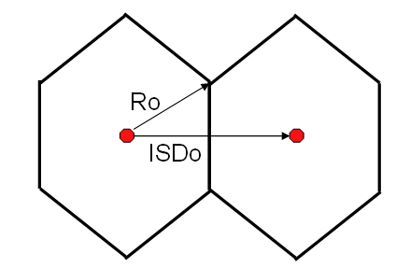 | 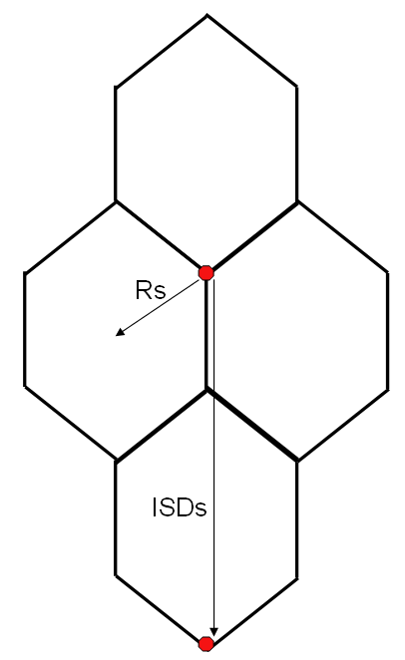
ISDo = 2*Ro*cos(30deg) | ISDs = 3*Rs
Figure 37: Omni versus tri-sector geometry for cellular systems

To get the same number of sites in a sectorized geometry:
ISDo = ISDs
so 3*Rs = 2*Ro*cos(30deg)
The models of Recommendation ITU-R F.1336-2 are used for the GSM base station antennas. Both omnidirectional and tri-sectorized antennas were used. The associated assumptions are as follows:
- Between 0 and 1000 m (altitude of the aircraft):
  - If the omni/peak model is used (see section 2.1 of Recommendation ITU-R F.1336-2), then a side-lobe factor (k) of 0.7 is taken;
  - If the sectoral/peak model is used (see section 3.1 of Recommendation ITU-R F.1336-2), then a side-lobe factor (k) of 0.7 is taken
- Above 1000 m:
  - If the omni/average model is used (see section 2.2 of Recommendation ITU-R F.1336-2), then a side-lobe factor (k) of 0.7 is taken;
  - If the sectoral/average model is used (see section 3.2 of Recommendation ITU-R F.1336-2), then a side-lobe factor (k) of 0.2 is taken

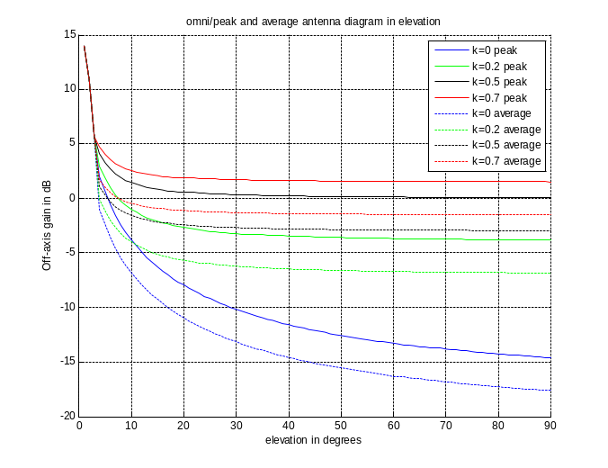
Figure 38: Antenna diagrams used in DME study

In the case where omnidirectional antennas are used, the interference from the GSM network is reduced by 2.5 dB. This factor represents the difference between the magenta curve (omni with a constant gain of 15 dBi) and the average of the values defining the red curve (tri-sectorized antenna).

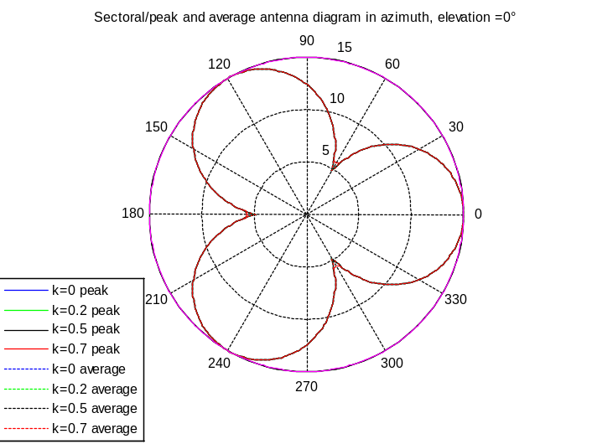

DME selectivity and MCBTS unwanted emissions
It is important to observe the relation between the two different components of the interference:
- Unwanted emissions; leakage from the GSM MCBTS into the spectrum above 960 MHz.
- Limited selectivity; the ability of the DME receiver to suppress emissions below 960 MHz.
Figure 39 below contains the selectivity curves of the DME receiver for two different equipments as well as the unwanted emissions of the MCBTS class 1 and class 2, for the reference case presented in Annexes 1 and 3 and annex 8 for the DME. Note further that these annexes contain information about SCBTS performance that will be used below in the simulation analysis.

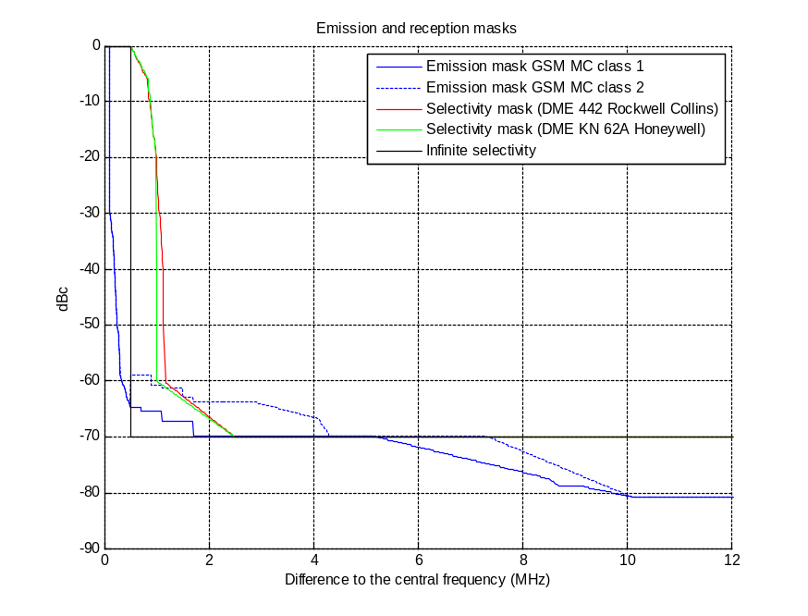
Figure 39: DME receiver selectivity and GSM MMC emission mask

Recognizing the fact that the two DME equipments have similar receiving performances, the results given in the following sections do not differentiate between these two equipments and are therefore applicable to both.

Effects on current deployments of DME
By comparing the unwanted emissions of SCBTS and MCBTS (see annexes 1 and 3), it is clear that the current DME deployment, 977 MHz and above, will not be interfered more by MCBTS than SCBTS

Simulations

Propagation model
- Model for DME planning:
The Recommendation ITU-R P.528 is considered for the DME planning link budgets (availability of 95% of the time).

- Model for calculation of GSM interference:
Free space loss (Recommendation ITU-R P.525): all the base stations are visible from the aircraft, without any obstacle.

Polarisation
A GSM network is slant polarised (+45°/-45°) whereas DME has a vertical polarisation. Therefore, a polarisation discrimination of 3 dB is introduced in the simulations.

Simulation scenarios
Three environments are studied, one rural and two urban, with cell radii as suggested in Annex 2. For convenience the basic parameters are given in Table 26 below.

 | rural | Urban 1 | Urban 2
Rs (km) | 2.4 | 0.6 | 1.4
Ro (km) | 4.2 | 1 | 2.5
Intersite distance (km) | 7.2 | 1.8 | 4.2
BS max gain (dB) | 18-3 | 15-3 | 15-3
BS antenna height (m) | 45 | 30 | 30
BS antenna tilt (°) | 3 | 3 | 3
Table 26: GSM deployment parameters for studied scenarios.

The number of visible base stations as a function of aircraft altitude in km is given in Figure 40. It has to be noted that a uniform MCBTS distribution is used. Closed to urban areas, the density of MCBTS is expected to be higher (the cell radius is lower). This is shown by the red curve in Figure 40 below.
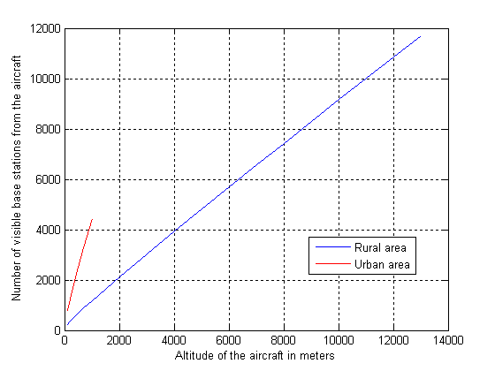
Figure 40: Number of MCBTS visible base stations (Rural and Urban 2 scenarios)

Basic analysis of interference to DME (in the band 962 - 971 MHz) without power control
With the assumptions previously detailed, the results are as follows.

It has been assumed in the simulations that the DME receiving filter would be capable of filtering totally the GSM signal in the band below 960 MHz. Interference due to limited selectivity of the DME receiver has not been taken into account in the simulations below.
Regarding the urban environment, only results associated to Urban 2 are shown in the following tables, this environment being the most representative for the range of altitudes given.

 | Type of environment
 | Urban 2 |  |  |  | Rural
 | 962 | 965 | 968 | 971 | 962 | 965 | 968 | 971
200m | -1 | -2 | -6 | -10 | -3 | -4 | -8 | -12
1000m | x | x | x | x | 0 | -2 | -6 | -10
12000m | x | x | x | x | 0 | -2 | -5 | -10
Table 27: Additional isolation needed in dB in the link budget between DME and MCBTS Class 1 without power control mechanism

 | Type of environment
 | Urban 2 |  |  |  | Rural
 | 962 | 965 | 968 | 971 | 962 | 965 | 968 | 971
200m | 4 | -2 | -3 | -10 | 2 | -4 | -5 | -12
1000m | x | x | x | x | 5 | -2 | -2 | -10
12000m | x | x | x | x | 5 | -2 | -2 | -10
Table 28: Additional isolation needed in dB in the link budget between DME and MCBTS Class 2 without power control

- The results are very much dependant on the scenarios : the major GSM MC parameters that have an impact on the results are :
  - the network geometry (cell radius) and also the aggregation of all base stations seen by the plane (especially in urban scenario),
  - the base station EIRP associated to the antenna pattern and tilt
  - the unwanted emissions mask
  - The frequency separation between the uppermost GSM carrier and the DME channel under consideration

The network geometry and the base stations settings are significant different from the urban scenario to the rural scenario and therefore lead to different results.
  - the number of carriers / networks
  - The location of the aircraft relatively to the closest base station at low altitudes. In the simulations, the closest distance between an aircraft and a BTS in the horizontal plane is 600m in the rural scenario and 300m in the urban scenario.

The network geometry and the base stations settings are significantly different from the urban scenario to the rural scenario and therefore lead to different results. The consideration of one of these scenarios, taken separately, is not representing the reality. Both rural and urban scenario should be considered as the reality is between both. Above a certain height (around 1000 m), the urban scenario is not relevant. The urban scenario is pessimistic in the sense that the urban area is not geographically limited, and that the number of base stations per area may be exaggerated.

Use of power control for GSM for MCBTS
Annex 9 contains a derivation of the unwanted emissions from a MCBTS class 2 based on two conservative cases of power control. Furthermore, it shows that the assumed power control is a reasonable approach from a statistical perspective. The main results of Annex 9 are incorporated below. These results can be further motivated by the fact that the down link signal strength for a GSM link is several tens of dB higher than necessary even at the cell border with the chosen cell radius.
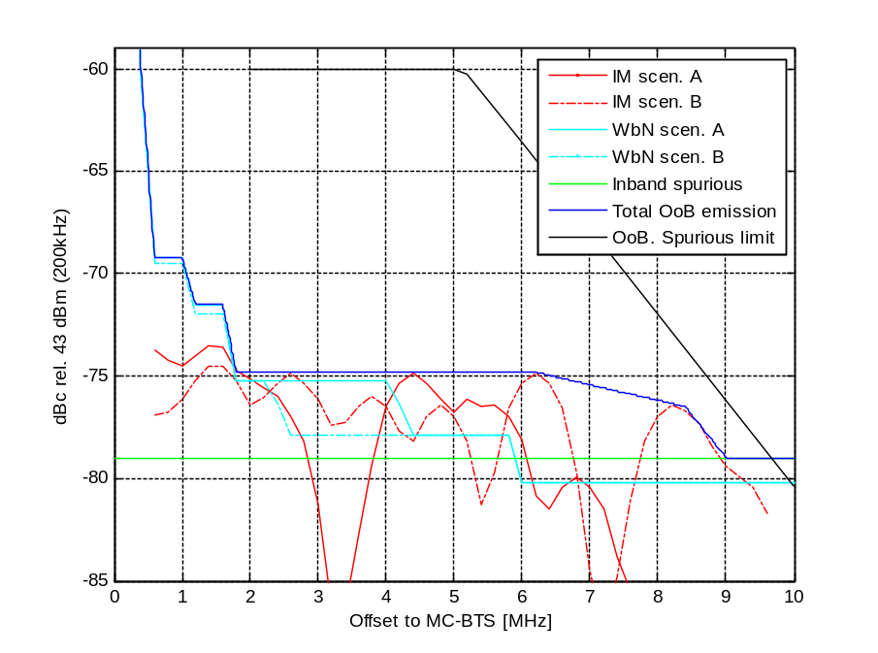
Figure 41: GSM unwanted emissions with power control

Freq/Freq-range  (MHz) | MCBTS class 2  (dBm/30kHz)
0,2 | 5
0,4 | -24.9
0,6 < δf < 1 | -34.2
1.2 < δf < 1.6 | -36.5
1.8 < δf < 6.2 | -39.8
8.4 | -41.5
9 < δf <10 | -44.0
Table 29: GSM unwanted emissions with power control

Additional information on the power control model can be found in annex 9.

Results with power control
The results of section 5.6.2.4 have shown that there was no interference from GSM MC to DME in the scenarios involving BTS Class 1 without power control. Therefore, no simulation is provided for class 1 with power control.

For BTS class 2, the results are as follows:

 | Type of environment
 | Urban 2 |  |  |  | Rural
 | 962 | 965 | 968 | 971 | 962 | 965 | 968 | 971
200m | -7 | -9 | -7 | -10 | -9 | -11 | -9 | -12
1000m | x | x | x | x | -7 | -9 | -7 | -10
12000m | x | x | x | x | -7 | -9 | -7 | -10
Table 30: Additional isolation needed in dB in the link budget between DME and MCBTS Class 2 with power control

Given the assumptions taken for these scenarios with the use of power control, the results show that there is no remaining interference from GSM MC BTS to DME.

Sensitivity analysis
This section gives an analysis on different assumptions, parameters and factors that have been considered in the study. In the presence of remaining interference (e.g. if the power control is not applied, see section 2.4), these could be used to improve the results.

Apportionment factor
The apportionment is proposed to model that several sources of interferences may occur simultaneously on the DME devices. However, the pre-requisite is the interferences are contributing in the same order. Otherwise, if one source of interference is predominant and the others are negligible, then he apportionment factor has no longer to be taken into account.

An apportionment factor (of 3 dB ≤ 966.5 MHz and 6 dB > 966.5 MHz) has been included in the calculations. If the GSM represents the major source of interference, then these values may be too conservative especially for the low altitudes of the aircraft. This would result in interference requirements 3 – 6 dB more relaxed than assumed here above.

Uppermost GSM carrier used in the study
A conservative approach of assuming that each cell (sector) is using the frequency at 959.8 MHz has been employed. In reality this will not be the case, resulting in lower interference than calculated in this study.

Frequency planning
In the simulations, the envelope of the GSM base station emissions is based on 600 kHz carrier separation. The same envelope is used on all sector always centered on the uppermost frequency.

However, the scheme is suggesting that the whole list of channels is transmitting simultaneously within a same frequency scheme and that two adjacent channels are simultaneously used on two adjacent sectors. The isolation between two sectors is not sufficient to ensure the capability to use adjacent channels on two adjacent sectors. A guard channel is therefore appropriate between two adjacent sectors to avoid blocking effects.

A more realistic scheme consists of extending the frequency offset between two channels transmitting within the same sector:
Cells #1: 959.8, 958.6, 957.4, 956.2 MHz
Cells #2: 959.4, 958.2, 957.0, 955.8 MHz
Cells #3: 959.0, 957.8, 956.6, 955.4 MHz

Revising the frequency plan as described above would have a slight positive impact on coexistence with DME systems.

Number of carriers in GSM base stations
Many base stations will be using fewer than 4 carriers, which will decrease interference compared to the calculations here.

Frequency Hopping of GSM base station
The Frequency hopping is a standard functionality of modern GSM networks. A list of frequency is assigned to each transmitting channel and the frequency of the channel is changed in every transmitted burst (217 hopping per second) providing frequency diversity and interference averaging.

Thus, the interference situation will be modified every 4.62 ms while the signal level will change every 0.5769 ms (since the power control applies to individual time slots within a frame) ; in other words, the interference of the GSM Network is bursty.

In, the bursty nature of the interference is assessed: “Building on the experience acquired over several decades of testing and operations of CNI compatibility with DME, which shows that even with CNI interference level as high as -36 dBm, DME performance is not impaired as long as received interference is of pulsed type with a low pulsed interference duty cycle (PIDC) of the order of 0,47 % or less.”

The bursty nature of the interference would therefore, improve further the compatibility situation with DME system.

DTX
The Discontinuous Transmission (DTX) function is a standard feature of modern GSM networks. DTX function senses when speaker makes a pause (e.g. listening to the other end of conversation or during natural conversational pauses) and stops the transmission during those pause periods. This function has become wide spread in modern GSM due to notably its contribution to an overall reduction of noise in a network.

The simulations provided in the ECC Report 096, 122 have assumed DTX voice activity factor of 0.4, which is known to be a standard industry average value that was also previously used in ITU-R (e.g. ITU-R Recommendation M.1184). Taking this effect into account, this would lead to interference requirement less stringent by 4 dB for the in-band transmitted power.

DME receiver bandwidth
Emission and reception bandwidths of 1 MHz have been assumed in the study. However, the DME MOPS specify that 90% of the transmitted power is contained in a 500 KHz bandwidth. Additionally ECC Report 128 defines the receiver bandwidth of the DME devices to 650 kHz.

In this Report, the protection criteria are applied to a 1 MHz channel bandwidth. Therefore, applying the 650 kHz channel bandwidth, would lead to a modification of 1.9 dB to the results provided for the altitudes lower than 3000 m.

Aggregation effect
It is important to note that a linear interpolation for considering the aggregation effect of all base stations potentially with the maximum power seen by the plane; it is assumed to be a worst case. Neither the variation of the output power, nor the geographic variation of the area seen by the plane nor the high speed of the plane is taken into account. Another less pessimistic scenario may be necessary in order to better estimate the impact of the aggregation effects.

DME Receiver Selectivity
From the results above, a selectivity of -70 dBc for the DME receiver may be insufficient to suppress interference from a GSM network even if there are no GSM unwanted emissions above 960 MHz. There are no measurements available of DME receivers that specify this any further, but it has been suggested that the DME receivers could be improved beyond this selectivity to approximately -80 dBc. Of course this improvement would be progressive and therefore would occur over a number of MHz offset from the DME carrier.

However, in the document [17] it is stated that:

“The sensitivity requirement shall be met within + 3dB tolerance when a continuous wave signal having a level of -40 dBm is applied over at the input frequency range of 90 kHz to 10000 MHz excluded the frequencies within ±10 MHz of the selected frequency.”

It is observed that a significant difference between the assumption of a selectivity of -70 dBc and the reference selectivity defined in the standard.

Averaging at higher altitudes
When the aircraft is at a high altitude, the interference will not be dominated by any single base station. Instead, the interference from a large number of base stations will contribute, leading to the conclusion that worst case behaviour for base stations should be replaced by average behaviour. For instance, it is not realistic to use maximum power for all base stations in such a scenario. Similarly, it is reasonable to approach unwanted emissions from this averaging perspective.

The magnitude of unwanted emissions:
- without averaging can be extracted from ANNEX 1;
- with averaging can be extracted from ANNEX 10.
The consideration of the averaging effect leads to the following table:
frequency (MHz) | Averaging effects  (dBm/30 kHz) | Averaging effects  (dBm/1 MHz) | Class 1  no averaging  (dBm/1 MHz) | Class 2  no averaging  (dBm/1 MHz)
962 | -39 | -24 | -19 | -14
964 | -41 | -26 | -20 | -17
966 | -44 | -29 | -22 | -20
968 | -44 | -29 | -26 | -23
Table 31: Unwanted emissions based on averaging effects

Additional information can be found in annex 3 (of this document).

Averaging at lower altitudes.
The simulations are pessimistic in the sense that they assume worst case behaviour of all base stations when the altitude of the aircraft is lower than 1 km. Whereas it is appropriate to make such an assumption regarding the worst receivers, it would be more appropriate to assume average behaviour of the vast majority of base stations. This applies to antenna characteristics, power control, DTX etc.

Multi-Screen Diffraction
In the simulation analysis it is assumed that there is free space propagation between all base stations and the airborne DME receiver. This is a pessimistic assumption, since the antennas of many base stations, especially in an urban environment, will be placed at roughly the same height as the rooftops of the surrounding buildings. For low angles between the horizon and the aircraft, as seen from such an antenna, there will be propagation loss due to multi-screen diffraction which is considerably higher than the free space loss.

Conclusions for DME versus GSM MC
The interference between GSM MCBTS and DME has been studied for rural and urban scenarios, taking into account both interference leakage from MCBTS into DME spectrum, and the limited selectivity of the DME receiver above 960 MHz.

For current DME deployments, at 977 MHz and above, there will be no increase in interference from MCBTS in relation to SCBTS. This is due to the fact that for such an offset, the unwanted emissions from an SCBTS and an MCBTS have the same characteristics.

In case DME is deployed below 977 MHz, a detailed analysis has been carried out. Realistic aspects such as power control for GSM and polarisation discrimination were considered in the simulations.

When power control is used, the result is that no additional isolation is needed for the unwanted emissions from MCBTSs for either the rural or the urban scenario, for both classes 1 and 2, for any altitude of an aircraft.

When power control is not used in GSM downlink, the results are as follows:
- for BTS Class 1, no additional isolation is needed
- for BTS class 2:
  - no additional isolation is needed when the DME frequency is above 962 MHz.
  - For a DME frequency of 962 MHz: an isolation of 4 dB is needed for the urban scenario studied (for an aircraft altitude below 200m); an isolation of 2 dB (below 200m) to 5 dB (above 1000m) is needed for the rural environment. For altitudes of 1000m and above, averaging interference over a large number of base stations would ensure a sufficient isolation.

It should be noted that power control is a widely deployed technique in the mobile networks so that no specific measure would be necessary to GSM MC BTS so as to fulfil the interference criterion of DME

Additionally, a number of possibilities to improve the compatibility between DME and GSM MC, that do not appear in the simulations results, have been investigated in this Report.

GSM MCBTS – MIDS 960 - 1215 MHz

Brief description of MIDS
MIDS (Multifunctional Information Distribution System) is a tactical military system. The MIDS receiver to consider is the MIDS terminal, integrated in a shelter. The antenna is mounted on a 16 metres mast. The terminal mode to consider is the frequency hopping mode (51 frequencies). The frequencies are as follows:

N° | Frequency (MHz) | N° | Frequency (MHz) | N° | Frequency (MHz)
0 | 969 | 17 | 1062 | 34 | 1158
1 | 972 | 18 | 1065 | 35 | 1161
2 | 975 | 19 | 1113 | 36 | 1164
3 | 978 | 20 | 1116 | 37 | 1167
4 | 981 | 21 | 1119 | 38 | 1170
5 | 984 | 22 | 1122 | 39 | 1173
6 | 987 | 23 | 1125 | 40 | 1176
7 | 990 | 24 | 1128 | 41 | 1179
8 | 993 | 25 | 1131 | 42 | 1182
9 | 996 | 26 | 1134 | 43 | 1185
10 | 999 | 27 | 1137 | 44 | 1188
11 | 1002 | 28 | 1140 | 45 | 1191
12 | 1005 | 29 | 1143 | 46 | 1194
13 | 1008 | 30 | 1146 | 47 | 1197
14 | 1053 | 31 | 1149 | 48 | 1200
15 | 1056 | 32 | 1152 | 49 | 1203
16 | 1059 | 33 | 1155 | 50 | 1206
Table 32: MIDS terminal frequencies

Receiver | MIDS terminal
Bandwith | 5 MHz
Feeder loss | 5 dB
Antenna gain | 9 dBi
Antenna height | 16 metres
Equivalent downtilt | + 3°
3 dB beam width in the vertical plane | 16°
Horizontal plan | omni
Table 33: MIDS terminal parameters
MIDS terminal antenna
0
10
20
30
40
50
60
70
80
90
100
-90
-80
-70
-60
-50
-40
-30
-20
-10
0
10
20
30
40
50
60
70
80
90
Elevation (degree)
Gain (in %)
1000 MHz
1100 MHz
1200 MHz

Figure 42: MCBTS MIDS terminal vertical antenna diagram

Existing compatibility study involving UMTS900
The compatibility between UMTS900 and MIDS was studied in ECC Report 096 [6]. This study stated that:
  - MIDS is more often deployed in rural and suburban areas; so the only relevant case corresponds to the UMTS macro-cell
  - Measurements have been performed in a French DoD laboratory to assess the protection criteria of MIDS receiver. These measurements give a permissible noise level equal to -103dBm, for one of the 51 channels, i.e. -104 dBm/5 MHz, taking into account a 1dB margin.
This tolerated value allows obtaining an acceptable MIDS sensitivity referred to MIDS SSS (System Segment Specification).
  - The MIDS receiver can tolerate a certain number of interfered channels amongst the 51 channels used, without any performance degradation. This threshold is classified and is not given in this document. This interference threshold, without being communicated in the report for security reason, is covered by the criterion of -104 dBm/5 MHz, when assessing the number of frequencies for which the permissible noise floor is exceeded.
  - The unwanted emissions for a UMTS900 Macro-cell base stations are as follows (Power = 43 dBm, e.i.r.p. = 58dBm):

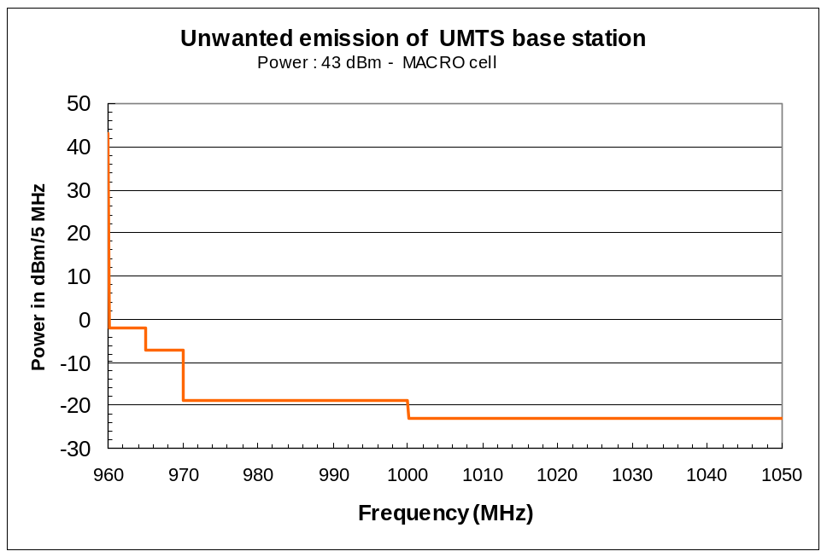
Figure 43: Unwanted emissions of UMTS Base Station at 960 MHz

This gives:

UMTS900 Transmission band | Level in dBc in 5 MHz | e.i.r.p. in dBm in 5 MHz | MIDS channels impacted
965 - 970 MHz | 50 dBc | +8 dBm | 969 MHz (1 channel)
970 MHz to 1 GHz | (62dBc) | -4 dBm | 972 to 999 MHz (10 channels)
1 GHz to 12.75 GHz | (66dBc) | -8 dBm | 1002 to 1206MHz (40 channels)
Table 34: UMTS900 unwanted emissions
  - The maximum calculated value of UMTS signal (macro-cell), for the frequency 960 MHz, is -21 dBm at the input of the MIDS receiver terminal. The corresponding distance is from 200 to 280 metres. This gives, according to Table 34:
A level of -71 dBm/5 MHz in the 969 MHz MIDS channel,
A level of -83 dBm/5 MHz in the 10 following MIDS channel,
A level of -87 dBm/5MHz for the rest of the MIDS channels.
Whatever the channel is, the threshold of the noise level of -104 dBm/5MHz is exceeded. To respect this level of -104 dBm/5MHz:

- for the 10 channels in the 970 - 1000MHz band, an additional isolation of 21 dB is necessary to ensure the nominal performances of MIDS. However, as mentioned previously, performance degradation is tolerated in this frequency range.
- for the highest 40 channels, an additional isolation of 17 dB is necessary.
  - It was stated that MIDS could tolerate the frequencies below 1 GHz to be interfered, so that the only frequencies that had to be taken care of were the ones above 1 GHz (40 frequencies). Therefore, the overall conclusion was that an additional 17 dB isolation was to be reached, compared to the existing UMTS900 specifications in order to fulfil the interference criteria. The associated assumption was a base station transmitting at full power in the direction of a MIDS receiver, situated at 200 m from the UMTS900 base station. The following Figure 44 gives the full results:
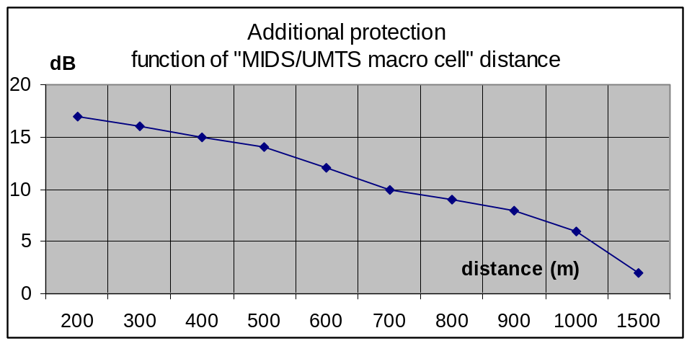
Figure 44: Compatibility results for UMTS900/MIDS
It has to be noted that, due to the antenna diagrams of MIDS and UMTS 900, the additional isolation, for a distance below 200 m, is less than 17 dB.
That means that a distance of 200 m between MIDS and UMTS900 represents the worst case. If the distance is below or above 200m, then the additional isolation is below 17 dB. This is ensured through an improved level of the spurious emissions of UMTS900 of 17dB compared to the specifications
According to ECC Report 096 conclusions for UMTS900, if there is an additional isolation of 17 dB above 1 GHz no additional separation distance is required to protect the MIDS receiver.”

Compatibility between GSM MC BTS and MIDS
The basic idea here is to compare the spurious emissions levels of UMTS900 and GSM MC BTS beyond 1 GHz.
The value is -30 dBm/3 MHz for GSM MC, whereas the value for UMTS 900 is -30 dBm/MHz, i.e:
- -50 dBm/30 kHz for GSM MC
- -45 dBm/30 kHz for UMTS900
By difference between the spurious emission levels of UMTS900 and GSM MC (5 dB), a preliminary conclusion is that an additional isolation of 12 dB above 1GHz is required to protect the MIDS receiver from GSM MC in the same conditions as for UMTS900, which means a UMTS900 base station transmitting at full power in the direction of a MIDS receiver, situated at 200 m from the UMTS900 base station. This can be achieved by ensuring that the spurious emissions of GSM MC, measured on deployed equipments, are 12 dB better than specified.
Therefore, similarly to the conclusions of ECC Report 096, with an additional isolation of 12dB for GSM MC above 1GHz, no additional separation distance is required to protect the MIDS receiver.
It has to be noted that the spurious emissions requirements of UMTS900 encompass the intermodulation product which is not the case of GSM.

Conclusion on the compatibility between GSM MC BTS and MIDS
This adjacent band compatibility study between GSM MCBTS (operating below 960 MHz) and the MIDS (operating above 969 MHz) considers the impact of the unwanted emissions (above 960 MHz) for the worst case situation, where the MIDS receiver is placed in the direction of the GSM MC base station antenna. It shall be noted than the assessment of interferences from MIDS on the GSM terminals has not been taken into account in this compatibility study, since the analysis only takes into account changes to the GSM equipment, and consequently only concerns the GSM downlink. Furthermore the GSM is separated by a considerable distance in the frequency domain from MIDS transmissions, and at that distance the blocking criteria for MC BTS are the same as those used for SC BTS. In this context, it should be noted that this study does not take into account the regulatory status of JTIDS/MIDS, which operates in the band 960 - 1215 MHz under the conditions of provision 4.4 of the Radio Regulations. It is additionally noted that MIDS is part of the navigation systems listed in the ERC Report 025 (ECA) operating above 960 MHz.
To avoid any interference on each MIDS frequency above 1 GHz, the protection distance between GSM MC base station and MIDS stations should be up to 1 km when the MCBTS sector is transmitting directly in the main lobe of the MIDS antenna.
However, the protection distance when the MCBTS sector is transmitting directly in the main lobe of the MIDS antenna should be reduced if the real unwanted emission level of the GSM MC equipment is better than specified. An improvement of 12 dB compared to the 3GPP specification in the 1000 - 1206MHz MIDS band (corresponding to the 1-12.75GHz spurious band) ensures the compatibility and no additional separation distance is required to protect the MIDS receiver and whatever the configuration. In the worst case (if the MIDS receiver is placed in the direction where the GSM MC base station antenna gain is maximum), for a separation distance greater than 1 km, no specific measure is needed. For other azimuths of antenna, the separation distance and the additional filtering requirements decrease.
Information put forward by some manufacturers about the performance of a typical GSM MC base station shows that the practical level of unwanted emission provides isolation considerably higher than the 12 dB required. Indeed, the interference criteria would be met already at 980 MHz or even lower. However, it will be important to ensure that the performances of other base stations which will be effectively deployed would also enable to provide the required protection to MIDS.

GSM MCBTS – DECT 1880 - 1990 MHz
In this section, the impact of GSM MCBTS onto DECT systems is assessed through two analyses:
- Comparison of the interference level created by GSM MCBTS to the interference created by the GSM Single Carrier;
- Coexistence study based on the ERC Report 100.

Analysis based on the comparison of GSM MC unwanted effects to the DECT blocking response

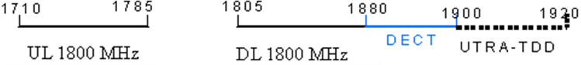
Figure 45: DECT frequency band is adjacent to the mobile 1800 DL allocation

The configuration considered to assess the interference from GSM MC onto DECT allocation:
The interference from mobile system onto DECT was intensively studied through the reports [6] and [13].
In order to evaluate the interference from the mobile system onto the DECT system, the upper GSM carrier centered onto 1879.8 MHz and the lowest DECT channels are considered, since this configuration represents the worst case in terms of coexistence, in line with the previous simulations.

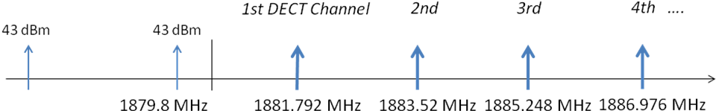
Figure 46: channels under consideration
The interference is evaluated by calculating ACS and ACLR figures
Moreover, it is necessary to differentiate the unwanted emissions from mobile systems into the DECT band from the blocking response from DECT when having an interfering signal in the adjacent allocation.
In the following, the evaluation of the DECT blocking response and the GSM MC unwanted emissions will be assessed through respectively the ACS and ACLR figures.

ACS figures for DECT derived from [13]
The C/I requirements are set with respect to the ability of DECT equipment to continue receiving in the presence of an interfering signal on the same or different DECT RF channel (with a wanted signal level: of-73dBm).

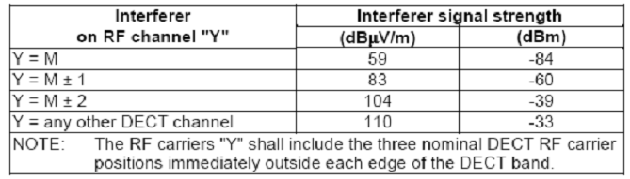
Table 35: C/I requirements for DECT
It should be noted that the RF carriers “Y” shall include the three nominal DECT RF carrier positions immediately outside each edge of the DECT band.

For a higher frequency offset, the following table should be considered:

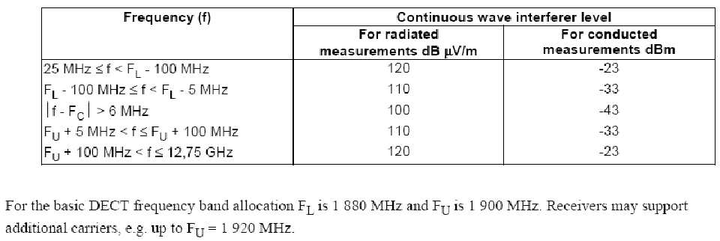
Table 36: Blocking requirements for DECT
Based on a C/I ratio of 11 dB, we obtained the following ACS figures for DECT equipments (see sections 6.4 and 6.5 of ESTI EN 300 175-2 v2.0.1 2007-03 [10]):

Interferer on RF channel | ACS Figures (dB)
Y=M +/- 1 | ACS_1 = 24
Y=M +/- 2 | ACS_2 = 45
Y=M +/- 3 | ACS_3 = 51
Y=M +/- 4 | ACS_4 = 58
Y=M +/- 5 | ACS_5 = 58
Y=M +/- 6 | ACS_6 = 58
Table 37: DECT ACS Figures
As the frequency offset between two DECT carriers is fixed to 1.728 MHz, the ACS figure for the lowest DECT channel is covered by the first ACS figure. For the second adjacent DECT channel, the ACS_2 of 45 dB should be considered and for the third adjacent DECT channel, the ACS_3 of 51 dB; etc.

The main interfering phenomenon is the blocking response of DECT system
The DECT ACS capabilities should be compared to the ACLR figures of GSM MC unwanted emissions calculated over the first three DECT channels and when the GSM MC emissions are settled as in Table 38:

 | ACLR_1 | ACLR_2 | ACLR_3 | ACLR_4 | ACLR_5 | ACLR_6
GSM MC Class 1 | 63.5 dB | 62.2 | 62.2 | 62.5 | 69.9 | 72.4
GSM MC Class 2 | 55.4 dB | 61.2 dB | 62.2 | 62.2 | 64.2 | 72.4
Table 38: GSM MC ACLR Figures

When comparing the ACS to the ACLR figures, it can be shown that the blocking response of DECT is the limiting factor when assessing the interference from mobile onto DECT system for the six adjacent DECT channels and for both GSM MC classes.

For the UMTS 1800 case [6], the unwanted interference (iRSS unwanted) created by the out-of-band emissions from UMTS 1800 is about 5 dB lower than the blocking response (iRSS blocking).

The multi-carrier capability is not increasing the interference onto DECT allocation compared to the GSM single carrier or the UMTS 1800 carrier.

It should be recalled that the power per GSM MC carrier is limited to 43 dBm. In other words, the GSM multi-carrier capability is not changing the nominal power transmitted by each GSM carrier.
As the dominant factor when considering the interference is the blocking response of DECT, the interference created by a GSM carrier at the upper part of the band 1800 onto the lowest DECT channels (GSM single carrier or multi-carrier, or UMTS 1800) would be the same.

Coexistence between macro MCBTS and DECT (1880 – 1900 MHz)
The ERC Report 100: “Compatibility between certain Radio Communications Systems Operating in Adjacent Bands: Evaluation of DECT / GSM1800 Compatibility”, February, 2000, contains a comprehensive study on compatibility between DECT and GSM 1800. The present study is based on the results of the ERC Report 100, taking into account the deviations between GSM 1800 and MCBTS specifications. The typical increase, since ERC Report 100 was written, of DECT receiver sensitivity has been considered. Furthermore, a different BTS antenna gain has been used.

Only interference to DECT has been considered. The reason is that interference from DECT to MCBTS is not critical, since the MCBTS receive band is separated from the DECT band by >95 MHz. Furthermore, there are no changes to the MCBTS receiver specification relative to SCBTS for the 1800 MHz band.

It is concluded that blocking of DECT is the dominating interference mechanism, is spite of increased out-of-band unwanted emissions (intermodulation products and spurious) from MCBTS compared to SCBTS.

The case studied in the present report is interference from urban macro MCBTS to DECT in-door residential and enterprise DECT systems. These system types represent the overwhelming majority of DECT installations.
The critical scenario is when GSM is allocated in the band 1875 - 1880 MHz and DECT sites are in line-of sight of an MCBTS. In these cases there is a large probability that the lower 6 MHz (3 DECT carriers) of the DECT band cannot be utilized by DECT. The fraction of DECT system sites that are in line-of-sight of an MCBTS is however small.

The conclusion from the present study is the same as for the previous study [13], that no guard band is required, provided that DECT is able to properly detect GSM interference on the (three) DECT carriers closest to the 1880 MHz border, and escape to the (seven) more distant carriers. How to detect GSM interference is described in DECT specification ETSI EN 300 175-3 [15], clause 11.4.5, “Handover criteria due to Interference”. For more details see the Annex 7.

WLL has not been further analysed in this study for two reasons: Europe has very few DECT WLL installations, and site engineering and special planning will sometimes be required. It shall however be noted that a proposed mitigation technique (see section 4.4.1 of [13]), to reduce the interference to DECT WLL, is to increase the DECT blocking performance. This will only be efficient to a certain extent in MCBTS environments, since interference due to unwanted out-of-band emissions (which are increased for MCBTS compared to SCBTS) will then dominate instead, unless the MCBTS out-of-band unwanted emissions are improved beyond the specification limits. Thus MCBTS sites close to DECT WLL installations may have to employ some mitigation technique like external filters between the MCBTS and the antenna to provide the required reduction of unwanted emissions into the DECT band.

The detailed analysis is found in the Annex 7.

Conclusions
Interference from urban macro GSM 1800 MCBTS to DECT indoor residential and enterprise DECT systems has been studied in the present document. Those DECT systems represent the overwhelming majority of DECT installations.

- Blocking of DECT is the dominating interference mechanism, is spite of increased unwanted emissions (intermodulation products and spurious) from MCBTS compared to single carrier GSM BTS. It can be concluded that the interference created by the GSM MC system would be the same to the interference created by GSM Single carrier.
The conclusion is the same as for the previous study [13], that no guard band is required, provided that DECT is able to properly detect GSM interference on closest DECT carriers F9-F7 and escape to more distant carriers F6-F0. How to detect GSM interference is described in [15], clause 11.4.5, “Handover criteria due to Interference”.

- In practice GSM 1800 single carrier BTS has demonstrated good coexistence with DECT residential and enterprise systems. Thus we can assume good coexistence also with GSM 1800 MCBTS.

- WLL has not been further analyzed in this study for two reasons: Europe has very few DECT WLL installations, and site engineering and special planning will sometimes be required.
It shall however be noted that a proposed mitigation technique (see section 4.4.1 of [13]), to reduce the interference to DECT WLL, is to increase the DECT blocking performance. This will only be efficient to a certain extent in MCBTS environments, since interference due to unwanted emissions (which are increased for MCBTS compared to SCBTS) will then dominate instead, unless the MCBTS unwanted emissions are improved beyond the specification limits. Thus MCBTS sites close to DECT WLL installations may have to employ some mitigation technique like external filters between the MCBTS and the antenna to provide the required reduction of the unwanted emissions into the DECT band.

Interference from other Systems into MCBTS Due to relaxations in blocking requirements for MCBTS

Description of the relaxed MCBTS requirements
The changes in interference caused to systems adjacent to GSM due to relaxations of the unwanted emissions of the MC BTS transmitter have been discussed above. The GSM specification also includes another relaxation for the MC BTS, which concerns the blocking requirements on the MC BTS receiver side. The basic facts about this relaxation are as follows:
- For the DCS 1800 band nothing has been changed.
- The relevant sub-clause of ETSI TS 45.005 [9] is 5.1.
- Requirements are the same for Class 1 and Class 2.
- MC BTS: -25 dBm at 3 dB above sensitivity level, to be compared with SC BTS: -13 dBm at 3dB above sensitivity level.
- Only changes for in-band performance (although note that the frequency range for in-band for blocking is partly outside of the relevant receiver band).
- Out of band requirements were not changed (relaxed) because the out of band blocking signal is usually anyway attenuated by the duplex filter and thus these values were not seen as a problem for the MC receiver.
Table 39 and Table 40 below are copied from TS 45.005 [9] Section 5.1 and list the details of the blocking requirements.
Frequency | Frequency range (MHz)
band | GSM 900 |  | E-GSM 900 | R-GSM 900
 | MS | BTS | BTS | BTS
in-band | 915 - 980 | 870 - 925 | 860 - 925 | 856 - 921
out-of-band (a) | 0,1 - < 915 | 0,1 - < 870 | 0,1 - < 860 | 0,1 - < 856
out-of-band (b) | N/A | N/A | N/A | N/A
out-of band (c) | N/A | N/A | N/A | N/A
out-of band (d) | > 980 - 12,750 | > 925 - 12,750 | > 925 - 12,750 | > 921 - 12,750
Table 39: Overview of the in-band and out-of-band frequency ranges in TS 45.005 [9], Sub-Clause 5.1

Frequency | GSM 400, T-GSM 810, P-, E- and R-GSM 900 |  |  |  |  |  |  |  | DCS 1 800 & PCS 1 900
band | other MS |  | small MS  (Note 1) |  | BTS except Multicarrier BTS |  | Multicarrier BTS (Note 2) |  | MS |  | BTS including  Multicarrier BTS
 | dBµV | dBm | dBµV | dBm | dBµV | dBm | dBµV | dBm | dBµV | dBm | dBµV | dBm
 | (emf) |  | (emf) |  | (emf) |  | (emf) |  | (emf) |  | (emf)
in-band
600 kHz ≤ |f-fo | < 800 kHz | 75 | -38 | 70 | -43 | 87 | -26 | 78 | -35 | 70 | -43 | 78 | -35
800 kHz ≤ |f-fo | < 1.6 MHz | 80 | -33 | 70 | -43 | 97 | -16 | 97 | -16 | 70 | -43 | 88 | -25
1.6 MHz ≤ |f-fo | < 3 MHz | 90 | -23 | 80 | -33 | 97 | -16 | 97 | -16 | 80 | -33 | 88 | -25
3 MHz ≤ |f-fo | | 90 | -23 | 90 | -23 | 100 | -13 | 97 | -16 | 87 | -26 | 88 | -25
out-of-band
(a) | 113 | 0 | 113 | 0 | 121 | 8 | 121 | 8 | 113 | 0 | 113 | 0
(b) | - | - | - | - | - | - | - | - | 101 | -12 | - | -
(c) | - | - | - | - | - | - | - | - | 101 | -12 | - | -
(d) | 113 | 0 | 113 | 0 | 121 | 8 | 121 | 8 | 113 | 0 | 113 | 0
NOTE 1: For definition of small MS, see subclause 1.1.
NOTE 2: In case of either multicarrier BTS class with multicarrier receiver, the inband requirements for frequency offsets 800 kHz ≤ |f-fo | and blocking signal levels higher than -25 dBm, the performance shall be met X dB above the reference sensitivity level or input level for reference performance, whichever applicable, as specified in subclause 6.2 where X is
- 8 dB for blocking signal levels below -20 dBm, and
- 12 dB for blocking signal levels above -20 dBm.
The relaxed values for multicarrier BTS classes are not applicable for GSM-R usage.
The requirements apply to both multicarrier BTS classes.
The requirements for Multicarrier BTS apply to multicarrier BTS with multicarrier receiver.
Table 40: Overview of the blocking requirements in TS 45.005 [9], sub-clause 5.1
The relaxed blocking level (–25 dBm) was introduced because simulations presented during the standardization process in 3GPP GERAN have shown that in most cases, the power level received at a base station will stay below –25 dBm. At this blocking level of -25 dBm, the MCBTS Rx has to fulfill the existing sensitivity requirement (-104 dBm from the non-blocked case, desensitized by 3 dB, thus -101 dBm). However, further simulations assuming a high number of GSM mobiles operating at full power at the same time (worst case situation for an uncoordinated MCBTS receiver) have shown that there is also a non-negligible probability that receive levels might exceed -25 dBm in certain cases. In order to protect the receiver from being fully blocked in these cases but to enable the feasibility of multicarrier receivers, it was then decided to introduce two additional blocking levels above –25 dBm with relaxed sensitivity requirements:
- At a second blocking level of -20 dBm (i.e. the received signal would be 5 dB higher than at -25 dBm), the sensitivity requirement is relaxed by 5 dB to a value of –96 dBm.
- At a third blocking level of -16 dBm (i.e. the received signal would be 9 dB higher than at -25 dBm), the sensitivity requirement is relaxed by 9 dB to a value of –92 dBm.

That means, in order to protect the MCBTS receiver from being fully blocked, the relaxation is actually split into a relaxation of the blocking level and a relaxation of the required sensitivity. In order to limit the test effort, no further intermediate steps of the blocking and sensitivity levels were introduced. Consequently, the MCBTS receiver sensitivity has the following step-wise definition:
- At receive levels up to -25 dBm: -101 dBm
- At receive levels between -25 and -20 dBm: -96 dBm
- At receive levels between -20 dBm and–16 dBm: -92 dBm.

Application to interference from the systems considered in this Report
The information above indicates that it is only necessary to consider an increased risk of blocking for a MC BTS when the interfering system is GSM-R. This follows from the fact that the other systems are sufficiently separated in frequency from the GSM uplink (see the frequency arrangement in Section 3), or as in the case of DECT, no change has been made to the MC BTS blocking requirement in DCS 1800 in relation to SC BTS.
An estimation of the power level received at an MCBTS caused by a GSM-R terminal, based on a minimum coupling loss analysis, is presented in the following Figure 47 and Figure 48. They contain curves describing the combined path loss (Free Space loss and MC BTS antenna gain (F.1336, sector antenna)) as a function of the distance between the GSM-R terminal and the MC BTS, GSM antenna pointing directly towards the railway line. The absolute value of this path loss is never less than 64 and 60 dB respectively for 45 m and 30 m MC BTS antenna. A minimum coupling loss analysis thus yields the following:
39 dBm (GSM-R terminal power) – 3 dB (feeder loss at GSM-R terminal) + 0 dBi (antenna gain of GSM-R terminal) – 60 dB (lowest LoS path loss and MC BTS antenna gain) – 3 dB (feeder loss in GSM BTS) = - 27 dBm
Consequently, even the lowest blocking level of –25 dBm will not be exceeded by interference from high power GSM-R terminals.

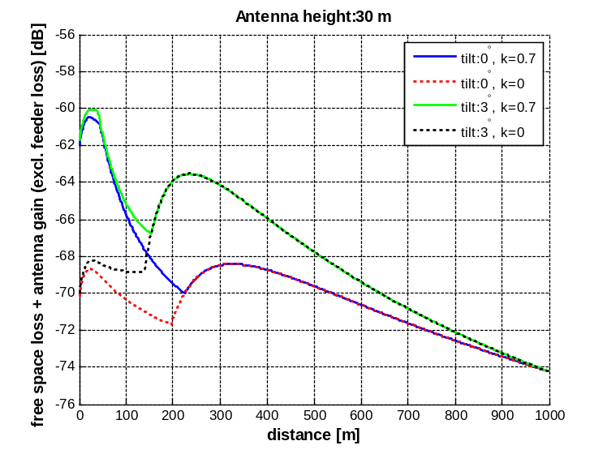
Figure 47: Free space path loss and public GSM BTS antenna gain as a function of distance between GSM-R terminal and public GSM BTS. Antenna height 30 m

Figure 48: Free space path loss and public GSM BTS antenna gain as a function of distance between GSM-R terminal and public GSM BTS. Antenna height 45 m

Network simulations
During the standardization process in 3GPP GERAN, simulations were already done on the network level in order to estimate the likelihood of blocking signals exceeding a level of –25 dBm. A description is given in the following.

In order to investigate the possible impact of high power mobiles (as used in GSM-R networks) on the receive level at an MCBTS, a hexagon cell of radius 2000 m was assumed. The power values received at the MCBTS from each of the mobiles were accumulated and the cumulative distribution function of this receive power level was calculated. A minimum distance between MS and BTS of 30 m was assumed. The propagation loss was modelled using the equation:

loss = A + B log (distance/km).
The Walfish-Ikegami model with the parameters A = 101.7 dB and B = 26.0 was used to calculate the path loss because in other simulations this has led to the worse case (i.e. higher receive levels) compared to using the Hata model (note that the Walfish-Ikegami model is better suited for small distances between MCBTS and mobiles). Since these high power mobiles are not used by the public, a number of 10 mobiles was placed randomly within the cell, all operating at maximum power at the same time, thus leading to a rather high receive level at the MCBTS as it would usually never occur. In addition, in these simulations only the horizontal antenna pattern of the MCBTS was taken into account. However, in reality a mobile very close to a MCBTS would be received at a much lower level (due to the vertical antenna pattern) than assumed in the simulation. Furthermore, in reality, the signals from a number of GSM-R mobiles would be attenuated by the duplex filter of the MCBTS (depending on the offset between the operating frequency of the GSM-R mobile and the band edge of the public GSM network). All in all, that means that the results described below can be seen as a very worst case scenario.
Figure 49 shows the cumulated distribution function (CDF) vs. the receive level in a larger range of receive levels and Figure 50 shows a zoom at higher power levels. Going from –13 dBm to –25 dBm, the CDF value changes from 0.9986 to 0.9854. This is a difference of approx. 1.3 %. Taking into account that a worst case scenario was used as basis for this simulation, it can be stated that the relaxation of the blocking requirement to –25 dBm leads to a negligible difference in the likelihood of blocking cases.

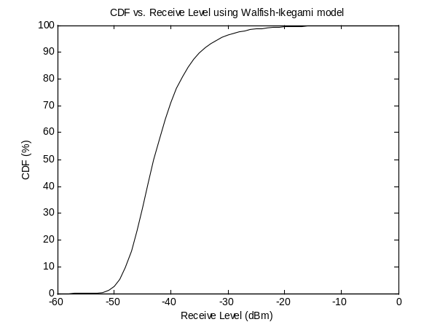
Figure 49: Receive level in the case of 10 high power MSs, using Walfish-Ikegami propagation model

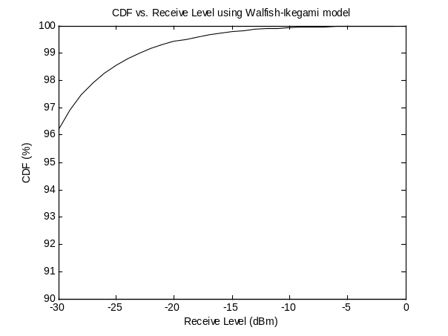
Figure 50: Receive level in the case of 10 high power MSs, using Walfish-Ikegami propagation model, zoom at higher receive levels
The simulation results presented in 3GPP GERAN and described above have already shown the low probability of receive levels exceeding a level of –25 dBm. During the further standardization and as mentioned before, two higher blocking levels (at –20 dBm and at –16 dBm) were introduced for MCBTS. This reduces the difference in the likelihood of blocking cases, compared between the relaxed and the “non-relaxed” receiver, even further below the value of 1.3 %.

Taking into account the results of the minimum coupling loss analysis together with the network simulations presented at 3GPP GERAN, it can be concluded that the impact from GSM-R mobiles on the performance of MCBTS receivers is completely negligible.

Conclusions
The information above indicates that it is only necessary to consider an increased risk of blocking for a MC BTS when the interfering system is GSM-R. This follows from the fact that the other systems are sufficiently separated in frequency from the GSM uplink, or as in the case of DECT, no change has been made to the MC BTS blocking requirement in DCS 1800 in relation to SC BTS.

A Minimum Coupling Loss analysis shows that the relaxation of blocking levels will not cause any difficulties, since even the lowest blocking level of –25 dBm will not be exceeded by interference from high power GSM-R terminals. Simulations based on a worst-case scenario give similar results, i.e. that the relaxation of the blocking requirement to –25 dBm leads to a negligible difference in the likelihood of blocking cases.

Conclusions
For the band 915 - 935 MHz there are ECC decisions to potentially use part of it for GSM-R and additional part on national basis. Therefore the study case for the TRR adjacent channel to GSM is only valid for a limited amount of countries within CEPT. The same is valid for the RSBN/PRMG studies. For the ARNS case it is important to also remember that it is only the ARNS stations that are using the frequencies below the MC BTS systems that are affected. The other stations would have the same situation as for SC BTS.

The TRR study shows that there are no changes for MC BTS compared to SC BTS when it concerns the planning of the two systems adjacent to each other for carrier separation below 1 MHz. For larger carrier separation site engineering is required together with a separation distance of 2-3 km to keep the TRR cell size as for the SC BTS case.

The C/I requirements for both PRMG azimuth (C/I>7 dB at 2000 meters) and RSBN course (C/I> 17dB at 2000 meters) are met when RSBN/PRMG is operated with 1 MHz carrier separation from the lowest carrier of MC BTS. For the usage of the standard GSM features PC and DTX the carrier separation might be even smaller. The main parameter for the performance of the RSBN/PRMG system, above 1 MHz carrier separation, is the ACS value. The difference between GSM SC and MC BTS is therefore negligible both for class 1 and class 2.

The ECA footnotes indicate that there are a limited number of CEPT countries that use the bands for ARNS and the majority uses it for GSM.

The HC-SDMA study shows that in the worst case situation (rural scenario and C/I = 14) the probability of interference due to the unwanted mechanism is about 3.75 %. In most cases, the probability of interference is approximately 2%. The interference due to blocking effect is 0% in all considered cases. Therefore it can be concluded that the impact from the introduction of MCBTS on HC-SDMA is negligible.

Co-existence between GSM MCBTS and GSM-R
Minimum Coupling Loss analysis and simulations have been used to analyse this co-existence scenario. The MCL analysis indicates that under certain worst-case conditions the GSM-R network may experience interference. The MCL analysis also indicates, however, that the dominating interference problems are the blocking and adjacent channel performance of the GSM-R terminal.
The simulation analysis considers a more detailed scenario, incorporating also dynamic aspects of both networks. For the case with minimum frequency separation between GSM-R and public GSM and the antenna sector of the GSM MCBTS is transmitting directly on the GSM-R cell edge area, the geographical separation distances for the different deployment scenarios with typical antennas are never more than 55 meters, provided that only unwanted emissions from the MCBTS are taken into account in the interference analysis, i.e. GSM-R terminal limitations regarding IM products, blocking and adjacent channel performance are disregarded. If frequency hopping and power control is applied to the public GSM network, which is normally the case, the required separation distance is never more than 20 meters under these assumptions. A carrier separation of 0.4 MHz (0.2 MHz between the edges of the channels) between GSM MC BTS and GSM-R as defined in ECC/DEC/(02)05 is thus sufficient to avoid harmful interference to GSM-R dowlink due to unwanted emissions from a MCBTS.
The GSM-R uplink power control, especially for the train mounted MS, is necessary to reduce constraints on GSM Base stations in the same geographical areas; otherwise the impact on GSM UL capacity could be important when the GSM network is using the 2 MHz band adjacent to the GSM-R band.

Co-existence between GSM MCBTS and Aeronautical Systems (DME)

The interference between GSM MCBTS and DME has been studied for rural and urban scenarios. taking into account both interference leakage from MCBTS into DME spectrum, and the limited selectivity of the DME receiver above 960 MHz. For current DME deployments, at 977 MHz and above, there will be no increase in interference from MCBTS in relation to SCBTS. This is due to the fact that for such an offset, the unwanted emissions from an SCBTS and an MCBTS have the same characteristics.
In case DME is deployed below 977 MHz, a detailed analysis has been carried out. Realistic aspects such as power control for GSM and polarisation discrimination were considered in the simulations.
When power control is used, the result is that no additional isolation is needed for the unwanted emissions from MCBTSs for either the rural or the urban scenario, for both classes 1 and 2, for any altitude of an aircraft.
When power control is not used in GSM downlink, the results are as follows:
- for BTS Class 1, no additional isolation is needed
- for BTS class 2:
  - no additional isolation is needed when the DME frequency is above 962 MHz.
  - For a DME frequency of 962 MHz: an isolation of 4 dB is needed for the urban scenario studied (for an aircraft altitude below 200m); an isolation of 2 dB (below 200m) to 5 dB (above 1000m) is needed for the rural environment. For altitudes of 1000m and above, averaging interference over a large number of base stations would ensure a sufficient isolation.

It should be noted that power control is a widely deployed technique in the mobile networks so that no specific measure would be necessary to GSM MC BTS so as to fulfil the interference criterion of DME. Additionally, a number of possibilities to improve the compatibility between DME and GSM MC, that do not appear in the simulations results, have been investigated in this Report.

Co-existence between GSM MCBTS and MIDS
To avoid any interference on each MIDS frequency above 1 GHz, the protection distance between GSM MC base station and MIDS stations should be up to 1 km in the worst case (if the MIDS receiver is placed in the direction where the GSM MC base station antenna gain is maximum).
However, the protection distance is reduced if the real unwanted emission level of the GSM MC equipment is better than specified. An improvement of 12 dB compared to the 3GPP specification in the 1000 - 1206MHz MIDS band (corresponding to the 1-12.75GHz spurious band) ensures the compatibility and no additional separation distance is required to enable adjacent band sharing between MCBTS and the MIDS receiver. In the worst case (if the MIDS receiver is placed in the direction where the GSM MC base station antenna gain is maximum), for a separation distance greater than 1 km, no specific measure is needed. For other azimuths of antenna, the separation distance and the additional filtering requirements decrease. In this context, it should be noted that this study does not take into account the regulatory status of JTIDS/MIDS, which operates in the band 960 - 1215 MHz under the conditions of provision 4.4 of the Radio Regulations.
Information put forward by some GSM MCBTS manufacturers about the performance of a typical GSM MC base station shows that the practical level of unwanted emission provides isolation considerably higher than the 12 dB required for both class 1 and class 2 MCBTSs. Indeed, the interference criteria would be met already at 980 MHz or even lower. However, it will be important to ensure that the performances of other base stations which will be effectively deployed would also enable to provide the required protection to MIDS.

Co-existence between GSM MCBTS and DECT
Interference from urban macro GSM 1800 MCBTS to DECT indoor residential and enterprise DECT systems has been studied in the present document. Those DECT systems represent the overwhelming majority of DECT installations.

- Blocking of DECT is the dominating interference mechanism, is spite of increased unwanted emissions (intermodulation products and spurious) from MCBTS compared to single carrier GSM BTS. It can be concluded that the interference created by the GSM MC system would be the same to the interference created by GSM Single carrier.
The conclusion is the same as for the previous study [13], that no guard band is required between the 1800 MHz and DECT allocations, provided that DECT is able to properly detect GSM interference on closest DECT carriers F9-F7 and escape to more distant carriers F6-F0. How to detect GSM interference is described in [15], clause 11.4.5, “Handover criteria due to Interference”.

- In practice GSM 1800 single carrier BTS has demonstrated good coexistence with DECT residential and enterprise systems. Thus we can assume good coexistence also with GSM 1800 MCBTS since the main interfering phenomenon is the DECT blocking.

- WLL has not been further analyzed in this study for two reasons: Europe has very few DECT WLL installations, and site engineering and special planning will sometimes be required.
It shall however be noted that a proposed mitigation technique (see section 4.4.1 of [8]), to reduce the interference to DECT WLL, is to increase the DECT blocking performance. This will only be efficient to a certain extent in MCBTS environments, since interference due to unwanted emissions (which are increased for MCBTS compared to SCBTS) will then dominate instead, unless the MCBTS unwanted emissions are improved beyond the specification limits. Thus MCBTS sites close to DECT WLL installations may have to employ some mitigation technique like external filters between the MCBTS and the antenna to provide the required reduction of the unwanted emissions into the DECT band.

Interference from other systems to GSM MCBTS
The GSM specification includes a relaxation for the MC BTS regarding the blocking requirements on the MC BTS receiver side. Relaxations are the same for Class 1 and Class 2. However, for the DCS 1800 band nothing has been changed. Changes have only been introduced for in-band performance (although note that the frequency range for in-band for blocking is partly outside of the relevant receiver band). Consequently is only necessary to consider an increased risk of blocking for a MC BTS when the interfering system is GSM-R. This follows from the fact that the other systems are sufficiently separated in frequency from the GSM uplink, or as in the case of DECT, no change has been made to the MC BTS blocking requirement in DCS 1800 in relation to SC BTS.
A Minimum Coupling Loss analysis shows that the relaxation of blocking levels will not cause any difficulties, since even the lowest blocking level of –25 dBm will not be exceeded by interference from high power GSM-R terminals. Simulations based on a worst-case scenario give similar results, i.e. that the relaxation of the blocking requirement to –25 dBm leads to a negligible difference in the likelihood of blocking cases.

Annex 1: MC BTS UNWANTED EMISSIONS characteristiCs

A1.1 Introduction
In 3GPP TSG GERAN a Work Item has been performed to review some RF performance requirements related to multicarrier transceivers for GSM, thereby improving performance of the base stations. Based on the results of the investigation, TSG GERAN has agreed to introduce two classes of MCBTS. This annex describes the MCBTS spectrum requirements specified in [9].
A presentation of the requirements on unwanted emissions for Single Carrier BTS is also included, for comparison purposes and to simplify the explanation of the MCBTS requirements.

In this report the nomenclature and definitions for unwanted emissions and spurious emissions are defined according to the present GSM/EDGE TS 145.005 [9]. These are slightly different from the terms defined in ERC Recommendation 74-01 and ITU-R Recommendation SM.329 category B. When GSM MCBTS requirements were developed, the definitions in ERC 74-01 were applied to align with other 3GPP access technologies. However, this is not visible in present GSM specification version available for this report, but work is in progress to clarify this in the GSM specification. The main differences are summarized below.

- In TS 145.005 the out of band, unwanted emissions are defined as spurious emissions for all offset frequencies larger than 2 MHz from the band edge of the operating transmit band.
ERC Recommendation 74-01 defines the spurious emission domain for larger offsets than 2 times the transmitter bandwidth needed for the service. For smaller offsets the term out-of-band emission domain is used.
- The transmitter bandwidth for a GSM MCBTS based system is in this report is 5 MHz, i.e. the frequency range allocated to a system to provide the requested service.
- For GSM MCBTS the out-of-band emissions are specified up to 10 MHz offset in the same way as for other 3GPP access technologies. Beyond 10 MHz offset the spurious emission requirements apply.
- The spurious emission requirements for GSM MCBTS are at least as stringent as specified in ERC/REC 74-01. If any remaining deviation can be found in existing version of the GSM specification is under progress to be removed.
- For the out of band emission region of 10 MHz, an absolute upper limit applies as some of the GSM requirements are specified in relative terms.
- In TS 145.005 the term relevant transmit band means the full frequency band, e.g. for E-GSM 925 - 960 MHz. Other 3GPP technologies are using operating band for the same frequency range.

A1.2 Single Carrier BTS RF transmitter requirements
The unwanted emissions are defined as the total emissions outside the necessary bandwidth, which for one GSM carrier can be approximated by the channel separation, 200 kHz. The occupied bandwidth, however, is approximately 300 kHz, guaranteeing that 99% of the emissions are included. (ITU-R Rec SM. 328-10). The unwanted emissions consist of accumulated spectrum for modulation and wideband noise, switching transients, intra BSS intermodulation products and spurious emissions.

Modulation and wide band noise for a GSM 900 BTS is described per carrier in Table a2) in Section 4.2.1 of [9]. Table A1.1 contains an excerpt of this information. The characteristics are also depicted in Figure A1.1.

 | Power | 100 | 200 | 250 | 400 | ≥ 600 | ≥ 1 200 | ≥ 1 800 | ≥ 6 000
 | level |  |  |  |  | < 1 200 | < 1 800 | < 6 000
Case A | ≥ 43 | +0,5 | -30 | -33 | -60* | -70 | -73 | -75 | -80
 | 41 | +0,5 | -30 | -33 | -60* | -68 | -71 | -73 | -80
 | 39 | +0,5 | -30 | -33 | -60* | -66 | -69 | -71 | -80
 | 37 | +0,5 | -30 | -33 | -60* | -64 | -67 | -69 | -80
 | 35 | +0,5 | -30 | -33 | -60* | -62 | -65 | -67 | -80
 | ≤ 33 | +0,5 | -30 | -33 | -60* | -60 | -63 | -65 | -80
Table A1.1: Spectrum due to modulation and wideband noise for single GMSK carrier
The requirements are expressed in dB relative to a measurement in 30 kHz on the carrier. The different columns correspond to different offsets from the carrier (kHz). Measurements of the unwanted emissions shall be conducted in 30 kHz bandwidth up to 1800 kHz, and in 100 kHz beyond that.
The requirements apply to the whole relevant transmit band (e.g. 925 - 960 MHz), and up to 2 MHz on either side of it (out-of-band emissions).

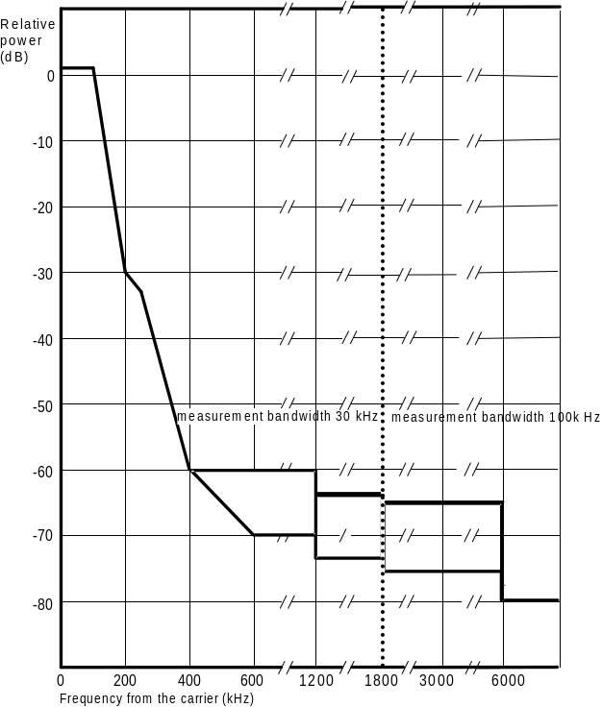
Figure A1.1: Spectrum due to modulation and wideband noise for single GMSK carrier
The contribution from each carrier is aggregated using the single carrier spectrum mask and applying offset by the relevant carrier spacing. In the 3GPP specification the requirements are specified for the case when all carriers are equally spaced at minimum frequency spacing and using the same power level. In this case the contributions are easily calculated for frequency offsets ≥ 1.8 MHz outside the group of carriers by adding 10∙¹⁰log(n), where n is the number of active carriers. Below 1.8 MHz offset the contribution from the closest carrier will dominate.

Switching transients defined for an offset to the carrier of up to 1800 kHz (Section 4.2.2 of [9]) do not significantly alter the total requirements and they are not dealt with further here, especially since wide-band noise will dominate for more than one active carrier. Furthermore, the requirements for a MC BTS are not different from a SC BTS regarding switching transients, i.e. no relaxation of the requirements has been introduced.

Beyond 1.8 MHz, in-band spurious emissions (Section 4.3 of [9]) are specified by measuring the peak power in a given bandwidth at various frequencies. (Note that average power would be roughly 10 dB lower.) Measured peak power must be no more than -36 dBm. The measurement bandwidth is 30 kHz below 6 MHz offset, and 100 kHz beyond that.
Similarly, requirements on spurious emissions outside the transmit band are defined from 2 MHz. Measurement bandwidths of 30, 100 and 300 kHz are used beyond 2, 5 and 10 MHz respectively. Table A1.2 describes the conditions outside the relevant transmit band. The spurious emissions requirements are different for different frequency bands, in particular for GSM900 and GSM1800.

 |  | All BTS except multicarrier BTS
Band | Frequency offset outside relevant transmit band | Maximum power limit
9 kHz to 1 GHz | ≥ 2 MHz | -36 dBm (250 nW)
 | ≥ 5 MHz | -36 dBm
 | ≥ 10 MHz | -36 dBm
1 GHz to 12.75 GHz | ≥ 2 MHz | -30 dBm (1 µW)
 | ≥ 5 MHz | -30 dBm
 | ≥ 10 MHz | -30 dBm
Table A1.2: Out-of-band requirements on spurious emissions and switching transients for single GMSK carrier
BTS intermodulation (Section 4.7.2.1 of [9]) is restricted to a peak value of -70 dBc or -36 dBm, whichever is less stringent, for frequency offsets between 6 MHz and the edge of the relevant Tx band, where both the unwanted emissions and the carrier power (see [18]) are measured in 300 kHz bandwidth.

Note that for a single carrier BTS the strictest of the requirements defined at a certain offset frequency holds.

The single carrier BTS requirements on unwanted emissions are summarized in Table A1.4 below.

A1.3 MultiCarrier BTS RF transmitter requirements
The transmitter emission in GSM specifications for a MultiCarrier BTS is a combination of the three same requirements used for a single carrier BTS. In-band unwanted emissions beyond 1.8 MHz offset from (the center of) the outermost carrier should be less than
max{cumulated wideband noise; spurious emissions; intermodulation product power}.

This is a different approach than for the SC case, and has been used to be more aligned with other technologies like UTRA and E-UTRA. For an offset between 0 and 1.8 MHz, the requirement is a sum of modulation and wide-band noise (accumulation of single-carrier masks) and intermodulation.

For the out-of-band unwanted emissions, the following expression holds beyond 1.8 MHz offset:
min{spurious emission; max{cumulated wideband noise; intermodulation product power}}.

For an offset between 0 and 1.8 MHz, the requirement is given by the same calculation as for the in-band case, i.e. a sum of modulation and wide-band noise (accumulation of single-carrier masks) and intermodulation.

Cumulated wideband noise and intermodulation product power are only defined up to 10 MHz offset from the edge of the transmit band. Furthermore, intermodulation product power is strictly speaking only defined at centre frequencies of intermodulation components and their adjacent channels. This is however due to the fact that this is where maximum power will occur, and the requirements can thus be assumed to hold for other frequencies as well.

There are two different MCBTS classes, Class 1 and Class 2, which differ regarding the requirements for spurious emissions and for intermodulation products.

For spectrum due to modulation and wide band noise (Section 4.2.1 of [9]), the MC BTS requirement is given by accumulating single-carrier masks for the first 1.8 MHz. Beyond that, unwanted emissions may not increase by more than 10log(N) dB compared to a single carrier BTS, where N is the maximum supported carrier number. (For a MCBTS the manufacturers need to declare and verify the available output power for each configurable number of active carriers, i.e. for 1, 2…..N carriers, where N is the maximum supported number of carriers and all carriers use the same power level.) Measurements shall be conducted with all carriers operating at full power at minimum frequency spacing, which is defined in TS 51.021, the test specification for compliance with [9]. An important difference in relation to a single carrier BTS is that the requirement is valid outside the transmit band up to 10 MHz (compared to 2 MHz for single carrier) above the uppermost and below the lowermost carriers respectively.

For MCBTS spurious emissions (Section 4.3 of [9]), average measurements are assumed instead of the peak-hold measurements of single carrier BTS. For in-band (off-set 1.8 MHz or more) the limit is -36 dBm average power (or the requirement due to modulation spectrum and wideband noise, whichever is less stringent) per 30 or 100 kHz measurement bandwidth. Since the measurement method is average and not peak hold, it is a more relaxed requirement than for single carrier BTS. As for single carrier BTS, the spurious emissions requirements are different for different frequency bands, in particular for GSM900 and GSM1800.

Table A1.3 describes the requirements for out-of-band emissions.

 |  | Multicarrier BTS
Band | Frequency offset outside relevant transmit band | Maximum power limit  Class 1 | Maximum power limit Class 2
9 kHz to 1 GHz | ≥ 2 MHz | -35 dBm | -25 dBm
 | ≥ 5 MHz | -30-2.2*(Δf - 5) dBm  (Note) | -20-4,2*(Δf - 5) dBm  (Note)
 | ≥ 10 MHz | -36 dBm | -36 dBm
1 GHz to 12.75 GHz | ≥ 2 MHz | -30 dBm | -25 dBm
 | ≥ 5 MHz | -25-2*(Δf - 5) dBm  (Note) | -20-3*(Δf - 5) dBm (Note)
 | ≥ 10 MHz | -30 dBm | -30 dBm
Table A1.3: Out-of-band requirements on spurious emissions and switching transients for MC BTS
Measurements of the spurious emissions outside the BTS transmit band shall be conducted for the case of maximum supported number of carriers at maximum nominal power for each carrier. Note that out-of-band spurious emissions in general are dominated by intermodulation products (see below).

For MC BTS intra BTS intermodulation (Section 4.7.2 of [9]) requirements also differ between Class 1 and Class 2. For Class 1, average power measured at centre frequency of intermodulation components and their adjacent channels shall not exceed -70 dBc for frequency offsets up to 10 MHz outside the edge of the relevant Tx band.
Measurement bandwidth equals 30 kHz up to 1.8 MHz, 100 kHz for offsets up to 6 MHz, and 300 kHz between 6 and 10 MHz, both for measurements on the carrier and of the intermodulation products.
For Class 2 products, the same requirement holds, except for IM3 frequencies and their adjacent channels, where the power may increase to -60 dBc.

The requirement shall apply for all supported configurations of the multicarrier BTS independently of the number of active carriers, assuming equal power distribution between all carriers, and independently of the modulation type.

The requirements for single carrier BTS and multicarrier BTS are summarised in Table A1.4.

 | Active in-band requirements.  (925 - 960 MHz) | Active out-of-band requirements.  (above 960 MHz or below 925 MHz)
 | Offset from carrier. (MHz) | Offset from the transmit band edge. (MHz)
Single Carrier BTS | Most restrictive active requirement holds.
Single Carrier BTS | From 0 to 1.8 MHz:  modulation and wide-band noise (accumulation of single carrier masks)  From 1.8 to 6 MHz:  - modulation and wide-band noise (accumulation of single-carrier masks)  - spurious  Beyond 6 MHz:  - modulation and wide-band noise (accumulation of single-carrier masks)  - spurious  - intermodulation | From 0 to 2 MHz offset : aggregation of modulation and wide-band noise (accumulation of single-carrier masks) and intermodulation  Beyond 2 MHz:  spurious
Multi Carrier BTS | max{cumulated wideband noise; spurious emissions; intermodulation product power}.* | min{spurious emission; max{cumulated wideband noise; intermodulation product power}}.**
Multi Carrier BTS | From 0 to 1.8 MHz offset:  MC mode:  aggregation of modulation and wide-band noise (accumulation of single-carrier masks) and intermodulation according to class  Beyond 1.8 MHz  MC mode:  - modulation and wide-band noise (10logN method)  - spurious  - intermodulation | Between 0 and 1.6 MHz offset:  MC mode:  aggregation of modulation and wide-band noise (accumulation of single-carrier masks) and intermodulation according to class  Between 1.6 and 2 MHz offset:  MC mode:  - Modulation and wide-band noise (10logN method)  - Intermodulation  Between 2 and 10 MHz offset:  MC mode:  - modulation and wide-band noise  - intermodulation  - spurious  Beyond 10 MHz:  spurious
 | *Note: For frequency offsets between 0 and 1.8 MHz this formula is not applicable | **Note: For frequency offsets between 0 and 1.6 MHz this formula is not applicable
Table A1.4: Summary of MC BTS requirements

A1.4 Typical MCBTS implementation
An implementation with 4 carriers in 5 MHz has been used as a reference case in this Report. 80W total power is assumed for the MCBTS, resulting in 43 dBm per carrier. The derivation of the corresponding emission masks in the figures below can be found in Annex 3.

The MC BTS class 1 and class 2 requirements on unwanted emissions for this reference implementation have been summarized in the Figures A1.2 to A1.5 below for 0 - 10 MHz, both for GSM900 and GSM1800. The results are also presented as values in the Tables A1.5 to A1.8. Note that the uppermost (or lowermost) GSM carrier has its centre frequency at 0 MHz for the in-band picture.

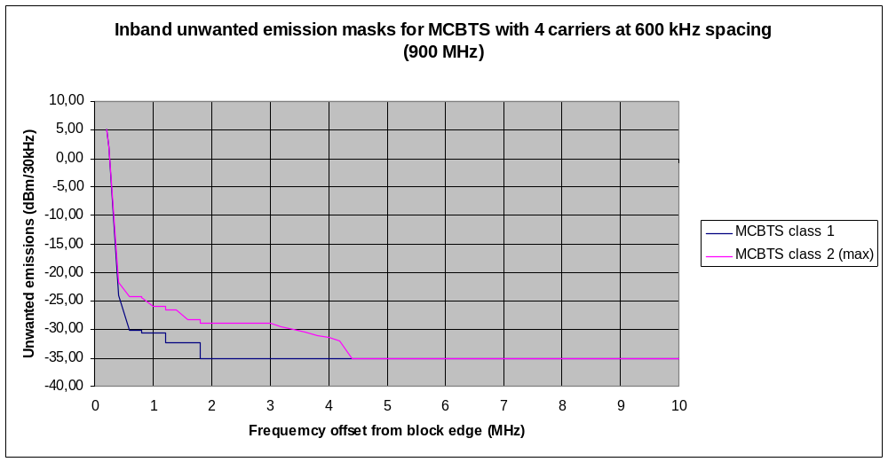
Figure A1.2: Inband unwanted emission masks for MCBTS with 4 carriers at 600 kHz spacing (900 MHz)
Freq/Freq-range  (MHz) | MCBTS class 1  (dBm/30 kHz) | Freq/Freq-range  (MHz) | MCBTS class 2  (dBm/30kHz)
0,2 | 5,0 | 0,2 | 5,0
0,25 | 2,0 | 0,25 | 2,0
0,4 | -24,0 | 0,4 | -21,7
0,6 ≤ δf <0,8 | -30,1 | 0,6 ≤ δf <0,8 | -24,2
0,8 ≤ δf < 1,0 | -30,7 | 0,8 ≤ δf < 1,0 | -24,3
1,0 ≤ δf < 1,2 | -30,7 | 1,0 ≤ δf < 1,2 | -26,0
1,2 ≤ δf < 1,4 | -32,4 | 1,2 ≤ δf < 1,6 | -26,5
1,4 ≤ δf < 1,8 | -32,4 | 1,6 ≤ δf < 1,8 | -28,2
1,8 ≤ δf < 10,0 | -35,0 | 1,8 ≤ δf < 3,0 | -29,0
 |  | 3,0 | -29,0
 |  | 4,2 | -32,0
 |  | 4,4 ≤ δf < 10,0 | -35,0
Table A1.5: Inband unwanted emission masks for MCBTS with 4 carriers at 600 kHz spacing (900 MHz)
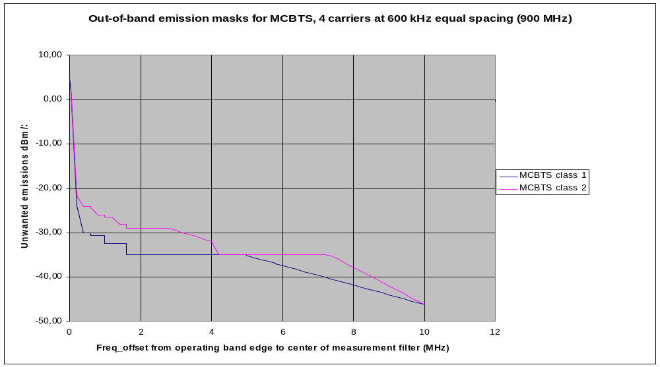
Figure A1.3: Out-of-band emission masks for MCBTS with 4 carriers at 600 kHz spacing (900 MHz)

Freq/Freq-range  (MHz) | MCBTS class 1  (dBm/30 kHz) | Freq/Freq-range  (MHz) | MCBTS class 2  (dBm/30kHz)
0 | 5,0 | 0 | 5,0
0,05 | 2,0 | 0,05 | 2,0
0,2 | -24,0 | 0,2 | -21,7
0,4 ≤ δf <0,6 | -30,1 | 0,4 ≤ δf <0,6 | -24,2
0,6 ≤ δf < 0,8 | -30,7 | 0,6 ≤ δf < 0,8 | -24,3
0,8 ≤ δf < 1,0 | -30,7 | 0,8 ≤ δf < 1,0 | -26,0
1,0 ≤ δf < 1,4 | -32,4 | 1,0 ≤ δf < 1,4 | -26,5
1,4 ≤ δf < 1,6 | -32,4 | 1,4 ≤ δf < 1,6 | -28,2
1,6 ≤ δf < 5,0 | -35,0 | 1,6 ≤ δf < 2,8 | -29,0
5,0 | -35,0 | 2,8 | -29,0
8,4 | -42,7 | 4,0 | -32,0
8,6 ≤ δf < 9,0 | -44,0 | 4,2 ≤ δf < 7,2 | -35,0
10,0 | -46,0 | 7,2 | -35,0
 |  | 10,0 | -46,0
10 ≤ δf < 20 | -46,0 | 10 ≤ δf < 20 | -46,0
20 ≤ δf < 30 | -51,2 | 20 ≤ δf < 30 | -51,2
30 ≤ δf < 40 | -56,0 | 30 ≤ δf < 40 | -56,0
δf ≥ 40 | -50,0 | δf ≥ 40 | -50,0
Table A1.6: Out-of-band emission masks for MCBTS with 4 carriers at 600 kHz spacing (900 MHz)

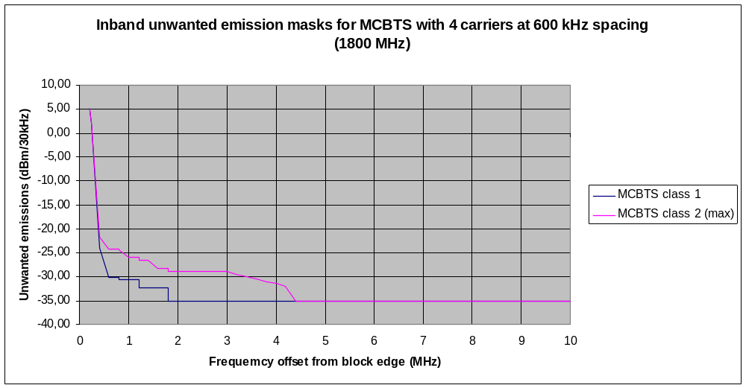
Figure A1.4: Inband unwanted emission masks for MCBTS with 4 carriers at 600 kHz spacing (1800 MHz)

Freq/Freq-range  (MHz) | MCBTS class 1  (dBm/30 kHz) | Freq/Freq-range  (MHz) | MCBTS class 2  (dBm/30kHz)
0.2 | 5.0 | 0.2 | 5.0
0.25 | 2.0 | 0.25 | 2.0
0.4 | -24.0 | 0.4 | -21.7
0.6 ≤ δf <0,8 | -30.1 | 0.6 ≤ δf <0.8 | -24.2
0.8 ≤ δf < 1,0 | -30.7 | 0.8 ≤ δf < 1.0 | -24.3
1.0 ≤ δf < 1,2 | -30.7 | 1.0 ≤ δf < 1.2 | -26.0
1.2 ≤ δf < 1,4 | -32.4 | 1.2 ≤ δf < 1.6 | -26.5
1.4 ≤ δf < 1,8 | -32.4 | 1.6 ≤ δf < 1.8 | -28.2
1.8 ≤ δf < 10,0 | -35.0 | 1.8 ≤ δf < 3.0 | -29.0
 |  | 3.0 | -29.0
 |  | 4.2 | -32.0
 |  | 4.4 ≤ δf < 10.0 | -35.0
Table A1.7: Inband unwanted emission masks for MCBTS with 4 carriers at 600 kHz spacing (1800 MHz)
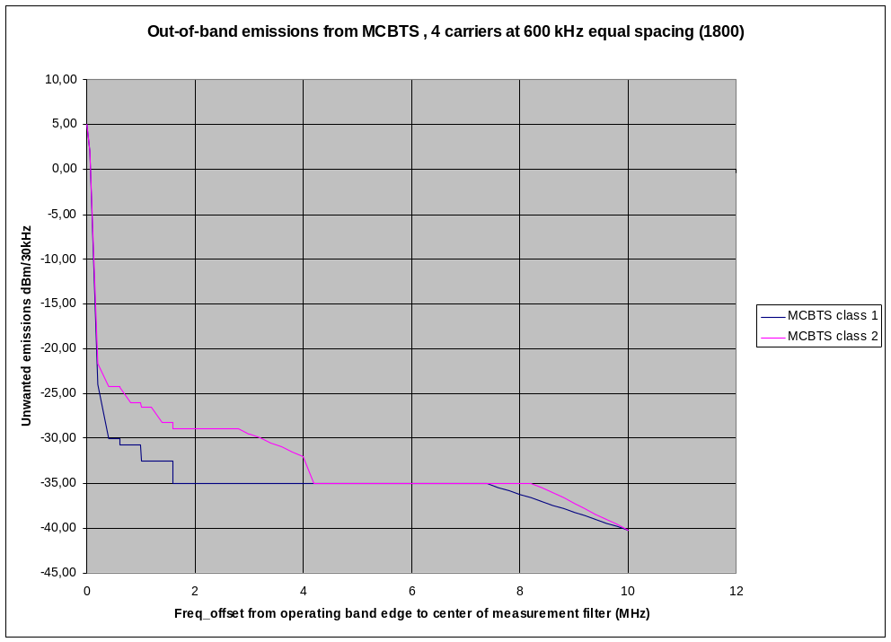
Figure A1.5: Out-of-band emission masks for MCBTS with 4 carriers at 600 kHz spacing (1800 MHz)

Freq/Freq-range  (MHz) | MCBTS class 1  (dBm/30 kHz) | Freq/Freq-range  (MHz) | MCBTS class 2  (dBm/30kHz)
0 | 5.0 | 0 | 5.0
0.05 | 2.0 | 0.05 | 2.0
0.2 | -24.0 | 0,2 | -21.7
0.4 ≤ δf <0.6 | -30.1 | 0.4 ≤ δf <0.6 | -24.2
0.6 ≤ δf < 0.8 | -30.7 | 0.6 ≤ δf < 0.8 | -24.3
0.8 ≤ δf < 1.0 | -30.7 | 0.8 ≤ δf < 1.0 | -26.0
1.0 ≤ δf < 1.4 | -32.4 | 1.0 ≤ δf < 1.4 | -26.5
1.4 ≤ δf < 1.6 | -32.4 | 1.4 ≤ δf < 1.6 | -28.2
1.6 ≤ δf < 7.4 | -35.0 | 1.6 ≤ δf < 2.8 | -29.0
7.4 | -35.0 | 2.8 | -29.0
10.0 | -40.0 | 4.0 | -32.0
 |  | 4.2 ≤ δf < 8,2 | -35.0
 |  | 8.2 | -35.0
 |  | 10.0 | -40.0
10 ≤ δf < 20 | -40.0 | 10 ≤ δf < 20 | -40.0
20 ≤ δf < 30 | -45.2 | 20 ≤ δf < 30 | -45.2
δf ≥ 30 | -50.0 | δf ≥ 30 | -50.0
Table A1.8: Out-of-band emission masks for MCBTS with 4 carriers at 600 kHz spacing (1800 MHz)

Annex 2: MC BTS Systems parameters

Deployment, Network layout
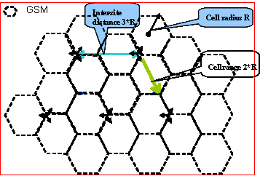
Figure A2.1: GSM network layout
The typical GSM900 deployment scenario considered in the sharing studies is the rural area deployment with cell range 2*R=4800 m, where the network layout is shown in Figure A2.1 above.

A2.1 900 MHz system
The GSM system characteristics are mainly based on parameters from ECC Report 082 and 096.

 | GSM900
Downlink band (MHz) | 925 - 960
Uplink band (MHz) | 880 - 915
Frequency Hopping | TCH channel
Carrier separation (kHz) | 200
 | BS | MS
Tx Power (Maximum per carrier) (dBm) | 43 | 33
Antenna gain (dBi) | 18 (rural)  15 (urban) | 0
Feeder loss (dB) | 3 | 0
Antenna height (m) | 45 (Rural)  30 (Urban) | 1.5
Antenna down-tilt (°) | 3 (Rural)  3 (Urban) | -
BS Antenna | 3 Sector, Horizontal and vertical according to ITU-R F1336.2 | Omni-directional
Spectrum mask | TS45.005  (Section 4.2) | TS45.005
Spurious emissions | TS45.005  (section 4.3) | TS45.005
Receiver noise figure (dB) | 8 | 10
Receiver Thermal Noise Level (dBm) | −121 | -121
Receiver reference sensitivity* | -104 | -102
Receiver ACS (dB)  First channel  Second channel | 18  50 | 18  50
Receiver in-band blocking (dBm) | (3dB desensitization) | (3dB desensitization)
0.6 MHz ≤ δf <0.8 MHz | -35 | -43
0.8 MHz ≤ δf <1.6 MHz | -25* | -43
1.6 MHz ≤ δf <3.0 MHz | -25* | -33
3.0 MHz ≤ δf | -25* | -23
Receiver out-of-band blocking (dBm)
F_{c} <860 MHz | +8 | 0
860 MHz < F_{c} < 905 MHz | (inband) | 0
905 MHz < F_{c} < 915 MHz | (inband) | -5
915 MHz < F_{c} < 925 MHz | (inband) | (inband)
925 MHz < F_{c} < 935 MHz | 0 | (inband)
935 MHz < F_{c} < 980 MHz | +8 | (inband)
Fc> 980 MHz | +8 | 0
Receiver in-band blocking
Cell radius (km) | 2.4 (rural)  0.6 (urban 1)  1.4 (urban 2) | 2.4 (rural)  0.6 (urban 1)  1.4 (urban 2)
Number of carriers per BTS | 4 (typical)
Frequency separation between carriers  (For worst case the last carrier placed at the edge of the transmit band) | 600 kHz
* In addition -16 dBm is specified for 12 dB desensitization.
Table A2.1:GSM900 system characteristics

A2.2 1800 MHz system
 | GSM1800
Downlink band (MHz) | 1805 - 1880
Uplink band (MHz) | 1710 - 1785
Frequency Hopping | TCH channel
Carrier separation (kHz) | 200
 | BS | MS
Tx Power (Maximum per carrier) (dBm) | 43 | 30
Antenna gain (dBi) | 18 (rural)  18 (urban) | 0
Feeder loss (dB) | 3 | 0
Antenna height (m) | 45 (Rural)  30 (Urban) | 1.5
Antenna down-tilt (°) | 3 (Rural)  3 (Urban) | -
BS Antenna | 3 Sector, Horizontal and vertical according to ITU-R F1336.2 | Omni-directional
Unwanted emissions | See Annex 1 or TS 45.005 [9]
Receiver noise figure (dB) | 8 | 10
Receiver Thermal Noise Level (dBm) | −121 | -121
Receiver reference sensitivity | -104 | -100/-102**
Receiver ACS (dB)  First channel  Second channel | 18  50 | 18  50
Receiver in-band blocking (dBm) | (3dB desensitization) | (3dB desensitization)
0.6 MHz ≤ δf <0.8 MHz | -35 | -43
0.8 MHz ≤ δf <1.6 MHz | -25 | -43
1.6 MHz ≤ δf <3.0 MHz | -25 | -33
3.0 MHz ≤ δf | -25 | -26
Receiver out-of-band blocking (dBm)
F _{c}< 1690 MHz | 0 | 0
1690 MHz < F _{c}< 1705 MHz | (inband) | 0
1705 MHz < F _{c}< 1785 | (inband) | 0
1785 MHz < F _{c}< 1805 MHz | (inband) | (inband)
1805 MHz < F _{c}< 1920 MHz | 0 | (inband)
1920 MHz < F _{c}< 1980 MHz | 0 | -12
F _{c} > 1920 MHz | 0 | 0
Cell radius (km) | 2.4 (rural)  0.6 (urban) | 2.4 (rural)  0.6 (urban)
Number of carriers per BTS | 4 (typical)
Frequency separation between carriers  (For worst case the last carrier placed at the edge of the transmit band) | 600 kHz
**-102 is required sensitivity while -100 dBm is used as reference sensitivity for other receiver parameters
Table A2.2: GSM1800 system characteristics
Annex 3: Characterization of GSM MC BTS intermodulation products

A3.1 Introduction
In Annex 1 the specification for multicarrier BTS is described. When writing a specification with minimum requirements, the maximum values for a number of configurations and frequency allocations need to be considered and specified. Very seldom the actual characteristics are considered. Thus in practice the different phenomena causing unwanted emissions could be overestimated if the specification is taken literally without additional information. This contribution describes the physical nature of the dominant unwanted emission for MCBTS, intermodulation, and how this additional information affects the unwanted emissions. Both multicarrier BTS classes are considered. This contribution also describes some useful models for analysis of impact on systems in adjacent frequency blocks that reflect realistic behaviour of unwanted emissions. In addition some effective interference mitigation techniques are highlighted.

A3.2 Intermodulation Attenuation physics
For the purpose of this document, it is beneficial to include a somewhat more detailed description of intermodulation products.
Due to non-linearity in the transmitter, intermodulation products are generated when several signals are processed in a common active element. For MCBTS the Multi-Carrier Power Amplifier is the dominating source of IM products. The transfer function for n signals can in general be presented by a series of powers, i.e. for n input signals
S_{out} = Σ{a_{k}∙(S₁+S₂….S_{n})^{k}}
The value of k represents the order of intermodulation as this describes the number of signals involved in the process. In this calculation multiples of the same carrier signals are included as well. For GSM only odd orders (3rd, 5th, 7th etc) may fall inside GSM transmit or receive bands. Normally the factor a_{k} is decreasing rapidly with the IM order. Thus the most important IM products to consider are 3rd, 5th and 7th order.
Third order IM products from n carriers may be found at
|2∙f_{i}-f_{j}|, |2∙f_{j}-f_{i}| but also on |f_{i}+f_{j}-f_{k}|, |f_{i}+f_{k}-f_{j}| etc
for any combination of i, j and k in the range 1 to n and where f_{i} is the centre frequency for carrier i.
These products can be found for offsets up to | f₁-f_{n}| outside the group of carriers. Another characteristic for these products is the broadening of spectrum. Assuming GMSK signals and 200 kHz channels, the IM products will occur at the adjacent channels as well, it can be shown theoretically that in these channels the power will be 3 dB lower. Other modulation methods used by GSM systems will result in further attenuation at adjacent channels.
Similarly, the 5th order IM products may be found at
|3∙f_{i}-2∙f_{j}|, |3∙f_{j}-2∙f_{i}| but also on |f_{i}+f_{j}+f_{k}-(f_{a}+f_{b})|, | f_{i}+f_{a}+f_{k}-(f_{j}+f_{b})| etc
for any combination of i, j, k, a and b in the range 1 to n and where f_{i} is the centre frequency for carrier i.
These products may be found for offsets up to 2∙| f₁-f_{n}| outside the group of carriers. For this case the spectrum broadening is higher; the power is 2 – 2.5 dB lower in the adjacent channels.
It should be noted that if the carriers are equally spaced in frequency several IM3 and several IM5 (or higher order) products will coincide on the same frequencies and add up, thus creating the maximum amplitude of the IM products. This means that the IM products with highest amplitude are closest to the carriers and that the others are decreasing by increasing offset.
In the 3GPP specification the requirements are defined at equal frequency spacing and equal power, thus limiting the strongest products to a specified value, as stated in [9]:
MCBTS class 1: -70 dBc relative the carrier power for any intermodulation product.
MCBTS class 2: same as class 1 but allow for -60 dBc at frequencies where third order intermodulation products can be expected.
An example of IM spectrum with 3 equally spaced carriers with equal power is shown in Figure A3.1.
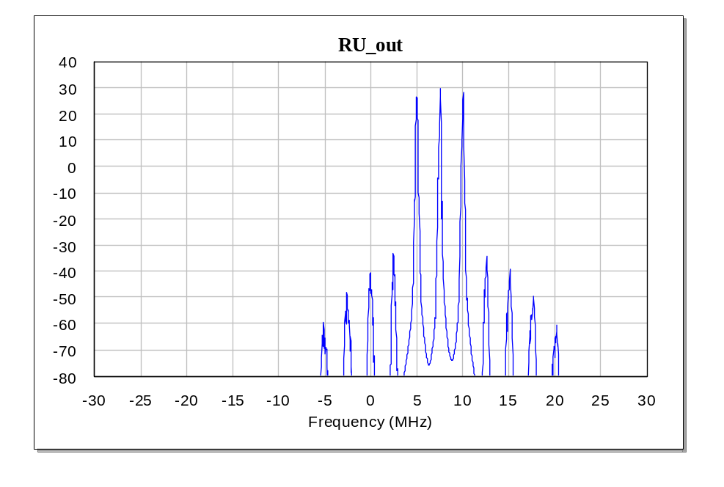
Figure A3.1: Example of IM spectrum for 3 GSM carriers
In this figure the 3rd order intermodulation products are found between 0 and 15 MHz, i.e. at 2.5 and 5 MHz frequency offsets on both sides of the outermost carriers. The IM products outside this range are primarily related to 5th order intermodulation.
Reduction of the number of active carriers, while keeping the same output power for the active ones, thus means that the IM3 is reduced rapidly as the factor a₃ is the same and fewer products add up.

A3.3 Modeling the unwanted emissions

A3.3.1 Characterization of different types of unwanted emissions
As an example, the requirements for in-band unwanted emissions are drafted in the following graph, Figure A3.2, for the different contributions to unwanted emissions, assuming maximum +43 dBm per carrier for a 4 carrier configuration. For comparison the emission mask for UMTS900 is included. The centre of the UMTS/WCDMA carrier is located at -2.5 MHz and the centre of the last GSM carrier at 0 MHz. Note that 2.8 MHz separation is needed between UTRA900 and GSM to achieve the same noise level in a 200 kHz channel from GSM and UTRA900.
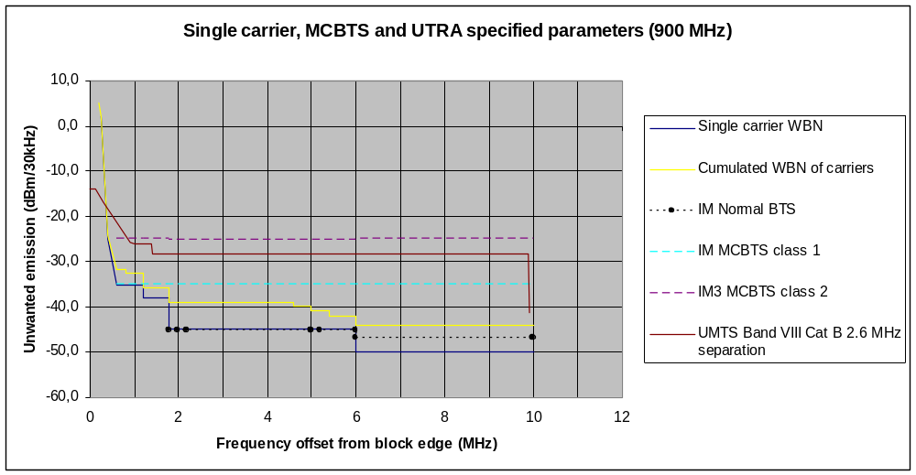
Figure A3.2: In-band unwanted emissions for UTRA, GSM single carrier and multi-Carrier BTS in 900 MHz frequency band
For MCBTS the total emissions shall be less than the aggregation of the GSM cumulated Wideband Noise mask, (WBN, yellow line) and the IM products for respective class below 1.8 MHz offset, and at 1.8 MHz and above the GSM cumulated Wideband Noise mask except at centre frequencies of the MCBTS IM products and their adjacent channels (± 200 kHz) where the least stringent requirement applies. (For simplicity spurious is not discussed in this section, it is dealt with in Section A3.4.) The limit for the IM products are illustrated with the turquoise, dashed line for MCBTS class 1 (all orders of IM products) and for fifth order and higher in MCBTS class 2. In addition for class 2, the IM products at frequencies, where the third order modulation products occur and at their adjacent channels (± 200 kHz), may increase up to the MCBTS class 2 IM3 (dashed, violet) line. However, IM3 only exists for offsets up to the frequency separation between the lowest and highest frequency allocated in the cell. In addition, as described in the previous section, the IM3 products are decreasing in amplitude for increasing frequency offset. A detailed model based on the principles above was used within 3GPP TSG GERAN when analyzing the impact between two uncoordinated systems, e.g. in reference [6] and [7]. However, in these simulations the maximum power of the IM products at IM3 frequencies for MCBTS class 2 is equal to the specified limit independent of the frequency offset. (Note that the MC BTS in-band spurious emissions are lower than the requirement on modulation and wide band noise for 6 aggregated carriers.)

A3.3.2 Impact on systems in adjacent frequency blocks

A3.3.2.1 Modeling IM products for an MCBTS
In the results of simulations performed and presented in reference [6], it is shown that due to the definition of the MCBTS IM requirements, the impact from MCBTS (class 1 and class 2) is less than from UMTS/WCDMA in the 900 MHz band. To explain this, an alternative way of looking at the MCBTS requirements is proposed:
- The unwanted emissions from the WCDMA system are more or less noise-like whereas for MCBTS a lower “noise-like” level is required but with some occurrences of IM peaks added.
- The impact of MCBTS class 1 is assumed to be due to “noise-like” emissions at -30 dBm/100 kHz.
- An equivalent “noise-like” level is established for class 2 causing the same impact as the complete MCBTS model, based on MCBTS class 1 “noise-like” level with IM3 added.

This approach is useful when investigating the impact on other GSM systems or average impact on other 3GPP access technology. For investigation of maximum impact on individual timeslots in any 3GPP access technology or on non-GSM system with unknown error-correction features the maximum envelope curve is applicable.

A3.3.2.2 Detailed analysis of intermodulation products from MCBTS GSM system
To compare the impact on other systems, the time-varying and frequency-allocation dependent interference is presented as maximum instantaneous interference as well as transformed into equivalent constant interference level. Interference to other systems from a 4 carrier GSM system is used as a reference case.

In addition to a maximum emission curve, an envelope of the possible interference for different scenarios, the impact is transformed to an equivalent interference level by link level simulations, to provide a possible comparison with spectrum masks like that of UMTS. (This equivalent interference level is however not used in the analysis in this Report.)

Different BCCH carrier allocations are tested, and for each of those all possible TCH carrier allocations are tested. This is done in order to investigate worst case interference, mean and minimum interference over all different allocations.

The impact of the IM requirements MCBTS class 2 may be estimated by taking the occurrence and size of IM3 and higher IM order products into account for different configurations and frequency allocations. For MCBTS class 2 the MCBTS specification makes it possible to calculate the actual amplitude relation between IM3 and higher IM products (dominated by IM5). As a base line it is assumed that MCBTS class 1 requirements (-70 dBc) apply exactly to all channels above 1.8 MHz offset in this case, although this is a pessimistic assumption as some would in reality experience a lower level of unwanted emissions.

A number of configurations are evaluated with cyclic or random hopping sequences. As an example of a configuration, consider a 4 carrier case where one carrier is dedicated to BCCH and minimum TCH spacing is 600 kHz. Cyclic hopping is used as this seems to result in a worst case.

This is illustrated in Figures A3.3a – 3d and Figures A3.4a – 4d, which describe how the IM3/IM5 products for MCBTS class 2 vary in size when the TCHs are frequency hopping. The analysis is based on A3.2 and Annex 1.

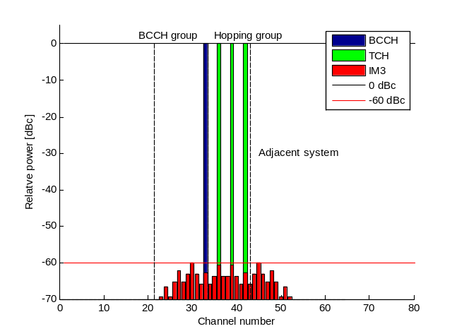 | 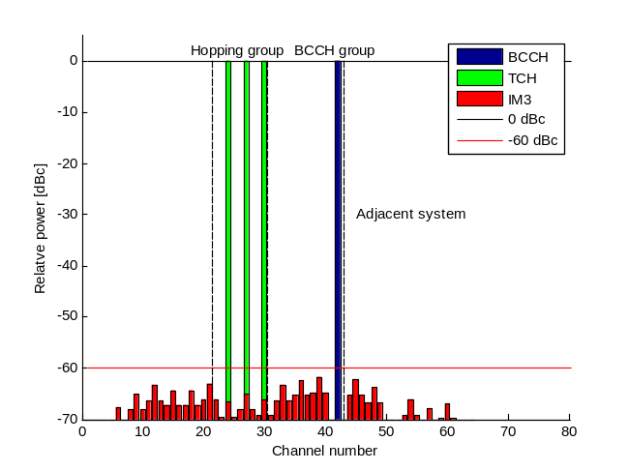
Figure A3.3a: TCH hopping group close to adjacent system and BCCH closest to hopping group. | Figure A3.3b: BCCH group at block edge and BCCH closest to band edge.
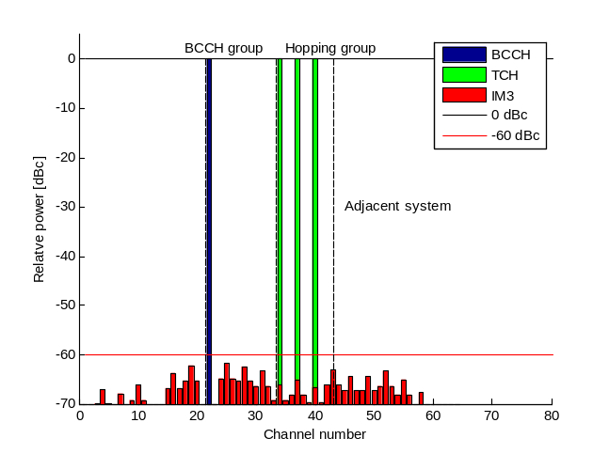 | 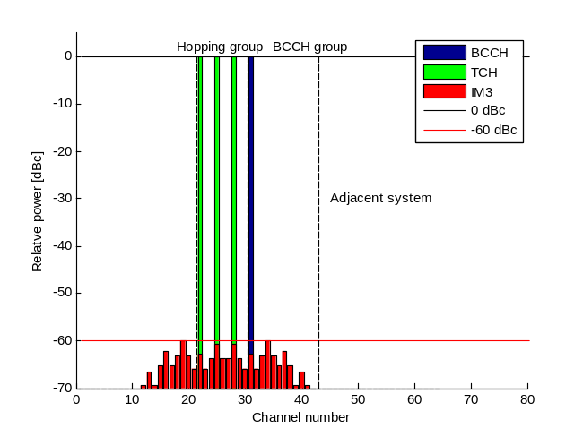
Figure A3.3c: TCH hopping group close to band edge and BCCH furthest away from TCH group | Figure A3.3d: BCCH group at block edge and BCCH furthest away from band edge in that group.
Figure A3.3a-A3.3d: Allocation of BCCH and TCHs in the frequency band adjacent to another system
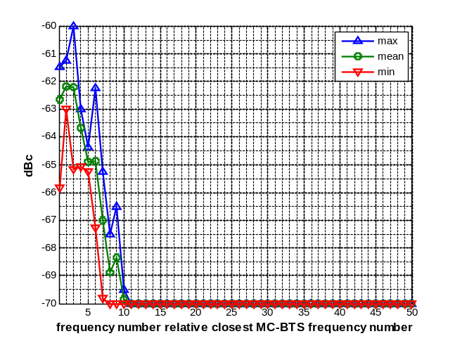 | 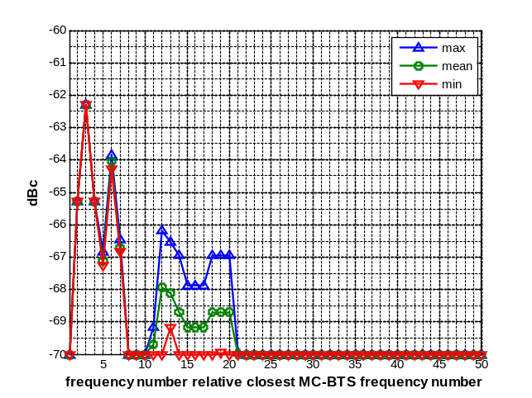
Figure A3.4a: TCH hopping group close to adjacent system and BCCH closest to hopping group. | Figure A3.4b: BCCH group at block edge and BCCH closest to band edge.
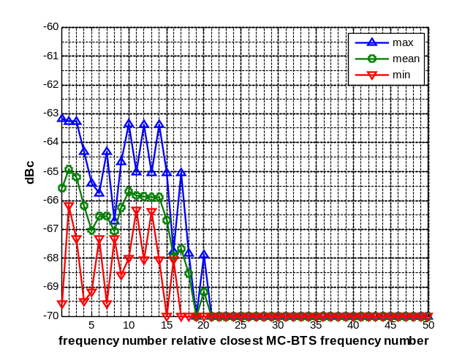 | 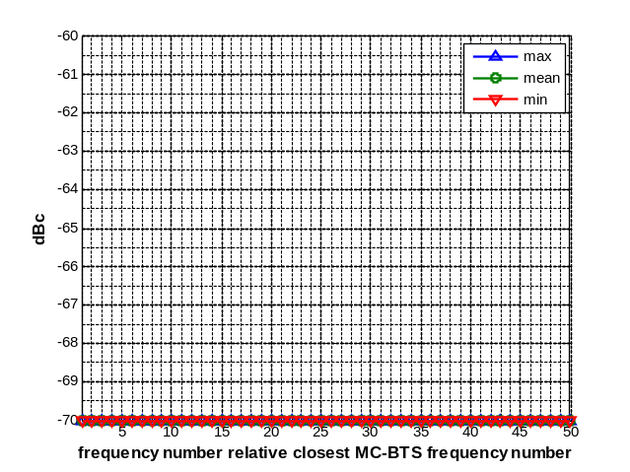
Figure A3.4c: TCH hopping group close to band edge and BCCH furthest away from TCH group | Figure A3.4d: BCCH group at block edge and BCCH furthest away from band edge in that group.
Figure A3.4a-A3.4d: Maximum and Equivalent emitted noise levels relative -70 dBc for the allocations in figure A3.3a-A3.3d
Max represents the maximum IM amplitude during the hopping sequence, min is the minimum (although assumed to be at least -70 dBc) and mean represents the value that corresponds to the actual impact on the specific GSM channel. The actual impact has been calculated by link level simulations, see Annex 3.6.
It should be noted that the case 3a describes the carrier allocation corresponding to the intermodulation requirements in [9].
From Figure A3.4 it is clear that the character of the interference from IM3 products depends on the allocation of the BCCH frequency.
To estimate the impact from this GSM MCBTS independently on frequency planning strategy or frequency-hopping an envelope curve can be designed which would cover any configuration (including non-hopping case), see Figure A3.5. In summary, the equivalent interference level (“mean” in the figures, can be used for co-existence analysis with other GSM networks, whereas the envelope can be used for co-existence with systems in general.

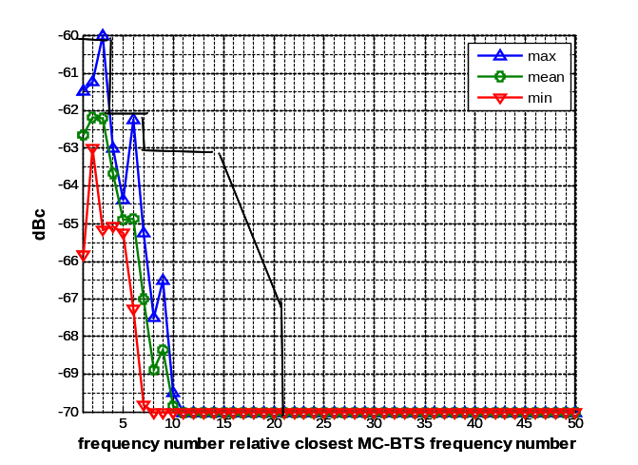 | 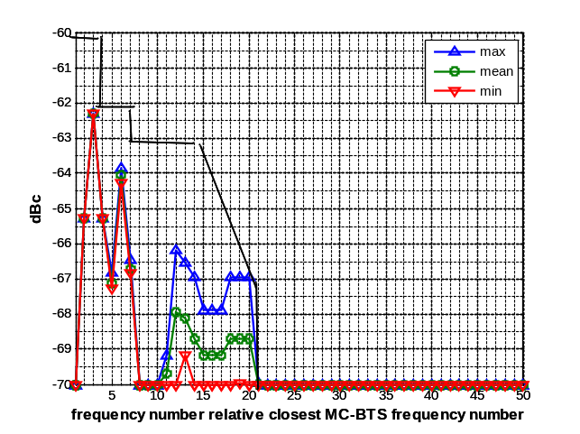
Figure A3.5a: TCH group close to band edge,  BCCH close to TCH group | Figure A3.5b: BCCH group close to band edge,  BCCH close to TCH group
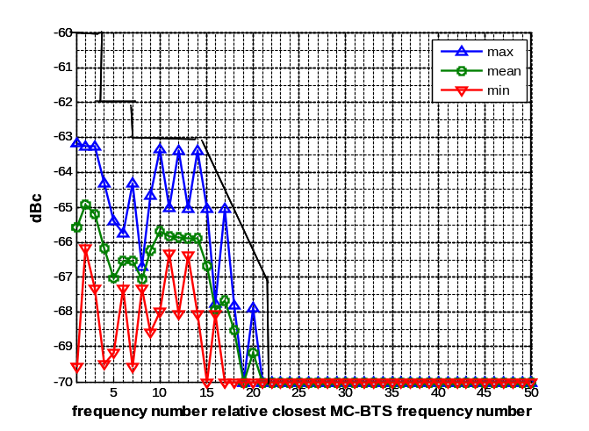 | 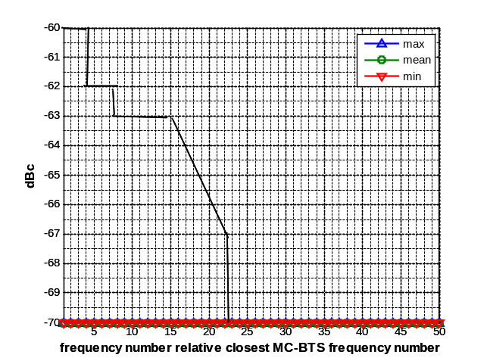
Figure A3.5c: TCH group close to band edge,  BCCH distant from TCH group | Figure A3.5d: BCCH group close to band edge,  BCCH distant from TCH group
Figure A3.5a-A3.5d: Creating a mask for Maximum emitted noise levels relative -70 dBc for the allocations in figure A3.3a-A3.3d
In addition the effect of power control was investigated. Applying a fairly restrictive degree of power reduction on the example configuration used in Figure A3.6a-A3.6d, we can see that the IM products diminish just above -70 dBc, see Figure A3.6. It is proposed to use a constant level of -66 dBc for this scenario. With power control applied, the IM levels for class 1 will also decrease significantly, although not shown.
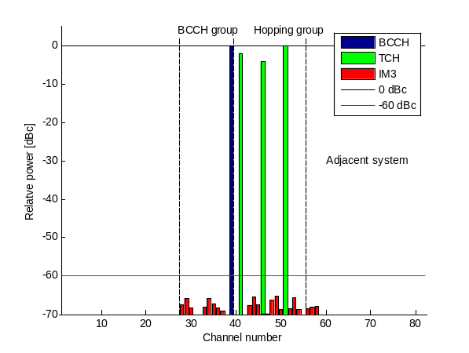 | 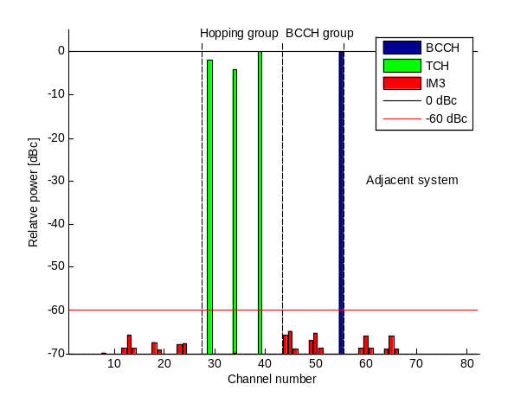
Figure A3.6a: TCH hopping group close to adjacent system and BCCH closest to hopping group | Figure A3.6b: BCCH group at block edge and BCCH closest to band edge
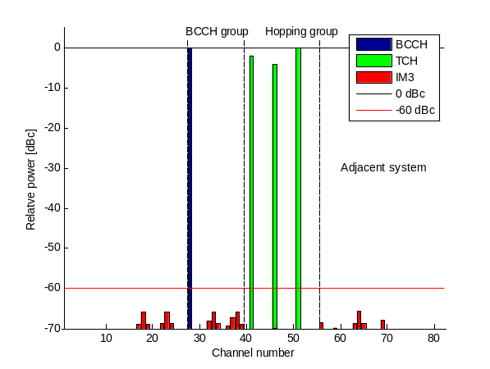 | 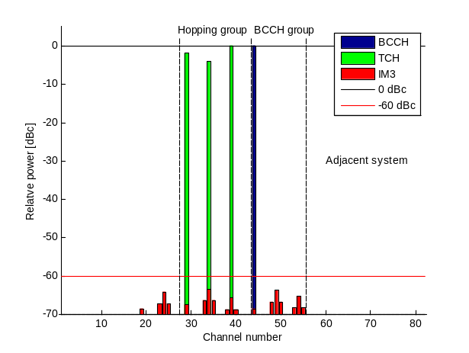
Figure A3.6c: TCH hopping group close to band edge and BCCH furthest away from TCH group | Figure A3.6d: BCCH group at block edge and BCCH furthest away from band edge
Figure A3.6a-A3.6d: Frequency allocations according figure A3.3a-A3.3d with power control applied. Power control is 0 dBc, -2 dBc, and -4 dBc for the 3-TCHs
It can be noted that locating the BCCH far away from the band edge and usage of power control will significantly reduce the impact of interference.

Summary
Based on the results above, a possible model is to use -35 dBm per 30 kHz (calculated from a carrier with 43 dBm per 200 kHz and with a -70 dBc intermodulation requirement) for MCBTS class 1, and for MCBTS class 2 the equivalent interference level, for co-existence with other GSM systems, is -2 dB to -3 dB below the maximum level in the figures. Another curve, the “envelope” of Figure A3.5, is suggested for co-existence with other systems. Power control will reduce unwanted emissions further, -66 dBc (-32 dBm per 30 kHz) is suggested for class 2 MCBTS. The different contributions are illustrated in Figure A3.7.
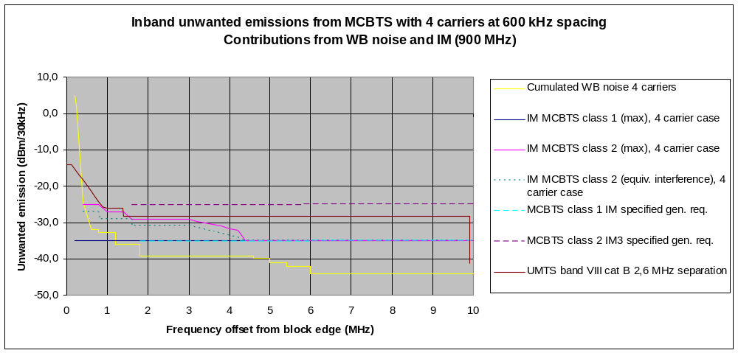
Figure A3.7. Unwanted emission- contributions from IM and Wideband noise
Aggregating the IM and Wideband noise contributions for the 4 carrier case according to [9], the following spectrum masks are achieved (“max” here refers to the envelope as discussed above):
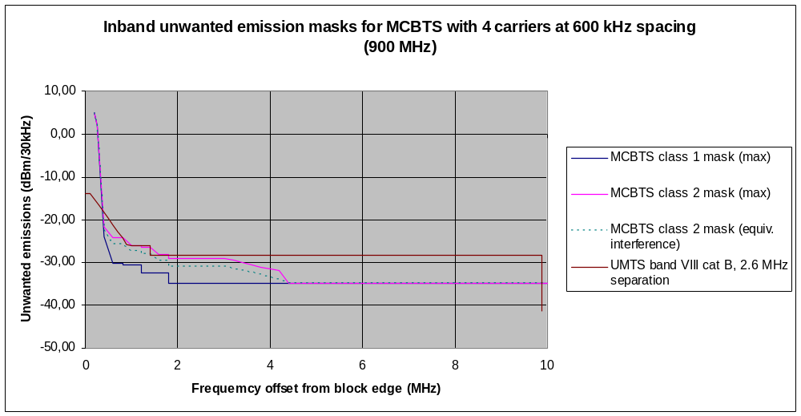
Figure A3.8: Spectrum mask for max interference levels (class 1 and 2) and equivalent noise level to evaluate the effect of IM3 for MCBTS class 2
One should also note that using -70 dBc as an approximation for all IM products for class 1 exaggerates the impact of IM for both classes. Basically the products will reduce with some slope for class 1 as well. The impact will be even lower when power control is applied, since power control will of course have a positive effect on class 1 as well.
Although the discussion above is based on GSM 900, the same requirements and masks apply to DCS 1800.

A3.4 Incorporating spurious emissions
On top of the modulation and wide band noise and IM products discussed above, spurious emissions must also be incorporated. The requirements can then be summarized for the 4 carrier case in the following spectrum graph, Figure A3.9, also including the applicable UTRA mask. The centre frequency of the outermost GSM carrier is located 200 kHz from band edge and the centre frequency of the UMTS carrier is located 2.5 MHz from the band edge.
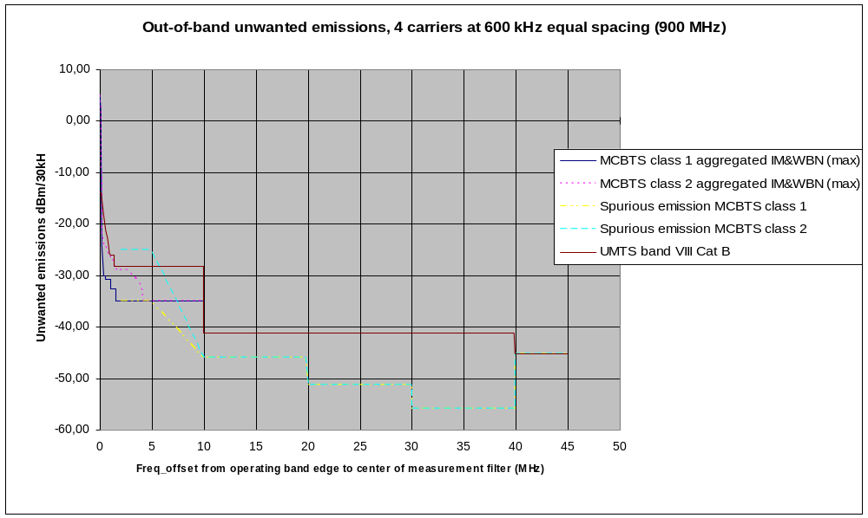
Figure A3.9: Spectrum requirements GSM 900 MHz band
Correspondingly for DCS 1800:
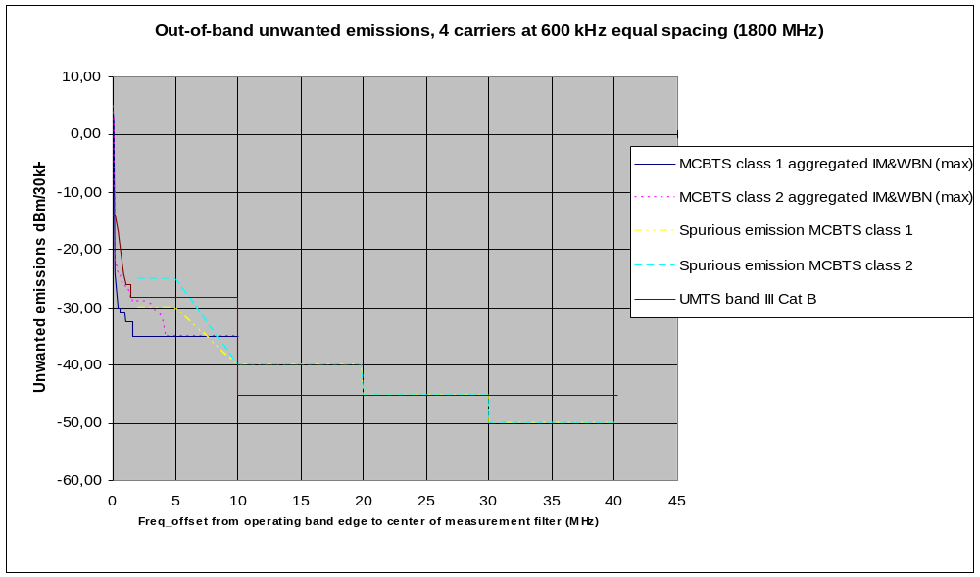
Figure A3.10: Spectrum requirements DCS 1800 MHz band
The MCBTS emissions shall, for offsets less than 2 MHz, not exceed the requirements for inband in section A3.3 for corresponding frequency offsets up to 2.2 MHz (dark blue line for MCBTS class 1 and dotted red line for class 2 in Figures A3.9 and A3.10). Above 2 MHz offset the most stringent requirements for the maximum emission of the spurious emission mask and the inband unwanted emission mask for respective MCBTS class between 2.2 MHz and 10.2 MHz frequency offset (see Annex 1, Table A1.4).
For the frequency offset 0 to 10 MHz the unwanted emission mask for out-of-band can be simplified according to the following graphs:

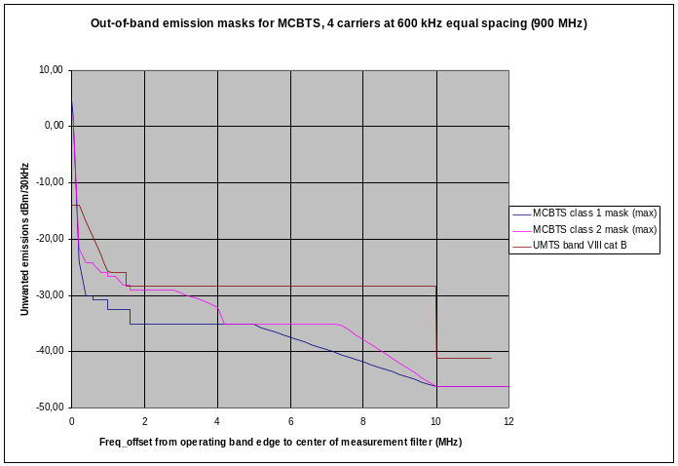 | 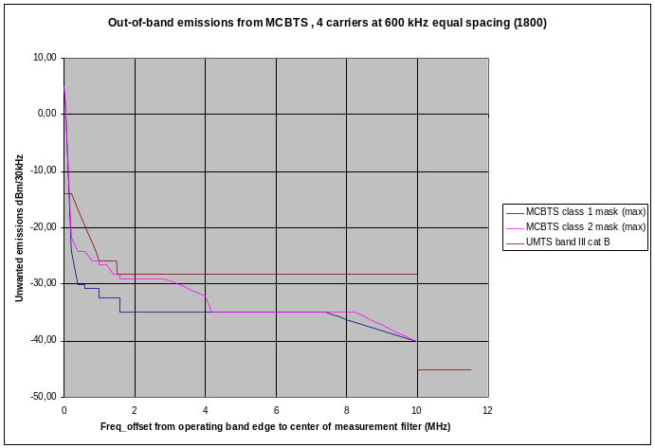
Figure A3.11: Spectrum masks for GSM 900 MCBTS class 1 and 2 and UMTS900, and
DCS 1800 MCBTS class 1 and 2 and UMTS1800 respectively
However, it should be noted that the values presented in these graph assumes the maximum emission at any time without taking into account frequency occurrence or variation in power level as discussed in section 3.1. This assumption is not applicable to any deployed GSM system. In fact, the out-of-band spurious emissions are dominated by intermodulation products, defined for up to 10 MHz offset. For offsets up 5 MHz the method described in section 3.2 can be applied (the equivalent noise level to evaluate the effect of IM3 for MCBTS class 2 is indicated as the teal blue dotted line in Figure A3.8). Between 5 and 10 MHz offset the allowed maximum emission is additionally limited by the spurious emission curves. Beyond 10 MHz Class 1 and Class 2 MCBTS have equal requirements.

A3.5 Scenario considerations
MCBTS is only defined for macro cell scenarios with possibility to adjust maximum power in steps according to existing standard.

A3.6 Link level simulations
This IM3 interference sequence was used as input to an interference model in a GSM link level simulator, where CS speech frames (AFS5.90) are sent over a non-hopping fading channel (TU50), with an AWGN interferer. The interfering noise was assumed to represent the -70 dBc level, which is the limit for all orders of intermodulation for MC-BTS class 2, except the third order. This represents a pessimistic and a deliberately quite unrealistic situation where all interference received by the MS in the victim GSM system comes from the aggressor system. In a real situation there would be internal interference originating from the victim network itself, which would mask the external interference contribution to some degree.

The power of the interferer was scaled according to the input IM3 sequence. With no IM3 product, the original -70 dBc interferer level was used, but with an IM3 present this level would be scaled with a maximum 10 dB, representing the -60 dBc level.

Some results can be seen below in Figure A3.12. The green line represents the original interferer at -70 dBc and the blue line a situation where GSM-R bursts are constantly being interfered by -60 dBc third-order modulation. Note the 10 dB separation in C/I. Any IM3 distribution will show up somewhere between these lines. The red and black lines line represent the scenario described in Figure 3a and 3b, respectively, with 6 TRXs in total on 39 frequencies and cyclic hopping. When reading at the 1% FER level, it can be concluded that an equivalent noise emission level for this scenario would be somewhat higher than the original noise level of -70 dBc, e.g. for 16th channel (BCCH group close) it is 2.4 dB higher i.e. -67.6 dBc.
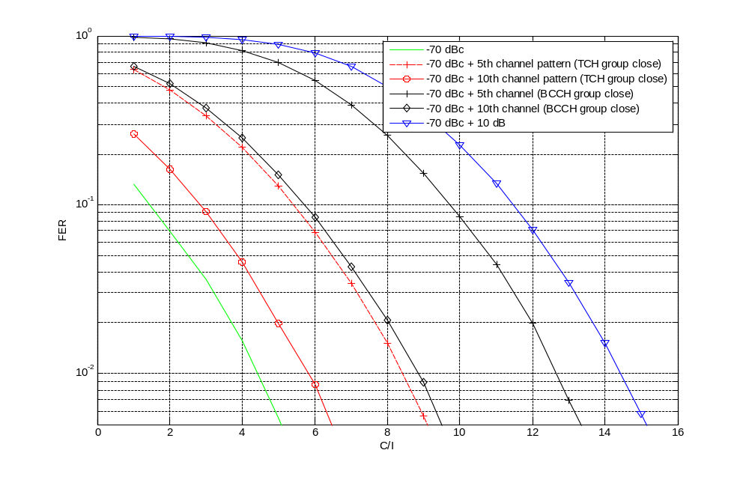
Figure A3.12: AFS5.90 FER as a function of C/I, comparing the original -70 dBc noise level to noise with IM3 exceptions for MCBTS class 2 at channel nr 5 and 16 in figure 3
This analysis was performed for a number of channels. Comparing the results with the mean value of the IM3 power for each channel, it was found that the equivalent noise level closely follows the mean value (within 1 dB approximately) and never exceeds this value. Thus the conclusion is that mean IM3 power could be used as measure of interference impact.

References for Annex 3
- GP-081126 “Investigations of GSM-R impact from BTS IM relaxations”, TSG GERAN meeting #39.
- GP-081241 “Impact on system performance from relaxation of intermodulation attenuation for multicarrier transmitters, version 5 “, TSG GERAN meeting #39.
Annex 4: TRR characteristics
Technical parameters

Parameter |  |  | TRR
Channel Spacing |  | kHz | 750
Cell Radius – Urban |  | km | 30-70
Transmit Power |  | dBm | 37
Receiver Bandwidth |  | kHz | 1500
Antenna Height |  | m | 25
Antenna Gain |  | dBi | 16 (bore sight)
Receiver Sensitivity |  | dBm | -93
Receiver Protection Ratio |  | dB | 15
Power Control Characteristics | Step | dBm | N/A
Power Control Characteristics | Minimum | dBm | N/A
Power Control Characteristics | Dynamic range | dBm | N/A
Power Control Characteristics | Threshold | dBm | N/A
Table A4.1: Technical parameters

TRR Antenna Pattern

Angle | dB Gain relative to bore sight
0 | 0
10 | -3
18 | -10
24 | -15
30 | -30
36 | -12
48 | -14
60 | -20
84 | -24
90 | -26
136 | -40
168 | -32
180 | -40
192 | -26
224 | -24
270 | -20
276 | -14
300 | -12
312 | -12
324 | -30
336 | -15
342 | -10
350 | -3
360 | 0
Table A4.2: TRR antenna pattern
Unwanted Emissions
Frequency Offset |  |  | TRR
 |  |  | STANAG 4212 | EUROCOM
0 | MHz | dBc | 0 | 0
0.025 | MHz | dBc
0.05 | MHz | dBc |  | -0.8
0.075 | MHz | dBc
0.1 | MHz | dBc |  | -2.5
0.15 | MHz | dBc |  | -2.5
0.2 | MHz | dBc |  | -4.2
0.25 | MHz | dBc |  | -6.7
0.3 | MHz | dBc |  | -10
0.35 | MHz | dBc |  | -16.7
0.375 | MHz | dBc | 0
0.4 | MHz | dBc |  | -25.8
0.45 | MHz | dBc |  | -20.8
0.5 | MHz | dBc |  | -20
0.55 | MHz | dBc |  | -23.3
0.6 | MHz | dBc |  | -29.2
0.65 | MHz | dBc |  | -38.3
0.7 | MHz | dBc |  | -40.8
0.75 | MHz | dBc |  | -40.8
0.8 | MHz | dBc |  | -42.9
0.85 | MHz | dBc |  | -46.7
0.9 | MHz | dBc |  | -50
0.95 | MHz | dBc |  | -46.7
1 | MHz | dBc |  | -45.4
1.05 | MHz | dBc |  | -47.5
1.1 | MHz | dBc |  | -54.2
1.15 | MHz | dBc |  | -60
1.2 | MHz | dBc |  | -61.7
1.25 | MHz | dBc |  | -62.5
1.3 | MHz | dBc |  | -64.2
1.35 | MHz | dBc |  | -66.7
1.4 | MHz | dBc |  | -68.3
1.425 | MHz | dBc |  | -70
1.5 | MHz | dBc | -80
1.7 | MHz | dBc
1.8 | MHz | dBc
2 | MHz | dBc |  | -70
2.9 | MHz | dBc
3 | MHz | dBc
4 | MHz | dBc |  | -71.6
5.9 | MHz | dBc
6 | MHz | dBc |  | -74
8 | MHz | dBc |  | -77.5
10 | MHz | dBc | -80 | -80
Table A4.3: TRR unwanted emissions

Receiver Blocking Characteristics

Frequency Offset |  |  | TRR
 |  |  | STANAG 4212 | EUROCOM
0.01 | MHz | dBc |  | 0
0.06 | MHz | dBc |  | 0.2
0.1 | MHz | dBc
0.12 | MHz | dBc |  | 0.7
0.18 | MHz | dBc |  | 1.6
0.24 | MHz | dBc |  | 2.9
0.36 | MHz | dBc |  | 6.5
0.48 | MHz | dBc |  | 11.7
0.6 | MHz | dBc |  | 18.2
0.72 | MHz | dBc |  | 26.2
0.75 | MHz | dBc | 0
0.799 | MHz | dBc
0.8 | MHz | dBc
0.84 | MHz | dBc |  | 35.7
0.96 | MHz | dBc |  | 46.7
1.28 | MHz | dBc |  | 60
1.5 | MHz | dBc |  | 70
1.599 | MHz | dBc
1.6 | MHz | dBc
2 | MHz | dBc | 65 | 70
2.999 | MHz | dBc
3 | MHz | dBc
4 | MHz | dBc |  | 71.6
5 | MHz | dBc | 85
6 | MHz | dBc |  | 74
8 | MHz | dBc |  | 77.5
10 | MHz | dBc | 110 | 80
88 | MHz | dBc | 110
Table A4.3: TRR receiver blocking characteristics

Annex 5: RSBN/PRMG characteristics
RSBN is an ARNS system that provides information for approach and en-route navigation similar to VOR, DME and TACAN. RSBN consists of ground-based beacon signal transmitters and receivers in the aircraft to determine the azimuth and distance from the airport. PRMG is an ARNS system that provides information for landing purposes similar to ILS.
RSBN and PRMG are still in use in some European countries.

For the purpose of this Report, the RSBN/PRMG frequencies which overlap the frequency band 915 - 960 MHz are relevant.

Channel | PRMG azimuth  RSBN course | RSBN distance  PRMG distance  PRMG glide path
no | MHz | MHz
1 | 905.1 | 939.6
2 | 905.8 | 940.3
3 | 906.5 | 941.0
4 | 907.2 | 941.7
5 | 907.9 | 942.4
6 | 908.6 | 943.1
7 | 909.3 | 943.8
8 | 910.0 | 944.5
9 | 910.7 | 945.2
10 | 911.4 | 945.9
11 | 912.1 | 946.6
12 | 912.8 | 947.3
13 | 913.5 | 948.0
14 | 914.2 | 948.7
15 | 914.9 | 949.4
16 | 915.6 | 950.1
17 | 916.3 | 950.8
18 | 917.0 | 951.5
19 | 917.7 | 952.2
20 | 918.4 | 952.9
21 | 919.1 | 953.6
22 | 919.8 | 954.3
23 | 920.5 | 955.0
24 | 921.2 | 955.7
25 | 921.9 | 956.4
26 | 922.6 | 957.1
27 | 923.3 | 957.8
28 | 924.0 | 958.5
29 | 924.7 | 959.2
30 | 925.4 | 959.9
31 | 926.1 | 960.6
32 | 926.8 | 961.3
33 | 927.5 | 962.0
34 | 928.2 | 962.7
35 | 928.9 | 963.4
36 | 929.6 | 964.1
37 | 930.3 | 964.8
38 | 931.0 | 965.5
39 | 931.7 | 966.2
40 | 932.4 | 966.9
Table A5.1: RSBN/PRMG frequencies

Technical and operational characteristics of the RSBN/PRMG transmitting stations in the band 915-935 MHz:

 | PRMG Course  channel | RSBN  Azimuth channel | RSBN  Azimuth Reference  channel
Class of station | AL | AL | AL
Nature of service | RD | RT | RC
City of TX station | Airport | Airport | Airport
RX radius | 50 km | 400 km | 400 km
Class of emission | 700KP2D | 700KN0D | 700KP3D
ERP | 9 dBW | 19 dBW | 44.8 dBW
Antenna direction | 120/300 | rotating | ND
Antenna height | 10 m | 10 m | 10 m
Table A5.2: RSBN/PRMG characteristics
Alternative technical and operational characteristics, as provided by one administration, of the RSBN/PRMG transmitting stations operating in the frequency band 915 - 935 MHz are presented in the Table A5.2bis below.

 | PRMG | RSBN
Station class | AL | AL
Service type | RD | RT
Deployment at the terrestrial transmitter | Airport | Airport
Terrestrial transmitting station range | up to 45 km | up to 400 km
Emission class | 700KРХХ | 700KРХХ
Airborne receiver passband | 1,5 MHz | 1,5 MHz
EIRP | 40 dBW | 51 dBW
Antenna direction | directional AG =10 dB | directional, AG =6 dB
Antenna height | 10 m | 10 m
Airborne receiver actual sensitivity, dBW | -120 | -110…-120
Table A5.2bis: RSBN/PRMG characteristics

The wanted carrier to interference signal ratios of the RSBN/PRMG receivers [4]:

 | PRMG azimuth | RSBN distance | RSBN course | PRMG glide path | PRMG distance
C/I (dB) | 7 | -17 | 17 | 20 | -17
Table A5.3: Carrier to interference signal ratios of the RSBN/PRMG receivers

These values are based on the measurements when processing of the wanted signal of the RSBN/PRMG compared to the interfering GSM signal on the same carrier frequency.

RSBN/PRMG receiver filter characteristics [4]:

Freq offset (kHz) | PRMG azimuth | RSBN distance | RSBN course | PRMG glide path | PRMG distance
 | (dB) | (dB) | (dB) | (dB) | (dB)
0 | 0 | 0 | 0 | 0 | 0
100 | -5 | -3 | -3 | -3 | -3
200 | -9 | -6 | -5 | -5 | -6
300 | -29 | -8 | -6 | -12 | -8
400 | -33 | -20 | -7 | -15 | -20
500 | -37 | -21 | -9 | -35 | -21
600 | -43 | -23 | -13 | -40 | -23
700 | -49 | -30 | -23 | -40 | -30
800 | -57 | -33 | -33 | -42 | -33
900 | -64 | -33 | -43 | -42 | -33
1000 | -64 | -33 | -45 | -42 | -33
1300 | -64 | -33 | -49 | -42 | -33
2000 | -64 | -33 | -55 | -46 | -33
Table A5.4: RSBN/PRMG receiver filter characteristics

These values are estimated from the curves representing protection ratio as a function of the frequency offset.

The receivers are at the aircraft. In earlier studies [5], an altitude of 2000 meters has been used.

ARNS antenna characteristics
The information in the following Fig. 15(a).a is extracted from Recommendation ITU-R M.1642 and provides the antenna gain for different elevation angles. For intermediate elevation angles (between two defined values), a linear interpolation should be used. The G_{r, max} value is 5.4 dBi as specified in Recommendation ITU-R M.1639. It is assumed that the elevation and gain pattern is the same for all azimuth angles.
The relevant range of elevation angles for the study to be conducted is: -90°…0°, as shown in Figure A5.1.

 | Extract from Rec.  ITU-R M.1642 | Elevation angle definition
Elevation angle  (degrees) | Antenna gain  G_{r}/G_{r, max}  (dB) | 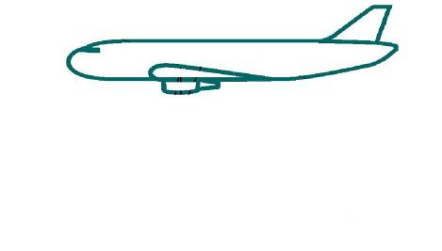  0°  -90°
–90 | –17.22
–80 | –14.04
–70 | –10.51
–60 | –8.84
–50 | –5.4
–40 | –3.13
–30 | –0.57
–20 | –1.08
–10 | 0
–5 | –1.21
–3 | –1.71
–2 | –1.95
–1 | –2.19
0 | –2.43
Figure A5.1: ARNS antenna gain for elevation angles between 0°…-90°

Annex 6: HC-SDMA characteristics
HC-SDMA is a terrestrial broadband wireless access system, whose technical characteristics are given in ITU-R Report M.2116 “Characteristics of broadband wireless access systems operating in the land mobile service for use in sharing studies” to be used for sharing studies. The system is also known as iBurst™.

For the purpose of this Report, the following parameters are used:

Parameter | Base station (BS) | Terminal station (TS)
Frequency band (MHz) | 1787.5-1802.5
Channel bandwidth (MHz) | 5
Reuse factor | 1:1
Nominal channel BW (MHz) | 0.625
Duplex method | TDD
Access technique | TDMA/FDMA/SDMA
Modulation type | BPSK, QPSK, 8-PSK, 12-QAM, 16-QAM, 24-QAM | BPSK, QPSK,  8-PSK, 12-QAM,  16-QAM
Antenna
Antenna gain (dBi) | 15 | 0
Antenna height (AGL) (m) | 15…45 | 1.5
№ of sectors | 3 | N/A
Antennas per sector | 12 | 1
Radiation pattern | Adaptive antennas system | Omni
Co-located antenna minimum coupling  loss (dB) | 30 | N/A
Receiver
Nominal reference sensitivity (dBm) | –109.8 | –108.5
Noise figure (dB) | 5 | 7
Thermal noise density (dBm/Hz) | -174
Adjacent channel selectivity 1 (ACS_1) (dB) | 46 | 47
Adjacent channel selectivity 2  (ACS_2) (dB) | 46 | 60
Required SINR (dB) | 1…17 | 0…14
Transmitter
Average power (dBm) | 24.2 | 20
Adjacent Channel Leakage Ratio (ACLR) 1 (dB) | 53,5 | 45
Adjacent Channel Leakage Ratio (ACLR) 2 (dB) | 66 | 50
TDD activity factor (dB) | -1.76 | -4.77
Misc. losses (dB) | 1 | 0
Table A6.1: HC-SDMA characteristics
Annex 7: Coexistence between macro MCBTS and DECT (1880 – 1900 MHz)

Introduction

This Report studies the coexistence between MCBTS and DECT operating in the band 1880 - 1900 MHz. A comprehensive study on compatibility between DECT and GSM 1800 already exists [13]. The present study is based on the results of [13], taking into account the parameter deviations between GSM 1800 and MCBTS specifications.

Conclusions from earlier study [13]

Below is the Executive summary and Table 1 Interference scenarios of [13]:
--------------------------------------------------------
EXECUTIVE SUMMARY from [13]

1.1 This Report details the findings of the SE7 Project Team study into the compatibility issues between DECT and GSM 1800. This Report supersedes all earlier JPT reports relating to DECT/GSM 1800.
1.2 Several interference scenarios were analysed to identify the scenarios that exhibited significant interference ranges. Compared to earlier reports DECT WLL and GSM 1800 indoor BTS scenarios have been added

Two main interference mechanisms were identified:
(i) Interference of DECT from GSM 1800 base station carrier power (blocking)
- Interference of GSM mobile stations by DECT out of band emissions

For the WLL scenarios one more interference mechanisms was identified:
(iii) Interference of DECT from GSM 1800 base stations out-of-band emissions

1.3 The means for reducing the compatibility problems are given in detail below. Error correction and the possible escape mechanisms (dynamic channel selection, power control, hand-over algorithms) for both systems to avoid local interference problems and the consequent reduction in capacity are also considered in the discussions leading the recommendations.

1.4 The important scenarios are when DECT and GSM operate in the same local environment. Important scenarios for the recommendations are when a GSM 1800 MS operates in the same indoor environment as a DECT indoor system, and when above rooftop DECT WLL systems and GSM macro cell systems operate in the same local outdoor environment.

From studying the critical scenarios it is observed and / or recommended that:

1.4.1 A guard band is not required, but specific restrictions should apply locally to the GSM sub-band 1878 - 1880 MHz. See Section 7.

    - Co-ordinated site engineering and system planning will be required to minimise interference from above roof -top GSM BTSs to DECT WLL systems.

1.4.3 DECT WLL applications would suffer less potential risk of range reduction due to GSM interference if installed DECT WLL equipment has improved blocking performance above minimum specification.

1.4.4 ETSI Project DECT should make sure that the provisions for DECT to detect interference from a single GSM bearer are properly defined.
----------------------------------------------------------------

1.3 Interference scenarios from [13]
Since GSM is an FDD system, DECT is a TDD system, the GSM BTS transmit band is adjacent to the DECT band and the GSM mobile transmit band is distant from the DECT band, it is seen that:
- GSM BTSs are the main interferers to DECT RFP, PP and CTA victims.
- GSM MSs are the main victims for interference from DECT RFP, PP and CTA interferers.

See the table below for a simplified overview of relevant interference scenarios.
GSM1800  DECT (Interferer and victim) | Above roof-top macro BTS  (Interferer) | Below roof-top micro BTS  (Interferer) | Indoor micro BTS  (Interferer) | - Outdoor MS  (victim) | Indoor MS  (victim)
Indoor system (Residential and office applications) | Case 1 |  | Case 8 |  | Case 2
Below roof-top outdoor system  (CTM and outdoor extension of indoor systems) | Cases 3 & 4 |  |  | Case 5
Above roof-top  WLL system | Cases 6 & 7
Table A7.1
Some scenarios are not very likely to occur, and only some are critical. Cases 1 and 3 are the most common cases and cases 6 and 7 are the most critical. Cases with “Below roof-top micro BTS (Interferer)” are in this study not treated as separate cases, but are discussed as cases with low power version macro BTSs.
-----------------------------------------------------------------

- Assumptions for the present study
The present study is made with the following limitations/assumptions:
- Only interference to DECT is considered. The reason is that interference from DECT to MCBTS is not critical [8], since the MCBTS receive band is separated from the DECT band by >95 MHz. Furthermore, there are no changes to the MCBTS receiver specification relative to SCBTS for the 1800 MHz band.
- Only DECT indoor residential and enterprise DECT systems are considered. Those represent the overwhelming majority of DECT installations. The service areas of DECT residential and enterprise systems sometimes include outdoor areas, however, since the main service area is typically indoors, it is justified to limit this study to indoor areas. WLL is not considered here for two reasons: Europe has very few DECT WLL installations, and site engineering and special planning will anyhow be required.
- Only interference from macro-cell (outdoor) MCBTS is considered because only the macro-cell version has been specified. Case 1 of Table 1.
- DECT will be able to properly detect GSM interference on closest DECT carriers F9-F7 and escape to more distant carriers F6-F0 (see below for more information) See [15] clause 11.4.5, “Handover criteria due to Interference”, for proper implementation.
- In c the DECT specified receiver sensitivity of -83 dBm is used. In more recent studies -93 dBm has been used [6], [14]. Both these sensitivity levels are considered.
With these limitations we see from Table 1 from [13] above, that only Case 1 remains to be studied.

  - Analysis of Case 1 of Table 1 [13]
In [8] three cases of Case 1 are analysed, Case 1A, 1B and 1C. Case 1A regards line-of-site between the macro BTS and the building floor where the DECT system in installed. The propagation model for Case 1A is free space propagation with 15 dB extra attenuation for wall penetration. Cases 1B and 1C are non-line-of-sight cases with considerably higher propagation loss. Below is part of section 4.4.3 and Table 7 from [13], showing calculations for the critical Case 1A:
------------------------------------------------

4.4.3 GSM1800 above roof-top BTS interferes with a private cordless telephone DECT FP in a neigh-bouring building. Case 1. from [13]
For Case 1 A, see the table below, the DECT building is in the direct beam of the GSM BTS. Cases 1B and 1C apply for the majority of DECT residential and office systems. Case 1 A is more critical than cases 1B and 1C.

GSM 1800 BTS 54 dBm EIRP  on carrier | MSD with MCL | Average MSD with E-MCL | maximum MSD with E-MCL  N = 10 dB | maximum MSD with E-MCL  N = 26 dB | Blocking probability with Monte Carlo
1879.8 MHz | 1000 m | 206 m | 374 m | 50 m | 28 %
1878.4 MHz | 178 m | 36 m | 67 m | 9 m | 3 %
1876.6 MHz | 89 m | 18 m | 33 m | 4.5 m | 1 %
1805 – 1875 MHz | 50 m | 10 m | 19 m | 2.5 m | <1 %
Table A7.2: Blocking probability and separation distances for DECT carrier F9 case 1A
--------------------------------------------------------------

By blocking in Table A7.2 is meant that the interference comes from the main power of the GSM BTS carrier operating on the skirts of the combined RF- and IF-filters of the DECT receiver.

Table A7.2 shows different required minimum separation distances, MSD, between the GSM BTS and a DECT receiver operating on the DECT carrier F9. (For comparison between the MCL, E-MCL och Monte Carlo methods see [16]).
DECT has ten carriers in the frequency band: 1880 - 1900 MHz:

F9 = 1881.792 MHz, F8 = 1883.520 MHz, ... , F1 = 1895.616 MHz, F0 = 1897.344 MHz

F9 is closest to the 1880 MHz boarder. Table 7 relates to interference of DECT carrier F9. The closest possible GSM carrier position is 1879.8 MHz. The selection of GSM carrier positions 1878,4, 1876,6 and 1875 MHz have been selected so that the results in the last three lines of Table A7.2 can be alternatively interpreted as interference from the closest GSM carrier (1879.8 MHz) into DECT carriers F8, F7 and F6-F0 respectively.

The conclusions from [13] is that it will be impossible to avoid interference to DECT carriers F9-F7, but the probability for interference to carriers F6-F0 will be very low. See the relevant last line of Table A7.2. It is also anticipated in [13] that DECT will be able to properly detect GSM interference on carriers F9-F7 and escape to carriers F6-F0. See [15] clause 11.4.5. With these assumptions [13] concludes that no special guard band is required for Case 1A.

Thus this study will concentrate on the interference to DECT carriers F6-F0. These carriers are positioned >6 MHz from the closest GSM carrier position (1879.8 MHz). Thus the relevant separation distances are given by the last line of Table 7.

The next step is to study to which extent the differences in specification between GSM 1800 and MCBTS will affect the conclusions of [13].

Blocking from MCBTS
The study [13] states that blocking is the main cause for interference form GSM BTS to DECT.
The BTS EIRP in [13] is 54 dBm. In the present study an urban MCBTS with EIRP of 58 dBm (43 dBm + 18 dBi urban antenna – 3 dB feeder loss) has been selected.

This corresponds to 4 dB higher EIRP than the GSM BTS used in [13]. 4 dB higher power corresponds to a factor 1,6 times larger separation distances for Case 1A Table 7. This is not an effect of using a MC BTS instead of a SC BTS, but only a different choice of system parameters.

The DECT blocking specification, Appendix 1 Table 4A of [13], is -33 dBm for carriers F0-F6 for a DECT wanted signal of -80 dBm. With an EIRP of 58 dBm, as selected for this study, the required minimum coupling loss, MCL, becomes 91 dB (58 + 33 dB).

Unwanted emissions from MCBTS
As seen in Annex 1, the unwanted emissions from the reference base station used in this Report (incorporating modulation and wide-band noise, spurious emissions and intermodulation products) for the 1800 MHz range with an offset of 5 MHz (corresponding to F6) beyond the transmit band, are -35 dBm/30 kHz for the reference case used in this Report. This corresponds to -20 dBm per 1 MHz, the DECT receiver bandwidth. Adding 18 dBi for the antenna gain and subtracting 3dB for feeder loss results in -5 dBm/MHz EIRP. With -80 dBm DECT sensitivity level, maximum interference level is -90 dBm. Thus the minimum coupling loss, MCL, for unwanted emissions becomes 85 dB, which is 6 dB less than the 91 dB for blocking.

Conclusion on blocking versus unwanted emissions:
The conclusion is that the unwanted emissions from MCBTS into carriers F0-F6 will not dominate over interference due to blocking. The margin is 6 dB.

The interference due to blocking is furthermore independent of whether SC or MC BTSs are used, since they only depend on the carrier power, which is the same for the two types of equipment.

Examining to DECT sensitivity parameters used in [13]
In [13] a –80 dBm wanted signal level and a related interference level of -90 dBm (Gaussian channel) has been used for DECT. This directly relates to the specified DECT sensitivity -83 dBm, since MCL calculations use a wanted signal 3 dB above the specified sensitivity. In more recent documents a DECT sensitivity of -93 dBm has been used (see [6] Table 4-2, and [14] section 5.6.3 the last paragraph). The reason is that this reflects typical sensitivity of today’s DECT systems, and because the big residential market consists of single cell systems, where the range directly is related to the interference levels, opposite to multi-cell enterprise systems where reduced cell range due to interference can be compensated by using more and smaller cells.

The question is thus if a change from -90 to -100 dBm for the maximum allowed interference level will change the conclusion for Case 1 from [13], that no guard band is required.

Decreasing maximum allowed interference level by 10 dB will increase the worst case minimum separation distance (by a factor 3,16) from 50 to 158 m for a 54 dBm GSM BTS, see Table 7 above and the table below.

Discussion on the EIRP of the GSM BTS and the sensitivity of DECT
Note that for this part of the analysis it makes no difference whether SC or MC base stations are considered, since the interference is caused by the carrier power. In the table below the last row of table 7 of [13] has been used to produce similar rows for combinations of GSM BTS EIRP values 54 and 58 dB and DECT wanted signal levels of -80 and -90 dBm. It is very simple to produce the new rows, since, for Case 1A, 10 dB change in link budget corresponds to a factor 3,16 (square root of 10) in distance. (2, 3, 4 and 6 dB corresponds to factors 1,26, 1,41, 1,6 and 2.) The MC blocking probability figures are taken from table 7 for rows with similar MSD:s.

Mechanism | BTS EIRP [dBm] /DECT wanted signal [dBm] | MSD with MCL | Average MSD with E-MCL | maximum MSD with E-MCL  N = 10 dB | maximum MSD with E-MCL  N = 26 dB | Blocking probability with Monte Carlo
Blocking 1 | 54/-80 [8] | 50 m | 10 m | 19 m | 2,5 m | <1 %
Blocking 2 | 58/-80 | 80 m | 16 m | 30 m | 4 m | 1 %
Blocking 3 | 54/-90 | 158 m | 32 m | 60 m | 8 m | 3 %
Blocking 4 | 58/-90 | 253 m | 51m | 95 m | 13 m | 5-6 %
Table A7.3. Minimum separation distances for interference due to blocking and OOB from MCBTS on carrier 1879.8 MHz to DECT on carriers F6-F0. Case 1A

None of the above cases, Blocking 1-4, is critical regarding the Monte Carlo blocking probability level. 5% is in study [6] regarded as the limit. This applies to Blocking 4, with maximum EIRP and maximum DECT sensitivity. 5% must however in the DECT case be regarded as too high if it would relate to the whole population of DECT systems. However the DECT connections related to the most critical Case 1A (in line-of-sight of a GSM BTS) is only a fraction of all DECT connections. Furthermore, in an urban area, not all MCBTS:s will use 58 dB EIRP. Smaller cells will use lower power. If we study the required separation distances, the column E-MCL N=10 dB is probably the most relevant column. From the above discussions the case Blocking 3 may be typical for an urban line of sight scenario. Very few DECT connections will have a direct line of sight to a GSM BTS within 60 m. Furthermore, the probability is low that DECT will experience less than -80 dBm wanted signal in a flat, which lead us to the cases Blocking 1 (20 m separation) and Blocking 2 (30 m separation).

Our conclusion is that still no guard band is required. This conclusion is supported by the fact that DECT systems for years have had a typical sensitivity of -93 dBm, and that single GSM BTS already are using up to 58 dBm EIRP. It is in this context appropriate to note that future studies and Monte Carlo simulations should use -93 dBm instead of -83 dBm as sensitivity for DECT.

Annex 8: DME characteristics

– Frequency of band of operation: 960 - 1215 MHz
– Receiving frequency (in the simulation): 962, 964, 966, 968 and 970 MHz
– Polarization: linear, vertical
– Maximum DME antenna gain: 5.4 dBi
– Channelization: 1 MHz
– Bandwidth: 1 MHz
– DME station location: the interference is analyzed at the following altitudes:
- 200 m (urban and rural scenarios)
- 1000 m (rural scenario)
- 12 000 m (rural scenario).
– DME Selectivity mask:
- DME 442 Rockwell Collins. The attenuations are:
6 dB at -0.38 MHz/+0.32 MHz (-0.88 MHz/+0.82 MHz from the central frequency)
20 dB at -0.55 MHz/+0.49 MHz (-1.05 MHz/+0.99 MHz from the central frequency)
40 dB at -0.80 MHz/+0.62 MHz (-1.30 MHz/+1.12 MHz from the central frequency)
60 dB at -0.96 MHz/+0.64 MHz (-1.46 MHz/+1.14 MHz from the central frequency)
- KN 62A Honeywell. The attenuations are:
6 dB at -0.15 MHz/+0.34 MHz (-0.65 MHz/+0.84 MHz from the central frequency)
20 dB at -0.26 MHz/+0.48 MHz (-0.76 MHz/+0.98 MHz from the central frequency)
40 dB at -0.29 MHz/+0.49 MHz (-0.79 MHz/+0.99 MHz from the central frequency)
60 dB at -0.30 MHz/+0.50 MHz (-0.80 MHz/+1.00 MHz from the central frequency)
It has to be noted that the values of the selectivity masks have been set to 70 dBc beyond 250% of the bandwidth (+/-2.5 MHz) with a linear interpolation between 60 and 70 dBc.

Historically, DME was designed with a selectivity mask as low as -75 dBc to -80 dBc. However, ICAO requirement are limited to a selectivity of -60 dBc. Therefore, a value of -70 dBc was chosen.

- DME power: The commonly used DME ground station ERP (effective radiated power) are given in the following Figure A8.1.
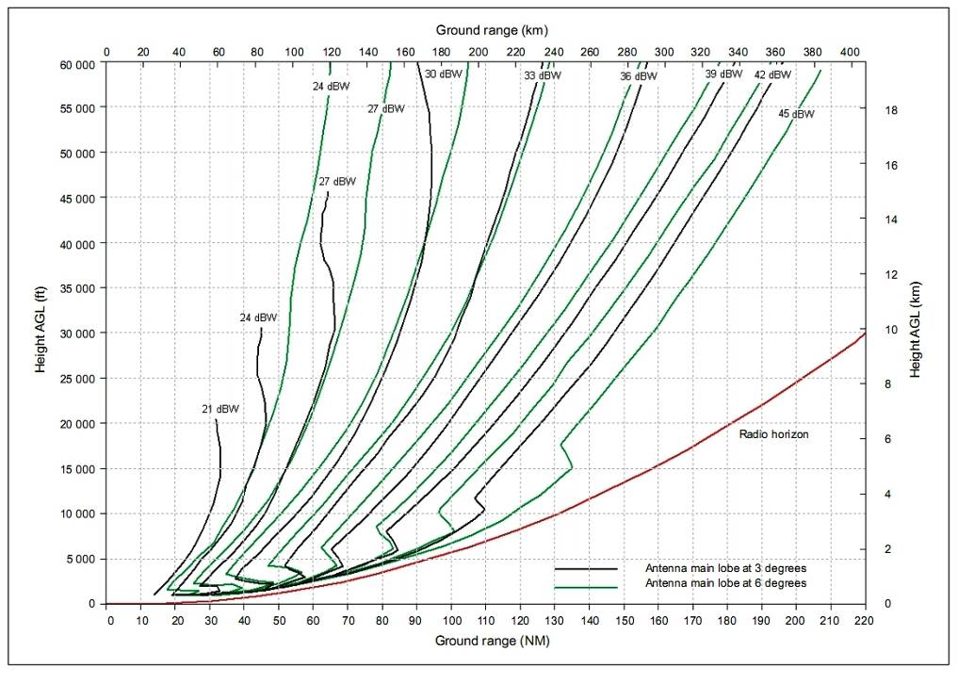
Figure A8.1: Necessary EIRP to achieve a power density of -89 dBW/m² as a function of height above and distance from the DME
This parameter is used to perform C/I calculation in the direction GSM MC → airborne DME in section 4.5.2. .
DME on board antenna characteristics

The information in the following figure A8.2 is extracted from Recommendation ITU-R M.1642 and provides the antenna gain for elevation values between -90° and 90°. For intermediate elevation angles, between two defined values, a linear interpolation should be used. The G_{r, max} value is 5.4 dBi as specified in Recommendation ITU-R M.1639. It is assumed that the elevation and gain pattern is the same for all azimuth angles. The relevant range of elevation angles for the study to be conducted is: -90°…0°, as shown in figure A8.2.

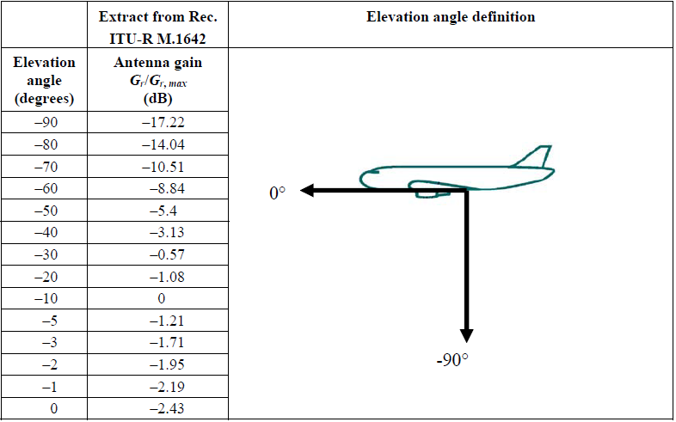
Figure A8.2: DME antenna gain for elevation angles between 0°…-90°

In the simulations, an angle of approach of 3° has been implemented.
Annex 9: POWER CONTROL FOR MCBTS CLASS 2
To obtain a realistic analysis of the MCBTS unwanted emissions, the effects of power control are studied here. Out of the four carriers in the BTS, two use maximum power (43 dB), one is 2 dB lower and one is 4 dB lower. This corresponds to a total BTS output power of 47.8 dBm instead of the maximum 49 dBm, i.e. only 1.2 dB lower, a very conservative approach. Another case that is investigated is one with 3 carriers at maximum power and one silent.

Intermodulation model
A model is used to calculate IM products on different frequencies given a set of input sinusoids. The calculated IM includes orders up to the fifth. On each IM frequency combination (2*f1-f2, 3*f1-2*f2, etc) of the input signal, an IM product is assigned with a relative power according to [8]. Many of these frequency combinations will give IM products on the same frequency, and their powers can be summed, assuming that the input signals are non-coherent.

3GPP TS 51.021 [18] specifies a test-setup for MCBTS class 2 on intermodulation attenuation, where the supported carriers are spread over the supported bandwidth, with equal spacing. This configuration is chosen to so that the maximum number of IM products will coincide on the same frequencies, comprising a worst-case. An illustration of the set-up is shown in figure A9.1.

5th and higher order IM
3rd and higher order IM
Carriers
-60 dBc
-70 dBc
Figure A9.1
By applying the IM model to this setup, it is possible to solve for the third and fifth order coefficients by assigning the summed powers to be -60 dBc and -70 dBc, respectively. These coefficients are later reused but with other input signals. It is further assumed that the adjacent channel of a third-order IM will also be affected, but with 3 dB attenuation. The adjacent channel of a fifth-order IM has 2 dB attenuation and the second adjacent 5 dB.

Carrier scenarios
Two carrier scenarios are considered that both consist of a BCCH-group of frequencies and a traffic channel layer. The network is considered to use tri-sector sites, with intra-site MAIO planning. All frequencies are available for all cells. See Table X for further information.

 | BCCH layer |  |  | TCH layer |  |  | Total
 | Re-use | TRXs | No. freqs | Re-use | TRXs | No. freqs | No. freqs | BW
Scenario A | 4/12 | 1 | 12 | 1/3 | 3 | 9 | 21 | 4.2 MHz
Scenario B | 4/12 | 1 | 12 | 1/6 | 3 | 18 | 30 | 6 MHz
Table A9.1

The TCH layer is frequency hopping, cyclically, with 600 kHz spacing between the TRXs. All available frequencies are used for hopping. It should be noted that Scenario A has an extreme fractional load on the TCH frequencies, 33%. So in terms of spectral density and IM concentration, this is a pessimistic case.

For each scenario, IM for 4 different configurations are studied, see figure A9.2. Intermodulation characteristics vary with frequency usage and these configurations are aimed to cover the possible permutations. The aggregated masks for wideband noise are also calculated.
BCCH frequencies
TCH frequencies
BCCH frequencies
TCH frequencies
BCCH frequencies
TCH frequencies
1
2
3
BCCH frequencies
TCH frequencies
4
Figure A9.2

Results
The intermodulation is calculated for all configurations and frequency hopping positions along with the aggregated wideband noise. A maximum envelope interference level for each 200 kHz channel and interference type is collected 960-970 MHz. This is compared with wide-band noise and spurious levels (in-band and out-of-band) in figure A9.3, with power control and without. Another curve is also shown, where the intermodulation is averaged over 1 MHz, before the envelope, modelling the interference experienced by a DME receiver. Figures A9.3 and A9.4, show the different interference types for scenarios A and B, respectively.

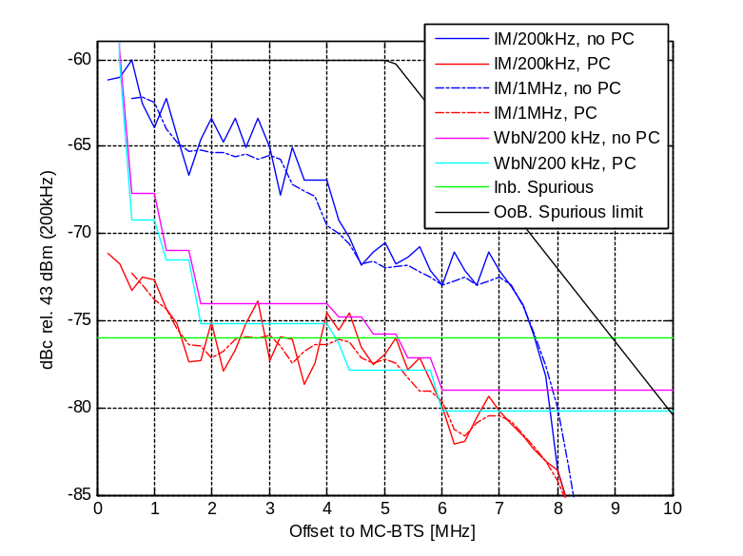
Figure A9.3

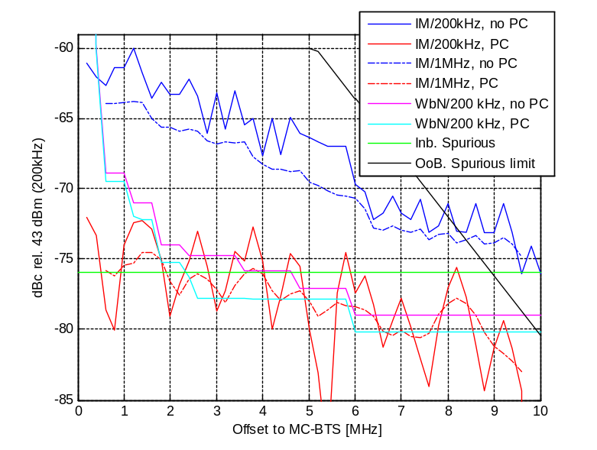
Figure A9.4

The relevant formula for combining wide-band noise (WBN), in-band and out-of-band spurious emissions and intermodulation products is explained below.
In Annex 1 the following expression was used to calculate the out-of-band unwanted emissions beyond 1.8 MHz offset:
min{spurious emission; max{cumulated wideband noise; intermodulation product power}}.

The spurious emission referred to in the expression above, is the absolute level requirements for the out-of-band unwanted emissions (OoB spurious emission). For in-band the following expression was used
max{cumulated wideband noise; spurious emissions; intermodulation product power}

The spurious emission referred to in this expression, is the absolute level requirements for the in-band unwanted emissions (Inb. spurious emission).
The out-of-band unwanted emissions for MCBTS were developed in 3GPP to align the principles used for other 3GPP standards, i.e. for the first 10 MHz out-of-band the in-band requirements apply. As some of the in-band requirements are relative to carrier power, additional absolute level requirements were added for out-of-band emissions. To be complete the out-of-band spurious emission expression should thus be
min{OoB spurious emission; max{cumulated wideband noise; Inb. spurious emission; intermodulation product power}}.
When calculating the out-of-band unwanted emission mask for MCBTS in the reference scenario in Annex 1 with no power control applied, the in-band spurious emissions were not considered as they are smaller than all other contributions. In addition the number of 200 kHz bands where in-band spurious emission are restricted in the specification. For the reference scenario the allowed number of bands is less than 10%, i.e. about 1 per 2 MHz if evenly distributed. A reasonable assumption would be to assume 3 dB lower level than indicated in the figure above, when integrating over 1 MHz bandwidth.
When power control is applied, it is not clear if all spurious emissions will be reduced to the same degree as cumulated wide band noise. A pessimistic assumption would be to use the reduced value of in-band spurious emission, i.e. -79 dBc.

Applying this formula to figures A9.3 and A9.4 above we get the following Figure and Table describing OOBE performance of MCBTS class 2 when power control is applied. The interference has been slightly overestimated for some intervals in order to obtain a somewhat simpler model.

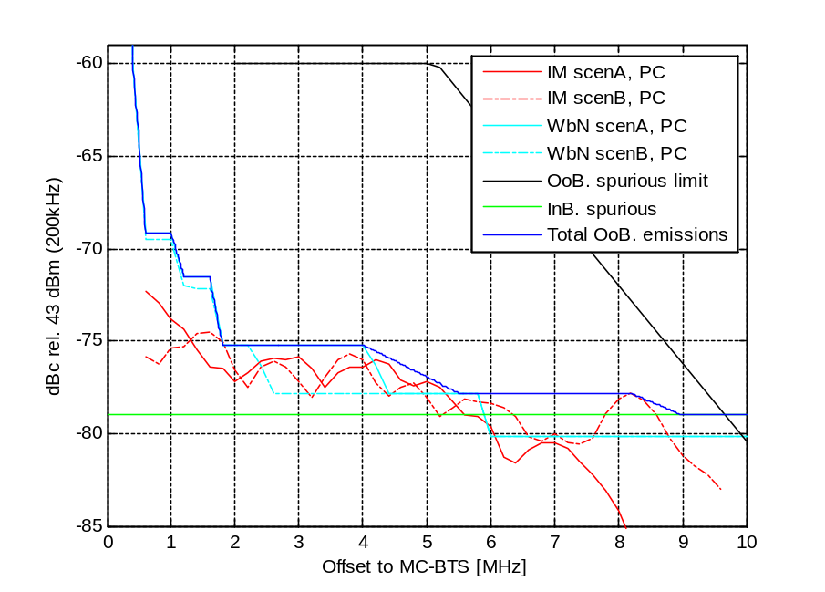
Figure A9.5

Freq/Freq-range  (MHz) | MCBTS class 2  (dBm/30kHz)
0,2 | 5
0,4 | -24.9
0,6 < δf < 1 | -34.2
1.2 < δf < 1.6 | -36.5
1.8 < δf < 4 | -40.2
5.5 < δf < 8.2 | -42.8
9 < δf <10 | -44
Table A9.2

Figure A9.6 below contains the information for the second case, with 3 carriers at max power and one silent. This scenario is somewhat worse that that above.

Figure A9.6

Freq/Freq-range  (MHz) | MCBTS class 2  (dBm/30kHz)
0,2 | 5
0,4 | -24.9
0,6 < δf < 1 | -34.2
1.2 < δf < 1.6 | -36.5
1.8 < δf < 6.2 | -39.8
8.4 | -41.5
9 < δf <10 | -44.0
Table A9.3

Since power control clearly affects the unwanted emissions, it is of interest to investigate how much this feature reduces power in real networks. Figure A9.7 below presents results from such an analysis. To investigate the probability of occurrence of a certain number of active carriers and power used, the power of each active carrier was registered and the probability of simultaneous usage of several carriers derived. These data are taken from one urban cell with very high load during rush hour and close to blocking limit. The diagram is interpreted as the number of occurrences when 1, 2, 3 or 4 carriers are used, dependent on the actual, instantaneous load, and the power used. For example, 30% of the bursts are using 1 carrier only at full power (20W), 21% are using 2 carriers at full power, while less than 3% use full power on all four carriers. The usage of four carriers is quite low, less than 10%. It is also found that the more carriers that are active, the more power reduction is used.
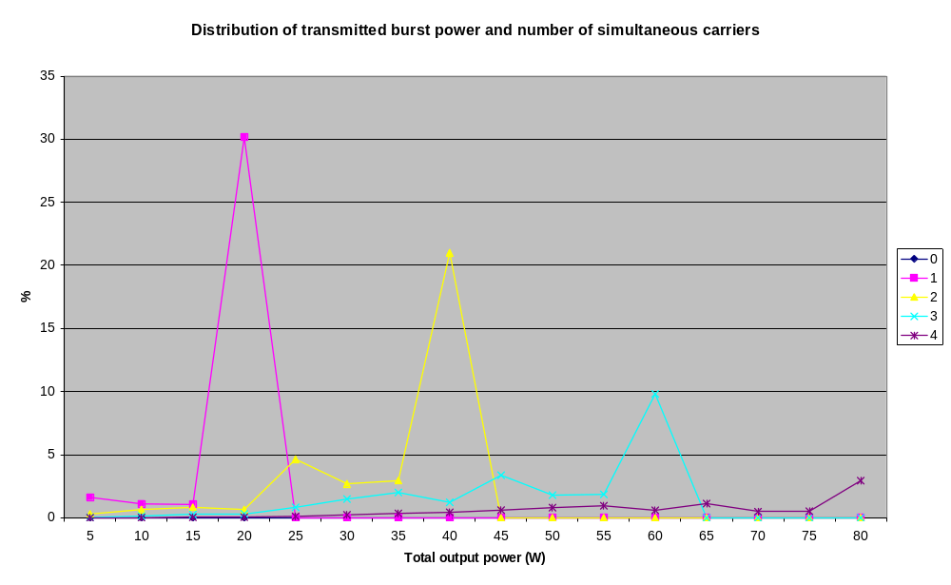
Figure A9.7: Distribution of used number of carriers and corresponding total carrier power
ANNEX 10: magnitude of unwanted emissions with averaging

The unwanted emissions of GSM MCBTS are described in Annexes 1 and 3, and incorporate modulation and wide band noise, spurious emissions and intermodulation products. These unwanted emissions may be modelled differently, depending on whether the intent is to represent an absolute (unrealistic) worst case, a particular base station set-up (like the reference case in Section 4) or an average behaviour.
It is important to take into account the averaging effects occurring when the altitude of the aircraft is so high that it will see a large number of base stations. In other words it is justified to consider average behaviour of the unwanted emissions from MCBTSs. Figure A10.1 below contains results on the averaging of the unwanted emissions, based on the following observations:
- To begin with, consider unwanted emissions for a certain frequency offset from a certain BTS. The BTS will transmit a sequence of bursts for which the unwanted emissions will change over time due to frequency hopping. One could then take the time average (for this frequency offset) to get a representative number to use in the DME calculations.
- However, for any frequency planning of an operator, the result as above will be biased towards interference for certain frequency offset depending on how the BCCH frequency is chosen, and which TCH frequencies are used in the hopping sequence. The solution for this is to also average over a number of base stations with different frequency allocations.

The results in Figure A10.1 include effects from modulation and wide band noise, spurious emissions and intermodulation products (third and fifth order). The averaging curves have only been calculated up to 5 MHz offset from the band edge, beyond that they are assumed to remain the same (a pessimistic assumption). Figure A10.1 also contains the unwanted emissions for the class 2 reference case as presented in Annex 1.
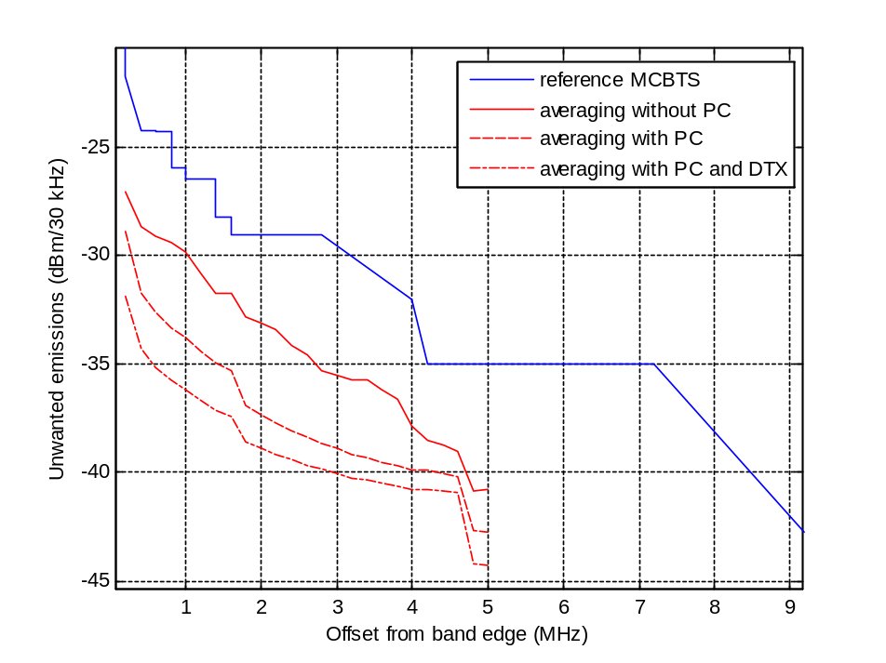
Figure A10.1: Reference and average unwanted emissions from a Class 2 MCBTS

The magnitude of unwanted emissions with and without averaging can be extracted from Figure A10.1 and Annex 1 and are as follows:
frequency (MHz) | Averaging effects  (dBm/30 kHz) | Averaging effects  (dBm/1 MHz) | Class 1  no averaging  (dBm/1 MHz) | Class 2  no averaging  (dBm/1 MHz)
962 | -39 | -24 | -19 | -14
964 | -41 | -26 | -20 | -17
966 | -44 | -29 | -22 | -20
968 | -44 | -29 | -26 | -23
Table A10.1: Unwanted emissions based on averaging effects

This refined analysis provides values for unwanted emissions that are substantially lower than those without averaging, leading to lower interference at higher altitudes where averaging applies. Note further that if only unwanted emissions are taken into account, (assuming perfect selectivity of the DME receiver), interference is sufficiently low for all DME frequencies in the rural case for the interference criterion above 3 km, as applied in Methodology 1.
ANNEX 11: DME coverage
Based on information and simulations on coverage of real DME ground stations, it has been concluded that for the lowest altitudes, the ground profile has an impact on the DME coverage and the capability for a on-board DME device to receive the signal above the sensitivity level from distant DME ground stations.

The analysis is based on simulations run with the tool ICS Telecom (v9.5) and DME ground stations declared at the French Frequency Agency. For the altitudes considered, the coverage is obtained with the free space propagation model (ITU-R Recommendation P.525) combined with the Deygout diffraction model. Consequently, the results are optimistic in particular regarding the Paris areas since the buildings are not taken into account and only the ground profile is impacting the propagation.

The following figure is showing the coverage of a DME (EIRP = 29 dBW) implemented in the area of the city of Bouxwiller distant of 35.6 km from Strasbourg airport for an altitude of 200 m.

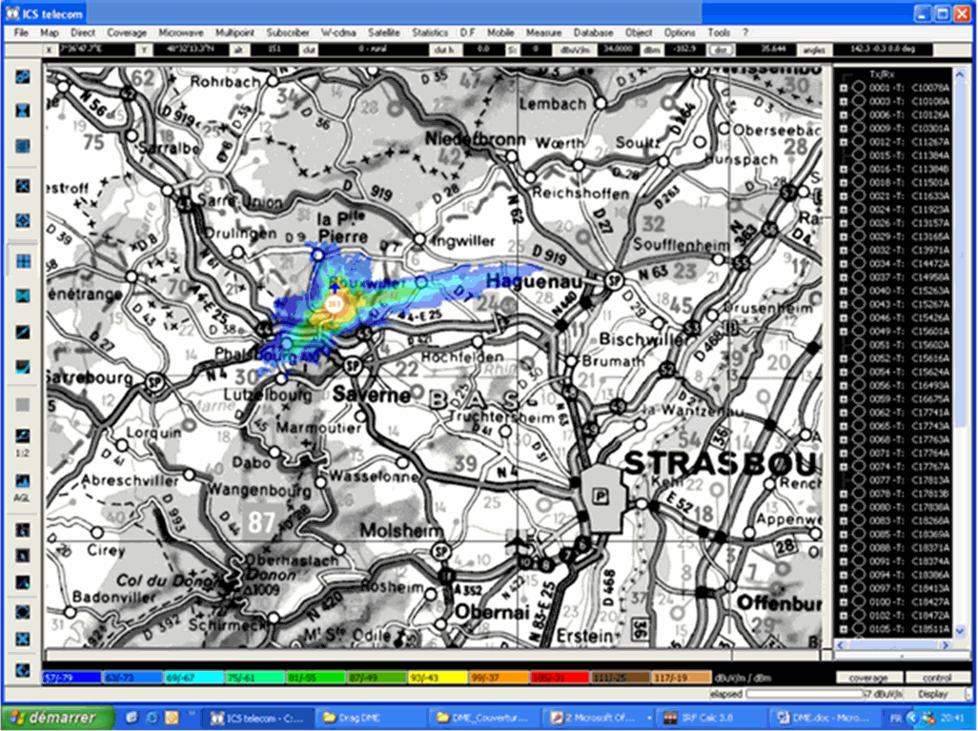
Figure A11.1: Coverage of the DME situated in Bouxwiller (67 330) at a 200 m altitude

Several other cases were considered in order to simulate a plane in a take-off/landing phase close to an airport. The results are summarized in the table below.

Ground DME situated at | Airplane around the airport | Horizontal distance (km) | Field strength level at an altitude of 200 m
Palaiseau | Roissy - Charles de Gaulle | 42,8 | Below -80 dBm
Orly | Roissy - Charles de Gaulle | 34 | Below -80 dBm
Autheuil-en-Valois | Roissy - Charles de Gaulle | 40 | Below -80 dBm
Rambouillet-Bullion | Orly | 31 | Below -80 dBm
Nice | Cannes-Madelieu Airport | 22 | -81 dBm
Table A11.1: The simulations are showing the on-board DME may not be able to receive the signal coming from DME distant of 22 to 40 km in the horizontal plan

Moreover, measurements in the area of Nice (south of France) have shown the distances (between the DME and the aircraft) as a function of the altitude of the aircraft are as follows:

Procedure | DME | Altitude of the aircraft | Approximated distance between the DME and the aircraft
SID 04 and 22 | NIZ | 90m < z < 270m | 11km
SID 04 | NIZ | 480m < z < 640m | 13 km
SID 04 | NIZ | 1660m < z < 2220m | 22 km
SID 22 | CGS | 0m < z < 90m | 6 km
SID 04 | CGS | 390m < z < 460m | 4 km
SID 22 | LUC | 1900m < z < 2490m | 75 km
Table A11.2

Therefore, for altitudes lower than 500 m which corresponds generally to the landing/taking off phases, it is assumed the plane is at less than 25 km from the airport and the DME ground stations deployed within this area, and the ground profile is masking the DME ground stations situated more than 25 km away in the horizontal plan.

This analysis has enabled to propose the following DME protection criteria for the altitudes lower or equal to 500 m: ensure the C/I ratio as defined above with a Cmin level of -68.6 dBm at the DME on-board receiver.
Annex 12: LIST OF REFERENCES

- SEAMCAT Manual for Okumura-Hata model
- ERC Report 081, Basic principles for spectrum sharing between the GSM and RSBN systems, Nicosia, January 1999
- ECC Report 058, Compatibility between TETRA Release 2 TAPS and Tactical radio Relays in the 870-876 and 915 - 921 MHz bands, Stockholm, October 2004
- Doc. FM Civ/Mil(98)16
- doc. FM(97)117
- ECC Report 096, Report on the compatibility study for UMTS being deployed within GSM900 and GSM1800 frequency bands, 2007-04
- EIRENE, European Integrated Railway Radio Enhanced Network, System Requirements Specification, Section 3: Network Configuration, p. 39.
- Larkin, R.S., Multiple-signal intermodulation and stability considerations in the use of linear repeaters, Vehicular Technology Conference, 1991. Gateway to the Future Technology in Motion., 41st IEEE, Volume , Issue , 19-22 May 1991 Page(s):747 – 752
- 3GPP TS45.005 / ETSI TS 145 005: GSM/EDGE Radio Access Network, Radio Transmission and Reception
- WP5D-TD-0160, February 2009
- ETSI EN 300 175-2 V2.0.1 (2007-03)
- ECC Report 122, The compatibility between GSM use onboard vessels and land-based networks
- ERC Report 100: “Compatibility between certain Radio Communications Systems Operating in Adjacent Bands: Evaluation of DECT / GSM1800 Compatibility”, February, 2000
- CEPT Report 19: “Report from CEPT to the European Commission in response to the Mandate to develop least restrictive technical conditions for frequency bands ad-dressed in the context of WAPECS”
- ETSI EN 300 175-3: "Digital Enhanced Cordless Telecommunications (DECT); Com-mon Interface (CI); Part 3: Medium Access Control (MAC) Layer".
- ERC Report 101: A comparison of the minimum coupling loss method, enhanced minimum coupling loss method, and the Monte-Carlo simulation, Menton, May 1999
- Minimum Operational Performance Requirements For distance Measuring Equipment Interrogator (DME/N and DME/P) Operating Within The Radio Frequency Range 960 to 1215 MHz, January 1987
- ETSI TS 151.021/3GPP TS 51.021, Digital cellular telecommunications system (Phase 2+);Base Station System (BSS) equipment specification; Radio aspects
- 3GPP TR 45.005, Technical Specification Group GSM/EDGE, Radio Access Network, Radio transmission and reception.
- ITU-R Recommendation SM.328-10

3 dB Coupling loss assumption is valid for GSM-R BTS with 2 DRX. It should be noted that some of GSM-R BTS have only one TRX.
- ITU-R Doc. 8D/205, Annex 20
The HC-SDMA standard uses a 625 kHz carrier bandwidth. For a 5 MHz channel bandwidth, deployment of multiple 625 kHz carriers is assumed
Number of sectors ranges from 1 (omnidirectional) to higher numbers such as 3. For the sake of sharing studies, three-sectored sites are being considered.
The HC-SDMA system utilizes a multi-antenna architecture with multiple antennas per sector.
HC-SDMA systems are deployed with adaptive multi-antenna arrays. Therefore, the BS antenna array radiation pattern varies in time and space depending on changes in the relative configuration of desired and interfering signals.
For co-located base stations, this parameter captures the minimum coupling loss between two systems. Note: Higher values are achievable. For example, Report ITU-R M.2045 suggests that a coupling loss of up to 70 dB is achievable with a few meters of antenna separation. In real deployment conditions, a coupling loss of up to 45 dB may be achievable.
Required SINR (dB) measured after array processing/equalization dependent on modulation class.
Average power per antenna per carrier. Equivalent isotropic radiated power for victim systems should be computed statistically based on the average power per antenna and array geometry.
The value -33 dBm is explained in section 2.3.1of [13].

