 Electronic Communications Committee (ECC)
within the European Conference of Postal and Telecommunications Administrations (CEPT)
Compatibility between RLAN on board aircraft and
radars in the bands
5250-5350 MHz and 5470-5725 MHz

Tromsø, May 2010

executive summary
This ECC Report addresses the issue of compatibility between RLAN on-board aircraft and radars (military and meteorological) in the bands 5250-5350 MHz and 5470-5725 MHz. It investigates whether the approach taken for the compatibility between ground-based RLAN and radars (i.e. DFS with the essential requirements as defined in EN 301 893 v1.5.1) is applicable in the case of the operation of RLAN on-board aircraft.

With regard to military radars in the bands 5250-5350 MHz and 5470-5725 MHz, the Report shows that:
- RLAN on-board aircraft compatibility with military radars, in these bands is theoretically feasible but should be carefully considered, in the light of the mobile nature of the aircraft. Detection of some specific military radar signals by DFS can not be ensured. In addition, in some specific scenarios, this may lead to a reduction of the ability of a military radar to identify the required target.
- Although EN 301 893 has not been specifically developed to address radars using Frequency Hopping modulation, detection of Frequency Hopping radar signals is ensured if these signals are covered by one of the existing radar test signals included in EN 301 893. In the case of RLAN on-board aircraft flying over areas where frequency hopping radars are in use, frequent DFS triggers may cause numerous channels to be temporarily unavailable for the RLAN on-board aircraft operation.

With regard to meteorological radars in the band 5600-5650 MHz, the Report shows that:
- For RLANs compliant with EN 301 893 v1.5.1, the DFS operation would only rely on the “in-service monitoring” (ISM) for RLAN on-board aircraft; some interference may occur into meteorological radars.
- Further analysis indicates that coexistence between meteorological radars, making use of some signals that may not be detectable by the DFS, and airborne RLANs can not be ensured since it doesn’t rely on 10 minutes “Channel Availability Check” (CAC).
- It is expected that, when flying over Europe, RLAN on-board aircraft would always be in view of a number of meteorological radars simultaneously. Therefore, frequent DFS triggers are expected, resulting that the channels within the band 5600-5650 MHz will not be available for the RLAN on-board aircraft operation.

In conclusion, when implementing RLAN on board aircraft the aviation industry must avoid the use of the band 5600-5650 MHz.

It should be stressed that these conclusions are only valid for the operation of RLAN on-board aircraft and that it does not put into question the satisfactory solution identified within Europe for the compatibility between ground-based RLAN and radars in the 5250-5350 and 5470-5725 MHz bands.

Table of contents

0 executive summary 2
List of abbreviations 4
Definitions 4
1 introduction 5
2 Characteristics of RLAN on board aircraft 5
2.1 General Characteristics 5
2.2 Spectrum requirement 5
2.3 Propagation model 6
2.4 Attenuation from the plane (aircraft fuselage) 6
2.5 General scenario 7
3 Radar detection DFS capabilities in the band 5 250-5350 MHz and 5470-5725 MHz bands 7
3.1 DFS principles and details 7
3.2 DFS compliance criteria 8
3.3 Meteorological radars case 10
3.3.1 Visibility distance 10
3.3.2 Interference distance 10
3.3.3 DFS application to RLAN on board aircraft 11
3.3.4 Conclusion for meteorological radars 12
3.4 Military radars case 13
3.4.1 Military radars characteristics 13
3.4.2 Theoretical analysis 13
3.4.2.1 Background on DFS 13
3.4.2.2 Mutual link budget analysis 13
3.4.3 Coexistence scenarios and operational impact 14
3.4.4 Conclusions for military radars 17
4 Conclusions 18
ANNEX 1: Statistical assessment of probability of interference to meteorological radars caused by RLANs on board aircraft 19
A1.1 Introduction 19
A1.2 Detection and interference ranges 19
A1.3 DFS detection margin: impact of beam shape and antenna gain 20
A1.3.1 Impact of link budget differences 20
A1.3.2 Impact of antenna gain/angle profile 21
A1.4 Number of aircraft in the potential interference area of a radar 23
A1.4.1 Lateral detection 25
A1.4.2 Full beam detection 25
A1.5 Meteorological radar emission schemes and detectable signals 27
A1.5.1 Current radar pulse patterns and scanning strategies 27
A1.5.2 Future Radar pulse patterns and scanning strategies 27
A1.6 Probability detection under ISM for future radars 29
A1.6.1 Intrinsic probability of detection under DFS ISM mode 30
A1.6.2 Determining the RLAN OBA detection capabilities under ISM mode 30
A1.7 Elements of Impact analysis 32
A1.8 Applicability Current DFS compliance requirements 33
A1.8.1 Introduction 33
A1.8.2 DFS detection requirements 34
A1.8.3 DFS behaviour requirements 34
A1.9 Conclusions 34
ANNEX 2: Examples of characteristics of military radars 37
ANNEX 3: LIST OF REFERENCES 38

List of abbreviations

Abbreviation | Explanation
CAC | Channel Availability Check – mode of DFS radar detection while the RLAN device is not operating (not actively sending data)
CEPT | European Conference of Postal and Telecommunications
DFS | Dynamic Frequency Selection
e.i.r.p. | Equivalent isotropically radiated power
ECCM | Electronic Counter Counter Measure
EUMETNET | European Meteorological Network
ISM | In Service Monitoring – mode of DFS radar detection while the RLAN device is operating
LDM | Lateral Detection Margin
ITU | International Telecommunication Union
PRF | Pulse Repetition Frequency
PPS | Pulses Per Second
RLAN | Radio Local Area Networks
TPC | Transmit Power Control
WLAN IFE | Wireless Local Area Networks – In-Fight Entertainment system

Definitions
Term | Description
(RLAN) Interference zone | Area or space around a radar from which (RLAN) devices could cause interference
(DFS) Full beam detection | Triggering of (DFS) detection by a radar’s illumination passing over the detector.
(DFS) Lateral detection | Triggering of (DFS) detection as a radar’s illumination passes over the detector but before interference can occur during that illumination period
(DFS) Lateral detection margin | Part of the pulse pattern of a radar that could effect lateral detection. Can be expressed in degrees or pulse count

Compatibility between WAS/RLAN on board aircraft and radars in the bands 5250-5350 MHz and 5470-5725 MHz

introduction
RLANs in the 5 GHz range are covered by EC Decision 2005/513/EC (11 July 2005), amended by EC Decision 2007/90/EC (12 February 2007) [1] and ECC Decision (04)08 [2] that, in particular, impose the implementation of Dynamic Frequency selection (DFS) in the 5250-5350 MHz and 5470-5725 MHz frequency bands to ensure protection of radars.

These regulations authorised mobile RLAN usage including RLAN on board aircraft although no specific compatibility studies were performed at the time of the development of these regulations.

Since the adoption of ECC Decision (04)08, use of RLAN on board aircraft has been considered on a more specific basis. In addition, the DFS performance requirements as in EN 301 893 [3] have considerably evolved.

In the light of these new elements, this ECC Report presents a specific compatibility analysis between RLAN compliant with EN 301 893 v1.5.1 installed on board aircraft and radars (military and meteorological) in the 5250-5350 MHz and 5470-5725 MHz bands.

Characteristics of RLAN on board aircraft

General Characteristics
RLAN on-board aircraft could be used to provide different types of applications:
1 Intra-aircraft non-safety communications
2 Hotspot services for passengers devices (laptop, PDA etc. ..)
3 In-Flight Entertainment systems - wireless distribution of streaming audio and/or video in airborne platforms
In general, these applications require an RLAN transmit power level of 100 mW; the number of channels needed and the numbers of access point needed vary by application.
These applications are expected to be used during all phases of the flight and on the ground.

Spectrum requirement
Table 1 below provides the frequency bands, number of channels and operational restrictions related that would apply to RLAN use on board aircraft.
Table 1 below provides the frequency bands, number of channels and related operational restrictions that would apply to RLAN use on board aircraft.

Frequency Band | Channel Count | Total Capacity | DFS Requirements
5 150 to 5 250 MHz | 4 | 80 Mbit/s | None
5 250 to 5 350 MHz | 4 | 80 Mbit/s | DFS Required
5 470 to 5 725 MHz | 11 | 220 Mbit/s | DFS Required
Table 1: Frequency bands, number of channels, total capacity and DFS requirements
Depending on the applications, the number of required channels may vary from few channels to almost all of the channels.

Applications requiring less than 4 channels would be able to be accommodated in the 5150-5250 MHz band, hence without DFS requirements, but it is more than likely that a number of applications would require more than 4 channels, up to almost all channels if considering applications type 1 and 2 (previous information provided to ECC for entertainment applications were based on a total maximum throughput requirement of 330 Mbit/s and a minimum of 17 available channels, see [4]).

It has to be noted that in the Russian Federation, the band 5600-5650 MHz is not available for RLAN.

Propagation model
The propagation model to be considered is based on the free space model and considers the aircraft fuselage and orientation as well as the aircraft altitude and distance: even at maximum altitude – 11km – aircraft that are far away will be under the radar horizon or in a propagation path that grazes the horizon. Since the resulting propagation conditions are highly variable, this report only considers line of sight propagation between the radar and aircraft that are above the radar’s horizon.

Attenuation from the plane (aircraft fuselage)
A Boeing measurement campaign has been realised in 2004 (see [5]) to determine the attenuation fuselage of a B747 air-plane within the 5150-5250 MHz band.

Results of attenuation measurement can be summarised as following:
Figure 1: Measurement of fuselage Attenuation

List of fuselage attenuation values (dB) at each measurement point of a 747 airplane.

 | Measurement point number
Measurement point height | 1 | 2 | 3 | 4 | 5 | 6 | 7 | 8 | 9
H3 | 36.1 | 21.1 | 0 | 18.8 | 6.3 | 19.3 | 22.8 | 21 | 19.5
H2 | 42 | 7.5 | 6.3 | 0.6 | -2 | 25 | 7.7 | 28.1 | 7.3
H1 | 24.1 | 17.3 | 10.6 | 8.1 | 11.6 | 27.6 | 24.3 | 23.6 | 21
Table 2: Fuselage Attenuation (dB)
Although these results present a quite large variation from -2 to 42 dB attenuation, Boeing calculated at that time a mean value of around 17dB. Some measurements [5] showed that significant increases of fuselage attenuation are visible in the axial directions (nose-on and tail-on orientations). Attenuation may be smaller in the other orientations.

Individual aircraft may show slight different values and the same applies for new materials like carbon fiber reinforced aluminum (called Glare) which show a somewhat higher attenuation that plain aluminum. However, these differences are considered small compared to other factors in this report.

In the absence of any other measurements relevant for the 5 GHz range, a value of 17 dB is considered as an average attenuation from the plane.

General scenario
The figure below puts the RLAN power density emitted by an aircraft in the context of the thermal noise floor of a 1 MHz receiver.

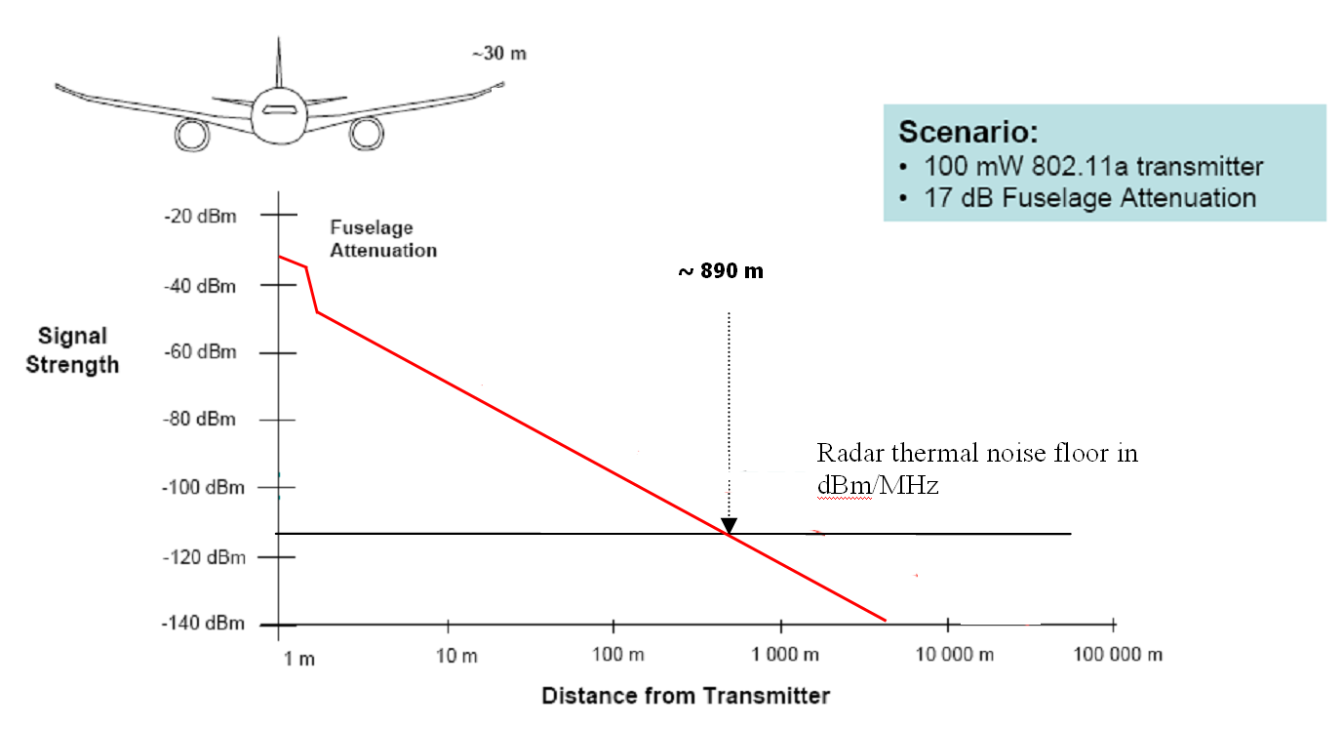
Figure 2: RF power level from an RLAN on board aircraft

Radar detection DFS capabilities in the band 5 250-5350 MHz and 5470-5725 MHz bands

DFS principles and details
RLAN Dynamic Frequency Selection (DFS) specifications are provided in ETSI standard EN 301 893 [3].

Following interference cases to meteorological radars, a new version V1.5.1 of EN 301 893 has been released. The approach taken for in this version of EN 301 893 to improve the protection of meteorological radars assumes the RLAN is ground based.

More specifically, this new version recognizes the specificities of meteorological radars in the band 5600-5650 MHz and relies on an efficient detection during the 10 minutes Channel Availability Check (CAC) process.

EN 301 893 v1.5.1, was part of a compromise solution, together with the EUMETNET Recommendation [6] by which the European meteorological community committed itself to operate only in the 5600-5650 MHz band and to include a minimum of 2 detectable signals over their scanning strategy (typically lasting around 15 minutes) (minimum detectable signal concept).

RLAN Dynamic Frequency Selection (DFS) specifications are provided in EN 301 893 [3].

Following interference cases to meteorological radars, EN 301 893 v1.5.1 has been released. The approach taken for in this version of EN 301 893 to improve the protection of meteorological radars assumes the RLAN is ground based.

More specifically, this new version recognizes the specificities of meteorological radars in the band 5600 - 5650 MHz and relies on an efficient detection during the 10 minutes Channel Availability Check (CAC) process.

EN 301 893 v1.5.1 was part of a compromise solution, together with the EUMETNET Recommendation [6] by which the European meteorological community committed itself to operate only in the 5600 - 5650 MHz band and to include a minimum of 2 detectable signals over their scanning strategy (typically lasting around 15 minutes) (minimum detectable signal concept).

DFS compliance criteria
This section addresses DFS compliance requirements, not the design or implementation of DFS functions in RLANs and other equipment. For an introduction to the statistics of DFS radar detection, see the next section.
RLAN Dynamic Frequency Selection (DFS) requirements are provided in ETSI standard EN 301 893 [3].
Version V1.5.1 of EN 301893 has been developed to address:
- 0.8 μsec pulse widths and variable PRF’s,
- the specific operational modes of weather radars
A future version of EN 301 893 is assumed to address shorter pulses down to 0.5 μsec.
Table 3 below provides the compliance test criteria for RLAN.
 | EN 301 893  v1.3.1/  v1.4.1 | EN 301 893  v1.5.1
Date of Withdrawal (DOW) | 1 July 2010 (April 09 for 5600-5650 MHz band) | 1 January 2013
Parameter | All frequencies | 5600-5650 MHz | Other frequencies
Minimum pulse width (see detailed test signals in table below) | 1 μs | 0.8 μs
PRF (see detailed test signals in table below) | Fixed | Fixed, Staggered and Interleaved
Channel Availability Check (CAC) time | 1 minute | 10 minutes | 1 minute
Off-Channel CAC (Note 1) | No | Yes
CAC and Off-Channel CAC detection probability (Note 2) | 60% | 99.99% | 60%
In-service monitoring detection probability | 60% | 60%
CAC for slave devices with power above 200 mW (after initial detection by In-service) | No | Yes
Detection Threshold | -64 dBm (>200 mW)  -62 dBm (<200 mW) | -62 +10 -EIRP Spectral Density (dBm/MHz) + G (dBi), however the DFS threshold level shall not be lower than -64 dBm assuming a 0 dBi receive antenna gain
Channel Move time | 10s | 10s
Channel closing time | 260 ms | 1s
Non-occupancy period | 30 minutes | 30 minutes
Possibility to exclude 5600-5650 MHz band from the channel plan or to exclude these channels from the list of usable channels | No | Yes
Note 1: The alternative optional “Off-Channel” CAC process consists of an RLAN operating in another channel that will perform (meteorological) radar signal detection on a non-continuous and statistical basis. . This process is based on short-time slots detection periods (down to few ms) over a sufficiently long period of time (several hours)
Note 2: The corresponding probability relates to the detection of one single radar burst (18 pulses for the 5600-5650 MHz band) over the CAC time period.
Table 3: Main DFS requirements as contained in EN 301 893

Table 4 lists the test signals to be used in compliance testing.
Radar test signal #  (see notes 1 to 3) | Pulse width  W [µs] |  | Pulse repetition frequency (PRF)  Pulses per second (PPS) |  | Number of different PRFs | Pulses per burst for each PRF (PPB)  (see note 5)
Radar test signal #  (see notes 1 to 3) | Min | Max | Min | Max | Number of different PRFs | Pulses per burst for each PRF (PPB)  (see note 5)
1 | 0.8 | 5 | 200 | 1000 | 1 | 10  (see note 6)
2 | 0.8 | 15 | 200 | 1600 | 1 | 15  (see note 6)
3 | 0.8 | 15 | 2 300 | 4000 | 1 | 25
4 | 20 | 30 | 2 000 | 4000 | 1 | 20
5 | 0.8 | 2 | 300 | 400 | 2/3 | 10  (see note 6)
6 | 0.8 | 2 | 400 | 1200 | 2/3 | 15  (see note 6)
NOTE 1: Radar test signals 1 to 4 are constant PRF based signals. These radar test signals are intended to simulate also radars using a packet based Staggered PRF.
NOTE 2: Radar test signal 4 is a modulated radar test signal. The modulation to be used is a chirp modulation with a ±2,5MHz frequency deviation which is described below.
NOTE 3: Radar test signals 5 and 6 are single pulse based Staggered PRF radar test signals using 2 or 3 different PRF values. For radar test signal 5, the difference between the PRF values chosen shall be between 20 and 50 pps. For radar test signal 6, the difference between the PRF values chosen shall be between 80 and 400 pps.
NOTE 4: Apart for the Off-Channel CAC testing, the radar test signals above shall only contain a single burst of pulses.
For the Off-Channel CAC testing, repetitive bursts shall be used for the total duration of the test.
NOTE 5: The total number of pulses in a burst is equal to the number of pulses for a single PRF multiplied by the number of different PRFs used.
NOTE 6: For the CAC and Off-Channel CAC requirements, the minimum number of pulses (for each PRF) for any of the radar test signals to be detected in the band 5600 to 5650 MHz shall be 18.
Table 4: Parameters of radar test signals

The DFS parameters described in the Table 5 and Table 6Table 6, derived from compatibility studies between ground-based deployment of RLAN and radars, are deemed appropriate to address the compatibility between ground-based RLAN and radars. Their applicability to aircraft deployment of RLAN is considered in the following sections.

A major change introduced by EN 301 893 v1.5.1 is the 10 minute Channel Availability Check (CAC). For typical civilian and many military radars, a 60 second CAC was incorporated in the DFS requirements from the beginning but because of the specific operational mode of weather radars, the CAC time for the 5600-5650 MHz range was set to 10 minutes. Further, the required detection probability for this band was set to 99.99% in order to assure that, in the case of millions of RLANs deployed near a weather radar, the probability of one RLAN inadvertently starting operations on the weather radar’s channel is reduced to one in ten days.

Meteorological radars case

Visibility distance
Being on-board aircraft, RLAN would obviously operate at location presenting quite high visibility distance from radars without taking advantage of any shielding, unlike for “terrestrial” RLAN. Such distances are given in the following table, for radar typical antenna height range (7 to 30 m) and RLAN operating altitude of 3000 and 10000 m.

Radar height | Visibility distance for an airplane at 3000 m altitude | Visibility distance for an airplane at 10000 m altitude
7 m | 205 km | 366 km
30 m | 215 km | 376 km
Table 5: Visibility of RLAN

Interference distance
The following calculations are made under the following assumptions:
For RLAN:
e.i.r.p: 20 dBm (0 dBi antenna assumed)
Plane attenuation: 17 dB
Bandwidth: 20 MHz

For Meteorological Radar:
Antenna gain: 44 dBi
Noise figure : 3 dB
Protection criteria : I/N = -10 dB.
The following table provides, for the typical radar pulses cases (0.5 and 2 μs), the analysis of necessary e.i.r.p. discrimination between RLAN emissions and radar protection threshold taking into account bandwidth factors.

 | 0.5 μs pulses | 2 μs pulses
Necessary bandwidth | 2 MHz | 0.5 MHz
Interference threshold | -118 dBm/2 MHz | -124 dBm/0.5 MHz
Relative RLAN EIRP density | 10 dBm/2 MHz | 4 dBm/0.5 MHz
EIRP discrimination | 128 dB | 128 dB
Table 6: e.i.r.p. discrimination
It is interesting to note that, irrespective of the radar pulse width, the necessary e.i.r.p. discrimination is constant, i.e 128 dB.
Finally, the necessary free space attenuation between RLAN and radars is given by:

L_{nec} = e.i.r.p_{disc} – A_{plane} + G
where:
L_{nec} =Necessary free space attenuation (dB)
e.i.r.p _{disc} = e.i.r.p discrimination
A_{plane} = Plane attenuation
G = Radar antenna gain
Leading to: L_{nec} = 128 – 17 + 44 = 155 dB and corresponding to a free space distance of 238 km
RLAN on board aircraft will hence present an interference potential at distances up to 238 km from any meteorological radars, noting in particular that such distance is well beyond the typical distance between meteorological radars to ensure efficient territory coverage.
To this respect, it can be seen on the figure below that there is roughly no location over Europe at a distance below 238 km from any meteorological radars, in particular taking into account regular aeronautical routes that are crossing over Western Europe.

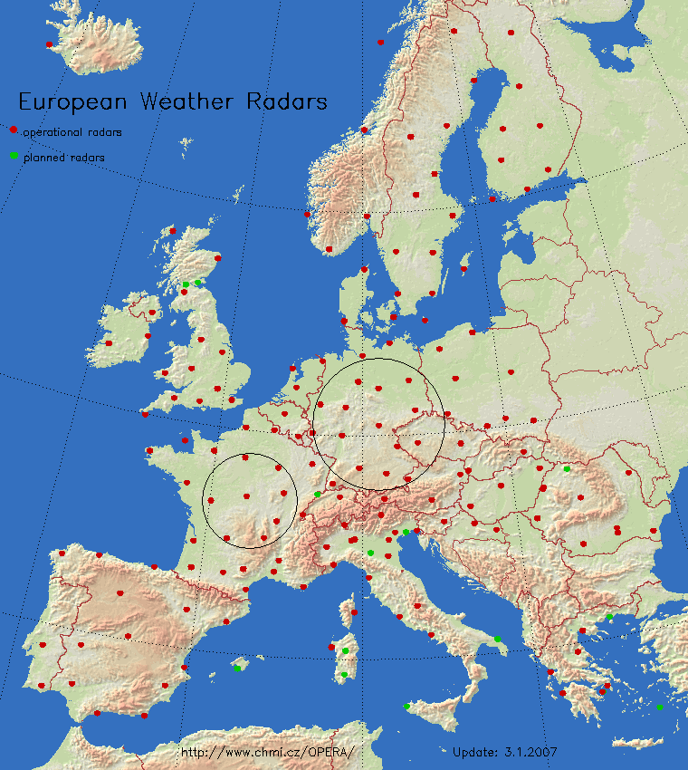
Figure 3: Meteorological radars in European countries which are members of EUMETNET
(Note that some radars in the south of Europe are S-Band radars and that, far east, the existing radars are not plotted since the corresponding countries are currently not part of EUMETNET)

In the light of Figure 3, one can obviously note that, within an interference distance of 238 km (small circle over France) from a given radar, the corresponding RLAN will also be at interference distance from a large number of radars (5 to 8) that could hence represent a risk of interference not only to a single radar but to the whole network.
This is in particular exacerbated by the fact that some RLAN on board aircraft applications would lead to the simultaneous use of a large number of RLAN channels.
It is hence obvious that, to ensure protection of meteorological radars in the 5600-5650 MHz band, an efficient DFS mechanism would be necessary.

DFS application to RLAN on board aircraft
Compared to the RLAN-to-radar link budget, the radar-to-RLAN link budget (controlling the DFS threshold detection) presents roughly a 5 to 7 dB difference (depending on the threshold), leading to a 424 to 534 km detection distance. Recognising that such detection would likely occur only in case of visibility means that RLAN on board aircraft would detect Radars at about 380 km.
One can note that this is consistent with information initially provided within the ETSI SRDoc TR 102 631 on WLAN IFE [4]:
“In an airborne platform, the situation is somewhat different. At altitude, the radio horizon is approximately 400 km in radius – a much larger radio horizon than a terrestrial installation. As a result, the RLAN has the potential of detecting a substantially larger number of radars at any given point in time.”
At such distance, a RLAN on-board an aircraft would simultaneously detect signals from a large number of radars (more than 2/3 of networks for large countries such as UK, France or Germany).
These radars (13 in example case of Germany as shown in Figure 3) will obviously operate on different frequencies within the 5600-5650 MHz band and hence are likely to already override any use of the relevant channels over the whole Europe, taking into account the fixed and 24/7 operation nature of meteorological radars. To this respect, it is expected that airborne RLANs compliant with EN 301 893 v.1.5.1 will get frequent DFS triggers which makes the band 5600-5650 MHz unattractive for RLANs installed on board of a plane.
In addition, even though successful “in-service monitoring” have been performed during testing in the US and Canada, it is necessary to consider up-to-date DFS development in ETSI (see section 3.1) that shows that for meteorological radars in the 5600-5650 MHz band, “in-service monitoring” (ISM) is much less important than CAC.
Indeed, for meteorological radars, a 10 minutes CAC with a 99.99% detection probability is the main tool allowing successful DFS monitoring and radar protection, building upon such specificities (including noise calibration without emission) as well as the necessity to ensure a long term coexistence between RLAN and radars (under the minimum detectable signal concept).
However, due to the mobile nature of RLAN on board aircraft, the aircraft speed of about 800 km/h would make the corresponding RLAN access point “move” by about 130 km during the possible 10 minutes CAC. It is hence obvious that such CAC process will not be efficient to ensure adequate detection of meteorological radars since such RLAN “move” would lead, during the 10 min CAC process, to radars “sorting-out” or “entering” from the detection zone. The new “entering” radars during the CAC process would hence not benefit from a whole 10 min CAC, hence leading to affecting the capability to detect with 99.99% probability the absence of any radar on the corresponding channel.
It is hence obvious that mobile RLAN, and in particular RLAN on-board aircraft are not compatible with a DFS mechanism relying on CAC process. To this respect, it is interesting to note the following abstract from document [5] in its section 2.2, that confirms such statement:
“All DFS algorithms approved to-date have assumed a non-mobile RLAN infrastructure. While the 802.11 clients were expected to be mobile, the access points (APs), which serve as the connection point to a wired infrastructure, were expected to be fixed in location. As such, the architects of the DFS algorithm did not explicitly consider the case of RLANs installed within mobile platforms, such as trains, watercraft, or aircraft. Specifically, the notion of a Channel Availability Check, a test that is run by the AP to ensure the channel is clear of radars before the channel is used by the RLAN (discussed further in Section 3.2.1), is compromised if the AP is mobile. As RLAN equipment has become more popular for mobile installations, additional questions arise concerning the applicability and efficacy of DFS to a mobile platform.”
One can finally stress the fact that, unlike for typical RLANs that target using 1 channel at a location where it is more than likely that only 1 meteorological radar would be operating, the IFE, by principle, would operate in visibility of multiple radars more than likely operating over the 3 channels in the 5600-5650 MHz band and for which 3 simultaneous CAC would have to be performed.
Acknowledging that 1 single RLAN is able to produce severe interference to radar (referring to current interference cases from “terrestrial” RLAN), it would then have made no sense to work toward finding solutions to solve interference cases from “terrestrial” RLAN if, in the same time, no global solutions are found for RLAN on-board aircraft (or all type of mobile RLANs).
Finally, the detailed dynamic analysis as given in Annex 1, has shown that in the case of airborne RLAN (compliant with EN 301 893 v1.5.1) reliable detection of meteorological radars cannot be ensured. Although non-detection does not necessarily mean interference to meteorological radars, one can assume that there might be situations where meteorological radars operations are disturbed.
In addition, future development of meteorological radars may result in signals that are not detectable by the DFS ISM mode of airborne RLANs and therefore coexistence with meteorological radars in the 5600-5650 MHz cannot be ensured relying only on the DFS ISM mode.
In view of the important role of meteorological radars in current society, including aviation, special caution has to be taken.
It is expected that, when flying over Europe, RLAN on-board aircraft would always be in view of a number of meteorological radars simultaneously. Therefore, frequent DFS triggers are expected resulting that the channels within the band 5600-5650 MHz will not be available for the RLAN on-board aircraft operation. Therefore, to facilitate the implementation of RLAN on board aircraft in other parts of the 5 GHz band, the Aviation industry should avoid the use of channels falling in the 5600-5650 MHz range by any means not relying on DFS

Conclusion for meteorological radars
With regard to meteorological radars in the band 5600-5650 MHz, the Report shows that:
- For RLANs compliant with EN 301 893 v1.5.1, the DFS operation would only rely on the “in-service monitoring” (ISM) for RLAN on-board aircraft; some interference may occur into meteorological radars.
- Further analysis indicates that coexistence between meteorological radars, making use of some signals that may not be detectable by the DFS, and airborne RLANs can not be ensured since it doesn’t rely on 10 minutes “Channel Availability Check” (CAC).
- It is expected that, when flying over Europe, RLAN on-board aircraft would always be in view of a number of meteorological radars simultaneously. Therefore, frequent DFS triggers are expected, resulting that the channels within the band 5600-5650 MHz will not be available for the RLAN on-board aircraft operation.
In conclusion, when implementing RLAN on board aircraft the aviation industry must avoid the use of the band 5600-5650 MHz.

Military radars case

Military radars characteristics
Recommendation ITU-R M.1638 [7] and CEPT Report 006 [8] provide characteristics of a wide range of military radars. Annex 2 of this report provides some examples of characteristics of military radars.

Theoretical analysis

Background on DFS
Coexistence between radar and RLAN in the 5 GHz range and work on the efficiency of DFS have been studied in several working groups. In France practical testing campaigns have been performed with military radars in 2004. The situation can be summarized as below:
- Studies within CEPT (e.g. JPT 5G, SE38, JPT BWA, SE41…): see ERC Report 072 [9], ECC Report 068 [10] and ECC Report 110 [11],
- EN 301 893 standard v 1.2.3 (for RLAN in the 5150-5350 and 5470-5725MHz bands) has been published in 2003,
- Tests have shown that DFS characteristics in compliance with EN 301893 v1.2.3 were not sufficient to protect all military radars,
- EN 301 893 has been improved (but frequency hopping signals are not taken into account) in versions 1.3.1 and 1.4.1,
- EN 301 893 has been further improved in version v1.5.1 and future version v1.6.1 but frequency hopping signals are still not taken into account.

Tests done with off-the-shelf RLAN equipment in the period 2004-2008 with a variety of radars, including a high performance air defense system and a mobile, theatre air defense system, have shown that the detection and avoidance of such radars by DFS can be very effective. It is important to note that the protection of frequency hopping radars depends on the specifics (e.g. hopping rate, rotation speed, PRF, beam width, etc…) of the operation of the radar.

Also in Sweden practical testing campaigns regarding coexistence between military radar and RLAN (equipped with DFS mechanism) have been performed during the same period. The main results indicated shortcomings w.r.t. the detection of radars using staggered PRFs [12].

Mutual link budget analysis
Regarding the impact on radars, some uncertainties are related to the mobile nature of RLAN on-board aircraft whereas all previous studies and analysis were performed so far on DFS applied to fixed or nomadic scenarios.

This difference creates additional difficulties in the coexistence with radars, especially for those which have a function of air surveillance.

A first analysis is based on a mutual link budget calculation. This is based on the assumption of a symmetrical propagation path between the RLAN and a typical mobile military radar.

“RLAN → radar” link budget |  |  | Unit
RLAN IFE eirp | 200mW | 23 | dBm
Aircraft Attenuation | 17dB | -17 | dB
Radar Antenna gain | 34 to 50 dBi | 35 | dBi
10log(BWLAN/BRADAR) | 10log (20/4) | -7 | dB
Radar Sensitivity | -105 dBm | -(-105) | dBm
Radar protection criteria (I/N) | -6 dB | - 6
 | Necessary Attenuation loss | 145 | dB
 | Distance (free space) | 73 | km
Table 7: “RLAN → radar” Link budget

“Radar → RLAN” link budget |  |  | Unit
Radar eirp |  | 105 | dBm
Aircraft attenuation |  | -17 | dB
Antenna gain |  | 0 | dB
DFS threshold |  | -62 | dBm
 | Necessary attenuation loss | 154 | dB
 | Distance (free space) | 164 | km
Table 8: “Radar → RLAN” Link budget

This analysis shows that, in theory, with the DFS detection threshold contained in EN 301893, the DFS mechanism detects this radar before the radar ‘sees’ RLAN interference.
The following sections highlight some practical scenarios that can lead to coexistence difficulties between RLAN on-board aircraft and military radars.

Coexistence scenarios and operational impact
The following scenarios are considered.

 | Scenario 1: radar near an airport
Usually air traffic surveillance is performed with radar in L or S band; but sometimes, a 5 GHz band radar can replace the fixed radar in case of failure
As well, protection of an area near an airport can be performed by a 5 GHz band radar.

1.1 | Aircraft traffic detection: X aircrafts  The radar is able to detect many aircraft in its coverage area, which, per the data given in Table 7, has a radius of e.g. 73 km. | 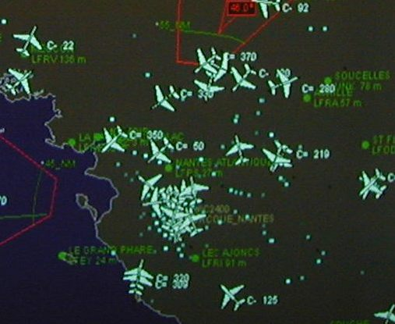
1.2 | Hypothetical worst case:  RLANs without DFS (or with DFS not detecting frequency hopping radar signals) may cause that the radar detects RLAN signals that may appear like false detections or “radar spoofing” by a foreign aircraft. This could lead the radar to create false tracks or to identify a potential threat. Other possible consequences include:  - loss of range in the direction of each aircraft with on-board RLANs  - time computer reduced for real threat  Notes: Saturation of the radar screen, even of a small part, is highly unlikely given the low power level of RLANs and the distances involved.  - The potential loss of process time caused by the interference depends on the number of airplanes in view and the intensity of the interference.
Figure 4: Scenarios 1 and 2 radar near an airport
Without DFS or with an inefficient DFS mechanism, radar functioning is not realistic (scenario 1.2). Each aircraft fitted with RLANs will be equivalent to a low power jammer.

1.3 | Hypothetical best case:  This scenario assumes that RLAN will stop their transmissions immediately on detection of the radar signal.  RLANs on board incoming aircraft detect the radar beyond the radar’s coverage area and avoid the use of its channel  RLANs on board aircraft departing from nearby airport will detect the radar before or during take-off, before the issues noted in 1.2 appear.  In case of a frequency hopping radar, the RLANs on board aircraft may find all channels occupied and have to shut down
Figure 5: Scenario 3 radar near an airport
Scenarios 2 and 3 Scenarios 4 and 5 present cases of RLANs on board civilian aircraft in the airspace of an air defense system involved in either a peace keeping operation or a maritime situation. The main goal of the radar is to detect a target with ECCM (Electronic Counter Counter Measure) capabilities. In both cases, the radar may have some difficulties to detect the required target with the presence of an aircraft with 5 GHz on-board RLAN in the vicinity. .

Scenario 4: Example of peace keeping scenario
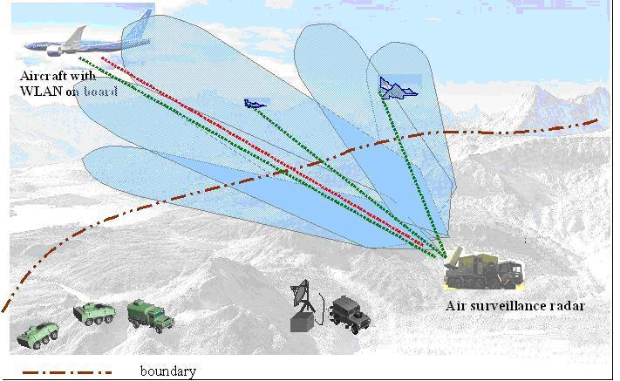
Possible evolution of the scenario in a ‘worst case’ situation
(in a short time, < a few seconds) :
Detection of aircrafts

RLAN signal may be considered as a jamming signal co-located with one aircraft and will cause false alarm and jamming detection.

Figure 6: Example of peace keeping scenario

Scenario 5: airspace and maritime space check
Example of intentional and no-intentional jamming on aircraft
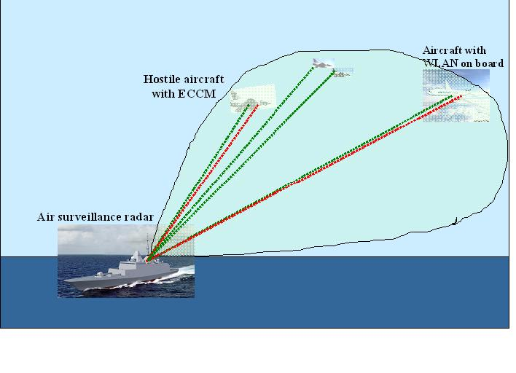
4 aircrafts detected
Detection of potential jamming signal collocated with two aircrafts (one is real ECCM jamming, the other is RLAN signal) : the ability to discriminate the hostile aircraft is reduced.

Figure 7: Airspace and maritime space check

These situations can be more or less critical, according to the DFS efficiency. The EN 301893 standard (RLAN) was designed for terrestrial RLAN systems in a stationary environment or with a limited speed compared to the speed of an aircraft.

Conclusions for military radars
Coexistence between military radars and RLAN on-board aircraft systems (WLAN on-board aircraft) in the bands 5250-5350 MHz and 5470-5725 MHz can be summarized as follows:
- Without DFS, coexistence is impossible.
- With DFS:
- RLAN on-board aircraft compatibility with military radars, in these bands is theoretically feasible but should be carefully considered, in the light of the mobile nature of the aircraft. Detection of some specific military radar signals by DFS can not be ensured. In addition, in some specific scenarios, this may lead to a reduction of the ability of a military radar to identify the required target.
- Although EN 301 893 has not been specifically developed to address radars using Frequency Hopping modulation, detection of Frequency Hopping radar signals is ensured if these signals are covered by one of the existing radar test signals included in EN 301 893. In the case of RLAN on-board aircraft flying over areas where frequency hopping radars are in use, frequent DFS triggers may cause numerous channels to be temporarily unavailable for the RLAN on-board aircraft operation.

Conclusions
This ECC Report presents a specific compatibility analysis between RLAN on board aircraft and radars (military and meteorological) in the bands 5250-5350 MHz and 5470-5725 MHz. It investigates whether the approach taken for the compatibility between ground-based RLAN and radars (i.e. DFS with the essential requirements as defined in EN 301893 v1.5.1) is applicable in the case of the operation of RLAN on-board aircraft.

With regard to military radars in the bands 5250-5350 MHz and 5470-5725 MHz, the Report shows that:
- RLAN on-board aircraft compatibility with military radars, in these bands is theoretically feasible but should be carefully considered, in the light of the mobile nature of the aircraft. Detection of some specific military radar signals by DFS can not be ensured. In addition, in some specific scenarios, this may lead to a reduction of the ability of a military radar to identify the required target.
- Although EN 301 893 has not been specifically developed to address radars using Frequency Hopping modulation, detection of Frequency Hopping radar signals is ensured if these signals are covered by one of the existing test radar signals included in EN 301 893. In the case of RLAN on-board aircraft flying over areas where frequency hopping radars are in use, frequent DFS triggers may cause numerous channels to be temporarily unavailable for the RLAN on-board aircraft operation.

With regard to meteorological radars in the band 5600-5650 MHz, the Report shows that:
- For RLANs compliant with EN 301 893 v1.5.1, the DFS operation would only rely on the “in-service monitoring” (ISM) for RLAN on-board aircraft; some interference may occur into meteorological radars.
- Further analysis indicates that coexistence between meteorological radars, making use of some signals that may not be detectable by the DFS, and airborne RLANs can not be ensured since it doesn’t rely on 10 minutes “Channel Availability Check” (CAC).
- It is expected that, when flying over Europe, RLAN on-board aircraft would always be in view of a number of meteorological radars simultaneously. Therefore, frequent DFS triggers are expected resulting that the channels within the band 5600-5650 MHz will not be available for the RLAN on-board aircraft operation.
In conclusion, when implementing RLAN on board aircraft the aviation industry must avoid the use of the band 5600-5650 MHz.

It should be stressed that these conclusions are only valid for the operation of RLAN on-board aircraft and that it does not put into question the satisfactory solution identified within Europe for the compatibility between ground-based RLAN and radars in the 5250-5350 and 5470-5725 MHz bands.

- Statistical assessment of probability of interference to meteorological radars caused by RLANs on board aircraft

A1.1 Introduction
This annex aims at calculating and qualifying the probability of interference to meteorological radars caused by RLANs on-board aircraft. Such RLANs use the DFS In-Service Monitoring (ISM) mode.
The probability of interference depends mainly on 5 factors:

- detection and interference distances
- the DFS detection margin which is determined by radar antenna gain profiles and distance
- intrinsic detection efficiency of DFS using ISM mode
- number of aircraft in the potential interference area of a radar
- meteorological radar emission schemes and detectable signals.
Careful consideration of all factors involved, notably the impact of distance and antenna gain profiles shows that DFS employed on RLANs on board aircraft could theoretically provide adequate detection of meteorological radars signals, as far as signals are within RLAN detection capabilities, with the main exceptions of the older low PRF/high RPM radar types and radars presenting 0.5 μs pulses.
However, the current DFS compliance criteria as in EN 301 893 v1.5.1 do not address the operating conditions and related requirements for RLANs on board aircraft, and therefore RLANs on board aircraft that comply with these criteria may cause interference and affect radar operations, which is of particular concern with regard to radar products that are and will be increasingly used for Civil aviation control and safety. This would in particular be of importance for future meteorological radars that could present signals non detectable by RLAN compliant with EN 301 893 v1.5.1 (or future version of this standard).
In addition, high level DFS detection performance will lead to the reduced usability of the band 5600-5650MHz for RLANs on board aircraft due to DFS triggers. Indeed, when an aircraft is in visibility range of one or more radars, the corresponding RLAN channels will be unavailable.

A1.2 Detection and interference ranges
The following tables give the maximum (i.e. corresponding to radar main beam) detection range and interference range for a typical 20 dBm 5 GHz RLAN on board aircraft with regards to a typical meteorological radar.

Radar DFS Detection range | Main beam
Tx power at a given frequency (dBm) | 84 (1)
Absolute Radar Tx Antenna Gain (dBi) | 45
RLAN Antenna Gain (dBi) | 0
RLAN DFS threshold (dBm) | -60
Fuselage attenuation (dB) | 17
Net link budget (dB) | 172
Operating frequency (GHz) | 5.6
Maximum detection range (km) (free space) | 1697 km
Actual detection range (km) | ~ 400 km (2)
(1) For radars using dual polarisation (i.e. 81 dBm per channel), the situation remains the same since RLANs are using non-polarised antennas
(2) Due to horizon and aircraft altitude
Table A 1.1: Maximum DFS detection range for a 250 kW radar

RLAN - Radar interference range | Main beam
RLAN Tx power (dBm) | 20
RLAN Antenna Gain (dBi) | 0
Radar Antenna Gain (dBi) | 45
RLAN bandwidth (MHz) | 16.5
Radar bandwidth (MHz) | 1
Bandwidth ratio (RLAN/Radar) (dB) | 12.2
Radar interference threshold at I/N = -10dBm(dBm) | -121
Aircraft fuselage attenuation (dB) | 17
Net link budget (dB) | 156.8
Operating frequency (GHz) | 5.6
Maximum interference range (free space) | 300 km
Table A1.2: Maximum RLAN interference range for a 100 mW RLAN

A1.3 DFS detection margin: impact of beam shape and antenna gain

A1.3.1 Impact of link budget differences
The difference between the two link budgets represents the DFS margin allowing for radar detection before the RLAN is able to produce interference (assuming similar propagation conditions on both paths).
In this case, this difference is 172 – 156.8 = 15.2 dB and can be summarised as in Figure A1.1 below.


Apparent beam shape seen by DFS detector (grey)
~15.2 dB difference for a 250kW radar
Apparent beam shape seen by the radar receiver (blue)
Figure A1.1: Description of beam shapes difference

For an airborne RLAN within the radar interference distance, this difference also leads to the fact that the RLAN would detect the radar over a wider radar beam width compared to the one within which the radar would be interfered, as described in Figure A1.2 below.
Because of this difference, DFS will have time to detect the radar’s beam as it sweeps over the aircraft. It should be noted that the RLAN has to stop using its transmitter as soon as radar detection occurs. However some “coordination” traffic of maximum 1s (“Channel closing transmission time”) is allowed over a period of 10 seconds (“Channel move time”) following the detection event.

Rotation of the radar

DFS detection period

Radar interference period

R
adar
pulses
detected by
RLAN DFS

Lateral detection margin
15.2 dB
3 dB
Figure A1.2: Description of DFS detection during a radar burst for a potential interference impacting the radar main beam

The implications of the preceding are as follows:
- if the DFS is able to detect the radar in the lateral detection margin (LDM) above, i.e. before reaching the radar interference period, the RLAN has to leave the channel immediately, i.e. before interfering the radar, see the following cases. However, this is closely linked to the application of the “channel move time” (10 s) and “Channel closing transmission time”(1 s) within which the RLAN system transmits after detection to ensure full closure of the channel.
- if the DFS needs more pulses - up to the overall pulses in the burst - although DFS detection may be successful, the RLAN will cause interference to the radar.

A1.3.2 Impact of antenna gain/angle profile
The antenna gain profile has an impact on the lateral detection margin seen by the DFS detector.

ITU-R F.1245 [15] gives formulas for calculating the antenna gain profile for interference analysis purposes. These formulas are conservative in that they emphasize the antenna gain at off beam angles. Table A1.3 provides gain figures for a hypothetical 5 meter antenna that matches real antennas more closely than the Rec. ITU-R F.1245 model.

High gain antenna - D > 100λ, DFS margin = 15.2dB
ITU-R F.1245 | relative gain (dB) | Lateral Detection Margin (LDM) * 2 | relative interference range | Degree off axis | real antenna gain (dBi) | estimated relative gain – real (dB) | Lateral Detection Margin (LDM) * 2 | relative inteference range | Interference power
45.67 |  |  |  | 0 | 45.67
42.67 | -3.0 |  |  | 0.45 | 42.67 | -3.0
39.55 | -6.1 |  |  | 0.6
37.87 | -7.8 |  |  | 0.7 | 37.00
36.42 | -9.2 |  |  | 0.8 | 35.00 | -10.7
35.14 | -10.5 |  |  | 0.9
34.00 | -11.7 | 2.0 |  | 1 | 32.00
32.97 | -12.7 |  |  | 1.1 | 30.50 | -15.2 | 2.2 | 1.00 | -10.0
32.02 | -13.6 |  |  | 1.2 | 29.00 | -16.7 | 2.4
31.15 | -14.5 |  |  | 1.3 | 28.00 | -17.7 | 1.7
30.35 | -15.3 |  |  | 1.4 | 26.50 | 21.0 | 1.9 | 0.50 | -4.0
29.60 | -16.1 |  |  | 1.5 | 24.00 | 22.3 | 1.8
28.24 | -17.4 | 3.4 | 1.00 | 1.7 | 22.00 | -23.7 | 2.0
27.03 | -18.6 | 3.4 |  | 1.9 | 19.00 | 25.2 | 2.2 | 0.33 | 0.0
26.47 | -19.2 | 3.4 |  | 2 | 17.00 | -28.7 | 2.2 | 0.28 | 2.0
25.44 | -20.2 | 3.8 |  | 2.2 | 14.50 | -31.2 | 2.4
24.05 | -21.6 | 4.2 |  | 2.5 | 14.00 | -31.7 | 3.0
22.82 | -22.8 | 3.6 |  | 2.8 | 12.00 | -33.7 | 3.4
22.07 | -23.6 | 4.2 | 0.28 | 3 | 11.00 | -34.7 | 4.0 | 0.14 | 9.0
20.40 | -25.3 | 5.6 |  | 3.5 | 9.00 | -36.7 | 5.0
18.95 | -26.7 | 6.2 | 0.16 | 4 | 6.00 | -39.7 | 5.0 | 0.08 | 14.0
14.55 | -31.1 | 9.6 | 0.08 | 6 |  | -45.7 | 8.0
11.42 | -34.2 | 12.6 |  | 8 | -2.00 | -47.7
Table A1.3: Antenna gain pattern for a >100/λ antenna: ITU-R F.1245 and “real” antenna

Using the values for the “real” antenna gain profile, gives the different lateral detection margins (LDM) for different interference levels:
I/N = -10 dB: At the edge of the I/N = -10 dB interference area, the radar would not be interfered with whereas the RLAN would potentially detect it over the “15.2 dB” beamwidth (i.e. about 2 x 1.1°). In this case, the RLAN would therefore have a “slot” corresponding to the full beamwidth.
I/N = -7 dB: in this case the RLAN is potentially interfering the whole radar main beam. the radar would be potentially interfered over its 3 dB beam width (i.e. 0.9°) whereas the RLAN would potentially detect it over the “18.2 dB” beamwidth (i.e. about 2*1.3°). In this case, the RLAN would therefore have a “slot” corresponding of 0.4° ((2.6-1.8)/2) = LDM in Table A1.3 and the corresponding pulses (grey pulses in Figure A1.2) to detect the radar before reaching the interference period.
I/N = 0 dB: At the edge of the I/N = 0 dB interference area, the radar would be potentially interfered over its 10 dB beam width (i.e. 1.6°) whereas the RLAN would potentially detect it over the “25.2 dB” beamwidth (i.e. about 2*1.9°). In this case, the RLAN would therefore have a “slot” corresponding of 1.1° ((3.8-1.64)/2) = LDM in Table A1.3 and the corresponding pulses (grey pulses in Figure A1.2) to detect the radar before reaching the interference period.
I/N = +10 dB: At the edge of the I/N = +10dB interference area, the radar would be potentially interfered over its 20 dB beam width (i.e. 1.4°) whereas the RLAN would potentially detect it over the “35.2 dB” beamwidth (i.e. about 2*3.5°). In this case, the RLAN would therefore have a “slot” corresponding of 2.1° ((7-2.8)/2) = LDM in Table A1.3 and the corresponding pulses (grey pulses in Figure A1.2) to detect the radar before reaching the interference period.
These cases show that:
- the RLAN will see between 50% and 300% more pulses than would be expected on the basis of the nominal radar antenna specification, hence increasing the DFS detection efficiency compared to the compliance criteria of EN 301-893- v1.5.1
- The detection efficiency at shorter ranges (and higher interference levels) increases exponentially

One mode of operation used by some radars: PRF = 250 Hz at 6 RPM gives a nominal burst length of 6.25 pulses per burst. The DFS detection efficiency for this mode of operation is illustrated in table A1.4, together with other representative modes (for radars presenting only signals in the RLAN detectable range).

 |  |  | Radar properties |  |  |  |  |  |  | Predicted DFS detection efficiency at max RPM
 |  |  | PRF | RPM | Pulse based staggered PRF |  |  | Packet Based staggered PRF |  | Nom. Burst length | Eff burst length | P_{det} in ISM mode, 50% load Note 3 | P_{det} , LDM at 100km  Note 1 and 3
Country |  | # | PRF | RPM | PRF 1  (Hz) | PRF 2  (Hz) | PRF 3  (Hz) | PRF 1  (Hz) | PRF 2  (Hz) |  |  |  |  | Idem, at 32km  Note 2 and 3
Cyprus |  | 1 | 250 | 6 |  |  |  |  |  | 6.25 | 24.3 | 0.9992 | 0.1094 | 0.9408
Denmark |  | 4 | 250 | 3.3 |  |  |  |  |  | 11.2 | 43.8 | 1.0000 | 0.8062 | 0.9999
Finland |  |  |  | 4 |  |  |  | 900 | 675 | 31.8 | 124.4 | 1.0000 | 1.0000 | 1.0000
France |  | 16 |  | 2.8 | 379 | 325 | 303 |  |  | 18.1 | 69.9 | 1.0000 | 0.8204 | 1.0000
Germany |  | 16 | 500 | 2 |  |  |  |  |  | 37.4 | 145.8 | 1.0000 | 1.0000 | 1.0000
Note 1: This corresponds to an interference level of I/N = 0dB
Note 2: This corresponds to an interference level of I/N = +10dB
Note 3: Higher channel load than 50% will present lower detection probabilities whereas lower channel load would lead to higher probability
Table A1.4: Predicted ISM detection efficiency (lateral and full beam) for 5 typical radar types/modes of operation

One should however note that these calculation in Table A1.4 assume a 50% RLAN channel load, which may not be representative to all airborne applications (up to 80%), and that such a higher load would decrease the above mentioned detection probabilities.

The exception case is the low PRF/fast rotating radar (mode) exemplified by the Cyprus case: lateral detection efficiency is low for interferers at the noise floor. At 10dB above the noise floor, detection efficiency is quite good.

For the case of France and Denmark, the “lateral detection” is such that there remains a non-negligible probability that the radar is not detected before the interference occurs. Also, if detection occurs in “lateral detection margin (LDM)”, the process of changing channels and necessary transmission (under “channel move time” and “Channel closing transmission time”) could also lead to radar interference.

On the other hand, for all radars, full beam detection is above 99.9%, that should ensure that the same RLAN will not interfer twice the radar (i.e at the next rotation).

Appendix 1 to this Annex gives a full overview of DFS efficiency for a large collection of meteorological radars.

A1.4 Number of aircraft in the potential interference area of a radar
The number of aircraft in visibility of a given radar is rather small, recognizing that the highest density of aircraft occurs around airports.
One can consider 2 different scenarios:
- Aircraft starting their flight beyond the horizon of the radar that would then enter the visibility distance. In this case, one can agree that the time for the aircraft to cover the distance between this visibility distance (about 344 km) and the interference distance of the radar (about 294 km) should allow RLANs on board this aircraft to detect the radar signals under ISM mode, recognising that the potential non-detection during this period would not induce interference to the radar. This scenario is therefore not representative for the current study.
- Aircraft starting their flight within the interference distance from the radar. Taking into account the busy periods of the day near an airport, the number of aircraft in view is about 120 for weather radars near airports and 4 aircraft enter the radar’s space every minute (assuming 4 runways, 1 aircraft per minute/runway, 30 minutes flight time while in range). On average, one can consider a situation with 2 aircraft enter the radar’s space every minute. Half of these aircraft are arriving to the airport (and as such are assuming to relate to scenario a) above whereas the other half are departing are hence those to be considered for the current study.

The following analyses scenario b): aircraft departing from an airport within the interference zone of a radar.

The distance to the airport is assumed to be 60 km which implies the departing aircraft are not visible to the radar until they reach a certain altitude, e.g. 500 meter.

The average aircraft speed during the first 5 minutes of flight is estimated at half the cruising speed: 360km/h or 30km/radar scan cycle. After 5 minutes, cruising speed is assumed. This leads to the aircraft pattern (ignoring the altitude aspect) shown in Figure A1.3.

In this case, 2 detection configurations are relevant: lateral detection before interference occurs as the beam sweeps over the aircraft and full beam detection in case the lateral detection does not take place.

Figure A1.3 shows at two zones around an airport: the departure zone in which aircraft climb to cruising altitude, and the cruising zone in which altitude has been reached and the aircraft fly at full speed towards their destination. The width of these zones is the distance travelled in one scan cycle of the radar – for meteorological radars this is assumed to be 5 minutes.

Aircrafts in the departure zone will be concentrated in a sector that is determined by the distance to the airport and the radius of the departure zone. In this case that distance is 60 km and the radius is 30 km giving a sector of 60 degrees wide.
Distance to airport = 60km
5 minutes “departure zone” = 30km wide, 5/10 aircraft
5 minutes “flight zone” = 60km wide, 5/10 aircraft
Figure A1.3: Distribution of aircraft leaving an airport at 60 km away from a (meteorological) radar

A1.4.1 Lateral detection
The distance between radar and airport determines the power level of the radar pulses as seen by the DFS detector. At 60 km this is 84+45 – (47.3+17+96) + 60 = 28.7 dB above the DFS threshold. At this power level the effective beamwidth is ~ 5 degrees according to antenna model used here. The corresponding 13.7 dB beamwidth of the radar is about 1 degree. This gives a LDM value of 2 degrees and this corresponds to 2/.9 = 2.2 times the nominal burst length.

Depending on the radars characteristics, the detection probability, for a RLAN channel load of 50 %, varies from 10 to 100%.

A1.4.2 Full beam detection
Here the full beam with counts with regards to the detection probability. Since the burst length is at least twice the LDM value, it stands to reason that full detection will be 100% successful for any radar considered here. However, under this mode, interference to radars can occur before the detection is completed.

In this area no interference will be caused by departing aircraft because all are detected in the inner, darker, area
In this area lateral detection probability is generally > 0.99 and full beam detection probability is ~1.00
Figure A1.4: Aircraft distribution and associated detection probabilities for departing aircraft

For the flight zone the average distance is 90 km, and the pulse power is reduced to 29dBm. This does not affect the detection probabilities noticeably. A more important factor is the residual non-detection rate in the departure zone. As noted above, full beam detection at short distances is virtually 100% - even for the most difficult to detect radars - and therefore no interference will be caused by departing aircraft in the “flight zone”.

The following Table A1.5 gives the residual interference probabilities for an airport at 60km and 2 departing aircraft per minute (= 10 per scan cycle).

The only case of residual interference is the radar modelled by the “Cyprus” type radar which is known not to be near a major airport.
In this example, the interference is 3.7 dB or less above the noise floor for this type of radar.
Assuming the affected radial is removed from the data collected by the radar the potential data loss per scan cycle is 0.2452*400*24 = 0.0425%.

For a small airport, this figure may well drop by a factor 10.

 | Radar properties (1) |  |  |  |  |  |  |  | Residual interference for 10 departing aircraft per scan cycle
 | PW (µSec) (2) | Single PRF | Pulse based staggered PRF |  |  | Packet Based staggered PRF |  | RPM | eff burst length | Lateral detection, first 90 km zone | Beyond 90 km
Country | PW (µSec) (2) | Single PRF | PRF 1  (Hz) | PRF 2  (Hz) | PRF 3  (Hz) | PRF 1  (Hz) | PRF 2  (Hz) | Max | eff burst length | Lateral detection, first 90 km zone | Beyond 90 km
Cyprus | 2.0 | 250 |  |  |  |  |  | 6.0 | 48.6 | 0.2452 | 0
Denmark | 2.0 | 250 |  |  |  |  |  | 3.3 | 87.6 | 0.0001 | 0
 | 2.0 |  |  |  |  | 570 | 472 | 1.3 | 497.8 | 0 | 0
France | 2.0 |  | 379 | 325 | 303 |  |  | 2.8 | 139.9 | 0 | 0
Germany | 2.0 | 500 |  |  |  |  |  | 2.0 | 291.7 | 0 | 0
Table A1.5: Interference potential per scan cycle for a busy airport at 60 km from a 250 kW radar

Another way of looking at the interference potential is to relate probability of interference and intensity of interference. The former depends on the radar’s emission scheme (= burst length) whereas the latter depends on distance.

Figure A1.5 and A1.6 show that for all but a few radar types that combine low pulse rates with high rotation speed, the interference is either very low or absent. No modern meteorological radar operates with less than 12 pulses per burst.
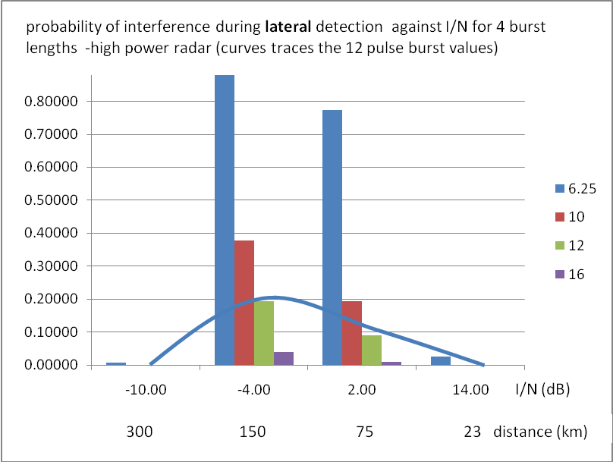
Figure A1.5: Probability of interference against I/N for lateral detection- 15.2 dB detection margin

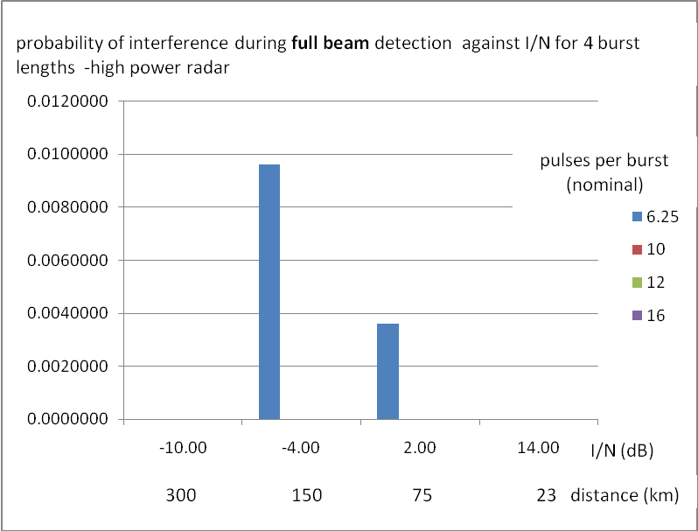
Figure A1.6: Probability of interference against I/N for full beam detection

A1.5 Meteorological radar emission schemes and detectable signals

A1.5.1 Current radar pulse patterns and scanning strategies
Currently, The EN 301-893 calls for a minimum detectable pulse width of 0.8 μs. By 2013 this should be reduced to 0.5 μs. This pulse width is already required by the Japanese DFS rules and RLAN products on the market today prove that this requirement can be met. It may be noted that this change affects the detector design but not the pulse detection statistics.
The EN 301 893 v1.5.1 requires a minimum detectable pulse width of 0.8 μs. By 2013 this will be reduced to 0.5 μs. It may be noted that this change affects the detector design but not the pulse detection statistics.

The detection statistics tested by EN 301-893-V1.5.1 include staggered PRFs (2 or 3 different PRF, pulse based and packet based). A special requirement applies to the 5600-5650 MHz band: here DFS is tested to provide a 99.99 % detection efficiency for a burst length of 18 pulses per PRF, under a 10 min CAC mode and therefore without any load on the RLAN channel.

As can be seen from the preceding material, the effective beamwidth as seen by the DFS detector in RLANs on board aircraft scenario is much larger than the nominal beamwidth assumed in the work that lead to EN 301-893-V1.5.1. Therefore nearly all existing radars are easily detected at the required high level of efficiency by RLANs on board aircraft.

Finally, It should also be noted that, should the RLAN interference occur during a “noise calibration” period (noise measurement without emission, fixing the noise reference for the whole 10 to 15 minutes scan), it could impact the whole data over the complete radar scan and not only one single radial element. These periods are by definition not detectable.

A1.5.2 Future Radar pulse patterns and scanning strategies
Although the future is hard to predict, some factors, like SNR and the speed of light limit the degree of freedom radar designers have in developing new scanning strategies. Given these factors, it is fair to assume that the current mix of pulse patterns and scanning strategies seen in the modern meteorological radar deployments is a good baseline for the future detectability of these radars.
Short pulses
Short pulses provide better resolution in range than long pulses – if one ignores pulse compression – but the large spectral width of such pulses reduces the Doppler resolution. Recent developments in meteorological radar technology and processing point towards two pulse width regimes being used on the same radar in different modes of operation: 2 μs and 0.5/0.8 μs. Other developments are considering pulse widths down to 0.1 μs.
Short bursts
Short bursts typically mean a slow PRF and a high rotation rate – in some combination. In older radars, slow PRFs are used to increase range discrimination. However, the energy per “target” is reduced and therefore the SNR is reduced as well. This makes such PRF unsuitable for a number of weather observations. The range discrimination issue is effectively addressed by using multiple PRFs, either on a pulse by pulse basis or on a packet by packet basis.
Pulse compression
Pulse compression requires the transmission of a long coded pulse that changes frequency in some way while being transmitted. Compression of the return signal reverses those changes and provides enhanced range resolution or enhanced SNR – by integrating the noise received with the wanted signal – but not both. The effectiveness of pulse compression is affected by the Doppler spread of the return signal. However, these pulses are transmitted at much lower peak power than typical pulses that could lead to much lower DFS margins and could therefore affect DFS detection.
PRF Staggering schemes
Currently the most frequently used PRF staggering scheme is the packet based staggering: many tens of pulses are transmitted at one PRF followed by a number at another PRF. Some schemes fix the burst duration, others fix the number of pulses per burst. Range ambiguity is eliminated by signal processing.

The detectability of such PRFs is very good and almost the same as for a single PRF and generally requires the same number of pulses per burst as a single PRF signal except for short burst, i.e. less than 6 pulses.

Pulse staggering changes the pulse interval on every pulse (multi-PRT) and range ambiguity is resolved over two or three pulses. The detectability of these PRF’s is linked to the number of different PRF (maximum 3 for detection under EN 301 893 v1.5.1) and with very short bursts - i.e. less than 8 pulses, detection is severely affected.

Some current developments are investigating to increase the number of different PRF up to 7 to further improve the radars accuracy, in particular in Doppler mode.
Scanning strategies
Currently, not all weather radars signals can be detected by RLAN, encompassing short pulse widths below 0.8 μs or various combinations of PRF/rotation speed. Also, one should note that, within their scanning strategies, a number of radars perform a “noise calibration” without emissions that is a reception only phase and cannot therefore be detected by RLAN. Finally, a number of different radar emission schemes are currently under development (e.g. very short pulses, PRF, pulse compression, multi-PRT,…) that would in the future not be detectable by RLAN.
To this respect and to ensure a long-term coexistence between weather radar and RLAN based on EN 301 893 (v1.5.1 or v1.6.1), the associated EUMETNET Recommendation on C-Band radars [6] specifies that only two detectable signals per complete 15 minutes scan are designed at lower elevation angles in order to be detected by terrestrial by RLAN. The abstracts from the EUMETNET Recommendation on C-Band radars [6] to specify the minimum detectable concept:“ On this basis, and to allow that during a 10 minutes CAC at least 1 signal be seen and detected by RLANs, the abovementioned EUMETNET commitment has to be considered in relation with scanning strategies durations and could be summarised as follows:
- As a general statement : make sure that, when considering consecutive strategies, the interval between detectable signals be lower than 10 minutes
- for the typical 10 to 15 minutes scanning strategies, transmit 2 detectable signals (at relevant interval)
- for scanning strategies lower than 10 minutes, transmit 1 detectable signal”
and
“ By detectable signal, one should understand:
- operation at minimum elevation used by the radar, to ensure that all RLAN in the potential “interference area” would be able to detect it,
- Fixed, Staggered or interleaved PRF within the range 250 – 1200 Hz. It has to be noted that the highest the PRF, the highest the number of detected pulses.
- Pulse width higher or equal than 0.8 μs (based on EN 301 893 Standard version V1.5.1), at initial step and then, 0.5 μs when version V1.6.1 of the EN 301 893 standard will be the only version in force (i.e. 1st January 2013). It is important to note that, during quite a while, equipment based on V1.5.1 will remain in use so that it is strongly encouraged to use pulse width higher than 0.8 μs as long as possible.
- Lowest possible rotation speed to ensure a minimum 18 pulses detection by the RLAN when the radar main beam is passing over the RLAN location. The minimum number of pulses is a combination of the 3 dB beamwidth (0.9° for 45 dBi antenna), the PRF of the signal (or the minimum PRF for staggered PRF) and the rotation speed (RPM) using the following formula :
N = (0.9 x PRF)/(RPM x 6)
where N is the minimum number of pulses detected”

On this basis, it is proposed to assess the airborne RLAN DFS ISM probability of interference using 3 different scenarios for the radar emission schemes:
- scenario 1 : all radar signals are detectable by RLAN (Best case : this is already not the case for a number of radars in Europe)
- scenario 2 : 2 detectable radar signals over a 15 minutes scan (this is the meteorological community commitment in TCAM and was used in the derivation of DFS requirements in EN 301 893 v1.5.1)
- scenario 3 : 1 radar signal over 2 detectable by RLAN (intermediate scenario)

The following Figure A1.7 describes the principle of these 3 scenarios, representing the possible radar pulses that can be detected by the RLAN DFS. Each of these burst is assumed to represent one rotation of the radar and is described in Figure A1.2.

Figure A1.7: Description of detectable signal scenarios
It should however be noted that, consistently with EUMETNET commitments, the radar signals detectable by RLAN are designed to be detected by RLAN on the ground and, as such, will be transmitted at minimum radar elevation (typically in the order of 0.4 – 0.5°). Within the radar interference distance, airplanes would in most cases be “seen” from the radar at higher elevations (few °). Therefore, it is possible that airborne RLAN would not detect these detectable radar signals.

A1.6 Probability detection under ISM for future radars
Based on the elements above, it is proposed to further assess the airborne RLAN DFS ISM probability of interference using the 3 different scenarios for the radar emission schemes as described on the figure above.

A1.6.1 Intrinsic probability of detection under DFS ISM mode
In accordance with EN 301 893 (v1.5.1), the basic specification and test requirements for the DFS ISM mode are the following:
- probability of detection : 60 % (with 50% channel load)
- radar test signal presenting a burst of between 10 and 25 pulses (depending on the signal type) (one can also note that for staggered test radar signals “The total number of pulses in a burst is equal to the number of pulses for a single PRF multiplied by the number of different PRFs used”)
- Upon radar detection, all devices shall stop transmitting on the corresponding channel within the “channel move time” (10 s), the aggregate duration of all transmissions on this channel being limited to the “Channel Closing Transmission Time” (1 s).
The detection efficiency of DFS varies depending on the total number of pulses seen by the RLAN, the minimum number of pulses needed for reliable DFS detection and the RLAN channel load.
On a theoretical basis, this detection efficiency can be calculated using a cumulative binomial distribution. The following table provides some results using a minimum number of 5 pulses needed for reliable DFS detection:

 | Burst length in pulses
RLAN channel load | 10 | 18 | 24 | 48
80 % | 3.3 % | 28.4 % | 54 % | 97.5 %
50 % | 62.3 % | 98.5% | 99.9 % | 100 %
30 % | 95.3 % | 99.99 % | 100 % | 100 %
Table A1.6: Intrinsic probability of detection under ISM mode
These calculations show that the ISM detection probability goes up rapidly with the number of pulses per burst seen by the RLAN, it also decreases rapidly with increased RLAN channel load and that it is rather difficult to specify a single figure.
NOTE : the above DFS detection figures are simplified and only represent a theoretical best case for the present analysis. Indeed, the process of detection is not only an issue of number of pulses in the burst but also of the type of radar scheme (e.g. interval between pulses, staggered PRF,…). However, it was agreed that such elements would not represent significant difference in detection probability.
On this basis, and considering previous elements in section A1.3.2, it is proposed to assess the airborne RLAN probability of interference using the following different ISM detection probabilities:
- 60 % as specified in EN 301 893 (corresponding to 10 pulses and 50% channel load)
- 90 % corresponding to 9 pulses and a 30 % channel load
- 99.99 % corresponding to 18 pulses and a 30 % channel load
For simplification, and representing a best case for ISM detection, the following elements will not be taken into account in the calculation (although representative of detection probabilities listed above):
- the potential impact of the RLAN “channel move time” and “Channel Closing Transmission Time”. The calculation will therefore assume that upon radar signal detection, the RLAN cease instantly its transmission.
- the potential continuation of the detection process over the radar interference period. The calculation will therefore assume that the radar detection will be made within the Lateral Detection Margin (LDM) (see Figure A1.2 above).

A1.6.2 Determining the RLAN OBA detection capabilities under ISM mode
This section aims at determining the RLAN OBA detection capabilities under ISM mode in view of assessing how many planes (per minute or per scan) will remain transmitting on the radar channel (and hence potentially interfering the radar).
Under the iterative process (1 or 2 new planes every minutes), at each minute, the number of planes N to be considered will be the sum of:
  - 1 or 2 new planes
  - Remaining planes which RLAN will not have detected the radar (this is linked to the radar signal scenario and the probability of detection under ISM)
At the end, the number of “non-detecting planes” presenting an interference potential to meteorological radars every minute will then be those among this total N that would not detect the radar (depending on the detection probability) and the resulting number of potential interference per minute will be given by averaging the “non-detecting planes” over 15 minutes.
The table below provides (for an established 15 minutes period) the situation for the “radar scenario 3”, 2 new planes every minute and a detection probability under ISM of 99.99%.

Minute | Nb of new plane /min | Detectable signal (1=yes) | Total remaining planes | Non-detecting planes
1 | 2 | 1 | 4.00 | 0.00
2 | 2 | 0 | 2.00 | 2.00
3 | 2 | 1 | 4.00 | 0.00
4 | 2 | 0 | 2.00 | 2.00
5 | 2 | 1 | 4.00 | 0.00
6 | 2 | 0 | 2.00 | 2.00
7 | 2 | 1 | 4.00 | 0.00
8 | 2 | 0 | 2.00 | 2.00
9 | 2 | 1 | 4.00 | 0.00
10 | 2 | 0 | 2.00 | 2.00
11 | 2 | 1 | 4.00 | 0.00
12 | 2 | 0 | 2.00 | 2.00
13 | 2 | 1 | 4.00 | 0.00
14 | 2 | 0 | 2.00 | 2.00
15 | 2 | 1 | 4.00 | 0.00
 |  |  | TOTAL | 14
Nb of potential radar interference per min |  |  |  | 0.93
Table A1.7: Potential radar interference per minutes
(scenario 3, 2 new planes per minutes and 99.99% ISM detection probability)

Similarly, the table below provides (for an established 15 minutes period) the situation for the “radar scenario 2”, 2 new planes every minute and a detection probability under ISM of 60%.

Minute | Nb of new plane /min | Detectable signal (1=yes) | Total remaining planes | non-detecting planes
1 | 2 | 0 | 20.29 | 20.29
2 | 2 | 0 | 22.29 | 22.29
3 | 2 | 1 | 24.29 | 9.71
4 | 2 | 0 | 11.71 | 11.71
5 | 2 | 0 | 13.71 | 13.71
6 | 2 | 0 | 15.71 | 15.71
7 | 2 | 0 | 17.71 | 17.71
8 | 2 | 0 | 19.71 | 19.71
9 | 2 | 0 | 21.71 | 21.71
10 | 2 | 0 | 23.71 | 23.71
11 | 2 | 1 | 25.71 | 10.29
12 | 2 | 0 | 12.29 | 12.29
13 | 2 | 0 | 14.29 | 14.29
14 | 2 | 0 | 16.29 | 16.29
15 | 2 | 0 | 18.29 | 18.29
 |  |  | TOTAL | 247.71
Nb of potential radar interference per min |  |  |  | 16.51
Table A1.8: Potential radar interference per minutes
(scenario 2, 2 new planes per minutes and 60% ISM detection probability)

As a summary, the following table provides potential radar interference occurrences per minute considering the different radar scenarios, ISM detection probabilities and number of new planes every minutes:

 | Potential radar interference per minute
Probability of ISM detection | 60% |  | 90% |  | 99.99%
Nb of new plane /min | 1 | 2 | 1 | 2 | 1 | 2
Radar Scenario
1 | 0.67 | 1.34 | 0.11 | 0.22 | 0.00 | 0.00
2 | 8.26 | 16.52 | 4.10 | 8.20 | 3.27 | 6.54
3 | 1.80 | 3.60 | 0.69 | 1.38 | 0.47 | 0.94
Table A1.9: Potential radar interference per minutes (summary)

These probabilities are representatives of an RLAN system on-board an aircraft making use of almost all channels (19 in the current RLAN channel plan), such as IFE systems. For RLAN system that would make use of fewer channels (e.g. 1 or 4), these probabilities would be inversely proportional, e.g. multiplied by 1/19 and 4/19 respectively. However, although also presenting high potential for interference, these scenarios are not representative since these systems using only few RLAN channels on board aircraft should therefore be accommodated outside of the 5600-5650 MHz without any constraints.

The RLAN on-board aircraft that would require large number of channels is therefore the controlling scenario, consistent with table above, for which one can see that, depending on the scenarios and RLAN types:
- RLAN on-board aircraft present a potential of interference to meteorological radars for all scenarios (up to 16 events per minutes) at the exception of one presenting no potential radar interference
- Considering the only case for which no interference event is given in the table above (radar scenario 1 (all signals detectable) and 99.99 % detection, one should however stress that :
  - this radar scenario is already not representative of a number of radars in Europe for which not all signals are detectable by RLAN based on EN 301 893 V 1.5.1.
  - the calculation and the detection probability is made under a simplified assumption that once detecting a radar, the RLAN cease instantly its emissions on the channel (i.e. not considering the RLAN “channel move time” and “Channel Closing Transmission Time”).
In any case, these potential interference events are far above what was accepted from Terrestrial RLAN in the derivation of EN 301 893, i.e. maximum 1 potential interference every 10 days.

A1.7 Elements of Impact analysis
The meteorological radar pulse pattern illuminates a volume of space as the (pencil) beam (0.9 degree) passes over it up to the maximum range of the radar. Signal processing is used to derive data from these returns and the range is divided up in data elements which each describe a “pixel” between 250 and 1000 m of a geographical weather radar chart.
Typically, meteorological radars perform measurements in every azimuths and in multiple elevation angles. For example, for a weather radar with 0.9° main beam and 14 elevation, steps in a 600s (10 minutes) scan, the number of “radial elements” is 360/0.9*14 =5600 “radial elements” per complete scan cycle of 5 minutes (which is the typical interval between the instances that the radar beam illuminates the same azimuth/elevation..
The combination of range, azimuth and elevation information is sometimes used to create volume related weather data, e.g. organized by column or by stacks of cells. Depending on the method of processing, loss of raw radar data caused by interference would affect a series of columns or a series of cells along a radial.

For example, if an interference event occurs, it occurs from one single aircraft that only impacts the main beam, one out of the 5600 (i.e. 0.018%, decreasing the overall radar data availability to 99.982%) radial elements would be affected. As shown in table 5, for existing radars, this may occur only for very low PRF radars and only for less than 1 in 4 scan cycles – assuming the radar is near a busy airport. However, for future radars, this could occur up to several times per minutes.

Impact that would extend over larger azimuth than the 3 dB beamwidth (i.e. up to 2 or 4°) could imply, respectively, that 0.04% to 0.08% of the radar data be affected by one single plane and lead to a decrease of the overall data availability down to 98.4% and 96.8% respectively.

However, it should be noted that, for meteorological radars (as for all radar types), every azimuth is as important as another and such averaging of interfered data over 360° measurements is not representative and can lead to a confusion. To this respect, it should also be noted that the radar azimuths in direction of a given airport or specific air control routes would likely be more subject to RLAN OBA interference. This should be in particular considered in the light of the fact that meteorological radars are increasingly providing wind Doppler data for civil aviation authorities and would be key in current major Civil Aviation European Programs (Flysafe and Sesar).

On this basis, considering that each radar azimuth represents an important data set, interference from a single plane would affect data at one of the 14 elevations, hence representing a 1/14 (= 7%) of data loss for the corresponding azimuths (applying between 0.9° and 4° azimuths for one single plane) representing a decrease of data availability in this direction down to 93%.

It is quite difficult to assess how the interference events calculated above would aggregate themselves in azimuths, but one can state that:
- If not aggregated in same azimuths, these interference events would however more than likely be present at close azimuths (in direction of airports or specific air control routes) and would hence represent large azimuth ranges in which the data availability would dramatically decrease
- If aggregated in same azimuth, the interference events would then lead to loosing almost all data in those related azimuths
Finally, It should also be noted that, should the RLAN interference occur during a “noise calibration” period (noise measurement without emission, fixing the noise reference for the whole 10 to 15 minutes scan), it could impact the whole data over the complete radar scan and not only one single radial element. It is not proposed to quantify this specific situation but to keep it in mind as a potential non negligible scenario of radar data loss.
As a summary, from the meteorological radar perspective, the potential effect of RLAN on-board aircraft interference can be assessed as follows:
- Interference may impact both precipitation and Doppler meteorological products. Doppler products, as well as dual-polarisation products, are by far the most sensitive and, in addition, are heavily used for Aviation control and safety.
- Currently, there are no means to allow for any filtering of interference on Doppler products (and dual-polarisation) and that, should it be possible, any filtering on precipitation products leads to the loss of corresponding data.
- Measurements performed at several elevations are used to derived volume products and that measurements performed at a given elevation relates to several altitude products. Therefore, an interference occurring at a given elevation will have an impact on the overall products for a given azimuth.
- In case an airport is located within interference range, most of these interference cases would occur in the same azimuth sector corresponding to the airport direction or the direction of specific air control routes.
- The impact of interference from a population of RLAN on-board several aircraft can lead to significant decreasing of meteorological data availability, hence putting at risk their safe operation and overall data reliability.

A1.8 Applicability Current DFS compliance requirements

A1.8.1 Introduction
The DFS compliance criteria in force in Europe today are defined in EN 301-893-v1.5.1.

Similar criteria have been developed e.g. in the US – FCC R&O 06-96: Report and Order (on compliance criteria for DFS) [13].

These criteria are all based on ITU-R Recommendation M.1652 [14] which provides the baseline on which other criteria have been added - like the long pulse radar and the frequency hopping radar in the United States and the ability of an RLAN to detect 0.5 μs radar pulse widths required in Japan. The scenarios which are described in Recommendation ITU-R M.1652 are for terrestrial deployments of RLANs in very large numbers and involve ground-based, ship based and airborne radar systems. Since most of these are military radars, the requirements of the military radars regarding the DFS compliance criteria were considered. These requirements can be met by a combination of Channel Availability Check (CAC) before actual channel use and In Service Monitoring (ISM) during channel use. The latter is necessary for mobile radars – for which the CAC cannot be used.

The compliance criterion of 99.99% detection probability during the CAC in the EN 301 893 for the sub-band 5600-5650 MHz considers the protection of meteorological radars in case of massive RLAN deployments within the radar’s horizon.

A1.8.2 DFS detection requirements
The focus on terrestrial RLANs and fixed radars has led to emphasis on the CAC as primary means of radar detection and of interference avoidance and this is reflected in the DFS compliance criteria.

In the case of RLANs on board aircraft, the only means of radar detection and interference avoidance is the ISM mode. As shown in this document, ISM can provide adequate protection against interference from RLANs on board aircraft for all but some older, slow PRF/high rotation speed radars. The required detection efficiencies are in the order of 99.9% at burst lengths of 24 or more pulses per burst. As distance between radar and aircraft diminish, the interference power increases but the DFS detection efficiency increases as well and makes de facto interference very unlikely.

However, the EN 301-893 v1.5.1 does not include the corresponding compliance criteria for validating that increasing burst lengths lead to higher detection efficiencies.

Therefore, the compatibility of RLANs on board aircraft and meteorological radars can not be assured on the basis of EN 301-893 v1.5.1.

A1.8.3 DFS behaviour requirements
The DFS behavior requirements include the fact that following detection, the RLAN should cease operations on the channel on which it has detected a radar but that an RLAN master device is allowed to send some coordination messages (for channel switching) to the members of its network. No constraints are given on the timing of such messages only on the aggregated duration.

For RLANs on board aircraft it is important that transmission stops immediately upon detection and that coordination messages are delayed until the radar beam has passed the aircraft. Here the lowest rotation rate of the radar the key factor.
Another consideration is that the CAC required for terrestrial RLANs serves no purpose in case of RLANs on board aircraft.

Both of the above have implications for the compliance criteria for RLANs on board aircraft; however, these are outside the scope of this document.

A1.9 Conclusions
Careful consideration of all factors involved, notably the impact of link budget and antenna gain profiles shows that DFS ISM mode employed on RLANS on board aircraft can theoretically provide adequate detection for a majority of existing meteorological radars.

However, the current DFS compliance criteria as required in EN 301 893 v1.5.1 do not address the operating conditions and related requirements for RLANs on board aircraft, and therefore RLANs on board aircraft that comply with these criteria may cause interference and affect meteorological radar operations.

In addition, future development of meteorological radars may result in signals that are not detectable by the DFS ISM mode of airborne RLANs and therefore coexistence with meteorological radars in the 5600-5650 MHz cannot be ensured relying only on the DFS ISM mode requirements.

This is of particular concern with regards to radar products that are and will be increasingly essential for Civil aviation control and safety requirements for meteorological products.

In addition, ETSI ERM stated that “For RLANs on-board of a aircraft, it is expected that, when flying over land, that multiple weather radars (operating within the band 5600-5650 MHz) may be in view of the RLANs. As a consequence, it is expected that RLANs compliant with version 1.5.1 of EN 301 893 will get frequent DFS triggers which makes the band 5600-5650 MHz unattractive for RLANs installed on board of a aircraft. As a conclusion, Boeing confirmed us that they will avoid the usage of the 5600-5650 MHz for on-board RLANs.”

On this basis, one can conclude that the band 5600-5650 MHz will be unavailable in airplanes due to multiple DFS triggers from fixed meteorological radars while anyhow presenting a risk of interference to meteorological radars.

Considering the above, RLAN on board aircraft should therefore not be in a position to make use of channels within the 5600-5650 MHz band and it is recommended that the aviation industry avoids the use of this band (e.g. by making these channels constantly unavailable).

Appendix A: Analysis of European weather radar detectability

090826-Analysis - EU meteo radar detectability-r3-used for se24 contr.xls

- Examples of characteristics of military radars
General characteristics of military radars
Frequency band: 5250 - 5850 MHz
Operational Mode: fixed frequency / frequency hopping
EIRP : 98.5dBm to 148.5dBm
Antenna Gain: 28 to 54 dBi
Receiver IF 3dB BW: 0.1 - 10 MHz

Example of military radar: Saab Giraffe AMB radar with main parameters:
- C-band with radio frequency agility within 5 400 – 5 850 MHz
- Radar peak output power less than 100 dBm (e.i.r.p.)
- Antenna gain radar receiver approx. 32 dBi.
- Antenna gain radar transmitting approx. 24 dBi.
- Agile multi beam technique with a volume coverage between -10º to 70º in elevation and approx. 2º in azimuth
- Rotating antenna 60 or 30 rpm
- Dwell time 5-10 milliseconds
- Pulse Repetition Frequency (PRF) 1 - 10 kHz
- Pulse length 1-20 microseconds
- Radio frequency agility with the possibility to change frequencies between each revolution or between each PRF-pulses depending in which modes the radar are operating in.

- LIST OF REFERENCES

- Commission Decision 2005/513/EC of 11 July 2005 on the harmonised use of radio spectrum in the 5 GHz frequency band for the implementation of wireless access systems including radio local area networks (WAS/RLANs), amended by EC Decision 2007/90/EC of 12 February 2007
- ECC/DEC/(04)08: “ECC Decision of 12 November/9 July 2004 on the harmonised use of the 5 GHz frequency bands for the implementation of Wireless Access Systems including Radio Local Area Networks (WAS/RLANs)”, latest amendment of 30 October 2009
- ETSI EN 301 893- V1.5.1: “Broadband Radio Access Networks; 5 GHz High Performance RLAN. Harmonized EN covering essential requirements of article 3.2 of the R&TTE Directive”
- ETSI System Reference Document TR 102 631 (Airborne In-flight entertainment systems)
- Dynamic Frequency Selection (DFS) Functionality with airborne radio local Area networks (RLAN’s) Flight Tests, Results, and Conclusions.(Document Number D6-83753, 19April 2007)
- EUMETNET Recommendation on C-Band Met radars (see document M47_15)
- ITU-R M.1638: Characteristics of and protection criteria for sharing studies for radiolocation, aeronautical radionavigation and meteorological radars operating in the frequency bands between 5 250 and 5 850 MHz
- CEPT Report 006: Response to the Mandate to: Harmonised technical and, in particular, operational conditions aiming at efficient spectrum use by RLANs in the bands 5150-5350 MHz and 5470-5725 MHz
- ERC Report 072: Compatibility studies related to the possible extension band for HIPERLAN at 5 GHz
- ECC Report 068: Compatibility studies in the band 5725-5875 MHz between Fixed Wireless Access (FWA) systems and other systems
- ECC Report 110: Compatibility studies between Broad-Band Disaster Relief (BBDR) and other systems
- Info003SE(09): Continuing field measurements and analysis for the C-band with purpose to study the efficiency of the DFS mechanism in coexistence with military radar systems
- Revision of Parts 2 and 15 of the Commission’s Rules to Permit Unlicensed National Information Infrastructure (U-NII) devices in the 5 GHz band, MEMORANDUM OPINION AND ORDER FCC 96-06, June 2006
- ITU-R Recommendation M.1652: Dynamic frequency selection (DFS) in wireless access systems including radio local area networks for the purpose of protecting the radiodetermination service in the 5 GHz band
- ITU-R Recommendation F.1245 – Mathematical model of average and related radiation patterns for line-of-sight point-to-point radio-relay system antennas for use in certain coordination studies and interference assessment in the frequency range from 1 GHz to about 70GHz)

The ITU-R F.1245 model gives about ~10 degrees

