ERC Recommendation 14-02

Radio-frequency channel arrangements for high, medium and low capacity digital fixed service systems operating in the band 6425 to 7125 MHz

**Approved Bonn 1995**

**Amended 19 September 2014**

# erC recommendation 14-02 of 19 sEPTEMBER 2014 on RADIO-FREQUENCY CHANNEL ARRANGEMENTS FOR HIGH, MEDIUM AND LOW CAPACITY DIGITAL FIXED SERVICE SYSTEMS OPERATING IN THE BAND 6425-7125 mhZ

“The European Conference of Postal and Telecommunications Administrations,

*considering*

1. that CEPT has a long term objective, where appropriate, to harmonise the use of frequencies throughout Europe to benefit from technical and economic advantages;
2. that the preferred channel arrangements are one of the important factors in achieving the most effective use of spectrum by the fixed service (FS) systems;
3. that in some CEPT countries, analogue systems are still operating in the frequency range 6425-7125 MHz;
4. that a wide variety of digital FS applications may operate in the frequency range 6425-7125 MHz;
5. that ETSI harmonised standards provide for high capacity digital radio equipment families in either 40 MHz or 28/30 MHz channel arrangements, as well as for medium and low capacity digital radio systems in 20, 14, 7 and 3.5 MHz channel arrangements;
6. that, when very high capacity links are required, further economy may be achieved using wider channel bandwidth associated to high efficient modulation formats;
7. that the Recommendation ITU-R F.384 provides channel arrangement for the band 6425-7125 MHz;
8. that administrations implementing different channel arrangement provided in Annex 1 may have to coordinate on case by case bases at bilateral/multilateral level for the cross border areas;
9. that the channel plan contained in this recommendation for the 30 MHz raster introduces an additional channel (channel 11) to that provided by Recommendation ITU-R F.384; which will require additional technical consideration by those administrations who wish to implement this additional channel;
10. that Recommendation ECC/REC/(14)06 contains arrangements for smaller channels spacing in the guard bands and centre gap of the 6425-7125 MHz band;

*recommends*

1. that administrations, which have the band 6425-7125 MHz available for the Fixed Service should, totally or in part, consider the channel arrangements in Annex 1 taking into account recommends 2;
2. that administrations wishing to implement channel 11 under the 30 MHz plan should carefully consider the impact of introducing this channel due to its limited centre gap between channels 11 and 1’ (10 MHz) and overlap with the channel 1’ of the 20 MHz plan;
3. that administrations may consider merging any of two adjacent 30 MHz channels specified in Annexe 1 to create one 60 MHz channel, with centre frequency lying in the central point of the distance between the merged channels. Before using channel 11, consideration should be given to recommends 2. This option may be subject to minimum bit rate obligations. To assist international co-ordination, administrations may refer to the channel identifiers described in Annex 2;
4. that administrations may consider merging any of two adjacent 40 MHz channels specified in Annexe 1 to create one 80 MHz channel, with centre frequency lying in the central point of the distance between the merged channels. This option may be subject to minimum bit rate obligations. To assist international co-ordination, administrations may refer to the channel identifiers described in Annex 2;
5. that the channel arrangements may still be used for existing analogue systems.”

*Note:*

*Please check the Office documentation database http://www.ecodocdb.dk for the up to date position on the implementation of this and other ECC Recommendations.*

1. DERIVATION OF RADIO FREQUENCY CHANNELS

The radio frequency channel arrangement for carrier spacings of 40 MHz, 30 MHz, 20 MHz, 14 MHz, 7 MHz and 3.5 MHz shall be derived as follows:

Let

f0 be the frequency (MHz) of the centre of the band of frequencies occupied, f0 = 6770 MHz

fn be the centre frequency (MHz) of one radio-frequency channel in the lower half of the band,

fn’ be the centre frequency (MHz) of one radio-frequency channel in the upper half of the band,

then the frequencies (MHz) of individual channels are expressed by the following relationships:

1. for systems with a carrier spacing of 40 MHz:

lower half of the band: fn = f0 - 350 + 40 n

upper half of the band: fn’ = f0 - 10 + 40 n where n = 1, 2, 3 … 7, 8

1. for systems with a carrier spacing of 30 MHz:

lower half of the band: fn = f0 - 340 + 30 n

upper half of the band: fn’ = f0 + 30 n where n = 1, 2, 3, …….10, 11

Note: Channel 11/11’is not currently provided by Recommendation ITU-R F.384, possibly due to the limited centre-gap (10 MHz) between channels 11 and 1’ and overlapping with channel 1’ of the 20 MHz spacing. However, its usage might add further flexibility in co-ordinating congested areas of the network.

1. for systems with a carrier spacing of 20 MHz:

lower half of the band: fn = f0 - 350 + 20 n

upper half of the band: fn’ = f0 - 10 + 20 n where n = 1, 2, 3, …… 15, 16

1. for systems with a carrier spacing of 14 MHz:

lower half of the band: fn = f0 - 340+9+n*14+2*integer((n-1)/2)

upper half of the band: fn’ = f0 + 9+n*14+2*integer((n-1)/2) where n = 1, 2, 3, ….…21, 22

1. for systems with a carrier spacing of 7 MHz:

lower half of the band: fn= f0 - 340+12.5+n*7+2*integer((n-1)/4)

upper half of the band: fn’ = f0 + 12.5+n*7+2*integer((n-1)/4) where n = 1, 2, 3, …… 43, 44

1. for systems with a carrier spacing of 3.5 MHz:

lower half of the band: fn = f0 - 340+14.25+n*3.5+2*integer((n-1)/8)

upper half of the band: fn’ = f0 + 14.25+n*3.5+2*integer((n-1)/8) where n = 1, 2, 3, ...… 87, 88

Note: Channels with 3.5, 7 and 14 MHz sizes are not currently provided by Recommendation ITU-R F.384 which gives 5 and 10 MHz alternatives. However, 5 and 10 MHz are not considered appropriate since they are not considered in the ETSI Harmonized Standard.

1. Calculated parameters according to Recommendation ITU-R F.746

| XS  MHz | n | f1  MHz | fn  MHz | f’1  MHz | fn  MHz | Z1S  MHz | Z2S  MHz | YS  MHz | DS  MHz |
| --- | --- | --- | --- | --- | --- | --- | --- | --- | --- |
| 40 | 1…8 | 6460 | 6740 | 6800 | 7080 | 35 | 45 | 60 | 340 |
| 30 | 1…11 | 6460 | 6760 | 6800 | 7100 | 35 | 25 | 40 | 340 |
| 20 | 1…16 | 6440 | 6740 | 6780 | 7080 | 15 | 45 | 40 | 340 |
| 14 * | 1…22 | 6453 | 6767 | 6793 | 7107 | 28 | 18 | 26 | 340 |
| 7 * | 1…44 | 6449.5 | 6770.5 | 6789.5 | 7110.5 | 24.5 | 14.5 | 19 | 340 |
| 3.5 * | 1…88 | 6447.75 | 6772.25 | 6787.75 | 7112.25 | 22.75 | 12.75 | 15.5 | 340 |

* These channel raster are not continuous, because they are embedded in 30 MHz channels (See Figure 1)

XS Separation between centre frequencies of adjacent channels

YS Separation between centre frequencies of the closest go and return channels

Z1S Separation between the lower band edge and the centre frequency of the first channel

Z2S Separation between centre frequencies of the final channel and the upper band edge

DS Duplex spacing (fn’ - fn)

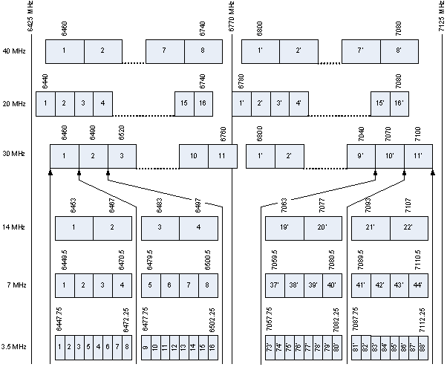

All frequencies are in MHz.

1. Occupied spectrum 6425-7125 MHz
2. CHANNEL IDENTIFIERS FOR DERIVATIVE 60 MHz AND 80 MHz CHANNELS

The derivative 60 MHz channels (ref. *recommends 3*) can be identified by using the following numbering and illustrated in Figure 2:

lower half of the band: fn = f0 - 325 + 30 n

upper half of the band: fn = f0 + 15 + 30 n where n = 1, 2, 3, ….9, 10

The derivative 80 MHz channels (ref. *recommends 4*) can be identified by using the following numbering and illustrated in Figure 3:

lower half of the band: fn = f0 - 330 + 40 n

upper half of the band: fn = f0 + 10 + 40 n where n = 1, 2, 3, ….6, 7

In both cases f0 = 6770 MHz

Note: The numbering is just for identification of the channelling. It should be noted, that adjacent channel numbers cannot be used on the same physical link due to channel overlap. See diagrams below for channel arrangement example.



1. Illustration of the channel identifiers for derivative 60 MHz channels



1. Illustration of the channel identifiers for derivative 80 MHz channels