 Electronic Communications Committee (ECC)
within the European Conference of Postal and Telecommunications Administrations (CEPT)
inductive limits in the frequency range
9 kHz to 148.5 kHz

Bordeaux, September 2009

executive summary
This report considers a possible relaxation of the limits for the magnetic field strength required for inductive applications (Annex 9 of ERC/REC 70-03) operating in the frequency range 70 to 90 kHz. After considering the impact on other services, the limits given in Table 1 are expected to protect radio services from harmful interference under the assumption that current long wave radio receivers are not used in an area of about 100 m around the proposed inductive devices. In addition, the services listed in Table 2 should be protected by applying a limit of 42 dBµA/m at 10m. A comparison of the proposed limits versus the existing limits is provided in Figure 1.

Frequency band | Magnetic field | Duty cycle | Channel spacing | Notes
a. 9-90 kHz | 72 dBµA/m at 10 m  Note 1 | No restriction | No channel spacing | I case of external antennas, only loop coil antennas may be employed.  Field strength level descending 3 dB/oct above 30 kHz
b. 90-119 kHz | 42 dBµA/m at 10 m | No restriction | No channel spacing | In case of external antennas, only loop coil antennas may be employed.
c. 119-135 kHz | 66 dBµA/m at 10 m  Note 1 | No restriction | No channel spacing | In case of external antennas, only loop coil antennas may be employed.  Field strength level descending 3 dB/oct above 30 kHz
d. 135-140 kHz | 42 dBµA/m at 10 m  Note 2 | No restriction | No channel spacing | In case of external antennas, only loop coil antennas may be employed.
e. 140-148.5 kHz | 37.7 dBµA/m at 10 m | No restriction | No channel spacing | In case of external antennas, only loop coil antennas may be employed.
Note 1: Limit reduced to 42 dBµA/m at 10 m according to table 2
Note 2: RFID operating in the frequency band 119 -kHz to 135 kHz shall meet the spectrum mask given in EN 300 330 (under revision). This will permit a simultaneous use of the various sub-bands within the range 90-148.5 kHz
Table 1: Proposed revised inductive limits for ERC/REC 70-03 Annex 9

Station | Frequency | Protection bandwidth | Maximum Field strength at 10 m | Location
MSF | 60 kHz | +/-250Hz | 42 dBµA/m | United Kingdom
RBU | 66.6 kHz | +/-750Hz | 42 dBµA/m | Russian Federation
HBG | 75 kHz | +/-250Hz | 42 dBµA/m | Switzerland
DCF77 | 77.5 kHz | +/-250Hz | 42 dBµA/m | Germany
DCF49 | 129.1 kHz | +/-500Hz | 42 dBµA/m | Germany
Table 2: Standard frequencies and time standards inside to be protected 9-90 kHz and 119-135 kHz

In addition, for clarification, a reference to the frequency range in which RFID and similar systems may operate for operation in the band 105.5 kHz to 148.5 kHz may need to be included in Annex 9 to ERC/REC 70-03 (see figure 3).

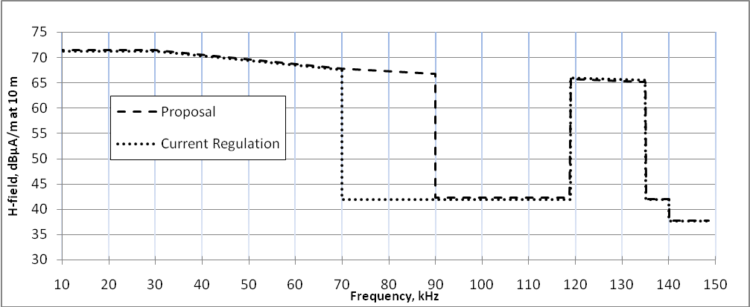

Figure 1: Existing regulations given in ERC/REC 70-03 versus the proposal given in Table 1 (note: the notches given in Table 2 are not shown for simplification)
Table of contents

0 executive summary 2
List of abbreviations 4
1 introduction 5
2 Existing Regulation 5
3 Overview of the systems/services operating in the frequency range 70 kHz to 119 kHz 6
4 New Requirements for Inductive Systems 7
4.1 RFID carriers 7
4.2 Electronic Article Surveillance (EAS) 7
4.3 New inductive applications 8
5 Findings of ERC Report 44 9
6 Updated information since publication of ERC Report 44 9
7 Proposed change in ERC/Rec 70-03 12
8 conclusions 13
ANNEX 1: ECA frequency table [5] 14
ANNEX 2: LIST OF REFERENCES 16

List of abbreviations
Abbreviation | Explanation
CEPT | European Conference of Postal and Telecommunications Administrations
CISPR | Comite International Special des Perturbations Radioelectriques (Special International Commitee on Radio Interference)
DCF49 | German Transmitter frequency designation for controlling public and private energy consumption in Germany and neighbouring countries
DCF77 | Transmitter frequency designation for time signal transmissions
DECCA | Radio navigation system named after “Decca Navigator Company” UK
EAS | Electronic Article Surveillance
ECA | European Common frequency Allocations table
ECC | Electronic Communications Committee
ETSI | European Telecommunications Standards Institute
HBG | Swiss transmitter frequency designation for time signal transmission (similar to DCF77)
ISO | International Organization for Standardization
ITU | International Telecommunication Union
LORAN C | Long Range Navigation
MSF | UK Transmitter frequency designation for time signal transmissions
RBU | Russian transmitter frequency designation for time signal transmissions
RFID | Radio Frequency Identification
RNS-E (A, D) | Russian transmitter frequency designation for time signal transmissions
RNS-V (A) | Russian transmitter frequency designation for time signal transmissions
SRD | Short Range Devices

Inductive Limits in the Frequency Range 9 kHz to 148.5 kHz

introduction
The radiated limits for inductive systems in the frequency range 9 kHz to 148.5 kHz are given as magnetic field strength in Recommendation ERC/REC 70-03, Annex 9 [1]. Apart from minor adjustments these limits are in force since January 1997. These limits were based on a study published in ERC Report 44 (1997) [2].

Recently, ETSI published a SRDoc TR 102 756 [3] requesting some adjustments of the above mentioned limits as the following:
- A request of an additional 10 kHz channel in the frequency range 70 kHz to 90 kHz with a radiated limit of 72 dBµA/m at 10 m descending 3dB/oct above 30 kHz similar to the existing limits below 70 kHz given in ERC/REC 70-03 Annex 9 [1];
- A clarification of the frequency range in which RFID and similar systems may operate in the band 105.5 kHz to 148.5 kHz was requested. The existing mask is given in sub-bands b, c, c1 and c2 in ERC/REC 70-03 Annex 9. This implementation confuses the test laboratories system as it is not clear if several adjacent sub-bands can be used simultaneously by a RFID equipment. A clear defined frequency range is the solution, where a note in ERC/REC 70-03 Annex 9 can refer to a specific RFID frequency range as given in ISO RFID standards and other international RFID standards which are covered by ETSI standard EN 300 330 [4] (currently under revision). No changes of the current emission limits of Annex 9 for RFIDs are required for this case.
An initial analysis of ETSI SRDoc TR 102 756 [3] by SRDMG requested an investigation if the Regulation below 135 kHz in ERC/REC 70-03 Annex 9 [1] could be simplified for example by a single sub-band with one higher limit.

Existing Regulation
Annex 9 to ERC/REC 70-03 [1] provides the regulation for inductive systems in the frequency range 9 kHz to 148.5 kHz as follows:
Frequency Band | Magnetic field | Duty cycle | Channel spacing | Notes
aa 9 -59.750 kHz | 72 dBμA/m at 10m | No Restriction | No spacing | In case of external antennas only loop coil antennas may be employed.  Field strength level descending 3 dB/oct at 30 kHz
ab 59.750-60.250 kHz | 42 dBμA/m at 10m | No Restriction | No spacing | In case of external antennas only loop coil antennas may be employed
ac 60.250-70.000 kHz | 69 dBμA/m at 10m | No Restriction | No spacing | In case of external antennas only loop coil antennas may be employed.  Field strength level descending 3 dB/oct at 30 kHz
b 70-119 kHz | 42 dBμA/m at 10m | No Restriction | No spacing | In case of external antennas only loop coil antennas may be employed
c 119-135 kHz | 66 dBμA/m at 10m | No Restriction | No spacing | In case of external antennas only loop coil antennas may be employed.  Field strength level descending 3 dB/oct at 30 kHz
c1 135-140 kHz | 42 dBμA/m at 10m | No Restriction | No spacing | In case of external antennas only loop coil antennas may be employed
c2 140-148.5 kHz | 37.7 dBμA/m at 10m | No Restriction | No spacing | In case of external antennas only loop coil antennas may be employed
Table 3: Existing regulation for inductive systems in the frequency range 9 kHz to 148.5 kHz –
Annex 9 to ERC/REC 70-03 [1]
The following Figure illustrates the existing regulation.
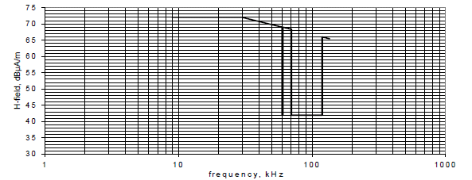
Figure 2: Overview of the existing regulation in the frequency range 9 kHz to 148.5 kHz [1]
These limits were based on a study published in ERC Report 44 [2] allowing the higher field strength level in the bands:
9-70 kHz
119-135 kHz
with a notch to protect others systems at 60 kHz.

In addition, ECC Report 7 [4] considered the frequency range 135-148.5 kHz and indicated that in order to protect the Fixed Service and the Amateur Service a the limit of 42 dBµA/m @ 10m in the band 135-140 kHz and 37.7 dBµA/m @ 10m in the band 140-148.5 kHz would be adequate.

Overview of the systems/services operating in the frequency range 70 kHz to 119 kHz
Table 4 provides the list of services/systems operating in this frequency range.

FREQUENCY BAND | ALLOCATIONS | APPLICATIONS
70.0 - 72.0 kHz | RADIONAVIGATION | Medical Implants (9.0 - 315.0 kHz)  Inductive applications (9.0 - 30000.0 kHz)  Inductive applications (20.05 - 148.5 kHz)
72.0 - 84.0 kHz | FIXED  MARITIME MOBILE  RADIONAVIGATION | Medical Implants (9.0 - 315.0 kHz)  Inductive applications (9.0 - 30000.0 kHz)  Inductive applications (20.05 - 148.5 kHz)  Maritime  Standard Frequency and Time Signal  Defence systems (72.0 – 148.5 kHz)
84.0 - 86.0 kHz | RADIONAVIGATION | Medical Implants (9.0 - 315.0 kHz)  Inductive applications (9.0 - 30000.0 kHz)  Inductive applications (20.05 - 148.5 kHz)  Defence systems (72.0 - 148.5 kHz)
86.0 - 90.0 kHz | FIXED  MARITIME MOBILE  RADIONAVIGATION | Medical Implants (9.0 - 315.0 kHz)  Inductive applications (9.0 - 30000.0 kHz)  Inductive applications (20.05 - 148.5 kHz)  Defence systems (72.0 - 148.5 kHz)  Maritime
90.0 - 110.0 kHz | RADIONAVIGATION  Fixed | Medical Implants (9.0 - 315.0 kHz)  Inductive applications (9.0 - 30000.0 kHz)  Inductive applications (20.05 - 148.5 kHz)  Defence systems (72.0 - 148.5 kHz)  Loran C
110.0 - 112.0 kHz | FIXED  MARITIME MOBILE  RADIONAVIGATION | Medical Implants (9.0 - 315.0 kHz)  Inductive applications (9.0 - 30000.0 kHz)  Inductive applications (20.05 - 148.5 kHz)  Defence systems (72.0 - 148.5 kHz)  Maritime
112.0 - 115.0 kHz | RADIONAVIGATION | Medical Implants (9.0 - 315.0 kHz)  Inductive applications (9.0 - 30000.0 kHz)  Inductive applications (20.05 - 148.5 kHz)  Defence systems (72.0 - 148.5 kHz)  Maritime
115.0 - 117.6 kHz | RADIONAVIGATION  Fixed  Maritime Mobile | Medical Implants (9.0 - 315.0 kHz)  Inductive applications (9.0 - 30000.0 kHz)  Inductive applications (20.05 - 148.5 kHz)  Defence systems (72.0 - 148.5 kHz)  Maritime
117.6 - 126.0 kHz | FIXED  MARITIME MOBILE  RADIONAVIGATION | Medical Implants (9.0 - 315.0 kHz)  Inductive applications (9.0 - 30000.0 kHz)  Inductive applications (20.05 - 148.5 kHz)  Defence systems (72.0 - 148.5 kHz)  Maritime
Table 4: Services/Systems operating in the frequency range 70-119 kHz

The ECA [5] table is provided in Annex 1.

New Requirements for Inductive Systems
SRDoc TR 102 756 [3] provides updated information on the spectrum requirements for inductive applications. Some details are provided in the following sections.
  - RFID carriers
Since the publication of ERC Report 44 [2], several types of inductive RFIDs have been introduced and are specified by ISO and other standardization organizations to operate within the frequency range of 105.5 kHz to 148.5 kHz. The RFID frequency range including out-of-band emissions and DCF49 protection from Table 3 are shown in Figure 3 below.

105.5 114 119 135 140 148.5 kHz

dB/µA/m
66,2

42,0

37.7

15,0
129.1 ±0.5
Figure 3: Frequency range for RFID carriers in the frequency range 119 kHz to 135 kHz

In addition to the ISO frequency range specification for RFID it may be necessary to develop a spectrum mask for general SRDs operating in the frequency range 9 kHz to 148.5 kHz. This may be based on the general outlines given in ERC/REC 74-01 [6].
Note: This frequency range specification is not to be considered as a transmitter mask for a specific system but as a mask for all emissions of RFIDs or similar systems. For instance under the ISO specifications there are a number of RFID systems operating at different carrier frequencies. All such emissions have to meet the limits of Figure 3.
At the time of publication of ERC Report 44 [2], transmitter limits and spurious emissions for SRDs were based on Recommendation T/R 01-04. Today this recommendation is abrogated as it is replaced ERC/REC 74-01 and ERC/REC 70-03. These changes are implemented in ETSI standard 300 330 [7] several years ago.
Annex 9 to REC/REC 70-03 may need to be revised in order to include a reference to the mask (see figure 2) to be met by RFID systems.
  - Electronic Article Surveillance (EAS)
Electronic Article Surveillance (EAS) anti-theft systems has successfully been on the market for more than 60 years and is the only real protection against theft in shops, mega-stores, supermarkets, etc. The market growth for EAS tags has increased due to a more wide open European market including free travel of the European population and there is increasing market need to reduce the size of the tag to allow for attachment to as many items as possible. Low cost EAS systems are using two different types of technology in the frequency range from 9 kHz to approximately 120 kHz:
- Large tags based on a printed resonating coil on a flexible foil.
- Smaller tags using an amorphous metal material.
The large tag is used primary to protect large items where the large area can be accepted, for example on or inside a package or on library books where the tag is integrated into the book binder itself. The smaller tag using amorphous metal material has been very universally usable for anti-theft purposes. The mechanism is coupling between a magnetic RF field and the tag mechanical resonance. The resonance Q of a tag is in the order of 400. Technology developments in the area of amorphous material have increased the usability of these tags. It is now possible to design a good quality tag with a significant smaller size. As the mechanical resonance frequency for the tag depends on the tag size a smaller tag will require a higher frequency.
Industry has determined a suitable frequency range between 70 kHz to 90 kHz [3]. Two centre frequencies of 82 kHz and 85 kHz are proposed for two independent market segments. In order to read the tags reliably, a radiated field limit of +67.5 dBμA/m measured at 10 m distance in this frequency range would be needed. This value was determined via the necessary link budget in combination with the already used formula for magnetic field limits in ERC/REC 70-03, Annex 9:
H(f) = 72 dBμA/m @ 10 m at 30 kHz – 3.5 dB/oct.
For the operating frequencies below 59.750 kHz, between 60.250 kHz to 70 kHz and 119 kHz to 135 kHz, the limit of ERC/REC 70-03 Annex 9 applies [1] (see Table 3).
However, in the frequency range between 70 kHz to 90 kHz, a modification will be needed in Annex 9 of ERC/REC 70-03.
It is assumed that there are no compatibility issues with the proposed limit as the EAS systems are operation in the reactive near field where the radiated magnetic field strength decreases with -60 dB/decade versus distance. Consequently, the interference distances to other services are very short most often in the order of 100 m or less (see chapter 6).
However, it is important to note that the band 70 kHz to 90 kHz is and remains allocated to naval navigation. A major use was Decca in which the transmitters were mounted as coastal stations. The Decca receivers were mounted onboard ships and operated off-shore and therefore never in proximity with EAS systems. It is important to note that the Decca system operation was discontinued in year 2000. Naval navigation systems are today served by means of the Global Position System (GPS).
  - New inductive applications
Based on the inductive technology operating below 135 kHz, a number of new applications appeared for wireless power transmission.
These applications are under development and will be standardized for industry solutions and commercial solutions in the near future.
The basic principle of these applications is the combination of power transmission and communication between the charging unit and different batteries to be charged.
The principle function is as follows: a “primary” or “charger” (main or transmitter coil) sends out the energy for charging to the “secondary” or “battery” (receiver coil). To start the communication the “primary” sends out a “ping” signal or “wake up” and then, the “secondary” answers with information about his load status, type.
Alternatively the charger or “primary” device with its receiver can be on standby in the idle mode and upon connecting or activating a “secondary” device to be charged, it can itself send out a “ping” signal to initiate the charging function.
With the information from the secondary it is possible to optimize the system setup (e.g. resonance/working frequency etc.).
This optimization of the system setup (charging and communication), charging time, and resonance frequency of the system will reduce the interference to other systems. In this optimal power efficient setup of the system the energy (for charging and communication) will mainly transfer between “primary” and “secondary” and not emitted into free space
For power transfer normally no radio regulations are envisaged. The ISM bands are dedicated by the radio regulations of the ITU-R for non-radio communication. However in the frequency range for inductive applications there are no ISM allocations available. All present ISM allocations reside at higher frequencies which are not usable for these applications because of low efficiency and higher field strength emissions due to far field operation in these bands.

The emitted signals will have a low bandwidth and can work under the proposed spectrum emission limits given in section 7 and as foreseen in the draft amended ETSI standard EN 300 330 [7].

Findings of ERC Report 44
The following was the main findings of ERC Report 44 [2]:
Quote:
“The different types of primary and secondary services, as defined in the ITU Radio Regulations, were identified by ERC Report 44. These types were grouped into generic types, which have similar protection needs:
Maritime radio navigation / Mobile
-These services are protected. They do not, however, require special protection from inductive short range devices because the receivers are located at greater than 100 m distance from the inductive loop systems.
Aeronautical radio navigation
- Similarly, these services do not require special protection from inductive loop systems because the receivers are located at greater than 100 m height from the inductive systems. At low heights the ILS or similar systems are used.
Land radio navigation
- The receivers of these systems are mobile and any interference is both localised and temporary. There would not be any significant degradation in the service caused by inductive systems.
Fixed, point to point communication
- These systems operate between dedicated, defined sites. They have high quality receivers, which could be protected by distance and site engineering due to their location.
Fixed, point to multi-point communication
- There are a number of systems, which have a single point transmitter with multiple receivers. The location of the receivers is not specific and often not known in advance. Examples of this type of system are Time Clocks and Utility Control. Special protection at lower power levels may be required for these systems.
Referring to these groups, it is obvious that only fixed point to multi-point types of primary service need additional protection from inductive loop systems. One example of fixed point to multi-point service is the DCF77 time clock, which three administrations had indicated to need specific protection“.
Unquote.

Updated information since publication of ERC Report 44
Since publication of Report 44 in 1997 [2], the maritime navigation DECCA was discontinued in year 2000. Also a renewal of the LORAN-C navigation has been discussed as back-up to GPS for aeronautical radio navigation. However, both of these systems are automatically protected due to distance.
Fixed, point to multi-point communication systems like the European DCF 77 and the MSF-60 time signals operating at 77.5 kHz and at 60 kHz respectively are both still in operation and may still need to be protected. The necessary guard bands (total protected bandwidth) for both systems are ±250 Hz.
As these clock receivers may be positioned close to the inductive transmitters and may therefore be protected by a lower transmit limit if this is still considered to be necessary by ECC.
Additionally, if any additional request to relax the inductive limit between 70 kHz to 119 kHz is considered, it would be necessary to investigate if other systems positioned in this frequency range needs protection.
Inductive systems below 148.5 kHz operate, due to physical facts, exclusively in the reactive near field. In this case the propagated magnetic field strength is attenuated by 3rd order or 60 dB/decade of the distance and is therefore rapidly versus distance attenuated down to the ambient noise floor. For example, to double the range of an equipment it is necessary to increase the radiated field strength by 60 x (log 2) = 18 dB. The above facts were verified by both measurements and calculations in ERC Report 44 [2].
CISPR 16 [8] recommends that the measurements on radiated fields below 30 MHz are measured by using a shielded loop antenna. This method ensures that only the magnetic H-field in dBµA/m is measured. However, it shall be noted that instruments may be calibrated in the far-field in dBµV/m. In this case the difference between the E- and H-field is -51.5 dB. For near-field measurements in the frequency range 9 kHz to 148.5 kHz such calibration cannot be used to measure the E-field and in this case H-field can be measured as the dBµV/m reading minus 51.5 dB. Although the actual wave impedance can be calculated, it is considered to be more accurate to only measure the H-field directly as agreed previously for frequencies below 30 MHz
Another important fact is that the wave impedance is very low for near-field inductive (magnetic) generated fields. Thereby such fields have a good penetration through various materials which is very important characteristic for RFID and similar equipments as EAS antitheft systems. An EAS system can be described as a one bit RFID equipment.
The roll-off of the radiated field versus distance for various ECC propagation models are shown in Figure 4 below:

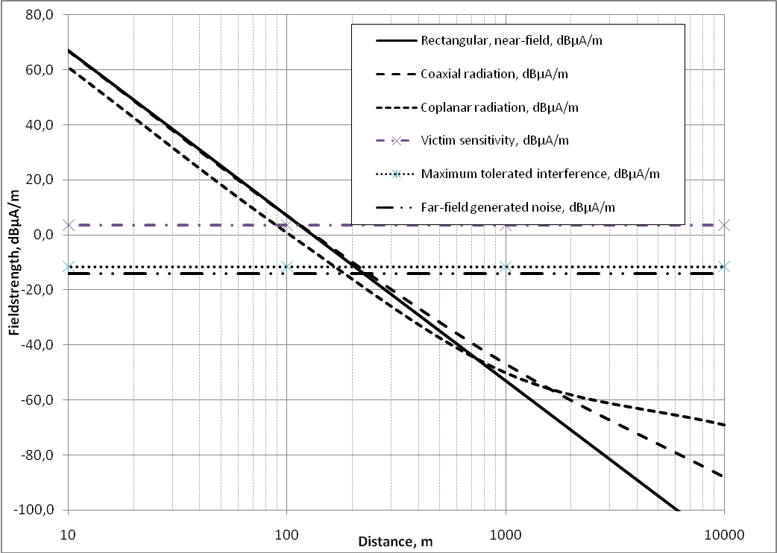
Figure 4: Field strenght roll-off versus distance calculated according to ERC Report 69, section 2 and 3

The field strength roll-offs calculated according to ERC Report 69 [9] -section 2 and 3- are shown in Figure 4 for a frequency of 80 kHz.
It shall be noted that the change of the roll-off rate at around 1000 m is dependent of the frequency. At 135 kHz this change is around 600 m.
The protection distance from a potential interferer is easily determined as the point where the radiated magnetic field strength is crossing the ambient noise level. The noise level is mainly determined by man made noise such as industrial noise from switch mode power supplies, electric motors, energy saving lamps but may also be caused by atmospheric lightning. From the curves in Figure 4, it can be seen that the protection distance is approximately 210 m.
A typical victim receiver operating at 100 kHz has a sensitivity of 55 dBµV/m. This signal is in the far-field as the transmitting station depending on the power level may be more than 100 km away. Consequently, the receiving sensitivity is 55 dBµV/m -51.5 dB = 3.5 dBµA/m.
Additionally, the tolerated interference to the victim receiver is assumed to be 40 dBµV/m corresponding to -11,5 dBµA/m. Therefore, critical services need to be protected by adding a narrow notch with an inductive limit of 42 dBµA/m at 10m.
According to ERC Report 69 [9], it is necessary to consider if any ground wave effect is to be added by using ITU-R P.368-7 [10]. The calculation is made by a software programme, CILIR110, which is available as part of ERC Report 69.
The input data are:
Frequency: 80.00 kHz
The magnetic field strength limit: 68.0 dBuA/m
The measuring distance: 10.0 m
The E_1kW@1km according ITU-R P.368-7 [10]: 156.5 dBuV/m
The max. acceptable interference level: 40.0 dBuV/m
The bandwidth of the victim receiver: 200.00 Hz.

The calculated results are:
The 20/40 dB/decade transition distance: 223872.1 m
The field strength at the measuring position is maximal in the coaxial direction
Magnetic dipole moment: 16 A.m2
The Effective radiated power: -104.1 dBkW / 39 nW
The interference range is inside the near field range.
The ground wave interference range is: 211 m.
The value of the interference range, 211 m, is very near to the corresponding value found from figure 4. It can therefore be concluded that there is almost no ground wave effect at the intended operating frequencies.
Consequently is an increased H-field down at the noise floor at approximately 100 - 150 m and protection is only needed if the interference source can be positioned closer than this distance.
The standard frequencies and other frequencies to be protected with a limit of 42 dBµA/m at 10 m falling inside the band 9-135 kHz are given in Table 5 below:

Station | Frequency | Protection bandwidth | Location
MSF Note 1 | 60 kHz | +/-250Hz | United Kingdom
RBU | 66.6 kHz | +/-750Hz | Russian Federation
HBG | 75 kHz | +/-250Hz | Switzerland
DCF77 | 77.5 kHz | +/-250Hz | Germany
LORAN C | 90-110 kHz | Over the entire band | world-wide
RNS-E(A)  RNS-E(D)  RNS-V(A) | 100 kHz | +/-250Hz | Russian Federation
DCF49 | 129.1 kHz | +/-500Hz | Germany
Note 1: this band is already protected by the exiting regulation via a notch in the limit.
Note 2: Standard frequencies and time standards are defined by ITU-R TF.768 [11]

Table 5: Standard frequencies and time standards inside 9 kHz-135 kHz

Proposed change in ERC/Rec 70-03
Considering all above it may be possible to simplify the inductive limit in ERC/REC 70-03 Annex 9 as described in the following table.
Frequency band | Magnetic field | Duty cycle | Channel spacing | Notes
a. 9–90 kHz | 72 dBµA/m at 10 m  Note 1 | No restriction | No channel spacing | I case of external antennas, only loop coil antennas may be employed.  Field strength level descending 3 dB/oct above 30 kHz
b. 90-119 kHz | 42 dBµA/m at 10 m | No restriction | No channel spacing | In case of external antennas, only loop coil antennas may be employed.
c. 119-135 kHz | 66 dBµA/m at 10 m  Note 1 | No restriction | No channel spacing | In case of external antennas, only loop coil antennas may be employed.  Field strength level descending 3 dB/oct above 30 kHz
d. 135-140 kHz | 42 dBµA/m at 10 m  Note 2 | No restriction | No channel spacing | In case of external antennas, only loop coil antennas may be employed.
e. 140-48.5 kHz | 37.7 dBµA/m at 10 m | No restriction | No channel spacing | In case of external antennas, only loop coil antennas may be employed.
Note 1: Limit reduced to 42 dBµA/m at 10 m according to table 7
Note 2: RFID operating in the frequency band 119 kHz to 135 kHz shall meet the spectrum mask given in EN 300 330 (under revision). This will permit a simultaneous use of the various sub-bands within the range 90-148.5 kHz.
Table 6: Proposed revised inductive limits for ERC/REC 70-03 Annex 9

Station | Frequency | Protection bandwidth | Maximum Field strength at 10 m | Location
MSF | 60 kHz | +/-250Hz | 42 dBµA/m | United Kingdom
RBU | 66.6 kHz | +/-750Hz | 42 dBµA/m | Russian Federation
HBG | 75 kHz | +/-250Hz | 42 dBµA/m | Switzerland
DCF77 | 77.5 kHz | +/-250Hz | 42 dBµA/m | Germany
DCF49 | 129.1 kHz | +/-500Hz | 42 dBµA/m | Germany
Table 7: Standard frequencies and time standards inside to be protected 9-90 kHz and 119-135 kHz

Figure 5 provides an overview of the existing regulations given in ERC/REC 70-03 Annex 9 versus the proposed regulation given in Tables 6-7.

Figure 5: Existing regulations given in Table 3 versus the proposal given in 6
(note the notches given in Table 7 are not shown for simplification)

The existing notch at 60 kHz should be maintained (see Table 3 band ab).

conclusions
The limits given in chapter 7 for inductive SRD’s for the frequency range 9 kHz to 148.5 kHz are not expected to produce harmful interference to radio services under the assumption that current long wave radio receivers are not used in an area of about 100 m around the proposed inductive devices. A more stringent limit of 42 dBµA/m at 10m is needed for current known sensitive radio services which are expected to be used in that area (see table 5).

If in the future, additional relaxation of the limits is requested in the frequency range 90 kHz to 119 kHz, the protection of those systems listed in table 8 should be considered.

Station | Frequency | Protection bandwidth | Location
LORAN C | 90-110 kHz | Over the entire band | world-wide
RNS-E(A)  RNS-E(D)  RNS-V(A) | 100 kHz | +/-250Hz | Russian Federation
Table 8: Standard frequencies and time standards inside 90-119 kHz
- ECA frequency table [5]
This Annex provides the frequency use within CEPT according to the ECA (see ERC Report 25 [5]) in the frequency range 9 kHz to 148.5 kHz, although the proposed modifications for this document is for the frequency range 70 kHz to 90 kHz only.

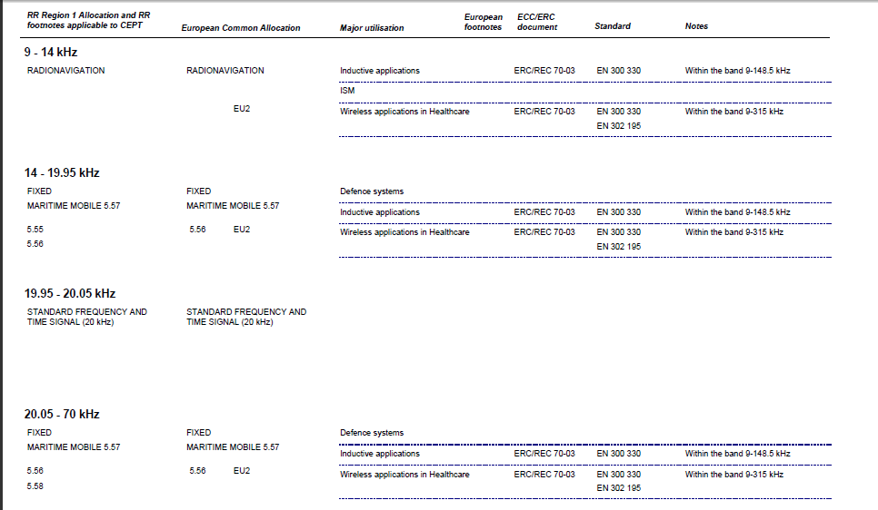
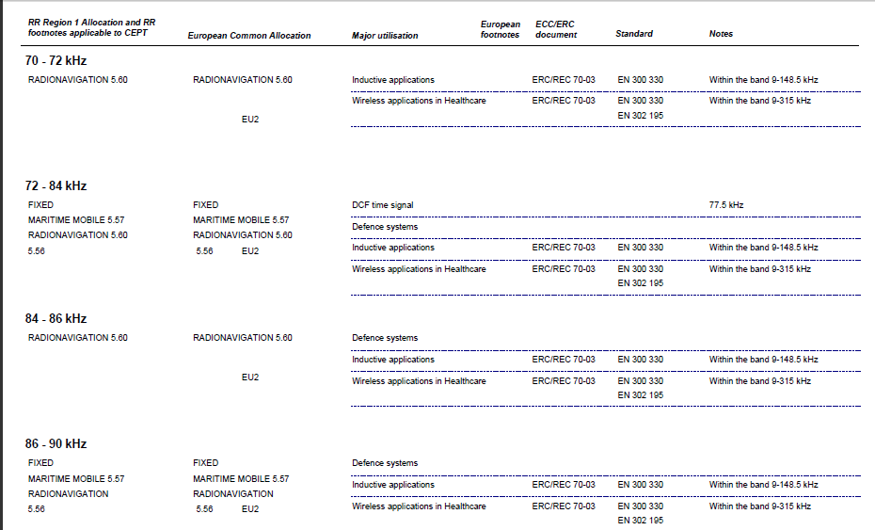

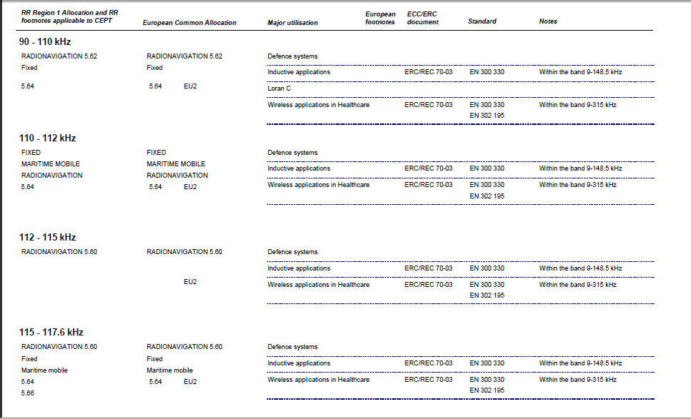
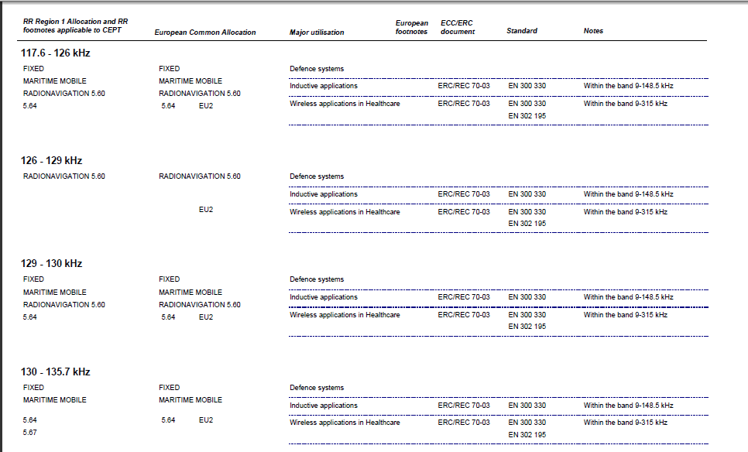
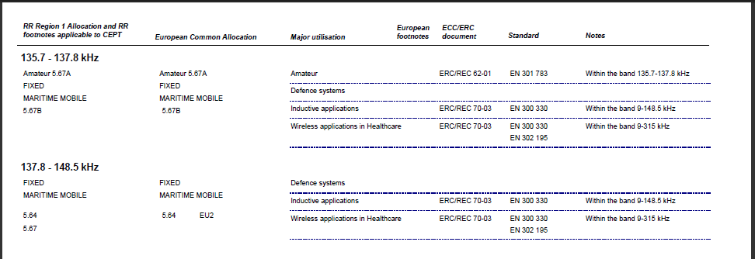
- LIST OF REFERENCES
[1] ERC/REC 70-03 (February 2009): Short Range Devices (SRD) (http://www.erodocdb.dk/)
[2] ERC Report 044: (http://www.erodocdb.dk/) in the band 9 - 135 kHz
[3] TR 102 756: System Reference Document for revised spectrum requirements for RFID equipment and inductive loop systems operating in the frequency range 9 kHz to 148,5 kHz (www.etsi.org)
[4] ECC Report 007: Compatibility between Inductive LF RFID Systems and radio Communications Systems in the Frequency Range 135-148.5 kHz (www.erodocdb.dk)
[5] ERC Report 025: European Common Allocation Table (ECA) (www.erodocdb.dk)
[6] ERC/REC 74-01: Unwanted Emissions in the Spurious Domain (www.erodocdb.dk)
[7] EN 300 330: Technical characteristics and test methods for radio equipment in the frequency range 9 kHz to 25 MHz and inductive loop systems in the frequency range 9 kHz to 30 MHz (www.etsi.org)
[8] CISPR 16: Specification for radio disturbance and immunity measurement apparatus and methods
[9] ERC Report 069: Ground-wave propagation curves for frequencies between 10 kHz and 30 MHz (www.itu.int)
[10] ITU-R Recommendation P.368: Ground-wave propagation curves for frequencies between 10 kHz and 30 MHz (www.itu.int)
[11] ITU-R Recommendation TF.768: Standard frequencies and time signals (www.itu.int)

http://www.wirelesspowerconsortium.com/,

