ECC Report 178

Open and Closed Dialling Plans
Approved 11 May 2012

Executive summary
This report gives an overview on the impacts of closing a national dialling plan. It clarifies the differences between numbering plans and dialling plans, and shows that the closure of a dialling plan fosters a more efficient use of a numbering plan.
The report draws the following conclusions:
- Closing the dialling plan facilitates more efficient use of the numbering plan as it releases additional numbers for use for operators, subscribers and services.
- Geographic significance in numbers is not automatically removed when closing the dialling plan.
- Removing the geographic significance in numbers fosters an even more efficient use of numbering capacity within a numbering plan.
- Closing the dialling plan may be a prerequisite for further possible evolution of a national numbering plan, but there is no link between a dialling plan and geographic numbering significance, i.e. a country may choose to close its dialling plan, but still keep the geographic significance of numbers.
- Although in many countries location portability is considered as a voluntary service aspect, closing the dialling plan and removal of geographic significance of numbers will widen the scope of location number portability to the whole country. This means that the geographic information of a number will gradually diminish, but this will be a slow process.
- As tariff transparency is a clear user benefit, tariffs should not be distance based in a closed dialling plan with possible location portability.

TABLE OF CONTENTS

0 Executive summary 2
1 Introduction 5
2 Definitions 6
2.1 The Terms 6
2.2 Usage of Certain Terms 8
3 Scope 9
4 Numbering Plans and Dialling Plans 10
4.1 Numbering Plan and Dialling Plan 10
4.2 Open Dialling Plan 10
4.3 Closed Dialling Plan 10
4.4 Illustrated Usage of Geographic Numbers 10
5 Example on Closing the Dialling Plan 13
6 Regulatory impacts with Closing a Dialling Plan 16
6.1 Geographic Significance of a Number 16
6.2 Number Portability – Location Portability and Service Provider Portability 16
6.3 Number Block Allocation and Assignment 16
6.4 Tariff Transparency 16
7 Conclusions 18
ANNEX 1: List of references 19

LIST OF ABBREVIATIONS

Abbreviation | Explanation
CC | Country Code
CEPT | European Conference of Postal and Telecommunications Administrations
E.164 | ITU-T Recommendation on “International Public Telecommunication Numbering Plan”
ECC | Electronic Communications Committee
ITU-T | International Telecommunication Union – Telecommunication Standardization Sector
M2M | Machine-to-machine (communications)
N(S)N | National (Significant) Number
NDC | National Destination Code
NNP | National Numbering Plan
NRA | National Regulatory Authority
SN | Subscriber Number
TC | Trunk Code

Introduction
In recent years developments in the telecommunications sector led to an increasing demand for E.164 numbers. Scarcity within established number ranges or the absence of free ranges for new services occasionally cause national regulatory authorities (NRAs) to review their numbering plans.
The terms ‘numbering plan’ and ‘dialling plan’ are often used interchangeably. This is incorrect as the terms have different meanings. A national numbering plan specifies the format and structure of the numbers used within that plan. A dialling plan is a string or combination of decimal digits, symbols, and additional information that defines the method by which the numbering plan is used. Only a dialling plan – i.e. not a numbering plan – can be either open or closed.
This report gives an overview on the impact of closing a dialling plan. It clarifies the differences between numbering and dialling plans, and shows that the closure of a dialling plan fosters a more efficient use of a numbering plan.

Definitions

The Terms
The definitions in this report are taken from ITU-T Recommendation E.101 “Definitions of terms used for identifiers (names, numbers, addresses and other identifiers) for public telecommunication services and networks in the E-series Recommendations” [1].
Term | Definition
Area code | The combination of the national (trunk) prefix and the trunk code (TC) that identifies a specific geographic region/numbering area of the national numbering plan.
Closed dialling plan | A dialling plan where the national (significant) numbers [N(S)N] are used when dialling geographic numbers.
Dialling plan | A string or combination of decimal digits, symbols, and additional information that defines the method by which the numbering plan is used. A dialling plan includes the use of prefixes, suffixes, and additional information, supplemental to the numbering plan, required to complete the call.
E.164 number | A string of decimal digits that satisfies the three characteristics of structure, number length and uniqueness specified in ITU-T Recommendation E.164. The number contains the information necessary to route the call to the end user or to a point where a service is provided.
E.164 numbering plan | A type of numbering plan that specifies the format and structure of the numbers used within that plan. It typically consists of decimal digits segmented into groups in order to identify specific elements used for identification, routing and charging capabilities, e.g., to identify countries, national destinations and subscribers. An E.164 numbering plan does not include prefixes, suffixes, and additional information required to complete a call. The national numbering plan (NNP) is the national implementation of the international E.164-numbering plan (also called the international public telecommunication numbering plan).
Geographic number | An E.164 number which corresponds to a discrete geographic area.
National (significant) number  N(S)N | That portion of the international E.164 number that follows the country code for geographic areas and is defined in national numbering plans (NNP). The national (significant) number consists of the National Destination Code (NDC), if present, and the Subscriber Number (SN). In some cases the NDC could be absent or to form part of the SN and in that case the N(S)N and the SN coincide. The function and format of the N(S)N is nationally determined.
National (trunk) prefix | A digit or combination of digits defined in a dialling plan and used by a calling subscriber, making a call to a subscriber in his own country but outside his own numbering area.
National destination code (NDC) | A nationally optional code field, within the international public telecommunication numbering plan (hereafter referred to as the “international E.164-numbering plan”), which – combined with the Subscriber’s Number (SN) – will constitute the national (significant) number of the international E.164-number for geographic areas.  The NDC can be a decimal digit or a combination of decimal digits (not including any prefix) identifying a numbering area within a country (or group of countries included in one integrated numbering plan or a specific geographic area) and/or network/services.
Non-geographic number | A number which has no geographic significance.
Numbering area | A geographic area covered by a national destination code (NDC) or area code inside a national numbering plan.
Open dialling plan | A dialling plan where both numbers on the local level (subscriber numbers (SN) without area code) and numbers on the national level are used when dialling geographic numbers.
Prefix | A prefix is an indicator consisting of one or more digits that allows the selection of different types of number formats, networks and/or services. Prefixes are part of the dialling plan and they do not form part of the numbering plan.
Service number | A non-geographic E.164 number allocated to a specific category of services.
Subscriber number (SN) | The portion of the E.164 number that identifies a subscriber in a network or numbering area.
Trunk code (TC) | A digit or combination of digits, not including the national (trunk) prefix, identifying the numbering area within a country (or group of countries included in one integrated numbering plan or a specific geographic area).  The trunk code has to be used before the called subscriber’s number when the calling and called subscribers are in different numbering areas. The trunk code is a particular application of NDC.

Usage of Certain Terms
Structure of the international E.164-number
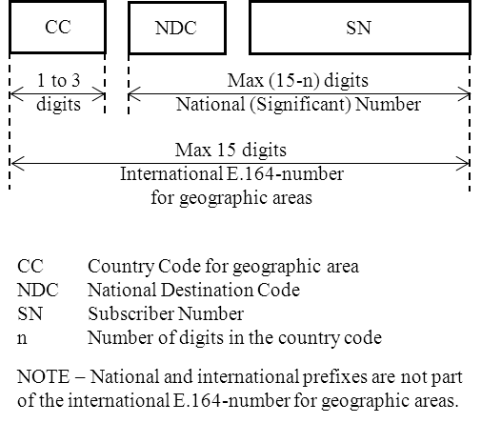
- International E.164-number structure for geographic areas [2]
Figure 2 aims to clarify the usage of the terms area code’, ‘national (trunk) prefix’, ‘trunk code’ and ‘national destination code’.
The explanation of terms is divided in two: for geographic numbers, such as (fixed) subscriber numbers, and for non-geographic numbers, such as nation-wide service numbers and (e.g. mobile) subscriber numbers.

Explanation |  | Geographic numbers
Number example (a geographic number) |  | 0 | 21 | 456 1234
General terms |  |  | National (significant) number
 |  | National (trunk) prefix | National destination code | Subscriber number
Terms for geographic numbers |  | National (trunk) prefix | Trunk code | Subscriber number
 |  | Area code |  | Subscriber number
Explanation |  | Non-geographic numbers
Number example (a freephone number) |  | 0 | 800 | 234 567
General term |  |  | National (significant) number
Terms for non-geographic numbers |  | National (trunk) prefix | National destination code | Subscriber number

- Explanation of terms used
Removal of the country code from an international E.164 number leaves the national (significant) number. Nationally, a number consists of a national destination code and a subscriber number. These terms apply to geographic and non-geographic numbers.
For geographic numbers (further to the general terms above) a numbering area is identified by the term ‘trunk code’. A trunk code is preceded by a national (trunk) prefix, which is typically ‘0’. The term ‘area code’ is used to combine the national (trunk) prefix and the trunk code.

Scope
This report examines the differences between numbering plans and dialling plans, and in particular the implications of closing a dialling plan.
Details of numbering plans are not within the scope of this report. Additional information about the structure of numbering plans can be found in the ECC Report 154 “Evolution of Geographic Numbers” [3].

Numbering Plans and Dialling Plans

Numbering Plan and Dialling Plan
The ITU-T Recommendation E.164 “The International Public Telecommunication Numbering Plan” [2] defines the format and structure of the numbers used for public international telecommunication. The numbering plan consists of decimal digits segmented into groups in order to identify specific elements used for identification, routing and charging capabilities, e.g. to identify countries, national destinations and subscribers. The E.164 numbering plan does not include prefixes, suffixes, and additional information required to complete a call. A national numbering plan is the national implementation of the international E.164-numbering plan. It specifies the format and structure of the numbers used within telecommunication networks for subscriber numbers and for services, e.g. freephone numbers and premium rate numbers. The numbers in the numbering plan can either have uniform length or variable length or include both numbers of uniform and variable lengths. [1]
A dialling plan explains how the end-user should use the numbering plan in order to place a call to another end-user or to a service. It is a string or combination of decimal digits, symbols, and additional information that defines the method by which the numbering plan is used. A dialling plan includes the use of prefixes, suffixes, and additional information, supplemental to the numbering plan, required to complete the call.

Open Dialling Plan
In an open dialling plan a country is divided into several numbering areas indicated by area codes. Local dialling is typically possible within a numbering area between numbers with the same area code, i.e. without dialling the area code. Thus the local dialling facility means that it is sufficient to dial only the subscriber number to reach a subscriber within the same numbering area. It is a national matter whether it is allowed to use full national dialling (i.e. area code [national (trunk) prefix and trunk code] + subscriber number) within the same numbering area. A call between numbering areas is indicated by a national (trunk) prefix followed by a trunk code and a subscriber number.

Closed Dialling Plan
In a closed dialling plan the caller must always dial the full national (significant) number [N(S)N] when placing a call. A national (trunk) prefix (typically 0) may or may not be required for calls within the country. Even though the prefix may not be essential as part of the structure of the dialling plan, it may be retained to facilitate later expansion of the numbering plan.

Illustrated Usage of Geographic Numbers
Figure 2 illustrates a division of a country to numbering areas, in this case four numbering areas identified as A1, A2, A3 and A4 with trunk codes 21, 22, 23 and 24 respectively. This dialling plan is typically also known as an open dialling plan.
In this example local dialling is possible: subscriber S1 may reach subscriber S2 by dialling just his subscriber number ‘456 6789’. If he wishes to reach a subscriber in another numbering area, the area code (the national (trunk) prefix + the trunk code) must precede the subscriber number, for example S1 → S4: ‘024 456 6789’. Without dialling the area code S1 would reach S2 in the same numbering area instead of S4.
Number portability is only possible within a numbering area. This means that, for example, subscriber S2 may move within numbering area A1 and retain his number. An attempt for S2 of moving from numbering area A1 to numbering area A4 and retaining his A1-number ‘456 6789’ would clash with subscriber S4 already having a connection in numbering area A4 with the same geographic number.
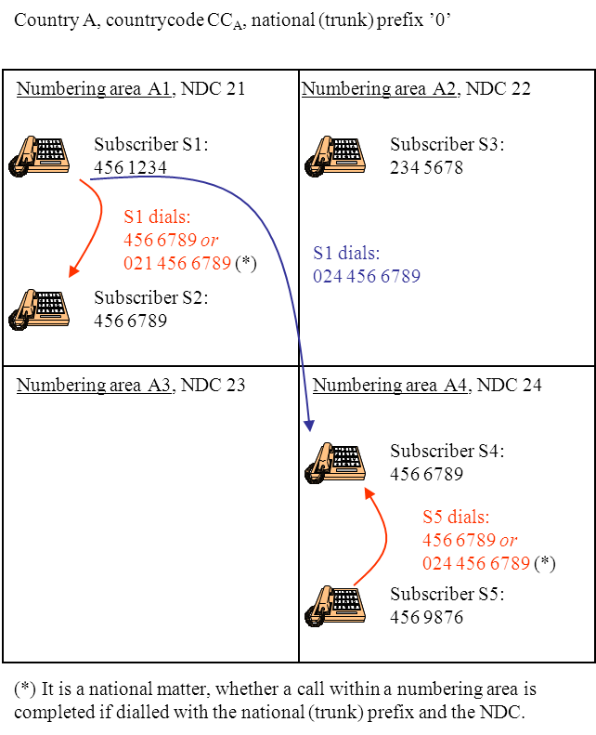
- Illustration of numbering areas and
dialling within and between them (open dialling plan)
Figure 4 illustrates relations between geographic and non-geographic numbers. The example shows a mobile numbering area M1 covering the whole country – quite naturally – with NDC ‘5’.
To reach subscribers within M1 it would be enough to dial just the mobile subscriber number without the NDC. However, it would be necessary to dial both the national (trunk) prefix and the (mobile) N[S]N for a fixed network user to reach a mobile user. Dialling of the national (trunk) prefix and the (mobile) NDC presents the mobile number always in the same way, i.e. the trunk prefix, NDC, mobile subscriber number, regardless of whether the call originates from a fixed or a mobile network. Furthermore, the national (trunk) prefix and the (mobile) NDC can provide tariff transparency. Therefore it was decided that the whole number shall be dialled even within a mobile network. This means that the national (trunk) prefix and the mobile NDC will always be included. Similarly, a mobile user will need to dial the whole national (significant) number preceded by the national (trunk) prefix in order to reach any fixed subscriber in any numbering areas.
Although local dialling within numbering areas in an open dialling plan is possible, it is a matter of implementation as to whether it is also allowed to dial the area code preceding the subscriber number. It would facilitate closing the dialling plan if full national dialling was already permitted, as it would be easier to educate consumers on the required change to dialling behaviour.
As a simplified example related to Figure 3, the dialling plan could be closed by removing the facility of local dialling, i.e. full national dialling would always be required. This could be done by ensuring the existing subscriber numbers include their area code, for example in case of subscriber S1 the subscriber number ‘456 1234’ would become ‘021 456 1234’. Now, in fact, the preceding zero (the national (trunk) prefix) in the new subscriber numbers (actually in all numbers in the country) can be dropped to make a new shorter subscriber number of S1 to be ’21 456 1234’. Numbers in mobile numbering area M1 would become subscriber numbers beginning with digit ‘5’.
Closing a dialling plan does not change the geographic meaning of the numbering plan. However, if location portability (a subscriber’s ability to move his geographical location while retaining his number and original service provider) was also applied within the whole country, the geographical significance would gradually diminish.

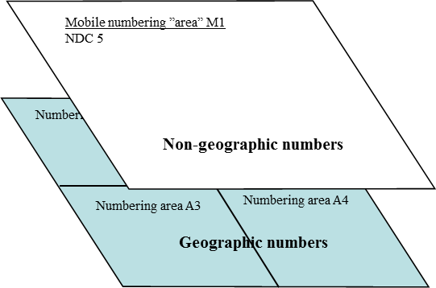

- Separation of geographic and non-geographic numbers

Example on Closing the Dialling Plan
In general, closing a dialling plan does not create free capacity within a numbering plan, but it may, via rearranging the usage of numbers and allocating new number ranges free capacity, for example, for subscriber numbers. This depends mostly on the existing numbering plan and what other kinds of numbering changes are carried out in connection with closing the dialling plan.
A simplified fictitious example may illustrate impacts on number capacity. The example illustrated in section 4.4 is also used here.
To simplify the example in the open dialling plan only fixed and mobile telephone numbers are in use (i.e. other non-geographic numbers such as freephone and premium rate numbers do not exist). The mobile numbering range is identified with NDC ‘5’ and the geographic numbering areas are all identified with a trunk code starting with digit ‘2’, i.e. NDC ‘2X’. Within the NDCs the mobile and fixed subscribers are identified with subscriber numbers starting with digits 2-9. A (fixed) subscriber number cannot start with digit ‘0’ as it is the national (trunk) prefix, and digit ‘1’ is reserved (in this example) for short codes (e.g. 112) and service numbers.
On national level the international prefix ‘00’, the national (trunk) prefix ‘0’, NDCs ‘2X’ (geographic numbers) and ‘5’ (mobile) are in use, i.e. in theory 70% of the capacity is free. However, to make some of this capacity available for use, new numbering areas and NDCs would need to be introduced.
On a local level (i.e. a subscriber’s point of view in dialling without the national (trunk) prefix and the trunk code) the situation is more difficult (see Figure 5). Depending on the usage of the first digits in subscriber numbers there may or may not be significant amounts of free capacity. In the worst case all the starting digits 2-9 are in use for local dialling within a trunk code as shown in Figure 5.
The Figure 5 illustrates the general number usage within a numbering area for geographic numbers. Note, that the 1st (A) and 2nd (B) digits in Figure 5 are the first two digits within the numbering area behind the area code: 02X ABy₃…y_{n} (y_{n} represents the last digit of the subscriber number).
Example 1: If A=2 and B= 5 this would include all geographic subscriber numbers starting with digits 25, i.e. 25y₃y₄y₅y₆y₇
Example 2: If A=0 and B=5 this would represent the national (trunk) prefix ‘0’ followed by trunk code or national destination code ‘5’ indicating – in this case – mobile number range, i.e. 05 y₁y₂y₃y₄y₅y₆y₇

Second digit (B) | 0 | 1 | 2 | 3 | 4 | 5 | 6 | 7 | 8 | 9
First digit (A)
0 | International  prefix |  | Geographic  NDCs |  |  | Mobile  NDC
1 | Short codes and service numbers
2
3
4
5
6
7
8
9

Free numbering range | Geographic subscriber numbers (local dialling)

- Illustration of number usage before closure of the dialling plan
(within a numbering area)
If the dialling plan is closed in the simplest way, local dialling is ceased and full national dialling is required. In the above example all subscribers in fixed networks would be reached by dialling 02X + SN, where 02X identifies the national (trunk) prefix and the old trunk code and SN is the actual (‘old’) subscriber number. Dialling just SN would not be possible anymore (it would be an incomplete number). Mobile users could be reached with numbers starting with digits ‘05’. For mobile users there’s no change as the national (trunk) prefix ‘0’ and the mobile NDC ‘5’ had to be dialled previously. After a transition period the ‘old’ national (trunk) prefix ‘0’ may be removed from the new closed dialling plan since there is no technical requirement. In Figure 6 the national (trunk) prefix (‘0’) has been removed from the dialling plan.
Now, in the new numbering plan with closed dialling the following applies (shown in Figure 6) based on the situation of the old open dialling plan numbers.

Second digit | 0 | 1 | 2 | 3 | 4 | 5 | 6 | 7 | 8 | 9
First digit
0 | International  prefix
1 | Short codes and service numbers
2 |  | Geographic subscriber numbers
3
4
5 | Mobile numbers
6
7
8
9

Free numbering range | Geographic subscriber numbers

- Illustration of number usage after closure of the dialling plan
(national level without preceding national (trunk) prefix)
As this is a figurative example the theoretically freed numbering ranges may appear excessive. However, the free number ranges have been there already during the open dialling plan (in both cases – Figures 5 and 6 – there is approximately 70% of number capacity free). Within an open dialling plan the usage of the free space required to open up a new NDC.
The old geographic subscriber numbers, with numbering areas (trunk codes) ‘21’, ‘22’, ‘23’ and ‘24’ now cover 40% of the fixed line subscriber numbering range starting with digit ‘2’ providing room for expansion. For mobile numbers closing the dialling plan did not give any extra capacity. Now the number ranges starting with digits 3-4 and 6-9 are totally free, for example to expand geographic numbering areas if needed or to introduce new mobile numbering ranges.
As indicated before, closing the dialling plan does not create more numbers. However, closing the dialling plan facilitates more efficient use of the existing numbering plan as it makes free capacity available for new operators, subscribers and services.

Regulatory impacts with Closing a Dialling Plan
Closing a dialling plan may require review of national numbering related regulations, although the regulations may not be affected whether the dialling plan is open or closed. However, the following implications may take place.

Geographic Significance of a Number
In an open dialling plan the country’s area is divided into numbering areas, and dialling between them requires the national (trunk) prefix and the trunk code before a subscriber number. The geographic significance of subscriber numbers is related to numbering areas.
When closing the dialling plan no immediate changes take place on the number structure within a numbering area. Provided that the technical prerequisites exist, the scope for location portability may then be enlarged to cover the whole country and the existing numbers can then be used in the whole country. This means that the geographic significance of a number will gradually diminish, but this will be a very slow process.
In most cases – depending on national circumstances – it seems to be advisable to close the dialling plan before it is intended to remove the geographic significance of numbers in the numbering plan.

Number Portability – Location Portability and Service Provider Portability
In open dialling plan location portability (a subscriber’s ability to move his geographical location while retaining his number and original service provider) is restricted within a numbering area as described in section 4.4. Although in many countries location portability is considered as a voluntary service aspect, closing the dialling plan and removing the geographic significance of numbers will widen the scope of location portability to the whole country.
Provided operators allow location portability country wide, this would gradually mix the existing numbers geographically thus diminishing slowly the geographic significance of numbers.
Closing the dialling plan does not affect service provider portability.

Number Block Allocation and Assignment
In both an open and a closed dialling plan – if geographic significance of numbers exists – an operator requires a number block in each numbering area in order to serve potential customers there. As some operators or service providers may have only a few customers in certain numbering areas compared to the capacity of the number block, this procedure may lead to inefficient use of numbering capacity.
In a closed dialling plan, and if geographic significance of numbers in the numbering plan does not exist anymore, it is possible for operators and service providers to use the same number blocks all around the country. This requires that the operator’s network architecture supports this kind of number block usage. As separate number blocks are no longer required in every geographic numbering area (area codes do not exist anymore), closing the dialling plan may save numbering capacity.

Tariff Transparency
Tariff transparency means a subscriber’s ability to assess the cost of a telephone call based on the dialled number. In the past most countries had at least two different tariffs, e.g. one for calls inside a number area (local calls) and one for calls between different numbering areas. In an open dialling plan a local call was in the past typically cheaper than a long distance call between numbering areas.
Although closing the dialling plan does not necessarily remove the geographical significance of numbers, it fosters the introduction of a nation-wide ‘local’ tariff. However, if distance based tariffs remain, and numbers gradually mix within a country, a subscriber no longer has the means to assess the tariff based on numbering areas. Therefore tariff transparency may be affected.

Conclusions
The report draws the following conclusions:
- Closing the dialling plan facilitates more efficient use of the numbering plan as it releases additional numbers for use for new operators, subscribers and services.
- Geographic significance in numbers is not automatically removed when closing the dialling plan.
- Removing the geographic significance in numbers fosters a more efficient use of numbering capacity within a numbering plan.
- Closing the dialling plan may be a prerequisite for further possible evolution of a national numbering plan; there is no link between a dialling plan and geographic numbering significance.
- In most cases – depending on national circumstances – there are advantages in closing the dialling plan before it is intended to remove the geographic significance of numbers in the numbering plan.
- Although in many countries location number portability is considered as a voluntary service aspect, closing the dialling plan and removal of geographic significance of numbers will widen the scope of location portability to the whole country. This means that the geographic information of a number will gradually diminish, but this will be a slow process.
- As tariff transparency is a clear user benefit, tariffs should not be distance based in a closed dialling plan with possible location number portability.

- List of references
- ITU-T Recommendation E.101 (11/2009)
Definitions of terms used for identifiers (names, numbers, addresses and other identifiers) for public telecommunication services and networks in the E-series Recommendations
- ITU-T Recommendation E.164 (11/2010)
The international public telecommunication numbering plan
- ECC Report 154 on Evolution of Geographic Numbers (Luxembourg, November 2010)

In this report this definition is understood as “A geographic area covered by an area code inside a national numbering plan or by a national destination code (NDC) in case of non-geographic numbers.”
ITU-T Recommendation E.164, section 7.3.2 [2]
Please see Reference [3], especially section 7.2.2.
Closing the dialling plan does not automatically remove the geographic significance of a number.

