Field measurement campaigns from some administrations related to MFCN in 3400-3800 MHz and Radio Altimeters in 4200-4400 MHz

Results of the preliminary test of compatibility between MFCN operating in 3400-3800 MHz and Radio Altimeters (RA) operating in 4200-4400 MHz

Test setup

Test location
The test was performed at Norwegian International Airport Bergen-Flesland (BGO)
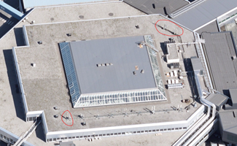
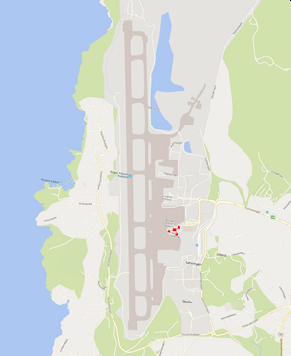
Figure 1: Location of the test base station at BGO
The test was performed using a commercial Ericsson 5G base station operating in the band 3700-3800 MHz. The base station is mounted on top of the roof of the terminal building (Terminal 2), and there were not made any changes in sector directions of the base station for testing purposes. This base station uses active antenna systems (AAS) antennas.
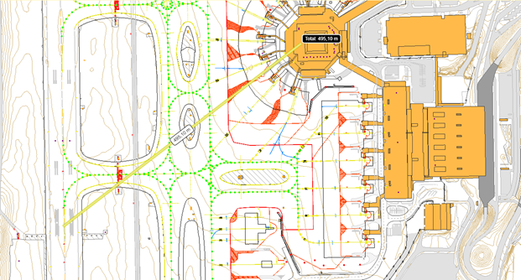
Figure 2: Distance to Touchdown Zone approx. 495 m
Antenna with azimuth 250° points directly towards touchdown zone at the runway (RWY 35). The sector 150°, due to AAS, may influence the flight instruments during approach, therefore it has been scheduled to an emergency shutdown too, in case of any abnormalities under the test.
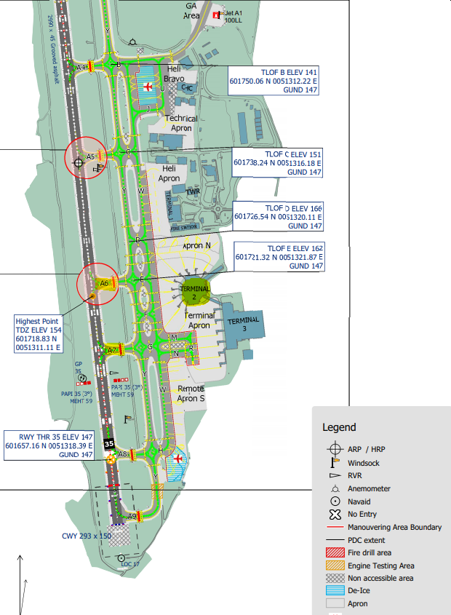
Location of 5G base station
For landing RWY 35 two sectors are active, 150° and 250°
Radiated power from antenna: max 100W pr element.
In real ca. 2 x 95W.
Touchdown zone
Avstand ca. 495m fra antenna
Figure 3: Detailed information about location of runway (RWY) and touchdown zone

Test prerequisites and procedure
The test prerequisites and procedure were developed by Avinor and Air Traffic Control.
The following prerequisites was required to perform test:
- All parties participating in the test (Air Traffic Control, Norwegian Communications Authority, Telia) must be in constant contact on-line during the entire test period.
- Air Traffic Control Tower (ATCT) Flesland frequency TWR (VHF/AM): 119,100 MHz
- Weather:
minimum visibility: 10 km
cloud base minimum: 3000 ft
- Flight control should separate aircrafts participating in the test from the other ones if it is needed.
- Do not enable 5G test-signal before touchdown of the previous plane unless it is also a part of the test.
- Flight control (tower frequency) immediately forwards the request to immediate shut down 5G base station in case pilot of the aircraft participating in the test requests it.
Test procedure:
- Nkom monitoring ATCT frequency and “Flightradar24” to clarify when the aircraft participating in the test is entering the test area.
- When the aircraft participating in the test is in position, enable the 5G base station at full power towards the aircraft.
- Turn of the 5G test-signal when the aircraft under test has touched down.

Setup of the 5G base station
The commercial 5G base station was set to test mode for emulation of approx. 100% traffic load. The 5G base station was still operational, when 5 handsets onboard the aircraft successfully connected to the base station during the test, after the landing. The use of beam forming during test mode is uncertain since it was not possible to measure it.
Table 1: Antenna parameters
Antenna: Ericsson AIR3239 B78G
Base station longitude | 5° 13' 39.92" E
Base station latitude | 60° 17' 20.8" N
Vertical beamwidth | 9.5° +/- 2°
Horizontal beamwidth | 65° +/- 5°
Front to back ratio | 25 dB
Antenna gain | 15,9 dBi
Antenna sectors azimuth | 60°, 150°, 250°
Antenna tilt | 6°
Antenna altitude AGL | 19 m
Base Station altitude ASL | 50 m

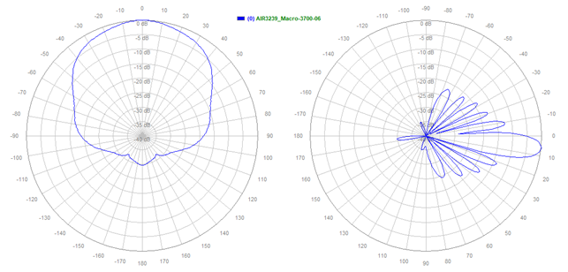
Figure 4: Antenna AIR3239 radiation pattern

Table 2: Test setup of Telia 5G base station
Radio: Ericsson Baseband 6630
Test mode | Air Interface Load Generator
Coverage mode | Macro
Power nominal | 44,77 dBm
Power radiated | 60,67 dBm
Modulation | 256 QAM
Downlink frequency | 3700-3800MHz

Aircraft types participating in the test
Aircrafts participating in the test are representative for Norwegian airports. The test consisted of aircrafts which are representative for aircrafts and helicopters landing at Norwegian airports.
      - Helicopters
- Sikorsky S-92A
- Airbus H145 (Eurocopter EC145)
- NH Industries NH90
      - Passenger aircrafts
- De Havilland Canada/Bombardier DHC-8-400
- De Havilland Canada/Bombardier DHC-8-300
- Boeing 737-705
- Airbus A320-232
- Embraer E190-E2

Radar types used in the test
Three different radio altimeters were used during the test: Sperry SPER RT 300, Honywell KRA 405 B and Rockwell Collins LRA-900. For two of the aircrafts (NH90 and Airbus A320neo) the type of radar altimeter was not identified.
Table 3: Radar types mounted in the aircrafts participating in the test
Aircraft | Radar type
Sikorsky S-92 | Sperry SPER RT 300
Airbus H145 | Honeywell KRA 405B
NH90 | Unknown
DHC-8-300 | Sperry SPER RT 300
DHC-8-Q400 | 2x Honeywell KRA 405B
B737-700 | 2x Rockwell Collins LRA-900
A320neo | Unknown
Embraer E190-E2 | Honeywell KRA 405B

Test results

Test time and weather conditions
Test date: 15. April 2021
Test time: 07:00 – 13:00 (05:00-11:00 UTC)
Weather conditions: CAVOK (Clouds and Visibility OK)
Wind: 5 kn, 350°
Visibility: 10+ km

Position of Nkom's monitoring point
Table 4: Position of measurement point
Position | Latitude | Longitude
True position of antenna az. 250° of Telia's 5G base station | 60° 17' 19.608" | 5° 13' 37.956"
Nkom position (MP1) | 60° 17' 4.668" | 5° 13' 44.472"
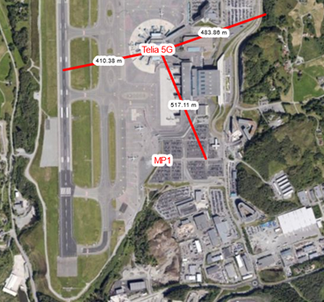
Figure 5: Location of Nkom's measurement point

Readout from Nkom's and Telia's monitors
Table 5: Nkom's instrumentation
Instrument | Usage
R&S EB500 (1) | Telia 5G base station test mode logging
R&S EB500 (2) | Visual verification of Telia 5G base station test mode
R&S PR200 | ATCT monitoring channel, verification of flights
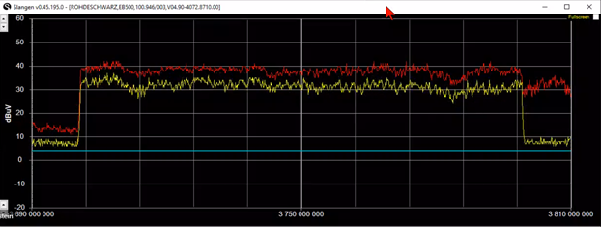
Figure 6: Signal measured in Nkoms position
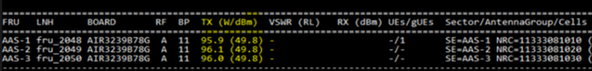
Figure 7: Power rapported by base station software

Test log
Table 6: Test log
Aircraft type | Landing | Comment
Sikorsky S-92A | ILS RWY 35 | No abnormalities. Status of Rad-Alt continuously monitored
DHC-8-400 | ILS RWY 35 | No abnormalities. Status of Rad-Alt continuously monitored
Boeing B737-705 | ILS RWY 35  (auto-landing) | No abnormalities.  Auto-landing on RWY 35.
DHC-8-300 | Visual RWY 17 | No abnormalities. Status of Rad-Alt and EGPWS continuously monitored
DHC-8-400 | Visual RWY 17 | No comments from crew à all OK.
H145 HEMS | ILS Y RWY 35 | Route shown in Figure 8  Helicopter exposes for 5G signal ca. 10 NM from the airport, it means ca. from establishing of ILS connection. After passing TDZ:  - hover taxi RWY 35  - exit RWY @ A6,  - holding for other departing traffic  - enter RWY @ A7,  - departure (visual) RWY 35  - return to base
Airbus A320-232 | ILS RWY 35 | No comments from crew à all OK
Embraer E190-E2 | Visual RWY 35 | No comments from crew à all OK  Base station notes 2 connections from the mobile device located onboard aircraft
NH90 | Low approach RWY 35 | No comments from crew à all OK
Sikorsky S-92A | Departure RWY 35  enter RWY @ A7 | No abnormalities. Status of Rad-Alt continuously monitored

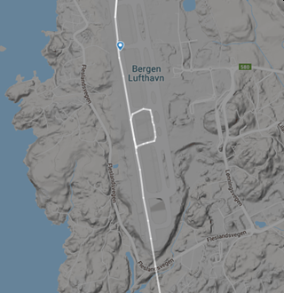
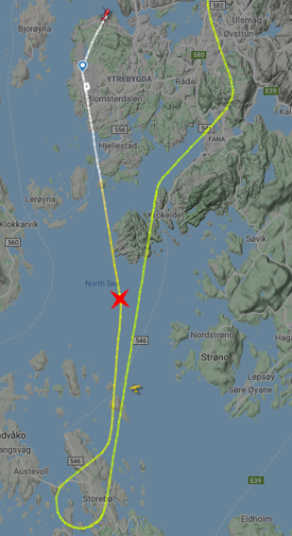
Figure 8: Path of the H145 HEMS - red cross indicates establishing of ILS connection (picture from "Flightradar24")

Conclusions
The tests were carried out with a wide range of aircrafts representative for aircrafts landing at Norwegian airports
Test results showed no abnormalities on the Radio Altimeters during the test.
During the test the base station transmitted 100% of power with help of the air interface load generator. The aircrafts participating in the test have passed by antennas of the base station at the distance of less than 500 m taxiing along the runway, while helicopters using helipad passed antennas at distances of 200 m.
During the test pilots have been instructed to continuously observe radio altimeters and other systems related to start and landing operations. There were not reported any abnormalities or signs of interference towards radio altimeters and related systems, such as EGPWS (Enhanced Ground Proximity Warning System).
There were no reports related to interference or errors of TCAS/ACAS (Traffic Collision Avoidance System/Airborne Collision Avoidance System), auto-landing functions or "cockpit call-outs".
It is worth to point out, that most of the aircrafts used in the test are relative new ones.

Test of 5G in 3400-3800 MHz and helicopter-mounted radar altimeters operating in 4200-4400 MHz

Summary
Radar altimeters are essential for aircraft operation, including auto-land systems (auto-throttle and automated landing flare and rollout). Radar altimeters at aircrafts and helicopters operates in the frequency band 4200-4400 MHz.
Technical reports from US aviation organisations and authorities indicates that a number of different radar altimeter installations may be severely impacted by the introduction of 5G in frequency bands below 4200 MHz. They may be impacted both by blocking due to lack of Rx-filtering, and due to emission levels in the spurious domain (spurious from 5G in-band in 4200-4400 MHz). The studies focus on the core frequency band for 5G roll-out in US, 3700-3980 MHz.
In Europe, CEPT (European Conference of Postal and Telecommunications Administrations) have started looking into the potential impact from 5G in the European harmonized frequency band, 3400-3800 MHz, into radar altimeters. The study will consist of both theoretical simulations and real tests. This report will be contributed into the ongoing study.
The main goal of the tests was to assess the impact of a 5G NR mobile network operating in the 3400-3800 MHz-band on radar altimeters installed onboard helicopters used by Norwegian ambulance, rescue- and police service.
During normal operations the helicopters may use barometric altimeter, radar altimeter(s) or a combination of these. During normal landings, including helipads at hospitals, barometric altimeter is the preferred option for some of the pilots, and radar altimeter for others. Some pilots use the radar altimeter display to call out the height above ground (AGL) during operations close to the ground. Radar altimeter(s) are used during instrument approaches to airports (glide-path approach to runways) and are commonly used during auto-hovering. Some of the pilots indicated that barometric altimeter is the preferred option when auto-hovering over land, as it is not sensitive to terrain variations as the helicopter drifts or banks.
In the test the following helicopter models and altimeter models were used:
- Leonardo AW169 - Altimeter: Rockwell Collins ALT-4000;
- Airbus H135-T3 - Altimeter: Honeywell (previously Bendix King) KRA 405B;
- Leonardo AW101 SAR Queen - Altimeter: Thales AHV1600-01-0200A.
During the tests a mobile 5G NR base station was placed at the runway, with an output power (EIRP) that equals the maximum output power of commercial 5G NR base stations used in commercial 5G networks in Norway as of today. The helicopters were during the tests exposed for the 5G signal from different directions, at different heights, while the altimeter(s) in the helicopters were observed by the pilots.
Actual field strength measurements done from one of the helicopters throughout the test flight, shows that the helicopter was exposed for a 5G signal up to 30 dB higher than interference threshold presented for radar altimeters mounted on helicopters in the report from the US based aviation organisation RTCA (Radio Technical Commission for Aeronautics). This report also takes in an additional 6 dB margin, on top of the 30 dBs above.
A few instances of a slight variation in the reported height by the radar altimeter were observed, but there was no malfunction or black-out of the altimeter measurements.
Overall conclusions from the tests are that no operational impact could be observed by any of the participating helicopters. This gives us a good level of confidence in the resilience of these specific radar altimeters to conduct its missions.

Introduction
The aim of the tests was to assess the impact of a 5G NR mobile network operating in the 3400-3800 MHz-band on radar altimeters installed onboard helicopters used by Norwegian ambulance, rescue- and police service.
The RTCA Paper No. 274-20/PMC-2073 – “Assessment of C-Band Mobile Telecommunications Interference Impact on Low Range Radar Altimeter Operations” published in October 2020, assess the potential impact on radar altimeters 4200-4400 MHz from 5G below 3980 MHz. In the report several altimeters have been bench-marked, and the theoretical interference in given scenarios are simulated. The report focuses on the frequency band for 5G in US, 3700-3980 MHz.
In Europe CEPT (European Conference of Postal and Telecommunications Administrations) have started a study to look at the potential impact from 5G in the European harmonized frequency band, 3400-3800 MHz, into radar altimeters. The study will consist of both theoretical simulations and real tests. This report will be contributed into the ongoing study.
Figure 9 gives an overview of the allocated frequency bands for 5G in Europe (including Norway) and US, in respect to the frequency band used by radar altimeters. The green dotted line illustrates a typical radar altimeter receive mask (Rx-filtering). The radar altimeters may be impacted both by blocking due to lack of Rx-filtering, and due to emission levels in the spurious domain (spurious from 5G in-band in 4200-4400 MHz).
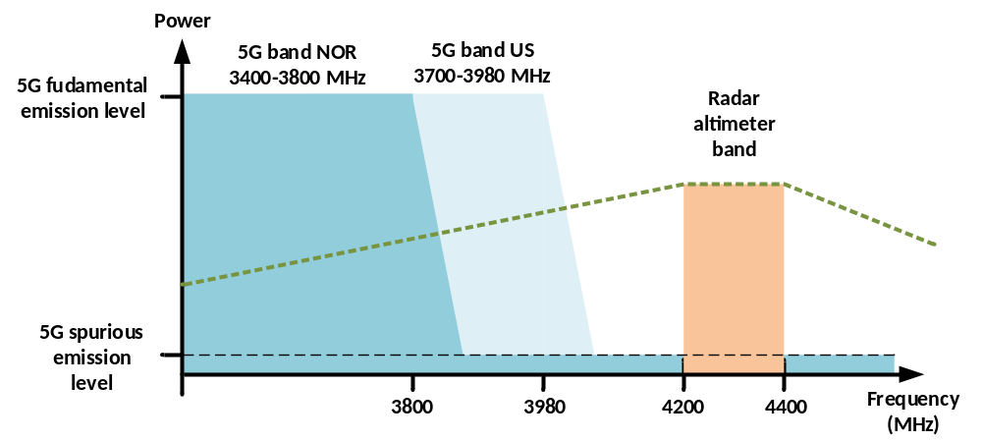
Figure 9: Illustration of 5G fundamental and spurious emissions
To relate the conclusions in the RTCA report to the actual tests, a distance versus Power Spectral Density (PSD) plot can be made. The plot below is a worst-case illustration of the PSD at different distances for the test setup. The plot is based on an BS EIRP of 78.8 dBm/40 MHz, and free-space loss. To illustrate side-lobe and back-lobe situations, -15 dB and -25 dB plots are also included. The two red plots are taken from RTCA paper and shows interference limits for Category 2 and Category 3 without the additional 6 dB margin. The actual PSD seen by the altimeter(s) will be affected by the position of the helicopter relative to the 5G NR antenna and the pointing direction of the traffic beam. The physical placement of the altimeter(s) on the helicopter may also cause physical shielding of the altimeter(s) from the 5G signal.

The plot shows that the radar altimeters of the helicopters that participated in the tests were exposed by an interference level significantly above the critical levels shown in the RTCA report.
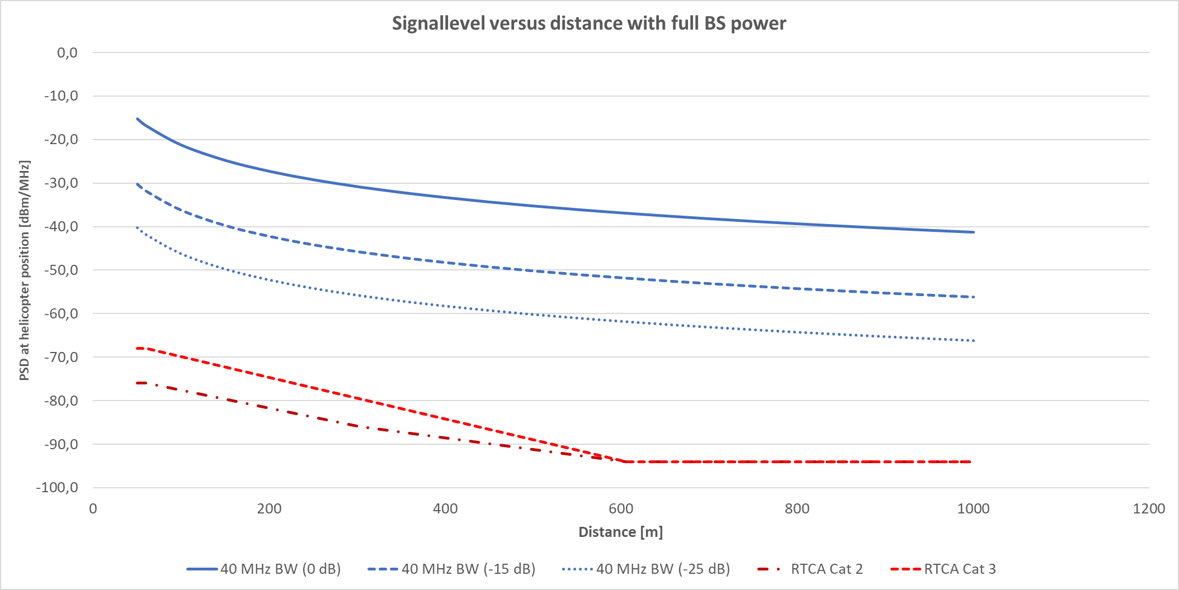
Figure 10: Theoretical PSD at helicopter position at different distances from BS

Participating helicopters

Leonardo AW169
Leonardo AW169 is the new helicopter serving the Norwegian Police Service. The helicopter service within the police (Politiets Helikoptertjeneste) operates three AW169s.
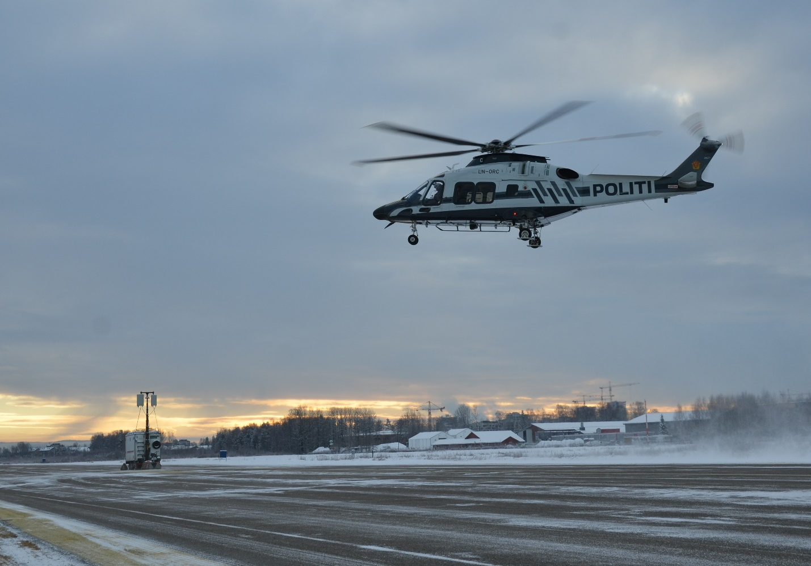
Figure 11: Norwegian Police Services AW169 (Photo: Nkom)
The AW169 has two radar altimeters, mounted underneath the tail boom.
Radar altimeter model:
Rockwell Collins ALT-4000.
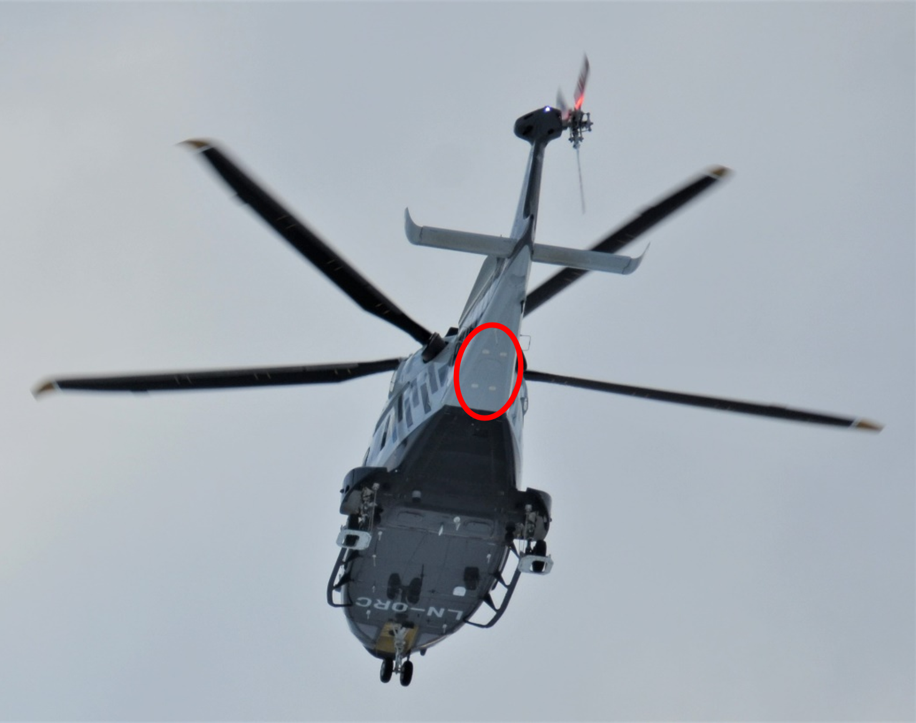
Figure 12: AW169 – Placement of radar altimeters (Photo: Nkom)

Airbus H135-T3
Airbus H135-T3 is one of the helicopter models in use by the Air Ambulance Services of Norway (Luftambulansetjenesten). The Air Ambulance Services of Norway also operates helicopters of the type AW139 and H145-T2 (same altimeter as H135-T3). These two models did not participate in the tests.
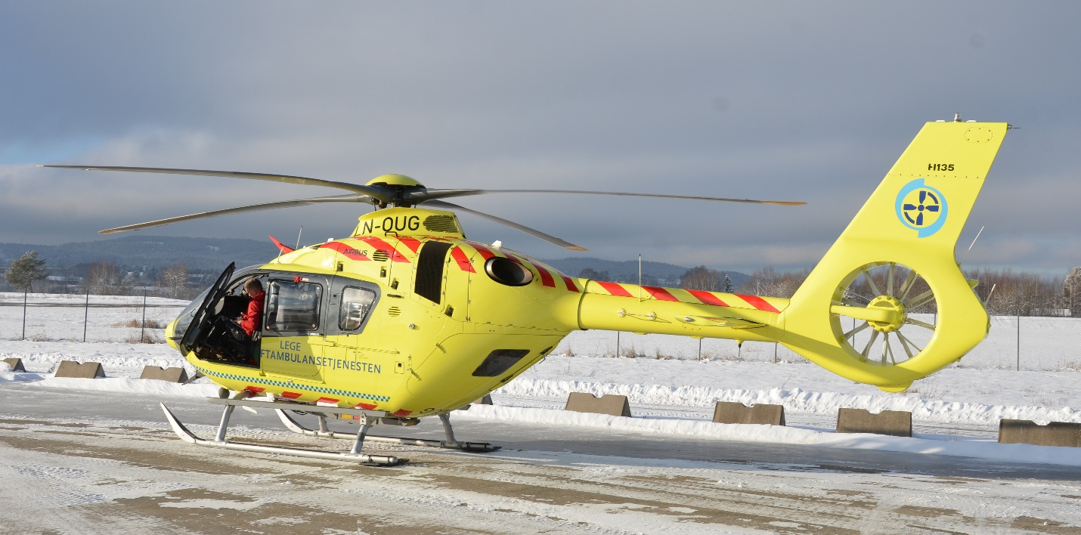
Figure 13: Air Ambulance Services of Norway H135-T3 (Photo: Nkom)
The H135-T3 has one radar altimeter, situated underneath the tail boom.
Radar altimeter model:
Honeywell (previously Bendix King) KRA 405B.
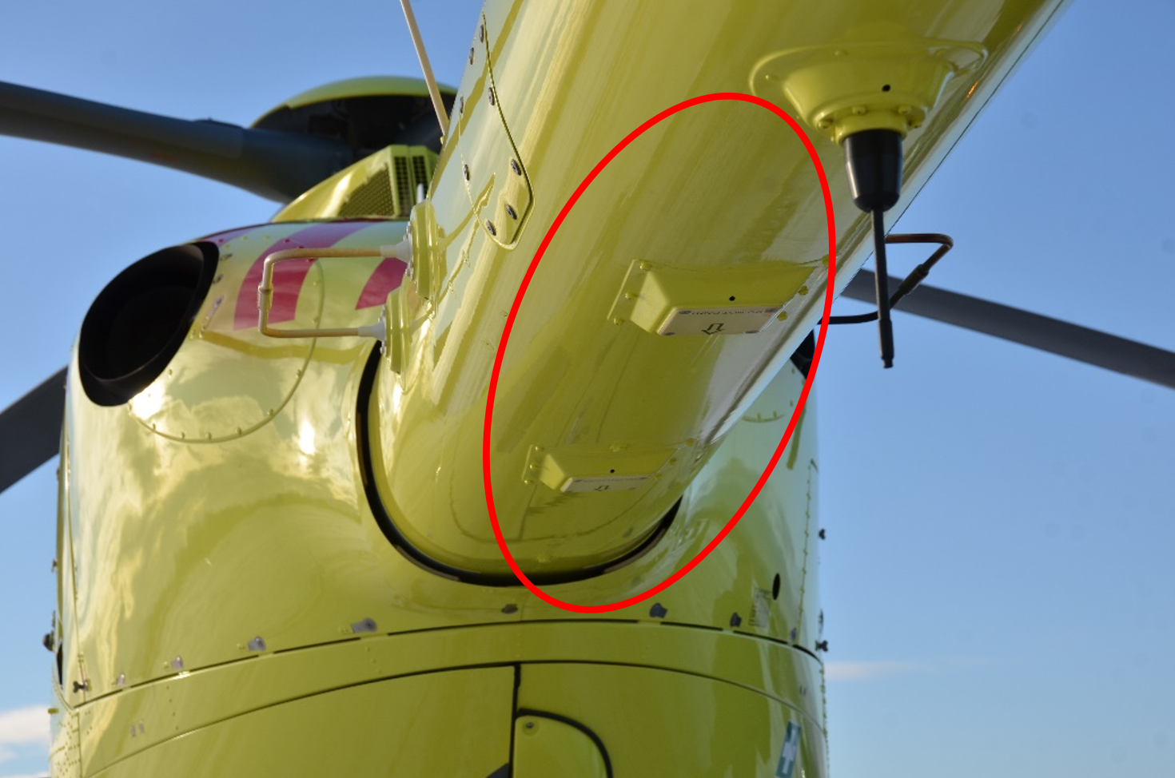
Figure 14: H135-T3 - Placement of the radar altimeter (Photo: Nkom)

Leonardo AW101 SAR Queen
Leonardo (previously AugustaWestland) AW101 SAR Queen (AW101-612) is the new NAWSARH (Norwegian All-Weather Search and Rescue Helicopter), operated by the Royal Norwegian Air Force (Luftforsvaret). The process of replacing the existing Westland Sea King helicopters is ongoing. As of today the SAR helicopter service operates from five air bases around Norway (Rygge, Sola, Ørland, Bodø and Banak). The air base in Florø will also be included in the operation as soon as the 16 ordered helicopters are phased into service.
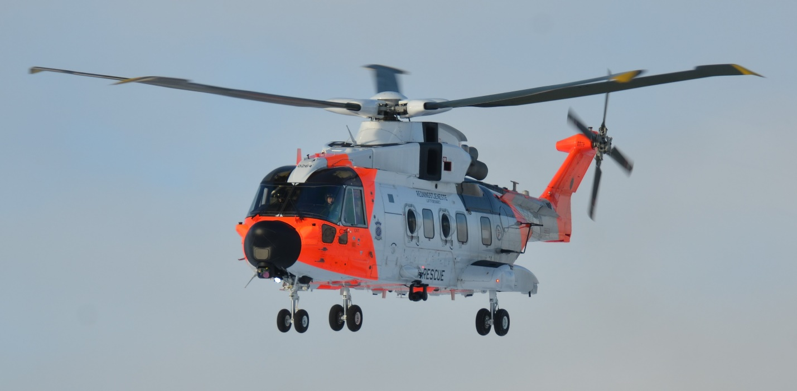
Figure 15: Royal Norwegian Air Force AW101 SAR Queen (Photo: Nkom)
AW101 SAR Queen is equipped with two radar altimeters, situated underneath the rear part of the main body of the helicopter.
Radar altimeter model:
Thales AHV1600-01-0200A.
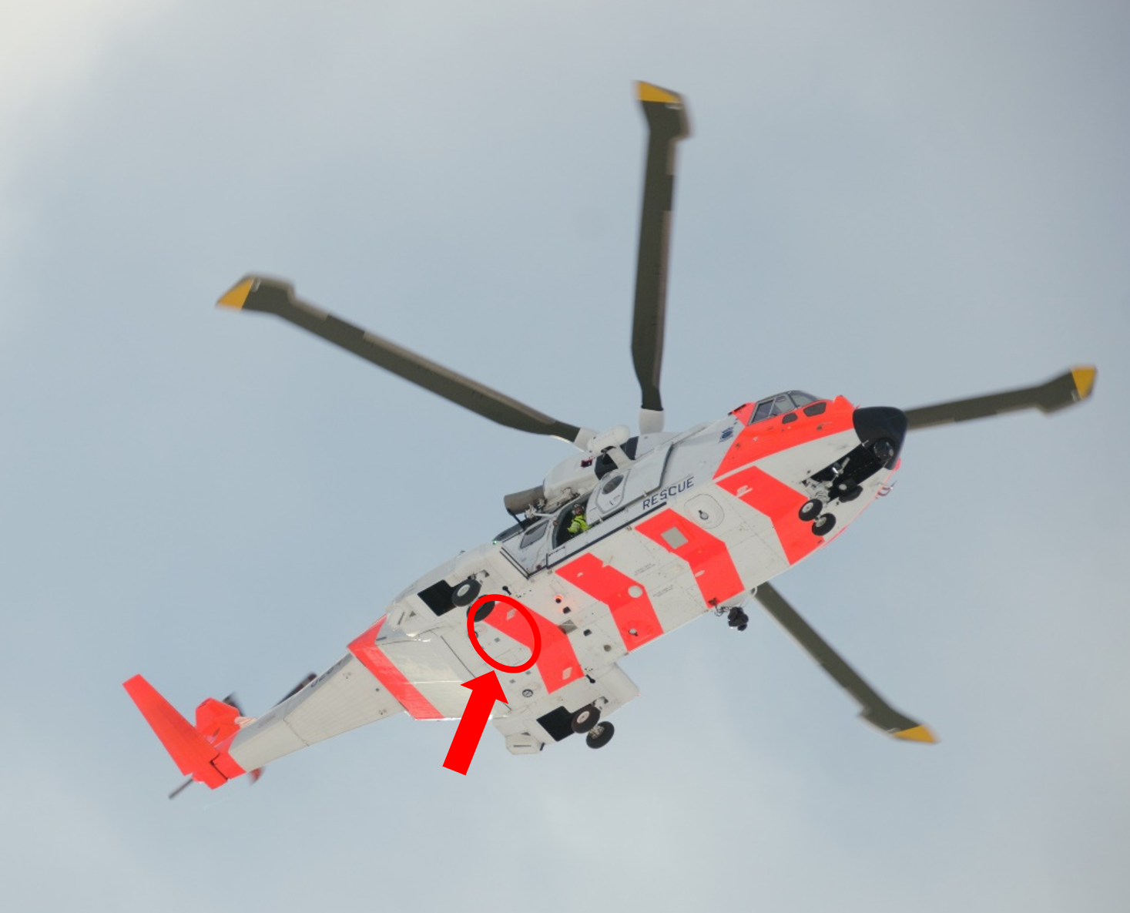
Figure 16: AW101 SAR Queen - Placement of radar altimeters (Photo: Nkom)

Test setup and configuration

Test location
The tests took place at Kjeller airport in the vicinity of Lillestrøm city. The airport is operated by Norwegian Defence Logistics Organisation (Forsvarets logistikkorganisasjon (FLO)). The runway was closed off during the tests.

5G network
As a part of the EU-project FUDGE-5G (https://fudge-5g.eu/en) Norwegian Defence Materiel Agency (Forsvarsmateriell) have in close cooperation with Telenor Research and a number of other partners, constructed a mobile 5G network, FUDGE-5G Network on Wheel (NOW). The FUDGE-5G NOW is a fully autonomous mobile network based on 5G Standalone. It hosts the 5G Radio, 5G core and the vertical applications all in-one-box. The NOW is used for Public Protection and Disaster Relief (PPDR) use cases of the FUDGE-5G EU-project.

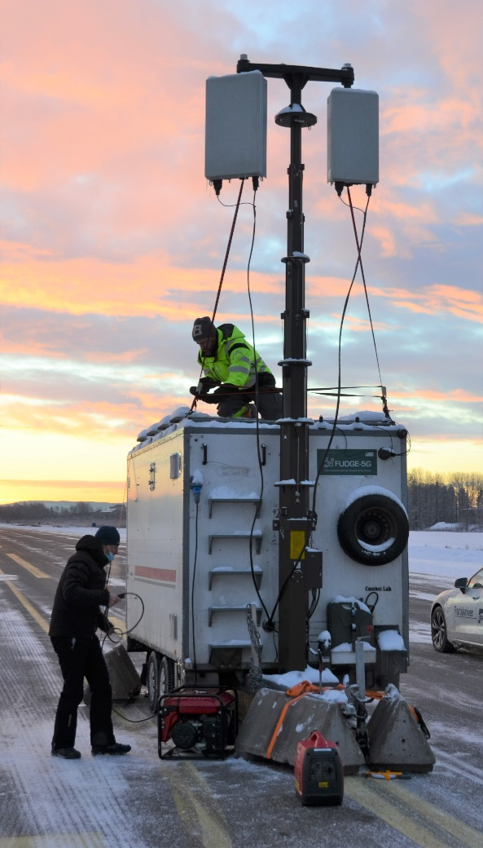
Figure 17: FUDGE-5G Network on Wheel (NOW) (Photo: Nkom)
The 5G radio specification of FUDGE-5G NOW is shown in the table below:
Table 7: 5G radio specification
5G radio specification:
Antenna and RF unit: | Huawei AAU5649
MIMO: | 64T64R
Frequency range: | 3420-3800 MHz
Maximum Output Power: | 240 W
NR TDD gain: | 25 dBi
NR TDD horizontal beam sweeping range: | -60 to +60 degrees
NR TDD vertical beam sweeping range: | -15 to +15 degrees

Wireless 5G router
To set up and maintain a stable traffic beam, a Huawei H138-380 5G CPE Wireless 5G Router was used.
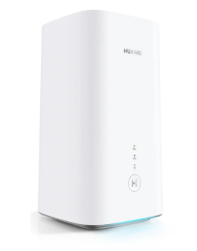
Figure 18: Huawei H138-380 5G CPE Wireless 5G Router (Photo: https://www.dustinhome.no/)

Test setup
The mobile 5G network with antenna was placed in the centre of the runway. To reduce the risk of interference into commercial 5G networks operating in the 3400-3800 MHz in the vicinity of the airport, a pointing direction of 345 degrees were used.
Table 8: 5G antenna placement
5G antenna placement:
Coordinates: | 59.97004514, 11.03755094  (EU89, UTM-sone 33)
Height of terrain: | 105.4 m ASL
Height of antenna: | 4.8 m
Absolute height: | 110.2 m ASL
Pointing direction: | 345 degrees
The wireless 5G router was placed at the end of the runway, approx. 680 m from the 5G antenna. The pointing direction of the wireless 5G router as seen from the 5G antenna was approx. 305 degrees. With an opening of ±60 degrees, this was well within the antenna diagram of the antenna to achieve full power for the traffic beam.
Table 9: Wireless 5G router placement
Wireless 5G router placement:
Coordinates: | 59.9733096, 11.0270011  (EU89, UTM-sone 33)
Height of terrain: | 105.9 m ASL
Height of antenna: | 1.5 m
Absolute height: | 107.4 m ASL
Pointing direction from BS: | 305 degrees
The used spectrum and power setting during test is shown in Table 10.
Table 10: Spectrum and power
Spectrum and power:
Frequency band: | 3760-3800 MHz
Bandwidth: | 40 MHz
Centre frequency: | 3779.04 MHz
ARFCN: | 652000
Channel: | 8040
Output power: | 35.7 dBm
Total power (EIRP): | 78.8 dBm (traffic beam)
MCC/MNC: | 999 99
During the tests iPerf 3 was used to maintain a stable data flow within the 40 MHz bandwidth. The following commands were used at the client side:
DL: iperf3 -c <IP-address> -p 6000 -R -P 5 -t <duration>
UL: iperf3 -c <IP-address> -p 6000 -P 5 -t <duration>
Figure 19 shows the test setup. The red pie wedge illustrates the 5G antenna sector. The blue pie wedge illustrates the traffic beam towards the terminal at the end of the runway.
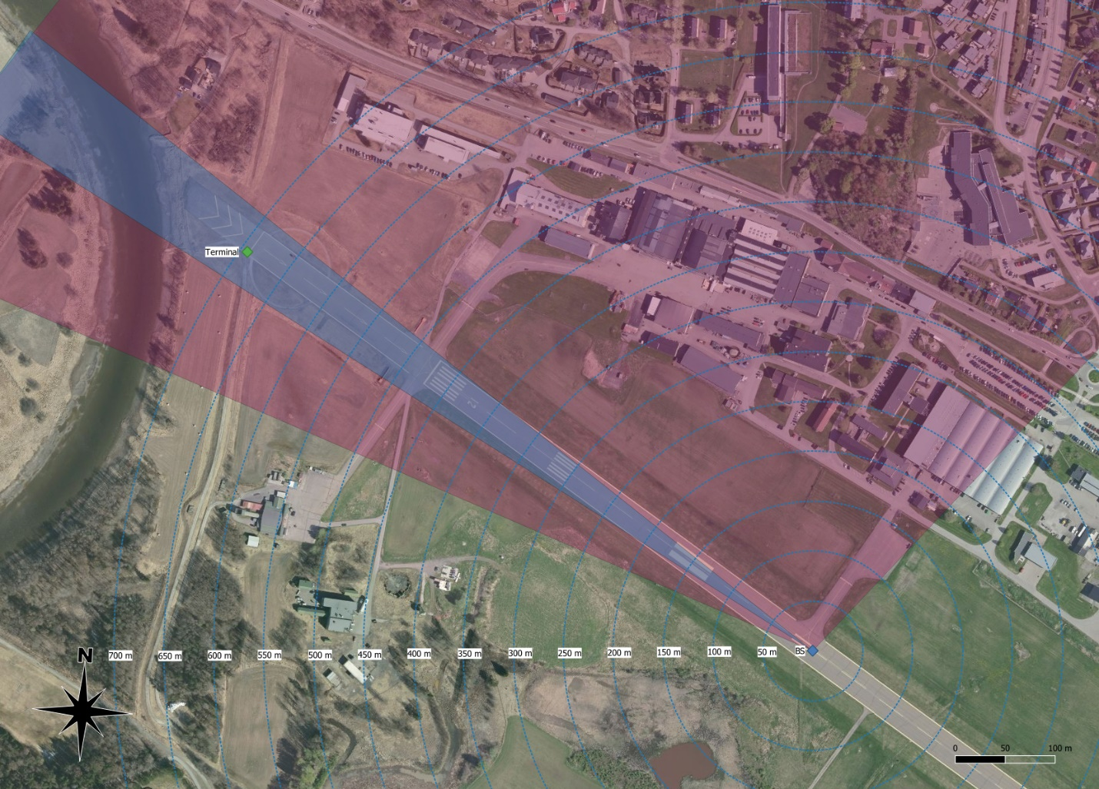
Figure 19: Test setup
Field strength measurements were conducted at 50m, 100 m and 686 m from the 5G antenna, within the traffic beam, to confirm full power (EIRP) from the 5G BS. All measurements were done over the entire 40 MHz bandwidth.
Table 11: Reference measurements
Position |  | Distance [m] | Height [m] | Measuered avg. FS [dBuV/m] | Calc. EIRP at BS [dBm]
59.97028883,  11.03684333 |  | 50 | 2 | 145.1 | 74.3
59.97052683,  11.03608533 |  | 100 | 2 | 142.0 | 77.2
59.97338183,  11.02721867 |  | 686 | 2 | 130.6 | 82.5
Calculated EIRP at BS from reference measurements, only considering free-space loss, are close to theoretical EIRP from base station in traffic beam (78.8 dBm/ 40 MHz).

Test scenarios

Introduction
For each helicopter three different tests were conducted. For all three test scenarios there were no active 5G terminals in the helicopters. The altimeter(s) in the helicopters were observed manually by the pilots, and system fault logs were checked after end of tests.

Test 1 – Helicopter at ground, 50 m from BS, pre-flight system check

Test description
Helicopter at ground 50 m from BS, with nose facing BS. Pre-flight system check.

Test purpose
Confirm that the 5G signal does not interfere with critical instruments pre-flight.

Test 2 – Flight test, fixed positions

Test description
Pre-defined grid pattern with flight height 50 m and 100 m above ground, and from 0 m to 500 m from the BS in direction of the terminal. For every 50 m (test point) the helicopter hovers. While hovering at the test point, the helicopter rotates 360 degrees around its own axis.
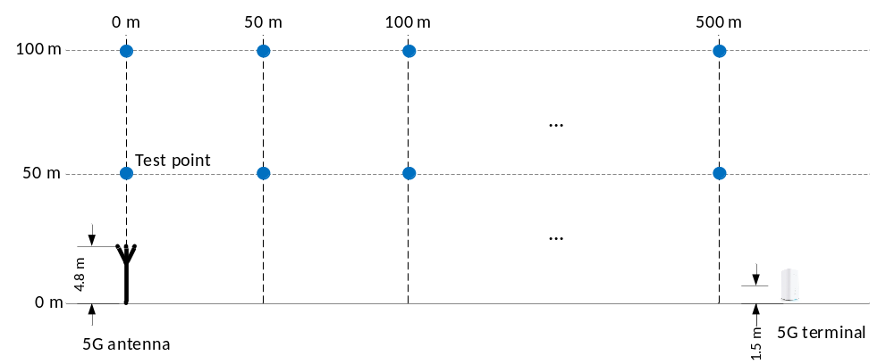
Figure 20:

Test purpose
Controlled flight pattern with dwell time at each test-point for the pilots to observe the altimeter(s). A 360 degrees rotation to expose the altimeter(s) from 5G signal from different directions.

Test 3 – Flight test, predefined flight route

Test description
A pre-defined flight path that consists of a BS fly-over at 100 m height, a circle around the BS at approx. 100 m distance and at different heights and other manoeuvres decided by the pilots during the flight.
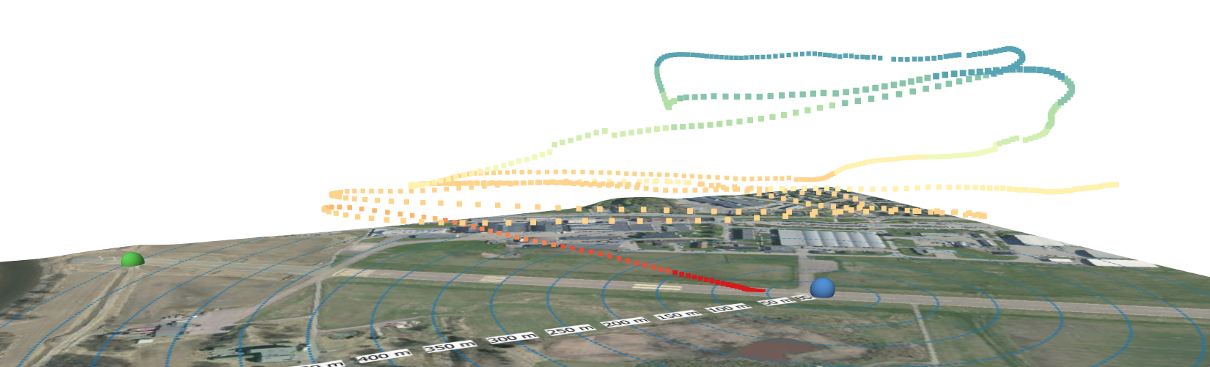
Figure 21: Example of flight path during test 3

Test purpose
To expose the altimeter(s) of the helicopters from a 5G signal from different directions, during realistic manoeuvres around the base station. To re-create a flight pattern that the helicopters may experience during daily operations.

Test results

Test 1 - Helicopter at ground, 50 m from BS, pre-flight system check

Test 1 – Leonardo AW169
Helicopter taxied to starting position 50 m in front of BS while BS was active. Altimeters and instruments pre-flight check. No deviations observed.

Test 1 – Airbus H135-T3
Helicopter landed at starting position 50 m in front of BS while BS was inactive. Signal turned on at BS. Altimeter and instruments pre-flight check. No deviations observed.

Test 1 – Leonardo AW101 SAR Queen
Helicopter taxied to starting position 50 m in front of BS while BS was active. Altimeters and instruments pre-flight check. No deviations observed.

Test 2 - Flight test, fixed positions

Test 2 – Leonardo AW169
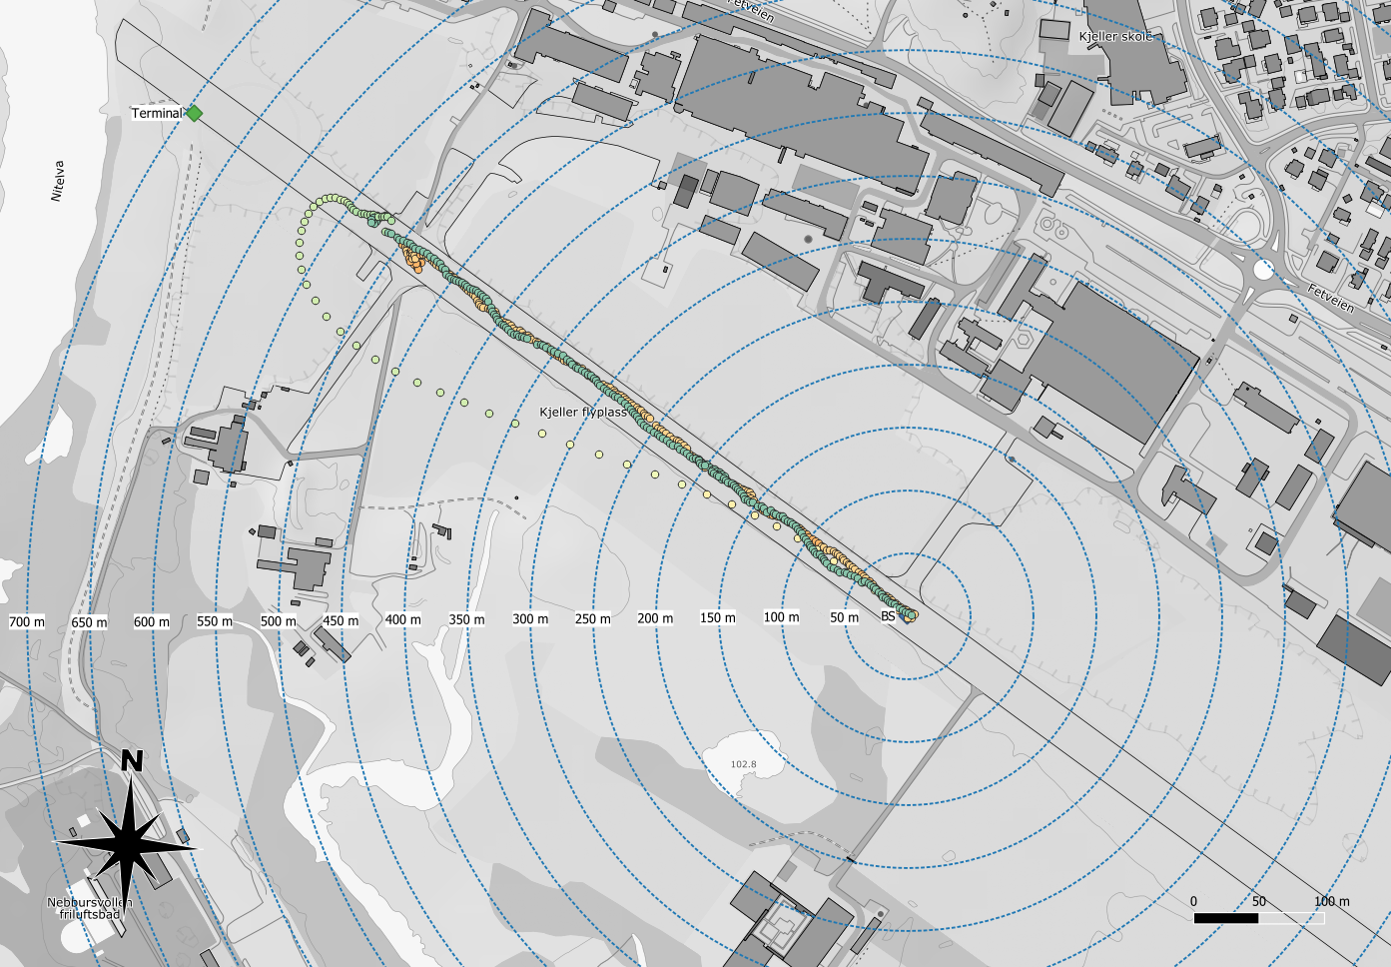
Height (m above BS)
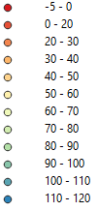
Figure 22: Leonardo AW169 – Test 2 – Flight test, fixed positions – Position plot

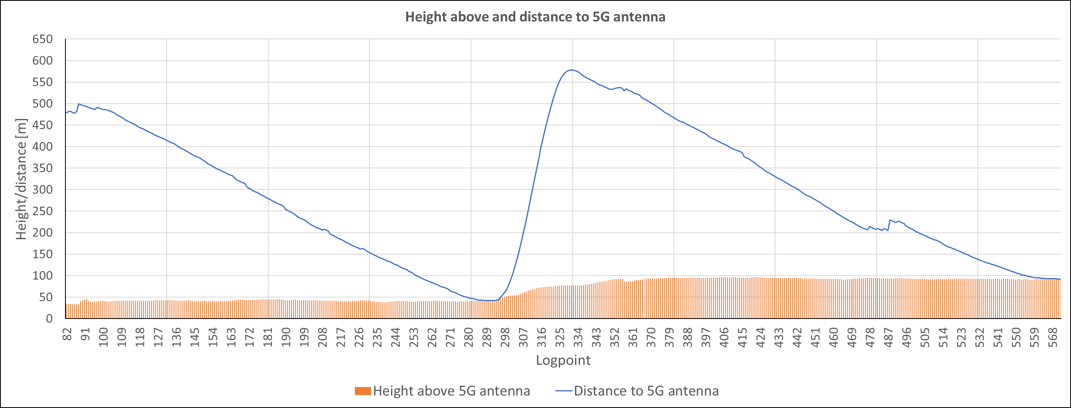
Figure 23: Leonardo AW169 – Test 2 – Flight test, fixed positions – Height and distance plot
Note to the test: The AW169 did not perform the 360 degrees rotation around its own axis at each test point.
Observations
With a horizontal distance of 100-200 meter from the BS at 100 m height, the altimeter was observed to jump sporadic between 320 and 340 feet (97,5-103,6 m).
Other than this observation, no deviations were observed.

Test 2 – Airbus H135-T3
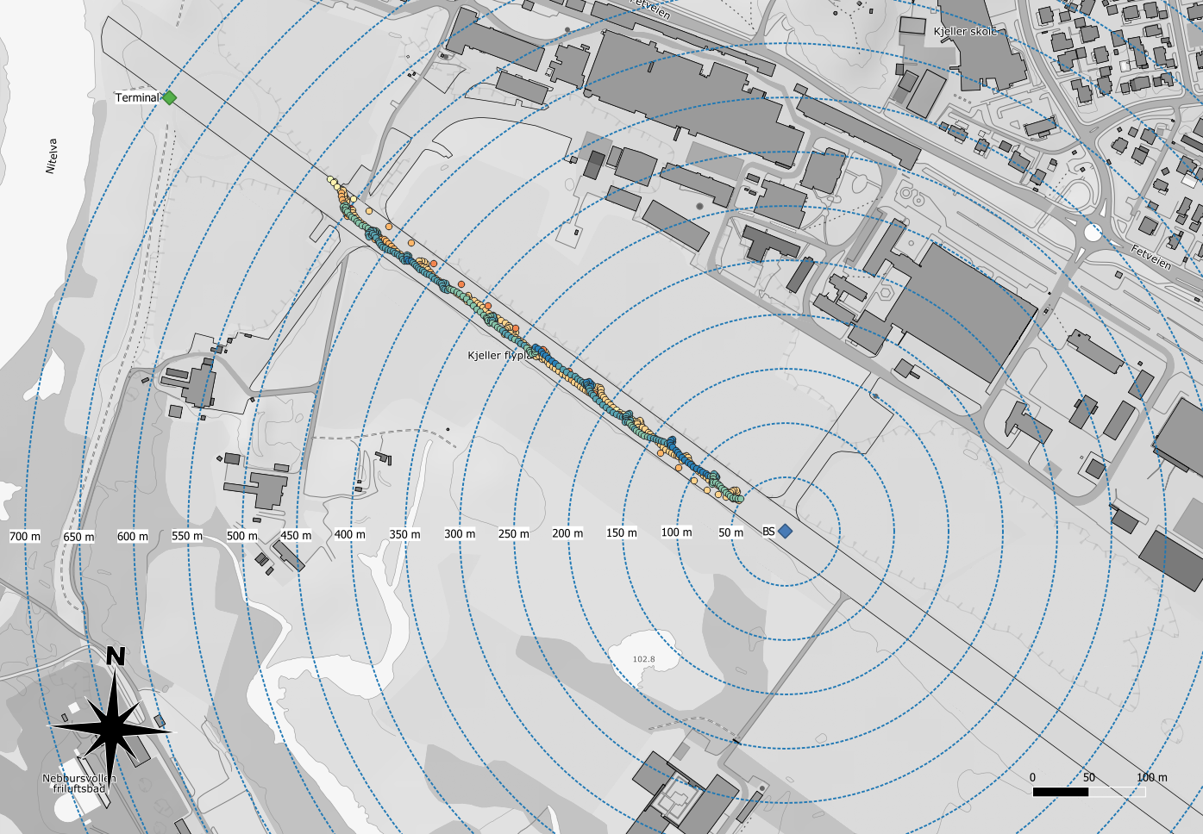
Height (m above BS)
Figure 24: Airbus H135-T3 – Test 2 – Flight test, fixed positions – Position plot
Note to the test: The H135-T3 stopped at 50 m horizontal offset from the BS, thus the test point straight above BS was not tested under test 2.

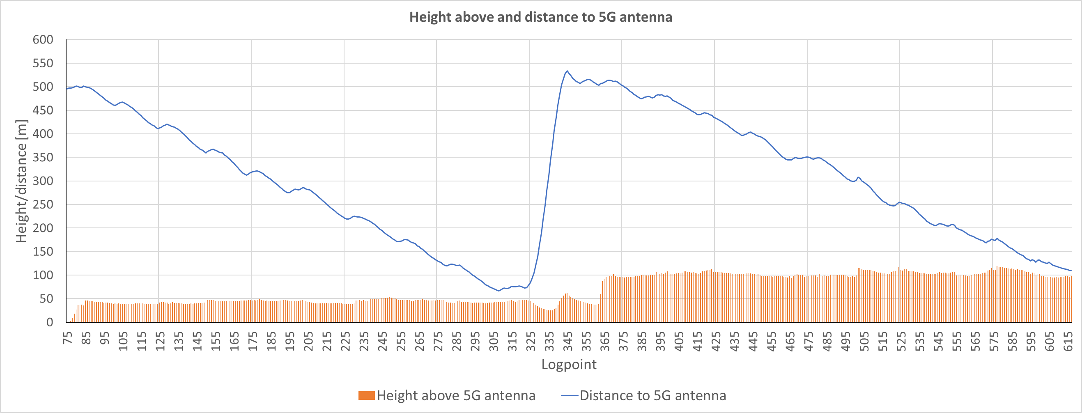
Figure 25: Airbus H135-T3 – Test 2 – Flight test, fixed positions – Height and distance plot
Observations
At three occasions, all at 100 m height, a variation of 10-15 ft was observed. Other than that, no deviations were observed.

Test 2 – Leonardo AW101 SAR Queen
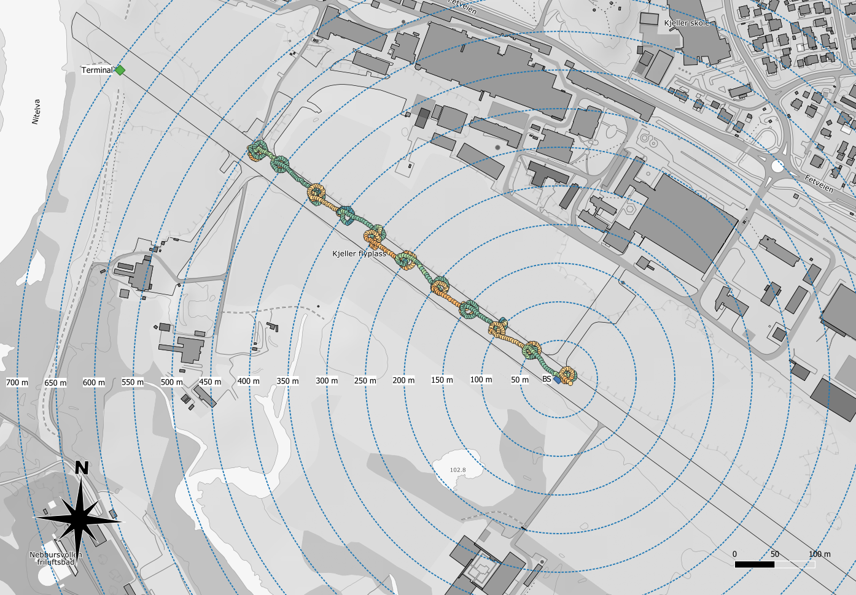
Height (m above BS)
Figure 26: Leonardo AW101 SAR Queen – Test 2 – Flight test, fixed positions – Position plot
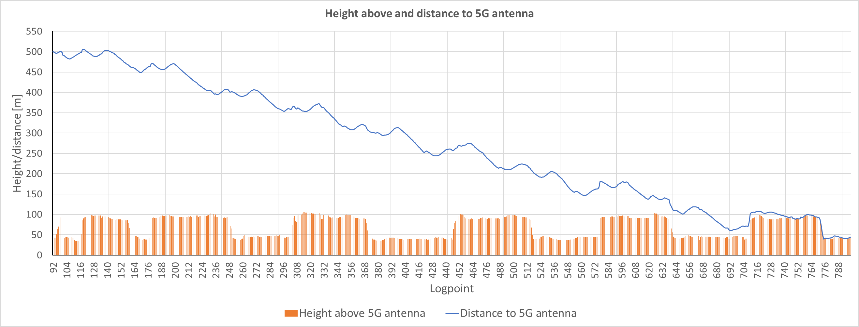
Figure 27: Leonardo AW101 SAR Queen – Test 2 – Flight test, fixed positions – Height and distance plot
Observations
No deviations were observed.

Test 3 – Flight test, predefined flight route

Test 3 – Leonardo AW169
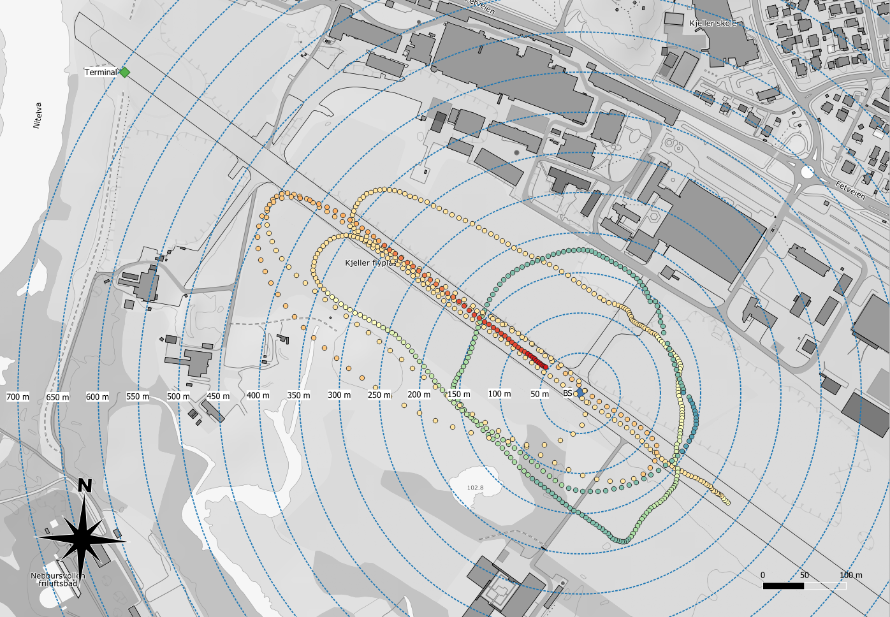
Height (m above BS)
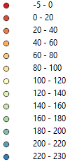
Figure 28: Leonardo AW169 – Test 3 – Flight test, predefined flight route – Position plot
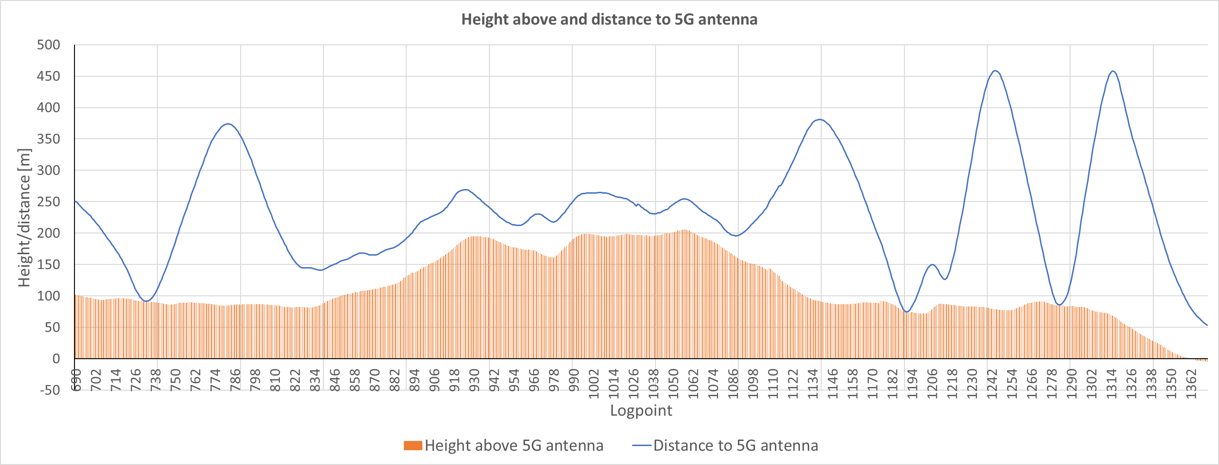
Figure 29: Leonardo AW169 – Test 3 – Flight test, predefined flight route – Height and distance plot
Observations
No deviations were observed.

Test 3 – Airbus H135-T3
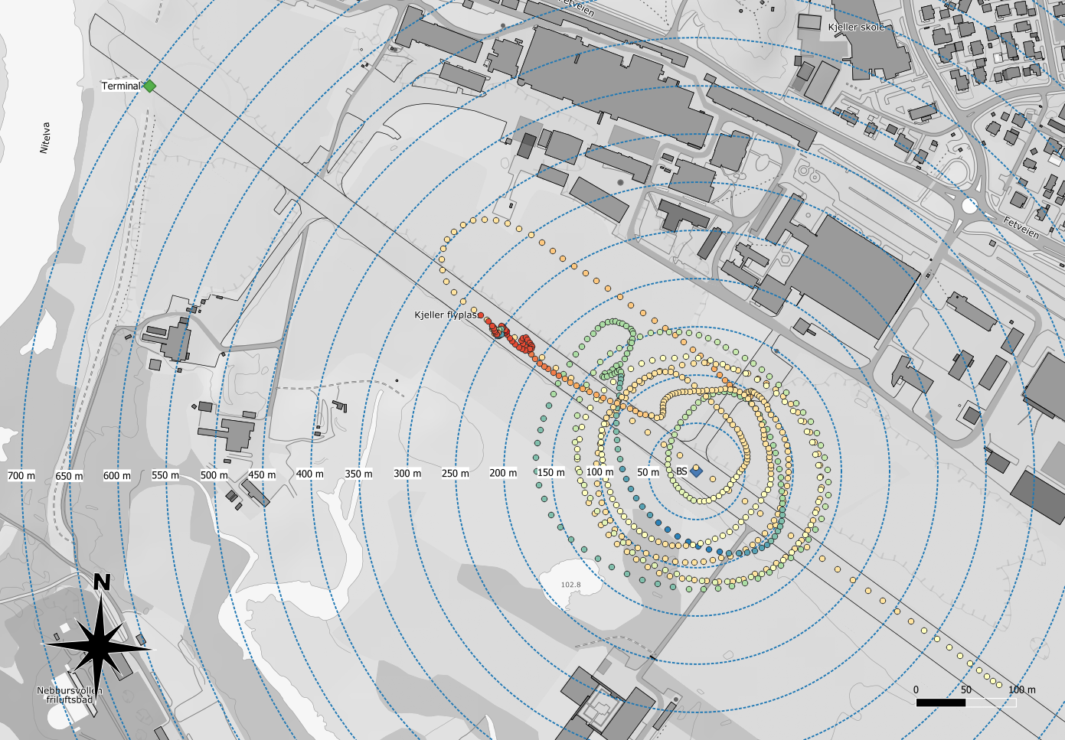
Height (m above BS)
Figure 30: Airbus H135-T3 – Test 3 – Flight test, predefined flight route – Position plot
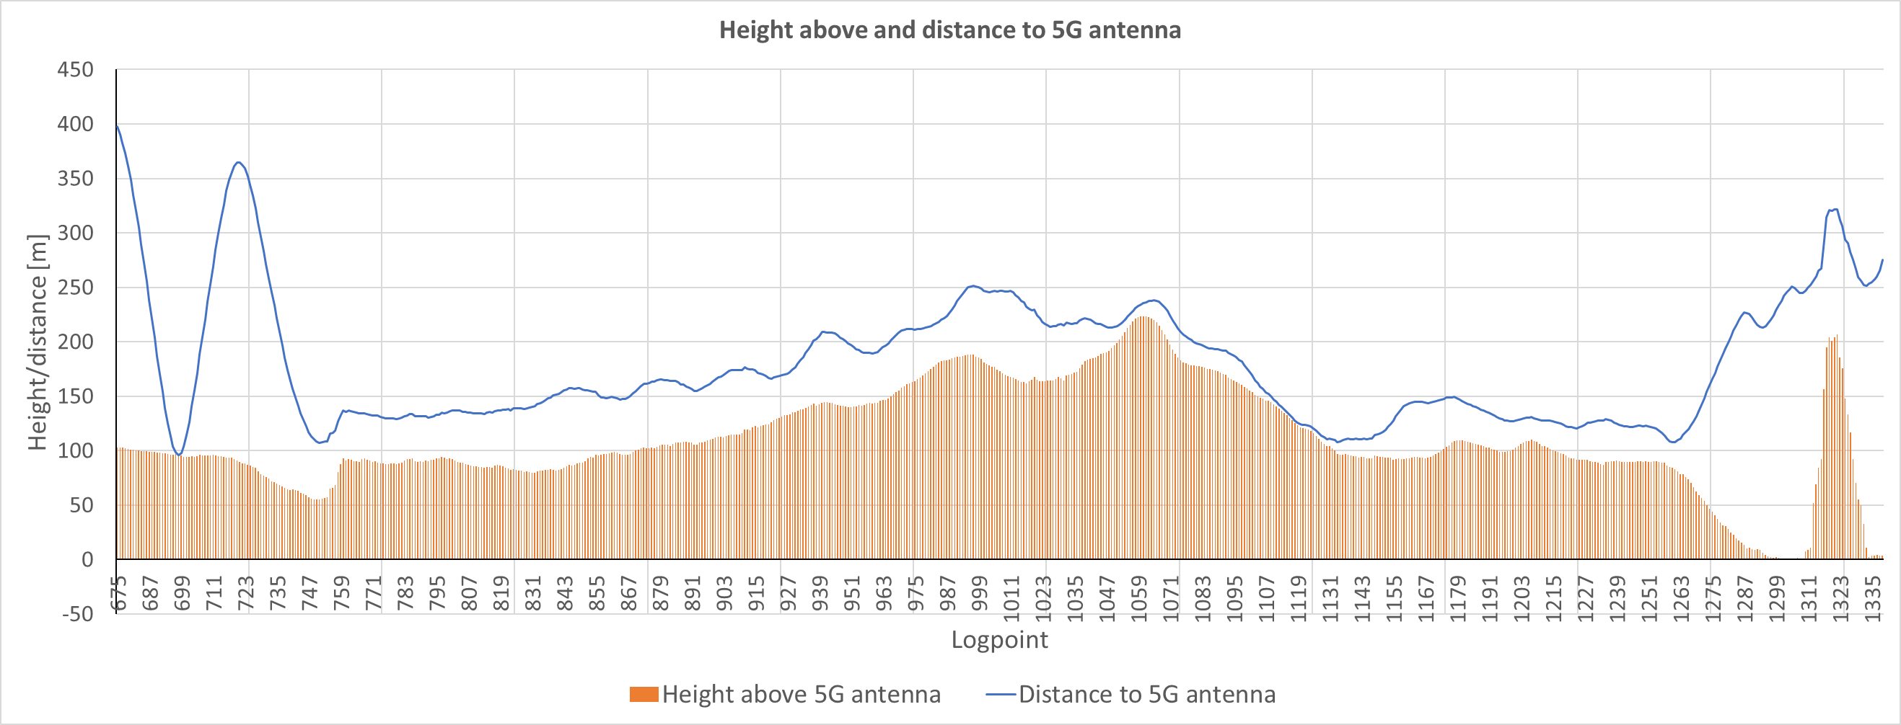
Figure 31: Airbus H135-T3 – Test 3 – Flight test, predefined flight route – Height and distance plot
Observations
Pilots reported that a quick variation/jump up to 50 ft was seen once. They added that this could be a result of ground variations and slightly change in aircraft tilt as the helicopter moved/hovered around in circle. Snow and ice on the ground could also cause variations.
No other deviations were observed.

Test 3 – Leonardo AW101 SAR Queen
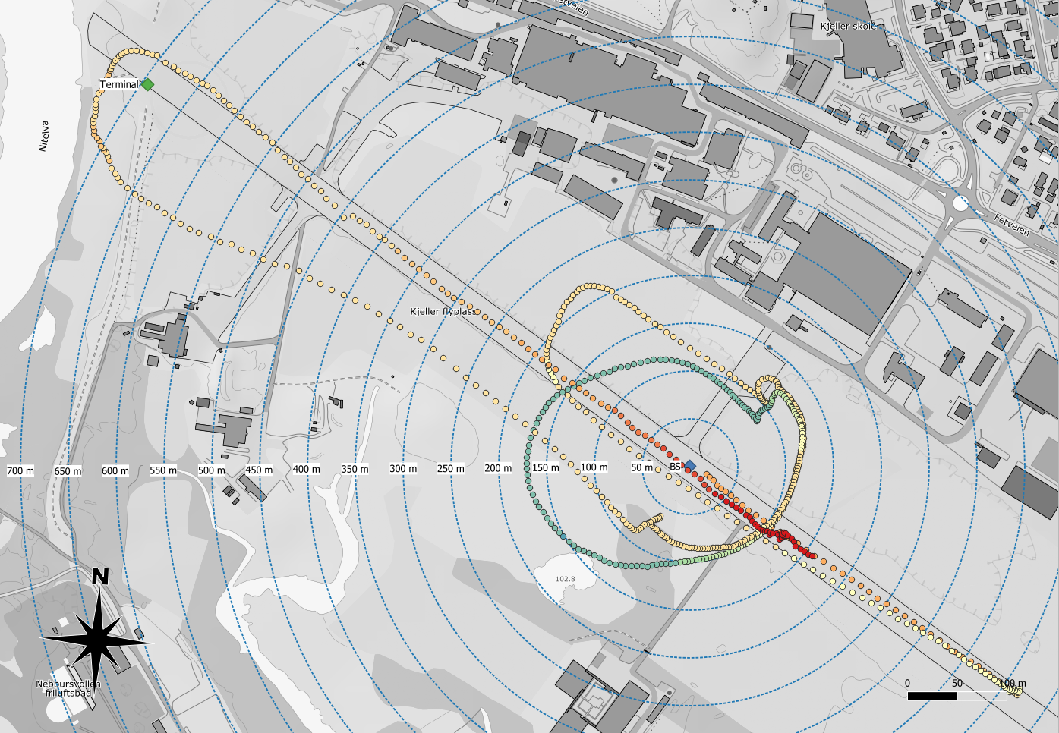
Height (m above BS)
Figure 32: Leonardo AW101 SAR Queen – Test 3 – Flight test, predefined flight route – Position plot
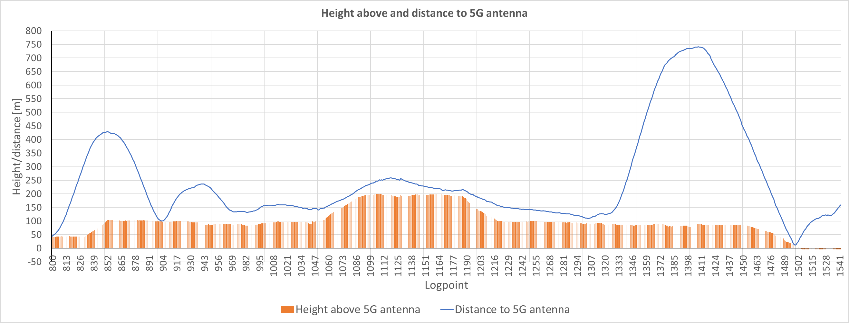
Figure 33: Leonardo AW101 SAR Queen – Test 3 – Flight test, predefined flight route – Height and distance plot
Observations
No deviations were observed.

Conclusions
Radar altimeters are essential for aircraft operation, including auto-land systems (auto-throttle and automated landing flare and rollout). Radar altimeters at aircrafts and helicopters operates in the frequency band 4200-4400 MHz.
Technical reports from US aviation organisations and authorities indicates that a number of different radar altimeter installations may be severely impacted by the introduction of 5G in frequency bands below 4200 MHz. They may be impacted both by blocking due to lack of Rx-filtering, and due to emission levels in the spurious domain (spurious from 5G in-band in 4200-4400 MHz). The studies focus on the core frequency band for 5G roll-out in US, 3700-3980 MHz.
In Europe, CEPT (European Conference of Postal and Telecommunications Administrations) have started looking into the potential impact from 5G in the European harmonized frequency band, 3400-3800 MHz, into radar altimeters. The study will consist of both theoretical simulations and real tests. This report will be contributed into the ongoing study.
The main goal of the tests was to assess the impact of a 5G NR mobile network operating in the 3400-3800 MHz-band on radar altimeters installed onboard helicopters used by Norwegian ambulance, rescue- and police service.
During normal operations the helicopters may use barometric altimeter, radar altimeter(s) or a combination of these. During normal landings, including helipads at hospitals, barometric altimeter is the preferred option for some of the pilots, and radar altimeter for others. Some pilots use the radar altimeter display to call out the height above ground (AGL) during operations close to the ground. Radar altimeter(s) are used during instrument approaches to airports (glide-path approach to runways) and are commonly used during auto-hovering. Some of the pilots indicated that barometric altimeter is the preferred option when auto-hovering over land, as it is not sensitive to terrain variations as the helicopter drifts or banks.
In the test the following helicopter models and altimeter models were used:
- Leonardo AW169 - Altimeter: Rockwell Collins ALT-4000
- Airbus H135-T3 - Altimeter: Honeywell (previously Bendix King) KRA 405B
- Leonardo AW101 SAR Queen - Altimeter: Thales AHV1600-01-0200A
During the tests a mobile 5G NR base station was placed at the runway, with an output power (EIRP) that equals the maximum output power of commercial 5G NR base stations used in commercial 5G networks in Norway as of today. The helicopters were during the tests exposed for the 5G signal from different directions, at different heights, while the altimeter(s) in the helicopters were observed by the pilots.
Actual field strength measurements done from one of the helicopters throughout the test flight, shows that the helicopter was exposed for a 5G signal up to 30 dB higher than interference threshold presented for radar altimeters mounted on helicopters in the report from the US based aviation organisation RTCA (Radio Technical Commission for Aeronautics). This report also takes in an additional 6 dB margin, on top of the 30 dBs above.
A few instances of a slight variation in the reported height by the radar altimeter were observed, but there was no malfunction or black-out of the altimeter measurements.
Overall conclusions from the tests are that no operational impact could be observed by any of the participating helicopters. This gives us a good level of confidence in the resilience of these specific radar altimeters to conduct its missions.

Annex 1 – Measurement from helicopter

A1.1 Introduction
During the flight tests with AW101 SAR Queen field strength measurements were done throughout the flight. A tri-axis hand-held antenna was used in the cargo-door at the side of the helicopter.

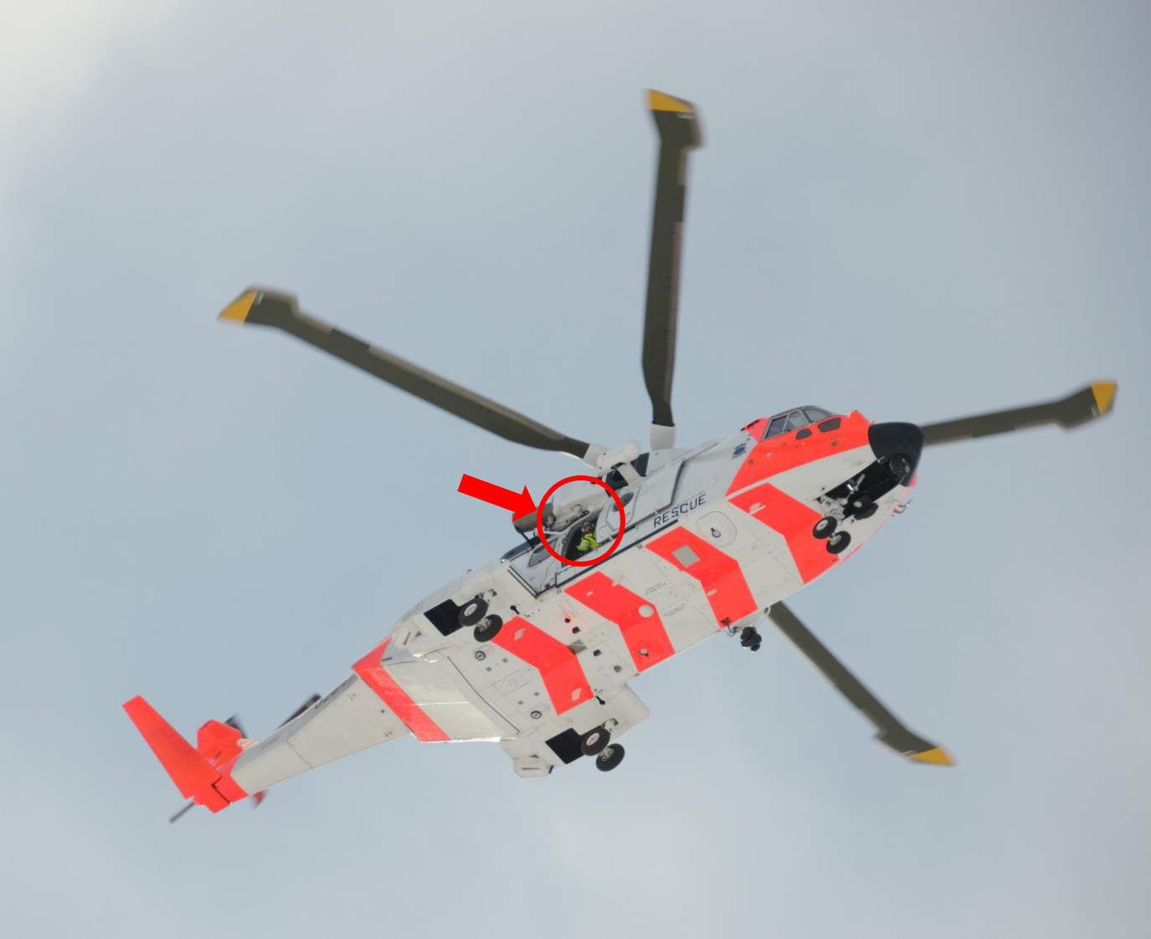
Figure 34: Position of antenna during field strength measurements from AW101 SAR Queen
Table 12: Technical data for measurement setup
Type: | Manufacture: | Model:
Spectrum analyzer | Keysight | N9914A
Triaxial Receiving Antenna | Agos | ARIA-6000
Antenna Cable | Agos | SDCF02
From the measured field-strength the PSD, in dBm/MHz, at the measurement antennas position have been calculated. This to be able to compare the measured values with the RTCA report. The results are shown below.

A1.2 Measurements from helicopter during test 2
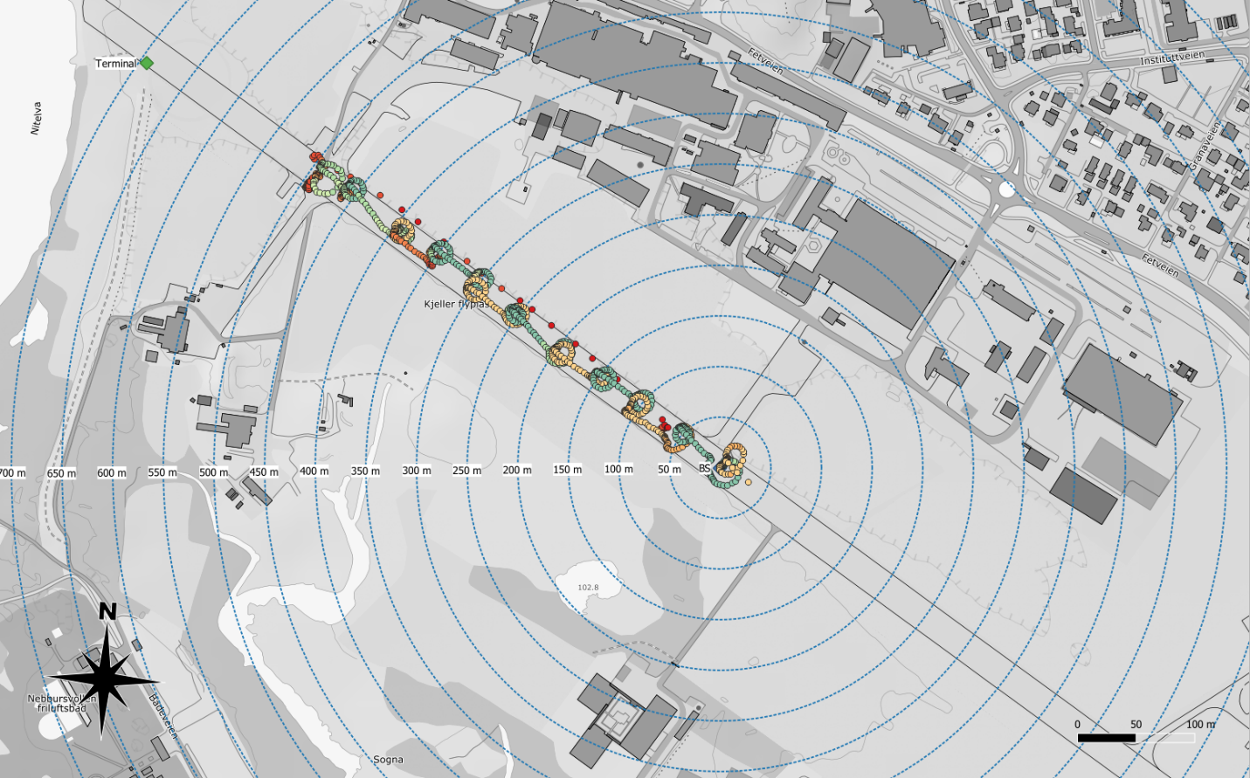
Height (m above BS)
Figure 35: Test 2 - Flight path as logged by the instruments GPS
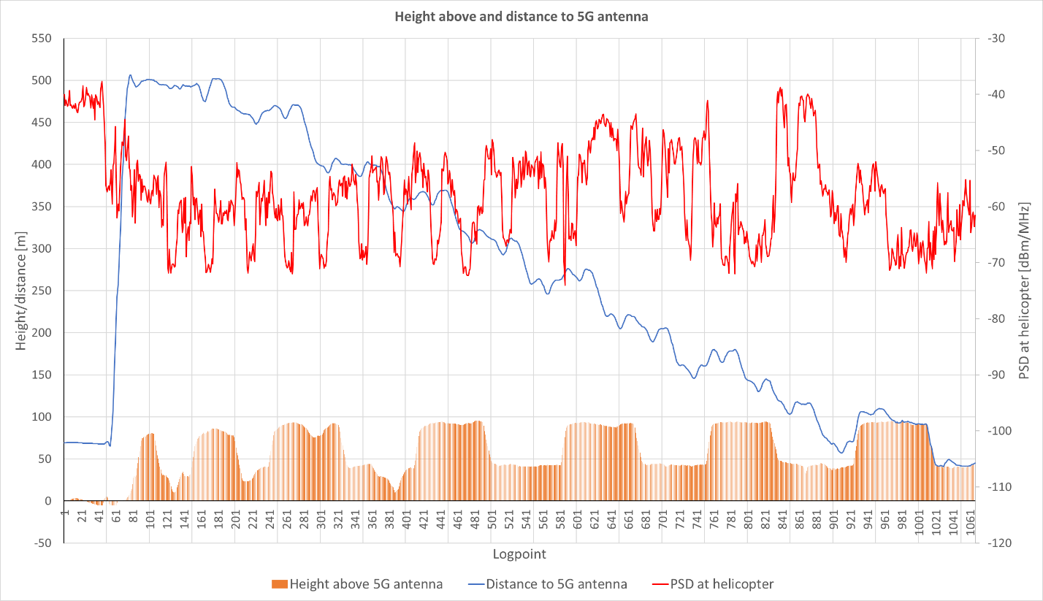
Note 2
Note 1
Figure 36: Test 2 – Height, distance and PSD plot
Note 1: At each 50 m mark the helicopter turned 360 degrees around its own axis. The body of the helicopter then came between the measurement antenna and the 5G BS. This is seen as distinguished dips in the measured field-strength.
Note 2: Highest measured field-strength during flight at 100 m horizontal and 100 m vertical distance from the BS and at 50 m horizontal and 50 m vertical distance from the BS. This observation is consistent with the antenna diagram of the 5G antenna, with a distinct side-lobe at approx. 45 degrees vertical angle.

A1.3 Measurements from helicopter during test 3
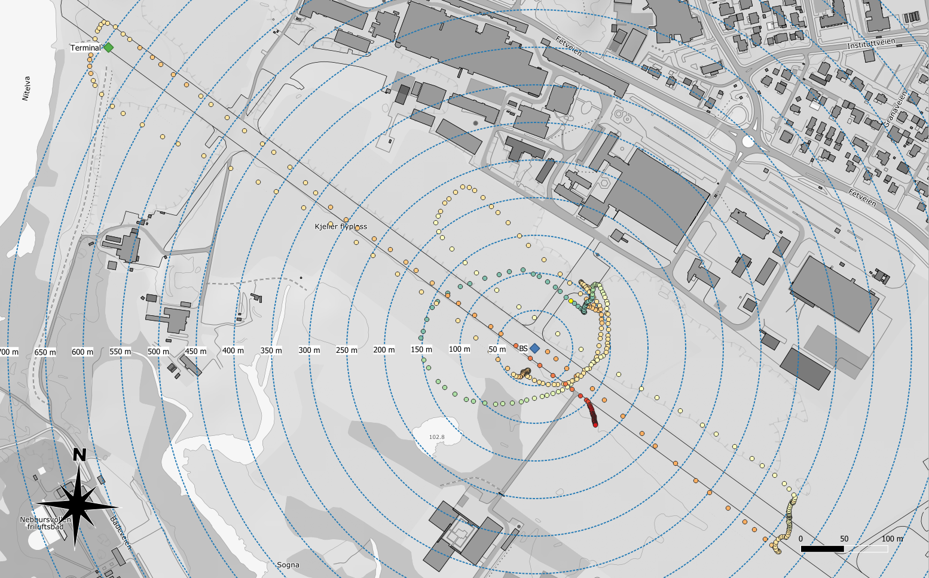
Height (m above BS)
Figure 37: Test 3 - Flight path as logged by the instruments GPS

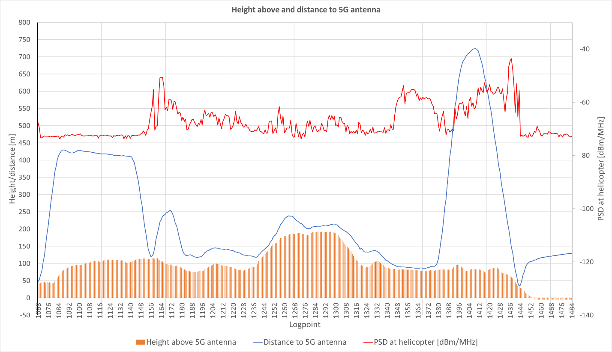
Note 1

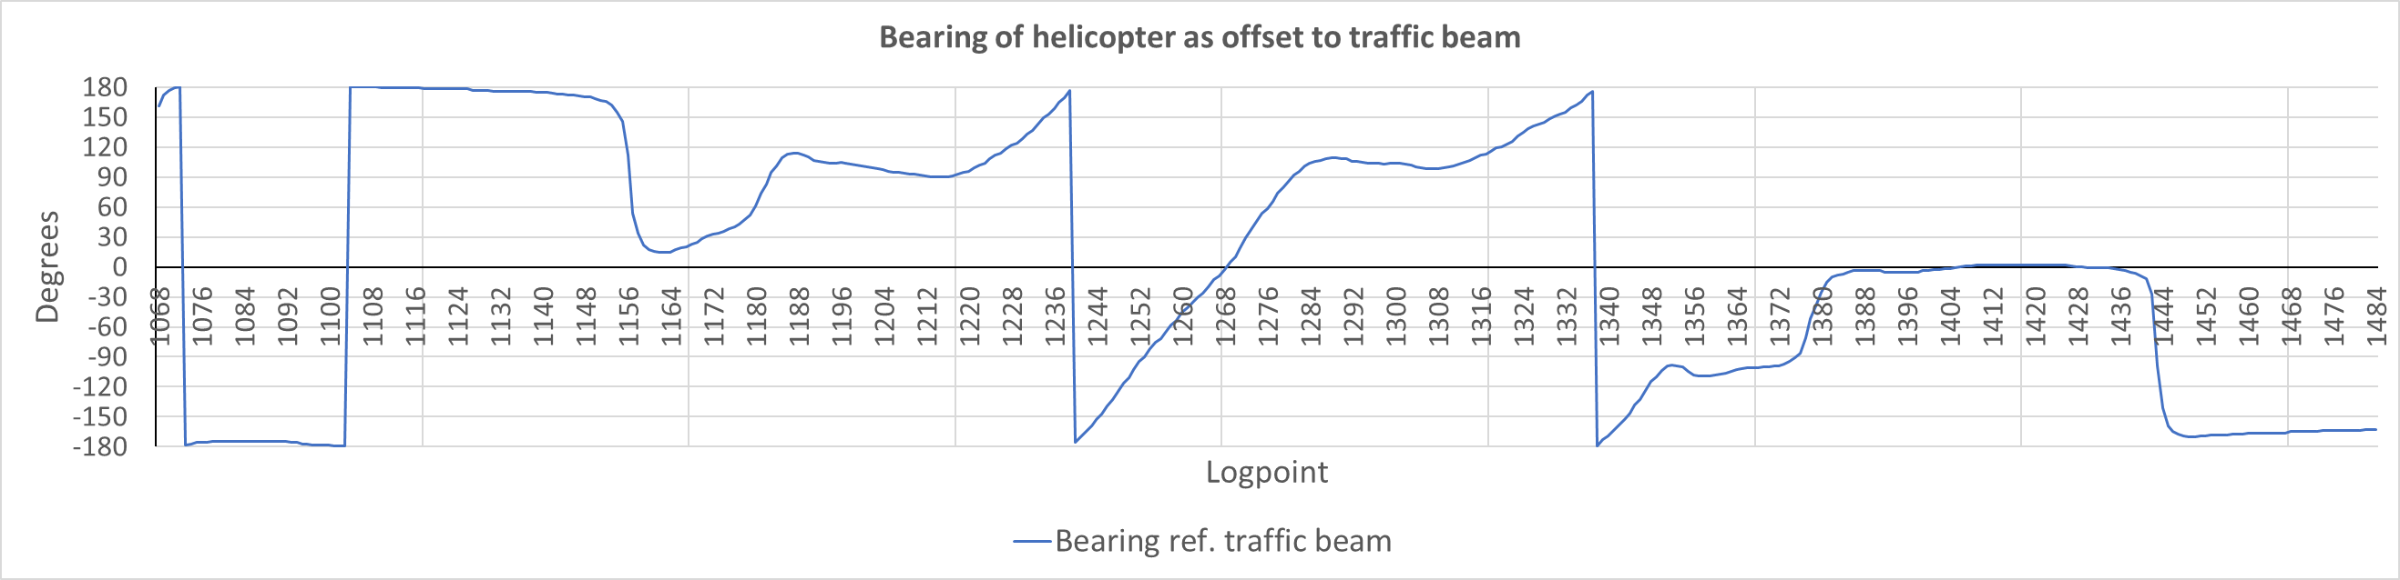
Figure 38: Test 2 – Height, distance, PSD and bearing plot

Note 1: Highest measured field-strength during flight at approx. 50 m horizontal and 50 m vertical distance from the BS. This observation is consistent with the 5G antenna diagram of the antenna, with a distinct side-lobe at approx. 45 degrees vertical angle.

Description of preliminary trials on one type of helicopter of the French gendarmerie

Purpose
The aim of the test is to assess the impact of the 5G NR mobile network on the operational behaviour of altimeter installed onboard the model EC135 and model EC145 helicopters of the French gendarmerie and civil protection in France and, the altimeter onboard the AS 350 helicopters of the French gendarmerie.
The helicopter flew at different distances from the 5G NR base station, at multiple altitudes and roll and pitch angles in such a way as to get configurations which would ease the radio altimeter disturbances.
No specific instrumentation or modifications of the aircraft were performed for this test.

Configurations
Prior to the flight and in order to increase the probability of being disturbed, half a day was spent refining the actual position of the main lobe of the 5G NR Base station’s antenna by an ANFR instrumented vehicle. Following these measurements, the direction of the main lobe was marked on the ground by the presence of the ANFR vehicle at point B, visible from the helicopter in flight.
The 5G NR base station was configured to provide the maximum worst-case of the used antenna with 78 dBm eirp on a 60 MHz channel in the 3640-3710 MHz frequency range. From the chosen setting of the 5G base station used for the campaign that was seeking the maximum impact on the radio altimeter of the helicopter, none of the main beams for the 5G data were directed above the horizon from the base station.
In the test, a DGPS was used to record the coordinates and altitude of the helicopter. 5G signal level is recorded by the 5G test UE in the helicopter.

Flight analysis

General information
The trials took place in the South West of France.
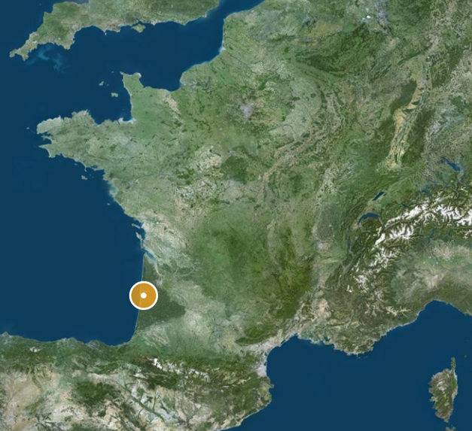
Figure 39: Location of the trials on IGN map
The 5 configurations were followed as described in the Table below.
Table 13:
Test runs | 5G NR base station | UE on ground | UE on board
1 – Identification | OFF | OFF | OFF
2 – Helicopter on the ground | ON | OFF | ON
3 – «fixed beam» | ON | ON | OFF
4 – «free beam» | ON | OFF | ON
5 – 1500 ft flight | ON | OFF | ON
The sequence below was followed for the both flight trials.
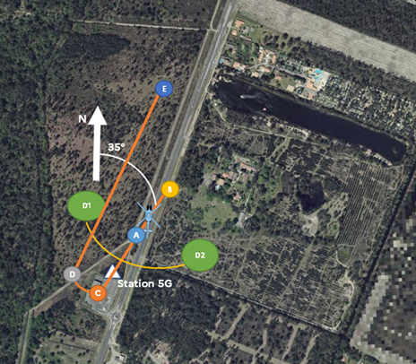
Figure 40:
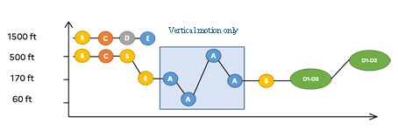
Figure 41:
During the identification phase, 5G BS and mobiles were switched off to have a reference for the path and on the radio altimeter behaviour.
The test with the helicopter on the ground were conducted with the helicopter with rotating engine and blades before take-off with a 5G mobile onboard in the cell of the helicopter and downloading large files from the 5G BS.
The trials with the ”fixed bean” were conducted with a 5G mobile on the ground at about 30 meters in North from the point B and, The 5G BS was set in a configuration for the terminal located as described above leading to its main-beam in the direction of the point B with a downtilt of 6°.
The trials with the ”free beam” were conducted with a 5G mobile on the ground switched off and the operative 5G mobile onboard the helicopter downloading large files from the 5G BS. The 5G BS behaved like in ”real life”.
The 1500ft flight phase are to complete the sequence described above.

EC 135 Helicopter
All the test points were completed except for the first part of run #2 "fixed beam" where the 5G could not be continuously activated by user equipment on the ground. The three 5G NR user equipment on the ground had in turn overheated (high data rates causing the chips to overheat and an outside temperature of 35°C), so this run was interrupted to continue with run #3 "free beam", leaving time to find the nominal operation of user equipment on the ground and to complete run #2. Below, the GPS tracks of the helicopter and the different test configurations.
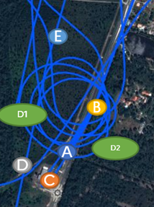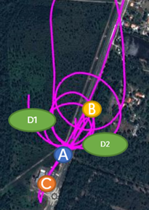
5G NR base station
2
1
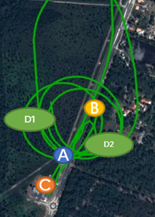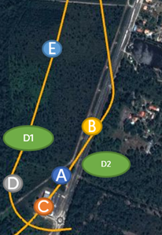
5G NR base station
4
3
Figure 42: GPS trajectories of the helicopter during runs 1 to 4
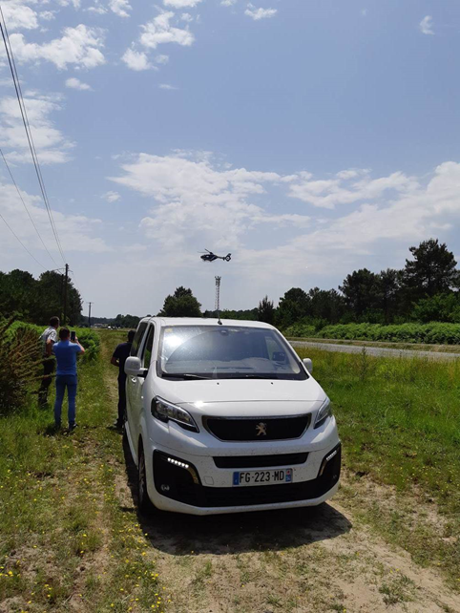
Figure 43: Picture of the trial with EC 135 with the white van as point B
As an indication and from the barometric measurements (not accurate) taken by the recorder on board the EC135, the altitude indication throughout the flight. The same colour code as the GPS tracks above has been kept to facilitate the understanding of the flight profile.
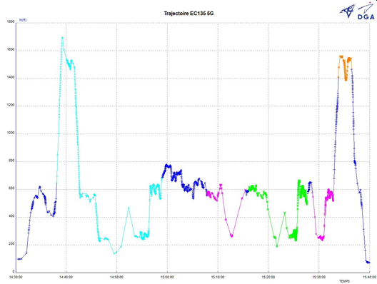
Figure 44:

AS 350 Helicopter
To be developed with recorded helicopter locations and other analysis as appropriate.
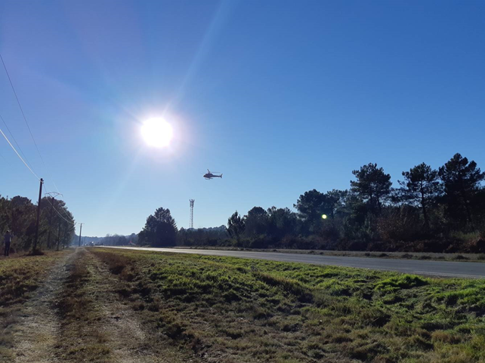
Figure 45:

Conclusion of the test
No disturbance to the radio altimeter on board the EC135 helicopter of the French gendarmerie nor on the one on board the AS 350 helicopter of the French gendarmerie was detected during the flight, when using the 5G in the configuration for the test flight. In view of these in-flight observations, the emission of 5G NR base station had no impact on the operational behaviour of the both types of radio altimeters fitted on the EC135 and EC145 helicopters of French gendarmerie and the civil protection and, on the AS350 of the French gendarmerie, which gives us a reasonable level of confidence in the resilience of these types of radio altimeters to conduct their mission.

https://www.rtca.org/wp-content/uploads/2020/10/SC-239-5G-Interference-Assessment-Report_274-20-PMC-2073_accepted_changes.pdf

