
Electronic Communications Committee (ECC)
within the European Conference of Postal and Telecommunications Administrations (CEPT)
COMPATIBILITY STUDIES BETWEEN PROFESSIONAL WIRELESS MICROPHONE SYSTEMS (PWMS) AND OTHER SERVICES/SYSTEMS
IN THE bands 1452-1492 MHz, 1492-1530 MHz, 1533-1559 MHz also considering the services/systems in the adjacent bands (below 1452 MHz and
above 1559 MHz)

Vilnius, September 2008

EXECUTIVE SUMMARY
Following a request from ETSI, WG FM requested WG SE to consider the possible deployment of Professional Wireless Microphone Systems (PWMS), in the bands:
- 1452 MHz to 1492 MHz,
- 1492 MHz to 1530 MHz,
- 1533 MHz to 1559 MHz.
In all of these bands, compatibility and sharing issues need to be assessed in order to identify the preferred sub-bands for PWMS.
This report provides compatibility studies between PWMS and the services possibly affected by their deployment in the bands 1452-1492 MHz, 1492-1530 MHz, 1533-1559 MHz also considering the services in the adjacent bands (below 1452 MHz and above 1559 MHz).
The following table gives an overview of the different results coming from the compatibility studies developed in this report.

Band (MHz) | SERVICES
1429-1452 | FIXED | MOBILE | Aeronautical Telemetry
1452-1492 | BS 1452-1479.5 MHz | BSS 1479.5-1592 MHz | Aeronautical Telemetry | Fixed | Mobile
1492-1518 | FIXED | MOBILE | Aeronautical Telemetry
1518-1525 | FIXED | MOBILE | MSS (s-E) | Aeronautical Telemetry
1525-1530 | FIXED | SPACE OPERATION (s-E) | MSS(s-E) | Mobile | Aeronautical Telemetry
1533-1535 | MSS (s-E) | SPACE OPERATION (s-E) | Aeronautical Telemetry | Mobile | Eess
1535-1559 | MSS (s-E)

Compatibility is achieved
Compatibility may be achieved with mitigation techniques or restriction
Compatibility is not achieved

Taking into account the conclusions of the compatibility analyses, it was found that the following bands could be used by PWMS:

- 1452 MHz – 1477.5 MHz, in this band the following restrictions are applicable:
  - To protect FS operating in the frequency range1429 - 1452 MHz, the unwanted emissions defined in e.i.r.p of PWMS should not exceed -58 dBm in 200 kHz bandwidth
  - To protect FS/BSS operating above 1479.5 MHz, the unwanted emissions defined in e.i.r.p of PWMS in the frequency range 1479.5 – 1492 MHz should not exceed -58 dBm in 600 kHz bandwidth
  - The use of PWMS may be outdoor or indoor in this frequency range with a maximum radiated power of 50 mW (e.i.r.p)
Administration may need to consider the following when deploying PWMS on their territory:
  - To protect FS operating in the band 1452 – 1479 MHz:
      - a separation distance of 15 km between the FS receiving station and the PWMS transmitter should be considered in a co-frequency situation. It is possible to reduce this separation distance in case of indoor usage of PWMS;
      - the PWMS emissions at the frequency used by a FS receiver should not exceed -48dBm in 200 kHz for PWMS operating at a distance from the considered FS receiver lower than the separation distance (15 km).
  - To protect ground stations in the Aeronautical Telemetry Service operating in the frequency range 1429-1492 MHz, separation distance of 36 km between aeronautical receivers and PWMS transmitter is required. In case of PWMS deployment on the territory of a neighbouring country this separation distance should not be less than 36 km to the national border (see 5.342). To protect airborne stations, separation distances are assumed to be greater.

- 1494 MHz – 1517.4 MHz, in this band the following restrictions are applicable:
  - To protect FS/Mobile/BSS operating below 1494 MHz, the unwanted emissions defined in e.i.r.p of PWMS in the frequency range 1479.5 – 1492 MHz MHz should not exceed -58 dBm in 600 kHz bandwidth
  - The use of PWMS should be limited to indoor use in this frequency range with a maximum radiated power of 50 mW (e.i.r.p)
  - To protect Fixed/Mobile/MSS operating above 1518 MHz, the unwanted emissions defined in e.i.r.p of PWMS in the frequency range 1518 – 1559 MHz should not exceed -48 dBm in 200 kHz bandwidth

Administration may need to consider the following when deploying PWMS on their territory:
  - To protect FS operating in the band 1492 – 1518 MHz:
      - a separation distance of 15 km between the FS receiving station and the PWMS transmitter should be considered in a co-frequency situation;
      - the PWMS emissions at the frequency used by a FS receiver should not exceed -48dBm in 200 kHz for PWMS operating at a distance from the considered FS receiver lower than the separation distance (15 km).
  - To protect ground stations in the Aeronautical Telemetry Service operating in the frequency range 1492-1535 MHz, separation distance of 28 km between aeronautical receivers and PWMS transmitter is required. In case of PWMS deployment on the territory of a neighbouring country this separation distance should not be less than 28 km to the national border (see 5.342). To protect airborne stations, separation distances are assumed to be greater.

These conclusions are valid for both analogue and digital cases. The compatibility studies between PWMS devices and Mobile Satellite service concluded that sharing is not feasible. Possible mitigation techniques (e.g. DAA) will be further investigated. When these results are available, this report should be revised or a complementary report will be developed.

For information, the SEAMCAT files used for the calculations for the study are available in a zip-file at the www.ero.dk (ERO Documentation Area) next to this Report.

Table of contents
0 EXECUTIVE SUMMARY 2
List of Abbreviations 6
1 Introduction 7
2 Description of PWMS systems 7
2.1 Current “operating mode” of PWMS 8
2.2 Technical parameters for PWMS considered for compatibility analyses (1452-1530 MHz and 1533-1559 MHz) 8
2.2.1 Analogue PWMS with bandwidth up to 200 kHz 8
2.2.2 Digital Systems with bandwidth 200 kHz – 400 kHz – 600 kHz 9
2.2.3 Antenna pattern 9
3 Consideration on the compatibility studies 10
3.1 General considerations 10
3.1.1 General considerations on the use of the 1.5 GHz band by the FS 13
3.1.2 General considerations on the use of the 1.5 GHz band by the MS 13
3.1.3 General considerations on the use of the 1.5 GHz band by the MSS 13
3.1.4 General considerations on the use of the 1.5 GHz band by the BS 13
3.1.5 General considerations on the use of the 1.5 GHz band by the Aeronautical Telemetry 14
3.2 Assumptions used in the compatibility studies 14
3.2.1 PWMS Characteristics (see also section 2) 14
3.2.2 Propagation model used in the compatibility studies 14
3.2.3 Absorption in walls 14
4 Compatibility studies in the band 1429-1452 MHz 15
4.1 Compatibility between PWMS and Service 15
4.1.1 Fixed Service Characteristics 15
4.1.2 PWMS Characteristics 16
4.1.3 Simulations 16
4.1.4 Results of simulations 17
4.2 Compatibility between PWMS and Mobile Service 18
4.3 Compatibility between PWMS and Aeronautical service 18
4.4 Conclusions for the protection of systems operating below 1452 MHz 18
5 Compatibility studies in the band 1452-1492 MHz 18
5.1 Compatibility between PWMS and Fixed Service 18
5.1.1 Fixed Service Characteristics 18
5.1.2 PWMS Characteristics 18
5.1.3 Simulations 18
5.1.4 Results of simulations 19
5.1.5 Conclusion for the FS in the 1452-1492 MHz 20
5.2 Compatibility between PWMS and Mobile Service 20
5.3 Compatibility between PWMS devices and Broadcasting service (1452-1479.5 MHz) 20
5.3.1 Characteristics for T-DAB 21
5.3.2 Considerations on the protection of T-DAB (1452-1479.5 MHz) 21
5.4 Compatibility between PWMS devices and Broadcasting Satellite service (1479.5-1492 MHz) 22
5.4.1 Compatibility analyses 22
5.4.2 Conclusions 26
5.5 Compatibility between PWMS devices and Aeronautical Telemetry 26
5.6 Discussion for the band 1452-1492 MHz 28
6 Compatibility studies in the band 1492-1518 MHz 28
6.1 Compatibility between PWMS and Fixed Service 28
6.2 Compatibility between PWMS and Mobile Service 28
6.3 Compatibility between PWMS and Aeronautical 28
6.4 Conclusions 29
7 Compatibility studies in the band 1518-1530 MHz 29
7.1 Compatibility between PWMS and Fixed Service or Mobile Service 29
7.2 Compatibility between PWMS devices and Mobile Satellite service 29
7.2.1 MSS characteristics 30
7.2.2 Impact of PWMS on MSS 31
7.3 Compatibility between PWMS devices and Space Operation 38
7.4 Compatibility between PWMS devices and Aeronautical Telemetry 38
7.5 Discussion for the band 1518-1530 MHz 38
8 Compatibility studies in the band 1533-1559 MHz 39
8.1 Compatibility between PWMS and Mobile Service 39
8.2 Compatibility between PWMS devices and Mobile Satellite Service 39
8.2.1 Impact of PWMS with MSS in the band 1533-1559 MHz excluding the band 1544 – 1545 MHz 39
8.2.2 Impact of PWMS on Cospas-Sarsat MSS in the band 1544 – 1545 MHz 39
8.3 Compatibility between PWMS devices and Earth exploration satellite service 43
8.4 Compatibility between PWMS devices and Aeronautical Telemetry 44
8.5 Discussion for the band 1533-1559 MHz 44
9 Conclusions 44
ANNEX 1: SPECTRUM REQUIREMENTS FOR PWMS 48
ANNEX 2: SEAMCAT ANALYSIS - CO-CHANNEL CASE – INDOOR CASE 6DB WALL LOSS 50
ANNEX 3: PWMS MEASUREMENT EXERCISES AT 1.5 GHz 51
Annex 4: References 75

List of Abbreviations

Abbreviation | Explanation
Band III | The frequency range 174 – 230 MHz
Band IV | The frequency range 470 – 614 MHz
Band V | The frequency range 614 – 862 MHz
BS | Broadcast Service
BSS | Broadcast Satellite Service
CEPT | European Conference of Postal and Telecommunications
CGC | Complementary Ground Component
CS | Central Station
DVS | Digital Video Sender
ECC | Electronic Communications Committee
EESS | Earth Exploration Satellite Service
e.i.r.p. | Equivalent isotropically radiated power
ETSI | European Telecommunications Standards Institute
FS | Fixed Service
FSS | Fixed Satellite Service
GMDSS | Global Monitoring Distress and Safety System
GOES | Geostationary Orbiting Earth Satellites
GSO | Geo Stationary Orbit
HD | High Definition
IM | Intermodulation
ITU | International Telecommunication Union
IEM | In Ear Monitor
L Band | Frequency range 1452 – 1559 MHz
LEO | Low Earth Orbit (for satellites)
LBT | Listen Before Talk
MCL | Minimum Coupling Loss
MSG | Meteosat Second Generation, a European geostationary meteorological satellite
MSS | Mobile Satellite Service
NJFA | NATO Joint Frequency Agreement
N/A | Non Applicable
OoB | Out Of Band emissions
OS | Out Station
P-MP | Point-to-Multipoint
P-P | Point-to-Point
PSD | Power Spectral Density
PWMS | Professional Wireless Microphone Systems
SAR | Search And Rescue
SARP | Search and Rescue Processors
SARR | Search and Rescue Repeaters
S-DAB | Satellite-Digital Audio Broadcasting
SEAMCAT | Spectrum Engineering Advanced Monte Carlo Analysis Tool
SESAR | Single European Sky Programme
SRD | Short Range Devices
SRDoc | System Reference Document (ETSI)
T-DAB | Terrestrial-Digital Audio Broadcasting
TPC | Transmitter Power Control
UWB | Ultra Wide Band

Introduction
Following a request from ETSI, WG FM requested WG SE to consider the possible deployment of Professional Wireless Microphone Systems (PWMS), in the bands:
- 1452 MHz to 1492 MHz,
- 1492 MHz to 1530 MHz,
- 1533 MHz to 1559 MHz.
In all of these bands, compatibility and sharing issues need to be assessed in order to identify the preferred sub-bands for PWMS. This report provides compatibility studies between PWMS and the services possibly affected by their deployment in the bands 1452-1492 MHz, 1492-1530 MHz, 1533-1559 MHz also considering the services in the adjacent bands (below 1452 MHz and above 1559 MHz).

Description of PWMS systems
The term PWMS (Professional Wireless Microphone Systems) includes all wireless equipment used at the front-end of all professional audio productions. PWMS are intended for use in the entertainment and installed sound industry by Professional Users involved in stage productions, public events, TV programme production, public and private broadcasters’ installation in conference centres / rooms, city halls, musical and theatres, sport / event centres or other professional activities / installation. These can range from touring stage shows to sporting events, such as the Tour de France.

PWMS have traditionally been used in broadcasting bands III, IV and V, since 1957. The growth of theatrical and musical productions along with the requirements of “wireless” microphones in all forms of media, plus the growth of independent television and film production has resulted in the plethora of uses. Future PWMS microphone systems need to transmit high bandwidth HD sound. The typical audio quality of wireless audio transmission services is developing from 16 bit CD-quality towards HD-Sound with 28 to 32 bit resolution.

The main characteristics of PWMS systems are provided in ETSI TR 102 546 [1]. Section 2.2 provides the technical characteristics required to assess the compatibility between PWMS and other systems/services. A summary of the characteristics to be considered is given in Table 1 as proposed in ETSI TR 102 546.

Frequency band | Maximum mean power and mean power density | Duty cycle | Channel spacing  (see note 1) | Remarks
1452 MHz to 1492 MHz | 50 mW e.i.r.p. | No restriction | Up to 600 kHz | All user groups individual license required.
1492 MHz to  1530 MHz and  1533 MHz to  1559 MHz | 50 mW e.i.r.p. | No restriction | Up to 600 kHz | All user groups individual  license required.  For indoor installations only.
Table 1: Extract of the PWMS characteristics given in ETSI TR 102 546 [1]
Two types of PWMS systems are considered:
- Radiomicrophone transmitters (either hand held, or used as body packs, where the transmitter unit will be hidden about the person of the artist, using a minimally-sized microphone affixed to their clothing). Wireless microphones, including the new High Definition microphones. These would be both hand held and body worn devices, used mainly indoors, but with some outdoor usage.
- In Ear Monitor transmitters using fixed installations.

It has to be noted that Audio Links are not considered in this report.

Considerations on the spectrum requirements for PWMS are given in Annex 1.
  - Current “operating mode” of PWMS
PMSE in the UHF band [2] may be authorized under general or individual licenses, depending on national licensing regime and on the category of PMSE. However, even in the case of general license, the devices are to the large extent used by professional users, which enable to ensure the coexistence with broadcasting service. This permits to grant a high quality of usage of the UHF band, and usually to avoid interferences to primary services.

PWMS cannot use occupied channels in the neighbourhood of a transmitter as this would also interfere with their systems. Therefore, there is an inherent necessity on the part of the PWMS operator to avoid co-channel interference scenarios for their own protection.
  - Technical parameters for PWMS considered for compatibility analyses (1452-1530 MHz and 1533-1559 MHz)
Table 2 provides characteristics for PWMS transmitter/receiver.
Parameter | Value | Comments
Maximum radiated power | 50 mW e.i.r.p.
Antenna beam shape/gain | Below 1525 MHz: Omni directional | Body worn antenna. Dipole: 2.14dBi max.
Antenna beam shape/gain | Above 1525 MHz: Directional | Fixed antenna (IEM). Max antenna gain 8 dB
Minimum wanted signal level | -80dBm at 50 Ω
Communication mode | Continuous carrier, 100% duty cycle
Table 2: Characteristics of PWMS given in ETSI TR 102 546 [1]
The spectrum mask given in the following section are extracted from EN 300 422 [3].
Initially only up to 200 kHz analogue will be deployed, then, it is expected that digital systems will be deployed with bandwidth extending from 200 kHz to 600 kHz.
For compatibility analyses purpose, two cases should be considered:
- 200 kHz worst case between analogue and digital masks and
- 600 kHz digital.
    - Analogue PWMS with bandwidth up to 200 kHz
Figure 1 provides the emissions mask for transmitter up to 200 kHz bandwidth [3].
Figure 1: PWMS (except audio links) Transmitter Emission Mask – Bandwidth up to 200 kHz [3]

    - Digital Systems with bandwidth 200 kHz – 400 kHz – 600 kHz
Figure 2 provides the emissions mask for transmitter of 600 kHz bandwidth as given in ETSI EN 300 422 [3].
Figure 2: PWMS (except audio links) Transmitter Emission Mask – normalised to channel bandwidth B [3]
    - Antenna pattern
Below 1525 MHz: only body worn antennas are considered for PWMS, the corresponding antenna pattern is omni directional linear polarized dipole gain 2.14 dBi max (see Figure 3 below).

Figure 3: PWMS Body Worn Antenna Pattern below 1525 MHz

These systems are assumed to be 1.5 m above ground for hand-held and 1m for body-worn devices.

Above 1525 MHz: only fixed antennas In Ear Monitor (IEM) are considered.

The usual configuration for IEM transmitter antennas is to mount them high above the stage at a height of at least 6 meters. They are then angled down towards the stage at approximately 45º (see Figure 4).

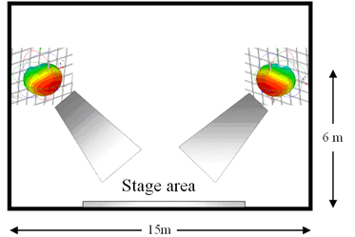
Figure 4: IEM Configurations

This has the multiple benefits of keeping the antennas out of sight of the audience, keeping the propagation path to the performer relatively un-obstructed and reducing interference to nearby systems. The latter comes about because propagation in a horizontal direction is via a combination of the side lobes of the antenna and scatter from the stage.
Figure 5 provides the horizontal and vertical pattern of IEM antennas.

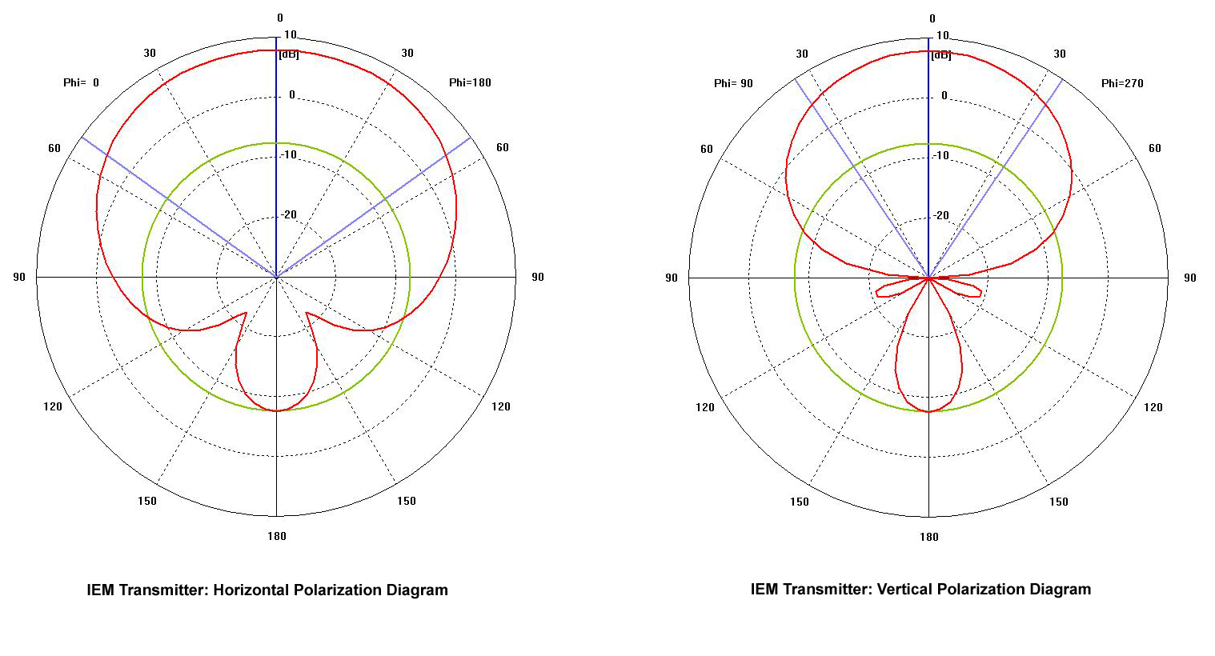
Figure 5: PWMS IEM Antenna Pattern above 1525 MHz

It is estimated that this attenuates the IEM transmitter signal by around 6dB in the side lobe.

Consideration on the compatibility studies
  - General considerations
The report investigated the compatibility between PWMS and other services/systems in co-frequency cases and non co-frequency cases.

For co-frequency cases, the required separation distances are investigated.

Two non co-frequency cases, two cases are investigated:

- First cases: “adjacent bands case”, where the victim is operating in a given band and the PWMS systems are operating in an adjacent band in order to determine the size of the guard band between the edge of the band used by the victim and the edge of the first channel possibly available for PWMS systems (figure 10 provides an example of such cases).

1452.2 MHz MhMHzMHz
600 kHz
25 kHz
200 kHz
1452.6 MHz
200 kHz
200 kHz
PWMS 1
PWMS 2
Victim
1451.4875 MHz MHz
1452 MHz MhMHzMHz
100 kHz
Guard Band
Figure 6: Example of adjacent bands cases 200 kHz PWMS operating above 1452 MHz and 25 kHz FS operating in the frequency range below 1452 MHz
- Second cases: “off channel case”, where the victim and the PWMS systems are operating in the same band, determining the frequency offset between the edge of the channel of the possible victim and the edge of the channel of the first adjacent possibly available for PWMS system.

The following table provide an overview of the cases to be considered in the compatibility analyses and the corresponding assumptions for PWMS deployment.

Note: considering the conclusions given in section 8.5 the impact of unwanted emissions falling above 1559 MHz was not considered.

Band  (MHz) | Service /Applications |  |  |  |  | Compatibility analyses
1429 – 1452 | FIXED | MOBILE  (except Aeronautical Mobile) | Aeronautical telemetry (5.342) |  |  | Non co-frequency case limited to “adjacent bands case”  Outdoor  Body Antenna / IEM
1452-1492 | BS  1452-  1479.5 MHz | BSS  1479.5 – 1492 MHz | Fixed  (secondary) | Mobile  (except Aeronautical Mobile)  (secondary) | Aeronautical telemetry (5.342) | Co-frequency case  Adjacent cases  Outdoor  Body worn antenna / IEM
1492-1518 | FIXED | MOBILE  (except Aeronautical Mobile) | Aeronautical telemetry (5.342) |  |  | Co-frequency case  Adjacent cases  Indoor  Body worn antenna / IEM
1518-1525 | FIXED | MOBILE  (except Aeronautical Mobile) | MSS (s-E) | Aeronautical telemetry (5.342) |  | Co-frequency case  Adjacent cases  Indoor  Body worn antenna / IEM
1525-1530 | FIXED | SPACE OPERATION (s-E) | MSS (s-E)  ( 5.351) | Aeronautical telemetry (5.342) |  | Co-frequency case  Adjacent cases  Indoor  IEM
1533-1535 | MSS (s-E) 5.351.A 5.353A) | SPACE OPERATION (s-E) | Aeronautical telemetry (5.342) | Mobile  (except Aeronautical Mobile) | Eess | Co-frequency case  Adjacent cases  Indoor  IEM
1535-1559 | MSS (s-E) 5.351° 5.353°  5.357° |  |  |  |  | Co-frequency case  Adjacent cases  Indoor  IEM
Table 3: List of compatibility analyses [4]
5.342 Additional allocation: in Armenia, Azerbaijan, Belarus, Bulgaria, the Russian Federation, Uzbekistan, Kyrgystan and Ukraine, the band 1 429-1 535 MHz is also allocated to the aeronautical mobile service on a primary basis exclusively for the purposes of aeronautical telemetry within the national territory. As of 1 April 2007, the use of the band 1 452-1 492 MHz is subject to agreement between the administrations concerned. (WRC-2000).
5.351A For the use of the bands 1 525-1 544 MHz, 1 545-1 559 MHz, 1 610-1 626.5 MHz, 1 626.5-1 645.5 MHz, 1 646.5-1 660.5 MHz, 1 980-2 010 MHz, 2 170-2 200 MHz, 2 483.5-2 500 MHz, 2 500-2 520 MHz and 2 670-2 690 MHz by the mobile-satellite service, see Resolutions 212 (Rev.WRC-97) and 225 (WRC-2000). (WRC-2000).
5.353A In applying the procedures of Section II of Article 9 to the mobile-satellite service in the bands 1 530-1 544 MHz and 1 626.5-1 645.5 MHz, priority shall be given to accommodating the spectrum requirements for distress, urgency and safety communications of the Global Maritime Distress and Safety System (GMDSS). Maritime mobile-satellite distress, urgency and safety communications shall have priority access and immediate availability over all other mobile satellite communications operating within a network. Mobile-satellite systems shall not cause unacceptable interference to, or claim protection from, distress, urgency and safety communications of the GMDSS. Account shall be taken of the priority of safety-related communications in the other mobile-satellite services. (The provisions of Resolution 222 (WRC-2000) shall apply.) (WRC-2000).
5.357A In applying the procedures of Section II of Article 9 to the mobile-satellite service in the bands 1 545-1 555 MHz and 1 646.5-1 656.5 MHz, priority shall be given to accommodating the spectrum requirements of the aeronautical mobile-satellite the service providing transmission of messages with priority 1 to 6 in Article 44. Aeronautical mobile-satellithe(R) service communications with priority 1 to 6 in Article 44 shall have priority access and immediate availability, by pre-emption if necessary, over all other mobile-satellite communications operating within a network. Mobile-satellite systems shall not cause unacceptable interference to, or claim protection from, aeronautical mobile-satethete (R) service communications with priority 1 to 6 in Article 44. Account shall be taken of the priority of safety-related communications in the other mobile-satellite services. (The provisions of Resolution 222 (WRC-2000) shall apply.) (WRC-2000).
It has to be noted that WG FM is considering the feasibility of introduction of CGC in the mobile satellite service bands 1626.5-1645.5 and 1646.5-1660.5 MHz and 1525-1544 and 1545-1559 MHz. This compatibility study at 1525-1544 MHz and 1545-1559 MHz between CGC and PWMS was not considered when developing this report.
The following sections provide general consideration on the use of some of the services considered in the compatibility studies. Additional information may also be found in each of the relevant section.
    - General considerations on the use of the 1.5 GHz band by the FS
ECC Report 03 [5] gives the general trends for the use of the FS links within CEPT. For the 1.5 GHz band, 1350-2690 MHz, the overall CEPT spectrum policy foresees optimisation of this band for the use by mobile and other radiocommunication services, which for line-of-sight and similar operational limitations may not be accommodated in the bands higher than about 3 GHz.
However, many CEPT administrations stressed the need to continue FS use in parts of this band and the availability of suitable channel arrangements (Recommendation T/R 13-01 [6]) to allow the long-term development of fixed services side-by-side with mobile and other services in this frequency range. The annex 1 of this report [6] gives the different national use of this band by FS.

Beside the civil FS use, the 1350-2690 MHz frequency range, is also extensively used for tactical fixed links within NATO as well as in non-NATO countries. Within the NATO Joint Frequency Agreement (NJFA) particular frequency bands in the ra–ge 1350 - 2670 MHz are identified for the use of tactical radio relay systems. As a result of the WARC-92 decisions a transition of the tactical radio relay applications to harmonized sub-bands above 2000 MHz is envisaged. With regard to the military usage in the bands considered in this report, representative from NATO indicated that there was no NATO system to be protected from PWMS in the bands under considerations. Therefore, if there are national systems to be protected, they are covered in the report only if administration expressed concerns on the protection of a given service.
    - General considerations on the use of the 1.5 GHz band by the MS
According to EU15A, the use of the bands considered in this report by the Mobile Service is limited to tactical radio relay applications. Therefore, the considerations given in section 3.1.1 with regard to the Fixed Service are applicable to the Mobile Servic.
    - General considerations on the use of the 1.5 GHz band by the MSS
ECC/DEC/(04)09 [7] has designated the band 1518-1525MHz to MSS use. Many other ECC Decisions the bands 1525-1559 MHz are designated by CEPT to MSS [8] [9].
The MSS bands covered in this report are used for many different MSS applications. Two of the MSS applications relate to provision of safety and distress communications for the maritime and aeronautical communities. Under ITU regulations footnotes 5.353a and 5.357a, the Global Maritime Distress and Safety System (GMDSS) has regulatory protection for its transmissions, anthehe AMS(R)S service has requirements for access to suitable spectrum for its services.
While indoors PWMS is unlikely to be geographically local to maritime services, the use of PWMS outdoors may not be. If used outdoors these transmissions could interfere with GMDSS and maritime services (if local to a coastal area) or over flying aeronautical aircraft utheg the AMS(R)S services. The European Space Agency and the EC within the Single European Sky Programme (SESAR) is using the use of satellite communications for aeronautical services.
    - General considerations on the use of the 1.5 GHz band by the BS
The frequency band 1452-1479.5 MHz is planned for terrestrial mobile multimedia services through the Maastricht 2002 Special Arrangement, as revised in Constanta 2007 (MA02revCO07) [10]. The basis for the entries in the frequency plan is the use of T-DAB. However, through the spectrum mask concept and the aggregation of contiguous T-DAB frequency blocks, also other systems can be implemented, as long as these systems do not cause more interference nor claim more protection. Systems that may be considered are e.g. T-DMB or future developments of DVB-H. The availability of this frequency band for other services than terrestrial mobile multimedia services, are therefore dependant on the implementation of such services, which may vary between countriEurope.
    - General considerations on the use of the 1.5 GHz band by the Aeronautical Telemetry
According to footnote 5.342 the band 1429-1535 MHz could be used on primary basis in some countries. Due to primary status and nature of aeronautical telemetry regulations in those countries there are no means to limit frequency usage for such systems. Therefore, aeronautical telemetry can switch to any carrier anytime without noticing civilian regulatory body. This makes the band 1429-1535 MHz virtually occupied by aeronautical telemetry. In such case there is no possibility to ascertain adjacent channel PWMS operation in the band 1452-1492 MHz. Any PWMS carrier in the band 1452-1535 MHz will have corresponding aeronautical telemetry co-channel receiver and needed separation will be acquired from co-channel scenario. Adjacent channel operation could be investigated only in the band 1535-1559 MHz where aeronautical telemetry has no allocation.
  - Assumptions used in the compatibility studies
    - PWMS Characteristics (see also section 2)
Two kinds of devices PWMS except audio devices have to be considered with:
- 200 kHz bandwidth
- 600 kHz bandwidth

When comparing the emissions mask for Analogue PWMS with the one given for Digital PWMS it appeared that the digital is the worst case, therefore only this case is considered.

With regard to the antenna for PWMS, ETSI [1] proposed that the body antenna case was considered first for frequency below 1525 MHz (see Figure 3) and that the IEM antenna case was considered for frequency above 1525 MHz. However, it was agreed to considered the IEM case also for frequency below 1525 MHz.

The deployment of PWMS is assumed to be outdoor for frequency below 1492 MHz and indoor for frequency above 1492 MHz.
    - Propagation model used in the compatibility studies
Measurements have been conducted in order to identify the propagation model corresponding to the PWMS situation (see Annex 3). The results did not allow identifying “the” propagation to be used in order to assess compatibility with PWMS and other Services/Systems. Therefore, several propagation models are considered in the compatibility analyses.
    - Absorption in walls
The SRDoc [1] considered a range of values based of a campaign of measurements which are provided below:

Wall type / material | Absorption  @1450MHz
Lime sandstone 24cm | 34 dB
Lime sandstone 17cm | 29 dB
Ytong 36.5cm | 23 dB
High hole brick 24cm | 19 dB
Reinforced concrete 16cm | 13 dB
Lightweight concrete 11.5cm | 9 dB
ThermoPlane | 6 dB
Table 4: Wall Attenuation values
The measurements provided in Annex 4 have confirmed the range of value for the wall loss attenuation. The value of 10 dB is considered for the compatibility analyses.

Compatibility studies in the band 1429-1452 MHz
This section considers the possible effect of the unwanted emissions of PWMS falling below 1452 MHz.
  - Compatibility between PWMS and Service
    - Fixed Service Characteristics
The ITU-R Recommendation F.1334 [11] on the Protection criteria for systems in the fixed service sharing the same frequency bands in the 1 to 3 GHz range with the land mobile service gives some indication about characteristics and protection criteria, in particular a receiver noise floor level in the order of -140dBW/MHz with a protection of I/N= -20dB for Fixed Service operating with a primary status.

Characteristics of P-P FS links are described in the relevant ETSI documents, EN 300 630 [12] and EN 300 631 for antenna gains [13].

Different channel bandwidths are available in the range 25 kHz-3.5 MHz mostly used for narrow bandwidth (<1 MHz).

The channel plan given in Recommendation T/R 13-01 is considered [6]. The closest channel from 1542 MHz will be: 1451.4875 MHz.

The noise density after the antenna is -140dBm/kHz.

Typical antenna gain is about 13dBi but may be higher. Therefore 2 types of antenna are considered hereafter: a Yagi antenna with 13 dBi gain, and a dish antenna with a 30 dBi gain. Figure 7 gives the antenna radiation patterns for both antenna derived from ITU-R Rec. F.1245 [14]. It can be seen that the gains for angle greater than 45° are approximately -9 dBi for a dish antenna and -4 dBi for a Yagi antenna. Therefore the mainlobe to sidelobe attenuations are 39 dB for a dish antenna and 17 for a Yagi antenna.

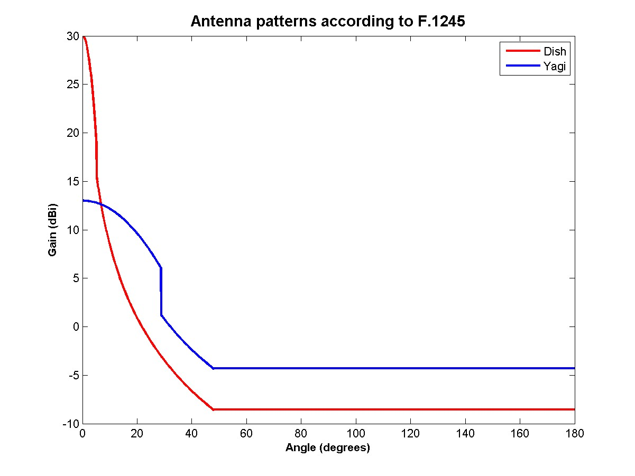
Figure 7: FS antenna patterns derived from ITU-R Rec. F.1245

FS deployment:
Fixed services are mainly located in rural areas, with a typical antenna height of 20m. However, as described in ERC Report 10 [15], Radio relay systems in this band are also used in urban areas and are typically mounted on a roof of a building.
    - PWMS Characteristics
The following table provides a summary of the assumptions considered for PWMS (see also section 3.2.1.).

Parameter | Value | Comments
Maximum radiated power | 50 mW e.i.r.p.
Bandwidth | 200 kHz – 600 kHz
Emission mask | Digital | See Figure 2
Antenna beam shape/gain | Omni directional | Body worn antenna. Dipole: 2.14dBi max (see Figure 3)
Antenna beam shape/gain | Directional | Fixed antenna (IEM). Max antenna gain 8 dB see Figure 5)
Antenna height | 2.5 m | Body worn antenna.
 | 7 m | IEM
Deployment | Outdoor
Operating Frequencies | 1542.2 MHz and 1542.6 MHz | 200 kHz case (see Figure 6 where a guard band of 100 MHz is assumed between 1542 MHz and the edge of the first PWMS channel)
Table 5: PWMS Characteristics
It is important to note that since there is a guard band of 500 MHz below 1452 MHz within the FS band, the frequency offset between the edge of the first FS channel and the center frequency of the PWMS system will always be larger than 500 MHz + B/2 (where B is the bandwidth of the PWMS system). This results in frequency offset values of 600 MHz for the 200 kHz case and 800 MHz for the 600 kHz. This implies, considering the emissions mask of PWMS systems, that the rejection will always be 60dB between the e.i.r.p of the PWMS system (17dBm) and the level falling into the FS receiver bandwidth.

Then, the level of the unwanted emissions of the PWMS systems to be considered for the calculations will be for the 200 kHz:

17dBm – 60 dB = -43 dBm in 200 kHz

And for the 600 kHz case:

17dBm – 60 dB = -43 dBm in 600 kHz or about -48 dBm in 200 kHz

It can then be concluded that the results achieved considering the 200 kHz PWMS case and a given level of rejection will be worse than those achieved considering the 600 kHz case for the same level of rejection.

The level received by the FS receiver would then be calculated taking into account the correction resulting from the size of the FS bandwidth (i.e. 10 x log (25/200) = -9dB in case of a 25 kHz channel).
    - Simulations
Simulations were conducted using SEAMCAT (www.ero.dk/seamcat). For the purpose of these simulations the density of PWMS operating on a given channel is assumed to be 0.1 Tx per km². This number seems realistic taking into account the results of the measurements (see Annex 4) and the corresponding possible re-use distance of a given frequency for PWMS systems.

For the rural environment case, the FS antenna is assumed to be deployed outside from a city, and the PWMS are assumed to be deployed within the city, therefore, a separation distance of 1km is considered between the FS receiver and the first PWMS transmitter. In order to model a deployment within a city (i.e. not spread everywhere around the FS receiver), 10 PWMS transmitters are deployed in angles ranging from 0 degree to 90 degrees seen from the FS receiver station (see Figure 8).

Figure 8: PWMS deployment around a FS antenna in rural environment

For the urban environment case, 10 PWMS transmitters are deployed without any restriction around the FS antenna.
    - Results of simulations
Table 6 provides results of simulation for the 200 kHz PWMS system and 25 kHz FS for a rejection of 60 dB.

FS antenna | 13 dB Yagi |  | 30 dB Dish
PWMS Antenna | Body antenna | IEM | Body antenna | IEM
Rural | 18 % | 24 % | 17.5 % | 22 %
Urban | 1 % | 1.5 % | 1 % | 1.5 %
Table 6: 25 kHz FS / 200 kHz PWMS – 60dB rejection

Considering the results above, additional simulations were conducted considering a level of rejection of 70dB for the emissions falling into the FS receiver.

FS antenna | 13 dB Yagi |  | 30 dB Dish
PWMS Antenna | Body antenna | IEM | Body antenna | IEM
Rural | 1.5 % | 3 % | 1.5 % | 8 %
Urban | 0.5 % | 1 % | 0.5 % | 1.5 %
Table 7: 25 kHz FS / 200 kHz PWMS – 70dB rejection

Finally, simulations were conducted for the 30dB dish antenna IEM case and a rejection of 75dB, leading to a probability of 4 %.

Noting that:
- for the considered frequency offsets, the level of emissions resulting from PWMS is flat over the 25 kHz of the FS receiver (constant 60dB rejection)
- for the considered frequency offsets, the level of emissions resulting from PWMS is flat over larger FS receiver bandwidth (i.e. for example 2000 kHz)
- the ratio between the calculated levels of unwanted emissions in the 2000 kHz FS and the level of unwanted emissions in the 25 kHz FS will be equal to the ratio of the bandwidths
- the respective Noise (N) use as a reference to calculate the probability (I/N criterion) are also linked by the same ratio of bandwidths,
It may be concluded for other FS receivers bandwidths that the results will be similar to those given in Tables 6 and 7.
The results provided in table 7 above are calculated for a given rejection and are relative to the power of the PWMS system. Therefore, as indicated in section 4.1.2, for the 600 kHz case, the corresponding absolute level in dBm in 200 kHz is 5dB lower
  - Compatibility between PWMS and Mobile Service
Considering section 3.12, the considerations given in section 4.1 with regard to the Fixed Service are applicable.
  - Compatibility between PWMS and Aeronautical service
In the frequency range 1452-1535 MHz, separation distances will be calculated to protect the Aeronautical Telemetry Service (see section 5.5 and 6.3). The application of these separation distances will ensure the protection of Aeronautical Telemetry systems operating in1429-1452 MHz.
  - Conclusions for the protection of systems operating below 1452 MHz
The following limits should be considered for the protection of Fixed Service operating below 1452 MHz
- Body worn antenna: 70dB rejection or 17-70 = -53dBm in 200 kHz applicable for 200 kHz to 600 kHz channel spacing
- IEM: 75dB rejection or 17-75 = -58dBm in 200 kHz applicable for 200 kHz to 600 kHz channel spacing

Therefore a limit of -58dBm in 200 kHz should be considered.

The Aeronautical service will be protected by the application of separation distances calculated for the co-channel case (see section 5).

These conclusions are valid for both analogue and digital cases and for outdoor deployment.

Compatibility studies in the band 1452-1492 MHz
  - Compatibility between PWMS and Fixed Service
    - Fixed Service Characteristics
The same characteristics as in section 4.1.1 are considered.

In the band 1492-510 MHz, the Fixed Service has a secondary status, therefore, the I/N is taken equal to -10dB.

In addition, according to Recommendation T/R 13-01 [6], this part of the spectrum corresponds to center gap of the frequency plan for the band 1350-1375 MHz paired with 1492-1517 MHz.
    - PWMS Characteristics
The characteristics of PWMS given in section 4.1.2 are considered.
    - Simulations
In this band, all cases identified in section 3.1 should be considered.
- Determination of separation distance between PWMS and FS operating on the same frequency (MCL calculations and SEAMCAT simulations)
- “adjacent bands case”, where the victim is operating in 1452-1492 MHz and the PWMS systems are operating above 1492 MHz, in order to determine the size of the guard band between the edge of the band used by the victim and the edge of the first channel possibly available for PWMS systems (SEAMCAT calculations using the same scenarios as in 4.1.3)
- “off channel case”, where the victim and the PWMS systems are operating in the band 1452-1492 MHz, determining the frequency offset between the edge of the channel of the victim and the edge of the channel of the first adjacent possibly available for PWMS system (SEAMCAT calculations using the same scenarios as in 4.1.3)
    - Results of simulations

Co-frequency studies (protection distances to protect FS operating in the band 1452-1492 MHz from PWMS operating in the same band)
Table below shows some MCL calculations with a 200 kHz PWMS body antenna as interferer and a FS victim with a yagi antenna at various bandwidths.
Resulting protection distances are calculated using a dual slope free space model (20 log for distances up to 5 km and 40 log above) and an extended Hata model for rural environment (with a PWMS height of 2m and a FS height of 20m).

Table 8: Protection distances between a 200 kHz body antenna and a fixed service (Yagi)

Considering the results of the rural extended Hata model, the distance separation ranges from 29 km (main lobe PWMS to main lobe FS, 25 kHz bandwidth) to 5 km (main lobe PWMS to side lobe FS, 3500 kHz bandwidth).

Replacing the Yagi antenna (maximum antenna gain 13dBi) by a dish (maximum antenna gain 30dBi)), the required path attenuation should be increased by 17 dB for the main lobe PWMS to main lobe FS and decreased by 4 dB for the main lobe PWMS to side lobe FS (-9dB in the side lobes of the dish and -5dB in the side lobes of the Yagi antenna).

For the 600 kHz, noting the difference of 5 dB in spectral density, the distances will be shorter than those given in Table 8 for cases where the victim bandwidth is smaller than 600 kHz and identical for cases where the victim bandwidth is larger than 600 kHz.

For the IEM case, the rejection in the side lobes will result in 6 dB less required attenuation (due to the IEM pointing direction: 45 degree). In the victim side lobe, for the 25 kHz FS case (worst case according to Table 8); this will result in a separation distance of 15 km.

The following separation distances are then necessary:
Body worn antenna: 11 km
IEM: 15 km

Off channel/Adjacent case
The results provided in this section are applicable to FS operating in the band 1452-1492 MHz from PWMS in the same band but not on the same channel (note: when considering this section the results on BSS given in section 5.4 need to be considered since they result in a limitation of the spectrum possibly usable for PWMS).

The results will be similar to those given in the section 4.1.4 taking into account the difference of I/N (-10dB instead of-20dB). Then, the results achieved for a rejection of 70dB will be achieved for a rejection of 60 dB in the body worn antenna case while those achieved for a rejection of 75dB are achieved for a rejection of 65 dB. It can then be concluded that:

- A rejection of 60 dB is needed for body antenna, corresponding to a level of 17-60dB=-43dBm in 200 kHz
- A rejection of 65dB is needed for IEM, corresponding to a level of: 17-65dB=-48dBm in 200 kHz
    - Conclusion for the FS in the 1452-1492 MHz
Co-channel case:
15 km is required between PWMS and FS stations.

In order to protect FS receiver, the following level should be met at the frequency received by the FS station:
- A rejection of 65dB is needed corresponding to a level of: 17-65dB=-48dBm in 200 kHz

These conclusions are applicable for outdoor deployment for both IEM and body worn antenna.
  - Compatibility between PWMS and Mobile Service
The Mobile Service is also with a secondary service status in this band according to ERC Report 25 [4]. In addition, according to EU15A, the use of the bands considered in this report by the Mobile Service is limited to tactical radio relay applications. Therefore, the considerations given in section 3.1.1and 5.1 with regard to the Fixed Service are applicable.
  - Compatibility between PWMS devices and Broadcasting service (1452-1479.5 MHz)
The 1452-1479.5 MHz band (27.5 MHz) has been planned in Europe by two CEPT T-DAB Planning Meetings. The resulting frequency Plan as associated with the MA02revCO07 Special Agreement uses 16 x 1.7 MHz T-DAB blocks to provide 1-3 nation-wide coverage(s) per country for mobile reception.

The CEPT supplemented the MA02 revCO07 Special Arrangement with additional regulatory and technical provisions to add flexibility to specifically allow among others for other reception modes for T-DAB and the introduction of radio-communication services other than T-DAB through the application of an interference envelope concept similar to that in the GE06 Agreement.

    - Characteristics for T-DAB
For the compatibility studies it is appropriate to consider the following T-DAB parameters as extracted from MA02 revCO07 Special arrangement:

 | T-DAB portable outdoor or mobile reception at 1.5 GHz
Bandwidth | 1.536 MHz
Minimum equivalent field strength (dB(µV/m)) | 46
Location percentage correction factor (50% to 99%)¹ | +13
Antenna height gain correction (dB) | +10
Minimum median field strength for planning (dB(µV/m)) at an antenna height of 10m | 69
NOTE 1: The required location percentage for T-DAB services is 99%. Taking into account an estimated standard deviation of 5.5 dB for a location variation of a T-DAB signal, the location correction factor is 2.33 x 5.5 = 13 dB.
Table 9: Characteristics of T-DAB
The maximum allowable field strength of an interference signal (FS_{I}) to protect the minimum wanted field strength of a T-DAB signal (FS_{T-DAB}) is calculated as follows:

Maximum allowable –S_{I} =–(FS_{T-DAB} - PR - 18) dB(µV/m)
where
FS_{T-DAB} = 69 dB(µV/m)
PR is the Protection Ratio to protect T-DAB signals from PMWS.
18 dB is the propagation correction factor to protect T-DAB signals for 99% locations against unwanted signals (2.33 x 5.5 x √2 = 18 dB). The field strength values for wanted and unwanted signals are assumed to be uncorrelated.
NOTE: It is assumed that receiving antenna directivity or polarisation discrimination are not considered as both wanted and unwanted signals use omnidirectional antennas.

Video link
Service identifier | Field strength to be protected in dB(µV/m) | Transmit antenna height (m)
YB | 69.0 | 10.0

Δ f (MHz) | -8.0 | -7.5 | -7.0 | -6.5 | -6.0 | -5.5 | -5.0 | -4.5 | -4.0 | -3.5 | -3.0
PR (dB) | -42.0 | -23.5 | -10.0 | -3.0 | -2.0 | -3.0 | -24.0 | -21.0 | -23.0 | -31.0 | -31.5
Δ f (MHz) | -2.5 | -2.0 | -1.5 | -1.0 | -0.9 | -0.8 | -0.7 | -0.6 | 0.0 | 0.6 | 0.7
PR (dB) | -30.0 | -28.5 | -25.0 | -19.5 | -17.5 | -11.0 | -7.0 | -1.5 | -1.5 | -4.0 | -5.5
Δ f (MHz) | 0.8 | 0.9 | 1.0 | 2.0 | 3.0
PR (dB) | -13.5 | -17.0 | -20.0 | -33.0 | -47.5
Table 10: Protection Ratio to protect T-DAB from Video Link in MA02RevCo07
    - Considerations on the protection of T-DAB (1452-1479.5 MHz)
Currently, PWMS applications of all types co-exist in an acceptable manner with T-DAB services in UHF. There administrations may consider the same arrangement in the T-DAB segment of L Band. Other administrations may consider taking appropriate measure such as:
- calculating separation distances to protect T-DAB from PWMS systems
- calculating the required guard band
using the material provided in section 5.2.1.

It should also be noted that, following the revision of the Maastricht, 2002, Special Arrangement at the Constanţa, 2007 (MA02revCO07 [10]), allows for flexible use by mobile multimedia technologies. Administrations are considering appropriate measures on a case by case to protect the services/systems operating through the BS allocation (T-DAB) from PWMS emissions.

It is also possible that some administrations may elect not to deploy L band T-DAB services, leaving this band very suitable for geographic sharing.
  - Compatibility between PWMS devices and Broadcasting Satellite service (1479.5-1492 MHz)
At international level, WARC-92 allocated the band 1452-1492 MHz on a co-primary basis to the broadcasting-satellite service (sound) and complementary terrestrial audio broadcasting. These allocations form the basis of the deployment of satellite and terrestrial components of S-DAB hybrid systems, whereas the introduction of satellite components of S-DAB systems is limited at global level to the 1467-1492 MHz band, as a result of ITU Resolution 528.
In Europe, the frequency band 1452-1479.5 MHz was used as a basis for the development of a T-DAB plan, whereas the 1479.5-1492 MHz band is harmonised for S-DAB use since October 2003, as a result of the adoption of ECC/DEC/(03)02 [16]. In effect, this CEPT Decision provides scope for a harmonised deployment of satellite and terrestrial components of S-DAB hybrid systems in the upper 12.5 MHz of the 1452-1492 MHz international allocation:
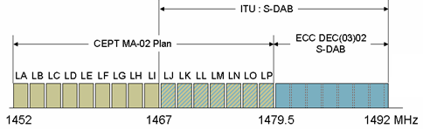
Figure 9: International and European BS and BSS allocations in the frequency band 1452-1492 MHz
In Q4-2006, the ETSI has published a series of documents which establish the “Satellite Digital Radio” (SDR) standard:
- ETSI TR 102 525 (2006-09), technical report on SDR technology [17]
- ETSI TS 102 550 (2006-11), Outer Physical Layer [18]
- ETSI TS 102 551-1 (2006-12), SDR Inner Physical Layer Single Carrier [19]
- ETSI TS 102 551-2 (2006-12), SDR Inner Physical Layer Multiple Carrier [20]
This standard identifies the 1.5 GHz band as the main candidate band for the deployment of SDR-compliant hybrid technologies.
    - Compatibility analyses
Compatibility studies to be carried out between PWMS systems and S-DAB systems in the 1479.5-1492 MHz band are twofold, and need to address both the satellite and terrestrial components of such S-DAB hybrid systems.

Compatibility of PWMS systems with terrestrial components of S-DAB hybrid systems
Terrestrial components of S-DAB hybrid systems consist in complementary gap-filler networks to be deployed in areas where the satellite reception is subject to line-of-sight blockage – primarily urban areas – where the satellite signal is likely to be blocked by natural obstacles or buildings.
Depending on the size of the complementary terrestrial coverage to be achieved, these local networks may consist of single transmitters or OFDM SFNs. Although the SDR terrestrial component waveform slightly differs from the T-DAB EU-147 OFDM waveform, the design of local S-DAB terrestrial gap-filler networks basically obey to a similar link budget, and it is therefore proposed that results of compatibility studies to be developed between T-DAB and PWMS systems in the 1452-1479.5 MHz band be extended to apply in the 1479.5-1492 MHz to cover the case of compatibility between PMWS systems and S-DAB terrestrial components.

Compatibility of PWMS systems with satellite components of S-DAB hybrid systems
The SDR standard defines various profiles for satellite component carriers. The analyses presented in this document are based on the 1.49 Msps carrier profile (1.71 MHz channel bandwidth).
S-DAB receivers operate on the satellite link with a G/T of -22 dB/K, and a reception antenna of 2 dBi. Because this antenna is designed for mobile reception, no antenna gain discrimination can be factored when addressing interference potentials.
The table below defines the resulting PWMS maximum interference level into a 1.49 Msps S-DAB carrier:
Channel bandwidth | 1712 | kHz
G/T | -22.0 | dB/K
Antenna gain | 2.0 | dBi
Receiver noise temperature | 251 | K
Receiver thermal noise level | -142 | dBW
Required I/N criterion | -20 | dB
I _{max} | -162 | dBW
Table 11: PWMS maximum interference level into a 1.71 MHz AB carrier
a) PWMS single carrier compatibility analysis: co-channel case
This section aims at defining the separation distance which would be necessary to ensure the protection of an S-DAB satellite component reception from a co-channel PWMS single carrier emission, according to the maximum interference level defined in Table 1.
Because the S-DAB channel bandwidth (1.712 MHz – 1.49 Msps SDR profile) is larger than that of either PWMS carrier (200 kHz or 600 kHz), this single carrier interference analysis is expected to apply to both types of PWMS carriers.
A low power PWMS interferer is considered (50 mW), and is assumed to be radiated from an in-door location (a wall absorption of 10 dB is considered):

PWMS radiated power (50 mW) | -13 | dBW
Wall absorption | -10 | dB
Path loss Attenuation | -141 | dB
Separation distance | 2.9 | km
S-DAB receiver antenna gain | +2 | dBi
⇒ I = I _{max} | -162 | dBW
Table 12: Required separation distance from an indoor co-channel PWMS interferer
(50 mW, 200 kHz or 600 kHz, single carrienterference
b) PWMS single carrier compatibility analysis: adjacent channel case
This section aims at defining the separation distance which would be necessary to ensure the protection of an S-DAB satellite component reception from a PWMS single carrier emission at a given frequency offset. Like in section a) above, indoor low-power PWMS carriers are considered.
The spectrum mask reproduced in figures B.4 (B=600 kHz) of document ETSI TR 102 546 [1] is used for PWMS emissions, which are assumed to interfere into the following equivalent S-DAB receiver filter:
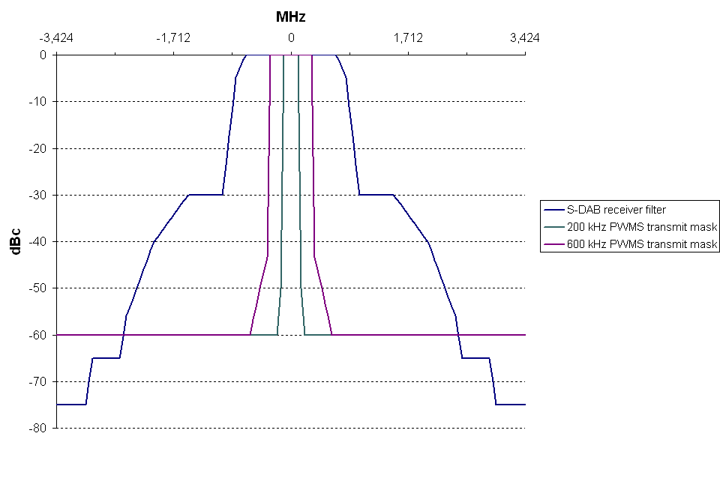
Figure 10: S-DAB and PWMS spectrum masks
These S-DAB and PWMS masks are then correlated to derive the ACI relaxation which can be applied at a given frequency offset:
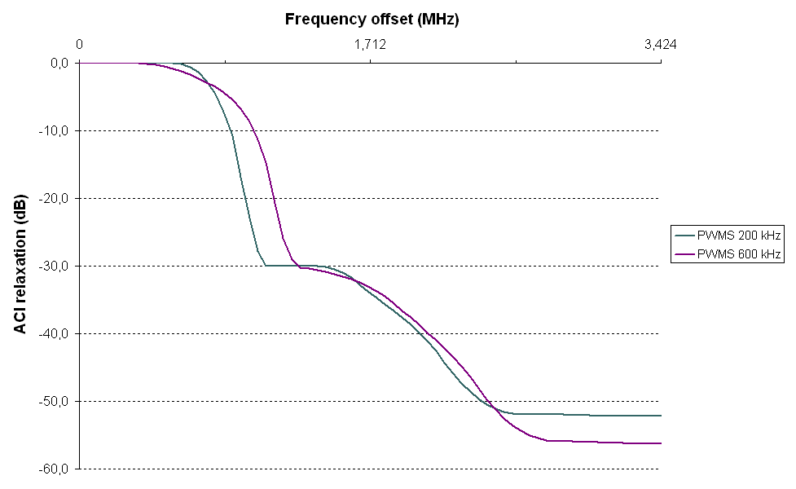
Figure 11: ACI relaxation masks
For each value of frequency offset, the corresponding relaxation is applied in order to derive the separation distanceError: Reference source not found which is necessary to ensure the protection of an S-DAB satellite component carrier (I ≤ I _{max} as defined in Table 11) from a 50 mW PWMS (indoor) transmission:
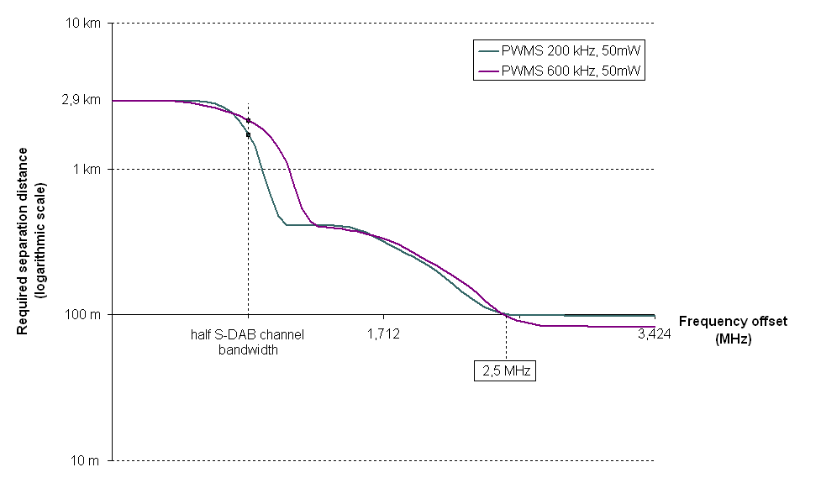
Figure 12: Separation distance required from an indoor adjacent channel PWMS interferer (50 mW, 200 kHz and 600 kHz, single carrier interference) for wall absorption = 10dB

If PMWS are located outdoor (i.e. band below 1479.5 MHz), it will not be possible to reach the 100 m point, therefore a rejection of 70 dB is considered.

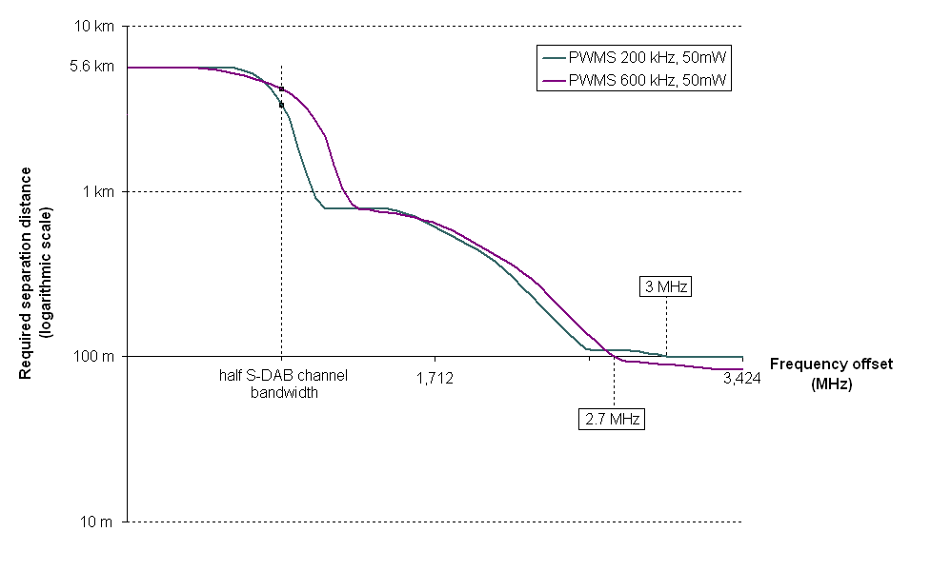
Figure 13: Separation distance required from an outdoor adjacent channel PWMS interferer – 70dB rejection (50 mW, 200 kHz and 600 kHz, single carrier interference)

For 50 mW outdoor emissions of resp. 200 kHz and 600 kHz would require guard bands of 2.0 and 1.5 MHz to ensure compatibility with S-DAB satellite component operating in the 1479.5-1492 MHz band. If the systems are indoor the guard bands would become 1.5 MHz and 1.3 MHz.

The following table provides the results in term of guard band for the indoor / outdoor case.

 | outdoor | Indoor
200 kHz | 2 MHz | 1.5 MHz
600 kHz | 1.5 MHz | 1.3 MHz
Table 13: guard bands indoor / outdoor case
In-band
- compatibility:
Figure 12 shows that the operation of even low-power indoor PWMS systems is not possible within the 1479.5-1492 MHz allocation, since a minimum between 1.8 km and 2.9 km of separation distance is necessary between a PWMS transmitter and an S-DAB receiver to mitigate the interference potential in all cases of frequency offsets (up to half the S-DAB channel bandwidth).
- Out-of-band compatibility:

For indoor PWMS deployment (above 1492 MHz): According to Figures 12 1.5 MHz guard band is needed with a rejection of 60 dB is needed resulting in a level of 17dB – 60dB = - 43dBm in 600 kHz for the PWMS unwanted emissions falling below 1492 MHz.

For outdoor PWMS deployment (below 1479.5): According to Figures 13, 2 MHz guard band is needed with a rejection of 70 dB is needed resulting in a level of 17dB – 70dB = - 53dBm in 600 kHz for the PWMS unwanted emissions falling above 147 MHz. .
    - Conclusions
Co-channel interference analyses demonstrate that PWMS systems – even low power (50 mW) and radiating from in-door locations – are not compatible with S-DAB satellite components, and can therefore not operate within the 1479.5-1492 MHz band.
PWMS with 50 mW emissions appear however possible in bands immediately adjacent to the 1479.5-1492 MHz European S-DAB allocation, subject to the accommodation of guard bands of 2 MHz in order to restrict PWMS deployment in frequency bands above 1493.5 MHz and below 1477.5 MHz. The level of unwanted emissions in the S-DAB band should not exceed -58dBm in 600 kHz taking into account the possible aggregated impact of PWMS systems.
  - Compatibility between PWMS devices and Aeronautical Telemetry
Deployment limited to some CEPT countries. It is proposed to determine a separation distance to protect the aeronautical systems in the whole band.

Table 14 summarises the technical parameters used in order to assess the impact of PWMS on Aeronautical systems. The simulation results are extracted using the SEAMCAT simulator. It should be noted that the interference scenarios and results of calculations presented below refer to ground stations of aeronautical telemetry systems only (downlink). The interference level in uplink interference scenarios (interference to the aircraft telemetry receiver) is assumed to be higher than in downlink.

 | Common Parameters | Value | Description
Victim Link | Interference Criterion (I/N) [dB] | -3.0
Victim Link | Frequency Constant [MHz] | 1494
Victim Link | Reception bandwidth [kHz] | 1000
Victim Link | Noise Floor Constant [dBm] | -112.0
Victim Link | Antenna Heigth [m] | 50
Victim Link | Antenna Gain [dBi] | 41.2
Victim Link | Antenna pattern | ITU R M.1459 | See Figure 13
Victim Link | Azimuth [deg] | 0 to 360 | Uniform Distribution
Victim Link | Elevation [deg] | 3 to 80 | Uniform Distribution
Interference Link | Frequency Constant [MHz] | 1494
Interference Link | Power Supplied Constant [dBm] | 14.86
Interference Link | Reference Bandwidth [kHz] | 200
Interference Link | Antenna Height [m] | 1.5 to 6.0 | Discrete Uniform Distribution (step of 0.5 m)
Interference Link | Antenna pattern | Omni-directional
Interference Link | Peak Gain [dBi] | 2.14
Interference Link | Azimuth [deg] | 0 to 360 | Uniform Distribution
Interference Link | Interference Path Correlation | Closest Interferer | The interference value is calculated from where the interferer is closest to the protection distance
Interference Link | Protection distance [km] | 2-36
Interference Link | Path azimuth [deg] | 0 to 360 | Uniform Polar Angle distribution
Interference Link | Propagation Model | Extended Hata | General Environment: rural, suburban  Local Environment Victim: outdoor  Local Environment Interferer: outdoor
Table 14: Common technical parameters for the simulations
The figure below provides the assumed antenna pattern for aeronautical system.

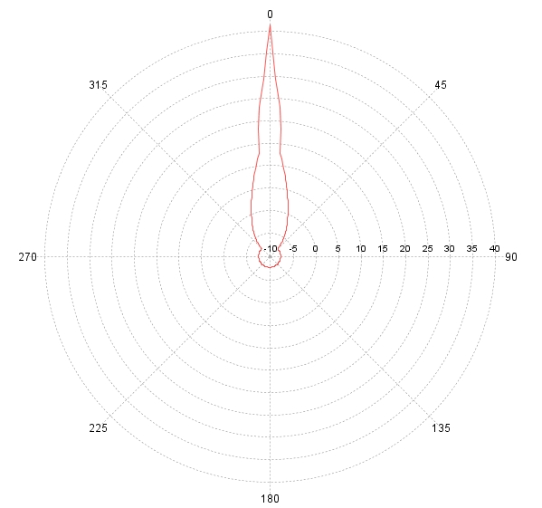
Figure 14: Antenna Pattern given by the ITU R M.1459 [21]

Local Environment Interferer | Wall Attenuation [dB] | Required separation distance, km  (with ≈1% probability of interference)
Local Environment Interferer | Wall Attenuation [dB] | Rural | Suburban | Urban
Outdoor | 0 | 36 | 12.5 | 5.5
Table 15: Results of simulations
  - Discussion for the band 1452-1492 MHz
PWMS was found not compatible with BSS in the frequency range 1479.5 to 1492 MHz. In addition, a guard band of 2 MHz should be considered at the edges of the band 1479.5 – 1492 MHz in order to protect BSS systems. This implies that there should not be deployment of PWMS in the frequency range 1477.5 to 1494 MHz. In addition, unwanted emission level of -58dBm in 600 kHz in the BSS band should be met within any 600 kHz in the BSS band 1479.5 to 1492 MHz.

For T-DAB, no general guidance is provided since the situations are going to differ from administration to administration.

Aeronautical Telemetry systems:

Based on the results obtained with SEAMCAT simulations it can be concluded that in rural and suburban areas the compatibility of PWMS systems with aeronautical telemetry systems may be achieved with restriction of separation distances between PWMS transmitter and Aeronautical Telemetry receiver:
- 36 km in rural and 12.5 km in suburban area for outdo or PWMS systems;
- In urban area compatibility of PWMS systems with aeronaut28ystem sisetry systems is achieved.

Since the exact frequencies used by Aeronautical systems are not known, these separation distances will have to applicable over the whole frequency range used by aeronautical systems (i.e. 1429-1492 MHz for the PWMS outdoor case).
Fixed and Mobile

A separation distance of 15 km is necessary for the co-channel case to protect the frequencies received by FS station. theThe unwanted emissions of PWMS operating in the band 1452 – 1477.5 MHz at the frequency received by FS stations in the frequency range 1452-1492 MHz should meet:
- A rejection of 65dB, corresponding to a level of: 17-65dB=-48dBm in 200 kHz

The limits given in section 4.4 are also applicable.

These conclusions are valid for both analogue and digital cases and for outdoor deployment.

Compatibility studies in the band 1492-1518 MHz
  - Compatibility between PWMS and Fixed Service
In this band the Fixed Service has a Primary Status therefore the value of the I/N will be -20dB. It is proposed to limit the use of PWMS to indoor usage, therefore a 10dB attenuation will have to be considered. Considering the difference of I/N (-20dB instead of -10dB) and the difference of PWMS usage (indoor instead of outdoor), it can be conclude that the conclusions given in section 5.1 are applicable.
  - Compatibility between PWMS and Mobile Service
According to EU15A, the use of the bands considered in this report by the Mobile Service is limited to tactical radio relay applications. Therefore, the considerations given in section 6.1 with regard to the Fixed Service are applicable.
  - Compatibility between PWMS and Aeronautical
The same approach as in section 5.5 is considered, taking into account the fact that the usage of PWMS will be limited to indoor usage. The following table provides the corresponding separation distances calculated using SEAMCAT.

Local Environment Interferer | Wall Attenuation [dB] | Required separation distance, km  (with ≈1% probability of interference)
Local Environment Interferer | Wall Attenuation [dB] | Rural | Suburban | Urban
Indoor | 6 | 28 | 8 | 3.5
Indoor | 30 | 6 | 1.5 | 0.7
Table 16: Results of simulations – indoor case
Therefore, based on the results obtained with SEAMCAT simulations it can be concluded that in rural and suburban areas the compatibility of PWMS systems with aeronautical telemetry systems may be achieved with restriction of separation distances between PWMS transmitter and Aeronautical Telemetry receiver:
- 28 km in rural and 8 km in suburban area for indoor (Thermoplane shielding) PWMS systems;
- 6 km in rural and 1.5 km in suburban area for indoor (Lime sandstone shielding) PWMS systems;

In urban area compatibility of PWMS systems with aeronautical telemetry systems is achieved.
  - Conclusions
Aeronautical Telemetry systems:

Based on the results obtained with SEAMCAT simulations, it can be concluded that in rural and suburban areas the compatibility of indoor PWMS systems with aeronautical telemetry systems may be achieved with restriction of separation distances between PWMS transmitter and Aeronautical Telemetry receiver:
- 28 km in rural and 8 km in suburban area for indoor (Thermoplane shielding) PWMS systems;
- 6 km in rural and 1.5 km in suburban area for indoor (Lime sandstone shielding) PWMS systems;

In urban area compatibility of PWMS systems with aeronautical telemetry systems is achieved.

Since the exact frequencies used by Aeronautical systems are not known, these separation distances will have to applicable over the whole frequency range used by aeronautical systems (i.e. 1492-1518 MHz for the PWMS indoor case).

Fixed and Mobile

A separation distance of 15 km is necessary for the co-channel case to protect the frequencies received by FS station.

The following level should be met by the PWMS operating in the band 1492-1518 MHz at the frequency received by FS stations at a receiving station:
- A rejection of 65dB is needed, corresponding to a level of: 17-65dB=-48dBm in 200 kHz

See also section 5.6 for the protection of BSS operating below 1518 MHz and section 7.5 for the protection of MSS operating above 1518 MHz.

Compatibility studies in the band 1518-1530 MHz
  - Compatibility between PWMS and Fixed Service or Mobile Service
See section 6.1 and 6.2.
  - Compatibility between PWMS devices and Mobile Satellite service
    - MSS characteristics
For the compatibility studies it is appropriate to consider the following three types of representative GSO MES terminals:
- GAN
- BGAN
- Handheld
The parameters for MSS systems are given in Table 17 below.
 | GAN | BGAN | Hand-held
Channel Rate (kbps) | 65.2 | 732 | 28.8
Symbol Rate (ksps) | 33.6 | 183 | 33.85
Bandwidth (kHz) | 60 | 200 | 50
G/T of the terminal (dB/ºK) | -7 | -9 | -23
Antenna Peak Gain (dBi) | 18 | 17 | 2
Antenna Radiation Pattern | G= 18 dBi for 0º ≤ø < 30º  G=41-25 log(ø ) dBi for 30º ≤ ø < 63º  G= -4 dBi for ø ≥ 63º | G= 17 dBi for ø < 7º  G= 0.0026 ø²-0.5029ø+20.27914 dBi for 7º ≤ ø < 76º  G= -3 dBi for ø ≥ 76º | G= 2 dBi for ø < 45º  G= 0 dBi for ≤ ø ≥ 45º
Required I/N criterion (dB) | -20 | -20 | -20
Table 17: Typical MSS power flux densities

Inmarsat Carrier Parameters
Carrier Type |  | Max EIRP* | BW
 |  | dBW | kHz
GAN | Inmarsat-3 | 31.3 | 60
BGAN | Inmarsat-4 | 44.8 | 200
Hand-held | Inmarsat-4 | 43 | 50
* Typical operational beam peak levels
PFD Calculations
 | Range | 40000 | Km
 | Spreading loss | 163.0 | dBm2
GAN | Inmarsat-3 | -119.5 | dB(W/m2/MHz)
BGAN | Inmarsat-4 | -111.2 | dB(W/m2/MHz)
Hand-held | Inmarsat-4 | -107.0 | dB(W/m2/MHz)
Other satellite networks
Thuraya (Source: EMARSAT-1F Filing)
200KG7W | Max e.i.r.p | 63 | dBW
 | Range | 39500 | Km
 | Spreading loss | 162.9 | dBm2
 | BW | 200 | kHz
 | PFD | -92.9 | dB(W/m2/MHz)
Aces (Source: Garuda-2 Filing)
50K0G7W | Max e.i.r.p | 59.8 | dBW
 | Range | 39500 | Km
 | Spreading loss | 162.9 | dBm2
 | BW | 50 | kHz
 | PFD | -90.1 | dB(W/m2/MHz)
Table 18: Typical MSS power flux densities
    - Impact of PWMS on MSS

Co-channel interference analysis
In this section, interference analysis is presented taking into account the following propagation models:
- Free space attenuation
- Free space attenuation up to 5 km and 40 log d attenuation beyond 5 km
- Hata propagation model in urban, sub-urban, rural/flat environments

A building attenuation value of 10 dB is assumed. In addition, for the interfering PWMS system two values of bandwidth have been considered in the analysis: 200 kHz and 600 kHz.

The summary of the analysis is given below.
Table 19: Summary of the results
Interference analysis for free space attenuation propagation model is presented in Table 19 and for a combination of free space attenuation and 40 log d attenuation is Table 20. Interference analyses for Hata propagation model are presented in Tables 21 and 22 for interfering PWMS systems bandwidth of 200 kHz and 600 kHz respectively.

Table 20: Interference analysis for free space attenuation propagation model

Table 21: Interference analysis for “free space attenuation (up to 5 km) and 40 log d attenuation (beyond 5km)” propagation model

Table 22: Interference analysis for Hata Propagation model (PWMS bandwidth of 200 kHz)
Table 23: Interference analysis for Hata Propagation model (PWMS bandwidth of 600 kHz)

Interference analysis with PWMS Transmitter emission mask
In this section an analysis is performed to estimate the frequency offset required between the victim MSS MES terminals and the interfering PWMS system with 600 kHz bandwidth.

The PWMS transmitter emission mask used in the analysis is given in Figure 2.
The required separation distances in km as a function of frequency offset between the interfering transmitter and victim MES terminal receiver for free space propagation model and “free space attenuation up to 5 km and 40 log d attenuation beyond 5km” propagation model are given in Figures 23 and 24 respectively.
Figure 15: Required separation distance from PWMS interferer
(50 mW and 600 kHz; building attenuation = 10 dB) under free space propagation model
Figure 16: Required separation distance from PWMS interferer
(50 mW and 600 kHz; building attenuation = 10 dB) under “free space attenuation up to 5 km and 40 log d attenuation beyond 5 km” propagation model

Conclusion
From the analysis the following conclusions can be drawn.
Free space propagation model
- At a separation distance of 100 m the interference deficits vary from 67.42 dB to 71.42 dB for an interfering system bandwidth of 200 kHz and from 62.65 dB to 66.65 dB for an interfering system bandwidth of 600 kHz.
- Separation distances ranging from 235 km to 372 km for an interfering system bandwidth of 200 kHz and from 136 km to 215 km for an interfering system bandwidth of 600 kHz are required to protect mobile earth stations.
- At a frequency offset of 600 kHz to 1 MHz (between the centre frequencies of victim MES receiver and interfering PWMS transmitter of 600 kHz bandwidth), separation distances ranging from 140 meters to 220 meters are required to protect mobile earth stations
“Free space attenuation up to 5m and 40 log d attenuation beyond 5 km” propagation model
- At a separation distance of 6 km the interference deficits vary from 30.27 dB to 34.27 dB for an interfering system bandwidth of 200 kHz and from 25.5 dB to 29.5 dB for an interfering system bandwidth of 600 kHz.
- Separation distances ranging from 34 km to 43 km for an interfering system bandwidth of 200 kHz and from 26 km to 33 km for an interfering system bandwidth of 600 kHz are required to protect mobile earth stations.
- At a frequency offset of 600 kHz to 1 MHz (between the centre frequencies of victim MES receiver and interfering PWMS transmitter of 600 kHz bandwidth), separation distances ranging from 140 meters to 220 meters are required to protect mobile earth stations
Hata propagation model
- At a separation distance of 0.1 km the interference deficits vary from 38.71 dB to 42.71 dB in urban environment and from 42.11 dB to 46.11 dB in sub-urban and rural environments for an interfering system bandwidth of 200 kHz.
- At a separation distance of 0.1 km the interference deficits vary from 33.94 dB to 37.94 dB in urban environment and from 37.34 dB to 41.34dB in sub-urban and rural environments for an interfering system bandwidth of 600 kHz.
- Separation distances ranging from 0.98 km to 1.25 km in urban environment and from 1.2 km to 1.52 km in sub-urban and rural environments for an interfering system bandwidth of 200 kHz are required to protect mobile earth stations.
- Separation distances ranging from 0.74 km to 0.94 km in urban environment and from 0.91 km to 1.15 km in sub-urban and rural environments for an interfering system bandwidth of 600 kHz are required to protect mobile earth stations.

It is concluded that sharing between MSS systems and PWMS systems is not feasible. Possible mitigation techniques, such as Detect and Avoid, etc., have not yet been studied and should be further investigated.
  - Compatibility between PWMS devices and Space Operation
This band is not listed in ITU-R Rec. RS.1166-3 [22] which provides the bands for Space Operation and there was no support to consider this case, therefore, this case is not covered.
  - Compatibility between PWMS devices and Aeronautical Telemetry
See 6.3.
  - Discussion for the band 1518-1530 MHz
Since PWMS are not compatible with MSS this band should not be made available for PWMS. In addition a guard band of 600 kHz should be implemented at the edge of the frequency range 1517 to 1518 MHz in order to protect the operation of MSS systems. The unwanted emission from PWMS should not exceed 17dBm-70=-53dBm in 600 kHz in the band 1518-1530 MHz.

The conclusions given in section 6.5 for Fixed / Mobile are applicable.

Based on the results obtained with SEAMCAT simulations it can be concluded that in rural and suburban areas the compatibility of PWMS systems with aeronautical telemetry systems may be achieved with restriction of separation distances between PWMS transmitter and Aeronautical Telemetry receiver:
- 28 km in rural and 8 km in suburban area for indoor (Thermoplane shielding) PWMS systems;
- 6 km in rural and 1.5 km in suburban area for indoor (Lime sandstone shielding) PWMS systems;
In urban area compatibility of PWMS systems with aeronautical telemetry systems is achieved.

Since the exact frequencies used by Aeronautical systems are not known, these separation distances will have to applicable over the whole frequency range used by aeronautical systems (i.e. 1492-1535 MHz for the PWMS indoor case).

Compatibility studies in the band 1533-1559 MHz
  - Compatibility between PWMS and Mobile Service
The Mobile Service allocation is limited to 1533-1535 MHz and in this frequency range the status is secondary.

Since no information on the characteristics of mobile systems was available, the characteristics provided in Rec. ITU-R M.1388 [23] are considered (see also table 5).

Thermal noise (kTBF) (noise factor of 5dB) | dB (W/4 kHz) | –162.8
Antenna gain | dBi | 0
Antenna height | M | 1.5
I/N | dB | -10
Bandwidth | kHz | 12.5 | 25 | 64
Max allowable interfering power at receiver antenna input | dBm | -138 | -135 | -131
Max allowable interfering power at receiver antenna input | dBm in 1 KHz | -149 | -149 | -149
Table 24: Characteristics for Mobile systems
The e.i.r.p. from PWMS being 17dBm, or -6 dBm per kHz. The attenuation to reach the maximum allowable power at the receiver antenna input will be:
-6 dBm per kHz –149 dBm per kHz -10 dB (wall loss attenuation) = 133 dB
Assuming that the mobile deployment is in Urban area, the Urban Extended Hata model could be used. The attenuation of 143 dB will be achieved for a distance of the order of 400 m for the co-channel case.

For the adjacent case, the rejection at the edge of the PWMS bandwidth will be 40dB, which implies that the requested attenuation will be: 133-40dB = 93dB. This distance will be achieved at a distance of about 30 m.
  - Compatibility between PWMS devices and Mobile Satellite Service
    - Impact of PWMS with MSS in the band 1533-1559 MHz excluding the band 1544 – 1545 MHz
See section 7.2.
    - Impact of PWMS on Cospas-Sarsat MSS in the band 1544 – 1545 MHz

Description of the COSPAS-SARSAT downlink 1544-1545 MHz
Recommendation ITU-R M.1731 [24] « Protection criteria for Cospas-Sarsat local user terminals in the band 1 544-1 545 MHz » provides protection criteria for Cospas-Sarsat local user terminals that receive 1 544-1 545 MHz downlinks from satellites in geostationary and low-Earth orbits. The Cospas-Sarsat system receives and processes signals from emergency position indicating radio beacons (EPIRBs) and other distress beacons operating on 406 MHz. In some cases the signals are delivered to ground stations via a downlink operating in the 1 544-1 545 MHz band. The Cospas-Sarsat global search and rescue satellite-aided system operates within the band 1 544-1 545 MHz which is limited by No. 5.356 of the Radio Regulations (RR) to distress and safety, space-to-Earth communications.
The following table shows the various configurations and corresponding characteristics and interference criteria that can be found in the above recommendation. The maximum interference power spectral-density in dBm/MHz is expressed at the low noise amplifier of the ground station, i.e. at the output of the antenna.

Figure 17: Typical Cospas-Sarsat antenna pattern at 1.5 GHz (ground station)

Type of system | Maximum level of broadband noise-like interference in dB(W/(m² ∙ Hz)) | Maximum interference power spectral-density in dBm/MHz | Corresponding antenna on-axis gain in dBi
Cospas-Sarsat SAR onboard GOES | −206.4 | -108.3 | 33.3 (first side lobe at 16 dBi)
The Cospas and Sarsat SARP on board low earth orbit satellites | –209.0 | -117.5 | 26.7 (first side lobe at 10 dBi)
The Cospas and Sarsat SARR on board low earth orbit satellites | –206.2 | -114.7 | 26.7 (first side lobe at 10 dBi)
Cospas-Sarsat SARR onboard MSG | –220.5 | -119.7 | 35.7 (first side lobe at 18 dBi)
Table 25: Characteristics and interference criteria in the band 1 544-1 545 MHz for various categories of satellites

Description of the PWMS devices
The PWMS systems to be considered are IEM with the characteristics given in section 4.1.2.

Compatibility analysis with the integral method
The following compatibility analysis makes usage concerning the aggregate case of the integral method. This method is detailed in ECC Report 64 and in the ITU-R TG1/8 Report on UWB. This method computes for a minimum and maximum radius R0 and R1 and for various average densities per km², the average aggregate interference power density I in Watts per reference bandwidth written as:
I = 2π.αηρ ln(R_{o}/R_{I})
where:

α = (e.i.r.p.).G_{R} .(λ/4π)² | : | constant term valid in the case of omnidirectional emissions and free-space propagation;
e.i.r.p | : | average e.i.r.p. of the UWB transmitting device in Watts per reference bandwidth;
λ | : | wavelength in metres;
ρ | : | average density of emitters (emitters per m²);
η | : | activity factor of emitters;
R_{o} | : | outer radius of the observed zone;
R_{I} | : | inner radius of the observed zone.
R_{X}
R_{I}
dr
R_{o}
r
dA
Figure 18: The integral methodology

This compatibility analysis is based on the following assumptions:
• I/N = -6 dB,
• for LEO and GSO satellites, the first side lobe of the antenna is taken into account.

A 100% duty cycle (100 % activity factor) is envisaged by local operators. Therefore, as frequency sharing is impossible, up to 5 microphones (indoor or outdoor) can be in operation within the 1544-1545 MHz band at the same time. The average density of emitters per km2 is therefore 5/(pi*( R_{o} ²- R_{I} ²)). Depending on the type of event, wo kinds of operation are planned: outdoor and indoor. For indoor events, an attenuation of 13 dB is used, which corresponds to a Reinforced concrete of 16cm.

Hypothesis for compatibility analysis | Margin for GSO GOES | Margin for LEO SARR | Margin for LEO SARP | Margin for GSO MSG
R_{o}: 2.7 km  R_{I} : 2 km  average density of emitters: 0.5 emitters per km² | Indoor case: -44  Outdoor case: -57  Mixed indoor(50%)-outdoor(50%): -55 | Indoor case: -45  Outdoor case: -58  Mixed indoor(50%)-outdoor(50%): -55 | Indoor case: -48  Outdoor case: -61  Mixed indoor(50%)-outdoor(50%): -58 | Indoor case: -71  Outdoor case: -58  Mixed indoor(50%)-outdoor(50%): -68
R_{o}: 21 km  R_{I} : 20 km  average density of emitters: 0.04 emitters per km² | Indoor case: -26  Outdoor case: -39  Mixed indoor(50%)-outdoor(50%): -36 | Indoor case: -26  Outdoor case: -39  Mixed indoor(50%)-outdoor(50%): -36 | Indoor case: -29  Outdoor case: -42  Mixed indoor(50%)-outdoor(50%): -39 | Indoor case: -39  Outdoor case: -52  Mixed indoor(50%)-outdoor(50%): -49
Table 26: Compatibility analysis between PWMS devices (except audio) and a Cospas/Sarsat ground station in the band 1 544-1 545 MHz for GSO and LEO satellites

For PWMS audio devices, the above margins are to be decreased by about 10 dB according to the characteristics of the devices as shown in table 2 (spectral density about 10 dB higher for audio).

The table above shows the results for various sets of hypothesis. In all cases, it shows severe cases of interference: in the most favorable case, the margin is -26 dB (indoor case, 20-21 km, LEO SARR, non audio device) and for the worst case, the margin is -71 dB (outdoor case, 2-2.7 km, LEO SARP, audio device). Therefore, it is obvious that PWMS devices are not compatible with MSS within the band 1544-1545 MHz.

Compatibility analysis with SEAMCAT
Victim: Cospas Sarsat for MSG
Frequency | 1544MHz
Reception bandwidth | 80 kHz
Max interference level | -131 dBm for BW=80kHz
Protection criterion | I/N=-20 dB
Noise | -111 dBm
Antenna gain | Azimuth : 0°, Elevation : 0°, Height : 5m  Peak gain : 37.5 dBi
Horizontal antenna pattern
Table 27: Characteristics of Cospas Sarsat for MSG

Interferer: PWMS (Indoor IEM with 10 dB wall attenuation)
Frequency | 1544MHz for co-channel,  variable for adjacent case
Emission power | 9 dBm (EIRP- peak gain)
Bandwidth | 200 kHz
Antenna | Peak gain : 8 dBi  Azimuth : 0°, Elevation : -45°, Height : 6m
Antenna patterns | See figure 5 for horizontal and vertical pattern
Unwanted emission mask | Digital (see figure 2)
It → Victim location | N=10 PWMS limited in 0-90° sector relative to the victim  Density : 0.1 Tx/km2  Probability of transmission : 1, Activity time : 1  Protection distance : variable for co-channel, 100m for adjacent case
It → Victim propagation model | Extended rural Hata Indoor-outdoor with 10 dB indoor-outdoor attenuation
Table 28: Characteristics of PWMS

SEAMCAT simulations results

Co-channel
Protection distance | Unwanted interference level | Interference probability
10 km | -132 dBm | 40 %
20 km | -142 dBm | 15 %
30 km | -150 dBm | 6 %
40 km | -157 dBm | 2.5 %
50 km | -163 dBm | 1.2 %
60 km | -168 dBm | 0.6 %
100 km | -184 dBm | 0.045 %
Table 29: Results – co-channel case

Adjacent case
Frequency offset | Unwanted interference level | Interference probability
100 kHz | -115 dBm | 93.2 %
150 kHz | -160 dBm | 2.8 %
200 kHz | -169 dBm | 0.8 %
250 , 300, 500 kHz | -172 dBm | 0.5 %
Table 30: Results – adjacent case

Conclusions for Cospas-Sarsat
In case of a co-channel deployment, a protection distance of 100 km is required between PWMS and Cospar Sarsat stations.

Otherwise, PWMS systems can be deployed until a 100m distance from a Cospar Sarsat station, provided a band guard of 250 kHz from the central frequency of the Cospar Sarsat system.
  - Compatibility between PWMS devices and Earth exploration satellite service
The EESS has a secondary status in this band.

This band is not listed in ITU-R Rec. RS.1166-3 [22] which provides the bands for Space Operation and there was no support to consider this case, therefore, this case is not covered.
  - Compatibility between PWMS devices and Aeronautical Telemetry
In this band two cases are considered:
- Co-channel case (PWMS operating in 1533-1535 MHz): Results will be similar to those given in section 6.3 (indoor).
- Adjacent band case (PWMS operating in 1535-1559 MHz): For accurate adjacent band compatibility estimation the selectivity of the receiver is needed. For simplification SEAMCAT approximates selectivity with receiver bandwidth which usually leads to some discrepancies. In actual equipment the receiver response is a product of several filters matching the signal and selectivity is different from rectangular filter. To compensate such difference actual receiver bandwidth could be extended to some equivalent bandwidth passing approximately the same amount of interfering power as actual cascade of filters. But such approximation requires the knowledge of selectivity function.
  - Discussion for the band 1533-1559 MHz
The conclusions given in section 7.5 are applicable for MSS therefore this band should not be identified for PWMS.

Mobile

In the band 1533-1535 MHz, 30 m separation distance should be applied.

Aeronautical

Based on the results obtained with SEAMCAT simulations it can be concluded that in rural and suburban areas the compatibility of PWMS systems with aeronautical telemetry systems may be achieved with restriction of separation distances between PWMS transmitter and Aeronautical Telemetry receiver:
- 28 km in rural and 8 km in suburban area for indoor (Thermoplane shielding) PWMS systems;
- 6 km in rural and 1.5 km in suburban area for indoor (Lime sandstone shielding) PWMS systems;

In urban area compatibility of PWMS systems with aeronautical telemetry systems is achieved.

Since the exact frequencies used by Aeronautical systems are not known, these separation distances will have to applicable over the whole frequency range used by aeronautical systems (i.e. 1492-1535 MHz for the PWMS indoor case).

Conclusions
The different compatibility studies realised in this report lead to the conclusions depicted in a simple way an overview of the results of these interference assessments for the different frequency bands.
Band (MHz) | SERVICES
1429-1452 | FIXED | MOBILE | Aeronautical Telemetry
1452-1492 | BS 1452-1479.5 MHz | BSS 1479.5-1592 MHz | Aeronautical Telemetry | Fixed | Mobile
1492-1518 | FIXED | MOBILE | Aeronautical Telemetry
1518-1525 | FIXED | MOBILE | MSS (s-E) | Aeronautical Telemetry
1525-1530 | FIXED | SPACE OPERATION (s-E) | MSS(s-E) | Mobile | Aeronautical Telemetry
1533-1535 | MSS (s-E) | SPACE OPERATION (s-E) | Aeronautical Telemetry | Mobile | Eess
1535-1559 | MSS (s-E)

Compatibility is achieved
Compatibility may be achieved with mitigation techniques or restriction
Compatibility is not achieved

Taking into account the conclusions of the compatibility analyses, it was found that the following bands could be used by PWMS:

- 1452 MHz – 1477.5 MHz, in this band the following restrictions are applicable:
  - To protect FS operating in the frequency range1429 - 1452 MHz, the unwanted emissions defined in e.i.r.p of PWMS should not exceed -58 dBm in 200 kHz bandwidth
  - To protect FS/BSS operating above 1479.5 MHz, the unwanted emissions defined in e.i.r.p of PWMS in the frequency range 1479.5 – 1492 MHz should not exceed -58 dBm in 600 kHz bandwidth
  - The use of PWMS may be outdoor or indoor in this frequency range with a maximum radiated power of 50 mW (e.i.r.p)

Administration may need to consider the following when deploying PWMS on their territory:
  - To protect FS operating in the band 1452 – 1479 MHz:
      - a separation distance of 15 km between the FS receiving station and the PWMS transmitter should be considered in a co-frequency situation. It is possible to reduce this separation distance in case of indoor usage of PWMS;
      - the PWMS emissions at the frequency used by a FS receiver should not exceed -48dBm in 200 kHz for PWMS operating at a distance from the considered FS receiver lower than the separation distance (15 km).
  - To protect ground stations in the Aeronautical Telemetry Service operating in the frequency range 1429-1492 MHz, separation distance of 36 km between aeronautical receivers and PWMS transmitter is required. In case of PWMS deployment on the territory of a neighbouring country this separation distance should not be less than 36 km to the national border (see 5.342). To protect airborne stations, separation distances are assumed to be greater.

- 1494 MHz – 1517.4 MHz, in this band the following restrictions are applicable:
  - To protect FS/Mobile/BSS operating below 1494 MHz, the unwanted emissions defined in e.i.r.p of PWMS in the frequency range 1479.5 – 1492 MHz MHz should not exceed -58 dBm in 600 kHz bandwidth
  - The use of PWMS should be limited to indoor use in this frequency range with a maximum radiated power of 50 mW (e.i.r.p)
  - To protect Fixed/Mobile/MSS operating above 1518 MHz, the unwanted emissions defined in e.i.r.p of PWMS in the frequency range 1518 – 1559 MHz should not exceed -48 dBm in 200 kHz bandwidth

Administration may need to consider the following when deploying PWMS on their territory:
  - To protect FS operating in the band 1492 – 1518 MHz:
      - a separation distance of 15 km between the FS receiving station and the PWMS transmitter should be considered in a co-frequency situation;
      - the PWMS emissions at the frequency used by a FS receiver should not exceed -48dBm in 200 kHz for PWMS operating at a distance from the considered FS receiver lower than the separation distance (15 km).
  - To protect ground stations in the Aeronautical Telemetry Service operating in the frequency range 1492-1535 MHz, separation distance of 28 km between aeronautical receivers and PWMS transmitter is required. In case of PWMS deployment on the territory of a neighbouring country this separation distance should not be less than 28 km to the national border (see 5.342). To protect airborne stations, separation distances are assumed to be greater.

These conclusions are valid for both analogue and digital cases. The compatibility studies between PWMS devices and Mobile Satellite service concluded that sharing is not feasible. Possible mitigation techniques (e. g. DAA) will be further investigated. When these results are available, this report should be revised or a complementary report will be developed.

ANNEX 1: SPECTRUM REQUIREMENTS FOR PWMS
In the bands IV and V, the transition from Analogue TV to Digital TV and the possible use of digital dividend by new applications (see WRC-11 Agenda Item 1.17) have eroded the availability of spectrum for PWMS. Therefore, the frequency range 1 452 MHz to 1 559 MHz ("L band") is investigated as a possible alternative band for PWMS. It should be noted that this resource will only compensate for the reduced resources brought about by the “Digital Dividend” (790 to 862 MHz). Any L band resources made available cannot substitute for the future UHF usage of PWMS.

Estimation of the spectrum requirement in the L band
An initial estimate of the typical L-band resource requirement for PWMS is as follows:
- 20 standard (16 bit) or 16 HD-sound microphones (28 to 32 bit)
- 20 IEM back links
It also noted that for operation in a single band, 100 MHz of IM-free spectrum would be required. This estimate is based on the amount of spectrum that will no longer be available after Digital Switch Over.
Rationale
Figure 6 shows the required spectrum spread against the numbers of channels needed in operation.
Table A1.1: Spectrum spread against the numbers of channels required
40 channels require just over 100 MHz of spectrum, but in practice, and for simplicity, this can be rounded down to 100 MHz. This is not a continuous block of spectrum, but rather the amount of spectrum over which the channels are spread. This model has been developed over many years, based on practical, real-life, deployments.
The various PWMS channels need to be spread out to minimise IM products and in the process. This principle is explained below, using the example of a 20 channel system for clarity.
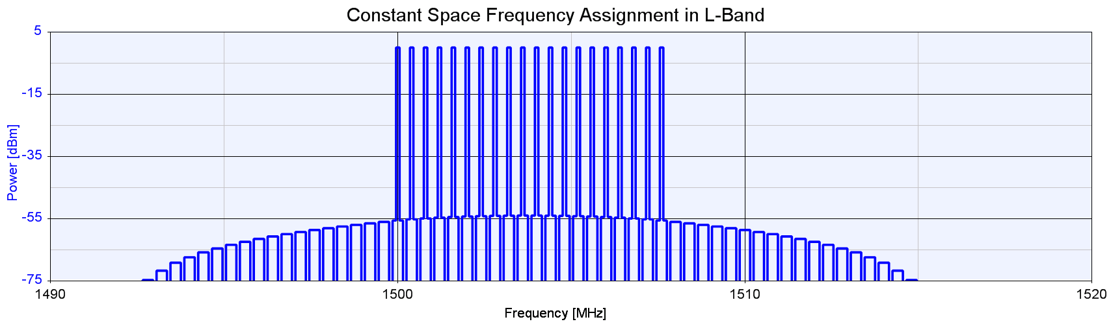
Figure A1.2: 20 channel system in a compact band, using equal spacing
This figure was produced using an industry-standard system simulation application. This application is used in real-life to plan PWMS channel plans for PWMS installations.
If the 20 channels are placed close together (see figure 9) IM products cumulate to produce a significant increase in background noise and interference – as much as 20dB in the centre of the frequency range. This IM interference spreads out to around 15 MHz beyond the edges of the frequency range.
If the PWMS channels can be spread out, the intermodulation products can be distributed so that they are minimised and do not accumulate (see Figure A1.3 where the blue curve represents the PWMS channels.).
In addition, Figure 9 shows the corresponding deployment of PWMS in the gaps between fixed link emissions. It should be emphasised that the PWMS deployment is flexible and can be adapted to fit around whatever protected emissions are operating in the band.
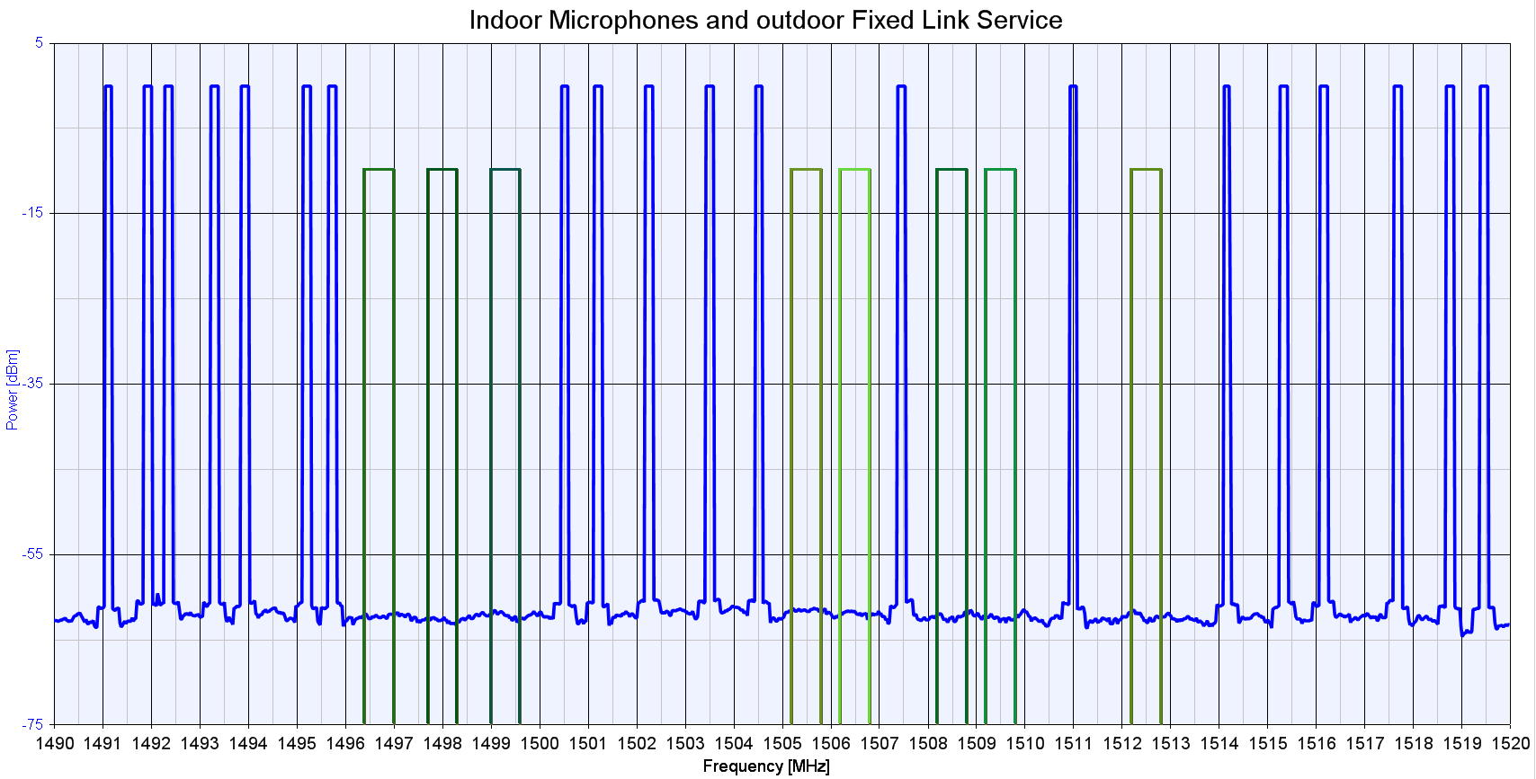
Figure A1.3: Typical 20 channel PWMS deployment showing co-existence with other services
This example showed a 20 channel deployment in 30 MHz for clarity. The same principle applies to, for example, a 40 channel deployment in 100 MHz.

ANNEX 2: SEAMCAT ANALYSIS - CO-CHANNEL CASE – INDOOR CASE 6DB WALL LOSS

This annex was developed for information in order to assess the impact of a separation distance of 10 km for the indoor case (6dB wall loss)

Victim and interfering links parameters

Victim link parameters
Frequency | 1500 MHz
Reception Bandwith | 25 kHz or 2000 kHz
I/N | -10dB
Noise Floor  (-110 dBm/MHz) | -126 dBm (for the 25kHz reception BW)  -107 dBm (for the 2000kHz reception BW)
Antenna height | 20m
Antenna peak gain | 13 dBi
Antenna horizontal pattern | See blue line Figure 7
Interferer link parameters
Frequency | 1500 MHz
Power supplied | 15 dBm
Antenna | Height : 2m  Azimuth : 0°  Elevation : 0°  Peak gain : 2.1 dB  Vertical pattern of figure 3 (right)
Interferer → victim path | Transmitter density : 0.1/km2  Number of active transmitters : 1 or 10 (see results)  Probability of transmission : 1  Activity time : 1  Protection distance : 10 km
Interferer → victim path model | Extended Hata, rural, indoor-outdoor attenuation 6 dB
Table A2.1: Scenario 1 SEAMCAT Parameters

Simulation results
 | N=1 interferer |  | N=10 interferers
 | 200 kHz | 600 kHz | 200 kHz | 600 kHz
FS with 25 kHz bandwidth
Mean iRSS (std) | -138.7 dBm  (std : 11,6) | -143.4 dBm  (std : 11,6) | -120.5 dBm  (std : 7,2) | -125.3 dBm  (std : 7,3)
Interference probability (with I/N criterion) | 40% | 25% | 99.8% | 96%
FS with 2000 kHz bandwidth
Mean iRSS (std) | -129.6 dBm  (std : 11,7) | -134.4 dBm  (std : 11,5) | -111.6 dBm  (std : 7,3) | -116,4 dBm  (std : 7,2)
Interference probability (with I/N criterion) | 14.4% | 7.1% | 75.6% | 48%
Table A2.2: Results of simulations

ANNEX 3: PWMS MEASUREMENT EXERCISES AT 1.5 GHz

Introduction

This annex provides the results of measurement of PWMS emissions at 1.5 GHz. Wireless microphone and IEM, in typical sport and theatre installations using L-Band frequencies were tested.

Part A provides results of measurement using the example of a typical conference installation undertaken in Hanover and Part B provides results of measurements undertaken in Vienna in an open stadium and in a theatre.
Part A: PWMS measurement exercise at L-Band frequencies in Hanover (4th February 2008)

Position of Microphone and IEM test installation

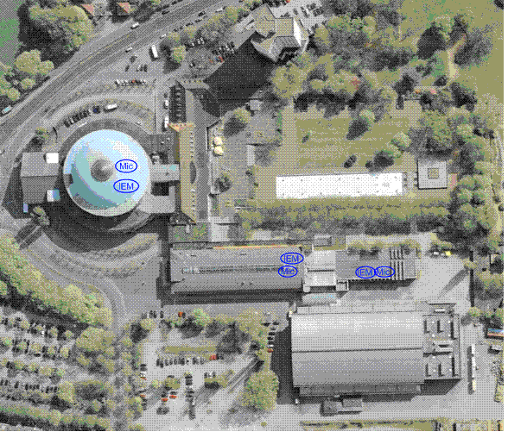
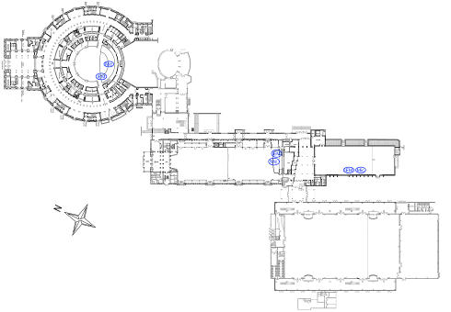
Wireless microphone and IEM set up at Kuppelsaal, Niedersachsenhalle and Glashalle

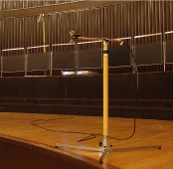


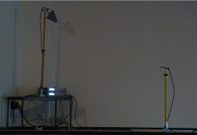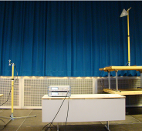

IEM transmitter and Hand Held wireless microphone configurations (see the description in Part B)

Measurement set up on top floor of hotel

- RF spectrum analyser FSQ03
- Laptop, software ‘UHF Recorder’
including L-Band option (DKE-AK731.0.8)
- L-band-antenna LAT54 mounted on microphone
stand, directed to Glashalle

LAT54 at 1500 MHz

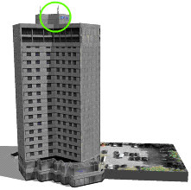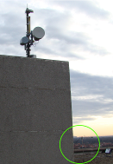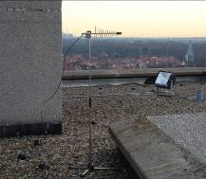
Measurement antenna set up on mid-height floor of hotel
Mobile measurement set up

- RF network and spectrum analyzer ZVL06
- Laptop, software ‘UHF Recorder’ including L-Band option (DKE-AK731.0.8)
- Omni directional ground plane antenna
- External battery including DC/DC converter

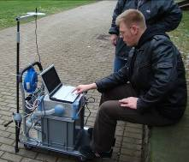
Mobile measurement set up in front of Glashalle
Measurement location at ground level
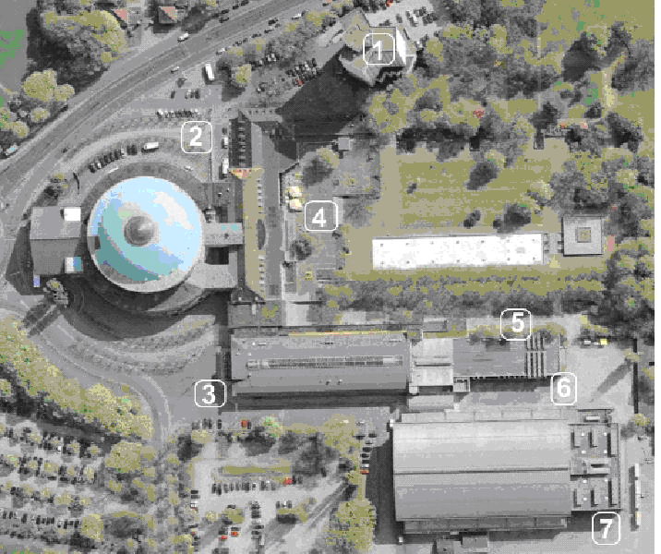

Distance to measurement stations located in the hotel
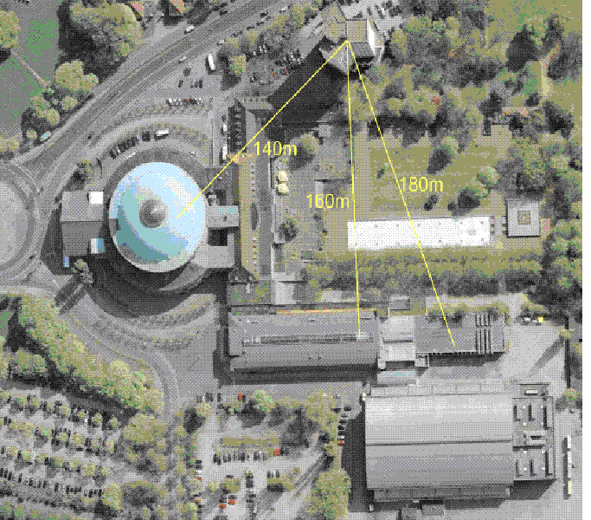
Description of measurement setup at RF receiving locations

- Hotel Location
The directional antenna is pointed at Glashalle. The measured RF levels show the maximum interference level for a RF link in the main link direction Glashalle. Building walls made out of standard glass, no metallic coating, distance to RF measurement receiver is 180m, identical antenna polarization. The table shows the maximum levels measured over a continuous time period.
- Location of mobile measurement setups (indoor and outdoor)
The antenna is adjusted for maximum field strength and the measurements were recorded in the table below.

Measurement results: Wireless microphone transmitter and IEM transmitter

Receiver  location  Transmitter  location | Maximum receiving level [dBm]
Receiver  location  Transmitter  location | 1 |  | 2 |  | 3 |  | 4 |  | 5 |  | 6 |  | 7
Receiver  location  Transmitter  location | f1 | f2 | f1 | f2 | f1 | f2 | f1 | f2 | f1 | f2 | f1 | f2 | f1 | f2
Kuppelsaal | n/a. | n/a. | -80 | -100 | -87 | -92 | n/a | -101 | n/a | n/a | n/a. | -105 | n/a | -105
Glashalle | -86 | -78 | n/a | n/a. | -95 | -105 | -76 | -88 | -63 | -63 | -70 | -67 | -105 | -105
Niedersachenhalle | -90 | -98 | n/a | -103 | -88 | -90 | -91 | -106 | -106 | -107 | -94 | -104 | -111 | -106
Table results rounded to integer values
n/a = Not applicable, i.e. receiving level below minimum receiving level of receiving measurement equipment
(-112dBm)
f1, f2 = frequencies 1485 / 1515 MHz
Antenna amplification = 10dBi antenna used at hotel / 0dBi mobile antenna

Estimation of building attenuation
Measurement path | Path length | Receiving level based on free space path loss formula | Measured receiving level | Calculated attenuation by building
Hotel to Glashalle | 180 m ^{*1} | -75 dBm | -86 dBm | 11 dB
Hotel to Niedersachsenhalle | 160 m ^{*1} | -74 dBm | -90 dBm | 16 dB
Kuppelsaal to test point 3 | 89 m | -61 dBm | -88 dBm | 27 dB

Table results rounded to integer values
*1 antenna gain measurement antenna used at Hotel included
Comparison of free space path loss calculation with measured values

- Niedersachsenhalle
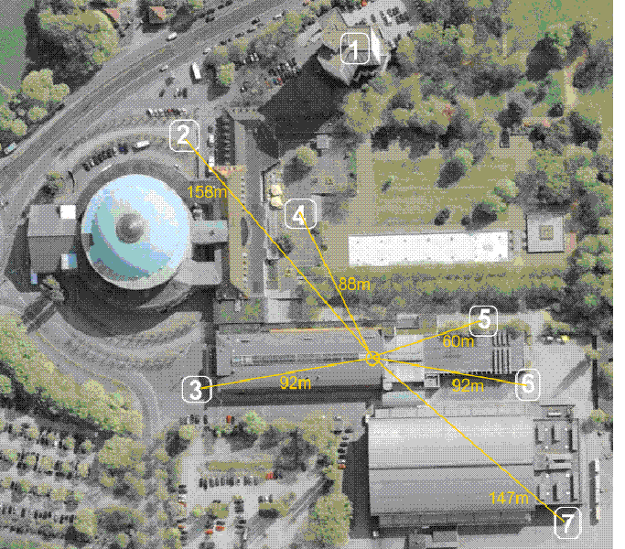

Estimation of additional path loss due to surrounding buildings (f1)

Path calculated from Niedersachsenhalle to outdoor test points @1500 MHz
Path to  test  point | Path  length  [km] | Micro  Anten.  height  [m] | Used  PT  [dBm] | Mobil  Anten.  height  [m] | Meas.  RI  [dBµV] | Calcul.  RI  [dBm] | Used  AG  [dBi] | Used  CL  [dB] | Calcul.  PR  [dBm] | Calcul.  PL  [dB] | Free  space  PL  [dB] | Extended Hata Path Loss  [dB]  Open / Suburb. / Urban
2  (Note 1) | 0,158 | 2,5 | 17 | 1,5 | <-8,0 | <-115 | 0,0 | 1,6 | -113,4 | >96,4 | 79,9 | 94,8 | 114,3 | 125,7
3 | 0,092 | 2,5 | 17 | 1,5 | 19,0 | -88,0 | 0,0 | 1,6 | -86,4 | 69,4 | 75,2 | 85,5 | 103,3 | 113,6
4 | 0,088 | 2,5 | 17 | 1,5 | 16,0 | -91,0 | 0,0 | 1,6 | -89,4 | 72,4 | 74,9 | 84,3 | 101,1 | 110,9
5 | 0,060 | 2,5 | 17 | 1,5 | 1,0 | -106,0 | 0,0 | 1,6 | -104,4 | 87,4 | 71,5 | 75,2 | 83,9 | 88,9
6 | 0,092 | 2,5 | 17 | 1,5 | 13,0 | -94,0 | 0,0 | 1,6 | -92,4 | 75,4 | 75,2 | 85,5 | 103,3 | 113,6
7 | 0,147 | 2,5 | 17 | 1,5 | -4,0 | -111,0 | 0,0 | 1,6 | -109,4 | 92,4 | 79,3 | 93,7 | 113,2 | 124,6
Note 1: Receiving level below minimum receiving level of receiving measurement equipment. Therefore -8dBµV is used.

f1 = 1485 MHz
- Kuppelsaal

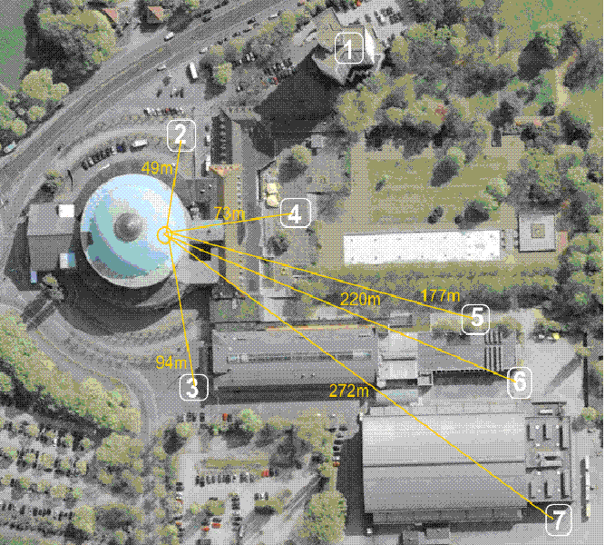

Estimation of additional path loss due to surrounding buildings (f1)
Path calculated from Glashalle to outdoor test points @1500 MHz
Path to  test  point | Path  length  [km] | Micro  Anten.  height  [m] | Used  PT  [dBm] | Mobil  Anten.  height  [m] | Meas.  RI  [dBµV] | Calcul.  RI  [dBm] | Used  AG  [dBi] | Used  CL  [dB] | Calcul.  PR  [dBm] | Calcul.  PL  [dB] | Free  space  PL  [dB] | Extended Hata  Path Loss  [dB]  Open / Suburb. / Urban
2  (Note 1) | 0,198 | 2,5 | 17 | 1,5 | <-8,0 | <-115 | 0,0 | 1,6 | -113,0,4 | >96,4 | 81,9 | 98,2 | 117,7 | 129,2
3 | 0,149 | 2,5 | 17 | 1,5 | 12,0 | -95,0 | 0,0 | 1,6 | -93,4 | 76,4 | 79,4 | 93,9 | 113,4 | 124,8
4 | 0,125 | 2,5 | 17 | 1,5 | 31,0 | -76,0 | 0,0 | 1,6 | -74,4 | 57,4 | 77,9 | 91,2 | 110,8 | 122,1
5 | 0,024 | 2,5 | 17 | 1,5 | 44,0 | -63,0 | 0,0 | 1,6 | -61,4 | 44,4 | 63,6 | 63,5 | 63,5 | 63,5
6 | 0,038 | 2,5 | 17 | 1,5 | 37,0 | -70,0 | 0,0 | 1,6 | -68,4 | 51,4 | 67,6 | 67,5 | 67,5 | 67,5
7 | 0,101 | 2,5 | 17 | 1,5 | 2,0 | -105,0 | 0,0 | 1,6 | -103,4 | 86,4 | 76,1 | 87,9 | 107,5 | 118,9
Note 1: Receiving level below minimum receiving level of receiving measurement equipment. Therefore -8dBµV is used.
f1 = 1485 MHz
Glashalle

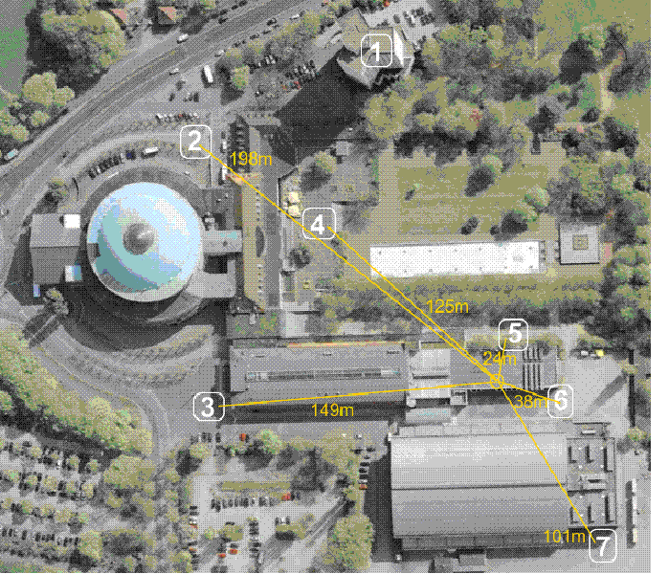

Estimation of additional path loss due to surrounding buildings
Path calculated from Kuppelsaal to outdoor test points @1500 MHz
Path to  test  point | Path  length  [km] | Micro  Anten.  height  [m] | Used  PT  [dBm] | Mobil  Anten.  height  [m] | Meas.  RI  [dBµV] | Calcul.  RI  [dBm] | Used  AG  [dBi] | Used  CL  [dB] | Calcul.  PR  [dBm] | Calcul.  PL  [dB] | Free  space  PL  [dB] | Extended Hata  Path Loss  [dB]  Open / Suburb. / Urban
2 | 0,049 | 2,5 | 17 | 1,5 | 27,0 | -80,0 | 0,0 | 1,6 | -78,4 | 61,4 | 69,8 | 71,3 | 75,6 | 78,2
3 | 0,094 | 2,5 | 17 | 1,5 | 20,0 | -87,0 | 0,0 | 1,6 | -85,4 | 68,4 | 75,4 | 86,1 | 104,3 | 114,9
4  (Note 1) | 0,073 | 2,5 | 17 | 1,5 | <-8,0 | <-115 | 0,0 | 1,6 | -113,4 | >96,4 | 73,2 | 79,6 | 92,5 | 99,9
5  (Note 1) | 0,177 | 2,5 | 17 | 1,5 | <-8,0 | <-115 | 0,0 | 1,6 | -113,4 | >96,4 | 80,9 | 96,5 | 116,1 | 127,5
6  (Note 1) | 0,220 | 2,5 | 17 | 1,5 | <-8,0 | <-115 | 0,0 | 1,6 | -113,4 | >96,4 | 82,8 | 99,8 | 119,4 | 130,8
7  (Note 1) | 0,272 | 2,5 | 17 | 1,5 | <-8,0 | <-115 | 0,0 | 1,6 | -113,4 | >96,4 | 84,7 | 103,0 | 122,5 | 134,0
Note 1: Receiving level below minimum receiving level of receiving measurement equipment. Therefore -8dBµV is used.
f1 = 1485 MHz

Part B: on PWMS measurement exercise at L-Band frequencies in Vienna
(13th and 14th of February 2008)

IEM transmitter configuration
1. Directional antenna: Schwarzbeck ESLP9145,
→ Gain@1.4-1.5GHz~6.3dBi

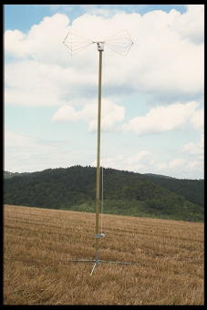

Antenna was mounted
on a fibreglass mast,
Schwarzbeck AM9104

2. Signal generator: Rohde & Schwarz SML02 and SMB 100A
→ Output power up to 30dBm
→ analogue modulation: AF tone = 1kHz, +/-40kHz deviation
→ Manufactory calibration 2007
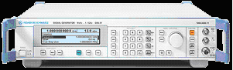
3. 10/20m RF cable: SSB electronic Ecoflex 10
→ Loss@1.5GHz~1.5/3dB
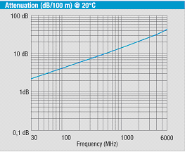

Hand held & instrument wireless microphone configuration
1. Signal generator: Rohde & Schwarz SML02
→ Output power up to 19dBm
→ analogue modulation: AF tone = 1kHz, +/-40kHz deviation
→ Manufactory calibration 2007
2. 10/20m RF cable: SSB electronic Ecoflex 10
→ Loss@1.5GHz~1.6 / 3.4dB
3. Dipole (omnidirectional) antenna, Schwarzbeck SBA 9113
→ Gain@1.5GHz = -0.22dBi

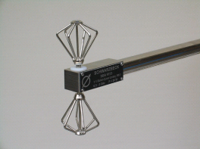

Antenna was mounted on a microphone stand
Calibration and test equipment:

Network and spectrum analyzer combination, Rohde & Schwarz ZVL6
→ Manufactory calibration 2007
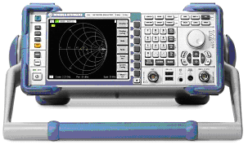

Principle calibration of radiated transmit power
- IEM antenna emulation (1515MHz, 50mW e.i.r.p)
10.6dBm

Generator
14dBm
20m coaxial cable
cable loss ~
3.4dB @ 1.5GHz

Antenna gain ~
6.4dBi @ 1.5GHz
Radiated power
~17dBm e.i.r.p.

- Hand held microphone and instrument microphone emulation (1495MHz, 50mW e.i.r.p)
Generator
18.8dBm
10m coaxial cable
cable loss ~
1.6dB @ 1.5GHz

Antenna gain ~
-0.2dBi @ 1.5GHz
Radiated power
~17dBm e.i.r.p.

17.2dBm

3. Hand held microphone and instrument microphone emulation (1500MHz, 100mW e.i.r.p)

20.2dBm
Generator
21.8dBm
10m coaxial cable
cable loss ~
1.6dB @ 1.5GHz

Antenna gain ~
-0.2dBi @ 1.5GHz
Radiated power
~20dBm e.i.r.p.

Note:
100mW used to increase signal strength above the noise level at remote locations. This power level will not be used in deployed PWMS systems.
Test equipment to measure the outdoor field strength (supported by BMVIT)
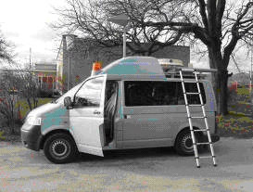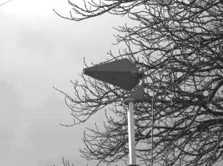

Parameter of car antenna HL040 (HL015)

For obtaining broadband characteristics, the HL040 antenna has a log periodic dipole structure.  The antenna was mounted for mobile use, on a crank-type telescopic mast.  The interpolated antenna gain @ 1500 MHz is about 5.6 dBi. | 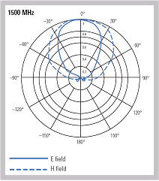

Principle of field strength conversion to receiving power level

P[dBm] = E[dBµV/m] - AF[dB] - 107
P [dBm] - Receiver input power level generated by a 50 Ω dipole
E [dBµV/m] - Radio frequency field strength
AF [dB] - Antenna factor including cable loss (e.g. Dipole: ~31 dB@1500MHz)

Path loss calculation using free space path loss formula
PL[dB] = 32.45 + 20 * log(d[km]) + 20Log(f[MHz])

d [km] - Distance
f [MHz] - Frequency

Path loss calculation using measurement results

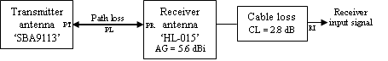

PL[dB] = PT[dBm] – PR[dBm] PR[dBm] = RI[dBm] - AG[dB] + CL[dB]

AG [dBd] - Receiver antenna gain (referred to an isotropic antenna)
CL [dB] - Receiver cable loss
PL [dB] - Free space path loss
PR [dBm] - Receiver antenna input signal
PT [dBm] - Effective isotropic radiated power (e.i.r.p)
RI [dBm] - Receiver input signal

Path loss calculation using ‘Extended Hata method’
Results were calculated with the SEAMCAT simulator (see appendix).
For additional information refer: http://www.seamcat.org/xwiki/bin/view/Seamcat/extended_hata_model

Locations of the transmitting antennas

Vienna Volksoper

The Vienna Volksoper (Volksoper Wien or Vienna People's Opera) is a major opera house in Vienna, Austria.. Coordinate 48° 13' 29" N, 16° 20' 59" E Decimal 48.224722°, 16.349722°
Location Volksoper Map supported by www.viamichelin.com
Blue colored measurement points with signal below receiver noise level (-92dBm)
Microphone setup inside the theatre

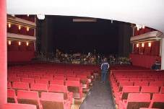
Microphone antennas (height~1.5m)

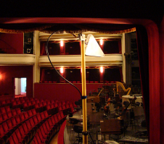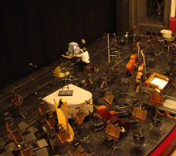
IEM antenna (height~4m) Top view on test setup

Test setup outside the theatre


Rx Position 1 2 3

Rx  Position | Distance to  microphones  [m] | Calculated  free space  RX level  (min to max)  [dBµV/m] | Measured  additional  path loss  (min to max)  [dB] | Antenna  height  [m] | Outdoor field strength [dBµV/m]  /  Receiver level [dBm @ 50 Ω dipole]
 |  |  |  |  | 1495 MHz | 1500 MHz | 1515 MHz
1 | 82¹⁾ | 86 to 89¹⁾ | 27 to 33¹⁾ | 2.5 | 63 / -75 | 62 / -76 | 54 / -84
2 | 45¹⁾ | 91 to 94¹⁾ | 13 to 21¹⁾ | 2.5 | 73 / -65 | 81 / -57 | 70 / -68
3 | 60¹⁾ | 88 to 91¹⁾ | 24 to 32¹⁾ | 8.0 | 55 / -83 | 65 / -73 | 54 / -84
Table calculation and measurement results rounded to integer values
¹⁾ Source: BMViT Report, 14th February 2008

Gerhard Hanappi Stadion

The Gerhard-Hanappi Stadion is a football stadium in Hütteldorf, in the west of Vienna, Austria. (Wikipedia)

Coordinate 48° 11' 52" N, 16° 15' 55" E Decimal 48.197778°, 16.265278°

Stadium location Map supported by www.viamichelin.com

Spectrum occupation measured inside the Gerhard-Hanappi Stadion
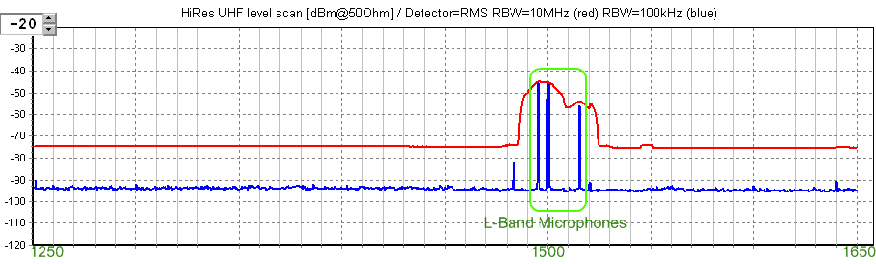
Microphone setup inside the stadium

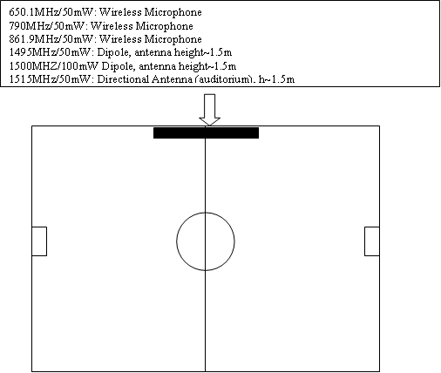

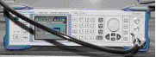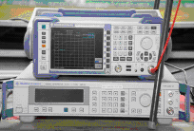

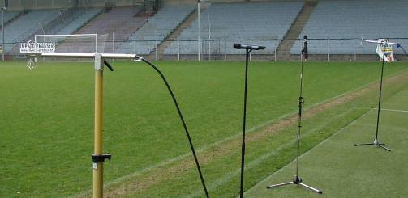
Test setup outside the stadium
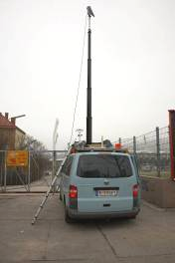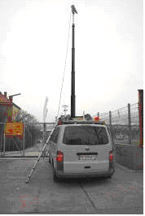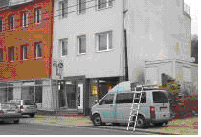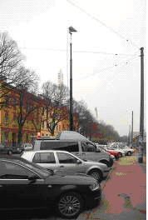
Rx Position 1 2 3

Rx Position | Distance to  microphones  [m] | Calculated  free space  RX level  (min to max)  [dBµV/m] | Measured  additional  path loss,  (min to max)  [dB] | Antenna  height  [m] | Outdoor field strength [dBµV/m]  /  Receiver level [dBm @ 50 Ω dipole]
 |  |  |  |  | 1495 MHz | 1500 MHz | 1515 MHz
1 | 205¹⁾ | 78 to 81¹⁾ | 17 to 23¹⁾ | 2.5 | 58 / -80 | 63 / -75 | 55 / -83
2 | 367¹⁾ | 73 to 76¹⁾ | 26 to 28¹⁾ | 5.0 | 47 / -91 | 49 / -89 | 47 / -91
3 | 205¹⁾ | 78 to 81¹⁾ | 25 to 30¹⁾ | 8.0 | 49 / -89 | 56 / -82 | 48 / -90
Table calculation and measurement results rounded to integer values
¹⁾ Source: BMViT Report, 13th February 2008
Long distance field strength monitoring

The microphone field strength level were recorded by the Austrian Radio Monitoring System ‘Funküberwachung’(located at Krapfenwaldgasse and Satzberg).
Results of Satzberg monitoring station:
Distance to  microphones  (estimated value)  [m] | Calculated  free space  path loss  (1500MHz)  [dB] | Calculated  free space  RX level  (Dipole AF=31)  [dBm]  /  [dBµ/m] | Measured  additional  path loss  [dB] | Satzberg |  | Outdoor field strength  [dBµV/m]
 |  |  |  | Antenna  height  [m] | Height above  see level  [m] | 1500 MHz
4450 | 109 | -92 / 46 | 28 ¹⁾ | 22 | 323 | 18
¹⁾ Includes antenna factor of Satzberg antenna (No further details available)

There was no microphone signal reception at Krapfenwaldgasse monitoring station.

Results of Krapfenwaldgasse monitoring station:
Distance to  microphones  (estimated value)  [m] | Calculated  free space  path loss  (1500MHz)  [dB] | Calculated  free space  RX level  (Dipole AF=31)  [dBµV/m]  /  [dBm] | Measured  additional  path loss  [dB] | Krapfenwaldgasse |  | Outdoor field strength  [dBµV/m]
 |  |  |  | Antenna  height  [m] | Height above  see level  [m] | 1500 MHz
2240 | 103 | -86 / 52 | 27 ¹⁾ | 25 | 323 | 25
¹⁾ Includes antenna factor of antenna at Krapfenwaldgasse (No further details available)
There was no microphone signal reception at Satzberg monitoring station.

Appendix 1: Comparison with the Extended HATA Propagation Model
1st Volksoper (indoor scenario)
RX  Position | Path  lenght  [km] | Micro  Antenna  height  [m] | Used  PT  [dBm] | Car  Antenna  height  [m] | Measured  RI  [dBµV] | Calculated  RI  [dBm] | Used  AG  [dBi] | Used  CL  [dB] | Calculated  PR  [dBm] | Calculated  PL  [dB] | Free space  PL  [dB] | Ex-Hata  PL  open  [dB] | Ex-Hata  PL  suburban  [dB] | Ex-Hata  PL  urban  [dB]
1 | 0,082 | 1,5 | 20 | 2,5 | 32,6²⁾ | -74,4 | 5,6 | 2,8 | -77,2 | 97,2¹⁾ | 74,2 | 88,9³⁾ | 100,2³⁾ | 109,1³⁾
2 | 0,045 | 1,5 | 20 | 2,5 | 50,9²⁾ | -56,1 | 5,6 | 2,8 | -58,9 | 78,9¹⁾ | 69,0 | 71,4³⁾ | 73,9³⁾ | 75,4³⁾
3 | 0,060 | 1,5 | 20 | 8,0 | 35,2²⁾ | -71,8 | 5,6 | 2,8 | -74,6 | 94,6¹⁾ | 71,5 | 75,3³⁾ | 82,9³⁾ | 87,9³⁾
4⁴⁾ | 0,150 | 1,5 | 20 | 8,0 | <15,0 | <-92,0 | 5,6 | 2,8 | <-94,8 | >114,8 | 79,5 | 83,9³⁾ | 103,5³⁾ | 114,8³⁾
5⁴⁾ | 0,250 | 1,5 | 20 | 8,0 | <15,0 | <-92,0 | 5,6 | 2,8 | <-94,8 | >114,8 | 83,9 | 91,7³⁾ | 113,3³⁾ | 122,6³⁾
Calculation frequency = 1500 MHz
¹⁾ Including theatre wall attenuation
²⁾ Source: BMViT Report, 14th February 2008
³⁾ Results calculated with SEAMCAT
⁴⁾ RX Positions without significant signal reception. Therefore as reception level the receiver signal sensitivity of -92 dBm is used.

2nd Gerhard Hanappi Stadion (semi outdoor scenario)
RX  Position | Path  lenght  [km] | Micro  Antenna  height  [m] | Used  PT  [dBm] | Car  Antenna  height  [m] | Measured  RI  [dBµV] | Calculated  RI  [dBm] | Used  AG  [dBi] | Used  CL  [dB] | Calculated  PR  [dBm] | Calculated  PL  [dB] | Free space  PL  [dB] | Ex-Hata  PL  open  [dB] | Ex-Hata  PL  suburban  [dB] | Ex-Hata  PL  urban  [dB]
1 | 0,205 | 1,5 | 20 | 2,5 | 33,8²⁾ | -73,2 | 5,6 | 2,8 | -76,0 | 96,0¹⁾ | 82,2 | 98,8³⁾ | 118,3³⁾ | 129,7³⁾
2 | 0,367 | 1,5 | 20 | 5,0 | 19,2²⁾ | -87,8 | 5,6 | 2,8 | -90,6 | 110,6¹⁾ | 87,3 | 101,7³⁾ | 121,2³⁾ | 132,6³⁾
3 | 0,205 | 1,5 | 20 | 8,0 | 26,1²⁾ | -80,9 | 5,6 | 2,8 | -83,7 | 103,7¹⁾ | 82,2 | 88,7³⁾ | 108,2³⁾ | 119,6³⁾
Calculation frequency = 1500 MHz
¹⁾ Including multi path effects (e.g. reflections)
²⁾ Source: BMViT Report, 13th February 2008
³⁾ Results calculated with SEAMCAT

Appendix 2: Volksoper Measurement report provided by BMViT, Austria
RX Position 1:

RX Position 2:

RX Position 3:

Appendix 3: ‘Gerhard Hanappi Stadion’ Measurement reports provided by BMViT

RX Position 1:

RX Position 2:

RX Position 3:

Annex 4: References

[1] SRDoc TR 102 546: Technical characteristics for Professional Wireless Microphone Systems (PWMS)
[2] ERC/REC 70-03: Relating to the use of Short Range Devices (SRD)
[3] ETSI EN 300 422: Wireless microphones in the 25 MHz to 3 GHz frequency range
[4] ERC Report 25: The European table of frequency allocations and utilisations covering the frequency range 9 kHz to 275 GHz
[5] ECC Report 003: Fixed Service in Europe Current and Future Use and Future Trends Post-2002
[6] Recommendation T/R 13-01: Channel arrangements for fixed services in the range 1-3 GHz
[7] ECC/DEC/(04)09: on the designation of the bands 1518-1525 MHz and 1670-1675 MHz for the Mobile-Satellite Service
[8] ECC/DEC/(07)04 : Free circulation and use of mobile satellite terminals operating in the Mobile-Satellite Service allocations in the frequency range 1-3 GHz
[9] ECC/DEC/(07)05 : Reserving the National Numbering Range beginning with '116' for Harmonised Numbers for Harmonised Services of Social Value. Amended 26 February 2008
[10] MA02revCO07: The Maastricht, 2002, Special Arrangement, as revised in Constanţa, 2007
[11] ITU-R Recommendation F.1334: Protection criteria for systems in the fixed service sharing the same frequency bands in the 1 to 3 GHz range with the land mobile service
[12] EN 300 630: Low capacity point to point digital radio relay systems in the 1,4 GHz band
[13] EN 300 631 : Fixed Radio Systems; Point-to-Point Antennas; Antennas for Point-to-Point fixed radio systems in the 1 GHz to 3 GHz band
[14] ITU-R Recommendation F.1245: Mathematical model of average radiation patterns for line-of-sight point-to-point radio-relay system antennas for use in certain coordination studies and interference assessment in the frequency range from 1 GHz to about 70 GHz
[15] ERC Report 10: Compatibility between DECT and radio relay systems in the 2 GHz band.
[16] ECC/DEC/(03)02: Designation of the frequency band 1479.5-1492 MHz for use by Satellite Digital Audio Broadcasting systems
[17] ETSI TR 102 525 (2006-09), technical report on SDR technology
[18] ETSI TS 102 550 (2006-11), Outer Physical Layer
[19] ETSI TS 102 551-1 (2006-12), SDR Inner Physical Layer Single Carrier
[20] ETSI TS 102 551-2 (2006-12), SDR Inner Physical Layer Multiple Carrier
[21] ITU-R Recommendation M.1459: Protection criteria for telemetry systems in the aeronautical mobile service and mitigation techniques to facilitate sharing with geostationary broadcasting-satellite and mobile-satellite services in the frequency bands 1 452-1 525 MHz and 2 310-2 360 MHz
[22] ITU-R Recommendation RS.1166-3: Performance and interference criteria for active spaceborne sensors
[23] ITU-R Recommendation M.1388: Threshold levels to determine the need to coordinate between space stations in the broadcasting-satellite service (sound) and particular systems in the land mobile service in the band 1 452-1 492 MHz
[24] ITU-R Recommendation M.1731: Protection criteria for Cospas-Sarsat local user terminals in the band 1 544-1 545 MHz

Based on the Extended Hata propagation model implemented in SEAMCAT, in rural environment
Cascading of a SAW filter and a Nyquist filter

