ECC Recommendation (11)04

Cross-border Coordination for Mobile/Fixed Communications Networks (MFCN) in the frequency band 791-862 MHz
approved 26 May 2011
latest amended 7 November 2025

introduction
This Recommendation contains provisions for cross-border coordination between Mobile/Fixed Communications Networks (MFCN) in border areas in the frequency band 791-862 MHz.
In this Recommendation, MFCN includes LTE and New Radio (NR) non-AAS base stations.

ECC Recommendation (11)04 of 26 May 2011 on Cross-border coordination for Mobile/Fixed Communications Networks (MFCN) in the frequency band 791-862 MHz, amended 3 February 2017,updated 18 November 2022 and amended 7 November 2025
“The European Conference of Postal and Telecommunications Administrations,
considering
- that the frequency band 790-862 MHz has been allocated to the mobile service on a primary basis in a number of countries in Region 1 for more than 20 years subject to provisions of RR 5.316 [1];
- that WRC-07 allocated the band 790-862 MHz to the mobile service on a primary basis in additional countries in Region 1 from 1 January 2009 subject to the provisions of RR 5.316A;
- that WRC-07 allocated the band 790-862 MHz to the mobile service on a primary basis in the whole of Region 1 from 17 June 2015 subject to the provisions of RR 5.316B and identified this band for IMT (see RR 5.317A);
- that “mobile/fixed communications networks” for the purpose of this Recommendation includes IMT and other communications networks in the mobile and fixed services;
- that ECC Decision (09)03 [2] provides the harmonised conditions for mobile/fixed communications networks (MFCN) operating in the band 791-862 MHz;
- that EC Decision 2010/267/EU of 6 May 2010 [3] on harmonised technical conditions of use in the 790-862 MHz frequency band for terrestrial systems capable of providing electronic communications services in the European Union is mandatory for EU and EFTA countries;
- that in many CEPT member countries there may be multiple operators for MFCN systems;
- that different administrations may wish to adopt different approaches to cross border coordination;
- that administrations may diverge from the technical parameters, propagation models and procedures described in this Recommendation subject to bilateral/multilateral agreements;
- that cross-border coordination between MFCN systems and other services in neighbouring countries should be based on bilateral/multilateral agreements;
- that CEPT Report 29 [4] provides guidelines on cross border coordination issues between mobile services in one country and broadcasting services in another country;
- that Physical-layer-Cell Identity (PCI) coordination is necessary for LTE/NR systems to avoid unnecessary signalling load and handover failures;
- that other radio parameters may need to be coordinated for LTE/NR systems on a bilateral/multilateral basis.
recommends
- that coordination between MFCN systems in border areas should be based on bilateral or multilateral agreements between administrations;
- that bilateral/multilateral agreements should define coordination methods which encompass all MFCN radio interfaces present on each side of the border;
- that coordination between MFCN FDD systems should be based on the principles and the field strength limits provided in Annex 1;
- that the coordination of LTE/NR systems in border areas should be based on the PCI’s provided in Annex 5 when synchronisation signal centre frequencies are aligned;
- that if the levels in Annex 1 are exceeded coordination is required and the procedure detailed in Annex 4 should be used;
- that interference field strength predictions should be made using one of the propagation models defined in Annex 3;
- that administrations should encourage and facilitate the establishment of arrangements between operators of neighbouring countries with the aim to enhance the efficient use of the spectrum and the coverage in the border areas;
- that coordination in coastal areas is based on prediction of field strength levels at the coastline of the neighbouring country. Other principles for coordination in coastal areas may be agreed between the administrations concerned;
- that administrations may diverge from the technical parameters and procedures described in this Recommendation subject to bilateral/multilateral agreements;
- that this Recommendation should be reviewed within 5 years of its adoption in the light of practical experience of its application and of the operation of MFCN systems.”
Note:
Please check the ECO Documentation Database https://docdb.cept.org for the up to date position on the implementation of this and other ECC Recommendations.
- Field strength levels for the cross -border operation WITHOUT COORDINATION between MFCN FDD systems in the frequency band 791-862 MHz
In this annex, field strength values are given for cross-border scenarios between MFCN FDD systems for non-AAS base stations on both sides of the borderline.
Preferential and non-preferential PCIs for LTE and NR are given in Annex 5.
Administrations/operators may agree on other trigger values of field strength and preferential frequency usage based on bilateral/multilateral agreements/arrangements.
Synchronisation signal means Synchronisation Signal Block (SSB) for NR and Primary/Secondary Synchronisation Signal (PSS/SSS) for LTE.
The field strength values in this Annex are given for 5 MHz frequency block size. In cases of other frequency block sizes other than 5 MHz, a factor of 10 × log₁₀ (channel bandwidth/5 MHz) should be added to the field strength values. The data and control channels are fixed and therefore the same field strength values in dB(µV/m)/5 MHz apply to both channel types. The mean value is with respect to e.g. changing traffic load and downlink transmission time. The field strength values are upper bounds of each cell produced by the base station. In the case of a SCS other than 30 kHz, a correction factor of 10 × log₁₀ (SCS in kHz / (30 kHz)) dB, should be added to the SSB field strength value.
  - Field strength levels for MFCN FDD systems in the frequency band 791-862 MHz
- Non-AAS base stations of MFCN FDD systems on both sides of the borderline in the frequency band 791-821 MHz with synchronisation signal centre frequencies not aligned for all PCIs or with synchronisation signal centre frequencies aligned and for preferential PCIs may be used without coordination with a neighbouring country if the field strength of each cell produced by base station does not exceed the values of:
59 dB(µV/m)/5 MHz at a height of 3 m above ground at the borderline between countries and
41 dB(µV/m)/5 MHz at a height of 3 m above ground at a distance of 6 km inside the neighbouring country.
- Non-AAS base stations of MFCN FDD systems on both sides of the borderline in the frequency band 791-821 MHz with synchronisation signal centre frequencies aligned and for non-preferential PCIs may be used without coordination with a neighbouring country if the field strength of each cell produced by base station does not exceed the value of:
41 dB(µV/m)/5 MHz at a height of 3 m above ground at the borderline between neighbouring countries.
- It is not usually considered necessary to define preferential frequencies. If administrations/operators wish to agree on cross-border coordination based on preferential frequencies, while ensuring a fair treatment of different operators, then they can do so based on agreements/operator arrangements.
Table 1 gives an overview of the field strength values for non-AAS base stations.
Table 1: Field strength values at a height of 3 m above ground for MFCN FDD systems
Non-preferential frequency usage |  |  | Preferential frequency usage
Synchronisation signal centre frequencies aligned |  | Synchronisation signal centre frequencies not aligned
Preferential PCIs | Non-preferential PCIs | All PCIs
59 dB(µV/m)/5 MHz @ 0 km  and  41 dB(µV/m)/5 MHz @ 6 km | 41 dB(µV/m)/5 MHz @ 0 km | 59 dB(µV/m)/5 MHz @ 0 km  and  41 dB(µV/m)/5 MHz @ 6 km | Based on bilateral or multilateral agreements / operator arrangements
@ stands for “at a distance from the borderline into the neighbouring country”
For NR base station the mean values in this table correspond to the following SSB values:
59 dB(μV/m)/5 MHz corresponds to 37 dB(µV/m)/30 kHz
41 dB(μV/m)/5 MHz corresponds to 19 dB(µV/m)/30 kHz

- Propagation model
The following methods are proposed for assessment of anticipated interference inside neighbouring country based on established field strength values. Due to complexity of radiowave propagation nature different methods are proposed to be considered by administrations and are included here for guidance purposes only.
It should be noted that following methods provide theoretical predictions based on available terrain knowledge. It is practically impossible to recreate these methods with measurement procedures in the field. Therefore only some approximation of measurements could be used to check compliance with those methods based on practical measurement procedures. The details of such approximation are not included in this recommendation and should be negotiated between countries based on their radio monitoring practices.
  - Path specific model
Where appropriate detailed terrain data is available, the propagation model for interference field strength prediction is the latest version of Recommendation ITU-R P.452 [5]. For the relevant transmitting terminal, predictions of path loss would be made at x km steps along radials of y km at z degree intervals. The values for those receiver locations within the neighbouring country would be used to construct a histogram of path loss – and if 10% of predicted values exceed the threshold the station should be required to be coordinated.
Values for x, y and z to be agreed between the administrations concerned.
  - Site General model
If it is not desirable to utilise detailed terrain height data for the propagation modelling in the border area, the basic model to be used to trigger coordination between administrations and to decide, if coordination is necessary, is Recommendation ITU-R P.1546 [6]. This model is to be employed for 50% locations, 10% time and using a receiver height of 3 m.
For specific reception areas where terrain roughness adjustments for improved accuracy of field strength prediction are needed, administrations may use correction factors according to terrain irregularity and/or an averaged value of the TCA parameter in order to describe the roughness of the area on and around the coordination line.
Administrations and/or operators concerned may agree to deviate from the aforementioned model by mutual consent.
  - Area calculations
In the case where greater accuracy is required, administrations and operators may use the area calculation below.
For calculations, all the pixels of a given geographical area to be agreed between the administrations concerned in a neighbouring country are taken into consideration.
For the relevant base station, predictions of path loss should be made for all the pixels of a given geographical area from a base station and at a receiver antenna height of 3 m above ground.
For evaluation:
- only 10 percent of the number of geographical area between the borderline (including also the borderline) and the 6 km line itself inside the neighbouring country may be interfered by higher field strength than the field strength value given for the borderline in Annex 1 at a height of 3 m above ground;
- only 10 percent of the number of geographical area between the 6 km (including also 6 km line) and 12 km line inside the neighbouring country may be interfered by higher field strength than the field strength value given for the 6 km line in Annex 1 at a height of 3 m above ground.
It is recommended that during area calculations not only detailed terrain data but also clutter data be taken into account. Use of correction factors for clutter is crucial in particular where the border area is ‘open’ or ‘quasi-open’ from the point of view of clutter or where the interfering base station is just a few kilometres from a borderline.
If the distance between a base station and a terrain point of a borderline is closer than or equal to 1 km, free space propagation model needs to be applied. Furthermore, if there is no terrain obstacle within the 1st Fresnel zone, also the free space propagation model should be applied.
If clutter data is not available, it is proposed to extend the usage of free space propagation model to a few kilometres, depending on the clutter situation in border areas.
For area type interference calculations, propagation models with path specific terrain correction factors are recommended (e.g. Recommendation ITU-R P.1546 [6] with the terrain clearance angle correction factor TCA, HCM method with the terrain clearance angle correction factor or Recommendation ITU-R P.1812 [10]).
As to correction factors for clutters ‘open area’ and ‘quasi-open area’, 20 dB and 15 dB should be used respectively. Recommendation ITU-R P.1406 [7] should be used if a finer selection of clutter is required. It must be noted that terrain irregularity factor Δh is not recommended to be used in area calculations. Administrations and/or operators concerned may agree to deviate from the aforementioned models by mutual consent.
- Coordination procedure
When requesting coordination the relevant characteristics of the base station and the PCI numbers should be submitted to the administration affected. All of the following characteristics should be included:
- channel centre frequency (MHz);
- synchronisation signal centre frequency (MHz), if differs from channel centre frequency;
- channel bandwidth (MHz);
- subcarrier spacing (kHz) (only for NR)
- name of transmitter station;
- country of location of transmitter station;
- geographical coordinates (W/E, N; WGS84);
- effective antenna height (m);
- antenna polarisation;
- antenna azimuth (deg);
- directivity in antenna systems or antenna gain (dBi);
- effective radiated power (dBW);
- expected coverage zone or cell range (km);
- date of entry into service (month, year);
- PCI numbers used (only for LTE and NR);
- antenna tilt (electrical and mechanical tilt) (deg);
- antenna pattern or envelop.
The administration affected should evaluate the request for coordination and should within 30 days notify the result of the evaluation to the administration requesting coordination.
In the course of the coordination procedure an administration may request additional information.
If no reply is received by the administration requesting coordination within 30 days, it may send a reminder to the administration affected. An administration not having responded within 30 days following communication of the reminder should be deemed to have given its consent and the station may be put into use with the characteristics given in the request for coordination.
The periods mentioned above may be extended by common consent.
- PHYSICAL-LAYER CELL IDENTITIES (PCI) FOR LTE and NR
ETSI TS 136.211 [8] defines 168 “unique physical-layer cell-identity groups” in section 6.11, numbered 0…167, hereafter called “PCI groups” for LTE. Within each PCI group there are three separate PCIs giving 504 PCIs in total.
For NR in ETSI TS 138 211, section 7.4.2 [9], the number of physical-layer cell-identity groups (different cell IDs) have been increased to 336, numbered 0..335.
Administrations should apply sharing of PCIs in border areas, an equitable distribution of these PCIs when synchronisation signal centre frequencies are aligned as provided in Table 3.
Sharing of PCIs between operators of neighbouring countries should only be applied where synchronisation signal centre frequencies used in the neighbouring countries are aligned independent of the channel bandwidth or where it is not known whether or not the synchronisation signal centre frequencies used in the neighbouring countries are aligned, or where there is no network in operation in the neighbouring country unless otherwise stated in Annex 1 or administration/operator agreements/arrangements.
As shown in Table 3, the PCIs for LTE and NR are divided into 6 sub-sets containing each one sixth of the available PCIs. Each country is allocated three sets (half of the PCIs) in a bilateral case and two sets (one third of the PCIs) in a trilateral case, therefore dividing the PCI groups or PCIs is equivalent.
The preferential PCIs of a two country PCI sharing should be applied for a base station if the level of field strength relating to non-preferential PCIs could be exceeded at the borderline of only one neighbouring country. The preferential PCIs of a three country PCI sharing should be applied for a base station if the level of field strength related to non-preferential PCIs could be exceeded at the borderline of only two neighbouring countries.
Four types of countries are defined in a way such that no country will use the same code set as any one of its neighbours. The following lists describe the distribution of European countries:
Type country 1: AZE, BEL, CVA, CYP, CZE, DNK, E, FIN, GRC, IRL, ISL, LTU, MCO, SMR, SRB, SUI, SVN and UKR;
Type country 2: AND, BIH, BUL, D, EST, G, GEO, HNG, I and MDA;
Type country 3: ALB, AUT, F, HOL, HRV, MLT, POL, POR, ROU and S;
Type country 4: LIE, LUX, LVA, MKD, MNE, NOR, SVK and TUR.
For each type of country, Table 3 and Figure 1 describe the sharing of the PCI’s with its neighbouring countries, with the following conventions of writing:
Preferential PCI
Non-preferential PCI

Table 3: PCI sub-sets for LTE and NR for use in border areas when synchronisation signal centre frequencies are aligned
PCI | Set A | Set B | Set C | Set D | Set E | Set F |  | PCI | Set A | Set B | Set C | Set D | Set E | Set F
Country 1 LTE | 0..83 | 84..167 | 168..251 | 252..335 | 336..419 | 420..503 |  | Country 2 LTE | 0..83 | 84..167 | 168..251 | 252..335 | 336..419 | 420..503
Country 1 NR | 0..83  504-587 | 84..167  588..671 | 168..251  672..755 | 252..335  756..839 | 336..419  840..923 | 420..503  924..1007 |  | Country 2 NR | 0..83  504-587 | 84..167  588..671 | 168..251  672..755 | 252..335  756..839 | 336..419  840..923 | 420..503  924..1007
Border 1-2 |  |  |  |  |  |  |  | Border 2-1
Zone 1-2-3 |  |  |  |  |  |  |  | Zone 2-3-1
Border 1-3 |  |  |  |  |  |  |  | Border 2-3
Zone 1-2-4 |  |  |  |  |  |  |  | Zone 2-1-4
Border 1-4 |  |  |  |  |  |  |  | Border 2-4
Zone 1-3-4 |  |  |  |  |  |  |  | Zone 2-3-4
PCI | Set A | Set B | Set C | Set D | Set E | Set F |  | PCI | Set A | Set B | Set C | Set D | Set E | Set F
Country 3 LTE | 0..83 | 84..167 | 168..251 | 252..335 | 336..419 | 420..503 |  | Country 4 LTE | 0..83 | 84..167 | 168..251 | 252..335 | 336..419 | 420..503
Country 3 NR | 0..83  504-587 | 84..167  588..671 | 168..251  672..755 | 252..335  756..839 | 336..419  840..923 | 420..503  924..1007 |  | Country 4 NR | 0..83  504-587 | 84..167  588..671 | 168..251  672..755 | 252..335  756..839 | 336..419  840..923 | 420..503  924..1007
Border 3-2 |  |  |  |  |  |  |  | Border 4-1
Zone 3-1-2 |  |  |  |  |  |  |  | Zone 4-1-2
Border 3-1 |  |  |  |  |  |  |  | Border 4-2
Zone 3-1-4 |  |  |  |  |  |  |  | Zone 4-2-3
Border 3-4 |  |  |  |  |  |  |  | Border 4-3
Zone 3-2-4 |  |  |  |  |  |  |  | Zone 4-3-1

Note:
In certain specific cases (e.g. AUT/HRV) where the distance between two countries of the same type number is very small (< few 10s km), it may be necessary to address the situation in bi/multilateral coordination agreements as necessary, and may include further subdivision of the allocated codes in certain areas.
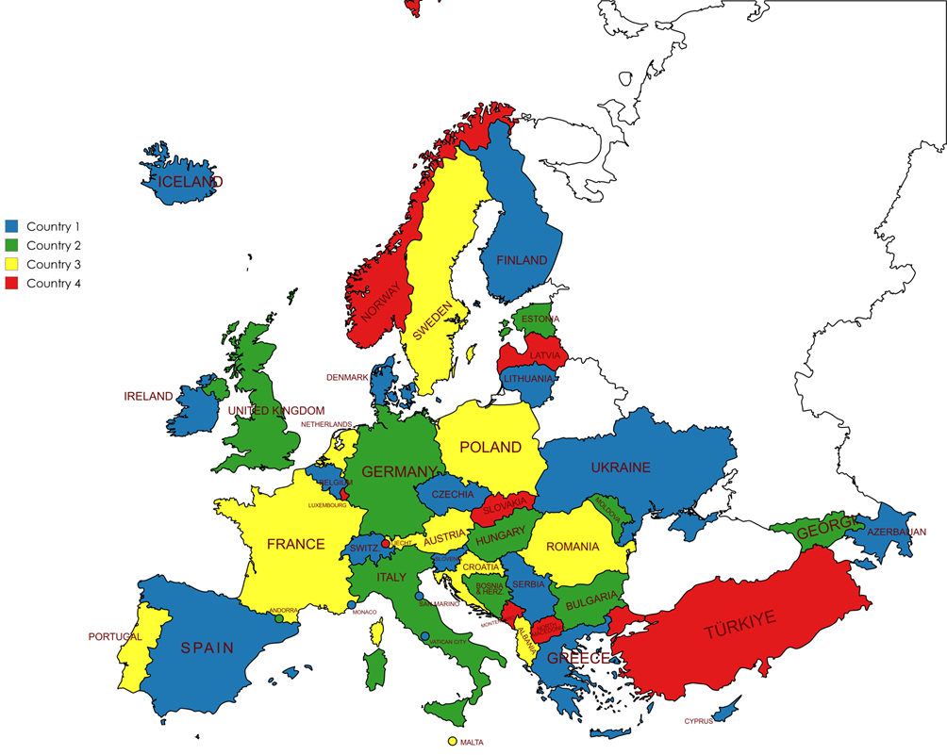
Figure 1: Country type map

- List of references
- ITU Radio Regulations, edition of 2024
- ECC Decision (09)03: “Harmonised conditions for Mobile/Fixed Communications Networks (MFCN) operating in the band 791-862 MHz”, approved October 2009, latest amended November 2025
- EC Decision 2010/267/EU: “Commission Decision of 6 May 2010 on harmonised technical conditions of use in the 790-862 MHz frequency band for terrestrial systems capable of providing electronic communications services in the European Union”
- CEPT Report 29: “Report from CEPT to the European Commission in response to the Mandate on “Technical considerations regarding harmonisation options for the digital dividend in the European Union”
“Guideline on cross border coordination issues between mobile services in one country and broadcasting services in another country”, approved June 2009
- Recommendation ITU-R P.452: “Prediction procedure for the evaluation of interference between stations on the surface of the Earth at frequencies above about 100 MHz”
- Recommendation ITU-R P.1546: “Method for point to area predictions for terrestrial services in the frequency range 30 MHz to 4000 MHz”
- Recommendation ITU-R P.1406: “Propagation effects relating to terrestrial land mobile and broadcasting services in the VHF and UHF bands”
- ETSI TS 136 211 V16.6.0 (2021-08): “LTE; Evolved Universal Terrestrial Radio Access (E-UTRA); Physical channels and modulation”
- ETSI TS 138 211 V16.2.0 (2020-07): “5G; NR; Physical channels and modulation”
- Recommendation ITU-R P.1812: “A path-specific propagation prediction method for point-to-area terrestrial services in the frequency range 30 MHz to 6 GHz”

not occupied bandwidth
e.g. as used by members of the HCM-Agreement

