SMS to 112 and other national emergency numbers for roaming end-users
approved 16 October 2025
ECC Report 368

Executive summary
In many European countries, the emergency services can be reached by dialling the pan-European emergency number ‘112’. In member states of the EU/EEA, it is obligatory to implement the emergency number ‘112’. Some countries have also implemented services that allow Short Message Service (SMS) messages to be sent to ‘112’ or other national numbers. This provides an alternative but complementary means of requesting emergency assistance, and is particularly useful for end-users who may have difficulty making a voice call. It shall be highlighted, that this means of access, is not harmonised on a legislative or technical level in Europe, compared to a call to Public Safety Answering Point (PSAP), or more specifically a call to ‘112’. Therefore, the exact details of how it works, including the availability, capabilities, and procedures, can vary from one country to another. It is important to note, that communication with the PSAP through SMS, can also be used as a means of transmission of the end-user location information. In this Report, the generic term "SMS-to-PSAP" is used to describe the SMS addressed to the PSAP, covering these two purposes: an emergency communication itself and the automatic transmission of additional data (e.g. location information).
The communication with the PSAP through SMS is not only relevant to national subscribers, but also to other end-users, including roamers. However, the conveyance of SMS-to-PSAP in roaming poses challenges. The purpose of this Report is to examine the current implementation of SMS-to-PSAP in Europe, current practices and challenges of providing it in roaming scenarios.
Section 1 provides an overview of the meaning of SMS-to-PSAP in the scope of this Report introducing the importance of it for the emergency communications.
Section 2 analyses the current legal requirements related to emergency communications, including the European Electronic Communications Code (EECC), the European Accessibility Act (EAA), and other relevant regulations governing inter-alia access to emergency services.
Section 3 reinforces the different aspects that leverage the relevance of SMS-to-PSAP, presents technical descriptions of the transmission of SMS and the side-effect of it when in roaming. Covering these topics, this section explains the problem in analysis in the Report.
Section 4 lists and explains the possible solutions to solve or to mitigate the problem.
Section 5 gives a view of the current implementations across the CEPT countries and resumes the limitations of the SMS-to-PSAP.
Section 6 summarises the key conclusions drawn from this Report, highlighting that while SMS remains an active and evolving technology under 3GPP/ETSI standards, it lacks the inherent emergency handling capabilities found in voice services - particularly under conditions such as Limited Service State or international roaming. Despite the continued use of SMS in emergency communications and the support of protocols like SMPP, current solutions are essentially workarounds. These approaches carry notable limitations and cannot guarantee successful message delivery to PSAPs in roaming scenarios.
A core issue identified is the absence of a regulatory obligation to route SMS traffic to the most appropriate PSAP, unlike for emergency voice calls. This lack of mandate discourages the development of fully reliable solutions. Furthermore, the current home routing model used for SMS in roaming situations contributes to delivery failures. To address these challenges, a shift to local break-out routing is necessary. Without such structural and regulatory changes, SMS solutions for emergency communication will remain incomplete and prone to failure.

TABLE OF CONTENTS

0 Executive summary 2
1 Introduction 6
1.1 High-level Description of SMS-to-PSAP 6
1.1.1 Emergency communication by SMS 6
1.1.2 Transmission of end-user location by SMS (AML) 7
2 Regulatory Framework 8
2.1 Access to emergency services through emergency communications 8
2.2 Establishment and provision of emergency caller location information 9
2.3 Equivalent access to emergency services for end-users with disabilities 9
2.4 Roaming Regulation 11
3 Problem description 12
3.1 Relevance of SMS-to-PSAP to handset location (AML) 12
3.1.1 Android and iOS Emergency Location 12
3.1.2 Advanced Mobile Location 13
3.2 General description of the routing of national and roaming SMS 13
3.3 SMS-to-PSAP (2G/3G) 15
3.4 SMS-to-PSAP (4G/5G) 15
3.5 Roaming SMS-to-PSAP 17
4 Possible solutions 19
4.1 Belgian solution 19
4.2 Long Number 20
4.3 3GPP work item SMS2EC 21
4.4 RTT AS AN ALTERNATIVE? 21
5 Current implementation and Limitations 22
5.1 Current Implementations in some CEPT countries 22
5.2 Limitations of the SMS-to-PSAP 22
6 Conclusions 24
ANNEX 1: List of references 25

LIST OF ABBREVIATIONS

Abbreviation | Explanation
A2P | Application-to-Person SMS
A-GNSS | Assisted-GNSS
AML | Advanced Mobile Location (as described in ETSI TS 103 625)
AT | Application Terminated
BEREC | Body of European Regulators for Electronic Communications
CA | Competent Authority
CDMA | Code-division multiple access
CEPT | European Conference of Postal and Telecommunications Administrations
ECC | Electronic Communications Committee
EAA | European Accessibility Act
EEA | European Economic Area
EECC | European Electronic Communications Code
ELS | Emergency Location Service
eSIM | Embedded Subscriber Identity Module
ESME | External Short Messaging Entity
EU | European Union
GNSS | Global Navigation Satellite System
GSM | Global System for Mobile Communications
HELO | Hybridised Emergency Location
HLR | Home Location Register
HSS | Home Subscriber Server
IMS | IP Multimedia Subsystem
IoT | Internet of Things
IP-SM-GW | IP Short Message Gateway
LBO | Local Break-Out
LSS | Limited Service State
LTE | Long-Term Evolution
MAP | Mobile Application Part
MNO | Mobile Network Operator
MSC | Mobile Switching Centre
MT | Mobile Terminated
OTA | Over-The-Air
OTT | Over-The-Top
P2A | Person-to-Application SMS
P2P | Person-to-Person SMS
PSAP | Public Safety Answering Point
PIDF-LO | Presence Information Data Format – Location Object
RTT | Real-time Text
S8HR | S8 Home Routing
SC_Address | Service Centre Address
SIM | Subscriber Identity Module
SIP | Session Initiation Protocol
SGSN | Serving GPRS Support Node
SMPP | Short Message Peer-to-Peer
SMS | Short Message Service
SMSC | Short Message Service Centre
SMSoIP | SMS over Internet Protocol
SMSoNAS | SMS over Non-Access Stratum
SS7 | Signalling System No.7
UMTS | Universal Mobile Telecommunications System
USD | Universal Service Directive
VoLTE | Voice over Long-Term Evolution
VoNR | Voice over New Radio
VoWiFi | Voice over WiFi

Introduction
In many European countries, the emergency services can be reached by dialling the pan-European emergency number ‘112’. In member states of the EU/EEA it is obligatory to implement the emergency number ‘112’. In order to provide an alternative but complementary means of access, particularly for end-users who may have difficulty making a voice call, some countries have implemented services that allow end-users to send Short Message Service (SMS) messages to ‘112’ or other national numbers, to request emergency assistance. It shall be highlighted that this means of access is not harmonised at either the legislative or technical level in Europe, compared to a call to Public Safety Answering Point (PSAP), or more specifically a call to ‘112’. Therefore, the exact details of how it works, including the availability, capabilities, and procedures, can vary from one country to another. It is important to note that communication with the PSAP through SMS can also be used as a means of transmission of the end-user location information. In this Report, the generic term "SMS-to-PSAP" is used to describe the SMS addressed to the PSAP, covering these two purposes: an emergency communication itself and the automatic transmission of additional data (e.g. location information).
Apart from providing an alternative access to emergency services for end-users with disabilities, SMS-to-PSAP as an emergency communication can be useful in situations where speaking is not possible due to an end-user disability or where speaking may pose a threat to the end-user requesting emergency assistance.
The purpose of this Report is to examine the current implementation of SMS-to-PSAP in Europe and the current practices and challenges of providing it in roaming scenarios. This Report draws conclusions on the effectiveness of some possible solutions of handling SMS-to-PSAP in roaming scenarios.

High-level Description of SMS-to-PSAP
In this context, SMS-to-PSAP is a communication between an end-user handset and the PSAP made by SMS. The following description covers the two cases mentioned above, when the SMS-to-PSAP is used as an emergency communication and when it is used to transmit additional data, more specifically, end-user location information using Advanced Mobile Location (AML).

Emergency communication by SMS
End-user initiation: an end-user in need of emergency assistance sends an SMS to the appropriate number instead of making a voice call. This could be to the pan-European emergency number ‘112’, another national short number (that can be also an emergency number) or a specific long number in E.164 format designated for this emergency communication at the national level. In some countries it may be necessary to register for the service before using it. This process is called pre-registration. The end-user will typically provide details about the emergency in the SMS, including the nature of the emergency situation, the number of individuals involved, the location and any other relevant information.
Receipt of the SMS at the PSAP: the SMS is received by the most appropriate PSAP. A trained PSAP operator will receive and respond to the SMS using operating procedures similar to those for handling voice calls. They assess the situation, ask follow-up questions, and coordinate a response. The end-user location information is usually part of this assessment, being validated during the SMS exchange. In addition, the location information can be automatically provided by the mobile network (network-derived location), from a database where the user has provided address information during pre-registration and/or from the handset (handset-derived location) using AML. Not all European countries with emergency communications by SMS available have activated AML for it yet or even any location services.
Emergency Response Coordination: based on the information gathered automatically (e.g. location) and manually, during the SMS exchange with the end-user, the PSAP operator can alert, dispatch and coordinate the response of the appropriate emergency services. Like in an emergency communication by voice call, the location information is crucial for dispatching the emergency response units to ensure a timely and effective emergency intervention.

Transmission of end-user location by SMS (AML)
End-user initiation: where AML has been deployed and when the end-user makes an emergency communication the end-users' handset may automatically initiate an SMS containing end-user location information addressed to the PSAP. Depending on the AML implementation, on the handset operating system and its configuration, subsequent SMSs with location update may be sent during an emergency voice call. These automatic SMSs are not visible to the end-user.
Receipt of the SMS at the PSAP: the PSAP will receive the previous SMS(s) containing end-user location information sent automatically by the handset. This(ese) SMS(s) will be processed on the PSAP infrastructure and matched with the respective emergency communication, showing to the PSAP operator the location of the end-user who initiated the emergency communication. Without this correlation, the reception of this kind of SMS may not be useful and may not trigger an emergency response, but on the other hand, the successful correlation is a key factor to achieve a timely and effective emergency response coordination, among other methods to deliver end-user handset-derived location with recent evolutions (e.g. AML using HTTPS, location sent in the IP signalling).
From a technical perspective, there are some differences and limitations in how SMS-to-PSAP is conveyed for end-users connected to their home network when compared to end-users roaming on another network internationally.

Regulatory Framework
The relevant aspects of the European legislation and regulatory framework related to the topic SMS-to-PSAP are highlighted further in this section.
Technological developments have opened up new possibilities for emergency communications and these developments have been reflected also on a legislative level, e.g. in EU regulatory frameworks.
At EU level, Articles 108 and 109 of the European Electronic Communications Code (EECC) [1] provides the conceptual framework for emergency communications covering several distinct aspects in a form of legal obligations including new and also long-standing requirements in one concept:
- The strive towards uninterrupted access to emergency services - EECC Article 108;
- Free of charge access to emergency services through emergency communications - EECC Article 109(1 - 3);
- The establishment and provision of caller location information – EECC Article 109(6);
- Equivalent access to emergency services for end-users with disabilities – EECC Article 109(5);
- Routing of emergency communications to the most appropriate PSAP – EECC Article 109(2);
- Continuous access to emergency services while roaming in the EU – EECC Article 109(8).
Article 109(8) places an obligation on the European Commission to adopt delegated acts to ensure effective access to emergency services through emergency communications to the single European emergency number ‘112’ in the Member States that supplement paragraphs 2 (routing to the most appropriate PSAP), 5 (equivalent access for end-users with disabilities) and 6 (establishment and provision of caller location information). This is to ensure the compatibility, interoperability, quality, reliability and continuity of emergency communications in the Union. The European Commission must consult Body of European Regulators for Electronic Communications (BEREC) before the adoption of any such acts. The first such delegated act (Delegated Regulation (EU) 2023/444 [2]) was adopted on 16 December 2022 and published on 2 March 2023 in the Official Journal of the European Union.

Access to emergency services through emergency communications
Access to emergency services was first introduced in EU legislation through a Council Decision [3] mandating the introduction of the single European emergency call number ‘112’ in the EU. This was followed up in 2002 with the entry into force of the original Universal Service Directive (USD) [4] and amended in 2009. This Directive recognised the importance of access to emergency services and extended the scope of EU law to ensure that all end-users, including end-users with disabilities, have access to emergency services.
A conceptual change was introduced at legislative level in the EU legislation as regards emergency communications with the entry into force of the EECC in 2018. The EECC recognised the technological developments that have made it possible for end-users to access emergency services through a wider range of interpersonal communications services other than through traditional voice calls. Therefore, the concept of “emergency communications” is defined in Article 2 of the EECC as a “communication by means of interpersonal communications between an end-user and the PSAP with the goal to request and receive emergency relief from emergency services”. EECC Recital 285 further describes, that the form of an emergency communication can be taken as “means of communication that includes not only voice communications services, but also SMS, messaging, video or other types of communications, for example real time text, total conversation and relay services”.
The legal requirement to provide access to emergency services through emergency communications applies to all providers of number-based interpersonal communications services that allow end-users to originate calls to a number in a national or international numbering plan.
The legal requirement to ensure access to emergency services through emergency communications applies to EU/EEA Member States, in various forms of legal obligations. This includes that EU/EEA Member States shall ensure that end-users are adequately informed about the existence and the use of the single European emergency number ‘112’, as well as its accessibility features, including alternative means of access such as SMS.
Also, EU/EEA Member States shall establish, in the manner best suited to the national organisation of emergency systems, a national emergency communication handling system, that ensures that all emergency communications to the single European emergency number ‘112’ are appropriately answered and handled.

Establishment and provision of emergency caller location information
The amendment to the USD of 2009 required caller location information to be provided with emergency calls. At the time it was envisaged that location information would be provided by the network. However, further technological developments provided vast improvements in the accuracy and reliability of caller location information which can now be provided automatically by most handset models, such as smartphones, as well as from the network. The handset-derived location can be sent to the PSAP by different means with SMS being one of them when AML is used.
The legal instruments related to caller location information can be summarised as follows:
- The caller location information provided automatically by the handset plays a major role to achieve better accuracy. Its importance has been reinforced by the legal framework through Commission Delegated Regulation (EU) 2019/320 [5] which requires that all smartphones available for sale on the European market must be capable of providing automatically handset-derived emergency caller location information;
- EECC: includes in the caller location information definition, the data processed derived from handsets, indicating the geographic position of an end-user´s mobile terminal equipment. The establishment and the transmission of the caller location information are free of charge for the end-user and the PSAP as well, irrespective of the means of establishment, for example through the handset or the network, or the means of transmission, for example through voice channel, SMS or IP-based. EU/EEA Member States may extend that obligation to cover emergency communications to national emergency numbers, according to EECC Article 109(6);
- Commission Delegated Regulation (EU) 2023/444 [2]: establishes principles for competent authorities (CAs) in order to lay down criteria for the accuracy and reliability of caller location information. CAs within the limits of technical feasibility shall ensure that the end-user’s position is located as reliably and accurately as is necessary to enable the emergency services to come to the end-user’s assistance. For mobile networks, it considers the mix of technical solutions to gather the caller location information, considering in this way the handset derived location.

Equivalent access to emergency services for end-users with disabilities
The EECC also requires EU/EEA Member States to ensure that access by end-users with disabilities to emergency services is available through emergency communications, including when travelling within the EU and that such access is equivalent to that enjoyed by other end-users. The requirement of equivalence was first mandated in the amendment to the USD from 2009 when access to emergency services was only mandated through calls to ‘112’, a two-way voice communication. Therefore, meeting the equivalence requirement may be assessed in terms of the functional equivalence of a means of access to emergency services through emergency communications by comparing and contrasting it to the effectiveness of a voice call to ‘112'. Those means of access could include a Real-Time Text (RTT) service or Total Conversation service as provided for by the European Accessibility Act (EAA) [6] or other non-voice communications services, such as fax, SMS, messaging or video services through emergency applications, or relay services, which EU/EEA Member States deploy taking into account the requirements laid down in Union law and the capabilities of national PSAPs to receive and process such communications. Therefore, when assessing equivalence, the legal and functional requirements explained above for the calls to ‘112’ have to be met in order for a means of emergency communications to be considered equivalent with regards a specific type of disability.
When implementing means of access to emergency services through emergency communications for end-users with disabilities, Article 4 of the Delegated Regulation (EU) 2023/444 sets out specific functional equivalence requirements that must be met to ensure that, subject to technical feasibility, the following functional equivalence requirements are met:
- the emergency communication enables two-way interactive communication between the end-user with disabilities and the PSAP;
- the emergency communication is available in a seamless way, without pre-registration, to end-users with disabilities travelling in another EU/EEA Member State;
- the emergency communication is provided to end-users with disabilities free of charge;
- the emergency communication is routed without delay to the most appropriate PSAP that is qualified and equipped to appropriately answer and process the emergency communication from end-users with disabilities;
- equivalent levels of accuracy and reliability of caller location information are ensured for the emergency communication for end-users with disabilities as for emergency calls by other end-users;
The European Accessibility Act (EAA) is an EU legal instrument, that requires products and services, including emergency services to be accessible for persons with disabilities by harmonising the respectable accessibility requirements.
EU/EEA Member States have a general obligation to ensure that the answering of emergency communications to ‘112’ by the most appropriate PSAP, complies with all the accessibility requirements set out in the EAA, in the manner best suited to the national organisation of emergency systems.
As regards emergency services, additional accessibility requirements are defined in order to maximise the use of them by persons with disabilities, by including functions, practices, policies and procedures and alterations in the operation of the service targeted to address the needs of persons with disabilities and ensure interoperability with assistive technologies:
- Electronic communications services, including emergency communications referred to in EECC Article 109(2):
providing RTT in addition to voice communication;
providing Total Conversation where video is provided in addition to voice communication;
ensuring that emergency communications using voice, text (including RTT) is synchronised and where video is provided is also synchronised as Total Conversation and is transmitted by the electronic communications service providers to the most appropriate PSAP.
As regards emergency services, the EAA also defines specific accessibility requirements related to the answering of emergency communications to ‘112’ by the most appropriate PSAP as follows:
- In order to maximise their foreseeable use by persons with disabilities, the answering of emergency communications to the single European emergency number ‘112’ by the most appropriate PSAP, shall be achieved by including functions, practices, policies and procedures and alterations targeted to address the needs of persons with disabilities;
- Emergency communications to the single European emergency number ‘112’ shall be appropriately answered, in the manner best suited to the national organisation of emergency systems, by the most appropriate PSAP using the same communication means as received, namely by using synchronised voice and text (including RTT), or, where video is provided, voice, text (including RTT) and video synchronised as Total Conversation.
In accordance with the EAA, voice synchronised with RTT and, where video is available, Total Conversation shall be deployed by electronic communication service providers by 28 June 2025. EU/EEA Member States will have to ensure that by 28 June 2027 at the latest, the PSAP systems handle emergency communications based on RTT and, where video is available, Total Conversation to the single European emergency number ‘112’

Roaming Regulation
While roaming throughout the EU/EEA many of the provisions of the Roaming Regulation (Regulation (EU) 2022/612) [7] should apply for end-users directly, however it is the EECC in the first place that requires Member States to ensure that access by end-users with disabilities to emergency services is available through emergency communications, including when travelling within the Union, and that such access is equivalent to that enjoyed by other end-users. Those means of access could include a RTT service or Total Conversation service as provided for by the EAA or other non-voice communications services, such as SMS, messaging or video services through emergency applications, or relay services, which Member States deploy taking into account the requirements laid down in Union law and the capabilities and technical equipment of the national PSAP system.
It is for the Member States to determine the type of emergency communications that are technically feasible for ensuring roaming customers’ access to emergency services.
In order to foster transparency towards roaming end-users regarding equivalent access to emergency services while roaming in the EU/EEA, the Roaming Regulation requires roaming providers to inform their roaming customers of the possibility of accessing emergency services free of charge by calling the single European emergency number ‘112’ and also about alternative means of access to emergency services through emergency communications mandated in the visited Member State that are technically feasible for use by roaming customers, in particular by roaming customers with disabilities.
To support this requirement, BEREC has been tasked with establishing and maintaining a single, Union-wide database of means of access to emergency services mandated in each EU/EEA Member State that are technically feasible for use by roaming customers. This database is accessible to operators, national regulatory authorities and, where applicable, other competent authorities. For the purpose of establishing and maintaining this database, national regulatory authorities or other competent authorities are required to provide BEREC with the necessary information and relevant updates by electronic means without undue delay.
The Roaming Regulation ensures that customers, especially those with disabilities, are informed about the alternative means of access to emergency services while roaming. These alternatives may include emergency applications, messaging, relay services, real-time text, or total conversation, as specified in Article 4 of the EAA (Directive (EU) 2019/882 [6]).

Problem description
In recent years, Over-The-Top (OTT) applications have become popular for text communication; however, SMS remains widely used in Europe due to its native integration with handsets and networks, making it both reliable and intuitive. Despite not being a real time communication method, SMS is used for emergency communications in several countries. AML utilizes SMS to transmit handset-derived location information with software on the handset automatically handling this process. SMS-to-PSAP offers an alternative channel for emergency communication, enabling the transmission of location data while complementing traditional voice technology. While SMS is considered a legacy technology, it continues to be improved upon in future releases of 3GPP specifically in Voice over Long-Term Evolution (VoLTE) and 5G implementations.
The use of SMS for emergency communication is especially important for individuals with disabilities, such as those who are deaf, hard of hearing, or speech impaired, as voice calls alone may not adequately meet their needs. Additionally, SMS may be used for persons in distress such as, but not limited to, kidnappings or domestic violence. SMS requires less signal strength and network resources compared to voice calls; therefore, when an emergency voice call is not possible, emergency communications may still operate over SMS. Emergency communications should have a set of predefined requirements, including, but not limited to, bidirectional and real-time communication, the ability to route to the most appropriate PSAP, localisation of end-users, and the transmission of this information to the appropriate PSAP. Additionally, the solution should ensure equivalent behaviour for all end-users, including roamers, end-users without a SIM, and end-users with no contracted network coverage (Limited Service State (LSS)).
Over the last years and given the widespread usage of SMS, its significance in emergency communications has grown, not only as a means for end-users to contact emergency services but also as a crucial tool for enhancing PSAP response. This is particularly true when the PSAP is capable and is configured to receive automatic SMS messages used to transmit AML location data. For this specific use case, not all previously mentioned requirements, are essential. However, it is critical that SMS messages are routed to the most appropriate PSAP and that the service functions reliably for all end-users, including those who are roaming.
The challenge of how roamers can use SMS to contact the PSAP for emergency communications stems from the inherent architecture of SMS, specifically its home routed nature, and the absence of local break-out. This is presented in more detail under sections 3.2 to 3.5 of this Report.

Relevance of SMS-to-PSAP to handset location (AML)
Smartphones have the capability to provide automatically handset-derived location information and use multiple location methods to establish a location estimate. The way each handset operating system uses measurements from Global Navigation Satellite System (GNSS), Assisted-GNSS (A-GNSS), Wi-Fi and mobile network location information (e.g. Cell ID and A-Cell ID) to calculate a location estimate is not publicly available information and is protected by intellectual property rights and patent protections, but the main idea to retain is that this ability is very important in the emergency communication context. Due to several technological evolutions, the transmission of handset-derived location information to the PSAP during an emergency communication is now considered in different ways:
  - when the call is made by IP Multimedia Subsystem (IMS) (VoLTE, VoNR, VoWiFi), the location information is transmitted in the signalling Presence Information Data Format - Location Object (PIDF-LO) as defined in ETSI TS 124.229 [8];
  - when the call is made by a smartphone with AML configured, the location information is transmitted as described in ETSI TS 103 625 [9].

Android and iOS Emergency Location
Android and iOS handsets use two different services to automatically compute handset-derived location from sources such as GNSS and Wi-Fi, and then transmit this information in a standard protocol, known as AML, to emergency services which are configured to receive it. These services are Emergency Location Service (ELS) for Android handsets, and Hybridised Emergency Location (HELO) for Apple. It is also possible that other handset manufacturers will develop their own services for transmitting AML information in the future.
While ELS can transmit location information by HTTPS or SMS, HELO transmission for AML is supported by SMS only. The automatic transmission of handset-derived location information to PSAPs is invaluable for emergency services and has been found to halve response times.

Advanced Mobile Location
AML is a protocol to automatically transmit handset-derived location information by SMS or HTTPS to emergency services when an emergency call or emergency SMS is placed. It is the most widely used form of handset-derived location, being used in most European countries, and is supported by all smartphones running recent versions of Android or iOS. The AML service is rolled out on a country-by-country basis and requires cooperation between handset provider/handset operating system provider, mobile network operators and emergency services authorities.
While AML can be transmitted by either SMS or HTTPS, in practice, most countries rely on SMS transmission. Where an SMS is used to transmit information, the SMS does not appear in the end-user’s sent messages.
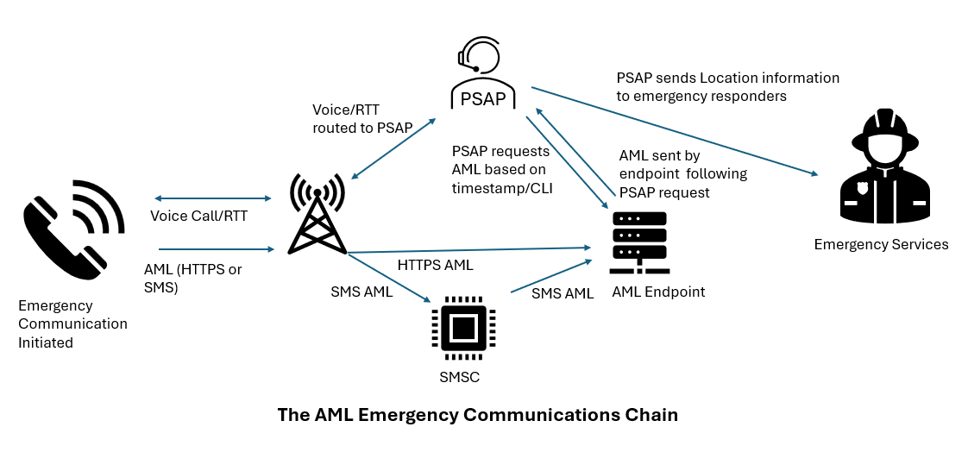
Figure 1: The AML Emergency Communications Chain
Nowadays, AML assumes special relevance in the scope of this Report due to the high-value information that it is providing to the PSAPs and its dependency on the SMS as the most used transmission means. In the future, the importance of AML may change with the migration of emergency communications to VoLTE/VoNR/VoWiFi, accelerated by 2G and 3G networks shutdown, and with the evolution of PSAPs toward next generation architecture that leverages the transmission of handset-derived location information in the signalling (using PIDF-LO in SIP).

General description of the routing of national and roaming SMS
In the SMS architecture, depending on the message flow, several types of traffic flow can be identified. For example:
- Person-to-Person (P2P): stands for the traditional communication by SMS between end-users; is an SMS exchanged between two telephone numbers (E.164 numbering);
- Application-to-Person (A2P): is an SMS sent from an application to an end-user's telephone number; as examples, A2P SMS is commonly used in marketing campaigns and in public warning solutions based on SMS, when the same message is sent to a large number of people; but A2P is also used in direct communication when the source is an application, for example SMS received in Two-Factor-Authentication;
- Person-to-Application (P2A): is an SMS sent from an end-user's telephone number to an application; is mostly used when subscribing to services, but there are other use-cases; the SMS-to-PSAP described in this Report, is a P2A SMS because the SMS will be received on a PSAP application (to allow the call taker to process and answer the emergency communication or to process the location when the SMS-to-PSAP is an AML-SMS);
- Other types based on A2P: for example, Over-The-Air messaging (OTA SMS) sent by OTA platforms to establish communication with SIM card/eSIM or SMS communications with IoT devices.
Regarding the technological evolution of mobile networks, SMS was designed in Global System for Mobile Communications (GSM) standards, but it was kept in the following wireless generations (UMTS, LTE, 5G NR). Its technical characteristics include the role of the SMS Centre (SMSC), which belongs to the end-user’s home network architecture and two main steps in SMS communication: message submission and message delivery.
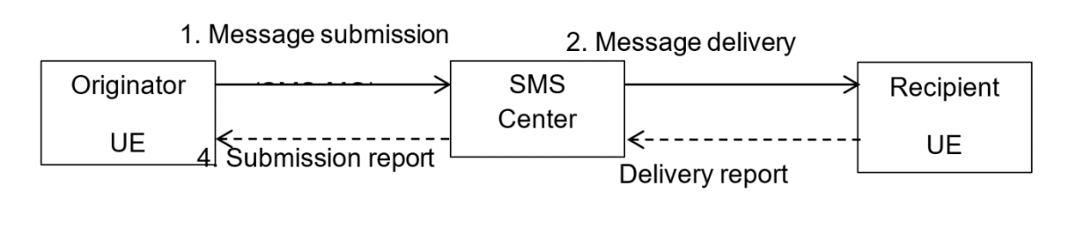
Figure 2: SMS communication
(Source: GSMA - "SMS Evolution version 3.0")
The SMSC's main functions are interworking between various interfaces (MAP, Diameter, SMPP, SIP, etc.) and providing the Store-and-Forward functionality. When the end-user sends an SMS, it is routed through the network to a SMSC that belongs to the end-user’s home network - this is done using the SMSC address (SC_Address) which has the same format as an international standard telephone number (E.164). The SC_Address is part of the mobile network provider's configuration and is configured in the SIM profile. In other words, whether the end-user is connected to his home network or roaming on another network, the SMS will always be submitted to his home network's SMSC (home SMSC). Due to this process, to send SMS, the handset must be successfully registered on a network - it does not work in LSS.
So far, the SMSC has carried out the Store process - it receives the SMS, validates it and, if successful, stores it; the handset then receives confirmation of the submission, a process that is transparent to the end-user; however, if this process is unsuccessful, the end-user realises it because he will receive an error alert. The next phase is message delivery, which depends on the SMSC's Forward function. This process differs depending on the type of destination: in a Mobile Terminated (MT) message, the SMSC interacts with the Home Location Register (HLR) of the recipient’s home network and in an Application Terminated (AT) message, the SMSC delivers the message via IP to the destination.
To forward the SMS, the SMSC needs to know the routing information to use. For MT SMS, the SMSC queries the recipient HLR to discover where the recipient is and in which state (available or not to receive SMS). After that, the SMSC will deliver the SMS by signalling based on the routing information received.
If the recipient’s number is a short number, like in P2A traffic, the delivery will only be successful if the short number is known by the SMSC - usually corresponding to an IP connection to application servers (destination will be External Short Messaging Entity (ESME)) via Short Message Peer-to-Peer (SMPP) or similar protocol.
In both scenarios, regardless of the handset’s location, whether connected to the home network or roaming on a visited network, the SMS submitted is managed and routed by the home network. In contrast, in a voice call over 2G or 3G, routing is managed by the network to which the end-user is connected, either the home or visited network, depending on their location. In a voice call over 4G or 5G using IMS, the routing can vary; however, in the context of an emergency call, the same principle applies routing is managed by the network to which the end-user is connected, home network or visited network, depending on the location (local break-out).
After submission (whether through the home network or the visited network), the message delivery will behave the same in both cases.

SMS-to-PSAP (2G/3G)
The transmission of messages in SMS is supported by signalling protocols. In 2G/3G networks, the Mobile Application Part (MAP) protocol is particularly important; it is a key component of the SS7 (Signalling System No. 7) protocol suite used for mobility management, call control, and other services in mobile networks. MAP is an integral component for enabling SMS as it facilitates the exchange of messages between handsets and providing functions like message delivery, acknowledgment, and storage through an SMSC.
The SMPP protocol allows for the establishment of a connection between an ESME and the SMSC, to send/receive messages over an IP socket connection (applicable to A2P/P2A traffic). It was developed as a protocol for exchanging SMS messages between external applications and SMSCs.
Figure 3 illustrates an SMSC existing in a 2G/3G network configuration. Mobile transfer procedures are detailed under ETSI TS 129 002 [10] and ETSI TS 123 040 [11]. When considering 2G/3G networks, a Mobile Originated (MO) SMS may be sent either to an MSC or SGSN. For MT traffic, the SMSC may send a short message towards an MSC or SGSN. The option to which network to try first is operator defined; however, in the case that the first node fails, delivery can then be attempted via the other node.
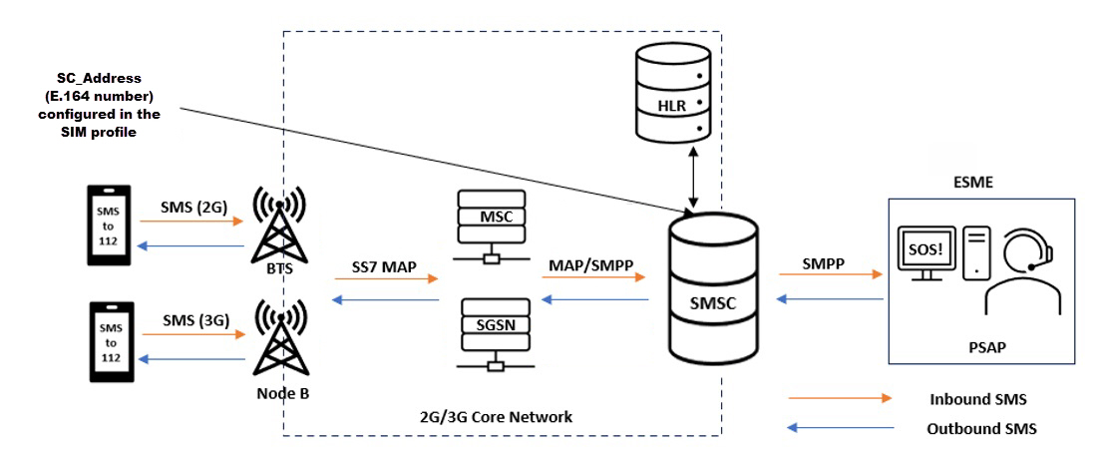
Figure 3: Overview of SMS to Emergency Services in 2G/3G Networks (Inbound and Outbound)

SMS-to-PSAP (4G/5G)
With the introduction of 4G and 5G networks, SMPP remains the dominant protocol for connecting an SMSC with an External Short Messaging Entity (ESME). The industry has adopted the GSMA standard IR.92 VoLTE [12] which details support for SMS over IP. As an interim step, the interface SMS over SGs details how SMS may be sent over 4G LTE networks. This interface is explained in ETSI TS 123 272 [13]. SMS over Diameter protocol specified under ETSI TS 129 338 [14] is also a consideration. With the introduction of VoLTE, operators may provision their end-users to send and receive SMS messages over IP using SIP. A new node, IP Short Message Gateway (IP-SM-GW), is introduced, enabling end-users to SIP Register and SIP Deregister, controlling their ability within the IMS core to send and to receive SMS. In addition to ETSI TS 129 002, ETSI TS 123 204 [15] and ETSI TS 124 341 [16] detail the signalling flows for this service evolution. Operator policy dictates how subscribers may access SMS services while roaming; however, it is important to state that the SMS originator will always use the SMSC on its home network.
In 5G networks, there are two options for SMS transmission, namely, SMS over IP (SMSoIP) and SMS over Non-Access Stratum (SMSoNAS), as illustrated below in Figure 4. For SMSoIP, the IP-SM-GW is retained and used to send and receive SMS over IP using SIP. For SMSoNAS, a new node called the Short Message Service Function (SMSF), as defined in ETSI TS 123 501 [17], is introduced. SMSoNAS depends on the SMSF being present in the visited network. The SMSF is relevant for operators without an IMS network. The evolution from GSMA IR.92 VoLTE is detailed under GSMA NG.114 [18]. This Report highlights deficiencies in SMS-to-PSAP. Currently, there are no released 3GPP technical specifications addressing these issues; however, within the scope of 3GPP, a change request has been created for an SMS2EC work item to enable access to emergency services through SMS over IMS.
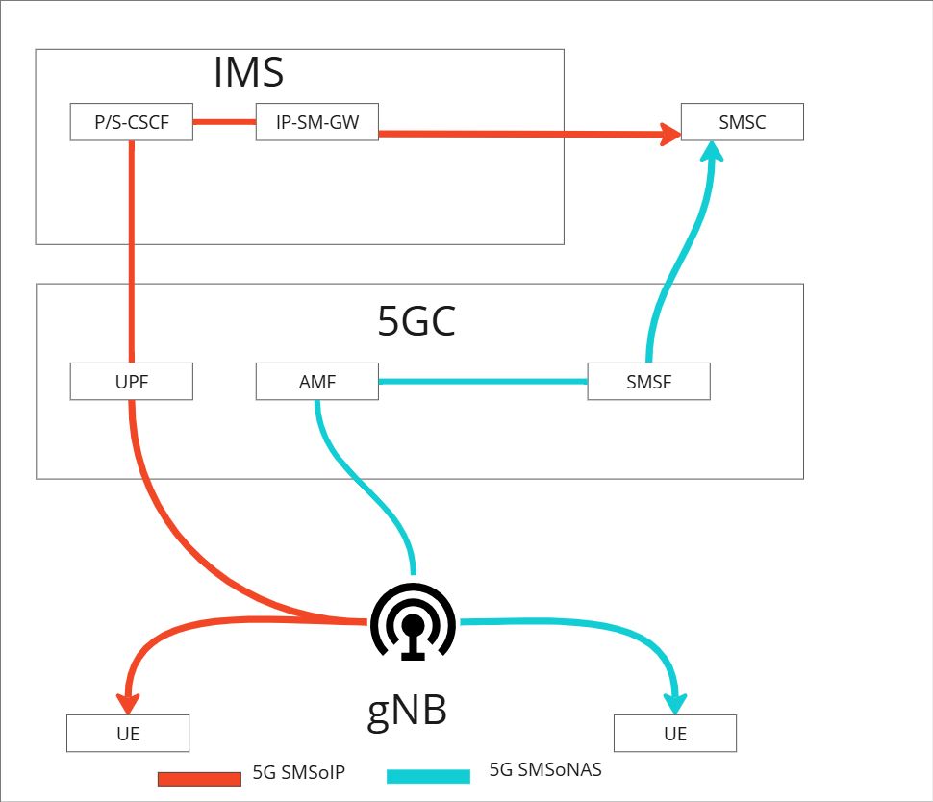
Figure 4: SMSoIP and SMSoNAS in 5G networks
Despite the evolution in SMS implementation and the different options available across various network types, especially in 4G/5G networks due to the expected sunset of 2G/3G networks in the coming years, SMS is always submitted to the home SMSC.
SMS technology continues to evolve, benefiting from advancements in 3GPP. Figure 5 illustrates the protocols and network nodes that enable SMS support across 3GPP releases. Further details can be found under the above-mentioned 3GPP and ETSI specifications.
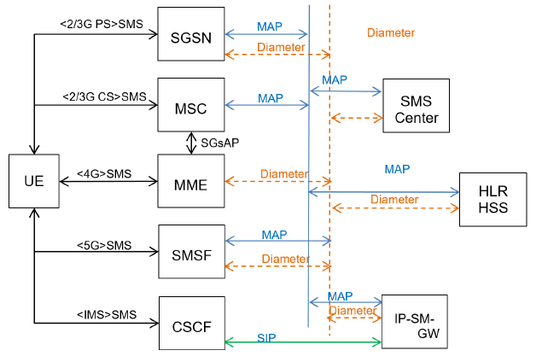
Figure 5: Future SMS architecture (4G/IMS/5G)
(Source: GSMA NG.111 SMS Evolution)

Roaming SMS-to-PSAP
In both cases of SMS-to-PSAP, the routing is technically the same. The main difference is that when transmitting the end-user location using AML, the SMS is encoded in a specific type of message that is not visible to the end-user.
When roaming and sending SMS-to-PSAP, certain challenges arise. As mentioned, due to the SMS architecture, the SMS message is always sent to the home network for onward delivery, and not to the visited network where the end-user is roaming. In most SMS traffic flows, the home routing of the SMS does not raise concerns because, in P2P case, the use of long numbers in E.164 format ensures correct routing, and in the P2A case, the addressed application is usually configured in the home network. However, in the context of emergency communications while roaming, the delivery of the communication should be directed to the visited country, so the SMS-to-PSAP should be delivered to the visited PSAP.
So, when an end-user roaming abroad sends an SMS-to-PSAP addressed to ‘112’ or another short number used in the visited country for this purpose, the SMS will not reach the visited country’s PSAP that would be the most appropriate one; instead, it will be sent to the home country. Depending on the implementation of emergency communications by SMS in the home country, the home PSAP may receive the SMS if the same number is also a recognised emergency number in the home country. However, the home PSAP will likely be unable to respond effectively to the emergency, as the end-user is roaming on a visited network. In the same way, if the AML configuration in the visited country also uses ‘112’ or a short number as destination address, the handset-derived location information of the end-user sent by SMS will not be delivered to the visited PSAP.
When the chosen AML transport mechanism is SMS, either for voice or SMS emergency communications, some additional configuration is needed to ensure that the service is available to international roaming customers.
When an emergency communication is initiated while roaming, the initial communication (e.g. a voice call to 112) will originate on the visited network and be transferred to the most appropriate PSAP in the same country.
The AML message containing the location information will be sent to the home network of the end-user using the SC_Address configured on the handset. This means that the PSAP handling the call will not have access to the location information. If the emergency communication is via SMS, then it is possible that neither the emergency communication itself nor the AML message would be routed correctly.
The potential routing outcomes depend on the number used as the destination of the SMS, for example:
- For SMS to 112 in a European country, the SMSC in the home network would route the SMS to the most appropriate PSAP in the end-user's home country. This would not be a good outcome as the PSAP would not be able to directly provide assistance to the end-user in a different country. If the end-user is roaming in a country outside of Europe, and 112 is not a recognised emergency number, then the sending of the SMS may fail. In the case of AML, triggered by an emergency call, the PSAP will be able to respond to the emergency but without the end-user handset-derived location received by AML;
- For SMS to a national short number in a European country, the SMSC in the home network would route the SMS to the most appropriate PSAP in the end-user’s home country if the same number was also a recognised national emergency number. Again, this would not be a good outcome as the PSAP would not be able to directly provide assistance to the end-user in a different country. If the number used is not a recognised emergency number in that country, then it is highly likely that the sending of the SMS would also fail. In the case of AML, triggered by an emergency call, the PSAP will be able to respond to the emergency but without the end-user handset derived location received by AML.
The implementation of voice in 4G networks with VoLTE and its roaming implementation presents two different approaches: Local Break-Out (LBO), where voice traffic is routed through the visited network, and S8 Home Routing (S8HR), where voice traffic is routed through the home network. Based on GSMA recommendations, VoLTE roaming deployments are based on S8HR, as explained in the GSMA document “VoLTE Implementation Guide” [19]. This document also explains that emergency calls fall in a specific scenario: if the emergency call is already initiated in the packet-switched domain and correctly detected by the handset or network, it will be established through an emergency session and handled locally rather than routed to the home network. However, due to the S8HR implementation that does not consider or need interconnection between the visited and home IMS, the emergency session is assumed to be established without IMS authentication. While this does not pose a problem for establishing and answering the emergency call at the PSAP, it may compromise the success of SMS-to-PSAP in transmitting handset-derived location information from AML.
It is relevant to mention that, in a VoLTE emergency call, if the PSAP has already implemented next generation PSAP architecture, it is expected to receive handset-derived location information in the signalling of the communication using PIDF-LO. However, considering that this transition at PSAPs is still ongoing, the transmission of handset-derived location by SMS using AML remains important.
For 5G networks, this is expected to remain the same or similar.

Possible solutions
The first European country to implement SMS-to-PSAP service was Denmark, which introduced the service in 2009 to provide an alternative means of access to emergency services for end-users with disabilities. The service is now available in many European countries and is provided using 2G/3G as well as 4G/5G technology. However, as stated earlier, end-users roaming in a visited country are most likely unable to access emergency services via SMS or send their handset-derived location information through AML. In recent years, some solutions have been developed to address this issue.

Belgian solution
A solution developed in Belgium is presented here to address the SMS-to-PSAP issue related to transmitting end-user location via AML. This approach is currently referred to as the “Belgian Solution”.
This solution takes advantage of the automatic triggering of the SMS by the AML software on the handset. The main action involves programming a specific SC_Address in the handset for the transmission of these SMSs. The goal is to define a SC_Address for this specific purpose that enables routing of these SMSs to the visited network SMSC, instead of delivering the SMSs to the home network SMSC, as in the case with SMSs sent by end-users using the SC_Address configured in the SIM, which belongs to the home network SMSC. To achieve routing to the visited network SMSC, the specific SC_Address will be in the format <visited>CC + 112 (e.g. for Belgium +32 112). It is configured in this way to ensure the message will be sent even if the subscriber’s profile on the network has the parameter “Call Barring Outgoing International Except Home Country CBOIexHC” enabled.
To complete the implementation of this solution, configurations are needed in the visited network’s core network and SMSC. The specific SC_Address identifies a virtual SMSC; the visited core network must recognise it and translate it to its SMSC address. This SMSC should be configured to accept SMS coming from inbound roamers and to control that only these SMSs are accepted.
Figure 6 and Figure 7 represent how this solution works.
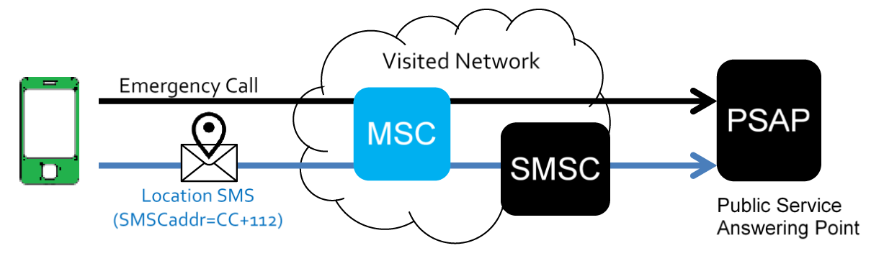
Figure 6: Solution to enable AML for roaming customers
(Source: ETSI TS 103 625)

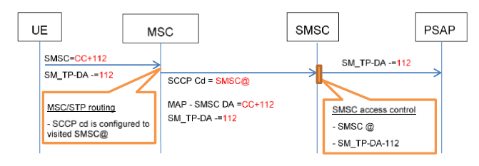
Figure 7: AML SMS flow for roamers
(Source: GSMA NG.119 Emergency Communication v.4.0)
This solution ensures that SMS-to-PSAP related to AML are routed to the correct PSAP i.e. the PSAP serving the mobile network or area where the end-user has originated the emergency communication and consequently where the AML is triggered. The use of a specific in-country SMSC for these SMSs ensures that the AML messages are directed or routed to the correct PSAP serving that mobile network and/or country.
Cooperation from handset providers is paramount for this solution, due to the need for specific handset configuration to use a different SC_Address than the one configured in the SIM profile.
This solution for the transport of AML SMS-to-PSAP has been implemented and is currently live on Android handsets only in a number of countries, where it has proven very successful.
Technically, the same solution could be utilised to ensure that SMS-to-PSAP used as emergency communications themselves are routed to the correct PSAP when the handset is roaming. However, this would require modifications to the default SMS transport logic on the handset.
In conclusion, this solution is tested and working properly in some countries for SMS-to-PSAP when used by AML to transmit handset-derived location information of the end-user. When used as an emergency communication itself, it is recognised that this is technically feasible but no implementations are known so far.
Nevertheless, there are limitations. One is that this solution is not implemented by Apple reducing the number of compatible handsets. Another issue arises when AML is triggered by an emergency call made over VoLTE. Due to S8HR implementation, this results in an anonymous IMS call, which can prevent the sending of SMS. This scenario limits this type of SMS-to-PSAP. However, if the PSAP in the visited country has already been upgraded to next-generation PSAP architecture, it will be able to receive and process handset-derived location information sent in the signalling of the call (using PIDF-LO). In this case, even without reception of the SMS-to-PSAP with the AML handset-derived location information, the intended purpose is achieved.

Long Number
This solution, which is currently used in some countries for SMS-to-PSAP, can facilitate both end user-initiated SMS to 112 and the sending of additional data by SMS when roaming.
In this approach, the destination of the SMS-to-PSAP is a long number in E.164 format, instead of ´112´ or another short number. Like any other SMS, it will be submitted to the home network SMSC and will appear as a P2P SMS to it. The home SMSC then manages the routing of the SMS as described in section 3.2, querying the destination network (in this case, the visited network) to determine where to deliver the SMS and subsequently delivering it. In this step, the delivery will be made to a SMSC in the visited network, which will forward it via SMPP or a similar protocol to the visited PSAP – in practice, this is a P2A SMS.
In the AML use-case of SMS-to-PSAP, aside from the required configuration in the visited network, the AML configuration in the handset must include the long number in E.164 format configured as the AML endpoint. This configuration can be applied specifically for roaming scenarios or can be the same endpoint for all SMSs for AML, whether originated by home or roaming in end-users. The endpoint of the SMS for AML is a basic parameter in the handset configuration when implementing AML. This solution has been implemented in Android handsets.
In the use-case where SMS-to-PSAP is used as the emergency communication itself, only configuration in the visited network is necessary. No handset configuration is required, as the end-user enters the SMS destination number. However, this approach poses challenges. When the destination number for emergency communication is different from the European emergency number ‘112’, the effectiveness can be compromised. Even if roamers receive information on the correct long number to access emergency services via SMS, as required by the Roaming Regulation, they may struggle to remember a long number correctly in a distress situation.
Another issue with this solution is that the end-user may not be able to send the message if they have no prepaid credit or if outgoing international calls/SMS barred. Even if the message is routed successfully, sending the location information or SMS-to-PSAP to the designated endpoint may incur a charge.

3GPP work item SMS2EC
In 3GPP Release 18, the requirements for IMS to enable access to emergency services via SMS have been defined under the SMS2EC work item (960014) . This work item focuses on regulatory requirements arising from European legislation e.g. EECC.
This work item has been postponed but is running in the 3GPP workflow and procedures, with Release 20 as the target release at the time of writing. Given the early stage of this work item, it is not yet possible to provide detailed information on its scope, aside from acknowledging that routing of an emergency SMS to the local PSAP is part of the requirements.

RTT AS AN ALTERNATIVE?
The RTT service is not a solution to the issue of SMS-to-PSAP delivery during roaming to the most appropriate PSAP. However, it should be considered in this discussion, as it provides an alternative, and in fact complementary, means of communication to voice calls, meeting several emergency communication requirements, including accessibility. Another reason for including RTT in this context is the obligations imposed by the EAA regarding this service.
In this context, and considering the future of the networks, PSAPs and handsets, RTT could serve as an alternative to SMS-to-PSAP for emergency communications. However, it cannot replace SMS-to-PSAP when used to transmit end-user location information via AML. That said, in an end-to-end next generation emergency communication architecture, handset-derived location information is transmitted using PIDF-LO. Therefore, any failure in AML transmission could be manageable.
Nevertheless, RTT also presents certain challenges, especially in achieving full end-to-end interoperability among handsets, networks and PSAPs. Compatibility in roaming is also not guaranteed by default, despite RTT using the same transport channel as a voice call, due to the aforementioned interoperability issues.
Lastly, there are known use cases (e.g. burglary and kidnapping) where sending an SMS to emergency services is preferred over making a voice call or using RTT particularly for personal safety reasons.

Current implementation and Limitations

Current Implementations in some CEPT countries
Based on 15 responses to a questionnaire, the availability of SMS to 112 varies between CEPT countries. SMS to 112 is available nationally without pre-registration to all end-users in Czech Republic, Netherlands, Hungary, Greece, Ireland, Croatia and North Macedonia. In Norway it is available only for end-users with disabilities and requires pre-registration. The service is not available in Poland, Portugal, Bulgaria, Switzerland, Austria, Cyprus and Romania.
Regarding AML, it is not implemented in Cyprus and Poland. In the other countries, AML is deployed for Android via SMS (and in some cases, via HTTPS) and for iOS, with the exception of Austria and the Czech Republic.
SMS to other national emergency numbers is only available in Czech Republic to all end-users without pre-registration and in Romania to end-users with disabilities and requires pre-registration.
SMS to 112 for roaming end-users is available only in North Macedonia and does not require pre-registration.
AML for SMS to 112 for roaming end-users is not available in, Czech Republic, Bulgaria, Netherlands, Hungary, Austria, Greece, Ireland, Romania and Norway. North Macedonia, Switzerland and Portugal have activated AML for SMS to 112 for roaming end-users.
Roaming end-users can send SMS to other national numbers only in Norway. The service is only available for end-users with disabilities and requires pre-registration.
AML for SMS to other national emergency numbers for roaming end-users is available in Switzerland (for Android over SMS and iOS) and Norway (only for Android over SMS).
The Czech Republic and Norway have included details about the available alternative means of reaching emergency services into a database hosted by BEREC.
The diversity of solutions demonstrates that these CEPT countries have pursued different approaches to these services, with some opting not to provide them at all, in accordance with their distinct national circumstances.

Limitations of the SMS-to-PSAP
There are several notable limitations of the SMS-to-PSAP for roaming and national end-users:
- Network-based location information: when an end-user initiates an emergency communication, the emergency services need to obtain the end-user’s location to provide assistance. However, due to the complexity of implementation, location information of the sender of the SMS-to-PSAP is typically not available when SMS-to-PSAP solutions are used. Nevertheless, alternative solutions such as querying the MNO’s database or using a pre-registration database, can be implemented to provide location information. However, these solutions may not be feasible or reliable when the end-user is roaming;
- Handset-based location information: it is also highly likely that handset-based location information (i.e. AML) will not be available for roaming end-users as not all European countries have made the necessary configuration changes to support AML for roaming end-users yet. In addition, when an emergency call is made over VoLTE/VoNR/VoWiFi, it can benefit from the ability to send the handset-based location information via call signalling (using PIDF-LO). However, this capability is currently not available for SMS-based emergency communication;
- Pre-registration: in some countries, access to emergency services by sending an SMS to 112 or other emergency numbers requires the end-user to be pre-registered for the service. It is highly unlikely that an end-user would be aware of the need for such registration or indeed of the number to send the message to. While SMS to 112 is available in some countries, in others, the service is available only to long numbers in E.164 format or national short numbers. As a result, lack of awareness of the destination number or specific requirements to access the service may present a barrier to access;
- Awareness: another factor is the impact of the SMS destination address on the effectiveness of SMS-to-PSAP. If the destination address for emergency communication is different from the European emergency number 112, its effectiveness for roamers can be compromised. Even if the roamers receive the correct information about the means of access to emergency services, as required by the Roaming Regulation, they may not remember it during a distress situation. On the other hand, when it comes to AML SMS, the destination address is not visible to the end-user. Therefore, in this use case, although handset configuration updates may be required, effectiveness is not compromised by lack of end-user awareness;
- Routing to most appropriate PSAP: was described in the report, this is the main limitation posed by the SMS-to-PSAP when roaming. Different behaviours are expected:
For SMS to 112, the home SMSC would be configured to route the SMS to the most appropriate PSAP in the home country. This PSAP may not be able to provide any assistance unless they have a way of contacting a PSAP in the country in which the end-user is roaming;
Where the SMS is sent to a national short number in use in the visited country, delivery is likely to fail for a roaming end-user as the national short number routing rules may not be configured in the home SMSC;
Where the SMS message is sent to a long number in E.164 format, the SMS should be received by the most appropriate PSAP via the home network.
- Limited-service state: SMS-to-PSAP does not work in LSS;
- Real time communication: SMS-to-PSAP is generally not considered real-time communication due to the store and forward messaging technique unless prioritisation delivery policies are used e.g. first delivery attempt. The PSAP’s ability to reply to the end-user in roaming can also be compromised.

Conclusions
SMS remains an active and evolving technology within 3GPP/ETSI standards, with no indication that it will be phased out. However, despite its use in emergency communications and the continued support of the SMPP protocol, SMS lacks robust emergency handling capabilities that are inherently supported by voice services. As highlighted in ETSI TS 103 625 [9], this is evident in SMS submission during LSS and international roaming. To address these shortcomings, ongoing standardisation efforts under the SMS2EC work item aim to enhance SMS emergency handling mechanisms.
Regarding the addressed solutions in this report, it must be concluded that all currently implemented solutions are essentially workarounds and none of these are without any drawbacks or risk of failure when it comes to reliably reaching the PSAP in a roaming scenario. This goes for SMS-to-PSAP when it is an emergency communication itself and the automatic transmission of AML location information.
The limitations outlined in section 5.2 also support the conclusion that it is not possible to guarantee the delivery of an SMS-to-PSAP in a roaming scenario due to the added complexity.
The core of the identified problem in this report lies in the fact that there is currently no obligation to bring SMS traffic to the most appropriate PSAP. There is only such an obligation for voice calls. Without a similar obligation for SMS, there is no real incentive to develop solutions which will solve the issues without any drawbacks. The home routing principle in roaming must be changed into local break-out to alleviate all drawbacks and make the partially successful workarounds for roamers no longer necessary.
- List of references

- Directive (EU) 2018/1972 of the European Parliament and of the Council of 11 December 2018 establishing the European Electronic Communications Code (Recast)
- Commission Delegated Regulation (EU) 2023/444 of 16 December 2022 supplementing Directive (EU) 2018/1972 of the European Parliament and of the Council with measures to ensure effective access to emergency services through emergency communications to the single European emergency number ‘112’
- 91/396/EEC: Council Decision of 29 July 1991 on the introduction of a single European emergency call number
- Directive 2002/22/EC of the European Parliament and of the Council of 7 March 2002 on universal service and users’ rights relating to electronic communications networks and services (Universal Service Directive) OJ L 108, 24.4.2002, p. 51-77
- Commission Delegated Regulation (EU) 2019/320 of 12 December 2018 supplementing of Directive 2014/53/EU of the European Parliament and of the Council with regard to the application of the essential requirements referred to in Article 3(3)(g) of that Directive in order to ensure caller location in emergency communications from mobile devices, OJ L 55, 25.2.2019, p. 1-3
- The European Accessibility Act (EAA), Directive (EU) 2019/882 of the European Parliament and of the Council of 17 April 2019 on the accessibility requirements for products and services (OJ L 151, 7.6.2019, p. 70)
- Roaming Regulation (EU) 2022/612 of the European Parliament and of the Council of 6 April 2022 on roaming on public mobile communications networks within the Union (Recast)
- ETSI TS 124 229: ”Digital cellular telecommunications system (Phase 2+) (GSM); Universal Mobile Telecommunications System (UMTS); LTE; 5G; IP multimedia call control protocol based on Session Initiation Protocol (SIP) and Session Description Protocol (SDP); Stage 3”
- ETSI TS 103 625: “Emergency Communications (EMTEL); Transporting Handset Location to PSAPs for Emergency Calls - Advanced Mobile Location”
- ETSI TS 129 002: “Digital cellular telecommunications system (Phase 2+) (GSM); Universal Mobile Telecommunications System (UMTS); LTE; 5G; Mobile Application Part (MAP) specification”
- ETSI TS 123 040: “Digital cellular telecommunications system (Phase 2+) (GSM); Universal Mobile Telecommunications System (UMTS); LTE; 5G; Technical realization of the Short Message Service (SMS)”
- GSMA Standard IR.92 “VoLTE”
- ETSI TS 123 272: “Digital cellular telecommunications system (Phase 2+) (GSM); Universal Mobile Telecommunications System (UMTS); LTE; Circuit Switched (CS) fallback in Evolved Packet System (EPS); Stage 2”
- ETSI TS 129 338: “Universal Mobile Telecommunications System (UMTS); LTE; 5G; Diameter based protocols to support Short Message Service (SMS) capable Mobile Management Entities (MMEs)”
- ETSI TS 123 204: “Universal Mobile Telecommunications System (UMTS); LTE; Support of Short Message Service (SMS) over generic 3GPP Internet Protocol (IP) access; Stage 2”
- ETSI TS 124 341: “Digital cellular telecommunications system (Phase 2+) (GSM); Universal Mobile Telecommunications System (UMTS); LTE; 5G; Support of SMS over IP networks; Stage 3”
- ETSI TS 123 501: “5G; System architecture for the 5G System (5GS)
- GSMA NG 114 “IMS Profile for Voice, Video and Messaging over 5GS”, January 2025
- GSMA “VoLTE Implementation Guide”, September 2025
- GSMA "SMS Evolution Version 3.0", June 2024
- GSMA "NG.119 Emergency Communication Version 4.0", January 2025

EU/EEA Member States have the option to defer, by way of derogation, the implementation of certain obligations specified in Article 4(8) of the European Accessibility Act until 28 June 2027, providing an additional two-year period beyond the standard deadline set for other measures under this Act. This includes the capability of PSAPs to be able to appropriately answer emergency communications to the single European emergency number ‘112’, in the manner best suited to the national organisation of emergency systems using the same communication means as received, namely by using synchronised voice and text (including real time text), or, where video is provided, voice, text (including real time text) and video synchronised as Total Conversation.
Or equivalent functionality in other mobile system generations e.g. 4G and 5G like HSS (Home Subscriber Server)
https://portal.3gpp.org/desktopmodules/WorkItem/WorkItemDetails.aspx?workitemId=960014
The European Communications Office (ECO) hosts a confidential directory (PSAP-DIR) of contact information for European Public Safety Answering Points (PSAPs) to contact each other in emergency incidents where cross-border assistance is required.

