ECC Recommendation (25)04

Measures to handle alphanumeric SMS Sender IDs
approved 16 October 2025

LIST OF ABBREVIATIONS

Abbreviation | Explanation
3GPP | 3rd Generation Partnership Project
A2P | Application-to-Person
CEPT | European Conference of Postal and Telecommunications Administrations
CLI | Calling Line Identification
ECC | Electronic Communications Committee
GSM | Global System for Mobile Communications
ID | Identification
KYC | Know Your Customer
NPA | Numbering Plan Administrator
NRA | National Regulatory Authority
P2A | Person-to-Application
P2P | Person-to-Person
PSD2 | Payment Services Directive
SMS | Short Message Service
SMSC | Short Message Service Center
TS | Technical Specification
URL | Uniform Resource Locator

Introduction
The ECC has already developed two Recommendations on how to handle the Calling Line Identification (CLI) in voice communications. The first, ECC Recommendation (19)03 of 21 November 2019 on Measures for increasing Trust in Calling Line Identification and Originating Identification [1], contains a set of rules in order to handle the CLI to ensure trust. The second, the ECC Recommendation (23)03 of 28 November 2023 on Measures to handle incoming international voice calls with suspected spoofed national E.164 numbers [2], recommends measures in order to maintain trust in numbers and focuses on preventing fraud based on CLI spoofing.
SMS Sender ID is the equivalent identifier as CLI is for voice calls but for SMS. SMS is mainly used for person-to-person (P2P) communications, but also more and more for application-to-person (A2P) communications. In this last category, one can distinguish between premium rate SMS, where the receiver of the SMS pays for the premium rate service, and business messaging, such as one-time passwords or alerts for appointments, for which the receiver is not charged. While the premium rate SMS-service is in decline, business messaging, including the use of SMS as an extra security layer, is getting more and more popular. A typical example is to implement strong customer authentication as defined in the Payment Services Directive (PSD2) (e.g. 2-factor authentication) [3].
The scope of this Recommendation is limited to measures to handle alphanumeric SMS Sender IDs for A2P, primarily via the implementation of alphanumeric SMS Sender ID registries. Such registries may be implemented either in a centralised or a decentralised manner. Beyond the context of A2P communications, there is no utility in using an alphanumeric SMS Sender ID in SMS in person-to-person (P2P) or person-to-application (P2A) context. So, SMS service providers typically offer the transmission of SMS with alphanumeric SMS Sender ID to companies or institutions, i.e. to juridical person/legal person, although where appropriate the service could also be provided to a natural person.
While the CLI for voice communications and the Sender IDs for P2P and P2A SMS are always a telephone number using only decimal numbers, it is possible to use alphanumeric characters in the Sender IDs for A2P SMS. Whilst this offers an attractive user-friendly marketing proposition, it also creates additional risks, as SMS receivers are more likely to be misled by a spoofed alphanumeric identifier (e.g. well-known brands) than by a spoofed telephone number. Fraudsters can send messages that appear to originate from a legitimate business to deceive consumers. Very often the SMS will include a Uniform Resource Locator (URL) link or a telephone number that, when clicked or called, will take the victim to a malicious or phished website, or connect the victim to a telephone number used for fraudulent purposes. In most cases, the fraudsters seek to collect the victim’s personal information and/or account credentials, and that information is then used as a second step for fraud. In this regard, it should be noted that measures based on scanning the content of the SMS are not included in the scope of this Recommendation, particularly since such measures may require legislative developments in CEPT countries related to privacy in electronic communications. Notwithstanding, measures comprising the detection of the use of an alphanumeric SMS Sender ID are not being considered as comprising content scanning.
From a technical point of view, it is easy to modify the Sender ID in an A2P context. Sender ID spoofing for SMS is considered by many CEPT administrations to be a problem with a very negative impact for end-users, since often it is used to facilitate fraud. Moreover, in case of provisioning of business messaging via SMS, various actors may be involved and this increases the complexity in identifying the real sender of the messaging and increases opportunities for fraudsters. In this respect, Annex 2 contains a description of the SMS signalling flow for A2P SMS, showing the different parties that may be involved depending on the applicable scenario.
Given this context, it is justified to exercise control on such service provision, and the implications of such Sender ID spoofing should be closely monitored. It has to be highlighted that permitting the use of alphanumeric SMS Sender IDs alongside numbers in the national numbering plan is a matter of national competence. There is no legal or technical harmonisation in this field, therefore the regulation of alphanumeric SMS Sender ID in CEPT countries may vary. For example, a CEPT administration may decide not to allow SMS service providers to offer the service to legal persons of other countries, on the basis that the use of alphanumeric SMS Sender ID for end-users of other countries should be determined by the competent administrators of such other countries.
Moreover, where the SMS Sender ID is an ordinary 'long number', it is noted that for international communications, in general, Recommendation ITU-T E.157 [4] should be respected, and the sending party should be identified through the use of the full international E.164 number. By the time of publication of this Recommendation, ITU-T has not defined an international format for alphanumeric SMS Sender IDs.
This Recommendation aims to increase trust in alphanumeric SMS Sender IDs by proposing policies and best practices on how to handle alphanumeric SMS Sender ID. Considering the role of alphanumeric SMS Sender ID, special attention will be given to safeguard the commercial benefit for the various legitimate actors while minimising the risk of fraud and/or abuse. The Recommendation will draw from best practices currently applied by some CEPT countries, with a specific focus on the implementation of alphanumeric SMS Sender ID registries. It is acknowledged that there are multiple approaches that CEPT administrations can adopt when implementing a national alphanumeric SMS Sender ID registry, with differences in terms of both the underlying policy scope and the corresponding implications on the various actors involved in A2P messaging. Moreover, as noted above, the implementation of alphanumeric SMS Sender ID registries may be on a centralised basis, or a decentralised basis and the registry may be queried in real-time during the SMS transmission and/or in an offline (non-real time) manner.
In terms of policy scope, some CEPT administration may justify the establishment of a national alphanumeric SMS Sender ID registry based on the concept that registration offers an opportunity to protect any registered alphanumeric SMS Sender IDs from being spoofed by fraudsters in SMS targeting end-users in the same CEPT country. Such a policy’s main focus would be to ensure that entities with an interest to protect their alphanumeric Sender IDs (e.g. brand names, names of Government departments, large banks, etc.) would have an opportunity to do so. Actors involved in the conveyance and/or termination of SMS would in turn be required to carry out verifications against the alphanumeric SMS Sender ID registry to ensure that registered alphanumeric SMS Sender IDs are not fraudulently used.
An alternative policy scope adopted in some CEPT administrations is to focus instead on an approach whereby the use of alphanumeric SMS Sender IDs in SMS terminating in the country is prohibited, unless the SMS service provider and/or SMSC Operator are nationally authorised or registered, and recorded in the alphanumeric SMS Sender ID registry as being responsible for the origination of SMS with specific alphanumeric SMS Sender IDs. With such an approach, actors involved in the conveyance and/or termination of SMS may also be required to block all SMS with an alphanumeric SMS Sender ID if the source for that SMS was not the source (typically the SMSC) as specified in the alphanumeric SMS Sender ID registry. Such blocking typically relies on real-time checks against the alphanumeric SMS Sender ID registry.
Another approach used is to protect all the SMS with an alphanumeric SMS Sender ID in the same way and, consequently, protect the users that receive any alphanumeric SMS Sender ID. Such approach foresees that SMS with an alphanumeric SMS Sender ID received from abroad and destinated to national telephone numbers are blocked. More precisely, SMS with an alphanumeric SMS Sender ID destinated to national telephone numbers would be blocked by all authorised parties whenever they receive SMS from any non-authorised party. At the national level a traceback procedure can facilitate the identification of both possible bad behaviours in blocking from abroad and the use of unregistered alphanumeric SMS Sender IDs by authorised parties. In contrast to the preceding approach, this approach relies on real-time check of the type of number (Annex 1) coming from non-authorised parties and does not rely on querying in real-time the alphanumeric SMS Sender ID registry.
Depending on the policy scope adopted, there would be implications on the type of anti-fraud measures that would be applicable, as well as on the conveyance of cross-border SMS with an alphanumeric SMS Sender ID.

ECC Recommendation (25)04 of 16 october 2025 on measures to handle alphanumeric SMS Sender IDs
“The European Conference of Postal and Telecommunications Administrations,
considering
- the attractiveness of using alphanumeric characters in the Sender ID for A2P SMS for business;
- the risks for fraud associated with using alphanumeric SMS Sender IDs for A2P SMS;
- that alphanumeric SMS Sender ID is only possible in an A2P context;
- that various CEPT administrations recognise that it may be necessary to reduce the risk of fraud;
- that whether alphanumeric SMS Sender ID is allowed relies on national policies;
- that the use of alphanumeric SMS Sender ID in a CEPT country could be managed in a similar manner to national numbering resources and made subject to national regulation;
- that alphanumeric characters means digits (0-9), Latin characters (a-z, A-Z) and other characters coded according to GSM 7-bit default alphabet as defined in 3GPP TS 23.038 [5] and TS 23.040 [6] technical specifications;
- that alphanumeric SMS Sender ID has a maximum length of 11 characters, while numeric Sender ID has a maximum length of 15 digits;
- that in the typical SMS signalling flow, covered in Annex 2, multiple actors are involved in the origination, conveyance and termination of SMS traffic;
- that a service provider offering services to end-users in the CEPT countries must comply with the applicable legislation in the country of the receiving end-users, and ensure it is authorised or can legitimately operate;
- that an alphanumeric SMS Sender ID registry can facilitate fraud reduction and investigations through real-time queries to the registry or checks/blocks at the border interfaces, as well as through offline traceback;
- that for the purposes of this Recommendation, the term "registration" is to be understood to mean a process of determining right of use of the respective alphanumeric SMS Sender ID following an application and assignment process, and a successful applicant for registration is considered to be the ‘assignee’ of the registered alphanumeric SMS Sender ID;
- Recommendation ITU-T E.157 and Recommendation ITU-T E.164 [7].
recommends
that, where alphanumeric SMS Sender IDs for A2P messaging are allowed and the CEPT administration in the respective country observes or anticipates fraudulent usage, it should:
- consider to facilitate the establishment of a national alphanumeric SMS Sender ID registry, which would contain the alphanumeric SMS Sender IDs to be used for sending SMS to end-users of that country, and the establishment of a registration process as applicable:
  - determine aspects related to registering an alphanumeric SMS Sender ID (e.g. criteria, limitations, eligibility to submit an application for registration, etc.). Where a centralised model is adopted, the registry can be managed by the NPA or by another organisation that is independent and with no commercial interests in the messaging ecosystem;
  - determine a registration process that allows for a single (one-time) registration, even when a decentralised (distributed) registry model has been implemented;
  - consider making the relevant (non-sensitive) information (e.g. registered SMS Sender ID) in the registry publicly available, whilst taking into account the potential risks related to fraud, privacy, and/or commercial sensitivity ;
  - consider that the information in the registry could be queried in real-time, or alternatively downloaded, by registered parties (e.g. relevant operators) for verification purposes, including to validate alphanumeric SMS Sender IDs, when originating, conveying and/or terminating SMS to end-users;
  - consider registering the actors that are nationally permitted to offer services comprising the origination, conveyance, and/or termination of SMS with alphanumeric SMS Sender ID, taking into account any existing regulation related to authorisation or licensing to streamline the registration process, to the maximum extent possible;
- ensure that clear registration criteria apply, such as:
  - the alphanumeric SMS Sender ID should be unique in the national registry;
  - the alphanumeric SMS Sender ID should not be deceptive for the receiver e.g. the alphanumeric SMS Sender ID must not start or end with a space-character and there must not be two or more consecutive space-characters to avoid messages imitating other alphanumeric SMS Sender IDs by adding spaces;
  - the alphanumeric SMS Sender ID must not be composed exclusively of digits (0-9) or make use of alphanumeric characters to simulate a number in national or international format (Annex 1). (For example, using the vowel “O” instead of the number “0” [zero]). An exception could be for number-based brands where the decimal-only-number, e.g. “112”, is used as an alphanumeric SMS Sender ID and the registration is done by the number assignee;
  - the NRA or an entity that is nationally authorised could determine if the registry should be:
    - case sensitive i.e. the registered alphanumeric SMS Sender ID must be sent in the same case as it is registered. No case variant can be registered to avoid confusion/possible scams; or
    - case insensitive i.e. the registered alphanumeric SMS Sender ID can be sent in any case variant by the assignee compared to what is registered.
  - establishing a minimum length for the alphanumeric SMS Sender IDs to be registered;
  - the NRA or an entity that is nationally authorised could define generic names that should not be viable for registration;
  - the applicant seeking registration of an alphanumeric SMS Sender ID must affirm that all national regulatory and legal requirements where the service will be provided would be met, provide the information requested by the NRA e.g. company registration documents, and it shall be the applicant’s responsibility to ensure that the alphanumeric SMS Sender ID does not infringe the rights of other relevant parties, for example, intellectual property rights, tradenames, names of origin or brands;
  - the applicant seeking registration may apply for multiple alphanumeric SMS Sender IDs;
  - the applicant seeking registration of an alphanumeric SMS Sender ID must operate and/or offer services in the country of the receiving end-users as determined by their E.164 country code;
  - the applicant must indicate the designated connectivity provider(s) permitted to send SMS with the requested alphanumeric SMS Sender ID on its behalf;
  - the applicant seeking registration of an alphanumeric SMS Sender ID is authenticated and vetted as part of the application process to ensure that the applicant is genuinely who they claim to be;
  - the applicant may also nominate one or more third-parties (e.g. SMS service provider) to submit the application to register an alphanumeric SMS Sender ID on its behalf, provided that robust KYC procedures are in place to facilitate this and the third party is able to provide the proof of representation. Where a third party submits an application on behalf of the applicant, a successful application would still confer rights of use to the applicant, not the third party.
- ensure that an assignee can, if required, also apply to register alternative or additional designated connectivity provider(s) throughout the period of assignment;
- depending on the scope of national policy on alphanumeric SMS Sender ID registration and the registry model adopted, consider requiring any of the following anti-fraud measures, as applicable:
  - introduce mandatory registration of alphanumeric Sender IDs and prohibit SMS Service Providers from originating SMS with unregistered alphanumeric SMS Sender ID;
  - as an alternative to the mandatory registration and prohibition in (a), SMS service providers may be permitted to originate SMS with an unregistered alphanumeric SMS Sender ID;
  - regardless of whether the national policy approach corresponds to 4(a) or 4(b), impose obligations on SMS service providers to only originate SMS with a registered alphanumeric SMS Sender ID if the client sending the SMS is the legitimate assignee of the alphanumeric SMS Sender ID intended for use; and the SMS service provider is registered in the alphanumeric SMS Sender ID registry as a designated connectivity provider for the assignee;
  - regardless of whether the national policy approach corresponds to 4(a) or 4(b), prohibit all operators from conveying and/or terminating any SMS with a registered alphanumeric SMS Sender ID, destinated to national telephone numbers, unless the SMS in question was originated by the designated connectivity provider associated with that alphanumeric SMS Sender ID;
  - prohibit all operators from conveying and/or terminating any SMS, destinated to national telephone numbers, with an unregistered alphanumeric SMS Sender ID;
  - as an alternative to the prohibition in (e), where (nationally destinated) SMS with unregistered alphanumeric SMS Sender IDs are received by operators, either for conveyance or for termination to end-users, consider:
    - either not imposing any specific obligations, therefore permitting further conveyance and/or termination as applicable;
    - or imposing obligations on such operators to modify the alphanumeric SMS Sender ID in such a manner to show the recipient that the SMS Sender ID in question was not verified nationally.
  - as an alternative to the prohibition in (d), the obligations in (f)(ii) may also be applied in cases where (nationally destinated) SMS with a registered alphanumeric SMS Sender ID are received by operators, either for conveyance or for termination to end-users, from SMS service providers that are not the designated connectivity provider for that SMS;
  - imposing restrictions on the number of designated connectivity providers or the number of hops for the transmission of the SMS from the origination to the destination.
- consider the possible impact and benefits of the anti-fraud measures on cross-border traffic for SMS with alphanumeric SMS Sender ID, including for SMS destinated towards end-users that are in international roaming, both in the case of inbound roamers and outbound roamers;
- introduce measures to address misuse and abuse of assigned alphanumeric SMS Sender IDs, possibly including measures where the assigned alphanumeric SMS Sender ID is withdrawn if the misuse or abuse was carried out by the assignee.
- consider, if necessary, setting further alphanumeric SMS Sender ID policies such as quarantine periods, recycling, temporary registrations, renewal, obligations to use, transfer of rights, etc;
- consider adopting a phased approach to implement the alphanumeric SMS Sender ID registry in order to allow all actors involved in the SMS ecosystem to align with regulation, carry out sufficient testing, and minimise risks of disrupting legitimate traffic.
Note:
Please check the ECO Documentation Database https://docdb.cept.org/ for the up to date position on the implementation of this and other ECC Recommendations.

- Format of the SMS Sender ID
The protocol layers of the SMS comprise of the Short Message Lower Layers (SM-LL), Short Message Relay Layer (SM-RL), Short Message Transfer Layer (SM-TL) and Short Message Application Layer (SM-AL). These protocol layers are structured as shown below [6]:

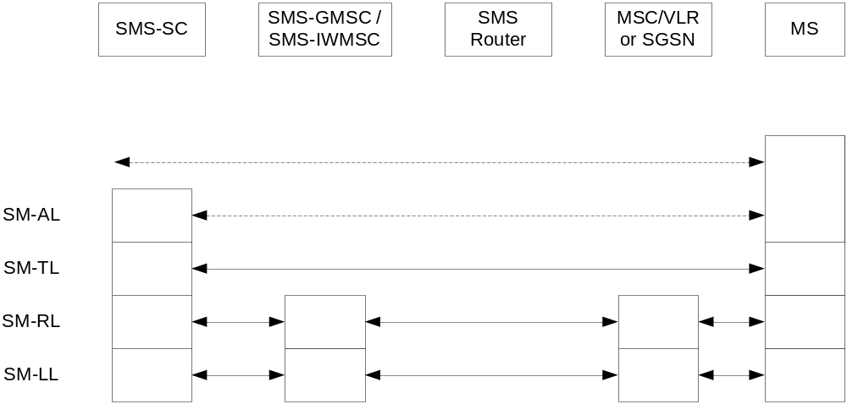
Figure 1: SMS protocol layers
NOTE: The SMS Router is an optional functional entity, and is used only in the mobile terminated (MT) case.

Protocol layer overview for the Short Message Service
Each address field of the SM-TL consists of the following sub-fields: An Address-Length field of one octet, a Type-of-Address field of one octet, and one Address-Value field of variable length; as shown below:
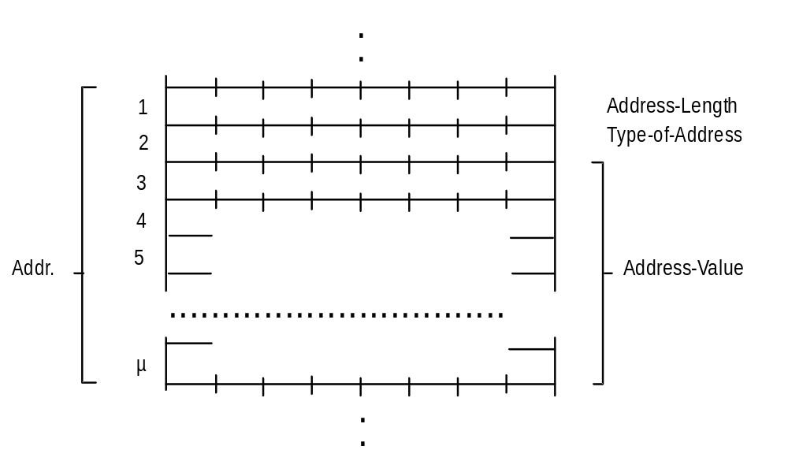
Figure 2: SMS address at SM-TL
The SMS Sender ID format depends on the Type-of-Address field which comprises the Type-of-number and the Numbering-plan-identification.
The Type-of-Address field format is as follows:

Figure 3: Type-of-Address field format
Type-of-number:
Bits 6 5 4
0 0 0 Unknown 1)
0 0 1 International number 2)
0 1 0 National number 3)
0 1 1 Network specific number 4)
1 0 0 Subscriber number 5)
1 0 1 Alphanumeric, (coded according to GSM TS 03.38 7-bit default alphabet)
1 1 0 Abbreviated number
1 1 1 Reserved for extension
1) "Unknown" is used when the user or network has no a priori information about the numbering plan. In this case, the Address-Value field is organized according to the network dialling plan, e.g. prefix or escape digits might be present;
2) The international format shall be accepted also when the message is destined to a recipient in the same country as the MSC or as the SGSN;
3) Prefix or escape digits shall not be included;
4) "Network specific number" is used to indicate administration/service number specific to the serving network, e.g. used to access an operator;
5) "Subscriber number" is used when a specific short number representation is stored in one or more SCs as part of a higher layer application. (Note that "Subscriber number" shall only be used in connection with the proper PID referring to this application).
Numbering-plan-identification (applies for Type-of-number = 000,001,010)
Bits 3 2 1 0
0 0 0 0 Unknown
0 0 0 1 ISDN/telephone numbering plan (E.164/E.163)
0 0 1 1 Data numbering plan (X.121)
0 1 0 0 Telex numbering plan
1 0 0 0 National numbering plan
1 0 0 1 Private numbering plan
1 0 1 0 ERMES numbering plan (ETSI DE/PS 3 01-3)
1 1 1 1 Reserved for extension
All other values are reserved.
For Type-of-number = 101 bits 3,2,1,0 are reserved and shall be transmitted as 0000.

Whilst the SMS Sender ID is included as part of the User Data of the Forward Short Message sent by the SMSC to the MSC/VLR or SGSN, specific processes may be required to ‘extract’ the alphanumeric SMS Sender ID from the User Data to carry out any necessary verifications depending on the national policy approach adopted.
- SMS Signalling Flow for A2P SMS
General note: The following figures only show the main elements involved in the signalling flow, and the names of these elements could change with the different technology in use, e.g. 2G, 3G, 4G and 5G.
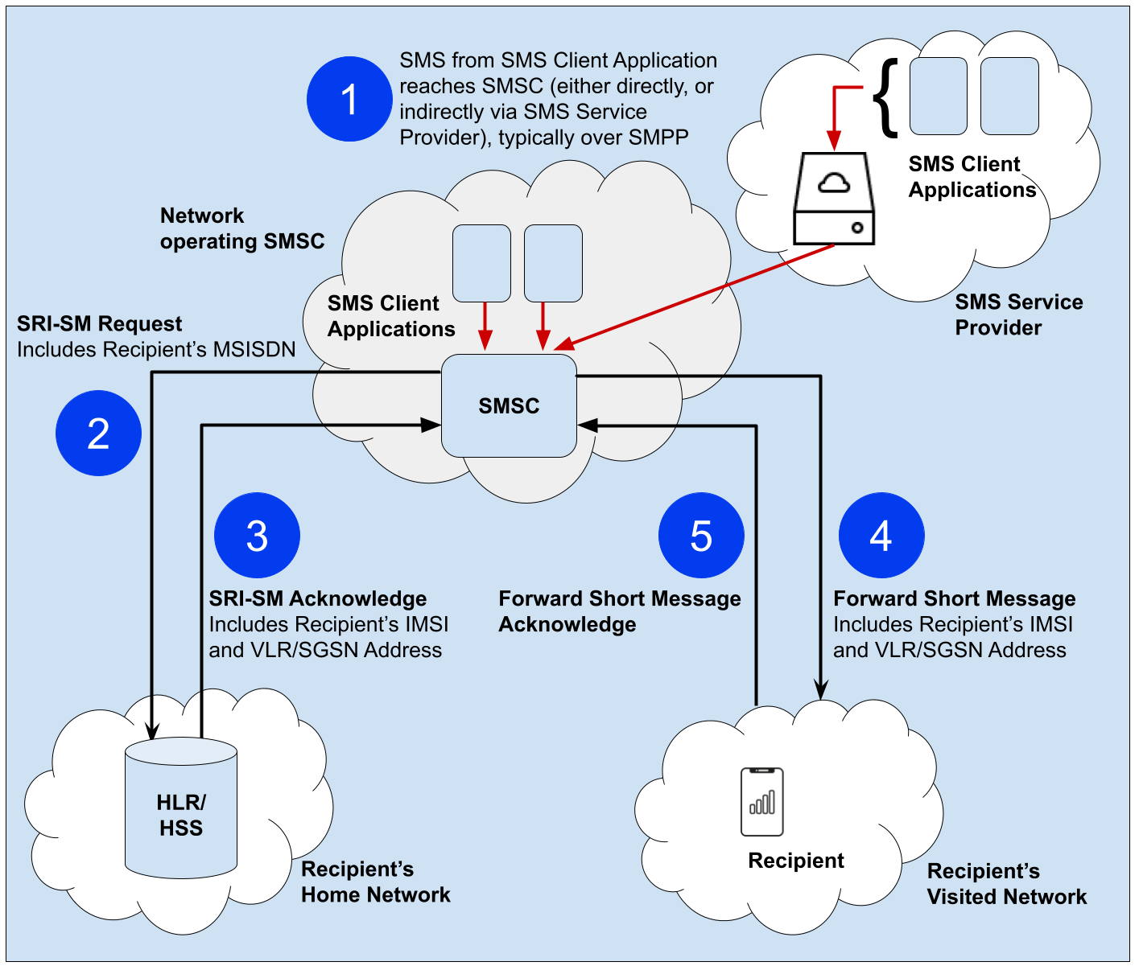
Figure 4: SMS signalling flow for A2P SMS
- The short message is sent from the SMS client application towards the SMSC through either a direct interface, or indirectly via an SMS service provider;
- The SMSC is responsible to terminate the SMS towards the recipient. Thus, the SMSC sends a Send Routing Information Short Message (SRI-SM) Request, including the recipient’s MSISDN, towards the home network of the recipient. The SRI-SM Request reaches the HLR within the recipient’s home network;
- The HLR then responds to the SMSC by an SRI-SM Acknowledge which includes the recipient’s IMSI and the global title address of the VLR and/or SGSN to which the recipient is attached;
- The SMSC sends a Forward Short Message (FSM), which includes the recipient’s IMSI, to the VLR and/or SGSN address included in the SRI-SM Acknowledge to deliver the short message towards the recipient;
- A Forward Short Message Acknowledge is sent to the SMSC indicating whether the short message was delivered successfully or otherwise. If the short message delivery has failed, the SMSC receives information on the cause of failure and it would reattempt the delivery of the short message in accordance with the retry scheme configured on the SMSC for the specific cause of failure.
The above signalling flow stays the same, regardless of whether the actors involved are in the same country or otherwise. However, as presented in the following scenario diagrams, there may be differences for each scenario in terms of which of the actors involved can carry out verifications against the national Sender ID registry. Moreover, there may be differences depending on whether the recipient of the SMS is roaming abroad and/or whether there are arrangements in place for the national Sender ID registry to be also checked by actors outside the country, or otherwise.
Scenario 1 - SMS signalling flow where all actors, including the recipient of the SMS, are in the same country (Country A):
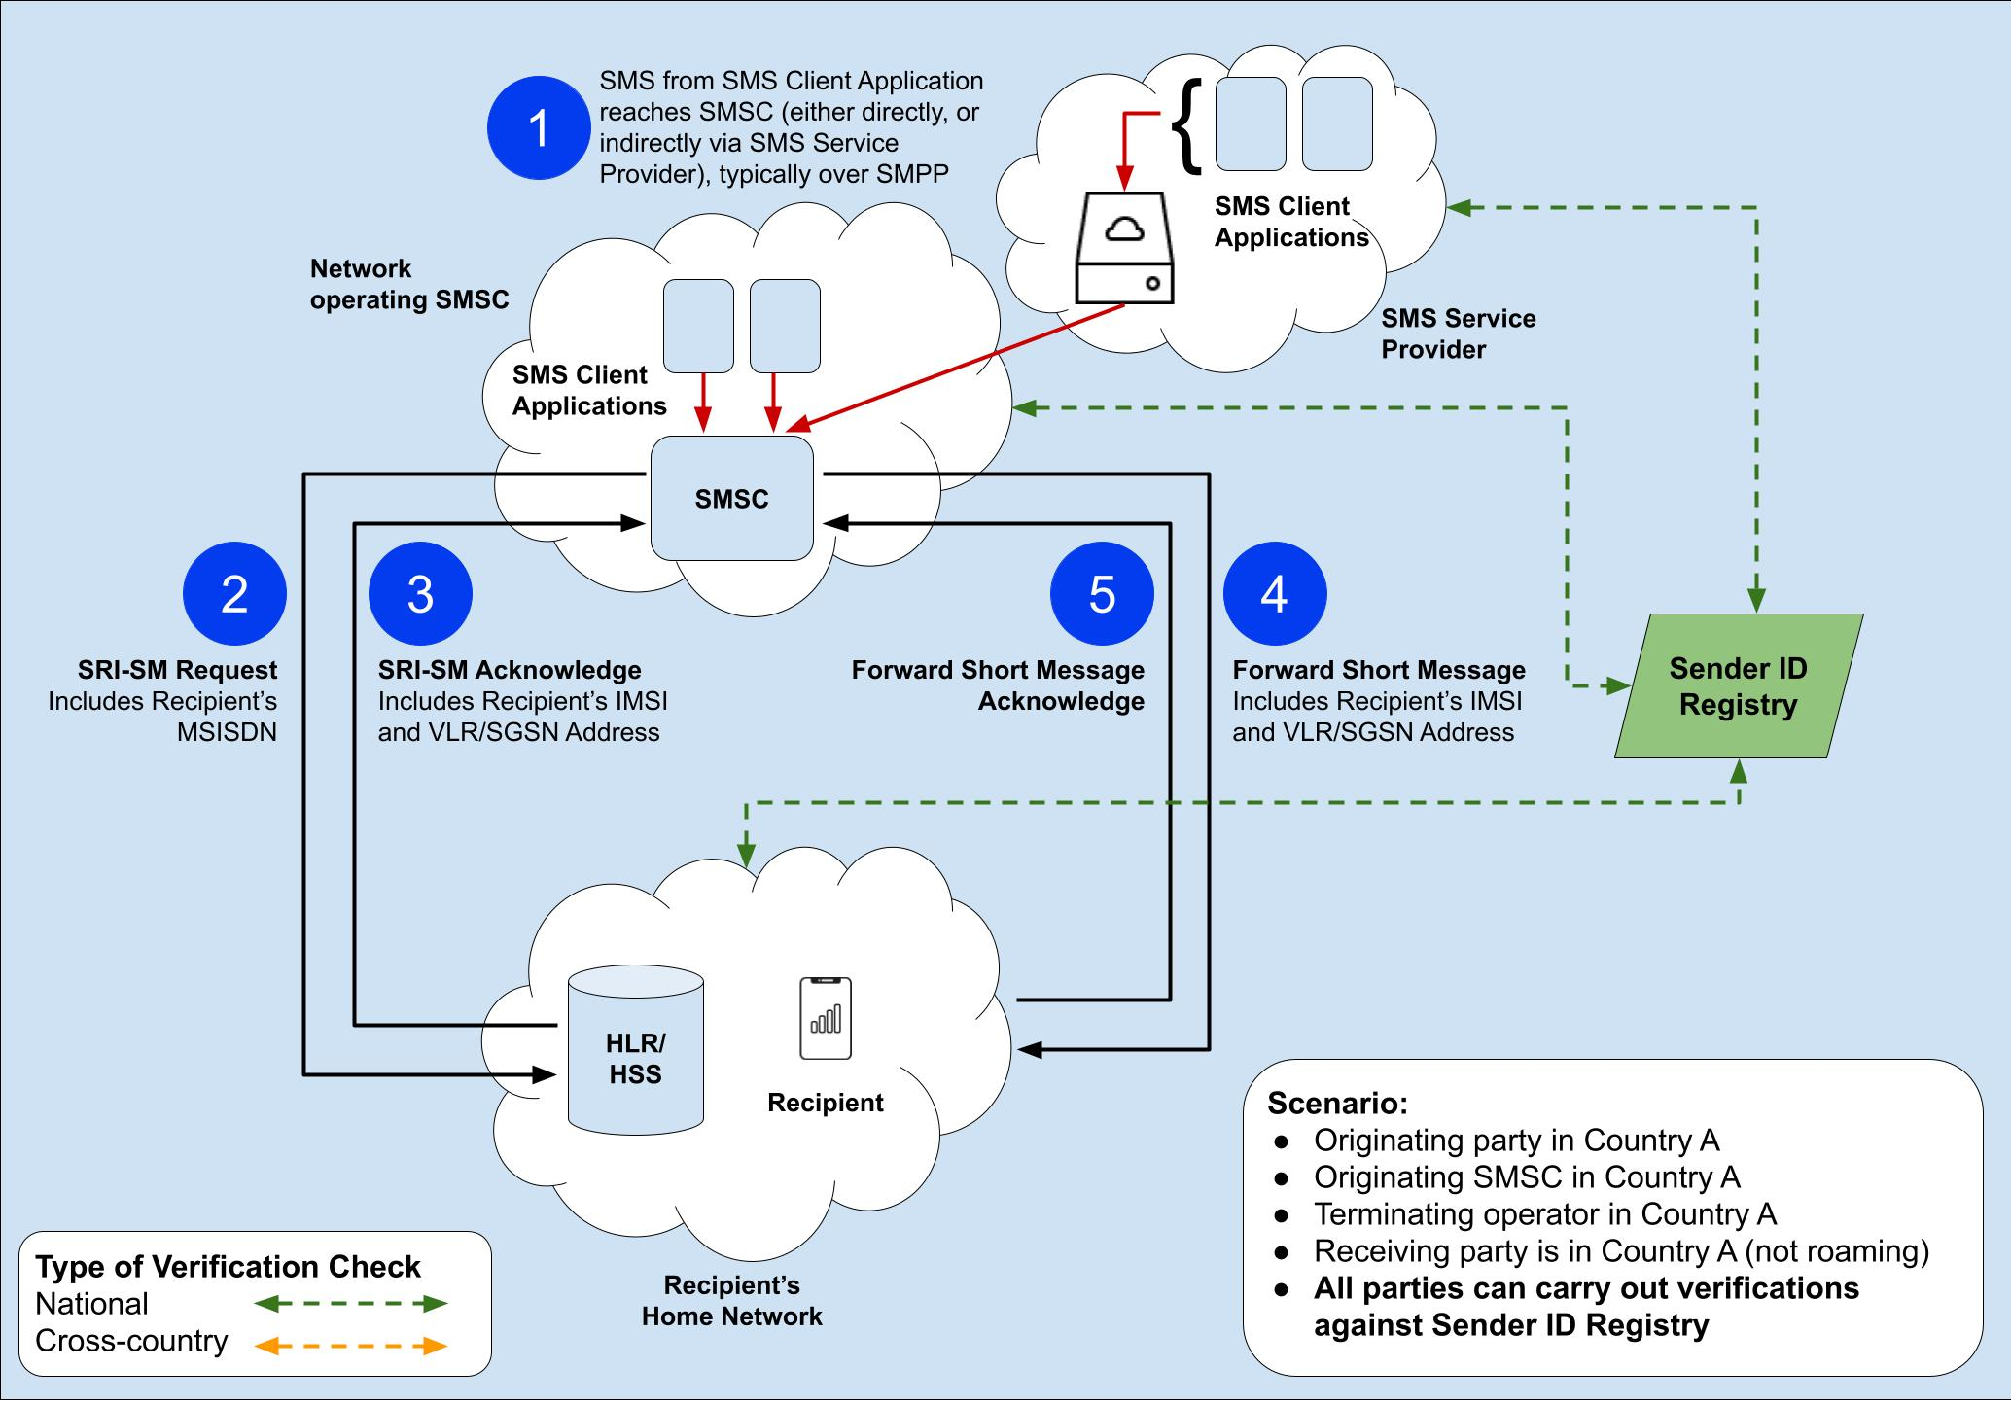
Figure 5: SMS signalling flow (Scenario 1)

Scenario 2 - SMS signalling flow whereby the both the originating party and originating SMSC are in a foreign country (Country B) and the Sender ID registry is only nationally accessible:
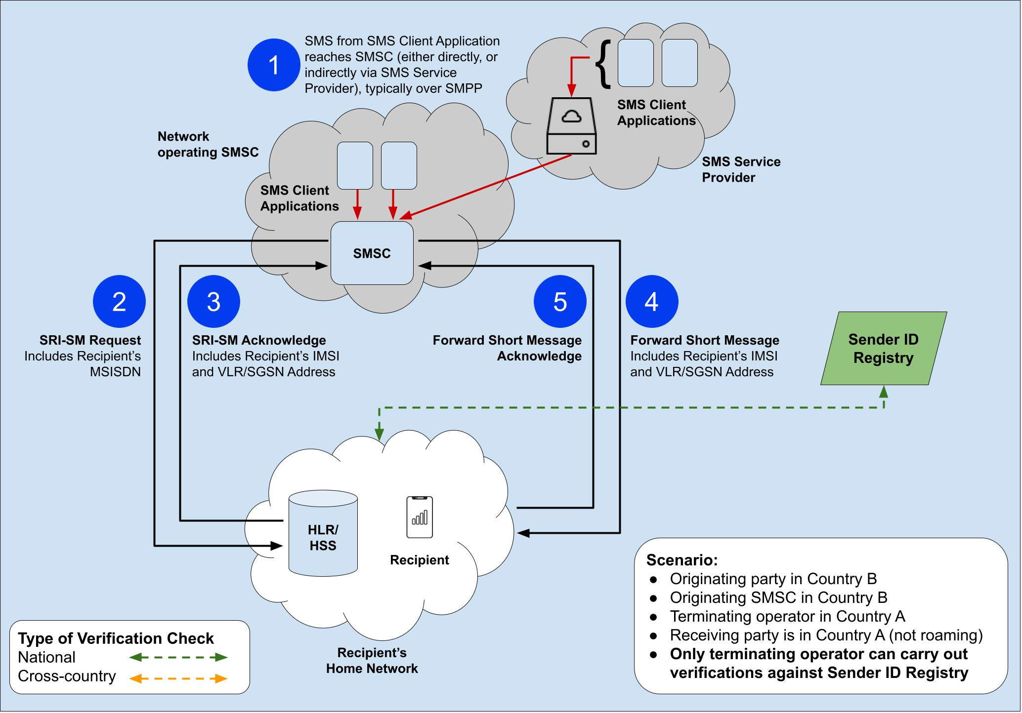
Figure 6: SMS signalling flow (Scenario 2)

Scenario 3 - SMS signalling flow whereby the both the originating party and originating SMSC are in a foreign country (Country B) but there are cross-country arrangements in place for the national Sender ID registry to be accessible by parties abroad:
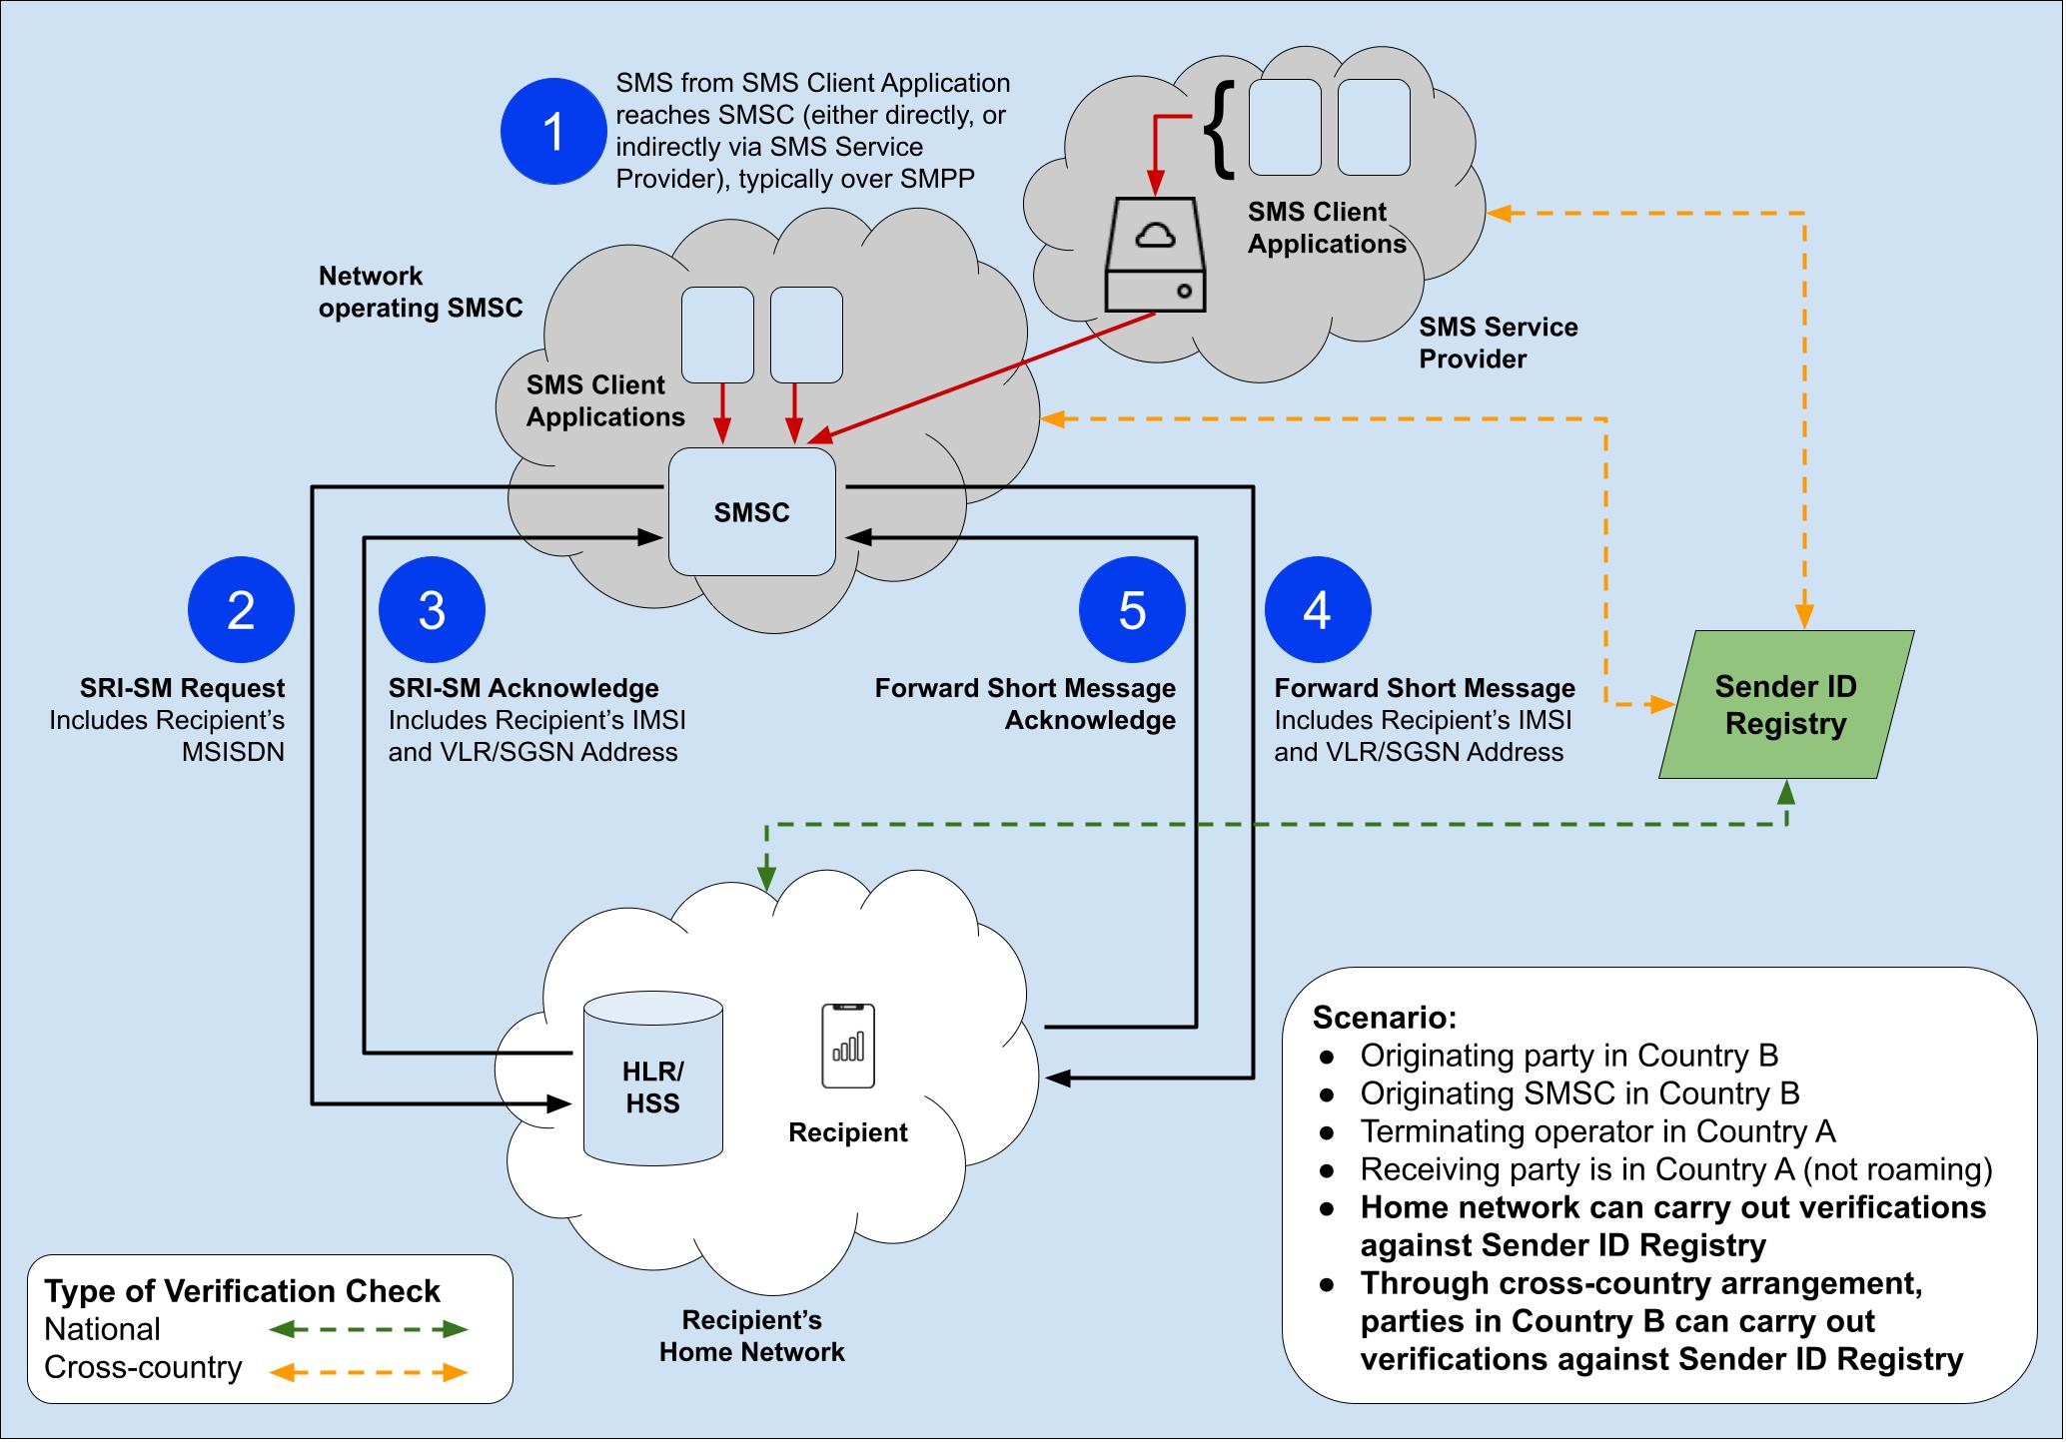
Figure 7: SMS signalling flow (Scenario 3)

Scenario 4 - SMS signalling flow where all actors, except the recipient of the SMS, are in the same country (Country A), whereas the recipient is roaming abroad. The Sender ID registry is only nationally accessible:
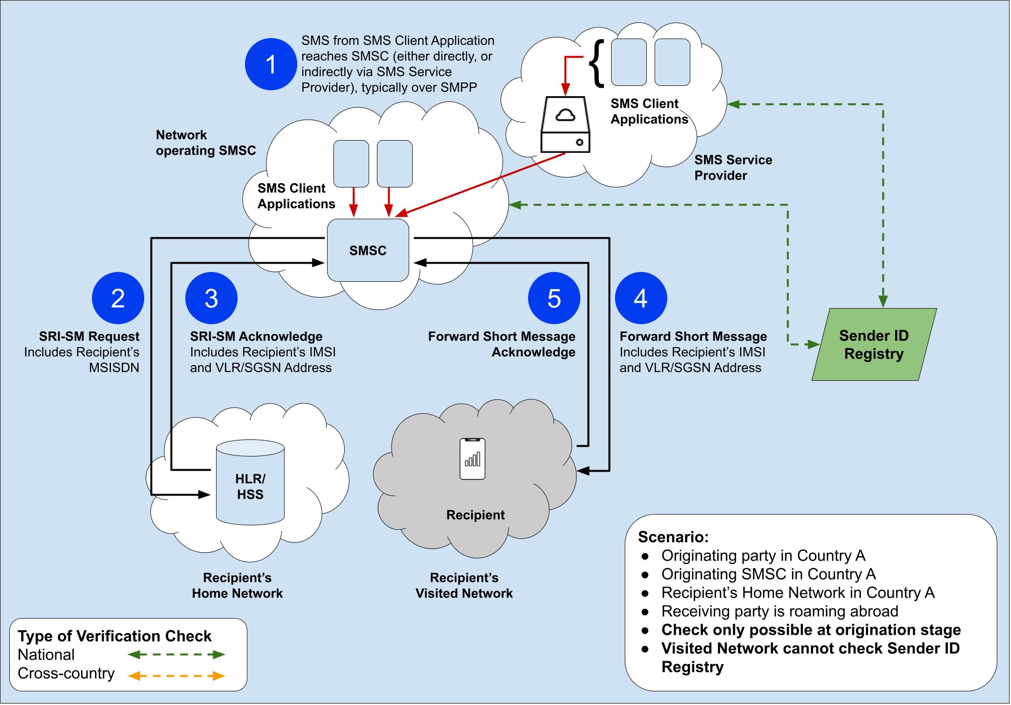
Figure 8: SMS signalling flow (Scenario 4)

Scenario 5 - SMS signalling flow where all actors, except the recipient of the SMS, are in the same country (Country A), whereas the recipient is roaming abroad. In this scenario, there are cross-country arrangements in place for the national Sender ID registry to be accessible by parties abroad:
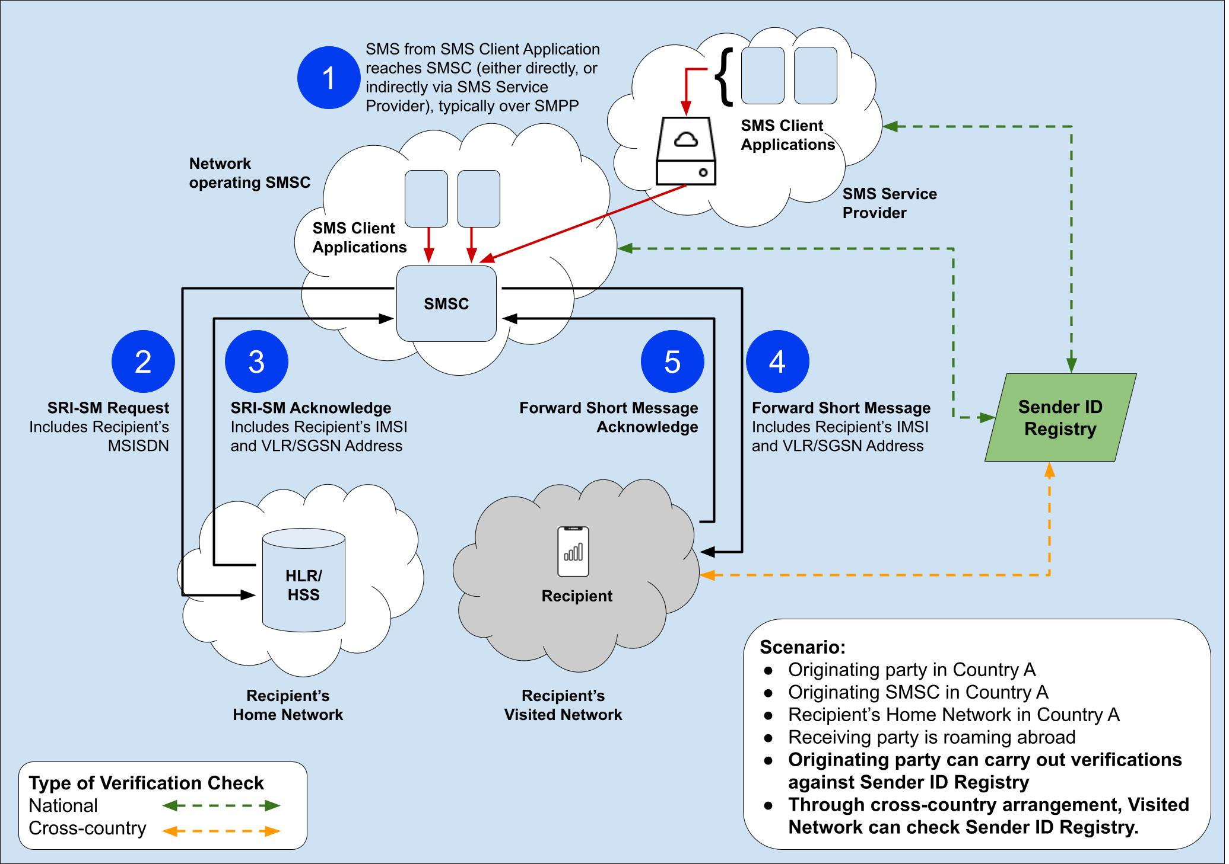
Figure 9: SMS signalling flow (Scenario 5)

Scenario 6 - SMS signalling flow whereby the originating party and originating SMSC are in a foreign country (Country B), the recipient of the SMS is also roaming abroad, and the Sender ID registry is only nationally accessible:
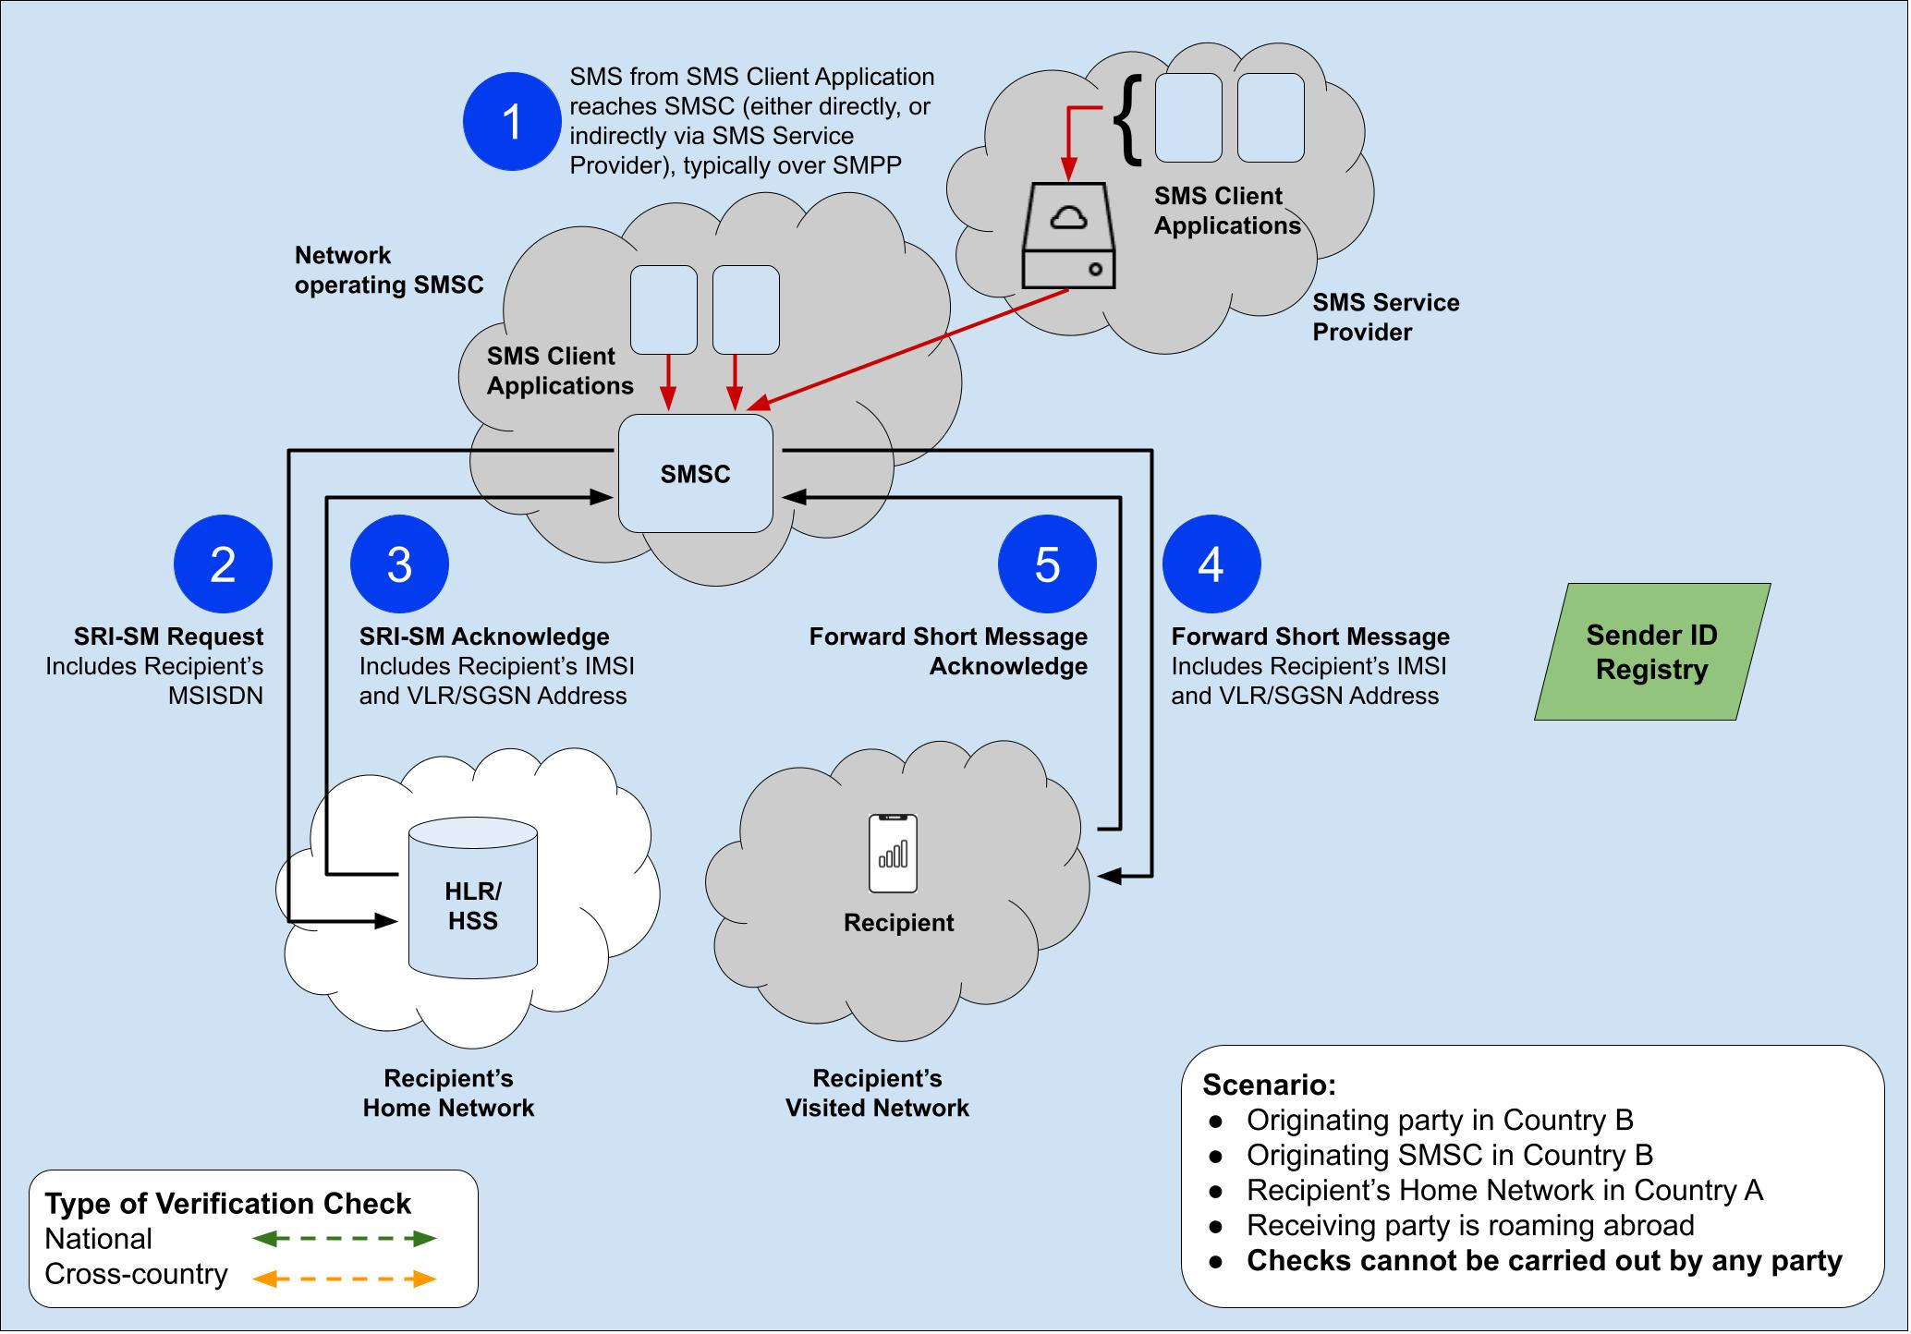
Figure 10: SMS signalling flow (Scenario 6)

Scenario 7 - SMS signalling flow whereby the originating party and originating SMSC are in a foreign country (Country B), the recipient of the SMS is also roaming abroad. In this scenario, there are cross-country arrangements in place for the national Sender ID registry to be accessible by parties abroad:
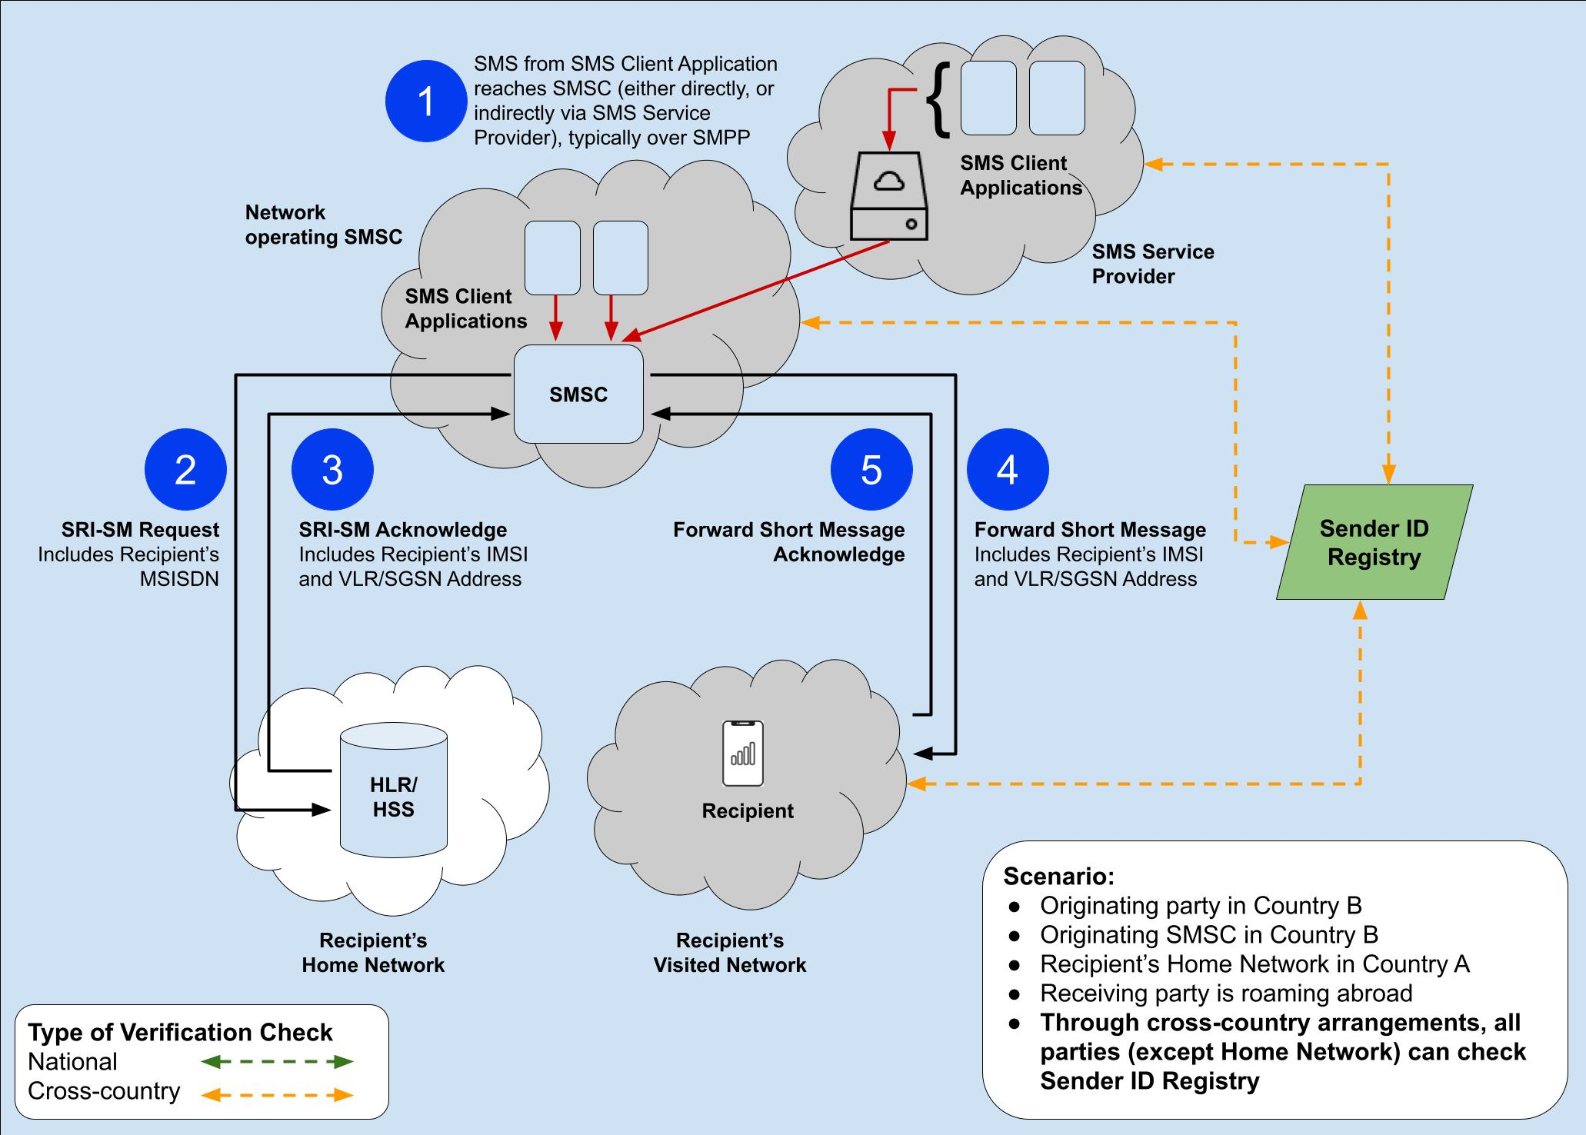
Figure 11: SMS signalling flow (Scenario 7)
- List of references
- ECC Recommendation (19)03: ”Measures for increasing Trust in Calling Line Identification and Originating Identification”, approved November 2019
- ECC Recommendation (23)03:“Measures to handle incoming international voice calls with suspected spoofed national E.164 numbers”, approved November 2023
- Directive (EU) 2015/2366 of the European Parliament and of the Council of 25 November 2015 on payment services in the internal market, amending Directives 2002/65/EC, 2009/110/EC and 2013/36/EU and Regulation (EU) No 1093/2010, and repealing Directive 2007/64/EC. Available here.
- Recommendation ITU-T E.157: “International calling party number delivery”
- 3GPP TS 23.038/ETSI TS 123 038 - Alphabets and language-specific information. Available here.
- 3GPP TS 23.040/ETSI TS 123 040: “Technical realization of the Short Message Service (SMS)”. Available here.
- Recommendation ITU-T E.164: “The international public telecommunication numbering plan”

SMS Sender ID registries implemented in a decentralised manner would comprise multiple registries administered by distinct entities (e.g. different SMS Service Providers, MNOs, etc.), and typically feature technical functionalities to allow for data synchronisation, querying and/or communication between the different registries (e.g. for updating the list of registered Sender IDs).
If MySenderID is registered that case must be sent and for example MYSENDERID cannot be registered
If MySenderID is registered, (MySenderID, MYSENDERID, mYsEnDeRiD, mysenderid are all the same) and must be delivered as a valid SenderID.
By way of example, such modification may include adding the three characters [?] before the alphanumeric SMS Sender ID (E.g. Changing ‘CEPT’ to ‘[?]CEPT’). In such a case, some truncation may be necessary for alphanumeric SMS Sender IDs that are longer than eight characters (E.g. Changing ‘ECC WG NaN2’ to ‘[?]ECC WG N’.)

