Recommendation
T/R 25-08

Planning criteria and cross-border coordination of frequencies for land mobile systems in the range 29.7 - 470 MHz
approved 15 January 1990
latest amended 6 June 2025

introduction
This Recommendation contains provisions for the planning and cross-border coordination of frequencies for land mobile systems in the range 29.7-470 MHz for various analogue and digital land mobile applications, e.g. PMR (Professional (Private) Mobile Radio), PAMR (Public Access Mobile Radio), PPDR (Public Protection Disaster Relief), etc., and systems with various channel spacing, e.g. 25 kHz, 1.25 MHz, 5 MHz, etc. The focus is on the interference-free co-existence of systems with different channel spacing on both sides of a border.
Such land mobile systems typically can support the industrial sector, transportation sector (including airports and railways) and governmental sector (blue light forces, but also e.g. embassies), life-saving services, the energy/utilities sector (smart metering/smart grids), hotels/tourism sector, financial sector, the agricultural and forestry sector, the retail sector, or electronic communications for the public.
In order to avoid harmful interference, indicative coordination threshold levels (see Annex 1) triggering the coordination between neighbouring countries are established at the border-line with regard to a reference bandwidth of 25 kHz.
In addition, for systems using a channel bandwidth greater than 1 MHz, field strength triggers are also established that can ensure coverage in border areas (see Annex 3 and Annex 4).
In cases where bilateral or multilateral coordination agreements already exist, for example in which levels are agreed in line with a previous version of Recommendation T/R 25-08 or other agreed values, these agreements are still relevant.

recommendation T/R 25-08 of 15 January 1990 on planning criteria and CROSS-BORDER coordination of frequencies for land mobile Systems in the range 29.7-470 MHz,revised in Vienna 1999, in Utrecht 2005, in Brussels 2008 and in Helsinki 2016, Amended 28 September 2018 and latest amended 6 June 2025
“The European Conference of Postal and Telecommunications Administrations,
considering
- that coordination between neighbouring countries should be triggered by common threshold levels;
- that each new frequency assignment above the defined coordination threshold level must be coordinated with frequencies already assigned in the same geographical area for use by the stations of neighbouring administration(s);
- that to balance interference-free frequency usage and service coverage needs in border areas, coordination or bilateral agreements are likely to be required;
- that the probability of obtaining a successful cross-border coordination diminishes rapidly as a function of the number of radio stations;
- that the difficulties encountered with cross-border coordination depend on a great number of parameters (technical, operational or topographical);
- that agreements have successfully been concluded between some administrations concerning coordination of frequencies for the land mobile service, notably the “HCM Agreement” [7] which also contains details of propagation issues and coordination procedures;
- that in order to facilitate cross-border coordination, a large number of parameters (technical and operational) need to be presented in an agreed format;
- that it is desirable that channelling arrangements for the land mobile services be harmonised;
- that in order to reduce the risks of harmful interference and facilitating cross-border coordination, the lowest possible antenna height and the lowest possible radiated power, and wherever possible, directional antennas should normally be used;
- that ECC Report 97 [1] contains a study of methods required to carry out the calculations of interference across a border for a number of technologies, but not used for broadband technologies. Administrations may consider using the methods and the results described in ECC Report 97 in their bilateral or multilateral agreements;
- that ECC Report 108 [2] contains a study and proposes the method of Border Code Coordination between CDMA-PAMR Systems in the 450 MHz band. Administrations may consider using the methods and the results described in ECC Report 108 in their bilateral or multilateral agreements;
- that ECC Report 276 [4] provides the technical background for the coordination of land mobile systems with channel bandwidth greater than 1 MHz in situations where no or some overlap with systems with channel bandwidth up to 25 kHz occurs across the border;
- that Physical-Layer Cell Identity (PCI) and code coordination is necessary for CDMA/LTE/NR systems to avoid unnecessary signaling load and handover failures;
- that only non-AAS base stations are covered by this Recommendation;
- that European common frequency allocations and applications are given in the latest version of ERC Report 25 [3];
- that one may find all relevant information in the frequencies in the range 29.7-470 MHz in DocDB on the following applications PMR, PAMR, PMR/PAMR and PPDR;

recommends
- that CEPT administrations should enter into coordination agreements with their neighbouring countries. The “HCM Agreement” [7] or parts of it may be used as a basis for these agreements, if applicable provisions are given in the "HCM Agreement";
- that CEPT administrations should endeavour to comply with the provisions in Annex 1 and in Annex 2 when assigning frequencies to land mobile systems in border areas, where coordination with neighbouring countries is necessary;
- that bilateral or multilateral agreements should be established for frequency coordination in the 400 MHz range between land mobile systems using preferential channels based on the 25 kHz channel plan on one side and land mobile systems with channel bandwidth greater than 1 MHz on the other side of the border, based on the principles and provisions provided in Annex 3;
- that bilateral or multilateral agreements should be established for frequency coordination in the 400 MHz range between neighbouring land mobile systems with channel bandwidth greater than 1 MHz, based on the principles and provisions provided in Annex 4;
- that frequency coordination between neighbouring land mobile systems with channel bandwidth greater than 1 MHz in border areas should be based on the codes and Physical-Layer Cell Identities (PCI) provided in Annex 5 when channel centre frequencies are aligned;
- that CEPT administrations may diverge from the technical parameters, propagation models and procedures described in this Recommendation subject to bilateral / multilateral agreements;
- that administrations should encourage and facilitate the establishment of arrangements between operators of different countries with the aim to enhancing the efficient use of the spectrum and the coverage in the border areas.
- PROVISIONS RELATED TO OPERATING CONDITIONS AND CHOICE OF FREQUENCIES
  - Use of frequencies
    - Harmonised use of frequency bands in different countries
Whenever practicable, frequency bands should be assigned for harmonised frequency use by land mobile systems according to Annex 2.
For this purpose, relevant ERC/ ECC Decisions and Recommendations, which designate and identify certain frequency bands or their parts for some particular application, should be used as a primary guidance for transnational harmonisation of frequency use.
    - Use of frequencies in border area
In border areas, a set of frequencies may be shared between certain user groups in adjacent countries in order to make the most effective use of the frequency spectrum. Such shared frequencies shall be frequencies assigned in a particular region, by a bilateral or multilateral agreement of administrations concerned, to users with similar traffic conditions and using comparable equipment. The number of stations per channel might also be coordinated in the same agreement. Administrations may also conclude bilateral or multilateral agreement in order to improve the service coverage in border areas (e.g. preferential use of frequencies, code / pseudo-noise (PN) or PCI coordination, methods presented in Annex 3 and Annex 4, etc.).
  - PROVISIONS OF A TECHNICAL NATURE
    - Channelling
      - Analogue and digital narrowband land mobile systems using a channel spacing up to 25 kHz
Administrations should select channel centre frequencies (hereinafter called centre frequencies) using the following preferred formula. This preferred formula should be used whenever possible, but at least in new and re-farmed bands.
FCH = Band Edge – (Channel Spacing/2) + n*Channel Spacing
where
F_{CH} = channel centre frequency
n = 1, 2, 3,… - channel number;
Band Edge is lower edge of allocated frequency band, MHz, e.g. 29.7, 54, 68, 146, 174, 380, 406.1, and 440 (see Annex 2)
Note: Before 1999 the following old formula was used:
F_{CH} = Band Edge + n*channel spacing
Channelling arrangements based on this old formula are still in use in some bands in some countries but the usage should be aligned with the preferred formula whenever possible.
      - Digital land mobile systems using a channel spacing greater than 25 kHz
Administrations should select centre frequencies as follows:
- For systems using a channel spacing of 50 kHz, 100 kHz or 150 kHz the centre frequencies should be selected according to the preferred formula in section A1.2.1.1.
- For systems using a channel spacing of 200 kHz the centre frequencies should be selected according to the preferred formula in section A1.2.1.1 with an option to offset these centre frequencies by 100 kHz.
- For systems using a channel spacing of 1.25 MHz the centre frequencies should be selected according to the preferred formula in section A1.2.1.1 with an option to offset these centre frequencies by multiples of 12.5 kHz, in order to provide flexibility to locate the centre frequencies in the optimum position within the band.
- For systems using a channel spacing of 1.4 MHz, 3 MHz, or 5 MHz, the centre frequencies should be selected according to the preferred formula in section A1.2.1.1 with an option to offset these centre frequencies by multiples of 100 kHz.
    - Duplex or two-frequency simplex channel separation, location of sub-bands and guard bands
In so far as administrations are in a position to define the duplex separation, its values and the respective positions of the sub-bands as given in Annex 2 should be taken into consideration. A sub-band can be simplex or duplex. The lower and upper part of a duplex sub-band should be in the same allocated band. For instance, MS2 in the 146-174 MHz allocated band cannot be paired with BS2 in the 174-230 MHz allocated band.
The frequencies of emissions of base or repeater stations should be placed in the upper band and those of mobile stations in the lower band. The same positions of upper and lower bands should be selected for bordering/adjacent countries (see examples in Annex 2).
The channel centre frequency of a digital land mobile system using a channel spacing greater than 25 kHz may be selected in a way that the channel pertaining to the centre frequency with its nominal channel spacing falls entirely into a sub-band given in Annex 2 and does not overlap the guard band necessary around the edges of simplex sub-bands and the edges of the lower parts and upper parts of duplex sub-bands.
    - Indicative coordination thresholds for analogue or digital land mobile systems
The aim of coordination thresholds is to avoid harmful interference between stations located in neighbouring countries. In order to achieve this, indicative coordination thresholds are established which should not be exceeded without coordination between neighbouring countries.
Indicative coordination thresholds for land mobile systems (co-channel, 50% locations, 10% time, 10 m receiving antenna height, within a reference bandwidth of 25 kHz, at the border-line) are:
0 dB(µV/m) for frequencies between 29.7 and 47 MHz;
6 dB (µV/m) for frequencies between 47 and 108 MHz;
12 dB (µV/m) for frequencies between 108 and 380MHz;
18 dB (µV/m) for frequencies between 380 and 400 MHz;
20 dB (µV/m) for frequencies between 400 and 470 MHz.
For systems using a channel spacing greater than 25 kHz, the following bandwidth conversion formula can be used provided that the spectral power distribution within this channel spacing is uniform within the channel.
BC = 10 x log10 (channel spacing / 25 kHz) dB
The value (BC) resulting from the formula should be added to the indicative coordination threshold as listed above.
For all other spectral power distributions, indicative coordination threshold levels should be applied within every 25 kHz bandwidth within the channel spacing.
    - Planning characteristics in border areas
The location, the power and the antenna heights of all stations in the network should be selected in such a way that their range is confined, as far as possible, to the zone to be covered by the intended service.
Excessive antenna heights and transmitter outputs should be avoided, by using several locations of reduced height wherever possible. In border areas directional antennas should be used in order to minimise the interference potential.
The effective radiated power and the height of the antenna should be as low as possible in relation to the area to be served.

- Recommended duplex separation, use and location of simplex and duplex bands including the upper and lower parts of duplex bands (based on the European Common Allocations Table; ERC Report 25 [3])
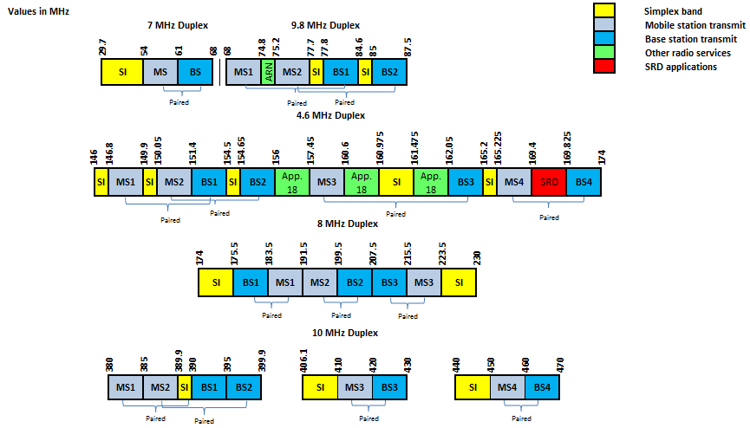
- Recommended frequency bands
App. 18: RR Appendix 18 for VHF maritime communications
ARN: Aeronautical radio navigation (ILS/marker beacons)
In paired bands, the figure above indicates the duplex separation for the individual bands for the pairing of the respective MS (mobile station transmit band) and BS (base station transmit band), e.g. MS1 with BS1 within one frequency range.

- Field Strength LEVELS for Cross-border Coordination between FDD Land Mobile systems using preferental channels up to 25 kHz and systems using A channel greater than 1 MHz within the 410-430 MHz and 450-470 MHz Frequency bands
This Annex considers the coordination between preferential channels of land mobile systems up to 25 kHz on one side and land mobile systems with a channel greater than 1 MHz on the other side of the border, for operation within the 400 MHz frequency bands.
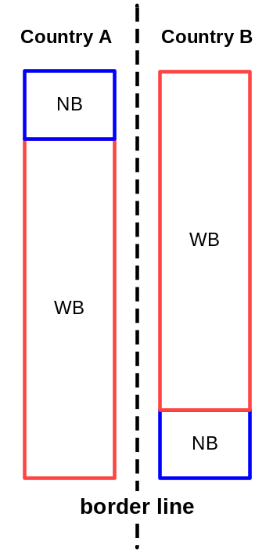
Figure 2: Overlapping narrower channel and wider channel land mobile systems across the border
According to recommends 3, the following should be taken into account:
- ECC Report 276 [4] provides a technical background for cross-border coordination of systems with a channel greater than 1 MHz in the 400 MHz band (410-430 MHz and 450-470 MHz) and proposes a method which can be applied in bilateral or multilateral agreements that allow for higher cross-border coordination thresholds for wideband systems in the 400 MHz band in situations where no or some overlap of narrowband and wideband allocations across the border occurs. In consequence, it means that land mobile systems up to 25 kHz keep their existing preferential rights and may extend them to all non-preferential channels in the overlapping range, if preferential rights of other administrations involved are not affected;
- The overlap is typically as small as a few hundred kilohertz. ECC Report 276 does not cover the case of full overlap between land mobile systems up to 25 kHz on one side and land mobile systems with a channel greater than 1 MHz on the other side of the border;
- In the situation where land mobile systems up to 25 kHz use preferential rights not to the full extent, i.e. they do not generate the maximum allowed field strength at a distance of 40 or 50 km in the territory of the neighbouring administration, solutions should be found between administrations or operators. One possible solution would be to increase the radiated power of the preferential system to the extent possible under preferential rights conditions. If not possible, a reduction of the radiated power of the system with a channel bandwidth > 1 MHz within the preferential frequency of the system with channel bandwidth up to 25 kHz may be considered;
- The two most common preferential regimes for narrowband systems were considered, both defined as the field strength threshold of 20 dB μV/m at 10 m height in 25 kHz at a distance inside the neighbouring country: Preferential Regime a) at 40 km distance and Preferential Regime b) at 50 km distance. The proposed coordination thresholds for a partial overlap of land mobile systems up to 25 kHz on one side and land mobile systems with a channel greater than 1 MHz on the other side of the border are given in Table 1:
Table 1: Trigger values for partial overlap between narrowband system and wideband systems at a height of 10 m above ground
 | Field strength at 10 m height
 | Regime a) | Regime b)
System up to 25 kHz using preferential frequency | 20 dBμV/m/25 kHz@40 km beyond the borderline | 20 dBμV/m/25 kHz@50 km beyond the borderline
System up to 25 kHz using NON-preferential frequency | 20 dBμV/m/25 kHz@0 km (on the borderline) | 20 dBμV/m/25 kHz@0 km  (on the borderline)
System with a channel greater than 1 MHz | 41 dBμV/m/25 kHz@0 km  (on the borderline) | 48 dBμV/m/25 kHz@0 km  (on the borderline)
Note: @ stands for “at a distance inside the neighbouring country”.
Note 1: Predictions for calculations: 50% location probability, 10% time probability
Note 2: If a channel bandwidth other than 25 kHz is used, then a bandwidth conversion factor of 10 x Log10 (channel bandwidth/25 kHz) should be added to the field strength values.
Note 3: For narrowband land mobile systems using preferential frequencies and bandwidth greater than 25 kHz (e.g. 50 kHz, 100 kHz, 150 kHz or 200 kHz), indicative coordination threshold levels should be applied within every 25 kHz bandwidth within the channel spacing.
For practical purposes, an antenna height correction factor of 10 dB from 10 m to 3 m height may be used. Other examples are the Okumura-Hatta model [6] that provides 15.6 dB, the ITU-R Recommendation P.1546 [8] that provides 10.3 dB or HCM that provides 9 dB.
- FIELD STRENGTH LEVELS FOR CROSS-BORDER coordination BETWEEN fdd land moBile systems with channels greater than 1 MHz IN the FREQUENCY BANDS 410-430 mhz AND 450-470 mhz
This Annex considers the coordination between land mobile systems with channel bandwidths greater than 1 MHz on both sides of the border, for operation within the 400 MHz ranges. ECC Report 276 [4] provides technical background information. The deployment mode considered is FDD in the frequency bands 410-420 MHz (duplex with 420-430 MHz) and 450-460 MHz (duplex with 460-470 MHz).
  - Field strength trigger values for LTE/NR vs. LTE/NR and CDMA vs. CDMA systems
    - Case A
Base stations using the same technologies on both sides of the borderline with centre frequencies not aligned for all codes/PCIs, or using preferential PCIs or PN (Pseudo-Noise) codes given in Annex 5 with centre frequencies aligned may be used without coordination between neighbouring countries if the mean field strength produced by the cell (all transmitters within the sector) does not exceed the value of 55 dBμV/m/5MHz at a height of 3 m above ground at the borderline between neighbouring countries and does not exceed a value of 37 dBμV/m/5MHz at a height of 3 m above ground at a distance of 10 km inside the neighbouring country.
    - Case B
Base stations using the same technologies on both sides of the borderline with centre frequencies aligned and using non-preferential PN codes or PCIs given in Annex 5 may be used without coordination between neighbouring countries if the mean field strength produced by the cell (all transmitters within the sector) does not exceed the value of 37 dBμV/m/5MHz at a height of 3 m above ground at the borderline between neighbouring countries.
  - Field strength trigger values between LTE/NR and CDMA
    - Case A
In case of different technologies used on both side of the borderline, with centre frequencies aligned or not aligned, base stations may be used without coordination with a neighbouring country if the mean field strength produced by the cell (all transmitters within the sector) does not exceed the value of 55 dBμV/m/5MHz at a height of 3 m above ground at the borderline between neighbouring countries and does not exceed a value of 37 dBμV/m/5MHz at a height of 3 m above ground at a distance of 10 km inside the neighbouring country.
  - Overview of the trigger values
For land mobile systems with channel bandwidth greater than 1 MHz, an overview of the trigger values of the field strength and the relevant paragraphs of this Annex are given in Table 2.

Table 2: Field strength triggers for FDD LTE/NR/CDMA systems at a height of 3 m above ground
 | Non-Preferential frequency usage
 | Centre frequencies  aligned |  | Centre frequencies  not aligned
 | Preferential  codes/PCIs | Non-preferential  codes/PCIs | All codes/PCIs
LTE/NR vs. LTE/NR  or  CDMA vs. CDMA | 55 dBμV/m/5 MHz@0 km and 37 dBμV/m/5 MHz@10 km  Case A | 37 dBμV/m/5 MHz@0 km  Case B | 55 dBμV/m/5 MHz@0 km and 37 dBμV/m/5 MHz@10 km  Case A
LTE/NR vs. CDMA | 55 dBμV/m/5 MHz@0 km and 37 dBμV/m/5 MHz@10 km  Case A
Note: @ stands for “at a distance inside the neighbouring country”.
Note 1: Predictions for calculations: 50% location probability, 10% time probability
Note 2: If a channel bandwidth other than 5 MHz is used, then a bandwidth conversion factor applies: 10 x Log10 (channel bandwidth /5 MHz)
  - Preferential frequencies for LTE/NR/CDMA
Administrations may agree in bilateral or multilateral agreements/arrangements on preferential usage of frequencies, while ensuring a fair treatment of different operators.

- PREFERENTIAL PHYSICAL-LAYER CELL IDENTITIES (PCI) FOR LTE, NR AND CODES FOR CDMA
  - PCI coordination for LTE and for NR
PCI coordination is only needed when channel centre frequencies are aligned independent of the channel bandwidth.
ETSI TS 136 211 [5] defines 168 “unique physical-layer cell-identity groups for LTE” in §6.11, numbered 0…167, hereafter called “PCI groups”. Within each PCI group there are three separate PCIs giving 504 PCIs in total.
ETSI TS 138 211 [9] defines 336 “unique physical-layer cell-identity groups for NR” in §7.4.2, numbered 0…335, hereafter called “PCI groups”. Within each PCI group there are three separate PCIs giving 1008 PCIs in total.
Administrations should agree on a repartition of these 504 PCIs for LTE and 1008 PCIs for NR on an equitable basis when channel centre frequencies are aligned as shown in Table 3. It has to be noted that dividing the PCI groups or PCIs is equivalent. Each country should only use its own preferential PCIs close to the border.
As shown in Table 3, the PCIs should be divided into 6 sub-sets containing each one sixth of the available PCIs. Each country is allocated three sets (half of the PCIs) in a bilateral case, and two sets (one third of the PCIs) in a trilateral case.
Four types of countries are defined in a way such that no country will use the same code set as any one of its neighbours. The following lists describe the distribution of European countries:
Type country 1: AZE, BEL, CVA, CYP, CZE, DNK, E, FIN, GRC, IRL, ISL, LTU, MCO, SMR, SUI, SRB, SVN, and UKR;
Type country 2: AND, BIH, BUL, D, EST, G, GEO, HNG, I and MDA;
Type country 3: AUT, F, HOL, MLT, MNE, MKD, POL, POR, ROU and S;
Type country 4: ALB, HRV, LIE, LUX, LVA, NOR, SVK, and TUR.
For each type of country, the following tables and figure describe the sharing of the PCIs with its neighbouring countries, with the following conventions of writing:
Preferential PCI
Non-preferential PCI

The PCIs should be divided into the following 6 sub-sets when the carrier frequencies are aligned in border areas:

Table 3: PCI sub-sets for LTE and NR for use in border areas
PCI | Set A | Set B | Set C | Set D | Set E | Set F |  | PCI | Set A | Set B | Set C | Set D | Set E | Set F
Country 1  LTE | 0..83 | 84..167 | 168..251 | 252..335 | 336..419 | 420..503 |  | Country 2  LTE | 0..83 | 84..167 | 168..251 | 252..335 | 336..419 | 420..503
Country 1  NR | 0..83  504..587 | 84..167  588..671 | 168..251  672..755 | 252..335  756..839 | 336..419  840..923 | 420..503  924..1007 |  | Country 2  NR | 0..83  504..587 | 84..167  588..671 | 168..251  672..755 | 252..335  756..839 | 336..419  840..923 | 420..503  924..1007
Border 1-2 |  |  |  |  |  |  |  | Border 2-1
Zone 1-2-3 |  |  |  |  |  |  |  | Zone 2-3-1
Border 1-3 |  |  |  |  |  |  |  | Border 2-3
Zone 1-2-4 |  |  |  |  |  |  |  | Zone 2-1-4
Border 1-4 |  |  |  |  |  |  |  | Border 2-4
Zone 1-3-4 |  |  |  |  |  |  |  | Zone 2-3-4
PCI | Set A | Set B | Set C | Set D | Set E | Set F |  | PCI | Set A | Set B | Set C | Set D | Set E | Set F
Country 3  LTE | 0..83 | 84..167 | 168..251 | 252..335 | 336..419 | 420..503 |  | Country 4  LTE | 0..83 | 84..167 | 168..251 | 252..335 | 336..419 | 420..503
Country 3  NR | 0..83  504..587 | 84..167  588..671 | 168..251  672..755 | 252..335  756..839 | 336..419  840..923 | 420..503  924..1007 |  | Country 4  NR | 0..83  504..587 | 84..167  588..671 | 168..251  672..755 | 252..335  756..839 | 336..419  840..923 | 420..503  924..1007
Border 3-2 |  |  |  |  |  |  |  | Border 4-1
Zone 3-1-2 |  |  |  |  |  |  |  | Zone 4-1-2
Border 3-1 |  |  |  |  |  |  |  | Border 4-2
Zone 3-1-4 |  |  |  |  |  |  |  | Zone 4-2-3
Border 3-4 |  |  |  |  |  |  |  | Border 4-3
Zone 3-2-4 |  |  |  |  |  |  |  | Zone 4-3-1
Note: The country type map is given in Figure 3.

  - Code coordination for CDMA
For code coordination each base station shall use a unique time offset of the pilot pseudo-noise (PN) sequence to identify a Forward CDMA Channel. Time offsets may be reused within a CDMA cellular system. Distinct pilot channels shall be identified by an offset index (0 through 511 inclusive). This offset index specifies the offset time from the zero offset pilot PN sequence in multiples of 64 chips. The same pilot PN sequence offset shall be used on all CDMA frequency assignments for a given base station. To distinct signals with PN sequence offsets all base stations should be time synchronised but such synchronisation is mandatory requirement for CDMA2000 standard.
Administrations should agree on a repartition of these offset indexes on an equitable basis. Each country should only use its own codes close to the border.
In border areas, codes will be divided into 6 "index sets" containing each one sixth of the available offset indexes. Each country is allocated three index sets (half of the indexes) in a bilateral case, and two index sets (one third of the indexes) in a trilateral case.
Four types of countries are defined in such a way that no country will use the same index set as any one of its neighbours. The following lists describe the distribution of European countries:
Type country 1: AZE, BEL, CVA, CYP, CZE, DNK, E, FIN, GRC, IRL, ISL, LTU, MCO, SMR, SRB, SUI, SVN and UKR;
Type country 2: AND, BIH, BUL, D, EST, G, GEO, HNG, I and MDA;
Type country 3: AUT, F, HOL, MLT, MNE, MKD, POL, POR, ROU and S;
Type country 4: ALB, HRV, LIE, LUX, LVA, NOR, SVK and TUR.
For each type of country, the following tables and figure describe the sharing of the indexes with its neighbouring countries, with the following conventions of writing:
Preferential index
non-preferential index

Table 4: Sharing of the indexes
 | Set A | Set B | Set C | Set D | Set E | Set F |  |  | Set A | Set B | Set C | Set D | Set E | Set F
Country 1 | 2..83 | 88..168 | 173..253 | 258..338 | 343..423 | 428..509 |  | Country 2 | 2..83 | 88..168 | 173..253 | 258..338 | 343..423 | 428..509
Border 1-2 |  |  |  |  |  |  |  | Border 2-1
Zone 1-2-3 |  |  |  |  |  |  |  | Zone 2-3-1
Border 1-3 |  |  |  |  |  |  |  | Border 2-3
Zone 1-2-4 |  |  |  |  |  |  |  | Zone 2-1-4
Border 1-4 |  |  |  |  |  |  |  | Border 2-4
Zone 1-3-4 |  |  |  |  |  |  |  | Zone 2-3-4
 | Set A | Set B | Set C | Set D | Set E | Set F |  |  | Set A | Set B | Set C | Set D | Set E | Set F
Country 3 | 2..83 | 88..168 | 173..253 | 258..338 | 343..423 | 428..509 |  | Country 4 | 2..83 | 88..168 | 173..253 | 258..338 | 343..423 | 428..509
Border 3-2 |  |  |  |  |  |  |  | Border 4-1
Zone 3-1-2 |  |  |  |  |  |  |  | Zone 4-1-2
Border 3-1 |  |  |  |  |  |  |  | Border 4-2
Zone 3-1-4 |  |  |  |  |  |  |  | Zone 4-2-3
Border 3-4 |  |  |  |  |  |  |  | Border 4-3
Zone 3-2-4 |  |  |  |  |  |  |  | Zone 4-3-1
Note: The country type map is given in Figure 3.

Because of the time shifting mechanism for code generation, the situation can appear that propagation delay may lead to the synchronisation of two different base stations signals occurring in some parts of the service area. The average diameter of such correlation areas could be up to 245 meters (one chip duration multiplied on light speed). To prevent such situations in border areas it is recommended not to use some codes and to introduce 4 exclusion codes between neighbouring index sets what gives 78.125 km propagation path before a possible correlation area appears. This precludes any real synchronisation and will not affect network planning, causing a reduction of code space less than on 5% only in border areas.
Code sharing between two countries should be applied or used by base stations that exceed the relevant trigger level (Annex 4, Table 2) of only one neighbouring country. Code sharing between three countries should be applied or used by base stations that exceed the relevant trigger level (Annex 4, Table 2) of two neighbouring countries.

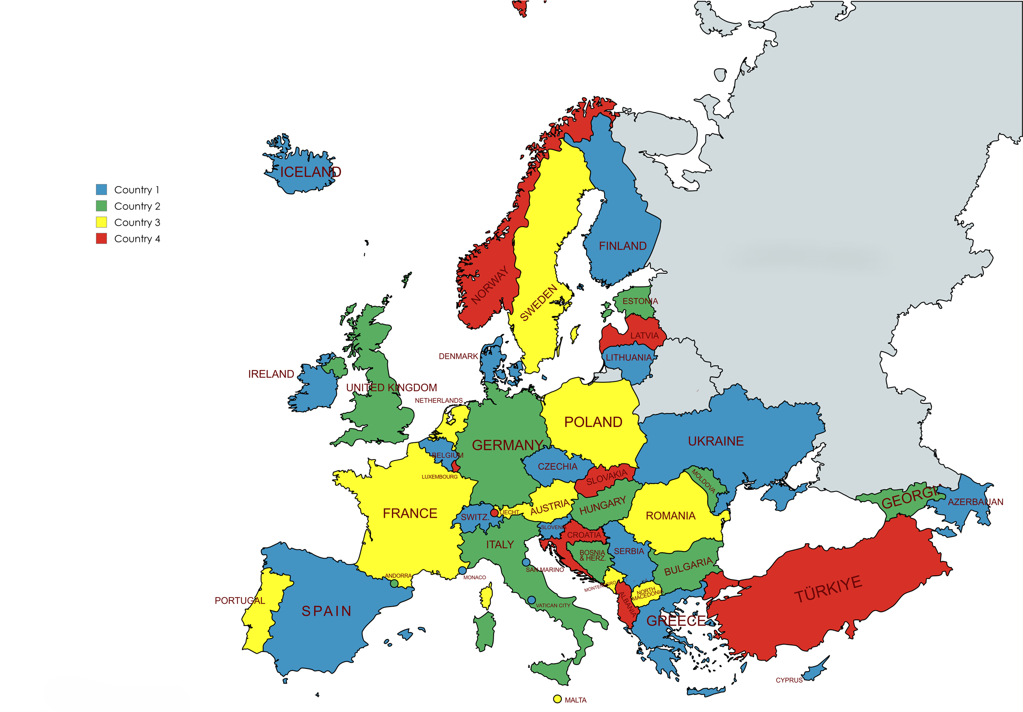
Figure 2: Country type map

- List of References
- ECC Report 97: “Cross Border Interference for Land Mobile Technologies”, approved February 2007
- ECC Report 108: “Border Code Coordination between CDMA-PAMR Systems”, approved October 2007
- ERC Report 25:“The European table of frequency allocations and applications in the frequency range 8.3 kHz to 3000 GHz”, approved 1994, latest amended January 2025
- ECC Report 276: “Thresholds for the coordination of CDMA and LTE broadband systems in the 400 MHz band”, approved April 2018
- ETSI TS 136 211: LTE; Evolved Universal Terrestrial Radio Access (E-UTRA); Physical channels and modulation (3GPP TS 36.211 version)
- ERC Report 68: “Monte-Carlo Radio Simulation Methodology for the use in sharing and compatibility studies between different radio services or systems, approved February 2000, latest revised June 2002
- HCM Agreement: https://hcm.bundesnetzagentur.de/http/englisch/verwaltung/index_europakarte.htm
- ITU-R Recommendation P.1546-6 (08/2019): “Method for point-to-area predictions for terrestrial services in the frequency range 30 MHz to 4 000 MHz
- ETSI TS 138 211: “NR; Physical channels and modulation (3GPP TS 38.211 version)”
- Radio Regulations, edition 2024

Channel spacing refers to the distance between the nominal centre frequencies of adjacent channels. Channel bandwidth is most commonly understood as the bandwidth which is used by the system as defined in the respective standards.
In certain situations, the 1% time curves should be used for digital systems, e.g. to better protect analogue systems.

