
Electronic Communications Committee (ECC)
within the European Conference of Postal and Telecommunications Administrations (CEPT)

COMPATIBILITY STUDIES BETWEEN
MULTIPLE GIGABIT WIRELESS SYSTEMS
IN FREQUENCY RANGE 57-66 GHz AND
OTHER SERVICES AND SYSTEMS
(EXCEPT ITS IN 63-64 GHz)

Budapest, September 2007
Revised Hvar, May 2009

EXECUTIVE SUMMARY
Introduction
This study was carried out in order to determine the technical and operational requirements to be associated with deployment of Multiple Gigabit Wireless Systems (MGWS) in Europe. The compatibility study was initiated in response to the requirements for MGWS deployment specified in ETSI TR 102 555 [1]. The report considered frequency range 57-66 GHz for MGWS deployment, excluding the compatibility with ITS in 63-64 GHz, which is a subject studied in a different ECC Report 113.

Compatibility findings
Three of the existing services in the subject band were identified for detailed compatibility analysis with MGWS as presented in this report: Fixed Service, Radiolocation and EESS, with the conclusions summarised below. For details of the scenarios see the Section 4 (with an e.i.r.p. of 40 dBm) and Annex 4 (with an e.i.r.p. of 55 dBm) of this report.

Frequency band | Required separation distances with offset angles of 5-15⁰ (see section 4 and Annex 4 for details), m |  | Critical scenario
Frequency band | MGWS WLAN/WPAN | MGWS FLANE | Critical scenario
57-59 GHz | 330-18 | 2250-1500 | PP FS into FLANE
59-63 GHz | 370/1100 | 2220(Note) | FLANE into RLS
59-63 GHz | 1000/1950 | 3300 (Note) | RLS into FLANE
63-64 GHz | Subject of a separate study, see ECC Report 113
64-66 GHz | 670-33 | 6500-2650 | FLANE into PP FS
Note: side-lobe gain of 10 dBi applied for radar antenna.

Regarding the critical case of MGWS-FS co-existence, it appears that indoor WLAN and WPAN applications of MGWS may be deployed in 57-59 GHz and 64-66 GHz without significant risk of interference to PP FS/HDFS links, whereas deployment of FLANE may require taking some precautionary provisions in both considered bands, to ensure co-existence with the PP FS links.

No compatibility problems between MGWS and EESS in the frequency range 57- 59.3 GHz were identified since the density of MGWS transmitters that would be needed to exceed the EESS interference limits is comfortably above expected MGWS deployment densities, also noting that the real tolerable density of WLAN/WPAN deployment will be much higher due to additional attenuation provided by indoor deployment.

Discussion of regulatory options requiring further consideration
Analysis of the results of compatibility studies suggests that the introduction of various applications in MGWS family across the range 57-66 GHz may not be resolved through a single cut regulatory solution, therefore this report outlines some ideas that could be used to develop appropriate regulatory framework for introduction of MWGS.

The first obvious observation is that the very different compatibility results for FLANE as opposed to WLAN & WPAN applications of MGWS call for different regulatory considerations, which are discussed below.

It should be also noted that introduction of different types of MGWS applications (that might be both MOBILE and FIXED) may need an update of the current service allocations in the ECA (ERC Report 25).

MGWS WLAN/WPAN
It may be safely assumed that MGWS WLAN & WPAN applications would be deployed pre-dominantly indoors leading to overall low risk of interference. Therefore it would appear that WLAN & WPAN applications might be allowed to be deployed across entire frequency range 57-66 GHz on the licence-exempt provisions with emission limitations considered in this study, based on current TR 102 555 (+40 dBm e.i.r.p., etc.).
Possible technical measures to ensure indoor usage and give additional degree of interference protection could include obligations for integral antennas.

It was also noted that some kind of Dynamic Frequency Selection (DFS)/Detect-And-Avoid (DAA) mechanism may be introduced to ensure intra-system co-existence between WLAN/WPAN installations, which would also provide additional mitigation of inter-service interference, but practical implementation and feasibility of this measure was not further considered in this report as this was felt being outside the mandate of this study.

MGWS FLANE
MGWS FLANE applications would be deployed pre-dominantly outdoors and would require significant separation distances or sufficient antenna discrimination to avoid interference into radio links of other systems as well as between different FLANE links.

Note: According to ECC/REC/(09)01, it should be considered that FLANE MGWS systems are technically equal to any PP application and are considered to be part of the Fixed Service.

In that respect it should be also noted that in terms of technical parameters as well as physically and conceptually the FLANE links would resemble the PP FS links used today in 57-59 GHz and 64-66 GHz bands.

Therefore it may be suggested that the regulatory framework for FLANE should either:
- be identical to one or the combination of the regulatory frameworks existing today for PP FS (ERC/REC 12-09 [2] for PP FS in 57-59 GHz and ECC/REC/(05)02 [3] for PP FS in 64-66 GHz),
or
- any new provisions for the FLANE application throughout the entire range 57-66 GHz should be also applicable for “traditional” FS PP links with the same access conditions (radio interface specifications).

However since FLANE brings some new technical elements to the current PP FS technology, such as using very high bandwidth channels, some mutual mitigation provisions might be appropriate, e.g. setting a minimum antenna gain in association with relevant maximum e.i.r.p. limits.

It should be further noted that the present regulatory framework for PP FS in 57-59 GHz provides channels up to 100 MHz only, which is considered insufficient for FLANE applications.

Allocations in other parts of the world
It should be noted that US/Canada and Korea allocated the band 57-64 GHz for licence exempt applications similar to MGWS. Similar allocation in Japan for licence-exempt operation is in 59-66 GHz, whereas in Australia it is in 59-63 GHz.

Table of contents
0 EXECUTIVE SUMMARY 2
1 Introduction 6
2 Global market situation 6
3 Description of MGWS at 57-66 GHz 6
3.1 Overview 6
3.2 Technical description of MGWS 8
3.2.1 Parameters for MGWS WPAN and WLAN 9
3.2.2 Parameters for MGWS FLANE 10
3.2.3 General MGWS parameters used for interference assessment 10
3.2.4 Propagation modelling 11
4 Compatibility between MGWS and other services/systems 12
4.1 MGWS vs Fixed Services in 57-59 GHz and 64-66 GHz 13
4.1.1 Fixed Services in 57-59 GHz 13
4.1.2 Fixed Services in 64-66 GHz 14
4.1.3 Impact of MGWS on PP FS links 16
4.1.4 Impact of PP FS links on MGWS 20
4.1.5 Conclusions on MGWS-FS compatibility 22
4.2 MGWS vs Radiolocation in 59-64 GHz 23
4.2.1 Introduction 23
4.2.2 Impact of MGWS on Radiolocation 24
4.2.3 Impact of Radiolocation on MGWS FLANE 24
4.2.4 Conclusions on MGWS-Radiolocation compatibility 26
4.3 MGWS vs Earth Exploration Satellite Service 27
4.3.1 EESS frequency bands in 57-66 GHz range 27
4.3.2 Interference criteria for EESS (passive) in 57-59.3 GHz 27
4.3.3 Atmospheric attenuation around 60 GHz 28
4.3.4 Nadir-looking passive sensors in the 60 GHz range 29
4.3.5 Compatibility between MGWS and EESS in 57-59.3 GHz 30
4.3.6 Conclusions on EESS-MGWS compatibility 31
4.4 Situation with other services 31
4.4.1 Inter-Satellite Service 31
4.4.2 Fixed Services in 59-62 GHz 31
4.4.3 Radio Astronomy Service in 58.2-59 GHz 32
4.4.4 Mobile Service in 57-58.2 / 59-64 GHz 32
4.4.5 Mobile Service in 64-66 GHz 32
4.4.6 Mobile Service in adjacent band 66-71 GHz 32
4.4.7 Radio Navigation in adjacent band 66-71 GHz 32
4.4.8 Radio Navigation Satellite in adjacent band 66-71 GHz 32
4.4.9 Space Research in 55.78-59.3 / 65-66 GHz 32
4.4.10 Short Range Devices in 61-61.5 GHz 32
5 Overall conclusions of the report 32
5.1 Conditions for compatibility 32
5.1.1 MGWS co-existence with Fixed Service links 33
5.1.2 MGWS co-existence with Radiolocation 33
5.1.3 MGWS co-existence with EESS 33
5.2 Consequential regulatory considerations 33
5.2.1 MGWS WLAN&WPAN 33
5.2.2 MGWS FLANE 34
5.2.3 Allocations in other parts of the world 34
Annex 1: Specific Oxygen Attenuation (dB) – Recommendation ITU-R P.676 35
Annex 2: Zenith Oxygen Attenuation (dB) – Recommendation ITU-R P.676 [6] 36
Annex 3: Results for AMSU and Push broom systems 37
Annex 4: Compatibility Between MGWS PP (FLANE with e.i.r.p. of 55dBm) and other Services/Systems 38
Annex 5: List of References 44
List of Abbreviations

Abbreviation | Explanation
CEPT | European Conference of Postal and Telecommunications Administrations
DAA | Detect-And-Avoid
e.i.r.p. | Equivalent isotropically radiated power
EESS | Earth Exploration Satellite Service
ETSI | European Telecommunications Standards Institute
FLANE | Fixed Local Area Network Extension, a sub-system of MGWS
FS | Fixed Service
HDFS | High Density Fixed Service applications
ISS | Inter Satellite Service
ITS | Intelligent Transport System
MGWS | Multiple Gigabit Wireless System
WLAN | Wireless Local Area Network, a sub-system of MGWS
WPAN | Wireless Personal Area Network, a sub-system of MGWS
RLS | Radio Location Service
SRD | Short Range Devices
SRDoc | System Reference Document

Compatibility studies between multiple GIGABIT wireless systems in frequency range 57-66 GHz
and other services and systems (except its in 63-64 GHz)

Introduction
This study was carried out in order to determine the technical and operational requirements to be associated with deployment of Multiple Gigabit Wireless Systems (MGWS) in Europe. The compatibility study was initiated in response to the requirements for MGWS deployment specified in ETSI TR 102 555 [1].

Originally, the ETSI SRDoc has envisaged deployment of MGWS across the tuning range of 59-66 GHz, however, at a later stage it was decided by CEPT ECC/WGFM to extend compatibility studies to the frequency range 57-66 GHz in order to align it with the frequency use in other parts of the world.

Accordingly this report considered the compatibility of MGWS operating across the frequency range 57-66 GHz, except compatibility with ITS applications in 63-64 GHz. The issue of MGWS-ITS compatibility was studied as a part of separate study on introduction of ITS with results being published in a separate ECC Report.

Global market situation
Envisaged by ETSI license-exempt operations in the 60 GHz range are expected to encompass applications for wireless digital video, audio, and control applications, as well as multiple gigabit wireless local area networks. The total available market addressed by these applications in the 60 GHz range is expected to be 50 million units by 2010. Further details are provided in Annex A of ETSI TR 102 555.

To achieve international harmonization with bands approved for use in Australia, Canada, Japan, and the United States, and under final review in the Republic of Korea, there was expressed a desire for similar license exempt usage in Europe for the frequency range from 57 GHz to 66 GHz. Enabling the full band would enable consumers to legitimately access devices created for the various international markets. Expansion of license exempt regimes to the 60 GHz would reduce spectrum congestion at lower, license exempt frequencies and increase the availability of low cost, gigabit and faster wireless systems in Europe.
Recent technological advances in high frequency, wide band radios are enabling low cost, mass-market implementations that use air interfaces between 500 MHz and 2 500 MHz of bandwidth, and use the propagation characteristics of the band along with directional antennas to enable a high level of spectrum reuse. Thus, an allocation of 9000 MHz in the frequency tuning range from 57 GHz to 66 GHz was requested to enable multiple, co-located wireless designs with similar characteristics to those in North America and the Pacific Rim.
As a percentage of the carrier frequency, the bandwidth of individual channels and the total allocation in the 60 GHz range as a whole would be comparable to the proportions of license-exempt bands at lower frequencies.

Description of MGWS at 57-66 GHz

Overview
MGWS applications are sub-divided into three types: two nomadic applications (WPAN, WLAN) and one fixed application (FLANE). Description of these applications is provided below.

Wireless Local Area Network (WLAN): radiocommunications network used in short range, line-of-sight and non-line-of-sight circumstances. Total range and performance will vary depending on the environment, but full WLAN performance is typically expected at ranges of 10 to 100 m. The access point is mounted indoor with service covering an office space with a nomadic user terminal typically also used indoor, i.e. the entire WLAN system would be used in indoor environment. WLAN deployment is illustrated below in Figure 1.

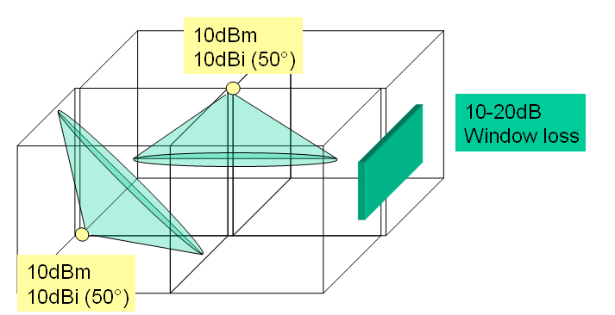

Figure 1: Illustration of indoor WLAN deployment

Wireless Personal Area Network (WPAN): radiocommunications network or single link used in line-of-sight or near-line-of-sight circumstances. Total range and performance will vary depending on the environment, but full WPAN performance is typically expected at ranges of less than 10 m or within a single room in an indoor environment. Typical application is equipment to equipment (e.g. Laptop to Projector) and it may be assumed that while predominantly WPAN would be used indoor, an occasional outdoor use may not be precluded. An illustration of WPAN deployment is given in Figure 2.

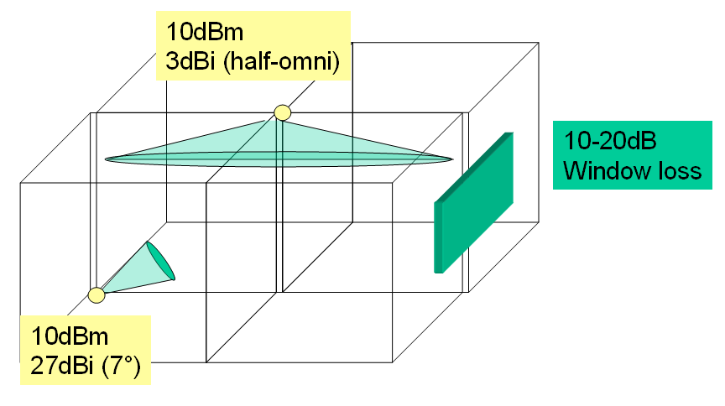
Figure 2: Illustration of indoor WPAN deployment

Fixed Local Area Network Extension (FLANE): radiocommunications link established between two points (identical to traditional Point-to-Point FS link, but addressing much higher bandwidth than used by FS today) used in line-of-sight circumstances. Total range and performance will vary depending on the environment, but full FLANE performance is typically expected at ranges of 10-800 m. The typical application is LAN extension in cases where cable is not appropriate. Possible deployment scenarios may include connections between buildings, on a campus etc. Example of FLANE deployment is given in Figure 3.

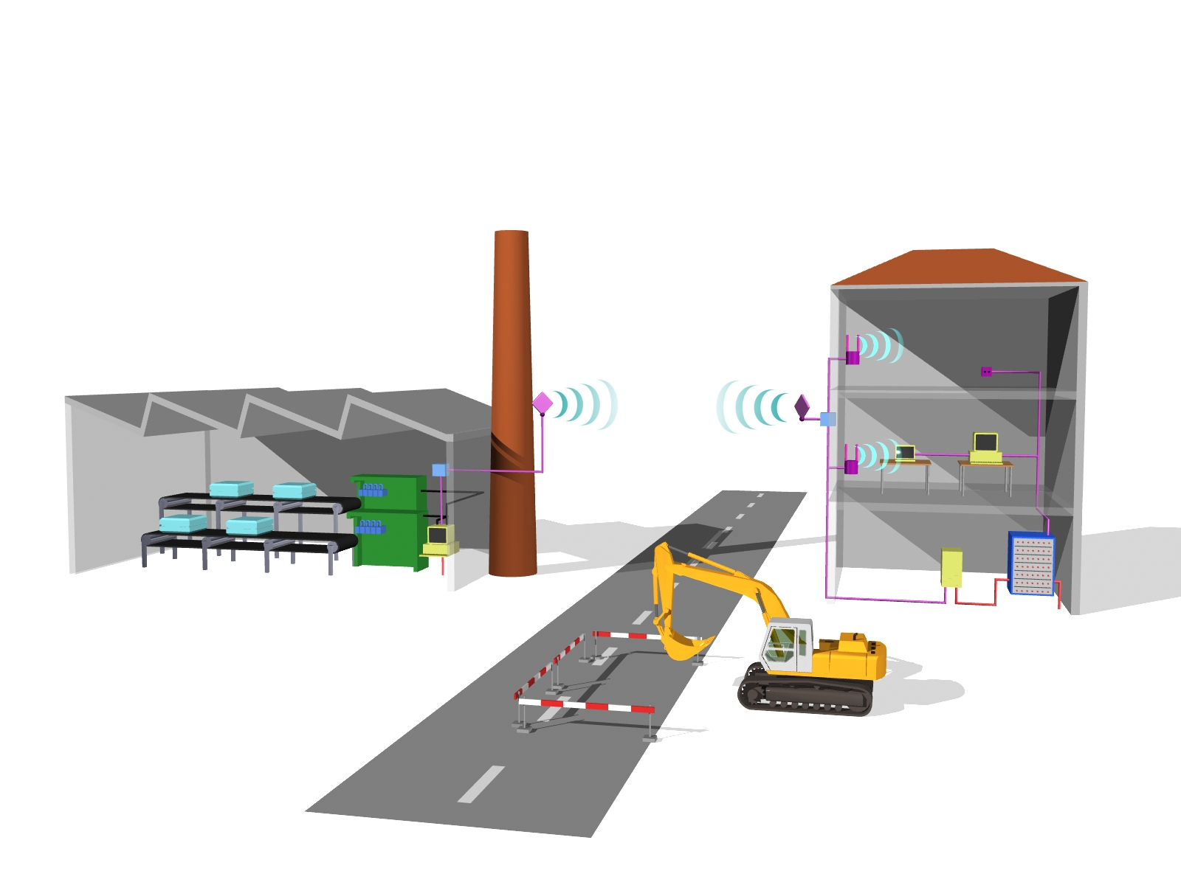
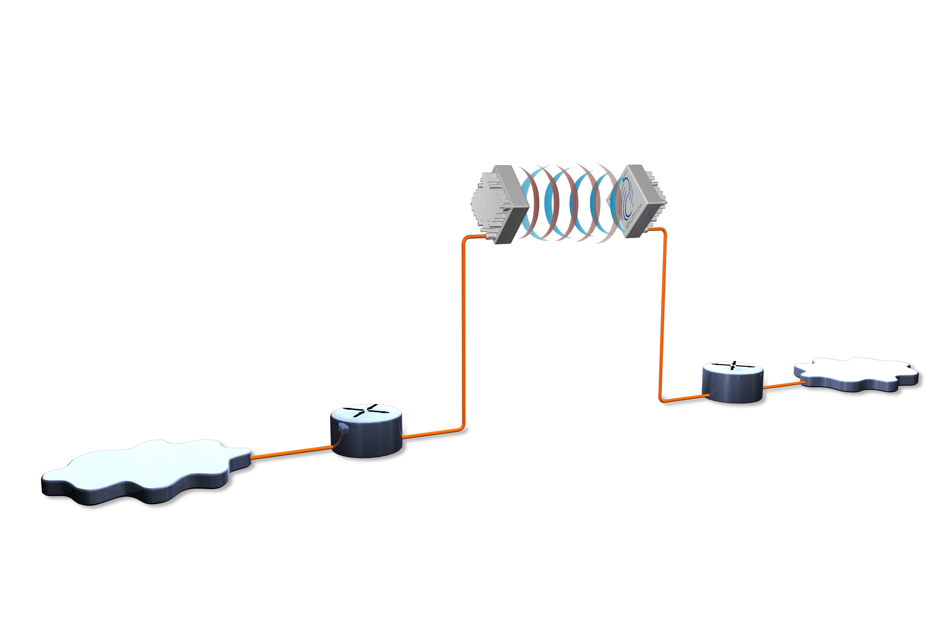
Network A
Network B

Figure 3: Illustration of outdoor FLANE deployment

Technical description of MGWS
The parameters of MGWS are provided in this section based on specifications in ETSI TR 102 555.

It should be noted that ETSI TR 102 555 [1] specifies two generic power limits: maximum e.i.r.p. of 40 dBm and maximum conducted output power of 27 dBm. However the latter value was not considered appropriate in this study due to a possible conflict with maximum e.i.r.p. and antenna gain considerations for the various MGWS applications (in particular FLANE case).

Parameters for MGWS WPAN and WLAN

Parameter | Value/characteristic | Comments
Maximum mean e.i.r.p. | +40 dBm
Antenna aperture/gain | 50° / 10dBi  7° / 27dBi | A variety of antennas may be used according to specific applications.  Typical indoor distribution scenario connecting user to an access point with very little alignment effort. Both user equipment and access point use similar antenna.  Indoor distribution system using half-omni antenna at access point in combination with highly directional user equipment antenna.
Examples of typical modulation schemes | ASK, FSK, QPSK, OFDM | Modulation schemes currently used by broadband wireless air interfaces
Typical data rates | 100Mbps-10 Gbps  physical layer | Depending on the channel size and modulation method
Channel Bandwidth | From 500 MHz to 2.5 GHz | Depending on desired data rate and modulation. Channel spacing is not formally defined but assumed to be equal to at least channel bandwidth
Communication mode | Half Duplex, Full Duplex, Simplex | FDD and simplex are believed to be adequate for the applications considered to date. TDD was not envisaged up to date, but is not excluded.
Typical maximum BER | <10⁻⁶ | Depending on the application
Typical Noise Figure | 10 dB
Protection criteria | I/N= -10 dB
Table 1: MGWS WPAN and WLAN parameters

An example of required typical channel bandwidth for a reference 1 Gb/s link is listed in Table 2.

Modulation scheme | Occupied bandwidth, MHz
16QAM | 500
4QAM | 1000
FSK | 1250
On-Off Keying | 2200
Table 2: Typical occupied bandwidth for a reference 1 Gb/s bitrate

Parameters for MGWS FLANE

Parameter | Value/characteristic | Comments
Maximum mean e.i.r.p. | +40 dBm  +55 dBm | In case FLANE is deployed with max. e.i.r.p of 55dBm please see Annex 4
Maximum OOB noise floor e.i.r.p. | −24 dBm/MHz | Evaluated from Figure 4 for a 250 MHz FLANE bandwidth
Antenna aperture/gain | 2° / 38 dBi | Typical building to building FLANE application
Gain in side lobes (>~5º) | < 18 dBi (Note) | Evaluated on typical ITU-R F.699 radiation patterns
Gain in side lobes (>~15º) | < 8 dBi (Note) | Evaluated on typical ITU-R F.699 radiation patterns
Examples of typical modulation schemes | ASK, FSK, QPSK, OFDM | Modulation schemes currently used by broadband wireless air interfaces
Typical data rates | 100 Mbps-10 Gbps  physical layer | Depending on the channel size and modulation method
Channel Bandwidth | From 150 MHz to 2.5 GHz | Depending on desired data rate and modulation. Channel spacing is not formally defined but assumed to be equal to at least channel bandwidth
Communication mode | Half Duplex, Full Duplex | FDD is considered to date. TDD was not envisaged up to date, but is not excluded.
Typical maximum BER | <10⁻⁶ | Depending on the application
Typical Noise Figure | 10 dB
Protection criteria | I/N= -10 dB | Generic interference protection criterion
Minimum C/I (co-channel equivalent) | C/I ≥ 25 dB | To be applied in case of co-located routes, different channel scenarios
Table 3: MGWS FLANE parameters
Note: the given antenna side-lobe values are derived from the ITU-R Rec. F.699. However some existing antenna technologies may give better side lobe reduction, e.g. one manufacturer quoted side lobe gains of 8 dBi at 5⁰ and -10 dBi at 15⁰.

It was noted that in the frequency bands 57-59 GHz and 64-66 GHz the P-P FLANE applications might be deployed under provisions applicable to “traditional” PP FS service (ERC/REC 12-09 [2] in 57-59 GHz and ECC/REC/(05)02 [3] in 64-66 GHz), which e.g. allow higher e.i.r.p.. However, it was understood that these FS regulations might not be appropriate for FLANE MGWS applications, in particular in the band 57-59 GHz due to higher channel bandwidth requirements.

General MGWS parameters used for interference assessment
List of additional technical parameters of MGWS used in the compatibility analysis:
- Antenna pattern – based on ITU-R Rec. F.699 [4] or -20dB rejection in the side lobes;
- “Typical” power is referred in simulations which is understood to be the power which will make sure the application will work in typical weather conditions and related availability, whereas “Maximum” power is the theoretical maximum emitted power given in corresponding CEPT REC or ETSI TR/EN;
- Emission mask of MGWS transmitter is given below in Figure 4 (reproduced from Figure B.3 of TR 102 555 [1]).
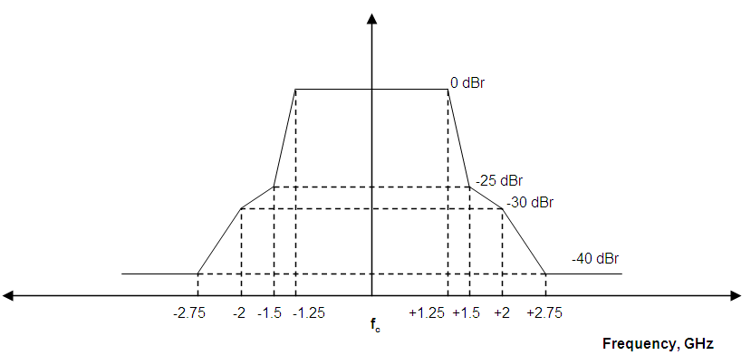

Figure 4: MGWS emission mask

It should be also noted that MGWS equipment will have to comply with spurious emission limits given in ERC/REC 74-01 [5].

Propagation modelling
The attenuation on the path may be calculated by adding to the free space attenuation the gaseous absorption as described in Recommendation ITU-R P.676-6 (Annex 1) [6].

The indoor-to-outdoor penetration loss value of 15 dB may be assumed, based on average value derived from simple practical measurements, representative of double-glazed window.

Compatibility between MGWS and other services/systems
List of other services to be considered for compatibility study was derived from information on allocation of frequencies in European Common Frequency Allocations table.

The following Table 4 provides a resulting list of frequency allocations that might be relevant for in-band or adjacent band compatibility analysis vis-à-vis considered MGWS deployment in the frequency range 57-66 GHz.

FREQUENCY BAND | ALLOCATIONS | APPLICATIONS
55.78 - 56.9 GHz | EARTH EXPLORATION-SATELLITE (passive)  FIXED  INTER-SATELLITE  SPACE RESEARCH (passive) | Passive sensors (satellite) (52.6 - 59.3 GHz)  Fixed links (55.78 - 59.0 GHz)
56.9 - 57.0 GHz | EARTH EXPLORATION-SATELLITE (passive)  FIXED  MOBILE  SPACE RESEARCH (passive) | Passive sensors (satellite) (52.6 - 59.3 GHz)  Fixed links (55.78 - 59.0 GHz)
57.0 - 58.2 GHz | EARTH EXPLORATION-SATELLITE (passive)  FIXED  INTER-SATELLITE  MOBILE  SPACE RESEARCH (passive) | Passive sensors (satellite) (52.6 - 59.3 GHz)  Fixed links (55.78 - 59.0 GHz)
58.2 - 59.0 GHz | EARTH EXPLORATION-SATELLITE (passive)  FIXED  RADIO ASTRONOMY  SPACE RESEARCH (passive) | Passive sensors (satellite) (52.6 - 59.3 GHz)  Fixed links (55.78 - 59.0 GHz)
59.0 - 59.3 GHz | EARTH EXPLORATION-SATELLITE (passive)  FIXED  INTER-SATELLITE  MOBILE  RADIOLOCATION  SPACE RESEARCH (passive) | Passive sensors (satellite) (52.6 - 59.3 GHz)  Defence systems (59.0 - 61.0 GHz)
59.3 - 62.0 GHz | FIXED  INTER-SATELLITE  MOBILE  RADIOLOCATION | Defence systems (59.0 - 61.0 GHz)  Fixed links  ISM  Non-specific SRDs  Radio LANs
62.0 - 63.0 GHz | INTER-SATELLITE  MOBILE  RADIOLOCATION | Land mobile  Radiolocation (military) (62.0 - 64.0 GHz)
63.0 - 64.0 GHz | INTER-SATELLITE  MOBILE  RADIOLOCATION | Radiolocation (military) (62.0 - 64.0 GHz)  RTTT
64.0 - 65.0 GHz | FIXED  INTER-SATELLITE  MOBILE except aeronautical mobile | Fixed links (64.0 - 66.0 GHz)
65.0 - 66.0 GHz | EARTH EXPLORATION-SATELLITE  FIXED  INTER-SATELLITE  MOBILE except aeronautical mobile  SPACE RESEARCH | Fixed links (64.0 - 66.0 GHz)  Land mobile
66.0 - 71.0 GHz | INTER-SATELLITE  MOBILE  MOBILE-SATELLITE  RADIONAVIGATION  RADIONAVIGATION-SATELLITE
Table 4: European Frequency Allocations in 60 GHz range

Based on the list of other services identified in Table 4, the following sub-sections address the different compatibility scenarios.

MGWS vs Fixed Services in 57-59 GHz and 64-66 GHz

Fixed Services in 57-59 GHz
The band 57-59 GHz had been used by point-to-point (PP) Fixed Service (FS) links for quite some time, including the High Density Fixed Service applications (HDFS). The main regulatory provisions for deployment of FS in this band were established by the ERC/REC 12-09 [2] on “Radio Frequency Channel Arrangement for Fixed Service systems operating in the band 57.0 – 59.0 GHz which do not require frequency planning”. This recommendation stipulated that PP FS links may be deployed in this band under simplified licensing regime (or licence-exempt) without individual frequency co-ordination. The channel plan foreseen in the recommendation provided for either 50 MHz or 100 MHz channels. The maximum power levels were set to 10 dBm at transmitter output and 55 dBm e.i.r.p. It was also assumed that the PP FS links might use “Detect And Avoid” technique whereas equipment may listen for a free channel before transmission to recognise existing transmissions in order to minimise interference problems and to ensure continued operation of existing transmissions.

Under this regulation (ERC/REC 12-09 [2]), a significant number of PP FS links were deployed in Europe, in most countries under licence-exempt conditions. The typical application for these links would be connecting base stations of 2G/3G mobile networks in the dense urban areas to their network backbone.

A list of technical parameters used to describe PP FS links in the band 57-59 GHz is given below in Table 5.

Parameter | Value/characteristic
Tx output power | +10 dBm
Transmitter e.i.r.p. | +55 dBm
Maximum OOB noise floor e.i.r.p. | −5 dBm/MHz
Assumed (typical) antenna gain | 45 dBi
3 dB Beamwidth (°) | 0.9
Gain in side lobes (>~5º) | < 15 dBi
Gain in side lobes (>~15º) | < 4 dBi
Channel Bandwidth | 100 MHz
Communication mode | TDD currently used today
Typical maximum BER | <10⁻⁶
Receiver Noise Figure | 13 dB
Protection criteria | I/N = -10 dB (Note)
Minimum C/I (co-channel equivalent on co-located routes) | C/I ≥ 25 dB (Note)
Table 5: Parameters of PP FS links in 57-59 GHz used in compatibility study

Note: In principle, the I/N criterion is necessary for links where fading is uncorrelated. Standing the shortness of the links and the only impact from rain, this might not be the case, in particular for co-directional victim/interfering hops of the same path and length.

It might be noted that most of the values in Table 5 were selected with reference to maximum limits allowed in ERC/REC 12-09 [2].

Fixed Services in 64-66 GHz
One PP FS application known today plans to utilise this band for the backbone of the Intelligent Transport System (ITS), see Figure 5 below. The study has therefore used this application as reference for calculations. Typical distance between ITS Road Side Equipment (RSE) to RSE is 300 m. For margin purposes calculations are using 350 m as typical RSE-RSE distance.

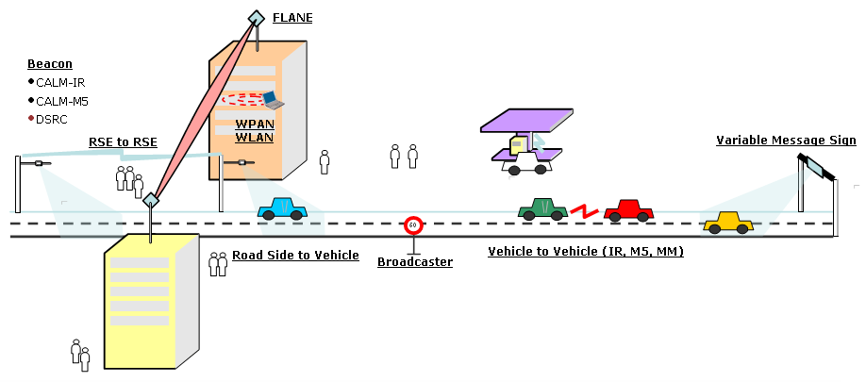
Figure 5: Example of ITS system deployment scenario, with FS links used in ITS backbone (RSE to RSE)

In the process of first development of ECC/REC/(05)02 and ETSI TS 102 329, other “conventional” PP FS applications have been presented for very high capacity (e.g. 1000baseT) with margins suitable for hop lengths of several hundred meters (depending on the rain rate).

Assumed technical parameters of PP FS used for ITS RSE-RSE backbone (hereafter referred to as (“Conv PP FS”) and those Very High Capacity PP FS links (hereafter referred to as “VHC PP FS”) are shown below in Table 6. Note that unless a distinction is clearly made, a simple reference to “PP FS” in this report would mean a general reference to any/both of these types of PP FS links.

Parameter | Value/characteristic |  | Comments
Parameter | Conv PP FS | VHC PP FS | Comments
Assumed e.i.r.p. | +45 dBm(*) | +67 dBm (*) | Note 1  (*) Higher e.i.r.p. is possible if higher antenna gain is used (with consequent higher directiity)
Maximum OOB noise floor e.i.r.p. | - 2dBm/MHz | - 2 dBm/MHz
Assumed antenna gain | 30 dBi (*) | 41 dBi (**) | (*) Assumed suitable for ITS infrastructure links  (**) Higher value (up to 50 dBi) might be possible for conventional PP links
3 dB beamwidth | 5.4⁰ | 1.5⁰ | Evaluated on typical ITU-R F.699 radiation patterns
Gain in side lobes (>~5º) | <18 dBi | <18 dBi (Note 2) | Evaluated on typical ITU-R F.699 radiation patterns
Gain in the side lobes (>~15º) | <12 dBi | <7 dBi (Note 2) | Evaluated on typical ITU-R F.699 radiation patterns
Examples of typical modulation schemes | QPSK, 16QAM | AAK, FSK, PSK, QPSK | Modulation schemes currently used by broadband wireless air interfaces
Typical data rates | 100Mbps-1 Gbps  physical layer | STM-1 ÷ 1.25 Gbps | Depending on the channel size and modulation method
Typical Channel Bandwidth | 350 MHz (*) | Up to 2 GHz (**)  Typical assumption 1 GHz (***) | Depending on desired data rate and modulation:  (*) 400Mbps @ min.QPSK  (**) STM16 Gbps @ min QPSK (TDD)  (***) STM4 @PSK (TDD)
Communication mode | Full Duplex | TDD  (FDD lower capacities)
Typical maximum BER | <10⁻⁶ | <10⁻⁹ | Based on IP protocol transport
Typical Noise Figure | 10 dB | 10 dB
Protection criteria | I/N=-10 dB | I/N=-10 dB | Note 3
Minimum C/I (co-channel equivalent on co-located routes) | C/I ≥ 25 dB | C/I ≥ 25 dB | Note 3
Table 6: Parameters of PP FS links in 64-66 GHz used in compatibility study

Note 1: ETSI TS 102 329 foresee a maximum radiated mean power limit of +33 dBW. At the time of writing this report, TS 102 329 [7] was soon expected to be superseded by the forthcoming harmonized standard EN 302 217-3 [8], which relevant revision was still in the approval stage at the time of this study. The new EN would change the +33 dBW e.i.r.p. fixed limit for FS in the frequency band 64-66 GHz with maximum value linked to the used antenna gain. The e.i.r.p. values in Table 6 are derived by those provisional limits associated to the antenna gain for the two FS applications mentioned.
Note 2: the given antenna side-lobe values are derived from the ITU-R Rec. F.699-7 (ref. relevant equations under point 3 and 2.2 respectively 2.1 therein). However some existing antenna technologies may give better side lobe reduction, e.g. one manufacturer quoted side lobe gains of 8 dBi at 5⁰ and -10 dBi at 15⁰.
Note 3: In principle, the I/N criterion is necessary for links where fading is uncorrelated. Standing the shortness of the links and the only impact from rain, this might not be the case, in particular for co-directional victim/interfering hops of the same path and length.

Impact of MGWS on PP FS links

Scenarios
Impact of MGWS on PP FS links in 57-59 GHz and 64-66 GHz was considered through the following four scenarios:
- Scenario 1: impact of MGWS FLANE into PP FS (offset angled links coupling);
- Scenario 2: impact of MGWS FLANE into PP FS (co-located links, main beam coupling);
- Scenario 3: impact of MGWS WPAN into PP FS;
- Scenario 4: impact of MGWS WLAN into PP FS.

The following Figures 6-9 illustrate the above scenarios.

G₀ (Main Beam)
G₁ (Side Lobe)
FLANE
PP FS link
Interferer
Victim

Figure 6: Scenario 1: FLANE Tx main beam to PP FS Rx side lobes

Within Scenario 1, the evaluation of the variation of the separation distance (for frequency reuse) with the “offset angle” between the victim/interfering links will give basic idea of the “occurrence probability” as function of the separation distance.
It should be noted that the probability of link alignment (offset = 0°) within the antenna main beam is very low and the rain induced attenuation on the two links become highly correlated implying that the I/N = −10 dB would become an unnecessarily stringent protection criteria. However, evaluation with 0° offset would indicate the worst-case asymptotic protection distance.

G₀ (Main Beam)
FLANE
PP FS link
Interferer
Victim
<≈1⁰

Figure 7: Scenario 2: FLANE Tx main beam to PP FS Rx main beam (co-located case)

In Scenario 2, the resulting links being parallel, the interference can not be evaluated in terms of separation distance as for scenario 1. A co-channel operation (as assumed for other scenarios) in this case is not possible; the only possible co-existence would be to use different channels, taking into account a NFD improvement due to OOB spectral reduction; in addition the rain-induced path attenuation is fully correlated. Therefore an I/N objective is not appropriate; a minimum C/I (co-channel equivalent) should be used as alternative.

Victim
Interferer
G₀ (Main Beam)
G₁ (Side Lobe)
WPAN Terminal
PP FS link
Offset angles

Figure 8: Scenario 3: WPAN (note directional WPAN antenna) to PP FS Rx

Victim
Interferer
G₀ (Main Beam)
G₁ (Side Lobe)
WLAN Terminal
PP FS link
Offset angles

Figure 9: Scenario 4: WLAN to PP FS Rx

In Scenarios 3 and 4 a victim link can have a corresponding terminal on the same building with WLAN/WPAN or on a different building (dashed line in the figures). Both these placement cases geometrically indicate that the closer are victim and interferer the wider becomes the offset angle (and consequently the PP antenna discrimination). In addition, the elevation component of the offset angle might enhance the indoor/outdoor attenuation due to possible floor(s)/roof penetration loss.

4.1.3.2 Calculation results
Within the bands 57-59 GHz and 64-66 GHz the variation of oxygen absorption gives moderate differences (few %) in terms of separation distance. The calculations have been made at the worst frequency, corresponding to the lowest oxygen attenuation within the bands (i.e. 57 GHz and 66 GHz, respectively).
FLANE bandwidth has been conservatively assumed being 250 MHz (resulting in higher spectral power density).

4.1.3.2.1 Scenarios 1, 3 and 4
Calculations based on straightforward MCL check were performed using MS Excel spreadsheet; see the file “Rep114app1_MCL_check_MGWS-FS.xls” in the attachment to this report.
For more detailed calculations, suitable for planning purposes, please refer to an example calculation spreadsheet in the attached file “Rep114app2_planning_MGWS-FS.xls”.

The results of calculations in terms of required interferer-victim separation distance for different scenarios are given below in Figs. 10-12.
Regarding worst case of the scenario 1 depicted in Figure 10, it should be noted that the limit for offset angle = 0° was presented for giving qualitative trend if reducing the offset angle; however, besides the fact that the probability of link alignment within the antenna main beam is very low, the rain induced attenuation on the two links would become highly correlated and the I/N = −10 dB would no longer be an appropriate protection criteria (this case is more appropriately covered by the Scenario 2).

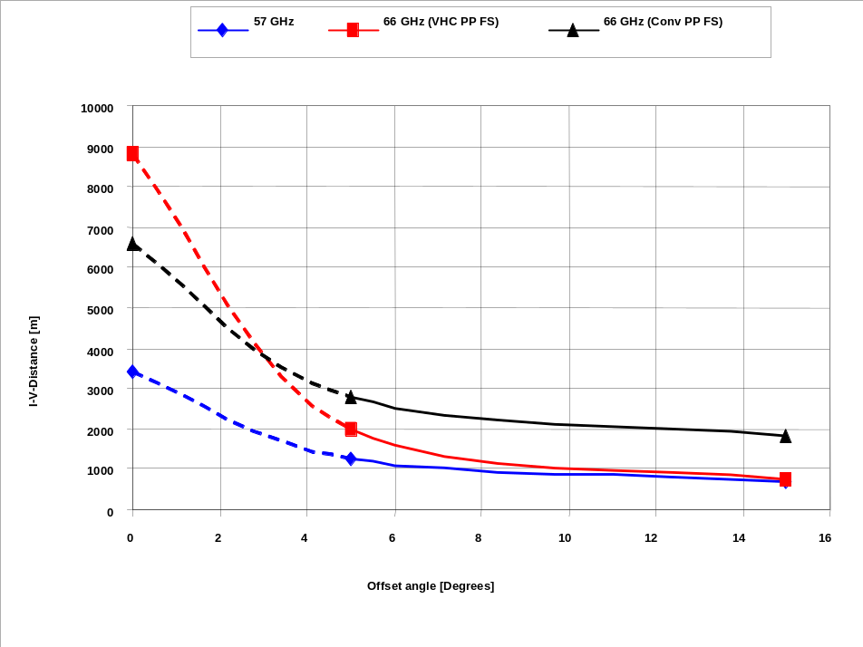
Figure 10: Required separation distances for Scenario 1: FLANE Tx main beam to PP FS Rx as a function of offset angle between the links

In Figure 10, the notable cross-over of the curves for two considered 66 GHz applications may be explained by similar cross-over of radiation patterns of their respective antennas, calculated with F.699 formulas for 30 dBi and 41 dBi antenna gains.

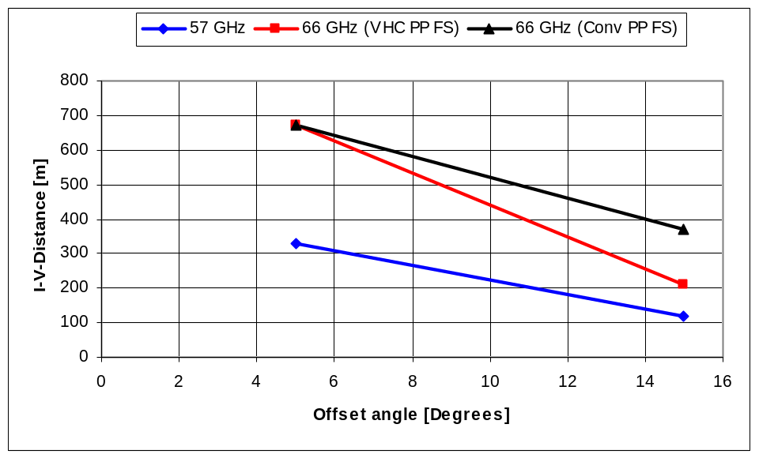
Figure 11: Required separation distances for Scenario 3: WPAN Tx main beam to PP FS Rx as a function of offset angle between the links

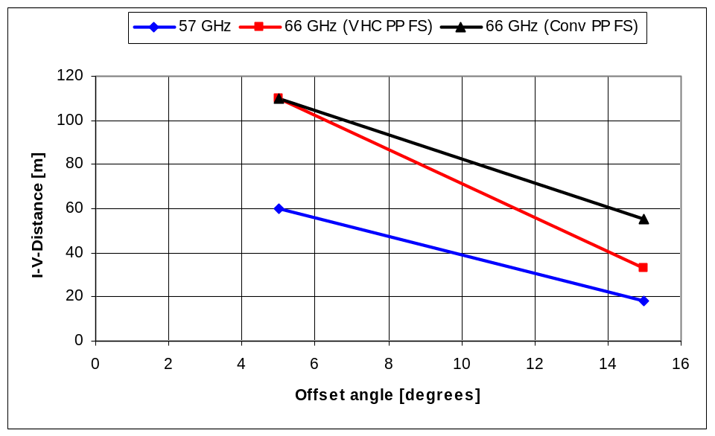
Figure 12: Required separation distances for Scenario 4: WLAN Tx main beam to PP FS as a function of offset angle between the links

However it should be once again noted that the above calculation results reflect worst cases of direct alignment of antennas. In reality the probability of such direct alignment will be extremely low.

4.1.3.2.2 Scenario 2 (co-location case)
From the relevant e.i.r.p. and OOB noise floor values, reported in Tables 3, 5 and 6, the following C/I results can be obtained:
57-59 GHz
- C/I = +55 dBm − (−24 dBm/MHz + 10log100) = +59 dB (Best case)
- C/I = +55 dBm − (−5 dBm/MHz + 10log100) = +40 dB (assuming FLANE would follow the less stringent PP FS OOB regulation).
For reference only it should be noted that PP→PP co-location situation in 58 GHz band will result in a mutual C/I = 40 dB.
64-66 GHz
- C/I (Conv PP FS) = +45 dBm − (−24 dBm/MHz + 10log350) = +44 dB (Best case)
- C/I (Conv PP FS) = +45 dBm − (−2 dBm/MHz +10log350) = +22 dB
(assuming FLANE would follow the less stringent PP FS OOB regulation).
- C/I (VHC PP FS) = +63 dBm − (−24 dBm/MHz +10log350) = +62 dB (Best case)
- C/I (VHC PP FS) = +63 dBm − (−2 dBm/MHz +10log350) = +40 dB
(assuming FLANE would follow the less stringent PP FS OOB regulation).

For reference only, it should be noted that PP→PP co-location situation in 65 GHz band will result in a mutual C/I = 21.5 dB (Conv PP FS) or C/I = 40 dB (VHC PP FS). However, the co-location of two identical PP FS systems or co-location of PP FS with a FLANE is not considered an actual situation.

Impact of PP FS links on MGWS

Scenarios
In this direction of interference it was considered that the most critical case would be interference from the PP FS into FLANE application of MGWS, due to absence of outdoor-to-indoor loss mitigation factor. The considered scenarios are two: a symmetric Scenario 2 (co-located links) or new Scenario 5 (offset angle coupling) of PP FS interfering into FLANE link is depicted in Figure 13.

G₀ (Main Beam)
G₁ (Side Lobe)
FLANE
PP FS link
Interferer
Victim
Offset angle

Figure 13: Scenario 5: PP FS Tx main beam into FLANE Rx side lobes

4.1.4.2 Calculation results
Calculation results for this scenario are also contained in the file “Rep114app1_MCL_check_MGWS-FS.xls” in the attachment to this report.
For more detailed calculations, suitable for planning purposes, please refer to an example calculation spreadsheet in the attached file “Rep114app2_planning_MGWS-FS.xls”.

4.1.4.2.1 Scenario 2 (Co-location case)
From the relevant e.i.r.p. and OOB noise floor values, reported in Tables 3, 5 and 6, the following C/I results can be obtained:
57-59 GHz
- C/I = +40 dBm − (−5 dBm/MHz + 10log250) = +21 dB
64-66 GHz
- C/I = +40 dBm − (−2 dBm/MHz + 10log250) = +18 dB
These values are lower than the objective (C/I≥ 25 dB) and FLANE link use is marginal or impossible unless an e.i.r.p. higher than 40 dBm would be possible.

4.1.4.2.2 Scenario 5
The results of calculations in terms of required interferer-victim separation distance for both considered frequency bands are reproduced below in Figure 14.

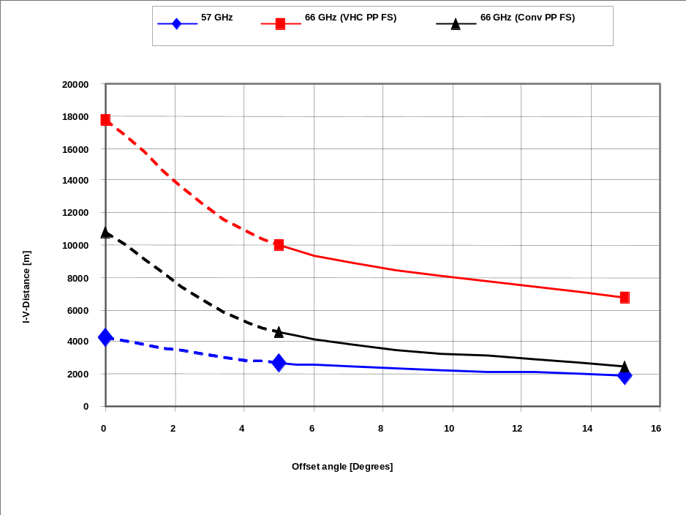
Figure 14: Required separation distances for Scenario 5: PP FS Tx main beam into FLANE Rx as a function of offset angle between the links

As in the relevant FLANE vs. PP FS mirror case, it should be noted that the limit for offset angle = 0° was presented for giving qualitative trend if reducing the offset angle; however, besides the fact that the probability of link alignment within the antenna main beam is very low, the rain induced attenuation on the two links would become highly correlated and the I/N = −10 dB would no longer be an appropriate protection criteria (this case is more appropriately covered by the Scenario 2).

Conclusions on MGWS-FS compatibility

4.1.5.1 Co-existence of MGWS WLAN/WPAN vs FS
It may be concluded from the results of calculations presented in this section that the required separation distances between MGWS WLAN/WPAN and PP FS links are given in Table 7.a.

Table 7.a: Required Separation Distances between MGWS WLAN/WPAN and FS
 | Required separation distances, m
Scenario | 57-59 GHz band |  | 64-66 GHz band
 | Offset >5° | Offset >15° | Offset >5° | Offset >15°
WPAN (indoor) vs. FS links | 330 | 120 | 670 | 370
WLAN (indoor) vs. FS links | 60 | 18 | 110 | 55
Table 7.a: Required Separation Distances between MGWS WLAN/WPAN and FS

Considering the very high directivity of PP FS antennas, the physical probability of direct geometric alignment of victim’s and interferer’s antennas with offset angles of 5⁰ or less, assumed in the discussed worst case scenarios, is rather low. In addition, the scenario geometrically indicates that the closer are victim and interferer the wider the offset angles become. Therefore, it may be concluded that the overall probability of interference to FS from the indoor deployments of MGWS WPAN and WLAN applications would be suitably low.

4.1.5.2 Co-existence of MGWS FLANE vs FS

4.1.5.2.1 Randomly distributed links
The results of calculations presented in this section give the required separation distances between MGWS FLANE and PP FS links; they are summarised in Table 7.b as a function of the offset angle between interferer and victim links.
 | Required separation distances, m
Scenario | 57-59 GHz band |  | 64-66 GHz band
 | Offset >5° | Offset >15° | Offset >5° | Offset >15°
FLANE vs. FS links | 1250 | 700 | 2000 (*) | 750 (*)
FLANE vs. FS links | 1250 | 700 | 2800(**) | 1800(**)
FS links vs. FLANE | 2700 | 1950 | 10000 (*) | 6700 (*)
FS links vs. FLANE | 2700 | 1950 | 4600 (**) | 2500 (**)
(*) For VHC PP FS applications
(**) For Conv PP FS as used in backbone between ITS RSE applications
Table 7.b: Required Separation Distances between MGWS Flane and FS for 40 dBm Flane e.i.r.p.
(for 55 dBm e.i.r.p. see Annex 4)

Note: It should be noted that the worst values would be obtainable for offset angle ~0° (see figures in sections 4.1.3 and 4.1.4), but these were not considered here because: (a) the fact that the probability of link alignment within the antenna main beam is very low, and (b) the rain induced attenuation on the two links became highly correlated and the I/N = −10 dB would no longer be an appropriate protection criteria; the latter scenario is better described in the following sub-section.

The very high separation distances required for the case of MGWS FLANE may not be so simply disregarded.

4.1.5.2.2 Co-located links
Possibilities of co-locating MGWS FLANE and PP FS links on the same buildings have been considered. In such cases, co-existence can be only obtained by operating the two links on different channels. With the rain-induced attenuation fully correlated, the expected co-channel equivalent C/I seems to be sufficient for PP FS link as victim, but it looks marginal or insufficient for FLANE link as victim. Sufficient C/I co-existence for both applications might be obtained only if FLANE could also operate at e.i.r.p. levels similar to those of PP FS link (i.e. it would become, in practice, another PP FS link).

4.1.5.3 Overall conclusions on MGWS vs FS co-existence
As an overall conclusion of this section, it appears that indoor WLAN and WPAN applications of MGWS may be deployed in 57-59 GHz and 64-66 GHz without significant risk of interference to PP FS links, whereas deployment of MGWS FLANE will require taking some precautionary provisions in both considered bands, to ensure co-existence with the PP FS links.
The opportunity to merge PP FS and MGWS FLANE regulations is further discussed in the final section of this report.

MGWS vs Radiolocation in 59-64 GHz

Introduction
The study has received official information from NATO, stating that currently 60 GHz range is not generally used by military services (radiolocation). However at least one country has military usage in this band (fixed) and further military usages (mobile, ground/airborne) might be expected in the future.

Impact of MGWS on Radiolocation
In the absence of detailed technical information on this issue, the following working assumptions were made with regard to the protection requirements of radio location systems that may operate in the band 59-64 GHz. These assumptions are similar to the one made in ECC Report 113:

Central Frequency | 63 GHz
K | 1.38 x 10^-23 (J/K) | -229 dBJ/K
T | 300 K | 25 dBK
B | 100 MHz | 80 dBHz
F | 4 | 6 dB
I/N | ¼ | -6 dB
I (dBm) |  | -94 dBm
Table 8: Radar protection requirements used in compatibility study

The calculations assumed that the MGWS is seen in the side lobes of the radar, with the effective gain of 10 dBi in the direction of MGWS transceiver. The maximum e.i.r.p. of MGWS transmitter (in the main beam) is 40 dBm. Therefore, using the set of assumptions given above, the required attenuation is equal to 144 dB.

Assuming that the gaseous absorption is equal to 11dB/km (see ETSI TR 102 400 [9]) and the free space attenuation, the required attenuation is achieved for:

144 (dB) = 11 x d + 32.4 + 20 x log (63 000) + 20 x log (d)

i.e. a distance of 1250 m would be sufficient to protect radiolocation system from MGWS transmissions in the side lobes of the radar. This result is shown in Figure 16 (FLANE/RLS). The direct main beam-to-main beam coupling of radar and MGWS link is highly unlikely and therefore was not considered.

Impact of Radiolocation on MGWS FLANE
In the scenarios of interference to MGWS systems, the FLANE case is the most critical since high gain antenna are used. The scenario is assuming that radiolocation equipment is radiating with its side lobe G₁ into the main beam of the FLANE. Radiolocation system emissions parameters were not available to the study and the hypothetical assumptions have been made as shown in the following Table 9.

e.i.r.p. of radar | 40 dBW
Antenna main beam Go | 38 dBi
Antenna side lobe G₁ | 10 dBi
Central Frequency | 63 GHz
Gaseous absorption | 11 dB/km
Bandwidth | 100 MHz
Table 9: Assumed operational radar parameters for compatibility study

Based on these assumptions, the simple calculations were performed as shown in Figure 16, and as provided in Excel spreadsheet in the attached file “Calc_Radar-FLANE_63 GHz.xls”.

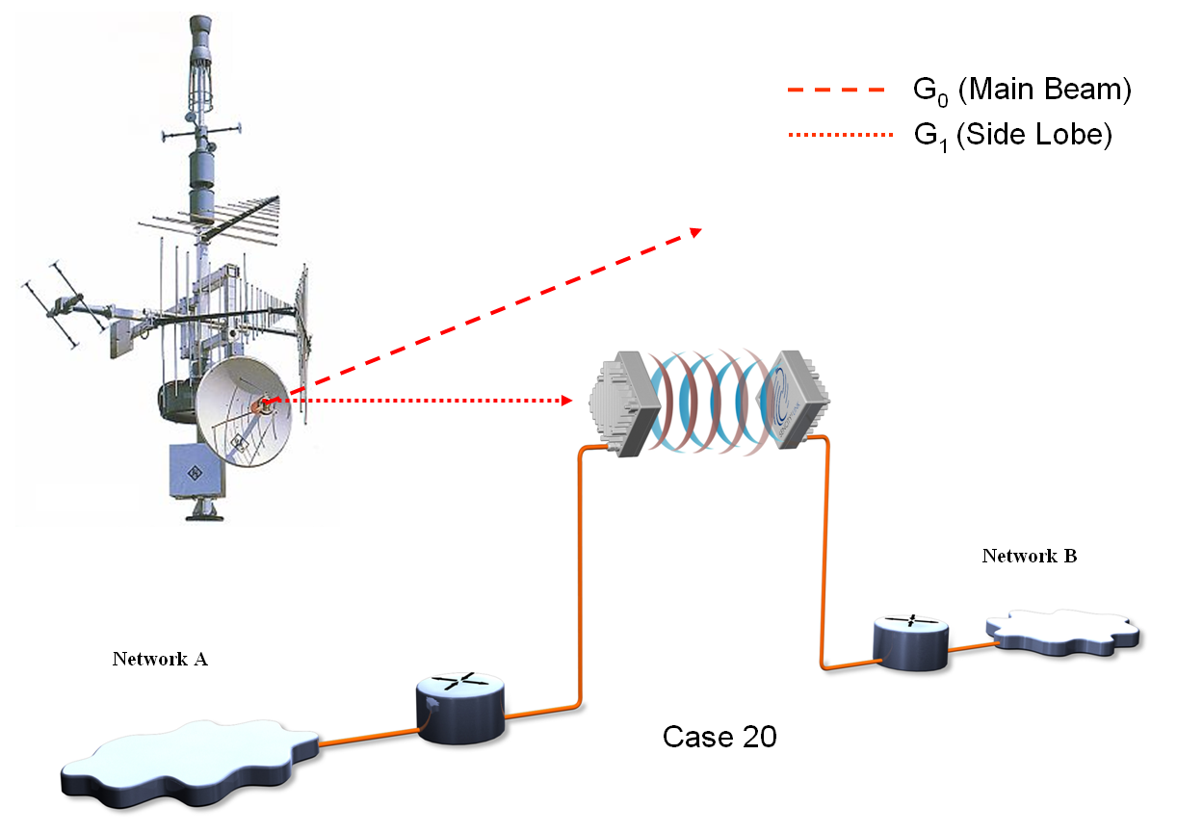

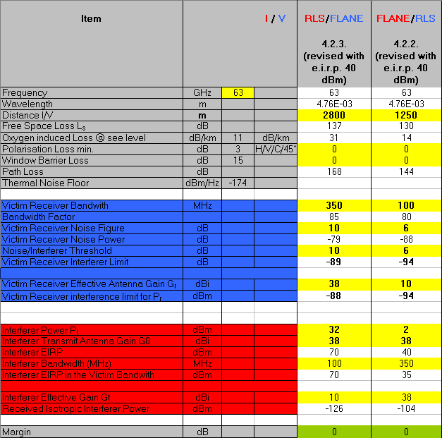

Figure 16: Radar vs FLANE interference scenario and calculation results

These calculations shown that the required separation distance to avoid interference from radars to MGWS FLANE would be in the order of 2800 m.

Impact of Radiolocation on MGWS WLAN/WPAN
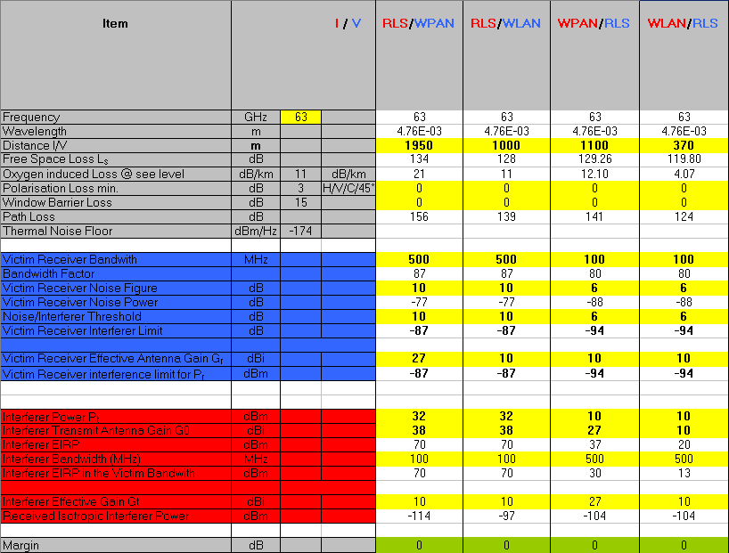
Figure 16a: Radar vs WLAN/WPAN interference scenario and calculation results

Conclusions on MGWS-Radiolocation compatibility
Using the assumptions defined above, it appears that the separation distance to protect MGWS FLANE (considered being the most critical of MGWS FLANE applications in this case due to absence of wall/window penetration loss) from the radars is actually about twice as large as the distance required to protect radars from the FLANE.

It may be therefore concluded that the required maximum separation distances to ensure mutual co-existence of radiolocation systems with MGWS would be in the order of 2800 m.

MGWS vs Earth Exploration Satellite Service

EESS frequency bands in 57-66 GHz range
Frequency band 55.78-59.3 GHz
The present regulatory status in the oxygen absorption band around 60 GHz is the following for the Earth Exploration Satellite Service (Passive):
55.78 - 58.2 GHz Shared with FIXED and MOBILE
58.2 - 59 GHz Shared with FIXED and MOBILE
59 – 59.3 GHz Shared with INTER-SATELLITE, RADIOLOCATION, FIXED and MOBILE.

Frequency band 65-66 GHz

The allocation to EESS in this sub-band is on a shared basis with ISS, FIXED, MOBILE and SPACE RESEARCH.

The 5.547 of ITU RR [10] states: “The bands 31.8-33.4 GHz, 37-40 GHz, 40.5-43.5 GHz, 51.4-52.6 GHz, 55.78-59 GHz and 64-66 GHz are available for high-density applications in the fixed service (see Resolutions 75 (WRC-2000) and 79 (WRC-2000)). Administrations should take this into account when considering regulatory provisions in relation to these bands. Because of the potential deployment of high-density applications in the fixed-satellite service in the bands 39.5-40 GHz and 40.5-42 GHz (see No. 5.516B), administrations should further take into account potential constraints to high-density applications in the fixed service, as appropriate. (WRC-03)."

ITU-R CPM Report from WRC-2000 (see http://www.wmo.ch/web/www/WRC2000/cpmpassens.htm) stated that "There is currently no planned usage for the EESS allocation within the 65-66 GHz band and no studies on potential sharing have been done to date."

It therefore appears that there is no anticipated use of EESS (passive) in the band 65-66 GHz.

Interference criteria for EESS (passive) in 57-59.3 GHz
The performance criteria for satellite passive remote sensing are contained in Recommendation ITU-R RS.1028 [11].
The following Table 9 provides the appropriate interference level for spaceborne passive sensors in operation in the 52.6-59.3 GHz frequency range according to Recommendation ITU-R RS.1029-2 [12] that should be used in any interference assessment or sharing studies. This interference level in Table 10 should not be exceeded for more than a percentage of sensor viewing area or a percentage of measurement time.

Table 10: Interference criteria for passive remote sensing of environmental data in 52.6-59.3 GHz
Frequency band(s)⁽¹⁾  (GHz) | Total bandwidth required (MHz) | Reference bandwidth (MHz) | Maximum interference level  (dBW) | Percentage of area or time permissible interference level may be exceeded ⁽²⁾ (%) | Scan mode (N, L)⁽³⁾
52.6-54.25P,  54.25-59.3p | 6 700⁽⁵⁾ | 100 | −161/−169⁽⁴⁾ | 0.01 | N
⁽¹⁾ P: Primary allocation, shared only with passive services (No. 5.340 of the Radio Regulations); p: primary allocation, shared with active services; s: secondary allocation.
⁽²⁾ For a 0.01% level, the measurement area is a square on the Earth of 2 000 000 km², unless otherwise justified; for a 0.1% level, the measurement area is a square on the Earth of 10 000 000 km² unless otherwise justified; for a 1% level, the measurement time is 24 h, unless otherwise justified.
⁽³⁾ N: Nadir, Nadir scan modes concentrate on sounding or viewing the Earth’s surface at angles of nearly perpendicular incidence. The scan terminates at the surface or at various levels in the atmosphere according to the weighting functions. L: Limb, Limb scan modes view the atmosphere “on edge” and terminate in space rather than at the surface, and accordingly are weighted zero at the surface and maximum at the tangent point height.
⁽⁴⁾ First number for sharing conditions circa 2003; second number for scientific requirements that are technically achievable by sensors in next 5-10 years.
⁽⁵⁾ This bandwidth is occupied by multiple channels, typically Channel 11 in Tables 3 and 4, which are all required for the measurements that are undertaken.

Maximum interference level to be considered in compatibility study is -189 dBW/MHz or -159 dBm/MHz.

Atmospheric attenuation around 60 GHz
The figure given in Annex 2 describes the absorption spectrum around 60 GHz and the multiple absorption lines. The resulting passive sensors requirements are depicted in the following Figure 17.
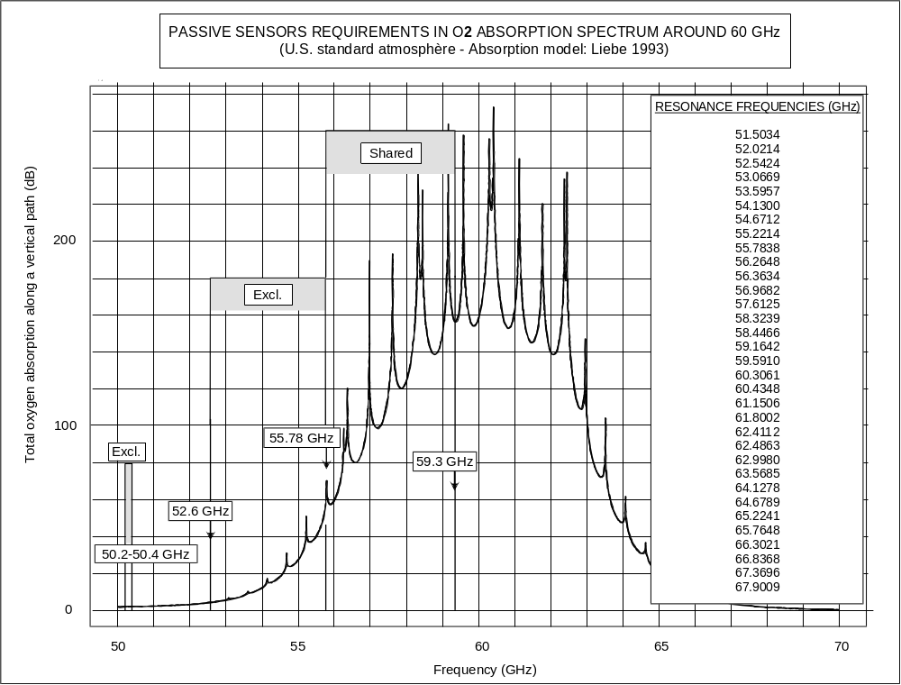Figure 17: Frequencies for passive sensors in oxygen absorption spectrum
In the frequency range 57-59.3 GHz the attenuation is always above 90 dB in the zenith direction. It has to be noted that in ERC Report 45 [13] a value of 98.8 dB is used for the O2 zenith absorption. A conservative value of 90dB will be considered.

Nadir-looking passive sensors in the 60 GHz range
Most passive microwave sensors designed for measuring tropospheric/stratospheric parameters, are nadir-looking instruments. They use a cross-track mechanical (current) or push-broom (future) scanning configuration in a plane normal to the satellite velocity containing the nadir direction. This configuration provides optimum field-of-view and optimum average quality of data. Typical characteristics of temperature sounders working around 60 GHz and operated on board low earth orbiting satellites are given in Table 10.

Characteristic | Mechanical scanning AMSU type | Mechanical scanning ATMS type | Push-broom scanning
3 dB points IFOV (°): | 3.3 | 2.2 | 1.1
Cross-track FOV (°): | +/- 50 | +/- 53 | +/- 50
Antenna gain (dBi): | 36 | 41 | 45
Fare lobes gain (dBi): | -10 | -10 | -10
Beam efficiency (%): | > 95 | > 95 | > 95
Swath-width (km): | 2300 | 2200 | 2300
Nadir pixel size (km): | 49 | 32 | 16
Number of pixels/line: | 30 | 96 | 90
Altitude (km): | 833 | 833 | 850
Table 11: Typical characteristics of microwave vertical sounders in the 60 GHz frequency range

Table 12 describes the various channels in operation for the ATMS (Advanced Technology Microwave Sounder) radiometer and AMSU-A (Advanced Microwave Sounder Unit, release A) radiometer.

Channel Frequency (MHz) | Nominal Bandwidth (MHz) | Polarization at nadir | Function
57290.344 | 330 | H | Stratospheric Temp
57507.544 | 78 | H | Stratospheric Temp
57660.544 | 36 | H | Stratospheric Temp
57634.544 | 16 | H | Stratospheric Temp
57622.544 | 8 | H | Stratospheric Temp
57617.044 | 3 | H | Stratospheric Temp
Table 12: ATMS/AMSU-A channel characteristics in the 60 GHz frequency range
NOTE: Nominal beamwidth for ATMS is 2.2 degrees, for AMSU-A it is 3.3 degrees.

The definitions of the polarization at nadir are as follows:
- V: Polarization vector is parallel to scan plane at nadir;
- H : Polarization vector is perpendicular to scan plane at nadir.

The antenna beamwidth of all AMSU-A channels is 3.3 degrees. The beamwidth is defined as the half-power points beamwidth (HPBW). The beamwidth in any plane containing the main beam axis (electrical boresight axis) is within ±10% of the 3.3 degree value. Beamwidth variation from channel to channel is smaller than 10% of the specified beamwidth value.

It is to be noted that for sharing studies, it is recommended to use the maximum interference level of -169 dBW/100 MHz for the following reasons. AMSU-A has been recently mounted on METOP launched in October 2006, which represents a new series of meteorological satellites. ATMS is a new generation of sounders being developed for NPOESS. Eventually, the push broom represents future radiometers which are not yet launched.

Compatibility between MGWS and EESS in 57-59.3 GHz
Table 13 provides results of calculations with regard to compatibility between MGWS and EESS.
Characteristic | Unit | Mechanical scanning AMSU type | Mechanical scanning ATMS type | Push-broom scanning
Protection Criterion | dBW/100 MHz | -169 | -169 | -169
Antenna gain | dBi | 36 | 41 | 45
Maximum interfering Power at the Antenna Input | dBm/MHz | -195 | -200 | -204,00
O2 Absorption Along Vertical Path | dB | 90 (1) | 90 (1) | 90 (1)
Altitude of the EESS Satellite | km | 833 | 833 | 850
Attenuation due to Free Space | dB | 186.1 | 186.1 | 186.1
Total Attenuation of the path | dB | 276.1 | 276.1 | 276.1
Maximum interfering Power on the Earth per Pixel | dBm/MHz | 81.1 | 76.1 | 72.1 (2)
Nadir pixel size | km | 49 | 32 | 16
Pixel Size | km² | 1885 | 804 | 201
Maximum interfering Power on the Earth per Pixel per km² | W/MHz/km² | 68.4 | 50.6 | 80.6
Table 13: Results of calculations on compatibility between MGWS and EESS
(1) ERC Report 45 [13] considered a value of 98.8 dB
(2) ERC Report 45 provided a value of -6.5dBW/Hz (83.5 dBm/MHz)

The following Table 14 provides the corresponding MGWS densities for the worst case (ATMS Type). The other results are provided in Annex 3 for AMSU and Push broom systems.

Characteristic | Unit | FLANE transmitter | WLAN/WPAN transmitter
Maximum interfering Power on the Earth per Pixel for different passive sensors | dBm/MHz | 76.1 for ATMS | 76.1 for ATMS
Definition of a MGWS transmitter
Power of a MGWS transmitter | dBm | 2 | 10
Bandwidth | MHz | 150 | 325
Power per MHz | dBm/MHz | -19.8 | -15.1
Antenna Gain | dBi | 38 | 27
Antenna Gain in the Zenith Direction | dBi | 8 | 27
E.i.r.p of a single MGWS transmitter in the Zenith Direction | dBm/MHz | -11.8 | 11.9
Computation of the maximum transmitter per EESS(passive) pixel
Maximum number of Transmitters per pixel | Tx | 10^{8.79}= 616595001 | 10^{6.42}= 2630267
Maximum density of Transmitters per km2 | Tx/km² | 766909 | 3271 (*)
Table 14: Maximum density of MGWS transmitters to avoid interference to ATMS
(*) Note that this value was calculated for outdoor deployment.

For WLAN/WPAN systems it might be additionally noted that:
- WLAN/WPAN systems intend to be deployed indoor. The attenuation resulting from the building loss (about 15 dB) will improve the sharing situation.
- For WLAN/WPAN, simpler modulations like QPSK are used to transport 1Gbps, therefore 500MHz bandwidth systems may be more realistic. This will give an additional margin of 1.5 dB in the calculations.

Conclusions on EESS-MGWS compatibility
No compatibility problems between MGWS and EESS are expected in the frequency range 57-59.3 GHz since the density of MGWS transmitters that would exceed the EESS interference limits is comfortably above expected MGWS deployment densities, also noting that the real tolerable density of WLAN/WPAN deployment will be much higher due to additional attenuation provided by indoor deployment.

For the unwanted emissions of MGWS falling in the adjacent band below 57 GHz, it has to be noted that the assumptions considered in the calculations for the absorption in the zenith direction covers also the frequency range down till ca. 56.4 GHz (see figure in Annex 2), therefore the conclusions reached for the co-sharing case are also directly applicable for the unwanted emissions case.

Situation with other services

Inter-Satellite Service
Although the study had no information on actual ISS use in this band, it was assumed that due to high oxygen absorption, see Annex 2, resulting in approximately 50 dB attenuation in this case, plus free space loss for over 700 km distance, no compatibility issue is expected.

Fixed Services in 59-62 GHz
There was no information on FS used in this sub-band until now, therefore no studies were deemed necessary.

Radio Astronomy Service in 58.2-59 GHz
It was noted that ITU RR footnote 5.556 [10] states that: “In the bands 51.4-54.25 GHz, 58.2-59 GHz and 64-65 GHz, radio astronomy observations may be carried out under national arrangements (WRC 2000)”.

Therefore it appeared that any potential use of this band by radio astronomy would be a matter for national consideration.

Mobile Service in 57-58.2 / 59-64 GHz
It was noted that the Mobile Service allocation might be used by defence systems in the harmonised military band 59-61 GHz, however the information received from NATO at the time of this study was inconclusive and not sufficient for detailed co-existence studies.

Some of the ITS applications working under Mobile allocation are subject of the separate ITS-MGWS study.

Mobile Service in 64-66 GHz
No Mobile Services are envisaged in this band, which is designated for Fixed Services in CEPT.

Mobile Service in adjacent band 66-71 GHz
No actual use or systems in Mobile Services in this band were reported.

Radio Navigation in adjacent band 66-71 GHz
No information on Radio Navigation Service in this band was available to the study.

Radio Navigation Satellite in adjacent band 66-71 GHz
No information on Radio Navigation Satellite Service in this band was available to the study.

Space Research in 55.78-59.3 / 65-66 GHz
No information on Space Research Service use or protection requirements in this band was available to the study.

Short Range Devices in 61-61.5 GHz
The band was originally envisaged to be used for SRD sensors and short range radar applications. However later those applications were realised in other frequency bands (such as SRR in 77 GHz range) and currently there were no evidence of planned SRD usage in this frequency range.

Overall conclusions of the report

Conditions for compatibility
The report analysed situation with co-existence of proposed MGWS applications vis-à-vis some of existing or planned services and systems in frequency range 57-66 GHz (except co-existence with ITS, which is subject of separate study, see ECC Report 113.

Three of those other services were considered in more detail: Fixed Service, Radiolocation and EESS, with the conclusions summarised below.

MGWS co-existence with Fixed Service links
The study found that the required separation distances between MGWS and FS links, at offset angles between 5-15º, are in the order of 700-2800 m (with a FLANE e.i.r.p. of 40 dBm) and 1500 to 6500 m (with a FLANE e.i.r.p. of 55 dBm) for MGWS FLANE applications and some 18-670 m for MGWS WPAN and WLAN applications, see section 4.1.5 for details.

As an overall conclusion for MGWS-FS co-existence, it appears that indoor WLAN and WPAN applications of MGWS may be deployed in 57-59 GHz and 64-66 GHz without significant risk of interference to PP FS links, whereas deployment of FLANE may require taking some precautionary provisions in both considered bands, to ensure co-existence with the PP FS links.

MGWS co-existence with Radiolocation
The study based on hypothetical parameters of radiolocations systems that might be deployed in the frequency range concluded that the separation distance to protect MGWS FLANE (considered being the most critical of MGWS applications in this case due to absence of wall/window penetration loss) from the radars is actually twice as large as the distance required to protect radars from the FLANE.

It may be therefore concluded that the required maximum separation distances to ensure mutual co-existence of radiolocation systems with MGWS would be in the order of 2800 m (with a FLANE e.i.r.p. of 40 dBm) and 3300 m (with a FLANE e.i.r.p. of 55 dBm).

MGWS co-existence with EESS
No compatibility problems between MGWS and EESS are expected in the frequency range 57- 59.3 GHz since the density of MGWS transmitters that would be needed to exceed the EESS interference limits is comfortably above expected MGWS deployment densities, also noting that the real tolerable density of WLAN/WPAN deployment will be much higher due to additional attenuation provided by indoor deployment.

Consequential regulatory considerations
Analysis of the results of compatibility studies suggests that the introduction of various applications in MGWS family across the range 57-66 GHz may not be resolved through a single cut regulatory solution, therefore this section outlines some ideas that could be used to develop appropriate regulatory framework for introduction of MWGS.

The first obvious observation is that the very different compatibility results for FLANE as opposed to WLAN & WPAN applications of MGWS call for different regulatory considerations, which are discussed below.

It should be also noted that introduction of different types of MGWS applications (that might be both MOBILE and FIXED) may need an update of the current service allocations in the ECA (ERC Report 25).

MGWS WLAN&WPAN
It may be safely assumed that MGWS WLAN & WPAN applications would be deployed pre-dominantly indoors leading to overall low risk of interference. Therefore it would appear that WLAN & WPAN applications might be allowed to be deployed across entire frequency range 57-66 GHz on the licence-exempt provisions with emission limitations considered in this study, based on current TR 102 555 (+40 dBm e.i.r.p., etc.).
Possible technical measures to ensure indoor usage and give additional degree of interference protection could include obligations for integral antennas.

It was also noted that some kind of Dynamic Frequency Selection (DFS)/Detect-And-Avoid (DAA) mechanism may be introduced to ensure intra-system co-existence between WLAN/WPAN installations, which would also provide additional mitigation of inter-service interference, but practical implementation and feasibility of this measure was not further considered in this report as this was felt being outside the mandate of this study.

MGWS FLANE
MGWS FLANE applications would be deployed pre-dominantly outdoors and would require significant separation distances or sufficient antenna discrimination to avoid interference into radio links of other systems as well as between different FLANE links.
In that respect it should be also noted that in terms of technical parameters as well as physically and conceptually the FLANE links would resemble the PP FS links used today in 57-59 GHz and 64-66 GHz bands.

Therefore it may be suggested that the regulatory framework for FLANE should either:
- be identical to one or the combination of the regulatory frameworks existing today for PP FS (ERC/REC 12-09 [2] for PP FS in 57-59 GHz and ECC/REC/(05)02 [3] for PP FS in 64-66 GHz),
or
- any new provisions for the FLANE application throughout the entire range 57-66 GHz should be also applicable for “traditional” FS PP links with the same access conditions (radio interface specifications)..

However since FLANE brings some new technical elements to the current PP FS technology, such as using very high bandwidth channels, some mutual mitigation provisions might be appropriate, e.g. setting a minimum antenna gain in association with relevant maximum e.i.r.p. limits.

It should be further noted that the present regulatory framework for PP FS in 57-59 GHz provides channels up to 100 MHz only, which is considered insufficient for FLANE applications.

Allocations in other parts of the world
It should be noted that US/Canada and Korea allocated the band 57-64 GHz for licence exempt applications similar to MGWS. Similar allocation in Japan for licence-exempt operation is in 59-66 GHz, whereas in Australia it is in 59-63 GHz.

Annex 1: Specific Oxygen Attenuation (dB) – Recommendation ITU-R P.676
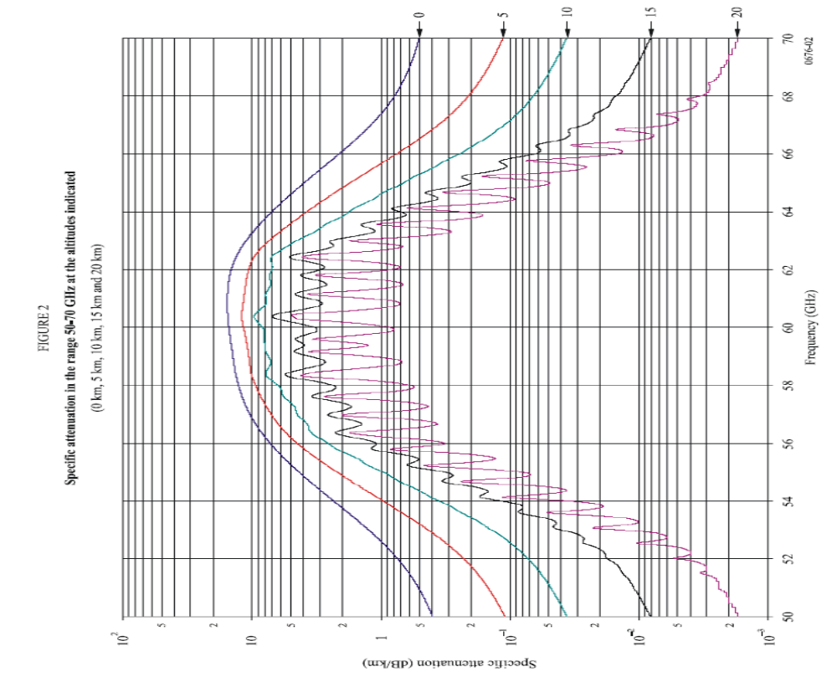

Annex 2: Zenith Oxygen Attenuation (dB) – Recommendation ITU-R P.676 [6]

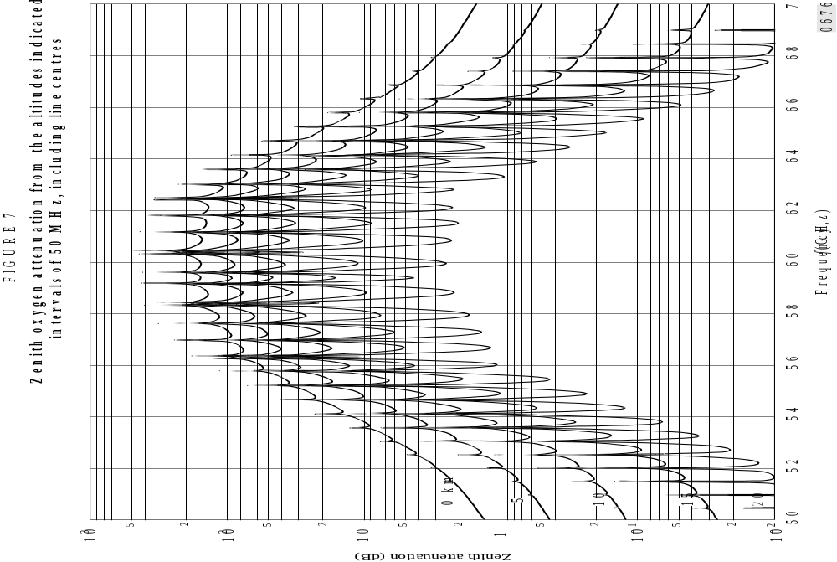

Annex 3: Results for AMSU and Push broom systems

Characteristic | Unit | FLANE transmitter | WLAN/WPAN transmitter
Maximum interfering Power on the Earth per Pixel for different passive sensors | dBm/MHz | 81.1 for AMSU | 81.1 for AMSU
Definition of a MGWS transmitter
Power of a MGWS transmitter | dBm | 2 | 10
Bandwidth | MHz | 150 | 325
Power per MHz | dBm/MHz | -19.8 | -15.1
Antenna Gain | dBi | 38 | 27
Antenna Gain in the Zenith Direction | dBi | 8 | 27
E.i.r.p of a single MGWS transmitter in the Zenith Direction | dBm/MHz | -11.8 | 11.9
Computation of the maximum transmitter per EESS(passive) pixel
Maximum number of Transmitters per pixel | Tx | 10 ^{9.29} =1949844599 | 10 ^{6.92} = 8317637
Maximum density of Transmitters per km² | Tx/km² | 1034400 | 4412
Table 15: Density of MGWS Transmitters for AMSU

Characteristic | Unit | FLANE transmitter | WLAN/WPAN transmitter
Maximum interfering Power on the Earth per Pixel for different passive sensors | dBm/MHz | 72.1 | 72.1
Definition of a MGWS transmitter
Power of a MGWS transmitter | dBm | 2 | 10
Bandwidth | MHz | 150 | 325
Power per MHz | dBm/MHz | -19.8 | -15.1
Antenna Gain | dBi | 38 | 27
Antenna Gain in the Zenith Direction | dBi | 8 | 27
E.i.r.p of a single MGWS transmitter in the Zenith Direction | dBm/MHz | -11.8 | 11.9
Computation of the maximum transmitter per EESS(passive) pixel
Maximum number of Transmitters per pixel | Tx | 10 ^{8.39} = 245470891 | 10 ^{6.02} = 1047128
Maximum density of Transmitters per km² | Tx/km² | 1221248 | 5209
Table 16: Density of MGWS Transmitters for push broom

Annex 4: Compatibility Between MGWS PP (FLANE with e.i.r.p. of 55dBm) and other Services/Systems

A.5.1 Technical description of MGWS (see section 3.2.2. for e.i.r.p at 40 dBm)

The technical descriptions of the MGWS are the same as for section 3.2.2., except that the FLANE e.i.r.p is increased from 40 dBm to 55 dBm and the consequent antenna characteristics used as well as the maximum transmit power to 10 dBm.

A.5.2 MGWS vs Fixed Services in 57-59 GHz and 64-66 GHz
The excel calculation sheet presenting the updated compatibility study “ECCRep114_revised” can be found on the ERO server.

A.5.2.1 Fixed Services in 57-59GHz with FLANE (PP) 55dBm e.i.r.p. (see Section 4.1.1)
Since in this band already a e.i.r.p. limit of 55dBm e.i.r.p. with a maximum of 10dBm transmitter output has been implemented, the new implemented links are regarded in this band as equal equipment and is reducing this compatibility situation to a intra-service compatibility situation. Therefore no special interference calculation has been added in the new situation.

A.5.2.2 Fixed Service in 64-66GHz
Already existing PP systems in this frequency range are using max. 63dBm e.i.r.p. which exceeds the 55dBm e.i.r.p. of FLANE. Coexistence is even improved with the introduction of e.i.r.p. increase trough antenna gain increase in fact reducing the side lobe sensitivity of the victim FLANE. As a conclusion introduction of 55dBm e.i.r.p. is improving the interoperability of these systems.

A.5.2.3 Impact of MGWS on PP FS Links (see section 4.1.3 for e.i.r.p of 40 dBm)
A.5.2.3.1 Scenarios
Scenario 1 is being revised due to the new e.i.r.p. value. Scenario 2, 3 and 4 are not considered here.

A.5.2.3.2 Calculation results
In the bands 57-59GHz and 64-66GHz, the cases are now only involve intra-service issue. In the band 57-59GHz we are changing FLANE to an equivalent PP system with same antenna gain and antenna input power.

A.5.2.3.2.1 Scenario 1 (see section 4.1.3.2.1 for e.i.r.p of 40 dBm)

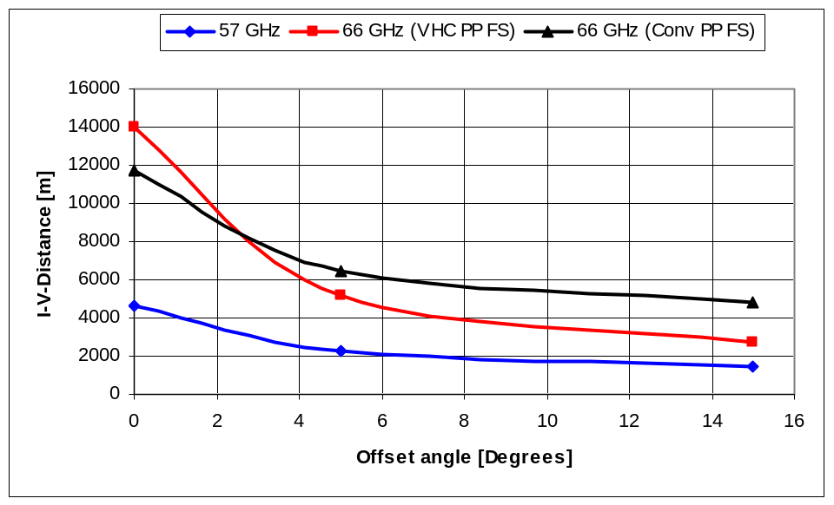
Figure 18: Required separation distances for scenario 1 : FLANE 55dBm Tx main beam into PP FS (VHC and Conv.) Rx as a function of offset angle between the links (see Figure 10 for comparison with an e.i.r.p of 40 dBm).

As shown in Figure 18, the required separation distances for scenario 1 have increased when the e.i.r.p is increased from 40 dBm to 55 dBm for all the offset angles. A comparison of the required separation distance for an e.i.r.p. of 40 dBm and 55 dBm is presented in Table 17.

- | Offset angle [degrees]
- | 0 |  | 5 |  | 15
Band | e.i.r.p = 40 dBm | e.i.r.p = 55 dBm | e.i.r.p = 40 dBm | e.i.r.p = 55 dBm | e.i.r.p = 40 dBm | e.i.r.p = 55 dBm
57 GHz | 3400 | 4600 | 1250 | 2250 | 700 | 1500
66 GHz (VHC PP FS) | 8800 | 13950 | 2000 | 5200 | 750 | 2650
66 GHz (Conv PP FS) | 6600 | 11600 | 2800 | 6500 | 1800 | 4800
Table 17: Comparison of the required separation distances for scenario 1 for an e.i.r.p.
of 40 dBm and 55 dBm

A.5.2.4 Impact of PP FS Links on MGWS (see section 4.1.4 for e.i.r.p of 40 dBm)

A.5.2.4.1 Scenario 5 (see section 4.1.4.2.2 for e.i.r.p of 40 dBm )

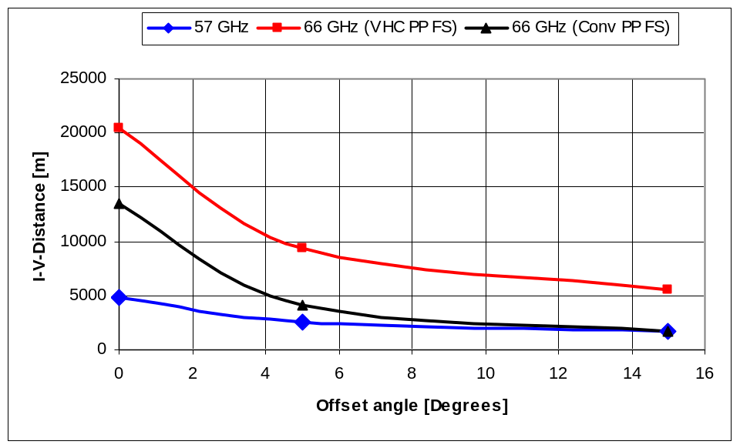

Figure 19 : Required separation distances for scenario 5 PP FS (VHC and Conv.) Tx main beam into FLANE Rx as a function of separation angle between the links (see Figure 14 for comparison).

As shown in Figure 19, the required separation distances for scenario 5 have increased when the e.i.r.p is increased from 40 dBm to 55 dBm in the main lobe (0 degree). For 5 and 15 degrees the required separation has decreased and remains of the same order. A comparison of the required separation distance for an e.i.r.p. of 40 dBm and 55 dBm is presented in Table 18.

- | Offset angle [degrees]
- | 0 |  | 5 |  | 15
Band | e.i.r.p = 40 dBm | e.i.r.p = 55 dBm | e.i.r.p = 40 dBm | e.i.r.p = 55 dBm | e.i.r.p = 40 dBm | e.i.r.p = 55 dBm
57 GHz | 4300 | 4900 | 2700 | 2500 | 1950 | 1700
66 GHz (VHC PP FS) | 17800 | 20500 | 10000 | 9200 | 6700 | 5500
66 GHz (Conv PP FS) | 10800 | 13500 | 4600 | 4200 | 2500 | 1800
Table 18: Comparison of the required separation distances for scenario 5 for an e.i.r.p.
of 40 dBm and 55 dBm

A.5.2.5 Conclusions on MGWS-FS compatibility

A.5.2.5.1 Co-existence of MGWS FLANE vs. FS (see section 4.1.5.2 for e.i.r.p of 40 dBm)
The results of calculations presented in this section give the required separation distances between MGWS FLANE and PP FS links for an e.i.r.p of 55 dBm. They are summarised in Table 19 as a function of the offset angle between interferer and victim links.

 | Required separation distances, m
Scenario | 57-59 GHz band |  | 64-66 GHz band
 | Offset >5° | Offset >15° | Offset >5° | Offset >15°
FLANE vs. FS links | 2250 | 1500 | 5200 (*) | 2650 (*)
FLANE vs. FS links | 2250 | 1500 | 6500(**) | 4800(**)
FS links vs. FLANE | 2500 | 1700 | 9200 (*) | 5500 (*)
FS links vs. FLANE | 2500 | 1700 | 4100 (**) | 1750 (**)
(*) For VHC PP FS applications
(**) For Conv PP FS as used in backbone between ITS RSE applications
Table19: Required Separation Distances between MGWS Flane and FS with an e.i.r.p. of 55 dBm
(see Table 7.b for comparison with e.i.r.p. of 40 dBm)

Similarly to the conclusion made with and e.i.r.p. of 40 dBm, the very high separation distances for the case FLANE 55dBm may not be simply disregarded

A.5.2.5.2 Co-located links
The conclusion of the previous study with an e.i.r.p. of 40 dBm is still applicable since C/I co-existence for both applications might be obtained only if FLANE could also operate at e.i.r.p. levels similar to those of PP FS link (i.e. it would become, in practice, another PP FS link)

A.5.2.5.3 Overall conclusions on MGWS-FLANE vs FS co-existence
The conclusion of the previous study with an e.i.r.p. of 40 dBm is still applicable since the deployment of MGWS FLANE will require taking some precautionary provisions in both considered bands, to ensure co-existence with the PP FS links.

A.5.3 MGWS vs Radiolocation in 59-64 GHz
The excel calculation sheet presenting the updated compatibility study “ECCRep114_CalcRadar_revised” can be found on the ERO server.

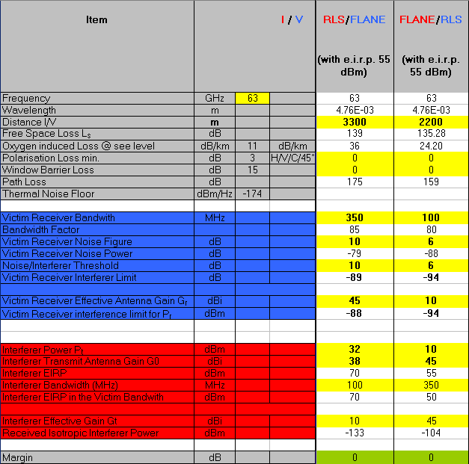
Figure 20: Required separation distances for MGWS vs Radiolocation at 63 GHz (see Figure 16 for comparison with an e.i.r.p. of 40 dBm).

A.5.3.1 Impact of MGWS on Radiolocation
A distance of 2200 m (63GHz) or 1850 m (59GHz) would be sufficient to protect radiolocation system from MGWS transmissions in the side lobes of the radar. The direct main beam-to-main beam coupling of radar and MGWS link is highly unlikely and therefore was not considered.

A.5.3.2 Impact of Radiolocation on MGWS
These calculations show that the required separation distance to avoid interference from radars to MGWS FLANE would be in the order of 2550 m at 59GHz up to the order of 3300 m at 63GHz

A.5.3.3 Conclusions on MGWS-Radiolocation compatibility
It may be therefore concluded that the required maximum separation distances to ensure mutual co-existence of radiolocation systems with MGWS would be in the order of 3300 m.

A.5.4 MGWS vs. Earth Exploration Satellite Service

A.5.4.1 MGWS FLANE characteristics

The MGWS FLANE characteristics are given in table 3. The parameters considered for the EESS compatibility study are the following:
- Power of a MGWS transmitter: 2 dBm
- Bandwidth: 150 MHz
- Antenna Gain: 38 dBi
- Antenna Gain in the Zenith direction: 8 dBi
The latter characteristics was derived from F699, since it was mentioned in table 3 that for angles greater than 15° typical ITU-R F699 radiation pattern give antenna gain < 8 dBi

Figure represent typical antenna pattern corresponding to 38 and 45 dBi maximum gain:

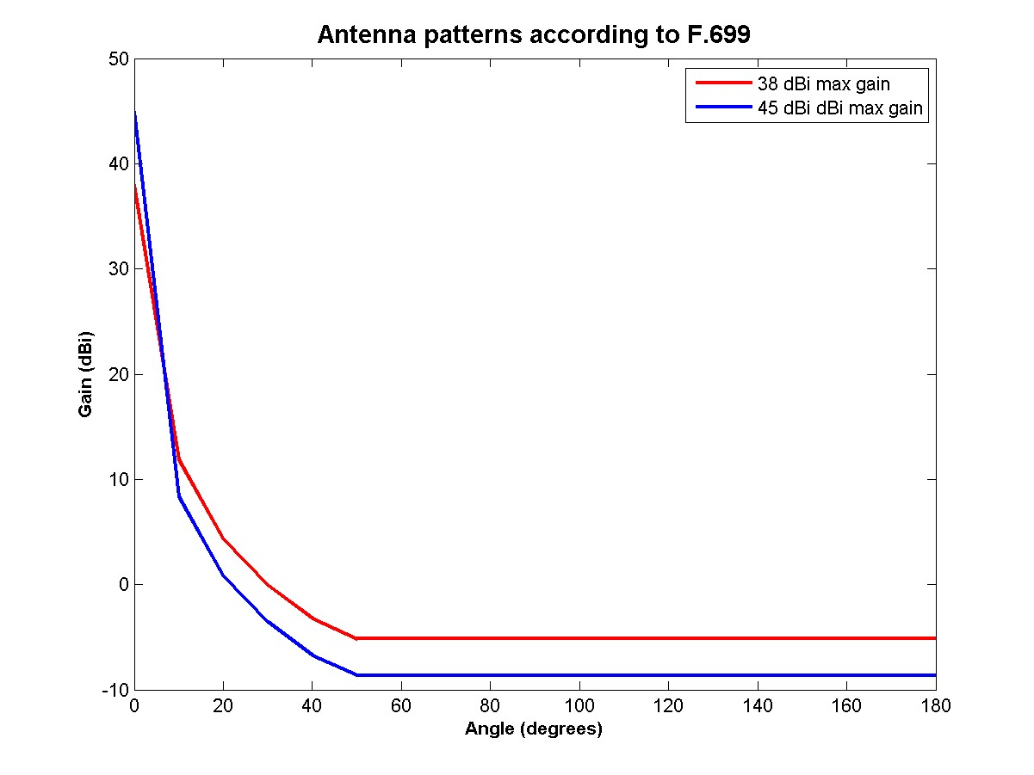
Figure 21: Antenna pattern according to ITU-R F.699 for a nominal gain of both 38 and 45 dBi.

For the compatibility study with an e.i.r.p. of 55 dBm, it is suggested to keep the conservative value of 8 dBi for angle greater than 15° in the case of a 45 dBi maximum gain. Thus the parameters proposed for the EESS compatibility study with an e.i.r.p. of 55 dBm are as follow:
- Power of a MGWS transmitter: 10 dBm
- Bandwidth: 150 MHz
- Antenna Gain: 45 dBi
- Antenna Gain in the Zenith direction: 8 dBi

A.5.4.2 MGWS FLANE / EESS calculation (see section 4.3.5 for e.i.r.p. of 40 dBm)

The table below is a revision of Table 14 which explains MCL calculation for ATMS. ATMS corresponds to the most sensitive mechanical scanning type and therefore the worst case for considered passive services. This means that it is not needed to repeat the other calculations. Table 14 shows the sensitivity of various RF figures in terms of input power and antenna gain.

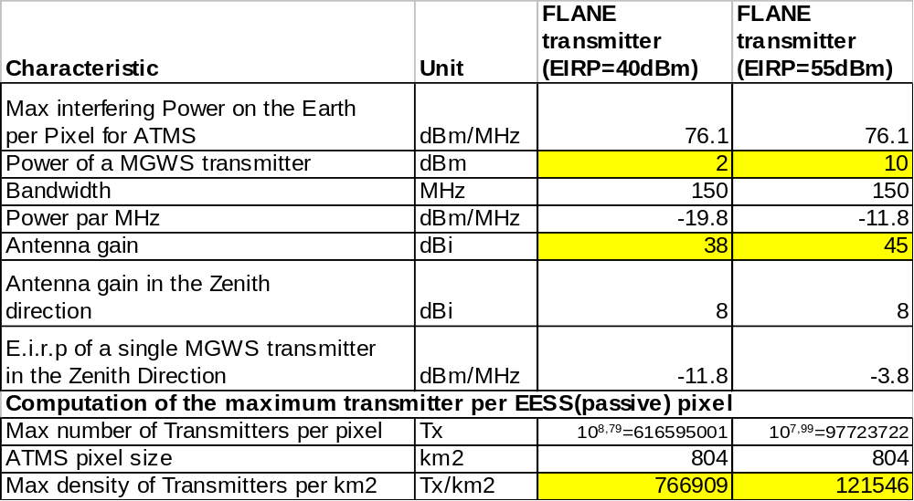
Table20: Comparison of the maximum density of MGWS transmitters to avoid interference to ATMS with an e.i.r.p. of both 40 and 55 dBm

Instead of max density of 766909 FLANE transmitters per km2 with a e.i.r.p. of 40dBm, the calculation leads to a reduced number of 121 546 tx/km2 FLANE with 10 dBm power and 45 dBi antenna gain (i.e. e.i.r.p. of 55 dBm).

According to ECC/REC/(09)01, it should be considered that FLANE systems are technically equal to any PP application and are considered to be part of the Fixed Service. Therefore the conclusions given in this annex are also applicable to the Fixed Service.

Annex 5: List of References

- TR 102 555: “Technical characteristics of multiple gigabit wireless systems in the 60 GHz range System Reference Document”
- ERC/REC 12-09: “Radio frequency channel arrangement for Fixed Service systems operating in the band 57.0 - 59.0 GHz which do not require frequency planning”
- ECC/REC/(05)02: "Use o f the 64-66 GHz frequency band for Fixed Service"
- Recommendation ITU-R F.699 : “Reference radiation patterns for fixed wireless system antennas for use in coordination studies and interference assessment in the frequency range from 100 MHz to about 70 GHz”
- ERC/REC 74-01: “Unwanted Emissions in the Spurious Domain”
- Recommendation ITU-R P.676: “Attenuation by atmospheric gases”
- TS 102 329: “Radio equipment and antennas for use in Point-to-Point High Density applications in the Fixed Service (HDFS) frequency band 64 GHz to 66 GHz”
- EN 302 217-3 : “Fixed Radio Systems;Characteristics and requirements for point-to-point equipment and antennas;Part 3: Harmonized EN covering essential requirements of Article 3.2 of R&TTE Directive for equipment operating in frequency bands where no frequency co-ordination is applied”
- TR 102 400: Intelligent Transport Systems (ITS); Road Traffic and Transport Telematics (RTTT); Technical characteristics for communications equipment in the frequency band from 63 GHz to 64 GHz; System Reference Document”
- Radio Regulations (www.itu.int)
- Recommendation ITU-R RS.1028-2: “Performance criteria for satellite passive remote sensing ”
- Recommendation ITU-R RS.1029-2: “Interference criteria for satellite passive remote sensing”
- ERC Report 45: “Sharing between the Fixed and Earth Exploration Satellite (passive) Services in the band 50.2 - 66 GHz”

The conclusions referring to “entire range 57-66 GHz” are without prejudice to situation in 63-64 GHz which is subject of a separate study
Scenario study in the project WIGWAM: System Concept Development for 1 Gbit/s Air Interface: http://www.ifn.et.tu-dresden.de/MNS/veroeffentlichungen/2005/Fettweis_G_WWRF_05.pdf
Study carried out by Fraunhofer Institute
Available on-line via EFIS (http://www.efis.dk)

