

CEPT Report 34

Report B from CEPT to European Commission
in response to the Mandate 4 on

Ultra-Wideband (UWB)

Final Report on 30 October 2009 by the

Electronic Communications Committee (ECC)
within the European Conference of Postal and Telecommunications Administrations (CEPT)

Executive summary
This report by the European Conference of Postal and Telecommunications Administrations (CEPT) to the European Commission (EC) completes CEPT Report 27 adopted by ECC at its meeting in March 2009.

CEPT Report 27 provides an overview of CEPT investigations on the generic ultra-wideband (UWB) regulation that have been completed with the amendment of Decision ECC/DEC/(06)12 in October 2008.

This report focuses on additional work achieved under this mandate on UWB applications, in particular further investigations concerning specific ultra-wideband applications as well as possibilities to expand the scope of the generic UWB regulation to different operating environments.

CEPT has actually emphasized on several occasions that the generic UWB regulation shall remain the cornerstone of European regulatory package on UWB.

ECC at its meeting in Cordoba in October 2008 recalled that the industry should be guided that in general the generic UWB regulations should be used primarily, including for planned specific UWB applications, without totally excluding the possibility for specific solutions and only in case of duly justified needs.

The so called “generic UWB regulation” aims to be applicable to any kind of application. Only variations due to compatibility reasons can be envisaged pending the operating environment (i.e. general case / road and rail vehicles/ aircraft) or the type of installation (fixed / non fixed installation).

Conversely, a “specific UWB regulation” is meant to apply only to a well defined type of application.

This report presents recent CEPT investigations on licence-exempt “imaging” applications using UWB technology, in particular those relating to the incorporation of Object Discrimination and Characterisation (ODC) into Decision ECC/DEC/(07)01 (see section 2).

CEPT overall approach and criteria for handling new industry requests for specific UWB regulations are then presented (see section 3), as well as CEPT position on new ETSI SRDoc agreed at the light of these principles (see Annex).

CEPT overall approach was developed within WGFM Project Team FM47. It distinguishes the type of licensing regime that is foreseen (Licence-exempt versus Individual licence / light licensing regime) and is summarized below:

- Licence-exempt regime

CEPT has well accepted the principle of derogation to the generic UWB regulation for “imaging” applications such as BMA and ODC. Decision ECC/DEC/(07)01 aims to provide a stable regulatory framework for this kind of licence-exempt applications.

Other types of application should basically fit into the generic UWB regulation.

As a matter of equitable access to spectrum, CEPT considers indeed that technical conditions requested by the industry for a type of application foreseen under the generic UWB framework should be applicable to any kind of application. Regulators simply cannot discriminate one type of application from another one which could claim to benefit from similar conditions.

For example, allowing higher power spectral density would be beneficial to any kind of licence-exempt application foreseen under the generic UWB framework (e.g. High Data Rate communication, transmission in highly cluttered / Non-LOS indoor environment, positioning) and cannot be envisaged only for one type of application on the ground of limited deployment assumptions.

For CEPT, possible evolution of the generic regulation shall not rely on assumptions that are relevant only to specific market needs and should assume potential wide scale generic deployment.

Coexistence may instead rely on the implementation of adequate generic mitigation techniques. Only some variations are possible pending the operating environment (i.e. general case / road and rail vehicles/ aircraft) or the type of installation (fixed / non fixed installation).

- Individual licence / light licensing regime

The report indicates that a “licensed” approach may be envisaged for mobile/portable UWB applications. Such possibility needs to be investigated on a case by case and is illustrated by the example of GPR/WPR imaging systems.

A “licensed” approach is however more problematic for fixed outdoor UWB installations as the possible authorization for use of a fixed outdoor UWB installation at a given location is source of conflicts and uncertainties for the future deployment of radio stations from radio communication services which are duly authorized in the same bands.

Individual licensing of fixed outdoor UWB infrastructure may challenge the rights of Radiocommunication Services with primary status and contradicts the principle of an “underlay” regulation. It could furthermore imply that a certain degree of protection is granted to the UWB operator and is therefore not supported by CEPT. Further investigation could take place within CEPT on other forms of registration and coordination as interference control mechanism, like in the case of Location tracking applications type 2.

Table of contents

0 Executive summary 2
1 Introduction 5
2 Material sensing devices 5
2.1 Application definitions 5
2.2 Technical requirements for ODC 6
2.3 Technical requirements for BMA 6
3 CEPT overall approach and criteria for the handling of new industry requests for specific UWB regulations 7
3.1 License-exempt applications 7
3.1.1 Frequency management 7
3.1.2 Compatibility studies 8
3.2 Individual license / light licensing regime 8
ANNEX 1: Review of new ETSI SRDoc on UWB 10
ANNEX2: 4th EC Mandate on UWB 13

Introduction
This report by the European Conference of Postal and Telecommunications Administrations (CEPT) to the European Commission (EC) completes CEPT Report 27 adopted by ECC at its meeting in March 2009.

CEPT Report 27 provides an overview of CEPT investigations on the generic ultra-wideband (UWB) regulation that have been completed with the amendment of Decision ECC/DEC/(06)12 in October 2008.

This report focuses on additional work achieved under this mandate on UWB applications, in particular further investigations concerning specific ultra-wideband applications as well as possibilities to expand the scope of the generic UWB regulation to different operating environments.

It presents recent CEPT investigations on “imaging” applications using UWB technology, in particular those relating to the incorporation of Object Discrimination and Characterisation (ODC) devices into Decision ECC/DEC/(07)01.

CEPT overall approach and criteria concerning the handling of new industry requests for specific UWB regulations is then clarified.

CEPT position and approach in response to recent request from ETSI for specific UWB regulations is finally presented:
- Location Tracking Application for Emergency Services (LAES)
- Location Tracking Applications type 2 (LT2) in the frequency bands 3.4 – 4.8 GHz and 6 – 8.5 GHz for person and object tracking and industrial applications
- Airborne UWB applications in the frequency bands 3.1 – 4.8 GHz and 6 – 8.5 GHz
- Location tracking and sensor Applications for automotive and transportation environments (LTSA-AT) in the frequency bands 3.1 – 4.8 GHz and 6 – 8.5 GHz

Material sensing devices

Application definitions
Decision ECC/DEC/(07)01 was originally developed in order to set conditions of use of the spectrum for Building Material Analysis (BMA) devices.

CEPT has then investigated the case of Object Discrimination and Characterisation (ODC).

Two types of UWB ODC applications were distinguished in the compatibility studies:
- Application A: Proximity Sensing of Human tissue
- Application B: “Break through” protection and direct contact avoidance for building work

Some description of both types of application is given in ECC Report 123.

Proper regulatory definitions are needed for ODC applications A & B. Terminology being used should be clear: the applicability of the regulation for a given product should not be ambiguous, neither for industry, nor for radio enforcement authorities.

Particular attention to the definition was also given in view of possible future incorporation in the EC Decision on UWB, as was done for BMA devices.

Preferably such definition should not be “overspecific”. Notions such as “Break through protection” or “direct contact avoidance” seem rather unclear outside the context of ECC Report 123. It was also questioned whether the notion of “saw” or “drill” application should at all be mentioned in the regulatory part of the Decision.

As underlined in the introduction of ECC Report 123 concerning BMA, ODC and GPR/WPR, “All three basically aim to detect the location of objects contained within a structure or to determine the physical properties of a material, following the same physical principles”.

BMA devices are defined as field perturbation sensors that are designed to detect the location of objects within a building structure or to determine the physical properties of a building material.

The notion of “building” needs obviously to be removed in case of ODC devices.

The following definitions were finally agreed when amending Decision ECC/DEC/(07)01:
- Material Sensing device: a radiodetermination system that is designed to detect the location of objects within a structure or to determine the physical properties of a material.
- Building Material Analysis (BMA) device: a type of Material Sensing device that is designed to detect the location of objects within a building structure or to determine the physical properties of a building material;

Remark: under proposed approach, the general rules set under Decision ECC/DEC/(07)01 would apply to “Material Sensing device”. The case of BMA devices becomes the exception, characterized by lower active device densities and in general less stringent technical requirements.

Technical requirements for ODC
The amended “spectrum mask” for ODC devices can be found in Annex 1 to the amended Decision ECC/DEC/(07)01.

It should be noted that this spectrum mask sets only ‘Maximum mean e.i.r.p. spectral density’.

These regulatory requirements distinguish two different cases:
- Fixed installation (application A)
- Non fixed installation (application B)

‘Peak power’ and ‘PRF’ limits are referred to in a section on “other requirements” under Annex 3 of the amended Decision ECC/DEC/(07)01. These requirements would not be part of the “radio interface specification” but would aim to provide clear guidance to ETSI for relevant Harmonised Standard.

Technical requirements for BMA
The following adjustments of the technical requirements for BMA devices have been proposed to and agreed by ECC when amending Decision ECC/DEC/(07)01:
- increase the maximum mean e.i.r.p. spectral density in the frequency band 2.7 – 3.4 GHz from -82 dBm/MHz (without mitigation technique) to -70 dBm/MHz consistently with Decision ECC/DEC/(06)04 amended July 2007.
- extend the upper band edge for operation at -50 dBm/MHz up to 8.5 GHz instead of 8 GHz. The band edges for operation at -50 dBm/MHz would become the same for both BMA and ODC applications.

The proposed increased maximum mean e.i.r.p. spectral density in the frequency band 2.7 – 3.4 GHz (i.e. -70 dBm/MHz) is basically justified by complementary technical studies performed within the frame of the work on the generic UWB regulation on the impact on aeronautical S-band radars. It should however be noted that BMA devices are in practice expected to implement a Listen Before Talk (LBT) mechanism and to operate within frequency band 2.7 – 3.4 GHz with a maximum mean e.i.r.p. spectral density of –50 dBm/MHz. This “fine-tuning” of the regulatory parameters applicable without using mitigation techniques aims primarily to bring greater consistency with the generic UWB regulation.

Concerning frequency band 8 – 8.5 GHz, the proposed amendment consists of increasing the maximum mean e.i.r.p. spectral density from -70 dBm/MHz to -50 dBm/MHz. More restrictive power limit above the frequency range 2.2 – 8 GHz is primarily justified by the protection of the Radiolocation Service. However, given that the Radio Regulations allocation for the Radiolocation Service starts at 8.5 GHz, there is no justification to keep this more restrictive limit in the band 8 – 8.5 GHz.

These more efficient conditions of use of the spectrum should support innovation and greater products performances.

The amended “spectrum mask” for BMA devices can be found in Annex 2 to the amended Decision ECC/DEC/(07)01.

It should be noted that this spectrum mask sets only ‘Maximum mean e.i.r.p. spectral density’.

‘Peak power’ and ‘PRF’ limits are now referred to in a section on “other requirements” under Annex 3 of the amended Decision ECC/DEC/(07)01. These requirements would not be part of the “radio interface specification” but would aim to provide clear guidance to ETSI for relevant Harmonised Standard.

CEPT overall approach and criteria for the handling of new industry requests for specific UWB regulations
In order to further clarify CEPT criteria concerning the handling of industry requests for specific UWB regulations, it is proposed to distinguish first the type of licensing regime that is foreseen:
- License-exempt regime: where radio equipment operates under a pre-defined set of conditions that does not include any provision for registration and/or notification.
- Individual licence / light licensing regime: where the administration still hold a certain degree of control of the deployment and/or use of transmitters

ECC Report 132 on LL&LEC provides an analysis on the relation of these different types of licensing regime with the Authorisation Directive 2002/20/EC.

License-exempt applications

Frequency management
In case of license-exempt applications, CEPT has well accepted the principle of derogation to the generic UWB regulation for “imaging” applications such as BMA and ODC.

BMA and ODC devices are characterized by emissions only when in contact or close proximity to the investigated material. As explained in CEPT Report 10 (July 2006), their operational performances rely typically on the following key benefits/features of using UWB technology:
- Recognition and accuracy in imaging applications
- Differentiation between materials or objects by determining their physical properties

The development of a specific regulatory framework is justified because of physical reasons (e.g. lower frequencies with higher levels are needed due to reflections of clutter and the needed penetration depth).

The recent development of draft amended Decision ECC/DEC/(07)01 so as to incorporate ODC has enabled proper regulatory terminology to be set up for the type of license-exempt imaging applications using UWB technology that are eligible for a specific UWB regulation.

Decision ECC/DEC/(07)01 aims to provide a stable regulatory framework for license-exempt Material Sensing devices using UWB technology. The technical requirements may be adjusted with time so as to take into account technological change while ensuring the protection of radio services.

Other types of application should basically fit into the generic UWB regulation which enables various types of applications using UWB technology in bands below 10.6 GHz including location-tracking and other sensor technologies.

The generic regulatory framework for UWB ought to remain stable. It was primarily designed with the aim of enabling application relying typically on the following key benefits/features of using UWB technology:
- High Data Rate communication
- Transmission in highly cluttered / Non-LOS indoor environment
- Accuracy in positioning

As a matter of equitable access to spectrum, CEPT considers that technical conditions requested by the industry for a type of application foreseen under the generic UWB framework should be applicable to any kind of application. Regulators simply cannot discriminate one type of application from another one which could claim to benefit from similar conditions.

Compatibility studies
In case some adjustments are foreseen so as to meet new needs, compatibility shall be ensured with radio services assuming potential wide scale generic deployment. This point is of particular importance taking into account the concern on potential aggregate UWB interference on Radiocommunication Services in the long term, which is well captured in CEPT Report 27.

CEPT has indeed concluded that UWB operation within the frequency bands 3.4 – 4.8 GHz and 6 – 8.5 GHz with a maximum mean e.i.r.p. spectral density level of -41.3 dBm/MHz is compatible with outdoor stations of radio services. This conclusion relies however on the complementary technical studies on FS/FSS which assumed low average activity factors of 1% for UWB devices and takes into account regulatory provisions aiming to minimise UWB outdoor activity. Final ECC TG3 investigations have led European regulators deciding to maintain the prohibition on fixed outdoor UWB installations recognizing that it would also limit the operation of mobile outdoor devices.

With respect to the protection of outdoor stations of radio services, the reference point for coexistence under existing generic UWB regulation can be summarized simply:
- predominant indoor use;
- average 1% activity factor;
- 100 devices/km² (rural), 1000 devices/km² (suburban) or 10000 devices/km² (urban), pending the type of victim service;
- In addition, in case of UWB installations in vehicles, a 12 dB TPC (or LDC) applies for operation at max -41.3 dBm/MHz within the bands 3.4 – 4.8 GHz and 6 – 8.5 GHz.

It must be underlined that the deployment assumptions above and hence the emissions limitations in the generic UWB regulation result from long discussions and carefully constructed compromises.

Possible evolution of the generic regulation shall not rely on assumptions that are relevant only to specific market needs as the generic regulatory provisions will ultimately apply to all type of application.

Coexistence may instead rely on the implementation of adequate generic mitigation techniques. Only some variations are possible pending the operating environment (i.e. general case / road and rail vehicles/ aircraft) or the type of installation (fixed / non fixed installation).

Individual license / light licensing regime
- Mobile/portable applications

The acceptance of derogation to the generic rules in case of GPR/WPR imaging systems primarily relied on the nature of the application (i.e. radar imaging system).

The protection of some sensitive radio stations (radars, radio astronomy observatories) can be achieved through adequate coordination procedures.

This “licensed” approach was feasible as GPR/WPR systems are mobile or portable by nature and are used in relative small numbers by trained professionals.

“Licensed” approach is here to be understood in a broad meaning where the administration still holds a certain degree of control of the deployment and/or use of transmitters, as opposed to the strict “license-exempt” case. Its applicability to other types of mobile/portable applications needs to be considered on a case by case basis and cannot be generalized for commercial applications.

- Fixed outdoor installations

ECC TG3 discussions in 2007/2008 have already shown the inadequacy of a regulatory approach based on individual licensing in case of fixed outdoor UWB installations.

During ECC TG3 discussions in March 2007, it had indeed been suggested that individual national administrations may allow fixed outdoor UWB installations (e.g. for location/tracking within hazardous plants or large logistics storage facilities) under an appropriate licensing regime. This approach was agreed to be inserted in “square brackets” in the draft amended Decision ECC/DEC/(06)04 adopted for public consultation by the ECC in March 2007. However, this approach was not supported by CEPT and not retained by in Decision ECC/DEC/(06)04 amended 6 July 2007.

Beyond the possible administrative burden of authorising fixed outdoor UWB installations, it was underlined that after licensing a UWB infrastructure, administrations may have to face requests from FS operators for new links that would be affected by the existing UWB infrastructure: this may lead to difficult decisions being taken over who should have access to the spectrum, the "primary" FS link or the "no status" UWB infrastructure. Under these circumstances, should the UWB licensee pay similar FS link fees for acquiring the "rights" over the FS spectrum?

The possible authorization for use of a fixed outdoor UWB installation at a given location is thus source of conflicts and uncertainties for the future deployment of radio stations from radio communication services which are duly authorized in these bands.

Individual licensing of fixed outdoor UWB infrastructure could challenge the rights of Radiocommunication Services with primary status and contradicts the principle of an “underlay” regulation.

It could furthermore imply that a certain degree of protection is granted to the UWB operator and is therefore not supported by CEPT. Further investigation could take place within CEPT on other forms of registration and coordination as interference control mechanism, like in the case of Location tracking applications type 2.

During the discussions within WGFM Project Team FM47, some industry stakeholders challenged the rationale for distinguishing the status of a fixed station operating as Fixed Service from that of a UWB station. It was also argued that such distinction favours exclusive use of the spectrum for FS and as such contradicts the evolving European legal framework.

It was clarified that a Fixed Service station operating under an individual frequency assignment requires adequate protection. Licensed operators that deploy a transmission network infrastructure need their investment to be secured. Conversely, UWB devices operate on a non-interference / non-protected basis. ECC Report 64 concluded in 2005 that a maximum mean e.i.r.p. density of –41.3dBm/MHz would not adequately protect a FS Point-to-Point link against interference from a single fixed outdoor UWB installation located in direct Line of Sight of the victim receiver.

It was also suggested to refer to “light-licensing” regime where the UWB fixed station would be “registered” instead of being “licensed”. Ensuring compatibility would require some sort of coordination mechanism as well as possible site engineering. However, it is possible that the same frequency management difficulties would occur in case of a FS operator request for a new link that would be affected by the existing UWB infrastructure: administrations need to keep record of permanent UWB installations and to be able to force on-site reengineering in case of new FS assignment nearby. Proposals describing how a “light-licensing” regime could overcome the above difficulties need therefore to be presented and discussed.

CEPT could also further investigate, as an alternative “licence-exempt” approach, the definition of adequate generic mitigation technique to protect FS P-P links. It should however be noted that such type of fixed outdoor installations would increase the operation of related mobile outdoor devices, which is in contradiction with conclusions in CEPT Report 27. The potential aggregate interference on radio services need to be also further investigated.

ANNEX 1: Review of new ETSI SRDoc on UWB
WGFM considered the proposals contained in the following ETSI system reference documents:
- Location Tracking Application for Emergency Services (LAES)
- Location Tracking Applications type 2 (LTA-t2) in the frequency bands 3.4 - 4.8 GHz and 6 - 8.5 GHz for person and object tracking and industrial applications
- Location tracking and sensor Applications for automotive and transportation environments(LT&SA-A&T) in the frequency bands 3.1 – 4.8 GHz and 6 – 8.5 GHz
- Airborne UWB applications in the frequency bands 3.1 - 4.8 GHz and 6 - 8.5 GHz

The actions proposed by WGFM were reviewed and agreed by the ECC at its 23rd meeting in Douglas (Isle of Man), 22 – 26 June 2009.

1. Location Tracking Application for Emergency Services (LAES)

ETSI SRDoc: see doc. FM47(09)008 / Draft ETSI TR 102 496 V2.1.1

Since LAES applications are mobile/portable by nature and their use may be restricted to governmental organisations, an individual licensing regime can be envisaged.

This possibility is subject to assessment of both compatibility and government users’ needs. FM47 developed a questionnaire as to better assess and confirm the needs for such application. The questionnaire should also help clarifying the intended market for this equipment which should primarily be government agencies responsible for public safety (fire and rescue services, but also including police and other services).

Following a request from ETSI ERM, ECC noted that FM47 agreed to ask SE24 to initiate compatibility considerations in parallel with the development of this questionnaire, noting that the scenarios to be investigated may need to be refined based on the results of the questionnaire

SE24 is invited to focus on single interference studies on the impact on FS/FSS and BWA terminals, taking into account the expected low deployment.

2. Location Tracking Applications type 2 (LT2) in the frequency bands 3.4 – 4.8 GHz and 6 – 8.5 GHz for person and object tracking and industrial applications

ETSI SRDoc: see doc. FM47(09)012 / Draft ETSI TR 102 495-5 V1.1.1

CEPT considered the proposal contained in Draft ETSI SRDoc on LT2. Two types of request for new regulation were to be distinguished:
- Fixed outdoor installations subject to individual licensing, in the bands 3.4 – 4.8 GHz and 6 – 8.5 GHz, with max -41.3 dBm/MHz and duty cycle < 5%/s
- License-exempt indoor use in the band 6 – 8.5 GHz with max -31.3 dBm/MHz e.i.r.p. and duty cycle < 5%/s

- Fixed outdoor installations subject to individual licensing

As explained in section 3.2 of this report, as a general rule ECC does not support the principle of fixed outdoor installations subject to individual licensing but some other forms of registration and coordination may be possible. In any case, it is important not to confer any primary rights to what is essentially an underlay service. Practical proposals of implementation of a type of “light-licensing” regime need to be submitted so as to better assess their feasibility.

The feasibility of the two approaches simply described below could be further investigated in case of location-tracking fixed installations:
- Light licensing allowing coordination and site engineering
- Mix-regime
- registration of installation (only for location tracking in industrial areas), plus
- mitigation technique to protect FS/FSS in single interference scenarios

The ECC is invited to initiate technical studies on the impact of fixed UWB outdoor location-tracking on radio services and in particular on FS/FSS in different single interference scenarios. The potential aggregate interference on radio services will also need to be investigated

- License-exempt indoor use

The ECC does not support the possibility of license-exempt use in the band 6 – 8.5 GHz with emission levels above -41.3 dBm/MHz e.i.r.p.

Allowing emission levels at -31.3 dBm/MHz e.i.r.p. on a license-exempt basis would contradict the outcome of previous compatibility assessment and challenge the compromises reached to facilitate the introduction of UWB. A wide range of application could claim to benefit from such conditions on a license-exempt basis. The associated proposal of a duty cycle < 5%/s does not offer an equivalent level of protection when assuming generic deployment scenarios.

It is also unclear how the indoor use restriction could be enforced.

3. Location tracking and sensor Applications for automotive and transportation environments (LTSA-AT) in the frequency bands 3.1 – 4.8 GHz and 6 – 8.5 GHz

ETSI SRDoc: see doc. FM47(09)013 / Draft ETSI TR 102 495-7

The table below provides a short description of 3 categories of location tracking and sensor applications for automotive and public transportation environments:

Category | application | short description
A | Location Tracking in a public transportation environment | Location positioning datagrams are exchanged through one or more of the reference stations mounted inside the vehicle at convenient locations, with mobile tags carried by passengers and/or luggage. The typical range of radio operation is 1m to 30m. Environmental conditions can be challenging in selected cases. All cases must be covered with high reliability.
B | Location Tracking in the automotive environment | Location tracking datagrams are exchanged between a base station located inside the vehicle and corresponding mobile tags and/or the vehicle key.
C | Sensing in the automotive environment | Telemetry datagrams are exchanged in a vehicle mounted sensor network.

The ECC reviewed these industry requirements and concluded the following:

- Category A: Location tracking in public transportation (road and rail vehicles)

Industry requests the possibility to allow up to -35 dBm/MHz e.i.r.p. in the frequency band 3.1 – 4.8 GHz and up to -25 dBm/MHz e.i.r.p. in the frequency band 6 – 8.5 GHz under specific conditions.

The ECC does not support License-exempt use in the bands 3.1 – 4.8 GHz and 6 – 8.5 GHz with emission levels above -41.3 dBm/MHz e.i.r.p.

Allowing emissions levels above -41.3 dBm/MHz e.i.r.p. on a license-exempt basis would contradict the outcome of previous compatibility assessment and challenge the compromises reached to facilitate the introduction of UWB, unless generic mitigation techniques providing an equivalent level of protection could be implemented. A wide range of application, including RFID-like applications, could claim to benefit from such conditions on a license-exempt basis.

The ECC considered that the proposed mitigation techniques of additionally reducing the signal duty cycle compensating for extended 6 dB TPC range is not likely to provide an equivalent level of protection of BWA and FS/FSS under generic deployment assumptions.

- Category B: Location tracking and positioning in the automotive environment

This industry request (max -41.3 dBm/MHz + LDC in bands 3.1 – 4.8 GHz and 6 – 8.5 GHz) is consistent with current regulatory provisions given under generic UWB regulation. No new investigation is therefore needed.

- Category C: Sensing in the automotive environment

The operation of ‘Telemetry network inside vehicles’ and ‘Passenger alarm systems’ described under category C (max -41.3 dBm/MHz + LDC in bands 3.1 – 4.8 GHz and 6 – 8.5 GHz) is consistent with current regulatory provisions given under generic UWB regulation. No new investigation is therefore needed.

The case of ‘smart tire’ requires more careful analysis. It is explained in the ETSI SRDoc (doc. 13, page 28) that LDC technical requirements are not strictly met.

The ECC does not support the development of specific regulatory conditions applicable to ‘smart tire’ only. The ECC noted that FM47 agreed to ask SE24 to investigate alternative LDC mitigation technique for the automotive environment.

Such LDC in the frequency band 3.1 – 4.8 GHz may be acceptable provided it ensures an equivalent level of protection when assuming generic deployment scenarios toward BWA terminal stations and aggregate interference on outdoor stations of radio services.

Industry representative emphasized that some of the applications foreseen can be operated by design only when the vehicle is moving.

4. Airborne UWB applications in the frequency bands 3.1 - 4.8 GHz and 6 - 8.5 GHz

ETSI SRDoc: see doc. FM47(09)015 / Draft ETSI TR 102 834 V0.0.4 (2008-12)

Devices installed in “aircraft and other aviation” are excluded from the scope of Decisions ECC/DEC/(06)04 (amended July 2007) and ECC/DEC/(06)12 (amended October 2008).

The industry request allowing existing generic regulatory provisions for use inside an aircraft:
- 3.1 – 4.8 GHz -41.3 dBm/MHz + LDC
- 6.0 – 8.5 GHz -41.3 dBm/MHz

Both communication and location-tracking applications for transmission inside an aircraft are foreseen by the industry. The potential impact of such UWB deployment on FSS and on radiolocation was underlined and should be studied. FM47 underlined that proper assessment of the effective attenuation from aircraft fuselage needs to be made.

The subject was broken down into two main elements – the possibility of interference to radio systems outside of aircraft and the possibility of UWB interference to “aviation systems” within an aircraft.

On the first element, ECC noted that FM47 agreed to ask SE24 to study the compatibility of UWB airborne with radio systems outside the aircraft.

On the second element it was recognised that UWB interference on “aviation systems” within an aircraft is the responsibility of relevant aeronautical regulatory authorities. FM47 developed a liaison to relevant European aeronautical regulatory authority/group to inform them on the CEPT investigations being initiated in this area.

ANNEX2: 4th EC Mandate on UWB
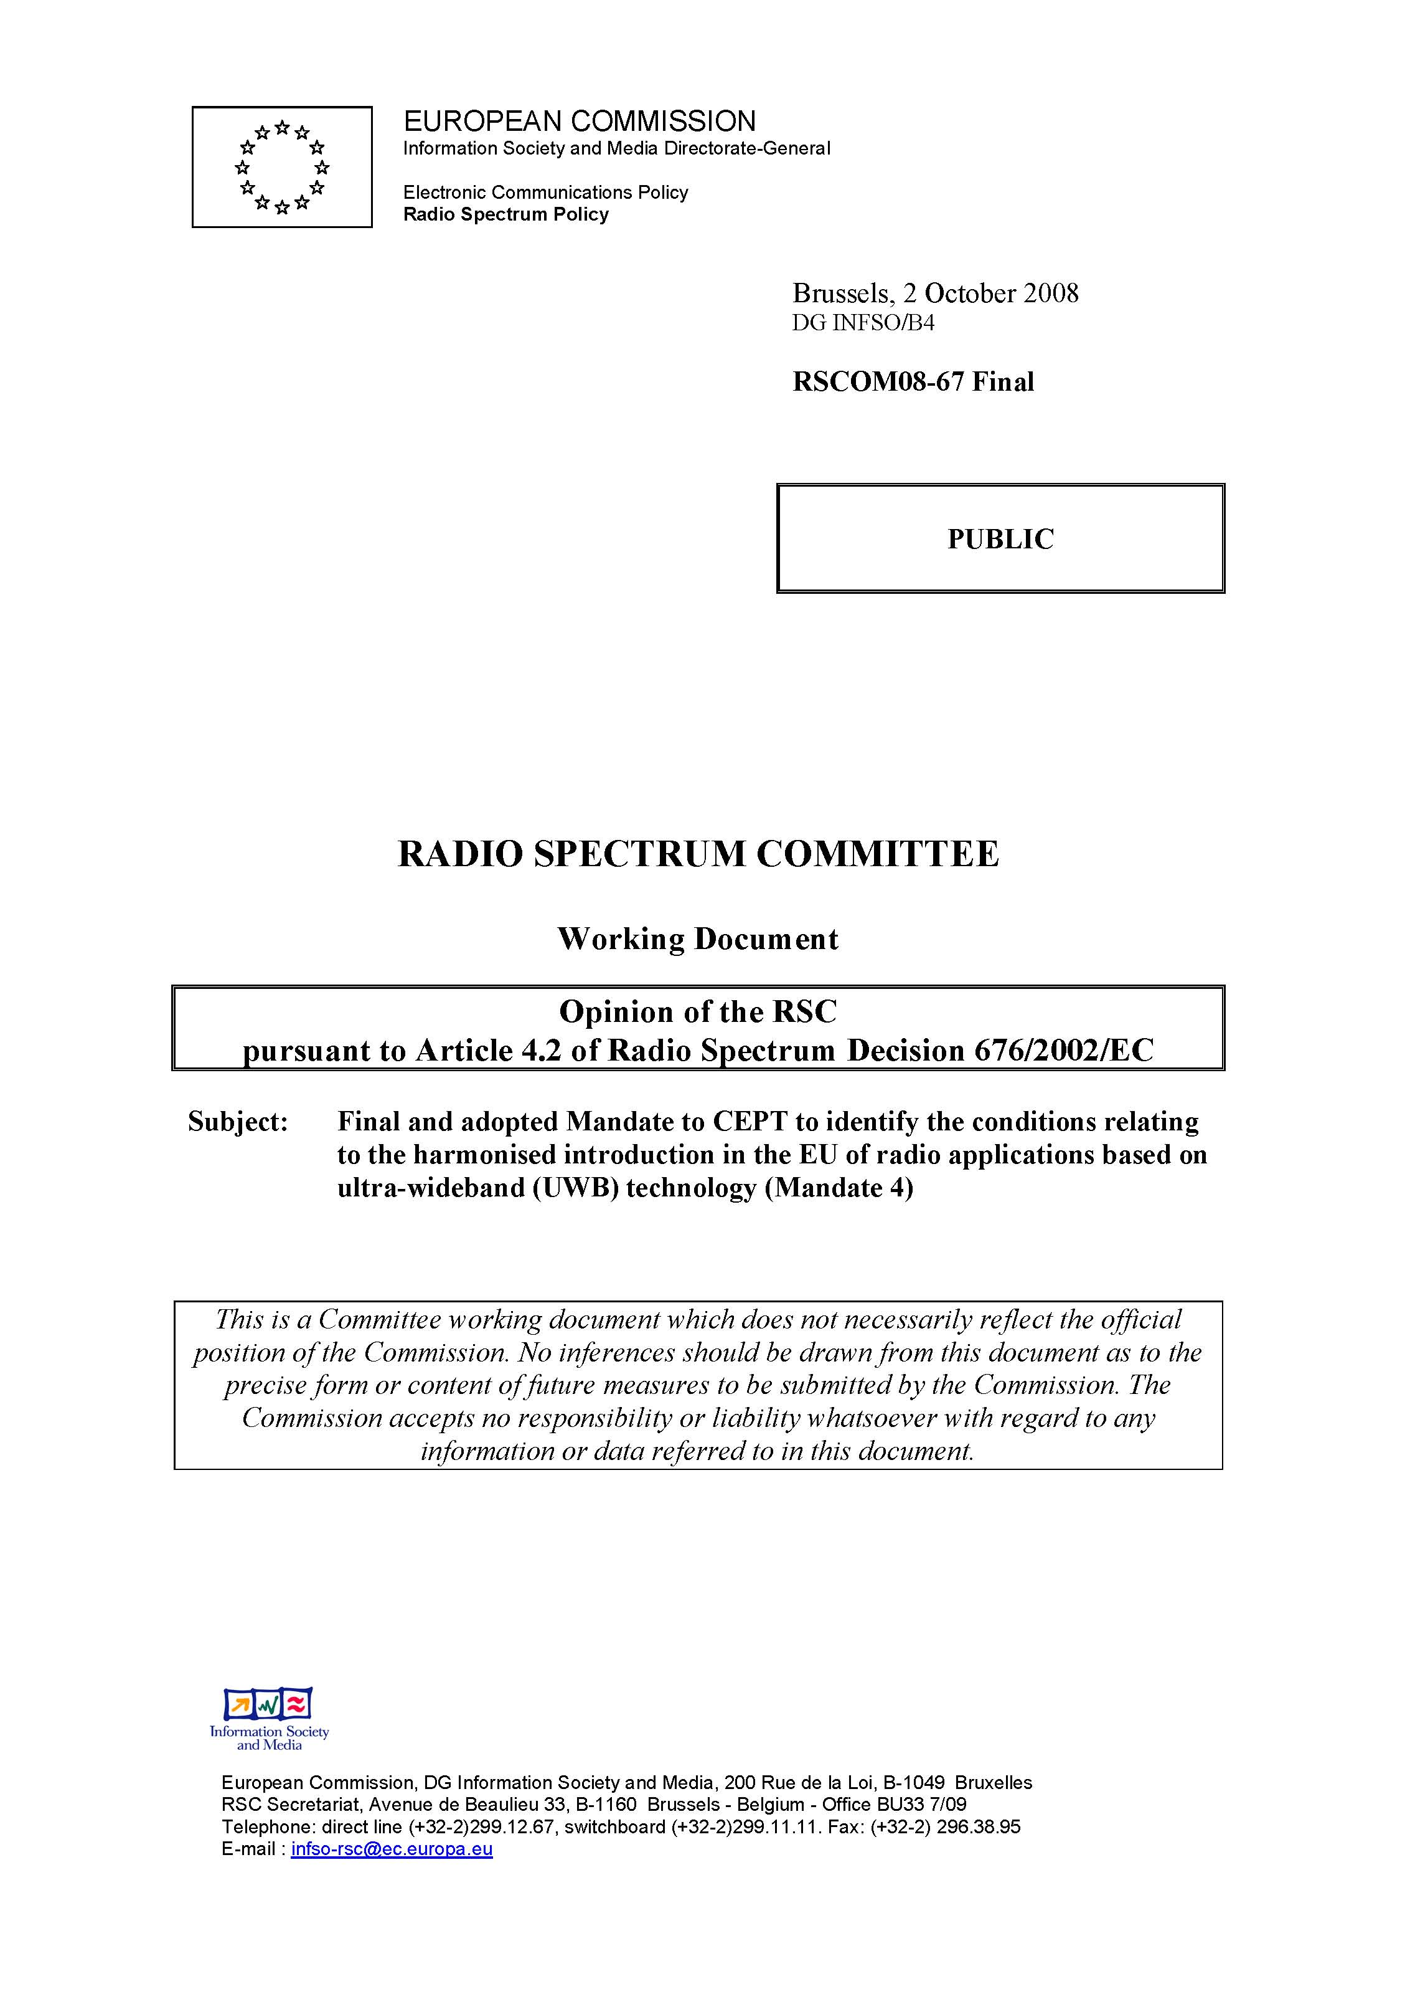
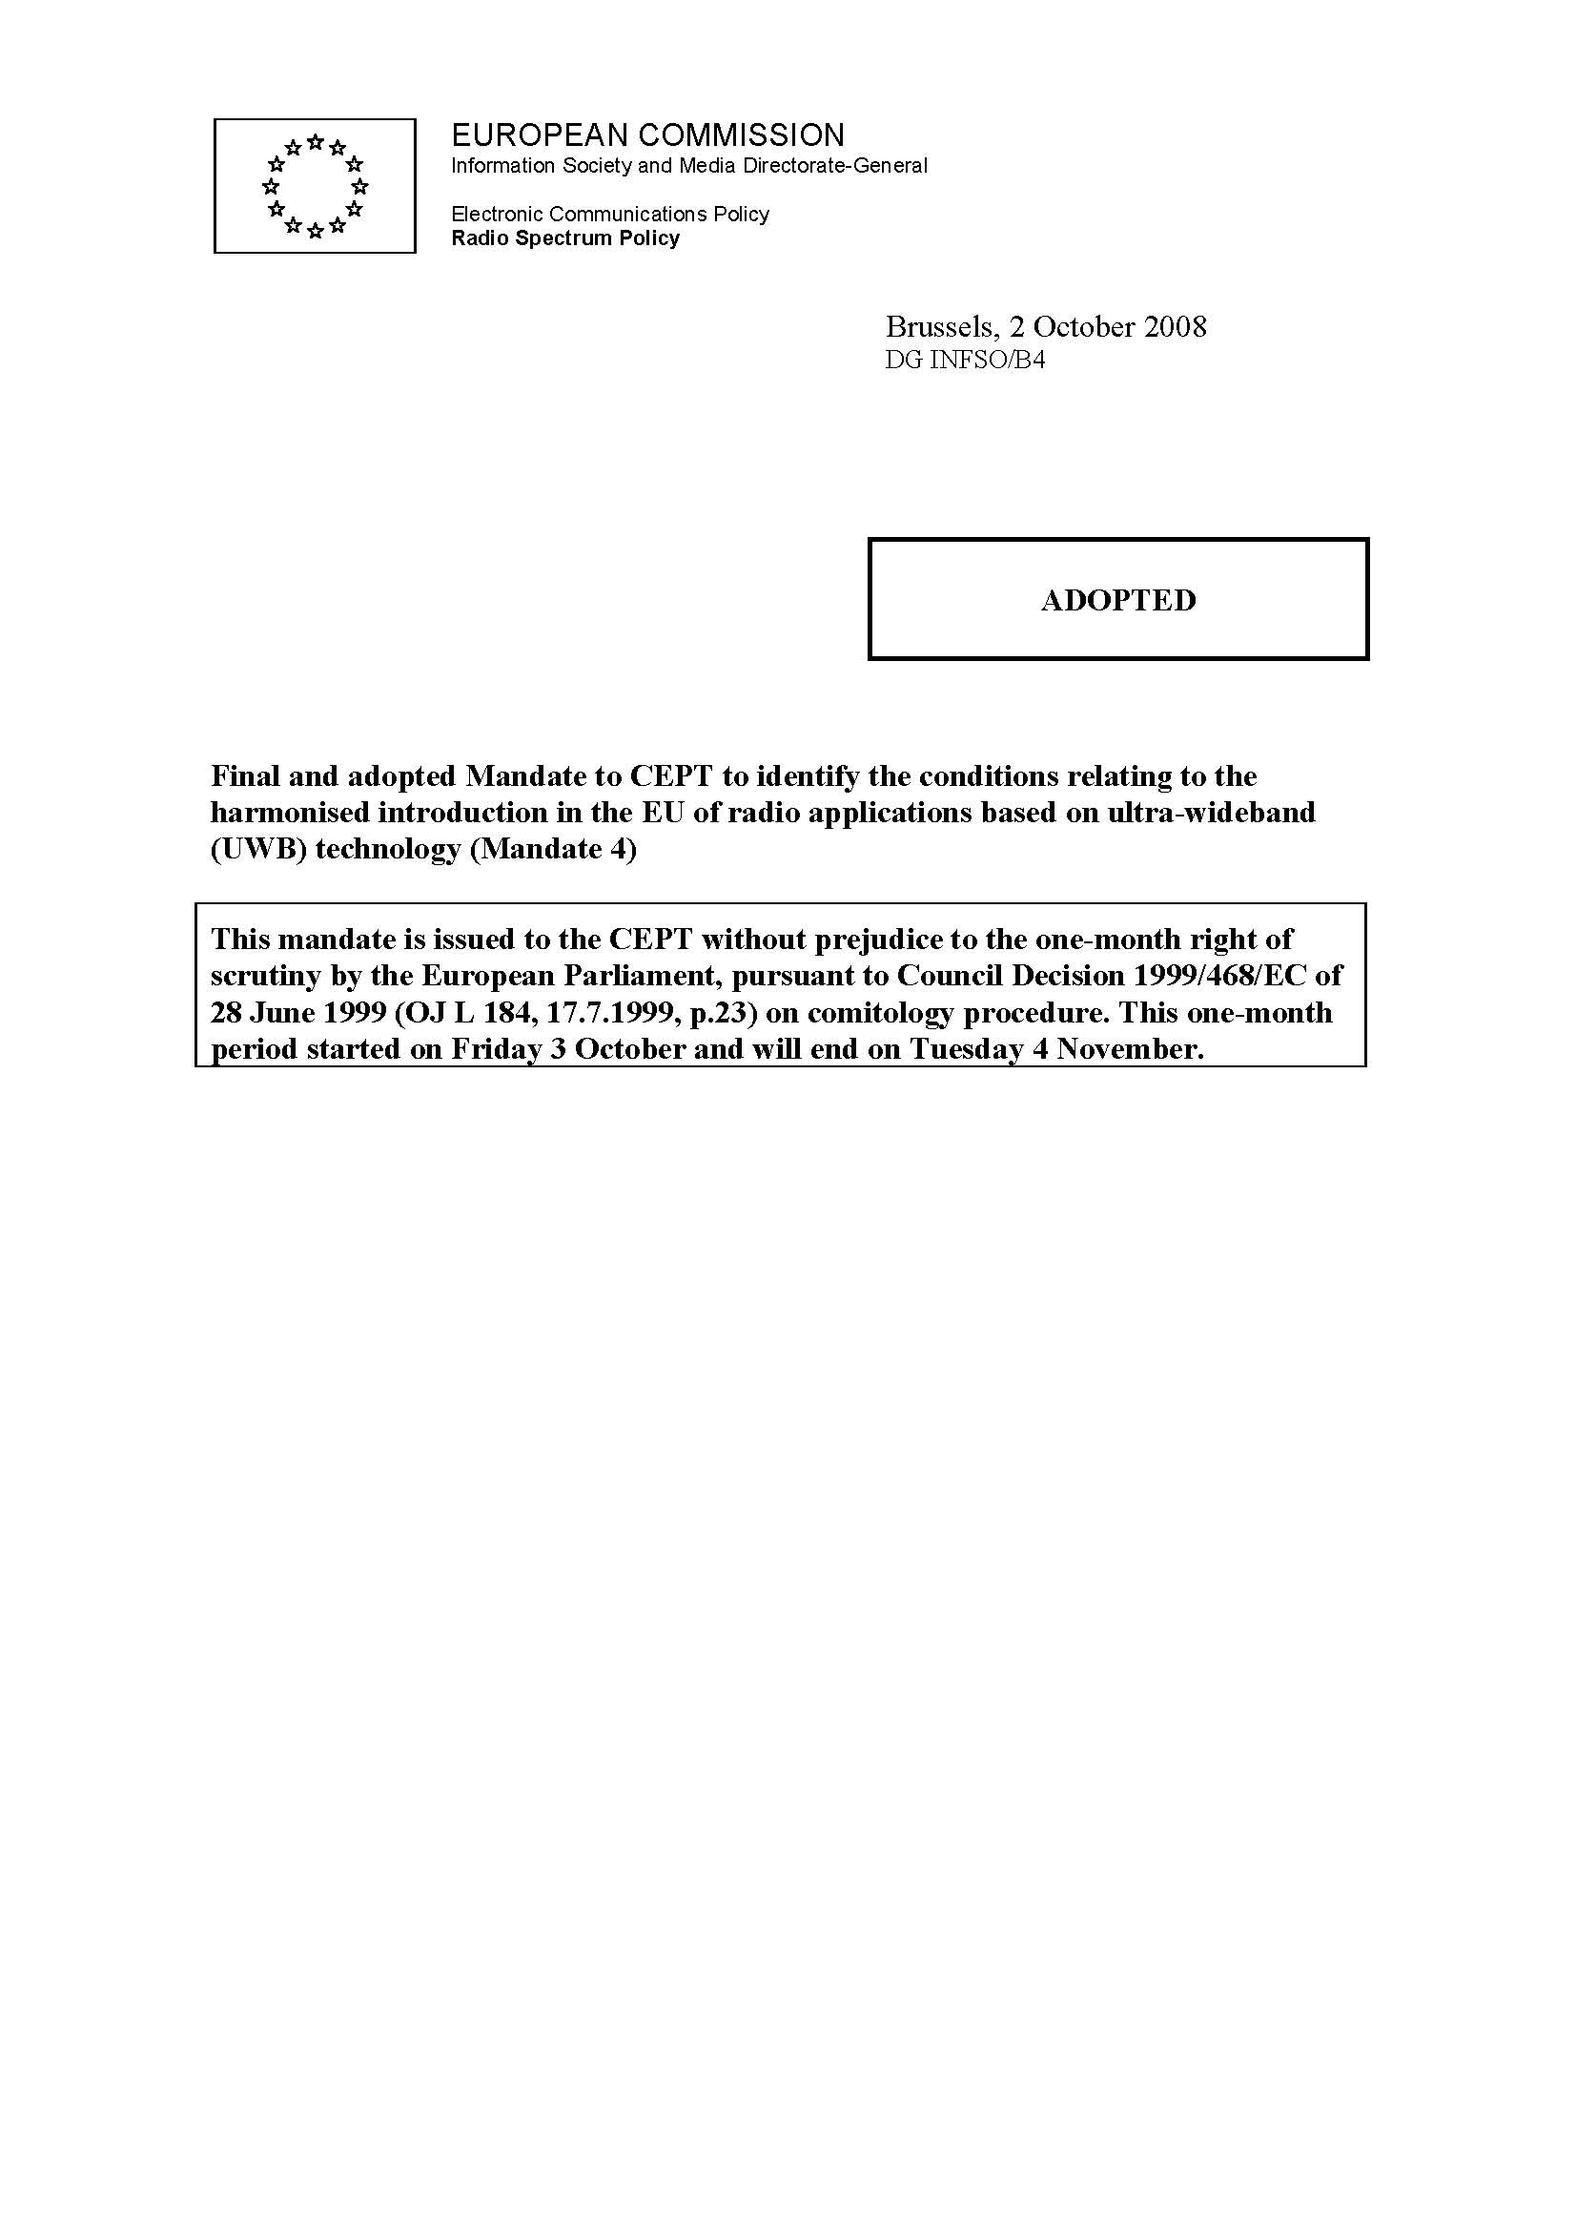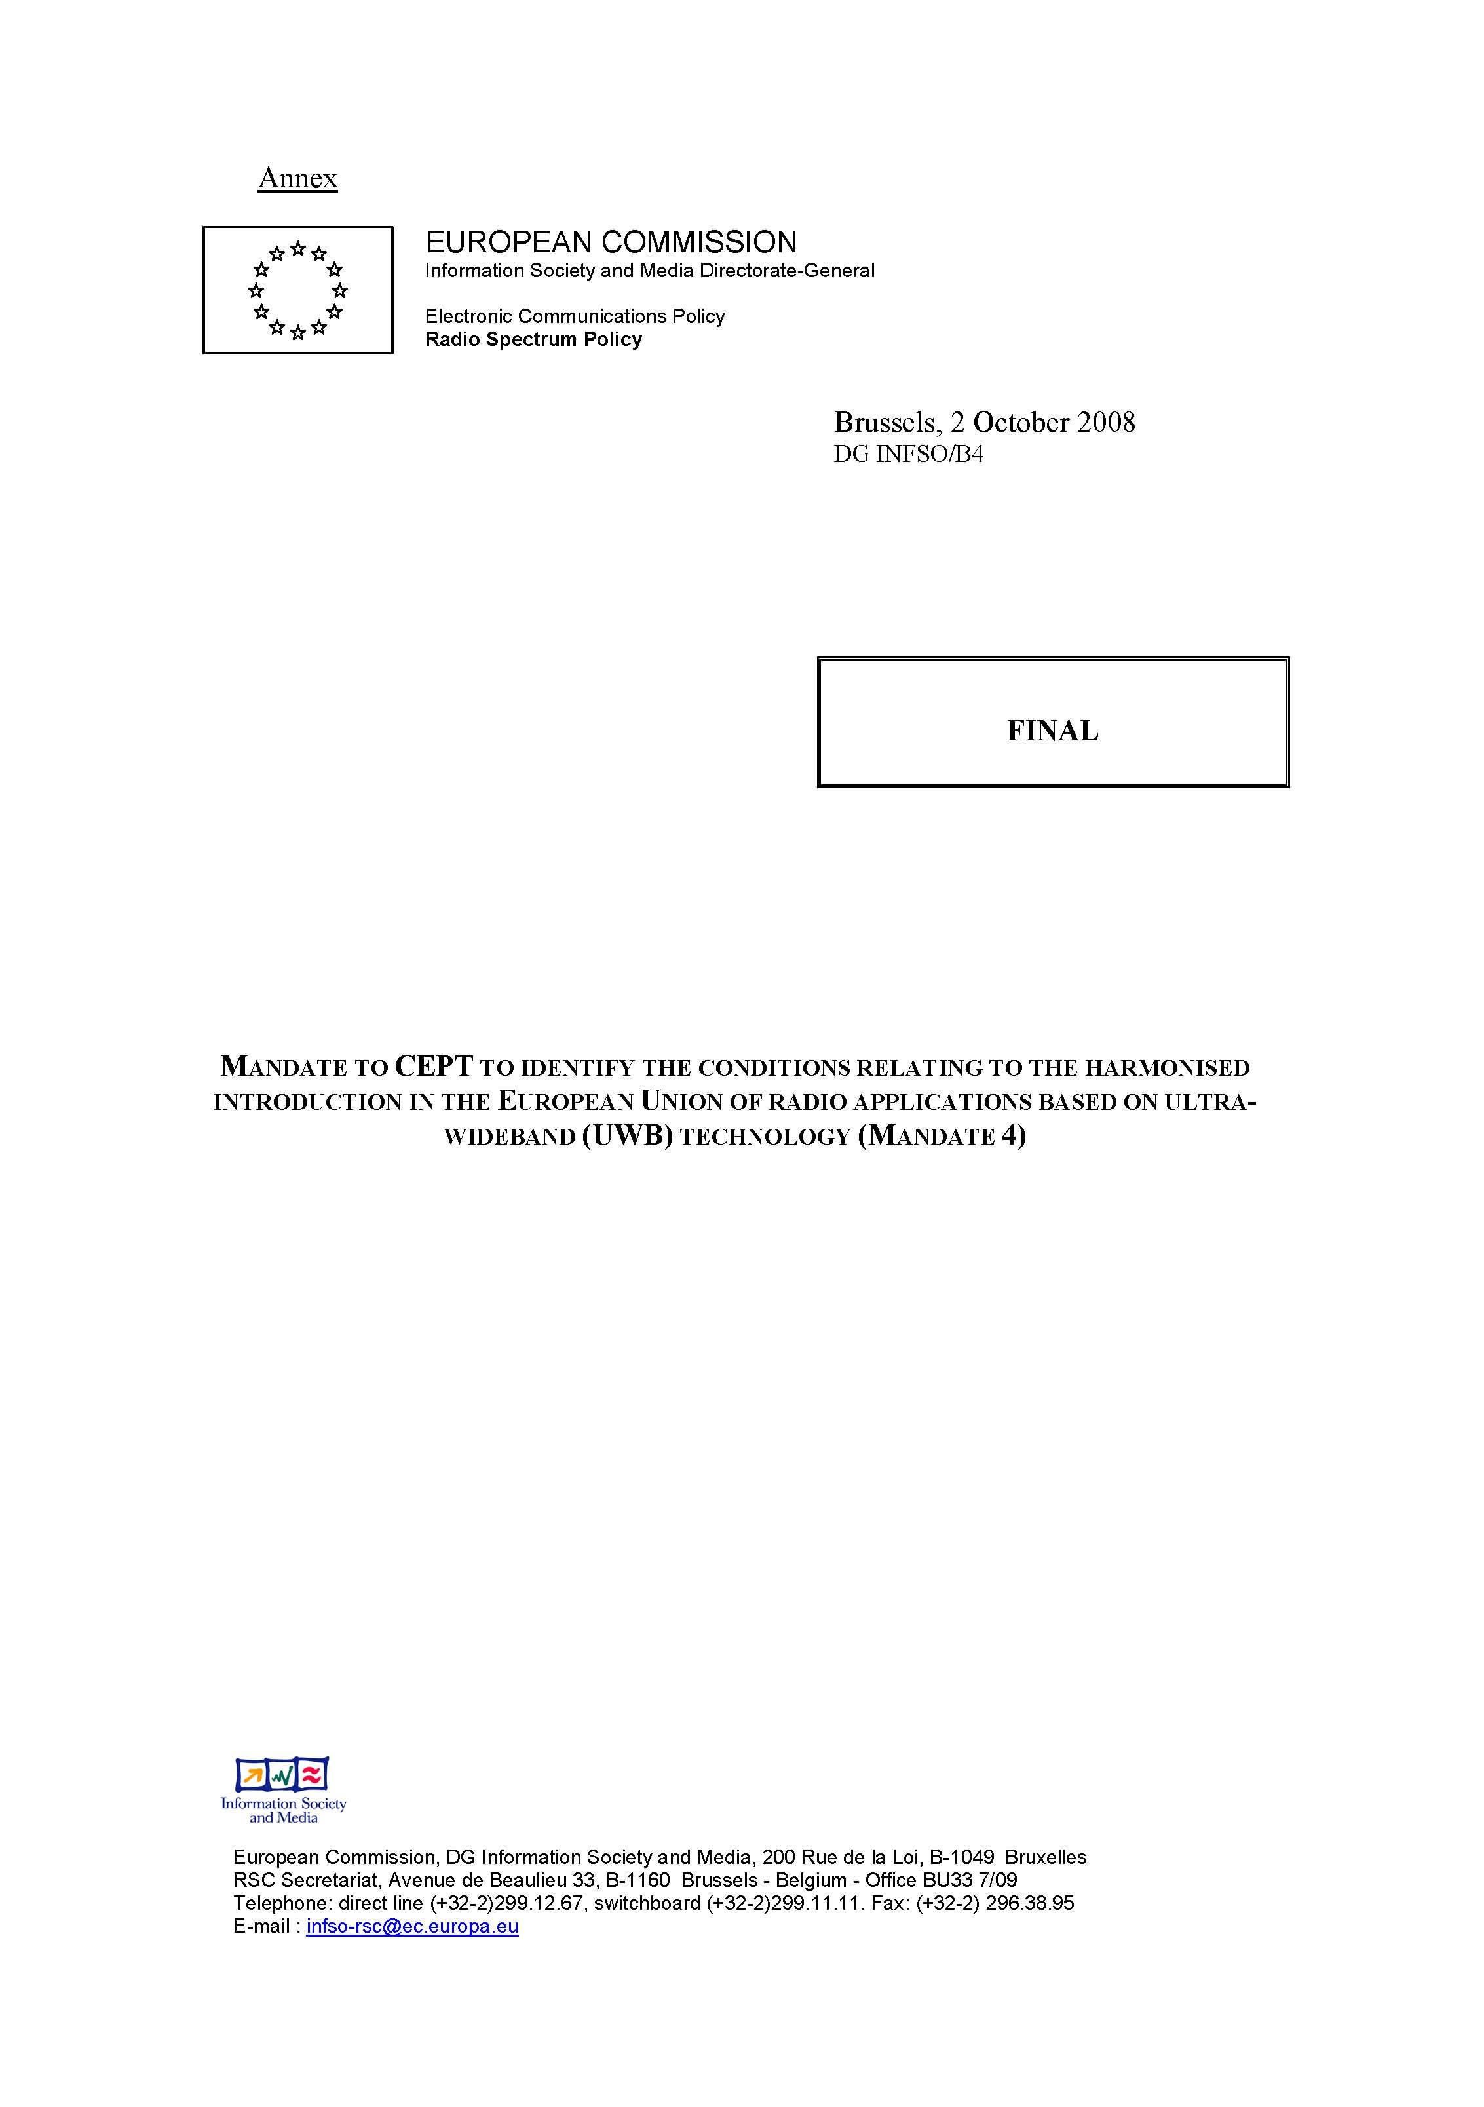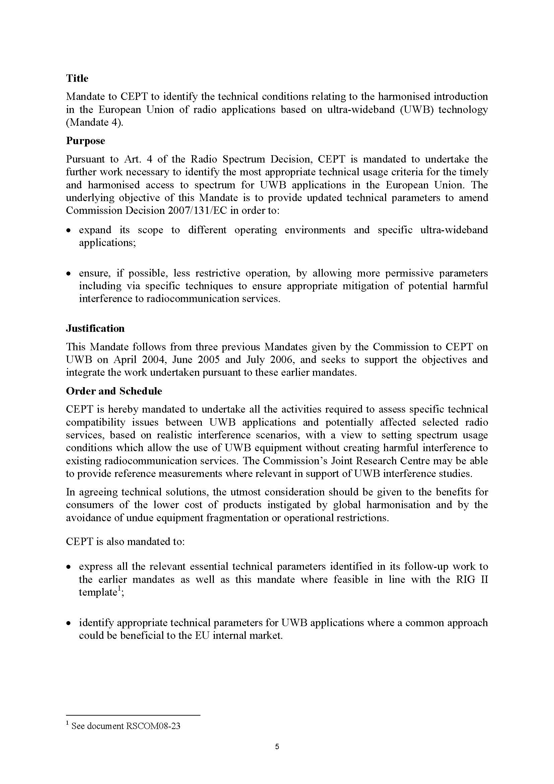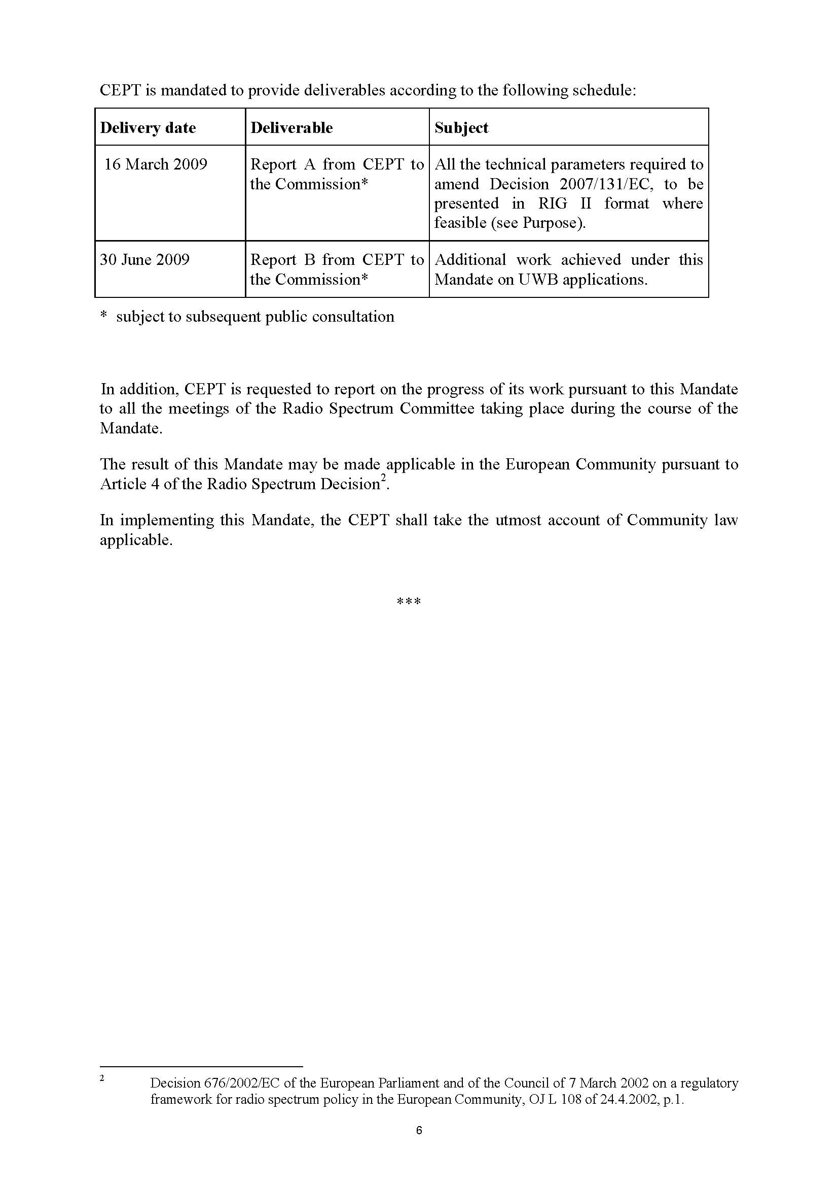
Bibliography

ECC Reports (available on www.ero.dk, cf. Deliverables/Reports)
- ECC Report 123 (September 2008) on the impact of Object Discrimination and Characterisation (ODC) applications using UWB technology on radio services

CEPT Reports in response to EC Mandates to CEPT to harmonise radio spectrum use for UWB systems in the European Union (available on www.ero.dk, cf. Deliverables/CEPT Reports)
- CEPT Report 10 (July 2006)
- CEPT Report 17 (March 2007)
- CEPT Report 27 (March 2009): Report A from CEPT to European Commission in response to the Mandate 4 on Ultra-Wideband (UWB)

Other related CEPT/ECC deliverables
- Doc. ECC(08)023 ANNEX 12: Final report on UWB in response to a request from the European Commission (March 2008)

Material Sensing device: a radiodetermination system that is designed to detect the location of objects within a structure or to determine the physical properties of a material.

