ECC Recommendation (24)04

Field strength measurements of Mobile/Fixed Communications Networks (MFCN) in border areas up to 6 GHz

**approved 18 October 2024**

# Introduction

This Recommendation contains methods to determine the field strength of base stations of Mobile/Fixed Communications Networks (MFCN) in frequency range FR1 specified by the 3GPP and which covers frequency bands up to 6 GHz.

This Recommendation could be used by the administrations to determine the field strength of MFCN base stations in border area if this is necessary for the purpose of frequency planning, cross-border coordination, monitoring, enforcement and other use cases.

This Recommendation could also be used in cases when it is important that equal measurement methods in border area are applied by the administrations involved, e.g. to assess the compliance of MFCN base stations with the technical conditions of cross-border coordination agreements, in case of harmful interference reports, etc.

This Recommendation complements ERC Recommendation 74-02 “Method of measuring the field strength at fixed points in the frequency range 29.7-960 MHz” [1] in order to cover MFCN systems operating in frequency bands harmonised for MFCN usage.

Basic principles for measurements along a route are described in Recommendation ITU-R SM.1708 “Field-strength measurements along a route with geographical coordinate registrations” [2]. Principles in this ITU Recommendation could also be used within the framework of this Recommendation where applicable.

# ECC Recommendation (24)04 on Field strength measurements of Mobile/Fixed Communications Networks (MFCN) in border areas up to 6 GHz

“The European Conference of Postal and Telecommunications Administrations,

*considering*

1. that Mobile/Fixed Communications Networks (MFCN) includes IMT and other mobile and fixed services which would include fixed wireless access but not point-to-point links;
2. that administrations may diverge from the technical parameters and procedures described in this Recommendation subject to bilateral/multilateral agreements;
3. that commonly agreed measurement methods to determine field strength of MFCN base stations are necessary in cases of harmful interference reports, to assess compliance with technical conditions of cross-border coordination agreements and other use cases applicable for frequency planning, coordination, monitoring and enforcement in border area;

*recognising*

1. that ERC Recommendation 74-02 [1] describes general methods of field strength measurements at fixed points in the frequency range 29.7-960 MHz;
2. that Recommendation ITU-R SM.1708 [2] describes the basic principles of signal field measurement along a route;
3. that methods of field strength measurement of 3G (UMTS), 4G (LTE) and 5G (NR) technology signals of MFCN have not been defined so far by CEPT;
4. that ERC Recommendation 74-02 covers frequency range only from 29.7 MHz to 960 MHz, although MFCN operates in frequencies up to 3800 MHz;

*recommends*

1. that measurements of the field strength of Mobile/Fixed Communication Networks (MFCN) and other radio frequency (RF) parameters relevant for the purpose of frequency planning, cross-border coordination, monitoring, enforcement and other use cases are carried out according to the methods described in ANNEX 1.

*Note:*

*Please check the Office documentation database* [*https://docdb.cept.org*](https://docdb.cept.org) *for the up to date position on the implementation of this and other ECC Recommendations.*

1. Field strength measurements of Mobile/Fixed Communications Networks (MFCN) in border areas up to 6 GHz
   1. Introduction

Cross-border coordination agreements (cross-border agreements) are generally based on methods that provide theoretical predictions of field strength using radio wave propagation models. It is practically impossible to recreate these methods with measurement procedures in the field. Therefore, only some approximation of measurements could be used to check compliance with those methods. Measurements to assess compliance with the conditions derived from theoretical predictions should therefore aim to apply the conditions that were used for the calculations (e.g. detector, bandwidth, location and time probability, etc.) as much as possible.

The permissible field strength produced by base stations at the border or on a certain distance from the border defined in cross-border agreements depends on the following parameters:

* the type of duplex mode, i.e. TDD or FDD;
* the operation mode, i.e. synchronised, semi-synchronised or non-synchronised operation of TDD systems;
* the alignment of centre frequencies;
* the use of preferential or non-preferential frequencies;
* the use of preferential or non-preferential Physical Cell Identities.

These parameters have to be known by the administrations. CEPT has developed a number of recommendations for cross-border coordination of mobile systems. These recommendations could be considered by the administrations when developing their bilateral/multilateral agreements. Some CEPT members are also signatories of “HCM Agreement” (“[http://www.hcm-agreement.eu](http://www.hcm-agreement.eu/)”) [3] which defines conditions for coordination of frequencies between 29.7 MHz and 43.5 GHz for fixed service and land mobile service. It should be noted that field strength in those deliverables may be defined differently (i.e. mean, medium, maximum permissible or predicted field strength). This also impacts the measurement procedure.

Field strength levels of MFCN base stations between neighbouring countries should be based on bilateral/multilateral agreements between administrations.

If a cross-border agreement also contains procedures of measurement of field strength, those procedures should be applied. Otherwise, the procedures described in this Recommendation should be applied.

If no cross-border agreement between neighbouring countries exists, the Table 1 provides a list of relevant ECC/ERC Recommendations which contains provisions for planning and coordination of relevant frequencies for use by MFCN. Apart from the field strength levels, these documents also contain details relevant for the measurements (such as antenna height and measurement distance from the border).

Table 1: Relevant ECC/ERC Recommendations containing provisions for cross-border coordination conditions

|  |  |  |
| --- | --- | --- |
| Frequency range | MFCN technology | Reference |
| 694–790 MHz | LTE, 5G NR | [ECC Recommendation (15)01](https://docdb.cept.org/document/515) [4] |
| 790–862 MHz | all | [ECC Recommendation (11)04](https://docdb.cept.org/document/500) [5] |
| 870–960 MHz | GSM | [ECC Recommendation (05)08](https://docdb.cept.org/document/480) [6] |
| 880–915 MHz  925–960 MHz | all except GSM | [ECC Recommendation (08)02](https://docdb.cept.org/document/489) [7] |
| 1427–1518 MHz | LTE, 5G NR | [ECC Recommendation (15)01](https://docdb.cept.org/document/515) |
| 1710–1785 MHz  1805–1880 MHz | all except GSM | [ECC Recommendation (08)02](https://docdb.cept.org/document/489) |
| 1920–1980 MHz  2110–2170 MHz | all | [ERC Recommendation (01)01](https://docdb.cept.org/document/855) [8] |
| 2300–2400 MHz | all | [ECC Recommendation (14)04](https://docdb.cept.org/document/512) [9] |
| 2500–2690 MHz | all | [ECC Recommendation (11)05](https://docdb.cept.org/document/501) [10] |
| 3400–3800 MHz | LTE, 5G NR | [ECC Recommendation (15)01](https://docdb.cept.org/document/515) |
| Note that recommendations in the above table are only applicable if MFCN are used on both sides of the border. | | |

In case no cross-border agreement with the neighbouring country exists and the ECC/ERC Recommendations in Table 1 do not apply, the provisions and procedures from the HCM Agreement can be taken, if available.

The field strength in those ECC/ERC Recommendations are specified as follows:

* maximum field strength for GSM;
* mean field strength for UMTS, LTE and 5G NR using passive antennas;
* median field strength for LTE and 5G NR using active antenna system (AAS).
  1. Determination of relevant MFCN system parameters

Most of the parameters relevant for the measurements of field strength should be requested by the administration or operators. It is also possible to determine some of them by measurement equipment with a directional antenna directly at the borderline. The antenna should be pointed either in the direction of the nearest domestic or nearest foreign base station. However, in situations when information of the MFCN system is not available, for determination of relevant system parameters specialised or dedicated measurement equipment with decoding capabilities (receiver or scanner) should be used.

Determination of the technology and frequency alignment can be done with a spectrum analyser in the frequency domain, with the following settings.

Table 2: Spectrum analyser settings for frequency domain measurements

|  |  |
| --- | --- |
| Centre frequency: | Centre frequency of the downlink channel under investigation |
| Span: | ≥100 MHz (5G/NR), ≥20 MHz (4G/LTE), ≥5 MHz (3G/UMTS) |
| RBw/capture Bw: | 300 kHz (5G/NR), 30 kHz (4G/LTE), 10 kHz (3G/UMTS) |
| Sweep/Capture time: | (auto) |
| Trace: | MaxHold |

Determination of the duplex mode can be done with a spectrum analyser in the time domain, with the following settings:

Table : Spectrum analyser settings for time domain measurements

|  |  |
| --- | --- |
| Centre frequency: | Centre frequency of the downlink signal measured in the frequency domain |
| Span: | Zero |
| RBw/capture Bw: | Nearest available RBw/capture Bw to the signal, Bw measured in the frequency domain |
| Sweep/Capture time: | 20 ms (5G/NR) or 10 ms (4G/LTE and 3G/UMTS) |
| Trace: | ClearWrite |
| Trigger: | Fixed every 20 ms (5G/NR), every 10 ms (4G/LTE and 3G/UMTS), or Video  (Note 1) |
| Note 1: For a fixed trigger setting, an analyser which is frequency-locked to a GNSS signal is necessary. Video triggering may only work for UMTS TDD systems | |

The aim is to achieve a trace display, which is time synchronised with a frame of the MFCN system. In FDD systems, the whole frame is (temporarily) filled with data signals, while in TDD systems a certain timeslot or fraction of the frame time is always left empty.

Alternatively, the system parameters above may also be determined by a specialised or dedicated measurement equipment capable of decoding the signal. Apart from being simple in handling, one advantage of this equipment is the capability to decode parameters for multiple signals, and not only the strongest. If the same system technology and centre frequency is used on both sides of the border, the parameters of both can be measured on one location, even with omnidirectional antennas.

* 1. Relevant signals to be measured
     1. General

In addition to different modulation techniques and bandwidths, the transmitted power, and hence the measured field strength at a certain location, of MFCN systems depends on the actual user traffic. Because it cannot be assumed that the network is fully loaded with traffic during the time of measurement, only certain, traffic-independent parts of the signal are actually measured, hence the result should then be extrapolated to simulate a situation with full traffic load. Selection of signals to be measured and extrapolation method depends on the system technology and is described in the following sections. As cross-polarised antennas and MIMO are commonly used in MFCN systems. Those sections would also address this element whenever relevant. Theoretical background is given in A2.1 and A2.2.

* + 1. 2G / GSM

One of the RF channels used by a GSM base station is carrying the broadcast control channel (BCCH) and is transmitted with full power on all 8 time slots. Measurements should therefore be done on this channel frequency (C0) and are possible with a spectrum analyser using the following settings.

Table : Spectrum analyser settings for measurements of the GSM system

|  |  |
| --- | --- |
| Centre frequency: | Centre frequency of the C0 channel |
| Span / capture BW: | 500 kHz |
| RBw: | 1 kHz |
| Detector: | RMS |
| Sweep / capture time: | Auto |
| Trace: | ClearWrite |
| Measurement function: | Channel power measurement with a channel Bw of 200 kHz |

Although the occupied bandwidth of a GSM signal is slightly higher than 200 kHz (see Figure 1), the smaller setting of the channel width is recommended to avoid influences of neighbouring channels.

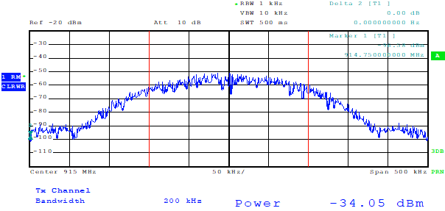

Figure 1: Measurement of a GSM signal with a spectrum analyser

No extrapolation is necessary because the measured level is independent of the traffic.

* + 1. 3G / UMTS

The traffic-independent signal in UMTS is the primary common pilot channel (P-CPICH). It is transmitted at the same frequency and with the same bandwidth as the logical traffic channels, only with a different spreading code. Measurement of the maximum signal level from a UMTS station is therefore only possible with dedicated equipment after decoding in the code domain.

Figure 2: Sample screen for UMTS level measurements with dedicated equipment

Extrapolation to a full traffic situation is done by adding a correction factor to the measurement result (red circle in Figure 2). The correction factor usually is in the range from 9.5 to 10.5 dB unless other information from the provider is available. For the purpose of this Recommendation the correction factor is assumed to be 10 dB (see also A2.4 for additional information).

* + 1. 4G / LTE

In LTE, the traffic-independent signals used for the measurement is the physical broadcast channel (PBCH), which is transmitted every 10 ms over the inner 1.05 MHz of bandwidth in the centre of LTE channel (see Figure 3). Its length is 4 symbols or about 266 µs. However, during the first two symbols, reference signals are also transmitted. The „pure” PBCH is transmitted during the last two symbols for a length of about 133 µs.

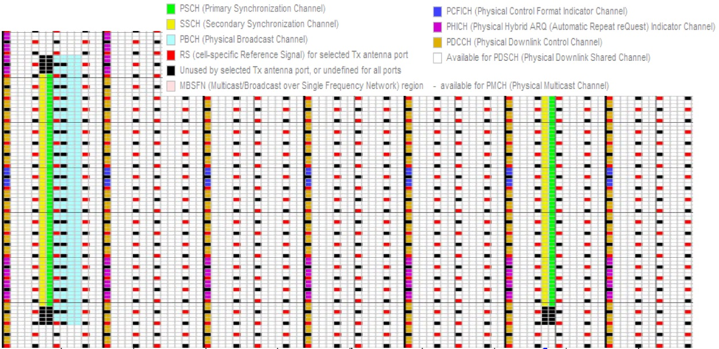

Figure 3: LTE resource grid of the inner 1.2 MHz

The measurement has to be time-synchronised and limited in time and bandwidth. Although challenging, it is in principle possible with a spectrum analyser that is synchronised by GNSS.

Table : Spectrum analyser settings for measurements of the LTE system

|  |  |
| --- | --- |
| Centre frequency: | Centre frequency of the LTE channel |
| Span: | Zero span |
| RBw/capture Bw: | 1 MHz |
| Detector: | RMS |
| Sweep / capture time: | 2 ms |
| Trace: | ClearWrite |
| Trigger: | Fixed every 10 ms. Offset adjusted so that PBCH is in display window |
| Measurement function: | Time domain power with limits set to the PBCH |

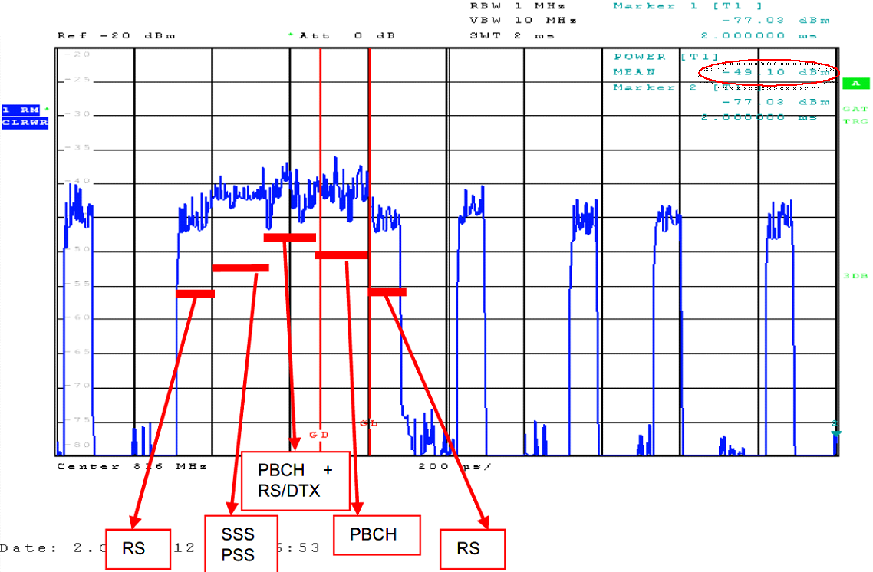

Figure 4: Sample screen for a measurement of the LTE PBCH with spectrum analyser

The actual measurement has to be limited to the last two symbols of the PBCH block (gate length about 133 µs), because the reference symbols transmitted during the first two symbols may be boosted in power.

In Figure 4, the resulting level of the PBCH is circled in red (-49.1 dBm). This is the level of all subcarriers in 1 MHz bandwidth. In a full traffic situation it is assumed that all traffic carriers could be transmitted with the same power as the PBCH. The total mean level with full traffic would then be:

|  |  |  |
| --- | --- | --- |
|  |  | () |

Where:

* *Ptot* is the total mean level in a full traffic load situation in dBm;
* *Pmeas* is the measured PBCH-level in dBm;
* *BLTE* is the bandwidth of the LTE channel in MHz.

It should be noted that using a spectrum analyser, in the case of MIMO the total power of the PBCH produced by all transmitting antennas is measured.

A more convenient way of measurement is the use of dedicated equipment that is able to decode the LTE signal and display the level of the different components separately, like in the following example.

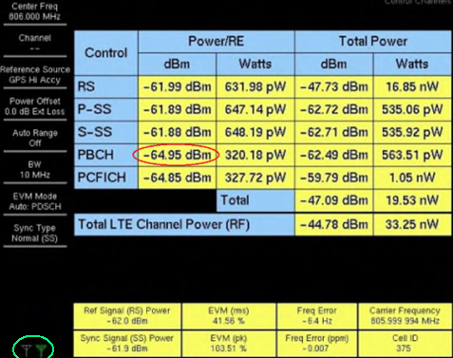

Figure 5: LTE measurement with dedicated equipment

Most dedicated equipment after decoding displays the power per resource element for each transmitting antenna or, which is the same, for each MIMO streams. In Figure 5, the power of one resource element in the PBCH for one antenna is circled in red (-64.95 dBm) and measured antenna is circled in green. Extrapolation to a full traffic situation can be done with the following formula:

|  |  |  |
| --- | --- | --- |
|  |  | () |

Where:

* *Ptot* is the total mean level in a full traffic load situation in dBm;
* $P_{RE}^{i}$ is the measured level of one resource element in the PBCH for *ith* transmitting antenna in dBm;
* *k*is the number of antennas,
* *REtot* is the total number of resource elements in the LTE channel.

This assumes that all traffic resource elements are transmitted with the same power as the PBCH and MIMO streams are completely uncorrelated with each other.

When taking measurements of LTE signal along a route, dedicated equipment with scanners are usually used. They usually measure reference signal received power (RSRP) for each transmitting antenna.

Figure 6: RSRP measurement with dedicated equipment

Extrapolation to a full traffic situation can be calculated with the following formula (see further information and examples in A2.5):

|  |  |  |
| --- | --- | --- |
|  |  | () |

Where:

* *Ptot* is the total mean level for all antennas in a full traffic load situation in dBm;
* *RSRPi* is reference signal power produced by *ith* transmitting antenna;
* *k*is the number of antennas;
* *n*is the number of subcarriers in the relevant LTE signal as provided in Table 6;
* $P_{B}$ is reference signal power boosting value (usually equal to 0 dB unless other information from the provider is available).

Table : Number of active subcarriers in the LTE signal depending on bandwidth of LTE signal

|  |  |
| --- | --- |
| LTE signal bandwidth, MHz | Number of subcarriers in LTE downlink signal |
| 1.4 | 72 |
| 3 | 180 |
| 5 | 300 |
| 10 | 600 |
| 15 | 900 |
| 20 | 1200 |

* + 1. 5G / NR

The 5G NR signal is also composed of some traffic-independent signals and resource elements that are activated during traffic only. In 5G NR, the traffic-independent signal used for the measurement, similarly like in LTE, contains PBCH which carry broadcast information, together with Primary Synchronisation Signal (PSS) and Secondary Synchronisation Signal (SSS) is called Synchronisation Signal Block or SSB (see Figure 7). Typical periodicity of SSB (Synchronisation Signals + PBCH) in 5G NR is 20 ms, but the periodicity can vary according to 3GPP specification.

Figure : SSB structure in 5G NR

One of the specifics about the NR system is, however, that it may use active (or advanced) antenna system (AAS) that are able to form the antenna beam and point it in specific directions. In case of an AAS, the SSB is transmitted with different antenna characteristics and sometimes with different gain from traffic beams. The number of SSBs specified in the 5G NR Standard for FR1 frequency range is between 1 and 8 SSBs. Typical configurations in Europe are one beam with 120° horizontal main lobe, and 7 or 8 beams transmitted in sequence (see Figure 8).

Tx

Tx

1

2

3

4

5

6

7

Figure 8: Configurations with 1 SSB (left) and 7 SSBs (right)

Unlike PBCH in LTE, the SSB in 5G NR is not necessarily transmitted on the centre frequency of the 5G channel. Common configurations are either at the centre frequency, or at the lower or upper end of the 5G channel. For FR1, the 5G NR channel bandwidth is up to 50 MHz when using 15 kHz subcarrier spacing, and up to 100 MHz when using 30 kHz or 60 kHz subcarrier spacings. Each band may have its own restrictions of possible channel bandwidth.

The bandwidth occupied by the SSB contains 240 subcarriers and is 3.6 MHz for systems with 15 kHz subcarrier spacing, 7.2 MHz for systems with 30 kHz subcarrier spacing and 14.4 MHz for systems with 60 kHz subcarrier spacing. Note that in 5G NR the SSB is transmitted in various different patterns which depends on subcarrier spacing, frequency range and other parameters. Figure 9 shows an SSBs pattern for 5G NR base station with 8 beam AAS (SSB Index from SSB 0 to SSB 7), for frequency range from 3 GHz to 6 GHz with 15 kHz subcarrier spacing.

Figure : SSBs pattern for 5G NR base station with 8 beam AAS for frequency range from 3 GHz to 6 GHz with 15 kHz subcarrier spacing

Measurements of 5G NR signals can principally be made with spectrum analysers, provided they are synchronised by GNSS. Preferably, real-time analysers should be used. As a first step, frequency and index number of the SSB has to be determined. With a real-time spectrum analyser, this is preferably done with a spectrogram display with the following settings:

Table : Realtime analyser settings for determination of the SSB configuration

|  |  |
| --- | --- |
| Centre frequency: | Centre frequency of the 5G channel |
| Span / capture Bw: | Equal to the bandwidth of the 5G channel, e.g.100 MHz |
| RBw: | Auto |
| Detector: | Peak or sample |
| Sweep / capture time: | 20 ms |
| Trace: | ClearWrite |

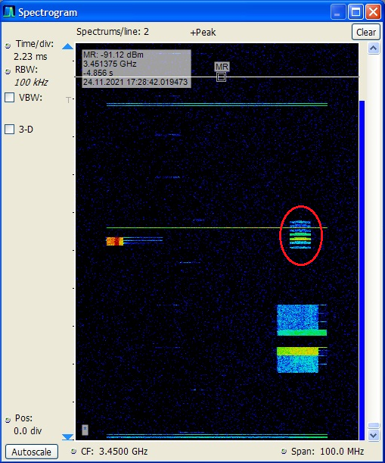

Figure : Sample spectrogram of a 5G NR frame with 7 SSBs

The station in Figure 10 is configured for 7 SSBs transmitted at the upper end of the channel (red circle).

Once the frequency of the SSB is determined, its level can be measured with a standard or real-time spectrum analyser with the following settings:

Table : Spectrum analyser settings for measurement of the SSB level in 5G NR signals

|  |  |
| --- | --- |
| Centre frequency: | Centre frequency of the SSB |
| Span: | Zero span |
| RBw / Capture Bw: | 1 MHz |
| Detector: | RMS |
| Sweep / capture time: | 20 ms |
| Trace: | ClearWrite |
| Trigger: | Fixed every 20 ms. Offset adjusted so that SSBs are in display window |
| Measurement function: | Time domain power with limits set to the strongest SSB (gate length) |

Figure 11: Sample measurement of a 5G NR station with 7 SSBs

The displayed result (Figure 11) represents only the fraction of the strongest SSB in the selected measurement bandwidth.

The total level of the SSB could be calculated as:

|  |  |  |
| --- | --- | --- |
|  |  | () |

Where:

* *PSSB* is the total received level of the strongest SSB in dBm;
* *Pmeas* is the measured level of the strongest SSB in selected *RBw* in dBm;
* *BwSSB* is the bandwidth occupied by the SSB in MHz (equals to 240 × subcarriers spacing);
* *RBw* is the measurement bandwidth in MHz.

A more convenient method of measuring the 5G NR levels is using dedicated equipment that is able to decode the 5G signal and measure the levels of the different resource elements separately.

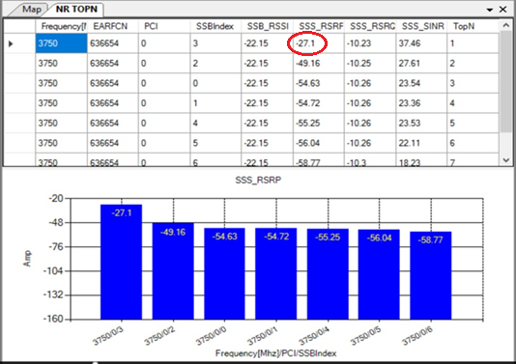

Figure 12: SSB measurement with dedicated decoding equipment

The base station in Figure 12 is transmitting 7 SSBs. The level of the strongest SSB (index 3) is circled in red (‑27.1 dBm).

One assumption that has to be made when measuring 5G NR signals from neighbouring countries is that the measurement location is in the main lobe range of both broadcast and traffic beams.

Correct extrapolation to a full traffic situation which would produce the maximum field strength is only possible with knowledge of the antenna gain difference between broadcast and traffic beams. This information may be obtained from the operator, but in practice it is not usually available for foreign stations.

In the absence of information about the antenna gain difference (∆G) data between traffic and broadcast beams from the operator, or measurement results, the following gain differences should be applied:

* For AAS stations with 1 SSB: ∆G = 7 dB;
* For AAS stations with 2 to 8 SSB: ∆G = 1 dB;
* For stations with passive antenna systems: ∆G = 0 dB.

The above-mentioned gain differences present a conservative approach with the aim not to overestimate the resulting maximum field strength. In some AAS stations, the gain difference is higher. In this case, the measurement would underestimate the maximum possible field strength. If the antenna types are known, it is recommended to use that actual gain differences instead of the generic ones above.

The total mean level of the 5G signal under a full traffic situation could then be calculated as:

|  |  |  |
| --- | --- | --- |
|  |  | () |

Where:

* *Ptot* is the total received mean level of the 5G signal under simulated full traffic situation in dBm;
* *PSSB*is the SSB level in dBm;
* *∆G* is the gain difference between broadcast and traffic beam in dB;
* *BwSSB* is the bandwidth occupied by the SSB in MHz (equals to 240 × subcarriers spacing);
* *Bw5G* is the bandwidth of the 5G channel in MHz.
  1. Derivation of the field strength

Directly measured is the voltage or the power of a signal at the receiver input. The field strength in dBµV/m can be calculated from the measured power in dBm with the following equation:

|  |  |  |
| --- | --- | --- |
|  |  | () |

Where:

* *Emax* is the maximum field strength produced by the MFCN station in dBµV/m;
* *Ptot* is the maximum (extrapolated) received level in dBm;
* *Kant* is the antenna factor of the measurement antenna in dB/m;
* *ac* is the attenuation of the RF cable between measurement antenna and receiver in dB;
* 107 is the conversion coefficient from dBm to dBµV (for 50 Ω RF system).

For LTE and 5G NR, the power $P_{tot}$ is the maximum value of mean power (ETSI TS 136 141 (V14.14.0 (2022-03)), section 6.2 [12] and ETSI TS 138 104 (V16.18.0 (2024-02)), section 3 [13]). Accordingly, the field strength $E_{max}$ is the maximum mean value of the field strength. Knowing that the median field strength value is usually about 1 dB higher than its average value, the measured average field strength value is easily converted to the median value.

Some measurement equipment is able to indicate field strength values once the relevant parameters (antenna gain or antenna factor and cable attenuation) have been entered.

So far, *Emax* is the maximum field strength that could be received in case the network is fully loaded with traffic.

* 1. Measurement at fixed locations
     1. Application and principle

This method is applicable in cases of reported or assumed interference to a receiver at a specific location, e.g. a base station, or if an administration wants to determine whether the field strength from foreign MFCN does not exceed the values in a cross-border agreement at a specific location.

The propagation models used for field strength calculations can only predict the average field strength at a certain distance from the transmitter. Specific terrain conditions and clutter cannot be considered. Excess of the agreed limits at one particular location does not automatically prove a violation of the agreement. It is therefore necessary to perform a cluster measurement of the field strength around the location of interest.

* + 1. Required equipment

The following equipment is recommended for these measurements:

* Measurement car with retractable mast of at least 10 m maximum height;
* Directional antenna suitable for the frequency range of the MFCN band;
* Spectrum analyser or dedicated decoding equipment according to section A1.3.
  + 1. Measurement procedure

The required number of measurement locations depends on the required reliability and the difference between the measured values at the best reception point and at the worst reception point, where:

|  |  |  |
| --- | --- | --- |
|  |  | () |

Where:

* *∆E* is the difference between field strength at the best reception point and worst reception point in dB;
* *Emax* is the field strength at the best reception point in dBµV/m;
* *Emin* is the field strength at the worst reception point in dBµV/m.

For a given confidence level of 90% that the real field strength lies within 1 or 1.5 dB of the average measured level, the following table provides guidance on the required number of measurement locations.

Table 9: Required measurement locations for cluster measurements

|  |  |  |  |  |  |
| --- | --- | --- | --- | --- | --- |
| Confidence | | ∆E = Emax – Emin | | | |
| **level** | **interval** | **0-5 dB** | **5-10 dB** | **10-15 dB** | **15-20 dB** |
| 90% | 1 dB | 3 | 11 | 24 | 43 |
| 90% | 1.5 dB | 2 | 5 | 11 | 19 |

According to CEPT/ERC Recommendation 74-02 [1], the minimum number of test points is 5, regardless of the entry in Table 9.

Measurement locations should be selected so that there are no reflecting objects and as few overhead conductors (power and telephone lines, antennas, buildings with metal roofs or gutters) as possible within ten times the wavelength.

The directional antenna is set to the applicable height and pointed in the direction of maximum received level.

If the antenna allows flexible polarisation, the orientation with maximum level is chosen. Otherwise, vertical polarisation is used.

The spectrum analyser or dedicated equipment receiver is adjusted to the settings applicable to the MFCN technology used (see section A1.3).

To eliminate the effect of ground reflection, the antenna height is varied around the nominal height (3 m or 10 m) until a maximum and an adjacent local minimum of the received level is detected. When a spectrum analyser is used, a standard height scan can be performed where the received level is constantly measured and recorded while raising/lowering the antenna height. If a dedicated equipment is used, the maximum and minimum values have to be determined manually by changing the antenna height in small steps.

The field strength of the direct wave can be calculated as:

|  |  |  |
| --- | --- | --- |
|  |  | () |

Where:

* *ED* is the field strength of the direct wave (without reflection) in µV/m;
* *Emax* is the maximum measured field strength during the height scan in µV/m;
* *∆E* is the difference between maximum and next minimum of the field strength during the height scan in µV/m.

If measured in logarithmic units (dBµV/m), the field strength of the direct wave can be calculated as:

|  |  |  |
| --- | --- | --- |
|  |  | () |

Where:

* *ED* is the field strength of the direct wave (without reflection) in dBµV/m;
* *Emax* is the maximum measured field strength during the height scan in dBµV/m;
* *ηk* is the correction coefficient to be applied (see Figure 13) in dB.

E:\RRT input rec 12(03)\Kor 2.tif

Figure : Correction coefficient to eliminate ground reflection

The final result is the linear average value of the field strengths measured at all measurement locations.

* 1. Measurements over longer time periods
     1. Application and principle

In cases of interference to a specific receiver, the ERC Recommendation 74-02 [1] foresees measurement over longer time periods. The aim is to evaluate time-fluctuations of the interfering signal, e.g. caused by varying propagation conditions.

The measurements are taken either at the antenna of the interfered station, or with a calibrated directional measurement antenna close to the interfered station. Field strength samples taken at regular intervals are evaluated statistically, and the values for 10%, 50% and 90% of the time are determined.

* + 1. Required equipment

If the measurements are taken at the interfered antenna, the following equipment is recommended:

* Spectrum analyser or decoding equipment according to section A1.3;
* Computer to retrieve and store measurement results from the analyser or decoding equipment.

If the measurements are taken at a measurement antenna, the following equipment is necessary in addition:

* Measurement car with retractable mast of at least 10 m maximum height;
* Directional antenna suitable for the frequency range of the MFCN band.

If the spectrum analyser or dedicated equipment receiver has built-in facilities to store multiple measurement results, a separate computer is not necessary.

* + 1. Measurement procedure

The spectrum analyser or dedicated equipment receiver is connected to the antenna of the interfered station (possibly via a directional coupler), or mounted on the measurement car positioned near the interfered station, in 10 m height.

Depending on the service to be monitored, the equipment settings according to section A1.3 are applied.

It is recommended to take at least one measurement sample per hour. The resulting field strength is recorded.

According to ERC Recommendation 74-02 [1], the measurement should run at least for a period of 24 hours. If weather or seasonal influences of the propagation should be considered, the duration has to be prolonged accordingly. Longer measurement times also increase the confidence level.

After the measurement period is finished, all measurement samples are sorted by level and evaluated to state:

* the field strength that is exceeded by 10% of the samples;
* the median field strength (50%);
* the field strength that is exceeded by 90% of the samples.

These results represent the time probability.

* 1. measurements along A Route (DRIVE TEST MEASUREMENTS)
     1. Application and principle

Basic principles for measurements along a route are described in ITU Recommendation ITU-R SM.1708 “Field-strength measurements along a route with geographical coordinate registrations”. Principles in this ITU Recommendation could also be used within the framework of this Recommendation, where applicable.

Generally, measurements along a route or drive test measurements are performed for measuring and assessing a mobile radio network's coverage, capacity and quality of service.

For administrations this method is applicable to assess the overspill of MFCN signals from neighbouring countries in border regions. Although there may not be a case of harmful interference, excess signals strengths may result in mobiles unintentionally logging into the foreign network, thereby introducing roaming charges for the users in border regions. For operators this could also result in a reduction of coverage area. Such overspill of signal strength usually could be observed when a foreign country operator exceeds provisions of the cross-border agreement (infringement of the agreement).

The main purpose of the measurements along a route is to identify and measure MFCN signals of a neighbouring country which creates the overspill.

The drawback of this method is higher measurement uncertainty compared to measurements in fixed locations due to the influence of ground reflections and reflections from many obstructions (also from metallic roof of the vehicle) while driving. For that reason, measurements along a route are intended for statistical evaluation of the signal coverage and determination of the place and amount of signal overspill from neighbouring country.

After measurements along a route, administrations might have to decide on measurements at fixed points (cluster measurements) in places where signal overspill from a neighbouring country was detected to get more accurate measurement results.

* + 1. Required equipment

Usually during measurements along a route, it is possible that foreign and own country MFCN base stations operate on same frequencies and many signals from both sides of the border whose level can change rapidly are expected. Thereby, the only way to distinguish between foreign and own country base stations are by decoding MFCN country code (MCC), network code (MNC) and cell identifier (Cell ID). Therefore, for measurements along a route dedicated equipment is required– scanner or receiver that can detect, decode and record a wide variety of MFCN signals and relevant system parameters.

The following equipment is recommended for the measurements along a route:

* Car or vehicle with retractable mast of height at maximum of 3 m above ground;
* Omni-directional vertically polarised antenna appropriate for the frequency range of the MFCN band;
* Dedicated measurement equipment – receiver or scanner combined with GNSS location position referencing system;
* Portable computer with specialised software – for the control of measurement equipment and measurement process.
  + 1. Measurement procedure

Measurements along a route involves simultaneous collection and recording of data from dedicated measurement equipment (scanner or receiver and GNSS receiver) to measure signal strength and other parameters while driving. This data is then analysed to identify places where signal excess or overspill from a neighbouring country have been observed.

**Antenna height**

For the measurements along a route the height of the measurement antenna should be at least 1.5 m to 3 m above ground. The results will be considered as being carried out at a height of 3 m.

Note: Extra precautions should be taken to avoid mechanical damage to the mast and antenna while driving.

**Measurement settings and parameters to be measured**

To identify MFCN signal, certain system parameters should be determined:

* MCC (Mobile Country Code);
* MNC (Mobile Network Code);
* Channel number (according to 3GPP);
* PCI (Physical-Layer Cell Identifier).

Note that for non-standalone (NSA) 5G NR networks MCC and MNC usually cannot be decoded directly due to the fact that in NSA mode operation of 5G NR network is controlled by 4G network.

To measure level of the signal while driving, following system parameters should be determined for relevant technologies as provided in Table 10.

Table : Parameters which should be determined to measure level of the signal

|  |  |
| --- | --- |
| Technology | System parameter characterising signal power, dBm |
| GSM | BCCH power |
| UMTS | RSCP |
| LTE | RSRP |
| 5G NR | SS-RSRP |

For GSM no extrapolation is necessary because BCCH is always transmitted with full power.

For UMTS RSCP represents the power measured by a receiver of dedicated equipment on a particular physical communication channel. To extrapolate to maximum mean possible power, an additional margin or correction factor is added to the measured RSCP. For the purpose of this Recommendation the correction factor is assumed to be 10 dB (see also section A1.3.3 and section A2.4 for additional information).

For LTE further extrapolation to full traffic situation is necessary as RSRP is transmitted on one reference signal which represents the power of one subcarrier within 15 kHz bandwidth (see section A1.3.4).

For 5G NR extrapolation to full traffic situation also is necessary as SS-RSRP (similarly to RSRP in LTE) is transmitted on one reference signal which represents the power of one subcarrier within 15 kHz, 30 kHz or 60 kHz bandwidth (see section A1.3.5).

* 1. Result evaluation and presentation

The final result of the field strength measurement along a route is the level measured according to the sections above plus measurement uncertainty defined in section A1.9.

As each field strength measurement point has a location position recorded, measurement results also can be plotted on a map to clearly depict the places where signal overspill was detected.

In Figure 14 there is an example of the measurements along a route on a map showing overspill of the signal of GSM channels inside Country B used by the Operator 1 of Country A (see green oval). GSM channels showed on the map (see red oval) are preferential to Country B and non-preferential to Country A.

Figure 14: Measurement results along a route plotted on the map and showing signal overspill

The following Information can be taken from Figure 14:

* The continuous black line on the map shows the route driven;
* The colour of the dots indicate the BCCH measured (see the table below the map);
* The size of the dots indicate the received signal level.

The actual values of the received level, together with the network ID, can be exported, extrapolated to full channel width and compared with the limits in the relevant agreement.

* 1. Measurement uncertainty

The field strength measuring system includes an antenna, an antenna cable and measuring equipment. Therefore, the main sources of measurement uncertainty are:

* the antenna factor;
* cable losses;
* the accuracy of the measuring equipment;
* the mismatch between the elements of the measuring system.

As mentioned in section A1.3.5, for 5G NR, an additional uncertainty contributor is the gain difference between broadcast and traffic beams in case its value is unknown.

The calculation of the uncertainty of these sources and the calculation of the total measurement uncertainty are discussed in detail in ECC Recommendation (17)01 “Measurement uncertainty assessment for field measurements” [11]. Therefore, this recommendation can be used to calculate the uncertainty of field strength measurements. This is also applicable to measurements of reference signal received power since the same system is used.

Another way to evaluate the measured results is to apply a typical maximum measurement uncertainty. This approach is less precise; however, it allows quick evaluation of the obtained results with sufficient probability.

If the measuring equipment and the measurement process comply with the recommendations of the ITU-R Spectrum Monitoring Handbook, then under typical measurement conditions the maximum value of total measurement uncertainty is 3 dB.

1. Theoretical background
   1. Field strength of overlapping electromagnetic fields

This section describes the procedure for calculating the resulting field strength when several electromagnetic waves with collinear field strength vectors overlap in space. Let us first consider the situation when at some point in space two transmitting different signals antennas individually produce field strengths EA and EB. In the general case, the amplitudes of these field strengths are random variables. Let that the amplitude of the first field strength be equal to A and variance be equal σ2(A), and the second - B and σ2(B) respectively. As is known, the variance of the sum of two random variables is

|  |  |  |
| --- | --- | --- |
|  |  | () |

The correlation *Cor*(*A*+*B*) is related to the correlation coefficient *R*(*A*,*B*) by the following expression

|  |  |  |
| --- | --- | --- |
|  |  | () |

Therefore, expression () can be written in the following form

|  |  |  |
| --- | --- | --- |
|  |  | () |

Taking the root of the right and left parts, expression () is reduced to the form

|  |  |  |
| --- | --- | --- |
|  |  | () |

For electromagnetic waves the average values of the amplitudes of field strength are equal to zero. Therefore, the standard deviation *σ* of the amplitude of field strength is equal to the root-mean-square (rms) value of their amplitude.

The field strength of electromagnetic waves is usually characterised by the rms value, so expression () can be written in the following form

|  |  |  |
| --- | --- | --- |
|  |  | () |

The correlation coefficient between wave amplitudes *R*(*A*,*B*) (hereinafter referred to as *R*) is usually equal to or slightly different from the correlation coefficient between the transmitted signals that "carry" these waves. It should be noted that the field strengths are vector quantities. Therefore, when adding waves with *parallel* field strength vectors, the resulting field strength *ERES* is equal to

|  |  |  |
| --- | --- | --- |
|  |  | () |

and when adding waves with *antiparallel* ones, is equal to

|  |  |  |
| --- | --- | --- |
|  |  | () |

It should be noted that expressions () and () are valid only for the rms values of the field strength.

Let us consider in more detail how the strengths of two overlapping in space waves add up when vectors $\vec{Е_{A}}$ and $\vec{Е_{B}}$ are parallel. If the transmitted signals are perfectly **correlated** (*R*=1), then, as follows from equation (), the resulting field strength is equal to

|  |  |  |
| --- | --- | --- |
|  |  | () |

and if they are completely **uncorrelated** (*R*=0), the resulting field strength is equal to

|  |  |  |
| --- | --- | --- |
|  |  | () |

Similarly, one can obtain an expression for the resulting field strength when *N* antennas of the same polarisation individually produce field strengths *E*1, *E*2...*E*N. If any transmitting signals are perfectly correlated with each other, the resulting field strength is equal to

|  |  |  |
| --- | --- | --- |
|  |  | () |

and if they are completely uncorrelated with each other, the resulting field strength is equal to

|  |  |  |
| --- | --- | --- |
|  |  | () |

* 1. Field strength of the system using cross-polarised antennas

This section will look into the properties of the fields produced by *antenna array without beamforming, i.e. conventional passive antennas*, as they are widely used in mobile networks, e.g. LTE. As a rule, these arrays are a combination of two or more cross-polarised (orthogonal) individual antennas. The individual antennas themselves are assembled from a large number of dual-polarised elements. Figure 14 shows that simplest array. Dual-polarised array consist of two antenna columns: one with radiating elements with the polarisation of +45 degrees, and the second with radiating elements with the polarisation of -45 degrees (to be more correct the polarisation actually is +135 degrees rather than -45 degrees).

Figure 14: An array of two cross-polarised antennas (2T2R configuration)

Each physical antenna has individual RF chain (also known as antenna port). The first antenna PA0 (corresponds to the antenna port AP0) consists of radiating elements with a polarisation of +45 degrees, the second antenna PA1 (corresponds to the antenna port AP1) consist of radiating elements with a polarisation of +135 degrees. This antenna array can be used for 2xMIMO technology. More complex antenna array is a combination of subarrays. One subarray includes only antennas with a polarisation of +45 degrees and +135 degrees.

From the above it is clear that the waves emitted by antenna arrays with cross-polarised antennas are slant polarised where each wave is rotated 45 degrees from the horizontal, mirrored, so the first is at +45 degrees and the other is at +135 degrees, as shown in Figure 15.

Figure 15: slant 45° dual‐pol mode

Each of these two waves is characterised by its field strength at the measurement point *E*(45) and *E*(135). In the case of the simplest antenna array, the field strength *E*(45) is created by antenna PA0, and the field strength *E*(135) by antenna PA1.

In the case of array that consists of four antennas (4T/4R) (see Figure 16), each antenna PA0, PA1, PA2 and PA3 individually produce field strengths *E0*(45), *E1*(45), *E2*(135) and *E3*(135) respectively.

Figure 16: An array of four cross-polarised antennas (4T4R configuration)

In this case, the field strength *E*(45) is the result of adding the field strengths *E*0(45) and *E*1(45) according to equation () (because vectors $\vec{Е_{0}(45)}$ and $\vec{Е_{1}(45)}$ are parallel), and the field strength *E*(135) is the result of adding the field strengths *E*2(135) and *E*3(135) according to the same equation. According to this equation, the resulting field strengths *E*(45) and *E*(135) depend on the correlation coefficient between the signals transmitted by antennas PA0 and PA1 and between PA2 and PA3 respectively. This dependence is described in detail in section A2.1. The same method would also apply for the array that consists of eight antennas (8T8R),

* 1. Measuring field strength of cross-polarised waves

As follows from section A2.2, in the case of cross-polarised fields, two field strengths *E*(45) and *E*(135) must be measured. In principle, this is easy to do using a linearly polarised measuring antenna and a conventional spectrum analyser. Since this is not always convenient in practice, instead of measuring two individual field strengths, the vertical component *E(V)* of the resulting field strength of the two waves is measured (using a measuring antenna with vertical polarisation).

This section will analyse how this vertical component *E(V)* depends on the individual field strengths *E*(45) and *E*(135). Figure 17 shows the vertical and horizontal projections of these field strength vectors.

Figure 17: Decomposition of two perpendicular field strength vectors, E(45) and E(135),

into vertical and horizontal components

Let us consider the result of the case when the fields strengths *E*(45) and *E*(135) are equal (let's denote them as *E*). The vertical and horizontal components of individual field strengths *E*(45) and *E*(135) are:

|  |  |  |
| --- | --- | --- |
|  |  | (a) |
|  |  | (b) |

For the two parallel vertical components the sum *E(V)* depends on correlation coefficient *R* according to equation 15). For the two antiparallel horizontal components the sum *E*(*H*) also depends on correlation coefficient *R* according to equation (16).

If correlation coefficient *R* = 1, i.e. perfectly **correlated** vertical components, then according to equation the sum *E*(*V*) is

|  |  |  |
| --- | --- | --- |
|  |  | () |

From this expression it is easy to get that the sum *E*(*V*) is higher by 3 dB:

|  |  |  |
| --- | --- | --- |
|  |  | () |

If correlation coefficient *R* = 0, i.e. the vertical components are completely **uncorrelated**, then according to equation (15) the sum *E*(*V*) is equal to individual field strength (with a polarisation of 45 degrees or 135 degrees):

|  |  |  |
| --- | --- | --- |
|  |  | () |

Thus, depending on the degree of correlation (coefficient *R*), the field strength of vertical component is equal or 3 dB higher than the field strength of individual field strength (with a polarisation of +45 degrees or +135 degrees). Therefore, if **the maximum value** of the total field strength of cross-polarised waves is required to measure, then measurements should be done for **the vertical component** of this field.

For the two horizontal components *EH*(45) and *EH*(135) the sum *E*(*H*) depends on correlation coefficient *R* according to equation (16). If correlation coefficient *R* = 1, i.e. perfectly **correlated** horizonal components, then according to equation (16) the sum *E*(*H*) is equal to 0:

|  |  |  |
| --- | --- | --- |
|  |  | () |

If correlation coefficient *R* = 0, i.e. the horizontal components are completely **uncorrelated**, , then according to equation (16) the sum *E*(*H*) is equal to individual field strength (with a polarisation of +45 degrees or +135 degrees):

|  |  |  |
| --- | --- | --- |
|  |  | () |

In general for MIMO systems it can be assumed that signals between individual antennas are **uncorrelated,** and all antennas create fields with **equal** average field strengths. Therefore, it can be concluded that measuring with vertical polarised antenna the average values of the resulting field strength in the vertical plane is equal to the average value of the individual field strength in the +45 degrees or +135 degrees planes. The same result is obtained when measuring with horizontally polarised antenna.

* 1. Determination the field strength of UMTS from measurement results of power of primary common pilot channel (P-CPICH)

The power of primary common pilot channel (P-CPICH) is defined by the factor *r* between the power of the P-CPICH and the maximal power of the cell, which is defined as the maximum value of mean power. Factor *r* is expressed in % and is usually between 5% and 15% of the total cell transmit power. Commonly, the CPICH power is 10% of the typical total transmit power of 43 dBm.

Knowing the factor *r* and the measured value of the P-CPICH, it is possible to determine the total UMTS level for full traffic:

|  |  |  |
| --- | --- | --- |
|  |  | () |

Using the logarithmic scale and coefficient *r*=10% the equation can be written as follow

|  |  |  |
| --- | --- | --- |
|  |  | () |

Using this value, the resulting mean field strength is calculated.

* 1. Determination of the field strength of LTE MIMO from measurement results of reference signal received power (RSRP)

For LTE dedicated reference signals (RS) are assigned for all the antenna ports individually. Therefore, using a dedicated decoding equipment (usually a radio scanner) the reference signal received power (RSRP) is measured for each physical antenna. The RS power is the maximum mean power of the port uniformly distributed over all subcarriers plus a possible addition boosting power. RSRP is power only of one reference signal which allocates one sub-carrier. Extrapolation of RSRP to the mean power corresponding to full traffic situation is carried out according to the formula:

|  |  |  |
| --- | --- | --- |
|  |  | () |

Where:

* is the total LTE signal received mean power level produced by *ith* transmitting antenna extrapolated to a full traffic situation;
* *n*is the number of subcarriers in the relevant LTE signal;
* $P_{B}$ is reference signal power boosting value.

Considering that MIMO streams are completely uncorrelated with each other the total mean level of the LTE 2xMIMO signal under a full traffic situation could be calculated as:

|  |  |  |
| --- | --- | --- |
|  |  | () |

For 4xMIMO the RSRP-0, RSRP-1, RSRP-2 and RSRP-3 are measured (see Figure 18) and using these values and equation (1) the total mean field strength is calculated.

Figure 18: RSRP measurement with dedicated equipment

The total mean level of the LTE 4xMIMO signal under a full traffic situation could be calculated as:

|  |  |  |
| --- | --- | --- |
|  |  | () |

1. List of references

1. [ERC Recommendation 74-02](https://docdb.cept.org/document/847): “Method of measuring the field strength at fixed points in the frequency range 29.7-960 MHz”, approved 1999
2. Recommendation ITU-R SM.1708: “Field-strength measurements along a route with geographical coordinate registrations”’
3. HCM Agreement: <http://www.hcm-agreement.eu/>

1. [ECC Recommendation (15)01](https://docdb.cept.org/document/515): “Cross-border coordination for mobile/fixed communications networks (MFCN) in the frequency bands: 694-790 MHz, 1452-1492 MHz, 3400-3600 MHz and 3600-3800 MHz”, approved February 2015, latest amended June 2022

1. [ECC Recommendation (11)04](https://docdb.cept.org/document/500): “Cross-border Coordination for Mobile/Fixed Communications Networks (MFCN) in the frequency band 790-862 MHz”, approved May 2011, latest updated November 2022

1. [ECC Recommendation (05)08](https://docdb.cept.org/document/480): “Frequency planning and cross-border coordination between GSM Land Mobile Systems (GSM 900, GSM 1800, and GSM-R)”, approved February 2006, latest amended October 2021

1. [ECC Recommendation (08)02](https://docdb.cept.org/document/489): “Cross-border coordination for Mobile/Fixed Communications Networks (MFCN) in the frequency bands 900 MHz and 1800 MHz excluding GSM vs. GSM systems”, approved February 2008, latest amended October 2021

1. [ERC Recommendation 01-01](https://docdb.cept.org/document/855): “Cross-border coordination for mobile/fixed communications networks (MFCN) in the frequency bands: 1920-1980 MHz and 2110-2170 MHz”, approved 2001, latest updated November 2022

1. [ECC Recommendation (14)04](https://docdb.cept.org/document/512): “Cross-border coordination for mobile/fixed communications networks (MFCN) and between MFCN and other systems in the frequency band 2300-2400 MHz”, approved May 2014, amended June 2024

1. [ECC Recommendation (11)05](https://docdb.cept.org/document/501): “Cross-border Coordination for Mobile/Fixed Communications Networks (MFCN) in the frequency band 2500-2690 MHz”, approved May 2011, latest corrected March 2024

1. [ECC Recommendation (17)01](https://docdb.cept.org/document/946): “Measurement uncertainty assessment for field measurements”, approved February 2017
2. ETSI TS 136 141 (V14.14.0 (2022-03)): “LTE; Evolved Universal Terrestrial Radio Access (E-UTRA); Base Station (BS) conformance testing (3GPP TS 36.141 version 14.14.0 Release 14)
3. ETSI TS 138 104 (V16.18.0 (2024-02)): “5G; NR; Base Station (BS) radio transmission and reception (3GPP TS 38.104 version 16.18.0 Release 16)”