Regulatory analyses of satellite use in the band 862-870 MHz to communicate with terrestrial SRD
approved 7 June 2024
ECC Report 357

Executive summary
This Report explores the European regulatory framework for short range devices (SRD) communicating with satellites in the band 862-870 MHz and whether this fits within current SRD regulations, while recognising that SRD-to-satellite transmissions are already possible in certain sub-bands under current ERC Recommendation 70-03 [1] provided the use is compliant with the technical and other conditions including the application category (such as non-specific short-range devices).
Commercial IoT satellite systems have become available in the frequency band 862-870 MHz since the release of ECC Report 305 [2]. ECC Report 305 recommended that the operation of commercial and long terms systems under provision No. 4.4 should be discouraged and avoided. This Report reviews this consideration in the band 862-870 MHz.
Along with the analysis described in ECC Report 305, it is confirmed that there is no need for changes to the current regulatory framework for SRD-to-satellite transmissions (Earth-to-space). This may not be the case for Decision 2006/771/EC [3], as amended by (EU)2022/180 [4]. In this EC Decision, technology evolutions towards longer range transmissions at the same low interference level might require an update to the SRD definition from the European Commission.
Furthermore, the assessment of satellite-to-SRD transmissions has demonstrated both feasibility of such links and these transmissions do not create any unacceptable interference to current SRD applications (see Table 3) in the 862-870 MHz band when a PFD limit of -142 dBW/(m² 4 kHz) is not exceeded on Earth surface. This value was proposed based on the link requirements of satellite-to-SRD transmissions, and it was shown that even aggregate effect of multiple satellite systems does not pose any additional risk for existing SRD applications.
It is highlighted that receivers of SRD communicating with satellites cannot claim protection from other applications or services. Any future ECC regulatory provision to manage conforming satellite systems does not require to implement any form of specific protection of such systems (both satellites and their devices).
Maintaining a list of satellite systems committing to adhere to certain operational parameters (e.g. the proposed PFD limit in this Report) in this frequency band may assist CEPT administrations in securing the efficient use of spectrum, assessing applications, granting licences, resolving harmful interference, etc. Such a list could be included in an ECC deliverable that would require updates whenever new satellite systems are requested to be added, along with the reference to such a deliverable in ERC Recommendation 70-03.

TABLE OF CONTENTS

0 Executive summary 2
1 Introduction 5
2 Satellite operators and operational concepts for satellite-SRD 6
2.1 Satellite operators 6
2.1.1 Lacuna Space 6
2.1.2 Eutelsat 6
2.1.3 Plan-S 6
2.1.4 Hello Space Systems 7
2.1.5 FOSSA Systems 7
2.2 Operational concepts 8
3 Analysis of SRD-to-satellite and satellite-to-SRD Transmissions and analysis of the application of ITU RR No. 4.4 10
3.1 SRD-to-Satellite in the frequency band 862-870 MHz 10
3.2 Satellite-to-SRD in the frequency band 862-870 MHz 12
3.3 Impacts of the use of ITU RR No 4.4 notified assignments by space systems 15
4 Identification of regulatory updates to reflect SRD-satellite systems 18
4.1 SRD definition 18
4.2 ECC Regulatory Provisions on satellite-to-SRD and SRD-to-satellite transmissions 18
4.3 Modifications to ERC Recommendation 70-03 19
5 Conclusions 20
ANNEX 1: ITU Satellite Filings satellite filings in 862-870 MHz Under ITU RR No. 4.4 21
ANNEX 2: Impact assessment 23
ANNEX 3: Field study 26
ANNEX 4: List of references 27

LIST OF ABBREVIATIONS

Abbreviation | Explanation
AFA | Adaptive Frequency Agility
ALD | Assistive Listening Device
BNetzA | Federal Network Agency (Germany)
BR IFIC | BR International Frequency Information Circular
DC | Duty Cycle
ECC | Electronic Communications Committee
e.r.p. | Effective Radiated Power
e.i.r.p. | Equivalent Isotropic Radiated Power
EESS | Earth Exploration-Satellite Service
FSPL | Free Space Path Loss
FSS | Fixed Satellite Service
GEO | Geostationary Earth Orbit
IoT | Internet of Things
LBT | Listen Before Talk
LEO | Low Earth Orbit
LPWAN | Low-Power, Wide-Area Network
MEO | Medium Earth Orbit
MSS | Mobile-Satellite Service
PFD | Power Flux Density
RFID | Radio Frequency Identification
RHCP | Right Hand Circular Polarised
RR | Radio Regulations
SRD | Short Range Device
UHF | Ultra High Frequency
VHF | Very High Frequency

Introduction
Short Range Device (SRD) transmissions to satellites have been proven to be technically feasible while respecting the current SRD regulatory parameters defined in ECC Recommendations. Satellites can now be designed to receive the signals transmitted by SRD devices for satellite reception, and satellite operators have demonstrated such transmissions through real satellite connections in recent years in the band 862-870 MHz (see section 2 and Annex 3).
SRD-satellite operators and the LoRa Alliance contributed to the CEPT Workshop on satellite innovations and regulatory challenges in November 2022, where it was recognised that a new regulatory framework may be needed for these new satellite-based applications.
ECC Report 305, published in 2020 [2], recognised that SRD transmissions operating according to ERC Recommendation 70-03 [1] can be received by satellites. This Report explores further the European regulatory framework for SRD communications, focussing on developments which new satellite technology enables in the 862-870 MHz band for both transmission directions, i.e. from SRD to satellites and satellites to SRD. The frequency range 862-870 MHz is used as a whole or in parts by many SRD applications in Europe such as radio microphones and assistive listening devices (ALD), alarms, non-specific SRD, networked SRD, RFID, tracking, tracing and data acquisition applications, and wideband data transmission systems.
This Report aims to provide:
- An overview of interested satellite operators and operational concepts including project timelines;
- Separate analysis of SRD-to-satellite and satellite-to-SRD transmissions, including an analysis of satellite applications notified under No. 4.4 of the ITU Radio Regulations (RR) [5] and their additional impact on SRD;
- An identification of any regulatory text that needs revision/update to reflect SRD-satellite systems.
The concept of transmissions through satellites in 862-870 MHz in Europe can also be applied in other 'SRD' bands, such as the 902-928 MHz ISM-band in ITU Region 2. NGSO satellites for this purpose are capable of receiving and/or transmitting signals in both bands (see also ITU-R Report SM.2153 [6] for information about spectrum use for SRD worldwide).

Satellite operators and operational concepts for satellite-SRD

Satellite operators
The following are examples of satellite systems that aim to provide communications with SRD in the band 862-870 MHz.

Lacuna Space
Lacuna Space is a UK company that has launched eight IoT gateways into orbit. This first gateway was launched in 2019. Since then, Lacuna has extensively tested the performance in the frequency ranges 862-870 MHz in Europe. The uplink of user payload messages is conducted in line with regional regulations including transmit power, duty cycle or dwell time limitations. The satellites store the received messages and downlink all stored data during passes over earth stations. These downlink transmissions are performed in frequency bands with satellite service allocations.
Lacuna SRD (user terminals) possess information on the orbits of all Lacuna satellites and only wake up when a satellite is in view. At such events, the devices transmit to the satellite (Earth-to-space direction). Since the orbit information needs to be updated, Lacuna uses a device configuration downlink (space-to-Earth direction) in the 862-870 MHz in Europe under ITU Radio Regulations No. 4.4 [5].
Lacuna plans to launch 24 more satellites into orbit until 2025. Depending on market needs, the constellation will grow up to 240 satellites. Commercial service has started in 2023.

Eutelsat
Eutelsat was created as an international organisation in 1977, launched its first satellite in 1983 and became a private company in 2001. In September 2019, Eutelsat unveiled its ELO (Eutelsat LEO for Objects) constellation, targeting the internet of things (IoT) market. Low Earth Orbit (LEO) is particularly well-suited to this narrowband connectivity, processing signals emitted by connected objects. It offers a satellite link anywhere in the world, complementing low-power, wide-area wireless technology (LPWA) IoT terrestrial networks, without increasing the cost or energy consumption of the objects.
Currently Eutelsat has three ELO operational satellites in orbit. Each satellite is able to receive signals in portions of the 862-870 MHz band. The initial end-to-end “direct device to satellite” tests confirmed the feasibility of operations and Eutelsat teams are currently working with partners on development of optimised end-user devices. The start of commercial operations with the satellites currently in orbit is foreseen by Eutelsat for 2024.
With satellites in operation, the ELO constellation could already provide a global coverage. Deployment of additional satellites to scale-up the ELO constellation to 25 satellites in orbit would increase capacity of the system and decrease the average message delivery time to 1 hour.

Plan-S
Plan-S was established in 2021 with the primary mission of providing IoT connectivity and Earth Observation services across diverse sectors such as agriculture, oil & gas, maritime, transportation, energy, finance, and more. Additionally, Plan-S is dedicated to design and manufacture of satellite systems, encompassing satellites, ground stations, and ground devices, as well as the essential network software for seamless operation. Plan-S has five operational satellites and has started to partner with industry leaders in proof of concept projects.
Plan-S have plans to operate within 862-870 MHz in Europe, while fully adhering to regional and national regulations for the device-to-satellite link (Earth-to-space). IoT satellites employ this range from space-to-Earth direction as well for sending wake-up beacons and broadcast messages only for a short period of time. Nevertheless, Plan-S recognises the need for an intermediate layer between satellites and IoT devices in cases where IoT devices are densely deployed. This intermediate layer aims to offer higher physical data rates, utilising frequency ranges other than those mentioned.
In the second half of 2024, Plan-S plans to commence its IoT services with the deployment of 12 IoT satellites into orbit until the end of that year. The company's long-term vision includes the deployment of a constellation comprising 200+ satellites by 2027, to be executed in three major phases, contingent upon market demands and requirements.

Hello Space Systems
Hello Space is a company that was founded in 2022 and entered space with the launch of its first satellite called Istanbul in Q2 2023. It has launched two satellites in November 2023. It aims to provide IoT communication and also develops products that will serve the IoT market in Q3 2024. It is expected to launch IoT communication by a constellation covering the whole world with 80 pico-satellites into LEO orbit.
Hello Space satellites will serve IoT customers using the band 862-870 MHz for both uplinks and downlinks.
The data received from these frequencies will first be stored on the satellite and then transmitted to ground stations using S band or VHF/UHF bands with a satellite service allocation and given to the end user.

FOSSA Systems
FOSSA Systems is a company based in Spain, specializing in satellite manufacturing and operations, and delivering low-power IoT solutions. FOSSA Systems' services include space-related technologies and solutions for IoT applications. The company operates within the European market.
Currently at a proof-of-concept stage, FOSSA plans to offer commercial service for IoT satellite connectivity and satellite space services for remote asset management to industries operating in outlying regions from 2025, through a planned 80-satellite LEO constellation distributed in several planes to provide ubiquitous coverage.
At present, FOSSA has 4 active satellites in orbit, operating in several bands, including the 868-870 MHz band in Europe for the SRD-to-satellite link (ITU filing FOSSASAT-2E), and holds a national licence in Spain for the use of the orbit-spectrum resource.

Operational concepts
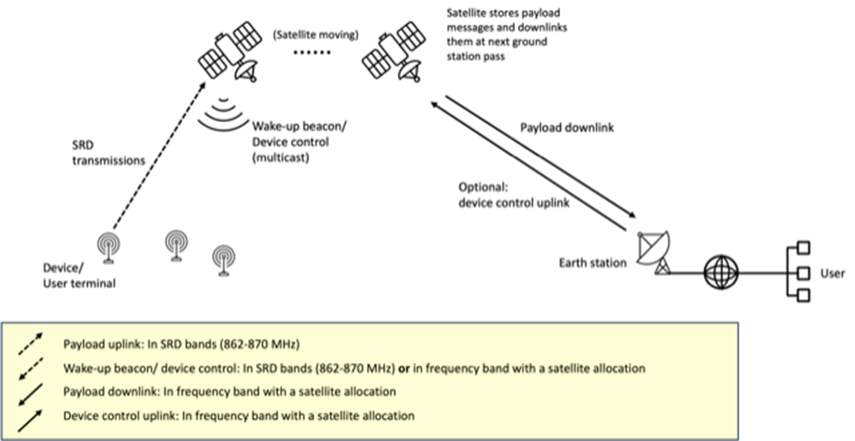
Figure 1: Satellite SRD operational concept
The operational concept for LEO/MEO constellations is shown in Figure 1. A device transmits messages to the satellite in the SRD bands. The satellite stores the data and downlinks received messages during earth station passes. The device initiates transmissions either after being triggered by a wake-up beacon or based on orbit information that is stored on the device:
- Wake-up beacon: devices always wait for a wake-up message from a satellite which could be represented by a satellite beacon. Only when the satellite is visible and sends this wake-up signal, could the device decide to transmit. Any device transmissions intended for satellite reception without prior reception of a dedicated wake-up signal from a satellite are prevented by (software) design. A satellite could be commanded not to transmit a downlink signal (or beacon) over a specific area or time window to prevent SRD-to-satellite transmissions;
- Time-triggered wake-up: devices are always in sleep mode, except when it is estimated that a receiving satellite is in view. The time window when a receiving satellite is in view will be calculated before the devices go into sleep mode (transmit window calculation). The devices transmit their messages when the satellite is estimated to be in view, without a wake-up message by the satellite. For correct transmit window calculation, the devices will regularly receive updates on the current satellite ephemerides (device control). These updates are transmitted as multicast to all devices. Devices will prevent transmissions (by software) if ephemerides updates have not been received for a defined period. It should be noted that for this concept the receiving payload and the transmitting payload can be on different satellites;
- Once triggered by a beacon reception or a wake-up timer, a device may transmit somewhere within the transmission window. SRD-to-satellite transmissions are distributed within the transmission window, thereby reducing the risk of packet losses due to overlapping;
- The downlink (optional for some operators) in SRD bands is intended for wake-up or device control (multicast or beacon), and therefore uplink and downlink are addressed separately.
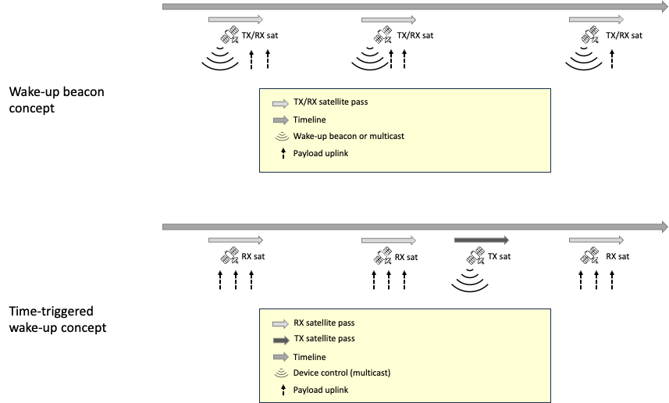
Figure 2: Operational timeline. Only device-satellite links are shown
(satellite-earth station links are not shown)
In both wake-up beacon concept and time-triggered concept, dedicated transmissions from satellites to individual devices are not used (only multicast satellite-to-device or beacon transmissions are performed) in order to limit the increase of the noise floor in the band.
In any of the mechanisms above, the devices can receive additional information that is used to control the network, for example: set the transmit frequency, choose a specific type of devices allowed to transmit.
SRD transmissions to satellites can be feasible in the “typical” IoT frequency ranges (862-870 MHz and 902-928 MHz, depending on the region). In Europe, in 862-870 MHz, a signal from a device transmitting with 25 mW e.r.p. (-16 dBW) output power can be received by an orbiting IoT gateway. This is because a typical LEO pathloss of 145-150 dB and a typical satellite receiver gain of 5-10 dB would result in a signal strength of around -160 dBW. Current state-of-the-art IoT receivers have a sensitivity below this value (typically -157 to
-167 dBW). The link performance can be tuned (with e.g. antenna gain or elevation angle) to also for example achieve MEO links. The link budget for multicast satellite-to-SRD transmissions in SRD bands is similar to the SRD-to-satellite direction. Operators might choose to use less directional antennas on the satellite and increase the transmit power, in order to reach more devices during each pass. When the bands not allocated to space services are used for satellite multicast transmissions to SRD, the satellite transmit power should be limited in order not to create harmful interference to other systems (including SRD) operating in the band (see the following section).
SRD transmissions to satellites are intended transmissions, i.e. satellites should not intercept messages that are not intended for their reception. This requires the device to possess information if a satellite is in view. Methods for identification of receiving satellites are described above. As is the case for terrestrial gateways, it may happen that a satellite unintentionally receives SRD signals. In the case of LoRaWAN networks, such signals will not be further carried by the system as the corresponding NetIDs will not be found in a customer database.
Contrary to SRD transmissions towards satellite, multicast satellite transmissions in SRD bands go beyond current SRD regulations which are limited to national boundaries of the countries. Therefore, such satellite transmissions are currently not covered by the SRD framework or any other regulatory framework (CEPT or ITU). Satellite transmissions in the bands allocated to space services are not considered in this report as they should respect the existing regulation applicable to the band in question.
The description above only contains multicast messages, either for wake-up beaconing or for device control configuration, but no unicast transmissions to individual devices. This significantly reduces the capacity needs of satellite-to-SRD transmissions.

Analysis of SRD-to-satellite and satellite-to-SRD Transmissions and analysis of the application of ITU RR No. 4.4

SRD-to-Satellite in the frequency band 862-870 MHz
As already recognised in ECC Report 305 [2], SRD transmissions under ERC Recommendation 70-03 [1] can regularly be received by satellites. As for any other earth station, the satellites communicating with it and its associated ITU frequency assignments need to be known by administrations.
There are no dedicated protection criteria but clear transmit power limitations and channel occupation rules in the SRD regulation, which are confirmed to fulfil the intended purpose and performance of SRD-to-satellite. SRD-to-satellite transmissions as addressed in this report sufficiently respect these limitations, including the duty cycle limitations in the various sub-bands.
On the technical side, an example of a link budget for transmissions from an SRD to a satellite are shown in Table 1 and Figure 3. The SRD used in this example does not exceed the limitations of ERC Recommendation 70-03, while providing sufficient link margin for the signal's reception by the satellite.
Table 1: Example link budget for an SRD transmitting to a LEO satellite at 868 MHz
(Source: Lacuna Space)
# | Parameter | Value | Formula
1 | Orbit altitude (km) | 500.0
2 | SRD transmit power (dBW) | -16
3 | SRD max. gain (dBi) | 1.5
4 | SRD e.i.r.p. (dBW) | -14.5 | (2) + (3)
5 | Frequency (MHz) | 868.0 (Note 1)
6 | Elevation (deg) | 90
7 | Slant range (km) | 500 | (= altitude for 90 deg elevation)
8 | Path loss (dB) | 145.2 | Free space path loss (Note 2)
9 | Propagation losses (dB) | 1.0 | Empirical
10 | Satellite antenna max. gain (dBi) | 7.0
11 | Interference margin  (relative to sensitivity) (dB) | 5.0 | Empirical, varies in sub-bands based on terrestrial use  Note: conservative worst-case assumption to reflect man-made noise, impacting receiver performance
12 | Received power (dBW) | -153.7 | (4)-(8)-(9)+(10)
13 | Sensitivity (dBW) | -167.0 | Receiver-specific, in this example for receiving a 125 kHz LoRa signal.
14 | Link margin (dB) | 8.3 | (12)-(13)-(11)
Note 1: Any frequency within the tuning range 862-870 MHz (plus or minus bandwidth/2) is possible.
Note 2: Free Space Path Loss: FSPL = - (20*log10(4*π*distance[m]*frequency[Hz]/speed_of_light[m/s])
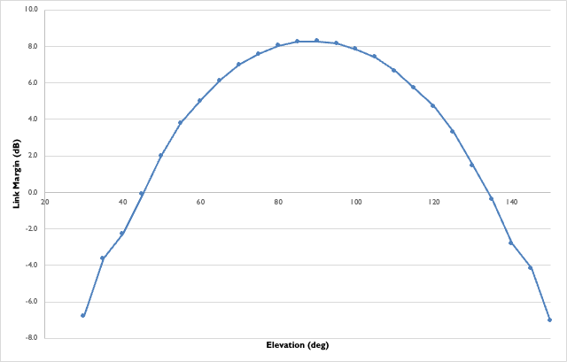
Figure 3: Link Margin for an SRD transmitting to a satellite at 868 MHz,
using RF parameters as defined in ERC Recommendation 70-03
(Source: Lacuna Space)
Devices transmitting to satellites are operating using the same technical characteristics as non-specific SRD devices as described in ERC Recommendation 70-03 (operating in annex 1 bands h0, h1.0, h1.2, h1.3, h1.4, h1.5, h1.6, h1.7, h1.8 and h1.9) [1].
Table 2: Technical requirements for non-specific SRD from ERC Recommendation 70-03, annex 1 [1]
ERC/REC  70-03  Identifier | Lower Frequency | Higher Frequency | Power | Spectrum access and mitigation requirements
h0 | 862 MHz | 863 MHz | 25 mW e.r.p. | ≤ 0.1% DC
h1.3 | 863 MHz | 865 MHz | 25 mW e.r.p. | ≤ 0.1% DC or LBT+AFA
h1.2 | 863 MHz | 870 MHz | 25 mW e.r.p.  -4.5 dBm/100kHz e.r.p. | ≤ 0.1% DC or LBT+AFA
h1.0 | 863 MHz | 870 MHz | 25 mW e.r.p. | ≤ 0.1% DC
h1.4 | 865 MHz | 868 MHz | 25 mW e.r.p. | ≤ 1% DC or LBT+AFA
h1.5 | 868 MHz | 868.6 MHz | 25 mW e.r.p. | ≤ 1% DC or LBT+AFA
h1.6 | 868.7 MHz | 869.2 MHz | 25 mW e.r.p. | ≤ 0.1% DC or LBT+AFA
h1.7 | 869.4 MHz | 869.65 MHz | 500 mW e.r.p. | ≤ 10% DC or LBT+AFA
h1.9 | 869.7 MHz | 870 MHz | 25 mW e.r.p. | ≤ 1% DC or LBT+AFA
h1.8 | 869.7 MHz | 870 MHz | 5 mW e.r.p. | No requirement
Note: AFA = Adaptive Frequency Agility
DC = Duty Cycle
e.r.p. = Effective Radiated Power
LBT = Listen Before Talk
For the purposes of ERC Recommendation 70-03 [1], the duty cycle is defined as the ratio, expressed as a percentage, of Σ(Ton)/(Tobs) where Ton is the 'on' time of a single transmitter device and Tobs is the observation period. Ton is measured in an observation frequency band (F_{obs}). T_{obs} is a continuous one hour for the ERC Recommendation 70-03, annex 1 entries within 862-870 MHz.
Spectrum used by analogue audio and voice applications such as consumer cordless audio devices may be affected by nearby digital uplink transmissions ('scratches') with long individual T_{on} times.
As recognised in ECC Report 305, section 5.3 [2], "the emissions from an SRD application on the ground that comply with the technical conditions specified in the relevant general authorisation in the country where the system operate can obviously equally be received by a terrestrial receiver (e.g. acting as a relay or a base station in a data network) or by a space station in low earth orbit without the need for additional regulatory measures" and overall "frequencies in the 860 MHz frequency range may be particularly suitable for delivering services in Europe for uplink transmission in the sub-GHz range". Today, these satellites networks are foreseen to be used for commercial applications, in contrast with some of the challenges noted in ECC Report 305.
As SRD-to-satellite transmissions are already possible under the current ERC Recommendation 70-03 framework, therefore there should be no additional impact on other SRD devices provided SRD-to-satellite transmissions operate according to the relevant limits specified in the Recommendation.

Satellite-to-SRD in the frequency band 862-870 MHz
For this type of transmissions, there are no effective regulatory mechanisms and no coordination procedure (No. 9.3 of the Radio Regulations only foresees a process of resolution of difficulties) for national authorities to protect their national terrestrial services and application from satellite transmissions over their territory in the frequency band considered or in any other frequency band without allocations to satellite services. Even if the potentially affected administrations react to such publications, it is normally not possible to efficiently address the difficulties of national administrations given the lack of applicable regulatory procedures.
Receivers of SRD communicating with satellites cannot claim protection as for other SRD applications.
As there is no satellite allocation in the band 862-870 MHz, Satellite-to-SRD transmissions in that range can only be conducted using assignments notified under ITU Radio Regulations No. 4.4 [5] and strictly complying with its associated principles (see section 3.3). Transmissions have to be performed on a non-interference basis. There is no PFD limit specified in the ITU Radio Regulations for the band 862-870 MHz.
A list of ITU filings that are known to be intended for satellite-to-SRD transmissions in the frequency range 862-870 MHz is provided in ANNEX 1:. When interference potential is assessed, it should be noted that the range 862-870 MHz is already identified in CEPT to systems that work on a non-interference, non-protection basis. These systems are designed to coexist with other users in the shared band. The interference signal power of satellite signals on earth surface are often lower than transmissions from terrestrial SRD.
For terrestrial SRD receivers no protection criterion is defined. Instead limits for technical and operational conditions are defined to achieve coexistence while accepting a given interference probability. In studies, an interference probability of 5% is often considered acceptable. Accordingly, devices operating in SRD frequency bands should be designed to tolerate a certain level of interference. A detailed compatibility study would exceed the scope of this Report. However, a simple link budget can be provided to assess the general feasibility of satellite-to-SRD transmissions in SRD bands. State-of-the-art SRD receivers can decode messages at signal levels as low as -157 to -167 dBW (depending on the used technology). Based on this, one CEPT administration has reviewed the interference potential of satellite-to-SRD transmissions in detail and thereafter authorised at least one satellite operator to transmit in a space-to-Earth direction in the range 862-870 MHz, while not exceeding a PFD (power-flux density) value of -142 dBW/(m2 4 kHz), which has proven to be a value at which limited interference may be expected.
Table 3: -142 dBW/(m2 4 kHz) equivalent received power from non-specific SRD transmitter
# | Parameter | Value | Formula
1 | PFD limit (dBW/(m2 4 kHz)) | -142
2 | Transformation dBW to dBm | +30
3 | Isotropic antenna equivalent surface (m2) | 0.0095 | λ2 /(4π)
4 | Correction for antenna size | 10*log10(0.0095)
5 | Adaptation to channel size | 10*log10(125/4)
6 | Equivalent received signal strength (dBm) | -117.2 | (1)+(2)+(4)+(5)
In the case of a typical LPWAN system (125 kHz bandwidth, omnidirectional antenna), receiving a transmission with a PFD value of -142 dBW/(m2 4 kHz) would represent an equivalent received power of -117.2 dBm. The received power would represent a worst-case scenario (victim device antennas on the ground usually have low gain towards sky). For a typical non-specific SRD transmitter, using Okumara-Hata propagation model and fixing the 14 dBm (25 mW) transmitter at a 10 m height, any transmitter closer than 1.0/1.8/5.3 km (urban/suburban/rural scenario) would have a higher impact than the satellite's transmission. The distance would naturally vary according to antenna heights, gains and environments.
The C/I limit of LPWAN systems based on the maximum sensitivity of the receiver, may be exceeded by the presence of an interfering signal with a PFD of -142 dBW/(m²·4 kHz). A maximum PFD of -142 dBW(m²·4kHz) could lead to a reception power of -117.2 dBm in a bandwidth of 125 kHz. This would concern LPWAN receivers operating with a sensitivity level of -137 dBm and a C/I of -17 dB in a bandwidth of 125 kHz. However, as outlined above, SRDs are designed to operate with a certain probability of getting interfered by other SRDs since they are subject to interference from other SRD and man-made noise. By what amount the interference probability in LPWAN systems would increase in the presence of interfering satellite downlink signals of a PFD of -142 dBW/(m²·4 kHz) was not studied in all detail, however, practical testing revealed that the noise presence in the band is much higher and that the illumination level of -142 dBW/(m²·4 kHz) does not increase the noise level in the band. It should be noted, that the interference signal duty cycle is of major importance for SRD interference, Annexes 2 and 3 contain additional information on those considerations. In particular, it should be noted that the illumination level is not stable but varies between the maximum value of
-142 dBW/(m²·4 kHz) and -155 dBW/(m²·4 kHz) during the passover of a single satellite. Taking into account a radio noise according to Rec. ITU-R P.372-14 [9] of 8 dB for rural environments and taking into account the antenna discrimination loss, the increase in the probability of interference can be assumed to be acceptable. Furthermore, in available SRD studies such as in ECC Report 37 [10], it was considered that SRD would be subject to an allowable noise increase by interference from other SRD of 1 dB which corresponds to an I/N of -6 dB.
The frequency range 862-870 MHz is a harmonised spectrum environment in Europe. Therefore, it should be possible to agree on a common PFD limit. Operators would need to respect this maximum PFD limit when transmitting over CEPT countries. Annex 1 provides information on some example existing systems including their maximum PFD levels.
The example link budget and link margin for a LEO satellite (500 km orbit altitude) that complies with the PFD limit of -142 dBW/(m²·4 kHz) is shown in Table 4 and Figure 4.
Table 4: Example link budget for a LEO satellite transmitting in the space-to-Earth direction at 868 MHz (Source: Lacuna Space)
# | Parameter | Value | Formula
1 | Orbit altitude (km) | 500
2 | Satellite transmit power (dBW) | -3
3 | Satellite antenna max. gain (dBi) | 1.9
4 | Satellite e.i.r.p. (dBW) | -1.1 | (2)+(3)
5 | Frequency (MHz) | 868 (Note 1)
6 | Elevation angle (deg.) | 90
7 | Slant range (km) | 500 | (= altitude for 90 deg. elevation)
8 | Path loss (dB) | 145.21 | FSPL (Note 2)
9 | Propagation losses (dB) | 1.0 | Empirical
10 | Earth station antenna max. gain (dBi) | 1.5
11 | Interference margin (relative to sensitivity) (dB) | 2.0 | Empirical  Note: conservative worst-case assumption to reflect man-made noise in remote regions (incl. SRD), impacting receiver performance
12 | Received power (dBW) | -145.72 | (4)-(8)-(9)+(10)
13 | Sensitivity (dBW) | -160 | Receiver specific
14 | Link margin (dB) | 12.18 | (12)-(13)-(11)
15 | Transmitted bandwidth (kHz) | 125
16 | PFD value (dBW/(m2 4 kHz)) | -142.02 | Power flux density (Note 3)
Note 1: Any frequency within the tuning range 862-870 MHz (plus or minus bandwidth/2) is possible. Typical occupied bandwidth for this example is 125-500 kHz
Note 2: Free space path loss: FSPL = - (20*log10(4*π*distance[m]*frequency[Hz]/speed_of_light[m/s])
Note 3: Power flux density: PFD = e.i.r.p. + 10* log10(1/(4 π distance[m]^2) + 10*log10(4000/bandwidth[Hz]) - propagation_loss
It should be noted that orbit altitude (and consequently transmit power) varies between different satellite systems. The interference is added to reflect the current usage of the bands. It can be concluded that the PFD value of -142 dBW/(m² 4 kHz) is reasonable and provides sufficient margin for receiving a signal in the frequency band 862-870 MHz.
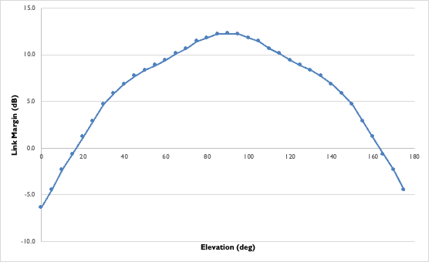
Figure 4: Link Margin for a typical LEO satellite downlink in the 862-870 MHz range. RF parameters are chosen such that a PFD value of -142 dBW/(m2 4 kHz) is not exceeded
(Source: Lacuna Space)
The next step is to review whether transmissions of such satellite systems would harmfully impact other systems in the band. While a detailed analysis is outside the scope of this Report, it can be seen from Annex 2 that C/I values of typical applications are not degraded for some SRD applications. It should be noted, that the interference margin for some other, more sensitive applications are not calculated. but it is shown that the C/I limit of those applications may be exceeded. Also, ECC Report 261 [7] can be used for a simplified coexistence assessment. Chapter 4.1 and Annex 4 of that Report describe the minimum path loss and impact range between different SRD. Even for the highest transmit powers (-3 dBW, Table 60 in Annex 4 of ECC Report 261), the required path loss is 145 dB, which would be met by the LEO satellite example in this Report.

Impacts of the use of ITU RR No 4.4 notified assignments by space systems
According to the Rules of Procedure on No. 4.4 of the Radio Regulations [8], derogations are limited to a limited set of provisions of the Radio Regulations [5]
- "1.2 The scope of the terms “in derogation of either the Table of Frequency Allocations in this Chapter or the other provisions of these Regulations” is specified in No.8.4 by the indication that the “other provisions” shall be identified and included in a Rule of Procedure. The Rules of Procedure on No. 11.31 provide a complete list of these “other provisions”.
- 1.3 The scope of No. 4.4 is therefore limited to derogations to the Table of Frequency Allocations and to the provisions listed in the Rules of Procedure on No. 11.31 with regard to the “other provisions”. In particular, administrations intending to authorize the use of spectrum under No. 4.4 still have the obligation, under Sections I and II of Article 9, Nos. 11.2 and 11.3, to notify to the Bureau “any frequency assignment if its use is capable of causing harmful interference to any service of another administration”.
According to the Rules of Procedure on No. 11.31, the "other provisions" are limited to the following:
- "conformity with the Table of Frequency Allocations, including its footnotes and any Resolution or Recommendation which is referred to in such a footnote;
- the successful application of No. 9.21, when mention is made of that provision in a footnote (see also Rules of Procedure relating to Nos. 9.21 and 11.37);
- all “other” mandatory provisions that are contained in Articles 21 to 57, in Appendices to the Radio Regulations and/or in Resolutions that are relevant to the service in the frequency band in which a station of that service operates."
Therefore, derogating to Article 5 of the Radio Regulations, space systems having communications with SRD under No 4.4 notified assignments still need to be compliant will all other requirements from the Radio Regulations.
In addition, such frequency assignments recorded under Radio Regulations No. 4.4 in the MIFR for information are not entitled to protection from harmful interference from other frequency assignments recorded under Radio Regulations No. 4.4. The international rights and obligations of administrations in respect of their own frequency assignments and other administrations frequency assignments are defined in Article 8 of the Radio Regulations as well as other provisions of the Radio Regulations. From this, it can be derived that such satellite-based use should not be considered in SRD coexistence and compatibility studies in the future within 862-870 MHz with the aim to introduce any specific protection for it, even from terrestrial SRD.
For interference provisions (Article 15 and 16), the non-interference and non-protection basis is addressed in section 3.1 and 3.2. ECC Report 305 [2] already address the risks to operate such systems under the provision No. 4.4 of the Radio Regulations. In particular, regarding space-to-Earth transmissions, the Report recommends to assign space-to-Earth frequencies under provision No. 4.4 only for the purpose of experimentation, technical demonstrators, scientific research and short terms missions. In complement, the Report 305 recommended that the operation of commercial and long terms systems under provision No. 4.4 should be discouraged and avoided, and this Report reviews this consideration in the band 862-870MHz.
For administrative provisions (Article 17 to 20) there is a need to clarify the status of the implicated radiocommunications when SRD communicate with satellites.
- the frequency band 862-870 MHz has no space allocations (except Ukraine according to Radio Regulations No. 5.319) but several terrestrial services are opened in the band. The ECA table mentions several applications in the band including SRD under ERC Recommendation 70-03, Radio microphones and ALD, and Land and maritime military systems. A satellite having a receiver in this band may involuntarily receive radiocommunications from other applications; including from SRD terminals located in countries that do not authorise communications with satellites. According to Article 17 and No. 18.4 of the Radio Regulations, restrictions have to be mentioned in the licence of such receiving space stations. A space system wishing to communicate with SRD located in CEPT countries may only communicate with its own associated SRD and all others received radiocommunications may be covered by restrictions of No 18.4. CEPT countries may only authorised SRD communications with satellites that only communicate with their own SRD and that operate under a licence that includes explicit reference to prohibition in Article 17 and No 18.4;
- According to No 11.4 of the Radio Regulations, as such communication is an international radiocommunication, transmitting and receiving stations need to be notified to the Bureau. As a consequence, ITU filings supporting such communications in CEPT countries need to include transmitting space stations and associated receiving space stations, also the transmitting and receiving characteristics of the SRD terminals described in the filings as associated earth stations operating in the relevant satellite service e.g. EESS, MSS and FSS. CEPT countries may only authorise SRD communications with satellites that operate under a compliant assignment.
According to No. 22.1 of the Radio Regulations, “space stations shall be fitted with devices to ensure immediate cessation of their radio emissions by telecommand, whenever such cessation is required under the provisions of these Regulations”. In this context, the notifying administration of the satellite network shall ensure and clarify with the operating entity how the spacecraft will be operated in compliance with No. 22.1 of the Radio Regulations and with section 1.6 b) of the Rules of Procedure on Radio Regulations No. 4.4 that requires to cease transmissions in the event that an interference is reported.
In this context, in order to increase the transparency, WRC-23 instructed the Radiocommunication Bureau (BR) to insert the indication of the frequency assignment submission under Radio Regulations No. 4.4 at the Summary Table of the Special Section or Part. In addition, to facilitate information sharing, WRC-23 instructs the Radiocommunication Bureau (BR) to make any information it may have regarding notification and bringing into use of frequency assignments under Radio Regulations No. 4.4 available in an easily accessible format, such as publishing it in BR's website and implementing a new filter option in the ITU Space Explorer Data Analytics tool. The shared information could include a list of filings that are using Radio Regulations No. 4.4 as well as historical data, including the date of receipt of these assignments. In addition, BR is also instructed to periodically inform administrations on the updated information regarding notification and bringing into use of frequency assignments under Radio Regulations No. 4.4 made available by BR in its website and to invite the notifying administrations to take steps to cancel the Radio Regulations No. 4.4 assignments if no longer in use. WRC-23 urges administrations when using frequency assignments under Radio Regulations No. 4.4 to fully comply with the objectives and purpose of this provision, including the Rules of Procedures (RoP) related to Radio Regulations No. 4.4.

Identification of regulatory updates to reflect SRD-satellite systems
Some administrations consider that the current European regulations implicitly include transmissions from SRD to satellites. However, explicit references are missing for such type of transmissions in regulatory text.

SRD definition
From the introduction of ERC Recommendation 70-03, the term “Short Range Device” (SRD) is intended to cover radio equipment which has a low capability to cause interference. The use of SRD is usually covered by general / non-exclusive authorisations on a non-protected, non-interference basis. SRD applications are not a “radiocommunication service” as defined by the ITU Radio Regulations in Article 1.
The term SRD is also defined in Article 2.1 of Decision 2006/771/EC [3], as amended by (EU)2022/180 [4] as follows: “short-range device” means a radio device which provides either unidirectional or bidirectional communication and which receives and/or transmits over a short distance at low power;".
The main issue raised when discussing the SRD definition is that SRD operate “over short distances at low power”. While the maximum transmitted power is one of the explicitly defined regulatory parameters, the definition of short distance is vague, and already not including other, well-accepted SRD applications. When initially operating at low power led to the short distances of communications, it is no longer the case today. For example, “standard” LoRa can (by its name, Long Range) operate over larger distances. If deemed necessary, in order not to limit the advancement of technology, the SRD definition should be amended instead of insisting on the current wording and any potential implications.
An example modification of the definition of SRD could be:
- “’short-range device’ means a radio device which provides either unidirectional or bidirectional communication and which receives and/or transmits at low power, typically (but not necessarily) over a short distance.”
Such a change, if needed, would be achieved through an EC decision, and either the satellite industry, or FM44 through the ECC, approach the commission to seek their view on amending the definition.
However, no change of the definition in ERC Recommendation 70-03 is required prior to a potential change in the EC decision or prior development of a new ECC regulation.

ECC Regulatory Provisions on satellite-to-SRD and SRD-to-satellite transmissions
An administration has the authority to file a satellite system under ITU Radio Regulations No 4.4 without requiring prior approval from other administrations. However, any potentially affected administration retains the right to comment on a filing and to request additional information concerning this satellite system. Nonetheless, there are no provisions allowing administrations to exclude their national territory from the service area of the non-compliant satellite system. Additionally, in the event of reported harmful interference that remains unresolved, this satellite system is obliged to immediately cease transmissions in the national territory of the affected administration. No user of SRD can report harmful interference, including those communicating with satellites.
ANNEX 1: provides an overview of satellite systems that have been notified under ITU Radio Regulations No 4.4 have beams overlapping within the frequency band 862-870 MHz. Not all of these systems might be intended for Satellite-to-SRD transmission, and thereby might not comply with PFD limits as proposed value in this Report.
Therefore, CEPT administrations intending to regulate the frequency band 862-870 MHz for satellite-to-SRD links within their territories may find it advantageous to benefit from a list encompassing systems wherein operators have committed to adhere to defined operational parameters. Additionally, in case of resolving any harmful interference this list can serve as a reference.
Furthermore, considering maximum PFD values in ANNEX 1 for frequency ranges of each satellite overlapping with the concerned range, higher PFD values could be detrimental to SRD applications, presenting unpredictable challenges within this band. ANNEX 1 also illustrates the diverse PFD values that vary from country to country and operator to operator. This highlights the need to establish harmonised spectrum rules to ensure the efficient use of the spectrum.
For these reasons, an ECC regulatory provision on satellite communications with SRD may be more advantageous for CEPT countries than non-harmonised spectrum rules, especially employing higher power values for satellite-to-SRD, could impose unpredictable challenges for SRD applications in this band, which operate on a non-protected and non-interference basis. If an administration grants a license for such usage, it should align with the harmonised rules to ensure the secure use of spectrum for all users. Additionally, listing operators in an ECC regulatory provision can be used as a reference and assistance for administrations in regulating this band. In conclusion, harmonising the spectrum for satellite-to-SRD transmission through an ECC regulatory provision proves advantageous for all stakeholders, not limited to SRD community.

Modifications to ERC Recommendation 70-03
In order to provide guidance to CEPT regulators and satellite operators, it may also be needed to explicitly specify SRD-to-satellite communications in ERC Recommendation 70-03 [1] with a reference to a new ECC Decision on satellite communications with SRD (to be developed, see section 4.2). Such a reference may identify that all devices fulfilling the technical conditions developed in ERC Recommendation 70-03 for the 862-870 MHz band are also able to communicate with satellite networks that are listed in the new ECC Decision mentioned above.

Conclusions
Commercial IoT satellite systems have become available in the frequency band 862-870 MHz since the release of ECC Report 305 [2]. This Report reviews the consideration of commercial IoT satellite systems in the band 862-870 MHz. After careful examination, it has also been confirmed that the initial technical feasibility assessments in ECC Report 305 regarding satellite operations remain applicable and are shown in this Report.
Along with the analysis described in ECC Report 305, it is confirmed that there is no need to change the SRD definition in in ERC Recommendation 70-03 [1] for SRD-to-satellite transmissions (Earth-to-space). This may not be the case for Decision 2006/771/EC [3], as amended by (EU)2022/180 [4]. In this EC Decision, technology evolutions towards longer range transmissions at the same low interference level might require an update to the SRD definition from the European Commission.
Furthermore, the assessment of satellite-to-SRD transmissions has demonstrated both feasibility of such links and these transmissions do not create any unacceptable interference to current SRD applications (see Table 3) in the 862-870 MHz band when a PFD limit of -142 dBW/(m² 4 kHz) is not exceeded on Earth surface. This value was proposed based on the link requirements of satellite-to-SRD transmissions, and it was shown that even aggregate effect of multiple satellite systems does not pose any additional risk for existing SRD applications.
It is highlighted that receivers of SRD communicating with satellites cannot claim protection from other applications or services. Any future ECC regulatory provision to manage conforming satellite systems does not require to implement any form of specific protection of such systems (both satellites and their devices).
Maintaining a list of satellite systems committing to adhere to certain operational parameters (e.g. the proposed PFD limit in this Report) in this frequency band may assist CEPT administrations in securing the efficient use of spectrum, assessing applications, granting licences, resolving harmful interference, etc. Such a list could be included in an ECC deliverable that would require updates whenever new satellite systems are requested to be added, along with the reference to such a deliverable in ERC Recommendation 70-03.
- ITU Satellite Filings satellite filings in 862-870 MHz Under ITU RR No. 4.4
Table 5 shows ITU filings of SRD-satellite systems from operators mentioned under section 2.1 with space-to-Earth frequency assignments covering the frequency band 862-870 MHz.
Table 6 shows all other satellite networks filed under ITU Radio Regulations No. 4.4, whose frequency ranges for space-to-Earth links overlap with this band. Many of these filings largely extend beyond 862-870 MHz, suggesting that usages other than SRD-satellite applications are foreseen. It might be useful for administrations to have a list of "conforming" satellite systems which commit to be aligned with the certain operational parameters. Such a list and the corresponding parameters could be defined and maintained in an ECC Decision.
Table 5: ITU filings of known SRD-satellite systems under ITU RR No. 4.4 with space-to-Earth frequency assignments covering the frequency range 862-870 MHz
ITU Filing Name | Notifying administration | Frequency range covering 862-870 MHz | Operator | Number of satellites | Maximum PFD Value (Note 2 & 3) (dBW/(m²·4kHz))
HELLO TEST 5-6 | Türkiye | 867.4375-867.5625 MHz | Hello Space Systems | 2 | -143
LS-4 | Germany | 862-870 MHz | Lacuna Space | 528  (Note 1) | -143.01
CONNECTA IOT | Türkiye | 862-870 MHz | Plan-S | 280 | -143.3
Note 1: As indicated by the operator, a maximum of 24 of these satellites will be used for downlinks in SRD bands.
Note 2: Maximum PFD Value is calculated by using maximum power density, satellite antenna gain, and perigee mentioned in the relevant ITU Database for the satellite networks concerned.
PFD = maximum power density (dBW/Hz) + antenna gain (dBi) + 10* log10(1/(4 π distance[m]^2) + 10*log10(4000) - propagation loss (dB) (see Table 4)
Note 3 : In order to comply with a potential ECC provision, operators would need to not exceed the PFD value, proposed in this Report, when transmitting over CEPT countries
Table 6: ITU filings as of BR IFIC No. 3012 under ITU RR No. 4.4 with space-to-Earth
frequency assignments overlapping the frequency range 862-870 MHz
from operators not mentioned under section 2.1
ITU Filing Name | Notifying Administration | Frequency range (Note 1) | Maximum PFD Value (Note 2) (dBW/(m²·4 kHz))
ASTROBIENE | D | 806-890 MHz | -114.11
ATHENE-1 | D | 806-890 MHz | -130.87
BLACKSPIDER | CHN | 806-890 MHz | -97.37
CSN-NT-1 | CHN | 869-880 MHz | -98.49
CSN-NT-2 | CHN | 869-880 MHz | -99.79
HISPASAT-LEO-ATL-A | E | 862-870 MHz | -146.49
LYNK-2A | USA | 869-890 MHz | -112.24
LYNK-SHANNON | USA | 869-870 MHz | -109.15
MARS-ULS | D | 790-890 MHz | -100.30
MICRONSAT | PNG | 853-870 MHz | -85.05
MICRONSAT-2 | PNG | 852-890 MHz | -111.22
NULION | D | 863-890 MHz | -137.75
ORB-ASTRO-2 | D | 869.4-869.65 MHz | -125.78
SAILSPACE-2-M | CHN | 806-960 MHz | -114.08
SI-SAT-KIOKIO | SLM | 863-870 MHz | -110.38
SKY-G2 | RRW | 862.25-869.75MHz | -125.41
USASAT-NGSO-10 | USA | 859-890 MHz | -101.65
Note 1: Each satellite networks can have multiple frequency ranges overlapping with the frequency band 862-870 MHz.
The frequency range corresponding maximum PFD value is indicated under this column.
Note 2: Maximum PFD Value (dBW/(m2 4 kHz) is calculated by using maximum power density, satellite antenna gain, and perigee mentioned in the relevant BR IFICs for the satellite networks concerned.
PFD = maximum power density (dBW/Hz) + antenna gain (dBi) + 10* log10(1/(4 π distance[m]^2) + 10*log10(4000) - propagation loss (dB) (see Table 4)
The purpose of the ITU filings listed in Table 6 can be totally different from the concept of use discussed in the present Report. E.g. Radio Regulations No. 4.4 use could be limited to LEOP/emergency situations, use could be in support to existing MSS allocations in certain countries outside of Europe, use under Radio Regulations No.4.4 for M2M/IoT applications but in service area(s) outside of Europe, or use for NTN direct-to-cell applications to smartphones in certain jurisdictions. Also note the sub-banding in Radio Regulations Article 5 is 862-890 MHz for ITU Region 1, 806-890 MHz for ITU Region 2 and 610-890 MHz for ITU Region 3 (i.e. much wider than 862-870 MHz).
- Impact assessment
As mentioned in section 3.2, this Annex briefly describes the impact of satellite-to-SRD transmissions on other SRD. The LEO satellite in this example transmits with an e.i.r.p. of -1.1 dBW and bandwidth of 125 kHz to simulate the PFD value of -142 dBW/(m2 4 kHz). Other orbits (MEO and GEO) could be simulated by adjusting the e.i.r.p. to reach the same PFD.
The “victim” characteristics were taken from ECC Report 261 [7]. The antenna type, receiver bandwidth, sensitivity and C/I thresholds are provided in this Report. The worst-case scenario was taken to be the scenario where the satellite is closest to the device (nadir case). The maximum gain of the victim antenna was used, which is a very conservative assumption, given that the maximum gain of the victim cases in almost all cases is not in the zenith (upwards) direction.
The assumptions can also be cross-checked by other data, such as in ECC Report 37 [10], ECC Report 44 [11], ECC Report 207 [12], the UHF measurement report in FM22(09)77 [13], ECC Report 182 - market survey on 863-870 MHz [14]. Available SRD studies in CEPT consider an allowable noise increase by interference of 1 dB which corresponds to an I/N of about -6 dB. Any SRD victim receiver would be subject to aggregate interference from other SRD devices as well as man-made thermal noise. Studies performed show that the electrical field strength received from a single SRD with reference e.r.p. of 25 mW at 1 km distance, using the Okumura-Hata model for open land, is unlikely to be lower than an electrical field strength of 50 dBµV/m and resulting in a PFD on ground at around -126 dBW/(m² 4 kHz). A PFD value of -142 dBW/(m² 4 kHz) can therefore be considered as not increasing the noise floor for other users in the band at all. It should be noted that the current terrestrial SRD device population operating within 862-870 MHz in the European market can be assumed to be greater than 1 billion devices (extrapolating from information in ECC Report 182). For specific frequencies for which the default reference e.r.p. is higher than 25 mW, a PFD value which is higher than -142 dBW/(m² 4 kHz) seems also possible given the available margin. However, not all applications may use the maximum e.r.p. since many SRD applications are battery-powered. Specific frequency sub-bands may therefore need specific additional considerations, if a satellite operator would request a higher PFD on downlink.
Figure 5 shows the PFD level over time for a satellite passing over a device at an altitude of 500 km. One minute before and after the time of closest approach, the power level is already 3 dB below the maximum.
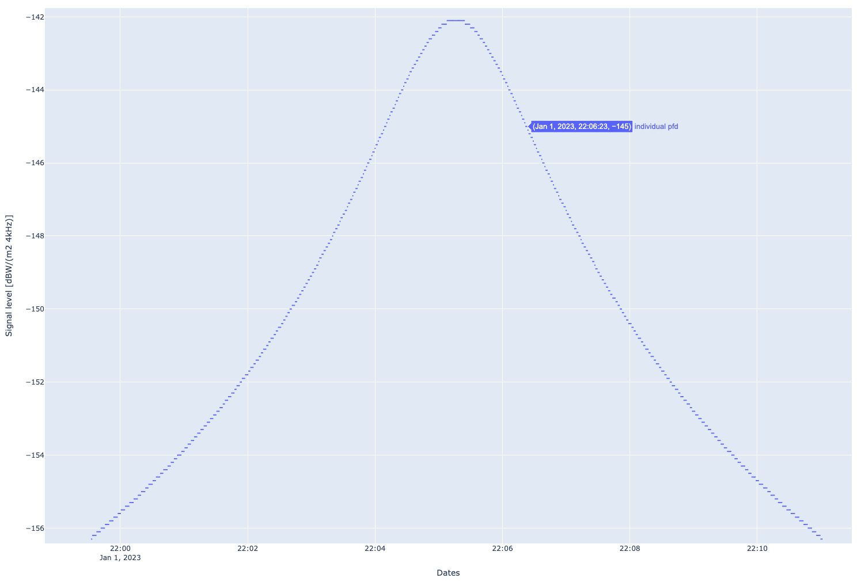
Figure 5: PFD level during a LEO satellite pass
(satellite altitude: 500 km, max. elevation during pass: 90°)
Figure 6 shows the aggregate PFD for a constellation of 24 satellites (4 planes with 6 satellites each) at a latitude of 65° (worst-case assumption for Europe). The blue lines represent the received power at the location from individual satellites, while the red line represents the aggregate power of all 24 satellites for one day. The PFD limit of -142 dBW/(m² 4 kHz) is never exceeded. This can be further proven by looking at the percentage of time over which the power exceeds a certain PFD value (Figure 7). The blue line (-142 dBW/(m² 4 kHz)) is never exceeded.
Therefore, a 24-satellite constellation has an aggregate impact that is 16 dB below the impact of a single terrestrial SRD at 1 km distance (see -126 dBW/(m² 4 kHz) result above). In other words, 40 constellations of 24 satellites each would be needed to have the same interference potential as a single SRD that is located 1 km away from the victim receiver.
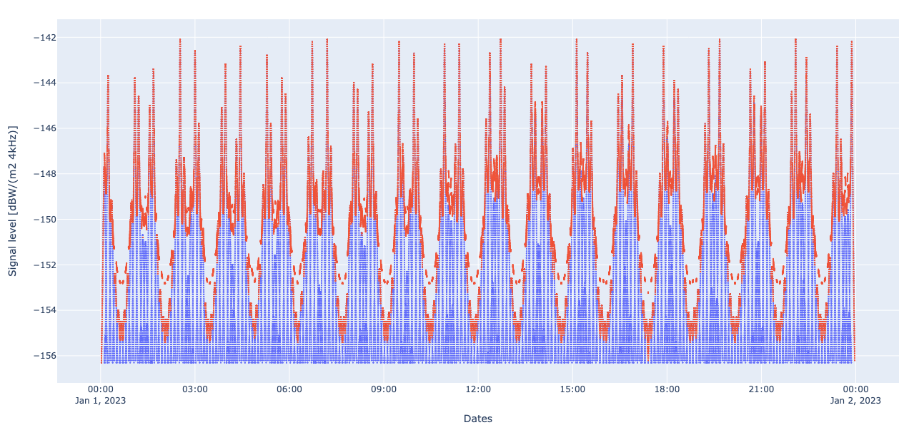
Figure 6: Aggregate PFD for a 24-satellite constellation in a 500 km orbit
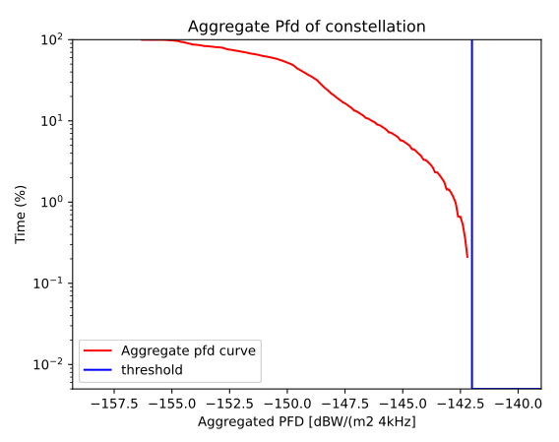
Figure 7: Percentage of time during which a certain PFD limit is exceeded. The blue line shows a PFD value of -142 dBW/(m² 4 kHz)
Table 7: Assessment of satellite-to-SRD transmissions with other SRD. Victim characteristics are taken from ECC Report 261 [7]. All path losses were calculated for the shortest distance between satellite and SRD (worst case)
# | System/  Parameter | Non-specific type A | Sub-metering | Alarms | RFID omni | RFID direc-tional | Cordless audio | Hearing aids | Unit | Formula
1 | Frequency range/ typical frequencies | 862-870 | 868.3, 868.95 | 868.6-869.7 | 865.7, 866.3, 866.9, 867.5 | 865.7, 866.3, 866.9, 867.5 | 864.9 | 863-865 | MHz
2 | Satellite e.i.r.p. | -1.1 | -1.1 | -1.1 | -1.1 | -1.1 | -1.1 | -1.1 | dBW
3 | Satellite transmitter bandwidth | 125 | 125 | 125 | 125 | 125 | 125 | 125 | kHz
4 | Satellite altitude | 500 | 500 | 500 | 500 | 500 | 500 | 500 | km
5 | Path loss | -145.2 | -145.2 | -145.2 | -145.2 | -145.2 | -145.2 | -145.2 | dB | FSPL  (Note 1)
6 | Propagation loss | -1.0 | -1.0 | -1.0 | -1.0 | -1.0 | -1.0 | -1.0 | dB
7 | Polarisation loss | -3.0 | -3.0 | -3.0 | -3.0 | 0.0 | 0.0 | -3.0 | dB
8 | Victim antenna gain | -2.85 | -2.85 | -2.85 | 0 | 6.00 | -2.85 | -20.85 | dB
9 | Power at victim receiver input | -153.1 | -153.1 | -160.1 | -150.3 | -141.3 | -150.1 | -171.1 | dBW | (2)+(5)+(6)+(7)+(8)+ BWC  (Note 2)
10 | Victim receiver bandwidth | 350 | 300 | 25 | 200 | 200 | 200 | 600 | kHz
11 | Victim sensitivity | -134 | -134 | -142 | -115 | -115 | -127 | -124 | dBW
12 | C/I threshold | 8 | 8 | 8 | 12 | 12 | 17 | 17 | dB
13 | Imax | -142 | -142 | -150 | -127 | -127 | -144 | -141 | dBW | (11)-(10)
14 | Margin | 11.1 | 11.1 | 10.1 | 23.3 | 14.3 | 6.1 | 30.1 | dB | (13)-(9)
Note: This table does not include LPWAN systems. The SRD-satellite systems presented in ANNEX 1: also use LPWAN technology. It is reasonable that transmissions from satellites to 'victim' LPWAN devices have at most the same impact as they have on 'wanted' LPWAN devices.
Note 1: Free Space Path Loss: FSPL = - (20*log10(4*π*distance[m]*frequency[Hz]/speed_of_light[m/s])
Note 2: If the transmitter bandwidth is larger than receiver bandwidth, the following bandwidth correction term is added:
BWC = 10 log10 (receiver_bandwidth/transmit_bandwidth)
- Field study
As mentioned in section 3.2, a PFD value of not more than -142 dBW/(m² 4 kHz) can assure sufficient protection for other systems, while closing the link to sensitive receivers as used in SRD-satellite systems. As part of a grant to operate satellite systems under Radio Regulations No 4.4 in the range 862-870 MHz, BNetzA requested the operator (Lacuna Space) to prove the link feasibility at such a PFD value. Members of BNetzA and Lacuna Space conducted measurements at the Leeheim monitoring station.
The ground station in Leeheim provides calibrated antennas that can measure PFD in the frequency band 862-870 MHz. The measuring campaign took place on a day when one of Lacuna Space's satellites passed over the ground station with a maximum elevation of 86.1 degree (date: 11 October 2021, 9:46:46 UTC). The satellite transmitted with an e.i.r.p. of 26 dBm and a peak PFD of -149.78 dBW/(m² 4 kHz) was measured. A Lacuna Space user terminal was placed outside and the decoding of received messages was monitored. The first message could be recorded at around 40-degree elevation. The successful demonstration was confirmed by employees of measuring station and administration.
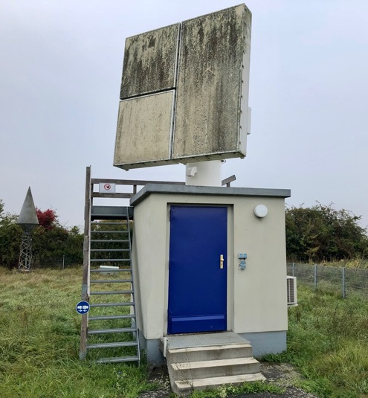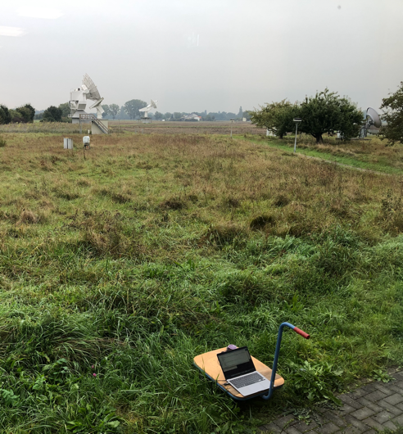
Figure 8: Leeheim Monitoring Station
Left: Calibrated antenna to measure PFD value;
Right: Lacuna Space user terminal and laptop placed on a cart to confirm reception of messages
- List of references
- ERC Recommendation 70-03: "Relating to the use of Short Range Devices (SRD)", latest amended March 2024
- ECC Report 305: "M2M/IoT Operation via Satellite", approved February 2020
- Decision 2006/771/EC: Commission Decision of 9 November 2006 on harmonisation of the radio spectrum for use by short-range devices
- Commission Implementing Decision (EU) 2022/180 of 8 February 2022 amending Decision 2006/771/EC as regards the update of harmonised technical conditions in the area of radio spectrum use for short-range devices
- ITU Radio Regulations, Edition of 2020
- ITU-R Report SM.2153-7 (06/2019): “Technical and operating parameters and spectrum use for short-range radiocommunication devices“
- ECC Report 261: "Short Range Devices in the frequency range 862-870 MHz", approved January 2017
- Rules of Procedure approved by the Radio Regulations Board, for the application, by the Radiocommunication Bureau, of the provisions of the Radio Regulations, Regional Agreements, Resolutions and Recommendations of World and Regional Radiocommunication Conferences, 2021 edition (+ rev.2)
- Recommendation ITU-R P.372-14 (08/2019), “Radio noise”
- ECC Report 37: "Compatibility of planned SRD applications with currently existing radiocommunication applications in the frequency band 863-870 MHz", approved February 2004
- ECC Report 44: “Guidance for radio usage at special events", approved October 2014
- ECC Report 207: “Adjacent band co-existence of SRD in the band 863-870 MHz in light of the LTE usage below 862 MHz", approved January 2014
- FM22(09)77: "Monitoring Campaign 863-870 MHz on behalf of SRD MG and SE 24", November 2009
- ECC Report 182: "Survey about the use of the frequency band 863-870 MHz", approved October 2012

https://cept.org/ecc/tools-and-services/cept-workshops/presentations-cept-workshop-21-22-nov-2022
https://lora-alliance.org/resource_hub/netid-faqs

