ECC Recommendation (24)02

On guidance for the use of governmental UAS operating within the frequency bands 1880-1900 MHz and 1910-1920 MHz

approved 7 June 2024

# Introduction

ECC Report 332 [1] provides the results of the studies on the technical compatibility related to the UAS for governmental use of command and control links as well as payload links in the 1880-1900 MHz and 1900 - 1920 MHz frequency bands.

ECC Report 352 [2] addresses the assessment on the feasibility of spectrum solutions for the operational needs for governmental use of UAS and establishes the relevant technical conditions.

It should be noted that governmental use does not address military usage (which is considered as a national matter) and therefore it is not in the scope of the present ECC Recommendation.

This Recommendation contains guidance, including technical conditions, to administrations on the use of 1880-1900 MHz and 1910-1920 MHz frequency bands for the operation of governmental UAS ensuring the protection of services and applications in-band and in adjacent bands. This Recommendation sets out a minimum coordination distance between RMR and governmental UAS.

**ECC recommendation (24)02 OF 7 June 2024 on GUIDANCE FOR THE USE OF GOVERNMENTAL UAS OPERATING WITHin the FREQUENCY BANDS 1880-1900 MHZ AND 1910-1920 MHZ**

“The European Conference of Postal and Telecommunications Administrations,

*considering*

1. that there is a need for spectrum for governmental UAS use and operation including command, control and payload communication between the UAS GS (Ground Station) and the UAS UE (User Equipment);
2. that the term “governmental use” refers to operations for carrying out the maintenance of law and order, protection of life and property, disaster relief and emergency response activities or services undertaken in the public interest excluding military operations/activities. These operations are carried out by or on behalf of a public authority;
3. that the aim of this Recommendation is to provide guidance on technical and operational conditions for the use of the 1880-1900 MHz and 1910-1920 MHz bands for the operation of governmental UAS at a national level;
4. that governmental UAS are expected to use DECT-2020 NR[1] or compatible technology with channel bandwidths of 1.728 MHz, 3.456 MHz or 6.912 MHz;
5. that a routine mission is a planned mission of a single UAS without overlapping operating[2] area with other UAS and flying within RMR exclusion zones is not permitted;
6. that critical mission corresponds to exceptional situations (such as natural disasters), where multiple actors (police, firefighters, etc.) would need aerial coverage of the geographical area where the exceptional situation is happening;
7. that the band 1880-1900 MHz is designated for Digital Enhanced Cordless Telecommunications (DECT) under a general authorisation regime as set out in ERC Decision (94)03 [3], ERC Decision (98)22 [4] and EU Council Directive 91/287/EEC [15];
8. that the frequency band 1900-1910 MHz is designated for Railway Mobile Radio (RMR) by ECC Decision (20)02 [5] and the Commission Implementing Decision (EU) 2021/1730 [6];
9. that the frequency bands 1710-1785 MHz / 1805-1880 MHz is designated for MFCN (Mobile Fixed Communication Network) by ECC Decision (06)13 [10] and Commission Implementing Decision (EU) 2022/173 [12];
10. that the frequency bands 1920-1980 MHz / 2110-2170 MHz are designated for MFCN by ECC Decision (06)01 [11], Commission Implementing Decision 2012/688/EU and Commission Implementing Decision (EU) 2020/667 [13];
11. that, based on technical compatibility studies in ECC Report 332 [1] and ECC Report 352 [2] identifies technical and operational conditions for governmental UAS that will facilitate coexistence with services and applications in-band and in adjacent bands;
12. that there is a necessity to protect RMR operating in 1900-1910 MHz from governmental UAS operating in adjacent bands;
13. that administrations wishing to authorise the use of governmental UAS may consider performing coexistence measurements between RMR in the band 1900-1910 MHz and governmental drones operating in the adjacent band, when these systems become available, to confirm the theoretically calculated mitigation distances and coexistence behaviour;
14. that there is a necessity to protect MFCN systems operating in 1805-1880 MHz and 1920-1980 MHz from governmental UAS operating in adjacent bands and that administrations may consider the need for additional measures on a national basis;
15. that governmental UAS are intended to be operated to a maximum flight altitude of 120 m as set out in Commission Implementing Regulation (EU) 2019/947 [14] for Open category of UAS operation;

*recommends*

1. that administrations make available the 1880-1900 MHz and 1910-1920 MHz bands for the use and operation of governmental UAS, using DECT-2020 NR or compatible technology;
2. that UAS equipment should comply with the technical conditions specified in ANNEX 1;
3. that for routine missions the maximum operational range[3] of governmental UAS should be limited to 500 m in urban areas and 1 km in rural areas;
4. that the definition and calculation of the minimum coordination distances and the corresponding exclusion zones for the protection of RMR (e.g. ANNEX 2) are a national issue;
5. that a cross-border coordination process should be agreed amongst involved administrations to address coexistence issues between UAS operators and railway infrastructure managers at the borders, which could also include the notification process between UAS operator and RMR infrastructure managers (ANNEX 3);
6. that, for critical missions, a maximum of 3 governmental UAS could be simultaneously used in a geographical area of 1 km² and that, under these circumstances, the maximum operational range of governmental UAS should be limited to 500 m;
7. that, for the case when a governmental UAS flies during a critical mission within an exclusion zone, a notification process between the UAS operator and the RMR infrastructure manager should be implemented. The notification procedure should be agreed at a national level. An example of a possible workflow is presented in ANNEX 4.”

*Note:*

*Please check the Office documentation database* [*https://docdb.cept.org/*](https://docdb.cept.org/) *for the up to date position on the implementation of this and other ECC Recommendations.*

1. Technical conditions for Governmental UAS in the 1880-1900 MHz and 1910-1920 MHz bands

These technical requirements apply to both, ground station and user equipment.

Table 1: Requirements on governmental UAS

|  |  |
| --- | --- |
|  | **Technical conditions** |
| Transmit power | ≤ 24 dBm e.i.r.p.  Transmitter Power Control (TPC) as set out in ETSI TS 103 636-2 [8], or equivalent method |
| Channel access | DECT instant Dynamic Channel Selection (iDCS) as set out in ETSI TS 103 636-4 [9], or equivalent method |

A 6.912 MHz channel shall only be used below 1893.1 MHz (corresponding to the higher edge of the upmost channel).

Use of governmental UAS in the band 1910-1920 MHz is limited to bandwidths 1.728 MHz or 3.456 MHz.

For critical missions the maximum occupation of each of the bands 1880-1900 MHz and 1910-1920 MHz should be no more than 6.912 MHz.

1. Example of exclusion zones definition to be provided by the RMR infrastructure manager

This annex provides a polygon that could be provided by the RMR infrastructure manager to UAS operator for the definition of the exclusion zones. Values for d1 and d2 are defined as follows:

* d1 = 500 m in rural areas, 100 m in urban areas;
* d2 = 50 m.

These values will be reviewed based on field experience.



1. Definition on the exclusion zones

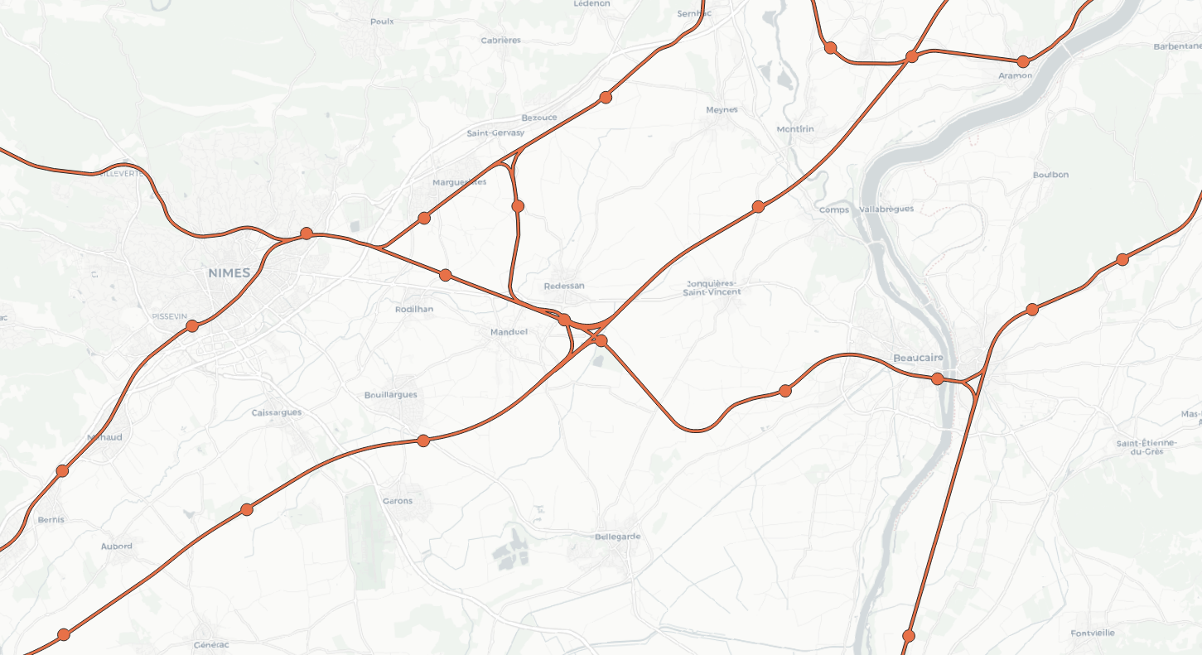

1. Example of exclusion zones in the South of France (orange lines and circles around BS indicate the exclusion zones)
2. Specific cases of Cross-border areas

Close to national borders, it is also needed to involve the RMR infrastructure manager of the neighbouring country in the proposed process. The distance inside the neighbouring country where information needs to be shared with foreign parties (UAS operator and RMR operator) will depend on the implementation of the RMR BS and the service continuity requirement. This distance is normally agreed between the involved RMR infrastructure managers.

Note: in some specific cases, the RMR operator of a country A needs to deploy a RMR BS in country B to allow service continuity between both countries, but the principle remains the same.



1. Cross-border area situation

In case of UASA is flying close to the shared exclusion zone represented above by ░, the flowchart presented in A4.1 is applicable. In addition, RMRA will also inform RMRB and vice-versa.

For more details on different situations for cross-border areas, please refer to ECC Report 353, annex 1: Typical railway deployment scenarios [7].

The exclusion zones along the borders have to be exchanged between the RMR infrastructure managers of the countries involved.

1. Example of Notification process between UAS operator and RMR infrastructure manager applicable only for critical missions

This example of a notification process only applies for critical missions (according to *recommends 8*).

This process may be adapted to each national situation.

* 1. Principles for a Notification process

The following figure provides a generic process that is further detailed in the following sections.



1. Example of generic notification process
   1. Detailed description of the activities

|  |  |
| --- | --- |
|  | * Definition of the exclusion zones around railway tracks (geofencing):   Task performed by the RMR infrastructure manager;  The size of these exclusion zones is derived according to the parameters set out in Figure 2:;  The periodicity for the delivery of this information shall be defined on a national basis (example: every year);  Format of the geographical data (format of the file(s) and geographical projection’s system) has to be defined on a national basis. |
|  | * Download of the exclusion zones in UAS devices(UE/GS). |
|  | * After a UAS flight inside the exclusion zone, the UAS operator creates a record in a national database (to be set up) to inform the RMR infrastructure manager. * The minimum information to be exchanged is the following:   Flight Plan (date/time/duration & location). |
|  | * The RMR infrastructure manager will then update the national database mentioned above with RMR losses of service identified in the area flown over. |

The format and the exact data to be registered by RMR in step 4 shall be adjusted on a national basis. The details of the contact names of each involved party (UAS and RMR), the notification delay and the exact flowchart shall also be adjusted on a national basis. All this information shall be defined in a multilateral agreement between the involved parties. This agreement could also be shared with the national frequency authority depending on the national rules.

Remark: based on the number of cases which had an impact on railway operation within a certain period of time (e.g. six months) the size, the shape of the exclusion zones and the flowchart may be adjusted on a national basis.

1. List of references

1. [ECC Report 332:](https://docdb.cept.org/document/26189) “Technical compatibility studies related to UAS (Unmanned Aircraft System) in the 1880-1920 MHz band”, approved January 2022

1. [ECC Report 352](https://docdb.cept.org/document/28595): “Harmonised conditions and spectrum bands for the operation of governmental Unmanned Aircraft System (UAS)”, approved June 2023

1. [ERC Decision (94)03](https://docdb.cept.org/document/718): “The frequency band to be designated for the coordinated introduction of the Digital European Cordless Telecommunications system”, approved October 1994

1. [ERC Decision (98)22:](https://docdb.cept.org/document/774) “Exemption from individual licensing and free circulation and use of DECT equipment”, approved November 1998, latest amended March 2024

1. [ECC Decision (20)02](https://docdb.cept.org/document/16736): “Harmonised use of the paired frequency bands 874.4-880.0 MHz and 919.4-925.0 MHz and of the unpaired frequency band 1900-1910 MHz for Railway Mobile Radio (RMR)”, approved November 2020, updated 10 June 2022

1. [Decision (EU) 2021/1730](https://docdb.cept.org/document/21718): “Commission implementing Decision (EU) 2021/1730 of 28 September 2021 on the harmonised use of the paired frequency bands 874.4-880.0 MHz and 919.4-925.0 MHz and of the unpaired frequency band 1900-1910 MHz for Railway Mobile Radio”;

1. [ECC Report 353](https://docdb.cept.org/document/28593): “Cross-border coordination and synchronisation for Railway Mobile Radio (RMR) networks in the 1900-1910 MHz TDD frequency band”, approved June 2023

1. [ETSI TS 103 636-2](https://www.etsi.org/deliver/etsi_ts/103600_103699/10363602/01.05.01_60/ts_10363602v010501p.pdf): “DECT-2020 New Radio (NR); Part 2: Radio reception and transmission requirements”; Release 1

1. [ETSI TS 103 636-4](https://www.etsi.org/deliver/etsi_ts/103600_103699/10363604/01.05.01_60/ts_10363604v010501p.pdf): “DECT-2020 New Radio (NR);Part 4: MAC layer”; Release 1
2. [ECC Decision (06)13: “Harmonised technical conditions for mobile/fixed communications networks (MFCN) including terrestrial IMT systems, other than GSM and EC-GSM IoT, in the bands 880-915/925-960 MHz and 1710-1785/1805-1880 MHz’’, approved December 2006, latest amended March 2022](https://docdb.cept.org/document/406)
3. [ECC Decision (06)01](https://docdb.cept.org/document/394): “Harmonised utilisation of the bands 1920-1980 MHz and 2110-2170 MHz for mobile/fixed communications networks (MFCN) including terrestrial IMT’’ Approved 24 March 2006, latest amended on 8 March 2019

1. [Decision (EU) 2022/173](https://docdb.cept.org/document/26193): “Commission Implementing Decision (EU) 2022/173 of 7 February 2022 on the harmonisation of the 900 MHz and 1800 MHz frequency bands for terrestrial systems capable of providing electronic communications services in the Union and repealing Decision 2009/766/EC”

1. [Decision (EU) 2020/667](https://docdb.cept.org/document/15109): “Commission Implementing Decision (EU) 2020/667 of 6 May 2020 amending Decision 2012/688/EU as regards an update of relevant technical conditions applicable to the frequency bands 1920-1980 MHz and 2110-2170 MHz”
2. Commission implementing regulation (EU) 2019/947 of 24 May 2019 on the rules and procedures for the operation of unmanned aircraft
3. Council Directive 91/287/EEC of 3 June 1991 on the frequency band to be designated for the coordinated introduction of digital European cordless telecommunications (DECT) into the Community

1. ETSI TS 103 636-1: DECT-2020 New Radio (NR); Part 1: Overview
2. Operating area is the area which is covered during a planned regular mission
3. Operational range is the maximum distance between UAS GS and UAS UE