**Recommendation T/R 13-01 E**

(Montreux 1993, Revised Rottach-Egern, February 2010, Corrected May 2024)

**PREFERRED CHANNEL ARRANGEMENTS FOR FIXED SERVICE SYSTEMS**

**OPERATING IN THE FREQUENCY RANGE 1 - 2.3 GHz**

Recommendation adopted by the Working Group "Spectrum Engineering" (SE)

“The European Conference of Postal and Telecommunications Administrations,

*considering*

1. that CEPT has a long-term objective to harmonise the use of frequencies throughout Europe in order to make the most effective use of the spectrum available,
2. that there are technical and economic factors that will require continued operation of fixed services in the 1 - 2.3 GHz range,
3. that there is a range of different fixed service applications (point-to-point and point-to-multipoint), requiring various channel bandwidths, which need to be accommodated in the 1 - 2.3 GHz range,
4. that according to RR 5.340 all emissions are prohibited in the band 1400 to 1427 MHz.

*recommends*

1. that administrations using fixed service in the band 1350 - 1375 MHz paired with 1492 - 1517 MHz should consider the channel plan given in Annex A;

2. that administrations using fixed service in the band 1375 - 1400 MHz paired with 1427 - 1452 MHz should consider the channel plan given in Annex B;

3. that administrations using fixed service in the band 2025 - 2110 MHz paired with 2200 - 2290 MHz should consider the channel plan given in Annex C (Note 1).

Note 1: According ERC Report 65 a separation distance of 2 km and a carrier separation of 8.3 MHz is required between FS and MS stations operating in adjacent bands. Therefore a carefully deployment and coordination between MS and FS with channel spacing below 14 MHz is needed.

*Note:*

*Please check the Office web site (https://docdb.cept.org/) for the up to date position on the implementation of this and other ECC and ERC Recommendations.*

**Annex A**

**Frequency band 1350 - 1375 MHz paired with 1492 - 1517 MHz**

Due to the fact that this band only offers 25 MHz of spectrum for each direction of transmission it will be limited to low capacity digital systems for point-to-point and point-to-multipoint systems. The channel arrangement is based on Recommendations ITU-R F.701 and ITU-R F.1242 which offers the maximum amount of possible channels.

The following detailed channel arrangement is proposed:

Let

fo be the centre frequency of **1433.5**  MHz

fn be the centre frequency of the radio-frequency channel in the lower half of the band

fn' be the centre frequency of the radio-frequency channel in the upper half of the band

TX/RX separation = **142** MHz

Separation band = **117** MHz

then the frequencies of individual channels are expressed by the following relationships :

a) for systems with a carrier spacing of 2 MHz

lower half of the band: fn = fo - 84 + 2n MHz

upper half of the band: fn' = fo + 58 + 2n MHz where n = 1, ... 12

b) for systems with a carrier spacing of 1 MHz

lower half of the band: fn = fo - 83.5 + 1n MHz

upper half of the band: fn' = fo + 58.5 + 1n MHz where n = 1, ... 24

c) for systems with a carrier spacing of 0.5 MHz

lower half of the band: fn = fo - 83.25 + 0.5n MHz

upper half of the band: fn' = fo + 58.75 + 0.5n MHz where n = 1, ... 48

d) for systems with a carrier spacing of 0.25 MHz

lower half of the band: fn = fo - 83.125 + 0.25n MHz

upper half of the band: fn' = fo + 58.875 + 0.25n MHz where n = 1, ... 96

e) for systems with a carrier spacing of 0.025 MHz

lower half of the band: fn = fo - 83.0125 + 0.025n MHz

upper half of the band: fn' = fo + 58.9875 + 0.025n MHz where n = 1, .. 960

For 75 kHz channel spacing use the 0.025 MHz formula restricted to n = 2, 5, 8, .....

f) for systems with a carrier spacing of 3.5 MHz derived from the 0.5 MHz channels by multiplication and with 2 MHz guard bands

lower half of the band: fn = fo - 83.25 + 3.5n MHz

upper half of the band: fn' = fo + 58.75 + 3.5n MHz where n = 1, ... 6



**Figure 1: Occupied spectrum 1350 - 1517 MHz**

**Annex B**

**Frequency band 1375 - 1400 MHz paired with 1427 - 1452 MHz**

This band is comparable to band 1350-1375 MHz/1492-1517 MHz and therefore is used for the same kind of applications. Thus the channel arrangement, also based on Recommendation ITU-R F.701 and F.1242, has been developed on a similar basis.

The following detailed channel plan is proposed:

Let

fo be the centre frequency of **1413.5** MHz

fn be the centre frequency of the radio-frequency channel in the lower half of the band

fn' be the centre frequency of the radio-frequency channel in the upper half of the band

TX/RX separation = **52** MHz

Separation band = **27** MHz

then the frequencies of individual channels are expressed by the following relationships :

a) for systems with a carrier spacing of 2 MHz

lower half of the band: fn = fo - 39 + 2n MHz

upper half of the band: fn' = fo + 13 + 2n MHz where n = 1, ... 12

b) for systems with a carrier spacing of 1 MHz

lower half of the band: fn = fo - 38.5 + 1n MHz

upper half of the band: fn' = fo + 13.5 + 1n MHz where n = 1, ... 24

c) for systems with a carrier spacing of 0.5 MHz

lower half of the band: fn = fo - 38.25 + 0.5n MHz

upper half of the band: fn' = fo + 13.75 + 0.5n MHz where n = 1, ... 48

d) for systems with a carrier spacing of 0.25 MHz

lower half of the band: fn = fo - 38.125 + 0.25n MHz

upper half of the band: fn' = fo + 13.875 + 0.25n MHz where n = 1, ... 96

e) for systems with a carrier spacing of 0.025 MHz

lower half of the band: fn = fo - 38.0125 + 0.025n MHz

upper half of the band: fn' = fo + 13.9875 + 0.025n MHz where n = 1, ... 960

For 75 kHz channel spacing use the 0.025 MHz formula restricted to n = 2, 5, 8 , ...

f) for systems with a carrier spacing of 3.5 MHz derived from the 0.5 MHz channels by multiplication and with 2 MHz guard bands

lower half of the band: fn = fo - 38.25 + 3.5n MHz

upper half of the band: fn' = fo + 13.75 + 3.5n MHz where n = 1, ... 6



**Figure 2: Occupied spectrum 1375 - 1452 MHz**

**Annex C**

**Frequency band 2025 - 2110 MHz paired with 2200 - 2290 MHz**

Future use of this band will be for some traditional multi-channel, multi-hop radio relay systems and also for modern access radio applications. It is therefore essential that the new channel plans, based on Recommendation ITU-R F.1098, allow sufficient flexibility to support a range of equipment capacities, modulation schemes and transmission techniques.

The following detailed channel plan is proposed:

Let

fo be the centre frequency of **2155**  MHz

fn be the centre frequency of the radio-frequency channel in the lower half of the band

fn' be the centre frequency of the radio-frequency channel in the upper half of the band

TX/RX separation = **175** MHz

Separation band = **90** MHz

then the frequencies of individual channels are expressed by the following relationships:

a) for systems with a carrier spacing of 14 MHz

lower half of the band: fn = fo - 130.5 + 14n MHz

upper half of the band: fn' = fo + 44.5 + 14n MHz where n = 1, ... 5

b) for systems with a carrier spacing of 7 MHz

lower half of the band: fn = fo - 127.0 + 7n MHz

upper half of the band: fn' = fo + 48.0 + 7n MHz where n = 1, ...11

c) for systems with a carrier spacing of 3.5 MHz

lower half of the band: fn = fo - 128.75 + 3.5n MHz

upper half of the band: fn' = fo + 46.25 + 3.5n MHz where n = 1, ... 23

d) for systems with a carrier spacing of 1.75 MHz

lower half of the band: fn = fo - 130.500 + 1.75n MHz

upper half of the band: fn' = fo + 44.500 + 1.75n MHz where n = 1, ... 47

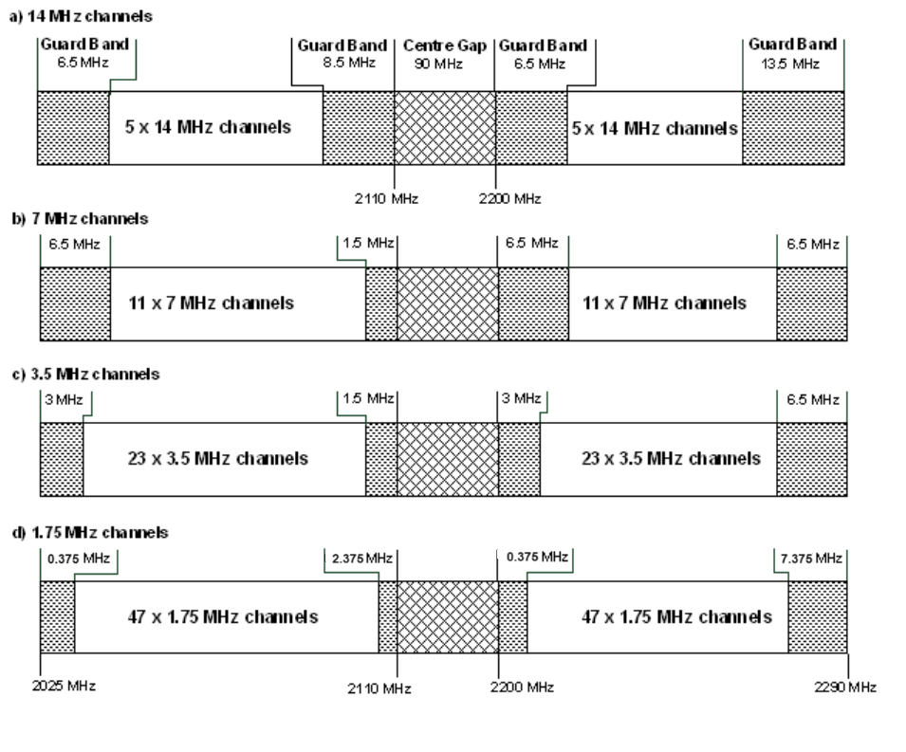

**Figure 3: Occupied spectrum 2025 - 2290 MHz**