ECC Recommendation (23)02

Cross-border coordination for Mobile/Fixed Communications Networks (MFCN) in the frequency band 24.25-27.5 GHz
approved 7 July 2023

introduction
This Recommendation covers cross-border coordination scenarios for wideband (WB) vs. wideband systems in the 24.25-27.5 GHz (hereinafter 26 GHz) frequency band but does not address cross-border coordination of mobile/fixed communications networks (MFCN) vs. other systems.
In this Recommendation, wideband systems include New Radio (NR) for mobile and fixed wireless access (FWA) deployments.
This Recommendation covers only unsynchronised time-division duplex (TDD) operation due to the propagation characteristics at this frequency range resulting in low separation distances and administrations/operators may agree on synchronisation of the networks in bilateral/multilateral agreement/arrangement.

ECC recommendation 23(02) of 7 july 2023 on Cross-border coordination for Mobile/Fixed Communications Networks (MFCN) in the frequency band 24.25-27.5 GHz
“The European Conference of Postal and Telecommunications Administrations
considering
- that ECC Decision (18)06 [1] provides the harmonised technical conditions for MFCN in the 26 GHz frequency band;
- that 26 GHz frequency band will mainly be used for urban and suburban hotspot areas but can also be used in rural areas (e.g. industrial and agriculture usage);
- that differences in the market demand for the spectrum for MFCN and different authorisation regimes across CEPT countries is likely to lead to different timescales concerning the introduction of MFCN in the 26 GHz frequency band;
- that bilateral/multilateral agreements will be needed concerning the use of MFCN in one country and other systems in a neighbouring country when MFCN is close to the border of the neighbouring country;
- that ECC Report 303 [2] provides guidance to administrations for coexistence between 5G systems and fixed links in the 26 GHz frequency band;
- that radioastronomy stations are observing in the adjacent (passive) frequency band 23.6-24 GHz and require specific national measures for their protection;
- that frequency planning of MFCN in border areas will be based on coordination between national administrations in cooperation with their operators;
- that different administrations may wish to adopt different approaches to cross-border coordination;
- that administrations may diverge from the technical parameters, propagation models and procedures described in this Recommendation subject to bilateral/multilateral agreements;
- that coordination is necessary between neighbouring countries operating different technologies and different channel bandwidths in the same frequency band in border areas;
- that in the case of operator arrangements approved by national administrations it is possible to deviate from this Recommendation;
- that Physical-Layer Cell Identity (PCI) coordination may be necessary for NR systems to avoid unnecessary signalling load and handover failures;
recommends
- that coordination between MFCN systems in border areas should be based on bilateral/multilateral agreements between administrations;
- that coordination between MFCN systems and other systems in neighbouring countries should be based on bilateral/multilateral agreements between administrations;
- that operation of MFCN systems in border areas should be based on the principles and the field strength levels provided in Annex 1;
- that field strength predictions should be made using the appropriate propagation models defined in Annex 2;
- that if the field strength levels in Annex 1 are exceeded, the coordination is required and system characteristics and exchange of information detailed in Annex 3 should be used in the request;
- that MFCN systems using NR technology in border areas should use the PCIs, where needed, as provided in Annex 4;
- that administrations should encourage and facilitate the establishment of arrangements between operators in different countries with the aim to enhance the efficient use of the spectrum and to optimise the coverage/throughput in their respective border areas;
- that this Recommendation should be reviewed within 3 years of its adoption in the light of practical experience of its application and of the operation of MFCN systems.”

Note:
Please check the Office documentation database https://docdb.cept.org/ for the up to date position on the implementation of this and other ECC Recommendations.

- FIELD STRENGTH LEVELS FOR THE CROSS-BORDER OPERATION between mfcn systems
In this annex, field strength values are given for unsynchronised cross-border scenario between wideband vs wideband MFCN systems.
Field strength values in this annex are median values for base stations using active antenna systems (AAS), i.e. an antenna that consists of an array of active elements.
Administrations/operators may agree on other field strength values, preferential frequency usage and synchronisation based on bilateral/multilateral agreements/arrangements.
AAS base stations of unsynchronised MFCN TDD systems on both sides of the borderline in the 26 GHz frequency band for all PCIs (in case of NR) may be used without coordination with a neighbouring country if the median field strength of each cell produced by the base station does not exceed a value of 62 dBµV/m/(200 MHz) for traffic channels (which corresponds to SSB field strength level of 52 dBµV/m/(120 kHz) for NR considering the subcarrier spacing (SCS) of 120 kHz) at a height of 3 m above ground level at the borderline between countries.
Table 1 gives an overview of the field strength values.
Table 1: Field strength values at 3 m height for unsynchronised operation
Unsynchronised operation
All PCIs
62 dBμV/m/(200 MHz) @ 0 km
@ stands for “at a distance from the borderline into the neighbouring country”.
The value of 62 dBμV/m/(200 MHz) corresponds to SSB field strength level of 52 dBµV/m//(120 kHz) for NR considering the SCS of 120 kHz
In the case of channel bandwidth other than 200 MHz, a correction factor of 10 × log₁₀ (channel bandwidth in MHz/200 MHz), dB, should be added to the field strength value.
In the case of a SCS other than 120 kHz, a correction factor of 10 × log₁₀ (SCS in kHz/120 kHz), dB, should be added to the SSB field strength value.

- PROPAGATION MODELS
The following method is proposed for assessment of anticipated interferences inside neighbouring country based on established field strength levels. Due to the complexity of radiowave propagation, different methods can be considered by administrations and are included here for guidance purposes only.
It should be noted that the following method provides theoretical predictions. It is practically impossible to recreate this method with measurement procedures in the field. Therefore only some approximation of measurements could be used to check compliance with this method based on practical measurement procedures. The details of such approximation are not included in this Recommendation and should be negotiated between countries based on their radio monitoring practices.
  - Path loss model
The basic model to be used for assessment of anticipated field strength level and to decide if coordination is necessary, is 3GPP TR 38.901 [3] (equivalent to Report ITU-R M.2412 [4]). This model includes clutter loss and as such it is not to be combined with other clutter loss models. This model is to be employed using a receiving antenna height h_{MS} = 3 m and Line of Sight (LoS) probability (UMa LoS probability for base station antenna height above clutters and UMi LoS probability for base station antenna height below clutters).
Administrations and/or operators concerned may agree to deviate from the aforementioned model by mutual consent.
  - Area calculations
In the case where greater accuracy is required, administrations and operators may use the area calculation below.
For calculations, all the pixels of a given geographical area in a neighbouring country to be agreed between the concerned administrations are taken into consideration.
For the relevant base station, predictions of path loss should be made for all the pixels of a given geographical area from a base station and at a receiver antenna height of 3 m above ground.
- EXCHANGE OF INFORMATION
When requesting coordination the relevant characteristics of the base station should be forwarded to the affected administration. All of the following characteristics should be included:
- carrier frequency (GHz);
- channel bandwidth (MHz);
- subcarrier spacing (kHz);
- name of transmitter station;
- country of location of transmitter station;
- geographical coordinates (W/E, N; WGS84);
- antenna height (m);
- antenna polarisation;
- antenna azimuth (deg);
- directivity in antenna systems or antenna gain (dBi);
- effective radiated power (dBW);
- expected coverage zone;
- date of entry into service (month, year);
- PCI (physical-layer cell-identity) numbers used in case of NR;
- antenna tilt (deg / electric and mechanic tilt);
- antenna pattern(s) or envelope of data (traffic) channel;
- antenna pattern(s) or envelope of control (SSB in case of NR) channel.
In addition, when TDD systems are synchronised, the following characteristics should be included as well:
- frame structure, including the special slot “S” configuration (the format at symbol level for slots between downlink and uplink slots);
- Time base (start of UTC second epoch);
- Global Synchronisation Channel Number (GSCN) in case of NR.
The affected administration shall evaluate the request for coordination and shall notify the result of the evaluation within 30 days to the administration requesting coordination.
During the coordination procedure, an administration may request additional information.
If no reply is received by the administration requesting coordination within 30 days, it may send a reminder to the affected administration. An administration not having responded within 30 days following communication of the reminder shall be deemed to have given its consent and the code coordination may be put into use with the characteristics given in the request for coordination.
The periods mentioned above may be extended by common consent.
As a basis during the exchange of information besides listed characteristics above administrations could use formats created within ITU in accordance with Resolution 906 (rev. WRC-15) [8].
- PHYSICAL-LAYER CELL IDENTITIES (PCI) FOR NR
ETSI TS 136 211 [6] defines 168 “unique physical-layer cell-identity groups” in §6.11, numbered 0..167, hereafter called “PCI groups” for LTE. Within each PCI group there are three separate PCIs giving 504 PCIs in total.
For NR in ETSI TS 138 211 [7] (section 7.4.2) the number of physical-layer cell-identity groups (different cell IDs) have been increased to 336, numbered 0..335.
Administrations should apply sharing of PCIs in border areas, an equitable distribution of 1008 PCIs, for preferential and non-preferential PCIs as proposed in Table 2.
Each country should use their own preferential PCIs as a result of sharing of PCIs, depending on cross-border co-ordination scenario and field strength level.
Sharing of PCIs between operators of neighbouring countries should only be applied where synchronisation signal centre frequencies used in the neighbouring countries are aligned independent of the channel bandwidth or where it is not known whether or not the synchronisation signal centre frequencies used in the neighbouring countries are aligned, or where there is no network in operation in the neighbouring country unless otherwise stated in Annex 1 or administration agreements/operator arrangements.
The preferential PCIs of a two country PCI sharing should be applied for a base station if the level of field strength relating to non-preferential PCIs could be exceeded at the borderline of only one neighbouring country. The preferential PCIs of a three country PCI sharing should be applied for a base station if the level of field strength related to non-preferential PCIs could be exceeded at the borderline of only two neighbouring countries.
As shown in Table 2, the PCIs for NR are divided into 6 sub-sets containing each one sixth of the available PCIs. Each country is allocated three sets (half of the PCIs) in a bilateral case and two sets (one third of the PCIs) in a trilateral case, therefore dividing the PCI groups or PCIs is equivalent. Four types of countries are defined in such a way that no country will use the same code set as any one of its neighbours. The following lists describe the distribution of European countries:
Type country 1: AZE, BEL, CVA, CYP, CZE, DNK, E, FIN, GRC, IRL, ISL, LTU, MCO, SMR, SRB, SUI, SVN and UKR
Type country 2: AND, BIH, BUL, D, EST, G, GEO, HNG, I and MDA
Type country 3: ALB, AUT, F, HOL, HRV, MLT, POL, POR, ROU and S
Type country 4: LIE, LUX, LVA, MKD, MNE, NOR, SVK and TUR
(Note: Country type map can be found in Figure 1).
For each type of country, the following Table 2 and Figure 1 describe the sharing of the PCIs with its neighbouring countries, with the following conventions of writing:
preferential PCI
non-preferential PCI

Table 2: PCI sub-sets for use in border areas
PCI | Set A | Set B | Set C | Set D | Set E | Set F |  | PCI | Set A | Set B | Set C | Set D | Set E | Set F
Country 1 | 0..83  504..587 | 84..167  588..671 | 168..251  672..755 | 252..335  756..839 | 336..419  840..923 | 420..503  924..1007 |  | Country 2 | 0..83  504..587 | 84..167  588..671 | 168..251  672..755 | 252..335  756..839 | 336..419  840..923 | 420..503  924..1007
Border 1-2 |  |  |  |  |  |  |  | Border 2-1
Zone 1-2-3 |  |  |  |  |  |  |  | Zone 2-3-1
Border 1-3 |  |  |  |  |  |  |  | Border 2-3
Zone 1-2-4 |  |  |  |  |  |  |  | Zone 2-1-4
Border 1-4 |  |  |  |  |  |  |  | Border 2-4
Zone 1-3-4 |  |  |  |  |  |  |  | Zone 2-3-4
PCI | Set A | Set B | Set C | Set D | Set E | Set F |  | PCI | Set A | Set B | Set C | Set D | Set E | Set F
Country 3 | 0..83  504..587 | 84..167  588..671 | 168..251  672..755 | 252..335  756..839 | 336..419  840..923 | 420..503  924..1007 |  | Country 4 | 0..83  504-587 | 84..167  588..671 | 168..251  672..755 | 252..335  756..839 | 336..419  840..923 | 420..503  924..1007
Border 3-2 |  |  |  |  |  |  |  | Border 4-1
Zone 3-1-2 |  |  |  |  |  |  |  | Zone 4-1-2
Border 3-1 |  |  |  |  |  |  |  | Border 4-2
Zone 3-1-4 |  |  |  |  |  |  |  | Zone 4-2-3
Border 3-4 |  |  |  |  |  |  |  | Border 4-3
Zone 3-2-4 |  |  |  |  |  |  |  | Zone 4-3-1

Note
- In certain specific cases (e.g. AUT/HRV) where the distance between two countries of the same type number is very small (< few 10s km) and at the same time harmful interference for that distance could occur, it may be necessary to address the situation in bilateral /multilateral coordination agreements as necessary, and further subdivision of the allocated PCIs may be included in certain areas.

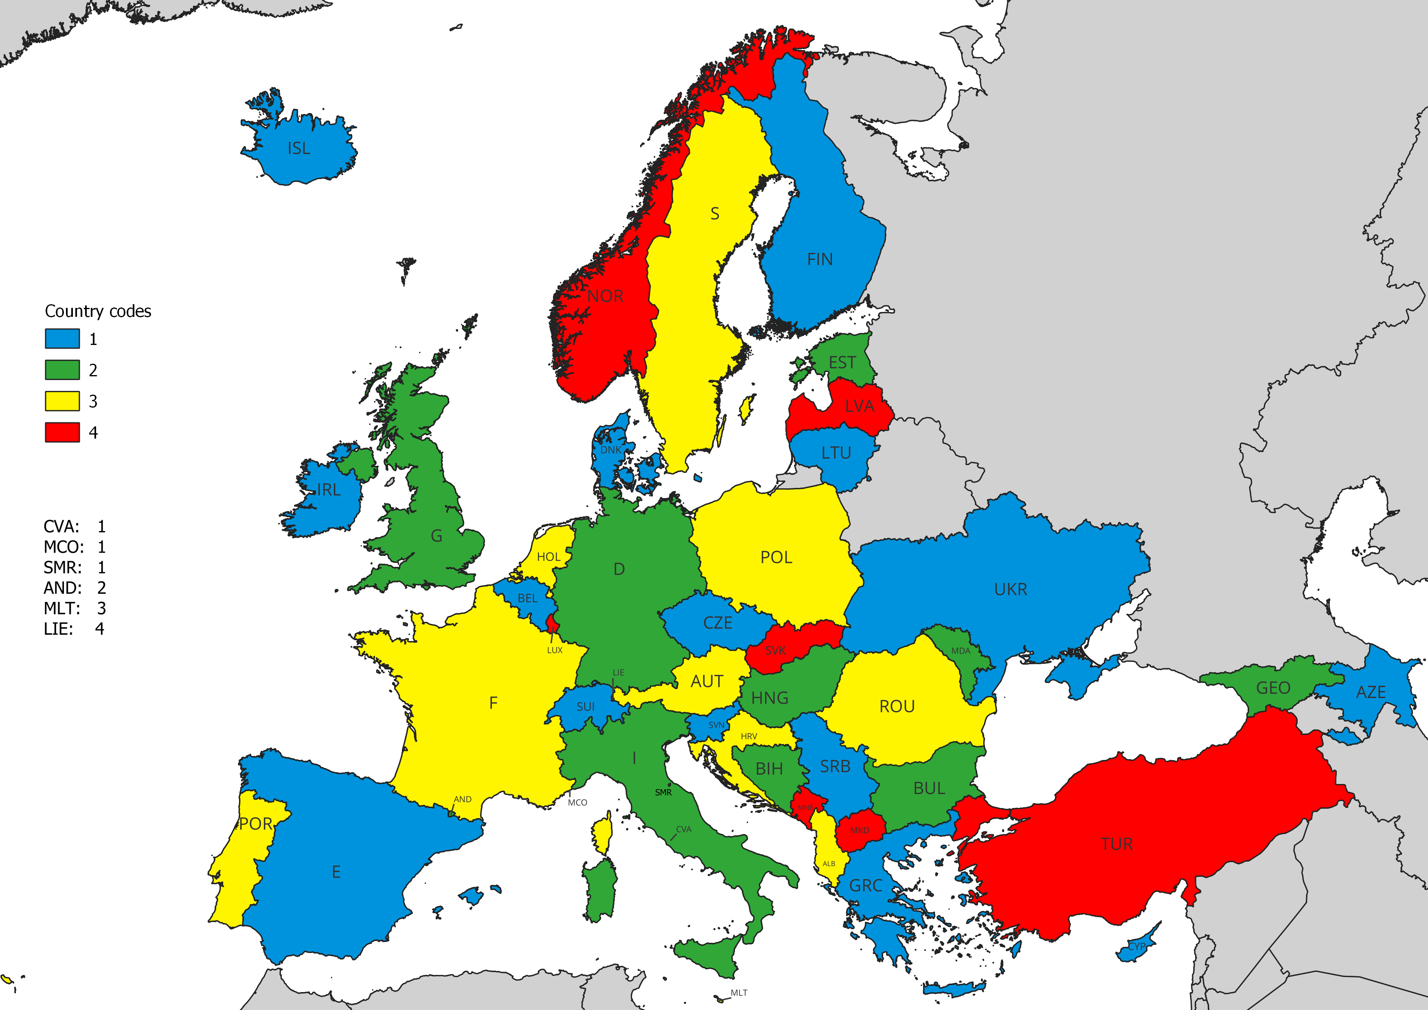
Figure 1: Country type map

- LIST of references
- ECC Decision (18)06: “Harmonised technical conditions for Mobile/Fixed Communications Networks (MFCN) in the band 24.25-27.5 GHz”, approved 6 July 2018, latest amended 20 November 2020
- ECC Report 303: “Guidance to administrations for coexistence between 5G and fixed links in the 26 GHz ban“ ("Toolbox")”, approved 5 July 2019
- 3GPP TR 38.901 V17.0.0 (2022-03): “5G; Study on channel model for frequencies from 0.5 to 100 GHz”
- Report ITU-R M.2412-0 (11/2017): “Guidelines for evaluation of radio interface technologies for IMT-2020”
- HCM Agreement: http://www.hcm-agreement.eu/
- ETSI TS 136 211 V16.6.0 (2021-08): “LTE; Evolved Universal Terrestrial Radio Access (E-UTRA); Physical channels and modulation”
- ETSI TS 138 211 V16.2.0 (2020-07): “5G; NR; Physical channels and modulation”
- Resolution 906 (rev. WRC-15): “Electronic submission of notices for terrestrial services to the Radiocommunication Bureau and exchange of data between administrations”

SSB – Synchronisation Signal Block for NR
The value was derived for one resource element (one subcarrier during one OFDM symbol) in secondary synchronisation signal (SSS) for the SCS of 120 kHz applying a bandwidth conversion factor for the transmitting power of traffic channels and taking into account that the maximum antenna gain for SSB is 9 dB lower than for traffic channels.
not occupied bandwidth
UMa – Urban Macro
UMi – Urban Micro
e.g. as used by members of the HCM-Agreement [5]
Clock phase, frequency and time synchronisation

