Electronic Communications Committee (ECC)
within the European Conference of Postal and Telecommunications Administrations (CEPT)

COMPATIBILITY STUDIES IN THE BAND 3400- 3800 MHz BETWEEN BROADBAND WIRELESS ACCESS (BWA) SYSTEMS AND OTHER SERVICES

Bern, February 2007
- EXECUTIVE SUMMARY AND CONCLUSIONS
This report presents studies of the compatibility between Broadband Wireless Access (BWA) systems in the frequency range 3400-3800 MHz and other existing systems/services. Those other existing systems/services considered in this study were:
- Point-to-point fixed links,
- ENG/OB systems, otherwise referred to as SAB/SAP,
- Fixed-satellite service (Space-to-Earth),
- Radiolocation.

Typical characteristics for BWA systems were considered in the report, covering various BWA usage modes, i.e. Fixed (FWA), Nomadic (NWA) and Mobile (MWA) Wireless Access. Each of the studies took into account specific propagation models that were deemed to be suitable for the considered scenarios.

The main conclusion of the report is that when deciding on deployment of BWA networks in subject bands, administrations need to take into account the situation regarding the use of the frequency band in the concerned area and that co-ordination with the existing users may be required.

The detailed results for different compatibility scenarios are summarised below.

Compatibility between BWA and Point-to-Point fixed links
The analysis of both directions of interference (BWA interfering into P-P and vice-versa) has shown that BWA and P-P systems can co-exist with a certain frequency separation, depending on the BWA and P-P characteristics and with the required co-ordination between the BWA Central Station (CS) and the P-P systems. Co-channel sharing between BWA and P-P links is not feasible in the same geographic area. The co-ordination process will have to ensure that there is no BWA system in the main lobe of the P-P system and that the separation distance between the P-P system and the BWA CS is such that the interference between BWA Terminal Stations (TS) and the P-P is limited.

Compatibility between BWA and ENG/OB
This study provides the values of the frequency separation which are required to enable the co-existence between BWA and ENG/OB systems in a set of scenarios, described in the document. It is shown that the interference effect from an ENG/OB into the BWA is less than the interference effect from a BWA CS into an ENG/OB receiver. For the impact of TS on ENG/OB, the study, based on worst case assumptions, shows that the required guard band between an ENG/OB and BWA TS is relatively small and the main constraint will come from the BWA CS.
The frequency separation required to protect ENG/OB will be quite important when ENG/OB and BWA are supposed to operate in close vicinity (distances around 1 km) and decreases significantly when the separation distance is larger (5 km).
For the case of airborne ENG/OB, the required frequency separation is significantly higher, in particular when considering an omni-directional BWA CS antenna.

Compatibility between BWA and FSS (S-E)
The study noted that there is a number of FSS earth stations deployed in Europe, especially in frequencies above 3700 MHz.

The study of the impact from BWA into FSS Earth Station (ES) was based on the determination of a mitigation zone or area which is defined here as a geographical area delimited by the distance on a given azimuth and elevation from an ES (that shares the same frequency band with terrestrial BWA stations) within which there is a potential for the level of permissible interference to be exceeded and therefore co-ordination is necessary to ensure successful operation between BWA stations and that ES.

The required mitigation distances with respect to FSS ES naturally depend on the type and characteristics of the BWA station. Some examples of mitigation distances are provided in the report based on generic calculations without terrain model and also for some realistic cases of FSS ES with consideration of terrain model.

BWA operation at distances shorter than the required mitigation distance is often feasible due to the benefits gained from using actual terrain topography and clutter database information in propagation loss calculations.

Operation of BWA CS may be feasible within the mitigation zone, based on a detailed, case-by-case evaluation.

BWA TS have generally less impact than the CS. In addition, it has been demonstrated that the co-ordination of the BWA CS will generally be sufficient to ensure the co-existence with BWA TS. Furthermore, TS may benefit from the additional clutter loss which is available in some environments, particularly urban environments.

Studies show that when both BWA systems and FSS are deployed in a ubiquitous manner (with no individual licensing of ES), the sharing is not feasible in the same geographical area since no minimum separation distance can be guaranteed.

In the case of BWA operating in adjacent frequency bands, there is a need for mitigation distance to avoid the LNBs of the ES receivers being driven into non-linear operation, or even being saturated.

Interference from FSS spacecraft transmitting with Article 21 limits into BWA may exceed the required interference criterion by few dB in few cases; however the probability of such cases is expected to be low.

When deciding on deployment of BWA networks in subject bands, administrations will have to take into account the actual use of the band by FSS earth stations.

Compatibility between BWA and radiolocation
The impact from radar systems operating below 3400 MHz on BWA operating in the band 3400-3800 MHz has been assessed. It is clear that the principal way for assuring co-existence of radars vs. FWA is the co-ordination on a case-by-case basis. Theoretical studies are provided that give elements related to the co-ordination process.

In addition, the report also provides a non-exhaustive list of ways to manage interference and facilitate the co-existence between BWA and other systems/services.

Table of contents

0 EXECUTIVE SUMMARY AND CONCLUSIONS 2
1 Introduction 6
2 Services operating in Europe in the 3400-3800 MHz band 6
3 Broadband Wireless Access 6
4 Characteristics of other services/systems for the sharing studies in the band 3400-3800 MHz 8
4.1 Fixed P-P links 8
4.2 ENG/OB 9
4.3 FSS 9
4.4 Radiolocation 10
5 Compatibility studies 12
5.1 General considerations 12
5.1.1 Consideration on BWA usage modes 12
5.1.2 Propagation models 12
5.2 BWA versus Fixed point-to-point link 13
5.2.1 Assumptions used in the studies regarding system parameters 13
5.2.2 Calculation method 13
5.2.3 Interference from BWA into P-P links 14
5.2.3.1 Impact from an BWA CS into a P-P link 14
5.2.3.2 Impact from BWA TS into P-P link 16
5.2.4 Interference from P-P link to BWA 18
5.2.4.1 Impact from a P-P system into a BWA CS 18
5.2.4.2 Impact of P-P system on a BWA TS 21
5.2.5 Analysis of the results and conclusion for the compatibility study P-P link versus BWA 22
5.3 BWA versus ENG/OB 22
5.3.1 Assumptions used in the studies regarding system parameters 22
5.3.2 Calculation method and propagation model 23
5.3.3 Interference from BWA to terrestrial ENG/OB 24
5.3.3.1 Results for the impact from an omni-directional BWA CS into terrestrial ENG/OB 24
5.3.3.2 Results for the impact from a sectorial BWA CS into terrestrial ENG/OB 25
5.3.3.3 Interference calculation from BWA TS on a terrestrial ENG/OB 25
5.3.3.4 Conclusion 27
5.3.4 Interference from terrestrial ENG/OB into BWA 28
5.3.4.1 Results for the impact from terrestrial ENG/OB into an omni-directional BWA CS 28
5.3.4.2 Results for the impact from terrestrial ENG/OB into a sectorial BWA CS 28
5.3.4.3 Results for the impact from terrestrial ENG/OB into an omni-directional BWA TS 29
5.3.4.4 Results for the impact from terrestrial ENG/OB into a sectorial BWA TS 29
5.3.4.5 Analysis of the results for the interference from terrestrial ENG/OB into BWA 29
5.3.5 Interference between BWA and airborne ENG/OB 30
5.3.5.1 Impact from BWA CS on airborne ENG/OB 30
5.3.5.2 Impact of airborne ENG/OB on an omni-directional and sectorial BWA CS 30
5.3.6 Conclusion for the compatibility BWA versus ENG/OB 30
5.4 BWA versus FSS (Space to Earth) 31
5.4.1 BWA System characteristics for sharing analysis 31
5.4.2 Interference from BWA into the FSS ES receiver in co-channel configuration 31
5.4.2.1 Bandwidth considerations 31
5.4.2.2 Objectives and Methodology (including choice of scenarios and propagation model) 32
5.4.2.3 Determination of a generic mitigation area around the FSS ES 33
5.4.2.4 Example of required real mitigation area around FSS ES 38
5.4.2.5 Determination of an “aggregate mitigation area” around the FSS ES 46
5.4.2.6 Impact from BWA TSs on an FSS ES 48
5.4.2.7 Impact from BWA on VSAT 52
5.4.3 Interference from BWA into FSS ES receivers in adjacent band scenario 53
5.4.3.1 Interference from out-of-band emissions 53
5.4.3.2 Saturation of the LNBs in the entire 3400-4200 MHz band 55
5.4.4 Interference from the FSS spacecraft into the BWA CS and/or TS receivers 56
5.4.5 V.4.5 Summary of results 57
5.5 BWA versus Radiolocation 58
5.5.1 V.5.1 Analysis of the impact from radar systems operating below 3.4 GHz on BWA operating in the band 3400-3800 MHz 58
5.5.2 Results of measurements on the impact of pulsed signals on the performance of a radiocommunications receiver 59
5.5.3 Additional considerations on the compatibility between BWA and radars 59
6 Managing interference, mitigation factors 59
7 Conclusions 61
8 Abbreviations 62
Annex 1: Extract of the ERC Report 25 63
Annex 2: Spectrum masks of BWA systems considered in the studies 64
Annex 3: Transmitter spectrum masks for P-P systems 66
Annex 4: Transmitter spectrum mask of ENG/OB systems at 3.5 GHz 67
Annex 5: Plot of ES deployment over Europe in the frequency band 3400 – 4200 MHz from the ITU ES Database and those using the Netherlands fleet of satellites (excluding governmental and military services & ROES) 68
Annex 6: Compatibility Study between Radiolocation Radars and BWA Systems in the 3 GHz Band 69
Annex 7: Impact from a Radar System on BWA: Measurements of the Bit Error Rate in a Radiocommunications Receiver in Dependence of the Interference from Continuous and Pulsed Signals 83

Compatibility studies in the band 3400- 3800 MHz between
Broadband Wireless Access (BWA) systems and other services
- Introduction
Following the emerging of new promising technology, the interest for the use of the 3400-3600 MHz and 3600-3800 MHz bands for FWA/BWA applications has increased. Those intended BWA uses may involve BWA deployment on local, regional or national scales. In this context, several administrations started carrying out consultations to obtain better views on the possible ways of granting licences and the need for guidance on inter-service sharing studies has been expressed.

The ECC Report 33 and the recommendation ECC/REC(04)05, which were approved in February 2006 deal with the intra-service compatibility of FWA/NWA and give some guidelines for the co-existence of PMP FWS cells in the considered bands.

The bands 3400-3600 MHz and 3600-3800 MHz are also envisaged for other BWA usage modes, such as mobile (MWA).

The purpose of this report was to present the compatibility studies between BWA and other existing systems/services in the frequency range 3400-3800 MHz.

This report identifies the different services/systems operating in the 3400-3800 MHz frequency band to consider, provides their characteristics and gives the results of compatibility studies.
- Services operating in Europe in the 3400-3800 MHz band
An abstract of the ERC Report 25 for the 3400-3800 MHz band is given in Annex 1.

The following services/systems, for which compatibility studies with BWA should be conducted, have been identified:
- Fixed point-to-point links,
- ENG/OB, otherwise referred to as SAB/SAP,
- FSS (Space-to-Earth),
- Radiolocation.

In the Radio Regulations, the band 3400-3475 MHz is also allocated on a secondary basis to the Radio Amateur service in two CEPT countries through RR No. 5.431. In the 3400-3410 MHz band, the amateur service operates on a secondary basis in some CEPT countries in accordance with ERC Report 25. Due to the secondary status of the allocation to the amateur service, no compatibility study between BWA and the radio amateur service was felt necessary.

It should also be noted that the impact from UWB systems on BWA in the 3400-3800 MHz range has been studied in the ECC Report 64 and is not addressed in this report.
- Broadband Wireless Access
The characteristics of BWA systems have been provided based on technical data available in the Annex D of the draft ETSI TR 102 453 v1.1.1 (System Reference Document on converged fixed-nomadic BWA above 3.4 GHz) and are consistent with those used in the ECC REPORT 33: “The nalysis of the co-existence of Point-to-Multi-Point FWS cells in the 3400-3800 MHz band”.

These characteristics may be applicable to BWA in general covering all possible usage modes. Difference between the various usage modes will be reflected, where necessary, in the scenarios considered for the studies.

The following table includes parameters for different types of BWA deployment, applicable for both FDD and TDD. In particular, the parameters for omni-directional antennas for TS may enable to cover various possible usage modes (e.g. nomadic or even mobile applications) provided that the scenarios considered for the sharing studies are carefully chosen to accurately reflect these deployment types.

Param | Value | Unit | Remarks
Considered channel bandwidth | 1.75…14 | MHz | Narrower channels are preferable to minimize probability of interference. Also, support for frequency re-use in cellular deployments as well as concurrent service providers in same area make this channel bandwidth optimal.
FDD; duplex spacing | 100 | MHz | This is the preferred duplex spacing value; in particular cases, 50MHz can be also used
TX peak output power, CS | 35 | dBm | In some scenarios the CS power may need to be up to 43dBm, to cope with Nomadic deployment
TX peak output power, TS-Fixed | 22 | dBm | The typical TS power is limited by cost and limitation of the CS power: the OFDMA/sub-channelisation gain compensates for the power difference. In some scenarios the TS power may need to be up to 30dBm.
TX peak output power, TS-Nomadic | 20 | dBm
Power Control reduction for outdoor units | 14 | dB
OFDMA/channelisation up-link gain | 3…15 | dB
UL/DL ratio, TS-Fixed | 0.01…1 |  | For FDD, max. 1:1
UL/DL ratio, CS | 0.3…1 |  | For FDD, max. 1:1
CS sector antenna gain | 17 | dBi | Assuming 60° and 90° antennas
CS omni-directional antenna gain | 9 | dBi
Adaptive antenna gain improvement | 20*logN | dBi | N=number of antennae (N=4 typically), assuming beam forming
Roof-top TS-Fixed antenna gain | 20 | dBi
Roof-top TS-Fixed antenna beam-width | 20 | Degrees
Window TS-Fixed antenna gain | 10 | dBi
Indoor TS directional antenna gain | 9 | dBi
TS omni-directional antenna gain for nomadic use | 3…5 | dBi
TS omni-directional antenna gain for mobile use | 0 | dBi
% rooftop TSs | 10-50 | %
% window TSs | 10-30 | %
% mobile TSs | 10-30 | %
% indoor TS-Fixed + TS-Nomadic | 30-70 | % | A bias to Nomadic use is anticipated
Number of channel in reuse pattern | 4
Receiver sensitivity (CS) | -96…-74 | dBm | Evaluated for 7MHz  NF=5dB; SNR=2.5…24.5dB, for different modulation/coding variants; 2dB-implementation loss
Receiver sensitivity (TS) | -94…-72 | dBm | Evaluated for 7MHz  NF=7dB; SNR=2.5…24.5dB, for different modulation/coding variants; 2dB-implementation loss
Table 3.1: BWA systems characteristics

In addition, this type of equipment should comply with the essential requirements of the EN 302 326-2. In particular, the transmitter spectrum density masks considered in this Report are taken from the EN 302 326-2.

- Characteristics of other services/systems for the sharing studies in the band 3400-3800 MHz
The following services and systems were covered within this study:
IV.1 Point-to-point systems in the Fixed service,
IV.2 ENG/OB systems,
IV.3 FSS (Space to Earth),
IV.4 Radiolocation.

Fixed P-P links
ITU-R Recommendation F.635 defines the channel arrangements for the 3.6-4.2 GHz band. Recommendations ERC/REC14-03 and ERC/REC12-08 define the CEPT harmonised channel plans for Radio-frequency channel arrangements for low and medium capacity system operating in the band 3410 MHz - 3600 MHz and 3600 MHz – 3800 MHz.
The ERC report 040 gives the main parameters of fixed services to be used in sharing studies. Characteristics of P-P links are also addressed in the TR 102 243 produced by ETSI TM4.

For the purpose of this study, two types of P-P links used in 3410-3800 MHz have been chosen. Their main characteristics are provided in the Table 4.1.

 | P-P type 1 | P-P type 2
Bandwidth | 1.4 to 2.8 MHz | 30 MHz
Channel raster | 1.75 to 3.5 MHz | 32 MHz
Antenna gain | 30 dBi | 46 dBi
Transmitter output power | 27 dBm | 36 dBm
Feeder loss | 3 dB | 3 dB
Noise figure F | 4 dB | 8 dB
Noise level N (kTBF) | -108.5 to -105.5 dBm | -91 dBm
Antenna height | 30-50 m | 30-50 m
Tilt | 0° | 0°
Table 4.1: Fixed service P-P links parameters used in the sharing studies

The P-P systems antennas are modelled in accordance with the ITU-R Recommendation F.699-5. It would also be possible to use the Recommendation UIT-R 1245-1 which gives slightly higher attenuation for the side lobes (around 3 dB).
Figure 4.1: P-P systems antenna diagram with 30 dBi antenna gain modelled with
the ITU-R REC F.699-5
For the P-P systems, transmitter masks in accordance with the EN 302 217-2.2 are assumed (cf Annex 3).
In the absence of additional information, calculations in this study are made on the basis of the classes 2 and 4 as referred to in the EN 302 217-2.2.

ENG/OB
The recommendation ERC/REC 25-10 gives the preferred bands for SAB/SAP (ENG/OB), which includes the 3400-3600 MHz frequency bands for mobile video links (airborne and vehicular) and, in the ECC Report 002, the Annex 1 gives the national use of the identified bands within CEPT countries at June 2001.

The main characteristics of ENG/OB in this band (Mobile video links, airborne and vehicular, see ERC Rec. 25-10) are summarised below (see also ERC Report 38 and ECC Report 002):
- Digital modulation systems, based on DVB-T technology,
- Bandwidth: between 5 to 12 MHz; 8 MHz is assumed in the studies,
- Maximum output power: 1 W,
- Omni-directional antenna gain: between 2 dBi (indoor and outdoor use) and 10 dBi (outdoor use),
- Antenna height (above ground): 2 m to 10 m,
- Antenna height (system on board aircraft, typically helicopter): 50 m to 700 m,
- Spectrum mask: in accordance with DVB-T EN 300 744 (see Annex 4).

Some other ENG/OB uses may be envisaged with directional antennas (up to 17 dBi) for applications similar to P-P applications and are addressed in the studies related to P-P links (section V.2).

FSS
The band 3400-4200 MHz is allocated worldwide to the FSS (space – to –Earth) on a co-primary basis.
The band 3400-3625 MHz is used by few FSS systems and is used for the feeder links of some MSS systems. The 3625-4200 MHz band is used by more FSS networks than the 3400-3625 MHz band. In line with the greater number of FSS networks above 3.6 GHz; more ES are deployed in the band 3625-4200 MHz than in the band 3400-3600 MHz.

The Annex 5 provides for information the non-exhaustive set of geographical locations of the FSS ES across Europe. This is based on the list obtained from the ITU ES database as well as those using the satellites of SES New Skies and may therefore not be complete. Some FSS ES used by other FSS operators and not registered with the ITU may not appear and it does not include end-users that are subject to national security concerns (governmental and military services), VSAT and Receive Only ES (ROES).

This band is mainly used by large ES and below some of the typical characteristics of this equipment are provided.
Range of carrier bandwidths | 4 kHz to 72 MHz
Elevation angle | 4° - 30°
Antenna diameter (m) | 4.5 | 8 | 32
Antenna Gain (dBi) | 42.6 | 47.7 | 59.8
Antenna centre height a.g.l. (m) | 3 | 5 | 25
Receiver Noise temperature (K) | 70 | 82 | 70
Short-term and long-term maximum permissible Interference level (dBW/MHz) | Recommendations ITU-R S.1432, ITU-R SF 558 and SF.1006
Antenna diagram | Recommendation ITU-R S.465
Table 4.2: Typical FSS ES receiver parameters at 3.4 – 4.2 GHz

Recommendation ITU-R SF 558 deals with interference from fixed services into FSS systems and allows an interference level equivalent to 10% of the clear sky satellite system noise that would give rise to a BER of 1 x10⁻⁶ for not more than 20% any month.

Recommendation ITU-R S.1432 apportions aggregate interference budget of 32% or 27% of the clear sky satellite system noise in the following way:
- 25% for other FSS systems for victim systems not practising frequency re-use
- 20% for other FSS systems for victim systems practising frequency re-use
- 6% for other systems having co-primary use and
- 1% for all other sources of interference.
These interference allowances, in terms of percentage of system noise can be converted into corresponding values of interference to noise ratios, I/N. Ten percent of the system noise is equal to I/N of -10 dB. Extrapolating this I/N value of -10 dB for 20% of the time of any given month to 100% of the time of any given month will yield a value of -12 dB. This I/N corresponds to 6% of the satellite system noise.

On the basis of this I/N criterion of -10 dB for 20 % of the time, equations of Recommendation SF.1006 are used to derive the maximum permissible interference levels for the long-term.

To develop short term criteria, the method in Recommendation ITU-R SF.1006 may be used. Using Equation 4 of Annex-1 of Rec. SF1006 with a receiver noise temperature, Tr, of 76K, a reference bandwidth, B, of 4 kHz, a fade margin, Ms, of 2 dB, a link noise contribution, N_{L,} of 1 dB and ratio of incremental thermal noise power to interference power of 0 dB in the reference bandwidth, and with a value of n₂=1 corresponding to single entry of interference, one can arrive at the short term interference criteria as follows:
 | Pr(p) in 4 kHz reference bandwidth (dBW) | Percentage of time p for which Pr(p) may be exceeded (%)
Long term | -184 | 20
Short term | -175.1 | 0.005
In addition, this band may also be used for VSAT. The methodology for sharing studies and characteristics of VSAT are provided in recommendation ITU-R SF.1486 “Sharing methodology between fixed wireless access systems in the fixed service and very small aperture terminals in the fixed-satellite service in the 3 400 – 3 700 MHz band”. Table 4.3 provides the relevant technical characteristics:

Table 4.3: Typical VSAT system parameters (from Recommendation ITU-R SF.1486)
Frequency band (GHz) | 3.4-3.7
Transmit rate (kbit/s) | 64
Modulation | 2-PSK
FEC rate | 1/2
Channel bandwidth (kHz) | 153.6
Antenna diameter (m) | 1.8/2.4
Antenna gain (dBi) | 35.7/38.2
Noise temperature (K) | 114.8
TX e.i.r.p. (maximum) (dBW) | 38
Receiver sensitivity (dBm) | –126.1
Height of VSAT station (m) | 10

With regard to the FSS satellite transmitter characteristics, the limits of the power flux-density (pfd) at the Earth’s surface produced by emissions from a space station are provided in the table 21-4 of the Article 21 of the RR (see section V.4.4). Calculations of the impact from FSS satellite on BWA may be derived from these pfd levels.

Radiolocation
The band 3.1-3.4 GHz is allocated on the primary basis to the radiolocation and the band 3400-3600 MHz is allocated to the radiolocation on the secondary basis. For the purpose of studies, representative characteristics of radar systems can be found in ITU-R REC M.1465 “Characteristics of, and protection criteria for radars operating in the radiodetermination service in the frequency band 3 100-3 700 MHz”. These typical characteristics are provided in the table 4.4 below.

Table 4.4: Table of characteristics of radiolocation systems in the band 3 100-3 700 MHz
Param | Land-based systems |  | Ship systems |  |  |  | Airborne system
Param | A | B | A |  | B |  | A
Use | Surface and air search | Surface search | Surface and air search |  |  |  | Surface and air search
Modulation | P0N/Q3N | P0N | P0N |  | Q7N |  | Q7N
Tuning range (GHz) | 3.1-3.7 |  | 3.5-3.7 |  | 3.1-3.5 |  | 3.1-3.7
TX power into antenna (kW) (Peak) | 640 | 1 000 | 850 |  | 4 000 |  | 1 000
Pulse width (s) | 160-1 000 | 1.0-15 | 0.25, 0.6 |  | 6.4-51.2 |  | 1.25(1)
Repetition rate (kHz) | 0.020-2 | 0.536 | 1.125 |  | 0.152-6.0 |  | 2
Compression ratio | 48 000 | Not applicable | Not applicable |  | 64-512 |  | 250
Type of compression | Not available | Not applicable | Not applicable |  | CPFSK |  | Not available
Duty cycle (%) | 2-32 | 0.005-0.8 | 0.28, 0.67 |  | 0.8-2.0 |  | 5
TX bandwidth (MHz) (–3 dB) | 25/300 | 2 | 4, 16.6 |  | 4 |  | > 30
Antenna gain | 39 | 40 | 32 |  | 42 |  | 40
Antenna type | Parabolic |  | Parabolic |  | PA |  | SWA
Beamwidth (H,V) (degrees) | 1.72 | 1.05, 2.2 | 5.8, 4.5 |  | 1.7, 1.7 |  | 1.2, 3.5
Vertical scan type | Not available | Not applicable | Not applicable |  | Random |  | Not available
Maximum vertical scan (degrees) | 93.5 | Not applicable | Not applicable |  | 90 |  |  60
Vertical scan rate (degrees/s) | 15 | Not applicable | Not applicable |  |  | Not available
Horizontal scan type | Not applicable | Rotating | Rotating |  | Random | Rotating
Maximum horizontal scan (degrees) | 360 |  | 360 |  |  | 360
Horizontal scan rate (degrees/s) | 15 | 25.7 | 24 | Not applicable |  | 36
Polarization | RHCP | V | H | V |  | Not available
Rx sensitivity (dBm) | Not available | –112 | –112 | Not available |  | Not available
S/N criteria (dB) | Not applicable | 0 | 14 | Not available |  | Not available
Rx noise figure (dB) | 3.1 | Not available | 3 | Not available |  | 3
Rx RF bandwidth (MHz) (–3 dB) | Not available | 2.0 | Not available |  |  | Not available
Rx IF bandwidth (MHz) (–3 dB) | 380 | 0.67 | 8 | Matched to emission |  | 1
Deployment area (1 000 km2) | 32 | 1 468 | 188 | 511 |  | Worldwide
Number of systems per area | 1 | 6 | 1-2 | 7 |  | 36
(1) 100 ns compressed.
CPFSK: continuous-compression FSK; PA: phased array; SWA: slotted waveguide array

According to the ERC Report 25, upper limit for airborne radars is 3 410 MHz.

It should be noted that, in addition, radars operating in the bands 2.7-2.9 GHz and 2.9-3.1 GHz were reported to have an impact on BWA systems operating above 3.4 GHz, but this could not be verified by this study.
- Compatibility studies

General considerations
    - Consideration on BWA usage modes
The bands 3400-3600 MHz and 3.6-3.8 GHz are envisaged for different BWA usage modes. Those usage modes can be fixed (FWA or Broadband - BFWA), nomadic (NWA) and mobile (MWA) and have their own characteristics and specific deployment:
- FWA
It can be used for cellular backhaul, residential broadband or a wireless backhaul for hot spots. The main application of this usage seems to be focalised on providing an alternative to xDSL application in area where it is not possible to reach subscribers through wired due to the installation cost or the service can not be provided through the wired due to its limitation, the high distance between the subscriber and the CS.
A typical deployment of a P-MP BFWA consists of one CS and several TS which are installed on the roof or a mast and are fixed. The antenna type for the TS can be either omni-directional one which will allow a self-installation by the subscribers or directional one. The TS can be then linked through wire (Ethernet cable) to subscribers. Each subscriber has a dedicated channel.
- NWA
A typical deployment consists of a CS, which may be indoor as well as outdoor and TS, which are in fixed positions at a given time. This service is used to provide high data rate to laptops through a PCMCIA card in a given local area. The terminal antenna is either omni-directional or directional with a relatively low antenna gain (8-10 dBi). The number of users may be higher than in the case of FWA. The data rate may be varied according to the number of subscribers.
To have a connection to the nearest CS, the terminal will scan all channels in order to find one available and when finding one, will attempt connection to the CS.
Several CSs with lower power (hotspots) can be deployed in a defined zone, but in any case, they should not have any hand-over and roaming option, neither mechanisms to deal with the speed/mobility of terminals. A terminal going from one CS to another one will cause interruption of transmission and the terminal will have to start again a new connection procedure.
- MWA
It is similar to a cellular mobile telephony network. All TS can be connected whilst being in motion and can pass on from one CS to another one without having the communication cut (hand-over). The CS should have specific features, such as the hand-over and mobility management. The density of TS may be higher and they have no particular specified position. According to the environment (i.e. urban, rural), the number of CS and the output power will vary in order to give a higher level of connectivity.
The terminal output power will be adapted (TPC) as a function of the terminal location (distance from the CS or indoor/outdoor). It means that when the terminal is closer to the CS, it’s power will be lower. Before getting connected to a CS, the terminal will scan all channels to find one available.
    - Propagation models
Since the services or systems other than BWA considered in the Report are very different, the methodologies and assumptions considered for each of the studies may differ.
In particular, there is no single propagation model used for the different sharing studies and the main reason is the particular deployment of the considered systems or the particular use of the system. This requires using specific propagation model relevant to the specific system.
The fixed links operate in fixed positions, usually high above ground to ensure a line-of-sight condition. There should be no obstruction in the Fresnel zone in order not to attenuate the transmitting signal. Therefore, it is likely that also the BWA CS might be in line-of-sight of the fixed service, and the free space model seems to be relevant.

The ENG/OB has a specific usage as it may be fixed or mobile. It is deployed to cover some events in different environments on a temporary basis. Therefore, it is likely that there is no line-of-sight between the BWA and the ENG/OB. As the Erceg model (also know as 802.16 model) was used in some other CEPT studies for similar frequency, it was chosen for this compatibility scenario. However a few cases related to airborne ENG/OB are using the free space propagation model.

For the studies of co-existence between the Fixed service and FSS Earth-stations, ITU-R Recommendation SF.1006 recommends using the Recommendation ITU-R P.452 model. ITU-R P.452-12 takes into account various propagation mechanisms (e.g. the diffraction and the tropospheric diffusion) and is also relevant for studies related to the radiolocation.

BWA versus Fixed point-to-point link
This section provides results of compatibility studies between BWA and some typical P-P links operating around 3.5 GHz. Both co-frequency sharing and adjacent frequency compatibility are addressed.
Calculations are based on typical characteristics and assumptions which are described in the document. Results can be adjusted with alternative assumptions or on a case-by-case basis with real parameters.
The method used consists in assessing the level of the power transmitted by the interferer falling into the victim receiver bandwidth.
    - Assumptions used in the studies regarding system parameters
The system characteristics for 3.5 GHz BWA systems are given in section 3. The main assumptions used in the study are summarised below:
- Channel bandwidth : 7 MHz,
- Transmitting power for BWA CS : 35 dBm,
- Transmitter mask: in accordance with the EN 302 236.2. For the calculations in this document, the case of a mask corresponding to the OFDM modulation (cf Annex 2) is chosen,
- CS antenna type: omni-directional with a 9 dBi gain or sectorial with a 17 dBi gain and 2° down-tilt modelled with the Recommendation ITU-R F.1336.
- CS antenna height: 20 or 30 m (30 m used in the calculations)
- BWA CS noise figure : 5 dB
- Transmitting power for TS : 22 dBm
- TS antenna type: the type of TS antenna depends mainly upon the type of BWA deployment (see section III). We can assume a 20° sectorial antenna or a directional antenna with 20 dBi antenna gain for fixed use. For nomadic and mobile use, TS antennas are typically omni-directional with gains of 5 and 0 dBi respectively. It should be noted that BWA TS can operate indoor. This case is not addressed in this Report due to the additional attenuation due to outdoor-to-indoor penetration.
- TS antenna height: 1.5 m to 10 m.
- BWA TS noise figure: 7 dB.
The characteristics of fixed P-P systems used in this study are provided in section 4.1.
    - Calculation method
The method consists in calculating the resulting I/N and then comparing it with the necessary I/N at the victim (I/N=-10 for both cases of BWA and P-P).

The interferer level I(dBm) is calculated by assessing the level of emissions from the interferer falling within the victim receiver bandwidth for both co-frequency and adjacent frequency cases:

I/N (Δf)= Pt + mask(Δf) + corr_band+ Gt(β) + Gr (θ)– Att -N
where:
- Pt: transmitted power of the interferer in dBm
- mask(Δf): adjacent frequency attenuation due to the mask when Δf is the difference between the carriers of the interferer and the victim.
- corr_band: corrective factor of band ratio,
= - 10*log(Bwinterferer/BWvictim) if Bwinterferer≥BWvictim
= 0, if not.
- Gt: gain of the interferer antenna.
- Gr.: gain of the victim antenna
- Att: attenuation due to the propagation (free space in this case)
- N= noise level of the victim receiver (in dBm).

    - Interference from BWA into P-P links
      - Impact from an BWA CS into a P-P link
In this section, we assume an omni-directional BWA CS with an antenna gain of 9 dBi. It is assumed that both BWA CS and P-P system have the same antenna height, which is a worst case assumption.

The distance between the BWA CS and the P-P system is d and θ is the angle between the main axis of the P-P and the axis between the BWA CS and the P-P system:
P-P
BWA CS omni
P-P axis
θ
d
The curves provided below give the resulting I/N according to the frequency difference between the carriers. The frequency separation equal to the half-sum of bandwidths, which corresponds to a null guard band, is depicted with a vertical line.
Each figure gives three curves corresponding to the values of θ =0 (pink), θ =30° (blue) and θ =50° (red).
The resulting I/N is to be compared with the I/N required by the P-P link (-10dB).
Figure 5.2.1: Interference from an omni-directional BWA CS on a P-P type 1 (1.4 MHz) with a 2 km separation distance
Figure 5.2.2: Interference from an omni-directional BWA CS on a P-P type 1 (1.4 MHz) with a 20 km separation distance

Figure 5.2.3: Interference from an omni-directional BWA CS on a P-P type 2 (30 MHz) with a 2 km separation distance
Figure 5.2.4: Interference from an omni-directional BWA CS on a P-P type 2 (30 MHz) with a 20 km separation distance

Analysis of the results: In all cases, the P-P system will be interfered with in its main axis by the omni-directional BWA CS.

Out of this axis, the resulting I/N is below the required I/N with a certain frequency separation.
The amount of the required frequency separation will depend upon the P-P and BWA characteristics and the distance between both systems.

As an example, in the case of P-P type 1 (1.4 MHz), a guard band in the order of 1 MHz is required at a distance of 20 km, whereas for P-P type 2 (30 MHz), a guard band=0 should be sufficient even at a distance of 2 km.

At the considered distances (2 and 20 km), co-channel sharing is not feasible.
It should be noted that the chosen configuration, with both systems facing each other at the same height without taking into account any elevation discrimination is a worst case scenario.

In the case of a sectorial BWA CS with a 17 dBi antenna gain, the required frequency separation will be slightly larger in main-beam-to-main-beam configuration, i.e. when the P-P receiver is within the sector of the BWA CS and the BWA CS is within the main-lobe of the P-P. This is due to the 8 dB higher maximum e.i.r.p of the BWA CS. However, due to the discrimination of the BWA CS sectorial antenna both in azimuth and elevation, the probability of such a configuration is smaller than in the case of an omni-directional BWA CS.

Therefore, co-existence in adjacent bands of BWA CS and P-P link can only be achieved through co-ordination.
      - Impact from BWA TS into P-P link
As concluded in the previous section, there is a need for co-ordination between BWA CS and P-P. In order to assess whether such co-ordination is sufficient, it is also necessary to study the impact from BWA TS into P-P link.

As an example, the impact on the P-P type 1 (1.4 MHz) was considered. Taking into account, the range of possible TS configurations, two cases were studied with a BWA TS transmitting power of 22 dBm in 7 MHz:

- Impact from a 20 dBi directional antenna TS into P-P type 1 (relevant for fixed BWA usage).
Since the maximum e.i.r.p of the TS is smaller than the e.i.r.p of the BWA CS, the required separation distance to protect P-P from the TS will be smaller than the one given by the impact from the BWA CS to the P-P.

Since the BWA TS is directional, it will point towards its associated CS. Therefore, if the separation distance between the BWA CS and the P-P is adequately chosen, either the P-P receiver will be in the TS back-lobe (position 1 in the figure below) or the distance between the P-P and the BWA TS will be larger than the distance P-P to BWA CS (position 2). In both cases, the level of interference from the TS to a P-P will be lower than the level of interference from the CS. Therefore, in that case, co-ordination between the CS and the P-P is sufficient, taking also into account the BWA cell radius.
P-P
BWA CS
1
2

- Impact from a 5 dBi omni-directional antenna TS into P-P type 1 (relevant for nomadic and mobile usage)

In that scenario, the position 1 in the figure below is the worst case, since the TS antenna is omni-directional and the distance between the TS and the P-P is smaller than the distance from the P-P to the BWA CS.
It is assumed that the BWA cell radius is around 2 km. Therefore, taking into account the separation distances of 2 and 20 km assumed in the previous section between the BWA CS and the P-P receiver, two separation distances between the BWA TS and the P-P receiver are considered, 500 m and 18 km.

Figure 5.2.5: Interference from an omni-directional BWA TS on a P-P type 1 (1.4 MHz) with a 500m separation distance

Figure 5.2.6: Interference from an omni-directional BWA TS on a P-P type 1 (1.4 MHz) with a 18km separation distance

By comparing figures 5.2.5 to 5.2.1 on one hand and figure 5.2.6 to 5.2.2, it appears that, for a constant frequency separation, the resulting I/N from the BWA CS (figures 5.2.1 and 5.2.2) is significantly higher than for the corresponding BWA TS (figures 5.2.5 and 5.2.6).

Since the difference is of the order of 10 to 15 dB, then the aggregate effect of several BWA TS transmitting simultaneously on the same channel will still be less important than the impact from the BWA CS taking into account the expected number of co-channel TS per BWA CS (around 16 with 25% activity factor).

Therefore, a co-ordination between the BWA CS and the P-P link is sufficient to protect the P-P link.
    - Interference from P-P link to BWA
      - Impact from a P-P system into a BWA CS

In this section, an omni-directional BWA CS with an antenna gain of 9 dBi is assumed. It is also assumed that both BWA CS and P-P system have the same antenna height, which is a worst case assumption.

The distance between the BWA CS and the P-P system is d and θ is the angle between the main axis of the P-P and the axis between the BWA CS and the P-P system:
P-P
FWA CS omni
P-P axis
θ
d

The curves provided below give the resulting I/N according to the frequency difference between the carriers. The frequency separation equal to the half-sum of bandwidths, which corresponds to a null guard band, is depicted with a vertical line.

Each figure gives three curves corresponding to the values of θ =0 (pink), θ =30° (blue) and θ =50° (red). The resulting I/N is to be compared with the I/N required by the BWA system (-10dB).

Figure 5.2.7: Interference from a P-P system (1.4 MHz bandwidth, 1.75 MHz channelling) class 4 on an omni-directional BWA CS at a 2 km distance

Figure 5.2.8: Interference from a P-P system (1.4 MHz bandwidth, 1.75 MHz channelling) class 4 on an omni-directional BWA CS at a 20 km distance

Figure 5.2.9: Interference from a P-P system (1.4 MHz bandwidth, 1.75 MHz channelling) class 2 on an omni-directional BWA CS at a 2 km distance
Figure 5.2.10: Interference from a P-P system (1.4 MHz bandwidth, 1.75 MHz channelling) class 2 on an omni-directional BWA CS at a 20 km distance

On the basis of figures 5.2.7 to 5.2.10, it is shown that class 2 P-P systems create slightly more interference to BWA than class 4 P-P systems. As a consequence, only class 2 systems are considered in the following scenarios.
Figure 5.2.11: Interference from a P-P system (30 MHz bandwidth) class 2 on an omni-directional BWA CS at a 2 km distance

Figure 5.2.12: Interference from a P-P system (30 MHz bandwidth) class 2 on an omni-directional BWA CS at a 20 km distance

Analysis of the results:
In most cases, the omni-directional BWA CS will be interfered with by P-P system when it is located in the P-P main axis.
Out of this axis, the resulting I/N is below the required I/N with a certain frequency separation. The amount of the required frequency separation will depend upon the P-P and BWA characteristics and the distance between both systems.

The results are more favourable for the compatibility when using class 4 filters for P-P systems.
At the considered distances (2 and 20 km), co-channel sharing is not feasible.
It should be noted that the chosen configuration, with both systems facing to each other at the same height without taking into account any elevation discrimination is a worst case scenario.

In the case of a sectorial BWA CS with a 17 dBi antenna gain, the required frequency separation will be slightly larger in main-beam to main-beam configuration, i.e. when the P-P transmitter is within the sector of the BWA CS and the BWA CS is within the main-lobe of the P-P. This is due to the 8 dB higher maximum antenna gain of the BWA CS. However, due to the discrimination of the BWA CS antenna both in azimuth and elevation, the probability of such a configuration is smaller than in the case of an omni-directional BWA CS.

Therefore, co-existence in adjacent bands of BWA CS and P-P link can only be achieved through co-ordination.
      - Impact of P-P system on a BWA TS
For the same reasons than the ones described in the section V.2.3.2, the directional antennas TS will be protected by the choice of a proper separation distance between the P-P transmitter and the BWA CS.

Therefore this study will be limited to the assessment of the impact from P-P type 1 (1.75 MHz) class 2 to a 5 dB omni-directional BWA TS. As explained in section V.2.3.2, two separation distances between the P-P transmitter and the BWA TS are considered, 500 m and 18 km.

Figure 5.2.13: Interference from a P-P system (1.4 MHz bandwidth, 1.75 MHz channelling) class 2 on an omni-directional BWA TS at a 500 m distance
Figure 5.2.14: Interference from a P-P system (1.4 MHz bandwidth, 1.75 MHz channelling) class 2 on an omni-directional BWA TS at a 18 km distance

By comparing figures 5.2.13 to 5.2.9 on one hand and figure 5.2.14 to 5.2.10, it appears that, for a constant frequency separation, the resulting I/N from the P-P into the BWA CS is slightly higher than for the TS when the distance between the P-P and the BWA CS is sufficiently larger than the BWA cell radius (figures 5.2.14 and 5.2.10). However, when this is not the case, the BWA TS can be very close to the P-P link (500 m in our example) and therefore can receive a higher level of interference from the P-P than the CS.

Therefore, a co-ordination between the BWA CS and the P-P link with an appropriate separation distance between the P-P and the BWA CS is sufficient to protect all the BWA stations.
    - Analysis of the results and conclusion for the compatibility study P-P link versus BWA
The analysis of both directions of interference (BWA interfering with P-P and vice-versa) has shown that BWA and P-P systems can coexist with a certain frequency separation, depending upon the BWA and P-P characteristics and with co-ordination between the BWA CS and the P-P systems. Co-channel sharing between BWA and P-P systems is not feasible.

The co-ordination process will have to ensure that there is no BWA systems in the main lobe of the P-P systems and that the separation distance between the P-P system and the BWA CS is such that the interference between BWA TS and the P-P is limited.

BWA versus ENG/OB
The objective of this study is to calculate the impact in co-channel and adjacent band cases of ENG/OB systems on BWA systems operating at 3.5 GHz as well as the impact of systems BWA on ENG/OB systems.
Calculations are based on typical characteristics or assumptions described in the document. They must thus be regarded as examples which could be refined thanks to the knowledge of the real parameters.
This study focussed mainly on terrestrial ENG/OB, but a few calculations were made with airborne ENG/OB.
    - Assumptions used in the studies regarding system parameters
BWA
The BWA characteristics considered in the study are based on those provided in section 3 and the main assumptions are summarised below:
- Bandwidth: 7 MHz,
- Transmitted CS power: 35 dBm,
- Transmitter spectrum masks: in conformity with the EN 302 326-2. For calculations, the case of a mask corresponding to a modulation OFDM (cf Appendix 2) will be chosen,
- Type of CS antenna: omni-directional with a uniform maximum antenna gain at 9 dBi or sectorial at 17 dBi with -2° of elevation tilt modelled with Rec. F.1336 (cf figure 1 below),
- Height of CS antenna: 20 m
- TS Power: 22 dBm
- Type of TS antenna: the type of TS antenna depends mainly upon the type of BWA deployment (see section III). We can assume a 20° sectorial antenna or a directional antenna with 20 dBi antenna gain for fixed use. For nomadic and mobile use, TS antennas are typically omni-directional with gains of 5 and 0 dBi respectively. It should be noted that BWA TS can operate indoor. This case is not addressed in this Report due to the additional attenuation due to outdoor-to-indoor penetration.
- Height of TS antenna: 1.5m to 10 m.

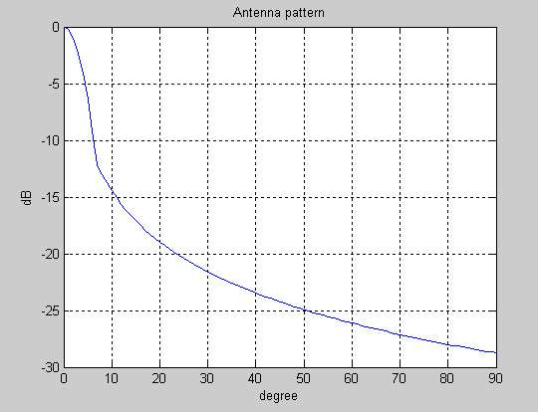
Figure 5.3.1: Diagram of sectorial antenna modelled with Rec. F.1336

ENG/OB
The characteristics considered are extracted from the section IV.2:
- Bandwidth: 8 MHz,
- Transmitted power: 30 dBm,
- Masks of emission: in conformity with the EN300 744 (DVB-T).
- Type of antenna: omni-directional with a gain between 2 dBi and 10 dBi (10 dBi used in calculations)
- Height of antenna: 2 or 10 m (8 m used in calculations) for terrestrial ENG/OB. For airborne ENG/OB, typical heights of the antenna are in the order of 50-700 m. For the calculations of interference in that case, the antenna height is taken into account in the separation distance between the BWA and the ENG/OB.

    - Calculation method and propagation model
The method consists in calculating the resulting I/N and then to compare it with the necessary I/N at the victim (I/N=-10 in the case of the BWA and -6dB in the case of the ENG/OB):

I/N (Δf)= Pt + mask(Δf) + corr_band+ Gt (β) + Gr (θ)– Att -N

- Pt: transmitted power of the interferer in dBm
- mask(Δf): attenuation due to the mask when Δf is the difference between the carriers of the interferer and the victim.
- corr_band: corrective factor of band ratio,
= - 10*log(Bwinterferer/BWvictim) if Bwinterferer≥BWvictim
= 0, if not.
- Gt: gain of the interfering transmitter antenna
- Gr.: gain of the victim receiver antenna
- Att: attenuation due to the propagation (Erceg 'C' model)
- Bw_{BWA} = 7MHz (in general)
- BW_{ENG/OB} = 8 MHz
- N=-114 +NF+10log(BWvictim) with:
NF = 5 dB for CS BWA and 7 dB for TS BWA
NF = 5 dB for the ENG/OB.

The study did not consider the impact of receiver selectivity, due to the absence of information on victim receiver selectivity masks.
Erceg propagation model
For this study, the Erceg model was used and is defined as follow:

Pl= A + 10.γ. log₁₀(D/D₀) + Cf + Ch
with:
D_{O} = 100 m
A = 20*log₁₀(4.π.D₀/λ) where λ is the wavelength associated with the centre frequency of operation
γ = (a – b.h_{b}+ c/h_{b}) where h_{b} is the antenna height of the BWA. It should be noted that, for the validity of the model, h_{b} should be between 10 m and 80 m, which is consistent with the assumptions for the BWA antenna heights.

 | Terrain category
Coefficient | Hilly/ moderate to heavy tree density  - A model - | Flat/moderate-to-heavy Tree density  – B model - | Flat/ light Tree density  - C model -
a | 4.6 | 4.0 | 3.6
b | 0.0075 | 0.0065 | 0.0050
c | 12.6 | 17.1 | 20.0

Although the Erceg propagation model was developed based on measurements taken in the 2 GHz band, this model included a correction factor Cf in order to extend this model to other frequencies, which is defined as follow:

$\text{Cf}=6⋅{\text{log}}_{\text{10}}\left(\frac{f(\text{MHz})}{\text{1900}}\right)$.
The Erceg propagation model takes also into consideration a receiver antenna height correction factor, which is defined as follow:
Ch = -10.7*log₁₀(h/2) where h is the antenna height of the ENG/OB. It should be noted that, for the validity of the model, h should be between 2 and 8 ms, which is consistent with the assumptions for the ENG/OB antenna heights.

The following figure shows the difference of attenuation between free space loss and the different Erceg model modes:
Figure 5.3.2: Erceg propagation model

For the above curve, the antenna height hb is considered to be 20 m and h to be 8 m. For the different terrain category, the value of γ is as follows:
* 4.5 for model C,
* 4.725 for model B and,
* 5.08 for model A.
In all calculations made for this report, the model C was used.
    - Interference from BWA to terrestrial ENG/OB
In the following section, the diagrams below give the resulting I/N according to the frequency difference between the carriers. The frequency separation equal to the half-sum bandwidths, corresponds to a null guard band is represented by a vertical feature. The resulting I/N is to be compared with the I/N required by ENG/OB link (-6dB).
      - Results for the impact from an omni-directional BWA CS into terrestrial ENG/OB

Figure 5.3.3: Interference from an omni-directional BWA CS into an ENG/OB located
at a distances of 1 km and 5 km
      - Results for the impact from a sectorial BWA CS into terrestrial ENG/OB
The sectorial BWA antenna was assumed to have a gain Gt of 17 dBi. It was further assumed that the height of BWA CS antenna is 20 m and height of the ENG/OB antenna is 8 m.
The ENG/OB is located at a distance d from BWA CS. For the calculations, it is supposed that the ENG/OB is in azimuth in the axis of the BWA antenna, the only antenna discrimination being in elevation.

The BWA antenna gain outside the main-axis is -9 dBi. In that case, if the BWA main axis antenna doesn't point toward the ENG/OB, the sharing will be easier:
d
FWA
θ
ENG/OB

Figure 5.3.4: Interference from a sectorial BWA CS into an ENG/OB located at distances of 1 km and 5 km
      - Interference calculation from BWA TS on a terrestrial ENG/OB
In this section, two cases are considered:
- single entry with an omni-directional and sectorial antenna. The BWA TS is placed at a given distance from the ENG/OB.
- aggregate entry for both antenna types.

Single entry case:

Figure 5.3.5: Interference from a BWA omni-directional TS into an omni-directional ENG/OB located at distances of 500 m and 1 km

Figure 5.3.6: Interference from BWA sectorial TS into an omni-directional ENG/OB located at distances of 500 m, 1 km and 2 km

Aggregate entry:

The number of BWA TS placed around the BWA CS will be 6 and will be placed uniformly around the CS, all being at a constant distance from the CS. The ENG/OB will be placed outside the cell and at a given distance from the BWA CS. It is also considered that all BWA TS transmit all the time. Another approach could be to increase the number of BWA TS and to take into account in the calculation their activity factor.

ENG/OB
Interference
FWS cell
Each BWA TS is located at 500 m from the BWA CS.

Two different scenarios are considered:
- Scenarios with omni-directional TS at the edge of the coverage
The BWA TS antennas are omni-directional (5 dBi antenna gain) with an antenna height of 1.6 m. This scenario is representative of an MWA type of deployment.
- Scenarios with directional TS antennas
The BWA TS are sectorial (20 dBi antenna gain) with a 10 m antenna height. This scenario is representative of a BWA type of deployment.

Figure 5.3.7: Interference from 6 omni-directional BWA TS with 5 dBi gain into ENG/OB

Figure 5.3.8: Impact of 6 sectorial BWA TS with 20 dBi gain on ENG/OB

The main interference comes from the BWA TS, which face the main axis (main beam) of ENG/OB. The other TS will have lesser impact as the ENG/OB will only see the back lobe of those TS.
      - Conclusion
The calculations presented in sections V.3.3.1 to V.3.3.3 show that the co-channel sharing between BWA and terrestrial ENG/OB is not feasible at reasonable separation distances (1 to 5 km with BWA TS, 0.5 to 2 km for BWA CS).

However, with a certain frequency separation, the resulting I/N is below the required I/N and therefore, the adjacent band compatibility is possible. The amount of the required frequency separation will depend upon the characteristics of terrestrial ENG/OB and BWA and the distance between both systems.
It is also shown that the impact from BWA TS is less critical than the impact from BWA CS. Even the consideration of aggregate impact from 6 BWA TS transmitting simultaneously on the same channel does not change that conclusion.

    - Interference from terrestrial ENG/OB into BWA
      - Results for the impact from terrestrial ENG/OB into an omni-directional BWA CS
The omni-directional BWA CS antenna is assumed to have a constant Gt at 9 dBi with an antenna height of 20 m, the height of ENG/OB antenna assumed to be 8 m. The ENG/OB is located at a distance d from the BWA CS.

The diagrams below give the resulting I/N according to the frequency difference between the carriers. The frequency separation equal to the half-sum of bandwidths corresponds to a null guard band. The resulting I/N is to be compared with the I/N required by the BWA link (the value of -10dB was assumed in the following as one possible requirement).

Figure 5.3.9: Interference from an omni-directional ENG/OB into an omni-directional BWA CS located at distances of 250 m, 500 m and 1 km

      - Results for the impact from terrestrial ENG/OB into a sectorial BWA CS
The sectorial BWA CS antenna was assumed to have a maximum Gt of 17 dBi, modelled with ITU-R Rec. F.1336. BWA CS antenna height is 20 m. ENG/OB antenna height is 8 m.
The diagrams below give the resulting I/N according to the frequency difference between the carriers. The frequency separation equal to the half-sum bandwidths corresponds to a null guard band. The resulting I/N is to be compared with the I/N required by BWA link (-10dB). The ENG/OB transmitter is assumed to be located within the sector covered by the sectorial BWA antenna.

Figure 5.3.10: Interference from a terrestrial ENG/OB into a sectorial BWA located at distance of 500 m and 1 km

      - Results for the impact from terrestrial ENG/OB into an omni-directional BWA TS
BWA TS antenna was assumed to have a gain Gt of 3 dBi. BWA TS antenna height is 10 m. ENG/OB antenna height is 8 m. No additional losses have been added in the calculation, but this application may be rather used indoor.

The ENG/OB transmitter is assumed to be located within the sector covered by the sectorial BWA TS antenna.

Figure 5.3.11: Interference from an omni-directional ENG/OB into BWA TS located at distance of 250 m, 500 m and 1 km
      - Results for the impact from terrestrial ENG/OB into a sectorial BWA TS
BWA TS antenna gain Gt is 20 dBi with a 20° aperture. BWA TS antenna height is 10 m. ENG/OB antenna height is 8 m.
The ENG/OB transmitter is assumed to be located within the sector covered by the sectorial BWA TS antenna.

Figure 5.3.12: Interference from an omni-directional ENG/OB into BWA TS located at distance of 500 m and 1 km

      - Analysis of the results for the interference from terrestrial ENG/OB into BWA
The calculations presented in sections V.3.4.1 to V.3.4.3 confirm the results obtained in V.3.3 that the co-channel sharing between BWA and terrestrial ENG/OB is not feasible.

However, in all considered cases, operation of terrestrial ENG/OB in the adjacent channel to the BWA will lead to a resulting I/N below the required I/N with separation distances between 250 m and 1 km.
    - Interference between BWA and airborne ENG/OB
In this part, it will be considered that the airborne ENG/OB is above the BWA CS and the separation distance will be calculated. The free space model will be used without any additional loss such as atmospheric gases.
For the BWA CS, both omni-directional and sectorial antenna will be considered. The omni-directional antenna is considered to have the same antenna gain in any direction. The BWA sectorial back lobe antenna gain in the ENG/OB direction is -9dBi.
      - Impact from BWA CS on airborne ENG/OB

Figure 5.3.13: Impact from an omni-directional and sectorial BWA CS to an airborne ENG/OB

      - Impact of airborne ENG/OB on an omni-directional and sectorial BWA CS

Figure 5.3.14: Impact from an airborne ENG/OB on an omni-directional and sectorial BWA CS

The two above figures show that the co-channel sharing between airborne ENG/OB and BWA CS is not feasible.
The operation of airborne ENG/OB and BWA CS with a certain frequency separation will lead to the reduction of the required separation distance that may make the co-existence possible.
The amount of the required frequency separation will depend upon the characteristics of airborne ENG/OB and BWA and the distance between both systems. It should be noted that the possibilities of co-existence are enhanced with the use of a sectorial antenna for the BWA CS.
    - Conclusion for the compatibility BWA versus ENG/OB
This study provides the values of the frequency separation which are required to enable the co-existence between BWA and ENG/OB in some scenarios described in the document. For this study, the Erceg 'C' model was used. It is shown that the interference from an ENG/OB on the BWA is less profound than the interference from a BWA CS into the ENG/OB receiver.

By taking into account the worst case for the study on the impact of TS on ENG/OB, the study shows that the guard between the ENG/OB and the BWA TS is relatively small and the main constraint will come from the protecting from BWA CS.

The frequency separation required to protect ENG/OB will be quite important when ENG/OB and BWA are supposed to operate in close vicinity (distances around 1 km) and decreases significantly when the separation distance is larger (5 km).

For the case of airborne ENG/OB, the required frequency separation is significantly higher, in particular when considering an omni-directional BWA CS.

BWA versus FSS (Space to Earth)
    - BWA System characteristics for sharing analysis
Overall BWA characteristics are shown in Table 3.1. These have been distilled into representative example technical characteristics for use in the sharing studies reported in this section. Two types of CS and three types of TS were considered. CS-1 and TS-1 have “critical case” characteristics and CS-2 and TS-2 have more typical characteristics. The figures for the TS-3 (“Omni”) are general figures for these proposed systems.

 | BWA CS |  | BWA TS
 | CS-1 (critical case) | CS-2 (typical) | TS-1 (critical case) | TS-2  (typical) | TS-3 (“Omni”)
TX peak output power (dBm) | 43 (for nomadic) | 35 | 30 | 22 | 20
channel bandwidth (MHz) | 7 | 7 | 7 | 7 | 7
feeder loss (dB) | 1 | 1 | 1 | 1 | 1
Power control (dB) | 0 | 0 | 0-30 dB  (12 dB) | 0-30 dB  (12 dB) | 0-30 dB  (12 dB)
peak antenna gain (dBi) | 17 | 17 | 20 | 10 | 0
antenna gain pattern | Rec. ITU-R F.1336, | Rec. ITU-R F.1336, | Rec. ITU-R F.1336 | Rec. ITU-R F.1336 | Omni
antenna elevation (deg) | 0 | 0 | 0 | 0 | 0
antenna height a.g.l. (m) | 50 | 30 | 20 | 10 | 1.5
noise figure (dB) | 5 | 5 | 7 | 7 | 7
receiver noise in reference bandwidth of 4 kHz (dBW) | -163.0 | -163.0 | -161.0 | -161.0 | -161.0
Number of co-channel TSs per CS | n/a | n/a | 16 with 25% activity factor | 16 with 25% activity factor | 16 with 25% activity factor
Table 5.4.1: Basic BWA characteristics used for the sharing with FSS

The resulting e.i.r.p. of BWA station will be an addition of: “TX peak output power (dBm)” + “Peak Antenna Gain” – “Feeder Loss”.
    - Interference from BWA into the FSS ES receiver in co-channel configuration
      - Bandwidth considerations
It has to be mentioned that FSS operations do not follow any type of channelisation or plan in this band. In any part of the band 3400-3800 MHz, any kind of frequency bandwidth from 4 kHz to 72 MHz may be used with any arrangement.
The area within which interference may occur should be determined on the basis of co-channel calculations. Where FSS ES are registered with a precise frequency assignment, co-channel interference is considered.

      - Objectives and Methodology (including choice of scenarios and propagation model)
Since the density and number of FSS ES is not expected to be very high in CEPT, it is felt that the final evaluation of BWA impact into FSS ES should be made through the process of co-ordination on a case-by-case basis.
Appendix 7 of the Radio Regulation establishes methods for the determination of the co-ordination area around an ES in frequency bands between 100 MHz and 105 GHz. However, it was felt that it is necessary to conduct studies to assess whether these methods are applicable in the case of BWA. where it is possible to locate the CS (e.g. by the way of licensing, registration…) and BWA TS locations are not known due to their ubiquitous nature.

The study in this Report on the impact from BWA into FSS ES is based on the determination of a mitigation zone or area which is defined as the geographical area delimited by the distance on a given azimuth and elevation from an ES, sharing the same frequency band with terrestrial stations, within which there is a potential for the level of permissible interference to be exceeded and co-ordination is necessary to ensure successful operation between terrestrial stations and ES.
Existing provisions of the Radio Regulations relating to international co-ordination are unaffected by this definition, which is intended for national co-ordination purposes.

The objectives of this study are:
- to determine a generic mitigation area around each FSS ES without terrain profiles data, determined by studying the impact from the BWA/BWA CS on the FSS ES. This would give a worst case estimation for deployment of coordinated BWA CS, i.e. identify the impact/size of the problem.
- to determine the size of real mitigation area that will typically be required, based on example existing FSS ES and terrain data.
- to determine an “aggregate mitigation area”: It consists in assessing the aggregate interference from several BWA deployments. A number of BWA CS is placed randomly outside the mitigation area obtained in the first step. The mitigation area is adjusted in order to meet the protection criterion. This step enables to finalise the limit of the mitigation area around an ES.
- to evaluate whether eventual un-coordinated deployment of BWA TS (both directional and omni-directional) anywhere around coordinated CS (i.e. possibility of un-coordinated TSs intruding into mitigation area and impact from aggregation of TSs) would increase the potential of interference into protected FSS ES. This would allow concluding whether co-ordination of CSs alone is sufficient to protect FSS ES from BWA TS.

The methodology outlined in Recommendation ITU-R SF.1006 is proposed to be used for assessing the calculations of interference into large ES. In this case, the propagation model in ITU Recommendation P.452 should be used.

The characteristics and interference criteria outlined in section III for BWA and in section IV.3 for FSS ES receiver are used. In particular, two options of FSS antenna elevation angle are considered (4° and 30°).

      - Determination of a generic mitigation area around the FSS ES
It consists in determining the impact from a BWA CS on the FSS ES. This will allow defining a generic mitigation area around the ES, for the different types of BWA CS defined in V.4.1.

In this situation, and as explained above, the interference calculation is made on a co-channel basis.
BWA characteristics used are CS-1 and CS-2 which are the one presented in section V.4.1. The next table gives the several types of modelled FSS ES which complies with the section IV.3 dealing with FSS parameters:

 | ST-1 | ST2 | ST3 | ST4 | ST5 | ST-6
Antenna Diameter (m) | 4.5 | 4.5 | 8 | 8 | 32 | 32
Gain (dBi) | 42.6 | 42.6 | 47.7 | 47.7 | 59.8 | 59.8
Antenna Diagram | ITU-R S.465 | ITU-R S.465 | ITU-R S.465 | ITU-R S.465 | ITU-R S.465 | ITU-R S.465
Antenna Height (m) | 3 | 3 | 5 | 5 | 25 | 25
Noise temperature (K) | 70 | 70 | 82 | 82 | 70 | 70
Elevation angle (°) | 4 | 33 | 4 | 33 | 4 | 33
Azimuth (°) | 104 | 190 | 104 | 190 | 104 | 190
Table 5.4.2: ES parameters

The approach described in this section enables us to define a generic mitigation zone around the ES, ensuring that, under generic conditions without consideration of terrain model, any BWA CS station out of this zone will create an I/N value no worse than -10 dB for 20% of time.

It should be noted that no terrain model was used in these generic studies. Such a terrain model can impact the mitigation distances in two ways:
• reducing the distance thanks to the presence of obstacles;
• increasing the distance due to the increase of the line-of-sight area if one of the stations is located on a hill, for example.

In order to show the impact of the terrain model, section V.4.2.4 presents the results of two sharing studies taking into account ES in an actual rural environment.

The results of this interference calculation give the following diagrams (the mitigation zone is specified with the yellow/red colours):

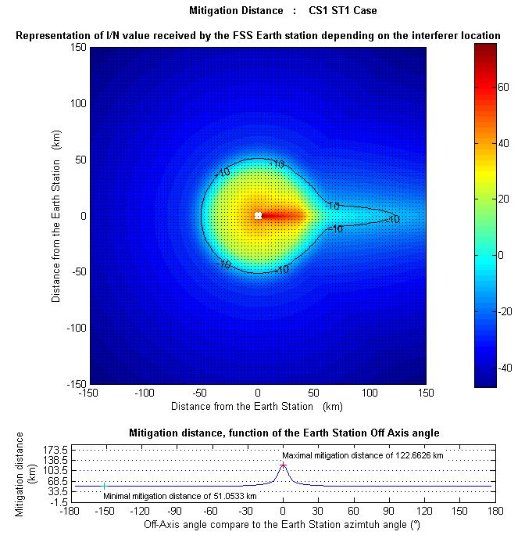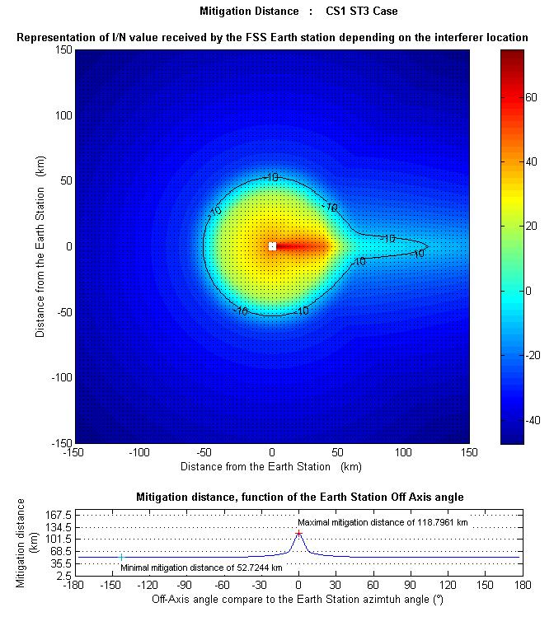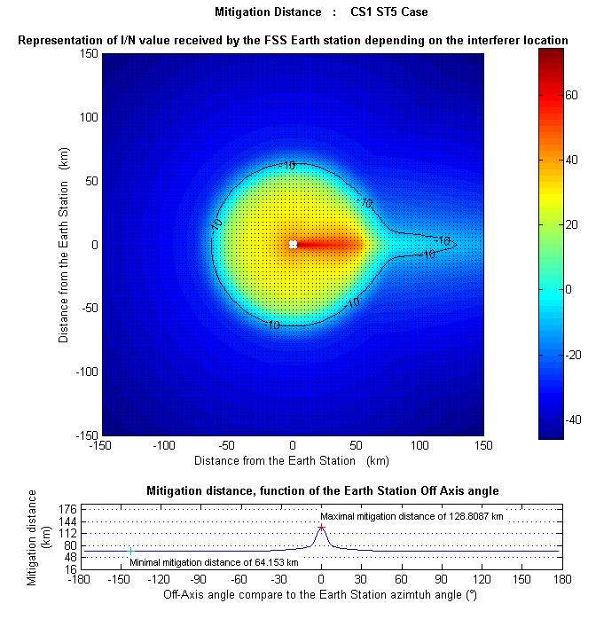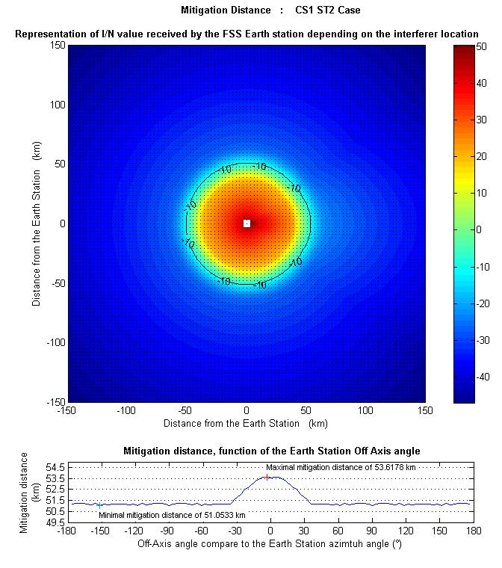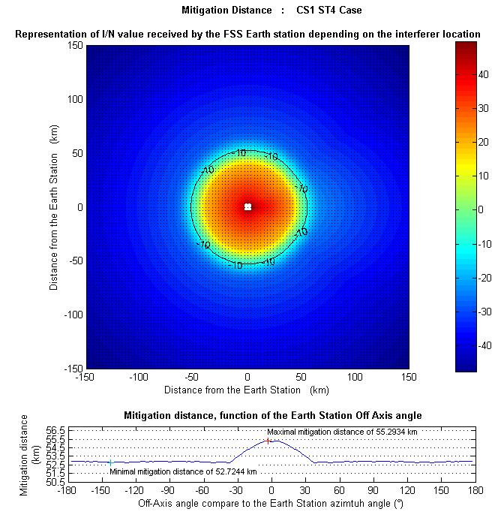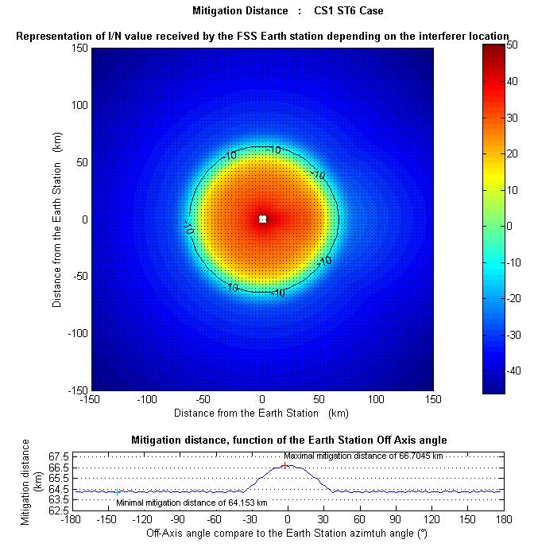

Figure 5.4.1: Generic mitigation zones for each type of FSS ES in CS1 BWA case

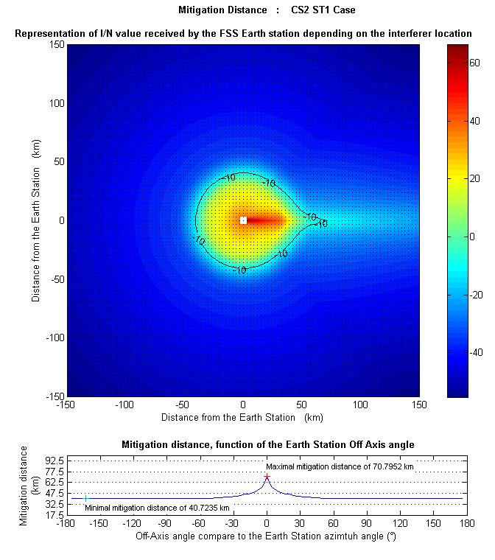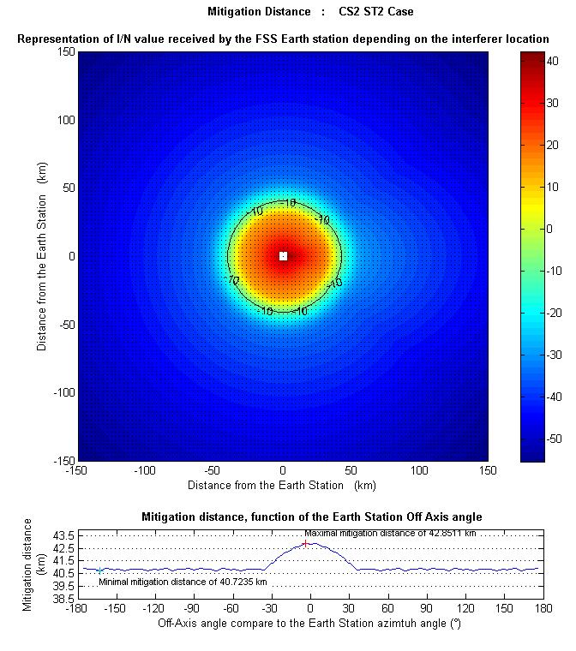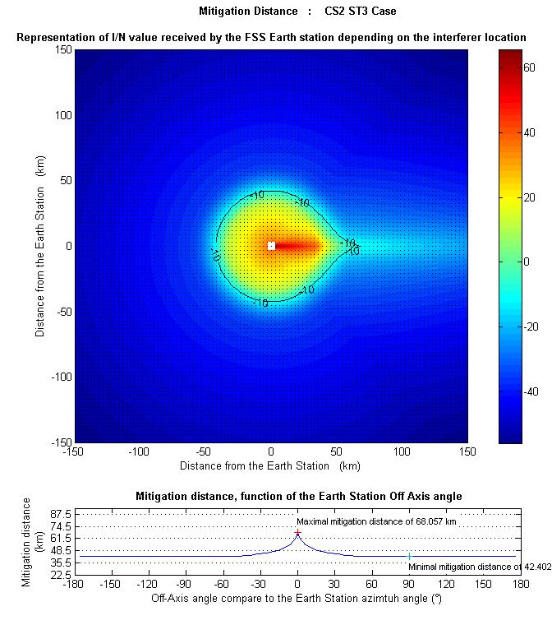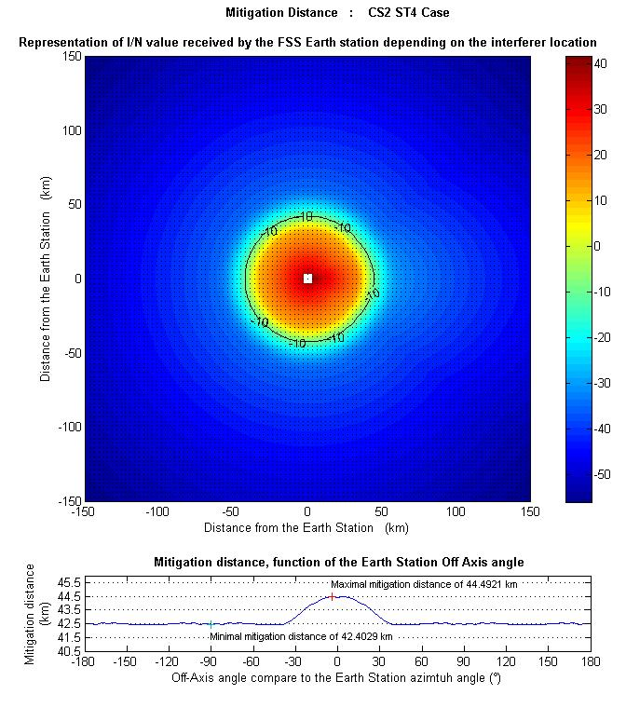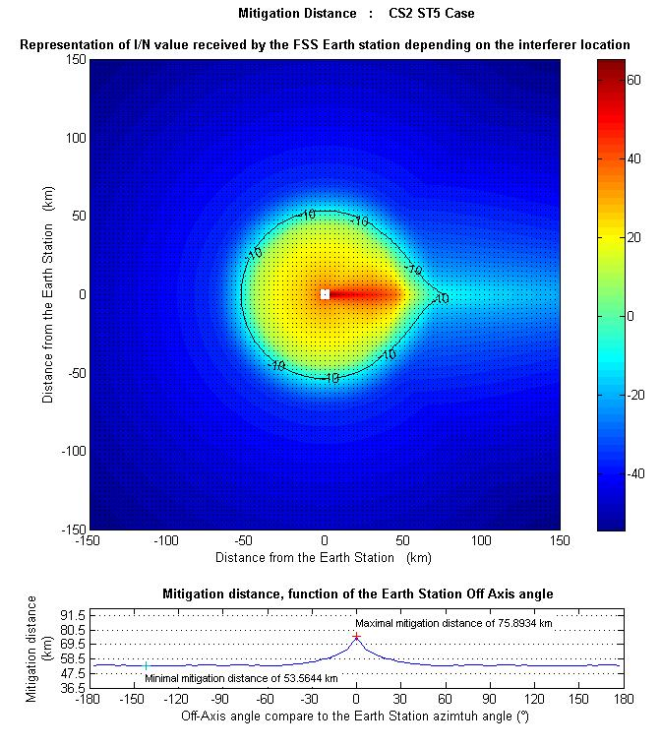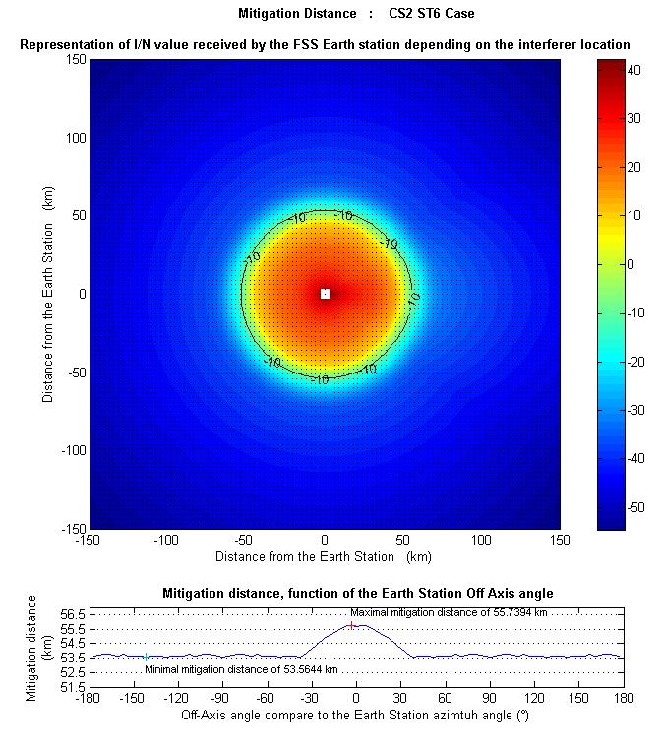
Figure 5.4.2: Generic mitigation zones for each type of FSS ES in CS2 BWA case

For each of the scenarios, the maximum distances of mitigation areas are listed in the table below:

Type of FSS ES | Interfering BWA station  CS-1 | Interfering BWA station  CS-2
Type of FSS ES | Distance (km) | Distance (km)
ST 1 | 122 | 71
ST 2 | 53 | 43
ST 3 | 119 | 68
ST 4 | 55 | 44
ST 5 | 128 | 76
ST 6 | 67 | 56
Table 5.4.3: Summary of mitigation distances

This generic study, that does not consider any terrain model or obstacles when using the ITU-R P.452 propagation model, considers only long term interference criterion. Additional studies have shown that the consideration of the short term criterion leads to mitigation distances between 250 km and 700 km. With such distances, the assumption of flat earth without any terrain model or obstacles is not valid any longer.
Thus, it may not be appropriate to consider short term criterion for the generic study without terrain model. The short term interference criterion will only be considered when using the Recommendation ITU-R P.452 with terrain model in section V.4.2.4 of the Report.

Sensitivity of the FSS ES and BWA CS parameters on the size of the mitigation area
In addition, an analysis has been conducted to determine the effect of the ES characteristics (e.g. elevation angle, antenna diameter) and the BWA CS type on the results. The results are summarised in the diagrams below.
Figure 5.4.3: Influence of the FSS ES and BWA CS parameters on the mitigation area

      - Example of required real mitigation area around FSS ES
Study 1

The following diagrams show example mitigation areas around example FSS ES locations. The mitigation areas are the areas within which either of the sharing criteria is exceeded. The calculations have used the ITU-R Recommendation P.452 propagation model and the actual terrain profiles.

Plots of mitigation area
The plots of mitigation areas for a site specific FSS ES antenna of 8-m diameter (47.7 dBi gain) at Brookmans Park are given in Fig 5.4.4(a-b) and 5.4.5(a-b) for long term propagation and short term propagation conditions respectively. It is noted that this ES corresponds to the type ST4 as referred to in section V.4.2.3. The ES characteristics are:
Brookmans Park
Location | N51:43:44, W0:10:39
Antenna height a.g.l. (m) | 5
Antenna gain (dBi) | 47.7
Antenna elevation (deg) | 31
Antenna azimuth (deg) | 180
Delta N | 45

The plots of mitigation area for a site specific FSS ES antenna of 32-m diameter (59.8 dBi gain) at Goonhilly are given in Fig. 5.4.6(a-b) and Fig. 5.4.7(a-b) for long term propagation and short term propagation conditions respectively. It is noted that this ES corresponds to the type ST6 as referred to in section V.4.2.3. The ES characteristics are:
Goonhilly
Location | N50:02:55,  W5:10:46
Antenna height a.g.l. (m) | 25
Antenna gain (dBi) | 59.8
Antenna elevation (deg) | 32
Antenna azimuth (deg) | 173
Delta N | 45

It should be noted that in both cases, the ES antenna is approximately at its highest possible elevation towards a geostationary satellite. In this respect, the results are therefore optimistic and in typical situations lower elevation angles will exist, increasing the size of the mitigation area on some azimuths.
It should also be noted that in each case interference from a single BWA CS is considered.

Based on these plots, the maximum separation distances required in the absence of additional clutter loss to protect the example FSS ES at Brookmans Park and Goonhilly from the emissions of two types of CS of BWA/BWA systems in terms of long term interference and short term interference levels are given in Table 5.4.4 below.
Type of interfering BWA/BWA station | FSS ES Antenna  8 m diameter (47.7 dBi gain) at Brookmans Park |  |  | FSS ES Antenna¹  32 m diameter (59.8 dBi gain) at Goonhilly
Type of interfering BWA/BWA station | Long Term Propagation | Short Term Propagation | Maximum mitigation distance | Long Term Propagation | Short Term Propagation | Maximum mitigation distance
CS-1 | 100 | 300² | 300 | 115 | 320² | 320²
CS-2 | 80 | 225² | 225² | 100 | 270² | 270²
Table 5.4.4: Maximum mitigation distances (in km) required to protect site specific FSS ES receivers without the additional clutter loss
Note 1: The maximum separation distances indicated for this station are over the land mass.
Note 2: The farthest point of the separation distance is over the territory of France.

For the antenna heights considered, the additional losses from local clutter may be derived from the Recommendation ITU-R P.452-12 as follows:
Clutter (ground-cover) category | BWA Station
Clutter (ground-cover) category | CS-1 | CS-2
High crop fields | -0.3 | -0.3
Park land | -0.3 | -0.3
Irregularly spaced sparse trees | -0.3 | -0.3
Orchard (regularly spaced) | -0.3 | -0.3
Sparse houses | -0.3 | -0.3
Village centre | -0.3 | -0.3
Deciduous trees (irregularly spaced) | -0.3 | -0.3
Deciduous trees (regularly spaced) | -0.3 | -0.3
Mixed tree forest | -0.3 | -0.3
Coniferous trees (irregularly spaced) | -0.3 | -0.3
Coniferous trees (regularly spaced) | -0.3 | -0.3
Tropical rain forest | -0.3 | -0.3
Suburban | -0.3 | -0.3
Dense suburban | -0.3 | -0.3
Urban | -0.3 | -0.3
Dense urban | -0.3 | -0.3
Industrial zone | -0.3 | -0.3
Table 5.4.5: Additional clutter loss (dB)

A negative value indicates a reduction in the path loss (and hence an increased separation distance). In the case of CS-1, CS-2, it can be seen that the local clutter loss has negligible effect on the propagation path loss.

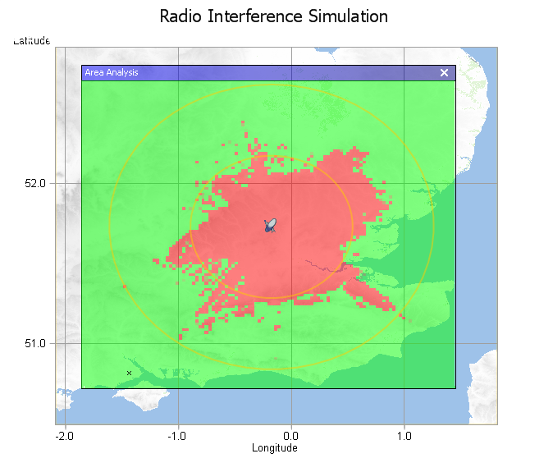

Fig. 5.4.4(a): Mitigation area around Brookmans Park ES for interference from CS-1 (Long Term Propagation; circles 50 and 100 km)

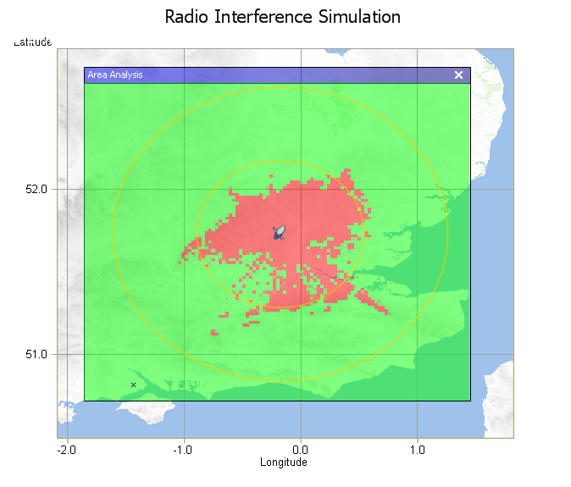
Fig. 5.4.4 (b): Mitigation area around Brookmans Park ES for interference from CS-2 (Long Term Propagation; circles 50 and 100 km)
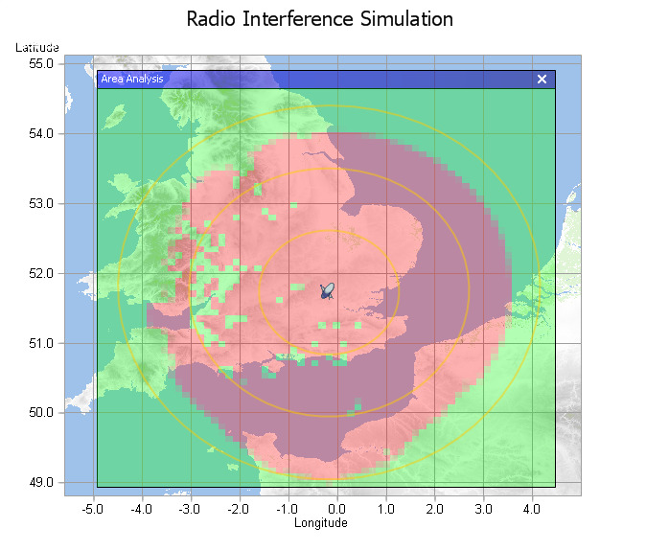
Fig. 5.4.5(a): Mitigation area around Brookmans Park ES for interference from CS-1 (Short Term Propagation; circles 100, 200 and 300 km)

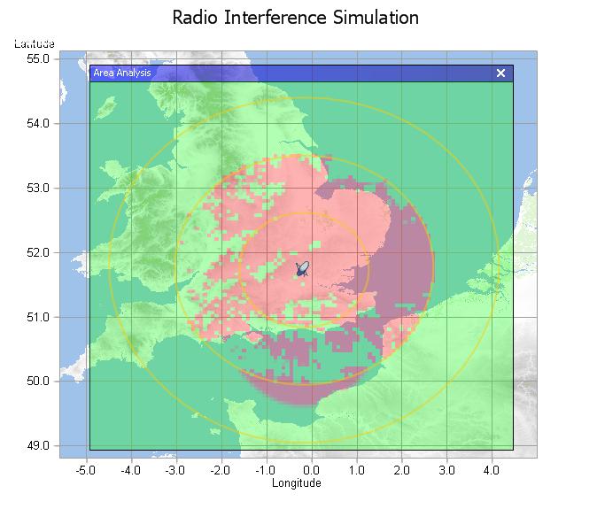
Fig. 5.4.5(b): Mitigation area around Brookmans Park ES for interference from CS-2 (Short Term Propagation; circles 100, 200 and 300 km)

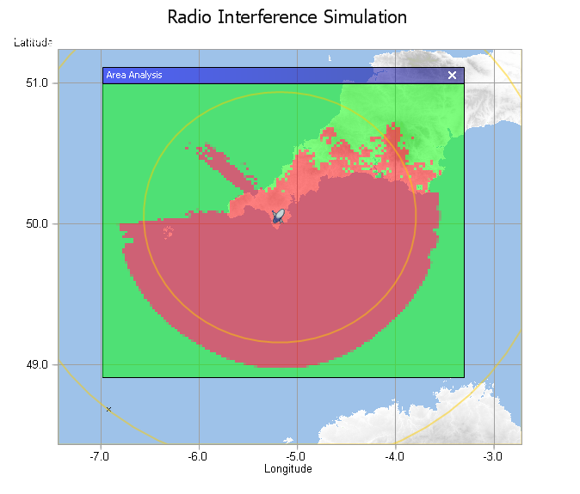

Fig. 5.4.6(a): Mitigation area around Goonhilly ES for interference from CS-1 (Long Term Propagation; circle 100 km).

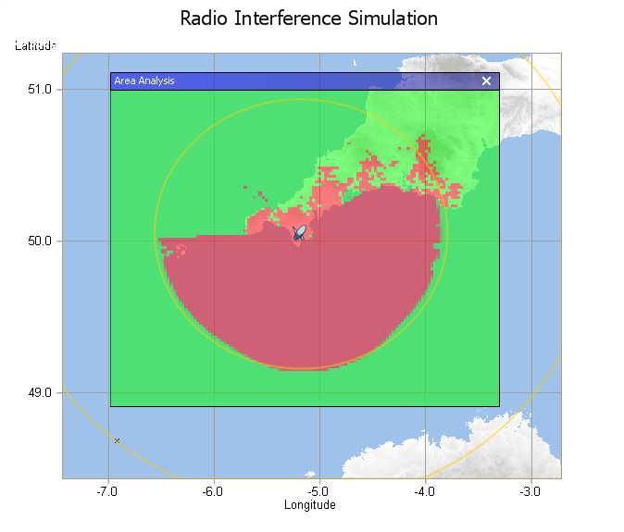

Fig. 5.4.6(b): Mitigation area around Goonhilly ES for interference from CS-2 (Long Term Propagation; circle 100 km).

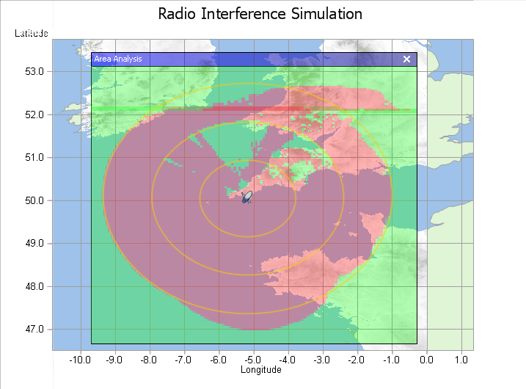

Fig. 5.4.7(a): Mitigation area around Goonhilly ES for interference from CS-1 (Short Term Propagation; circles 100, 200, 300 km)

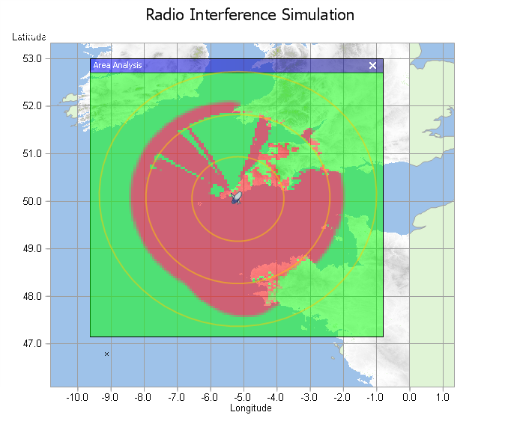
Fig. 5.4.7(b): Mitigation area around Goonhilly ES for interference from CS-2 (Short Term Propagation; circles 100, 200, 300 km)

Study 2

This section presents detailed mitigation zones around an example FSS ES location. The mitigation areas are the areas within which either of the sharing criteria is exceeded from one BWA station. The calculations have used the Recommendation ITU-R P.452 propagation model, the actual terrain profiles and clutter. They have considered only FSS ES types ST1 and ST2 (see section V4.1.3) and both BWA types CS1 and CS2. The following figure presents, in one azimuth from the ES, the terrain profile. It can be noticed that, for this example, the receiving ES is quite well naturally protected, which may not always be the case. It should be noted that this study considers only the long-term interference criterion and additional simulations may be performed with short-term interference criterion.

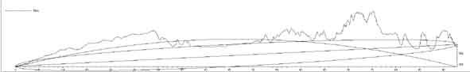
Figure 5.4.8: Profile terrain for one azimuth from the ES

The following maps give the mitigation zone results for the different cases.
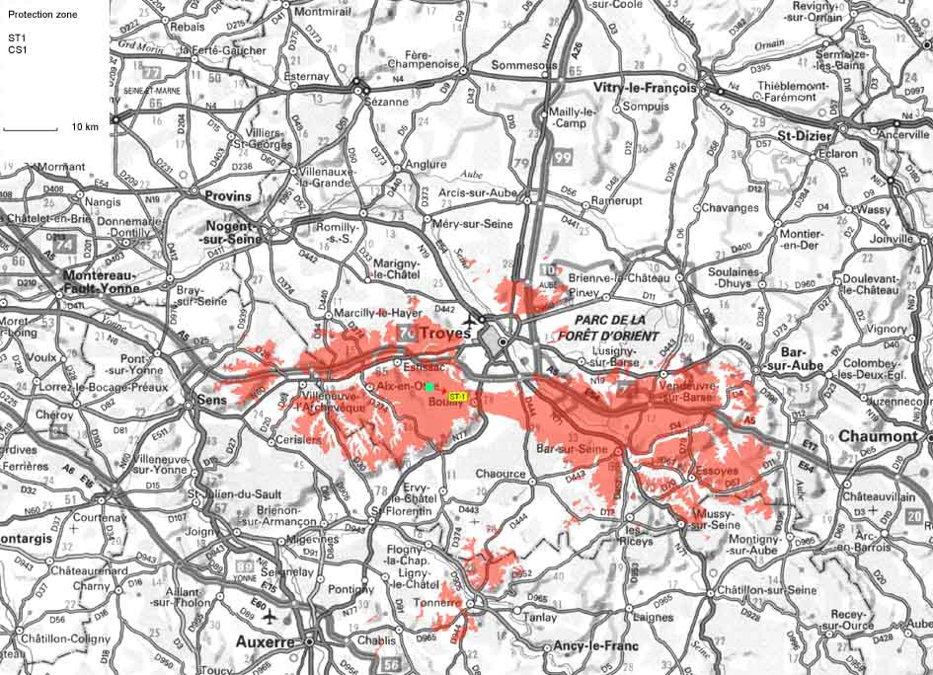
Figure 5.4.9: Mitigation zone for ST1 ES and CS1 BWA
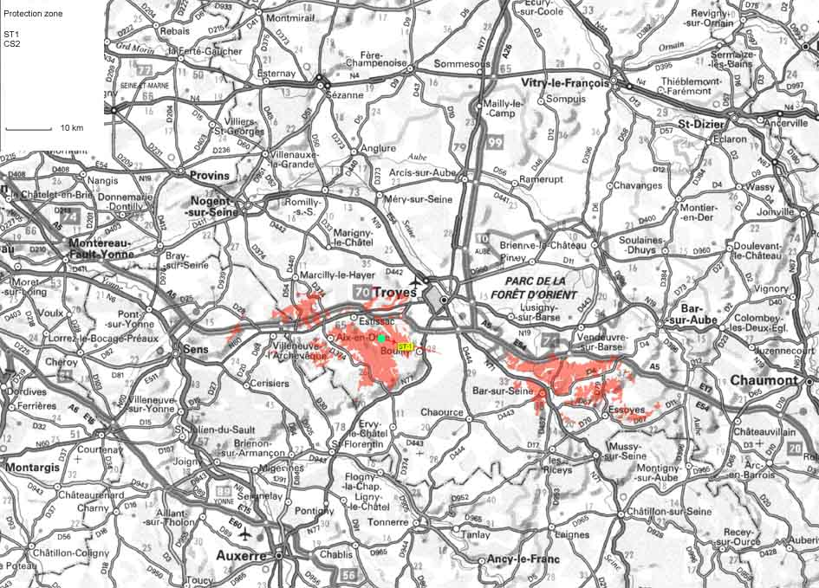
Figure 5.4.10: Mitigation zone for ST1 ES and CS2 BWA

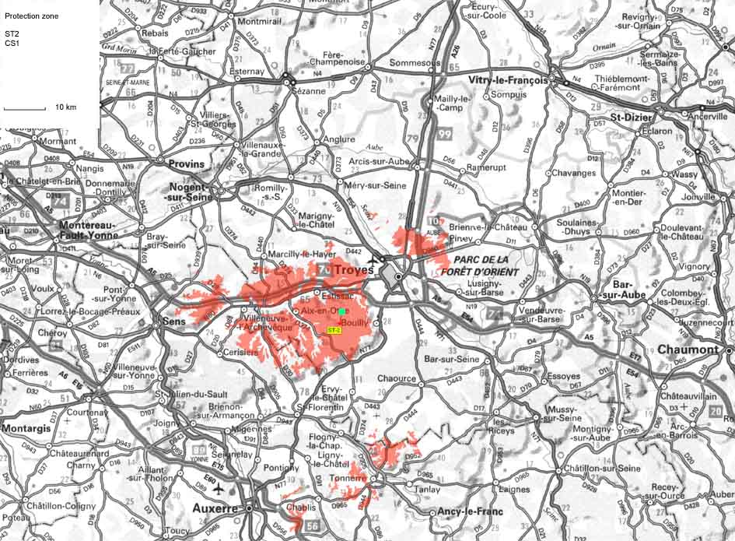
Figure 5.4.11: Mitigation zone for ST2 ES and CS1 BWA
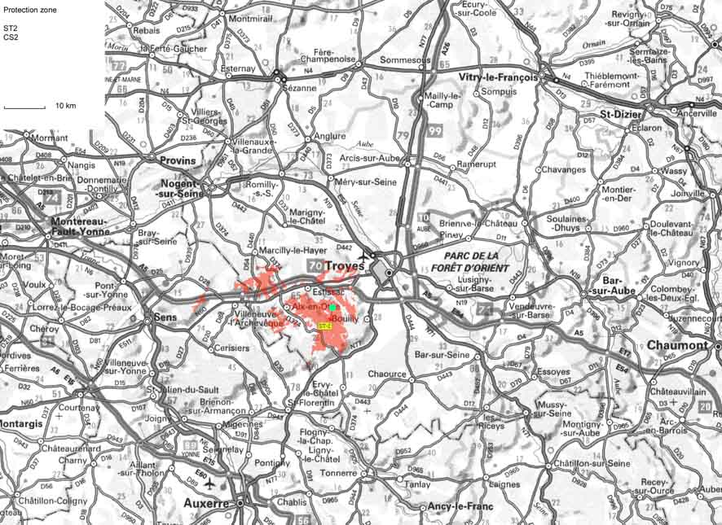
Figure 5.4.12: Mitigation zone for ST2 ES and CS2 BWA
The size of the mitigation zones varies from 5 km to 70 km depending on the considered azimuth angle and depending on the considered types of stations.
      - Determination of an “aggregate mitigation area” around the FSS ES
This section provides an assessment of the aggregate interference from several BWA CS. A number of BWA CS is placed outside the mitigation area obtained in the first step. The mitigation area is adjusted in order to meet the protection criterion.

As an example, it is proposed to consider the aggregate interference from several BWA type 2 CS into the FSS ES Type 2.

The generic mitigation zone for each of the BWA CS is determined with the calculation provided in V.4.1.3.

To determine the number of BWA CS that can be located around the mitigation area, the following assumptions are made:
- R(bwa) - the cell radius of BWA is 2 km (rural case),
- the channel bandwidth of a BWA CS is 7 MHz,
- the frequency reuse factor of BWA is 4.

As a result, assuming that the generic mitigation area can be modelled as a circle with R(FSS) as a radius, the maximum number Ntotal of BWA CS that can be located around the mitigation area can be approximated by using the following formula:

Ntotal = π *(R(FSS) + R(bwa))/R(bwa).

Scenario 1

FSS

Within each BWA cell, it is assumed that, considering the reuse factor of 4, one channel in a cell corresponds to a same angle for the pointing of the CS in a fixed azimuth direction. Therefore, all BWA CS that can operate co-channel in a single 7 MHz channel have the same pointing (see figure above).
Considering the azimuth of the ES, it will lead to a distribution of the discrimination angle. By considering the directivity of the FSS ES antenna, we can limit the number of BWA CS that will have an impact.

The aggregate interference level for the aggregate case depending on the distance from the FSS ES is represented below.
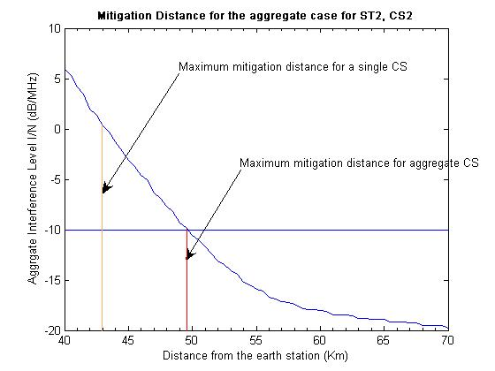
Figure 5.4.13: Mitigation distance for the aggregate impact from BWA CS2 into FSS ES ST2 – Scenario 1

The increase of the maximum mitigation distance in the aggregate case compared to the single interferer case is of 7 km, which represents about a 15 % increase of the distance.

Scenario 2

The aggregate case described in the Scenario 1 is representative of some deployments and especially for "fixed" and nomadic BWA deployments.

However, it seems that for some cases of BWA deployment (for mobile usage in particular), another scenario may be more appropriate. In this case, the same channel may be used in all sectors at the same time (e.g. using IMT-2000 technology). Consequently, as far as interference analysis is concerned, it seems that BWA CS is seen as an omni-directional directional antenna, but with a gain of a sectorial antenna. The main difference with the previous scenario is that for all BWA CS, there will be a maximum azimuth gain of the CS towards the ES, as illustrated in the following picture:
FSS

The resulting mitigation area for the above case is shown in Fig. 5.4.14 below.

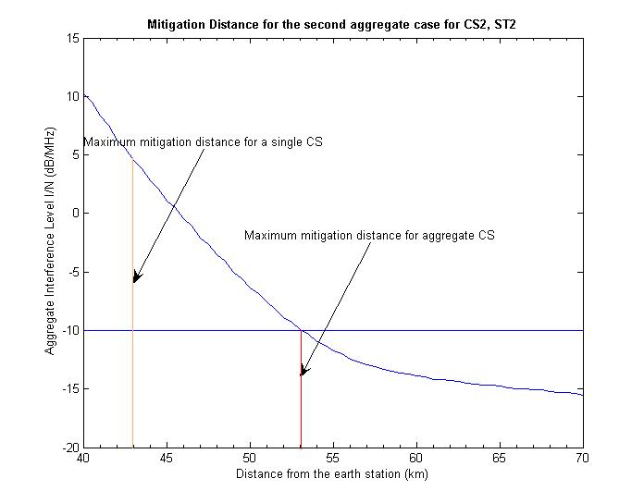
Figure 5.4.14: Mitigation distance for the aggregate impact from BWA CS2 into FSS ES ST2 – Scenario 2

The increase of the maximum mitigation distance in the aggregate case, compared to the single interferer case is of 10 km, which represents about a 25% increase of the distance.

Analysis:
The two considered scenarios show, that when assuming a dense deployment of BWA CS, the size of the mitigation area will increase due to the aggregate impact from the BWA CS. This should be taken into account when performing co-ordination between BWA CS and the FSS ES.
      - Impact from BWA TSs on an FSS ES
Based on the generic assumptions (see section V.4.2.3), the impact of a BWA TS2 and a BWA TS3 has been calculated through the assessment of a mitigation zone around the FSS ES. For the purpose of this study, FSS ES type 2 is chosen. It also has been assumed that the TS azimuth of the main beam is towards the FSS ES.

The results of this interference calculation give the following diagrams:
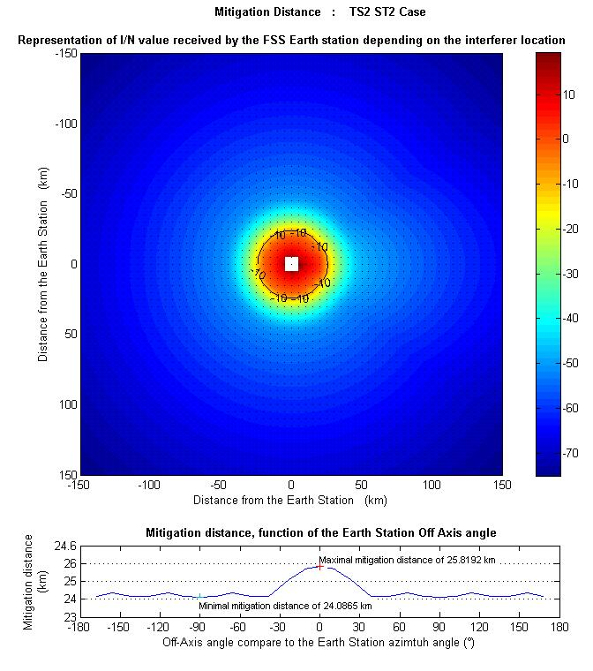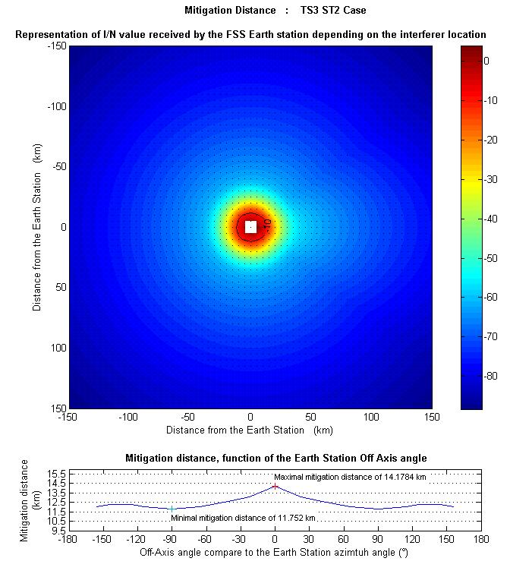
Figure 5.4.15: Generic mitigation zones for TS2 and TS3 interfering with FSS ES ST2

This calculation has also been conducted for information, considering the terrain model from study 1 (see section V.4.2.4), for the long term and short term analysis, but only for the TS2 case.
In this case, more significant values of clutter loss are given for certain clutter categories, compared to the CS calculation. Taking as an example the additional clutter losses for the urban environment, the separation distances required for TS-2 will be reduced by a factor of 6.38.

Clutter (ground-cover) category | Clutter losses for TS2 (dB)
High crop fields | -0.3
Park land | -0.3
Irregularly spaced sparse trees | -0.3
Orchard (regularly spaced) | -0.3
Sparse houses | -0.3
Village centre | -0.3
Deciduous trees (irregularly spaced) | 7.0
Deciduous trees (regularly spaced) | 7.0
Mixed tree forest | 7.0
Coniferous trees (irregularly spaced) | 15.6
Coniferous trees (regularly spaced) | 15.6
Tropical rain forest | 15.9
Suburban | -0.3
Dense suburban | 1.2
Urban | 16.1
Dense urban | 18.5
Industrial zone | 15.6
Table 5.4.6: Additional clutter loss for TS2 (dB)

Results are given in the following diagrams:

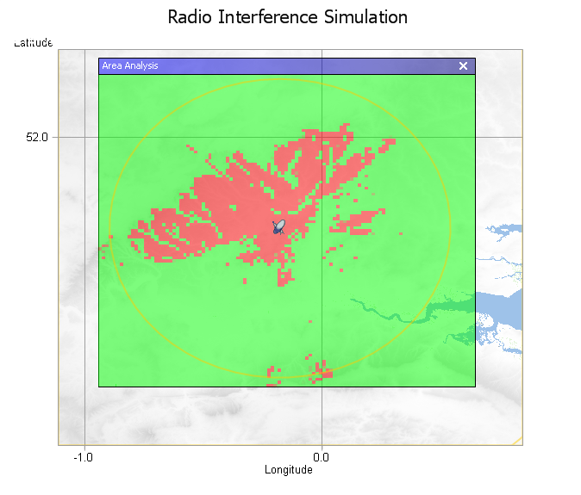
Figure 5.4.16: Mitigation area around Brookmans Park ES for interference from TS-2 (Long Term Propagation; circle 50 km)

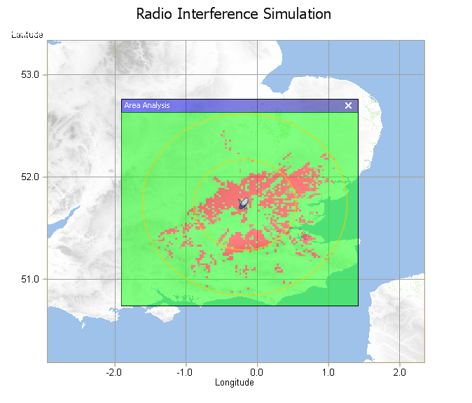

Figure 5.4.17: Mitigation area around Brookmans Park ES for interference from TS-2
(Short Term Propagation; circles 50 and 100 km)

The following table summarises the maximum mitigation distances for each of the TS scenarios considered in this study.

Type of interfering BWA/BWA station | Mitigation distance for Long term  (without terrain model) (km) | Mitigation distance for Long term(with terrain model)  (km) |  | Mitigation distance for Short term  (with terrain model)  (km)
 |  | Without clutter loss | With clutter loss | Without clutter loss | With clutter loss
TS-2 | 26 | 50 | 8.5 | 100 | 17
TS-3 | 14
Table 5.4.7: Maximum mitigation distances (in km) required to protect type ST2 ES receivers
from BWA TS

However, the impact of BWA TS should be correlated with the location of the CS relative to the FSS ES. The following section proposes some views on the relative location of the TS compared to the CS.

As a result of the determination of the mitigation area given by the interference from BWA CS to the FSS ES, the BWA CS is located at a certain distance of the FSS ES. The BWA TS is then located within the BWA cell, noting that BWA cell radius is assumed to be of the order of about 2 km. It is assumed that the mitigation distance is larger than the BWA cell radius. As described in the diagram below, two particular positions (quoted as positions 1 and 2) of the TS are considered as important when assessing the impact from BWA TS into FSS ES. Position 1 corresponds to the minimum possible distance between the BWA TS and the FSS ES, whereas in position 2, the BWA TS that is pointing towards its CS is also pointing towards the FSS ES.

FSS E-S
BWA CS
1
2

Taking into account the range of possible TS configurations, two cases are studied:

- Impact from a 20 dBi directional antenna TS into the ES (relevant for fixed BWA usage).
Since the BWA TS is directional, it will point towards its associated CS. When the TS is in position 1, the FSS ES will be in the TS back-lobe. Taking into account the attenuation in the back lobe and the output power for BWA TS (22 dBm), it appears than the level of interference from the TS into the ES in that configuration will be lower than the one produced by the CS. Similarly, assuming that the TS is in position 2, even though the TS is pointing towards the FSS ES, the level of interference from the TS to the ES will be lower than the level of interference from the CS due to the lower TS maximum e.i.r.p (42 dBm maximum) compared to the CS one (44 dBm minimum) and the larger distance to the ES from the TS than from the CS.

- Impact from a 5 dBi omni-directional antenna TS into P-P type 1 (relevant for nomadic and mobile usage).
In that scenario, the position 2 is clearly not problematic since the TS e.i.r.p. will be much smaller (27 dBm) than the CS e.i.r.p. and the distance will be larger. Therefore, the position 1 in is the worst case, since the TS antenna is omni-directional and the distance between the TS and the P-P is smaller than the distance from the P-P to the BWA CS. Depending upon the BWA CS characteristics, the TS e.i.r.p. is at least 17 dB lower than the CS e.i.r.p. Therefore, it is possible to give a rough estimation of the condition under which the TS will not create more interference to the ES than the CS.

If D is the mitigation distance between the FSS ES and the BWA CS and the R the cell radius (equal to the CS to TS distance in our case) and if we assume line of sight propagation, then the propagation ratio in dB between the CS to ES path and the TS to ES path is:
Ratio (dB) = 20*log(D/(D-R))
The interference from the TS to the ES will be lower than the interference from the CS to the ES if,
20*log(D/(D-R)) < eirpCS(dBm) – eirpTS(dBm)

With the assumed characteristics, this condition under which the interference from the TS to the ES will be lower than the interference from the CS to the ES is then:

R<6D/7

It can therefore be concluded that, in all cases, a co-ordination between the CS and the P-P, that takes into account the ratio between the mitigation distance and the BWA cell radius is sufficient to protect the FSS ES from both the BWA CS and the BWA TS.

Impact of BWA TS outside BWA coverage area
For BWA TS, no transmission occurs as far as they did not receive any information from their CS. Consequently, a BWA TS outside of a BWA coverage area will not be able to communicate with a CS. So, such a TS, even if located inside the co-ordination area and near by the ES, will not create interference into the FSS ES.
      - Impact from BWA on VSAT
The methodology which has been used for the derivation of generic mitigation area around a VSAT station is the same as the one used in the case of FSS ES.

Calculations were done for elevation angles of 20° and 40° for the VSAT station. Additionally, the results presented include the possibility to have site shielding or clutter loss at the VSAT station, ranging from 20 to 40 dB, as proposed in Recommendation ITU-R SF.1486, bearing in mind that the 40 dB isolation value may be obtained to provide physical or natural shielding at the VSAT stations, but may not be achievable at all VSAT sites.

Figure 5.4.18: Impact from BWA CS1 into VSAT

Figure 5.4.19: Impact from BWA CS2 into VSAT

These figures show that significant mitigation distances are required between the VSAT and the BWA CS, even when considering additional shielding. That leads to a need for co-ordination between BWA and VSAT, which may not be feasible for unlicensed VSAT.

    - Interference from BWA into FSS ES receivers in adjacent band scenario
      - Interference from unwanted emissions
Unwanted emissions from BWA stations operating in one part of the 3400-3800 MHz band may generate interference into FSS reception in other parts of the band. The overall unwanted emission levels from BWA CS equipment can be derived from Annex 3 of ECC Recommendation (04)05. To improve co-existence of adjacent frequency blocks, ECC Recommendation (04)05 recommends a limit beyond the block edge for CS, which considers filtering at the CS transmitter. As far as the BWA TSs are concerned, it has been suggested to use spurious domain emission limit of -40 dBm/MHz (with reference to terminal stations limits in Annex 1-Fixed service of ERC/REC 74-01) as representative value for unwanted emissions.

The FSS ES characteristics and allowable interference level is shown in table 5.4.8 below.

Arrival angle of BWA signal at FSS E/S | 5° | 15° | 30°
FSS E/S antenna off-axis gain (dBi) | 14.5 | 2.6 | -4.9
Total FSS E/S system noise temperature (°K) | 76 | 76 | 76
Thermal noise power (dBW/MHz) | -149.8 | -149.8 | -149.8
Allowable interference power density at receiver input for I/N = 6% (dBW/MHz) | -162.0 | -162.0 | -162.0
Allowable interference power density at the antenna for I/N=6% (dBW/MHz) | -176.5 | -164.6 | -157.1
Table 5.4.8: FSS ES Characteristics and Allowable Interference Level

Based on Annex 3 of ECC Recommendation (04)05 for BWA CS and the spurious domain emission specification of -40 dBm/MHz for BWA TS, the resulting BWA CS and TS unwanted emission EIRP density levels are derived in table 5.4.9 below.

CS-1 and CS-2 | Antenna gain | 17 dBi
CS-1 and CS-2 | Unwanted power density | -77 to -89 dBW/MHz
CS-1 and CS-2 | Unwanted emissions EIRP density | -60 to -72 dBW/MHz
TS-1 | Antenna gain | 20 dBi
TS-1 | Unwanted power density | -70 dBW/MHz
TS-1 | Unwanted emissions EIRP density | -50 dBW/MHz
TS-2 (Indoor) | Antenna gain | 10 dBi
TS-2 (Indoor) | Unwanted power density | -70 dBW/MHz
TS-2 (Indoor) | Unwanted emissions EIRP density | -60 dBW/MHz
TS-3 (Mobile) | Antenna gain | 0 dBi
TS-3 (Mobile) | Unwanted power density | -70 dBW/MHz
TS-3 (Mobile) | Unwanted emissions EIRP density | -70 dBW/MHz
Table 5.4.9: Derivation of unwanted emissions EIRP density from BWA

Using the above information, the minimum distances that a single BWA CS or TS would have to be from an FSS ES in order for the FSS interference criteria not to be exceeded assuming free space loss is summarized in table 5.4.10 below.

 |  | Required Separation Distance (km)
Type of BWA Station | FSS ES antenna off-axis angle
CS-1 and CS-2 | 5° | 1.087-4.33
CS-1 and CS-2 | 15° | 0.277-1.1
CS-1 and CS-2 | 30° | 0.117-0.464
TS-1 | 5° | 13.7
TS-1 | 15° | 3.48
TS-1 | 30° | 1.47
TS-2 (Indoor) (Note1) | 5° | 0.77
TS-2 (Indoor) (Note1) | 15° | 0.196
TS-2 (Indoor) (Note1) | 30° | 0.083
TS-3 (Mobile) | 5° | 1.37
TS-3 (Mobile) | 15° | 0.348
TS-3 (Mobile) | 30° | 0.147
Table 5.4.10: Summary of required separation distance between BWA CS or TS and FSS ES

Note 1: For indoor TS (TS-2), an additional excess path loss of 15 dB for building penetration is taken into account in calculating separation distances given in table 5.4.10.

The above analysis does not take into account clutter loss.

The interference effects can become more severe due to aggregation from out-of-band emissions generated by several BWA transmitters.
      - Saturation of the LNBs in the entire 3400-4200 MHz band
Satellite LNBs are designed for reception of very low satellite signals and the dynamic range is designed accordingly. Typically, an LNB will be saturated with a total incoming power of around -50 dBm. Accordingly, the LNBs will start to show a non-linear behaviour, creating intermodulation products and suppression of carriers at a total incoming power about 10 dB lower than the saturation power, about -60 dBm. Traditional LNBs are made to receive the entire 3400-4200 MHz band. Moreover, LNBs specified for reception of only the 3700-4200 MHz band normally have the filtering at the IF side. BWA signals in the 3400-3600 MHz band therefore can saturate satellite LNBs or bring them into non-linear operation and thus block reception of signals anywhere in the entire 3400-4200 MHz band.

The required separation distance for a single CS or TS in order not to saturate the FSS LNB is shown in tables 5.4.11 and 5.4.12 respectively for the various types of CS and TS.

 | CS-1 |  |  | CS-2
Arrival angle of BWA signal at FSS E/S | 5 | 15 | 30 | 5 | 15 | 30
FSS E/S antenna off-axis gain (dBi)¹ | 14.5 | 2.6 | -4.9 | 14.5 | 2.6 | -4.9
BWA EIRP (dBm) | 60 |  |  | 52
LNB Saturation Level (dBm) | -50
Excess over LNB Saturation Level (dB) | 124.5 | 112.6 | 105.1 | 116.5 | 104.6 | 97.1
Frequency (MHz) | 3700
Required Separation Distance (km) | 10.89 | 2.76 | 1.16 | 4.33 | 1.10 | 0.46
Table 5.4.11: Required separation distance between BWA CS and FSS ES to avoid LNB saturation

 | TS-1 |  |  | TS-2 (Indoor)² |  |  | TS-3 (Mobile)
Arrival angle of BWA signal at FSS E/S | 5 | 15 | 30 | 5 | 15 | 30 | 5 | 15 | 30
FSS E/S antenna off-axis gain (dBi)¹ | 14.5 | 2.6 | -4.9 | 14.5 | 2.6 | -4.9 | 14.5 | 2.6 | -4.9
BWA EIRP (dBm) | 50 |  |  | 32 |  |  | 20
LNB Saturation Level (dBm) | -50
Excess over LNB Saturation Level (dB) | 114.5 | 102.6 | 95.1 | 96.5 | 84.6 | 77.1 | 84.5 | 72.6 | 65.1
Frequency (MHz) | 3700
Required Separation Distance (km) | 3.44 | 0.87 | 0.37 | 0.43 | 0.11 | 0.05 | 0.11 | 0.03 | 0.01
Table 5.4.12: Required separation distance between BWA TS and FSS ES to avoid LNB saturation

The required separation distance to avoid driving the satellite LNB into non-linear operation (-60 dBm) will be greater than those distances indicated in the table above that are calculated to avoid saturation (-50 dBm).
It should also be noted that the separation distances given above are calculated without clutter loss.

These calculations show that there is a need for mitigation distance in the case of interference from BWA operating in adjacent frequency bands to avoid the LNBs of the satellite receivers being driven into non-linear operation, or even being saturated.
    - Interference from the FSS spacecraft into the BWA CS and/or TS receivers
It is currently addressed by the power flux-density (pfd) requirements of Article 21 of the RR, but may require future studies.

21.16 § 6 1) The power flux-density at the Earth’s surface produced by emissions from a space station, including emissions from a reflecting satellite, for all conditions and for all methods of modulation, shall not exceed the limit given in Table 21-4. The limit relates to the power flux-density which would be obtained under assumed free-space propagation conditions and applies to emissions by a space station of the service indicated where the frequency bands are shared with equal rights with the fixed or mobile service, unless otherwise stated.

Frequency band | Service* | Limit in dB(W/m²) for angles  of arrival () above the horizontal plane |  |  | Reference bandwidth
Frequency band | Service* | 0-5 | 5-25 | 25-90 | Reference bandwidth
3 400-4 200 MHz | Fixed-satellite  (space-to-Earth)  (geostationary-satellite orbit) | –152 | –152  0.5( – 5) | –142 | 4 kHz
3 400-4 200 MHz | Fixed-satellite  (space-to-Earth)  (non-geostationary-satellite orbit) | –138 – Y  ^{17, 18} | –138 – Y   (12 + Y )( – 5)/20  ^{17, 18} | –126 ¹⁸ | 1 MHz
¹⁷ 21.16.15 The value of Y is defined as Y  0 for max(NN, NS) ≤ 2; Y  5 log(max(NN, NS)) for
max(NN, NS)  2, where NN is the maximum number of space stations in a system simultaneously transmitting on a co-frequency basis in the fixed-satellite service in the Northern Hemisphere, and NS is the maximum number of space stations in the same system simultaneously transmitting on a co-frequency basis in the fixed-satellite service in the Southern Hemisphere. In determining NN and NS, two space stations simultaneously transmitting during periods of short-duration handover shall be considered as one satellite. (WRC-03)
¹⁸ 21.16.16 The applicability of these limits may need to be reviewed by a future competent conference if the number of co-frequency non-geostationary systems brought into use and simultaneously operating in the same hemisphere is greater than five. (WRC-03)

The maximum downlink pfd from a GSO FSS satellite that should be anticipated is that given by the pfd limits defined in the Radio Regulations. A worst case situation is likely to be when an FSS satellite is in-line with the maximum antenna gain of the BWA station. As the BWA station will typically have an elevation angle of about 0º, the lower value of the pfd limits would apply.

For the two types of CS and three types pf TS, the interference is shown in Table 5.4.13.

 | CS-1 | CS-2 | TS-1 | TS-2 | TS-3
pfd in 4 kHz reference bandwidth (dBW/m²) | -152 | -152 | -152 | -152 | -152
receiver antenna gain (dBi) | 17 | 17 | 20 | 10 | 4
receiver feeder loss (dB) | 1 | 1 | 1 | 1 | 1
receiver noise in 4 kHz reference bandwidth (dBW) | -163.2 | -163.2 | -161.2 | -161.2 | -161.2
interference in 4 kHz reference bandwidth (dBW) | -168.6 | -168.6 | -165.6 | -175.6 | -181.6
I/N ratio (dB) | -5.4 | -5.4 | -4.4 | -14.4 | -20.4
Table 5.4.13: Interference from a GSO FSS satellite into a BWA receiver

In practice, some benefit from polarisation isolation may be achieved. If the FSS space station uses a single circular polarisation (LHC or RHC), 3 dB reduction in interference can be expected. If the FSS space station uses linear polarisation, the isolation will depend on the angle between the polarisation of the FSS downlink emission at the BWA receiver location and the polarisation alignment of the BWA antenna.

The above figures may therefore be considered as worst-case, but give an indication of the maximum interference from an FSS satellite that the BWA operator should anticipate.

    - V.4.5 Summary of results
The main results of the compatibility studies between BWA and FSS are the following:
- The required mitigation distances with respect to FSS ES naturally depend on the type and characteristics of the BWA station. For three types of BWA station considered in this analysis and the example ES, the maximum separation distances are (km):

Station type  (see Table 5.4.1) |  | Mitigation distance for long term  (without terrain model) (km) | Mitigation distance for long term(with terrain model) (Note)  (km) | Mitigation distance for short term  (with terrain model) (Note)  (km)
CS-1 |  | 68 | 115 | 320
CS-2 |  | 56 | 100 | 270
TS-2 | without clutter loss | 26 | 50 | 100
TS-2 | with clutter loss | 26 | 8.5 | 17
Table 5.4.14: Summary of the required mitigation distances for co-channel interference
Note:
Note that using terrain model can impact the mitigation distances in two ways:
• reducing the distance thanks to the presence of obstacles;
• increasing the distance due to the increase of the line-of-sight area if one of the stations is located on a hill for example.
So while the overall mitigation area may be reduced when using terrain model, the maximum distance could be higher in some azimuths under certain conditions.

- Operation at shorter distances (within mitigation zone) is often feasible due to the benefits gained from using actual terrain topography and clutter database information in propagation loss calculations.
- Operation of BWA CS may be feasible within the mitigation zone, based on a detailed, case-by-case evaluation.
- BWA TS are generally less impacting than the CS. In addition, it has been demonstrated that the co-ordination of the BWA CS will generally be sufficient to ensure the co-existence with BWA TS. Furthermore, TS may benefit from the additional clutter loss which is available in some environments, particularly urban environments. As an example, in an urban environment, the separation distances for TS-2 reduce to about 17 km.
- Studies show that ubiquitously deployed BWA systems and FSS, when the FSS is deployed in a ubiquitous manner and/or with no individual licensing of ES, can not share in the same geographical area since no minimum separation can be guaranteed.
- In the case of BWA operating in adjacent frequency bands, there is a need for mitigation distance to avoid the LNBs of the satellite receivers being driven into non-linear operation, or even being saturated.
- Interference from FSS spacecraft transmitting with Article 21 limits into BWA may exceed the required interference criterion by few dB in few cases, however the probability of such cases is expected to be low.

BWA versus Radiolocation
This study includes the assessment on the impact from radar systems operating below 3.4 GHz on BWA operating in the band 3400-3800 MHz, information on measurements related to the impact from pulsed signals and additional general considerations on the co-existence between BWA and radiolocation
    - V.5.1 Analysis of the impact from radar systems operating below 3.4 GHz on BWA operating in the band 3400-3800 MHz
From the various discussions in this issue it should be first made clear that the principal way for assuring co-existence of radars vs. BWA is the co-ordination on a case-by-case basis, but then some additional (generic) case studies could be used to illustrate the extent of the problem.

In Annex 6, there is a detailed case study that represents a case-by-case basis of co-existence of radars vs. BWA, summarized below.

The study presents the compatibility between radiolocation radars operating in the band 3.1 to 3.4 GHz and a specific BWA system in the band 3.4 to 3.6 GHz. Based on the emissions levels of the radar, obtained with practical measurements, three different studies were conducted:
  - Two studies based in the spurious emissions levels complying with the mask limit - a “co-ordination” study that takes into account the values of the ECC Report 76 and a “detailed” study to evaluate the impact on the degradation caused by interference on BWA systems;
  - One study based in the emission level of the radar - a study based in the blocking value (blocking value complying with ETSI EN 301 021 v1.6.1) to determine the separation distance required to protect BWA system from being blocked by the radar.

The following considerations should be made:
  - It was recognised that in several real cases radars were found not to comply with the unwanted emissions limits. Therefore an example was included in the study to show what would be the impact of not compliant radars;
  - The measurements were done with the radar operating normally, i.e., rotating, scanning, etc. Noting that the spectrum analyser kept the maximum levels of the radar emissions by saving the maximum levels in each frequency (related to the measurement bandwidth), it is possible to conclude that the measured levels corresponds approximately to the main beam of the radar aligned with the measurement set up (worst case situation for victim BWA systems);
  - A radar system radiates directional beams and, for instance, a victim BWA CS in a rotation period of the radar will only be affected x percentage of time. This probability was not considered in the studies and in this manner the minimum separation distances obtained between the systems would be lower if it was possible to include this approach.

The main results of the studies are:
- From the co-ordination study results it appears that the installation of BWA systems closer than ca. 5 km from the radar should be coordinated;
- In order to guarantee a limited C/I degradation of the P-MP BWA system, it is necessary to establish a protection distance of approximately 11 km in some areas (this value may be much less in some directions);
- Considering the degradation for blocking effect, the radar can have impact in the BWA systems until 30 km (this value may be much less in some directions).

From these results it is possible to conclude that the blocking effect is the main interference problem.
    - Results of measurements on the impact of pulsed signals on the performance of a radiocommunications receiver
In order to have better understanding of the impact from pulsed signals on the performance of a radiocommunications system receiver (such as an BWA receiver for example), measurements have been performed that compare the impact of continuous and pulsed interfering signals to a radiocommunications receiver.

The results are detailed in the Annex 7.
    - Additional considerations on the compatibility between BWA and radars
The study was informed of the cases of interference into BWA in 3400-3600 MHz from radars operating in the band 2700-2900 MHz.
It was also noted that “jamming pods” mounted on aircrafts also could be a source of interference.
It was further noted that the interference from the naval radars inside the band 3410-3500 MHz could cause a significant interference since it was understood (with reference to provisions of NATO Joint Civil-Military Frequency Agreement) that such radars could be operated without co-ordination outside territorial waters, i.e. anywhere beyond 12 nautical miles from coast and such distance might be not sufficient for preventing interference into BWA. Administrations were invited to provide further input on this point.

However it was not possible to verify this information or study these points further during preparing this report due to absence of any further inputs on those issues.
- Managing interference, mitigation factors
This section provides a non-exhaustive list of ways to manage interference and facilitate the co-existence between BWA and other systems/services.

Possible approach to avoid interference

CSs of cellular (mobile) systems normally apply omni-directional or sector antennas in order to cover a wide geographical area where terminals can operate. New developments make it possible to use in a CS a certain Adaptive Antenna Systems (AAS), which aim the RF signal in the specific directions where the terminal is located. The AAS has multiple dynamic beams in order to serve a large number of terminals in its working area.

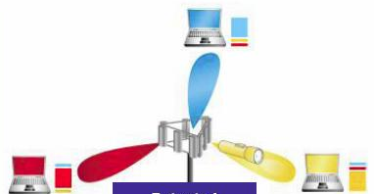
Figure 6.1: Principle of AAS operation

Directional antenna pattern
CS using AAS can produce directional antenna patterns, which can avoid that RF-signals were aimed at FSS stations. AAS have the possibility of attenuating signals in a specific direction by notching the antenna gain in that direction.

This makes it possible to locate a BWA CS relatively closer to a FSS station, on the assumption that there will be no coverage in the direction of the FSS station. This means no BWA or NWA stations can be located between the BWA CS and the FSS station. A mobile station must stop its activities as soon as it enters an area where harmful interference may occur.

This should be controlled by the CS and the mobile must use ‘listen before talk’.


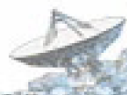
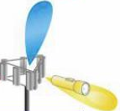

Figure 6.2: Showing directional antenna pattern with exclusion zone

Mitigation zone for the protection of FSS
Each area where harmful interference may occur must be calculated beforehand. The calculation parameters depend on the local circumstances and the equipment parameters in relation to the equipment parameters of the FSS station in question, as described in previous sections of this report.
When such measures have been taken into account, it is expected that BWA applications could operate in the 3600-3800 MHz band relatively closer to FSS stations. Exact values of separation distances should be the results of sharing studies, as shown in this report.

Frequency separation (for the protection of FSS)
It seems that most FSS activities in the C band can be found between 3700 and 4200 MHz. Therefore, BWA applications should be concentrated as much as possible within the band 3400-3700 MHz. In that situation, additional filtering at the FSS ES receiver may improve the operation of LNA/LNB (i.e. avoid their saturation).

Mitigation for the protection of ENG/OB
Due to the temporary nature of the ENG/OB use, it may be possible to find ways to facilitate the co-existence between ENG/OB and BWA by ways of exchange of information between the ENG/OB user and the BWA operator. This can be based on the knowledge of the positioning of the ENG/OB and BWA CSs, their particular assigned frequencies and the duration of ENG/OB operation.

- Conclusions
This Report presents some studies on the compatibility between Broadband Wireless Access (BWA) in the frequency range from 3400-3800 MHz and other existing systems/services.
The other existing systems/services under consideration were:
- Point-to-point fixed links,
- ENG/OB systems,
- Fixed-satellite service (Space-to-Earth),
- Radiolocation.

Typical characteristics for BWA systems are considered in the Report, covering various BWA usage modes, i.e. Fixed (BWA), Nomadic (NWA) and Mobile (MWA) Wireless Access.
Each of the studies takes into account specific propagation models that were deemed to be suitable for the various scenarios under consideration.

The main outcome of the Report is that when deciding on deployment of BWA networks in subject bands, administrations need to take into account the situation regarding the use of the frequency band in the concerned area and that, co-ordination with the existing users may be required. The details of each compatibility scenarios are summarised as follows:

- Compatibility between BWA and Point-to-Point fixed links:

The analysis of both directions of interference (BWA interfering with P-P and vice-versa) has shown that BWA and P-P systems can coexist with a certain frequency separation, depending upon the BWA and P-P characteristics and with co-ordination between the BWA Central Station (CS) and the P-P systems. Co-channel sharing between BWA and P-P links is not feasible in the same geographic area. The co-ordination process will have to ensure that there is no BWA systems in the main lobe of the P-P systems and that the separation distance between the P-P system and the BWA CS is such that the interference between BWA TS and the P-P is limited.

- Compatibility between BWA and ENG/OB:

This study provides the values of the frequency separation which are required to enable the co-existence between BWA and ENG/OB in some scenarios described in the document. It is shown that the interference effect from an ENG/OB on the BWA is less than the interference effect from a BWA CS into the ENG/OB receiver. By taking into account the worst case for the study on the impact of TS on ENG/OB, the study shows that the guard band between the ENG/OB and the BWA TS is relatively small and the main constraint will come from the BWA CS.
The frequency separation required to protect ENG/OB will be quite important when ENG/OB and BWA are supposed to operate in close vicinity (distances around 1 km) and decreases significantly when the separation distance is larger (5 km).
For the case of airborne ENG/OB, the required frequency separation is significantly higher, in particular when considering an omni-directional BWA CS

- Compatibility between BWA and FSS (S-E):

The study noted that there is a number of FSS earth stations deployed in Europe, especially in frequencies above 3700 MHz.

The study in this Report on the impact from BWA into FSS ES is based on the determination of a mitigation zone or area which is defined as the geographical area delimited by the distance on a given azimuth and elevation from an ES, sharing the same frequency band with terrestrial stations, within which there is a potential for the level of permissible interference to be exceeded and co-ordination is necessary to ensure successful operation between terrestrial stations and ES.

The required mitigation distances with respect to FSS ES naturally depend on the type and characteristics of the BWA station. Some examples of mitigation distances are provided based on generic calculations without terrain model and also for some realistic cases of FSS ES with consideration of terrain model.

BWA operation at distances shorter than the required mitigation distance is often feasible due to the benefits gained from using actual terrain topography and clutter database information in propagation loss calculations.

Operation of BWA CS may be feasible within the mitigation zone, based on a detailed, case-by-case evaluation.

BWA TS are generally less impacting than the CS. In addition, it has been demonstrated that the co-ordination of the BWA CS will generally be sufficient to ensure the co-existence with BWA TS. Furthermore, TS may benefit from the additional clutter loss which is available in some environments, particularly urban environments.

Studies show that ubiquitously deployed BWA systems and FSS, when the FSS is deployed in a ubiquitous manner and/or with no individual licensing of ES, can not share in the same geographical area since no minimum separation can be guaranteed.

In the case of BWA operating in adjacent frequency bands, there is a need for mitigation distance to avoid the LNBs of the satellite receivers being driven into non-linear operation, or even being saturated.

Interference from FSS spacecraft transmitting with Article 21 limits into BWA may exceed the required interference criterion by few dB in few cases, however the probability of such cases is expected to be low.

When deciding on deployment of BWA networks in subject bands, administrations will have to take into account the actual use of the band by FSS earth stations.

- Compatibility between BWA and radiolocation:

The impact from radar systems operating below 3.4 GHz on BWA operating in the band 3400-3800 MHz has been assessed. It is clear that the principal way for assuring co-existence of radars vs. BWA is the co-ordination on a case-by-case basis. Theoretical studies are provided that give elements related to the co-ordination process.

In addition, the Report also provides a non-exhaustive list of ways to manage interference and facilitate the co-existence between BWA and other systems/services.
- Abbreviations
ENG | Electronic News Gathering
OB | Outside broadcasting
FSS | Fixed Satellite Service
P-P | Point-to-point
BWA | Fixed Wireless Access
CS | Central Station
TS | TS

Annex 1: Extract of the ERC Report 25
RR region 1 allocation and RR footnotes relevant to CEPT and frequency band | European Common Allocation | Utilisation | EU footnote | ECC/ERC document | Standard | Note
3400 – 3500 MHz
FIXED  FIXED-SATELLITE (S/E) | FIXED  FIXED-SATELLITE (S/E) | Amateur applications | EU17 |  | EN 301 783 | EU17 within the band 3400-3410 MHz
Mobile  Radiolocation | MOBILE  Amateur | Fixed links |  | ERC REC 14-03 | EN 301 751  EN 301 753 | Including point to multipoint
 | Radiolocation | Fixed wireless access systems |  | ERC REC 13-04  ERC REC 14-03 | EN 301 751  EN 301 753
5.431 |  | Radars |  |  |  | Upper limit for airborne radars is 3410 MHz
 |  | SAP/SAB | EU17A |  |  | For coordinated SAP/SAB applications for occasional use
3500 – 3600 MHz
FIXED  FIXED-SATELLITE (S/E) | FIXED  FIXED-SATELLITE (S/E) | Fixed links |  | ERC REC 14-03 | EN 301 751  EN 301 753 | Including point to multipoint
Mobile  Radiolocation | MOBILE | Fixed wireless access systems |  | ERC REC 13-04  ERC REC 14-03 | EN 301 751  EN 301 753
 |  | Mobile applications | EU17A |  |  | For coordinated SAP/SAB applications for occasional use
3600 – 4200 MHz
FIXED  FIXED-SATELLITE (S/E) | FIXED  FIXED-SATELLITE (S/E) | Coordinated ES in FSS |  |  | EN 301 443 | Priority for civil networks
Mobile |  | Fixed wireless access systems |  | ERC REC 14-03 | EN 301 751  EN 301 753 | 3600 – 3800 MHz including point to multipoint
 |  | Medium/high capacity fixed links |  | ERC REC 12-08 | EN 301 751

Annex 2: Spectrum masks of BWA systems considered in the studies
This is an extract of the standard harmonized EN 302326.2

EqC-PET = T
F/ChS ⇨ | 0 | 0,43 | 0,5 | 0,5 | 0,8 |  | 1,06 | 2 | 2,5
EqC-EMO 
2
For EqC-SET ≠ HC | 0 dB | 0 dB |  |  | -25 dB |  | -25 dB | -45 dB | -45 dB
For EqC-SET = HC | 0 dB | 0 dB |  |  | -27 dB |  | -27 dB | -45 dB | -45 dB
4 | 0 dB | 0 dB |  |  | -32 dB |  | -37 dB | -45 dB | -45 dB
6 | 0 db |  | 0 dB | -13 dB | -34 dB |  | -42 dB | -45 dB | -45 dB
EqC-PET = C or H
F/ChS ⇨ | 0 |  | 0,5 |  | 0,8 |  | 1,0 | 1,5 | 2,5
EqC-EMO 
Not applicable | 0 |  | 0 |  | -25 dB |  | -25 dB | -45 dB | -45 dB
EqC-PET = O
F/ChS ⇨ | 0 |  | 0,5 | 0,5 | 0,71 |  | 1,06 | 2 | 2,5
EqC-EMO 
2 | 0 dB |  | 0 dB | -8 dB | -25 dB |  | -27 dB | -50 dB | -50 dB
4 | 0 dB |  | 0 dB | -8 dB | -27 dB |  | -32 dB | -50 dB | -50 dB
6 | 0 dB |  | 0 dB | -8 dB | -32 dB |  | -38 dB | -50 dB | -50 dB
EqC-PET = F
F/ChS ⇨ | 0 |  | 0,5 | 0,5 | 0,6 | 0,85 |  | 1,5 | 2,5
EqC-EMO 
2 | 0 |  | 0 | -23 dB | -25 dB | -25 dB |  | -45 dB | -45 dB
3 | 0 |  | 0 | -27 dB | -29 dB | -29 dB |  | -45 dB | -45 dB
4 or 6 | 0 |  | 0 | -31 dB | -33 dB | -33 dB |  | -45 dB | -45 dB
Table 1: Power Spectrum Reference Points

Annex 3: Transmitter spectrum masks for P-P systems
This is an extract from the ETSI EN 302 217-2.2
Number of segments | K1 in dB  f1 in MHz | K2 in dB  f2 in MHz | K3 in dB  f3 in MHz | K4 in dB  f4 in MHz
5 | K1/f1 | K2/f2 | K3/f3 | K4/f4

Type 1 Bfh=1.4 MHz : Spacing 1.75 MHz
Class 2
f1 (MHz), K1 (dB) | f2 (MHz), K2 (dB) | f3 (MHz), K3 (dB) | f4 (MHz), K4 (dB)
0.7 | 1.4 | 1.75 | 3.5
+1 | -23 | -23 | -45

Class 4
f1 (MHz), K1 (dB) | f2 (MHz), K2 (dB) | f3 (MHz), K3 (dB) | f4 (MHz), K4 (dB)
0.7 | 1.4 | 1.75 | 3.5 (4)
+1 | -32 | -37 | -55 (-60)

Type 2 Bfh = 30 MHz : Spacing 32 MHz
Class 2
f1 (MHz), K1 (dB) | f2 (MHz), K2 (dB) | f3 (MHz), K3 (dB) | f4 (MHz), K4 (dB)
11 | 19 | 25 | 45
+1 | -23 | -23 | -45

Class 4
f1 (MHz), K1 (dB) | f2 (MHz), K2 (dB) | f3 (MHz), K3 (dB) | f4 (MHz), K4 (dB)
11.2 | 22.4 | 28 | 56
+1 | -32 | -37 | -55

Annex 4: Transmitter spectrum mask of ENG/OB systems at 3.5 GHz
It is supposed that digital equipments ENG/OB are based on the OFDM technology used for DVB-T (EN 300 744).

Figure: Spectral mask of a 8 MHz digital ENG/OB based on the DVB-T standard (EN 300 744)
Table
Spectral mask
8 MHz channels
 |  | Sensitive cases
Relative frequency  (MHz) |  | Relative level  (dB)
–12 |  | –120
–6 |  | –95
–4.2 |  | –83
–3.9 |  | –32.8
+3.9 |  | –32.8
+4.2 |  | –83
+6 |  | –95
+12 |  | –120

Annex 5: Plot of ES deployment over Europe in the frequency band 3400 – 4200 MHz from the ITU ES Database and those using the Netherlands fleet of satellites (excluding governmental and military services & ROES)
Disclaimer: the chart below is provided for illustration purposes only, therefore the correctness of provided information was not verified

Annex 6: Compatibility Study between Radiolocation Radars and BWA Systems in the 3 GHz Band
1. Introduction
In 2004, one Administration decided to develop a measurement campaign on radiolocation radars operating in the band 3.1 to 3.4 GHz. These measurements followed others made in previous years as a consequence of interference complaints onto BWA systems operating in the band 3.4 to 3.6 GHz.

The main objective of the campaign was to evaluate the behaviour of the radars, concerning the out-of-band and the spurious emissions, and verify if they could cause interference to BWA systems operating in the adjacent band.

- Frequency Allocations
The Recommendation CEPT/ERC/REC 14-03 was adopted in order to harmonise the channel arrangements and block allocations for low and medium capacity systems in the band 3400 MHz to 3600 MHz, for point to point (P-P) and point to multipoint (P-MP) applications.

The frequency allocations of that Administration according to the Radio Regulations are provided in table 1.

FREQUENCY BAND (MHz) | RADIO REGULATIONS (ART. 5) ALLOCATIONS | NATIONAL APPLICATIONS | NOTES
3100 - 3300 | RADIOLOCATION  Earth exploration-satellite (active)  Space research (active)  5.149 | Radars | Government
3300 - 3400 | RADIOLOCATION  5.149 | Radars | Government
3400 - 3600 | FIXED  FIXED-SATELLITE (space-to-Earth)  Mobile  Radiolocation | BWA (1 bloc of 2x28 MHz in the 3400-3600 MHz sub-band) | CEPT Rec. T/R 14-03, Annex B
3600 - 4200 | FIXED  FIXED-SATELLITE (space-to-Earth)  Mobile | Fixed links  BWA (3 blocs of 2x28 MHz in the 3600-3800 MHz sub-band )  Fixed-satellite  VSATs; SNGs; occasional carriers; permanent carriers | 4 GHz band  Rec. ITU-R F 382 (3800-4200 MHz)  CEPT/ERC/REC 12-08 Annex B (3600-3800 MHz)
TABLE 1

- Radar Measurements And Main Conclusions
The Radio Regulations define “primary radar” as “a radio determination system based on the comparison of reference signals with radio signals reflected from the position to be determined”. The radars (radiolocation radars) tested can be included in this category. The work was based in three recommendations:
- ITU-R M.1177 – “Techniques for measurement of unwanted emissions of radar systems”;
- ITU-R SM.1541 (Annex 8) – “Unwanted Emissions in the out-of-band domain”;
- ITU-R SM.329 – “Spurious Emissions”.

In 2004, the emissions of the radars were measured in order to evaluate their behaviour, concerning the unwanted emissions (out-of-band and spurious emissions). A “mask” was applied to the measurements, based on the Annex 8 of ITU-R SM.1541, as the following:
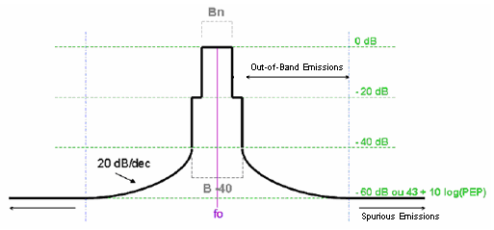
FIGURE 1

The main results of the campaign were:
- In the out-of-band emissions domain the emissions levels rolls off at 20 dB per decade from the 40 dB bandwidth to the spurious level, but with higher emissions levels when compared with the mask;
- In the spurious emissions domain in some of the measurements the emissions levels are higher than the recommended, in particular inside the band 3.4 to 3.6 GHz.

The measurements were made approximately at 150 ms from the radar and the set-up configuration used is presented in figure 2.
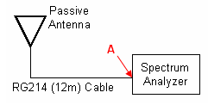
FIGURE 2

Let’s consider that in the spurious emissions domain, in particular inside the band 3.4 to 3.6 GHz, the “worst value” measured complies with the “mask” limit. This value used throughout the compatibility studies, was:
P_{A_measured} = P_{radar_spurious} = - 78 dBm,
with a Resolution Bandwidth (RBW) set to 200 kHz.

This value can be extrapolated from 200 kHz RBW to 1 MHz bandwidth, giving - 71 dBm/MHz.

- Compatibility Studies
In order to evaluate if the “mask” limit of the radar in the spurious domain, in the band 3.4 to 3.6 GHz, can interfere with Point to Multipoint BWA Systems, two different theoretical studies were conducted:
  - A “co-ordination” study that takes into account the values of the ECC Report 76;
  - A “detailed” study to evaluate the impact on the degradation caused by interference on BWA systems.
A third study based in the blocking value, considering the emission power of the radar measured, to determine the separation distance required to protect BWA system from being blocked by the radar, has been realized.

4.1. Co-ordination Study
To coordinate the installation of BWA systems in the 3 GHz band, a co-ordination threshold of Power Flux Density (PFD) equal to S = - 122 dBW/MHz/m² (S = - 92 dBW/MHzxm²), and suggested in Report 76 can be used.
Based in the “mask” limit in the spurious domain applied to the measurements done approximately at 150 m from the radar and the co-ordination threshold, a co-ordination distance (d_{c} – minimum distance for protection) that guarantees that the co-ordination threshold is fulfilled is derived, as depicted in figure 3.
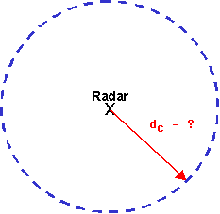
FIGURE 3

Relevant characteristics of the measurement set-up are presented in table 2.

RG214 CABLE | PASSIVE ANTENNA
for 3 GHz → Attenuation = 60 dB / 100m | for 3 GHz → Gain = 6,78 dBi
TABLE 2

The effective area (A_{eff}) of an antenna is given by $A_{\text{eff}}=\frac{λ^{2}}{4π}G$
A_{eff} = 3.13x10⁻³ m² with f = 3,3 GHz

Knowing that S = – 92 dBm/MHz/m², A_{eff} = 3.13x10⁻³ m² and L_{cable} = 7.92 dB/12m (f=3.3 GHz), we have

P_{A_maximum} = 10*log(A_{eff}) + S - L_{cable}

P_{A_maximum} = - 125 dBm/MHz

P_{A_maximum} corresponds to the power that would be received assuming the PFD threshold.

The difference between P_{A_maximum} and P_{A_measured} is 54 dB. Based in this value it is possible to determine the distance d_{c} until which is necessary to coordinate the installation of BWA systems (see figure 4).
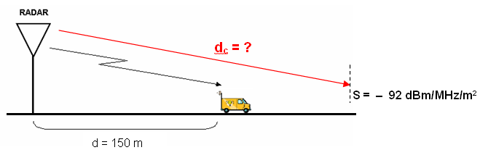
FIGURE 4

Considering a generic model which propagation losses are given by
$$\text{PL}(\text{dB})=\text{10}n\text{log}(\frac{d_{c}}{d})+k$$
(k – Propagation constant dependent of several factors like antenna height, frequency, terrain morphology …)
And choosing n = 3.5 (typical “urban” environment), it comes,
$$Δ\text{PL}(\text{dB})=\text{10}n\text{log}(\frac{d_{c}}{d})$$
$$\frac{\text{54}}{\text{35}}=\text{log}(\frac{d_{c}}{d})$$
And then, $d_{c}={\text{10}}^{1\text{.}\text{54}}d≈5 \text{km}$

As an exercise of the sensitivity analysis, different values of the spurious emissions
(- 80, -70 and – 60 dBm referenced to 200 kHz) are assumed, in order to obtain the corresponding co-ordination distances, as seen in table 3.

Spurious Emissions  (dBm/200kHz) | Co-ordination Distance (d_{c}) (km)
- 80 | 4.5
- 70 | 9
- 60 | 17
TABLE 3

Also, a more general propagation model can be taken, e.g. different path loss exponent “n”, for different radar spurious emissions levels. The results can be oCServed in the graph 1.
- 60 dBm/200kHz
- 70 dBm/200kHz
- 80 dBm/200kHz
GRAPH 1

The co-ordination distances increase considerably when the exponent “n” takes values near to 2.5, environment similar to “open area/ free space”.

4.2. Detailed Study

The study presented in this section is based in the following documents:
- ETSI TR 101 904 v1.1.1 (in particular Annex F) – “Transmission and Multiplexing (TM); Time Division Duplex (TDD) in Point-to-Multipoint (P-MP) Fixed Wireless Access (BWA) systems; Characteristics and network applications”;
- ETSI EN 301 021 v1.6.1 – “Fixed Radio Systems; Point-to-multipoint equipment; Time Division Multiple Access (TDMA); Point-to-multipoint digital radio systems in frequency bands in the range 3 GHz to 11 GHz”;
- CEPT/ERC/REC 14-03 E – “Harmonised radio frequency channel arrangements and block allocations for low and medium capacity systems in the band 3400 MHz to 3600 MHz”;
- Recommendation ITU-R PN.525-2 – “Calculation of Free-Space Attenuation”;
- Recommendation ITU-R F.758-3 – “Considerations in the development of criteria for sharing between the terrestrial fixed service and other services”

For BWA P-MP systems it is possible to adopt a lot of different configurations to the channel arrangements and block allocations. In this study it has been adopted the configuration presented in figure 5, with a duplex spacing of 100 MHz and a channel spacing of 14 MHz, using the FDD (Frequency Division Duplex) technique and the access technology TDMA (Time Division Multiple Access).

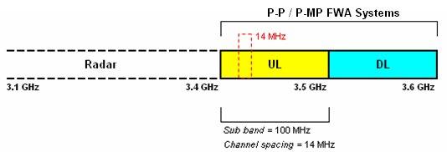
FIGURE 5

The scenario that has been studied is presented in figure 6. The objective is then to determine the minimum distance from which there will be a limited degradation of the BWA system (d_{d}). So, as long as in the band 3.4 to 3.5 GHz (uplink) the BWA CS is in the reception mode, the situation that should be analysed in terms of interference is the one presented below.

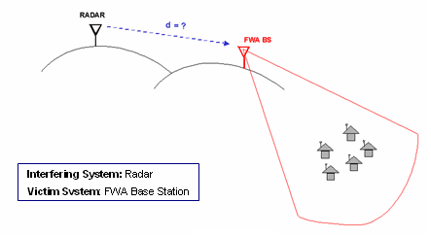
FIGURE 6

4.2.1. Methodology
The threshold param to analyse the occurrence of interference is based in the increase of the noise floor, which occurs with the appearance of in-band external interference. The required minimal signal attenuation of the interfering signal in the air interface is calculated by applying a predefined propagation model, resulting in the corresponding minimum protection distance.
Note that the probability of interference is not taken into account, since it is assumed a “static” scenario (e.g. the periodic rotation of the radar radiating system).

4.2.2. Propagation Model
The calculations were done with two different propagation models. One of the models was the free space attenuation, Recommendation ITU-R PN.525-2, which is given by:

L [dB] = 32,4 + 20 log f’ [MHz] + 20 log d’ [Km]

With some simplifications and extending the propagation model to 3.5 GHz, it can be written as
L [dB] = 43,3 + 20 log d [m]

A more detailed propagation model (ITU-R P.452-10) has also been used, which calculations were done with a specific software tool.

4.2.3. Maximum External Interfering Level Allowed in the Victim System (BWA CS)
The effect of interference can be modelled as an increase in the received interference power. Therefore, the increase in the noise floor (D) implies the increase in noise + interference power compared to the original noise + interference power:
D = (N + I_{act} + I_{ext}) / (N + I_{int}) (linear units)

Or in dB, D = 10 log(N + I_{act} + I_{ext}) – 10 log (N + I_{int})

N – Equivalent noise power in the receiver (including thermal noise);
I_{int} – Internal interference power from the victim system itself (ex.: adjacent cell/sector) before any external interference is applied;
I_{act} - Internal interference power from the victim system itself (ex.: adjacent cell/sector) after any external interference is applied. Note that in same cases I_{act} = I_{int};
I_{ext} – The incremental external interference power received from the interfering system.

Assuming I_{act} = I_{int} , we have
D = 1 + I_{ext} / (N + I_{int}) (1)
On the other hand, the fundamental relationship between C, I and N can be modelled as:
M = C / (N + I) (2)

C – The received carrier power level on the channel;
N – Equivalent noise power in the receiver (including thermal noise);
I – The same-channel received interference power;
M – The specified minimum carrier-to-noise + interference ratio needed to guarantee the specified performance. M is colloquially referred to as the C-to-I (C/I) ratio.

Assuming,
C_{min} = RX_{sens} + M_{fading} and I = I_{int} RX_{sens} – Receiver Sensitivity
M_{fading} – Fading Margin

M = C/I = C_{min} / (N + I_{int})
What is equivalent to
N + I_{int} = C_{min} / M = C_{min} / (C/I)

SuCStituting (N + I_{int}) = C_{min} / (C/I) in (1), it comes

D = 1 + I_{ext} / (C_{min} / (C/I))

And from this equation, the maximum external interference level allowed by the receiver can be deduced:

I_{ext-max} = (D – 1) . C_{min} / (C/I)
Or in dB
I_{ext-max} = RX_{sens} + M_{fading} - (C/I) + 10 log(10^{0,1D} – 1)

To determine the minimum separation distance between the victim and the interfering systems we have
I_{ext-max} = P_{esp-radar} - L + G_{CS} – L_{cable_CS}

P_{esp-radar} – Spurious emission power from the radar
L – Path Losses
G_{CS} – Gain of the BWA CS
L_{cable_CS} – Losses in the cable between the antenna and the receiver of the
BWA CS

And then,

L (dB) ≥ P_{esp-radar} (dBm) – I_{ext-max} (dBm) + G_{CS} – L_{cable_CS}

To determine the distance with the formulae deduced in 4.2.2 it becomes,
d_{d} = 10^{((L-43,3) / 20)}

As mentioned before two propagation models (L) are used in this study.

4.2.4. Interfering Signal Emitted by the Radar
Considering spurious emissions complying with the radar mask, we have the following value
P_{A_measured} = - 71 dBm/MHz

To determine the Received Power in the antenna (P_{r}), we do

P_{A_measured} = P_{r} – L_{cable} +G

P_{r} = ≅ - 70 dBm

Considering free space attenuation

L (dB) = 43.3 + 20 log (150) = 86 dB

Therefore, the “equivalent” radiated power of the spurious emissions in the radar are given by
P_{esp-radar} = P_{A_measured} + L_{cable} – G + L

P_{esp-radar} = - 71 + 7.92 – 6.78 + 86 = 16.14 dBm/MHz

In the following calculations we assume that the radar emits a signal level equal to 16 dBm/MHz in the frequency 3.5 GHz.
4.2.5. Calculations and Results
The characteristics of the victim system are presented in table 4 (more information in document ETSI EN 301 021 v1.6.1). The following considerations are relevant for the study:
- The radar transmits an Interfering Power of 16 dBm;
- C/I degradation of 1 and 3 dB;
- Free space and ITU-R P.452-10 propagation models;
- Sensitivity of the victim system and the “equivalent” power of the spurious emissions integrated over a bandwidth of 1 MHz.

Victim System – BWA CS
P-MP system / FDD / TDMA / System type: HC / 3.4 – 3.5 GHz (UL)
Abbreviations | Description | Values from standard ETSI EN 301 021 v1.6.1 | Units
RX_{sens} | Receiver Sensitivity level | -81 | dBm
C/I  (co-channel ratio) | Carrier to Interference Ratio  (1 dB threshold degradation) | 19 | dB
C/I  (co-channel ratio) | Carrier to Interference Ratio  (3 dB threshold degradation) | 16 | dB
D | Rise in the Noise Floor | 1 and 3 dB | dB
Gross bit rate | Defined as the transmission bit rate over the air | 16 | Mbit/s
BER | Bit Error Rate | ≤ 10⁻⁶
BW_{rx} | Channel Spacing | 14 | MHz
 | Duplex Spacing | 100 | MHz
System Type HC - lower complexity modulation formats, but with higher requirements for receiver sensitivity and tolerance to interference
TABLE 4

The calculations and the results obtained can be oCServed in table 5. The maximum external interference allowed is calculated with the formula deduced in section 4.2.3.
Taking into account:
- the maximum external interference allowed,
- the maximum transmitter interference (spurious emissions power of the radar),
- the gain of the BWA CS, and
- the losses of the cable between the antenna and the receiver of the BWA CS,
it is then possible to calculate the path losses, as:
L (dB) ≥ P_{esp-radar} (dBm) – I_{ext-max} (dBm) + G_{CS} – L_{cable_CS}

The minimum separation distance between the systems is calculated below with the free space model.

VICTIM SYSTEM |  |  | C/I co-channel ratio (threshold degradation 1 dB) | C/I co-channel ratio (threshold degradation 3 dB)
Parameters |  | Units | Scenario 1 | Scenario 2
C/I co-channel ratio | (C/I) | dB | 19 | 16
Rise in the Noise Floor (Desensitisation) | D | dB | 1 | 3
RX bandwidth | BWrx | MHz | 14 | 14
RX sensitivity (for BER = 10⁻⁶) | RXsens | dBm/14MHz | -81 | -81
RX sensitivity (for BER = 10⁻⁶) | RX_{sens} | dBm/MHz | -92.46 | -92.46
Fading Margin | M_{fading} | dB | 10 | 10
Maximum allowed  External Interference | I_{ext-max} | dBm/MHz | -107.3 | -98.5
BWA CS Gain | G_{CS} | dB_{i} | 10 | 10
BWA CS Feeder Losses | L_{cable_CS} | dB/20m | 1.6 | 1.6
Maximum Transmitted Interference | P_{esp-radar} | dBm/MHz | 16 | 16
Required air propagation  losses (LOS) | L | dB | 131.7 | 122.9
Minimum Separation Distance | d_{d} | km | 26,4 | 9,5
TABLE 5

With a software tool other calculations have been performed, using the propagation model ITU-R P.452-10 and making use of a digital terrain model with a precision of 25 m. In the definition of the propagation parameters a “time probability” value of 20% has been used, which is based on the Recommendation ITU-R F.758-3, - the reference value relies on the “long term” interference.

The table below should be used as legend in the interpretation of the results.

 | I_{ext-max} |  | C/I co-channel ratio degradation
>= | - 98.5 |  | More than 3 dB
>= | - 107.3 |  | Until 3 dB
< |  |  | Until 1 dB
TABLE 6

The results obtained with the software tool using the propagation model ITU-R P.452-10 and terrain model for the reference value (P_{esp-radar}= 16 dBm) can be oCServed in figures 7 and 8.

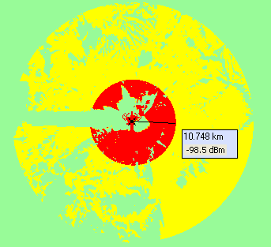
FIGURE 7

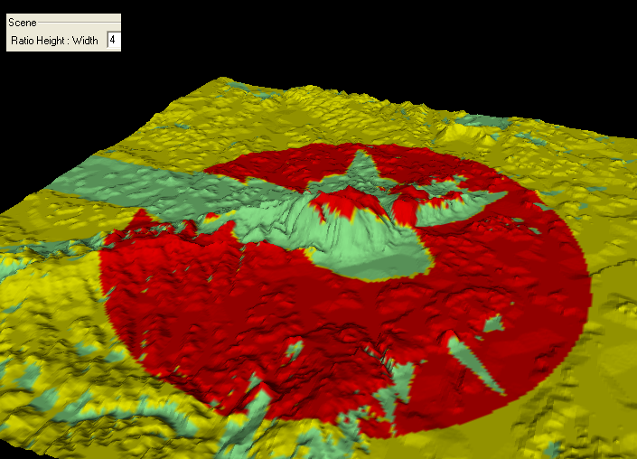
FIGURE 8

Note that the value of 10.748 km corresponds to the “worst case” since in some cases, e.g. in some other directions, this value can be lower dependent on the terrain profile between the radar and the BWA CS.

In Appendix 1 some calculations and results are attached considering that the spurious emissions in the band 3.4 to 3.6 GHz are higher than the “mask“ limit. In the simulation the radar emitted a signal level equal to 24 dBm/MHz in the frequency 3.5 GHz.

4.3. Blocking Study
A possible definition of blocking is the capacity of the receiver to receive a modulated desired signal in the presence of non desired signals. For a victim receiver operating in the sensitivity level, with a BER of 10⁻⁶, the introduction of a interfering system with a higher level of +30 dB (L_{B1}) in relation to the sensitivity of the victim system and in any frequency up to 5 times the carrier frequency, should not cause a degradation greater than 1 dB in the BER of the system.

In the detailed calculations done in the previous section two scenarios were considered, for C/I co-channel ratio degradation of the victim system of 1 and 3 dB. In order to compare the “detailed study” with the “blocking study”, there is a need to determine the value that an interfering system can have in relation to the sensitivity of the victim system (L_{B2}), that don’t cause a degradation greater than 3 dB in the BER of the victim system.

From table 5 it is found that:

Scenario 1
I_{ext-max_1} = - 107.3 dBm/MHz
(C/I)₁ = 19 dB
Scenario 2
I_{ext-max_2} = - 98.5 dBm/MHz
(C/I)₂ = 16 dB

Than:
I_{ext-max_2} - I_{ext-max_1} = 8.8 dB ≈ 9dB and (C/I)₂ - (C/I)₁ = - 3 dB

So, L_{B2} is given by:

L_{B2} = L_{B1} + 9 - 3 = + 36 dB
From the measurements we know the emission power of the radar, measured at 150 m from it, which has the following value
P_{A radar_emission} = - 18.5 dBm/200 kHz

The “equivalent” radiated interfering signal from the radar, as explained in point 4.2.4, can be calculated with

P_{A radar_emission} = P_{A_measured} + L_{cabo} – G + L

The result comes as

P_{A radar_emission} = 75.63 dBm/MHz

The sensitivity of the victim system is -92,46 dBm/MHz for a BER of 10⁻⁶, and if we sum +30 and +36 dB for BER degradations until 1 and 3 dB, respectively, we obtain the following values of Blocking Power:

Scenario 1
P_{blocking_1} = RX_{sens} + 30 dB
P_{blocking_1} = - 62.46 dBm/MHz

Scenario 2
P_{blocking_2} = RX_{sens} + 36 dB
P_{blocking_2} = - 56.46 dBm/MHz

Making a brief analysis with the free space propagation, we have

 |  | Scenario 1 (BER degradation  until 1 dB) | Scenario 2 (BER degradation  until 3 dB)
P_{A radar_emission} | dBm/MHz | 75.63 | 75.63
P_{blocking} | dBm/MHz | - 62.46 | - 56.46
L (path losses) | dB | 138.09 | 132.09
d (separation distance) | km | 54.89 | 27.51
TABLE 7

More realistic results were obtained using propagation model ITU-R P.452-10 (with input parameters of the model as in section 4.2.5. The legend to analyse the results is presented in the table 8.

 | Value | BER degradation of the system
>= | - 56.46 | Greater than 3 dB
>= | - 62.46 | Until 3 dB
< | - 62.46 | Until 1 dB
TABLE 8

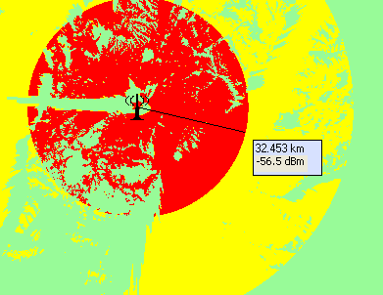
FIGURE 9

5. Conclusions
The studied radars, even with the spurious emissions complying with the mask limits, present levels which may have some impact on the operation of BWA systems in the band 3.4 to 3.6 GHz.

From the theoretical analyses we conclude that:
- From the co-ordination study results a distance approximately equal to 5 km from the radar where the installation of BWA systems should be coordinated. This value was determined assuming that the spurious emissions of the radar comply with the mask limit, with a level of - 78 dBm/200kHz, and using an exponent of 3.5 (“urban environment”) in the propagation model. It’s important to point out that this result is extremely sensitive to a different, especially lower, path loss exponent;
- In order to guarantee a limited C/I degradation of the P-MP BWA system, it is necessary to establish a protection distance of approximately 11 km in some areas (this value may be much less in some directions);.
- Considering the degradation for blocking effect, the radar can have impact in the BWA systems until 30 km (this value may be much less in some directions).

It is important to refer that the studies were done assuming various “worst case” factors, like:
- The interference level was based in a linear conversion of the bandwidth used in the measurements (200 kHz) to the calculations (1 MHz); this may be somewhat pessimistic.
- These studies don’t take into account that the BWA systems have mechanisms to avoid interference, for instance, frequency hopping.
- These studies don’t take into account the rotation/scanning of the radiant system of the radar, and that the probability of the radar to “hit” BWA systems is low.

Appendix 1

The minimum separation distance between the systems is calculated below with the free space model.

VICTIM SYSTEM |  |  | C/I co-channel ratio (threshold degradation 1 dB) | C/I co-channel ratio (threshold degradation 3 dB)
Parameters |  | Units | Scenario 1 | Scenario 2
C/I co-channel ratio | (C/I) | dB | 19 | 16
Rise in the Noise Floor (Desensitisation) | D | dB | 1 | 3
RX bandwidth | BWrx | MHz | 14 | 14
RX sensitivity (for BER = 10⁻⁶) | RXsens | dBm/14MHz | -81 | -81
RX sensitivity (for BER = 10⁻⁶) | RX_{sens} | dBm/MHz | -92.46 | -92.46
Fading Margin | M_{fading} | dB | 10 | 10
Maximum allowed  External Interference | I_{ext-max} | dBm/MHz | -107.3 | -98.5
BWA CS Gain | G_{CS} | dB_{i} | 10 | 10
BWA CS Feeder Losses | L_{cable_CS} | dB/20m | 1.6 | 1.6
Maximum Transmitted Interference | P_{esp-radar} | dBm/MHz | 24 | 24
Required air propagation  losses (LOS) | L | dB | 139.7 | 130.9
Minimum Separation Distance | d_{d} | m | 66,294.37 | 23,938.41

In the following figure we present the results obtained with the software tool using the propagation model ITU-R P.452-10 for the reference value (P_{esp-radar}= 24 dBm).

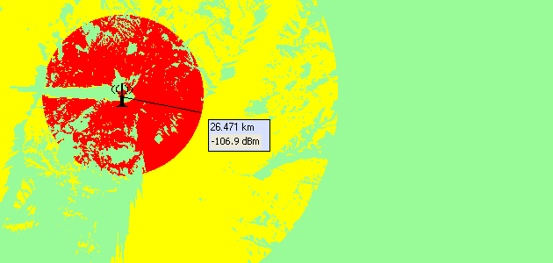
FIGURE 10

Note that the value of 26 km corresponds to the “worst case” since in some cases, e.g. in some other directions, this value can be lower dependent on the terrain profile between the radar and the BWA CS.

Annex 7: Impact from a Radar System on BWA: Measurements of the Bit Error Rate in a Radiocommunications Receiver in Dependence of the Interference from Continuous and Pulsed Signals
This Annex describes the results of a measurement investigation to the impact of continuous and pulsed interfering signals to a radiocommunications receiver. The measurements were carried out by the Radio Monitoring Station Itzehoe (near Hamburg, Germany) of the Federal Network Agency.

Following input parameters and conditions were given:
- Channel Bandwidth: 27.5 MHz
- Modulation: 128 QAM
- Coding : Forward Error Correction, Reed-Solomon
- Centre Frequency of the Interferer was within the Radio Communication Channel (Co-channel situation)
- Wanted Received Signal Level (S): -65 dBm and -55 dBm
- Interfering Signal: Continuous Signal and Pulsed Signals with Pulse Duty Ratios of
- 1:10, 1:100, 1:1000 (Pulse Durations of 100 µs, 10 µs, 1 µs, Pulse Interval of 1 ms)

The interfering signal level was increased from 0 dBm to this level at which the link is broken off. Depending on the interfering signal level the bit error rate was taken in.

The resulted SIR values for a bit error rate of 10⁻⁹ were:
- 30 dB for a continuous interfering signal and a wanted signal level of -65 dBm
- 27 dB for a pulsed interfering signal with a pulse duty ratio of 1:100 and a wanted signal level of -65 dBm
- 27 dB for continuous interfering signal and a wanted signal level of -55 dBm
- 25 dB for a pulsed interfering signal with a pulse duty ratio of 1:100 and a wanted signal level of -55 dBm

Disconnection for a pulsed interfering signal with a pulse duty ratio of 1:100 was detected at an SIR of -13 dB. For a pulsed interfering signal with a pulse duty ratio of 1:1000 no disconnection could be detected.

Figure A7.1
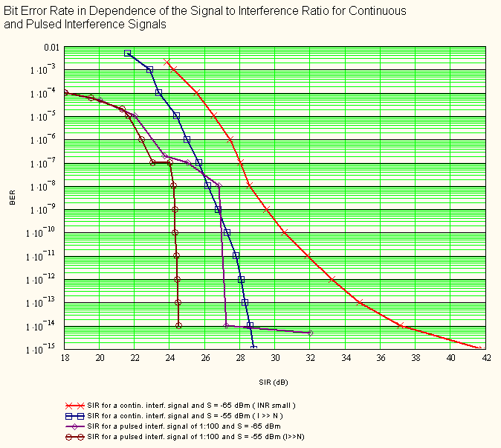

Figure A7.2
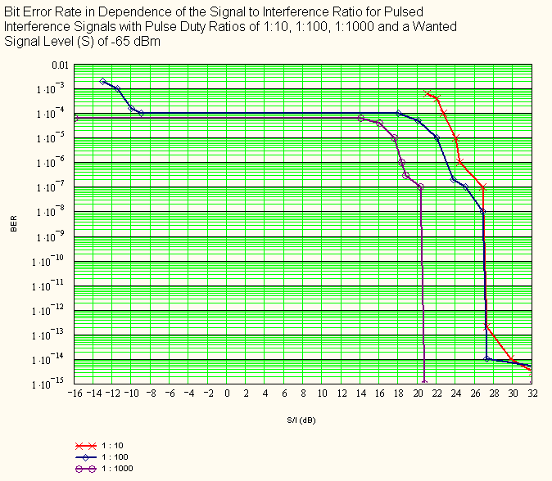

Existing provisions of the Radio Regulations relating to international coordination are unaffected by this definition, which is intended for national coordination purposes.
As ERC/DEC/(99)26 decided to exempt ROES from individual licensing, the locations of ROES are usually not known to administrations. The impact from BWA into ROES may be addressed at a national level.
Note the most up-to-date version, P.452-12, is expected to be available soon.
Reference antenna pattern is based on Recommendation ITU-R S.465
The 15 dB loss figure was obtained from the WiMAX Forum document titled “WiMAX Deployment Consideration for Fixed Wireless Access in the 2.5 GHz and 3.5 GHz Licensed Bands” (June 2005)
It was reported that, according to initial trials conducted in some regions of the world, the phenomena described above have been noted to practically all satellite receivers when BWA was introduced there. However results of these trials were not yet publicly available at the time of completing this report.
Existing provisions of the Radio Regulations relating to international coordination are unaffected by this definition, which is intended for national coordination purposes.

