Electronic Communications Committee (ECC)
within the European Conference of Postal and Telecommunications Administrations (CEPT)

SHARING BETWEEN MSS SYSTEMS USING TDMA and MSS SYSTEMS USING CDMA IN THE BAND 1610 – 1626.5 MHz

Bern, February 2007

EXECUTIVE SUMMARY
Previous studies conducted by ERC Working Group SE PT 28 showed that there is no reasonable frequency band sharing between time division multiple access (TDMA) based systems like IRIDIUM and code division multiple access (CDMA) based systems like GLOBALSTAR. That is why the frequency plan proposed by the FCC in the USA was based on a frequency segmentation and separation between IRIDIUM and GLOBALSTAR.
In CEPT, Decision ERC(97)03 designates the band 1610-1621.35 MHz for use by CDMA systems such as GLOBALSTAR whereas the band 1621.35-1626.5 MHz is designated for use by TDMA systems such as IRIDIUM.
The US frequency plan today allows for co-frequency operation between IRIDIUM and GLOBALSTAR in the band 1618.25-1621.35 MHz. In common with the US allocations, IRIDIUM proposes this band to be shared between IRIDIUM and GLOBALSTAR in Europe.
Furthermore, if a second CDMA system (COURIER) becomes operational, this system should operate in the same spectrum as the GLOBALSTAR system and will have to seek coordination in order to do so.
This report analyses the feasibility of sharing between MSS systems using CDMA such as GLOBALSTAR and COURIER and MSS systems using TDMA such as IRIDIUM in this band 1618.25-1621.35 MHz and concludes that, on the basis of the technical characteristics provided:
- In order to operate on a co-frequency basis, with GLOBALSTAR, at full capacity, the German system COURIER has to use a polarization orthogonal to GLOBALSTAR, and therefore the same as IRIDIUM.
- The IRIDIUM satellite will suffer from harmful interference from a deployment of GLOBALSTAR terminals during 45% of the time at best, which confirms the studies conducted by SE28 in 1998.
- The IRIDIUM satellite will suffer from harmful interference from a deployment of COURIER terminals during 100% of the time when operating on a co-polarization and co-frequency basis.
- The GLOBALSTAR satellite will suffer from interference from IRIDIUM handsets, which may or may not exceed the defined protection criterion. This is dependant upon the assumptions made, including those concerning the cross-polarisation isolation and the shielding due to the proximity of the handheld terminal to the human body. Table 1 gives (for a frequency reuse factor of 5) the percentage of time for which the increase in noise+self interference exceeds 3% in all situations. The 6% increase in noise criterion is exceeded for 100% of time in the situations shown.
TABLE 1
% of time of harmful interference from IRIDIUM Terminals to GLOBALSTAR satellite
Slope | Human body (dB) | Voice | Voice / Data | Data
1.605 | 0 | 0 % | 0 % | 0 %
1.605 | 3 | 0 % | 0 % | 0 %
3 | 0 | 0.02 % | 0.2 % | 2 %
3 | 3 | 100 % | 100 % | 100 %
- The COURIER system, operating on a co-polarization and co-frequency basis with the IRIDIUM system, will suffer from harmful interference from a deployment of TDMA terminals during 100% of the time for all above cases.
- The GLOBALSTAR satellites will suffer from unacceptable interference from IRIDIUM satellites (irrespective of the polarisation that is used) when the IRIDIUM system is fully loaded, as shown in Table 2.
TABLE 2
Interference from IRIDIUM satellites to GLOBALSTAR satellites
IRIDIUM Activity | Frequency reuse factor | Maximum increase in noise + self interference * | % of time the 3% N+I criterion is exceeded
Voice | 12 | 30 % | 2.5 %
Voice | 5 | 70 % | 2.5 %
Data | 12 | 1200 % | 100 %
Data | 5 | 3000 % | 100 %
* There is a ten-fold increase in noise against the 6% criterion during the same period of time.

- Unlike GLOBALSTAR, the COURIER satellites are planned to operate in close proximity of the IRIDIUM satellites. Although this case was not simulated, simple geometrical considerations show that the noise + interference level in a COURIER channel will exceed the GLOBALSTAR case by far. Therefore the results of Table 2 have to be considered as too optimistic for the COURIER system.
It should be noted that the findings of this report can be applied to the whole frequency range 1610-1626.5 MHz.
The more appropriate way to achieve compatibility between MSS systems using CDMA and MSS systems using TDMA is the frequency separation of these systems.It should also be noted that satellite systems in this band are subject to frequency co-ordination under Articles 9 and 11 of the Radio Regulations.
Table of contents

0 EXECUTIVE SUMMARY 2
1 List of Abbreviations 5
2 INTRODUCTION 6
3 MSS ALLOCATION 6
4 MSS SYSTEM CHARACTERISTICS 7
4.1 The TDMA system: IRIDIUM 7
4.2 The CDMA system 1: GLOBALSTAR 11
4.3 The CDMA system 2: COURIER 15
5 sharing analysis 18
5.1 Introduction 18
5.1.1 Propagation effects 18
5.1.2 Protection criteria 21
5.1.3 Sharing scenarios 22
5.2 SCENARIO 1: TDMA satellite to CDMA satellite 23
5.3 SCENARIO 2: TDMA handset to CDMA satellite 29
5.4 SCENARIO 3: CDMA handset to TDMA satellite 33
5.5 SCENARIO 4: CDMA handset to TDMA handset 34
6 MEASUREMENT OF RADIO LINK FAILURES ON GLOBALSTAR 35
7 CONCLUSIONS 36
8 References 37

ANNEX 1 Co-frequency interference from CDMA GLOBALSTAR into CDMA COURIER …………… 38
and vice versa if both systems are at capacity
Sharing between MSS systems using TDMA and MSS systems using CDMA in the band 1610 – 1626.5 MHz

List of Abbreviations

Abbreviation | Explanation
BER | Bit Error Rate
CDMA | Code Division Multiple Access
CEPT | European Conference of Postal and Telecommunications
CPI | Cross Polarisation Isolation
ECC | European Electronic Communications
EIRP | Equivalent Isotropically Radiated Power
FCC | Federal Communications Commission
FDD | Frequency Division Duplex
FDM | Frequency Division Multiplex
FDMA | Frequency Division Multiple Access
GIS | Geological Information System
GOCC | Ground Operations Control Center
GPS | Global Positioning System
HPA | High Power Amplifier
ITU | International Telecommunication Union
LEO | Low Earth Orbit
LHCP | Left Hand Circular Polarized
MLS | Microwave Landing System
MSS | Mobile Satellite Service
PN | Pseudo Noise
PSTN | Public Switched Telephone Network
RLF | Radio Link Failure
RHCP | Right Hand Circular Polarized
SDM | Satellite Data Modems
STA | Special Temporary Authority
TDD | Time Division Duplex
TDMA | Time Division Multiple Access
UMTS | Universal Mobile Telecommunications System

INTRODUCTION
When originally licensed by the regulation body (e.g. FCC for America), it was expected that a number of LEO satellite based mobile communication systems should operate in the band 1610-1626.5 MHz.
However, IRIDIUM and GLOBALSTAR are today the only two big LEO systems that are operational. Furthermore, the German LEO Sat COURIER is planning to start its operation within the next few years.
Early investigations showed very clearly, that there is no reasonable frequency band sharing between time division multiple access (TDMA) based systems like IRIDIUM and code division multiple access (CDMA) based systems like GLOBALSTAR. That is why the US frequency plan proposed a clear frequency segmentation and separation between IRIDIUM and GLOBALSTAR. However, the US frequency plan today allows for co-frequency operation between IRIDIUM and GLOBALSTAR. It was also intended, that other CDMA based systems should share the same frequency bandwidth as identified for GLOBALSTAR.
Decision ERC(97)03 designates the band 1610-1621.35 MHz for use by CDMA systems such as GLOBALSTAR whereas the band 1621.35-1626.5 MHz is designated for use by TDMA systems such as IRIDIUM.
In common with the US allocations, IRIDIUM proposes the band 1618.25-1621.35 MHz to be shared between IRIDIUM and GLOBALSTAR. Furthermore, if COURIER becomes operational, a second CDMA system should operate in the same bandwidth of the GLOBALSTAR system.
This report analyses the feasibility of sharing between MSS systems using CDMA such as GLOBALSTAR and COURIER and MSS systems using TDMA such as IRIDIUM in this band 1618.25-1621.35 MHz. It should be noted that the findings of this report can be applied to the whole frequency range 1610-1626.5 MHz.

MSS ALLOCATION
TABLE 3
Frequency allocations in the band 1 610-1 626.5 MHz
Allocation to services
Region 1 | Region 2 | Region 3
1 610-1 610.6  MOBILE-SATELLITE  (Earth-to-space) 5.351A  AERONAUTICAL  RADIONAVIGATION | 1 610-1 610.6  MOBILE-SATELLITE  (Earth-to-space) 5.351A  AERONAUTICAL  RADIONAVIGATION  RADIODETERMINATION-  SATELLITE  (Earth-to-space) | 1 610-1 610.6  MOBILE-SATELLITE  (Earth-to-space) 5.351A  AERONAUTICAL  RADIONAVIGATION  Radiodetermination-satellite  (Earth-to-space)
5.341 5.355 5.359 5.363 5.364 5.366 5.367 5.368 5.369 5.371 5.372 | 5.341 5.364 5.366 5.367 5.368 5.370 5.372 | 5.341 5.355 5.359 5.364 5.366 5.367 5.368 5.369 5.372
1 610.6-1 613.8  MOBILE-SATELLITE  (Earth-to-space) 5.351A  RADIO ASTRONOMY  AERONAUTICAL  RADIONAVIGATION | 1 610.6-1 613.8  MOBILE-SATELLITE  (Earth-to-space) 5.351A  RADIO ASTRONOMY  AERONAUTICAL  RADIONAVIGATION  RADIODETERMINATION-SATELLITE (Earth-to-space) | 1 610.6-1 613.8  MOBILE-SATELLITE  (Earth-to-space) 5.351A  RADIO ASTRONOMY  AERONAUTICAL  RADIONAVIGATION  Radiodetermination-satellite  (Earth-to-space)
5.149 5.341 5.355 5.359 5.363 5.364 5.366 5.367 5.368 5.369 5.371 5.372 | 5.149 5.341 5.364 5.366 5.367 5.368 5.370 5.372 | 5.149 5.341 5.355 5.359 5.364 5.366 5.367 5.368 5.369 5.372
1 613.8-1 626.5  MOBILE-SATELLITE  (Earth-to-space) 5.351A  AERONAUTICAL  RADIONAVIGATION  Mobile-satellite (space-to-Earth)  5.347A | 1 613.8-1 626.5  MOBILE-SATELLITE  (Earth-to-space) 5.351A  AERONAUTICAL  RADIONAVIGATION  RADIODETERMINATION-  SATELLITE  (Earth-to-space)  Mobile-satellite (space-to-Earth)  5.347A | 1 613.8-1 626.5  MOBILE-SATELLITE  (Earth-to-space) 5.351A  AERONAUTICAL RADIONAVIGATION  Mobile-satellite (space-to-Earth)  5.347A  Radiodetermination-satellite  (Earth-to-space)
5.341 5.355 5.359 5.363 5.364 5.365 5.366 5.367 5.368 5.369 5.371 5.372 | 5.341 5.364 5.365 5.366 5.367 5.368 5.370 5.372 | 5.341 5.355 5.359 5.364 5.365 5.366 5.367 5.368 5.369 5.372

IRIDIUM is designated to occupy 5.15 MHz of spectrum in the band between 1621.35 MHz and 1626.5 MHz. The IRIDIUM system utilises time division multiple access (TDMA) technology for satellite access, with service link transmission in both directions (i.e., bi-directional TDMA where both the satellite uplink and downlink occupy the same frequency assignment).
CDMA systems such as GLOBALSTAR and COURIER are designated to share 11.35 MHz of spectrum in the band between 1610 MHz and 1621.35 MHz for service uplinks and 11.5 MHz of spectrum in the band between 2483.5 MHz and 2495 MHz for service downlinks.
FIGURE 1
Proposed usage of the MSS allocation between 1610 and 1626.5 MHz
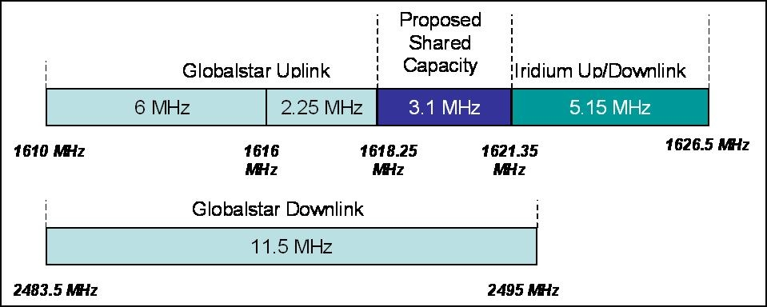
These 3 systems were considered in the sharing studies contained in this report.

MSS SYSTEM CHARACTERISTICS

The TDMA system: IRIDIUM
The IRIDIUM system employs 66 Low Earth Orbit (LEO) satellites that support user-to-user, user-to-gateway, and gateway-to-gateway communications. The 66 satellites are evenly distributed in six orbital planes with a 86.4° inclination, with one in-orbit spare for each orbital plane. Except for planes 1 and 6, the orbital planes are co-rotating planes spaced 31.6° apart. The first and last orbital planes are spaced 22° apart and form a seam where the satellites are counter-rotating. The IRIDIUM satellite constellation is depicted in Figures 2 and 3. The satellites orbit at an altitude of 780 kilometres and have an orbital period of approximately 100 minutes 28 seconds.

Figure 2
IRIDIUM Satellite Constellation

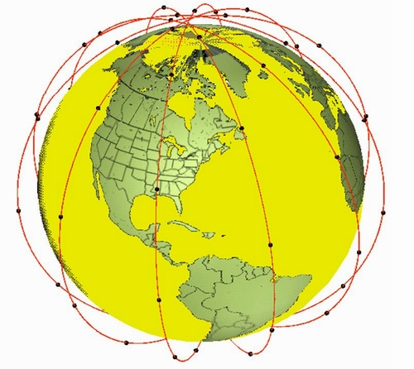
Figure 3
IRIDIUM System coverage

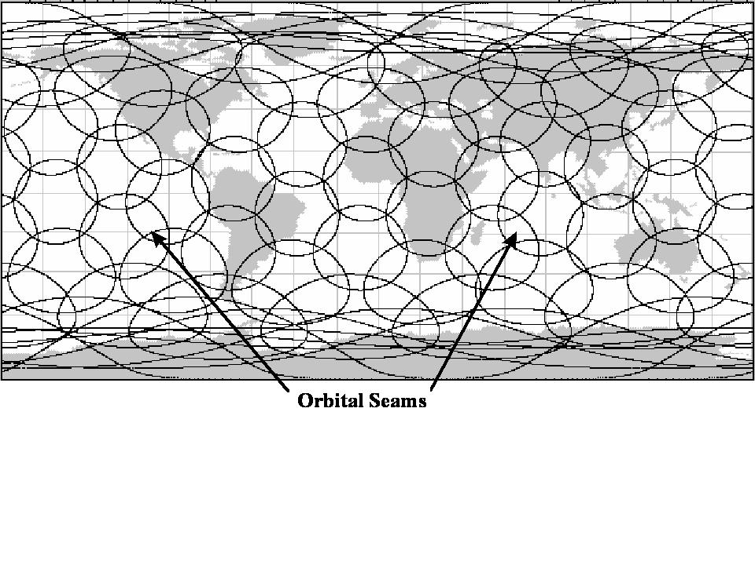
The IRIDIUM system uses an algorithm which dynamically controls the frequency reuse factor employed by the network. The typical range of frequency reuse factors used lie between 5 and 12. As the satellites converge at the poles beams on individual satellites are turned off allowing for a lesser frequency reuse in these regions.

IRIDIUM user terminals employ a time division duplex (TDD) approach wherein they transmit and receive in an allotted time window within the frame structure. The TDD structure is built on a 90 ms frame and is composed of a 20.32 ms downlink simplex time slot, followed by four 8.28 ms up-link time slots and four 8.28 ms down-link time slots, with some guard times interspersed as is depicted in Figure 7. Since the system is TDD, the subscriber units transmit and receive in the same frequency band. The access technology is a Frequency Division Multiple Access/ Time Division Multiple Access (FDMA/ TDMA) method whereby a subscriber is assigned a channel composed of a frequency and time slot in any particular beam. Channel assignments may be changed across cell/ beam boundaries and are controlled by the satellite.
FIGURE 4
IRIDIUM Frame Structure
The maximum transmit power of an IRIDIUM handset is 7 W (The HPA is 8W with typical tranmission line losses of 1dB). The gain of the handset antenna is 0 dBi, therefore the maximum transmited EIRP is 8.5 dBW. If we assume any two channels are active per frame, the maximum transmited EIRP per time slot is 1 dBW.
The system provides the full average link margin at maximum power, but it is also capable of reducing transmit power and adjusting link margin according to the local fading conditions. This is accomplished with an adaptive power control system that can reduce the subscriber transmit power by up to 8 dB but can also be adjusted in 1 dB steps over the complete range. The effect of the power control is to allow the subscriber equipment to operate at the lowest power necessary to assure quality communications.
The satellite receiver measures received Eb/(No+Io) and compares it to a threshold value, which is defined to be that value for which a X% BER can be achieved for a voice channel in Gaussian noise. This comparison of real Eb/(No+Io) to the threshold value results in a margin value. If the margin is poor, the handset immediately rises to full power. If the margin is 'good', it does nothing. If it is 'very good', it decreases by one step size (1 dB). Maximum power control range is 8 dB. Also, the loop operates over a 4 frame period, i.e., the satellite commands the handset to adjust (or stay the same) once every 4 frames. However, upon receiving a command to power up or down, the handset does so in the very next frame.
The measured cross-polarisation isolation performance for a typical IRIDIUM handset is shown in Figure 5. It is clear from the following antenna plot that isolation of greater than 20 dB is achieved.
FIGURE 5
Typical Measured Cross-Polarisation Isolation Performance for an IRIDIUM Handset
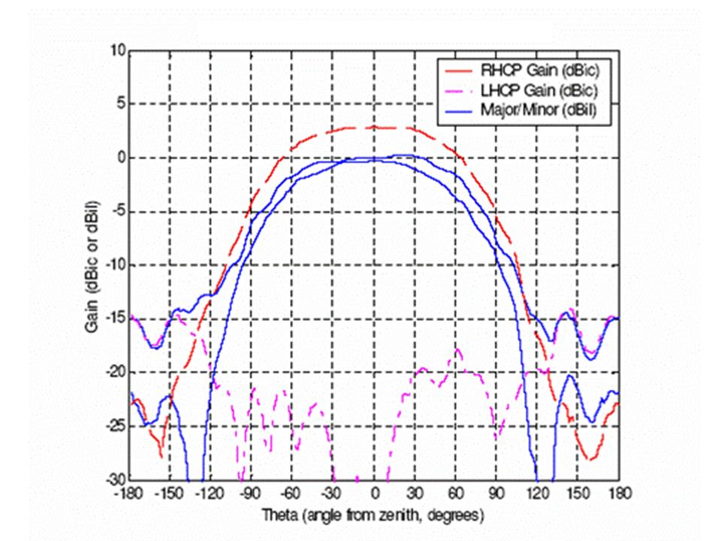

The CDMA system 1: GLOBALSTAR
The GLOBALSTAR system provides communications from any point on the earth’s surface to any other point on the earth’s surface, exclusive of the Polar Regions as shown in Figure 6.
FIGURE 6
GLOBALSTAR constellation

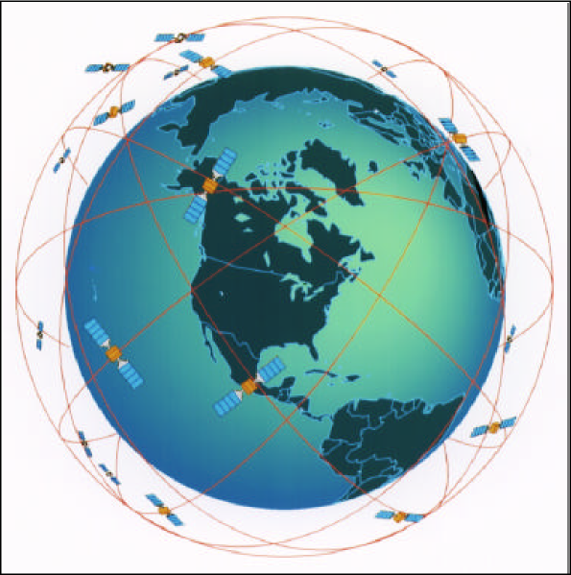

The system consists of satellites, user terminals, gateways, which connect calls transmitted over the satellites to/from the Public Switched Telephone Network (PSTN) as well as to/from the Internet, and a Ground Operations Control Center (GOCC).
The satellite orbits are optimized to provide highest link availability in the area between 70 degrees South latitude and 70 degrees North latitude. Service is feasible in higher latitudes with decreased link availability. The GLOBALSTAR space segment consists of 40 satellites in 1410 km Low Earth Orbits. The low orbits permit low power hand sets similar to cellular phones. These satellites are distributed in 8 orbital planes with 5 equally spaced satellites per orbital plane. Satellites complete an orbit every 114 minutes. User Terminals in a particular location on the surface of the earth are illuminated by a multibeam satellite antenna as it passes over the earth.
User Terminals can be served by a satellite 10 to 15 minutes out of each orbit. A smooth transfer process between beams within a satellite and between satellites provides unbroken communications for the users. The orbital planes are inclined at 52 degrees. Coverage is maximized in the temperate areas with at least two satellites in view, providing path diversity over most of the area. There is some small sacrifice in multiple satellite coverage at the equator and at latitudes above 60 degrees.
The Gateways to the terrestrial network are illuminated by an earth coverage beam. The Gateway connects the User Terminal to the terrestrial network via the Gateway.
The User Terminals come in several varieties. There are hand held units, mobile units and station units for voice calls, as well as Satellite Data Modems (SDMs). Gateways transmit pilot signals via the satellites. The User Terminal looks for the best satellite pilot signal. When this is found it then switches to the sync channel and obtains the satellite database and other information. This database facilitates rapid acquisition of the pilot for any future calls. To place a call the user dials the number and presses "SEND". The User Terminal contacts the Gateway via the access channel. The Gateway and the User Terminal then work together to connect the call and support communications. Since the satellites are moving, the user is continuously being illuminated by different satellite beams or even different satellites. Diversity combining within the receivers supports a process of transferring traffic that is completely transparent to the user. The diversity combining process also provides better call reliability. The handoff process is accomplished without interruption to the call in process. If the user moves into an area that shadows or blocks access to one satellite, the space diversity link through a satellite that is not blocked maintains uninterrupted user communication.
The fixed User Terminals have a performance equivalent to the mobile terminal except that the antenna gain and transmitter power may be even higher. Fixed terminals do not require path diversity to combat fading and blockage.
Each GLOBALSTAR satellite has 16 S band beams and 16 L band beams, with each beam reusing the allocated 11.35 MHz at L-band (user to satellite) and 16.5 MHz at S-band (satellite to user). As shown in Figures 7 and 8, the MSS bandwidth of 16.5 MHz at L-Band and S-Band is conceptually divided into channels of 1.23 MHz width. At L band, channels 1 through 9 are used by GLOBALSTAR, and channels 10-13 fall into the band allocated to Iridium. The same set of frequencies is reused in each of the 16 beams at L band and each of the 16 beams at S band. Note that C-Band feederlink frequencies are assigned to communicate between the satellite and gateway, with 5 GHz being used for the gateway-to-satellite direction and 7 GHz for the satellite-to-gateway direction.
FIGURE 7
L band frequency designations
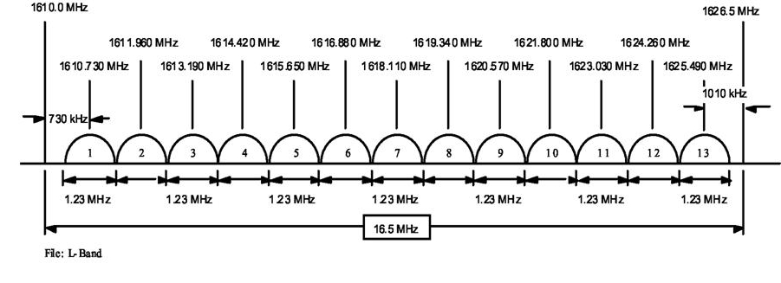
FIGURE 8
S band frequency designations
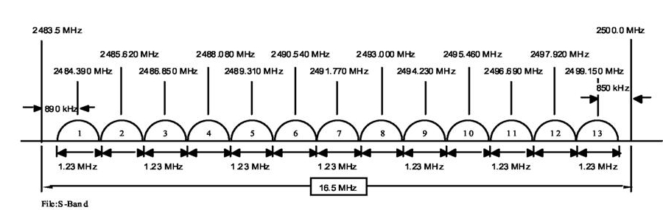
Within a channel, spread spectrum is used to convey the voice or data intelligence. Multiple voice or data circuits may be carried within a single 1.23 MHz FDM channel. The circuit data is separated by unique PN spreading sequences. This allows the same spectrum to be shared by other CDMA users.
The earth’s surface except for Polar Regions, is covered by multiple overlapping satellites as shown in Figure 9.
FIGURE 9
Typical ground tracks of GLOBALSTAR at an instant in time
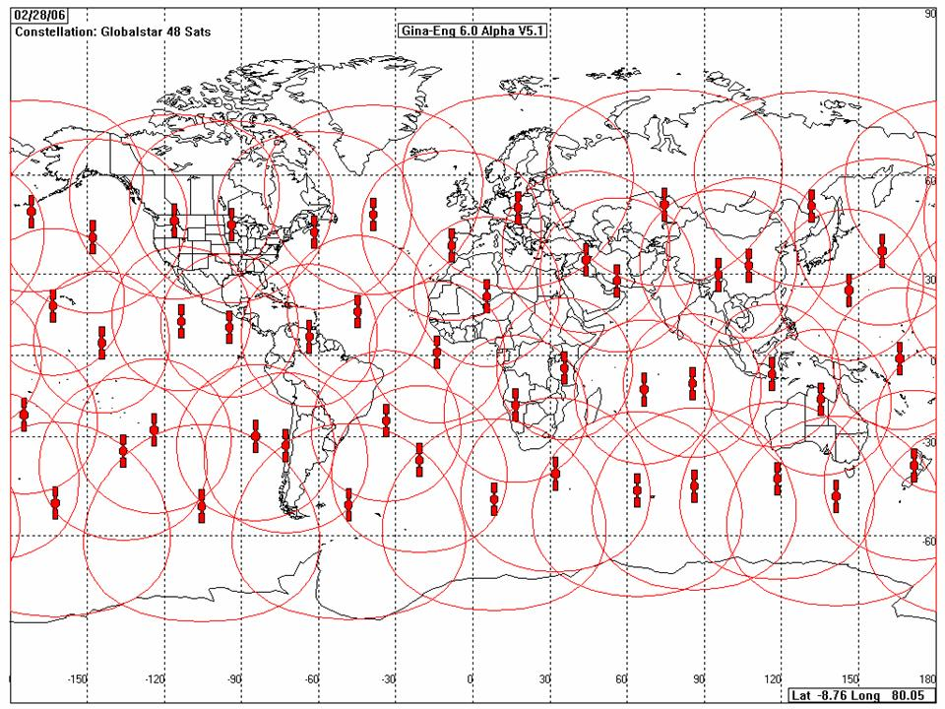
The contours shown indicate that a User Terminal within the contour can communicate with the satellite at an elevation angle above 10 degrees.
Figure 10 illustrates a typical user terminal orientation in a temperate latitude with multiple satellite coverage.
FIGURE 10
Multiple satellites coverage
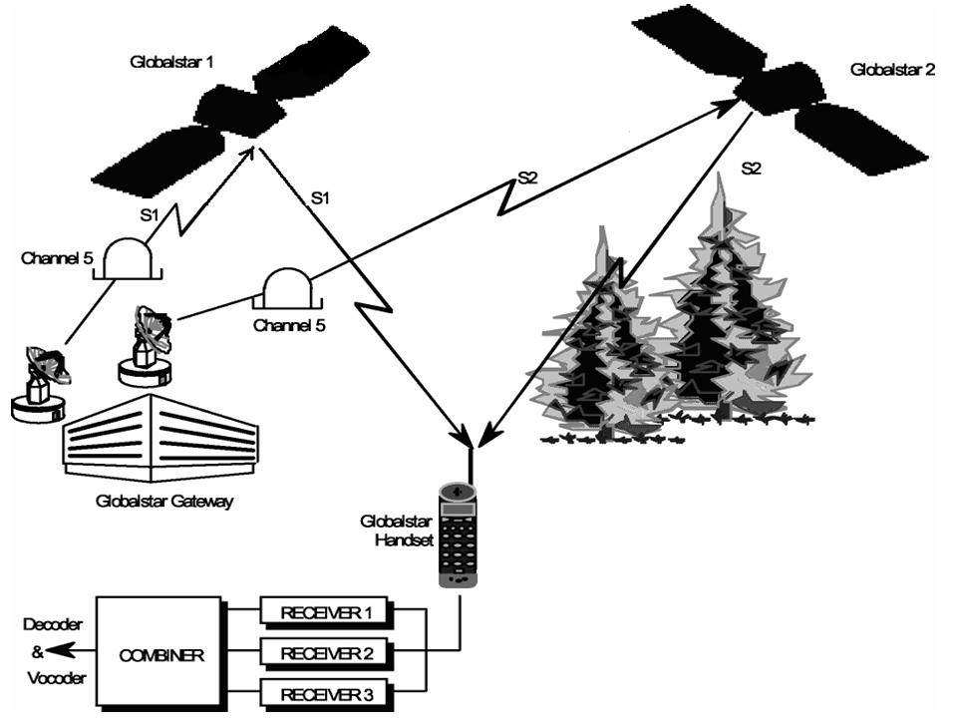

Line of Sight: For the GLOBALSTAR system, many of the obstructions in the direct line of sight do not completely block the line of sight, but rather simply attenuate the signal. Given two satellites in view at the same time, the probability of signal blockage or shadowing to both satellites is significantly less than the probability of blockage to a single satellite.
Specular Reflection: The specular reflection component is the signal reflected off the surface of the earth. The magnitude of the reflected signal can be large if the surface is relatively smooth and flat at the point of reflection. The specular component will prove to be an insidious problem for the hand held antennas. It can either add to or subtract from the signal received from the direct line of sight. This problem can be managed effectively for the mobile and the fixed station antennas.
Diffuse Reflection: The diffuse component is composed of a sum of a large number of individual terrain scatter from outside the first Fresnel zone. This diffuse component is characterized by phase incoherent multi-path with a uniform phase distribution and a Rayleigh amplitude distribution. The signal fading associated with the diffuse component combining with the direct component produces the fast-fading characteristics of the propagation channel.
Building Penetration: GLOBALSTAR has limited ability to penetrate buildings. Operation is possible in wood frame buildings or near windows with a wide angle view of the sky. The best locations within building results in 6 to 13 dB added insertion loss. There is a high degree of sensitivity to antenna location within the building. A change in lateral position of 20 to 30 centimeters can produce a 30-dB variation in signal power.
In Pocket: With the antenna extended, operation depends on orientation. Body blockage can insert attenuation in excess of 15 dB. If the antenna is stowed, operation is not considered feasible.
Interference: User Terminal receivers may experience interference when operating in close proximity to microwave ovens, plywood plants or hospitals. The transmitters are frequency coordinated for operation with Radio Astronomy sites, for operation with GPS, and with GLONASS. The Gateway site locations are selected to avoid interference with the Microwave Landing Systems (MLS) associated with airports.

The CDMA system 2: COURIER
COURIER is a future land mobile satellite communication system for voice and broadband data services based on UMTS technology (Universal Mobile Telecommunications System) and intended to complement with terrestrial communication systems and therefore serves as a logical addition to the land-based network structures, amending them through the global mobile component.
The COURIER-Service-Portfolio focuses on the following dominating user interests:
- Executives and service personnel
- Telecommunication service outside conurbations across all continents and oceans
- Global passenger service (entertainment, telephone, internet) for all transportation modes, specifically air and sea traffic
- Regional providers of mobile telecommunication systems require a global satellite network to ensure their competitiveness
- Internet in the Sky – universal interface for mobile internet access
- Precise navigation and tracking, e.g. for worldwide telemetric and logistics
- Monitoring of the environment as well as energy resources and generation
- Catastrophe warning and management system
- Multimedia applications, i.e. global mobile entertainment as well as transmission of image functions
- Tracking and tracing – a main application in the field of logistics
- Remote sensing of the earth (Electronic Geological Information System /GIS, cartography, environmental planning and management, agriculture and forestry, national security)
The data and voice terminals of the users have direct communication links to the satellites whereas these satellites are connected to earth stations with gateways to connect calls transmitted over the satellites to/from the Public Switched Telephone Network (PSTN) as well as to/from the Internet. Furthermore, inter satellite links are used for an efficient communication network.
The main parameters of the satellite constellation are as follows:
Total number of satellites 72
Number of orbit planes 8
Number of satellites per plane 9
Altitude 800 km
Inclination 76 degrees
Type of orbit circular
Reserve Satellites 8

For this investigation, only the user to satellite communication links and vice versa are of further interest. With the displayed satellite orbit parameters, an efficient coverage of the relevant earth surface areas is possible. Each of the satellite is covering a visible area with 1.767 km radius measured along the earth meridian. By using an advanced smart antenna technology, the overall visible area is further divided into 37 hexagonal beams per satellite antenna system. Thus, individual and independent coverage areas with a radius of 252 km are defined, resulting in an enhanced voice and data traffic capacity per satellite. For illustration purposes, the Rx antenna system footprint of one satellite is shown in figure 12bis. The aperture angle of such a beam formed by the satellite antenna is about 17 degrees.
The communication protocol and air interface approach is based on a CDMA technology based on UMTS / CDMA2000 standards.The basic RF parameters are in terms of access technology and RF bandwidth similar to the GLOBALSTAR satellite system. However regarding the traffic capacities and various types of voice and data services, COURIER is applying the latest versions of the standard.
The following table summarizes the important RF parameters of the COURIER communication links:
Frequency ranges
The following frequency ranges were applied with the Federal Net Agency, Germany, on 26th May 2005 (Follow-up Application according API/CR of the RR / ITU)
Mobile - Satellite 1 610 – 1 626.5 MHz
Satellite - Mobile 2 483.5 – 2 500 MHz
Due to frequency sharing and coordination requirements, only the sub-segment of the overall bandwidth, designated in CEPT, Decision ERC(97)03, may be used.

RF Bandwidth
Chip rate 1.2288 Mchips/s
Channel spacing 1.25 MHz

The whole uplink bandwidth is subdivided into 13 channels starting at a centre frequency of 1610.75 MHz and ending at a centre frequency of 1625.75 MHz. Each of these channels can be occupied by a transmit signal having an RF bandwidth of 1.1 MHz which results from the chip rate of 1.2288 Mchips/s, the chosen roll-off factor and the bandwidth definition by the 99% power rule. Accordingly to the uplink direction, the whole downlink bandwidth is subdivided into 13 channels starting at a centre frequency of 2484.25 MHz and ending at a centre frequency of 2499.25 MHz.

The communication mode and modulation scheme is characterized by 1M10G1W.

Modulation methods
Mobile - Satellite BPSK, QPSK (16QAM)

RF Transmission power per beam
Mobile – Satellite 6.9 dBW (BW = 1.1 MHz, voice)
Satellite – Mobile 2.0 dBW (BW = 1.1 MHz)

Polarization
The polarization is circular. It has been chosen contrary to GLOBALSTAR in order to be able to use the same frequency band at full capacity (see Annex 1 and ECC report 059 “co-frequency co-coverage sharing issues between two CDMA systems”).

Power Control
Signal to Interference Ratio driven, uplink and downlink, up to 800 Hz

User terminals
Mobile terminals and stationary terminals for voice and data communication

Capacity per beam
Up to 49 simultaneous voice calls, up to 307 kbps data rate (version 1x EV) or 2.4 Mbps (only downlink, version 1x EV-DO)

Fading Margin

According to actual interference level; the Signal-to-Interference Ratio depends upon actual service and bit-error-rate requirements
FIGURE 11
COURIER Overview
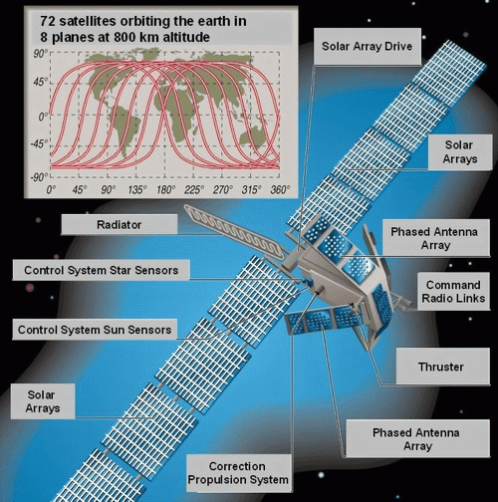

Figure 12
COURIER Applications
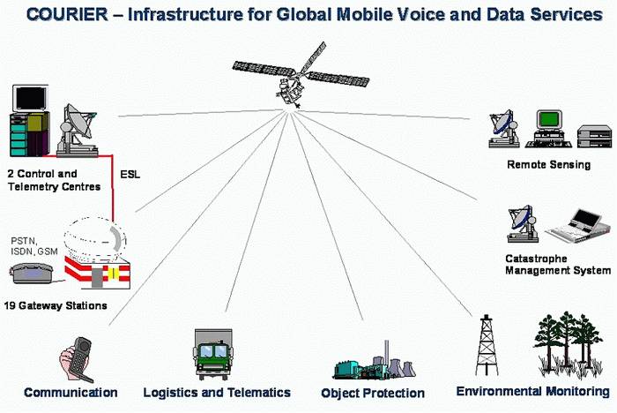

Figure 12bis

Rx Antenna Footprint of the COURIER Satellite

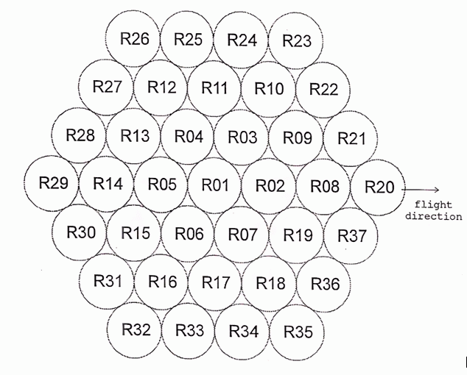

sharing analysis

Introduction

Propagation effects
Propagation losses in MSS result from several factors due to the mobile nature of the terminal as well as its low gain antenna. In L-band, two main contributors are multipath and shadowing. For a matter of simplification, the analysis contained in section 5 do not take into account shadowing effects.
As mentioned in several reference documents, including ITU-R recommendations, it was considered that the multipath fading follows a Ricean distribution. The ratio between the direct path and multipath components (Also noted K) varies according to the nature of terrain. A value of 5 was considered for high multipath situations and 13 for low multipath situations. It was assumed a constant value for the direct path and a random value for the multipath component.
Figure 13 gives the distribution functions obtained using these assumptions.
FIGURE 13
Ricean distribution of fading due to multipath
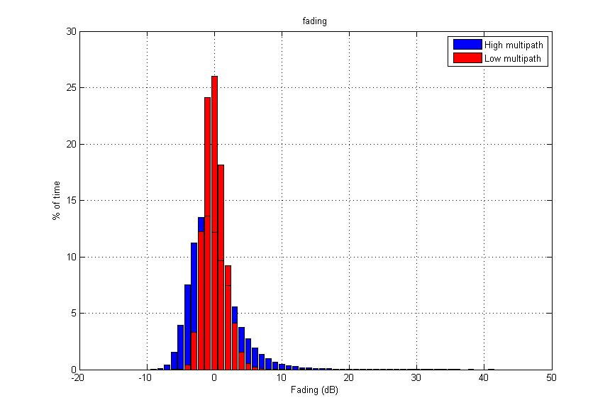

The mean value is 0 dB in both cases: The signal may be attenuated or, to the contrary, enhanced.
The effect of fading on the cross-polarization isolation or discrimination (CPI) has been assessed in the “handbook on propagation effects for vehicular and personal mobile satellite systems” (see ref 1). According to this book, the cross-polarization isolation varies with the fade value as follows:
$$\text{CPI}=−1\text{.}\text{605}A+\text{18}\text{.}\text{94}$$
where A is the co-polarized fade (in dB). Although the details of the antenna used for these measurements are not given, it should be identical to other measurements performed in this book, ie an antenna of 60° aperture (15 to 75° in elevation) and a decrease of 10 dB of the gain for elevation angles below 15°. The CPI maximum value is 19 dB, not far away from the 20 dB of an IRIDIUM terminal.
As no information is available on the variation of the CPI with the antenna gain it is proposed to retain the equation above as a first approximation. In order to take into account a possible change in the slope of the formula for handheld terminals, the calculation of interference from IRIDIUM to GLOBALSTAR has also been made assuming an alternative slope of 3 instead of 1.605 to represent a less directional antenna.
Additionaly, the fading and CPI values for handheld terminals need to take into account the effect of the body and head. An additional 3 dB fading value was assumed to take into account this effect.
Applying this equation with a slope of 1.605 to the fade values obtained above, we obtain the distributions in figure 14.
FIGURE 14
Distribution of cross-polarization isolation
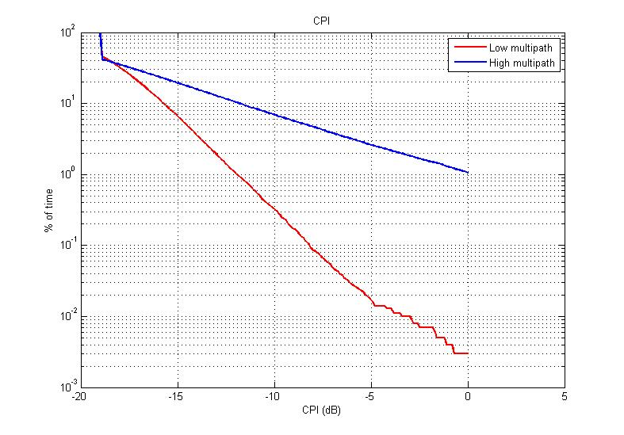
For example, for high multipath situations, there is no cross-polarisation effect during less than 1% of the time. This explains why the cross-polarization isolation may not be used within one single system, since there are particular moments in time this cross-polarization isolation may simply not exist.
The effect of precipitation on the CPI are assumed to be negligible at this frequencies compared to the effect of fading. Recommendation ITU-R P.618 gives a formula to calculate this effect only for frequencies above 4 GHz.
It has been assumed that the power control used by the handset is correlated with the fade level to the wanted path (the path between the IRIDIUM terminal and the IRIDIUM satellite). Using a Power control range of 8 dB, a nominal value of 8 dB and a step of 1 dB, the following equation and distribution may be derived.
$$\text{PC}=\text{max}(0\text{;min}(8\text{;int}(8−A)))$$
where A is the fade value on the path between the IRIDIUM terminal and the IRIDIUM satellite.
FIGURE 15
Distribution IRIDIUM terminals power control
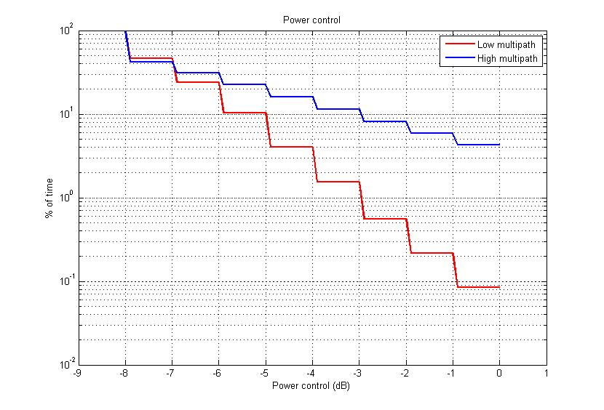
For high multipath situations, the terminal is emitting at full power less than 3% of the time, in order to compensate for fading.
The same assumptions were taken for GLOBALSTAR and COURIER, although this time the power control value is centred around a nominal value of 6 dB (thus allowing a nominal emission power value of -10 dBW) with a step of 0.5 dB.

Protection criteria
Two different protection criteria were considered for the CDMA MSS systems:
- An increase in noise + self interference (N+I) of 3%,
- An increase in noise (N) of 6%.
The results are given in terms of increase in the noise + self-interference. The increase in noise may be directly derived for GLOBALSTAR and COURIER using the following equation:
Increase in noise = Increase in noise plus self interference x 10.2
The interference criterion assumed for the TDMA system is based on the minimum signal to interference ratio (C/I).

Sharing scenarios
Figure 16
Sharing scenarios
CDMA (GLOBALSTAR OR COURIER)
TDMA (IRIDIUM)

Scenario 1
Scenario 4
Scenario 2
Scenario 3

SCENARIO 1: TDMA satellite to CDMA satellite
The allocation to MSS (space-to-Earth) is on a secondary basis, which means that MSS satellites shall not cause harmful interference to other primary services allocated in the same frequency band, such as MSS (Earth-to-space).
Each GLOBALSTAR satellite will suffer from interference from both IRIDIUM terminals deployed on the ground and IRIDIUM satellites emitting in the same band. This analysis evaluates the level of interference created by IRIDIUM satellites in one GLOBALSTAR satellite beam and channel.
At one moment in time, one GLOBALSTAR satellite will be in visibility of about 14 to 20 IRIDIUM satellites, as shown in Figure 17.

FIGURE 17
IRIDIUM satellites in visibility of one GLOBALSTAR satellite
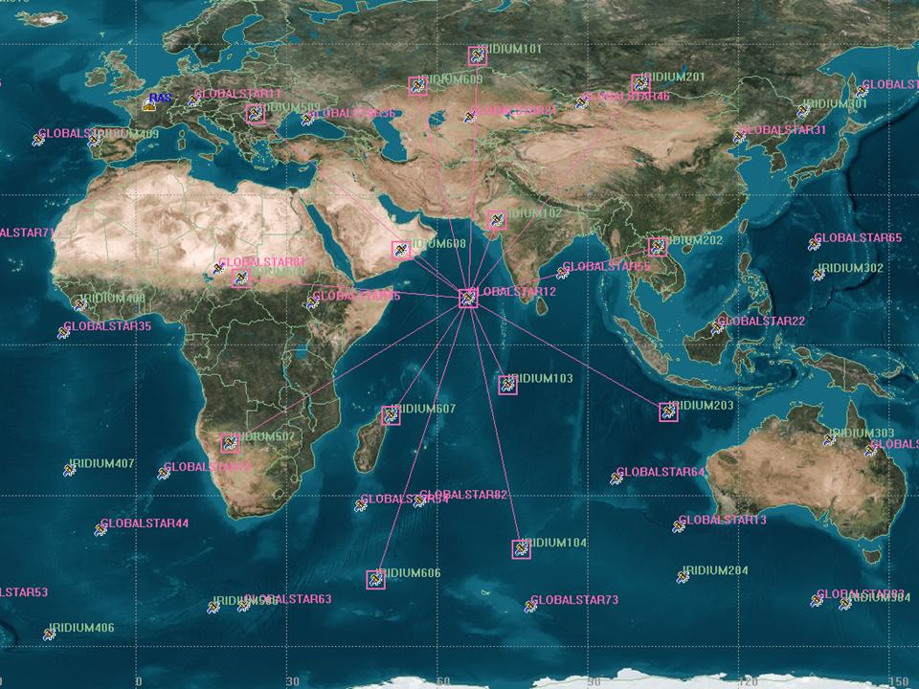

The total interference received will be the aggregate interference coming from those satellites in visibility. The interference generated by one single IRIDIUM satellite can be calculated using this equation:

$$I=\sum_{i}{\sum_{j}{\frac{\text{Pe}(i,j)\text{Ge}(i)\text{Gr}λ^{2}}{(4πd)^{2}L}}}$$
where

Pe(i,j) Emission power in channel j in beam i
Ge(i) Antenna gain of beam i towards the GLOBALSTAR satellite
Gr Antenna gain of the GLOBALSTAR beam towards the IRIDIUM satellite
λ Wavelength
d Distance between the IRIDIUM and GLOBALSTAR satellites
L Diverse losses
A GLOBALSTAR terminal is located at a given position on the Earth. At each instant, the interference is calculated in the satellite beam pointing towards the terminal.
NUMBER OF IRIDIUM CHANNELS PER GLOBALSTAR CHANNEL
The total number of channels to be considered depends on the activity of each satellite at one moment in time. The maximum number of channels per IRIDIUM satellite emitting at one moment in time in a GLOBALSTAR channel, is:
$$\text{nbchannel}=\text{nbbeam}\frac{B_{\text{GLOBALSTAR}}}{F\text{.}B_{\text{IRIDIUM}}}$$
where
nbbeam Number of beams per IRIDIUM satellite (48)
B_{GLOBALSTAR} GLOBALSTAR channel bandwidth (1230 kHz)
B_{IRIDIUM} IRIDIUM channel separation (41.7 kHz)
F Frequency reuse factor (12 or 5)
This gives at maximum 120 IRIDIUM channels active per IRIDIUM satellite for a frequency reuse factor of 12 and 283 for a frequency reuse factor of 5. It should be noted that the frequency reuse factor of 5 is used as the satellites orbit the poles, where population density is the lowest.
POWER PER CHANNEL
The power radiated by IRIDIUM satellites per channel is, according to recommendation ITU-R M.1184, between -10 dBW (unshadowed) and +2 dBW (shadowed). This does not take into account the voice activity factor of 40% (4 dB) for terminals transmitting in voice mode. An average value of -14 dBW per channel has been assumed in the analysis for terminals in voice mode and +2 dBW for terminals in data mode. In practice, the IRIDIUM network supports a mixture of terminals transmitting voice and data traffic.
IRIDIUM ANTENNA GAIN
The antenna gain of the IRIDIUM satellite towards the GLOBALSTAR satellite varies with the direction of the GLOBALSTAR satellite, the antenna panel considered and the beam considered on the panel.
The distance between the GLOBALSTAR and IRIDIUM satellites varies from 630 to 7700 km. When the distance is minimal, the IRIDIUM satellite is just below the GLOBALSTAR satellite, in one of the GLOBALSTAR antenna beams. In this case the antenna gain of the IRIDIUM satellite towards the GLOBALSTAR satellite is minimal, corresponding to the backlobes. No information on the Iridium satellite antenna diagram was provided. Therefore a value of -6 dBi has been assumed, taking into account recommendation ITU-R S.1528, and extrapolating from the minimum value of 3.4 GHz for which this recommendation is valid. It is noted that the level of an unshielded backlobe of an active array such as the IRIDIUM antenna may be much higher. The value of -6 dBi should be considered as a compromise, noting that the GLOBALSTAR L-band phased array antenna was measured at less than -10 dBi.
The elevation angle of GLOBALSTAR satellites as seen from one IRIDIUM satellite varies between -27 and 90°. As the antenna panels on board the IRIDIUM satellites are tilted by 40° from the vertical, the minimum offset angle between the panel boresight and the GLOBALSTAR satellite is therefore 13° (40° - 27°). As the outer beams are pointed from the panel boresight by more than 13° this means that some emissions from the IRIDIUM satellite main beams may be encountered. However in this case the GLOBALSTAR satellite will be separated by about 7000 km from the IRIDIUM satellite, leading to a free space loss 20 dB higher than the case where the distance is minimal.
GLOBALSTAR ANTENNA GAIN
Information found on the Internet and confirmed by GLOBALSTAR, gives the following antenna pattern for one of the outer beams of the GLOBALSTAR satellite antenna.
FIGURE 18
GLOBALSTAR satellite antenna pattern measured
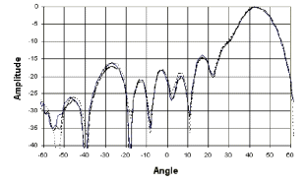
Since the interference will be the aggregate effect of several IRIDIUM satellites it is proposed to retain this average pattern for the sidelobes rather than a peak pattern. One antenna beam is therefore modelled using the following simplified antenna pattern.
FIGURE 19
GLOBALSTAR satellite antenna pattern modelization (single beam)
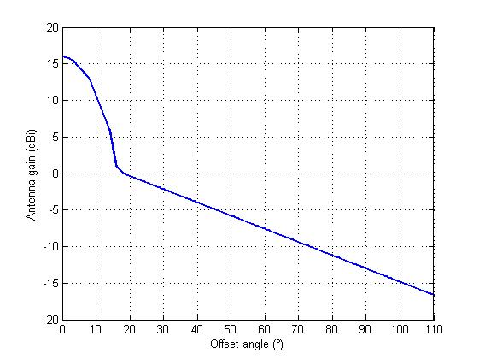
The overall antenna combines 16 beams, one is in the centre and the other ones compose 2 rings around it. The combined antenna pattern is given herafter.
FIGURE 20
GLOBALSTAR satellite antenna pattern modelization (all beams)
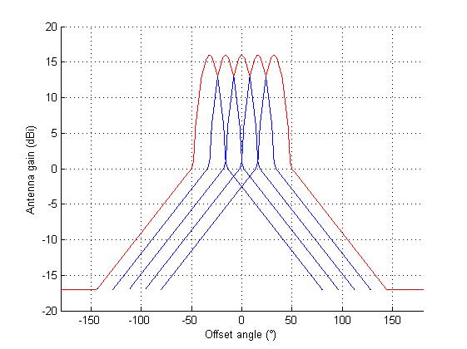

As the same frequency is used from one beam to the other, this is roughly equivalent to the antenna pattern of a single beam antenna following a terminal on the ground while the satellite is in visibility from the terminal with an elevation angle greater than 10°.
It should be noted that both Iridium’s and Globalstar’s satellite transmit and receive antennas are designed so that the power level received to or from anywhere within the footprint is equal. It is, therefore, necessary that the outer beams are designed with a higher gain than the inner beams or boresight beam. Therefore, the assmption, made for the purpose of this analysis, that the gain is equal across all beams represents a simplification.
DIVERSE LOSSES
Polarisation losses are not considered here since the emissions of IRIDIUM satellites are in the sidelobes of the antenna. In this case both RHCP and LHCP component are at the same level.
SIMULATION RESULTS
Using these assumptions, the movement of the satellites of both constellations has been simulated over one hour.
The increase in noise + self interference in one GLOBALSTAR channel at the satellites in visibility from one terminal located at 16°W 45°N is shown in figures 21 (frequency reuse factor of 12) and 21bis (frequency reuse factor of 5) for the IRIDIUM satellites fully loaded with only voice activity.
FIGURE 21
Interference from IRIDIUM satellites to GLOBALSTAR satellites as seen by a singular GLOBALSTAR terminal (frequency reuse factor of 12 and voice activity)
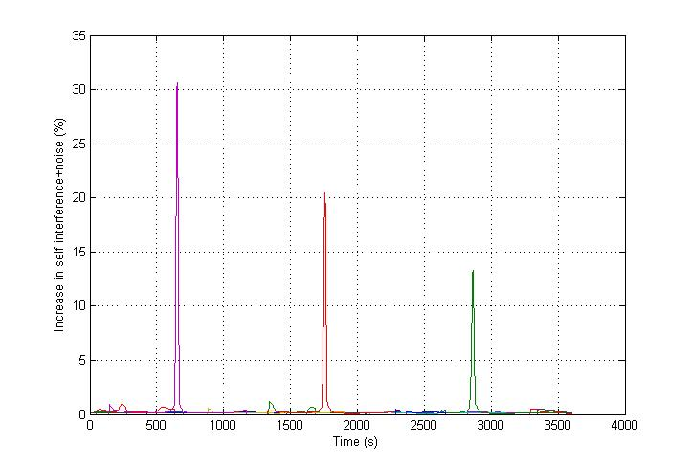
FIGURE 21bis
Interference from IRIDIUM satellites to GLOBALSTAR satellites as seen by a singular GLOBALSTAR terminal (frequency reuse factor of 5 and voice activity)
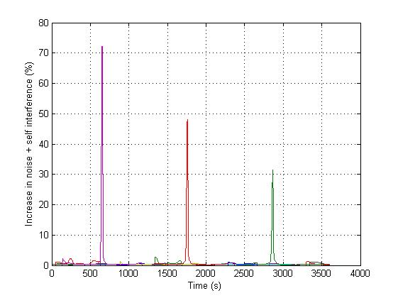

It can be seen that, assuming a fully loaded IRIDIUM system with only voice activity, the GLOBALSTAR satellites in communication with a given terminal will suffer during this hour of simulation from harmful interference during 3 periods each of 30 seconds duration, equating to 2.5% of the time.
In the GLOBALSTAR system, the Rake receiver concept is exploited by intentionally creating diversity paths through alternate beams and satellites. The user terminals naturally create intentional diversity paths since their near omnidirectional antennas transmit multiple beams to multiple satellites. The satellite diversity used in the GLOBALSTAR system may mitigate the interference for a given terminal in some cases. However in other cases, or for other terminals, such a high interference may result in the call being interrupted.
When assuming that all IRIDIUM channels are active in data mode, at full power, then the emission power becomes +2 dBW, and the interference is increased as shown in figures 22 and 22bis.
FIGURE 22
Interference from IRIDIUM satellites to GLOBALSTAR satellites as seen by a singular GLOBALSTAR terminal (frequency reuse factor of 12 and data activity)
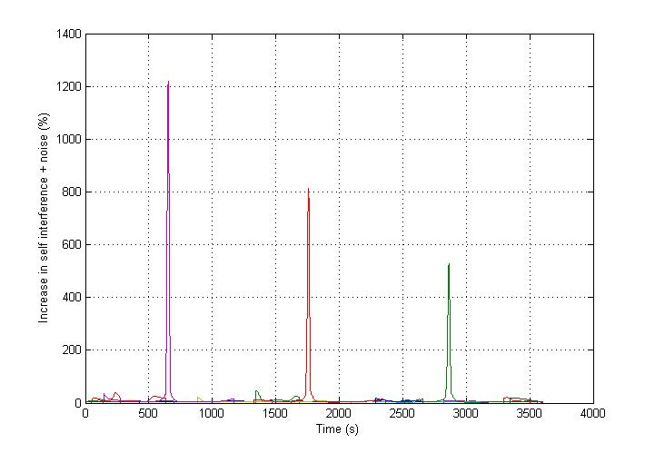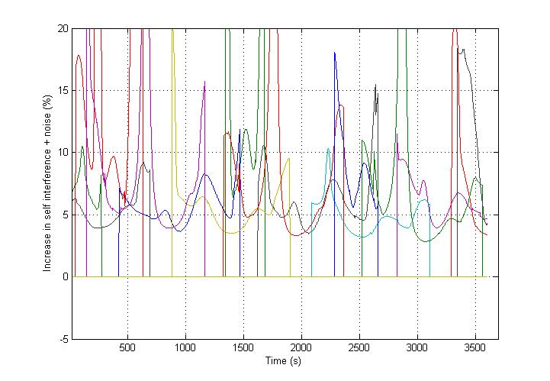
FIGURE 22bis
Interference from IRIDIUM satellites to GLOBALSTAR satellites as seen by a singular GLOBALSTAR terminal (frequency reuse factor of 5 and data activity)
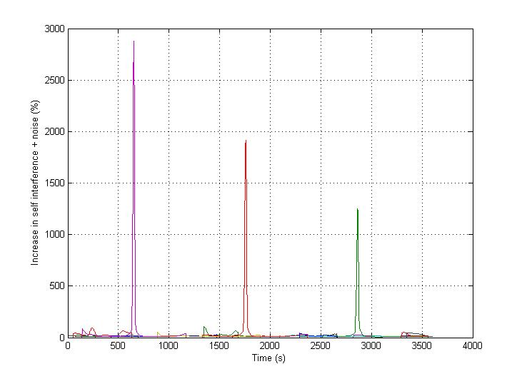
It can be seen that, assuming a fully loaded IRIDIUM system with only data activity, the GLOBALSTAR satellites in communication with the terminal will suffer during this hour of simulation from harmful interference during 100% of the time.
If the number of active channels per IRIDIUM satellite is reduced from 120 to 10, then in this case the increase in I+N becomes acceptable as shown in figure 23 (the corresponding increase in N is still above the 6% criterion).
FIGURE 23
Interference from IRIDIUM satellites to GLOBALSTAR satellites as seen by a singular GLOBALSTAR terminal (IRIDIUM not fully loaded, voice activity)
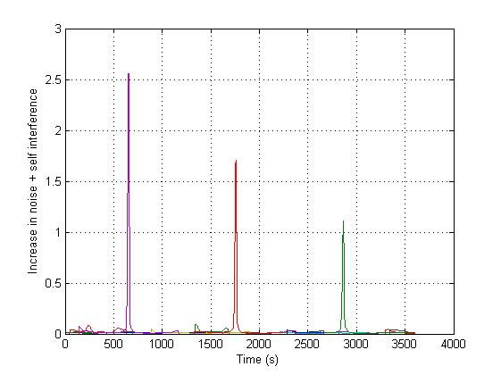

As COURIER satellites altitude is lower than GLOBALSTAR, the interference from IRIDIUM satellites into COURIER satellites would be greater in magnitude than that from IRIDIUM satellites into GLOBALSTAR satellites.

SCENARIO 2: TDMA handset to CDMA satellite
The maximum possible number of TDMA channels per CDMA channel and footprint is given by the following equation
$$\text{nbchannel}=\text{nbbeam}\frac{B_{\text{Globalstar}}}{F\text{.}C_{\text{Iridium}}}$$
where,
nbchannel: Number of TDMA frequency channels per CDMA beam,
nbbeam: Number of TDMA cells contained in one CDMA beam
B_{Globalstar}: CDMA channel bandwidth (kHz),
C_{Iridium}: TDMA channel width (kHz),
F: Frequency reuse factor.
For a frequency reuse factor of 5, this equation gives 18 IRIDIUM channels per GLOBALSTAR beam and channel and 6 IRIDIUM channels per COURIER beam and channel. The analysis does not take into account the effect of adjacent IRIDIUM beams or channels which may increase the level of interference received by the CDMA system.
The wanted CDMA signal does not need to be considered since it does not participate in the criterion. The following methodology was adopted :
- The number of IRIDIUM terminals is calculated according the formula agreed in previous meetings. It contains a given percentage of voice terminals and the complement of data terminals.
- The average power of the IRIDIUM terminal is calculated according to the explanation given in previous meetings. It includes a voice activity factor for voice signals and time-averaging of the time slot power over the duration of a frame.
- For each terminal
  - A random coefficient K is determined, following a uniform distribution, between 5 and 13. This coefficient determines the multipath environment where this terminal is located.
  - A multipath random fading value is determined, following a Ricean distribution characterised by the coefficient K.
  - A cross polarisation isolation is determined from this multipath fading value using the linear formula extracted from the MSS propagation handbook.
  - A power control value is determined from this same multipath value since the attenuation on the wanted path is the same as the attenuation on the unwanted path
  - The interference received at the CDMA satellite from this terminal is derived from the average power, minus the fading value, minus the cross-polarisation isolation (only for the GLOBALSTAR case), minus the power control (if voice signal is transmitted), minus the free-space loss, added to the terminal and satellite antenna gains.
- The interferences produced by each terminal are linearly summed and give the aggregate interference.
This calculation is performed 100000 times and the results given as a cumulative distribution function. This allows determining the degradation related to a percentage of time ranging from 0.001 to 100%.
The calculation has been made assuming a frequency reuse factor of 5 for the IRIDIUM system.
The following figure gives the results obtained for GLOBALSTAR, for 3 configurations (100% data terminals, 100% Voice terminals and 50-50% of Voice and Data terminals).
FIGURE 24
Interference generated by IRIDIUM terminals to GLOBALSTAR satellite
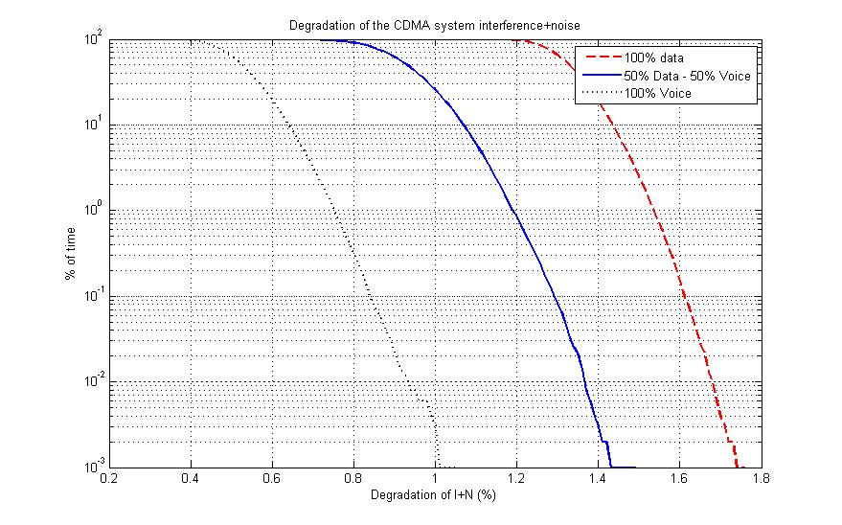

Figure 24bis gives the same results when an additional 3 dB fade due to body or head is assumed for handset terminals.
FIGURE 24BIS
Interference generated by IRIDIUM terminals to GLOBALSTAR satellite with an additional 3 dB fade due to human body
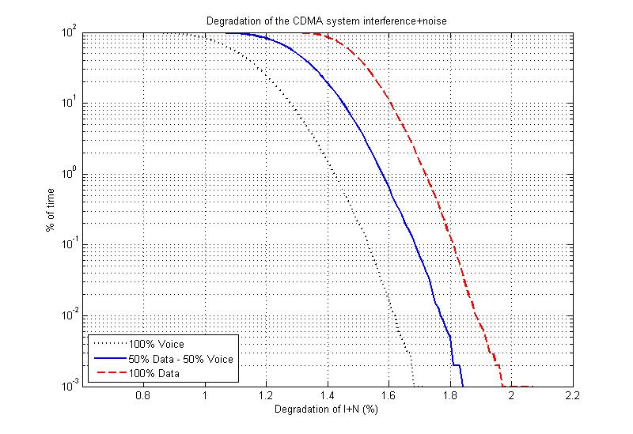
For a slope of 1.605 for the CPI formula for all configurations and percentages of time the degradation of noise + self interference is below the value of 3%.
Figure 24ter gives the same results as figure 24 but with a value of 3 (rather than 1.605) for the slope of the formula giving the cross-polarization isolation degradation vs fading.
FIGURE 24TER
Interference generated by IRIDIUM terminals to GLOBALSTAR satellite for a slope of 3
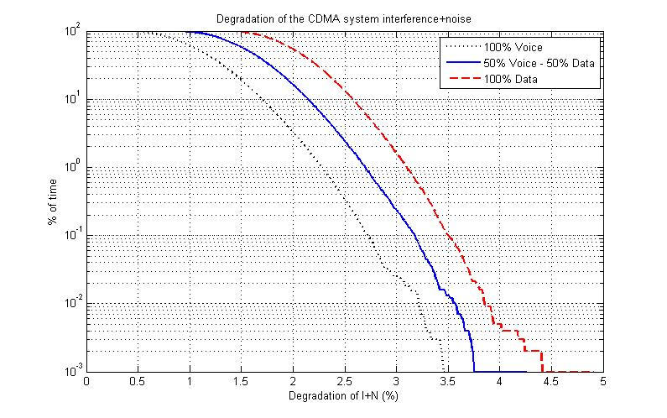
In this case the protection criterion of 3% of degration of I+N is exceeded for a deployment of IRIDIUM terminals transmitting only in data mode (without power control) for 1.5% of the time.

Figure 24qua gives the same results as figure 24bis but with a value of 3 (rather than 1.605) for the slope of the formula giving the cross-polarization isolation degradation vs fading.
FIGURE 24QUA
Interference generated by IRIDIUM terminals to GLOBALSTAR satellite for a slope of 3 and an additional fade of 3 dB due to human body
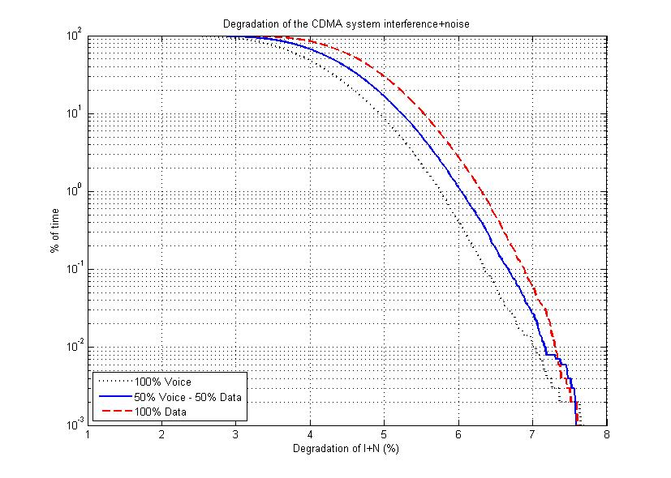
In this last case the protection criterion is exceeded all the time.
The increase in noise+self interference is summarized in Table 5. In all cases the 6% increase in noise criterion is exceeded for 100% of time.
TABLE 5
% of time of harmful interference from IRIDIUM Terminals to GLOBALSTAR satellite
Slope | Human body (dB) | Voice | Voice / Data | Data
1.605 | 0 | 0 % | 0 % | 0 %
1.605 | 3 | 0 % | 0 % | 0 %
3 | 0 | 0.02 % | 0.2 % | 2 %
3 | 3 | 100 % | 100 % | 100 %
The same analysis was performed for COURIER, using the same polarisation as IRIDIUM. The results are given in the figure below. In this case the protection criteria for COURIER are exceeded in all cases.
FIGURE 25
Interference generated by IRIDIUM terminals to COURIER satellite
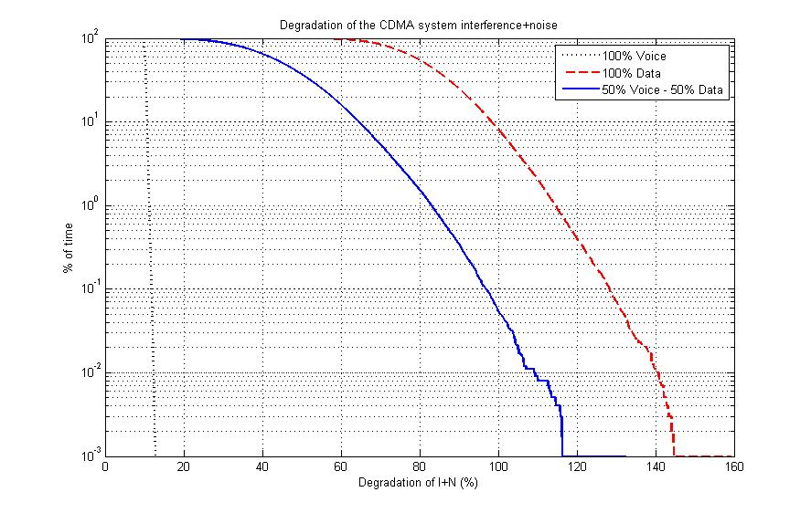

The satellite diversity used in the GLOBALSTAR system may mitigate the interference for a given terminal in some cases. However in other cases, or for other terminals, high interference levels may result in the call being interrupted.
In Europe, considering a GLOBALSTAR system with 48 operationnal satellites, for look angles greater than 10°, 2 GLOBALSTAR satellites are in view for a minimum of 95% of the time, 3 satellites are in view for a minimum of 70% of the time and 4 satellites are in view for a minimum of 10% of the time.

SCENARIO 3: CDMA handset to TDMA satellite
In this case the protection criterion is a C/I ratio of 18 dB. The following methodology was adopted:
- The power of the CDMA terminal may vary between -4 dBW (or 26 dBm) under high fading conditions and -20 dBW (or 10 dBm) under low fading conditions. The value of -10 dBW is the nominal value (corresponding to a fading value of 0 dB). This power value in 1230 kHz is then scaled to the IRIDIUM bandwidth of 31.5 kHz.
- The average power of the IRIDIUM terminal is calculated according to the explanation given in previous meetings. Only the Data signal case (corresponding to an emission at full power) is analysed.
- For each CDMA terminal
  - A random coefficient K is determined, following a uniform distribution, between 5 and 13. This coefficient determines the multipath environment where this terminal is located.
  - A multipath random fading value is determined, following a Ricean distribution characterised by the coefficient K.
  - A cross polarisation isolation is determined from this multipath fading value using the linear formula extracted from the MSS propagation handbook.
  - A power control value is determined from this same multipath value since the attenuation on the wanted path is the same as the attenuation on the unwanted path
  - The interference received before the antenna of the TDMA satellite from this terminal is given by the power, minus the fading value, minus the cross-polarisation isolation (only for the GLOBALSTAR case), minus the power control, minus the free-space loss, added to the terminal antenna gain.
- The interferences produced by each terminal are linearly summed and give the aggregate interference.
- The wanted signal before the TDMA satellite antenna is the sum of the TDMA average power, the TDMA emission antenna gain, minus the fading value, minus the free-space loss.
- The C/I is then compared to the 18 dB criterion.
This calculation is performed 100 000 times and the results given as a cumulative distribution function. This allows determining the degradation related to a percentage of time ranging from 0.001 to 100%.
The following figure shows the results in terms of C/I for an IRIDIUM terminal transmitting voice or data signals in presence of 40 GLOBALSTAR terminals. The C/I is over 18 dB less than 45% of the time for the data signal case, and 70% of the time for the voice signal case, where power control is used. This means that in order to compensate, the terminal will emit at maximum power, leading to the data terminal case.
FIGURE 26
Interference generated by GLOBALSTAR terminals to IRIDIUM satellite
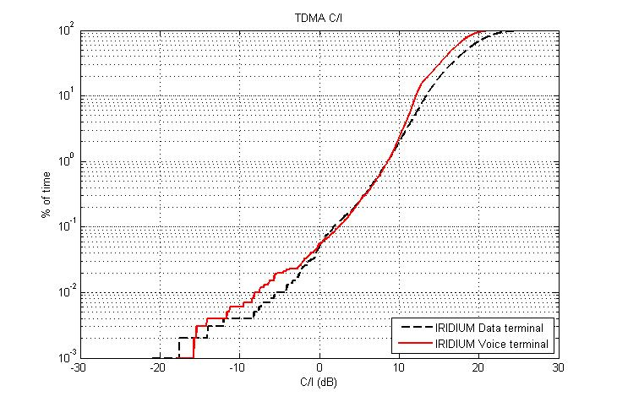

The following figure shows the results in terms of C/I for an IRIDIUM terminal transmitting voice or data signals in presence of 49 COURIER terminals. The C/I is always below 18 dB.
FIGURE 27
Interference generated by COURIER terminals to IRIDIUM satellite
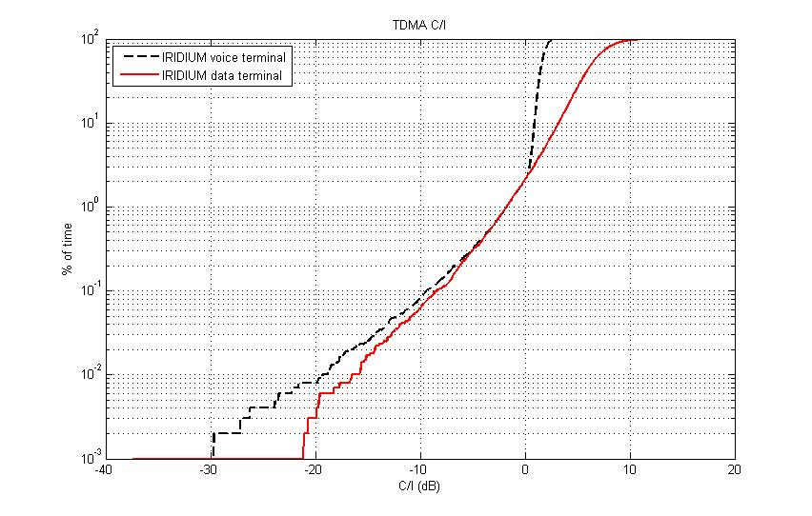

SCENARIO 4: CDMA handset to TDMA handset
The allocation to MSS (space-to-Earth) is on a secondary basis which means that any MSS Earth station or terminal shall not claim protection from other primary services allocated in the same frequency band, such as MSS (Earth-to-space).
This analysis has not been performed.

MEASUREMENT OF RADIO LINK FAILURES ON GLOBALSTAR
A Special Temporary Authority (STA) was given to IRIDIUM by the FCC in August 2005 to operate in the frequency band 1616-1618.25 MHz, which is used by GLOBALSTAR, from 2nd September 2005 to 1st November 2005 during an emergency situation (Hurricane “Katrina” in August 2005).
- The complete GLOBALSTAR channel 7 band is from 1617.495 to 1618.725 MHz.
- The complete GLOBALSTAR channel 8 band is from 1618.725 to 1619.955 MHz.
During the STA period the entire GLOBALSTAR channels 7 and 8 were shared with IRIDIUM. Before and after the STA, the 1618.25 to 1618.725 MHz portion of channel 7, as well as the entire Channel 8, are shared with IRIDIUM.
Figure 28 shows the radio link failures (RLF) by channel for GLOBALSTAR’s Clifton gateway service from August 3 to November 23, 2005. An RLF is registered when the link can not be closed.
Figure 28 shows:
- That the percentage of radio link failures increased in GLOBALSTAR channels 7 and 8 at the beginning of the event and continued to be high compared to channel 3 after the 3 of September 2005 (The RLF data is only available for channel 3 after approximately the 3rd September 2005).
- That GLOBALSTAR’s RLF rate nearly tripled during the 4 day period of 28th August to 1st September 2005.
- That GLOBALSTAR’s RLF rate for channel 8 is nearly identical on 23rd November, 3 weeks after the STA expired, as it was on the 1st September, prior to the STA.
- That GLOBALSTAR’s RLF rate for channels 7 and 8, which are still shared with IRIDIUM partially or entirely, respectively, increases over the 3 weeks period following the expiration of the STA.
- The results of the test conducted by GLOBALSTAR from October 27 to October 31, 2005, after GLOBALSTAR channel 7 had been replaced with GLOBALSTAR channel 4. During this test period, the RLF in Channel 4 were identical to the RLF in Channel 3. In contrast, RLF in Channel 8 continued to remain high during this period. On November 1, Channel 7 was brought back in service to confirm the previously observed performance degradation. The RLF in Channel 7 returned to its high rate after it was switched with Channel 4, and the performance did not match the superior performance of Channel 4 during the test period.
FIGURE 28
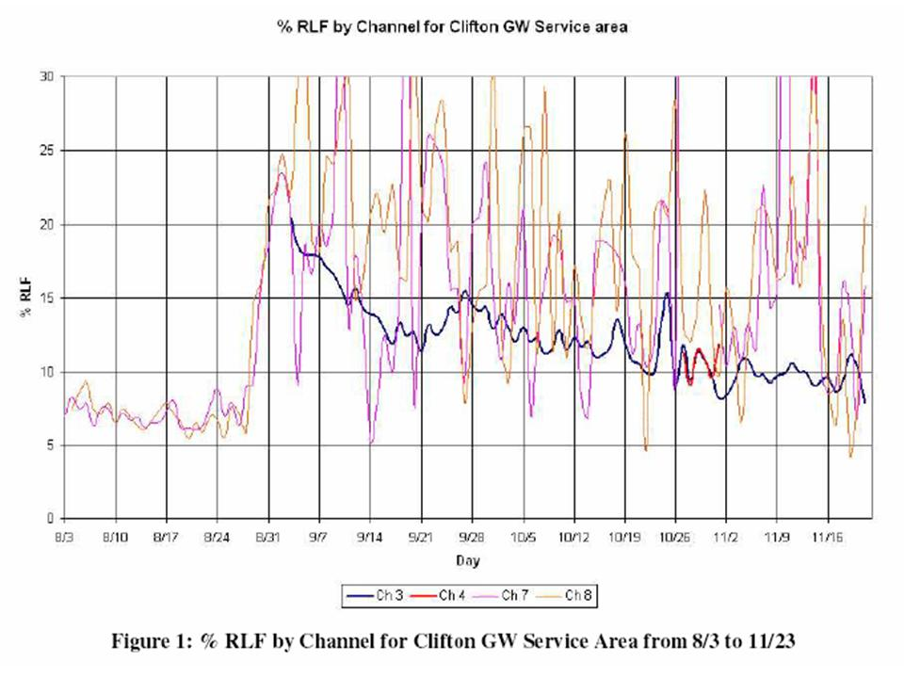

CONCLUSIONS
The studies show that:
- In order to operate on a co-frequeny basis at full capacity, the German system COURIER has to use a polarization orthogonal to GLOBALSTAR, and therefore the same as IRIDIUM.
- The IRIDIUM satellite will suffer from harmful interference from a deployment of GLOBALSTAR terminals during 45% of the time at best, which confirms the studies conducted by SE28 in 1998.
- The IRIDIUM satellite will suffer from harmful interference from a deployment of COURIER terminals during 100% of the time when operating on a co-polarization and co-frequency basis.
- The GLOBALSTAR satellite will suffer from interference from IRIDIUM handsets, which may or may not exceed the defined protection criterion. This is dependant upon the assumptions made, including those concerning the cross-polarisation isolation and the shielding due to the proximity of the handheld terminal to the human body. Table 6 gives (for a frequency reuse factor of 5) the percentage of time for which the increase in noise+self interference exceeds 3% in all situations. The 6% increase in noise criterion is exceeded for 100% of time in the situations shown.
TABLE 6
% of time of harmful interference from IRIDIUM Terminals to GLOBALSTAR satellite
Slope | Human body (dB) | Voice | Voice / Data | Data
1.605 | 0 | 0 % | 0 % | 0 %
1.605 | 3 | 0 % | 0 % | 0 %
3 | 0 | 0.02 % | 0.2 % | 2 %
3 | 3 | 100 % | 100 % | 100 %
- The COURIER system, operating on a co-polarization and co-frequency basis with the IRIDIUM system, will suffer from harmful interference from a maximum deployment of TDMA terminals during 100% of the time for all above cases.
- The GLOBALSTAR satellites will suffer from unacceptable interference from IRIDIUM satellites (irrespective of the polarisation that is used) when the IRIDIUM system is fully loaded, as shown in Table 7.
TABLE 7
Interference from IRIDIUM satellites to GLOBALSTAR satellites
IRIDIUM Activity | Frequency reuse factor | Maximum increase in noise + self interference * | % of time the 3% N+I criterion is exceeded
Voice | 12 | 30 % | 2.5 %
Voice | 5 | 70 % | 2.5 %
Data | 12 | 1200 % | 100 %
Data | 5 | 3000 % | 100 %
* There is a ten-fold increase in noise against the 6% criterion during the same period of time

- Unlike GLOBALSTAR, the COURIER satellites are planned to operate in close proximity of the IRIDIUM satellites. Although this case was not simulated, simple geometrical considerations show that the noise + interference level in a COURIER channel will exceed the GLOBALSTAR case by far. Therefore the results of Table 7 have to be considered as too optimistic for the COURIER system.

References

- Julius Goldhirsh and Wolfhard J. Vogel, “Handbook of propagation effects for vehicular and personal mobile satellite systems”
- Seong-Youp Suh, "A propagation simulator for Land mobile satellite communications”
- Motorola, “Sharing Analysis between CDMA and TDMA”
- Document SE28(96)41
- Leonard Schiff and A Chockalingham, Qualcomm Inc., “Design and system operation of Globalstar versus IS 95 CDMA – similarities and differences”.

ANNEX 1

Co-frequency interference from CDMA GLOBALSTAR into CDMA COURIER and vice versa if both systems are at capacity
 | Interference from Courier into Globalstar |  | Interference from Globalstar into Courier
 | Orthogonal polarization | Same polarization | Orthogonal polarization | Same polarization
Frequency (MHz) | 1618 | 1618 | 1618 | 1618
CDMA MSS system channel BW (kHz) | 1230 | 1230 | 1230 | 1230
Average CDMA transmit power per carrier (dBW) | -10 | -10 | -10 | -10
Number of CDMA channels per carrier | 49 | 49 | 40 | 40
Average CDMA transmit power per carrier (dBW) | 6,9 | 6,9 | 6,0 | 6,0
Terminal antenna gain (dBi) | 0 | 0 | 0 | 0
Number of interferening CDMA beams per CDMA MSS system beam | 3 | 3 | 1 | 1
Aggregate EIRP per CDMA MSS beam and channel (dBW) | 11,7 | 11,7 | 6,0 | 6,0
Typical range at 40 degree Elevation (km) | 1952 | 1952 | 1105 | 1105
Path loss (dB) | -162,4 | -162,4 | -157,5 | -157,5
CDMA MSS satellite receive antenna gain (dBi) | 16 | 16 | 16,8 | 16,8
Cross-polarization discrimination + fading + Power control (dB) | -17 | 0 | -17 | 0
Interference per beam from other CDMA users received at CDMA MSS satellite input (dBW) | -151,8 | -134,8 | -151,7 | -134,7
CDMA MSS typical self interference plus thermal noise density (dBW/Hz) | -192,4 | -192,4 | -192,4 | -192,4
CDMA MSS typical self interference plus thermal noise in the whole CDMA MSS band (dBW) | -131,5 | -131,5 | -131,5 | -131,5
Allowable % degradation due to external interference | 3% | 3% | 3% | 3%
Actual degradation in self-interference plus noise | 0,951% | 47,656% | 0,971% | 48,651%

EIRP = 8.5 + (10*log((2*8)/90) = 1 dBW
For data traffic Iridium handset transmits at maximum EIRP

