Analysis of the suitability and update of the regulatory technical conditions for 5G MFCN and AAS operation in the 2300-2400 MHz band

approved 18 November 2022

ECC Report 347

# 0BExecutive summary

The development of this Report was triggered in March 2020 by the need to assess the technical conditions in ECC Decision (14)02 [1] to enable a timely introduction of 5G and AAS (Active Antenna Systems), while maintaining adequate protection of other services and applications and to adapt them accordingly.

The 2300-2400 MHz frequency band is in the Radio Regulations [2] in Region 1 allocated to the following services: FIXED, MOBILE (FN 5.384A), amateur and radiolocation and through FN 5.384A identified for IMT. Furthermore, through FN 5.395 this band is identified in France and Turkey for telemetry (with priority over mobile service). The frequency band is still frequently used for Military systems, Telemetry and PMSE (portable or mobile wireless video and cordless cameras) in CEPT countries, with 13 countries implementing Mobile/Fixed Communications Networks (MFCN) in the band, or part of the band, according to ECC Decision (14)02.

This ECC Report summarises the current harmonised technical conditions defined for MFCN in the 2300‑2400 MHz band in ECC Decision (14)02, approved 27 June 2014, and studies their suitability for 5G NR and AAS, while maintaining the current regulatory status of the band.

The introduction of AAS in this frequency band will only be effective on the Base Station (BS) side as it is not foreseen for the User Equipment (UE).

This Report concludes on the need to update the regulatory framework to support the introduction of 5G NR and AAS in the 2300‑2400 MHz band, and recommends an updated framework. It is concluded that there is no need to update the current band plan for 2300‑2400 MHz in ECC Decision (14)02. The analysis confirms that the current technology neutral Block Edge Mask (BEM) remains applicable for 5G NR non-AAS MFCN, and confirms the need for a new BEM for AAS MFCN (5G NR as well as LTE).

For AAS MFCN, a technology neutral BEM is derived, consisting of Total Radiated Power (TRP) limits for the in-block, baseline and transitional regions, with limits defined for synchronised and unsynchronised (or semi-synchronised) operation. The BEM also includes a mandatory in-block power limit in the frequency range 2390‑2400 MHz and additional baseline requirements above 2403 MHz, ensuring that the compatibility between AAS MFCN networks in 2300-2400 MHz and applications (e.g. SRD, ISM, etc.) in the adjacent band above 2400 MHz is the same as currently for non-AAS MFCN networks.

For the case of unsynchronised (or semi-synchronised) MFCN operation, the baseline TRP limit for AAS BS is -45 dBm/(5 MHz) per cell. This baseline power limit, which guarantees compatibility between different MFCN users within the band, cannot be achieved without additional operator specific filtering, which at the time of the publication of this Report it is not possible to cost-effectively implement for AAS. Operation of unsynchronised AAS BSs would instead require a guard band0F[1] that significantly affects an efficient spectrum use, and without operator specific filters a guard band alone may not be sufficient to enable operation of unsynchronised AAS BSs. Alternatively, other mitigation techniques which could enable unsynchronised operation of AAS MFCN in the 2300-2400 MHz band require additional isolation between BSs, e.g. geographic separation or low power indoor use. With mobile network operators expected to provide access to the 2300-2400 MHz band on a wide area basis, geographic separation between MFCN operators is unlikely to be a viable solution for outdoor deployments. Therefore, in the case of two or more wide area operators, synchronised operation of AAS MFCNs (outdoors) is recommended in the 2300-2400 MHz band. To avoid unsynchronised operation, one option could be to have only one operator within the 2300-2400 MHz frequency band.

Field strength values for cross-border coordination for non-AAS MFCN are specified in ECC Recommendation (14)04 [3]. For AAS MFCN an update of the ECC Recommendation (14)04 will be needed.

Also, for cross-border coexistence additional coordination may need to be considered, not only to mitigate cross-border interference across MFCN networks, but also to protect other incumbent services. Conclusions from ECC Report 172 [4] related to isolation or separation distances with other services such as aeronautical/terrestrial telemetry remain valid for AAS MFCN under the assumptions used in the simulations, in particular the 46 dBm/(20 MHz) TRP in-block BS power. For the co-channel case higher in-block BS power will typically result in larger coordination distances, noting that this also depends on many other parameters such as actual radio propagation condition, BS/victim antenna height and antenna gain, etc.

To protect the existing rights of in-band incumbent systems, some administrations have defined out-of-block (in-band) e.i.r.p. limits. The equivalent TRP limits for AAS MFCN may not be achievable, meaning that the operation of AAS MFCN in the 2300-2400 MHz band may not be possible in these countries without the implementation of a guard band, geographical separation, or restricting MFCN deployment to low BS power or indoor use only. A guard band is not a spectrally efficient solution, while the feasibility of geographical separation and that of having AAS MFCN operating in the band will depend on the incumbent use in each country and on their adopted e.i.r.p./TRP limits (if any).

TABLE OF CONTENTS

0 Executive summary 2

1 Introduction 7

2 Existing regulatory framework for MFCN systems 8

2.1 Existing band plan 8

2.2 Existing technical conditions – BEM requirements 8

2.2.1 General information regarding the BEM 8

2.2.2 In-block requirements for MFCN base stations 8

2.2.3 Baseline requirements for TDD base stations (non-AAS) 9

2.2.4 Transitional region requirements for MFCN base stations 9

2.2.5 Relation of the existing non-AAS synchronised baseline and transitional region BEM power limits to the ETSI operating band unwanted emission mask 9

2.3 Licensed Shared Access 10

3 Suitability of current technical framework for 5G 12

3.1 Suitability for non-AAS MFCN base stations 12

3.2 Suitability for AAS MFCN base stations 12

3.2.1 Out-of-band domain 13

3.2.2 Implications from the AAS architecture 13

3.2.3 Synchronised and unsynchronised operation 14

3.2.4 In-band incumbent systems 15

3.2.5 Suitability of LSA for MFCN with AAS 15

4 In-band and adjacent band services overview and coexistence analyses 16

4.1 Overview of spectrum situation 16

4.2 In-band and adjacent band coexistence analysis for AAS MFCN BS 16

4.2.1 Adjacent-band coexistence analysis for AAS MFCN BS below 2300 MHz 16

4.2.2 In-band coexistence analysis for AAS MFCN in 2300-2400 MHz 20

4.2.3 Adjacent-band coexistence analysis for AAS MFCN above 2400 MHz 25

5 Recommended updates to the regulatory Framework 29

5.1 Recommended band plan 29

5.2 Applicable technical conditions 29

5.2.1 BS in-block power limits 29

5.2.2 BS out-of-block power limits 29

5.2.3 BS out-of-band power limits: Interference towards adjacent applications above 2400 MHz 31

5.2.4 UE in-block power limits 31

6 Conclusions 32

ANNEX 1: Spectrum information 33

ANNEX 2: In-band and adjacent band coexistence analysis Study #1 37

ANNEX 3: In-band and adjacent band coexistence analysis Study #2 61

ANNEX 4: In-band and adjacent band coexistence analysis Study #3 74

ANNEX 5: Example of LSA in Europe 84

ANNEX 6: List of References 85

LIST OF ABBREVIATIONS

|  |  |
| --- | --- |
| Abbreviation | Explanation |
| 3GPP | 3rd Generation Partnership Project |
| 5G | 5th Generation of mobile communication |
| AAS | Active Antenna System |
| ACLR | Adjacent Channel Leakage Ratio |
| ACS | Adjacent Channel Selectivity |
| BC | Band Category |
| BEM | Block Edge Mask |
| BS | Base Station |
| BWS | Broadband Wireless Systems |
| CEPT | The European Conference of Postal and Telecommunications Administrations |
| CDF | Cumulative Distribution Function |
| DL | Down Link |
| DRS | Data Relay Satellite |
| ECC | Electronic Communications Committee |
| EESS | Earth Exploration Satellite Service |
| ES | Earth Station |
| e.i.r.p. | Equivalent Isotropic Radiated Power |
| ERP | Extended Rate PHY |
| ETSI | European Telecommunications Standards Institute |
| FS | Fixed Services |
| GSO | Geostationary Orbit |
| IMT | International Mobile Telecommunications |
| iRSS | Interfering Received Signal Strength |
| iRSS | iRSS AAS MFCN - iRSS non-AAS MFCN |
| ISM | Industrial, Scientific, and Medical |
| ITU | International Telecommunication Union |
| LRTC | Least Restrictive Technical Conditions |
| LSA | Licensed Shared Access |
| LTE | Long Term Evolution |
| MCL | Minimum Coupling Loss |
| MFCN | Mobile/Fixed Communications Networks |
| MSR | Multi Standard Radio |
| NF | Noise Figure |
| NLOS | Non Line of Sight |
| Non-AAS | Non-Active Antenna Systems |
| NR | New Radio |
| OBUE | Operating Band Unwanted Emission |
| OCBW | Occupied Channel Bandwidth |
| OOB | Out-of-Band |
| OTA | Over the Air |
| PMSE | Programme Making and Special Events |
| RAN | Radio Access Network |
| RFID | Radio Frequency Identification |
| RLAN | Radio Local Area Networks |
| RR | Radio Regulations |
| SDO | Standards Developing Organisation |
| SEAMCAT | Spectrum Engineering Advanced Monte Carlo Analysis Tool |
| SOS | Space Operation Service |
| SRD | Short Range Device |
| SRS | Space Research Service |
| SSB | Synchronisation Signal Block |
| TDD  TLM | Time Division Duplex  Telemetry |
| TRP | Total Radiated Power |
| UAS | Unmanned Aircraft Systems |
| UAV | Unmanned Aerial Vehicles |
| UE | User Equipment |
| UEM | Unwanted Emission Mask |
| UL | Up Link |
| WAS | Wireless Access System |
| WLAN | Wireless Local Area Network |
| WTS | Wideband Transmission System |

# Introduction

The frequency band 2300-2400 MHz is allocated to the Mobile Service on a co-primary basis by the ITU Radio Regulations [2] in all three ITU regions. WRC-07 identified the band 2300-2400 MHz for IMT, see footnote RR 5.384A. ECC Decision (14)02 [1] provides harmonised technical and regulatory conditions for the use of the band for MFCN, however although a CEPT Report was produced it never resulted in an EU Decision because of the need in many countries to maintain the long-term incumbent use. As of May 2022, 13 CEPT countries indicate implementation of IMT systems in all or part of the band.

This Report analyses the necessary changes in the existing ECC Decision (14)02 for the 2300-2400 MHz frequency band in order to introduce 5G New Radio (NR) and Active Antenna Systems (AAS). The analysis leverages results from existing reports for non-AAS such as ECC Report 172, "Broadband Wireless Systems Usage in 2300-2400 MHz" [4].

New studies/simulations for AAS MFCN have been performed, to understand coexistence with respect to non-AAS MFCN and other applications and services within the frequency band, and to services in adjacent frequency bands. The analysis assumes that the current technical conditions will remain as part of the regulatory framework to ensure that current and future deployments of non-AAS MFCN, as well as deployments of other services, will not be impacted. As a result, this ECC Report gives the least restrictive technical conditions for the introduction of 5G NR and AAS in the 2300-2400 MHz frequency band, maintaining the current BEM for non-AAS BSs while defining a new BEM for AAS BSs.

# 1BExisting regulatory framework for MFCN systems

## Existing band plan

ECC Decision (14)02 [1] includes, in its Annex 1, a harmonised spectrum scheme for MFCN in the band 2300-2400 MHz. Administrations may assign the frequency band 2300-2400 MHz for TDD but may also maintain the use of some or all of the band by incumbent services. The band is divided into 20 blocks of 5 MHz, as depicted in Figure 1. An operator can aggregate several blocks of 5 MHz to obtain a wider channel.

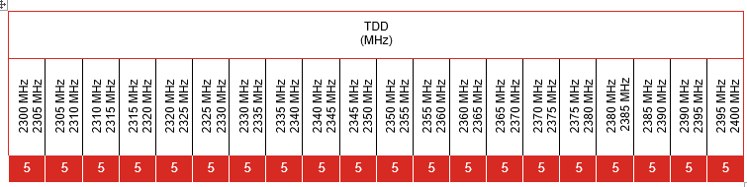

Figure 1: Existing harmonised frequency arrangement for MFCN in the 2300-2400 MHz band

## Existing technical conditions – BEM requirements

The existing harmonised technical conditions are given in Annex 2 of ECC Decision (14)02 "Least Restrictive Technical Conditions (LRTC) for MFCN in the 2300-2400 MHz band". They are defined in form of a Block Edge Mask (BEM) and are derived from scenarios in ECC Report 203 [5]. General information of the BEM in ECC Decision (14)02 and the different elements of the BEM are summarised below.

### General information regarding the BEM

The BEM derived:

* is intended to allow coexistence between MFCN applications within the 2300-2400 MHz band and to apply to the harmonised frequency arrangement;
* is intended to ensure coexistence with the applications above 2400 MHz;
* does not consider coexistence with adjacent services below 2300 MHz for which general guidance is provided in ECC Report 172 [4];
* does not consider coexistence with other incumbent services inside the frequency band 2300-2400 MHz.

### In-block requirements for MFCN base stations

2300-2390 MHz: An in-block e.i.r.p. limit is not obligatory. In case an upper limit is desired by an administration, a value which does not exceed 68 dBm/(5 MHz) e.i.r.p. per antenna may be applied.

2390-2400 MHz: The in-block e.i.r.p.1F[2] limit shall not exceed 45 dBm/(5 MHz) to ensure coexistence with systems above 2400 MHz.

For femto base stations, the use of power control is mandatory in order to minimise interference to adjacent channels.

### Baseline requirements for TDD base stations (non-AAS)

The baseline requirements for unsynchronised and synchronised MFCN base stations are provided in Table 1.

Table 1: Baseline requirements BS BEM out-of-block e.i.r.p. limits over other TDD blocks within the frequency band 2300-2400 MHz

|  |  |  |
| --- | --- | --- |
| BEM element | Frequency range | Power limit |
| Baseline | Unsynchronised TDD blocks (2300-2400 MHz) | -362F[3] dBm/(5 MHz) e.i.r.p. |
| Baseline | Synchronised TDD blocks (2300-2400 MHz) | Min(Pmax-43, 13) dBm/(5 MHz) e.i.r.p. per antenna |

The additional baseline requirements above 2400 MHz for unsynchronised and synchronised MFCN base stations, are provided in Table 2. Coexistence analysis showed that they need to apply at frequencies above 2403 MHz.

Table 2: Additional baseline requirements above 2403 MHz BS BEM out-of-band e.i.r.p.2 limits

|  |  |  |
| --- | --- | --- |
| BEM element | BS e.i.r.p. | Power limit |
| Additional baseline | Pmax > 42 dBm | 1 dBm/(5 MHz) |
| Additional baseline | 24 dBm < Pmax  42 dBm | (Pmax -41) dBm/(5 MHz) |
| Additional baseline | Pmax  24 dBm | -17 dBm/(5 MHz) |

### Transitional region requirements for MFCN base stations

The requirements in the transitional region within the frequency band 2300-2400 MHz are shown in Table 3.

Table 3: Transitional region requirements (when applicable) BS BEM out-of-block e.i.r.p. limits

|  |  |  |
| --- | --- | --- |
| BEM element | Frequency range | Power limit |
| Transitional region | -5 to 0 MHz offset from lower block edge  0 to 5 MHz offset from upper block edge | Min(Pmax-40, 21) dBm/(5 MHz) e.i.r.p. per antenna |
| Transitional region | -10 to -5 MHz offset from lower block edge  5 to 10 MHz offset from upper block edge | Min(Pmax-43, 15) dBm/(5 MHz) e.i.r.p. per antenna |

Note: The transitional region applies either in the case of synchronised adjacent blocks, or in-between unsynchronised TDD blocks that are separated by 5 or 10 MHz. The transitional region do not apply below 2300 MHz or above 2400 MHz.

### 7BRelation of the existing non-AAS synchronised baseline and transitional region BEM power limits to the ETSI operating band unwanted emission mask

The existing non-AAS synchronised baseline and transitional region BEM power limits are related to the wide area (i.e. macro BS) operating band unwanted emission mask in ETSI TS 137 104 (Table 6.6.2.1-1) [6]. The maximum e.i.r.p. limit per antenna for the transitional and baseline region for synchronised TDD blocks is obtained by assuming an antenna gain of 21 dBi, with Table 4 describing the relationship.

Table 4: ETSI Wide Area operating band Unwanted Emission Mask (UEM) for BC1 and BC33F[4] and the comparison to the ECC limits

|  |  |  |  |  |  |  |  |
| --- | --- | --- | --- | --- | --- | --- | --- |
| From ETSI TS 137 104, table 6.6.2.1-1:  Wide Area operating band UEM for BC1 and BC3 | | | | Comparison between ETSI and ECC synchronised baseline and transitional region limits | | | |
| Frequency offset (MHz) | ETSI UEM | Average Tx power | Units | ETSI Tx Power (dBm/(5 MHz)) | | ETSI e.i.r.p. (dBm/(5 MHz)) | ECC e.i.r.p. (dBm/(5 MHz)) |
| 0.0-0.2 | -14 | -14.0 | dBm/30 kHz | 8.2 | -0.8 | 20.2 | Min(Pmax-40, 21) |
| 0.2-1.0 | -14 to -26 | -18.7 | dBm/30 kHz | 3.6 |
| 1.0-5.0 | -13 | -13.0 | dBm/MHz | -6.0 |
| 5.0-10.0 | -13 | -13.0 | dBm/MHz | -6.0 | | 15.0 | Min(Pmax-43,15) |
| 10.0-15.0 | -15 | -15.0 | dBm/MHz | -8.0 | | 13.0 | Min(Pmax-43, 13) |

For 10 MHz offset from the downlink band the general spurious emission limit of -30 dBm/MHz applies [7].

## Licensed Shared Access

Subject to national considerations, the frequency band 2300-2400 MHz may be made available for MFCN while also enabling administrations to maintain the use of the band by incumbent services with an appropriate sharing framework. Licensed Shared Access (LSA) is a framework developed in CEPT/ECC and ETSI to accommodate different national sharing frameworks. LSA is generally described in ECC Report 205 [8], and specifically for the frequency band 2300-2400 MHz in e.g. ETSI TS 103 154 [9], CEPT Report 55 [10] and Annex 3 of ECC Decision (14)02 [1].

In CEPT Report 55 [8], the following is stated:

"Necessary requirements are to be established by the national regulators to share the band through LSA, assessing the protection and preserving usage of the incumbent use of the band. Depending upon the national circumstances, these requirements may have an impact on the conditions of introduction of WBB in the band 2300-2400 MHz and in particular on the amount of spectrum available for WBB.

The implementation of the LSA sharing framework on national level, which can lead to additional restrictions in concerned areas for WBB, will not have an impact on the common and minimal technical conditions for wireless broadband usage of the 2300-2400 MHz frequency band as described in this CEPT Report. Those additional restrictions will be related to timely and/or geographical restrictions and will therefore not be in contradiction with the aim of getting European wide common technical conditions."

Different approaches have been studied based upon the national circumstances in different European countries, and as such the implementation (or not) of the LSA framework and approach for protecting incumbent use of the band can be different from country to country. These approaches for protecting incumbent use do not impact on the common and minimal technical conditions for MFCN in the 2300-2400 MHz frequency band.

Where relevant, studies into the protection of incumbent use of the 2300-2400 MHz band, and implementation of this protection within the authorisation of MFCN use, are held at a national level by the relevant regulatory authority. An example from Portugal is briefly described in ANNEX 5:.

# Suitability of current technical framework for 5G

## Suitability for non-AAS MFCN base stations

MFCN base station with transmitters which are manufactured and supplied separately from the antenna systems are in this report referred to as non-AAS MFCN BS. For non-AAS MFCN BS, including 5G, the antenna connector would most likely be connected to a passive antenna array, meaning that the resulting antenna gain is fairly invariant (between different implementations and between wanted and unwanted signals). Given the passive nature of the antenna array, setting requirements for non-AAS MFCN BS in terms of e.i.r.p. is appropriate.

Non-AAS MFCN base stations comply with existing BEM power limits in ECC Decision (14)02 [1]. Those requirements were derived from the analysis of the sum of the radiated powers across multiple antenna connectors, and in some cases accounting for the potential for harmful interference to victim receivers both in-band and in adjacent bands.

For wideband systems such as 5G NR, a minimum block size of 5 MHz is recommended. This is consistent with the assumptions used in coexistence studies presented in ECC Report 172 [4].

Based on the need to avoid disrupting the usage right that have already been assigned for non-AAS MFCN in the 2300-2400 MHz frequency band, it is proposed to maintain the existing in-block, out-of-block and out-of-band BEM e.i.r.p. limits as specified in ECC Decision (14)02.

## Suitability for AAS MFCN base stations

AAS is one of the key features for 5G NR and LTE evolution products. According to Recommendation ITU-R M.2101 [11], a MFCN BS using AAS will actively control all individual signals being fed to individual antenna elements in the antenna array in order to shape and direct the antenna emission diagram to a wanted shape, e.g. a narrow beam towards a user. An AAS MFCN BS continually adjusts the amplitude and/or phase between antenna elements resulting in an antenna pattern that varies in response to short-term changes in the radio environment. This is intended to exclude long-term beam shaping such as fixed electrical down tilt.

With the introduction of AAS MCFN BS, the antenna arrays are embedded in the base station without an accessible interface between the AAS and the RF unit (see Figure 2). Contrary to the case of non-AAS MFCN BS, AAS MCFN BS do not have the possibility to install additional external filter between the base station antenna connector and the antenna. This implies that the regulatory BEM requirements must be met by product design, as it has been discussed in ECC Report 281 [12] and CEPT Report 67 [13]. Thus, since the conducted power cannot be measured due to the antenna arrays being included in the BS without an accessible interface between the AAS and the RF unit, ECC Report 281 concluded that the unwanted emissions are to be specified as Over-The-Air (OTA) requirements, rather than as conducted requirement.

The OTA emission limits will be expressed in terms of Total Radiated Power (TRP4F[5]) rather than e.i.r.p. This is in line with the approach described in 3GPP 37.840 [14] and in ECC Report 281, which indicate that harmful interference from AAS BSs to adjacent mobile systems is primarily dictated by the total amount of interference which is injected into the network. This total amount of interference is well represented by the TRP (rather than the e.i.r.p.) of a BS in any given cell or sector, and as such TRP is the most appropriate metric for specifying the out-of-block emission limits as well as the ACLR.

Based on the above observations, suitable technical conditions (BEM in TRP) should be incorporated in the current ECC Decision (14)02 [1] to account for the introduction of AAS MFCN base stations.

### 8BOut-of-band domain

The out-of-band emission requirement for the BS transmitter is specified both in terms of Adjacent Channel Leakage power Ratio (ACLR) and Operating Band Unwanted Emissions (OBUE). The OBUE limits in FR1 (frequency range 1: 410-7125 MHz) are defined from a certain frequency offset, ΔfOBUE, below the lowest frequency of each supported downlink operating band up to ΔfOBUE above the highest frequency of each supported downlink operating band [15]. The values of ΔfOBUE are defined in Table 5 for the NR, MSR and AAS BSs operating bands. BS type 1-H is for AAS and BS type 1-C is for non-AAS. ECC Report 172 [4] considers non-AAS only, which has a smaller OBUE domain compared to AAS in this band. This is considered in the studies on co-existence with other services in section 4.2.

Table 5: Maximum offset of OBUE outside the downlink operating band [15]

|  |  |  |
| --- | --- | --- |
| BS type | Operating band characteristics | ΔfOBUE [MHz] |
| BS type 1-H (AAS) | FDL_high – FDL_low < 100 MHz | 10 |
| 100 MHz  FDL_high – FDL_low  900 MHz | 40 |
| BS type 1-C (non-AAS) | FDL_high – FDL_low  200 MHz | 10 |
| 200 MHz < FDL_high – FDL_low  900 MHz | 40 |

ΔfOBUE: Maximum offset of the operating band unwanted emissions mask from the downlink operating band edge.

### Implications from the AAS architecture

ECC Decision (14)02 [1] defines the BEM requirements for MFCN in terms of e.i.r.p. limits versus frequency separation from the spectrum block edge, as described in section 2.2. Some of these requirements (i.e. the baseline requirement for unsynchronised MFCN BS operation and the additional baseline requirement to protect systems above 2400 MHz) are not specified in the equipment standard but are used by national regulators as part of MFCN license conditions, therefore representing a regulatory obligation for mobile operators. To respect such regulatory limits in non-AAS MFCN BSs, if needed, mobile operators have the possibility of installing additional external filters between the BS antenna connector and the antenna. In the case of the baseline requirements for unsynchronised MFCN BS operation, these filters would be operator specific.

In the case of AAS MFCN BSs, as illustrated in Figure 2, the antenna arrays are included in the BS without an accessible interface between the antennas and the RF unit. At the time of the publication of this Report, it is not possible to cost-effectively implement operator-specific filtering for AAS systems. As the equivalent baseline requirement of unsynchronised (or semi-synchronised) AAS MFCN BS operation, which guarantees the compatibility between different MFCN users within the band, cannot be achieved without additional and operator specific filtering, operation would instead require a guard band5F[6] that significantly affects efficient spectrum use. Alternatively, other mitigation techniques which could enable unsynchronised operation of AAS systems in the 2300-2400 MHz band require additional isolation between BSs, e.g. geographic separation or low power indoor use. With mobile network operators expected to provide access to the 2300-2400 MHz band on a wide area basis, geographic separation between MFCN operators is unlikely to be a viable solution for outdoor deployments. Therefore, in the case of two or more wide area operators, synchronised operation of AAS MFCNs (outdoors) is recommended in the 2300-2400 MHz band.

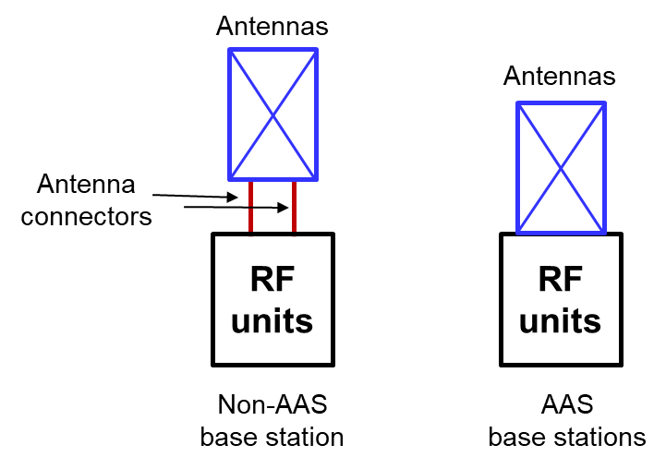

Figure 2: AAS and non-AAS base stations architecture, [12]

### 9BSynchronised and unsynchronised operation

Between adjacent TDD MFCN networks in 2.3-2.4 GHz it is assumed that coexistence can be handled similarly to what has been done for TDD MFCN in the 3.4-3.8 GHz band (where synchronised operation is highly recommended in order to avoid large separation distances). The same framework as for the 3.4-3.8 GHz band might also be used to address cross-border coordination topics in the 2.3-2.4 GHz band (co-channel or adjacent-channel) (see ECC Recommendation (15)01 [16] and ECC Report 331 [19]).

Some conclusions from ECC Report 296 [17] regarding unsynchronised operation in the 3.4-3.8 GHz frequency band are provided below. Recommendation regarding cross border coordination are also extracted from other reports such as, "Synchronisation frameworks & cross-border coordination" [18] and ECC Report 331 [19]. These conclusions are also valid for the 2300-2400 MHz frequency band. In addition, some countries have licensed all or part of the 2300-2400 MHz frequency band to only one MFCN operator.

Macro-cellular networks in the same area:

* Synchronised operation is the strongly recommended operating mode for Macro-cellular networks operating in the same area. Synchronised operation avoids any BS-BS and MS-MS interference therefore allowing coexistence between adjacent networks without the need for guard bands, additional filters or other measures, noting that such measures are challenging to implement in AAS BSs as explained above;
* Without operator-specific filters, it may not be possible to rely on guard bands alone to enable unsynchronised (or semi-synchronised) operation between operators;
* Separation distances for unsynchronised (or semi-synchronised) operation are therefore needed but a specific recommendation or single set of trigger values cannot be provided due to the dependency from various factors6F[7]. The studies in ECC Report 296 show that minimum distances required between unsynchronised Macro-cellular networks could be up to 60 km for co-channel operational and up to 14 km when operating in the adjacent channel in the 3.4-3.8 GHz band (see also ECC Report 331).

Micro BS networks and Macro-cellular networks in the same area:

* The studies show that, in general, adjacent channel unsynchronised (or semi-synchronised) operation of Macro-cellular networks and Micro BS networks might not be feasible in the same area. Separation distances have not been assessed in ECC Report 296 [17];
* If there is no Macro-cellular network, adjacent channel unsynchronised (or semi-synchronised) operation between two Micro BS networks might be feasible with careful planning avoiding line of sight between Micro BS.

Indoor BS networks and Macro-cellular networks in the same area:

* Under specific assumptions in the adjacent channel case, unsynchronised operation should be possible with careful installation7F[8] of the indoor BSs;
* Synchronised operation of indoor BS may be difficult in practice because of the challenges involved in distributing the common clock signal to indoor BS.

Cross-border coordination:

* Synchronised operation between countries should be encouraged as much as possible. Administrations are encouraged to initiate effective cross-border coordination discussions with neighbouring countries considering the need for cross-border synchronisation while assessing the most suitable frame structure at national level. In addition, agreeing on a common phase clock reference is an important first step for a successful cross-border coordination. ECC Report 331 provides a detailed assessment on this topic, including on the implementation of downlink symbol blanking when two countries have different requirements on the frame structure but use frames compliant with ECC Recommendation (20)03 [20];
* As mentioned in ECC Report 296, “The chosen frame structure will contribute to the network performance (e.g. latency, spectral efficiency, throughput and coverage)”.

### In-band incumbent systems

To protect the existing rights of in-band incumbent systems, some administrations have defined out-of-block (in-band) e.i.r.p. limits (see also section 3.2.5). The equivalent TRP8F[9] limits for AAS may not be achievable, meaning that the operation of AAS MFCN in the 2300-2400 MHz band may not be possible in these countries without the implementation of a guard band, geographical separation, or restricting MFCN deployment to low BS power or indoor use only. A guard band is not a spectrum efficient solution, while the feasibility of geographic separation and that of having AAS MFCN operating in the band will depend on the incumbent use in each country and on their adopted e.i.r.p./TRP limits (if any).

### Suitability of LSA for MFCN with AAS

LSA is still appropriate as one solution to protect the existing rights of incumbent systems in the frequency band 2300-2400 MHz from MFCN system with AAS, in line with what is stated in CEPT Report 55 [8] (see also section 2.3).

In cases where geographical restrictions, e.g. exclusion zones, are dependent on unwanted emission levels the exclusion zones may be larger, or may even be impracticable, when MFCN with AAS is used compared to MFCN with non-AAS. This is because it may not be possible to implement the necessary operator-specific filtering for AAS systems with current technology due to complexity issues. In case of AAS/beamforming, the result of the coexistence studies also depends on the allowed time percentage for interference towards the incumbent system.

# 2BIn-band and adjacent band services overview and coexistence analyses

## 5BOverview of spectrum situation

An overview of the spectrum situation in the frequency band 2300-2400 MHz, and in the adjacent bands below 2300 MHz and above 2400 MHz, is presented in Figure 3.

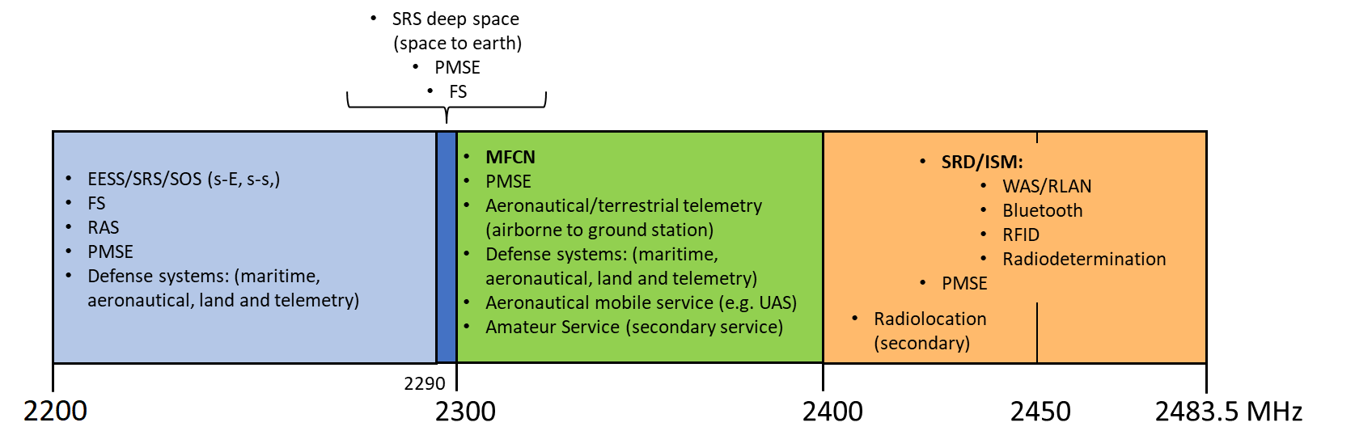

Figure 3: In-band and adjacent band services and applications for the 2300-2400 MHz MFCN band

More detailed information about the European Common Allocations and the applications in use in Region 1, as well as the relation to European standards, can be found in ANNEX 1:.

## In-band and adjacent band coexistence analysis for AAS MFCN BS

ECC Report 172 [4] provided compatibility studies with respect to the use of the band 2300-2400 MHz for MFCN. Published in March 2012, ECC Report 172 covered the use of non-AAS MFCN only. Therefore, this Report expands on the analysis and conclusions of ECC Report 172 to include the compatibility of 5G (NR) and AAS.

### Adjacent-band coexistence analysis for AAS MFCN BS below 2300 MHz

This section covers coexistence analysis for AAS MFCN BS with services and applications in adjacent band below 2300 MHz. This includes the spurious domain (2200-2260 MHz), as well as the OOB domain (2260-2300 MHz).

#### 14BSOS/EESS/SRS (space-to-Earth and space-to-space), 2200-2290 MHz

**Space-to-Earth**

The frequency band 2200-2290 MHz is used for SOS/EESS/SRS in the space-to-Earth direction.

Existing studies for non-AAS MFCN

ECC Report 172 [4] studies the compatibility between non-AAS LTE TDD BSs in 2300-2400 MHz and SOS/EESS/SRS Earth Stations (ES) in the 2200-2290 MHz frequency band for different BS antenna heights and other non-AAS BS assumptions using a deterministic method (see ECC Report 172, section 4.3.1). This study assumes that the BS interference is received in the direction of the first side lobe of the ES receiver, and hence with a gain of 31 dBi, based on a typical antenna gain of 46 dBi. Based on non-AAS BS spurious emission requirements of -30 dBm/MHz conducted power and a protection criteria of -216 dBW/Hz at the ES, the separation distances between the ES and non-AAS BS are calculated using the ITU-R P.1546-4 propagation model [21], for an interference probability of 0.1% and for three different BS heights. From this study, ECC Report 172, with single BS and single antenna, deterministic method and different BS heights, concludes the following:

* For an SOS/EESS/SRS ES in 2200-2290 MHz, a coordination distance up to 7 km could be required for the interference levels to remain below the tolerated limit.

Analysis for AAS MFCN

It is possible to understand the compatibility between AAS BSs in 2300-2400 MHz and SOS/EESS/SRS ES in the 2200-2290 MHz by considering the compatibility of existing non-AAS BSs and comparing the difference in conducted power and gain of AAS and non-AAS BSs as seen towards the horizon (valid for distance >1 km between BS and ES (see A4.2). Depending on the frequency separation between the MFCN BS operating in 2300-2400 MHz and the SOS/EESS/SRS ES receiver, the AAS beamforming in the unwanted emission domain may be correlated or uncorrelated. The in-block power, transitional region and baseline BEM for non-AAS are specified per antenna in ECC Decision (14)02 [1]. For the out-of-band case (2260-2290MHz) the difference in possible interference (iRSS = iRSSAAS - iRSSnon-AAS), assuming the worst case AAS and non-AAS BS sector pointing with horizontal fixed boresight towards the ES, for rural deployment is:

* iRSS = 14.4 dB for four cross-polarised non-AAS antennas and iRSS = 20.4 dB for one cross-polarised antenna, for uncorrelated AAS beamforming;
* iRSS = 28.9 dB for four cross-polarised non-AAS antennas and iRSS = 34.9 dB for one cross-polarised antenna, for correlated AAS beamforming (CDF ≥99.9%).

For the spurious domain case, in 2200-2260 MHz, the expected difference for iRSS is marginal.

Since the number of SOS/EESS/SRS ES is limited and the location of the receiving ES is known in many countries, often in rural environments, the actual radio propagation condition should be considered. Similar to non-AAS BS, various mitigation techniques can be used to limit the interference from AAS BS towards victim ES, i.e. coordination zones with local restrictions on BS height, antenna direction, mechanical antenna downtilt, and/or output power restriction, etc. Due to the higher potential interference from AAS BS compared to non-AAS, the suitable coordination zone around the SOS/EESS/SRS ES is expected to be larger.

Space ES receiver performance parameters can be found in ECC Report 172. Possible apportionment factor with respect to allowed interference was not seen as needed for non-AAS in ECC Report 172 versus SOS/EESS/SRS ES receivers. This factor is independent of non-AAS or AAS deployment and therefore there is no need to consider it for AAS in this report as the relative study is based on existing regulation (ECC Decision (14)02) for non-AAS BSs.

**Space-to-space**

The frequency band 2200-2290 MHz is also used for EESS in the space-to-space direction.

Existing studies for non-AAS MFCN

ECC Report 172 [4], in its section 4.2, uses a simple link budget analysis to calculate the interference level from a single non-AAS BS towards a Data Relay Satellite (DRS) receiver in GSO, which is then used to calculate the maximum number of non-AAS BS that can be tolerated in the satellite footprint. The compatibility study assumes a satellite antenna gain of 34.7 dBi, a protection threshold of at the EESS satellite of   
-181 dBW/kHz for <0.1 % of time and required I/N ratio of -10 dB. It is concluded that over a satellite footprint with a radius of 1885 km (assuming a flat earth), which is roughly equal to the land area of Europe, the number of non-AAS BSs required to cause noticeable interference towards the satellite receiver is unrealistically high (>3 Million BSs, single antenna per sector), far exceeding the average base station density over such large area. In addition the analysis does not consider network loading factor as described in references [11] and [22] where it is stated that: "most of the cells are not heavily loaded simultaneously and only a small percentage of cells are heavily loaded at any specific point in time".

Analysis for AAS MFCN

In ECC Report 172 the average effective antenna gain towards the satellite for non-AAS BSs is assumed to be 0 dBi (side lobes). For AAS BSs the average sidelobe gain over the satellite footprint for Europe can be estimated considering elevation angle above horizon from 5 to 45 degrees. The gain from AAS BS towards satellite over the very large satellite footprint of 5 to 10 million km2 is between 2.8 dBi and ­15.2 dBi (see Figure 4), considering urban, sub-urban and rural BSs deployment, fully correlated beamforming and calculated for single element AAS model as well as for sub-array AAS model (detailed parameters are given in A4.3). Considering the footprint size and rural, suburban and urban deployments and that all deployment exists within the footprint the worst-case average gain will be close to 0 dBi for elevation angles towards the satellite below 30 degrees. For elevation angles above 30 degrees the average antenna gain rapidly drops to below -10 dBi (see Figure 4).

For the 2260-2290 MHz frequency range (OOB domain for AAS), and based on the 0 dBi worst-case average gain towards satellites below 30 degrees, as shown in Figure 4, the iRSS is 17 dB for four cross-polarised non-AAS antennas and 23 dB for one cross-polarised non-AAS antenna per BS sector (see A4.2). The in-block power, transitional region and baseline BEM for non-AAS BSs are specified per antenna in ECC Decision (14)02 [1]. The expected difference for iRSS for the 2200-2260 MHz frequency range (spurious domain) is marginal and the same conclusion as for non-AAS in Report 172 [4] can be drawn.

Due to the higher level of interference towards the satellite from AAS BS compared to non-AAS BS in the 2260-2290 MHz frequency range, the number of heavily loaded AAS BS in this frequency range required within the satellite's large footprint (which roughly equals the land area of Europe) to cause noticeable interference would be less than the number of heavily loaded non-AAS BS. However, as it is unlikely that all BS within such a large satellite footprint would be transmitting and/or heavily loaded at the same time, the aggregate interference from both non-AAS and AAS BSs will be reduced compared to the result from the calculation in ECC Report 172, meaning a higher number of BSs can be accepted. Additionally, not all BS within the satellite footprint will be oriented with worst-case average gain towards the satellite (i.e. satellite will be above 30 degrees elevation with respect to some BS). Therefore, it is expected that the number of transmitting and/or heavily loaded non-AAS and AAS BS required to cause noticeable interference should not be exceeded within the satellite's footprint, although no studies have been completed to confirm this.

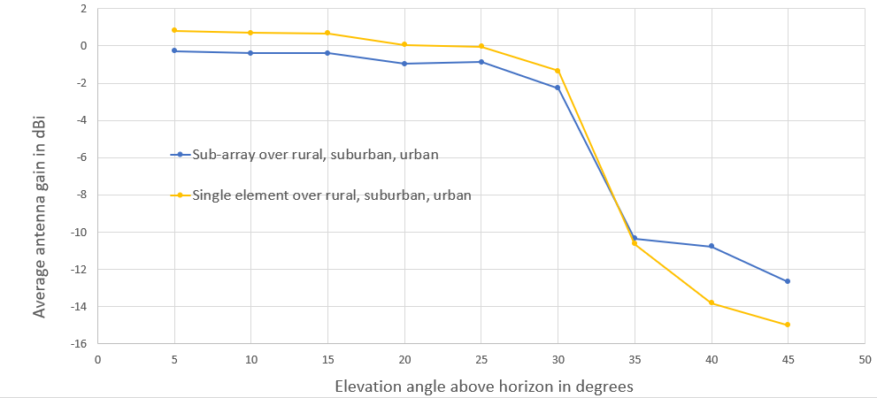

Figure 4: Average antenna gain above horizon for satellite footprint size from 5 to 10 million km^2 covering about all of Europe. Average over rural, urban and suburban deployment

Space service receiver performance parameters can be found in ECC Report 172. A possible apportionment factor with respect to allowed interference was not seen as needed for non-AAS MFCN in ECC Report 172 versus DRS space service receiver. This factor is independent of non-AAS or AAS MFCN deployment and therefore there is no need to consider it for AAS MFCN in this report as the relative study is based on existing regulation (ECC Decision (14)02 for non-AAS BS).

#### Defence systems (aeronautical, maritime, land, telemetry/telecommand), 2200-2290 MHz

These applications are studied within the frequency band 2300-2400 MHz which is the more limiting case ( see sections 4.2.2.3 and 4.2.2.4).

#### RAS, 2200-2290 MHz

Existing studies for non-AAS MFCN

ECC Report 172, section 4.5 [4], uses a MCL analysis and propagation model Recommendation ITU-R P.452-11 [23], to conclude that a coordination distance of 73 km is needed to protect a RAS with antenna height of 50 m in a rural area from non-AAS BS unwanted emissions.

Analysis for AAS MFCN

It is possible to understand the compatibility between AAS BS in 2300-2400 MHz and RAS receivers in 2200-2290 MHz by considering the compatibility of existing non-AAS BS and comparing the difference in conducted power and gain of AAS and non-AAS BS as seen towards horizon (valid for distance >1 km between BS and RAS ( see A4.2). Depending on the frequency separation between the MFCN BS operating in 2300-2400 MHz and the RAS receiver, the AAS beamforming may be correlated or uncorrelated. The in-block power, transitional region and baseline BEM for non-AAS are specified per antenna in ECC Decision (14)02 [1]. The difference in possible interference (iRSS) assuming the worst case AAS and non-AAS BS sector pointing with horizontal fixed boresight towards the RAS receiver for rural deployments for the 10-40 MHz out-of-band case is:

* iRSS = 14.4 dB for four cross-polarised non-AAS antennas and iRSS = 20.4 dB for one cross-polarised antenna, and uncorrelated AAS beamforming;
* iRSS = 27.9 dB for four cross-polarised non-AAS antennas and iRSS = 33.9 dB for one cross-polarised antenna, and correlated AAS beamforming (CDF 98%).

For the spurious domain case, i.e. 2200-2260 MHz, the expected difference for iRSS is marginal.

Since the number of RAS stations is limited and the location of the receiving station is known in many countries, often in rural environments, the actual radio propagation condition should be considered. Similar to the conclusions for non-AAS BS, various mitigation techniques can be used to limit the interference towards the victim, i.e. coordination zones with local restrictions on BS height, antenna direction, antenna downtilt, and/or output power restriction, etc. Due to the higher potential interference from AAS BS compared to non-AAS BS, the suitable coordination zone around the RAS receiver is expected to be larger. In practice the coordination distance is likely to be limited to the radio horizon.

#### 15BPMSE (Portable and mobile wireless video, cordless camera), 2200-2300 MHz

The more limiting case is for the in-band case, i.e. in 2300-2400 MHz, and it is covered in section 4.2.2.2.

#### Fixed service, 2200-2300 MHz

According to the assessment from ECC Report 173 [24], the usage of the adjacent bands (below 2290 MHz) by Fixed Service (FS) is limited to 128 links in total, across all CEPT countries. Due to the varying characteristics of different types of FS systems and their deployment, no single compatibility solution can be applied e.g. separation distance, guard band or signal strength limit. If needed, coexistence can be achieved through coordination on a case-by-case basis, at national level. According to ECC Report 172 [4]: “Interference studies were not performed in this report as the risk of interference was, because of highly directional antennas and the probable deployment in rural areas, considered to be very low”.

Based on the observations above, no specific study is developed in this report for coexistence between MFCN AAS 5G NR and the FS.

#### 16BDeep space SRS (space-to-Earth) 2290-2300 MHz

Existing studies for non-AAS MFCN

Two studies of the compatibility between a non-AAS BS and a deep space ES receiver are presented in ECC Report 172 [4] in its sections 4.3.2.2 and 4.3.3 for single BS and single antenna using deterministic approach for various BS heights, BS masks and victim receiver gains, etc., coordination is required with studies finding various coordination distances between 8 km and 50 km.

Analysis for AAS MFCN

It is possible to understand the compatibility between AAS BS in 2300-2400 MHz and deep space SRS ES in 2290-2300 MHz by considering the compatibility of existing non-AAS BS and comparing the difference in conducted power and gain of AAS and non-AAS BSs as seen towards horizon (valid for distance between BS and ES >1 km (see A4.2). The in-block power, transitional region and baseline BEM for non-AAS are specified per antenna in ECC Decision (14)02 [1]. The difference in possible interference (iRSS), assuming the worst case AAS and non-AAS BS sector pointing with horizontal fixed boresight towards the ES for rural deployments for the 0-10 MHz out-of-band case is:

* iRSS = -0.6 dB for four cross-polarised non-AAS antennas and iRSS = 5.4 dB for one cross-polarised antenna and AAS uncorrelated beamforming;
* iRSS = 13.9 dB for four cross-polarised non-AAS antennas and iRSS = 19.9 dB for one cross-polarised antenna and AAS correlated beamforming (CDF ≥ 99.9%).

Since the number of deep space SRS ESs is limited and the location of the ES is known in many countries, often in rural environments, the actual radio propagation condition should be considered. Similar to the conclusions for non-AAS BS, various mitigation techniques can be used to limit the interference towards the victim, i.e. frequency separation, additional filtering at the SRS ES, and coordination zones with local restrictions on BS height, antenna direction, antenna downtilt, and/or output power restriction, etc. Due to the higher potential interference from AAS BS compared to non-AAS BS, the suitable coordination zone around the deep space SRS ES is expected to be larger.

Deep space SRS ES receiver performance parameters can be found in ECC Report 172 [4]. A possible apportionment factor with respect to allowed interference was not seen as needed for non-AAS in ECC Report 172 versus SRS ES receiver. This factor is independent of non-AAS or AAS MFCN deployment and therefore there is no need to consider it for AAS MFCN in this report as the relative study is based on existing regulation (ECC Decision (14)02) for non-AAS BSs).

### In-band coexistence analysis for AAS MFCN in 2300-2400 MHz

The LSA concept for in-band sharing is described in section 3.2.5.

#### Synchronised and unsynchronised operation between MFCN systems in 2300-2400 MHz

The general recommendations for synchronised and unsynchronised operation (including semi-synchronised) is provided in section 3.2.3 of this Report. For co-existence between legacy non-AAS and AAS MFCN systems, the same conclusions as in ECC Report 281 [12] and ECC Report 308 [25] for TDD systems with reference to 3GPP TR 37.840 [14] and TR 37.842 [26] for this frequency range can be drawn.

The BEM power limits in ECC Decision (14)02 [1] are suitable for non-AAS MFCN BS, including 5G, as described in section 3.1. The baseline requirements for unsynchronised and synchronised non-AAS MFCN base stations are as given in section 2.2, Table 1, and the transitional requirements are given in section 2.2, Table 3.

For AAS BSs, the proposed baseline requirements for synchronised operation and transitional region requirements are based on the core requirements in ETSI TS 137 105 [27] in its Table 9.7.5.2.2-1b, with Table 6 describing the relationship between these ETSI OBUE limit and the proposed ECC limits in section 5.2.2.1.

Table 6: ETSI Wide Area (WA) BS OBUE for BC1 and BC3 band > 1 GHz and the comparison to the proposed ECC limits for synchronised AAS BS

|  |  |  |  |  |  |
| --- | --- | --- | --- | --- | --- |
| From ETSI TS 137 105 [27] Table 9.7.5.2.2-1b: WA BS OBUE in BC1 and BC3 band > 1 GHz | | | | Comparison between ETSI and ECC synchronised baseline and transitional region limits | |
| **Frequency offset (MHz)** | **ETSI OBUE** | **Average Tx power** | **Units** | **ETSI Tx Power (dBm/(5 MHz))** | **ECC TRP Limits (dBm/(5 MHz))** |
| 0-5 | 2 to -5 | -1 | dBm/(100 kHz) | 16 | Min(Pmax'-40, 16) |
| 5-10 | -5 | -5 | dBm/(100 kHz) | 12 | Min(Pmax'-43,12) |
| 10-15 | -6 | -6 | dBm/MHz | 1 | Min(Pmax'-43, 1) |

The AAS BS baseline requirement for unsynchronised operation can be determined using the same analysis as for the 3400-3800 MHz band in ECC Report 281 [12]. Considering the propagation path loss differences between 2.4 GHz and 3.4 GHz of approximately 2 dB, the baseline value in Table 7 below is proposed for unsynchronised TDD blocks.

Table 7: Updated baseline power limits for unsynchronised MFCN networks, for non-AAS and AAS base stations

| BEM element | Frequency range | Non-AAS e.i.r.p. limit dBm/(5 MHz) per cell (**Note** 1) | AAS TRP limit dBm/(5 MHz) per cell (**Note** 1) |
| --- | --- | --- | --- |
| Restricted baseline | Unsynchronised blocks.  Below the lower block edge.  Above the upper block edge.  Within 2300-2400 MHz | -36 | -45 |
| Note 1: In a multi-sector base station, the radiated power limit applies to each one of the individual sectors | | | |

#### Programme Making and Special Events (PMSE) services (cordless camera) in 2300-2400 MHz

Based on the study in Annex A2.3 which compares the compatibility with PMSE from non-AAS LTE (ECC Report 172 [4]) with that from AAS 5G NR, it is expected that in general the separation distances between AAS 5G NR and PMSE will be similar or smaller than the separation distance between non-AAS LTE and PMSE, for co-channel and adjacent channel cases. The separation distance between non-AAS LTE and PMSE to compatibility is defined in ECC Report 172, Table 25 to 34.

The co-channel and first adjacent channel compatibility studies are presented in Annex A2.3 include “cordless camera links”, “Mobile Video Links" and “Portable Video Link's” operating in 2300-2400 MHz. The study calculates the difference between the iRSS level at PMSE from non-AAS MFCN and the iRSS level from AAS MFCN. The equation applied is ∆iRSS = iRSS AAS 5G NR - iRSS non-AAS LTE. For each simulation, the same and fixed separation distance between PMSE and MFCN (non-AAS and AAS) is applied. The CDF value used is 90 % for non-AAS and AAS MFCN. For non-AAS MFCN, a single antenna is assumed in the comparison below.

Summary of the compatibility studies in Annex A2.3:

* Cordless Camera PMSE

In general, the separation distance needed between PMSE and AAS 5G NR BSs is smaller than the separation distance between PMSE and non-AAS LTE BSs.

Compared to non-AAS LTE BS, the power level from AAS 5G NR BS received at PMSE is reduced by:

3 to 7 dB for co-channel,

2 to 6 dB for first adjacent channel.

* Mobile video link PMSE:

In general, the separation distance needed between PMSE and AAS 5G NR BSs is smaller than the separation distance between PMSE and non-AAS LTE BSs;

Compared to non-AAS LTE BS, the power level from AAS 5G NR BS received at PMSE is reduced by:

3 to 4 dB for co-channel;

3 to 11 dB for the first adjacent channel;

For the scenario: "separation distance between non-AAS LTE BS and PMSE = 500 m and when PMSE uses the first adjacent channel to AAS 5G NR", the separation distance is expected to be marginally different because the power level from AAS 5G NR BS received at PMSE is increased by 4 dB;

* Portable video link PMSE:

In general, the separation distance needed between PMSE and AAS 5G NR BSs is smaller than the separation distance between PMSE and non-AAS LTE BSs;

Compared to non-AAS LTE BS, the power level from AAS 5G NR BS received by PMSE is reduced by:

7 to 8 dB for co-channel;

5 to 6 dB for the first adjacent channel;

For the scenario: “separation distance between non-AAS LTE BS and PMSE = 100 m and when PMSE uses the first adjacent channel to AAS 5G NR”, the separation distance is expected to be marginally different because the power level from AAS 5G NR BS received at PMSE is increased by 2 dB.

Thus, when the distance between PMSE and non-AAS LTE BSs is the same as the distance between PMSE and AAS 5G NR BSs, the interference probability will be reduced when AAS is used. Or, with the same probability of interference, the separation distance can be reduced.

In order to optimise spectrum utilisation efficiency, it may be necessary to adapt some PMSE parameters because there are a large number of PMSE applications and the compatibility studies in Annex A2.3 only cover the three main PMSE applications.

Conclusion:

Annex A2.3 provides ΔiRSS analysis between "iRSS to PMSE from AAS 5G NR BSs" minus "iRSS to PMSE from non-AAS LTE BSs". A negative value of the ΔiRSS indicates that the iRSS of AAS 5G NR system is smaller than the iRSS of non-AAS LTE system. In general, the studies in this report to compare AAS 5G NR and non-AAS LTE and compatibility with PMSE, ΔiRSS is negative. Thus, the conclusion of the ECC report 172 [4] on PMSE is still applicable andthe same process as for non-AAS LTE MFCN can be applied to AAS 5G NR MFCN. The separation distance between non-AAS LTE MFCN and PMSE to ensure compatibility is defined in ECC Report 172, Table 25 to 34.

Below is the conclusion of ECC Report 172 on PMSE vs non-AAS MFCN which can also be applied for AAS MFCN:

"*This study provides a worst-case analysis of constraints in terms of minimum coupling loss and separation distances for the coexistence between an LTE-TDD system as the interferer and a wireless video link system as the victim, and vice versa. It is assumed that apart from geographical separation, no interference management and operator coordination can be conducted. The results of the study do not apply to situations where operators could coordinate their activities or to situations where the actual propagation conditions can be taken into account. New studies are required for systems using advanced interference management mechanisms, for example system deployments taking into account acceptable transmit powers (micro base stations) for particular geographical areas, or based on cognitive technologies.*

*The results regarding scenario “Cordless Camera Link” indicate that coexistence can be feasible in the adjacent and alternate channel case, since the required separation distance is moderate. If the receiver performance of wireless video links and the LTE transmitter performance exceed the requirement values in Table 6 and Table 13, the observed separation distances can further be reduced to even smaller values. It has to be decided on a case-by-case basis if additional protection and sharing mechanisms have to be employed. In the co-channel case, dedicated protection and coexistence mechanisms would be required under worst case conditions.*

*In scenario 2 “Mobile Video Link”, such further protection and coexistence mechanisms are probably required except in the presence of a guard band of more than 20 MHz between the systems. For the case of video link as a victim, this is mainly due to the very low path loss propagation model under worst case conditions and large coverage of the receiver antenna mounted on a helicopter. This is certainly a special propagation case which calls for dedicated coordination measures. In the case of video link transmitters interfering into LTE receivers in this scenario, separation distances are significantly reduced.*

*The results for scenario 3 “Portable Video Link” indicate that coexistence based on geographical separation is feasible at least in the alternate channel (guard band) case if on a case-by-case basis, some additional protection measures are deployed. If certain separation corridors around the main lobe of the narrow-beam video link receive antenna could be employed, geographical separation could be feasible in the adjacent channel case as well, especially if the employed devices exceed the performance limits by a significant amount. In the co-channel case, additional dedicated protection and coexistence mechanisms would probably be required due to significant necessary separation distances.*"

#### 17BAeronautical/terrestrial telemetry on national basis (airborne to ground station) and Telemetry/Tele-command in 2300-2400 MHz

For tele-command telemetry, ECC Report 172 [4] states that "*According to the MCL based studies, simultaneous operation of the BWS in a co-channel configuration with Telemetry Systems / UAV is feasible only with large separation distances. These separation distances are not feasible in situations where BWS and Telemetry systems/UAV are co-located. Additionally, co-channel operation may be facilitated if simultaneous operation of BWS and telemetry / UAV can be avoided. (…) The coexistence between BWS and Telemetry Systems (and coexistence between BWS and UAV – Unmanned aeronautical vehicles) is not ensured in a co-channel/co-location configuration. Adjacent channel operation, geographical separation, time sharing or a combination of the previous may help to ensure coexistence*" and derives associated separation distances.

Conclusions from ECC Report 172 related to isolation or separation distances with other services such as aeronautical/terrestrial telemetry remain valid for AAS MFCN under the assumptions used in the simulations, in particular the 46 dBm/(20 MHz) TRP in-block BS power. For the co-channel case higher in-block BS power will typically result in larger coordination distances, noting that this also depends on many other parameters such as actual radio propagation condition, BS/victim antenna height, antenna gain, etc.

For Aeronautical/terrestrial telemetry on a national basis (airborne to ground station) in 2300-2400 MHz, the simulations were done for co-channel, the first adjacent channel in the 2300-2400 MHz band, and out-of-band scenarios. The study calculates the iRSS level at the telemetry system. The iRSS level is calculated for a telemetry received channel bandwidth of 10 MHz and 4 MHz. The maximum iRSS level to protect telemetry is -106 dBm for 10 MHz channel bandwidth and -110 dBm for 4 MHz channel bandwidth. The CDF is minimum 99.9%. Free space propagation model is used. For each simulation, the same separation distance as described in ECC Report 172 between telemetry and non-AAS LTE is used between telemetry and AAS 5G NR. For non-AAS, a single antenna is assumed. The key results are provided in Table 25 "Simulation results compared between LTE and AAS 5G NR" of Annex A2.2 and summarized below:

* Co-channel: with the same protection distance as for non-AAS LTE MFCN, AAS 5G NR MFCN does not cause significant interference into Telemetry ground station.
* First adjacent channel: AAS 5G NR BS show slightly better compatibility than non-AAS LTE BS,
* Out of band: the protection distance for AAS 5G NR MFCN is of similar range as for non-AAS LTE MFCN.

The results of the compatibility studies between AAS 5G NR BS and telemetry, both for co-channel and adjacent channel (in band) and out-of-band cases (telemetry just below 2300 MHz and AAS 5G NR just above 2300 MHz) in Annex A2.2, are similar in comparison with the result for non-AAS LTE BS. The details of the solutions to achieve compatibility (i.e. separation distance) between AAS 5G NR and telemetry ground station can thus be found in section 5.2 of the ECC Report 172: "This study provides a worst-case analysis regarding telemetry. The results of this deterministic study show that in a co-channel configuration, large separation distances are needed to avoid harmful interference on telemetry system from LTE (and vice versa). In adjacent channel, the separation distances decrease drastically so that the operation of Telemetry (TLM) and LTE is possible. Some reasonable mitigation techniques may however be needed to ensure that no interference occurs when the airborne TLM is in the main lobe of the LTE base station antenna. In practice, depending on the trajectory of the aircraft, an airborne TLM might not stay in the LTE base station main beam for a long time".

#### Aeronautical mobile service defence systems (e.g. UAS) in 2300-2400 MHz

Existing studies for non-AAS MFCN

Section 5.3 of ECC Report 172 [4] studies the coexistence between Unmanned Aircraft Systems (UAS) and non-AAS BS for a co-channel situation using MCL and single BS and single antenna. It finds that the separation distances required to protect the UAS can be large, i.e. exceed the maximum potential radio line-of-sight distance between the interferer and the victim. ECC Report 172 concludes that non-AAS LTE MFCN and UAS cannot share spectrum on a co-channel co-location basis. Frequency separation, geographical separation, time sharing, or a combination of these mitigation methods may help to ensure coexistence.

Analysis for AAS MFCN

It is possible to estimate the compatibility between AAS BS and UAS by considering the compatibility of existing non-AAS BS and comparing the difference in conducted power and gain of AAS and non-AAS BSs a seen towards the horizon (see Annex A4.2). The actual separation distance in order not to cause interference will depend on the actual radio propagation environment as well as on BS and victim receiver heights (ground/air). The aeronautical mobile service system can operate in the 2300-2400 MHz band which means co-channel and adjacent channel operation. The in-block power, transitional region and baseline BEM for non-AAS MFCN are specified per antenna in ECC Decision (14)02 [1]. The difference in possible co-channel and adjacent channel interference (iRSS) assuming the worst case AAS and non-AAS BS sector pointing with horizontal fixed boresight towards the UAS ES or UAS aircraft vehicle is:

* iRSS = 5.9 dB for four cross-polarised non-AAS antennas and iRSS = 11.9 dB for one cross-polarised antenna, for co-channel case and AAS, correlated beamforming (CDF ≥ 99.9%) and rural area;
* iRSS = 9.9 dB for four cross-polarised non-AAS antennas and iRSS = 15.9 dB for one cross-polarised antenna, for co-channel case and AAS correlated beamforming (CDF ≥ 99.9%) and urban area;
* iRSS = 13.9 dB for four cross-polarised non-AAS antennas and iRSS = 19.9 dB for one cross-polarised antenna, for adjacent channel case (0 to 10 MHz transitional region) and AAS, correlated beamforming (CDF ≥99.9%) and rural area;
* iRSS = 17.9 dB for four cross-polarised non-AAS antennas and iRSS = 23.9 dB for one cross-polarised antenna, for adjacent channel case (0 to 10 MHz transitional region) and AAS, correlated beamforming (CDF ≥ 99.9%) and urban area.

In real MFCN networks there will be a mixture of urban, suburban, macro deployment and actual radio propagation condition. For urban deployment clutter losses can be expected.

Similar to the conclusions for non-AAS MFCN, AAS MFCN BSs and UAS cannot share spectrum on a co-channel, co-location basis. Frequency separation, geographical separation, time sharing, or a combination of these mitigation methods may help to ensure coexistence.

#### 18BAmateur Service (secondary service) in 2300-2400 MHz

ECC Report 172 [4] reaches the following conclusion with reference to the amateur service:

“In co-channel case where the antenna main lobes are pointing at each other, the required MCL between LTE and stations in the Amateur Service can be significant. Various mitigation techniques can be used to protect both BWS and Amateur service".

Similar technical compatibility solutions are expected for 5G NR and AAS MFCN.

The required MCL between non-AAS BS and amateur stations with antenna height of 25 m are large, of the order of 201/164 dB for BS/UE respectively towards amateur service receiver. For AAS BS it is highly unlikely that the main beam will align with the main lobe of the amateur station antenna (33 dBi assumed in ECC Report 172) due to AAS random nature by serving UEs in the cell (see Figure 29, ANNEX 4:. Therefore, any larger difference between non-AAS/AAS BSs with respect to possible interference towards amateur service is not expected.

Also, it should be noted that the amateur service has a secondary allocation in the band.

### Adjacent-band coexistence analysis for AAS MFCN above 2400 MHz

This section covers adjacent band coexistence analysis above 2400 MHz, this includes the OOB domain (2400-2440 MHz) as well as the spurious domain (2440-2484 MHz).

#### 19BSRD/ISM applications (RLAN, Bluetooth, RFID, Radiodetermination, etc.) unlicensed spectrum, 2400-2483.5 MHz

General aspects

The following aspects should be taken into account when assessing the Bluetooth and RLAN technology:

* ECC Report 172 [4] has studied “In-device coexistence properties between LTE TDD and Bluetooth”. The UE technical characteristics described in ECC Report 172 (LTE TDD) will not change significantly when considering 5G NR UEs; In-device coexistence between MFCN services and RLAN and Bluetooth (SRD) is addressed in 3GPP;
* The additional baseline requirements above 2403 MHz for base stations need to be defined for AAS BS using TRP as the metric;
* 2390-2400 MHz: The in-block requirement for BS with AAS in 2390-2400 MHz shall ensure coexistence with systems above 2400 MHz.

Existing studies for non-AAS MFCN

For non-AAS MFCN, ECC Report 172 [4] concludes:

"The results for the impact of macro LTE TDD BS on WLAN show that coexistence is feasible for indoor WLAN systems at antenna height of 1.5 m with an interference probability smaller than 1%. The outdoor placed WLAN systems at 10 m height (worst case) will have very high interference probability. For the indoor case, WLAN AP interfering the Pico LTE TDD BS, there is a degradation in average bit rate. The results clearly show that increasing the offset frequency of LTE TDD decreases the bit rate degradation significantly. In all scenarios it is shown that using WLAN channel 5 instead of channel 1 will improve the situation significantly so that the coexistence between LTE TDD and WLAN would be feasible without mutual harmful interference."

The proportion of the indoor and outdoor RLAN is predominantly indoor usage. For example, in 2014 a split of deployments between domestic, outdoor and indoor public as well as enterprise were presented by Ofcom9F[10]. Ignoring the unknown enterprise locations and assuming all domestic installations are indoors leads to 99.98% RLAN networks are installed as “indoor”. In ECC Report 302 [28], actual historical and projected shipment data was used for outdoor Wi-Fi sales and LTE-based small cells. Combining the forecast for small cell and Wi-Fi devices for the outdoor market gives 1% of total units worldwide in 2021. Based on the ratio between RLAN indoor deployment and RLAN outdoor deployment, only RLAN indoor use has been studied in this ECC Report.

The ISM band, 2400-2484 MHz, is also used for other applications like e.g. Bluetooth (see Figure 3). The in-block limit for 2390-2400 MHz and the additional baseline requirement above 2403 MHz in ECC Decision (14)02 [1] gives protection to all these systems above 2403 MHz (see Table 2). In ECC Report 172 for non-AAS MFCN studies were carried out for 1.5 and 10-m victim antenna height and the findings were that victims at 10 m height experience higher interference from MFCN. The additional baseline in ECC Decision (14)02 are mainly based on the 10 m victim height and with this give also the same protection to victims at e.g. 1.5 m height. To ensure that an equivalent level of protection is maintained for all applications in the ISM band, relative studies between non-AAS and AAS MFCN have been completed in this report, and show that the height of the victim antenna exhibits marginal impact on the findings.

Analysis for AAS MFCN

In Annex A2.1, Annex A3.1, Annex A4.1 Monte Carlo (SEAMCAT) simulations are performed to evaluate maximum BS output power in 2390-2400 MHz to avoid blocking of systems operating above 2400 MHz. The studies also include simulations on the additional baseline above 2403 MHz for unwanted emission. Looking at RLAN channel 1 with centre frequency at 2412 MHz and fully correlated AAS beamforming ( = 1):

The results in Annex A2.1 and Annex A3.1 consider the absolute interference level as seen at the victim. Annex A3.1 and Annex A4.1 consider the relative interference between AAS and non-AAS MFCN, making it independent with respect to the actual victim system and location. This is because the existing additional baseline for non-AAS MFCN in ECC Decision (14)02 [1] is used as the basis for the relative comparison. The simulations in Annex A3.1 and Annex A4.1 look at two fixed antenna heights with 1.5 or at 10 m, separately. Whereas Annex A2.1 considers a height probability for the RLAN antennas between 1.5 m to 28.5 m, according to ECC Report 302 [28]. The principle to use all victim antenna heights at either 1.5 or 10 m was used in ECC Report 172 [4] for non-AAS MFCN, as reference points, for the observed interference from MFCN BSs towards RLAN. For the relative comparison between AAS and non-AAS MFCN in Annex A3.1 and Annex A4.1 the two victim antenna heights 1.5 m or at 10 m exhibit marginal impact on the findings. The results in Annex A2.1 and A3.1 uses the MFCN BS antenna height and non-AAS tilt parameters from ECC Report 172 [4], whereas the analysis in Annex A4.1 is based on the ITU-R BS parameters. All three studies assume fully correlated maximum AAS BS beamforming antenna gain.

Unwanted emissions case:

* Studies in Annexes A2.1, A3.1 and A4.1 have shown that depending on RLAN antenna height and probability distribution of the RLAN antenna height the following is found:

For fixed 1.5 m RLAN antenna height (100% case), it can be concluded from the results that there is low probability of interference above I/N = 0 dB threshold from non-AAS MFCN (≤ 0.5%) or AAS MFCN (≤0.6%) towards RLAN (indoor), not considering the additional baseline. The non-AAS MFCN results are in alignment with those obtained in ECC Report 172 [4].

For fixed 10 m RLAN antenna height (100% case), AAS MFCN shows possible interference above I/N = 0 dB threshold with ~27% and for non-AAS MFCN with ~32% of cases, not considering existing additional baseline. The non-AAS MFCN results are in alignment with those obtained in ECC Report 172.

Considering a probability distribution for the RLAN antenna height between 1.5 to 28.5 m, like suggested in ECC Report 302 [28] which is a new parameter compared to ECC Report 172, the probability of interference from AAS MFCN BS towards RLAN is <1% with a threshold of I/N = 0 dB, not considering an additional baseline for AAS BS.

Relative comparison between AAS MFCN and non-AAS MFCN for unwanted emission and possible interference (iRSSUnwantedEmission ≈ 0 dB) towards RLAN considering existing additional baseline and for fixed 1.5 and 10 m RLAN antenna heights. In this case it is found that for AAS MFCN using the existing 3GPP mask a corresponding additional baseline to avoid increase of interference is required, which considering the findings above is due to the RLAN at fixed 10 m height. For the relative comparison the same probability of interference (above I/N threshold) is taken for non-AAS and AAS MFCN and using existing non-AAS additional baseline as specified in ECC Decision (14)02 [1].

Blocking case:

* Studies in Annexes A2.1, A3.1 and A4.1 have shown that depending on RLAN antenna height and probability distribution of the RLAN antenna height the following is found:

For fixed 1.5 m RLAN antenna height (100% case), it can be concluded from the results that there is low probability of blocking interference (< 3%) above I/N = 0 dB threshold from non-AAS MFCN or AAS MFCN towards RLAN at 1.5 m height (indoor). This is assuming no BS maximum output power restriction;

For fixed 10 m RLAN antenna height (100% case), AAS MFCN shows blocking caused interference with 77% above I/N = 0 dB threshold and for non-AAS MFCN with 92% above I/N = 0 dB threshold. This is assuming no BS maximum output power restriction;

Considering a probability distribution for the RLAN antenna height between 1.5 to 28.5 m, a suggested in ECC Report 302 [28], the probability of blocking interference from AAS MFCN BS towards RLAN is <8% for above I/N = 0 dB threshold. This is assuming no AAS BS maximum output power restriction;

Relative comparison between AAS MFCN and non-AAS MFCN for possible blocking caused interference (iRSSBlocking ≈ 0 dB) considering existing output power restriction in 2390-2400 MHz as given in existing ECC Decision (14)02 [1] and for fixed 1.5 and 10 m RLAN antenna heights. For this case, it is found that also for AAS BS the maximum output power needs to be limited in 2390-2400 MHz to avoid an increase of the blocking interference to RLAN, which, considering the findings above, is due to the RLAN at fixed 10 m antenna height. For the relative comparison the same probability of interference (above I/N = 0 dB threshold) is taken for non-AAS MFCN and AAS MFCN and using existing non-AAS BS power restriction for 2390-2400 MHz as specified in ECC Decision (14)02.

The blocking gives higher interference compared to unwanted emission. All results above from Annexes A2.1, A3.1 and A4.1 are based on the iRSS level of -92 dBm (I/N=0 dB).

The relative comparison (iRSS) with existing unwanted emission limits above 2403 MHz and maximum BS power in 2390-2400 MHz, as defined in ECC Decision (14)02 for non-AAS MFCN, ensures also protection to other possible unlicensed services in the band above 2400 MHz. For example, with the relative comparison the same finding would be obtained for outdoor victims as the building loss would be the same for non-AAS and AAS MFCN. For the relative study the important aspect is to find the AAS/TRP levels corresponding to the existing non-AAS/e.i.r.p. levels in ECC Decision (14)02. Non-AAS MFCN systems in the field should comply with the additional baseline limits from ECC Decision (14)02. The findings in Annex A3.1 and Annex A4.1 for iRSS differ mainly due to different deployment assumptions for non-AAS and AAS MFCNs, such as BS antenna height, non-AAS antenna gain and antenna tilt. Another difference resides on the way the non-AAS BS feeder loss is applied in the SEAMCAT simulations.

Summarising the findings in order to protect SRD (unlicensed systems) above 2400 MHz in the same way as for non-AAS MFCN using AAS BS metrics with TRP the following is suggested for the updated version of ECC Decision (14)02:

* 2300-2390 MHz for non-AAS BS: An in-block e.i.r.p. limit is not obligatory. In case an upper limit is desired by an administration, a value which does not exceed 68 dBm/(5 MHz) e.i.r.p. per antenna may be applied;
* 2300-2390 MHz for AAS BS: An in-block TRP limit is not obligatory;
* 2390-2400 MHz for non-AAS BS: The in-block e.i.r.p. (Note 1a) limit shall not exceed 45 dBm/(5 MHz) to ensure coexistence with systems above 2400 MHz;
* 2390-2400 MHz for AAS BS: The in-block TRP (Note 1b) limit shall not exceed 31 dBm/(5 MHz) to ensure coexistence with systems above 2400 MHz;
* For femto base stations, the use of power control is mandatory in order to minimise interference to adjacent channels.

Note 1a: The e.i.r.p. is the total radiated power in any direction at a single location independent of any base station configuration.

Note 1b: In a multi-sector base station, the radiated power limit applies to each one of the individual sectors.

The additional baseline requirements above 2403 MHz for unsynchronised and synchronised non-AAS and AAS MFCN base stations are provided in Table 8 and Table 9.

Table 8: Additional baseline requirements above 2403 MHz BS BEM out-of-band e.i.r.p. (Note 1a) limits for non-AAS BS

|  |  |  |
| --- | --- | --- |
| BEM element | Non-AAS BS e.i.r.p. | Power limit |
| Additional baseline | Pmax > 42 dBm | 1 dBm/(5 MHz) |
| Additional baseline | 24 dBm < Pmax  42 dBm | (Pmax -41) dBm/(5 MHz) |
| Additional baseline | Pmax  24 dBm | -17 dBm/(5 MHz) |

Table 9: Additional baseline requirements above 2403 MHz BS BEM out-of-band TRP (Note 1b) limits for AAS BS

|  |  |  |
| --- | --- | --- |
| BEM element | AAS BS TRP per carrier | AAS TRP limit per cell (Note 1) |
| Additional baseline | Pmax' > 47 dBm | -13 dBm/(5 MHz) |
| Additional baseline | 33 dBm < Pmax'  47 dBm | (Pmax' -60) dBm/(5 MHz) |
| Additional baseline | Pmax'  33 dBm | -27 dBm/(5 MHz) |
| Note 1: PMax' is the maximum mean carrier power in dBm for the base station measured as TRP per carrier in a given cell. | | |

The values in this section including Table 9, for AAS BS in TRP, contain the array ohmic losses.

#### Programme Making and Special Events (PMSE) services (cordless camera) in 2400-2483.5 MHz

The more limiting case for PMSE is for the in-band case, and it is covered in section 4.2.2.2

#### Radiolocation (secondary service) in 2400-2450 MHz

Radiolocation service has a secondary allocation in 2400-2450 MHz and is only used in a few CEPT countries. There is no explicit study performed in ECC Report 172 [4].Thus, no specific studies will be developed in this report for coexistence between MFCN (AAS and 5G NR) and the Radiolocation service.

#### Amateur Service, Amateur Satellite (secondary service) in 2400-2450 MHz

Amateur service has a secondary allocation in 2400-2450 MHz and there is no explicit study performed in Report 172 [4] for this. Thus, no specific studies will be developed in this report for coexistence between MFCN (AAS and 5G NR) and the amateur service in 2400-2450 MHz. Nevertheless, the coexistence with amateur services in-band is analysed in section 4.2.2.5.

# 3BRecommended updates to the regulatory Framework

## Recommended band plan

In the context of ensuring suitability for 5G and AAS in the 2300-2400 MHz band, the recommended band plan for MFCN is aligned with the current harmonised spectrum scheme in ECC Decision (14)02 [1], as depicted in Figure 5, i.e.:

* the frequency arrangement is based on 20 blocks of 5 MHz;
* an operator can aggregate several blocks of 5 MHz to obtain a wider channel.

P711#yIS1

Figure 5: Harmonised frequency arrangement for MFCN in the 2300-2400 MHz band [1]

## 6BApplicable technical conditions

### 10BBS in-block power limits

As described in section 2.2.2, no mandatory limit is defined in the existing regulatory framework for the frequency blocks 2300-2390 MHz, while to ensure coexistence with systems above 2400 MHz a mandatory limit is defined for the frequency blocks 2390-2400 MHz. The same approach will be used in the updated regulatory framework.

As described in section 3.1, it is proposed to maintain the existing in-block e.i.r.p. limits, as specified in ECC Decision (14)02 [1], for non-AAS MFCN BS.

For the case of AAS BS, the studies to protect systems above 2400 MHz is summarised in section 4.2.3 and a TRP limit of 31 dBm/(5 MHz) is proposed for the frequency blocks 2390-2400 MHz (see Table 10).

Table 10: Updated in-block power limits for non-AAS and AAS BS

|  |  |  |  |
| --- | --- | --- | --- |
| BEM element | Frequency range | Non-AAS e.i.r.p. limit (Note 1) | AAS TRP limit |
| In-block | Block assigned to the operator (2300-2390 MHz) | Not obligatory.  In case an upper limit is desired by an administration, a value which does not exceed 68 dBm/(5 MHz) per antenna may be applied. | Not obligatory |
| Block assigned to the operator (2390-2400 MHz) | 45 dBm/(5 MHz) (Note 2) | 31 dBm/(5 MHz) (Note 3) |
| Note 1: For femto base stations, the use of power control is mandatory in order to minimise interference to adjacent channels.  Note 2: This e.i.r.p. limit is the total radiated power in any direction at a single location, independent of any base station configuration.  Note 3: In a multi-sector base station, the radiated power limit applies to each one of the individual sectors. | | | |

### 11BBS out-of-block power limits

As described in section 3.1, it is proposed to maintain the existing out-of-block e.i.r.p. limits, as specified in ECC Decision (14)02 [1], for non-AAS MFCN BS.

#### AAS BS out-of-block power limits for: Interference between synchronised MFCNs

For the case of synchronised MFCNs with time aligned UL/DL transmissions, the following Table 11 gives the proposed out-of-block TRP limits for AAS BS for the update of ECC Decision (14)02 [1]. These are derived from ETSI core requirements, as described in section 4.2.2.1 (see Table 6).

Table 11: Baseline and transitional power limits for synchronised MFCN networks, for AAS base stations

|  |  |  |
| --- | --- | --- |
| BEM element | Frequency range | AAS TRP limit dBm/(5 MHz) per cell (Note 1) |
| Transitional region | -5 to 0 MHz offset from lower block edge  0 to 5 MHz offset from upper block edge | Min(PMax'-40,16)  (Note 1) (Note 2) |
| Transitional region | -10 to -5 MHz offset from lower block edge  5 to 10 MHz offset from upper block edge | Min(PMax'-43,12)  (Note 1) (Note 2) |
| Baseline | Below -10 MHz offset from lower block edge.  Above 10 MHz offset from upper block edge.  Within 2300-2400 MHz. | Min(PMax'-43,1)  (Note 1)( Note 2) |
| Note 1:The transitional regions and the baseline power limits apply to the synchronised operation of MFCN networks.  Note 2: PMax' is the maximum mean carrier power in dBm for the base station measured as TRP per carrier in a given cell. | | |

For TDD blocks the transitional region applies in case of synchronised adjacent blocks, and in-between adjacent TDD blocks that are separated by 5 or 10 MHz. The transition region does not extend below 2300 MHz or above 2400 MHz.

Less stringent technical parameters, if agreed among the operators of synchronised networks, may also be used.

#### 20BAAS BS out-of-block power limits: Interference between unsynchronised or semi-synchronised MFCNs

In-line with the analysis carried out in section 4.2.2.1, for the case of unsynchronised or semi-synchronised MFCNs, Table 12 gives the proposed baseline TRP limits for AAS MFCN BS for the update of ECC Decision (14)02.

Table 12: Baseline power limits for unsynchronised (and semi-synchronised) MFCN networks, for AAS base stations in the same geographical area

|  |  |  |
| --- | --- | --- |
| BEM element | Frequency range | AAS TRP limit dBm/(5 MHz) per cell (Note 1) |
| Baseline | Within 2300-2400 MHz:  - Below the lower block edge  - Above the upper block edge | -45 |
| Note 1: In a multi-sector base station, the radiated power limit applies to each one of the individual sectors. | | |

The difficulties of meeting the limit for unsynchronised operation are described in section 3.2.2.

The out-of-block power limit applies to unsynchronised and semi-synchronised MFCN BSs if no geographic or indoor/outdoor separation is available. Less stringent technical parameters, if agreed among operators of such networks, may also be used, such as where there is appropriate radio isolation between networks (e.g. due to geographic or indoor/outdoor separation). In addition, depending on national circumstances, CEPT administrations may define an alternative baseline power limit for unsynchronised and semi-synchronised MFCN BSs which applies to specific implementation cases to ensure efficient use of spectrum.

### 12BBS out-of-band power limits: Interference towards adjacent applications above 2400 MHz

As described in section 3.1, it is proposed to maintain the existing out-of-band e.i.r.p. limits above 2400 MHz, as specified in ECC Decision (14)02 [1], for non-AAS MFCN BS.

In-line with the findings in section 4.2.3, an additional baseline requirement is also required for AAS MFCN BS at frequencies above 2403 MHz. The proposed additional baseline TRP limits for the update of ECC Decision (14)02, is given in Table 13.

Table 13: Additional baseline requirement above 2403 MHz, for AAS BS

|  |  |  |
| --- | --- | --- |
| BEM element | AAS BS TRP | AAS TRP limit dBm/(5 MHz) per cell (Note 1) |
| Additional baseline | Pmax' > 47 dBm (Note 2) | -13 |
| Additional baseline | 33 dBm < Pmax'  47 dBm (Note 2) | Pmax' -60 (Note 2) |
| Additional baseline | Pmax'  33 dBm (Note 2) | -27 |
| Note 1: In a multi-sector base station, the radiated power limit applies to each one of the individual sectors.  Note 2: PMax' is the maximum mean carrier power in dBm for the base station measured as TRP per carrier in a given cell. | | |

### 13BUE in-block power limits

It is proposed that the technical conditions applying to UEs is aligned with the current harmonised technical conditions in ECC Decision (14)02 [1], as described below.

The recommended upper limit for the in-block power of the user equipment (UE) is 25 dBm.

The power limit is specified as e.i.r.p. for UE designed to be fixed or installed and as TRP for the UE designed to be mobile or nomadic.

A tolerance of up to + 2 dB has been included in this limit, to reflect operation under extreme environmental conditions and production spread.

Administrations may relax this limit in certain situations, for example fixed UE in rural areas, providing that protection of other services, networks and applications is not compromised and cross-border obligations are fulfilled.

# 4BConclusions

The findings of this ECC Report recommend updates to the existing ECC Decision (14)02 [1] for AAS MFCN with BEM based on TRP in analogy to the existing BEM for non-AAS MFCN, including:

* In-block, baseline and transitional requirements for AAS MFCN, based on TRP;
* Baseline requirement for unsynchronised (or semi-synchronised) operation of AAS MFCN, based on TRP;
* Measures for coexistence with services above 2400 MHz;
* A mandatory upper in-block power limit in the frequency range 2390-2400 MHz for AAS MFCN, based on TRP;
* An additional baseline requirement above 2403 MHz for AAS MFCN, based on TRP;
* The BEM does not take into account coexistence with adjacent services below 2300 MHz, for which general guidance is provided in section 4.2.1 of this Report for AAS (and in ECC Report 172 [4] for non-AAS);
* The derived BEM does not take into account coexistence with other incumbent services inside the 2300-2400 MHz band. Administrations wishing to implement MFCN under LSA should identify which existing applications need to be considered as incumbent and maintained, and assess sharing opportunities through study at a national level. Compatibility studies not considering LSA have been provided in section 4.2.2 of this Report for AAS MFCN (and in ECC Report 172 for non-AAS MFCN).

This Report concludes on the need to update the regulatory framework to support the introduction of 5G NR and AAS in the 2300‑2400 MHz band, and recommends an updated framework. It is concluded that there is no need to update the current band plan for 2300‑2400 MHz in ECC Decision (14)02. The analysis confirms that the current technology neutral BEM remains applicable for 5G NR non-AAS MFCN, and confirms the need for a new BEM for AAS MFCN in order to ensure coexistence intra-band and with adjacent services.

Field strength values for cross-border coordination for non-AAS MFCN are specified in ECC Recommendation (14)04 [3]. For AAS MFCN an update of the ECC Recommendation (14)04 will be needed.

Also, for cross-border coexistence additional coordination may need to be considered, not only to mitigate cross-border interference across MFCN networks, but also to protect other incumbent services. Conclusions from ECC Report 172 related to isolation or separation distances with other services such as aeronautical/terrestrial telemetry remain valid for AAS MFCN under the assumptions used in the simulations, in particular the 46 dBm/(20 MHz) TRP in-block BS power. For the co-channel case higher in-block BS power will typically result in larger coordination distances, noting that this also depends on many other parameters such as actual radio propagation condition, BS/victim antenna height, antenna gain, etc.

1. Spectrum information
   1. Detailed information about allocations and applications in 2200-2483.4 MHz in Region 1

For the band in and around 2300-3400 MHz band, ERC Report 25 [29] indicates the systems operating below 2300 MHz, in the band 2300-2400 MHz and above 2400 MHz.

ECO Report 03 [30] provides information on licensing for MFCN in this frequency band in CEPT countries.

An extract from ERC Report 25, is provided in Table 14 which provides details about the allocations and also the relevant standard, applications and some notes for:

* Below 2300 MHz;
* In the 2300-2400 MHz band;
* Above 2400 MHz.

Table 14: Detailed information of allocations and applications in-band and adjacent for the 2300-2400 MHz band for Europe/Region 1, from reference ERC Report 25 [29], <https://efis.cept.org/view/compare-applications.do>, November 2020

|  |  |  |  |  |  |
| --- | --- | --- | --- | --- | --- |
| Band | European Common Allocation and ECA Footnotes | ECC/ERC harmonisation measure | Applications | Standard | Notes |
| **Below 2300 MHz** | | | | | |
| 2200-2290 MHz | EARTH EXPLORATION-SATELLITE (SPACE-TO-EARTH) (SPACE-TO-SPACE)  FIXED  MOBILE 5.391  SPACE OPERATION (SPACE-TO-EARTH)  (SPACE-TO-SPACE)  SPACE RESEARCH (SPACE-TO-EARTH)  (SPACE-TO-SPACE)  5.392 ECA16A  ECA36 | T/R 13-01 [31] | Aeronautical military systems |  |  |
|  | Fixed | EN 302 217 [32] |  |
|  | Land military systems |  |  |
|  | Land military systems |  |  |
| ERC/REC 25-10 [33] | PMSE | EN 302 064 [34] | Portable or mobile wireless video and cordless cameras |
|  | Radio astronomy |  | Continuum observations, VLBI (used by SRS) |
| ECC/REC/(10)01 [35] | Space research |  | EESS Satellite payload and platform telemetry |
|  | EESS Satellite payload and platform telemetry |  |  |
| 2290-2300 MHz | FIXED  MOBILE EXCEPT AERONAUTICAL MOBILE  SPACE RESEARCH (DEEP SPACE) (SPACETO-EARTH) |  | Land mobile |  | Land mobile |
|  | PMSE | EN 302 064 [34] | Portable or mobile wireless video and cordless cameras |
|  | Space research |  | Satellite payload and platform telemetry for space research (deep space). Continuum observations, VLBI (used by SRS) |
| **Within 2300-2400 MHz** | | | | | |
| 2300-2400 MHz | FIXED  MOBILE 5.384A  Amateur  Radiolocation  ECA36 |  | Aeronautical military systems |  |  |
| ERC/REC 62-02 [36] | Aeronautical telemetry |  | Parts of the band are used for aeronautical telemetry on a national basis |
|  | Amateur | EN 301 783 [37] | Within the band 2300-2450 MHz |
|  | Land military systems |  |  |
| ECC/DEC/(14)02 [1]  ECC/REC/(14)04 [3] | MFCN | EN 301 908 [38] | Shared use of spectrum envisaged |
|  | ECC/REC/(14)04 [3] |  |  |
| ERC/REC 25-10 [33] | PMSE | EN 302 064 [34] | Portable or mobile wireless video and cordless cameras |
|  | Telemetry/Telecommand (military) |  |  |
| **Above 2400 MHz** | | | | | |
| 2400-2450 MHz | FIXED  MOBILE  Amateur  Amateur-Satellite  Radiolocation  5.150  5.282 |  | Amateur | EN 301 783 [37] | Within the band 2300-2450 MHz |
|  | Amateur-satellite |  |  |
|  | ISM |  |  |
| ERC/REC 70-03 [39] | Non-specific SRDs | EN 300 440 [40] | Within the band 2400.0-2483.5 MHz |
| ERC/REC 25-10 [33] | PMSE | EN 302 064 [34] | Portable or mobile wireless video and cordless cameras |
| ERC/REC 70-03 [39] | RFID | EN 300 440 [40] | Within the band 2446-2454 MHz |
| ERC/REC 70-03 [39] | Radiodetermination applications | EN 300 440 [40] | Within the band 2400.0-2483.5 MHz |
| ERC/REC 70-03 [39] | Wideband data transmission systems | EN 300 328 [41] | Within the band 2400.0-2483.5 MHz |
| 2450-2483.5 MHz | FIXED  MOBILE  5.150 |  | ISM |  |  |
| ERC/REC 70-03 [39] | Non-specific SRDs | EN 300 440 [40] | Within the band 2400.0-2483.5 MHz |
| ERC/REC 25-10 [33] | PMSE | EN 302 064 [34] | Portable or mobile wireless video and cordless cameras |
| ERC/REC 70-03 [39] | RFID | EN 300 440 [40] | Within the band 2446-2454 MHz |
| ERC/REC 70-03 [39] | Radiodetermination applications | EN 300 440 [40] | Within the band 2400.0-2483.5 MHz |
| ERC/REC 70-03 [39] | Wideband data transmission systems | EN 300 328 [41] | Within the band 2400-2483.5 MHz |

* 1. Existing mobile licences in Europe

Existing cellular licences in the 2300-2400 MHz band in Europe are shown in Table 15.

Table 15: Existing licences for the 2300-2400 MHz band in Europe, from reference ECO Report 03 [30], <https://efis.cept.org/views2/report03.jsp>, May 2022

|  |  |  |  |  |  |  |  |
| --- | --- | --- | --- | --- | --- | --- | --- |
| Frequency Table | Frequency band | Application | Licence holder | Start date | Expiry date | Location Information | Spectrum Trading |
| Denmark | 2300-2360 MHz | TRA-ECS | TDC Netco A/S | 2019-04-26 | 2041-12-31 | 100 Landsdaekkende | Yes |
| Estonia | 2300-2330 MHz | MFCN | Tele 2 Eesti AS | 2016-04-01 | 2030-01-27 | National coverage | No |
| Estonia | 2330-2360 MHz | MFCN | Tele2 Eesti AS | 2006-05-19 | 2030-05-19 | National coverage | No |
| Georgia | 2300-2350 MHz | MFCN | Silknet LLC | 2016-05-05 | 2026-05-05 | Tbilisi | Yes |
| Georgia | 2300-2350 MHz | MFCN | Silknet LLC | 2017-01-18 | 2027-01-18 | National coverage | Yes |
| Latvia | 2300-2330 MHz | IMT | Latvijas Mobilais Telefons | 2012-12-06 | 2027-12-05 | National coverage | Yes |
| Latvia | 2330-2360 MHz | IMT | Bite Latvija | 2012-12-06 | 2027-12-05 | National coverage | Yes |
| Lithuania | 2310-2390 MHz | TRA-ECS | AB Lietuvos radijo ir televizijos centras | 2014-07-24 | 2029-07-25 | National coverage | Yes |
| Norway | 2300-2320 MHz | BWA | Neptune Energy Norge AS | 2009-10-01 | 2021-12-31 | gjøa-feltet | Yes |
| United Kingdom | 2350 - 2390 MHz | TRA-ECS | TELEFONICA UK LIMITED | 2018-04-05 | 2100-01-01 | National coverage | Yes |
| Sweden | 2300 - 2380 MHz | MFCN | Teracom AB | 2021-01-20 | 2045-12-31 | National coverage | Yes |
| Slovenia | 2320 - 2390 MHz | MFCN | Two operators | 2022-01-01 | 2037-01-01 | National coverage | Yes |

1. In-band and adjacent band coexistence analysis Study #1
   1. Adjacent band blocking of NR AAS in the 2.3 GHz band with Wi-Fi operating in the 2.4 GHz band
      1. Introduction

In this Annex, compatibility studies between AAS 5G NR BSs operating below 2400 MHz and Wi-Fi operating above 2400 MHz are provided.

ECC Report 172 [4] contains compatibility studies between LTE operating in the 2300-2400 MHz band and Wi-Fi operating above 2400 MHz.

Only one parameter has been added to these AAS 5G NR new simulations compared to the parameters defined in ECC Report 172: the RLAN compatibility level of -81 dBm/(10 MHz). A public document provides explanations about this additional compatibility level [42]. In ECC Report 172, the factor I/N was defined as an objective, thus the compatibility level was defined at -92 dBm. Thus, this study looks at the two compatibility levels, -81 dBm and -92 dBm.

Another parameter that is not well defined (but used) in ECC Report 172 is indoor penetration loss. In this study, the indoor loss is assumed to be 18 dB.

This study looks at the RLAN blocking.

This study looks at simulations based on worst case assumptions.

All the simulations have been done using SEAMCAT.

* + 1. Simulation parameters

This study focuses on the indoor case only. The following two tables summarise the parameters used in this simulation for Wi-Fi receivers and AAS 5G NR BSs, respectively.

* + 1. RLAN Parameters

Table 16: Parameters of WLAN 802.11n AP system operating in the band 2400-2483.5 MHz [43]

|  |  |  |
| --- | --- | --- |
| Victim WLAN receiver |  | Comment |
| AP antenna height | 1.5 m to 28.5 m | Note: Based on ECC Report 302 Table 10 [28] (see more explanations below) |
| Propagation model | ITU-R P.525 [44] (Free space) |  |
| Wall penetration loss | 18 dB |  |
| I/N objective | 0 dB |  |
| Receiver bandwidth | 16.25 MHz |  |
| Receiver noise figure (NF) | 10 dB |  |
| Receiver thermal noise (No) | -102.07 dBm |  |
| Noise floor N = No + NF | -92.07 dBm  or  -81 dBm | Other sources define another limits which are about -80.3 dBm or 81.5 dBm (see [42]) |
| Centre frequency | 2412 MHz | First Wi-Fi channel |
| WLAN TX power | 20 dBm | ECC Report 172 [4] |
| Antenna gain | 2 dB |  |
| Layout | Generic layout with 2 km radius | ECC Report 172 |

* + 1. RLAN antenna height

When the ECC Report 172 [4] was drafted, the compatibility studies took into account only two RLAN antenna heights, 1.5 m or 10 m. These two heights were not realistic RLAN deployments.

However, today there is greater precision on the height of RLAN antennas, as described in ECC Report 302 [28].

In this compatibility study, cases which were taken into account are, "Urban Indoor - Public" and "Suburban indoor - Public", as defined in Table 17.

Table 17: From ECC Report 302 [28] => RLAN source height distribution”

|  |  |  |  |  |  |  |  |  |  |  |  |
| --- | --- | --- | --- | --- | --- | --- | --- | --- | --- | --- | --- |
|  |  | Urban indoor | | | Suburban indoor | | | Rural indoor | | | Out-door |
| **Buil-ding Story** | **Height (m)** | **Corp** | **Public** | **Home** | **Corp** | **Public** | **Home** | **Corp** | **Public** | **Home** |
| 1 | 1.5 | 82.35% | 82.35% | 77.85% | 82.35% | 82.35% | 77.92% | 84.17% | 84.17% | 84.17% | 95.00% |
| 2 | 4.5 | 13.35% | 13.35% | 17.85% | 13.35% | 13.35% | 17.92% | 14.17% | 14.17% | 14.17% | 2.00% |
| 3 | 7.5 | 2.85% | 2.85% | 2.85% | 2.85% | 2.85% | 2.92% | 1.67% | 1.67% | 1.67% | 2.00% |
| 4 | 10.5 | 0.52% | 0.52% | 0.52% | 0.52% | 0.52% | 1.25% | 0.00% | 0.00% | 0.00% | 0.50% |
| 5 | 13.5 | 0.36% | 0.36% | 0.36% | 0.36% | 0.36% | 0.00% | 0.00% | 0.00% | 0.00% | 0.00% |
| 6 | 16.5 | 0.24% | 0.24% | 0.24% | 0.24% | 0.24% | 0.00% | 0.00% | 0.00% | 0.00% | 0.00% |
| e | 19.5 | 0.16% | 0.16% | 0.16% | 0.16% | 0.16% | 0.00% | 0.00% | 0.00% | 0.00% | 0.00% |
| 8 | 22.5 | 0.09% | 0.09% | 0.09% | 0.09% | 0.09% | 0.00% | 0.00% | 0.00% | 0.00% | 0.00% |
| 9 | 25.5 | 0.05% | 0.05% | 0.05% | 0.05% | 0.05% | 0.00% | 0.00% | 0.00% | 0.00% | 0.00% |
| 10 | 28.5 | 0.02% | 0.02% | 0.02% | 0.02% | 0.02% | 0.00% | 0.00% | 0.00% | 0.00% | 0.50% |
| Total |  | 100% | 100% | 100% | 100% | 100% | 100% | 100% | 100% | 100% | 100% |

* + 1. RLAN Blocking mask

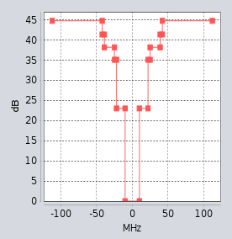

Figure 6: RLAN blocking mask

* + 1. AAS 5G NR BS Parameters

Table 18: Parameters of AAS 5G NR BS interfering BS

|  |  |  |
| --- | --- | --- |
| Parameter | Value used for simulations | Comment |
| 5G Centre frequency | 2390 MHz |  |
| 5G Bandwidth | 20 MHz | Band n40 in theory can include up to 100 MHz |
| 5G Antenna height | 20 m and 37.5 m | 20 m is in ECC Report 172 [4], but the e.i.r.p. is associated to micro BS (e.i.r.p. = 38 dBm in ECC Report 172 [4]). AAS will be used by macro BS |
| 5G Antenna tilt | 10 degrees |  |
| 5G Cell radius | 1 km | ECC Report 172 |
| 5G AAS antenna | SEAMCAT default parameters |  |
| 5G Tx power | 46 dBm |  |
| Propagation model | Extended Hata  Free space | Antenna high at 20 m could not use Extended Hata model because this input parameter is outside of the scope of applicability |

* + 1. AAS 5G NR Blocking mask (Out of the 2300-2400 MHz band)

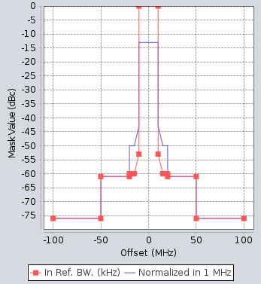

Figure 7: AAS 5G NR Blocking mask (Out of the 2300-2400 MHz band)

* + 1. Extract of simulations results

The final results for the simulations - iRSS unwanted curves and iRSS blocking curves, are shown below. 20000 events were made.

* + 1. iRSS Unwanted

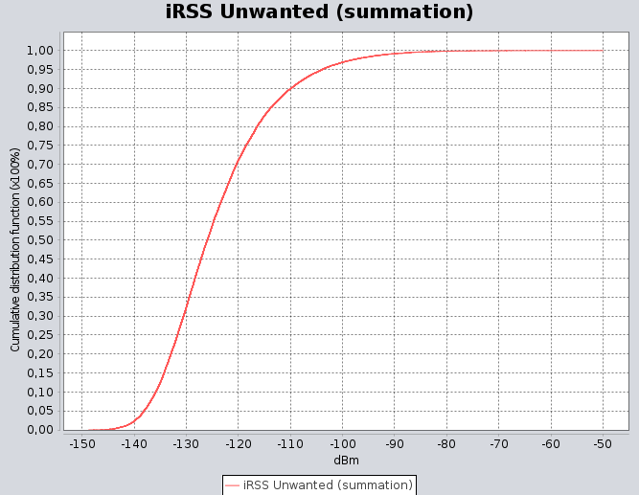

Figure 8: Hata propagation model and AAS 5G NR antenna height of 37.5 m

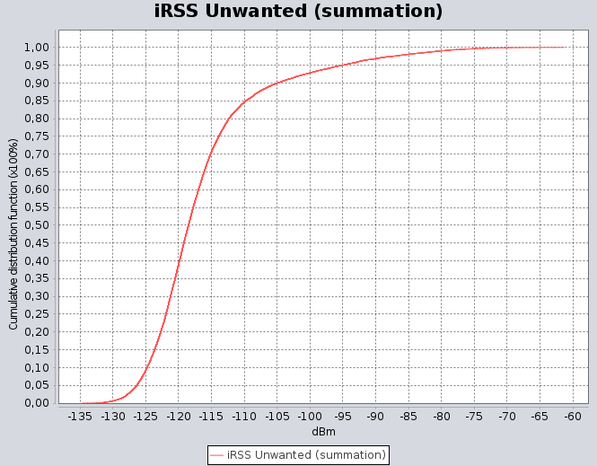

Figure 9: Free space propagation model and AAS 5G NR antenna height of 20 m

* + 1. iRSS Blocking

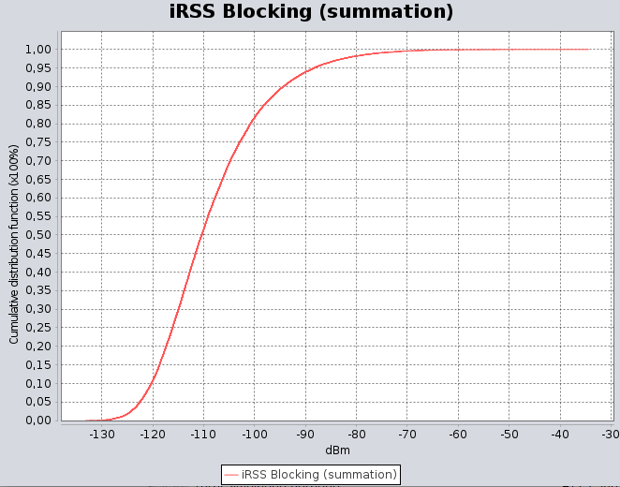

Figure 10: Hata propagation model and AAS 5G NR antenna height of 37.5 m



Figure 11: Free space propagation model and AAS 5G NR antenna height of 20 m

* + 1. Simulation results

Table 19 shows a summary of the key results for iRSS unwanted and iRSS blocking:

Table 19: Simulation results: AAS 5G NR BS to RLAN

|  |  |  |  |
| --- | --- | --- | --- |
| Category | Parameter | Hata | Free space |
| 5G NR AAS | Bandwidth | 20 MHz | 20 MHz |
| Frequency centre | 2390 MHz | 2390 MHz |
| High antenna (in ECC Report 172) | 37.5 m | 20 m |
| throughput | Full RB 51 | Full RB 51 |
| Cell layout | 2 tier | 2 tier |
| Cell radius | 1 km | 1 km |
| scenario propagation model | Ext Hata | P525 free Space |
| Number of events | 20000 | 20000 |
| RLAN | antenna height | 1.5 m to 28.5 m | 1.5 m to 28.5 m |
| frequency centre | 2412 MHz | 2412 MHz |
| Simulation results | iRSS Unwanted Mean | -124 dBm | -117.5 dBm |
| iRSS Unwanted Median | -126 dBm | -120 dBm |
| iRSS Unwanted (summation < -92 dBm) | 99% | 96.1% |
| iRSS Unwanted (summation < -81 dBm) | 99.8% | 98.8% |
| iRSS blocking (summation) Mean | -108.6 dBm | -101.9 dBm |
| iRSS blocking (summation) Median | -110.5 dBm | -104.4 dBm |
| iRSS blocking (summation < -92 dBm) | 92.2% | 88.1% |
| iRSS blocking (summation < -81 dBm) | 98% | 94.4% |

* + 1. Conclusions

In this study, simulations are provided to take into account some parameters regarding the compatibility between AAS MFCN below 2400 MHz and indoor RLAN above 2400 MHz.

The RLAN antenna height was aligned with ECC Report 302 [28], Table 10 (1.5 m to 28.5 m).

The simulation (third column) when the AAS 5G NR BS is 37.5 m is more realistic since the maximum height of the RLAN antenna is 28.5 m.

The Hata simulations show that the blocking (see iRSS blocking), in the worst case (when AAS 5G NR uses a 20 MHz channel bandwidth with the frequency centre at 2390 MHz) has a low probability of occurring.

The blocking produces a higher level than unwanted emission.

* + 1. Complementary RLAN study => Blocking levels and percentages in function of the TRP in 2390-2400 MHz

The study below looks at more details to try to help the definition of the max TRP in 2390-2400 MHz band.

This study also made some alignments on input parameters compared to the study above. The differences are:

* RLAN blocking mask is based on annex A3.1;
* 5G NR channel bandwidth = 10 MHz (2390-2400 MHz);
* Other parameters are not changed.

The goal of this alignment is to have a better coherence between the different studies in this Report. Table 20 is an extract from annex A3.1 when RLAN is at 10 m height. Table 21 is the result of the update of this simulations (A2.1) with RLAN at 10 m height:

Table 20: E**xtract from ANNEX 3: study**

|  |  |  |
| --- | --- | --- |
| RLAN Channel | RLAN AP antenna height [m] | Total median sum iRSS blocking / Interference probability (blocking) |
| **Case 1** |
| CH 1 | 10 | -86.7 dBm |

Table 21: **Results from the simulation with the update of the parameters of this study (A2.1)**

|  |  |
| --- | --- |
| Tx 5G NR in 2390-2400 MHz | TRP |
| AAS 5G NR: SEAMCAT definition; Tilt 10°; height 37.5 m | =46 dBm/(10 MHz) |
| RLAN: height 10 m; blocking mask as define in ANNEX 3: study | |
| iRSS blocking mean | -87.16 dBm |

The results of the two simulations are quite similar, thus there is a high coherence between the input parameters of this study and the study in ANNEX 3:.

* + 1. AAS 5G NR unwanted emission mask (Out of the 2300-2400 MHz band) for channel bandwidth 10 MHz

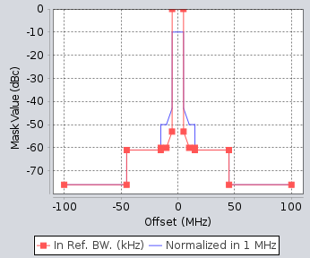

Figure 12: AAS 5G NR unwanted emission mask

* + 1. AAS RLAN Blocking mask (based on ANNEX 3 study)

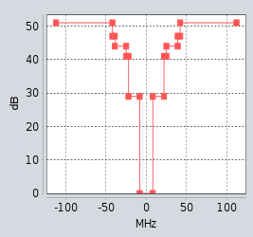

Figure 13: AAS RLAN Blocking mask (based on ANNEX 3: study)

* + 1. AAS Result with fixed probability of RLAN height as defined in ECC Report 302

Table 22: AAS Result with fixed probability of RLAN height as defined in ECC Report 302 [28]

|  |  |  |  |
| --- | --- | --- | --- |
| Tx 5G NR: 2390-2400 MHz | TRP | | |
| AAS 5G NR: SEAMCAT definition; Tilt 10°; height 37.5 m | =43 dBm/(5 MHz)/(5 MHz) | =40 dBm/(5 MHz)/(5 MHz) | =37 dBm/(5 MHz)/(5 MHz) |
| RLAN: height 1.5 to 28.5 m ECC Report 302 [28] fixed probability; blocking mask from ANNEX 3: study | | | |
| iRSS blocking mean | -111.15 dBm | -114.15 dBm | -117.15 dBm |
| iRSS blocking (summation < -92 dBm) | 95.50% | 96.80% | 97.90% |
| iRSS blocking (summation < -81 dBm) | 99.40% | 99.60% | 99.90% |

* + 1. Conclusion

Taking into account the fixed RLAN antenna height (fixed probability between 1.5 to 28.5 m) as defining in ECC Report 302 [28], SEAMCAT simulations highlight that the blocking compatibility between AAS 5G NR and RLAN is quite good in all simulations, as described in the above table.

To have about 3% probability of iRSS at the RLAN receiver higher than -92 dBm, it is recommended to have a maximum TRP = 40 dBm/(5 MHz) in the band 2390-2400 MHz.

To have strictly less than 3% probability of iRSS at the RLAN receiver higher than -92 dBm, it is recommended to have a maximum TRP = 37 dBm/(5 MHz) in the band 2390-2400 MHz.

Note: the trigger level "-92 dBm" is based on the noise floor

* 1. Co-channel and Adjacent channel compatibility studies between Telemetry and AAS 5G NR with 2.4 GHz band
     1. Introduction

This compatibility study focuses on the ground telemetry station to investigate if compatibility is possible in co-channel and adjacent channels in the 2300-2400 MHz band and outside the 2300-2400 MHz band.

Telemetry parameters are mainly taken from ECC Report 172.

In ECC Report 172 [4], an MCL study was performed. However, as the AAS is studied here, it is almost impossible to use an MCL study.

Therefore, all simulations have been done via SEAMCAT.

* + 1. Simulation parameters

Table 23 and Table 24 summarise the parameters used in this simulation for Telemetry ground station and AAS 5G NR BS, respectively.

Table 23: Telemetry Parameters from ECC Report 172 [4]

|  |  |  |
| --- | --- | --- |
|  | Parameter | Value (aeronautical telemetry in the 2300/2400 MHz band |
| Airborne  Transmission | Bandwidth (MHz) | 1 to 40 |
| Max output power (dBm) | 2 to 40 |
| Antenna gain (dB) | 0 to 3 |
| Max e.i.r.p. (dBm) | 43 |
| Antenna height (m) | Varies between 0 to 20000 |
| Ground  Reception | Noise level (dBm/MHz) | -110 (assumption) |
| Feeder loss (dB) | 1 |
| Antenna Gain | 28 to 45 dBi (tracking antenna) |
| Antenna diagram | See ECC Report 172 [4] on Antenna pattern used for “ground” telemetry stations |
| Aperture (3 dB) | 1 to 10 degrees |
| Diameter | 2 to 18 m |
| Antenna height (receiver) | 5 m to 30 m (assumption for this study: 20 m) |
| Polarisation | Left-hand circular, right‑hand circular, as well as linear |
| Tracking band | Azimuth +/- 180°, elevation from 0 to 90° |

Table 24: Parameters of 5G NR AAS interfering BS

|  |  |  |
| --- | --- | --- |
| Parameter | Value used for simulations | Comment |
| 5G Centre frequency | 2350 MHz or 2310 MHz |  |
| 5G Bandwidth | 20 MHz | Band n40 in theory can include up to 100 MHz |
| 5G Antenna height | 37.5 m |  |
| 5G Antenna tilt | 10 degrees |  |
| 5G Cell radius | 0.5 km | ECC Report 172 [4] |
| 5G AAS antenna | SEAMCAT default parameters |  |
| 5G Tx power | 46 dBm |  |
| Propagation model | Free space | As in ECC Report 172 [4], Hata was used for the telemetry study. But several distances exceed the maximum distance, thus the free space was used. |

* + 1. Extracts of simulation results

Some final results from the compatibility simulations between AAS 5G NR and Telemetry are show below.

There are two figures, the general picture about the scenario (Figure 14) followed by the “iRSS unwanted” curve (Figure 15). 20000 events were made.

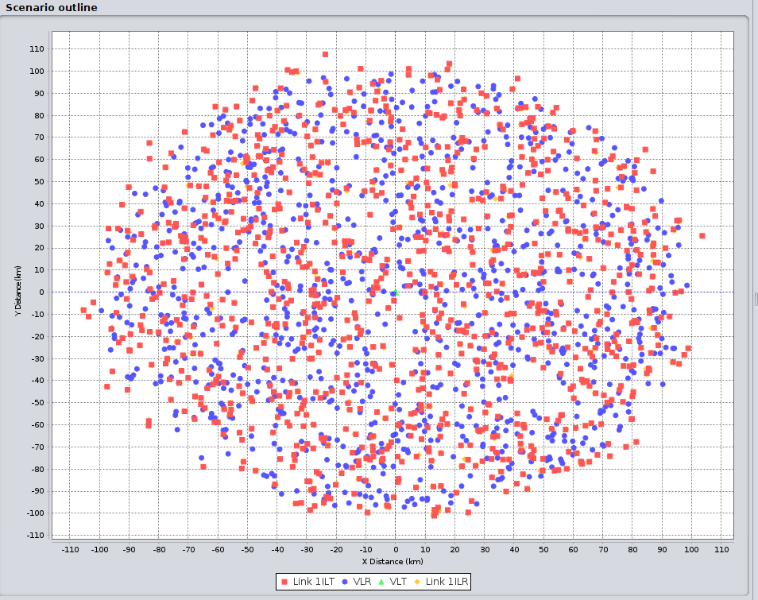

Figure 14: Example of scenario for Telemetry with 10 MHz channel bandwidth and antenna gain of 28 dBi

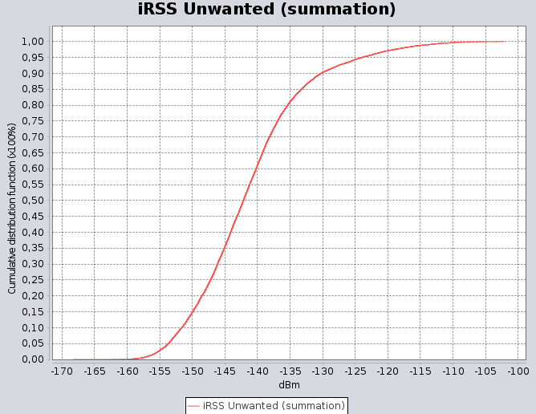

Figure 15: Example of scenario for Telemetry with 10 MHz channel bandwidth and antenna gain of 28 dBi

* + 1. Simulation results

Table 25 provides the summary the key results for co-channel and the first adjacent channel:

Table 25: Simulation results compared between LTE and AAS 5G NR

|  |  |  |  |  |  |  |  |  |  |  |  |  |
| --- | --- | --- | --- | --- | --- | --- | --- | --- | --- | --- | --- | --- |
| From ECC Report 172, table 37 [4] | | | | | | | | | | | | New simulations |
| **LTE-BS** | | **LTE-BS** | | | **Telemetry** | | | | **Separation distance (km)** | | | **AAS 5G NR BS (km)** |
| Scenario | Interferer main beam directed towards | Pe (dBm) | Ge (dB) | Pfe (dB) | Gr (dB) | PFr (dB) | IC (dBm) (10/4 MHz) | EPM73 | | Extended Hata Distance taken in 5G NR studies | Free space Clutter P.2108 [45] | |
| Co-channel scenario | Victim main beam (For 5G NR, the full beam mask is used) | 46 (43) | 17 | 3 | 28 | 1 | =-106/-110 | 81 | | 150 | Min 99.9% of the simulations are below -106 dBm for the 10 MHz TLM channel or -110 dBm for the 4 MHz TLM channel | |
| 46 (43) | 17 | 3 | 45 | 1 | =-106/-110 | 175 | | 270 | Min 99.8% of the simulations are below -106 dBm for the 10 MHz TLM channel or -110 dBm for the 4 MHz TLM channel | |
| Victim side lobes | 46 (43) | 17 | 3 | -2 | 1 | =-106/-110 | 44 | | 50 | N/A | |
| Adjacent-channel scenario | Victim main beam (For 5G NR, full beam mask is used) | -12 (-9) | 17 | 3 | 28 | 1 | =-106/-110 | 31/28 | | 13/11 | Min 99.9% of the simulations are below -106 dBm for the 10 MHz TLM channel or -110 dBm for the 4 MHz TLM channel | |
| -12 (-9) | 17 | 3 | 45 | 1 | =-106/-110 | 50/46 | | 60/55 | Min 99.9% of the simulations are below -106 dBm for the 10 MHz TLM channel or -110 dBm for the 4 MHz TLM channel | |
| Victim side lobes | -12 (-9) | 17 | 3 | -2 | 1 | =-106/-110 | 04-03 | | 1.8/1.5 | N/A | |
| Spurious scenario (Out of band for AAS 5G NR BS) | Victim main beam (For 5G NR, the full beam mask is used) | -30 | 17 | 3 | 28 | 1 | =-106/-110 | 11 | | 3 | Min 99.9% of the simulations are below -106 dBm for the 10 MHz TLM channel or -110 dBm for the 4 MHz TLM channel | |
| -30 | 17 | 3 | 45 | 1 | =-106/-110 | 27 | | 12 | Min 99.8% of the simulations are below -106 dBm for the 10 MHz TLM channel or -110 dBm for the 4 MHz TLM channel | |
| Victim side lobes | -30 | 17 | 3 | -2 | 1 | =-106/-110 | 0.4 | | 0.5 | N/A | |
| N/A: Not applicable | | | | | | | | | | | | |

* + 1. Conclusions

This study provides SEAMCAT simulations on the compatibility between telemetry and AAS 5G NR BSs.

The compatibility was made for co-channel, adjacent channel and out of band.

A comparison of non-AAS LTE and AAS 5G NR BS for the simulations above shows:

* Co-channel: with the same protection distance as non-AAS LTE, AAS 5G NR does not produce significant interference into telemetry ground stations;
* Adjacent channel: AAS 5G NR BS shows slightly better compatibility than non-AAS LTE;
* Out of band: AAS 5G NR has similar ranges of protection distance to non-AAS LTE.

Taking into account the studies above, AAS 5G NR BS has similar compatibility result in comparison with non-AAS LTE for co-channel case, adjacent channel and out of band (Telemetry just below 2300 MHz and AAS 5G NR just above 2300 MH). Thus, it is proposed to apply the same protection distances than in Table 25.

* 1. Comparison between AAS 5G NR and non-AAS LTE on PMSE compatibility
     1. Introduction

This study looks at the variation of the compatibility between PMSE/AAS 5G NR and PMSE/non-AAS LTE

Thus, the study will provide the variation (in dB and km as the minimum separation distance) between non-AAS LTE and 5G NR AAS to achieve compatibility with PMSE.

The study is made in 2300-2400 MHz band and for two scenarios, co-channel and the first adjacent channel.

PMSE parameters are mainly taken from ECC Report 172 [4]. Some PMSE parameters were not available in ECC Report 172, so in this case the most realistic parameters are proposed.

The same PMSE input parameters were applied to AAS 5G NR and LTE non-AAS.

All simulations have been done via SEAMCAT.

* + 1. Simulation parameters

Table 26, Table 27 and Table 28 summarise the parameters used in this simulation for 3 PMSE types, non-AAS LTE and AAS 5G NR BSs, respectively.

Table 26: PMSE Parameters from ECC Report 172 [4]

|  |  |  |  |  |  |  |
| --- | --- | --- | --- | --- | --- | --- |
| # | Name | Transmitter | Tx Ant. Type, Gain, Height | Receiver | Rx Ant. Type, Gain, Height | Propagation Model [46] |
| 1 | Cordless Camera Link | portable hand-held camera | semi-sphere omnidirectional, 5 dBi, 1.5 m | portable hand-held receiver | directional (e.g., Disk Yagi),  16 dBi, 1.5 m | Urban, below rooftop |
| 2 | Mobile Video Link | portable camera on motorcycle | semi-sphere omnidirectional, 5 dBi, 1.5 m | receiver on helicopter | semi-sphere omnidirectional,  5 dBi, 150 m | Free Space (helicopter links); Open area (ground links) |
| 3 | Portable Video Link | two-man radio camera | directional (e.g., Disk Yagi),  16 dBi, 3 m | TV van | 1.2 m Parabolic Dish, 27 dBi, 5 m | Suburban, below rooftop |

Table 27: LTE Parameters

|  |  |
| --- | --- |
| LTE Parameter | Value used for simulations |
| Centre frequency | 2350 MHz |
| Channel bandwidth | 20 MHz |
| Tx power | 46 dBm |
| BS feeder loss | 3 dB |
| Max antenna gain | 17 dBi |
| Antenna height | 37.5 m |
| Downtilt | 3 deg |
| Cell radius | 0.5 km |
| Number of layout tiers | 1 tiers with 3GPP2 tri-sector layout |

Table 28: Parameters of 5G NR AAS interfering BS

|  |  |  |
| --- | --- | --- |
| Parameter | Value used for simulations | Comment |
| 5G Centre frequency | 2350 MHz |  |
| 5G Bandwidth | 20 MHz | Band n40: Channel can be up to 100 MHz of bandwidth |
| 5G Antenna height | 37.5 m |  |
| 5G Antenna tilt | 10 degrees |  |
| 5G Cell radius | 0.5km |  |
| 5G AAS antenna | SEAMCAT default parameters |  |
| 5G Tx power | 46 dBm |  |

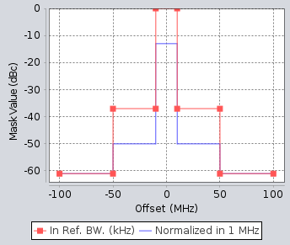

Figure 16: AAS 5G NR unwanted emission mask (in 2300-2400 MHz band) for channel bandwidth 20 MHz

For PMSE it is assumed that ACLR is similar to ACS. Thus, the same mask is applied:

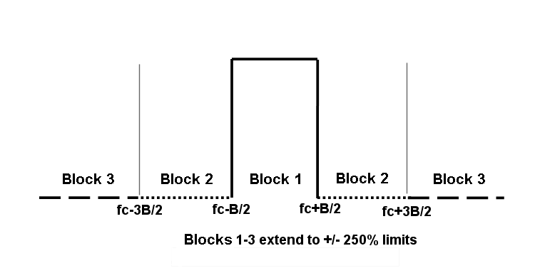

Figure 17: PMSE ACLR and ACS

The measurement mask is normalised to the channel bandwidth.

As it is assumed that the AAS 5G NR power at the PMSE device is low, the PMSE mask adapted to very low power was used, which is also the less selective mask:

Table 29: Integrated power limits relative to PMAX for P0 < 0.3 W e.i.r.p., from ECC Report 172 [4]

|  |  |  |
| --- | --- | --- |
| Block | Each half of the region | Both halves of the region |
| Block 2 | -36 dB | -33 dB |
| Block 3 | -42 dB | -39 dB |

In addition, some examples of figures to illustrate the simulations are shown below.

The figures show Rx antenna gain for Mobile video PMSE, Rx antenna gain for Cordless Camera PMSE, AAS 5G NR BS definition, LTE BS definition, the position between "Mobile Video link PMSE and 5G NR AAS" and "Cordless Camera PMSE and AAS 5G BS"

The same PMSE Rx antenna gain, the same fixed separation distance for each simulation and the same BS definition (excluding non-AAS and AAS) are used for LTE and 5G NR.

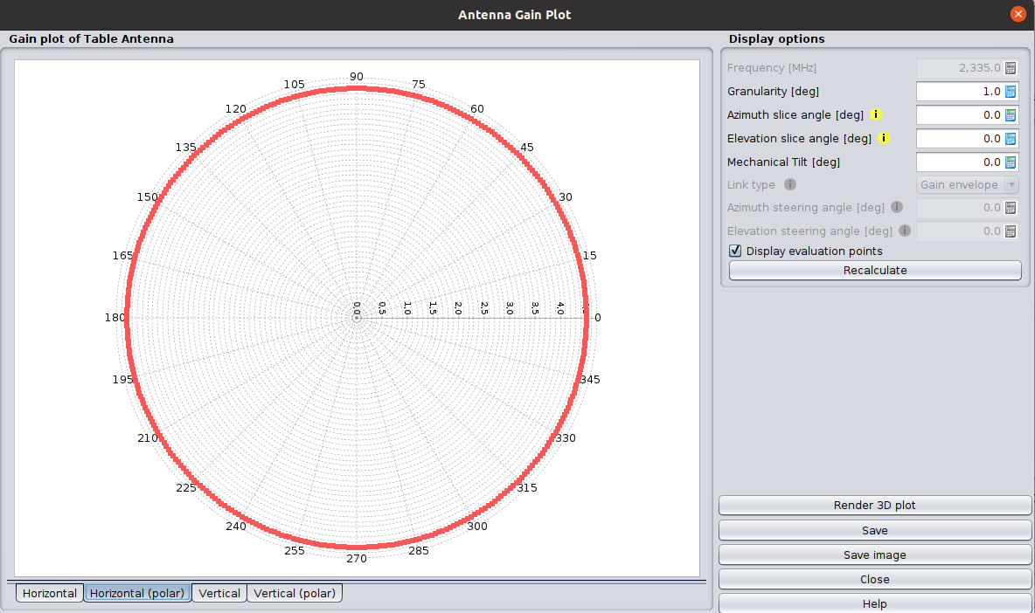

Figure 18: Mobile video PMSE - Rx antenna gain

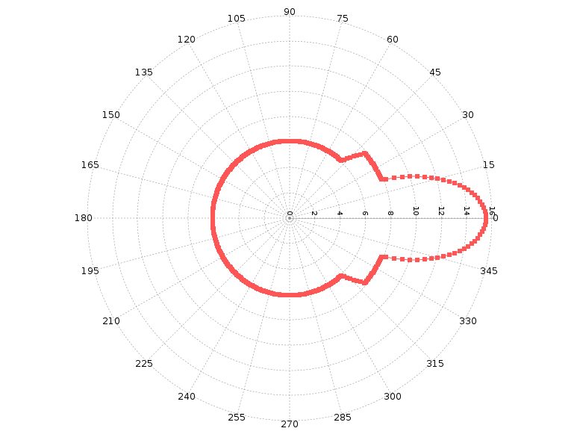

Figure 19: Cordless Camera PMSE - Rx Antenna gain

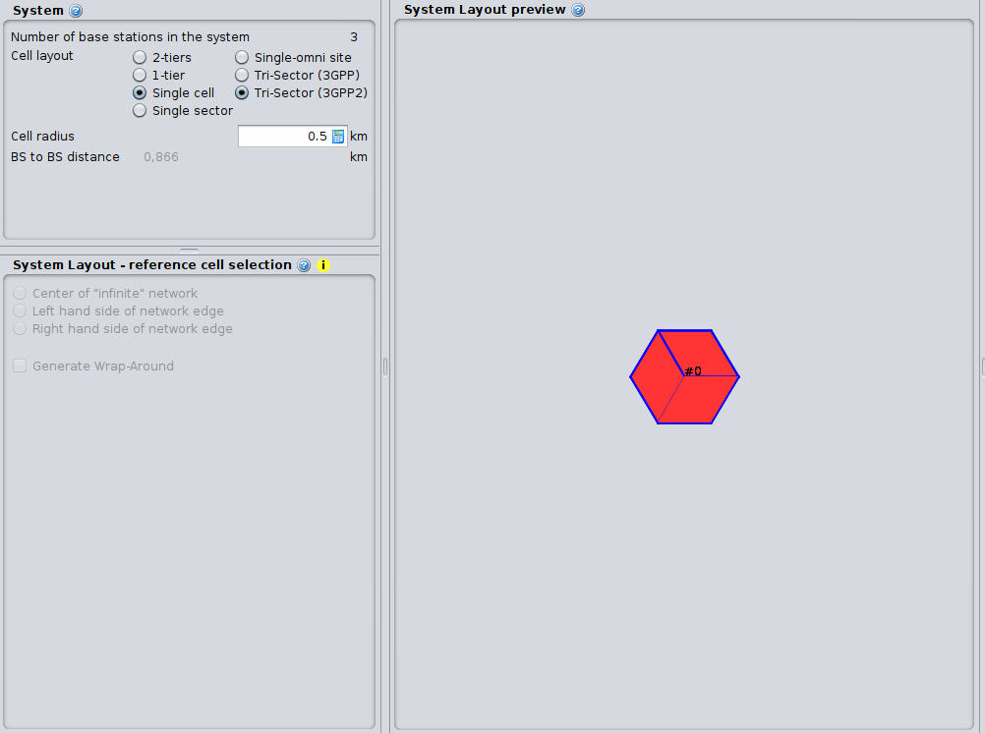

Figure 20: Non-AAS LTE BS definition

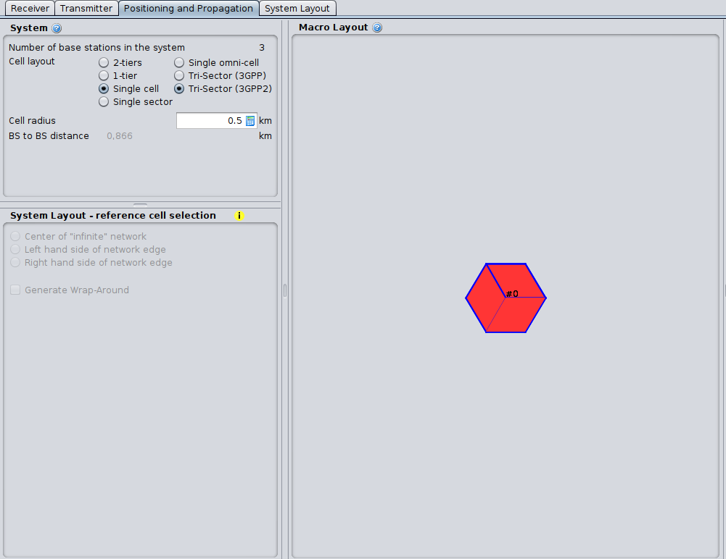

Figure 21: AAS 5G NR BS definition

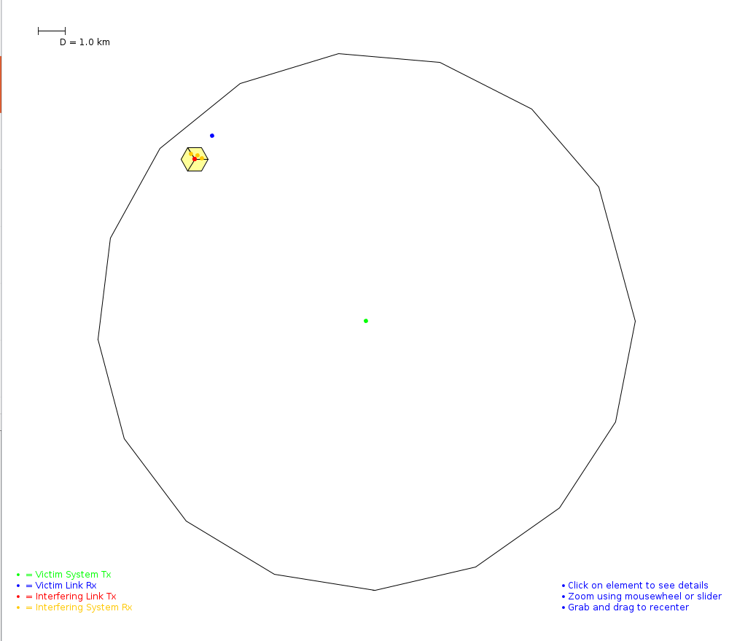

Figure 22: Distance of 1 km between Mobile Video link PMSE and AAS 5G NR

* + 1. Simulation results

Table 30 provides a summary of the key results for co-channel and the first adjacent channel:

Table 30: summary of the key results for co-channel and the first adjacent channel

|  |  |  |  |  |
| --- | --- | --- | --- | --- |
| Co-channel - PMSE Cordless Camera | | | | |
| Propagation | Hata, below roof | | | |
| Separation distance between PMSE and MFCN | 100 m | 1 km | 10 km | 25 km |
| Channel bandwidth PMSE | 10 MHz | 10 MHz | 10 MHz | 10 MHz |
| Channel bandwidth non-AAS LTE or AAS 5G NR | 20 MHz | 20 MHz | 20 MHz | 20 MHz |
| Frequency centre | 2350 MHz | 2350 MHz | 2350 MHz | 2350 MHz |
| 90% probability of the level at separation distance Δ iRSS (dB) =AAS 5G NR - non-AAS LTE | -3 | -6 | -8 | -7 |
| 50% probability of the level at separation distance Δ iRSS (dB) =AAS 5G NR - non-AAS LTE | -8 | -12 | -13 | -13 |
| First adjacent channel - PMSE Cordless Camera | | | | |
| Propagation | Hata, below roof | | | |
| Separation distance between PMSE and MFCN | 100 m | 1 km | 2 km | 3 km |
| Channel bandwidth PMSE | 10 MHz | 10 MHz | 10 MHz | 10 MHz |
| Channel bandwidth non-AAS LTE or AAS 5G NR | 20 MHz | 20 MHz | 20 MHz | 20 MHz |
| Frequency centre | 2350 MHz MFCN / 2335 MHz PMSE | 2350 MHz MFCN / 2335 MHz PMSE | 2350 MHz MFCN / 2335 MHz PMSE | 2350 MHz MFCN / 2335 MHz PMSE |
| 90% probability of the level at separation distance Δ iRSS (dB) =AAS 5G NR - non-AAS LTE | -2 | -5 | -5 | -6 |
| 50% probability of the level at separation distance Δ iRSS (dB) =AAS 5G NR - non-AAS LTE | -7 | -11 | -11 | -11 |
| Co-channel - Mobile video link | | | | |
| Propagation | Free space | | | |
| Separation distance between PMSE and MFCN | 1 km | 10 km | 50 km | 100 km |
| Channel bandwidth PMSE | 10 MHz | 10 MHz | 10 MHz | 10 MHz |
| Channel bandwidth non-AAS LTE or AAS 5G NR | 20 MHz | 20 MHz | 20 MHz | 20 MHz |
| Frequency centre | 2350 MHz | 2350 MHz | 2350 MHz | 2350 MHz |
| 90% probability of the level at separation distance Δ iRSS (dB) =AAS 5G NR - non-AAS LTE | -3 | 0 | -1 | -1 |
| 50% probability of the level at separation distance Δ iRSS (dB) =AAS 5G NR - non-AAS LTE | -12 | -13 | -12 | -12 |
| First adjacent channel - Mobile video link | | | | |
| Propagation | Free space | | | |
| Separation distance between PMSE and MFCN | 10 m | 100 m | 500 m | 1 km |
| Channel bandwidth PMSE | 10 MHz | 10 MHz | 10 MHz | 10 MHz |
| Channel bandwidth non-AAS LTE or AAS 5G NR | 20 MHz | 20 MHz | 20 MHz | 20 MHz |
| Frequency centre | 2350 MHz MFCN / 2335 MHz PMSE | 2350 MHz MFCN / 2335 MHz PMSE | 2350 MHz MFCN / 2335 MHz PMSE | 2350 MHz MFCN / 2335 MHz PMSE |
| 90% probability of the level at separation distance Δ iRSS (dB) =AAS 5G NR - non-AAS LTE | -3 | -11 | 4 | -1 |
| 50% probability of the level at separation distance Δ iRSS (dB) =AAS 5G NR - non-AAS LTE | -16 | -17 | -6 | -10 |
| Co-channel - Portable Video link | | | | |
| Propagation | Hata, below roof | | | |
| Separation distance between PMSE and MFCN | 1 km | 5 km | 10 km | 20 km |
| Channel bandwidth PMSE | 10 MHz | 10 MHz | 10 MHz | 10 MHz |
| Channel bandwidth non-AAS LTE or AAS 5G NR | 20 MHz | 20 MHz | 20 MHz | 20 MHz |
| Frequency centre | 2350 MHz | 2350 MHz | 2350 MHz | 2350 MHz |
| 90% probability of the level at separation distance Δ iRSS (dB) =AAS 5G NR - non-AAS LTE | -7 | -8 | -8 | -8 |
| 50% probability of the level at separation distance Δ iRSS (dB) =AAS 5G NR - non-AAS LTE | -12 | -14 | -13 | -13 |
| First adjacent channel - Portable video link | | | | |
| Propagation | Hata, below roof | | | |
| Separation distance between PMSE and MFCN | 100 m | 1 km | 2 km | 5 km |
| Channel bandwidth PMSE | 10 MHz | 10 MHz | 10 MHz | 10 MHz |
| Channel bandwidth non-AAS LTE and AAS 5G NR | 20 MHz | 20 MHz | 20 MHz | 20 MHz |
| Frequency centre | 2350 MHz MFCN / 2335 MHz PMSE | 2350 MHz MFCN / 2335 MHz PMSE | 2350 MHz MFCN / 2335 MHz PMSE | 2350 MHz MFCN / 2335 MHz PMSE |
| 90% probability of the level at separation distance Δ iRSS (dB) =AAS 5G NR - non-AAS LTE | 2 | -5 | -6 | -6 |
| 50% probability of the level at separation distance Δ iRSS (dB) =AAS 5G NR - non-AAS LTE | -4 | -8 | -11 | -12 |

* + 1. Conclusions

This contribution provides SEAMCAT simulations on the variation of the iRSS levels between AAS 5G NR and non-AAS LTE received at PMSE.

PMSE systems studied were “cordless camera link”, “Mobile Video Link and “Portable Video Link”.

Compatibility studies were performed for co-channel and first adjacent channel in the 2300-2400 MHz band.

The main conclusions are:

* For cordless camera PMSE, the separation distance needed between PMSE and AAS 5G NR is smaller than the separation distance between PMSE and AAS 5G NR. Compared to non-AAS LTE, the power level from AAS 5G NR received by PMSE is reduced from 2 dB to 13 dB.
* For mobile video link PMSE, in general, the separation distance between PMSE and AAS 5G NR is smaller than the separation distance between PMSE and non-AAS LTE. Compared to non-AAS LTE, the power level from AAS 5G NR received by PMSE is reduced between 4 dB to 17 dB. But for a scenario which is: "separation distance between PMSE and non-AAS LTE = 500 m + PMSE uses the first adjacent channel to AAS 5G NR", the separation distance is little bit longer and the power level from AAS 5G NR received by PMSE increases of 4 dB;
* For portable video link PMSE, in general, the separation distance between PMSE and AAS 5G NR is smaller than the separation distance between PMSE and non-AAS LTE. Compared to non-AAS LTE, the power level from AAS 5G NR received by PMSE is reduced from 4 dB to 14 dB. But for a scenario which is: "separation distance between PMSE and non-AAS LTE = 100 m + PMSE uses the first adjacent channel to AAS 5G NR", the separation distance is little bit longer and the power level from AAS 5G NR received by PMSE increases of 2 dB.

Thus, in general with the same separation distances than non-AAS LTE, the interference probability will be reduced with AAS 5G NR. Or, with the same probability interference, the distance can be reduced with AAS 5G NR compared to non-AAS LTE.

Only for two scenarios the power level from AAS 5G NR and received by PMSE mobile video link or the PMSE portable video link is increased respectively by 4 dB and 2 dB compared to non-AAS LTE.

In the tables below, an assessment of the distance between MFCN BS (non-AAS LTE or AAS 5G NR) and PMSE was performed.

The reference iRSS is based on the iRSS transmitted by the non-AAS LTE BS to the PMSE.

This assessment is based on the propagation of free space model and the scenarios described above (see Table 30), so that the reduction or increase in the separation distance is the maximum reduction or increase that might be expected.

Table 31: Co-channel - PMSE Cordless Camera

|  |  |  |  |  |
| --- | --- | --- | --- | --- |
| Co-channel - PMSE Cordless Camera | | | | |
| Referent distance between PMSE and non-AAS LTE [km] | 0.1 | 1 | 10 | 25 |
| New distance between AAS 5G NR AAS and PMSE to have the same iRSS (90%) than non-AAS LTE at PMSE [km] | 0.07 | 0.5 | 4 | 19.5 |
| New distance between AAS 5G NR AAS and PMSE to have the same iRSS (50%) than non-AAS LTE at PMSE [km] | 0.04 | 0.25 | 2.3 | 17.3 |

Table 32: First adjacent channel - PMSE Cordless Camera

|  |  |  |  |  |
| --- | --- | --- | --- | --- |
| First adjacent channel - PMSE Cordless Camera | | | | |
| Referent distance between PMSE and non-AAS LTE [km] | 0.1 | 1 | 2 | 3 |
| New distance between AAS 5G NR AAS and PMSE for a probability of 90% [km] | 0.08 | 0.56 | 1.12 | 1.5 |
| New distance between AAS 5G NR AAS and PMSE for a probability of 50% [km] | 0.045 | 0.28 | 0.56 | 0.85 |

Table 33: Co-channel - Mobile video link

|  |  |  |  |  |
| --- | --- | --- | --- | --- |
| Co-channel - Mobile video link | | | | |
| Referent distance between PMSE and non-AAS LTE [km] | 1 | 10 | 50 | 100 |
| New distance between AAS 5G NR AAS and PMSE for a probability of 90% [km] | 0.7 | 0 | 44.6 | 89.2 |
| New distance between AAS 5G NR AAS and PMSE for a probability of 50% [km] | 0.25 | 2.25 | 12.5 | 25 |

Table 34: First adjacent channel - Mobile video link

|  |  |  |  |  |
| --- | --- | --- | --- | --- |
| First adjacent channel - Mobile video link | | | | |
| Referent distance between PMSE and non-AAS LTE [km] | 0.01 | 0.1 | 0.5 | 1 |
| New distance between AAS 5G NR AAS and PMSE for a probability of 90% [km] | 0.007 | 0.028 | 0.68 | 0.9 |
| New distance between AAS 5G NR AAS and PMSE for a probability of 50% [km] | 0.0016 | 0.014 | 0.25 | 0.32 |

Table 35: Co-channel - Portable Video link

|  |  |  |  |  |
| --- | --- | --- | --- | --- |
| Co-channel - Portable Video link | | | | |
| Referent distance between PMSE and non-AAS LTE [km] | 1 | 5 | 10 | 20 |
| New distance between AAS 5G NR AAS and PMSE for a probability of 90% [km] | 0.45 | 2 | 4 | 8 |
| New distance between AAS 5G NR AAS and PMSE for a probability of 50% [km] | 0.26 | 1 | 2.3 | 4.5 |

Table 36: First adjacent channel - Portable video link

|  |  |  |  |  |
| --- | --- | --- | --- | --- |
| First adjacent channel - Portable video link | | | | |
| Referent distance between PMSE and non-AAS LTE [km] | 0.1 | 1 | 2 | 5 |
| New distance between AAS 5G NR AAS and PMSE for a probability of 90% [km] | 0.12 | 0.56 | 1 | 2.5 |
| New distance between AAS 5G NR AAS and PMSE for a probability of 50% [km] | 0.064 | 0.4 | 0.57 | 1.3 |

1. In-band and adjacent band coexistence analysis Study #2
   1. Adjacent band coexistence of NR AAS in the 2.3 GHz band with Wi-Fi operating in the 2.4 GHz band
      1. Introduction

This annex provides more details on the simulation parameters for the adjacent band coexistence of NR AAS in the 2.3 GHz band with Wi-Fi operating in the 2.4 GHz band. ECC Report 172 [4] contains compatibility studies between LTE operating in the 2.3 GHz band and Wi-Fi in the 2.4 GHz band. The analysis for the new report is based on ECC Report 172. Firstly the ECC Report 172 indoor scenarios are re-simulated and in a second step the LTE system is replaced with an NR system to ensure a fair comparison. All the simulations are done using SEAMCAT V5.4.3.

* + 1. Simulation parameters

In line with ECC Report 172 this study focuses on the indoor case only. Table 37 and Table 38 summarise the parameters used within ECC Report 172 for WLAN receivers and LTE base stations (BS), respectively.

Table 37: Parameters of WLAN 802.11n AP system operating in the band 2400-2483.5 MHz [4] [43]

|  |  |  |
| --- | --- | --- |
| Victim WLAN receiver |  | Comment |
| AP antenna height | 1.5 m and 10 m |  |
| Propagation model | ITU-R P.525 [44] (Free space) |  |
| Wall penetration loss | 18 dB with STD 5 dB | Based on ECC Report 203  Macro BS to Pico/Femto BS at Table 41 [5] |
| I/N objective | 0 dB | From ECC Report 172. ITU-R Recommendation M.1739 [47] recommends that the I/N at the RLAN receiver should not exceed -6 dB. |
| Receiver bandwidth | 16.25 MHz |  |
| Receiver noise figure (NF) | 10 dB |  |
| Receiver thermal noise (No) | -102.07 dBm |  |
| Noise floor N = No + NF | -92.07 dBm |  |
| Maximum acceptable unwanted emission received from a macro-BS | -92.07 dBm/16,25 MHz | Given that I/N = 0 (ECC Report 172) |
| Centre frequency | 2412 and 2432 MHz | WLAN channel 1 and WLAN channel 5 |
| WLAN TX power | 20 dBm | ECC Report 172 |
| Antenna gain | 2 dB |  |
| Layout | Generic layout with 2 km radius | As used in ECC Report 172 |

Table 38: Parameters of LTE interfering BS [1]

|  |  |  |
| --- | --- | --- |
| LTE (Interfering network) |  | Comment |
| Centre frequency | 2390 MHz |  |
| Channel bandwidth | 20 MHz |  |
| Tx power | 46 dBm |  |
| BS feeder loss | 3 dB |  |
| Max antenna gain | 17 dBi |  |
| Antenna height | 20 m and 37.5 m |  |
| Tilt | 3 deg |  |
| Cell radius | 0.5 km | Cell range 1 km |
| Number of layout tiers | 2 tiers with 3GPP tri-sector layout | 19 BS with 57 cells |
| Propagation model | Extended Hata | Urban environment used for that cell range.  Used also as cross propagation model between aggressor and victim. |

To ensure a fair comparison between the compatibility of 5G AAS with Wi-Fi, the assumptions from ECC Report 172 [4], for LTE non-AAS coexistence, should be reused, as far as applicable for 5G AAS, in the new studies. Only technical parameters that are a consequence of using 5G AAS instead of LTE non-AAS should be changed like the emission mask and AAS parameters. Therefore, Table 39 summarises the proposed parameters of the NR AAS interfering BS used for the analysis. Those parameters are also adopted for the NR simulations below.

Table 39: Parameters of NR AAS interfering BS

|  |  |  |  |
| --- | --- | --- | --- |
| Parameter | | Value used for simulations | Comment |
| 5G Centre frequency | | 2390 MHz |  |
| 5G Bandwidth | | 20 MHz | Band n40 in theory can include up to 100 MHz |
| 5G Antenna height | | 37.5 m | ECC Report 172 [4] |
| 5G Antenna tilt | | 3 degrees | ECC Report 172 |
| 5G Cell radius | | 0.5 km for Urban case | As captured in ECC Report 172 with cell range 1 km |
| 5G AAS antenna | | 8x8 elements  Element gain 7.1 dB  0.5 element spacing in H and 0.9 for V  3 dB H 90 deg  3 dB V 54 deg | Max BF gain 25.2 dB |
| 5G Tx power | | 46 dBm |  |
| 5G subcarrier spacing (SCS) | 30 kHz |  | |
| Number of UEs | 1 per cell | 51 RBs per UE | |
| Propagation model | | Extended Hata |  |

* + 1. Unwanted emission mask

The LTE emission mask which is applied in the LTE compatibility study within ECC Report 172 [4] is used as a reference, as depicted in Figure 2 of that Report. It was derived based on ETSI TS 136 104 [48] and is depicted in Figure 23 as “mask 1”. Furthermore, the multi standard radio (MSR) mask from ETSI TS 137 104 [6] is used, and the additional base line limits from ECC Decision (14)02 [1] are applied on top. For this mask 8 non AAS antennas are assumed. The resulting mask is shown in Figure 23 labelled as “mask 2”. For 10 MHz offset from the downlink band the general spurious emission limit of -30 dBm/MHz applies. It should be noted that the unwanted emission limits and spurious emission limit are given per antenna connector. For that reason, the unwanted emission limits and the spurious emission limit for mask 2 are scaled by the number of antennas. The masks in Figure 23 are normalised to 1 MHz and denoted in dBc, noting that the assumed carrier power is 46 dBm.

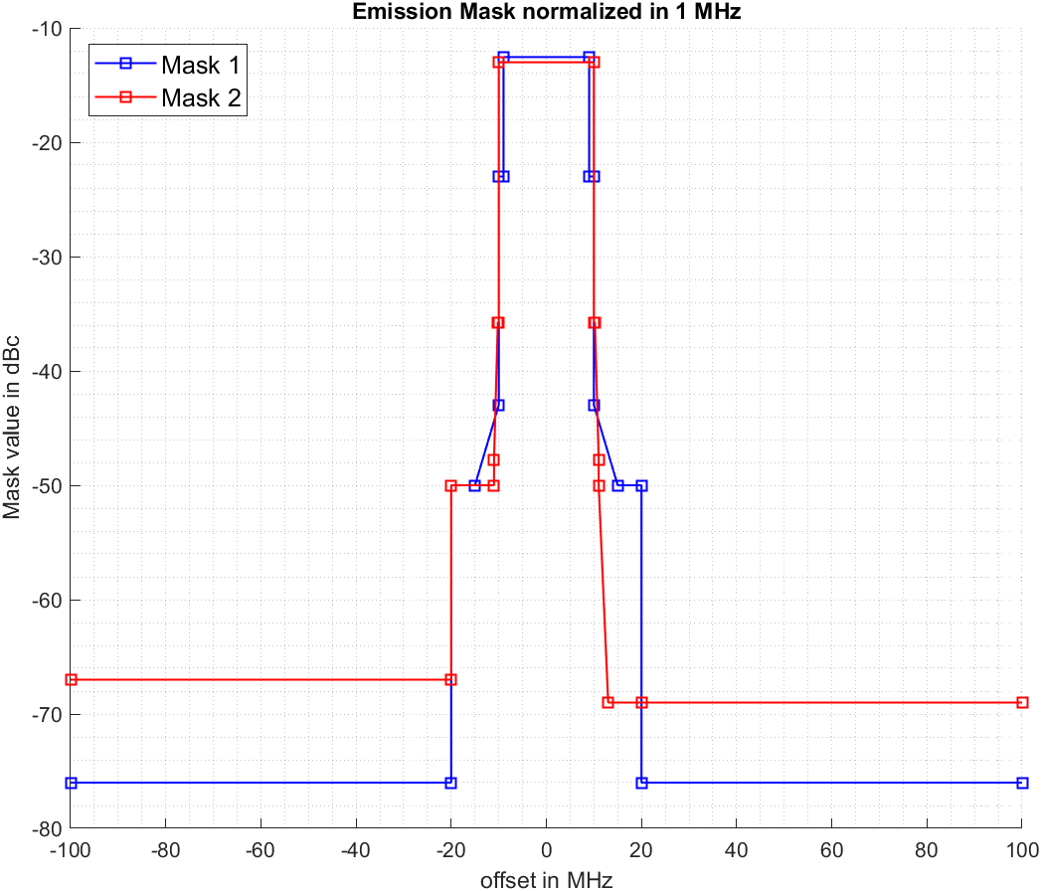

Figure 23: LTE unwanted emission masks

The emission mask which is used in the NR compatibility study is based on ETSI TS 137 105 Table 6.6.5.2.2-1b [27] and shown in Figure 24 as “mask 3”. As an alternative emission mask, the AAS TRP limits from the Swedish regulations are applied on top of mask 3, resulting in “mask 4” in Figure 24. The TRP limit from the Swedish regulation limits is -11 dBm/(5 MHz), which corresponds to -18 dBm/MHz.

As a third emission mask the additional baseline requirements above 2403 MHz out-of-band limits from ECC Decision(14)02 [1] are applied on top of “mask 3”, which is depicted as “mask 5” in Figure 24. The e.i.r.p. limit above 2403 MHz is 1 dBm/(5 MHz) according to ECC Decision (14)02 [1]. Assuming an antenna gain of 17 dBi a TRP limit of -16 dBm/(5 MHz) is obtained, which corresponds to -23 dBm/MHz.

For NR in the 2.3 GHz band starting at a frequency offset of 40 MHz from the downlink band the general spurious emission limit of -30 dBm/MHz applies, which is significantly relaxed compared to the 10 MHz offset for LTE. The masks in Figure 24 are normalised to 1 MHz and denoted in dBc, noting that the assumed carrier power is 46 dBm.

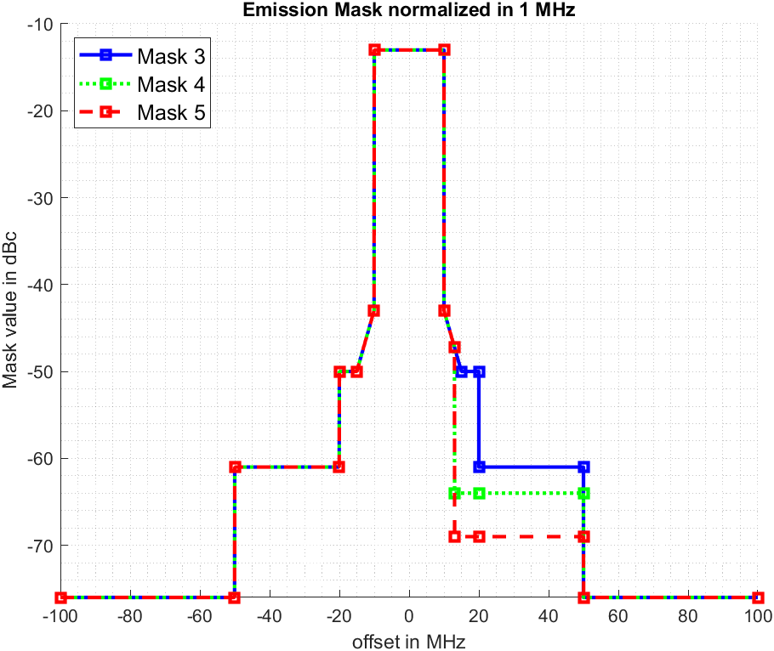

Figure 24: NR unwanted emission masks

* + 1. WLAN blocking mask

The receiver blocking mask depicted in Figure 25 and is assumed for the WLAN receiver in the simulations. The detailed derivation of the WLAN blocking mask is provided in Annex A3.1.7.

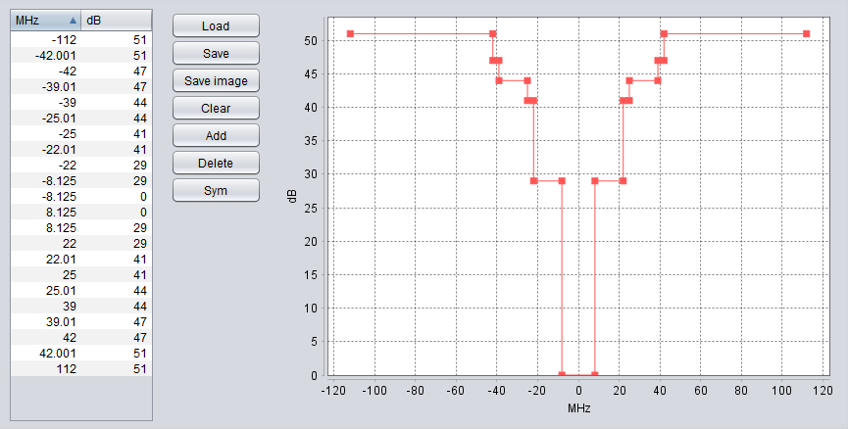

Figure 25: WLAN receiver blocking mask

* + 1. Simulation results

In the following sections the interfering received signal strength (iRSS) and the probability that I/N exceeds 0 dB for the WLAN channel 1 and WLAN channel 5 are investigated.

* + - 1. LTE simulation results

To verify the simulation assumptions above, the indoor scenario simulations from Table 57 in ECC Report 172 [4] for the unwanted interference have been repeated. Table 40 summarises the results obtained from the simulations and the reference results from ECC Report 172. The results for “mask 1”, which is identical to the emission mask used in ECC Report 172, show a very good alignment of the results. Also, it is observed that the interference probability on WLAN channel 5 is significantly lower compared to results for WLAN channel 1. That is because the WLAN channel 5 is within the spurious domain of the 2.3 GHz band, which starts after an offset of 10 MHz from the MFCN band edge. Furthermore, it is observed observe that the emission limits defined in ECC Decision (14)02 [1] exhibit a positive effect on the unwanted interference, since the result for “mask 2” exhibit a low interference probability for both WLAN AP antenna heights, using I/N=0 dB as interference criterion.

Table 40: LTE simulation results (unwanted interference)

|  |  |  |  |  |
| --- | --- | --- | --- | --- |
| WLAN Channel | WLAN AP antenna height [m] | ECC Report 172 [4] results (Reference value) | Total median sum iRSS unwanted / Interference probability Mask 1 | Total median sum iRSS unwanted / Interference probability  Mask 2 |
| CH 1 | 10 | 32% | -95.4 dBm / 31.9% | -110.3 dBm / 2.7% |
| 1.5 | 0.9% | -121.1 dBm / 0.5% | -136.1 dBm / 0% |
| CH 5 | 10 | 4.9% | -117.3 dBm / 0.8% | -110.3 dBm / 2.7% |
| 1.5 | 0.1% | -143.1 dBm / 0% | -136.1 dBm / 0% |

ECC Report 172 did not study the blocking effect of LTE base stations on WLAN. However, since ECC Decision (14)02 requires an in-block e.i.r.p. limit of 45 dBm/(5 MHz) for the frequency range 2390-2400 MHz, the blocking effect using SEAMCAT is also investigated in the following sections. For this the following three cases are investigated:

* Case 1: No in-block power requirement considered.
* Case 2: In-block e.i.r.p. requirement of 45 dBm/(5 MHz) applied to the full channel BW of 20 MHz.
* Case 3: No in-block power requirement considered, carrier centre frequency is reduced to 2380 MHz to ensure a guard band of 10 MHz.

Table 41 summarises the results for the interference cause by blocking in all three cases.

Table 41: LTE simulation results (blocking interference)

|  |  |  |  |  |
| --- | --- | --- | --- | --- |
| WLAN Channel | WLAN AP antenna height [m] | Total median sum iRSS blocking / Interference probability (blocking)  Case 1 | Total median sum iRSS blocking / Interference probability (blocking)  Case 2 | Total median sum iRSS blocking / Interference probability (blocking)  Case 3 |
| CH 1 | 10 | -85.2 dBm / 92.1% | -94.2 dBm / 37.1% | -97.1 dBm / 24% |
| 1.5 | -111 dBm / 2.9% | -120 dBm / 0.5% | -122.9 dBm / 0.4% |
| CH 5 | 10 | -100.2 dBm / 15.2% | -109.2 dBm / 3.4% | -104.4 dBm / 8.9% |
| 1.5 | -126.07 dBm / 0.1% | -135.07 dBm / 0% | -130.2 dBm / 0% |

The results summarised in Table 41 show that the effect of blocking is even more severe than the interference due to unwanted emissions. Without applying any counter measures in case 1, the interference probability is 92.1% and 2.9% for 10 m and 1.5 m WLAN AP height, respectively. The e.i.r.p. requirement from ECC Decision (14)02 [1] and a 10 MHz guard band show that the interference probability reduces significantly for 1.5 m WLAN AP height, while for 10 m WLAN AP height blocking is still causing a high interference probability on WLAN channel 1. For channel 5 the interference probability for 10 m WLAN AP height exceeds 15% without applying any counter measures in case 1. It exhibits that employing a guard band reduces the interference for WLAN channel 1 significantly but causes higher interference to WLAN channel 5 than utilising an in-block e.i.r.p. requirement.

* + - 1. NR simulation results

Based on the parameters summarised in Table 37 and Table 39, the simulation results for NR are summarised in the following table. The results are obtained for the three different emission masks depicted in Figure 24. For all simulations 1 UE per cell with 51 RBs for MS and BS are assumed, respectively.

Table 42: NR simulation results (unwanted interference)

|  |  |  |  |  |
| --- | --- | --- | --- | --- |
| WLAN Channel | WLAN AP antenna height [m] | Total median sum iRSS unwanted / Interference probability  Mask 3 | Total median sum iRSS unwanted / Interference probability  Mask 4 | Total median sum iRSS unwanted / Interference probability  Mask 5 |
| CH 1 | 10 | -96.4 dBm / 26.6% | -106.8 dBm / 5.8% | -111.8 dBm / 2.3% |
| 1.5 | -122.1 dBm / 0.6% | -132.5 dBm / 0.1% | -137.5 dBm / 0% |
| CH 5 | 10 | -103.8 dBm / 10% | -106.8 dBm / 5.8% | -111.8 dBm / 2.3% |
| 1.5 | -129.5 dBm / 0.1% | -132.5 dBm / 0.1% | -137.5 dBm / 0% |

From Table 42 it can be observed that using “mask 5”, which is applying the ECC Decision (14)02 [1] limits, exhibits similar interference compared to LTE non-AAS results in Table 41. Furthermore, it is observed that using mask 3 and mask 4 results in a higher probability of interference for 10 m WLAN AP antenna height on both WLAN channel 1 and channel 5. That is because the spurious domain starts after 40 MHz offset from the downlink band edge.

Table 43 summarises the results of the blocking interference for the following three cases:

* Case 1: No restrictions considered;
* Case 2: In-block TRP requirement of 28 dBm/(5 MHz) applied to the full channel BW of 20 MHz;
* Case 3: No in-block power requirement considered, carrier centre frequency is reduced to 2380 MHz to ensure a guard band of 10 MHz.

For case 2, the 28 dBm/(5 MHz) is equivalent to the current ECC Decision (14)02 e.i.r.p. limit for non-AAS and has been converted assuming an antenna gain of 17 dBi.

Table 43: NR simulation results (blocking interference)

|  |  |  |  |  |
| --- | --- | --- | --- | --- |
| WLAN Channel | WLAN AP antenna height [m] | Total median sum iRSS blocking / Interference probability (blocking)  Case 1 | Total median sum iRSS blocking / Interference probability (blocking)  Case 2 | Total median sum iRSS blocking / Interference probability (blocking)  Case 3 |
| CH 1 | 10 | -86.7 dBm / 76.9% | -98.7 dBm / 19.7% | -98.7 dBm / 19.7% |
| 1.5 | -112.4 dBm / 2.3% | -124.4 dBm / 0.2% | -124.4 dBm / 0.2% |
| CH 5 | 10 | -101.8 dBm / 14.2% | -113.8 dBm / 1.9% | -105.9 dBm / 7.3% |
| 1.5 | -127.5 dBm / 0.1% | -139.5 dBm / 0% | -131.6 dBm / 0.1% |

The results summarised in Table 43 show that similar to the results for LTE, the effect of blocking is more severe than the interference due to unwanted emissions. Without applying any counter measures in case 1, the interference probability is 76.9% and 2.3% for 10 m and 1.5 m WLAN AP height, respectively, for WLAN channel 1. For channel 5 the interference probability for 10 m WLAN AP height exceeds 14% without applying any counter measures in case 1. Like LTE, it exhibits that employing a guard band reduces the interference for WLAN channel 1 significantly but causes higher interference to WLAN channel 5 than utilising an in-block e.i.r.p. requirement. Using the converted e.i.r.p. requirement from ECC Decision (14)02 exhibits a significant interference probability reduction for WLAN channel 1 and 5.

* + - 1. Relative comparison

In the following the unwanted emissions and the blocking are compared between LTE non-AAS, based on ECC Decision (14)02 [1], i.e., based on mask 2, and NR AAS with different protection criteria. For the unwanted emissions the impact of the three masks depicted in Figure 24 is investigated, while for the blocking different TRP in-block power level requirements for 2390–2400 MHz are investigated.

* + - 1. Unwanted emissions

A relative comparison of the interfering received signal strength (iRSS) is performed by subtracting the iRSS due to unwanted emissions obtained for LTE non-AAS iRSS_nonAAS_unwanted from the iRSS for NR AAS iRSS_AAS_unwanted:

|  |  |
| --- | --- |
| ∆iRSS_unwanted = iRSS_AAS_unwanted – iRSS_nonAAS_unwanted | (1) |

Table 44: iRSS for unwanted emissions (with non-AAS LTE Mask 2)

|  |  |  |  |  |
| --- | --- | --- | --- | --- |
| WLAN  Channel | Protection criteria w/ | Mask 3 | Mask 4 | Mask 5 |
| CH 1 | ∆iRSS_unwanted @ 1.5 m | +14 dB | +3.6 dB | -1.4 dB |
| ∆iRSS_unwanted @ 10 m | +13.9 dB | +3.5 dB | -1.5 dB |
| CH 5 | ∆iRSS_unwanted @ 1.5 m | +6.6 dB | +3.6 dB | -1.4 dB |
| ∆iRSS_unwanted @ 10 m | +6.5 dB | +3.5 dB | -1.4 dB |

Table 44 summarises the results of the relative comparison for unwanted emissions. For mask 3 and mask 4, positive values are observed, which means that the 5G AAS system causes higher interference than the LTE non-AAS system for both WLAN channel 1 and channel 5. This shows that the interference caused by using AAS with mask 3 and 4 is not limited to channel 1 but also has a significant impact on WLAN channel 5. This exhibits that using WLAN channel 5 instead of channel 1, as recommended by ECC Report 172 [4], is not an option for AAS anymore. For mask 5, which applies the ECC Decision (14)02 [1] limits, ∆iRSS_unwanted exhibits small negative values, which shows that the interference from NR AAS is slightly lower than LTE non-AAS. It is also observed that using the limits from mask 4, which corresponds to the limits from the Swedish regulation, does not ensure the same protection of WLAN as before for both WLAN channel 1 and channel 5.

* + - 1. Blocking

A relative comparison of the interfering received signal strength (iRSS) is performed by subtracting the iRSS due to blocking obtained for LTE non-AAS iRSS_nonAAS_blocking from the iRSS for NR AAS iRSS_AAS_blocking:

|  |  |
| --- | --- |
| ∆iRSS_blocking = iRSS_AAS_blocking – iRSS_nonAAS_blocking | (2) |

For the LTE non-AAS simulations the e.i.r.p. requirement of 45 dBm/(5 MHz) for the frequency range 2390-2400 MHz is always assumed. For NR AAS four different TRP power limits in the same frequency range are investigated, where 28 dBm/(5 MHz) corresponds to the LTE case 2 in Table 41.

The results in the following table which exhibits that the TRP power reduction of 32 dBm/(5 MHz) for the frequency range 2390-2400 MHz is sufficient to ensure the same blocking interference protection for WLAN as guaranteed by ECC Decision (14)02 [1] for LTE non-AAS.

Table 45: TRP in-block power for AAS 2390-2400 and iRSS for blocking

|  |  |  |  |  |  |
| --- | --- | --- | --- | --- | --- |
| WLAN Channel | TRP in-block power for AAS 2390-2400 MHz | 28 dBm/(5 MHz) | 32 dBm/(5 MHz) | 33 dBm/(5 MHz) | 36 dBm/(5 MHz) |
| CH 1 | ∆iRSS blocking @ 1.5 m | -4.4 dB | -0.4 dB | +0.6 dB | +3.6 dB |
| ∆iRSS blocking @ 10 m | -4.5 dB | -0.5 dB | +0.5 dB | +3.5 dB |
| CH 5 | ∆iRSS blocking @ 1.5 m | -4.4 dB | -0.4 dB | +0.6 dB | +3.6 dB |
| ∆iRSS blocking @ 10 m | -4.6 dB | -0.6 dB | +0.4 dB | +3.4 dB |

NOTE: To ease simulations, the 20 MHz channel BW for AAS and non-AAS has been maintained with different TRP requirements for AAS.

* + 1. Conclusions

In this annex more details on the compatibility between AAS MFCN below 2400 MHz and WLAN channel 1 and 5 above 2400 MHz are provided. The simulation results show that additional emission and power limits are required to ensure an equivalent protection of WLAN in the 2400 MHz band from interference caused by 5G AAS systems as currently guaranteed by LTE non-AAS systems. Based on the simulation results in this annex it is observed that converting the unwanted emission limits from ECC Decision (14)02 [1] to TRP limits, which corresponds to a TRP limit of -16 dBm/(5 MHz) above 2403 MHz ensures protection of WLAN. For the power in-block power limits in the frequency range 2390 – 2400 MHz a TRP limit of 32 dBm/(5 MHz) seems to be sufficient to ensure an equivalent blocking protection. Note that using WLAN channel 5 instead of channel 1, as recommended by ECC Report 172 [4], is not an option for AAS anymore when using higher limits.

* + 1. Derivation of the blocking mask

From ETSI EN 300 328 V2.2.2 [41] the following information for receiver category 1 is obtained.

The following table in ETSI EN 300 328 V2.2.2 contains the Receiver Blocking parameters for Receiver Category 1 equipment which is applicable for our case.

Table 46: Receiver Blocking parameters for Receiver Category 1 equipment

|  |  |  |  |
| --- | --- | --- | --- |
| Wanted signal mean power from companion device (dBm)  (see notes 1 and 4) | Blocking signal frequency  (MHz) | Blocking signal power (dBm)  (see note 4) | Type of blocking  signal |
| (-133 dBm + 10 × log10(OCBW)) or -68 dBm whichever is less (see note 2) | 2380 2504 | -34 | CW |
| (-139 dBm + 10 × log10(OCBW)) or -74 dBm whichever is less  (see note 3) | 2300 2330 2360 2524 2584 2674 |
| NOTE 1: OCBW is in Hz.  NOTE 2: In case of radiated measurements using a companion device and the level of the wanted signal from the companion device cannot be determined, a relative test may be performed using a wanted signal up to Pmin + 26 dB where Pmin is the minimum level of wanted signal required to meet the minimum performance criteria as defined in clause 4.3.1.12.3 in the absence of any blocking signal.  NOTE 3: In case of radiated measurements using a companion device and the level of the wanted signal from the companion device cannot be determined, a relative test may be performed using a wanted signal up to Pmin + 20 dB where Pmin is the minimum level of wanted signal required to meet the minimum performance criteria as defined in clause 4.3.1.12.3 in the absence of any blocking signal.  NOTE 4: The level specified is the level at the UUT receiver input assuming a 0 dBi antenna assembly gain. In case of conducted measurements, this level has to be corrected for the (in-band) antenna assembly gain (G). In case of radiated measurements, this level is equivalent to a power flux density (PFD) in front of the UUT antenna with the UUT being configured/positioned as recorded in clause 5.4.3.2.2. | | | |

From this test, it is understood that there are two blocking requirement regions: One with centre frequency of interferer at 2380 MHz and one with 2360 MHz or lower. From the test description in Clause 5.4.11.2.1 of ETSI EN 300 328 V2.2.2 [41], it is understood that the requirement is applicable ±10 MHz around the blocking signal frequency 2 380 MHz.

Furthermore, some specific requirements need to be considered if the test is executed at an offset more than ± 7 MHz of the blocking signal frequency according to Section 5.4.11.2.1 of ETSI EN 300 328 V2.2.2:

"Step 5:

If the performance criteria as specified in clause 4.3.1.12.3 or clause 4.3.2.11.3 is not met, step 3 and step 4 shall be repeated after that the frequency of the blocking signal set in step 2 has been increased with a value equal to the Occupied Channel Bandwidth except:

For the blocking frequency 2 380 MHz, where this frequency offset shall be less than or equal to 10 MHz. If this frequency offset is more than 7 MHz, the level of the wanted signal shall be increased by 3 dB.

If the performance criteria as specified in clause 4.3.1.12.3 or clause 4.3.2.11.3 is still not met, step 3 and step 4 shall be repeated after that the frequency of the blocking signal set in step 2 has been decreased with a value equal to the Occupied Channel Bandwidth except:

For the blocking frequency 2 380 MHz, where this frequency offset shall be less than or equal to 10 MHz. If this frequency offset is more than 7 MHz, the level of the wanted signal shall be decreased by 3 dB."

Using the definitions from ECC Report 310 [49], for a blocking signal frequency of 2380 MHz:

$$I_{adj-ch}=-34 dBm$$

$$C=-68 dBm$$

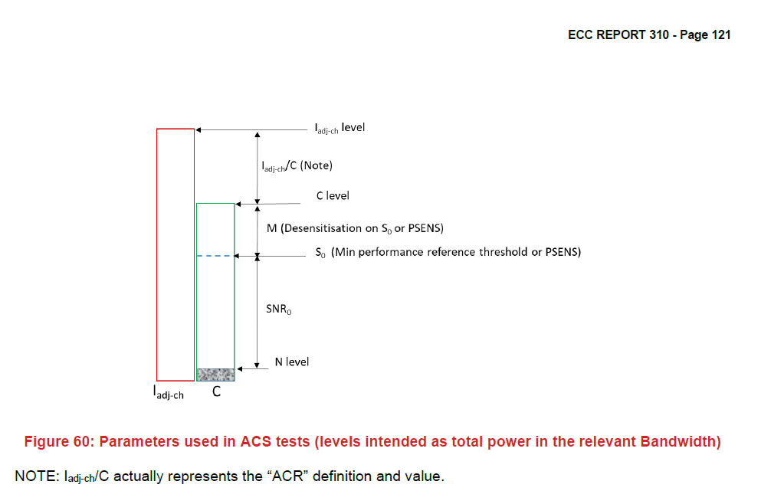

Figure 26: Parameters used in ACS tests (levels intended as total power in the relevant bandwidth

Note: $I_{adj-ch}/C$ actually represens the “ACR” definition and value.

From IEEE 802.11-2020 [43], Table 17-18 a reference sensitivity level of $S_{0}=-82 dBm$ is obtained for 20 MHz and the lowest modulation and coding scheme (MCS), as well as the information that a “noise factor of 10 dB and 5 dB implementation margins are assumed”. The implementation margin was considered only for the derivation of the reference sensitivity and will not be considered in the noise floor derivation.

Table 47: Receiver performance requirements (IEEE 802.11-2020 Table 17-18 [43])

|  |  |  |  |  |  |  |
| --- | --- | --- | --- | --- | --- | --- |
| Modulation | Coding rate (R) | Adjacent channel rejection (dB) | Alternate adjacent channel rejection (dB) | Minimum sensitivity (dBm) (20 MHz channel spacing) | Minimum sensitivity (dBm) (10 MHz channel spacing) | Minimum sensitivity (dBm) (5 MHz channel spacing) |
| BPSK | 1/2 | 16 | 32 | –82 | –85 | –88 |
| BPSK | 3/4 | 15 | 31 | –81 | –84 | –87 |
| QPSK | 1/2 | 13 | 29 | –79 | –82 | –85 |
| QPSK | 3/4 | 11 | 27 | –77 | –80 | –83 |
| 16-QAM | 1/2 | 8 | 24 | –74 | –77 | –80 |
| 16-QAM | 3/4 | 4 | 20 | –70 | –73 | –76 |
| 64-QAM | 2/3 | 0 | 16 | –66 | –69 | –72 |
| 64-QAM | 3/4 | –1 | 15 | –65 | –68 | –71 |

This is in-line with the following requirement from Section 5.4.11 of ETSI EN 300 328 V2.2.2 [41].

"If the equipment can be configured to operate with different Nominal Channel Bandwidths (e.g., 20 MHz and 40 MHz) and different data rates, then the combination of the smallest channel bandwidth and the lowest data rate for this channel bandwidth which still allows the equipment to operate as intended shall be used."

The occupied channel bandwidth is used in ETSI EN 300 328 V2.2.2 rather than system channel bandwidth. For that, the thermal noise is calculated by using 16.25 MHz occupied channel bandwidth, from that an approximate thermal noise power of -101.9 dBm is obtained. When including the noise figure of 10 dB then the noise floor is:

|  |  |
| --- | --- |
| $$N=N_{thermal}+NF=-101.9 dBm+10 dB= -91.9 dBm$$ | (3) |

Using ECC Report 310, figure 60 [49], the following information can be derived:

|  |  |
| --- | --- |
| $$SNR_{0}=S_{0}-N=\left(-82 dBm\right)-\left(-86 dBm\right)=\left(-91.9 dBm\right)\left(-86 dBm\right)=9.9 dB$$ | (4) |
| $$M=C-S_{0}=\left(-68 dBm\right)-\left(-82 dBm\right)=14 dB$$ | (5) |

Note that the implementation margin is already included in the reference sensitivity level $S_{0}$.

The ACS can be calculated according to ECC Report 310, equation (55) [49] as

|  |  |
| --- | --- |
| $$ACS=-\left(C-I_{adj-ch}\right)+SNR_{0}+M-10\log_{10}\left({10}^{\frac{M}{10}}-1\right)$$ $$ACS=-\left(-68 dBm-\left(-34 dBm\right)\right)+9.9 dB+14 dB-10\log_{10}\left({10}^{1.4}-1\right)$$ $$ACS=34 dB+23.9 dB-13.82 dB=44.08 dB$$ | (6) |

For a blocking signal frequency of 2380 MHz the ACS derived above is valid for the frequency range 2373-2387 MHz, while for the frequency range 2387-2390 MHz and 2370-2373 MHz ACS = 40.98 dB and ACS = 47.2541 dB are obtained, respectively.

For a blocking signal frequency of 2360 MHz, with the same steps as above:

$$I_{adj-ch}=-34 dBm$$

$$C=-74 dBm$$

$$SNR_{0}=9.9 dB$$

$$M=C-S_{0}=\left(-74 dBm\right)-\left(-82 dBm\right)=8 dB$$

$$ACS=-\left(-74 dBm-\left(-34 dBm\right)\right)+9.9 dB+8 dB-10\log_{10}\left({10}^{0.8}-1\right)$$

$$ACS=57.9 dB-7.25 dB=50.65 dB$$

The applicable frequency ranges are derived from the blocking signal frequency in Table 14 from [41].

For the frequency range 2390 to 2403 MHz the adjacent channel rejection from [43], Table 17-18 should be applied. The desensitization value is obtained from the test description in [43] (3 dB above reference sensitivity).

$$M=3 dB$$

$$I_{adj-ch}=S_{0}+M+ACR=\left(-82 dBm\right)+3 dB+16 dB=-63 dBm$$

$$C=S_{0}+M=\left(-82 dBm\right)+3 dB=-79 dBm$$

$$SNR_{0}=9.9 dB$$

$$ACS=-\left(C-I_{adj-ch}\right)+SNR_{0}+M-10\log_{10}\left({10}^{\frac{M}{10}}-1\right)$$

$$ACS=-\left(-79 dBm-\left(-63 dBm\right)\right)+9.9 dB+3 dB-10\log_{10}\left({10}^{0.3}-1\right)$$

$$ACS=28.9 dB+0.02 dB=23232328.9223 dB$$

Table 48 summarises the ACS based values of the blocking mask.

Table 48: Blocking mask

|  |  |
| --- | --- |
| Range (MHz) | Blocking mask (dB) |
| 2403.875–2420.125 | 0 |
| 2390–2403.875 | 29 |
| 2387-2390 | 41 |
| 2373–2387 | 44 |
| 2370–2373 | 47 |
| 2300–2370 | 51 |

The SEAMCAT handbook ECC Report 252 [50] provides an alternative approach to derive the blocking mask. Based on Eq. (130) in ECC Report 252 [50], instead of ACS, the blocking response is computed.

The results are identical to the derivation above, except for the sign of the result, since the blocking response is defined inverse to the ACS definition.

Detailed calculations are provided in the attached Excel file, comparing both methods to obtain the blocking mask.



1. In-band and adjacent band coexistence analysis Study #3
   1. Adjacent-band coexistence analysis for AAS above 2400 MHz (in OOB 2400-2440 MHz and spurious domain 2440-2483.5 MHz)

Simulation for unwanted emission and blocking is performed with SEAMCAT for non-AAS and AAS with one-tier/two-tier network and placing the SRD/WLAN receiver random within the three-sector reference cells and within the 1-tier cells in case of 2-tier simulation. The settings used in SEAMCAT are targeted for simulating the unwanted emission and blocking scenario towards WLAN. The iRSS with iRSSAAS - iRSSnon-AAS for the mean value is computed. The parameters for the non-AAS, AAS and SRD/WLAN are given in A4.3 and A4.4. following ITU-R M.2292 and WRC-23 recommendation as given in reference [50], [22]. The focus in the simulations is on the more demanding case and WLAN protection namely:

* Suburban case and WLAN indoor at 1.5 m and 10 m height;
* WLAN Channel 1 with centre frequency at 2412 MHz.

It is noted that the 1.5 m WLAN height showed no real problem with respect to interference in ECC Report 172 [4] and it was the 10 m height which triggered the definition of the additional baseline for >2403 MHz for the unwanted emission and BS power restriction in 2390-2400 MHz.

The figure below shows the methodology for the simulation, with WLAN as the victim randomly placed within the dashed circle. SEAMCAT cannot place the RLAN victim exactly within the outer bounds of the 1st tier hexagon sectors and therefore two simulations radii were used with the smaller one to have equal area covered as with all the 1-tier sectors and the larger cell radius with the far most outer distance of the hexagon 1-tier sectors. The difference in the results for the mean iRSS value is less than 1 dB.

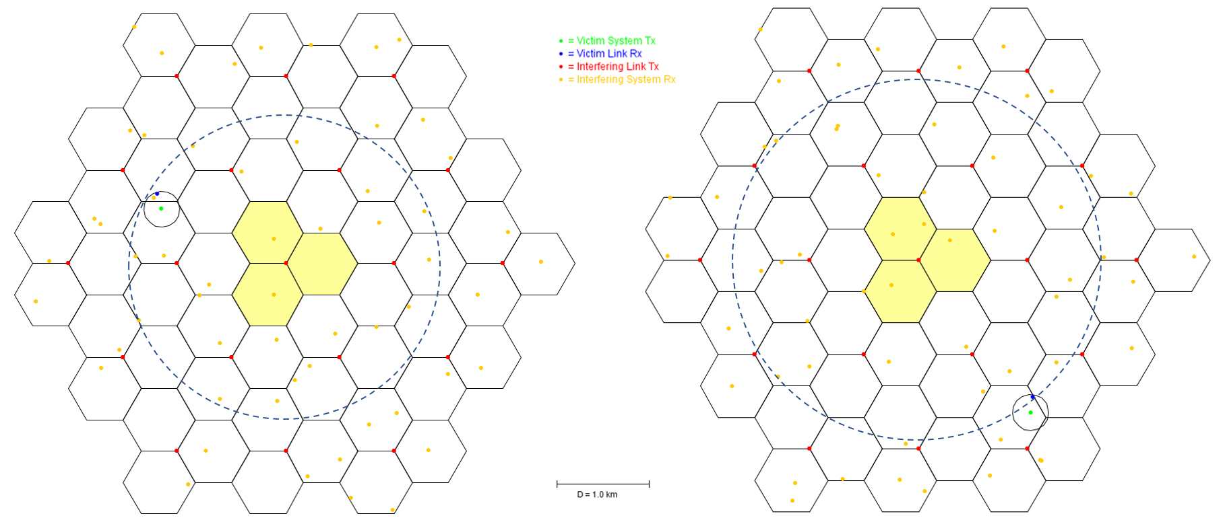

Figure 27: Methodology used for the simulation with WLAN as victim Rx within the 1-tier hexagons, with simulation radii to have same circular area as within the 1-tier sectors and with outer most 1-teir hexagon distance

Table 49 gives the iRSSUnwantedEmission with (iRSSAAS - iRSSnon-AAS) for various unwanted emission levels for >2403 MHz in TRP for AAS with respect to the non-AAS max value given in Table 3 in ECC Decision (14)02 [1] with 1 dBm/(5 MHz) e.i.r.p. (total e.i.r.p. independent of BS configuration), non-AAS antenna gain of 16 dBi and 3 dB feeder loss10F[11]. The TRP values include array ohmic losses of 2 dB. The relative study with iRSS takes the existing non-AAS unwanted emission limit towards RLAN in ECC Decision (14)02 and ECC Report 172 [4] as the basis for the AAS study. The results, considering also that the victim 10 m height probability is much less than at 1.5 m, suggests an additional baseline of -10 dBm/(5 MHz) TRP per sector in order not to cause more interference above 2403 MHz relative to non-AAS with additional baseline 1 dBm/(5 MHz) e.i.r.p. as specified in ECC Decision (14)02.

Table 49: AAS unwanted emission in TRP per sector for above 2403 MHz and iRSSUnwantedEmission = iRSSAAS- iRSSnon-AAS

|  |  |  |  |
| --- | --- | --- | --- |
| TRP unwanted emission for AAS >2403 MHz | -8 dBm/(5 MHz) | -10 dBm/(5 MHz) | -12 dBm/(5 MHz) |
| iRSS for WLAN at 1.5 m height | +1.6 dB | -0.3 dB | -2.3 dB |
| iRSS for WLAN at 10 m height | +2.3 dB | +0.2 dB | -1.9 dB |

Table 50 gives the iRSSBlocking due to blocking for various in-block output powers levels in TRP for AAS with 10 MHz BW operating in 2390-2400 MHz. The TRP values include array ohmic losses of 2 dB. For non-AAS the restricted power level as given in ECC Decision (14)02 is used. In general, it can be observed that the blocking response or WLAN receiver selectivity for 2390 to 2400 MHz is about 12 dB to 22 dB less than for the 2390 to 2300 MHz frequency range, as can be seen from Table 59. The results suggest an in-block power restriction of 31 dBm/(5 MHz) TRP per sector in 2390-2400 MHz frequency range in order to cause not more blocking relative to non-AAS with 45 dBm/(5 MHz) e.i.r.p. as specified in ECC Decision (14)02.

Table 50: AAS in-block power in TRP per sector for 2390-2400 MHz and iRSSBlocking = iRSSAAS- iRSSnon-AAS

|  |  |  |  |
| --- | --- | --- | --- |
| TRP in-block power for AAS 2390-2400 MHz (The value includes array ohmic loss of 2 dB) | 29 dBm/(5 MHz) | 31 dBm/(5 MHz) | 33 dBm/(5 MHz) |
| iRSS for WLAN at 1.5 m height | -2.1 dB | -0.3 dB | +1.7 dB |
| iRSS for WLAN at 10 m height | -1.9 dB | +0.2 dB | +2.1 dB |

* 1. General consideration for the in-band and adjacent band relative AAS/non-AAS comparison

The out-of-block and out-of-band emission requirement for the BS transmitter is specified both in terms of ACLR and OBUE. For the co-existence studies in the OOB region and systems with similar BWs ACLR for BS 43 dBm total conducted output power per polarisation for non-AAS and AAS and 10/20 MHz BW can be considered as given in reference [22]. Maximum offset of the OBUE from the operating band edge is 10 MHz for non-AAS and 40 MHz for AAS. The relative ACLR is 45 dB for macro BSs and the absolute ACLR is -15 dBm/MHz for non-AAS (single polarisation and per antenna connector [6]) and -6 dBm/MHz for AAS (dual polarisation and OTA [27]) and is measured at BS adjacent channel centre frequency offset below the lowest or above the highest carrier centre frequency transmitted. The less stringent of the two is applied. The 0 to 10 MHz and 10 to 40 MHz OOB regions are of interest for the studies. The in-block power, transitional region and baseline BEM for non-AAS are specified per antenna in ECC Decision (14)02 [1]. For non-AAS MFCN BS the unwanted emission scales with number of antennas (white noise) and up to four cross-polarised non-AAS antennas are assumed below. (MIMO operation). For AAS MFCN BS the unwanted emission is independent of number of antenna elements. The difference in Conducted Powerin-band power and Conducted Powerunwanted emission is given in Table 51 and Table 52. The non-AAS feeder loss and the AAS array ohmic loss are considered in the antenna gain (Table 53 and Table 54).

Additional external RF filters are considered for some of the non-AAS coexistence studies in ECC Report 172 [4] in order to minimise coordination zones. For AAS such an additional filter would need to be implemented inside the AAS BS itself as described in ECC Report 281 (see section 6.3 [12]) and the economical feasibility needs to be considered [12].

Table 51: Macro BS in-block conducted power difference between AAS and non-AAS for 10, 20 MHz BWs, [22]. Four cross-polarised non-AAS antennas are assumed

|  |  |
| --- | --- |
| BW (MHz) | Conducted Power in-block power in dB |
| 10, 20 MHz | -6 dB |

Table 52: Macro BS OOB unwanted emission difference between AAS and non-AAS for 20 MHz BW, [22]. Four cross-polarised non-AAS antennas are assumed

|  |  |
| --- | --- |
| Frequency range | Conducted Powerunwanted emission in dB |
| 0 to 10 MHz | 2 dB |
| 10 to 40 MHz including spurious emission for non-AAS | 17 dB |

Relative comparison of difference in antenna gains along horizon and horizontal boresight for victims >1 km from the BS, as sketched in Figure 28, can be used if coordination is possible in order to estimate possible interference from AAS and non-AAS. For the non-AAS/AAS the BS parameters are given in A4.3. For distances >1 km and typical h = hBS - hVictim above ground the difference in antenna gain as seen towards horizon is small (see e.g. ECC Report 174, section 5.5.4 [52] or ECC Report 308, Annex 4 [25]). Comparing the AAS and non-AAS antenna gains (CDF) gives the delta in effective antenna gain probability over time for fixed single sector with worst-case horizontal boresight towards victim.

The relative comparison does not use the network activity factor and receiver requirements (including time aspects and protection limits) as it can be expected to be the same for non-AAS and AAS network. But due to the inherent statistic of AAS beamforming and other probabilities like BS/victim location and antenna direction, etc. the delta effective antenna gain (CDF threshold value) has to be chosen with care in order not to e.g. overestimate protection needed for AAS compared to existing non-AAS. Such has been discussed in ECC Report 308, Annex 4 and Annex 7 [25] in details using time-variant gain (TVG) method which would suggest also in the context of this report lower CDF values for the AAS beamforming can be used to fulfil victim receiver requirements. The single-sector worst case relative non-AAS/AAS comparison is especially useful in bands with existing non-AAS networks and was used in recent studies including the 1800 MHz, 2100 MHz and 2600 MHz bands for introducing AAS in the ECC Decisions.

For possible interference towards victims <1 km separation distances and where coordination may not be feasible, e.g. for RLAN as described in section 4.2.3.1, Monte Carlo simulation can be used.

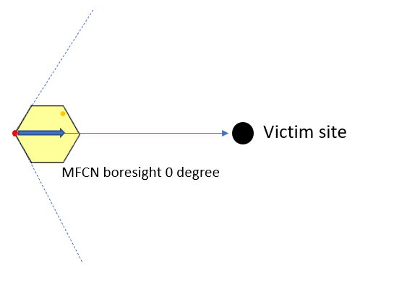

Figure 28 BS AAS/non-AAS horizontal boresight pointing towards victim

The CDF values for the effective antenna gain difference Gain between AAS and non-AAS for single sector with horizontal fixed boresight pointing towards victim receiver in horizon (radio horizon) and for 3 UEs sharing bandwidth per snapshot are provided in Table 53. and for the sub-array the CDF is shown in Figure 29. The effective gain is an abstract term to consider the interference sum (unwanted emission) for AAS serving 3UEs in the DL and the resulting interference towards the victim receiver. The non-AAS antenna gain for rural is 18 dBi, and suburban/urban is 16 dBi, see A4.3. The non-AAS antenna gain towards horizon considering 3 dB feeder loss and mechanical antenna tilt is: 13 dBi for rural deployment, 10 dBi for sub-urban and 4.6 dBi for urban case. For AAS the values consider single-element and sub-array AAS models with values as given in A4.3. The UEs are dropped randomly within the cellular cell radius for regular hexagon with no handover area and more general irregular hexagon/shape of same cell radius. For the sub-array beam steering limit is also used for the simulated values below. It can be seen in Table 53 that for victim along the horizon the difference in gain for higher CDF values is small between the single-element and sub-array AAS models.

Table 53: Macro rural/suburban/urban case Gain along horizon for fully correlated case ( = 1) and three UEs sharing bandwidth per snapshot using single-element and sub-array AAS model for regular hexagon and irregular hexagon/shape with same cell radius. The values include feeder and ohmic losses for non-AAS and AAS.

|  |  |  |  |
| --- | --- | --- | --- |
|  | Effective GainCorrelated (AAS - non-AAS) in dB for 3UEs | | |
|  | **Rural** | **Suburban** | **Urban** |
| @50% CDF | -6.7 to 2.8 | -6.2 to 1.6 | -3.6 to 2.6 |
| @90% CDF | 5.5 to 8.2 | 7.1 to 8.8 | 10.7 to 12.2 |
| @95% CDF | 5.9 to 9.5 | 8 to 9.6 | 11.8 to 12.9 |
| @98% CDF | 6.9 to 10.9 | 8.6 to 10.8 | 12.6 to 14.1 |
| @ ≥99.9% CDF | 8.8 to 11.9 | 11.2 to 12.2 | 15.1 to 15.9 |

Table 54 gives the effective Gain for the uncorrelated AAS beamforming case with  = 0 for single-element and sub-array.

Table 54: Macro suburban case GainUncorrelated along horizon for uncorrelated case ( = 0) including feeder loss and ohmic loss

|  |  |
| --- | --- |
|  | Effective GainUncorrelated (AAS - non-AAS) in dB |
| Rural | -7.4 to -2.6 |
| Sub-urban | -4.3 to 0.4 |
| Urban | 1.1 to 5 |

P3200#yIS1

Figure 29: Effective GainCorrelated in dB for 3UEs for rural, suburban and urban case along horizon with sub-array model for AAS

* 1. LTE/NR non-AAS/AAS parameters

The parameters for macro non-AAS and macro AAS BSs as used in other recent studies ECC Report 298 [53], ECC Report 308 [25] and ECC Report 281 [12] are provided in Table 55 to Table 57. Ohmic loss include dissipation, matching and PCB transmission line losses, etc. BS array ohmic loss is considered to be 2 dB. For AAS in the 2300 MHz only macro AAS BSs are foreseen.

Table 55: Deployment scenarios of radio access networks and parameters in common for non-AAS and AAS [11], [22]

|  |  |  |
| --- | --- | --- |
| Parameter | Range examples | Used for this study |
| Area | Macro rural, suburban, urban, indoor | Rural, suburban and urban area |
| BS type | Macro, micro, pico | Macro non-AAS and AAS |
| Cell radius | ITU-R M.2292 [51], [22]:  Rural: > 2 km (typical value to be used in sharing studies 4 km)  Suburban: 0.4-2.5 km (typical figure to be used in sharing studies 0.8 km suburban, BS-to-BS ISD 1.2 km).  Urban: 0.2-0.8 km (typical value to be used in sharing studies for urban macro 0.4 km)  ECC Report 172 [4]: cell radius 0.433 km and BS-to-BS distance 0.75km (used 3GPP2 cell layout) | Rural with 4 km cell radius, BS-to-BS ISD 6 km (in SEAMCAT 2 km cell radius with 3GPP layout)  Suburban with 0.8 km cell radius BS-to-BS ISD 1.2 km (in SEAMCAT 0.4 km cell radius with 3GPP layout)  Urban with 0.4 km cell radius BS-to-BS ISD 0.6 km (in SEAMCAT 0.2 km cell radius with 3GPP layout) |
| Antenna height | ECC Report 172: 10 to 37.5 m  ITU-R M.2292 [51]: 30 m rural, 25 m for suburban, 20 m urban | 30 for rural and 25 m for suburban, 20 m for urban |
| Channel bandwidth | 5 to 100 MHz from 3GPP spec [15]  10 or 20 MHz, from ITU-R [22]  ECC Report 172: 10 and 20 MHz | 10 and 20 MHz  (with centre frequencies at 2395 and 2390 MHz) |
| Number of UEs served simultaneously in DL sharing allocated channel bandwidth | Share bandwidth with a number of UEs: 1 to 3 | 1 UE with current SEAMCAT version for Wi-Fi study, this is as there are warning information on RB per UE and BW and for blocking calculation if using more than one UE |
| UE above ground | 1.5 m and 5 m | 1.5 m |
| Network loading factor (base station load probability X%) | 20% (for larger areas), 50% (smaller areas)  Note: SEAMCAT with current version up to 5.4.1 has not implemented load-based activity factor. For 1-tier networks the BS typical power may be reduced by 3 dB to account for it [50]. | For 1-tier and higher reduce BS power by 10*log10(x% loading factor) |
| BS TDD activity factor | 75% (1.2 dB lower average power) | Reduce BS power by 1.2 dB |
| Indoor user terminal usage | 70% [50] |  |
| Indoor penetration loss | ECC Report 172 SEAMCAT files: 10 dB,  = 5 dB  ITU-R M.2292: 20 dB  ITU-R P.2109 [54] |  |

Table 56: Deployment related non-AAS parameters for macro rural/suburban/urban cases from various references including ECC Report 172 [4], ITU-R M.2292 [50] and ITU-R WP5D WRC-23 parameters [22]

|  |  |  |
| --- | --- | --- |
| Parameter | Range examples | Used for this study |
| Downtilt | Rural: 3 degrees  Suburban: 6 degrees  Urban: 10 degrees  [4], [51], [22] |  |
| Antenna Pattern | Recommendation ITU-R F.1336-4 rec 3.1 [56] with antenna parameters given in [51], [22].  Use peak envelope for single cell |  |
| Feeder loss | 3 dB [22] | 3 dB for urban, suburban and macro non-AAS |
| BS typical transmit power (per sector) | 43 dBm for 5 MHz BW and 46 dBm for 10 and 20 MHz BW | 46 dBm for 10 and 20 MHz BW |
| Max. Antenna gain dBi (3-sector sites assumed for macro) | 16 to 21 dBi for urban to rural considering also existing non-AAS networks | 16 dBi for urban and suburban and 18 dBi for rural |

Table 57: Deployment related AAS parameters for macro suburban case

|  |  |  |
| --- | --- | --- |
| Parameter | Range | Used for this study |
| Antenna pattern | 1) Sub-arrays: ITU-R M.2101 [11] extended / WP5D WRC-23 [22]  2) Single elements: ITU-R M.2101 [11] / 3GPP TR 37.840 [14] |  |
| Element gain (dBi)  (including array ohmic loss of 2 dB) | 1) 6.4 dBi  2) 6 dBi |  |
| Horizontal/vertical 3 dB beam width of single element (degree) | 1) 90º for H and 65º for V  2) 80º for H and 65º for V |  |
| Antenna array configuration (Row × Column) | 1) 4x8 elements with 3x1 sub-arrays  2) 8×8 single elements |  |
| Horizontal/Vertical radiating element spacing | 1) 0.5 for H, 2.1 for V (with 0.7 for V in subarray)  2) 0.6 for H, 0.9 for V |  |
| BS typical transmit power per sector conducted | 46 dBm | 46 dBm |
| Mechanical downtilt (degrees) | 1) 6 degree for urban, suburban and 3 degree for rural  2) 10 degree |  |
| BS vertical coverage range | 1) 90 - 100 degree |  |
| Correlation (antenna beamforming) | ❒ = 0 and 1 | 0 and 1 |

* 1. WLAN parameters in the band 2400-2483.5 MHz

The parameters used in ECC Report 172 for WLAN (Table 55 [4]) and for co-existence studies are listed in Table 58 and Table 59.

Table 58: WLAN parameters from ECC Report 172 [4] and relevant SRD specification for operation in the SRD band 2400-2483.5 MHz

|  |  |  |
| --- | --- | --- |
| Parameter | Range examples | Used for this study |
| Receiver bandwidth, MHz | 16.25 for WLAN 802.11g/n with 20 MHz channel spacing [4] | 16.25 |
| Receiver noise figure (NF), dB | 10 dB [4] | 10 |
| Receiver antenna height, m | 1.5 or 10 m [4] | 1.5 and 10 m |
| Receiver antenna gain, dBi | 2 dBi [4].  From -2 dBi to 3 dBi for client devices and within the range 1 dBi to 4 dBi for Access Points [55] | 2.15 dBi |
| WLAN Centre frequency, MHz | 2412 MHz (Channel 1)  2432 MHs (Channel 5)  used in [4] |  |
| Receiver thermal noise (No), dBm | -102 dBm [4] |  |
| Noise floor (N) =No + NF | -92 dBm with NF: 10 dB, [4] |  |
| I/N objective, dB | 0 dB [4] | 0 |
| Rx sensitivity for ERP | -82 dBm for 6 Mbps  -65 dBm for 54 Mbps from [57], [43] |  |
| Implementation Margin | 5 dB [43] | Not used for the blocking response when deriving N |

The Adjacent Channel Selectivity (ACS) and blocking receiver parameters for Wideband Transmission Systems (WTS) in the 2.4 GHz are specified in reference [41], [57] and [43]. The blocking with respect to the cellular band in 2300-2400 MHz is specified for < 2390 MHz. In SEAMCAT [50], the blocking response is calculated by: Blocking response = IOOB-Standard - IIIB-Standard in dB with IOOB-Standard the allowed power of an interfering blocking signal as specified in the relevant standard and IIIB-Standard the equivalent in-band interfering signal. (Blocking Response = N + 10.log10[10^(DSTANDARD/10) - 1] - IOOB-STANDARD). The blocking response for ACS/ACR and blocking is provided in Table 59, as specified in the standard OCBW = 16.25 MHz, data rates of 6 to 54 Mbps, I/Ntarget = 0 dB, DStandard = 3 dB and NF = 10 dB and channel spacing 20 MHz. For 0 dBi antenna assembly gain and Receiver Category 1. BSs or terminals have the same blocking performance for SRD equipment. The blocking seems to be only tested with the lowest data rate and because the wanted signal and blocking signal is fixed, as described in ETSI EN 300 328 V2.2.2 [41] for the test, the blocking performance is rather relaxed if comparing with other wireless systems.

Table 59: Blocking response for SRD/WLAN in 2400-2483.5 MHz band

|  |  |
| --- | --- |
| Frequency, MHz | Blocking Response for 20 MHz channel spacing, dB |
| 2400 - 2390 | 29 |
| 2390 - 2387 | 41 |
| 2387 - 2373 | 44 |
| 2373 - 2370 | 47 |
| 2370 - 2300 | 51 |

The generic blocking parameters for WTS in the ISM band 2400-2483.5 MHz can be found in ETSI EN 300 328, table 14 Section 4.3.2.11.4.2 [41] for receiver category 1 equipment. The blocking levels apply from 2390 to 2370 MHz and from 2370 to 2300 MHz as described in ETSI EN 300 328, section 5.4.11.

The sensitivity for IEEE 802.11 devices and ACS/ACR (Adjacent Channel Selection/Adjacent Channel Rejection) values are given in Table 17-18 in reference [43].

1. Example of LSA in Europe

In Portugal, incumbent services in the 2.3-2.4 GHz band consist of PMSE applications, and there are currently three radio licences awarded for the frequency bands 2300-2330 MHz, 2330-2360 MHz and 2360-2390 MHz, to broadcasting operators, which grant the usage right for the spectrum assigned to them, anywhere and at any time within the national territory, with no need to provide information of any kind to ANACOM regarding the type of use of these frequencies, pursuant to the respective licences. The "Study on the Licensed Shared Access (LSA) Spectrum-Sharing Model" in Portugal was launched on 10 January 2018, involving ANACOM and several strategic partners. The study was conducted with the aim of analysing alternative spectrum management scenarios and models, specifically the LSA in the 2.3-2.4 GHz band. The LSA concept was proven, and the LSA Warner system (developed in Portugal) to detect LTE TDD signals functioned successfully, allowing the deployment of basic features that can enable the introduction of the LSA model, tailored to the scenario of spectrum use in the 2.3-2.4 GHz band in Portugal. The tests demonstrated that the LTE TDD and PMSE signals using the “same channel” are not compatible, regardless of the signals’ bandwidth. The full report is available at [58].

1. List of References

1. [ECC Decision (14)02](https://docdb.cept.org/document/443): "Harmonised technical and regulatory conditions for the use of the band 2300-2400 MHz for Mobile/Fixed Communications Networks (MFCN)", approved June 2014
2. ITU Radio Regulations, Edition of 2020

1. [ECC Recommendation (14)04](https://docdb.cept.org/document/512): "Cross-border coordination for mobile/fixed communications networks (MFCN) and between MFCN and other systems in the frequency band 2300-2400 MHz", approved June 2014

1. [ECC Report 172](https://docdb.cept.org/document/280): "Broadband Wireless Systems Usage in 2300-2400 MHz", approved March 2012

1. [ECC Report 203](https://docdb.cept.org/document/310): "Least Restrictive Technical Conditions suitable for Mobile/Fixed Communication Networks (MFCN), including IMT, in the frequency bands 3400-3600 MHz and 3600-3800 MHz", approved November 2013
2. ETSI TS 137 104, "NR, E-UTRA, UTRA and GSM/EDGE; Multi-Standard Radio (MSR) Base Station (BS) radio transmission and reception"

1. [ERC Recommendation 74-01](https://docdb.cept.org/document/1001): “Unwanted emissions in the spurious domain”, approved 1998, latest corrected May 2022

1. [ECC Report 205](https://docdb.cept.org/document/312): “Licensed Shared Access (LSA)”, approved February 2014
2. ETSI TS 103 154: “Reconfigurable Radio Systems (RRS); System requirements for operation of Mobile Broadband Systems in the 2 300 MHz - 2 400 MHz band under Licensed Shared Access (LSA)”

1. [CEPT Report 55](https://docdb.cept.org/document/55): "Report A from CEPT to the European Commission in response to the Mandate on ‘Harmonised technical conditions for the 2300-2400 MHz (‘2.3 GHz’) frequency band in the EU for the provision of wireless broadband electronic communications services’", approved November 2014
2. Recommendation ITU-R M.2101: "Modelling and simulation of IMT networks and systems for use in sharing and compatibility studies"

1. [ECC Report 281](https://docdb.cept.org/document/3360): "Analysis of the suitability of the regulatory technical conditions for 5G MFCN operation in the 3400-3800 MHz band", approved July 2018

1. [CEPT Report 67](https://docdb.cept.org/document/3357): "Report A from CEPT to the European Commission in response to the Mandate

“to develop harmonised technical conditions for spectrum use in support of the introduction of next-generation (5G) terrestrial wireless systems in the Union” Review of the harmonised technical conditions applicable to the 3.4-3.8 GHz ('3.6 GHz') frequency band", approved July 2018

1. 3GPP TR 37.840: "Study of Radio Frequency (RF) and Electromagnetic Compatibility (EMC) requirements for Active Antenna Array System (AAS) base station"
2. 3GPP TS 38.104: “Technical Specification Group Radio Access Network; NR; Base Station (BS) radio transmission and reception”

1. [ECC Recommendation (15)01](https://docdb.cept.org/document/515): “Cross-border coordination for mobile/fixed communications networks (MFCN) in the frequency bands: 694-790 MHz, 1452-1492 MHz, 3400-3600 MHz and 3600-3800 MHz”, approved February 2015 latest amended on 10 June 2022

1. [ECC Report 296](https://docdb.cept.org/document/9067): "National synchronisation regulatory framework options in 3400-3800 MHz: a toolbox for coexistence of MFCNs in synchronised, unsynchronised and semi-synchronised operation in 3400-3800 MHz", approved March 2019
2. GSA: "Synchronisation frameworks & cross-border coordination", <https://gsacom.com/paper/synchronisation-frameworks-cross-border-coordination/>

1. [ECC Report 331](https://docdb.cept.org/document/22509): "Efficient usage of the spectrum at the border of CEPT countries between TDD MFCN in the frequency band 3400-3800 MHz", approved November 2021

1. [ECC Recommendation (20)03](https://docdb.cept.org/document/15492): “Frame structures to facilitate cross-border coordination of TDD MFCN in the frequency band 3400-3800 MHz”, approved October 2020
2. Recommendation ITU-R P.1546-4: “Method for point-to-area predictions for terrestrial services in the frequency range 30 MHz to 3 000 MHz”
3. Working Party 5D Chairman’s Report, "CHARACTERISTICS OF TERRESTRIAL COMPONENT OF IMT FOR SHARING AND COMPATIBILITY STUDIES IN PREPARATION FOR WRC-23", Annex 4.4 to Document 5D/716-E
4. Recommendation ITU-R P.452-11: “Prediction procedure for the evaluation of interference between stations on the surface of the Earth at frequencies above about 0.1 GHz”

1. [ECC Report 173](https://docdb.cept.org/document/281): “Fixed Service in Europe Current use and future trends post 2016”, approved April 2012, latest updated April 2018

1. [ECC Report 308](https://docdb.cept.org/document/13861): “Analysis of the suitability and update of the regulatory technical conditions for 5G MFCN and AAS operation in the 2500-2690 MHz band”, approved March 2020
2. 3GPP TR 37.842: “Evolved Universal Terrestrial Radio Access (E-UTRA) and Universal Terrestrial Radio Access (UTRA; Radio Frequency (RF) requirement background for Active Antenna System (AAS) Base Station (BS)”
3. ETSI TS 137 105: “Active Antenna System (AAS) Base Station (BS) transmission and reception (3GPP TS 37.105)”

1. [ECC Report 302](https://docdb.cept.org/document/10170): "Sharing and compatibility studies related to Wireless Access Systems including Radio Local Area Networks (WAS/RLAN) in the frequency band 5925-6425 MHz", approved May 2019

1. [ERC Report 25](https://docdb.cept.org/document/593): "The European table of frequency allocations and applications in the frequency range 8.3 kHz to 3000 GHz (ECA table)", approved June 1994, latest amended October 2021

1. [ECO Report 03](https://docdb.cept.org/document/939): "The licensing of "Mobile bands" in CEPT", approved August 2020

1. [T/R 13-01](https://docdb.cept.org/document/868): “Recommendation T/R of 1993 on preferred channel arrangements for fixed service systems operating in the frequency range 1-2.3 GHz”, revised on 5 February 2010
2. ETSI EN 302 217: “Characteristics and requirements for point-to-point equipment and antennas”

1. [ERC Recommendation 25-10](https://docdb.cept.org/document/838): “ERC Recommendation of 1995 on frequency Ranges for the Use of Terrestrial Audio and Video Programme Making and Special Events (PMSE) applications”, editorial update on 28 May 2021
2. ETSI EN 302 064: “Wireless Video Links (WVL) operating in the 1.3 GHz to 50 GHz frequency band”

1. [ECC Recommendation (10)01](https://docdb.cept.org/document/494): “Guidelines for compatibility between Complementary Ground Components (CGC) operating in the band 2170-2200 MHz and EESS/SOS/SRS earth stations operating in the band 2200-2290 MHz”, approved January 2010

1. [ERC Recommendation 62-02](https://docdb.cept.org/document/844): “Harmonised frequency band for Civil and Military Airborne Telemetry applications”, approved February 1998
2. ETSI EN 301 783: “Land Mobile Service; Commercially available amateur radio equipment”
3. ETSI EN 301 908: “IMT cellular networks”

1. [ERC Recommendation 70-03](https://docdb.cept.org/document/845): “Relating to the use of Short Range Devices (SRD)”, approved October 1997, latest amended on 10 June 2022, editorial update on 14 October 2022
2. ETSI EN 300 440: “Radio equipment to be used in the 1 to 40 GHz frequency range”
3. ETSI EN 300 328: "Wideband transmission systems; Data transmission equipment operating in the 2,4 GHz band; Harmonised Standard for access to radio spectrum"
4. Technical Brief: “5Ghz IEEE 802.11a For Interference Avoidance”, Motorola:  
   <https://www.motorolasolutions.com/content/dam/msi/docs/business/_documents/static_files/interference_tb_0809.pdf>
5. IEEE 802.11-2020, "Part 11: Wireless LAN Medium Access Control (MAC) and Physical Layer (PHY) Specifications"
6. Recommendation ITU-R P.525: “Prediction of building entry loss”
7. Recommendation ITU-R P.2108: “Prediction of building entry loss”

1. [ERC Report 68](https://docdb.cept.org/document/636): “Monte-Carlo simulation methodology for the use in sharing and compatibility studies between different radio services or systems”
2. Recommendation ITU-R M.1739: “Protection criteria for wireless access systems, including radio local area networks, operating in the mobile service in accordance with Resolution 229 (WRC-03) in the bands 5 150-5 250 MHz, 5 250-5 350 MHz and 5 470-5 725 MHz”
3. ETSI TS 136 104: "LTE; Evolved Universal Terrestrial Radio Access (E-UTRA); Base Station (BS) radio transmission and reception", Table 6.6.3.2.1-6

1. [ECC Report 310](https://docdb.cept.org/document/13606): "Evaluation of receiver parameters and the future role of receiver characteristics in spectrum management, including in sharing and compatibility studies", approved January 2020

1. [ECC Report 252](https://docdb.cept.org/document/993): “SEAMCAT Handbook Edition 2”, approved April 2016
2. Report ITU-R M.2292: "Characteristics of terrestrial IMT-Advanced systems for frequency sharing/interference analyses"

1. [ECC Report 174](https://docdb.cept.org/document/282): “Compatibility between the mobile service in the band 2500-2690 MHz and the radiodetermination service in the band 2700-2900 MHz”, approved April 2012

1. [ECC Report 298](https://docdb.cept.org/document/9069): “Analysis of the suitability and update of the regulatory technical conditions for 5G MFCN and AAS operation in the 1920-1980 MHz and 2110-2170 MHz band”, approved March 2019
2. Recommendation ITU-R P.2109: “Prediction of building entry loss”
3. ETSI TR 103 665: "System Reference document (SRdoc); Data Transmission Systems using Wide Band technologies in the 2,4 GHz band", chapter 8
4. Recommendation ITU-R F.1336-4: "Reference radiation patterns of omnidirectional, sectoral and other antennas for the fixed and mobile services for use in sharing studies in the frequency range from 400 MHz to about 70 GHz"
5. ETSI ES 202 131: “Data transmission equipment operating in the 2,4 GHz ISM band and using spread spectrum modulation techniques; Specification of Reference Receiver Performance Parameters for Spectrum Planning"
6. Study on the Licensed Shared Access (LSA) Spectrum-Sharing Model, ANACOM, May 2021: <https://anacom.pt/render.jsp?contentId=1636571>

1. under current technology a guard band of at least 10 MHz might be needed in order to fulfil the requirements
2. The e.i.r.p. in this case is given as the total radiated power in any direction at a single location independent of any base station configuration.
3. This value is based on a scenario including all base station classes (macro, micro, pico and femto). A more restrictive scenario may allow a more relaxed value for some BS classes.
4. BC1 and BC3 are band categories, for details see ETSI TS 137 104 [6]
5. TRP is defined as the integral of the power radiated by an antenna array system in different directions over the entire radiation sphere.
6. under current technology a guard band of at least 10 MHz might be needed in order to fulfil the requirements
7. Network technologies and topologies (LTE/5G-NR, non-AAS/AAS BS, BS antenna height), propagation environment and propagation model, frequency assignments, protection criteria (I/N or network throughput loss at x%, etc.….).
8. For example ”careful installation” would include measures like ceiling-mounted installation, placement of indoor BS away from windows, additional shielding around buildings in the worst case. Such measures may be more appropriate for professional installations which seem less suitable for consumer-type of scenario (without further mitigation schemes implemented in the indoor BS). Such measure seems to be feasible in case of industrial – type of use case (e.g. smart factory indoor coverage).
9. TRP is a measure of how much power the antenna actually radiates. The TRP is defined as the integral of the power transmitted in different directions over the entire radiation sphere. For an isotropic antenna radiation pattern, e.i.r.p. and TRP are equivalent. For a directional antenna radiation pattern, e.i.r.p. in the direction of the main beam is (by definition) greater than the TRP.
10. [https://www.ofcom.org.uk/__data/assets/pdf_file/0026/33497/pssr.pdf](https://eur01.safelinks.protection.outlook.com/?url=https%3A%2F%2Fwww.ofcom.org.uk%2F__data%2Fassets%2Fpdf_file%2F0026%2F33497%2Fpssr.pdf&data=04%7C01%7CSteve.Leach%40ofcom.org.uk%7C413e4dd46108479c327408da08e2c850%7C0af648de310c40688ae4f9418bae24cc%7C0%7C1%7C637832067362796715%7CUnknown%7CTWFpbGZsb3d8eyJWIjoiMC4wLjAwMDAiLCJQIjoiV2luMzIiLCJBTiI6Ik1haWwiLCJXVCI6Mn0%3D%7C3000&sdata=445rgRbwtmZaacW8O493E8WWcuQASbGVJQbJreqOGu4%3D&reserved=0) (see Figure 6.1)
11. In SEAMCAT there is no separate input field for the feeder loss and it has to be either considered with the antenna gain or BS output power. The unwanted emission in SEAMCAT is defined relative to the BS power at the BS antenna connector. In the SEAMCAT files used for the simulation results this is considered in order to not exceed the +1 dBm e.i.r.p. as given in ECC Decision (14)02 (for non-AAS and independent of antenna configuration) with the set BS power and the used antenna gain (43 dBm – 58 dBc (Ref BW 5 MHz) + 16 dBi = +1 dBm/5 MHz e.i.r.p.).